Nunphung lei le Holh lei in Aa
dangmi Tuahtoning 2023-2027

Kan lim cangmi
Fawi tein Rel ding a tawinak in tialmi
Hakha Chin | Laiholh

Hi report hman ning
 | Rampumpi Pumtlinglo Aamahkhan Riantuanpiaknak (National Disability Insurance Agency, NDIA) nih hi report cu a rak tial. ‘Kanmah’ (we) timi biafang na hmuh tikah, hi a sullam cu NDIA tinak a si.
Hi report cu rel a fawi dingmi in kan rak tial.
Cheukhat ruahnak pawl fianter dingah hmaanthlak pawl kan hman.
A biapimi biafang pawl kha anak (bold) in kan
rak tial.
Hihi a sullam cu cafang pawl kha a chah deuhmi le anak deuhmi an si.
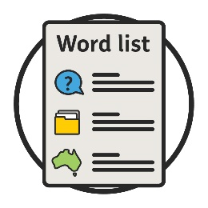 | Hi biafang pawl a sullam kha kan fianter.  Hi biafang pawl i cazin cu cahmai 30 ah a um.
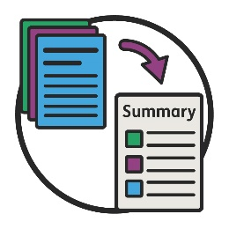 | Hi Fawi tein Rel ding report cu adang report i a tawinak in tialmi a si. Hihi a sullam cu a biapi bikmi ruahnak pawl lawng aa tel.
Kan website ah adang report na hmuh khawh.
www.ndis.gov.au
Hi report rel dingah bawmh na hal khawh.
Hawikom, innchungkhar chungtel asilole bawmtu minung nih an in bawmh khawh men.

Hi report chungah zeidah a um?
Hi report nih zei kong dah a chim? 4
Tuahtimi-pungsan hmannak 6
Mibu he zeitindah riantuannak kan rak ngeih? 7
Mibu nih zeidah an rak kan chimh? 9
Adang tlangtar pawl le tinhmi pawl 12
1. Rian kan tuan tikah CALD aa telmi pawl cungah i papeknak 14
2. Kan riantuantu pawl nih a dikmi thiamnak pawl an ngeih fehternak 17
3. Thawngthanhmi kan phawtzamh ning 19
4. Thimnak le uknak 21
5. CALD aa telmi pawl kong data 23
Hmailei ah zeidah a cang lai? 26
Thawngthanhmi tamdeuh 28
Biafang cazin 30

Hi report nih zei kong dah a chim?
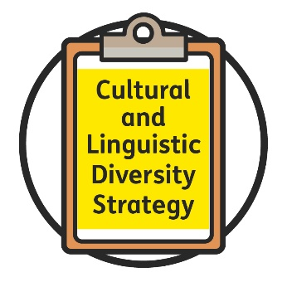 | Nunphung lei le Holh lei in Aa dangmi Tuahtoning (Cultural and Linguistic Diversity Strategy) kan  rak tial.  Hihi Tuahtoning tiah kan auh.
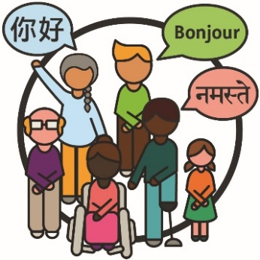 | Nunphung lei le holh lei in aa dangmi (CALD) minung (people):  - aa dangmi sining dirhmun pawl sin in a rami  - Mirangholh nak in holh dang a hmangmi.
 | Cun aa telmi pawl (participants) cu NDIS ah aa telmi pumtlinglo minung an si.
 | Tuahtoning nih CALD aa telmi pawl nih an herhmi bawmhnak pawl le riantuanpiaknak pawl an hmuh khawh ning kha a fianter.
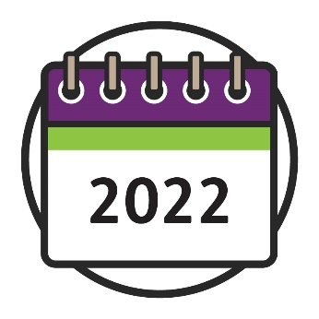 | Tuahtoning cu 2022 ah a dih te lai.
Tuahtoning (Strategy) a thar kan tuah cuahmah.
Hihi cu 2023 in aa thawk lai.
CALD aa telmi pawl caah Tuahtoning a thar tha
tein rian a tuannak fehter dingah mibu he riantuanti kan duh.
Hi report nih mibu he rian kan tuan khawh ning kha a fianter:
- kan Tuahtoning a thar ser ding
- kan itinhmi pawl lei ah riantuan ning timhtuah ding.
 | Hihi ah aa telmi cu:
 | - kan lim cangmi
 | - hmailei tuah dingin timhtuahmi.

Tuahtimi-pungsan hmannak
Tuahtimi-pungsan (Co-design) cu a thar pakhat khat timhtuah dingah minung hna hmunkhat ah riantuanti caan khi a si.
Tuahtoning a thar ser dingah tuahtimi-pungsan hman kan duh.
 | Hngalh kan duhmi:
 | - CALD aa telmi pawl nih zuamcawhnak an tonmi pawl kong
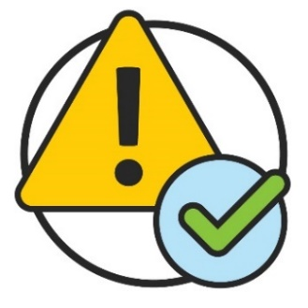 | - hi harnak pawl cu remhnak kha  Tuahtoning a thar nih zeitindah a bawmh khawh ning kong.
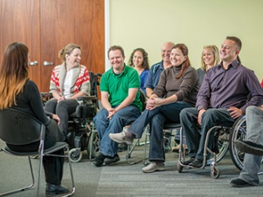 | Mibu he riantuanti kan duh fawn:  - Tuahtoning a thar phawtzamh ding  - tha tein rian tuanter hrimhrim ding.
 | Hi report cu CALD minung nih an tonmi zuamcawhnak pawl kong a si.

Mibu he zeitindah riantuannak kan rak ngeih?
Tho (October) in Dipa (December) 2021 tiang, CALD aa telmi nih an tonmi zuamcawhnak pawl kawl dingah mibu he rian kan rak tuan.
Rian kan rak tuantimi cu:
- CALD aa telmi pawl
- an innchungkhar pawl le zohkhenhtu pawl
- CALD minung he rian a tuanmi buu
- pumtlinglo he rian a tuantimi buu.

 | An ruahnak pawl kong an chim khawhnak dingah phu pawl kan rak ser.
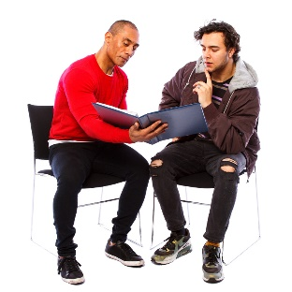 | Cun pakhat cio in biaruahnak kan rak ngei hna.

Mibu nih zeidah an rak kan chimh?
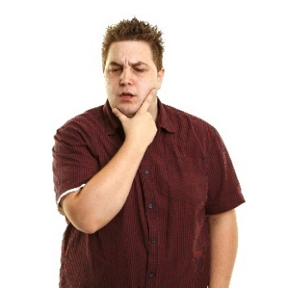 | NDIS a riantuan ning ifian dingah a har khomi a si tiah an rak chim.
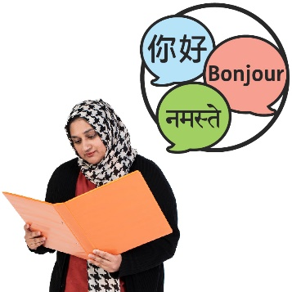 | Cun hman dingin CALD aa telmi pawl caah a fawi peng lomi adang holh pawl in thawngthanhmi an kan chimh.
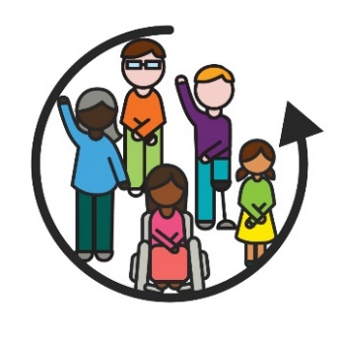 | CALD aa telmi pawl caah NDIS a riantuan  ning cu telhchihmi (inclusive) a si lo kha an rak kan chimh.  Pakhat khat kha telhchihmi a si tikah,  aho paoh nih:  - thawngthanhmi an hmuh khawh i an  hman khawh  - biakhiahnak pawl ah an i tel khawh.
CALD aa telmi pawl bawmh ning kha NDIS riantuantu pawl nih an ifiang peng lo tiah an
rak chim.
 | CALD aa telmi pawl herhmi he aa tlakmi riantuanpiaknak pawl hmuh le hman ding kha a har ngai tiah an rak kan chimh.
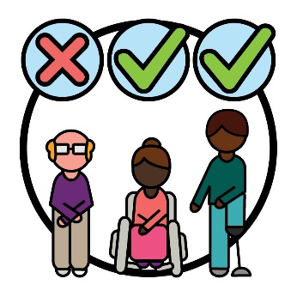 | CALD sining dirhmun pawl in aho paoh kha ‘CALD’ nih a telh hna lonak kong kan fianter ning kha an rak chim.
 | Cun CALD aa telmi pawl kongah NDIS sin in thawngthanhmi hmuh ding a har ngaimi kha an kan chimh.

Kan i hmaithlakmi
Kan i hmaithlak dingah kan herhmi kha an rak
kan chimh:
 | - Anmah he pehtlaih dingah CALD aa telmi pawl nih an kan duhpiak ning i fiannak
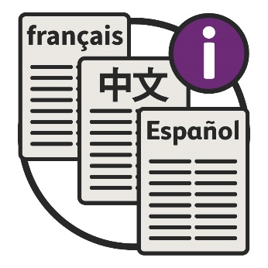 | - a dang holh in thawngthanhmi tha tein rian a tuan ning i fiannak.

CALD aa telmi pawl an herhmi kong ruah kan herhmi an kan chimh:
- NDIS kan tuah tikah
- timhtuahmi pawl kan tial tikah
- biakhiahnak pawl kan tuah tikah.
 | CALD aa telmi pawl he riantuan ning kong cawn peng dingin kan riantuantu pawl bawmh kan herhmi an rak kan chimh.
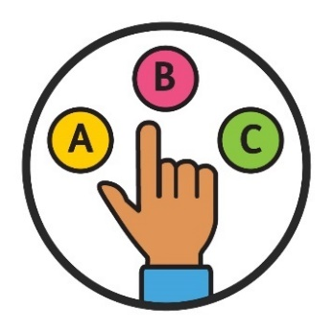 | CALD aa telmi pawl nih tamdeuh thimnak le uknak pek kan herhmi an rak chim.
Cun thawngthanhmi tamdeuh phawtzamh
kan herhmi:
- CALD aa telmi pawl
- bawmhnak an herhmi.

Adang tlangtar pawl le tinhmi pawl
Nohawng (February) 2022 ah biaruahnak (roundtable) kan rak tuah.
Biaruahnak cu a tlangpi pakhat kong minung phu khat nih chimmi kha a si.
Minung pakhat cio nih a tlangpi kong kha chimnak an ngei.
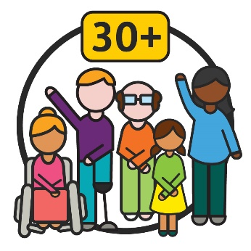 | Biaruahnak ah minung 30 leng an i tel.  Cun mibu nih an rak kan chimhmi kong an  rak ceih.
Hi ruahnak pawl cu kan Tuahtoning a thar caah tlangtar pawl (themes) le tinhmi pawl ser dingah biaruahnak nih a rak hman.
Tlangtar pawl cu kan riantuannak le nunnak i
aa dangmi hmunhma ah a biapimi ruahnak pawl an si.
24 Biangreithlep (May) 2022 ah adang biaruahnak kan rak tuah.
Biaruahnak tuah lio ah, aho paoh nih hmailei i tuah kan herhmi tlangtar pawl le tinhmi pawl ah an hna a rak tla.

Kan tlangtar pawl cu zeidah an si?
Biaruahnak nih tlangtar 5 cungah biakhiahnak a rak tuah.
Tlangtar pakhat cio nih tinhmi cazin an i ngeih.
CALD aa telmi pawl caah kan tlangtar pawl le tinhmi pawl tha tein rian a tuan dingmi fehter dingah tuahtimi-pungsan kan hman lai.
Hi nih hin CALD aa telmi pawl a bawmh hna lai:
- NDIS he a tha deuhmi hmuhtonnak ngeih
- an herhmi bawmhnak hmuh.
A hung zulmi cahmai pawl ah tlangtar pakhat cio kong kha a dikthlir in kan fianter.

1. Rian kan tuan tikah CALD aa telmi pawl cungah i papeknak
CALD aa telmi pawl kong kan ruah tikah kan fehter hrimhrim a hau:
- NDIS kan tuah tikah
- timhtuahmi pawl kan tial tikah
- biakhiahnak pawl kan tuah tikah.
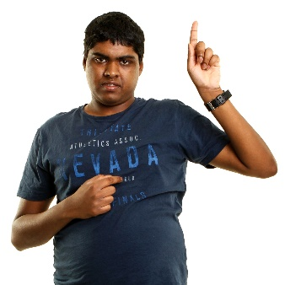 | Minung pakhat cio i an herhmi cungah kan papek a herh.
 | Cun aa dangmi CALD sining dirhmun pawl in minung caah kan thil tuah ning tha tein rian a tuan ko timi fehter kan herh.
 | Tahchunhnak ah, aa dangmi holh pawl caah dothlatnak pawl tuah dingin kan hmanmi website kha san a tlai lo.
 | Nunphung (culture) kip caah a himmi riantuanpiaknak pawl le bawmhnak pawl a si fehter dingah timhtuahmi ngeih kan herh fawn.
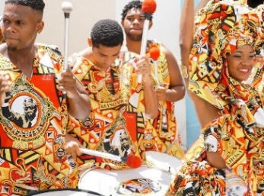 | Na nunphung cu:  - na nunning  - nangmah caah a biapimi a si.

Kan itinhmi pawl cu zeidah an si?
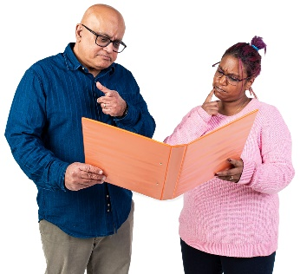 | CALD aa telmi kip nih anmah bawmhnak pawl kong i biakhiahnak pawl tuahnak ah an i tel khawh hrimhrim ding kha kan duh.
Hihi ah aa telmi cu:
- NDIS i an i tel tikah
- anmah bawmnak pawl timhtuah tikah
- anmah bawmnak pawl hman tikah.

Hihi a sullam cu hihi an tuah tikah CALD aa telmi pawl bawmh ning kong kan ruah hrimhrim a hau tinak a si.
Kan riantuanpiaknak pawl cu a himmi le cohlan a fawimi siter kan duh.
Nunphung dihlak caah a himmi riantuanpiaknak a si khawhnak ifian dingah mibu he riantuanti kan duh.
Hihi ah hin a himmi riantuanpiak si dingin sullam a ngeihmi cungah hnatlaknak aa tel.

2. Kan riantuantu pawl nih a dikmi thiamnak pawl an ngeih fehternak
Kan riantuantu pawl nih an fian a herhmi:
- CALD aa telmi pawl he riantuan ning
- bawmhnak an herhmi.
Riantuanpiaknak pek ning zong an hngalh a hau:
- telhchihmi
- nunphung dihlak caah a himmi.
Kan riantuantu kong kan chim tikah, hihi ah hin aa telmi pawl he rian a tuantimi pawl an i tel.

Kan riantuantu pawl nih an telh ve mi hna cu:
- kan zung pawl ah rian a tuanmi
- NDIS a tuahmi.

Kan itinhmi pawl cu zeidah an si?
CALD aa telmi pawl nih an herhmi ifian ding kha kan riantuantu pawl kan duh piak hna.
Cun anmah pawl bawmh ding kha kan riantuantu pawl kan duh piak hna.
Nunphung dihlak caah kan riantuannak kha a himmi si dingah kan duh fawn.

3. Thawngthanhmi kan phawtzamh ning
Kan phawtzamhmi thawngthanh kha ifian dingah a fawimi a si a hau.
Hihi ah hin a dang holh pawl in kan phawtzamh caan khi aa tel.
Kan ruah awk a herhmi:
- biafang pawl kan hmanmi
- aa dangmi nunphung pawl nih an ifian ning.
Thawngthanhmi tamdeuh in phawtzamh ning kongkau ah rian kan tuan a hau:
- cucu aa dangmi holh pawl kha
- fawi tein ifian ding kha a si.
Holhlettu pawl (interpreters) tamdeuh kan ngeih a hau.
Cun anmah kha kan bawmh hna awk a si.
Holhlettu cu minung pakhat khat:
- na holh a chimmi
- minung pakhat khat nih a chimmi i fian dingah nangmah an bawmhmi a si.

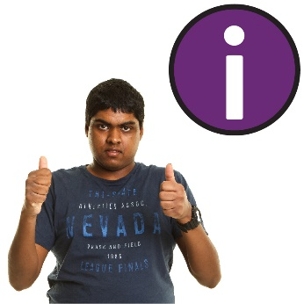 | Kan phawtzamhmi kong kha CALD mibu pawl nih hmuh le hman khawh hrimhrim dingin kan tuah  a hau.
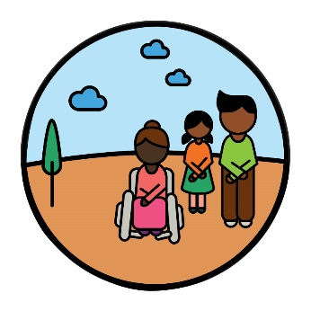 | Phak dingah a harmi mibu pawl he thawngthanhmi phawtzamh ning kong kha kan ruah a hau.  Tahchunhnak ah, aa dang liangluangmi lam in thawngthanhmi phawtzamhnak, minung pum tibantukin.

Kan itinhmi pawl cu zeidah an si?
CALD mibu pawl le aa telmi pawl he pehtlaih dingah a thadeuhmi lam pawl kawl kha kan duh.
Manlo in holhletu nih riantuanpiaknak kan ngeihmi kong hngalh dingah CALD aa telmi pawl tamter deuh kan duh.
Cun hi riantuanpiaknak pawl hman dingah CALD aa telmi pawl tamter deuh kan duh.
Thawngthanhmi tamdeuh phawtzamh kan duh:
- cucu aa dangmi holh pawl kha
- fawi tein ifian ding kha a si.

4. Thimnak le uknak
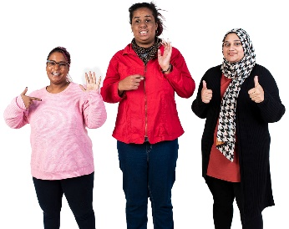 | CALD aa telmi pawl i herhmi a tlinhmi bawmhnak le riantuanpiaknak tamdeuh a um a hau.
An herhmi pawl he aa tlakmi pechantu pawl hmuh le hman dingah CALD aa telmi pawl nih bawmhnak an herh a hau.
Pechantu pawl nih riantuanpiaknak pakhat peknak hmangin midang kha an bawmh hna.
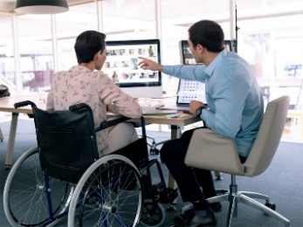 | CALD aa telmi pawl sin ah riantuanpiaknak pek ning cawn dingah pechantu pawl nih bawmhnak tamdeuh an ngah a hau fawn.
 | Cun pechantu tamdeuh nih CALD sining dirhmun pawl in minung a papekmi riantuanpiaknak pawl an pek a hau.

Kan itinhmi pawl cu zeidah an si?
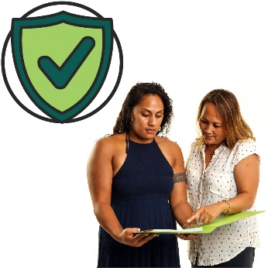 | An nunphung caah a himmi riantuanpiaknak hmuh le hman dingah CALD aa telmi pawl bawmh ding kha kan duh.
A thami riantuanpiaknak pawl tamdeuh pek dingah pechantu pawl kha kan duhpiak fawn hna:
- nunphung dihlak a upatmi
- CALD aa telmi pawl caah tha tein rian
a tuanmi
- nunphung dihlak caah a himmi.

5. CALD aa telmi pawl kong data
Data kong kan chim tikah, kan chim duhmi cu:
- thilsining pawl
- thawngthanhmi
- record pawl.
I fian dingah a thadeuhmi data kan herh:
- CALD aa telmi pawl
- bawmhnak an herhmi.
 | Data tamdeuh kan herh CALD minung kong:
 | - aa dangmi nunphung pawl sin in a rami
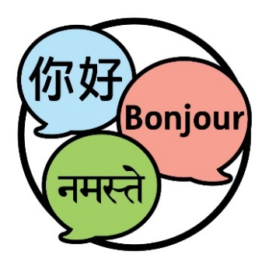 | - aa dangmi holh a chimmi.
 | Hihi a sullam cu a dikmi biaruahnak pawl kan hal hrimhrim lai tinak a si.
 | Mah cucu CALD aa telmi pawl kong data hmuh le hman dingin aho paoh caah a fawimi a si a hau.
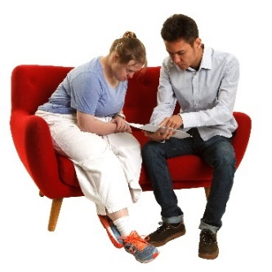 | Cun hi data hmuh le hman dingah bawmhnak an hmuh a hau.
Data kan khawmhsuat ning le phawtzamh ning kong ah zulhmi phungphai pawl kan i chiah a hau.
Hi phungphai pawl nih minung him tein chiah kha a bawmh.

Kan itinhmi pawl cu zeidah an si?
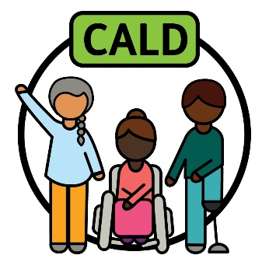 | CALD minung dihlak aa telmi ‘CALD’ fianter dingah lam pakhat hman kan duh.
 | Hihi nih a thadeuhmi data khawmhsuat kha a kan bawmh khawh.

 | Hi data cu hman kan duh:
 | - CALD aa telmi pawl caah a thadeuhmi riantuanpiaknak pek dingah
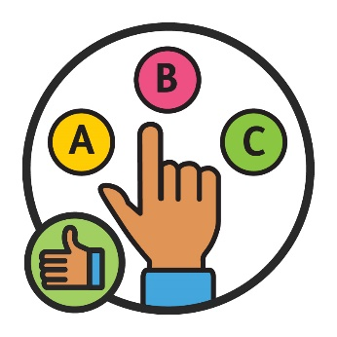 | - a thami biakhiahnak pawl tuah dingah.
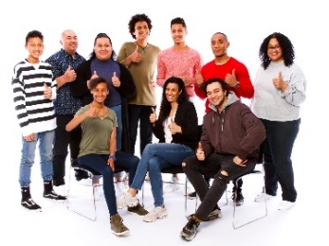 | Cun CALD aa telmi pawl kong data hmuh le hman dingah minung tamter deuh kan duh.

Hmailei ah zeidah a cang lai?
CALD aa telmi pawl bawmh dingin a thadeuhmi lam kawl dingah mibu he riantuannak kan ngei peng lai.
Ruahnak cheuhtu phu (advisory group) pakhat caah minung kan thim lai.
Ruahnak cheuhtu phu cu kanmah he rian a tuantimi minung phu pakhat a si:
- tha tein rian a tuanmi phawtzamh ding
- thatter deuh a herhmi phawtzamh ding.
Ruahnak petu phu nih:
- CALD mibu pawl he riantuanti a kan
bawmh lai
- Tuahtoning a thar tha tein rian a tuan kha a fehter lai.

Ruahnak cheuhtu phu ah telh kan duhmi:
- CALD aa telmi pawl
- pumtlinglo buu pawl
- CALD buu pawl.
CALD aa telmi pawl le innchungkhar pawl he rian kan tuanti lai:
- Mirangholh nak in holh dang a hmangmi he
- biachimnak lam a ngei lomi he.

Thawngthanhmi tamdeuh
Hi report kongah thawngthanhmi tamdeuh hmuhnak caah, zaangfahnak in pehtlaihnak kan tuah.
Kan website na zoh khawh.
www.ndis.gov.au
Na kan chawnh khawh.
1800 800 110
Facebook ah follow kan tuah.
www.facebook.com/NDISAus
Twitter ah follow kan tuah.
@NDIS

Kanmah he biaruah dingah bawmhnak
Kan website i a cungbik ah a ummi kan webchat tiah hmuhmi hmangin online in na kan chimchawn khawh.
www.ndis.gov.au
 | Mirangholh nak in holh dang na hman ahcun, na chawnh khawh:
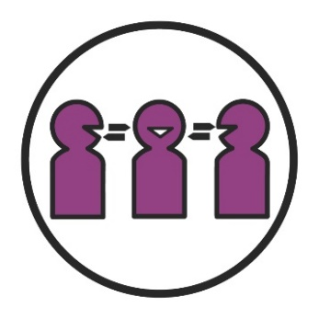 | Calehnak le Holhlehnak lei Riantuanpiaknak (TIS)  131 450
 | Biachimnak asilole hnatheihnak lei ah chambaunak na ngeih ahcun, na chawnh khawh:
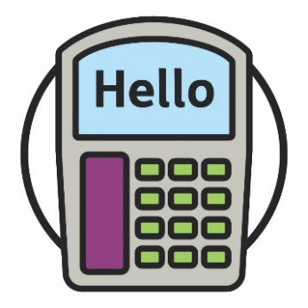 | TTY  1800 555 677
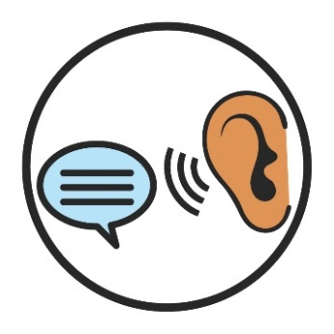 | Chim law Ngai  1800 555 727
Rampumpi huap Chawnhchinnak lei Riantuanpiaknak
133 677
www.relayservice.gov.au

Biafang cazin
Hi cazin nih hi catialmi ah anakmi (bold) biafang pawl a sullam kha
a fianter.
Ruahnak cheuhtu phu
Ruahnak cheuhtu phu cu kanmah he rian a tuantimi minung phu pakhat a si:
- tha tein rian a tuanmi phawtzamh ding
- thatter deuh a herhmi phawtzamh ding.
Tuahtimi-pungsan
Tuahtimi-pungsan cu thil pakhat khat a thar timhtuah dingah hmunkhat te in riantuanti caan khi a si.
Nunphung lei le holh lei in aa dangmi (CALD)
CALD minung:
- aa dangmi sining dirhmun pawl sin in a rami
- Mirangholh nak in holh dang a hmangmi.
Nunphung
Na nunphung cu:
- na nunning
- nangmah caah a biapimi a si.
Data
Data kong kan chim tikah, kan chim duhmi cu:
- thilsining pawl
- thawngthanhmi
- record pawl.
Telhchihmi
Pakhat khat kha telhchihmi a si tikah,
aho paoh nih:
- thawngthanhmi an hmuh khawh i an hman khawh
- biakhiahnak pawl ah an i tel khawh.
Holhlettu
Holhlettu cu minung pakhat khat:
- na holh a chimmi
- minung pakhat khat nih a chimmi i fian dingah nangmah an bawmhmi a si.
Aa telmi
Aa telmi pawl cu NDIS ah aa telmi pumtlinglo pawl an si.
Pechantu
Pechantu pawl nih riantuanpiaknak pakhat peknak hmangin midang kha an bawmh hna.
Biaruahnak
Biaruahnak cu a tlangpi pakhat kong minung phu khat nih chimmi kha a si.
Minung pakhat cio nih a tlangpi kong kha chimnak an ngei.
Tlangtar pawl
Tlangtar pawl cu kan riantuannak le nunnak i
aa dangmi hmunhma ah a biapimi ruahnak pawl an si.

Stock hmaanthlak le nunphung he aa pehtlaimi hmaanthlak pawl hmangin Thawngthanhmi Hmuhkhawhnak Phu nih hi Fawi tein Rel dingmi a rak ser. Nawlpeknak tel lo in hmaanthlak pawl cu hmanthan khawh a si men lai lo. Hmaanthlak pawl kongkau i hlathlaimi pakhat khat caah, zaangfahnak in hika ah zoh visit www.informationaccessgroup.com. Chirchanhmi rian lei nambar 4978.

