Outcome measurement tools for Early Supports
Evaluation report
Version 1.0 - June 2023
Research and Evaluation Branch

Research and Evaluation Branch
The Research and Evaluation Branch helps ensure trustworthy and robust evidence informs National Disability Insurance Agency (NDIA) policies, practices and priorities. This ensures that decisions can be based on an understanding of what works, what does not work, and the benefits to those receiving Early Interventions, Participants and the Agency.

This document
This report summarises an evaluation of the validity and reliability of Outcome Measurement (OM) tools identified as suitable for use for families of children receiving early supports. The purpose is to compare the measurement characteristics of the proposed tools and to recommend which one is most suitable for adoption by the Agency. This document outlines the evidence for this decision.

Disclaimer
The NDIA accepts no responsibility for the accuracy or completeness of any material contained in this report. Further, the NDIA disclaims all liability to any person in respect of anything, and of the consequences of anything, done or not done by anyone in whole or part reliance upon any information in this report.
Material in this report is based on analysis of data collected as part of the OM tool evaluation, which underwent independent ethical review prior to commencing. The report is available on the understanding that the NDIA is not signalling a course of action to use the in-scope assessment tools for decision making in the NDIS. However, findings from the report may feed into decisions made around the integration and recommendations for use of OM tools.

Acknowledgements
The NDIA acknowledges the Traditional Owners and Custodians throughout Australia and their continuing connection to the many lands, seas and communities. The NDIA pays respect to Elders past and present, and extends this acknowledgement and respect to any Aboriginal and Torres Strait Islander people who may be reading this report.
Acknowledgements also to the ECS Branch and the many Partner organisations that helped with enrolment, data collection, and analysis. Thanks to Denise Luscombe, Janet Walker, Jami Langley, Allison Harries, Myra Puttock, Annie Mackin and other ECS Branch staff who assisted in the development of materials and in the provision of training and dissemination of training materials. An especially big thanks to all participating EC Partners and their staff.

Contents

1. Introduction 3
1.1. The early childhood years 3
1.2. Early Childhood Intervention 3
1.3. The NDIS Early Childhood Approach 3
1.4. The role of outcome measurement tools in delivering Early Supports 4
1.5. Evaluation objectives and scope 4
2. Evaluation design and data 6
2.1. Tools 6
2.2. Study design 6
2.3. Participating EC Partners 8
2.4. Data 9
2.5. Limitations 11
3. Reliability and validity of tools for capturing goals and predicting outcomes 13
3.1. Change in tool scores 13
3.2. Agreement between tools 15
3.3. Responsiveness of OM tools 18
3.4. Predicting outcomes from Early Supports 20
4. The utility of OM tools for guiding practice in Early Supports 22
4.1. Applicability of OM tools and the PEEM for Early Supports 22
4.2. Ease of use 24
4.3. Time to complete 26
4.4. Cost 29
5. Considerations for the future use of OM tools in Early Supports 30
5.1. Considerations for future implementation 30
5.2. Conclusion 32
Appendices 33

Abbreviations
COPM Canadian Occupational Performance Measure
EC Early Childhood
ECI Early Childhood Intervention
ECEI Early Childhood Early Intervention
ECS Early Childhood Services
ES Early Supports
FSSP Family Service and Support Plan
GAS Goal Attainment Scale
GAS-Light Goal Attainment Scale-Light Version
HREC Human research ethics committee
PCG Parent/Carer/Guardian
PEDI-CAT Paediatric Evaluation of Disability Inventory-Computer Adaptive Testing
PEEM Parent Empowerment and Efficacy Measure
NDIA National Disability Insurance Agency
NDIS National Disability Insurance Scheme

Key findings
This evaluation assessed the performance of the Goal Assessment Scale (GAS), GAS-Light and Canadian Occupational Performance Measures (COPM). The purpose was to identify the most reliable, valid and acceptable tool to capture and measure progress against context-specific goals and outcomes in Early Supports. The evaluation also assessed the utility and acceptability of an objective measure, the Parent Empowerment and Efficacy Measure (PEEM), in measuring family outcomes.
The GAS and GAS-Light showed marked increases in the average T-scores from goal setting to reassessment, suggesting they are potentially responsive to observed changes. Objective measures (PEDI-CAT and PEEM) failed to show marked improvement in scores, although there was a reduction for the PEDI-CAT responsibility domain.
There were only weak associations between scores at and between goal setting and reassessment on the goal setting tools and the objective measures. This suggests each tool measures change in different areas of functioning.
Using numerical scores collected from OM tools to predict scheme access and scheme budgets showed that GAS/GAS-Light and the ‘responsibility’ domain scores of the PEDI-CAT are significant predictors of future NDIS access. Higher scores on the ‘responsibility’ domain of the PEDI-CAT also appear to predict lower NDIS personalised budgets.
However, the evaluation found evidence that it is common for the same PEDI-CAT scores from a child’s initial assessment in Early Supports (ES) to be reused at a child’s first NDIS planning meeting rather than recollected. This practice significantly limits the value of the PEDI-CAT to evaluate child outcomes and the effectiveness of Early Supports.
EC Coordinator and parent/carer/guardian feedback on the tools generally favoured the GAS-Light due to its brevity and ease of scoring. Interview feedback highlighted how scoring could be easier as well as areas where clinical, cultural, and linguistic interpretation might influence scoring and acceptability of the tools. Minor changes to scoring approaches and improved training could address these issues.
EC Coordinators found the PEEM to be a brief, acceptable and valid tool that helps to structure conversations with families.
Overall, the evaluation findings suggest that the GAS-Light best meets the NDIA’s requirements for a brief goal setting measure due to its brevity, ease of use, similarity to existing processes, and preliminary estimates of predictive ability. Adapting the tool for different contexts could make it easier to score, better align it to identified domains of function and potentially increase its value for predicting NDIS access and personalised budgets. Most importantly, these tools may assist parents and families in better achieving their Early Support goals.

Introduction

The early childhood years
The early childhood years lay the foundation for future development. What happens in our early years has a major effect on our health and social development. It is critical that a child’s early experiences are positive and that they have a secure foundation for development.
These years are as or more important for children with developmental concerns, developmental delay or disability. This time is critical for the whole family as it is when they begin to learn how to support and nurture their child, meet their child’s needs, and adapt positively to having a child with developmental concerns, developmental delay or disability.

Early Childhood Intervention
Early Childhood Intervention (ECI) comprises specialised support and services for infants and young children with developmental delay or disability, and their families, to promote development, well-being and community participation. The aim of ECI is to ensure that caregivers can provide their child with experiences and opportunities. This will then assist them to participate in the key environments in their lives.

The NDIS Early Childhood Approach
Currently in Australia, the National Disability Insurance Scheme (NDIS), funded by the National Disability Insurance Agency (NDIA), delivers ECI services for children with developmental concerns, developmental delay or disability.
The NDIA’s Early Childhood (EC) Approach includes provision of ECI to children with developmental delay or disabilities who are eligible to become NDIS Participants (Tier 3) as well as Early Supports to children and families of children with developmental concerns who are not eligible as NDIS Participants (Tier 2). The National EC Partners network is responsible for enabling children and their families to access the right supports or interventions as early as possible.
Early Supports are available for children with developmental concerns who do not meet the criteria for developmental delay or permanent and significant disability. Early Supports intend to build a family’s capacity to support their child in developing skills to engage in daily activities. EC partners may provide Early Supports in the form of individual or group therapy, parent education programs or workshops, and peer support groups. They may work collaboratively with mainstream services such as early childhood education and care to build the capacity of the adults present in supporting the child’s learning, development and participation.
In addition, they may link families with mainstream services at a private, local, state, and federal level to meet the support needs of children and families. Families may independently access other mainstream or privately funded supports to optimise their child’s learning and development.

The role of outcome measurement tools in delivering Early Supports
The consistent and accurate use of outcome measurement (OM) tools to guide and measure Early Supports is key to better understanding the effectiveness of Early Supports and identifying potential improvements to their delivery.
The ‘ECEI Implementation Reset’ project, launched in May 2020, focused on reforming the Agency’s implementation of the EC approach (then termed Early Childhood, Early Intervention (ECEI)). The report ‘ECEI Implementation Reset: Project consultation report’ outlines findings and recommendations from the ECEI Reset project. A common thread throughout the report was the need to improve the measurement of outcomes and ensure that measures used can inform decision making. As such, there is an interest in ensuring that the tools used by EC Partners to determine goals, make decisions, and measure progress, are clear and informative. There is also a growing interest in understanding what value OM tools have in predicting future outcomes for children and their families.
In March 2021, the Early Childhood Services (ECS) Branch undertook a desktop review to identify OM tools commonly used by the early supports sector. The Branch also consulted with EC Partners. The review found that the most used OM tools are Canadian Occupational Performance Measure (COPM), the Goal Attainment Scale (GAS) and GAS-Light, and the Parent Empowerment and Efficacy Measure (PEEM) and COPM for recording family goals (the tools are described in more detail in Chapter 2). The review found variation in the OM tools EC Partners used, including inconsistencies in their implementation, and that not all EC partners were using validated OM tools.

Evaluation objectives and scope
The purpose of this evaluation is to assess the relative performance of the COPM, GAS, GAS-Light and PEEM which are either proposed or currently used as part of Early Supports. Specifically, the evaluation will answer the following questions:
- Of the OM tools, which one provides the most valid and reliable approach to capturing context-specific goals for the child and family?
- Which OM tools do EC partners and families identify as the most useful in guiding Early Supports (i.e. which tool best measures what the child and their family is wanting to achieve?)
- Which tools will best assist EC partners measure functional change and predict future outcomes?
This evaluation assessed family and EC partners’ experiences using the tools and their views on the tools to support child and family goal setting and re-assessment within Early Supports.

2. Evaluation design and data

Tools

Table 1: Characteristics of the OM tools used
Tool | Tool type | Number of Questions | Domains | Scoring
PEEM | Family Outcome | 20 | 1. Total  2. Efficacy to Parent  3. Efficacy to Connect | Additive 0-100 standardisation (with population values)
COPM | Subjective Child Outcome | Dependent on identified goals | Performance  Satisfaction | 0-10 scale (with change scores)
GAS/  GAS-Light | Subjective Child Outcome | Dependent on identified goals | Dependent on identified goals | (GAS) -2 to +2  (GAS-Light) Limited numerical scoring
PEDI-CAT | Objective Child Outcome | Approximately 15 per domain | 1. Daily Activities  2. Mobility  3. Social/Cognitive  4. Responsibility | Factor Scoring with population norms and 0-100 standardisation
Existing and proposed OM tools for assessing ES can be organised into three groups, outlined in Table 1: Family outcome tools (PEEM), subjective child outcome tools (COPM, GAS, and GAS-Light, i.e. ‘goal setting tools’), and objective child outcome tools (PEDI-CAT).
For subjective tools, goal identification and definition are through observation and discussion with the parents/carers. This contrasts with the PEEM and PEDI-CAT, which use a consistent set of questions to give an understanding of a respondent’s functioning relative to the population. Subjective OM tools cannot do this because the goals set, and the level of progress required to meet those goals are specific and unique to every child. Appendix A gives more detail on the tools and the domains they measure.

Study design
Table 2 gives an overview of the evaluation design. The design accommodated EC Partner’s existing practices and familiarity with one or more of the OM tools. Organisations were categorised into three groups:
- EC Partners familiar with the COPM as part of their goal setting process
- EC Partners familiar with the GAS as part of their goal setting process
- EC Partners that have not yet incorporated an OM tool in their practice
EC Partners recruited evaluation participants on an alternating basis, to either receive the tool EC Coordinators are familiar with (COPM or GAS) and the GAS-Light. If the organisation had no prior experience with a tool, they were allocated to use the GAS-Light exclusively. Allocations were also based on EC Partners’ estimates of the likely number of children recruited during the study period to collect the same number of COPM, GAS, and GAS-Light responses.

Table 2: OM tool study design and data collection intervals
 | Organisation type 1: Familiar with COPM | Organisation type 2: Familiar with GAS | Organisation type 3: No prior use of tools
Immediately before first meeting with EC Partners | PEEM | PEEM | PEEM
During first session | COPM or GAS-Light  and  PEDI-CAT | GAS or GAS-Light  and  PEDI-CAT | GAS-Light  and  PEDI-CAT
Immediately after first meeting | PCG Survey | PCG Survey | PCG Survey
Between first and final session | PEEM | PEEM | PEEM
During final session before evaluation ends | COPM or GAS-Light and  PEDI-CAT | GAS or GAS-Light  and  PEDI-CAT | GAS-Light  and  PEDI-CAT
Immediately before final meeting | PCG Survey | PCG Survey | PCG Survey
After the outcome measurement collection period | EC Partner Interview or Focus Group  and EC Partner Survey | EC Partner Interview or Focus Group  and EC Partner Survey | EC Partner Interview or Focus Group  and EC Partner Survey
We asked that EC Partners collect PEDI-CAT scores at both sessions, even though they customarily only collect it at the initial assessment. Families independently completed the PEEM before both goal setting and reassessment sessions.
Collection of OM data from families was at the beginning when goal setting occurs and the last session (when re-assessment occurs) on advice of standard practice from the ECS Branch. If families had not completed Early Supports, final OM data collection was at the end of the evaluation period for data completeness.

Participating EC Partners
Seven EC Partners participated in the evaluation. All operate across multiple sites and a wide range of urban and rural locations. However, those who participated represent less than half of the 19 EC Partners nationally.
Table 3 outlines the extent EC Partners participated in the evaluation at three critical stages: the number of coordinators who consented to participate, the number that participated in training and completed the practical exercise and those who recruited at least one participant. Partners participating have been anonymised from the report.
Results indicate that while many coordinators consented to be part of the evaluation and an appreciable proportion participated in training, this did not translate into enrolment of participants.

Table 3: Number of EC coordinators consenting to participate, participating in training, and who enrolled participants
Note: Percentages for “Number of EC Coordinators participating in training” and “Number of EC Coordinators who enrolled at least one participant” are the proportion in that group out of those who consented to participate.
EC Partner | OM tools allocated | Number of EC Coordinators consenting to participate | Number of EC Coordinators participating in training | Number of EC Coordinators who enrolled at least one participant
EC Partner 1 | GAS/GAS-Light | 34 | 23 (67%) | 5 (15%)
EC Partner 2 | GAS-Light | 2 | 2 (100%) | 0 (0%)
EC Partner 3 | COPM/GAS-Light | 25 | 22 (88%) | 4 (16%)
EC Partner 4 | GAS/GAS-Light | 16 | 12 (75%) | 5 (16%)
EC Partner 5 | GAS-Light | 33 | 7 (12%) | 7 (21%)
EC Partner 6 | GAS/GAS-Light | 23 | 21 (91%) | 9 (39%)
EC Partner 7 | COPM/GAS-Light | 6 | 5 (83%) | 1 (17%)
Total |  | 139 | 89 (64%) | 31 (22%)
Source: OM tool evaluation consent forms, training records, and participant enrolments

Data
Appendix B shows the alignment of the data sources to the evaluation questions.

2.4.1 Tool collection
Study enrolment commenced in October 2021 and ceased in late May 2022. A total of 123 families enrolled in the OM evaluation across six providers. Of those, six withdrew their consent to participate at some point in the evaluation, leaving 117 families.
Table 4 outlines the number of responses for each OM tool as well as overlap between tools.
In summary:
- EC Partners collected OM tool data from 59 families at the goal setting phase, 31 for GAS and 27 for the GAS-Light. Only one family completed the COPM at baseline and none at follow-up. Therefore, the evaluation could not assess the reliability and validity of the COPM.
- The 59 families reported 152 separate goals (average = 2.5) with a minimum of one goal and a maximum of five. Based on alignment to PEDI-CAT domains, most recorded goals related to socialisation/cognition (119, 78%) goals followed by daily activities (29, 19%).
- EC Partners recorded reassessment of at least one goal for 40 families (25 based on GAS and 15 based on GAS-Light).
- Just over half of enrolled families completed the PEEM at goal setting (66 of 117, 56%) and 30 (26%) at reassessment.
- The evaluation used PEDI-CAT domain scores as the ‘gold standard’ on which to assess the concurrent validity between objective (PEDI-CAT) and subjective tools (GAS and the GAS-Light). For those accessing Early Supports, the NDIA KPIs only assess PEDI-CAT completion at entry. However, the NDIA requires that children also receive a PEDI-CAT assessment upon entry to the NDIS. So, of the 53 children enrolled in the evaluation who went on to apply for the NDIS, PEDI-CAT assessments for two time-points were available for 41 (77%).

Table 4: Number of responses recorded across OMs and all tool combinations
Note: *Asterisk indicates that questions related to the Responsibility domain were not asked if the child was under the age of three.
† Crucifix indicates 98% of the PEDI-CAT scores recorded at follow-up were recorded as part of applying for NDIS access.
Measure | Goal setting | Reassessment | Goal setting and reassessment
PEDI-CAT | 91* | 49*† | 41*
PEEM | 66 | 32 | 30
PEEM and PEDI-CAT* | 52 | 17 | 12
OM tool (All) | 59 | 40 | 40
GAS | 31 | 25 | 25
GAS-Light | 27 | 15 | 15
COPM | 1 | 0 | 0
OM tool (All) and PEEM | 53 | 31 | 29
GAS | 27 | 19 | 18
GAS-Light | 25 | 12 | 11
COPM | 1 | 0 | 0
OM tool (All) and PEDI-CAT | 50 | 22 | 18
GAS | 27 | 18 | 15
GAS-Light | 23 | 4 | 3
COPM | 0 | 0 | 0
Source: CRM (PEDI-CAT) internal data systems and data collected as part of OM tool evaluation.

2.4.2 EC Partner survey
Of the 89 EC Coordinators who consented to participate in the evaluation and who underwent training, 29 (33%) responded to a 15-minute survey (13 about the GAS, 16 about the GAS-Light with seven about both). Respondents came from all EC Partners involved in the evaluation.

2.4.3 EC Partner focus groups
There were nine focus groups with 50 EC Partner staff. Four EC Partners hosted two focus groups each due to the size of the Partner organization, the number of locations, and the number of staff interested in participating. For the remaining EC Partner, a single focus group was conducted. Focus group attendees were a mix of operational staff, team leaders, and organisational management.

2.4.4 Parent/Caregiver/Guardian (PCG) surveys
After goal setting and reassessment sessions, parents/carers/guardians completed a short survey to understand their experience of the tools and reassessment process. Of the 117 caregivers consenting to participate in the evaluation, 40 (34%) responded to the survey after goal setting and 31 (26%) after reassessment (Table 5). As responses were anonymous, respondents at both occasions could not be linked.

Table 5a: Personal characteristics of parent/caregiver/guardian survey respondents at goal setting and reassessment
Demographic criteria | Goal Setting  (N=40) | Reassessment  (N=31)
n (%) Child Gender-Male | 27 (68%) | 22 (71%)
Mean (SD) age of child | 4.3 (1.3) | 4.6 (1.0)
n (%) English as a first language | 33 (83%) | 27 (87%)
n (%) Aboriginal and/or Torres Strait Islander | 2 (5%) | 2 (6%)
n (%) Session conducted in person | 26 (65%) | 18 (58%)

Table 5b: Parent/caregiver/guardian survey respondents, by recruiting EC partner organisation, at goal setting and reassessment
Note: This table is missing data due to non-response. EC Partners have been anonymised.
EC Partner | Goal Setting  (N=40) | Reassessment  (N=31)
n (%) EC Partner 4 | 19 (48%) | 20(65%)
n (%) EC Partner 1 | 3 (8%) | 0 (0%)
n (%) EC Partner 5 | 3 (8%) | 4 (13%)
n (%) EC Partner 6 | 11 (28%) | 6 (19%)
n (%) EC Partner 7 | 1 (3%) | 1 (3%)
n (%) EC Partner 3 | 2 (5%) | 0 (0%)

Table 5c: Parent/caregiver/guardian survey respondents, by OM tool used, at goal setting and reassessment
Note: This table is missing data due to non-response.
OM Tool used | Goal Setting  (N=40) | Reassessment  (N=31)
n (%) The Goal Assessment Scale (GAS) | 25 (63%) | 18 (58%)
n (%) The Goal Assessment Scale (GAS-Light) | 10 (25%) | 9 (29%)
n (%) Canadian Occupational Performance Measure (COPM) | 1 (3%) | 0 (0%)
Source: PCG survey responses at goal setting and reassessment.

Limitations
Lower than anticipated recruitment limited the evaluation. Estimates submitted by EC Partners of the likely number of individuals they could recruit over 4 months indicated approximately 400 families with recruitment quotas across the three OM tools balanced equally. Despite recruitment remaining open for almost eight months, EC Partners only enrolled 123 families. This precluded more in-depth psychometric assessment and conclusions about the suitability of the tools.
Low recruitment was especially a limitation for the COPM. EC Partners which signed up to use the COPM only recruited two families at goal setting and of those only one was reassessed (Follow-up data was not submitted but the PCG survey was completed). Therefore, the evaluation could not undertake psychometric analysis on the COPM.

3. Reliability and validity of tools for capturing goals and predicting outcomes
This section uses the OM data collected to assess the validity and reliability of the tools as well as their ability to inform the Agency about a child’s future course.

Change in tool scores

3.1.1 GAS/GAS-Light
Figure 1 shows that the average T-scores at goal setting and reassessment were almost identical for the GAS and GAS-Light. This is due to their common calculation method. Both showed marked increases in T-scores between the two time periods, indicating large improvement in average goal attainment between assessments. However, the T-scores are not gender or age normalised, with the only adjustment for the recorded importance or perceived difficulty of the goals. Therefore, some goal attainment is attributable to natural development and maturation rather than Early Supports.
Communication with the developer of the GAS/GAS-Light suggested that the NDIA not use ratings of goal difficulty when calculating T-scores. This makes T-scores only dependent on the number of recorded goals, baseline functioning, goal importance (for the GAS only), and the degree of change. This means the tool only measures 25 to 30 unique states (goal setting/reassessment score combinations), despite scores being scaled between 0 and 100.

Figure 1: Average GAS/GAS-Light T-scores at goal setting and reassessment

Source: Research and Evaluation Branch analysis of data collected using the GAS/GAS-Light.

3.1.2 PEEM
Figure 2 shows the average PEEM scores at goal setting and reassessment. According to the developers, the Australian population average for the total empowerment score is 154 (out of a possible 200) and that a score below 130 indicates low parenting efficacy. Based on this, on average parents enrolled in the evaluation had low parenting efficacy at goal assessment and only marginally improved by reassessment (+3.8). The magnitude of this change is not statistically significant (p<0.05).
For the ‘efficacy to parent’ domain, the average score was 70.8 at goal assessment, increasing to 73.2 at reassessment. Both are below the Australian population average of 87. The result was similar for the ‘efficacy to connect’ domain with the average goal setting (63.2) and reassessment (60.3) both being below the Australian population average of 67. However, unlike ‘efficacy to parent,’ caregivers ‘efficacy to connect decreased slightly between goal setting and reassessment (-2.9).

Figure 2: Average PEEM domains scores at goal setting and reassessment

Source: Research and Evaluation Branch analysis of collected PEEM data.

3.1.3 PEDI-CAT
Figure 3 shows that for all PEDI-CAT domains, there was a reduction in average child function between initial goal setting and reassessment. Previous research has suggested that a clinically important change in function requires a six-point or larger change in PEDICAT scores. Given this, only the average reduction for the ‘responsibility domain’ was clinically meaningful (-11.3 points).
There was a high degree of similarity in PEDI-CAT scores recorded at the commencement of Early Supports and upon entering the NDIS. Of the 41 evaluation participants who had a follow-up PEDI-CAT, 28 (68%) had identical scores for all four domains on both occasions. This strongly suggests that upon NDIS access, multiple EC coordinators commonly re-use the PEDI-CAT scores (and possibly assessments) from the commencement of Early Supports, even though months have commonly passed between these events. This and the fact that children not entering the NDIS do not receive a follow-up PEDI-CAT assessment, severely limits the NDIA’s ability to measure the impact of Early Supports.

Figure 3: Average PEDI-CAT domains scores at goal setting and reassessment

Source: Research and Evaluation Branch analysis of PEDI-CAT domain scores collected during ES and upon entry to the NDIS.

Agreement between tools
Table 6 shows correlations between tools and their domains at goal setting and reassessment, as a form of concurrent validity testing. Correlations above the 45-degree diagonal relate to scores collected during goal setting; correlations below the 45-degree diagonal relate to correlations between scores at reassessment. Assessing concurrent validity using other methods was not possible due to sample size constraints.
At goal setting, there were only moderate or weak relationships between OM and subjective tools. Notably, although most goals identified related to social/cognitive functioning, the correlations between that PEDI-CAT domain and the OM tools were particularly poor. The exception was a moderately strong relationship between the PEDI-CAT ‘responsibility’ domain and the GAS. The pattern at reassessment confirmed the weak correlations between GAS and GAS-Light and the PEDI-CAT domains, except for a negative correlation between the PEDI-CAT ‘responsibility’ domain and the GAS-Light.
At goal setting, the relationship between the PEEM and other OM tools was also weak. At reassessment, correlations between PEEM and other OM tools were stronger, with little difference between domains. Correlations between objective tools (e.g. PEDI-CAT and PEEM) were generally higher, except between the PEDI-CAT ‘responsibility domain’ and other PEDI-CAT domains.
Correlations confirm previously reported results indicating that tools like the GAS and GAS-Light are poorly correlated with standard scales used in routine practice in paediatrics. Outside of early childhood, others have recommended not collecting goal attainment ratings without simultaneously collecting more traditional measures of treatment outcomes.

Table 6: Correlations at goal setting (above the diagonal line) and reassessment (below the diagonal line) across all tools
Notes: *Goal Setting, †Reassessment. Sample sizes for each pairwise correlation is provided in Table 3 of section 2.4.1.
Source: Research and Evaluation Branch analysis of GAS/GAS-Light and PEEM data collected during the evaluation, and CRM-recorded PEDI-CAT domain scores collected during Early Supports and upon entry to the NDIS.
Correlations of less than +/- 0.3 (negligible/weak) are highlighted in red, correlations between +/- 0.3 and +/- 0.5 (moderate) are highlighted in yellow, and correlations between +/- 0.5 and +/- 1 (strong) are highlighted in green.
Measure and domain | PEDI-CAT  Daily activity | PEDI-CAT  Mobility | PEDI-CAT  Social and cognitive | PEDI-CAT  Responsibility | GAS | GAS-Light | PEEM  Total | PEEM  Efficacy to parent | PEEM  Efficacy to connect
PEDI-CAT Daily activity | NA | 0.67* | 0.69* | 0.65* | -0.07* | 0.17* | 0.25* | 0.22* | 0.24*
PEDI-CAT Mobility | 0.82† | NA | 0.46* | 0.42* | 0.02* | 0.07* | 0.30* | 0.28* | 0.28*
PEDI-CAT Social and cognitive | 0.63† | 0.43† | NA | 0.66* | -0.11* | 0.02* | 0.25* | 0. 9* | 0.27*
PEDI-CAT Responsibility | -0.03† | -0.19† | <0.01† | NA | 0.40* | 0.13* | 0.28* | 0.19* | 0.27*
GAS/GAS-Light | 0.15† | <0.01† | 0.09† | -0.18† | NA | NA | 0.26* | 0.28* | 0.22*
PEEM Total | -0.23 | 0.23 | -0.05 | -0.76† | NA | NA | 0.19* | 0.26* | 0.11*
PEEM Efficacy to parent | 0.55† | 0.43† | 0.31† | 0.24† | 0.33† | 0.47† | NA | 0.94* | 0.93*
PEEM Efficacy to connect | 0.61† | 0.48† | 0.37† | 0.21† | 0.34† | 0.41† | 0.97† | NA | 0.76*
PEDI-CAT Daily activity | 0.49† | 0.37† | 0.23† | 0.27† | 0.30† | 0.46† | 0.97† | 0.89† | NA

Responsiveness of OM tools
An important feature of tool performance is its responsiveness to measuring meaningful change in an outcome. As such, changes in T-scores from goal setting to reassessment for the subjective GAS and GAS-Light measures should ideally strongly correlate with changes in score changes for objective measures such as the PEEM and PEDI-CAT.
Table 7 shows this not to be the case. Again, the strongest correlations between change scores were between domains of the same tool. However, correlations between change scores of the GAS/GAS-Light and the PEEM, and between both tools and the PEDI-CAT were low and in some cases negative. This included correlations with change scores for the PEDI-CAT ‘social and cognitive’ and ‘daily activity’ domains which aligned to most recorded goals of evaluation participants.
This poor agreement between the GAS and GAS-Light and more objective outcome measures (i.e., PEEM and PEDI-CAT) suggest they are weak indicators of child and family outcomes due to Early Supports. However, the suspicion that EC Partner staff are copying PEDI-CAT scores from one period to the next limits confidence in this conclusion.

Table 7: Correlations of changes scores across measures
Measure and domain | PEDI-CAT  Daily activity | PEDI-CAT  Mobility | PEDI-CAT  Social and cognitive | PEDI-CAT  Responsibility | GAS/GAS-Light | PEEM  Total | PEEM  Efficacy to parent | PEEM  Efficacy to connect
PEDI-CAT Daily activity | NA | 0.83 | 0.67 | 0.08 | 0.06 | -0.12 | -0.12 | -0.12
PEDI-CAT Mobility | NA | NA | 0.65 | 0.01 | 0.31 | -0.16 | -0.16 | -0.16
PEDI-CAT Social and cognitive | NA | NA | NA | 0.18 | 0.03 | 0.05 | 0.05 | 0.05
PEDI-CAT Responsibility | NA | NA | NA | NA | -0.02 | 0.23 | 0.21 | 0.25
GAS/GAS-Light | NA | NA | NA | NA | NA | 0.08 | 0.08 | 0.08
PEEM Total | NA | NA | NA | NA | NA | NA | 1.00 | 0.99
PEEM Efficacy to parent | NA | NA | NA | NA | NA | NA | NA | 0.98
PEEM Efficacy to connect | NA | NA | NA | NA | NA | NA | NA | NA
Source: Research and Evaluation Branch analysis of GAS/GAS-Light and PEEM data collected during the evaluation, and CRM-recorded PEDI-CAT domain scores collected during Early Supports and upon entry to the NDIS.
Notes: Analyses pooled GAS and GAS-Light data to increase the sample size.
Correlations of less than +/- 0.3 (negligible/weak) are highlighted in red, correlations between +/- 0.3 and 0.5 (moderate) are highlighted in yellow, and correlations between +/- 0.5 and +/- 1 (strong) are highlighted in green.

Predicting outcomes from Early Supports
An important consideration in the adoption of the OM tools is the degree to which they assist the NDIA predict Participant outcomes and needs. Two relevant outcomes resulting from ES are whether a child will be eligible for the NDIS (either under early intervention or permanent disability criteria) and the amount of support they receive from the NDIS (i.e. their package of individualised supports).

3.4.1 NDIS access
As of mid-September 2022, 35 (29.9%) of the 117 individuals enrolled were still active with Early Supports. A further 49 (42%) met Scheme access criteria under either early intervention (45) or permanent disability criteria (4). A further seven families (6.0%) applied for their child to enter the NDIS but did not meet eligibility requirements. 25 families (18.8%) indicated they no longer required Supports under the NDIS. We could not determine the status of the one remaining child.
We compared OM tool scores for evaluation participants who entered the NDIS following Early Supports (n=49) with those who did not (n=33). Those that did not enter the NDIS either unsuccessfully applied or decided they did not need support under the NDIS. We excluded children still receiving Early Supports as their outcome is yet to be determined. Given the small sample size and the exploratory approach, we tested each predictor separately and without covariate adjustment.
Table 8 shows that amongst evaluation participants, T-scores for the GAS/GAS-Light at both goal setting and reassessment were significant predictors of future NDIS access (i.e. lower scores increased the likelihood of future NDIS access). PEEM scores had no relationship with the likelihood that a caregiver’s child would access the NDIS following Early Supports.
For the PEDI-CAT, we only tested scores at goal setting as EC Coordinators only record follow-up/reassessment scores shortly before an access request, limiting their predictive utility. The finding that most of these scores were identical to those recorded upon commencement of ES also limits their utility. Lower scores at goal setting on the ‘responsibility’ domain significantly predicted NDIS access following Early Supports, although the strength of the association is lower than the GAS/GAS-Light.

Table 8: Relationship between OM tools and NDIS access and individual packages of supports
Notes: Domain results were tested but were not significant and are not presented. Green highlights indicate significant results. ‘ns’ indicates that the p-value for the statistical test was >=0.05*: Goal setting only.
OM Tool | Predictor | Probability of NDIS access  (estimate, significance,  sample size) | NDIS plan budgets  ($ estimate, significance,  sample size)
GAS/ GAS-Light T-Score | Number of goals recorded | 0.21, ns (n=41) | -184, ns (n=25)
GAS/ GAS-Light T-Score | Goal Setting | -0.25, p<0.05 (n=41) | 752, ns (n=24)
GAS/ GAS-Light T-Score | Reassessment | -0.12, p=0.03 (n=31) | 235, ns (n=24)
GAS/ GAS-Light T-Score | Change | -0.03, ns (n=31) | 14.5, ns (n=21)
PEEM Score* | Goal Setting | 0.001, ns (n=51) | -23.2, ns (n=29)
PEEM Score* | Reassessment | -0.003, ns (n=26) | -53.9, ns (n=18)
PEEM Score* | Change | 0.007, ns (n=26) | 69.7, ns (n=18)
PEDI-CAT* | Daily activities | -0.05, ns (n=65) | 309.9, ns (n=37)
PEDI-CAT* | Mobility | -0.001, ns (n=65) | 183.2, ns (n=37)
PEDI-CAT* | Social/Cognitive | -0.04, ns (n=65) | 290.9, ns (n=37)
PEDI-CAT* | Responsibility | -0.04, p=0.01 (n=65) | -160.6; p=0.04 (n=37)
Source: REB analysis of OM tool evaluation data NDIS access plan budget data from the NDIS Business system.

3.4.2 NDIS plan budgets
Table 8 shows that none of the OM tools under evaluation significantly predict the future size of NDIS plan budgets for children who enter the NDIS after receiving Early Supports. Again, only the score at goal setting for the PEDI-CAT ‘responsibility’ domain significantly predicted future NDIS plan budgets. For every one-point increase in the T-score at goal setting (i.e. one-point increase in functional capacity for the ‘responsibility’ domain) future NDIS budgets decreased by $161 on average.

The utility of OM tools for guiding practice in Early Supports

Applicability of OM tools and the PEEM for Early Supports

4.1.1 OM Tools - Goal setting
Figure 4 outlines staff feedback surrounding the goal setting process. For all EC Partner and parent/caregiver/guardian feedback, response options are converted to numerical values and the average response is presented.
The feedback was generally more positive for the GAS-Light than the GAS, especially about which tool they would recommend. This is likely because the GAS takes longer to complete as it describes the level of goal achievement at multiple levels. Feedback from the family survey also favoured the GAS-Light over the GAS (refer to Appendix C).

Figure 4: EC Partner feedback on the goal setting process, by OM tool
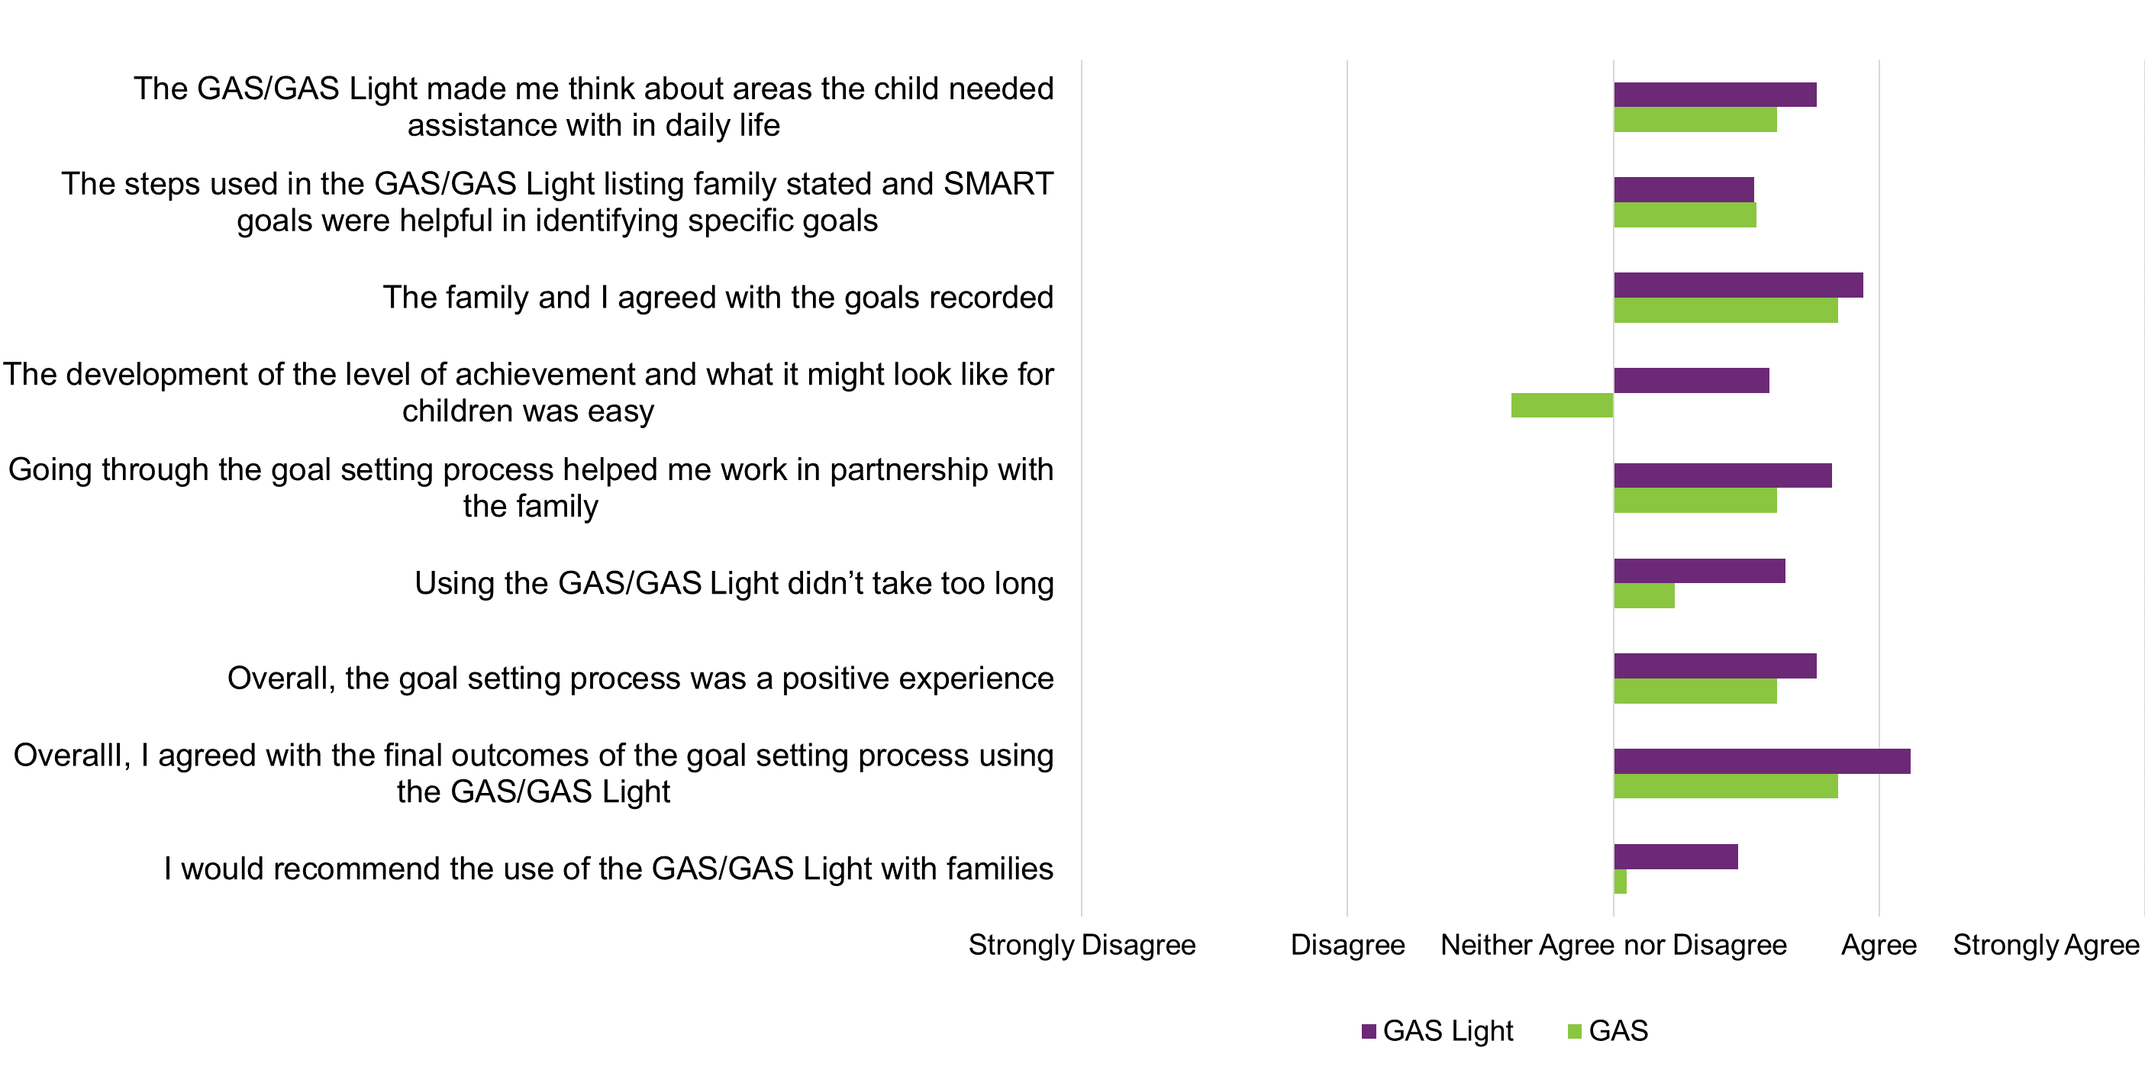
Source: Research and Evaluation Branch analysis of EC Coordinator’s survey responses (29 completed responses, 13 GAS and 16 GAS-Light).
Feedback from the semi-structured interviews identified that respondents from organisations who had enrolled more families had a more positive view of the tools than organisations that experienced limited uptake. It is uncertain if the experience gained by using the tools as part of the evaluation positively influenced sentiment. Another explanation is that people with a more positive experience of the tools were more likely to commit to using them from the outset.

4.1.2 OM Tools - Reassessment
Figure 5 shows that staff survey respondents (majority EC Coordinators with a small number of senior staff/team leaders) were less positive about using the OM tools and their importance at reassessment than at goal setting. Notwithstanding this, EC Coordinators reported that compared to the GAS, the GAS-Light made it easier to explain the reassessment process with families and incorporate their views at reassessment than the GAS. This could be because the GAS-Light does not require pre-specification of the levels of achievement at goal setting. However, pre-specified levels of achievement might make it easier to objectively identify a child’s progress.
EC Coordinators also reported that it was easier to explain the scoring of the GAS-Light than the GAS, which could explain their perception that families were more in agreement with the reassessment scores from the GAS-Light. As with responses provided during goal setting, those EC coordinators who had engaged with the tools more found more value in them, stating that reassessment provided a good way to wrap up supports and show families their progress.

Figure 5: EC Partner feedback on the reassessment process, by OM tool
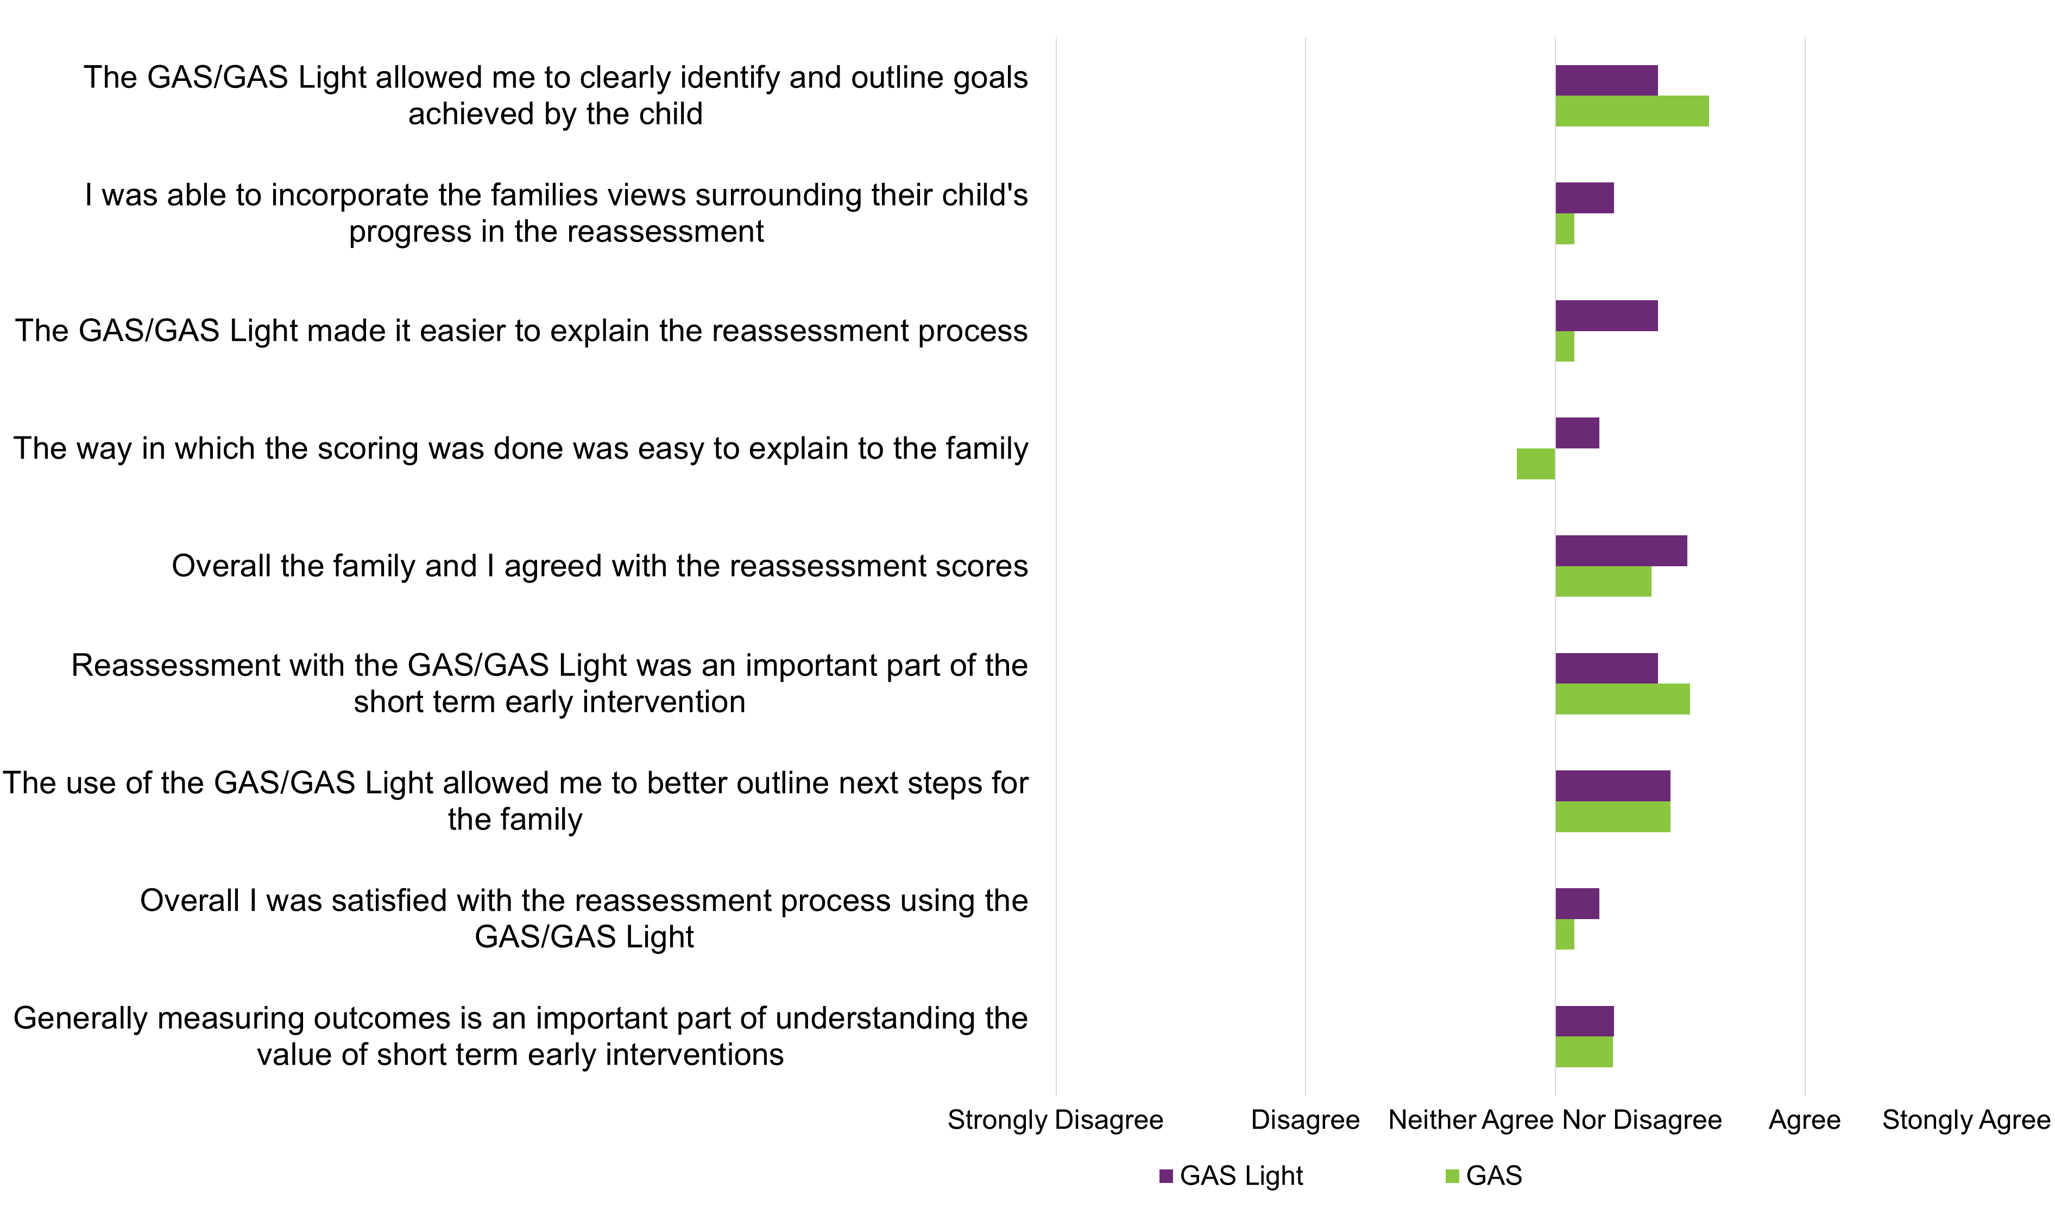
Source: Research and Evaluation Branch analysis of EC Partner survey responses (29 completed responses, 13 GAS and 16 GAS-Light).
Responses from parents/carers/guardians were more positive than EC Partners about their experience with the GAS and GAS-Light (Appendix C). Scores on the GAS-Light were generally more positive than for the GAS on all statements. At goal setting, respondents agreed least with statements which said that the scoring approaches were clear and that articulating levels of agreement was easy. Respondents agreed most with the statements ‘Setting goals with the early childhood partner helped us work well together’ and ‘Overall, I felt the [goal setting] process was a positive experience.’

4.1.3 PEEM - Goal setting and reassessment
During focus groups, most EC coordinators commented that the PEEM fits with the current approach to Early Supports considering that capacity building with caregivers is a core component of the program.
“I really found that it was really naturally aligned with a lot of the processes we already engaged in.”
A few EC Coordinators felt that families could be reluctant to openly and honestly discuss the topics covered in the PEEM for fear of highlighting dynamics in the house which may have potential cultural or legal consequences. Others felt that the topics in the PEEM may be confronting to some families. They felt for some families it would be better to complete the PEEM with an EC Coordinator who could clarify questions and provide alternative wording if necessary. One person suggested that it would be more appropriate to collect information covered in the PEEM as part of the structured interview, although this may result in inconsistency across families.
Supporting sentiment in focus groups, survey responses from EC Coordinators were generally positive about the PEEM. They were especially positive around the clarity and transparency of the PEEM’s scoring approach and the time it takes for families to complete and then to discuss with EC Coordinators. Surveyed caregivers were also positive about the value and ease of completing the PEEM but more so at goal setting than at reassessment (refer to Appendix C).

Ease of use

4.2.1 IT/data collection
During the evaluation, EC Coordinators completed the OM tools via Microsoft Word or paper copy. Several EC coordinators reported that completing, scanning and submitting paper copies of the OM tools were onerous. During focus groups, some commented that the tools were especially hard to complete and discuss collaboratively over the phone or MS Teams using either paper or electronic copies. They commented that it is important that the format supports interactive use with families to agree goals and finalise the scoring, especially during the goal setting phase.
Some EC Coordinators also commented during focus groups that the requirement that caregivers complete the PEEM by themselves out of session (in accordance with the developer’s and NDIA’s recommendations) complicated service delivery rather than freeing up contact time. A few EC Coordinators stated that having to complete the PEEM prior to the appointment were cumbersome, especially in situations where the appointment was due to occur in naturalistic settings (e.g. a family home). One coordinator stated they had to deliver a paper copy to a client who had no online access prior to the appointment, resulting in significant effort. Relaxing the requirement to complete the PEEM prior to the session may allow staff to better cover the topic area, but this might also miss important changes or improvements in parental efficacy that might occur in families resulting from the first session.
Most EC coordinators stated that successful widespread adoption of the OM tools and PEEM will depend on their integration into the client relationship management system.

4.2.2 Scoring
A lot of feedback from EC Coordinators related to the way OM tools introduced a quantitative component to setting goals and measuring their achievement. Figure 6 shows that in their survey responses, EC Coordinators reported clarity around the PEEM’s scoring approach but not the GAS or GAS-Light. Caregivers reported being much clearer about the scoring of the GAS and GAS-Light. However, it is unclear whether they truly understood the scoring algorithm or whether acquiescence influenced their sentiment.

Figure 6: EC coordinator and Parent/Caregiver/Guardian sentiment on GAS/GAS-Light and PEEM scoring
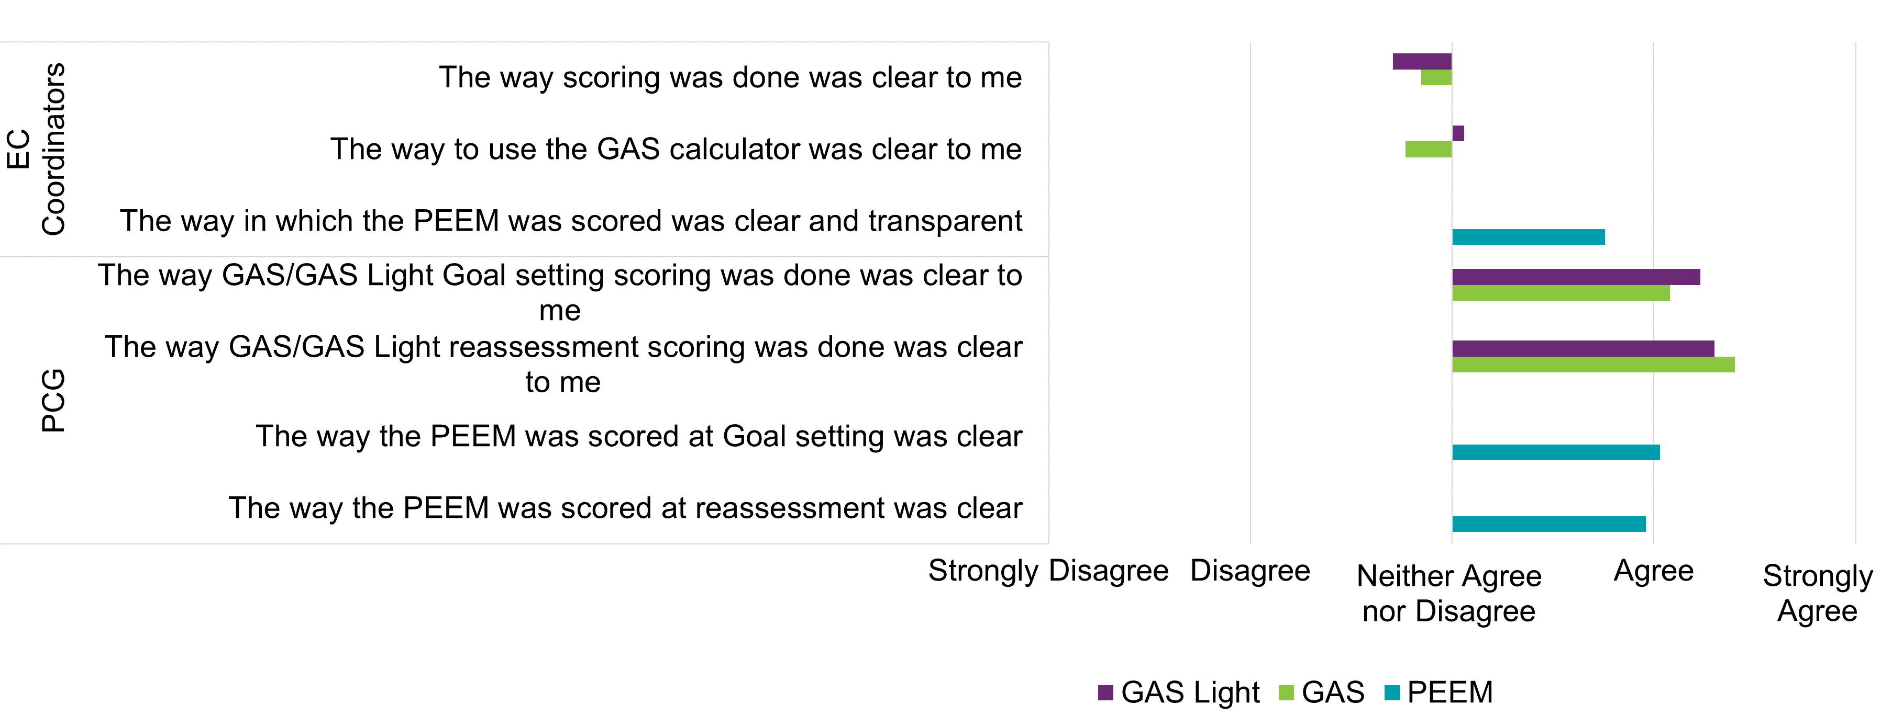
Source: Analysis of EC Coordinator survey data (n=22 completed responses) and Research and parent/caregiver/guardian responses (n= 39 at Goal setting, n= 30 at reassessment).
In interviews, EC coordinators almost unanimously commented that the scoring approaches for the GAS and the GAS-Light, which required a separate spreadsheet to integrate multiple pieces of information into the required T-score, is confusing. A review of submitted forms show that the T-score remained uncalculated for more than 90%.
“The point system for GAS can be confusing…parents just want to know if their child has met the goal.”
A few EC Coordinators, during interviews and in surveys, queried the validity and consistency of the scoring options in the GAS/GAS-Light, with terms like ‘a little more achieved’ and ‘a lot more achieved’ being open to interpretation and dependent upon how caregivers articulated the goal. They discussed that ongoing training, feedback, and the provision of more examples may increase the consistency in the use of these terms across EC coordinators to describe a given level of observed change.
A technical review of the scoring procedure of the GAS/GAS-Light and correspondence with the tools’ developer indicated that using ‘importance’ ratings in calculating T-scores may bias achievement ratings. The developer recommended an easier scoring approach that does not rate the importance of goals. Although this may reduce user burden, it is uncertain how this change will alter T-scores collected by the NDIA and may hamper comparisons with scores between children, limiting comparability and interpretation of the tool.

4.2.3 Duplication of effort
Most EC coordinators agreed that there is overlap between the proposed use of the GAS/GAS-Light and the COPM and the existing use of the Family Service and Support Plan (FSSP).
The FSSP is an internal NDIA form which EC Partners should complete when a child is suitable for Early Supports. The FSSP contains many of the same fields as both the GAS and the GAS-Light, although does not require recording of importance, level of functioning or improvement related to goals. The sentiment from EC Coordinators was that that whatever the choice of OM tool/s, the NDIA should withdraw the FSSP to avoid duplication.

4.2.4 English as a second language
During focus groups, some EC Coordinators commented that the tools were difficult to use with families with low English proficiency, especially explaining SMART goals.
“I have a high number of families with English as a second language, getting the language correct was difficult. The fact that translators couldn’t always differentiate the content of some of the questions or convey it correctly didn’t help.”
Other feedback questioned the cultural appropriateness of the content for Aboriginal and Torres Strait Islander families. Some coordinators felt that having to complete the tools at designated time periods did not give them the flexibility to probe certain topic areas more delicately, especially if some topics were seen as potentially culturally sensitive and difficult to address through an interpreter.
The content and the nature of the PEEM was seen to require coordinators to improve their ability to interact with parents as opposed to children. This was seen to be an area where some EC coordinators felt they had little training and required additional time to complete.

Time to complete
The survey asked caregivers to estimate the time taken to complete the OM tools and the PEEM. Figure 7 shows that on average caregivers spent longer completing the GAS than the GAS-Light at goal setting (51 minutes c.f. 37 minutes) but not at reassessment (19 minutes c.f. 22 minutes). At goal setting this reflects the need to characterise multiple future states for each goal when using the GAS. Although the GAS-Light requires characterising an end state at reassessment, this only increased the average time to complete by three minutes. Caregiver reported time to complete the PEEM was identical at both goal setting and reassessment (17 minutes).
PCG survey respondents were positive about the length of time to complete the GAS and GAS-Light, although indicated a preference for the GAS-Light, presumably due to its brevity. Only one PCG respondent stated that the PEEM took too long to complete, with the remainder indicating the time taken was appropriate.

Figure 7: PCG assessments of the time taken to complete the GAS/GAS-Light and the PEEM
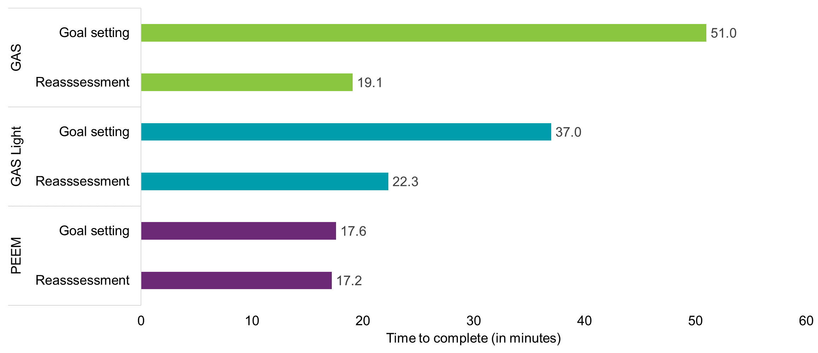
Source: Research and Evaluation Branch analysis of PCG responses (n=23, 9 and 32 for GAS, GAS-Light and PEEM at Goal setting, n=13, 13, and 21 for GAS, GAS-Light and PEEM at reassessment).
In surveys, EC Coordinators were also positive about the length of time to complete the GAS and GAS-Light, and reported a preference, albeit stronger, preference for the GAS-Light. EC Coordinators also reported positive sentiment about the time the PEEM takes to complete and the amount of session time it took up (Figure 8).

Figure 8: EC Coordinator and Parent/Caregiver/Guardian (PCG) views on the time taken to complete the GAS/GAS-Light and the PEEM
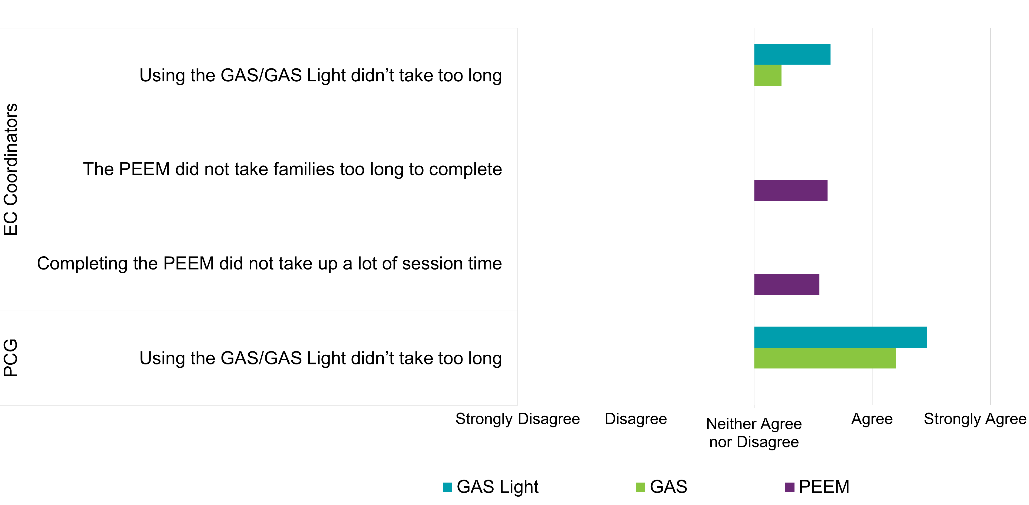
Source: Research and Evaluation Branch analysis of EC Coordinator survey data (n=22 completed surveys) and Research and PCG responses (n=30 at reassessment).
During focus groups, EC coordinators commented that with the GAS, the need to characterise and record five possible SMART outcomes for each goal at goal setting was time consuming. The GAS-Light is less onerous as only one future state is defined at initial assessment.
“I feel like it is really time consuming to sit down and ask families ‘so, if someone actually just didn't quite achieve this goal, what would that look like? And if they didn't really achieve the goal much at all, what would that look like?’ And then when you've got three main goals that you're working towards, it's so time-consuming when in our context…”
Some EC Coordinators also commented that they did not have much experience to quickly develop SMART goals with families, which also contributed to the length of time to complete the GAS. They felt that with additional training in this area, they could reduce the length of time to complete the GAS.
“Although I was familiar with SMART goals but because it was basically the first time doing that in a clinical setting.”

Cost
The developer of the GAS and GAS-Light has approved their use by the NDIA free of charge. However, use of the COPM carries an annual licensing fee. This fee which may exceed $10,000 AUD annually at full implementation in Early Supports and more if also used with NDIS Participants.

Considerations for the future use of OM tools in Early Supports

Considerations for future implementation
Table 9 summarises the evaluation findings and considerations for the future implementation of OM Tools in Early Supports.

Table 9: Criteria review of the tools trialled as part of the OM tool evaluation
Criterion | OM Tools  (GAS, GAS-Light) | PEEM | Considerations
Applicability-Goal setting | EC Coordinators generally agreed that the GAS and GAS-Light are relevant for goal setting but indicated a clear preference for the GAS-Light due to brevity and ease of explanation with families. | EC Coordinators saw the PEEM as relevant for Early Supports, prompting dialogue with families. | Prioritise the GAS-Light and PEEM in Early Supports.
Applicability-Reassessment | EC Coordinators were less positive about the benefit of OM tools at reassessment but still favoured the GAS-Light for the same reasons as at goal setting. | As above | As above.
Scoring | The weighting scoring approach incorporating importance and probability is complex, poorly understood and prone to bias. It is difficult to score without using an automated scoring template.  The 0-10 scaling of the COPM is more straightforward and would be simpler to understand.  All OM tools lack age and gender norms due to the unique set of goals assessed. This makes it difficult to assess the contribution of Early Supports over natural child development. | Scoring for the PEEM is straightforward and easy to interpret. | Consider integrating the COPM scoring approach into the GAS-Light.
Validity -Concurrent | There is little correlation between GAS/GAS-Light T-scores and PEDI-CAT domain scores (or PEEM scores). As the PEDI-CAT is a well validated measure of functional ability in children, the low correlation suggests the GAS and GAS-Light do not measure functional ability but novel constructs. | Correlations between total and domain-level PEEM scores and PEDI-CAT scores are much higher than for the GAS/GAS-Light | Retain the PEDI-CAT at goal setting for Early Supports and introduce it at reassessment to supplement the GAS-Light.  Introduce the PEEM into Early Supports.
Validity - Responsiveness | The GAS and GAS-Light seem to show greater change in scores from goal setting to reassessment than either the PEDI-CAT or PEEM, although the scoring is more subjective. Correlation between change scores for the GAS/GAS-Light and PEDI-CAT were low except with the PEDI-CAT mobility domain. | There is only weak correlation between PEEM and PEDI-CAT change scores. However, as many follow-up PEDI-CAT scores are identical to baseline, EC Partners may simply be copying over PEDI-CAT scores instead of readministering. | If the NDIA introduces the PEDI-CAT at reassessment for Early Supports, introduce a system requirement that ensures EC Partners readminister the PEDI-CAT and cannot copy it over.
Validity -Predictive | The GAS/GAS-Light have some ability to predict NDIS access following Early Supports but not the size of plan budgets.  PEDI-CAT scores at goal setting (responsibility domain) seem to predict both. | The PEEM does not seem to predict NDIS access or plan budgets following Early Supports. | Introduce the PEDI-CAT for the reassessment phase of Early Supports to give a better assessment of a child’s need for the NDIS (or further Early Supports).
Implementation | Some EC Partner staff found it difficult to develop SMART goals with families and calculate T-scores.  EC Partner staff found the GAS-Light easier and quicker to administer than the GAS.  There is no cost for the NDIA to use the GAS or GAS-Light.  The NDIA would have to pay at least a $10,000 AUD annual licencing fee for the COPM. | The PEEM seems to be easy to understand and implement | EC Partner staff will require training to develop informative SMART goals with families and consistently administer and score the GAS-Light.  The NDIA should further evaluate the predictive value of the PEEM with a larger sample.
Source: Information and analysis provided in Chapters 2 through 5.

Conclusion
There is evidence to suggest that the GAS-Light meets the NDIA’s requirements for a brief goal setting measure due to its brevity, ease of use, similarity to existing processes, and preliminary estimates of predictive ability. However, there is a case to alter the scoring to something more intuitive such as that of the COPM. This would make the GAS-Light easier to score, could increase its value for predicting NDIS access and plan budgets and be more relatable with families.
This evaluation also indicated a need to continue, and expand, the use of objective measures as part of Early Supports. This includes introducing the PEDI-CAT at the reassessment phase and ensuring EC Partners complete it instead of copying over. The PEDI-CAT measures something different than the GAS or GAS-Light and seems to better predict future need for the NDIS better than the GAS or GAS-Light. However, copying over PEDI-CAT scores, as currently suspected, would limit the PEDI-CAT’s value to both determine child outcomes and evaluate the effectiveness of Early Supports.
Introducing the PEEM would ensure measurement of novel areas that align with the focus of Early Supports but not assessed.
- OM tools

A1. Family outcome tools

PEEM: Parent Empowerment and Efficacy Measure
The PEEM consists of 20 positively worded statements. Respondents use a 10-point scale to indicate how well each statement captures the way they feel about themselves and their role as a parent. In addition to a measure of total empowerment (20 items), scores on two subdomains (efficacy to parent (11 items) and efficacy to connect (9 items)) can also be calculated. As the PEEM is short and straightforward; developers suggest that parents and carers can complete it independently without the need for assistance from EC partners.

A2. Subjective child outcome tools (goal setting tools)

COPM: Canadian Occupational Performance Measure
The Canadian Occupational Performance Measure (COPM) assesses perceived performance of daily activities and the satisfaction of the child and their family with that performance. COPM is an individualised outcome measure to detect changes in a client’s self-perception of their occupational performance over time. ‘Occupational performance’ in the context of children equates to their ability to play, learn, and interact with their environment.

GAS: Goal Attainment Scale
Goal Attainment Scaling (GAS) allows for a standardised evaluation of the effect of an intervention based on individualised goals. The GAS allows people to set individual treatment goals with their treating professional. The goals need to be defined so that an independent evaluator can assess the extent of goal achievement. This means goals must be measurable and preferably align to a functional domain. The number and content of the goals may differ between clients, but the measurement of goal achievement is standardised.

GAS-Light: Goal Attainment Scale-Light Version
Although the GAS is a flexible and responsive assessment for evaluating outcomes in complex interventions, users have reported three problems that have limited its uptake:
- Using the current scoring method, descriptions of achievements should be pre-defined for each of the five outcome score levels (-2, -1, 0, +1, +2) using a ‘follow up guide.’ This is time consuming given that only one level will be endorsed as the outcome of the intervention.
- Users have reported confusion surrounding the complexity and diversity of numerical scoring methods used for the GAS.
- Users dislike applying negative scores which may be discouraging to families.
Differences between the GAS and the GAS-Light, which respond to these problems, are.
- Descriptions of achievement only need to be pre-defined for the most likely of the five outcome score levels, as opposed to each of them. Rating of all other levels, if attained, will be retrospective.
- The client and practitioners are both involved in goal setting and evaluation.
- Scoring now allows practitioners to record goal attainment without reference to numeric scores, avoiding the perceived negative connotations of negative scores.
The GAS-Light is not a novel tool but a different approach to applying and scoring the GAS.

Children Outcome Measures-Objective assessment of outcomes

PEDI-CAT: The Paediatric Evaluation of Disability Inventory-Computer Adaptive Test
PEDI-CAT is a standardised, population norm-based tool designed to evaluate paediatric disability. PEDI-CAT allows identification of functional delay, examination of improvement for a child after intervention, and the evaluation and monitoring of progress in a wide range of disability groups. Although the children in ES do not have developmental delay (as defined by the Act) or disability, it is still suitable as an assessment measure for children receiving ES. The NDIS currently requires all children to have a PEDI-CAT completed upon entry if they receive ES. The assessment is also used to inform Scheme Access.
PEDI-CAT assesses responses to items grouped into four domains: Daily activities, Mobility, Social/Cognitive, and Responsibility. The measure is administered using a computerised adaptive testing algorithm, which reduces the number of items respondents need to answer.

- OM tool evaluation methods and questions
The table below shows which data sources were used for each evaluation question.

Table B1: Alignment of evaluation questions to Data Sources
Evaluation Questions | EC Partner interview transcripts | Parent and carer online survey | EC Partner online survey | ECS Expert review CRM notes | Results from Assessment tools uploaded to CRM | Demographic data (PEDI-CAT) collected in CRM
- Do the tools (PEEM, COPM, GAS, and GAS-Light) proposed to assess outcomes commonly identified in ES do so comprehensively, accurately and consistently? | Y | Y | Y | Y | Y | N
- To what extent did EC partners and families feel like the PEEM comprehensively captured parental empowerment and efficacy? | Y | Y | Y | Y | N | N
- To what extent did EC partners/families feel that the GAS-Light comprehensively captured the outcomes of the children? How does the GAS-Light compare to OM tools currently in use (COPM and GAS)? | Y | Y | Y | Y | N | N
- What was the EC partners’ experience using each OM tool (e.g. ease of administration, time requirements, appropriateness of language and methods, acceptance to Participants, etc.)? | Y | Y | N | N | N | N
- Ability of each OM tool to predict the following:  - Further Supports  - Referral Pathways  - Transition to NDIA Access.  - Cost of ES | Y | N | Y | Y | Y | Y
- Additional results
Survey responses have been converted from a categorical value to a representative numerical value and the averages have been reported. This is to improve interpretability and allow for easier score comparisons. Please see the footnote in Chapter 5 for more information.

Figure C1: Parent/caregiver/guardian responses surrounding goal setting processes, by OM tool
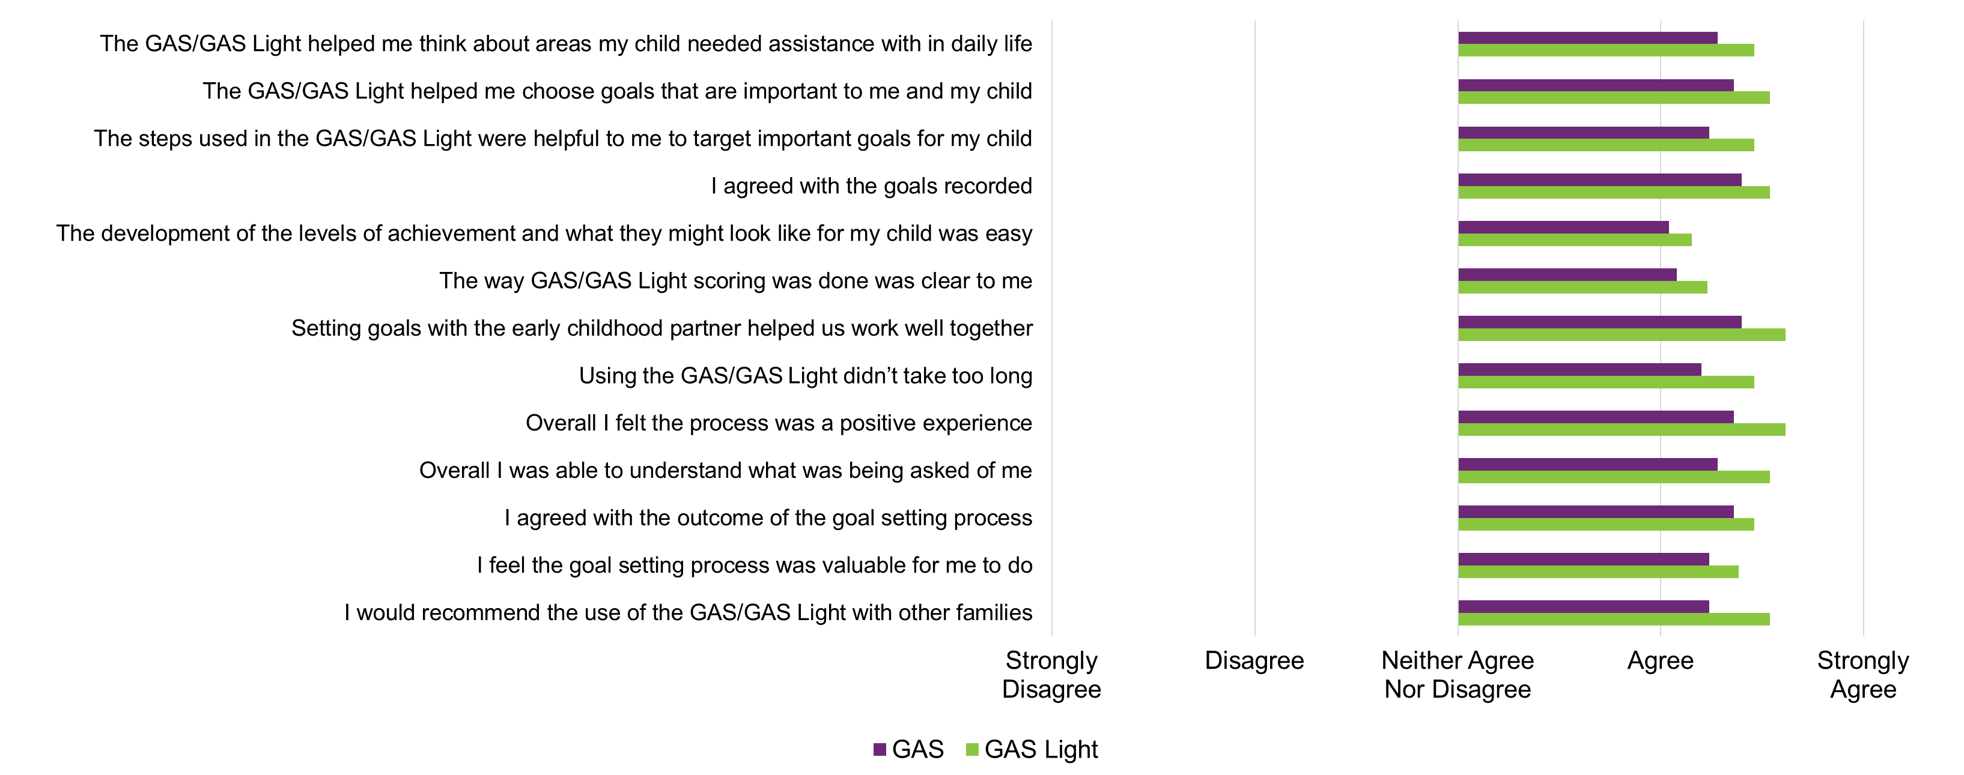
Source: Research and Evaluation Branch analysis of parent/caregiver/guardian survey data collected after goal setting (n=39)

Figure C2: Parent/caregiver/guardian responses surrounding reassessment, by OM tool
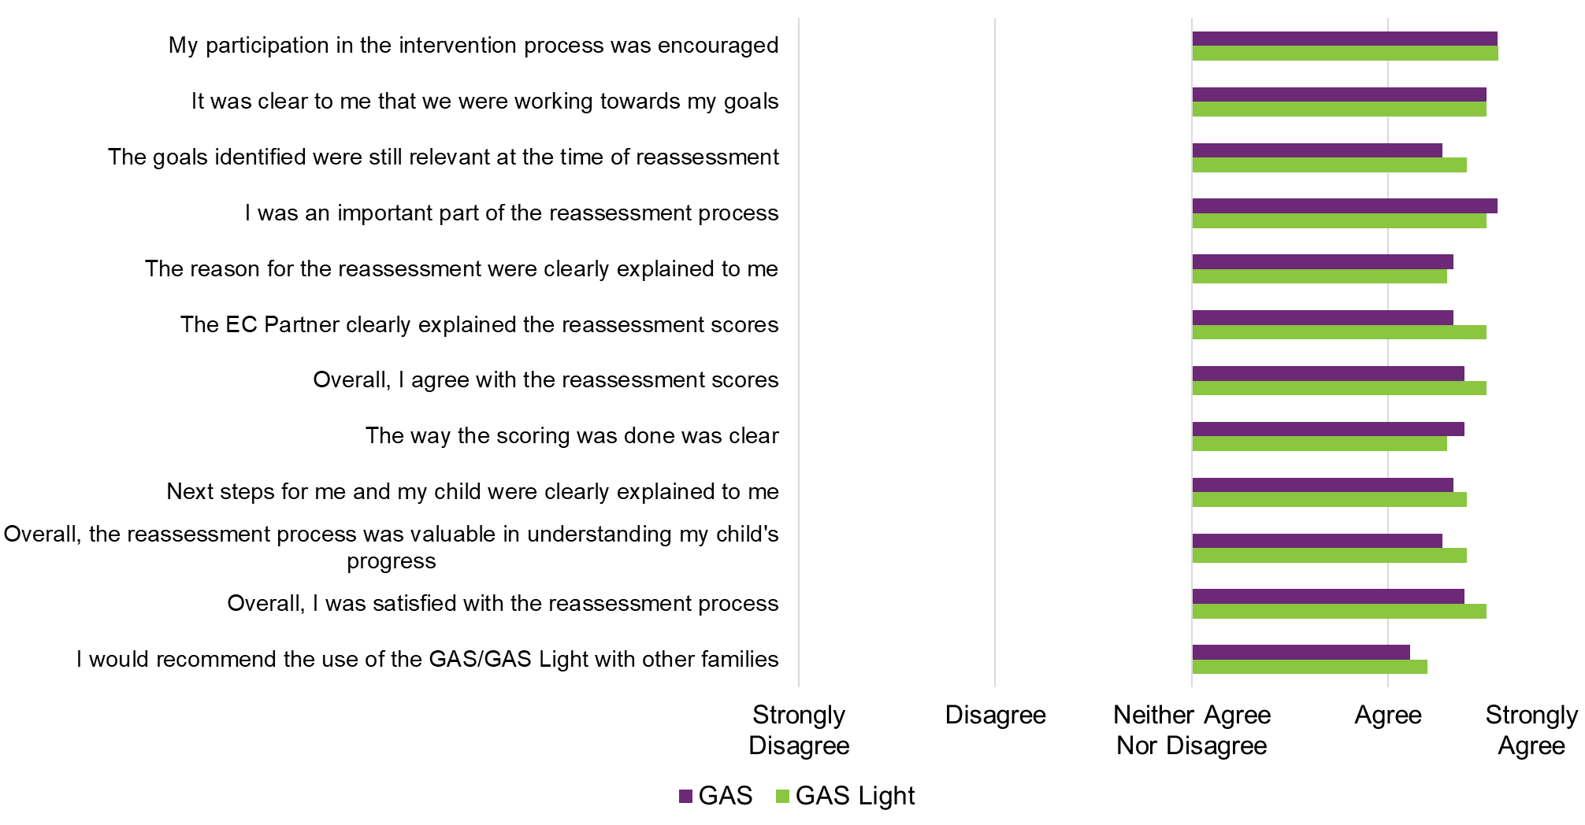
Source: Research and Evaluation Branch analysis of PCG survey data collected after reassessment (n=30)

Figure C3: EC Partner survey responses surrounding the PEEM
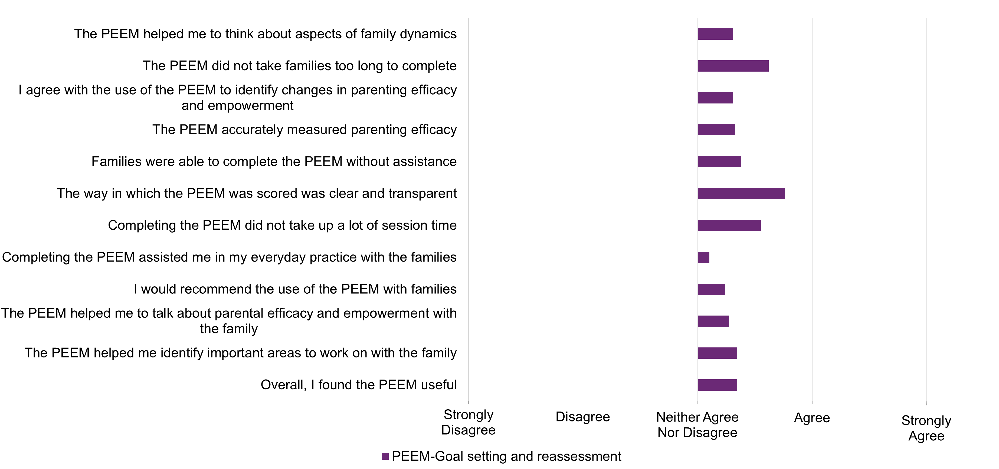
Source: Research and Evaluation Branch analysis of EC Partner survey (n=58 as Goal setting and reassessment scores are combined).

Figure C4: Parent/caregiver/guardian survey responses surrounding the PEEM, at goal setting and reassessment
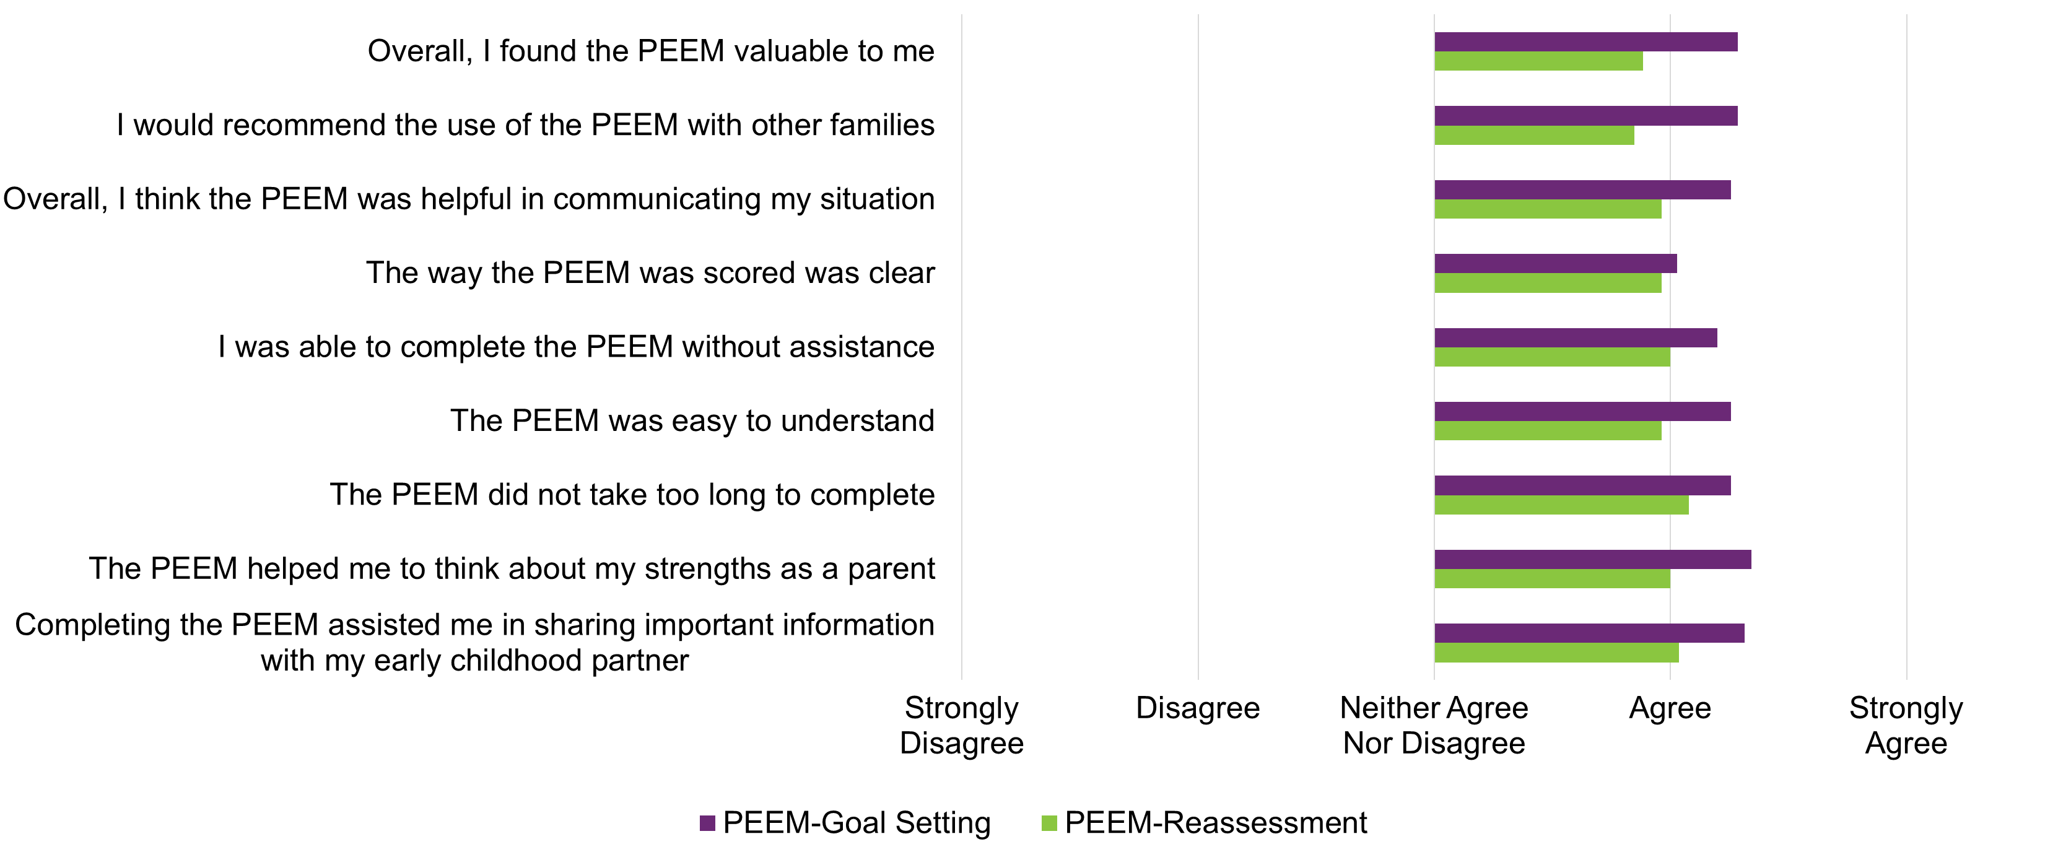
Source: Research and Evaluation Branch analysis of PCG survey responses (n=35 at goal setting, n=27 at reassessment)

NDIA, Our guidelines: Early childhood approach, Our Guidelines website, 21 October 2022. Accessed 24 November 2021
NDIA, Our guidelines: Early childhood approach, Our Guidelines website, 21 October 2022. Accessed 24 November 2021
Fact Sheet: The Parent Empowerment and Efficacy Measure (PEEM). Accessed on 23/09/2022 from: https://www.realwell.org.au/wp-content/uploads/2016/03/PEEMFactSheet-June-03-06-2016.pdf.
Iyer LV, Haley SM, Watkins MP, Dumas HM. Establishing minimal clinically important differences for scores on the pediatric evaluation of disability inventory for inpatient rehabilitation. Phys Ther. 2003 Oct;83(10):888-98. PMID: 14519060.
Krasny-Pacini A, Hiebel J, Pauly F, Godon S, Chevignard M. Goal attainment scaling in rehabilitation: a literature-based update. Ann Phys Rehabil Med. 2013 Apr;56(3):212-30. doi: 10.1016/j.rehab.2013.02.002. Epub 2013 Feb 28. PMID: 23562111.
Willer, Barry & Miller, G. (1977). On the validity of goal attainment scaling as an outcome measure in mental health. American journal of public health. 66. 1197-8. 10.2105/AJPH.66.12.1197.
In Chapter 5, ratings provided on PCG, and EC Partner surveys were recoded into numerical values, reported as averages. Ratings were recoded as follows: Strongly Disagree; -2, Disagree; -1, Neither Agree nor Disagree; 0, Agree; 1, Strongly Agree; 2. An average score between 1 and 2 would be between Agree and Strongly Agree.
Acquiescence is a type of bias where people tend to agree with a statement or answer regardless of what they believe. This happens because subconsciously or not, most people like to be seen as polite, likeable and knowledgeable.
Law, M., & Canadian Association of Occupational Therapists. (1991). Canadian occupational performance measure. Toronto: CAOT = ACE.
Turner-Stokes L. Goal Attainment Scaling (GAS) in rehabilitation: a practical guide. Clin Rehabil. 2009; 23:362–370
Haley S, Ni P, Ludlow L, Fragala-Pinkham M. Measurement precision and efficiency of multidimensional computer adaptive testing of physical functioning using the Pediatric Evaluation of Disability Inventory. Archives of Physical Medicine & Rehabilitation. 2006; 87:1223-1229.

