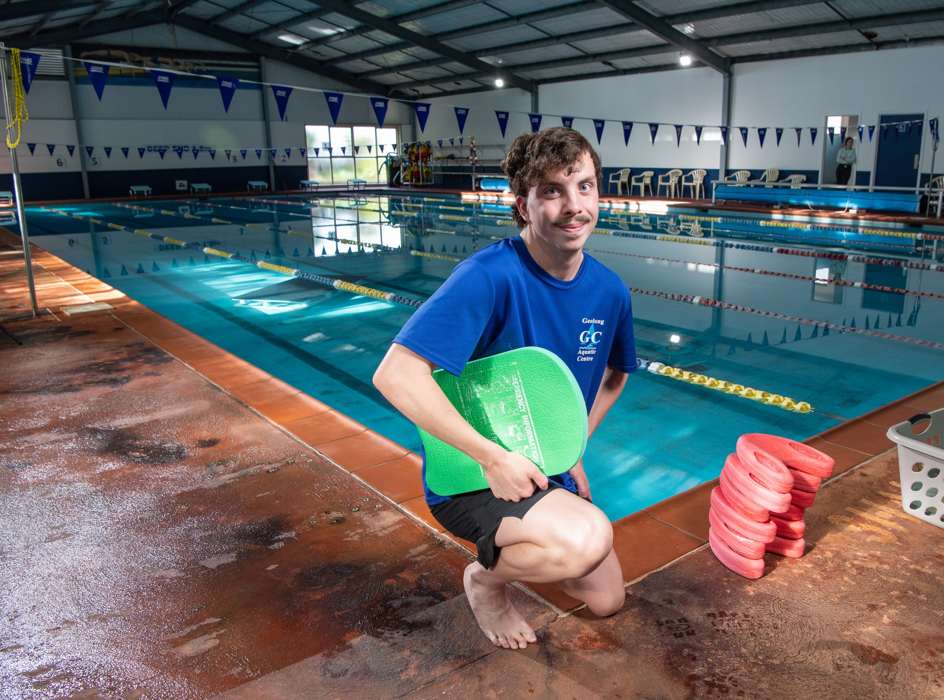
School leaver employment support
Provider reported services
January to December 2022

Report produced September 2023
Market Innovation & Employment Branch
ndis.gov.au

Jono’s Story

When leaving school unsure of which path to follow in life, Jonathan White just knew he wanted to give himself a sporting chance.
Affectionately known as “Jono”, the 20-year-old from Geelong, who lives with a chromosomal condition and intellectual disability, was unsure of what may lay ahead.
But combining his love of sport with career ambition, the National Disability Insurance Scheme (NDIS) participant has become a swim instructor and is now leading an all-round fulfilling life.
“I always liked swimming and did it through school. I got a second place in regionals in a 4x50 freestyle relay team,” Jono said.
“I was working in hospitality and my dad said ‘let’s look at teaching. I did a course, and 2 days later I started (swim teaching).”
Out of the pool, Jono is an all-round sports lover. A cricket tragic, he loves to spend his summers wielding the willow with Marshall Cricket Club.
While his sporting pursuits are supported by his close-knit family, Jono’s success in navigating the workforce with confidence was built through NDIS-funded School Leaver Employment Supports.
During the COVID-19 pandemic, Jono linked up with NDIS provider 4gr Employment Consulting Service.
Building on his employment skills, Jono’s provider worked with him to find employers that matched his likes and interests.
Jono undertook a swimming instructor course before engaging in interview preparation and planning. He then secured a casual role with Geelong Aquatic Centre.
In 2022 Jono landed a 2nd job with the Geelong City Council’s Leisurelink.
“With Jono, we delivered a training model to build a foundation of job-ready skills through simulation sessions both face-to-face and online. Ahead of Jono’s interview, we did some role playing and preparation, and helped him get ready.” said Jono’s employment lead and mentor, Nina.
Jono now works across Monday to Saturday shifts at Geelong Aquatic Centre. He also works 3-hour shifts on Wednesday afternoons at Leisurelink Aquatic and Recreation Centre.
Performing a range of duties, Jono teaches children and primary school groups the critical skills of swimming.
While supervising and instructing a range of school children in the water can be overwhelming, Jono said building skills through his training and support had really benefited him.
“I love the job, but my communication skills needed work,” he said.
“Now I’m just really putting myself out there and trying to be a bit louder. I’m trying my best, and the coaching really helped me find my voice and confidence.”
Building on that confidence, Jono took the next step in securing his long-term employment goals by deciding to study towards the end of last year.
Supported in contacting education providers while researching his options, Jono enrolled in a Certificate III of Fitness.
With a long-term goal of becoming a qualified personal trainer, Jono receives support from Nina to organise the filming of role-plays and complete assessments.
Through employment mentorship, Jono said he was supported in managing his stress levels and anxiety when he begins to feel overwhelmed.
“I’ve coped pretty well, and Nina is always there for me,” Jono said. We work through things and if I say, ‘I can’t do this’, it’s great to have that support as then I know I can.”
Following the course, Jono said he’ll continue to build towards a future, with an aim of securing a traineeship or full-time job on the horizon.
In his personal life, Jono uses his NDIS supports to engage support workers and occupational therapy, as he works towards his goal of independent living.
“My support workers check-in on me to see how I’m going with work and my course,” Jono said.
“Occupational therapy helps with my organisational skills. I’ve tried to get my confidence up with cooking, packing things up, cleaning my room and that type of thing as I’m looking forward to moving out eventually.”
Whether it’s excelling in the classroom, wowing the kids at work, or simply making his way in the world, Nina said Jono had a lot to be proud of.
“Having access to employment funding through the NDIS, can really change somebody’s life. As Jono’s mentor, seeing his growth and confidence build has been amazing to witness,” she said.
“Jono should really be proud of himself.”
“I’m definitely proud of how far I’ve come,” Jono added. “The NDIS has been really important for me.”

Contents
School leaver employment support 1
Contents 4
1. Executive summary 6
1.1 Introduction 6
1.2 Employment support provider reporting 6
1.3 Report enhancements 6
1.4 Key findings 7
2. Provider and participant count 10
2.1 Provider count 10
2.2 Participant count 11
3. Participant demographics 11
3.1 Employment support recipients 11
3.2 Location 12
3.3 Primary disability 13
3.4 Age 13
3.5 Gender 14
3.6 Aboriginal or Torres Strait Islanders Status 14
3.7 Culturally and Linguistically Diverse status 14
4. Supports & milestones 15
4.1 Support type hours 15
4.2 Support delivery method 16
4.3 Progress towards milestones – snapshot at each reporting period 16
4.4 Progress towards milestones – cumulative for the year 18
5. Final outcomes 20
6. Final employment outcomes 23
6.1 Employment type 23
6.2 Hours worked 24
6.3 Industry of employment 25
6.4 NDIS supports in employment 26
6.5 Supported wages 26
7. Intermediate employment outcomes 27
7.1 Employment outcomes (January to December 2022) 27
7.2 Employment type 27
7.3 Hours worked 29
7.4 Industry of employment 30
7.5 NDIS supports in employment 31
7.6 Supported wages 31
8. Model summary 32
8.1 Modelling approach 32
8.2 Differences in modelling approach between reporting period ending December 2022 versus the period ending June 2022 33
8.3 What helps (or hinders) finding paid employment 34
8.4 Differences in modelled predictors between reporting period ending December 2022 versus the period ending June 2022 35
9. Appendix 36
9.1 Appendix 1 – Methodology for the section titled “Progress towards milestones – cumulative for the year” 36
9.2 Appendix 2 – Model accuracy 38

Executive summary

Introduction

The Agency is committed to ensuring participants have the same opportunities to work as other Australians and the confidence, support and skills to achieve their work goals.

The NDIS can make a key difference for young participants by supporting them early to aspire to work, develop skills and connect to the right job role and employer.
School leaver employment support is an individualised early intervention support intended to smooth the transition from school to employment by building a young participant’s skills, confidence, and capacity for work.

This third edition of the School Leaver Provider Report analyses the supports provided to participants, their progress and the outcomes they’ve achieved, allowing us to share insights on the factors that lead to successful employment outcomes.

Employment support provider reporting

Since January 2021, providers of school leaver employment supports report to the Agency on a quarterly basis on the supports they deliver to participants, and the progress and outcomes participants achieve.
This third edition of the Provider report contains the aggregated data submitted by providers for the 12 months January 2022 to December 2022. Previous editions can be found here. The purpose of this report is to give visibility to the outcomes achieved through school leaver employment funding. This allows providers to benchmark their own results against those for the sector as a whole. It also allows participants to request providers to advise their results to compare with whole of sector figures.
Analysis is updated at 6 monthly intervals to provide results for the preceding 12 months. This gives a rolling view of outcomes achieved over the latest 12 months giving a wholistic picture and eliminating the peaks and troughs which may occur over the course of the period. For example, more young people may start receiving employment supports in January to March, following their graduation from high school.

Report enhancements
For the purpose of this analysis, we have only included data collected in the 4 quarters of 2022 instead of data collected across all quarters from January 2021.

New information has been added to this report at Section 2 ‘Provider and participant count’. From payments claimed during 2022 calendar year, section 2 contains information on the number and size of providers, the number of participants they support and the providers who submitted reporting.

New providers reported on participant activity in Q1 and Q2 2022. The additional number of participants are now included in those quarters' totals. This might result in Q1 and Q2 2022 numbers being slightly different to the same periods published in the last report.

Reporting outcomes by provider
To equip participants with information and enable them to consider performance when choosing a provider, the Agency is releasing the ‘Provider Final Outcomes Breakdown’. This document will show the final outcomes reported by each provider during 2022 including open employment, supported employment (including Australian Disability Enterprises) and non-employment outcomes.

Providers were given the opportunity to confirm the data to be published and the Agency contacted a sample of participants. Participants confirmed the majority of outcomes as reported. This validation with a sample group of participants will continue each quarter.

It's important to note that only those providers who reported a participant exit from their service in 2022 appear in the Provider Final Outcomes Breakdown. There may be participants who are in employment and still receiving support from the provider, who are not represented in the ‘Provider Final Outcomes Breakdown’. It should also be noted that the providers listed vary in size, area of operation and length of time delivering employment services.

We encourage participants to discuss the available information with providers when considering selecting or changing providers. Additional questions that participants can ask providers about their service are available here.

This report will feature a participant story, like Jono’s, in each release showcasing a positive employment outcome. Participants, or providers with the consent of the participant, are invited to forward stories to participant.employment@ndis.gov.au.

If you have general feedback or questions about this report, please email participant.employment@ndis.gov.au.

Key findings
The information contained in this report represents data submitted to the Agency by providers of school leaver employment supports delivered to participants from January to December 2022.

As at December 2022, 7,419 young participants aged 15-24 either had school leaver employment support included in their NDIS plan or had claimed school leaver employment supports. Out of these, only participants for whom service had been provided, and whose data providers submitted to the Agency are included in this report.

For January to December 2022, providers reported:

Demographics
- 5,700 unique participants received school leaver employment supports of which 2,582 commenced between 1 January 2022 and 31 December 2022.
- 1,077 participants commenced receiving school leaver employment supports in January to March 2022, 530 commenced in April to June 2022, 506 commenced in July to September 2022, and 469 commenced in October to December 2022.
- Participants receiving school leaver employment supports predominantly have autism (55%) or intellectual disability (34%), with 67% being male.
- The majority of employment support recipients are in NSW (38%), followed by VIC (25%), and QLD (14%).
- 6% of employment support recipients identified as Aboriginal or Torres Strait Islander people. This is slightly lower than the 8% of all NDIS participants aged 15-24 who identify as Aboriginal or Torres Strait Islander.
- 7% of employment support recipients identified as being from a Culturally and Linguistically Diverse community. This is slightly higher than the 6% of all NDIS participants aged 15-24 who identified as being from these communities.
Time spent in training
- 46% of the training time was spent building participants’ social, presentation, communication and work skills.
- Participants receive supports via group-based activities (56% of support time), one to one support (42% of support time) with the amount of support via distance or online methods reducing to 2% over the period.
Exits from school leaver employment
- 1,420 participants were reported to exit school leaver employment supports during the four quarters.
- Of the 1,420 participants who exited employment supports, 31% achieved open employment outcomes compared to 29% in the report of June 2022, 4% achieved supported employment outcomes (in a Disability Enterprise) which reduced 1% from the report of June 2022.
- 15% went on to further study or volunteer work, whilst 49% of participants exited without an employment outcome compared to 51% in the report of 30 June 2022.
- Providers did not report a final outcome for 2% of participants who exited, a reduction of 10% from the report of June 2022. Of the participants who achieved open and supported employment outcomes over the four quarters, 33% were employed on a part time basis while 55% were employed casually, 7% were employed full time.
- Of participants who started employment, 81% worked up to 21 hours per week.
- Of participants who finished employment support with paid employment, 69% worked in retail, hospitality, tourism, trades, manufacturing or operations.
- Of participants who started employment, 33% said they will be using NDIS supports in employment to maintain their employment. This percentage has been increasing over time.
- Of participants who finished employment support with paid employment, 18% of employers said they will use supported wages for the participants’ employment.
Note: Figures in this report have been rounded to the nearest whole percentage.

Interventions compared to outcomes.
- More time receiving employment supports or skill specific training was associated with a higher chance of making significant progress towards, or fully gaining the specific skills.
- Participants who were assisted to get a job are more likely to gain paid employment.
- Participants where more time was spent in training, in achieving employer engagement and job customisation milestones were more likely to gain paid employment.
- Participants who made significant progress or fully achieved their goals in relation to developing work skills, employer engagement and job customisation milestones were more likely to gain paid employment.
- Participants who fully achieved their work experience milestone goals were more likely to gain paid employment.
- Active involvement in a community, cultural or religious group improved the likelihood of gaining paid employment.

For more information on the modelling insights and methodology see Section 8

Provider and participant count

Provider count

Figure 1. Providers represented in reporting – October to December 2022

Provider Size by Participants Supported | Providers | % Who submitted the reporting tool | % Who did not submit the reporting tool
101+ | 5 | 100% | 0%
51-100 | 15 | 100% | 0%
11-50 | 52 | 94% | 6%
2-10 | 174 | 53% | 47%
*1 | 300 | 14% | 86%

From October to December 2022 (Figure 1), there were 546 providers delivering school leaver employment support across the country, with 20 providers delivering to 51 or more participants. While 52 providers delivered services to 11-50 participants and 474 providers delivered supports to 10 or fewer participants. The largest 20 providers delivered support to 46% of participants and were able to report on them all during the year. Across all providers, data was submitted for 86% of participants.

For January to December 2022 (Figure 2), providers who have 10 or fewer participants have lower submission rates, though they have been steadily improving over the year. For these providers, the slight decrease in the proportion of providers that submitted data from September to December 2022 quarters was mainly driven by more providers claiming supports overall (larger denominator).

* The Agency is investigating the authenticity of providers supporting only one participant and ensuring smaller providers comply with reporting requirements.

Figure 2. Percentage of providers who submitted the reporting tool – January to December 2022

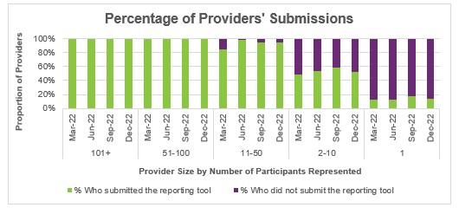

Participant count

Figure 3. Participants represented in reporting – October to December 2022

Provider Size by Participants Supported | % of participants in provider tool | % of participants not in provider tool
101+ | 100% | 0%
51-100 | 100% | 0%
11-50 | 97% | 3%
2-10 | 60% | 40%
1 | 14% | 86%

Overall, 14% of participants who received school leaver employment supports in the last quarter were not represented in the reporting submitted by providers. The Agency is investigating potential reasons for this and working with providers to ensure reporting compliance.

Participant demographics

Employment support recipients

The Provider Reporting Tool data provides information on participants receiving employment support during the year. Participants that started employment support during a previous period and continue to be recipients in the current period are included in the ‘Existing’ numbers, and those that started receiving employment support during the current period are included in the ‘New’ numbers. While participants that exited employment support during the current period are included in the ‘Exited’ numbers.

Note, if the participant exits employment support in a quarter, then they will be counted in the "Exit" numbers for that quarter, and if that same participant re-enters employment support a few quarters later then they will be counted in the "New" numbers again.

Figure 4. Number of participants

Group | Jan to Mar 2022 | Apr to Jun 2022 | Jul to Sep 2022 | Oct to Dec 2022
Existing | 3,118 | 3,938 | 4,162 | 4,266
New | 1,077 | 530 | 506 | 469
Total | 4,195 | 4,468 | 4,668 | 4,735
Exit | 257 | 306 | 402 | 455

The number of participants receiving employment supports reported by the Provider Reporting Tool (the Tool) has steadily increased over all 4 quarters.

Adjusting the analysis to include only the data reported in the 4 quarters of 2022.

The number of participants included in this report for January to March and April to June quarters differs from the previous report due to the following reasons:

“Silent" exits
In the previous report, the analysis used all available data submitted up to 30 June 2022 (6 quarters from January 2021 to June 2022) to determine which participants received services during the 4 quarters July 2021 to June 2022. This relied on the Start and Exit Dates being accurately populated in the Tool. However, this meant that Participants who were reported in some quarters with no reported exit date, and who were no longer reported in subsequent quarters (“silent exits”) were counted as ‘existing’ participants.
This report does not count these “silent exits” i.e., if the participant is no longer receiving a service and the provider ceased reporting without recording a final outcome or exit date. They are omitted from the data in this report.

To reduce the number of these in future, we have instituted a check at the end of each quarter to ensure any ‘silent exits’ are identified and providers reminded to report an exit date and final outcome for all participants who received a service.

Late-reported participants

These are participants who were not reported when the report to June 2022 was compiled but were then reported as having received employment support during the January to March 2022 and/or April to June 2022 quarters. These participants are now counted as new in either Q1 or Q2 2022 in this report.

Location

Figure 5. State or Territory of residence – number of participants

State or Territory | Jan to Mar 2022 | Apr to Jun 2022 | Jul to Sep 2022 | Oct to Dec 2022
NSW | 1,644 | 1,719 | 1,748 | 1,788
VIC | 1,133 | 1,145 | 1,175 | 1,175
QLD | 577 | 654 | 684 | 666
SA | 396 | 447 | 486 | 480
WA | 288 | 326 | 378 | 416
TAS | 87 | 103 | 118 | 127
ACT | 64 | 65 | 67 | 67
NT | <11 | <11 | 12 | 16

The majority of employment support recipients were in NSW (38%), followed by VIC (25%), and QLD (14%). For comparison, the top 3 states for all NDIS participants aged 15-24 are NSW (30%), VIC (24%) and QLD (21%). The over-representation in NSW is partly due to the earlier roll out to full scheme in that state and the influence of the legacy NSW Transition to Work program which involves transition teachers helping students to consider post school options and connecting many with employment providers.

Primary disability

Figure 6. Primary disability – number of participants

Primary disability | Jan to Mar 2022 | Apr to Jun 2022 | Jul to Sep 2022 | Oct to Dec 2022
Autism | 2,202 | 2,380 | 2,538 | 2,608
Intellectual Disability | 1,529 | 1,597 | 1,628 | 1,614
Down Syndrome | 130 | 129 | 128 | 127
Cerebral Palsy | 84 | 96 | 97 | 104
Other Neurological | 54 | 58 | 58 | 63
Hearing impairment | 53 | 53 | 61 | 61
Psychosocial Disability | 43 | 45 | 44 | 38
Acquired Brain Injury | 44 | 51 | 54 | 53
Visual Impairment | 23 | 22 | 22 | 23
Other or Not populated | 33 | 37 | 38 | 44
Total | 4,195 | 4,468 | 4,668 | 4,735

The top primary disabilities experienced by participants utilising these supports were autism (55%), followed by intellectual disability (34%). For comparison, 56% and 27% of all NDIS participants aged 15-24 report having autism and intellectual disability, respectively.

Age

Figure 7. Age – percentage of participants

Age | Jan to Mar 2022 | Apr to Jun 2022 | Jul to Sep 2022 | Oct to Dec 2022
up to 14 | 0% | 0% | 0% | 0%
15 to 17 | 6% | 6% | 7% | 6%
18 | 25% | 21% | 18% | 16%
19 | 32% | 32% | 31% | 30%
20 | 21% | 23% | 25% | 27%
21 to 24 | 15% | 17% | 19% | 21%
25+ | 0% | 0% | 0% | 0%
Not populated | 0% | 0% | 0% | 0%
Total | 100% | 100% | 100% | 100%

Participants aged 18-20 accounted for 73% of employment support recipients. Recipients aged 21 to 24 has steadily grown in proportion over the calendar year.

Gender

Figure 8. Gender – percentage of participants

Gender | Jan to Mar 2022 | Apr to Jun 2022 | Jul to Sep 2022 | Oct to Dec 2022
Female | 31% | 31% | 32% | 32%
Male | 68% | 67% | 67% | 67%
Other | 1% | 1% | 1% | 1%
Prefer not to say | 0% | 0% | 0% | 0%
Not populated | 0% | 0% | 0% | 0%
Total | 100% | 100% | 100% | 100%

In the most recent period, employment support recipients were 32% female and 67% male. In comparison to all NDIS participants aged 15-24, 34% were female and 64% were male. This is in line with the high proportion of employment supports recipients reporting autism as the primary disability, as the majority of participants who report autism are male.

Aboriginal or Torres Strait Islanders Status

Figure 9. Aboriginal and Torres Strait Islanders – percentage of participants

Aboriginal or Torres Strait Islanders status | Jan to Mar 2022 | Apr to Jun 2022 | Jul to Sep 2022 | Oct to Dec 2022
Yes | 5% | 6% | 6% | 6%
No | 76% | 76% | 76% | 76%
Not Stated | 19% | 18% | 18% | 18%
Not populated | 0% | 0% | 0% | 0%
Total | 100% | 100% | 100% | 100%

In the most recent period, 6% of employment support recipients identified as Aboriginal or Torres Strait Islander people. This is slightly lower than the 8% of all NDIS participants aged 15-24 who identified as Aboriginal or Torres Strait Islander.

Culturally and Linguistically Diverse status

Figure 10. Culturally and linguistically diverse – percentage of participants

Culturally and Linguistically Diverse status | Jan to Mar 2022 | Apr to Jun 2022 | Jul to Sep 2022 | Oct to Dec 2022
Yes | 7% | 7% | 7% | 7%
No | 92% | 92% | 92% | 92%
Not Stated | 1% | 1% | 1% | 1%
Not populated | 0% | 0% | 0% | 0%
Total | 100% | 100% | 100% | 100%

In the most recent period, around 7% of employment support recipients identified as being from a Culturally and Linguistically Diverse community. This is slightly higher than the 6% of all NDIS participants aged 15-24 who identify as being from a Culturally and Linguistically Diverse community.

Supports & milestones

Support type hours

Figure 11. Support type provided – percentage of hours per participant

Support type provided | Jan to Mar 2022 | Apr to Jun 2022 | Jul to Sep 2022 | Oct to Dec 2022
Assessments | 3% | 3% | 3% | 3%
Planning and reviewing progress | 5% | 5% | 5% | 5%
Exploring employment options | 10% | 9% | 8% | 8%
Engagement with family / carer to support employment directions | 4% | 3% | 3% | 4%
Engagement with other professionals / providers to support employment goals | 3% | 3% | 3% | 3%
Building social, presentation and communication skills | 23% | 24% | 23% | 22%
Travel training | 5% | 5% | 6% | 5%
Work skills training | 25% | 24% | 23% | 23%
Employer engagement education and job customisation | 6% | 5% | 6% | 5%
Work experience support (on the job) | 12% | 14% | 15% | 15%
On the Job Support | 1% | 1% | 1% | 1%
Other (Field 1) | 4% | 4% | 4% | 4%
Other (Field 2) | 0% | 0% | 0% | 0%
Total | 100% | 100% | 100% | 100%

Almost half (46%) of the training time was spent building the participant’s social, presentation, communication, and work skills. The amount of time dedicated to work experience support (on the job) has been gradually increasing and accounted for 15% of the total training time. From a separate analysis (NDIS Outcomes Framework Employment Deep Dive 31 December 2020), gaining work experience was listed as one of the top supports participants think will help them gain employment.

Support delivery method

Figure 12. Delivery method – percentage of hours

Delivery method | Jan to Mar 2022 | Apr to Jun 2022 | Jul to Sep 2022 | Oct to Dec 2022
One to One | 40% | 39% | 41% | 42%
Group Based | 55% | 58% | 57% | 56%
Distance or Online | 5% | 2% | 2% | 2%
Total | 100% | 100% | 100% | 100%
Participants have been excluded from this section where the sum of One to One, Group based, Distance or Online percentages did not equal 100%.

The percentage of distance or online learning declined to 2% in the second quarter and has remained constant over the subsequent quarters. The percentage of one to one support has slightly increased over the period.

Progress towards milestones – snapshot at each reporting period

This section looks at the distribution of progress for participants who worked on a particular milestone (where there are training hours reported for that specific skill), for each reporting period in isolation (non-cumulative).

To assist in interpretation of data, comments below each table summarise progress in the final quarter reported. Comments below each chart describe trends across the different quarters.

Social, presentation and communication skill

Figure 13. Social, presentation and communication skill milestone – percentage of participant progress

Social, presentation and communication skill milestone | Jan to Mar 2022 | Apr to Jun 2022 | Jul to Sep 2022 | Oct to Dec 2022
No progress | 6% | 5% | 5% | 5%
Some progress | 68% | 71% | 70% | 73%
Significant progress | 25% | 24% | 24% | 22%
Current goals fully achieved | 1% | 1% | 1% | 1%
Total | 100% | 100% | 100% | 100%

For participants who worked on this specific milestone, 73% reported some progress and 22% reported significant progress. There was a decrease in those who achieved significant progress in the last quarter.

Travel skill

Figure 14. Travel skill milestone – percentage of participant progress

Travel skill milestone | Jan to Mar 2022 | Apr to Jun 2022 | Jul to Sep 2022 | Oct to Dec 2022
No progress | 9% | 6% | 8% | 5%
Some progress | 63% | 68% | 62% | 66%
Significant progress | 22% | 21% | 23% | 23%
Current goals fully achieved | 5% | 5% | 7% | 6%
Total | 100% | 100% | 100% | 100%

For participants who worked on this specific milestone, 66% reported some progress and 23% reported significant progress.

Work skill

Figure 15. Work skill milestone – percentage of participant progress

Work skill milestone | Jan to Mar 2022 | Apr to Jun 2022 | Jul to Sep 2022 | Oct to Dec 2022
No progress | 6% | 6% | 7% | 6%
Some progress | 71% | 71% | 70% | 72%
Significant progress | 23% | 22% | 22% | 21%
Current goals fully achieved | 1% | 1% | 1% | 1%
Total | 100% | 100% | 100% | 100%

For participants who worked on this specific milestone, 72% reported some progress and 21% reported significant progress. Percentages have remained consistent over the calendar year.

Employer engagement, education, and job customisation

Figure 16. Employer engagement, education, and job customisation milestone – percentage of participant progress

Employer engagement, education, and job customisation milestone | Jan to Mar 2022 | Apr to Jun 2022 | Jul to Sep 2022 | Oct to Dec 2022
No progress | 9% | 5% | 7% | 7%
Some progress | 70% | 74% | 69% | 71%
Significant progress | 19% | 19% | 22% | 20%
Current goals fully achieved | 2% | 2% | 3% | 2%
Total | 100% | 100% | 100% | 100%

Providers who reported activities as “engaging with employers, educating and customising jobs” for participants reported that 71% made some progress and 20% made significant progress.

The percentage of participants showing significant progress or have current goals fully achieved has been consistent over all quarters.

Work experience

Figure 17. Work experience milestone – percentage of participant progress

Work experience milestone | Jan to Mar 2022 | Apr to Jun 2022 | Jul to Sep 2022 | Oct to Dec 2022
No progress | 7% | 5% | 6% | 5%
Some progress | 55% | 59% | 55% | 59%
Significant progress | 36% | 34% | 36% | 33%
Current goals fully achieved | 3% | 2% | 3% | 2%
Total | 100% | 100% | 100% | 100%

Of the participants engaging in work experience in the most recent quarter, 59% were reported as making some progress, and 33% were reported as making significant progress.

Of those who engaged in work experience, there was a decrease in those who achieved significant progress in the latest quarter. As work experience is strongly associated with achieving an employment outcome, NDIA will carefully monitor support provided and progress achieved against this milestone.

Progress towards milestones – cumulative for the year

The following sections show that more time receiving supports or training is associated with better progress towards mastering specific skills. For each participant, the best progress (across 4 quarters) towards mastering the specific skills is used for this analysis, and compared against the cumulative time receiving employment supports, and training for the specific skills.

Appendix 1 includes more detail on the methodology used in this section.

Social, presentation and communication skill

Figure 18. Social, presentation and communication skill milestone – percentage of participant progress

Cumulative training hours | No progress | Some progress | Significant progress | Current goals fully achieved | Total
0-9 | 26% | 55% | 14% | 5% | 100%
10-49 | 2% | 62% | 33% | 2% | 100%
50-99 | 1% | 59% | 39% | 2% | 100%
100+ | 1% | 61% | 38% | 1% | 100%
Of the participants who received up to 9 hours of training on social, presentation, and communication skills, around 14% were able to make significant progress towards mastering these skills. The proportion of participants making significant progress increased to 39% for those who received 50+ hours of the skill-specific training.

Figure 19. Travel skill milestone – percentage of participant progress

Cumulative training hours | No progress | Some progress | Significant progress | Current goals fully achieved | Total
0-9 | 45% | 32% | 7% | 17% | 100%
10-49 | 3% | 58% | 28% | 11% | 100%
50-99 | 1% | 45% | 44% | 10% | 100%
100+ | 0% | 34% | 59% | 7% | 100%

While 17% participants were able to fully achieve their goal within 0-9 hours of training, almost half (45%) did not make any progress. This suggests that for some participants, travel skills may be a primary area of focus and that they need only a few hours of personalised support to fully achieve their goals, while others need more than 10 hours of training to start making progress towards their goals.

Work skill

Figure 20. Work skill milestone – percentage of participant progress

Cumulative training hours | No progress | Some progress | Significant progress | Current goals fully achieved | Total
0-9 | 35% | 49% | 12% | 5% | 100%
10-49 | 4% | 62% | 30% | 4% | 100%
50-99 | 2% | 59% | 36% | 3% | 100%
100+ | 1% | 63% | 34% | 2% | 100%
Attaining significant progress in work skills was achieved through more cumulative hours of training demonstrating the need for more tailored support.

Employer engagement, education, and job customisation

Figure 21. Employer engagement, education, and job customisation milestone – percentage of participant progress

Cumulative training hours | No progress | Some progress | Significant progress | Current goals fully achieved | Total
0-9 | 42% | 43% | 12% | 4% | 100%
10-49 | 2% | 64% | 28% | 5% | 100%
50-99 | 2% | 59% | 35% | 4% | 100%
100+ | 0% | 56% | 39% | 5% | 100%
Making significant progress towards employer engagement, education, and job customisation milestones increased markedly with more hours of training.

Work experience

Figure 22. Work experience milestone – percentage of participant progress
Cumulative training hours | No progress | Some progress | Significant progress | Current goals fully achieved | Total
0-9 | 69% | 20% | 5% | 6% | 100%
10-49 | 3% | 60% | 33% | 4% | 100%
50-99 | 2% | 48% | 43% | 6% | 100%
100+ | 0% | 33% | 62% | 5% | 100%
Similarly, making significant progress towards work experience milestones increased markedly after more than 100 hours of training.

Final outcomes

This section shows the distribution of outcomes upon exiting employment support (based on the employment support reported end/exit date). In this report “Supported Employment” refers to participants who commenced with an ADE. In future reports we will include information on participants who receive ongoing support to maintain their employment in open settings so that changes in both of these outcome categories can be tracked over time.

Figure 23. Final outcomes (upon exiting employment support) – number of participants
Outcome | Jan to Mar 2022 | Apr to Jun 2022 | Jul to Sep 2022 | Oct to Dec 2022
Open Employment | 74 | 91 | 124 | 155
Supported Employment | 12 | <11 | 19 | 20
Non-Employment | 166 | 200 | 249 | 274
Not populated | <11 | <11 | <11 | <11

The number of participants finishing employment supports with open or supported employment was lower in January to March 2022, which coincided with the COVID-19 Omicron variant outbreak shutting down a large portion of Australia’s economy. This quarter was followed by a subsequent rebound in the number of participants in April to June 2022 as economic conditions improved. The last 2 quarters saw a constant increase in the number of participants finishing employment supports with open or supported employment.

From January to December 2022, 505 participants finished employment support with open or supported employment.

Figure 24. Final outcomes (upon exiting employment support) – percentage of participants
Outcome | Jan to Mar 2022 | Apr to Jun 2022 | Jul to Sep 2022 | Oct to Dec 2022 | Total
Open Employment | 29% | 30% | 31% | 34% | 31%
Supported Employment | 5% | 3% | 5% | 4% | 4%
Non-Employment | 65% | 65% | 62% | 60% | 63%
Not populated | 2% | 2% | 2% | 1% | 2%
Total | 100% | 100% | 100% | 100% | 100%

The percentage finishing with open or supported employment has been increasing in the last 3 quarters, making a new high of 38% in October to December 2022.
From January to December 2022, 35% of participants finished employment support with open or supported employment.

The following table provides a more granular breakdown of outcomes for participants who exited employment supports from January to December 2022.

Figure 25. Final outcomes breakdown – percentage and total number of participants:
Outcome | Jan to Mar 2022 | Apr to Jun 2022 | Jul to Sep 2022 | Oct to Dec 2022 | Total (%) | Total (Numbers)
Job in the open labour market with full award wages | 19% | 12% | 14% | 16% | 15% | 214
Job in the open labour market with full award wages, with assistance of DES | 5% | 12% | 12% | 12% | 11% | 155
Job in the open labour market with supported wages | 2% | 1% | 1% | 2% | 2% | 25
Job in the open labour market with supported wages, with assistance of DES | 3% | 3% | 3% | 3% | 3% | 42
Self-employed / Micro-enterprise | 1% | 1% | 0% | 0% | 1% | <11
Job in an Australian Disability Enterprise (ADE) | 5% | 3% | 5% | 4% | 4% | 61
Education or further study | 9% | 4% | 8% | 7% | 7% | 98
Volunteering or other unpaid work | 10% | 8% | 7% | 8% | 8% | 115
Referred to another provider | 4% | 9% | 5% | 10% | 7% | 103
Exit from Supports for other reasons (e.g., personal/ family circumstances / relocation) | 42% | 45% | 42% | 35% | 40% | 573
Not populated | 2% | 2% | 2% | 1% | 2% | 26
Total | 100% | 100% | 100% | 100% | 100% | 1,420

The absolute numbers (non-percentages) have been shown as a total only in the above table (not broken down into individual quarters) due to low volume in the individual quarter. Individual quarter absolute numbers will be shown once there is sufficient volume.

Open employment outcomes comprise:
- jobs in the open labour market, with full award or supported wages, with or without the assistance of Disability Employment Services (DES)
- or Self-employment/Micro-enterprise.

A job in an Australian Disability Enterprise (ADE) is classified as Supported Employment. The other categories in the chart above are classified as non-Employment outcomes.

For participants whose final outcome is Exit from Supports for other reasons, the common reasons reported were:
- personal or family circumstances,
- relocated,
- not engaging or contactable,
- school leaver employment supports funding ended,
- transferred to DES or another provider.

Figure 26. Final outcomes breakdown – participants in open and supported employment, by primary disability – percentage:

Primary Disability | Open Employment | Supported Employment | Total
Autism | 54% | 44% | 53%
Intellectual Disability | 36% | 49% | 38%
Down Syndrome | 2% | 2% | 2%
Cerebral Palsy | 1% | 0% | 1%
Other Neurological | 2% | 2% | 2%
Hearing impairment | 2% | 0% | 2%
Psychosocial Disability | 1% | 0% | 1%
Acquired Brain Injury | 1% | 2% | 1%
Visual Impairment | 0% | 2% | 1%
Other or Not populated | 0% | 0% | 0%
Total | 100% | 100% | 100%

The top primary disabilities reported by participants finishing employment supports and gaining open or supported employment were autism (53%), followed by intellectual disability (38%). For comparison, 54% and 35% of all participants receiving employment supports from January to December 2022 experience autism and intellectual disability, respectively.

More broadly, the table is indication that no disabilities are being under or over-represented in the final outcomes for open and supported employment (when compared to all participants receiving this support).

Final employment outcomes

Employment type

Figure 27. Employment type – number of participants

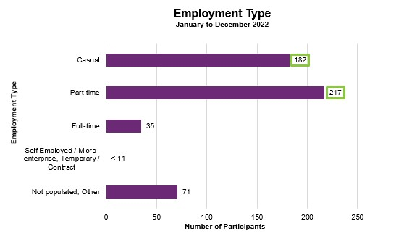

From January to December 2022, of participants who finished employment support with paid employment, 182 gained casual work while 217 gained part-time work.

Figure 28. Employment type – percentage of participants

Employment Type | Jan to Mar 2022 | Apr to Jun 2022 | Jul to Sep 2022 | Oct to Dec 2022 | Total
Casual | 37% | 40% | 34% | 35% | 36%
Part-time | 38% | 43% | 44% | 45% | 43%
Full-time | 8% | 2% | 11% | 6% | 7%
Self Employed / Micro-enterprise | 0% | 0% | 0% | 0% | 0%
Temporary / Contract | 0% | 0% | 0% | 0% | 0%
Not populated | 16% | 16% | 10% | 15% | 14%
Total | 100% | 100% | 100% | 100% | 100%

The percentage of participants finishing with part-time employment increased in every quarter. The percentage of participants finishing with full time employment increased by 3% from the last report.

From January to December 2022, of participants who finished employment support with paid employment, 36% gained casual work while 43% gained part-time work and 7% gained full-time work.

Hours worked

Figure 29. Hours worked per week – percentage of participants

Hours | Jan to Mar 2022 | Apr to Jun 2022 | Jul to Sep 2022 | Oct to Dec 2022 | Total
0-7 | 7% | 10% | 6% | 9% | 8%
8-14 | 23% | 31% | 29% | 33% | 30%
15-21 | 28% | 33% | 30% | 32% | 31%
22-28 | 8% | 10% | 13% | 3% | 8%
29-35 | 5% | 1% | 7% | 3% | 4%
36+ | 9% | 1% | 7% | 5% | 5%
Not populated | 20% | 15% | 9% | 15% | 14%
Total | 100% | 100% | 100% | 100% | 100%

The percentage of participants working between 8-21 hours per week was lowest in January to March 2022, which coincided with the COVID-19 Omicron variant outbreak and a large portion of Australia’s economy being shut down. This quarter was followed by a subsequent rebound in April to June 2022, due to improved economic conditions. The rebound was maintained in the last 2 quarters.

From January to December 2022, of participants who finished employment support with paid employment, 69% worked up to 21 hours per week.

Industry of employment

Figure 30. Industry of employment – percentage of participants

Industry | Jan to Mar 2022 | Apr to Jun 2022 | Jul to Sep 2022 | Oct to Dec 2022 | Total
Hospitality & tourism | 22% | 27% | 23% | 26% | 25%
Retail & consumer products | 19% | 20% | 26% | 26% | 23%
Trades & services | 9% | 3% | 10% | 7% | 8%
Manufacturing / Operation | 10% | 13% | 17% | 13% | 14%
Community & support | 2% | 7% | 3% | 6% | 5%
Transport & logistics | 2% | 4% | 1% | 1% | 2%
Banking & financial services | 0% | 1% | 1% | 2% | 1%
Education & training | 2% | 0% | 2% | 2% | 2%
Administration | 1% | 0% | 1% | 1% | 1%
Healthcare & medical | 2% | 5% | 1% | 1% | 2%
Information technology | 3% | 0% | 1% | 1% | 1%
Construction | 1% | 0% | 1% | 0% | 1%
Sales & marketing | 0% | 2% | 1% | 0% | 1%
Media & entertainment | 1% | 1% | 2% | 1% | 1%
Government / Defence | 1% | 0% | 1% | 0% | 0%
Engineering | 0% | 0% | 0% | 1% | 0%
Not populated | 22% | 18% | 8% | 13% | 14%
Total | 100% | 100% | 100% | 100% | 100%

The percentage of participants who worked in Hospitality and tourism rebounded significantly in April to June 2022 due to the easing of travel restrictions, and this percentage remained high in subsequent quarters. While the percentage of participants working in Retail and consumer products saw a significant increase in July to September 2022, becoming the top industry for participants to be employed in over the last two quarters.

From January to December 2022, of participants who finished employment support with paid employment, 69% work in Hospitality, Tourism, Retail, Trades, Manufacturing, or Operation.

NDIS supports in employment

Figure 31. Will the participant be utilising NDIS supports in employment? – percentage of participants

Response | Jan to Mar 2022 | Apr to Jun 2022 | Jul to Sep 2022 | Oct to Dec 2022 | Total
Yes | 12% | 17% | 14% | 24% | 18%
No | 51% | 41% | 45% | 43% | 45%
Unknown | 16% | 28% | 31% | 17% | 23%
Not populated | 21% | 15% | 10% | 15% | 15%
Total | 100% | 100% | 100% | 100% | 100%

The percentage of participants that will be utilising NDIS supports in employment has been increasing, after the low in January to March 2022. This quarter coincided with the COVID-19 Omicron variant outbreak and a large portion of Australia’s economy being shut down. This quarter was followed by a subsequent rebound in April to June 2022, due to improved economic conditions.

From January to December 2022, providers reported 18% of participants who finished employment support with paid employment will be using NDIS supports in employment to maintain their employment.

Supported wages

Figure 32. Will the participant receive a wage determined under the supported wage system? - Percentage of participants
Response | Jan to Mar 2022 | Apr to Jun 2022 | Jul to Sep 2022 | Oct to Dec 2022 | Total
Yes | 20% | 15% | 18% | 19% | 18%
No | 55% | 65% | 71% | 63% | 65%
Unknown | 2% | 1% | 2% | 1% | 1%
Not populated | 23% | 19% | 8% | 17% | 16%
Total | 100% | 100% | 100% | 100% | 100%

Of participants who finished employment support with paid employment, the percentage who were reported to receive a wage determined under the Supported Wage System (SWS) has remained generally steady. These participants are employed under Industrial Awards which allow the individual’s wage to be determined in accordance with their assessed level of productivity.
Over the 12 months, 18% of participants who commenced paid employment receive a wage determined under the SWS.
.

Intermediate employment outcomes

This section contains the employment features for all the participants who commenced employment from January to December 2022. The participants may or may not have exited employment support. Participants with Employment Type "Work Experience" are excluded.

Employment outcomes (January to December 2022)
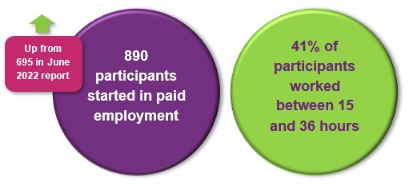

The top 4 industries in which participants started employment were Retail, Hospitality/Tourism, Trades/Services and Manufacturing/Operations.

Employment type

Figure 33. Employment type – number of participants

Employment Type | Jan to Mar 2022 | Apr to Jun 2022 | Jul to Sep 2022 | Oct to Dec 2022 | Total
Casual | 126 | 108 | 118 | 139 | 491
Part-time | 63 | 69 | 80 | 82 | 294
Full-time | 17 | 12 | 23 | <11 | 62
Self Employed / Micro-enterprise | <11 | <11 | <11 | <11 | <11
Temporary / Contract | <11 | <11 | <11 | <11 | <11
Not populated | 13 | 13 | <11 | 13 | 43
Total | 219 | 202 | 225 | 244 | 890

The number of participants commencing casual and part-time employment generally increased across the four quarters.

A total of 890 participants were reported to have commenced employment from January to December 2022. During this period, 491 started casual work while 294 started part-time work.

Figure 34. Employment type – percentage of participants

Employment Type | Jan to Mar 2022 | Apr to Jun 2022 | Jul to Sep 2022 | Oct to Dec 2022 | Total
Casual | 58% | 53% | 52% | 57% | 55%
Part-time | 29% | 34% | 36% | 34% | 33%
Full-time | 8% | 6% | 10% | 4% | 7%
Self Employed / Micro-enterprise | 0% | 0% | 0% | 0% | 0%
Temporary / Contract | 0% | 0% | 0% | 0% | 0%
Not populated | 6% | 6% | 2% | 5% | 5%
Total | 100% | 100% | 100% | 100% | 100%

The percentage of participants who started part-time work was lowest in January to March 2022, which coincided with the COVID-19 Omicron variant outbreak and a large portion of Australia’s economy being shut down. This quarter was followed by a subsequent rebound in April to June 2022, due to improved economic conditions.

From January to December 2022, of participants who started employment, 55% started casual work, while 33% started part-time work.

Hours worked

Figure 35. Hours worked per week – percentage of participants

Hours | Jan to Mar 2022 | Apr to Jun 2022 | Jul to Sep 2022 | Oct to Dec 2022 | Total
0-7 | 24% | 17% | 18% | 23% | 20%
8-14 | 29% | 32% | 33% | 33% | 32%
15-21 | 26% | 29% | 26% | 34% | 29%
22-28 | 7% | 12% | 10% | 5% | 8%
29-35 | 5% | 5% | 4% | 3% | 4%
36+ | 10% | 5% | 8% | 2% | 6%
Not populated | 1% | 0% | 1% | 0% | 1%
Total | 100% | 100% | 100% | 100% | 100%

The percentage of those working 15 – 21 hours was lowest in January to March 2022, which coincided with the COVID-19 Omicron variant outbreak and a large portion of Australia’s economy being shut down. This quarter was followed by a subsequent rebound in April to June 2022, due to improved economic conditions.

From January to December 2022, of participants who started employment, 81% worked up to 21 hours per week.

Industry of employment

Figure 36. Industry of employment – percentage of participants

Industry | Jan to Mar 2022 | Apr to Jun 2022 | Jul to Sep 2022 | Oct to Dec 2022 | Total
Hospitality & tourism | 33% | 30% | 27% | 29% | 29%
Retail & consumer products | 22% | 25% | 26% | 35% | 27%
Trades & services | 13% | 6% | 11% | 11% | 10%
Manufacturing / Operation | 11% | 11% | 16% | 6% | 11%
Community & support | 5% | 7% | 5% | 4% | 5%
Education & training | 3% | 1% | 1% | 1% | 2%
Administration | 2% | 3% | 2% | 3% | 3%
Construction | 2% | 2% | 1% | 3% | 2%
Transport & logistics | 3% | 2% | 4% | 2% | 3%
Healthcare & medical | 2% | 3% | 2% | 1% | 2%
Media & entertainment | 1% | 2% | 0% | 1% | 1%
Information technology | 1% | 2% | 1% | 1% | 1%
Banking & financial services | 0% | 0% | 1% | 1% | 1%
Government / Defence | 0% | 0% | 0% | 0% | 0%
Sales & marketing | 0% | 1% | 1% | 0% | 1%
Engineering | 0% | 0% | 0% | 0% | 0%
Not populated | 3% | 3% | 0% | 2% | 2%
Total | 100% | 100% | 100% | 100% | 100%

The percentage who worked in hospitality and tourism was was relatively stable across the four quarters. A noteworthy increase in the percentage who worked in retail and consumer products was seen in the most recent quarter.
From January to December 2022, of participants who started employment, 78% worked in Hospitality, Tourism, Retail, Trades, Manufacturing or Operation.

NDIS supports in employment

Figure 37. Will the participant be utilising NDIS supports in employment? – percentage of participants

Response | Jan to Mar 2022 | Apr to Jun 2022 | Jul to Sep 2022 | Oct to Dec 2022 | Total
Yes | 34% | 32% | 32% | 34% | 33%
No | 47% | 49% | 44% | 41% | 45%
Unknown | 18% | 19% | 23% | 21% | 20%
Not populated | 1% | 0% | 0% | 3% | 1%
Total | 100% | 100% | 100% | 100% | 100%

From January to December 2022, of participants who started employment, providers report 33% will be using NDIS supports in employment to maintain their employment.

This percentage has been relatively flat across the four quarters.

Supported wages

Figure 38. Will the participant receive a wage determined under the supported wage system? - Percentage of participants

Response | Jan to Mar 2022 | Apr to Jun 2022 | Jul to Sep 2022 | Oct to Dec 2022 | Total
Yes | 13% | 12% | 13% | 15% | 13%
No | 78% | 79% | 79% | 75% | 77%
Unknown | 5% | 6% | 5% | 5% | 5%
Not populated | 5% | 3% | 2% | 6% | 4%
Total | 100% | 100% | 100% | 100% | 100%

This percentage has seen an increase in the last quarter.

From January to December 2022, providers report 13% of the participants who started employment will receive a wage determined under the Supported Wage System (SWS).

Model summary

Modelling approach
A model was built to predict successful employment outcomes, defined as any of the following:
- Job in the open labour market, with full award or supported wages, with or without the assistance of Disability Employment Services (DES)
- Self-employed / Micro-enterprise
- Supported employment.
The modelling dataset is sourced from the Provider Reporting Tool and NDIA’s own participant data, with the former containing outcomes and support hours and the latter containing characteristics such as Culturally and Linguistically Diverse Status and education activities.
In addition, Socio-Economic Indexes for Areas (SEIFA) data was attached to the modelling dataset, mapping to the 2021 LGA. Note that some LGA names in the Provider Tool were updated to the 2021 LGA due to changes in LGA boundaries between 2016-2021.
Using 3 statistical techniques – Gradient Boosting Machine (GBM), Least Absolute Shrinkage and Selection Operator (LASSO) and Random Forest – we determine the significant predictors of employment success. Ranked in order from most to least important, the significant predictors are:
- Progress made towards achieving employer engagement and job customisation milestone
- Progress made towards achieving work skills milestones
- Progress made towards achieving work experience support milestones
- Housing arrangement
- Whether a participant is assisted to get a job
- Whether a participant has been actively involved in a community, cultural or religious group in the last 12 months
A Generalised Linear Model was then constructed using the above significant variables.
Appendix 2 has more details on the accuracy of the model.

Differences in modelling approach between reporting period ending December 2022 versus the period ending June 2022
Figure 39. Differences in modelling approach

Model on period ending December 2022 | Model on period ending June 2022
The response variable is derived from the latest quarter the participants exited SLES, while the predictor variable is derived from the quarter PRECEDING the quarter where participants exited SLES. | Both the predictor and response variable is derived from the latest quarter the participants exited SLES
Variable grouping is no progress /some progress vs significant progress /current goals fully achieved for ALL progress variables (work experience, employer engagement, work skills, travel, and building progress) | Variable grouping is no progress /some progress /significant progress vs current goals fully achieved for work experience progress, and no progress /some progress vs significant progress /current goals fully achieved for the rest of progress variables (employer engagement, work skills, travel, and building progress)
Excludes observations where payment data (from NDIS provider claiming data) is missing, because the majority of the observations are self-managed plans. | Payment data was imputed
SEIFA and unemployment rate variables considered as raw predictors | SEIFA and unemployment rate variables were not considered
Variable selection using GBM, lasso, and random forest | Variable selection using lasso, information value, and random forest
Excludes IRSD (Index of Relative Socio-economic Disadvantage) and IRSAD (Index of Relative Socio-economic Advantage and Disadvantage) as these variables are constructed using the question 'are you disabled?'  Excludes variables used to construct IEO (Index of Education and Occupation) like education activities, highest level of school completed, and unemployment rate | Excludes total payment and the indicator for whether a participant is active in clubs and sport

What helps (or hinders) finding paid employment
Figure 40. Variables that help or hinder finding paid employment – for the model covering period ending in December 2022

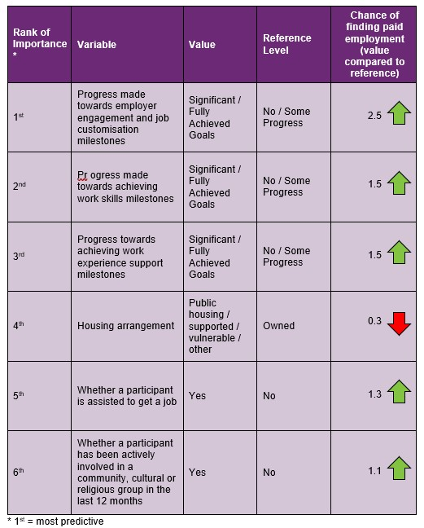

* 1st = most predictive
How to interpret the above table:
- Participants who made significant progress towards or fully achieved their employer engagement, education, and job customisation milestones were 2.5 times as likely to find employment compared to participants who made no or some progress towards similar milestones.
- Participants who were assisted to get a job are 1.3 times as likely to find employment compared to participants who were not assisted to get a job.

Differences in modelled predictors between reporting period ending December 2022 versus the period ending June 2022
The following table summarises the differences in significant variables selected in the model covering the period ending in December 2022, versus the model covering the period ending in June 2022.

Figure 41. Differences in significant predictors

Model on period ending December 2022 | Model on period ending June 2022
Progress made towards employer engagement and job customisation milestones | Progress made towards employer engagement and job customisation milestones
Progress made towards achieving work skills milestones | Progress made towards achieving work skills milestones
Progress towards achieving work experience support milestones | Progress towards achieving work experience support milestones
Whether a participant is assisted to get a job | Whether a participant is assisted to get a job
Housing arrangement | Hours spent in achieving employer engagement and job customisation milestones
Whether a participant has been actively involved in a community, cultural or religious group in the last 12 months | N/A

The differences in modelling insights are caused by the following:

- Number of observations. The modelling insights from period ending December 2022 data are based on 1,124 observations, which is more than the 936 observations used to model the period ending in June 2022. Higher number of observations affects the 95% confidence interval of each predictor (i.e., confidence that the mean response for each predictor variable will fall within a specified range), which affects the significance of each predictor.

- Change in model methodology. As outlined in the section 8.2 differences in modelling approach.

Appendix

Appendix 1 – Methodology for the section titled “Progress towards milestones – cumulative for the year”
This Appendix provides more details on how to interpret the section titled “Progress towards milestones – cumulative for the year,” and the methodology used.
How to interpret the table below

Work experience milestone – percentage of participant progress

Cumulative training hours | No progress | Some progress | Significant progress | Current goals fully achieved | Total
0-9 | 69% | 20% | 5% | 6% | 100%
10-49 | 3% | 60% | 33% | 4% | 100%
50-99 | 2% | 48% | 43% | 6% | 100%
100+ | 0% | 33% | 62% | 5% | 100%

Out of all participants who have received 100+ hours of on-the-job work experience support (cumulative for the year)
- 0% have "No progress" as the best result for the year.
- 33% have "Some progress" as the best result for the year.
- 62% have "Significant progress" as the best result for the year.
- 5% have "Current goals fully achieved" as the best result for the year.
The sum of each row in the above table equals 100%.

Methodology (for cumulative training hours)
The starting universe is all participants reported in the Provider Reporting Tool across the 4 quarters. For each participant, the "cumulative training hours" is then calculated as the total of the milestone-specific training hours reported in the Provider Tool for the 4 quarters. The best progress for the specific milestone is used (of all progress entries reported in the Provider Reporting Tool across the 4 quarters).
For example, if for participant John Smith, below are the progresses and hours reported across the 4 quarters.
Work experience support (on the job)
Provider Tool Quarter | Progress towards milestone | Hours spent
Quarter 1 | No progress | 5
Quarter 2 | Significant progress | 15
Quarter 3 | Some progress | 10
Quarter 4 | Some progress | 9

then "cumulative training hours" = 39 = 5 + 15 + 10 + 9 and the progress selected for John is "Significant progress" (the best progress of the 4 quarters). The "cumulative training hours" is then rounded down to the nearest whole number (e.g., 6.75 is rounded down to 6), and grouped into bands. Then for each cumulative training hours group (e.g., 0-9), the percentage of participants in each (best) progress category is calculated so that the sum of the row is 100%.

Appendix 2 – Model accuracy

The generalised linear model presented in Section 8 has the following accuracy:
Figure 42. Model accuracy – Gini and AUC
Measures | Training Data | Test Data
Gini | 0.49 | 0.47
AUC | 0.75 | 0.74

The closer the test set AUC and Gini is to 1, the better the model performance.
The Test Data AUC (and Gini) is typically smaller than the Training Data AUC (and Gini). This is because the model was built on the Training Data, hence predicts more accurately on it. The Test Data Gini and AUC however, give an indication of the model prediction accuracy when the model predicts on unseen data (on which it was not built).

Figure 43. Model accuracy – receiver operating curve
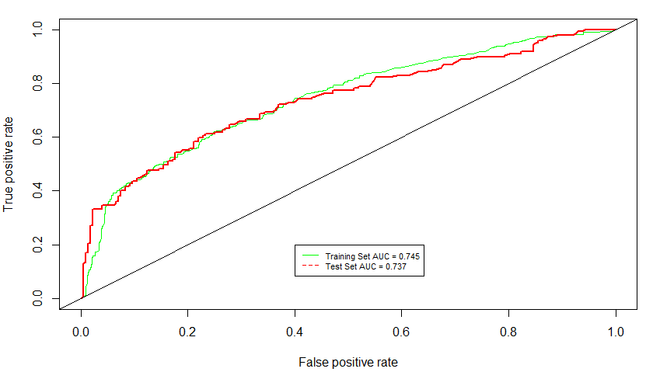

Figure 44. Model accuracy – actual versus predicted

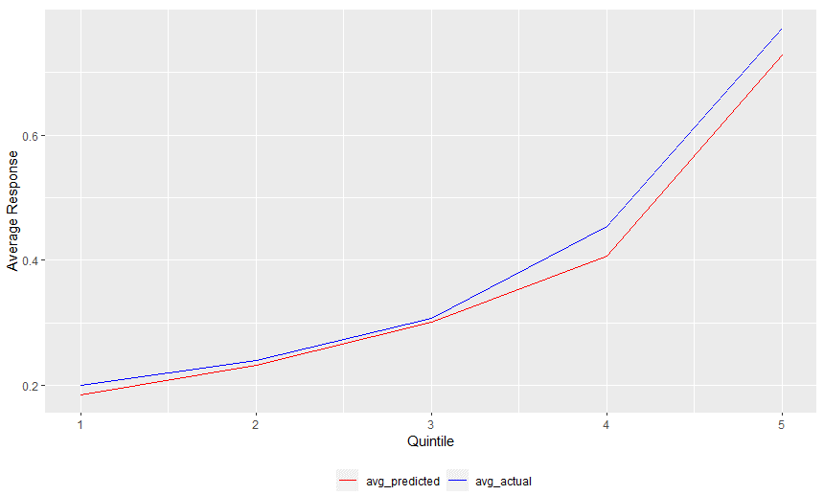

The model predicted probability (red) curve is close to the actual outcome (blue) curve, indicating that the model is able to accurately predict the probability of recipients finding paid employment.

Source: Australian Bureau of Statistics. For further information: Socio-Economic Indexes for Areas (SEIFA): Technical Paper, 2021 | Australian Bureau of Statistics (abs.gov.au) Link to the data: Socio-Economic Indexes for Areas (SEIFA), Australia, 2021 | Australian Bureau of Statistics (abs.gov.au) - Local Government Area, SA1 Distributions, SEIFA 2021.xlsx

