Cultural and Linguistic Diversity

Our Strategy

2024–2028
Easy Read version

How to use this Strategy
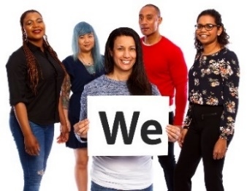 | The National Disability Insurance Agency (NDIA) wrote this Strategy.  When you see the word ‘we’, it means the NDIA.
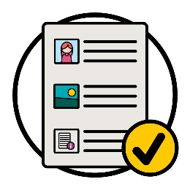 | We wrote this Strategy in an easy to read way.  We use pictures to explain some ideas.
We wrote some important words in bold.
This means the letters are thicker and darker.
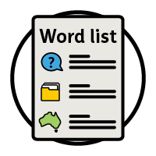 | We explain what these words mean.  There is a list of these words on page 34.
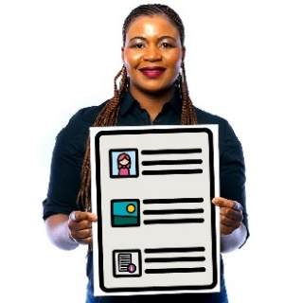 | This is an Easy Read version of the Cultural and Linguistic Diversity Strategy 2024–2028.
You can find the Cultural and Linguistic Diversity Strategy 2024–2028 on our website.
www.ndis.gov.au/CALD
You can ask for help to read this Strategy.
A friend, family member or support person may be able to help you.
 | This is a long document.
You do not need to read it all at once.
You can take your time.
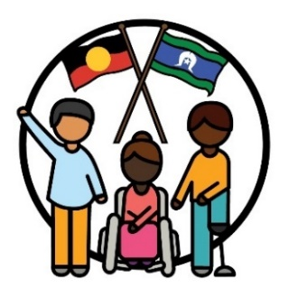 | We recognise Aboriginal and Torres Strait Islander peoples as the traditional owners of our land – Australia.
They were the first people to live on and use the:
- lands
- waters.

What is in this Strategy?
What does CALD mean? 5
What is the Strategy about? 7
Why is the Strategy important? 10
How did we make the Strategy? 12
What are our goals for the Strategy? 15
What will we do next? 29
More information 32
Word list 34

What does CALD mean?
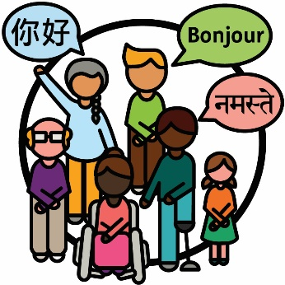 | Culturally and linguistically diverse (CALD) people are people who:  - come from different backgrounds  - speak languages other than English.
 | In Australia:
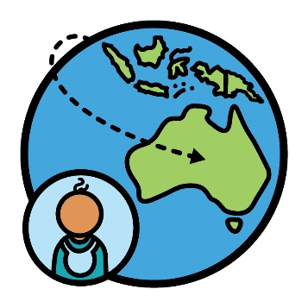 | - there are close to 8 million people who were born overseas
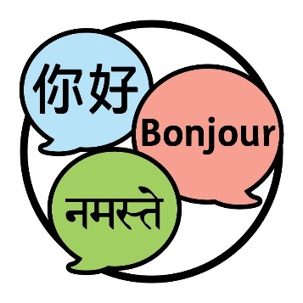 | - people speak more than 300 different languages.

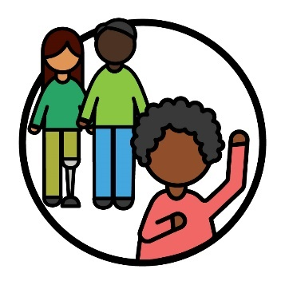 | When you identify as something, you are saying that you belong to a certain group of people.
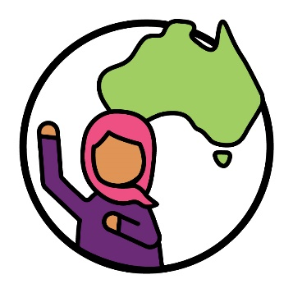 | 30% of people who live in Australia identify as a CALD person.
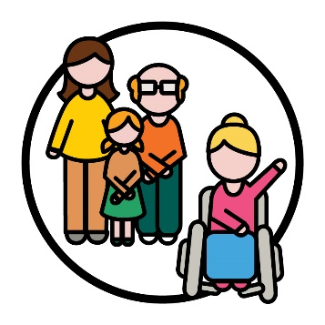 | 10% of participants in the National Disability Insurance Scheme (NDIS) identify as a CALD person.
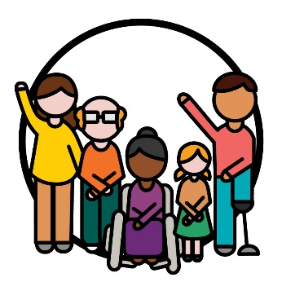 | Participants are people with disability who take part in the NDIS.

What is the Strategy about?
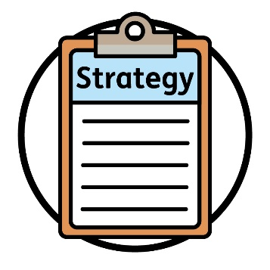 | We wrote the new Cultural and Linguistic Diversity Strategy 2024–2028.  We call it the Strategy.
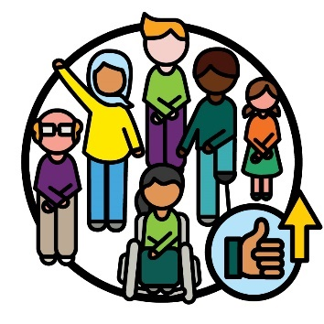 | This Strategy is a plan for how we will make the NDIS better for CALD participants.
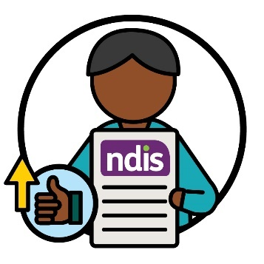 | It also explains how we will improve the experiences CALD participants have with the NDIS.

 | This includes their experience with:
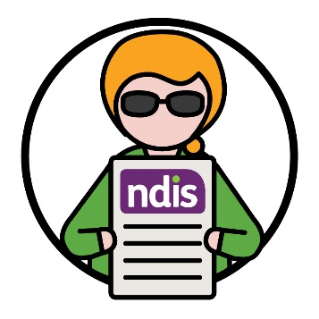 | - using the NDIS
 | - NDIS staff
 | - NDIS partners.
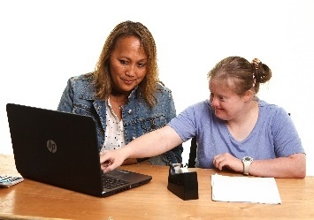 | NDIS partners are people who help others find and use services.  In this Strategy, we just call them our partners.

 | This Strategy also explains how we will support:
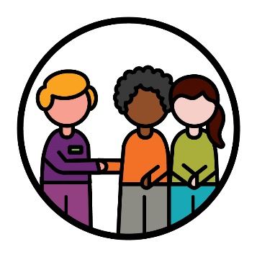 | - CALD communities to take part in the NDIS
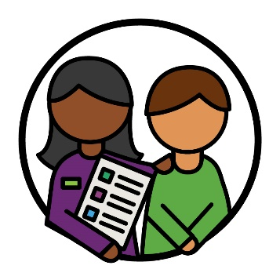 | - CALD participants to use the NDIS.

Why is the Strategy important?
 | Some CALD people experience more barriers when they want to take part in the NDIS.
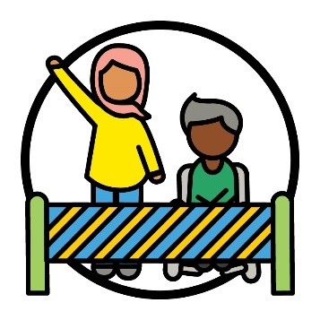 | A barrier is something that stops you from doing something you:  - need to do  - want to do.
 | Barriers can make it harder for CALD people to:
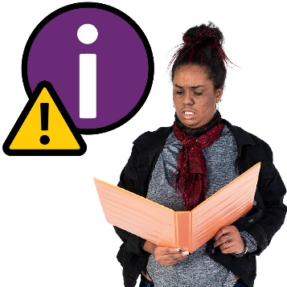 | - find information about the NDIS
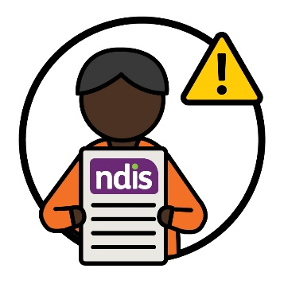 | - use the NDIS.
 | Our staff and partners do not always understand how to support CALD participants.
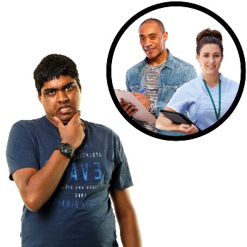 | It is hard for some CALD participants to find and use the services that they need.  And there are not enough services that are safe for all cultures.
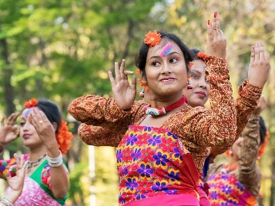 | Your culture is:  - your way of life  - what is important to you.
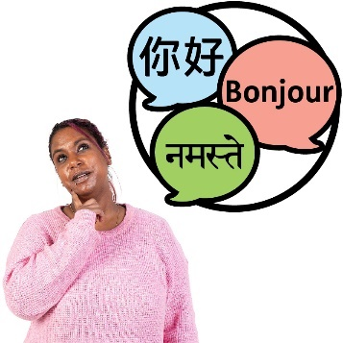 | Information in other languages is not always easy for CALD people to use.
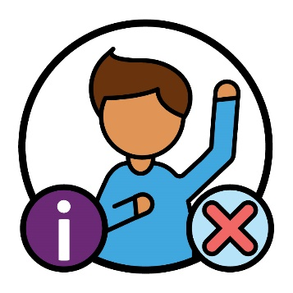 | And there is not enough information about what CALD participants:  - experience  - need.

How did we make the Strategy?
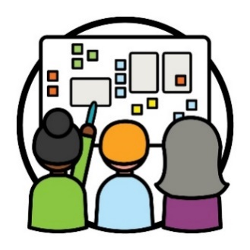 | We used co-design to make the Strategy.  Co-design is when people work together to:  - make something new  - improve how something works.
 | We made sure we worked with lots of different people, this includes:
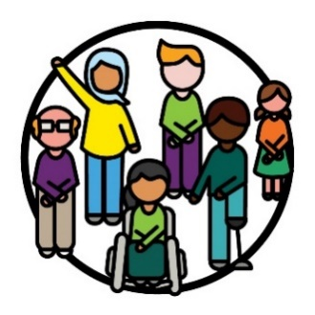 | - CALD people with disability
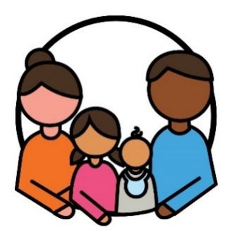 | - their families and carers
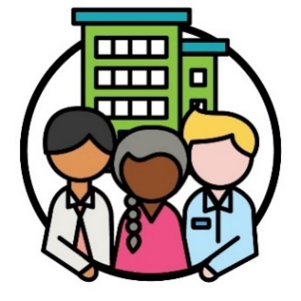 | - organisations that work with CALD people
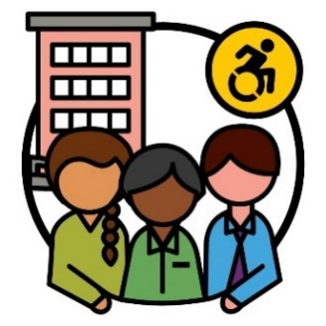 | - disability organisations.
We made sure we found the best ways to work together with different people.
For example, we ran meetings where people could talk about their ideas.
 | And we talked to people one-on-one.
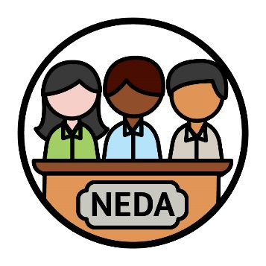 | We also worked with the National Ethnic Disability Alliance (NEDA).  NEDA is an organisation that supports the rights of CALD people with disability and their families.
Rights are rules about how people must treat you:
- fairly
- equally.
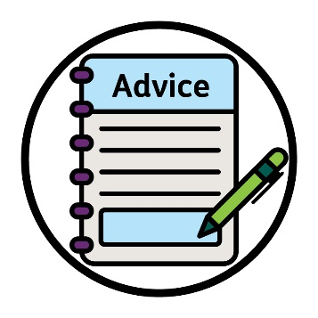 | NEDA shared with us their advice about the rights of CALD people with disability.  We used this advice to make the Strategy.
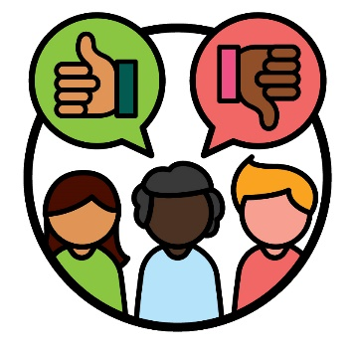 | We also made an advisory group outside of the NDIA.
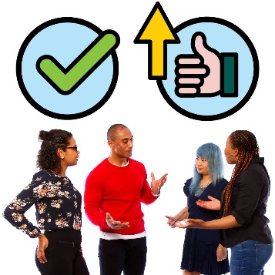 | An advisory group is a group of people who work with us to share what:  - is working well  - needs to work better.
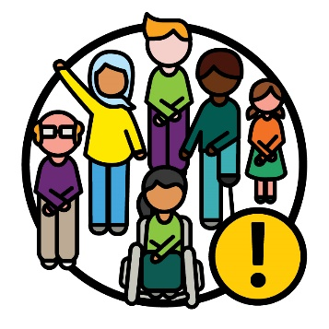 | CALD people with disability were an important part of this advisory group.
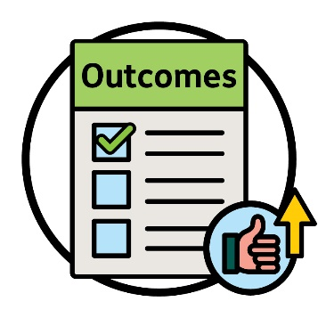 | We listened to this advisory group’s advice on how to make outcomes better for CALD participants.  Outcomes are the ways our work changes people’s lives.

What are our goals for the Strategy?
Themes are important ideas that come up in different parts of our work and lives.
The Strategy has 6 themes.
We explain each theme on the following pages.
Each of the themes include our goals to better support CALD participants.
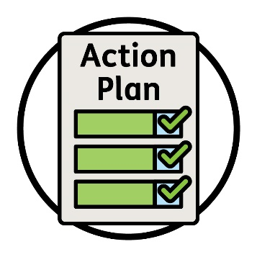 | We have a plan for what we need to do to reach our goals.  We call it our Action Plan.  We explain this more on page 29.

1. Focusing on CALD participants when we work
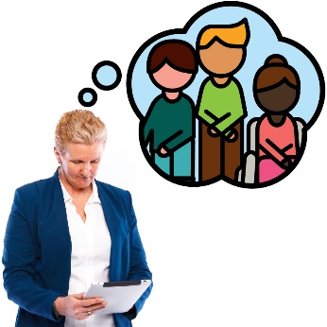 | We need to focus on what each CALD participant needs when we look at how:  - participants use the NDIS  - we share information  - we do our work.

Our goals
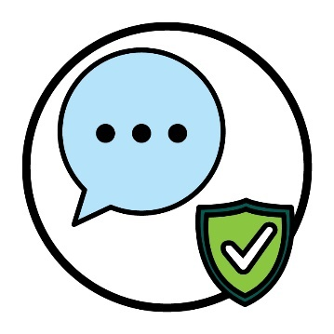 | We want to work with others to agree on words we can use that are safe for all cultures.
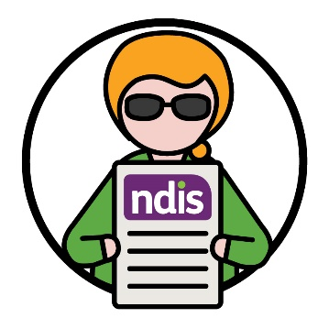 | And we want to make sure more CALD people with disability can take part in the NDIS.

 | This includes making sure:
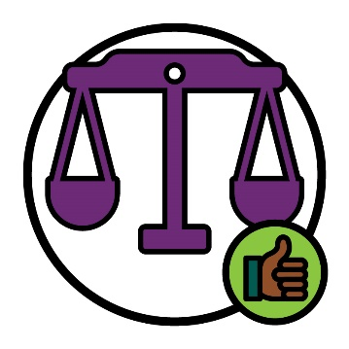 | - the NDIS is fair for CALD participants
 | - more CALD participants know how to use their NDIS plans.
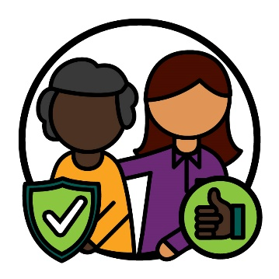 | When we communicate with CALD communities, we want to make sure it:  - is safe for all cultures  - works well  - supports CALD people to trust the NDIS.
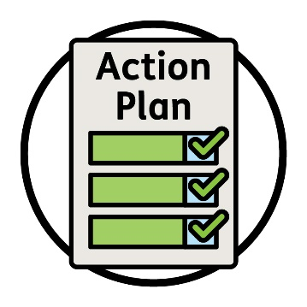 | You can read about our actions on page 8 in our Action Plan.  You can find our Action Plan on our website.  www.ndis.gov.au/CALD

2. Making sure our staff have the right skills
Our staff and partners should understand:
- how to work with CALD participants, their families and carers
- what support they need.
They should also know how to deliver services that are:
- inclusive
- safe for all cultures.
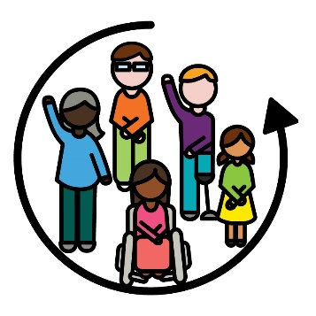 | When something is inclusive, everyone:  - can take part  - feels like they belong.

Our goals
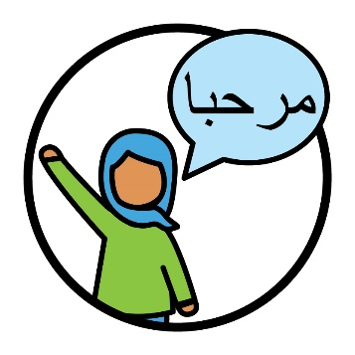 | We want our staff and partners to understand what CALD participants need for their:  - culture  - language.
 | And how their supports need to work well with their culture and language.
 | We also want our staff and partners to work in a way that is safe for:
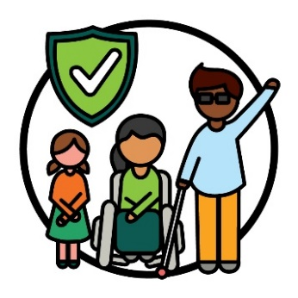 | - every culture
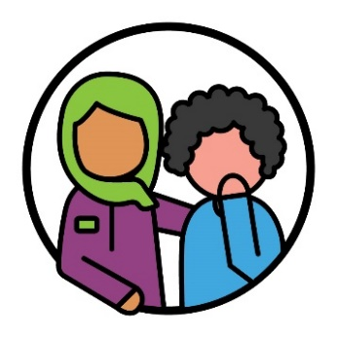 | - people who have experienced trauma.
Trauma is the way you feel about something bad that happened to you.
For example, you might feel scared or stressed.
Trauma can affect people in different ways.
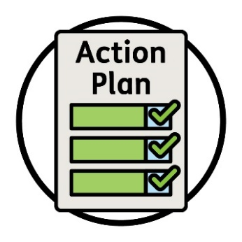 | You can read about our actions on page 16 in our Action Plan.  You can find our Action Plan on our website.  www.ndis.gov.au/CALD

3. How we share information
When we share information, it should be easy to understand for:
- CALD communities
- CALD participants, their families and carers.
The information should also be in different:
- languages
- formats – like videos.

Our goals
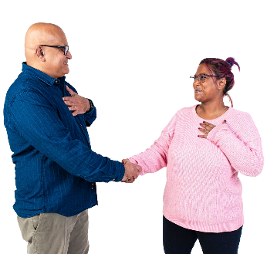 | We want to find better ways to share information with CALD communities and participants.
 | We want more CALD participants to know about the interpreter services they can use.
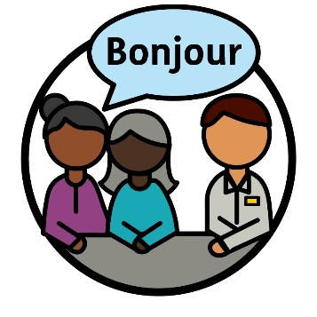 | An interpreter is someone who:  - uses your language  - helps you communicate with others  - helps you understand what someone is saying.
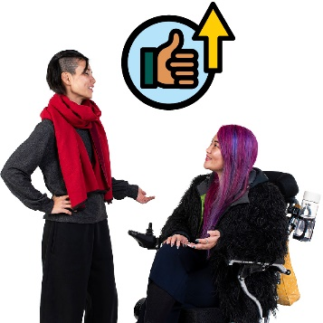 | We also want to improve the experiences CALD participants have with interpreter services.
You can read about our actions on page 23 in our Action Plan.
You can find our Action Plan on our website.
www.ndis.gov.au/CALD

4. Choice and control
 | There should be more supports and services that meet the needs of CALD participants.
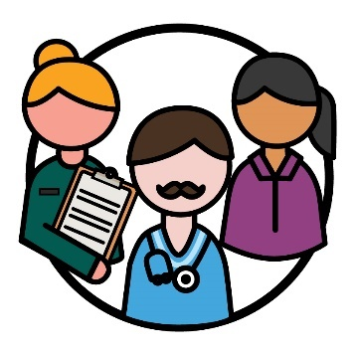 | CALD participants should get support to find and use providers that suit their needs.  Providers support participants by delivering a service.

Our goals
 | We want to make sure we share information with CALD communities about how to:
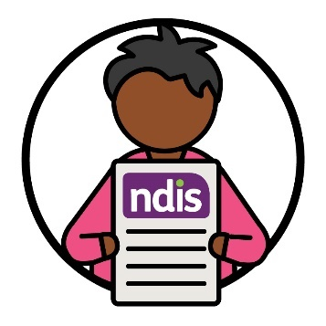 | - take part in the NDIS
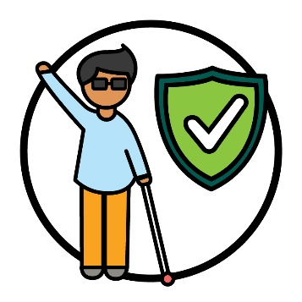 | - find and use services that are safe for their culture.
 | We also want more providers to offer good services that:
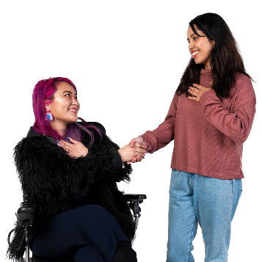 | - respect all cultures
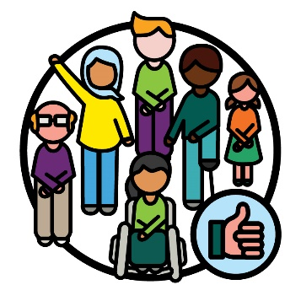 | - work well for CALD participants
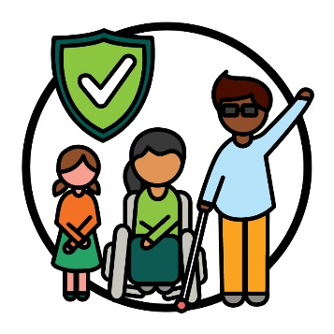 | - are safe for all cultures.
You can read about our actions on page 31 in our Action Plan.
You can find our Action Plan on our website.
www.ndis.gov.au/CALD

5. Data about CALD participants
When we talk about data, we mean:
- facts
- information
- records.
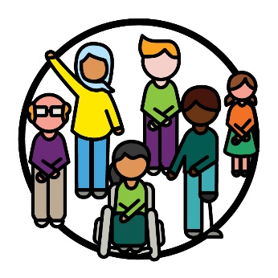 | We need better data to understand:  - CALD participants  - what support they need.
 | We also need more data to understand:
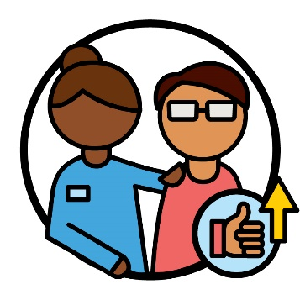 | - how we can improve services
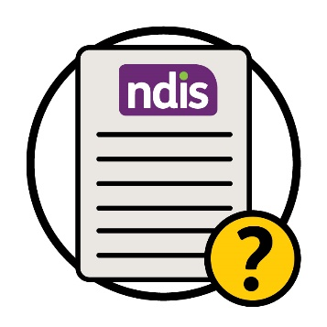 | - how well the NDIS works.

Our goals
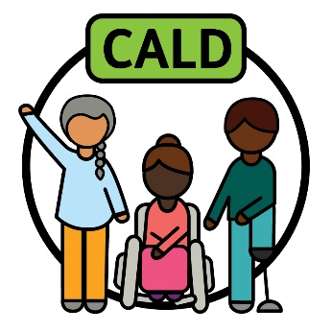 | We want to explain ‘CALD’ in a way that supports what CALD people need.
 | It is important we collect and use good data, so we can:
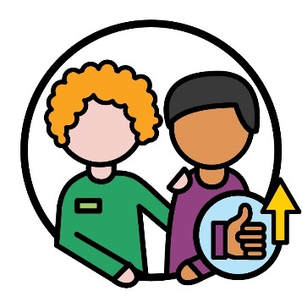 | - deliver better services for CALD participants
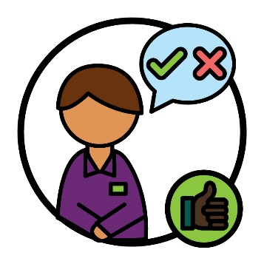 | - make good decisions.
You can read about our actions on page 37 in our Action Plan.
You can find our Action Plan on our website.
www.ndis.gov.au/CALD

6. How we connect with the community
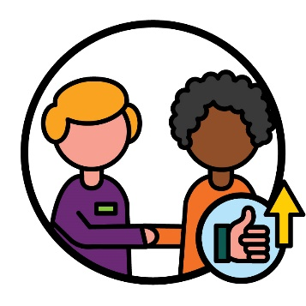 | We need to find better ways to connect with communities who we have not reached well in the past.
 | This includes:
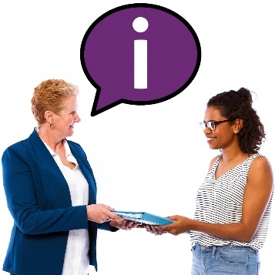 | - sharing information with these communities
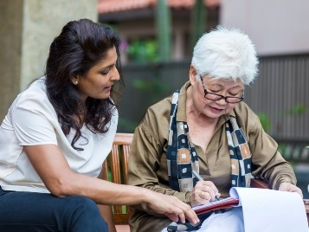 | - making sure services meet the needs of the communities.

Our goals
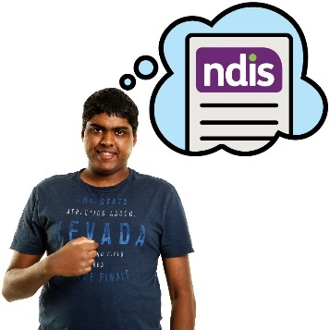 | We want to improve how CALD people with disability understand the NDIS.

 | This includes sharing information about:
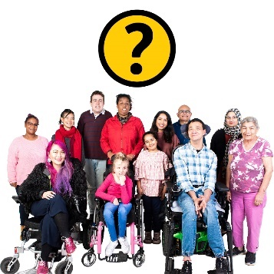 | - who can take part in the NDIS
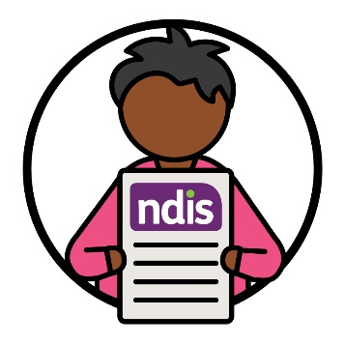 | - how to use the NDIS.
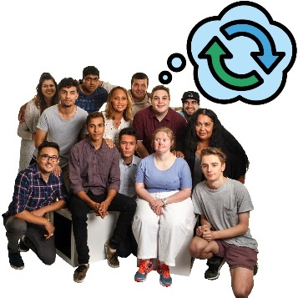 | We also want to share information that helps change community attitudes about disability.
Attitudes are what you:
- think
- feel
- believe.

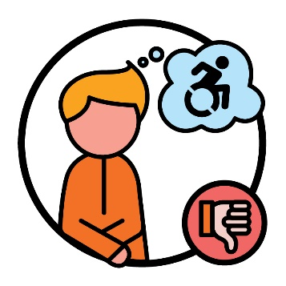 | For example, some people think badly about disability.  And this can stop CALD people with disability from using the NDIS.
You can read about our actions on page 40 in our Action Plan.
You can find our Action Plan on our website.
www.ndis.gov.au/CALD

What will we do next?
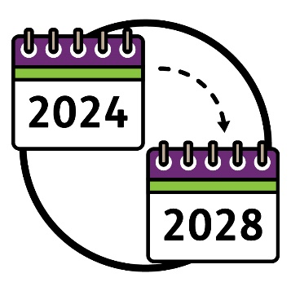 | The Strategy will:  - start in 2024  - finish in 2028.
 | We made an Action Plan that explains:
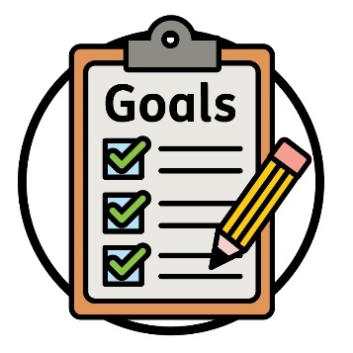 | - what we need to do to reach our goals in the Strategy
 | - how we will work on each action
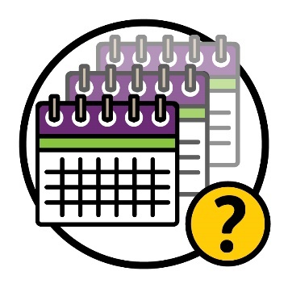 | - how long we will work on each action
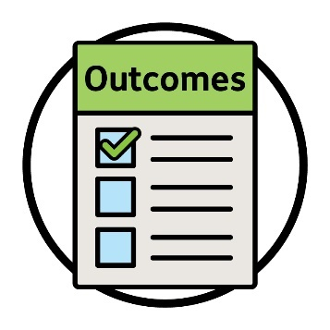 | - the outcomes of each action.
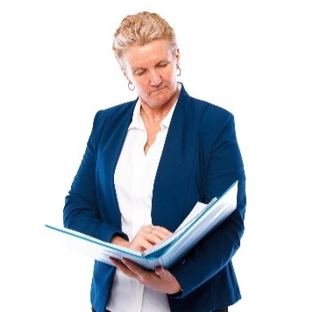 | We will use the Action Plan to check how well the Strategy is going.
You can find the Action Plan on our website.
www.ndis.gov.au/CALD
And you can find the Easy Read version of the Action Plan on our website.
www.ndis.gov.au/CALD
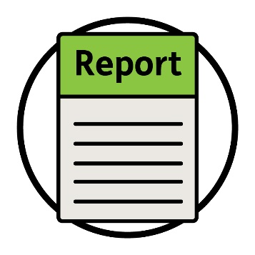 | In late 2024, we will share our report on the work we have done so far to support the Strategy.
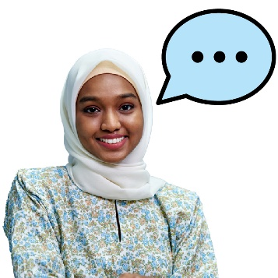 | And we will ask others to share what they think about the Strategy.

 | This includes:
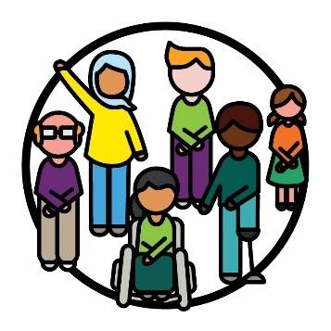 | - CALD people with disability
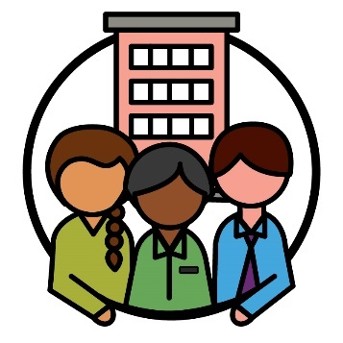 | - community organisations
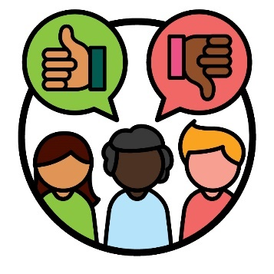 | - advisory groups outside of the NDIA.
This will help us to understand what parts of the Strategy:
- are working well
- need to improve.

More information
For more information about this strategy, please contact us.
You can visit our website.
www.ndis.gov.au
You can call us.
1800 800 110
You can follow us on Facebook.
www.facebook.com/NDISAus
You can follow us on Twitter.
@NDIS
Twitter is also called X.

Support to talk to us
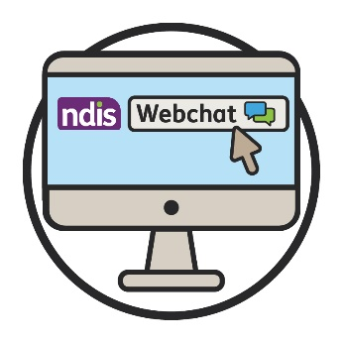 | You can talk to us online using our webchat feature at the top of our website.  www.ndis.gov.au
 | If you speak a language other than English, you can call:
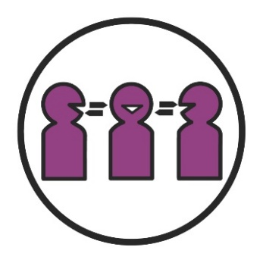 | Translating and Interpreting Service (TIS)  131 450
 | If you have a speech or hearing impairment, you can call:
TTY
1800 555 677
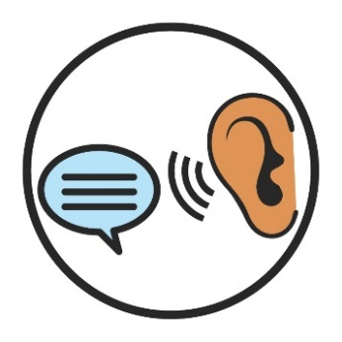 | Speak and Listen  1800 555 727
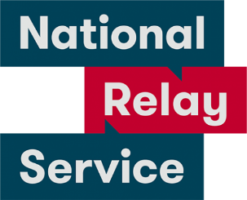 | National Relay Service  133 677  www.accesshub.gov.au/about-the-nrs

Word list
This list explains what the bold words in this document mean.

Attitudes
Attitudes are what you:
- think
- feel
- believe.

Advisory group
An advisory group is a group of people who work with us to share what:
- is working well
- needs to work better.

Barrier
A barrier is something that stops you from doing something you:
- need to do
- want to do.
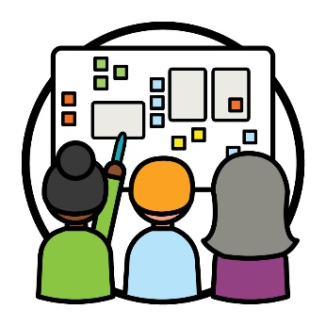 | Co-design  Co-design is when people work together to:  - make something new  - improve how something works.

Culturally and linguistically diverse (CALD)
CALD people are people who:
- come from different backgrounds
- speak languages other than English.

Culture
Your culture is:
- your way of life
- what is important to you.

Data
When we talk about data, we mean:
- facts
- information
- records.

Identify
When you identify as something, you are saying that you belong to a certain group of people.
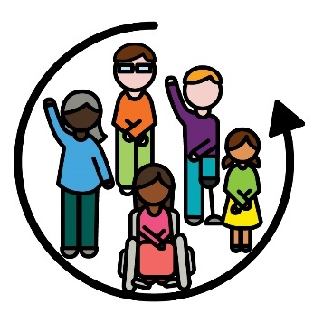 | Inclusive  When something is inclusive, everyone:  - can take part  - feels like they belong.

Interpreter
An interpreter is someone who:
- uses your language
- helps you communicate with others
- helps you understand what someone is saying.

NDIS partners
NDIS partners are people who help others find and use services.

Outcomes
Outcomes are the ways our work changes people’s lives.

Participants
Participants are people with disability who take part in the NDIS.
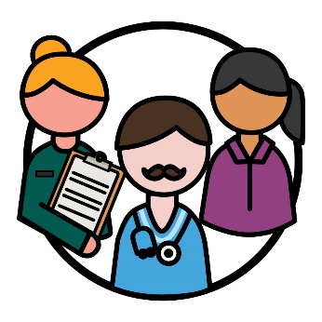 | Providers  Providers support participants by delivering a service.

Rights
Rights are rules about how people must treat you:
- fairly
- equally.

Themes
Themes are important ideas that come up in different parts of our work and lives.

Trauma
Trauma is the way you feel about something bad that happened to you.
For example, you might feel scared or stressed.
Trauma can affect people in different ways.

The Information Access Group created this Easy Read document using stock photography and custom images. The images may not be reused without permission. For any enquiries about the images, please visit www.informationaccessgroup.com. Quote job number 5212-A.

