Building the National Disability Insurance Scheme

PROGRESS REPORT: YEAR ONE

JULY 2014

Foreword from Bruce Bonyhady
“The NDIS is a truly pioneering piece of economic and social reform which will finally provide fairness, security and opportunity to over 400,000 Australians and their families who for too long have missed out on the Australian fair go.”
The National Disability Insurance Scheme is an idea whose time has come. These are the words of Prime Minister Tony Abbott and the sentiments of Australians right across the country. The NDIS is a truly pioneering piece of economic and social reform which will finally provide fairness, security and opportunity to over 400,000 Australians and their families who for too long have missed out on the Australian fair go. The Productivity Commission concluded that Australia simply cannot afford any further policy inaction on this front. It found that the NDIS is the most effective way to make government spending on disability sustainable and will add one per cent to our national income when it’s fully operational. The Productivity Commission recommended that a new national organisation be set up to establish and operate the NDIS. The purpose of this organisation – the National Disability Insurance Agency - is to combine the principles of insurance and market competition with the best expertise from the disability sector to build a world leading Scheme.
The scale of change required to implement the NDIS should not be underestimated. Many commentators are calling the NDIS the most significant social reform since Medicare was introduced in 1975. It is also important to acknowledge that the NDIS has been set up as a genuinely national scheme, with a national governance framework. The Board is charged with reporting directly to the Council of Australian Governments (COAG) Disability Reform Council, ensuring that all stakeholder governments are contributing to the development of the Scheme. It is unusual for a reform of the scale of the NDIS to be made the responsibility of a start-up organisation. Like all new organisations, the establishment of the National Disability Insurance Agency, governed by a Board and led by a CEO, presents a number of challenges, but also many opportunities.
We intend to publish a Progress Report each year as part of our commitment to bringing the Australian community with us on this extraordinary journey. It will also ensure we’re delivering on our Strategic Plan, in particular by benchmarking our progress against what we have set out to achieve. Our Progress Reports will complement our Annual Reports, the first of which will be released later this year. Importantly, these Progress Reports will outline what we have heard by listening carefully to all of our stakeholders, what we have learned from our experiences so far, and what we are doing as a result. It is timely that we’re releasing this Progress Report as we celebrate the one year anniversary of the Scheme. We have achieved an enormous amount in this short time, and on behalf of the Board I thank everyone involved in delivering the NDIS for their hard work, professionalism and commitment to building a world-class Scheme.
Of course there is still an enormous amount of hard work, listening, learning and building ahead of us as we move from the trial phase to the full-roll out of the Scheme. We hope this Progress Report helps you to understand how far we’ve come and how far we’ve got to go, so you can share our energy and enthusiasm for this remarkable journey.
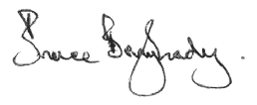

Introduction from David Bowen
”The National Disability Insurance Agency is committed to a “learn, build, learn, build” approach – an approach which underpins our ongoing growth and development as an organisation.”
The National Disability Insurance Agency is committed to a “learn, build, learn, build” approach – an approach which underpins our ongoing growth and development as an organisation.
In keeping with this approach, over the past 12 months the Agency has reflected on what we have heard from all our stakeholders and then implemented improvements to strengthen our operations.
In addition, early in 2014 the Board approved a formal process for continuous improvement and learning within the Agency. This is essential as part of our development as a learning organisation and is now embedded across the Agency. The continuous learning and improvement process identifies potential changes, prioritises them based on expected benefits and costs and seeks external advice from experts where it is needed. It also engages with stakeholders and integrates the lessons learned back into the development of the Agency, our insurance model and our governance arrangements.
Over the last year, there have been a number of significant reviews of the Agency to ensure we are well placed to deliver a sustainable and effective NDIS. The reviews considered issues like our internal capacity, capabilities and business processes, and considered risks and transition planning towards becoming a truly national Scheme.
We also appreciate the work of the Joint Standing Committee on the NDIS to gather feedback on how the scheme is working on the ground for participants, their families and carers, along with providers and other stakeholders.
All this will ensure that the Agency remains well placed to actively manage the Scheme’s performance and costs, and to build the essential infrastructure, linkages and processes to ensure the Scheme’s sustainability. They also highlight how important it is that we continue to create an environment of continuous learning and improvement.
As well as the formal reviews, the Agency has been working to collect robust qualitative and quantitative data on how the Scheme is performing. Our Scheme Actuary has been appointed and has been working with the Agency to monitor and ensure the Scheme’s financial sustainability. We have also put in place a number of internal improvements to harness the experiences of our most important stakeholders – people with disability, their families and carers.
A key challenge for the Agency will be to carefully prioritise the many operational and design issues that we have identified and manage these effectively as we roll out the full Scheme in the years ahead.
I’m very proud of what has been achieved so far through our “learn, build” approach and very confident that this approach will serve the Agency well as we navigate the challenges which will no doubt lie ahead.

NDIA Strategic Overview
The Agency’s vision, mission and goals support the positive transformation of Australia’s disability sector and are underpinned by our dedicated culture and the effective use of technology.
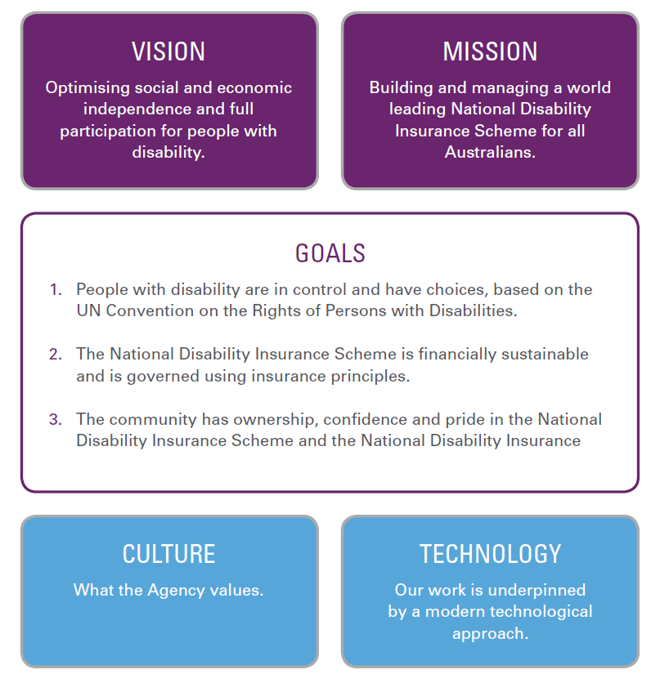

Culture
To deliver a world class NDIS it is vital that we build a culture at the NDIA which has at its core the values of respect, listening and putting people with disabilities, their families and carers at the centre of the Scheme.
What we do in delivering the NDIS is crucial to the Scheme’s success, but how we do it is just as important. That’s why the NDIA’s Strategic Plan sets out clearly the values that we have committed to and why we’ve been working hard to live up to those values.
Giving participants and their families assurance that they will receive high quality supports has been central to our efforts in the NDIS trial sites so far. Our work has been especially intent on respecting the diversity among Scheme participants as we go about building this sense of assurance.
Empowering participants, their families and carers to make genuine choices about the supports they receive, and exercising genuine control over their own lives is a core value of the NDIA, and has underpinned the work we have done. As mentioned later in this Progress Report, satisfaction ratings among participants has been very high, reflecting our commitment to effective empowerment.
Everyone in both the disability community and the wider Australian community must share responsibility for providing supports to people with disability which build up their potential, independence and inclusion in the community. This shared responsibility has shaped our thinking within the NDIA and has informed our decision-making at all points of the trial phase.
Learning from everything we do, and from the contributions and experiences of people in the disability community is critical to building an NDIA which is constantly improving its performance and its service. The success of the NDIA in the trial phase attests to our willingness to learn as we go and will be critical to our effectiveness as we move to roll out the full Scheme.
Acting with integrity at all times is at the core of our values as we build an organisation that maintains and builds the trust of the Australian community. A key part is employing a very large proportion of our workforce with lived experience of disability.

Technology
Technology is a central platform to the efficient and effective delivery of the NDIS. The NDIS was born by the smart use of technology with the Every Australian Counts campaign harnessing people from all around Australia to support and build the NDIS from the ground up.
We are committed to using technology to connect people in new and dynamic ways, to develop innovative solutions for participants to improve their lives, to share knowledge with one another about what works and to help us find more efficient ways of doing our business.
The NDIA’s long term ICT infrastructure still needs to be built. It needs to be fit for purpose and deliver for people with disability. Significant development and investment is needed over the next few years to build systems capable of supporting the actuarial models that will drive the NDIS.
The systems will also monitor the scheme as a whole, on a day to day basis, comparing actual experience with projections and highlighting areas that need to be improved.
As the PC Report said, one of the key functions of the NDIA is improved data collection and analysis. We are starting from a very low base. Developing a robust longitudinal data set is the actuarial heart of the Scheme. It will be an important driver of more responsive and effective interactions that will be the key to the Scheme’s future sustainability. Excellent information systems are what underpin high performing public and private insurance models.
The Agency must have a highly flexible technology platform which meets our needs and the needs of participants, carers, families and service providers.
We still have a lot of work to do.
Service providers have found the provider portal to be cumbersome and not always fit for purpose. This needs to be streamlined as soon as possible. Work is underway to make this happen.
Participants do not have access to their own data on-line. Increasingly, people want to be able to use apps on their phones, as well is computers to interact with the Agency. Work is also underway to make this happen.
Our participants are increasingly using social media to interact with one another and with us. We need to communicate with them in the ways that they want to communicate with us, as part of our commitment to choice and control. People with disability are early adopters of technology and we need to be at the cutting edge to deliver for them – our webinars are an example of where we are making progress on this front.

Customer Satisfaction
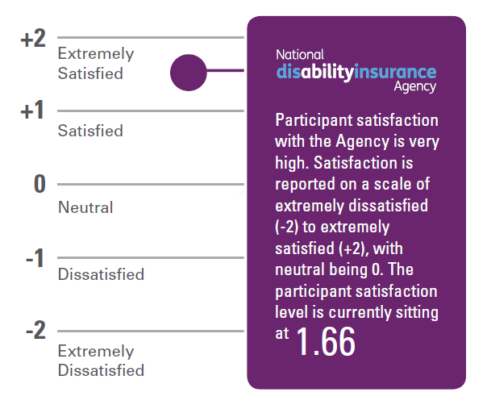

Strategic Progress Report – Year One
This Progress Report provides our first yearly update on building a world leading National Disability Insurance Scheme.
The Progress Report benchmarks how we are tracking against the goals and outcomes identified in the National Disability Insurance Agency’s Strategic Plan 2013-2016.
The Strategic Plan sets out the Agency’s values, goals and what we expect to achieve over the trial period of the Scheme – from 2013 to 2016. There have been remarkable achievements in the last 12 months:
- 6,434 participants have been found eligible for the Scheme, with 5,414 having an approved plan by the end of March 2014.
- The majority of participants are very satisfied, with a satisfaction rating of 1.66 on a scale of -2 (extremely unsatisfied) to +2 (extremely satisfied).
- We have prepared to expand the NDIS trial sites across the whole of ACT, Barkly in the NT and Perth Hills, in WA. These sites join four existing one-yearold sites in the Hunter (NSW), Barwon (VIC), South Australia (for children under six years of age) and in Tasmania (for young people, aged 15 to 24 years). In addition, we are expanding our footprint by opening a new office in Colac in the Barwon region.
- We have relocated our Head Office, with the Prime Minister, the Hon Tony Abbott, MP, opening the Head Office of the National Disability Insurance Agency in Geelong in April 2014.
- We have recruited over 450 staff – of which almost 11 per cent identify as having a disability. Over 50 per cent of staff in the Agency have identified as having lived experience of disability – which refers to close or personal experience with disability.
- We are continuing to implement major operational improvements to manage Scheme costs. At present costs remain comfortably within the allocated budget - around $107 million of support will flow to participants in 2013/14. This is well within the funding envelope of $152 million for 2013/14.
Of course, we still have a significant amount of work to do. There are a number of areas where we need to improve and we are working hard to prioritise and implement these improvements as we go about pursuing our strategic goals, as set out in this Progress Report. 11

Shahni’s Story...
Maitland mother-of-one Shahni Moore didn’t have the confidence to work after acquiring a brain injury at the age of 15.
“I was coming down the hill on my friend’s bicycle and found the brakes didn’t work,” Ms Moore said.
“I crashed into the gutter, catapulted over the handlebars, went head-first into a power pole and stopped breathing instantly. I received mouth-to-mouth resuscitation until the ambulance got there. I was wearing a helmet — they said if I had not, I wouldn’t have been able to be revived.”
With the support of the National Disability Insurance Scheme, Shahni, now 31, has built up her self-confidence and work skills and recently graduated from a six-month TAFE certificate in business administration, focusing on legal studies. She is now a qualified legal secretary.
“I didn’t just skim through the course – I really passed it with flying colours. I am proud of myself that I did it, and can do it, and nothing can stop me,” she said.
She is looking forward to every aspect of employment — meeting new people, using her new business skills and earning a wage.
“I have never worked before so I’m not sure what to expect. It’s a bit daunting but mostly extremely exciting,” she said.
When Ms Moore approached the NDIA, she was keen to pursue education but was unsure what she wanted to do.
“The NDIA staff were amazing and so encouraging,” she said.
“They asked what I wanted to do with my life — I said I wanted to work but wasn’t smart enough.”
The NDIA accompanied Ms Moore to see a TAFE career counsellor and, after a long meeting, she decided on the legal course. She was also referred to TAFE’s disability unit to ensure she had the supports needed to succeed in her study.
“I can now do the things that have been previously financially out of my reach because I’m disabled. The NDIS is giving me opportunities I simply wouldn’t have been able to take advantage of.”
Her individualised NDIS plan funds what she needs to do the course, physiotherapy and an assessment by an occupational therapist.
Shahni said the NDIS is essential, not only for its economic benefits but also because the insurance principle recognises that anybody’s life can be turned upside down by a disability at any time, regardless of how much care you take in life.
“I can now do the things that have been previously financially out of my reach because I’m disabled.”

Strategic Goal
People with disability are in control and have choices, based on the UN Convention on the Rights of Persons with Disabilities.
OUTCOME 1: Build the capacity of people with disability to exercise choice and control in the pursuit of their goals.
OUTCOME 2: Promote the independence and social and economic participation of all people with disability and especially those who are vulnerable or marginalised.
OUTCOME 3: Recognise, nurture and uphold informal support and care arrangements, especially for children and vulnerable adults.

What have we learned?
We know that people with disability must be at the centre of the NDIS. The Agency has been working hard to ensure that this is the central principle of the Scheme’s design and continues to be our core focus through the implementation phase.
We have heard about lots of positive outcomes for people in trial sites, particularly around improved choice and control. We are seeing more participants involved in managing their own plans, making informed choices and working with planners and family to identify their goals and aspirations – currently 2 per cent of people solely self-manage their plans and 26 per cent partly self-manage.
We are seeing instances where the Scheme is enabling people to be more independent and participate in their communities – people like Shahni.
We know that carers and their families are central to the success of the Scheme and so we want to work with them to continue to build safe and inclusive communities.
There are also a lot of areas where we need to do more work. We have listened to the experiences of our participants and this is what we’ve heard:
- We need to ensure that we are providing the right level of support for participants to ensure they have maximum choice and control, especially for participants who are unlikely to reach out for support.
- We need to communicate very clearly and ensure access to simple, accessible and consistent information about NDIA processes and policies.
- We need to ensure that support arrangements are sustainable and forward-looking.
- We need to enable people to share experiences and learn from one another.
- We need to improve our processes for developing and implementing plans for participants. For example, some people feel that planning is rushed. Others are concerned that it takes too long. Some people feel that their plans are inconsistent with the plans of other people in similar circumstances. Other are worried that plans aren’t individualised enough. We need to keep examining what is working best so that we make sure we are getting the balance right.
- People also need to more actively own decisions and understand how they are made, particularly around funded supports and be aware of the flexibility they can exercise around the use of their funds.
- We have heard that people need more explanation around the concept of “no disadvantage”. This is the principle agreed to by governments that says nobody should be disadvantaged by joining the NDIS. It is important that we are clear that no disadvantage relates to the overall outcome for a participant – rather than a direct comparison in the quantum of supports or level of funding they receive under the NDIS relative to previous arrangements.
- Some people find our processes hard to use – they say we need to improve and simplify the self-management process and overhaul our participant portal.
- People have told us that in some instances we don’t get back to them quickly enough when they raise concerns.
These are some of the key themes we’ve heard over the last year which relate to issues around choice and control. Some of these concerns have already been addressed, some of them are being addressed and the others will be priorities for us over the next 6 to 12 months.

What are we doing?
The Agency has implemented a number of changes to respond to the lessons we have learned so far. We know that we have to ensure that people with disability continue to be at the centre of the Scheme. We know that choice and control are paramount. We know that it’s vital to enable people with disability to participate in the community and build up their social and economic independence.
To help make this happen, here is what we are doing:
- From 1 July 2014 the Agency has replaced the current catalogue of supports with plans that put supports into three principal categories:
- capital items, such as wheelchairs
- investment items, which will include early intervention, therapy, behavioural supports and sustaining family care arrangements; and
- consumption, which will include personal care, recreation and access to the community.
Plans based on capital, investment and consumption will lead to very different conversations between participants and providers, because participants will be seeking maximum value from their total package. This will not only deliver choice and control at all times, but drives effectiveness, efficiency and innovation over time.
- The Agency has undertaken a major review of processes and operational guidelines. As a result:
  - We are giving more guidance to planners to help them determine what is reasonable support for families to provide and to understand what isn’t reasonable.
  - We have provided more direction to ensure planners consider current and informal supports, as well as available community-based supports before considering funded supports.
  - We are continually learning and revising guidance for planners on the role of the NDIS and responsibilities of mainstream services, such as health and education.
  - We have engaged experts to work with us on refining some specific guidelines, starting with autism.
- We are implementing internal improvements to the planning process. For example, we have developed an organisational competency framework to ensure that planners and staff clearly understand their roles and responsibilities.
- We are finalising significant changes to the existing Quality Assurance Framework. This includes new training modules and improving supporting documentation for planners with a focus on consistency and quality.
- We are refining our Service Charter to make sure we respond to people in a timely and appropriate way. This will include clear service standards and expectations. Feedback from participants and families is critical in giving us information about what we are doing well and where we need to improve. Our current monthly survey is confirming high levels of satisfaction but we need to hear more from others about the quality of their contact with us. To this end, we are implementing a more robust way of gathering feedback from more of our participants about their experiences with us.
- Across all trial sites, we are helping participants with pre-planning sessions to make sure they are prepared and able to make the most of their plans. This includes giving people practical advice on what to expect in their planning session so they can think about what they need in advance, and support to implement their plans where this is needed.
- Our new trial sites are implementing a safeguarding assessment to ensure we have the right supports in place for our most vulnerable participants from the very beginning of their contact with us. We will monitor this process closely, particularly as we begin to roll out across remote Australia.
- We have agreed that a key performance indicator for the Agency will be assessing the extent to which participants achieve their own goals. We know we need to make sure people are achieving their aspirations to participate in the community and build up their independence. Implementing these assessments will be a priority as we roll out the full Scheme.
- We are making progress to ensure the concept of reasonable and necessary support is well understood. The Independent Advisory Council on the NDIS is working with us on this important issue.
Considering the number of participants entering the scheme and the distribution of support packaged committed to these participants, we are on track to be within the total projected cost of the NDIS in 2019/20 (the first year of full scheme)
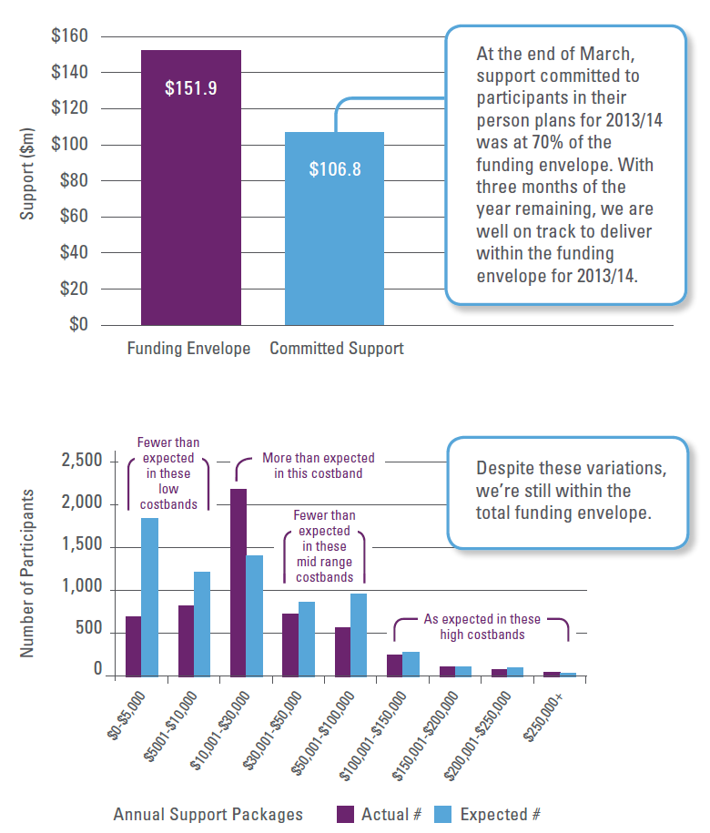

Strategic Goal
The National Disability Insurance Scheme (NDIS) is financially sustainable and governed using insurance principles.
OUTCOME 1: Base governance and operations on strong insurance principles using comprehensive and reliable data
OUTCOME 2: Invest, including early intervention in a lifetime approach
OUTCOME 3: Drive support services and workforce to be high quality, effective, efficient and responsive to the diversity of NDIS participants, so as to create a new dynamic and noninflationary market for disability supports

What have we learned?
The Agency is committed to managing the NDIS on sound insurance principles. Our insurance framework also needs to ensure Scheme sustainability, as well as drive efficiency and effectiveness. Our insurance approach is about ensuring lifetime support - once a participant is in the Scheme, the Scheme is intended to meet their lifetime costs.
We understand the need to base our decision-making on rigorous actuarial advice and the best available evidence. We also know that all our work needs to be underpinned by robust data and that this needs to be both quantitative and qualitative.
We know that developing the disability support services market is a key challenge. We understand that the performance of the future disability support services market will have a major effect on the lives of participants and also on Scheme costs. The transition to a competitive market means that the disability support sector will face major structural changes. These include increased funding and demand, changes in the design of supports, and the challenge of responding to consumer choice and new governance arrangements. We are committed to enabling a robust and dynamic market for disability supports. We have listened carefully to the concerns of many in the sector about how this transition will work and what it means for them.
We also understand the economic imperative of early intervention if we want to reduce the long term impact and cost of disability. We also know that early intervention needs to be aligned with effective way for participants and providers to interact with other mainstream service systems such as education, health and transport services.
We have heard that access to options for independent living including housing continues to be a concern for people with disability right across the country. This is a significant issue which needs substantial new work to develop innovative solutions which tackle both the demand and supply sides of the problem.
We need to develop a better understanding of how technology can make a difference to how people with disability interact with supports. For example, we need to consider the benefits of technology to help self-management of supports and to assist providers to operate efficiently and market their supports. We also need to consider the potential of technological solutions to give individuals greater independence through aids and other equipment. These are some of the key themes we’ve heard over the last year relating to financial sustainability and using insurance principles to govern the Scheme. Some of them have already been addressed, some of them are being addressed and the others will be priorities for us over the next 6 to 12 months.

What are we doing?
We have appointed a highly experienced Scheme Actuary and her team is up and running effectively. They are working to ensure the financial sustainability of the Scheme and make sure that our work is underpinned by robust data. The Actuary has been producing quarterly monitoring reports which provide important public updates on expenditure and revenue, risk, scheme experience from participants’ point of view, and cost projections.
Progress to date is encouraging.
We are on budget:
- At the end of March, support committed to participants in their person plans for 2013/14 was at 70% of the funding envelope. With three months of year remaining, we are well on track to deliver within the funding envelope for 2013/14.
We are on track to be sustainable:
- Considering the number of participants entering the scheme and the distribution of support packages committed to these participants, we are on track to be within the total projected cost of the NDIS in 2019/20 (the first year of full scheme).
The Agency is committed to growing and building a disability support services market. We have developed a Market Action Plan which identifies and prioritises areas of work to grow the market and help it make the transition to a competitive basis. We also recognise that it will take time for a competitive market to emerge, and that this market will be shaped by the size and variety of supports that will be available. It will take time, but we have started the process of developing a robust market that increases the mix of support options and innovative approaches. This is vital if we want to provide real choice to Scheme participants.
A good example of the Agency’s commitment to market principles is the recent announcement we made about an efficient price for the self-care and community participation services which make up the bulk of supports.
An efficient price is absolutely critical to building a competitive market in disability support services. We’ve set the efficient price at a level that will enable providers to deliver the high quality services that consumers need and want. At the same time it will ensure a NDIS which is efficient, sustainable and good value for money for Australian taxpayers in a difficult fiscal environment. We recognise that much of the market is unable to meet demand at present so we have implemented a transition price while we work with the industry to help restructure business models.
We are committed to being fiscally sustainable and responsible. We are working towards the objective that at least 93 per cent of the NDIA’s expenditure will be directly related to support for individuals. In other words, 93 per cent of the Scheme’s spending will be controlled by participants themselves. The remaining 7 per cent refers to the Agency’s operating budget - 7 per cent administration costs represents best practice.
The Agency is also developing a discussion paper on a housing strategy for people with disability for the Agency in consultation with state housing officials and the Independent Advisory Council.
We are using trial site experience to work collaboratively with the mainstream sectors to improve outcomes and simplify processes for participants – an early example of this is the work that is happening in Tasmania with young people who are leaving school.
We are committed to overhauling and improving our IT systems. We have put in place a plan to do just this, and work is well underway to ensure our IT systems are delivering for all our users. This will include a total overhaul of our website and significant improvements to the provider portal.
We understand the need for clear, accessible and dynamic online systems. We have made some progress. For example, our online webinars have attracted over 100,000 views in total. We will shortly introduce regular live chats on Facebook which will mean that senior staff in the Agency and members of the public can talk in real time about issues and ideas.
As a learning organisation we are committed to building a strong evidence base to inform our work.
This evidence base will:
- draw on expert advice
- be developed over time, by collecting data on what supports lead to good outcomes; and
- assist in establishing a website and other mechanisms to allow participants to share information on what has helped them to achieve good outcomes.

New & Existing Trial Sites
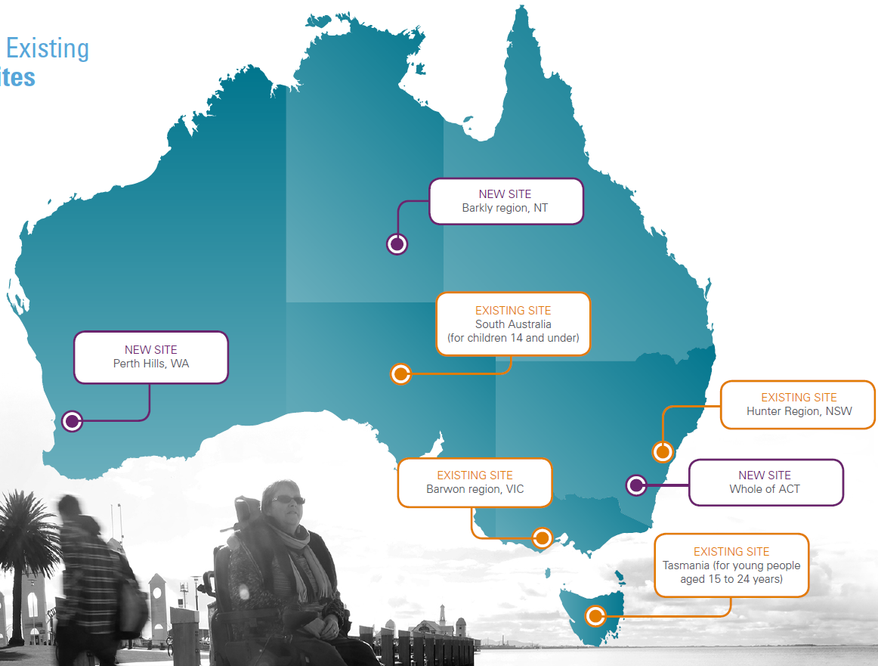

Strategic Goal
The community has ownership, confidence and pride in the National Disability Insurance Scheme and the National Disability Insurance Agency.
OUTCOME 1: Respect and actively seek the views of people with disability, their families, carers and the community
OUTCOME 2: Work constructively with governments
OUTCOME 3: Raise community awareness and knowledge of how to support people with disability

What have we learned?
The Agency needs to continue to share what we are learning and doing with the boarder community to maintain momentum and support for the Scheme. It is essential that the broader Australian community is part of the NDIS if it is to truly succeed in its objectives.
The NDIS needs to work with our stakeholders to create communities which welcome people with disability and ensure they can easily access supports from mainstream services.
We have heard that we need to improve the way we communicate. We know that our communications products, particularly our online presence, need to be made simpler and easier to use. The information resources we provide to participants and families need to be easier to access and understand, and delivered in a wide range of formats and in different languages.
We have heard that we need to improve how we get feedback from our participants, their families, carers and the community about their experiences and concerns.
We need to better share information on what we are doing as an Agency, including how we are performing and what our priorities are.
A strong message from the Review of Agency Capability, published in March 2014 was that too much of the Agency’s effort has been on short-term priorities and more attention needs to be given to planning, building and learning. The Agency has accepted all of the recommendations in the report and a detailed action plan has been developed and is well progressed.
These are some of the key themes we’ve heard over the last year relating to community ownership and confidence in the Scheme. Some of them have already been addressed, some of them are being addressed and the others will be priorities for us over the next 6 to 12 months.

What are we doing?
In the past 12 months we have seen trials take place for cohorts of people in the Hunter region of New South Wales, across the whole of Tasmania, in the Barwon region of Victoria and in parts of South Australia. We have done the work needed to launch in parts of Western Australia, the whole of the Australian Capital Territory and the Barkley region of the Northern Territory. This is the result of remarkable efforts by many people.
Co-design has been essential in the development of the Scheme from the very beginning. Co-design is an approach that brings those affected by the NDIS into the design process to help find the right balance between what is desirable, possible and viable. For co-design to be effective, the Agency must continue to seek the views of people with disability and the broader public in the way we design and implement our systems and processes. We are committed to further refining and developing our co-design strategy now that we are moving into a different phase of the Scheme. This will include a focus on making sure that people with disability, particularly people with intellectual disability, are part of the decision-making process around Agency governance arrangements and systems.
We have a number of processes in train to improve the way we communicate and listen to the views of our stakeholders.
These include:
- Implementing a National Quality Action Plan, including a comprehensive participant feedback strategy. This outlines our processes to gather qualitative and quantitative feedback, analyse this information to identify systemic issues, and then use this information to improve the performance of the Agency.
- The CEO and Deputy CEO have scheduled visits to all trial sites across June, July and August to talk to participants, providers and staff about their views and ideas. This will continue to happen regularly.
- We will continue to improve our IT systems to make sure they deliver for all our users.
- We also intend to undertake a cultural audit later in the year which will seek feedback from participants and stakeholders on whether the Agency is living up to its values. We are committed to using this information to strengthen our operations and adapt our priorities going forward.
We have learned valuable lessons about staffing, continuous improvement and strong communication from the Capability Review and are in the processes of implementing the recommendations. It is likely that we will commission a further review in 12 months’ time to ensure that the Agency’s capabilities grow in line with the needs of the Scheme. We have implemented a number of internal improvements, such as internal training and planning sessions, to build our culture and values as one Agency operating across many locations.
We will continue to focus on strengthening the organisation’s staffing to deliver the Scheme successfully and to ensure that the Agency’s processes are efficient, transparent and can grow as the full Scheme is rolled-out across Australia.

