KPMG interim report:
Review of the optimal approach to transition to the full NDIS

This interim report has been prepared for the Board of the National Disability Insurance Agency
16 July 2014
Disclaimer
Inherent Limitations
This report has been prepared as outlined in the Scope Section. The services provided in connection with this engagement comprise an advisory engagement, which is not subject to assurance or other standards issued by the Australian Auditing and Assurance Standards Board and, consequently no opinions or conclusions intended to convey assurance have been expressed.
No warranty of completeness, accuracy or reliability is given in relation to the statements and representations made by, and the information and documentation provided by, The National Disability Insurance Agency management and personnel / stakeholders consulted as part of the process.
KPMG have indicated within this report the sources of the information provided. We have not sought to independently verify those sources unless otherwise noted within the report.
KPMG is under no obligation in any circumstance to update this report, in either oral or written form, for events occurring after the report has been issued in final form.
The findings in this report have been formed on the above basis.
The definitive version of this report is the PDF version dated 16 July 2014.
Third Party Reliance
This report is solely for the purpose set out in the Scope Section and for The National Disability Insurance Agency s’ information, and is not to be used for any other purpose or distributed to any other party without KPMG’s prior written consent.
This report has been prepared at the request of The National Disability Insurance Agency in accordance with our Proposal (dated
13 February 2014) and the contract for services (signed 21 March 2014). Other than our responsibility to The National Disability Insurance Agency , neither KPMG nor any member or employee of KPMG undertakes responsibility arising in any way from reliance placed by a third party on this report. Any reliance placed is that party’s sole responsibility.

Introduction
The purpose of this interim report is to provide an overview the risks and opportunities associated with the capacity and capability of participants, the Agency, suppliers, and the workforce to transition to the full National Disability Insurance Scheme (NDIS or ‘the Scheme’), with a view to developing an optimal approach.
This interim report is supported by a series of detailed working papers which will ultimately underpin the key findings of the review and the advice to be provided to the Board of the National Disability Insurance Agency (NDIA or ‘the Agency’) through the final report.

Overview
The NDIS represents the most significant social reform package in Australia since the introduction of Medicare in 1975. The Scheme represents the transition to a new market and model for service delivery that will substantially change the nature, focus, and funding of disability support service delivery.
Significant pressures and constraints have made the current system for disability support services across Australia’s States and Territories unsustainable. These constraints resulted in a broad ranging Productivity Commission report in 2011 that demonstrated the need for the NDIS and put forward recommendations related to its design, implementation, and management.
In developing and implementing the new NDIS, there is a need for a framework to underpin its effectiveness and sustainability over time, and this report has identified three key drivers of successful transition (in addition to the timeframe for transition):
- a clear blueprint for the full Scheme, to articulate the vision for the full Scheme and the parameters within which the Scheme is intended to develop and evolve;
- a detailed design framework – underpinned by flexible and tailored market intervention approaches – to support the sustainable development and evolution of a market that is driven by the capacity and capability for Scheme participants to exercise choice and control over their purchasing; and
- clarity over the authorising environment required for the NDIA to effectively deliver the Scheme – an environment defined by accountability, flexibility, and control.

Scope
The scope of the review is to:
- review the progress of the Agency and States and Territories to date in working together to determine the operational blueprint for the full Scheme design;
- identify opportunities to clarify gaps in accountability, decision making, and control structures, including any lack of clarity regarding roles and responsibilities across all organisations involved; and
- consider how any current practices or progress to date might impact the risk of successfully transitioning to the full Scheme under the current transition schedule.
With specific regard to market, sector and workforce capacity and capability, the scope of this review is to:
- identify quantitative and qualitative analysis undertaken to date to inform the NDIA’s understanding of the structure, requirements, and readiness of the disability services sector for the full Scheme;
- review all available analyses to determine their usefulness in assisting the NDIA and its Board to understand the risks and requirements in addressing the gaps and effectively transitioning to the full Scheme; and
- identify additional activities that may be required to better understand the structure, requirements, and readiness of the disability services sector in transitioning to the NDIS under the current transition schedule.
Approach
Overarching approach
The review was undertaken in three major phases.
- Phase 1 involved the development of a clear framework to document evidence and undertake the review.
- Phase 2 involved the development of a comprehensive evidence base to underpin the review findings through the framework developed in Phase 1.
- Phase 3 involves analysis to identify the optimal transition approach to full Scheme which will be included in the final report.
This interim report presents high-level findings from Phase 1 and 2. The outcomes of Phase 3 will be presented in the final report.
As outlined in the Scope section, it is noted that the development of the evidence base and the review of the anlaysis to date has focussed on the implications relative to the current framework and timeframe for the transition to the full Scheme. Further detail on the framework for the approach will be included within the series of detailed working reports to be prepared as part of this review.
1. Clear frameworks for the current market for disability support services and the NDIS were developed and contrasted to identify the key implications – and therefore the determinants of success – for the transition to the full Scheme. These were then used as the basis to compile evidence to underpin the review. The identified determinants of success include:
- Scheme blueprint and the market architecture – the design elements and scaffolding to enable the development of the market and to support its evolution over time;
- capacity and capability to transition – the ability for participants, suppliers, and the NDIA to effectively and sustainably transition to the full Scheme; and
Scheme accountability, flexibility, and control – the structures to support clear decision making and accountability
- A detailed evidence base was compiled within the framework developed in Phase 1 to support the review outcomes and underpin the scenario analysis. This included:
- a thorough review of internal structures (e.g. gaps in accountability, flexibility, control, and the Scheme blueprint) and analysis undertaken to date to inform the transition to the full Scheme under the current transition timeframe;
- identification of interdependencies within the Scheme and the ability for the NDIA to either control or influence these in preparation for the transition to the full Scheme;
- identification of gaps in information, capacity, or capability to identify requirements for the NDIA to ensure the success of the Scheme; and
- classification of risks and opportunities for the NDIA in undertaking the work packages to fulfil these requirements.
Background
Current disability support services system
Currently, most of the funding for disability services is provided by government directly to suppliers, who in turn deliver a prescribed set of services to individuals. Whilst funded service provision across jurisdictional proportions differ, States and Territories provide the majority of funding for disability services. Program delivery fragmentation exists and block funding is a common characteristic.
Figure 1: The current disability support services market
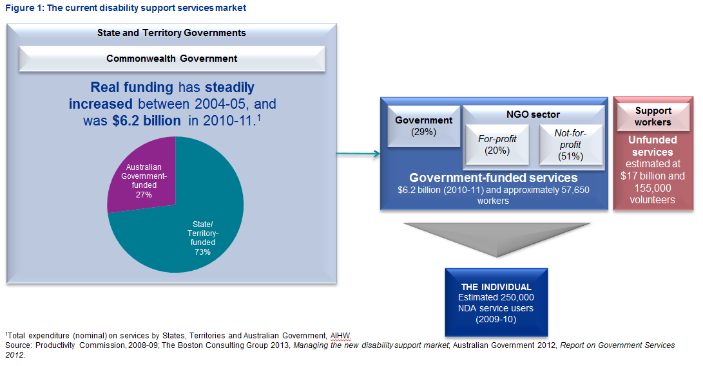
Background
Service delivery under the NDIS
Under the NDIS, the role of the individual will be largely reversed compared to the current approach for disability support service provision, with individuals exercising choice and control over a needs-based funding envelope to purchase supports that will most effectively meet their needs.
Figure 2: Model for service delivery under the NDIS
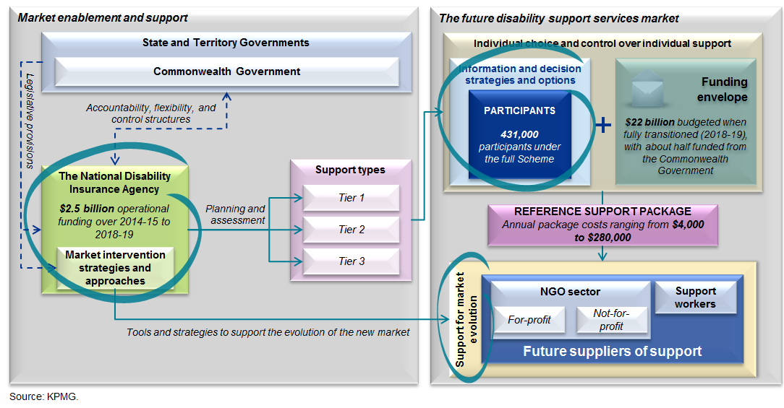
Background
Implications for the transition to the NDIS

Overview
Contrasting the current approach to disability support service delivery with the approach under the NDIS highlights a number of transition implications. To guide the development of the detailed evidence base to underpin the review, these were summarised into a set of three determinants for Scheme success, namely:
- Scheme blueprint and the market architecture – the design elements and scaffolding to enable the development of the market and to support its evolution over time;
- Capacity and capability to transition – the ability for participants, suppliers, and the NDIA to effectively and sustainably transition to the full Scheme; and
- Scheme accountability, flexibility, and control – the structures to support clear decision making and accountability.
The implications of the transition with respect to each determinant of success are summarised in Table 2 below.
Table 2: Implications of the transition to the NDIS
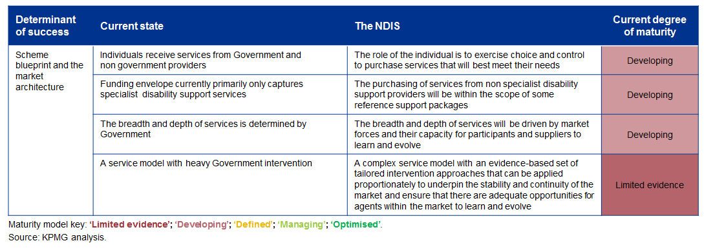
Table 2: Implications of the transition to the NDIS cont’d
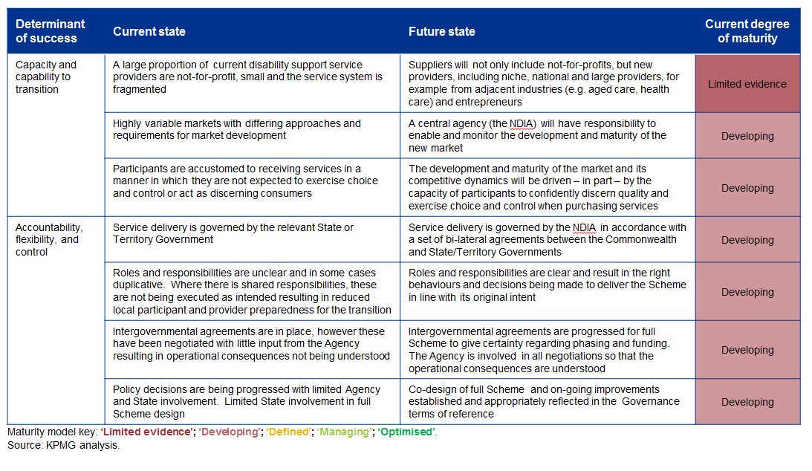
Key findings of the review
Scheme blueprint and market architecture

Overview
The NDIS represents a significant change to the market for disability support services, and its transition must be carefully guided and monitored to underpin the most effective and sustainable outcomes for participants, providers, and governments.
To most effectively support and enable this transition, a clear blueprint needs to be developed that encompasses the full range of design elements within the Scheme. The Scheme blueprint also needs to contain a detailed market architecture to support the development and evolution of the new market and its participants over time.
Without clear principles and a strong, comprehensive framework to support the market development, there are serious risks to the capacity for participants, suppliers, and the NDIA to effectively or sustainably transition to the full Scheme.

Key findings
In respect to the full Scheme design and the supporting market architecture, the overarching finding of the review is that there is commonality of vision across stakeholders as to the outcomes desired from a future market. However, the detailed design required to achieve this vision has neither been agreed, nor fully conceptualised, by all stakeholders.
Full Scheme Design
While there has been some progress on specific design issues, there is a lack of clarity regarding the full Scheme blueprint, and the timing for resolving key design elements to inform transition planning. Outstanding policy areas need to be addressed as a matter or urgency to inform Scheme design.
- Key areas where further work is required to underpin the full Scheme design include:
- Tier 2 – The key finding regarding Tier 2 is that, to enable greater flexibility in developing Tier 2, there needs to be greater fungibility between Tier 2 and Tier 3.
Tier 2 was identified as key to achieving scheme sustainability as it is the gateway to effective diversion from specialist supports. Clarity on how Tier 2 will be designed, including how it will link to the broader human services sector within each jurisdiction, is critical. The development of Tier 2 is required as soon as possible to ensure that appropriate supports are in place for those not eligible for Tier 3 - this will be important for working with those individuals who are currently in receipt of community care services.
- Pricing – greater clarity is required on the methodology used for pricing and there is a need for a strategy within the market architecture to monitor and respond to the evolution of prices within the market, including across service types and geographies.
- Choice and control across market segments – the adequacy of the supply response will vary across different market segments (e.g. geography, age, disability type, service types). This means that there needs to be a flexible and targeted approach to managing potential market failures. To be best placed to respond, further work is required to inform the most effective approaches across different market segments. In this regard, the Trials will provide important information and learnings for the NDIA to support this development.
- Interface with mainstream service provision – it is not yet clear how the linkages will work with mainstream service provision (e.g. health, criminal justice, education, child care/protection), and a clear understanding of the impacts of the NDIS on the demand for, and delivery of, mainstream services. There is a need to consider and develop the most effective set of incentives to shape the market upfront and also allow it the flexibility to grow and evolve over time to interface with mainstream service provision.
- Role of government as a direct service provider – greater clarity is required on the role of government as an enabler or provider of services. This will be important in managing the transition of different market segments to the full Scheme. Importantly, the new market needs to have the breadth and depth to support demand where government chooses to no longer provide services directly.
- Agency infrastructure strategies – the current timetable is requiring the NDIA to make infrastructure decisions (e.g. property and ICT systems) prior to having a sufficient understanding the optimal infrastructure. This means that there is increased risk of becoming locked into sub-optimal infrastructure (e.g. insufficient capacity to integrate the Scheme with digital channels) because of being driven by the implementation timetable rather than an informed evidence base to guide decision making.
- Access to housing – further work will be required in the full Scheme blueprint to recognise the long lead times required to deliver housing services to participants.
- Participants aged over 65 years – further analysis is also required to understand the implications for demand and costs to provide services to participants aged over 65 years.
Market architecture
- To be best placed for success, the market’s development and evolution over time needs to be supported by a framework with:
- clear, targeted, and evidence based approaches to intervene in the market to enable the evolution of participants and help to prevent potential market failures;
- clarity over the determinants of service quality to contribute to effective and informed decision making by participants and underpin the standards of suppliers; and
- an approach to proactively monitor and respond to market developments to underpin its stability and the continuity of service delivery over time.
- It is acknowledged that work commissioned to date in respect to the market design – notably the Boston Consulting Group’s report Managing the New Disability Support Market – provided important considerations in respect to how different market evolution scenarios may require different intervention approaches by Government.
- Analysis to date has, however, been high level. Further, it has not sufficiently considered the relative strengths and limitations of alternate approaches in the context of the Scheme, its objectives, and how challenges might vary across the Scheme (for example with respect to geography).
- In testing and refining the most effective intervention approaches, there are constraints in respect to both:
- the granularity and longitude of available data may not currently be sufficient to develop the most effective intervention approaches for different market circumstances; and
- the capacity for current Trial site planning and execution to represent the breadth of participants, services, and geographies to be covered by the full Scheme.
- Without a clear and comprehensive market architecture, there are likely to be significant risks to the capacity of the market to develop effectively and sustainably.

Key findings of the review
Capacity and capability to transition

Overview
Successful transition to the full Scheme will be dependent on the:
- capacity to deliver – this relates to the level of resources required to effectively deliver; and
- capability to embrace new approaches to service funding and delivery, invest and innovate, and learn and evolve over time – this will be dependent on processes, systems and the workforce to deliver on stated objectives.

Key findings
- It is acknowledged that a significant amount of work has been undertaken to inform and develop the capacity and capability of all parties to transition to the full Scheme.
- The overarching finding of the review is that this analysis has been informative, however, there are opportunities to improve market capability, in particular through planning and delivery.
- Without more detailed analysis and strategies to support participants, suppliers, and the Agency, there are serious risks for the effectiveness and sustainability of the full Scheme transition.

Market
- It is acknowledged that there has been a substantial volume of analysis undertaken to date across a broad range of areas, including – for example – demand estimates, cost modelling, Scheme Actuarial monitoring, and provider and Agency workforce modelling.
- The Scheme is complex and the intended future market has not yet been observed in practice. This means that data to inform modelling and assumptions is limited in respect to capturing the dynamics of the new system. It is, however, acknowledged that data to inform modelling has become increasingly more available at the time of undertaking modelling.
- Notwithstanding the above, much of the analysis to date, particularly in respect of workforce modelling, has been undertaken through the lens of the current system. For example, workforce modelling has largely not considered:
- the role of support networks in the new market – although this is a hidden component of the current market (and there is therefore a lack of data), there is some qualitative evidence that could underpin more informed sensitivity testing and scenario analysis than has been undertaken to date;
- that different workforce capacity and skills risks that may materialise under different market evolution scenarios – for example, loss of capacity and the current sector’s experience (due to lack of capability for current providers to transition) may pose different challenges to needing to fill a capacity and skills gap from insufficient investment by future suppliers; and
- new sources of workers, for example peer workers, which is a developing area in mental health care.
- Considering the impacts of the NDIS through the lens of the current system risks overlooking key drivers of market change and the circumstances in which constraints may materialise as the market develops and evolves.
- Given that the market architecture will have implications for participants, suppliers, and the workforce, its full conceptualisation is a pre-condition to planning how best to support and enable the capacity and capability for transition to the full Scheme.

Participants
- It is critical that the implementation of the full Scheme attempts to shape demand, so that it too can evolve over time from traditionally delivered in the market. Supports for participants need to help participants consider what services they really want, build participants’ confidence in the system, and provide natural safeguards and support so that participants can try new options and be best placed to achieve the desired outcomes of the Scheme.
  - Information and communication products can be a very effective way to prepare participants for the increased choice that will be available to them. To be an effective tool, however, these need to be tailored to each audience taking into account differences in geography, disability type, and cultural differences.
  - The Agency has been making use of multiple channels for their communications to date including face-to-face, television campaigns, radio and local newspapers, social media, and websites.
  - The national office is currently developing a communications capacity, and it will need to work much more closely with States and Territories to ensure that local communications strategies and plans are sufficient and robust.

Agency
  - The review has found that the NDIA can execute against any approach put forward by governments – the constraints to the transition to the full Scheme lie predominately outside of the control of the NDIA. The more important focus needs to be on creating an appropriate authorising environment to enable the NDIA to fulfil the transition requirements with the greatest degree of accountability, flexibility and control.
  - The establishment of the Agency and commencement of the Trial sites was achieved one year earlier than recommended in the Productivity Commission report. As a consequence of time constraints to achieve this, the systems and processes supporting the Agency’s operations are suboptimal and are currently not at a scale sufficient to support the full Scheme.
  - Progress with the implementation of the Scheme, through the use of Trial sites is being viewed positively by the disability community. The Agency has identified the potential to flex the delivery model following initial trials and is therefore testing alternative staffing models in some of the next trial locations.
  - The Agency needs to be clear regarding what can and cannot be learned from the trial sites through testing and modifying ways of working. For any area where trial sites cannot be used to test in this manner, the evidence for making the design decisions needs to be clearly set out and all stakeholders need to be engaged in the decision making process. This will reduce the risk of design decisions being challenged.
  - While there has been some progress in relation to the full Scheme design, the focus of the Agency to date has been on trial site success. A much greater focus on full Scheme design is now required to enable components of the policy to be agreed in time to be appropriately reflected in the full Scheme blueprint.

Workforce
- Activity currently being undertaken in respect to the Workforce Development Strategy provides an opportunity for revised workforce and skills analysis, and this should consider:
- the competitive nature of the market, particularly in the context of changes occurring in health and aged care markets as a result of demand pressures and policy reform – there should be active engagement across all arms of government to ensure that strategies support the most effective outcomes across all sectors;
- all components of the workforce, in particular how the new market changes the role and funding of individuals within support networks;
- flow-on workforce implications, for example in respect to increased participation of Scheme participants and support workers; and
- the potential impact of different market development and market failure scenarios on workforce capacity and skills – this will help to illustrate a range of potential outcomes, given limitations in respect to data.
- With more effective data collection and management, there will also be opportunities to undertake more detailed demand and cost analysis, Scheme monitoring, and Scheme sustainability.
Key findings of the review
Scheme accountability, flexibility, and control

Overview
The Commonwealth has agreed with States and Territories to share oversight of the NDIS through the Standing Council of Disability Reform. This means that governance is a shared responsibility which is reflected in the terms of the NDIS Act and the current Inter Governmental Agreements (IGAs).
Structures that underpin accountability, flexibility, and control that have been established for the NDIS are in line with the recommendations contained within the Productivity Commission report. Terms of Reference define the role of each body and, in some instances, the NDIS Act also sets out the powers of these bodies. In addition, Heads of Agreements and IGAs are in place for all trial site locations covering the first three years of transition.
The manner in which these bodies are operating results in the Agency having some influencing capability, however, there is no direct control, over Scheme design decisions.

Key findings
- The manner in which accountability and decision making is being executed appears to result in decision making being disconnected from those who understand the potential operational impacts.
- It has been observed that, currently, funding influences policy which influences operations. Ideally, this flow should be reversed to enable operations to inform policy, policy to set the direction for implementation, and funding to enable effective and sustainable implementation. Moving to this model will reduce the risk of developing an unsustainable solution for the Scheme and also avoid any unintended consequences of funding agreements.
- Introducing a more formal process of co-design that leverages existing expertise and infrastructure within States and Territories would reduce the risks to the full Scheme design.
Key findings of the review
Actions to fulfil the transition requirements

Overview
The overarching implication of the key findings is that there are a number of requirements that are yet to be fulfilled and need to be progressed to ensure a successful and sustainable transition to the full Scheme. The staging of work packages to fulfil these requirements is provided below, and the following slides provide further detail around these actions and the feasibility of these being delivered on time for NDIA’s consideration.
Figure 3: Actions to fulfil the transition requirements
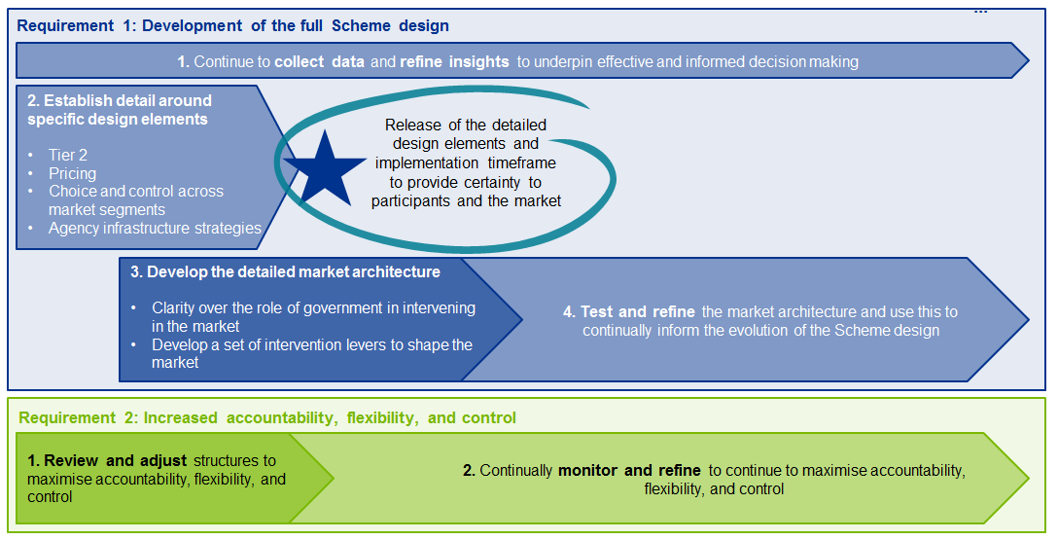

Key issues

Overview
Monitoring and supporting the development and evolution of markets is complex, and will require targeted and evidence based decision levers and decision making processes. The critical issues arising from the key findings are explored below.
- Effective management of demand growth to underpin sustainability – clarity over the design of Tier 2 and the interface with Tier 3 will be required to anticipate and respond to demand growth. This will assist in mitigating the potential adverse impacts of price inflation.
- Maximised participant enablement and shaping of demand – for people with disabilities and their families, changing services has high transaction costs. With tailored support through the right communication channels (e.g. face-to-face, technological assistance, education of support workers), there will be greater capacity to shape demand, maximise choice and control and inspire the confidence of participants. This will underpin the transition to an effective and sustainable Scheme.
- Optimising the evolution of the market through strategic and targeted intervention approaches – the shaping and development of markets does not necessarily involve more, or more heavy handed, interventions. The evolutionary nature of markets implies that different segments will evolve at different rates and require different levels of interventions. There are a range of potential intervention approaches, and it is essential that these employed to support the market to learn and evolve so that the market has the capacity to deliver on the Scheme’s objectives. As the market develops, this will provide a more complete evidence to understand the drivers of different market outcomes and can also underpin the approach to strategic, proportional, and targeted interventions.
- A flexible model to support the market’s natural development and evolution – markets evolve through a process of their agents becoming established, and learning and refining their behaviours over time. In different segments of the markets, there may be different enablers or impediments to the learning and evolution process. For example, different geographies will have different depths and breadths of service delivery capacity and capability – in metropolitan areas, there may be more providers that provide a broader range of services, whereas in rural and remote areas, markets are likely to be less developed. This means that different levels and/or types of intervention may be required to shape and support the market to best achieve its intended outcomes.
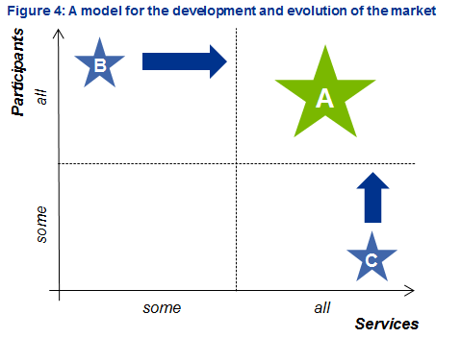
Figure 4 above illustrates the evolutionary nature of markets. For the NDIS, the vision for the market – labelled ‘A’ – is that a full range of services and supports will be available to all eligible Scheme participants. To achieve this vision, however, there needs to be a process of learning and evolution by all agents within the market. This means that, when established, different segments of the market may correspond to points ‘B’ or ‘C’, depending on their characteristics. For example, when segmented by geography, rural and remote areas may become established at point ‘B’, whereas metropolitan areas may be become established at point ‘C’.
In different segments of the market, there may be different enablers or impediments to the market’s capacity or capability to learn and evolve. In the context of the NDIS, impediments through which market invention may be required include natural safeguards and decision supports for participants, a clear and transparent quality framework, and constraints within workforce development (particularly given developments in adjacent industries such as health and aged care). There needs to be evidence based, proportional, and targeted intervention approaches by governments to shape and support the market in the most effective and sustainable way.

Key issues
- An effective and sustainable full Scheme blueprint that helps to manage the risks to achieving the Scheme objectives – the actions recognise that the development and management of Tier 2 will be a critical in underpinning the effectiveness and sustainability of Tier 3, and therefore the full Scheme. In particular, clarity over the role of government as a service provider or service enabler in Tier 2 and Tier 3 will help to manage a range of risks for service delivery and Scheme objectives.
- Clarity over the authorising environment to underpin accountability, flexibility, and control – it is important to understand the nature and implications of existing relationships between service delivery other systems and supports. With greater accountability, flexibility, and control over managing these relationships, the NDIA will have greater capacity to reduce any unintended consequences of losing these linkages.
The information contained herein is of a general nature and is not intended to address the circumstances of any particular individual or entity. Although we endeavour to provide accurate and timely information, there can be no guarantee that such information is accurate as of the date it is received or that it will continue to be accurate in the future. No one should act on such information without appropriate professional advice after a thorough examination of the particular situation.
© 2014 KPMG, an Australian partnership and a member firm of the KPMG network of independent member firms affiliated with KPMG International Cooperative (“KPMG International”), a Swiss entity. All rights reserved.
The KPMG name, logo and "cutting through complexity" are registered trademarks or trademarks of KPMG International).
Liability limited by a Scheme approved under Professional Standards Legislation.

