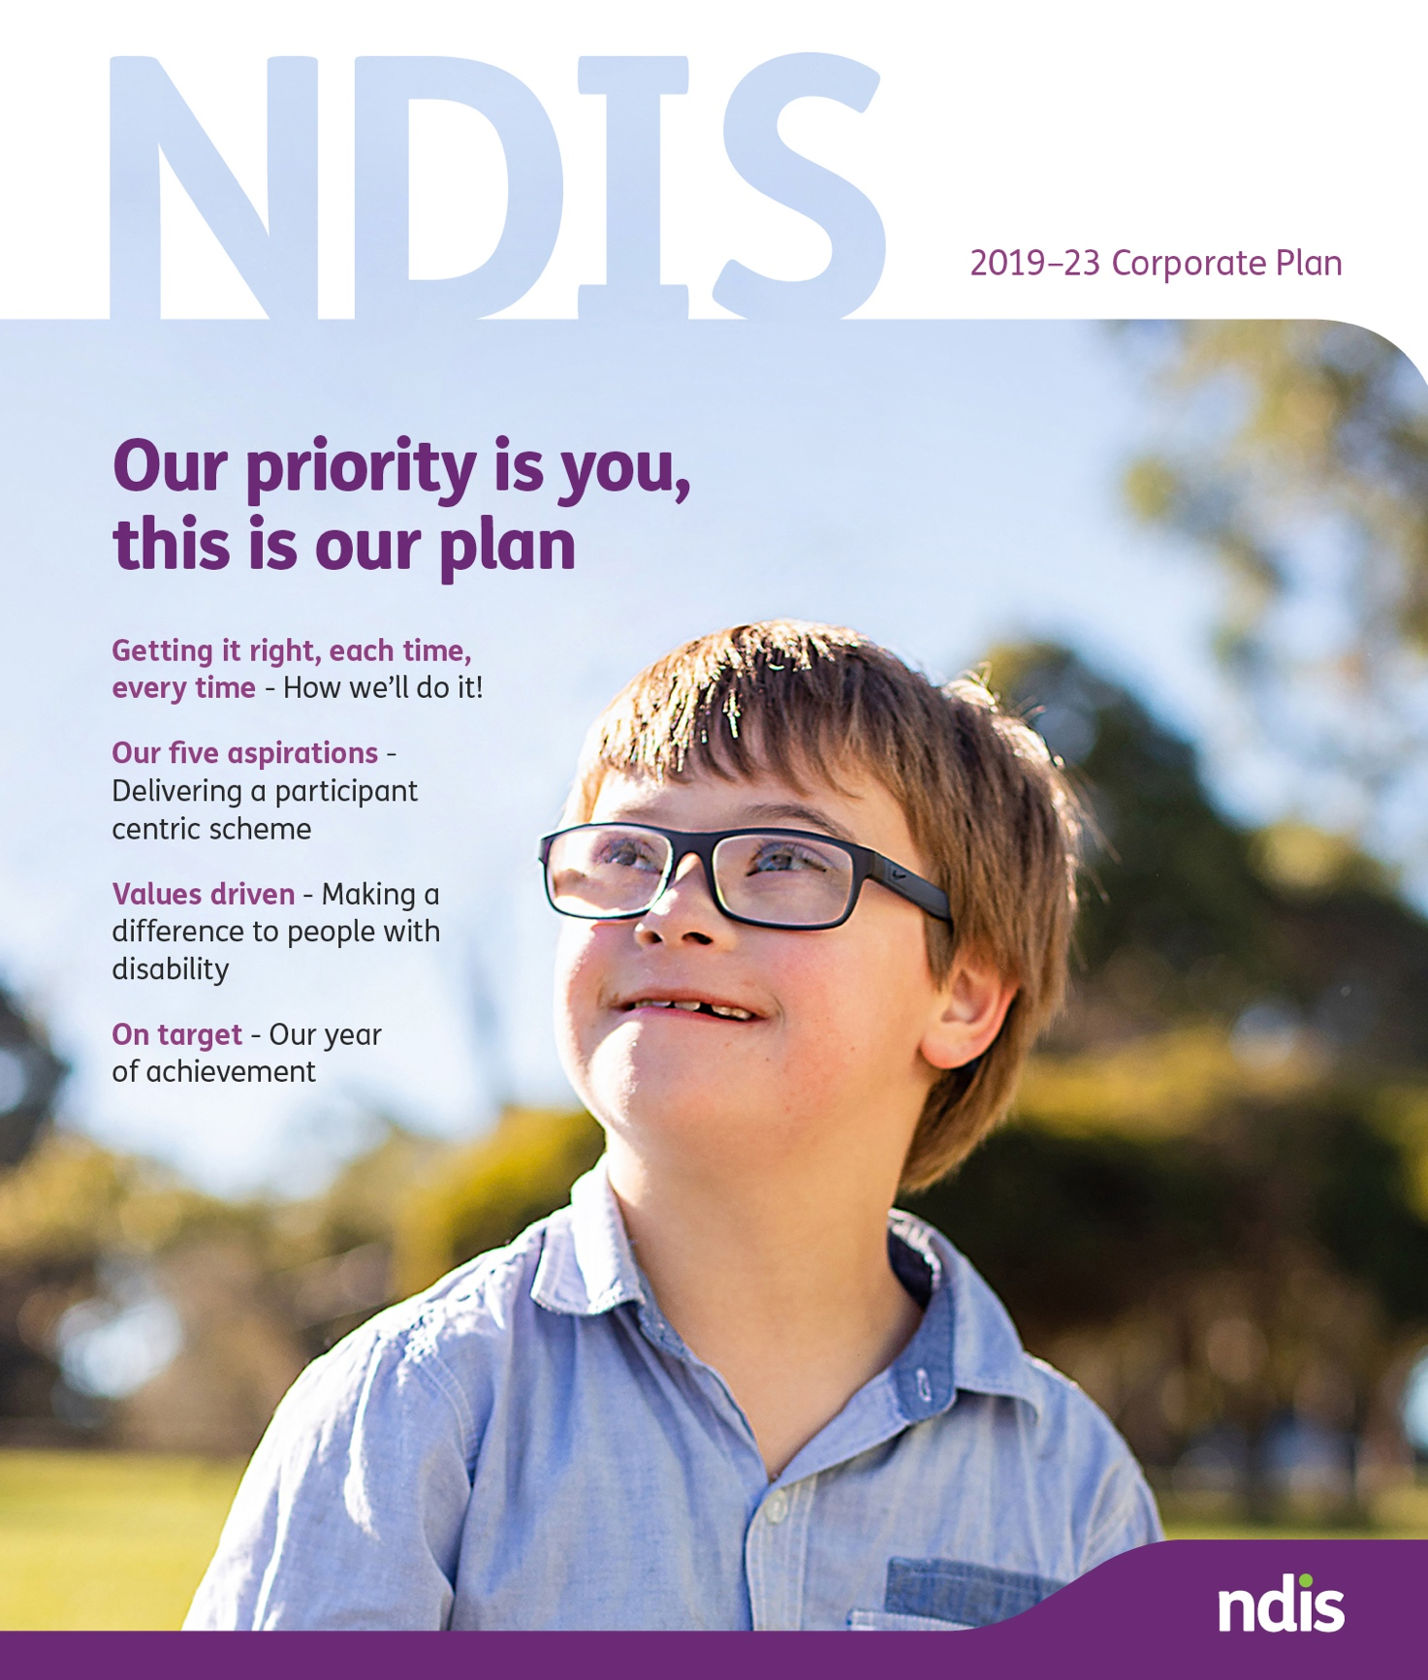

Contents
This is our plan 3
A word from the Chairman 4
About the Scheme 5
Our Achievements 6
Meet Jessie, aged 13 and NDIS Participant 8
The heart of our plan – Our Aspirations, Goals, Focus areas and Metrics 9
Local disability provider serving up Paddock to Plate 15
Our risk approach and governance 16
Justin is an important cog in the school wheel 17
For more information 18

This is our plan for getting it right for each participant, each time, every time.
A plan to empower participants to use choice and control in pursuing their goals.
A plan for reinforcing the Scheme so that satisfaction rates are high and always improving.
A scheme that offers a range of high-quality services with real-life benefits and easy access.
A scheme that is financially sustainable and will provide value for money now and into the future.
This is our plan for creating lifetime value for participants.

Participants are, and always will be, our priority.

A word from the Chairman
The NDIA Board commends its corporate plan for the continued rollout of the NDIS, which is unprecedented in its scale and scope.
During the period of this plan from 2019 to 2023, covering the shift from Transition to full Scheme, the core focus will continue to be on participants. We want participants to realise the benefits of this visionary social reform, by ensuring choice and control are put firmly in their hands with a view to them achieving better outcomes and their goals. It will be on helping ensure that participants are not just able to live an ordinary life, but that they have much greater access to employment and that the positive trends already being delivered in social inclusion and engagement continue and are enhanced.
Over the life of this plan, the rollout of the Scheme will continue so that every person eligible for the Scheme can expeditiously gain access. More than 300,000 participants have joined the NDIS, with more than 100,000 receiving supports for the first time. This is an unprecedented increase from just over 30,000 participants at the beginning of transition on 1 July 2016. That pace will continue as full Scheme is reached and the service requirements for existing participants magnifies.
Our focus is on getting it right for each participant, each time, every time. Even though participant satisfaction rates are high and improving, we know that more needs to be done to make dealing with the Scheme easier for participants. Central to this is the ongoing rollout of the ‘pathways’ work, designed to provide more empathetic and simplified interactions for participants, their families and carers, delivered by more skilled and experienced staff.
In addition, we will continue to work with providers to ensure they are able to offer participants services that increase their choice and control. Much has already been done in that regard, including enhanced information, adjustments to pricing, implementation of a customer relationship approach and improved systems.
None of this will be possible without the Agency having skilled and committed staff and partners dedicated to delivering on the promise of the Scheme for participants. We recognise and applaud our staff for all that has been done and all that they will do into the future.
Getting it right for each participant, each time, every time, in a sustainable and engaging way will be the rallying call of this corporate plan. We ask you to join us in fulfilling this sacred mission.
Dr Helen Nugent AO
Chairman

About the Scheme
The NDIS (also known as ‘the Scheme’) is a fundamental shift in the way our country provides and funds disability support for Australians under the age of 65 who have a significant and permanent disability.
Participant choice and control are core features of the Scheme’s design.
In this new market-based system, participants work closely with planners and local area coordinators (LACs) to determine a plan that focuses on their individual goals.
Participants are able to choose and move between their providers, rather than having providers chosen for them.
The NDIS forms an important part of the Australian Government’s National Disability Strategy 2010–2020, a 10-year policy framework for improving lives of Australians with disability, their families and carers.
Governments across Australia are working together to develop a new strategy for beyond 2020, making sure people with disability can participate in all areas of Australian life and fulfil their potential as equal citizens.
The Scheme is founded on insurance principles. We draw on the practice of commercial and government social insurance companies, making evidence-based decisions on individuals’ Scheme access.
Statistical analysis informs our decisions, including:
- the extent of financial support a person needs; and
- other reasonable and necessary supports a person needs.
This approach means financial support is considered over the life of the participant, unlike the previous shorter-term welfare-based approach.

Our Achievements
- The Scheme is now accessible in every region of every state and territory (except for parts of Western Australia).
- More than 85,000 people are now receiving support for the first time.
- 277,155 people with disabilities, including 11,504 children in the ECEI approach, have joined the NDIS, a 915 per cent increase since 30 June 2016.
- Overall, participant satisfaction is high at 88 per cent
- 20,208 registered providers are in the Scheme, a 574 per cent increase since 30 June 2016.
- There are $10.1 billion of committed supports in active participant plans.
- We exceeded our operational target for nine months to end of March 2019.

Our progress
The Agency has made some extraordinary progress during 2018-19, welcoming the largest number of participants to the Scheme so far. This achievement has been made, while making real progress across a number of areas identified in the corporate plan, these have been highlighted below:
- The establishment of a Participant Employment Taskforce which aims to improve outcomes for participants in finding and retaining employment.
- The Pathways Program is making progress in transforming the experience of participants and providers and whilst we still have much to do in this area, satisfaction rates are improving.
- The Complex Support Needs pathway is being offered in all states and territories and ensures specialised planners and liaison officers are able to help our most vulnerable participants.
- The release of the Market Enablement Framework which will assist providers to better understand the demand and supply characteristics of their local market place.
- The implementation of our first Health and Wellbeing strategy for Agency staff is a great example of where we continue to embed a culture that will drive high performance for the benefit of our Participants and the Australian community more broadly.

Our opportunities and challenges
Whilst we are proud of our progress to date there is still much to do. There are a number of opportunities and challenges that we have sought to address through our aspirations and goals identified in the corporate plan. Focus will be around the following:
- Planning processes and engagement must be further refined to meet the needs of different cohorts of eligible people with disability.
- Continue to improve our systems and processes so we become more responsive to participants, service providers and those who represent them.
- Reduce backlogs and wait times currently being experienced across the Participant Pathway, from access to reviews, complaints, and assistive technology.
- Work with Partners in the Community to improve the consistency and quality of ECEI services and LAC planning support provided to participants.
- Implement the actions identified in the Young People in Residential Aged Care action plan in collaboration with Department of Social Services.
- Leverage the ILC program to grow capacity and confidence within mainstream and community organisations.
- Improve clarity between the interface of the Scheme and other mainstream service systems to ensure services are applied consistently at all levels of government.

Meet Jessie, aged 13 and NDIS Participant
Jessie loves life and is on a mission to be the best she can be, dreaming one day of joining the police force.
Dad, Paul, said his 13-year-old daughter, who has Down syndrome, is certainly a stickler when it comes to anyone in the family breaking the rules.
“I regularly get a stern warning when having a glass of wine of the dangers of drink-driving and ending up on the TV show, RBT,” he said with a laugh.
Paul said “Jessie has come a long way since joining the National Disability Insurance Scheme (NDIS) four years ago and he credits the continuity of supports she now receives in her NDIS plan, in particular the fortnightly speech therapy she attends”.
Paul admits he never realised the extent of what regular speech therapy could offer.
“When Jessie started speech therapy, I thought it would be purely about how you pronounce words and the physical control needed to just get the words out. I soon realised Saskia, Jessie’s speech therapist, was teaching her a whole lot more, including questioning phrases and broader social skills”.
“Who knows? Anything’s possible with the right supports. Christine (Jessie’s mother) and I can’t wait to see her in police uniform following her dreams. She’s certainly getting the skills now, to have a much better chance of achieving her dream job.” Paul added.

The heart of our plan – Our Aspirations, Goals, Focus areas and Metrics

Aspiration 1: A quality experience and outcomes for participants
Facilitate outcomes of economic and social independence and deliver a quality service for participants and their families, carers and providers.

Goals
  - Plan volume and quality
  - Quality participant experience
  - Improved participant economic outcomes
  - Improved participant social outcomes

Focus areas
- Develop goal-orientated plans that provide reasonable and necessary supports in a timely manner.
- Continue to improve the planning experience through the Participant Pathway reforms.
- Improve the timeliness of ECEI supports.
- Review and revise resource, capability and service models to meet transitional targets.
- Work with Partners in the Community to improve the consistency, quality and our productivity of the planning and plan review process.
- Enhancing our planners’ collaboration with LACs and facilitating joint planning processes and face to face planning.
- Provide a consistent point of contact to discuss how to best use the approved funding in plans.
- Improve understanding of participants’ satisfaction by rolling out our new survey tool.
- Continue the development of learning resources to broaden the knowledge of our planners.
- Improve our systems to make it easier to access assistive technology aides and home modification arrangements.
- Build participants’ capacity to achieve employment outcomes, through purposeful interactions with LACs.
- Work with employers to develop employment opportunities for participants and supports at work.
- Enhance access to information about employment services and suppliers including mainstream employment services when appropriate.
- Refresh and build a national network of regional employment champions.
- Monitor, analyse and report on the performance of the provider market in getting enduring employment.
- Build participants’ capacity to engage in community and social activities, through meaningful interactions with LACs and planners.
- Develop and improve the approach towards ongoing ILC grants and programs to promote and support awareness of disability and inclusion.
- Monitor, analyse and report on participant social and community engagement outcomes, including enduring social participation outcomes.
- Implement the actions identified in the Young People in Residential Aged Care action plan.
- Implement and expanded Community Connector model.

Metrics
Performance metric | FY 18/19 | FY 19/20
Participants in work (%) | 23 | 24
Participants involved in community and social activities (%) | 46 | 47
Operational Targets (% met) | 102 | 100
Participant Plan Reviews (% met) | 93 | >95
Participant satisfaction (%) | 88 | >90

Aspiration 2: A competitive market with innovative supports
Work with participants and other stakeholders to enable the growth of a market of adequate size, quality and innovation.

Goals
  - Available market of supports and services
  - Provider sentiment and confidence

Focus areas
- Strengthen the NDIA’s capabilities in fostering growth and innovation including regional and remote areas.
- Address expected supply shortfalls in collaboration with key stakeholders (i.e. the Australian Government and state and territory governments).
- Share detailed market information on supply and demand to help stimulate market growth across regions.
- Ensure price limits support the sustainable supply of services to participants.
- Change core and supporting processes to reduce burden and complexity for providers and improve contact experience, including through ICT investment.
- Support DSS and the NDIS Quality and Safeguards Commission in implementing the National Disability Insurance Scheme Quality and Safeguarding Framework.
- Engage with providers and the sector to prioritise ongoing improvements to the provider portal that will further enhance its functionality and efficiency.

Metrics
Performance metric | FY 18/19 | FY 19/20
% of participants who choose who supports them | 44 | 45
Provider sentiment and confidence | 5.0 | 5.5
Plan utilisation by region (% of regions that are more than 10 percentage points from the national benchmark) | 9 | <8
Market concentration (% of regions where the top 10 providers supply more than 85% of the supports $) | 11 | <10

Aspiration 3: A connected and engaged stakeholder sector
A strong and engaged stakeholder sector that genuinely collaborates and contributes to the delivery of the Scheme, with confidence in the NDIA.

Goals
  - Enduring stakeholder confidence and sentiment
  - Meaningful partnerships and collaboration with key stakeholders – listening to what matters
  - Genuine collaboration with and influence from the broader sector to deliver a world-class NDIS

Focus areas
- Ensure accessible, responsive, clear and transparent communication through a range of channels.
- Provide streamlined and personalised contact for participants and providers to ensure timely resolution of enquires and issues.
- Foster partnerships with our key stakeholders, and strengthen our existing relationships with state and territory governments through thoughtful and constructive collaboration.
- Engage in a meaningful way in the external discussion on the NDIS, encouraging public debate on the issues that matter.
- Clarify stakeholder groups’ roles and responsibilities in relation to mainstream interface issues.
- Engage actively with the community and sector on opportunities for ILC grants.
- Develop targeted, evidence-based campaigns to influence change and improve NDIS awareness.
- Enhance data sharing policies and explore opportunities to involve industry and sector in research, design and evaluation, to strengthen Scheme outcomes.

Metrics
Performance metric | FY 18/19 | FY 19/20
Sector sentiment (rating out of 10) | 5.3 | 5.5
% of engagement activities completed | n/a | +50
Total unique website users – ndis.gov.au in (‘000’s) | 2,254 | 2,367

Aspiration 4: A financially sustainable Scheme
Deliver a financially sustainable Scheme within agreed funding, based on insurance principles and risk awareness.

Goals
  - Scheme costs within funding envelope
  - Robust risk management and control environment

Focus areas
- Consistently apply the Scheme’s insurance principles while continuing to refine planning tools and processes.
- Continue to use access and planning data and analysis to predict the expected number of participants.
- Monitor and address any emerging cost pressures.
- Work with governments on the National Disability Strategy.
- Enhance and roll out the ECEI approach.
- Implement the Scheme Integrity Program including robust risk management systems and processes.
- Enhance systems and processes to address inappropriate payments.

Metrics
Performance metric | FY 18/19 | FY 19/20
Scheme support costs within budget for the year ($m) | 11,752 | 16,262
Payment errors/anomalies (% of program outlay) | 5 | 5

Aspiration 5: A high-performing NDIA
Develop a high-performing NDIA that has an engaged workforce with systems and processes that facilitate service excellence.

Goals
  - Engaged and capable NDIA
  - Efficient and effective processes and systems

Focus areas
- Develop a strategic workforce plan which identifies capability needs and resources to support the successful delivery of the Scheme.
- Improve accessibility and employment opportunities for people with disability within the NDIA.
- Invest in leadership and capability building to support our workforce.
- Refresh the performance and reward framework.
- Embed our values and behaviours and recognise and celebrate individuals and teams who exemplify them.
- Continue to strengthen our work health and safety practices, including implementing the Health and Wellbeing Strategy and Mental Health Framework actions.
- Enhance workflow processes and systems to understand service break points better, improve turnaround times and reduce errors as part of our commitment to operational excellence.
- Embed an increased participant-centric culture across our workplace.
- Enhance and invest in business systems functionality and overall system connectivity and performance.
- Monitor and continually improve data and system security capabilities.

Metrics
Performance metric | FY 18/19 | FY 19/20
Employee engagement (%) | 74 | 76
Female representation in leadership (%) | 50 | 50
People with disability employment (%) | 14 | 15
Risk culture (% staff agreeing Agency has positive risk culture) | 50 | 50
For more information on our aspirations, see the full edition of the plan online at www.ndis.gov.au.

NDIA Success Framework

Our Purpose
To increase the ability of individuals with a significant and permanent disability (participants) to be more independent, and engage more socially and economically, at the same time as delivering a financially sustainable Scheme that inspires community and stakeholder confidence.

Our Aspirations
- A quality experience and outcomes for participants
- A competitive market with innovative supports
- A connected and engaged stakeholder sector
- A financially sustainable Scheme
- A high-performing NDIA

Our Values
We value people: We put participants at the heart of everything we do.
We grow together: We work together to deliver quality outcomes.
We aim higher: We are resilient and always have the courage to do better.
We take care: We own what we do and we do the right thing.

Who benefits?
- Scheme participants will improve their social and economic engagement.
- All people with disability will gain a greater awareness of services available to them.
- Families and carers enjoy greater wellbeing, and social and economic participation.
- Providers will benefit from increased demand for disability care and support services.
- Community members will have more inclusive community across Australia, reflecting the diversity of all Australians.
- The economy will benefit reducing the total future cost of disability for Australia.

Local disability provider serving up Paddock to Plate
A Rockhampton disability provider has found a creative way to engage their clients and give back to the local community, with their Paddock to Plate program getting participants to build, grow and maintain a sustainable vegetable and herb garden, while learning to cook with the produce and sell it locally.
Rockhampton National Disability Insurance Scheme (NDIS) provider Access Rec provides a range of support for locals living with a disability – including home supports, group activities and skill development programs – but it’s Paddock to Plate that is having the biggest impact.
Access Rec Groups Coordinator Katrina Christensen said the program encourages education about food and food preparation.
“A typical day’s activities start with our gardening session, which includes weeding, tending to the garden, pruning trees, watering and planting,” Katrina said.
“Once we’ve completed our outdoor tasks we move inside to cook and eat lunch, which usually incorporates produce from the garden. This encourages healthy eating and reduces food waste.”
Katrina said the program is having a profound impact on their participants.
“All of the participants have benefited from being outdoors and being active in the garden.”

Our risk approach and governance
We have identified the risk systems, capabilities and the culture needed to align with the scale, speed and rollout of the Scheme. We have embedded an understanding of risk in every aspect of the organisation, from business planning processes to day-to-day operations.
Consistent with our practice of identifying, escalating and mitigating key risks, we have identified 11 strategic risks that have the potential to adversely impact the achievement of one or more of our five aspirations.
We have a robust governance framework to proactively monitor risk management efforts. The NDIA Board has dedicated risk and audit committees, supported by a chief risk officer and chief internal auditor, respectively. Management-level risk and audit committees are also in place and meet on a monthly basis.
The chief risk officer assists the Board and our executives by providing objective risk reviews, oversight, monitoring and reporting.
The Scheme Actuary is responsible for assessing risks and issues impacting on the financial sustainability of the Scheme, and reporting those risks in the annual financial sustainability report.
The NDIS Act also requires us to have a reviewing actuary who is responsible for reviewing actuarial reports and the annual financial sustainability report.

Strategic risks
  - Failure to deliver high-quality plans and reviews at the rate required to meet operational targets and obligations.
  - Failure to meet participant expectations for delivery of high-quality services.
  - Failure to deliver expected participant social and economic outcomes.
  - Failure to establish necessary Partners in the Community capacity and capability.
  - Failure to facilitate adequate participant access to services, including through required provider market growth resulting in critical gaps in service.
  - Failure to deliver to sector and stakeholder expectations.
  - Costs, scope or eligibility deviate significantly from funding expectations.
  - Failure to protect the integrity of the Scheme (including privacy management and fraud).
  - Inability to operationalise a high performing, participant centric service excellence delivery model, due to inadequate workforce capacity, core capability and immature culture.
  - Inability to establish and maintain a workforce which provides the volume of delegated authority required to successfully deliver aspirations.
  - Failure to develop and maintain adequate IT systems and support (including cyber security).

Justin is an important cog in the school wheel
National Disability Insurance Scheme (NDIS) participant, Justin Tala provides administration support at Glenwood Public School doing important every day jobs, saving teaching staff valuable time.
Every morning Justin does a round of photocopying and delivers class materials to teachers, helping them start their day off on the right note. Then he helps with recycling, administration, filing, sorting class readers and other necessary jobs around the school.
Justin started working at Glenwood two years ago after setting a goal of getting a job. Before he finished school Justin and his parents sat down with his Local Area Coordinator and they discussed what NDIS supports could help him prepare to secure employment.
School Leaver Employment Support (SLES) funding was included in his NDIS plan. Justin was then linked to local employment provider, JobSupport, who worked with him to help build his confidence and skills to become work ready.
Principal Jay McInney said, “Justin is just another staff member, one who is valued and everyone enjoys having around”.
“He’s an important cog in the school’s wheel,” he added. “Justin does a lot of those jobs teachers would normally do, which eats into precious classroom planning time.
“When he started, one of vocational trainers spent every day with him until he was confident he was independent in his role. It took about five weeks. Justin has just excelled from there.”
With a moderate intellectual disability and autism, Justin works to a daily timetable so his environment is structured and he knows exactly what to do. His structured day works to the 21-year-old’s advantage and compliments his skill sets.
“I love working at the school,” Justin said. “I get the bus there and everyone is nice. I have a staff uniform and a name badge.”

For more information about this plan, please contact:
National Disability Insurance Agency
Telephone 1800 800 110

For people with hearing or speech loss
TTY: 1800 555 677
Speak and Listen: 1800 555 727

For people who need help with English
TIS: 131 450

The full edition of this plan can be accessed online at www.ndis.gov.au
Find us on Facebook/NDISAus
Follow us on Twitter @NDIS

