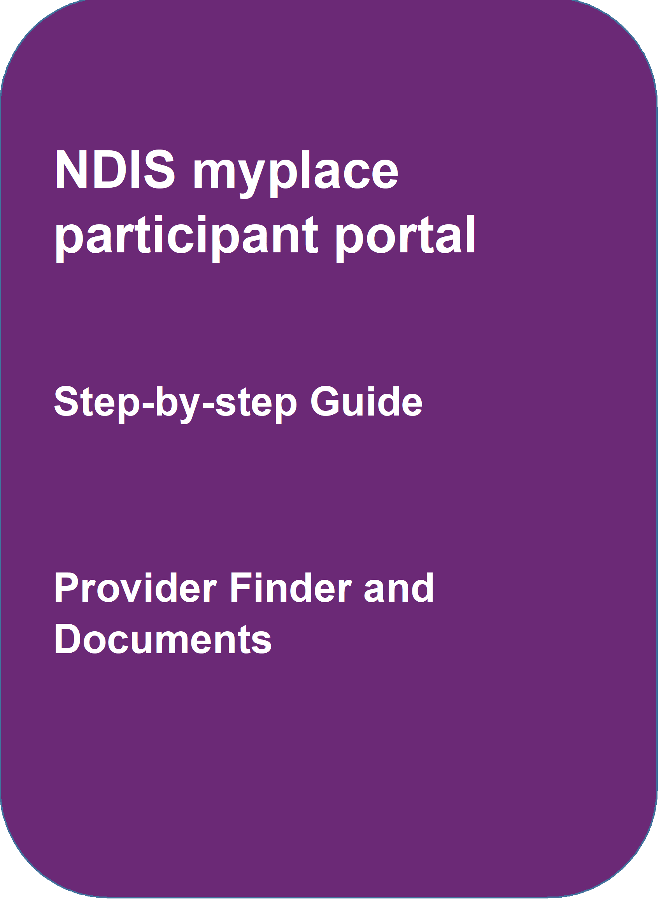
May 2024
NDIS myplace portal
May 2020

Table of Contents
Table of Contents 2
Changes from the last version 3
Provider Finder 3
Provider search 3
Recent providers 8
Document Upload 10
myGov Inbox 13

Changes from the last version
The following updates have been made to the last published version of the myplace portal step-by-step guide:
- General updates.

Provider Finder
The Provider Finder enables you to find and contact a registered provider. You can also view providers you have a service booking with. This section contains contact information of providers via the View Details link, and detailed directions via the Find Directions link.

Provider search
- Select Provider Finder tile on the homepage.

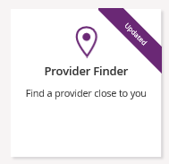

The Provider Finder page displays.

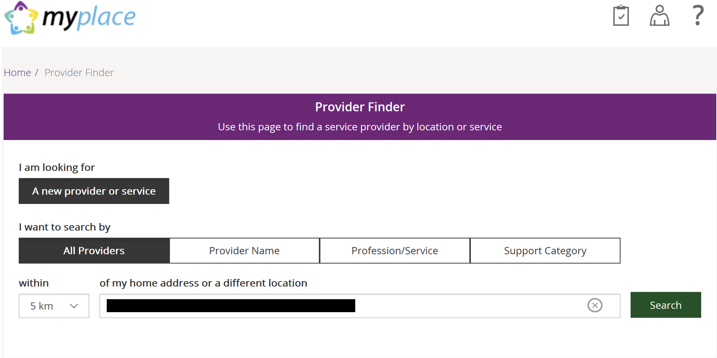

You have the option to search by:
- All providers: All providers within the selected distance to your address will display.
- Provider name: You can enter the name of the provider you are looking for.
- Profession/service: You can choose the profession/service (for example, dietician) from a drop-down menu.
- Support Category: You can choose the support category you are looking for from a drop-down menu.
The following steps is an example of searching by a profession/service.
2. Select the Profession/Service tab.
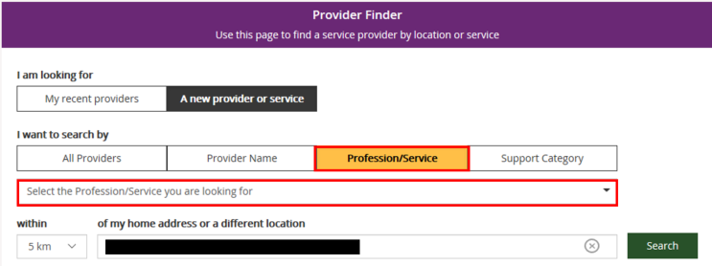

3. Click the dropdown box and select a service.
4. The search radius defaults to 5 kilometres from your home address. You can expand
the search distance by clicking the within dropdown arrow.
5. You can change the address that the search is on by clicking the delete icon in the ‘of
my home address or a different location’ field and type in an address.
6. Select Search. The search results display.
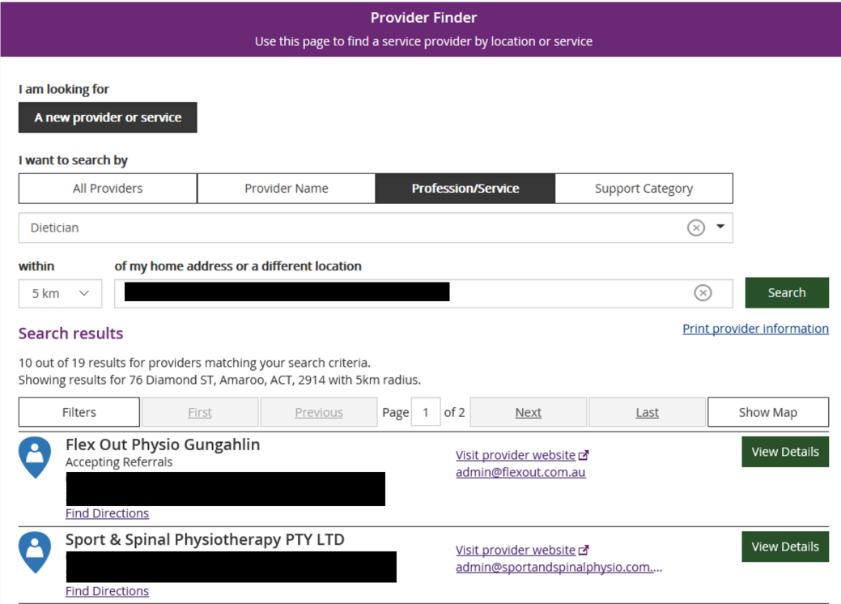
7. To print your search results, select the Print provider Information link.
8. If there is more than one page of results use the buttons of Next and Last to look at all
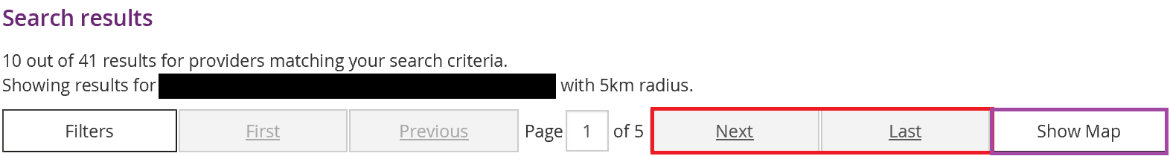
the providers.
9. To narrow down your search results, you can apply filters to your search by selecting
the Filters button at the top of the window.
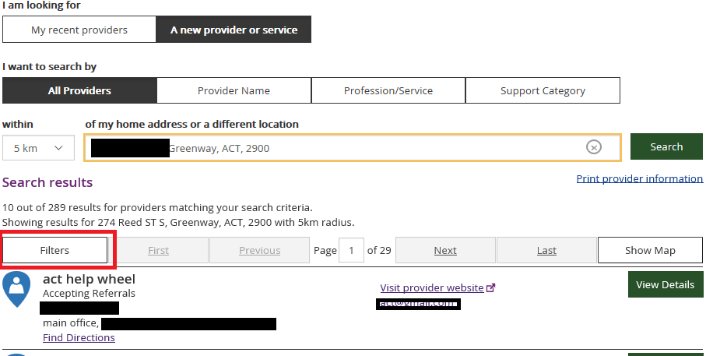
10. The following filters can be applied to your search:
- Accepting new referrals
- Open extended hours on weekdays
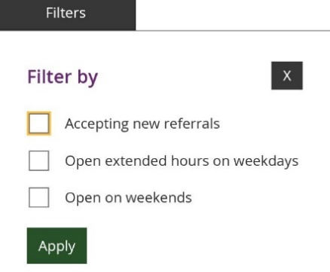
- Open on weekends

11. To see more information on a specific provider, select the View Details button.

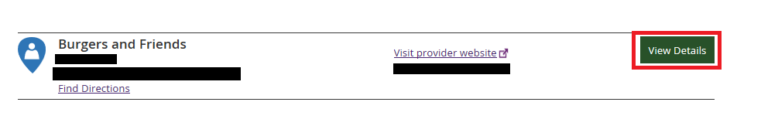
12. The details of the provider will display with the following:
- Organisational name: The provider business name.
- Contact person: The name of the person you can speak within the organisation.
- Contact details: Including contact phone numbers and email addresses.
- Address: The street address of the provider.
- Outlet status: This tells you if the provider is able to take referrals.
- Services provided: A list of all services provided is listed here.
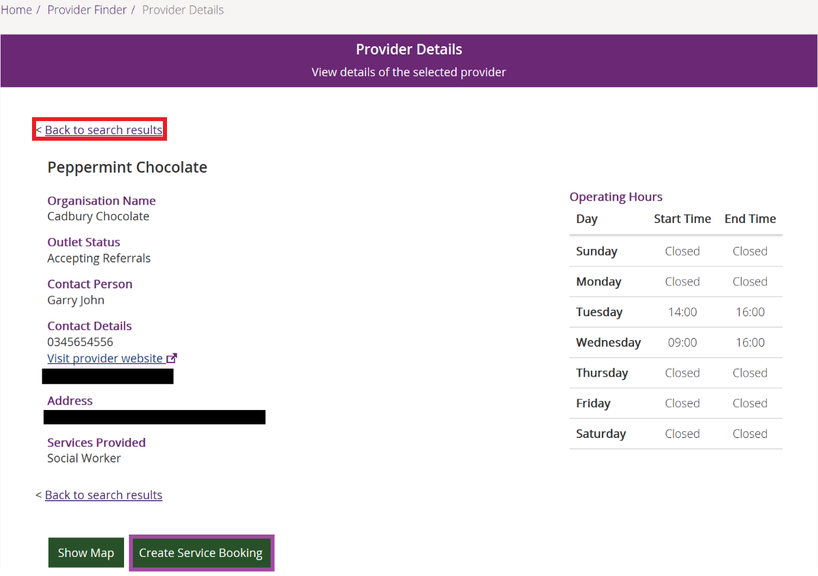
- Operating hours: Details of the days and times the provider is open for business.

Note: If you would like to conduct another search, select Back to search results link at the top or bottom of the screen. This returns you to the Provider Finder screen, where you are able to complete another search.
13. Select Show Map if you want to see the location of the provider.
14. Once you have found the right provider, select Create Service Booking to make a
booking with this provider. This button only displays if you have support funding that is
Agency managed.

Recent providers
The My recent providers section only displays if you have had service bookings. It displays the providers of your last five service bookings.

- Select My recent providers. This list the last five providers that you have had a service booking with.

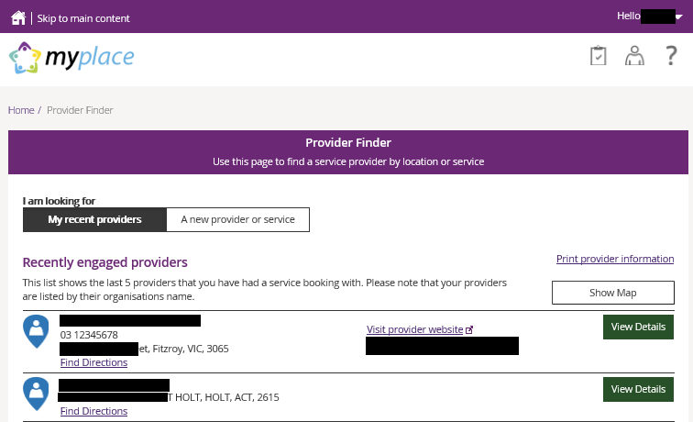
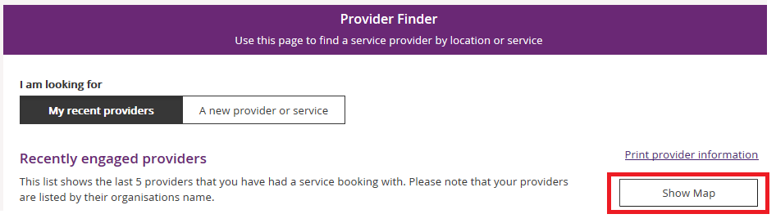
- To view the location of these providers, select the Show Map near the top right-hand corner of the window.

A map will populate on screen with markers identifying where the providers are located.

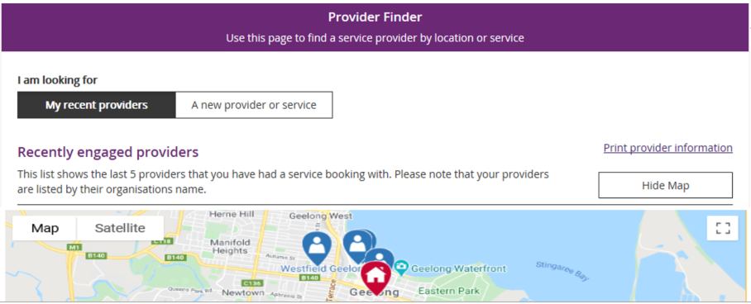

- Select Hide Map to return to the listing of providers.
- To view contact details and services provided by specific providers, click the View
Details button to the right of the provider.

Document Upload
This screen is where you can send copies of documents to the NDIS.
Note: Once you have uploaded a document it cannot be deleted from the system.
- Click the Document Upload tile on the homepage.
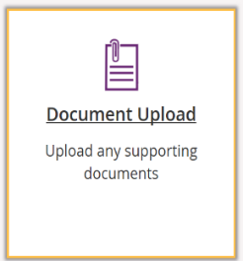

- The Document Upload page displays.

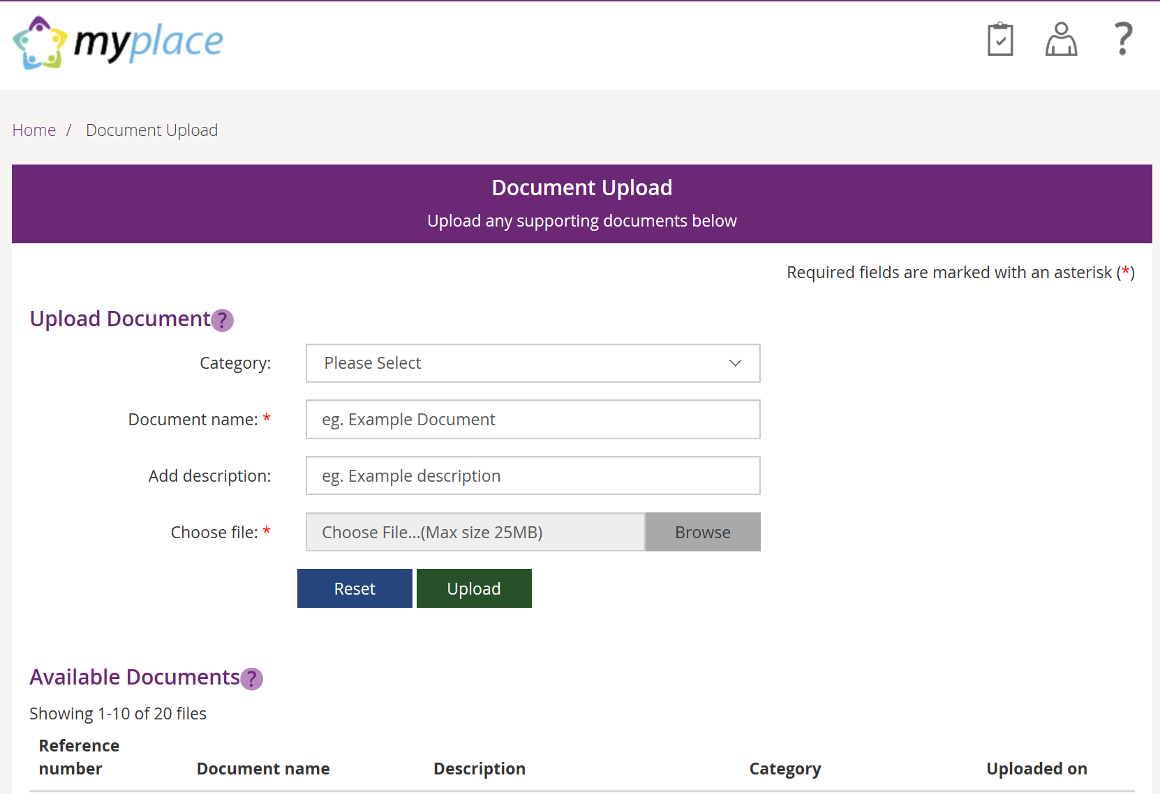
- In the Category field, select from the drop-down list.
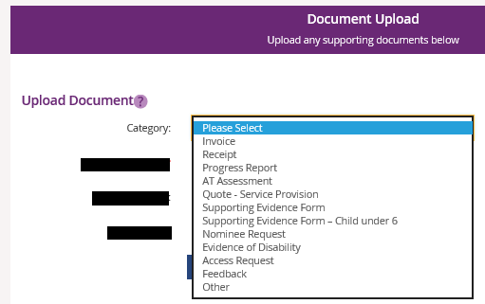
- In the Document name field, type the name of the document. Ensure the document name captures the main purpose of the document.
- In the Add description field, type a description of the file. Ensure the description is connected to the content within the document.
- Select Browse to find the file you want to upload from your computer.
Note: you can only upload a maximum file size of 25MB (Megabytes) per upload.

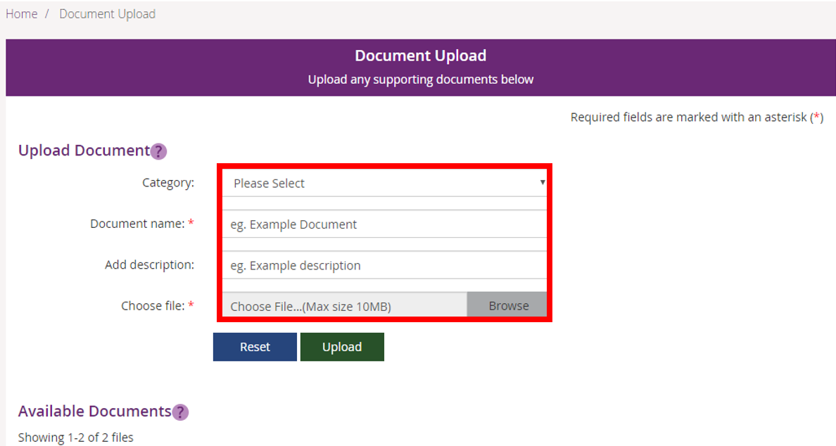
- Once you have selected the file, click the Upload button to send the document to the NDIS.
- Successfully uploaded documents are visible under the Available Documents section. The documents are displayed from the most recent date.
Note: If the matter relating to your document needs to be actioned urgently by an NDIS staff member or your local area coordinator (LAC), please contact the NDIS on 1800 800 110.
Note: If you have a new plan in the new computer system, you can use Document Upload to see the list of documents that have been uploaded in the past.
My helpful documents
This screen is where you can access helpful guides and resources.
- Select My Helpful Documents tile on your homepage

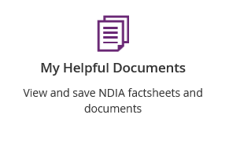

- Planning Support Booklets hyperlink will display

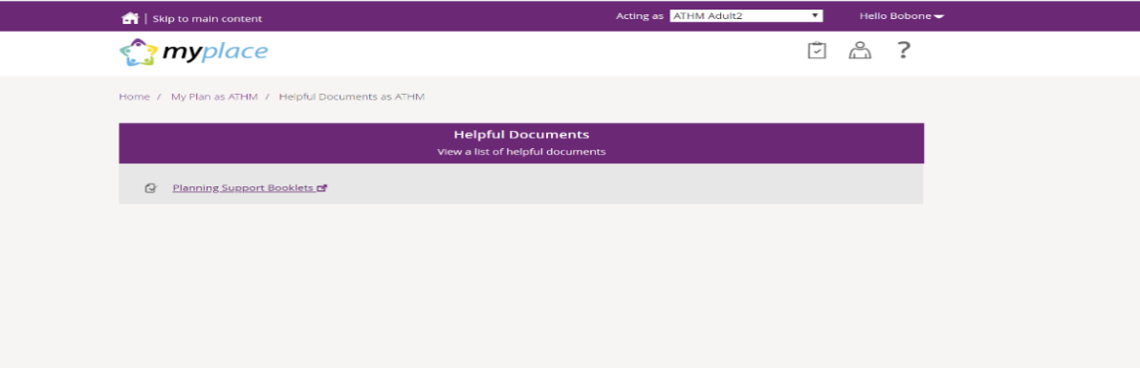

- Click on the Planning Support Booklets hyperlink
- This will direct you to the ‘For participants’ page in the NDIS participant website
- The ‘For participants’ page will display.

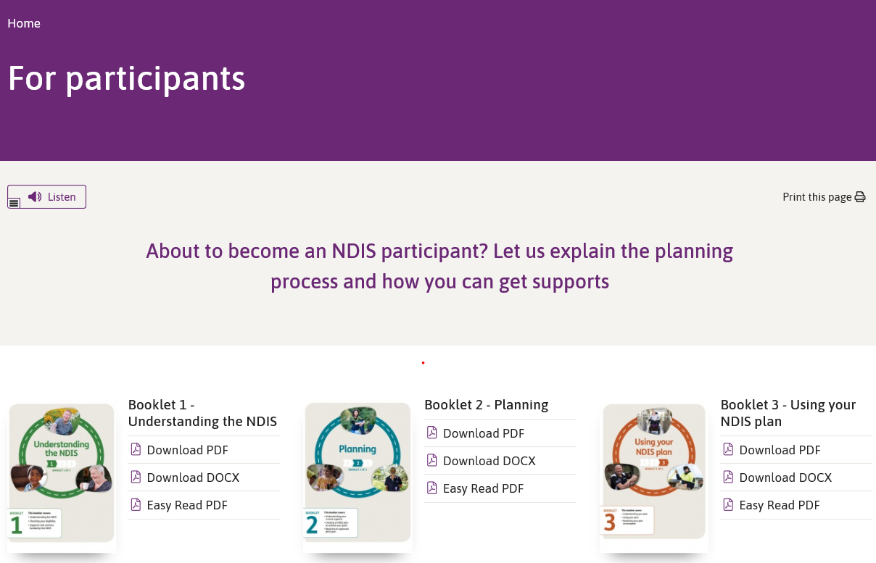

- You will be able to select and view each booklet.

myGov Inbox
You can view all your myGov messages in the myGov Inbox.
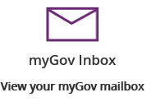
Note: This function is not available for participants with a plan in our new business system.
- Select the myGov Inbox tile on your homepage.
- Your myGov inbox displays all messages you have in your myGov account.

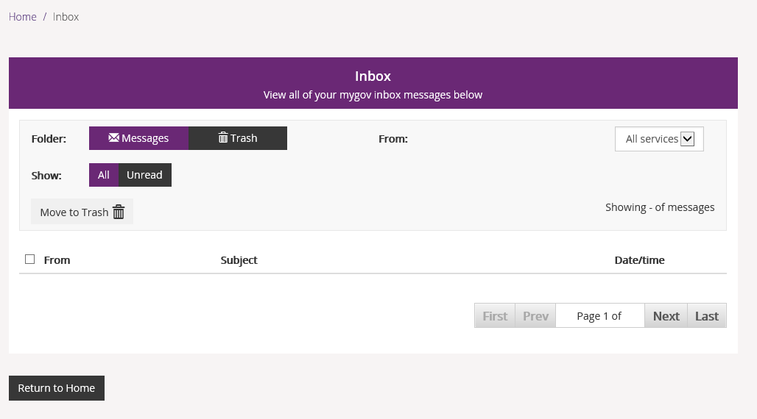
- Select the From dropdown to view specific messages.

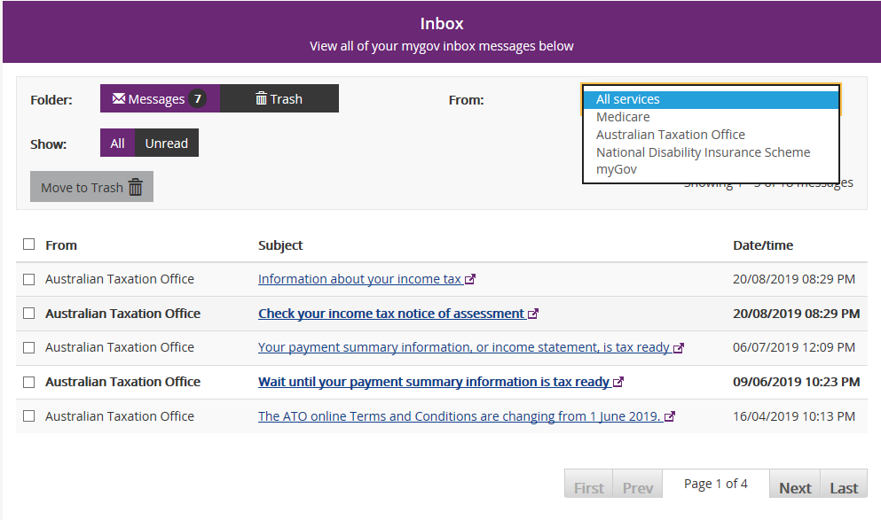

- Select Unread in the Show field to only display unread messages.
- To read a message, click on the message subject hyperlink. The message displays.

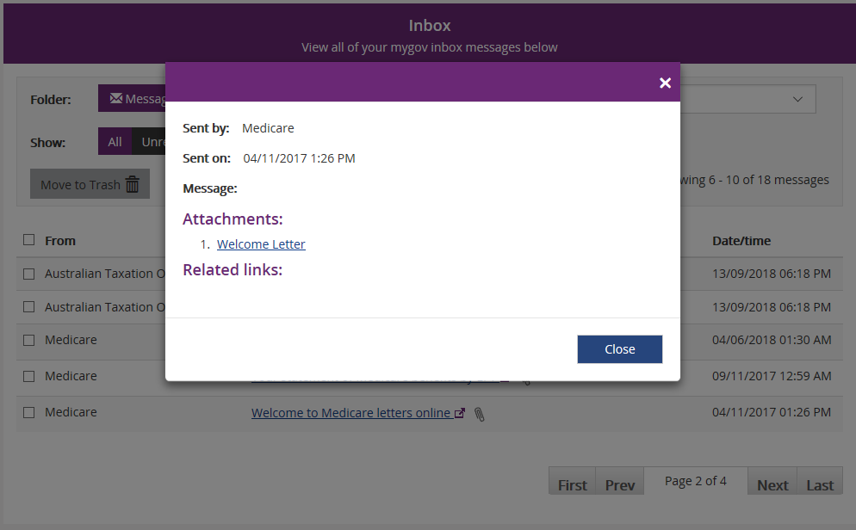

- Select Close to return to the Inbox screen.
- If you want to move a message to trash, click in the tick box next to the message and then select Move to Trash.
- Select Home to return to the myplace homepage.

