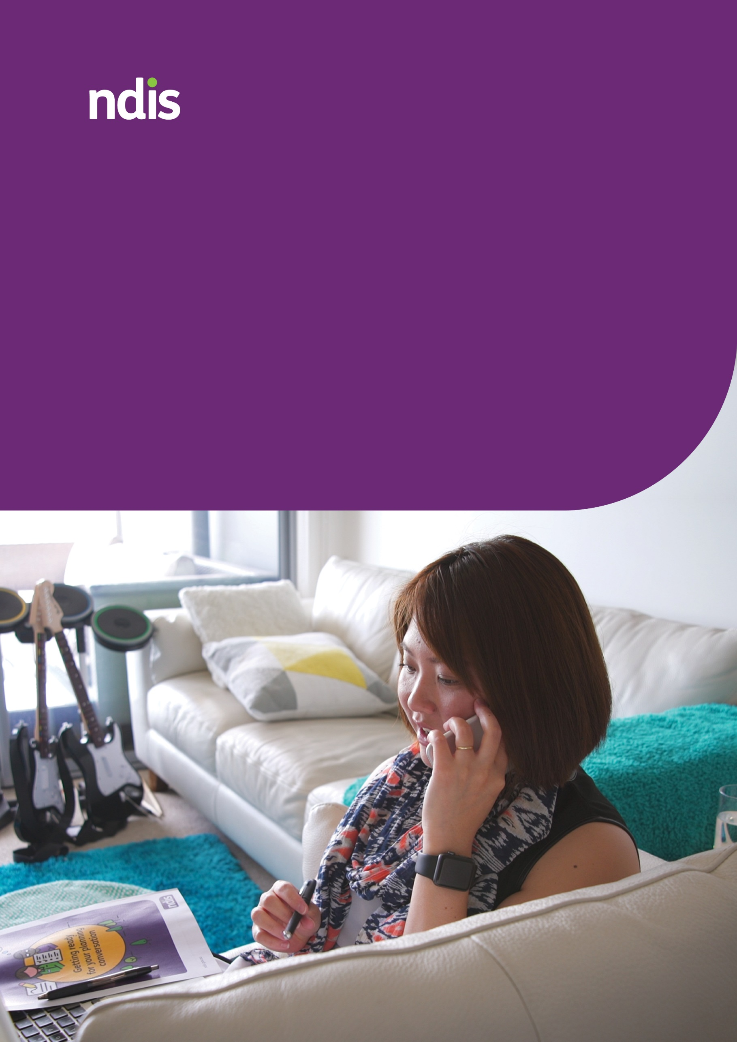
National Disability Insurance Scheme
The Participant Safeguarding Co-design Story
2023 | Version 1.0 | ndis.gov.au

Contents

Contents 2
1. Introduction 3
2. What we co-designed 4
3. How we worked with people with disability 5
3.1 Co-Design workshops 5
3.2 Hearing from people with diverse backgrounds and experiences 6
3.3 Consultation with the disability community 7
4. Research 7
5. What people told us 8
5.1 Key participant safeguarding themes 8
5.2 Feedback on the co-designed principles 9
6. How we confirmed the final Policy 10
7. Lessons 10

Introduction
This paper provides an overview of the co-design and consultation activities delivered to develop the Participant Safeguarding Policy (Policy). This includes the feedback we received and how this has been incorporated into our final Policy and Implementation Plan.
The NDIS Independent Advisory Council’s paper ‘choice and control to safely live a good life of belonging and citizenship’ recognises the system-wide focus on improving supports for people with disability who are at risk of harm. In response to this paper, the National Disability Insurance Agency (NDIA/we) committed to developing a Policy to guide and enhance the way the NDIA works with National Disability Insurance Scheme (NDIS) participants and people with disability.
We recognise that when an individual is at risk or experiencing violence, abuse, neglect and exploitation, a proactive approach to building or enhancing formal and informal safeguards can protect their rights, decision making, choice and control, safety and wellbeing, citizenship, and quality of life.
This Policy outlines a shift to a stronger focus on proactive identification, assessment, and management of risk to minimise the risk of harm occurring.
It has been informed by research, consultation, and co-design with people with disability and the disability sector.
Background
We are committed to working positively with, and supporting, all people with disability who engage with the NDIS to take steps to help them be safe. This includes working in partnership with people with disability to co-design improvements to the NDIS.
Co-design means we work alongside people with disability, the disability community, and other interested groups. We do this by collaborating on specific problems, issues and situations requiring improvement or change.
Through the Co-design Advisory Group, the disability community agreed that this Policy would be co-designed.
In March 2022, the Participant Safeguarding Co-Design Steering Committee (Steering Committee) was established. The Steering Committee consisted of:
- NDIS participants and families and carers of participants
- Independent Advisory Council members
- Disability Representatives and Carer Organisations
- State and Territory and Commonwealth government representatives
- NDIA representatives.
The role of the Steering Committee was to provide strategic advice, governance, and oversight over the co-design approach for the development of the Policy and Implementation Plan. Their responsibilities included:
- providing advice on the stakeholders who should be involved in co-design activities
- providing recommendations for effective engagement with people from diverse backgrounds and experiences
- providing guidance on how to ensure people with disability have a clear voice throughout the co-design and consultation activities
- contributing to the development of the Policy and Implementation Plan with consideration of lived experience and evidence-informed research.
The Steering Committee met formally seven times over the nine-month period. Members were also involved in small group or individual out-of-session engagement activities during the final stages of the Policy and Implementation Plan development.

What we co-designed
Principles
This Policy includes six co-designed Participant Safeguarding Principles (principles) that guide the way the NDIA and Partners work with and support people with disability to make informed decisions about their own safety and safeguards in their life.
NDIA Safeguarding Approaches and Implementation Plan
The ideas and solutions that emerged as part of the co-design of the principles were used to inform and develop the NDIA commitments outlined in the “NDIA safeguarding approaches” section of the Policy and specific actions outlined in the Implementation Plan.

How we worked with people with disability
In 2022, we worked with NDIS participants (participants), their families and carers, and the disability community in a variety of ways to ensure their voices were heard in the development of the Policy and Implementation Plan.
Overall, we heard from more than 210 people, held over 75 hours of online workshops and facilitated over 15 individual or small group activities.
Within these groups, approximately 85 people (40.7%) were participants. The self-reported data provided by these participants showed:
- All Australian states and territories were represented.
- There was greater representation of females (60%) than males (31.8%).
- 8.2% identified as gender diverse or preferred not to state their gender.
- 10.6% of participants identified as Aboriginal or Torres Strait Islander.
- 25.9% of participants identified as being Culturally and Linguistically Diverse (CALD).
- There was representation from all age groups:
  - under 18 years old
  - 18 – 24 years old
  - 25 – 34 years old
  - 35 – 44 years old
  - 45 – 60 years old
  - older than 60 years old.
- A diverse range of disabilities were represented. Participants self-identified their disabilities.

Co-Design workshops
We ran a series of virtual workshops with target groups from June 2022 to October 2022. These workshops provided opportunities for participants, families and carers, NDIS intermediary providers and NDIA staff to co-design, shape and inform key components of the Policy and Implementation Plan.
The workshops were delivered in three parts to facilitate shared understanding on the topic of participant safety and safeguarding, and to create an environment where attendees could build rapport with their peers and feel comfortable to share their experiences, views, reflections, and ideas. A trauma informed approach to these workshops was taken, with the presence of experienced trauma counsellors from Relationships Australia. This ensured that participants well-being was maintained through the process.
Examples of what attendees said about the co-design workshops
“Very positive experience to feel heard and be a part of a culture capable of change for the good of those most concerned.” – Family/carer
““I felt that there were good conversations, and they were respectful and well facilitated.” – NDIS provider
“I really liked that we had mental health support incorporated into our focus groups, more of that in multiple part feedback sessions, please.” - Participant

Hearing from people with diverse backgrounds and experiences
In addition to the co-design workshops, we worked with People with Disability Australia (PWDA) to engage participants from diverse backgrounds and experiences. Tailored engagement strategies were used with these groups to test, validate and refined the co-designed Participant Safeguarding Principles.
A total of 38 individuals participated in this engagement activity. The diverse groups included:
- CALD
- LGBTQIA+
- those experiencing, have previously experienced or are at risk of homelessness
- those with complex communication access needs
- First Nations (noting: First Peoples Disability Network conducted the engagement for this group).
There were two opportunities for participants from diverse backgrounds and experiences to provide their feedback:
- In the first round of feedback, most groups were engaged through online workshops facilitated by PWDA. For First Nations people, individual interviews were conducted (led by First Peoples Disability Network). The groups were asked to provide feedback on the co-designed draft principles that were initially developed by workshop attendees.
- In the second round of feedback, refined co-designed principles were sent to participants from diverse backgrounds and experiences for their final feedback and input. In this round of feedback, a total of 21 individuals participated, representing 55.2% of the original group.

Consultation with the disability community
In addition to co-design activities with target groups and participants from diverse backgrounds and experiences, we engaged with members of the disability community on key components of the Policy and Implementation Plan. This included:
- Disability Representative and Carer Organisations
- Independent Advisory Council
- NDIS Mental Health Sector Reference Group (NMHSRG)
- Participant Reference Group (PRG).

Research
To inform our policy approach, the NDIA Research and Evaluation Branch conducted a scoping review on strategies to safeguard people with disability against violence, abuse, neglect, and exploitation.
The key objectives of this research were to:
- Identify strategies or actions that people with disability experiencing threats to safety and wellbeing can use to advocate for, take control of, or think about their own safety, including participating in society if they choose.
- Identify strategies or actions that organisations and service providers can use to encourage, empower, or support people with disability to think about, advocate for, or take control of their own safety, and participate in society if they choose.
- Identify key tools and resources that can be used to support safeguarding strategies among:
  - people with disability
  - advocates/guardians/substitute decision makers.
- Compare safeguarding strategies and actions across different high-risk populations within the NDIS.
- Identify and summarise the core components of existing theoretical frameworks underlying existing safeguarding practices identified in the above dot points.
The results of this research have been used to inform and validate key components of the Policy and Implementation Plan.

What people told us

Key participant safeguarding themes
The feedback we received focused on the following key themes.
Although there was consistency in feedback, individual circumstances must always be acknowledged and considered when working with people with disability to identify risks and develop safeguards in their lives.

Individual empowerment and self-determination
- Training, education, information, and resources is key to supporting participants and their support network to build capability and confidence to take action around safety ​and safeguards.
- Empowerment is strongly linked to developing a greater understanding and recognition of risks and safeguards that assists participants to make informed decisions about their safety.
- There is a strong desire and need for participants and their support networks to have better access to easy-to-understand information about safety risks, participant rights and how to take action​ or make a complaint.

Supportive informal networks
- “Informal supports” is strongly linked to words such as family, friends, neighbours, community, and peer support groups.
- Some participants shared with us that having family and friends around them made them feel safe.
- Other participants expressed that they didn’t have informal supports and wanted support to build their informal safeguards.
- There was strong consensus that it is the participant’s choice whether to have informal supports.
- There were also concerns raised about the sustainability of the supports provided by those with family and non-paid carer support, particularly aging carers.

A stronger culture of participant safety
- The groups expressed a perception of low trust in the NDIS when it comes to protecting participant safety.
- There is a perceived lack of accountability from NDIS service and support systems, including the NDIA.
- Participants and families and carers are seeking greater responsibility and accountability from NDIA and NDIS services.
- NDIA staff and providers expressed a desire to do more to support participants and to receive more support to achieve this.
- Participants and families expressed strong feelings about the NDIS workforce needing more training to build their capability to protect the safety of participants.

The role of NDIA and others in the NDIS service and support system
- There was general agreement that the roles and responsibilities of NDIS services and supports were unclear.
- Participants and families and carers felt that the role of Support Coordinators varied significantly, and they wanted greater consistency and accountability.
- There was limited understanding of the role of the NDIS Commission and how it differs from the role of the NDIA.
- Access to and information about essential mainstream services to support participant safety was seen to be significantly lacking.

Improved NDIA practices and processes
- Participants shared that they wanted a more personal experience from the NDIA and Partners including being able to easily contact the NDIA when required.
- Most participants and families and carers could not recall having any conversations about safety with their Planner.
- There needs to be greater acknowledgement by the NDIA that at times participants need support to develop and establish safeguards, this may include funded supports.

Feedback on the co-designed principles
The initial draft principles developed by the co-design workshop groups were tested by other key stakeholders including the PRG, NMHSRG and participants from diverse backgrounds and experiences. The common feedback included:
- the language and phrasing of the principles were difficult to understand.
- too much onus placed on the participant, when people felt responsibility should lie with the NDIA or service providers
- clarity was needed about who the subject of the principles is. Such as, who supports and works with participants?
- the lack of genuine autonomy, especially around participants’ right to take an informed risk
- the lack of explanation and definitions around certain vague terms such as risk.

How we confirmed the final Policy
The primary objective of the co-design and consultation activities was to co-design the Participant Safeguarding Principles. Other key input was used to shape and inform key components of the Policy and Implementation Plan
Alongside the principles, the groups involved in co-design and consultation also shared their views, ideas, and solutions for how the principles could be successfully implemented by the NDIA. This feedback was instrumental in shaping and refining the focus areas outlined in the Policy and the Implementation Plan.
In the final round of consultation, we heard from stakeholders that we needed to be clear about our roles and responsibilities and how we will support participants to be safe. Given the actions that we will take to reduce the risk of harm to participants are safeguards, it was important to make this clear in the policy title. Based on this feedback, the title of the policy was changed to “Participant Safeguarding Policy” to emphasise how the NDIA will work with and support participants to develop and enhance safeguards in their lives.

Lessons
In addition to the valuable feedback, input, and insights we have used in the development of the Policy and Implementation Plan, we have also learnt about how our consultation, co-design and engagement processes can be improved.
The lessons we have learnt through this process include:
- Co-design is a process that takes significant time to do properly.
- The benefit of using a range of engagement methods and strategies to enable as much feedback and input as possible e.g., smaller group sizes for online workshops, break-out rooms to draw out more detailed feedback, online surveys, individual interviews.
- The benefit of having a facilitator with lived experience to help build shared understanding and create an environment where people felt comfortable to share their experiences.
- Careful consideration of language and words during engagement, acknowledging that jargon can often confuse the audience.
- Engaging individuals with varied and diverse experiences and perspectives is critical for developing a policy that is relevant to all stakeholders impacted by the Policy.
- The value of partnering with Disability Representatives and Carer Organisations to connect with and hear the voices of key population groups and people from diverse backgrounds and experiences.
- The positive impact of making trauma informed counselling support, through the engagement of Relationships Australia, available to online workshop attendees given the sensitive nature of the topic.
- The involvement of key members of the disability community, including those with lived experience, on the Steering Committee was key to implementing effective co-design activities and supporting the development of the Policy and Implementation Plan.
- The need for the NDIA to support people involved in co-design activities to understand their role including everyone’s responsibility to be respectful of others’ views and opinions.

