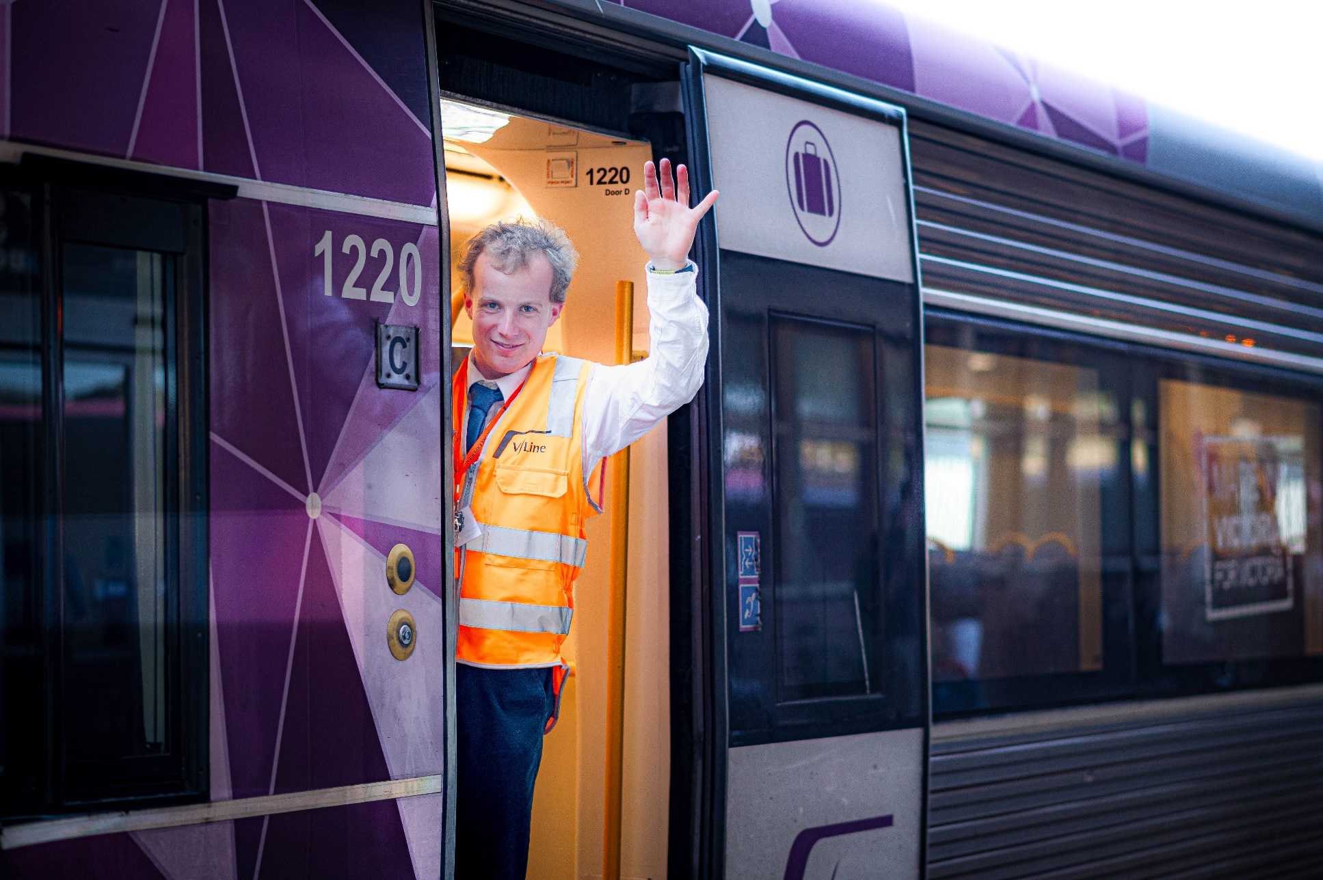

School leaver employment support
Provider reported services
July 2022 to June 2023

Report produced February 2024
Market Innovation & Employment Branch
ndis.gov.au

Henry’s story

NDIS participant Henry John is right where he wants to be, working for Victoria’s largest regional train and bus network.
The 21-year-old, who has autism and who has overcome speech difficulties thanks to NDIS supports, is now working part-time as a Railway Station Assistant.
Much to the train enthusiast’s delight he’s selling tickets, directing and assisting customers on and off trains, making station announcements, and doing other general admin duties.
‘I can’t believe I’m finally working for V/Line. It’s a dream come true. It means I’m one step closer to my long-term employment goal to one day become a conductor,’ Henry said.
To get to this point, Henry used his NDIS employment supports to engage a career mentor from local disability employment provider Connecting Futures Australia.
Henry’s mentor Scott worked with Henry to identify his strengths and skills.
He helped Henry to build his confidence, introducing Henry to young adults with similar interests to grow his friendship groups. He also provided additional support to help Henry become independent and job ready.
‘I wouldn’t be where I am today without the NDIS and Scott’s support. Living with autism is challenging. After leaving school I realised I did need a bit more help than others,’ Henry said.
‘I had a really hard time applying for jobs or finding a job to get me to where I am today.
‘My speech was also a huge barrier, so my mum and stepfather helped me to connect with the NDIS. It meant I could start looking around for employment support and speech therapy.
‘‘My career mentor worked with me one-on-one weekly. He helped me tweak my resume, showed me how to write a good cover letter, and we did mock job interviews. We also worked on some life skills, like budgeting and cooking.’
Henry’s career mentor also supported him through an employment training program called BOUNCE to determine his level of work-readiness. It helped Henry identify some barriers preventing him from achieving his employment goals, and areas he needed to work on.
‘BOUNCE helped to build my confidence. It also helped me to set clear goals about what I wanted to achieve,’ Henry said.
Henry’s career mentor encouraged him to set long and short-term employment goals.
‘My short-term goal was to find a job to help me build my customer service skills and to earn and save some money,’ Henry said.
‘My mentor thought a job at a supermarket would be a good start. He supported me to apply to Woolworths, then helped me prepare for my interview. A few days later I received an email to say I got the job. It felt so good. My parents were really proud of me.’
Working for Woolworths casually, Henry never lost sight of his long-term goal to work for V/Line.
While he did have experience as a railway volunteer, Henry knew he needed to continue to build his customer service skills so he would be well placed to apply for future V/Line roles.
Knowing Henry’s potential and still focused on supporting his long-term goal, Scott worked hard behind the scenes connecting with V/Line to discuss possible work experience.
After lengthy talks and an extensive assessment process Henry was granted a V/Line internship, working at a railway station 2 days a week over 6 weeks.
‘I was so excited. Everyone was so inclusive and supportive. I learnt a lot,’ Henry said.
Scott said Henry made ‘a lasting impression’ on all the staff he worked with.
‘At the end of Henry’s internship, he was presented with a certificate of achievement. It was such a great moment for him. He’s worked so hard. He really deserved it,’ Scott said.
Not long after Henry’s internship finished Henry saw an opening advertised for a local part-time railway service officer. He applied - and the rest is history.
‘I’m working 2 jobs I really enjoy and now I’m truly confident about my future,’ Henry said.

Contents
School leaver employment support 1
Contents 4
1. Executive summary 6
1.1 Introduction 6
1.2 Employment support provider reporting 6
1.3 Report enhancements 6
1.4 Key findings 7
2. Provider and participant count 9
2.1 Provider count 9
2.2 Participant count 10
3. Participant demographics 10
3.1 Employment support recipients 10
3.2 Location 11
3.3 Primary disability 11
3.4 Age 12
3.5 Gender 13
3.6 Aboriginal or Torres Strait Islanders Status 13
3.7 Culturally and Linguistically Diverse status 13
4. Supports & milestones 14
4.1 Support type hours 14
4.2 Support delivery method 15
4.3 Progress towards milestones – snapshot at each reporting period 15
4.4 Progress towards milestones – cumulative for the year 17
5. Final outcomes 19
6. Final employment outcomes 21
6.1 Employment type 21
6.2 Hours worked 22
6.3 Industry of employment 24
6.4 NDIS supports in employment 25
6.5 Supported wages 25
7. Intermediate employment outcomes 26
7.1 Employment outcomes (July 2022 to June 2023) 26
7.2 Employment type 26
7.3 Hours worked 27
7.4 Industry of employment 28
7.5 NDIS supports in employment 29
7.6 Supported wages 29
8. Model summary 30
8.1 Modelling approach 30
8.2 What helps (or hinders) finding paid employment 31
8.3 Differences in modelled predictors between reporting period ending December 2022 versus the period ending June 2023 32
9. Appendix 33
9.1 Appendix 1 – Methodology for the section titled “Progress towards milestones – cumulative for the year” 33
9.2 Appendix 2 – Model accuracy 35

Executive summary

Introduction

The Agency is committed to ensuring participants have the same opportunities to work as other Australians and the confidence, support, and skills to achieve their work goals.

The NDIS can make a significant difference for young participants by supporting them early to aspire to work, develop skills and connect to the right job role and employer.
School leaver employment support is an individualised early intervention support intended to smooth the transition from school to employment by building a young participant’s skills, confidence, and capacity for work.

This fourth edition of the School Leaver Provider Quarterly Report analyses the supports provided to participants, their progress and the outcomes they’ve achieved, allowing us to share insights on best practice and the factors that lead to successful employment outcomes.

Employment support provider reporting

Employment support providers submit data through the provider reporting tool (the tool) to the NDIA each quarter. The data submitted includes participants’ demographic details, activities, progress towards milestones, the method of delivery, outcomes achieved, and employment details. The provider confirms the details they are including, particularly the outcomes achieved, with the participant prior to submitting the report to the NDIA.

This report provides insights on the data submitted through the tool, aggregated across all Providers’ that contributed from July 2022 to June 2023.

Report enhancements
For the purpose of this analysis, we have only included data collected in the past 4 quarters instead of data collected across all quarters from January 2021.

New information has been added to this report at Section 2 ‘Provider and participant count’. From payments claimed during the 2023 financial year, section 2 contains information on the number and size of providers, the number of participants they support and the providers who submitted reporting.

New providers reported on participant activity in Q1 and Q2 2023. The additional number of participants are now included in those quarters' totals. This might result in Q3 and Q4 2022 numbers being slightly different to the same periods published in the third edition of the report for calendar year 2022.

We encourage participants to discuss the available information with providers when considering selecting or changing providers. Additional questions that participants can ask providers about their service are available here.

The report will feature a participant story in each release, like Henry’s, showcasing a positive employment outcome. Participants, or providers with the consent of the participant, are invited to forward stories to participant.employment@ndis.gov.au.

If you have general feedback or questions about this report, please email participant.employment@ndis.gov.au.

Key findings

The information contained in this report represents data submitted to the Agency by providers of school leaver employment supports delivered to participants from July 2022 to June 2023.

As at June 2023, 8,323 young participants aged 15 to 24 either had school leaver employment support included in their active plan or had claimed school leaver employment supports. Out of these, only participants for whom service had been provided, and whose data providers submitted to the Agency are included in this report.

For July 2022 to June 2023, providers report:

Demographics
- 6,553 unique participants received school leaver employment supports of which 2,632 commenced during the year.
- Commencement varies across quarters with the highest number starting in the January to March quarter after leaving school. 608 participants commenced receiving school leaver employment supports in July to September 2022, 643 commenced in October to December 2022, 954 commenced in January to March 2023, and 427 commenced in April to June 2023.
- Participants receiving school leaver employment supports predominantly have autism (56%) or intellectual disability (33%), with 67% being male.
- The majority of employment support recipients are in N S W (37%), followed by V I C (24%), and Q L D (15%).
- 6% of employment support recipients identified as Aboriginal or Torres Strait Islander people. While this is slightly lower than the 8% of all NDIS participants aged 15-24 who identify as Aboriginal or Torres Strait Islander, the last quarter has seen the gap close slightly.
- 7% of employment support recipients identified as being from a Culturally and Linguistically Diverse community. This is slightly higher than the 6% of all NDIS participants aged 15 to 24 who identified as being from these communities.
Time spent in training
- 47% of the training time was spent building participants social, presentation, communication and work skills.
- Participants receive supports via group-based activities (56% of support time), one to one support (43% of support time) and via distance or online methods (2%) in the latest quarter.

Exits from school leaver employment
- 1,548 participants were reported to exit school leaver employment supports during the four quarters.
- Of the 1,548 participants who exited employment supports, 49% of participants exited without an employment outcome compared to 48% in the report of 30 December 2022. 14% went on to further study or volunteer work, 30% achieved open employment outcomes compared to 31% in the report of December 2022, 5% achieved supported employment outcomes (in A D E) which increased 1% from the report of December 2022. 3% did not have an outcome reported.
- Of the participants who achieved open and supported employment outcomes over the four quarters, 41% were employed on a part time basis while 34% were employed casually, 10% were employed full time.
- Of participants who started employment, 81% worked up to 21 hours per week.
- Of participants who finished employment support with paid employment, 67% worked in retail, hospitality, tourism, trades, manufacturing or operations.
- Of participants who started employment, 33% said they will be using NDIS supports in employment to maintain their employment.
- Of participants who finished employment support with paid employment, 20% of employers said they will use supported wages for the participants’ employment.
Interventions compared to outcomes
- More time receiving skill specific training was associated with a higher chance of making significant progress towards, or fully gaining the specific skills.
- Participants who were assisted to get a job by their provider are more likely to gain paid employment.
- Participants where more time was spent in training, in achieving employer engagement and job customisation milestones were more likely to gain paid employment.
- Participants who made significant progress or fully achieved their goals in relation to developing work skills, employer engagement and job customisation milestones were more likely to gain paid employment.
- Participants who fully achieved their work experience milestone goals were more likely to gain paid employment.

Note: Figures in this report have been rounded to the nearest whole percentage.

Provider and participant count

Provider count

Figure 1. Providers represented in reporting – April to June 2023
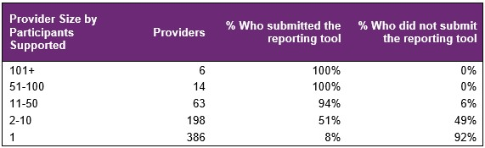

From April to June 2023 (Figure 1), there were 667 providers delivering school leaver employment support across the country, with 20 providers delivering to 51 or more participants. 63 providers delivered services to 11 to 50 participants and 584 providers delivered supports to 10 or fewer participants. The largest 20 providers delivered support to 42% of participants and were able to report on them all during the year. Across all providers, data was submitted for 84% of participants.

For July 2022 to June 2023 (Figure 2), providers who have 10 or fewer participants have lower submission rates. For these providers, the slight decrease in the proportion of providers that submitted data over the 4 quarters was mainly driven by more providers claiming supports overall (larger denominator). Providers with small numbers of participants and those claiming large amounts from participant budgets are now the focus of further investigation.

Figure 2. Percentage of providers who submitted the reporting tool – July 2022 to June 2023

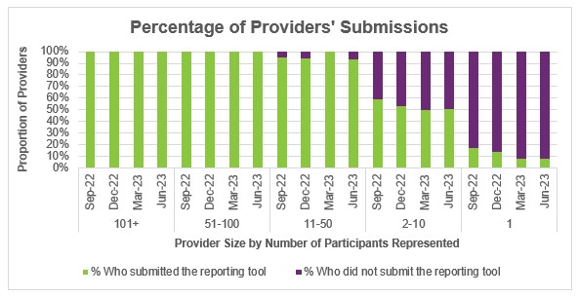

Participant count

Figure 3. Participants represented in reporting – April to June 2023
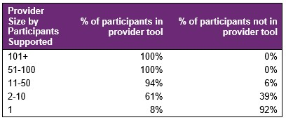

Overall, 16% of participants who received school leaver employment supports in the last quarter were not represented in the reporting submitted by providers. The Agency is investigating potential reasons for this.

Participant demographics

Employment support recipients

The Provider Reporting Tool data provides information on participants receiving employment support during the year. Participants that started employment support during a previous period and continue to be recipients in the current period are included in the ‘Existing’ numbers, and those that started receiving employment support during the current period are included in the ‘New’ numbers. While participants that exited employment support during the current period are included in the ‘Exited’ numbers.

Note, if the participant exits employment support in a quarter, they will be counted in the "Exit" numbers for that quarter. If that same participant re-enters employment support a few quarters later, they will be counted in the "New" numbers again.

Figure 4. Number of participants
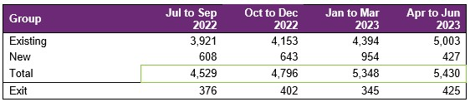
The number of participants receiving employment supports reported by the Provider Reporting Tool (the Tool) has steadily increased over all 4 quarters.

Please note that the number of participants reported in this report for the July to September 2022 quarter and the October to December 2022 quarter differs from the previous third edition report due to late reporting. Participants who were not reported when the report to December 2022 was compiled but were then reported as having received employment support during the July to September 2022 or October to December 2022 quarters are counted as new in those respective quarters in this report.

Location

Figure 5. State or Territory of residence – number of participants
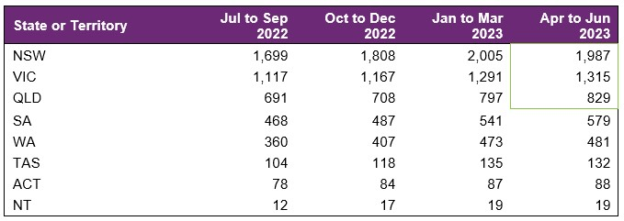

The majority of employment support recipients were in N S W (37%), followed by V I C (24%), and Q L D (15%). For comparison, the top 3 states for all NDIS participants aged 15-24 are
N S W (30%), V I C (24%) and Q L D (21%). The over-representation in N S W is partly due to the earlier roll out to full scheme in that state and the influence of the legacy N S W Transition to Work program which involved transition teachers helping students to consider post school options and connecting many with employment providers.

Primary disability

Figure 6. Primary disability – number of participants

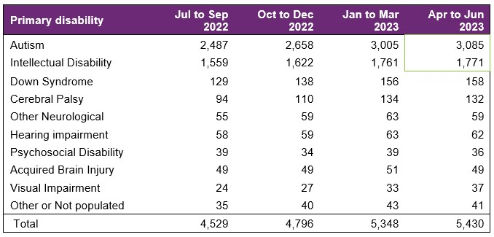

The top primary disabilities experienced by participants utilising these supports were autism (57%), followed by intellectual disability (33%). For comparison, 58% and 23% of all NDIS participants aged 15-24 report having autism and intellectual disability, respectively.

Age

Figure 7. Age – percentage of participants
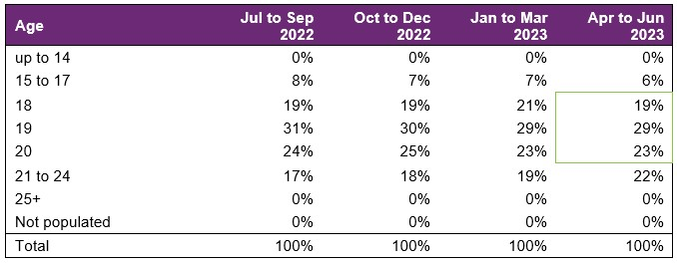

Participants aged 18 to 20 accounted for 71% of employment support recipients. Recipients aged 21 to 24 has steadily grown in proportion over the financial year.

Gender

Figure 8. Gender – percentage of participants
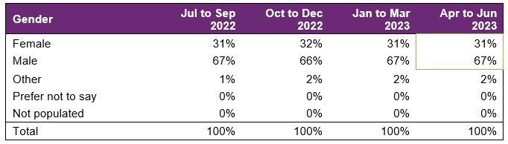

In the most recent period, employment support recipients were 31% female and 67% male. In comparison to all NDIS participants aged 15 to 24, 35% were female and 64% were male. This is in line with the high proportion of employment supports recipients reporting autism as the primary disability, as the majority of participants who report autism are males.

Aboriginal or Torres Strait Islanders Status

Figure 9. Aboriginal and Torres Strait Islanders – percentage of participants
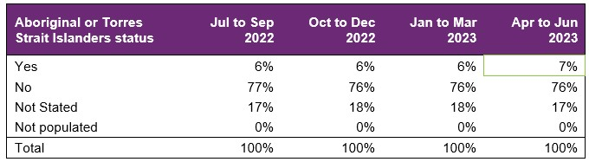

In the most recent period, 7% of employment support recipients identified as Aboriginal or Torres Strait Islander people. This is slightly lower than the 8% of all NDIS participants aged 15-24 who identified as Aboriginal or Torres Strait Islander.

Culturally and Linguistically Diverse status

Figure 10. Culturally and linguistically diverse – percentage of participants
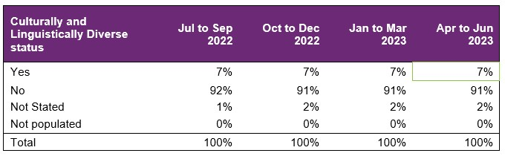

In the most recent period, around 7% of employment support recipients identified as being from a Culturally and Linguistically Diverse community. This is slightly higher than the 6% of all NDIS participants aged 15 to 24 who identified as being from a Culturally and Linguistically Diverse community.

Supports & milestones

Support type hours

Figure 11. Support type provided – percentage of average hours per participant
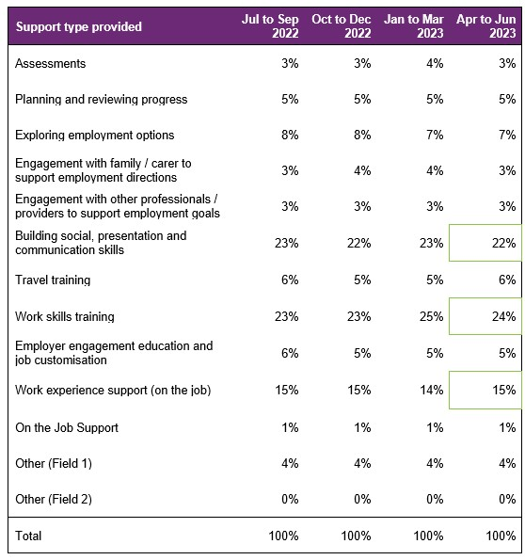

Almost half (47%) of the training time was spent building the participant’s social, presentation, communication, and work skills. The amount of time dedicated to work experience support (on the job) has been steady and accounted for 15% of the total training time. From a separate analysis (NDIS Outcomes Framework Employment Deep Dive 31 December 2020), gaining work experience was listed as one of the top supports participants think will help them gain employment.

Support delivery method

Figure 12. Delivery method – percentage of hours
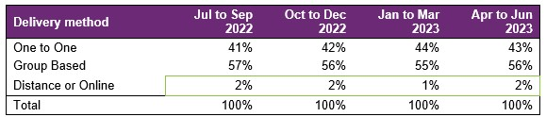

Participants have been excluded from this section where the sum of One to One, Group based, Distance or Online percentages did not equal 100%.

The percentage of one to one support has slightly increased over the period, at the expense of group based support.

Progress towards milestones – snapshot at each reporting period

This section looks at the distribution of progress for participants who worked on a particular milestone (where there are training hours reported for that specific skill), for each reporting period in isolation (non-cumulative).

Social, presentation and communication skill

Figure 13. Social, presentation and communication skill milestone – percentage of participant progress
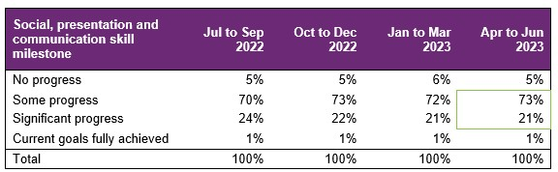

For participants who worked on this specific milestone, 73% reported some progress and 21% reported significant progress. There was a decrease in those who achieved significant progress over the 4 quarters (from 24% to 21%).

Travel skill

Figure 14. Travel skill milestone – percentage of participant progress
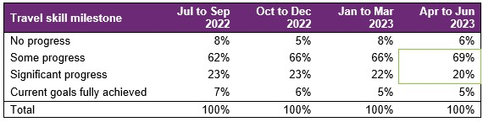

For participants who worked on this specific milestone, 69% reported some progress and 20% reported significant progress.

Work skill

Figure 15. Work skill milestone – percentage of participant progress
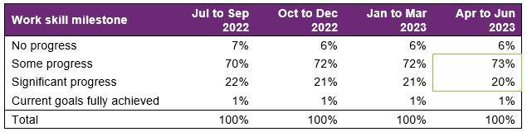

For participants who worked on this specific milestone, 73% reported some progress and 20% reported significant progress. Percentages have remained consistent over the 4 quarters.

Employer engagement, education, and job customization

Figure 16. Employer engagement, education, and job customisation milestone – percentage of participant progress
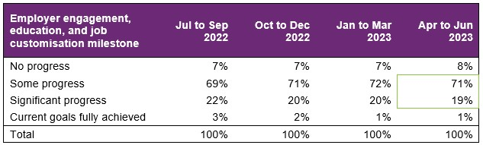

Providers who reported activities as “engaging with employers, educating and customising jobs” for participants reported that 71% made some progress and 19% made significant progress.

The percentage of participants showing significant progress or have current goals fully achieved has slightly decreased over the 4 quarters.

Work experience

Figure 17. Work experience milestone – percentage of participant progress
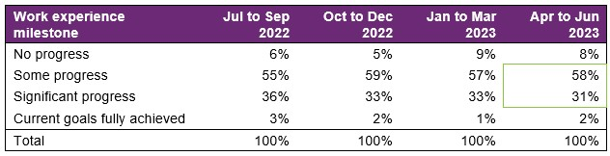

Of the participants engaging in work experience in the most recent quarter, 58% were reported as making some progress, and 31% were reported as making significant progress.

Of those who engaged in work experience, there was a decrease in those who achieved significant progress over the 4 quarters. As work experience is strongly associated with achieving an employment outcome, NDIA will carefully monitor support provided and progress achieved against this milestone.

Progress towards milestones – cumulative for the year

The following sections show that more time receiving supports or training is associated with better progress towards mastering specific skills. For each participant, the best progress (across 4 quarters) towards mastering the specific skills is used for this analysis, and compared against the cumulative time receiving employment supports, and training for the specific skills.

Appendix 1 includes more detail on the methodology used in this section.

Social, presentation and communication skill

Figure 18. Social, presentation and communication skill milestone – percentage of participant progress
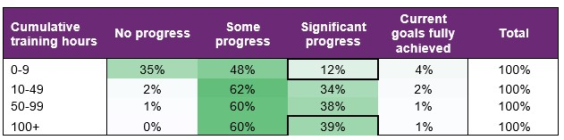

Of the participants who received up to 9 hours of training on social, presentation, and communication skills, around 12% were able to make significant progress towards mastering these skills. The proportion of participants making significant progress increased to 39% for those who received 100+ hours of the skill-specific training.

Travel skill

Figure 19. Travel skill milestone – percentage of participant progress
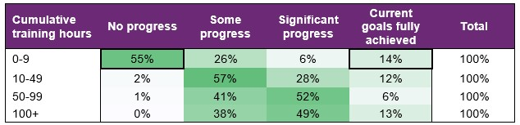

While 14% participants were able to fully achieve their goal within 0-9 hours of training, more than half (55%) did not make any progress. This suggests that for some participants, travel skills may be a primary area of focus and that they need only a few hours of personalised support to fully achieve their goals, while others need more than 10 hours of training to start making progress towards their goals.

Work skill

Figure 20. Work skill milestone – percentage of participant progress
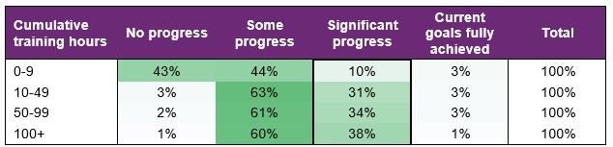

Attaining significant progress in work skills was achieved through more cumulative hours of training demonstrating the need for tailoring this support for the individual.

Employer engagement, education, and job customization

Figure 21. Employer engagement, education, and job customisation milestone – percentage of participant progress
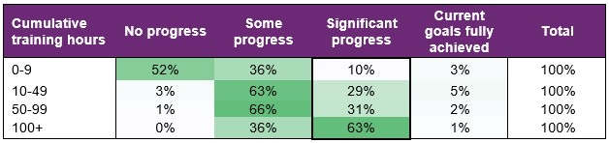

Making significant progress towards employer engagement, education, and job customisation milestones increased markedly with more hours spent on these activities.

Work experience

Figure 22. Work experience milestone – percentage of participant progress
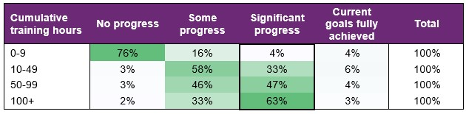

Similarly, making significant progress towards work experience milestones increased markedly after more than 100 hours of training.

Final outcomes

This section shows the distribution of outcomes upon exiting employment support (based on the employment support reported end/exit date).

Figure 23. Final outcomes (upon exiting employment support) – number of participants
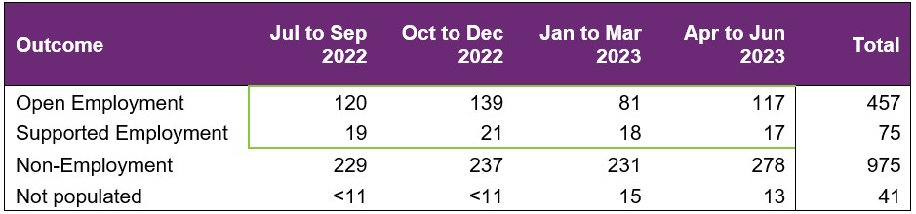

The number of participants finishing employment supports with open or supported employment was lower in the 2 most recent quarters. These tend to be seasonally low quarters, as seen in previous versions of this report.

From July 2022 to June 2023, 532 participants finished employment support with open or supported employment.

Figure 24. Final outcomes (upon exiting employment support) – percentage of participants
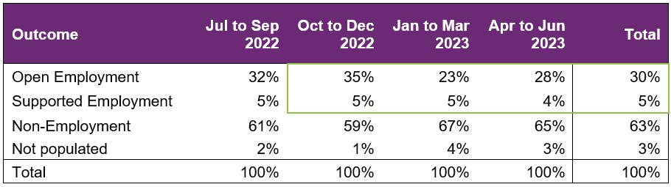

The last 2 quarters are seasonally low quarters for open or supported final employment outcomes and this is reflected in the percentages.

The period of reporting may have contributed to the lower annual rate for employment outcomes of 30% for the year to June 2023, compared to 31% for the year to December 2022.

The following table provides a more granular breakdown of outcomes for participants who exited employment supports from July 2022 to June 2023.

Figure 25. Final outcomes breakdown – percentage and total number of participants:
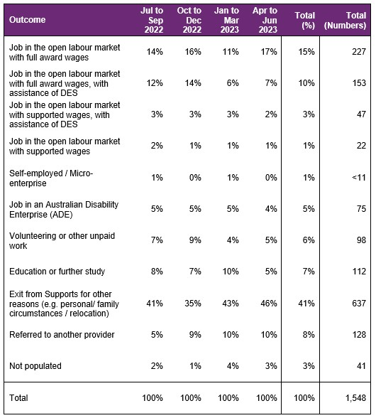

The absolute numbers (non-percentages) have been shown as a total only in the above table (not broken down into individual quarters) due to low volumes in the individual quarter. Individual quarter absolute numbers will be shown once there is sufficient volume.

For participants whose final outcome is Exit from Supports for other reasons, the common reasons reported were:
- personal or family circumstances,
- relocated,
- not engaging or contactable,
- school leaver employment supports funding ended,
- transferred to D E S or another provider,
- not a good fit or ready for employment preparation.

Open employment outcomes comprise of:
- jobs in the open labour market, with full award or supported wages, with or without the assistance of Disability Employment Services (D E S )
- or Self-employment/Micro-enterprise.

A job in an Australian Disability Enterprise (A D E) is classified as Supported Employment. The other categories in the chart above are classified as non-Employment outcomes.

Figure 26. Final outcomes breakdown – participants in open and supported employment, by primary disability – percentage:
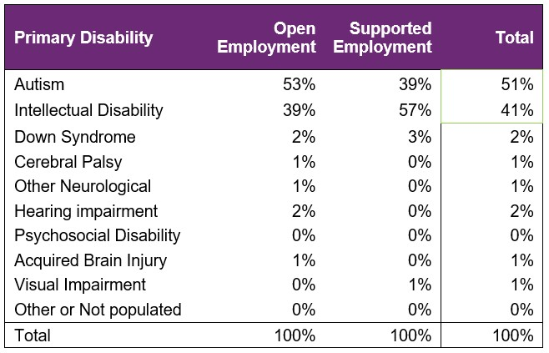

Primary disability of autism seems to be slightly underrepresented when comparing participants who finished employment supports (51%), versus participants who received employment supports from July 2022 to June 2023 (57% from Section 3.3).

On the other hand, primary disability of Intellectual Disability seems to be over-represented (41% finished versus 33% received).

Final employment outcomes

Employment type

Figure 27. Employment type – number of participants

From July 2022 to June 2023, of participants who finished employment support with paid employment, 183 gained casual work while 217 gained part-time work.

Figure 28. Employment type – percentage of participants
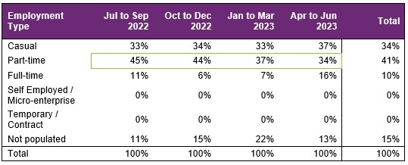

From July 2022 to June 2023, of participants who finished employment support with paid employment, 34% gained casual work while 41% gained part-time work and 10% gained full-time work.

In the report from January to December 2022, the proportion of casual work was 36%, part-time work was 43%, and full-time work was 7%. So a shift towards full-time employment and away from casual and part-time work is being seen.

Hours worked

Figure 29. Hours worked per week – percentage of participants
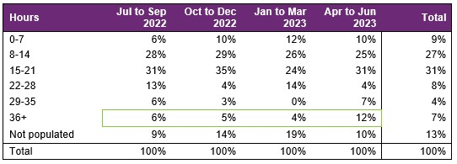

From July 2022 to June 2023, of participants who finished employment support with paid employment, there has been an increase in those who worked 36+ hours per week. This is consistent with the increase in full-time employment as mentioned previously.

67% of participants who finished employment support with paid employment worked up to 21 hours per week.

Industry of employment

Figure 30. Industry of employment – percentage of participants
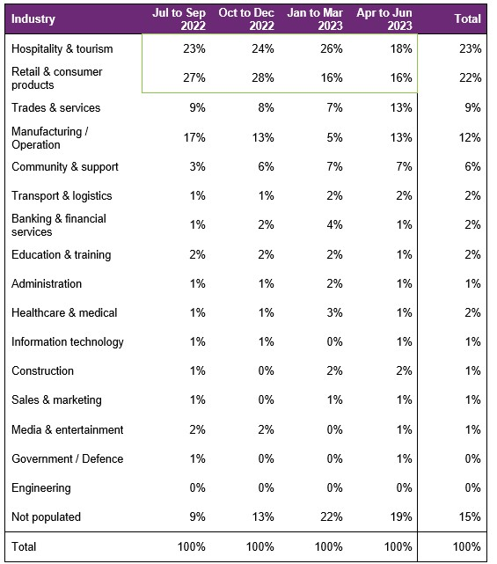

The percentage of participants who worked in Hospitality and tourism dropped in the most recent quarter, while the percentage of participants working in Retail and consumer products dropped in the last two quarters. Both are still the top two industries for participants to be employed in over the last four quarters.

From July to June 2023, of participants who finished employment support with paid employment, 67% work in Hospitality, Tourism, Retail, Trades, Manufacturing, or Operation.

NDIS supports in employment

Figure 31. Will the participant be utilising NDIS supports in employment? – percentage of participants
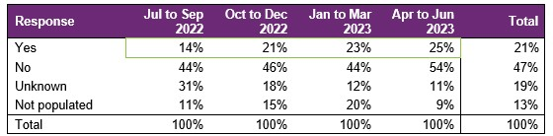

The percentage of participants that will be utilising NDIS supports in employment has been increasing, after the low in July to September 2022.

For the year, providers reported 21% of participants who finished employment support with paid employment will be using NDIS supports in employment to maintain their employment.

Supported wages

Figure 32. Will the participant receive a wage determined under the supported wage system? - Percentage of participants
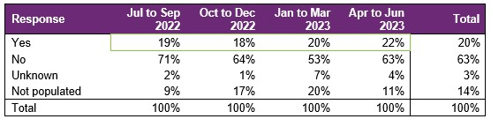

Of participants who finished employment support with paid employment, the percentage who were reported to receive a wage determined under the Supported Wage System (S W S) has slightly increased.
Over the 12 months, 20% of participants who commenced paid employment receive a wage determined under the S W S .

Intermediate employment outcomes

This section contains the employment features for all the participants who commenced employment from July 2022 to June 2023. The participants may or may not have exited employment support. Participants with Employment Type "Work Experience" are excluded.

Employment outcomes (July 2022 to June 2023)
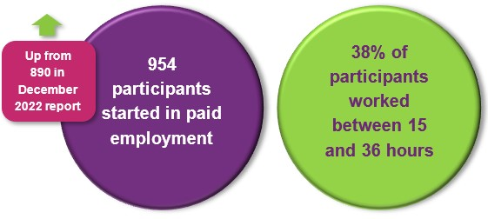
The top 4 industries in which participants started employment were Retail, Hospitality/Tourism, Trades/Services and Manufacturing/Operations.

Employment type

Figure 33. Employment type – number of participants
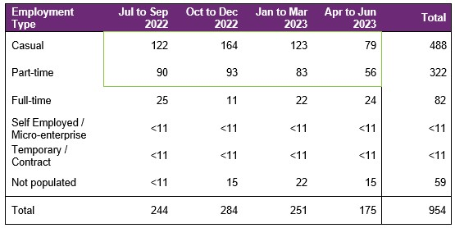

The number of participants commencing casual and part-time employment generally remained steady across the four quarters, apart from the seasonal drop in the most recent quarter.

A total of 954 participants were reported to have commenced employment from July to June 2023. During this period, 488 started casual work while 322 started part-time work.

Figure 34. Employment type – percentage of participants
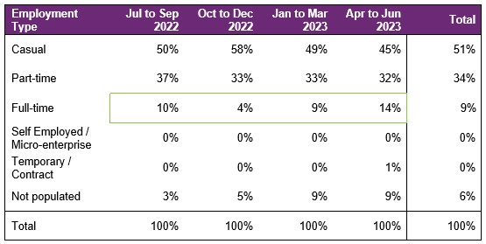

The percentage of participants who started full-time work generally increased, totalling 9% for the 4 quarters (versus 7% in December 2022 report).

From July to June 2023, of participants who started employment, 51% started casual work, while 34% started part-time work.

Hours worked

Figure 35. Hours worked per week – percentage of participants
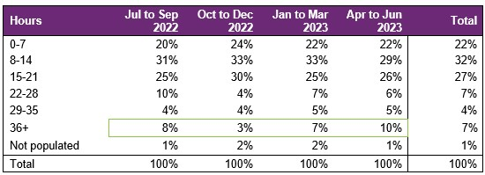

The percentage of those working 36+ hours has generally increased over the 4 quarters, in line with the increase in proportion of full-time work.

From July 2022 to June 2023, of participants who started employment, 81% worked up to 21 hours per week.

Industry of employment

Figure 36. Industry of employment – percentage of participants
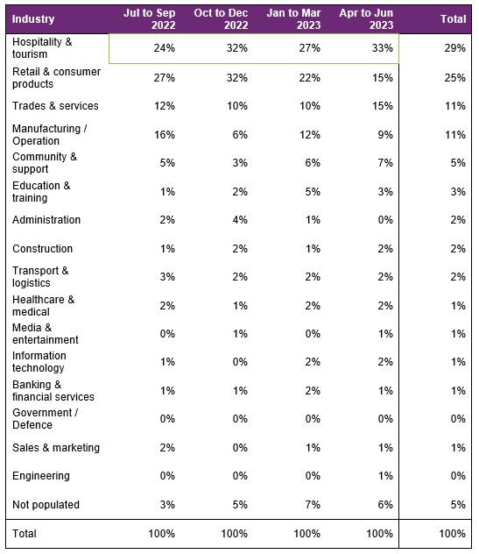

The percentage who worked in hospitality and tourism fluctuated across the four quarters, and there was a decrease in the percentage who worked in retail and consumer products in the two most recent quarters.
From July 2022 to June 2023, of participants who started employment, 75% worked in Hospitality, Tourism, Retail, Trades, Manufacturing or Operation.

NDIS supports in employment

Figure 37. Will the participant be utilising NDIS supports in employment? – percentage of participants
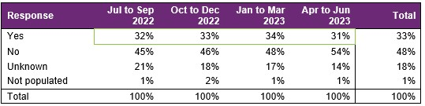

From July 2022 to June 2023, of participants who started employment, providers report 33% will be using NDIS supports in employment to maintain their employment.

The last quarter saw a decrease in this percentage.

Supported wages

Figure 38. Will the participant receive a wage determined under the supported wage system? - Percentage of participants
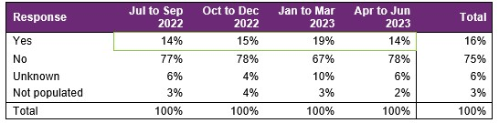

This percentage has been relatively flat apart from the spike in the 3rd quarter.

For the year, providers report 16% of the participants who started employment will receive a wage determined under the Supported Wage System (S W S).

Model summary

Modelling approach
A model was built to predict successful employment outcomes, defined as any of the following:
- Job in the open labour market, with full award or supported wages, with or without the assistance of Disability Employment Services (D E S)
- Self-employed / Micro-enterprise
- Supported employment.
The modelling dataset is sourced from the Provider Reporting Tool and NDIA’s own participant data, with the former containing outcomes and support hours and the latter containing characteristics such as Culturally and Linguistically Diverse Status and education activities.
In addition, Socio-Economic Indexes for Areas (S E I F A) data was attached to the modelling dataset, mapping to the 2021 LGA. Note that some LGA names in the Provider Tool were updated to the 2021 LGA due to changes in LGA boundaries between 2016-2021.
Using 3 statistical techniques – Gradient Boosting Machine (GBM), Least Absolute Shrinkage and Selection Operator (L A S S O) and Random Forest – we determine the significant predictors of employment success. Ranked in order from most to least important, the significant predictors are:
- Progress made towards achieving employer engagement and job customisation milestone
- Progress made towards achieving work skills milestones
- Progress made towards achieving work experience support milestones
- Housing arrangement
- Whether a participant is assisted to get a job
A Generalised Linear Model was then constructed using the above significant variables.
Appendix 2 has more details on the accuracy of the model.

What helps (or hinders) finding paid employment
Figure 40. Variables that help or hinder finding paid employment – for the model covering period ending in June 2023
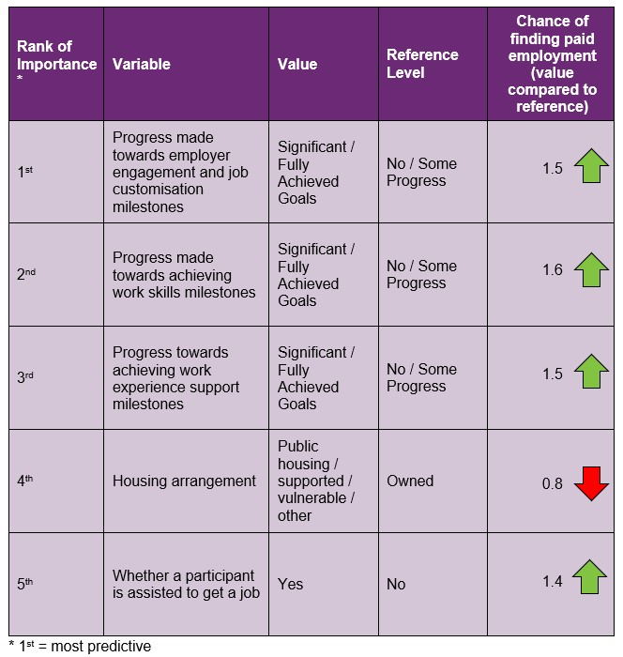

How to interpret the above table:
- Participants who made significant progress towards or fully achieved their employer engagement, education, and job customisation milestones were 1.5 times as likely to find employment compared to participants who made no or some progress towards similar milestones.
- Participants who were assisted to get a job are 1.4 times as likely to find employment compared to participants who were not assisted to get a job.

Differences in modelled predictors between reporting period ending December 2022 versus the period ending June 2023
The following table summarises the differences in significant variables selected in the model covering the period ending in December 2022, versus the model covering the period ending in June 2023.

Figure 41. Differences in significant predictors

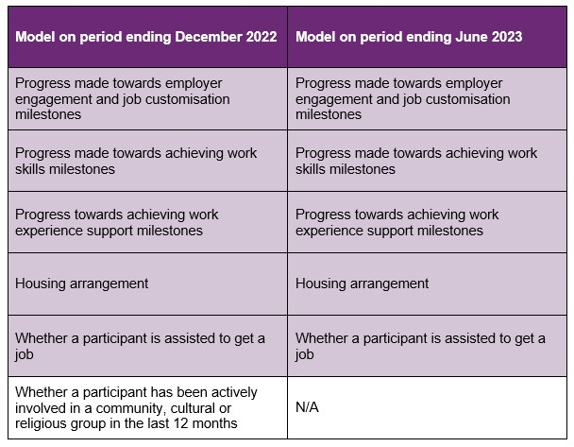

As shown above, the predictor “Whether a participant has been actively involved in a community, cultural or religious group in the last 12 months” was significant in the model covering the period ending December 2022, but no longer significant in the model covering the period ending June 2023.

The main reason for this is the additional data used in the more recent period ending June 2023. The modelling insights from the period ending June 2023 data are based on 1,504 observations, which is more than the 1,124 observations used to model the period ending in December 2022. These additional observations have led to a slight change in significant predictors although most have stayed the same.

Appendix

Appendix 1 – Methodology for the section titled “Progress towards milestones – cumulative for the year”
This Appendix provides more details on how to interpret the section titled “Progress towards milestones – cumulative for the year,” and the methodology used.
How to interpret the table below

Work experience milestone – percentage of participant progress
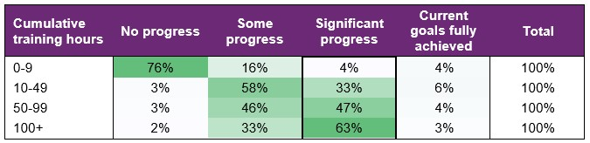

Out of all participants who have received 100+ hours of on-the-job work experience support (cumulative for the year)
- 2% have "No progress" as the best result for the year.
- 33% have "Some progress" as the best result for the year.
- 63% have "Significant progress" as the best result for the year.
- 3% have "Current goals fully achieved" as the best result for the year.
The sum of each row in the above table equals 100%.

Methodology (for cumulative training hours)
The starting universe is all participants reported in the Provider Reporting Tool across the 4 quarters. For each participant, the "cumulative training hours" is then calculated as the total of the milestone-specific training hours reported in the Provider Tool for the 4 quarters. The best progress for the specific milestone is used (of all progress entries reported in the Provider Reporting Tool across the 4 quarters).
For example, if for participant John Smith, below are the progresses and hours reported across the 4 quarters.
Work experience support (on the job)
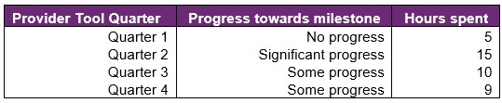
then "cumulative training hours" = 39 = 5 + 15 + 10 + 9 and the progress selected for John is "Significant progress" (the best progress of the 4 quarters). The "cumulative training hours" is then rounded down to the nearest whole number (e.g., 6.75 is rounded down to 6), and grouped into bands. Then for each cumulative training hours group (e.g., 0-9), the percentage of participants in each (best) progress category is calculated so that the sum of the row is 100%.

Appendix 2 – Model accuracy

The generalised linear model presented in Section 8 has the following accuracy:
Figure 42. Model accuracy – Gini and AUC
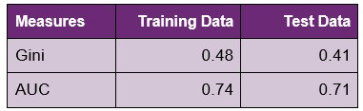
The closer the test set AUC and Gini is to 1, the better the model performance.
The Test Data AUC (and Gini) is typically smaller than the Training Data AUC (and Gini). This is because the model was built on the Training Data, hence predicts more accurately on it. The Test Data Gini and AUC however, give an indication of the model prediction accuracy when the model predicts on unseen data (on which it was not built).
Figure 43. Model accuracy – receiver operating curve
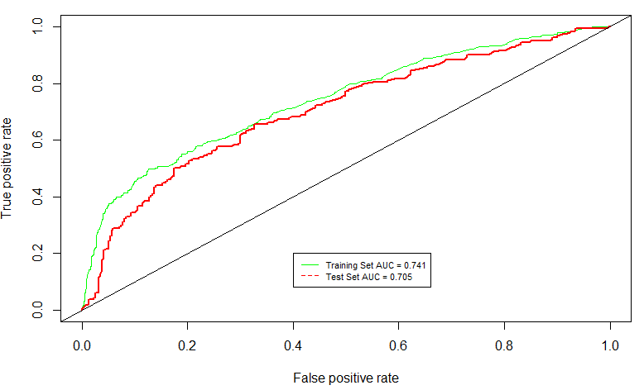

Figure 44. Model accuracy – actual versus predicted

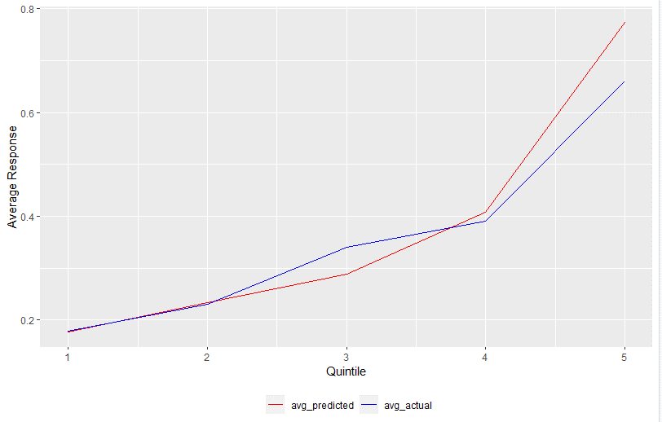

The model predicted probability (red) curve is close to the actual outcome (blue) curve, indicating that the model is able to accurately predict the probability of recipients finding paid employment.

Source: Australian Bureau of Statistics. For further information: Socio-Economic Indexes for Areas (SEIFA): Technical Paper, 2021 | Australian Bureau of Statistics (abs.gov.au) Link to the data: Socio-Economic Indexes for Areas (SEIFA), Australia, 2021 | Australian Bureau of Statistics (abs.gov.au) - Local Government Area, SA1 Distributions, SEIFA 2021.xlsx

