About the Research and Evaluation Branch
The Research and Evaluation Branch is responsible for ensuring that National Disability Insurance Agency (NDIA) policies, practices and priorities are informed by trustworthy and robust evidence so decisions can be based on an understanding of what works, what doesn’t and the benefit to participants and the Agency.

This document
This report summarises the findings of an online survey asking participants, families and their carers about their experiences interacting with the National Disability Insurance Scheme (NDIS) during the COVID-19 pandemic.

Disclaimer
The NDIA accepts no responsibility for the accuracy or completeness of any material contained in this report. Further, the NDIA disclaims all liability to any person in respect of anything, and of the consequences of anything, done or omitted to be done by any such person in reliance, whether wholly or partly, upon any information presented in this report.
Material in this report is made available on the understanding that the NDIA is not providing professional advice. Before relying on any of the material in this report, users should obtain appropriate professional advice.
Views and recommendations of third parties, which may also be included in this report, do not necessarily reflect the views of the NDIA, or indicate a commitment to a particular course of action.

Citation
Morello R, Smith L, Lawford B, Hinman, R and Bennell K (2021), Participant Experiences with NDIS Services During COVID-19 pandemic (Part 1). National Disability Insurance Agency, Australian Government and the University of Melbourne, Australia.
Enquiries about this publication should be addressed to:
National Disability Insurance Agency
Email: research@ndis.gov.au

Acknowledgements
The NDIA acknowledges the Traditional Owners and Custodians throughout Australia and their continuing connection to the many lands, seas and communities. The NDIA pays respect to Elders past and present, and extends this acknowledgement and respect to any Aboriginal and Torres Strait Islander people who may be reading this Report.
The Research and Evaluation Branch, would like to gratefully acknowledge the NDIS participants, carers, and family members who participated and shared their experiences.
This research was supported by funding from the Melbourne Disability Institute of the University of Melbourne. The NDIA gratefully acknowledges the University of Melbourne researchers on this project Professor Kim Bennell, Professor Rana Hinman and Professor Alicia Spittle, who are National Health and Medical Research Council Fellowships.

Why we did the research
COVID-19 has brought significant disruption to the way NDIS and disability support services were offered. From March 2020, as part of a whole of government response to slowing the spread of COVID-19, the National Disability Insurance Agency (NDIA) made a number of changes to assist our NDIS participants stay safe and to ensure they were able to continue to access their essential services and supports. Some of these changes included:
- Offering phone or internet based video conferencing options for planning consultations (for both first and review plans).
- Offering the extensions of current plans (up to 24 months) to make sure participants were able to continue to access their funding to get the supports they needed.
- Increasing the number of delegates in the contact centre to help respond to the significant changes of many of participants.
- Reaching out to high-risk participants to ensure they have the essential support they required during lock down.
- Providing access low cost assistive technology to help participants transition to remotely delivered to ensure the continuity of NDIS funded supports (e.g. therapy).
The purpose of this research project was to give participants, their families and carers a chance to share their experience interacting with the NDIS during the COVID-19 pandemic. We also wanted to understand how participants found using remotely delivered services to access NDIS funded supports (such as allied health and therapy).

About the research project
- We partnered with The University of Melbourne on this research.
- The research involved a national online survey between 25th June 2020 and 31st August 2020.
- The survey had 2 parts:
  - Part 1 was about experiences interacting with the NDIS
  - Part 2 was about experiences using remotely delivered services to access allied healthcare
- The survey was advertised on the NDIA website, through Peak Bodies and other organisations, and social media
- The Melbourne Disability Institute funded the research
- The University of Melbourne provided ethics approval
The information in this report is about part 1 of the survey. It tells you what we found and what we are doing with this information.

Who took part?
- 2,391 NDIS participants, family members or carers completed the survey.
- 52% respondents were female, 46% were male and 2% chose ‘other’ or preferred not to answer.
- 41% were NDIS participants and 59% were family members, carers or supporters who completed the survey on behalf of the participant.
- They lived in metropolitan (62%), regional (36%), and remote (2%) areas of Australia.
- 29% were aged 0-18 years, 32% 19-44 years and 29% 45+ years.
- A range of disabilities were represented including: 28% autism, 11% intellectual disability and 8% psychosocial disability.
- NDIS participants from all states and territories filled in the survey (Figure 1).
Figure 1: NDIS participant state of residence
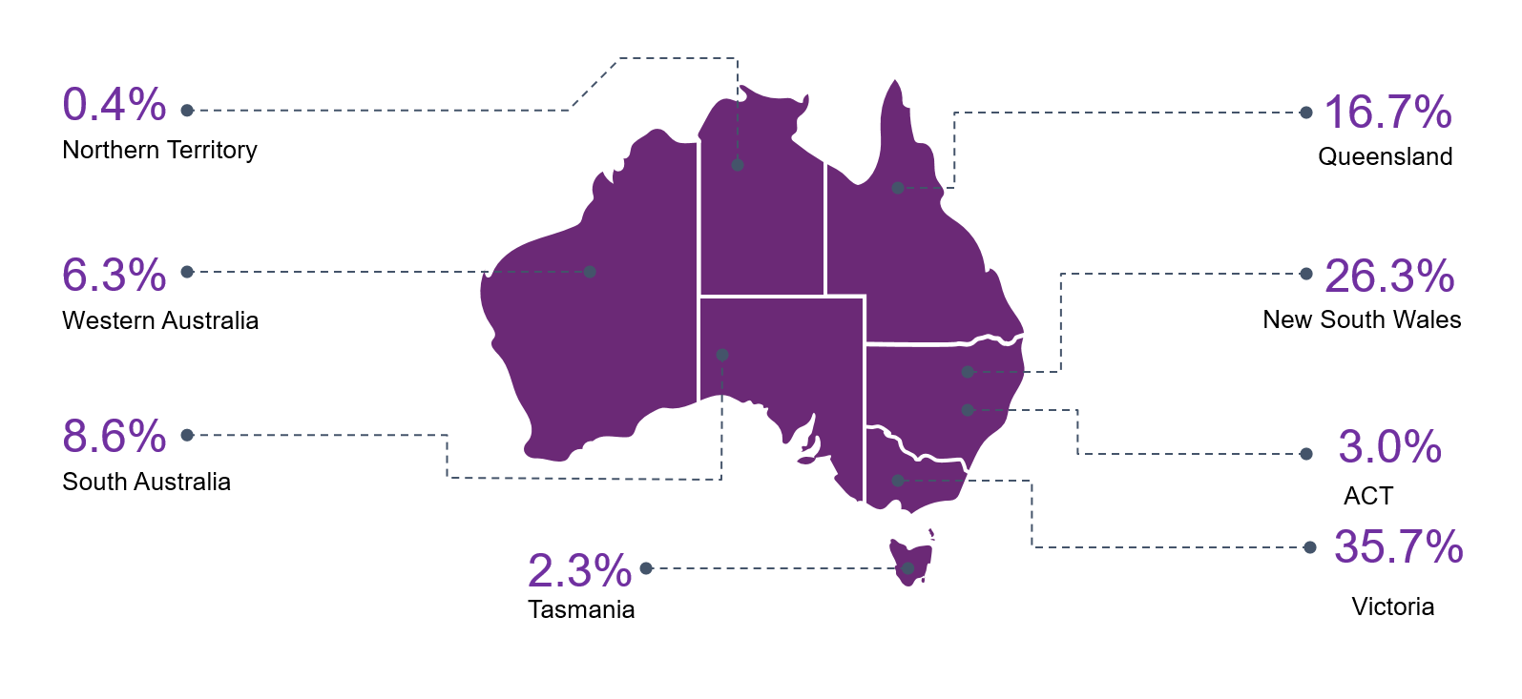

Research findings

What we found: Contact with the NDIS
60% of survey respondents (n=1,447) said they had contact with the NDIS during the pandemic, of those 70% (n=1013) had contact either via email or telephone.

What we found: Plan reviews via technology
We asked participants about their experiences having plan reviews using technology such as phones and video (over the internet).
530 participants had a plan review during the pandemic. 78% had their plan reviews via the phone or video (Figure 2).
- 76% were happy or indifferent about having their plan review by phone or video.
- 77% were happy or indifferent with the explanation NDIA staff gave about the plan review process.
- 74% found using the telephone or video for their plan review acceptable in terms of ease. Around a quarter found it difficult (26%).
- 71% were acceptably comfortable communicating with an NDIS staff member over the phone or video.
- Most (91%) were happy with the privacy and security of their plan review meeting by phone or video.
Overall 2 in 3 participants felt that their recent experience was better or the same as their previous face-to-face meetings.
Nearly half of participants (45%) said they would likely choose a plan review by phone or video (over the internet) in the future.
Figure 2: Participant experiences with plan reviews via technology

What we found: Plan extensions
237 participants were offered a plan renewal during the pandemic.
- 82% of those offered a plan extension were happy or indifferent with their contact with the NDIS during the COVID-19 lockdown
- Most (79%) said they would like the option for plan extensions to continue in the future.

What we found: Advantages and disadvantage to plan reviews using technology
Three quarters of participants (320) reported at least one advantage to plan reviews using technology.
The most commonly cited advantages of having a plan review by telephone or internet were:
- convenience (63% of respondents),
- accessibility (33%) and
- safety (21%).
The most commonly cited disadvantages of having a plan review by telephone or internet were:
- the lack of visual contact (53% of respondents),
- the inability to see and share materials, reports and/or paperwork (49%),
- difficulty communicating (31%), and
- not having enough time to fully explain their situation (30%).
- 21% of respondents (88) said there were no disadvantages.

What we found: Use of NDIS funded supports
We asked participants if, on average, they used their supports more or less during COVID-19 (Figure 3). Participants accessed some supports more during COVID-19 and others less.
- On average assistive technology (45%) and consumables (37%) were more accessed more during COVID-19 than before.
- Participants reported accessing social and community participant supports (60%), transport (55%) and improved daily living skills (41%) less.
Most participants felt overall it was harder to get services or supports during the COVID-19 pandemic.
Analysis of open-text responses to the question “What were the reasons that is was harder for you to access these services during the COVID-19 pandemic?” identified the following reasons (these are ordered according to most mentioned reason):
- Services were closed or reduced due to physical distancing restrictions
- Providers weren’t offering in-person services and participants were unable or unwilling to transition to remote service delivery
- There was a greater demand for some services such as support workers willing to provider in-person care
- Participants didn’t want to risk their health with in-person supports
- Partcipants were unable to or unwilling due to difficulties with accessing and using technology
- Reduction of transport options
- Providers not taking on new participants
Figure 3: Participant experiences with accessing supports during COVID-19 lock down

What we found: Challenges and benefits of COVID-19 restrictions
To supplement this research, and as part of another research project, we interviewed some 80+ participants to better understand some of their experiences during this time. They told us some providers closed or suspended services, which left them without support during the pandemic, while others, charged more. Some participants also reported challenges with maintaining regular services due to COVID itself.
Half of my supports were by phone, which is exhausting. So I have cancelled some of them. And then every second week it’s cancelled because I get a COVID test or they get a COVID test. And then I can’t really do any exercise, which is mainly what I wanted to use my plan for, because most of that’s closed. (Harrison, aged 33, NDIS participant)
A number of participants also reported some benefits that have come out of COVID:
- Reduced social expectations: Some NDIS participants have welcomed the reduced expectation to participate in social activities such as social skills groups (while parents worrying about this)
- Online communities: more access to some participants to services that previously difficult to access.
- Increased time to spend with an individual to build their capacity.
- New connections: Opportunity to develop new connections and broadening perspectives of what a community is, i.e., virtual communities
A number of training that would have previously been face-to-face in Sydney or Melbourne, that I wouldn't have been able to attend, they've been online, so they've been advertised a bit wider in networks. So, I've been able to just join online. (Shannon, aged 38 years, NDIS participant)
I could get telehealth so things were better because all this stuff come about like Zoom and telehealth and all these things we really could have been using for the last decade and a half. Because all of a sudden it was affecting everyone they were suddenly available so in a lot of ways it got better… Because our condition is really rare finding a GP that knows anything about it is next to impossible. Getting there and getting back to our GP, it’s like a full day for us. By the time I’ve done the travel and I’ve done the appointment and everything I’m so exhausted when I come back. Yeah, just being able to have a 15 minute phone call and say hey I need a script it’s been fantastic. (Felicia, aged 42, NDIS participant)

What do the findings mean?
Participants told us they:
- Were mostly happy about their contact with the NDIS during the COVID-19 pandemic.
- Mostly found it easy to do plan review meetings on video or phone.
- Wanted the option to use phones and video technology to do plan reviews in the future.
- Thought that using technology for plan reviews was convenient and accessible, but that it was difficult sharing materials.
- Wanted the option to extend plans to two years in the future.
- Some supports were used more during the COVID-19 pandemic. These included assistive technology, consumables, and support coordination.
- Some supports were used less during the COVID-19 pandemic. These included assistance with social and community participation and transport.
- Like many Australians, participants found it harder to get services or supports during the COVID-19 pandemic. This was because, like mainstream service, many disability support services were closed, were working at a reduced capacity, focused on supports directed to participant safety (e.g. personal care supports) or were unable to provide in-person services due to the COVID 19 restrictions or availability of staff.

What we plan to do next
Part 2 of this survey asked participants about their experiences using telephone and video for NDIS funded allied health supports. Findings from Part 2 of the survey is available on the University of Melbourne website.

What the NDIS is doing with these findings
2020 was a year of unprecedented challenges, particularly for people in the disability community. Like the rest of Australia, the National Disability Insurance Scheme (NDIS) had to quickly adapt to sustain our community through this very stressful time. Our immediate response was to ensure we could help participants, their families and carers, with urgent needs as the pandemic unfolded and during the initial lockdown. We supported participants as they navigated the constant changes and restrictions to their daily lives, while making sure staff, partners and providers kept delivering essential services.
With these changes and this research we have learnt much about the NDIS and how to better support participants and providers during emergency responses. We are also using this data to help support decisions we make around what COVID related initiatives we will keep for the future and our proposed reforms to the NDIS planning processes, which aim to further enhance participant choice and control.
Some of the changes we made during the pandemic have become part of our ongoing, every day practice. This includes participant check-ins and continuing with the flexible approach to reviewing NDIS plans so plan review meetings can be held face-to-face, over the phone, or even via a video call if available at a convenient time. Participants are able to request plan durations of up to three (3) years. For more information about these new changes visit our website. For those participants that had negative experiences we are working on ways to improve these experiences for the future if needed.
Like many Australians, NDIS participants found it difficult to access some non-essential services during the COVID-19 restrictions. Due to the continuing risk of COVID-19 in the Australian community, we have extended some of the support measures and mechanisms in place to help providers and participants safely deliver and receive supports as we adjust to ‘COVID normal’. In addition, we have been working with other government agencies and states and territories to ensure State emergency plans are more inclusive of people with disability and to share and discuss initiatives to help respond to issues in the future.

