Cultural and Linguistic Diversity Strategy

Progress Update
July 2021
ndis.gov.au

Contents

1. Introduction 1
2. CALD participant experience and outcomes 2
3. What we’ve done so far 5
4. Priority actions 8

Introduction
The Cultural and Linguistic Diversity Strategy (Strategy) details the National Disability Insurance Agency’s (the Agency or NDIA) approach to working with people from culturally and linguistically diverse (CALD) backgrounds. It is the Agency’s commitment to give people with disability from CALD backgrounds the opportunity to benefit from the National Disability Insurance Scheme (NDIS) on an equal basis with others in the Australian community.
The Strategy was released in May 2018. It was developed through internal and external consultation, including with the NDIA’s Cultural and Linguistic Diversity Stakeholder Advisory Group.
This progress update details the Agency’s key activities over the past three years against the five priority areas identified in the Strategy. The update also identifies additional actions to further drive the implementation of the Strategy over the next 18 months, while the NDIA completes a full refresh of the Strategy.
The NDIA will commence engagement in late 2021 with stakeholders from CALD backgrounds, including participants, families, carers and the sector to develop the refreshed Strategy, which will be completed in 2022.

CALD participant experience and outcomes
At 31 March 2021, 42,265 people with disability from CALD backgrounds were receiving NDIS support. This is an increase of 288 per cent over the past three years.
Number and proportion of CALD participants over time cumulatively
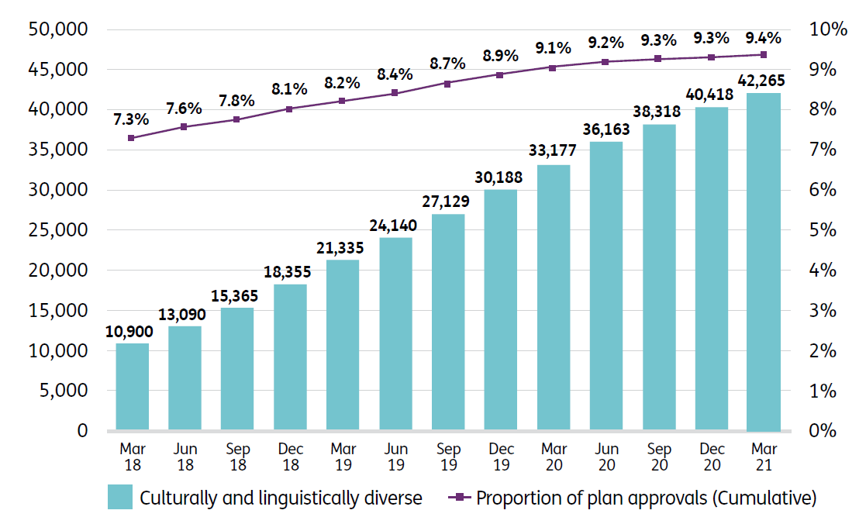
While the proportion of participants who identify as CALD is gradually increasing (9.4 per cent at 31 March 2021), it is below the estimate of around 20 per cent. The NDIA is examining the CALD participant cohort to further understand this lower than expected proportion of identified CALD participants. The Agency believes this may in large part be explained by low rates of self-identification of CALD people seeking access to the NDIS.
The number of participants engaging in community and social activities is a key measure for ensuring quality experiences and outcomes for participants. CALD participant outcomes continue to increase.
For CALD participants who entered the NDIS between 1 July 2016 and 30 June 2017, community and social participation increased from 35 to 59 per cent for 15 to 24 year olds, and from 39 to 52 per cent for those aged 25 and over, after three years in the Scheme.

Proportion of participants participating in community and social activities
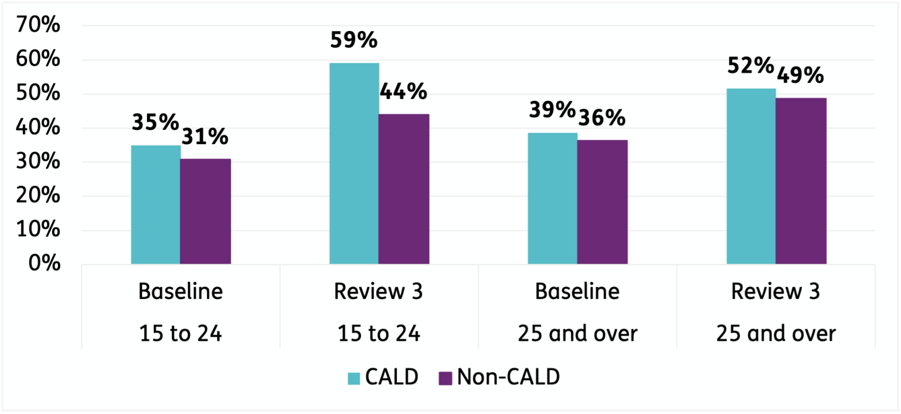
Further, the percentage of CALD participants aged 15 to 24 in employment increased from 12 per cent to 19 per cent after three years in the Scheme. The same increase in employment was not evident for CALD participants aged 25 and over during the same period. This is also true for non-CALD participants in the Scheme. The NDIA understands the benefits that employment brings to participants, and is committed to supporting more NDIS participants set and achieve their employment goals.
Proportion of participants in paid employment
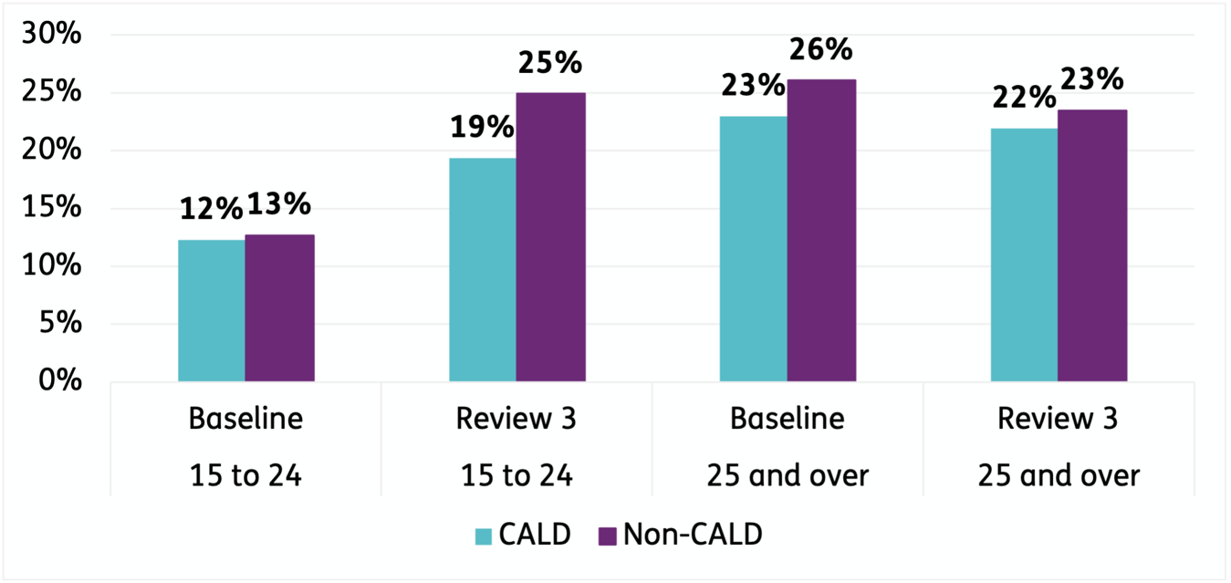
Generally, CALD participants have similar satisfaction rates as the general NDIS population. In the December 2020 quarter, 87 per cent of CALD participants rated the planning process as either good or very good. A further 9 per cent rated the experience as neutral.

Rating of experience with the NDIS for CALD participants (1 October 2020 to 31 December 2020)
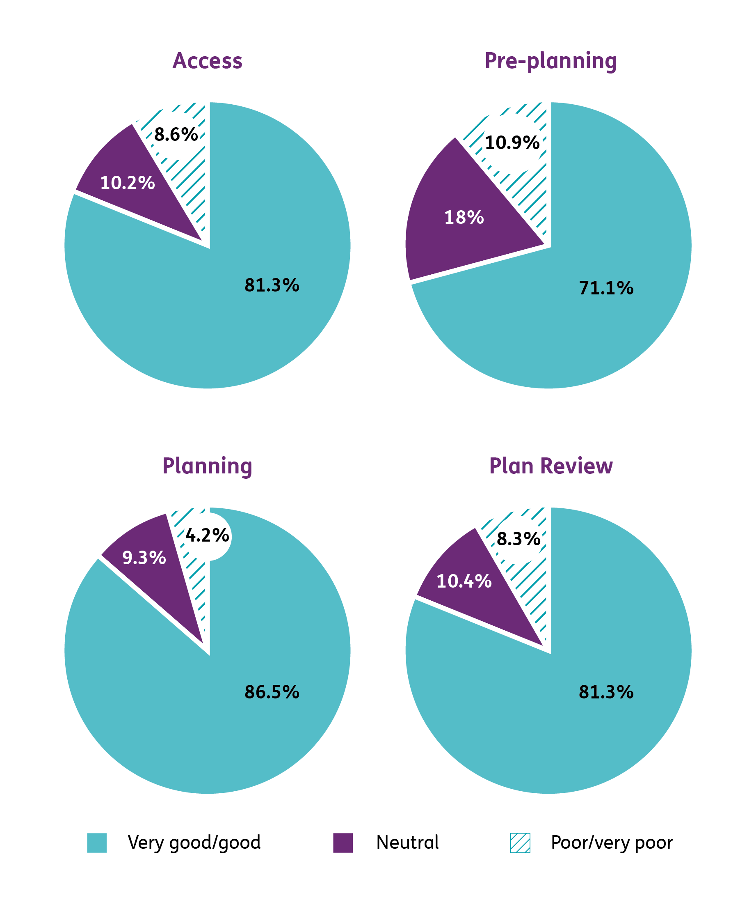

What we’ve done so far
The Agency has delivered a number of activities against the five priority areas identified in the Strategy. The NDIA will build on these activities to further enhance the NDIS experience and outcomes for CALD participants.

Priority 1: Engage with communities

Action 1.1: Targeted NDIA community engagement
Since 2013, the NDIA has engaged and worked with CALD communities in a respectful, inclusive and culturally appropriate way.
This has included establishing and strengthening relationships with key stakeholders in CALD communities, hosting community meetings, delivering presentations, and participating in expos and conferences.

Action 1.2: National Community Connectors
In 2019, the Australian Government committed $20 million to the National Community Connector Program. This community outreach program increased awareness of the NDIS in four identified communities, including CALD communities.

Action 1.3: Practice Guide
In 2018, the NDIA developed an Assisting Communications Practice Guide for planners and Local Area Coordinators. The Guide supports staff to understand specific considerations when meeting with CALD participants.
This includes cultural considerations, and guidance for booking and using interpreting services for interactions with the NDIA and PITC, and when participants are accessing supports funded in NDIS plans.

Action 1.4: NDIA Independent Advisory Council (IAC)
The IAC was established in 2013 through the National Disability Insurance Scheme Act 2013 to bring the views of participants, carers and experts to the heart of the NDIS. The IAC provides the Board with independent advice, which the Board must consider when performing its duties. The IAC has two members representing the CALD community.

Action 1.5: Participant Reference Group (PRG)
In 2018, the NDIA established the PRG to provide feedback and input for continuous improvement of the NDIS. As at December 2020, two members identified as from the CALD community.

Action 1.6: Participant consultations
In 2018, the NDIA held two workshops to hear how the participant pathway could be enhanced for CALD participants. This led to service delivery improvements, including multicultural awareness training for staff.

Action 1.7: Participant First Engagement Initiative
In 2020, the NDIA introduced the Participant First Engagement Initiative. This initiative expands the different ways that participants can be involved in the design, development and implementation of NDIA policies, procedures and products.
As at May 2021, more than 2,200 members have registered, including 73 CALD participants

Action 1.8: Campaigns
In 2019, the NDIA delivered an advertising radio campaign to raise awareness about the NDIS in CALD communities. The radio campaign was broadcast through five National Ethnic and Multicultural Broadcasters’ Council (NEMBC) member community radio stations in Victoria and NSW.
In November 2019, a campaign in Queensland encouraged new participants to join the Scheme, with a focus on people with disability from CALD backgrounds.
In 2020, the NDIA delivered an NDIS advertising campaign targeting culturally and linguistically diverse communities to raise awareness about support for participants during COVID-19. The campaign aired on Sydney and Melbourne's ethnic and multicultural radio stations.

Priority 2: Make information about the NDIS accessible

Action 2.1: Translation of information
In 2018, the NDIA introduced a project to translate and test key participant resources with CALD people with disability.
The project translated a number of resources into 12 languages other than English, including:
- Booklets to support participants throughout the NDIS journey
- Video transcripts and subtitles
- Easy English Glossary of Terms
- Fact Sheets for Early Childhood Early Intervention (ECEI), translation and interpreting supports, psychosocial disability, feedback and complaints.
The CALD Strategy and information about COVID-19 is also available in languages other than English.

Action 2.2: Translating and Interpreting Services National
In 2019, the NDIA partnered with the Translating and Interpreting Services National to provide interpreter services, free of charge, for participants from CALD backgrounds to use with supports funded in their NDIS plan.

Priority 3: Increase community capacity and broaden consumer choice

Action 3.1: Information, Linkages and Capacity Building (ILC)
Between 2016 and 2020, the NDIA delivered almost $25.5 million in ILC grants for projects directly aimed at assisting people from CALD backgrounds. ILC transitioned from the NDIA to the Department of Social Services in 2020–21.

Priority 4: Improve our approach to monitoring and evaluation

Action 4.1: Deep dive
In June 2019, the NDIA released a deep-dive report into CALD participants. This is in addition to comprehensive quarterly reports, and other reports that assist stakeholders to better understand CALD participant characteristics.

Priority 5: Enhance cultural competency within the NDIA and our Partners in the Community

Action 5.1: Multicultural awareness training
In November 2020, the NDIA released mandatory multicultural awareness training for all NDIA and Partner staff.
As at February 2021, 52 per cent of NDIA staff have completed, or are in the process of completing, the training.

Action 5.2: CALD Agency and Partner in the Community staff
As at 30 June 2021, 16 per cent of NDIA APS staff identified as CALD.
As at March 2020, 15 per cent of Partner in the Community staff identified as CALD.

Priority actions
In addition to continuing many of the activities outlined in Section 3, the Agency will implement the following actions over the next 18 months while the Agency completes a refresh of the Strategy.

Priority 1: Engage with communities

Action 1.1: Improve communications and engagement with CALD communities
- Develop an NDIS communications and engagement plan, targeting LGAs with a high representation of CALD participants. To be completed by October 2021.
- Implement communications and engagement plan in identified LGAs. To be completed by December 2022.

Action 1.2: Update project management processes to ensure engagement and consultation with people with disability from CALD backgrounds (as appropriate)
- Engagement and consultation with people with disability from CALD backgrounds will be included in key Agency projects (as appropriate). To be completed by October 2021.

Action 1.3: Implement tailored early childhood services and methods to support families and children from CALD backgrounds, as part of the ECEI reset
- Consult with CALD communities on the ECEI reset, including:
  - Tailoring culturally appropriate services and resources; and
  - Increasing Early Childhood partner capacity to identify and help young children and families from hard-to-reach communities.
  - These consultations are to be completed by June 2022.

- Develop, trial and implement approach.
  - To be completed by December 2022.

Action 1.4: Gather feedback from people with disability in harder-to-reach communities to continually improve the NDIS
- Establish a panel to hear directly from people with disability, with a focus on harder-to-reach communities. To be completed by September 2021.

Priority 2: Make information about the NDIS accessible

Action 2.1: Deliver translation of information
- Review ‘Our Guidelines’ to ensure they consider cultural sensitivities. To be completed by December 2021.
- Review Agency standards for translation. To be completed by December 2021.
- Develop a suite of resources to support participants with the NDIS journey, through a user-led design approach with participants. This includes testing the resources with CALD communities to ensure appropriately tailored products. To be completed by June 2022.

Priority 4: Improve our approach to monitoring and evaluation

Action 4.1: Investigate lower than estimated proportion of CALD participants in the NDIS
- Examine the CALD participant cohort to further understand the lower proportion of CALD identified participants than estimated. To be completed by September 2021.

Priority 5: Enhance cultural competency within the NDIA and our Partners in the Community

Action 5.1: Enhance staff knowledge of culturally sensitive approaches to working with people from CALD backgrounds
- Centralise resources on the NDIA Intranet to support staff and Partners in respectful interactions with people from CALD backgrounds. To be completed by August 2021.

NDIS Cultural and Linguistic Diversity Strategy 2018 available on the NDIS website.

