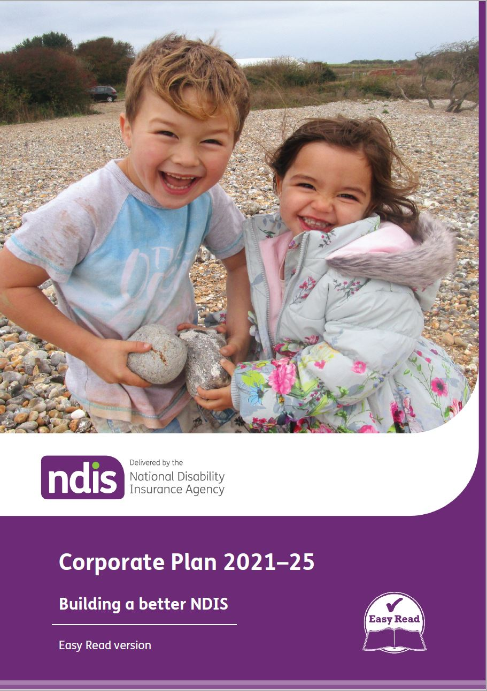

# Introduction and Statement of Preparation

We, the Board of the National Disability Insurance Agency, as the accountable authority, present the 2021–25 NDIA Corporate Plan, as required under section 35 (1)(b) of the *Public Governance, Performance and Accountability Act 2013* (PGPA Act) and section 177(1) of the *National Disability Insurance Scheme Act 2013* (NDIS Act).

The Corporate Plan has been prepared in accordance with the *Public Governance, Performance and Accountability Rule 2014* (PGPA Rule).

A final draft of the 2021-25 NDIA Corporate Plan was provided to the responsible Minister and Chair of the Ministerial Council on 28 June 2021. It has been subsequently amended following the Disability Ministerial Council meeting of 9 July 2021.

The NDIA’s Corporate Plan provides strategic direction to guide our activities for the financial years 2021–22 through to 2024-25.

The Board acknowledges the objectives of the United Nations Convention on the Rights of Persons with Disabilities (UNCRPD).

In this document, we refer to the National Disability Insurance Agency as the NDIA or the Agency and the National Disability Insurance Scheme as the NDIS or the Scheme.

The NDIA acknowledges the Traditional Owners and Custodians of country throughout Australia and their continuing connection to land, sea and community. We pay our respects to their Elders, past, present and emerging.

# Contents

Introduction and Statement of Preparation 2

Contents 3

Foreword from the Chairman 4

Introduction from the CEO 6

1. About the NDIS 9

Our insurance principles 10

Key highlights 11

2. Building a better NDIS in partnership with people with disabilities, their families, communities and the disability sector 13

A stronger partnership with participants and the disability sector on policy and service design 13

Delivering an affordable and sustainable NDIS for all Australians 14

Building blocks to deliver a better and affordable NDIS 15

Participant Service Charter and the Participant Service Guarantee 16

Participant Service Improvement Plan 16

Delivering an integrated service system for Australians with disabilities 19

3. Our operating environment 21

4. Our strategy 27

Aspiration 1 – A quality experience and improved outcomes for participants 30

Aspiration 2 – A competitive market with innovative supports 32

Aspiration 3 – A genuinely connected and engaged stakeholder sector 34

Aspiration 4 – A high-performing NDIA 37

Aspiration 5 – A financially sustainable NDIS 39

5. Performance metrics and targets 44

6. Financials 48

7. Risk governance 51

# Foreword from the Chairman

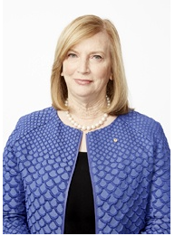

The Board of the National Disability Insurance Agency (NDIA) is pleased to present its 2021-25 Corporate Plan. The Corporate Plan is an essential part of our planning framework that provides our strategic direction for the coming year through to 2025.

The National Disability Insurance Scheme (NDIS) is delivering significant benefits to Australians with disability. Almost 467,000 participants across Australia are now receiving support, with 53% of participants receiving support for the very first time.

Importantly, participant outcomes, which in many cases are life-changing, are significantly improving. Children are becoming more independent, more participants aged 15 to 24 are in paid jobs, and fewer participants aged over 25 are going to hospital. We are also working hard to reduce the number of participants in residential aged care, with positive results. Residents under 65 have reduced by 33% (6,135 to 4,105) in just over three years, and admissions to aged care for those aged under 65 have reduced by 68% in the same timeframe.

Notwithstanding these significant achievements, improved engagement with stakeholders is required to address significant challenges facing the Scheme to ensure it delivers on the participant-focused vision embodied in the 2011 Productivity Commission Report, which led to the introduction of the NDIS.

Critically, we will engage deeply with people with disability, the sector and state and territory governments to develop a new person-centred model for assessments, consistent with the legislative requirements for assessments as set out in the NDIS Act.

We will build on the valuable work undertaken in July 2021 by the Independent Advisory Council and disability representatives on strengthening Scheme reforms to access and planning. The disability sector’s input is critical in ensuring we address the significant challenges facing the Scheme so the NDIS is available for current and future generations. From the outset, it was envisaged that the NDIS would support participants to exercise choice and control over their life with a fair, flexible and consistent package of reasonable and necessary supports. The need for the NDIS to remain affordable was also integral to that initial vision.

Historically, there has been no consistency in the way participants entered the NDIS and were assessed for reasonable and necessary supports. This has resulted in inconsistent outcomes that are not always fair and equitable. Currently, participants in higher socio-economic areas receive average plan budgets that are 7% higher than participants in lower socio-economic areas. This reflects in part participants’ ability to afford to gather evidence.

In addition, current legislation has driven a complex, rules based decision-making process that inhibits participants flexibly using their plan. It also reduces choice and control over how participants can use their support package.

As with any organisation, we have a responsibility to make sure that growth is affordable so the NDIS is available well into the future. The current rate of growth in participant payments poses significant challenges to Scheme affordability. In the last three years, the average payment per participant has grown by 11.8%. This is well above wage inflation (1.5% to 2.5% per year), future portfolio budget estimates (6.4% growth per annum), and the assumptions in the 2017 Productivity Commission Report (around 4% per annum). In addition, the number of participants continuing to approach the NDIS is well above projections.

The NDIA will continue to implement the Participant Service Guarantee, and progress improvements to the Early Childhood Early Intervention approach to provide eligible children with access to world-class early childhood intervention to help them achieve their developmental milestones. We will also further strengthen fraud and integrity measures, including addressing provider behaviour.

None of this will be possible without the commitment of our dedicated staff and partners. We will continue to invest in building the capability of our workforce to deliver on our strategic and operational goals now and into the future.

This Corporate Plan will assist in delivering the NDIA’s aspirations and priorities to enhance outcomes for participants, and to ensure this world-leading Scheme remains in place for future generations of Australians with disability.

Dr Helen M. Nugent AO

Chairman

# Introduction from the CEO



The 2021-25 Corporate Plan sets out our vision to improve the fairness, consistency, flexibility and affordability of the NDIS.

I want to acknowledge the strength and resilience shown by participants, providers, families, carers and NDIA staff and partners over the past 12 months. Their capacity to adapt and respond to the COVID-19 pandemic has been extraordinary.

Despite the challenges of COVID-19, the NDIA has made significant progress in delivering better outcomes for participants.

Over the past 12 months, we have made changes to the way we engage with participants following the introduction of the Participant Service Charter and Participant Service Improvement Plan. Due to the incredible efforts of our staff, we have significantly improved service levels, making faster access and planning decisions that ensure participants have the supports and services they need as quickly as possible.

Despite these efforts, there are still challenges with the operation of the NDIS that stem from trying to do something on a large scale for the first time.

The NDIS was never meant to be about public servants making hundreds of decisions about the life and supports of hundreds of thousands of participants. This is not the best way to support participants and does not deliver choice and control. It is very difficult to do it accurately, consistently and fairly right across the country, in a timely way, with good customer service.

In addition, it is very difficult to get a controlled and predictable overall cost for the NDIS based on decisions like that. As the Chairman noted in her foreword, there are significant challenges to Scheme affordability and we have a responsibility to tackle in partnership with the broader disability community, to ensure the NDIS endures.

Following the Disability Ministers’ meeting in July 2021, the NDIS will now engage deeply with people with lived experience of disability on the co-design of a new person-centred model that delivers consistency and equity in access and planning outcomes, consistent with the legislative requirements for assessments as set out under the NDIS Act.

The 2021–25 Corporate Plan outlines how we plan to improve the NDIS in line with the participant-focused vision embodied in the 2011 Productivity Commission Report.

I renew our commitment to working in partnership with participants, their families and carers to develop the best Scheme possible. We all have a shared goal to improve the NDIS and I care deeply about getting this right for participants, their families and carers.

Martin Hoffman

NDIA Chief Executive Officer

**‘I am very grateful to have the NDIS. It is a wonderful service. Without it I couldn’t give my son the services he needs.’**

- Parent of NDIS participant

# About the NDIS



The NDIS provides Australians with a permanent and significant disability with financial support to build capacity, increase independence and establish stronger connections with their community.

The NDIA is the Commonwealth corporate entity responsible for managing the NDIS. Our purpose is to:

‘Support individuals with a significant and permanent disability (participants) to be more independent and engage more socially and economically, while delivering a financially sustainable NDIS that builds genuinely connected and engaged communities and stakeholders’.

In its 8 years of operation, the NDIS has grown to support more than 460,000 Australians with disabilities to access the services and supports they need to live a more independent life. This includes supporting more than 70,000 children with developmental delay or disability through our Early Childhood Early Invention (ECEI) approach, ensuring they receive supports early in life so that they can take part in daily activities and achieve the best outcomes throughout their lives.

As a Commonwealth entity, we are subject to the [Commonwealth Performance Framework](https://www.finance.gov.au/government/managing-commonwealth-resources/planning-and-reporting/commonwealth-performance-framework). The Corporate Plan is a key element of this framework, outlining the aspirations and strategic goals that will ensure we achieve our purpose.

We also provides an annual performance statement in the annual report and issues detailed quarterly reports to the Disability Ministerial Council on NDIS performance.

All of our reports are available for download on the [NDIS](https://ndis.gov.au/about-us/publications) website.

The NDIA Board sets the strategic direction of the NDIA, manages risk and ensures compliance with relevant legislative and statutory requirements.

## Our insurance principles

The NDIS is based on the guiding principles that people with a disability:

* have the same rights as all Australians to realise their potential for physical, social, emotional and intellectual development
* are supported to participate in and contribute to social and economic life to the full extent of their ability.

The NDIS is founded on 5 insurance principles:

1. Evidence-based decision making
2. Consistency in decision making
3. Regular monitoring of experience to manage emerging risks
4. Lifetime and person-centric approach
5. Early investment to drive lifetime participant outcomes.

Using these principles, we make evidence-based decisions on access and funding by drawing on the data that is collected on all participants.

We also take a lifetime, person-centric approach to funding supports for people with disability, where early investment in disability related supports are expected to drive better outcomes for participants, their family and carers over their lifetime.

## Key highlights[1]

NDIS at a glance

467,000 people with disability are being supported by the NDIS. Yearly increase of 74,620 participants.

35% of new participants for quarter 4 were aged 0-6 – 6,386 children.

11,410 children are receiving initial ECEI gateway supports.

Participant outcomes

72% of parents think the NDIS has helped their child to become more independent.

60% of adults over 25 choose who supports them.

33% decrease in younger people in residential aged care over 3 years (6,135 at 31 December 2017 to 4,105 at 31 March 2021).

NDIS service delivery responded quickly during the COVID-19 pandemic to help keep participants safe. This assisted in the participant infection rate being lower than the general population.

Service delivery excellence

100% of access decisions made within the 21 days timeframe over the last 6 quarters.

79% of first plans were approved for participants aged 7 and above within the 56 days timeframe.

75% participant satisfaction on average across the four stages of the participant pathway.

91% of complaints closed within the 21 days timeframe, compared to 67% a year ago.

91% of reviewable decisions completed within the 90 days timeframe, compared to 51% a year ago.

83% of participants rated the planning process as either good or very good.

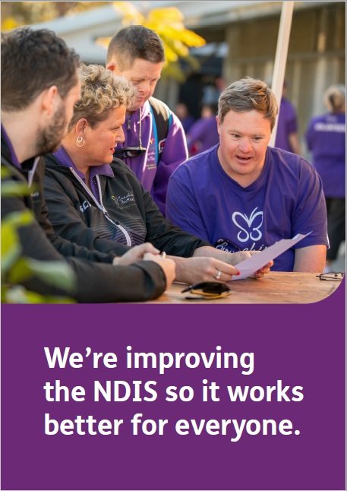

# Building a better NDIS in partnership with people with disabilities, their families, communities and the disability sector

The NDIS has been life changing for many Australians with over half of participants receiving supports for the first time. However, like every new social reform, there is still more work to be done.

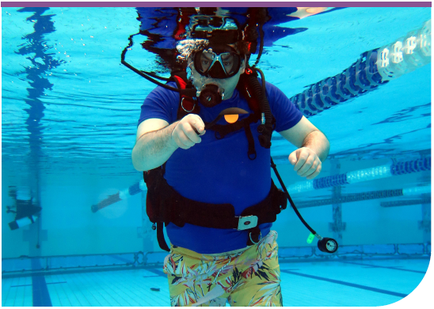

We are always listening to participants, their carers and families and the community to understand how we can build a better NDIS. Through these conversations, we know that:

* it is sometimes hard to understand how the NDIS works
* it is hard to understand what the NDIS does and doesn’t fund
* our processes can sometimes be confusing and take longer than people expect
* people with similar needs sometimes get very different levels of funded support.

It is our responsibility to make sure participants continue to receive the reasonable and necessary supports they need with choice and control over their plan. We also need to make sure the NDIS remains sustainable so all Australians can be confident it will be there for them, if and when, they need it over their lifetime.

## A stronger partnership with participants and the disability sector on policy and service design

We know participants continue to experience challenges with the NDIS. We have consistently heard that it is not as fair, simple and flexible as it could be.

We remain committed to improving the fairness, consistency and flexibility of the NDIS, in line with the participant-focussed vision embodied in the 2011 Productivity Commission Report. We are also committed to ensuring the NDIS remains affordable and sustainable so that is available to Australians with disability for generations to come.

We will work together with people with disability, their carers and families, the disability sector and the community to address priority areas for reforming and improving the NDIS. This work will be underpinned by a new partnership agreement with the Independent Advisory Council and disability representative organisations that includes co-design principles and a forward consultation and engagement roadmap.

This agreement will also reflect both the Independent Advisory Council’s recent advice on reforms and improvements to the NDIS, and the statutory role of the NDIA in administering the NDIS.

## Delivering an affordable and sustainable NDIS for all Australians

We are committed to improving the NDIS in line with the participant-focused vision embodied in the 2011 Productivity Commission Report.

From the outset, it was envisaged that the NDIS would support participants to exercise choice and control over their life with a fair, flexible and consistent package of reasonable and necessary funding. The need for the NDIS to remain affordable was also integral to that initial vision.

The overall NDIS budget will increase significantly over the next four years. In the 2021-22 Budget announced on 11 May 2021, an additional $13.2 billion over four years was committed to the NDIS.

While the Portfolio Budget Statement (PBS) estimates provide an increase over the next four years, data shows that the rate of growth poses significant challenges to the affordability of the NDIS. The average spend per participant has increased 11.8% on average per annum between 1 July 2017 and 30 June 2021. This is higher than wage growth, the 2017 Productivity Commission projections and the assumptions built into the PBS.

Figure 1. A comparison of PBS four year estimates ($bn) in 2020-21 and 2021-22

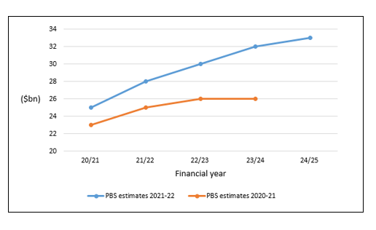

In addition, the number of people with disability continuing to approach the NDIS is well above projections, even in the areas that have been in the NDIS since the beginning.

The annual cost of the NDIS is projected to grow to $40 billion by FY2024/25.

We have a responsibility to make sure that growth is affordable over the long-term so the NDIS is available to all Australians well into the future.

## Building blocks to deliver a better and affordable NDIS

The building blocks for delivering a better and affordable NDIS are:

* partnering with participants, their families, and the disability sector to plan, design, test and implement improvements
* delivering fair access and planning decisions for all Australians with disability through a person-centred approach that provides consistent and equitable outcomes for all
* defining a ‘reasonable and necessary’ funding package that is fair for each participant, rather than individual supports
* maximising budget flexibility so that participants can use their package in a way that best meets their needs.

These building blocks were fundamental to the original design of the NDIS, as set out in the recommendations of the 2011 Productivity Commission. They will deliver an NDIS that has greater fairness and equity for all Australians with disability and give participants more choice and control over the supports and services they need to live their lives.

As a result, the 2021-25 Corporate Plan builds on activities detailed in the Participant Service Charter and Participant Service Improvement Plan. In total, this effort will deliver a better, fairer, simpler, more flexible and affordable NDIS for all Australians today and into the future.

## Participant Service Charter and the Participant Service Guarantee

Our [Participant Service Charter](https://www.ndis.gov.au/about-us/policies/service-charter) sets out what participants can expect from the NDIA. It provides overall principles for the way the NDIA interacts with participants and details clear service standards and timeframes.

Service standards are defined in the Service Charter through five engagement principles. We work to ensure that every interaction with a participant is:

* **Transparent:** we will make it easy to access and understand our information and decisions
* **Responsive:** we will respond to individual needs and circumstances
* **Respectful:** we will recognise your individual experience and acknowledge you are an expert in your own life
* **Empowering:** we will make it easy to access information and be supported by the NDIS to lead your life
* **Connected:** we will support you to access the services and supports you need

The Participant Service Guarantee sets timeframes for key NDIS processes such as access, plan approvals, plan reviews and nominee changes. Since mid-2020, we have been reporting against these standards in our [quarterly reports](https://www.ndis.gov.au/about-us/publications/quarterly-reports).

## Participant Service Improvement Plan

The [Participant Service Improvement Plan](https://www.ndis.gov.au/about-us/policies/service-charter/participant-service-improvement-plan) is the key to making real our promises in the Participant Service Charter and Participant Service Guarantee. It reflects the feedback participants have given us and sets out specific and tangible commitments that we will use to build a better NDIS.

We will also be focusing on making our digital services easier and more efficient for participants, staff and service providers. This will include tracking an access request online and making payments easily through a new mobile app.

In the past 12 months, we have fully implemented 16 commitments and started implementing another 23.

A full list of the commitments and our progress towards achieving each of them can be found on the [NDIS website](https://www.ndis.gov.au/).



Participant Service Improvement Plan: Commitment 2.6

We will be clearer on what reasonable and necessary supports means, with case studies and examples.

To help people understand how we make decisions, we have been working hard to improve our guidelines.

By the end of 2021, we will have rewritten all our Operational Guidelines in plain English. This means more consistent language and less jargon.

Our [‘Would we fund it?](https://ourguidelines.ndis.gov.au/would-we-fund-it)’ guide also provides clear examples and case studies on the things the NDIS does and does not fund.

These new format guidelines do not make any changes to the planning process. Instead, they explain our existing process in more detail.

Participant Service Improvement Plan: Commitments 5.2, 5.3 and 5.5

Your plan will be longer and ongoing.

It will be reviewed when you or we request it - for example if your circumstances change or something significant happens in your life.

We will check-in with you on how the plan is going, and whether an update or review is needed.

During the 2019 Review of the NDIS Act 2013 (the Tune Review), participants told us they wanted longer plans and fewer reviews.

Longer plans will give participants the time, flexibility, stability and certainty they need to set meaningful, long-term goals that give them greater choice and control over how they live.

That’s why we are taking steps to make 24-month plans or longer the norm. Participants can choose to have plans of up to 36 months if their support needs are stable.

Longer plans mean that participants won’t have to undergo a full plan review process every 12 months, which takes time for participants.

Instead, we’ll continue to embed the participant check-in approach we started during COVID-19, which puts participants in regular contact with their NDIA planner, Partner in the Community or Support Coordinator to discuss if their supports are working for them.

Participant check-ins focus on meaningful conversations about the participant’s goals, funded supports and wellbeing, to make sure they are getting the supports they need.

If a participant has a change of circumstances, they can request a plan review at any time or during their regular check-in.

The participant check-in process also helps us to identify if we need to initiate a review because the participant’s supports aren’t meeting their needs and can’t be used flexibly.

## Delivering an integrated service system for Australians with disabilities

We know that people with disability achieve the best outcomes when they have access to the same services and facilities as the broader community, such as housing, healthcare, education, justice and community safety, shops, sports clubs, transport, websites and work.

Disability supports provided through the NDIS are intended to complement, not replace, mainstream services provided by other parties.

To deliver a more integrated service system for Australians with disability, we work closely with all Australian governments to build a strong mutual understanding of:

* how the NDIS and other service delivery systems interact and complement one another
* how to determine the most appropriate funding and service delivery approach

For further information please read the [Council of Australian Governments’ Principles to Determine the Responsibilities of the NDIS and other service systems.](https://www.coag.gov.au/sites/default/files/communique/NDIS-Principles-to-Determine-Responsibilities-NDIS-and-Other-Service.pdf)

Our Partners in the Community also help people with disabilities, their families and carers access a broad range of community and government services.

In this way, we aim to work at both the individual and systemic level to support Australians with disability to access and enjoy services available to all Australians.

The National Disability Strategy also sets out the responsibilities of all governments to support more than four million Australians living with disability. Through a whole of government approach, the NDIS will be a significant contributor to delivery of the agreed outcomes in the strategy.

It is anticipated that the new National Disability Strategy will be released in late 2021.

Additionally, the NDIS also gives effect to obligations Australia has under the UNCRPD, to which Australia became a signatory in 2008.

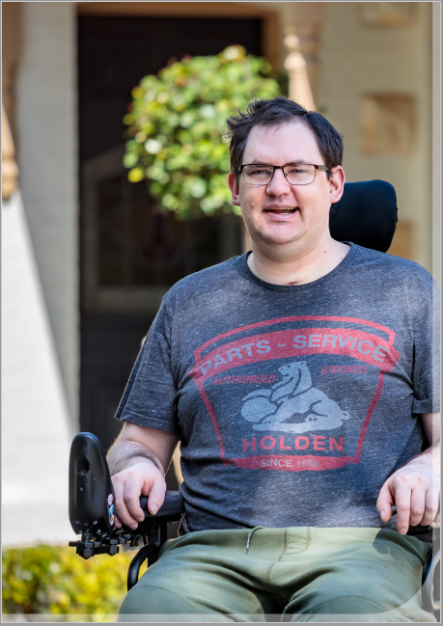

# Our operating environment

When determining our key priorities for the year ahead, we take into consideration a range of internal and external factors that are likely to affect operational and scheme performance.

Playing a pivotal role in driving outcomes through the revised National Disability Strategy.

We all benefit from a more inclusive Australia where everyone has the same opportunity to participate – both socially and economically.

Collaboration across government, private and community sectors, as well as the broader community, is central to breaking down the attitudes, practices and structures that can prevent people with disability from:

* participating fully in work
* staying connected with family and friends
* engaging with their community.

The new National Disability Strategy, which will be released later this year, provides an opportunity to drive significant change through all levels of government and deliver improved outcomes for people with a disability.

This approach will ensure people with disability can access the same services and facilities as the broader community, including healthcare, education, transport, housing services and community clubs and organisations.

The NDIS is a key player in the ecosystem of supports that Australians with a disability rely on.

Building a better NDIS enabled by legislative reform

As the NDIS has moved from transition into ‘full scheme’, it has become clear that key elements of the original NDIS design outlined by the Productivity Commission have not been fully realised.

The Minister for the NDIS has reiterated the Australian Government’s commitment to delivering on these final elements.

The NDIA and the Department of Social Services have been working towards implementing the recommendations of the 2019 Tune Review. Together, we are examining changes to the legislation to enact the recommendations of the Tune Review.

It is critical that we undertake this work to make sure that the NDIS is equitable, sustainable and most importantly provides an improved service experience for participants.

Delivering a consistent, high quality service experience to all participants

The NDIS is an ambitious, world-leading social reform and there is significant complexity in delivering a consistent, high quality service experience to 467,000 participants across the nation.

With a workforce of more than 10,000 people designing, implementing and evaluating all aspects of the NDIS, it is critical that we identify opportunities to streamline and improve the way we operate.

Technology can also improve service experience and maximise opportunities for people with disabilities to participate in the broader community.

Wearables, sensors, robotics and artificial intelligence are changing the lives of people with a disability and becoming powerful drivers of inclusion. Technology is also allowing many people with disability to reach their potential at home, in their community and in the workplace.

Nothing can stop this self-confessed ‘MS Warrior’

Point Lonsdale’s Bree-Arne Manley is a self-confessed ‘MS Warrior’ and thrill seeker, ready to tackle anything. She refuses to let her Multiple Sclerosis (MS) get in the way.

“I want to reach as many Otway Ranges waterfalls as I can. The only way I can access some is to go alongside them and abseil down into them,” she said.

With her NDIS funding, Bree-Arne has been able to buy a new portable wheelchair and the Batec hand bike, enabling her to hike waterfall trails with greater independence:

“The portable wheelchair and Batec have seriously changed my life. Now, I can access all areas of my house and I can tackle waterfall trails, as long as my husband, Lachlan, is there to pull me over anything I might get stuck on!”

When Bree-Arne and Lachlan reach a waterfall Bree-Arne can’t reach by path, they gear up in abseiling equipment and down the muddy slopes they go, still able to enjoy the great outdoors together.

“It’s not an Otway’s trip if I’m not covered in mud from head to toe,” Bree-Arne joked.

“Prior to the portable wheelchair and Batec, if we were hiking to a waterfall and I was going too slow, or being stubborn, crawling, Lachlan would throw me over his shoulder and off we’d go. Or sometimes I would wait patiently in the car for the guys to return. But now I’ve got my independence back and I can actually keep up and even overtake them at times!”

The use of telehealth and telecare during the COVID 19 pandemic has also had an enormous impact on those living with disability in remote areas.

These advances have the potential to improve outcomes and experience for participants, and help simplify our operations.

We also recognise ethical challenges and risks that technology present. We will make sure participants are aware of potential issues and have the choice to opt-in or opt-out as they so choose.

Moving towards a post-COVID new normal

COVID-19 has significantly changed the way we live, work and play. The impacts are far-reaching and will persist for some time as the vaccination program rolls out and social and economic recovery efforts continue.

We have been working hard to deliver new and enhanced capability that ensures participants and providers are supported throughout the pandemic. This includes the participant check-in process, which was developed in response to the successful COVID-19 outreach calls to vulnerable participants in 2020. Participant check-ins are now an ongoing feature of the NDIS and are designed to complement and incorporate scheduled plan reviews.

Our improved internal capability means we are ready to support participants in the event of an outbreak. We are also supporting the Department of Health in rolling out the vaccine to participants, including providing assistance for providers to help participants in supported independent living access the COVID-19 vaccination.

Supporting vulnerable population groups

We recognise the importance of a participant’s ability to experience the ‘dignity of risk’, and their right to make decisions for themselves on how they choose to live their life. We are working to improve NDIA processes and communicate our expectations to the sector on how to support a participant’s decision making.

In addition, we are deeply committed to supporting Australians with disability to exercise choice and control to live life safely. It is abhorrent that violence, abuse, neglect and exploitation of people with disability continues in Australian society.

Several Royal Commission hearings and Joint Standing Committee Inquiries are underway or have recently ended. We will continue to actively participate in these inquiries and their outcomes. We will engage with Commissioners, staff, partners, stakeholders and participants to ensure we get the best outcomes for people with disability.

It is important that violence, abuse, neglect and exploitation of people with disability in all  
settings and contexts are exposed and examined, including through the sharing of individual experiences. Many participants, their carers and family members have given evidence in these inquiries and we acknowledge their courage and strength to share their personal stories.

Strengthening Scheme integrity

We are committed to educating, preventing and detecting fraud and non-compliance and most importantly protecting all participants. We maintain a zero-tolerance approach to fraud.

We have a range of comprehensive compliance activities to identify, investigate and act on fraudulent activity in relation to the NDIS. This includes working with the Australian Federal Police to proactively identify, warn, and prosecute offenders.

We are aware of some providers engaging in unacceptable behaviour, including inappropriately charging NDIS participants for services that are not reasonable. We will undertake work to further strengthen fraud and integrity measures through amendments to the NDIS Act.

We want to support participants to get the most out of their NDIS funded supports, and make sure they spend their funds in accordance with relevant laws and regulations. We will continue to deploy a range of preventative and reactive measures to identify, notify, and reduce instances of non-compliance and inappropriate action. We will also focus on building participant knowledge and capability on what fraud looks like, how to report it and how to use NDIS funds appropriately.

Case study 1

NAIDOC award just one of Peter’s growing list of achievements

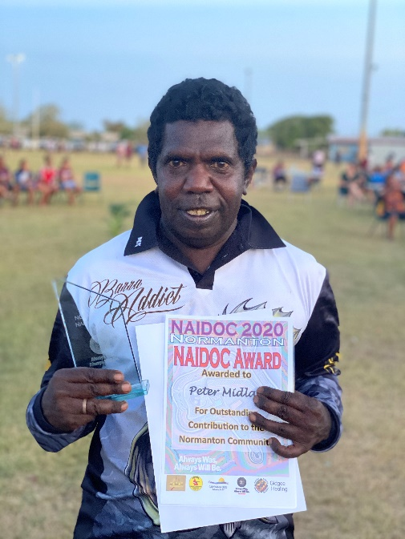

Peter Midlan barely had the confidence to speak a year ago

The 42-year-old Aboriginal man from Normanton in the Gulf country region of northwest Queensland spent most of his time alone fishing, he was afraid to talk to others, especially anyone he didn’t know.

These days Peter is a changed man. He’s happy to chat with people, loves catching up with friends to do art or sing and he’s busy helping others in his local community.

Peter lives with an intellectual disability, which affects his communication and social skills.

Since the NDIS began supporting Peter four years ago, he has gained confidence, increased his independence and become an active and important member of his community.

“Peter had a lot of trouble communicating, he would just freeze, even with people he knew. He didn’t speak at all about a year ago,” said Anthea Amos, Peter’s NDIS-funded support worker with provider, Cootharinga North Queensland.

“He’s made really good progress in the last 12 months.

“He’s such an awesome man and he just loves working with children and helping out in his community every way he can.”

Peter belongs to the Kurtijar Aboriginal group. He is still a fervent fisherman and spends most afternoons at the local Norman River angling for something to take home to his extended family for dinner.

His life has changed dramatically since joining the NDIS.

With help from support workers, Peter has been learning new life skills, socialising more and learning to communicate with others to pursue his goals.

Peter now takes part in a variety of activities that add joy and richness to his own life, as well as the lives of others in his community.

He enjoys volunteering at the Carpentaria Shire Council Local Sports Centre where he often helps supervise children’s activities.

In recognition of his efforts, Peter has been honoured for his volunteering work with a NAIDOC award for his ‘outstanding contribution to the Normanton community’.

“I was very happy for that,” Peter said. “It made me feel pretty good and the family was pretty happy.”

**‘There’s no way I could do without that support, everything I do is because of the support I have around me through the NDIS.’**

- NDIS participant

# Our strategy

Our high-level strategic roadmap for 2021–25 continues the three phases outlined in the 2020–24 Corporate Plan.

All three phases will be implemented over the life of the Corporate Plan. Individual activities will increase or decrease in intensity depending on the priority and focus outlined in the strategic roadmap.

Figure 2: Strategic roadmap

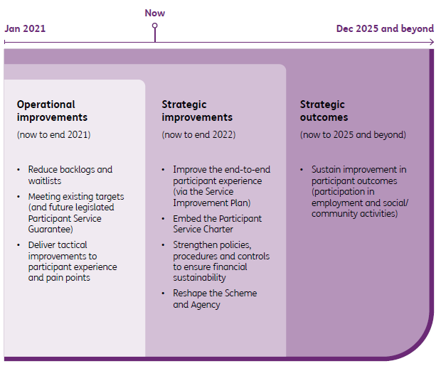

Our efforts in 2020-21 focused on addressing operating improvements including:

* responding to COVID-19 and ensuring participant safety
* improving operational efficiency and effectiveness to:
* meet the Participant Service Guarantee
* reduce wait times
* serve participants in accordance with the Participant Service Charter
* delivering improvements as identified in the Participant Service Improvement Plan
* developing stronger policies, procedures and controls to address financial sustainability issues
* building capability to implement reforms and improvements to the NDIS.

In 2021-22, we will:

* maintain our focus on strategic improvements by delivering the actions in our Participant Service Charter and Participant Service Improvement Plan
* co-design a new person-centred model that delivers consistency and equity in access and planning outcomes and is consistent with the legislative requirements for assessments in the NDIS Act
* establish a new partnership agreement with the Independent Advisory Council and disability representative organisations that includes co-design principles and a forward consultation and engagement roadmap.

In addition to realising our own strategic priorities, it is important we work with other organisations to achieve the overall purpose of the NDIS and the NDIA. This includes:

* ongoing interaction with the Minister, Ministerial Council and Department of Social Services to deliver a portfolio of initiatives that enhance NDIS outcomes
* engaging with the Commonwealth, state and territory governments, along with the broader disability sector to better align mainstream and other support services.

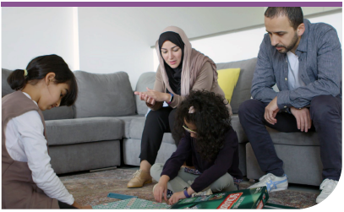

Our aspirations

We have five aspirations that are aligned with our purpose and contain specific strategic goals and focus areas, outlined in the following figure.

Figure 3: Strategy framework

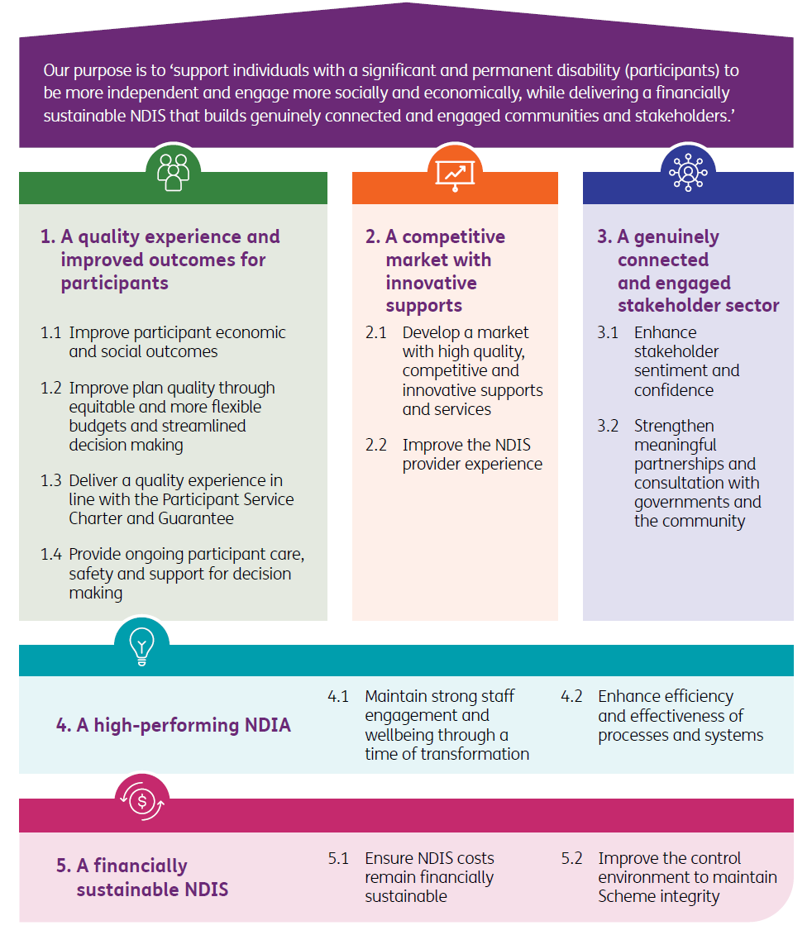

## Aspiration 1 – A quality experience and improved outcomes for participants

Logo presents an image of a group of people on a green circular background and a description of the aspiration in the green bar.

Description: Facilitate outcomes of economic and social independence and deliver a quality for participants and their families, carers and providers.

Participant outcomes are at the centre of our work. While COVID-19 presented a number of challenges in the past year, the proposed initiatives are designed to drive better outcomes for participants over the life of the Corporate Plan.

We will assist participants to build their capacity to participate socially and economically and become more independent.

We will continue our work on the Participant Service Charter and Participant Service Improvement Plan to ensure we make good on the commitments we made in 2020.

We will continue to listen to and work closely with participants, their families and carers to achieve this by:

* making decisions in the timeframes outlined in the Participant Service Guarantee
* being transparent about our decision making process
* being clear in our decisions and communications
* simplifying our processes to support people to access NDIS
* providing funding packages needed to achieve better participant outcomes
* supporting groups requiring additional support to access the NDIS, receive a plan and use their supports through our diverse cohort strategies (e.g. Aboriginal and Torres Strait Islander)

This will mean faster decisions on access, plan approvals and plan reviews and will build on the improvements made to wait times.

While the timeframes outlined in the Participant Service Guarantee have yet to be legislated, we have been measuring and meeting many of these timeframes for some time.

Our specific goals under this aspiration and examples of initiatives that we will undertake to achieve these goals are outlined below:

**Strategic goal 1.1:** Improve participant economic and social outcomes

* Deliver sustainable employment outcomes for participants through the implementation of the Employment Strategy in partnership with the Department of Social Services
* Build participant capacity to engage in community and social activities, enabled by meaningful connection to our Partners in the Community
* Develop a new approach to home and living that gives participants more choice and control over where they live, who they live with and the supports they use
* Provide eligible children with access to world-class early childhood intervention to help them achieve their developmental milestones

**Strategic goal 1.2**:Improve plan quality through equitable and more flexible budgets and streamlined decision making

* Increase plan flexibility so that participants have greater choice and control over the supports they need to pursue their goals
* Deliver fairer and more equitable access and planning decisions and funding support through the introduction of a new co-designed person-centred model.
* Work with governments to clarify what is considered a reasonable and necessary support and whether these supports should be provided by the NDIS or other mainstream or community services

**Strategic goal 1.3:** Deliver a quality experience in line with the Participant Service Charter and Guarantee

* Update operational processes to ensure key performance indicators and timelines outlined in the Participant Service Guarantee are met
* Improve the way we deliver our services in accordance with the Participant Service Charter engagement principles
* Upgrade our participant portal and release an accessible mobile app

**Strategic goal 1.4:** Provide ongoing participant care, safety and support for decision making

* Increase support for participants to make their own decisions, including stronger participant capability and, where appropriate, reduced reliance on nominees and representatives
* Increase opportunities for participants to experience the dignity of risk[2]
* Redefine the way we support participants with complex support needs
* Ensure continuity of essential disability funded supports for all participants, especially the most vulnerable
* Work with our partners, Commonwealth, state and territory governments and other key stakeholders to support participant safety

## Aspiration 2 – A competitive market with innovative supports

Logo presents an image of a person presenting a growth chart on an orange circular background and a description of the aspiration in the orange bar.

Description: Work with participants and other stakeholders to enable the growth of a market of adequate size, quality and innovation.

There is a diverse range of providers delivering disability supports across the country, including existing organisations that transitioned from state and territory disability systems and new providers entering the market for the first time.

We will continue to work with stakeholders to support the market to grow so that there is a reliable supply of quality and innovative supports that meet participant needs and goals at a price that is reflective of the market.

We will continue to refine our approach as we respond to emerging market issues, limited variety, inaccessible services and limited consumer choice.

We will continue to work with participants and providers to help shape the market and better respond to participant demand by:

* empowering participants as consumers of disability supports and services and increasing informed purchasing of supports
* encouraging providers to continue to put the participant first in their service delivery models
* encouraging the market to find innovative ways to respond to the needs of participants
* promoting contemporary and evidence-based supports and services
* increasing competition and price deregulation by mitigating the risk of limited market readiness
* simplifying NDIS processes to drive greater productivity
* assisting communities in specific geographical locations to build local supply solutions

We will improve the efficiency of interactions among the NDIA, participants, providers and other stakeholders through the delivery of an enhanced Application Program Interfaces (APIs) system. This will automate processes and enable Digital Partners to connect their systems directly with ours.

We will continue to seek advice on how to improve our digital ecosystem from the recently established Digital Community of Interest.

To ensure participants gain timely access to high-quality supports, there may be circumstances where we will directly commission services on their behalf.

Our specific goals under this aspiration and examples of initiatives that we will undertake to achieve these goals are outlined below:

**Strategic goal 2.1:** Develop a market with high quality, competitive and innovative supports  
and services

* Collaborate with governments, communities, providers and other key stakeholders to address markets with supply gaps, especially in regional, remote and very remote areas
* Support the development of new and innovative markets for home and living supports to increase participant choice and control over who they live with, where they live and the supports they use
* Work with governments and stakeholders to reduce the number of younger people living in residential aged care facilities
* Improve how participants get support for implementing and managing their plans
* Support market development and innovation so that participants have access to a greater range of supports and services
* Continue to simplify our price guide, support catalogue and pricing more generally
* Support the implementation of the NDIS Quality and Safeguarding Framework, the National NDIS Workforce Plan and the National Disability Employment Strategy by the Department of Social Services and the NDIS Quality and Safeguards Commission
* Collaborate with local communities, participants and their representatives and providers to drive market improvements that are culturally safe and best meet their needs (for example, encouraging entry of new providers)

**Strategic goal 2.2:** Improve the NDIS provider experience

* Implement processes and systems that assist providers to operate effectively under the NDIS and simplify how they work with us
* Enhance provider claim and payment systems to provide more efficient and timely payments
* Enable providers to engage with us via secure technology, including APIs, as per our Digital Partnership Program
* Consult with providers regularly to identify continuous improvement opportunities that will enhance provider confidence and sentiment



## Aspiration 3 – A genuinely connected and engaged stakeholder sector

Title: Logo of aspiration three - Description: Logo presents an image of a stakeholder group and arrows pointing from one to the other on a blue circular background and a description of the aspiration in the blue bar.

Description: A strong and engaged stakeholder sector that genuinely collaborates and contributes to the delivery of the Scheme, with confidence in the NDIA.


To successfully deliver and improve the NDIS, we need the input, expertise and advice of participants, their families and carers, providers, the disability sector and community.

The NDIS was born in 2013 as a result of a grassroots campaign along with the Productivity Commission’s public inquiry into Disability Care and Support. Both were backed by thousands of people who came together to demand a fair go for Australians with disability. We’re proud of the strong community and sector ownership of the NDIS.

We will strengthen our partnerships with people with disability and their representative organisations through deep engagement and a partnership agreement that includes co-design principles, so that we can reform and improve the NDIS and ensure it delivers on the participant-focused vision embodied in the 2011 Productivity Commission Report.

Tackling affordability, again in partnership with the disability community and governments, will also remain a priority so that we can ensure the NDIS is in place for generations to come.

We also recognise the important contributions made by government agencies and other stakeholders to achieve our shared goals and aspirations.

We will continue to work collaboratively to promote and strengthen the roles and responsibilities of all governments, mainstream and community services.

We will ensure a coordinated whole of government approach to supporting people with disability by consulting, engaging and collaborating with stakeholders. This aligns with the proposed vision of a new National Disability Strategy that will make sure people with disability can fulfil their potential as equal members of a more inclusive Australian society.

We will work closely with the Department of Social Services and the NDIS Quality and Safeguards Commission in line with our responsibilities under the Commonwealth Performance Framework.

Our specific goals under this aspiration and examples of initiatives that we will undertake to achieve these goals are outlined below:

**Strategic goal 3.1:** Enhance stakeholder sentiment and confidence

* Develop a partnership agreement to outline co-design expectations for working together that recognises the statutory decision-making responsibilities of the Board and the NDIA
* Develop a roadmap of, and framework for, engagement on Scheme reform
* Continue to simplify the language we use to deliver clear, accessible communication across all our channels
* Continue to implement and refine our satisfaction and sentiment surveys so that we can gather, share and act on stakeholder feedback
* Build greater understanding of new financial sustainability issues facing the Scheme

**Strategic goal 3.2:** Strengthen meaningful partnerships and consultation with governments and the community

* Consult and cooperate with Disability Ministers and state and territory governments to administer the funding and governance arrangements for the NDIS
* Engage and promote opportunities with the mainstream and community sectors
* Engage participants, mainstream and community stakeholders through the delivery of inclusive and diverse events and engagement activities
* Actively seek and act on participant and stakeholder feedback and expertise to improve operations, particularly from participants whose voices may not always be heard



## Aspiration 4 – A high-performing NDIA

Logo presents an image of a lightbulb on a green circular background and a description of the aspiration in the green bar.

Description: Develop a high-performing NDIA that has an engaged workforce with systems and processed that facilitate service excellence.

We aspire to be a high-performing service delivery organisation that delivers consistent quality services to participants, their families and carers.

Over the next 12-18 months, there will be significant change as we continue to deliver on the commitments in the Participant Service Charter, Participant Service Improvement Plan and a range of other reforms and improvements to the NDIS.

Staff engagement and wellbeing is critical to delivering this volume of change. This is something that we have worked hard to maintain during the COVID-19 pandemic and will continue to do so as we move towards ‘COVID-normal’.

Our values

We are focused on developing a capable, engaged and healthy workforce that builds on our reputation as an employer of choice.

We do this through a values-driven culture, based on those of the Australian Public Service (APS) and supplemented by our own as detailed below:

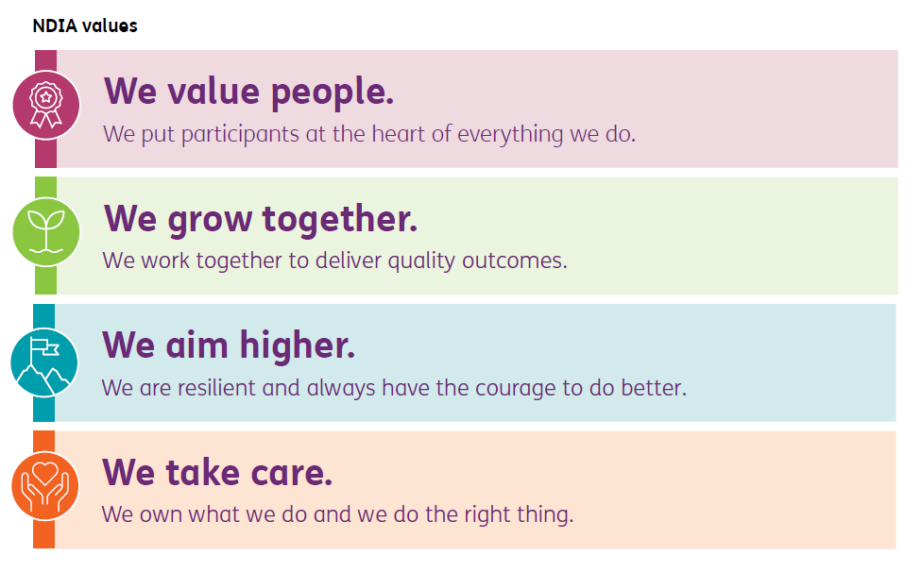

Our people are committed to supporting participants to achieve their goals. Equally, we are committed to supporting our people to realise the aspirations and goals identified in the Corporate Plan.

We will ensure our people are engaged, have the right skills and knowledge and are supported by systems and processes to deliver our operational goals by:

* enabling staff and partners through a full range of tools to provide a high quality experience
* providing additional guidance materials to support the changes being implemented across our front-line services.

We will build the capability of our workforce to deliver on our strategic and operational goals now and into the future. This will include training and upskilling the workforce to integrate the new processes, systems and skills necessary for transition to a new delivery model. We will do this through careful planning and change management.

Our capability uplift will be supported by a range of systems and technology enhancements including:

* implementing a new Customer Relationship Management (CRM) system
* improving our social media monitoring to better understand real-time sentiment and issues
* increasing operational effectiveness and efficiency in a post-COVID remote working environment
* enhancing digital engagement, transactional capability and security with participants, their families, carers and providers.

Our specific goals under this aspiration and examples of initiatives that we will undertake to achieve these goals are outlined below:

**Strategic goal 4.1:** Maintain strong staff engagement and wellbeing through a time of transformation

* Build and sustain workforce capability so that our people have the skills and knowledge to deliver the NDIS
* Enhance health, safety and wellbeing initiatives so that our people feel safe and supported at work
* Champion disability employment so that we are truly reflective of the diverse community we serve

**Strategic goal 4.2:** Enhance efficiency and effectiveness of processes and systems

* Simplify ongoing processes for participants, frontline staff and service providers through enhanced digital services
* Implement a new customer relationship management (CRM) system to support improved service experience for participants, providers and NDIA staff and partners
* Improve our payments and claims capability for participants
* Enhance operational guidelines and support materials to assist front-line staff and partners deliver a quality experience and better outcomes
* Improve our staff and partners' capability and adherence with operational systems and processes

## Logo presents an image of a dollar coin with two arrow circling around it on a pink circular background and a description of the aspiration in the pink bar. Description: Deliver a financially sustainable Scheme within agreed funding, based on insurance principle and risk awareness.Aspiration 5 – A financially sustainable NDIS

The NDIS Act requires us to manage the financial sustainability of the NDIS.

We must safeguard the financial sustainability of the NDIS in a risk-aware manner. We will achieve this through deep engagement with people with disability, the sector and state and territory governments to develop a new person-centred model to support access and planning, consistent with the legislative requirements as set out in the NDIS Act.

This approach will ensure that access and planning decisions are fair and equitable. It also will ensure the NDIS maintains public confidence to provide for people with disability in the long-term. **The NDIS is sustainable** if it materially improves the independence, economic outcomes and social participation of participants, and participants feel they are getting sufficient support to live a fulfilling life.

**The NDIS is financially sustainable** if it is delivered within agreed funding based on an insurance approach and is sustainable for taxpayers and governments over the short and long-term. In doing this we will strive to maintain stakeholder confidence.

It is the responsibility of the NDIA to identify and monitor pressures, and manage them appropriately, using an insurance-based approach that evaluates emerging experience against expectations. We use actuarial data and apply insurance principles to monitor the sustainability of the NDIS.

The insurance approach also means taking a lifetime view to supporting people with disability. This includes investing in participants in the short term to provide better outcomes over their lifetime, as well as to reduce the long term costs of disability support. The achievement of participant outcomes is vital to the financial sustainability of the NDIS.

The Office of the Scheme Actuary produces an Annual Financial Sustainability Report. In addition, NDIS quarterly reports provide thorough detail on financial and operational Scheme performance. All of these reports are available to view on the [NDIS website.](https://ndis.gov.au/about-us/publications)

Scheme integrity requires continued vigilance and ongoing improvements to our control environment. As the risks of cyber security and fraudulent activity across the world grow and escalate, we will continue to deploy effective processes and systems to manage the integrity of the NDIS and maintain financial sustainability. This includes strengthening our fraud detection and risk control arrangements.

Our specific goals under this aspiration and examples of initiatives that we will undertake to achieve these goals are outlined below:

**Strategic goal 5.1:** Ensure NDIS costs remain financially sustainable

* Engage with the sector to build a deeper understanding of the sustainability issues facing the Scheme
* Sharpen guidelines and strengthen the underlying process for initial and ongoing NDIS eligibility
* Increase consistency of Reasonable and Necessary plan budget decision making through clearer guidelines, and operating procedures
* Strengthen fraud, integrity, and compensation recovery practices

**Strategic goal 5.2:** Improve the control environment to maintain Scheme integrity

* Increase the use of data and analytics to predict and prevent sharp practices and potentially fraudulent behaviour
* Strengthen controls to ensure risk management processes are reliable and consistent

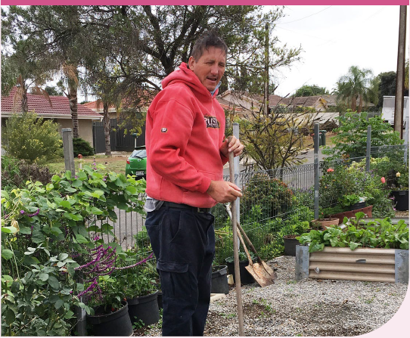

Case study 2

Emily channels success into welcome gift for Zoos SA



Unlike many teenagers, Emily West enjoyed her high school years. She attended a mainstream school where she felt welcome and included.

“Emily was always part of inclusive education—that part of her life was never segregated and she loved school,” says Emily’s mother, Julie West of Mitcham.

But life after school was different. Emily, who lives with a significant intellectual disability, severe anxiety, Tourette’s syndrome and autistic behaviours, struggled to find work.

“She did quite a few voluntary jobs, but none of them led to permanent employment and certainly not paid work,” Julie said. “Emily spent some time at supported day options and that’s the direction we thought her life was going.”

About two years ago, that direction changed.

Emily joined the NDIS. One of her service providers, Community Living Project (CLP), suggested an alternative pathway for Emily to find meaningful employment—owning and operating her own small business.

Julie admits she was sceptical.

“I never imagined in a moment Emily could operate her own business,” she said.

Today, thanks to her NDIS support, Emily owns and operates a thriving micro enterprise called ShredEm, which collects, shreds and recycles unwanted documents for local businesses and residents who want their paperwork safely destroyed.

Emily operates ShredEm herself, with help from a facilitator, funded through her NDIS plan. She enjoys being the boss, interacting with customers and earning her own income.

“It makes me feel good,” said Emily, “I also love going out into the community and I’m saving to go on holiday with a friend.”

Thanks to Emily’s passion for animal welfare, she’s not the only one smiling about her new business.

Emily donates her paper for animal enrichment and bedding.

“ShredEm’s paper provides our animals with a great source of enrichment,” says Adelaide Zoo Storekeeper Russell Ind.

“It is used by a lot of the animals at Adelaide Zoo and Monarto Safari Park, and we love the fact that the paper fits with our values of recycling and reusing materials.”



# Performance metrics and targets

Our performance metrics describe the NDIA’s long-term focus of NDIS outcomes.

These metrics are mostly consistent with the previous Corporate Plan. Changes this year include:

* adding measures of equity of plan values across socioeconomic cohorts, and staff well-being
* moving from tracking disability sector sentiment to a more inclusive and broader community sentiment metric[3]
* simplifying the calculation method for the Payment Growth metric
* increasing 2021-22 targets on metrics where we have achieved the target set in the 2020-24 Plan.

There are a number of challenges in setting realistic targets over the life of the Corporate Plan in the current climate. We have therefore provided specific targets for the first year of the plan, with a long-term aspiration that demonstrates an intent to improve the performance of the NDIS over time.

Our metrics, current state, goals for FY22 and long-terms aspirations are outlined in the tables below:

Table 1. Participant and Scheme outcomes

|  |  |  |  |  |
| --- | --- | --- | --- | --- |
| # | Performance metric | FY21 Q4 | FY22 Target | Long-term aspiration |
| 1.1 | Participant employment rate (%) | 22% | 24% | Lead the world in the sustainable and ongoing employment of people with disability. |
| 1.2 | Participant social and community engagement rate (%) | 45% | 48% | Close the gap in the social participation of people with disability compared to the general population. |
| 1.3 | Parent and carer employment rate (%) | 48% | 49% | Lead the world in the sustainable and ongoing employment of parents and carers of people with disability. |
| 1.4 | Children benefiting from the NDIS and no longer needing supports (%) | 4.5% | 5.5% | Lead the world in helping young children with developmental delays before they reach adulthood. |
| 1.5 | Socioeconomic Equity[4] | 106% | 100% | Ensure participants receive equitable funding regardless of their socioeconomic status and geography. |

Table 2. Participant and stakeholder sentiment

|  |  |  |  |  |
| --- | --- | --- | --- | --- |
| # | Performance metric | FY21 Q4 | FY22 Target | Long-term aspiration |
| 2.1 | Participant satisfaction (%) | 75% | 78% | Highest participant satisfaction rating amongst all Commonwealth Agencies. |
| 2.2 | Participant perception of choice and control (%) | 75% | 75% | Continuously and persistently improve participant perception of choice and control. |
| 2.3 | General community sentiment and confidence (%) | 68% | 70% | Continuously and persistently improve community sentiment and confidence regarding the NDIA. |
| 2.4 | Provider sentiment and confidence (%) | 62% | 62% | A majority of providers have the confidence to continue operating in the NDIS market. |

Table 3. NDIS financial sustainability and integrity

|  |  |  |  |  |
| --- | --- | --- | --- | --- |
| # | Performance metric | FY21 Q4 | FY22 Target | Long-term aspiration |
| 3.1 | Payment growth compared to healthcare and social assistance wages growth[5] | 4.7 | <3 | Growth is at or below the general healthcare and social assistance wages price index. |
| 3.2 | NDIS annual spend (Program 1.1) compared to PBS (%) | 107% | 100% | Sustained parity with established baseline over the life of the Corporate Plan. |

Table 4. NDIS operating performance

|  |  |  |  |  |
| --- | --- | --- | --- | --- |
| # | Performance metric | FY21 Q4 | FY22 Target | Long-term aspiration |
| 4.1 | Participant Service Guarantee timeframes met (%) | 47% | 100% | Meet 100% of the NDIS Participant Service Guarantee commitments. |
| 4.2 | Plan utilisation by region (%) | 7.5% | <8% | Participants across all regions utilise their plans consistently to realise their goals. |

Table 5. Market performance

|  |  |  |  |  |
| --- | --- | --- | --- | --- |
| # | Performance metric | FY21 Q4 | FY22 Target | Long-term aspiration |
| 5.1 | Market concentration (%)[6] | 7.5% | <10% | To ensure supply of services and supports across all markets in Australia, including rural and remote markets. |
| 5.2 | Providers charging below the price limit (%)[7] | 24% | 24% | To encourage price competition in the market for disability supports and services (i.e. providers pricing below the price cap) and to eventually deregulate prices. |

Table 6. NDIA operating performance

|  |  |  |  |  |
| --- | --- | --- | --- | --- |
| # | Performance metric | FY21 Q4 | FY22 Target | Long-term aspiration |
| 6.1 | NDIA spend (Program 1.3) compared to PBS (%) | 99% | 100% | Deliver NDIA annual spend within budget. |
| 6.2 | NDIA spend (Program 1.3) as proportion of NDIS spend (%) | 6.5% | 7% | To lead APS in operational efficiency. |
| 6.3 | Payment errors/anomalies (% of program outlay)[8] | 1.2% | <1% | To lead the APS in minimising improper payments due to error, mistake or fraud. |
| 6.4 | Staff engagement (%) | 77% | 78% | To lead the APS in employee engagement. |
| 6.5 | Staff wellbeing (%) | 70% | 70% | To lead the APS in employee wellbeing. |
| 6.6 | Staff with disability (%) | 17% | 17% | To lead the APS in employing staff with disability. |
| 6.7 | Senior Executive Service staff with disability (%) | 12% | 11% | To lead the APS in employing staff with disability in the SES. |
| 6.8 | Female representation in the Senior Executive Service (%) | 56% | 50% | To lead the APS in employing a gender balanced leadership cohort in the SES. |

**‘The NDIS is getting better as it’s time goes by, making it easier for participants... I feel very comfortable when I attend meetings.’**

- NDIS participant

# Financials

The NDIA was allocated $28 billion in funding in the 2021–22 Commonwealth Budget to fund reasonable and necessary supports and the operations of the NDIA. This is a 13% increase on the estimated level of expenditure in 2020-21 budget, noting that the increase reflects:

* support for participants in the NDIS
* new participants who are expected to enter the NDIS during 2021-22, and
* improvements to the participant experience.

Table 7. NDIS and NDIA expenditure by program

| Program | 20/21 ($m)  Revised  Estimate | 21/22 ($m)  Next budget | 22/23 ($m)  Forward estimate | 23/24 ($m)  Forward estimate | 24/25 ($m)  Forward estimate |
| --- | --- | --- | --- | --- | --- |
| Reasonable and necessary support for participants | 23,297 | 26,487 | 28,257 | 29,425 | 31,884 |
| Community inclusion and capacity development grants**[9]** | 26 | - | - | - | - |
| Agency costs | 1,517 | 1,482 | 1,466 | 1,270 | 1,370 |
| Total**[10]** | 24,840 | 27,969 | 29,724 | 30,696 | 33,254 |

Table 8. NDIS and NDIA revenue

| Source | 20/21 ($m)  Current year  revised budget | 21/22 ($m)  Next budget | 22/23  ($m)  Forward estimate | 23/24  ($m)  Forward estimate | | 24/25  ($m)  Forward estimate |
| --- | --- | --- | --- | --- | --- | --- |
| Australian Government (appropriations and contributions) | 14,139 | 16,674 | 18,089 | 18,583 | 20,616 | |
| State and territory jurisdiction contributions (cash) | 8,992 | 9,781 | 10,221 | 11,385 | 12,344 | |
| In-kind (Australian Government, state and territory governments) and other revenue**[11]** | 1,554 | 1,278 | 1,332 | 724 | 289 | |
| Total**[12]** | 24,685 | 27,733 | 29,642 | 30,691 | 33,249 | |

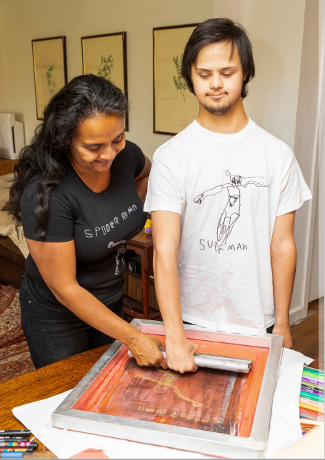

# Risk governance

Our approach to risk management is to embed an understanding of risk, controls and mitigations in every aspect of the organisation from business planning, reporting, decision making and operations.

The Board oversees our risk‑based approach through the Risk Committee and Audit Committee to ensure effective application of risk management and governance frameworks. The NDIA has ten strategic risks that are identified, evaluated, and treated through this approach. These are detailed below.

The NDIA’s risk governance and framework is underpinned by the:

* NDIS Act 2013
* NDIS Risk Management Rules 2013
* Public Governance, Performance and Accountability Act 2013
* other related Commonwealth Policies and Frameworks (as outlined in figure 4).

Our Chief Risk Officer has oversight of risk to ensure:

* our systems, reporting and processes have risk management embedded
* risk owners are supported by dedicated risk officers, and
* appropriate controls are in place to mitigate fraud, promote compliance and manage risk associated with safeguarding public funds, while supporting participant choice and control.

Risk governance and management framework

Together the Board, our CEO, Chief Risk Officer and the Executive Leadership Team oversee the proper, efficient and effective performance of the NDIA.

The risk management framework includes toolkits to guide all levels of the organisation to identify and manage risks and implement applicable risk strategies to minimise negative impacts and maximise opportunities.

The NDIA is optimising and aligning its risk management framework and activities under four key pillars of Assurance, Risk Management, Fraud and Corruption and Security (see figure 4).

Scheme integrity

We are committed to preventing and detecting fraud and non-compliance, and most importantly to protecting all participants.

We maintain a zero-tolerance approach to fraud and the misuse of funds.

We are continuously strengthening our end-to-end processes, including access, planning, claims and payments to further protect the integrity of the NDIS.

We continue to invest in building our capability and systems to identify, respond to, and prevent fraud and non-compliance. 

Strategic risks

Consistent with our practice of identifying, escalating and mitigating key risks, we have identified ten strategic risks that have the potential to adversely impact the achievement of aspirations.

Figure 4. Risk management architecture

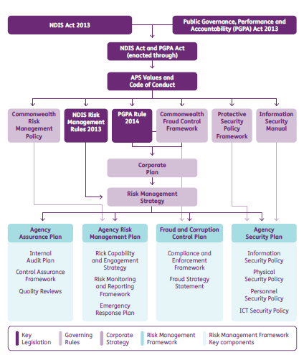

Table 9. Strategic risks

| # | Strategic Risk |
| --- | --- |
| 1 | Participant experience  Failure to meet participant expectations for access decisions, delivery of personalised plans and timely reviews, including responsiveness to the management of critical incidents and/or issues. |
| 2 | Participant outcomes  Failure to deliver expected participant social and economic outcomes. |
| 3 | Partner performance  Failure to establish necessary NDIA partners’ capacity and capability, including Partners in The Community and outsourced service providers. |
| 4 | Provider market quality  Failure to facilitate required provider market quality, depth and coverage, resulting in critical gaps in service, thin markets and/or insufficient disability workforce. |
| 5 | Financial sustainability  Costs, scope, eligibility or funding approvals deviate significantly from funding expectations. |
| 6 | Scheme integrity  Failure to protect the integrity of the NDIS, including data, information and privacy management, fraud, non-compliance and the overall control framework. |
| 7 | People capability and capacity  Inability to attract, retain and develop staff resulting in inadequate workforce capacity and capability to deliver a high performing participant-centric service model. |
| 8 | ICT delivery and cyber  Failure to develop and maintain reliable IT systems and effective cyber security prevention and detection. |
| 9 | Systemic interruption  Failure to maintain continuity of NDIA service delivery and enable market service provision during a systemic interruption. |
| 10 | Scheme transformation  Inability to fully execute and realise the benefits derived from major scheme reform whilst sustaining effective service delivery, including business continuity, participant safeguards and operational readiness. |

**‘Now I’ve got control back over my life. It’s certainly a huge improvement from how I was living before.’**

- NDIS participant

For more information about the NDIS please contact:

ndis.gov.au

National Disability Insurance Agency

Telephone 1800 800 110

Find us on Facebook/NDISAus

Follow us on Twitter @NDIS

For people who need help with English

TIS: 131 450

For people who are deaf or hard of hearing

TTY: 1800 555 677

Speak and Listen: 1800 555 727

1. Key highlights taken from the 30 June Quarterly report 2021. Full details can be found in the [NDIS Q4 report.](https://www.ndis.gov.au/about-us/publications/quarterly-reports)
2. Dignity of risk means giving a person the right (or dignity) to take reasonable risks in their own lives so that they may experience greater independence and self-determination.
3. The Disability Sector and Confidence metric is no longer reported separately. These results are now incorporated and covered by the other sentiment and satisfaction metrics.
4. This is calculated as Average annualised plan budgets of the top 2 deciles (top 20%) divided by the average annualised plan budget of the bottom 2 deciles (bottom 20%). Active participants aged 0 to 64 will be included in the calculation.
5. The name of the metric has been amended and the calculation method has been simplified to include all payments.
6. Percentage of regions where the top 10 providers supply more than 85% of the supports.
7. Percentage of payments that are below the price limit stipulated in the price guide.
8. Payment errors relate to either fraud, misuse or material payment error in the provision of payment for supports.
9. As a result of change in Australian Government policy, responsibility for the Information Linkages  
   and Capacity Building Program was transferred from NDIA to DSS effective 31 January 2020
10. Source: Expenditure in the above table is based on Portfolio Budget Statements 2021-22
11. Other revenue relates to interest received.
12. Total revenues are lower than total expenditures as they exclude approved operating loss of $622m, between 2020-21 to 2024-25, not requiring appropriation.