

my NDIS provider portal

Step-by-step guide

Specialist Disability Accommodation (SDA) Dwelling Enrolment

April 2023

Table of Contents

Changes from the last version 3

Introduction 3

What can you do in the my NDIS provider portal? 3

Minimum internet browser requirements 4

Requesting access to the my NDIS provider portal 4

Accessing the my NDIS provider portal 5

Selecting an organisation 6

SDA enrolment home page 8

Submit a new application to enrol a dwelling 8

Step 1 – Enter your dwelling address/es 10

Step 2 – Enter your dwelling details 11

Step 3 – Dwelling enrolment documents 15

Step 4 – Review dwelling enrolment 17

Step 5 – Authorised contacts and declaration 19

Submit an application to Modify a dwelling enrolment 22

Submit an application to Cancel a dwelling enrolment 24

Respond to a Request For Information 27

Dwelling enrolment application outcome 29

Applications to enrol or modify a dwelling as SDA 29

Applications to cancel a dwelling enrolment 30

Other Functions 31

Find a dwelling 31

Sort dwellings 32

View dwelling enrolment value 33

Find Application Number 34

Export Dwelling List 37

Trouble shooting 38

Portal Access 38

Connecting to multiple provider accounts 38

Duplicate Record 38

Reporting 38

Dwelling Enrolment History 39

Responding to a request for further information 39

Questions and Feedback 39

# Changes from the last version

The following updates have been made to the last published version of the my NDIS provider portal step-by-step guide:

As of April 2023:

* Removed instructions from Requesting access to my NDIS provider portal chapter (page 4).
* Removed instructions from Troubleshooting section PRODA access (page 37)
* Added instructions about new functionality to export a list of dwellings (page 37).

# Introduction

All Specialist Disability Accommodation (SDA) dwellings must be enrolled with the NDIA through the my NDIS provider portal. The my NDIS provider portal is separate from the myplace provider portal where providers submit payment claims and create service bookings.

The my NDIS provider portal enables providers to create SDA dwelling enrolment requests online and to view and manage the end-to-end application process.

This step-by-step guide describes how the my NDIS provider portal works using the general layouts of the menus and screens in the portal.

It also includes instructions on how to use each of the functions in the portal.

# What can you do in the my NDIS provider portal?

The my NDIS provider portal enables SDA Registered providers to:

* Create and submit new dwelling enrolment applications
* Modify existing enrolments
* Cancel existing enrolments
* Action requests for additional information
* View enrolled dwellings

Service bookings and payment requests **cannot** be completed though the my NDIS provider portal. SDA Service Bookings can only be created by a participant’s NDIA planner.

Payment requests are submitted through the myplace provider portal. Details are in the [myplace provider portal step-by-step guides](https://www.ndis.gov.au/providers/working-provider/myplace-provider-portal-and-resources#guides).

# Minimum internet browser requirements

To access the my NDIS provider. Please use one of following browsers:

* Google Chrome
* Microsoft Internet Explorer 11 on Windows 8.1 or Windows 10
* Microsoft Edge
* Mozilla Firefox
* Safari on Mac OS X

# Requesting access to the my NDIS provider portal

Individuals requesting access to the my NDIS provider portal must already be established as an authorised contact in the myplace provider portal. The myplace provider portal step-by-step guides are published [here](https://www.ndis.gov.au/providers/working-provider/myplace-provider-portal-and-resources).

# Accessing the my NDIS provider portal

Users can access the my NDIS provider portal from the links below:

1. <https://providers.apps.ndis.gov.au/myndisproviderportal>
2. Access [PRODA](https://proda.humanservices.gov.au/prodalogin/pages/public/login.jsf?TAM_OP=login&ERROR_CODE=0x00000000&URL=%2F&OLDSESSION=) and select my NDIS **provider portal** tile once logged in.

**Notes**

If you have already signed in to PRODA you will skip the PRODA sign in page.

Once you have logged in you can save the SDA enrolment homepage page to your browser favourites.

# Selecting an organisation

If you work on behalf of more than one provider organisation you can switch between those organisations in the **my NDIS** provider portal.

When you launch the **my** **NDIS** provider portal, you will be prompted to select the organisation you are representing. Click the name of organisation you wish to represent, and you will be taken to the SDA enrolment home page.

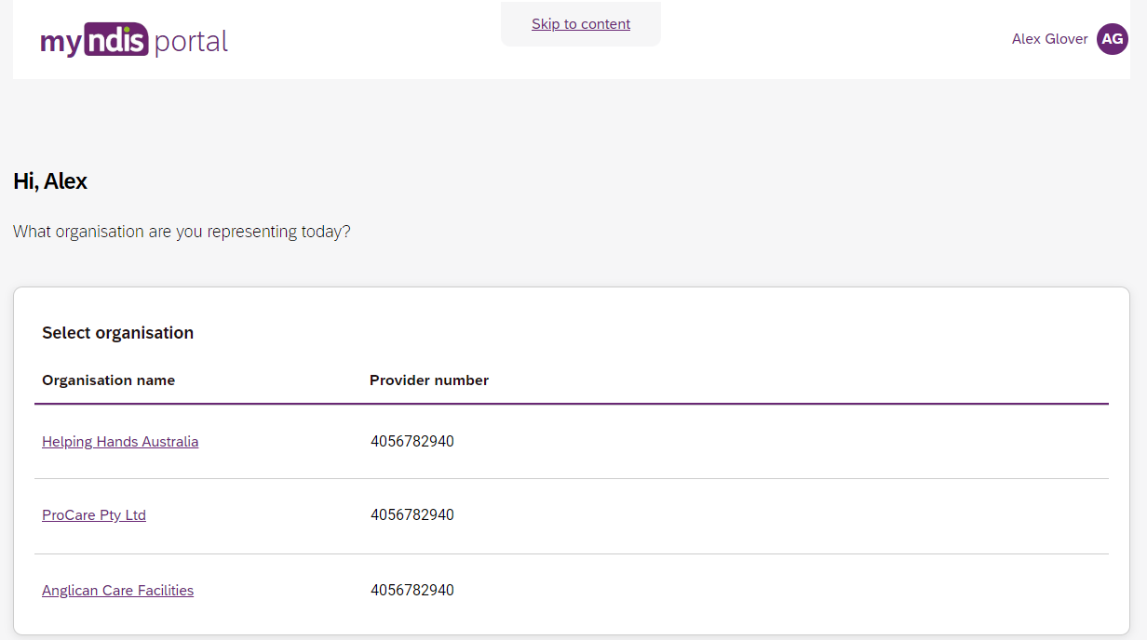

You can change the active organisation while using the portal. Select the dropdown menu by clicking the **Acting as** button on the top left side of the interface.

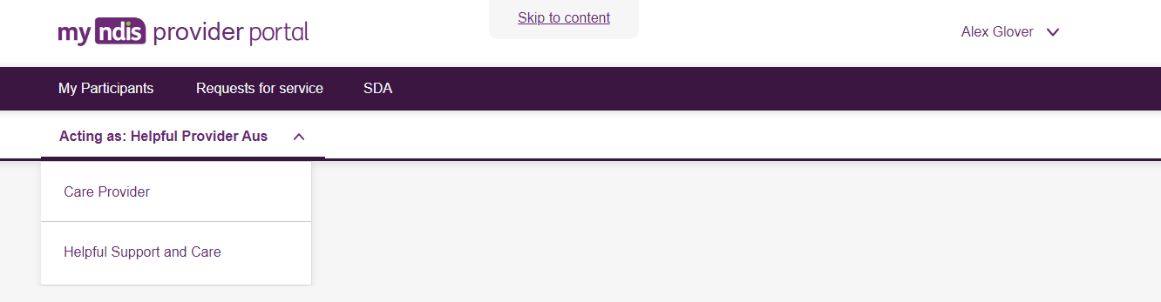

**Note**

If you work for only one provider organisation you will be automatically taken to the SDA enrolment home page.

You can configure relationships between users and provider organisations in the existing myplace provider portal.

Instructions for updating these relationships can be found in the [Part 2: Managing You Information guide](https://www.ndis.gov.au/providers/working-provider/myplace-provider-portal-and-resources). Please be aware that changes may take 24 hours to appear in the **my NDIS** provider portal.

# SDA enrolment home page

The my NDIS provider portal home page displays existing enrolled dwellings and gives the user the option of enrolling or finding a dwelling.

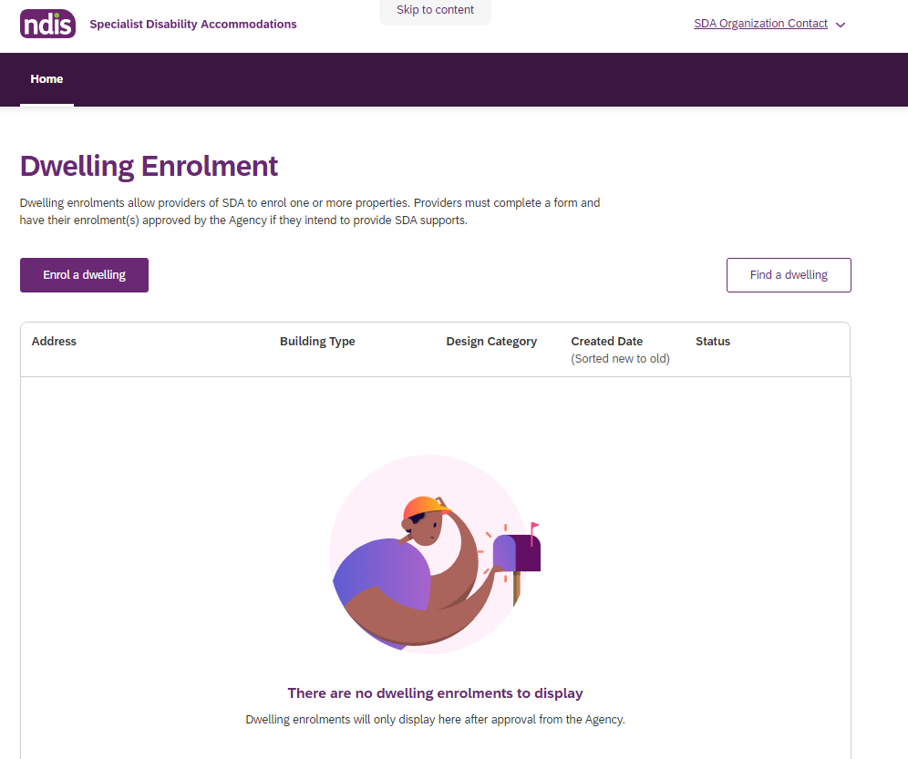

# Submit a new application to enrol a dwelling

1. On the home page, select **Enrol a dwelling**

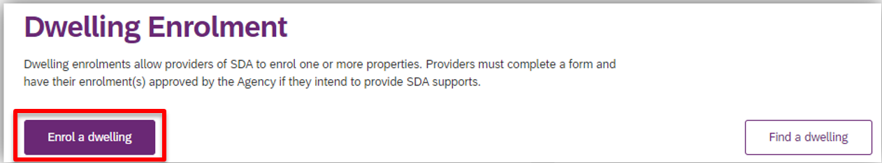

1. Read the content provided at **Before you start** and select **Continue enrolment**

Image of the Before you start page of the myNDIS provider portal.  There are five sections visible:
1. Submitting multiple dwellings
2. What address validation and details you need
3. What documentation and certificates are mandatory or necessary
4. Who can submit dwelling enrolments
5. Dwellings that are being built or not yet built
The Continue Enrolment function is highlighted.

## Step 1 – Enter your dwelling address/es

The dwelling address must be legitimate and correspond with the address as it appears on rates notices or other verifiable documents.

* It is possible to apply to enrol up to 10 dwellings per application process. Select **Yes** or **No** at **Are you enrolling multiple dwellings** to activate a single or multiple dwelling enrolment application.

1. Enter your **dwelling address/es** using the **Search street address** function. The search results are populated from Addressify and all attempts to find the matching result in Addressify should be made prior to manually entering the address. This may include things like typing ‘unit’ instead of ‘1/2’. If your dwelling address/es do/does not appear in the search results, use the **manually enter address** function. If you are entering multiple dwellings at the same time you may need to manually add a unit or apartment number (e.g. Unit 1, Unit 2).
2. If the build of the dwelling/s is not yet complete you will be unable to progress past this step. The application will be saved as a Draft.
3. If the build of the dwelling is complete select **Save and Continue to Details**.

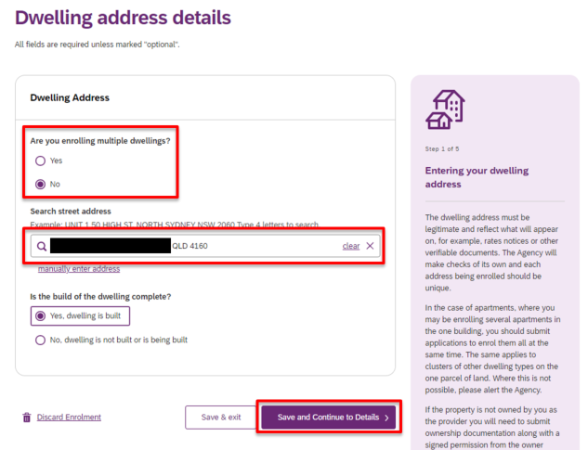

## Step 2 – Enter your dwelling details

Details to be submitted at Step 2 includes Type of SDA, Design Category, Building Type, Number of Residents, Number of Rooms, On-site Overnight Assistance, Fire Sprinklers, Home Modifications and Shared Land Restrictions.

The details submitted must be an accurate reflection of the dwelling.

More information about dwelling characteristics are published in the [SDA Rules](https://www.legislation.gov.au/latest/F2020L00769), [NDIS](https://www.ndis.gov.au/providers/housing-and-living-supports-and-services/specialist-disability-accommodation/sda-pricing-and-payments) Pricing Arrangements for SDA and [SDA Design Standard](https://www.ndis.gov.au/providers/housing-and-living-supports-and-services/specialist-disability-accommodation/sda-design-standard).

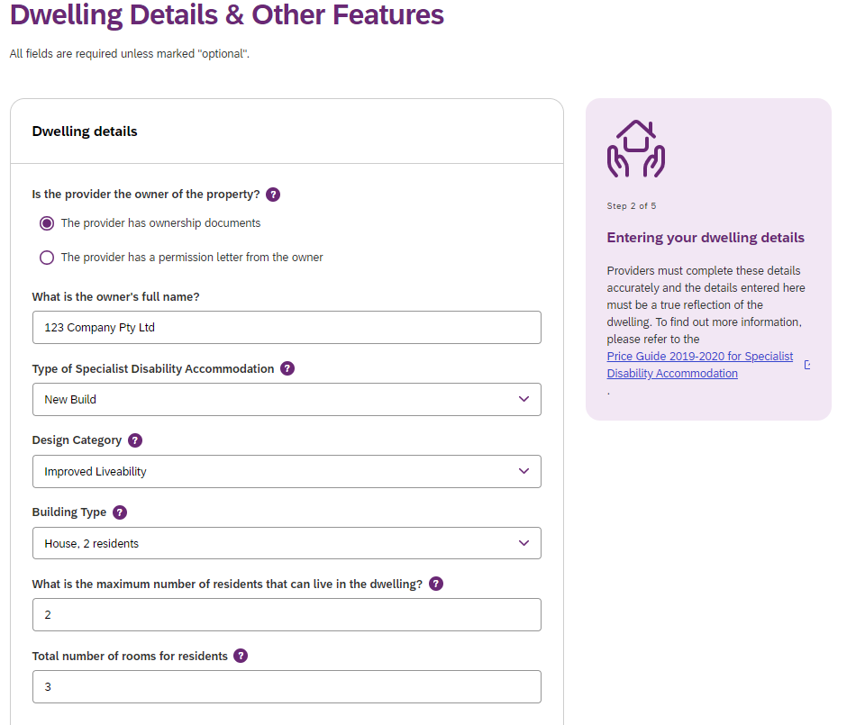

* If the dwelling is a Multi Design Category dwelling, select **Multi Design Category** from the drop down options at **Design Category.**

This function should only be used when a provider needs to enrol a dwelling with **bedrooms of different design categories**.

It should not be used for dwelling enrolment where the entire dwelling, and all its bedrooms, meet several different design categories.

It should not be used for dwellings with only one bedroom.

It should not be used when all bedrooms of the dwelling are the same design category.

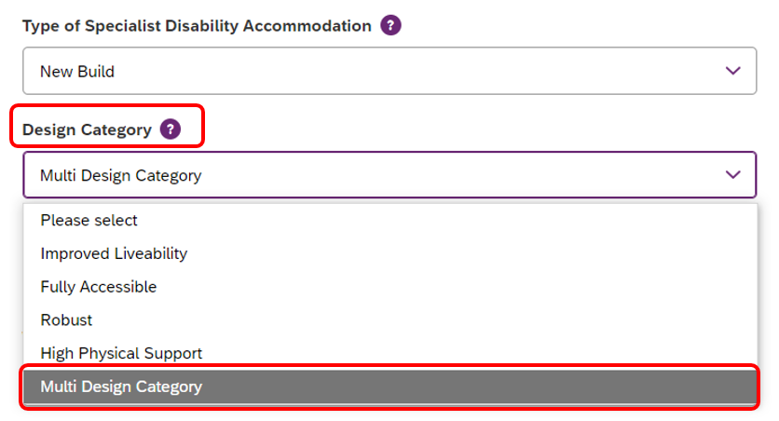

1. Populate the room level enrolment details at **Room Enrolment Details** by entering the number of bedrooms that comply with each Design Category.

A **minimum of 2 bedrooms** with different design categories must be reflected for the enrolment application to proceed. A **maximum of 5 bedrooms** in total only is acceptable.

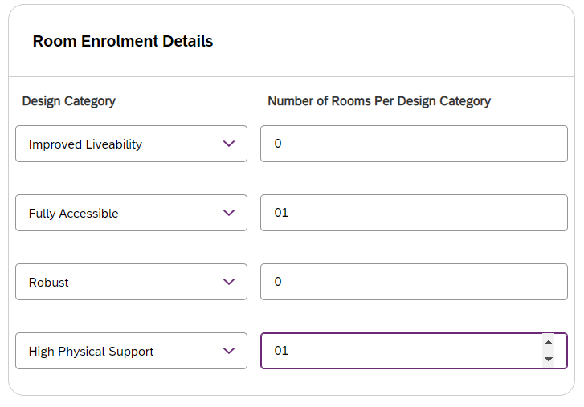

The following error message will appear if the **total number of rooms for residents** value submitted is greater than the total number of rooms per design category submitted (plus 1 to allow for OOA).

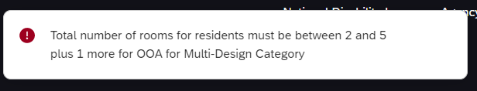

If this occurs, review the value submitted at **Total number of rooms for residents**.

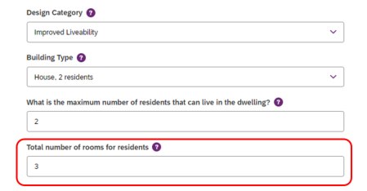

1. If the dwelling will be claiming On-site Overnight Assistant (OOA), select **Yes**. You must indicate if the OOA will be shared with other dwellings. Submit the **address of the OOA room/apartment** in the **OOA Space Details** field. In some instances you will need to indicate that even though the dwelling shares OOA, the dwelling will not be claiming OOA. Further information about OOA is available in [NDIS](https://www.ndis.gov.au/providers/housing-and-living-supports-and-services/specialist-disability-accommodation/sda-pricing-and-payments) Pricing Arrangements for SDA.

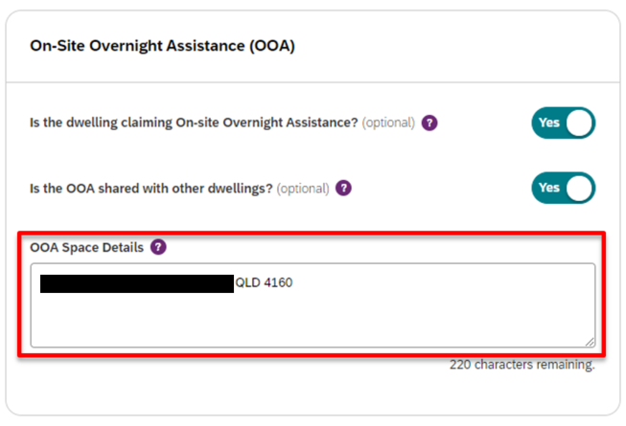

1. Complete the **Other features of the dwelling** and **Shared Land Restrictions** sections and select **Continue to Documents**.

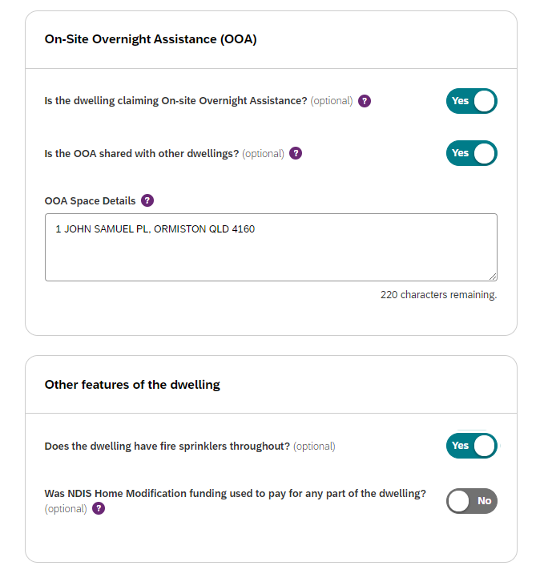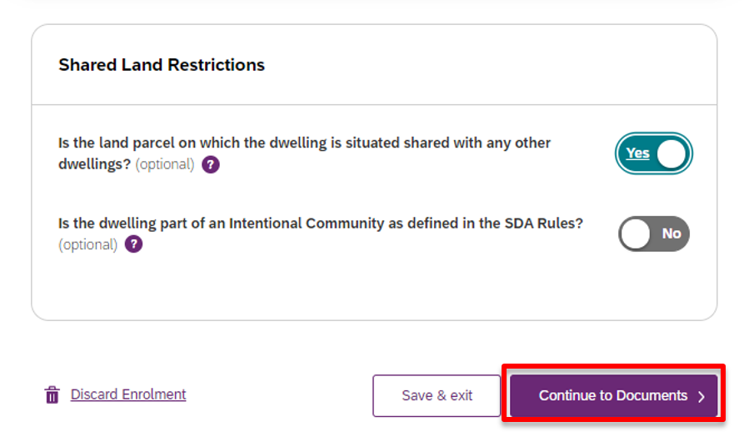

## Step 3 – Dwelling enrolment documents

Documents are used as evidence to support your application. Listed documents are mandatory. You have the option to upload additional documents to support your application.

* Click on the **Please select** drop down menu and select the category of document you are uploading

1. Select **Choose a file** to upload a file from your device

Image of Step 3 of the dwelling enrolment application form.  The document upload function is highlighted. 


1. As you upload each mandatory document, the list of documents will update and a green tick will appear.

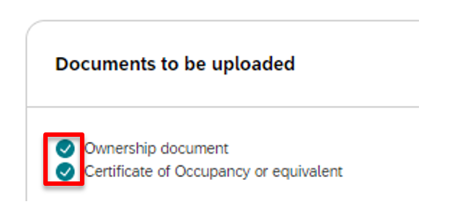

1. Select **Continue to Review**.

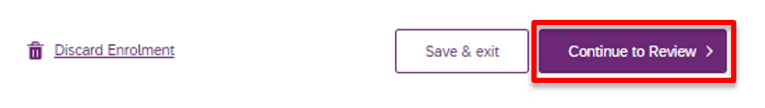

1. If you have not uploaded all the mandatory documents required, you will not be able to proceed. The following error message will be visible.

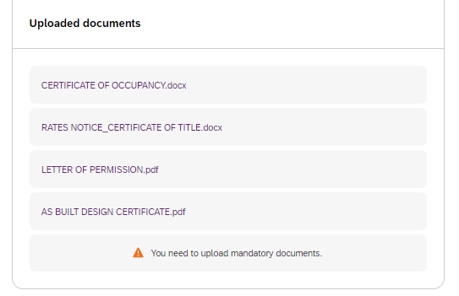

1. Select **Go back.** Check the list of documents to be uploaded and note which do not have a green tick. Return to items 14 to 17 to upload and continue.

## Step 4 – Review dwelling enrolment

Review the details submitted in your application to ensure they are correct.

* If you identify any errors select **Edit**

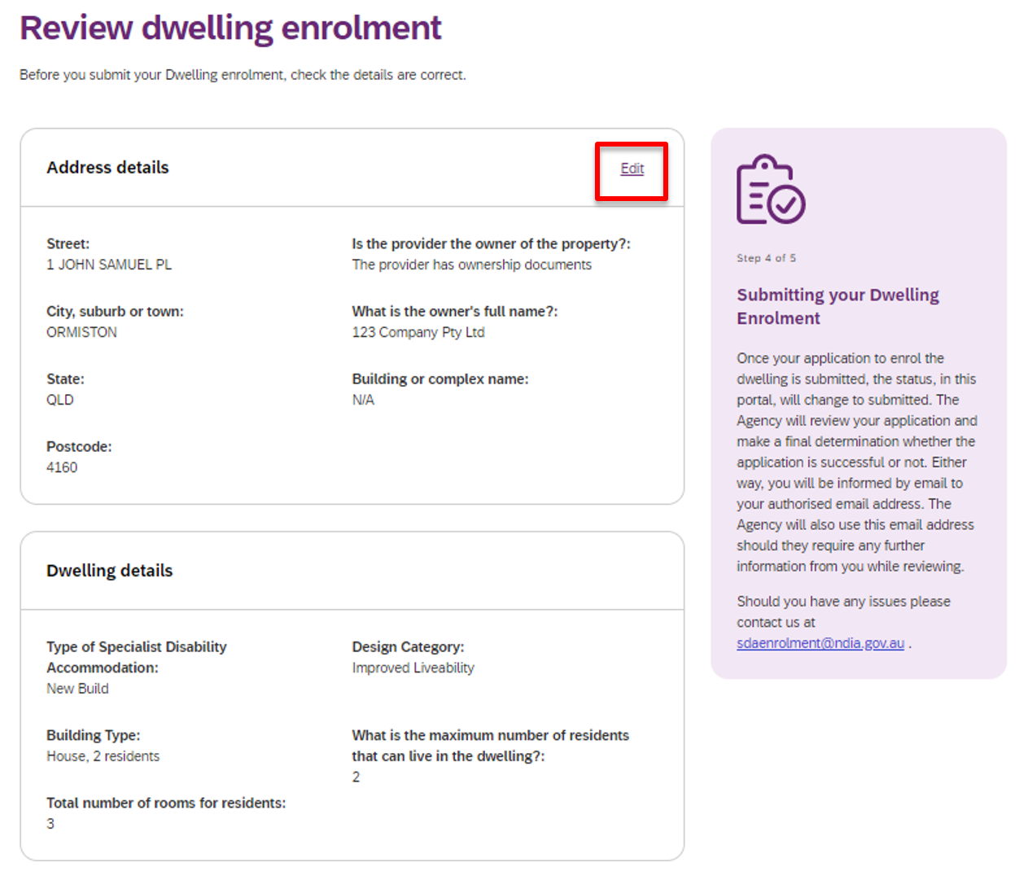

1. You will return to Step 1 (**Enter your dwelling address**) and have the opportunity to amend all details submitted by progressing through each step again.
2. If you wish to save your dwelling enrolment application at this point and return to it later, select **Save & exit.**

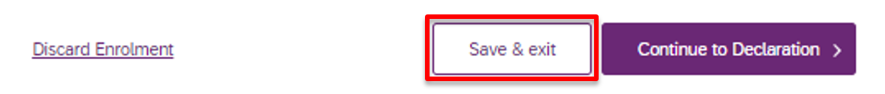

1. If you do not wish to continue with your dwelling enrolment application at this point select **Discard Enrolment.** This will require you to start the application from the beginning should it be later required.

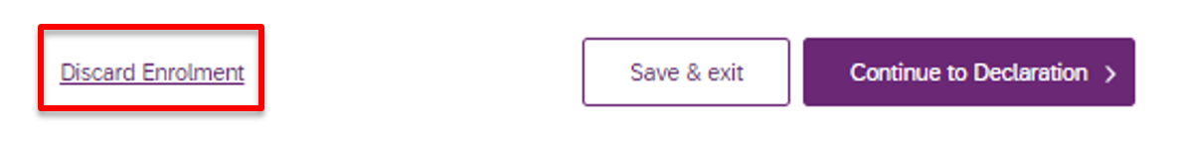

1. If you are satisfied with your dwelling enrolment application select **Continue to Declaration.**

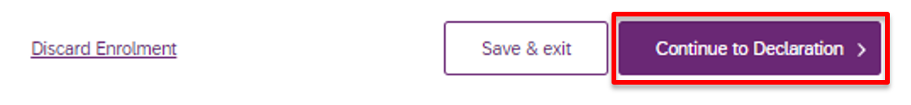

## Step 5 – Authorised contacts and declaration

The dwelling enrolment application must be completed by an Authorised Contact Person(s). An Authorised Contact person is the Account Manager or Primary Contact as established in the my Place provider portal.

* Select the Primary Contact Person and Secondary Contact Person for the dwelling enrolment application.

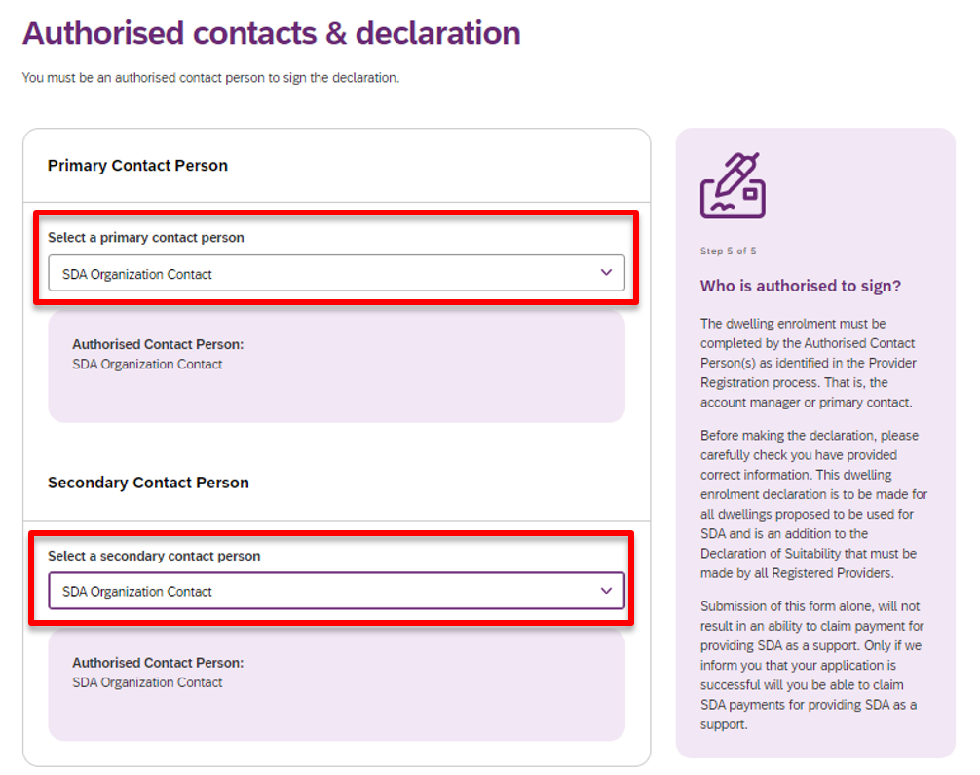

1. Review the Dwelling Enrolment Declaration.
2. Select the **Authorising Officer** to complete the Dwelling Enrolment Declaration on behalf of the organisation. Completion of the declaration is taken as certification of the matters contained in the submitted application.

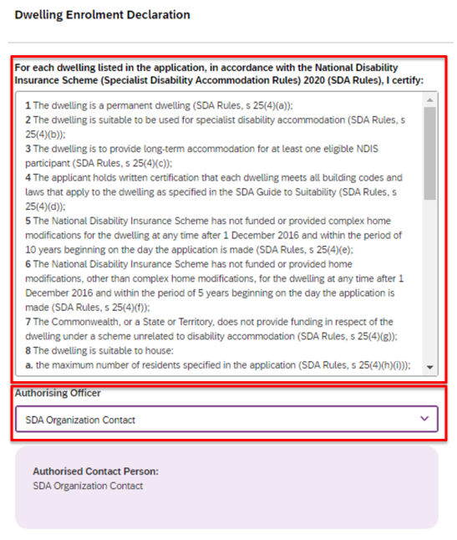

1. If you do not wish to continue with your dwelling enrolment application at this stage select **Discard Enrolment.** This will require you to start the application from the beginning should it be later required.



1. If you wish to save your dwelling enrolment application at this point and return to it later, select **Save & exit.**

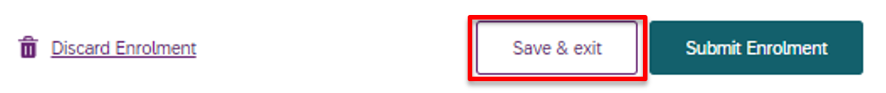

1. If you wish to proceed with your dwelling enrolment application, select **Submit Enrolment.**

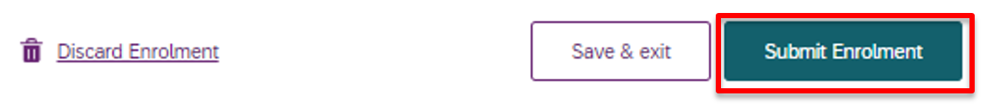

1. The application has now been sent to the SDA dwelling enrolment team for assessment and will be visible on the portal home page with a status of **Pending Approval.**

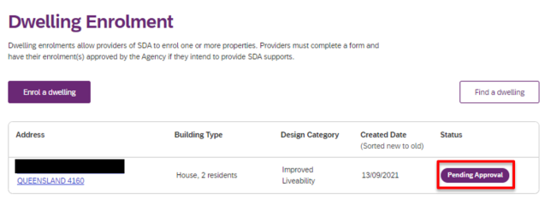

1. Proceed toDwelling enrolment application outcome**.**

# Submit an application to Modify a dwelling enrolment

If the characteristics of an enrolled dwelling change, an application to modify a dwelling enrolment can be submitted to the NDIA.

**Note**, that Addresses are unable to be modified. Please email [SDAEnrolment@ndis.gov.au](mailto:SDAEnrolment@ndis.gov.au) where corrections are required.

Note that Providers are also unable to be modified. Where there is a change in SDA provider, the dwelling enrolment must be cancelled by the outgoing provider.

* On the portal home page, click on the dwelling address. An application to modify a dwelling enrolment can only be created against dwellings with a status of **Enrolled.**

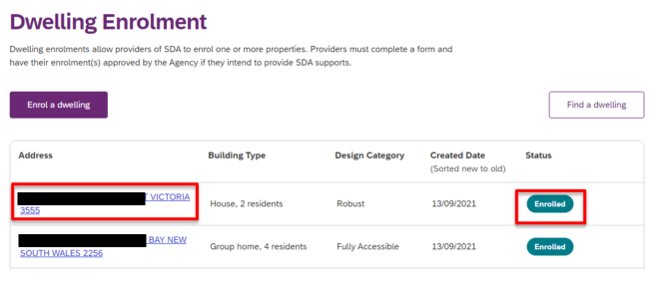

1. A summary of the dwelling enrolment characteristics is able to be viewed. Select **Update enrolment** to continue or **Back to enrolment list** if you do not wish to proceed.

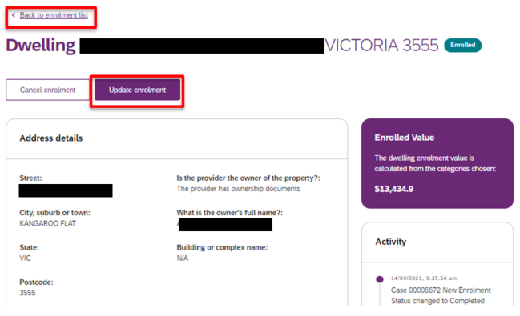

1. Review and update the required information and documentation through Steps 2 to 5 of the dwelling enrolment application process.
2. All other dwelling details, documents and contacts can be updated via Steps 2 to 5 of the dwelling enrolment application process.
3. Selecting **Submit Enrolment** when completing Step 5 will notify the NDIA that you have submitted an application to modify a dwelling enrolment. The status of the dwelling on the portal home page will change to **Pending Approval**.

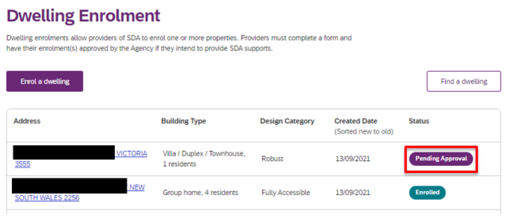

* Proceed to Dwelling enrolment application outcome.

# Submit an application to Cancel a dwelling enrolment

Providers can cancel a SDA dwelling enrolment via the my NDIS provider portal. Cancelling a dwelling enrolment will mean that you can no longer claim SDA payments for NDIS participants that reside in the dwelling.

There are a number of reasons a dwelling enrolment might be cancelled, including where there has been a change of provider.

Note that once a dwelling enrolment is cancelled, a new application to enrol process must be undertaken if a provider wishes to offer it as SDA again in the future.

* On the portal home page click on the dwelling address. An application to cancel a dwelling enrolment can only be created against dwellings with a status of **Enrolled.**

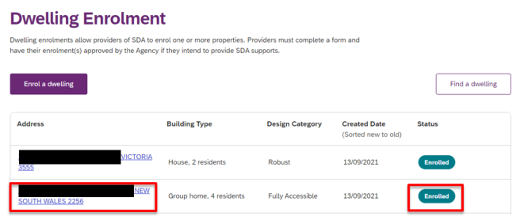

1. From thesummary of the dwelling enrolment characteristics, select **Cancel enrolment** to continue or **Back to enrolment list** if you do not wish to proceed.

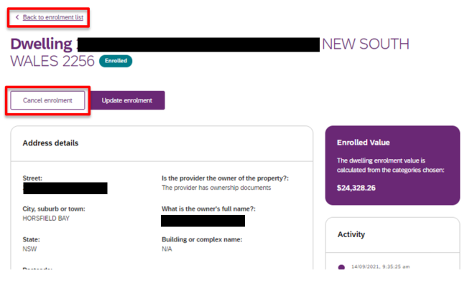

1. Enter a **Reason for cancelling enrolment** and **Effective date of cancellation.**

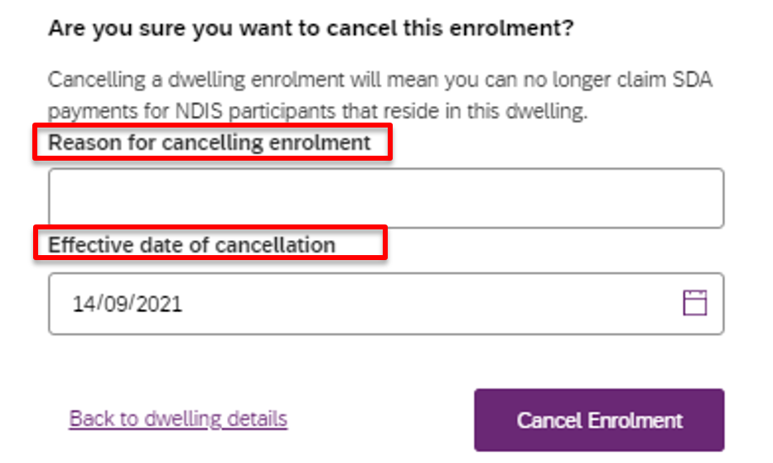

1. To submit the cancellation select **Cancel Enrolment**. If you do not wish to proceed select **Back to dwelling details**.

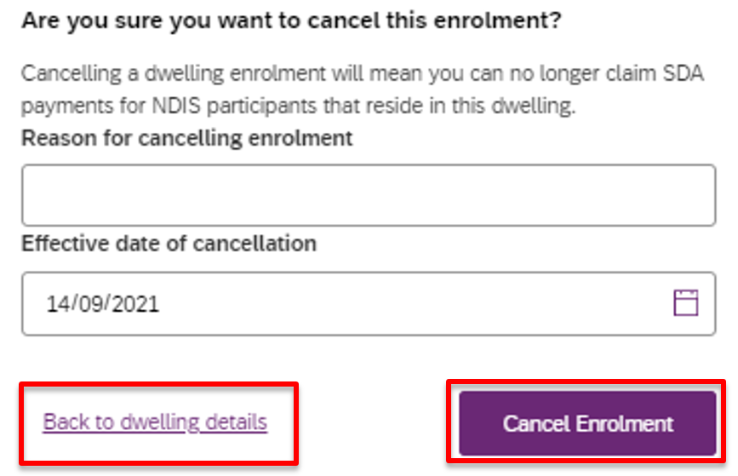

1. The NDIA will be notified that you have submitted an application to cancel the dwelling enrolment. The status of the dwelling on the portal home page will remain **Enrolled**.

* Proceed to Dwelling enrolment application outcome; providers are notified of cancellation outcomes in the same way as for enrolment applications.

# Respond to a Request For Information

If the NDIA requires more information in order to assess a dwelling enrolment application, the application contact will receive an email listing the information required. The status of the dwelling on the portal home page will change to **Pending Update**.

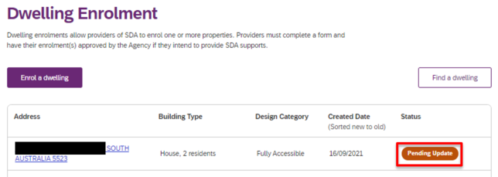

1. Click on the dwelling address with the status of Pending Update.
2. Select **Respond to Request for Information.**

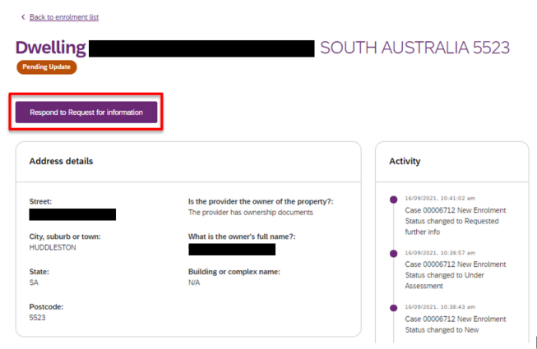

1. Review and update the required information and documentation through Steps 2 to 5 of the dwelling enrolment application process.
2. Dwelling details, documents and contacts can be updated via Steps 2 to 5 of the dwelling enrolment application process.
3. Selecting **Submit Enrolment** when completing Step 5 will notify the NDIA that you have responded to their request for information and the application will continue to be assessed. The status of the dwelling on the portal home page will change to **Pending Approval**.

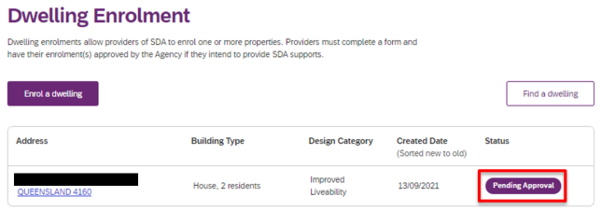

# Dwelling enrolment application outcome

1. When an outcome is finalised by the NDIA, the portal generates an automated email to the application contact with the subject line **Outcome of application.**

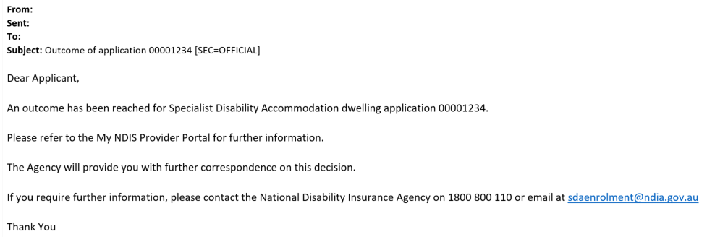

**Note**, the automated correspondence from the portal references an application number only, not a dwelling address. Further information is provided at Find Application Number.

## Applications to enrol or modify a dwelling as SDA

1. When a new dwelling enrolment application or application to modify a dwelling enrolment is **approved,** the NDIA will prepare a Certificate of Enrolment and email the application contact within 2 business days of the application approval. The certificate will include the dwelling address.
2. The enrolment status of the dwelling in the portal home page will immediately change to **Enrolled.** Providers can check the portal home page for status updates at any time.

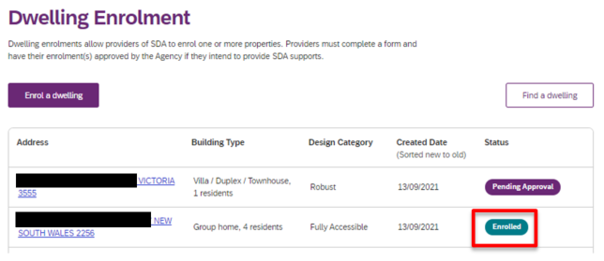

1. If the dwelling enrolment application is **not approved** the NDIA will prepare a letter confirming the outcome, including the reasons why the application was not approved and email the application contact within 2 business days of the decision.
2. The status of the dwelling in the portal home page will change to **Not Enrolled.**

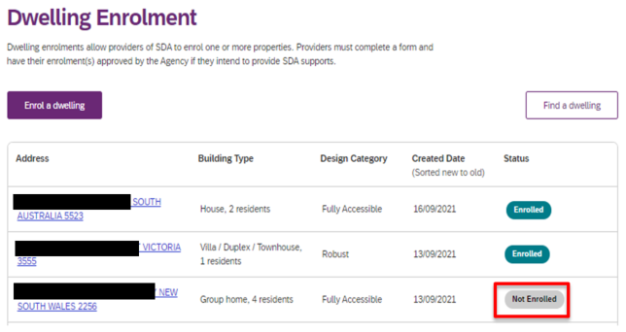

## Applications to cancel a dwelling enrolment

1. Where an application to cancel a dwelling enrolment is **approved,** the status of the dwelling in the portal home page will immediately change to **Not** **Enrolled.** Providers can check the portal home page for status updates at any time.



# Other Functions

## Find a dwelling

Your enrolled dwellings can be searched for using the **search and filter** functions.

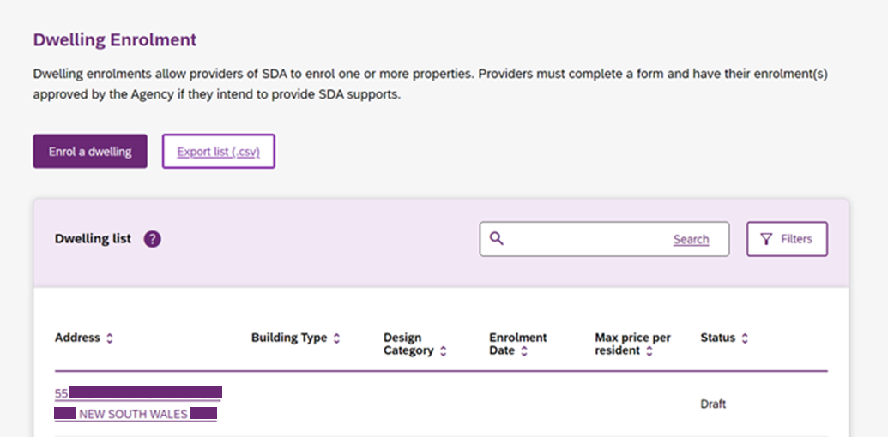

You may enter a search term; you can enter all or part of an address (e.g. postcode or suburb). Click **Search** to conduct the search.

Clicking **filters** will display the available filters.

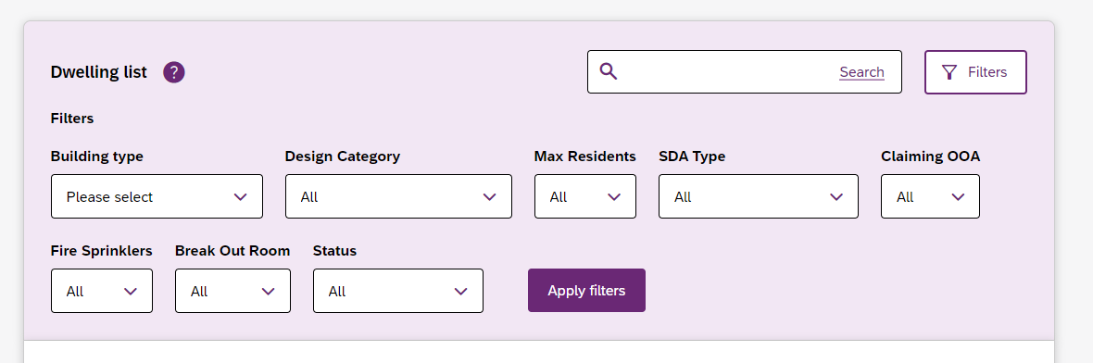

You may select an option from one or more of the available dropdowns. Click **Apply Filters** to filter results.

You may use filters and search tools at the same time.

The dwellings included in the **export list** file will be limited to those returned by the selected search parameters.

## Sort dwellings

You can sort the dwellings list based on any of listed columns, to apply a sort order click the desired column to toggle between ascending and descending sort order.



## View dwelling enrolment value

* On the portal home page click on a dwelling address.

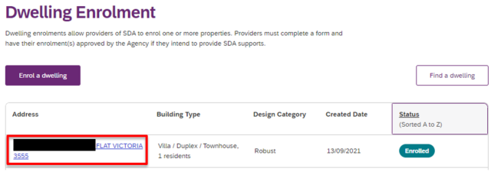

* The current **Enrolled Value** is displayed to the right of the screen in a purple box.

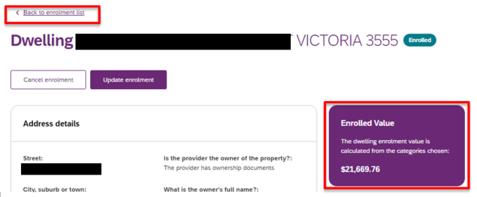

* Where the dwelling is a multi-design category dwelling the purple Enrolled Value box will not display a value.

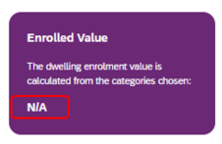

* The enrolled value of each bedroom in the dwelling is displayed at **Multi Design Category details**.

Image of the Multi Design Category details with Max Price Per Resident - Design Category highlighted.


* Return to the portal home page by clicking on **Back to enrolment list**.

## Find Application Number

Every Dwelling Enrolment Application created generates a unique Application ID Number (also known as a Case). Correspondence automatically generated by the my NDIS provider portal references these ID numbers. Application (or Case) ID numbers can be found in the Activity log of each dwelling summary.

* On the portal home page click on a **dwelling address**.
* The Activity log displays in a column to the right of the screen, below the **Enrolled Value**.

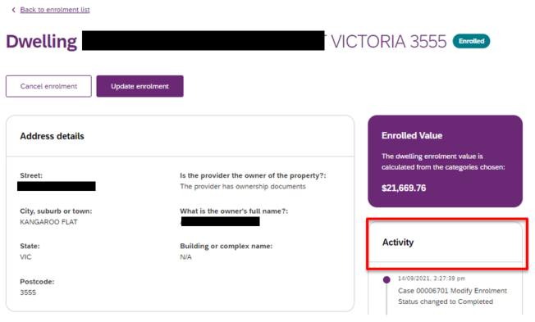

* Each entry in the Activity log will start with a Case number. This is the Application ID Number (also known as Case ID Number).

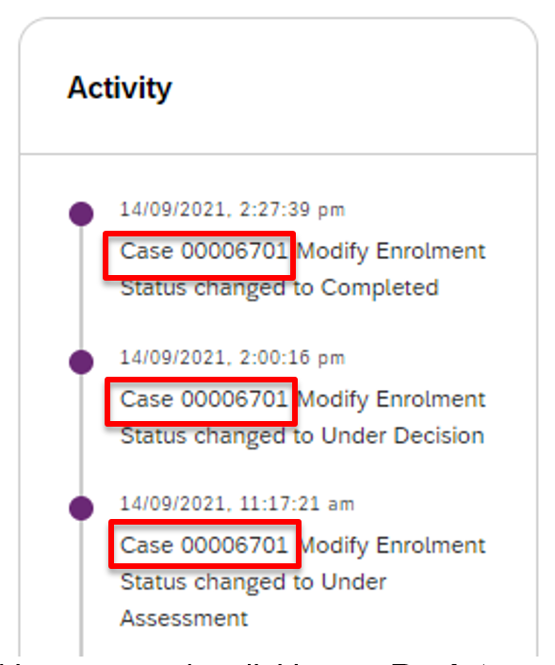

* Return to the portal home page by clicking on **Back to enrolment list**.

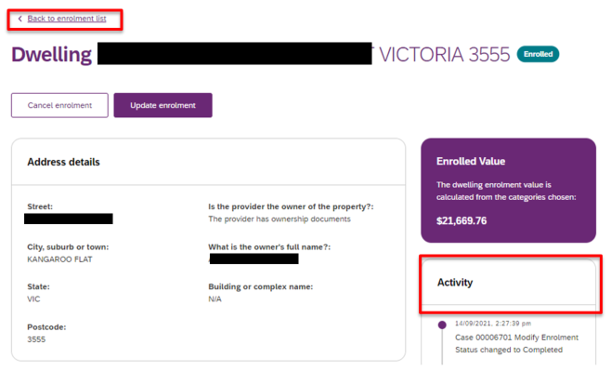

# Export Dwelling List

You may export a .csv file of the complete list of dwellings matching the selected search and filter settings.

Select the desired search and filter settings. You may also export a complete list of dwellings by selecting no search and filter settings.

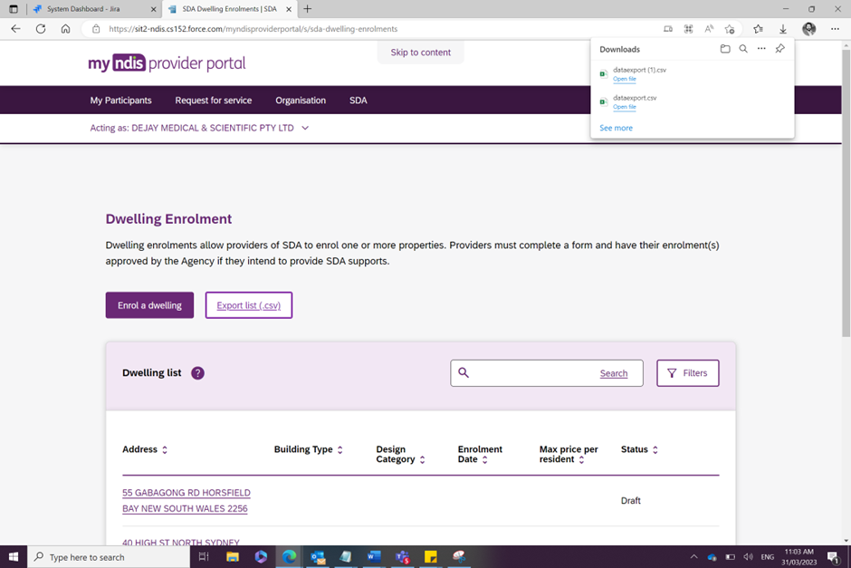

This will export a list of dwellings in .csv format, this will include columns for:

* Dwelling address
* Price (Showing the maximum price per resident)
* Maximum number of Residents
* Enrolment Start Date
* Enrolment End Date
* SDA Type
* Building
* Design category
* Break Out Room
* Fire Sprinklers
* On-site Overnight Accommodation
* Is OOA Shared with Other Dwellings
* Application Status
* Most recent dwelling application ID number

Trouble shooting

## Portal Access

If you have having difficulty in accessing the my NDIS provider portal:

* Check you are using the correct link to access the my NDIS provider portal (<https://providers.apps.ndis.gov.au/sda>). The my NDIS provider portal is separate from, and not able to be accessed via, the my Place provider portal.
* Try using the recommended internet browser, Google Chrome.
* If these steps do not resolve the issue please contact the NDIS for assistance.

## Connecting to multiple provider accounts

An existing limitation of the my NDIS provider portal is that it will not allow individual access to more than one SDA provider account. Individuals cannot gain access to the portal on behalf of more than one SDA provider. Should this limitation affect you, contact [SDAEnrolment@ndis.gov.au](mailto:SDAEnrolment@ndis.gov.au) for more information.

## Duplicate Record

The my NDIS provider portal is configured to prevent duplicate dwelling enrolments. Where an address is already recorded in the portal, the below error message may display if another account attempts to also enrol the address.

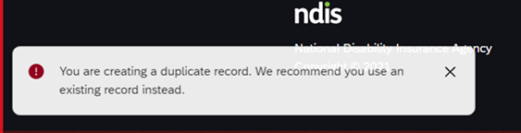

If this error occurs please contact the SDA Enrolment Team via [SDEnrolment@ndis.gov.au](mailto:SDEnrolment@ndis.gov.au). Please include the address you are attempting to enrol and screen shots from the provider portal. A team member will work to resolve the issue and will provide updates every 24 to 48 hours.

## Reporting

The my NDIS provider portal is not a reporting tool. It is an application processing interface. Information in the portal may be used by providers to create their own reports. The ability to extract reports from the my NDIS provider portal is not provisioned as this is not the purpose of this tool. List views of some details are available with further detail viewable when drilling down into records. The NDIA is unable to assist with providing reports related to an individual providers enrolled SDA dwellings.

## Dwelling Enrolment History

Where an application to modify an existing dwelling enrolment is submitted and approved, the enrolment effective (start) date will be modified by the portal. The modified enrolment date reflects the date of approval (effective date) of the modified dwelling enrolment details and current maximum price per resident. Portal users are encouraged to maintain a summary register of dwelling enrolment profiles that captures enrolment modifications including effective dates and maximum prices.

If a portal user is asked by an NDIA Planner/Delegate for the dwelling enrolment history of an individual dwelling, for purposes related to Service Bookings or Claims, please forward the request to the SDA Enrolment Team via [SDAEnrolment@ndis.gov.au](mailto:SDAEnrolment@ndis.gov.au).

## Responding to a request for further information

A Request For Information (RFI) may be sent to a portal user which requires a response in addition to updating dwelling details or documentation within the portal. Where this is the case, use the **Reply** function available in the RFI email sent to the portal users email account. This will ensure that the reply is correctly directed to the unique enrolment application (Case) ID.

Contact can be made with the SDA Enrolment Team outside of the portal via [SDAEnrolment@ndis.gov.au](mailto:SDAEnrolment@ndis.gov.au).

# **Questions and Feedback**

If you have any questions or feedback about this user guide please contact the SDA Enrolment Team at [SDAEnrolment@ndis.gov.au](mailto:SDAEnrolment@ndis.gov.au).

**Version Control**

| **Version** | **Page** | **Details of Amendment** | **Date Published** | **Date of Effect** |
| --- | --- | --- | --- | --- |
| 1.0 |  | my NDIS provider portal | 15 December 2021 | 15 December 2021 |
| 1.1 |  |  |  |  |
| 1.2 |  |  |  |  |
| 1.3 |  | Updates for the November 2022 release of my NDIS provider portal. Including capability to select an organisation. | 07 November 2022 | 07 November 2022 | |