Support organiser
This user guide explains how to use the Support Organiser spreadsheet. It has screen shots, so we have also created a version that is suitable for screen readers.
Many NDIS participants have approved funding for different supports. You can use the support organiser to help you make the best use of your funding to pursue your plan goals. It aims to help you stay within the amount of NDIS funding you have.
This user guide works through some examples on how to enter information into the support organiser. You can put your own information into the examples to see how the support organiser works, then download and use the support organiser to keep track of your supports.
Disclaimer:
The estimates calculated by the Support Organiser are indicative only and are based on the information you enter at the time.
You should not rely on the amounts calculated by the Support Organiser and the National Disability Insurance Agency (NDIA) gives no warranty as to relevance, accuracy, currency or completeness of any calculation.
The NDIA is not responsible for any loss or damage you may suffer as a result of relying on a calculation from the Support Organiser.
The NDIA does not use the Support Organiser for the calculations of reasonable and necessary supports.
If you have any questions about the Support Organiser, please use the feedback form at the bottom of this page or through Contacts on myplan.ndis.gov.au or call the NDIA on 1800 800 110

Notes for Excel

Spreadsheets
There are three spreadsheets. You can switch between the spreadsheets by clicking on the tabs at the bottom left-hand side of the spreadsheet or by pressing Control + Page up or Control + Page Down.
Read Me First has notes about the support organiser. Please make sure you read and understand these notes before using the support organiser.
The support organiser has the tables that you need to fill in to calculate your planned spending.
Data has the details to make the support organiser work. You don’t need to open this spreadsheet.

Understanding the Support Organiser spreadsheet
This spreadsheet is divided into Core Supports (services and consumables) and Capacity Building Supports (services).
Headings that end with a # show which columns you will need to enter information in.
Teal coloured cells are where you need to type in your information.
Grey coloured cells are where Excel will automatically calculate totals for you. These cells have formulas. Don’t enter data here or delete the contents. If you do, select the Undo button to reset it.

Troubleshooting tips

Automatic calculation function
When you put in your information, the totals in the grey boxes should update. If they don’t, the automatic calculation function may be turned off. You can press F9 to update the calculations.
You can check if the automatic calculation function is turned off by going to the Formulas tab and selecting Calculation Options on the right-hand side of the toolbar. If Manual is ticked, select Automatic.
You can also use the following keystrokes:
F10 – this gives all shortcuts and headings either a number or a letter
M – to get the Formulas tab
X – to select Calculation Options
A – to choose Automatic

Formulas
If you type over a formula, you can select Undo to get the formula back.

If a formula isn’t working, you can download the spreadsheet again from the NDIS website (link to support organiser) and copy your details from the teal-coloured sections (or the sections under the headings marked with #) into the downloaded spreadsheet.

Examples
There are two examples after the section explanations to help you understand how to enter information into the support organiser spreadsheet

Example 1: Jack’s Core Supports funding
(Note: these examples are made up)
To put his information into the support organiser, Jack needs to know how much funding he has in Core Supports. Jack looks at his NDIS plan in the myplace portal and finds the Total Core Supports funding amount of $13,092.75. In this example, the Total Core Supports amount is for one year of funding.
Jack enters this amount into the top of the Core Supports section in the support organiser spreadsheet. This is shown on the next page.

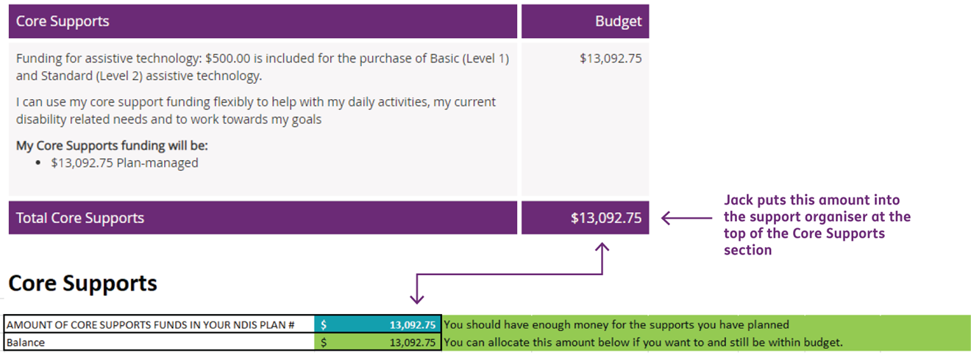
Jack decides that he wants to use his Core Supports funding in the following way:
- Support workers during the week and some Saturdays:
- The provider charges a one-time only establishment fee
- His plan also includes $500 for low-cost assistive technology.
Jack can type this information into the teal cells (rows 8 to 17, columns A to F) in the support organiser spreadsheet.

First support: Jack wants support workers during the week.
He enters 3 sessions every week (Monday to Friday), 1 hour per session and a cost of $57.10 per hour (on row 8, columns A to F).
The spreadsheet automatically works out the cost per session ($57.10) and annual amount ($8,907.60) displayed in cells row 8, columns G and H.
After Jack puts in the first support, the total annual amount adds up to $8,907.60 displayed in row 18, column H.
From the total funding in the plan ($13,092.75), there is now a balance of $4,185.15 (row 5, column B). This is shown on the next page.
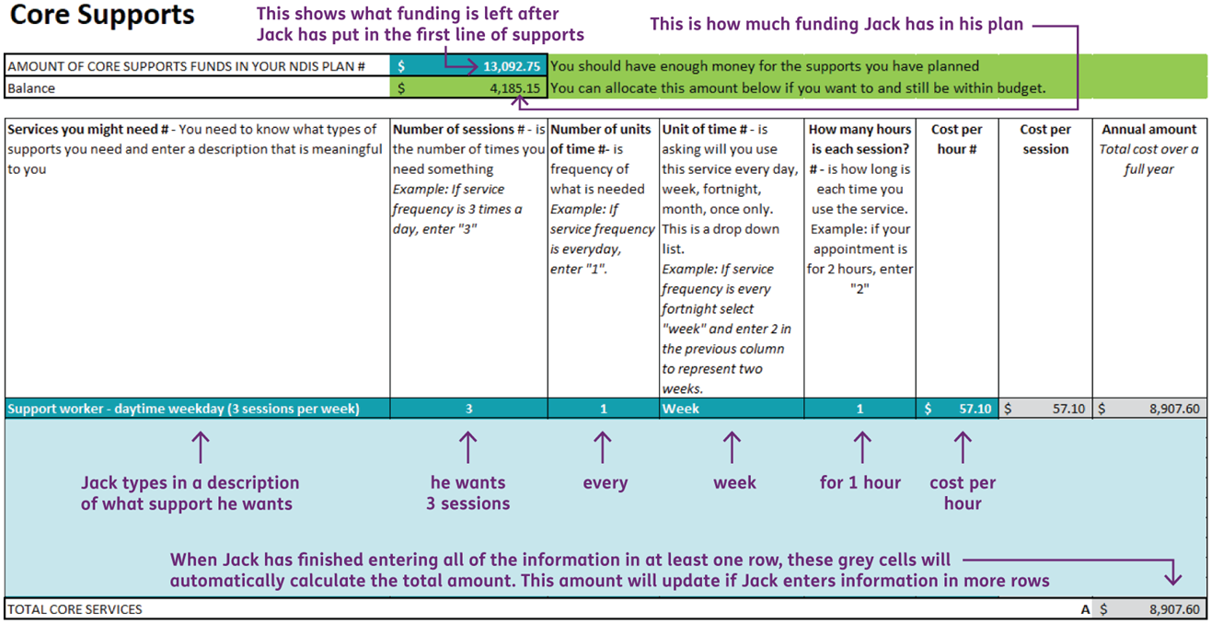

Second support: Jack wants a support worker on a Saturday night once a month.
He enters 1 session, 1 time a month, for 3 hours and a cost of $80.10 per hour (on row 9, columns B to F).
The spreadsheet automatically works out the cost per session ($240.30) and annual amount ($2,883.60) displayed in cells row 9, columns G and H.
After Jack puts in the second support, the total annual amount adds up to $11,791.20 displayed in row 18, column H.
From the total funding in the plan ($13,092.75), there is now a balance of $1,301.55 (row 5, column B). This is shown on the next page.
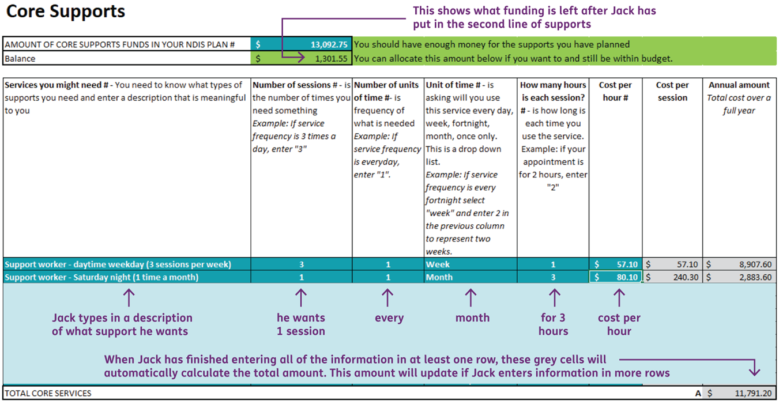

Third support: Jack’s provider charges a once off establishment fee of $571.00.
Jack notes this as a one-time cost for the year. If his plan is longer than 1 year, this cost isn’t repeated.
He enters 1 session, 1 time a year, for 1 hour and a cost of $571.00 per hour (on row 10, columns B to F).
The spreadsheet automatically works out the cost per session ($571.00) and annual amount ($571.00) displayed in cells row 10, columns G and H.
After Jack puts in the third support, the total annual amount adds up to $12,862.20 displayed in row 18, column H.
From the total funding in the plan ($13,092.75), there is now a balance of $730.55 (row 5, column B). This is shown on the next page.
Jack now goes to the consumables part of his plan. If you have no consumables, then skip this step.

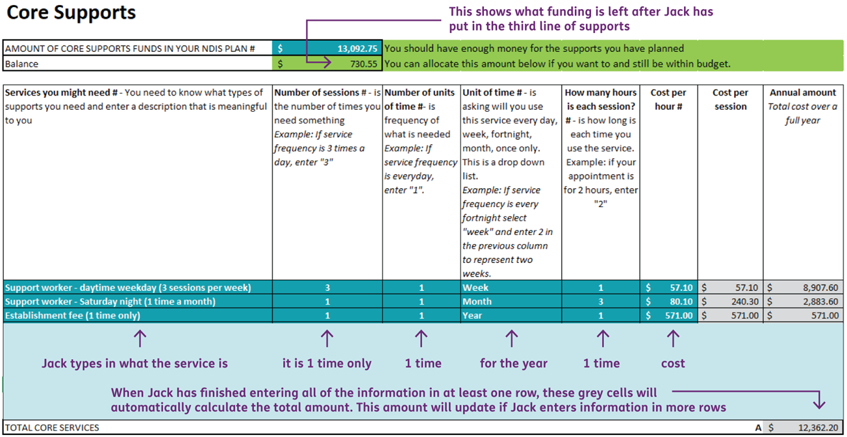

Consumables support: Jack has funding of $500.00 for basic assistive technology, or assistive technology.
Jack doesn’t know the prices of all the items he wants yet. He can put the full amount of $500 for now. Later, when he has the prices, he can update this information with the details of how he will spend the $500.
In row 21, columns A to D, he enters this information, and the spreadsheet automatically works out the annual amount displayed in row 21, column E ($500.00).
After Jack puts in the consumables support, the total annual amount for consumables adds up to $500.00 displayed in row 32, column E. This is shown on the next page.
Jack now looks at his total Core Supports.
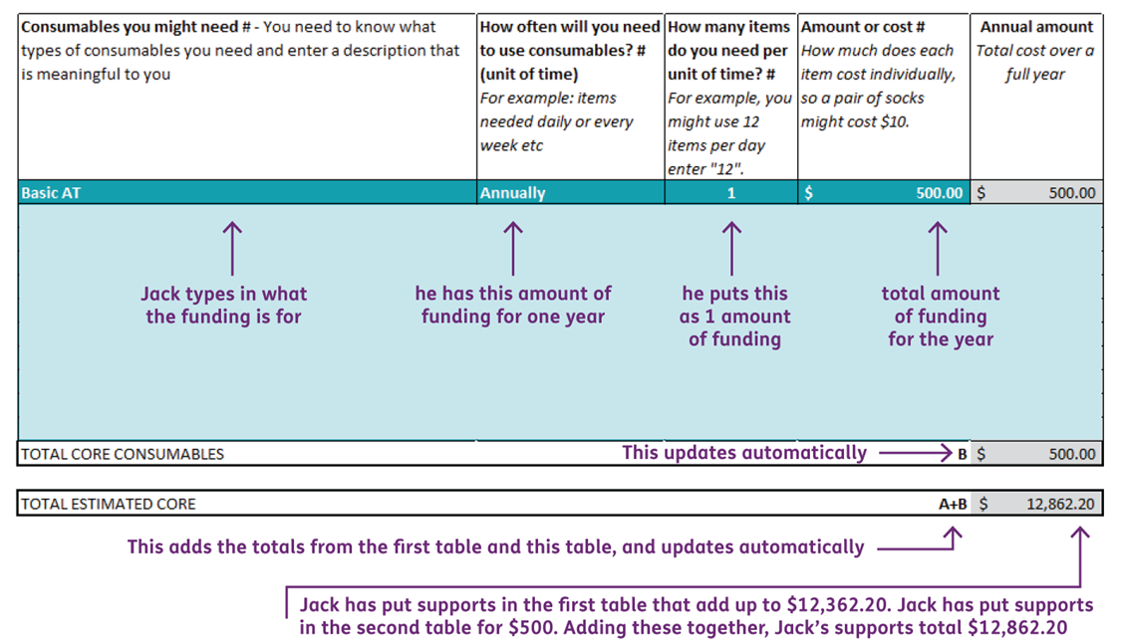

Jack’s total supports
After putting in all the details, Jack can look at the top of the Core Supports section to see whether he has enough funds to cover everything he has entered.
In this example, he will have enough funds to cover all his planned supports (displayed in row 4, column B).
He also has $230.55 left over (displayed in row 5, column B), and he can allocate this to a support if he wants to.
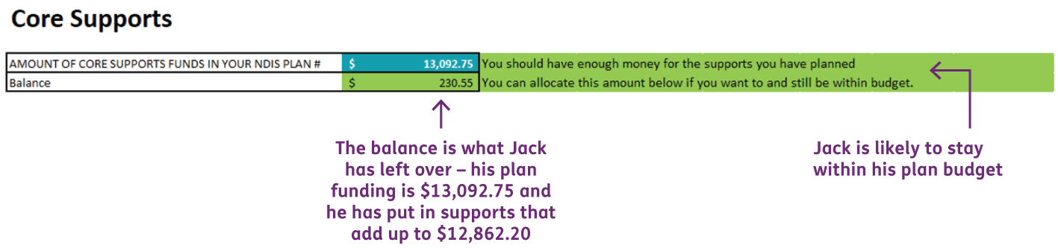

Example 2: Awaisha’s Capacity Building Supports funding
(Note: these examples are made up)
To put her information into the support organiser, Awaisha needs to know how much funding she has in Capacity Building.
She looks at her NDIS plan in the myplace portal and finds the Total Capacity Building Supports funding amount of $11,704.84. In this example, the Total Capacity Building Supports amount is for one year of funding.
Awaisha enters this amount into the top of the Capacity Building Supports section (row 38, column B) in the support organiser spreadsheet. This is shown on the next page.
Awaisha’s plan includes:
- Funding of $1,454.98 that is for a Stated Support and can only be used for plan management
- Improved Daily Living funding of $10,249.95 for her therapies, and decides she wants to spend her funding as follows:
  - Speech therapy – 1 session 1 time a month (monthly), for 2 hours
  - Occupational Therapy (OT) – 1 session every 2 months, for 2.5 hours (2½ hours)
  - Psychology – 6 sessions in 1 year, for 1 hour (first 6 months of the year only)
  - A support worker to help learn new cooking skills (working towards independence) – 1 session 1 time a week, for 1 hour.
The next pages show how Awaisha puts this information into the Capacity Building Supports section of the support organiser spreadsheet.
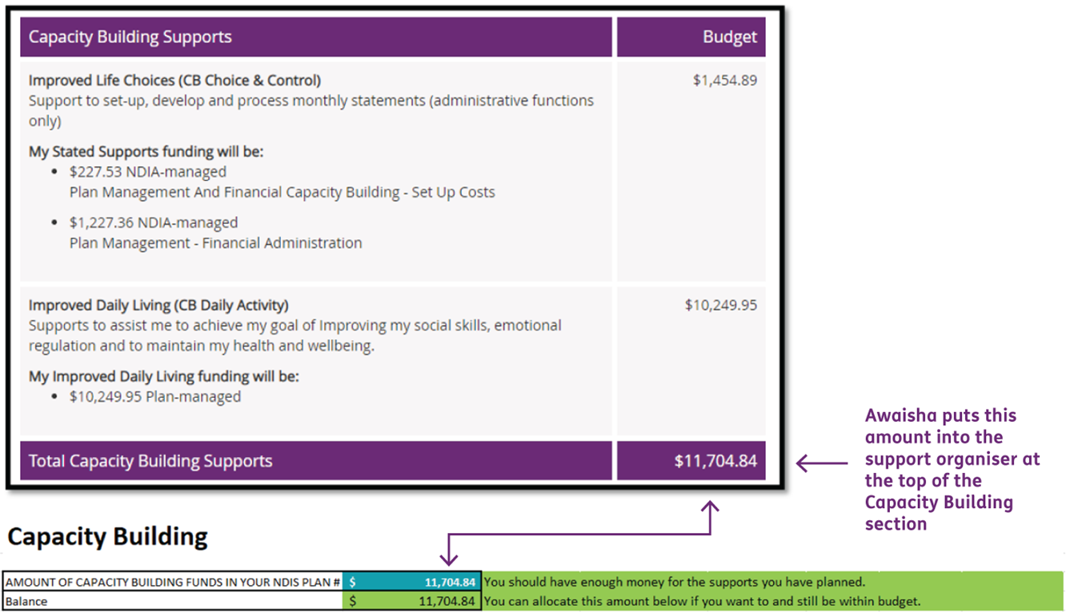

Awaisha’s first capacity building supports plan
Awaisha enters information using the same process as Jack did in the previous example.
She puts the information into the Capacity Building Supports section (rows 42 to 47, columns A to F) of the support organiser spreadsheet.
The total is displayed in row 52, column H. This is shown on the next page.
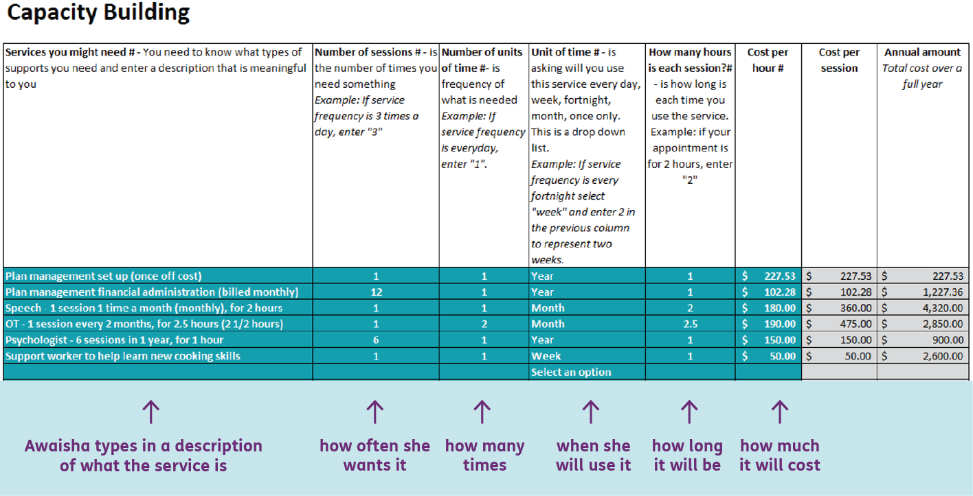

Awaisha’s second capacity building supports plan:
After putting in all the information, Awaisha can look at the top of the Capacity Building Supports section to see whether she has enough funds to cover everything.
In this example, Awaisha will exceed her plan budget by $420.05 (displayed in row 39, column B) with this combination of supports, so she needs to make changes. This is shown on the next page.

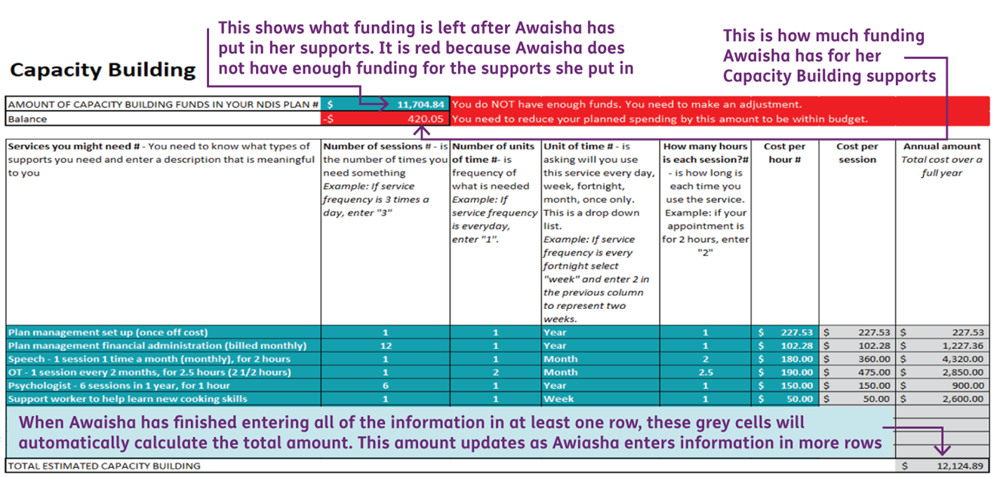
Since Awaisha’s first combination of supports exceeded her available plan funds by $420.05 (displayed in row 39, column B), she decides to make the following changes:
- A support worker to help learn new cooking skills (working towards independence):
  - 1 session every 2 weeks (instead of every week)
  - Increase the session from 1 hour to 1.5 hours (1½ hours).
Awaisha updates this information in the Capacity Building section of the support organiser in:
- row 47 column C to change from once a week to once every two weeks
- row 47 column E to change the session time from one hour to one and a half hours.
This changes the total in row 52, column H to $11,474.89 and the balance in row 39, column B becomes $229.95. This is shown on the next page.
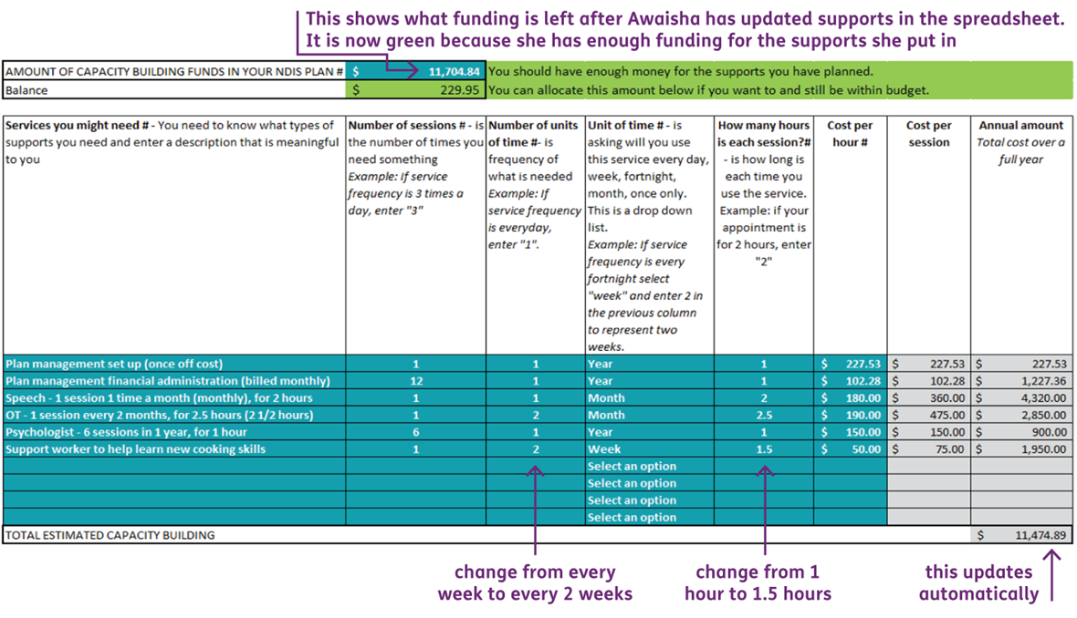
End of examples. If you have feedback on the support organiser you can email MyPlanFeedback@ndis.gov.au or contact the NDIS on 1800 800 110.

