|  |  |
| --- | --- |
| This is the logo for the Australian Government, Department of Social ServicesThis is the NDIS logo | This is the logo for the Tasmanian Government |
|  |  |
| Quality Assurance and Safeguards Working Arrangements During the Transition to a Full Scheme National Disability Insurance Scheme  As agreed between the Tasmanian Department of Communities Tasmania, the National Disability Insurance Agency and the Commonwealth Government | |
| 14 July 2016 - Updated November 2018 | |

**Contents**

[Background 3](#_Toc530071780)

[Purpose of Working Arrangements 4](#_Toc530071781)

[National Disability Insurance Agency Guiding Principles 5](#_Toc530071782)

[Individual Safeguards 5](#_Toc530071783)

[Transition of Commonwealth Funded Disability Services 6](#_Toc530071784)

[Tasmanian Quality and Safety Assurance 8](#_Toc530071785)

[Disability and Community Services (DCS) Due Diligence Process 8](#_Toc530071786)

[Due Diligence Requirements by Provider Type 10](#_Toc530071787)

[Existing Communities Tasmania Funded Providers not currently Registered with the NDIA 10](#_Toc530071788)

[Providers of NDIS Supports in Tasmania Wishing to Expand Registration Groups (including Communities Tasmania funded providers) 10](#_Toc530071789)

[Existing Commonwealth funded disability providers 10](#_Toc530071790)

[Requirements for new Specialist Disability Providers in Tasmania 10](#_Toc530071791)

[Therapeutic Supports: Sole Practitioners, and consortiums of practitioners, wishing to register to deliver Therapeutic Supports 11](#_Toc530071792)

[DCS Quality and Safety Review Process for NDIS Registered Providers in Tasmania 11](#_Toc530071793)

[Complaints Management 13](#_Toc530071794)

[Existing Tasmanian Arrangements 13](#_Toc530071795)

[NDIS Complaints Management/Referral Processes 13](#_Toc530071796)

[Complaints Managed by Communities Tasmania 13](#_Toc530071797)

[Serious Incidents 15](#_Toc530071798)

[Preventing and Responding to Abuse in Services Policy and Procedure 15](#_Toc530071799)

[Consumer Related Serious Incident Reporting for Tasmania’s Communities Tasmania Funded Community Sector Policy and Procedure 15](#_Toc530071800)

[Restrictive Practices - Senior Practitioner 15](#_Toc530071801)

[Authorised Officers Entry of Premises Policy and Procedure 16](#_Toc530071802)

[Addressing Quality and Safety Non-Compliance 16](#_Toc530071803)

[Consumer Protections 16](#_Toc530071804)

[Legislation, Standards and Reporting Requirements 18](#_Toc530071805)

[Attachments 20](#_Toc530071806)

# Background

The [Bilateral Agreement](https://www.coag.gov.au/sites/default/files/communique/NDIS_TAS.PDF) between the Commonwealth and Tasmanian Governments for Transition to a National Disability Insurance Scheme (NDIS) (the Bilateral Agreement) was signed on 11 December 2015.

The Governments recognise the importance of quality and safeguards in successfully supporting the phasing of a large number of participants into the NDIS, including those who are vulnerable and those with complex needs.

The Bilateral Agreement (Schedule F) sets out the quality and safeguards arrangements during the transition to full scheme NDIS in Tasmania from 1 July 2016 to June 2019, specifically:

***National Framework for Quality and Safeguards (Bilateral Agreement Schedule F)***

*3. The parties and the National Disability Insurance Agency (NDIA) are working together on the design of a nationally consistent quality and safeguarding system to be agreed by the Disability Reform Council (the Council) by early 2016.*

*4. The NDIS quality and safeguarding system will be consistent with the principles agreed by the Council as set out in the Consultation paper released on 17 February 2015.*

*5. Existing Tasmanian and Commonwealth quality and safeguarding systems will apply until the new system, including agreed roles and responsibilities, is implemented.*

*6. This schedule will be reviewed by June 2016 to reflect the outcomes of Ministers’ decisions and incorporating consequent implementation arrangements. Transition Arrangements*

*7. During the transition to full scheme, Tasmania and the Commonwealth will continue to operate existing quality and safeguarding systems for providers seeking to register with the NDIA to offer supports funded by the NDIS and existing safeguarding arrangements for participants, including existing approaches to the regulation of restrictive practices.*

# Purpose of Working Arrangements

The purpose of these working arrangements is to ensure that all parties are working to ensure high quality services for people with disability in a choice and control environment. The NDIA will also implement processes that are not overly arduous for support providers to ensure appropriate standards for NDIS participants, particularly where specific risks for the individual are identified.

Accordingly, the following arrangements during transition to the NDIS in Tasmania apply in order to:

* ensure that the strengths of the existing Commonwealth and Tasmania quality assurance and safeguards systems are retained until new national arrangements are in place by the end of the Tasmanian transition period;
* ensure that all participants in the NDIS are afforded protections through existing Commonwealth and state safeguarding mechanisms, including access to state based complaints and reporting mechanisms;
* provide a consistent framework and requirements to ensure the quality of services provided to people with disability as they transition from Tasmanian funding arrangements to become participants in the NDIS;
* minimise any additional administrative burden on Tasmanian service providers who have been funded through Tasmanian specialist disability programs, during transition;
* ensure an appropriate level of quality compliance for new service providers that may commence providing services to people with disability who participate in the NDIS in Tasmania; and
* recognise the NDIA’s duty of care towards NDIS participants, consistent with the objectives of the [*National Disability Insurance Scheme Act 2013*](https://www.legislation.gov.au/Details/C2013A00020) (NDIS Act).

The Commonwealth, Tasmania and NDIA will jointly monitor the implementation of the working arrangements, including working together with relevant Tasmanian statutory bodies to manage quality and safeguarding issues that arise during the transition to the NDIS in Tasmania to ensure the best possible outcomes for participants.

# National Disability Insurance Agency Guiding Principles

Governments and the National Disability Insurance Agency (NDIA or the Agency) are working to ensure high quality services for people with disability in a choice and control environment. The Agency will ensure that processes for disability service providers in interacting with the Agency are not overly arduous, but that they ensure appropriate standards for individuals, particularly where risk for the individual is identified.

## Individual Safeguards

Consistent with the choice and control principles, individual, service and some system level safeguards will be applied on an individual risk-basis and will be based on a presumption of capacity, unless there is evidence to the contrary or where there is a high risk of harm.

Under the NDIS, the importance of natural safeguards will be recognised through the development of an individual plan that identifies the person’s goals and aspirations and enables consideration of the unique risks and relevant safeguards for each person. The aim will be to identify how the different levels of safeguards, including natural and formal supports, blend together to provide the appropriate level of safeguards while supporting choice and control. Planners will work with participants to identify risks and safeguards, and Local Area Coordinators (LAC) will work with participants and their support network to build and support intentional natural and/or informal safeguards.

The key steps in the process will include:

* Understanding what is important to the person,
* Clarifying the capabilities and vulnerabilities the person may have,
* Understanding the nature and possible impact of the potential risks,
* Identify areas of concern and existing safeguards that may address potential risks,
* Consider additional creative measures to minimise the risks or improve outcomes,
* Consider possible impact of existing and proposed safeguard measures.

# Transition of Commonwealth Funded Disability Services

### Existing arrangements for Commonwealth funded services

The Commonwealth currently manages service provider quality and safeguards through program guidelines and legally enforceable funding agreements actively managed by departmental contract managers. The detail of the quality and safeguard requirements in funding agreements may vary based on a risk assessment of the services but generally includes requirements to ensure services:

* engage appropriately qualified staff to deliver the agreed services including meeting relevant Commonwealth arrangements and policies relating to Vulnerable Persons, Police Check and Criminal Offences;
* are delivered in accordance with the National Standards for Disability Services under the Commonwealth Disability Services Act 1986;
* meet relevant national standards and accreditation requirements;
* operate in line and comply with the requirements as set out within all state and territory and Commonwealth legislation and regulations;
* apply the highest standards of duty of care;
* ensure service provision is effective, efficient, and appropriately targeted;
* ensure Indigenous Australians have equal and equitable access to services;
* have appropriate internal complaints mechanisms in place;
* maintain adequate insurance;
* report performance against identified performance indicators;
* notify the Commonwealth of anything reasonably likely to affect the performance of the Activity or otherwise required under this Agreement; and
* provide necessary verification that the grant was spent in accordance with the grant details.

Clients and service providers also have recourse to the Department of Social Services complaints handling process.

### Arrangements for existing Commonwealth service providers transitioning to the NDIS

Existing providers that transition to deliver their services under the NDIS will continue to be subject to the Quality and Safeguards terms of their Commonwealth funding agreements in accordance with the Terms of Business for Registered Providers for the NDIA. NDIS participants will continue to have recourse to the existing Commonwealth safeguard arrangements including:

* service provider complaints processes;
* Department of Social Services complaints processes;
* The Commonwealth Ombudsman;
* The Australian Human Rights Commission; and
* Other mainstream law enforcement and legal avenues.

Transitioning Australian Disability Enterprises (ADEs) will be required to continue to meet their obligations against their Funding Agreements while also maintaining certification under JAS-ANZ against the National Standards for Disability Services.

### Arrangements for existing Commonwealth funded services to expand their support offering

Current Commonwealth funded providers that intend to expand their offer of supports to a new NDIS Registration Group will need to apply directly to the NDIA for registration of expanded scope. Expansion of scope will be subject to compliance with Tasmanian Quality and Safety Framework, including verification of capacity to deliver services not already covered by a Commonwealth service agreement. They will effectively become new NDIA providers for the expanded services.

### Arrangements for new providers of services previously delivered by the Commonwealth during transition

New providers will be subject to compliance with the NDIA Terms of Business for Registered providers and meet Tasmanian Quality and Safety Framework. NDIS participants will have recourse through the Complaints Management Process, (as outlined on pg. 15) as well as the Commonwealth mainstream safeguards.

In addition, new employment support service providers are required to meet the National Standards for Disability Services and new ADEs will be required to maintain certification under JAS-ANZ against the National Standards for Disability Services.

### Commonwealth Continuity of Support Program

During the transition to full scheme, Tasmania and the Commonwealth will continue existing quality and safeguards arrangements for providers delivering services to older people with disability under the Commonwealth Continuity of Support Program, including existing approaches to the regulation of restrictive practices.

Further detail about the Quality and Safeguards arrangements for the Continuity of Support Programme during transition in Tasmania are outlined under the administrative arrangements for Continuity of Support as referred to in Schedule D of the Bilateral Agreement between the Commonwealth and Tasmania for the transition to an NDIS.

# Tasmanian Quality and Safety Assurance

All existing and new providers of specialist disability services will be required to comply with the *Tasmanian Quality and Safety Framework for DHHS Funded Community Sector* (attachment 1)forthe transition to full scheme NDIS, or until a NDIS national quality and safeguards system has been agreed and implemented. This includes compliance with all associated Tasmanian legislation, regulations and reporting requirements.

The *Tasmanian Quality and Safety Framework for DHHS Funded Community Sector* (Quality and Safety Framework), supports providers to have systems and processes in place to deliver safe, high quality services to Tasmanian consumers. It aims to support the following outcomes for consumers, Community Sector Organisations (CSO/organisations/service providers) and the Department of Communities Tasmania (Communities Tasmania):

* High quality and safe services for Tasmanians through continual improvement of service delivery.
* Service systems and processes are enhanced using recognised evidence bases (such as standards).
* A culture of continuous improvement within the sector that is supported by, and inclusive of, all stakeholders.
* Minimising regulatory and administrative burden.
* Consumers, CSOs and Communities Tasmania work in partnership to enhance service delivery.
* Consumers, the community and Government have confidence that Communities Tasmania funded CSOs are delivering safe and high quality services.
* Learnings, both at the CSO and sector level, are used in planning and development activities.

## Disability and Community Services (DCS) Due Diligence Process

The *DHHS Due Diligence Policy* aims to ensure there is a minimum level of screening and a consistent approach throughout Communities Tasmania prior to funding or registering new service providers in Tasmania. The Policy requires all new service providers to complete a due diligence assessment before they are authorised to deliver Communities Tasmania funded services or able to register with the NDIA as a service provider.

The due diligence assessment will determine, from evidence provided by service providers, that there are systems and processes in place to meet the requirements of the Quality and Safety Framework, the *Disability Act 2011*, and relevant Tasmanian legislation, regulations and reporting requirements.

A completed due diligence assessment by Communities Tasmania - DCS is required before service providers can finalise approval with the NDIA for the following Specialist Disability Registration Groups:

* Daily Personal Activities (0107)
* High Intensity Daily Personal Activities (0104)
* Assistance with Daily Life Tasks in a Group or Shared Living Arrangement [Daily Tasks/Shared Living] (0115)
* Participation in Community, Social and Civic Activities [Participate Community] (0125)
* Group and Centre Based Activities [Group/Centre Activities] (0136)
* Development of Daily Living and Life Skills [Development-Life Skills] (0117)
* Management of Funding for Supports [Plan Management] (0127)
* Assistance in coordinating or managing life stages, transition and supports – [Assist-Life Stage, Transition] (0106)
* Specialist Positive Behaviour Support [Behaviour Support] (0110)
* Early Intervention Supports for Early Childhood (0118)
* Support Co-ordination (0132)
* Therapeutic Supports (0128) **– a Due Diligence is required for organisations only**

Service providers will be asked to provide the following minimum information to [ndisregistrations@communities.tas.gov.au](mailto:ndisregistrations@communities.tas.gov.au) prior to a due diligence assessment commencing:

* NDIS provider registration number
* Organisation/service provider name
* Trading name if different to provider name
* Entity type e.g. sole trader, incorporated association
* ABN
* City/suburb and state that is the base for the provider
* Profit or not for profit
* Contact person
* Contact details
* NDIS Registration Groups seeking registration for
* Areas of Tasmania intending to provide service
* Any other states that the provider is already NDIS registered in

On completing the due diligence process (or, for existing service providers, expanding service and completing a part due diligence process) DCS will provide the service provider with a letter. The letter will confirm the service provider’s point in time compliance with the Tasmanian quality and safeguards system and capacity to provide services in the Registration Group. The letter forms part of the supporting documentation required to complete the NDIA registration process.

Further information for providers on the due diligence process can be found [here](http://www.dhhs.tas.gov.au/disability/National_Disability_Insurance_Scheme/service_provider_registration_and_expansion_of_existing_registration).

# Due Diligence Requirements by Provider Type

## Existing Communities Tasmania Funded Providers not currently Registered with the NDIA

Existing Communities Tasmania funded service providers have a Funding Agreement with the Crown represented by Communities Tasmania. Under their Funding Agreement, service providers are required to comply with the Quality and Safety Framework and relevant legislation (including regulations), all associated checks (including National Criminal Checks) and all reporting requirements.

It is expected that all Communities Tasmania funded service providers wishing to register to provide NDIS supports in Tasmania meet the requirements of the Quality and Safety Framework.

Existing Communities Tasmania funded specialist disability support providers will be required to undergo the NDIA registration process for any new specialist disability registration groups they wish to register for, including undergoing the Tasmanian due diligence process.

## Providers of NDIS Supports in Tasmania Wishing to Expand Registration Groups (including Communities Tasmania funded providers)

All existing service providers registered to provide NDIS specialist disability supports in Tasmania are expected to comply with the Quality and Safety Framework, Tasmanian legislation, regulations and reporting requirements.

Service providers seeking to deliver Registration Group/s which differ from what they are presently registered to provide, may have to complete further quality and safety and due diligence checks to confirm the service provider’s capacity to deliver the Registration Group/s for which they are applying. Supporting documentation from Communities Tasmania will be required to complete the NDIS registration for additional registration groups.

## Existing Commonwealth funded disability providers

Service providers currently funded by the Commonwealth, who wish to expand their service delivery to new specialist disability registration groups (excluding employment services), will be required to undertake the Tasmanian due diligence process. Providers will follow the same process, as “new” specialist disability providers.

## Requirements for new Specialist Disability Providers in Tasmania

“New” service providers (those that have not previously provided specialist disability support in Tasmania) seeking to register with the NDIA to provide Specialist Disability Registration Groups (as listed under the section above ‘DCS Due Diligence Process’) within Tasmania must complete a due diligence assessment prior to completing the registration process with the NDIA. Please note specific requirements for the registration group ‘Therapeutic Supports’ under the next heading.

The due diligence process determines whether the service provider complies with the Quality and Safety Framework and relevant Tasmanian legislation, regulations and reporting requirements.

The due diligence process also determines the service provider’s capacity to deliver the supports for which they have applied to deliver to people with disability.

New service providers may seek to or be accredited for, an agreed equivalent quality management process. Communities Tasmania will seek evidence of accreditation/compliance by the service provider of the agreed quality management process as part of the due diligence process.

## Therapeutic Supports: Sole Practitioners, and consortiums of practitioners, wishing to register to deliver Therapeutic Supports

Sole practitioners, and groups of practitioners, eligible to deliver Therapeutic Supports are defined by the NDIA, and listed in the NDIA Provider Registration Guide to Suitability under the Therapeutic Supports registration group (No. 0128). Further, to register for Therapeutic Supports, sole practitioners, and consortiums of practitioners, are required to be registered with a relevant professional association and maintain appropriate registration and/or professional and clinical standards relevant to their profession.

Sole practitioners, and groups of practitioners in consortiums, who meet the above criteria and wish to register for Therapeutic Supports, register directly with the NDIA, and are not required to undertake a due diligence process with Communities Tasmania.

All sole practitioners, and consortiums of practitioners, wishing to register for other Specialist Disability Registration Groups are required to request and complete a due diligence process through Communities Tasmania (please refer to the NDIA’s Guide to Suitability for details).

Sole practitioners, and consortiums of practitioners, must comply with the Quality and Safety Framework and Tasmanian legislation, regulations and policy, and procedures.

*Please note:* Organisations applying for Therapeutic Supports are required to undertake a due diligence process with Communities Tasmania.

## DCS Quality and Safety Review Process for NDIS Registered Providers in Tasmania

NDIS registered service providers are required to participate in ongoing quality monitoring through the DCS Quality and Safety Review Process (NDIS DCS Q&S Review); this is in addition to the audit process which forms part of the Tasmanian Quality and Safety Framework. Organisations are required to participate in the NDIS DCS Q&S Review at least 12 monthly or earlier if concerns have been identified.

NDIS registered service providers who are required to complete the NDIS DCS Q&S Review include:

* Service providers who are registered with the NDIS to provide specialist disability services, following the completion of a due diligence process undertaken by DCS.
* Tasmania State Government funded specialist disability service providers also registered with NDIS, or those that have fully transitioned to NDIS, and/or have expanded services to provide new registration groups.

**Quality and Safety and Due Diligence Process During Transition to Full Scheme NDIS in Tasmania**

This is a flow chart representation of the Communities Tasmania Due Diligence Process during transition. 

Providers submit their request for a due diligence by email to the Tasmanian Government State Implementation Team (SIT). 

SIT conduct a basic check of application and then forward to the Tasmanian Government Community Partnerships Team (CPT) for due diligence. 

There are 3 possible outcomes to the due diligence: More Information Required, Successful or Unsuccessful. 

Providers who receive a successful outcome submit evidence of this to the NDIA to complete their registration process. 

# Complaints Management

## Existing Tasmanian Arrangements

The Tasmanian Quality and Safety Framework requires funded service providers to have systems and processes in place to manage and respond to complaints and use the feedback to contribute towards enhancing service delivery.

The existing protocol between Communities Tasmania and NDIA for complaints management will apply for transition to full scheme NDIS in Tasmania (attachment 2). The protocol aligns to the DCS Compliments and Complaints Policy and Procedure (attachment 3).

The purpose of this protocol is to set out the communication process to be followed during transition to full scheme by DCS and the NDIA; in particular, the receipt and investigation of complaints made by Tasmanian NDIS participants, their families and carers, advocates and other stakeholders.

During transition, complaints will be received by either DCS or NDIA and referred appropriately. Some complaints will contain components relating to both DCS and NDIA.

The NDIA complaints system will work in conjunction with other existing Commonwealth and State Government complaints management systems to provide an integrated approach for participants and providers.

## NDIS Complaints Management/Referral Processes

During NDIS transition, the NDIA will operate a complaints management system for complaints in relation to:

* agency staff
* agency processes
* complaints about market capacity and availability of service provision

Complaints about these matters can be made to the NDIA at [feedback@ndis.gov.au](mailto:feedback@ndis.gov.au). Find more information about this process at [www.ndis.gov.au/about-us/contact-us/feedback-complaints](file:///\\ebus.root.internal\dc\SPPP\DCCMAQ\DPR\CSIR\CONSUMER%20CHOICE\Individualising%20support\NDIS%20projects%20-%20Transition\Quality%20and%20Safeguards\Working%20Arrangements\www.ndis.gov.au\about-us\contact-us\feedback-complaints).

## Complaints Managed by Communities Tasmania

The Tasmanian Government will continue to manage complaints lodged in relation to Communities Tasmania funded providers.

The Tasmanian Government will also manage complaints about NDIS providers of specialist disability services.

The complaints process will reflect a ‘no wrong door’ approach, ensuring effective access to complaints resolution for all participants, their family, carers, advocates, service providers and other stakeholders interacting with the NDIS.

### Contact points - Complaints

|  |  |  |  |
| --- | --- | --- | --- |
| **Contact point** | **By whom** | **To whom** | **Contact details** |
| Referral of complaints | State | NDIA | feedback@ndis.gov.au |
| Referral of complaints | NDIA | State | ndis@communities.tas.gov.au |

# Serious Incidents

The *Consumer Related Serious Incident Reporting Policy and Procedure* [[1]](#footnote-2) (attachments 10 and 11) ensure there is a coordinated approach to the management and reporting of serious consumer related incidents, and that learnings are implemented to minimise the potential of recurrence. This policy applies to all Communities Tasmania funded service providers and to all other providers of NDIS services during the transition to full scheme NDIS in Tasmania.  This policy, and supporting documentation, does not override or replace legislative reporting requirements.  This policy and procedure requires providers to report serious consumer related incidents, including those that affect the service provider’s ability to deliver the contracted service, to be verbally reported within 24 hours, or the next business day, and a documented report to be provided within two working days of the incident occurring.

## Preventing and Responding to Abuse in Services Policy and Procedure

The provisions of the *Disability Services Act 2011 (TAS)* clearly outlines the obligations that service providers have to ensure that people with a disability receive support services which uphold and maintain their rights as equal members of society.

The *Disability Services Preventing and Responding to Abuse in Services Policy and Procedural Guidelines* (attachments 4 and 5) has been developed to assist service providers and staff in their response to situations where allegations of abuse have occurred. They provide a basis for service providers to develop procedures appropriate to the services they provide and to the nature of their particular organisation. The guidelines contain the essential elements of best practice in responding to allegations of abuse and protecting the safety and interests of the alleged victim.

## Consumer Related Serious Incident Reporting for Tasmania’s Communities Tasmania Funded Community Sector Policy and Procedure

This policy and procedure is to ensure there is a coordinated approach to the management and reporting of serious consumer related incidents, and that learnings are implemented to minimise the potential of recurrence. This policy applies to all Communities Tasmania funded community sector organisations and to all other providers of NDIS services during the transition to full scheme NDIS in Tasmania. This policy and supporting documentation does not override or replace legislative reporting requirements.

## Restrictive Practices - Senior Practitioner

The role and responsibilities of the Senior Practitioner have been established under the *Disability Services Act 2011(TAS)*.

One of the primary functions of the Senior Practitioner is the authorisation and monitoring of restrictive practices (attachment 8). The Senior Practitioner provides advice and information to the Guardianship and Administration Board on matters related to restrictive practices.

The Senior Practitioner has investigative powers and is able to access funded disability service provider’s property if there are concerns about the safety, wellbeing and care of a resident at that property. The investigative powers include being able to make copies of documentation pertinent to the concern and to talk to anyone involved in the restrictive intervention.

On completing an investigation the Senior Practitioner provides a report to the Secretary of Communities Tasmania including recommendations. The *Disability Services Act 2011 (TAS)* allows for financial penalties to be applied to any funded service provider or funded private person who do not follow the directions given by the Secretary about restrictive practices (attachment 9).

## Authorised Officers Entry of Premises Policy and Procedure

The purpose of the *Authorised Officers Entry of Premises Policy and Procedure* (attachments 6 and 7) is to ensure that State Service employees or State Service officers authorised to enter funded service provider’s premises, or private funded premises under Part 4, Division 3 of the *Disability Services Act 2011 (TAS),* perform their relevant duties and functions and meet their responsibilities in line with the requirements of the Act and departmental policy and procedures. The policy sets out the rights, processes and requirements to be followed by ‘authorised officers’ when entering funded premises.

## Addressing Quality and Safety Non-Compliance

Communities Tasmania will notify the NDIA when an NDIS registered provider of specialist disability services is non-compliant or at risk of non-compliance with Communities Tasmania ongoing Quality and Safety Framework requirements.

Following a review by Communities Tasmania, a service provider may be given the opportunity to undertake corrective actions to address compliance requirements. The inability to address issues may lead to a breach of legislation or policy and procedures. The NDIA will be notified of the outcome of the review by Communities Tasmania, including a summary of findings and issues.

The NDIA will initiate the next steps which may lead to the de-registration of the service provider. The NDIA may also initiate the de-registration of provider (in consultation with the Tasmanian Government) where the NDIA determines a provider poses an unreasonable risk to participants or has breached the NDIA Terms of Business.

## Consumer Protections

### Anti-Discrimination Commissioner

The Anti-Discrimination Tribunal is established by the *Tasmanian Anti-Discrimination Act 1998* (the Act). The role of the Commissioner is to undertake inquiries concerning complaints about behaviours prohibited by the Act, <http://equalopportunity.tas.gov.au/>

### Tasmanian Ombudsman/Health Complaints Commissioner

The Tasmanian Health Complaints Commissioner is an independent officer appointed by the Governor. The Commissioner is also the State Ombudsman. The Tasmanian Health Complaints Commissioner acts independently, impartially and in the public interest. The Commissioner's role is:

* To promote and protect the rights of consumers who use health services.
* To help resolve problems between consumers and providers of health services.
* To improve the safety and quality of health services in Tasmania.

<http://www.healthcomplaints.tas.gov.au/>

### Public Guardian

The Office of the Public Guardian promotes, speaks for, and protects the rights and interests of people with disabilities and acts as the guardian of people with disabilities when appointed by the Guardianship and Administration Board. The *Guardianship and Administration Act 1995* establishes the Office and gives the Public Guardian her/his powers and functions.

<http://www.publicguardian.tas.gov.au/>

## Legislation, Standards and Reporting Requirements

### Tasmanian Legislation

### Disability Services Act, 2011 (TAS)

<http://www.thelaw.tas.gov.au/tocview/index.w3p;cond=;doc_id=27%2B%2B2011%2BAT%40EN%2B20160304090000;histon=;prompt=;rec=;term>

Disability Regulations 2015

http://www.law.tas.gov.au/tocview/index.w3p;cond=;doc\_id=%2B16%2B2015%BAT2EN%2BSESSION

### Mental Health Act, 2013

<http://www.thelaw.tas.gov.au/tocview/index.w3p;cond=;doc_id=2%2B%2B2013%2BAT%40EN%2B20160304090000;histon=;prompt=;rec=;term>

### Health Complaints Act 2, 1995

<http://www.thelaw.tas.gov.au/tocview/index.w3p;cond=;doc_id=95%2B%2B1995%2BAT%40EN%2B20160304090000;histon=;prompt=;rec=;term>

### Registration to Work with Vulnerable People Act, 2013

<http://www.thelaw.tas.gov.au/tocview/index.w3p;cond=;doc_id=%2B67%2B2014%2BAT%40EN%2B20160304130000;histon=;prompt=;rec=;term>

### Personal Information Protection, 2004

<http://www.thelaw.tas.gov.au/tocview/index.w3p;cond=;doc_id=46%2B%2B2004%2BAT%40EN%2B20160304130000;histon=;prompt=;rec=;term>

### Ombudsman Act, 1978

<http://www.thelaw.tas.gov.au/tocview/index.w3p;cond=;doc_id=82%2B%2B1978%2BAT%40EN%2B20160304130000;histon=;prompt=;rec=;term>

### Guardianship and Administration Act, 1995

<http://www.thelaw.tas.gov.au/tocview/index.w3p;cond=;doc_id=44%2B%2B1995%2BAT%40EN%2B20160304130000;histon=;prompt=;rec=;term>

### Residential Tenancy Act, 1997

<http://www.thelaw.tas.gov.au/tocview/index.w3p;cond=;doc_id=%2B75%2B1998%2BAT%40EN%2B20160304130000;histon=;prompt=;rec=;term>

### Commonwealth Legislation

Commonwealth funded programs (including employment services) will remain the responsibility of the Commonwealth Government in regard to quality and safety assurance processes and accreditation.

### Disability Services Act, 1986

<https://www.legislation.gov.au/Details/C2013C00015>

### National Standards for Disability Services

<https://www.dss.gov.au/sites/default/files/documents/06_2015/nsds_full_version.pdf>

### Mental Health Act, 2013

<http://www.thelaw.tas.gov.au/tocview/index.w3p;cond=all;doc_id=2%2B%2B2013%2BAT%40EN%2BSESSIONAL;histon=;prompt=;rec=;term=mental%20health%20act>

# Attachments

*Please note: as at 1 July 2018, the Tasmanian Department of Health and Human Services (DHHS) became the Department of Communities Tasmania (Communities Tasmania). The below attachments were written prior to 1 July 2018.*

1. The Quality and Safety Framework for Tasmania’s DHHS Funded Community Sector
2. Protocol between DCS and NDIA – complaints management
3. Disability and Community Services Compliments and Complaints Procedure
4. Preventing and responding to Abuse in Services Funded by Disability and Community Services Policy
5. Preventing and responding to Abuse in Services Funded by Disability and Community Services Procedure
6. Authorised Officers – Entry of Premises Policy
7. Authorised Officers - Entry of Premises Procedure
8. Application for Approval to Carry Out Restrictive Intervention
9. Reporting Unauthorised restrictive Intervention
10. Consumer Related Serious Incident Reporting Policy
11. Consumer Related Serious Incident Reporting Procedure
12. Consumer Incident Report Form

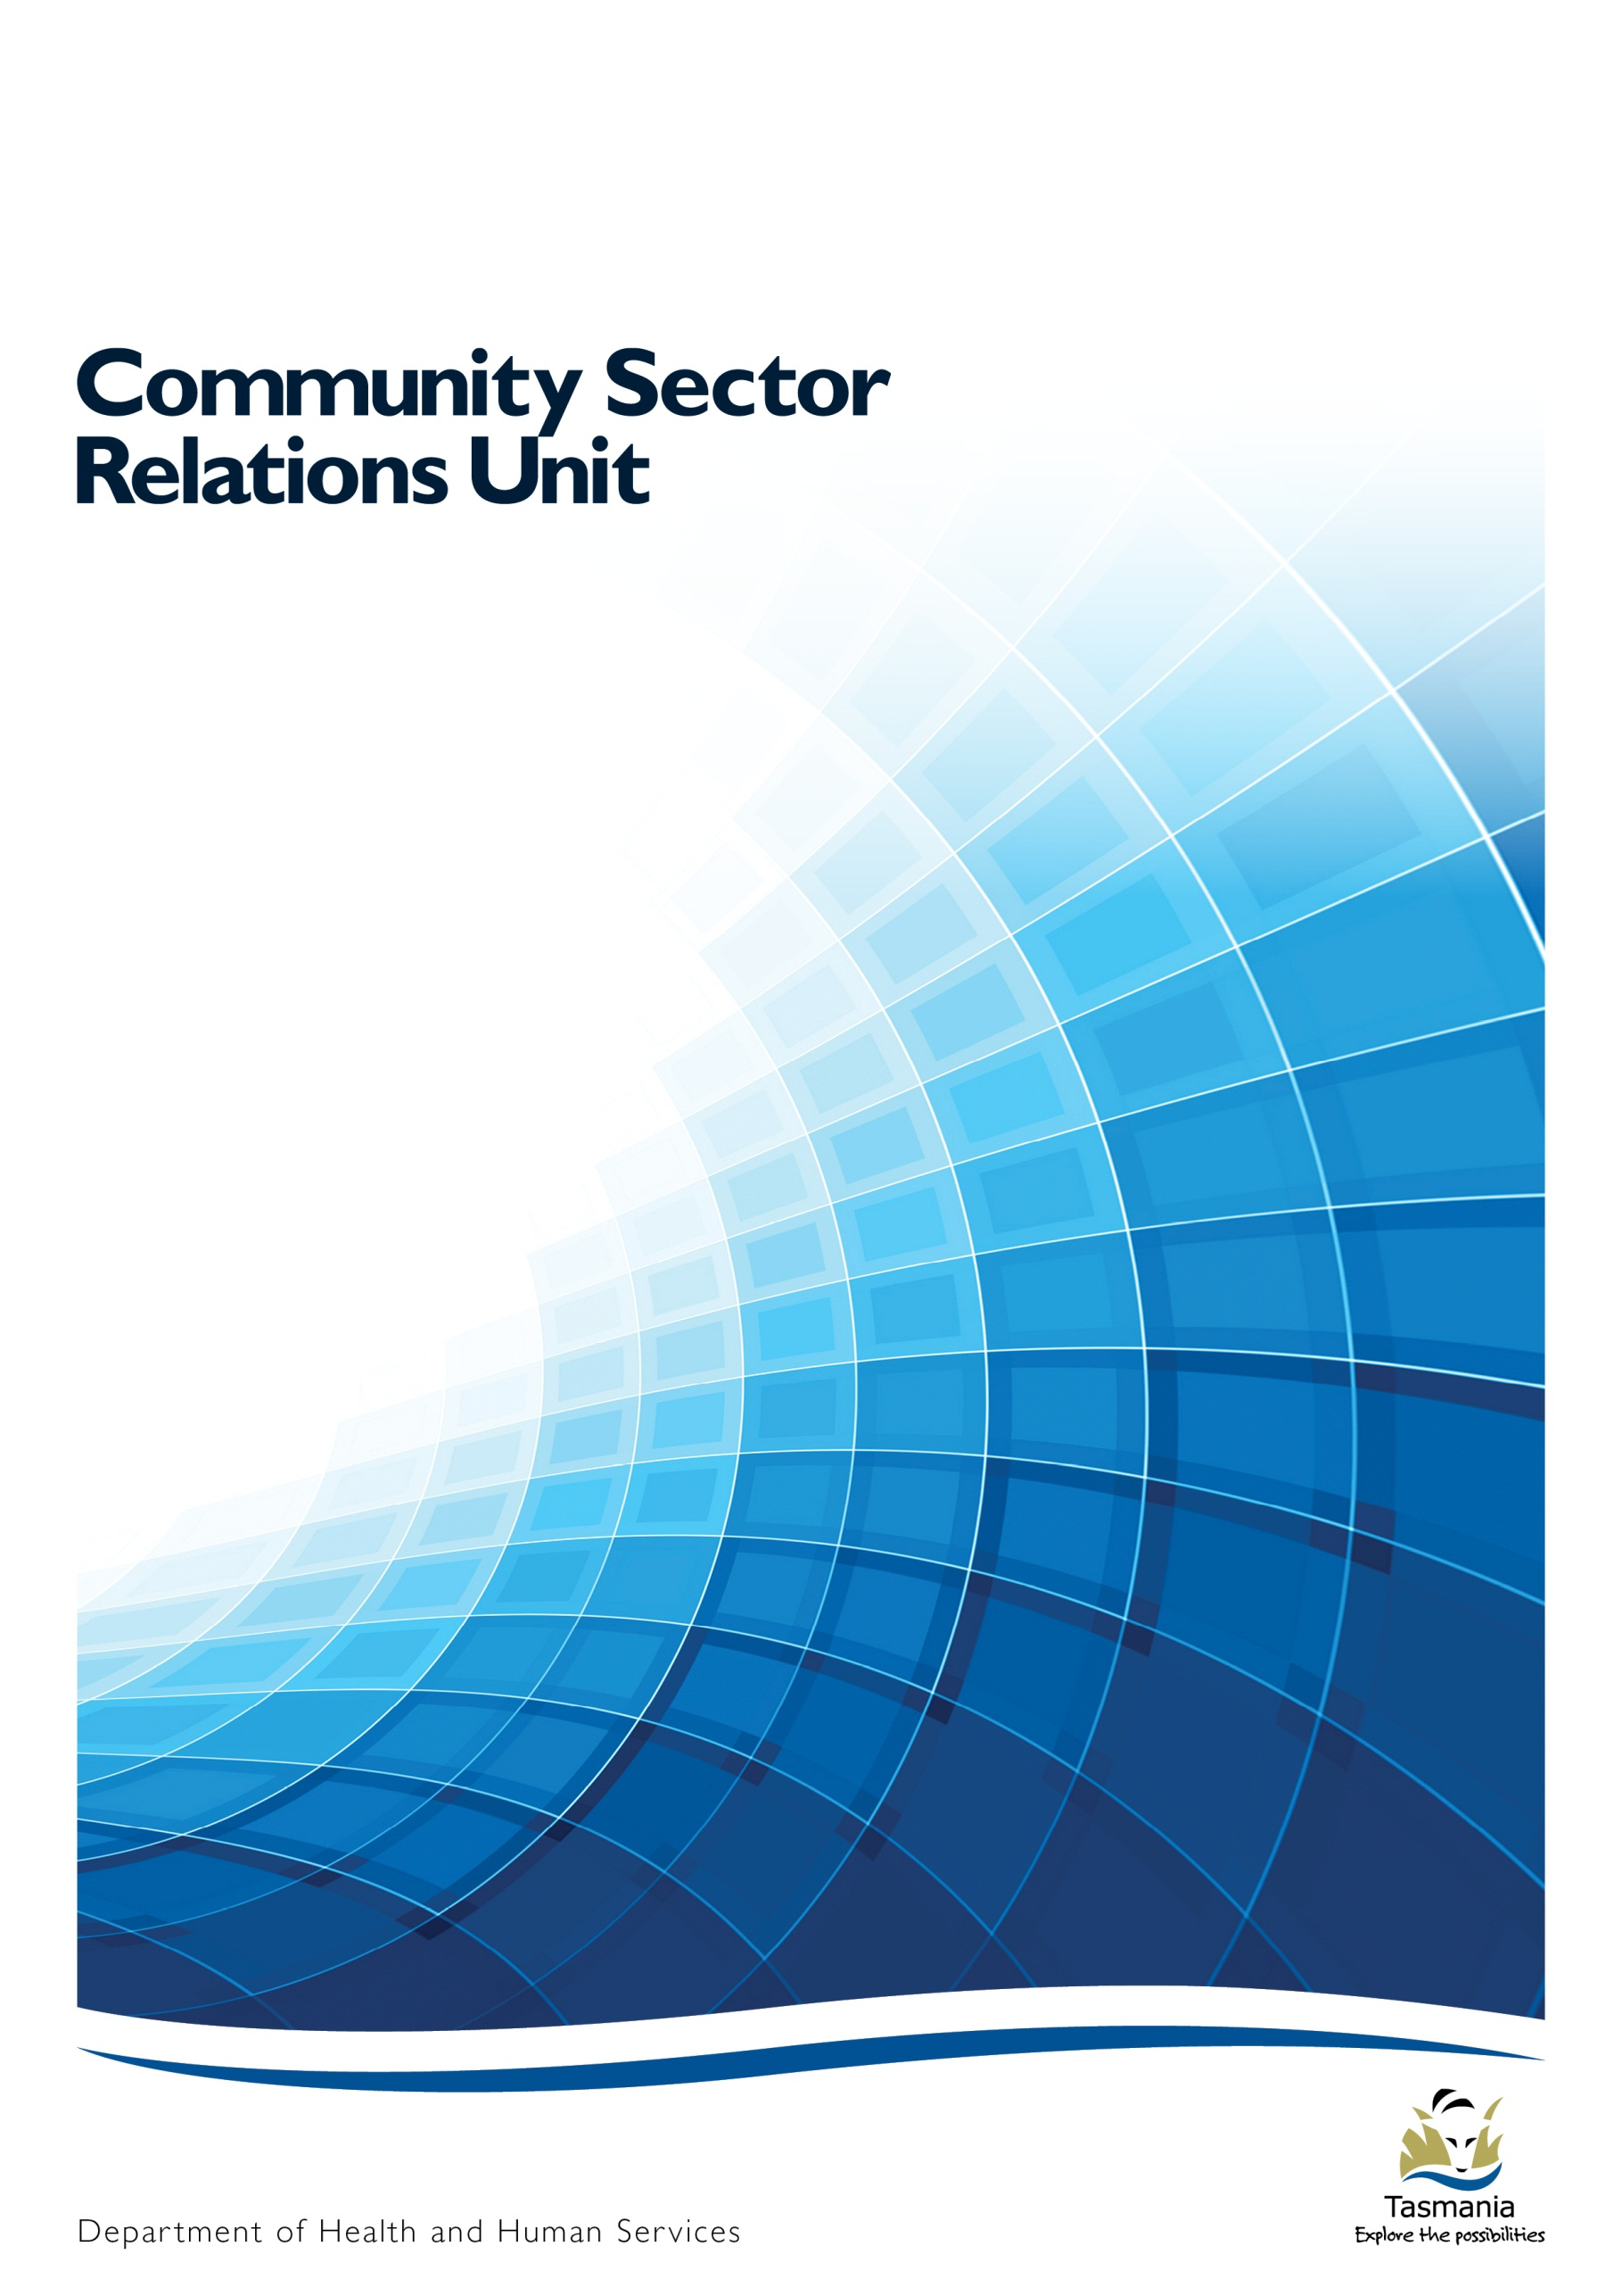

**The Quality and Safety Framework for Tasmania’s DHHS Funded Community Sector**

Community Sector Relations Unit

Department of Health and Human Services



**Department of Health and Human Services**

Community Sector Quality and Safety Team

Community Sector Relations Unit

Level 1 Henty House

1 Civic Square

Launceston

TAS 7250

Email: [communitysector.quality@dhhs.tas.gov.au](mailto:communitysector.quality@dhhs.tas.gov.au)

Web: [www.dhhs.tas.gov.au/communitysector](http://www.dhhs.tas.gov.au/communitysector)

**Version 1.0 17 January 2014**

Contents

1. Working in Partnership for all Tasmanians

[1.1. Tasmania’s Community Sector 28](#_Toc515542399)

[1.2. The Department of Health and Human Services 28](#_Toc515542400)

[1.3. The Community Sector Relations Unit 28](#_Toc515542401)

[1.4. The Partnership Agreement between DHHS, DPAC and the Community Sector 28](#_Toc515542402)

[2. The Integrated Financial and Performance Framework 29](#_Toc515542403)

[3. The Quality and Safety Framework for Tasmania’s DHHS Funded Community Sector 29](#_Toc515542404)

[3.1. About the Framework 29](#_Toc515542405)

[3.2. The aims of the Framework 29](#_Toc515542406)

[3.3. The requirements of the Framework 30](#_Toc515542407)

[4. Standards 32](#_Toc515542411)

[4.1. What are standards and why are they important? 32](#_Toc515542412)

[4.2. What standards should CSOs use? 32](#_Toc515542413)

[5. Continuous Improvement 33](#_Toc515542414)

[5.1. What is continuous improvement? 33](#_Toc515542415)

[5.2. How should CSOs document their continuous improvement activities? 33](#_Toc515542416)

[5.2.1. The Standards and Performance Pathways 34](#_Toc515542417)

[5.3. Meeting with the DHHS to discuss continuous improvement 34](#_Toc515542418)

[6. Reviews 35](#_Toc515542419)

[6.1. About Reviews 35](#_Toc515542420)

[6.2. The review process 36](#_Toc515542421)

[6.3. Preparing for the review 36](#_Toc515542422)

[6.4. An overview of the review process 37](#_Toc515542423)

[6.5. The review report 38](#_Toc515542424)

[7. Accredited or externally reviewed CSOs 39](#_Toc515542425)

[7.1. Accredited CSOs 39](#_Toc515542426)

[7.2. External reviews or reporting 39](#_Toc515542427)

[8. Incidents and feedback 40](#_Toc515542428)

[9. The Australian Safety and Quality Framework for Health Care 40](#_Toc515542429)

9.1 Adapted Principles of the Australian Safety and Quality Framework for Health Care

[10. Glossary 43](#_Toc515542431)

1. Working in Partnership for all Tasmanians
   1. Tasmania’s Community Sector

Every day, community sector organisations provide valuable services to Tasmanians. Community sector organisations (CSOs) embrace a wide range of community, voluntary and not for profit activities aimed at improving the health and well-being of Tasmanians through direct support such as disability, family and mental health services, and strategies for preventing or reducing the effects of chronic conditions.

* 1. The Department of Health and Human Services

The Department of Health and Human Services (DHHS) is the largest Tasmanian State Government agency.  
The DHHS is responsible for delivering integrated services that maintain and improve the health and wellbeing of individual Tasmanians, and the Tasmanian community as a whole.

Approximately two hundred and fifty community sector organisations are funded by DHHS for the delivery of services to Tasmanians.

* 1. The Community Sector Relations Unit

Established in March 2012 by bringing together existing functions under one business unit, the Community Sector Relations Unit (CSRU) provides a coordinated, standardised and strategic approach to working across DHHS and with the community sector.

This is achieved through strategic planning and policy development, grants management and co-ordination of the *Quality and Safety Framework for Tasmania’s DHHS Funded Community Sector.*

* 1. The Partnership Agreement between DHHS, DPAC and the Community Sector

A *Partnership Agreement between DHHS, DPAC and the Community Sector[[2]](#footnote-3)* was signed in November 2012, setting out how government agencies and the community sector commit to working together to achieve a shared vision. The Agreement promotes mutual understanding and guides community sector and government agency representatives to adopt processes and behaviour that value the role, contribution, perspectives and expertise of both sectors.

*The Quality and Safety Framework for Tasmania’s DHHS Funded Community Sector* outlines DHHS’ expectations of community sector organisations receiving DHHS funding and willsupport, and contribute to, the principles, goals and priorities of the Partnership Agreement.

1. The Integrated Financial and Performance Framework

The *Integrated Financial and Performance Framework* facilitates the effective delivery of grants payments from the DHHS to CSOs for the provision of a range of services across Tasmania. As a key component of performance for the provision of quality and safe services, the *Integrated Financial and Performance Framework* sets out the:

* principles and processes for the administration, monitoring and acquittal of grants
* roles and responsibilities of key stakeholders including DHHS and CSOs
* role of quality and safety in ensuring effective, efficient and sustainable services to Tasmanian consumers.

1. The Quality and Safety Framework for Tasmania’s DHHS Funded Community Sector 
   1. About the Framework

Implemented in 2009, the aim of the *Quality and Safety Framework for Tasmania’s DHHS Funded Community Sector* (the Framework) is to support DHHS funded CSOs to have systems and processes in place to deliver safe, high quality services to Tasmanian consumers.

* 1. The aims of the Framework

The Framework aims to support the following outcomes for consumers, CSOs and DHHS:

* High quality and safe services for Tasmanians through continual improvement of service delivery.
* Service systems and processes are enhanced using recognised evidence bases (such as standards).
* A culture of continuous improvement within the sector that is supported by, and inclusive of, all stakeholders.
* Minimising regulatory and administrative burden.
* Consumers, CSOs and DHHS work in partnership to enhance service delivery.
* The common goals and priorities of the Partnership Agreement are being contributed to.
* Consumers, the community and Government have confidence that DHHS funded CSOs are delivering safe and high quality services.
* Learnings, both at the CSO and sector level, are used in planning and development activities.
  1. The requirements of the Framework

Broadly, the Framework requires that:

* DHHS funded CSOs have systems and processes in place to record and monitor continuous improvement (CI) activities against recognised standards
* DHHS Funding Agreement Managers (FAMs) meet with funded CSOs at least once every 12 months to discuss the CI activity occurring within CSOs
* The Community Sector Quality and Safety Team (CSQS Team) facilitates reviews of DHHS funded services once in a three year period.

Specifically, the roles and responsibilities of CSOs, FAMs and the CSQS Team under the Framework are:

* + 1. DHHS Funded Community Sector Organisations will:
* ensure that safe and high quality services are delivered to consumers that meet their needs now and into the future
* continue to undertake CI activities against recognised standards, be they state, national or international
* have systems and processes in place to record and monitor their CI activities
* have systems and processes in place to ensure that learnings from incidents and feedback contribute towards enhancing service delivery
* have systems and processes in place to respond to the requirements of the *Consumer Related Serious Incident Reporting Policy for Tasmania’s DHHS Funded Community Sector (*Incident Reporting Policy*)[[3]](#footnote-4)*
* meet with FAMs at least annually to discuss CI activities and any issues
* participate in a review facilitated by the CSQS Team at least once in a three year cycle[[4]](#footnote-5).

CSOs that are applying for funding, must evidence compliance, or the commitment to comply, with the requirements of the Framework at the time of application.

* + 1. Funding Agreement Managers will:
* be the first point of contact for CSOs in relation to:
* providing information and resources on CI and the requirements of the Framework
* serious consumer related incidents in line with the Incident Reporting Policy
* meeting with CSOs at least annually to discuss quality and safety issues, notably:
* the CI activities that have been occurring and any issues that may have arisen
* feedback, such as compliments and complaints, received by the CSO and any actions stemming from it
* any actions stemming from consumer related incidents that have occurred
* monitor CSOs’ implementation of required activities that have been identified through reviews undertaken by the CSQS Team.
* record all interactions with CSOs relating to the Framework in the Electronic Grants Management System
* monitor that contractual requirements relating to the Framework are being met.
  + 1. The Community Sector Quality and Safety Team will:
* lead the implementation of the Framework – maintaining its sustainability and integrity
* make resources available to support the implementation of the Framework
* provide support, resources and advice to FAMs on:
* the Framework including CI, regulatory requirements and any issues identified with CSOs arising from a review
* state, national and international trends in quality and safety
* serious consumer related incidents.
* facilitate reviews of CSOs at least once in a three year cycle, or more frequently
* facilitate reviews of CSOs across specific sector or service types
* make available regular reports against key performance indicators, trends and findings of the Framework to all stakeholders.

1. Standards 
   1. What are standards and why are they important?

Standards establish a common language which defines quality and safety, and actively contributes towards ensuring that products, services and systems are safe, reliable and consistently performed at an effective and sustainable level.

Standards provide:

* the expectations of a service or product
* the foundation of continuous improvement
* the requirement for the protection of safety and human rights thereby maximising safety for consumers and CSOs
* a foundation for measuring performance
* the basis for feedback and evaluation of consumer outcomes
* accountability against a range of legislative and regulatory requirements, social expectation, human rights and evidence based practice.
  1. What standards should CSOs use?

Under the Framework, CSOs can nominate[[5]](#footnote-6) which standards they will use. For some organisations a regulatory requirement may exist that determines which standards are applicable to them, while other CSOs can self-select the state, national or international standards most relevant to the services they deliver. Some standards currently being used by DHHS funded CSOs include the:

* Home Care Standards
* National Standards for Mental Health Services
* National Disability Standards
* Quality Improvement Council Standards
* National Safety and Quality Health Service Standards
* Six DHHS Quality and Safety Standards.

CSOs seeking guidance on standards applicable to their service type can contact their peak body, TasCOSS, a peer service / organisation, DHHS or discuss this at a relevant forum.

1. Continuous Improvement
   1. What is continuous improvement?

Continuous improvement is an ongoing approach to monitoring and enhancing services delivered to consumers. It requires that an organisation’s processes and activities are analysed, measured, improved and evaluated on an ongoing basis. CI involves:

* taking into account the needs of consumers, and involving them in improvement planning and/or activities
* progressively enhancing services against state, national, or internationally recognised standards
* being part of an overall quality system, focusing on systematic and integrated improvements with clearly defined objectives
* a commitment to identifying needs and opportunities in a systematic and planned way
* activities ranging in scale from smaller, operational activities to significant strategic initiatives.

CI is:

* **not** a‘stop-start’ approach to improving services, but one that forms a central part of an integrated system to manage and improve the quality of services to consumers
* **not** a process that has an end. Even CSOs that believe they cannot further improve services, or that they have reached compliance with a set of standards, can and should be encouraged to identify CI opportunities and undertake incremental changes to improve their systems, process and service delivery.

The Australian Government’s Department of Health provides a guide[[6]](#footnote-7) that is designed to introduce the concepts of CI to community sector organisations, staff and consumers.

* 1. How should CSOs document their continuous improvement activities?

Documenting CI helps a CSO to keep track of their improvement activities and ensures a strategic approach to CI including prioritisation of activities. It also allows a CSO to reflect on what worked well, and what could be done differently, or better, next time. CSOs can choose any format they like to document their CI activities but must include clear information on the:

* standards the improvement activity relates to
* improvement activity being undertaken
* way the improvement activity will be achieved
* progress the organisation has made towards achieving the improvement
* person, or persons, within the organisation responsible for the implementation of the activity
* planned completion date
* actual completion date.

Some CSOs will already have systems and resources in place to record the CI activities. For those that don’t, the following are some options for consideration:

* DHHS has made available a [Continuous Improvement Plan](http://www.dhhs.tas.gov.au/communitysector) template[[7]](#footnote-8). This document can be adopted or adapted to meet the needs of the CSO, so long as it records the required level of information
* Developing your own tool, so long as it records the information outlined on the previous page
* Adopting or adapting your Peak Body or National Body process or tools
* the Standards and Performance Pathways.
  + 1. The Standards and Performance Pathways

The Standards and Performance Pathways (SPP) is an easy-to-use online system for quality standards and compliance reporting. An automatically generated electronic work plan is linked to guided activities, tools and templates specifically designed to enable users to complete tasks easily. This integration with the online workbook and evidence pack can:

* deliver efficiencies for CSOs undertaking, recording and monitoring CI activities
* demonstrate to CSOs their progress against multiple sets of standards
* assist DHHS in monitoring the performance of CSOs and reduce red tape associated with reporting.

Access to SPP is offered as an individual subscription to the TasCOSS Portal that gives an organisation a password protected access to an online account. For more information on SPP, please contact TasCOSS on 6231 0755 or visit [www.tascoss.org.au](http://www.tascoss.org.au).

* 1. Meeting with the DHHS to discuss continuous improvement

At least once a year, a DHHS FAM will meet with the CSO to discuss the CI activities that have been occurring. This discussion will occur as part of general meetings held between the DHHS and CSOs to discuss performance against the Funding Agreement, and in relation to the Framework, the topics to be covered will be:

* noting the standards the CSO is measuring their CI activities against
* the CI activities that the CSO is undertaking, recording and monitoring
* the CSO’s progress against any outstanding actions from reviews the service has participated in
* if any serious consumer related incidents have occurred, what actions have been taken following this
* a process is in place to record incidents and feedback
* what changes have occurred from the learnings / feedback following an incident or complaint.

Records of these meetings, including any actions stemming from them, will be recorded within DHHS’ Electronic Grants Management System and will be made available to CSOs.

1. Reviews
   1. About Reviews

The review process is an important component of the Framework as it provides an opportunity for:

* CSOs and DHHS to highlight innovative systems, processes and service delivery as well as identifying any areas that could be further enhanced
* supporting CSOs to deliver safe, high quality services to consumers
* monitoring that the requirements of the Funding Agreement, including the Framework, are being met.

Reviews are facilitated by the Community Sector Quality and Safety Team (CSQS Team) and occur at least once every three years. Reviews are:

* undertaken at the organisational level and focus on the DHHS funded services delivered by the CSO
* undertaken with consideration to the size, type and level of DHHS investment in the CSO
* undertaken by viewing the CSO’s documentation as well as discussions with consumer groups or individuals, staff, volunteers and the management team of the service and any other direct stakeholders
* focus on CI and the systems and processes that support service delivery.

Reviews are not:

* punitive or retributive. The purpose of the review is not to find reasons to withdraw funding or services. Conversely, reviews are not a process to increase funding
* about financial analysis. The CSQS Team are not financial reviewers and will not undertake any analysis of a CSOs financial situation
* trying to unduly find fault with a CSO. The CSQS Team will consider the individual characteristics of the CSO when undertaking the review and developing the *Review Report*.
  1. The review process

The CSQS Team will contact CSOs at least six weeks prior to the site visit to begin planning the review. During this period, further information on the process will be made available, information currently held by the DHHS will be confirmed and a date to visit the CSO to view documentation and speak with consumers, staff, volunteers and board or committee members will be negotiated.

On the day/s of the site visit, members of the CSQS Team will:

* meet with representatives of the organisation to discuss the agenda for the day/s
* view the organisation’s systems, processes and documentation
* speak with consumers, staff, volunteers, the management team and any other direct stakeholders
* provide a preliminary overview of the findings from the review.

Following the site visit:

* the CSQS Team will provide the CSO with the draft *Review Report* withinten business days
* the CSO has the opportunity to provide feedback on the draft report, provide some additional information or evidence to inform the process or further discuss the findings. In this case, the CSO must provide this information to the CSQS Team within twenty business daysof the draft *Review Report* being sent. The review team will then consider the additional information, and where necessary amend the *Review Report* to reflect the additional information prior to finalisation
* the *Review Report* will be finalised and forwarded to the CSO, and made available to FAMs, with a request to provide the DHHS advice of the response to any Required Activities. Where a CSO does not agree with the findings of the CSQS Team, a reconsideration can be requested
* DHHS FAMs will monitor the implementation and progress of all Required Activities.

Individual CSO’s reports will not be made public by the DHHS, however de-identified information relating to all reviews undertaken may be used for reporting or development activities across the sector.

* 1. Preparing for the review

Prior to the CSQS Team undertaking the site visit, the CSO will be provided with information about the types of documentation, systems and processes that will be viewed and the topics that will be discussed with consumers, staff, volunteers and the management team. In general, the types of information include:

* policies and procedures
* information provided to consumers about the services they receive and their rights and responsibilities
* systems and processes to monitor compliance with the Funding Agreement and legislative requirements
* systems and processes to monitor CI activities, incidents and feedback
* systems and processes that support staff and volunteers in their roles
* records, such as care plans, progress notes etc. of consumers receiving DHHS funded services.
  1. An overview of the review process

**Ongoing continuous improvement activity**

* Recommendations contribute to the CSOs continuous improvement activity
* DHHS FAM discuss the CSOs activities, including actions stemming from the review process as part of their visit/s

**Response to recommendations**

* If any Required Activities are identified, a response to these is sought
* CSOs response to Required Activities is reviewed by the CSQS Team
* CSOs response is either accepted or further information is sought
* CSQS Team provides a response on the Required Activities to the CSO and FAM
* Review process ends

**During the site visit**

* Opening Meeting
* Feedback sessions
* Documentation, systems and processes review
* Closing Meeting

**Prior to the site visit**

* CSQS Team contacts the CSO to advise of the commencement of the review
* Information about the CSOs service delivery is confirmed
* A site visit date is negotiated
* Site visit agenda is drafted and forwarded to the CSO

**Draft report is developed**

* CSQS Team analyses the information collected
* Draft report is prepared and forwarded to the CSO for feedback
* CSQS Team considers feedback and finalises report
* Final report forwarded to the CSO, FAM/s and the Board
  1. The review report

Following the site visit, the CSQS Team will provide the CSO with the *Review Report*. The *Review Report* is developed based on information contained in the Funding Agreement and the findings from the site visit and references the adapted Principles of the *Australian Safety and Quality Framework for Health Care[[8]](#footnote-9)* and provides:

* a succinct overview:
* any recommendations that could, or must, be implemented to enhance service delivery
* the context to support these recommendations.

The CSO will receive a copy of the draft *Review Report* prior to it being finalised. The CSQS Team will seek feedback on the draft to ensure that:

* information relating to the CSO in the *Review Report* is accurately represented by the CSQS Team
* CSOs have the opportunity to provide additional evidence in response to any recommendations that have been identified.

A key component of the review process is the identification of recommendations to enhance service delivery. There are two types of recommendations and these are based on the information collected during the site visit and feedback from stakeholders:

* *Required Activities* – Where an area of concern, such as non-compliance with the Funding Agreement is identified. Required Activities must be addressed within specified timeframes.
* *Improvement Activities* – Where an activity to further enhance service delivery is identified. Improvement Activities are suggestions for the CSO to consider, and while their implementation is not mandated, it is strongly encouraged.

*Required Activities* and, where adopted, *Improvement Activities* should form part of the CSOs CI planning process for implementation and tracking.

1. Accredited or externally reviewed CSOs
   1. Accredited CSOs

Accreditation:

* is an evaluation process that assesses the quality of service delivery against a set of standards
* contains both compliance and quality elements that work together to promote quality and safety
* focuses on CI strategies
* usually consists of a process involving self-assessment and ongoing monitoring against standards by the accreditation body
* is undertaken by an accrediting agency that is independent of the CSO and DHHS.

For CSOs that are accredited, or in some cases undergoing or considering undergoing accreditation, the Framework will generally recognise this work so long as evidence of the following is available:

* accredited CSOs can demonstrate that the accreditation processes being utilised relates to, and is inclusive of, DHHS funded services
* the accreditation process meets the requirements of the Framework
* the accreditation process incorporates consumer input, and the CSO provides evidence that it is meeting its obligations, as described in the Funding Agreement, to obtain feedback from consumers about services. The CSO must demonstrate that it is using this information to enhance service delivery to consumers
* feedback from consumers and learnings from incidents are being used to enhance service delivery.

The CSQS Team will work with accredited CSOs on an individual basis to determine how their accreditation can be recognised by the Framework. This will be undertaken by members of the CSQS Team meeting with the CSO to view and discuss the accreditation documentation and use of consumer feedback.

* 1. External reviews or reporting

Where a CSO also receives funding from another source, such as the Commonwealth, any reviews or reporting required by those bodies will not be accepted in lieu of participating in the review process, unless an agreement is in place between the DHHS and that party. However, these reports, or review documentation, may be used as supporting evidence during the DHHS review process.

1. Incidents and feedback**[[9]](#footnote-10)**

The Framework requires that CSOs have systems and processes in place to record, monitor and respond to consumer related incidents and feedback, and use learnings from these to enhance service delivery.

* *Compliments* are an expression of praise from consumers and other stakeholders on the services the CSO delivers.
* *Complaints,* both informal and formal,are expressions of dissatisfaction or concern made by a consumer or stakeholder about services the CSOs deliver.
* *Informal complaints* are typically those received verbally and that can be addressed with minimal follow-up.
* *Formal complaints* are those that cannot be resolved at the point of service delivery, or are received in writing and require a follow-up and formal response.
* *Incidents[[10]](#footnote-11)* are an unexpected event or occurrence that led to unintended or unnecessary harm to a consumer. Incidents are generally dealt with according to their severity. Under the Framework:
* *Less serious consumer related incidents*, such as those that cause limited service disruption or harm to a consumer, are managed by the CSO in line with their individual processes.
* *Serious consumer related incidents*, such as those that result in the death or significant injury to a consumer, or serious service disruption as defined by the [Incident Reporting Policy](http://www.dhhs.tas.gov.au/about_the_department/business/community_sector_relations_unit/resources,_publications,_and_tools) are required to be verbally reported to the relevant DHHS FAM within twenty-four hours, or the next business day, of the incident occurring.

1. The Australian Safety and Quality Framework for Health Care

The *Australian Safety and Quality Framework for Healthcare* describes a vision for safe and high quality care for all Australians, and sets out the actions needed to achieve this vision. In November 2010, the Framework was endorsed by State and Territory health ministers as the national safety and quality framework for Australia.

The framework specifies three core principles for safe and quality care, these being Consumer Centred, Driven by Information and Organised for Safety. The Framework has adapted the Principles of this framework to:

* align with the national quality and safety agenda and goals
* ensure that the Framework references a recognised evidence base
* support a consistent and coordinated approach to planning quality and safety across the sector regardless of the size or type of services being delivered
* provide a consistent method for analysing information collected during reviews and reporting these findings at both at the CSO and sector level – regardless of the set of standards the CSO is using.

**This means:**

**Providing services that are easy for consumers to get when they need them.**

**Making sure staff and volunteers respect and respond to consumer choices, needs and values.**

**Forming partnerships between consumers, their family, staff, volunteers and service providers.**

**CONSUMER  
CENTERED**

**1**



Safe, high-quality

services are always:

What it means for me as

a consumer:

Areas for action by people in the service system:

**This means:**

**Using up-to-date knowledge and evidence to guide decisions about service delivery.**

**Quality and safety data is collected, analysed and fed back for improvement.**

**Taking action to improve consumer’s experiences.**

**2**

**DRIVEN BY  
INFORMATION**



ADAPTED FROM THE

**This means making safety a central feature of how services are run, how staff and volunteers work and how funding is organised.**

**ORGANISED   
FOR SAFETY**

**3**

I can get high-quality services when I need them.

Develop methods and models to help   
consumers get services when they need them.

**1.1**

I have information I can understand.

It helps me to make decisions about

my health and wellbeing.

I can help to improve the safety of my services.

The services I receive are well organised. The service providers all work together.

I feel safe and well supported.

I know my rights. I understand my responsibilities.

My service providers support me. I am involved in, and receive an explanation of, what is happening.

Increase service literacy.

Partner with consumers, families and carers to share decision making about the services they receive.

Involve consumers and carers in planning for quality and safety.

Provide services that are respectful and sensitive to different cultures.

Improve continuity of service delivery.

Minimise risks at handover.

Promote consumer rights and awareness of responsibilities.

Inform and support the consumer, their family and carers.

**1.2**

**1.3**

**1.4**

**1.5**

**1.6**

**1.7**

**1.8**

**1.9**

Services are based on the best

knowledge and evidence.

The outcome of the services I receive and my experiences are used to help improve services.

Use agreed guidelines to reduce

inappropriate variation in the delivery

of services.

**2.1**

Collect and analyse quality and safety

data to improve services.

**2.2**

Learn from consumer’s and carer’s experiences.

experiences.

**2.3**

Encourage and apply research that will improve quality and safety.

**2.4**

I know that the service provider team,

including managers and governments, all take my safety seriously.

The service system is designed to

provide safe, high-quality support for

me, my family and my carers.

When something goes wrong,

actions are taken to prevent it

happening to someone else.

Staff take action for safety.

Governments take action for safety.

**3.1**

**3.2**

Ensure funding models are designed to

support quality and safety.

Support, implement and evaluate information systems.

Design and operate facilities, equipment

and work processes for safety.

**3.5**

**3.6**

**3.7**

Take action to prevent or minimise

harm from service system errors.

**3.8**

Volunteers take action for safety.

Management takes action for safety.

**3.3**

**3.4**

9.1 Adapted Principles of the Australian Safety and Quality Framework for Health Care

10. Glossary

|  |  |  |
| --- | --- | --- |
| Accreditation |  | A process in which certification of competency is achieved against a set of pre-defined standards. |
| Community Sector Organisation |  | An organisation within the Community Sector that receives Grant funding to deliver services on the Department’s behalf. |
| Complaint |  | Any written or verbal expression of dissatisfaction or concern regarding any service provision or support. |
| Compliance |  | Defined as conforming to a specification or policy, standard or law that has been clearly defined. |
| Compliment |  | An expression or implication of praise. |
| Consumer |  | A generic term for an individual or group of individuals that is the recipient of a service, activity or initiative delivered under a Funding Agreement.  Consumers are sometimes also referred to as clients, service users, service recipients or patients across particular Service Groups within the Department. |
| Continuous Improvement |  | An ongoing approach to monitoring and enhancing services delivered to consumers. It requires that an organisation’s processes and activities are analysed, measured, improved and evaluated on an ongoing basis. |
| Departmental Groups |  | Are responsible for the provision of support for policy, planning, funding performance monitoring and improvements across the service groups; interface with government. The DHHS Departmental Groups comprise Strategic Control, Workforce and Regulation and System Purchasing and Performance. |
| DHHS |  | The Department of Health and Human Services |
| DPAC |  | The Department of Premier and Cabinet |
| Funding Agreement |  | A legally enforceable written agreement between DHHS and a CSO that sets out the terms and conditions regarding the establishment, management and acquittal of Grants.  The Funding Agreement includes all of its clauses, schedules, appendices, annexures and attachments and includes any variation, Deed of Variation, or replacement of any of it. |
| Funding Agreement Manager |  | DHHS officers responsible for managing Funding Agreements and overseeing performance against those Funding Agreements. |
| Incident (Consumer related) |  | An event or circumstance that leads to harm, loss and / or damage resulting from, or impacting upon, service provision to consumers.  Also refer to the [*Consumer Related Serious Incident Reporting Policy for Tasmania’s DHHS Funded Community Sector*.](http://www.dhhs.tas.gov.au/about_the_department/business/community_sector_relations_unit/resources,_publications,_and_tools/_edit) |
| Quality |  | Meeting and exceeding the needs and expectations of consumers and stakeholders. |
| Review |  | A process of evaluating an organisation’s systems and processes, along with the experiences of stakeholders. |
| Service Group |  | Service Groups deliver services to the public. The DHHS Service Groups include Ambulance Tasmania, Children and Youth Services, Disability, Housing and Community Services and Population Health. |
| Staff |  | Any person in a paid role who has been hired by the organisation to perform specific tasks. |
| Stakeholders |  | Individuals or community sector organisations that have a key interest in an organisation or a consumer’s outcomes and health and wellbeing. A stakeholder can affect, or be affected by, the actions of the organisation. |
| Standards |  | Standards are published documents that set out specifications designed to ensure that services and systems are safe, of a high quality and meet the needs of consumers. Standards establish a common language that defines quality and safety criteria. |
| Volunteer |  | A person who performs, or offers to perform, a service out of his or her own free will, often without monetary payment. |



**Department of Health and Human Services**

Community Sector Quality and Safety Team

Community Sector Relations Unit

Level 1, Henty House

1 Civic Square

Launceston

TAS 7250

Email: [communitysector.quality@dhhs.tas.gov.au](mailto:communitysector.quality@dhhs.tas.gov.au)

Web: [www.dhhs.tas.gov.au/communitysector](http://www.dhhs.tas.gov.au/communitysector)

Protocol between DCS and NDIA –

Complaints Management

**Purpose**

This protocol is established between the Department of Health and Human Services, Disability and Community Services (DCS) and the National Disability Insurance Agency (NDIA).

The purpose of this protocol is to set out the communication process to be followed by DCS and the NDIA relating to the receipt and investigation of complaints made by NDIS participants in the Tasmanian NDIS trial, their families and carers, advocates and other stakeholders.

**Desired Outcome**

The desired outcomes of this protocol are:

* improved individual outcomes for participants
* improved safety and quality of services
* improved communication between DCS and NDIA.

**Which organisation will investigate a complaint?**

Complaints may be investigated by either DCS or NDIA depending on the nature of the complaint:

* DCS will investigate complaints and incidents relating to funded Disability Support Providers (DSPs) and services provided directly by DCS. Investigations will be undertaken in line with the DCS Compliments and Complaints Procedure.
* NDIA will investigate complaints and incidents relating to planning decisions or outcomes, Local Area Coordination (LAC), complaints from providers regarding pricing, claims and issues with the NDIS Provider Portal. Investigations will be undertaken in line with the NDIA procedure.

Other matters which do not fit into either of the above categories should be discussed on a case by case basis between DCS and NDIA.

**No Wrong Door Approach**

Complaints may be received by either DCS or NDIA.

The organisation who receives the complaint will make a decision about whether the complaint relates to a DCS or NDIA matter. Some complaints will contain components relating to both DCS and NDIA.

**Key Communication Points**

For DCS all communication around complaints should flow through the Director Disability Services.

For NDIA all communication relating to complaints should flow through the Service Delivery Director.

**Procedure**

Step 1 Receipt, Analysis and Referral

The party who received the complaint will undertake an analysis of the complaint and determine if:

1. the complaint relates only to either DCS or NDIA
2. the complaint has components relating to both DCS and NDIA.

The party who receives the complaint will communicate in writing with the other party, within 2 working days, providing details about the complaint and:

* advising that they will manage investigation of the complaint
* request that the other party manage investigation of the complaint
* if a complaint has multiple components, provide advice about which components of the complaint they will investigate and which components of the complaint the other party needs to investigate.

For example:

“On 29 May 2015 DCS received a complaint from Jo Smith who is an NDIS participant. The complaint relates to a DCS matter and DCS will undertake an investigation and provide NDIA with advice of an outcome within 21 days. Details of the complaint are as follows…”

OR

“On 29 May 2015 DCS received a complaint from Jo Smith who is an NDIS participant. The complaint relates to an NDIA matter and we are writing to request that NDIS undertake an investigation of the complaint. Details of the complaint are as follows…”

OR

“On 29 May 2015 DCS received a complaint from Jo Smith who is an NDIS participant. The complaint has multiple components which relate to both DCS and the NDIA. Details of the complaint are as follows… matter X, matter Y, matter Z. DCS will undertake an investigation relating to matter X as it relates to services provided by a Disability Support Provider. DCS will provide NDIA with advice

relating to this matter within 21 days. As matters Y and Z relate to the NDIA we would request that you undertake further investigation of these components of the complaint.”

A return email or letter acknowledging the notification should be prepared by the recipient:

For example:

“Thank you for notifying us about the complaint made by Jo Smith on 29 May 2015. We understand that you will be undertaking an investigation of this matter. We anticipate further advice relating to the outcome of your investigation.”

OR

“Thank you for notifying us about the complaint made by Jo Smith on 29 May 2015. We acknowledge that this complaint relates to an NDIA matter and will proceed with an investigation. We will notify you of the outcome of our investigation.”

OR

“Thank you for notifying us about the complaint made by Jo Smith on 29 May 2015. We understand that DCS will undertake an investigation of Matter X and confirm that the NDIA will undertake an investigation of Matters Y and Z. We will notify you of the outcome of our investigation and look forward to further advice relating to the outcome of your investigation of Matter X.”

The party undertaking the investigation will then write to the complainant, acknowledging receipt of the complaint and advising them about how the investigation will proceed. This correspondence should be forwarded within 24 hours of receiving the complaint.

For example

“Thank you for raising your concerns relating to Matter X with DCS. DCS will now undertake an investigation of your complaint. You should expect advice about the outcome of this investigation within 3 weeks.”

OR

“Thank you for raising your concerns relating to Matter X with DCS. As this complaint relates to a service which is provided by the NDIS we have referred your complaint to them for further investigation. You should also expect to receive a letter acknowledging receipt of your complaint from the NDIS.”

OR

“Thank you for raising your concerns relating to Matter X, Matter Y and Matter Z with DCS. As your complaint relates to services which are managed by both DCS and the NDIS both parties will be involved in an investigation. DCS will investigate your complaints relating to Matter X. The NDIS will undertake an investigation relating to Matter Y and Matter Z. You should expect advice about the outcome of these investigations within 3 weeks.”

Step 2 Investigation

The party responsible for investigating the complaint will then proceed as per their organisations process for doing so. The investigation should be finalised within the specified timeframe, eg. 21 days of receiving the complaint. Finalisation means that the complainant has received advice about the outcome on or before the 21st day. If the investigation is likely to take longer the complainant should be advised of a timeframe.

Step 3 Advise Complainant and other parties of the Outcome

Once the investigation has been finalised the party who undertook the investigation should advise the other party of the outcome.

For Example

“I am writing to advice you of the outcome of an investigation relating to a complaint made by NDIS Participant, Jo Smith, on 29 May 2015 concerning Matter X. As agreed DCS have investigated this complaint and have determined that….. We will now advise Ms Smith of the outcome of this investigation. DCS will now proceed with implementation of the following recommendations / actions arising from this investigation”.

The party who undertook the investigation should also advise the NDIS participant of the outcome.

“I am writing to you regarding a complaint you made recently relating to Matter X. DCS have investigated your complaint and have determined that…. Should you have any further concerns relating to this matter please….”

Step 4 Implementation of Recommendations / Actions arising

The party who has undertaken the investigation will also have responsibility for implementation of any recommendations or actions arising from the investigation. This may involve liaison with other organisations eg. DSPs, or referral of issues regarding practice, policy or procedure, quality and safety to the DCS Quality and Safety Team, DCS Policy and Programs or appropriate area of the NDIA.

Step 5 Reporting

On a monthly basis a report will be prepared for DCS Executive summarising each case, the outcome of the investigation and an indication of outstanding issues arising from the investigation. This report will facilitate the strategic analysis of policy and practice issues, highlighting issues which need to be addressed by DCS and issues which need to be raised with other Stakeholders eg. CSOs or the NDIA.

On a monthly basis DCS will provide a high level report to the NDIA in the form of a letter.

**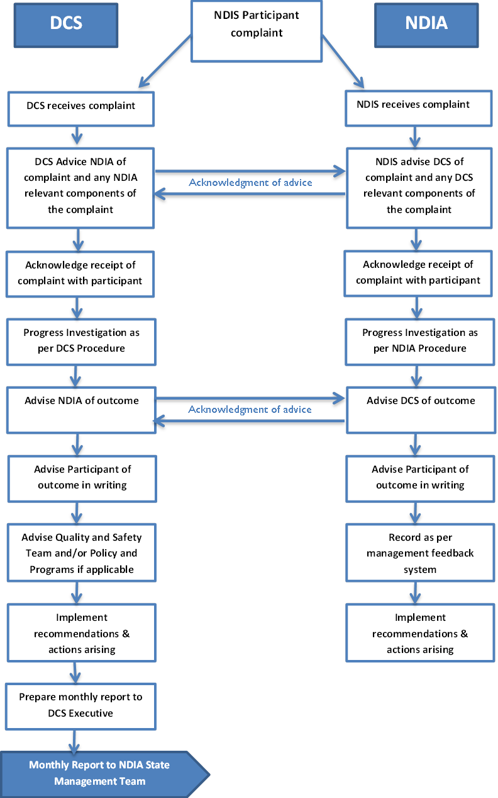**

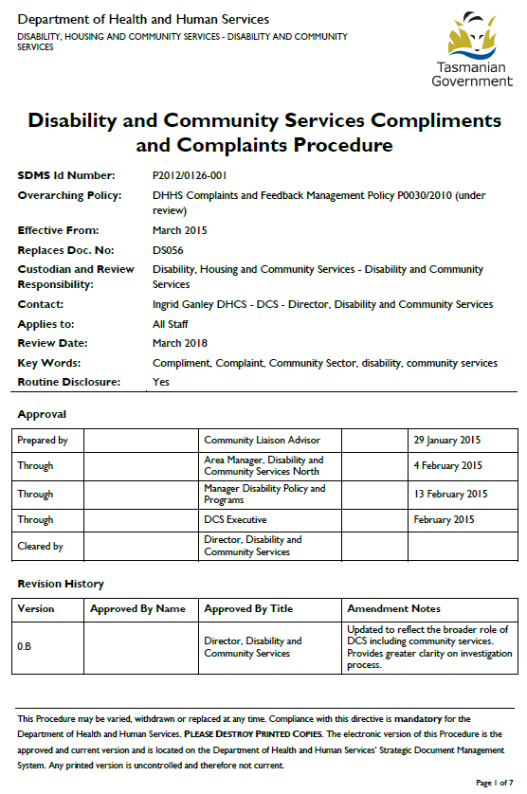

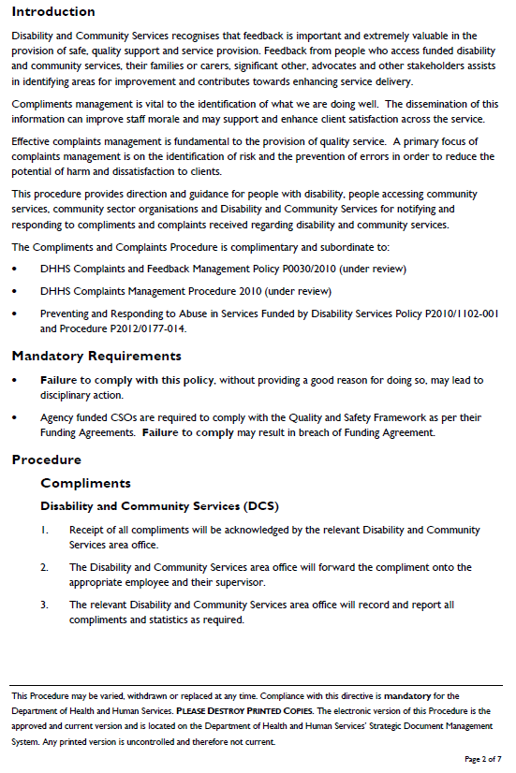

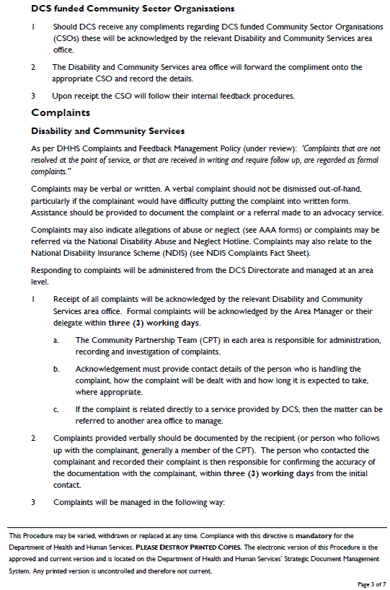

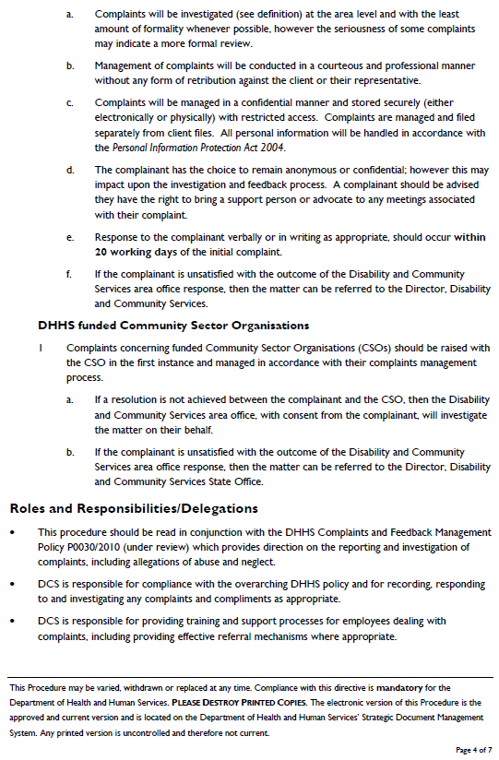

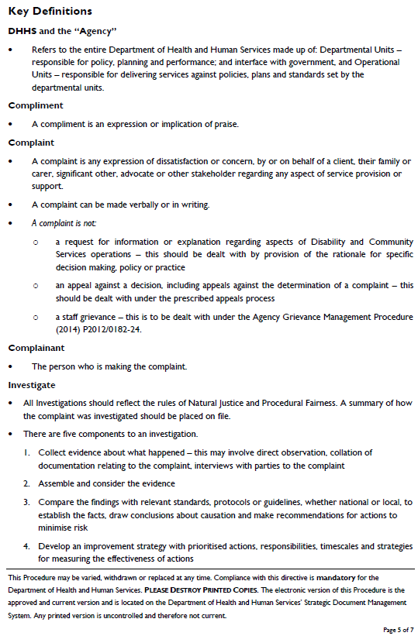

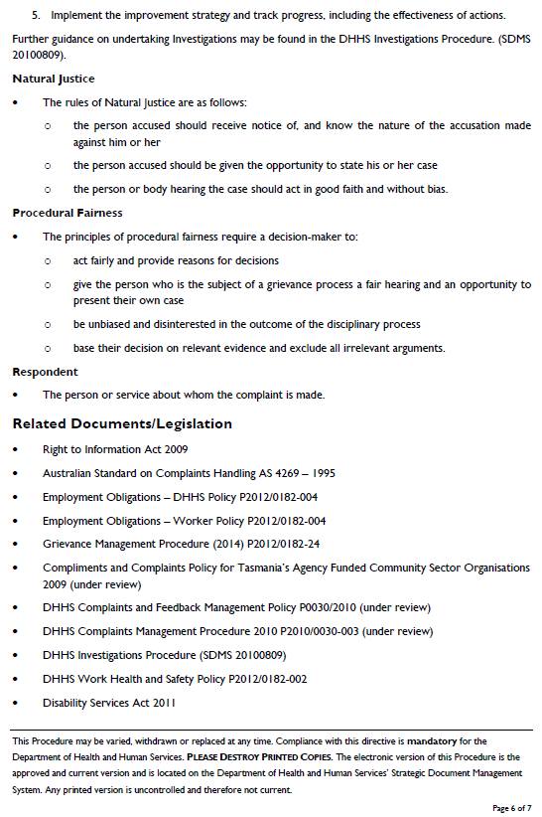

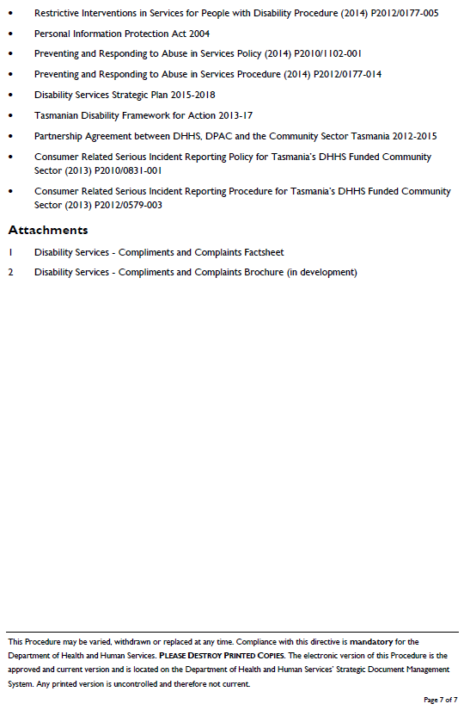

|  |  |  |
| --- | --- | --- |
| Department of Health and Human Services | | 2011-03-07 - 2010_TAS_Gov_Logo |
| **Preventing and Responding to Abuse in Services Funded by Disability and Community Services** | | |
| **SDMS Id Number** | P2010/1102-001 | |
| **Effective From** | September 2012 | |
| **Functional Sub Group** | - | |
| **Summary** |  | |
| **Replaces Doc. No.** | DS 001 | |
| **Author Area** | Disability Services Policy, Disability and Community Services | |
| **Contact** | Angela Proposch | |
| **Applies to** | All services provided or funded, in whole or in part, by Disability and Community Services. | |
| **Policy Type** | Preventing and Responding to Abuse in Services Funded by Disability and Community Services Policy Statement and Procedural Guidelines | |
| **Review Date** | September 2017 | |

|  |  |  |  |
| --- | --- | --- | --- |
| Prepared by | Project Officer, Disability and Community Services | 1300 135 513 | August 2012 |
| Through | Manager, Disability Services Policy, Disability and Community Services | 1300 135 513 | 8 October 2012 |
| Cleared by | Director, Disability and Community Services | 1300 135 513 | 8 October 2012 |

### Introduction/Purpose

The provisions of the *Disability Services Act 2011 (TAS)* clearly outline the obligations that service providers have to ensure that people with a disability receive support services which uphold and maintain their rights as equal members of society. Those rights include the right to feel safe and to live and receive services in an environment free from any form of abuse. People with a disability are also entitled to privacy, dignity and confidentiality in all aspects of their lives as well as the same legal and human rights as the rest of the community.

Disability and Community Services and other service providers therefore have a clear moral, professional and legal responsibility to provide an environment for its clients that is safe and where work practices aim to prevent any form of abuse.

Where abuse has occurred, service providers have a responsibility to respond promptly and sensitively to the allegations in consultation with relevant others, to protect the person/s from further harm and to offer medical and psychological assistance.

This policy and procedural guideline has been developed to assist service providers and staff in their response to situations where allegations of abuse have occurred. They provide a basis for service providers to develop procedures appropriate to the services they provide and to the nature of their particular organisation. The guidelines contain the essential elements of best practicein responding to allegations of abuse and protecting the safety and interests of the alleged victim.

Some organisations may choose to implement this document as their policy and procedures whilst others may choose to develop their own specific policy and procedures. It should be noted however, that any such policy and procedures would need to be consistent and compatible with these guidelines.

Developing procedures which ensure a swift and consistent response is only one element in preventing the incidence of abuse. Service providers are required to exercise a considerable degree of responsibility in their recruitment and induction of appropriate service staff. This responsibility also extends to the provision of continuing staff education, training and supervision based on values which respect and empower people with disability.

All Staff have a duty of care to report abuse according to their organisation's procedural guidelines. Reporting of abuse is a valid and appropriate action and staff should feel confident that they will receive support and encouragement from management for their action. This support is also a critical factor in preventing the incidence of abuse.

### Policy Statement

Reporting the Allegation

Allegations of abuse may be reported directly by the alleged victim (for example through the National Abuse Hotline on 1800 880 052), or to the Disability and Community Services Area Manager (in your local area). An Advocacy Service can be contacted to provide support in this process (see list of services on Page 11 of this document).

Support staff are required to report all allegations or concerns about possible abuse to a supervisor or manager in their organisation.

The worker who first becomes aware of the allegation is required to immediately advise the most senior staff member in the relevant work area of full details of the allegation. If the allegation is against the most senior staff member on duty it is a requirement that it is either be reported to their immediate line manager or, in accordance with that organisation's grievance mechanism.

A preliminary investigation may be required to clarify whether or not there is sufficient evidence to support a formal allegation of abuse.

Allegations of abuse which may be of a criminal nature must be reported to Tasmania Police in the first instance.

Note that in situations where the police have been notified, they may advise that no contact be made with other parties until their preliminary investigation has been completed.

If further action is not taken by police, an investigation should be undertaken by the organisation.

**Organisations must ensure:**

* That the client has immediate access to health care if required and that any injuries are documented and any evidence preserved. Whilst first-aid should be administered, evidence of the alleged assault should be preserved until such time as independent medical and police assessment has been completed. In the case of alleged sexual assault, the victim should be encouraged not to bathe, wash, shower, or change or discard their clothes.
* That an Allegation of Abuse Alert (AAA) ‘Form 1’ is provided to Disability and Community Services within two working days of being notified of an allegation of abuse (unless otherwise advised by the Police).
* That a report is provided to Disability and Community Services regarding the progress of the matter within 28 calendar days on the prescribed Allegation of Abuse or Neglect Report ‘Form 2’.

Within 48 hours, (unless otherwise advised by police) service providers are required to:

* inform the client’s guardian, person responsible or significant other of the alleged incident
* notify Disability and Community Services of the alleged incident on the prescribed form.

Other immediate action will depend on the nature, type and severity of the allegation and may include:

* engaging additional staff to be on duty
* ensuring that no further contact occurs between the alleged perpetrator and the alleged victim
* redeploying a staff member to another part of the service
* suspending staff from work for the duration of the investigation.

**Conducting an Investigation**

Organisations are required to develop appropriate internal mechanisms for investigating allegations of abuse. Clear reporting processes should be developed and communicated to staff at initial induction and on a regular basis from then on.

All persons including both the alleged victim and the alleged perpetrator have rights and responsibilities during the investigation process. It is important to guarantee procedural fairness for those involved in any matter covered by this policy.

All parties are entitled to:

* timely, adequate and appropriate responses
* adequate supports to deal with the matter
* freedom from pre-judgement and retribution
* confidentiality and respect for their privacy.

Note that confidentiality should be provided within the boundaries of the investigation process.

It is the right of all people with a disability to have the support of an advocate and this is particularly important at times of high stress and anxiety. An advocate may be a family member, friend or representative of an advocacy organisation. Organisations are responsible for ensuring that advocacy and support is offered and available to clients.

Disability and Community Services will directly investigate all notifications received through the National Disability Services Abuse and Neglect Hotline.

### Key Definitions

### Client

A person with disability, as defined by the *Disability Services Act 2011* (TAS) who may either be receiving support directly from, or be funded directly by Disability and Community Services or receiving support from a service provider funded under the Act.

### Abuse

Abuse is generally taken to be any action that results in a violation of a person’s human or civil rights. There are five main types of abuse: physical, sexual, emotional / psychological, neglect and financial abuse. Abuse can be one off or persist over a period of time. However, a defining element is that there is the potential for significant and enduring harm as a result of the abuse.

Generally the term abuse is used to refer to intentional acts committed by a person who has power over another person (e.g. parent – child; support worker – client; doctor – patient).

Some forms of abuse are criminal offences and can be punishable by law.

While certain forms of abuse may not be considered a criminal act (e.g. physical coercion, sexual harassment, all forms of psychological abuse) these behaviours are termed harassment under the *Anti-Discrimination Act 1998* and are also illegal. Complaints involving harassment are investigated by the Anti-Discrimination Commission (ADC).

For a more detailed definition of the types of abuse see Attachment 1 of the Procedural Guidelines accompanying this Policy.

### Principles

Prevention is the best protection against abuse. Service providers must demonstrate their commitment to the prevention of abuse and neglect through the development and implementation of strategies and systems to ensure that all staff and volunteers understand their role in preventing the abuse and neglect of clients.

Abuse and neglect is unacceptable and once identified must be promptly reported to management and immediate action taken to prevent recurrence and to protect the rights of both the client(s) and/or staff members involved. All incidents must be documented and reported in accordance with the organisation’s incident reporting process.

All allegations of abuse must be accurately documented and investigated in line with this policy and the accompanying procedural guidelines. An allegation of abuse is a serious matter that may have significant consequences and should not be taken lightly.

Disability service providers have a responsibility to provide services that are of a high standard and are free from abuse and neglect. Service providers are required to develop and implement strategies to further the objectives, principles and standards contained within the *Disability Services Act 2011* (TAS). This can be achieved by:

* developing systems to prevent the occurrence or recurrence of abuse or neglect
* identifying situations which may contribute to a person experiencing abuse, assessing the risk and developing processes to mitigate the risk
* developing clear practice standards and ensuring appropriate supervision of staff
* developing the ability for people with disability to improve their personal safety and to safely participate in daily activities
* developing the ability of staff and volunteers to identify, appropriately respond to and prevent abuse and neglect
* developing human resource systems and practices that support effective recruitment practices, including checks to ensure compliance with statutory requirements such as criminal history checks;
* developing a culture that promotes and encourages the open disclosure of suspected or alleged incidents and real or potential risks.

### Implementation/guideline in Operation

This is a state-wide procedural guideline and must not be re-interpreted so that subordinate policies exist.  Should discreet operational differences exist, these should be expressed in the form of an operating procedure or protocol that must be approved at the same level as this policy

**Rationale/Evidence Base**

* The *Disability Services Act 2011* outlines that disability service providers have a duty of care to deliver services that are free from abuse and neglect, and promote a culture of best practice and open disclosure of alleged incidences or the occurrence of abuse.

Certain types of abuse such as physical and sexual abuse are a criminal offence under the *Criminal Code Act 1924* and require notification to and investigation by Tasmanian Police.

### Outcomes

* Disability service providers have a clear understanding of what constitutes abuse, the different types of abuse, and understand the process and their obligations for responding to and reporting allegations of abuse.
* Disability service providers provide services that are in line with best practice and are free from abuse and neglect.
* Disability service providers have systems in place to prevent the occurrence of abuse.

### Responsibilities/Delegations

Disability and Community Services is responsible for:

* receiving reports of suspected abuse and neglect
* ensuring that organisations are responding appropriately to those reports
* maintaining an overview of the service system
* providing advice and support as required
* independently investigating notifications received through the National Disability Services
* Abuse and Neglect Hotline and reporting of outcomes to the Hotline
* initiating and undertaking service reviews, surveys and quality improvement activities as appropriate
* collecting statistics and data for local and national reporting purposes.

Funded organisations are responsible for ensuring compliance with this policy by:

* contacting Tasmania Police where allegations of abuse (as defined) have been raised
* developing systems and processes to prevent occurrences of abuse
* developing a system for responding appropriately to allegations of abuse and neglect
* supporting clients to understand what abuse and neglect is and how to report this and stay safe
* providing information to clients about Advocacy Services
* developing and implementing clear policies and processes relating to the documentation and reporting of incidents
* providing information to Disability and Community Services in a timely manner e.g. that the Abuse Allegation Form is forwarded within two working days
* ensuring that the organisation has an adequate complaints management policy and incident reporting and investigation processes
* ensuring that standards of service issues are addressed.

### Audit and Compliance

### Failure to comply with this policy, without providing good reason for doing so, may lead to disciplinary action for Disability and Community Services staff, or to action under Part 4, Division 2 of the Act for funded service providers.

It is the responsibility of CSO’s and managers of community sector organisations and Area Managers Disability and Community Services to communicate this policy and guideline to their employees and ensure compliance.

### Related Documents/Useful Resources

* *Anti Discrimination Act 1998*
* Restrictive Interventions Guideline 2012
* *Children, Young Persons and Their Families Act 1997*
* *Criminal Code Act 1924*
* *Disability Services Act 2011 (TAS)*
* Disability Services Compliments and Complaints Policy Statement
* *Disability Discrimination Act 1992* (Commonwealth)
* Disability Services Formal Incident Review Process

### Glossary

### N/A refer to Attachments.

### Attachments

**Physical Abuse**

Physical abuse is the act of applying force to another person either directly (e.g. hitting, pushing, grabbing) or indirectly (e.g. threats, physical intimidation). This includes inflicting pain of any kind or causing bruises, fractures, burns, electric shock or any unpleasant sensation. e.g., Hitting, kicking, punching, pinching, slapping, spanking, hair pulling, biting, spitting, force feeding, choking, shaking, pushing, scratching, corporal punishment and recklessly endangering the client’s life through the carer’s actions. Grabbing a person to protect them from potential harm is not defined as abuse.

**Sexual Abuse**

Sexual abuse occurs when a person is subjected to any sexual activity without their consent (this includes clients, employee, volunteer, carer, family member etc). It can be defined as any sexual contact between an adult and a child 17 years of age or under; or any sexual activity with an adult who is unable to understand, has not given consent, is threatened, coerced or forced to engage in sexual behaviour.

Sexual activity includes intercourse, genital manipulation, masturbation, voyeurism, sexual harassment, and also inappropriate exposure to pornographic media.

Sexual abuse in the above context is defined as sexual assault. The *Tasmanian Criminal Code Act* (1924) divides sexual assault offences into three categories, namely:

* rape - penetration of the vagina, anus or mouth by the penis
* aggravated sexual assault - penetration of the vagina or anus with any object or body part other than the penis
* indecent assault -touching or threatened touching which has sexual overtones

Inappropriate touching may or may not be classed as sexual abuse depending on the context in which it occurs and the level of functioning of the individuals involved.

Sexual harassment, while not classed as sexual abuse can have serious consequences for the persons concerned. Sexual harassment or suggestion that is uninvited, unwelcome or unwanted is unacceptable and complaints can be pursued under the *Tasmanian Anti-Discrimination Act* (1998).

**Financial Abuse**

Financial abuse is the unlawful or improper use of a person’s property or finances by someone with whom the person has a relationship that implies trust. Examples include: misappropriation of money or property (such as theft, fraud); any unauthorised denial of the person’s right of access to or control over their personal finances; any undue influence brought to bear on the person in relation to their financial affairs.

**Psychological or Emotional Abuse**

Any conduct which could cause mental anguish, fear or isolation, feelings of shame, humiliation and powerlessness or loss of dignity would constitute psychological abuse. Examples include: repeated verbal assaults; threats, humiliation or intimidation; emotional blackmail; failure to interact with a person or to acknowledge that person’s existence; and treating the person in a disrespectful manner. It also includes: the making of continual derogatory remarks about the individual, their appearance or attributes, their parents, family or cultural heritage; activities which place the individual in an unsafe environment or produce fear with the aim of demeaning the person; threats to make the individual perform a task/action they do not wish to perform; and threats to discharge the person from a program or restrict access to services.

**Neglect**

The failure to provide adequate food, shelter, stimulation, clothing, and medical or dental care all constitute neglect. This may involve the refusal to permit other people to provide appropriate care. Examples of neglect include, abandonment, non-provision of nourishing food, or adequate clothing or shelter, inappropriate use of medication (including over medication) and poor hygiene or personal care. It does not include self-neglect.

**Restrictive Practices**

The Disability Services Act defines restrictive practices as any action taken to restrict the rights or freedom of movement of a person with disability for the primary purpose of the behavioural control of the person. It does not include such actions that are taken for therapeutic purposes, or to enable the safe transportation of the person or actions authorised under mental health legislation or guardianship.

Restrictive practices that are not authorised under the Act may constitute abuse if they occur on a continual basis or if they are likely to cause harm. The use of restraint without authorisation under the Act is only acceptable where it is required, in emergency situations, to prevent the individual from harming themselves or others and where it is the least restrictive method available under the circumstances. The use of restrictive practices in emergency situations must be reported to the Senior Practitioner as soon as practicable after the event. The Senior Practitioner will monitor the practice to ensure that it complies with the requirements of the Act.

For further information on the use of restraint refer to the ‘Restrictive Interventions Guidelines 2012’*.*

1. **Name and address of Individual Person or Organisation reporting the allegation**

|  |  |
| --- | --- |
| **Individual or Organisation Name** |  |
| **Address** |  |

1. **Contact Person in Organisation reporting the allegation**

|  |  |
| --- | --- |
| **Name** |  |
| **Address** |  |
| **Telephone Number** |  |

1. **Name and address of victim of alleged abuse**

|  |  |
| --- | --- |
| **Name** |  |
| **Address** |  |

1. **Name and address of Organisation where the alleged abuse or neglect occurred (If different to above)**

|  |  |
| --- | --- |
| **Organisation Name** |  |
| **Address** |  |
| **Contact Person Name and phone Number** |  |

1. **What is the nature of the alleged abuse or neglect? *(tick box as appropriate*** ✓**)**

|  |  |  |  |  |  |
| --- | --- | --- | --- | --- | --- |
| Physical |  | Financial |  | Neglect |  |
| Psychological |  | Sexual |  | Other |  |

***Description of Alleged Incident***

1. **Please describe how the alleged abuse or neglect was discovered (include date and times, if possible).**

|  |  |
| --- | --- |
| Date(s) |  |
| Time(s) |  |

Details:

1. **Please describe any physical injuries that the client(s) received as a result of the alleged incident.**

Details:

1. **What immediate action has been taken in response to the allegation (please include the time when police, doctor, advocate or next-of-kin were contacted and when they arrived and what support has been provided to other clients who may have witnessed the alleged abuse).**

Details:

|  |  |  |  |  |
| --- | --- | --- | --- | --- |
| 1. **Has the alleged abuse or neglect been referred to Tasmania Police?** | **Yes** |  | **No** |  |

|  |  |  |  |  |
| --- | --- | --- | --- | --- |
| 1. **Is the allegation the subject of a Tasmania Police investigation?** | **Yes** |  | **No** |  |

1. **Which Advocacy agency is providing the support to the alleged victim?**

|  |  |
| --- | --- |
| **Organisation / Advocates Name:** |  |
| **Contact Details:** |  |

1. **What action does your organisation/service intend to take to manage the situation and prevent the recurrence of the alleged abuse or neglect?**

Details:

**Please provide name of the individual or organisation reporting the alleged abuse (as per Page 1) and sign below.** *Note: Please ensure all sections of the Form are completed and return to the Area Manager, Disability Services in your area:*

|  |  |
| --- | --- |
| **Signed:** |  |
| **Name of individual or organisation contact person:** | **Date: / /** |
|  |  |
| **Received By:** | **Date: / /** |
|  | **(Area Manager, Disability and Community Services)** |
|  |  |
| **Received by:** | **Date: / /** |

**(Community Partnership Team Leader)**

Area North

Drysdale House

39 Franklin Street

Launceston Tasmania 7250

Telephone: 6336 4130

Facsimile: 6336 4131

Email: [disability.north@dhhs.tas.gov.au](mailto:disability.north@dhhs.tas.gov.au)

Area South East

Woodhouse Building, St John’s Park

New Town Tasmania 7009

Telephone: 6230 7600

Facsimile: 6230 7605

Email: [disability.south@dhhs.tas.gov.au](mailto:disability.south@dhhs.tas.gov.au)

Area North West

2nd Floor, Parkside, Brickwell Street

Burnie Tasmania 7320

Telephone: 6434 4103

Facsimile: 6434 4122

Email: [disability.northwest@dhhs.tas.gov.au](mailto:disability.northwest@dhhs.tas.gov.au)

Area South West

Woodhouse Building, St John’s Park

New Town Tasmania 7009

Telephone: 6230 7600

Facsimile: 6230 7605

Email: [disability.south@dhhs.tas.gov.au](mailto:disability.south@dhhs.tas.gov.au)

\* This Form is to report on follow up to the alleged abuse

|  |  |
| --- | --- |
| **Name of Client:** |  |
| **Address:** |  |

|  |  |
| --- | --- |
| **Organisation Name:** |  |
| **Address:** |  |

1. **What actions has your organisation taken to date to manage the allegation of abuse or neglect and protect the client from any potential further abuse or neglect?**

Please provide details:

1. **What is the current status of the client and alleged perpetrator?**

Please provide details:

1. **Outline any further actions that need to take place to address the situation.**

Please provide details:

|  |  |  |  |  |
| --- | --- | --- | --- | --- |
| 1. **Is this matter now finalised from the organisation’s perspective?** | **Yes** |  | **No** |  |

**Comments**

|  |  |
| --- | --- |
| **Signed:** |  |
| **Name and Position:** | **Date: / /** |
|  |  |
| **Received By:** | **Date: / /** |
|  | **(Area Manager, Disability Services)** |
|  |  |
| **Received By:** | **Date: / /** |
|  | **(Community Partnership Team Leader)** |

*Note: Please complete all sections and return to Area Manager, Disability Services in your area as listed on the following page*

Area North

Drysdale House

39 Franklin Street

Launceston Tasmania 7250

Telephone: 6336 4130

Facsimile: 6336 4131

Email: [disability.north@dhhs.tas.gov.au](mailto:disability.north@dhhs.tas.gov.au)

Area South East

Woodhouse Building, St John’s Park

New Town Tasmania 7009

Telephone: 6230 7600

Facsimile: 6230 7605

Email: [disability.south@dhhs.tas.gov.au](mailto:disability.south@dhhs.tas.gov.au)

Area North West

2nd Floor, Parkside, Brickwell Street

Burnie Tasmania 7320

Telephone: 6434 4103

Facsimile: 6434 4122

Email: [disability.northwest@dhhs.tas.gov.au](mailto:disability.northwest@dhhs.tas.gov.au)

Area South West

Woodhouse Building, St John’s Park

New Town Tasmania 7009

Telephone: 6230 7600

Facsimile: 6230 7605

Email: [disability.south@dhhs.tas.gov.au](mailto:disability.south@dhhs.tas.gov.au)

|  |  |  |
| --- | --- | --- |
| Department of Health and Human Services  Disbaility and community services | | 2011-03-07 - 2010_TAS_Gov_Logo |
| **Preventing and Responding to Abuse in Services Procedure** | | |
| **SDMS Id Number:** | P2012/0177-014 | |
| **Effective From:** | May 2014 | |
| **Replaces Doc. No:** |  | |
| **Custodian and Review Responsibility:** | Disability Services Policy and Programs | |
| **Contact:** | Director, Disability Services Policy and Programs | |
| **Applies to:** | All services provided of funded, in whole or in part, by Disability and Community Services | |
| **Review Date:** | May 2017 | |
| **Keywords:** | abuse, prevent, respond, disability, | |
| **Routine Disclosure:** | yes | |

**Approval**

|  |  |  |  |
| --- | --- | --- | --- |
| Prepared by | Senior Program Officer  Disability Services Policy and Programs | 1300 135 513 | 27 March 2014 |
| Through | Manager Disability Services Policy and Programs | 1300 135 513 | 4 April 2014 |
| Through | Director, Disability and Community Services | 1300 135 513 | 15 April 2014 |
| Cleared by | Deputy Secretary, Disability, Housing and Community Services | 1300 135 513 | 15 April 2014 |

**Revision History**

|  |  |  |  |
| --- | --- | --- | --- |
| **Version** | **Approved by name** | **Approved by title** | **Amendment notes** |
|  | Name | Position Title |  |
|  | Name | Position Title |  |
|  | Name | Position Title |  |

**Introduction**

The purpose of this procedure is to:

* outline the obligations that service providers have to ensure that people with a disability receive support services which uphold and maintain their rights as equal members of society
* outline the steps necessary to uphold professional and legal responsibility to provide an environment for clients that is safe and work practices that aim to prevent any form of abuse
* assist staff to respond promptly and sensitively to allegations, in consultation with relevant others, to protect the person(s) from further harm and to offer medical and psychological assistance
* direct service providers and staff in their response to situations where allegations of abuse have occurred and provide the basis for service providers to develop procedures appropriate to the services they provide and to the nature of their particular organisation.
* This procedure has been developed to assist service providers and staff in their response to situations where allegations of abuse have occurred and provides the basis for service providers to develop additional procedures appropriate to the operational services they provide and to the nature of their particular organisation.
* The intent is to outline the essential elements of best practicein responding to allegations of abuse and to protect the safety and interests of the alleged victim.

**Mandatory Requirements**

* The Tasmanian *Disability Services Act 2011* outlines that disability service providers have a duty of care to deliver services that are free from abuse and neglect, and promote a culture of best practice and open disclosure of alleged incidences or the occurrence of abuse.
* This procedure must be read in conjunction with the Preventing and Responding to Abuse Policy P2010/1102-001.
* Certain types of abuse such as physical and sexual abuse are a criminal offence under the *Criminal Code Act 1924* and require notification to and investigation by Tasmanian Police.
* The Tasmanian *Disability Services Act 2011* provides the legislative basis for the provision of specialist disability services.
* The Act defines disability as an impairment that:
  + is attributable to a cognitive, intellectual, psychiatric, sensory or physical impairment, or a combination of these, and
  + is permanent or likely to be permanent, and
  + results in a substantial reduction in the capacity of the person to participate in everyday life, and
  + requires continuous significant support services, and
  + may or may not be of a chronic episodic nature.
* To be eligible for specialist disability services in Tasmania, a person must:
  + have a disability as defined under the Act
  + live permanently in Tasmania
  + be an Australian citizen, or a permanent Australian resident, or a Temporary Protection Visa holder, or a member of a family on a work or study visa sponsored by the Australian Government
  + have a disability that manifests before the age of 65 years.

|  |  |  |
| --- | --- | --- |
| Department of Health and Human Services  Departmental or SERVICE GROUP/Unit | | 2011-03-07 - 2010_TAS_Gov_Logo |
| **Authorised Officers – Entry of Premises**  **Policy** | | |
| SDMS Id Number: | Policy ID - P2012/0178 - 058) | |
| Effective From: | November 2013 | |
| Replaces Doc. No: | N/A, new policy | |
| Custodian and Review Responsibility: | Disability, Housing and Community Services | |
| Contact: |  | |
| Applies to: | Disability and Community Services program | |
| Policy Type: | DHHS Group/Unit Specific Policy | |
| Review Date: | October 2016 | |
| Keywords: | Authorised Officers, Disability Services | |
| Routine Disclosure: | Yes | |

Approval

|  |  |  |  |
| --- | --- | --- | --- |
| Prepared by | Project Management Officer | 1300135513 | September 2013 |
| Through | Director, Disability and Community Services | 1300135513 | 6 November 2013 |
| Cleared by | Deputy Secretary, Disability, Housing and Community Services | 1300135513 | 6 November 2013 |

**Revision History**

|  |  |  |  |
| --- | --- | --- | --- |
| **Version** | **Approved by name** | **Approved by title** | **Amendment notes** |
|  |  |  |  |
|  |  |  |  |
|  |  |  |  |

**Purpose**

* The purpose of this policy is to ensure that State Service employees or State Service officers authorised to enter funded service provider’s premises, or private funded premises under Part 4, Division 3 of the Tasmanian *Disability Services Act 2011* (the Act), perform their relevant duties and functions and meet their responsibilities in line with the requirements of the Act and Departmental policy and procedures.
* The policy sets out the rights, processes and requirements to be followed by ‘authorised officers’ when entering funded premises.

**Mandatory Requirements**

* Within the Disability and Community Services program, all Disability and Community Services Area Managers and all employees of the Disability Assessment and Advisory Teams (DAAT), the Community Partnership Teams (CPT) and Disability Consultants in each Area may become ‘authorised officers’ under section 25 of the Act.
* This will ensure adequate coverage and accessibility, and allow flexibility in appropriate and specific skill sets being available to address individual situations.
* In line with the requirements of the Act (section 25(2)) all relevant officers must be authorised in writing stating the type of funded premises covered by the authorisation.
* The Secretary may authorise any other State Service employee or officer as considered appropriate.
* As DAAT, CPT, Disability Consultants and Area Managers positions become vacant and are advertised for filling, the relevant Statements of Duties (SODS) are to be modified to include the functions of Authorised Officers. For current SODs the functions of Authorised Officers are to be covered under ‘other duties as directed’.
* The Disability and Community Services program, in conjunction with the Workforce Development Unit, will on an ongoing basis, identify and address relevant training needs for Authorised Officers.
* Authorised Officers will continue to operate under their current reporting structures.
* Area Managers must endorse the entry of premises, removal of documents or relocation of persons with disability, prior to any Authorised Officer entering any premises.
* Area Managers must provide, in line with current reporting processes, relevant data and client outcome information to the Director, Disability and Community Services, in regard to the activities of Authorised Officers.
* This is a DHHS wide policy and must not be re-interpreted so that subordinate policies exist.  Should discreet operational differences exist, these should be expressed in the form of an operating procedure or protocol.
* **Failure to comply with this policy**, without providing a good reason for doing so, may lead to disciplinary action.

### Roles and Responsibilities/Delegations

* Under Part 4, Division 3 of the Disability Services Act 2011, the Secretary of the Department of Health and Human Services, may authorise, in writing, a State Service employee or officer to enter funded provider’s premises, or private funded premises, or both.
* An ‘authorised officer’ may only enter premises, for the purposes of :

1. Determining the extent to which the terms and conditions of a Funding Agreement are being complied with;
2. Ensuring that persons with disability who reside or receive a service in the premises are receiving the care and support necessary or desirable for their health and wellbeing. Or
3. To ensure the safety of persons with disability who are within the premises.

* Currently within the Disability and Community Services program of the Department of Health and Human Services, all Disability and Community Services Area Managers, all employees of the Disability Assessment and Advisory Teams (DAAT), the Community Partnership Teams (CPT) and Disability Consultants in each Area may be authorised officers under section 25 of the Act.
* In line with the requirements of the Act (section 25(2)) all relevant officers and employees must be authorised in writing stating the type of funded premises covered by the authorisation.
* The Secretary may authorise any other State Service employee or officer as considered necessary or appropriate.
* The current authorised officer instrument can be found at http://www.dhhs.tas.gov.au/disability/publications/policies,\_procedures\_and\_guidelinesRisk Implications.
* Non-compliance with all or part of this policy may result in a breach of specific provisions under the Disability Services Act 2011 and duties of employment.

### Training

* Disability and Community Services program in conjunction with the Workforce Development Unit, will on an ongoing basis, identify and address relevant training needs for Authorised Officers.

### Audit

* This policy will be included in the work program of the DHHS Internal Audit function. This work program is approved by the Audit and Risk Committee and will assess underlying systems and procedures for compliance with the requirements of this policy. The overall focus of this assessment will be one of continuous improvement to DHHS activities.

### Attachments

1. Tasmanian *Disability Services Act 2011*.

|  |  |  |
| --- | --- | --- |
| Department of Health and Human Services  DepARTMENTAL OR SERVICE GROUP/Unit | | 2011-03-07 - 2010_TAS_Gov_Logo |
| **Authorised Officers – Entry of Premises**  **Procedure** | | |
| SDMS Id Number: | Procedure ID - 2012/0178 - 058 | |
| Effective From: | November 2013 | |
| Replaces Doc. No: | Not Applicable – new Procedure | |
| Custodian and Review Responsibility: | Disability Policy and Planning | |
| Contact: | John Nehrmann, Project Management Officer, 6233 4055 | |
| Applies to: | Pursuant to the Disability Services Act 2011, this Procedure applies to:   * All services directly managed by Disability and Community Services and all community based organisations, and individuals, funded by Disability and Community Services to provide services to people with disability. It applies to managers and support staff. * All persons with disability who are receiving services from Disability and Community Services or from organisations, services or programs funded by Disability and Community Services. | |
| Review Date: | October 2016 | |
| Keywords: | Authorised Officers, Disability Services | |
| Routine Disclosure: | Yes | |

**Approval**

|  |  |  |  |
| --- | --- | --- | --- |
| Prepared by | Project Management Officer | 1300 135 513 | September 2013 |
| Through | Director, Disability and Community Services | 1300 135 513 | 6 November 2013 |
| Approved by | Deputy Secretary, Disability, Housing and Community Services | 1300 135 513 | 6 November 2013 |

**Revision History**

|  |  |  |  |
| --- | --- | --- | --- |
| **Version** | **Approved by name** | **Approved by title** | **Amendment notes** |

**Introduction**

* The purpose of this procedure is to ensure that State Service employees or State Service officers authorised to enter funded service provider’s premises, or private funded premises under Part 4, Division 3 of the *Disability Services Act 2011*(the Act), perform their relevant duties and meet responsibilities in line with the requirements of the Act and Departmental policy and procedures.
* The procedure sets out the rights, processes and requirements to be followed by ‘authorised officers’ when entering funded premises.
* The procedure also assists service providers to meet their requirements under the Act in regard to authorised officers entering premises.

## Mandatory Requirements

* Sections 2, 3, 4 and 5 of the Procedure are ‘Mandatory Requirements’ under Part 4, Division 3 of the Act.

## Procedure

1. **Endorsement of Area Managers** – the relevant Area Manager must endorse, in writing, the entry of premises, removal of documents or relocation of persons with disability, prior to any Authorised Officer entering any premises.

Area Managers must ensure that, within 24 hours of an Authorised Officer having entered premises, the Director, Disability and Community Services, is provided with relevant facts, data and client impact information.

Area Managers must ensure that the endorsement of any entry to premises given to Authorised Officers is consistent with the Authorised Officer’s ‘protective’ function and is based on a specific complaint or specific suspected contravention of the Act.

1. **Rights and responsibilities of Authorised Officers who enter premises** – An authorised officer may enter premises specified in the authorisation only for the following purposes[[11]](#footnote-12):
2. To determine the extent to which the terms and conditions of a Funding Agreement are being complied with, or
3. To ensure that persons with disability who reside in, or receive specialist disability services in, the premises are receiving the care and support that is necessary or desirable for their health and wellbeing, or
4. To ensure the safety of persons with disability who reside at, or receive specialist disability services in, the premises.

An authorised officer may enter funded provider’s premises at any time without prior warning to the owner of, or any occupier of, the premises[[12]](#footnote-13).

An authorised officer who enters funded provider’s premises must ensure that, if he or she enters a part of the premises designated for the private use of a person with disability, while the person is present in the part of the premises, the authorised officer immediately tells the person the purposes for which the authorised officer has entered the premises.

An authorised officer who enters premises must, at the request of a person on the premises, show the person proof that the officer is authorised to enter the premises, or leave the premises as soon as practicable after the request is made. An authorised officer must wear the Authorised Officer Identification Card at all times when entering and staying on funded provider premises. The ID card will only be issued after the officer has completed the required training.

An authorised officer is not authorised to use force to enter premises. However a police officer may be requested by the authorised officer to use force to enter premises[[13]](#footnote-14).

A funded provider, any employee of a funded provider and any individual receiving a grant must not impede an authorised officer in performing their functions and duties under the Act, and this includes impeding access to premises.

Failure to comply with these provisions of the Act may result in the grant to the funded provider or individual being terminated.

3 **Requirements where private funded premises are entered[[14]](#footnote-15)** – an authorised officer should make reasonable attempts to give at least 48 hours’ prior notice to a person who resides at the premises prior to entering private funded premises, unless the authorised officer is reasonably of the opinion that it is necessary to enter the premises without notice in order to ascertain –

* Whether a person with disability is receiving the care and support that is necessary or desirable for the person’s health and wellbeing, or
* Whether a person with disability is safe.

An authorised officer may only enter private funded premises before 7 a.m., or after 7 p.m., if it is reasonably necessary to do so in order to ascertain whether –

* The person with disability is receiving, at the premises, or from a person who resides at the premises, the care and support that is necessary or desirable for the health and wellbeing of the person; or
* A person with disability is safe.

An authorised officer who enters private funded premises must as soon as practicable tell a person on the premises, and any person with disability on the premises, the purpose for which the authorised officer has entered the premises[[15]](#footnote-16).

1. **Rights of Authorised Officers after entry of premises[[16]](#footnote-17)** – An authorised officer who enters premises may take any of the following actions on the premises, in so far as it is necessary to do so for the purposes for which the officer has entered the premises:

* Inspect the premises;
* Open any container, filing cabinet, or storage facility, that is on the premises;
* Request a person on the premises to provide documents or records to the officer;
* Inspect any documents or records on the premises
* Take copies of, or request a person on the premises to make copies of, any documents or records that are on the premises or provided to the officer.

## An authorised officer who enters premises may request[[17]](#footnote-18) –

* Any employee of the funded provider, who is on the premises and any person who is receiving a grant under section 14(1)(c) of the Act, or
* Any person with disability, or other person, who is on the premises

## to answer questions in relation to the provision of specialist disability services or other goods and services to which the provider’s grant relates.

A person with disability who is requested by an authorised officer to answer questions is entitled to-

* Request that another person be present when the person with disability answers the questions, and
* Have another person be present, and to be assisted by that other person, when answering questions.

1. **Responsibilities of funded service providers** – the funded provider providing services at the premises, any employee of the funded provider and any person (other than a person with disability) who is receiving a grant under section 14(1)(c) of the Act **must**:

* Permit the authorised officer to ask employees of the provider, or any person who is on the premises, questions in relation to the provision of specialist disability services or other goods and services to which the grant relates;
* Permit the authorised officer to speak in private with employees of the provider or any person who is on the premises, and

## must not prohibit a person of whom a question is asked from answering, or threaten or punish a person of whom a question is asked if that person were to answer such a question.

A funded provider, any employee of a funded provider and any person (other than a person with disability) who is receiving a grant under section 14(1)(c) of the Act **must not** impede an authorised officer from performing or exercising the authorised officer’s functions and powers under the Act[[18]](#footnote-19).

1. **Reporting Requirements** – authorised officers should, whenever possible, operate in pairs when entering premises.

A written record must be made of all conversations, requests for information and questions that were asked, any interviews conducted and responses received from relevant persons on the premises.

The written record should also indicate which parts of the premises were inspected, documents and records that were cited, copied or removed from the premises.

The written record must be provided to the Area Manager within two working days after the authorised officer(s) entering the premises.

A copy of the written record should also be provided to the Director, Disability and Community Services and the Senior Practitioner.

If any person with disability is removed from the premises, that person’s family, guardian, person responsible, nominated person, advocate must be contacted immediately and provided with the person’s new address and the reasons for the relocation.

Authorised Officers must ensure that consent for relocation is obtained from the person with disability. Where the person lacks the capacity to consent, either because of age or the nature of their disability, Authorised Officers must obtain substitute authorised consent in line with the Disability and Community Services ‘*Consent by Clients (2011)*’ policy and guideline or, where applicable, the *Guardianship and Administration Act 1996*. Consent is not required where the removal is considered urgent, e.g. removal is necessary to save the person’s life or prevent serious damage to their health.

## *Roles and Responsibilities/Delegations*

* Under Part 4, Division 3 of the *Disability Services Act 2011*, the Secretary of the Department of Health and Human Services, may authorise, in writing, a State Service employee or officer to enter funded provider’s premises, or private funded premises, or both[[19]](#footnote-20).
* An ‘authorised officer’ may only enter premises, for the purposes of:

1. Determining the extent to which the terms and conditions of a Funding Agreement are being complied with;
2. Ensuring that persons with disability who reside or receive a service in the premises are receiving the care and support necessary or desirable for their health and wellbeing, or
3. To ensure the safety of persons with disability who are within the premises.

Currently within the Disability and Community Services program of the Department of Health and Human Services, **all Disability and Community Services Area Managers, and any employees of the Disability Assessment and Advisory Teams (DAAT), the Community Partnership Teams (CPT) and Disability Consultants in each Area may be authorised by the Secretary under section 25 of the Act.**

**Currently the following officers have been formally authorised under the Act as of 06/05/2014, (pending completion of training and issue of Identification Card).**

* **Area Manager, Disability and Community Services North – Position Number 511985**
* **Area Manager, Disability and Community Services North West – Position Number 511986**
* **Area Manager, Disability and Community Services South – Position Number 518898**

In line with the requirements of the Act (section 25(2)) all relevant officers and employees are authorised in writing stating the type of funded premises covered by the authorisation.

The Secretary may authorise any other State Service employee or officer as considered appropriate.

## Key Definitions

|  |  |  |
| --- | --- | --- |
| Authorised Officer | A person who is authorised to enter premises under section 25 of the Act. | |
| Disability Services Provider | A person or organisation that provides, whether or not for profit, specialist disability services but does not include a relative or friend of a person with disability who provides specialist disability services to the person or a prescribed person or body under the Act. | |
| Funded disability services provider | A disability services provider that is receiving a grant under section 14(1)(a) of the Act. | |
| Funded private person | A person who is receiving a grant under section 14(1)(c) of the Act. | |
| Funded provider’s premises | Premises that are owned, leased or occupied by a funded disability services provider and that are used by a disability services provider as a place in or from which to provide specialist disability services. | |
| Funding Agreement | | | A funding agreement entered into under Part 3 of the Act. | |
| Grant | | | Assistance (usually financial) provided under the Act to a person or organisation for the purpose of enabling the provision of specialist disability services or other goods or services. | |
|  | | |  | |
| Private funded premises | | | Premises in which a person resides to whom a grant under section 14(1)(c)of the Act is made, or premises in which a person with disability resides to whom a grant under section 14(1)(c) of the Act is made, but does not include supported accommodation. | |
| Secretary | | | The Secretary of the Department responsible for the administration of the Act (i.e. the Department of Health and Human Services). | |
| Section 14(1)(c) of the Act | | | This part of the Act enables the Secretary to make a grant directly to a person with disability, or to a person nominated by a person with disability to whom the grant is to relate, for the purposes of enabling the provision of specialist disability services or other goods or services. | |
| Specialist disability services | | | Services specifically for, or related to, the support of persons with disability and include, but are not limited to including, those listed under section 4(1) of the Act. | |
| The Act | | | The Tasmanian *Disability Services Act 2011*. | |

## Related Documents/Legislation

* *Disability Services Act 2011*
* Department of Health and Human Services – Authorised Officers Entry of Premises Policy 2013.

## Attachments

N/A

|  |  |
| --- | --- |
| Department of Health and Human Services  disability and community services - office of the senior practitioner | 2011-03-07 - 2010_TAS_Gov_Logo |

**Application for Approval to carry out Restrictive Intervention**

(Under Part 6 of the Tasmanian *Disability Services Act 2011*)

Use mouse or tab to enter grey areas to complete information.

Please complete all sections of this application form. If you require assistance completing this form please telephone 6166 3567.

1. **Details of Person with Disability to whom this application relates**

|  |  |  |
| --- | --- | --- |
| Title: | Name: | Date Of Birth: |
| Address: | | |
| Contact telephone number for the person with disability to whom this applications relates: | | |
| Email address: | | |

1. **Has the person with disability nominated a person with whom they wish the Department to consult on their behalf regarding this application?**

🞎 If no, why not?

🞎 If yes

|  |  |  |
| --- | --- | --- |
| Title: | Name: | |
| Address: | | |
| Relationship to the person with disability to whom this applications relates: | | |
| Contact Telephone Number: | | Contact Email Address: |

1. **Who is the primary carer of the person to whom this application relates?**

|  |  |  |
| --- | --- | --- |
| Title: | Name: | |
| Address: | | |
| Relationship to the person with disability to whom this application relates: | | |
| Contact Telephone Number: | | Contact Email Address: |

1. **Disability Details**

What is the nature of the disability of the person to whom this application relates? Explain how this impacts on general daily functioning and in the areas that relate to the application. (Please specify the disability by diagnosis if known and attach any relevant documentation.)

|  |
| --- |
|  |

Has a medical practitioner supplied a report regarding the person’s disability and **capacity to consent** to a restrictive intervention? If yes, provide details and attach report if available.

1. **Other Interested Parties**

Please provide details of any other people who are concerned for the welfare of the person to whom this application relates, even if they do not agree with the application. If you need more space, please attach additional sheets of paper.

|  |  |  |
| --- | --- | --- |
| Title: | Name: | |
| Address: | | |
| Relationship to the person with disability to whom this application relates: | | |
| Contact Telephone Number: | | Contact Email Address: |

1. **Details of Applicant**

|  |  |  |
| --- | --- | --- |
| Title: | Name: | |
| Address: | | |
| Contact Telephone Number: | | Contact Email Address: |

The applicant is a

🞎 Funded Disability Provider **OR** 🞎 Funded Private Person under the Tasmanian *Disability Services Act 2011*.

**7a. Description of the Restrictive Intervention for which approval is sought:**

🞎 Personal Restriction 🞎 Environmental Restriction

|  |
| --- |
| Describe in Detail: |

**7b Has this restrictive intervention had approval previously?**

|  |
| --- |
| If yes, provide date of approval: |

1. **Details of restrictive intervention for which approval is sought**

|  |
| --- |
| What is the primary purpose of the restrictive intervention? Please describe: |

**Are there persons who have expertise in carrying out the restrictive intervention(s) described above?**

🞎 If yes

|  |  |  |
| --- | --- | --- |
| Title: | Name: | |
| Address: | | |
| Contact Telephone Number: | | Contact Email Address: |

|  |
| --- |
| Describe expertise and involvement: |

🞎 If no

|  |
| --- |
| When ascertained and by whom? |

|  |
| --- |
| Can the purpose of the proposed intervention be affected by any other intervention which would be less restrictive of the person’s freedom of decision and action? If not, explain why? |

|  |
| --- |
| Is the proposed restrictive intervention in the best interests of the person to whom this application relates? Please describe: |

|  |
| --- |
| What will be the consequences to the person if the restrictive intervention is carried out?: |

|  |
| --- |
| Are there any alternative methods which are reasonably suitable and able to be used in relation to the person to whom this application relates, to control his or her behaviour?: |

|  |
| --- |
| Please describe the nature and degree of any significant risks to the person if the restrictive intervention is carried out: |

|  |
| --- |
| Will carrying out the restrictive intervention promote or reduce the health and wellbeing of the person to whom this application relates to? Please describe: |

**Applicant Declaration**

In making this application, I declare that to the best of my knowledge, all information provided in this application is complete, accurate and true and no details relevant to the application have been left out. I understand that the information within this application may be disclosed to other interested parties.

Signature: \_\_\_\_\_\_\_\_\_\_\_\_\_\_\_\_\_\_\_\_\_\_\_\_\_\_\_\_\_\_\_\_

|  |  |
| --- | --- |
| Position Title: | Date: |

**How to lodge this Application**

You can lodge the completed application form by:

Delivering it in person to:

The Senior Practitioner

Disability and Community Services

Level 5/22 Elizabeth Street

HOBART Tas 7000

Emailing to [seniorpractitionerdisability@dhhs.tas.gov.au](mailto:seniorpractitionerdisability@dhhs.tas.gov.au)

OR

Mailing it to:

The Senior Practitioner

Disability and Community Services

GPO Box 125

HOBART Tas 7001

**What happens next?**

When the application is received, the Senior Practitioner will:

* write to you acknowledging receipt of the application
* if necessary, contact you by telephone, email or mail to obtain more information
* prepare a report either supporting or not supporting the application
* forward the report and application, as appropriate, to either the Secretary of the Department of Health and Human Services or to the Guardianship and Administration Board for consideration.



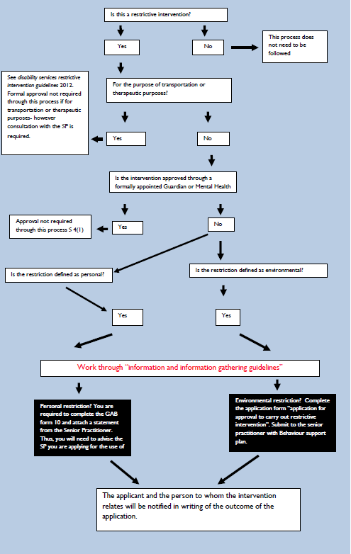

**Department of Health and Human Services**

DISABILITY AND COMMUNITY SERVICES



**Reporting Unauthorised Restriction**

(Under Part 6 of the Tasmanian *Disability Services Act 2011*)

A disability services provider or a funded private person must ensure that a type of restrictive intervention is not carried out in relation to a person with a disability who is under the care or control of the disability services provider or a funded person. If this has occurred the Senior Practitioner must be notified as soon as practicable after the intervention was carried out. This form should be used as part of the reporting process.

|  |  |  |  |
| --- | --- | --- | --- |
| Name of Client: |  | | |
| Organisation: |  | | |
| Address: |  | | |
| Name and position of person making the report: | |  | |
| Name and position of person who used the restriction: | |  | |
| Description of incident: | |  | |
| Was the client or others at risk of harm? Please describe: | | | |
| Are the protocols available to address the behaviour of concern? Please tick: Yes  No Unsure | | | |
| Were the protocols adhered to? Please tick: Yes No Unsure | | | |
| Please provide details: | | | |
| Has this restrictive intervention been used with this client on any other occasion?  Yes No Unsure | | | |
| If yes, please provide details: | | | |
| Describe any outcomes that resulted from the incident and restrictions eg any injury or harm? | | | |
| Please attach incident reports. | | | |
| Declaration:  In making this report I declare that to the best of my knowledge, all information provided in this report is complete, accurate and true and no details relevant to the report have been left out.  I understand that the information within this report may be disclosed to other interested parties. | | | |
| Name: | | | |
| Title: | | | Date: |

**How to lodge this Application**

You can lodge the completed application form by:

Delivering it in person to:

The Senior Practitioner

Disability and Community Services

Level 3, 99 Bathurst Street

HOBART Tas 7000

OR

Mailing it to:

The Senior Practitioner

Disability and Community Services

GPO Box 125

HOBART Tas 7001

**What happens next?**

When the application is received, the Senior Practitioner will:

* write to you acknowledging receipt of the application
* if necessary, contact you by telephone, email or mail to obtain more information
* make an assessment of the situation as per Section 36 of The Act

|  |  |  |
| --- | --- | --- |
| Department of Health and Human Services  Planning, Purchasing and Performance - Purchasing and Performance | | 2011-03-07 - 2010_TAS_Gov_Logo |
| **Consumer Related Reportable Incident Policy for Tasmania's DHHS Funded Community Sector** | | |
| **SDMS Id Number:** | P17/000629 | |
| **Effective From:** | 2 October, 2017 | |
| **Replaces Doc. No:** | P2010/0831-001 | |
| **Custodian and Review Responsibility:** | Planning, Purchasing and Performance - Purchasing and Performance | |
| **Contact:** | Mandy Bosworth Manager, Community Sector Quality and Safety Team | |
| **Applies to:** | All DHHS Funded Community Sector Organisations | |
| **Policy Type:** | DHHS wide policy | |
| **Review Date:** | 1 October, 2020 | |
| **Key Words:** | Consumer Incident Community Sector Serious Reportable | |
| **Routine Disclosure:** | No - | |

**Approval**

|  |  |  |  |  |
| --- | --- | --- | --- | --- |
| Prepared by | David Badcock | Senior Consultant - Quality and Safety | 6777 1982 | 24 August 2017 |
| Through | Mandy Bosworth | Manager - Community Sector Quality and Safety Team | 6777 1982 | 28 August 2017 |
| Through | Ella Haddad | Manager - Community Sector Relations Unit | 6166 3584 | 30 September 2017 |
| Cleared by | Ross Smith | A/Deputy Secretary, Children and Youth Services | 6166 3533 | 1 December 2017 |

**Revision History**

|  |  |  |  |
| --- | --- | --- | --- |
| **Version** | **Approved By Name** | **Approved By Title** | **Amendment Notes** |
| Final | Ross Smith | Deputy Secretary, Planning, Purchasing and Performance |  |

### Purpose

* The purpose of this policy is to ensure there is a coordinated approach to the management and notification of reportable consumer related incidents, and that learnings are implemented to minimise the potential of recurrence.
* The requirements of this policy are referenced within the Funding Instrument between the DHHS and the community sector organisation.
* This policy and supporting documentation does not override or replace legislative reporting requirements.

### Mandatory Requirements

* Community sector organisations must have systems and processes in place to:
  + take all reasonable actions to prevent incidents from occurring; and
  + appropriately manage and monitor reportable incidents involving consumers, and / or impacting on the organisation’s capacity to deliver services to consumers, in a consistent and coordinated manner.

This will ensure that:

* + all reasonable actions are taken to minimise the risk of incidents occurring and reoccurring;
  + learnings from incident reviews are utilised to further support a culture of continuous improvement; and
  + DHHS is notified of all reportable consumer related incidents as per the requirements of this policy.

### Roles and Responsibilities/Delegations

Effective incident management requires a whole of organisation approach with accountability for reporting and feedback at all levels. In partnership, the DHHS has the important role to engage with community sector organisations to promote the safety of consumers and service provision.

**Community Sector Organisations and the DHHS**

* All community sector organisations must ensure that local systems and processes are in place to support the effective implementation of this policy.
* DHHS Operational and Departmental Groups are responsible for:
  + supporting and monitoring community sector organisations’ compliance with the requirements of this policy; and
  + implementing internal processes that support this policy.
* The Community Sector Quality and Safety Team:
  + provide advice and support to Operational and Departmental Groups on the requirements of this policy; and
  + in accordance with the *Quality and Safety Framework for Tasmania’s DHHS Funded Community Sector*, will monitor community sector organisations’ compliance with this policy through the review process.

**Risk Implications**

* Compliance with this policy and associated procedure is a requirement of the:
  + DHHS Funding Agreement between the organisation and the Crown.
  + Grant Deed between the Director of Housing and the Organisation

Non-compliance with this policy and its associated procedure may result in a breach of these instruments.

**Training**

* Information on the requirements of this policy and its associated procedure, for both DHHS and funded community sector organisation staff, will be provided by the Community Sector Quality and Safety Team on an ongoing basis as required.

**Audit**

* Community sector organisations are responsible for:
  + regularly monitoring and reviewing the effectiveness of their incident management systems; and
  + ensuring compliance with this policy.
* DHHS is responsible for ensuring community sector organisations have systems and processes in place to meet the requirements of this policy.
* This policy will be included in the work program of the DHHS Internal Audit function. This work program is approved by the Audit and Risk Committee and will assess underlying systems and procedures for compliance with the requirements of this policy. The overall focus of this assessment will be one of continuous improvement to DHHS activities.

**Attachments**

[*Consumer Related Reportable Incident Procedure for Tasmania’s DHHS Funded Community Sector*](http://pssbpr-trim02/PandP/showdoc.aspx?recnum=P2012/0579-003)

Copies of this policy and the associated procedure can be found online at [www.dhhs.tas.gov.au/communitysector](http://www.dhhs.tas.gov.au/communitysector) or, internally, via the DHHS Strategic Document Management System.

|  |  |  |
| --- | --- | --- |
| Department of Health and Human Services  Planning, Purchasing and Performance - Purchasing and Performance | | 2011-03-07 - 2010_TAS_Gov_Logo |
| **Consumer Related Reportable Incident Procedure for Tasmania's DHHS Funded Community Sector** | | |
| **SDMS Id Number:** | P18/000016 | |
| **Overarching Policy:** | Consumer Related Reportable Incident Policy for Tasmania's DHHS Funded Community Sector | |
| **Effective From:** | 2 October, 2017 | |
| **Replaces Doc. No:** | P2010/831-001 | |
| **Custodian and Review Responsibility:** | Planning, Purchasing and Performance - Purchasing and Performance | |
| **Contact:** | Mandy Bosworth Manager Community Sector Quality and Safety | |
| **Applies to:** | All DHHS Funded Community Sector Organisations | |
| **Review Date:** | 1 October, 2020 | |
| **Key Words:** | Consumer Incident Community Sector Reportable Serious | |
| **Routine Disclosure:** | Yes | |

**Approval**

|  |  |  |  |  |
| --- | --- | --- | --- | --- |
| Prepared by | David Badcock | Senior Consultant - Quality and Safety | 6777 1982 | 24 August 2017 |
| Through | Mandy Bosworth | Manager - Community Sector Quality and Safety Team | 6777 1982 | 28 August 2017 |
| Through | Ella Haddad | Manager - Community Sector Relations Unit | 6166 3584 | 30 September 2017 |
| Cleared by | Ross Smith | A/Deputy Secretary, Children and Youth Services | 6166 3533 | 1 December 2017 |

|  |  |  |  |
| --- | --- | --- | --- |
| **Version** | **Approved By Name** | **Approved By Title** | **Amendment Notes** |
| Final | Ross Smith | Deputy Secretary, Planning, Purchasing and Performance |  |

**Revision History**

### Introduction

* The Department of Health and Human Services (DHHS) provides funding to community sector organisations to deliver high quality, safe services to Tasmanian consumers.
* It is recognised nationally and internationally that incidents occur in all health and human service systems. As such, community sector organisations have a responsibility to provide and maintain, as far as is reasonably practicable, a safe service-delivery environment.
* This procedure must be read in conjunction with the:
  + *Consumer Related Reportable Incident Policy for Tasmania’s DHHS Funded Community Sector.*
* Reporting of Special Circumstances clause contained within the Funding Agreement and/or the Notice by Recipient of Adverse Matters clause in the Grant Deed between the Director of Housing and the Organisation.

### Mandatory Requirements

In addition to the principles contained within the *Quality and Safety Framework for Tasmania’s DHHS Funded Community* Sector, the *Consumer Related Reportable Incident Policy for Tasmania’s DHHS Funded Community Sector* is based on the following principles:

* **Open disclosure** – consistent with a culture of no blame, errors are reported and acknowledged, and consumers and other relevant stakeholders are told what went wrong and why.
* **Emphasis on continuous quality improvement –** the recording and trending of reportable consumer related incidents is promoted in an environment that facilitates learning through a consistent approach to management and analysis.
* **Obligation to act –** the obligation to take action to remedy problems is clearly accepted and the allocation of this responsibility is unambiguous and explicit;
* **Accountability –** the limits of individual accountability are clear, individuals understand when they may be held accountable for their actions;
* **Natural Justice –** principles of natural justice and procedural fairness are adhered to in the management of reportable consumer related incidents;
* **Appropriate prioritisation of action –** action to address reportable consumer related incidents is prioritised and appropriately resourced;
* **Capacity Building –** resources that enable community sector organisations to develop procedures, staff education and service enhancements regarding reportable consumer related incident management are developed and distributed; and
* **Partnership –** collaborative reporting and management systems between community sector organisations and the DHHS are established and maintained.
* **Privacy and confidentiality –** information collected through the management of reportable consumer related incidents will adhere to the requirements of the Privacy Information Protection Act 2014 and the DHHS *Personal Information Protection statement*.

**Procedure**

It is the policy of the DHHS that, in accordance with the *Quality and Safety Framework*, community sector organisations will:

1. Notify the relevant Departmental or Service Group of all reportable consumer related incidents within 24 hours, or the next working day, after immediately addressing the health and wellbeing of those involved and securing the scene of the incident;
2. have localised documented processes to support the effective implementation of the *Consumer Related Reportable Incident Policy for Tasmania’s DHHS Funded Community Sector*;
3. have systems to appropriately manage all reportable consumer related incidents and ensure that they are progressed through open, responsive, fair and impartial processes;
4. take all reasonable steps to minimise the opportunity for occurrence / recurrence of all consumer related incidents;
5. investigate, identify and implement strategies that prevent or minimise the risk of incidents reoccurring, in a timely manner.
6. provide complete, comprehensive and consistent reporting to consumers on the management of all incidents, with the focus being to improve safety and quality; and
7. incorporate learnings from reportable incidents, as well as trended analysis, into the systems and processes of the organisation to enhance the quality and safety of services.

The requirements of the *Consumer Related Reportable Incident Policy for Tasmania’s DHHS Funded Community Sector* and the associated procedure is complementary to the requirements detailed in:

* *Reporting of Special Circumstances* of the DHHS Funding Agreement between the organisation and the Crown; and
* Notice by Recipient of Adverse Matters clause in the Grant Deed between the Director of Housing and the Organisation

**Roles and Responsibilities/Delegations**

Effective incident management requires a whole of organisation approach with accountability for reporting and feedback at all levels. In partnership, the DHHS has the important role to engage with community sector organisations to promote the safety of consumers and service provision.

**Community Sector Organisations and the** **DHHS**

* It is expected that community sector organisations will have established organisational documentation that support the effective implementation of the *Consumer Related Reportable Incident Policy for Tasmania’s DHHS Funded Community Sector* and:
* ensure that all consumer related incidents are appropriately monitored and managed by:
  + prioritising the health and wellbeing of those directly affected in an incident;
  + restoring a safe environment as soon as possible following an incident;
  + minimising the opportunity for others to be exposed to the incident environment; and
  + notifying relevant stakeholders of the incident.
* notify DHHS of the reportable consumer related incident:
  + **verbally** within 24 hours, or the next working day; and
  + by **documented report** to the DHHS within two working days of the incident occurring. community sector organisations may utilise the *Reportable Incident Form* (Attachment 1) or their existing templates so long as the information requested on the *Reportable Incident Form* is provided.
* clearly identify who within the community sector organisation is accountable for ensuring that reporting occurs in accordance with the above timeframes.
* contribute to a culture that actively minimises the opportunity for incidents to occur;
* approach the management of incidents within a partnership framework;
* actively contribute to enquiry and/or investigation of incidents as required;
* participate in the implementation of recommendations as required;
* manage verbal and documented information according to legal obligations;
* in accordance with the funding instrument, allow any person authorised by the Secretary of the Department of Health and Human Services immediate access for the purpose of investigating any reportable consumer related incidents.

**Operational and Departmental Groups**

Departmental and Operational Groups will:

* as appropriate, provide support to community sector organisations in responding to the immediate safety and wellbeing of consumers in the event of a reportable consumer related incident;
* support the participation of community sector organisations in an enquiry and/or investigation, including, but not limited to:
  + establishing the facts surrounding the incident;
  + ensuring that an appropriate response has occurred; and
  + ensuring the organisation has informed all relevant authorities and stakeholders regarding the incident.

In some cases, the DHHS may require an external party to undertake an enquiry to maximise high level expertise and independence. This will be approached within a partnership framework and consistent with the principles of this Procedure.

* record information relating to the reporting, management and investigation of incidents in the Electronic Grants Management System (EGMS);
* monitor community sector organisations’ compliance with the requirements of the *Consumer Related Reportable Incident Policy for Tasmania’s DHHS Funded Community Sector;* ;
* adhere to the *Consumer Related Reportable Incident Policy for Tasmania’s DHHS Funded Community Sector*; and
* provide guidance to community sector organisations as required about how and when consumers and relevant stakeholders will be notified of the occurrence and consequences of the incident.

**Key Definitions**

* The Department of Health and Human Services (DHHS) refers to:
* Departmental Groups that are responsible for the provision of corporate support services and system manager functions. The DHHS departmental Groups comprise Office of the Secretary, Corporate Policy and Regulatory Services and Planning Purchasing and Performance.
* Operational Groups deliver essential public services to the public. The DHHS operational Groups include Ambulance Tasmania, Children and Youth Services, Housing, Disability and Community Services and Public Health Services.
* Departmental and Operational Groups are further comprised of Units and Teams.
  + - A Unit refers to the individual business area under each Departmental and Operational Group. For example, Purchasing and Performance and Disability and Community Services.
    - A Team refers to people assembled for a common purpose under each Unit.
* **Community Sector Organisations** – Any organisation that receives DHHS funding through a funding instrument for the provision of services to Tasmanian consumers.
* **Consumer** – a person who directly, or indirectly, receives services from a DHHS funded community sector organisation.
* **Funding Instrument** – the contract between DHHS and Community Sector Organisations. Types of contracts may be:
  + Funding Agreement between the Crown in the Right of Tasmania and the Organisation; and
  + Grant Deed between the Director of Housing and the Organisation.
* **Reportable Incidents** are events or circumstances that are **unexpected** and **unintended** thatled to:
  + harm or suffering, loss or damage to a consumer **during an episode of service delivery** resulting in:
* Death, injury or admission to hospital that is unrelated to the ongoing health and wellbeing of the consumer and different from the immediate expected outcome of case management.
* Theft or misappropriation of consumer funds.
  + complete, or major, disruption to the provision of services to consumers resulting from:
* An environmental event (fire, flood etc.) requiring:
  + evacuation and temporary or permanent closure; or
  + significant reduction in service.
* A major external review that recommends closure or reduction in service provision or resources; and
* Financial loss, as a result of theft or misappropriation, that has a serious impact upon the community sector organisation’s ability to provide services as described in the Funding Instrument.
* For the purpose of the Consumer Related Reportable Incident Policy for Tasmania’s DHHS Funded Community Sector a reportable incident is **not** an event that is:
* expected or usual to a consumer’s ongoing health and wellbeing, presentation and / or behaviour;
* one occurring to staff, volunteers, contractors or visitors;
* an allegation, which is a claim that has not been tested or substantiated;
* outside the context of services for which the community sector organisation receives DHHS funding; or
* a complaint, either written or verbal, regarding service provision or support.

**Related Documents/Legislation**

* Funding Agreement between the Crown in the Right of Tasmania and the Organisation;
* Grant Deed between the Director of Housing and the Organisation;
* *The Quality and Safety Framework for Tasmania’s DHHS Funded Community Sector*;
* *Quality Governance Framework for Tasmania’s Public Health and Human Services Systems*
* *Australian Commission on Safety and Quality in Health Care*;
* *Australian Charter of Healthcare Rights*;
* *DHHS Corporate Plan 2016 - 2018*
* *Personal Information and Protection Act 2004*; and
* *Privacy Information Protection Act 2014*

**Attachments**

1 [Reportable Incident Form](http://pssbpr-trim02/PandP/showdoc.aspx?recnum=P2012/0579-004)

Organisation Details

|  |  |  |  |  |  |  |  |
| --- | --- | --- | --- | --- | --- | --- | --- |
| Organisation |  | | | | Service |  | |
|  | | | | | | | |
| Contact Person |  | |  | Contact Person’s Position | | |  |
|  | | | | | | | |
| Contact Person’s Phone Number | |  | | | | | |

Consumer Information

Details of the consumer affected by this incident.

|  |  |  |  |  |  |  |
| --- | --- | --- | --- | --- | --- | --- |
| Last Name |  | |  | First Name |  | |
|  | | | | | | |
| Gender |  | |  | Date of Birth |  | |
|  | | | | | | |
| Address |  | | | | | |
|  | | | | | | |
| Is the consumer subject to any legal orders? | | ☐ No | ☐ Yes – Specify ⏵ | | |  |

Incident Details

Details of when and where this incident occurred.

|  |  |  |  |  |  |
| --- | --- | --- | --- | --- | --- |
| Location of Incident | |  | | | |
|  | | | | | |
| Incident Date |  | |  | Incident Time |  |
|  | | | | | |
| Reported By |  | |  | Position |  |
|  | | | | | |
| Witnessed By |  | |  | Position |  |

Notifications

Who has been notified about this incident (Police, ambulance, family etc.)?

|  |  |  |  |  |
| --- | --- | --- | --- | --- |
| Name / Relationship |  |  | Time and Date |  |
|  | | | | |
| Name / Relationship |  |  | Time and Date |  |
|  | | | | |
| Name / Relationship |  |  | Time and Date |  |

Incident Type

Please indicate the nature of the incident that occurred (type of injury, cause/s of injury).

|  |
| --- |
|  |

Specific Incident Details

Please provide a clear, factual summary, including any contributing factors to the incident.

|  |
| --- |
|  |
|  |

Actions Taken

|  |
| --- |
| What actions were taken immediately following the incident? |
|  |
|  |

Further Planned Actions

What actions will be taken next?

|  |
| --- |
|  |

|  |  |  |  |  |
| --- | --- | --- | --- | --- |
| Name of Person Completing this Form |  |  | Signature |  |
|  | | | | |
| Position |  |  | Date |  |
| This report is to be completed in line with the *Consumer Related Reportable Incident Reporting Policy for Tasmania’s DHHS Funded Community Sector* and forwarded within 2 working days of the incident occurring. If you are unsure of who to forward this report to, please contact the Community Sector Quality and Safety Team on 6777 1982 or [communitysector.quality@dhhs.tas.gov.au](mailto:communitysector.quality@dhhs.tas.gov.au) | | | | |

|  |
| --- |
| **Please affix any additional information to this form** |

1. The Consumer Related Serious Incident Reporting Policy and Procedure for Tasmania’s Communities Tas Funded Community Sector Policy and Procedure and reporting template are currently under review [↑](#footnote-ref-2)
2. <http://www.dhhs.tas.gov.au/about_the_department/business/community_sector_relations_unit/partnership_agreement> [↑](#footnote-ref-3)
3. The Incident Reporting Policy can be found on the Resources, Publications and Tools page of the [http://www.dhhs.tas.gov.au/communitysector](http://www.dhhs.tas.gov.au/about_the_department/business/community_sector_relations_unit/resources,_publications,_and_tools) webpage. [↑](#footnote-ref-4)
4. Reviews are conducted once in a three year cycle. This three year period is not related to a funding cycle. [↑](#footnote-ref-5)
5. CSOs can nominate what standards they will use so long as no standards have been specified in the DHHS Funding Agreement. [↑](#footnote-ref-6)
6. <http://www.health.gov.au/internet/publications/publishing.nsf/Content/ageing-aged-care-quality-framework-atsi-toc~ageing-aged-care-s2~ageing-aged-care-s2-contin-improv> [↑](#footnote-ref-7)
7. The Continuous Improvement Plan template can be found on the Resources, Publications and Tools page of the [http://www.dhhs.tas.gov.au/communitysector](http://www.dhhs.tas.gov.au/about_the_department/business/community_sector_relations_unit/resources,_publications,_and_tools) webpage. [↑](#footnote-ref-8)
8. An overview of the adapted Principles from the *Australian Safety and Quality Framework for Health Care* can be found on page 17 of this document. For further information on the Principles, please visit [www.safetyandquality.gov.au](http://www.safetyandquality.gov.au) [↑](#footnote-ref-9)
9. The monitoring of incidents and feedback within the Standards Framework relates only to those directly related to consumers or impacting upon DHHS funded service delivery. [↑](#footnote-ref-10)
10. The *Consumer Related Serious Incident Reporting Policy for Tasmania’s DHHS Funded Community Sector* does not override or replace legislative reporting requirements. [↑](#footnote-ref-11)
11. *Disability Services Act 2011* s26 (2) [↑](#footnote-ref-12)
12. *Disability Services Act 2011* s26(3) [↑](#footnote-ref-13)
13. *Disability Services Act 2011* s26 (7) [↑](#footnote-ref-14)
14. *Disability Services Act 2011* s27 [↑](#footnote-ref-15)
15. *Disability Services Act 2011* s27(4) [↑](#footnote-ref-16)
16. *Disability Services Act 2011* s28 [↑](#footnote-ref-17)
17. *Disability Services Act 2011* s28 (2) (a) & (b) [↑](#footnote-ref-18)
18. *Disability Services Act 2011 s28 (5)* [↑](#footnote-ref-19)
19. *Disability Services Act 2011* s25 (2) [↑](#footnote-ref-20)