NDIS Early Childhood Early Intervention (ECEI) Approach
26 February 2016

Introduction
The National Disability Insurance Scheme (NDIS) was established to provide services and support to people with disability nation-wide, including children with developmental delay or disability.
Developmental delay is a term used when a child takes longer to reach age-appropriate developmental milestones. For some children developmental delays may be temporary. For others it may be a sign they have another condition, such as autism. Australian research suggests developmental delay occurs in up to 10 per cent of children aged 0-8.
Prior to the introduction of the NDIS, the approach to providing support to children with developmental delay or disability varied among the states and territories. Given the national responsibility of the NDIS, a single, best-practice approach to early childhood intervention to meet individual needs was required.
The National Disability Insurance Agency (NDIA) has worked with a range of leading Australian early childhood intervention practitioners and researchers to design an Early Childhood Early Intervention (ECEI) approach. This approach will help identify the type and level of early intervention support each child needs to achieve their best outcomes.
Research has shown providing children and families with timely, comprehensive and well-integrated early intervention support leads to better longer-term outcomes for children, fostering inclusion and participation in their environment. As an insurance scheme, the NDIS also uses effective early intervention to reduce its medium to long-term liability.

Designing the ECEI Approach
A rich academia and research history supports early childhood early intervention, forming an evidence-based approach to practice and services for children with developmental delay or disability.
The early childhood intervention best-practice and evidence base that underpins the NDIS ECEI approach is not new. A focus on achieving the best outcome via a family-centred approach that supports greater inclusion in mainstream settings and builds child and family capacity is proven to have positive effects in early childhood intervention. The NDIA has designed the ECEI approach using this strong research and evidence base.
Three key research pieces form the basis of the ECEI approach:
- KPMG (2011), Reviewing the evidence on the effectiveness of early childhood intervention, Department of Families, Housing, Community Services and Indigenous Affairs (FaHCSIA)
- Family & Community Services, NSW Government (2015), Strengthening supports for children and families 0-8 years: Now and into the future
- Department of Education and Early Childhood Development (DEECD), Victorian Government (2009), DEECD Early Childhood Intervention Reform Project: Literature review.
The common theme in these research pieces is a family-centred practice and timely, well-integrated early intervention does promote optimal individual outcomes.
A report on Autism Spectrum Disorder (ASD) – Autism Spectrum Disorder: Evidence-based/evidence-informed good practice for supports provided to preschool children, their families and carers, which the NDIA commissioned, also informed the ECEI approach.
The report highlights the need to match early childhood programs and services to the child’s natural settings. It also notes parents need support to give their child an opportunity to gain and use the functional skills they need to participate meaningfully in key environments in their life.
The NDIA convened an expert group in December 2014 to review the evidence on best-practice approaches to meeting the needs of children with autism. The group stressed how important relationships and participation were when it came to every child’s development.
The NDIA also commissioned Early Childhood Intervention Australia (ECIA) to develop best-practice guidelines for early childhood intervention. ECIA consulted with 400 participants and an expert steering committee to develop the guidelines.
ECIA made several recommendations to the NDIS, which were also referenced in the ASD report. This included the need for a child’s early intervention supports to be evidence-based and delivered using a family-centred approach which incorporated individualised planning to achieve positive outcomes.

The NDIS ECEI Approach
The NDIS ECEI approach will help all children with developmental delay or disability and their families to achieve better long-term outcomes through support services in their local community, regardless of diagnosis.
The NDIA will source experienced early childhood intervention service providers to work with it as access partners to ensure the NDIS supports all children as early as possible. To become an access partner, service providers will need to demonstrate strong clinical expertise and utilise best-practice approaches. The NDIA will closely monitor service provider performance and outcomes to ensure all children receive the appropriate quality and level of support.
Initially, families will meet with an access partner to discuss their needs. The access partner will draw on their specialised early childhood knowledge to determine appropriate supports for the child and family, including information, emotional support and specialised early intervention supports.
With an emphasis on inclusion, each child will be supported in a range of mainstream settings, such as preschool, play group and other early childhood settings. This gives them an increased opportunity to learn and develop positive social relationships.
Supports will be delivered through a family-centred approach, which builds on family and carer strengths in order to improve the child’s developmental trajectory and overall quality of life.

A child who requires more intensive early intervention support services will get a plan of supports and each family will be able to choose a provider(s) to best meet their child and their own needs.
The ECEI approach can be summarised as follows:
- Family meets with experienced early childhood intervention service provider (access partner) to discuss their needs
- The access partner determines the appropriate supports for the child and family – this may include a number of actions:
  - Information services, emotional support or referral to a mainstream service
  - Short to medium-term supports or longer term intensive supports.
- The access partner will assist a child and their family if they need more intensive supports. The access partner will complete a support plan and submit it to the NDIA for approval
- Once the plan is approved, the family can choose the early intervention provider(s) they wish to work with and the support begins.

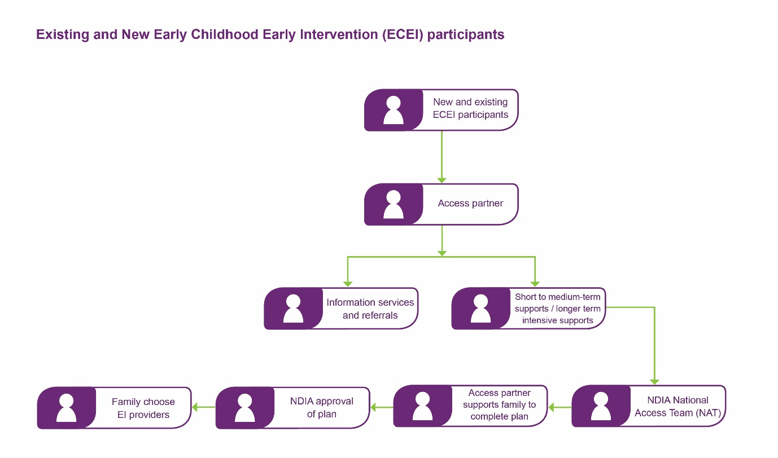

Sam’s story
Two and a half-year-old Sam’s parents were worried about some of his behaviours at home and in public.
Sam would often become quite upset and agitated in the trolley at the supermarket when his Mum touched him on the arm to stop him from grabbing things, or at childcare when other kids or staff members touched him or brushed past him. Sam would hit and yell out and would try and run away.
Sam’s parents took him to see their local GP for some advice. Their GP recommended they make an appointment to meet with an NDIS access partner to see if they were able to provide some assistance.
The access partner met with Sam and his Mum and Dad and talked about a range of things, like what situations made Sam’s behaviour worse, how long it had been happening and what they wanted to achieve. Sam’s parents really just wanted him to be able to physically interact with other people and children without getting so distressed. It was affecting their relationship with him and they could see him starting to withdraw around other people and children.

As an early childhood early intervention specialist, the access partner suggested there were probably some things Sam’s mum and dad could do at home, and when they were out and about, which would lead to improvements in his behaviour without Sam having to become an NDIS participant.
The access partner referred Sam and his parents to an occupational therapist (OT) to do some work on touch and language. They discovered Sam was ultra-sensitive to light-touch and figured out if they held him firmly or told him they were going to touch him, his behaviour was much better.
Sam’s parents developed some simple things to do in different situations, like telling him they were going to pick him up and put him in his car seat before doing it, and holding his arm more firmly in the trolley when he grabbed at things rather than softly patting it away.
The OT contacted Sam’s childcare centre and provided them with some information to better understand Sam’s behaviour and what they could do to assist him. They discussed the importance of communication – talking to Sam before touching him – touching him firmly instead of softly and recognising various non-verbal cues, which would alert them to know when Sam was feeling overwhelmed and what to do to intervene.
After a couple of visits to the OT, combined with the work Sam’s parents were doing along with his carers at childcare, Sam’s behaviour improved dramatically.
Sam’s story shows how providing quality intervention early in life can reduce the possible need for longer-term intervention.

Roll-out
The ECEI approach has already started in the Nepean Blue Mountains (for all new children aged 0 to 6 years).
It will begin in the Queensland early transition sites, in Townsville and Charters Towers, from late February (for all children aged 0 to 6). It will also start in coming months across South Australia (for children waiting for supports from the NDIS aged 0 to 6, and for all new children in this age cohort).
The approach will be rolled out around the rest of Australia in line with the arrangements in the bilateral agreements between the Commonwealth and state and territory governments.
As the NDIS is rolled-out around Australia, the NDIA will continue to monitor the Scheme closely and refine elements to ensure it delivers the best possible support for people with disability. In line with this, the NDIA will monitor and evaluate the ECEI approach as it is implemented and refined as necessary.

Georgia’s story
Three-year-old Georgia has significant communication, physical and social developmental delays. She and her family have been receiving services from a maternal and child health nurse and a pediatrician since she was a baby.
Georgia can’t walk so she gets around by rolling across the floor at home or in a pram when they go out. She’s not able to speak, so even though she responds when her family plays with her and looks for opportunities to interact with them, she can’t talk to them and tell them when she’s hungry or wants to play with her toys like her older brothers can.
Georgia’s family find it hard to know what she wants and what to do to encourage her development. It’s frustrating for Georgia too, who often screams and is unsettled for long periods during the day and night. She spends most of her time at home with her Mum, who is her primary carer, as it’s too hard to manage family outings because of the high level of care needed.
Georgia’s pediatrician suggested the NDIS may support Georgia and her parents and recommended they get in touch with their local access provider to discuss their support needs.

Georgia’s parents made an appointment to meet with the local access provider the following week. At the meeting, Georgia’s parents and the access partner discussed Georgia’s goals – helping Georgia to communicate her needs, decreasing her screaming episodes, developing a sleeping routine, developing her independence to do things like hold a spoon and increasing her ability to get around, and what supports Georgia and her family would need to achieve these.
From the family’s discussion with the access partner, they were advised in order to help Georgia achieve her goals, she would need a range of longer-term intensive supports. These included regular sessions with a speech pathologist to help with her verbal communication; physiotherapy to support her posture control development, strength and mobility; and occupational therapy to support her hand skills and self-care development. The access partner also suggested Georgia’s family might benefit from some informal and community supports so they were put in touch with a local peer support group and educational play program.
Georgia’s family worked with the access partner to develop a tailored plan of supports and it was submitted to the NDIA for approval.
The NDIA approved Georgia’s plan, which included:
- Regular sessions with a team of early childhood specialists, such as speech pathologists, physiotherapists and occupational therapists, to deliver treatment and work with Georgia’s family to implement things she had learned during her therapy sessions into her everyday home routine
- Funding for equipment, such as special seating, a standing frame and a wheelchair to increase Georgia’s mobility to make it easier for her to participate in everyday activities, like a visit to the park with her family or attending the educational play program
- Hours for specialised homecare so Georgia’s Mum can have a break from her caring role and do activities like supermarket shopping and taking Georgia’s brothers to basketball training after school.
Georgia is now an NDIS participant. She and her family will meet with the access partner every 12 months or so to review their plan and ensure the support they are getting continues to meet their needs and they help Georgia achieve her goals.
Georgia is now attending a regular playgroup. Her parents are starting to look at kindergartens and the supports Georgia will need to help her in these new environments. Her parents have been connected with a local peer support group and now they are enjoying sharing stories with other parents in similar situations and learning new ways for their family to help manage Georgia’s changing needs.

