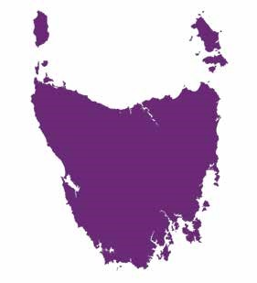
The National Disability Insurance Scheme
in Tasmania
Answers to your questions
Easy English December 2015
What is this factsheet about?
This factsheet is about the National Disability Insurance Scheme in Tasmania.
The National Disability Insurance Scheme is called the NDIS.
The NDIS is a new way to help people with disability get
- care
- supports.
You might already get money to pay for care and supports. For example, from Centrelink.
The NDIS might soon pay for some of your care and supports. We wrote this factsheet to answer questions about the NDIS.
This factsheet has some hard words.
The first time we use a hard word it is in blue.
We write what the hard word means.
When can I start to get the NDIS?
The government has made a plan for how the NDIS will happen in Tasmania.
The NDIS will help some groups soon.
It will help other groups later.
We want to go slowly and get things right.
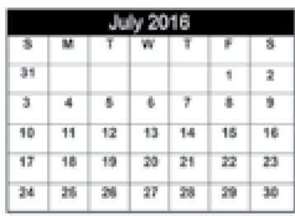
From 1 July 2016 children who are
12 to 14 years old can start to get the NDIS.
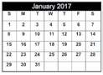
From 1 January 2017 adults who are
25 to 28 years old can start to get the NDIS.
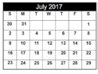
From 1 July 2017 children who are
4 to 11 years old can start to get the NDIS.
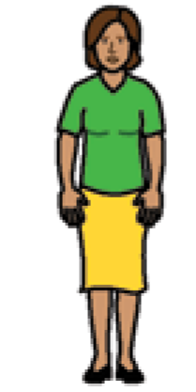
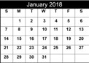
From 1 January 2018 adults who are
29 to 34 years old can start to get the NDIS.
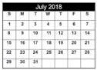
From 1 July 2018 more groups can start to get the NDIS
- children who are 0 to 3 years old
- adults who are 35 to 49 years old.
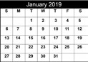
From 1 January 2019 adults who are
50 to 64 years old can start to get the NDIS.

People in supported accommodation
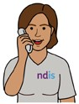
Some people with disability live in a house with other people with disability. They get special support to live in the house. We call this
supported accommodation.
The NDIS will contact each house to let people know when they can get the NDIS.
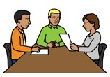
The NDIS will
- have meetings to tell people about the NDIS.
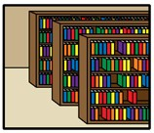
- tell people about the supports everyone can use. For example, public libraries and gyms.
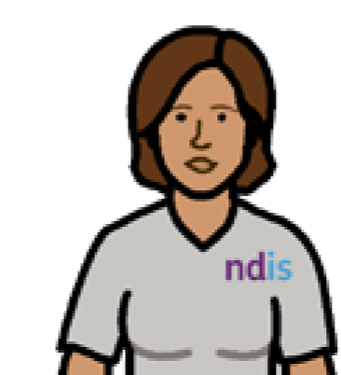
The NDIS will also help some of these people to
- get into the NDIS
- make an NDIS plan.
Who can get the NDIS in Tasmania?
You must be an Australian citizen. This means you
- were born in Australia or
- have a special piece paper saying you can live in Australia.
You must be the right age to get help.
You must
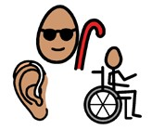
- have a permanent disability that fits the NDIS rules. Permanent means the disability will not go away.
or
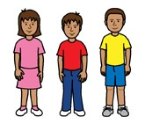
- need early intervention. This means to treat something early.
There is an NDIS website.
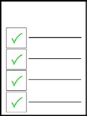
On the website, you can use the NDIS Access Checklist. You can check if you meet the NDIS rules.
Go to http://www.ndis.gov.au/ndis-access-checklist
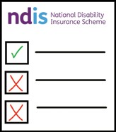
What are the NDIS rules?
The government has made rules for the NDIS.
The rules say your disability must be permanent.
The NDIS says your disability must affect your daily life. For example, it is hard to
- get dressed
- go shopping.
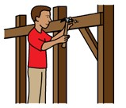
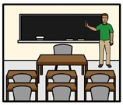
The NDIS says your disability must affect the way you join in things in the community.
For example, it is hard to
- get a job
- go to school.
To do things in your daily life, you must also need
- someone to help you most days
or
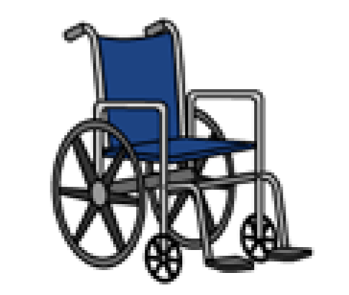
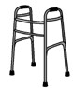
- equipment like a
  - wheelchair – walking frame
  - communication device.
Some people might have
- more than one disability
- a disability that comes, goes away and comes back again.
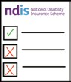
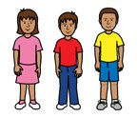
What are the rules for early intervention?
Early intervention means to treat something early.
The NDIS rules say your disability must be permanent.
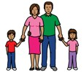
The NDIS rules say if the NDIS helps now
it will
- mean less support is needed later
- help carers and family members look after you
- make the disability better or
- stop the disability getting worse.
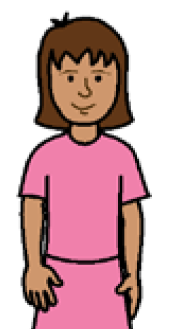
The NDIS will pay for some children to get early intervention if they
- are under 6 years old.
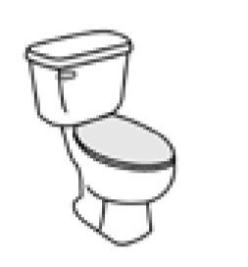
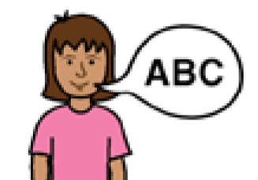
- have a developmental delay. That means the child finds it very hard to do everyday things. For example
  - use the toilet
  - talk – learn – walk.
- need help from
  - a speech pathologist
  - a physiotherapist
  - an occupational therapist.
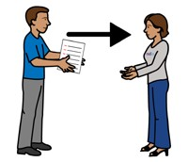
What information will I need to give the NDIS?
We want to help make the best choices for you. We need to know about
- your disability
- how your disability affects your daily life.
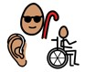
The NDIS might need to see some information about your
- disability
- developmental delay
- need for early intervention.
The information might be
- letters
- reports ● tests.
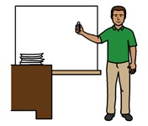
The information can be from your
- doctor
- teacher
- therapist.
What are informal supports?
Informal supports are the supports you get every day from people who care about you.
Informal support can come from
- family
- friends
- neighbours ● carers.
What does the NDIS pay for?
The NDIS pays for different supports for different people.
The supports must help you
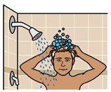
- be more independent. Independent means you can do things by yourself. For example, changes to your bathroom so you can shower yourself.
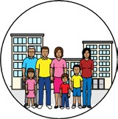
- join in the community. For example
  - get a job
  - join a group.
- get the help you need. For example
  - transport
  - a support worker to help you at home – therapy like speech pathology.
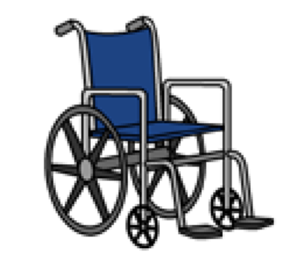
- get equipment and aids you need.
For example
  - a wheelchair
  - a communication device.
What does the NDIS not pay for?
The NDIS will say no to things that will not help with your disability.
The NDIS will not pay for
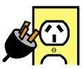
- things everyone has to pay for like
  - food
  - electricity
  - movie tickets.
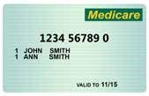
- supports someone else already pays for. For example, Medicare.
- things that might hurt you or other people.
What is an NDIS plan?
We will help you make an NDIS plan. The plan will say what supports
- you need
- the NDIS will pay for.
The plan might be different for everyone.
For example, you can choose
- the supports in your plan
- who gives you those supports.
How can I look after the money for my plan?
You can
- look after your own plan
- ask a special organisation who will give you a plan manager
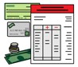
- ask us to put money in a bank account to pay for transport ● ask the NDIA.
The NDIA is the National Disability Insurance Agency. The NDIA makes the
NDIS happen.
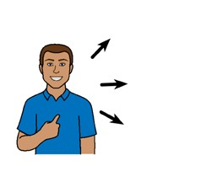
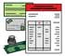
You can use more than one way to look after the money for your plan.
Sometimes the NDIA or someone else will need to look after the money for your plan. For example, if you hurt yourself.
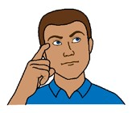
How do I get ready for my first NDIS plan?
It is good to think about
- how your life is
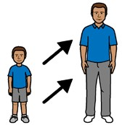
- how you want your life to be when you are older
- what you are good at
- what you like to do ● what is hard to do.
It is also good to think about
- the people you know
- who supports you now. For example, a day centre or your family.
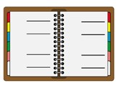
Where can I get help with planning?
To help you make a plan the NDIA wrote a planning workbook. The planning workbook is on the NDIS website.
Go to www.ndis.gov.au/participants/planning-process
Do as much of the planning workbook as you can.
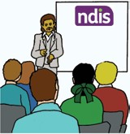
We have participant workshops to help you
- understand the NDIS
- know more about planning.
Go to www.ndis.gov.au/participants/news/events
Tasmanian Gateway Services can also help you prepare for the NDIS.
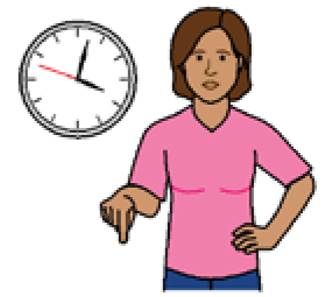
What will happen to the supports I get now?
You will get the government help and supports you get now until you start your NDIS plan.
When will I know when the NDIS can start helping me?
The NDIA and Tasmanian Department of Health and Human Services will work together so everyone knows what is happening.
We will let you know when it is time to change to the NDIS.
There is more information about the changes in Tasmania on the NDIS website.
More information
Go to our website www.ndis.gov.au/tas
Call 1800 800 110
Monday to Friday
8am to 5pm
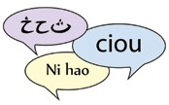
Is English hard for you?
Do you speak a different language?
Call 13 14 50
Are you deaf or hearing impaired?
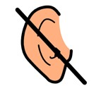
You can use TTY.
Call 1800 555 677
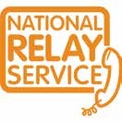
Then give the number 1800 800 110 Is your speech hard to understand?
You can use the NRS Speak and Listen
Call 1800 555 727
Then give the number 1800 800 110
Send us an email enquiries@ndis.gov.au
Follow us on Twitter
@NDIS
Find us on Facebook facebook.com/NDISAUS

© Scope (Vic) Ltd. You may use this document for your own personal, non-commercial purposes only. You must not use the document for any other purpose, and must not copy, reproduce, digitise, communicate, adapt, modify the document or any part of it (or authorise any other person to do so) without the prior consent of Scope (Vic) Ltd.
Scope’s Communication and Inclusion Resource Centre wrote the Easy English. December 2015 www.scopevic.org.au
To see the original contact National Disability Insurance Agency.
The Picture Communication Symbols ©1981–2010 by Mayer-Johnson LLC a Tobii Dynavox company. All Rights Reserved Worldwide. Used with permission.Boardmaker™ is a trademark of Mayer-Johnson LLC.
ClipArt © Inspired Services, UK. www.inspiredservices.org.uk.

