
National Disability Insurance Scheme WA Market Review
Final Report
June 2019

Copyright
© 2019 Copyright in the information contained in this document is owned and protected by the National Disability Insurance Scheme Launch Transition Agency (National Disability Insurance Agency).

Use of National Disability Insurance Agency copyright material
The material in this report with the exception of logos, trademarks, third party material and other content as specified is licensed under Creative Commons CC NC licence, version 3.0. With the exception of logos, trademarks, third party material and other content as specified, you may reproduce the material in this document, provided you acknowledge the National Disability Insurance Agency as the owner of all intellectual property rights in the reproduced material by using ‘© National Disability Insurance Scheme Launch Transition Agency 2018’ and do not use the material for commercial purposes.
Reproduction of any Creative Commons material in this document is subject to the CC NC licence conditions available on the Creative Commons site, as is the full legal code for this material.

Terms that we use
NDIA | National Disability Insurance Agency
NDIS | National Disability Insurance Scheme
NFP | Not For Profit
WA | Western Australia

Suggested Citation
National Disability Insurance Agency. (2019). Final Report of the NDIS Western Australia Market Review. www.ndis.gov.au
Publication Date
1 July 2019

Contents
Executive Summary 7
The State of the Market in WA 8
Appropriateness of NDIS Price Controls 11
Existing Service Delivery Models in WA 14
Transition costs 15
Other issues 16
1. Scope, Purpose and Conduct of the Review 17
1.1 Terms of Reference 17
1.2 Scope and Purpose of the Review 18
1.3 Conduct of the Review 19
2. How Does the NDIA Regulate Prices? 24
2.1 Terms of Business 25
2.2 NDIS Price Guide 2018-19 and NDIS Support Catalogue 2018-19 25
2.3 Special NDIS Pricing Arrangements 26
3. The State of the Market in Western Australia 30
3.1 Findings and Recommendations 30
3.2 Competition, Market Concentration and Efficient Costs 31
3.3 Labour Costs in WA, Relative to Other Jurisdictions 35
3.4 Non-labour Costs Relative to Other Jurisdictions 41
3.5 Regulatory Imposts 47
3.6 Benchmarks for Disability Supports from Related Sectors 50
4. Appropriateness of NDIS Price Controls 54
4.1 Findings and Recommendations 54
4.2 Remote and Very Remote Costs 55
4.3 Geographic Classification 62
4.4 Other Issues 64
5. Existing Service Delivery Models in WA 65
5.1 Findings and Recommendations 65
5.2 Individualised Living Arrangements 65
5.3 Individualised Community Living Strategy 66
5.4 Shared Management 67
5.5 The WA “Domestic” Worker Exception 67
6. Transition Costs and Other Issues 68
6.1 Transition Costs 68
6.2 Other Issues 69
Appendix A: Conduct of the Review 74

List of Figures
Figure 1: Research Framework 21
Figure 2: Research Components: price, cost and market 22
Figure 3: Employment Growth in WA and Rest of Australia, 1988-2014 32
Figure 4: Consumer Price Index (CPI) for Motor Vehicles, 1988 to 2018 43
Figure 5: CPI for Fuel, 1988 to 2018 43
Figure 6: CPI for Therapeutic Appliances and Equipment, 1988 to 2018 44
Figure 7: CPI for Medical Products, Appliances and Equipment, 1988 to 2018 44
Figure 8: CPI for Furniture and Furnishings, 1988 to 2018 45
Figure 9: CPI for Major Household Appliances, 1988 to 2018 45
Figure 10: CPI for Housing, 1988 to 2018 46
Figure 11: CPI for Property Rates and Charges, 1988 to 2018 46
Figure 12: CPI for Utilities, 1988 to 2018 46
Figure 13: Changes in Capital City House Prices, Five Years to December 2018 47
Figure 14: Standardised Workers Compensation Premiums by Jurisdiction 48
Figure 15: Standardised Workers Compensation Premium Rates by Jurisdiction 48
Figure 16: Distances from Labour Sources 56
Figure 17: Average Premiums for Combined Home and Contents Insurance (2016-17) 59
Figure 18: Impact of Distance from Perth on Regional Prices in 2017 59
Figure 19: Correlation of Summer Temperature and Remoteness 60
Figure 20: Relative Cost of Delivering Services by Remoteness Classification 61
Figure 21: Towns Surrounded by Remote or Very Remote Regions 63

List of Tables
Table 1: Geographical Areas in the Modified Monash Model (2015) 27
Table 2: Industrial Instruments Operating Organisations, by State 36
Table 3: Industrial Instruments of Providers 36
Table 4: EBA Leave Entitlements Comparison to the SCHADS Award 38
Table 5: EBA Penalty Rate Comparison to SCHADS 39
Table 6: Payroll Tax Comparison 49
Table 7: Comparison of 2018-19 NDIS Price Limits to WA NDIS Prices 52
Table 8: Population Density by Jurisdiction, 2017-18 55
Table 9: Proportion of SA2s with Less Than One Person per Square Km, 2017-18 55
Table 10: Highest Premiums per Sum Insured Areas, 2017-18 58
Table 11: Recovery Costs for Modified Vehicles 72
Table 12: Members of the Advisory Group 74
Table 13: Submissions 75
Table 14: Small and Medium Provider Joint Submission 76
Table 15: Meetings with Organisations 76

Executive Summary
On 12 December 2017, the Prime Minister and the Premier of Western Australia (WA) announced a new Bilateral Agreement for Transition to the National Disability Insurance Scheme (NDIS) in WA. As part of this transition, it was agreed that the National Disability Insurance Agency (NDIA) would review existing price controls and other market settings to determine whether they are appropriate for WA.
The WA Market Review (“the Review”) was formally established by the NDIA Pricing Reference Group (PRG) on 9 October 2018, to report to the PRG and the NDIA Board in the final quarter of 2018-19. The Review was required to examine, through independent research and consultation with industry, community and government stakeholders:
  - the state of the markets for the delivery of disability goods and services in WA, including any substantial differences from the markets for the delivery of disability goods and services in other jurisdictions;
  - whether the existing NDIS Support Catalogue, and the price controls and associated rules set out in the NDIS Price Guide:
    - would support the sustainable, efficient delivery of disability supports to participants in WA;
    - are appropriate for WA (e.g. allowances for provider travel); and
    - can accommodate existing WA service delivery models (including innovative support options); and
  - whether any material differences that currently exist in the cost of delivering disability supports in WA, relative to other jurisdictions, are likely to be sustained or transitory.
An advisory committee was established with senior representatives from eleven (11) providers and the peak body National Disability Services (WA). A public call for submissions was made on 25 February 2019, together with the release of an Issues Paper, with a closing date for submissions of 31 March 2019.
Thirty-two (32) submissions, including a group submission from thirteen (13) small and medium providers, were received from participants, providers, government and other organisations.
Twenty (20) meetings were also held with WA Government Departments, providers and other bodies, including the WA Government NDIS Transition Governance Advisory Group, the Chamber of Commerce and Industry WA, the WA Association for Mental Health, the Kimberley Aboriginal Medical Services, the Ngaanyatjarra Health Service, and the Council of Regional Disability Services.

The State of the Market in WA
The principal purpose of the Review, as set out in its Terms of Reference, was to establish if there were any issues in the markets for disability goods and services that so differentiated WA from the other jurisdictions as to require alternative price control arrangements. In contrast to many other jurisdictions, which only recently began to devolve from block funding, WA has long established and well-developed markets for disability goods and services. The Nulsen Group noted in their submission to the Review that, “WA commenced implementing individualised funding models in 1994 with individualised funding being fully part of the WA operating model for 25 years”. Nulsen argued that, if anything, the WA markets were more mature than the disability markets in the rest of the Australia. National Disability Services (WA), in their submission to the Review, noted that, “it has been 25 years since the WA Government first introduced individualised funding in disability services and seven years since the State Government provided a new partnership-based approach to commissioning and procurement”.
The Review found no evidence that the introduction of the NDIS had resulted in any major changes to the well-developed market in WA. Neither consultations nor submissions showed any evidence of market failure in metropolitan areas, or a rush to exit the market by providers. While there is a normal degree of market entry and exit, the net number of registered providers is increasing steadily. As at 30 June 2019, there were 1,141 registered service providers in WA, of which 234 were individual/sole trader operated businesses and 907 were companies or organisations. Some 190 providers began delivering supports in WA in the three months to 30 June 2019.
Levels of competition in WA appear to be similar to the rest of the country. Neither participants nor public officials raised any concerns about market power imbalances. In the last quarter of 2018-19, the share of the market delivered by the largest 25% of providers was, in general, smaller in WA than it was in other jurisdictions. For example, in the Daily Tasks/Shared Living Registration Group, the largest 25% of providers delivered 81% of those supports in WA compared to 89% nationally. Similarly, in the Participate Community Registration Group, the largest 25% of providers delivered 80% of those supports in WA compared to 83% nationally.
There was also little evidence of participants not being able to fulfil their plans – and no more so than in the rest of Australia. In the last quarter of 2018-19, some 89% of plans in WA were activated within 90 days, compared to 85% nationally. Overall plan utilisation was 74% in WA, compared to 68% nationally. Markets in remote areas are still thin, and the WA Government remains the provider of last resort in some of those areas. However, the causes of these issues affect remote regions in all jurisdictions and are not unique to WA. They are considered further below.
Input costs for goods and services, capital and labour, appear to be similar to those in other jurisdictions. WA does have cyclical labour cost fluctuations because of its dependence on mining, but, at the time of the Review, that was not having an adverse impact on the NDIS. All costs are far higher in remote and very remote areas, and more of WA is remote than any other state or territory, but these issues need to be dealt with on a national basis. Apart from possibly the greater impact of thin populations, there was no evidence that WA providers were any less efficient or any less innovative than were those in other states and territories. One major provider, who had been operating for over 60 years, indicated to the Review that they had chosen not to make a submission because they did not see significant costs differences in WA compared to other jurisdictions.
Many providers indicated in their submissions that the price controls recommended by the Independent Pricing Review (IPR) report in 2017 did not allow providers the reasonable margins they needed to transition to the new system. However, members of the Review’s Advisory Group indicated that the national price limit increases announced in March 2019 had gone a long way towards addressing their concerns on this front, at least for metropolitan services.
Finding 1: The Review found little evidence of substantial differences in the markets for delivery of disability goods and services in WA compared to other jurisdictions, in terms of levels of competition, market concentration, and efficient costs.
Finding 2: The Review found no significant evidence that the delivery of disability goods and services was inadequate in urban and regional areas. However, as with other jurisdictions, there was evidence that supply is an issue in remote and very remote areas.
Finding 3: The Review found no evidence of substantial differences in efficient labour costs, labour related regulatory imposts and other costs of delivery in WA relative to other jurisdictions at the time of the Review.
Finding 4: The Review found no significant evidence that the new national price limits published on 30 March 2019 to take effect from 1 July 2019 would not support the sustainable, efficient delivery of disability supports in metropolitan WA.
Recommendation 1: From 1 July 2019, the new national price limits for supports other than therapy supports published on 30 March 2019 should apply to WA. For therapy supports, the price limits that apply to South Australia, Tasmania and the Northern Territory should apply to WA.
Although the Review found that there was no need at present for differential price controls for WA, the WA economy is driven substantially more by commodity exports than the rest of Australia. Commodity exports are volatile, in terms of both volumes and values. Accordingly, WA is more characterised by boom/bust cycles than Australia as a whole. This means that disability providers in WA, compared to the rest of Australia, will more often face boom conditions that may make it more difficult to retain workers. At present, price control changes are reviewed on a national basis. However, the boom and bust cycles experienced in WA raise the question as to whether there should be provision for price control changes to differ across states and territories and for them to be able to be reviewed more rapidly when required.
Moreover, while this volatility arguably affects WA more than other jurisdictions, it is not unique to WA. The other mining states (South Australia and Queensland) also experience boom/bust cycles.
Submissions noted that the impact of a ‘mining boom’ does not directly equate to significant increases in employment opportunities outside of the mining sector. Further, the resultant pressures on the cost of living (e.g. inflated rental prices) for non-mining workers based in regional and remote areas of WA may reduce the ability of providers to attract disability workers in these areas. Specifically, National Disability Services WA noted that the reason many organisations remunerate staff at a higher classification level under Social, Community, Homecare and Disability Services Industry Award 2010 (SCHADS Award) in remote and very remote areas than in other areas because of the higher level of competition for labour from mining booms. The combined submission from small and medium providers reported that the sector was anxiously watching the new increase in mining and resources activity. Their experience was that the previous boom resulted in shortages in labour and housing markets, which placed pressure on the labour pool for regional disability services.
At a broad level, the current NDIA approach of national labour price limits may not fit well with a large and diverse economy. Australia is well known as a “two speed economy” because on occasion some states – WA, Queensland and South Australia – are in a mining boom, while others are languishing; or these states are experiencing a mining bust while the others are enjoying rapid growth.
Finding 5: The Review found that the fact that the WA economy (together to a smaller extent with the Queensland and South Australian economies) was subject to a more volatile boom/bust cycle associated with the mining sector than the rest of the Australian economy had the potential to substantially impact on labour costs in the disability sector from time to time relative to other jurisdictions.
Recommendation 2: The NDIA should work with the relevant Commonwealth and State/Territory Departments to monitor the economic conditions in WA (and Queensland and South Australia) with a view to making temporary adjustments to price controls when necessary, in order to proactively manage any potential impacts on the supply of disability goods and services from economic trends in those states that were counter cyclical to the trends in other states and territories.

Appropriateness of NDIS Price Controls
The submission, consultation and research processes uncovered evidence of financial sustainability issues in the WA market. There is evidence of providers withdrawing from lower value services, cross-subsidising services with other, more profitable services and drawing on cash reserves. Submissions raised working capital and cash flow issues that were arising from the shift being paid in advance to being paid in arrears, and these issues being intensified by delays in NDIS processes and payments. However, as these issues are not unique to WA, they were referred to the 2019-20 Annual Review of Price Controls for further consideration. As noted above, members of the Review’s Advisory Group indicated that the national price limit increases announced in March 2019 have gone a long way towards addressing their concerns with the appropriateness of the NDIS price limits for metropolitan services. However, the Review found that variations in population density, and density of participants across Australia and within WA did mean that some of the ancillary price control arrangements had the potential to impact on the viability of some services.

Remote and Very Remote Loadings
The NDIS recognises that providers who deliver services to participants in remote and very remote areas face higher costs than other providers. For participants who live in remote and very remote areas, a 20% loading is applied to the funding in their plans in remote areas (and 25% in very remote areas). Providers delivering services to participants in remote and very remote areas are similarly subject to price limits that are 20% and 25% higher, respectively, than the price limits for the same supports in the rest of Australia.
While concerns on remoteness price controls are not unique to WA, they do affect WA more than any other state or territory. Even the second least densely populated state, SA, has a 70% higher population density than WA. WA also has the highest proportion (16%) of Statistical Areas 2 (SA2s) with less than one person per square kilometre of any state or territory – almost double the national average (9%). The Kimberley-Pilbara region alone accounts for 36% of WA’s land mass and is 4.1 times the size of Victoria. These factors pose a difficult challenge in creating and sustaining effective transport and communication networks, and the business innovation required to succeed in these operating conditions.
The Review found that the current Remote and Very Remote price limit and plan funding loadings were not attracting sufficient supply to these regions in WA and that the ability to charge for time taken to travel in these areas was a key barrier. The current NDIS remoteness loadings were taken from the Independent Hospital Pricing Authority’s estimates of the additional costs of delivering services in small hospitals in remote and very remote areas. The evidence available to the Review indicates that these loadings are not necessarily appropriate for non-institutional services.
The Review examined the Commonwealth Grants Commission’s estimates of the relative costs of delivering services in regional, remote and very remote areas compared with metropolitan areas, and examined the cost loadings that currently apply in the WA NDIS Scheme and in the Commonwealth’s residential and community aged care programs. In all cases, the cost loadings were significantly greater than the price limit and plan funding loadings applicable in the NDIS of 20% in remote areas and 25% in very remote areas. This analysis also indicated that it was possible that costs structures in regional areas, and especially outer regional areas, were also higher than in metropolitan areas, although the evidence was not as compelling in these areas.
Finding 6: The Review found that the costs of delivering services in remote and very remote areas are significantly higher than in metropolitan areas, and the difference in costs is greater than currently provided for in the NDIS planning and pricing arrangements.
Finding 7: The Review found that the costs of delivering services in regional areas, and especially outer regional areas, may also be higher than in metropolitan areas, but that further research on the magnitude and significance of this difference was required.
Recommendation 3: The NDIA should increase, from 1 July 2019, the remote and very remote loadings on price limits and plan funding amounts from 20% to 40%, and from 25% to 50% respectively. The NDIA should examine in the 2020-21 Annual Price Review whether a loading should be applied to price limits and plan funding amounts in regional areas.

Geographic Classification
A significant number of submissions raised concerns with the geographic treatment of some towns located in remote areas, in particular, Kalgoorlie. Kalgoorlie is currently classified as MMM 3 under the Modified Monash Model, the same classification as Bowral in NSW, which is one and a half hours drive from Sydney and close to other regional centres, whereas Kalgoorlie is six and half hours from Perth, with no other major regional centres in proximity. GIFSA stated in their submission to the Review that “for Kalgoorlie-Boulder to have the same pricing as Metropolitan Perth is grossly inaccurate and unfair”. The combined small and medium providers’ submission observed that there was a disparity between Kalgoorlie’s current geographic price limit and plan funding loading and the actual costs that they incurred to provide services there: “Kalgoorlie is not considered ‘remote or very remote’, yet providers in the areas continue to experience higher costs associated with attracting and retaining staff, travel and transport, or purchase of training due to the location.”
The Review considered the Australian Statistical Geography Standard remoteness structure and confirmed that Kalgoorlie and Kambalda are the only towns in WA that are classified as Outer Regional and are surrounded by Remote or Very Remote regions. The Review noted that there were several other similar towns in other parts of Australia, including Broken Hill in New South Wales.
Finding 8: The Review found that the cost of service delivery in isolated centres – centres that are currently not classified as remote or very remote by the NDIA but that are completely surrounded by remote or very remote areas – were, in general, higher than in other non-remote areas.
Recommendation 4: The NDIA should amend its geographic classification arrangements so that all centres that are currently not classified as remote or very remote by the NDIA but that are completely surrounded by remote or very remote areas should be classified as remote areas for planning and pricing purposes.

Claimable Travel Time
There was also some evidence provided to the Review that the current claimable travel rules may hinder efficient provision of services. Providers in Metropolitan areas and regional centres are permitted to claim for up to 20 minutes travel associated with the delivery of support. Providers in regional areas are permitted to claim for up to 45 minutes travel associated with the delivery of support. For providers in remote and very remote areas, travel costs are not price controlled and providers can agree with participants on the cost of travel associated with the delivery of their supports.
The Review found that the lower population density in Perth (relative to some other capital cities) and in regional areas was inhibiting providers from being able to achieve the required scale to be able to operate within the 20 minute claimable travel limit (for Metropolitan areas and regional centres) and the 45 minute claimable travel limit (for regional areas). This issue is not unique to WA, as other cities and all regional centres may experience the same barriers. These matters were considered further in the 2019-20 Annual Review of Price Controls, which recommended that the claimable travel limits should be increased to 30 minutes for Metropolitan areas and regional centres and to 60 minutes for regional areas. These new arrangements came into effect on 1 July 2019.
The Review noted that the IPR had recommended (Recommendation 3) that in regions with limited local supply, the NDIA should allow providers to quote on the cost of delivering NDIS services in the short term to ensure supply. The Review also noted that the NDIA had already implemented this system on a trial basis in the Northern Territory and that further work was underway in respect of rolling out the arrangements across Australia.

Existing Service Delivery Models in WA
Consultations and submissions raised some concerns with the Review that there were a small number of existing service delivery models within WA that may be difficult to deliver within the existing NDIS arrangements: Individualised living arrangements; the Individualised Community Living Strategy; and Shared management.
Individualised living arrangements aim to support people with disability to live in as natural of a home environment as possible of their choice, for example, in a private home should they wish as compared to a residential group home. These arrangements include models such as host family, co-resident, alternative family models and house sharing with friends or peers. There is evidence that these individualised living arrangements have been found to be effective and that people with disabilities in more individualised living arrangements experience improved quality of life in regards to their overall well-being, sense of belonging to family and friends, and access to the community and community-based supports. Individualised living arrangements provided by state governments (including WA) have also been found to be cost effective compared to group home living arrangements in regard to the direct housing costs to government agencies, service providers and people with disability, as well as accommodation support and management costs.
The NDIA is already working with WA providers to bring individualised living arrangements into the NDIS. In general, it appears that the existing NDIS Support Catalogue, price controls and associated rules set out in the NDIS Price Guide, can accommodate existing WA service delivery models, including innovative support options. However, further market engagement is required to enable this.
Submission feedback indicated that it is difficult to find skilled Disability Support Workers to work with complex mental health clients, and that the skill set required more funding than was available through current NDIS supports. These workers are currently supported through the WA’s Individualised Community Living Strategy. The Review noted the NDIS was already examining the pricing of psychosocial supports and referred this issue for further consideration as part of that process.
Shared management was a unique feature of the WA NDIS system. Under this arrangement, the provider receives the funding, and the person or their representative engages staff. The person or their representative and the service provider share responsibility for meeting relevant legal obligations. The model focused on choice and control, and is aimed to close the divide between participant and provider managed supports.
Finding 9: The Review found that there was some evidence of the efficacy of the shared management arrangements that operated within the WA NDIS system and that the possibility of including these arrangements in the NDIS should be further examined.
Recommendation 5: The NDIA should engage with WA participants and providers to determine whether it would be appropriate to allow shared management arrangements within the NDIS, and mechanisms to support the delivery of these arrangements.
The Fair Work Act 2009 (Cth) does not have jurisdiction in WA where an individual directly engages a worker, as the individual is not a constitutional corporation. In these direct employment arrangements, the Industrial Relations Act 1979 (WA) will apply. However, the definition of “employee” in section 7 of the Industrial Relations Act (WA) specifically excludes a person engaged in domestic service in a private home from being an employee. In practical terms, this means that workers who are directly engaged by an individual to provide support in their private home are not employees for the purposes of either the state or the national employment systems.
Finding 10: The Review found that it was unclear how the domestic worker exemption would interact with NDIS arrangements and that further investigation of the issue was warranted.
Recommendation 6: The NDIA should examine, in consultation with participants, providers and the WA government, the implications of the WA “domestic worker” exception in the Industrial Relations Act 1979 (WA) for the delivery of disability supports under the NDIS.

Transition costs
Consultations indicated that some WA providers faced additional complexity in transitioning to the NDIS because they had previously transitioned to the WA NDIS and now needed to transfer to the nationally administered NDIS. Providers indicated there were two significant pain points in this transition: the structural transformation of the disability sector from a heavily regulated model to a market driven ecosystem; and the adaptation to NDIS standards, procedures, systems and administration. Other areas requiring transitional arrangements included the price variations between, and the different approaches of, the WA administered NDIS (WA NDIS) and the nationally administered NDIS, particularly the flexibility afforded by the former.
WA providers argued that transition costs were higher in WA than other states. In other states and territories, providers started from more or less a ‘clean slate’ under block funding. In WA, providers had complex individual funding systems under WA NDIS and the Disability Services Commission that require a myriad of changes to fit the NDIS system. Further, providers in other states and territories have had up to six years’ experience with various NDIS trials, whereas WA providers effectively have only two years to transition. In its submission to the Review, the WA Government, based on proposals for funding received by the Department of Communities, noted that there appeared to be significant costs for disability service providers associated with modifying or adapting their organisations to operate in the Australia-wide NDIS.
However, providers also argued (see above) that the WA sector is more mature than other jurisdictions, having had individualised payments for a quarter of a century, which should, arguably, reduce transition costs compared to other jurisdictions. The Review did not find any compelling evidence that the transition costs were significantly greater for WA providers than for providers in other jurisdictions. The Review also noted that funding had been made available to providers to support the transition through the WA Government’s Transition Fund and the Commonwealth Government’s NDIS Jobs and Market Fund.

Other issues
Several submissions raised a number of non-WA specific issues. These were referred to the 2019-20 Annual Review of Price Controls for further consideration, including:
- Supported Independent Living (SIL) vacancies;
- Emergency and contingencies;
- Provider travel and participant transport vehicle costs;
- Assistive Technology (AT); and
- NDIA compliance and process costs.

Scope, Purpose and Conduct of the Review
On 12 December 2017, the Prime Minister and the Premier of Western Australia (WA) announced a new Bilateral Agreement for Transition to the National Disability Insurance Scheme (NDIS) in WA. As part of this transition, it was agreed that the National Disability Insurance Agency (NDIA) would review existing price controls and other market settings to determine whether they are appropriate for WA. The WA Market Review (“the Review”) was formally established by the NDIA Pricing Reference Group (PRG) on 9 October 2018, to report to the PRG and the NDIA Board in the final quarter of 2018-19.

Terms of Reference
The Review was required to examine, through independent research and consultation with industry, community and government stakeholders:
  - the state of the markets for the delivery of disability goods and services in WA, including any substantial differences from the markets for the delivery of disability goods and services in other jurisdictions, such as:
    - labour costs in WA, relative to other jurisdictions;
    - the costs of delivering disability supports in WA, and in remote areas of WA, relative to other jurisdictions;
    - the existing level of competition in the markets for the delivery of disability goods and services in WA, and the efficiency of service providers in those markets, relative to other jurisdictions; and
    - benchmarks for disability supports from related sectors in WA (e.g. motor accident insurance; aged care), relative to other jurisdictions;
  - whether the existing NDIS Support Catalogue, and the price controls and associated rules set out in the NDIS Price Guide:
    - would support the sustainable, efficient delivery of disability supports to participants in WA;
    - are appropriate for WA (e.g. allowances for provider travel); and
    - can accommodate existing WA service delivery models (including innovative support options); and
  - whether any material differences that currently exist in the cost of delivering disability supports in WA, relative to other jurisdictions, are likely to be sustained or transitory.
The Review was tasked with making recommendations on whether NDIS price controls and other market settings, including the recommendations of the NDIS Independent Pricing Review (IPR), which was conducted by McKinsey & Company for the NDIA Board, are appropriate for WA, or should be modified, including for transitory differences how quickly arrangements in WA should converge to those in other jurisdictions.
In framing its recommendations, the Review was required to be cognisant of the objects and principles of the NDIS, as set out in the National Disability Insurance Scheme Act 2013, including that the NDIS should:
  - support the independence and social and economic participation of people with disability;
  - enable people with disability to exercise choice and control in the pursuit of their goals and the planning and delivery of their supports;
  - facilitate the development of a nationally consistent approach to the access to, and the planning and funding of, supports for people with disability;
  - promote the provision of high quality and innovative supports that enable people with disability to maximise independent lifestyles and full inclusion in the community;
  - adopt an insurance based approach, informed by actuarial analysis, to the provision and funding of supports for people with disability; and
  - be financially sustainable.

Scope and Purpose of the Review
Most price limits in the NDIA apply nationally. For some supports, the NDIA currently has different price limits for some supports in the Eastern states (New South Wales, Victoria, Queensland and Tasmania) and the Western states and the territories (‘the western states’) (the Australian Capital Territory, the Northern Territory, South Australia and WA). The differences between the price limits range from 0-13.5%. For example, the 2018-19 price limit for ‘Assistance with Self-Care Activities – Standard – Weekday Daytime’ differs by 1.8% between the Eastern and Western states. In WA, providers can charge up to $49.02 per hour, while in the Eastern states the maximum price is $48.14 per hour. The support item ‘House Cleaning and Other Household Activities’ has a price limit of $47.04 in WA and $41.43 in the Eastern states.
The IPR found that there was no clear rationale for maintaining separate Price Guides. It found that the disparity between the Eastern and Western Price Guides appeared to be based largely on legacy arrangements between jurisdictions, rather than on a direct correlation with regional costs. In particular, an analysis of labour costs other than award wages, such as leave entitlements and workers compensation requirements, did not show a consistent difference between the Eastern states and Western states. The IPR report recommended to the NDIA Board that the NDIS should converge the two Price Guides and move towards a single national price guide by 2021 (IPR Recommendation 5).
The IPR recommendation was made before WA joined the Australia-wide NDIS. Since then, representations have been made to the NDIA concerning the input costs faced by WA providers of disability goods and services. It has been argued that many WA providers may face additional costs in terms of delivery fees for the equipment that they require. This is as many equipment providers import equipment from overseas into the Eastern states to their main distributer and then service providers in WA have to pay the shipment costs for overseas freight and interstate freight to a ‘local distributer’ and then local delivery to their sites. It has also been argued that there are challenges in getting spare parts locally as local distributers carry a limited range of items that are high in demand and many spare parts have to be shipped interstate, which can make small items more expensive and add time for repairs. There may also be reduced options for trialling equipment – local distributers have a limited range. This is especially challenging in rural and remote areas.
A particular focus of the current Review was to understand the costs of delivering supports to remote and very remote areas. In particular, the Review welcomed submissions concerning those regional areas of WA that face labour shortages but do not qualify as remote or very remote. The Review also examined the issue of whether transitional arrangements were required to allow providers of disability supports in WA to adapt their business models to the NDIS’ price controls and other market settings.
The principal purpose of the Review, as set out in its Terms of Reference, was to establish if there were any issues in the markets for disability goods and services that differentiated WA from the other jurisdictions. Where matters were identified in the Review that were not solely related to WA, these were referred to the NDIA’s 2019-20 Annual Review of Price Controls for further consideration.

Conduct of the Review

Consultations
An Advisory Group, which met five times (19 December 2018, 22 January 2019, 27 February 2019, 16 April 2019 and 21 May 2019), was established with senior representatives from eleven (11) providers and National Disability Services WA. A total of thirty-two (32) submissions were received from participants, providers, government and other organisations. This included a group submission from thirteen (13) small and medium providers. Twenty (20) meetings were also held with WA Government Departments, providers and other bodies, including the WA Government NDIS Transition Governance Advisory Group, the Chamber of Commerce and Industry WA, the WA Association for Mental Health, the Kimberley Aboriginal Medical Services, the Ngaanyatjarra Health Service, and the Council of Regional Disability Services.
Appendix A provides further information, including details of the members of the Review’s Advisory Group and the organisations they represented, submissions to the Review and meetings held by the Review.

Methodology
Concurrent to the consultations, a research program (see Figure 1 below) was established to address two key research questions. First: Are there existing service delivery models that are occurring in WA that are not accommodated in the pricing framework? Second: Do material differences exist in the cost of delivering goods and services in WA relative to other jurisdictions?
In addressing the first research question, the Review engaged with stakeholders, including providers, participants, the community and governments, to:
  - Identify a list of service models;
  - Obtain the required data and evidence to understand: the service models; the funding mechanisms that underpinned the service models; and the participant cohorts that benefited from these services; and
  - Establish if these services were efficient and effective in their delivery.
The following overall approach was taken to the second research question:
  - Initial desktop scan to establish if the question in each sub-category had been answered before either directly or indirectly, and to leverage existing reports where appropriate and applicable;
  - If a question has not been answered before, or there were significant limitations in available research, identify the appropriate data sources to answer the question;
  - Establish a methodology based on the question and data available; and
  - Complete a comparison of WA relative to other Australian jurisdictions with the ability to disaggregate into the following components:
    - WA state compared to other jurisdictions;
    - Perth City compared to regional and remote WA; and
    - Perth City compared to other jurisdiction capital cities.
The sub-components for Question 2 are outlined in Figure 2 below.

Figure 1: Research Framework

Figure 2: Research Components: price, cost and market
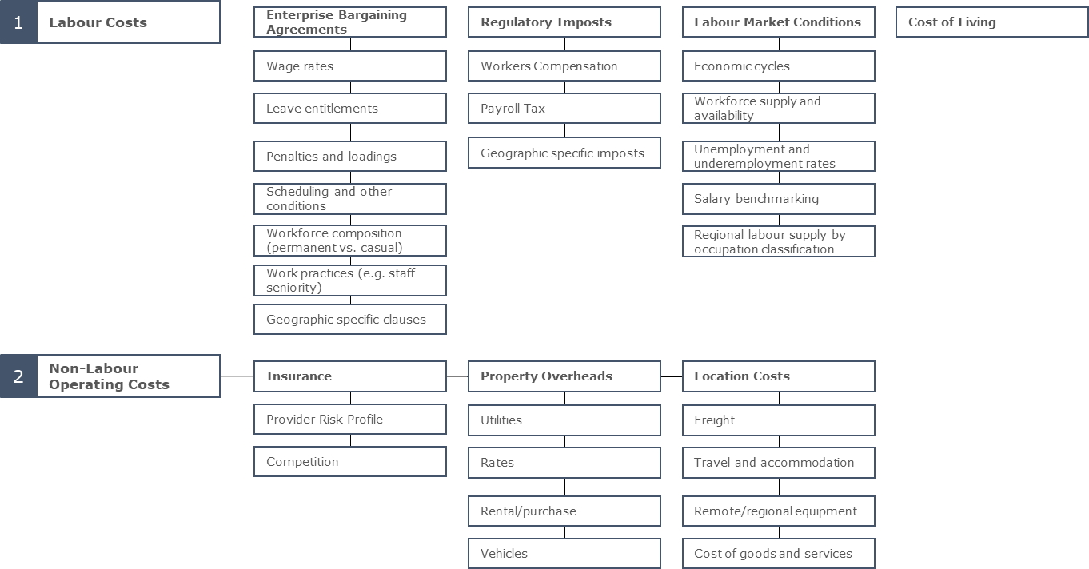
Figure 2 (continued): Research Components: price, cost and market
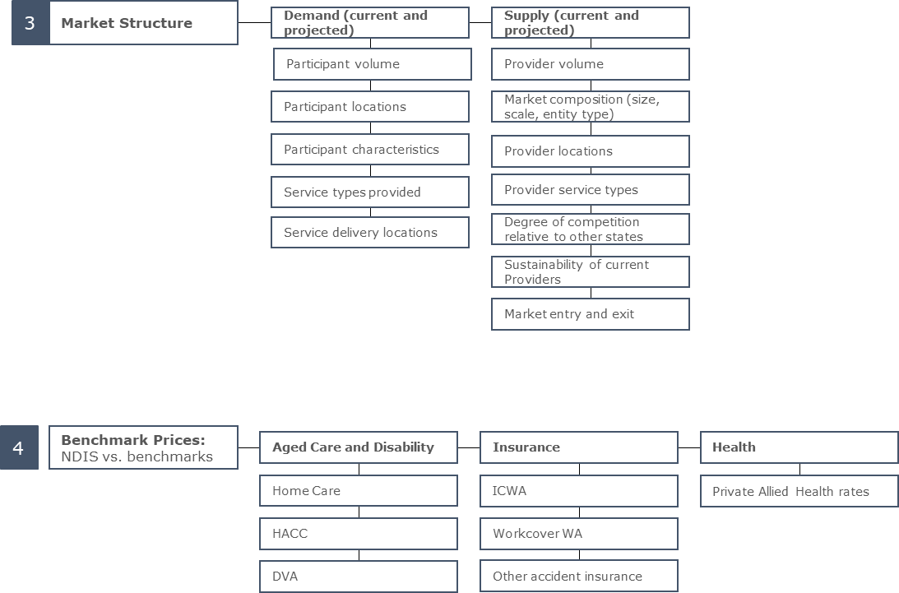

How Does the NDIA Regulate Prices?
Once the NDIS reaches maturity, it is intended that the market will set the price of supports. However, temporary price limits are needed to ensure participants can access affordable supports while the market is still growing. The NDIA imposes price limits on many supports and services to regulate prices, but striking the right balance when setting these maximum prices is challenging. If price limits are too high, they will encourage the supply of supports but reduce the purchasing power of participants, distort other markets (for instance aged care), and negatively impact the longer-term sustainability of the NDIS, which might lessen public confidence in the Scheme, with implications for participants. If price limits are too low, they could lead to a supply shortfall in the markets for disability goods and services, reduce availability of supports to participants, and compromise participant outcomes.
Section 34(1)(c) of the National Disability Insurance Scheme Act 2013 (NDIS Act) states that a funded support must represent “value for money in that the costs of the support are reasonable, relative to both the benefits achieved and the cost of alternative support”. There are therefore two elements in determining “value for money” under the NDIS Act, which should guide the consideration of price limits:
  - The costs of support are reasonable, relative to the benefits achieved: This implies that the cost should be reasonable and necessary (or “efficient”) when quality or “benefits” are considered. In other words, an efficient price should be charged for a service that delivers benefits (which may range in quality) in order for the support to represent value for money.
  - The costs of support are reasonable, relative to the cost of alternative support: In order for this condition to be fulfilled, participants should be charged costs for supports that are reasonable, relative to the cost of alternative support—i.e., relative to the market cost for that support.
Price controls are part of a broader set of pricing arrangements, which includes definitions of the services subject to price controls, and payment rules. The legislative framework for the NDIS is set out in:
  - the NDIS Act and the Rules made under the Act;
  - the Terms of Business for Registered Providers;
  - the NDIS Price Guide 2018-19 and the NDIS Support Catalogue 2018-19.

Terms of Business
All registered providers are required to adhere to the Terms of Business of the NDIS. This means that in their dealings with participants who are not self-managing:
  - Registered providers must adhere to the NDIS Price Guide or any other Agency price control arrangements and guidelines as in force from time to time.
  - Registered providers must declare relevant prices to participants before delivering a service. This includes declaring any notice periods or cancellation terms. Participants are not bound to engage the services of the registered provider after their prices have been declared.
  - Prices charged to participants must not exceed the price limit prescribed for that support in the NDIS Support Catalogue.
  - Providers cannot charge cancellation fees, except when specifically provided for in the NDIS Price Guide.
The Terms of Business also require all registered providers, regardless of whether funding for the support is managed by the participant, or managed by a registered provider, or managed by the Agency, to not add any other charge to the cost of the supports they provide, including credit card surcharges, or any additional fees including any ‘gap’ fees, late payment fees or cancellation fees.

NDIS Price Guide 2018-19 and NDIS Support Catalogue 2018-19
The NDIS Price Guide 2018-19 is a summary of NDIS price limits and associated arrangements (price controls) as set by the NDIA. It is designed to assist participants and disability support providers, both current and prospective, to understand the way that price controls for supports and services work in the NDIS. The NDIS Support Catalogue 2018-19 sets out clear definitions and any applicable price limits of all of the supports that providers can supply to participants through the NDIS.
The NDIA sets price limits for certain NDIS supports to ensure NDIS participants obtain reasonable value from their support packages. The price limits in the Price Guide are the maximum prices that registered providers can charge NDIS participants for specific supports. There is no requirement for providers to charge at the maximum price for a given support or service. Participants and providers are free to negotiate lower prices.
Price controls must be sustainable from a provider’s perspective, which means that efficient providers must be able to recover the cost of delivering high quality disability supports and make a reasonable return on their investment. The NDIA takes into account market risks, when setting price controls to protect against supply gaps and to ensure participants receive critical supports. This is important especially in markets that are immature or where there is limited choice for participants. Over time, the need for price controls will reduce, as disability support markets develop and competitive tension increasingly keeps support prices at reasonable levels.
Not all NDIS support items have price limits, and the NDIS Price Guide is not a comprehensive list of all supports that are available to NDIS participants. Instead, the NDIS Price Guide and NDIS Support Catalogue list the specific supports that have maximum prices, and also set out other rules and support definitions that are part of NDIA’s market intervention approach.
Where price limits apply, prices charged to participants must not exceed the price limit prescribed for that support in the NDIS Support Catalogue. No other charges are to be added to the cost of the support, including credit card surcharges, or any additional fees including any ‘gap’ fees, late payment fees or cancellation fees unless otherwise stated in the NDIS Price Guide.
When claiming, it is the responsibility of the provider to ensure that the claim accurately reflects the supports delivered, including the frequency and volume of supports. Falsifying claims for any aspect of supports delivered is a serious issue and may result in action against the provider. Providers are also required to keep accurate records of claims, which are subject to audit at any time.

Special NDIS Pricing Arrangements
In certain circumstances, providers may be entitled to charge for expenses incurred in the provision of supports. These may include certain transport and travel costs, or servicing remote or very remote areas, which are outlined below.

Regional, Remote and Very Remote Areas
Supports delivered in remote and very remote areas may have higher additional service delivery costs, and may require higher price limits to accommodate this. The NDIA uses the 2015 version of the Modified Monash Model (MMM), which is based on the Australian Statistical Geography Standard - Remoteness Areas (ASGS-RA) framework, to determine regional, remote and very remote areas using a scale from 1-7 based on population size and locality (see Table 1 below). Participants located in MMM4 and MMM5 areas are classified as ‘Regional’, MMM6 as ‘Remote’, and MMM7 as ‘Very Remote’. Further details on the MMM can be found on the Department of Health’s HealthWorkforceLocator website. This website also contains a resource to look up the MMM area for particular locations.
Table 1: Geographical Areas in the Modified Monash Model (2015)
MMM  Zone | Description | Definition
MMM 1 | Metropolitan | All areas categorised as Major Cities of Australia under the ASGS-RA
MMM 2 | Regional Centres | Areas categorised as Inner Regional Australia or Outer Regional Australia under the ASGS-RA that are in, or within 20km road distance, of a town with population >50,000.
MMM 3 | Regional Centres | Areas categorised as Inner Regional Australia or Outer Regional Australia under the ASGS-RA that are not in MM 2 and are in, or within 15km road distance, of a town with population between 15,000 and 50,000.
MMM 4 | Regional Areas | Areas categorised as Inner Regional Australia or Outer Regional Australia under the ASGS-RA that are not in MM 2 or MM 3, and are in, or within 10km road distance, of a town with population between 5,000 and 15,000.
MMM 5 | Regional Areas | All other areas in Inner Regional Australia or Outer Regional under the ASGS-RA Australia.
MMM 6 | Remote  Areas | All areas categorised Remote Australia under the ASGS-RA that are not on a populated island that is separated from the mainland and is more than 5km offshore.
MMM 7 | Very Remote  Areas | All other areas – that all areas categorised as Very Remote Australia under the ASGS-RA and areas on a populated island that is separated from the mainland in the ABS geography and is more than 5km offshore.
According to the NDIS Price Guide 2018-19, price limits in remote and very remote areas are 20% and 25% higher, respectively, for some supports than the price limits for the same supports in other areas. There is no additional loading applied to price limits for delivery of supports in regional areas. The relevant price limit is determined by where the support is delivered, which is not necessarily where the participant lives. For example, if a participant living in a remote location visits a therapist in their capital city, then no loading applies. Conversely, if a therapist based in a capital city visits that participant to deliver the support, then the relevant price limit would include the remote loading. If local providers are not available, the NDIA may enter into arrangements (and at times contracts) with specific providers for provision of services to more remote regions. The contract with a service provider will specify the cost of travel and any other associated expenses in these areas.

Provider Travel
According to the NDIS Price Guide 2018-19, providers of daily activity and community participation supports can claim travel costs when travelling to appointments in some circumstances.
  - Providers may not claim travel costs for the time that a support worker spends travelling from home to their workplace (or first participant) and from the workplace (or last participant) to home.
  - Where a support worker travels from one participant appointment to another, up to 20 minutes of time can be claimed against the next appointment at the hourly rate for the relevant support item.
  - Where a worker travels from one participant appointment to another in an MMM 4 or MMM 5 area, up to 45 minutes of time can be claimed against the next appointment at the hourly rate for the relevant support item.
Therapy providers may claim travel costs when travelling to and from appointments:
  - For travel to a first participant appointment each day, or for travel from one participant appointment to another, therapy providers can claim up to 20 minutes of time against the appointment they are travelling to, at the hourly rate for the relevant support item.
  - If the appointment is in a MMM 4 or MMM 5 area, therapy providers can claim up to 45 minutes of travel time against the appointment they are travelling to, at the hourly rate for the relevant support item.
  - Therapy providers can also claim for return travel from the final appointment in a day up to the appropriate travel limit.
  - In remote areas, therapy providers may enter specific arrangements with participants to cover travel costs, up to the relevant hourly rate for the support item. Providers should assist participants to minimise the travel costs that they need to pay (e.g. co-ordinating appointments with other participants in an area, so that travel costs can be shared between participants).
Providers who intend to claim travel costs from a participant must have the agreement of the participant in advance (i.e. the service agreement between the participant and provider should specify the travel costs that can be claimed).

Cancellations and “no shows” for scheduled supports
According to the NDIS Price Guide 2018-19, providers should have business arrangements in place to minimise the risk of cancellations, "no shows” or late changes to the delivery of a scheduled support. Service agreements between participants and providers need to include details of these arrangements including: rescheduling the appointment; notice periods for cancellations and the cancellation fee that can apply; and changes to agreed appointments.
If a participant makes a short-notice cancellation, which is after 3 pm the day before the service, the provider may charge up to 90% of the agreed price for the cancelled appointment. For other cancellations, where the participant has provided notice of cancellation prior to 3 pm the day before the scheduled service, providers may not charge a cancellation fee. Where participants make short-notice cancellations for therapy services, the therapist can charge a cancellation fee up to 90% of the agreed price for the cancelled appointment.
Where a participant fails, at short-notice or without notice, to keep the scheduled arrangement for the support, the provider must make every effort to contact the participant to determine if there is an additional problem (e.g. the person has fallen out of bed and cannot raise an alarm, or there is a sudden breakdown in the informal supports and additional support is likely to be required). Where there is a specific risk that a participant will frequently make short-notice cancellations for a support due to the nature of a person’s disability or the nature of the support (e.g. behaviour intervention supports), the provider should make individual arrangements to minimise the number of cancellations.
No fee is payable by the NDIA or the participant, for cancellation by a provider or due to the provider’s failure to deliver the agreed supports, unless previously agreed to and documented in the service agreement with the participant. The NDIA does not permit collection of deposits, or money as a bond from participants that a provider would retain in the event of cancellation of a support per the NDIS Terms of Business.

Other Payment Considerations
Some elements of a participant’s care may not be covered by the NDIS. These expenses are commonly medical, including those covered by private health insurance or Medicare. These expenses should be claimed under the relevant health care scheme or insurance policy. Some providers (e.g. therapists) may need to distinguish between the health services and disability supports that they provide to a single client, and make separate payment claims to, for example, Medicare and the NDIS.
Prepayments are generally not required under the NDIS, unless the NDIA has given prior approval to the registered provider. Providers should make claims only for supports that have been delivered. Approval for prepayment may be given for certain Assistive Technologies (AT) where this has been agreed to by the participant.
Co-payments by the participant are not required. However, where the participant would like a customisation to a support that is not considered reasonable or necessary, they are required to pay for these themselves. These may include an aesthetic customisation or modifications that are additional to the assistive components.
Participants are generally not required to pay exit fees, even when changing providers part way through a plan. A core principle of the NDIS is choice and control for participants, allowing them to change providers without expense.
Most items are GST-Free, as per Australian Tax Office information about GST and NDIS and the application of section 38-38 of the GST Act. For a small number of items where GST is applicable (for example, delivery fees and building materials), the price limit is inclusive of GST. Providers should seek independent legal or financial advice.

The State of the Market in Western Australia
The Review was required to examine the state of the markets for the delivery of disability goods and services in Western Australia (WA), including any substantial differences from the markets for the delivery of disability goods and services in other jurisdictions.

Findings and Recommendations
Finding 1: The Review found little evidence of substantial differences in the markets for delivery of disability goods and services in WA compared to other jurisdictions, in terms of levels of competition, market concentration, and efficient costs.
Finding 2: The Review found no significant evidence that the delivery of disability goods and services was inadequate in urban and regional areas in WA. However, as with other jurisdictions, there was evidence that supply is an issue in remote and very remote areas of WA.
Finding 3: The Review found no evidence of substantial differences in efficient labour costs, labour related regulatory imposts and other costs of delivery in WA relative to other jurisdictions at the time of the Review.
Finding 4: The Review found no significant evidence that the national price limits published on 30 March 2019 to take effect from 1 July 2019 would not support the sustainable, efficient delivery of disability supports in metropolitan WA.
Finding 5: The Review found that the fact that the WA economy (together to a smaller extent with the Queensland and South Australian economies) was subject to a more volatile boom/bust cycle associated with the mining sector than the rest of the Australian economy had the potential to substantially impact on labour costs in the disability sector from time to time relative to other jurisdictions.
Recommendation 1: From 1 July 2019, the new national price limits for supports other than therapy supports published on 30 March 2019 should apply to WA. For therapy supports, the price limits that apply to South Australia, Tasmania and the Northern Territory should apply to WA.
Recommendation 2: The NDIA should work with the relevant Commonwealth and State/Territory Departments to monitor the economic conditions in WA (and Queensland and South Australia) with a view to making temporary adjustments to price controls when necessary, in order to proactively manage any potential impacts on the supply of disability goods and services from economic trends in those states that were counter cyclical to the trends in other states and territories.

Competition, Market Concentration and Efficient Costs
In contrast to many other jurisdictions, which only recently began to devolve from block funding, WA has a long established and well-developed market for disability services. Nulsen noted in their submission to the Review that, “[i]t needs to be recognised that WA commenced implementing individualised funding models in 1994 with individualised funding being fully part of the WA operating model for 25 years.” Nulsen argued that, if anything, the WA market was more mature than the disability markets in the rest of the Australia. NDS, in their submission to the Review, noted that “WA has a significantly different service history and delivery challenges as compared to other jurisdictions. It has been 25 years since the WA Government first introduced individualised funding in disability services and seven years since the State Government provided a new partnership-based approach to commissioning and procurement.”
Many providers indicated in their submissions that the price controls recommended by the IPR report did not allow providers reasonable margins they need to transition to the new system. A survey completed by the NDS in 2018 indicated that 55% of WA providers believed that overall operating conditions for the disability sector had worsened over the past year, with a rise from 46% in 2017, and 36% in 2016. However, members of the advisory group indicated that the national price limit increases announced in March 2019 have gone a long way towards addressing their concerns on this front. One major provider, which services thousands of clients and has been operating for over 60 years indicated that they had chosen not to make a submission to the Review because of a lack of significant costs differences to other jurisdictions.
The NDS WA submission asserted that low price controls were acting as a disincentive for growth in supply. A submission by the Western Australian Association for Mental Health indicated that providers do not have the capacity and cash reserves required to establish new services under current NDIS prices. The submission further asserted there has been a ‘wait and see’ approach to market entry. Other submissions claimed that providers were opting to exit the market to focus on providing services in other markets such as aged care. However, the degree of provider churn in WA is no greater than in other jurisdictions and, while there is a normal degree of market entry and exit, the net number of registered providers is increasing steadily. As at 30 June 2019, there were 1,141 registered service providers in WA, of which 234 were individual/sole trader operated businesses and 907 were companies or organisations. Some 190 providers began delivering supports in WA in the three months to 30 June 2019.
Similarly, there was little evidence of participants not being able to fulfil their plans – and no more so than in the rest of Australia. In the last quarter of 2018-19, some 89% of plans in WA were activated within 90 days, compared to 85% nationally. Overall plan utilisation was 74% in WA, compared to 68% nationally.
On balance, the Review did not consider that the introduction of the NDIS had resulted in any major changes to the well-developed market in WA. Competition levels in WA appear to be similar to the rest of the country. Neither participants nor public officials raised any concerns about market power imbalances. (One small new entrant complained that existing providers were not willing to share their customers.) In the last quarter of 2018-19, the share of the market delivered by the largest 25% of providers was, in general, smaller in WA than it was in other jurisdictions. For example, in the Daily Tasks/Shared Living Registration Group, the largest 25% of providers delivered 81% of those supports in WA compared to 89% nationally. Similarly, in the Participate Community Registration Group, the largest 25% of providers delivered 80% of those supports in WA compared to 83% nationally.
As Figure 3 below illustrates, WA faces cyclical labour cost fluctuations because of its dependence on mining.
Figure 3: Employment Growth in WA and Rest of Australia, 1988-2014
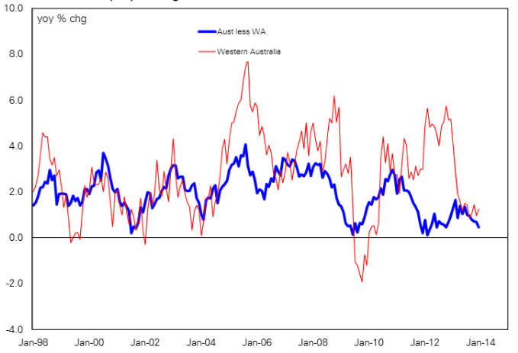
The NDIS needs to be aware that the WA economy is driven substantially more by commodity exports than the rest of Australia. Commodity exports are volatile, in terms of both volumes and values. Accordingly, WA is more characterised by boom/bust cycles than Australia as a whole. This means that in WA, disability providers will more often face boom conditions that may make it more difficult to retain workers. At present, price control changes are reviewed on a national basis, however the boom and bust cycles experienced in WA raise the question as to whether there should be provision for price control changes to differ across states and territories and for them to be able to be reviewed more rapidly when required. Moreover, while this volatility arguably affects WA more than other jurisdictions, it is not unique to WA. The other mining states (SA and Queensland) also experience boom/bust cycles.
Submissions noted that the impact of a ‘mining boom’ does not directly equate to significant increases in employment opportunities outside of the mining sector. Further, the resultant pressures on the cost of living (e.g. inflated rental prices) for non-mining workers based in regional and remote areas of WA may reduce the ability of providers to attract disability workers in these areas. Specifically, NDS WA noted that the reason many organisations remunerate staff at a higher classification level Social, Community, Homecare and Disability Services Industry Award 2010 (SCHADS Award) in remote and very remote areas than in other areas was because of the higher level of competition for labour from mining booms. The combined submission from small and medium providers reported that the sector was anxiously watching the new increase in mining and resources activity. Their experience was that the previous boom resulted in shortages in labour and housing markets, both of which placed pressure on the labour pool for regional disability services.
At a broad level, the current NDIA approach of one labour price limit for the whole nation may not fit well with an economy as large and diverse as Australia’s. Australia is the fifth largest country in the world in terms of size. It is also the world’s 13th largest economy. Therefore, it is not surprising that economic conditions – and therefore labour costs – vary around the country at any given time. Indeed, Australia is well known as a “two speed economy” – even referred to as such in official documents. This is because often half the states (WA, Queensland and SA) are in a mining boom, and the others are languishing; or these states are experiencing a mining bust while the others are enjoying rapid growth.
At present, however, the evidence available to the Review indicates that input costs for goods and services, capital and labour in WA appear to be similar to those in other jurisdictions (see Section 3.3 to 3.5 below). As noted above, apart from the greater impact of thin populations, there is also no evidence that WA providers are any less efficient or any less innovative than their peers in other jurisdictions.

Remote and Very Remote Costs
Markets in remote areas are, however, still thin, and the WA Government remains the provider of last resort in some of these areas. Submissions highlighted significant concerns in being able to attract providers (not-for-profit or private) to deliver services within regional areas. This is evident by the lack of interest from the large providers to enter regional markets. The Review received the following concerns during the submission process:
  - A remote region that is not able to attract a general speech therapist, let alone a therapist who is able to focus on people with a disability.
  - Therapy providers, who are currently operating in regional areas and have explored entering the NDIS market, have decided not to under current NDIS price controls.
  - A provider operating in the South West and Great Southern regions is not willing to expand to provide remote and very remote services given perceived barriers from NDIS price controls.
  - Limited available psychosocial providers in regional, remote and very remote areas.
  - Concerns that existing thin markets in remote areas, currently operating under state-based funding, will be exacerbated by the NDIS price control model due to perceived insufficient incentive for providers to expand into these areas.
These issues affect remote regions in all jurisdictions and are not unique to WA. They are considered further below.

Workforce Issues
A number of submissions raised concerns about the WA disability sector’s ability to meet the required workforce supply. These highlighted a number of perceived barriers to attracting and retaining the required workforce, including the trend towards workforce casualisation, the ability to remunerate staff competitively, and the availability of specific skill sets. These barriers are applicable to the Perth metropolitan area and amplified in regional, remote and very remote areas.
For example, the NDS WA submission also pointed to the casualisation trend, implying there was a “very real danger that the disability sector will become an employer of last resort rather than choice”. United Voice stated in their submission that given disability support workers’ (DSWs) wages are pegged against the minimum there is a real challenge for the sector to attract and retain the required staff to the sector. Furthermore, the SME submission indicated that it was becoming increasingly difficult for employers to be able to attract appropriately qualified and/or skilled employees, for the first time since the WA mining boom.
Submissions also raised concerns for the recruitment of staff with specific skill sets. Providers stated that whilst there are no current shortages for allied health professionals, there are difficulties attracting this cohort to the disability sector. Additionally, it is understood that shortages have also been identified for qualified support coordinators and team leaders who can work with people with higher intensity needs. A submission from one of the largest providers in WA identified that they were experiencing difficulty attracting psychologists, behavioural support specialists and quality and safeguarding specialists.
The Review noted the issues raised by providers and that they did not relate solely to WA. The Review noted that these matters were being addressed by the Commonwealth Government through the Boosting the Local Care Workforce Program.

Labour Costs in WA, Relative to Other Jurisdictions
To understand if material differences exist in the delivery of goods and services in WA relative to other jurisdictions, the Review considered the key costs of service delivery for a provider, and whether there is variation between WA and other jurisdictions. Being a service sector, labour costs represent the largest proportion of input costs for the delivery of disability services. In a benchmarking project, NDS reported that employee costs represented 71% of the benchmarked Panel’s expenditure, with higher proportions being reported for less capital-intensive businesses such as therapy. Given these proportions, labour costs have the greatest potential to drive a cost differential between jurisdictions.
To understand if substantial differences existed, the Review analysed the proportion of providers in the WA market that were operating under the Award versus EBAs, and analysed seven EBAs to evaluate differences between the SCHADS Award and WA EBAs. The Review also identified and analysed the key labour-related regulatory imposts in WA, and differences in these imposts across jurisdictions to establish if there were any substantial differences in WA compared to other jurisdictions.

Awards and Enterprise Bargaining Agreements
The labour costs a provider incurs are partially driven by the industrial instrument underlying their employee terms of employment. Given this context, the Review considered the type of industrial instruments adopted by providers in WA compared to other jurisdictions. The Review also considered variations across EBAs. DSWs were considered for the comparison given they represent a majority portion of the disability workforce, and allied health has been recently covered in the Review of Therapy Pricing Arrangements.
From a national perspective, data collected by NDS indicates that 59% of Disability Support Workers are covered under an Award, with the remaining 41% being covered under Agreements. Table 2 below shows the breakdown by state based off this data. Whilst based on this data set, WA has a higher share of its industrial instruments as Agreements (46%) than the national average (41%), it has a lower share compared to SA/NT (75%), and Victoria/Tasmania (51%), indicating variability in practices across all states and territories.
Table 2: Industrial Instruments Operating Organisations, by State
State | Award | Agreement | Number in sample
NSW / ACT | 87% | 13% | 30
Victoria / Tasmania | 49% | 51% | 37
Queensland | 73% | 27% | 22
SA / NT | 25% | 75% | 16
WA | 54% | 46% | 26
Multi-state | 56% | 44% | 16
Total | 59% | 41% | 147
The Review considered the industrial instruments adopted by WA identified through submissions, and data from the Fair Work Commission and the WA Industrial Relations Commission. Table 3 below shows the break-down, assuming that those without registered agreements or that did not declare an EBA are adopting the Award. Overall, 41% of submitters had an EBA in place; however, given the size of these providers, the proportion of the WA workforce that they represent is far greater.
Table 3: Industrial Instruments of Providers
State | Award | Agreement | Number in sample
Small | 100% | 0% | 5
Medium | 66% | 33% | 6
Large | 20% | 80% | 10
Total | 59% | 41% | 21

Comparison of Enterprise Bargaining Agreements to the SCHADS award
Given the indication that a significant portion of providers in WA may utilise Agreements, the Review has analysed the difference between the SCHADS Award and a sample of EBAs by comparing various terms of employment. The EBAs studied were selected to illustrate a good representation of the industry, with seven medium to large providers chosen. These include historically dominant providers and hence are assumed to be the major sources of labour supply of the WA disability sector. NDS estimate the top 20 providers in WA provide 80% of disability services in the state. The Review selected a representative sample of providers to assess their cost of employment under the EBA terms. This is compared to the SCHADS Award (MA000100), which is assumed to be a fair representation of the cost of employment for workers in the disability sector across Australia.
Due to the more generous terms of employment in EBAs including generous leaves, entitlements, etc., it appears that the cost of a worker is higher in WA as a result. Initial analysis suggested that wages could be between 6% to 30% higher under various EBAs, and leave entitlements up to 25% higher in some cases than were offered under SCHADS Award when the EBAs were determined.
However, it is unclear whether the EBA terms are more generous as a result of higher labour costs due the competition for labour from the mining boom or if there is a labour productivity gain in exchange for higher employee costs. It is also important to note that EBAs are time consuming and costly, hence, many of these EBAs could be outdated for the current labour market. Further, the Equal Remuneration Order (ERO) is eroding the difference between the SCHADS Award and older EBAs.
Therefore, while the Review recognises there may be a labour cost difference between EBAs and the SCHADS Award, further monitoring and data collection is required before any changes can be recommended. The NDIA will undertake further analysis of this issue as part of the 2019-20 Annual Review of Price Controls.

Wage Rates
There is a lack of available data on the current distribution of DSWs by level and wage rate, making it difficult to form a picture of the distribution of wage rates for DSWs in WA. When comparing the SCHADS Award and the individual EBAs sampled, there is significant variation in the number of levels featured, the wage rates for each level and the descriptions attributable to each level. This makes it problematic to compare without an understanding of the levels applied.
The NDS submission did point to possible work practices in WA whereby providers may be employing staff above the assumed reasonable cost model classifications including: remunerating DSWs at SCHADS Award Level 3 and 4 classifications or equivalent; and remunerating supervisors at a SCHADS Award Level 4, or even Level 5 classifications or equivalent.
The Activ submission further pointed to WA’s “unique recruitment challenges in a resources state” contributing to EBA pay rates being historically above the Award. However, some submissions suggest that although there may be a gap in the market rates and the Award, this gap is closing with the ERO. Further, some provider submissions indicated that their wage rates were in line with reasonable cost model assumptions.
Without an understanding of the prevalence of particular allowances in the whole market, whether there is an efficiency trade-off, and the match between service provided and wages paid, it is not possible to conclude that DSW wage rates are higher due to EBAs being more generous in WA than in other jurisdictions. The proposed Temporary Transformation Payment (TTP) benchmarking data may be able to establish true wage cost differences across jurisdictions and across instruments.
The Review also compared the leave entitlements contained in the SCHADS Award to the sampled EBAs. Table 4 below summarises the comparison. Analysis indicates the EBAs sampled are more generous in relation to leave, and thus could contribute to additional costs for the provider. However, as observed for wage rates, the application and uptake of these leave types are unknown, thus the true cost impact cannot be accurately estimated.
Table 4: EBA Leave Entitlements Comparison to the SCHADS Award
Types of leave | EBA range | SCHADS Award | EBA Weighted average | EBA to SCHADS ratio
Annual leave | 20 - 35 | 20 | 27.86 | 139%
Personal/carer’s leave | 10 – 14.6 | 10 | 11.59 | 116%
Compassionate leave | 2 - 3 | 2 | 2.43 | 121%
Community services leave | 10 | 10 | 10 | 100%
Parental leave | 105 - 155 | 90 | 122 | 136%
Grandparent leave | 2 | - | 2 | -
Long service leave | 43.35 - 65 | 43 | 59.76 | 139%
Professional development leave | 3 - 5 | - | 4.20 | -
Communicable infection leave | 3 | - | 3 | -
Cultural leave | 3 | - | 3 | -
NAIDOC week leave | 1 | - | 1 | -

There are also leave types contained in the EBAs that were not included in the SCHADS Award. Examples include:
  - Communicable infection leave: Up to three paid days approved under special conditions.
  - Gratis/cultural leave: Three days paid leave each year with the intention for all employees to enjoy cultural observance days.
  - NAIDOC week leave: One day paid leave offer to employees who identify as Aboriginal or Torres Strait Islander to join the NAIDOC week celebrations.
  - Education and Training: Option for leave associated with professional development, ranging from three to five paid days.

Penalties and Loadings
Penalty rates are paid as an entitlement for workers calculated on their ordinary hourly rates of pay. The Review evaluated the penalty rates for DSWs across the categories of Saturday loadings, Sunday loadings, afternoon loadings and evening loadings.
Table 5 below identifies that the penalty rates for the sample are all equal to or higher than the rates specified in the SCHADS Award, except for the Sunday loading. The Review has calculated the difference between EBAs and SCHADS Award penalty rates for each category of loading. This is computed by dividing EBA weighted average by SCHADS Award penalty rates. However, it is not feasible to compare the total costs from the SCHADS Award to the higher penalty rates from EBAs, as different providers have different working schedules and demand. Hence, it is difficult to say whether EBAs are costing providers more from a penalty rates perspective, because Sunday loading is significantly lower than the SCHADS Award loading at 84%.
Table 5: EBA Penalty Rate Comparison to SCHADS
Types of loading | EBA range | EBA average | SCHADS | EBA to SCHADS difference
Hourly rate | - | - | 27.61 | -
Saturday loading | 1.5 - 1.75 | 1.53 | 1.5 | 102%
Sunday loading | 1.5 - 1.75 | 1.69 | 2 | 84%
Afternoon loading | 1.15 | 1.15 | 1.12 | 103%
Evening loading | 1.15-1.3 | 1.19 | 1.15 | 103%
Annual leave loadings are not available in some of the EBAs studied. The SCHADS Award rate provides an annual loading at 17.5% at ordinary hourly rates of pay. EBAs can pay the same rate, or pay none. Hence, annual leave loadings do not necessarily present additional cost burden for WA providers.

Scheduling and Casualization
Scheduling requirements differ between the SCHADS Award and EBAs. Lower minimum scheduling requirements afford providers increased flexibility and the opportunity to achieve higher staff utilisation rates. The SCHADS Award specifies a minimum shift duration of one hour. In comparison, minimum shift durations of three to four hours, dependent on the type of care, were noted in EBAs.
Submissions raised concerns that, partly due to EBAs, the original 95% utilisation assumption in the NDIA’s reasonable cost model was unrealistically high. NDS stated in their submission “employers participating in the SME pricing submission identified the primary reason for an increased casualisation is the unit prices do not permit the financial security to commit to permanent contracts in conjunction with the need for the worker flexibility to reflect the “top and tail” daily patterns”. It is understood scheduling restrictions stemming from EBAs may affect a provider’s ability to schedule a “top and tail” shift for a permanent employee without being obligated to pay a loading for the second shift.
Further, providers argued the reasonable cost model did not enable adequate time for unbilled travel, training and administrative activities. Submissions commonly reported utilisation rates of 80-90%, exclusive of leave, with the NDS submission asserting, “NDS members report that they would struggle to achieve 85% utilisation”. The Review notes that the changes to the Reasonable Cost Model that were made in March 2019 reduced the utilisation assumptions and, that currently, the reasonable cost model assumes a utilisation rate, exclusive of leave, of 92% for Standard supports, 89% for High Intensity supports and 87.7% for Very High Intensity supports. The Review also notes that the most recent benchmarking data shows that support workers spent, on average, 92.5% of their time (excluding leave) on direct client activities in 2017-18.
Other submissions raised the impact that NDIS price controls is having on workforce composition and indicated it was resulting in higher rates of casualisation. The NDS workforce wizard data shows an increasing trend in casualisation in WA from December 2015 to March 2018. It should be noted that whilst the data shows that WA may have an increasing rate of casualisation for the period, it had one of the lowest rates to start with.
Submissions further raised that workforce casualisation had associated labour cost implications including:
  - Greater rates of absenteeism, and increased use of agency staff which are typically more expensive;
  - Higher turnover rates resulting in increased recruitment costs;
  - Increased training costs subsequent to minimum training requirements being exclusive of hours worked;
  - Higher supervisor to staff ratios given the higher headcount associated with a casualised workforce.

Non-labour Costs Relative to Other Jurisdictions
To evaluate if a substantial non-labour cost differential exists in WA compared to other jurisdictions, the Review considered the following categories:
  - Overheads: The Review evaluated the feedback provided by the market through submissions and consultations regarding general overhead costs to establish if there were any identifiable differences between WA and other jurisdictions.
  - Capital and Operating Expenditure: The prices of specific cost items in WA were compared to the rest of Australia including: motor vehicles, equipment, property and insurance.

Overheads
The Review evaluated submissions to establish if there were any identifiable differences in overhead costs in WA compared to other jurisdictions. For ease of analysis, overhead costs in this section refer to all other costs that are not attributable to direct labour and supervision. A theme in the submissions and consultations was a discussion around overhead costs and the reasonable cost model assumptions made around these costs. The updated reasonable cost model assumes provider overheads are 11.2% of direct labour costs. Overheads include both “indirect labour costs” (assumed 5.6%) and “other corporate overheads” (assumed 5.6%). Providers in submissions reported these to be higher reporting a range of 26% to 34% inclusive of service and corporate overheads.
Provider submissions reported a number of issues restricting their ability to operate within the reasonable cost model’s overhead assumption. They included: a requirement to invest in additional IT system infrastructure; the costs associated with inefficient NDIS infrastructure and additional administrative burdens; staffing requirements to support and deliver change; and direct service costs such as vehicles not being accounted for in the reasonable cost model. However, these issues are not specific to WA. In the absence of extensive benchmarking data, it is problematic to ascertain if in fact the cost base is higher in WA than other jurisdictions. It is noted that the submission process did not reveal unique factors in WA that would result in higher non-labour overhead costs than other jurisdictions.
Further, the limited benchmarking data that is available points to these issues being Australia-wide and the rates quoted in submissions are not outside the range being reported across Australia.

Capital and Operating Expenditure
The Review examined if the cost of goods and sales is higher in WA than other jurisdictions. Submissions and consultations did not raise any known items that are higher aside from the associated import costs, which is briefly discussed below. To the extent that goods are higher in regional or remote areas, this is considered under remoteness rather than state-specific costs.
There may be an additional import cost associated with goods in WA depending on the location of origin. This was raised in a submission by Rocky Bay, a large WA provider: “Our experience of dealing with equipment suppliers is that, whilst the manufacturer maybe outside of the country, in general equipment from overseas is delivered first to Eastern State hubs. This, in turn, means additional courier charges and mark ups when the goods are distributed to local branches in WA. This added cost compared to Eastern State providers can also lead to extended times of delivery.”
The Department of Foreign Affairs and Trade notes that NSW and Victoria account for 66.4% of Australian imports, and national distribution centres for many imported products are located in these states. Which means that WA businesses may also have to pay for freight forwarding costs from Sydney or Melbourne too. It is worth noting that Perth itself is remote from the rest of Australia. For example, Canberra is only the third closest national capital to Perth, and Canberra is closer to four other national capitals than it is to Perth. Indeed, Canberra is closer to Suva, Fiji than it is to Exmouth in WA.

Motor Vehicles
DFAT reports that the fifth largest import into WA by value was motor vehicles. Hence, vehicles could be a useful proxy to test whether imported goods are more expensive in WA. For example, the Volkswagen (VW) Golf is often used to benchmark international car price comparisons. A new VW Golf costs around $500 more in Perth than it does in Sydney. On the other hand, a Toyota Corolla may be a more appropriate benchmark for comparing prices within Australia, as almost twice as many are sold as Golfs. A new Toyota Corolla is around $750 cheaper in Perth than in Sydney. Australian Toyota Corollas are shipped from Thailand, which is around 3,000 kilometres closer to Perth than to Sydney by sea.
Australian Bureau of Statistics (ABS) data for motor vehicle and fuel prices show that, historically, prices for these products have tracked much the same in WA as the rest of Australia (Figure 4 and Figure 5 below).
Figure 4: Consumer Price Index (CPI) for Motor Vehicles, 1988 to 2018
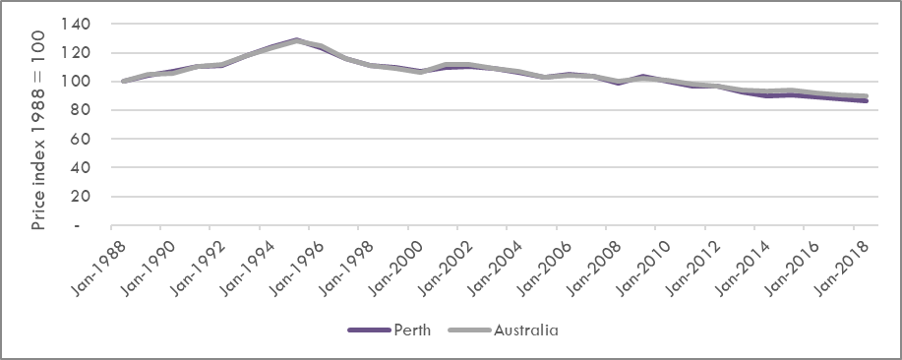
Figure 5: CPI for Fuel, 1988 to 2018
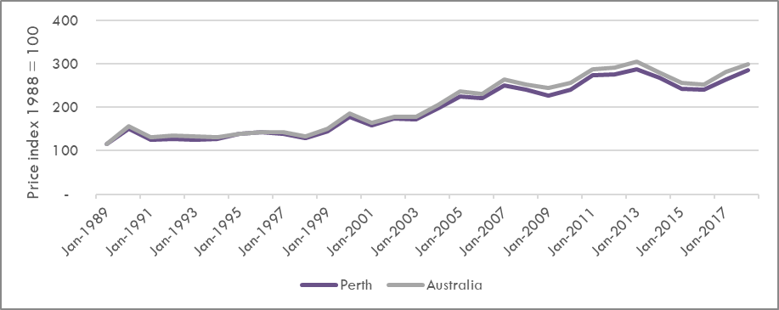

Equipment
In the absence of direct price data on disability equipment, the closest ABS categories that provider equipment would fall into were used as proxies: medical equipment, therapeutic equipment, furniture and major household appliances. Historically, prices for these items have at times been higher in Perth than in the rest of Australia. However, since the end of the mining boom, this is generally no longer the case. With the exception of therapeutic goods, there is little difference in prices for these goods between Perth and other capital cities. Refer to Figure 6 to Figure 9 below.
Figure 6: CPI for Therapeutic Appliances and Equipment, 1988 to 2018
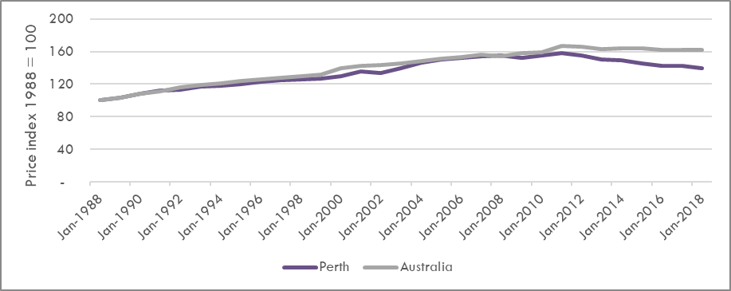
Figure 7: CPI for Medical Products, Appliances and Equipment, 1988 to 2018
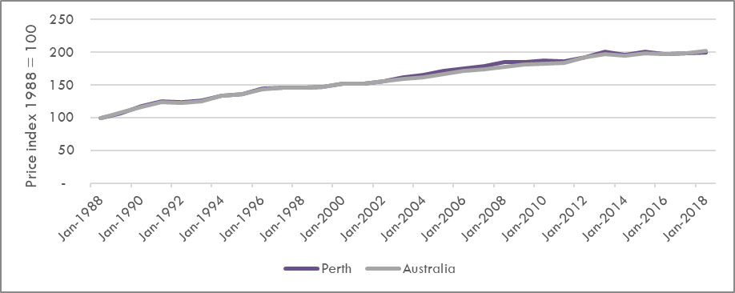
Figure 8: CPI for Furniture and Furnishings, 1988 to 2018
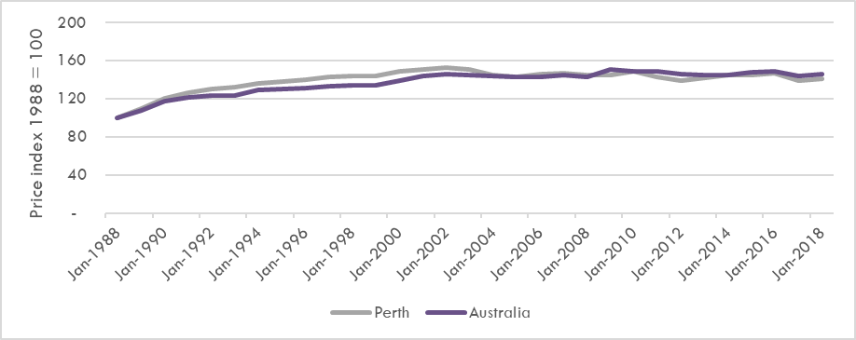
Figure 9: CPI for Major Household Appliances, 1988 to 2018
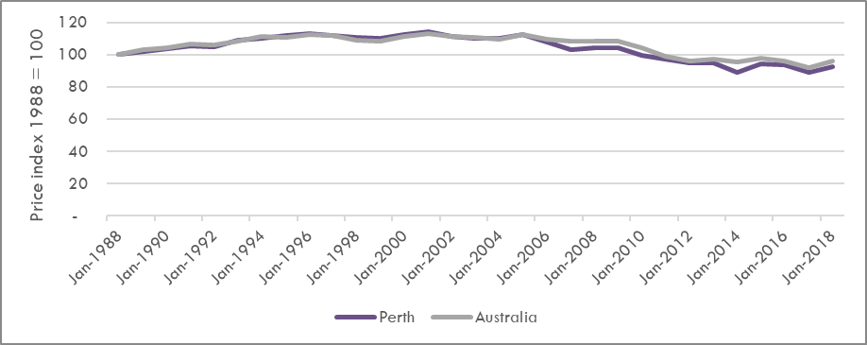

Property Costs
In the absence of commercial price data from providers, the ABS categories for property that have been considered as proxies include; housing, property rates and charges, and utilities (Figure 10 to Figure 12). Again, there is evidence of higher prices during boom periods, but generally, this is no longer the case. It is further noted, that the price of utilities nationally has outpaced the price of utilities in WA.
Housing costs will affect the price of buildings used for Specialist Disability Accommodation. While these buildings may have to be modified, the cost of the modifications is not large compared to the total property costs. Accordingly, it is reasonable to assume that disability accommodation costs would generally follow those for regular houses. Since the end of the mining boom, house prices in Perth have reduced more than all other capital cities besides Darwin (Figure 13).
Figure 10: CPI for Housing, 1988 to 2018
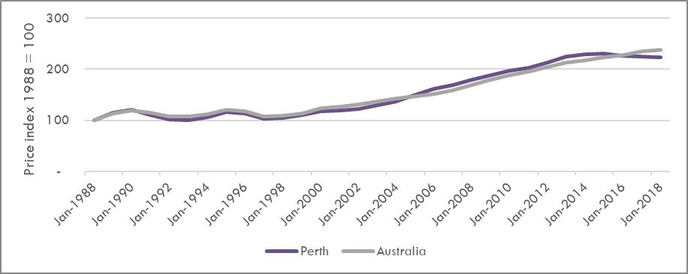
Figure 11: CPI for Property Rates and Charges, 1988 to 2018
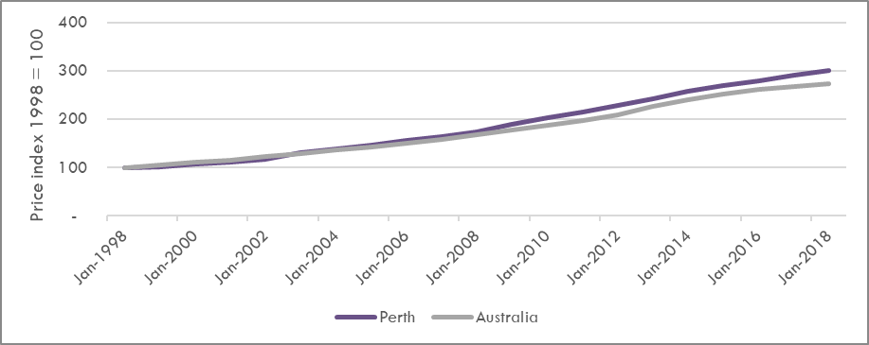
Figure 12: CPI for Utilities, 1988 to 2018
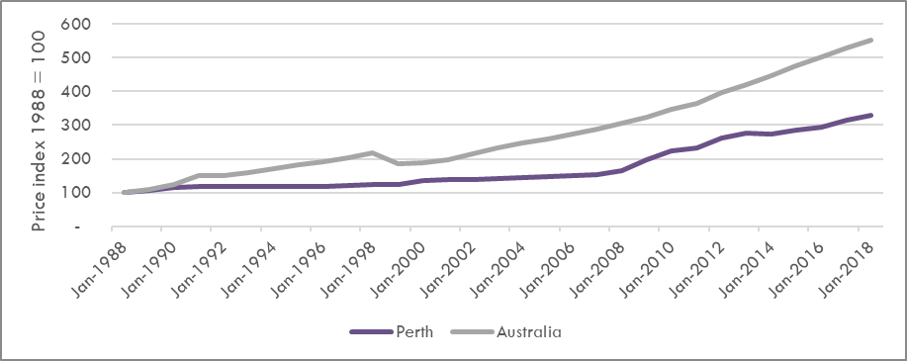
Figure 13: Changes in Capital City House Prices, Five Years to December 2018
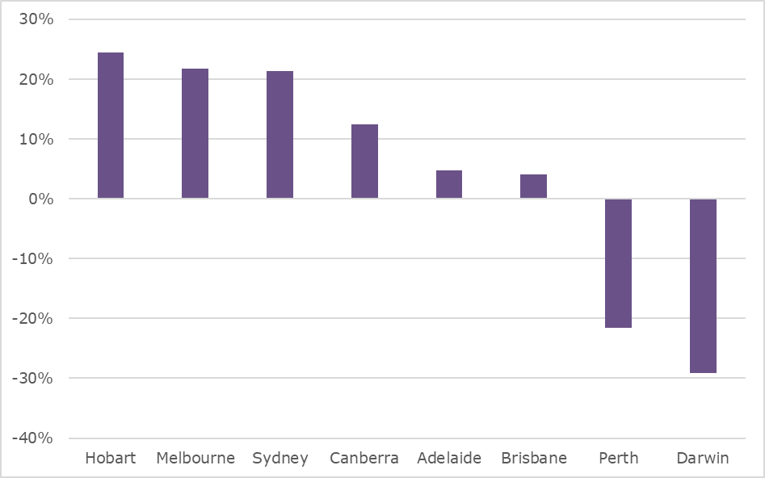

Other Input Costs
Insurance represents another common cost that providers incur. Analysis of ABS data on insurance costs shows that insurance prices in Perth have been growing at a greater pace than those nationally. However, this does not enable direct comparison of price levels across states and territories, only movements over time.
While producers of certain disability-specific capital goods may have a degree of market power, the remaining consumer goods market is fully competitive and is not considered here. Further, while the prices of consumable goods may have been higher in WA during the mining boom, this no longer appears to be the case.

Regulatory Imposts
The Review also considered whether there were any specific WA requirements that might affect the cost of service delivery. This analysis considered known variations such as Workers Compensation, Payroll Tax and those identified in submissions. Whilst there are differences in the Workers Compensation and Payroll Tax systems, this is present across all jurisdictions and there is limited evidence to indicate the WA providers would be worse off overall than other jurisdictions.

Workers Compensation
Workers Compensation premiums represent a labour cost impost to providers (with the exception of Self-Insurers). Across Australia, there are 11 Workers Compensation schemes, with each of the states and territories having their own individual schemes and the Commonwealth having three. The WA scheme is managed by WorkCover WA, a state government agency, and is privately underwritten. Based on the approach of comparing standardised premiums across the states, there is no indication that WA providers would be incurring a materially higher workers compensation premium than other jurisdictions. Workers Compensation premiums were not raised as an issue during the submission process. Figure 14 below shows a comparison across the states. In 2015-16, the Australian average premium was 1.32%, with WA having the lowest standardised average premiums at 1.16% of payroll.
Figure 14: Standardised Workers Compensation Premiums by Jurisdiction
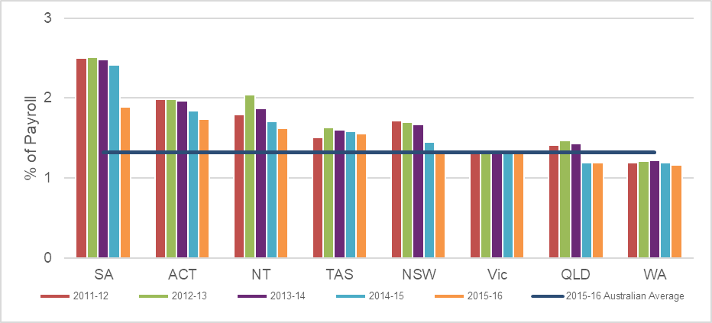
Figure 15 below considers the comparison at an industry level, for the Health and Community Services Sector. In 2015-16, the Australian standardised average premium was 1.52% across the sector, with WA having a marginally higher premium at 1.57%. Notably, six out of the eight jurisdictions fell above the average in 2015-16.
Figure 15: Standardised Workers Compensation Premium Rates by Jurisdiction
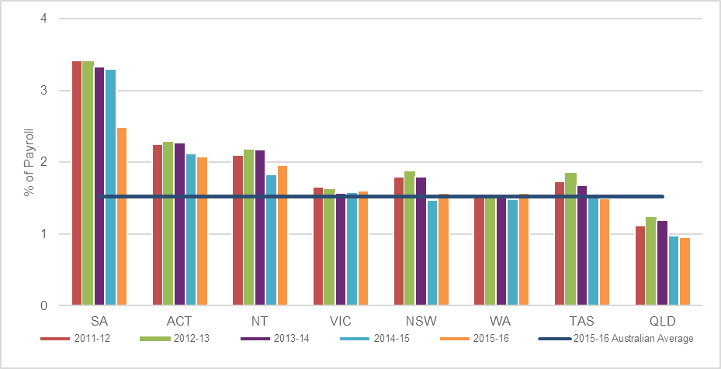

Payroll Tax
Payroll tax regimes vary across Australian jurisdictions and result in varying payroll tax liabilities for comparable businesses operating in different jurisdictions. Submissions raised the issue that WA has one of tightest payroll tax regimes with a high rate, and relatively low threshold. To understand if the WA payroll tax regime imposes higher payroll tax liabilities, the Review undertook a comparison of the same type of firm, with the same payroll costs, across the jurisdictions (see Table 6). The numbers in brackets indicating the jurisdictions relative ranking based on costs compared to other jurisdictions.
Table 6: Payroll Tax Comparison
State/  Territory | Payroll Tax |  | Employer Payroll Costs
NIL | Rate | Threshold | $2,000,000 | $10,000,000 | $20,000,000 | $50,000,000
ACT | 6.85% | 2,000,000 | 0 (8) | 548,000 (3) | 1,233,000 (1) | 3,288,000 (1)
NSW | 5.45% | 850,000 | 62,675 (3) | 498,675 (5) | 1,043,675 (5) | 2,678,675 (5)
NT | 5.50% | 1,500,000 | 34,375 (5) | 550,000 (1) | 1,100,000 (3) | 2,750,000 (3)
QLD | 4.75% | 1,100,000 | 53,437 (4) | 475,000 (6) | 950,000 (6) | 2,375,000 (8)
SA | 4.95% | 1,500,000 | 24,750 (7) | 420,750 (8) | 915,750 (8) | 2,400,750 (6)
TAS | 6.10% | 2,000,000 | 30,000 (6) | 518,000 (4) | 1,128,000 (2) | 2,958,000 (2)
VIC | 4.85% | 650,000 | 65,475 (2) | 453,475 (7) | 938,475 (7) | 2,393,475 (7)
WA | 5.50% | 850,000 | 71,335 (1) | 550,000 (1) | 1,100,000 (3) | 2,750,000 (3)
WA is ranked first highest for payroll tax costs for businesses with a $2 million payroll, and equal first with the NT for businesses with a $10 million payroll. In contrast, WA is ranked third for businesses with a $20 million or $50 million payroll, with the ACT being ranked first in both instances.
Whilst WA is ranked first or equal first in the $2 million and $10 million scenarios, this ranking is not consistent across all scenarios providing limited evidence that WA businesses consistently incur a higher payroll costs relative to all other jurisdictions.
Additionally, there are differing payroll tax exceptions across the jurisdictions. In WA, public benevolent institutions, charities, not for profit hospitals, state and local government bodies are all exempt from payroll tax. A significant proportion of providers fall into these categories and hence are not required to pay payroll tax.

Other Imposts
During the submission process, the Review heard that there were three additional imposts that would be new to WA providers as a result of the introduction of the NDIS:
  - Quality and Safeguarding: Submissions raised that under the previous WA pricing arrangements, the WA Government wore the cost of Provider Quality and Safeguarding evaluations. Under the NDIS, this cost is now borne by the providers, with a cost estimated at up to $14,000 for a provider irrespective of size.
  - Restrictive Practices: Submissions indicated that in WA, there is currently a code of practice that is guiding the disability sector on the use of restrictive practices. Under the NDIS, there will be mandatory reporting of restrictive practices in line with jurisdictional arrangements. WA is in the process of developing a mandatory process, and this will represent an impost to providers.
  - Screening: A confidential submission indicated that there is currently no disability-specific worker screening system in WA. Given that under the NDIS, a range of employees will be required to undergo NDIS worker screening, there may be labour implications for providers.
The Review noted that whilst these changes will represent a “new” cost to WA providers, they are a cost shared by other jurisdictions and thus do not require any specific WA adjustments to the NDIS pricing arrangements.

Benchmarks for Disability Supports from Related Sectors
The Review has considered the following sectors’ prices: Aged Care Home Care; Home and Community Care Program and WA Insurance Schemes. While existing state based disability schemes will not continue beyond the NDIS rollout, these schemes have also been considered to provide context. To secure the required increase in supply, the price limits offered under the NDIS need to be competitive to the prices offered under comparable schemes. In the event that price limits are not competitive, providers may not be able to attract the required workforce, or will opt to allocate resources to schemes that they deem to be more profitable or sustainable. However, price alone is not the only determinant, with market size being another factor. Aside from the aged care home care market, the other comparable schemes in WA are relatively small in comparison to the NDIS market.

Aged Care Home Care
Submissions received during the Review support the finding by the IPR that composite attendant care prices in the aged care home care market are higher than those offered by the NDIS. There has already been evidence in the WA market that providers who previously provided services to people with a disability and provide home care in the aged care sector have opted to either exit (e.g. Baptist Care and Adventist Care) or not enter (Silverchain) the NDIS market. However, this disparity has been significantly addressed by the national price limit increases for the NDIS announced in March 2019. The changes in prices announced by the NDIS on 30 March 2019 increased the NDIS hourly base rates in WA by between 5.6% and 15.4% in real terms. Combined with the Temporary Transformation Payment, NDIS hourly base rates in WA have increased by between 10.9% and 20.4% in real terms.

Home and Community Care Program
The WA Home and Community Care (WA HACC) services younger people (people aged under 65 and Aboriginal and/or Torres Strait Islander people aged under 50). It is funded and managed by the WA Department of Health. The current program provides low-level support to younger people, to assist them to maintain their independence and continue living at home in the community. For the 2017-18 financial year period, 10,528 younger people received care under the program. This number will reduce as the NDIS rollout continues, and it is anticipated there will be a residual number left who are deemed ineligible for the NDIS.
For the 2018-19 financial year, the WA HACC program funded approximately 80 service providers. Given the gradual transition of WA HACC clients, this number will gradually reduce. During consultations, WA Health noted that the unit prices are not standardised across providers, and are dependent on service provider cost structures, service delivery models and other factors.

WA Insurance Schemes
In WA, there are two other comparable insurance-based schemes: WorkCover WA and the Motor Injury Insurance scheme. The WorkCover WA scheme is the workers compensation insurance scheme, whilst the Motor Injury Insurance scheme covers injuries caused in a motor vehicle accident. In 2016, the latter scheme was expanded to include the Catastrophic Injury Support (CIS) scheme providing “lifetime treatment, care and support for people catastrophically injured in motor vehicle crashes in WA who are unable to establish fault of another driver”. Both the WorkCover WA and CIS schemes provide comparable supports to NDIS through the funding of care and support in the form of goods and services. However, the size of these schemes relative to the NDIS are very small. Further, there are no published or set rates for attendant care under the WA insurance schemes. Under the WorkCover WA scheme, attendant care is not a defined item that is subject to a published rate. Rather, if an individual requires home or community support, the rate is negotiated between the insurer and the provider. In 2017-18, “home help services” only accounted for $75,692 of payments, representing a small market. The CIS scheme has adopted the NDIS price limits for attendant care. Any change in attendant care NDIS price limits will have flow on effects to the CIS scheme. Since its inception, 106 people have been assessed as eligible for the CIS.

Existing State-based Disability Schemes
Whilst the existing Disability Services Commission scheme and WA NDIS will transition to NDIS, understanding how the funding is received under these schemes provides useful context. In 2012, the WA State Government moved from being a price setter to becoming a price taker in the marketplace. The policy aimed to recognise the true cost of service delivery, with providers being able to articulate to the WA State Government the cost of delivery and funding required. The prices developed for the WA NDIS framework were a result of analysis of pricing of registered service providers. It is understood that around 90% of pricing was centred on the mean, with a small standard deviation. The framework was flexible, featuring pricing bands.
Under the previous state-based schemes, providers were involved in setting prices and were afforded a degree of pricing flexibility. Using the example of ‘Assistance With Self-Care Activities – Standard – Weekday Daytime’, the comparable WA NDIS item is “Assistance with daily personal activities”. Table 7 summarises the comparison of 2018-19 rates and price limits. It should be noted that WA NDIS does not offer loading for weekends, evenings or public holidays. Without a known distribution for WA, true composite rates cannot be determined. Hence, this is purely illustrative. The rates below demonstrate the increased flexibility that providers were offered under the WA NDIS pricing and thus their ability to negotiate a higher rate.
Table 7: Comparison of 2018-19 NDIS Price Limits to WA NDIS Prices
Source | Lowest | Highest | Average
NDIS WA Price Limit | $49.02 | $51.18 | $50.10
NDIS Remote Price Limit | $58.60 | $63.78 | $61.19
NDIS Very Remote Price Limit | $60.99 | $66.39 | $63.69
WA NDIS Perth Metropolitan | $43.80 | $60.00 | $51.90
WA NDIS Regional | $43.80 | $70.60 | $57.20
In summary, NDIS price limits for attendant care supports were generally lower than in some related WA sectors based on historical prices paid. However, the disparity has been addressed by recent price increases in the NDIS. As noted above, the changes in prices announced by the NDIS on 30 March 2019 increased the NDIS hourly base rates in WA by between 5.6% and 15.4% in real terms. Combined with the Temporary Transformation Payment, NDIS hourly base rates in WA have increased by between 10.9% and 20.4% in real terms. Members of the Review’s Advisory Group indicated that the national price limit increases announced in March 2019 had gone a long way towards addressing their concerns with the appropriateness of the NDIS Price Limits in terms of metropolitan services.

Appropriateness of NDIS Price Controls
The Review was required to examine whether the existing NDIS Support Catalogue, and the price controls and associated rules set out in the NDIS Price Guide:
  - would support the sustainable, efficient delivery of disability supports to participants in WA; and
  - are appropriate for WA (e.g. allowances for provider travel).
Members of the advisory group indicated that the national price limit increases announced in March 2019 had gone a long way towards addressing their concerns with the appropriateness of the NDIS Price Limits in terms of metropolitan services. However, the Review found that variations in population density, and density of participants across Australia and within WA did mean that some of the ancillary price control arrangements had the potential to impact on the viability of some services.

Findings and Recommendations
Finding 6: The Review found that the costs of delivering services in remote and very remote areas are significantly higher than in metropolitan areas, and the difference in costs is greater than currently provided for in the NDIS planning and pricing arrangements.
Finding 7: The Review found that the costs of delivering services in regional areas, and especially outer regional areas, may also be higher than in metropolitan areas, but that further research on the magnitude and significance of this difference was required.
Finding 8: The Review found that the cost of service delivery in isolated centres – centres that are currently not classified as remote or very remote by the NDIA but that are completely by remote or very remote areas – were, in general, higher than in other non-remote areas.
Recommendation 3: The NDIA should increase, from 1 July 2019, the remote and very remote loadings on price limits and plan funding amounts from 20% to 40%, and from 25% to 50% respectively. The NDIA should examine in the 2019-20 Annual Price Review whether a loading should be applied to price limits and plan funding amounts in regional areas.
Recommendation 4: The NDIA should amend its geographic classification arrangements so that all centres that are currently not classified as remote or very remote by the NDIA but that are completely surrounded by remote or very remote areas should be classified as remote areas for planning and pricing purposes.

Remote and Very Remote Costs
The NDIS recognises that providers who deliver services to participants in remote and very remote areas face higher costs than other providers. For participants who live in remote and very remote areas (MMM6 and MMM7 areas under the Monash Modified Model (MMM) classification) a 20% loading is applied to the funding in their plans in remote areas (and 25% in very remote areas). Providers delivering services to participants in remote and very remote areas are similarly subject to price limits that are 20% and 25% higher, respectively, than the price limits for the same supports in the rest of Australia.
While concerns on remoteness price controls are not unique to WA, they do affect WA more than any other state or territory. As Table 8 illustrates, even the second least densely populated state, SA, has a 70% higher population density than WA.
Table 8: Population Density by Jurisdiction, 2017-18
Jurisdiction | Persons per square kilometre, 2016 | Ratio to WA | Proportion of SA2s with less than one person per square kilometre, 2017-18
VIC | 25.6 | 24.8 | 4.1%
NSW | 9.6 | 9.3 | 6.3%
TAS | 7.6 | 7.4 | 7.1%
AUST | 3.1 | 3.0 | 8.5%
QLD | 2.8 | 2.7 | 8.8%
SA | 1.7 | 1.7 | 12.3%
WA | 1.0 | 1.0 | 16.3%
WA also has the highest proportion of Statistical Areas 2 with less than one person per square kilometre – almost double the national average (see Table 9).
Table 9: Proportion of SA2s with Less Than One Person per Square Km, 2017-18
Jurisdiction | Share of empty shires
VIC | 4.1%
NSW | 6.3%
TAS | 7.1%
QLD | 8.8%
SA | 12.3%
WA | 16.3%
AUST | 8.5%
While all Australian states and territories (even Tasmania) have remote areas, WA providers considered that remoteness is more of an issue in WA than those on the Eastern seaboard. For example, the WA Association for Mental Health argued in their submission that “large swathes of remote and very remote areas, significant distances between regional centres, and a sparse population severely impact on provider viability and thus service availability”.
The Kimberley-Pilbara region alone accounts for 36% of WA’s land mass and is 4.1 times the size of Victoria. These factors pose a difficult challenge in creating and sustaining effective transport and communication networks, and the business innovation required to succeed in these operating conditions. Figure 16 illustrates the distance of regions of Australia from the nearest labour supply centre. It illustrates how some centres in WA and other remote areas are different from those on the east coast as they are often distant from the “next” labour centre even if they are close to a labour centre themselves.
Figure 16: Distances from Labour Sources
NDS WA noted in its submission that there are distinct characteristics of WA, which mean that regional strategies from other jurisdictions are not transferable. These include long distances between communities; competition for staff from diverse sectors; and significant differences in the availability of other services or infrastructure.
The Review received strong evidence that the current Remote and Very Remote price limit and plan funding loadings were not attracting sufficient supply to these regions in WA and that the ability to charge for time taken to travel in these areas was a key barrier. NDS WA stated in their submission that “a 25% price loading for regional and remote WA will probably not be sufficient to deliver access to good services of equal quality, safety and frequency in regional and remote parts of WA”. The combined SME submission stated that the current loading would not even cover their freight costs. “Providers who provide therapy supports in remote areas (MMM6) are paid an additional 20% on top of the standard hourly rate and in very remote areas (MMM7) they receive an additional 25%. If this could be applied to freight it still would be insufficient as the costs are well beyond the Metro due to distance”. Similarly, the Goldfields Individual and Family Support Association noted that it cost them more than $200,000 a year per worker in very remote areas and that the formula used to apply the current remote loadings is “totally inadequate”.
Carers WA noted that Merredin in the Wheatbelt region of WA has the same price limits as the Perth Metropolitan area - despite being 260km from Perth. They noted “The cost of delivering services in this region is too high. There are no additional incentives within the pricing structure for providers to commence service delivery in this area”. Provider submissions also cited other examples including Northcliffe (Lower South West region) and Karratha (Pilbara region) which are both MMM 6, despite Northcliffe being a four-hour drive from Perth and Karratha a 15.5-hour drive from Perth. Cases like this are further argued to not be an exception to the rule, but rather an endemic reality in the WA market.
Costs of providing services under the NDIS vary significantly by location. This is particularly apparent in regional and remote areas, where significant additional costs such as travel are incurred in service delivery. Low population densities and large distances mean that regional providers are also more likely to be smaller, which means they likely experience higher costs due to lower utilisation and higher proportions of fixed overhead costs. The current NDIS remoteness loadings were taken from the Independent Hospital Pricing Authority’s estimates of the additional costs of delivering services in small hospitals in remote and very remote areas. The evidence available to the Review indicates that these loadings are not necessarily appropriate for non-institutional services.
The Commonwealth Grants Commission (CGC) assessed WA as having the third highest health service provision cost per person, after Tasmania and NT. Analysis by the WA Government indicates that around half of the difference compared to the national average is due to remoteness-related factors. Some 15.5% was due to greater distances, 17.6% due to loss of economies of scale in sparsely populated locations, and 13.2% due to higher wages in remote areas. Given the similarities between health and disability services, it is reasonable to assume that these factors have similar impacts on disability providers in WA.
The WA Government’s submission to the CGS provided evidence that houses were at least 20% more expensive in remote areas - a large outlay for both housing disability workers and providing disability accommodation. Further, the Australian Competition and Consumer Commission (ACCC) found that insurance premiums per $1,000 insured were up to five times higher than the national average in remote WA towns (see Table 10 and Figure 17). Seven of the ten most expensive towns to insure a house and contents were in WA. Moreover, insurance premiums in remote areas are rising more than twice as quickly compared to the rest of the country. Premiums in Northern Australia have risen by 130% in real term from 2008 and 2018, compared to an average of 50% rise in the rest of the country.
Table 10: Highest Premiums per Sum Insured Areas, 2017-18
State | Postcode | Area | Premiums per $1000
WA | 6718 | Roebourne, Whim Creek | $11.32
WA | 6710 | Cane, Onslow, Peedamulia, Yannarie region | $9.05
WA | 6713 | Dampier, Dampier Archipelago | $8.22
WA | 6720 | Cossack, Point Sason | $8.20
Qld | 4809 | Shirbourne, Jerona, Barratta, Giru | $8.10
WA | 6722 | South Hedland, Pippingarra, De Grey, Finucane | $7.92
WA | 6721 | Port Hedland, Indee, Mundabullangana, Wallareenya | $7.69
Qld | 4806 | Arkendeith, CArstairs, Osborne, Wangaratta | $7.52
Qld | 4808 | Brandon, Cole | $7.40
WA | 6721 | Port Hedland, Indee, Mundabullangana, Wallareenya | $7.02
Northern Australia |  |  | $4.34
Rest of Australia |  |  | $2.17
Figure 17: Average Premiums for Combined Home and Contents Insurance (2016-17)
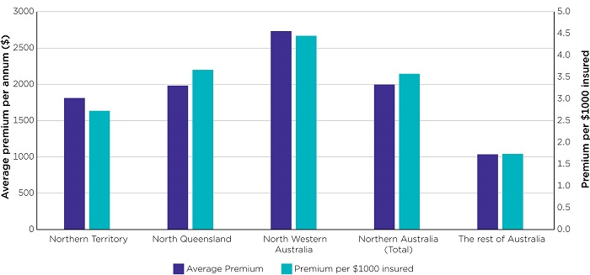
The WA Department of Primary Industries and Regional Development constructs a Regional Price Index (RPI) periodically. This allows for a comparison of location-based prices for a common basket of goods across different regional centres of WA. As Figure 18 illustrates this data shows that prices vary continuously in a statistically significant way with distance.
Figure 18: Impact of Distance from Perth on Regional Prices in 2017
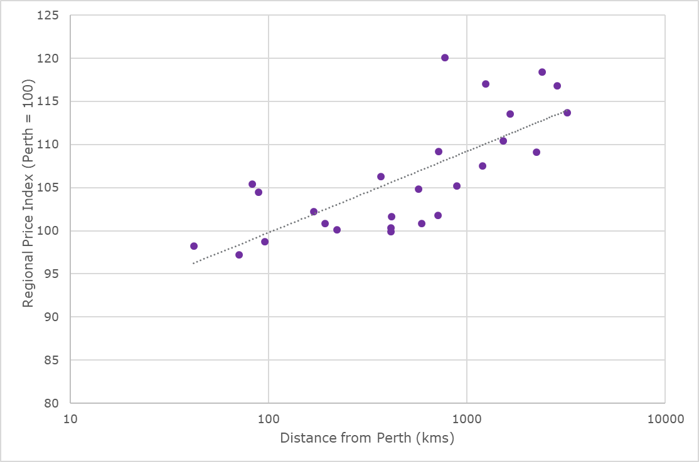
While the RPI showed that the costs of general basket of goods does not increase exorbitantly in remote areas, a basket of goods is only the start of increased costs in such areas. For example, petrol may only be up to 15% higher than in urban areas but the more remote the area, the cost of fuel is more expensive as the distance over which providers have to cover is much greater. The result is that fuel costs represent 3-7% of individuals’ annual income in remote Australia and up to 10% in very remote communities.
Similarly, electricity prices in remote area may only be 10% higher than urban areas (for example) but the excessive heat may mean air conditioners have to run constantly for six months of the year. Essentially, the further a settlement is from Perth, the hotter it is (see Figure 19).
Figure 19: Correlation of Summer Temperature and Remoteness
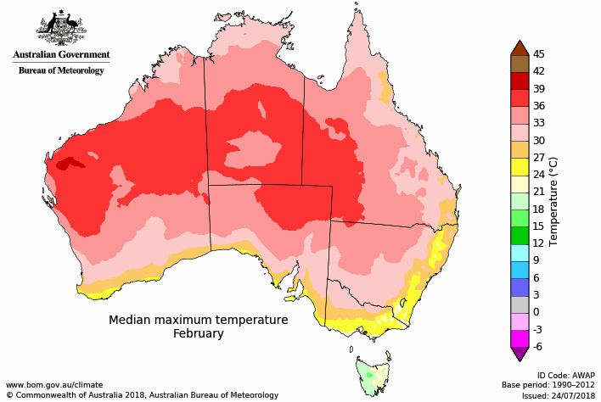
The Commonwealth Grants Commission (CGC) conducted research into the actual costs of placing government employees in remote locations. As with WA State Government figures, the CGC found that costs varied linearly with distance – rather than into just three discrete groups. The CGC also found that placing staff in very remote areas could cost almost double what it cost to place them in cities.
Figure 20 compares the CGC’s estimates of the costs of delivering services in regional, remote and very remote areas with metropolitan areas. It also shows the price loadings that currently apply in the WA NDIS Scheme and in the Commonwealth’s residential and community aged care programs.
Figure 20: Relative Cost of Delivering Services by Remoteness Classification
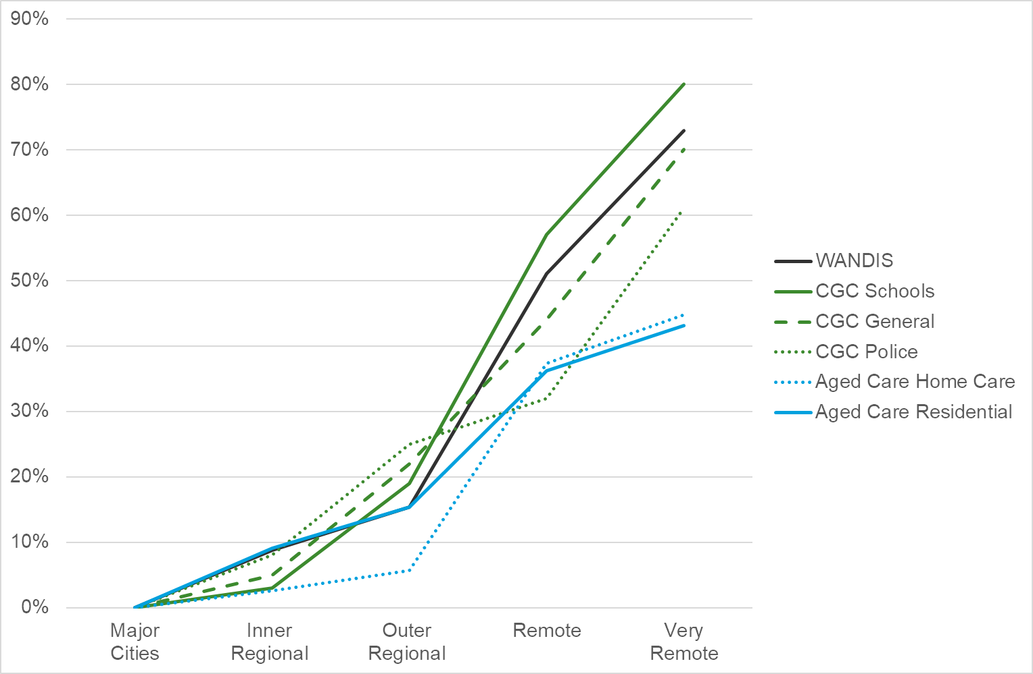
In all cases, these cost loadings are significantly greater than the price limit and plan funding loadings applicable in the NDIS. Because of this evidence, the Review found that the costs of delivering services in remote and very remote areas are significantly higher than in metropolitan areas, and the difference in costs is greater than currently provided for in the NDIS planning and pricing arrangements. The Review also found that the costs of delivering services in regional areas may also be higher than in metropolitan areas, but that further research on the magnitude and significance of this difference was required.
WA Treasury stated in consultations that they were concerned that even the CGC allowances (despite being much higher than the NDIS’s) were generally inadequate for WA. This was because of the truncation of distance impacts, and the lack of recognition of additional costs for very small communities, harsh environments and varying remoteness within the ‘remote’ and ‘very remote’ classifications. They noted that the methods currently assume remote and very remote locations in Tasmania attract the same higher costs as remote and very remote locations in WA.
NDS WA stated in their submission that “An alternative mixed-model funding approach could be trialled in WA that enables providers to access funding in the usual manner based on their initial quotes on a WA pricing guide, but also being given the opportunity to put forward a case and access to top up funding to cover the additional higher costs associated with staff training / retention and travel in many regional, rural and remote communities”.
Similarly, the Western Australian Association for Mental Health urged that the “NDIA urgently extend current initiatives to develop providers in remote areas across all remote WA including through the Market Enablement Framework, extension of ACCO arrangements and close engagement of the psychosocial sector in these developments”.
In the longer-term, more comprehensive benchmarking data is needed to allow the NDIA to monitor the extent to which price limits are impacting on the delivery of services in remote and very remote areas.

Geographic Classification
A significant number of submissions raised concerns with the geographic treatment of some towns located in remote areas, in particular, Kalgoorlie. Kalgoorlie is currently classified as MMM 3, the same classification as Bowral in NSW, which is one and a half hours drive from Sydney and close to other regional centres, as compared to the distance between Kalgoorlie and Perth being six and a half hours, with no other major regional centres in proximity.
The Goldfields Individual and Family Support Association stated in their submission to the Review that “for Kalgoorlie-Boulder to have the same pricing as Metropolitan Perth is grossly inaccurate and unfair”. The combined small and medium providers’ submission observed disparity between Kalgoorlie’s current geographic price limit and plan funding loading and the actual costs they incur to provide services there: “Kalgoorlie is not considered ‘remote or very remote’, yet providers in the areas continue to experience higher costs associated with attracting and retaining staff, travel and transport, or purchase of training due to the location.”
NDS WA recommended that rather than using just distance to the nearest town of a given population size, as used in the MMM, that “the NDIA may wish to rethink the application of regional/remote definitions so that if a town is relatively close to two or three other towns it might be classified as regional, and if it is not near other towns, it could be classified as remote” More particularly, NDS argued that remoteness classification should be based on costs, rather than the other way around as currently done: “NDS regional and remote members strongly advocate that the classification of towns into regional, remote or very remote should be based on WA local evidence, and particularly on the real cost structures in those localities.”
Similarly, providers noted that under WA NDIS, prices were not determined by MMM or any other geographic model (WA NDIS did not use the MMM), but by the State Governments RPI.
The Review examined the Australian Statistical Geography Standard remoteness structure and confirmed that Kalgoorlie and Kambalda are the only towns in WA that are classified as Outer Regional and are surrounded by Remote or Very Remote regions. The Review noted that there were several other similar towns on other parts of Australia, including Broken Hill in New South Wales (see Figure 21).
Figure 21: Towns Surrounded by Remote or Very Remote Regions

Other Issues

Working Capital Issues
The submission, consultation and research processes uncovered evidence of financial sustainability issues in some parts of the WA market. There is evidence of providers withdrawing from lower value services, cross-subsidising services with other, more profitable services and drawing on cash reserves. Submissions raised working capital and cash flow issues that were arising from the shift from being paid in advance under previous arrangements to being paid in arrears under the NDIS. They also argued that these issues were intensified by delays in NDIS processes and payments. However, as these issues are not unique to WA, they were not considered further by the Review.

Claimable Travel Rules
There was also some evidence provided to the Review that the current claimable travel rules may hinder efficient provision of services. Providers in Metropolitan areas and regional centres are permitted to claim for up to 20 minutes travel associated with the delivery of support. Providers in regional areas are permitted to claim for up to 20 minutes travel associated with the delivery of support. For providers in remote and very remote areas travel costs are not price controlled and providers can agree with participants on the cost of travel associated with the delivery of their supports.
The Review found that the lower population density in Perth (relative to some other capital cities) and in regional areas was inhibiting providers from being able to achieve the required scale to be able to operate within the 20 minute claimable travel limit (for Metropolitan areas and regional centres) and the 45 minute claimable travel limit (for regional areas). This issue is not unique to WA, as other cities, for example, Brisbane, and all regional areas may experience the same barriers. These matters were considered further in the 2019-20 Annual Review of Price Controls, which recommended that the claimable travel limits should be increased to 30 minutes for Metropolitan areas and regional centres and to 60 minutes for regional areas. These new arrangements came into effect on 1 July 2019.
The Review noted that the IPR had recommended that:
In very remote/isolated areas, the NDIA should work with other community services and providers to support local workforce development to deliver services in the most efficient way possible. In regions with limited local supply, allow providers to quote on the cost of delivering NDIS services in the short term to ensure supply.
The Review also noted that the NDIA had already implemented this system on a trial basis in the Northern Territory and that further work was underway in respect of rolling out the arrangements across Australia.

Existing Service Delivery Models in WA
The Review was required to examine whether the existing NDIS Support Catalogue, and the price controls and associated rules set out in the NDIS Price Guide can accommodate existing Western Australian service delivery models (including innovative support options).

Findings and Recommendations
Consultations and submissions raised some concerns with the Review that there were a small number of existing service delivery models within WA that may be difficult to deliver within the existing NDIS arrangements:
- Individualised living arrangements;
- Individualised Community Living Strategy; and
- Shared management.
Finding 8: The Review found that there was some evidence of the efficacy of the shared management arrangements that operated within the WA NDIS system and that the possibility of including these arrangements in the NDIS should be further examined.
Finding 9: The Review found that it was unclear how the domestic worker exemption would interact with NDIS arrangements and that further investigation of the issue was warranted.
Recommendation 5: The NDIA should engage with WA participants and providers to determine whether it would be appropriate to allow shared management arrangements within the NDIS, and mechanisms to support the delivery of these arrangements.
Recommendation 6: The NDIA should examine, in consultation with participants, providers and the WA Government, the implications of the WA “domestic worker” exception in the Industrial Relations Act 1979 (WA) for the delivery of disability supports under the NDIS.

Individualised Living Arrangements
Individualised living arrangements aim to support people with disability to live in as natural a home environment as possible of their choice, for example, in a private home should they wish as compared to a residential group home. These arrangements include models such as host family, co-resident, alternative family models and house-sharing with friends or peers. The most common type of these arrangements are shared living arrangements such as host family and co-residency. Host families welcome a person with a disability into their family home on a full-time basis, or for weekends or short breaks. A host family provides support to a person through connection, participation and a mutual sharing of lives. Co-residency is sometimes referred to as an informal carer arrangement; this is where a person chooses to reside with a person with disability and gives regular, ongoing assistance to that person where they may receive some form of benefit in the residential house (e.g. decreased rental payments in exchange for support). There are also host care arrangements, where a child who has resided in a foster care arrangement turns 18 and the foster carers and the individual wish to maintain the living arrangement and the continuity of support. The host carers receive a reimbursement for the care and support they continue to provide, through a Disability Sector Organisation that provides direct support to the living arrangement.
There is evidence that these individualised living arrangements have been found to be effective and that people with disabilities in more individualised living arrangements experience improved quality of life in regards to their overall well-being, sense of belonging to family and friends, and access to the community and community-based supports. This study also found that individualised living arrangements provided by state governments (including WA) have also been found to be cost effective compared to group home living arrangements in regard to the direct housing costs to government agencies, service providers and people with disability, as well as accommodation support and management costs.
The Review noted that NDIA is already working with WA providers to bring individualised living arrangements into the NDIS. In general, it appears that the existing NDIS Support Catalogue, price controls and associated rules set out in the NDIS Price Guide, can accommodate existing WA service delivery models, including innovative support options. However, further market engagement is required to enable this and is already underway.

Individualised Community Living Strategy
The Individualised Community Living Strategy (ICLS) in WA provides individualised support and funding as a contemporary mental health service delivery approach. The ICLS is a partnered approach between the Mental Health Commission, Department of Health, Community Managed Organisations (CMOs), Community Housing Organisations (CHOs) and the Department of Communities. It provides clinical and psychosocial supports and services, in addition to appropriate housing for individuals to maximise their success in recovery and living in the community.
The CMOs’ contracted hourly rate ($75-$90/hour) enables organisations to hire, train and retain a highly skilled and well-qualified workforce, with the capability to practice in ways that promote recovery, as well as relapse and psychiatric crises.
Submission feedback indicated that it is difficult to find skilled DSWs to work with complex mental health clients, and that the skill set required more funding than was available through current NDIS supports.
The Review noted the NDIS was already examining the pricing of psychosocial supports and referred this issue for further consideration as part of that process.

Shared Management
Shared management was a unique feature of the WA NDIS system. Under this arrangement, the provider receives the funding, and the person or their representative engages staff. The person or their representative and the service provider share responsibility for meeting relevant legal obligations. The model focused on choice and control, and is aimed to close the divide between participant and provider managed supports.
The Review found that there was some evidence of the efficacy of the shared management arrangements that operated within the WA NDIS system and that the possibility of including these arrangements in the NDIS should be further examined. This work is already underway.

The WA “Domestic” Worker Exception
There is one aspect of WA industrial legislation (the WA “domestic worker” exception) that is truly unique to the State and that could impact service delivery models. As United Voice pointed out in their submission, the Fair Work Act 2009 (Cth) does not have jurisdiction in WA where an individual directly engages a worker, as the individual is not a constitutional corporation. In these direct employment arrangements, the Industrial Relations Act 1979 (WA) will apply.
However, the definition of “employee” in section 7 of the Industrial Relations Act (WA) specifically excludes a person engaged in domestic service in a private home from being an employee. In practical terms, this exclusion means that workers who are directly engaged by an individual to provide support in their private home are not employees for the purposes of either the state or the national employment systems. This could apply to disability workers directly engaged by participants who are not agency managed, and may mean they are not afforded certain protections.
The Review found that it was unclear how the domestic worker exemption would interact with NDIS arrangements and that further investigation of the issue was warranted. The Review considered that the NDIA should investigate this matter further in consultation with participants, providers and the WA Government.

Transition Costs and Other Issues

Transition Costs
Consultations indicated that some WA providers considered that they faced additional complexity in transitioning to the NDIS because they had previously transitioned to the WA administered NDIS (WA NDIS) and now needed to transfer to the nationally administered NDIS. Providers indicated that there were two significant pain points in this transition: the structural transformation of the disability sector from a heavily regulated model to a market driven ecosystem; and the adaptation to NDIS standards, procedures, systems and administration. Other areas requiring transitional arrangements included the price variations between, and the different approaches of, the WA NDIS and the national NDIS, particularly the flexibility afforded by the former.
WA providers argued that transition costs were higher in WA than other states. In other states and territories, providers started from more or less a ‘clean slate’ under block funding. In WA, providers had complex individual funding systems under WA NDIS and the Disability Services Commission that require a myriad of changes to fit the NDIS system. Further, providers in other states and territories have had up to six years’ experience with various NDIS trials, whereas WA providers effectively have only two years to transition. In their submission, the NDS cited the example of MyPlace, which experienced additional cash costs of managing the transition to NDIS of about $500,000 per annum in the first year of transition. This was forecast to be between $250,000 and $375,000 in second year of transition, and is expected to be between $50,000 and $100,000 recurrent once the full transition has been achieved after the 2019-20 financial year.
In its submission to the Review, the WA Government, based on proposals for funding received by its Department of Communities, noted that there appeared to be significant costs for disability service providers associated with modifying or adapting their organisations to successfully operate in the Australia-wide NDIS. The requests for funding received by the WA Government had included requests for assistance with:
  - Business planning, including support to conduct, or engage a consultant to conduct, an analysis of their strategic and operational plans, supporting policies and procedures to ensure improved operational practices that will result in an increase in business efficiency, effectiveness and service responsiveness in a nationally administered NDIS environment.
  - Systems and software, including funding to develop, purchase and implement software platforms to improve operational efficiency, reduce administrative burden, lower employment costs and interface successfully with NDIS systems.
  - Workforce development, including additional support in developing, recruiting and upskilling a qualified and experienced workforce capable of delivering high quality, complex and culturally appropriate services.
  - Information and innovation, amidst an environment with tight profit margins, organisations are constrained in their ability to invest in initiatives to increase service reach, expand upon client base, and look at innovative business solutions to improve overall financial viability.
However, providers also argued (see above) that the WA sector is more mature than other jurisdictions, having had some form of individualised payments for a quarter of a century, which should, arguably, reduce transition costs compared to other jurisdictions.
On balance, the Review did not consider that the transition costs were greater for WA providers than for providers in other jurisdictions. The Review also noted that funding had made available to providers to support the transition through the WA Government’s Transition Fund and the Commonwealth Government’s NDIS Jobs and Market Fund.

Other Issues
Submissions raised a number of non-WA specific issues:
  - Supported Independent Living (SIL) vacancies;
  - Emergency and contingencies;
  - Provider travel and participant transport vehicle costs;
  - Assistive Technology (AT); and
  - NDIA compliance and process costs.
The Review noted the issues raised by providers. As the issues were not solely related to WA, the Review’s Terms of Reference precluded it from considering them further. The issues were referred for consideration in the 2019-20 Annual Review of Price Controls. The NDIA is currently undertaking further analysis of the issues.

Supported Independent Living Vacancies
A number of providers stated in their submissions to the Review that the WA State Government had previously covered the costs of vacancies in group houses for up to three months (with possible extension) through a centralised State vacancy management system. This was designed to cover identification of possible residents, compatibility issues, planning processes and funding approval processes for the new resident. However, under the NDIS, vacancies are not accounted for in the SIL funding. The NDS submission reported that the absence of specific funding for managing vacancies as part of SIL provision is a significant issue, with some providers reporting total expenses for vacancy costs in the order of $1 million to $2 million a year. NDS called for other arrangements to be put into place, such as a supplementary payment system or a bond, or a loading factored into the benchmark price for vacancy management for complex and regional and remote support services.
Sector consultation revealed that WA providers believed their occupancy rates were further complicated by other factors including participant and house characteristics, house location, and the transition to the NDIS being specifically called out.
The Review acknowledges that vacancies can represent a cost to providers given there may be limited change in a provider’s cost base upon a vacancy occurring as the same level of care is provided to the remaining occupants with no change in the level of funding provided. For example, a SIL provider delivering 24/7 care to a house with two residents with 1:2 SIL funding for each resident has the same cost structure after one of the resident leaves, but has only half the funding until the resident is replaced.
Three main options were identified to address the vacancy concerns:
  - Some providers suggested that the participant who had vacated the house should be required to pay for the vacancy out of their plan. However, this participant may require their plan funds to pay for SIL elsewhere. Also, this approach would not assist in the case of deceased participant as the participant’s plan ceases to exist once they are deceased.
  - Other providers suggested that it might be possible for the NDIS to adjust the plans of existing occupants. This would involve changing the plans of existing occupants when a vacancy arises to compensate for the change in the number of people within the house and, hence, staffing ratios. This is cumbersome and would add significant administrative burden to the NDIA and providers, as well as unnecessary stress and complexity for participants.
  - A third option is to build a vacancy cost into SIL benchmark pricing. This approach would apply an assumed occupancy rate to all SIL quotes, to provide the provider with funding for when vacancies occur. This would ensure the provider has funds available to cover the cost of the vacancy. Occupancy data is not available within the scope of the Review. However, stakeholder feedback has indicated that a rate of 95% may be appropriate outside of the transition period. However, during the transition period, an 85% rate might more appropriate to compensate for the lower occupancy rates experienced during the transition. Occupancy rates can be expected to be lower in remote and very remote areas.
The Review noted the issues raised by providers and that they did not relate solely to WA.

Emergencies and Contingencies
The submission and consultation process also revealed that providers were sometimes providing additional services that are outside of the funding within a participant’s plan in the event of an emergency, or to respond to incidents that occur. In some instances, the provider is not able to recover the cost of providing the additional service from the NDIS.
In their submission to the Review, Rocky Bay suggested, that the Agency, “should consider providing access to emergency funds that are auditable and traceable to an individual, where behavioural incidents or episodes occur that have previously never been observed.” The WA Association for Mental Health suggested that “NDIS could benefit from an ‘out of policy’ committee to support flexible funding decisions based on extenuating circumstances.”
Whilst the provider in most cases needs to apply discretion and limit services that fall outside the plan, the Review acknowledges that there are circumstances where the provider has a duty of care or a mission-driven obligation to assist. The Review noted the issues raised by providers and that they did not relate solely to WA.

Provider Travel and Participant Transport Vehicle Costs
Feedback from submissions and consultations identified there is a current gap in funding relating to provider travel and participant transport. The identified issue relates to the vehicle-related costs that the provider incurs during the travel or transport. Examples of feedback provided in submissions include:
“With the introduction of the NDIS there is no financial assistance for vehicles and with the reduction in the hourly rate, which has also reduced the margin allocated to running costs, it will be near on impossible to maintain a modified vehicle. The financial change is that now organisations will need to find approximately $60,000 per vehicle which is double previous budgeted amount” - Crosslinks
“As separate transport funding is inadequate, providers are being asked to include these costs in the service delivery price. The current cap makes this impossible to include.” - Nulsen
“Under the State system Rocky Bay received funds to modify vehicles to transport customers. The funding for modifications stopped in July 2018 and we are now running our vans to fail instead of refreshing the fleet. At a cost of $1.30 per kilometre (excluding driver wages) Rocky Bay is subsidising transport services.” – Rocky Bay
The Review identified that the provider may use a non-modified or modified vehicle during the course of the service, based on the participant’s needs. The unit cost per kilometre of each of these vehicles varies significantly.
The SCHADS Award requires an employer to reimburse an employee $0.78 per kilometre where the employee uses their own motor vehicle in the course of their duties. This could be used as an estimate of the costs to a provider for the kilometres travelled during the service, noting that providers also have associated overhead costs. A modified vehicle becomes more complicated. Table 11 below shows a range of scenarios pending the underlying cost of the modifications (including related repairs) and vehicle utilisation assumption. These costs are only indicative and market data is required to establish an appropriate price control.
Table 11: Recovery Costs for Modified Vehicles
Modification related expenditure: | $20,000 | $30,000 | $40,000 | $50,000
KM/Year
10,000 | $1.61 | $1.81 | $2.01 | $2.21
11,000 | $1.48 | $1.66 | $1.85 | $2.03
12,000 | $1.38 | $1.55 | $1.71 | $1.88
13,000 | $1.29 | $1.44 | $1.60 | $1.75
14,000 | $1.22 | $1.36 | $1.50 | $1.64
15,000 | $1.15 | $1.28 | $1.42 | $1.55
Note: Cost per km has been modelled based on publically available running costs provided by RACQ, RACWA and RAA. Costs derived are only indicative and market data is required to establish a more accurate cost.
The Review noted the issues raised by providers and that they did not relate solely to WA.

Assistive Technology
Under the NDIS, participants may be funded for Assistive Technology (AT) as part of their plans. The funding is individualised, where many items are ‘quotable’ meaning providers negotiate a price with a participant, written in a service agreement and provide a written quote for that AT support. AT can be categorised as follows:
- Assistive products for household tasks
- Assistive products for personal care and safety
- Community and information equipment
- Assistive products for vision
- Personal mobility equipment
- Vehicle modifications
- Assistive equipment for recreation
The consultation process unveiled a potential inefficiency in the current model. At present, the individualisation of AT-related items is driving the purchasing of new equipment for the reasonable and necessary needs of the participant. However, there is a potential for subsequent waste of equipment if the participant no longer has a purpose for it or the provider is unable to find a participant for a specific piece of AT. This issue is driven by there being no clear ownership over the piece of AT and therefore neither the participant nor the provider are in a position to sell the item. Additionally, Rocky Bay raised the following concerns:
  - The availability of sufficient funds in a participant’s plan to access emergency equipment requirements, or undertake urgent repairs;
  - Participant safety being compromised with there being no oversight or maintenance schedule for equipment; and
  - Additional cost and delays associated with equipment being delivered to WA.
It is understood that the AT market in WA is currently dominated by two or three providers who collectively hold an estimated 80% of the market share. The Review’s Advisory Group suggested a pilot occurring in WA trialling a leasing function to address the concerns raised. The Review noted the issues raised by providers and that they did not relate solely to WA.

NDIA Compliance and Process Costs
Some submissions to the Review by providers indicated that the complexities, delays and inconsistencies of dealing with NDIS systems were adding to the costs of delivering NDIS supports. NDS (WA) similarly argued that there are significant costs to providers associated with poor interactions with NDIS systems and processes that are not recognised in the current price control regime and that NDIS systems and processes are a source of ongoing frustration, inefficiency, and expense for providers. The NDS State of the Sector Report 2018 reported that 60% of providers found that NDIS systems and processes were not working well. Fixing the NDIS participant pathways and portal was rated the third highest priority by providers for the government to action, which would have the greatest positive impact on their organisation’s capacity to deliver good services in the next year. These issues, it was argued, translated to an increased need for administrative staff, and thus an additional unfunded administrative burden for providers. The Review noted the issues raised by providers and that they did not relate solely to WA.

Appendix A: Conduct of the Review
An Advisory Group, which met five times (19 December 2018, 22 January 2019, 27 February 2019, 16 April 2019 and 21 May 2019), was established with senior representatives from eleven (11) providers and National Disability Services (NDS) WA.
Table 12 provides details of the members of the Advisory Group and the organisations they represented, including in terms of their profit status, their size (annual turnover) and whether they operated other than in WA.
Table 12: Members of the Advisory Group
Org type | Name | Profit status | Size | Turnover | Regional Service | Other states
Provider | Stephanie Syme  Activ Foundation | NFP | Large | $102m | Y | N
Provider | Darren Cutri  Ability Centre | NFP | Large | $69m | Y | N
Provider | Nicola Abernethy  Autism Association of WA | NFP | Large | $59m | N | N
Provider | Lynsey McDonnell  Avivo | NFP | Large | $70m | Y | N
Provider | Frances Buchanan  WA Blue Sky | NFP | Small | $4m | N | N
Provider | Simone Kauffman  Crosslinks | NFP | Medium | $13m | Y | N
Provider | Robert Hicks  The Goldfields Individual and Family Support Association (GIFSA) | NFP | Medium | $7m | Y | N
Provider | Angel Yong  Mosaic Community Care | NFP | Medium | $17m | N | N
Provider | Bruce Land  My Place | NFP | Large | $44m | Y | N
Provider | Graham Holman  Nulsen Group – Nulsen Disability Services | NFP | Large | $50m | N | N
Provider | Adam Maxwell  Rocky Bay | NFP | Large | $70m | Y | N
Association | Julie Waylen  NDS WA | N/A | N/A | N/A | N/A | N/A
A total of thirty-two (32) submissions were received from participants, providers, government and other organisations, as set out in Table 13.
Table 13: Submissions
Org type | Name | Profit status | Size | Turnover | Regional Service | Other states
Provider | Activ Foundation | NFP | Large | $102m | Y | N
Provider | Agape Care | For profit | N/A | N/A | N | N
Provider | Autism Association of WA | NFP | Large | $59m | N | N
Provider | Avivo | NFP | Large | $70m | Y | N
Provider | Brightwater | NFP | Large | $152m | N | N
Provider | Community Vision | NFP | Medium | $8.5m | Y | N
Provider | Crosslinks | NFP | Medium | $13m | Y | N
Provider | Development Disability WA | NFP | Small | $0.9m | N/A | N
Provider | Enable WA | NFP | Medium | $17m | Y | N
Provider | Early Start | For profit | N/A | N/A | N/A | Y
Provider | The Goldfields Individual and Family Support Association (GIFSA) | NFP | Medium | $7m | Y | N
Provider | Identitywa | NFP | Large | $35m | N/A | N
Provider | Morrissey Homestead | NFP | Small | $2m | Y | N
Provider | Mosaic Community Care | NFP | Medium | $17m | N | N
Provider | My Place | NFP | Large | $44m | Y | N
Provider | Nulsen Group – Nulsen Disability Services | NFP | Large | $50m | N | N
Provider | Rise Network | NFP | Large | $46m | N | N
Provider | Rocky Bay | NFP | Large | $70m | Y | N
Provider | Technology for Ageing & Disability WA | NFP | Medium | $7m | Y | N
Provider | WA’s Individualised Services | NFP | Small | $4m | Y | N
Provider | Confidential | NFP | Large | $20m | Y | N
Association | Carers WA | NFP | Small | $5m | Y | N
Association | Chamber of Commerce and Industry WA | N/A | N/A | N/A | N/A | N
Association | National Disability Services | N/A | N/A | N/A | N/A | N/A
Association | Small and Medium providers’ Submission | N/A | Small & Medium | N/A | Y | N
Association | WA Association for Mental Health | N/A | N/A | N/A | N/A | N
Government | Kyran O’Donnell (MP) on behalf of The Goldfields Individual and Family Support Association | NFP | Medium | $7m | Y | N
Government | Confidential | N/A | N/A | N/A | N/A | N
Union | United Voice | N/A | N/A | N/A | N/A | Y
Participant | Mrs Minutillo | N/A | N/A | N/A | N/A | N/A
Participant | Mrs Davies | N/A | N/A | N/A | N/A | N/A
Participant | Confidential | N/A | N/A | N/A | N/A | N/A
As noted above, a group Submission was received from thirteen (13) small and medium providers, as set out in Table 14.
Table 14: Small and Medium Provider Joint Submission
Org type | Name | Profit status | Size | Turnover | Regional Service | Other states
Provider | Access Plus – WA Deaf | NFP | Small | $2m | N | N
Provider | Cahoots | NFP | Small | $0.9m | N | N
Provider | Connecting Communities | NFP | N/A | N/A | N | N
Provider | Diversity South | NFP | Medium | $9m | Y | N
Provider | Family Support Association | NFP | Small | $5m | N | N
Provider | Future Living | NFP | Small | $0.5m | N | N
Provider | Helping Minds | NFP | Medium | $8m | N | N
Provider | Independent Living Centre WA | NFP | Medium | $14m | Y | N
Provider | Kids are Kids | NFP | Small | $2m | Y | N
Provider | Nascha | NFP | Small | $3m | N | N
Provider | One2One | For Profit | N/A | N/A | Y | N
Provider | Valued Lives | NFP | Small | $5m | N | N
Provider | WA Blue Sky | NFP | Small | $4m | N | N
Twenty (20) meetings were also held with WA Government Departments, providers and other bodies as set out in Table 15.
Table 15: Meetings with Organisations
Org type | Name | Date of consultation
Provider | Therapy Focus | 19 December 2018
Association | Chamber of Commerce and Industry WA | 19 December 2018
Provider | WA Individualised Services (WAiS) | 19 December 2018
Government | Department of Communities | 21 January 2019
Government | WA Treasury | 21 January 2019
Government | WA Country Health Service | 21 January 2019
Government | Department of Primary Industries and Regional Development | 6 February 2019
Provider | Rocky Bay Disability Services | 12 February 2019
Provider | Intelife | 12 February 2019
Government | Australian Bureau of Statistics | 25 February 2019
Provider/Participant | WA Government NDIS Transition Governance Advisory Group | 27 February 2019
Government | Department of Health – HACC Program | 12 March 2019
Government | Department of Communities | 12 March 2019
Government | Department of Health | 27 March 2019
Provider | Ability Centre | 29 March 2019
Association | WA Association for Mental Health | 26 March 2019
Provider | Kimberley Aboriginal Medical Services (KAMS) | 26 March 2019
Provider | Patches Paediatrics & Therapy Services | 26 March 2019
Provider | Ngaanyatjarra Health Service | 26 March 2019
Association | Council of Regional Disability Services  - Far North Community Services  - Goldfields Individual & Family Support Association  - Accessability  - Midwest Community Living Association  - Empowering People In Communities  - ATLAS  - Anglicare WA  - Community Living Association (Great Southern)  - Senses  - CHORUS | 13 May 2019

McKinsey & Company. (2018). Independent Pricing Review, Report for the National Disability Insurance Agency. www.ndis.gov.au/media/359/download
www.legislation.gov.au/Details/C2018C00276
providertoolkit.ndis.gov.au/key-resources
www.ndis.gov.au/providers/price-guides-and-information
www.health.gov.au/health-workforce/health-workforce-classifications/modified-monash-model
www.health.gov.au/resources/apps-and-tools/health-workforce-locator/health-workforce-locator#hwc-map
http://www8.austlii.edu.au/cgi-bin/viewdoc/au/legis/cth/consol_act/antsasta1999402/s38.38.html
NDIA. (2019). Report to the COAG Disability Reform Council for Q4 of Y6 Full report, pp.236-37. www.ndis.gov.au/media/1611/download
Ibid. pp. 98, 112, 233, 249.
Ibid. pp. 101, 237.
Pash, C. (2014). How Australia's Mining Boom Changed Perth And Its People. Business Insider Australia, 31 Mach 2014. www.businessinsider.com.au/the-transformation-of-the-west-how-australias-mining-boom-changed-perth-and-its-people-2014-3
blcw.dss.gov.au/
Gilchrist D and Knight P. (2017). Australia's Disability Services Sector 2017: Report 2 - Financial Performance - Summary of Key Findings. National Disability Services.
National Disability Services. (2018). Australian Disability Workforce Report. (3rd edition)
Fair Work Commission. www.fwc.gov.au/awards-and-agreements/agreements
WA Industrial Relations Commission. www.wairc.wa.gov.au/index.php/en/Agreements
www.dss.gov.au/our-responsibilities/communities-and-vulnerable-people/grants-funding/fair-pay-for-social-and-community-services-workers/sacs-funding-supplementation-frequently-asked-questions
This also includes the annual leave available for workers who are required to be available to work on any public holiday.
These are weighted based on EBAs from Cerebral Palsy, Activ Foundation, Brightwater Care Group, Neami Limited, Nulsen Haven Association, Autism Association, and Rocky Bay. Nulsen Haven Association and Autism Association do not have penalty rates available for afternoon and evening loadings.
The SCHADS Award rate used for comparison is from social and community services employee level 2.3.
AbleInsight. (2019). Sector Summary Report – Benchmarking Survey Collection 3. www.surveymanager.ableinsight.com.au/media
National Disability Services. (2018). Australian Disability Services Workforce Report 3rd Edition.
AbleInsight. op. cit.
Department of Foreign Affairs and Trade. (2019). Australia’s trade by state and territory 2017-18. https://dfat.gov.au/about-us/publications/Documents/australias-trade-by-state-and-territory-2017-18.pdf
www.numbeo.com/cost-of-living/country_result.jsp?country=Australia
www.carsales.com.au/editorial/details/top-10-selling-vehicles-of-2018-116216/
www.numbeo.com/cost-of-living/country_result.jsp?country=Australia
www.carsguide.com.au/car-advice/q-and-a/where-are-toyota-corollas-made-68074
ABS. (2018). Consumer Price Index, Australia, Dec 2018. Cat no 6401.0
ABS. (2018). Consumer Price Index, Australia, Dec 2018.Cat no 6401.0.
www.corelogic.com.au/news/real-home-values-are-falling-across-most-capital-cities
Safe Work Australia: www.safeworkaustralia.gov.au/workers-compensation/comparing-workers-compensation-scheme-performance
Restrictive practices involve the use of interventions and practices that have the effect of restricting the rights or freedom of movement of a person with disability. These primarily include restraint (chemical, mechanical, social or physical) and seclusion.
McKinsey & Company. (2018). Op. cit.
www.icwa.wa.gov.au/motor-injury-insurance/product-information/catastrophic-injuries-support
Workcover WA. (2018). Service Status Report 2017/18. www.workcover.wa.gov.au/wp-content/uploads/2018/10/Service-Status-Report-2017-18-BISstatrep.pdf
Represents a simple average, only to be used for illustrative purposes.
NDIA. (2019). NDIS Price Guide, Australian Capital Territory, Northern Territory, South Australia, WA – Valid from 1 February 2019
NDIA. (2019). NDIS Price Guide, Remote – Valid from 1 February 2019
NDIA. (2019). NDIS Price Guide, Very Remote – Valid from 1 February 2019
Government of WA. Department of Communities. Disability Services. (2018). Perth Metropolitan: Support Clusters and Price Framework for Disability Service. www.disability.wa.gov.au/disability-service-providers-/for-disability-service-providers/pricing-arrangements/
Range taken from regional framework documents including: Great Southern, Goldfields Esperance, Kimberly Support, Midwest Gascoyne, Pilbara, South West, Wheatbelt. www.disability.wa.gov.au/disability-service-providers-/for-disability-service-providers/pricing-arrangements/
www.abs.gov.au/websitedbs/D3310114.nsf/Home/2016%20QuickStats
ABS. (2019). Regional Population Growth, Australia, 2018-18, Cat No 3218.0
WA Government. (2018). Submission to Commonwealth Grants Commission 2020 Methodology Review. www.treasury.wa.gov.au/uploadedFiles/_Treasury/Publications/WA-Submission-CGC-2020-Methodology-Review-October2018.pdf
Australian Competition and Consumer Commission (2018) Northern Australia Insurance Inquiry: First interim report.
Australian Competition and Consumer Commission, www.accc.gov.au/media-release/northern-australian-insurance-needs-immediate-action.
WA Department of Primary Industries and Regional Development. (2017). Regional Price Index.
Spandonide, B. (2014). Transport systems in remote Australia: Transport costs in remote communities, CRC-REP Working Paper CW017. Ninti One Limited, Alice Springs. apo.org.au/sites/default/files/resource-files/2014/06/apo-nid73684-1210746.pdf
Bureau of Meteorology. (2019). Median maximum temperature, February. www.bom.gov.au/jsp/sco/archive/index.jsp?map=tmax&outlook=climatology&period=month1&y=2019&m=1&d=17
Commonwealth Grants Commission. (2015). Report on GST Revenue Sharing Relativities 2015 Review – Volume 2 – Assessment of State Fiscal Capacities.
Costs were estimated by applying a regional cost scale based on schools and police data (the only comparable data across states and territories available when they were developed). The schools regional costs scale was developed from Australian Curriculum, Assessment and Reporting Authority data. The police regional costs scale was developed from state-provided police data, from a 2007-08 data request. A general regional cost scale is derived from the average of the schools and police scales, which is then discounted 25% due to uncertainty with its fit to other service delivery areas. The data have not been updated as the CGC considers that relative costs between states are unlikely to have significantly changed and the previous data request was a significant burden on states.
Kambalda, around 60 kilometres from Kalgoorlie, also shares this anomalous classification, because of its proximity to Kalgoorlie.
McKinsey & Company. (2018). Op. cit. Recommendation 3.
National Disability Services. (2018). State of the Disability Sector Report 2018. Available at: www.nds.org.au .

