
Review of Therapy Pricing Arrangements

National Disability Insurance Agency

March 2019
Copyright
Copyright of the information contained in this document is owned and protected by the National Disability Insurance Scheme Launch Transition Agency (National Disability Insurance Agency).

Use of National Disability Insurance Agency copyright material
The material in this report, with the exception of logos, trademarks, third party material and other content as specified, is licensed under Creative Commons CC NC licence, version 3.0. With the exception of logos, trademarks, third party material and other content as specified, you may reproduce the material in this document, provided you acknowledge the National Disability Insurance Agency as the owner of all intellectual property rights in the reproduced material by using ‘© National Disability Insurance Scheme Launch Transition Agency 2019’ and do not use the material for commercial purposes.
Reproduction of any Creative Commons material in this document is subject to the CC NC licence conditions available on the Creative Commons site, as is the full legal code for this material.

Terms that we use
NDIA | National Disability Insurance Agency
NDIS, Scheme | National Disability Insurance Scheme
NDIS Commission | National Disability Insurance Scheme Quality and Safeguards Commission

Contents
List of Exhibits 5
List of Tables 6
Executive summary 7
Context and background 7
Findings on market conditions 10
Findings from sector consultation 10
Findings from therapy benchmarking 12
Findings from therapy assistant benchmarking 14
Price-related recommendations 14
Other recommendations 22
1 Context and background 23
1.1 Introduction 23
1.2 Scope of therapy services under review 25
2 Market conditions for therapy 27
2.1 The national market for therapy services 27
2.2 Development of the NDIS therapy market 28
3 Sector consultation 31
3.1 Methodology 31
3.2 Findings 33
3.3 Other issues raised 41
4 Therapy benchmarking 43
4.1 Comparable insurance schemes 43
4.2 Private billing benchmarking 46
4.3 Benchmarking of awards/EBAs and bottom-up cost estimates 56
5 Therapy assistant benchmarking 60
5.1 Methodology 60
5.2 Findings 60
6 Price-related recommendations 65
6.1 Principles and the role of price caps 65
6.2 Differentiation by therapy type (or therapy profession) 69
6.3 Differentiation by type of service or therapist experience 74
6.4 Therapy Assistants 79
6.5 Payment and support catalogue recommendations 81
7 Other recommendations 84
7.1 Pricing transparency and education 84
7.2 Potential new costs being faced by providers 85
7.3 Implementation considerations 86
Appendix 87
Additional information and supplementary exhibits on Private billing benchmarking 87
Private billing benchmarking: analysis of the 2012–18 database 87
Health Professionals And Support Services Award [MA000027] 97
Additional details on general and endorsed psychologists 98
Glossary and Abbreviations 99

List of Exhibits
Exhibit 1: Overview of allied health services in Australia 27
Exhibit 2: Overview of registered allied health professionals in Australia 28
Exhibit 3: Therapy Providers: Growth from 2016, and Density, by state, 2018 29
Exhibit 4: Market concentration in NDIS therapy supports 29
Exhibit 5: Price distribution of NDIS therapy claims 30
Exhibit 6: Price distribution of therapy claims by state 30
Exhibit 7: Standard consultation rates by therapy type by insurance scheme 45
Exhibit 8: Average billing rates: by therapy type 49
Exhibit 9: Average billing rates: clinical and non-clinical psychology 50
Exhibit 10: Average billing rate: standard and initial consultations 51
Exhibit 11: Average billing rates: in-centre and in-community consultations 52
Exhibit 12: Average billing rates: standard in-centre consultations and non-direct services 52
Exhibit 13: Average billing rates: standard in-centre consultations by state 53
Exhibit 14: Distribution of billing rates: psychology and other therapies 55
Exhibit 15: Cumulative frequency chart for therapy billing rates (excluding psychology) 55
Exhibit 16: Comparison of rates for therapy assistants from comparable insurance schemes and private billing benchmarks 61
Exhibit 17: Minimum and maximum therapy assistant wage rates from the national award and different state government and provider EBAs 63
Exhibit 18: Estimated bottom-up cost rates for therapy assistants 64
Exhibit 19: Distribution of private billing rates for psychology and all other therapies 87
Exhibit 20: Average price per hour for standard in-clinic consultations by therapy type (2012 to 2018 database) 90
Exhibit 21: Average price per hour for in-clinic standard and initial consultations (2012 to 2018 database) 91
Exhibit 22: Average price per hour for in-clinic and in-community consultations (2012 to 2018 database) 92
Exhibit 23: Average price per hour for standard in-clinic consultations and non-direct supports (2012 to 2018 database) 92
Exhibit 24: Average price per hour for standard in-clinic consultations by state (2012 to 2018 database) 93
Exhibit 25: Distribution of standard in-clinic consultation rates for psychology and other therapies (2012 to 2018 database) 94
Exhibit 26: Distribution of Occupational therapy rates 94
Exhibit 27: Distribution of Speech pathology rates 95
Exhibit 28: Distribution of psychology rates (not including clinical psychology rates) 95
Exhibit 29: Distribution of physiotherapy rates 96
Exhibit 30: Distribution of rates for other therapies 96

List of Tables
Table 1: Registration groups and support items for therapy services 7
Table 2: Registration groups and support items for therapy services 26
Table 3: Size of NDIS Therapy markets 28
Table 4: List of organisations consulted during the therapy review 31
Table 5: Findings from NDS survey on workforce challenges 35
Table 6: Comparison of NDIS price caps versus prices in other schemes 46
Table 7: Distribution of 2018 private billing database by type therapy by state 48
Table 8: Distribution of 2018 private billing database by type therapy by state (standard in-centre consultations only) 48
Table 9: Average duration of private billing consultations by therapy type 49
Table 10: Price distribution by therapy type and jurisdiction 54
Table 11: Levels and wage rates for therapists under awards and EBAs 57
Table 12: Estimated bottom-up cost rates for therapy by compensation scheme and efficiency scenario 59
Table 13: Victorian framework for allied health assistants (AHA) 62
Table 14: Rationales for setting therapy price caps at various points of the private market distribution 68
Table 15: Illustrative pricing structure for therapy assistants 80
Table 16: Distribution of data points from the entire benchmarking database by therapy type and state (2012 to 2018 database) 89
Table 17: Distribution of standard in-clinic consultation rates by therapy type and state (2012 to 2018 database) 89
Table 18: Health professionals and support services award 97
Table 19: Number of endorsements held 98

Executive summary

Context and Background
The National Disability Insurance Scheme (NDIS) has been established to support people with disability to achieve their goals, to help them to realise their full potential, to participate in and contribute to society, and to exercise choice and control over their lives and futures.
Therapy services are among the crucial supports available to NDIS participants. In the NDIS, therapists (including nurses) deliver supports under five provider registration groups:
- Therapeutic Supports
- Early Intervention Supports for Early Childhood (Early Childhood Supports)
- Specialist Positive Behaviour Support
- Community Nursing Care
- Custom Prostheses and Orthoses
As Table 1 shows, eighteen (18) support items are delivered by therapists (including nurses) in the NDIS.
Table 1: Registration Groups And Support Items For Therapy Services
Support Category | Registration Group | Support Item | 2018-19 Price Limit
Finding and keeping a job | Therapeutic Supports | Employment Related Assessment and Counselling | $182.74
Improved daily living skills | Community Nursing Care | Individual Assessment And Support By A Nurse | $97.78
Improved daily living skills | Community Nursing Care | Community Nursing Care For Continence Aid | $97.78
Improved daily living skills | Custom Prostheses and Orthoses | Selection and/or manufacturing of customised or wearable technology. | $164.91
Improved daily living skills | Early Childhood Support | Specialised Group Early Childhood Interventions – Maximum Group of Four | $60.92
Improved daily living skills | Early Childhood Support | Capacity Building Supports for Early Childhood | $182.74
Improved daily living skills | Early Childhood Support | Transdisciplinary Early Childhood Intervention | None
Improved daily living skills | Therapeutic Supports | Counselling Group – Group of Three | $50.98
Improved daily living skills | Therapeutic Supports | Individual Counselling | $152.95
Improved daily living skills | Therapeutic Supports | Group Therapy – Group of Three | $59.76
Improved daily living skills | Therapeutic Supports | Community Engagement Assistance | $42.59
Improved daily living skills | Therapeutic Supports | Individual Assessment, Therapy and/or Training (Includes Assistive Technology) | $179.26
Improved daily living skills | Therapeutic Supports | Multidisciplinary Team | None
Improved daily living skills | Therapeutic Supports | Therapy Assistants  (Level 1) | $45.66
Improved health and wellbeing | Therapeutic Supports | Dietician Consultation and Diet Plan Development | $182.74
Improved health and wellbeing | Therapeutic Supports | Dietician Group Session – Group of 3 | $60.92
Improved relationships | Specialist Positive Behaviour Support | Specialist Behavioural Intervention Support | $200.58
Improved relationships | Specialist Positive Behaviour Support | Behaviour Management Plan Incl. Training in Behaviour Management Strategies | $182.74
The National Disability Insurance Agency (NDIA) sets price caps for certain NDIS supports to ensure that NDIS participants obtain reasonable value from their support packages.
In June 2017, the NDIA Board engaged McKinsey & Company to undertake an Independent Pricing Review (IPR). The final IPR report, which was delivered to the NDIA on 14 February 2018, contained 25 recommendations. Recommendations 17 to 21 directly related to therapy services. IPR Recommendations 19 to 21 were implemented on 1 July 2018.
Following the release of the IPR’s recommendations, therapy providers raised a number of concerns about the proposed approach, including whether the proposed arrangements were appropriate for remote and very remote areas and for all types of therapy. To address these concerns, the Board of the NDIA has requested that the NDIA undertake a comprehensive review of the price cap arrangements and other market settings for therapy services. This required the acquisition of significant additional data.
The Review of Therapy Pricing Arrangements (‘the Therapy Review’) was asked to examine, through research and consultation with industry, community and government stakeholders, whether existing price controls and other market settings under the NDIS, including the recommendations of the IPR, are appropriate in relation to therapy services or should be modified. In particular, the Therapy Review was asked to:
- examine the nature of the market for therapy services, including the extent to which the market is made up of distinct segments, including in thin and undersupplied markets and in regional and remote areas;
- undertake detailed benchmarking for both therapy supports and therapy assistants versus both relevant comparable schemes and private mainstream markets;
- examine the extent of competition in the market for therapy services, and whether segments of the therapy services market are ready to trial price deregulation; and
- make recommendations on:
  - the appropriate price control arrangements for therapy services in the NDIS;
  - options to encourage the development of innovative support offerings by providers of therapy services in the NDIS; and
  - market interventions, other than price caps, that may have positive impacts on the market for therapy services in the NDIS.
In framing its recommendations, the Therapy Review was required to be cognisant of the objectives and principles of the NDIS, as set out in the National Disability Insurance Scheme Act 2013, including that the NDIS should:
- support the independence and social and economic participation of people with disability;
- enable people with disability to exercise choice and control in the pursuit of their goals and the planning and delivery of their supports;
- facilitate the development of a nationally consistent approach to the access to, and the planning and funding of, supports for people with disability;
- promote the provision of high quality and innovative supports that enable people with disability to maximise independent lifestyles and full inclusion in the community;
- adopt an insurance-based approach, informed by actuarial analysis, to the provision and funding of supports for people with disability; and
- be financially sustainable.
The Therapy Review commenced in December 2018. A total of 29 consultation meetings were conducted across Australia, covering 52 organisations and over 125 individuals. Some 32 submissions were also received from the sector. Detailed additional benchmarking information and other evidence was also gathered and analysed to better understand the factors influencing the cost and price of therapy services in Australia.
- Comparable insurance schemes: Following the IPR recommendation to differentiate price levels based on comparable schemes, price structures and price levels from seven comparable insurance schemes from across Australia were analysed and benchmarked. In addition, detailed consultations were conducted with three schemes: the Victorian Transport Accident Commission, ComCare and iCare NSW.
- Private billing rates for therapy (2018): To test whether participants are getting value for money, and to understand price levels for comparable alternative supports, private billing data on therapy services from around Australia were benchmarked, collecting 2,293 unique 2018 price points.
- Awards and EBAs: To understand wage factors, which typically account for 70–80 per cent of the cost of delivering therapy supports, nine allied health professional award structures and salary levels from around Australia were benchmarked, as well as 48 different provider EBAs.
- Bottom-up cost analysis: Bottom-up cost models were also built to understand the potential benchmark efficient price for delivering an hour of therapy by a registered therapist and by a therapy assistant.
This Report sets out the findings and recommendation of the Therapy Review.

Findings On Market Conditions
Finding 2.1: The NDIS accounts for an estimated 2.4 per cent of Australia’s established national therapy market, suggesting that it has limited capacity to influence market prices for therapy services and is instead a “price taker”.
Finding 2.2: There are early signs of some competition in the therapy market.
- The number of NDIS registered therapy providers has grown rapidly, from 1,917 in September 2016 to 8,200 in June 2018.
- The market share of the largest therapy providers has declined significantly over the last five years, from 34 per cent in 2013-14 to 25 per cent in 2017-18.
- In addition, around 30 per cent of claims are estimated to have been charged below the price cap in 2017–18. This suggests greater competition in therapy services than in other areas of the NDIS, as the distribution of claims in therapy services is more variable than in attendant care supports, where a larger share of providers are charging at the price cap.

Findings From Sector Consultation
Finding 3.1: While there is no conclusive evidence of supply shortages, there was large variation in reported provider financial performance. The majority reported financial losses or were just breaking even and were strongly opposed to any price reduction. A minority reported healthy or sustainable margins.
- Commonly cited drivers of financial operating losses included low billable hours for therapists, as well as a significant increase in administrative costs during the transition to the NDIS.
- However, a minority of providers reported that their business was sustainable under current price caps. One provider confidently asserted that they believe it is possible for an efficient provider to make large margins under the current price caps.
- Most providers indicated that they were struggling to recruit and retain qualified workers and that, as a result, they were finding it difficult to keep up with the growing demand for therapy services.
Finding 3.2: Providers reported that they are carrying some additional costs that they do not believe can be fully recovered under the current price caps—for example, induction costs for new workers entering the growing disability segment of therapy.
Finding 3.3: Consultations revealed broad support for a more differentiated set of therapeutic support line items in the price catalogue (independent of any differentiation in actual price caps) to better reflect the diverse nature of therapy supports offered under the NDIS, with some caveats.
- The sector agreed that greater differentiation in the price catalogue would be valuable for the following purposes: (1) data collection and planning, including developing more granular insights into participant demand for various services; (2) transparency in billing and invoicing; (3) appropriately recognising the value of (and legitimacy of billing for) less well-known services, especially non-direct services; and (4) educating participants, their carers and planners on the full range of available therapy supports.
- In particular, there was support for: (1) differentiating the price catalogue by type of therapy profession; and (2) adding a separate support item for non-direct services.
- This support came with major caveats, however, including: (1) being mindful of the administrative burden that a longer price catalogue may impose, including whether the NDIS payment portal has the capacity to handle a greater volume of items; (2) ensuring that greater differentiation in the price catalogue does not result in less flexibility in how support packages are expended (for example, by prescribing or locking certain line items in the package); and (3) ensuring that the catalogue is participant-centred and remains flexible enough to support best practice.
Finding 3.4: Consultations revealed a general aversion to differentiated price caps for therapy services, although there were mixed views in some areas.
- Finding 3.4.1 – Current pricing behaviour: The majority of providers reported that they do not currently differentiate prices for therapy services, and that they charge at the NDIS price cap for all therapy services.
- Finding 3.4.2 – Therapy type (non-psychology): The majority of providers did not support price differentiation based on type of therapy because identical wage rates in most enterprise bargaining agreements (EBAs) and awards mean that input costs do not vary by type of therapy.
- Finding 3.4.3 – Therapy type (psychology): Providers noted that while most EBAs and awards do not differentiate by therapy type, average rates for psychologists tend to be higher in practice due to a supply shortage. Some providers also noted that market prices for clinical psychologists are higher still, reflecting higher price caps in many government schemes. For example, the Medicare Benefits Scheme rebate for clinical psychologists is higher (by around $40 per hour) than for other psychologists.
- Finding 3.4.4 – Therapy type (behaviour support): Providers noted that behaviour supports are delivered by psychologists or other highly trained behavioural specialists, who are often paid at the highest rate. They also highlighted that registration for behavioural supports imposes an additional administrative burden and additional expenses (compared to therapy services), which should be reflected in a higher rate.
- Finding 3.4.5 – Direct versus non-direct services: There was strong consensus that price caps for non-direct services should be the same as for direct services, as these services are of equal value and the time cost of the therapist is the same.
- Finding 3.4.6 – In-centre versus in-community services: There were mixed views on whether price caps should be differentiated for in-centre therapy services and in-community therapy services. Some providers argued that in-community services, which they believe align with best practice, involve higher costs and are currently being disincentivised under the NDIS. Other providers argued that in-centre services are just as costly to provide, once upfront fixed costs and rent have been factored into the hourly rate. Ultimately, no conclusive evidence was provided to demonstrate that in-community services have higher administrative costs.
- Finding 3.4.7 – Initial consultations versus standard consultations: There was broad consensus that initial consultations require more time (for example, for report writing or working as part of a multidisciplinary team). However, there was also consensus that this could be managed within existing price arrangements (i.e., the time-based price cap and separate billing for non-direct services).
- Finding 3.4.8 – Therapist’s level of experience: In principle, there was support for differentiating price caps based on the therapist’s level of experience, but there was also strong scepticism that this could be implemented in practice, given the absence of a standard industry award.
- Finding 3.4.9 – Remote versus non-remote services: Providers operating in remote and very remote areas noted the higher costs associated with delivering services in these areas due to: (1) the thinness of the market, resulting in unpredictable demand; (2) the need for higher wages to attract therapists; and (3) longer travel times.
- Finding 3.4.10 – After-hours services: Some providers noted that there is growing demand for after-hours services and proposed a differentiated weekend or after-hours rate to account for higher wages paid at these times under EBAs.
Finding 3.5: Consultations revealed variable but declining use of therapy assistants by providers, due to the current low price cap. There is overwhelming support for introducing a higher price cap tier for more qualified therapy assistants.
Finding 3.6: Consultations revealed mixed views on when the NDIS therapy segment may be ready for price deregulation. The majority of participants indicated that more time was needed, given that most providers are still transitioning to the NDIS.

Findings from Therapy Benchmarking

Findings from comparable insurance schemes
Finding 4.1: The majority of comparable insurance schemes appear to base prices on prevailing market rates.
Finding 4.2: Unlike the NDIS, the majority of comparable insurance schemes do not appear to set price caps. Instead, they set reference prices that form the basis for negotiation with providers.
Finding 4.3: Unlike the NDIS, the majority of comparable insurance schemes have separate line items in their price catalogue based on the type of: (1) therapy; and (2) service.
Finding 4.4: The majority of comparable insurance schemes do not have separate line items in their price catalogue based on: (1) complexity of participant; (2) therapist experience levels; or (3) geography.
Finding 4.5: The majority of comparable insurance schemes differentiate prices based on the type of therapy profession. In all such cases, the price for psychological therapy is higher than for other types of therapy.
Finding 4.6: The majority of comparable schemes do not differentiate hourly prices based on the type of service—i.e., initial versus standard consultations, in-centre versus in-community services, and direct versus non-direct services.
Finding 4.7: NDIS prices are, on average, comparable to the prices of other insurance schemes. However, these averages disguise two key differences: (1) NDIS psychology rates are typically lower than those of other schemes; and (2) NDIS non-psychology rates are typically higher, although this may reflect the fact that the NDIS sets price caps while other schemes set reference prices.

Findings from private billing benchmarking
Finding 4.8: At a national level, only private market prices for psychology are meaningfully different in a statistical sense (at a higher rate) from prices for other types of therapy.
Finding 4.9: A deep dive into psychology also revealed a meaningful statistical difference between clinical and non-clinical psychology, with average clinical psychology prices higher by almost $50 per hour.
Finding 4.10: Statistical analysis did not reveal conclusive evidence of any meaningful differences in private market prices based on the type of service—i.e., initial versus standard consultation, in-centre versus in-community services, and direct versus non-direct services.
Finding 4.11: Statistical analysis did not reveal conclusive evidence of any meaningful differences in private market prices by state or territory, but there were data limitations in some of the smaller jurisdictions (South Australia, Western Australia, Tasmania, and the Northern Territory). There is some evidence that billing rates for psychology and physiotherapy are distributed differently in the more concentrated jurisdictions (New South Wales, Victoria, Queensland and the Australian Capital Territory) than in the other jurisdictions (Western Australia, South Australia, Tasmania and the Northern Territory).
Finding 4.12: A comparison of the existing NDIS price cap for therapy ($179.26 per hour) and private billing rates indicates that the NDIS price cap is equal to or greater than 70 per cent of private non-psychology rates (i.e., at the 70th percentile), and equal to or greater than 50 per cent of private psychology rates (i.e., at the 50th percentile). The NDIS price cap is equal to or greater than 5 per cent of market rates for clinical psychology (i.e., at the fifth percentile).

Findings from benchmarking awards/EBAs and bottom-up cost analysis
Finding 4.13: Unlike attendant care, there is no commonly used standard award in the therapy sector. This makes it difficult to develop an accurate picture of the distribution of wage rates faced by therapy providers.
Finding 4.14: Given the lack of a common standard award in the therapy sector, bottom-up cost analysis generates a very wide range of estimates on the efficient hourly price of therapy supports. However, even based on the highest wages found in an EBA, the current price cap for therapy should allow providers to operate profitably with overheads as high as 25 per cent and billable therapist utilisation as low as 66 per cent.

Findings From Therapy Assistant Benchmarking
The Therapy Review undertook identical detailed benchmarking and evidence gathering to better understand the factors influencing the cost and price of therapy assistant services in Australia.
Finding 5.1: The current NDIA therapy assistant price cap of $45.66 per hour is lower than the NDIS standard attendant care price cap and the median private billing rate.
Finding 5.2: Despite the existence of national and state frameworks, there is currently no standardised definition of therapy assistants across Australia in terms of qualifications and activities.
Finding 5.3: Bottom-up cost analysis (based on an efficient provider model) estimates that the minimum rate for an entry-level therapy assistant is about $55 per hour, and that the maximum rate for a highly skilled therapy assistant is $83 per hour.

Price-Related Recommendations
On the basis of the evidence on market conditions and the sector consultations and benchmarking analysis outlined above, and in line with the principles of the National Disability Insurance Scheme Act 2013, including that a funded support must represent “value for money in that the costs of the support are reasonable, relative to both the benefits achieved and the cost of alternative support”, the Therapy Review has identified 13 key recommendations related to the price structure and price caps for therapy services under the NDIS.
Recommendation 1: The NDIA should maintain price caps on therapy services at least until the transition to the NDIS is complete and there is evidence that the distribution of NDIS payment claims is broadly in line with the distribution of prices observed in the private billing market.
Rationale: It is appropriate to maintain price caps on therapy services at this time. The NDIS market remains in transition, and the level of competition in the segment—while greater than in other NDIS segments—remains below that of the private market.
- While there are early signs of some competition in the NDIS market for therapy services, around 70 per cent of claims continue to be made at the price cap. The distribution of claims also remains significantly different from the private market distribution. The NDIA should avoid deregulating prices until the distribution of claims in the NDIS-funded therapy market is broadly similar to private market distribution in order to promote value for money for participants.
- The majority of organisations consulted by the Therapy Review do not believe that the market is ready for price deregulation, not least because most segments and geographies under the NDIS are still transitioning to the Scheme.
Recommendation 2: The NDIA should set price caps for therapy services primarily based on market prices and at the 75th percentile of the observed private billing distribution.
Rationale: It is appropriate to set price caps for therapy services towards the upper range of observed private market prices, given the NDIS’s lack of power to influence prices in the therapy market, and in order to strike a balance between: (1) ensuring participants’ ability to choose and fund different providers in the market; and (2) delivering value for money.
- The NDIS has limited capacity to influence market prices for therapy services because it accounts for only 2.4 per cent of Australia’s therapy market. As a result, the NDIS should set price caps based primarily on observed market prices, and at a level that is sufficiently competitive to incentivise a significant share of private providers to consider serving NDIS participants (i.e. to ensure sufficient choice and supply).
- Bottom-up cost estimates suggest that the benchmark efficient price may be significantly below observed market prices. However, these estimates are unreliable due to the lack of common industry wages, as well as a wide range of operational conditions and efficiency among providers. Moreover, setting prices below the market rate could increase the risk of future supply shortages at a time when private providers need to be encouraged to enter the disability segment to address growing demand.
- Setting price caps towards the upper range of observed private market prices could therefore be appropriate in the short term. Price caps for therapy set at the bottom of the top quartile (i.e., the 75th percentile) would translate to $190 per hour, based on the private billing data collected. This is around $11 (or 6 per cent) higher than the current price cap of $179.26 per hour that applies to the most commonly used support item for therapy services.
- While comparable insurance schemes have lower rates for other therapy types, this may be a result of using their market power to negotiate and achieve a better price (confirmed in interviews with representatives of comparable schemes). The NDIS is national in scale and caters to a more diverse set of participants than the competitive market. The NDIS also has a different pricing philosophy focused on developing a competitive market. For this reason, the Therapy Review does not recommend that the NDIA should use its market position to negotiate lower prices.
Recommendation 3: In line with the observed private billing distribution, the NDIA should introduce a number of new support items to replace the main therapeutic support item (item 15_048_0128_1_3) and set the price cap for those items as set out in the following Table in 2018-19 prices, with the price cap varying by:
- jurisdiction – with a different price cap in the more concentrated jurisdictions (New South Wales, Victoria, Queensland and the Australian Capital Territory) to the price cap in the other jurisdictions (Tasmania, South Australia, Western Australia and the Northern Territory); and
- by type of therapy – with a different price cap for services provided by psychologists, physiotherapists and all other therapists.
 | Psychology | Physiotherapy | Other Therapy
NSW, Vic, Qld, ACT | $210 | $190 | $190
Tas, SA, WA, NT | $230 | $220 | $190
Rationale: Market benchmarking indicated a large, statistically robust divergence in market prices for psychology, compared to all other types of therapy.
- Benchmarking found that the market rate for psychology is meaningfully higher than for all other types of therapy. Following the principles outlined in Recommendations 1 and 2, this suggests that a higher price cap is needed for psychology. To illustrate the implications of this, the market price for psychology would be $210 per hour at the 75th percentile, compared to $190 per hour for all other therapies.
- Not raising the price for psychology could increase the risk of future supply shortages for NDIS participants. The current price cap for therapy is set at around the 50th percentile of market rates for psychology, meaning that the price is unattractive for roughly half of private billing psychologists. While there is no compelling evidence of supply shortages in psychology, consultations highlighted anecdotal evidence that demand growth for psychology services is exceeding supply.
- There was also some evidence that billing rates for psychology and physiotherapy are distributed differently in the more concentrated jurisdictions (New South Wales, Victoria, Queensland and the Australian Capital Territory) than in the other jurisdictions (Western Australia, South Australia, Tasmania and the Northern Territory).
By way of comparison, the standard current price cap for Therapeutic Supports at the time of the Review was $179.26. As the following Table illustrates, the recommendation is to increase this price cap by between 6.0% and 28.3% in real terms depending on therapy type and location.
 | Psychology | Physiotherapy | Other Therapy
NSW, Vic, Qld, ACT | 17.1% | 6.0% | 6.0%
Tas, SA, WA, NT | 28.3% | 22.7% | 6.0%
Recommendation 4: The NDIA should not differentiate price caps for different types of psychology at this time but should collect further information and evidence on the demand and need for different types of psychological therapy under the NDIS.
Rationale: While there is evidence of a meaningful price difference between clinical psychology (at a higher rate) and other types of psychology, further evidence is needed to justify the potential complexity and scheme sustainability risks that price differentiation by different types of psychology could introduce.
- Benchmarking found that the market rate for clinical psychology is meaningfully higher than for all other types of psychology. This suggests that a higher price is needed for clinical psychology. To illustrate the implications of this, the market price for clinical psychology is $262 per hour at the 75th percentile, compared to $213 per hour for non-clinical psychology.
- Not raising the price for clinical psychology could increase the risk of future supply shortages for NDIS participants. The current price cap for therapy is set at around the fifth percentile of market rates for clinical psychology, meaning that it is unattractive for roughly 95 per cent of private billing clinical psychologists. The NDIS has no information on demand or usage of clinical psychology by NDIS participants, nor does it have conclusive evidence on what are reasonable and necessary needs. However, consultations highlighted anecdotal evidence that demand growth for clinical psychology services is exceeding supply.
- Some consultation participants noted that other types of psychology—such as educational and developmental psychology (one of the nine practice endorsements)—could be more relevant for NDIS participants.
- The Medicare Benefits Scheme (MBS) (which is a major determinant of market prices for psychology) is currently reviewing the two-tier Medicare rebate system for psychological therapy services. The Therapy Review recommends that the NDIA postpones any decision on differentiating prices by psychology type until the MBS review is complete.
- In the meantime, the NDIA should start collecting information on the use of different types of psychological therapies under the NDIS, covering both generalist psychologists and each of the nine psychology practice endorsements (see Recommendation 5 for further details).
Recommendation 5: The NDIS should align the price cap for specialist behavioural support with the psychology rate for the time being. However, this should be monitored closely in light of expected changes stemming from evolving quality and safeguard requirements (especially related to restrictive practices).
Rationale: It is appropriate to set the price cap at the same level as psychology while the NDIS gathers more evidence. This will help to minimise the risk of potential supply shortages for this vulnerable group of participants.
- Specialist behavioural support is used by participants with behaviours of concern, including those whose behaviours are so extreme that they may be subject to restrictive practice. Given that this is one of the most vulnerable groups of participants, the NDIA should be especially cautious regarding any risk of potential supply shortages.
- Provision of specialist behavioural services requires additional checks to protect the welfare of participants and is subject to additional oversight by the NDIS Commission. Compliance is time-consuming for providers and may entail additional costs, which could be prohibitive (at least for sole proprietors). Moreover, compliance requirements are evolving and are expected to change in the near future.
- While there is no data on the mix of therapists who deliver behavioural support, anecdotal evidence gathered during the consultations suggests that most providers are psychologists. To limit the risk of supply shortages while the NDIA gathers more evidence, it is appropriate to set the price cap at the same level as psychologists for the time being.
Recommendation 6: The NDIA should align the price caps for the following therapy support items with the new price cap for Other Therapy (or a fraction thereof in the case of group items).
Support Category | Support Item | Current Price | New Price  NSW  VIC  QLD  ACT | New Price  WA  SA  TAS  NT
Finding and keeping a job | Employment Related Assessment and Counselling | $182.74 | $190.00 | $190.00
Improved daily living skills | Selection and/or manufacturing of customised or wearable technology. | $164.91 | $190.00 | $190.00
Improved daily living skills | Specialised Group Early Childhood Interventions – Maximum Group of Four | $60.92 | $63.33 | $63.33
Improved daily living skills | Capacity Building Supports for Early Childhood | $182.74 | $190.00 | $190.00
Improved health and wellbeing | Dietician Consultation and Diet Plan Development | $182.74 | $190.00 | $190.00
Improved health and wellbeing | Dietician Group Session – Group of 3 | $60.92 | $63.33 | $63.33
Improved relationships | Behaviour Management Plan Incl. Training in Beh. Man. Strategies | $182.74 | $190.00 | $190.00
Improved daily living skills | Group Therapy – Group of Three | $59.76 | $63.33 | $63.33
Rationale: The Therapy Review found that these support items were in general delivered by the same therapists as were covered by the Other Therapy category in Recommendation 3.
Recommendation 7: The NDIA should maintain the existing price caps for counselling, nursing services, group therapy and community engagement services at this time but should collect further information and evidence on the demand and need for these services under the NDIS, and on the qualifications held by therapists claiming under these items.
Support Category | Registration Group | Support Item | Current Price
Improved daily living skills | Community Nursing Care | Individual Assessment And Support By A Nurse | $97.78
Improved daily living skills | Community Nursing Care | Community Nursing Care For Continence Aid | $97.78
Improved daily living skills | Therapeutic Supports | Counselling Group – Group of Three | $50.98
Improved daily living skills | Therapeutic Supports | Individual Counselling | $152.95
Improved daily living skills | Therapeutic Supports | Group Therapy – Group of Three | $59.76
Improved daily living skills | Therapeutic Supports | Community Engagement Assistance | $42.59
Rationale: The Review did not find compelling evidence to support an adjustment in the current price cap for individual counselling, nursing services, group therapy and community engagement services, although this is partly due to a lack of available information.
- These support items represent a small share of NDIA therapy spending, and there is currently no information on the qualifications held by therapists claiming this line item. Although counsellors, for example, are covered by the same national award and often fall under the same EBAs, there are no standardised qualifications for counsellors.
- It was not possible to assess market prices for these services based on private billing benchmarking. However, benchmarking of other schemes revealed that counselling other than psychological therapy cannot be claimed under the MBS. The New South Wales State Insurance Regulatory Authority (SIRA) has a different rate (20 per cent lower) for individual counselling provided by accredited counsellors, compared to psychologists.
Recommendation 8: The NDIA should not differentiate price caps for therapy services by type of service or the experience level of therapists.
Rationale: A lack of compelling evidence to support price differentiation and practical implementation challenges make further price differentiation unnecessary or infeasible at this time.
- Recommendation 8.1 Non-direct services should continue to be subject to the same price caps as direct services, assuming they are performed by a therapist.
  - Rationale: It is appropriate to set the same hourly price cap for direct and non-direct therapy support (assuming both activities are performed by the same therapist) because the therapist’s time has the same input costs.
    - Comparable insurance schemes do not differentiate prices between direct and non-direct services, and private billing benchmarking does not indicate a meaningful price difference.
    - However, the NDIS should monitor claims for non-direct services and investigate any irregularities (see Recommendation 12 for further details).
- Recommendation 8.2: The NDIS should not have different price caps for initial versus standard consultations.
  - Rationale: There is a lack of compelling evidence to support a higher price for initial consultations. Providers can bill in hourly increments and claim the full amount of time required for an initial consultation, and they can also charge separately for report writing (negating the two key arguments for a higher rate for an initial consultation).
    - The majority of comparable insurance schemes do not differentiate prices for initial and standard consultations, and private billing benchmarking does not indicate a meaningful price difference.
- Recommendation 8.3: The NDIS should not have different price caps for in-community services versus in-centre services.
  - Rationale: Provider interviews, benchmarking of comparable schemes and private billing benchmarking did not provide compelling evidence to support a price differential at this time.
    - Participants in sector consultations expressed mixed views on this issue, and no compelling evidence was submitted to the Therapy Review (Finding 3.4.5).
    - The majority of comparable insurance schemes do not differentiate prices for in-community and in-centre services. Some schemes have higher prices for in-community services, but these seem to include a travel top-up, which is reimbursed separately under the NDIS.
    - Private billing benchmarking does not provide evidence of a meaningful price difference.
- Recommendation 8.4: At this time, the NDIS should not differentiate price caps based on the experience or skill level of the therapist.
  - Rationale: While this idea has merit in principle, practical challenges mean that implementation is not feasible in the short to medium term.
    - Benchmarking of awards and EBAs indicates that graduated wage structures exist, based on experience level. However, there is no common industry standard upon which the NDIS could set differentiated prices based on experience level.
    - Consultations revealed support for this idea in principle but highlighted several implementation challenges that make it impractical, such as the lack of a common award (Finding 3.4.7). In addition, consultation participants reported that the relationship between therapist experience and cost is not linear. Both very experienced and very junior therapists cost more, due to strong market demand and high training and supervision requirements, respectively.
Recommendation 9: The NDIS should continue to apply the same remote and very remote price cap and plan funding loadings to therapy services as it does to other service types. Efforts to address therapy workforce supply issues in these areas should be consistent with approaches being developed under the NDIA’s Regional and Remote Markets Strategy.
Rationale: The Therapy Review found no evidence to support the contention that the differences between the costs of service delivery in metropolitan and remote/very remote areas were higher for therapy services than for other services.
- Consultations reconfirmed that operating in remote and very remote areas involves higher costs, especially due to workforce supply issues (Finding 3.4.8).
- Workforce supply issues in remote and very remote areas may be best addressed through bespoke non-price interventions that target specific barriers to access identified by local communities. Efforts to address such barriers in therapy should be consistent with approaches currently being developed as part of the NDIA’s Regional and Remote Markets Strategy.
Recommendation 10: The NDIA should introduce two tiers of prices for therapy assistants: Level 1, which is comparable to the attendant care price; and Level 2, for the delivery of therapy supports by a professional with a lower level of skill than a qualified therapist (consistent with IPR Recommendation 18). A clear framework should be developed to govern the use of therapy assistants under the NDIS, with detailed descriptions of required qualifications and eligible activities for each level.
Support Category | Support Item | Current Price | New Price  NSW  VIC  QLD  ACT | New Price  WA  SA  TAS  NT
Improved daily living skills | Therapy Assistants  (Level 1) | $45.66 | $55.00 | $55.00
Improved daily living skills | Therapy Assistants  (Level 2) | New item | $85.00 | $85.00
Rationale: A higher price cap for therapy assistants is required to reverse the decline in their usage, and to enable providers to work with an optimal mix of therapists and therapy assistants.
- Therapy assistants support the work of qualified therapists, can help to alleviate workforce pressures and provide value for money for participants (for example, by undertaking delegated tasks that do not require a qualified therapist).
- A Level 1 therapy assistant should be priced in the range of $48.14 to $55.00 per hour. The low end of this range mirrors the current hourly price of standard attendant care. The high end is based on bottom-up cost analysis of rates for an entry-level therapy assistant using an efficient provider model.
- A Level 2 therapy assistant should be priced in the range of $78 to $85 per hour. The low end of this range is based on the 75th percentile of private billing benchmarks. Bottom-up cost analysis of rates for an experienced therapy assistant using an efficient provider model resulted in a rate of $83 per hour.
Recommendation 11: The NDIA should pilot a higher “Level 3” price cap for therapy assistants in remote and very remote areas, where they may be operating independently in a separate location from the supervising therapist.
Rationale: A higher price cap for qualified therapy assistants in remote and very remote areas may help to alleviate acute workforce supply issues and enable NDIS participants to access supports where they otherwise could not.
Recommendation 12: The NDIS should have separate flags in the payment system for: (1) therapy profession or therapy type; (2) initial consultations versus standard consultations; (3) in-centre services versus in-community services; and (4) direct services versus non-direct services. These flags should not be included in the planning or service booking systems and so are not expected to increase payment plan errors.
Rationale: Introducing separate flags would enable more granular data collection on participant demand for the diverse range of therapy services, which in turn would support NDIA and provider planning.
- The sector supports efforts to improve data collection, provided this does not create significant new administrative burdens.
- The NDIA could also use these flags to detect irregularities in the use of non-direct supports and protect participants from unjustified claims.
- Flags on therapy type should also be applied to behavioural support and should include a distinction between endorsed and non-endorsed psychologists to quantify demand for these services.
Recommendation 13: The NDIA should update support item descriptions in the price catalogue to clarify what can be claimed as billable non-direct time for each participant.
Rationale: Clearer support item descriptions would promote consistency in claims and help to legitimise the value of non-direct time spent on a participant, without the additional administrative burden of creating a separate support item.
- The sector continues to report challenges in persuading participants (and planners) of the value and legitimacy of billing for non-direct time. It strongly supports adding a new support item in the price catalogue to help alleviate this challenge.

Other Recommendations
The Therapy Review has identified five further recommendations that are either not related to price or fall outside the scope of the review, but that are important to delivering NDIS goals in therapy services.
Recommendation 14: The NDIA should investigate options to provide participants with better information on value for money, including publishing information on prices observed in the market—for example, median prices by therapy type.
Recommendation 15: The NDIA should enhance education for participants, providers and planners on the appropriateness of paying for non-direct services.
Recommendation 16: The NDIA should investigate, as part of the Annual Review of Costs, Efficiency and Price Controls, whether evolving requirements stemming from the Quality and Safeguards Framework are resulting in new increased administrative overheads for therapy providers.
Recommendation 17: The NDIA should investigate issues raised during consultations regarding practices that do not align with policies (for example, planners not building plans in line with agency-dictated best practice).
Recommendation 18: The NDIA should announce any changes to price controls for therapy well in advance of implementation to give providers and participants time to prepare.

Context and background

Introduction
The National Disability Insurance Scheme (NDIS) has been established to support people with disability to achieve their goals, to help them to realise their full potential, to participate in and contribute to society, and to exercise choice and control over their lives and futures.
The NDIS is phasing in rapidly around Australia. On 31 March 2019, it was supporting 277,155 participants (including children in the Early Childhood Early Intervention [ECEI] gateway). It is now fully operational in all regions of New South Wales, South Australia and the Australian Capital Territory and will have been fully rolled out geographically in all states of Australia (with the exception of Western Australia) by 30 June 2019. Full roll-out in Western Australia is expected by 30 June 2020. By 2020–21, the NDIS is expected to be assisting 460,000 people across Australia, at an annual cost of $22.4 billion.
Therapy services are among the crucial supports available to NDIS participants, including services delivered by:
- Art therapists
- Audiologists
- Counsellors
- Developmental educators
- Dieticians
- Music therapists
- Nurses
- Occupational therapists
- Orthoptists
- Physiotherapists
- Podiatrists
- Psychologists
- Rehabilitation counsellors
- Social workers
- Speech and language pathologists
- Teachers
The National Disability Insurance Agency (NDIA) sets price caps for certain NDIS supports to ensure that NDIS participants obtain reasonable value from their support packages. In June 2017, the NDIA Board engaged McKinsey & Company to undertake an Independent Pricing Review (IPR). The final IPR report, which was delivered to the NDIA on 14 February 2018, contained 25 recommendations. Recommendations 17 to 21 directly related to therapy services:
- IPR Recommendation 17: The NDIA should develop differentiated price levels for physical therapy and psychological therapy based on price levels being paid in comparable schemes.
- IPR Recommendation 18: The NDIA should amend the description for therapy assistants and introduce two tiers of price caps for therapy assistants – one that is comparable to the attendant care price cap, and a second that is for the delivery of therapy supports by a professional with a lower level of skill than a qualified therapist.
- IPR Recommendation 19: The NDIA should align the travel policy for therapy supports to the travel policy for attendant care by removing the $1000 travel cap, allowing providers to charge up to 20 minutes at the hourly rate when travelling between participants.
- IPR Recommendation 20: The NDIA should amend the cancellation policy for therapy so that up to a certain threshold, providers can charge against a participant’s plan for up to 90 per cent of the scheduled service if the participant makes a short notice cancellation. A cancellation line item should be created as a governance mechanism for the NDIA.
- IPR Recommendation 21: The NDIA should allow providers to charge participants for the time spent writing reports that are requested by the NDIA. A new line item should be introduced for tracking purposes.
IPR Recommendations 19 to 21 were implemented on 1 July 2018.
Following the release of the IPR recommendations, therapy providers raised a number of concerns about the proposed approach, including whether the proposed arrangements were appropriate for remote and very remote areas and for all types of therapy. To address these concerns, the NDIA has undertaken a comprehensive review of the price cap arrangements and other market settings for therapy services.
The Review of Therapy Pricing Arrangements (“the Therapy Review”) was asked to examine, through research and consultation with industry, community and government stakeholders, whether existing price controls and other market settings under the NDIS, including the recommendations of the Independent Pricing Review, are appropriate in relation to therapy services or should be modified.
In particular, the Therapy Review was asked to:
- examine the nature of the market for therapy services, including the extent to which the market is made up of distinct segments, including in thin and undersupplied markets and in regional and remote areas;
- undertake detailed benchmarking for both therapy supports and therapy assistants versus both relevant comparable schemes and private mainstream markets;
- examine the extent of competition in the market for therapy services, and whether segments of the therapy services market are ready to trial price deregulation; and
- make recommendations on:
  - the appropriate price control arrangements for therapy services in the NDIS;
  - options to encourage the development of innovative support offerings by providers of therapy services in the NDIS; and
  - market interventions, other than price caps, that may have positive impacts on the market for therapy services in the NDIS.
In framing its recommendations, the Therapy Review was required to be cognisant of the objectives and principles of the NDIS, as set out in the National Disability Insurance Scheme Act 2013, including that the NDIS should:
- Support the independence and social and economic participation of people with disability.
- Enable people with disability to exercise choice and control in the pursuit of their goals and the planning and delivery of their supports.
- Facilitate the development of a nationally consistent approach to the access to, and the planning and funding of, supports for people with disability.
- Promote the provision of high quality and innovative supports that enable people with disability to maximise independent lifestyles and full inclusion in the community.
- Adopt an insurance-based approach, informed by actuarial analysis, to the provision and funding of supports for people with disability.
- Be financially sustainable.
The Therapy Review commenced in December 2018, with extensive consultations and benchmarking analysis undertaken in December 2018 and January and February 2019.
This report sets out the findings and recommendation of the Therapy Review.

Scope Of Therapy Services Under Review
Therapists (including nurses) deliver supports under five provider registration groups:
- Therapeutic Supports
  - Therapeutic supports are provided to assist participants aged from 7 years to apply their functional skills to improve participation and independence in daily, practical activities in areas such as language and communication, personal care, mobility and movement, interpersonal interactions and community living.
- Early Intervention Supports for Early Childhood (Early Childhood Supports)
  - Provision of a mix of therapies, and a key worker for the family. Supports all children 0-6 years with developmental delay or disability and their families to achieve better long-term outcomes, regardless of diagnosis.
- Specialist Positive Behaviour Support
  - Includes support items provided by allied health professionals with specialist skills in positive behaviour support including assessment and the development of a comprehensive plan that aims to reduce and manage behaviours of concern.
- Community Nursing Care
  - This is the provision of specialist care for participants who have high care needs requiring a high level of skill, and for the training of support workers to respond to the participant’s complex needs.
- Custom Prostheses and Orthoses
  - Prescription and manufacture of customised prostheses or orthoses requiring specialist skills.
As Table 2 shows, a total of 18 support items are delivered by therapists (including nurses) in the NDIS.
Table 2: Registration Groups And Support Items For Therapy Services
Support Category | Registration Group | Support Item | Current Price
Finding and keeping a job | Therapeutic Supports | Employment Related Assessment and Counselling | $182.74
Improved daily living skills | Community Nursing Care | Individual Assessment And Support By A Nurse | $97.78
Improved daily living skills | Community Nursing Care | Community Nursing Care For Continence Aid | $97.78
Improved daily living skills | Custom Prostheses and Orthoses | Selection and/or manufacturing of customised or wearable technology. | $164.91
Improved daily living skills | Early Childhood Support | Specialised Group Early Childhood Interventions – Maximum Group of Four | $60.92
Improved daily living skills | Early Childhood Support | Capacity Building Supports for Early Childhood | $182.74
Improved daily living skills | Early Childhood Support | Transdisciplinary Early Childhood Intervention | None
Improved daily living skills | Therapeutic Supports | Counselling Group – Group of Three | $50.98
Improved daily living skills | Therapeutic Supports | Individual Counselling | $152.95
Improved daily living skills | Therapeutic Supports | Group Therapy – Group of Three | $59.76
Improved daily living skills | Therapeutic Supports | Community Engagement Assistance | $42.59
Improved daily living skills | Therapeutic Supports | Individual Assessment, Therapy and/or Training (Includes Assistive Technology) | $179.26
Improved daily living skills | Therapeutic Supports | Multidisciplinary Team | None
Improved daily living skills | Therapeutic Supports | Therapy Assistants  (Level 1) | $45.66
Improved health and wellbeing | Therapeutic Supports | Dietician Consultation and Diet Plan Development | $182.74
Improved health and wellbeing | Therapeutic Supports | Dietician Group Session – Group of 3 | $60.92
Improved relationships | Behaviour Support | Specialist Behavioural Intervention Support | $200.58
Improved relationships | Behaviour Support | Behaviour Management Plan Incl. Training in Behaviour Management Strategies | $182.74

Market conditions for therapy

The National Market For Therapy Services
Finding 2.1: The NDIS accounts for an estimated 2.4 per cent of Australia’s established national therapy market, suggesting that it has limited capacity to influence market prices for therapy services and is instead a “price taker”.
The Australian Institute of Health and Welfare (AIHW) reported that 71 million therapy services were delivered in the 2017–18 financial year (FY), as shown in Exhibit 1. These services were delivered by a workforce of 108,000 registered allied health professionals (Exhibit 2). In FY2017–18, the NDIA received 1.7 million claims for therapy services, which represented just 2.4 per cent of total therapy services delivered.
Exhibit 1: Overview of Allied Health Services In Australia
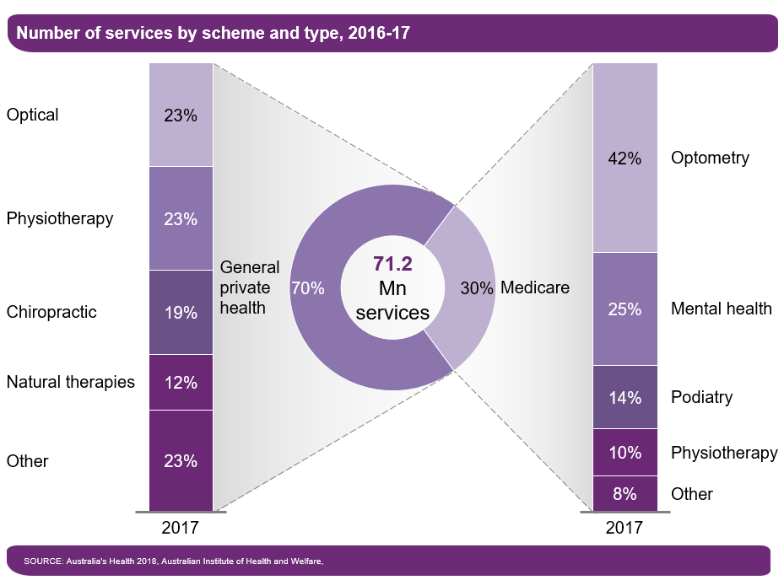

Exhibit 2: Overview of Registered Allied Health Professionals In Australia
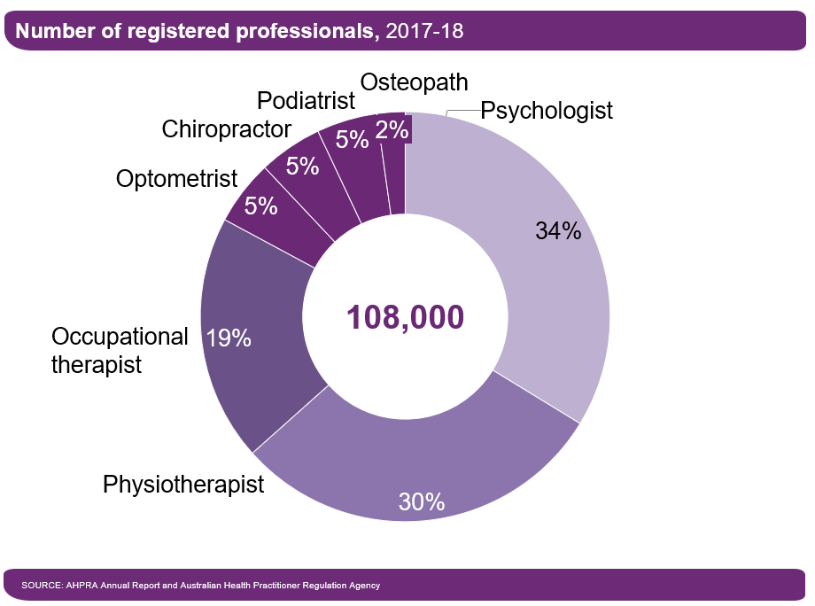

Development Of The NDIS Therapy Market
Table 3 below illustrates, by the provider registration group of the support item accessed, the number of participants who accessed therapy services in 2017-18, the total amount provided through the NDIS for therapy and the number of providers delivering therapy services to NDIS participants.
Table 3: Size Of NDIS Therapy Markets
Registration Group | Registration Group Name | Total amount of spending | Number of participants who claimed for an item in the Registration Group | Number of providers who provided an item in the Registration Group
0128 | Therapeutic Supports | $218,803,002 | 28,466 | 2,123
0110 | Behaviour Support | $19,331,633 | 2,198 | 304
0114 | Community Nursing Care | $2,314,898 | 525 | 103
0118 | Early Childhood Supports | $95,797,311 | 17,344 | 859
Just under 60 per cent of NDIS participants purchased one or more therapy services in 2017-18. On average, an NDIS participant who purchased therapy services in 2017-18, purchased services worth about $4,000.
Finding 2.2: There are early signs of some competition in the NDIS therapy market.
The number of NDIS registered therapy providers has grown rapidly, from 1,917 in September 2016 to 8,200 in June 2018 (see Exhibit 3). At the same time, the market share of the largest therapy providers has declined significantly over the last five years, from 34 per cent in 2013-14 to 25 per cent in 2017-18 (see Exhibit 4).
Exhibit 3: Therapy Providers: Growth From 2016, And Density, By State, 2018
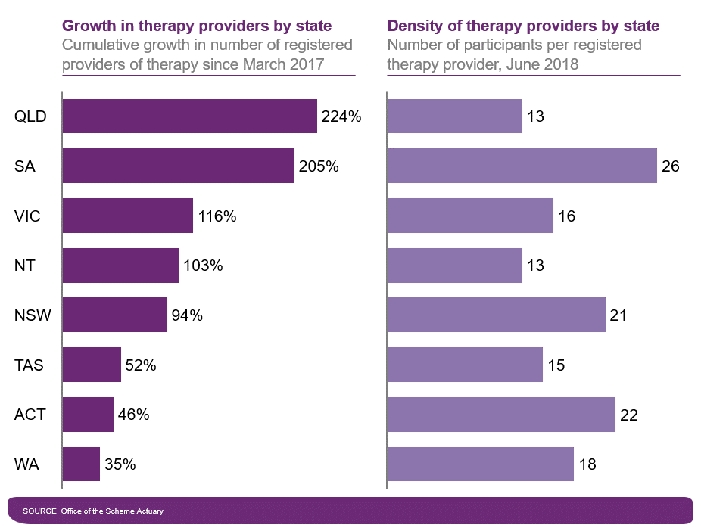
Exhibit 4: Market Concentration in NDIS Therapy Supports
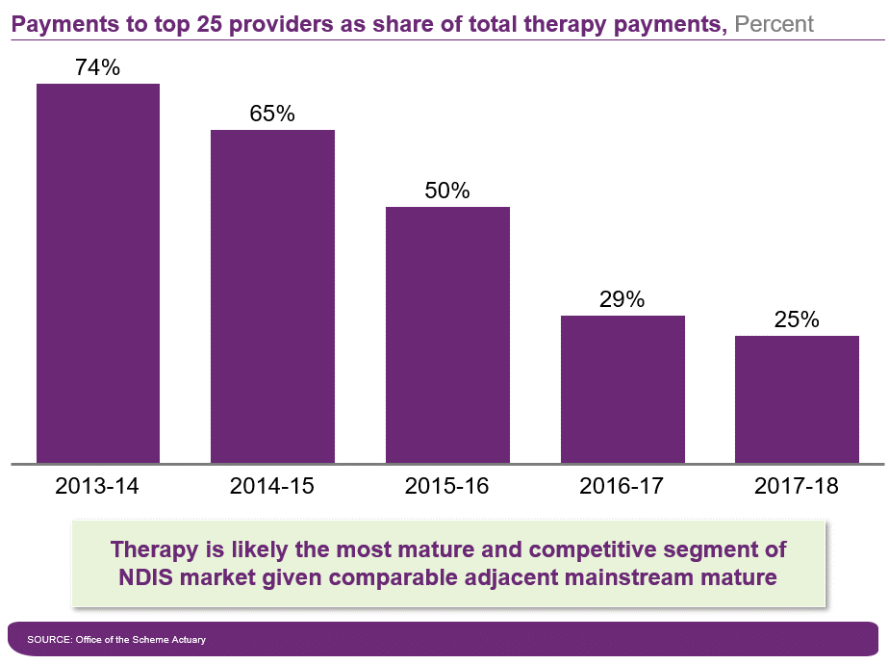
In addition, around 30 per cent of claims are estimated to have been charged below the price cap in 2017–18. This suggests greater competition in therapy services than in other areas of the NDIS, as the distribution of claims in therapy services is more variable than in attendant care supports, where a larger share of providers are charging at the price cap (See Exhibit 5 and Exhibit 6).
Exhibit 5: Price Distribution of NDIS Therapy Claims
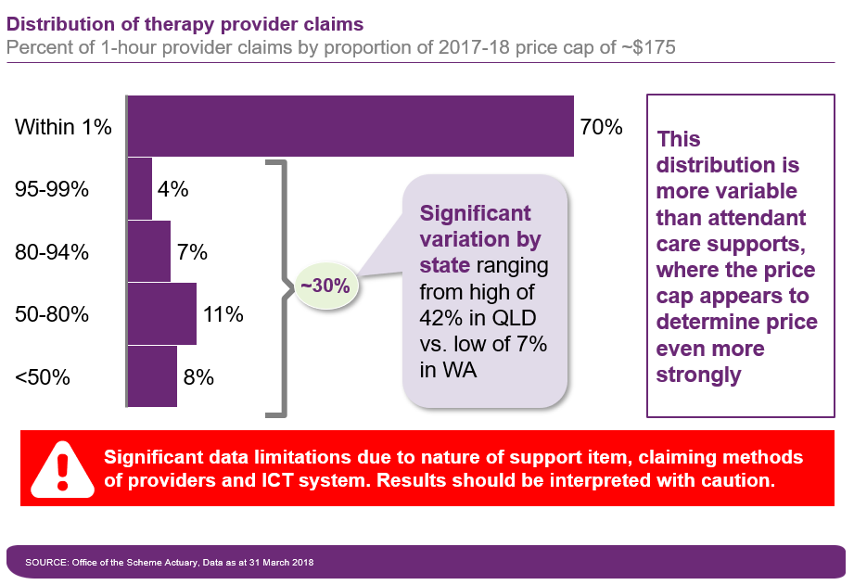

Exhibit 6: Price Distribution of Therapy Claims By State
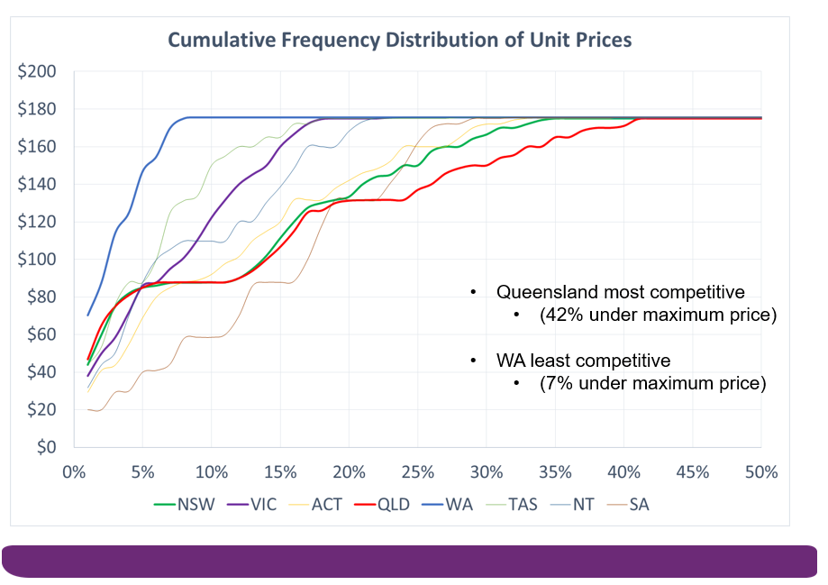

Sector consultation
This section outlines the methodology and results of consultations with providers (both organisations and individual practitioners) and peak bodies, conducted as part of the Therapy Review. In total, 29 consultation meetings were conducted across Australia, covering 52 organisations and over 125 individuals. The team also reviewed 32 submissions from the sector.

Methodology
Providers were selected for interviews by: (1) identifying the top one or two providers in each state and territory, based on claims for therapy services; (2) identifying smaller providers who serve different types of participants—for example, participants with more complex needs and disabilities with smaller proportions of claims; and (3) consulting with peak bodies, which reached out to their member organisations.
The sample of identified providers included:
- A range of providers serving more than 50 per cent non-metro and remote participants.
- A range of for-profit and not-for-profit providers.
- A range of providers for whom therapy claims accounted for less than 50 per cent or more than 50 per cent of total claims.
- Providers who serve participants with most disability types recorded under the NDIS.
Table 4: List Of Organisations Consulted During The Therapy Review
# | Org type | Name | More than 50% non-metro | For profit/  not for profit | More than 50% of total claims for therapy
1 | Provider | Ability Centre | N/A | Not for profit | N/A
2 | Provider | Cara Care | N | Profit | Y
3 | Provider | Cootharinga North Queensland | Y | Profit | N
4 | Provider | Cerebral Palsy Alliance | N | Not for profit | N
5 | Provider | LiveBetter Services Limited | Y | Profit | N
6 | Provider | Montrose Therapy & Respite Services | Y | Profit | Y
7 | Provider | Novita | N | Not for profit | Y
8 | Provider | Northcott | N | Profit | N
9 | Provider | Rocky Bay Mosman Park – Disability Services/Rocky Bay Inc | N | Profit | N
10 | Provider | ScopeAust | N | Profit | N
11 | Provider | St Giles Society Inc | Y | Profit | N
12 | Provider | Biala Peninsula Inc | N | Profit | Y
13 | Provider | ScopeAust | N | Profit | N
14 | Provider | Everyday Independence | N | Profit | Y
15 | Provider | Sunbury Community Health Centre | N | Not for profit | N
16 | Provider | ERMHA Ltd | N | Profit | N
17 | Provider | Autism Association of Western Australia | N | Profit | N
18 | Provider | Spinal Cord Injuries Australia | N | Not for profit | N
19 | Provider | Noah's Ark Inc | N | Profit | Y
20 | Provider | The Benevolent Society | N | Profit | Y
21 | Provider | Northern Territory of Australia | Y | Not for profit | Y
22 | Provider | Montrose Therapy & Respite Services | Y | Profit | Y
23 | Provider | AEIOU Foundation | Y | Profit | Y
24 | Provider | Royal Institute for Deaf and Blind Children | N | Not for profit | Y
25 | Provider | Cerebral Palsy Alliance | N | Not for profit | N
26 | Provider | Umbo | N/A | N/A | N/A
27 | Provider | Therapy Focus | N | Profit | Y
28 | Provider | Moira | N | Profit | N
29 | Provider | Novita | N | Not for profit | Y
30 | Provider | Department of Human Services | N | Profit | Y
31 | Provider | Yooralla | N | Profit | N
32 | Provider | Vision Australia | N | Profit | Y
33 | Provider | Spectrum Therapy Australia | N | Profit | Y
34 | Provider | Lifestart Co-operative Ltd. | N | Not for profit | Y
35 | Provider | Kurrajong | Y | Profit | N
36 | Provider | Therapy Pro | Y | Profit | Y
37 | Provider | Hunter Prelude Early Intervention Centre | N | Not for profit | Y
38 | Association | Ability First Australia | N/A | N/A | N/A
39 | Association | Speech Pathology Australia | N/A | N/A | N/A
40 | Association | Australian Physiotherapy Association | N/A | N/A | N/A
41 | Association | Australian Psychological Society | N/A | N/A | N/A
42 | Association | Australian Clinical Psychology Association (ACPA) | N/A | N/A | N/A
43 | Association | Occupational Therapy Australia | N/A | N/A | N/A
44 | Association | Australian Music Therapy Association | N/A | N/A | N/A
45 | Association | Audiology Australia | N/A | N/A | N/A
46 | Association | The Australian Orthotic Prosthetic Association Ltd. (AOPA) | N/A | N/A | N/A
47 | Association | Allied Health Professions Australia | N/A | N/A | N/A
48 | Association | Early Childhood Intervention Australia Victoria/Tasmania | N/A | N/A | N/A
49 | Association | Mental Health Australia | N/A | N/A | N/A
50 | Association | Australian Rehabilitation & Assistive Technology Association | N/A | N/A | N/A
51 | Association | AGOSCI | N/A | N/A | N/A
52 | Association | National Disability Services | N/A | N/A | N/A
Providers and peak bodies were presented with preliminary findings on price cap differentiation in comparable schemes and asked questions regarding:
- Provider business models and the therapy market.
- The structure of therapy supports in the price catalogue.
- Price caps for therapy services.
- Use of therapy assistants and pricing considerations.
- Views on the timeline for deregulation of price caps.
- Implementation considerations.

Findings

Therapy market
Finding 3.1: While there is no conclusive evidence of supply shortages, there was large variation in reported provider financial performance. The majority reported financial losses or were just breaking even and were strongly opposed to any price reduction. A minority reported healthy or sustainable margins.
The majority of providers reported making a financial loss in their therapy business or “only just breaking even”. Commonly cited drivers of financial operating losses included low billable hours for therapists, as well as a significant increase in administrative costs during the transition to the NDIS.
Billable hours
Most providers aim to bill between 4.5 and 6 hours a day for contracted therapists. However, this target is often not met, with some providers achieving below 4 billable hours a day. This is primarily due to providers spending unbilled non-direct time on various tasks, including:
- Preparation and conducting research.
- Writing case notes and reports.
- Case conferencing with other health professionals.
- Training and supervising junior therapists (initial training estimated at 2 to 3 months).
- Building carer capacity.
- Performing administrative tasks (e.g. developing a service agreement during intake).
- Interacting with the family and community.
- Reporting to or interacting with child protection or other government agencies.
Providers often do not bill for this time due to a combination of structural and cultural factors.
- Cultural factors:
  - Plan managers, participants and families often have an aversion to paying for non-direct time. One provider noted that the most common inquiry from participants was about billing non-direct time.
  - Some therapists consider it unethical to bill for non-direct time.
  - There is a perception that this time cannot be billed if multiple therapists are working with a participant concurrently.
- Structural factors:
  - Claims for cancellations are capped, and payment claims are only allowed for cancellations are only permitted up to 3pm on the day before an appointment. (One provider noted that 15 per cent of appointments are cancelled.
  - There are also caps on claims for travel time.
  - A participant’s plan may not have enough funds to cover these elements.
  - Demand is unpredictable under the NDIS, particularly in non-metro areas.
Overheads
Providers report high overheads and administrative costs that are specific to disability and the NDIS, including:
- Interacting with multiple complex systems, such as the NDIA portal.
- Making changes to property to ensure suitable access for people with disability (for example, widening doorways).
- Installing new computer systems to ensure compliance and auditability.
- Hiring staff to deal with quality and safeguard issues.
- Marketing and promoting the business and managing customer relationships.
- Managing human resource (HR) issues, the cost of which has increased due to high turnover rates among therapists under the NDIS.
Overheads can also be higher for early childhood providers due to: (1) higher building and maintenance costs for additional facilities (such as playgrounds, soft flooring); (2) higher insurance costs (for example, due to the occupational health and safety risks of working in a child’s home); and (3) higher administrative costs (for example, contacting the family the day before a home visit, getting them to fill out forms, etc.).
However, a number of providers reported that their business is sustainable under current price caps, and one provider confidently asserted that they believe it is possible to make large margins under the current price cap. These providers tend to focus on increasing billable hours to six hours a day or more and reducing overheads.
- One provider bills more than 80 per cent of staff hours and said that their business would not be viable if the figure dropped below 80 per cent. However, the provider noted that this approach causes staff burnout, resulting in 30 per cent annual staff turnover.
- One provider believed it was possible to make margins of around 30 per cent under price caps, assuming an overhead ratio of 20–25 per cent.
- These providers covered the full spectrum of service delivery, from one provider who delivered over 85 per cent of services in a centre to another provider who delivered 100 per cent of services in the community.
- One provider noted that they use a number of clinical specialists charged at the specialist behavioural intervention support rate of $200.58.
- One provider bills approximately 20 per cent below the price cap for physiotherapy services.
Most providers indicated that they were struggling to recruit and retain qualified workers and that, as a result, they were finding it difficult to keep up with the growing demand for therapy services.
- One provider described annual staff turnover of more than 30 per cent, and many providers noted that experienced therapists often leave to set up their own businesses, leaving only new graduates available for hire.
- Providers reported that new graduates—who can account for more than 50 per cent of a provider’s workforce and have become more common in the workforce during the transition to the NDIS—generally have higher supervision and training requirements and do not meet billable hour targets. (New graduates generally start at two to three billable hours per day and take 12 months to reach five billable hours a day.)
- Psychologists in particular are difficult to attract and retain due to market shortages, which means they are often paid significantly more than other therapy types (Table 5). For providers with enterprise bargaining agreements (EBAs), this may involve more rapidly graduating psychologists to higher levels.
- In non-metro areas, providers often have to pay higher salaries to attract/retain staff.
- Providers noted that additional training is required for therapists dealing with disability (compared to other therapists), and that further specialist training is required for those working in the area of early childhood.
Table 5: Findings From NDS Survey On Workforce Challenges
In the past financial year, how easy or difficult has it been to recruit competent staff in the following categories? |  | In the past financial year, how easy or difficult has it been to retain competent staff in the following categories?
Occupation category | Percentage of respondents who answered "extremely or moderately difficult" | Occupation category | Percentage of respondents who answered "extremely or moderately difficult"
Psychologist | 83% | Psychologist | 53%
Physiotherapist | 76% | Speech therapist | 40%
Speech therapist | 75% | Physiotherapist | 38%
Occupational therapist | 73% | Dietician | 33%
Local area coordinator/planner | 64% | Disability support worker | 33%
Disability support worker | 63% | Occupational therapist | 32%
Dietician | 63% | Support coordinator | 27%
Managers/supervisors of disability support | 55% | Local area coordinator/planner | 26%
Support coordinator | 50% | Marketing/business development | 23%
HR/workforce development | 38% | HR/workforce development | 23%
Marketing/business development | 38% | Managers/supervisors of disability support workers | 23%
Information technology | 37% | Finance/accounting | 17%
Finance/accounting | 32% | Information technology | 17%
Source: National Disability Services, 2018 State of the Disability Sector
Finding 3.2: Providers reported that they are carrying some additional costs that they do not believe can be fully recovered under the current price caps—for example, induction costs for new workers entering the growing disability segment of therapy.
Some providers noted that workforce training costs were falling on them (often due to dominance in a particular market) and that this was adversely affecting their operating model. The federal government and state governments support workforce development in many contexts, and several programs support workforce development for the NDIS.

Structure of therapy supports in the price catalogue
Finding 3.3: Consultations revealed broad support for a more differentiated set of therapeutic support line items in the price catalogue (independent of any differentiation in actual price caps) to better reflect the diverse nature of therapy supports offered under the NDIS, with some caveats.
The sector agreed that greater differentiation in the price catalogue would be valuable for the following purposes:
- Data collection and planning, including developing more granular insights into demand for various services.
- Transparency in billing and invoicing.
- Appropriately recognising the value of (and legitimacy of billing for) less well-known services, especially non-direct services.
- Educating participants, their informal supports and planners on the full range of available therapy supports.
In particular, there was support for differentiating the price catalogue by type of therapy profession, and adding a separate support item for non-direct services. However, this support came with some major caveats, including:
- Being mindful of the administrative burden that a longer price catalogue may impose, including whether the NDIS payment portal has the capacity to handle a greater volume of items.
- Ensuring that greater differentiation in the price catalogue does not result in less flexibility in how support packages are expended (for example, by prescribing or locking certain line items in the package).
- Ensuring that the catalogue is participant-centred and remains flexible enough to support best practice.

Price caps for therapy supports
Finding 3.4: Consultations revealed a general aversion to differentiated price caps for therapy services, although there were mixed views in some areas.
Finding 3.4.1 – Current pricing behaviour: The majority of providers reported that they do not currently differentiate prices for therapy services, and that they charge at the NDIS price cap for all therapy services.
- Some providers reported offering lower price caps to participants who did not have adequate funding under their plan in order to meet their needs.
- Providers reported that participants are more interested in value-added services than in reduced price offerings.
Finding 3.4.2 – Therapy type (non-psychology): The majority of providers did not support price differentiation based on type of therapy because identical wage rates in most EBAs and awards mean that input costs do not vary by type of therapy.
- Providers noted that any differentiation needs to support a team-based approach to service provision.
Finding 3.4.3 – Therapy type (psychology): Providers noted that while most EBAs and awards do not differentiate by therapy type, average rates for psychologists tend to be higher in practice due to a supply shortage. Some providers also noted that market prices for clinical psychologists are higher still, reflecting higher price caps in many government schemes. For example, the MBS rebate for clinical psychologists is higher (by around $40 per hour) than for all other types of psychologist.
- Some providers noted that clinical psychologists and other Australian Psychological Society practice-endorsed psychologists have higher qualifications, which should justify a higher rate. While the minimum requirement for general registered psychologists is six years, practice-endorsed psychologists are required to complete up to seven years of study and a two- to five-year registrar program before applying for practice endorsement (see the Appendix for further details). Many government schemes already differentiate by type of psychologist, including the MBS.
- Some providers highlighted that current NDIS prices are not attractive for clinical psychologists as they are able to charge higher rates in the private billing market.
Finding 3.4.4 – Therapy type (behaviour supports): Providers noted that behaviour supports are delivered by psychologists or other highly trained behavioural specialists, who are often paid at the highest rate. They also highlighted that registration for behavioural supports imposes an additional administrative burden and additional expenses (compared to therapy services), which should be reflected in a higher rate.
- Providers reported that they employ highly trained psychologists or other behavioural specialists—often paid at the highest rate—to provide behavioural supports. They do so because these supports are provided to participants with behavioural concerns, who represent one of the most vulnerable groups of participants and require highly trained staff.
- Providers noted that registration for the behaviour supports group involves additional costs and an additional administrative burden, compared to therapy services. Providers are required to undergo additional checks to protect the welfare of participants and are subject to additional oversight by the NDIS Commission to ensure they comply with the new arrangements regulating the use of restrictive practices. This increases overhead costs, justifying the higher NDIS rate.
- Some providers noted that the current NDIS rate for behaviour supports ($200.58) may still not be attractive, highlighting a risk of supply shortages. Providers highlighted that the premium of approximately $20 per hour (compared to therapy services) may not justify the additional administrative burden and expense, which could be prohibitive (at least for sole proprietors).
Finding 3.4.5 – Direct versus non-direct services: There was strong consensus that price caps for non-direct services should be the same as for direct services, as these services are of equal value and the time cost of the therapist is the same.
Finding 3.4.6 – In-centre versus in-community services: There were mixed views on whether price caps should be differentiated for in-centre therapy services and in-community therapy services. Some providers argued that in-community services, which they believe align with best practice, involve higher costs and are currently being disincentivised under the NDIS. Other providers argued that in-centre services are just as costly to provide, once upfront fixed costs and rent have been factored into the hourly rate. Ultimately, no conclusive evidence was provided to demonstrate that in-community services have higher administrative costs.
Some providers suggested that travel should be rolled into an in-community rate and should not be able to be claimed separately, on the basis that this is easier to justify to participants and reduces the administrative burden. However, the majority of providers noted that travel time varies significantly, which would make a single in-community rate untenable.
Some providers noted that there are additional costs when providing services in the community, including:
- Unbilled travel time (either because the travel time is greater than 20 minutes, or because the provider chooses not to bill travel time).
- Additional travel costs, such as car and petrol costs (although rent and utilities represent equivalent in-centre costs, and these travel costs could therefore be considered part of standard overheads).
- Additional cancellation costs (it is more difficult to rebook or move on to other work in the community).
- The cost of undertaking appropriate risk assessments, which in turn can lead to increased insurance costs.
- Additional training costs for therapists working in the community (for example, first aid training).
- Additional time requirements, reflecting providers’ duty of care and the complex situations faced by many families (for example, therapists may be required to interact with government agencies [public guardian, police] or medical practitioners).
- Safety and risk management costs (for example, in circumstances where providers need to send two workers but are unable to charge for the additional worker).
- Time costs for performing tasks that administrative staff or therapy assistants could undertake during in-centre service delivery.
However, many providers noted that in-centre service delivery can be just as costly once you factor in rent, upfront set-up costs, utilities and other facilities costs. Ultimately, consultations did not generate conclusive evidence that in-community service provision has higher costs than in-centre service provision.
Finding 3.4.7 – Initial consultations versus standard consultations: There was broad consensus that initial consultations require more time than standard consultations (for example, for report writing or working as part of a multidisciplinary team). However, there was also consensus that this could be managed within existing price arrangements (i.e., the time-based price cap and separate billing for non-direct services).
- Providers reported spending additional time with clients during an initial consultation, including time spent with the family, and on research and preparation, report writing and liaising with multiple therapists.
- Providers noted that initial assessments are more likely to occur in the community, incurring additional costs such as risk assessment costs and the costs of additional staff attendance (as discussed above).
- Some providers noted that additional equipment could be required for an initial consultation.
Finding 3.4.8 – Therapist’s level of experience: In principle, there was support for differentiating price caps based on the therapist’s level of experience, but there was also strong scepticism that this could be implemented in practice, given the absence of a standard industry award.
Differentiating price caps based on the therapist’s level of experience has several benefits:
- It would align with cost differentiation, as most providers differentiate wages based on experience and skill level.
- It also rewards expertise. Some providers noted that differentiation could be beneficial in incentivising providers to upskill their therapists. Most providers try to allocate experienced therapists to participants with more complex needs.
The approach also has a number of disadvantages:
- It presents planning challenges. Providers noted that the level of therapist experience allocated by a planner or requested by a participant may not be appropriate or available, particularly in non-metro areas.
- Experienced therapists may not exclusively see participants with complex needs. Some providers noted that experienced therapists may see a range of clients, including those with complex needs and those with simpler needs.
- It may not fully align with cost differentiation. Costs can be higher for less experienced therapists due to low numbers of billable hours and training and supervision requirements.
- Many workers in the market are recent graduates and would be classified as Level 1, which may create transition issues. Providers noted that it is hard to recruit experienced workers in the current therapist labour market, which is skewed towards inexperience.
Finding 3.4.9 – Remote versus non-remote services: Providers operating in remote and very remote areas noted the higher costs associated with delivering services in these areas, due to: (1) the thinness of the market, resulting in unpredictable demand; (2) the need for higher wages to attract therapists; and (3) longer travel times.
Finding 3.4.10 – After-hours services: Some providers noted that there is growing demand for after-hours services and proposed a differentiated weekend or after-hours rate to account for higher wages paid at these times under EBAs.

Therapy assistants
FINDING 3.5: Consultations revealed variable but declining use of therapy assistants by providers, due to the current low price. There is overwhelming support for introducing a higher price tier for more qualified therapy assistants.
Some providers use therapy assistants to support the work of therapists, alleviate staffing pressures and provide value for money for participants. It was suggested that therapy assistants could be critical to future NDIS sustainability, both from a workforce and a value-for-money perspective.
- One provider noted that they were able to pay casual therapy assistants $27.50 per hour and claim reimbursement at $45.66 per hour, and that participants bulk-buying sessions contributed to certainty and profitability.
- Providers noted that qualified therapy assistants could be particularly beneficial in remote areas to lessen the impact of the undersupply of therapists, including through the use of telehealth.
Other providers do not see the current price cap as enabling a viable business model for therapy assistants, given the qualifications and training required. Some providers found that unpredictability of demand meant that therapy assistants were employed on a casual basis, which increased their hourly costs and made them unviable. Concerns were also raised about the uncertainty created by the Quality and Safeguards Framework, and about the need for therapists to work simultaneously with therapy assistants at times (querying whether co-claiming for this was possible under the NDIS).
Establishing different rates for different levels of therapy assistant is important in order to recognise varying levels of skills and qualifications. Some therapy assistants have no qualifications or experience in therapy while others have an undergraduate degree or a certificate IV. Many providers also invest significantly in training for therapy assistants. Providers would like a framework to create certainty, noting that each therapy assistant level should be clearly defined in terms of required qualifications, experience and skills, and expected tasks (including requirements around supervision).
Some therapy assistants work across different types of therapy and some specialise in a particular type of therapy, but most providers prefer the simplicity of not distinguishing by therapy type.

Price deregulation
FINDING 3.6: Consultations revealed mixed views on when the NDIS therapy segment may be ready for price deregulation. The majority of participants indicated that more time was needed, given that most providers are still transitioning to the NDIS.
A small number of providers felt that some segments that had already fully transitioned to the NDIS were ready for price deregulation—for example, the ECEI segment in states that had completed the transition. However, the majority of providers who serve adults are still transitioning to the NDIS and are not ready to think about deregulation at this time.

Other Issues Raised

Implementation
Providers raised three key issues regarding implementation:
- The timeline should take into consideration the current workforce shortage and the large proportion of new graduates in the labour market (skewing billable hour rates down in the short term).
- Significant change is already underway, and generous lead times are critical (12 months for budgeting, redundancies and hiring new staff).
- Information should be communicated to participants as well as providers.

Travel
Some providers suggested that the NDIS price cap creates a bias towards in-centre delivery rather than in-community delivery (which many believe represents best practice). This arises for two reasons: (1) the additional cost of travel comes out of the participant’s budget, creating a trade-off between location and volume; and (2) several providers noted that current travel caps are inadequate to account for actual travel, even in metro areas. This leads to higher costs (and lower margins) for in-community services, compared to in-centre services. Providers believe that if all travel costs are separately funded and claimable, there will be a greater incentive for participants to request in-community services.

Cancellations
Several providers reported 15–20 per cent cancellation rates, which are inadequately addressed by the current limit on claiming cancellations. Some providers noted that limits on travel time create incentives for efficiency, including visiting multiple clients on one visit to an area by optimising visit times and routes.

Inadequate support for multidisciplinary care outside early childhood
One provider noted that the multidisciplinary package model used for early childhood works effectively to provide value for money to participants and ensure flexibility for providers, including in the use of therapy assistants.

Delivery of teletherapy
The current pricing structure does not account for the additional equipment and preparation costs required to deliver teletherapy.

Therapy benchmarking
A detailed benchmarking exercise was carried out as part of the Therapy Review, focused on three main sources of data:
- Comparable schemes: The Therapy Review analysed seven comparable national and state schemes, mapping the structure of these schemes and comparing prices.
- Private billing database (2018): The Therapy Review analysed 2,293 unique price points from 2018 private billing data on therapy services from around Australia. Rates for standard consultations and other services were compared, and statistical analysis was undertaken to identify statistical differences between therapy types, types of service and geography.
- Awards and EBAs: The Therapy Review analysed national and state awards and EBAs from 48 top providers, evaluating the differences between the awards and EBAs, as well as differences at the state level.
The methodology and main findings of this benchmarking exercise are presented below.

Comparable Insurance Schemes

Methodology
Seven comparable schemes (one national scheme and six state schemes) were identified as suitable for benchmarking: the Department of Veterans’ Affairs (DVA) insurance scheme was identified as a comparable national scheme, and WorkCover WA, the Victorian Transport Accident Commission (TAC), WorkSafe Victoria, Sira iCare, WorkCover QLD and Return to Work SA were identified as comparable state schemes.
For each of the selected schemes, price rates were classified based on the following:
- Type of therapy (i.e., physiotherapy, occupational therapy, speech pathology and psychology versus other therapies).
- Type of service provided (for example, initial consultation, standard consultation, report writing, case conference).
- Delivery location.
- Duration of service.
All entries for which time duration was not explicitly stated were discarded for benchmarking purposes but were still considered when mapping the price structure of each scheme.
All the relevant benchmarking entries were pro-rated to convert them into hourly rates. When duration was provided as a range, the middle point of the range was considered the average duration.
Representatives of three comparable schemes were also interviewed to understand scheme architecture, pricing decisions, reimbursement for therapy assistants or equivalents, perspectives on the market for therapy, and approaches to transparency of pricing data.

Approach to price setting
Finding 4.1: The majority of comparable insurance schemes appear to base prices on prevailing market rates.
When making pricing decisions, comparable schemes tend to focus on the market rate, analysing what private providers charge for similar services. These findings are backed up by a bottom-up analysis of business cost structures. Different line items are usually created for different service types for data collection purposes.
Finding 4.2: Unlike the NDIS, the majority of comparable insurance schemes do not appear to set price caps. Instead, they set reference prices that form the basis for negotiation with providers.
Some schemes have recommended prices. Providers who charge at the recommended prices can become preferred providers, with the benefit of potentially greater market share. As a result, comparable schemes are able to achieve rates significantly below the market average and NDIS price caps in some cases, having used their market power to negotiate. This was confirmed in interviews with representatives from three comparable schemes.

Price structure and architecture
Finding 4.3: Unlike the NDIS, the majority of comparable insurance schemes have separate line items in their price catalogue based on the type of: (1) therapy; and (2) service.
- Therapy type: All seven schemes have different line items for different therapy types (enabling effective data collection).
- Service type:
  - Five out of seven schemes provide separate line items for initial consultations and standard consultations.
  - Six out of seven schemes have separate line items for non-direct services.
  - Four out of seven schemes treat travel time as a separate item and do not have separate rates for in-community consultations. The three remaining schemes have a separate rate for in-community consultations but do not have a separate travel item.
Finding 4.4: The majority of comparable insurance schemes do not have separate line items in their price catalogue based on: (1) complexity of participant; (2) therapist experience levels; or (3) geography.
- Complexity: Comparable schemes do not differentiate prices based on complexity, with the exception of some schemes for physiotherapy. WorkCover WA differentiates physiotherapy rates based on the number of areas treated, and two schemes differentiate based on the type of injury (Return to Work SA and WorkSafe Victoria).
- Level of therapist: Comparable schemes do not differentiate based on the therapist’s level of experience.
- Geography: No schemes differentiate by rural or regional area. The DVA scheme—the one national scheme in our benchmarking exercise—does not differentiate its price catalogue by state.

Price levels
Finding 4.5: The majority of comparable insurance schemes differentiate prices based on the type of therapy profession. In all such cases, the price for psychological therapy is higher than for other types of therapy.
The published prices for different types of therapy across the seven comparable schemes is summarised in Exhibit 7.
- Five of the seven schemes differentiate rates by therapy type. In all cases, psychology rates are the highest, by an average of 24 per cent (with an average of $190.43 across five schemes, compared to an average of $149.29 for all other therapy types).
- One of the seven schemes (the New South Wales State Insurance Regulatory Authority [SIRA]) differentiates between psychology and counselling rates. Counselling rates are 20 per cent lower at $148.80, compared to psychology rates of $187.20.
Exhibit 7: Standard Consultation Rates By Therapy Type By Insurance Scheme
Finding 4.6: The majority of comparable schemes do not differentiate hourly prices based on the type of service—i.e., initial versus standard consultations, in-centre versus in-community services, and direct versus non-direct services.
- Initial consultation versus standard consultation: Of the five schemes that have separate line items for initial and standard consultations, three have higher rates for initial consultations (18–31 per cent higher). However, the duration of sessions is not specified in these cases, and the higher rates may simply reflect the fact that initial consultations tend to take longer.
- Direct services versus non-direct services: Of the five schemes that have separate line items for direct and non-direct services, none have different prices.
- In-centre services versus in-community services: The differences between prices for in-centre services and in-community services across schemes appear to reflect different approaches to travel costs.
  - Four of the seven schemes have the same rates but have a travel top-up for in-community services.
  - Three of the seven schemes have separate, higher rates for in-community services, which already include a travel top-up.
Finding 4.7: NDIS prices are, on average, comparable to the prices of other insurance schemes. However, these averages disguise two key differences: (1) NDIS psychology rates are typically lower than those of other schemes; and (2) NDIS non-psychology rates are typically higher, although this may reflect the fact that the NDIS sets price caps while other schemes set reference prices.
Table 6 compares NDIS hourly prices by therapy profession with the average prices of the six other comparable insurance schemes that have hourly rates.
- NDIS prices are in line with the two other schemes that have a fixed price across all therapy types (WorkCover Queensland and Back to Work SA).
- The price of psychological therapy is higher than for other therapy types across four schemes, two of which have prices that are higher than the current NDIS price cap.
- As noted in Finding 4.2, some schemes use recommended pricing and may benefit from the negotiating power that comes with market share.
Table 6: Comparison of NDIS Price Caps Versus Prices In Other Schemes
Therapy profession | Average hourly price of seven comparable schemes | NDIS price cap for therapy services | Difference (NDIS price versus average of comparable schemes)
Psychology | $190.43 | $179.26 | -6%
Physiotherapy | $169.61 | $179.26 | 6%
Occ. therapy | $144.45 | $179.26 | 24%
Speech therapy | $132.48 | $179.26 | 35%
Source: NDIA 2018 Private Billing Benchmarking Database

Private Billing Benchmarking

Overview of findings
Analysis of the distribution of 2,293 unique price points (collected by benchmarking 2018 private billing data on therapy services from around Australia) revealed statistically significant differences in certain prices at the 95 per cent confidence level.
- Only psychology is statistically different from other types of therapy in terms of price. The average price for psychological therapy is 9 per cent higher (approximately $15) than the prices for other types of therapy.
- The prices for initial and group consultations and non-direct services are all statistically different from the price for standard consultations, although this finding is not robust.
- The price of in-community consultations is not statistically different from the price of standard in-centre consultations.
- Price differences between states are not statistically significant, at the individual state/territory level, but there is some evidence that billing rates for psychology and physiotherapy are distributed differently in the more concentrated jurisdictions (New South Wales, Victoria, Queensland and the Australian Capital Territory) than in the other jurisdictions (Western Australia, South Australia, Tasmania and the Northern Territory).

Methodology
The Therapy Review collected 2,293 data points corresponding to 2018 therapy rates from web searches and the Department of Social Services’ (DSS) Helping Children with Autism and Better Start for Children with Disability provider lists. All rates were classified based on:
- Type of therapy (e.g., physiotherapy, occupational therapy, speech pathology, psychological therapy).
- Type of service (e.g., initial or standard consultation, report, case conference).
- Delivery location (for example, in-centre or in-community services).
- Therapist qualifications (for example, therapist versus therapy assistant).
- Duration of service.
- Geography (for example, by state, and remote versus non-remote locations).
All entries where duration was not explicitly provided were discarded for benchmarking purposes. All the relevant benchmarking entries were pro-rated to convert them into hourly rates. When duration was provided as a range, the middle point of the range was considered the average duration of sessions. The average rates per therapy per service were calculated by averaging all relevant entries.
Several statistical analyses were performed on the unique price points in the private billing database to assess the statistical differences between the following groups of prices:
- Therapy type: Standard consultation rates, by therapy type.
- Type of service: Standard versus initial consultation rates; In-centre versus in-community consultation rates; Individual versus group consultation rates; Direct consultation rates versus non-direct services.
- Geography: Standard consultation rates, by state.
Finally, to check the robustness of the statistical analysis conducted on the 2018 private billing database, similar analysis was conducted on a larger database of 4,668 unique price points from 2012 to 2018 (similarly collected by benchmarking private billing data on therapy services from around Australia). This robustness check revealed broadly similar results and the full analysis is presented in the Appendix.

Overview of the 2018 private billing database
The Therapy Review collected a total of 2,293 unique 2018 price points, with approximately 74 per cent of entries coming from the DSS database and the remainder from a web search. The split of data points across different states and therapy types is presented below.
Table 7: Distribution Of 2018 Private Billing Database By Type Therapy By State
 | Occupational Therapy | Physiotherapy | Psychology | Speech  Therapy | Mixed | Total
ACT | 2 | 15 | 15 | 5 | 11 | 48
NSW | 105 | 34 | 43 | 125 | 18 | 325
NT | 4 | 24 | 6 | 19 | 0 | 53
QLD | 158 | 18 | 112 | 194 | 80 | 562
SA | 2 | 10 | 11 | 53 | 1 | 77
TAS | 0 | 17 | 41 | 30 | 9 | 97
VIC | 250 | 39 | 209 | 307 | 74 | 879
WA | 121 | 15 | 20 | 85 | 11 | 252
Total | 642 | 172 | 457 | 818 | 204 | 2293
DSS % | 94% | 0% | 74% | 77% | 60% | 74%
Source: NDIA 2018 Private Billing Benchmarking Database

Within the database, 824 individual in-centre consultation rates were identified, approximately 63 per cent of which came from the DSS database.
Table 8: Distribution Of 2018 Private Billing Database By Type Therapy By State (Standard In-Centre Consultations Only)
 | Occupational Therapy | Physiotherapy | Psychology | Speech  Therapy | Mixed | Total
ACT | 1 | 8 | 7 | 2 | 5 | 23
NSW | 35 | 18 | 14 | 50 | 7 | 124
NT | 2 | 17 | 6 | 5 | 0 | 30
QLD | 44 | 13 | 46 | 59 | 31 | 193
SA | 2 | 6 | 4 | 36 | 0 | 48
TAS | 0 | 10 | 4 | 7 | 0 | 21
VIC | 78 | 21 | 65 | 121 | 17 | 302
WA | 30 | 8 | 10 | 32 | 3 | 83
National | 192 | 101 | 156 | 312 | 63 | 824
DSS % | 89% | 0.0% | 67% | 66% | 52% | 63%
Source: NDIA 2018 Private Billing Benchmarking Database
A significant difference was observed in the average duration of individual physiotherapy consultations, compared to other therapy types (as shown in Table 9). An average duration of approximately 39 minutes per individual consultation was found for physiotherapy, compared to an average of 52–59 minutes for other therapies. Hence, when entries were pro-rated to convert them into hourly rates, the rates for physiotherapy were adjusted upwards significantly more than for other types of therapy.
Table 9: Average Duration Of Private Billing Consultations By Therapy Type
Occupational therapy | Physiotherapy | Speech therapy | Other therapies | Psychology
53.8 min | 39.4 min | 52.0 min | 56.7 min | 58.9 min

Evidence of price differentials in the private market for therapy
Finding 4.8: At the national level, only private market prices for psychology are meaningfully different in a statistical sense (at a higher rate) from prices for other types of therapy.
Exhibit 8 shows the average hourly market price in the database for each therapy profession, along with its standard deviation. Some variation in average prices across therapy types can be observed in the private billing database.
Exhibit 8: Average Billing Rates: By Therapy Type
However, this does not provide sufficient evidence of a meaningful difference in prices. To test this, a statistical test was performed to compare the full range (or distribution) of prices for each therapy type with the distributions of all other therapy types. This analysis revealed that the distributions of prices for psychology (not including clinical psychology and other practice endorsements) and other therapies were statistically different from all other groups. The other therapies group consists of the following sub-groups: audiologists, art therapists, dieticians, drama therapists, developmental educators, teachers, floortime therapists, music therapists, social workers and multi-disciplinary therapists/others.
Further analyses were carried out to test the existence of meaningful differences between the other therapies sub-groups. The analysis revealed a lower unit cost for two of the sub-groups (art therapist and floortime therapist), with average rates over 15 per cent lower than the overall group average. However, these results are based on a very limited number of data points (nine rates in total for the two groups), and there is currently no evidence that providers with a low cost base are charging at the same rate as less efficient providers (i.e., at the price cap). As a result, there is no compelling evidence to support lower price caps for these groups.
Based on these analyses, the Therapy Review is confident that the average price for psychology—which is around 9 per cent higher than the average price of all therapies other than psychology—is a meaningful difference. For all other types of therapy, the Therapy Review cannot be confident that the observed differences in average prices are not simply caused by random factors or differences in sample size.
Finding 4.9: A deep dive into psychology also revealed a meaningful statistical difference between clinical and non-clinical psychology, with average clinical psychology prices higher by almost $50 per hour.
As the IPR found evidence supporting a price differentiation between clinical and non-clinical psychology, additional analyses were carried out to pressure test this finding, incorporating 67 additional clinical psychology rates collected through a web search.
Exhibit 9: Average Billing Rates: Clinical And Non-Clinical Psychology
Clinical psychology rates were found to be statistically different from non-clinical psychology rates at the 95 per cent confidence level, with a 25 per cent higher average rate of $236 per hour, and median and top quartile rates of $240.00 and $262.00, respectively. The analysis also highlighted that the current NDIS price cap for therapy is set at around the fifth percentile of market rates for clinical psychology, meaning that the NDIS market may, at current price caps, be unattractive for 95 per cent of clinical psychologists.
Finding 4.10: Statistical analysis did not reveal conclusive evidence of any meaningful differences in private market prices based on the type of service—i.e., initial versus standard consultations, in-centre versus in-community services, and direct versus non-direct services.
- Initial consultation versus standard consultation: As shown in Exhibit 10, rates for initial and standard consultations are statistically different. Average hourly rates for initial consultations are 6 per cent higher than standard consultation rates, on average, potentially due to the higher administration costs involved. However, it should be noted that other items might be included in the initial consultation rates, such as report writing and/or developing a treatment plan (which can be charged separately under the NDIS). This potentially makes this finding misleading.
Exhibit 10: Average Billing Rate: Standard and Initial Consultations
- In-centre services versus in-community services: As shown in Exhibit 11, rates for in-community services appear to be around 9 per cent higher than rates for in-centre services; this difference is statistically significant. However, as only 3.7 per cent of in-community rates explicitly exclude travel costs, it is likely that this difference can be attributed to travel costs being embedded in in-community rates, whereas travel costs are billed separately in the NDIS.
Exhibit 11: Average Billing Rates: In-Centre And In-Community Consultations
- Direct services versus non-direct services: As shown in Exhibit 12, rates for direct and non-direct services are statistically different; average hourly rates for non-direct services are 7 per cent lower. However, direct services are generally billed on an hourly basis, which means that duration might not be reflective of the actual time invested by the therapist. This potentially makes this finding misleading.
Exhibit 12: Average Billing Rates: Standard In-Centre Consultations and Non-Direct Services
FINDING 4.11: Statistical analysis did not reveal conclusive evidence of any meaningful differences in private market prices by state or territory, but there were data limitations in some of the smaller jurisdictions (South Australia, Western Australia, Tasmania, and the Northern Territory). There is some evidence that billing rates for psychology and physiotherapy are distributed differently in the more concentrated jurisdictions (New South Wales, Victoria, Queensland and the Australian Capital Territory) than in the other jurisdictions (Western Australia, South Australia, Tasmania and the Northern Territory).
As shown in Exhibit 13, only Western Australia prices are statistically different from prices for all other states, with an average price of $150 compared to the national average of $175.
However, when analysing the larger private billing database containing data points from 2012 to 2018, no statistically significant differences were observed for Western Australia (see the Appendix for details). This indicates that the results may be affected by sample size and are therefore inconclusive.
Exhibit 13: Average Billing Rates: Standard In-Centre Consultations by State
As Table 10 indicates, although the distributions of observed prices at jurisdiction level were not statistically different from each other (mainly because of sample size), combining jurisdictions into two groups - the more concentrated jurisdictions (NSW, VIC, QLD and ACT) and the other jurisdictions (WA, SA, TAS and NT) - indicated that the 75th percentile was significantly different between the two groups of jurisdictions for both psychology and physiotherapy.

Table 10: Price Distribution by Therapy Type And Jurisdiction
Group | State | Psychology |  | All other (ex. Psych) |  | Physio |  | All other  ex. psych, ex, physio
Percentile |  | 70th | 75th | 70th | 75th | 70th | 75th | 70th | 75th
National |  | 205 | 210 | 185 | 190 | 190 | 194 | 183 | 190
Concentrated |  | 204 | 210 | 185 | 190 | 188 | 190 | 185 | 190
Other |  | 225 | 229 | 180 | 190 | 199 | 219 | 179 | 183
NIL | NSW | 200 | 200 | 180 | 180 | 174 | 179 | 180 | 181
NIL | Vic | 213 | 215 | 196 | 200 | 186 | 192 | 200 | 200
NIL | Qld | 201 | 207 | 179 | 182 | 194 | 207 | 178 | 180
NIL | ACT | 187 | 191 | 190 | 190 | 191 | 192 | 187 | 187
Nil | WA | 180 | 203 | 165 | 172 | 249 | 250 | 160 | 162
Nil | SA | 250 | 255 | 190 | 190 | 169 | 172 | 190 | 191
Nil | Tas | 238 | 245 | 187 | 192 | 193 | 199 | 183 | 192
Nil | NT | n/a | n/a | 237 | 237 | 237 | 237 | 230 | 232

Evidence of major price differentials between the private therapy market and the NDIS
Finding 4.12: A comparison of the existing NDIS price cap for therapy ($179.26 per hour) and private billing rates indicates that the NDIS price cap is equal to or greater than 70 per cent of private non-psychology rates (i.e., at the 70th percentile), and equal to or greater than 50 per cent of private psychology rates (i.e., at the 50th percentile). The NDIS price cap is equal to or greater than 5 per cent of market rates for clinical psychology (i.e., the fifth percentile).
To encourage private therapists to register as NDIS providers, NDIS price caps need to be attractive compared to what a private therapist is currently charging. It is possible that the NDIS price may even need to be a little higher than the market price, given that there are additional costs associated with serving NDIS participants (such as audit costs to maintain accreditation under the quality and safeguard standards, or the costs of undertaking additional training to serve participants with disabilities).
Comparing the full distribution of market prices to the current NDIS therapy price cap ($179.26 per hour) provides an indication of the proportion of private therapists who would find the current NDIS price cap attractive. The distribution and comparison are shown in Exhibit 14 for both psychology and all other therapies. This analysis indicates that the current NDIS price is comparable to the 50th percentile of psychology prices. This means that half the prices in the private billing database are above the NDIS price, and half are below. All other things being equal, this suggests that only 50 per cent of private psychologists may find it attractive to enter the NDIS segment.
The analysis indicates that the current NDIS price is comparable to the 70th percentile of prices for other types of therapy. This means that around 30 per cent of the prices in the private billing database are above the NDIS price, and around 70 per cent are below. All other things being equal, this suggests that around 70 per cent of private therapists (excluding psychologists) may find it attractive to enter the NDIS segment.
Exhibit 14: Distribution of Billing Rates: Psychology and Other Therapies
The 75th percentile corresponds approximately to the inflection point of the cumulative frequency curve of the distribution of private billing rates for the other types of therapy (Exhibit 15). This represents the point at which the number of new incremental rates stops increasing and starts decreasing.
Exhibit 15: Cumulative Frequency Chart for Therapy Billing Rates (Excluding Psychology)

Benchmarking Of Awards/EBAS And Bottom-Up Cost Estimates
Labour costs are by far the largest input cost for the delivery of therapy services, possibly accounting for up to 70–80 per cent of all costs. To help develop NDIS price controls for therapy, this section examines the available evidence base on the wage rates faced by providers and estimates the potential bottom-up cost of delivering therapy services based on assumptions of operational efficiency (i.e., bottom-up cost analysis).

Methodology
Three sources of insight were considered for this analysis:
- The National Health Professionals and Support Services Award.
- Eight state or territory government EBAs for therapists employed in the public sector.
- EBAs from 48 providers distributed across all states (six providers per state, on average), selected from among the top NDIS providers by amount claimed.
Minimum and maximum pay rates for each group were compared with the national award rates. All pay levels clearly not involving clinical work were excluded from the analysis.
In addition to these benchmarks, bottom-up cost therapy price ranges were estimated for all three sources with a bottom-up cost model. This model includes assumptions for variables such as base salary, utilisation costs, corporate overheads and after-tax profit. This model provides an indication of the minimum cost to deliver therapy services.

Evidence on national wages for therapists
Finding 4.13: Unlike attendant care, there is no commonly used standard award in the therapy sector. This makes it difficult to develop an accurate picture of the distribution of wage rates faced by therapy providers.
In attendant care services, the vast majority of providers use or reference the Social, Community, Home Care and Disability Services (SCHADS) Award. This is considered a common industry standard and plays a significant role in setting price controls for attendant care services under the NDIS.
Although all allied health professions are covered by the same national award, there is no commonly used standard award in therapy. In consultations, therapy providers reported various approaches to wage determination. Some used or referred to national or state awards, some had EBAs, some reported hiring therapists under individual contracts and some hired therapists as employees.
Data on national and state awards is readily available and indicates that the number of levels in each award, as well as the descriptions and the wage rates, differ significantly. For example, the national award has four levels, with hourly wage rates ranging from $23.12 for an entry-level therapist to $53.26 for the most senior therapist.
To understand the prevalence of EBA usage by NDIS providers, the Therapy Review looked at whether any of the top 50 providers of therapy services (by claim amount) under the NDIS in each state or territory had lodged an EBA with the Fair Work Commission (reviewing 400 providers in total). This search revealed that only 48 providers (around 15 per cent of the 400 providers reviewed) had lodged an EBA, indicating that up to around 85 per cent of providers use either the award or private arrangements. This is consistent with what was observed during consultations.
Table 11 summarises the range of levels and hourly wage rates published under the national award, state awards and provider EBAs. No significant differences in wages were observed between the different professions, which were often covered by the same EBA/award.
The number of levels was found to vary based on compensation scheme: state government EBAs included between two and six levels; NDIS provider EBAs included between two and 12 levels; and the national award includes four levels. As the descriptions of different levels and the corresponding wage rates differ significantly across compensation schemes, it is not currently possible to benchmark EBA and award rates by state.
Table 11: Levels and Wage Rates For Therapists Under Awards And Ebas
Nil |  | National health professional award | State  health  awards | Average of 48  provider EBAs
Number of therapist levels specified |  | 4 | 2–6 | 2–12
Hourly wage rate | Highest level of therapist (excluding management levels) | $53.26 | $70.6 | $70.1
Hourly wage rate | Lowest entry level therapist | $23.1 | $25.7 | $19.8
Hourly wage rate | Mid-point (simple average of rates for highest and lowest levels) | $38.18 | $48.15 | $44.95
Minimum EBA rates were also found to be different and often lower than award rates. Some maximum EBA rates were also lower than award rates. These findings indicate a lack of alignment between classification levels for the three sources analysed. Some maximum EBA rates are up to 33 per cent higher than national award rates, indicating that award rates may not be representative of current market rates.
These variations by state and territory, along with a lack of data on the current distribution of therapists by level, make it difficult to develop an accurate picture of the distribution of wage rates faced by therapy providers under the NDIS.

Evidence on the bottom-up costs of delivering therapy services
Finding 4.14: Given the lack of a common standard award in the therapy sector, bottom-up cost analysis generates a very wide range of estimates on the benchmark efficient hourly cost of therapy supports. However, even based on the highest wages found in an EBA, the current price cap for therapy should allow providers to operate profitably with overheads as high as 25 per cent and billable therapist utilisation as low as 66 per cent.
Bottom-up analysis based on three different operational efficiency scenarios was conducted to shed light on the minimum possible benchmark price for therapy:
- Upper-end efficiency scenario: 80 per cent billable utilisation rates, corresponding to approximately six out of 7.6 billable hours per work day, with overheads corresponding to 20 per cent of labour costs.
- Mid-range efficiency scenario: 66 per cent billable utilisation rates, corresponding to approximately five out of 7.6 billable hours per work day, with overheads corresponding to 30 per cent of labour costs.
- Lower-end efficiency scenario: 50 per cent billable utilisation rates, corresponding to approximately four out of 7.6 billable hours per work day, with overheads corresponding to 40 per cent of labour costs.
These ranges were based on findings from provider consultations, which revealed a range of average provider utilisation rates from 50–85 per cent (and an average target utilisation rate of 66 per cent for most providers consulted), as well as overheads ranging from 20 per cent to 40 per cent.
Minimum and maximum pay rates for each benchmark compensation scheme were used in a bottom-up cost model to evaluate bottom-up cost therapy prices for the three operational efficiency scenarios. The results from the analysis are presented in Table 12.
- Large variation among the different bottom-up cost rates emerged from the analysis, with rates ranging from a low of $48 per hour (implying a positive operating margin of 73 per cent) to a high of $277 per hour (implying a negative operating deficit of -55 per cent).
- Even at the upper range of efficiency, bottom-up cost estimates ranged from a low of $48 per hour (implying a positive operating margin of 73 per cent) to a high of $149 per hour (implying a positive operating margin of 17 per cent).
- Based on the highest EBA wage rates, providers are able to operate profitably at the current NDIS price cap ($179.26) with overheads as high as 25 per cent and utilisation as low as 66 per cent.
These results suggest that providers who use EBAs and operate at the efficiency frontier could, in theory, be making very healthy margins under current price caps, while inefficient providers could be making significant losses.
Table 12: Estimated Bottom-Up Cost Rates For Therapy By Compensation Scheme And Efficiency Scenario
Nil |  | Compensation scheme
 |  | National health professional award | State government  awards | Provider EBAs
Range of hourly wage rates  (lowest to higher experience level of therapist) |  | $23.12 to $53.26 | $25.7 to $70.6 | $19.78 to $70.06
Estimated bottom up rate per hour,  2018-19  (implied margin based on price cap of $179, per cent) | Upper range efficiency: 20% overheads, 80% utilisation | $48 to $112  (73% to 38%) | $54 to $149  (70% to 17%) | $77.7 to $148  (57% to 17%)
 | Mid-range efficiency: 30% overheads, 66% utilisation | $64 to $147  (64% to 18%) | $71 to $195  (60% to -9%) | $61 to $216  (66% to -20%)
 | Low-range efficiency: 40% overheads, 50% utilisation | $90 to $209  (50% to -17%) | $100 to $277  (44% to -55%) | $77 to $275  (57% to -53%)
However, as noted above, up to 85 per cent of top NDIS providers by claim amount do not have an EBA. In addition, wages in the private billing market are likely to be almost entirely based on individual private agreements.
Comparing these bottom-up cost benchmarks with private billing rates for non-psychology therapy rates of $173 (50th percentile) and $190 (75th percentile), suggests that these private billing providers either: (1) operate at mid- to low-range efficiency; and/or (2) pay wage rates significantly above EBAs/awards; and/or (3) are currently making very healthy margins on therapy services.
If the answer is mostly “higher wages”—which is difficult to prove, given the lack of data on salaries in private billing—the above analysis becomes somewhat academic, since it implies that bottom-up cost analysis based on EBAs/awards is largely irrelevant.

Therapy assistant benchmarking
Findings from provider consultations suggest that therapy assistants have a wide spectrum of skills and qualifications, ranging from no formal training or experience to a certificate IV as an allied health assistant. The Therapy Review conducted the following analyses to determine the appropriate types of therapy assistant under the NDIS, and to determine what the price cap should be:
- Private billing benchmarking.
- Comparable insurance scheme benchmarking.
- Bottom-up cost modelling to estimate bottom-up cost rates based on different qualifications.

Methodology
Based on discussions with some therapy providers and a review of a small sample of private market rates, the IPR suggested that the price of a Level 2 therapy assistant should be between $70 and $90 an hour. To further substantiate this observation, the Therapy Review undertook more detailed benchmarking of therapy assistant support rates, as well as bottom-up cost analysis.
Two different benchmarks were examined:
- Comparable schemes (only two insurance schemes were observed to have rates for therapy assistants: the Victorian TAC and the Western Australia NDIS [WA NDIS]).
- Private billing (using the methodology outlined in Section 4).
In addition to these benchmarks, bottom-up cost rates were estimated using a bottom-up efficient price model that included assumptions for:
- Billable utilisation rates per work day.
- Overhead costs as a share of total labour costs.
- Supervision support requirements for therapy assistants.
Minimum and maximum rates were calculated by assuming that the lowest skilled therapy assistants would be supervised by junior therapists, and that highly skilled therapy assistants would be supervised by tenured therapists.

Findings

Benchmarking
FINDING 5.1: The current NDIA therapy assistant price cap of $45.66 per hour is lower than the NDIS standard attendant care price cap and the median private billing rate.
The Therapy Review collected comparable therapy assistant hourly rates (Exhibit 16). This comparison highlights that the current NDIS therapy assistant rate of $45.66 per hour is lower than:
- The current WA NDIS rate of $85 per hour.
- The median private billing rate of $52 per hour, and well below the rate of $78 per hour observed at the 75th percentile (based on 41 benchmark rates).
- The current NDIS standard weekday daytime attendant care price cap of $48.14 per hour.
Only the current Victorian TAC rate for therapy assistants is lower, at $38 per hour.
Exhibit 16: Comparison of Rates for Therapy Assistants from Comparable Insurance Schemes and Private Billing Benchmarks
Finding 5.2: Despite the existence of national and state frameworks, there is currently no standardised definition of therapy assistants across Australia in terms of qualifications and activities.
A benchmarking of comparable insurance schemes highlighted different requirements. For example:
- The Victorian TAC requires an Allied Health Assistant (AHA) Certificate III as a minimum qualification.
- The WA NDIA has no required minimum qualifications but specifies when tasks should be performed by trained staff.
Eleven different national and state public-sector awards and frameworks were also benchmarked to understand the required qualifications and activities of therapy assistants: the Supervision and Delegation Framework for AHAs (Australian Capital Territory), the Allied Health Assistant Framework (New South Wales), the Supervision and Delegation Framework for Allied Health Assistants (Victoria), the Allied Health Assistant Framework (Queensland Health), Supporting and Developing the Allied Health Assistant Workforce (Western Australia) and the Allied Health Assistants Translation Guide (South Australia). The Victorian framework is shown in Table 13 as an illustrative example.
Table 13: Victorian Framework for Allied Health Assistants (AHA)
Nil | Grade 1 AHA | Grade 2 AHA | Grade 3 AHA
Supervision and nature of work: | - Will be required to perform work of a general nature under the direct supervision of an AHP. | - Will be required to perform work of a general nature under the supervision of an AHP. | - Will be required to perform work of a general nature under the supervision of an AHP.
Education level entry criteria: | - No formal qualiﬁcations required | - Formal qualification of at least certificate III level from RTO, or its equivalent | - A grade 3 AHA is a person appointed as such  - Formal qualification of at least Certificate IV level from RTO, or its equivalent
Duties: | - May include collection and preparation of equipment, maintaining client contact details, monitoring clients to ensure they follow their program | - Perform the full range of duties of a Grade 1  - Work directly with an AHP; work alone or in teams under supervision following a prescribed program of activity  - Use communication and interpersonal skills to assist in meeting the needs of clients  - Accurately document client progress and maintain documents as required  - Demonstrate a capacity to work flexibly across a broad range of therapeutic and program related activities  - Identify client circumstances that need additional input from the AHP  - Prioritize work and accept responsibility for outcomes within the limit of their accountabilities | - Perform the full range of duties of a Grade 1 and Grade 2  - Understand the basic theoretical principles of the work undertaken by the AHP whom they are employed to support.  - Work with minimum supervision to implement therapeutic and related activities, including maintenance of appropriate documentation  - Identify client circumstances that need additional input from the AHP, including suggestions as to appropriate interventions  - Demonstrate very good communication and interpersonal skills.  - Organize their own workload and set work priorities within the program established by the AHP  - If required, assist in the supervision of the work being performed by Grade 1 and 2 AHAs and those in training.

Source: Supervision and Delegation Framework for Allied Health Assistants (2012), Victorian Department of Health (www.health.vic.gov.au/workforce)
A comparative analysis of these 11 awards highlighted numerous differences:
- Awards differentiate pay rates based on skill and experience level. Ten of the 11 awards have at least two or more pay levels.
- Experience and qualification requirements for the different pay levels are not standardised. The national award does not set specific requirements regarding level of experience and qualifications for each pay level. State awards have no standardised requirements in terms of skill level and qualifications for the different pay levels.
- There are minimal requirements for entry-level positions. Ten of the 11 awards have no minimum qualification requirements for entry-level staff. One of the 11 awards requires an AHA Certificate III for entry-level staff, one requires an AHA Certificate III to advance to higher sub-levels within Level 1, and one recommends an AHA Certificate I or II for entry-level therapy assistants.
- Higher requirements generally exist for higher levels of therapy assistant. Only two of the 10 EBAs that differentiate therapy assistant pay rates by level do not require a minimum qualification for higher level therapy assistants. Five of the 10 EBAs that differentiate pay rates by level require an AHA Certificate III for Level 2 therapy assistants. Two of the 10 EBAs that differentiate pay rates by level require at least one year of relevant work experience, and one requires an AHA Certificate IV. Three of the four EBAs that have a third level or higher require an AHA Certificate IV for therapy assistants at Level 3 or higher. The remaining EBA requires two or more years of relevant work experience instead.
The level of required supervision varies depending on skill level, with higher levels being subject to lower or minimal supervision in cases where three or more pay levels exist.

Bottom-up cost model
Eleven different EBAs were examined to estimate an appropriate salary range for therapy assistants (Exhibit 17). The benchmarking reveals an average minimum wage rate of $24 per hour and an average maximum wage rate of $28 per hour. All of these EBAs were found to have rates within 14 per cent of minimum and maximum national award rates for health support service employees, with the exception of the South Australian Public Sector EBA. The higher rate specified in the South Australian Public Sector EBA is justified by the higher level of responsibility associated with the position; the worker is subject to minimal supervision and is responsible for advanced clinical support tasks and for supervising Level 1 and 2 therapy assistants.
Exhibit 17: Minimum And Maximum Therapy Assistant Wage Rates From The National Award and Different State Government And Provider EBAS
Finding 5.3: Bottom-up cost analysis (based on an efficient provider model) estimates that the minimum rate for an entry-level therapy assistant is $55 per hour, and that the maximum rate for a highly skilled therapy assistant is $83 per hour.
The allied health national award rates for support service employees ($20 to $29 per hour) were chosen to evaluate an appropriate range of therapy assistant support rates. In addition to these benchmarks, bottom-up cost rates were estimated using a bottom-up cost model, based on the following assumptions:
- 80 per cent billable utilisation per work day.
- 20 per cent overhead costs as a share of total labour costs.
- Therapy assistant support would require one full-time hour of direct supervision per day from a qualified therapist (of a 7.6-hour day), identified in the national award as Level 3 or above.
Exhibit 18 presents the results, which indicate a cost of $55 per hour for an entry-level therapy assistant, $63 per hour for a therapy assistant with medium skill levels, and a maximum rate of $83 per hour for a highly skilled therapy assistant.
Exhibit 18: Estimated Bottom-Up Cost Rates for Therapy Assistants

Price-related recommendations
This section makes recommendations based on the findings presented in Sections 2 to 5. It starts by outlining the key principles that are applied when determining the appropriate price structure and controls.

Principles and The Role Of Price Caps
Once the NDIS reaches maturity, it is intended that the market will set the price of supports. However, temporary price caps are needed to ensure participants can access affordable supports while the market is still growing. The NDIA imposes price caps on many supports and services to regulate price, but striking the right balance when setting these limits is challenging. If price caps are too high, they will encourage the supply of supports but reduce the purchasing power of participants and negatively impact the sustainability of the NDIS to the detriment of participants in the long haul. If price caps are too low, they could lead to a supply shortfall in the market and compromise participant outcomes.
The National Disability Insurance Scheme Act 2013 states that a funded support must represent “value for money in that the costs of the support are reasonable, relative to both the benefits achieved and the cost of alternative support”. There are therefore two elements in determining value for money under the act, which should guide consideration of price caps:
- The costs of support are reasonable, relative to the benefits achieved: This implies that the cost should be reasonable and necessary (or efficient) when quality or benefits are considered. In other words, an efficient price should be charged for a service that delivers benefits (which may range in quality) in order for the support to represent value for money.
- The costs of support are reasonable, relative to the cost of alternative support: For this condition to be fulfilled, participants should be charged costs for supports that are reasonable, relative to the cost of alternative support—i.e., relative to the market cost for that support.
According to the act, the NDIS should:
- Support the independence and social and economic participation of people with disability.
- Enable people with disability to exercise choice and control in the pursuit of their goals and the planning and delivery of their supports.
- Facilitate the development of a nationally consistent approach to the access to, and the planning and funding of, supports for people with disability.
- Promote the provision of high quality and innovative supports that enable people with disability to maximise independent lifestyles and full inclusion in the community.
- Adopt an insurance-based approach, informed by actuarial analysis, to the provision and funding of supports for people with disability.
- Be financially sustainable.
Recommendation 1: The NDIA should maintain price caps on therapy services at least until the transition to the NDIS is complete and there is evidence that the distribution of NDIS payment claims is broadly in line with the distribution of prices observed in the private billing market.
Summary of rationale
It is appropriate to maintain price caps on therapy services at this time. The NDIS market remains in transition, and the level of competition in the segment—while greater than in other NDIS segments—remains below that of the private market.
Context
Once the NDIS reaches maturity, it is intended that the market itself will set the price of supports. Although the NDIS is largely a price taker in this market, temporary price caps are necessary to encourage participants to seek value for money and to prevent providers with large market shares from acting anti-competitively while the market is still growing.
Evidence and rationale
There are early signs of some competition in the NDIS market for therapy services. However, around 70 per cent of claims continue to be made at the price cap, and the distribution of claims remains significantly different from the private market distribution. The NDIA should not deregulate prices until the distribution of claims in the NDIS-funded therapy market is broadly similar to the distribution in the private market to promote value for money for participants.
Moreover, the majority of organisations consulted by the Therapy Review do not consider that the market is ready for price deregulation, not least because most segments and geographies under the NDIS remain in transition.
There are indications that the NDIS therapy market remains quite distinct from the broader competitive therapy market. For example, many traditional providers consulted by the Therapy Review reported that they only deliver therapy services to NDIS participants, and it is unclear to what extent non-traditional, mainstream providers have registered to serve NDIS participants. This suggests that while all providers may be competing for the same therapy workforce, they may still be focused on only one customer segment (i.e., either NDIS participants or mainstream consumers).
The NDIA should therefore take steps to support the development of a competitive market and conditions where price caps are no longer needed—for example, by reducing the current asymmetry of information and ensuring consumers have better information on market prices.
Recommendation 2: The NDIA should set price caps for therapy services primarily based on market prices and at the 75th percentile of the observed private billing distribution.
Summary of rationale
It is appropriate to base price caps for therapy services on the upper range of observed private market prices at this time, given that the NDIS lacks the power to influence prices in the national therapy market and needs to encourage supply.
Context
The IPR made a number of recommendations relating to therapy price caps, based on comparable insurance schemes in Australia. At that time, there was no available evidence on private billing rates. Based on rates under these comparable schemes, three levels of therapy pricing were proposed, with illustrative price ranges. It was proposed that providers of Level 1 and 2 therapy would have price caps lower than the then current NDIS price cap, and that providers of Level 3 therapy would be able to charge prices above that price cap.
Evidence and rationale
As outlined above, value for money under the NDIS is represented by an efficient price, relative to the market, for that type and quality of support. A price cap should therefore seek to balance value for money against supply. For this reason, the Therapy Review considered market conditions and conducted a bottom-up costing of an efficient price.
Market conditions
The NDIS has limited capacity to influence market prices for therapy services because it accounts for only 2 per cent of Australia’s established therapy market. As a result, the NDIS should set price caps based primarily on observed market prices, and at a level that is sufficiently competitive to incentivise a significant share of private providers to serve NDIS participants (i.e., to ensure sufficient supply).
Setting price caps towards the upper range of observed private market prices may therefore be appropriate at this time—for example, at the top quartile (75th percentile) or top quintile (80th percentile). Setting prices at the median of private market prices (50th percentile) could result in 50 per cent of private providers being unwilling to consider serving NDIS participants. In the context of growing demand and anecdotal evidence of workforce constraints, this could increase the risk of future supply shortages. The relative merits of setting NDIS price caps for therapy at the 50th, 75th and 85th percentiles of the distribution of private billing rates are summarised in Exhibit 19.
A technical argument in favour of setting price caps at the 75th percentile of observed private market prices is that this happens to roughly coincide with the inflection point of the cumulative frequency curve of the distribution of private billing rates—the point at which the number of new incremental rates stops increasing and starts decreasing.
A price cap at the bottom of the top quartile (for example, the 75th percentile) would translate into $190 per hour in 2018 for non-psychology therapy (just above the current FY2018–19 price for therapy of $179) and $213 per hour for psychology (about $30 above the current price). A price cap at the median (for example, the 50th percentile) would translate into $169 per hour in 2018 (approximately $10 below the current price).
A counter argument could be that setting prices at the 75th percentile might compromise value for money for participants. However, it is worth restating that this is a price cap and not a recommended price; providers do not have to charge at the price cap. Moreover, as the NDIS matures and competition intensifies, the average claim for therapy supports under the NDIS is expected to decline below the price cap and converge towards the median of the private billing distribution (currently $169 per hour). Indeed, such a development is a necessary pre-condition for price deregulation.
Table 14: Rationales for Setting Therapy Price Caps At Various Points Of The Private Market Distribution
Percentile | What you would need to believe to set the price cap at this point
50th | - Around 50 per cent of providers (not considering entry costs to the NDIS) will be able to provide all the necessary services to NDIS participants at current prices OR the other 50 per cent of providers will reduce their prices for NDIS participants.  - There is limited risk to supply.  - NDIS participants have sufficient choice within around 50 per cent of providers. The 50th percentile price point is a reasonable target for the top 50 per cent of providers (assuming efficiency is the primary driver of price versus other considerations such as complexity of participant, quality or premium service offering).
75th | - Around 75 per cent of providers (not considering entry costs to the NDIS) will be able to provide all the necessary services to NDIS participants at current prices OR the other 25 per cent of providers will reduce their prices for NDIS participants.  - There is substantial risk to supply.  - NDIS participants have sufficient choice within around 75 per cent of providers.  - The 75th percentile price point is a reasonable target for top-quartile providers (including those providing complex or premium services).
85th | - There is a significant risk of undersupply if the vast majority of providers are not able to charge current prices to NDIS participants.  - NDIS participants require access to around 85 per cent of providers in order to have sufficient choice.  - Only 15 per cent of providers are operating inefficiently and there is not a strong need to incentivise 85 per cent of providers to increase their efficiency.
Another counter argument is that comparable insurance schemes have rates that are significantly below the market in some cases. However, in many instances these schemes are setting reference prices, not price caps. In addition, and as confirmed in interviews, these schemes employ their market power to negotiate with providers. Negotiating with providers is unlikely to be feasible for the NDIS given its greater size and diversity of participants.
Such an approach would also be inconsistent with the market principles outlined in the NDIS Act. The NDIS endeavours to provide consumers with choice through an open market, with limits set on prices, rather than negotiating a set price directly with providers. The NDIS Act states that the NDIS should “enable people with disability to exercise choice and control in the pursuit of their goals and the planning and delivery of their supports”, adopting an “insurance-based approach, informed by actuarial analysis, to the provision and funding of supports for people with disability”.
Estimates of efficient price based on bottom-up costing
Bottom-up cost estimates suggest that the benchmark efficient price may be significantly below observed market prices. However, these estimates are unreliable due to the lack of common industry wages, as well as a wide range of operational efficiency among traditional providers. Moreover, setting prices below the market rate could increase the risk of future supply shortages at a time when private mainstream providers need to be encouraged to enter the disability segment to address growing demand.

Differentiation By Therapy Type (Or Therapy Profession)
Recommendation 3: In line with the observed private billing distribution, the NDIA should introduce a number of new support items to replace the main therapeutic support item (item 15_048_0128_1_3) and set the price cap for those items as set out in the following Table in 2018-19 prices, with the price cap varying by:
- jurisdiction – with a different price cap in the more concentrated jurisdictions (New South Wales, Victoria, Queensland and the Australian Capital Territory) to the price cap in the other jurisdictions (Tasmania, South Australia, Western Australia and the Northern Territory); and
- type of therapy – with a different price cap for services provided by psychologists, physiotherapists and all other therapists.
 | Psychology | Physiotherapy | Other Therapy
NSW, VIC, QLD, ACT | $210 | $190 | $190
WA, SA, TAS, NT | $230 | $220 | $190
Summary of rationale
Market benchmarking indicates a robust divergence in market prices for psychology, compared to all other types of therapy and some evidence for a higher price range for physiotherapy and psychology in some jurisdictions.
By way of comparison, the standard current price cap for Therapeutic Supports at the time of the Review was $179.26. As the following Table illustrates, this recommendation increase this price cap by between 6.0% and 28.3% in real terms depending on therapy type and location.
 | Psychology | Physiotherapy | Other Therapy
NSW, Vic, Qld, ACT | 17.1% | 6.0% | 6.0%
Tas, SA, WA, NT | 28.3% | 22.7% | 6.0%
Context
The IPR noted that while the NDIA has a single price for therapy supports, other comparable insurance schemes in Australia have differentiated pricing. It therefore recommended that physical therapy should be differentiated across three levels of care, and psychological therapy across two levels of care. The IPR did not examine private billing.
Evidence and rationale
The Therapy Review found evidence to support a higher price for psychological therapy.
Private billing benchmarks and comparable schemes demonstrate significantly higher prices for psychological therapy, compared to other therapy types. This was verified in interviews, where providers reported paying higher market rates for psychologists, despite all therapy types being covered at the same rate under awards and EBAs.
- The average private billing rate for psychology is $190 per hour, which is approximately 9 per cent higher than the mean for all therapy consultations ($175). This difference is statistically significant at the 95 per cent confidence level, and the difference in absolute prices is greater than 5 per cent.
- Five out of seven comparable insurance schemes differentiate by therapy type, and in all cases psychology rates are the highest (averaging $177 across five schemes, which is 18 per cent higher than the average of $150 for all other therapy types).
- Providers report higher wage costs for psychologists because demand outstrips supply, and because psychologists have higher qualifications than other therapists.
- The 2018 NDS report on the State of the Disability Sector noted that providers found it significantly more difficult to recruit and retain psychologists than any other type of therapist.
Current evidence demonstrates a convergence of prices at the national level for therapy types other than psychology at the 75th percentile. It should be noted, however, that there may be divergence in pricing in the future.
The Therapy Review did not find evidence to support a higher price for other therapy types at the national level.
- The distributions of prices for all other therapy types are either not statistically significant and/or the absolute difference in the mean is less than 5 per cent.
- Interviews confirmed that the costs for other therapy types are broadly comparable.
- An analysis of EBAs shows that they apply the same rates to all therapy types.
- Providers report paying market rates for psychologists—either at higher levels under the EBA or under individual contracts—primarily due to low supply and high demand.
There was also evidence that billing rates for psychology and physiotherapy are distributed differently in the in the more concentrated distributions (New South Wales, Victoria, Queensland and the Australian Capital Territory).than the other jurisdictions (Western Australia, South Australia, Tasmania and the Northern Territory). For that reason, different price caps are recommended in those jurisdictions.
Recommendation 4: The NDIA should not differentiate price caps for different types of psychology at this time but should collect further information and evidence on the demand and need for different types of psychological therapy under the NDIS.
Summary of rationale
While there is evidence of a meaningful price difference between clinical psychology (at a higher rate) and other types of psychology, further evidence is needed to justify the potential complexity and scheme sustainability risks that price differentiation by different types of psychology could introduce.
Context
The IPR noted that while the NDIA has a single price for therapy supports, other comparable insurance schemes in Australia have differentiated pricing. It also found evidence supporting a higher rate for clinical psychologists, based on interviews with relevant stakeholders.
Evidence and rationale
Benchmarking revealed that the market rate for clinical psychology is meaningfully higher than the rates for all other types of psychology. Following the principles outlined in Recommendations 1 and 2, this suggests that a higher price cap would be appropriate for clinical psychology. To illustrate the implications of this, the market price for clinical psychology is $262 per hour at the 75th percentile, compared to $213 per hour for non-clinical psychology.
Not raising the price for clinical psychology could increase the risk of future supply shortages for NDIS participants. The current price cap for therapy is set at around the fifth percentile of market rates for clinical psychology, meaning that it is unattractive for roughly 95 per cent of private billing clinical psychologists.
The NDIA does not have any information on clinical psychology demand or use in the NDIS, nor does it have compelling evidence of supply shortages in psychology. However, consultations highlighted anecdotal evidence that demand growth for clinical psychology services is exceeding supply. Consultations also highlighted anecdotal evidence that other types of psychology—such as educational and developmental psychology (another of the nine practice endorsements)—could be more relevant for NDIA participants than clinical psychology.
Finally, the MBS is currently reviewing the two-tier Medicare rebate system for psychological therapy services and there could be changes in the future that will influence market prices.
Weighing up all these considerations, the Therapy Review recommends that the NDIA delays any decision on differentiating prices by psychology type until the MBS Review is complete. In the meantime, the NDIA should start collecting information on the use of different types of psychological therapies under the NDIS, covering generalist psychologists and each of the nine psychology practice endorsements. In the meantime, the price cap of psychology overall has been increased.
Recommendation 5: The NDIS should align the price cap for specialist behavioural support with the psychology rate for the time being. However, this should be monitored closely in light of expected changes stemming from evolving quality and safeguard requirements (especially related to restrictive practices).
Summary of rationale
It is appropriate to set the price cap at the same level as psychology while the NDIS gathers more evidence. This will help to minimise the risk of potential supply shortages for this vulnerable group of participants.
Context
Specialist behavioural supports are used by one of the most vulnerable groups of participants and the NDIA does not want to risk potential supply shortages. The NDIS Commission recently introduced new behaviour support and restrictive practice arrangements, which will involve significant change for providers.
Evidence and rationale
Specialist behavioural support is used by participants with behaviours of concern, including those whose behaviours are so extreme that they may be subject to restrictive practice. Given this is one of the most vulnerable groups of participants, the NDIA should be especially cautious regarding any risk of potential supply shortages.
Provision of specialist behavioural services requires additional checks to protect the welfare of participants and is subject to additional oversight by the NDIS Commission. Compliance is time-consuming for providers and may entail additional costs, which could be prohibitive (at least for sole proprietors). Moreover, compliance requirements are evolving and are expected to change in the near future.
While there is no data on the mix of therapists who deliver behavioural support, anecdotal evidence gathered during the consultations suggests that most providers are psychologists. To minimise the risk of supply shortages while the NDIS gathers more evidence, it is appropriate to set the price cap at the same level as psychologists for the time being.
Recommendation 6: The NDIA should align the price caps for the following therapy support items with the new price cap for Other Therapy (or a fraction thereof in the case of group items).
Support Category | Support Item | Current Price | New Price  NSW  VIC  QLD  ACT | New Price  WA  SA  TAS  NT
Finding and keeping a job | Employment Related Assessment and Counselling | $182.74 | $190.00 | $190.00
Improved daily living skills | Selection and/or manufacturing of customised or wearable technology. | $164.91 | $190.00 | $190.00
Improved daily living skills | Specialised Group Early Childhood Interventions – Maximum Group of Four | $60.92 | $63.33 | $63.33
Improved daily living skills | Capacity Building Supports for Early Childhood | $182.74 | $190.00 | $190.00
Improved health and wellbeing | Dietician Consultation and Diet Plan Development | $182.74 | $190.00 | $190.00
Improved health and wellbeing | Dietician Group Session – Group of 3 | $60.92 | $63.33 | $63.33
Improved relationships | Behaviour Management Plan Incl. Training in Beh. Man. Strategies | $182.74 | $190.00 | $190.00
Improved daily living skills | Group Therapy – Group of Three | $59.76 | $63.33 | $63.33
Summary of rationale
The Therapy Review found that these support items were in general delivered by the same therapists as were covered by the Other Therapy category in Recommendation 3.
Recommendation 7: The NDIA should maintain the existing price caps for counselling, nursing services, group therapy and community engagement services at this time but should collect further information and evidence on the demand and need for these services under the NDIS, and on the qualifications held by therapists claiming under these items.
Support Category | Registration Group | Support Item | Current Price
Improved daily living skills | Community Nursing Care | Individual Assessment And Support By A Nurse | $97.78
Improved daily living skills | Community Nursing Care | Community Nursing Care For Continence Aid | $97.78
Improved daily living skills | Therapeutic Supports | Counselling Group – Group of Three | $50.98
Improved daily living skills | Therapeutic Supports | Individual Counselling | $152.95
Improved daily living skills | Therapeutic Supports | Group Therapy – Group of Three | $59.76
Improved daily living skills | Therapeutic Supports | Community Engagement Assistance | $42.59
Summary of rationale
The Therapy Review did not find compelling evidence to support an adjustment in the current price cap for individual counselling, nursing services, group therapy and community engagement services, although this is partly due to a lack of available information.
Context
The IPR noted that while the NDIA has a single price for therapy supports, other comparable insurance schemes in Australia have differentiated pricing. It therefore recommended that physical therapy should be differentiated across three levels of care, and psychological therapy across two levels of care. The IPR did not examine private billing.
Evidence and rationale
The Therapy Review did not find compelling evidence to support an adjustment in the current price cap for individual counselling, nursing services, group therapy and community engagement services, although this is partly due to a lack of available information.
- These items represent a small share of NDIS therapy spending, and there is currently no information on the qualifications held by therapists claiming this line item. There is also minimal information on the participants using this support.
- It was not possible to assess the price for individual sessions for these types of therapy based on private benchmarking.
- Counselling other than psychological therapy cannot be claimed under the MBS.
However, the Therapy Review found that:
- The New South Wales SIRA has a different rate (20 per cent lower) for individual counselling provided by accredited counsellors, compared to psychologists.
- There are no standardised qualifications for counsellors, despite the fact that counsellors are covered by the same national award and often fall under the same EBAs.

Differentiation By Type Of Service Or Therapist Experience
Recommendation 8: The NDIA should not differentiate price caps for therapy services based on profession type or service, or the experience level of therapists.
Summary of rationale
A lack of compelling evidence for price differentiation and practical implementation challenges make further price differentiation unnecessary at this time.
Recommendation 8.1: Non-direct services should continue to be subject to the same price caps as direct services, assuming they are performed by a therapist.
Summary of rationale
It is appropriate to set the same hourly price cap for direct and non-direct therapy support (assuming both activities are performed by the same therapist) because the therapist’s time has the same input costs.
Context
Providers are currently able to claim for non-direct services under the therapy items but there is no way to distinguish between these and direct services. The FY2018–19 price catalogue specifies a range of $179.26 to $182.74, regardless of whether direct or non-direct services are provided.
Evidence and rationale
Consultations highlighted a strong aversion to different price caps among providers and professional peak bodies, on the basis that the therapist’s wage for time spent—which is the main cost driver—is the same irrespective of the activity performed (Findings 3.4.4 – 3.4.6).
Comparable insurance schemes do not differentiate prices for direct and non-direct services.
Private billing benchmarking does not indicate a meaningful price difference.
Recommendation 8.2: The NDIS should not have different price caps for initial versus standard consultations.
Summary of rationale
There is a lack of compelling evidence to support a higher price for initial assessments. Providers can bill in hourly increments and claim the full amount of time taken to conduct an initial consultation and can also charge separately for writing reports (negating the two key arguments for a different higher rate for an initial consultation).
Context
The NDIS currently has one price for a therapy consultation, regardless of whether the consultation is an initial consultation or a standard consultation. The NDIS does not currently collect data on the number of initial and standard consultation claims.
It is often argued that initial consultations should attract a higher price cap because they either take longer or include additional services (for example, writing a report or creating a treatment plan).
Evidence and rationale
The majority of comparable insurance schemes do not differentiate prices for initial and standard consultations. Only one comparable scheme has a different (higher) hourly rate for initial consultations. The remaining seven schemes only differentiate prices for initial and standard consultations where rates are not given on an hourly basis.
Private billing benchmarking does not indicate a meaningful price difference between initial and standard consultations.
Consultations revealed anecdotal evidence that the only key difference between an initial consultation and a standard consultation is the length of time taken in the consultation. Sessions can already be billed in increments of one hour (assuming a separate support catalogue line item exists for writing up assessments or diagnoses, as well as a recommended treatment plan). This allows billing to account for this difference.
- Providers note that report writing is often included in an initial consultation but can usually be billed separately.
- Some providers require additional equipment for an initial consultation, but this is highly variable.
- Some providers report the need for multiple therapists, but these can be simultaneously billed under the NDIS. Some providers are doing so already.
The Therapy Review considered the potential need for an establishment fee but determined that this was inappropriate, given the higher rates for therapy (for example, compared to attendant care) and the significant overhead that is already built into the rate.
Recommendation 8.3: The NDIS should not have different price caps for in-community services versus in-centre services.
Summary of rationale
Having the same price cap for in-centre and in-community services is appropriate at this time. Provider interviews, analysis of comparable schemes and private billing benchmarking did not provide compelling evidence to justify a price differential.
Context
The NDIS currently has one price for a therapy consultation, regardless of whether the consultation is performed in a centre or in the community (for example, at home or in school). The NDIS does not currently collect data on where a consultation takes place and has no way of tracking the current mix of in-centre and in-community service delivery, or whether that mix has changed over time.
It has been argued that in-community consultations should attract a higher price cap because they represent best practice and should therefore be incentivised, and/or because they are costlier to deliver.
Evidence and rationale
A number of providers consider that current NDIS price controls (and planning processes) are disincentivising the provision of in-community therapy services.
- There is a concern that in-community services are disincentivised under current billing arrangements. Providers report that they are able to achieve higher billable hour rates for in-centre consultations.
- Some providers reported that participants are increasingly choosing in-centre services to maximise therapy volumes under their plans, and that this trade-off is happening at the expense of value, quality and improved outcomes (which may be linked to providing services in a participant’s natural environment).
In general, however, mixed views were expressed during sector consultations about whether there is a major cost differential between in-centre and in-community services. No compelling evidence of a major cost differential was submitted to the Therapy Review (Finding 3.4.5).
Interviews found anecdotal evidence of higher insurance costs and lower billable hours. This leads to higher costs for in-community consultations, even where travel is treated separately, due to:
- Additional cancellation costs (it is more difficult to rebook or move on to other work in the community).
- The costs of conducting appropriate risk assessments, which in turn can lead to higher insurance costs.
- The costs of additional training required for therapists working in the community (for example, first aid training).
- Additional time requirements reflecting providers’ duty of care and the complex situations faced by many families (for example, therapists may be required to interact with government agencies [public guardian, police] or medical practitioners).
- Safety and risk management costs (for example, providers may need to send two workers in some instances but are unable to charge for the additional worker).
- Time spent on tasks that could be performed by administrative staff or therapy assistants in a centre.
Some providers also mentioned travel costs that are not reimbursed under the NDIS, including car and petrol costs. However, other providers noted that there are similar costs (such as rent and electricity) for in-centre service delivery. These costs should be considered as part of the overhead costs of delivering a service. It is not appropriate to apply the attendant care approach (which includes an additional overhead for rent) to therapy price caps. This is because therapy price caps are based on market rates, rather than bottom-up costing, and market rates already account for any variation in costs between in-centre and in-community service delivery. It was also argued that in-community service delivery represents best practice and delivers better outcomes and should therefore be incentivised by the NDIS. This is not primarily a price issue and would be better addressed through outcomes-based top-up payments (as was recently piloted by the NDIA in the context of hearing).
The majority of comparable insurance schemes do not differentiate prices for in-centre and in-community services. Some schemes have higher prices for in-community services, but these seem to incorporate a travel top-up, whereas this cost is reimbursed separately under the NDIS.
Private billing benchmarking does not indicate that there is a meaningful price difference between in-centre and in-community prices.
Recommendation 8.4: At this time, the NDIS should not differentiate price caps based on the experience or skill level of the therapist.
Summary of rationale
While this idea has merit in principle, practical challenges mean that implementation is not feasible in the short to medium term.
Context
The NDIS currently has one price cap for a therapy consultation, regardless of the tenure or experience level of the therapist who performs the consultation. It has been argued that providers do not have a strong incentive under the current single price cap to employ highly skilled or experienced therapists, or to upskill existing therapists, as the rate remains the same despite higher wages, resulting in a smaller margin.
Evidence and rationale
While benchmarking of awards and EBAs indicate that graduated wage structures exist based on experience level, there is no common industry standard upon which the NDIS could set differentiated prices by experience level.
In principal, consultations revealed support for differentiated pricing based on experience. However, they also highlighted several implementation challenges that make this impractical, such as the lack of a common award. They highlighted that the relationship between therapist experience and cost is not linear. Both very experienced and junior therapists cost more, due to strong market demand and high training and supervision requirements, respectively. Interviews uncovered competing arguments regarding the costs and benefits of price differentiation based on the therapist’s level of experience and/or the complexity of the participant’s needs.
- Benefits
    - Differentiating price based on therapist experience aligns with cost differentiation, as most providers differentiate wages by experience and skill level.
    - It also rewards expertise. Some providers noted that differentiation could be beneficial in incentivising providers to upskill their therapists. Most providers try to allocate experienced therapists to participants with more complex needs.
- Disadvantages
    - There are planning challenges. Providers noted that the therapist experience level allocated by a planner or requested by a participant may not be appropriate or available, particularly in non-metro areas.
    - Experienced therapists may not exclusively see participants with complex needs. Some providers noted that experienced therapists may see a range of clients with both complex and simpler needs.
    - There is no demonstrated evidence of a linear relationship between therapist experience and cost. Costs can be higher for less-experienced therapists due to low billable hours (reflecting requirements for additional training and supervision).
    - The current labour market is skewed towards inexperience. At present, there are many workers who have just graduated and would be classified as Level 1.
With no standard modern award for therapy in the disability sector, it would be difficult to implement and enforce price caps based on experience level.
Comparable schemes do not differentiate price caps based on the experience of the therapist, although some schemes have other measures of complexity for physiotherapy rates.
Recommendation 9: The NDIS should continue to apply the same remote and very remote price cap and plan funding loadings to therapy services as it does to other service types. Efforts to address therapy workforce supply issues in these areas should be consistent with approaches being developed under the NDIA’s Regional and Remote Markets Strategy.
Summary of rationale
The Therapy Review found no evidence to support the contention that the differences between the costs of service delivery in metropolitan and remote/very remote areas were higher for therapy services than for other services.
Context
Price caps currently attract a 20 per cent loading in remote areas and a 25 per cent loading in very remote areas. The IPR recommended that in very remote or isolated areas, the NDIA should work with other community services and providers to support local workforce development, and to deliver services in the most efficient way possible. In regions with limited local supply, it recommended that the NDIA should allow providers to offer quotes on the cost of delivering NDIS services in the short term to ensure supply.
Evidence and rationale
Consultations reconfirmed that operating in remote and very remote areas incurs higher costs, especially due to workforce supply issues (Finding 3.4.8).
- Interviews demonstrated that the costs of delivering services in remote and very remote areas can be higher due to: (1) the thinness of market, which can result in unpredictable demand; (2) the need to offer higher wages to attract therapists; and (3) longer travel times.
Providers of attendant care in remote and very remote areas face similar challenges. A whole-of-NDIS review is currently taking place and a consistent approach to non-metro pricing should be adopted across the NDIS.
The IPR’s recommendations for very remote or isolated areas (see the “context” section above, specifically regarding quotes for the cost of delivering NDIS services) are applicable to therapy.
Workforce supply issues in remote and very remote areas may be best addressed through bespoke non-price interventions that target specific barriers to access identified by local communities. Efforts to address such barriers in therapy should be consistent with approaches currently being developed as part of the NDIA’s Regional and Remote Markets Strategy.

Therapy Assistants
Recommendation 10: The NDIA should introduce two tiers of prices for therapy assistants: Level 1, which is comparable to the attendant care price; and Level 2, for the delivery of therapy supports by a professional with a lower level of skill than a qualified therapist (consistent with IPR Recommendation 18). A clear framework should be developed to govern the use of therapy assistants under the NDIS, with detailed descriptions of required qualifications and eligible activities for each level.
Support Category | Support Item | Current Price | New Price  NSW  VIC  QLD  ACT | New Price  WA  SA  TAS  NT
Improved daily living skills | Therapy Assistants  (Level 1) | $45.66 | $55.00 | $55.00
Improved daily living skills | Therapy Assistants  (Level 2) | New item | $85.00 | $85.00
Summary of rationale
A higher price cap for therapy assistants is required to reverse the decline in their usage, and to enable providers to work with an optimal mix of therapists and therapy assistants.
Context
The IPR recommended that the NDIA amend the description for therapy assistants and introduce two tiers of prices: one that is comparable to the attendant care price, and a second for the delivery of therapy supports by a professional with a lower level of skill than a qualified therapist.
Evidence and rationale
Therapy assistants can effectively support the work of therapists, alleviate workforce pressures and provide value for money for participants. Some providers noted that therapy assistants will be critical to future NDIS sustainability, both from a workforce and a value-for-money perspective. Allied health assistants are already used effectively in all states and territories.
The Therapy Review also heard that some providers do not use therapy assistants because the current price cap is insufficient to cover the costs.
Each level of therapy assistant needs to be clearly defined in terms of required qualifications, experience and skills, and expected tasks (including requirements around supervision).
- Providers noted the uncertainty and risks associated with the absence of a framework and raised concerns about the QSC.
- There are existing frameworks for allied health assistants in most states and territories that can be used as a basis for these definitions (see, for example, the Victorian framework in Exhibit 18, Section 5.2).
Introducing two tiers of therapy assistant price caps will enable more providers to use therapy assistants, recognising variable levels of skills and experience.
- A Level 1 therapy assistant should be priced in the range of $48.14 to $55.00 per hour. As noted in the IPR, the activities performed by this type of therapy assistant are comparable to those performed by a disability support worker, but with a focus on capacity building. A relevant benchmark is the bottom-up cost rate for an entry-level therapy assistant estimated in Section 5.2.2 ($55 per hour). This estimate is based on a similar cost model for attendant care but with utilisation and overhead assumptions relevant to therapy.
- A Level 2 therapy assistant should be priced in the range of $78 to $85 per hour. As noted in the IPR, a Level 2 therapy assistant should deliver therapy supports where a qualified therapist has developed a treatment plan and can supervise relevant activities. The price of a Level 2 therapy assistant should be above the price of a Level 1 therapy assistant ($48.14 to $55 an hour). One benchmark for the price cap is the market price observed in private billing, which is $78 per hour at the 75th percentile. Another benchmark could be the estimated bottom-up cost rate for an experienced therapy assistant, which is $83 per hour (from Section 5.2.2). A final benchmark could be the $85 hourly rate used in the WA NDIS.
Table 15: Illustrative Pricing Structure for Therapy Assistants
Level | Description | Activities | Recommended price cap | Illustrative new price cap  (per hour)
1 | - No experience  - No qualification specified (in-house training only) | - Supervised activities only (e.g., assistance in group therapy)  - Resource maintenance/set-up | - Set price based on bottom-up efficient cost model | $55.00
2 | - Certificate III or IV or relevant undergraduate degree, or at least two years of relevant experience | - Work independently under a program directed by a therapist | - Introduce new (higher) price tier based on either bottom-up efficient cost model or upper ranges of market rates for therapy assistants | $85.00
As noted in the IPR, increasing the price of a standard therapy assistant so that it is comparable to the price of attendant care will allow providers to recover the costs of employing workers with the same level of skill as a support worker. Introducing a second tier to the therapy assistant price could allow participants to receive some therapy supports at a lower price, when the support is not required to be delivered by a qualified therapist and can be delivered with a high level of quality by a professional with a lower skill level. This could represent value for money for some participants, who could use Level 2 therapy assistants instead of qualified therapists and redirect the funds they save to other supports.
Recommendation 11: The NDIA should pilot a higher “Level 3” price cap for therapy assistants in remote and very remote areas, where they may be operating independently in a separate location from the supervising therapist.
Summary of rationale
A higher price cap for qualified therapy assistants in remote or very remote areas may help to alleviate acute workforce supply issues and enable NDIS participants to access supports where they otherwise could not.
Context
There is only one level of therapy assistant under the NDIS. There are anecdotal reports of therapist supply shortages in remote and very remote areas.
Evidence and rationale
Interviews with providers operating in remote and very remote areas highlighted the unique challenges they face, including a lack of available therapists to service these areas.
Providers operating in remote and very remote areas suggested that senior therapy assistants could be used to provide services between therapist visits, and/or with the support of a therapist over the phone or via videoconference.
Therapy assistants can be used in remote areas to alleviate the undersupply of therapists and the costs of delivering therapy in those areas. Anecdotal evidence from providers suggests that qualified therapy assistants could be particularly beneficial in remote areas to lessen the impact of the undersupply of therapists, including through the use of telehealth.

Payment And Support Catalogue Recommendations
RECOMMENDATION 12: The NDIS should have separate flags in the payment system for: (1) therapy profession or therapy type; (2) initial consultations versus standard consultations; (3) in-centre services versus in-community services; and (4) direct services versus non-direct services. These flags should not be included in the planning or service booking systems and so are not expected to increase payment plan errors.
Summary of rationale
Separate flags would enable more granular data collection on participant demand for the diverse range of therapy services, thereby supporting planning.
Context
Current systems have no way of differentiating the volume of claims by therapy type, initial versus standard consultation, in-centre versus in-community services, or direct versus non-direct interactions.
Evidence and rationale
- Profession or therapy type
  - Introducing separate support catalogue flags would enable NDIA data collection on participant demand by type of therapy. This is broadly supported by the sector— including professional peak bodies, and providers and their peak bodies—as long as the additional administrative burden is limited.
  - Flags on therapy type should also be applied to behavioural support to monitor usage and gather information on the prevalent qualifications of therapists providing these services.
  - These flags should include a distinction between endorsed and non-endorsed psychologists to quantify the demand for these services.
  - Several providers noted that the data acquired through this system would be useful, allowing them to break down their business by different therapy types.
- Initial versus standard consultations
  - Some providers noted the additional administrative overheads that are incurred when performing an initial consultation (for example, writing the service agreement). However, comparable schemes and private billing benchmarking do not provide strong evidence that a separate rate exists in the market.
  - Additional costs that are NDIS-specific may be incurred, and it would be helpful for the NDIA to gather data on the number of initial consultations when considering this issue in the future.
- In-centre versus in-community services
  - Several providers noted that there would be value in capturing data to enable the NDIA and providers to monitor rates of in-community service delivery, particularly change over time, and to examine how this aligns with best practice (including in early childhood intervention).
- Direct versus non-direct services
  - There is significant confusion among providers, planners and participants about what time can be billed under the NDIS. A separate line item for services other than consultations will create clarity on this issue.
  - Different flags will enable the NDIA to identify outliers and gather data, as well as enabling providers to analyse their own activities.
  - Changing from a single “non-direct” flag to multiple flags may provide benefits over time. Flagged categories may include case conferencing, writing reports and case notes, conducting research/preparation (relating to the specific participant), and interacting with family, carers and teachers (other than on occasions that are considered direct services).
  - These flags will also allow the NDIA to detect irregularities in the use of non-direct services and protect participants from unjustified claims.
Recommendation 13: The NDIA should update support item descriptions in the price catalogue to clarify what can be claimed as billable non-direct time for each participant.
Summary of rationale
Clearer support item descriptions would promote consistency in claims and help to legitimise the value of non-direct time spent on a participant (without the additional administrative burden of creating a separate support item).
Context
Currently, non-direct time can be claimed under the NDIS but the description is not particularly clear and there is wide variation in what is actually claimed by providers.
Evidence and rationale
Providers report that participants and planners are often unwilling to pay for non-direct time. Changes to the support item descriptions will help to legitimise the value of non-direct services and clarify billing eligibility.
There is wide variability in what is claimed under the NDIS.
- One provider clearly and specifically articulates in service agreements which non-direct time will be claimed (having checked this language with the NDIA).
- It would be helpful for all providers and participants to be given specific information on what time can and cannot be claimed.

Other recommendations
The Therapy Review has identified five further recommendations that are either not related to price or fall outside the scope of the review. These recommendations are important to delivering NDIS goals in therapy services and fall into three categories:
- Pricing transparency and education.
- Potential new costs being faced by providers.
- Implementation considerations.

Pricing Transparency And Education
Recommendation 14: The NDIA should investigate options to provide participants with better information on value for money, including publishing information on prices observed in the market—for example, median prices by therapy type.
Evidence and rationale
In an ideal world, with a perfectly competitive NDIS market and completely transparent pricing information for participants, the distribution of claims under the NDIS should mirror the distribution of prices in the private market. The NDIS has not yet reached this point, but the NDIA could be doing more to promote the provision of information to participants.
The NDIS accounts for an estimated 2.4 per cent of Australia’s established national therapy market. Despite this, the NDIA does not proactively provide any information to NDIS participants on the price of therapy services offered by the major funding schemes that dominate the market, such as the MBS or private insurance providers. A scan of some major NDIS provider websites indicates that most do not publish their prices, hindering the ability of participants to easily and efficiently compare prices.
There are signs that this information asymmetry—where providers have information on their own costs and prices, but participants do not—could be hindering the ability of NDIS participants to achieve value for money. For example, only 30 per cent of NDIS therapy providers are estimated to have claimed below the price cap of around $179 in 2017–18, even though 70 per cent of prices in the private market are below the price cap.
With 30 per cent of providers currently charging below the price cap, there is a significant opportunity for participants to seek out and find value for money. This may encourage more providers to consider charging below the price cap. Participants will then be able to achieve significantly better value for money as the market matures. In the interim, the NDIA should consider what role it can play to increase the ability and likelihood of participants seeking out lower prices, including making more information on market prices available.
One option is to provide participants with information on reference prices for therapy services (in addition to publishing a price cap)—for example, by type of therapy. This could be implemented through a grant to a third-party organisation. Another option is that the terms of business between the NDIS and providers could be amended to require providers to maintain a public-facing website stating prices for services offered under the NDIS.
The 75th percentile was chosen as the appropriate price cap to ensure adequate supply and empower consumers to choose from among 75 per cent of providers in the market. However, there is a significant opportunity for participants to seek out a price closer to the median, if they have information on the full distribution of prices in the private market by therapy type.
Recommendation 15: The NDIA should enhance education for participants, providers and planners on the appropriateness of paying for non-direct services.
Evidence and rationale
Consultations highlighted that low numbers of billable hours are partially the result of therapists undertaking unfunded activities, due to difficulties charging for non-direct services (for example, report writing, case conferencing). Many providers report that participants and planners are reluctant to pay for non-direct services despite this being eligible under the NDIS. However, there are several providers who charge effectively for non-direct services, including one provider who implements a 70:30 ratio: if a participant is unwilling to pay for additional time for non-direct services, the amount of direct support is limited to (for example) 40 minutes of a 60-minute appointment.
Educating providers, participants and planners that billing for non-direct services is common and appropriate practice will help providers increase their billable hours and operate more competitively in the market.
The NDIS should, however, monitor claiming of non-direct services and investigate any irregularities.

Potential new costs being faced by providers
RECOMMENDATION 16: The NDIA should investigate, as part of the Annual Review of Costs, Efficiency and Price Controls, whether evolving requirements stemming from the Quality and Safeguards Framework are resulting in new increased administrative overheads for therapy providers.
Evidence and rationale
Providers raised significant concerns during consultations about new burdens arising from the Quality and Safeguards Framework, which is currently operating in New South Wales and South Australia, and in particular the potential for increased reporting and overhead costs. One New South Wales provider estimated the new cost of audit for accreditation to be around $30,000 per cycle (including fees, time, energy, travel costs). This is a new cost, as audit was previously free under the New South Wales state system. This cost was not considered prohibitive for many large providers, and many providers saw benefits in moving to a national accreditation system, which replaces fragmented state accreditation. However, there were many stories of smaller practitioners or individual therapists withdrawing from the NDIS because accreditation costs were prohibitive given their small scale.
This issue is not specific to therapy supports (for example, it also applies to attendant care services) and should therefore be considered as part of the upcoming Annual Price Review to ensure a consistent outcome across all NDIS supports. The Review notes that this matter is also under the active consideration by the NDIS Commission.

Implementation Considerations
Recommendation 17: The NDIA should investigate issues raised during consultations regarding practices that do not align with policies (for example, planners not building plans in line with agency-dictated best practice).
Evidence and rationale
Several providers raised concerns during consultations about early childhood intervention, where participants are choosing in-centre services because they do not have funds allocated for travel. This does not align with NDIA-recognised best practice. However, some providers who deliver the vast majority of services in a centre argue that this is a highly successful model of service delivery.
Where there is a best practice model recognised by the NDIA, planning processes should support delivery of that best practice. The NDIA should clarify its perspective on what is best practice in early childhood intervention, and any other relevant areas, and follow up on any specific examples where the planning process may have deviated from NDIA guidelines.
Recommendation 18: The NDIA should announce any changes to price controls for therapy well in advance of implementation to give providers and participants time to prepare.
Evidence and rationale
Providers reported that previous changes to the NDIS price catalogue were announced within a month of the new price caps taking effect, and that the NDIA did not sufficiently notify participants about the changes. This created some difficulties for providers, who had to communicate the changes to participants.
Providers also noted that budgeting processes are performed 12 months in advance, and that workforce changes can take a significant amount of time to operationalise. It also takes time to adjust service agreements with participants after changes to the price catalogue have been announced.
The NDIA should endeavour to announce any changes to the price catalogue stemming from this review well in advance (for example, three months in advance) to ensure that both participants and providers have time to understand and adapt.

Appendix

Additional Information And Supplementary Exhibits On Private Billing Benchmarking

Methodology used for correction of outliers
Upper and lower bounds of each distribution were defined as follows:
- Upper bound = 75th percentile + 1.5 * interquartile difference (IQR)
- Lower bound = 25th percentile - 1.5 * interquartile difference (IQR)
- IQR = 75th percentile - 25th percentile
All values above the upper bound and below the lower bound were considered as outliers and discarded for analysis. This lead to the elimination of up to 10% of the data points.

Distribution of consultation rates for psychology and therapies other than psychology
Exhibit 19: Distribution of Private Billing Rates for Psychology And All Other Therapies
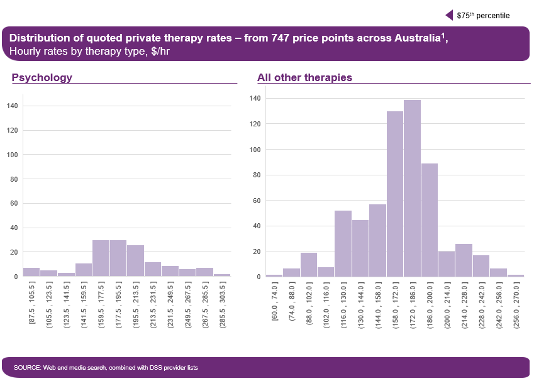

Private Billing Benchmarking: Analysis of the 2012–18 Database

Overview of findings
To check the robustness of the statistical analysis on conducted on the 2018 private billing database, similar analysis was conducted on a larger database of 4,668 unique price points from 2012 to 2018 (similarly collected by benchmarking private billing data on therapy services from around Australia). This check revealed broadly similar results, including statistically significant differences in certain prices at the 95 per cent confidence level.
- At the national level, only psychology is statistically different from other types of therapy in terms of price, with an average price that is 11–15 per cent higher
- The prices of initial and group consultations, and non-direct services are all statistically different from the price of standard consultations, though this finding is not robust.
- The price of in-community consultations is not statistically different from the price of standard in-centre consultations
- Price differences between states are not statistically significant.

Methodology
The Therapy Review collected 4,668 data points for 2012–18 rates for consultations and other services from web searches and the DSS Helping Children with Autism and Better Start for Children with Disability provider lists. All rates were classified based on:
- Type of therapy (for example, physiotherapy, occupational therapy, speech pathology, psychological therapy).
- Type of service covered (for example, initial consultation, standard consultation, report, and case conference).
- Delivery location (for example, in-centre or in-community services).
- Therapist qualifications (for example, therapist versus therapy assistant).
- Duration of service.
- Geography (for example, by state, and remote versus non-remote locations).
All entries where duration was not explicitly provided, or where travel was included as a separate item, were discarded for benchmarking purposes.
All the relevant benchmarking entries were pro-rated to convert them into hourly rates. When duration was provided as a range, the middle point of the range was considered the average duration of sessions. Older entries from before 2018 were indexed for inflation to make them comparable. The average rates per therapy per service were calculated by averaging all relevant entries.

Statistical analysis
Several statistical analyses were performed on the unique price points collected from the private billing database to assess the existence of statistical differences between the following groups of prices:
- Therapy type: Standard consultation rates, by therapy type.
- Type of service:
  - Standard versus initial consultation rates.
  - In-centre versus in-community consultation rates.
  - Individual versus group consultation rates.
  - Direct versus non-direct services.
- Geography: Standard consultation rates, by state.

Overview of the private billing database
The Therapy Review collected a total of 4,668 unique price points, with approximately 90 per cent of entries coming from the DSS database. The split of data points across different states and therapy types is presented in Table 16
Table 16: Distribution of Data Points From The Entire Benchmarking Database By Therapy Type And State (2012 To 2018 Database)
 | Occupational Therapy | Physiotherapy | Psychology | Speech  Therapy | Mixed | Total
ACT | 2 | 5 | 7 | 7 | 11 | 32
NSW | 362 | 49 | 163 | 555 | 108 | 1237
NT | 10 | 8 | 13 | 17 | 5 | 53
QLD | 278 | 27 | 243 | 339 | 149 | 1036
SA | 42 | 12 | 17 | 76 | 31 | 178
TAS | 32 | 5 | 28 | 58 | 28 | 151
VIC | 415 | 44 | 411 | 683 | 160 | 1713
WA | 116 | 15 | 63 | 60 | 14 | 268
National | 1257 | 165 | 945 | 1795 | 506 | 4668
DSS % | 98.0% | 18.8% | 93.8% | 92.4% | 84.0% | 90.7%
Source: Web and media search, combined with DSS provider lists
Within the database, 1,778 individual consultation rates were identified, with approximately 88 per cent coming from the DSS database (Table 17).
Table 17: Distribution Of Standard In-Clinic Consultation Rates By Therapy Type And State (2012 To 2018 Database)
 | Occupational Therapy | Physiotherapy | Psychology | Speech  Therapy | Mixed | Total
National | 409 | 89 | 397 | 738 | 155 | 1788
DSS % | 97.6% | 14.6% | 90.9% | 91.3% | 80.6% | 87.9%
Results from the multi-variate analysis performed on the entire database demonstrated that therapy type and type of service (i.e. initial vs standard, in-centre vs in-community and direct vs non-direct) are significant factors, while geography (i.e. state) is not. The regression produced an R² of 0.27.

Evidence of price differentials in the private market for therapy
Finding: At the national level, only private market prices for psychology are meaningfully different, in a statistical sense, from other types of therapy (at a higher rate)
Exhibit 20 shows the average hourly market price in the database for each therapy profession along with its standard deviation.
From this chart, some variation in the average prices across therapy types in the private billing database is observed. However, this is not sufficient evidence of a meaningful difference in prices. To test this, a statistical test was performed to compare the full range (or distribution) of prices for each therapy type with the distributions of all other therapy types. This analysis revealed that only the distribution of prices for psychology was statistically different.
It is therefore possible to be confident that the average price for psychology, which is around 12 per cent higher than the average price of other therapies, is a meaningful difference. For all other therapy types, it is not reasonable to be confident that the observed differences in the average prices are not simply because of random factors or different sample sizes.
Exhibit 20: Average Price per Hour for Standard In-Clinic Consultations by Therapy Type (2012 to 2018 Database)
Finding: Statistical analysis did not reveal conclusive evidence of any meaningful differences in private market prices based on type of service.
Initial vs standard consultation: As shown in Exhibit 21, rates for initial and standard consultations are statistically different, with average hourly rates for initial consultations on average 12 per cent higher than standard consultation rates, potentially due to the higher administration costs involved. However, it should be noted that other items might be included in the initial consultation rates, such as report writing and or development of a treatment plan (which can be charged separately under the NDIS), which potentially makes this finding misleading.
Exhibit 21: Average Price per Hour For In-Clinic Standard And Initial Consultations (2012 To 2018 Database)

In-centre versus in-community services: As shown in Exhibit 22, rates for in-community services (excluding travel) appear to be around 16 per cent higher than rates for in-centre services, and this difference is statistically significant. However, as less than 2 per cent of in-community rates explicitly exclude travel costs, it is likely that this difference can be attributed to travel costs being embedded in in-community rates.
Exhibit 22: Average Price per Hour for In-Clinic And In-Community Consultations (2012 To 2018 Database)
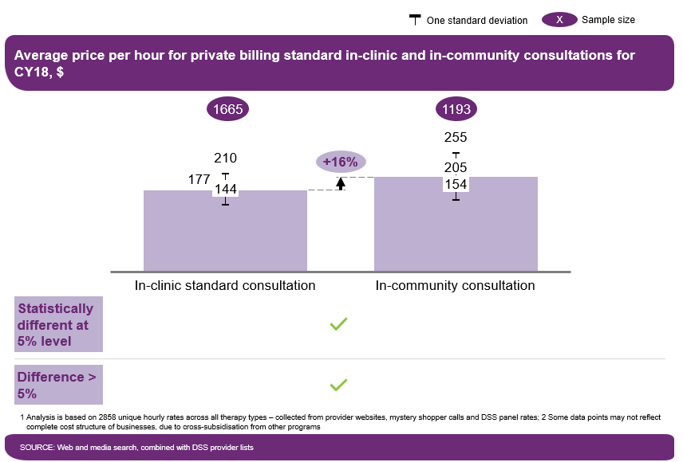

Direct versus non-direct services: As shown in Exhibit 23, rates for direct in-centre and non-direct services are statistically different, with average hourly rates for non-direct services on average 11 per cent lower. However, it should be noted that direct services are generally billed on an hourly basis, which means that duration might not be reflective of the actual time invested by the therapist in these activities. This potentially makes this finding misleading.
Exhibit 23: Average Price per Hour for Standard In-Clinic Consultations And Non-Direct Supports (2012 to 2018 Database)
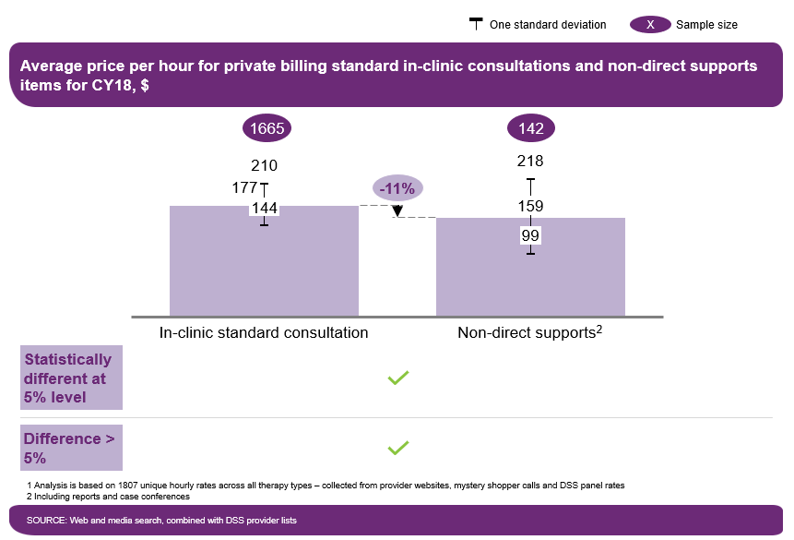
Finding: Statistical analysis did not reveal conclusive evidence of any meaningful differences in private market prices by state/territory.
As shown in Exhibit 24 prices across states are not statistically different from all other groups.
Exhibit 24: Average Price per Hour for Standard In-Clinic Consultations by State (2012 to 2018 Database)

Evidence of major price differentials between private market for therapy and NDIS
Finding: Current NDIS prices would make entering the disability segment attractive for up to around 70 per cent of private therapists but only up to around 50 per cent of private psychologists.
To attract private therapists to register as an NDIS provider, NDIS price caps need to be attractive compared to what a private therapist is currently charging. For example, the NDIS price must be close to their current charge out rate. It is possible that the NDIS price may even need to be a little higher than the market price given that there are additional costs associated with serving NDIS participants such as audit costs to maintain accreditation under the Quality and Safeguards standards or additional training to serve participants with disabilities.
Therefore, comparing the full distribution of market prices to the current NDIS therapy price of around $183 can provide an indication of what proportion of private therapists would find the current NDIS price cap attractive. This distribution and comparison is shown in Exhibit 25 for both psychology and all other therapies.
This analysis indicates that the current NDIS price is comparable to the 50th percentile of psychology prices. This means that half the prices in the private billing database are above the NDIS price and half below. All other things being equal, this suggests that only around 50 per cent of private psychologists may find it attractive to entering the NDIS segment.
Similarly, the analysis indicates that the current NDIS price is comparable to the 70th percentile of prices for other types of therapy. This means that around 30 per cent of the prices in the private billing database are above the NDIS price and around 70 per cent are below. All other things being equal, this suggests that around 70 per cent of private therapists (excluding psychologists) may find it attractive to entering the NDIS segment.
Exhibit 25: Distribution of Standard In-Clinic Consultation Rates for Psychology And Other Therapies (2012 to 2018 Database)

Scatter plots showing the distribution of data points for each therapy type
The scatter plots presented in Exhibits 27– 31 below show for each therapy type the distribution of data points from the indexed database among the different type of consultations and services provided.
Exhibit 26: Distribution of Occupational Therapy Rates
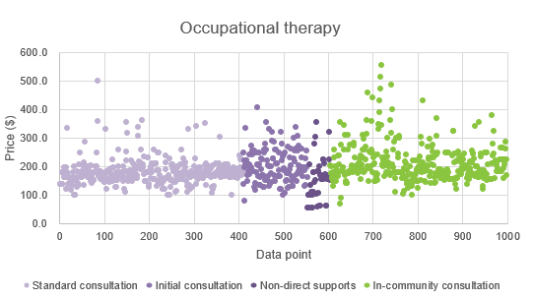

Exhibit 27: Distribution of Speech Pathology Rates
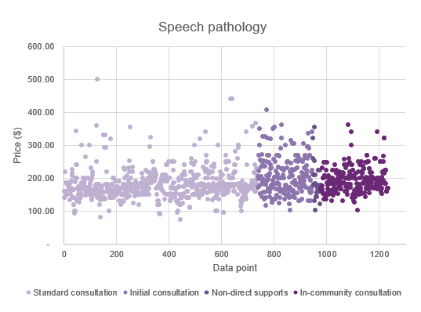

Exhibit 28: Distribution of Psychology Rates (Not Including Clinical Psychology Rates)
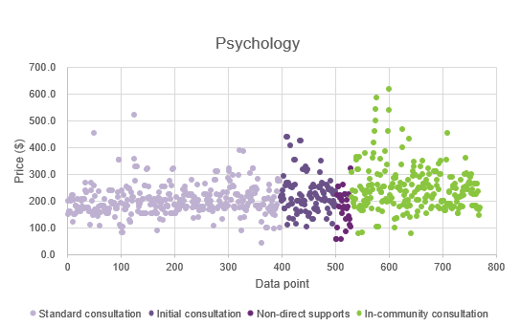

Exhibit 29: Distribution of Physiotherapy Rates
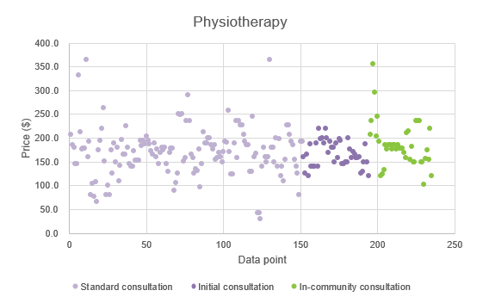

Exhibit 30: Distribution of Rates for Other Therapies
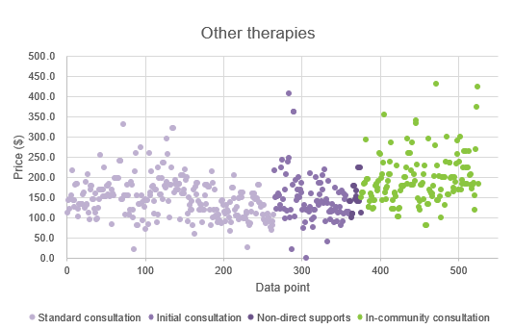

Health Professionals And Support Services Award [Ma000027]
Table 18: Health Professionals and Support Services Award
Classification | Weekly pay rate | Hourly pay rate | Shift work – Monday to Friday | Saturday | Sunday | Public holiday
Support services employee level 1 | $764.70 | $20.12 | $23.14 | $30.18 | $30.18 | $50.30
Support services employee level 2 | $796.30 | $20.96 | $24.10 | $31.44 | $31.44 | $52.40
Support services employee level 3 | $827.60 | $21.78 | $25.05 | $32.67 | $32.67 | $54.45
Support services employee level 4 | $837.40 | $22.04 | $25.35 | $33.06 | $33.06 | $55.10
Support services employee level 5 | $865.70 | $22.78 | $26.20 | $34.17 | $34.17 | $56.95
Support services employee level 6 | $912.40 | $24.01 | $27.61 | $36.02 | $36.02 | $60.03
Support services employee level 7 | $928.80 | $24.44 | $28.11 | $36.66 | $36.66 | $61.10
Support services employee level 8 - pay point 1 | $960.30 | $25.27 | $29.06 | $37.91 | $37.91 | $63.18
Support services employee level 8 - pay point 2 | $985.50 | $25.93 | $29.82 | $38.90 | $38.90 | $64.83
Support services employee level 8 - pay point 3 | $1,054.90 | $27.76 | $31.92 | $41.64 | $41.64 | $69.40
Support services employee level 9 - pay point 1 | $1,073.60 | $28.25 | $32.49 | $42.38 | $42.38 | $70.63
Support services employee level 9 - pay point 2 | $1,111.80 | $29.26 | $33.65 | $43.89 | $43.89 | $73.15
Support services employee level 9 - pay point 3 | $1,120.60 | $29.49 | $33.91 | $44.24 | $44.24 | $73.73
Health professional employee level 1 - pay point 1 (UG 2 qualification) | $878.40 | $23.12 | $26.59 | $34.68 | $34.68 | $57.80
Health professional employee level 1 - pay point 2 (three-year degree entry) | $912.40 | $24.01 | $27.61 | $36.02 | $36.02 | $60.03
Health professional employee level 1 - pay point 3 (four-year degree entry) | $952.60 | $25.07 | $28.83 | $37.61 | $37.61 | $62.68
Health professional employee level 1 - pay point 4 (Master’s degree entry) | $985.50 | $25.93 | $29.82 | $38.90 | $38.90 | $64.83
Health professional employee level 1 - pay point 5 (PhD qualification) | $1,073.60 | $28.25 | $32.49 | $42.38 | $42.38 | $70.63
Health professional employee level 1 - pay point 6 | $1,111.80 | $29.26 | $33.65 | $43.89 | $43.89 | $73.15
Health professional employee level 2 - pay point 1 | $1,117.90 | $29.42 | $33.83 | $44.13 | $44.13 | $73.55
Health professional employee level 2 - pay point 2 | $1,158.40 | $30.48 | $35.05 | $45.72 | $45.72 | $76.20
Health professional employee level 2 - pay point 3 | $1,202.60 | $31.65 | $36.40 | $47.48 | $47.48 | $79.13
Health professional employee level 2 - pay point 4 | $1,250.50 | $32.91 | $37.85 | $49.37 | $49.37 | $82.28
Health professional employee level 3 - pay point 1 | $1,304.80 | $34.34 | $39.49 | $51.51 | $51.51 | $85.85
Health professional employee level 3 - pay point 2 | $1,341.30 | $35.30 | $40.60 | $52.95 | $52.95 | $88.25
Health professional employee level 3 - pay point 3 | $1,370.20 | $36.06 | $41.47 | $54.09 | $54.09 | $90.15
Health professional employee level 3 - pay point 4 | $1,431.00 | $37.66 | $43.31 | $56.49 | $56.49 | $94.15
Health professional employee level 3 - pay point 5 | $1,483.90 | $39.05 | $44.91 | $58.58 | $58.58 | $97.63
Health professional employee level 4 - pay point 1 | $1,579.70 | $41.57 | $47.81 | $62.36 | $62.36 | $103.93
Health professional employee level 4 - pay point 2 | $1,685.90 | $44.37 | $51.03 | $66.56 | $66.56 | $110.93
Health professional employee level 4 - pay point 3 | $1,833.40 | $48.25 | $55.49 | $72.38 | $72.38 | $120.63
Health professional employee level 4 - pay point 4 | $2,023.90 | $53.26 | $61.25 | $79.89 | $79.89 | $133.15

Additional Details on General and Endorsed Psychologists
Table 19: Number of Endorsements Held
Endorsement | 1 | 2 | 3 | 4 | 5 | 6 | Total
Number of endorsed psychologists | 10.549 | 895 | 56 | 8 | 1 | 1 | 11,510
% of endorsed psychologists | 91.7% | 7.8% | 0.5% | <0.1% | <0.1% | <0.1% | 100.0%
Number of psychologists with general registration (endorsed and non-endorsed) |  |  |  |  |  |  | 29,843
% of all general psychologists with one or more endorsement | 35.3% | 3.0% | 0.2% | <0.1% | <0.1% | <0.1% | 38.6%
Source: Psychology board of Australia

Glossary and Abbreviations
Abbreviation | Meaning
Assistive Technology | Any device or system using a device that allows individuals to perform tasks that would otherwise be more difficult, unsafe or not possible. It does not include items for treatment, mainstream technology without modifications.
Attendant Care | Refers to all supports which are either assistance with daily living or assistance with social and community participation.
Award | Regulatory instrument which outlines the minimum pay rates and conditions of employment for a particular industry and/or occupation.
Board | The corporate governing board of the National Disability Insurance Agency
DVA | The Commonwealth Department of Veterans Affairs
DSS | The Commonwealth Department of Social Services
Eastern Price Guide | NDIS Price Guide (NSW, VIC, QLD, TAS) released by the NDIA
EBA | Enterprise Bargaining Agreement
ECEI | Early Childhood Early Intervention
FTE | Full-time equivalent
Full Scheme | Refers to the fully implemented state of the NDIS, estimated to operate from 2020.
FY | Financial Year
IPR | Independent Pricing Review
IT | Information Technology
LAC | Local Area Coordinator
NDIA | National Disability Insurance Agency
NDIS | National Disability Insurance Scheme
NDIS Commission | NDIS Quality and Safeguards Commission
Price cap | The maximum price that can be charged by a provider registered under the NDIS for a particular support service.
Price guide | One or all of the Eastern, Western, Remote and Very Remote Price Guides
Portal | A secure website that enables providers to transact online with the NDIA.
Quality and Safeguarding Framework | Refers to the content in the following document – Department of Social Services: NDIS Quality and Safeguarding Framework (9 December 2016)
SCHADS Award, or SCHADS | Social, Community, Home Care and Disability Services Award 2010 [MA000100] or its applicable state or territory equivalent
SIRA | NSW State Insurance Regulatory Authority
TAC | Transport Accidents Commission
TOR | Terms of Reference
Western Price Guide | NDIS Price Guide (WA, SA, ACT, NT) released by the NDIA

Note: unless specified otherwise, “Current Price” in this document refers to prices as at 31 March 2019.
Direct services are typically provided face to face and refer to either: (1) a consultation between the therapist and the participant and/or their informal supports (for example, family members); or (2) the administration of a treatment. All other services are considered non-direct—for example, developing an individual treatment plan, preparing a report or participating in case conferencing.
“In-community” refers to services performed in the home, at school or in any other mobile setting.
An “Area of Practice Endorsement” (AoPE) indicates that a registered psychologist has qualifications in a particular area of practice and an additional two years or more of supervised experience in that area. A psychologist with an AoPE therefore has at least eight years of training. Source: APS. See Appendix for further information.
Subsequent to this Review, the WA Market Review recommended that the price cap and plan funding loadings for all supports in remote and very remote areas should be doubled. This recommendation was accepted by the NDIA Board and this came into effect on 1 July 2019.
An “Area of Practice Endorsement” (AoPE) indicates that a registered psychologist has qualifications in a particular area of practice and an additional two years or more of supervised experience in that area. A psychologist with an AoPE therefore has at least eight years of training (source: APS). See the Appendix for further information.
https://www.dss.gov.au/disability-and-carers-programs-services-for-people-with-disability/helping-children-with-autism-hcwa-and-better-start-for-children-with-disability-better-start
All distributions were assumed to be normal and were corrected for outliers before performing the analysis (see the Appendix for additional details). After correcting the samples for outliers, statistical differences were assessed based on p-values, calculated based on a Kruskal Wallis and Bonferroni corrected Dunn’s post hoc test. P-values below 0.05 were considered statistically significant. A multi-variable regression analysis was also performed on the entire database to identify which factors dominate prices. This was done by introducing dummy variables for each of the factors mentioned above. The independent variable list was adjusted for collinearities before performing the analysis.
Only psychology was found to be different in a post hoc test with Bonferroni correction.
https://www.fairwork.gov.au/ArticleDocuments/872/health-professionals-and-support-services-award-ma000027-pay-guide.pdf.aspx
New South Wales Health Service Health Professionals (state) Award 2018; Health and Community Employees Psychologists (State) Award 2018; Victorian Public Health Sector (Medical Scientists, Pharmacists and Psychologists) Enterprise Agreement 2017–2021; Allied Health Professionals (Tasmanian State Service) Agreement 2016; Health Practitioners and Dental Officers (Queensland Health) Certified Agreement (No. 2) 2016; South Australian Modern Public Sector Enterprise Agreement: Salaried 2017; Australian Capital Territory Public Sector Health Professional Enterprise Agreement 2013–2017; https://ocpe.nt.gov.au/nt-public-sector-employment/Information-about-ntps-employment/rates-of-pay; Allied Health Professionals (Victorian Public Health Sector) Single Interest Enterprise Agreement 2016–2020; Western Australia Health System – Health Services Union of Western Australia – Pacts Industrial Agreement 2018.
https://www.fwc.gov.au/awards-and-agreements/agreements
Notes on EBA analysis: (i) rates that explicitly mention that the role does not involve client interactions were excluded; and (ii) only an average of seven out of the top 50 providers per state were available.
National Disability Services, 2018 State of the Disability Sector, https://www.nds.org.au/news/state-of-the-disability-sector-report-2018-now-available
An “Area of Practice Endorsement” (AoPE) indicates that a registered psychologist has qualifications in a particular area of practice and an additional two years or more of supervised experience in that area. A psychologist with AoPE therefore has at least eight years of training. Source: APS.
Indexing for inflation was done by compounding older entries using the five-year average health price index (I_{avg}): Rate₂₀₁₈ = Rate_{X} * (1+ I_{avg})^{2018-X} , where X is the year of the entry.
All distributions were assumed to be normal and were corrected for outliers before performing the analysis. After correcting the samples for outliers, statistical differences were assessed based on p-values. P-values below 0.05 were considered statistically significant. A multi-variable regression analysis was also performed on the entire database to identify which factors dominate prices. This was done by introducing dummy variables for each of the factors mentioned above. The independent variable list was adjusted for collinearities before performing the analysis.
Distributions of prices for each therapy were found to be statistically different at a group level, but only psychology was found to be statistically different from all other distributions in a post hoc test with Bonferroni correction.

