Request for NDIS Tailored Data Release
September 2019

Contents
Request for NDIS Tailored Data Release September 2019 1
1 Related documents 3
2 Purpose 3
3 Requesting Process 4
4 Terms and conditions 5
Terms and conditions upon which NDIS data is supplied 5
NDIS liability position regarding data 5
Limited licence provisions and copyright information 5
Agreement to terms and undertaking 6
Description of NDIS data being requested 7
Primary Contact Officer details 8

1 Related documents
Please refer to chapter 3 of the NDIS Public Data Sharing Policy for information on the tailored data release.

2 Purpose
The purpose of this document is to provide a mechanism for enabling access to NDIS data for a specific purpose. It applies to researchers, academics and government agencies/departments.
A tailored data release is released to named individuals and organisations with appropriate restrictions on the use and disclosure of NDIS data. The data will also be appropriately de-identified where required.
It also sets out the process for making a data request and how the process for evaluating tailored data releases. For more information on how the risk of a data request is evaluated, please refer to Figure 1 in the NDIS Public Data Sharing Policy.
Please complete this document and submit it to datasharing@ndis.gov.au

3 Requesting Process
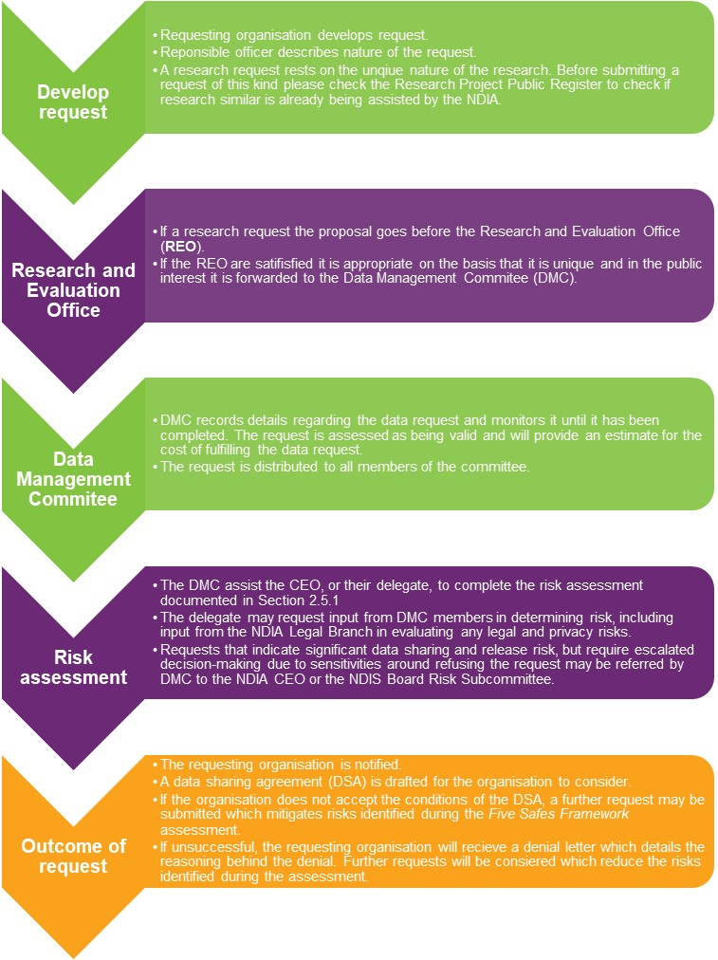
The following diagram sets out the formal process for a Requesting Organisation asking for NDIS data and the internal processes performed by the NDIA.

4 Terms and conditions
A scanned copy of the signed document must be sent to datasharing@ndis.gov.au. Any questions are to be sent to this email address.
The NDIA privacy policy explains how the NDIS will handle any personal information provided by you. A copy of this policy is available at www.ndis.gov.au/privacy.

Terms and conditions upon which NDIS data is supplied
If the NDIA agrees to supply you with the requested NDIS data, the data will be supplied to you on the basis of the following terms and conditions. In order for your request for NDIS data to be considered, you must sign this form to indicate your agreement to these terms and conditions. Additionally, a Data Sharing Agreement (DSA) will be drafted and must be accepted prior to any NDIS data being released.

NDIS liability position regarding data
Except to the extent that liability may not be lawfully excluded, the NDIA:
a) makes no warranty as to the suitability or fitness of the data for a particular purpose, quality, accuracy or merchantability; and
b) does not guarantee, and accepts no legal liability whatsoever arising from, or connected to, the use or representation of any data provided or subsequent use or representation through the use of this data by the requestor.

Limited licence provisions and copyright information
Intellectual Property Rights in data products, including copyright, are owned by the NDIA. Copyright notices appearing on data products or on information displayed or printed by the data product must not be removed.
A Requesting Organisation using data supplied by the NDIA is granted a non-exclusive, non-transferable license by the NDIA that allows authorised users to use the NDIS data for statistical purposes in accordance with the Undertaking signed by the Responsible Officer of the organisation.
Attribution and no relationship with NDIA
Any published article or report which has utilised or references NDIS data or analysis of a data product must cite the NDIA as the source of the data and include a prominently displayed notice that the results or views expressed are those of the author, and not those of the NDIA. Further, the Requesting Organisation must also stipulate that their research has not been prepared in collaboration or partnership with the NDIA. Lastly, intent to publish should be declared in the external data request.
Use and storage of NDIS data
Any NDIS data supplied must be stored securely and kept strictly confidential. The Requesting Organisation will not publish the data or disclose the data to any third parties, unless with the prior written agreement of the NDIA. If the Requesting Organisation becomes aware that the NDIS data supplied to it has been lost, published, or disclosed to or accessed by a third party, it will immediately inform the NDIA.
NDIS data must be deleted, with all hard copies securely destroyed, at the end of the research project. The Requesting Organisation agrees to immediately delete and destroy all records of NDIS data once no longer required, or otherwise as directed by the NDIA.
The Requesting Organisation agrees to allow the NDIA or any entity engaged on its behalf to audit how NDIS data is being stored or used by it, or to verify that the NDIS data has been securely disposed of.

Agreement to terms and undertaking
By signing this Undertaking, the person (Responsible Officer of the Requesting Organisation) agrees to the following, as a legally enforceable agreement with the Agency:
- That they personally, and their organisation and its agents and employees (including the responsible officer of the organisation), will comply with the terms and conditions (set out on this form) upon which the NDIS data is supplied, if the NDIA agrees to supply the requested data; and
- That they are responsible for any liability arising out of misuse, loss, unauthorised access to the summary data once provided and to indemnify the NDIA for any damages or loss incurred in connection with the supply of the summary data to the organisation or any of its employees (including the Responsible Officer).
Signed by:……………………………………………………….
Name (please print):………………………………………………..
Position held at Requesting Organisation:………………………………………
Date:……………………………………………

Description of NDIS data being requested
Please provide the following information:
- What NDIS data is being requested? Please refer to Appendix A in the NDIS Public Data Sharing Policy for available data.
……………………………………………………………………………………………………………………………………………………………………………………………………
- What is the name of your organisation and who specifically within the organisation will be responsible for handling the NDIS data? Please provide relevant details such as your organisations website.
……………………………………………………………………………………………………………………………………………………………………………………………………
…………………………………………………………………………………………………
- For what purpose will you use the requested data?
………………………………………………………………………………………………………………………………………………………………………………………………………………………………………………………………………………………………………
- Why do you need this data? How does the data assist you in meeting your project goals?
……………………………………………………………………………………………………………………………………………………………………………………………………
- What was the ethics committee process for your organisation to approve this data request (if required)?
……………………………………………………………………………………………………………………………………………………………………………………………………
- Do you intend to publish or on-disclose NDIS data? If so, please provide details.
……………………………………………………………………………………………………………………………………………………………………………………………………
…………………………………………………………………………………………………
- Please provide any further details which may be relevant to your application, having regard to the evaluation criteria set out in the NDS Public Data Sharing Policy and the Five Safes Framework.
……………………………………………………………………………………………………………………………………………………………………………………………………
……………………………………………………………………………………………………………………………………………………………………………………………………

Primary Contact Officer details
Organisation
Full Name
Position / Title
Division / Faculty
Telephone
Address
Email

