Copyright

National Disability Insurance Scheme

Pricing Strategy
August 2019
Copyright in the information contained in this Pricing Strategy is owned and protected by the National Disability Insurance Scheme Launch Transition Agency (National Disability Insurance Agency).

Use of National Disability Insurance Agency copyright material
The material in this report with the exception of logos, trademarks, third party material and other content as specified is licensed under Creative Commons CC NC licence, version 3.0. With the exception of logos, trademarks, third party material and other content as specified, you may reproduce the material in this Pricing Strategy, provided you acknowledge the National Disability Insurance Agency as the owner of all intellectual property rights in the reproduced material by using ‘© National Disability Insurance Scheme Launch Transition Agency 2019’ and do not use the material for commercial purposes.
Reproduction of any Creative Commons material in this document is subject to the CC NC licence conditions available on the Creative Commons site, as is the full legal code for this material.

Terms that we use
NDIA | National Disability Insurance Agency
NDIS | National Disability Insurance Scheme
NDIS Commission | National Disability Insurance Scheme Quality and Safeguards Commission

Further information
Further information on pricing in the National Disability Insurance Scheme can be found at the NDIS website

Contents
Executive Summary 5
1 Introduction 11
2 Current arrangements 13
2.1 Participants 13
2.2 Plans 14
2.3 Plan management 15
2.4 Pricing 15
2.4.1 Terms of Business 16
2.4.2 NDIS Price Guide and NDIS Support Catalogue 17
2.4.3 Special NDIS Pricing Arrangements 17
3 Market stewardship 23
3.1 Price controls 24
3.2 Other market interventions 25
3.3 Economic and regulatory context 25
3.4 Domestic and international lessons 29
3.4.1 Lessons from the Australian aged care sector 29
3.4.2 Lessons from international schemes 30
4 NDIS Pricing Strategy 33
4.1 The Evolution of the NDIS Pricing Strategy 35
4.2 Proposed Strategy – ‘Glide path’ to the new equilibrium 36
4.2.1 Balance efficiency and growth 38
4.2.2 Assist providers, and the market, to become more efficient 39
4.2.3 Address information asymmetries to empower consumers 40
4.2.4 Measuring success 41
Appendix A: Therapy pricing 43
References 47

Table of Figures
Figure 1: Transition from equilibrium prior to the NDIS to the long run NDIS equilibrium 9
Figure 2: Transition strategy 10
Figure 3: Employment growth in the disability support sector due to the NDIS 28
Figure 4: Historical and projected increases in selected economic sectors, 1995 to 2023 29
Figure 5: Transition from pre-NDIS equilibrium to the NDIS long run equilibrium 29
Figure 6: Average price impact of the NDIS on disability services 30
Figure 7: Average quantity impact of the NDIS on disability services 31
Figure 8: Phases of NDIS and pricing 38
Figure 9: Transition from equilibrium prior to the NDIS to the long run NDIS equilibrium 40
Figure 10: Transition strategy 41

Executive Summary
The supply of disability goods and services in Australia is undergoing significant reform with the phased creation, commencing from 1 July 2013, of the National Disability Insurance Scheme (NDIS). The National Disability Insurance Agency (NDIA) has responsibility for administering the NDIS, including (together with the NDIS Quality and Safeguards Commission) regulating the markets for disability goods and services.
As of 30 June 2019, some 298,816 people with disabilities, including children in the Early Childhood Early Intervention (ECEI) program were being supported by the NDIS. This number is estimated to increase to about 500,000 over the next five years. The market for supports has also substantially increased.
Where possible, the NDIA utilises market mechanisms to deliver the level of supply required to meet participant demand and deliver the required mix of goods/services, produced at market clearing (efficient) prices, to meet the needs of participants. Prices play an important role in coordinating this, within overall budget constraints. However, in underdeveloped or non-existent markets, reliance on deregulated market mechanisms may not meet participant demands; may not deliver adequate supply; may not deliver the required mix of disability supports and may not produce efficient prices. To address these issues, the NDIA has a role, as market steward, to create an efficient and sustainable marketplace through a diverse and competitive range of suppliers who are able to meet the structural changes created by a consumer-driven market.
As part of its market stewardship role, the NDIA caps the prices that registered providers can charge for some supports. During transition, price controls are in place to ensure that participants receive value for money in the supports that they receive. In the short to medium term, price controls are required for some disability supports because the markets for disability goods and services are not yet fully developed. The longer-term goal of the NDIA is to remove regulatory mechanisms from the markets for disability supports. Currently, the NDIA varies its approach to the regulation of prices, depending on market conditions, between:
- No regulation (deregulated markets): this is typically used in cases where markets are highly competitive – for example, transport.
- The imposition of price caps: this represents a maximum allowable price payable by participants for types of supports. This approach is used in a significant number of markets, which are still developing and growing, such as those for attendant care.
- Quotable supports: in which participants are expected to obtain quotations from suppliers to provide to the NDIA as part of verifying that prices are fair and reasonable. This approach is typically used in the case of highly specialised, differentiated supports that may not have a high level of competition – for example, assistive technology. They can also be used in cases where a bundle of supports or quasi-outcome is being purchased. In these situations, providers have greater flexibility to adjust how they achieve the required outcomes in response to the input costs they face.
The purpose of this document is to set out the NDIS Pricing Strategy for those types of core supports on which the NDIA currently imposes price caps, including:
- Attendant Care Services (Assistance with Self-Care Activities);
- Short Term Accommodation; and
- Assistance to access community, social and recreational activities, including community and centre group based supports.
The NDIS Pricing Strategy recognises the critical role that pricing plays in the NDIS in:
- empowering participants to exercise choice and control;
- maintaining and expanding the supply of high quality disability supports;
- driving efficiency and innovation in the market for those supports;
- and supporting the transition of the NDIS over the longer term to a more deregulated outcomes-based approach.
The NDIS Pricing Strategy is a critical component in transitioning the NDIS markets to cope with significant demand growth, reaching the longer-term goal of price deregulation and improving efficiency and quality of care. It recognises that during the transition to deregulation, there is a requirement to maintain current supply in the short term and significantly increase the supply of disability supports in the medium to long term, to meet the needs of increased numbers of people entering the scheme and increased levels of support. This transition and the required growth in supply will take time and may need to be adjusted to encourage providers to expand existing operations and new suppliers to enter the markets. Longer term, prices may increase or decrease, depending on the relative ease with which supply can be increased.
The NDIS Pricing Strategy is best understood in terms of four different concepts of pricing:
- Efficient price levels – Price levels that represent the long run minimum cost of production. Sufficient production at efficient price level is only expected to be achievable in the long run in mature markets, with strong competition between providers.
- Sustainable price levels – Price levels that represent, at a given time, the price at which the average current firm is viable (even if inefficient). In the short term, prices at or above sustainable levels are required to ensure that current supply levels remain stable and providers with costs somewhat above the most efficient level remain viable.
- Transitional price levels – Price levels that represent, at a given time, the price necessary to attract new providers to enter the market or to reduce exits from the market. Transitional price levels represent the price required to attract economic resources from other parts of the economy to expand provider supply. Transitional price levels are above sustainable price levels, but should only be adopted where, as is the case in the NDIS transition period, a significant expansion of supply is required.
- Price caps – Upper limits on prices, used to reduce the potential exercise of market power.
Figure 1 below shows the market clearing equilibrium price and quantity of disability supports prior to the NDIS (at point A) and the long run market clearing equilibrium price and quantity of disability supports including the NDIS demand (at point C). It also illustrates the paths that sustainable price levels (red arrow) and transitional price levels (green arrow) will take in real terms over the transition to the long run market clearing equilibrium price, recognising the potential inefficiency of some current providers and the need to significantly expand and not unnecessarily disrupt the supply of services to people with disabilities.
Figure 1: Transition from equilibrium prior to the NDIS to the long run NDIS equilibrium
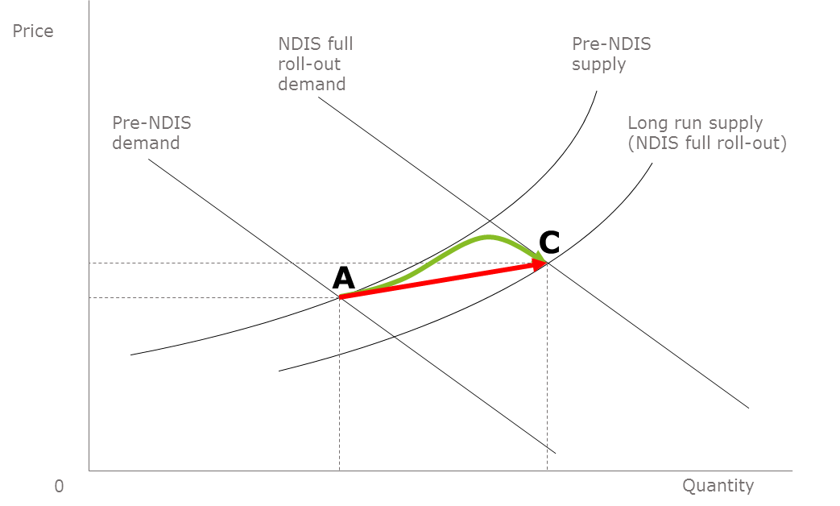
Whether the long-term efficient prices for disability goods and services are higher or lower than the prices that obtained prior to the introduction of the NDIS depends on the level of improvements in efficiency that market forces will drive into the future. It should not be assumed that the final efficient price would be higher than previously. Although there are some factors that will tend to increase costs for providers, there are also factors that will decrease those costs. For example, some providers are currently facing a drain on capital as they transition away from block funding, together with transition costs. These upward pressures on prices will not be sustained in the longer term. It is also important to note that participants now have much greater control over the bundle of services that they purchase, and the efficiencies gained from this are not reflected in the unit prices of individual supports but in the overall cost of the bundle of supports chosen by participants. The potential substitution effect of different support models could put downward pressure on prices. This substitution effect will potentially be accelerated if participants are provided with more flexibility in plans. Finally, it needs to be recognised that there are emerging registered providers charging significantly less than the current sustainable price - and probably even the current efficient price under a traditional business model - and at the same time paying support workers higher than award wages. This is made possible by a technology driven back office rather than the type of structure under which most large providers currently operate.
To date, NDIS price levels, both in terms of the level of funds included in participant’s plans, and price caps, have been predominantly set with longer run efficient price levels in mind. The pricing strategy proposed in this document better reflects the current situation of inefficient supply and growing demand. It represents an approach to pricing aimed at maintaining and increasing market supply, assisting in the transition of the NDIS to full roll out and helping markets grow to a more mature state in the future, while recognising the need for financial sustainability. Figure 2 below summarises the stages through which price regulation in the NDIS needs to move as the economic forces outlined above play out.
Figure 2: Transition strategy
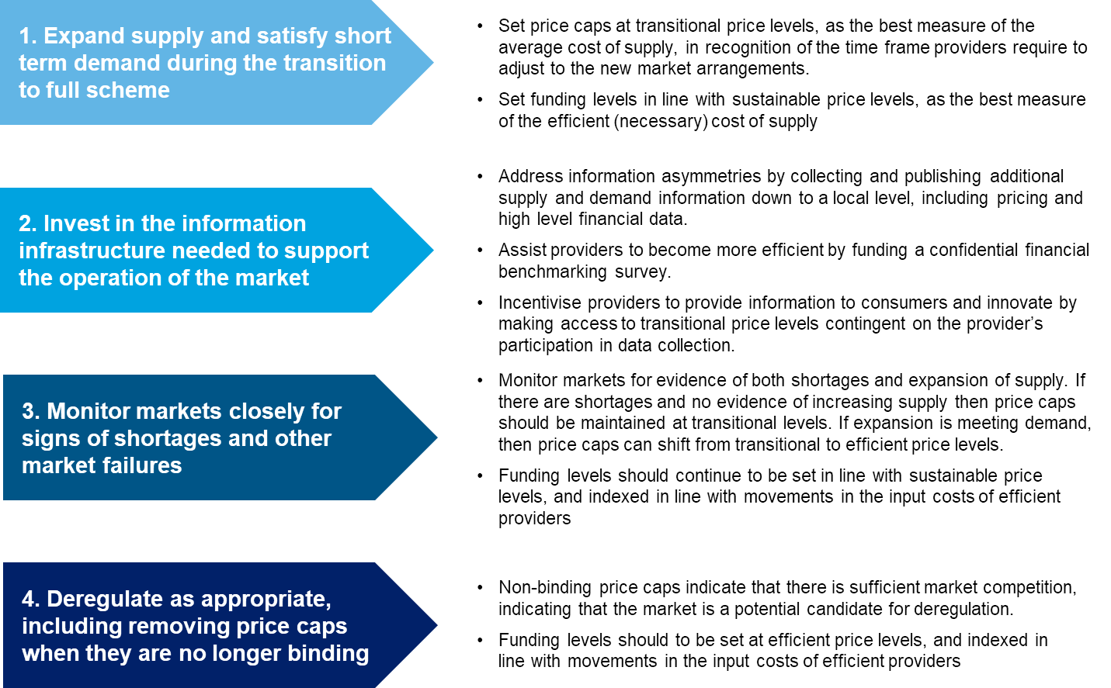
Price controls need to take into account efficiency and the need to expand supply. Markets for disability supports are continuing to develop, with both increases in market supply and improvements in production efficiency required. While improvements in production efficiency imply cost reductions in the long run, expansion of market supply necessitates higher short to medium term prices. In order to maintain and expand production volumes of disability supports, higher short-term prices are thus needed. This serves as an incentive to redirect the allocation of resources to the NDIS from other sectors in the economy. Without price growth, supply side shortages will likely exist.
In the longer term, efficient price levels are the best representation of the reasonable cost of the provision of a support and will eventually be the price levels best suited for the development of plans, which are concerned with efficient, effective, and appropriate supports. However, in the short to medium term, sustainable price levels are the best representation of the reasonable cost of the provision of a support. In the long run, sustainable price levels tend towards efficient price levels. In the short to medium term, however, as the market matures and expands, price caps need to be sufficient to both maintain current supply and attract new supply. That is, price caps for the NDIS need, in the short to medium-term at least, to be set with regard to transitional price levels, rather than sustainable and efficient price levels.
In brief, prices in the NDIS need to follow two paths under the NDIS Pricing Strategy:
- Funding levels in plans should be set at sustainable price levels (noting that current utilisation rates are not at capacity and can accommodae transitional price levels) and increased in line with movements in the unit input costs of providers (the red arrow in Figure 1). In the longer run, as transitional and sustainable price levels converge, participants will be able to purchase greater quantities of support for their fixed budgets, reaping the benefit of the improved efficiency of the sector.
- Price caps should be set in accordance with the movements in transitional price levels (the green arrow in Figure 1), to recognise the costs providers are facing in adjusting to the new arrangements, the time required to unwind established agreements, and to encourage growth in supply while driving efficiency. This should be done through an explicit and decreasing loading on sustainable price levels – the Temporary Transformation Payment (TTP) of about 7.5 per cent – with a clear statement to the market of the expected glide path over five years to efficient price levels through the phased reduction of the TTP. Detailed ongoing monitoring of markets should also be conducted to determine whether short-term price increases have been sufficient to expand supply, attract new entrants and increase competitive pressure. In the longer term, it is expected that competition between providers will result in a reduction of prices towards the long run efficient price. As market prices reduce towards long run efficient prices, the price caps imposed are expected to no longer be binding, in which case their removal can be considered.
At the same time, the collection and dissemination of more market and consumer information is essential to effective pricing and future outcomes based pricing. This should ideally include market information such as:
- quantity and prices of disability supports provided (for example, hours of care) by NDIS disability support group, and location (these data could be obtained by linking the details of suppliers to each payment made from NDIS support budgets);
- market entrants and exits;
- profitability and other financial metrics from financial statements of providers; and
- supply conditions such as the total expenditure of participants on supports by location.
Gathered supply data can be used to assist the NDIA determine pricing caps in the short term and enable better informed decision making when considering deregulation of markets in the medium to long term. As transitional pricing is above long run competitive equilibrium prices, it may also be reasonable to oblige providers to participate in data collection, as a form of ‘dividend’. To gain access to transitional prices, providers would need to participate in data collection in good faith (i.e. provide accurate responses), and discuss such changes with participants.
Providers also need to be given the tools to achieve long run efficiencies, by being able to properly understand the performance of their own organisation and to accurately compare their performance to that of their peers. This requires good accounting and governance standards and practices and the ability to compare performance across providers. The NDIA and the NDIS Quality and Safeguards Commission (NDIS Commission) can assist providers to do this by requiring providers to adopt better accounting and governance standards and practices over time as part of provider suitability requirements. The NDIA can also support the establishment of independent performance and financial benchmarking services and provider’s participation in those services, especially where providers are operating in thinner markets. The NDIA can also incentivise participation in such performance and financial benchmarking services, and the development of better accounting and governance standards practices, by making access to the transitional price level loading (Temporary Transformation Payment), or at least a part of that loading, contingent on such activities.
Going forward, consumer and outcomes data should be collected and published on a regular basis to enable consumers to obtain a detailed view of provider performance and enable future moves towards outcomes based pricing. Information collected could include:
- satisfaction with individual supports received;
- outcomes (for example, employment gained and engagement with the community);
- ease of market access (measuring any potential supply shortages);
- level of participant empowerment; and
- plan utilisation and any reasons plan budgets were not fully expended (especially where these indicate undersupply).
Collecting such additional consumer data can be used to both measure the performance of disability support providers in the longer-term transition to outcomes based pricing, and can help identify any areas in which undersupply is occurring in the short term.

Introduction
The supply of disability goods and services in Australia is undergoing significant reform with the phased creation, commencing on 1 July 2013, of the National Disability Insurance Scheme (NDIS). The NDIS operated on a trial basis in some regions between 1 July 2013 and 30 June 2016 and is transitioning to full Scheme from 1 July 2016 to 30 June 2019 (30 June 2020 in Western Australia). The National Disability Insurance Agency (NDIA) has responsibility for administering the NDIS, including (together with the NDIS Quality and Safeguards Commission) regulating the markets for disability goods and services.
As of 30 June 2019, some 298,816 people with disabilities, including children in the Early Childhood Early Intervention (ECEI) program were being supported by the NDIS. This number is estimated to increase to about 500,000 over the next five years. The market for supports has also substantially increased.
One of the principal objectives of the NDIS is for people with disability to exercise choice and control over how, and with which providers, they spend their available budgets. The role of pricing in the NDIS is therefore very important. Prices, or more precisely participants’ choices in response to the prices they face in the market, reflect the preferences and relative values that different participants place on different types of supports. The aggregation of these individual responses in turn signals to providers the quantity and mix of supports to supply. Prices also affect the purchasing power of participants. Higher prices reduce the supports participants can purchase within a given support budget. Prices also affect the total costs of the NDIS and therefore its financial sustainability, and the allocation of resources to the NDIS (and therefore possible production), relative to other sectors. Pricing can also affect providers’ choices, including by providing incentives: for entering the market; for upskilling and right-skilling; for innovation; and for improvements in service quality and outcomes.
As the markets for disability goods and services develop and operate more effectively, it is expected that the NDIA will be less interventionist. However, deregulation will necessarily occur at different points in time for different markets and may not be feasible in some cases. Currently, the NDIA varies its approach to the regulation of prices between:
- No regulation (deregulated markets): this is typically used in cases where markets are highly competitive – for example, transport.
- The imposition of price caps: these represent a maximum allowable price payable by participants for types of supports. This approach is used in a significant number of markets, which are still developing and growing, such as those for attendant care.
- Quotable supports: in which participants are expected to obtain quotations from suppliers to provide to the NDIA as part of verifying that prices are fair and reasonable. This approach is typically used in the case of highly specialised, differentiated supports that may not have a high level of competition – for example, assistive technology. They can also be used in cases where a bundle of supports or quasi-outcome is being purchased. In these situations, providers have greater flexibility to adjust how they achieve the required outcomes in response to the input costs they face.
The purpose of this document is to set out the NDIS Pricing Strategy for those types of core supports on which the NDIA currently imposes price caps, including:
- Attendant Care Services (Assistance with Self-Care Activities);
- Short Term Accommodation; and
- Assistance to access community, social and recreational activities, including community and centre group based supports.
The NDIS Pricing Strategy recognises the important role that pricing plays in the NDIS in: empowering people supported by the NDIS to exercise choice and control; maintaining and expanding the supply of high quality disability supports; driving efficiency and innovation in the market for those supports; and supporting the transition of the NDIS over the longer term to a more deregulated outcomes-based approach.
The NDIA also imposes price caps on Capacity Building supports, including therapy. To an extent, these price caps have a different purpose and operate differently from those for core supports because the NDIS only represents a part of the market for therapy services. The pricing strategy for therapy services was recently reviewed in the Review of Therapy Pricing and is discussed in Appendix A.

Current arrangements
The NDIS will fundamentally transform the way Australians with qualifying disabilities purchase, and are funded to purchase, the goods and services they need to mitigate or alleviate the activity limitations and participation restrictions that arise as a result of their qualifying impairments. The historical system of (mainly) budget-capped, program-based, primarily State/Territory government funded, managed and (often) delivered schemes is being replaced by a national no-fault insurance based approach jointly funded by the Australian Government and the governments of the eight States and Territories from general taxation.
The objectives and principles of the NDIS are set out in the National Disability Insurance Scheme Act 2013 (NDIS Act), including that the design of the NDIS should:
- support the independence and social and economic participation of people with disability (Section 3(1)(c) of the Act);
- enable people with disability to exercise choice and control in the pursuit of their goals and the planning and delivery of their supports (Section 3(1)(e) of the Act);
- promote the provision of high quality and innovative supports that enable people with disability to maximise independent lifestyles and full inclusion in the community (Section 3(1)(g) of the Act);
- adopt an insurance based approach, informed by actuarial analysis, to the provision and funding of supports for people with disability (Section 3(2)(b) of the Act); and
- have regard to the need to ensure the financial sustainability of the NDIS (Section 3(3)(b) of the Act).
The NDIS provides funding to eligible individuals (participants) so they can purchase, in the open market, those disability related goods and services (supports) they need. It is administered by an independent government agency, the National Disability Insurance Agency (NDIA), which has responsibility for determining whether an individual is eligible for assistance, and the level of that assistance – the participant’s personalised budget (plan) based on an assessment of their support needs.
The NDIA, together with the NDIS Commission, also has a role in regulating the markets for disability goods and services and the providers that operate in those markets.

Participants
When the Scheme is fully rolled out, a person will be eligible for assistance if they meet either the disability eligibility criteria or the early intervention eligibility criteria.
- To meet the disability eligibility criteria, a person needs to meet three basic requirements: specificity, permanence and substantiality. Their disability must be attributable to one or more intellectual, cognitive, neurological, sensory or physical impairments or to one or more impairments attributable to a psychiatric condition. The impairment or impairments must be, or be likely to be, permanent and the person must be likely to require support under the Scheme for their lifetime. This includes impairments that are chronic or episodic in nature, where the person’s support needs are likely to continue for the person’s lifetime. The impairment(s) must also result in substantially reduced functional capacity to undertake, or psychosocial functioning in undertaking, one or more core activities (communication; social interaction; learning; mobility; self-care; and self-management). They must also affect the person’s capacity for social and economic participation.
- To meet the early intervention eligibility criteria, a person needs to meet three basic requirements: specificity, permanence and a capacity to benefit from early intervention. As with the disability eligibility criteria, the person’s disability must be attributable to one or more intellectual, cognitive, neurological, sensory or physical impairments or to one or more impairments attributable to a psychiatric condition. The impairment or impairments must also be, or be likely to be, permanent. However, unlike in the case of the disability eligibility criteria, it does not have to be the case that the person must be likely to require support under the Scheme for their lifetime. A person who is a child can also meet the early intervention eligibility criteria, if they have developmental delay and a capacity to benefit from early intervention. The capacity to benefit from early intervention criteria is met if the provision of early intervention supports is likely to reduce the person’s future needs for supports in relation to disability. This could be because early intervention mitigates or alleviates the impact of the person’s impairment upon their functional capacity to undertake core activities; or prevents the deterioration of, or improves, their functional capacity to undertake core activities; or strengthens the sustainability of informal supports available to the person.

Plans
Funding for a support is included in a participant’s plan if and only if the support is both reasonable and necessary.
- A support meets the reasonableness criteria if it is efficient, effective, and appropriate. The support must represent value for money in that the costs of the support are reasonable, relative to both the benefits achieved and the cost of alternative support. It must also be, or is likely to be, effective and beneficial for the participant, having regard to current good practice. Finally, the Agency must consider whether it is not reasonable to expect families and carers to provide the support, and whether the support would be more appropriately provided by other mainstream services.
- A support meets the necessity criteria if it would assist the participant to pursue their goals, objectives and aspirations, including by facilitating their social and economic participation, by mitigating or alleviating the activity limitations and participation restrictions associated with the participant’s qualifying impairment. Put simply, a support would not pass the necessity test if it either was not in line with the participant’s goals, or if it was addressing an issue not related to the participant’s qualifying impairment(s). Supports, even when related to a qualifying impairment, are also only necessary in so far as they are concerned with restoring the participant’s capacity to live an ordinary life.

Plan management
If the NDIA agrees that the participant has the requisite capacity, then the participant can self-manage their budget, in which case they pay providers directly for the services they receive and are reimbursed by the NDIA from their personalised budget. Participants who are not self-managing can choose to appoint (and use some of the funds in their personalised budget to pay for) a plan manager. In this case, the plan manager pays the providers who deliver services to the participants (with the participant retaining choice of service provider) and is reimbursed by the NDIA from the participant’s budget. All other participants have their budgets managed by the NDIA (Agency-managed). In this case, the participant’s providers are paid directly by the NDIA from the participant’s budget, while the participant still chooses their providers and the supports they purchase. Where a provider is paid directly by the NDIA – that is, where the funding is Agency-managed – the provider is required to be registered with the NDIA (in WA) or with the NDIS Commission, meet specified quality and safeguarding standards, and agree to standard terms and conditions of business – including price caps. These restrictions do not apply to providers who are paid directly by self-managing participants or by plan-managers on behalf of participants.

Pricing
Once the NDIS reaches maturity, it is intended that the market will set the price of supports. However, temporary price limits are needed to ensure participants can access affordable supports while the market is still growing. The NDIA imposes price limits on many supports and services to regulate prices, but striking the right balance when setting these maximum prices is challenging. If price limits are too high, they will encourage the supply of supports but reduce the purchasing power of participants, distort other markets (for instance aged care), and negatively impact the longer-term sustainability of the NDIS, which might lessen public confidence in the Scheme, with implications for participants. If price limits are too low, they could lead to a supply shortfall in the markets for disability goods and services, reduce availability of supports to participants, and compromise participant outcomes.
Section 34(1)(c) of the NDIS Act states that a funded support must represent “value for money in that the costs of the support are reasonable, relative to both the benefits achieved and the cost of alternative support”. There are therefore two elements in determining “value for money” under the NDIS Act, which should guide the consideration of price limits:
  - The costs of support are reasonable, relative to the benefits achieved: This implies that the cost should be reasonable and necessary (or “efficient”) when quality or “benefits” are considered. In other words, an efficient price should be charged for a service that delivers benefits (which may range in quality) in order for the support to represent value for money.
  - The costs of support are reasonable, relative to the cost of alternative support: In order for this condition to be fulfilled, participants should be charged costs for supports that are reasonable, relative to the cost of alternative support—i.e. relative to the market cost for that support.
Price controls are part of a broader set of pricing arrangements, which include definitions of the services subject to price controls, and payment rules. The legislative framework for the NDIS is set out in:
- The NDIS Act and the NDIS Rules made under the Act;
- the Terms of Business for Registered Providers; and
- the NDIS Price Guide and NDIS Support Catalogue.

Terms of Business
All registered providers are required to adhere to the Terms of Business of the NDIS. This means that in their dealings with participants who are not self-managing:
- Registered providers must adhere to the NDIS Price Guide or any other Agency pricing arrangements and guidelines as in force from time to time;
- Registered providers must declare relevant prices to participants before delivering a service. This includes declaring any notice periods or cancellation terms. Participants are not bound to engage the services of the Registered Provider after their prices have been declared;
- Registered prices must not exceed the price caps prescribed in the NDIS Price Guide; and
- Registered providers cannot charge cancellation fees, except when specifically provided for in the NDIS Price Guide.
In addition, the Terms of Business require all Registered Providers, regardless of whether funding for the support is managed by the participant, or managed by a Registered Provider, or managed by the Agency to not add any other charge to the cost of the supports they provide, including credit card surcharges, or any additional fees including any ‘gap’ fees, late payment fees or cancellation fees.

NDIS Price Guide and NDIS Support Catalogue
The NDIS Price Guide is a summary of NDIS price limits and associated arrangements (price controls) as set by the NDIA. It is designed to assist participants and disability support providers, both current and prospective, to understand the way price controls for supports and services work in the NDIS. The NDIS Support Catalogue sets out clear definitions of all the supports that providers can supply to participants through the NDIS.
The NDIA sets price controls for certain NDIS supports to ensure NDIS participants obtain reasonable value from their support packages. The price limits in the Guide are the maximum prices that Registered Providers can charge NDIS participants for specific supports. There is no requirement for providers to charge the maximum price for a given support or service. Participants and providers are free to negotiate lower prices.
Price controls must be sustainable, which means that efficient providers must be able to recover the cost of delivering high quality disability supports. The NDIA takes into account market risks when setting price controls to protect against supply gaps and ensure participants receive critical supports. This is important especially in markets that are immature or where there is limited choice for participants. Over time, the need for price controls will reduce, as disability support markets develop and competitive tension increasingly keeps support prices at reasonable levels.
Not all NDIS support items have price limits, and the NDIS Price Guide is not a comprehensive list of all supports that are available to NDIS participants. Instead, the Guide lists the specific supports that have maximum prices, and also sets out other rules and support definitions that are part of NDIA’s market intervention approach.
Where price limits apply, prices charged to participants must not exceed the price limit prescribed for that support in the NDIS Price Guide. No other charges are to be added to the cost of the support, including credit card surcharges, or any additional fees including any ‘gap’ fees, late payment fees or cancellation fees unless otherwise stated in the NDIS Price Guide.
When claiming, it is the responsibility of the provider to ensure that the claim accurately reflects the supports delivered, including the frequency and volume of supports. Falsifying claims for any aspect of supports delivered, is a serious issue and may result in action against the provider. Providers are also required to keep accurate records of claims, which are subject to audit at any time.

Special NDIS Pricing Arrangements
In certain circumstances, providers may be entitled to charge for expenses incurred in the provision of supports. These may include certain transport and travel costs, set up costs and costs associated with cancellations.

Regional, Remote and Very Remote Areas
Supports delivered in remote and very remote areas may have higher additional service delivery costs, and may require higher price limits to accommodate this. The NDIA uses the 2015 version of the Modified Monash Model (MMM), which is based on the Australian Statistical Geography Standard - Remoteness Areas (ASGS-RA) framework, to determine regional, remote and very remote areas using a scale from 1-7 based on population size and locality (see Table 1 below). Participants located in MMM4 and MMM5 areas are classified as ‘Regional’, MMM6 as ‘Remote’, and MMM7 as ‘Very Remote’. Further details on the MMM can be found on the Department of Health’s HealthWorkforceLocator website. This website also contains a resource to look up the MMM area for particular locations.
Table 1: Geographical Areas in the Modified Monash Model (2015)
MMM  Zone | Description | Definition
MMM 1 | Metropolitan | All areas categorised as Major Cities of Australia under the ASGS-RA
MMM 2 | Regional Centres | Areas categorised as Inner Regional Australia or Outer Regional Australia under the ASGS-RA that are in, or within 20km road distance, of a town with population >50,000.
MMM 3 | Regional Centres | Areas categorised as Inner Regional Australia or Outer Regional Australia under the ASGS-RA that are not in MM 2 and are in, or within 15km road distance, of a town with population between 15,000 and 50,000.
MMM 4 | Regional Areas | Areas categorised as Inner Regional Australia or Outer Regional Australia under the ASGS-RA that are not in MM 2 or MM 3, and are in, or within 10km road distance, of a town with population between 5,000 and 15,000.
MMM 5 | Regional Areas | All other areas in Inner Regional Australia or Outer Regional under the ASGS-RA Australia.
MMM 6 | Remote  Areas | All areas categorised Remote Australia under the ASGS-RA that are not on a populated island that is separated from the mainland and is more than 5km offshore.
MMM 7 | Very Remote  Areas | All other areas – that all areas categorised as Very Remote Australia under the ASGS-RA and areas on a populated island that is separated from the mainland in the ABS geography and is more than 5km offshore.
Note: areas that are classified as ‘regional’ and that are completely surrounded by ‘remote’ or ‘very remote’ areas are classified as ‘remote’ for NDIA planning and pricing purposes.
For some supports, price limits in remote and very remote areas are 40% and 50% higher, respectively, than the price limits for the same supports in other areas. There is no additional loading applied to price limits for delivery of supports in regional areas.
The relevant price limit is determined by where the support is delivered, which is not necessarily where the participant lives. For example, if a participant living in a remote location visits a therapist in their capital city, then no loading applies. Conversely, if a therapist based in a capital city visits that participant to deliver the support, then the relevant price limit would include the remote loading.
If local providers are not available, the NDIA may enter into arrangements (and at times contracts) with specific providers for provision of services to more remote regions. The contract with a service provider will specify the cost of travel and any other associated expenses in these areas.

Provider Travel
Providers of daily activity and community participation supports can claim travel costs when travelling to appointments in some circumstances.
  - Providers may not claim travel costs for the time that a support worker spends travelling from home to their workplace (or first participant) and from the workplace (or last participant) to home.
  - Where a support worker travels from one participant appointment to another, up to 30 minutes of time can be claimed against the next appointment at the hourly rate for the relevant support item.
  - Where a worker travels from one participant appointment to another in an MMM 4 or MMM 5 area, up to 60 minutes of time can be claimed against the next appointment at the hourly rate for the relevant support item.
Therapy providers may claim travel costs when travelling to and from appointments:
  - For travel to a first participant appointment each day, or for travel from one participant appointment to another, therapy providers can claim up to 30 minutes of time against the appointment they are travelling to, at the hourly rate for the relevant support item.
  - If the appointment is in a MMM 4 or MMM 5 area, therapy providers can claim up to 60 minutes of travel time against the appointment they are travelling to, at the hourly rate for the relevant support item.
  - Therapy providers can also claim for return travel from the final appointment in a day up to the appropriate travel limit.
  - In remote areas, therapy providers may enter specific arrangements with participants to cover travel costs, up to the relevant hourly rate for the support item. Providers should assist participants to minimise the travel costs that they need to pay (e.g. co-ordinating appointments with other participants in an area, so that travel costs can be shared between participants).
Providers who intend to claim travel costs from a participant must have the agreement of the participant in advance (i.e. the service agreement between the participant and provider should specify the travel costs that can be claimed).

Cancellations and “no shows” for scheduled supports
Providers should have business arrangements in place to minimise the risk of cancellations, "no shows” or late changes to the delivery of a scheduled support. Service agreements between participants and providers need to include details of these arrangements including: rescheduling the appointment; notice periods for cancellations and the cancellation fee that can apply; and changes to agreed appointments.
Where a provider has a short notice cancellation (or no show) they are able to recover 90% of the fee associated with the activity, subject to the terms of the service agreement with the participant. Providers are only permitted to charge for a short notice cancellation (or no show) if they have not found alternative billable work for the relevant worker and are required to pay the worker for the time that would have been spent providing the support.
A cancellation is a short notice cancellation if the participant:
- does not show up for a scheduled support within a reasonable time, or is not present at the agreed place and within a reasonable time when the provider is travelling to deliver the support; or
- has given less than two (2) clear business days’ notice for a support that meets both of the following conditions:
  - the support is less than 8 hours continuous duration; AND
  - the agreed total price for the support is less than $1000; or
- has given less than five (5) clear business days’ notice for any other support.
No fee is payable by the NDIA or the participant, for cancellation by a provider or due to the provider’s failure to deliver the agreed supports, unless previously agreed to and documented in the service agreement with the participant. The NDIA does not permit collection of deposits, or money as a bond from participants that a provider would retain in the event of cancellation of a support per the NDIS Terms of Business.

Non-Face-to-Face Supports
Non face to face activities are billable if:
- the activities are part of delivering a specific disability support item to that participant (rather than a general activity such as enrolment, administration or staff rostering); and
- the provider explains the activities to the participant, including why they represent the best use of the participant’s funds (i.e. explains the value of these activities to the participant); and
- the proposed charges for the activities comply with the NDIS Price Guide, and
- the participant agrees to pay for the activities (preferably in a service agreement).
For example, the Assistance with Self Care support items are described as covering activities “Assisting with, and/or supervising, personal tasks of daily life to develop skills of the participant to live as autonomously as possible”. Therefore, time spent on non-face to face activities that assist the participant - for example, writing reports for co-workers and other providers about the client’s progress with skill development – could be charged against this support item. The costs of training and upskilling staff, and of supervision, are also included in the base price limits for supports and are not considered to be billable non-face-to-face supports. However, research undertaken by a capacity building provider specifically linked to the needs of a participant and to the achievement of the participant’s goals may be billable as a non-face-to-face support with the participant’s prior agreement.
Service agreements with each client can ‘pre-authorise' these activities, but providers should only charge a participant for delivering a support item if they have completed activities that are part of the support for that participant. Charging a fee that is not linked to completed activities would not be appropriate.
Time spent on administration, such as the processing of NDIS payment claims for all clients, is outside the description of the support item and should not be claimed from a participant’s budget as a non-face-to-face support. The NDIS price limits include an allowance for overheads, so that providers can fully recover the efficient costs, including the costs of administration tasks. Examples of administrative activities that are covered by the overhead component of the primary support price limits and that should not be billed as non-face-to-face supports include:
- Pre-engagement visits
- Developing and agreeing Service Agreements
- Entering or amending participant details into system
- Making participant service time changes
- Staff / participant travel monitoring and adjustment
- Ongoing NDIS plan monitoring
- Completing the Quoting tool
- Making service bookings and payment claims
In working out the cost of non-face-to-face supports it is not appropriate to charge all participants an average additional fee. The additional fee must be worked out in each case and related specifically to the non-face-to-face services delivered to the particular participant. This is not to say that the same additional fee might end up being charged to a number of participants, but it must be worked out separately.

Other Payment Considerations
Some elements of a participant’s care may not be covered by the NDIS. These expenses are commonly medical, including those covered by private health insurance or Medicare. These expenses should be claimed under the relevant health care scheme or insurance policy. Some providers (e.g. therapists) may need to distinguish between the health services and disability supports that they provide to a single client, and make separate payment claims to, for example, Medicare and the NDIS.
Prepayments are generally not required under the NDIS, unless the NDIA has given prior approval to the registered provider. Providers should make claims only for supports that have been delivered. Approval for prepayment may be given for certain Assistive Technologies (AT) where this has been agreed to by the participant.
Co-payments by the participant are not required. However, where the participant would like a customisation to a support that is not considered reasonable or necessary, they are required to pay for these themselves. These may include an aesthetic customisation or modifications that are additional to the assistive components.
Participants are generally not required to pay exit fees, even when changing providers part way through a plan. A core principle of the NDIS is choice and control for participants, allowing them to change providers without expense.
Most items are GST-Free, as per Australian Tax Office information about GST and NDIS and the application of section 38-38 of the GST Act. For a small number of items where GST is applicable (for example, delivery fees and building materials), the price limit is inclusive of GST. Providers should seek independent legal or financial advice.

Market stewardship
Where possible, the NDIA utilises market mechanisms to deliver the level of supply required to meet participant demand and deliver the required mix of goods/services, produced at market clearing (efficient) prices (NDIA, 2016). Prices play an important role in coordinating this, within overall budget constraints. However, in underdeveloped or non-existent markets (due to factors such as imperfect and asymmetric information or reduced competition), relying on deregulated market mechanisms: may not meet participant demands; may not deliver the required mix of disability supports; and may not produce efficient prices.
The operation of markets, which serve to match suppliers of services with consumers, are also affected by geography (including jurisdiction and remoteness) and the types of services offered (for example, support for activities of daily living, therapy, employment supports). Many markets in which the NDIS operates are also closely related to other sectors, such as aged care, may employ the same people as other sectors (for example aged care workers may also work in the disability support sector) or draw from the same labour market or education stream. As a result, markets may be subject to influences outside of the NDIS.
To address these issues, the NDIA has a market stewardship role during the evolution to a competitive and open markets for disability goods and services. As market steward, the NDIA aims to create an efficient and sustainable marketplace through a diverse and competitive range of suppliers who are able to meet the structural changes created by a consumer driven market. It also aims to ensure that participants have choice and control over their supports and providers, and to give providers the freedom to attract participants with innovative and high quality products and services. The sheer level of expansion of supply required over the next few years also necessitates close attention to market development – noting that the transition from block funding to a market approach requires careful management; and that some of the markets created may require some form of economic regulation, even after the transition is complete. The NDIA’s approach recognises that the operation of the markets for disability goods and services is not yet mature and that consumers are adapting to the new market and learning to exercise choice, and to express their individual needs. The matching of providers offering services, and participants wanting supports, is also still evolving.
Other stakeholders will also have vital roles to play. The expansion of disability support supply within the NDIS and progression towards deregulation of markets requires that barriers to entering or growing the markets for disability goods and services are addressed which, in turn, requires the enabling of facilitating factors, such as:
- appropriate employment, education and immigration pathways to ensure adequate levels of positions and training for disability support workers, and recruitment and retention of appropriate staff in the sector; and
- appropriate support infrastructure for the sector, such as digital platforms for their industry interfaces and networks.
Various Commonwealth and state/territory government departments and agencies need to play a key role in enabling these facilitating factors. Expansion of supply and progress towards deregulation also requires close coordination with stakeholders in the disability support sector, such as the providers themselves as well as representative bodies.

Price controls
Providers need to agree and adhere to operational guidelines, safeguards, and other rules to help protect market viability and the long term interests of both participants and providers. The NDIA also limits the prices that registered providers can charge for some supports. During transition, price controls are in place to ensure participants receive value for money in the supports and services they receive. In the short to medium term price controls are required for some disability supports because the markets for disability goods and services is not yet fully developed. Some participants do not have sufficient information or experience to make effective choices – participants need information on the quality and price of service to make effective choices about the best provider for them. This means providers have less incentive to improve their services if this information is not available as participants won’t use their power as consumers to ask for these improvements. Participants may also have insufficient incentives to look for alternative providers. This means that participants do not receive the full benefits of switching to lower cost providers and therefore may not actively seek out alternative providers. For example, a participant has less incentive to save money on a given support item if the remaining budget cannot be spent on other products or services.
In a developing markets, there can also be a lack of choice of providers coupled with barriers to entry – for example, markets for highly specialised supports may have a small number of providers and high entry costs that act as barriers to new entrants. Participants can also face high costs in switching providers. For example, many supports provided under the NDIS are highly personal in nature and so a strong relationship is established with the provider over time. This creates reluctance to switching providers and may limit competition.
These market immaturities may lead to higher prices and/or lower quality services for participants. Price limits can help ensure that prices do not rise too far above the competitive level for providers that have substantial market power, whilst allowing competition to occur between those providers that do not. Price limits are not needed when there is enough competition among providers to encourage efficiency. In this case, prices are set in accordance with costs and providers will meet consumers’ demand for quality and variety. Therefore, the role of price controls should diminish as the NDIS develops and markets for supports become more competitive.
The longer-term goal of the NDIA is to remove regulatory mechanisms from markets for disability supports. As markets develop and operate more effectively, the NDIA will intervene less and markets will be deregulated. However, deregulation will necessarily occur at different points in time and may not be feasible in some cases.
Different approaches to market regulation may also be required depending on geography, level of competition, cost factors (labour and overhead) and the type of services provided.
- Geography – Remote regions, relative to metropolitan regions tend to have both higher input costs (due to transport costs, thin labour markets etc.) and reduced competition. Therefore, different geographies may require different approaches to regulation.
- Level of competition – Some markets may have inherently low competition, due to the small size of the market or the complexity in offering supports. For example, in Australia there are few suppliers of guide dogs due to both the complexity of training and the relatively small market size. The ideal level of regulation will depend on the level of competition. Generally, those markets with greater competition will require less regulation and may be deregulated sooner.
- Cost factors (labour and overhead) – Highly specialised or costly labour, capital intensive supports or supports with high levels of overhead may represent significant barriers to market entry. In the case of highly specialised or costly labour and markets with significant barriers to entry, regulation may be required in the long term to avoid monopolistic or oligopolistic pricing.
- Type of service provided – Some supports may inherently have low levels of competition such as those which represent natural monopolies. The type of support offered may dictate the strategy for market regulation. Other markets may be inherently competitive such as the market for transport services.

Other market interventions
As well as price controls, the NDIA can also improve the operation of the market by:
- Providing market data, including on outcomes – To improve the level of information available in markets and therefore encourage market competition, the NDIA is able to collect and publish market information such as prices of particular providers, average prices and market share. This may assist consumers in determining which supplier of supports they choose, and therefore encourage market competition. It is also possible for the NDIA, or an independent body funded by the NDIA, to collect and publish aggregate data on the performance of providers, with data either collected from providers themselves or from participants. Examples of provider performance include satisfaction rates of participants or the change in employment rates for employment support providers. Publishing some measure of performance publically may assist consumers in choosing their most valued provider and encouraging competition. Further, it may assist producers in lowering costs by benchmarking their organisation’s cost against sector averages.
- Supporting providers to benchmark their performance – It is possible for the NDIA, or an independent body funded by the NDIA, to collect and publish data on the financial performance of providers, to assist providers to benchmark their performance against their peer providers and identify opportunities to improve efficiency and effectiveness.
- Educating and empowering participants – NDIS participants play a key role in assisting market transition to deregulation and facilitating increased supply. To ensure that providers are incentivised to compete and provide the best possible level of service at a given price, consumers need to be empowered to understand the value they receive and negotiate prices and better services from their providers. This will require education for participants or their representatives, an area where the NDIA can play an important role.

Economic and regulatory context
The NDIS Pricing Strategy has to be aware of and sensitive to its economic and regulatory environment. There are many factors that may influence prices, which are outside of the control of the NDIA. For example, the pricing strategy of the NDIS is unable to influence changes to labour costs resulting from the industrial bargaining system, including changes to Enterprise Bargaining Agreements (EBAs) or worker conditions in different jurisdictions. As almost half of the workforce is under EBAs, these factors may have significant impacts on NDIS pricing. In addition, input prices may change significantly due to macroeconomic conditions outside of the NDIS. Labour costs in particular may change significantly based on labour demand in other sectors. Immigration and skills policies may also influence the supply of workers in the sector and their relative wages. Finally, the broader regulatory environment may also influence prices. For example changes in compulsory superannuation contributions or minimum standards of care (for example, minimum required qualifications) may influence prices.
This section discusses the high-level dynamics of the transition of the markets for disability goods and services from the pre-NDIS equilibrium to the new long run equilibrium in which the NDIS is fully rolled out. The rollout of the NDIS represents a significant shift of resources in the Australian economy. When fully rolled out, the scheme is expected to provide overall funding for the disability support sector of $22.3 billion in 2020-21, with a net increase of approximately $11 billion in funding above annual expenditure in the sector prior to the NDIS. Given this doubling of expenditure, the NDIS has tangible impacts on Australia’s overall macro economy.
Analysis by the Productivity Commission (2011, 2017) suggests that one in five new jobs over the near term will need to be in disability care. The Productivity Commission also found that current growth in employment is far too low, risking significant shortages. Raising prices for disability supports would enable resources (labour and capital) to be attracted from other sectors of the Australian economy, going some way to increase supply and reduce risks of shortages. Figure 3 below shows estimates by Dixon and Cullen (2018) of the labour growth required to reach market-clearing equilibrium in the markets for disability goods and services.
Figure 3: Employment growth in the disability support sector due to the NDIS
Moreover, this growth is occurring at the same time as substantial growth in the entire Health and Social Assistance Sector, and after a period of considerable growth in those sectors (see Figure 4) (Australian Department of Jobs and Small Business, 2018).
Figure 4: Historical and projected increases in selected economic sectors, 1995 to 2023
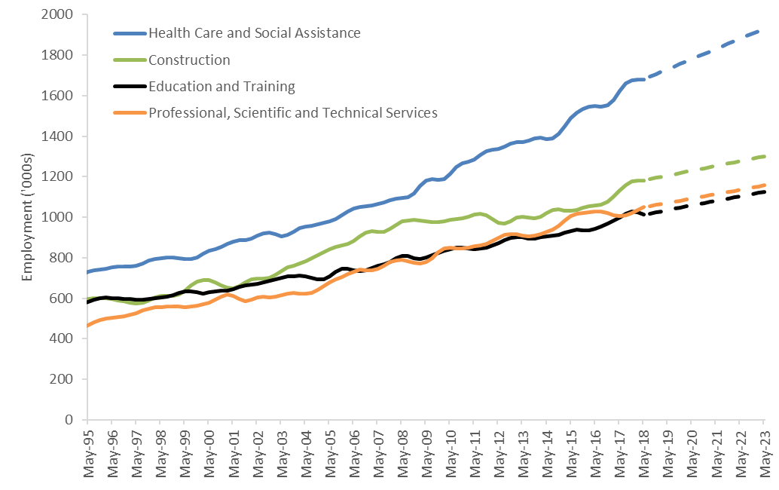
Macroeconomic modelling by Dixon and Cullen (2018) of the impact of the NDIS on the Australian economy shows that the scale and speed of growing demand for disability goods and services has significant impacts on market clearing equilibrium prices and wages in the sector. Figure 5 below shows the market clearing equilibrium price and quantity prior to the NDIS (at point A) and the long run market clearing equilibrium price and quantity with the increased demand from the NDIS (at point C).
Figure 5: Transition from pre-NDIS equilibrium to the NDIS long run equilibrium
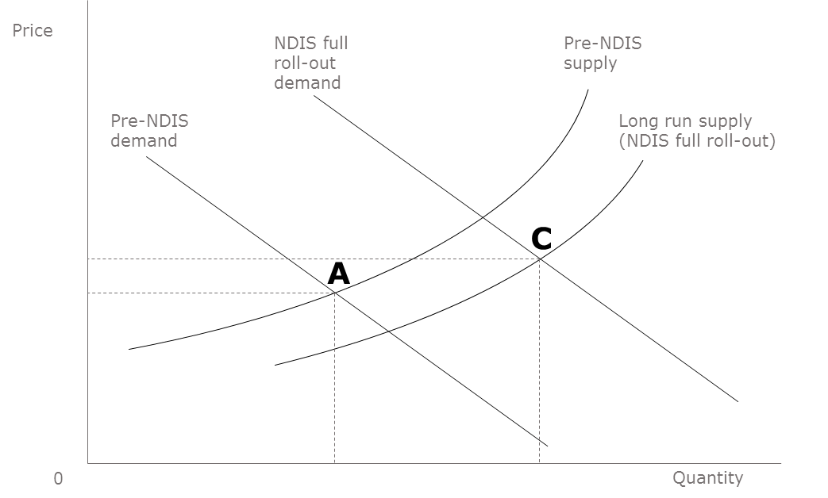
The macroeconomic model underpinning this analysis (a national computable general equilibrium model developed by Victoria University) assumes competitive market clearing prices. However, currently many markets within the disability support sector where the NDIS operates are not competitive and are subject to price regulation. As such, point C, together with price and quantity time series shown in Figure 6 and Figure 7 respectively, does not represent a ‘forecast’ of what is actually happening in the sector. Rather, this analysis shows the likely effects on market clearing prices and quantities of disability supports in competitive markets. Given this, Figure 6 and Figure 7 can be used to guide NDIS pricing policy as markets make the transition from pre-NDIS prices and quantities to long run prices and quantities with the NDIS fully rolled out (moving from point A to point C in Figure 5).
Prices and quantities shown in Figure 6 and Figure 7 represent the estimated set of market equilibrium prices and quantities, which minimise production cost and maximise consumer utility at every point of the transition, given competitive markets. Ideally, the NDIS regulated prices would match this transition path, in which prices rise from pre-NDIS levels to attract additional supply (peaking at approximately 14 per cent higher real prices – Point B in the Figures – and then start to reduce towards long run competitive equilibrium prices (approximately 6 per cent above real pre-NDIS levels) – Point C in the Figures.
Figure 6: Average price impact of the NDIS on disability services
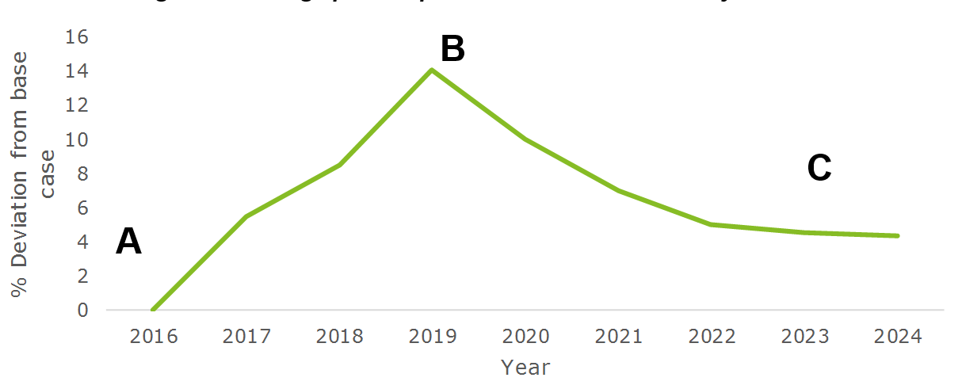
Figure 7: Average quantity impact of the NDIS on disability services
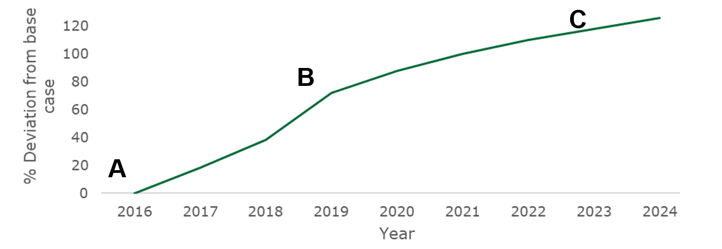
Increases in the level of competition through measures such as reductions in information asymmetries will likely assist in the reduction of longer term prices towards Point C. While information collection and dissemination are costly, reductions in information asymmetries will assist in driving efficiency and move the sector as a whole towards the long run efficient price.
Over the course of the introduction of the NDIS, equilibrium prices of disability services peak in 2019 with the increase in prices reflecting the fact that significant resources need to be redirected from other parts of the economy to meet the needs of the sector. However, in the longer term, prices decline and stabilise at a price that is still higher than previous levels, as new firms enter the sector and additional workers are trained and employed.
Key points relating to the NDIS pricing strategy made by Dixon and Cullen (2018) are that the relatively fast implementation of the NDIS results in significant price pressures; and the doubling of expenditure of disability supports does not double the volume of service delivery due to shorter term supply side constraints. Critically, higher prices are needed to both maintain current supply volumes and enable greater volumes of disability support, as this provides an incentive to redirect the allocation of resources to the NDIS from other sectors in the economy. Without price growth, supply side shortages will likely exist.
Overall, macroeconomic modelling shows that market-clearing efficient prices for disability services rise significantly in the short term and reach a long run equilibrium of approximately 5 per cent higher than pre-NDIS levels in real terms (and peaking at about 15 per cent higher than pre-NDIS levels in real terms – point B in the Figures). It is not clear at which point markets for disability supports are currently operating or whether they are at equilibrium or whether demand is fully satisfied (i.e. no shortages exist). However, there has been some past price increases from pre-NDIS levels and limited expansion in supply. Further, there has been some evidence of potential under-supply in the markets for disability goods and services (low plan budget utilisation, even for participants who have been in the NDIS for some time). The increased demand for labour in ‘competitor sectors’ noted above further exacerbates the need for increased prices to support the increased wages to attract the required labour supply. The implication of this analysis is that to avoid shortages in the short and longer term, NDIS prices might need to rise significantly in the short term.

Domestic and international lessons
This section seeks to draw lessons for the NDIS Pricing Strategy from similar systems in Australia (the reform of the Australian aged care system) and internationally (the social care schemes that operate in Germany, Sweden and the United Kingdom).

Lessons from the Australian aged care sector
In 2012, the Australian Government undertook major reforms of the aged care sector, with the aim of providing older Australians with more choice, more control and easier access to services. Key elements of the reform included (Productivity Commission, 2015):
- greater choice and control for consumers;
- new and more equitable ways of meeting the costs of aged care;
- the sector working more closely with the wider health system;
- a single identifiable entry point for consumers, called MyAgedCare; and
- access to aged care based on need and not ability to pay.
The policy change implemented a market mechanism to allow consumers to choose aged care and support based on their own needs and preferences. Consumers were empowered to choose the setting in which care is provided (be it in a person’s home, in the community or in a residential setting) and the types of care and support received. Under this policy, the Australian Government ceased regulating the number or distribution of services, allowing the market to respond to consumer demand. However, in situations where the market does not respond to consumer demand or cannot respond, the Australian Government acts as a safety net to ensure services are available and accessible.
Under this model, consumers are primarily responsible for their accommodation and everyday living costs, as they have been throughout their lives. Providers determine how much they expect consumers to pay for their accommodation/everyday living, and care/support costs. The Australian Government then sets and publishes reasonable prices it will pay on behalf of consumers who cannot afford to fully meet their own costs. The underlying principle of this market mechanism is that consumers will drive quality and innovation by exercising choice as to which providers they choose.
Similar to the NDIS, a market mechanism underlies the Australian Government approach to aged care policy. However, to improve market efficiency, price transparency and the level of consumer information, the MyAgedCare website publishes a full list of providers, their prices, features, services offered and other market information. The website also provides cost comparison tools and financial calculators to empower consumers to make informed choices, in addition to regulatory compliance reviews. This website serves to improve market efficiency and encourage competition between providers (Australian Department of Health, 2016).
In addition to publishing market information, the Australian Government also sets and publishes reasonable price guides for accommodation and everyday living costs. Price guidance varies based on factors such as the geographical location of the consumer. This serves to limit prices providers are able to charge and sets a base price in particular regions.

Lessons from international schemes
A number of countries have implemented schemes comparable to the NDIS, where the disabled or elderly are provided budgets to spend on a chosen allocation of goods or services. Most often, these schemes are focussed around provision of attendant care, where the needs of individuals are the most variable, and where the argument for self-directed care is the strongest. The most prominent examples of these schemes are in Germany, Sweden and the United Kingdom.
- Germany - The German system of ‘Pflegegeld’, similar to the NDIS, has also assisted people with severe disabilities since 2008. As of 2013, there were around 2,000 participants in total, most with physical disabilities (ENIL, 2013a).
- Sweden - The Swedish Personal Assistance scheme was created in 1993 for those between the age of 0 and 65. As of 2015, around 20,000 people participated in this scheme (ENIL, 2013b; Westberg, 2010).
- United Kingdom - In the United Kingdom, the Community Care (Direct Payments) Act of 1996 created a scheme similar to the NDIS for working-age and elderly people living with disabilities. The rate of uptake with older people, however, is relatively low. As of 2013, around 100,000 people participated in the scheme (Ungerson, 2003).
These schemes all have commonalities:
- participants receive an amount of money to spend on a combination of services and/or goods of their choosing;
- budget allocations are usually benchmarked as a gross sum or hourly rate by the level of care required;
- co-payments are implemented as a part of the schemes (although the size varies);
- choice of those employed as carers is relatively open (in some cases, carers may not be at arm’s length); and
- schemes face issues of labour shortages and/or affordability for service users.
In general, there is a complex balancing of various scheme features and market interventions in an attempt to provide systems where services are accessible, sustainable and efficient.

Price controls
In the pricing of disability services, the countries discussed aim to achieve similar outcomes through a number of difference policy approaches, including:
- encouraging greater supply and competition
- removing barriers to market entry
- through co-payments, incentivising consumers to seek out services which provide good value.
In addition to policies aimed at the performance of markets outlined above, these countries also have pricing policy settings tailored to their specific needs. Sweden sets a flat hourly rate for care based on industry minimum wages, regardless of the level of care requirements (instead varying the number of hours based on need). Germany addresses undersupply issues by giving suppliers access to a variety of grants and incentives to participate in the industry, essentially subsidising suppliers. Finally, the United Kingdom addresses the undersupply of services to rural areas by compensating suppliers for increased costs with flexible funding.

Supply issues
Regional variability in supply is an issue faced by the UK scheme. In many remote areas, the price of attendant care is relatively high. To address this issue, the UK system varies support based on the recipient’s disability and the location of the user or the local labour market. A 2007 study found local authorities most often changed the hourly direct payment rate, increasing the amount so the recipient was not required to cut down on care hours because of increased prices. The UK experiences issues of low supply of personal care workers, however it is not as urgent as in other countries, suggesting perhaps this method helps to alleviate supply issues (Davey et all, 2007).
The German scheme addresses labour supply issues by setting a relatively high legal minimum wage for personal care workers, encouraging workers to enter the sector. This has greater power given there are very few industry-specific minimum wages in the country (Pflege.de, 2019). The German scheme also takes further steps to encourage participation of suppliers in the Pflegengeld scheme. Government grants are available to cover project-related expenses incurred by providers in transitioning to the scheme. As of 2006, this had been paid out in approximately 250 cases (Deutscher Bundestag, 2006). The German government also provides publically funded vocational and retraining programs for personal care workers as of 2012 (Eurofound, 2013). An additional method employed by the German government to increase supply of care workers was a publicity campaign to improve the public image of the profession. This was in response to a social perception of care work as being undignified, leading to a lack of desire in young Germans to seek employment in the field (Eurofound, 2013). These strategies give the German government an ability to increase supply without intervening in markets directly.

Affordability
There are a diverse range of policy responses to affordability issues in disability schemes internationally. In Sweden, barriers to work in disability care such as licensing, minimum qualification and registration have been removed to reduce costs and therefore market prices of care. However, this has also led to a shortage of skilled workers and issues in quality control (Eurofound, 2013).
Sweden and Germany have also allowed employment of informal carers such as partners, relatives or friends. This is an important factor in the affordability of care support from a government standpoint, as it leads to cheaper care and also more widespread incidence of paid informal care. In Germany and Sweden, however, informal care is also more highly regulated than similar systems in Europe. In Germany, participants can use a proportion of their total care budget for paid informal care, in addition to formal care. However, informal carers can only receive half of the hourly formal care rate. Additionally, as of 2011, if a family member changes their employment to part-time to provide home care for a disabled relative, they are entitled to 75 per cent of their salary for up to two years (Eurofound, 2013). In some cases, income from informal care may also be tax exempt (Pflege.de, 2019).
Co-payments are also an important feature of the schemes in Germany and the United Kingdom. The German scheme has a 25 per cent co-payment on care received, although in cases of financial difficulties this can be waived (Eurofound, 2013). In the UK, direct payments tend to be less than the market value of the care, requiring top-up co-payments (Davey et all, 2007). Requiring co-payments may reduce overall government costs and encourage participants to seek out lower cost providers and create increased competition.

Conclusions
Overall, there are a number of difficulties faced by countries in market stewardship of disability goods and services. Examination of international schemes similar to the NDIS show that no scheme can completely alleviate these issues. However, a variety of policies designed to incentivise the supply of an effective workforce can create an accessible and high-quality system. To increase supply, policies such as higher minimum wages, business subsidies and publically-funded training schemes may help to alleviate supply side constraints. Internationally co-payments appear to have assisted in reducing prices and in driving stronger competition in the market. Although these policies may not be appropriate in an Australian context, they do provide insight into other potential options for market stewardship and the development of a pricing strategy for the markets for disability goods and services.

NDIS Pricing Strategy
The NDIS Pricing Strategy set out in this document is a critical component in transitioning the NDIS markets to cope with significant demand growth, reaching the longer-term goal of price deregulation and improving efficiency and quality of care, with a view to improving outcomes as well as choice and control for participants. It recognises that during the transition to deregulation, there is a need to maintain current supply in the short term and significantly increase the supply of disability supports in the medium to long term, to meet the needs of increased numbers of people entering the scheme and increased levels of support. This transition and the required growth in supply will take time and steps may be needed to be adjusted to encourage providers to expand existing operations and new suppliers to enter the markets. Longer term, prices may increase or decrease depending on the relative ease with which supply can be increased (referred to as price elasticity of supply).
Over the longer term, the introduction of the NDIS should reduce barriers to entry to the disability service sector. Supply will no longer be limited to those organisations funded and procured directly by government, or to services that governments deliver directly. Moreover, smaller and more innovative providers should be able to enter the market through direct engagement with participants as the consumers of disability goods and services. At the same time, providers should be able to achieve greater economies of scale by operating as a single entity across Australia. The nature of the market for disability goods and services should also fundamentally change, with the current arrangements, which primarily consist of long term, large scale volume-based transactions between a monopsony purchaser and a small number of providers, replaced by a myriad of smaller episodic transactions between almost half a million consumers and a larger number of providers. In sum, there should be a stronger market, as there are a significantly larger number of purchasers, accessing a wider range of providers.
In the immediate term, however, the picture is a little different. Large or monopoly providers of services in the historical arrangements (sometimes government operated services) were the first movers into the new market. They often transferred in with an established and loyal client base, where the budget constraints of the previous arrangements tended to induce a sense of gratitude amongst those people with disabilities who did manage to secure funding and services. At the same time, these providers were not well prepared for the new arrangements. They were often accustomed to block, or even deficit or cost plus, funding and had inefficient workforce and management practices. They may not have been encouraged to innovate and may have had no history of tailoring services to clients. Conversely, new and more innovative providers face difficulties in attracting a sufficient client base to establish businesses.
In this situation of constrained supply, the significant increase in available funding has meant there was a potential risk of rent seeking from existing providers. A set of price caps were therefore established. These price caps have, however, operated to an extent to stifle innovation within the market. This is because the nature of price caps requires that the products to which those caps apply be well defined. Thus, the Agency has produced a catalogue of all of the services on which participants can spend their personalised budget. This in turn requires participants to make their purchasing decisions at a micro level (and at the level of inputs rather than desired outcomes). That is, participants purchase from their providers a mix of strictly defined unit services rather than a bundle of services or an outcome.
This unbundling of services also has implications for the regulation of quality. It is important to note that a distinctive feature of social services delivery is that it often involves a bundle of related services. Successfully assisting clients can require a range of services that can be either mutually reinforcing or in conflict. Conversely, providing some services without other services risks undermining the effectiveness of the services provided. The delivery of social services can therefore require multiple interventions by one or more providers. This raises questions about how best to bundle provision by different providers, and the range of services to be offered by any one provider. Where participants purchase services from a number of different providers it can be difficult to ascertain which provider should be held to account when the outcome sought by the participant are not being achieved. A different approach has been adopted in Australia in the regulatory arrangements for long term care services for older people. Here a single head-provider is funded for and held responsible for the quality of the bundle of services and the outcomes achieved. They may subcontract the delivery of these services but regulators and consumers are each more able to hold a provider responsible for the failure to deliver outcomes.
On the demand side, more people are eligible to receive assistance with the costs of the disability goods and services that they need and the total demand for these goods and services will increase. The demand side implications of the introduction of the Scheme is not, however, limited to an increase in aggregate demand. Consumers also have greater control over the funds that are expended to purchase disability goods and services, which increases the efficiency of the expenditure, by better matching expenditure to the goods and services most valued by consumers. Because a wider range of supports are available to participants, they are more likely to be able to access the supports most useful to them, rather than being restricted in their choice to the supports determined by traditional programs. Moreover, person-centred plans should more efficiently allocate resources as they should be better aligned with the participant’s utility valuation.
In general, subsidiarity should lead to improved efficiency, and individualised budgets are the ultimate form of localisation. However, the competitive nature of the market also depends on the extent to which consumers can make informed choices. At a minimum, prior to choosing a provider, potential consumers must be able to compare many providers at low cost and observe the price and quality of care. On the positive side, unlike acute medical care, the demand for disability care is often not time sensitive. Potential consumers may have weeks or months in which to search, as they transition (for example) from informal care arrangements. Moreover, disability services are not necessarily technical and can be evaluated more easily by consumers than, say, surgical skills. Conversely, consumers of disability services can be unclear about the variety and quality of services on offer, or unclear as to which services might best meet their needs. They may also be unclear about their needs. These features are shared to varying degrees with other service markets (e.g., legal advice). In such markets, consumers face search and switching costs, and might only learn about service quality after using the service, by which time it might be too late (or costly) to change providers. Transaction costs of switching can also be high – especially if not met by the insurer.
Information asymmetries can seriously undermine the impact of subsidiarity. To exercise informed choice, individuals require accessible, accurate information. Information needs to be personalised to suit individual needs. The ability to exercise choice also depends on the availability of at least two positive alternatives.

The Evolution of the NDIS Pricing Strategy
The NDIS Pricing Strategy has evolved and will continue to do so as the NDIS advances towards full roll-out and further matures (see Figure 8 below). Before the introduction of the NDIS, most State and Territory governments block-funded, in the main, disability support providers to deliver services to a set number of people. Under this approach, consumers typically did not have a significant level of input into the supports allocated to them but, rather, a ‘one size fits all’ approach was used and no market prices were present.
In the trial phase of the NDIS (which had limited participant numbers) markets were regulated using unit price caps. These caps were in most cases determined using ‘cost-plus’ inputs based pricing based on block funding allocations made to providers prior to the NDIS. However, some markets, which were already well developed such as transport, were not price regulated. Although price regulation was imposed on the majority of market, this was intended as a temporary albeit necessary measure to ensure the scheme functions appropriately in the presence of non-existent markets, under developed markets or market failures.
As the NDIS transitioned towards full rollout, annual price reviews were conducted, whereby the unit price caps introduced were indexed annually based on updates to the costing methodology and consultations. As the number of participants in the NDIS grew, the supply requirements rapidly increased. Pricing needed to respond to this need and some questions were raised about how unit prices were constructed, leading in turn to the NDIA Board commissioning the Independent Pricing Review in 2017.
Figure 8: Phases of NDIS and pricing
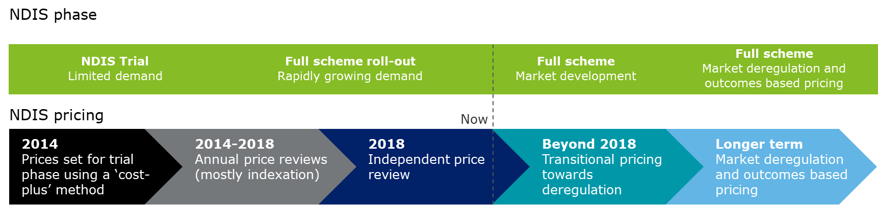

The Independent Pricing Review investigated the appropriateness of current price levels and the approach to pricing. The key findings of the report were:
- while there is no general evidence of supply shortages, there is a risk of undersupply in the future, as demand grows rapidly;
- while some providers are profitable at current prices, many are unsustainable at those prices, given future expected market conditions; and
- NDIS prices are broadly in line with similar schemes, although the aged care system typically has higher prices.
Overall, the Independent Pricing Review recommended that the NDIA should:
- collect information to allow monitoring of market supply and institutional capacity;
- implement a Temporary Support for Overheads to encourage supply growth and implement several price loadings to better reflect supplier costs;
- conduct a trial of outcomes based pricing and move to this approach in the longer term;
- aim for deregulation of markets in the long term; and
- better prepare for deregulation, including through investment in infrastructure such as an online e-market.
As outlined in Figure 8 above and highlighted by the Independent Pricing Review, the NDIS has the challenge of boosting the supply of disability services provided by the market, while maintaining consumer value. In order to do this, the Independent Pricing Review recommended that the NDIA continue on its path to deregulation and in the longer term, move to outcomes based pricing. However, as noted in the Independent Pricing Review, the NDIA does not currently have a clear path to deregulation and ultimately outcomes based pricing.

Proposed Strategy – ‘Glide path’ to the new equilibrium
The NDIS Pricing Strategy is best understood in terms of four different concepts of pricing:
- Efficient price levels – Price levels that represent the long run minimum cost of production. Sufficient production at efficient price level is only expected to be achievable in the long run in mature markets, with strong competition between providers.
- Sustainable price levels – Price levels that represent, at a given time, the price at which the average current firm is viable (even if inefficient). In the short term, prices at or above sustainable levels are required to ensure that current supply levels remain stable and providers with costs somewhat above the most efficient level remain viable.
- Transitional price levels – Price levels that represent, at a given time, the price necessary to attract new providers to enter the market or to reduce exits from the market. Transitional price levels represent the price required to attract economic resources from other parts of the economy to expand provider supply. Transitional price levels are above sustainable price levels, but should only be adopted where, as is the case in the NDIS transition period, a significant expansion of supply is required.
- Price caps – Upper limits on prices, used to reduce the potential exercise of market power.
To date, NDIS price levels, both in terms of the level of funds included in participant’s plans and price caps, have been predominantly set with longer run efficient price levels in mind.
The pricing strategy proposed in this document better reflects the current situation of inefficient supply and growing demand. It represents an approach to pricing aimed at maintaining and increasing market supply, assisting in the transition of the NDIS to full roll out and helping markets grow to a more mature state in the future, while being cognisant of the need for financial sustainability.
Figure 9 below shows the market clearing equilibrium price and quantity of disability supports prior to the NDIS (at point A) and the long run market clearing equilibrium price and quantity of disability supports including the NDIS demand (at point C). It also illustrates the paths that sustainable price levels (red arrow) and transitional price levels (green arrow) will take in real terms over the transition to the long run market clearing equilibrium price, recognising the potential inefficiency of some current providers and the need to significantly expand and not unnecessarily disrupt the supply of services to people with disabilities.
Figure 9: Transition from equilibrium prior to the NDIS to the long run NDIS equilibrium
Whether the long term efficient prices for disability goods and services are higher or lower than the prices that obtained prior to the introduction of the NDIS depends on the level of improvements in efficiency that market forces outlines above will drive into the future. It should not be assumed that the final efficient price will be higher than previously. Although there are some factors that will tend to increase costs for providers, there are also factors will decrease those costs. In part, providers are currently facing a drain on capital as they transition away from block funding, together with transition costs. These upward pressures on prices will not be sustained in the longer term. It is also important to note, as discussed above, the participants now have much greater control over the bundle of services that they purchase, and the efficiencies gained from this are not reflected in the unit prices of individual supports but in the overall cost of the bundle of supports chosen by participants. The potential substitution effect of different support models could put downward pressure on prices. This substitution effect will potentially be accelerated if participants are provided with more flexibility in plans. Finally, it needs to be recognised that there are emerging registered providers charging significantly less than the current sustainable price - and probably even the current efficient price under a traditional business model - and at the same time paying support workers higher than award wages. This is made possible by a technology driven back office rather than the type of structure under which most large providers currently operate. Figure 10 below summarises the stages through which price regulation in the NDIS needs to move as the economic forces outlined above play out. In the first phase, price controls need to balance the drive for greater efficiency with the need to expand supply. Providers need to be given time to adjust their operations and supply needs to expand significantly, requiring additional investment and roll out costs. In the second phase, the Agency, as market steward, needs to invest in the infrastructure needed to address information asymmetries and to assist providers gain access to the information that they need to improve their operations. In the third and fourth phase, the Agency needs to monitor the development of the markets closely and identify opportunities for deregulation as they arise.
Figure 10: Transition strategy

Balance efficiency and growth
Price controls need to take into account efficiency and the need to expand supply. Markets for disability supports are continuing to develop, with both increases in market supply and improvements in production efficiency required. While improvements to production efficiency imply reductions to costs in the long run, expansion of market supply necessitates higher short to medium term prices. To maintain and expand production volumes of disability supports, higher short-term prices are thus needed. This will serve as an incentive to redirect the allocation of resources to the NDIS from other sectors in the economy. Without price growth, supply side shortages will likely exist.
In the longer term, efficient price levels are the best representation of the reasonable cost of the provision of a support and will, eventually, be the price levels best suited for the development of plans, which are concerned with efficient, effective and appropriate supports. However, in the short to medium term, sustainable price levels are the best representation of the reasonable cost of the provision of a support. In the long run, sustainable price levels tend towards efficient price levels. In the short to medium term, however, as the market matures and expands, price caps need to be sufficient to both maintain current supply and attract new supply. That is, price caps for the NDIS need, in the short to medium-term at least, to be set with regard to transitional price levels, rather than sustainable and efficient price levels.
In brief, prices in the NDIS need to follow two paths under the NDIS Pricing Strategy:
- Funding levels in plans should be set at sustainable price levels (noting that current utilisation rates are not at capacity and can accommodate transitional price levels) and increased in line with movements in the unit input costs of providers (the red arrow in Figure 9). In the longer run, as transitional and sustainable price levels converge, participants will be able to purchase greater quantities of support for their fixed budgets, reaping the benefit of the improved efficiency of the sector.
- Price caps should be set in accordance with the movements in transitional price levels (the green arrow in Figure 9), to recognise the costs providers are facing in adjusting to the new arrangements, the time required to unwind established agreements, and to encourage growth in supply while driving efficiency. This should be done through an explicit and decreasing loading on sustainable price levels – the Temporary Transformation Payment (TTP) of about 7.5 per cent – with a clear statement to the market of the expected glide path over five years to efficient price levels through the phased reduction of the TTP. Detailed ongoing monitoring of markets should also be conducted to determine whether short-term price increases have been sufficient to expand supply, attract new entrants and increase competitive pressure. In the longer term, it is expected that competition between providers will result in a reduction of prices towards the long run efficient price. As market prices reduce towards long run efficient prices, the price caps imposed are expected to no longer be binding, in which case their removal can be considered.

Assist providers, and the market, to become more efficient
The NDIS is able to collect supply data from both observing market interactions and collecting data directly from suppliers. Supply data is able to assist the NDIA to monitor costs, supply conditions, prices, profitability and indicators of market competition, such as the number of organisations entering and exiting markets. Currently, the NDIA collects basic profitability information from market participants through a provider survey. However, given that participation in the survey is optional and responses are not verified, there is potential for this survey to present an inaccurate view of the supply conditions.
To effectively monitor market conditions in the NDIS, compulsory data collections from NDIS suppliers could be considered, as a basis for getting access to transitional pricing. Under such a system, NDIS-registered providers could be incentivised to provide their audited financial statements or to participate in a provider data collection process. Providers would be incentivised to participate in this collection process if access to transitional pricing was made contingent upon providing accurate financial information and good faith participation in the data collection. The collection of supply data is likely to be highly valuable in decision making as to the appropriateness of price caps and the market readiness for deregulation. This is the approach endorsed by the NDIA Board.
The collection and dissemination of more market and consumer information is essential to effective pricing and future outcomes based pricing. This should ideally include market information such as:
- quantity and prices of disability supports provided (for example, hours of care) by NDIS disability support group, and location (this data could be obtained by linking the details of suppliers to each payment made from NDIS support budgets);
- market entrants and exits;
- profitability and other financial metrics from financial statements of providers; and
- supply conditions such as the total expenditure of participants on supports by location.
Gathered supply data can be used to assist the NDIA determine pricing caps in the short term and enable better informed decision making when considering deregulation of markets in the medium to long term. As transitional pricing is above long run competitive equilibrium prices, it may also be reasonable to oblige providers to participate in data collection, as a form of ‘dividend’. To gain access to transitional prices, providers would need to participate in data collection in good faith (i.e. provide accurate responses). De-identified data could also be provided back to providers.
Providers also need to be given the tools to achieve long run efficiencies, by being able to properly understand the performance of their own organisation and to accurately compare their performance to that of their peers. This requires good accounting and governance standards and practices and the ability to compare performance across providers. The NDIA and the NDIS Commission can assist providers do this by encouraging providers to adopt better accounting and governance standards and practices over time as part of provider suitability requirements. The NDIA can also support the establishment of independent performance and financial benchmarking services and provider’s participation in those services, especially where providers operate in thinner markets. The NDIA can also incentivise participation in such performance and financial benchmarking services, and the development of better accounting and governance standards practices, by making access to the transitional price level loading (Temporary Transformation Payment), or at least a part of that loading, contingent on such activities. This is the approach endorsed by the NDIA Board.

Address information asymmetries to empower consumers
In addition to supplier data, the NDIS would ideally collect data from consumers (Scheme participants) to monitor short to medium term outcomes, including participant satisfaction rates of with their providers, the degree to which participants consider they are empowered to choose their own care, and plan utilisation rates (underutilisation may be one indication of supply shortage). Currently, participant data collection is limited to a brief annual survey collecting information about overall satisfaction. Additionally, one-off surveys have been used in the evaluation of the NDIS.
Going forward, consumer and outcomes data will be collected and published on a regular basis to enable consumers to get a detailed view of provider performance and enable future moves towards outcomes based pricing. Information collected could include:
- satisfaction with individual supports received;
- outcomes (for example, employment gained and engagement with the community);
- ease of market access (measuring any potential supply shortages);
- level of participant empowerment; and
- plan utilisation and any reasons plan budgets were not fully expended (especially where these indicate undersupply).
Collecting such additional consumer data can be used to both measure the performance of disability support providers in the longer-term transition to outcomes based pricing, and can help identify any areas where undersupply is occurring in the short term.
A key recommendation of the Independent Pricing Review were strategies to decrease the level of information asymmetries between suppliers of disability supports and NDIS participants. Specifically, the Independent Pricing Review recommended the introduction of a more mature digital market, enabling participants to compare prices across providers and transact with their preferred provider. This would decrease the current level of information asymmetries in the markets for disability goods and services. Currently, there is no requirement that prices of goods and services charged by NDIS-approved providers be publically available. Participants in the NDIS may have no mechanism to easily compare the prices and services offered by multiple providers, other than requesting quotes or making contact with each provider, which may impose significant transaction costs on the participant.
A key piece of infrastructure used in reducing information asymmetries in the NDIS and enabling the pricing strategy is a digital marketplace. The greatest value of such a market would be in providing an online tool where providers participate. Such an online tool could also provide information related to areas serviced, level of service offered, participant ratings and observed outcomes data (for example, proportion of people gaining employment in the case of employment services) in addition to pricing information. The creation of a digital market will reduce information asymmetries between participants and providers, assist in the transition to outcomes based pricing, increase market competition and empower participants to exercise choice in determining their care. This would likely result in greater price competition by better informing consumers and allowing multiple providers of supports to be compared easily. Publishing reasonable prices for deregulated markets may also assist consumers to make more informed choices between providers and in setting a ‘base’ price for providers.

Measuring success
In designing the glide path of the new NDIS Pricing Strategy, it is important to understand the criteria that indicate market maturity and precipitate progress towards market deregulation and expanded supply, to determine when the pricing strategy objectives have ultimately been reached. The following criteria are indicative of a well-functioning supports market, which has adequate supply, strong competition between providers and does not require market intervention through measures such as price caps.
- Demand is satisfied – Provider organisations enable adequate supply to fully satisfy participant demand. An indicator of this is higher levels of participant budget utilisation (as participants are able to purchase all supports they need within their budget) and high participant satisfaction rates.
- Price caps are not binding – When markets are well-functioning with adequate supply and strong competition, the price caps used by the NDIA (which are set at transitional prices, above the efficient long run minimum cost of production) will not be binding. Rather, prices will be close to or at long run efficient equilibrium prices.
- Competition between providers results in efficient equilibrium prices – Market prices are close to or at long run efficient equilibrium prices and there is evidence of strong competitive pressures between support providers.
Outcomes based pricing is about ensuring that prices are reflective of the value and outcomes received by participants as a result of the support, rather than the costs of providing the support. To move towards outcomes based pricing, a prerequisite is detailed information on the outcomes of participants resulting from their support. For example, potential outcomes of providing a disability service are wellbeing measures, education outcomes (for children and youth) and workforce participation (for adults). To implement outcomes based pricing, information on the improvement towards these outcome measures will be essential.
Collection and reporting of participant outcomes, or interim variables that reliably predict these outcomes in the longer term, is likely to also assist participants make informed choices regarding providers of support and could potentially also be reported on in a digital marketplace.

Appendix A: Therapy pricing
For most disability-specific services, the NDIS is attempting to create markets where none previously existed before, mostly having been historically supplied through block funding. The NDIS is not only attempting to grow these markets in terms of maturity, but also in terms of size. Further, for these services the NDIS has substantial market power – that is, it is a price maker. The NDIS can raise price limits to attract more suppliers and increase the size of the market; and it can reduce those price limits later as sustainable prices trend towards efficient prices. Those markets are the focus of the main body of this paper.
There are also services that the NDIS funds which are delivered by fully developed markets. An example is transport services, where many participants can use public transport or taxis. Here, the NDIS is a price taker in an intensely competitive market, so it does not need a pricing strategy. Nor does it need to grow the size of the market (especially not since the advent of ride sharing services). That is not to say these markets are perfect. Transport is often difficult to obtain in regional and remote areas. Vehicles catering for participants who use wheelchairs is closer at the disability-specific services end of the spectrum.
Therapy services for disability are in between these two ends of the spectrum. There are large and well developed markets for services such as physiotherapy, speech pathology and psychology. The NDIS’s 2019 Review of Therapy Services found that the NDIS only accounted for an estimated 2.4% of the total national market for therapy services in 2017-18, so the NDIS’s power to influence prices is limited.
On the basis of the evidence on market conditions and the sector consultations and benchmarking analysis outlined above, and in line with the principles of the National Disability Insurance Scheme Act 2013, including that a funded support must represent “value for money in that the costs of the support are reasonable, relative to both the benefits achieved and the cost of alternative support”, the Therapy Review made three key recommendations.
The Therapy Review recommended that the NDIA should maintain price limits on therapy services at least until the transition to the NDIS is complete and there is evidence that the distribution of NDIS payment claims is broadly in line with the distribution of prices observed in the private billing market.
It is appropriate to maintain price limits on therapy services at this time. The NDIS market remains in transition, and the level of competition in the segment—while greater than in other NDIS segments—remains below that of the private market. While there are early signs of competition in the NDIS market for therapy services, around 70 per cent of claims continue to be made at the price limit. The distribution of claims also remains significantly different from the private market distribution. The NDIA should not move to deregulate prices until the distribution of claims in the NDIS-funded therapy market is broadly similar to private market distribution in order to promote value for money for participants. The majority of organisations consulted during the Therapy Review did not consider that the market is ready for price deregulation, not least because most segments and geographies under the NDIS are still transitioning to the scheme.
The Therapy Review also recommended that the NDIA should set price limits for therapy services primarily based on market prices and at the 75th percentile of the observed private billing distribution.
The NDIS has limited capacity to influence market prices for therapy services because it accounts for only 2.4 per cent of Australia’s therapy market. As a result, the NDIS should set price limits based primarily on observed market prices, and at a level that is sufficiently competitive to incentivise a significant share of private providers to consider serving NDIS participants (i.e., to ensure sufficient choice and supply).
It is appropriate to set price limits for therapy services towards the upper range of observed private market prices, given the NDIS’s lack of power to influence prices in the therapy market, and in order to strike a balance between: (1) ensuring participants’ ability to choose and fund different providers in the market; and (2) delivering value for money.
Bottom-up cost estimates suggest that the benchmark efficient price may be significantly below observed market prices. However, these estimates are unreliable due to the lack of common industry wages, as well as a wide range of operational conditions and efficiency among providers. Moreover, setting prices below the market rate could increase the risk of future supply shortages at a time when private providers need to be encouraged to enter the disability segment to address growing demand. Setting price limits towards the upper range of observed private market prices is therefore appropriate in the short term.
The Therapy Review also recommended that, in line with the observed private billing distribution, the NDIA should vary its price limits or therapy by:
- Jurisdiction – with a different price limit in the more concentrated jurisdictions (New South Wales, Victoria, Queensland and the Australian Capital Territory) to the price limit in the other jurisdictions (Tasmania, South Australia, Western Australia and the Northern Territory); and
- by type of therapy – with a different price limit for services provided by psychologists, physiotherapists and all other therapists.
This was because market benchmarking indicated a large, statistically robust divergence in market prices for psychology, compared to all other types of therapy. Benchmarking found that the market rate for psychology is meaningfully higher than for all other types of therapy across Australia. Following the principles outlined in Recommendations 1 and 2, this suggests that a higher price limit is needed for psychology. To illustrate the implications of this, the market price for psychology was fond to be $210 per hour at the 75th percentile, compared to $190 per hour at the 75th percentile for all other therapies.
Not raising the price for psychology could increase the risk of future supply shortages for NDIS participants. The current price limit for therapy is set at around the 50th percentile of market rates for psychology, meaning that the price is unattractive for roughly half of private billing psychologists. While there is no compelling evidence of supply shortages in psychology, consultations highlighted anecdotal evidence that demand growth for psychology services is exceeding supply.
There was also evidence that billing rates for psychology and physiotherapy are distributed differently in the more concentrated jurisdictions (New South Wales, Victoria, Queensland and the Australian Capital Territory) than in the other jurisdictions (Western Australia, South Australia, Tasmania and the Northern Territory).

The NDIS’s need tor a price strategy for therapy services is lower than it is for most disability services. Ultimately, as discussed in Section 4.2.4, the NDIS intends that price limits should become redundant, as competition drives the sustainable price down the efficient price. For many therapy services, this is already the case - the 2019 Review of Therapy Services found that around 30% of therapy services to participants were delivered below NDIS price limits in 2017-18. The Review also found that NDIS price limits for therapy were similar to efficient prices. The median price for private (ie, non-Scheme) therapy services was $169 per hour. This was very close to the 2018-19 NDIS price limit of $179 per hour. This average private market price appears to also be efficient, based on the Review’s bottom-up cost estimates. The Review found that therapy providers with mid-range efficiencies, and average overheads and utilisation rates should be profitable at current NDIS price limits. (This contrasts with the situation in attendant care where the Independent Pricing Review found that only some providers were profitable at the then NDIS price points). Thus, while NDIS transition price limits are still above efficient prices in the therapy market, they are not substantially higher. Overall, the therapy market is closer to point C where most disability services are still closer to point A, in terms of Figure 9.
However, the fact that NDIS price limits are still above efficient prices, and that still only 30% of services are delivered below current price limits, indicates that a pricing strategy is still required for the therapy market. This was also supported by the sector: most providers consulted during the Review considered that more time was required before price deregulation, because they are still transitioning to the Scheme. (Some sectors and geographies did consider they were ready for price deregulation, for example, Early Childhood Early Intervention services in jurisdictions where the Scheme has fully rolled out.)
One of the key factors that drive efficiency in any market is competition. Competition in turn requires that there is a high level of supply for services. Higher levels of supply are still needed for NDIS therapy services. For example, in the first quarter of 2019, only 6,074 of the 9,636 nationally registered therapy providers (63%) were active in the market. Similarly, while Capacity Building entails more than just therapy services, national utilisation of Capacity Building plans over the same period was just 52%.
Higher price limits would help increase therapy supply. This is one of the reasons that NDIS price limits for therapists were increased by a minimum of $11 per hour following the Review.
However, higher prices are only one way to achieve the goal of increased supply. Provider rules should also play a part. While the NDIS tends to treat therapists as homogenous – at least in terms of price limits – participants do not. Participants often require a therapist with a particular set of skills, or have a strong desire to maintain an ongoing relationship with a therapist they had before entering the NDIS. Providers have also argued that there is robust evidence that therapy is more effective when delivered by a known and trusted health professional. It is possible that the current travel time allowance effectively restricts the supply of therapy services. In consultations for the 2019-20 Annual Price Review, therapists stated that travel restrictions in the Price Guide often preclude optimal provider-participant pairings, especially outside of metropolitan areas.
In response, NDIS travel limits have since been increased to 30 minutes (MMM 1-3) and 60 minutes (MMM 4-5) which should help. However, providers further argued that the therapy market was sufficiently mature that travel should be a quotable item. That is, if a participant would prefer fewer services from a distant therapist with condition-specific skills, rather than more services from a closer but less skilled provider, then the participant should be allowed to negotiate that with their chosen provider.
Accordingly, should the recent increases in prices and travel limits not lead to higher therapy utilisation, a smaller share of inactive therapy providers, or fewer complaints from participants about not being able to access particular therapists, then one strategy the NDIA could employ is allowing therapists to quote for travel. Alternatively, as this appears mostly to be a restriction in outer regional areas, perhaps the current rules, whereby therapy travel is effectively quotable in MMM 6-7 areas, could be extended to MMM 4-5 areas as a first step. As cost structures are known, and the market has been established to be competitive and efficient, there is little risk in terms of sharp rises in unit prices (ie, per hour of service). Individual services may cost more because they become longer through increased travel times. However, this should be limited, as participants will only be willing to trade so much travel time against face to face time.

References
Australian Department of Health. (2016). Aged Care Roadmap – Aged care sector committee. Canberra: Australian Department of Health. Available at agedcare.health.gov.au/sites/default/files/documents/04_2016/strategic_roadmap_for_aged_care_web.pdf
Australian Department of Jobs and Small Business. (2018). Industry Employment Projections 2018 Report. Canberra: Australian Department of Jobs and Small Business. lmip.gov.au/default.aspx?LMIP/GainInsights/EmploymentProjections
Davey V, Fernández J-L, Knapp M, Vick N, Jolly D, Swift P, Tobin R, Kendall J, Ferrie J, Pearson C, Mercer G and Priestley M. (2007). Direct Payments: A National Survey of Direct Payments Policy and Practice. London: Personal Social Services Research Unit. Available at www.pssru.ac.uk/pub/dprla.pdf
Deutscher Bundestag. (2006). Bericht der Bundesregierung über die Ausführung der Leistungen des Persönlichen Budgets nach § 17 des Neunten Buches Sozialgesetzbuch. Berlin: Deutscher Bundestag. www.bmas.de/SharedDocs/Downloads/DE/bericht-der-bundesregierung-ueber-die-ausfuehrung-der-leistungen-des-persoenliche-budget.pdf?__blob=publicationFile&v=2
Dixon J & Cullen DJ. (2018). Implementation of the NDIS: macroeconomic impacts. Presentation to the Australian Conference of Economists (2018), Canberra. Centre of Policy Studies, Victoria University - Paper forthcoming.
ENIL (European Network on Independent Living). (2013a). Sweden - European Network on Independent Living. Available at enil.eu/wp-content/uploads/2013/02/PA-SWEDEN.pdf Accessed 18/01/2019
ENIL (European Network on Independent Living). (2013b). Germany - European Network on Independent Living. Available at enil.eu/wp-content/uploads/2013/02/PA-GERMANY.pdf. Accessed 18/01/2019
Eurofound (European Foundation for the Improvement of Living and Working Conditions). (2013). More and better jobs in home-care services – Germany. Available at www.eurofound.europa.eu/sites/default/files/ef_publication/field_ef_document/ef1353en6.pdf
McKinsey & Company. (2018). Independent pricing review – National Disability Insurance Agency. www.ndis.gov.au/providers/price-guides-and-information/independent-pricing-review#final-report-and-ndia-response
NDIA. (2016). NDIS market approach: Statement of opportunity and intent. Available at www.ndis.gov.au/providers/market-information#market-approach
NDIA. (2019). COAG Disability Reform Council: Quarterly Report 30 June 2019. Available at www.ndis.gov.au/media/1611/download
Pflege.de. (2019). Pflegegeld. Available at www.pflege.de/pflegekasse-pflegerecht/pflegeleistungen/pflegegeld/
Productivity Commission. (2011). Disability Care and Support. Available at www.pc.gov.au/inquiries/completed/disability-support/report
Productivity Commission. (2015). Report on Government services: 2015 – Volume F: Community services. Available at www.pc.gov.au/research/ongoing/report-on-government-services/2015/community-services/download-the-volume/government-services-2015-volumef-community-services
Productivity Commission. (2017). National Disability Insurance Scheme (NDIS) Costs. Available at www.pc.gov.au/inquiries/completed/ndis-costs#report
Ungerson C. (2003). Commodified care work in European Labour Markets. European Societies 5(4):377-96.
Westberg K. (2010). Personal assistance in Sweden. Independent Living Institute. Available at www.independentliving.org

If a plan is approaching full utilisation, a review could be requested and undertaken.
Participants must also meet the following two conditions: - The age eligibility criteria: A person must be aged under 65, at the time they first apply for assistance from the Scheme. A person who is receiving assistance from the Scheme with their reasonable and necessary supports can continue to receive those supports after they turn 65. However, they become ineligible to receive supports if they enter a residential aged care service on a permanent basis or start being provided with home care (funded under the Aged Care Act 1997) on a permanent basis. - The residence eligibility criteria: A person must be resident in Australia and either an Australian citizen or the holder of Permanent Visa or a protected holder of Special Category Visa. Once eligibility is determined a person can continue to receive supports while temporarily absent from Australia.
The value for money test is concerned with effectiveness, direct cost comparison and investment effects. A support must substantially improve the life stage outcomes for, and be of long term benefit to, the participant. There must also be no comparable supports that would achieve the same outcome at a substantially lower cost. The cost comparison must also take into account any likely reduction in the cost of the funding of supports for the participant in the long term that may arise from the provision of a support, including whether the support will increase the participant’s independence and reduce the participant’s need for other kinds of supports.
www.legislation.gov.au/Details/C2018C00276
Since 1 July 2019, each support has had a single national price. Different price caps apply in remote and very remote areas, where the national price caps are inflated by 40 per cent and 50 per cent respectively.
www.health.gov.au/resources/apps-and-tools/health-workforce-locator/health-workforce-locator#hwc-map
http://www8.austlii.edu.au/cgi-bin/viewdoc/au/legis/cth/consol_act/antsasta1999402/s38.38.html
Switching costs are those associated with changing provider or supports, including both financial and social costs.
If a plan is approaching full utilisation, a review could be requested and undertaken.
Therapy services include those supplied by: art therapists, audiologists, counsellors, developmental educators, dieticians, music therapists, occupational therapists, orthoptists, physiotherapists, podiatrists, psychologists, rehabilitation counsellors, social workers, speech and language pathologists, and teachers.
As discussed in section 4.1 of this paper
https://www.ndis.gov.au/news/1992-ndis-price-increases-sustainable-and-vibrant-disability-services-market

