
Provider Toolkit

myplace registration for new providers

Step by step guide
1 July 2016

Table of Contents

Introduction 3
Authentication process 3
New providers 3
Registering as a NDIS provider 4
Steps for Primary Contacts 6
Adding registration groups and professions 12
Viewing registration approval status 15
Steps for other users of myplace 15

Introduction
The myplace Provider Portal is the means for registered NDIS providers to manage their products and services for participants. Providers can use myplace to:
- view information
- create service bookings
- manage payment requests
- communicate with participants.
Accessing the myplace provider portal involves a two-step online process. This Step-by-Step Guide is intended for use by new providers and provides information on setting up your access for the new myplace provider portal.
The Primary Contact of your organisation will need to complete the initial registration process which involves completing the Intent to Register form in myplace. If you are unsure who the Primary Contact is, we recommend you contact your organisation for clarification. This Step-by-Step Guide provides instructions for both the Primary Contact and other users of myplace.
The steps outlined in this document continues from the PRODA Step by Step Guide.

Authentication process
Since 1 July 2016 there has been a new online NDIS Provider Portal called myplace. To access myplace, a new authentication process called Provider Digital Access (PRODA) will be in place and managed by the Department of Human Services. All existing and new Providers will need to register for a PRODA account.
The authentication process through PRODA is designed to provide secure access to specific Government services. All users of myplace will need to create a PRODA account.
For new NDIS Providers, the PRODA authentication process will be your access point into myplace. Once your PRODA account is created and authenticated, you will need to submit your NDIS registration request using myplace.
The authentication system is a two-step online process:
- Create your account – provide basic personal information, create a username and password, and provide contact information for the secure management of your account
- Verify your identity – verify your identity online using Government issued identity documents which requires you to provide key information from your documents. Your identity will be verified online and in real-time using the Government’s Document Verification Service (DVS).

New providers
The key steps for registering as a NDIS Provider are:
- Create an account and verify your identity using PRODA
- Complete the Intent to Register form in the myplace portal
- Add Professions and Registration Groups for NDIS approval (including the states/territories for which you will be providing services)
- Upload required supporting documentation

Registering as a NDIS provider
Once a PRODA account is created and authenticated in PRODA, you will need to link your PRODA account to myplace and complete the remaining registration process in myplace.
Your registration is complete when you have:
- Linked your PRODA account to myplace (steps 1 to 17)
- Added the Registration Groups and Professions you wish to provide services for (steps 19 to 29)
- Access the myplace portal using the link provided on the NDIS website or type in https://myplace.ndis.gov.au/supplier into your internet browser address bar.
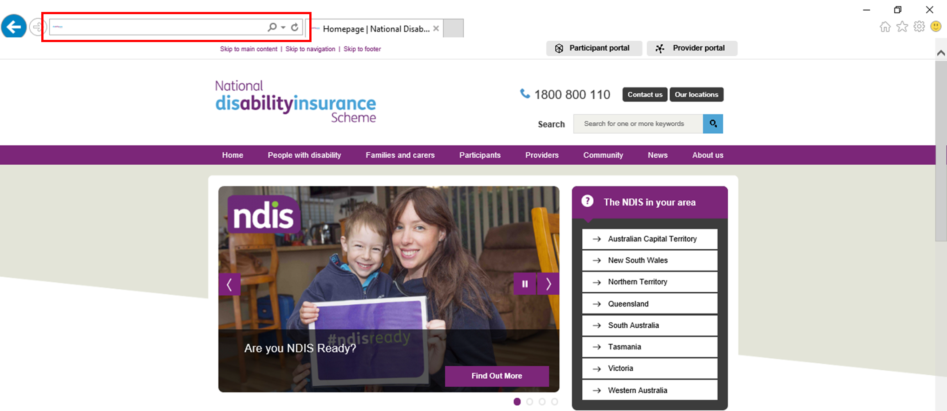
- Enter your Username and Password then select Login.
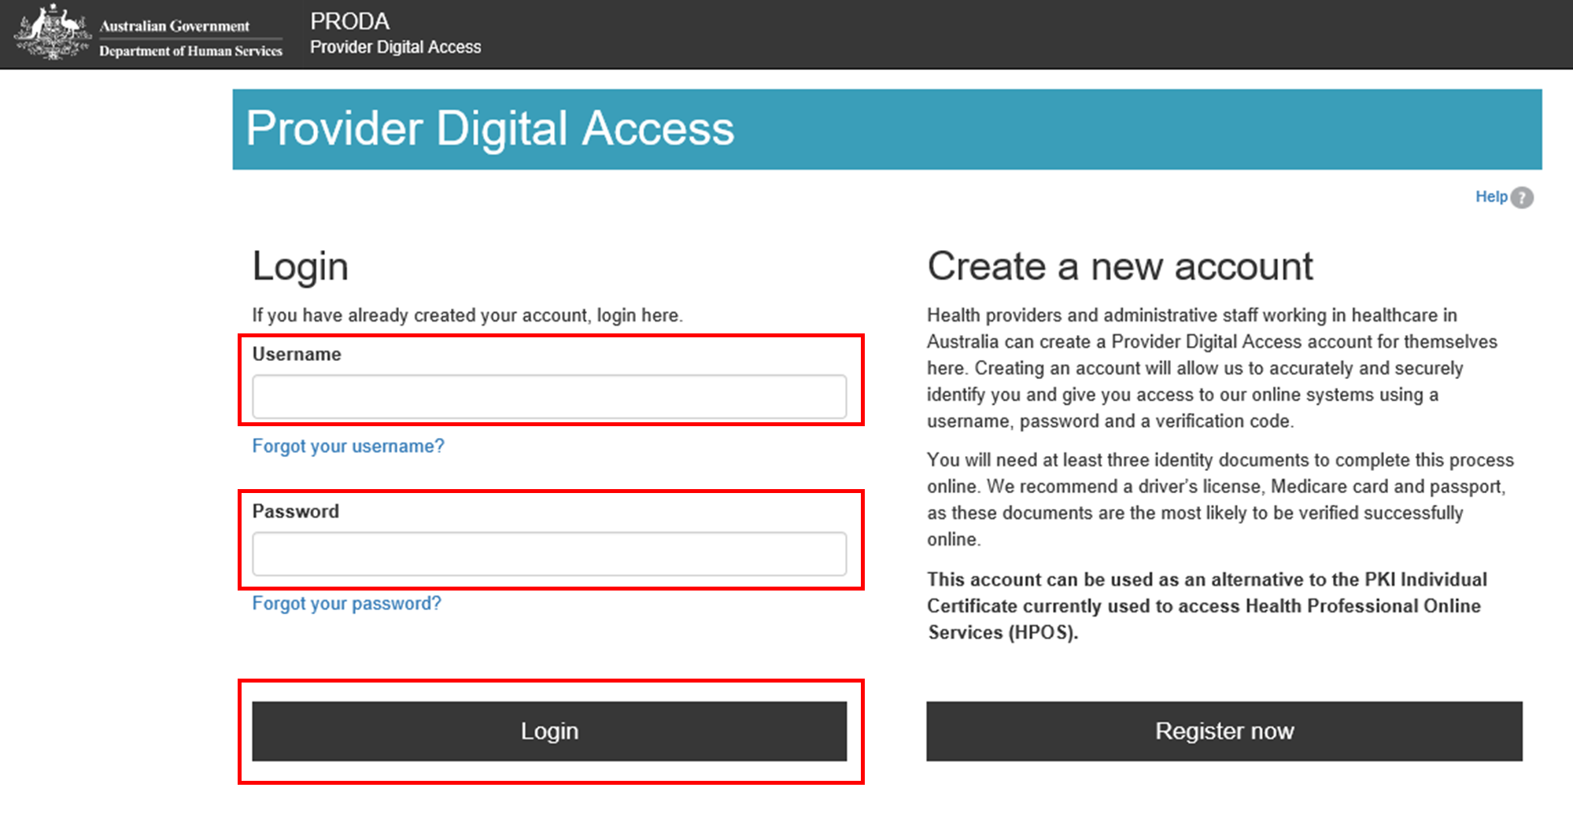
- Enter the verification code sent to your email or mobile phone or PRODA Code Generator app. Select Submit.
The method you receive your verification code is from the preference you selected when creating your PRODA account.
If you do not receive your verification code, select Resend code.
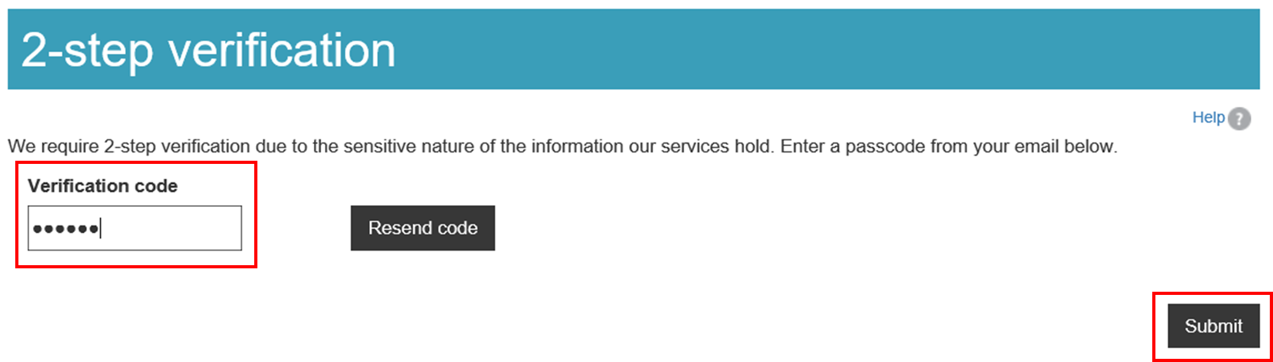
- Select NDIS for providers to be directed to the myplace portal.
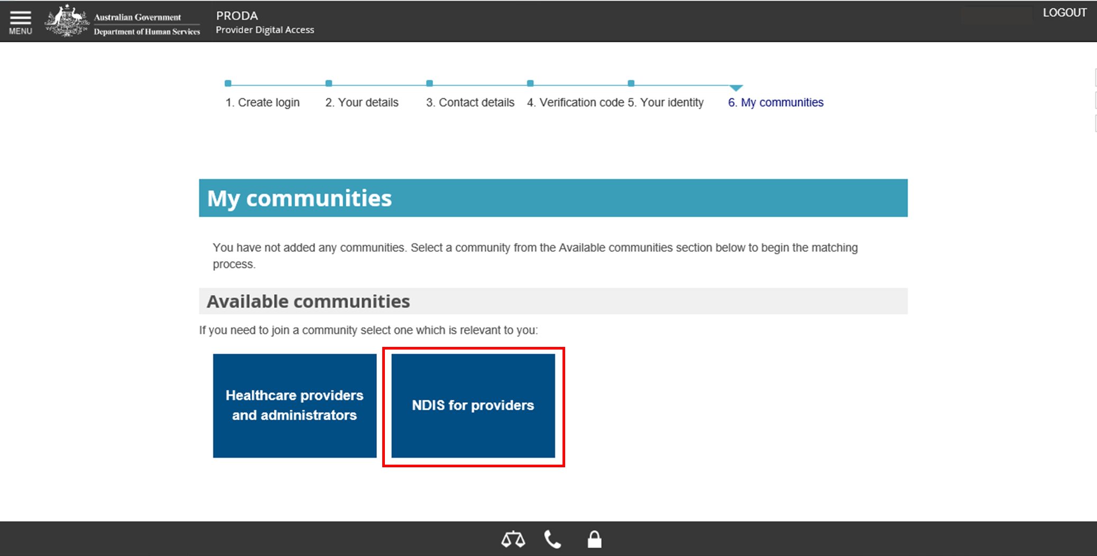
- You are now in the myplace portal. Enter your first and last names, date of birth, email and mobile phone number. Select Submit.
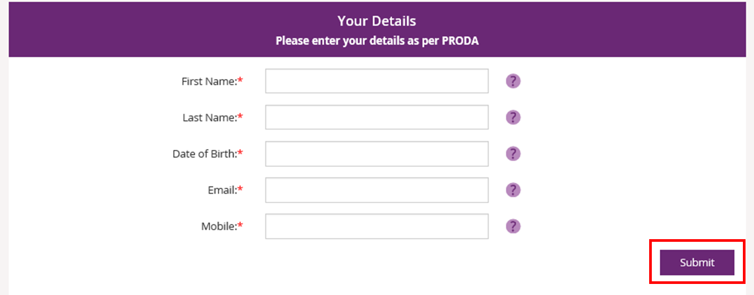
- The myplace homepage displays.
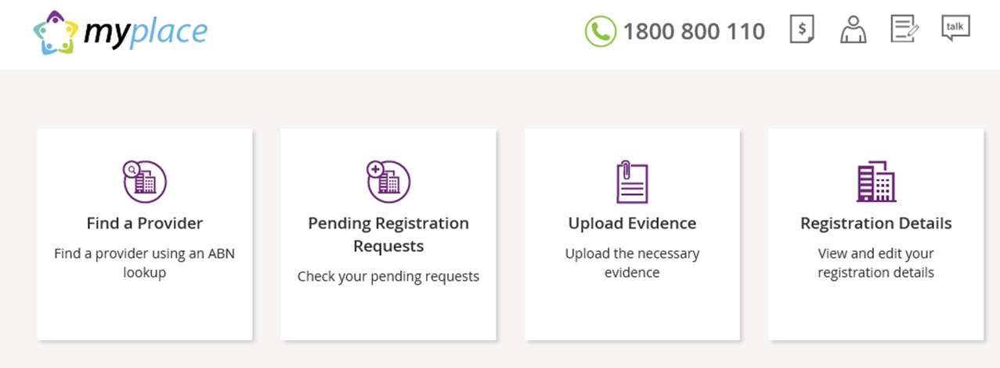
The following steps are divided into sections for Primary Contacts and other users. Refer to the relevant section for instructions on setting up your access to myplace.
Note that the first person to log in to the myplace Provider Portal with the correct Australian Business Number (ABN) and the provider organisation’s Registration Number will be automatically identified as the Primary Contact.

Steps for Primary Contacts
The following steps are for Primary Contacts only. Instructions for other users of myplace are provided in the next section.
- Select Find a Provider.
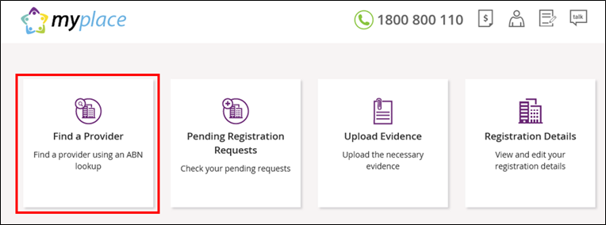
- Enter the Australian Business Number (ABN) of your Provider organisation and select Search.
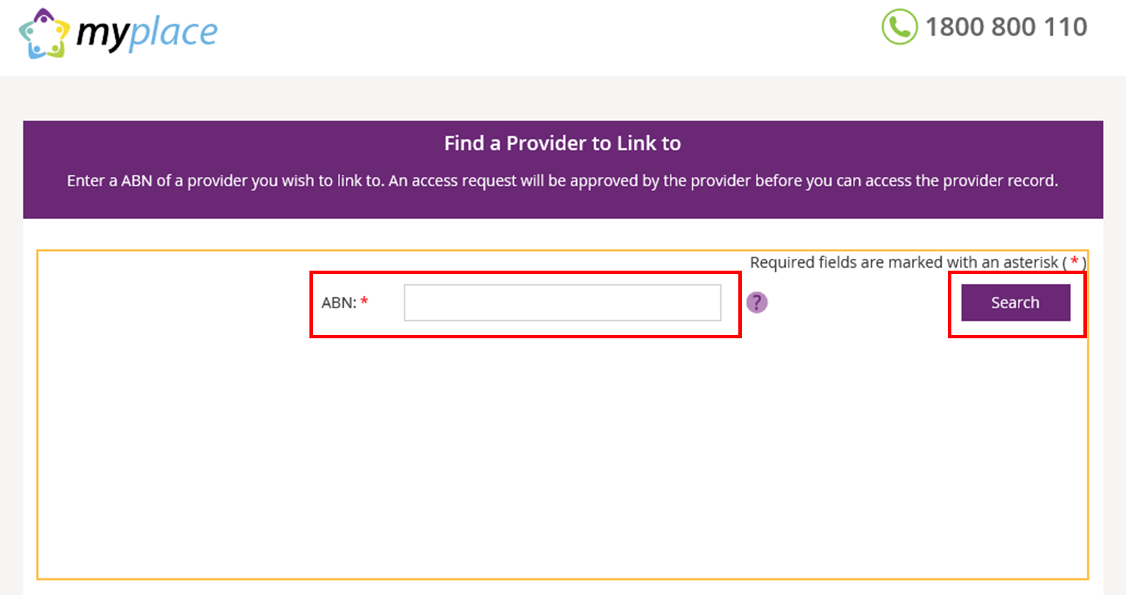
- As your organisation is not yet registered with NDIS, no search results will display. Select Intent to Register to begin the registration process.
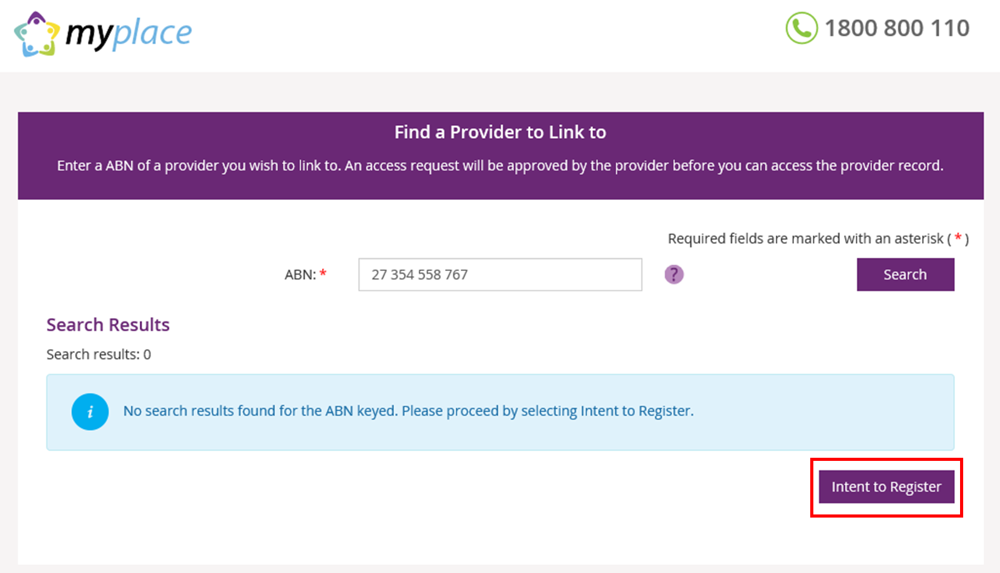
- Complete the required fields. Mandatory required fields are marked with a red asterisk (*). The required fields are divided into six parts:
- Type of Provider
Select the type of organisation you are registering.
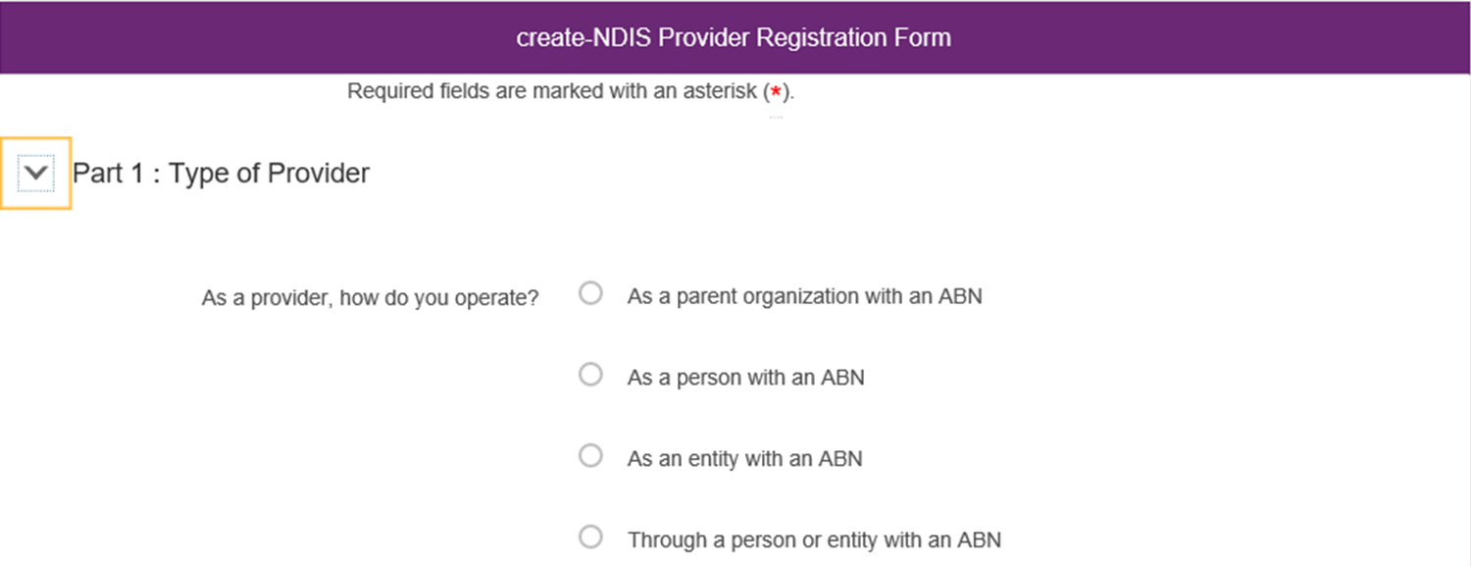
- Details about the Provider organisation
Complete the details of your organisation.
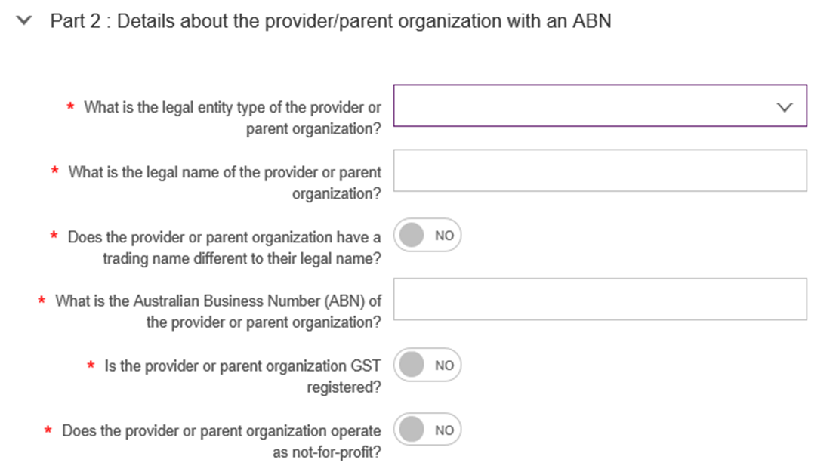

- Part 2b: Addresses of the organisation including postal address
Enter your organisation’s address. If the postal address is the same as the physical address, select the radio button next to Postal Address under Part 2b and it will turn to Yes.
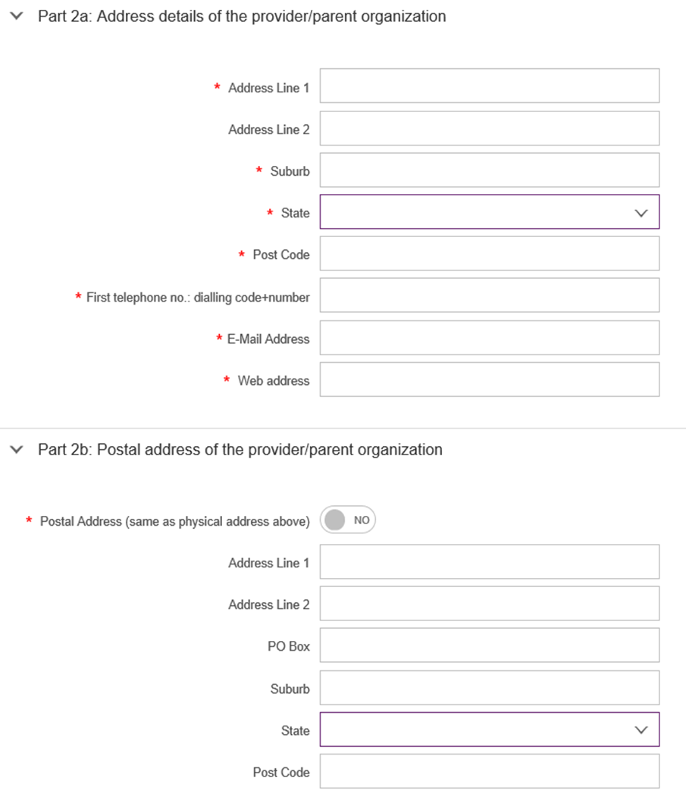
- Contact Details
The Contact Person ID is automatically generated. This is the ID number for the Primary Contact in your organisation.

- Declarations
Read the declarations and select the boxes to agree. Select Submit.
If you wish to return to the myplace homepage, select Back or Cancel.
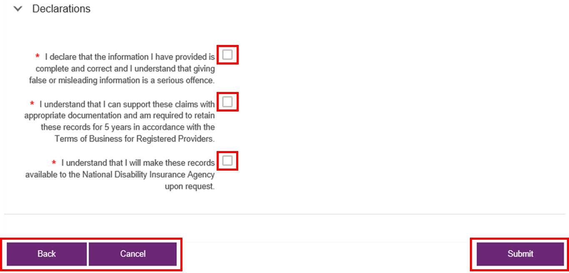
- You will be asked whether you wish to submit the information entered. Select Yes to continue or No to return to the Intent to Register form.
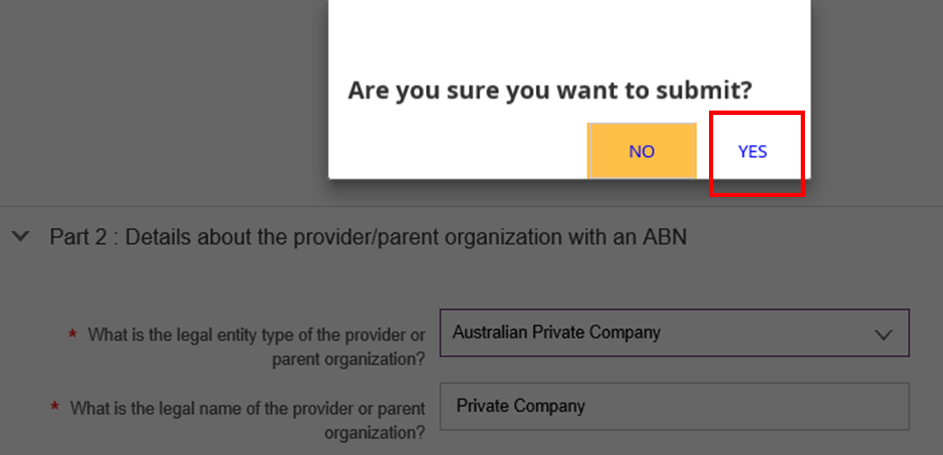
- After selecting YES, your details will be saved and a confirmation page will display. Select Close to exit the page.
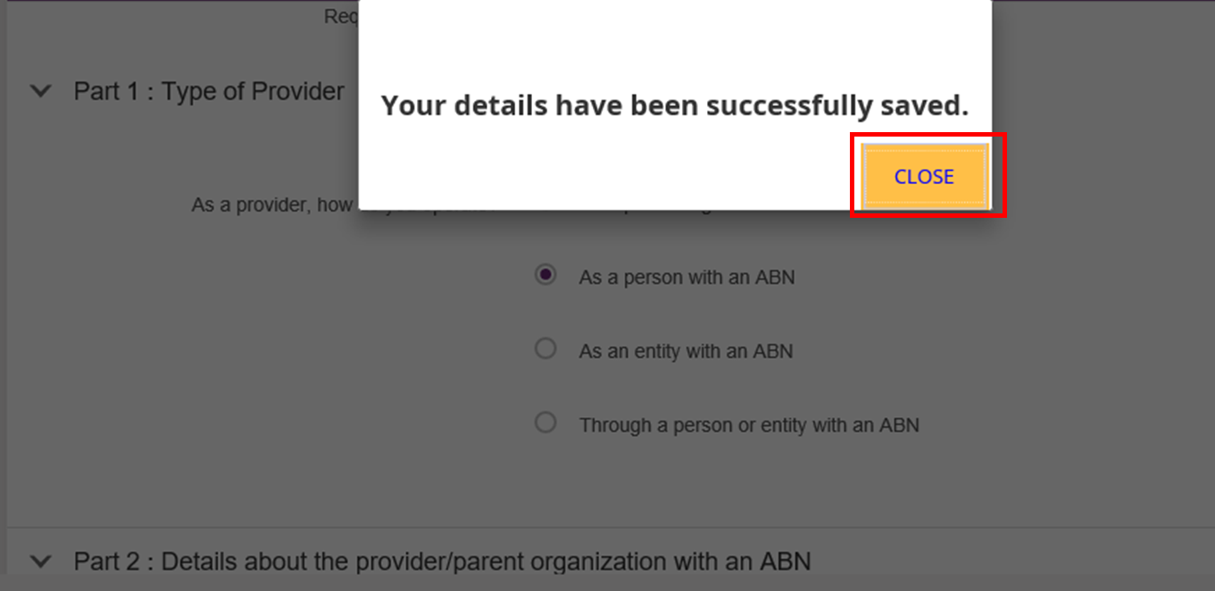
- Log out of myplace by selecting your username at the top right hand corner of the page then select Logout.
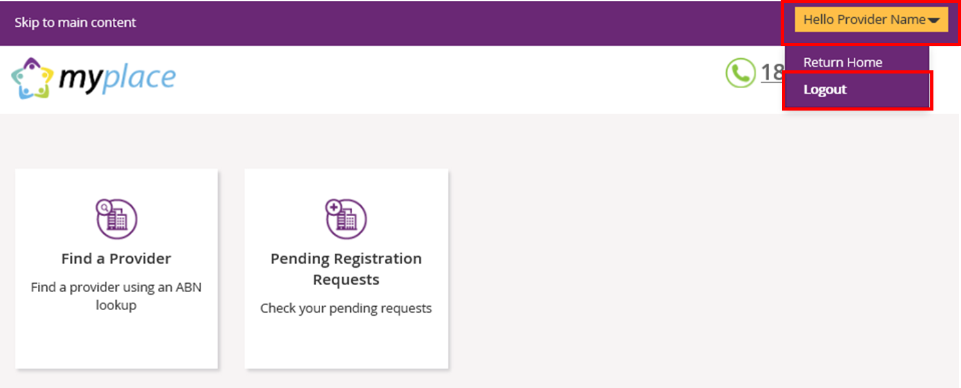
- Log back into PRODA to continue with the registration. For instructions on logging in to PRODA, refer to steps 2 and 3 outlined in this guide.
- When you log back into PRODA, the terms and conditions will display. These will only display for the first time you log back into PRODA. Read through the terms and conditions:
- If you accept the terms and conditions, select I agree. This will take you to the myplace portal.
- If you do not accept the terms and conditions, select I decline. This will take you out of PRODA.
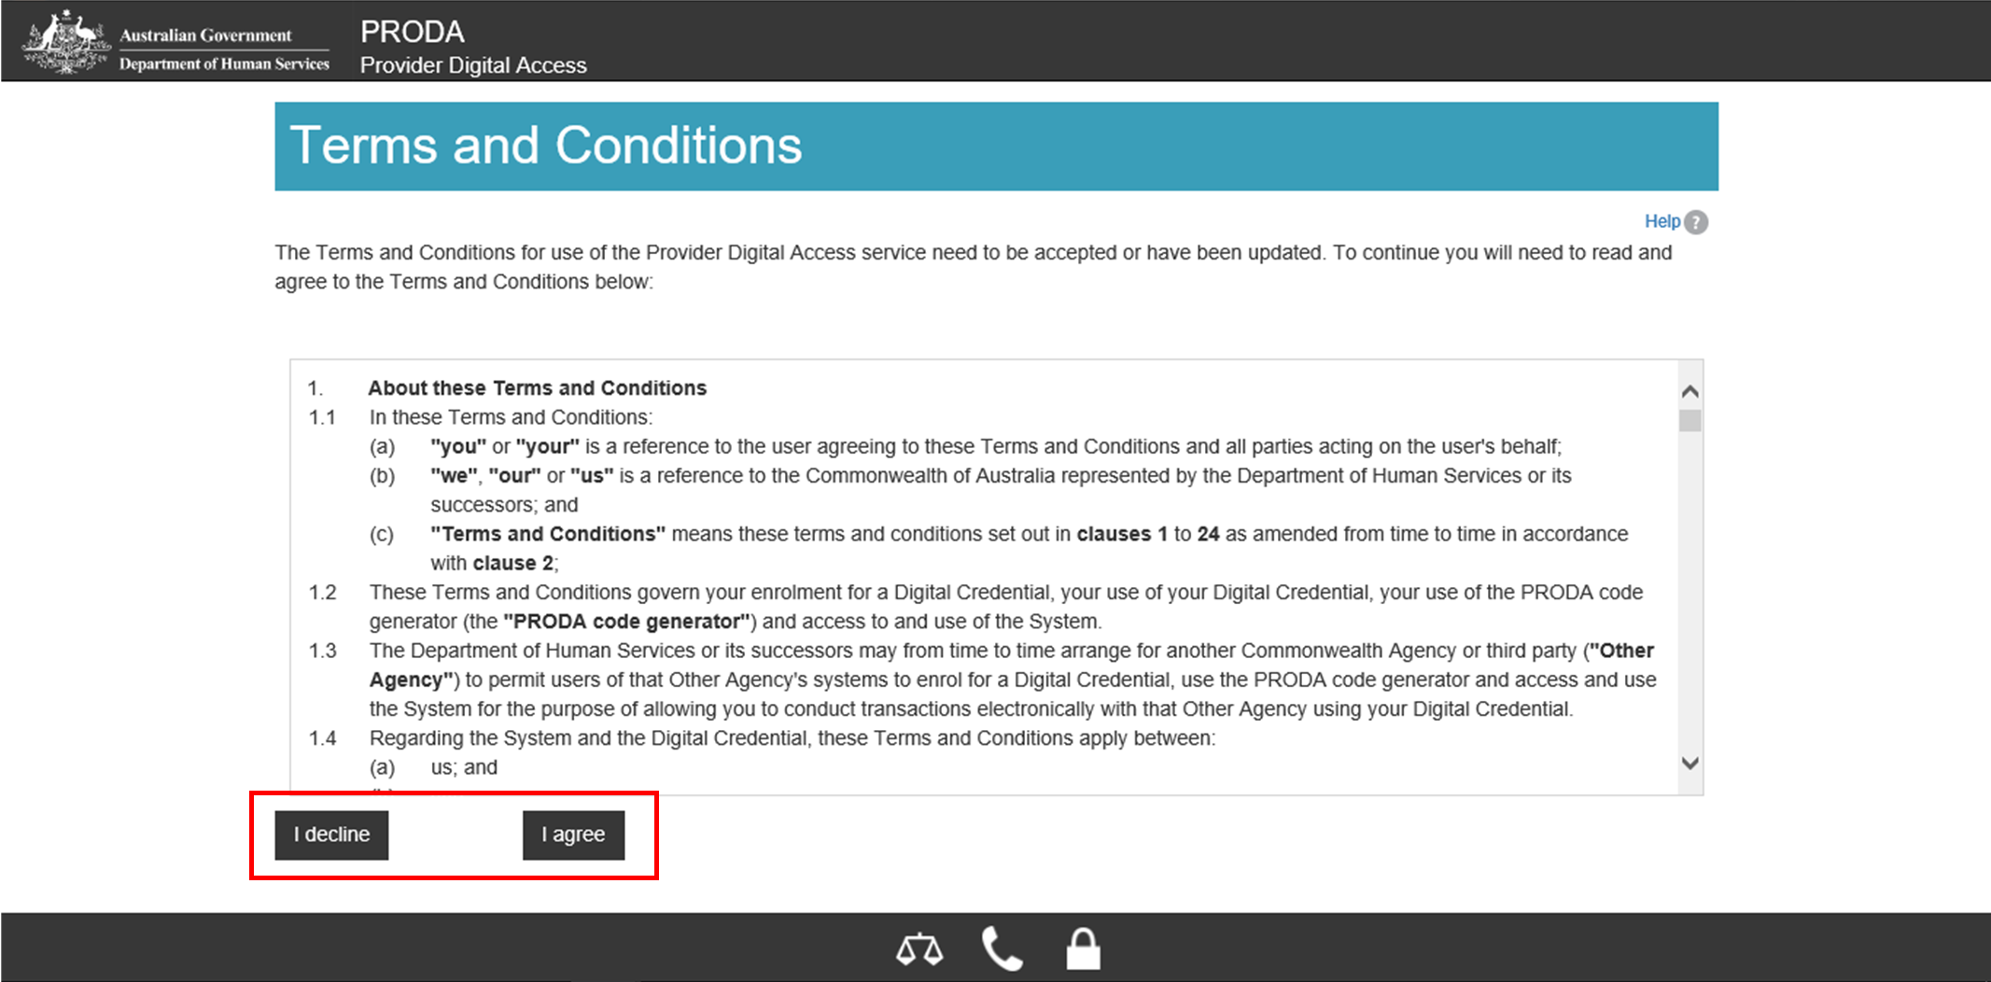
- Your PRODA account has now been linked to myplace. A confirmation is displayed in the green banner located at the top of the page. Select NDIS for providers to go into myplace.
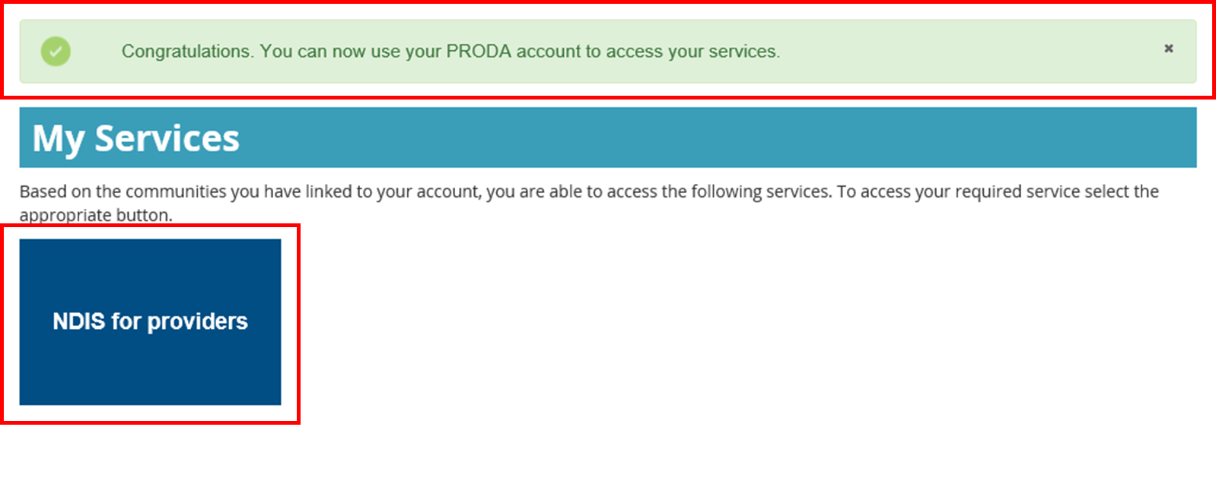

- The terms and conditions displays for the first time you log back into myplace. Read through the terms and conditions:
- If you accept the terms and conditions, select I have read and accepted the terms of use then I agree. This will take to the myplace portal.
- If you do not accept the terms and conditions, select I decline. This will take you out of the myplace portal.
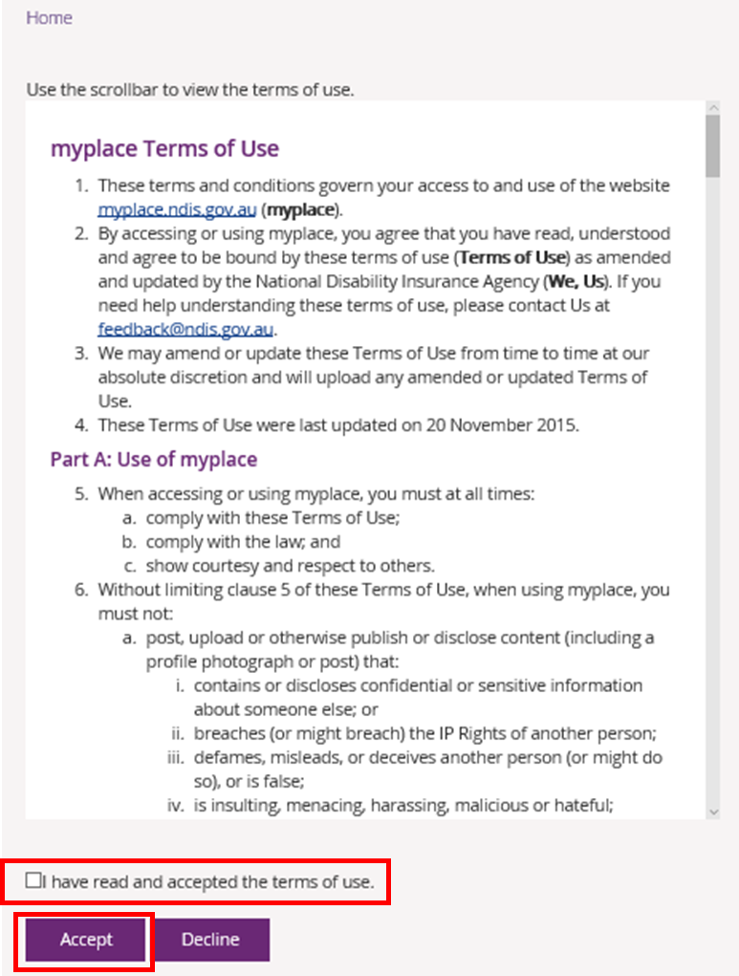
- Once the terms and conditions are accepted. The myplace homepage displays.

Adding registration groups and professions

- Select the Registration Details tile.
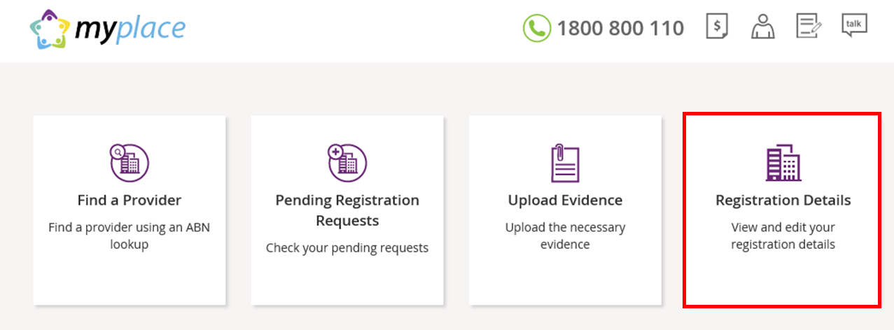
- Select Add a new Registration Group then Rego Group / Service Area.
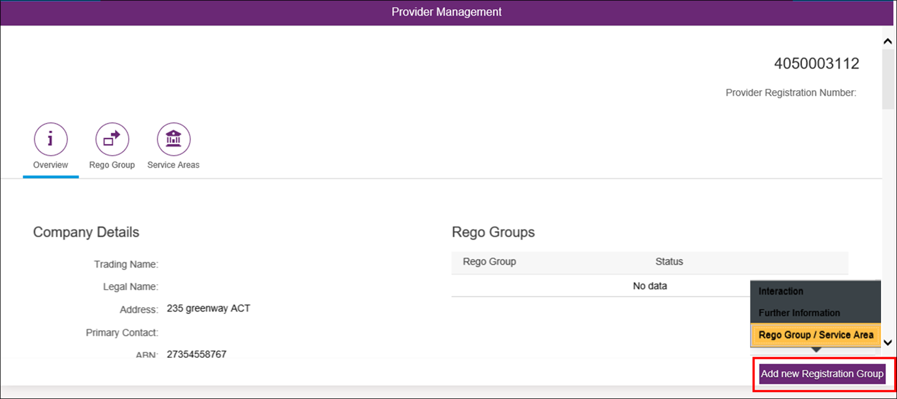
- Select the Registration Group, Profession(s) and State(s)/Territories you wish to register for using the drop down menus. You will also need to enter the start and end dates for the services.
Select Submit when all fields have been completed.
If you need to save the information and come back to complete this step at a later stage, select Save.
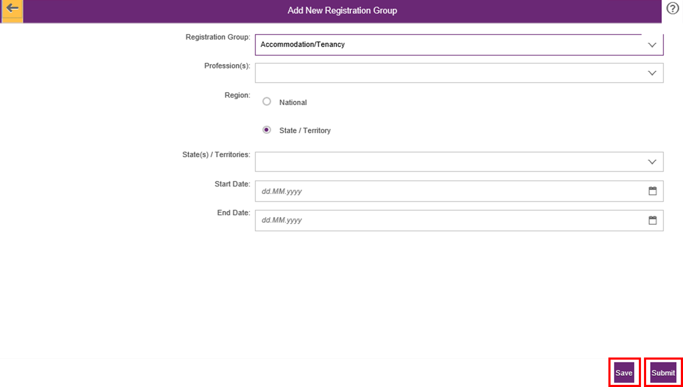
- A success screen will display indicating that your registration request has been successfully submitted. Select Close to exit this page.
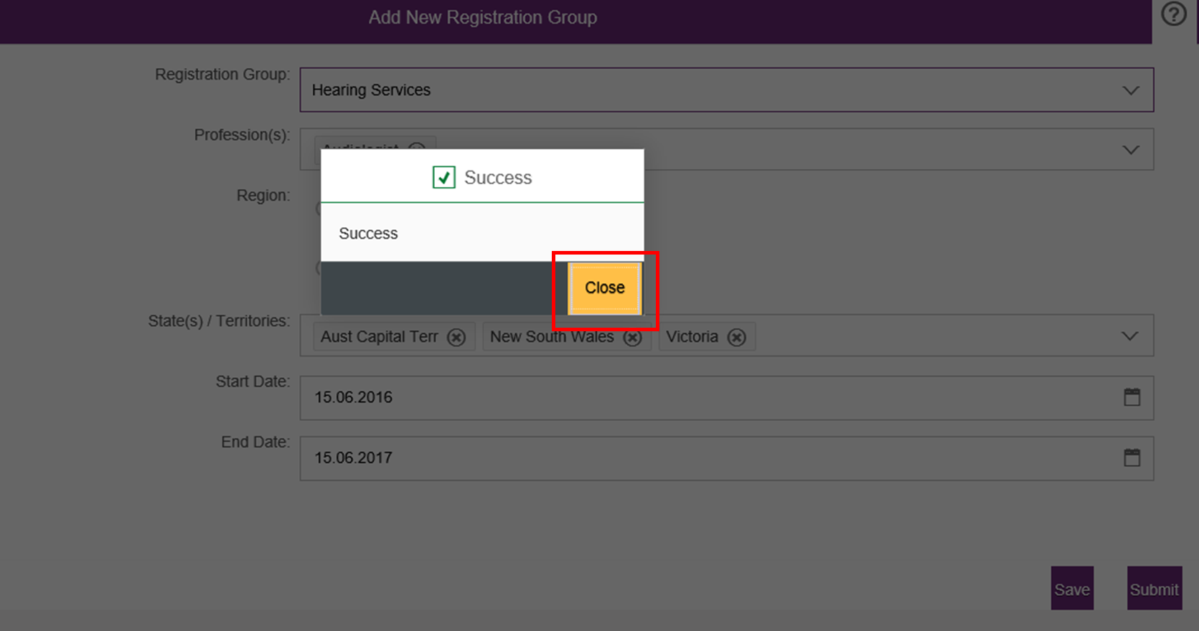
- If you wish to add another Registration Group, select Add new Registration Group.
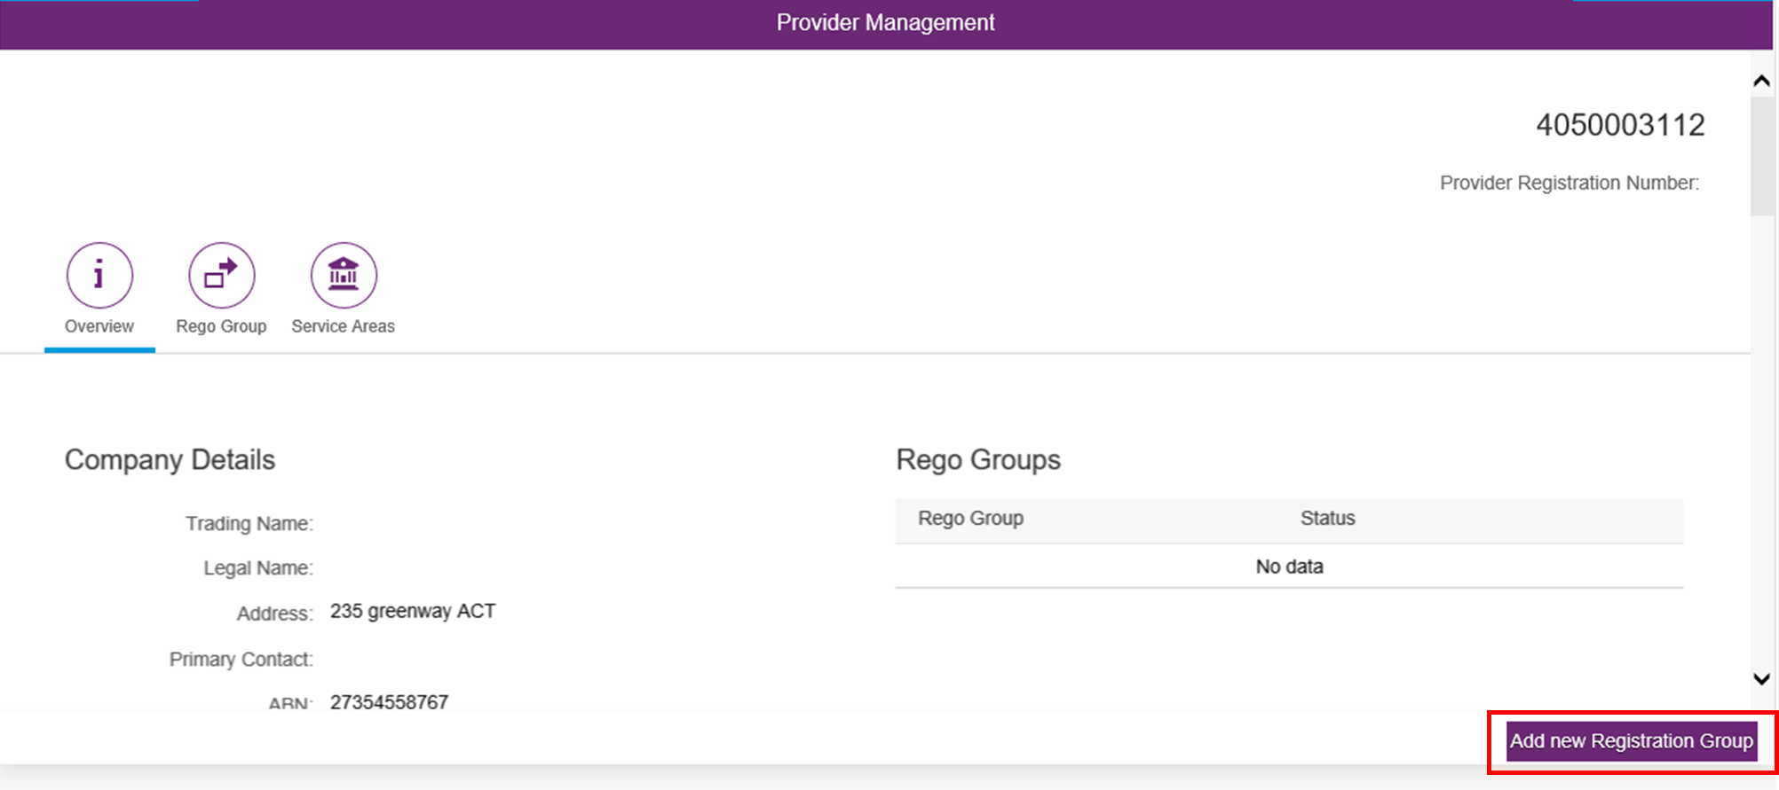
- To view a list of all the Registration Groups you have requested to register for, select Rego Group. A list of the Registration Groups requested are displayed with the status that they have been Submitted. Once the groups are approved, the status will change to Approved.
You can also add another Registration Group from this page. Select Add new Registration Group.
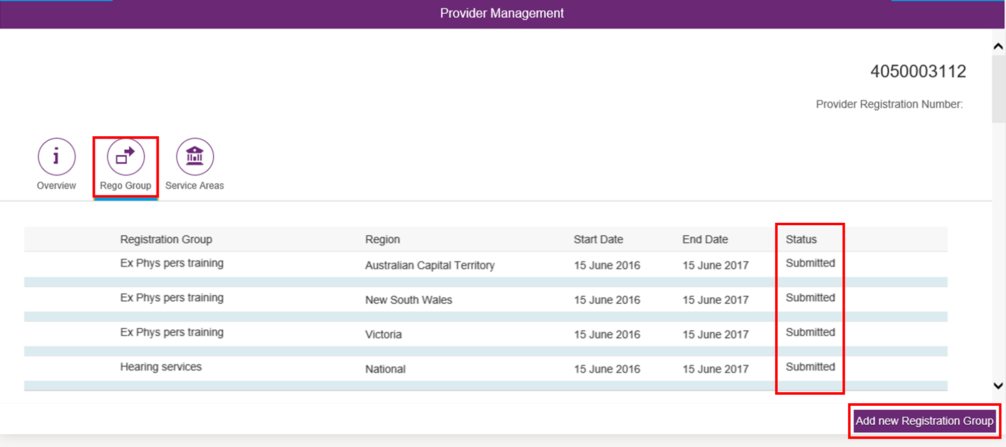

- After the Registration Groups are submitted, you will need to upload the required documentation. These include:
- Signed Terms of Business
- Signed Declaration of Suitability to be a Registered Provider
- Certificate of registration/accreditation (for specialist disability supports only)

- Return to the myplace homepage and select Upload Evidence.
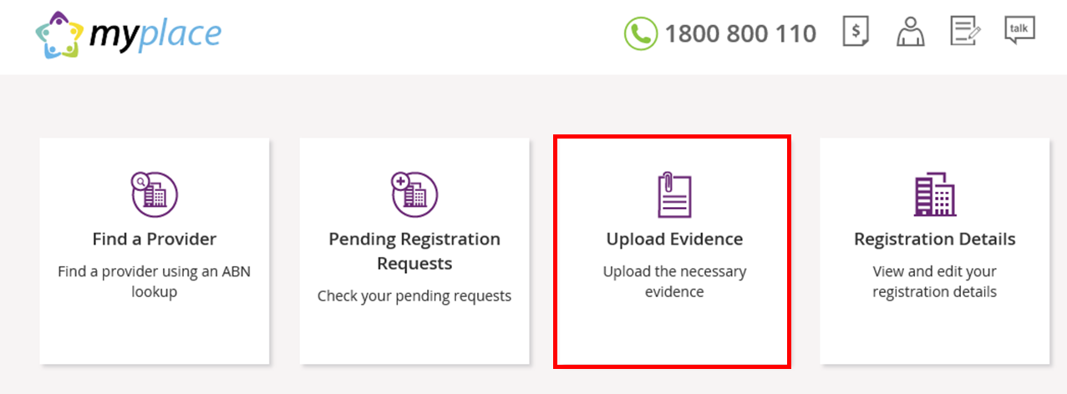
- Enter the Document Name and choose the document file from your computer by selecting Browse. Select Upload.
A list of the documents you have uploaded are displayed under the heading Available Documents.

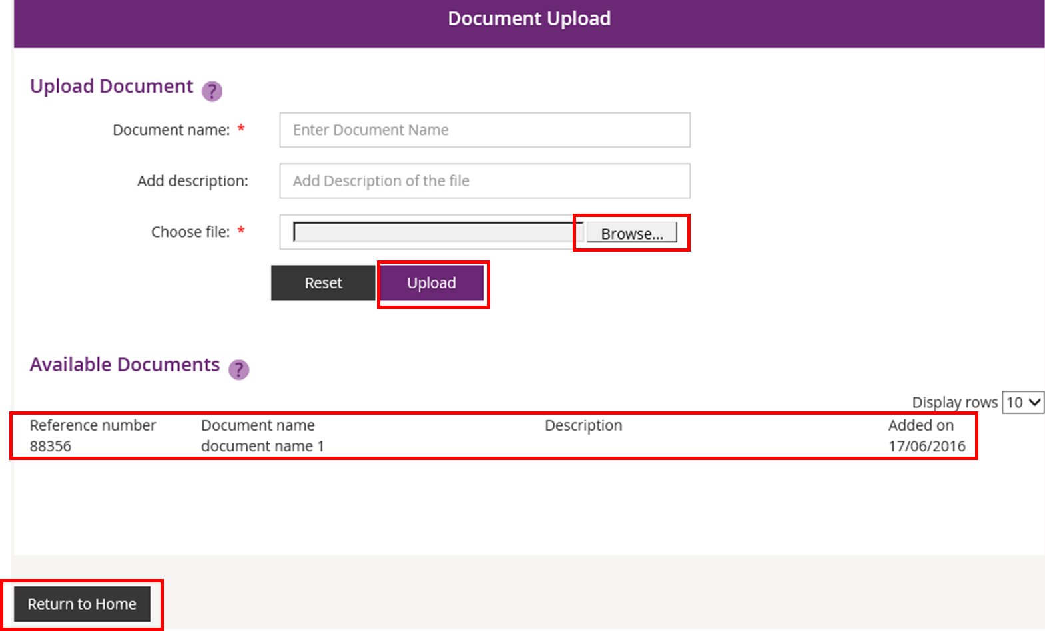
When you have uploaded all the requirement documents, select Return to Home.
Your organisation’s registration with NDIS is now complete. When the registration is approved, you will receive a letter and an email confirming that your organisation has successfully registered for NDIS. You will also receive a Certificate of Registration.

Viewing registration approval status
- If at any time you wish to view the status of your registration approval, select the Pending Registration Requests tile on the myplace homepage.
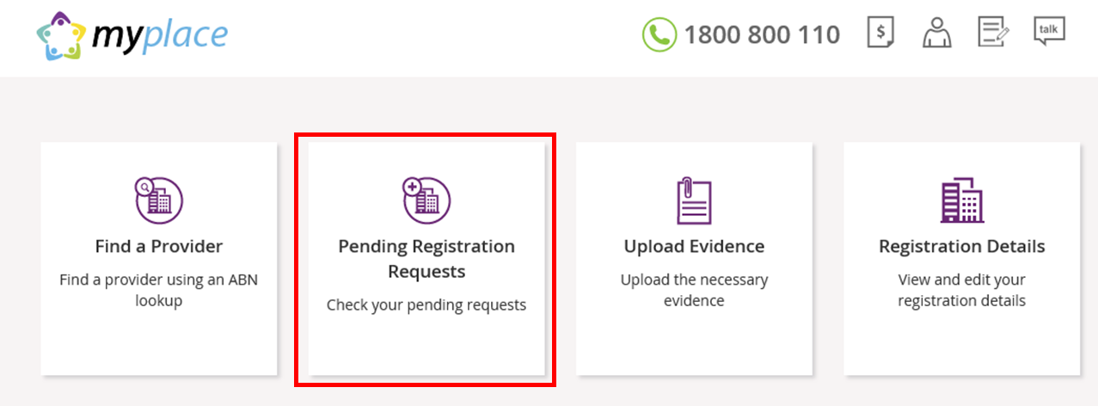
- The status of your access request is displayed. The status will be Open when your registration is pending approval. When it is approved, the status will change to Approved.
Select Return to Home to go back to the myplace homepage.
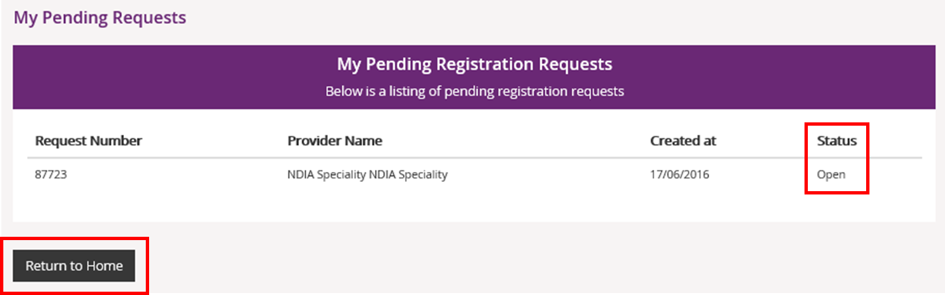
- Once your access is approved, the full myplace homepage will display when you log in.

Steps for other users of myplace
Your access to myplace will need to be approved by the Primary Contact of your Provider organisation. The following instructions continue from step 6.
- Select Find a Provider.
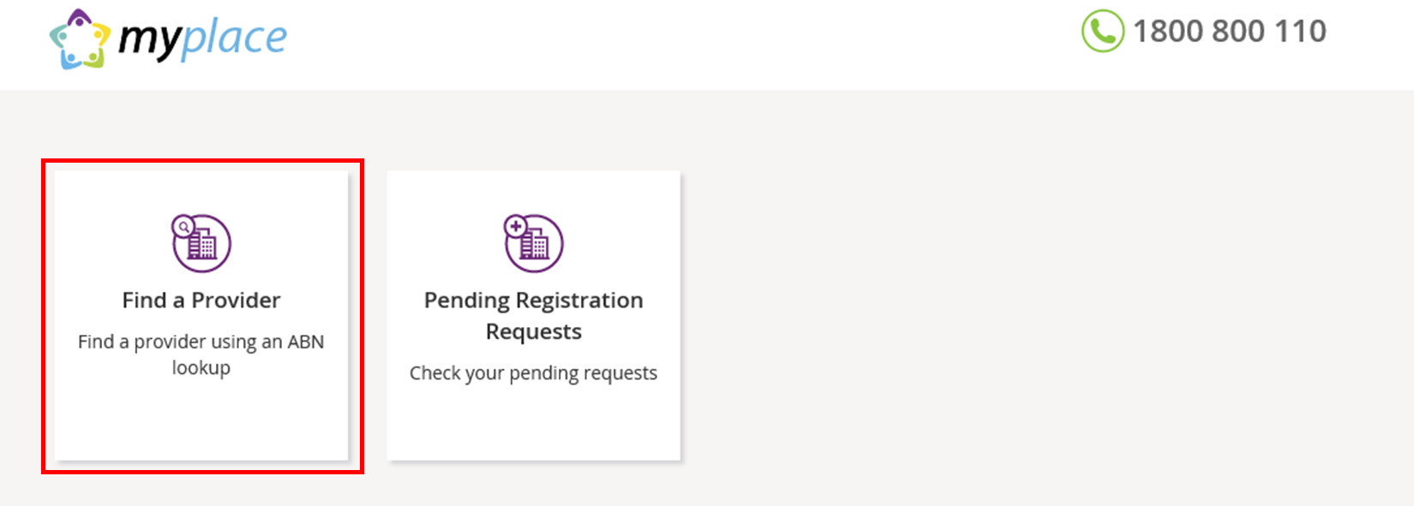
- Enter the Australian Business Number (ABN) of your Provider organisation and click Search.
- Your organisation should display under Search Results. Select the radio button for your organisation and select Next to continue. If you wish to return to the homepage, select Return to Home.
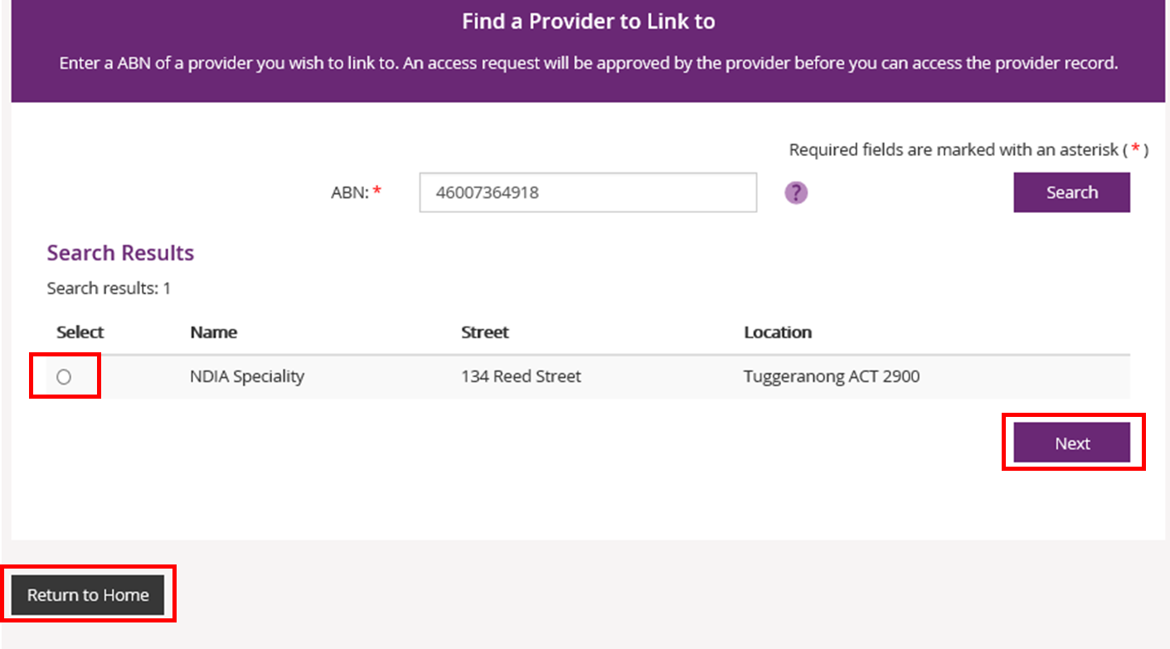
If your organisation is not listed and it is registered with NDIS, it may be that a Primary Contact has not been set up in myplace. We advise that you contact your organisation to clarify.
If a Primary Contact has been set up, contact NDIA on 1800 800 110 for assistance.
If you are interested in registering your organisation with NDIS, refer to the For New Providers: Registering with NDIS section below.

- Select Alternate Contact using the drop down button for the Contact Type field. Select Submit to continue.
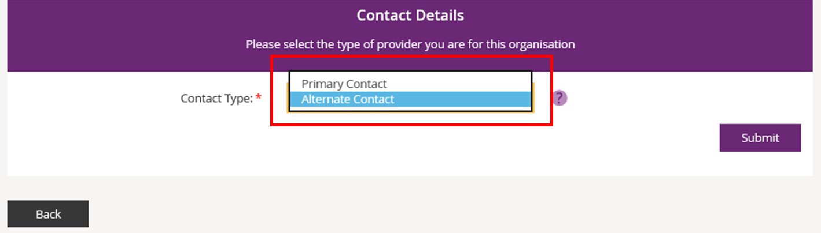
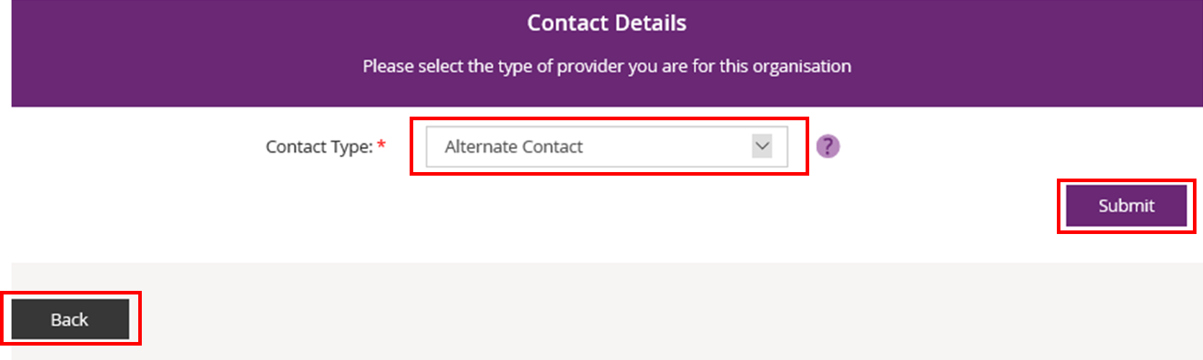
If you need to return to the myplace homepage, select Back.
- Your request to access myplace is now sent to your organisation’s Primary Contact for approval. Select MyPlace Dashboard to return to the myplace homepage.
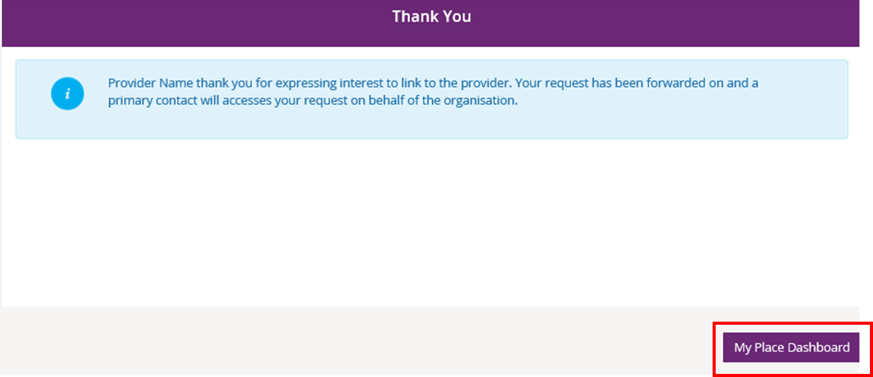
- If you work for more than one NDIS registered Provider organisation, you will need to link the other organisations to your PRODA account. To do this, repeat steps 1 to 5.
- You can view the progress of your access approval by selecting the Pending Registration Requests tile.
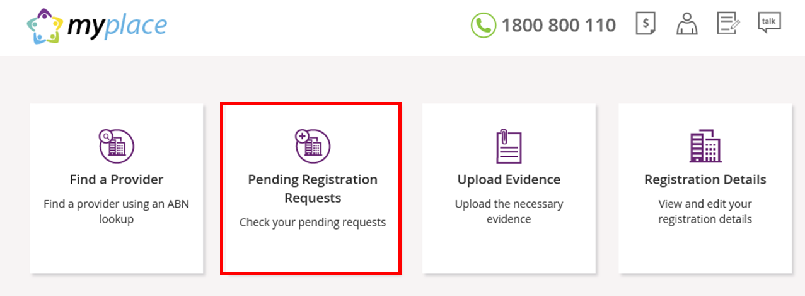
- The status of your access request is displayed. Select Return to Home to go back to the myplace homepage.
- Once your access is approved, the full myplace homepage will display when you log in.

