Provider Toolkit

# myplace registration for new providers

# Step by step guide

**1 July 2016**

# 

**Table of Contents**

Introduction 3

Authentication process 3

New providers 3

Registering as a NDIS provider 4

Steps for Primary Contacts 6

Adding registration groups and professions 12

Viewing registration approval status 15

Steps for other users of myplace 15

## Introduction

The **myplace** Provider Portal is the means for registered NDIS providers to manage their products and services for participants. Providers can use **myplace** to:

* view information
* create service bookings
* manage payment requests
* communicate with participants.

Accessing the **myplace** provider portal involves a two-step online process. This Step-by-Step Guide is intended for use by new providers and provides information on setting up your access for the new **myplace** provider portal.

The Primary Contact of your organisation will need to complete the initial registration process which involves completing the **Intent to Register** form in **myplace**. If you are unsure who the Primary Contact is, we recommend you contact your organisation for clarification. This Step-by-Step Guide provides instructions for both the Primary Contact and other users of **myplace**.

The steps outlined in this document continues from the ***PRODA Step by Step Guide***.

## Authentication process

Since 1 July 2016 there has been a new online NDIS Provider Portal called **myplace**. To access **myplace**, a new authentication process called Provider Digital Access (PRODA) will be in place and managed by the Department of Human Services. All existing and new Providers will need to register for a PRODA account.

The authentication process through PRODA is designed to provide secure access to specific Government services. All users of **myplace** will need to create a PRODA account.

For **new NDIS Providers**, the PRODA authentication process will be your access point into **myplace**. Once your PRODA account is created and authenticated, you will need to submit your NDIS registration request using **myplace**.

The authentication system is a two-step online process:

1. **Create your account** – provide basic personal information, create a username and password, and provide contact information for the secure management of your account
2. **Verify your identity** – verify your identity online using Government issued identity documents which requires you to provide key information from your documents. Your identity will be verified online and in real-time using the Government’s [Document Verification Service](http://www.dvs.gov.au/Pages/default.aspx) (DVS).

## New providers

The key steps for **registering as a NDIS Provider** are:

1. Create an account and verify your identity using PRODA
2. Complete the Intent to Register form in the myplace portal
3. Add Professions and Registration Groups for NDIS approval (including the states/territories for which you will be providing services)
4. Upload required supporting documentation

## Registering as a NDIS provider

Once a PRODA account is created and authenticated in PRODA, you will need to link your PRODA account to **myplace** and complete the remaining registration process in **myplace**.

Your registration is complete when you have:

* Linked your PRODA account to **myplace** (steps 1 to 17)
* Added the Registration Groups and Professions you wish to provide services for (steps 19 to 29)

1. Access the **myplace** portal using the link provided on the [NDIS website](http://www.ndis.gov.au/providers) or type in https://**myplace**.ndis.gov.au/supplier into your internet browser address bar.

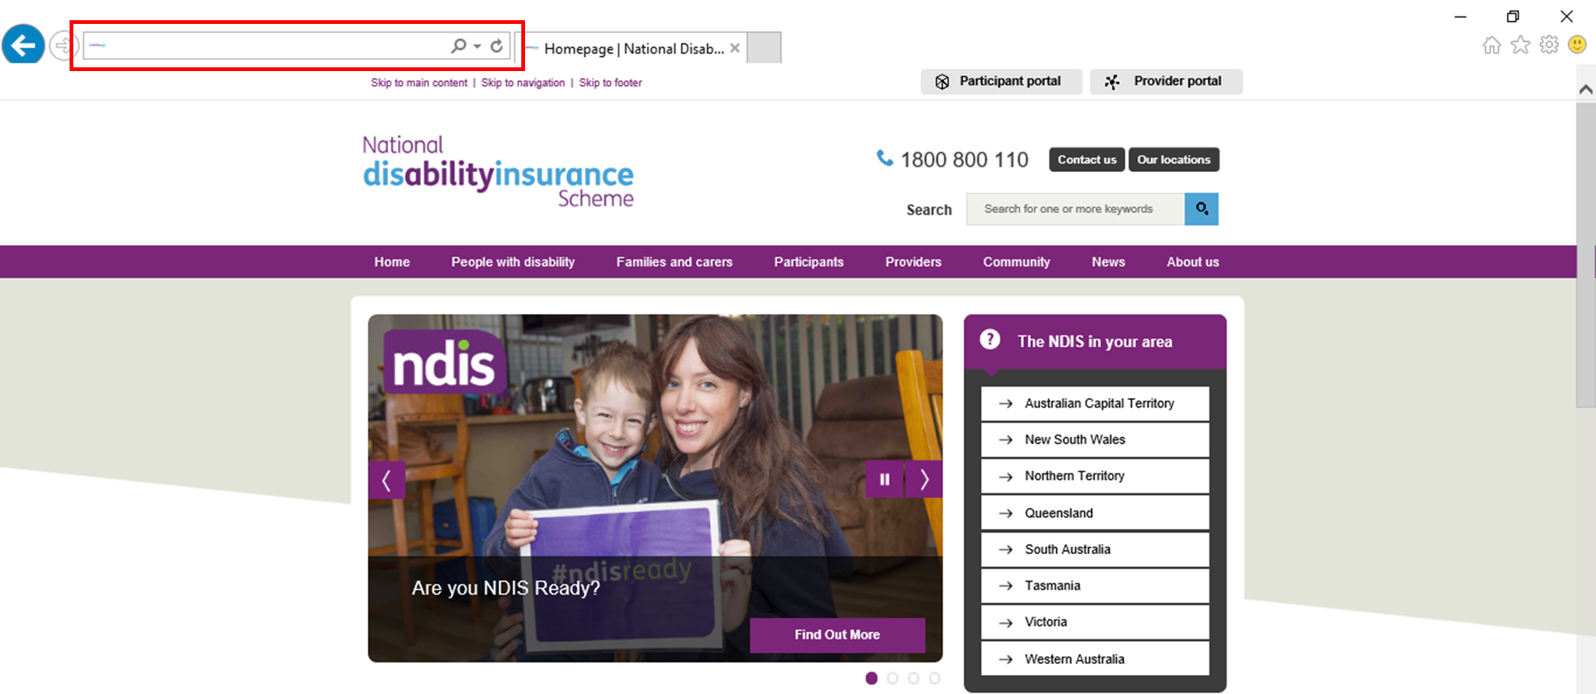

1. Enter your **Username** and **Password** then select **Login.**

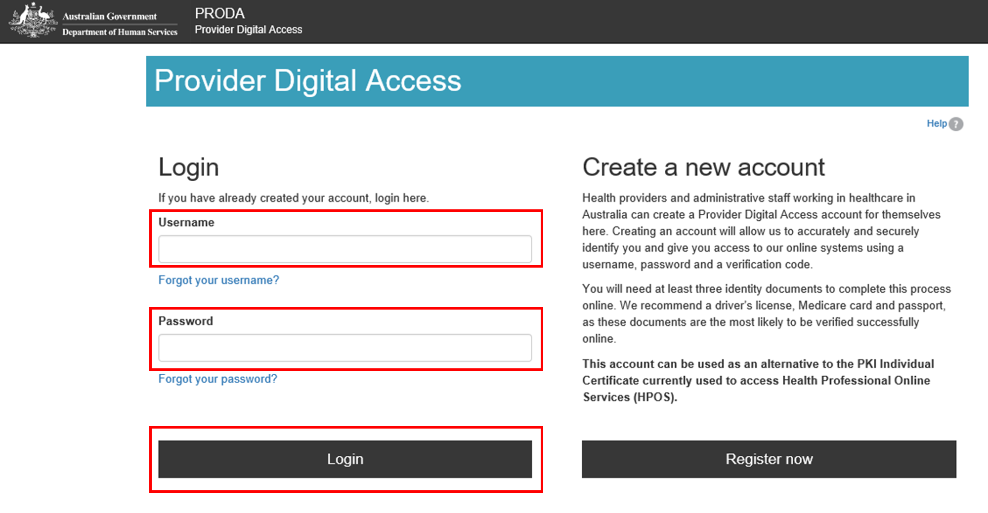

1. Enter the **verification code** sent to your email or mobile phone or PRODA Code Generator app. Select **Submit**.

The method you receive your verification code is from the preference you selected when creating your PRODA account.

If you do not receive your verification code, select **Resend code**.

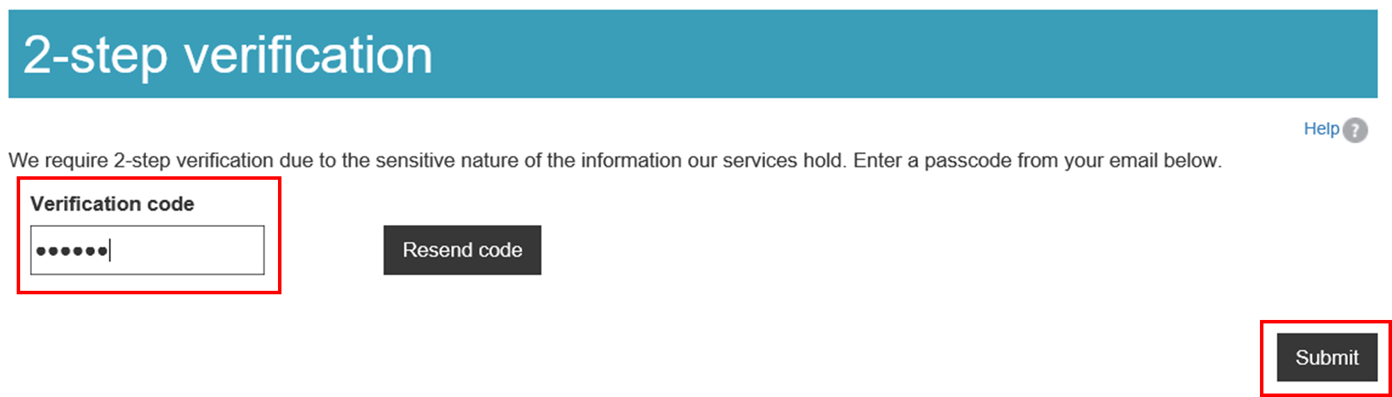

1. Select **NDIS for providers** to be directed to the **myplace** portal.

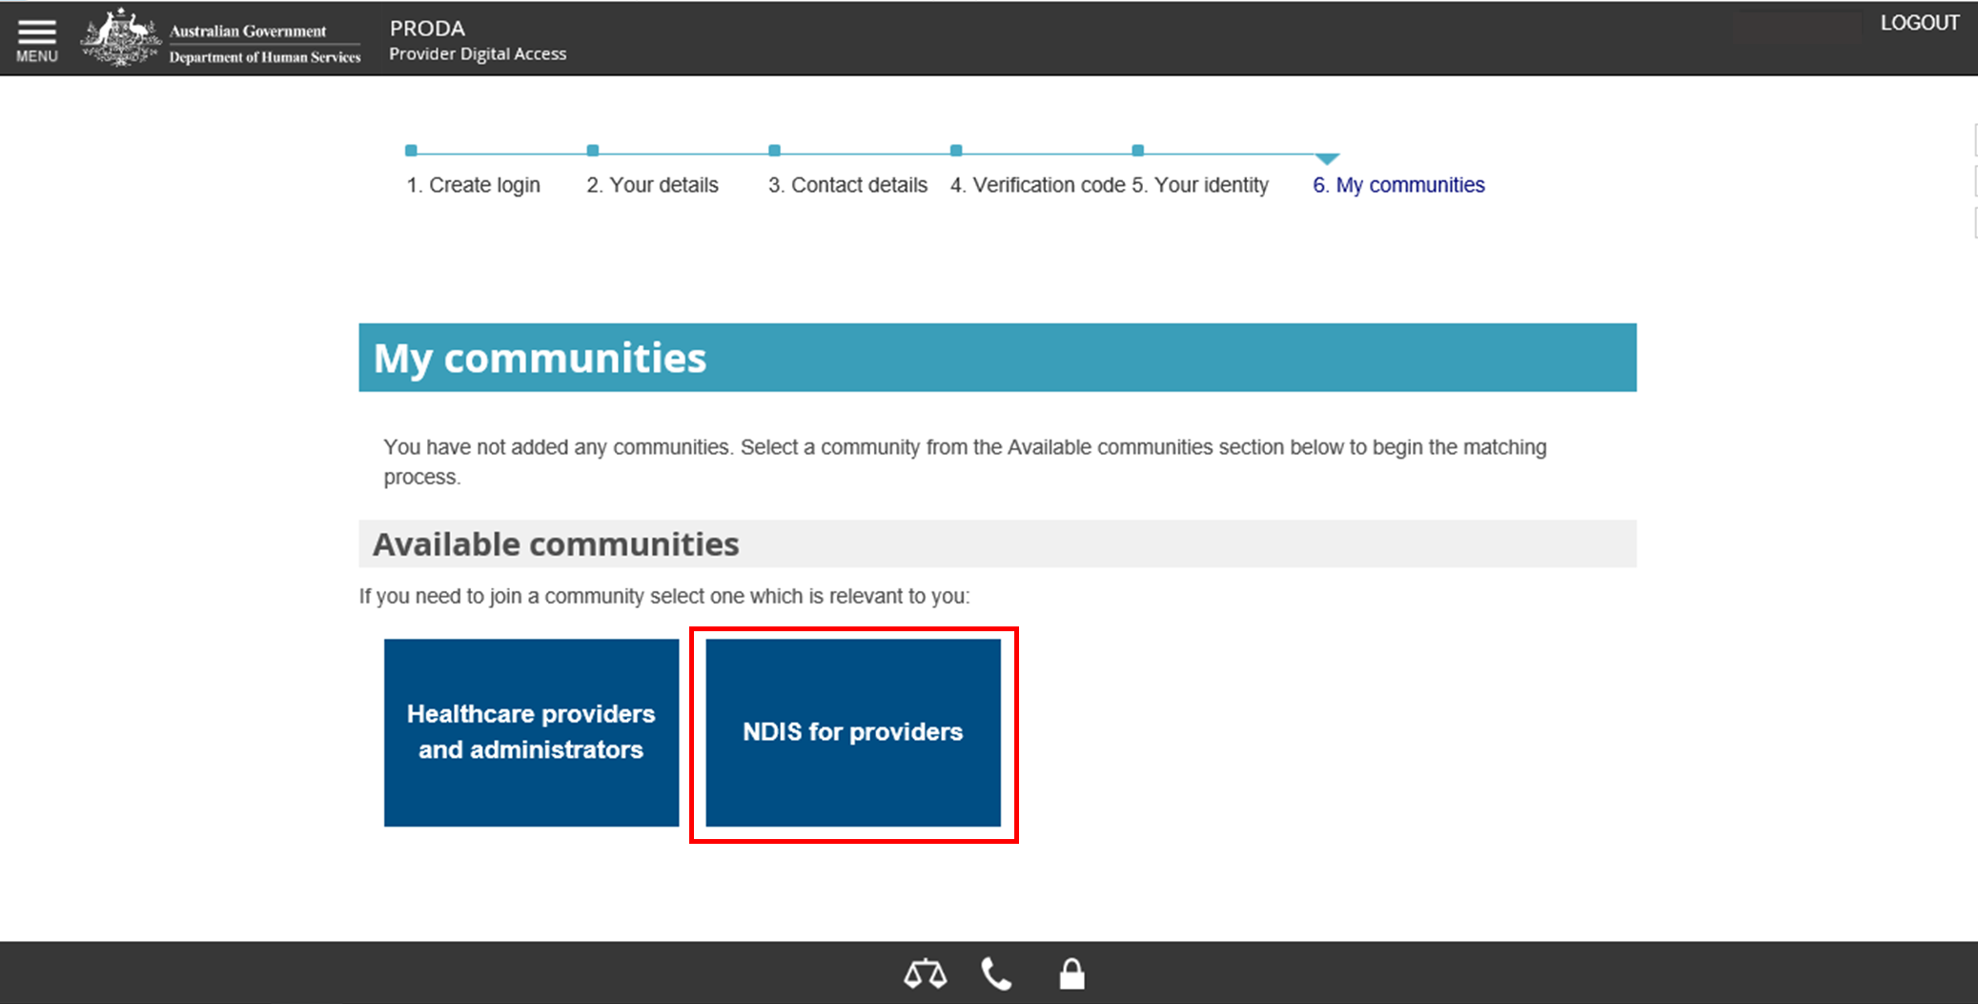

1. You are now in the **myplace** portal. Enter your **first and last names**, **date of birth**, **email** and **mobile phone number**. Select **Submit.**

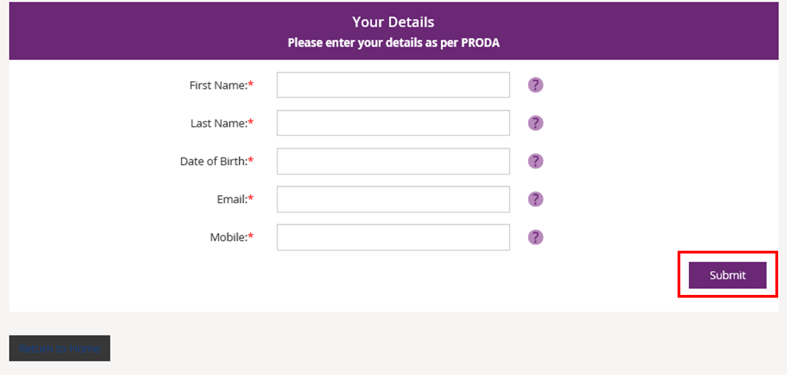

1. The **myplace** homepage displays.

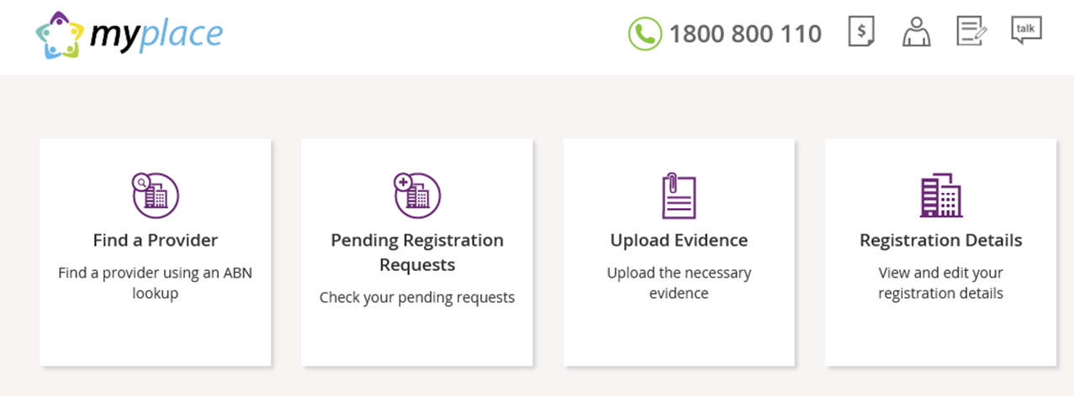

The following steps are divided into sections for Primary Contacts and other users. Refer to the relevant section for instructions on setting up your access to **myplace**.

Note that the first person to log in to the **myplace** Provider Portal with the correct Australian Business Number (ABN) and the provider organisation’s **Registration Number will be automatically identified as the Primary Contact.**

### Steps for Primary Contacts

The following steps are for Primary Contacts only. Instructions for other users of **myplace** are provided in the next section.

1. Select **Find a Provider**.

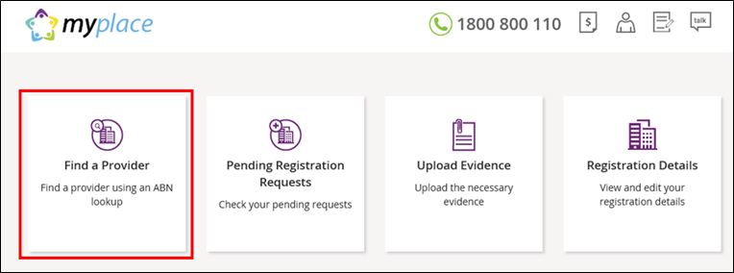

1. Enter the **Australian Business Number (ABN)** of your Provider organisation and select **Search.**

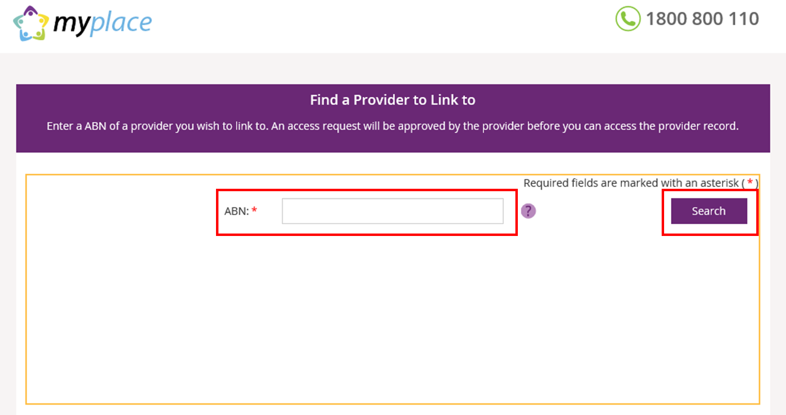

1. As your organisation is not yet registered with NDIS, no search results will display. Select **Intent to Register** to begin the registration process.

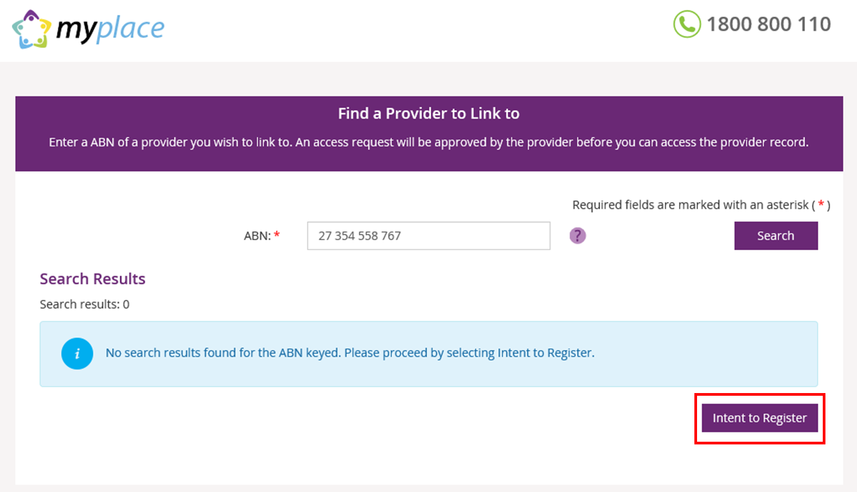

1. Complete the required fields. Mandatory required fields are marked with a red asterisk (**\***). The required fields are divided into six parts:

* **Type of Provider**

Select the type of organisation you are registering.

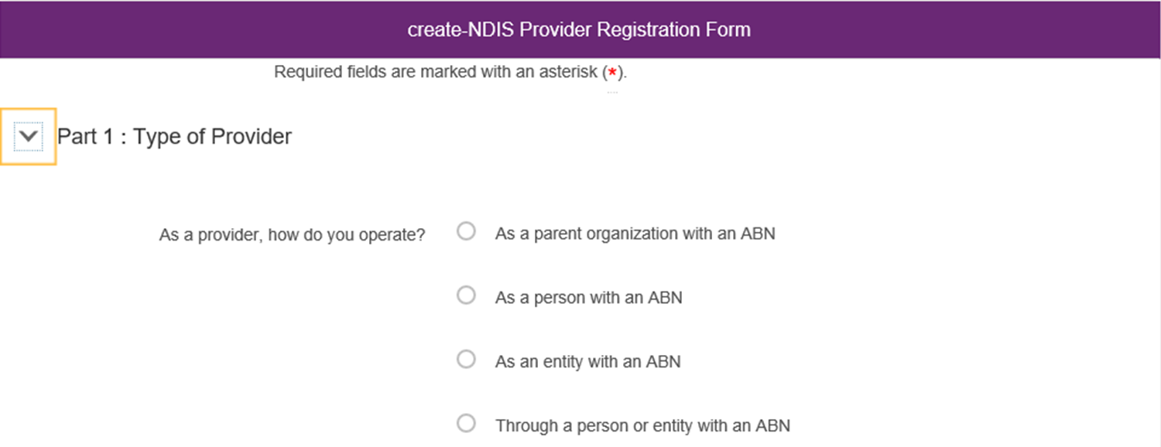

* **Details about the Provider organisation**

Complete the details of your organisation.

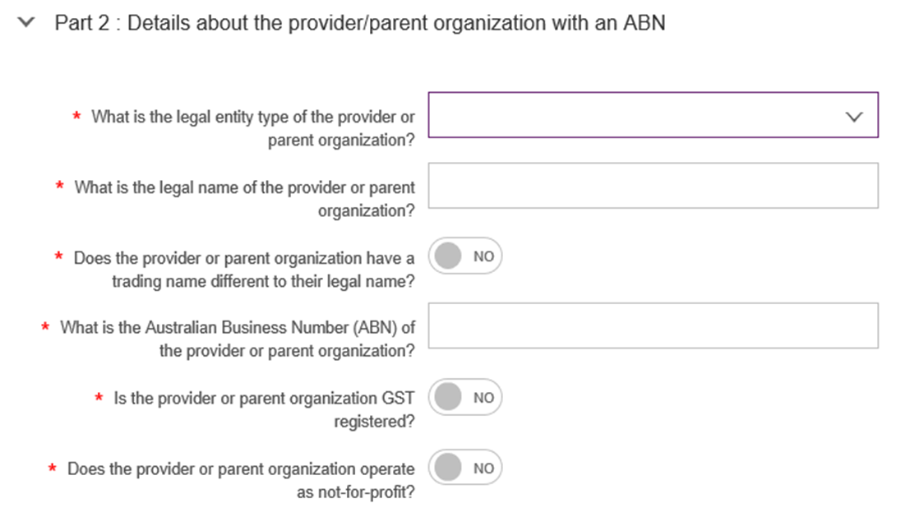

* **Part 2b: Addresses of the organisation including postal address**

Enter your organisation’s address. If the postal address is the same as the physical address, select the radio button next to **Postal Address** under **Part 2b** and it will turn to **Yes**.

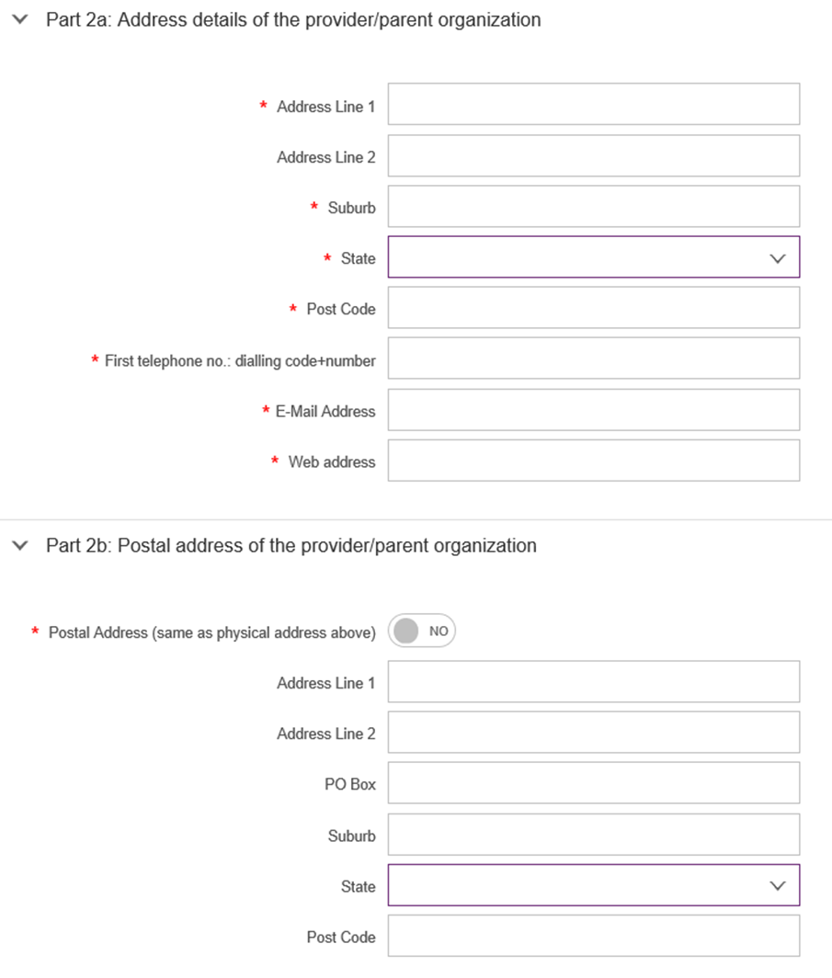

* **Contact Details**

The Contact Person ID is automatically generated. This is the ID number for the Primary Contact in your organisation.



* **Declarations**

Read the declarations and select the boxes to agree. Select **Submit.**

If you wish to return to the **myplace** homepage, select **Back** or **Cancel**.

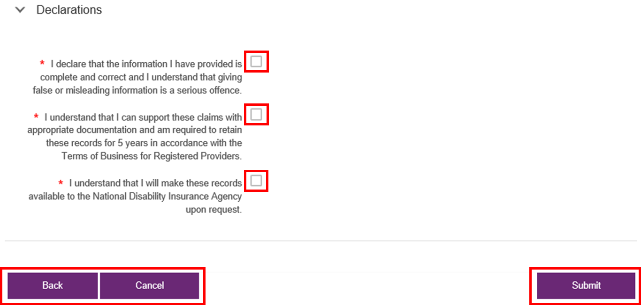

1. You will be asked whether you wish to submit the information entered. Select **Yes** to continue or **No** to return to the **Intent to Register** form.

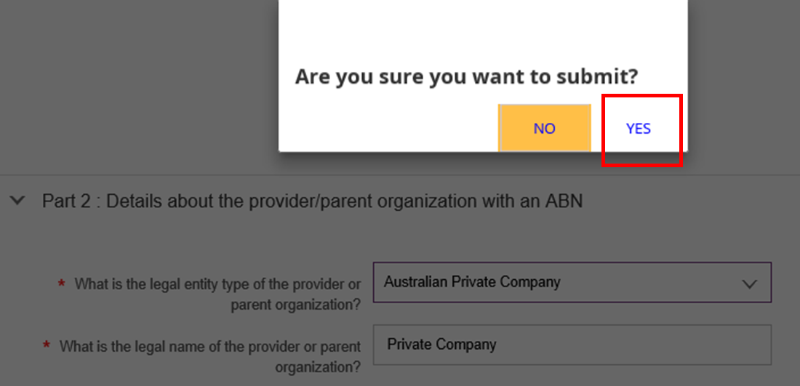

1. **After selecting YES, your details will be saved and a confirmation page will display. Select Close to exit the page.**

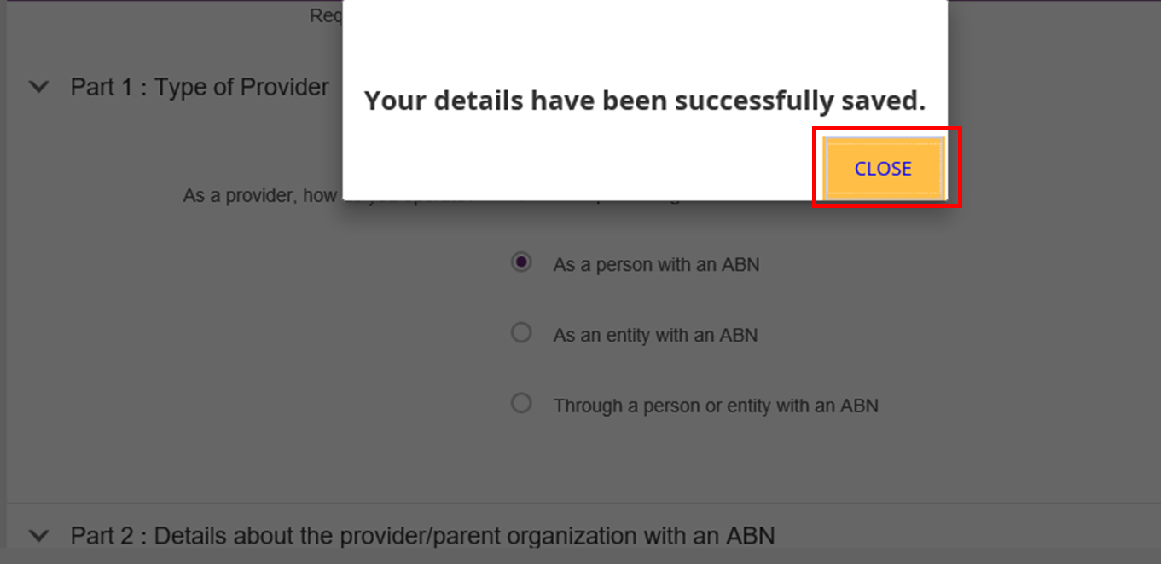

1. Log out of **myplace** by selecting your username at the top right hand corner of the page then select **Logout**.

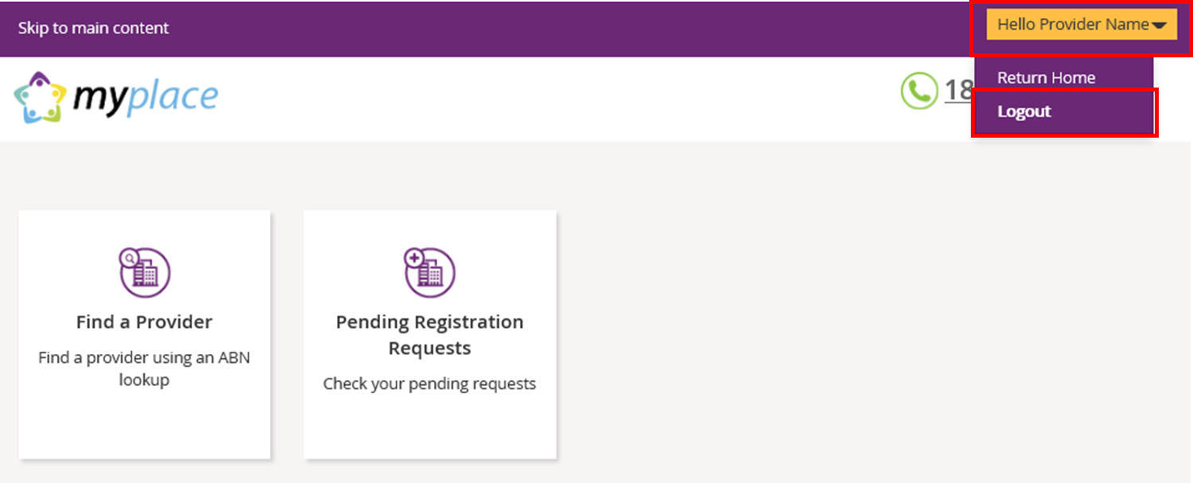

1. Log back into PRODA to continue with the registration. For instructions on logging in to PRODA, refer to steps 2 and 3 outlined in this guide.
2. When you log back into **PRODA**, the terms and conditions will display. These will only display for the first time you log back into **PRODA**. Read through the terms and conditions:

* If you accept the terms and conditions, select **I agree**. This will take you to the **myplace** portal.
* If you do not accept the terms and conditions, select **I decline**. This will take you out of PRODA.

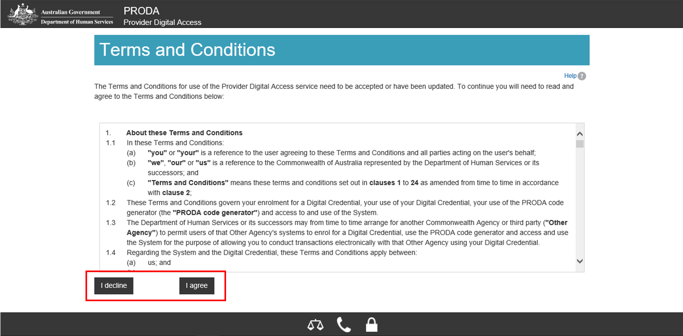

1. Your PRODA account has now been linked to **myplace**. A confirmation is displayed in the green banner located at the top of the page. Select **NDIS for providers** to go into **myplace.**

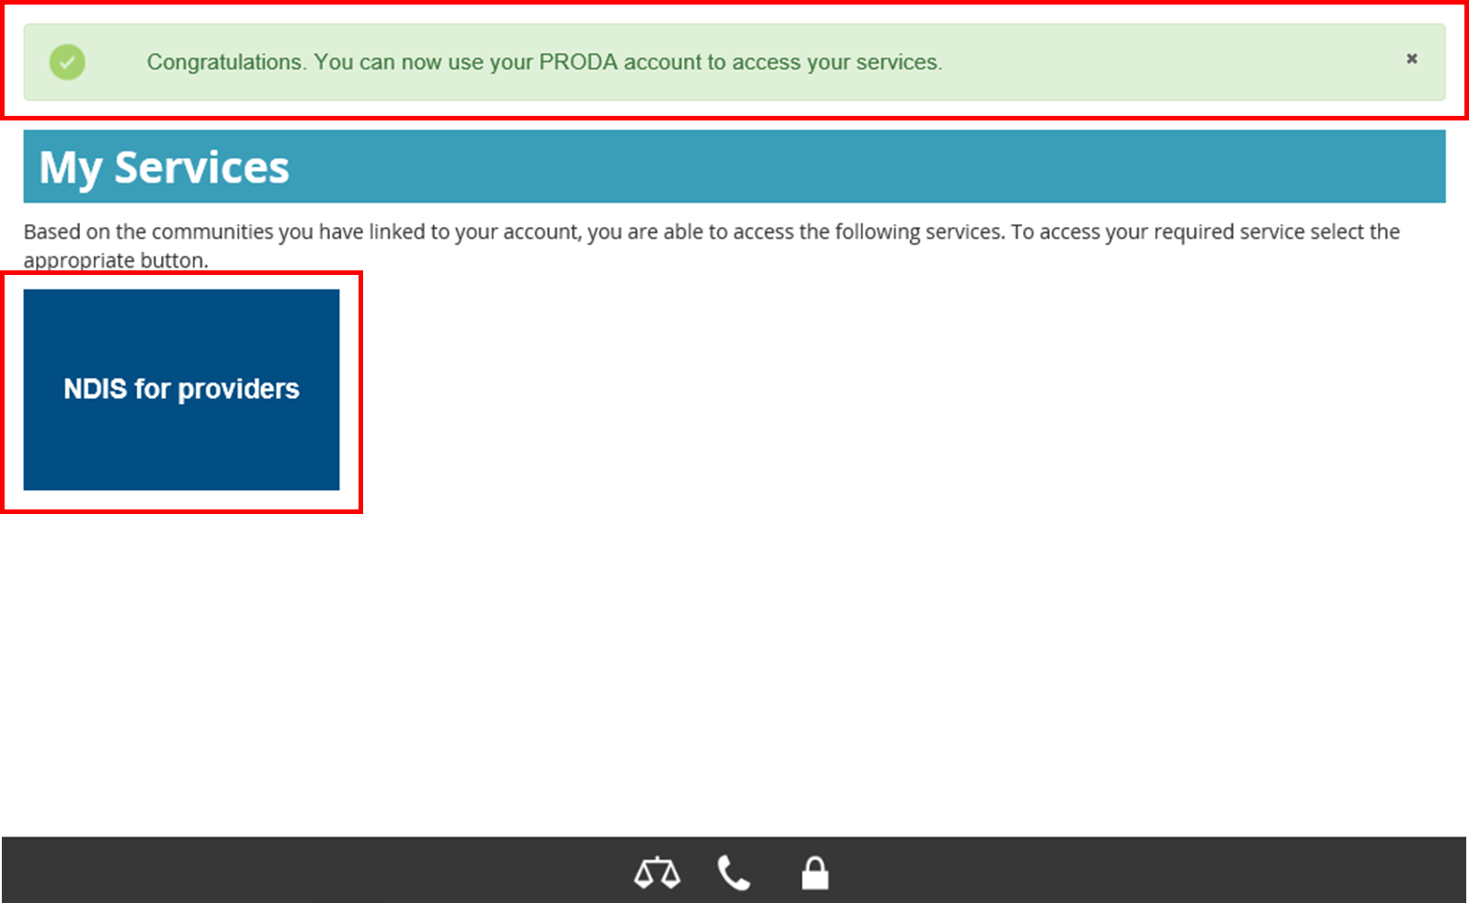

1. The terms and conditions displays for the first time you log back into **myplace**. Read through the terms and conditions:

* If you accept the terms and conditions, select **I have read and accepted the terms of use** then **I agree**. This will take to the **myplace** portal.
* If you do not accept the terms and conditions, select **I decline**. This will take you out of the **myplace** portal.

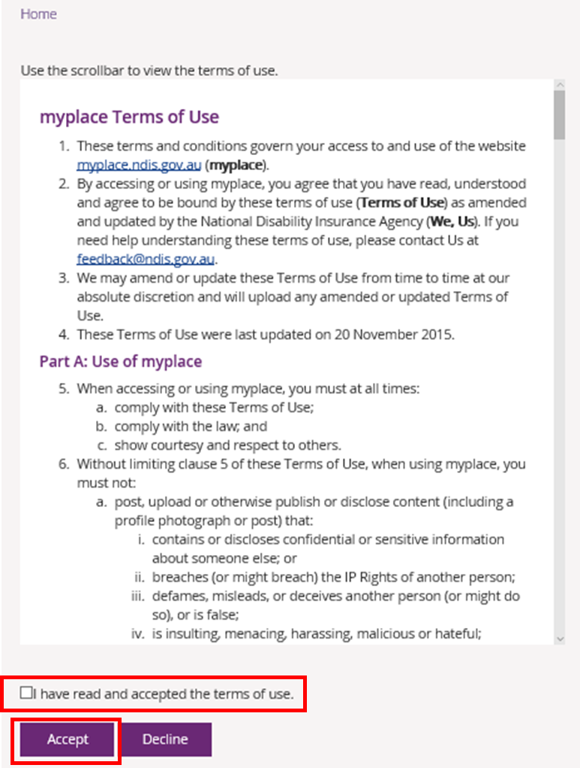

1. Once the terms and conditions are accepted. The **myplace** homepage displays.



#### Adding registration groups and professions

1. Select the **Registration Details** tile.

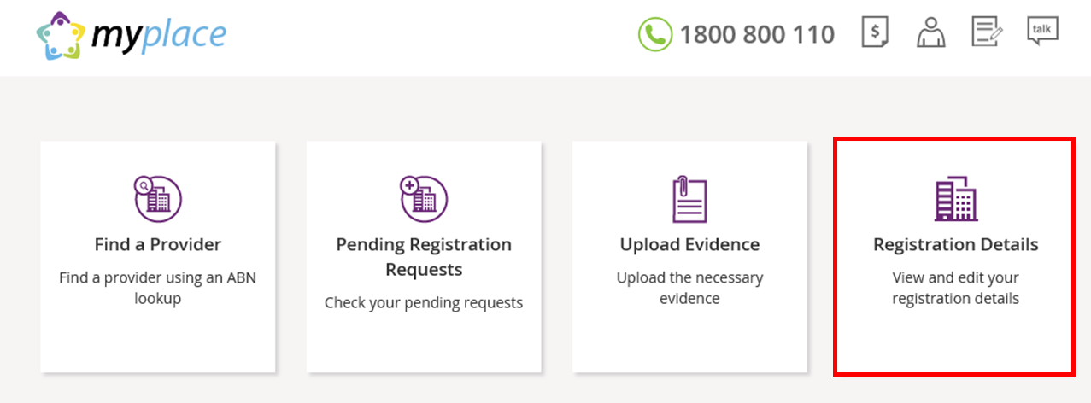

1. Select **Add a new Registration Group** then **Rego Group / Service Area.**

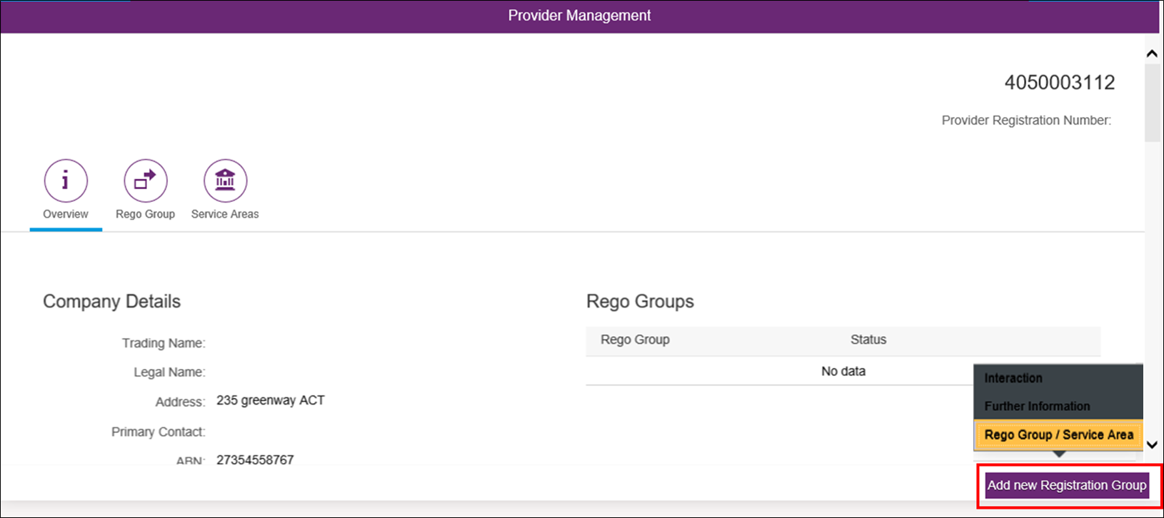

1. Select the **Registration Group, Profession(s) and State(s)/Territories** you wish to register for using the drop down menus. You will also need to enter the **start and end dates** for the services.

Select **Submit** when all fields have been completed.

additional noteIf you need to save the information and come back to complete this step at a later stage, select **Save**.

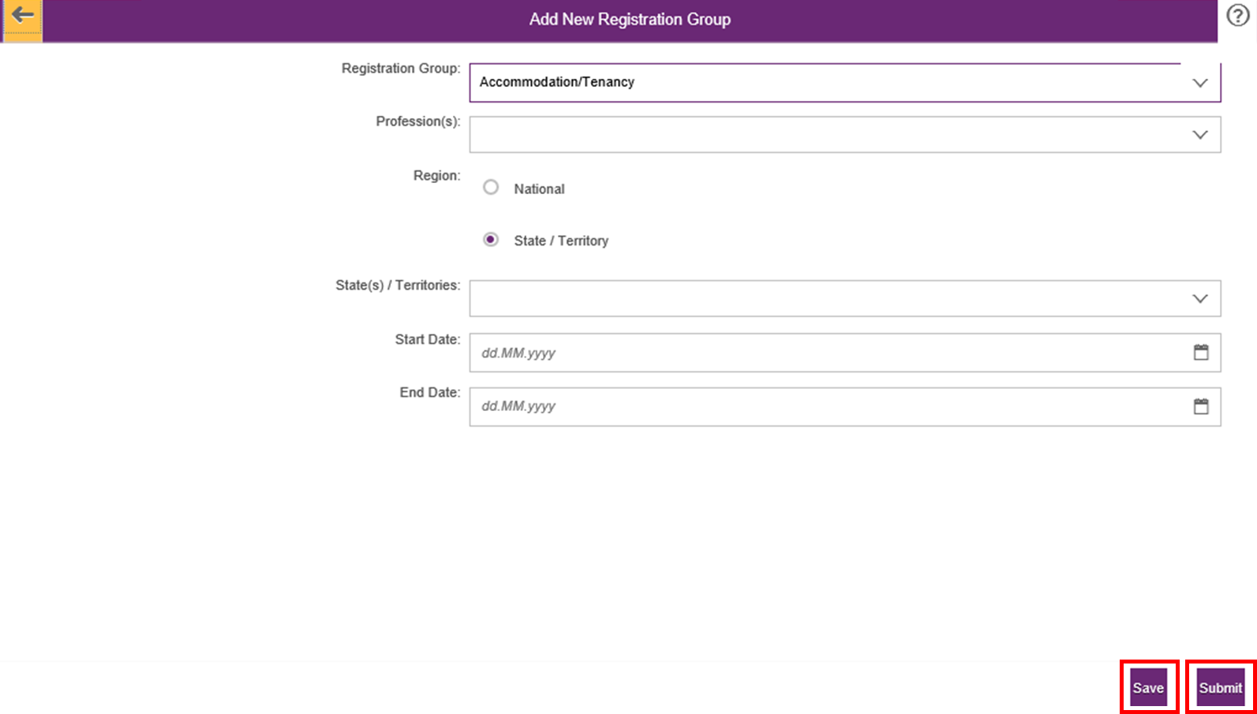

1. A success screen will display indicating that your registration request has been successfully submitted. Select **Close** to exit this page.

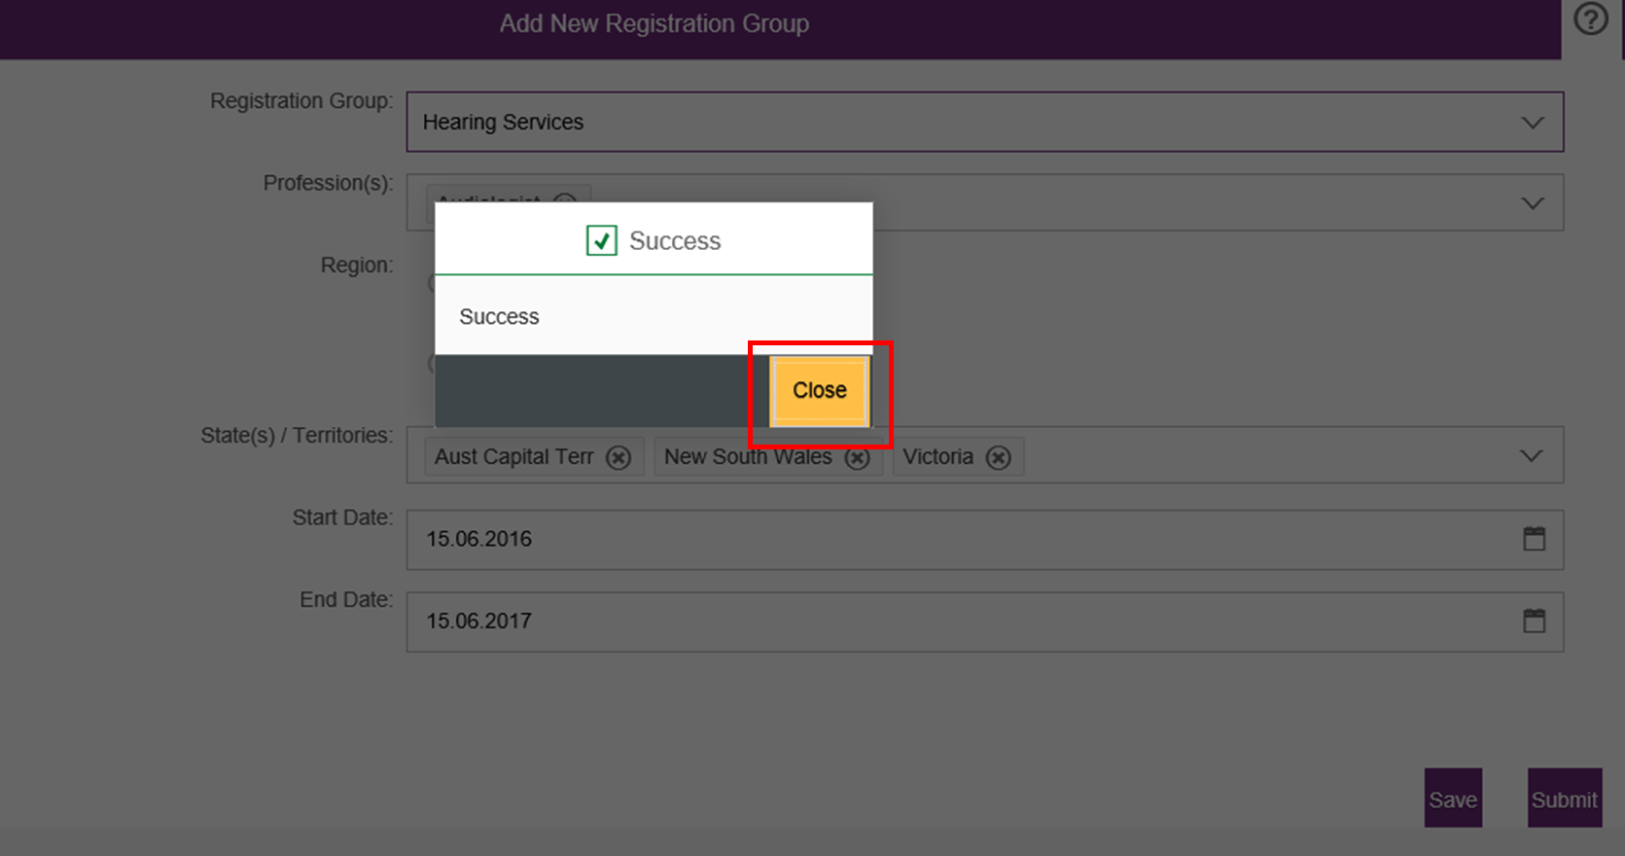

1. If you wish to add another **Registration Group**, select **Add new Registration Group.**

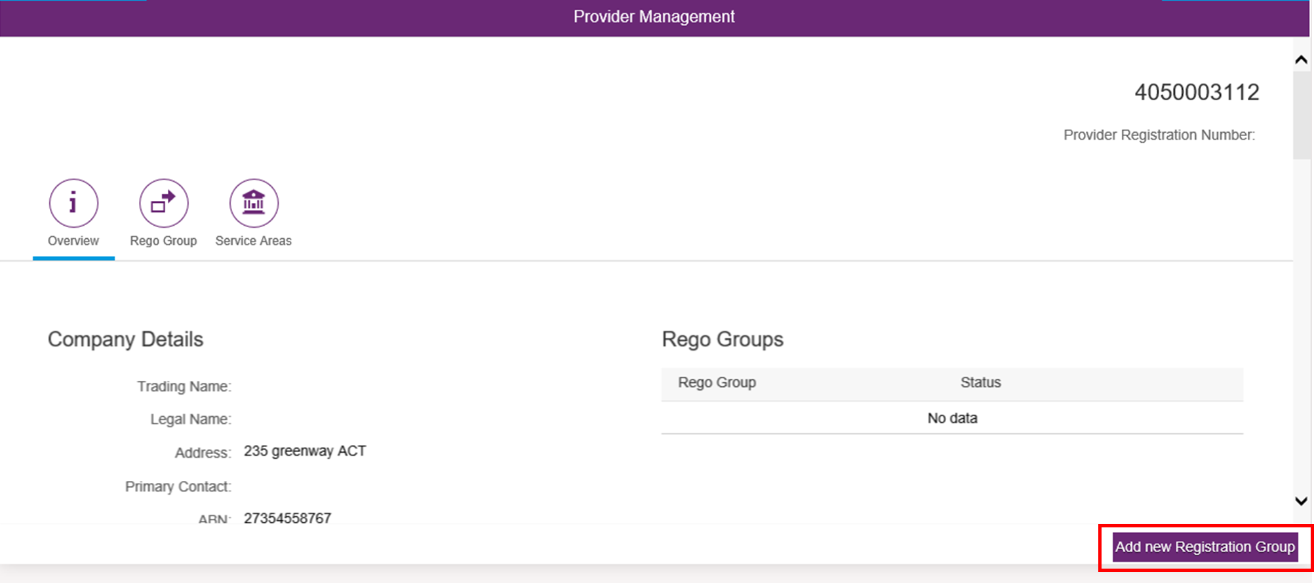

1. To view a list of all the **Registration Groups** you have requested to register for, select **Rego Group**. A list of the **Registration Groups** requested are displayed with the status that they have been **Submitted**. Once the groups are approved, the status will change to **Approved**.

You can also add another **Registration Group** from this page**.** Select **Add new Registration Group.**

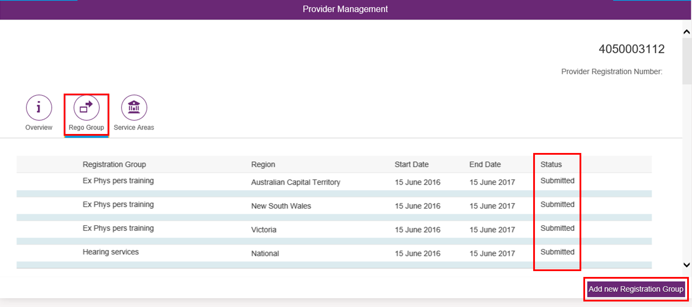

1. After the Registration Groups are submitted, you will need to upload the required documentation. These include:

* Signed Terms of Business
* Signed Declaration of Suitability to be a Registered Provider
* Certificate of registration/accreditation (for specialist disability supports only)

1. Return to the **myplace** homepage and select **Upload Evidence**.

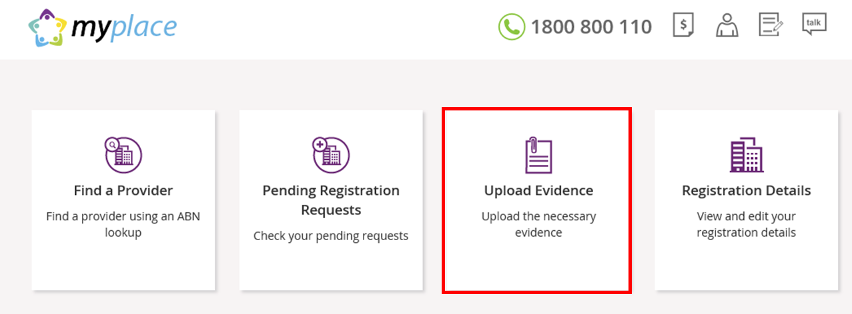

1. Enter the **Document Name** and choose the document file from your computer by selecting Browse. Select **Upload**.

A list of the documents you have uploaded are displayed under the heading **Available Documents.**

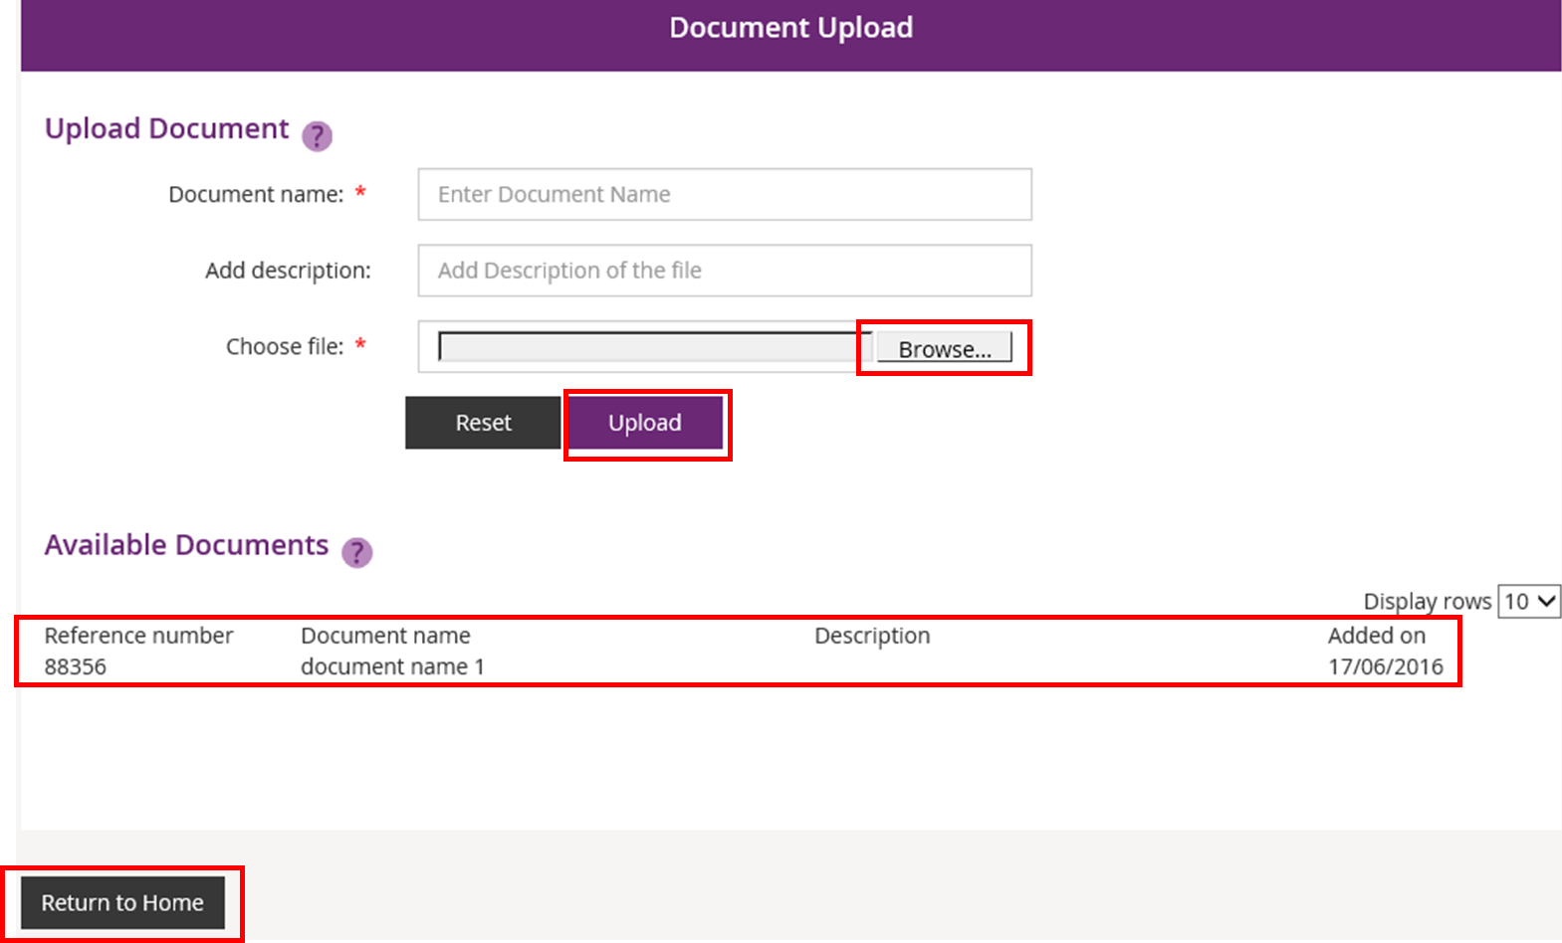

When you have uploaded all the requirement documents, select **Return to Home**.

Your organisation’s registration with NDIS is now complete. When the registration is approved, you will receive a letter and an email confirming that your organisation has successfully registered for NDIS. You will also receive a **Certificate of Registration**.

#### Viewing registration approval status

1. If at any time you wish to view the status of your registrationapproval, select the **Pending Registration Requests** tile on the **myplace** homepage.

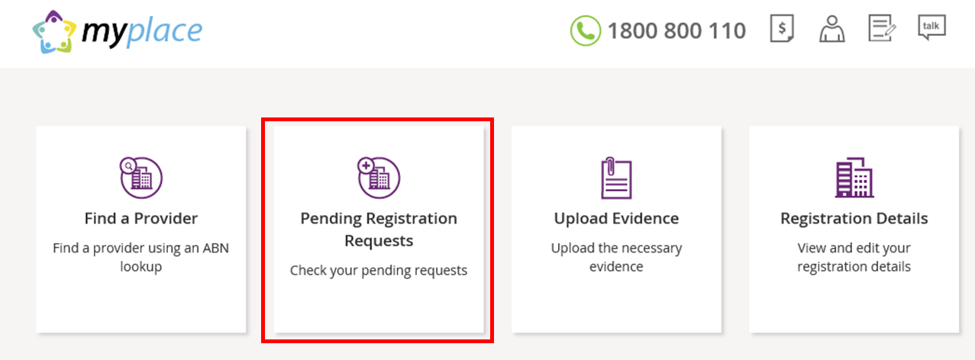

1. The status of your access request is displayed. The status will be **Open** when your registration is pending approval. When it is approved, the status will change to **Approved**.

Select **Return to Home** to go back to the **myplace** homepage.

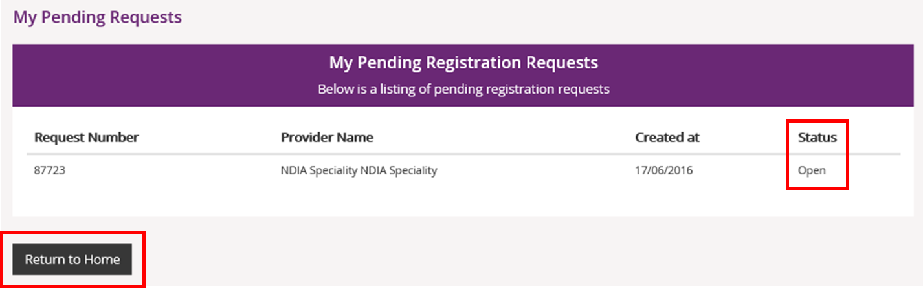

1. Once your access is approved, the full **myplace** homepage will display when you log in.

### Steps for other users of myplace

Your access to **myplace** will need to be approved by the Primary Contact of your Provider organisation. The following instructions continue from step 6.

1. Select **Find a Provider.**

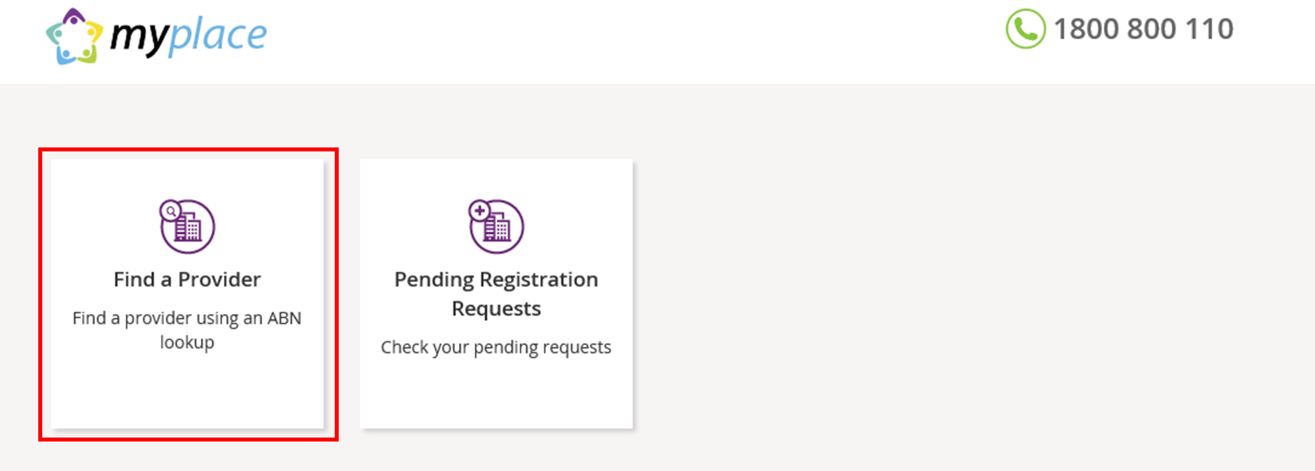

1. Enter the **Australian Business Number (ABN)** of your Provider organisation and click **Search.**



1. Your organisation should display under **Search Results**. Select the radio button for your organisation and select **Next** to continue. If you wish to return to the homepage, select **Return to Home**.

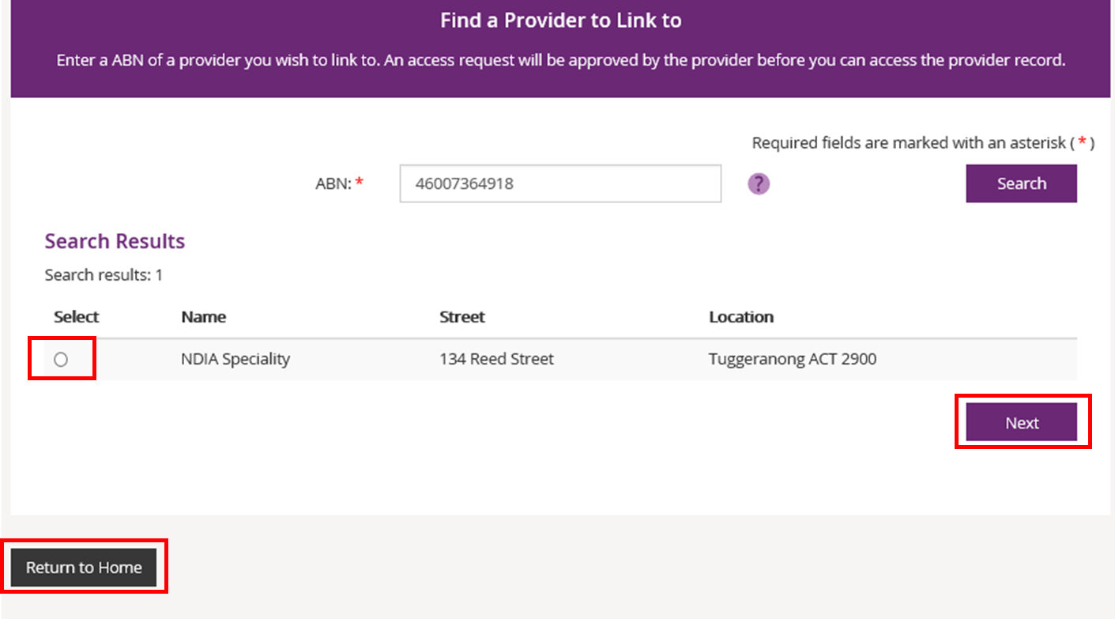

Additional NoteIf your organisation is not listed and it is registered with NDIS, it may be that a Primary Contact has not been set up in **myplace**. We advise that you contact your organisation to clarify.

If a Primary Contact has been set up, contact NDIA on 1800 800 110 for assistance.

If you are interested in registering your organisation with NDIS, refer to the **For New Providers: Registering with NDIS** section below.

1. Select **Alternate Contact** using the drop down button for the **Contact Type** field. Select **Submit** to continue.

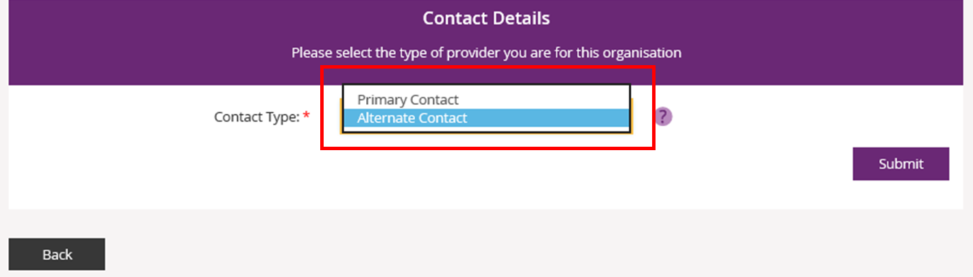

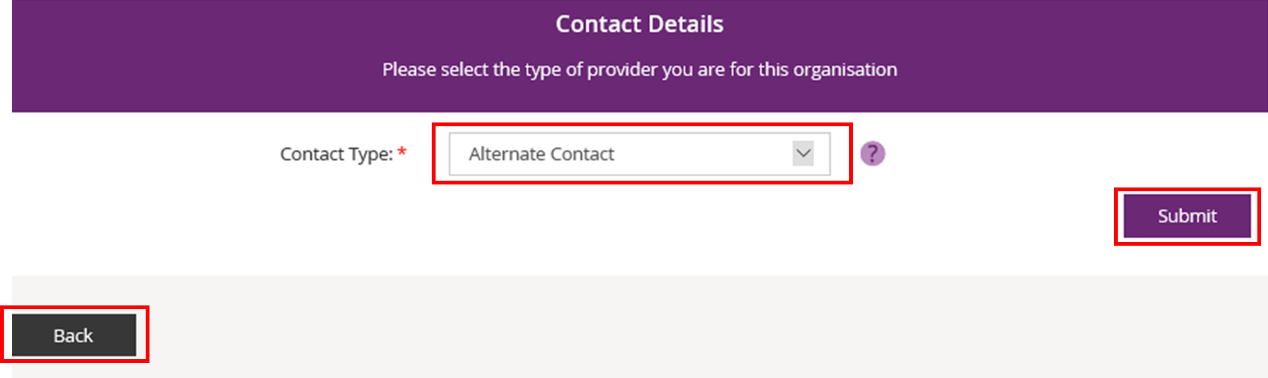

If you need to return to the **myplace** homepage, select **Back**.

1. Your request to access **myplace** is now sent to your organisation’s Primary Contact for approval. Select **MyPlace Dashboard** to return to the **myplace** homepage.

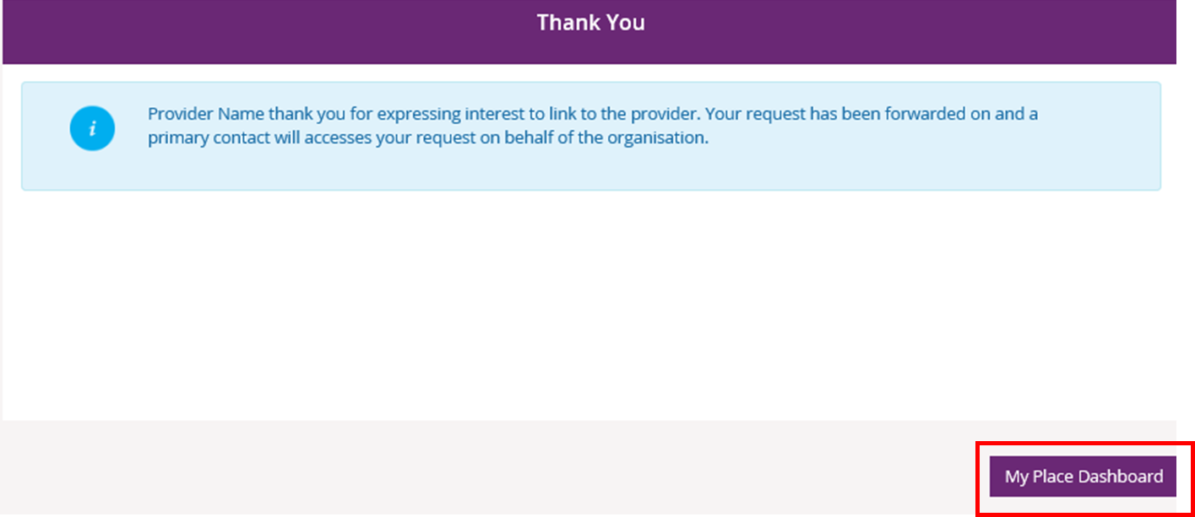

1. If you work for more than one NDIS registered Provider organisation, you will need to link the other organisations to your PRODA account. To do this, repeat steps 1 to 5.
2. You can view the progress of your access approval by selecting the **Pending Registration Requests** tile.

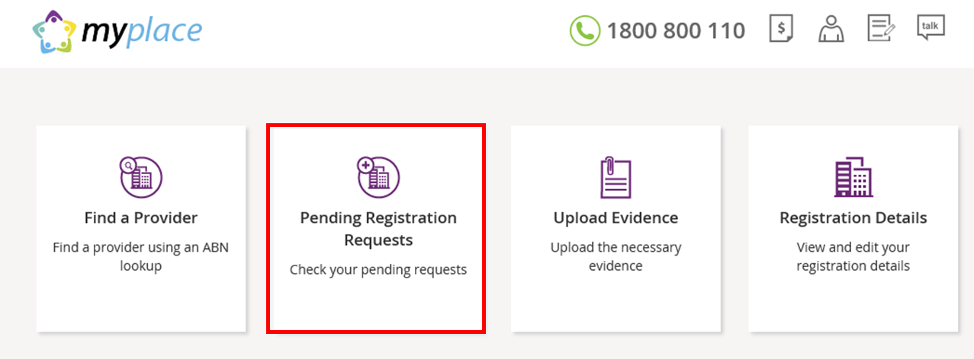

1. The status of your access request is displayed. Select **Return to Home** to go back to the **myplace** homepage.



1. Once your access is approved, the full **myplace** homepage will display when you log in.