myplace provider portal
Bulk Payment Request
Step by step guide
April 2020

Table of contents
Provider Bulk Payment Requests 3
Accessing the Bulk File Payment Request Screen 3
Reference Files 4
Creating the File 4
Completing the Bulk Upload File Template 6
Upload Document 9
Successful File Upload 10
Unsuccessful File Upload 11
Verifying the Bulk Upload to correct ERROR 11
Payment Reconciliation of a Bulk Payment Request Upload 13
Receiving Payment 14

Provider Bulk Payment Requests
This document is a short guide to help you upload a Bulk Payment Request on the myplace Provider Portal.
The Bulk Payment Request enables you to submit multiple requests for payment in a single file uploaded through the Provider Portal, rather than submitting individual requests for each service booking for each participant (see scenarios below).
- Scenario 1:
1 Participant, 1 service booking per week, for a month.
With Create Payment Request, you will need to lodge 4 individual requests.
With Bulk Payment Request, you only upload 1 request (1 Participant x 4 times x unit price for the service)
- Scenario 2:
10 Participants, each one has 1 service booking per week, for a month.
With Create Payment Request, you will have to lodge 40 requests (4 per Participant).
With Bulk Payment Request, you upload one file with 10 requests (10 Participants x 4 times x unit price) i.e. a request per Participant.

Accessing the Bulk File Payment Request Screen
To create a Bulk Payment Request:
Select the Payment Request tile and
Select the Bulk Payment Request Upload button.
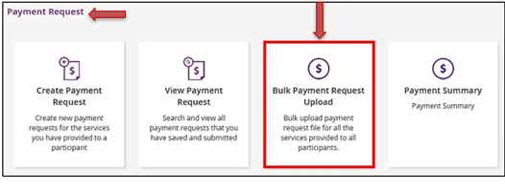
The Bulk Upload screen appears.

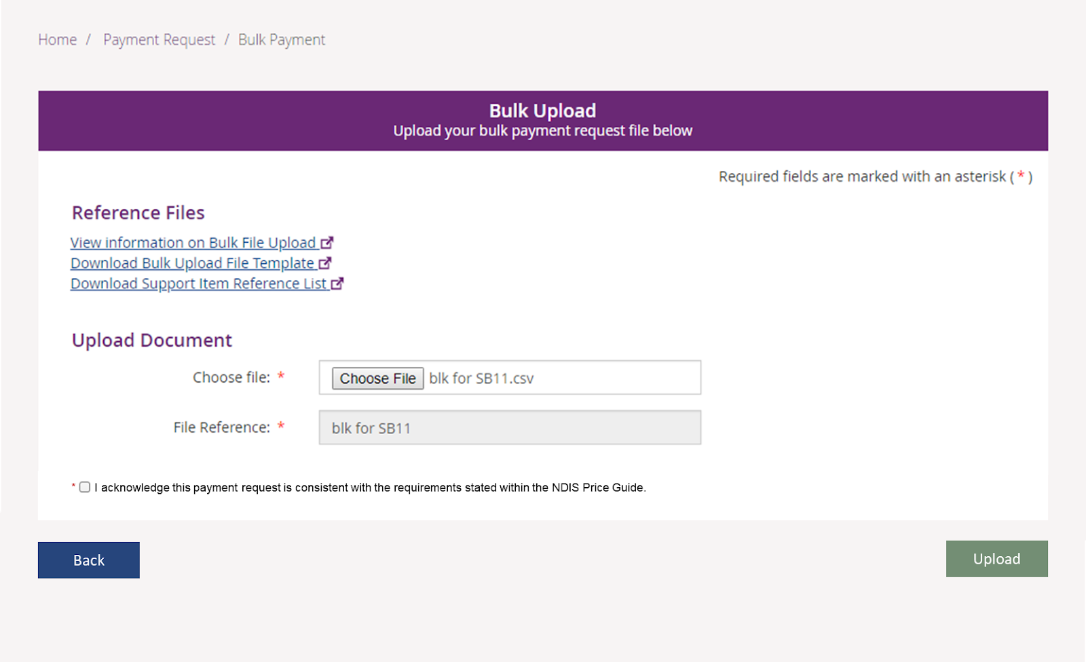

Reference Files
This screen has three reference files:
- View Information on Bulk File Upload: is a guide for providers on what and how to record information within the Bulk Upload File Template.
- Bulk Upload File Template: is the bulk Payment Request template that the provider will need to complete and upload to make the bulk Payment Request.
- Support Item Reference List: is an excel document that can be downloaded to view all support items (names and codes) that are currently active in Service Bookings with participants. The Support Item Reference List gives you the support number “code” to put into the CSV file when using bulk upload. For example, to claim for a Daily Activity support for Linen service, you will need to put 01_021_0120_1_1 in the SupportNumber field of the CSV file.
This helps you understand what support items are eligible for payment with your current participants with active service bookings.

Creating the File
You will need to download the bulk upload template to create your bulk upload file from the Bulk Upload screen.

- Be sure to download the Excel template as a .CSV file and save it as ‘Comma delimited’.
- Your filename must not exceed 20 characters in length. This limit includes the extension (.CSV) and all characters used in the filename, including the ‘.’ (dot) (e.g. BULKUPLOAD2.CSV is 15 characters).
- Line items within the bulk upload file should directly correspond to the number of Payment Requests (e.g. 100 rows/lines (excluding the header row) will create 100 payment requests).
- There can be up to 5000 rows uploaded using a bulk file. Check there are no extra characters in columns or rows that are beyond the viewable section of the worksheet. There should be no characters in rows or columns that are beyond the claim data you are entering (e.g. your claims end on row 47, but there is a character in a cell in row 102) as this will result in the whole file not loading.
- CSV files can be uploaded using the US date format; i.e. yyyy/mm/dd

Completing the Bulk Upload File Template
The following table describes the data required in the Bulk Upload File.
Note: This information is also available in the View Information on Bulk File Upload document located in the Reference files (see page 4). We recommend reviewing that document from time to time for any updates.
Template Field Name: | Required Data/Information: | Required Format: | Mandatory?
RegistrationNumber | The Provider’s registration number shown in your Profile as Organisation ID. | Number only, no spaces and up to 30 numeric characters.  Organisation ID number will start with ‘405’ and consists of a total of nine digits | Mandatory
NDISNumber | Participant NDIS Number | Number only, no spaces and up to 20 numeric characters.  Participant NDIA number will start with numbers ‘43’ and consists of a total of nine digits. | Mandatory
SupportsDeliveredFrom | Start date of the support provided | Accepts YYYY-MM-DD  Note: Also accepts instead of dashes (-) any of the following:  - Forward Slash ( / )  - Back Slash ( \ )  - Full stop ( . ) | Mandatory
SupportsDeliveredTo | End date of the support provided | Accepts YYYY-MM-DD  Note: Also accepts instead of dashes (-) any of the following:  - Forward Slash ( / )  - Backlash ( \ )  - Full stop ( . ) | Mandatory
SupportNumber | Support Item number of the service provided from the NDIS Support Catalogue 2019-20. | Up to 60 characters - underscore acceptable | Mandatory
ClaimReference | The Provider’s own Invoice reference for the payment. | Up to 50 characters, which includes:  - Forward Slash ( / )  - Underscore ( _ )  - Hyphen ( - )  - Alphanumeric | Optional but recommended
Quantity | Number of units. | Up to 5 Numeric characters  Accepts NNNNN OR NNN.NN format.  Can be used to represent hours (e.g. 2.5 hours = 2 hours 30 minutes) but cannot be in hour format (e.g. 2: 30 = 2 hours 30 minutes).  Note: you cannot use both hour and quantity formats for the same claim (i.e. A claim for one session of 2 hours 30 minutes should be either Quantity = 1 Hours = 2:30 or Quantity = 2.5 and Hours = 1). | Mandatory IF Hours are not entered
Hours | Actual duration of the service provided. For example, if the service was provided for 2 hours 15 minutes then enter 2:15 | Hours format:  HHH:MM e.g. 2: 30 = 2 hours 30 minutes.  Cannot use decimal format (e.g. 2.5 hours = 2 hours 30 minutes).  Note: you cannot use both hour and quantity formats for the same claim (i.e. A claim for one session of 2 hours 30 minutes should be either Quantity = 1 Hours = 2:30 or Quantity = 2.5 and Hours = 1). | Mandatory IF Quantity is not entered
UnitPrice | Price per unit sold or the hourly price of the service provided. | Up to 8 Numeric and 2 decimal digits, e.g.: NNNNNNN.NN | Mandatory
GSTCode | GST as applicable to the item or service.  P1 = Tax Claimable (10%)  P2 = GST Free  P5 = GST out of Scope | P1 or P2 or P5 | Mandatory
AuthorisedBy | Legacy data can be left blank | Not Applicable | Not Applicable
ParticipantApproved | Legacy data, can be left blank | Not Applicable | Not Applicable
InKindFundingProgram | Not Applicable | Not Applicable | Not Applicable
ClaimType | Claim type of the service provided  “(Blank)” – Direct Service. You must leave field blank.  CANC: Cancellation  REPW: NDIA Required Report  TRAN: Provider Travel  NF2F: Non-Face-to-Face Services | “(Blank)” or CANC or REPW or TRAN or NF2F  Note this must be capitalised. | Optional
CancellationReason | Reason of the cancellation type  NSDH: No show due to health reason.  NSDF: No show due to family issues.  NSDT: No show due to unavailability of transport.  NSDO: Other. | NSDH or NSDF or NSDT or NSDO  Note this must be capitalised. | Conditional (only applicable to Cancellation claim type)

Upload Document
- Select Choose file to upload your Bulk Payment Request file and enter a File Reference number.
- You must acknowledge this payment request is consistent with the requirements stated within the NDIS Price Guide.
- Select Upload.

Successful File Upload
If the Bulk Payment Request file meets the upload validation requirements, a message will be displayed advising that the file has been submitted and is pending payment validation. Note that file processing may not be immediate.
- To verify that the bulk payment request has been processed and ensure the individual payment requests are valid, proceed as follows:
- Select the View Payment Request tile and search for the recent bulk upload file.
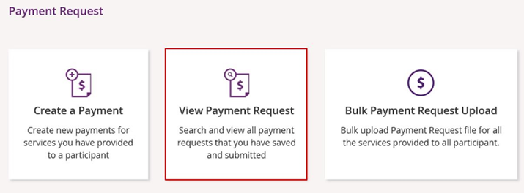
Note that this can be done by file name, or by ‘duration’ which means the period during which the files were submitted.
Successful payment requests will have SUCCESSFUL in the status field. If the payment request has been unsuccessful it will return an ERROR status.
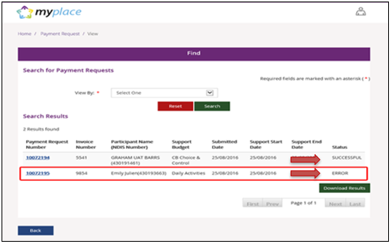

Unsuccessful File Upload
If the bulk Payment Request file does not meet the upload validation requirements, a message will be displayed advising that the file validation has failed.
In addition, an error file specifying the errors (column A) in the file will be available to download and view so you can make the required changes to the original file.
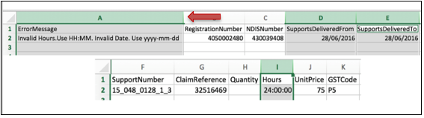
Note: When uploading the corrected bulk upload file, please ensure that the file is renamed, as it cannot be the same name as a file previously uploaded (successful or unsuccessful).

Verifying the Bulk Upload to correct ERROR
- Select the Payment Request Number with ERROR appearing to see the type of error.
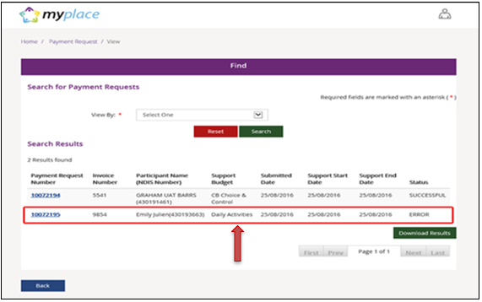
- Open the entry to verify the Reject Reason.
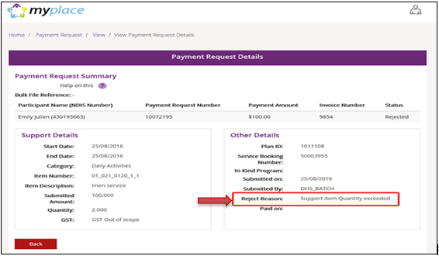
- Select Back and download the bulk upload results file to correct the error.
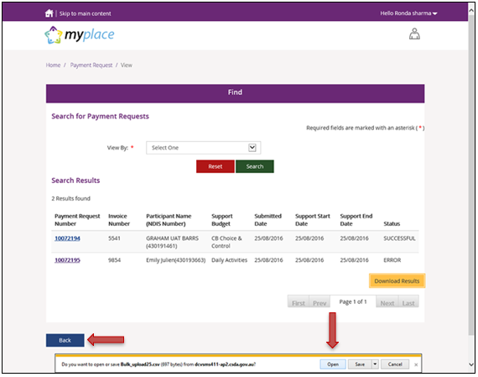
- The CSV file can be opened with Microsoft Excel and edited to correct the error. In the example below the quantity had been exceeded (2.0) but has now been corrected to 1.
Make sure to only edit the record(s) with error. You can keep the same Claim Reference number.
- Save the CSV file with a different name, only including the edited records, and re-upload using the Bulk Upload function. In a situation where you may have several errors, the new CSV file would include as many line items as there are errors, and the header line.
Note: Where the payment amount entered is greater than maximum per unit catalogue price for that item, the system will only pay up to the maximum catalogue price, refer to the NDIS Price Guide.
In such scenarios the claimed amount will be different to the paid amount and it will be marked in the bulk reconciliation file downloaded by the user (see Payment Reconciliation section below). The field Capped will be populated with a value of YES or NO based on the following:
- Where the amount paid is different than the amount claimed, then
Capped = YES.
- Where the amount paid is same as amount claimed, then
Capped = NO.

Payment Reconciliation of a Bulk Payment Request Upload
You can check the status of each Payment Request in the View Payment Request tile to compare this against the uploaded file.
You can check the reason for each incomplete Payment Request by selecting the Payment Request number in the View Payment Request tile.

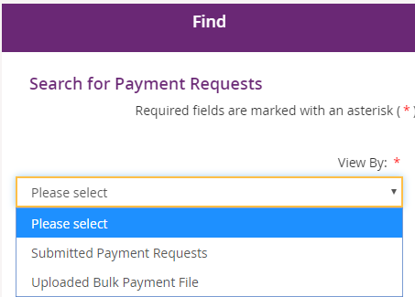

Payment Requests with a status of Rejected have failed due to some type of validation error (e.g. the support item price is not valid for the service dates being claimed).
Payment Requests that have been Rejected (or claims that do not create a Payment Request), must be rectified and reloaded. A ‘Rejected’ claim cannot be fixed in the portal, it will remain in ‘Rejected’ status forever, and a new request needs to be created.
If your bulk upload results in Rejected Payment Requests or fails to create some requests you should NOT reload the whole file. Create a new file with only those line items that failed, and fix the issues before attempting to reload.
Note: Payment Requests will not appear in the View Payment Request tile on the portal.
The Bulk Payment request outcomes are:
Status | Outcome
Pending Payment | View in Payment Request Tile
Rejected | Not Available in Payment Request Tile

Receiving Payment
Payment Requests that are created with a status of Pending will be paid after the next payment run cycle – this occurs a minimum of once a day, Monday to Friday.
A status of Pending will usually change to Paid following the completion of a payment run cycle.
Payment Requests created after the last payment run cycle on a Friday will be picked-up in the payment run cycle of the next business day – typically the next Monday.

