NDIS myplace provider portal
Step-by-step guide
Part 1. Using the myplace provider portal

December 2021

Table of Contents
Changes from the last version 3
Introduction 3
What can you do in myplace? 3
Minimum internet browser requirements 4
How to contact NDIS 5
Accessing myplace 6
Create a Provider digital account 7
Select a provider 7
myplace Portal home page 8
Provider portal navigation 12
Using a function 12
Returning to the myplace home page 12
Help and feedback 13
Getting help 13
Submit payment enquiries, complaints, compliments, feedback and other enquiries 13
Submit a complaint 15
Send feedback or a compliment 16
Submit an enquiry 16
Submit a payment enquiry 17
View existing complaints and enquiries 25

Changes from the last version
The following updates have been made to the last published version of the myplace provider portal step-by-step guide:

As of December 2021:
- Updated the minimum browser requirements (page 4)

Introduction
The myplace provider portal is a secure website developed for providers to manage their transactions with the NDIA, and view and manage their services with Participants.
This step-by-step guide describes how the myplace portal works and provides the general layouts of the menus and screens in the portal.
It also includes instructions for using each of the functions in the portal.

What can you do in myplace?
You can use myplace to:
- View your contact details
- View, add and edit NDIS (National Disability Insurance Scheme) registration details including updates to registration groups and professions
- Link another registered provider organisation (if applicable)
- View messages received from NDIS
- Instant message with your linked participants
- Create and manage service bookings
- Create and view payment requests (previously known as claims)
- View and respond to quotes received from NDIS
- View referrals made to your organisation
- View Support Coordination Requests for Service and action these requests
- Upload required documents
- Submit and review enquiries or complaints
- Download reports about all your service bookings and participants.

Minimum internet browser requirements
To access myplace, there are minimum browser requirements. These are:
- Google Chrome
- Microsoft Internet Explorer 11 on Windows 8.1 or Windows 10
- Microsoft Edge
- Mozilla Firefox
- Safari on Mac OS X

Contact the NDIS by
NDIS Webchat  You can live chat with us about:  - myplace provider portal  - Service bookings  - Payment requests  - Quotes  - Referrals  - Request for service  - Searching for a register provider | Phone  1800 800 110  You can call us about:  - myplace provider portal  - Service bookings  - Payment requests  - Quotes  - Referrals  - Request for service  - Searching for a register provider  - Submitting a general enquiry, feedback, compliment or a complaint | provider portal  You can use the provider portal to:  - Submit a payment enquiry  - Submit a general enquiry, feedback, compliment or a complaint  - Search for a provider  - Upload documents
Email us  enquiries@ndis.gov.au  You can email us about:  - Submitting a general enquiry, feedback, compliment or a complaint  - Emailing a document, form report or letter | Contact and Feedback form  NDIS Online Form  You can use the Online form to:  - Submit a general enquiry, feedback, compliment or a complaint  - Request a call back | Mailing address  National Disability  Insurance Agency  GPO Box 700  Canberra ACT 2601  You can mail us:  - Compliment, complaint or provide feedback,  - Document, form, report or letter

How to contact NDIS

Accessing myplace
- Access the myplace portal using the link provided on the NDIS website or type https://myplace.ndis.gov.au/supplier in your internet browser.
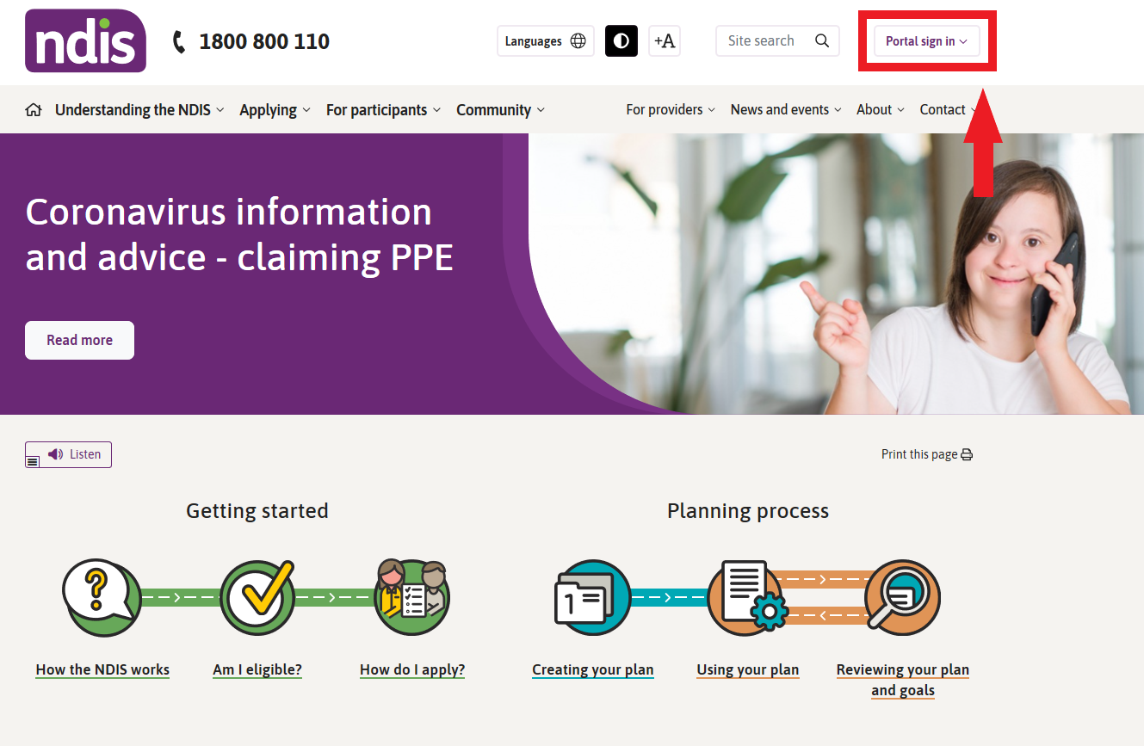
- If you already have a Provider Digital Account (PRODA), please enter your PRODA Username and Password then select Login. 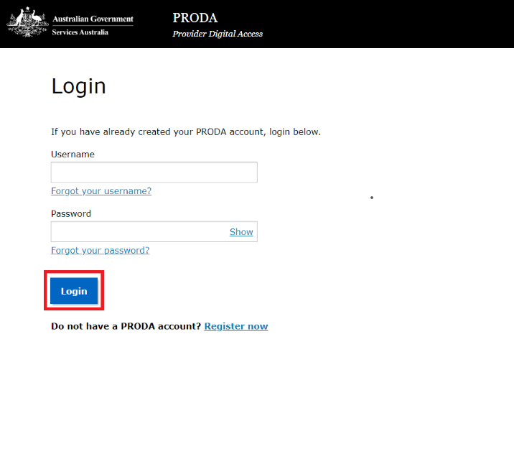
- If you do not have a PRODA (Provider Digital Access) account, please refer to the PRODA - Step-by-step guide found on the NDIS website.

Create a Provider digital account
If you do not have a Provider Digital Account, please refer to the myplace registration for new providers - Step-by-step guide found on the NDIS website.

Select a provider
A list of the organisation(s) you may act for (work on behalf of) is displayed.
- Select the organisation you wish to use myplace for on this occasion. The system will then display information relating to only that organisation.
Note: The provider number may also be referred to as Business Partner Number (BPN).
Note: You can select a different organisation at any time using the ‘Acting for’ link at the top right of the home page.
Note: If the organisation you are acting for is not on the list, you can link to it using Link to my Organisation.
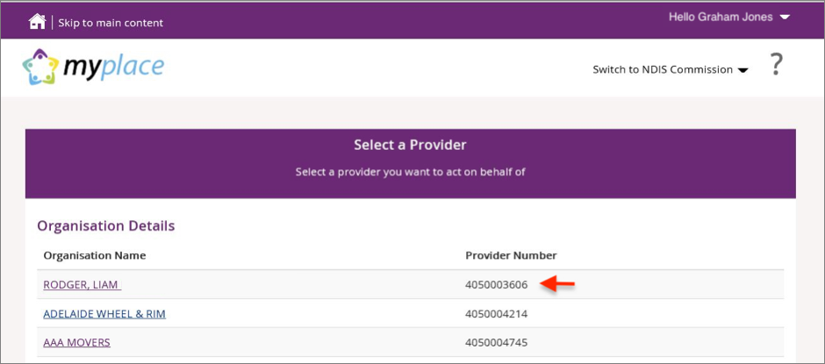
The myplace home page displays.

myplace Portal home page
The myplace home page contains a number of separate sections or functions.
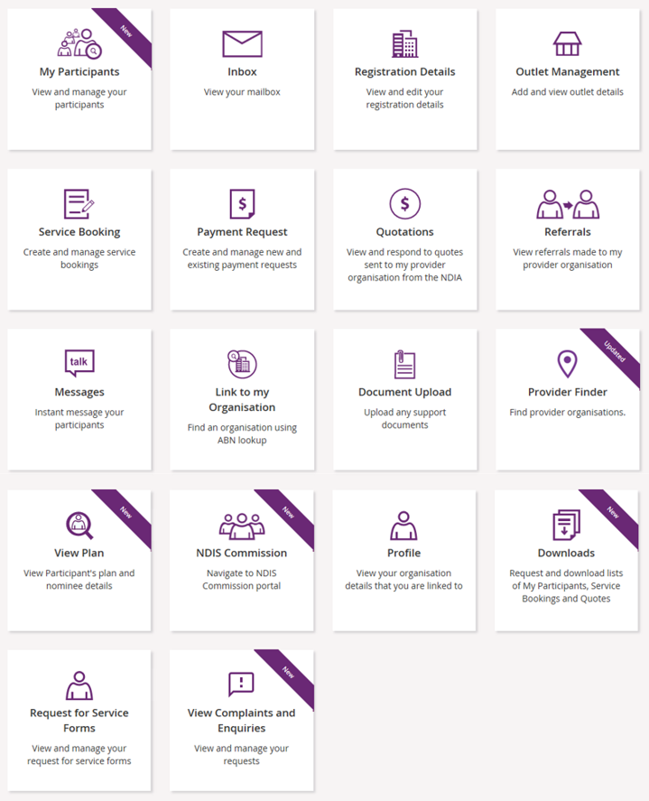
The following table provides an explanation of each of the information on the myplace portal home page.
myplace section | Function
The provider organisation you are acting for is displayed here. If you work for (and are linked to) more than one provider organisation, you can select which organisation you are using myplace for by selecting the Change Provider icon.
If you only work for one provider organisation, you do not need to change any settings here.
 | This is where your username is displayed. You can use the drop-down button to return to the home page or logout of myplace at any time.
 | Select this icon at any time to return to the myplace home page.
 | Select this icon for simple explanations of the functions displayed on the screen.
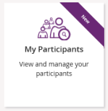 | View and manage your participants.
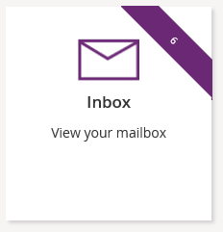 | View messages and letters sent to you by the NDIA.
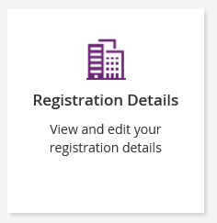 | View your registration details, including updates to Registration groups and Professions.
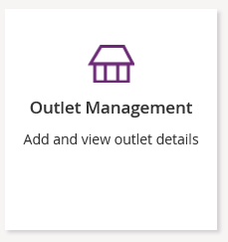 | View your organisation’s outlet details.
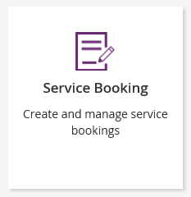 | Create and manage service bookings with participants.
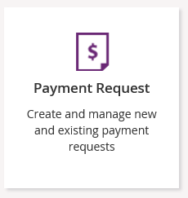 | Create and manage new and existing payment requests.
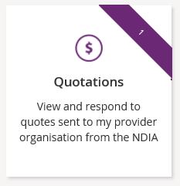 | View and respond to quotes sent to you by the NDIA.
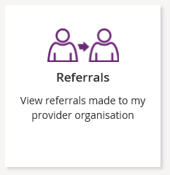 | View referrals made to your organisation.
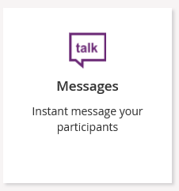 | Send instant messages to your Participants.
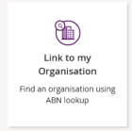 | Link to your organisation/s, in order to view them through the myplace provider portal.
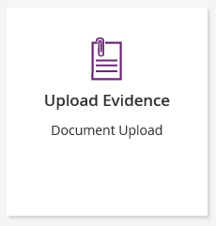 | Upload required documents.
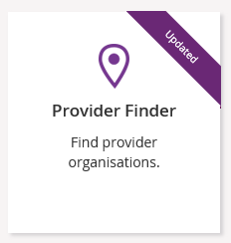 | Search for providers within a certain location.
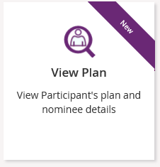 | View plan details when granted consent by a participant.
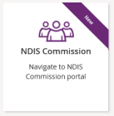 | Navigate to the NDIS Commission portal.
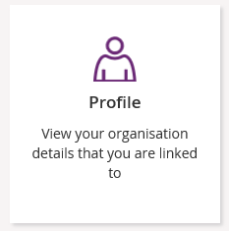 | View and edit information and contact details for yourself and your organisation.
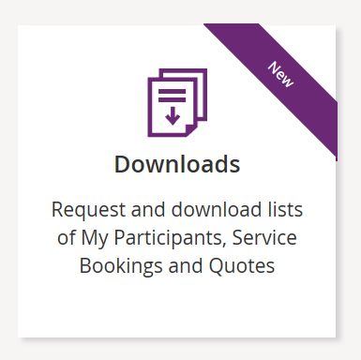 | Request and download service bookings information, quotes, or information for participants regarding their active service bookings
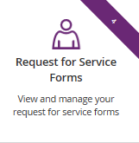 | View and action Support Coordination Requests for Service Forms.
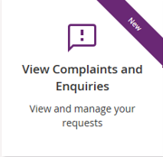 | Submit complaints, feedback, enquiries, payment enquiries and compliments.

Provider portal navigation

Using a function
Select the relevant tile displayed in the myplace home page to go into that section of the provider portal.
Tip: From most functions within the portal, the person icon on the top right of the screen will take you directly to your Profile.
You will note that some tiles have a purple banner across the top right-hand corner with a number showing. This indicates the number of items that have not been actioned. For example, the Inbox tile below shows a purple banner with the number ‘6’. This indicates that there are six messages in your Inbox requiring attention.

Returning to the myplace home page
You can return to the myplace home page in any of the following ways:
      - Select the myplace logo (top left corner of the portal page).
- Select the Home button (top left corner of the portal page) to return to the myplace home page.
- Select the Home link in the breadcrumb trail below the myplace logo.

Help and feedback

Getting help
Select the question mark icon (top right corner of the portal page) for simple explanations of the functions displayed.
Call NDIA on 1800 800 110 if you are unable to resolve a problem or need help to use myplace.

Submit payment enquiries, complaints, compliments, feedback and other enquiries
The View Complaints and Enquiries tile provides you with the options you need to submit:
- a payment enquiry
- complaints, compliments and other feedback
- any additional enquiries.
To access these functions:
- Go to the myplace home page and select the View Complaints and Enquiries tile.
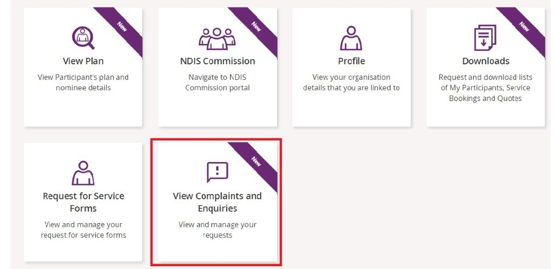
Note: You can also access the options you need by selecting the Feedback link in the page footer.
- On the View Complaints and Enquiries page, select Add new request.
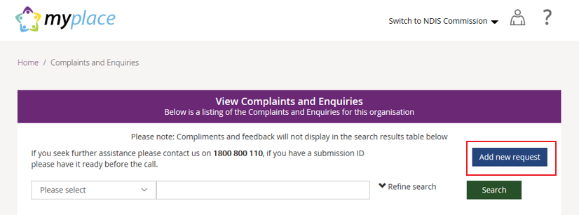
- The Add Feedback page will appear with your name, organisation name, registered business email address and phone details displayed.
On the Add Feedback page, use the Feedback type options to select the type of request you will be making.
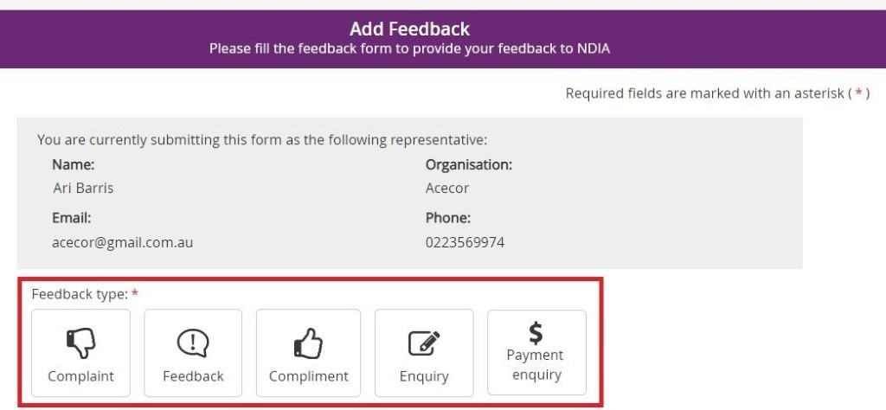You can choose to:
  - Submit a complaint
  - Send feedback or a compliment
  - Submit an enquiry
  - Submit a payment enquiry.

Submit a complaint
- Select Complaint.
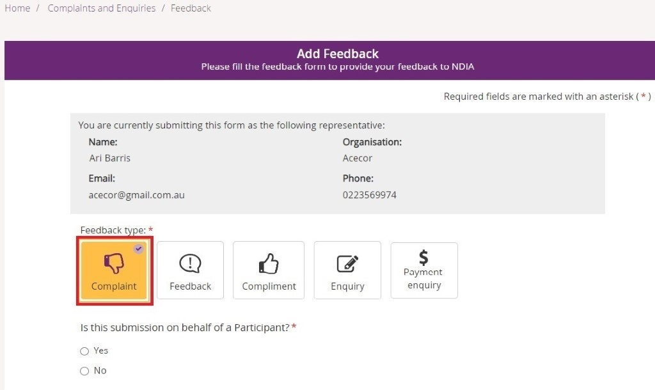
- Select whether this complaint is on behalf of a participant.
  - If a complaint is submitted on behalf of a participant select Yes. Then enter the participant’s NDIS number, last name and date of birth and select Verify participant.
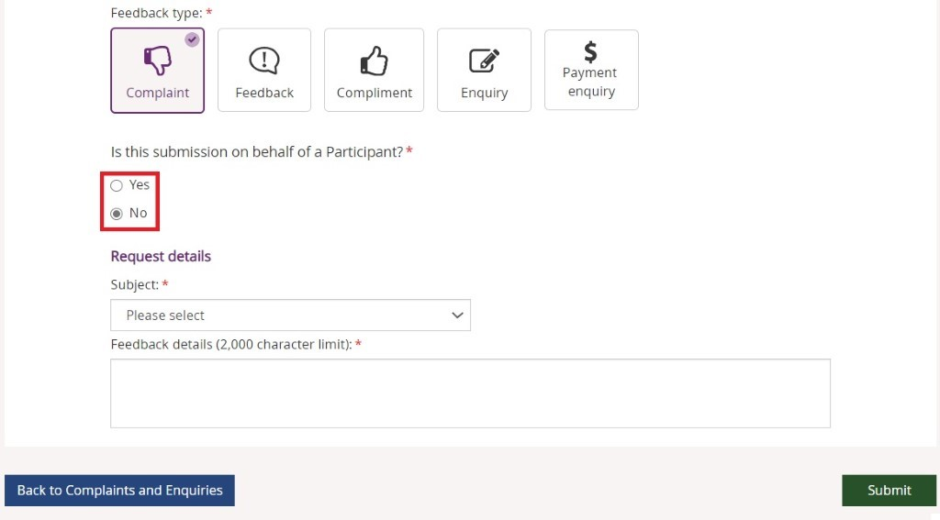
  - If the complaint is not on behalf of a participant select No.
- In the Subject field, choose the subject that relates to your complaint from the drop-down list.
- In the Feedback details field, enter a description of your complaint. This field has a 2000-character limit.
- Select Submit to send your complaint to the NDIA.

Send feedback or a compliment
- Select Feedback or Compliment.
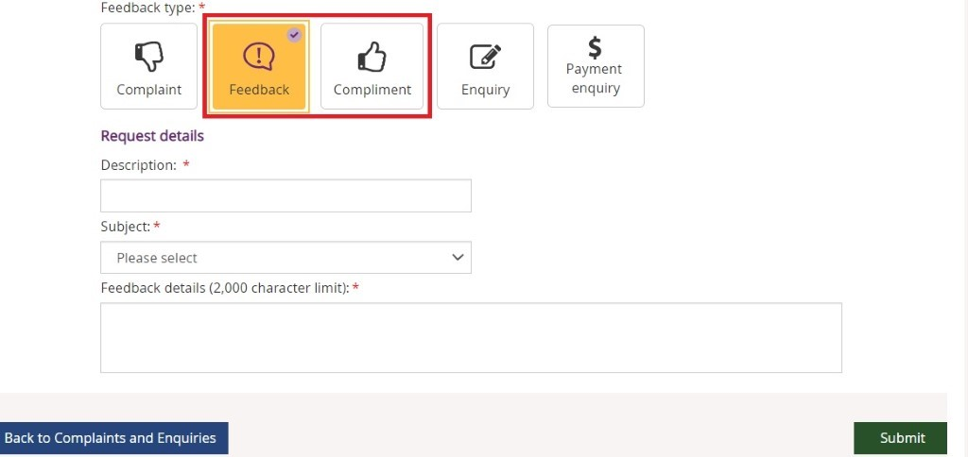
- In the Description field, provide a brief description of your feedback or compliment.
- From the Subject drop-down, select the subject that relates to your feedback.
- In the Feedback details field, enter a description of the feedback. This field has a 2000-character limit.
- Select Submit to send your feedback to the NDIA.

Submit an enquiry
- Select Enquiry.
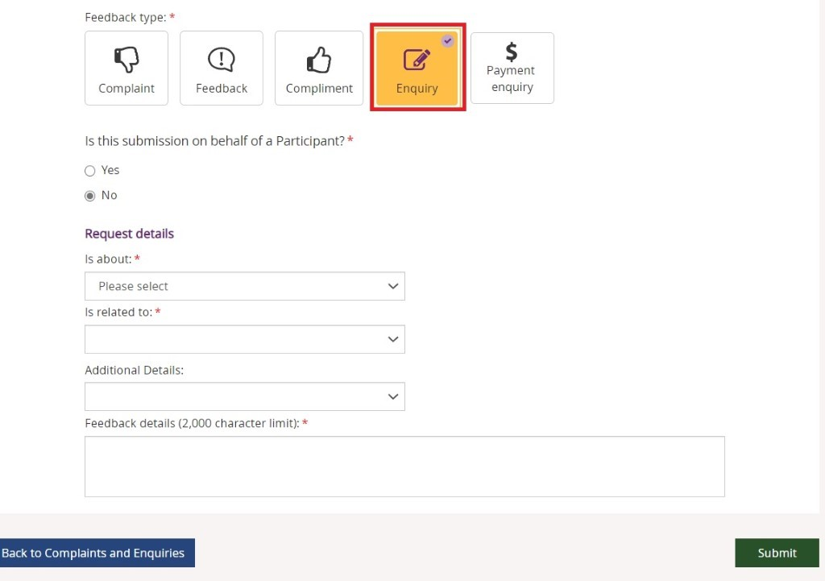
- Select whether this enquiry is on behalf of a participant.
  - If an enquiry is submitted on behalf of a participant select Yes. Then enter the participant’s NDIS number, last name and date of birth and select Verify participant.
  - If the enquiry is not on behalf of a participant select No.
- In the Is about field, select the area that your enquiry is about from the drop-down list.
NOTE: This drop-down selection is mandatory to submit your enquiry.
- In the Is related to field, select the area that your enquiry is about from the drop-down list. The available items are related to your previous drop-down selection made from the Is about. This drop-down is also a mandatory selection for your enquiry.
- In Additional Details, select an item that matches additional detail from the drop-down list. The available items are related to your previous drop-down selection made from Is related to. This selection is not a mandatory item to submit your enquiry.
- In Feedback details, enter a description of your enquiry. This field has a 2000 character limit.
- Select Submit to send your enquiry to the NDIA.

Submit a payment enquiry
There are two methods to submit a payment enquiry on behalf of your organsiation: as a new payment enquiry, or by linking to an existing payment request.

Submit a new payment enquiry
- Select Payment Enquiry.
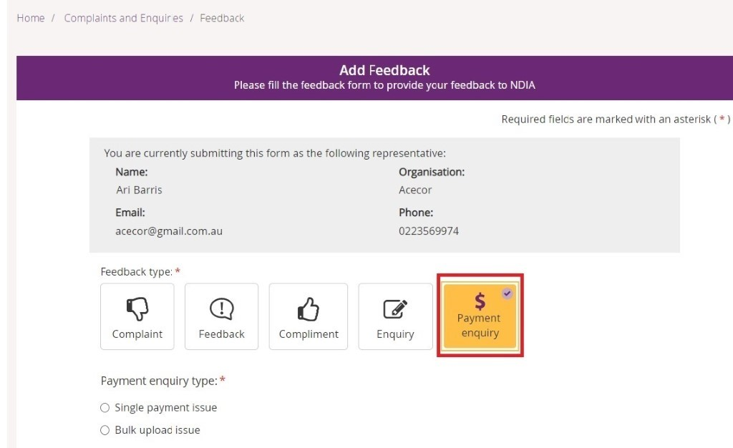
- Select the payment enquiry type: Single payment issue or Bulk Upload Issue.
Note: if you select Bulk Upload Issue then you will need to attach the document relating to the relevant bulk upload. This is a mandatory requirement of the Bulk Upload issue process.
- Select whether the enquiry is on behalf of a participant.
  - If the enquiry is submitted on behalf of a participant select Yes. Then enter the participant’s NDIS number, last name and date of birth and select Verify Participant.
  - If the enquiry is not on behalf of a participant select No.
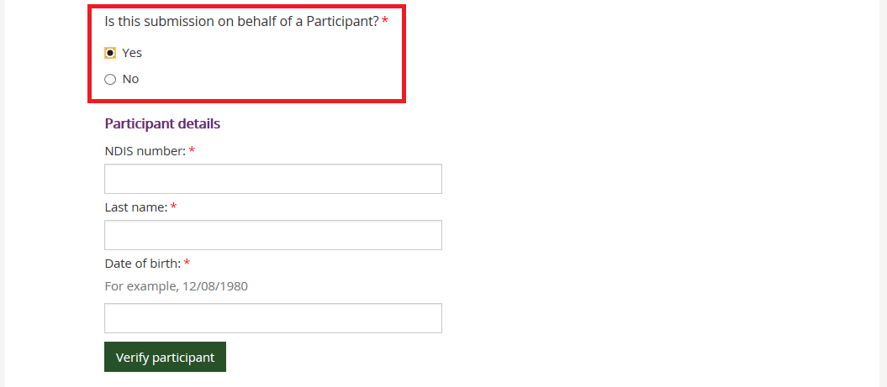

- From the Request details drop-down, choose the subject that relates to your enquiry.
  - Service Booking Enquiry
  - Payment Request Enquiry
  - General Payment Enquiry
  - AAT Decision / Legal Agreement to Pay
  - Ceased / deceased Participant
- Select whether you have a service booking number.
  - If not, select No.
  - If there is a service booking number, select Yes and enter the service booking number.

- Select whether you have a payment request number.
  - If not, select No.
  - If there is a payment request number, select Yes and enter the payment request number.
- Select whether there is any amount involved in the enquiry.
  - If not, select No.
  - If there is, select Yes and enter the amount in dollars and cents. Do not include $ (dollar sign) as you will get an error message when submitting the payment enquiry.
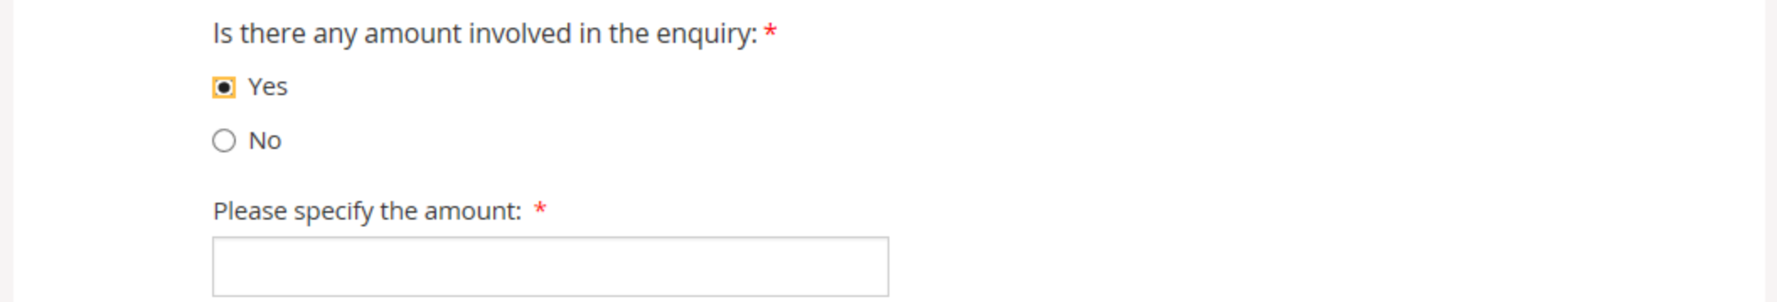
- In the Feedback details field, enter a description of your enquiry. This field has a 2000-character limit.

- If there are associated document, select Choose file to attach them. You can attach documents in.doc, .docx, .xls, .xlsx, .csv, .pdf, .jpeg, .jpg, .jpe, .gif, .bmp, .png, .pnt, .pntg, .xml, .txt format.
The file must be no larger than 10MB each. Up to 10 files may be uploaded.
Remember to attach any required supporting documents such as invoices before you select submit, as you won’t be able to add these after you submit your enquiry.
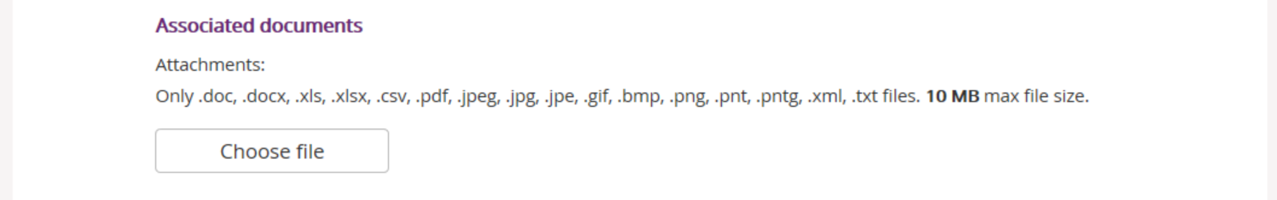

- Select what you would like to do with this payment issue.
  - Submit and create another payment enquiry with participant information – This will allow you to create a new payment enquiry for the same participant using the existing participant information.
  - Submit and create new payment enquiry – You will return to the payment enquiry screen so that you are able to immediately enter a new enquiry.
Or
  - Submit this payment enquiry – To submit your payment enquiry and provide you with details including the payment enquiry reference number.
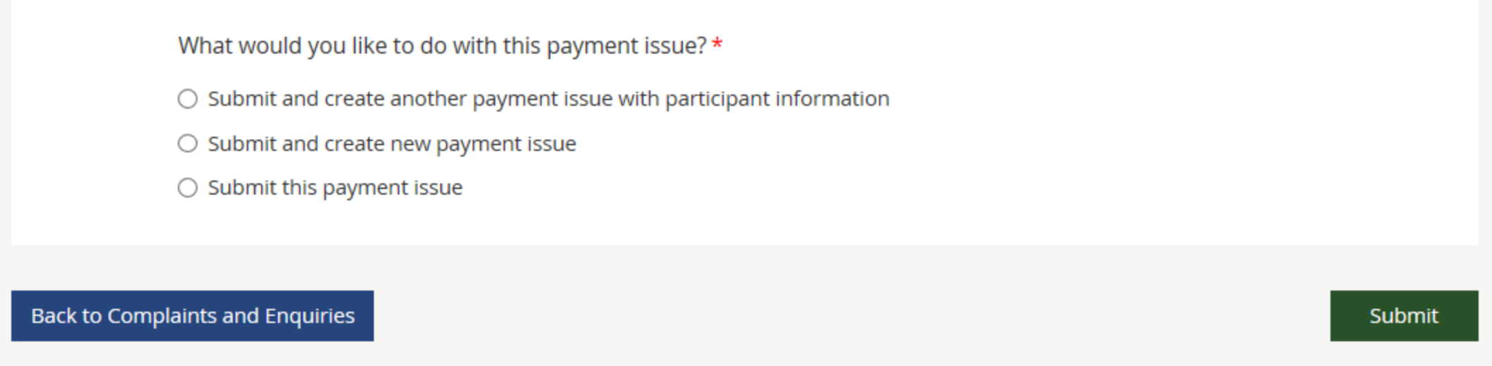

A list of your organisation’s submitted payment enquiries will display on the View complaints and enquiries page.
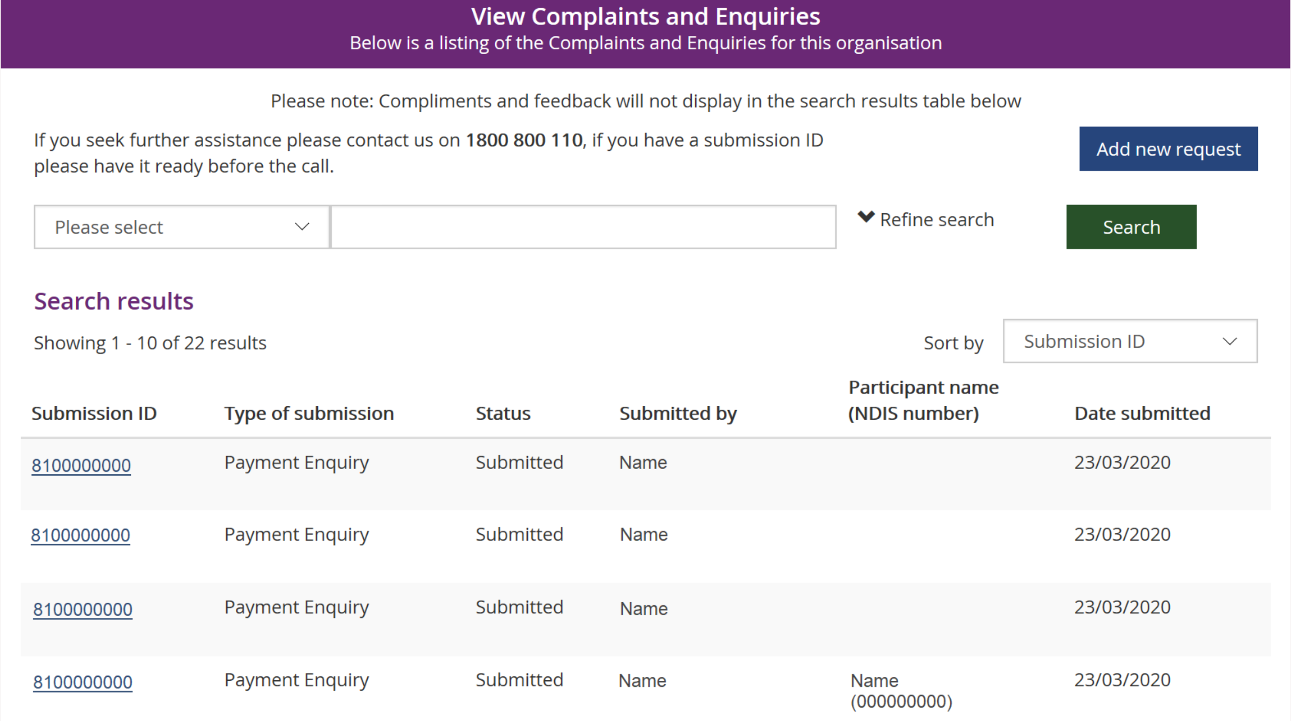

One of three statuses will be displayed in the Status column:
Submitted – Your enquiry has been submitted and will be reviewed by NDIA.
In Progress – Your enquiry is under review by NDIA.
Closed – Your enquiry has been completed. You may need to submit a new enquiry to provide more information.

Raising a Payment Enquiry from an existing Payment Request
- From the home page select the Payment Request tile.
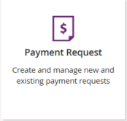
- Select the View Payment Request tile
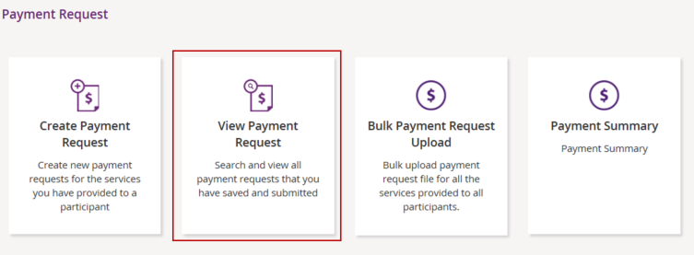
- View By - Select search criteria from the drop-down menu:
  - Submitted Payment Requests
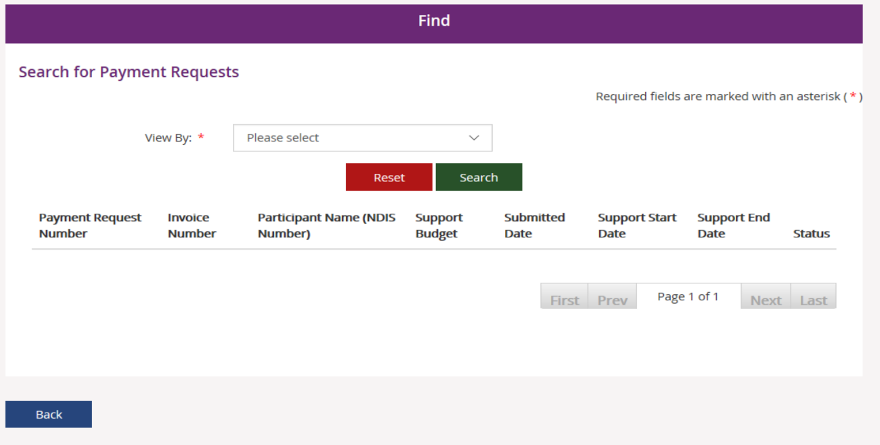
  - Uploaded Bulk Payment File
- Search By - Select search criteria from the drop-down menu:
  - NDIS Number
  - Payment Request Number
  - Status
  - Support Item Number
  - Submitted Date
  - Support Start Date
  - Support End Date
  - Your Invoice Number
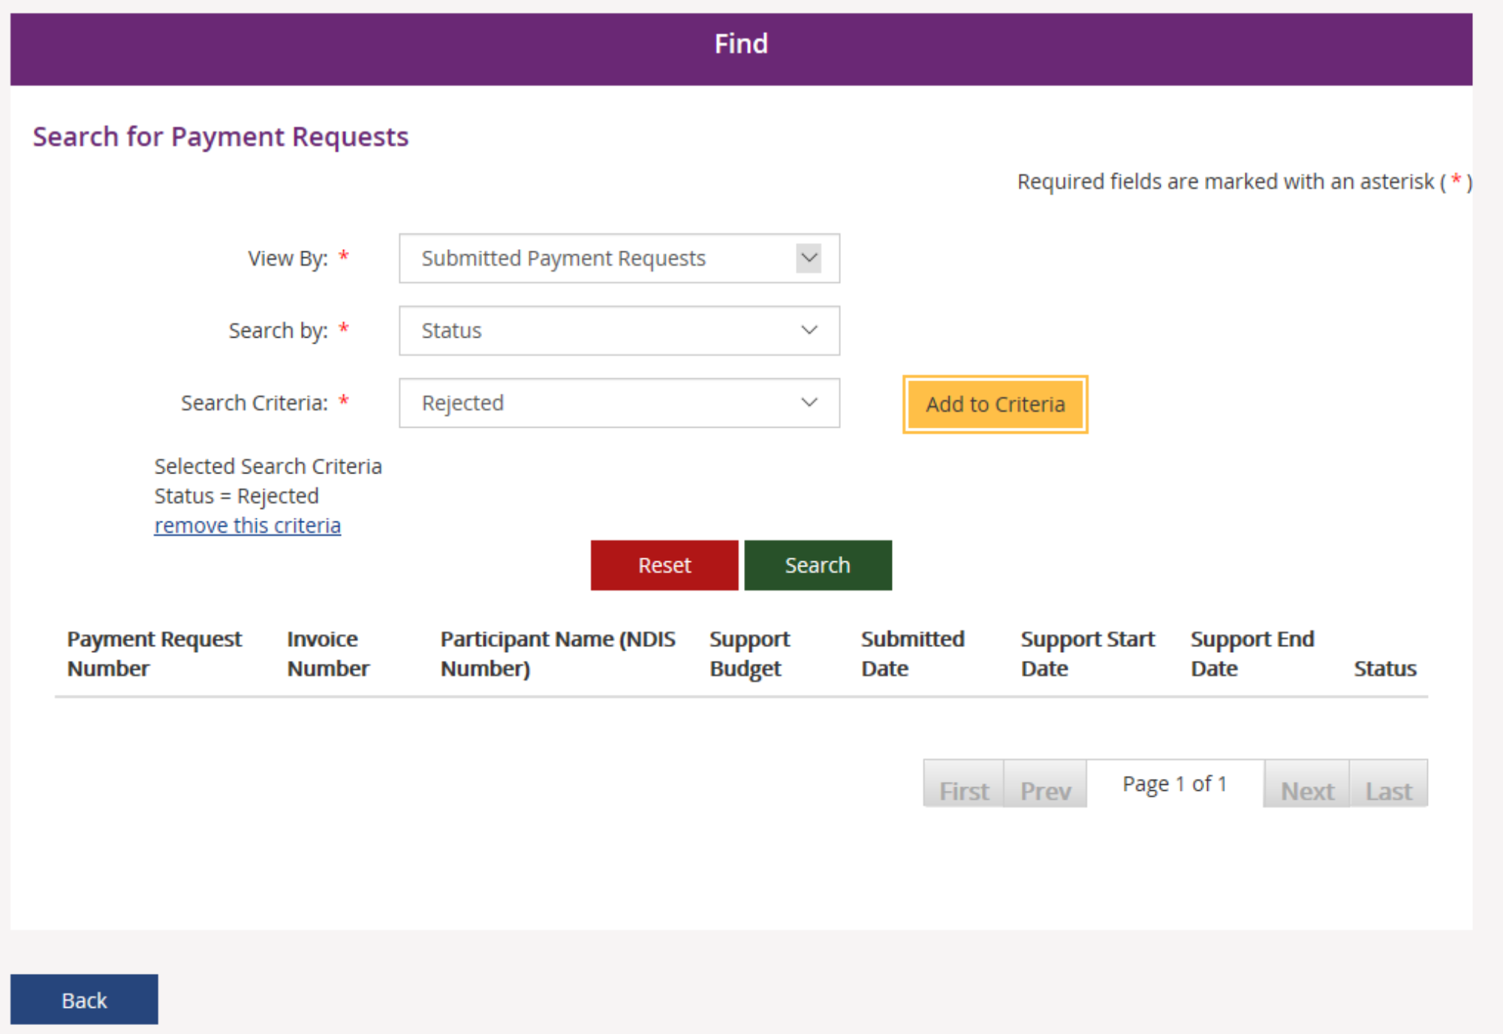

- Search Criteria - Select from the drop-down menu:
  - Rejected
  - Incomplete
  - Pending Payment
  - Paid
  - Cancelled
  - Awaiting Approval

- Select Add to Criteria.
- Select Search.
- From the display results, select the relevant payment request and the payment request will display. To add a new enquiry select Create payment enquiry.

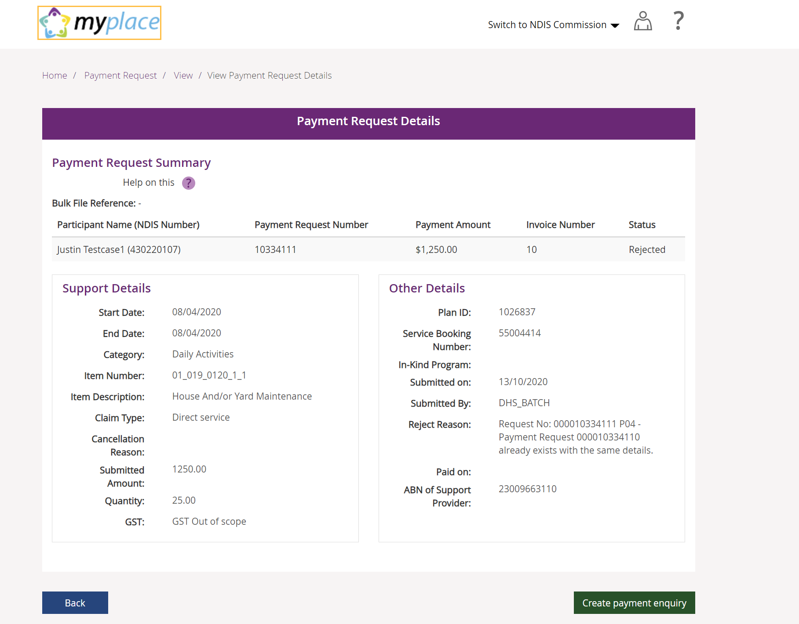

- Complete the steps from Submit a new payment enquiry to complete your payment enquiry.
Note: Some information will prepopulate, based on the existing payment request data.

View existing complaints and enquiries
- Select the View Complaints and Enquiries tile on the myplace home page.

The View Complaints and Enquiries page displays your submitted complaints and enquiries. Use Next and Previous to navigate through lists that have more than 10 entries.
For information about previously submitted compliments, payment enquiries or feedback, call NDIA on 1800 800 110.
Next to the free text search field use the drop-down selection to choose the criteria of the search:
- Submission ID
- Participant NDIS number
- Submitted by NDIS number
- Submitted by Surname.
Enter the details of the complaint or enquiry in the search box and select Search.
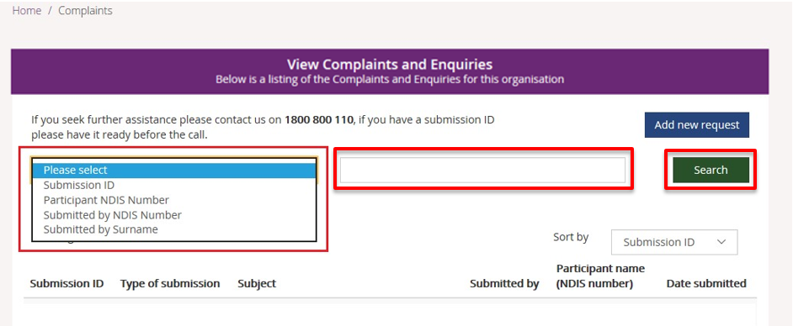
From the Sort By drop-down, select a sorting option:
- Submission ID
- Type of Submission
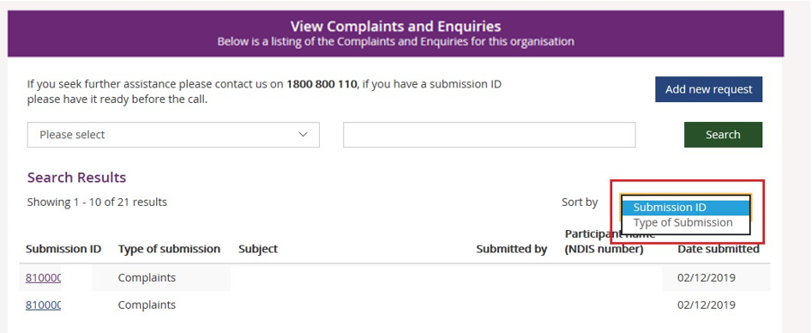
To view the details of the complaint or enquiry select the Submission ID (hyperlinked).
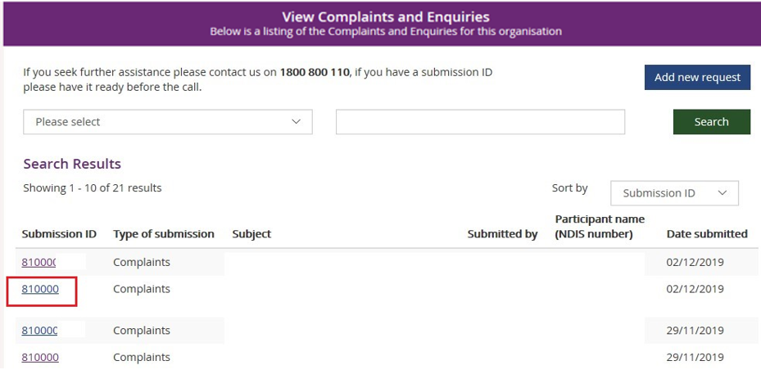
The details of the complaint or enquiry will be displayed.
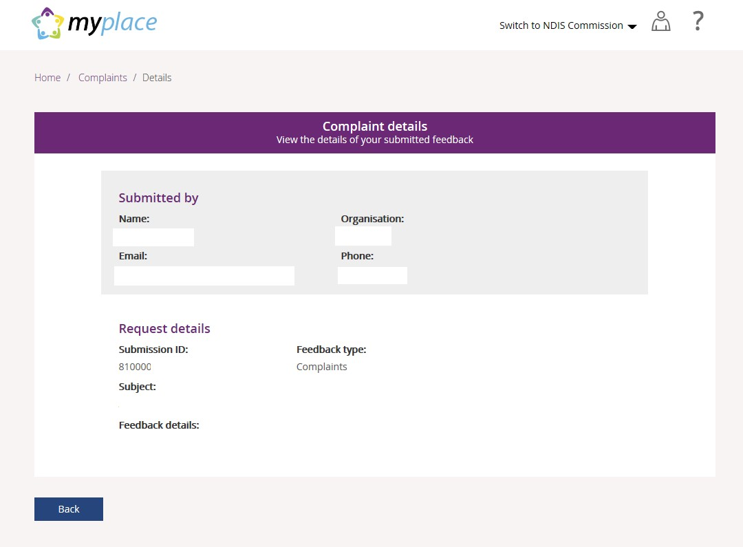
Select Back (bottom left corner of the page) to return to the search results.

