**Guide to using the Provider Supported Independent Living (SIL) Pack
September 2018
**

**Guide to using the provider SIL roster of care tool**

**July 2023**

**Version 3**

## Introduction

Supported independent living (SIL) is help and/or supervision of daily tasks to help participants live as independently as possible, while building their skills.

Participants with a goal to explore home and living supports need to complete a [Home and Living Supports Request Form](https://www.ndis.gov.au/participants/home-equipment-and-supports/home-and-living-supports-request-form) or provide information directly to the NDIA to help us decide which home and living supports best suit their needs. More information on the factors we consider when deciding if SIL is the best option for a participant is available in the [Supported independent living operational guideline](https://ourguidelines.ndis.gov.au/supports-you-can-access-menu/home-and-living-supports/supported-independent-living/whats-sil-and-whats-not-sil).

If we decide SIL is the best home and living option for the participant, we will use a participant’s roster of care, alongside other supporting information, to determine the reasonable and necessary supports to include in the participant’s plan.

This guide outlines how to fill out the Provider SIL roster of care tool.

We only require a roster of care in two situations:

* As part of the supporting information for a participant’s first plan with SIL.
* If the participant has experienced a change in circumstances, and this change in support needs can’t be delivered within the participant’s existing funding.

Providers must consult with the participant, or their nominee, to compile the information included in the roster of care submission.

Providers must include sufficient detail in the roster of care template and tool along with supporting evidence to assist the NDIA to decide the reasonable and necessary support needs of the participant.

Once completed, providers can send the roster of care template and tool to [enquiries@ndis.gov.au](mailto:enquiries@ndis.gov.au) or give it to the participant and their support coordinator to be included in the participant’s home and living supports request or plan reassessment.

## The Provider SIL roster of care tool

### Purpose

The Provider SIL roster of care tool (roster of care tool) is a Microsoft Excel spreadsheet. Providers fill in the roster of care tool to outline the supports they propose to deliver to a participant to meet their support needs and goals. The NDIA uses this information to gain an insight into what a typical week may look like for the SIL participant.

While participants are funded for SIL individually based on their support needs and goals, the roster of care tool gives providers an opportunity to describe how all residents in a shared living arrangement contribute to shared supports. For this reason, the supports for both NDIS and non-NDIS participants who share supports must be captured in the roster of care tool. The NDIA can then see the levels and variability of SIL support on a weekly basis, as well as other supports like community participation, supported employment and informal supports.

The roster of care tool combines the hourly breakdown spreadsheet and roster of care spreadsheet into one spreadsheet and calculates a weekly support summary. This overview of supports helps the NDIA understand if the cost of a participant’s home and living supports are reasonable and necessary. The Roster of Care is not the exact schedule of supports that will be provided to the person, nor an agreement with the NDIA. The actual supports must be agreed with the participant and or nominees once the NDIA approves their plan funding. For more information, please refer to the Supported Independent Living Operational Guideline.

### Shift type definition

The hourly breakdown spreadsheet summarises the supports to be provided to participants during different shifts and rates as defined below.

| Shift type | Description |
| --- | --- |
| Mon-Fri (6am-8pm) | Weekday hours between 6am to 8pm where participant requires SIL support, excluding participant sleeping time and crossover afternoon/evening shifts. During these hours, the weekday daytime rate applies. |
| Mon-Fri (8pm-12am) | Weekday hours between 8pm and 12am where participant requires SIL support, including crossover afternoon/evening shift starting before 8pm and excluding participant sleeping time. During these hours, the weekday evening rate applies. |
| Saturday & Sunday | This includes hours on Saturday or Sunday where:   * Participant is awake and requires SIL support; and * Active overnight shift hours.   During these hours, Saturday or Sunday rates apply.  Note: Active overnight shift hours are included as these shifts are paid at the Saturday / Sunday rates. Sleepover shifts are captured under ‘Sleepovers’. |
| Sleepovers | This is calculated as the number of nights per week when a participant requires sleepover support, including weekends. |
| Active overnight shift (Mon-Fri) | These are the number of hours per week between Monday and Friday where active overnight shifts are required. This excludes active overnight shift required on weekends. |
| Irregular support | The number of days per year where a participant requires unplanned irregular SIL support. The maximum number of irregular supports that can be included in a participant’s plan varies depending on the participant’s support intensity level. |

### How to fill in the roster of care tool

Step 1 – Fill in the overall information

Relevant sections of the roster of care tool will need to be selected according to the stages listed below.

Please selected the sheet titled: "Step 1: Enter overall info"

Step 1.1 – Enter overall details

Provider details: Provider name, ABN and registration number

Overall information: SIL property address, maximum number of support staff at the residence at any given time, state of residence, postcode, region (national, remote or very remote).

* Note that the ‘Region’ field determines if the area is classified as metropolitan, remote or very remote, based on the participant’s postcode. This is required to identify areas where remote or very remote loadings as per the NDIS Pricing Arrangements and Price Limits must apply.
* If the automatic classification is incorrect, providers can override this in the following field using the ‘Region (provider adjustment)’ field drop down list.
* The Home and Living assessment team will conduct internal checks to ensure any provider override of the Region field is accurate.

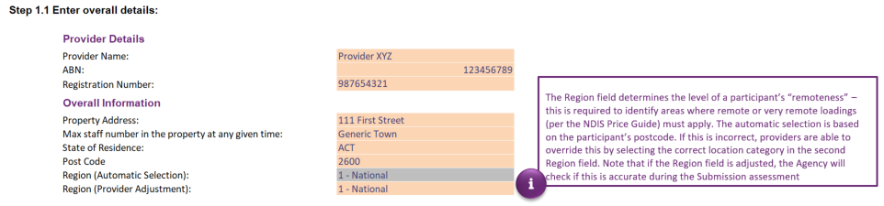

Step 1.2 – Enter participant details:

**For each participant:**

Enter their name in ‘Participant Name’ column. Please include all non-NDIS residents. To respect the privacy of non-NDIS residents, please list non-NDIS participant information by entering Non-NDIS A, Non-NDIS B. It is important that all residents in the dwelling are captured when considering the staffing levels.

Choose from the drop-down list if the participant is a NDIS participant or not.

Provide the participant’s NDIS number.

Choose from the drop down list each participant’s needs level (level of support need).

Choose from the drop down list each participant’s price level (standard or higher intensity). Please note that the participant’s needs level and price level are not the same.

Enter the estimated date the submission takes effect (dd/mm/yyyy format).

Enter the estimated plan start date (dd/mm/yyyy format).

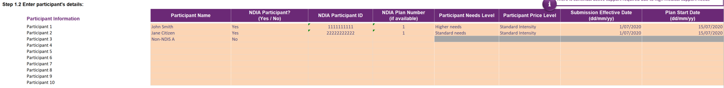

Please note, if there are more than 10 residents living at the property, please use more than one roster of care tool. For example, the first roster of care tool will contain information for 10 residents and the second roster of care tool will contain information for the remaining residents.

Step 1.3 (Optional) – Enter your hourly rates

Rates that are higher than NDIS price limits cannot be entered into the spreadsheet. The [NDIS Pricing Arrangements and Price Limits](https://www.ndis.gov.au/providers/price-guides-and-pricing) clarifies the Assistance with Daily Living rates per hour as the maximum rates that can be used for SIL supports.

Providers can enter any rate up to the price limit for each shift type’s hourly rate. Please note, any rate used that is lower than the price limit is inserted at step 1.3, description below. This is then reflected in the final weekly and annual calculations at step 3.4.

Two rate types can be used:

* standard intensity
* higher intensity.
* Standard rates are the default price limit.

Specific criteria that must be met to use the higher intensity rates. Providers must include evidence of at least one of the following to allow higher intensity rates to be considered:

* Frequent (at least 1 instance per shift) assistance is required to manage challenging behaviours that require intensive positive behaviour support; and/or
* Assistance from a disability support worker who has one or more of the high intensity support skills specified in the NDIS Commission’s NDIS Practice Standards: skills descriptors, which can be downloaded here.

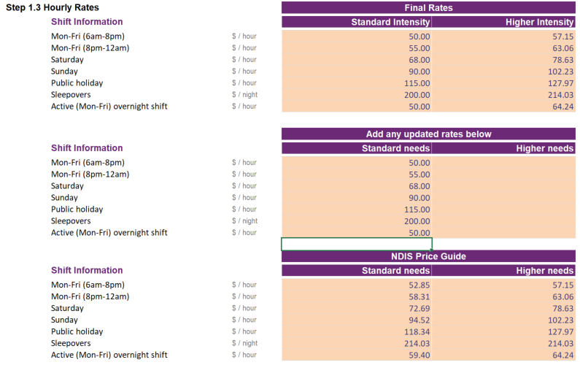

Step 2 – Fill in the roster of care

Please move to the sheet titled : "Step 2. Roster of Care(ROC)"

The purpose of this spreadsheet is to capture a participant’s typical week of supports. Irregular supports, either unplanned or unexpected, are not considered typical and are captured later in the process.

Step 2.1 – Review and fill in the support ratios in the legend

Support ratios should reflect the staffing required to provide necessary supports to the participant. Staff to participant ratios must be supported by evidence. If providers do not provide evidence for the support ratios they include in the roster of care tool, then the supports are unlikely to be considered reasonable and necessary.

By default, the spreadsheet has two fixed support ratios (marked in red below) which cannot be changed. If other support ratios are required, 19 placeholder ratios have been provided (right circle below).

Select the proposed support ratio from the drop-down selection. If the proposed ratio is not in the drop-down list, please choose the ratio that most closely matches the ratio required to support the participant and describe this in the roster of care notes section.

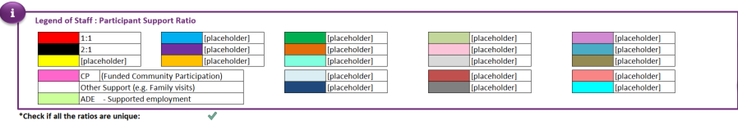

To select a ratio, click on [placeholder] and a drop-down arrow will appear as below. Click on the arrow and select the appropriate ratio from the drop-down list

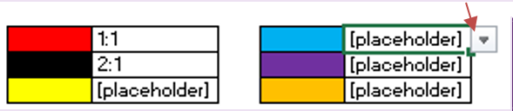

A green tick below the legend means all the ratios in the legend are unique and there are no duplicates.

If the check displays a red cross, please change the duplicated ratio to ensure all legend ratios are unique.

Step 2.2 – Complete the roster using the required ratios

Click on any cell in the roster and a drop-down list will appear. This drop-down list contains all inputted ratios. Select the appropriate support ratio. Each block represents 30 minutes.

Where a participant does not receive SIL support, the roster of care tool differentiates between different types.

* For funded community participation hours (if known), select pink ‘CP’ from the drop-down list.
* For other support, such as family visits or other informal support, please leave the cells blank (white).
* For supported employment (ADE) please select the green ‘ADE’ from the drop-down list.

Step 2.3 – Fill in the afternoon / evening and overnight support shift details

To complete the afternoon / evening shift information (also known as a cross over shift), select ‘yes’ or ‘no’ in the ‘Does the [afternoon / evening] shift start before 8pm?’ column. If the answer is ‘yes’, please select the ‘Average shift start time’ and ‘Average shift finish time’ for that particular shift from the drop-down list.

Cross over shifts should be used when a particular shift crosses over from one shift to another. For example, from afternoon shift to evening shift. Where there may be multiple cross over shifts starting at different times, please use an average shift start time from the drop-down list. If unsure which participants are receiving cross-over shift supports, then cross-over shift can be allocated across all participants.

To complete the overnight support information, go to the ‘Overnight shift’ column and select ‘Active overnight’ or ‘Sleepover’ from the drop-down list embedded in. If providers do not provide evidence for the support type they include in the roster of care tool then the supports are unlikely to be considered reasonable and necessary.

* Active overnight shifts are when support workers need to be awake during normal sleeping hours to provide supports to a participant due to their disability.
* Sleepover shifts are when support workers can sleep for an eight-hour shift, and may be required to give up to two hours of support when it is needed (e.g. going to the bathroom).

Select the sleep start and end time in the next two columns respectively. If the participant doesn’t have any overnight support on a particular day, then please select ‘None’ from the drop-down list or simply leave it blank.

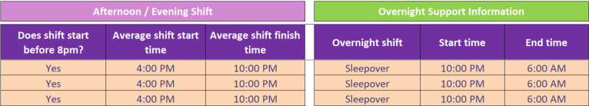

Step 2.4 – Solutions to fix invalid checks

We’ve built checks into the roster of care tool to ensure that the data entered is valid. When the below error messages appear, please resolve them as follows:

* “There are duplicate ratios in the legend” – This indicates that there are two or more of the same ratio in the legend. Please go back to the legend (step 1.3) and review all ratios to ensure they are unique.
* “Information provided is incomplete” – This indicates that the roster has been populated for the specific participant, however the overnight support information and/or afternoon / evening shift information has not been completed. The fields that need to be completed are shaded orange. Please ensure all orange cells are completed.
* “Start or finish time has not been completed” – This error indicates that either the ‘Sleep start / finish time’ or ‘Average shift start/finish time’ has not been completed. Please select them from the drop-down list.
* “No overnight support - crossover shift should finish no later than 12am” – If the participant doesn't have overnight supports on a particular day, the crossover shift should finish no later than 12am.

Step 2.5 – Review summary of total number of staff

Based on the information entered, a summary of the total number of support staff in the property or dwelling (per half hour) has been provided at the bottom of this sheet.

If the total number of hours is not a whole number, for example 1.1, the cell will be highlighted in red. This must be changed unless more than one roster of care is being used. An explanation for any errors should be detailed in the notes section.

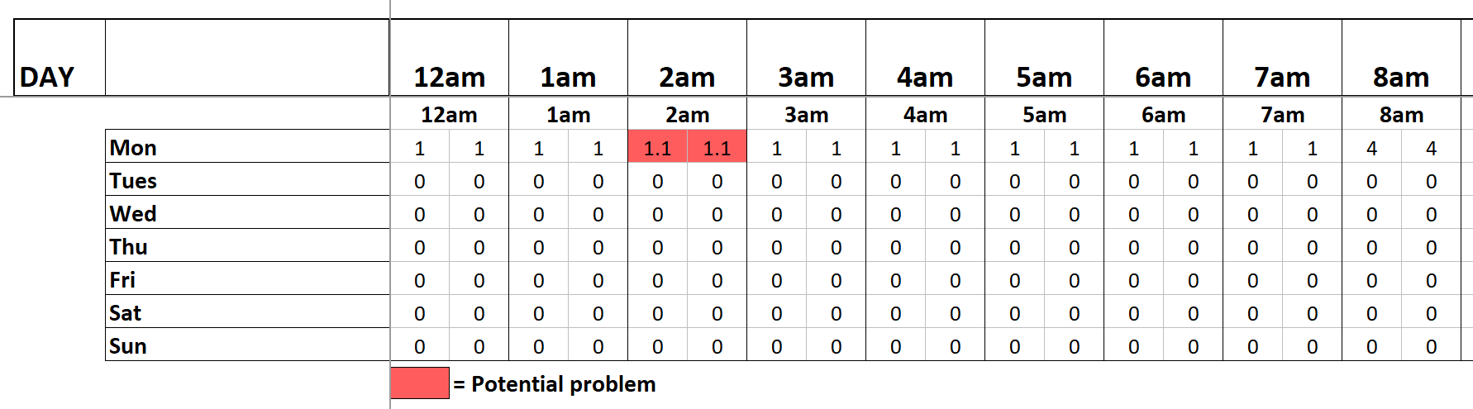

Step 2.6 – Add any notes that will assist the NDIA’s understanding of the roster

For example:

* Regular/scheduled time spent with family and/or friends.
* Regular or scheduled appointments, for example, doctor, dentist and specialist appointments.
* Transport to or from work and/or community participation activities.
* Attendance at work or other programs and/or services.
* Rationale for irregular hours. For example, the number of days at home during last 6-12 months.
* Handovers should be included and the time should be divided by the relevant number of residents in the house, at the relevant staff ratio.
* Any information that may assist the NDIA in understanding the roster of care.

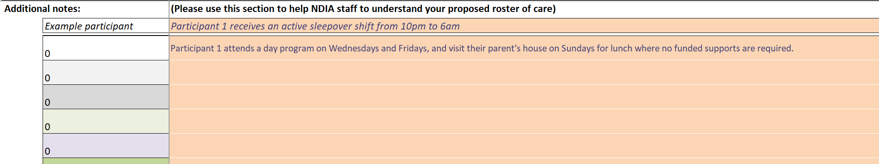

Step 3 – Review and complete the SIL hourly breakdown sheets

Select the sheet for the participant the roster of care is being developed for.Please move to the sheet titled : "Step 3. Participant 1" - "Step 3. Participant 6"

Step 3.1 – Review the Hours of Support Summary

This section summarises the hours of support by shift and support ratio, based on the information entered in step 1. Please review to ensure it is correct.

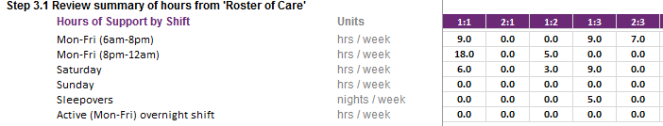

Step 3.2a (Optional) – Adjust the hour of support summary

If the summary in step 3.1 requires adjustments, please adjust the hours in this section. Type the appropriate number of hours by shift and support ratio in the relevant cell. Provide an explanation of why the adjustment was needed and explain how the change in values was determined.

Ensure correct hours / support ratios are recorded if a crossover shift (afternoon / evening shift) is used.

Please note, support hours for workers not entitled to the cross over allowance may be included in the cross over calculation due to limitations in the tool. The number entered will not increase or decrease the hours in step 3.1 by that amount, instead it will overwrite the hours in step 3.2b. For example, if 5 hours are included in the sleepover shift under 1:1 support ratio, the total number of hours that the participant is receiving for 1:1 support will become 5 hours.

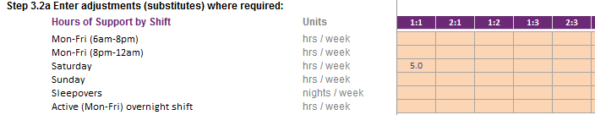

**Note:** Please also include the reason for the adjustment.

Please include the reason for adjustment. 

**Step 3.2b (Optional) – Review the Hours of Support Summary after adjustments have been made**

Review the hours of support summary for the adjustments made in Step 3.2a. If more adjustments need to be made, repeat Step 3.2a.

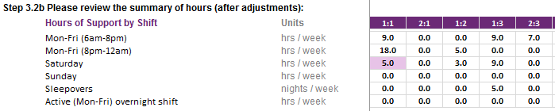

*Note: overwritten hours # will be highlighted in purple as above.*

Ensure all checks are green. Please note, the sleepover shift is for the number of nights per week, not the number of hours within the shift.

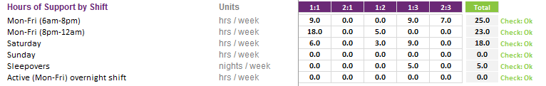

Please refer to the table below for the maximum time permitted per week for each shift type.

| Shift type | Max units | Units |
| --- | --- | --- |
| Mon-Fri (6am-8pm) | 70 | Hours / week |
| Mon-Fri (8pm-12am) – excluding cross over shifts | 20 | Hours / week |
| Saturday | 24 | Hours / week |
| Sunday | 24 | Hours / week |
| Sleepovers (based on 8 hour shift) | 7 | Nights / week |
| Total hours per week | **168** | **Hours / week** |

**Step 3.3 – Public holidays and irregular supports**

Up to 12 days for public holidays can be entered into the tool. These should be distributed across the ratios of support provided to the participant based on the average amount of hours of support provided for each ratio. The roster of care tool will automatically calculate the average weekly hours in the final summary (step 4).

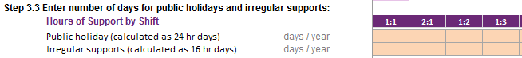

Public holidays are calculated as 24-hour days. A warning will appear if a number greater than the maximum number of gazetted public holidays is used. As a guide, most participants need similar levels of support on public holidays and Sundays

Irregular support days are automatically populated based on pricing intensity and are calculated as 16 hour days. The maximum number of irregular days that can be included in the participant’s plan are capped based on observable patterns of historical use:

| Support Level group | Max irregular days per annum |
| --- | --- |
| Higher intensity | 15.2 |
| Standard intensity | 10.3 |

**Step 3.4 - Review the estimated SIL amount for the selected participant**

The estimated regular roster of care plan value (weekly and annual (based on 52 weeks)) and irregular amounts are calculated automatically based on the hourly rates in (step 1.3) and the hours of support to be provided.



Please note that the amount shown in the estimated annual SIL amount is an estimate only. It is subject to NDIA review and reasonable and necessary decision-making processes.

**Step 3.5 – Review hours of support summary**

The hours of support summary is available at the bottom of the page for review.

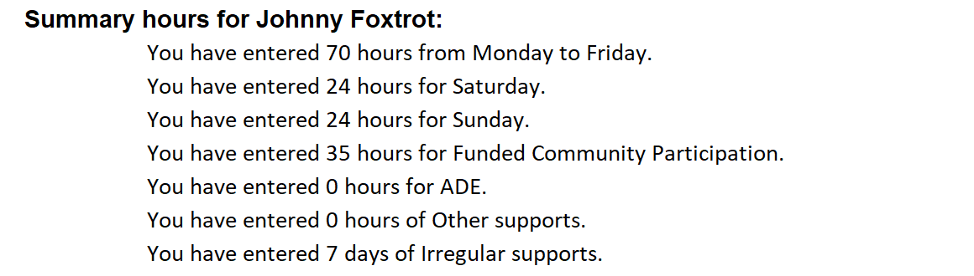

**Step 4 – Review the Final Submission**

Please move to the sheet titled "Step 4. Final Submission"

**Step 4.1 – Choose the participant you are submitting for**

Select the participant’s name from the drop-down list

Participant Name drop down list

**Step 4.2 – Review the final summary for completeness, accuracy and reasonableness**

Please review the roster of care tool and supporting evidence to ensure the information is complete, accurate and reasonable.

Please note, participants must be provided with a copy of the roster of care extracted from step 4 of the tool.

## Submitting the roster of care

Providers can send the roster of care tool and template to enquiries@ndis.gov.au or give it to the participant and their support coordinator to be included in the participant’s home and living supports request or plan reassessment.

Before sending the roster of care tool and template to the NDIA, providers must ensure:

1. The roster of care tool and template have been completed in full.
2. The participant or their nominees have agreed to the proposed service offering and have been provided a copy of the tool and template.
3. The roster of care tool includes:
   * only items funded under the NDIS
   * only items funded through SIL
   * evidence for the types of support included.

Please only use current NDIA tools and templates to avoid delays in assessment.

## Reasonable and necessary decisions

### Reasonable and necessary

The NDIA is required by legislation to make funding decisions that are deemed to be reasonable and necessary. In determining reasonable and necessary, the following criteria must be met:

1. it will enable the participant to meet their goals and objectives
2. it will assist the participant’s independence, social and economic participation
3. it represents value for money both in terms of the benefits achieved and the cost of alternative support
4. it is effective or beneficial for the participant having regard to current good practice
5. it must coordinate with but not replace informal support
6. it is most appropriately funded by the NDIS
7. it must relate to the person’s disability
8. it’s not likely to cause harm to the participant or pose a risk to others
9. it is not duplicating other supports delivered under alternative funding
10. it does not relate to day-to-day living costs that are not attributable to a participant’s disability support needs

Providers need to ensure the information included with the roster of care tool is sufficient to allow NDIA staff to make a reasonable and necessary decisions according to the above criteria.

For more information about reasonable and necessary supports for SIL, please read our [Supported independent living operational guideline](https://ourguidelines.ndis.gov.au/supports-you-can-access-menu/home-and-living-supports/supported-independent-living).