Information, Linkages and Capacity Building Commissioning Framework

November 2016

Table of contents
Introduction 3
The ILC Commissioning Framework at a glance 5
Part 1: Building an ordinary life
Building the foundation of the NDIS 7
Turning policy into action 7
The vision of an ordinary life 8
ILC is part of a bigger picture 12
Part 2: Putting the policy into action
Budget for ILC 16
ILC Activity Areas 16
ILC Focus Areas 17
Implications of our approach 19
Getting the balance right 22
Part 3: The grants process
What we learned 24
Expressions of interest 24
Full application 25
Assessment 25
Who may apply for funding? 26
Annual rounds 26
Measuring outcomes and managing performance 27
Part 4: Next steps
Transition Plans 30
Program Guidelines 30
Pilot in ACT 30
ILC Toolkit 30
This is just the beginning 31
Terms we use 32

Introduction
The National Disability Insurance Agency (the NDIA) is pleased to share the next version of the Information, Linkages and Capacity Building (ILC) Commissioning Framework with you. We understand that many people in the disability sector – including people with disability, their families and carers – have been waiting to learn more about what ILC will look like in the future. The purpose of this document is to share our plans with you, and to let you know how your feedback has been incorporated into our plans.
Talking to people with disability
This Framework is the product of two rounds of consultations with people with disability, their families and carers as well as people who work in the disability sector. In late 2015 more than 1000 people took part in workshops to talk about outcomes they expected from ILC as well as priorities for funding. We heard how much people valued ILC activities and the kinds of outcomes people wanted ILC to achieve. But we also heard that ILC was so important to people they wanted more time to consider our ideas.
So in December 2015 we released a consultation draft of the ILC Commissioning Framework. We then hit the road, holding face-to-face consultation sessions around the country. At each of the sessions, we spent some time explaining how we intended to roll out ILC. We asked people what they thought of our draft outcomes and what needed to change. We also asked them what we needed to consider as we designed the application and assessment process for ILC funding. We wanted to know what we could do to help organisations get ready for the changes that would come in the future. Again, more than 1,000 people attended one of these consultation sessions.
We also invited people to write to us and share their ideas. We received 135 written submissions.
What did we learn?
The feedback provided at the sessions and in the written submissions was consistent across the country. People reported that the draft outcomes were too broad, read too much like motherhood statements and were neither clear nor easily measurable. People said they seemed too much like outcomes for the scheme overall and did not reflect the specific contribution ILC was expected to make to improving the lives of people with disability. People also wanted the outcomes to be linked more clearly to the Activity Areas described in the ILC Policy.
It was also clear from the consultations that many people had not read the entire ILC Commissioning Framework. People told us the document was too long and complex. They said they did not really understand our thinking or our plans.
We have taken all this feedback into consideration when drafting this version of the Commissioning Framework. We thank everyone who took the time to attend a consultation session or write down their thoughts – our plans are stronger because of your input.

So what did we do?
As a result of this feedback, we have done two things. The first is that we have significantly changed the outcomes we expect for ILC. You will see this in Part 1 of this document.
The second is that we have redrafted the entire ILC Commissioning Framework. We have made it shorter and clearer. We have focused on explaining how we will use grants to achieve the outcomes we want to see for ILC. In order to keep it short we have concentrated on explaining what we are doing rather than explaining why.
So in this new version of the ILC Commissioning Framework you will find:
- the new outcomes identified for ILC,
- the way ILC will work with LAC, the NDIS and mainstream services and supports, and
- how the grants component of ILC will work.
You will not find a copy of our application form for ILC funding or the criteria we will use to select applications. Nor will you find what our reporting requirements will be or how we will collect data. More information will follow in our ILC Program Guidelines. They will be released by the end of 2016.
This is just the beginning
ILC represents a unique opportunity to have a real conversation about inclusion. People with disability don’t just want to be present in the community – they want to be active agents in it.
That will only happen when genuine partnerships are forged between people with disability and the community. Through the grants we will provide in ILC we have a chance to facilitate those partnerships – not just with what we fund but who we fund and how we fund it. We know that there has been limited opportunity to do that in the past and we want to make sure we make the most of the funding we have to drive change for individuals and communities.
While grants will be our focus in the short term, over time we will also look at other elements that will help drive inclusion, such as co-investment, innovation and the best way to share research and evidence about the benefits of inclusion across the community.
We are only at the beginning of implementing ILC. And just like the rest of the NDIS, we want to listen, learn, build and deliver. We anticipate this will be the first of many versions of the ILC Commissioning Framework. We want to keep listening and responding. We expect outcomes will change as we collect more evidence about what best meets the needs of people with disability. We expect our processes to change as we learn what delivers the best outcomes. And we expect our priorities to change as circumstances change. And while we know that everyone finds change hard, we also know it presents exciting opportunities.
We look forward to working with you on this journey.

The ILC Commissioning Framework
at a glance
- In July 2015, all governments in Australia agreed to the ILC Policy. The ILC Policy describes the kinds of activities that will be funded in ILC.
- The NDIA has now been given the ILC Policy Framework to implement. We are doing that through this ILC Commissioning Framework.
- The ILC Commissioning Framework is the action plan for ILC. The Commissioning Framework explains:
  - the role of ILC in the NDIS,
  - the outcomes expected for ILC,
  - how activities will be selected and funded, and
  - how performance will be measured and managed.
- ILC will not start on one date in the future. It will start at different times in each State and Territory. The NDIA will release information about those dates at the same time as this ILC Commissioning Framework.
- The ILC budget will build up slowly over the next few years to approximately $132 million when the full roll out of the NDIS is complete in 2019-20.
- ILC funding will be distributed through grants. Organisations will have to apply for funding to carry out activities. Organisations will have to explain in an application how their proposed activity fits into the Activity Areas described in the ILC Policy, fits one or more of the five Focus Areas identified by the NDIA and delivers one or more outcomes for people with disability.
- This ILC Commissioning Framework does not include a sample application form, or explain how the NDIA will assess applications. It does not explain how the NDIA will collect data or what our reporting requirements will be. More information will be included in the ILC Program Guidelines. We will release these guidelines by the end of 2016.

Part 1:
Building an ordinary life

Building the foundation of the NDIS
Up until now, the Commonwealth, State and Territory governments have funded all kinds of different activities to support people with disability. The types of activities and how they were funded have varied from state to state.
There has also been a large amount of volunteer effort dedicated to building opportunities for people with disability and a range of philanthropic contributions. There are some fantastic outcomes from these activities. But it has been difficult to extend their impact beyond local and/or state boundaries. The NDIS represents a chance to change that.
On the following pages we explain how we will implement ILC across the country. We describe the outcomes we expect to see from ILC. The outcomes are described from the perspective of a person with disability.
But ILC will also make a contribution to the outcomes identified for the scheme as a whole. It is one of the foundation stones on which the scheme is being built. ILC contributes to the sustainability of the scheme in two ways. By ensuring that people with disability are connected into their communities, using the same services and participating in the same activities as everyone else, it will reduce reliance on specialist supports over time.
It also has an important role to play in supporting people who do not have an NDIS plan. By providing appropriate support in the community, it will help those who are not NDIS participants to have access to the things that keep them strong, independent and connected in their community, and therefore reduce the need for funded supports.

Turning policy into action
All governments around Australia agreed to a policy framework for ILC last year. This ILC Commissioning Framework explains how the NDIA plans to turn that high level policy into action. We therefore encourage everyone to read the ILC Policy because it is the foundation of our work.
The ILC Policy describes five kinds of activities that will be funded in ILC in the future. They are grouped into five areas or streams. Just as a quick reminder, they are:
- Information, linkages and referrals,
- Capacity building for mainstream services,
- Community awareness and capacity building,
- Individual capacity building, and
- Local area coordination.
It is important to remember that the fifth area – Local Area Coordination (LAC) is being implemented by the NDIA separately. This ILC Commissioning Framework describes how we will fund and manage activities in the remaining four areas.

The vision of an ordinary life
People with disability want the same things in life as everyone else in the community. They want to be able to do the things that most people in the community take for granted – to have somewhere to live, to get a job, to get a good education, to enjoy the company of family and friends, to go to the beach or go to the movies. In short, what people with disability want is a chance at an ordinary life.
The vision of the NDIS is to optimise the social and economic independence and full participation of people with disability. In other words – the goal of the NDIS is to increase the opportunities for people with disability to live an ordinary life. We want people to be empowered to live the life they choose and to be citizens in the full meaning of the word – not just participate in the community but make an active contribution to it. Through ILC we will be looking to invest in those activities that develop independence, self-determination and community inclusion.
But empowerment on its own is not enough. In order for anyone to achieve a goal you need two things. You need capability and you need opportunity.
We know that for many people with disability it is the lack of opportunity that is the greatest source of frustration. We want to use the ILC funding we have to try and change that. We want to do that not just through the activities we fund but who we fund and how we fund them.
We will look to invest in projects that reflect a contemporary, progressive approach to inclusion. We will look for projects that don’t just carry out activities in the community but build the community right into every stage of the delivery of the project. That might be for example through the use of volunteers or through a partnership with another organisation.
We also want to work closely with existing organisations to build on the great work that is already being carried out in many communities. It is important that the energy, experience and ideas of those who are already working towards inclusion is not lost but is strengthened by ILC. Our approach to ILC respects – in fact relies upon – the continued effort of those who contribute their time and resources to building and creating understanding and respect for people with disability in our communities. In return it offers the opportunity to grow and expand effective activities that achieve real inclusion.
If we want full participation and not just presence we know we need to all walk together on the journey – people with disability, organisations, the community and the NDIA. When people work together and have shared experiences, that’s when the real change happens.
While the grant process will be the key tool we will use in the short term, there are a number of elements of the original ILC framework that we will develop further over time including how to drive co-investment, how to stimulate innovation and how to build research and evidence across the community about the benefits of inclusion.

Our goals for ILC
We have therefore set two big goals for ILC to address both capability and opportunity. We have
set one goal for people with disability and one for the community.
- People with disability – people with disability have the ability to achieve their
goals (capability)
- Community – people with disability are included in all aspects of community life (opportunity)
We expect progress towards both of these goals. They represent the big change we want to see. But we know that we need to break down those two big goals into smaller achievable pieces. So we have broken each of the goals into smaller objectives and outcomes. We have also made sure these objectives and outcomes are more closely linked to the ILC Policy.
We also know that these goals are not separate and distinct – they are related and feed into each other. Progress in one can push progress in the other. In the past we have often only had the opportunity to do one at a time. The exciting part of ILC is that we will have the opportunity to do both – we can create a continuous cycle that leads to better outcomes for people with disability and more vibrant inclusive communities.

Objectives for ILC
During the consultations we heard that people wanted the outcomes for ILC to be closely linked to the Activity Areas described in the ILC Policy. The four Activity Areas can be broken down into two groups – those that focus on developing the capacity of people with disability (capability) and those that focus on developing the capacity of the mainstream and community (opportunity). We have set two objectives for each.
Capability
- Activity 1 Information, linkages and referrals
People with disability are informed, connected and able to act.
- Activity 4 Individual capacity building
People with disability have the skills and confidence they need to participate in, and contribute to, the community.
Opportunity
- Activity 2 Capacity building for mainstream services
Mainstream services have the information and skills they need to meet the needs of people with disability.
- Activity 3 Community awareness and capacity building
Community programs and providers have the information and skills they need to meet the needs of people with disability.
We also think that it is important for ILC to focus on what it will look like when there is fair and effective capability and opportunity building supports. This focus can be summarised as:
- Connections and Relationships
People with disability have meaningful relationships and connections of their own choice in the community.

Outcomes for ILC
Many people at the ILC consultations said the outcomes we had identified for ILC were too big and complex and could not be easily measured. They also said the connection to the ILC Policy was not clear. So we have come up with five new outcomes for ILC. People with disability:
- Are connected and have the information they need to make decisions and choices.
- Have the skills and confidence to participate and contribute to the community and protect
their rights.
- Use and benefit from the same mainstream services as everyone else.
- Participate in and benefit from the same community activities as everyone else.
- Actively contribute to leading, shaping and influencing their community.
The ILC outcomes are focused on people with disability. Many activities we will fund in ILC will help both people with disability and their families and carers. We will also fund some activities designed to support families and carers in their important role. But just like the rest of the NDIS, our focus in ILC will be on people with disability. This is to make sure we comply with the NDIS Act.
We know that we have set the bar high. But we want ILC to drive real change. We do not want to talk about opportunities for people with disability – we want to create opportunities. We do not want increased capacity to meet people’s needs – we want people’s needs to be met. We do not want opportunities for participation – we want increased participation. As one young man at the consultations said – “I want real friends, not fake friends.”
A focus on outcomes is also consistent with the insurance approach of the NDIS. The NDIS looks to invest in those supports and activities that make a difference to people’s lives. We do that for two reasons – the first and most important is that it improves outcomes for people with disability. But we also do it to make sure we make wise use of taxpayer’s money. Doing this will help make sure the NDIS will be around for a long time to come.
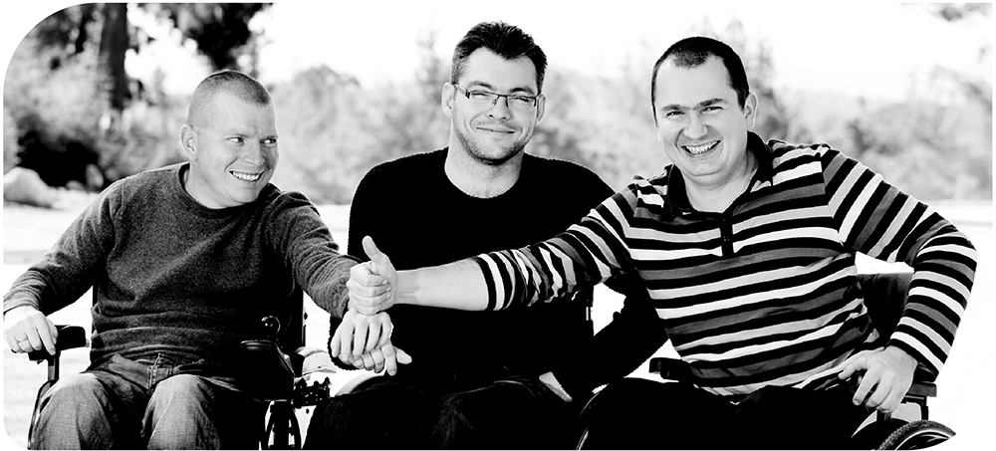
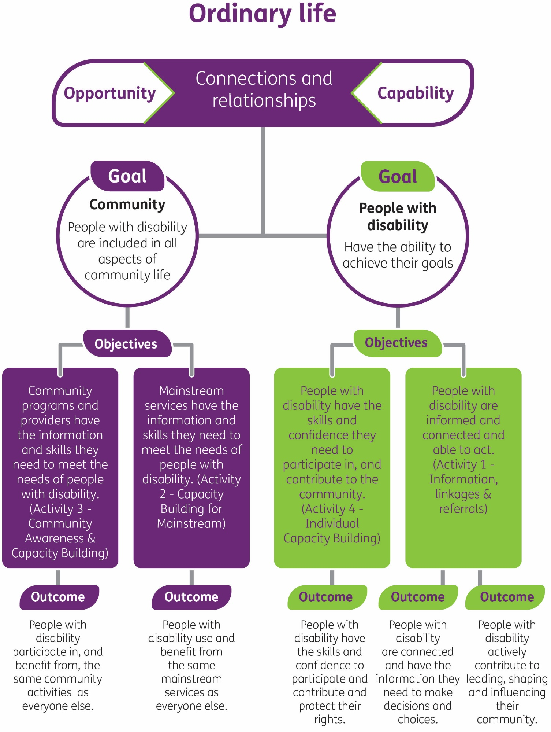

ILC is part of a bigger picture
We recognise that ILC cannot achieve true social change on its own. ILC sits within the NDIS, which itself sits within the framework of the National Disability Strategy. All three work together to achieve better outcomes for people with disability.

ILC is part of the NDIS
The NDIS is made up of two parts:
- Individual NDIS plans (sometimes known as individual funding packages) which provide reasonable and necessary supports for eligible people with disability, and
- Information, Linkages and Capacity Building (ILC).
Both parts work together to support people with disability and their families and carers. It is important to see ILC not as something separate from the rest of the NDIS but an integral part of it. Success in ILC will make an important contribution to the sustainability of the NDIS. Using the same services and taking part in the same activities as everyone else in the community means that people with disability will rely less on paid support over time. Providing support to people with disability who do not have an NDIS plan through ILC activities will also mean people will only move into individual funding when necessary. Both things will contribute to the sustainability of the NDIS in the long run.

Local Area Coordination is part of ILC
Just as ILC is essential to the success of NDIS, Local Area Coordination (LAC) is central to the success of ILC. Local Area Coordinators will be the single largest investment by the NDIA in delivering outcomes for ILC.
LACs have three important jobs:
- Work directly with people who have an NDIS plan to connect into mainstream services and community activities and get their plan into action,
- Provide short term assistance to people who do not have an NDIS plan to connect into mainstream services and community activities,
- Work with their local community to make it more accessible and inclusive for people with disability.
LACs will be skilled at working with people with disability who come from all walks of life. But it is not reasonable to expect they will be able to help everyone, with everything all of the time. So we will need to fund activities in the other four Activity Areas that support and strengthen the important work of the LACs.
We know from the consultations that people want more detail on the role of the LACs as well as our Early Childhood Early Intervention (ECEI) approach. Because we want to keep this document short, we have not included that detail here. The NDIA recently released more information about the work LACs and ECEI Partners in the Community will do. We encourage everyone to read those documents as well – you can find them on the NDIS website.

ILC is part of a bigger picture
ILC, Partners in the Community (LAC/ECEI) and individual NDIS plans all work together to support people with disability. But the NDIS on its own is not enough.
All governments around Australia have agreed to the National Disability Strategy. The Strategy is a 10 year plan for improving the lives of people with disability, their families and carers. It sets goals for people with disability in six domains and explains what governments will do to achieve those goals.
ILC is not intended as a funding source for organisations looking to meet their obligations under the National Disability Strategy. It is the responsibility of government, business and the community to make sure that their programs, services and activities are inclusive and accessible. ILC will not provide funding for this responsibility. But we will use the funds we have to build the capacity of organisations to better meet the needs of people with disability.

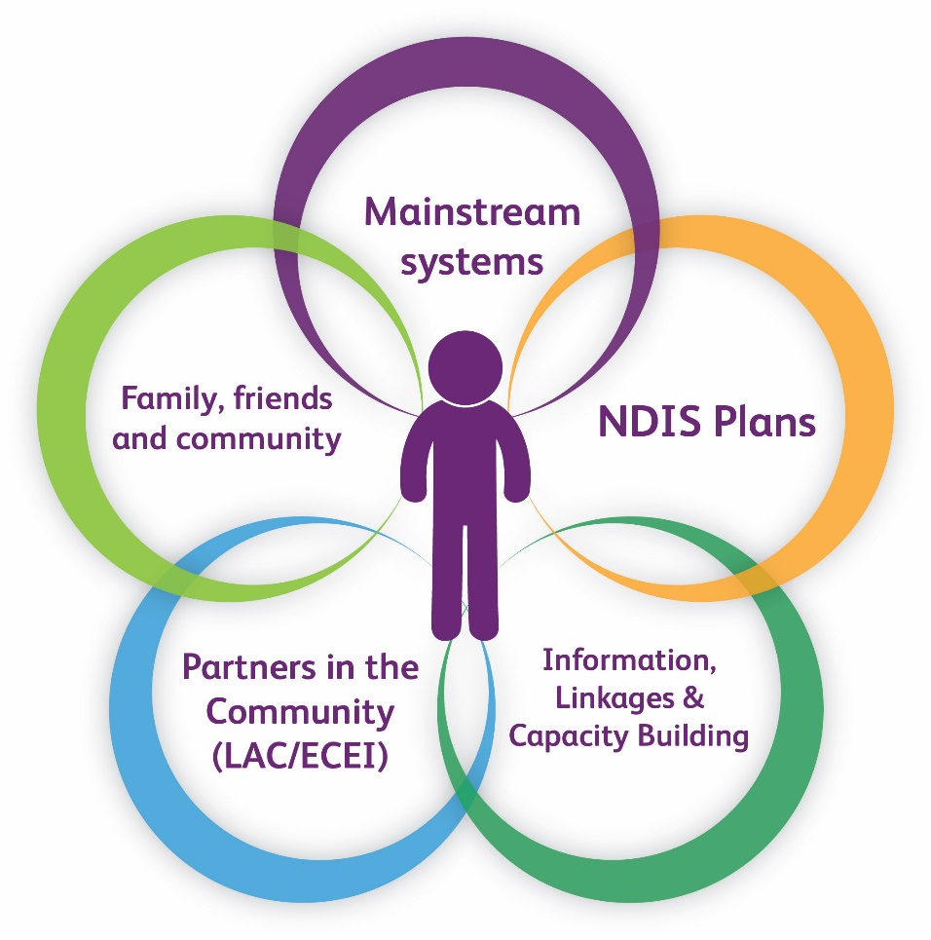

Beyond the National Disability Strategy, governments are also increasingly looking at ways programs and services can work more effectively together to improve outcomes for all Australians – not just people with disability. For example, Primary Health Networks have been established to try and improve the coordination of health care and to make sure patients receive the right care in the right place and at the right time. While we won’t provide ILC funding to duplicate this work, we will look at ways we can improve the capacity to mainstream services to meet the needs of people with disability. We see ILC is an important part of this overall government commitment to better coordination and collaboration between services.
This is an important point we will make a number of times in this ILC Commissioning Framework. ILC represents one area of effort to try and improve outcomes for people with disability and drive increased community participation and inclusion. But it is not the only area of effort. We know that governments, businesses and the community will continue to work together to realise the vision of an inclusive Australia where everyone has the opportunity to reach their full potential – and ILC is just one small part of that.

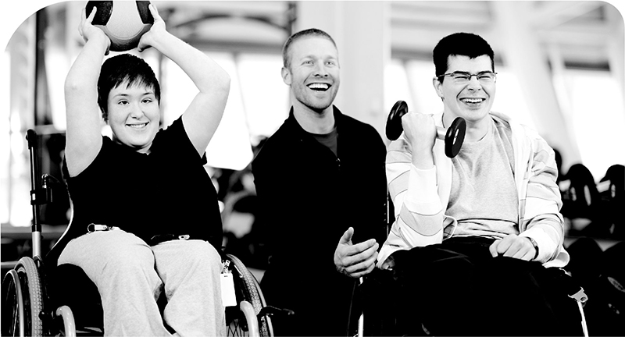

Part 2:
Putting the policy into action

Budget for ILC
The budget for ILC will build up slowly over time. The full budget of $132 million will be reached in 2019/20. The NDIA will distribute this funding through grants. Organisations will need to apply for a grant to deliver an activity.
Because the budget for ILC is limited, we will have to use the money wisely. We want to fund those activities that make a difference to the lives of people with disability, their families and carers. But we will also have to set priorities.

ILC Activity Areas
The NDIA will only be able to fund activities that fit into one of the four Activity Areas described in the ILC Policy. We have summarised them below:
Information, linkages and referrals – this area is about making sure that people with disability and their families and carers have access to up-to-date, relevant and quality information. It is also about making sure they are linked into services and supports in the community that meet their needs.
Community awareness and capacity building – this area is about making sure community activities and programs understand the needs of people with disability and have the skills and knowledge they need to be more inclusive.
Mainstream capacity building – this area is about making sure mainstream services have the knowledge and skills they need to meet the needs of people with disability. Mainstream services are those things usually funded by government such as education, transport and health.
Individual capacity building – this area is about making sure people with disability have the knowledge, skills and confidence they need to set and achieve their goals.

ILC Focus Areas
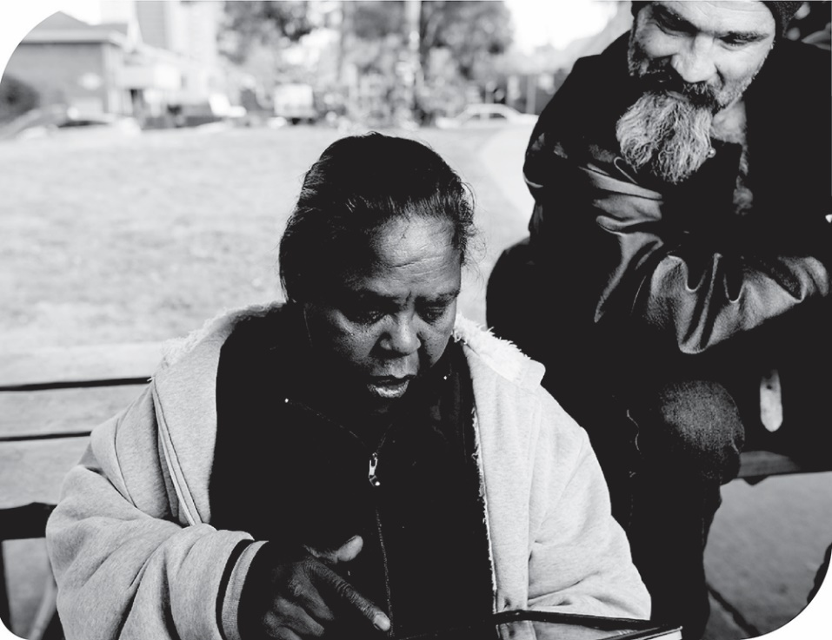
The Activity Areas described in the ILC Policy are very broad. Many different kinds of activities could fit into each of the areas. The NDIA will therefore have to set priorities for the funding. These priorities will help us choose which activities to fund. We have called these priorities ILC Focus Areas.

In the table on the next page we provide more information about each of the five areas. We have also included an example to help explain the kind of activity that might fit in each of the five areas. Please remember that these are just examples – we hope organisations will be creative when applying for funding and will show in their applications how their proposed activity meets the needs of people
with disability.
Focus Area | Definition | Example
Specialist or expert delivery | We will focus on activities that provide specific skills and knowledge in relation to disability – for example, diagnostic specific expertise or expertise in particular models of support or capacity building. | A comprehensive website that provides information about particular disabilities or conditions.
Cohort-focused delivery | We will focus on activities for specific groups of people that require detailed cultural or other knowledge to be effective – for example, multilingual activities to assist Aboriginal and Torres Strait Islander peoples or people from culturally or linguistically diverse backgrounds. | A yarning circle (peer group) for Aboriginal women run by a local Aboriginal organisation.
Multi-regional activities | We will focus on activities that would be inefficient if delivered separately in different local areas – for example, advice or information that is not based on location and could be relevant anywhere. | A community awareness campaign to increase employment opportunities for people with disability.
Remote/rural delivery | We will focus on ensuring activities are designed to address local needs, circumstances and conditions in rural and remote locations. | A project that connects young people with disability in a rural area with each other via multimedia or social media.
Delivery by people with disability, for people with disability | We will focus on supporting organisations that are run and controlled by people with disability. These are sometimes called user-led organisations. | A telephone information service for people with disability, staffed by people with disability.

Implications of our approach
ILC funding will be distributed through grants. Organisations will apply for a grant to deliver an activity. For an application to be successful, organisations will need to show:
- How their proposed activity fits into one of the four Activity Areas in the ILC Policy
- How their proposed activity fits into one or more of the five Focus Areas identified by the NDIA
- How their proposed activity delivers one or more of the five ILC outcomes.
This diagram explains how all three things will work together.
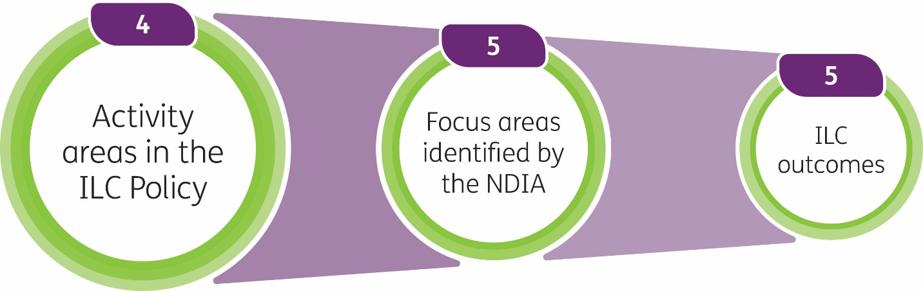
The five Focus Areas are not mutually exclusive – a proposed activity might fit into one or more areas. It might also deliver more than one outcome. For that reason we will not set a financial target for each area or outcome. Over time, we may build up enough data to set a target.
Our approach to ILC also means the focus is on the activity and the outcome it produces rather than the individual. Just as we will not set a target for the amount of funding we will spend in each of the Focus Areas, we will not set a target for the amount of money we will spend on particular groups of people or particular disabilities or conditions. Through the assessment process we will need to make sure we fund a wide range of activities that meet the needs of lots of different people. We will need to balance everyone’s needs and be fair.
During the consultations, people were worried that this approach might result in some people missing out. People were particularly worried about support for families and carers or people who do not have an NDIS plan. We will talk about that a little more in the next section.
Because we do want to be fair in our approach, we will also keep some money aside each funding round. If gaps emerge during the assessment process, we will use this money to fill those gaps. We will also use this contingency fund to seed new and innovative approaches to improving community inclusion for people with disability.

What we will fund
Activities that meet people’s needs
We will look for proposals that have strong evidence of need and are able to demonstrate how their proposed activity meets that need.
Activities that assist people who do not have an NDIS plan
Many of the activities we will fund in ILC will benefit all people with disabilities – for example, working to make community activities more accessible and inclusive will benefit people who have an NDIS plan as well as those who do not. But in one Activity Area in particular – individual capacity building – we will prioritise people with disability who do not have an NDIS plan. Organisations will need to make clear in their applications how they are meeting the needs of this group.
Activities that assist families and carers
There will be support for families and carers in ILC. Many of the activities that we will fund in ILC will be available to both people with disability and families. Providing information about a particular disability or condition on a website or through a phone line, for example, would be able to be used by people with disability as well as family members. And the activities we fund to build the capacity of mainstream services and community activities to be more inclusive will benefit both people with disability, as well as families and carers.
We will also fund some activities that will be targeted at families and carers. But we will need to make sure that those activities deliver an outcome for the person with disability they support. We must do that to comply with the National Disability Insurance Scheme Act 2013.
There are also things that we will not fund. We will not fund supports that should be in an NDIS plan. We will not duplicate work government is doing elsewhere such as the information provided through Carer Gateway. And we will not fund things that do not fit into one of the Activity Areas in the ILC Policy. That means, for example, we will not fund recreational activities such as holidays or outings because they do not fit into the areas described in the Policy.
What we won’t fund
There are some things that we will not fund in ILC.
Work that duplicates the role of LAC
We will not fund organisations to carry out activities that duplicate the role of the LACs. The 5 Focus Areas have been chosen to complement and strengthen the work of the LACs, not duplicate them.
Policy advice
We will not fund organisations to provide policy advice – that does not fit into the Activity Areas described in the ILC Policy.

Core funding
We will not provide recurrent core funding. We will fund reasonable overheads directly associated with delivering an activity – we will give more information about this in the ILC Program Guidelines. But we will not provide recurrent core funding for organisations to simply exist. They will need to carry out an activity that delivers an outcome for people with disability.
Activities that belong in an NDIS plan
We will not fund activities that rightly belong in an NDIS plan or package. If an NDIS participant needs a reasonable and necessary support, then it should be funded in their NDIS plan rather than through ILC. This includes both core supports and capacity building supports.
Mainstream services
Governments, businesses or organisations have a responsibility to be accessible and inclusive and meet the needs of people with disability. ILC funding cannot and will not be used to fulfil that obligation. What we want ILC funding to do is build capacity – not replace other services or systems or fill gaps within mainstream services.
Advocacy
Some activities that advocacy organisations currently do, including providing information, or education and capacity building, or support for decision making, fit into the Activity Areas described in the ILC Policy. Advocacy organisations will be welcome to apply for ILC funding to deliver activities that fit into these areas – just like any other organisation. Because of our focus on user-led organisations, we will particularly prioritise applications from self-advocacy or peer advocacy organisations.
We will not fund individual or systemic advocacy in ILC.
Support for people over age 65
Activities funded through ILC will also need to work effectively with services and supports provided through the aged care system. But it will not replace those services. We are aware, for example, that some organisations work with both people with disability and people over age 65. People under age 65 will be prioritised in ILC, while similar services and supports funded through the aged care system will meet the needs of those aged over 65.

Getting the balance right
We will need to balance the number and size of activities directed at individuals with the activities directed at the community. We will also need to balance the number of activities with national reach with the number of activities funded at the regional or local level. And we will need to make sure we get the balance between the four Activity Areas and the five Focus Areas right. We will, therefore, also have to assess ILC applications to make sure that the funding is spread effectively and fairly.
It will take time before we get all that right. Because we are moving from a state-based to a nationally consistent system, it will take some time before all the gaps are filled. It will take time before we have a diversity of organisations delivering a range of activities across the country. But through our data collection we should be able to get a better picture of needs and gaps as we go along. We will then be able to share that information with organisations so they can better target their activities.

Part 3:
The grants process

What we learned
During the recent consultations it was clear that many people were concerned about the proposed ILC grants process. People were particularly concerned that small organisations might struggle to compete against larger, well-resourced organisations. People were concerned that small organisations might lack the knowledge, skills and resources to craft a successful application. People wanted organisations to be selected because of their ability to deliver good programs that meet the needs and aspirations of people with disability, rather than their ability to write good applications.
People also felt very strongly that people with disability should be an important part of the assessment process. They felt people with lived experience were in the best position to judge whether proposed activities would meet the needs of people with disability.
We have redrafted the application process as a result of this feedback. We have split up the process to allow as many organisations as possible to participate. Organisations will be able to test whether their proposal is suitable through an expression of interest before devoting time, energy and resources to completing a longer application.
We will offer two tiers of grants – one for under $10,000 and one for over $10,000.
• For applications under $10,000 we will only have one short, simple application form – there will not be a two stage process. The reporting requirements for these grants will also be reduced.
• For grants over $10,000 we will run the expression of interest, followed by the full application.
We will also look at what other kinds of help we can give small organisations to make sure they are able to participate. We have funded the development of an ILC Toolkit to help organisations get ready for ILC but we will also consider other approaches.

Expressions of interest
We will begin by calling for expressions of interest. The expression of interest will be short and simple. It will ask organisations to describe the activity they are proposing, and how it meets an identified need. Organisations will be asked how the proposed activity fits into one of the four Activity Areas described in the ILC Policy and how it fits into the five Focus Areas identified in this Commissioning Framework. They will also be asked to explain how it delivers an outcome for people with disability. We will then assess all the expressions of interest. A shortlist of applications assessed as suitable will be developed and short-listed organisations will proceed to the next stage.

Full application
Short-listed organisations will be asked to submit a more detailed application. The full application will be longer and will ask organisations to provide more detail of how they intend to deliver the activity, the proposed budget as well as details of their capacity to deliver.

Assessment
In addition to considering how well a proposed activity fits into the four Activity Areas and the five Focus Areas, we will need to consider a number of other factors during the assessment process.
- We will look for strong evidence of need. We will look for applications that provide evidence of how the proposed activity meets a need identified by people with disability, their families and carers.
- We will look for evidence of good practice. We will look for applications that can demonstrate that what they are proposing will be effective.
- We will look for evidence of a contemporary, positive and progressive approach to inclusion. We will look for evidence that the proposed activity will result in meaningful participation and inclusion rather than simply presence in the community.
- We will look for evidence of connections into the community. We will look for ways in which the application demonstrates how the proposed activity has local or community support. That might be through the project partners, or through collaborative relationships with individuals or organisations in the community. It might be through volunteers.
- We will need to consider equity. We will need to make sure we have coverage in every region, and a range of activities that will meet the needs of a range of people with disabilities.
- We will also need to consider value for money.
We will have a four stage assessment process.
- We will consider how well the proposal meets our selection criteria (these criteria will be included in the ILC Program Guidelines).
- We will ask a panel of people with disability to review the applications.
- We will convene a panel of people with regional experience to provide advice about local needs and circumstances. This panel will be made up of people from the NDIA’s own regional offices and may also include representatives from state, territory or local government. We will also have a panel of people with technical expertise on hand to assist us if required.
- We will assess the mix of applications and compare them to our goals, objectives and outcomes so we make sure the recommended applications reflect the mix of activities we expect for ILC.
From this process, a short list of successful applications will be developed. The CEO of the NDIA will be responsible for approving the final successful applications.

Who may apply for funding?
There will be very few eligibility criteria for organisations. Organisations will have to be a formal entity such as an incorporated association. We will not enter into funding agreements with informal bodies. We will enter into funding agreements with consortiums, but one organisation will have to nominate as the lead agency. We will fund both for-profit and not-for-profit organisations. Organisations will not have to register with the NDIA to apply for an ILC grant.
We will allow registered providers of supports to apply for a grant to deliver ILC activities. We do however recognise that in a small number of cases, conflicts of interest could potentially emerge. We will provide greater detail in the ILC Program Guidelines about the circumstances under which we will, and will not, allow registered providers to deliver ILC activities.
Organisations contracted to provide LAC services may be eligible to apply for ILC funding under certain circumstances. Organisations who wish to apply for both will need to demonstrate how they will manage potential conflicts of interest, and how they will report against outcomes for both. They will also need to make sure their proposed ILC activity does not duplicate any LAC work.
We want a diversity of organisations delivering a diversity of activities. This is the best way to make sure the needs of people with disability are met. We want a mix of big, medium and small organisations. We want well established organisations with a strong track record of delivery. We also want organisations delivering new and innovative ideas. We particularly want to see more user led organisations. We think this is very important to the success of ILC. And finally we want collaboration and partnerships. We think this is one way small organisations can thrive in ILC.

Annual rounds
We will hold one grant round each year. But this does not mean we will only offer one year funding agreements. We may offer longer agreements for more established activities and offer shorter agreements for new innovative activities that are just getting off the ground. But over time we will look to provide longer funding agreements to give certainty and stability. We will use standard Commonwealth terms and conditions in our grant agreements.
Each State and Territory will start ILC at different times over the next few years. We will therefore not start the national annual round until all the states have moved in and we have the full ILC budget. This will affect our ability to fund national activities. We will only be able to fund national projects when all States and Territories have moved in. In the meantime however we could fund nationally consistent projects that are delivered on a state or regional level.

Measuring outcomes and managing performance
Measuring the impact of ILC activities, at both the individual and community level, will be important to demonstrating the contribution of ILC to the goal of an ordinary life. In order to capture the impact of ILC activities, we are developing an Outcomes Framework for ILC. This Framework will be consistent with the broader outcomes that have been developed for the NDIS as a whole.
Through the ILC Outcomes Framework, we will measure the impact of ILC activities at three different levels:
- Individual level – how activities are making a difference to individuals,
- Organisation level – how well organisations are delivering activities, and
- Community level – how activities are making a difference at a community level and whether there is evidence of greater inclusion of people with disability.
We will collect data on outputs as well as measures of outcomes. We will develop short, medium and long term measures of success. We will also collect data on the quality and effectiveness of the activities we fund. We will measure performance at a single point in time as well as over time.
We want to collect both quantitative and qualitative data. In the beginning we think it will be more important to collect qualitative data, through interviews or case studies, to build a picture of how ILC activities make a difference to people.
We will use the data we collect in the following ways:
- Identifying and addressing performance issues – for example if we are concerned that there are unusually low reported individual outcomes in a particular area or with a particular organisation,
- Informing future funding priorities – this might include shifts to, or away from, a particular kind of activity or a change to the ILC Focus Areas,
- Comparing different regions – to inform decisions about future funding and to inform other service systems, and
- Reporting to other service systems – this might include reporting to Ministers on trends in the areas identified in the National Disability Strategy, such as education and health.

We will get the data we need from different sources:
- We will ask organisations to report on outputs and ask them to collect data on the quality and effectiveness of their activity. This may include asking them to survey those who take part in their activities.
- We will independently survey individuals on the quality and effectiveness of activities they take part in, as well as the outcomes.
- We will compare data from sources such as the NDIS Outcomes Framework or through the Department of Social Services Data Exchange.
- We will use population data such as that from the Australian Bureau of Statistics (ABS).
We know ILC cannot achieve everything on its own. What we want to do through our new Outcomes Framework is capture the contribution ILC will make. So while the outcomes we have set are big, the measures we will use will focus on the specific contribution activities and organisations will make.
We also know we will not achieve these outcomes overnight. Change takes time – for both individuals and for ILC as a whole. For some people with disability, change might happen gradually and each step should be regarded as a successful outcome.
We also know that it will be a big change for organisations to start collecting data on the impact of the activities they deliver and how their work is contributing to outcomes. We know that many organisations are used to reporting about their outputs and that now we are asking them to show how those outputs are connected to outcomes. Many organisations will need time to develop their skills, knowledge and business systems to be able to capture information and report confidently about the outcomes of their activities. So we are going to move slowly in introducing this new approach to measuring and reporting.

Part 4:
Next steps

Transition Plans
Each State and Territory will move into ILC at a different time. We will release the start date for each State as soon as it is agreed.
State and Territory governments will work with organisations that currently deliver activities that may fit into ILC in the future to let them know what the funding arrangements will be leading up to the start of ILC in their State.

Program Guidelines
The ILC Program Guidelines will be released by the end of 2016. The guidelines will include details about the ILC grants application process, including the criteria for the assessment of applications, our standard terms and conditions as well as information about how we will deal with conflicts of interest.

Pilot in ACT
We will hold information sessions in the ACT later this year to explain the process for applying for ILC funding for the ACT pilot.
We will then call for applications in late January 2017. Organisations will have six weeks to complete their application and funding will be provided from 1 July 2017.
Because of the tight timelines for the pilot in the ACT, we will not be able to test our two stage process – we will call for full applications in January 2017. We will test the two stage application process in the next state that moves into ILC.

ILC Toolkit
We have funded an organisation to develop an ILC Toolkit. The Toolkit will be a simple practical resource for organisations to use to help them get ready for ILC. We will pilot the Toolkit in the ACT at the end of this year before rolling it out around the country next year. We will also look to adding more resources to the Toolkit as we go. Please keep checking the NDIS website for more information about the Toolkit.

This is just the beginning
Much has changed for people with disability over recent times. But we still have a long way to go before we achieve the kind of outcomes we want and expect for people with disability, their families and carers. For ILC in particular, this is just the beginning. The release of this version of the Commissioning Framework and the pilot in the ACT are the first steps in what will be a long journey. We are excited about what lies ahead. But we know we will not see the change we want to see unless we all pull together. We look forward to working with you on this journey.

Terms we use
Term | Definition
Capability | A talent, skill or ability to do something which can be developed and increased over time.
Capacity building | Increasing people’s knowledge, skills and abilities. This might apply to an individual – perhaps developing their skills in a certain area to allow them to live more independently. Or it might apply to the community as a whole – for example, building the capacity of organisations to be more inclusive.
Commissioning | A strategic approach to the identification and funding of activities that benefit individuals and communities. This Commissioning Framework explains how the NDIA intends to identify and fund activities in ILC.
Community programs and activities | Activities and programs run by, in and for the local community. They include everything from local businesses to local sporting or recreational groups.
Mainstream services | Services and programs usually funded by Commonwealth, State or Local governments that everyone in the community can use such as health, education or transport. They are sometimes called universal services.
NDIS Plans or Individually Funded Packages | People with disability that meet the access requirements for the NDIS are eligible to develop an NDIS plan. An NDIS plan outlines an individual’s needs, goals and how supports will be used to achieve those goals. NDIS plans are sometimes referred to as individual funding packages.
Information, Linkages and Capacity Building – ILC | ILC is part of the NDIS. ILC is a set of activities that will increase the capacity of people with disability, their families and carers to achieve their goals and increase the capacity of the community to be more inclusive. Originally, ILC was known as Tier 2.
Local Area Coordinators – LACs | Local Area Coordinators will play a central role in delivering the NDIS and ILC outcomes. They will help people to plan and access supports in the community, with an emphasis on connecting people with mainstream supports and services.
Outcomes | An outcome is the result of an action. In the case of ILC, it is the change or difference made to a person’s life which results from an activity or support or service they have used. We also expect to see changes at the community level as a result of ILC activities.
National Disability Insurance Agency – NDIA | The National Disability Insurance Agency is the agency responsible for delivering the NDIS.
National Disability Insurance Scheme – NDIS | The National Disability Insurance Scheme is a new way of providing support to people with disability in Australia. It consists of two parts – NDIS plans for eligible people with disability and ILC.
National Disability Strategy 2010–2020 – NDS | The National Disability Strategy 2010–2020 is a 10 year plan for improving the lives of people with disability in Australia. It has been agreed to by all the governments in Australia.
Opportunity | An opportunity is the situation, possibility or chance to do something you would like to do.
Sourcing | The selection of successful applications from a contestable grants process for the delivery of funded activities, such as ILC.
User led organisations | User led organisations are those run and controlled by people with disability. We expect these organisations to have a majority of people with disability on their board or committee of management.

