**Independent Assessments**

**Pilot learnings and ongoing evaluation plan**

**September 2020**

## Abbreviations

|  |  |
| --- | --- |
| ASD | Autism Spectrum Disorder |
| BSO | NDIA Business Support Officer |
| CHIEF | Craig Hospital Inventory of Environmental Factors |
| CRM | Customer Relationship Management business system |
| ECEI | Early Childhood Early Intervention |
| IA | Independent assessment, which is the part of the NDIS assessment process where an independent assessor gathers information from the participant/prospective participant to develop a holistic profile of their functional capacity |
| ICF | The International Classification of Functioning, Disability and Health used by the World Health Organization for measuring health and disability at both individual and population levels |
| ID | Intellectual Disability |
| IEO | Index of Education and Occupation |
| LAC | Local Area Coordinator |
| LEFS | Lower Extremity Functional Scale assessment instrument |
| LSP | Life Skills Profile assessment instrument |
| NDIA | National Disability Insurance Agency |
| NDIS | National Disability Insurance Scheme |
| PEDICAT | Paediatric Evaluation of Disability Inventory (PEDI) computer adaptive test (CAT) |
| PEDICAT-ASD | PEDI-CAT – for Autism Spectrum Disorder |
| PEM-CY | Participation and Environment Measure for Children and Youth |
| PSD | Psychosocial Disability |
| SDO Branch | NDIA Service Delivery & Outcomes Branch |
| SIL | Supported Independent Living |
| Vineland – 3 | Adaptive Behaviour Scales assessment instrument (3rd edition) |
| WHODAS | World Health Organization Disability Assessment Schedule assessment instrument |

**Contents**

Abbreviations i

Key messages i

1. Introduction 1

2. Testing and learning for the operationalisation of independent assessments 10

3. Ongoing evaluation 17

Appendix A: Independent assessment profiles 20

Appendix B: Characteristics of pilot applicants and participants 23

## Key messages

* The NDIS operates to insurance principles, which ensure that people with a permanent and significant disability have choice and control over the supports and services they need to pursue life opportunities.
* The availability of consistent information regarding participant needs and circumstances is central to this insurance approach. There is evidence that the current approach to assessing a person’s functional capacity is leading to inconsistent and inequitable access and planning decisions.
* The NDIA is introducing Independent Assessments (IA) to improve equity and consistency in decision making in response to the Tune Review, and in line with original scheme design recommendations from the Productivity Commission.
* From 2018, the NDIA piloted independent assessments of functional capacity on a voluntary opt-in basis to NDIS applicants and participants aged seven to 64 years in participating NSW service delivery regions.
* For the first pilot, eligibility was limited to participants and applicants with Autism Spectrum Disorder, Intellectual Disability or Psychosocial Disability. The NDIA chose these groups as they represent 63% of all NDIS participants. All participants were eligible for the second pilot.
* The first pilot achieved its target, completing 513 assessments. The majority (95%) were with individuals already part of the NDIS. The second pilot achieved just 99 assessments before COVID-19 restrictions forced its postponement. The second pilot will recommence in advance of the national rollout.
* The pilots provided evidence that the use of standardised assessments can support better decision-making by the NDIA. Of the 202 pilot one participants whose IA was undertaken prior to their scheduled plan review, 71% of pilot participants have a high level of function, 16% have a medium level of function and 13% have a low level of function.
* In the first pilot, the assessment scores of up to 8% of participants suggested functioning within the typical range for their age. Many of these participants might benefit from early intervention rather than individually funded supports.
* In the first pilot, 91% of participants or their representatives reported high levels of satisfaction with their appointment.
* Generally, independent assessors found the instruments to be comprehensive and reflected a participant’s functional capacity.
* Ongoing evaluation will be a part of the national rollout to ensure continuous improvement is part of the approach from the outset.

## Introduction

This paper outlines the rationale and need for independent assessments (IA) and summarises two IA pilots undertaken by the National Disability Insurance Agency (NDIA). The paper also outlines further testing and evaluation that will commence ahead rolling out IAs nationally in 2021.

### Insurance principles and the NDIS

The purpose of the National Disability Insurance Scheme (NDIS) is to provide reasonable and necessary funding to people with a permanent and significant disability so that they have choice and control over the supports and services they need to pursue life opportunities.

The NDIS replaces the welfare approach to disability that existed for decades in Australia, with a universal insurance scheme. Under the previous approach, State and Territory disability programs took a short-term view to supporting an individual, rather than considering the lifetime need (and cost) of an individual to achieve outcomes. These programs resulted in unmet need because they were underfunded to meet the support needs of all people who might need support. A person’s level of support was influenced by factors such as where they live and the cause of their disability. The unmet demand led to significant social and economic cost to people with disability, their families and Australian society as a whole.

The previous State and Territory disability systems had certainty over their costs, which was simply limited to the budget they received. However, the *NDIS Act* commits to the provision of reasonable and necessary funding, including early intervention supports, to all participants that meet the relevant criteria (*NDIS Act*, Section 3(1)(d)). Therefore, the NDIA unlike traditional disability support systems, must take a proactive forward view to ensure the sustainability of the NDIS for all participants and for Australian society as a whole.

The following principles, in line with the insurance approach are fundamental to operationalising the purpose of the NDIS:

* Evidence-based decision-making
* Consistency in decision-making
* Regular monitoring of experience to manage emerging risks
* Lifespan and person-centric approach
* Early investment to drive lifetime participant outcomes

These principles are crucial for the NDIS to be sustainable by ensuring that:

* All participants that meet the requirements as defined in Sections 21 to 25 of the *NDIS Act* are admitted to the Scheme.
* Decisions around the funding for individuals considers early intervention, equitable resource allocation between individuals with similar circumstances, and planning for positive and sustainable outcomes and independence.
* The NDIS invests in the social and economic participation, and independence of participants, so that in time and where appropriate for some participants, they are less reliant on funded supports.

### Deficiencies in the current approach

Central to the insurance principles is the availability of consistent data and information on a person’s functional capacity (and the environmental factors contributing to their functional capacity). This underpins both the assessment of a person’s eligibility for the NDIS and their package of funded supports. Consistent and accurate data also allows the NDIA to make iterative improvements to help inform the level of participants’ funded supports through understanding what supports achieve good outcomes. The accuracy of these models is crucial for both ensuring NDIS participants receive the support they need and the sustainability of the NDIS.

There is evidence that the current approach to assessing a person’s functional capacity is inadequate leading to inconsistent and inequitable eligibility and plan budgeting decisions. There is particular concern about the over-use of assessment tools by health professionals that rely solely on diagnosis of disability and impairment, or specify therapeutic and assistive technology treatments rather than describe a participant’s functional capacity. This information then requires subjective judgement from NDIS staff. The NDIA seeks holistic, consistent and standardised information on a participant’s functional capacity (including environmental factors which effect an individual’s support need) as required under the NDIS Act to inform decision-making on what is reasonable and necessary.

Comparing differences in the prevalence of being an NDIS participant between states and territories highlights inequity around accessing the NDIS depending on where a person lives. Figure 1 shows that as of June 2020, South Australia had the highest percentage with 2.47% of the population meeting the age and residence requirements participating in the NDIS. This is considerably higher than any other state and territory.

Figures 2 and 3 further highlight this inequity for the two largest age groups in the NDIS, 0 to 6 year olds and 7 to 14 year olds. In line with the overall percentage, there are substantial differences in the percentage of children participating in the NDIS between states and territories. Again, South Australia clearly has the highest percentage of children participating in the NDIS, in particular 7-14 years olds diagnosed with autism (4.4% of all 7-14 year olds in South Australia).

Figure 1: PERCENTAGE OF NDIS POPULATION in each state and territory

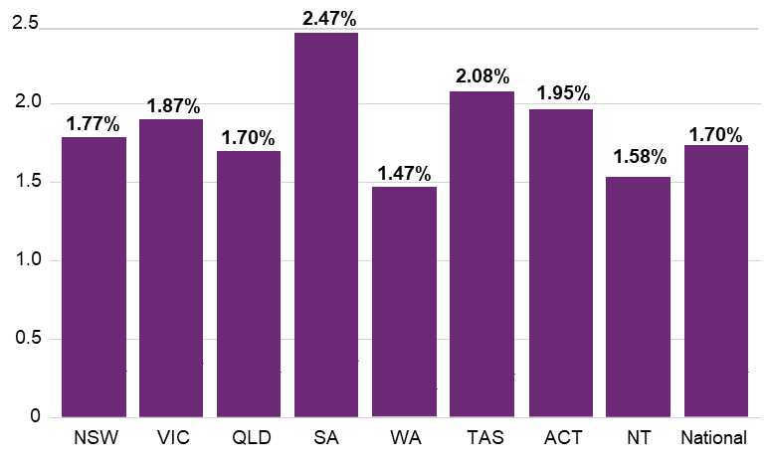

Source: NDIS participant statistics, June 2020.

Figure 2: Distribution of disability in 0-6 year old across the NDIS population

FIGURE 2: DISTRIBUTION OF DISABILITY IN 0-6 YEAR OLD ACROSS THE NDIS POPULATION 

Source: NDIS participant statistics, June 2020.

FIGURE 3: Distribution of 7-14 year old IN THE NDIS BY DISABILITY TYPE

FIGURE 3: DISTRIBUTION OF 7-14 YEAR OLD IN THE NDIS BY DISABILITY TYPE 

Source: NDIS participant statistics, June 2020.

Figure 4 shows that based on the Index of Education and Occupation (IEO)[1], NDIS participants who do not live in supported independent living (SIL) are more likely to live in areas associated with lower socio-economic status.

However, average annual plan budgets are higher for NDIS participants who live in areas associated with higher socioeconomic status. The average plan budgets of participants living in the most socioeconomically advantaged areas (IEO 10) are 16% higher than those of participants living in the most socioeconomically disadvantaged areas (IEO 1) (approximately $41,00 versus $36,000). This is most evident for NDIS participants aged 0-6 years where the difference is 29%.

The NDIA has undertaken individual reviews to explore some of these differences. They identified that evidence of a participant’s functional capacity, as opposed to diagnosis of their disability or impairment, is lacking in many cases.

Figure 4: Prevalence of NDIS participation and average annual plan budgets by socioeconomic status

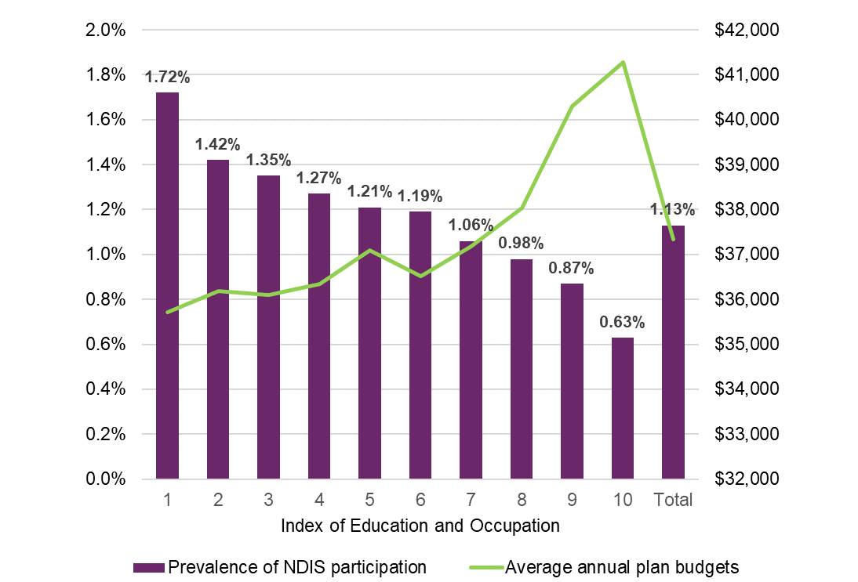

Source: NDIS participant statistics, September 2019

Further, plan budgets and payments to participants are increasing well above normal inflation. Payments to participants have increased by 5% per quarter (on average) over the last two years, resulting in payments which are approximately 40% higher in June 2020 compared with two years ago.

Figure 5 Average annualised payments per participant per quarter – SIL participants

FIGURE 5 AVERAGE ANNUALISED PAYMENTS PER PARTICIPANT PER QUARTER – SIL PARTICIPANTS

Source: Quarterly report to Disability Ministers, 30 June 2020

Figure 6 Average annualised payments per participant per quarter – non-SIL participants

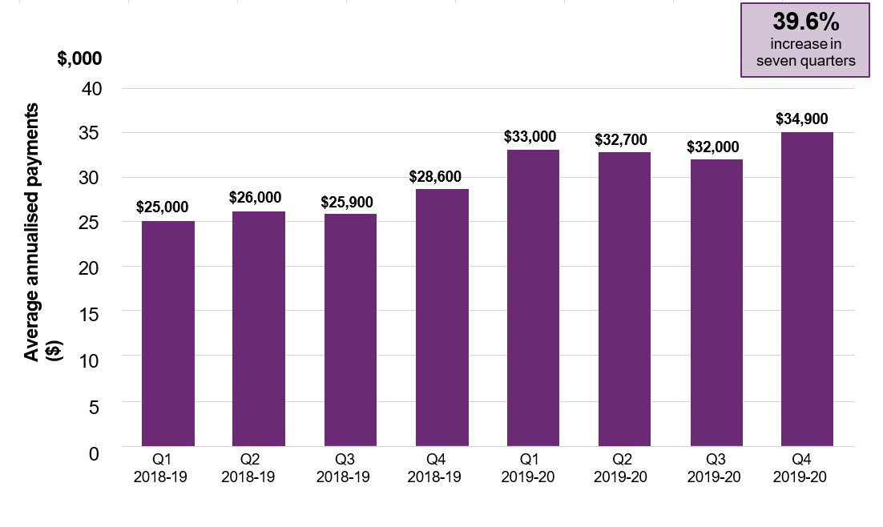

Source: Quarterly report to Disability Ministers, 30 June 2020

Further, the longer participants have been in the Scheme, the higher their average payments. For example, for participants who have received at least four plans, the average payment was $26,000 on their first plan, and $71,000 on their fourth plan (which is almost three times higher). This same trajectory is also evident for participants who have received three plans, with the average payment doubling from $27,000 to $55,000 from first plan to third.

Figure 7 Average payments to participaNts over time

FIGURE 6 AVERAGE PAYMENTS TO PARTICIPANTS OVER TIME

Source: Quarterly report to Disability Ministers, 30 June 2020

While it is noted that there are a range of short and long term drivers behind inflation rates, increases in plan budgets above inflation should be driven by changes in function and environmental circumstances. Currently there is no consistent approach to assess changes in a person’s functional capacity from plan to plan. NDIS planning staff, participants, and the disability sector indicate the need for more robust information to guide planning decisions.

### 

### The benefits of independent assessments of function

The above findings indicate there is a need for improved and more consistent information about a person’s functional capacity to inform NDIS decisions. The current largely disability-specific assessment approach could be leading to inequitable and unsustainable decisions, around both eligibility for the NDIS and plan budgets. In the long-term, this approach jeopardises the purpose and sustainability of the NDIS, and most importantly outcomes for people with disability.

In its Disability Care and Support Report, the Productivity Commission recommended that independent health professionals be engaged to assess people seeking access to the NDIS working within the framework of the World Health Organisation’s International Classification of Functioning, Disability and Health (ICF).[2] The NDIS Act Review (the Tune review) also recommended the National Disability Insurance Agency (NDIA) introduce assessments for prospective and existing participants for the purposes of decision-making, using NDIA-approved providers in a form set by the NDIA.[3]

In early 2021, in line with these recommendations, the NDIA will introduce free IAs for prospective NDIS participants beginning their NDIS journey, and progressively from mid-2021 for existing participants. The IAs will use a suite of recommended assessment tools (Table 1) that map to the domains of the ICF[4] and the six activities dependent on functional capacity in the NDIS Act (Section 24(1)(c))[5] (See [Assessment Framework](https://www.ndis.gov.au/participants/independent-assessments/independent-assessment-framework) and [Tools Selection Report](https://www.ndis.gov.au/participants/independent-assessments/independent-assessment-toolkit)). NDIA-approved suppliers will undertake IAs, employing suitably qualified allied health professionals.

**Table 1: ASSESSMENT INSTRUMENTS**

| **Eligibility** | **Assessment** |
| --- | --- |
| All | Lower Extremity Functional Scale (LEFS) |
| Adult | Craig Hospital Inventory of Environmental Factors (CHIEF) |
| Life Skills Profile (LSP) |
| Vineland Adaptive Behavior Scales, Third Edition (Vineland-3) (Comprehensive) |
| World Health Organisation Disability Assessment Schedule 2.0 WHODAS 2.0 (36-item) |
| Young adult/ children | Pediatric Evaluation of Disability Inventory Computer Adaptive Test (PEDI-CAT) |
| Participation and Environment Measure for Children and Youth (PEM-CY)[6] |
| Vineland Adaptive Behavior Scales, Third Edition (Vineland-3) (Domain) |

IAs aim to improve the flexibility to capture individual circumstances, and the equity and consistency of NDIS decisions. The use of consistent age-appropriate assessments for all disability types aligns with the disability agnostic approach of the ICF. This will allow the NDIA to assess function consistently and equitably among all participants and prospective participants irrespective of their diagnosis, where they live or socioeconomic status.

Using a defined panel of assessments administered by a specified panel of approved suppliers will also increase the reliability of assessments. Language and cultural adjustments are also easier to achieve with a small number of assessment tools.

To ensure integrity of the IA process, independent assessors will also conduct interaction sessions with participants or prospective participants. In most cases, interaction sessions will take place in the person’s everyday environment. This will allow assessors to observe the participant or prospective participant’s interactions with family members or participation in routine daily activities. This will help assessors understand how the person’s disability affects their daily functional capacity against the six activities specified in Section 24 1(c) of the NDIS Act.

## Testing and learning for the operationalisation of independent assessments

The NDIA has already completed one pilot and commenced a second pilot to test the suitability and effectiveness of IAs. There will also be ongoing evaluation beyond this date to ensure continuous learning and improvement. This section summarises the design and key findings from the first pilot and findings to date from the second pilot.

### Overview of the pilots

The first pilot ran from November 2018 to April 2019. Its overarching objective was to demonstrate the potential benefit of independently sourcing standardised functional assessments for NDIS applicants and participants, to improve the consistency, accuracy and reliability of NDIA decisions.

In the first pilot, the NDIA offered IAs on a voluntary opt-in basis to NDIS applicants and participants aged seven to 64 years with a primary disability of Autism Spectrum Disorder (ASD), Intellectual Disability (ID) or Psychosocial Disability (PSD). These groups were chosen as they represent 63% of all NDIS participants. The pilot included 513 opt-in IAs in nine metropolitan service delivery areas in NSW.[7]

To include a broader cross-section of participants and assessment instruments, the NDIA launched a second pilot on 25 November 2019 in four NDIS service delivery areas in NSW[8]. The second pilot planned to extend the eligibility of IAs to all disability types. The assessments also included a standardised environmental assessment as well as additional environment specific questions in the participant information sheet. This captured further information around support provided by family and friends, and barriers to participation in the home, school/work and community environments. This aligned the IA Framework to all domains of the ICF.

Unfortunately, the impact of COVID-19 reduced the number of IAs completed in the second pilot to just 99. Based on the Australian Government’s advice as set out in the COVID-19 Emergency Response Plan, the NDIA postponed the second pilot on 19 March 2020. Under the plan, the ‘social distancing’ rules directly impacted on the completion of IAs. This second pilot will recommence in October 2020 to support the operationalisation of IAs. This research will help enhance the implementation of Independent Assessments and allow the test and learn for specific elements that sector consultation is being sought.

As part of restarting the pilot we’ll offer independent assessments for up to 4,000 existing NDIS participants with all disability types on a voluntary basis from October 2020. The results of these assessments will not be used for any Agency decisions at access or planning. The NDIA will continue to contract a single independent provider with access to a panel of skilled and qualified allied health professionals to undertake the IAs to complete the pilot.

### Implementation of the pilots

#### Independent assessments

The pilots employed standardised assessments to understand how a person’s disability affects their functioning in daily life (Table 2). The first pilot tested the use of five standard assessment instruments, a participant information sheet and an observation session completed in a setting of the participants’ choosing.

The second pilot utilises three additional assessment instruments with some changes to the Participant Information Sheet based on feedback from the first pilot. Appendix A provides more information on the assessments administered by disability, age and qualification of assessor.

Table 2: ASSESSMENT instruments tested in the ia pilots

| **Assessment** | **Pilot number** |
| --- | --- |
| Vineland Adaptive Behavior Scales, Third Edition (Vineland-3) (Comprehensive) | 1 and 2 |
| Vineland Adaptive Behavior Scales, Third Edition (Vineland-3) (Domain) | 1 and 2 |
| Pediatric Evaluation of Disability Inventory Computer Adaptive Test (PEDI-CAT) | 1 and 2 |
| Life Skills Profile (LSP) | 1 and 2 |
| World Health Organisation Disability Assessment Schedule 2.0 WHODAS 2.0 (36-item) | 1 only |
| Lower Extremity Functional Scale (LEFS) | 2 only |
| Craig Hospital Inventory of Environmental Factors (CHIEF) | 2 only |
| Participation and Environment Measure for Children and Youth (PEM-CY) | 2 only |

Pilot participants also took part in an interaction session, which in most cases took place in the person’s everyday environment. Assessors recorded observations against the six activities specified in Section 24 1(c) of the NDIS Act: Communication, Social Interaction, Learning, Mobility, Self-Care, and Self-management as applicable.

Aligned with the NDIA’s plans for the use of IA for all NDIS applicants and participants, those involved in the pilot were able to choose who attended assessment sessions with them, including family members or their decision supporters, and had access to their assessment results.

#### Training

The NDIA’s pilot project team worked with access delegates, planners, Local Area Coordinators (LACs) and independent assessors, to deliver face-to-face and webinar-based training for delivery of the pilots.

Independent assessors also received comprehensive training guides with instructions on the end-to-end pilot process, procedures for scheduling assessments, administering the assessments and returning completed reports. Additional resources including learning pathways, reference sheets and frequently asked questions documents reinforced the training.

Across both pilots, attendees received the training well with overwhelmingly positive responses in feedback forms. All the independent assessors who received training strongly agreed or agreed that after the training they were confident to apply their learnings during the pilot.

#### Communications

The NDIA delivered a communication and engagement strategy to ensure participants and their representatives, staff and partners understood the purpose of each pilot. Prior to the launch of the first pilot, the NDIA engaged with approximately 40 external stakeholders across NDIS convened working groups and peak organisations. The NDIA updated the same stakeholders throughout the pilots.

### Data and methods

#### Statistical analysis of assessment results

The NDIA analysed the results of 513 IAs by participant characteristics and assessment results. Estimates on the impact of IAs on plan budgets were also calculated where a participant had a completed plan by the end of the pilot. The majority of IAs in the first pilot (95%) and all IAs in the second pilot were with individuals already granted access to the NDIS.

#### Surveys

Four surveys were undertaken with key stakeholders at the mid-point of the evaluation to inform ongoing implementation of the IA pilots. For the first pilot, additional surveys were conducted at the completion of the pilot (Table 3). In the first pilot, surveys were administered by telephone or face-to-face, while in the second pilot surveys were predominantly administered online.

Table 3: Surveys administered

|  | **Survey targets** | **Number completed in Pilot 1** | **Number completed in Pilot 2** |
| --- | --- | --- | --- |
| 1 | Pilot participants | 145 | 30 |
| 2 | Independent assessors and Clinical Leads | 46 | 9 |
| 3 | Local Area Coordinators and Business Support Officers | 54 | 22 |
| 4 | Planners | 17 | 9 |

Source: Pilot 1 and Pilot 2 survey data

#### Limitations

Postponement of the second pilot vastly reduced participant numbers and subsequent assessments. This limited the number of quantitative analyses performed, and participant and assessor feedback. Restrictions due to the COVID-19 pandemic also limited qualitative data collection.

While the first pilot had a more robust sample size, the assessments did not include all the instruments made available in the second pilot. Eligibility for the first pilot was limited to individuals with ASD, ID and PSD as these make up 63% of NDIS participants. The NDIA is resuming the pilot testing on how to operationalise IAs for the Scheme’s diverse participants .

### Pilot results

This section summarises the key findings across both IA pilots.

#### Functional capacity

In the first pilot, 202 IAs were undertaken prior to scheduled plan reviews.

The NDIA maps assessment scores to internal indicators of level of function. Based on this mapping 71% of pilot participants have a high level of function, 16% have a medium level of function and 13% have a low level of function.

Figure 8 (below) shows that older pilot participants were assessed as having lower levels of functions compared with younger participants. This is expected relative to the Scheme as a whole.

Figure 8: Level of Function by Age Group

FIGURE 5: LEVEL OF FUNCTION BY AGE GROUP

Source: Pilot 1, assessment results.

In the first pilot, for the purposes of the evaluation, an assumed “typical population range” was also set for each assessment tool in order to determine a participant’s likely functional capacity.[9]

To the extent that the PEDICAT and Vineland 3 instruments provide valid assessments of functioning in line with the NDIS Act (Section 24 1(c))[10], 8% of participants results in the first pilot suggested functioning within the assumed typical range across all domains of both instruments. The number of pilot participants with a psychosocial disability as their primary disability was too low to determine this percentage with any statistical relevance for this group.

The results indicated that providing these participants with early intervention rather than permanent disability supports would likely have been more appropriate.

#### Suitability of the assessment instruments

The tools selected are globally recognised and tested tools for assessing function (including the impact of environmental factors) across a broad cohort of disabilities. The NDIA has been testing their use within the NDIS context to support Agency delegates in exercising their accountabilities under the NDIS Act.

Building upon previous findings, further testing of the operationalising of the full suite of assessments is now planned (see section 3). This research will help enhance the implementation of Independent Assessments and allow the test and learn for specific elements that sector consultation is being sought.

#### Satisfaction with independent assessments

In the first pilot, 91% of participants or their representatives were either satisfied or very satisfied after with their IA appointment (n=126). Almost all (99%) felt that the assessor was professional and around three-quarters felt that the assessor was familiar with their disability (72%). Participants were especially satisfied with the comprehensive nature of the assessment and the skills of the assessors, as evidenced by the comments below.

“It was the first-time l have felt that anyone representing the NDIA has attempted to understand my son’s needs properly.” Participant representative.

“We were deeply impressed by the professionalism and knowledge of the assessor. We have dealt with a number of medical professionals in the last twelve months and [she] stood out for her insight and understanding of our son, and the challenges he faces. We found the pilot assessment extremely helpful as a means of understanding [him].” Participant representative.

The second pilot is delving more deeply into pilot participant’s ratings of having an IA. Of the 27 participants who provided responses to date:

* 100% were satisfied with the length of the appointment[11]
* 92% were comfortable talking to the assessor about their disability
* 81% agreed that the assessor understood their challenges
* 71% agreed that the assessor was familiar with their disability
* 70% agreed the assessor understood their strengths
* 63% were satisfied with the NDIA’s decision to select the assessor for them.

However, as the number of responses in the second pilot to date were low, readers should interpret these findings cautiously when generalising to IAs more broadly.

#### Usefulness of independent assessments

In interviews and focus groups, stakeholders reported that the collection of consistent evidence by independent health professionals benefited participants, staff and the NDIS. The benefits reported included:

* increased accuracy and confidence in decision-making
* plan values more closely aligning with reference packages[12]
* improved data quality.

LACs reported that information contained in the assessments informed their conversations with participants and helped save time and increase confidence when developing plans.

NDIS planners reported that IA results gave them greater confidence in the accuracy of planning decisions. They found that the assessments gave helpful insights and better information about the participant’s disability and functional capacities.

## Ongoing evaluation

In early 2021, the NDIA will introduce free IAs for prospective NDIS participants beginning their NDIS journey, and progressively from mid-2021 for existing participants for planning purposes.

To prepare for this rollout and ensure an ongoing commitment to learning how best to implement IAs for all participants and prospective participants, the NDIA will implement a two-stage evaluation and learning framework as outlined below.

### Stage one – resuming the second pilot

As part of reinitiating the postponed second pilot, the Agency will offer IAs to up to 4,000 existing NDIS participants with all disability types on a voluntary basis from October 2020. This research will help enhance the implementation of Independent Assessments.

Specifically, this stage of evaluation will focus on the following areas:

* Allow the test and learn for specific elements that sector consultation is being sought.
* The experiences of different types of participants (for example for people with different primary disabilities, and participants who are Aboriginal and Torres Strait Islander or culturally and linguistically diverse) and assessors with each of the proposed assessment tools and the assessment process.
* Develop and finalise the additional training and support to be provided to the new assessor workforce who will conduct the assessments and the Agency delegates who make Access and Planning decisions under the NDIS Act.
* The ability of IAs to contribute to reasonable and necessary plan decision-making that is fair and equitable. This is to ensure the sustainability of the NDIS, so that it can continue to support those that need support into the future.

### Stage two – continuous evaluation of the IA rollout

The NDIA will continuously evaluate the rollout of IAs to continuously learn and ensure a positive experience and outcomes for people with disability and the NDIS.

The evaluation approach will build on learnings from the further piloting and testing stage but will broadly focus on the extent that IAs gather a consistent and holistic picture of people’s functional capacity for supporting:

* Objective and equitable access and eligibility reassessment decisions.
* Equitable decision making for planning that aligns with a person’s level of capacity and need
* The sustainability of the NDIS by ensuring that NDIA decisions are robust and defensible.

To ensure the NDIA understands how best to implement IAs, the evaluation will also focus on people’s experiences with IAs including:

* NDIS participants and those seeking access to the NDIS
* Independent assessors
* NDIA access delegates
* LACs
* Planners.

The NDIA will periodically review these focus areas to ensure evaluation efforts target the most important evidence needs to ensure IAs are operating effectively.

#### Data collection

Data for ongoing evaluation is expected include the following data sources:

* NDIA business system data.
* Data collected directly from IA assessors under their contracts.
* Interviews or focus groups with stakeholders including but not limited to NDIA leads; IA suppliers; a sample of independent assessors, NDIA access delegates and NDIS planners; and disability advocates.
* Post-assessment surveys of people receiving an IA, or their families or carers.
* Focus groups with people with disability and their families or carers.
* Surveys of independent assessors, NDIA access delegates and NDIS planners.

The NDIA will release evaluation findings to ensure transparency and accountability on the operationalisation of IA and its ongoing quality improvement. Consultation is currently in progress to develop a governance committee with the sector and the NDIS Independent Advisory Committee.

#### Independence

The NDIA’s Research and Evaluation Branch will oversee and quality assure all evaluation activities, and the NDIA will undertake all statistical analyses of IA results and subsequent planning decisions.

However, the NDIA intends to commission a third party organisation to undertake the participant experience component of the IA rollout evaluation.

### Appendix A: Independent assessment profiles

|  | **Profile of Participant** | **Test Instruments to Administer & Order** | **Minutes Duration** | **Participant to Attend** | **Who should Complete the Tests.** | **Independent Assessor** |
| --- | --- | --- | --- | --- | --- | --- |
| **1** | 6-17 years  All Disabilities (excluding Autism) | 1. Interaction | 15-20 | Y | Participant | Psychologist  Speech Pathologist  Occupational Therapist  Physiotherapist |
|  | 2. Participant Information | 20 | Y | Parent or caregiver, Person very knowledgeable about the participant's behaviour. |
|  | 3. PEDI-CAT | 15-20 | Y | Parent or caregiver |
|  | 4. PEM-CY | 30 | Y | Parent or caregiver |
|  | 5. Vineland-3 | 60 | N | Parent or caregiver/  Person very knowledgeable about the participant's behaviour |
| **2** | 6-17 years  Autism | 1. Participant Interaction | 15-20 | Y | Participant | Psychologist  Speech Pathologist  Occupational Therapist  Physiotherapist |
|  | 2. Participant Information | 20 | Y | Parent or caregiver, Person very knowledgeable about the participant's behaviour. |
|  | 3. PEDI-CAT (ASD) | 15-20 | Y | Parent or caregiver |
|  | 4. PEM-CY | 30 | Y | Parent or caregiver |
|  | 5. Vineland-3 | 60 | N | Parent or caregiver/  Person very knowledgeable about the participant's behaviour |
| **3** | 18-20 years  All Disabilities (excluding Autism & Psychosocial) | 1. Participant Interaction | 15-20 | Y | Participant | Psychologist  Speech Pathologist  Occupational Therapist  Physiotherapist |
|  | 2. Participant Information | 20 | Y | Participant, Parent or caregiver, Person very knowledgeable about the participant's behaviour. |
|  | 3. CHIEF | 15 | Y | Participant (Preferred)  /Family member, plan nominee or carer |
|  | 4. PEDI-CAT | 15-20 | Y | Parent or caregiver |
|  | 5. Vineland-3 | 60 | N | Parent or caregiver/  Person very knowledgeable about the participant's behaviour |
| **4** | 18-20 years  Autism | 1. Participant Interaction | 15-20 | Y | Participant | Psychologist  Speech Pathologist  Occupational Therapist  Physiotherapist |
|  | 2. Participant Information | 20 | Y | Participant, Parent or caregiver, Person very knowledgeable about the participant's behaviour. |
|  | 3. CHIEF | 15 | Y | Participant (Preferred)  /Family member, plan nominee or carer |
|  | 4. PEDI-CAT (ASD) | 5-10 | Y | Parent or caregiver |
|  | 5. Vineland-3 | 60 | N | Parent or caregiver/  Person very knowledgeable about the Participant's behaviour |
| **5** | 18-20 years  Psychosocial | 1. Participant Interaction | 15-20 | Y | Participant | Psychologist  Speech Pathologist  Occupational Therapist  Physiotherapist |
|  | 2. Participant Information | 20 | Y | Participant, Parent or caregiver, Person very knowledgeable about the participant's behaviour. |
|  | 3. CHIEF | 15 | Y | Participant (Preferred)  /Family member, plan nominee or carer |
|  | 4. PEDI-CAT | 15-20 | Y | Parent or caregiver |
|  | 5. LSP-39 | 5-10 | N | Parent or caregiver/  Person very knowledgeable about the participant's behaviour |
|  | 6. Vineland-3 | 60 | N | Parent or caregiver/  Person very knowledgeable about the participant's behaviour |
| **6** | 18-20 years  Autism & Psychosocial | 1. Participant Interaction | 15-20 | Y | Participant | Psychologist  Speech Pathologist  Occupational Therapist  Physiotherapist |
|  | 2. Participant Information | 20 | Y | Participant, Parent or caregiver, Person very knowledgeable about the participant's behaviour. |
|  | 3. CHIEF | 15 | Y | Participant (Preferred)  /Family member, plan nominee or carer |
|  | 4. PEDI-CAT (ASD) | 15-20 | Y | Parent or caregiver |
|  | 5. LSP-39 | 5-10 | N | Parent or caregiver/  Person very knowledgeable about the participant's behaviour |
|  | 6. Vineland-3 | 60 | N | Parent or caregiver/  Person very knowledgeable about the participant's behaviour |
| **7** | 21-90+ years  All Disabilities  (excluding Psychosocial) | 1. Participant Interaction | 15-20 | Y | Participant | Psychologist  Speech Pathologist  Occupational Therapist  Physiotherapist |
|  | 2. Participant Information | 20 | Y | Participant, Parent or caregiver, Person very knowledgeable about the participant's behaviour. |
|  | 3. WHODAS* | 20 | Y | Participant (Preferred)  /Family member, plan nominee or carer |
|  | 4. CHIEF | 15 | Y | Participant (Preferred)  /Family member, plan nominee or carer |
|  | 5. Vineland-3 | 60 | N | Parent or caregiver/  Person very knowledgeable about the participant's behaviour |
| **8** | 21-90+ years  Psychosocial | 1. Participant Interaction | 15-20 | Y | Participant | Psychologist  Speech Pathologist  Occupational Therapist  Physiotherapist |
|  | 2. Participant Information | 20 | Y | Participant, Parent or caregiver, Person very knowledgeable about the participant's behaviour. |
|  | 3. WHODAS* | 20 | Y | Participant (Preferred)  /Family member, plan nominee or carer |
|  | 4.CHIEF | 15 | Y | Participant (Preferred)  /Family member, plan nominee or carer |
|  | 5.LSP-39 | 5-10 | N | Parent or caregiver/  Person very knowledgeable about the participant's behaviour |
|  | 6.Vineland-3 | 60 | N | Parent or caregiver/  Person very knowledgeable about the participant's behaviour |  |

### Appendix B: Characteristics of pilot applicants and participants

|  | **Pilot 1** | **Pilot 2** |
| --- | --- | --- |
| **Total Assessments** | **513[13]** | **99** |
| **Primary Disability Type** |  |  |
| Autism Spectrum Disorder | 66% | 29% |
| Intellectual Disability | 27% | 28% |
| Psychosocial Disability | 7% | 9% |
| Other | - | 34% |
| **Age** |  |  |
| 7 to 14 | 62% | 33% |
| 15 to 24 | 24% | 19% |
| 25 to 64 | 14% | 42% |
| 65 and over | - | 5% |
| **Gender** |  |  |
| Male | 71% | 64% |
| Female | 29% | 36% |
| **Cultural Status** |  |  |
| CALD | 7% | 11% |
| Indigenous | 1% | 4% |

1. [Australian Bureau of Statistics (2011), Census of Population and Housing: Socio-Economic Indexes for Areas (SEIFA) Australia (cat. no. 2033.0.55.001)](http://www.abs.gov.au/websitedbs/censushome.nsf/home/seifa#:~:text=Socio%2DEconomic%20Indexes%20for%20Areas%20(SEIFA)%20is%20a%20product,from%20the%20five%2Dyearly%20Census).
2. Productivity Commission. (2011). Disability Care and Support, Report no. 54, Canberra, p327.
3. Tune, D. (2019). Review of the National Disability Insurance Scheme Act 2013 report.
4. The ICF focuses on three components: body, activities, participation (at individual and societal levels) and contextual (personal and environmental). These three components underscore the importance of the interplay and inﬂuence of both internal and external factors to each individual's health status.([www.who.int/classifications/icf/en/#:~:text=The%20International%20Classification%20of%20Functioning,a%20list%20of%20environmental%20factors](http://www.who.int/classifications/icf/en/#:~:text=The%20International%20Classification%20of%20Functioning,a%20list%20of%20environmental%20factors).)
5. A person’s impairment or impairments must result in substantially reduced functional capacity to undertake, or psychosocial functioning in undertaking, one or more of the following activities: communication; social interaction; learning; mobility; self-care; self-management.
6. There are separate versions of the PEM-CY suitable for 0 to 5 and 6 to 17 year olds.
7. Sydney, Western Sydney, North Sydney, South East Sydney, Nepean Blue Mountains, South Western Sydney, Central Coast, Illawarra-Shoalhaven, Hunter New England.
8. Nepean Blue Mountains, Western Sydney, Mid North Coast and Illawarra Shoalhaven.
9. For the purposes of the first pilot a participant was considered to be in the assumed “normal population range” if Vineland 3 and PEDI-CAT domain scores fall within two standard deviations of the population mean.
10. Initial analysis undertaken for the pilot indicates that the assessment instruments map well to the Activities specified in Section 24 1(c) of the NDIS Act.
11. This was not explicitly measured but in Pilot One, the median time for assessments including travel time to and from the appointment was 4.5 hours.
12. Reference groups consider characteristics such as age, disability type and functional capacity. Reference packages are the estimated annual level of funding required for each reference group.
13. 18 assessments were excluded from the analysis of results, due to errors in the collection of Vineland 3 Comprehensive assessments. All Vineland 3 Domain assessments are included in the analysis.