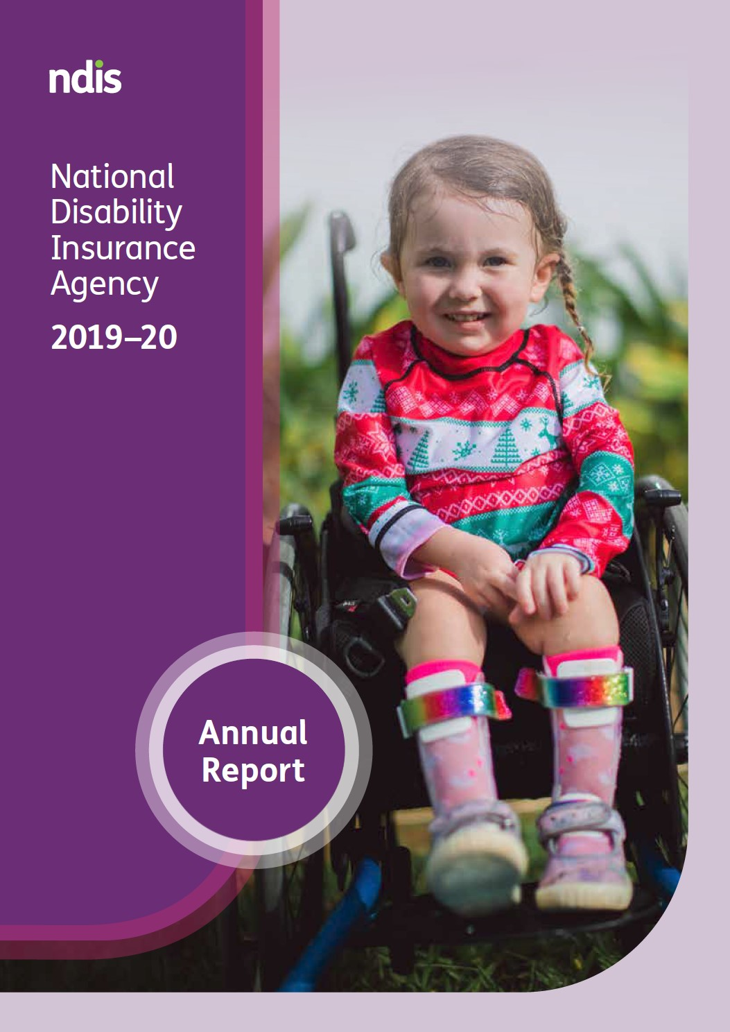

At the heart of the Agency are our participants, always.
Our first priority is to ensure each participant, no matter where located, lives the life they want today and into the future.
Meet five year old Reece Child from South Australia, who loves to hang from the monkey bars and jump on a trampoline like most boys his age.
When he was a baby, doctors initially diagnosed Reece with cerebral palsy, but later discovered he has his own unique syndrome consisting of, among other things, hypotonia (low muscle tone), which impacts his mobility, muscle strength and swallowing.
Today, not only does Reece not need a wheelchair; he can run, climb trees, kick a football, ride a balance bike and walk on a balance beam. He has tried pre-Auskick and his dad says he ‘absolutely nailed it’.
Reece’s parents say his astonishing progress is all thanks to early intervention through the National Disability Insurance Scheme (NDIS) and provider Novita.

Cover: Aviana McElwee, or Avi as her parents call her, has a rare genetic neuromuscular disorder—spinal muscular atrophy, type 1 (SMA1), the leading genetic cause of death in infants. “With NDIS funding, she’s going from strength to strength because of all the therapy we are able to access,” Avi’s mum, Bethan, said.
Contents
Letter of transmittal 5
1 Introduction 6
1.1 Acknowledgement 6
1.2 Chairman’s review 6
1.3 Chief Executive Officer’s review 7
1.4 The National Disability Insurance Scheme 9
1.5 The National Disability Insurance Agency 10
2 Implementing a participant focused scheme 11
2.1 Where we have come from 11
2.2 Where we are today 17
2.2.1 NDIA Aspirations 17
2.2.2 NDIA Values 18
2.2.3 Key achievements in 2019-20 19
2.3 How we intend to move forward 37
3 Financials 39
3.1 Financial statements 39
3.2 Summary of the Financial Sustainability Report 2019-2020 76
3.3 Annual performance statements 81
3.3.1 Introduction 81
3.3.2 Structure and content 81
3.3.3 Aspirations 81
4 Management and accountability 88
4.1 Governance 88
4.1.1 Responsible Minister 88
4.1.2 Ministerial Council 88
4.2 The Board 88
4.2.1 Directors 89
4.2.2 Board committees 94
4.2.3 Board and committee attendance 95
4.2.4 Board membership changes 97
4.3 The Independent Advisory Council 97
4.4 The Chief Executive Officer and Executive Team 99
4.4.1 The Executive Leadership Team 99
4.4.2 Organisation structure 101
4.5 Partners in the community 105
4.6 Workforce management 105
4.7 Staff engagement 107
4.8 Risk management 107
4.8.1 Scheme integrity 108
4.8.2 Internal audit 111
4.8.3 External audit 111
5 Appendices 112
5.1 Enabling legislation 112
5.2 Audit Committee Charter 112
5.3 Work health and safety 113
5.4 Workforce statistics 113
5.5 Executive remuneration policy 116
5.6 Executive remuneration 116
5.6.1 Key management personnel 116
5.6.2 Information about remuneration of key management personnel 119
5.6.3 Senior executives 122
5.6.4 Other highly paid staff 124
5.7 Reports by parliamentary committees 125
5.8 Judicial decisions and external reviews 126
5.9 Administrative Appeals Tribunal reviews and decisions 128
5.10 Other PGPA reportable items 129
5.11 Advertising and market research 129
5.12 Ecologically sustainable development and environmental performance 131
5.13 Compliance with Carer Recognition Act 132
5.14 Information on other specific statutory provisions 133
5.15 Glossary 134
5.15.1 Definitions 134
5.15.2 Acronyms 135
6 Index 138
6.1 Compliance index 138
6.2 Tables index 142
6.3 Figures index 143

Letter of transmittal
Dear Minister
On behalf of the National Disability Insurance Agency, I present to you the annual report for the reporting year 1 July 2019 to 30 June 2020.
The report provides a detailed description of the Agency’s operations during the year and has been prepared in accordance with the Public Governance, Performance and Accountability Act 2013 (PGPA Act) and the National Disability Insurance Scheme Act 2013 (the NDIS Act).
In accordance with section 39 of the PGPA Act, the report provides information about the Agency’s performance in achieving its purposes.
The report includes a copy of the Agency’s annual financial statements and the Auditor-General’s report as prescribed by subsection 43(4) of the PGPA Act.
The report is made in accordance with a resolution of the Board of Directors, on 15 September 2020, who are responsible for its preparation and content, and is being provided to you as the responsible minister under section 46 of the PGPA Act.
The incorporated summary of the Annual Financial Sustainability Report 2019–20 and the inclusion of the reviewing actuary’s report fulfils the Agency’s obligations under subsection 172(4) of the NDIS Act.
Yours sincerely
Dr Helen Nugent AO
Chairman
National Disability Insurance Agency
15 September 2020

Introduction
The 2019–20 Annual Report for the National Disability Insurance Agency (the Agency or NDIA) is prepared in accordance with legislative requirements. It summarises the Agency’s performance from 1 July 2019 until 30 June 2020. This includes how the Agency fulfilled the principles set out in the National Disability Insurance Scheme Act 2013 (NDIS Act).

Acknowledgement
We acknowledge and pay our respects to fellow Australians with disability - and reconfirm our commitment to the mission of the NDIS to contribute to a just and inclusive Australia where all can reach their full potential and contribution. We support the objectives of the Convention on the Rights of Persons with Disabilities.
The Agency also acknowledges the Traditional Owners and Custodians of the country throughout Australia, and their continuing connection to land, sea and community. We pay our respects to their Elders, past, present and emerging.

Chairman’s review
The National Disability Insurance Agency has a singular focus: to help participants improve their outcomes.
2020 was a landmark year for the National Disability Insurance Scheme.
Seven years after the launch of the Scheme, and four years after the move from Trial to Transition, the Scheme is now available to all eligible participants throughout Australia, with over 390,000 participants benefiting from the supports provided. But, from a participant perspective, the delivery of faster and improved services has also been significant. The time to deliver access decisions and first plans dramatically reduced; participant satisfaction rates climbed to over 80 per cent; the number of reviewable decisions declined; and the percentage of complaints fell to a record low. That reflects better service for participants.
This has not happened by chance. It has happened because of the ability to commit additional resources; through the energy and commitment of the Minister, the senior management team under the leadership of our new Chief Executive Officer (CEO), Martin Hoffman, and through the dedication of front line staff and partners. Simplified and streamlined processes have also been important.
Most importantly, the year saw improved outcomes for participants: participants exercising more choice and control in their decision-making; more carers joining the workforce; greater social inclusion for participants; and better health outcomes for some participants.
And, in the latter part of the year, those improvements occurred at the same time as participants faced the challenge of COVID-19. Participants were front and centre as we recognised that the challenges they faced were greater than most other groups in society.
In consultation with participants and providers, we learned together as events unfolded. We made it easier for participants to access supports; we made technology more accessible so they could get support without leaving home; we helped negotiate easier access to supermarket deliveries; and we made it possible for providers to access personal protective equipment so that participants and provider staff could be safe. Between March and June we made over 65,000 care calls to the Scheme’s most at-risk participants. And that has continued into the next stage of restrictions in Victoria. Through those calls, we have sought to let participants know we care about them as an individual and that they are not alone during this dark hour. Meeting the needs of participants in disability homes has also been a core focus as we work with providers and other state and federal agencies to keep participants as safe as possible. Nonetheless, a small number of participants have passed away. We offer our sincere condolences to their family and friends.
Our unrelenting focus on participants will continue and be amplified over the coming year, particularly through the early implementation of the Participant Service Guarantee. At the same time, we will respond to any challenges that COVID might bring, while striving to simplify and streamline the way we serve participants and those who provide supports to them.
The Board and management are equally focused on getting it right for participants. The CEO and his committed leadership team have made a real difference, as did Vicki Rundle, who was interim CEO before Martin joined.
So too have my dedicated colleagues on the Board. In particular, I wish to acknowledge and thank the Chairmen of the Board Committees, who bear a disproportionate workload: Estelle Pearson, Sandra Birkensleigh, Jim Minto, Paul O’Sullivan, and Robyn Kruk.
In addition, I pay a heartfelt tribute to John Walsh, who throughout the past year so ably led the Independent Advisory Council, through whose membership the voice of the participant resonates so profoundly with their frank, wise and fearless advice. Subsequent to the end of the financial year, John has advised of his intention to resign from the Board. The Board and all participants are in John’s debt for the legacy of the Scheme that he fought for and profoundly shaped. We know he will remain a passionate advocate for the Scheme.
We will also greatly miss another founding Director, Martin Laverty, with his background as a lawyer and his boundless passion for the Scheme. Andrea Staines also made a significant contribution through her first-hand knowledge of disability, as well as her insights into using technology to the benefit of participants. We also welcomed Jane Burns, who brings with her a wealth of knowledge of mental health and first -hand experience of disability.
In conclusion, I wish to acknowledge the many participants, providers and representatives of the sector with whom I have had the privilege of interacting over the past year, COVID-19 notwithstanding. I gain insight, wisdom and strength from each of you and I thank you for your ongoing commitment to the Scheme.

Chief Executive Officer’s review
I joined the Agency as CEO on 4 November 2019. I’m proud to be leading the Agency at this critical time as we make the transition from establishing a world-first Scheme, to improving the experience and outcomes our participants achieve with the Scheme.
This Annual Report sets out the significant achievements we made this year on that journey, culminating in the Scheme being fully available throughout Australia on 30 June 2020, and serving almost 400,000 participants with over a third of those receiving supports from government for the first time.
Most importantly, the Report highlights the positive impact the Scheme is having on the lives of participants. Participants are making more of their own decisions, are much more involved in the community and are better positioned to undertake activities that interest them.
We also made significant improvements in the operating efficiency of the Agency. Getting the operational detail right means we have a better chance of having the Scheme deliver on its real purpose – a different life trajectory for people with disability.
- In the June quarter, we had the lowest absolute number of complaints since June 2018, and that was when the Scheme had less than half the number of participants we do now.
- Our Satisfaction Survey results in the June quarter (based on a random sample of over 5,500 participants with ongoing oversight and input from the Independent Advisory Committee) recorded our highest scores, averaging over 83 per cent satisfaction across access, pre-planning, first-plans and plan reviews.
- We are getting more than 90 per cent of reviews of reviewable decisions done in less than 60 days, with more than 95 per cent of any resulting plan changes being implemented in less than 28 days.
- In September 2019 we had 8,400 review cases open; at June 2020 it was down to 2,100.
- Our focus on Participant Requested Plan Reviews is working too, in June 2019 we had 7,300 open reviews; at June 2020 it was down to 2,200.
- In June 2020, access decisions on average took 10 days, four times faster than 12 months ago. The average number of days to receive a first plan is 67 days, 50 per cent lower than 12 months ago.
And all this has been done through a year when we also added 106,000 new participants and were dealing with a pandemic and all that has meant for Australia.
These are all just operating statistics – but we never forget each one represents an interaction with a real person, a participant and their family.
The Annual Report also gives a sense of the future direction of our journey, which of course is set out in more detail in the 2020-24 Corporate Plan.
I want to focus also on the intangibles – how the Agency will act and feel both internally and, even more importantly, externally: how we will make real our culture and values. Again, this Report sets out the progress we have already made on this front.
We will have a renewed focus on our participants, constantly asking ourselves: if I was a participant or my child was, how would I want things to happen? And of course many of our staff are just that: participants or close family members of participants.
We will have a greater sense of urgency and pace in everything we do; decision velocity matters, just as decision quality does.
We will be resisting the tendency towards the bureaucratic inward focus on process and form for its own sake, and instead take an outward focus on the participant experience and outcomes.
We will continue to improve how we engage about the Agency, our guidelines and decision making. Co-design and consultation will be real and meaningful. We’ll show a willingness to genuinely listen even if we don’t always agree, and willingness to say directly where we don’t agree and not skirt around it.
We’ll also be working more closely with the other service systems – such as health, education, justice – across all jurisdictions that interact with our participants to reduce complexity.
We will continue to focus on maintaining a high performing, high engagement, flexible and fast-moving culture.
In my time with the Agency, I have been impressed by the passion and commitment of our workforce. Our staff and Partners in the Community teams have demonstrated the Agency’s resilience throughout the recent challenging times of severe bushfires and the COVID-19 pandemic. I thank them all for their incredible efforts over the last year.
I must recognise Vicki Rundle, who acted as CEO before my appointment and then continued as a Deputy providing tremendous support and guidance. Vicki left for a senior leadership role at the Department of Veterans’ Affairs at the end of the year, leaving a lasting contribution to the Scheme.
I also want to sincerely thank the many individual participants, families and carers, representative organisations, providers and peak bodies with whom we engage in many different ways for their expert assistance, support and encouragement, and for holding us to account too.
I should also acknowledge our colleagues at the NDIS Quality and Safeguards Commission and the Department of Social Services, with whom we work closely to deliver the Scheme.
I want to thank Helen Nugent as Chairman and the whole Board for its unstinting support and commitment to me and the whole Agency, in the interests of the Scheme and its participants. And the Independent Advisory Council for its significant and expert contribution over the year.
Let me close by stating simply that the whole Agency team and I are committed to bringing the Scheme ever closer to fulfilling the promise made to Australians living with disability. 2019-20 saw the Agency improve in delivering on that promise, with further progress to come.

The National Disability Insurance Scheme
The National Disability Insurance Scheme (NDIS or the Scheme) is a fundamental shift in the way Australians with a significant and permanent disability access supports. It ensures that all eligible Australians under the age of 65 years who have a permanent and significant disability can get the reasonable and necessary supports they need.
Under the Scheme, eligible people, known as participants, are given a plan of supports that is developed and tailored to their individual needs. A plan may include informal supports that a person receives through family or friends and from mainstream or other community services. If required, the Scheme will also fund reasonable and necessary supports that help participants achieve their goals.
Participant choice and control are core features of the Scheme’s design. In this market-based system, participants work closely with planners and Local Area Coordinators (LACs) to determine a plan that focuses on their individual goals. Participants can choose their providers and move between them, rather than having providers selected for them.
On 1 July 2020 Christmas Island and Cocos Island joined the Scheme, completing the staged national geographical rollout of the NDIS.
The Scheme provides specialist disability supports that complement mainstream services provided by the Australian Government and state and territory governments. It is founded on insurance principles, making evidence-based decisions on individuals’ access to the Scheme.
This insurance approach is underpinned by four key principles:
- Develop actuarial estimates of the reasonable and necessary support needs of the targeted population
The Scheme Actuary estimates the aggregate annual funding requirements through analysis of reasonable and necessary support needs. The Agency continually tests the aggregate funding requirement against emerging experience.
- Focus on lifetime value for Scheme participants
The Agency focuses on lifetime value for Scheme participants by funding competitively priced, best-practice supports that deliver benefits and outcomes for participants. This includes the allocation of resources through early investment in capacity building.
- Invest in research and innovation
The Agency invests in research and innovation aligned to the Scheme’s goals of improving social and economic participation, and independence for participants.
- Support the development of community capability and social capital
In addition to providing individual supports, the Agency invests at a systemic level. For example, the Agency encourages the use of mainstream services, building community capacity and social capital. These activities are designed to benefit all people with disability, including people with disability who are not participants in the Scheme.
These four insurance principles are governed by the Board, which assesses, monitors, reports and manages Scheme sustainability within a prudential framework and in line with the Portfolio Budget Statements. This means that decisions are informed by:
- a person’s level of functional capacity
- the reasonable and necessary supports required to enable a person to reach their goals, live and enjoy their life
- the overall context of Scheme financial sustainability.
This approach considers financial support over the lifetime of the participant and is a move away from a traditional welfare model. The Scheme also has greater capacity for cost management as it maintains sustainability by calculating the total future cost of support for all eligible participants.
The Scheme is ultimately designed to support participants to reach their individual goals and ensure they have the opportunity to participate in the community, get a job if they are able, and live more independent and full lives.
The Scheme forms an important part of the Australian Government’s National Disability Strategy 2010-2020, a 10-year policy framework for improving the lives of Australians with disability, their families and carers. Governments and communities across Australia are working together to develop a new strategy beyond 2020. The current and future strategy will be the key way Australia implements the United Nations Convention on the Rights of Persons with Disabilities, making sure people with disability can participate in all areas of Australian life and fulfil their potential as equal citizens.

The National Disability Insurance Agency
The Agency is a corporate Commonwealth entity under the PGPA Act with statutory authority under the NDIS Act. Funding and governance of the Scheme is shared among the federal and state and territory governments. All Australian governments are involved in decisions on NDIS policy, funding and governance.
The Agency is overseen by the NDIA Board, which has responsibility for ensuring the proper, efficient and effective performance of the Agency’s functions and for setting our strategic direction. The Agency’s governance structure also includes an Independent Advisory Council (IAC) that provides advice to the Board on how effectively the Agency is delivering the Scheme.
The NDIS Act, in conjunction with other laws, gives effect to Australia’s obligations under the United Nations Convention on the Rights of Persons with Disabilities.

Implementing a participant focused scheme
The 2020 financial year represents a significant milestone in the history of the NDIS, as this once in a generation social and economic reform moves from the Transition Phase into Full Scheme. It is, therefore, timely to reflect on where we have come from; where we are today; and how we intend to move forward.

Where we have come from
On 1 July 2020, the NDIS celebrated its seven year anniversary. This also marked completion of the staged national geographical rollout of the NDIS, with Christmas Island and the Cocos Islands joining the Scheme.
While the implementation of the NDIS started in 2013 in seven trial sites across Australia, 1 July 2016 marked the start of the Transition Phase and the rapid expansion of the Scheme. At the end of the Trial period, the Scheme was geographically available to only eight per cent of the Australian population in specific geographies. As at 30 June 2020, the Scheme is now available to all Australians, irrespective of where they live. Almost 30,000 participants entered the Scheme in the first three years of operation, while over the subsequent four years of transition, another 362,280 participants gained entry to the Scheme. This brought the total number of participants at 30 June 2020 to 391,999. It is now truly a national Scheme.
Figure 2.1A: The number of active participants has increased from around 30,000 after three years of Trial, to nearly 392,000 four years later
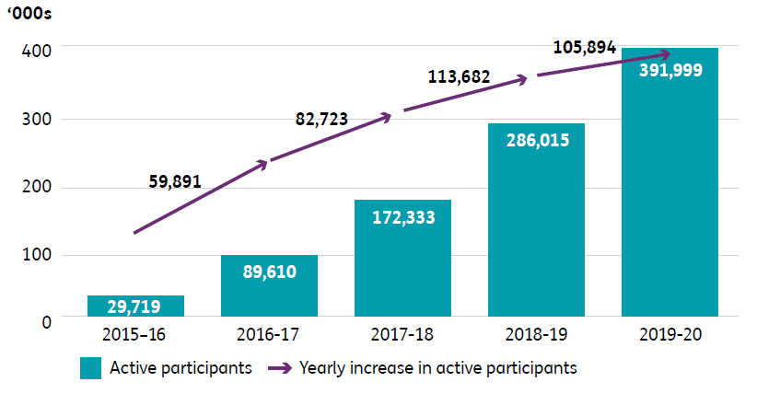
The increase in participant numbers has led to an acceleration in the number of plan reviews. In 2019-20, the Agency undertook 332,070 reviews, compared to 205,163 reviews in 2018-19.
Figure 2.1B: The increase in participant numbers has led to an increase in the number of plan reviews
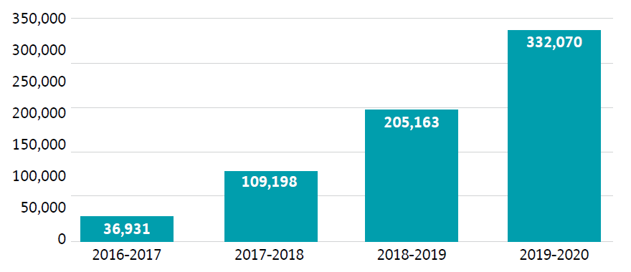
But the most important measure is the positive impact the Scheme is having on the lives of participants. Parents of children in the Scheme are seeing their child’s independence increase. Participants aged 15 to 24 are making more of their own decisions and are much more involved in the community. Participants over 25 are now in a better position to undertake activities that interest them. They also say that their access to health services has improved and that the time they have spent in hospital has decreased. These are small steps on the journey to far more significant improvements in the lives of people with disability.
Figure 2.1C: Reported participant outcomes
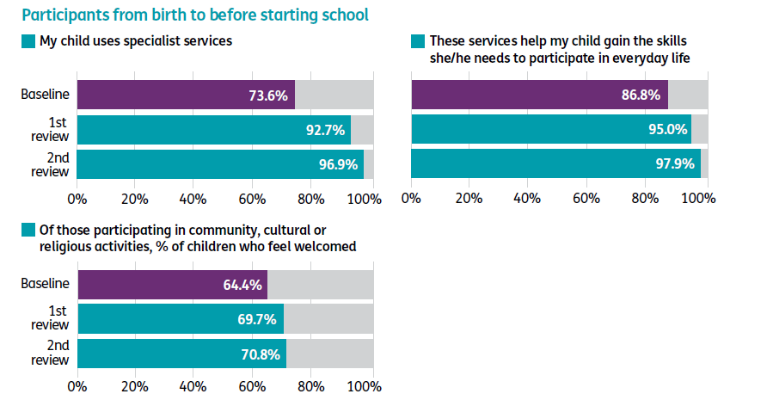
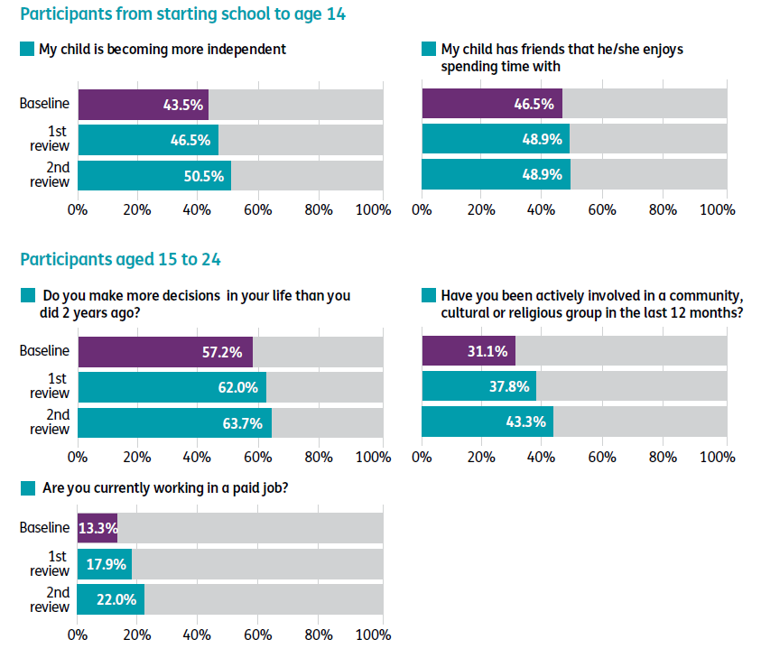
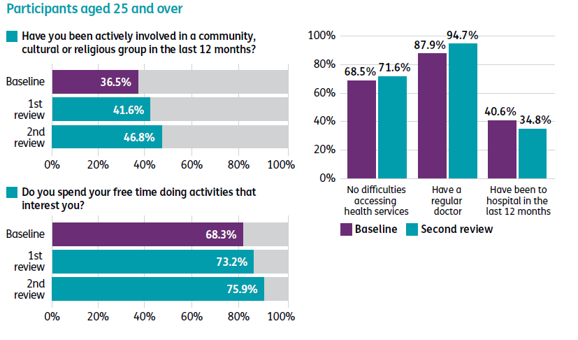
While the rate of participation in work for those in the Scheme continues to be stable, there are some marginal increases in employment for participants who entered the Scheme between 1 July 2016 and 30 June 2017 and have been in the Scheme for three years. More needs to be done to facilitate greater access to employment opportunities.

For participants who entered the Scheme between 1 July 2016 and 30 June 2017 and have been in the Scheme for three years, there was a:
- twelve percentage increase from 13% to 25% for participants aged 15 - 24 years
- two percentage decrease from 26% to 24% for participants aged 25+ years
- one percentage increase from 23% to 24% for participants aged 15+

For participants who entered the Scheme between 1 July 2017 and 30 June 2018 and have been in the Scheme for two years, there was also a marginal increase in employment:
- six percentage increase from 15% to 21% for participants aged 15 - 24 years
- two percentage decrease from 25% to 23% for participants aged 25+ years
- an unchanged result of 23% for participants aged 15+

The lives of families and carers are also improving. More of them are in paid jobs, and they are seeing improved relationships with the services that assist with the care of their loved ones. Importantly, they are also seeing significant improvements in obtaining services that meet the needs of their loved ones and their needs as carers. This data is a strong indicator of the benefits of the Scheme, not just for participants but also for families and carers.
Figure 2.1D: Reported family and carer outcomes
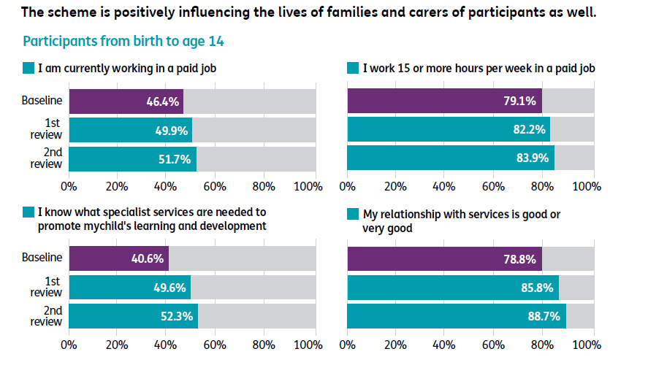
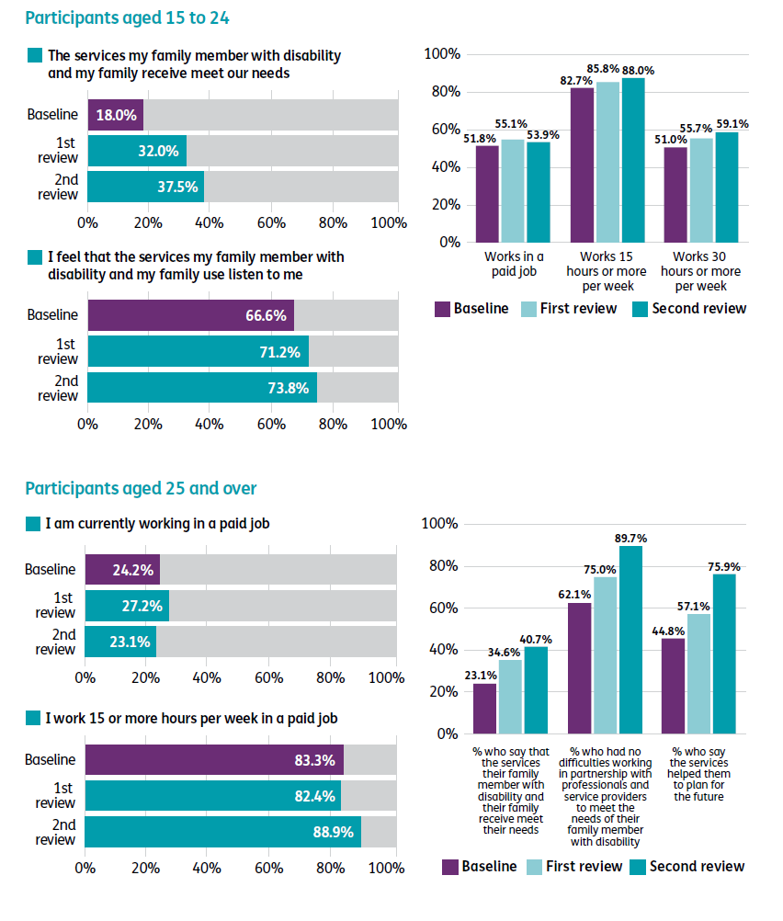
The payments being received by individual participants have increased significantly over the last four years. Participants received an average of $50,800, as at 30 June 2020, up from $32,300 as at 30 June 2017. While this significant increase has benefits and challenges, it reflects changes in participant mix, as well as real increases in participant benefits. Moreover, the longer participants are in the Scheme, the more empowered they are to utilise their plan. The significant increase in the number of participants and in the average payment per participant has resulted in total Scheme payments increasing from $2.18 billion in the first year of transition (2016-17) to $16.11 billion* in 2019-20.
* This number reflects payments made during the 2019–20 year for support provided in the 2019–20 year and differs from the amount in the annual financial statements. This number will progressively increase and will be re-stated in subsequent quarterly reports to reflect payments made for supports provided in 2019–20 post 30 June 2020.
Figure 2.1E: Over the last three years, the Scheme has grown by more than seven times
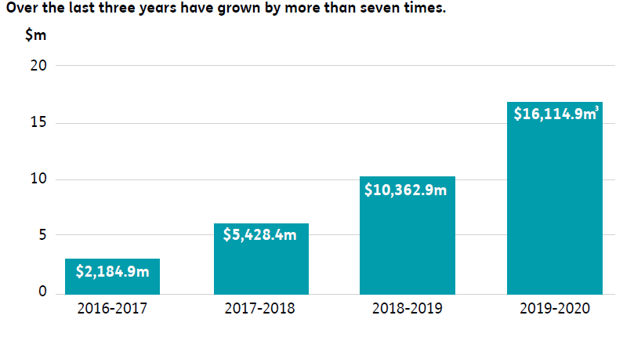
³The numbers in this chart reflect payments made for support provided in each financial year. For example, in 2018-19, $10,362.9m of support was provided to participants. As there is a lag between when support is provided and when it is paid, some of the support provided in 2018-19 was paid for in 2019-20–however, these payments are counted in the $10,362.9m in 2018-19 because this is when the support was provided. For 2019-20, the $16,114.9m is the support that has been provided in 2019-20 and paid for in 2019-20. The amount of support provided in 2019-20 is higher than the $16,114.9m as some support provided in 2019-20 had not been paid for by 30 June 2020 (when the data was analysed), and will be paid for post 30 June 2020. This number reflects payments made during the 2019–20 year for support provided in the 2019–20 year and differs from the amount in the annual financial statements. This number will progressively increase and will be re-stated in subsequent quarterly reports to reflect payments made for supports provided in 2019–20 post 30 June 2020.
Payments to participants are flowing through a larger and more vibrant provider sector, with the number of providers having increased from 4,005 in 2017 to 14,882 in 2020. This four-fold increase in the number of providers has led to greater choice and control for participants, and expanding employment opportunities for the disability workforce.
Figure 2.1F: The number of providers actively supporting participants has grown by almost four times since 2017
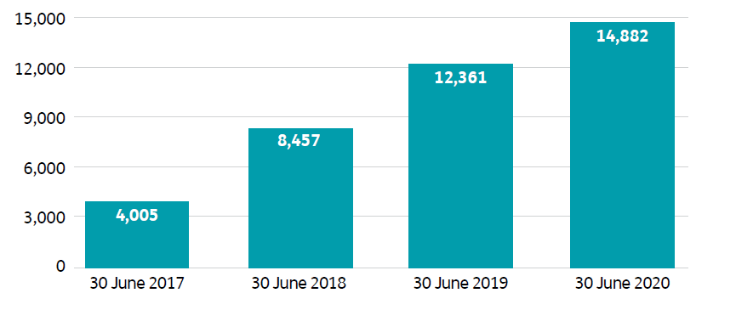
To support the significant growth in the Scheme, the number of staff engaged through the NDIA and its partner organisations that directly serve participants has also increased from 4,564 as at 30 June 2017 to 11,550 by the end of the 2020 financial year.
Figure 2.1G: The NDIA staff and partner workforce has increased 2.5 times over the last three years
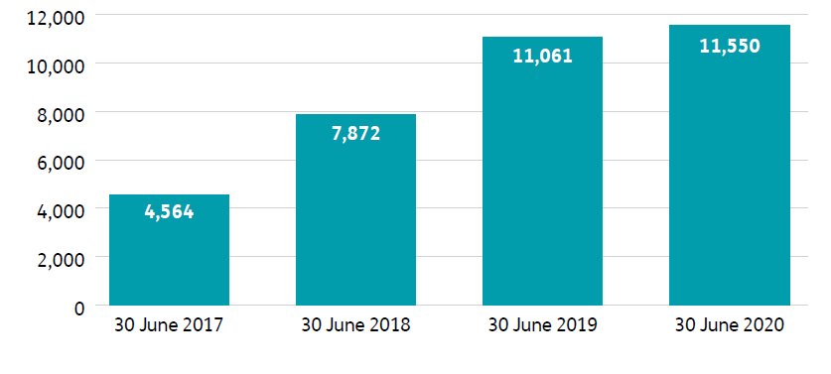
In summary, the past seven years – and particularly the last four – have seen the rollout of one of the most significant reforms in Australian history. The Scheme is now reaching people with disability in every region in Australia, and delivering life-changing improvements in their lives. At the same time, it is driving economic growth and providing more employment opportunities to support NDIS participants to achieve their goals. This reform is a critical boost to the Australian economy, when over 1.5 million jobs have been lost in recent months due the impact of COVID-19.

Where we are today

NDIA Aspirations
Drawing on the expectations of the former Council of Australian Governments Disability Reform Council, the Agency’s purpose is supported by five aspirations, as outlined in the NDIA Corporate Plan 2019–2023 and illustrated in figure 2.2.1A. The five aspirations are:
- A quality experience and outcomes for participants
- A competitive market with innovative supports
- A connected and engaged stakeholder sector
- A financially sustainable scheme
- A high-performing NDIA.
The Disability Ministers’ expectations for participant and community outcomes, supporting market development, and safeguarding the sustainability of the NDIS are reflected in Aspirations 1, 2 and 4. The expectations for developing a high-performing NDIA and building and maintaining stakeholder confidence are reflected in Aspirations 3 and 5.
The new NDIA Corporate Plan for 2020–2024 includes an additional aspiration that articulates the Agency’s work within a whole-of-government response in slowing the spread of COVID-19, and ensuring continuity of essential services to NDIS participants.
To view the current NDIA Corporate Plan, go to www.ndis.gov.au.
Figure 2.2.1A: NDIA Purpose and Aspirations (2019-2023)
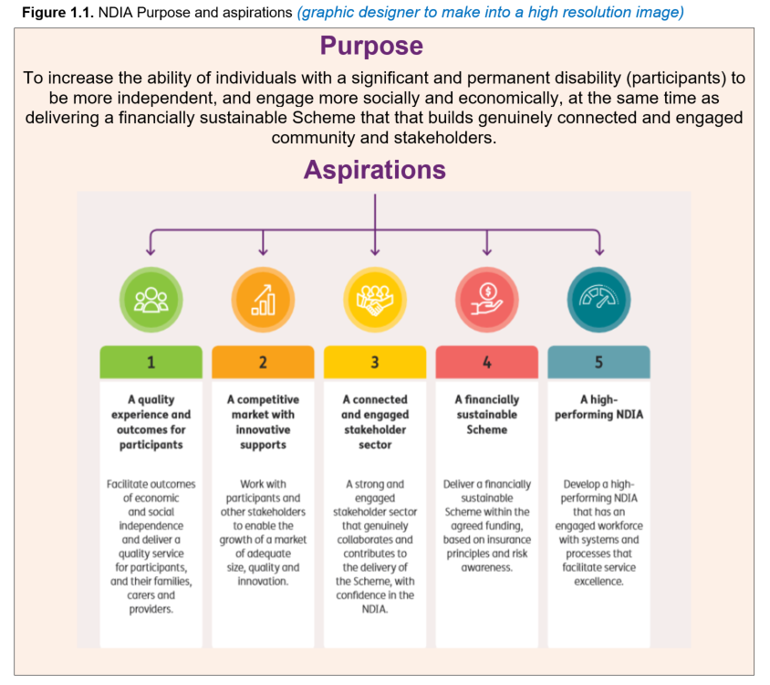

NDIA Values
The Agency works within a set of four key values, illustrated in figure 2.2.2A. These values, which were developed in consultation with staff and partners, reflect our passion for and commitment to an empowered, inclusive and participant-centred culture.
Figure 2.2.2A: National Disability Insurance Agency Values
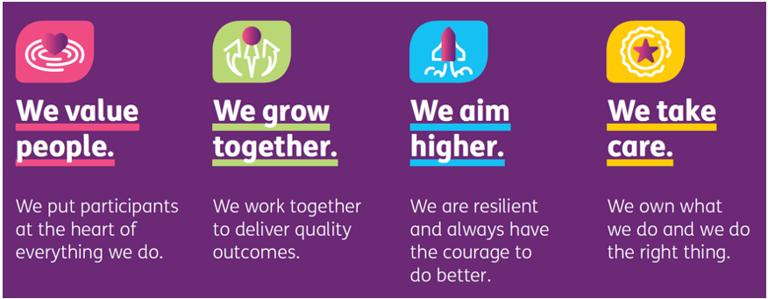
Additionally, all Agency staff are required to follow the Australian Public Service (APS) Values and Code of Conduct, which require all staff to be impartial, committed to service, accountable, respectful and ethical.

Key achievements in 2019-20

Response to coronavirus (COVID-19)
Throughout the first half of 2020, the priority of the NDIA was supporting participants, providers, staff and partners during the COVID-19 pandemic. The response required a rapid realignment of priorities as the Agency responded to ensure participants, including those deemed to be at high risk, continued to get the support they needed.
The NDIA continues to work across governments, including with the Department of Social Services (DSS), the NDIS Quality and Safeguards Commission, Services Australia, and state and territory governments to ensure continuity of essential supports for NDIS participants. This includes a specific focus on supporting participants in COVID-19 ‘hot-spots’, especially Victoria.
As at 30 June 2020, the NDIA had rolled out initiatives to support participants during the pandemic, including:
- Proactively contacting 65,844 vulnerable participants to ensure they had the essential support they required. This measure was very well received by participants. Subsequently, efforts have been redoubled with Victoria’s declaration of a State of Disaster in August 2020.
- Working closely with state and territory officials to alleviate pressure on the hospital system. More than 1,000 participants who were clinically ready for discharge from hospital exited the hospital system to alternative accommodation.
- Working with supermarket retailers to make sure NDIS participants wanting support to grocery shop had priority access to home delivery services.
- Encouraging participants to identify their essential supports and to use their funding flexibly to meet their critical needs, with plans being amended quickly where required to support this flexibility. Plan flexibility included participants being able to access low-cost assistive technology of up to $1,500 (e.g. smart devices) to help ensure the continuity of NDIS-funded supports (e.g. therapy and social participation).
- Staff and partners working flexibly to support participants through the pandemic – planning meetings were conducted via phone (or video-conference) or face to face at the preference of the participant.
During the COVID-19 pandemic, underlying payments for support remained at pre-pandemic levels and indeed increased, indicating that participants continued to receive supports while recognising that the mix of supports somewhat changed. Total average weekly payments increased from around $326 million in February and March 2020 to $364 million in June 2020. While community and social participation supports reduced due to community restrictions, activities of daily living supports increased for participants at home.
In addition to supporting participants during the pandemic, the NDIA implemented initiatives to support providers, complementing the broader suite of assistance provided by the Government to businesses and workers. Specific initiatives included:
- $668 million was paid in one-off advance payments to 4,769 registered providers to support them with immediate cash flow to help them continue to operate and support participants.
- A temporary 10 per cent COVID-19 price loading on some supports was added for three months (25 March 2020 to 30 June 2020) to help providers better cover the additional costs associated with operating during the pandemic.
- Increased flexibility with the NDIA’s cancellation policies from 25 March 2020 to 30 June 2020.
- Two new support items were introduced for participants in supported independent living (SIL) diagnosed with COVID-19 (cleaning services and additional supports to cover the costs of higher intensity support related to the participant’s diagnosis).
- Access to the National Medical Stockpile of personal protective equipment (PPE) for disability providers including registered and unregistered providers, and self-managed participants. As at 30 June 2020, 25,550 items of PPE from the National Medical Stockpile have been distributed to organisations delivering support to NDIS participants.
The NDIA has maintained regular engagement with providers and sector stakeholders to ensure the Agency is responsive to emerging issues on the ground, including workforce issues. This includes regular daily meetings as well as personal care calls to CEOs of disability organisations and providers.
The impacts of COVID-19 are far-reaching, and will continue to affect participants, their families, carers, providers and Agency staff for years to come. As the pandemic continues to evolve, and ‘hot-spots’ emerge, the NDIA’s absolute priority continues to be participants’ health, safety, and ensuring participants can continue to access their essential supports. The health of those caring for participants is also a priority. Without them, participants cannot be safe.
In addition to the pandemic, the NDIA supported participants affected by the January 2020 bushfires in Victoria and NSW, both during the emergency and in the recovery phase. Agency-initiated reviews for participants were used in affected areas to capture changes in circumstances and, where required, plans were adjusted to provide necessary supports as well as repairs or replacement of equipment. Agency staff also worked with Services Australia Mobile Service Vehicles and Pop-Up Service to support participants in affected areas.

Quality experience for participants
The NDIA’s central focus is to ensure participants realise the full benefits of this visionary social reform.
The path to ensuring the NDIS delivers on this promise has been challenging. Processes put in place during Trial were ill-defined and systems were inadequately scoped, creating multiple challenges in the Transition Phase of the Scheme. As a result, the Agency was not as well positioned to deliver the quality of service that the Board and management desired.
The focus of the past four years, and in particular of 2020, has been on initiatives to address these challenges, including those related to the underlying NDIS service delivery model. This work has resulted in significant progress being made.

Wait times
Wait times have been reduced. Access decisions are now being made on average within 10 days for adults and six days for children, which is four and seven times faster respectively than was the case 12 months ago. The time to obtain a first plan has significantly reduced by 50 per cent for adults, and 67 per cent for children. This reduction is particularly important for children, as getting support early reduces the impact of development delays or disability.
In addition, plan reviews requested by a participant are being undertaken at pace. As at 30 June 2020, 100 per cent of all decisions on whether a review would be undertaken were made within 21 days. Where it was decided to undertake a review, 53 per cent of the plans were reviewed within 28 days.
Figure 2.2.3A: The average number of days taken to complete an access decision (within the month)
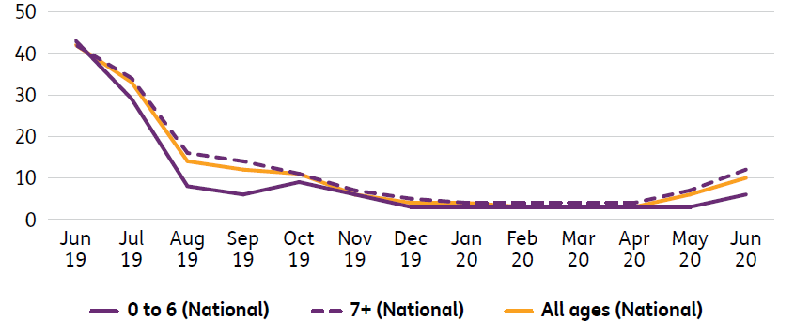
Figure 2.2.3B: The average number of days taken to complete and approve a first plan
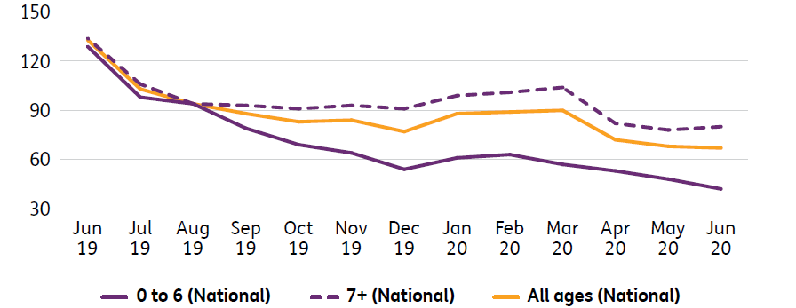
The number of review of reviewable decisions (RoRDs) has increased over the last year due to the increase in the number of participants. As at 30 June 2020, there was a significant reduction (69 per cent) in the number of open RoRDs.
Figure 2.2.3C: RoRDs received and closed during the March quarter and open as at 30 June 2020
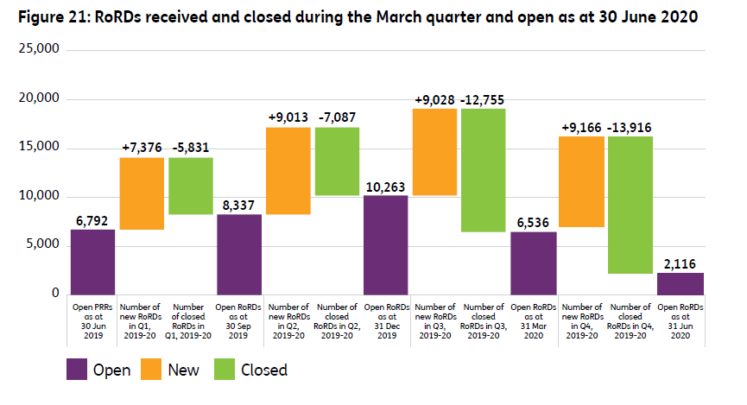
The backlog of assistive technology and home modification quotes has been cleared. The Agency aims to have 90 per cent of assistive technology and home modification requests completed in under 10 days.
Moreover, the National Contact Centre (NCC) continues to meet high service levels, with 84 per cent of calls answered within 60 seconds, and abandonment rates consistently are at a low 1.1 per cent. The average speed to answer was less than 26 seconds.
Satisfaction levels are high and continue to improve across each stage of participant engagement with the Scheme. A larger, more robust survey launched in Quarter 2 2018-19, shows the improvements made up to Quarter 4 2019-20: from 69 per cent to 81 per cent at the access stage; from 75 per cent to 83 per cent during the pre-planning process; from 77 per cent to 84 per cent at the planning process; and from 68 per cent to 85 per cent at the review stage. In response to a key empathy question as to whether the person from the NDIS understands a participant’s disability, satisfaction ranged from 83 per cent to 88 per cent across the pre-planning; planning; and plan review process.
Figure 2.2.3D: Trend of satisfaction across the pathway (% very good/good)
There has also been a reduction in the number of participant complaints over the past year, and it is now at the lowest rate in three years. Participant complaints received per quarter, as a percentage of access requests, was 5.4 per cent a year ago and is at 3.9 per cent in June 2020. In June 2020, 84 per cent of complaints were closed within 21 days, compared to 32 per cent of complaints in June 2019.
Figure 2.2.3E: Participant complaints received as a proportion of access requests
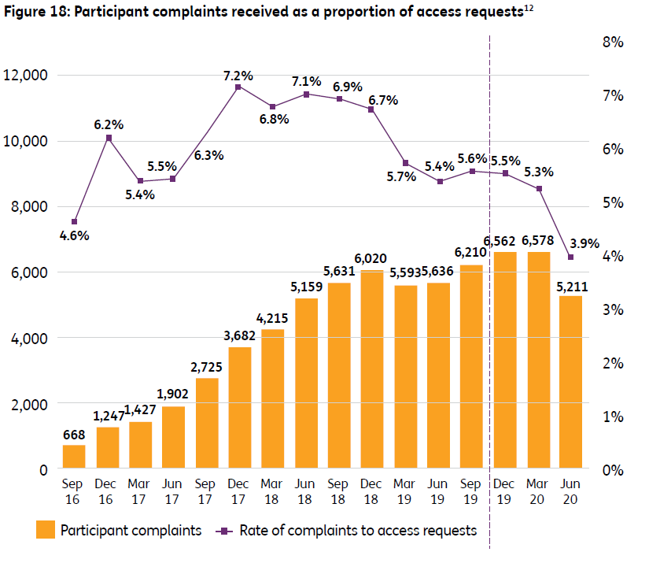

Participant characteristics
More than 120,000, or 31 per cent, of participants in the Scheme have a primary disability of autism, and a further 84,769, or 22 per cent, of participants have an intellectual disability. Understanding trends and differences in the prevalence rate of disability cohorts among age groups and states is important to ensuring equity and fairness in decision-making as well as the ongoing financial sustainability of the NDIS.

Participant diversity
In 2019-20, Scheme participants continued to reflect Australia’s diversity, with higher proportions of participants from Aboriginal and Torres Strait Islander and culturally and linguistically diverse (CALD) backgrounds entering the Scheme. As at 30 June 2020, 25,077 participants in the Scheme identified as Aboriginal and/or Torres Strait Islander, compared to 16,417 in the previous year (increase of 52.8 per cent) and 36,066 participants identified as CALD, compared to 24,023 in the previous year (increase of 52.8 per cent). The proportion of participants who identify as CALD (9.2 per cent) is well below the estimate of 21 per cent. The expanded NDIA Community Connector Program will assist the Agency to identify people with disability in CALD communities, increase awareness of the NDIS and provide support for people to access the Scheme. In addition, the NDIA Board has initiated further work to understand the slower than expected intake of CALD participants.

Support for children
Of the 391,999 participants with approved plans at 30 June 2020, 61,962 were children aged 0-6 (16 per cent). Over the past year, the number of children receiving support in the Early Childhood Early Intervention (ECEI) Approach has increased by 54 per cent.
The wait times for children to access NDIS supports have significantly decreased. Access decisions are now being made on average within six days for children, which is seven times faster than 12 months ago. The time to obtain a first plan has also significantly reduced by 67 per cent for children. This reduction is important for children as getting support early reduces the impact of their development delays or disability.
The Agency has commenced a review of the implementation of the ECEI Approach to ensure it is based on best practice and is family centred.

Enhanced planning to better respond to the episodic nature of psychosocial disability
In 2019-20, the NDIA continued to roll out improvements for people with a psychosocial disability nationally. This includes embedding processes for streamlined access into everyday practices, the development and sharing of key documents to support access decisions, delivering training and education regarding NDIS access requirements to the mental health sector, and the addition of a new support item called ‘psychosocial recovery coach’ in the NDIS Price Guide from July 2020. Indicative of this focus, as at 30 June 2020, 37,795 participants had a psychosocial disability, an increase of 50 per cent on last year.
In addition, a commitment from Disability Ministers to improve access and experiences for participants with a psychosocial disability was announced following the 9 October 2019 meeting. The NDIA, together with DSS, and state and territory health department representatives, have established project teams and commenced working collaboratively on the following key initiatives to be delivered in 2021:
- undertaking a joint examination of access and eligibility
- improving linkages and referral to mental health supports for people not eligible for the NDIS
- implementing a psychosocial disability recovery approach
- implementing a national approach to concurrent supports.

Younger people with disability in residential aged care
The Agency is reducing the number of younger people with disability in residential aged care by helping them access more age-appropriate housing and supported living options.
Over the past year, the number of younger people in residential aged care with a plan has increased by four per cent from 3,554 to 3,690. Since 1 July 2016, 377 participants who entered the Scheme in residential aged care have exited to a more appropriate accommodation setting. There also are fewer younger people entering aged care compared to previous years. Currently, 127, or three per cent, of participants in residential aged care are under the age of 45, with the overwhelming majority aged between 55 and 64.
A Joint Agency Taskforce has been formed between the DSS, the Department of Health and the NDIA to develop a new strategy that builds on the Younger People in Residential Aged Care Action Plan. The new strategy will ensure:
- no people under the age of 65 entering residential aged care by 2022
- no people under the age of 45 living in residential aged care by 2022
- no people under the age of 65 living in residential aged care by 2025.

Improved participant economic outcomes
In addition to improving community and social participation rates for participants, the NDIA continued to deliver on key actions and activities aligned to the NDIS Participant Employment Strategy 2019-2022. While the COVID-19 pandemic continues to have an impact on the labour market and broader economic conditions, the Agency remains focused on seizing opportunities arising due to changing work practices and supporting NDIS participants to achieve their employment goals. Key initiatives in 2019-20 included:
- joining the Collaborative Partnership, a Commonwealth-led collaboration between the public, private and not-for-profit sectors aimed at improving work participation and return to work success for people with disability or injury
- engaging with the Australian Public Service Commission (APSC) to develop the next iteration of the APS Disability Employment Strategy, with a particular focus on the engagement of Scheme participants in APS roles
- commencing research into the roles of the NDIS, participants and parents/guardians in supporting NDIS participants to gain and remain in paid employment. The research will deliver informed, evidence-based tools for decision-making that can be piloted and tested by the NDIS
- working with DSS to improve the interfaces between the Scheme and mainstream employment supports, including the Disability Employment Services program.
The NDIA is also supporting the evolution of supported employment. In July 2020, the NDIA introduced new pricing for supports in employment to give participants greater choice and control about where and how they work and who provides their supports, as well as creating new opportunities for providers.

Community Connectors
Community Connectors are trusted local community members who enable better linkages between people, communities and services. In 2019, an additional $20 million was committed to expand the NDIA’s Community Connectors Program over two years to more locations to support and assist four identified communities to navigate the NDIS, including Aboriginal and Torres Strait Islander, CALD, ageing parents caring for children with disability, and people with psychosocial disability.
Together with the DSS and Carers Australia, the NDIA has also developed a virtual Community Connector support service and referral pathway for ageing parents and carers of people with disability.

Information, Linkages and Capacity Building (ILC)
The ILC grants program continues to support organisations to build a more inclusive, accessible and connected Australia.
In 2019–20 ILC grants were provided to 198 organisations across the country, with an overall total value of $237.8 million awarded. The four grant rounds delivered the following funding to organisations across Australia:
- National Information Program: $65 million was awarded to 37 organisations for projects that increase the accessibility, quality and consistency of information available to people with disability.
- Individual Capacity Building: $105 million was awarded to 105 organisations for projects that will enable systematic nationwide access to peer support, mentoring and other skills-building activities.
- Economic and Community Participation: $32.7 million was awarded to 28 organisations for projects that will provide meaningful pathways to employment for people with disability.
- Mainstream Capacity Building: $35.1 million was awarded to 28 organisations for projects that will enable people with disability to benefit from the same mainstream health services as everyone else.
The activities delivered by the grant-funded organisations complement the work of the Partners in the Community Program (PiTC) to connect people with disability, their families and carers with the information they need to connect to their local community and mainstream services.
In reviewing the broad picture of support for the 4.4 million Australians who have disability, the Minister for the NDIS, the Hon Stuart Robert MP, and the Minister for Families and Social Services, Senator the Hon Anne Ruston, agreed that the administration of the grants component of the ILC will be transitioned from the NDIA to the DSS in 2020-21. This change will help ensure the ILC grants program is closely aligned with the new National Disability Strategy, a joint priority for all governments. The ILC appropriation will remain unchanged

A competitive market
NDIA continues to help develop and grow a market that reliably supplies quality and innovative supports to meet participant needs and goals. The NDIA recognises it has an important shared role as market steward in the disability support services marketplace to ensure participants are able to access the supports and services they need. The NDIA’s market stewardship role includes monitoring, evaluation, oversight and, where necessary, intervention.
In 2019-20, the NDIA invested in the development of the NDIS market through continued work with service providers to address key and emerging areas for improvement. Through market engagement activities, market analysis and strategic communications to drive market responses, the NDIA implemented a number of initiatives to improve the participant and provider experience.

Revisions to pricing
Prices are set to ensure the availability of supply for the benefit of participants. To ensure participants can better utilise their NDIS plans, the NDIA is committed to building market confidence by encouraging market development, particularly in thin markets.
While the longer-term goal of the NDIA is to deregulate prices for disability supports, this has not so far been possible given the rapid growth of the market and current areas of immaturity. Over the past year, the NDIA has continued to monitor and adjust pricing in accordance with market changes.

Annual Price Review
The NDIA completed the Annual Price Review for 2020-21 in consultation with participants, providers and the wider disability sector. The review examined NDIS price limits and related policies to ensure they continue to be appropriate to the market and to understand where changes may be required.
Recommendations from the Annual Price Review are reflected in changes to the NDIS Price Guide 2020-21. Key updates effective 1 July 2020 included:
- amending the Disability Support Worker Cost Model to better reflect the cost structures of efficient providers
- reducing Temporary Transformation Payment (TTP) from 7.5 per cent to six per cent
- clarifying definitions for high intensity support levels one to three and time of day and day of week
- retaining the cancellation rule regarding claiming 100 per cent rather than 90 per cent
- making more providers eligible to charge an establishment fee to assist with one-off costs such as assessing a participant's needs
- making plan managers eligible to claim provider travel and non-face-to-face supports.

Activity-based transport
In March 2020, changes were made to the NDIS pricing arrangements so that providers of community participation supports can, at the request of a participant, transport a participant to or from a community participation support. In these cases, the provider is entitled, if the participant agrees, to bill the participant’s plan for the time support workers spend providing transport as part of the community participation support. They are also entitled to bill for any associated non-labour costs.

Specialist disability accommodation
Reforms to specialist disability accommodation (SDA) are further strengthening and improving the market, providing investors with the confidence to deliver varied and innovative housing for participants eligible for SDA. Major initiatives are driving a rapid increase in the SDA market, with a 37.5 per cent growth in the year to June 2019 in enrolled dwellings, and 150 per cent growth in new SDA builds.
In October 2019, the NDIA released three major initiatives to support growth, innovation and sustainability in the SDA market.
The release of the SDA Design Standard brings clarity for providers on home design requirements and guidelines to seek pre-certification for the enrolment of a dwelling as SDA, at both the planning and final-as-built stages. The SDA Design Standard is based on four categories of SDA design, as outlined in the SDA Rules - Improved Liveability, Robust, Fully Accessible, and High Physical Support - and will be incorporated into newly built dwellings.
The SDA Innovation Plan was developed with input from participants and other stakeholders to identify and promote innovative SDA options, and is based on three key pillars: design in partnership, participants and their community, and promote the leading edge. The Innovation Plan will look to promote and enable the availability of innovative accommodation and ensure the flexibility to discover new and better ways to provide SDA. The NDIA will be undertaking activities throughout 2020 and into 2021 to encourage innovation in SDA and support models.
Commencing in April 2019, the SDA Limited Cost Assumptions Review was finalised and published on the NDIS website in October 2019. The review recommended a number of price limit increases for certain SDA categories and locations, to encourage investment in a diverse range of dwellings and to improve the choice of living options for participants eligible for SDA.
In addition, in June 2020, the Minister for the NDIS, the Hon Stuart Robert MP, signed significant updates to the NDIS SDA Rules 2020. The changes have removed previous requirements that prevented some dwelling configurations that are commonly suitable for families from being enrolled as SDA. Eligible participants may also now share their SDA bedroom with a partner, provided this does not present an unacceptable risk to their safety. Under the new SDA Rules, the Agency will take full responsibility for enrolling SDA dwellings.
Figure 2.2.3F: Number of enrolled dwellings (excluding in-kind)
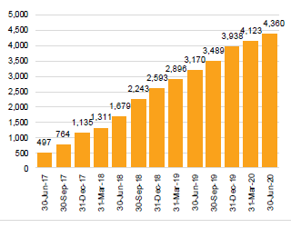

Digital Partnership Program
On 30 June 2020, the Minister for the NDIS, the Hon Stuart Robert MP, announced the next phase of the Digital Partnership Program to improve the digital experience for NDIS participants and providers. The program manages controlled and secure access to some of the Agency’s data and systems, with the latest phase expanding access to the Agency’s application programming interfaces (APIs) to more software developers working with registered providers.
The APIs are being created so providers and software developers can build new tools, applications and digital marketplaces to improve how participants, providers and the NDIA all connect and work together. The next phase gives more software developers who are working with registered NDIS providers the ability to request access to the NDIA’s APIs, creating more opportunities for digital experts to develop new tools and applications.

Utilisation
For support provided between 1 October 2019 and 31 March 2020, data at 30 June 2020 indicated that 70 per cent of support had been utilised nationally. Experience in other schemes with individual budgets (internationally and in Australia) indicates that plan utilisation is unlikely to be 100 per cent. However, for some participants utilisation should be higher than the current level.
The two biggest drivers of utilisation are:
- whether a participant is in supported independent living
- how long a participant has been in the Scheme (the longer they have been in the Scheme, the more they utilise their plan).
Figure 2.2.3G: Utilisation of committed supports by SIL status from 1 October 2019 to 30 June 2020
Figure 2.2.3H: Utilisation of committed supports by plan number from 1 October 2019 to 30 June 2020
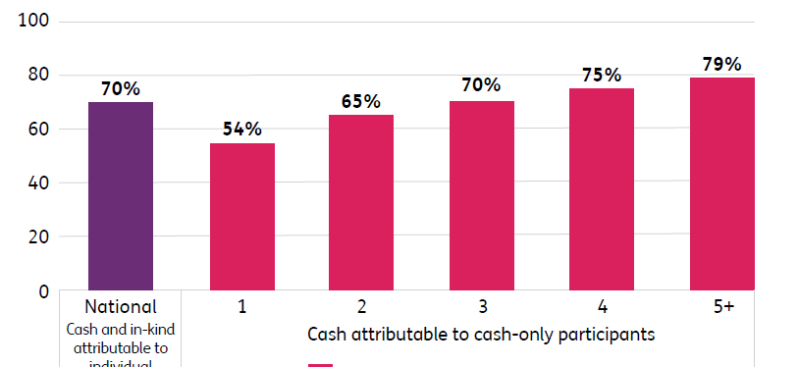

A detailed analysis of utilisation and market concentration by region is provided in the June 2020 Quarterly Report to Disability Ministers.

Thin markets
Supported by the NDIA Board and management, the December 2019 meeting of Disability Ministers agreed to use a more flexible approach to address market challenges in the Scheme, recognising that a one-size-fits-all approach to delivering the NDIS is not suitable to address market gaps faced by certain geographic locations, particular cohorts and disability support types.
In collaboration with the rollout plan being developed by DSS, the Agency is developing a market commissioning strategy to support a flexible approach to addressing market challenges. The strategy will be refined through a series of trial projects in all jurisdictions. These trials have been agreed with state and territory governments and are on track for delivery in the second half of 2020. They will collect evidential insights and test the Agency’s approach to market challenges.

A connected and engaged stakeholder sector
The disability sector and community are integral to the success of the NDIS. The Agency continued to build and maintain collaborative partnerships with the Scheme’s stakeholders, including participants, their families, carers, providers, the disability sector, the community, the Commonwealth and state and territory governments. These partnerships continue to inform the delivery of the Scheme.
In 2019–20, the Agency continued to collaborate with state and territory governments to manage Scheme transition and resolve outstanding policy issues. The NDIA worked closely with Victoria (Vic), Queensland (Qld) and Tasmania (Tas) to prepare for their expected transition to Full Scheme on 1 July 2020, and with Western Australia (WA) to ensure the complete transition of WA NDIS clients to the national Scheme. The Minister for the NDIS, the Hon Stuart Robert MP, increased the frequency of Disability Reform Council meetings to quarterly between July 2019 and March 2020, resulting in significant progress on mainstream interface policy issues, including clarifying responsibilities for:
- disability-related health supports
- supports for participants with psychosocial disabilities and those in justice settings
- respite supports for children in statutory care and children in voluntary out of home care arrangements.

Independent Advisory Council
The IAC was established in 2013 through the NDIS Act to bring the views of participants, carers and experts to the heart of the NDIS. The IAC provides the Board with independent advice, which the Board must consider when performing its duties. The IAC met 11 times in the past 12 months.
During 2020, the IAC completed important work. This included the paper on Early Childhood Early Intervention that has been vital in shaping the Agency’s ECEI Strategy Reset Project; the Participants who are Parents paper; and advice on support for decision-making. In addition, the IAC played a critical role in providing timely advice on COVID-19, which helped shape the Agency’s response.

Reference groups
The NDIA has a number of reference groups, advisory groups and small working groups drawn from stakeholders who provide advice to the Agency on the design, development and implementation of aspects of the Scheme. These groups have clear terms of reference and deliverables linked to the NDIA Corporate Plan. Current reference groups include:
- Autism Advisory Group (AAG)
- CEO Forum
- Industry Reference Group (IRG)
- National Mental Health Sector Reference Group (NMHSRG)
- Participant Reference Group (PRG)
- Pricing Reference Group
- Specialist Disability Accommodation (SDA) Reference Group.

Autism Advisory Group
The AAG was established to provide a strong voice on behalf of people with autism who are participating in the Scheme. It comprises autism experts, service providers and people with lived experience of autism. The AAG met five times during 2019-20.

CEO Forum
The NDIS CEO Forum continued to be a platform for the disability sector to engage, discuss and collaborate directly with the Agency on important areas of work relating to the operation and implementation of the NDIS. Membership consisted of 24 CEOs from national peak and advocacy organisations. The CEO Forum met five times in the past 12 months.

Industry Reference Group
The IRG advises on improvements to the Scheme that will support development of a competitive market of innovative supports and services and help empower participants to achieve their goals in inclusive communities and workplaces.
The IRG has provided feedback to the Agency on a number of projects, including the NDIA Research and Evaluation Strategy, participant employment strategies, the assistive technology policy, and invaluable insights into the trends and measures taken in the disability sector. The group also provided feedback on Agency initiatives during the COVID-19 pandemic. The Industry Reference Group met five times in the past 12 months.

National Mental Health Sector Reference Group
The NMHSRG was established to develop a strong working partnership between the mental health sector and the Agency. Its membership consists of consumers, carers, representatives from peak associations, IAC members and key government representatives, including mental health commissioners. The NMHSRG met four times in the past 12 months.

Participant Reference Group
The PRG provides feedback on the Agency’s work on NDIS pathways and input to the continuous improvement of participant pathways - the processes by which participants, their families and carers interact with the Scheme. The group comprises participants and carers from around Australia who have lived experience with disability. The PRG met seven times in the past 12 months.

Pricing Reference Group
The Pricing Reference Group was established in 2018 in response to the Independent Pricing Review. It provides advice to the Board through the CEO. Through the Pricing Reference Group, the Agency has a formal process to review NDIS pricing arrangements, conduct robust market reviews and determine how to consult and engage with sector stakeholders. This process includes evaluation and endorsement of the Annual Price Review outcomes.
During 2019–20, the Pricing Reference Group provided advice on the pricing arrangements for supports in employment, individualised living options, hearing supports, psychosocial recovery coaches, supported independent living and specialist disability accommodation. The Pricing Reference Group met eight times in the past 12 months.

Specialist Disability Accommodation Reference Group
The SDA Reference Group was established in March 2019 to support the development of the SDA market, increase choice and control for participants, and ensure the long-term viability of SDA investments under the Scheme. The creation of this group demonstrates the Agency’s commitment to the sustainability of the SDA market and improving the participant experience.
Throughout 2019–20 the SDA Reference Group provided advice on key programs and improvements such as design standards, operational guidelines, the SDA Innovation Plan, medium-term accommodation and amendments to the SDA Rules and Pricing released in July 2020. The SDA Reference Group met six times in the past 12 months.

Sector sentiment and satisfaction
The Agency continued to closely monitor sector sentiment and satisfaction to inform our partnerships and to help inform our approach going forward. The NDIA stakeholder sentiment survey of leaders from key stakeholder organisations was conducted in February 2020. The average rating of the experience of interacting with the Agency has increased to 5.89 out of 10, compared to 5.28 in November 2018 and 5.23 in July 2019, exceeding the 2019–20 target of 5.5.

Participant engagement model
The Agency recognises the important role participants, their families and carers play in identifying opportunities for service improvement and working collaboratively with the Agency on the design and implementation of policy and service improvement projects.
The new Participant First Engagement Model was launched in May 2020. Using this model, Agency business teams engage directly with participants, drawing on their experiences and expertise to support a range of policy and service improvements.
In 2019–20, participants collaborated with the Agency to ensure that the design and outcomes of a number of initiatives met the expectations of participants, the Agency and government. These included the future role of LACs, self-management resources, the NDIS portal refresh, assistive technology and home modification, and plan goals and attainment.

A financially sustainable scheme

Scheme costs
Scheme projections are in line with the estimates shown in the 2017 Productivity Commission report on NDIS costs at 2021-22, after allowing for costs not included in the Productivity Commission estimate, such as the introduction of school transport, personal care in schools, developmental delay and the incomplete implementation of the National Injury Insurance Scheme.
Table 2.2.3A: Committed supports ($m) and payments
 | 2013–14 | 2014–15 | 2015–16 | 2016–17 | 2017–18 | 2018–19 | 2019–20
Active  participants | 7,285 | 17,155 | 29,719 | 89,610 | 172,333 | 286,015 | 391,999
Total  committed ($m) | 132.7 | 496.7 | 939.1 | 3,234.4 | 7,741.0 | 14,567.7 | 24,163.9
Total paid ($m) | 85.8 | 370.9 | 704.3 | 2,184.5 | 5,423.7 | 10,247.4 | 16,114.9*
% utilised  to date | 65% | 75% | 75% | 68% | 70% | 71%
*This number reflects payments made during the 2019-20 year for support provided in the 2019-20 year and differs from the amount in the annual financial statements. This number will progressively increase and will be re-stated in subsequent quarterly reports to reflect payments made for supports provided in 2019-20 post 30 June 2020.

Addressing Scheme pressures
Pressures on the Scheme have been identified and are being responsibly managed. The drivers of costs to the NDIS include the number of participants, the amount of support allocated to each plan, how that allocated amount will change over time, the utilisation of individual supports, and the rate at which participants exit the Scheme.
It is the responsibility of the NDIA to monitor primary pressures, detect any associated risks and manage them appropriately, using the insurance-based structure as a means of evaluating emerging experience against expectations.
The current primary financial pressures relate to the average cost of supports for participants in SIL, increasing support costs for participants not in SIL, and the interfaces and boundaries with mainstream services and community and informal supports.
Figure 2.2.3I: Average annualised payments per participant by quarter – SIL participants
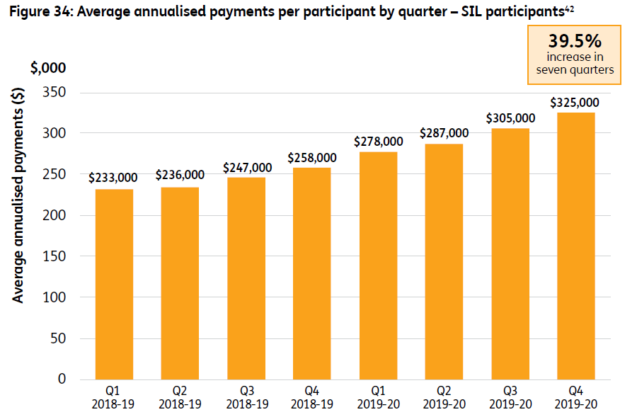
The payments are for all supports provided to participants in SIL (and not just the SIL daily activity payments).
Figure 2.2.3J: Average annualised payments per participant by quarter – non-SIL participants
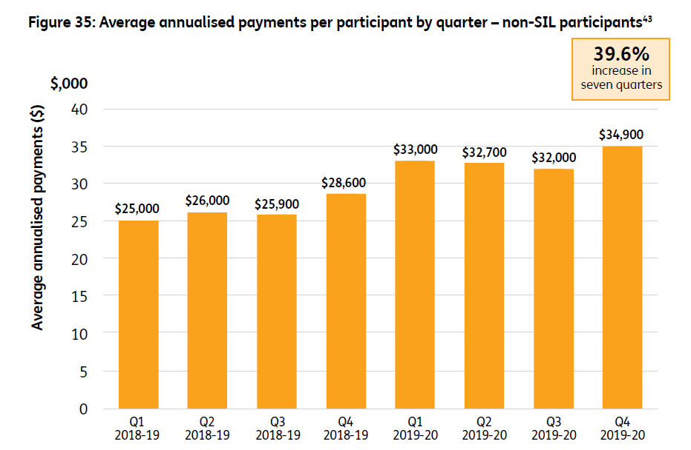
The payments are for all supports provided to non–SIL participants.
Specific and appropriate management responses are being developed to address the primary sustainability and equity pressures. The NDIA is also working on improving consistency and equity in both access and planning decisions across all participants.
The NDIA is implementing a package of NDIS reforms, including the implementation of the Government’s Response to the 2019 Review of the NDIS Act (Tune Review) and the new NDIS Participant Service Guarantee. As part of this work the NDIA will introduce independent assessments to help better align a participant’s support package with their circumstances. Independent assessments will ensure participants receive the right funding, as their plan budget will be matched to their level of functional capacity and environmental context.
The NDIA has been working on a policy to reform SIL. The NDIA is conducting a review of SIL price controls, and new SIL-specific price limits will be included in an updated NDIS Price Guide released later in 2020. Until this review is complete the price limits for assistance with daily living will apply to SIL supports. The assistance with daily living price limits have been in effect from 1 July 2020 for SIL supports, and these will also be applied to any open SIL quotes awaiting approval. Changes will be made incrementally to SIL to give participants and their families greater input, as well as more choice and control as to how their SIL supports are provided, and greater oversight of their roster of care. Changes will also be made to simplify plans and budgets.
In addition, the NDIA is looking at more contemporary options for people who require a high level of support. Traditionally, group homes, congregate living and SIL are commonly seen as living arrangement solutions for people with a disability who have a high need for ongoing care. However, a number of alternative accommodation options have emerged, termed contemporary individual living options (ILOs). These ILOs have the potential to create a more tailored solution to care and support needs for the subset of Scheme participants with higher needs. Further, ILOs help to increase choice and control for participants and improve outcomes.

A high-performing NDIA
The NDIA aspires to be a high-performing service delivery organisation with the people, capabilities and systems to deliver operational goals, in a participant-centric way.

Workforce
The NDIA has continued to grow its workforce to meet the needs of participants, their families and carers. At 30 June 2020, the total NDIS workforce was 11,550, including 4,396 APS employees, 1,692 labour hire contractors and consultants, and 5,462 people employed by NDIA’s partners. This is an increase of 4.4 per cent of the total workforce (including NDIA partners) since the end of the 2018–19 financial year (total workforce increase of 489).
The NDIA is committed to its goal to be an employer of choice, especially for people with disability, and to create a safe and inclusive environment that keeps its people engaged and committed. The percentage of employees identifying as having a disability was 11.1 per cent in 2019-20, well above the 2019 APS average of 3.7 per cent, but below the Agency’s target of 15 per cent. In addition, the Agency recognises the importance of supporting woman in leadership positions. Women hold 51 per cent of senior leadership roles in the Agency, representing a one per cent increase on last year.

Engaged and capable NDIA
The Agency continued to build the capability of staff to support high-quality service delivery to participants, their families and carers through improved training. The Agency implemented the following learning and development initiatives to increase the capability of its workforce:
- foundational skills development
- Graduate Development Program
- service delivery training
- leadership and management development
- joint planning meeting workshops for planners and partners.
Approximately 1,100 planners and LACs participated in the New Starter Induction program during the year.
There was high engagement with the NDIA Just Brilliant Leadership Series, which has helped increase frontline leadership capability. In 2019–20, 5,034 staff commenced the Learning to Lead program (aimed at entry-level team leaders), and 289 commenced the Leadership Excellence program (aimed at senior-level leaders). The satisfaction rating for the leadership programs was 96 per cent.
In addition, the NDIA collaborated with the Disability Advocacy Network of Australia, and disability peak bodies to raise disability awareness among staff and help improve the participant experience. A suite of learning resources, including a disability navigator containing 12 participant videos, were developed for staff. These modules included a focus on contemporary disability rights; family and gender-based violence prevention; mental health recovery and Aboriginal and Torres Strait Islander cultural awareness; LGBTIQA+ and CALD communities.
Results from the Agency’s Pulse survey showed the Agency Engagement Index increased by four per cent to 80 per cent, from the 2019 APS Census result of 76 per cent, illustrating that the workforce is engaged and committed. On 2 March 2020, the NDIA implemented a new organisational structure to reduce internal complexity and to allow the Agency to increase the speed of response for participants.
The NDIA’s Enterprise Agreement 2016–2019 nominally expired on 28 February 2020. Prior to this, bargaining with nominated representatives had commenced. Through extensive consultation a new NDIA Enterprise Agreement with supporting policies and procedures was developed and presented to staff for their consideration. A resounding ‘yes’ vote was recorded and the new NDIA Enterprise Agreement 2020–2023 was certified by the Fair Work Commission on 17 April 2020.

Work health and safety
The Agency’s work health and safety management system saw significant improvements, indicating a maturing organisation. As at 30 June 2020, the ‘lost time injury frequency rate’ (the number of lost time injuries that occurred during 2019–20, relative to the total number of hours worked in that period), was 2.11, which is the lowest in the Agency’s history. There were improved safety communications, capability, leadership and compliance across the system, with positive results across performance metrics.
The Agency’s National Health and Safety Committee refreshed its membership and increased the frequency of meetings to reflect the fast pace of change and safety improvements requiring consultation and endorsement. The Agency implemented new Local Safety and Consultation Committees in every state and territory, providing a robust governance framework for work health and safety consultation and communication. In addition, a work health and safety assurance program was developed to support assessment of compliance with the system.
Supporting mental health and wellbeing at work is a strong focus of the Agency. In 2019–20, the Agency implemented a new 12 month Mental Health and Wellbeing Action Plan to ensure that effective education, supports, pathways to care, risk management and controls are implemented in promoting health and wellbeing.
In response to the COVID-19 pandemic, the Agency stood up the Emergency Response and Recovery Committee. The Agency developed information, guidelines and toolkits to ensure the safety of its workers, and mobilised a contingency workforce to support safe and effective service delivery. As at 30 June 2020, there was no workplace transmission of COVID-19 in the Agency. The Agency was able to quickly and safely transition over 4,000 members of the workforce to working from home arrangements. Flexible working arrangements continue to be supported, where possible.

NDIS website
The NDIS website is one of the Agency’s key communication channels, with an average of over 1.5 million page views per month. The website was a vital communication tool during the January 2020 bushfires and COVID-19 pandemic, enabling the Agency to communicate quickly and effectively with participants, their families and carers. In April 2020, the website had almost 500,000 visitors and more than 2 million page views.
The website continues to evolve. In 2019-20, a live webchat function was introduced to provide an additional way to contact the Agency, and a new Easy Read section about finding, keeping and changing jobs provided information to participants in a simplified and easy to understand format.

Video
NDIS video content continues to play an important role in supporting participants, families, carers and providers through their NDIS journey and in educating the Australian community about the Scheme. In the past 12 months, the Agency produced 38 animated videos, playing a key role in assisting participants to navigate the Scheme. In addition, the Agency released 44 videos, highlighting the stories of participants and providers, and the positive impact the Scheme has had on their lives. As part of the Agency’s COVID-19 response, 17 animations and seven Auslan videos were released to help participants navigate the complex pandemic environment, and the Agency’s response.

Webinars
NDIS webinars on employment (‘Let’s talk about work’, February 2019), assistive technology (‘Wheelchairs, aids and devices’, June 2019), Information, Linkages and Capacity Building (‘Getting your ILC grant PiTCh right’, August 2019) and planning (‘How to get the most out of your NDIS plan’, November 2019) each had over 2,000 people register to watch live, with thousands more viewing the recorded versions published on the NDIS website. Viewers were able to ask questions in real time and hear responses from experts.

Campaigns
The NDIS rolled out a campaign in Queensland in November 2019 to encourage new participants to join the Scheme, with a focus on people with disability from CALD backgrounds, Aboriginal and Torres Strait Islander and rural and remote communities. It used in-language radio, Radio Print Handicapped, social media and closed-circuit television advisements in doctors’ waiting rooms. The campaign contributed to an increased number of access requests from Queensland in mid-January 2020.
Recognising the importance of leading the way with accessible communications, the NDIS activated an internal Agency campaign from November 2019 to March 2020 to give staff and partners a better understanding of what accessibility is, why it is important and how to make communications accessible.

Efficient and effective processes and systems
In 2019–20 the Agency continued working to improve its systems, processes, data management and people capabilities to deliver the Scheme effectively.

NDIA National Contact Centre
The NDIA National Contact Centre (NCC) delivers personal and high-quality contact services about the NDIS for people with disability, their family and carers, service providers and organisations.
The NCC service has been delivered since June 2018 by Serco Citizen Services Pty Ltd (Serco), who operate from Dandenong and Newborough in Victoria.
Under the contract with Serco, services are delivered for the NDIA according to an agreed performance framework. The performance framework includes a grade of service of 80 per cent of inbound calls answered within 60 seconds and email enquiries progressed within two business days. Over the past 12 months, Serco has provided a consistently high level of service, with an inbound call average speed of answer of 27 seconds. Figure 2.2.3K shows the sustained telephony performance since transition to Serco as Contact Centre service provider.
In addition to answering phones, the NCC has increased the amount of processing work it now does on behalf of the NDIA. Over the past 12 months, NCC has responded to an average of 70,000 emails per month, with 99.5 per cent of these progressed within the two business day key performance indicator.
The NCC commenced a live webchat service in December 2019, providing a new communication channel option for participants, carers, providers and the public. In March 2020, the webchat service was further enhanced to allow NCC staff to answer more individualised enquiries. The NCC averages over 2,700 webchat requests per month with 98 per cent of chats responded to within 10 seconds.
Figure 2.2.3K: National Contact Centre telephony performance July 2018 to June 2020
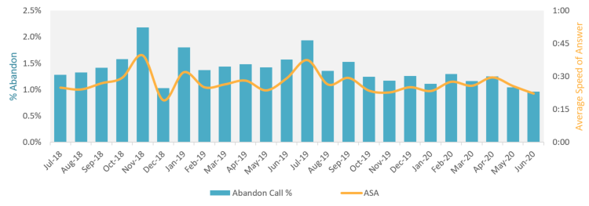

Information and communications technology (ICT) systems
The August 2018 Board meeting endorsed the ICT Strategy, recommending that the Agency retain both the SAP CRM platform and Services Australia as the Agency’s ICT delivery partner. This recommendation was modified at the June 2019 ICT Committee, with the decision being taken to adopt a parallel multi-vendor delivery approach for ‘non-core’ business functions. The strategy will assist the Agency to meet its Corporate Plan 2020–2024 objectives and continue the underlying business strategies that have helped to deliver high-quality outcomes for participants.
This has resulted in what has become the Alternative Cloud Environment strategy. The Alternative Cloud Environment platform and associated multi-vendor delivery strategy will provide more accessible, functional technology to support participants. The first cloud-based service supporting joint planning went live in May. This has allowed participant appointments to be coordinated across the Agency and partner organisations.
Participant research identified that mobile capability was the priority for participants. A participant mobile app is under development with a controlled pilot (250 participants). The app will enable participants to easily review their available budget, make claims and store receipts if required.
A project to refresh the NDIS participant web portal solution was progressed in 2019–20, with initial design concepts being tested by participant volunteers. The objective of this activity is to agree on a firm starting point for broader testing with participants and advocacy groups following availability of the Alternative Cloud Environment platform.
The Agency has continued to keep existing ICT systems fully functional, as well as deploying new capability to support the Agency’s COVID-19 pandemic response. Both the external-facing systems and the internal staff system are achieving their performance targets and have been consistently meeting these targets since November 2018. Staff, partners, participants and providers are experiencing faster system response times than ever. This is despite introducing more functionality to the systems, as well as the significant increase in numbers of participants, providers and staff using them over the period.
We continue to closely monitor performance and develop improvements to ensure that the Agency’s ICT systems maintain their effectiveness as the Scheme continues to scale up during rollout.

Protective security
The Australian Government provides mandated requirements and advice for corporate Commonwealth entities about their security requirements via the Protective Security Policy Framework (PSPF) and Information Security Manual. New PSPF arrangements came into effect on 1 July 2018.
The Agency has established close working relationships with Services Australia, the Department of the Prime Minister and Cabinet and the Australian Taxation Office regarding the safety and security of our staff around Australia. The Agency is currently finalising a project to enhance the physical and electronic security of 51 service delivery sites.
The Agency uses Services Australia as its ICT shared service provider. Services Australia has established an ‘Essential Eight’ uplift program designed to reduce cyber risk. The Essential Eight is a set of proven mitigation strategies for reducing cyber risk across many enterprises. The Agency is represented on the program’s steering committee. Our cybersecurity specialists are working with Services Australia to ensure that the Agency’s maturity targets are achieved as agreed.
The Agency’s cybersecurity team notes that we are operating at an increased level of cyber risk due to the COVID-19 pandemic. Work to support the Agency’s response to the COVID-19 pandemic includes intelligence reporting to the Executive Leadership Team to ensure we continue to provide up-to-date security advice regarding risks, trends and threats, to inform decision-making and mitigate risk.

How we intend to move forward
Having reached the significant milestone of transition to Full Scheme, our core focus over the coming year is to both improve the participant experience and to provide participants with even greater opportunities for improved outcomes. This includes helping participants build their independence by facilitating access to greater employment opportunities and social inclusion and engagement.
First and foremost, the safety of participants is paramount. The NDIA will continue to work across government to ensure continuity of essential supports for NDIS participants during the COVID-19 pandemic, including a focus on supporting those in ‘hot-spots’.
The Agency will continue to enhance the way we work with participants, their families and carers. The NDIA will simplify its processes to support people to gain access to the Scheme; provide more clarity and transparency around decisions; ensure plans include the supports required to achieve participant goals; and improve the timeframes in which we make decisions. The Participant Service Charter and the Participant Service Improvement Plan work together to outline how the Agency will deliver these enhancements. We aim not just to deliver on the benchmarks set but to strive to outperform them.
We will endeavour to deliver a Scheme that is fairer and more equitable. In part, that will be done by implementing independent functional assessments that will provide greater consistency not just in access decisions, but also in the level of supports provided to participants. To ensure greater access, those assessments will be paid for by the Scheme.
We will strengthen engagement with participants, their families and carers by providing them with more opportunities to provide feedback through a variety of channels, and by improving the way we communicate with participants and the way they get information from us.
Additionally, we will work with providers to continue to grow a market that reliably supplies quality and innovative supports to meet participant needs and goals. In partnership with our stakeholders, we are working to develop and shape the market as it matures. We will continue to refine our approach in response to emerging market issues such as inefficient service delivery, limited variety, inaccessible services, and lack of consumer choice.
We will continue to improve the digital experience for participants and providers. Work is progressing on a digital partnership strategy to transform the participant and provider experience through increased use of technology. This will encourage the Agency as well as participants and providers to become more open to innovation and change.
We will continue to build the Agency’s reputation as an employer of choice by developing a capable and engaged workforce. Achieving the commitments outlined in the Participant Service Charter and the Participant Service Improvement Plan will require a continued capability uplift. This includes supporting front line staff to implement these changes, along with reinvigorating current systems and processes. This work has already commenced with the national rollout of joint planning, customer service skills, rapport building and disability awareness delivered to planners and LACs.
The realisation of our capability uplift requires continued enhancement of systems and technology. The Agency has commenced a range of ICT initiatives to enhance our core systems, provide greater accessibility and visibility for people with disability and improve the efficiency and effectiveness of the way staff and partner staff perform their roles.
At the same time, we know that the Scheme must continue to be financially sustainable. This is critical to ensuring ongoing public confidence in the Scheme and that it remains in place for the benefit of future generations of participants. The insurance-based nature of the Scheme ensures any adverse trends are identified early and are acted upon. We are proactively addressing pressures.
Our priorities over the coming year will help ensure we deliver the Scheme that was originally envisaged, and a Scheme of which all Australians can be proud.
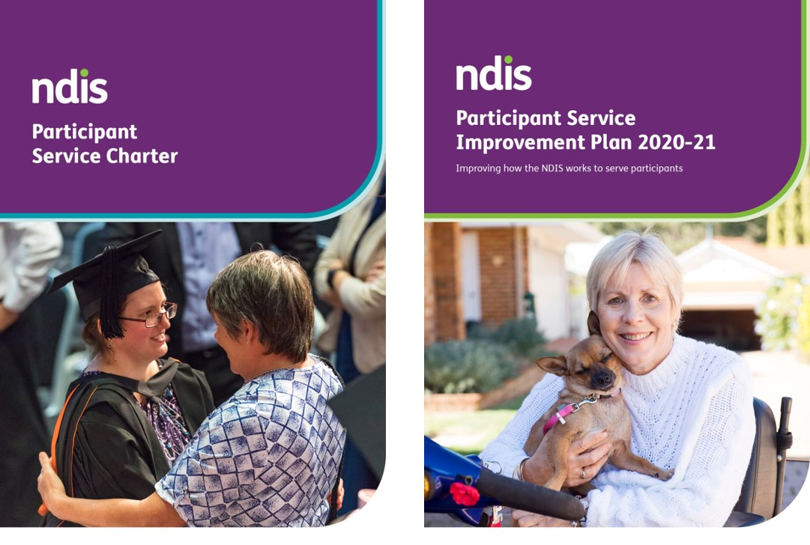

Financials

Financial statements
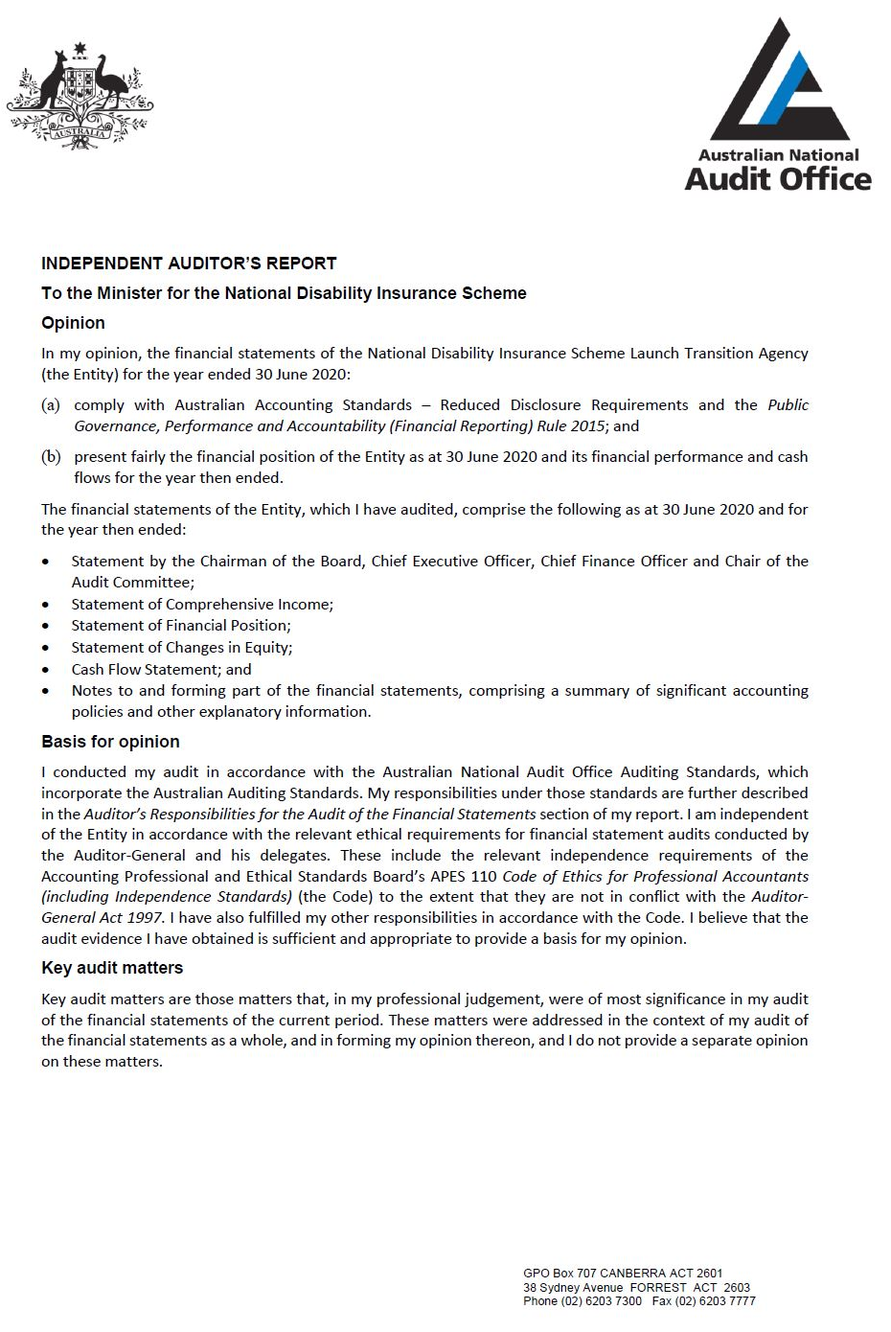
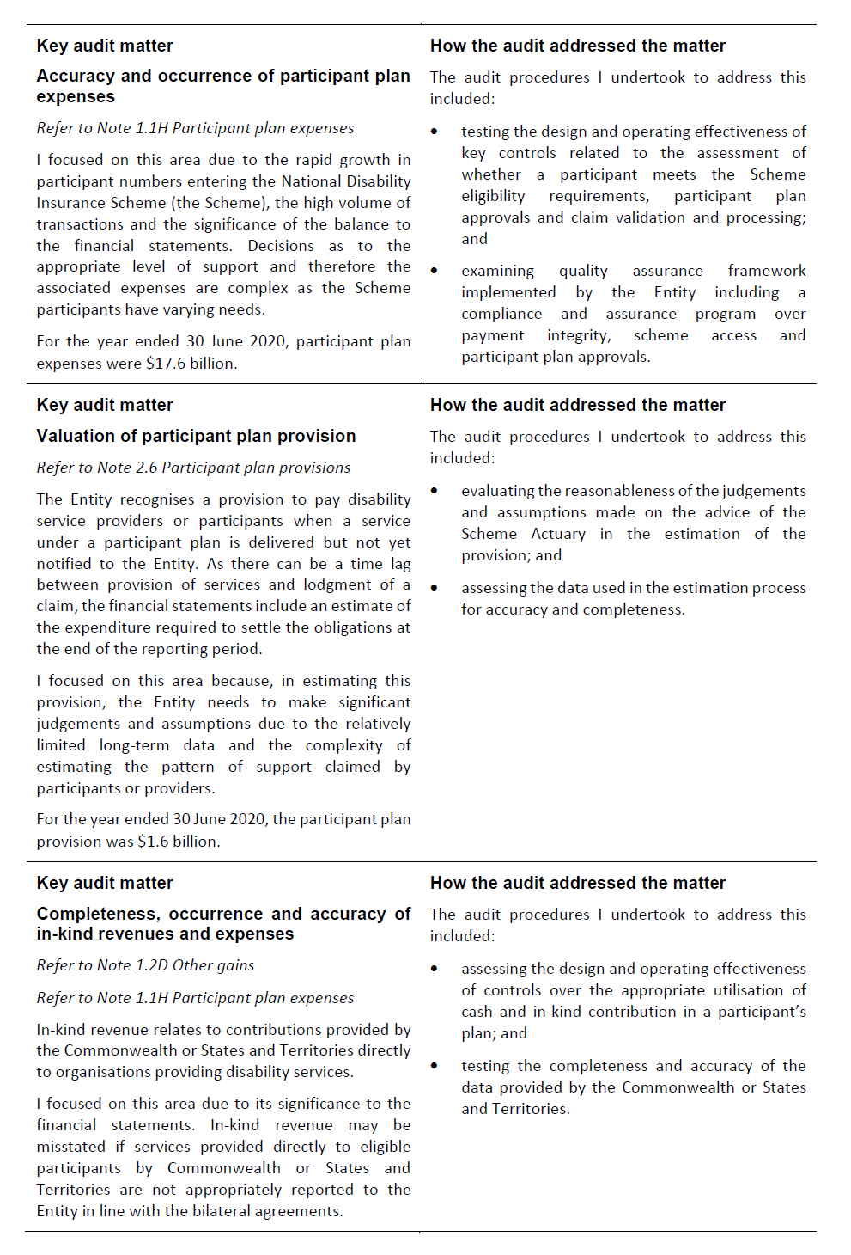
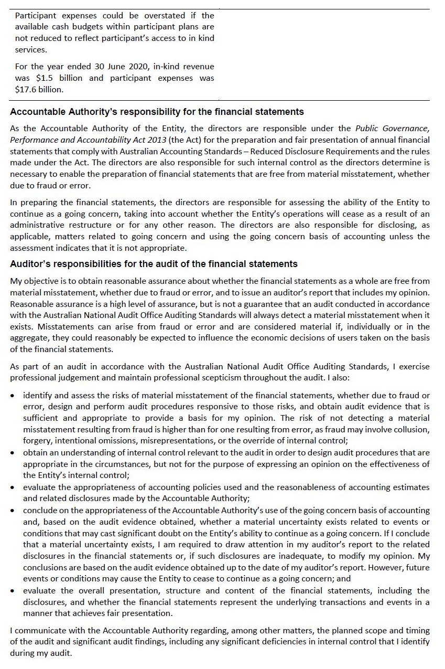
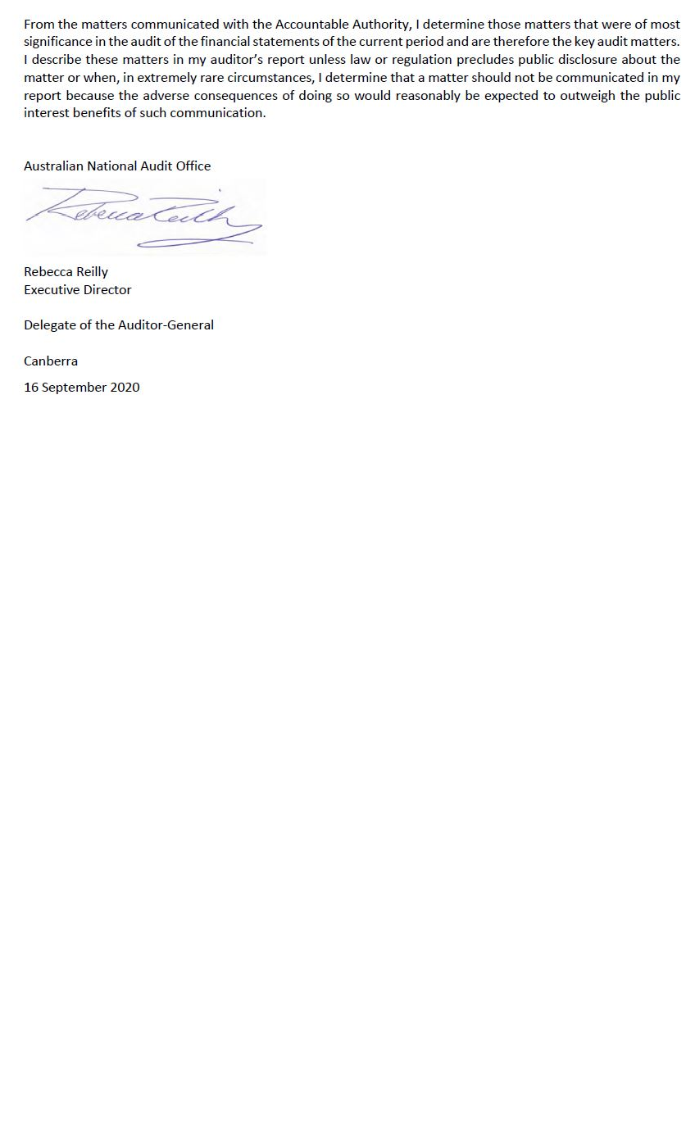
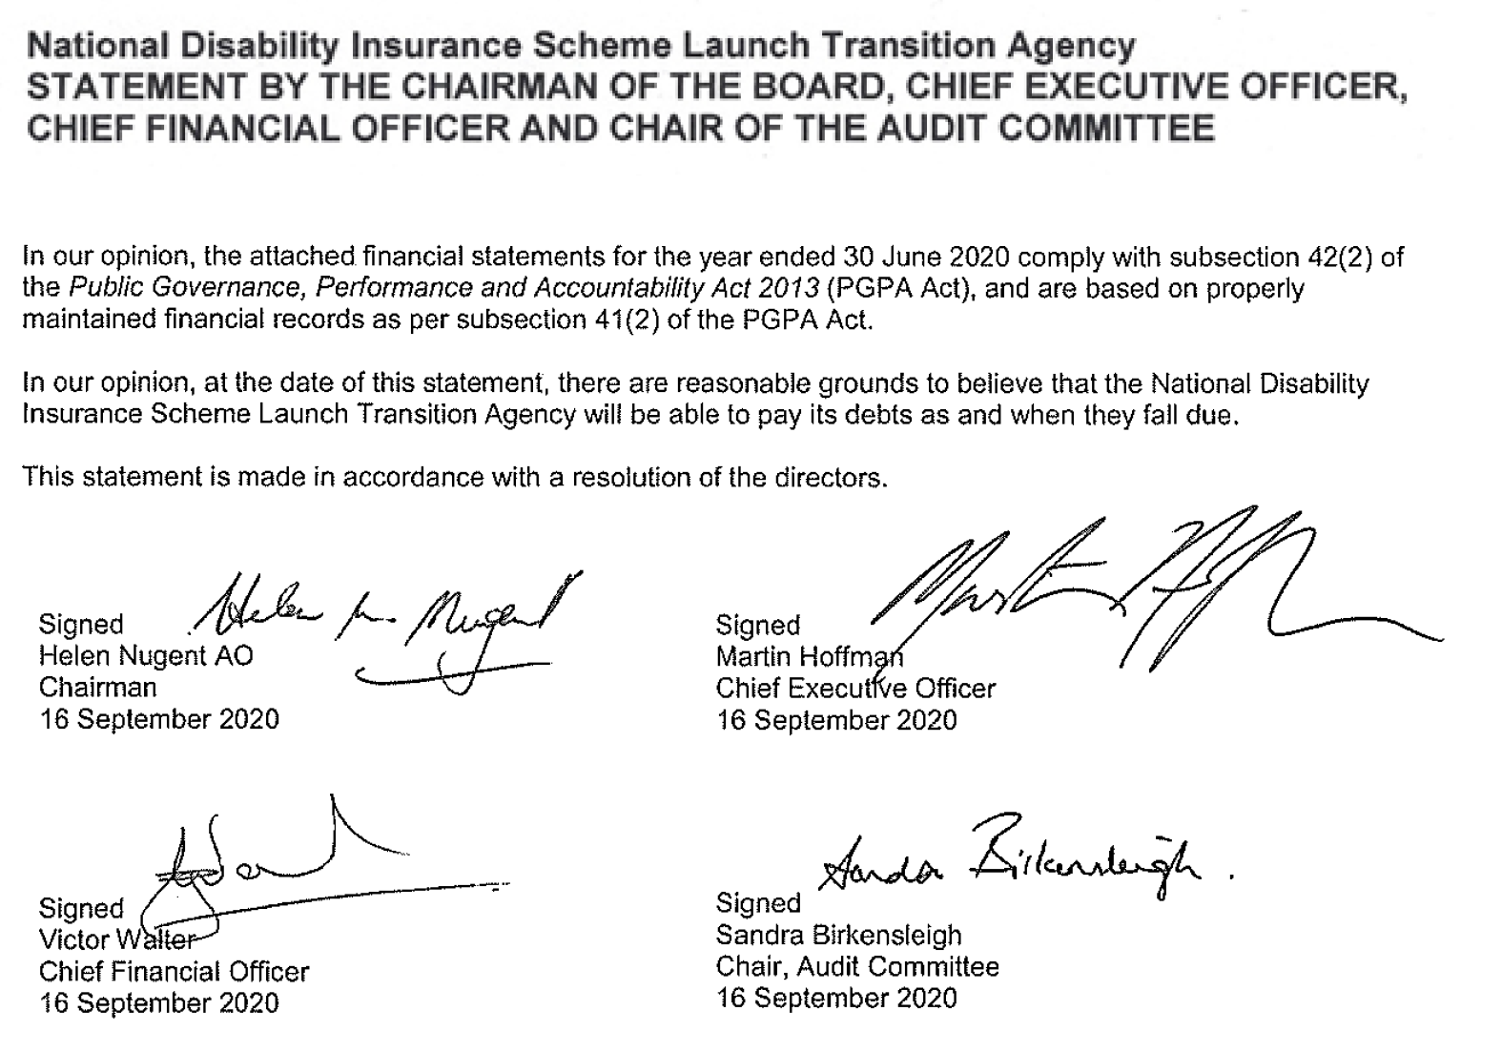
Original
Budget¹
 |  | 2020 |  | 2019 |  | 2020
 | Notes | $'000 |  | $'000 |  | $'000
NET COST OF SERVICES
Expenses
Employee benefits | 1.1A | 404,962 |  | 312,082 |  | 319,645
Suppliers | 1.1B | 516,514 |  | 528,402 |  | 1,115,771
Community partnership costs | 1.1G | 524,619 |  | 451,786 |  | -
Grants | 1.1C | 134,679 |  | 111,218 |  | 131,615
Participant plan expenses | 1.1H | 17,589,484 |  | 10,459,927 |  | 16,262,459
Depreciation and amortisation | 2.2A | 61,906 |  | 16,556 |  | 20,774
Finance costs | 1.1D | 2,205 |  | 1,308 |  | -
Impairment loss on financial instruments | 1.1E | - |  | 13 |  | -
Write-down and impairment of other assets | 1.1F | 31,494 |  | -
Total expenses |  | 19,265,863 |  | 11,881,292 |  | 17,850,264
OWN-SOURCE INCOME
Own-source revenue
Rendering of services | 1.2A | 14,895,148 |  | 9,776,306 |  | 14,736,125
Interest |  | 49,721 |  | 58,682 |  | -
Rental income | 1.2B | 638 |  | 108 |  | -
Other revenue | 1.2C | 7,235 |  | 4,088 |  | 47,935
Total own-source revenue |  | 14,952,742 |  | 9,839,184 |  | 14,784,060
Gains
Other gains | 1.2D | 1,524,039 |  | 1,258,834 |  | 1,657,949
Total gains |  | 1,524,039 |  | 1,258,834 |  | 1,657,949
Total own-source income |  | 16,476,781 |  | 11,098,018 |  | 16,442,009
Net (cost of)/contribution by services |  | (2,789,082) |  | (783,274) |  | (1,408,255)
Revenue from Government |  | 1,413,257 |  | 1,477,674 |  | 1,408,255
Surplus/(Deficit) |  | (1,375,825) |  | 694,400 |  | -
OTHER COMPREHENSIVE INCOME
Items not subject to subsequent reclassification to net cost of services
Changes in asset revaluation reserve |  | - |  | 11,145 |  | -
Total other comprehensive income |  | - |  | 11,145 |  | -
Total comprehensive income/(loss) |  | (1,375,825) |  | 705,545 |  | -

The above statement should be read in conjunction with the accompanying notes.
¹ Original Budget refers to the figures published in the Portfolio Budget Statements 2019–20.
Budget Variances Commentary
Statement of Comprehensive Income
Affected line items | Explanations of major variances
Expenses  Suppliers, Community partnership costs | The Budget aggregates supplier expenses and community partnership costs. The variance to Budget for supplier and community partnership costs is linked to the lower amount of expenses pertaining to consultancy costs, operating leases and travel activity. Consultancy costs reduced as a number of consultancies were internally sourced within the Agency. Operating lease expenses decreased with the implementation of AASB 16 Leases, which resulted in operating lease expenses being replaced by depreciation on right-of-use asset. The Agency's travel costs reduced significantly since March 2020 due to travel restrictions resulting from the COVID-19 pandemic. In addition, the variance to Budget is linked to a slower than expected increase in the provision of Local Area Coordinator (LAC) services by partners in the community.
Expenses  Participant plan expenses | Participant plan expenses were higher than projected in the Budget mainly due to a greater than expected increase in the number of participants in the Scheme as it continues to be rolled out across Australia, as well as an increase in the average cost per participant. Plan expenses increased due to a higher utilisation rate of committed supports than the rate assumed in the Budget.
Expenses  Employee benefits | The increase is attributable to the average staffing level cap for employees being increased during the year from that estimated in the Budget.
Expenses  Depreciation and amortisation | The revised standard AASB 16 Leases requires lessees to recognise a right of use asset/(s) and associated liabilities for all leases unless the lease term is 12 months or less, or the underlying asset has a low value. Therefore, the implementation of AASB 16 Leases resulted in operating lease expenses being replaced by depreciation on the right-of-use asset. This has resulted in related depreciation expenses being higher than projected in the Budget.
Expenses  Write-down and impairment of other assets | Write-downs and impairment of other assets were not contemplated in the Budget. The balance represents impairment of unanticipated pandemic plan receivables and an increase in the impairment of provider and participant receivables.
Own-source revenue  Interest, Other revenue | The Budget combines Interest revenue and other revenue within the other revenue line. Interest is derived from the Agency investing cash in short-term deposits. The variance to Budget is due to a significant amount of surplus cash which was held and invested during the year. Other revenue is primarily compensation recoveries made by the Agency during the year that were not specifically budgeted for by the Agency during the annual Budget process.
Own-source revenue  Rental income | The Budget did not forecast any rental income. This is attributable mainly to properties that the Agency had sublet to Services Australia, for the months of April, May and June 2020, at a commercial rate to support the whole-of-government response to the COVID-19 pandemic crisis.
Gains  Other gains | Other gains primarily reflect in-kind contributions made to the Scheme by Commonwealth, state and territory governments. In-kind contributions are lower than Budget due to the actual in-kind services utilisation being below the targeted amounts agreed in the Bilateral Agreements.

Original
Budget¹
 |  | 2020 |  | 2019 |  | 2020
 | Notes | $'000 |  | $'000 |  | $'000
ASSETS
Financial assets
Cash and cash equivalents | 2.1A | 2,497,240 |  | 3,859,860 |  | 2,353,966
Trade and other receivables | 2.1B | 1,009,117 |  | 592,887 |  | 241,905
Other financial assets | 2.1C | 140,000 |  | - |  | 156,276
Total financial assets |  | 3,646,357 |  | 4,452,747 |  | 2,752,147
Non-financial assets²
Buildings | 2.2A | 291,701 |  | 96,474 |  | 95,574
Plant and equipment | 2.2A | 1,969 |  | 46 |  | 46
Other non-financial assets | 2.2B | 12,414 |  | 5,833 |  | 22,891
Total non-financial assets |  | 306,084 |  | 102,353 |  | 118,511
Total assets |  | 3,952,441 |  | 4,555,100 |  | 2,870,658
LIABILITIES
Payables
Suppliers | 2.3A | 288,845 |  | 140,327 |  | 223,494
Other payables | 2.3B | 6,034 |  | 2,293 |  | 4,336
Total payables |  | 294,879 |  | 142,620 |  | 227,830
Interest bearing liabilities
Leases | 2.5 | 195,973 |  | - |  | -
Total interest bearing liabilities |  | 195,973 |  | - |  | -
Unearned revenue
Unearned revenue | 2.4 | 635,603 |  | 430,000 |  | -
Provisions
Employee provisions | 3.1 | 79,618 |  | 63,684 |  | 55,576
Participant plan provisions | 2.6 | 1,574,980 |  | 1,380,845 |  | 706,402
Provision for restoration obligations | 2.6 | 6,725 |  | 6,880 |  | 5,930
Total provisions |  | 1,661,323 |  | 1,451,409 |  | 767,908
Total liabilities |  | 2,787,778 |  | 2,024,029 |  | 995,738
Net assets |  | 1,164,663 |  | 2,531,071 |  | 1,874,920
EQUITY
Contributed equity |  | 205,733 |  | 205,733 |  | 205,733
Asset revaluation reserve |  | 22,137 |  | 22,137 |  | 11,012
Retained surplus |  | 936,793 |  | 2,303,201 |  | 1,658,175
Total equity |  | 1,164,663 |  | 2,531,071 |  | 1,874,920
The above statement should be read in conjunction with the accompanying notes.
¹ Original Budget refers to the figures published in the Portfolio Budget Statements 2019–20.
² Right-of-use assets are included in the following line items: buildings and plant and equipment.
Budget Variances Commentary
Statement of Financial Position
Affected line items | Explanations of major variances
Financial assets  Cash and cash equivalents | Cash comprises cash held on deposit and short-term term deposits, i.e. term deposits with an initial maturity of three months or less. Cash and cash equivalents are higher than Budget which assumed a higher cash utilisation. Major variances for cash and cash equivalents are detailed in the Budget Variances Commentary for the Cash Flow Statement.
Financial assets  Trade and other receivables | As at 30 June 2020, the majority of the receivables balance represents the pandemic plan provider receivables. During March-June 2020, the Agency made optional advance payments to eligible registered providers to support them during the COVID-19 pandemic crisis, to ensure service continuity for participants in the NDIS. These payments are recoverable and therefore, accounted for as receivables.
Financial assets  Other financial assets | The Budget did not anticipate other financial assets which are represented by term deposits with a maturity upon issue greater than 3 months (generally less than 100 days).
Non-financial assets  Buildings | The revised standard AASB 16 Leases requires lessees to recognise a right of use asset/(s) for all leases unless the lease term is 12 months or less, or the underlying asset has a low value. This has resulted in a significant increase in the value of buildings not anticipated in the Budget.
Non-financial assets  Plant and equipment | The Budget did not anticipate significant movement in plant and equipment. The movement represents recognition of motor vehicle right of use assets under AASB 16 Leases.
Non-financial assets  Other non-financial assets | Other non-financial assets comprises prepaid expenses. The major component of this balance relates to participant plan prepayments. This balance is assessed by the Scheme Actuary and is driven by the timing of receipts and payments of claims from providers.
Liabilities  Suppliers | Supplier payables are higher than Budget mainly due to the accrued expenses associated with the Department of Health invoices related to Younger People in Residential Aged Care (YPIRAC), which were not budgeted for as payables.
Liabilities  Other payables | Other payables are higher than Budget, primarily due to an increase in number of days for accrued salaries and superannuation at 30 June 2020. Additionally, the increase in full-time equivalent (FTE) staff in 2019-20 has also contributed to the overall increase in this liability.
Interest bearing liabilities  Leases | This balance is the right-of-use lease liability under AASB 16 Leases not reflected in the Budget.
Unearned Revenue | This balance represents in-kind or other cash contribution offsets relating to the current period, to be deducted from future contribution receipts, that were not budgeted for.
Provisions  Employee provisions | The Agency's employee provisions are assessed annually in accordance with parameters developed by the Australian Government Actuary. The decrease in interest rates post Budget has resulted in the use of a lower discount rate in the actual provision calculation to that used in Budget calculation. Additionally, the increase in full-time equivalent (FTE) staff in 2019-20 has also contributed to the overall increase of the Employee provisions.
Provisions  Participant plan provision | The participant plan provision is higher than projected in the Budget due to the rise in participant numbers in the Scheme. The Budget estimate assumed no growth in the provision from the time it was set in April 2019 (based on the balance at the end of the previous financial year).

Affected line items | Explanations of major variances
Provisions  Provision for restoration obligations | Whilst the Agency has adopted whole-of-government policies for co-locating service delivery sites within existing Commonwealth property infrastructure, where feasible, the 'Provision for restoration obligations' is higher than budget mainly due to an increase in the Agency's property footprint during the year, also reflected by the increase in purchase of leasehold improvements. The Agency commenced a number of new leases with restoration obligations during 2019-20.
Asset revaluation reserve | No revaluations were made during 2019-20. The Budget was set prior to a revaluation being made at the end of the prior period.
Retained surplus | Major variances for the retained surplus are detailed in the Budget Variances Commentary for the Statement of Comprehensive Income.

 | Retained Surplus |  |  | Asset Revaluation Reserve |  |  | Contributed Equity |  |  | Total Equity
 |  |  | Original  Budget¹ |  |  | Original  Budget¹ |  |  | Original  Budget¹ |  |  | Original  Budget¹
 | 2020 | 2019 | 2020 | 2020 | 2019 | 2020 | 2020 | 2019 | 2020 | 2020 | 2019 | 2020
 | $'000 | $'000 | $'000 | $'000 | $'000 | $'000 | $'000 | $'000 | $'000 | $'000 | $'000 | $'000
Opening balance | 2,303,201 | 1,608,801 | 1,658,175 | 22,137 | 10,992 | 11,012 | 205,733 | 205,733 | 205,733 | 2,531,071 | 1,825,526 | 1,874,920
Adjustment on initial application of AASB 15/1058 | - | - | - | - | - | - | - | - | - | - | - | -
Adjustment on initial application of AASB 16 | 9,417 | - | - | - | - | - | - | - | - | 9,417 | - | -
Adjusted opening balance | 2,312,618 | 1,608,801 | 1,658,175 | 22,137 | 10,992 | 11,012 | 205,733 | 205,733 | 205,733 | 2,540,488 | 1,825,526 | 1,874,920
Comprehensive income
Surplus/(Deficit) for the period | (1,375,825) | 694,400 | - | - | - | - | - | - | - | (1,375,825 | 694,400 | -
Other comprehensive income | - | - | - | - | 11,145 | - | - | - | - | - | 11,145 | -
Total comprehensive income/(loss) | (1,375,825) | 694,400 | - | - | 11,145 | - | - | - | - | (1,375,825) | 705,545 | -
Closing balance | 936,793 | 2,303,201 | 1,658,175 | 22,137 | 22,137 | 11,012 | 205,733 | 205,733 | 205,733 | 1,164,663 | 2,531,071 | 1,874,920
The above statement should be read in conjunction with the accompanying notes.
¹ Original Budget refers to the figures published in the Portfolio Budget Statements 2019–20.
Accounting Policy
Equity injections
Amounts received which are designated as ‘equity injections’ for a year (less any formal reductions) are recognised directly in contributed equity in that year.
Transfer to/from other entities
Net assets received from, or transferred to, another Government entity under a restructuring of administrative arrangements are adjusted at their book value directly against contributed equity.
Other distributions to owners
The Public Governance, Performance and Accountability (Financial Reporting) Rule 2015 (FRR) requires that distributions to owners be debited to contributed equity unless it is in the nature of a dividend.

Budget Variances Commentary
Statement of Changes in Equity
Major budget variances for balances contained in the Statement of Changes in Equity have been included in the budget variances commentary for the Statement of Comprehensive Income and the Statement of Financial Position.
Original
Budget¹
 |  | 2020 |  | 2019 |  | 2020
 | Notes | $'000 |  | $'000 |  | $'000
OPERATING ACTIVITIES
Cash received
Receipts from Government |  | 1,413,257 |  | 1,477,674 |  | 1,408,255
Rendering of services |  | 15,295,796 |  | 10,021,896 |  | 14,736,125
Interest received |  | 53,866 |  | 56,697 |  | 47,935
GST received |  | 124,382 |  | 103,853 |  | 116,642
Other |  | 7,891 |  | 4,184 |  | -
Total cash received |  | 16,895,192 |  | 11,664,304 |  | 16,308,957
Cash used
Employee benefits |  | 385,279 |  | 295,787 |  | 318,476
Supplier expenses |  | 417,191 |  | 662,239 |  | 1,318,904
Interest payments on lease liabilities |  | 2,147 |  | - |  | -
Community partnership costs |  | 562,506 |  | 484,210 |  | -
Participant plan expenses |  | 16,542,971 |  | 8,533,165 |  | 14,536,328
Grant payments |  | 147,368 |  | 115,941 |  | 131,615
Total cash used |  | 18,057,462 |  | 10,091,342 |  | 16,305,323
Net cash from / (used by) operating activities |  | (1,162,270) |  | 1,572,962 |  | 3,634
INVESTING ACTIVITIES
Cash received
Proceeds from sales of property, plant and  equipment |  | 9 |  | - |  | -
Total cash received |  | 9 |  | - |  | -
Cash received
Proceeds from sales of long-term deposits |  | - |  | - |  | -
Cash used
Purchase of leasehold improvements |  | 23,136 |  | 36,294 |  | 8,192
Purchase of financial instruments |  | 140,000 |  | - |  | -
Total cash used |  | 163,136 |  | 36,294 |  | 8,192
Net cash from / (used by) investing activities |  | (163,127) |  | (36,294) |  | (8,192)
FINANCING ACTIVITIES
Cash used
Principal payments of lease liabilities |  | 37,223 |  | - |  | -
Total cash used |  | 37,223 |  | - |  | -
Net cash from / (used by) financing activities |  | (37,223) |  | - |  | -
Net increase / (decrease) in cash held |  | (1,362,620) |  | 1,536,668 |  | (4,558)
Cash and cash equivalents at the beginning of the reporting period |  | 3,859,860 |  | 2,323,192 |  | 2,358,524
Cash and cash equivalents at the end of the reporting period | 2.1A | 2,497,240 |  | 3,859,860 |  | 2,353,966

The above statement should be read in conjunction with the accompanying notes.
¹ Original Budget refers to the figures published in the Portfolio Budget Statements 2019–20.

Budget Variances Commentary
Cash Flow Statement
Affected line items | Explanations of major variances
Operating activities  Rendering of Services | Cash from the rendering of services is higher than predicted in the Budget. The Budget anticipated faster phasing of participants in accordance with Bilateral Agreements. Both state and territory and Commonwealth governments’ contributions have increased in line with the growth in the number of active participants in the Scheme and the increase in the utilisation rate over the year. Revenue is higher than Budget due to lower than budgeted in-kind services being utilised which has resulted in a net higher cash receipts from state and territory governments and the Commonwealth.
Operating activities  Interest received | Interest received is derived from the Agency investing cash in short-term deposits. The variance to Budget is due to a significant amount of surplus cash which was held and invested during the year.
Operating activities  Employee benefits | The increase is attributable to the average staffing levels cap for employees being increased more than estimated in the Budget.
Operating activities  Supplier expenses, Interest payments on lease liabilities, Community partnership costs | The Budget aggregates supplier expenses and community partnership payments. The variance to Budget for supplier and community partnership payments is linked to the lower amount of cash outflows pertaining to consultancy costs, operating leases and travel activity. Consultancy costs reduced as a number of consultancies were internally sourced within the Agency. Operating lease costs decreased with the implementation of AASB 16 Leases, which resulted in operating lease expenses being replaced by depreciation on right-of-use asset. The agency's travel costs reduced significantly since March 2020 due to travel restrictions owing to the COVID-19 pandemic.
Operating activities  Participant plan expenses | Participant plan payments are more than projected in the Budget, primarily due to a larger than projected increase in participant numbers in the Scheme and higher than projected utilisation of committed supports.
Operating activities  Grant payments | The Budget did not anticipate the carry forward of some grant payments from the prior year.
Investing activities  Purchase of leasehold improvements | Whilst the Agency has adopted whole-of-government policies for co-locating service delivery sites within existing Commonwealth property infrastructure, where feasible, the 'Purchase of leasehold improvements' is higher than budget mainly due an increase in the Agency's property footprint during the year.
Investing activities  Purchase of financial instruments | The Budget did not anticipate other financial assets which are represented by term deposits with a maturity upon issue greater than 3 months.
Financing activities  Principal payments of lease liabilities | The payment of principal for lease liabilities under AASB 16 Leases was not reflected in the Budget.

Table of Contents
Overview 55
1. Financial Performance 58
1.1. Expenses 58
1.2. Own-Source Revenue and Gains 61
2. Financial Position 64
2.1. Financial Assets 64
2.2. Non-Financial Assets 66
2.3. Payables 69
2.4. Unearned Income 69
2.5. Interest Bearing Liabilities 69
2.6. Provisions 70
3. People and Relationship 71
3.1. Employee Provisions 71
3.2. Board and Other Key Management Personnel Remuneration 72
3.3. Related Party Disclosures 72
4. Managing Uncertainties 74
4.1. Contingent Assets and Liabilities 74
4.2. Financial Instruments 75
5. Other Information 76
5.1. Aggregate Assets and Liabilities 76

Overview

General information

The National Disability Insurance Scheme Launch Transition Agency (‘the Agency’) was established on 29 March 2013 by the National Disability Insurance Scheme Act 2013 (‘the Act’). The Agency is an Australian Government controlled not-for-profit entity.

The Scheme has operations in all states and territories of Australia with full access to the Scheme commencing progressively from 1 July 2016.

Objectives of the Agency

The objective of the Agency is to operate under the Act, and in conjunction with other legislation, to give effect to Australia’s obligations under the Convention on the Rights of Persons with Disabilities. In doing so, the Agency supports the independence, social and economic participation of people with a disability.

The Agency is structured to meet a single Government outcome (Outcome 1):

To implement a National Disability Insurance Scheme that provides individual control and choice in the delivery of reasonable and necessary supports to improve the independence, social and economic participation of eligible people with disability, their families and carers, and associated referral services and activities.

The Agency supports participants in the Scheme to exercise individual choice and control in respect to the delivery of reasonable and necessary supports. This allows people with disabilities, their families and carers to achieve improved outcomes in their lives. It also works to support the wider disability sector to promote better outcomes for people with a disability, in areas such as research and building community awareness.

The Agency makes estimates of current and future expenditure as well as identifying and managing financial risks and issues relevant to the financial sustainability of the Scheme. This is achieved by adopting an insurance-based approach, informed by actuarial analysis, to the provision and funding of support for people with a disability. The Agency also regularly reports on the sustainability of the Scheme.

The continued existence of the Agency in its present form and with its present programs is dependent on Commonwealth Government policy, continuing funding by Parliament for the Agency’s administration and programs and agreement with state and territory governments. States and territories have continued to provide funding as set out in the bilateral agreements between states and territories and the Commonwealth.

The Agency is not aware of any instances whereby the Australian Government will cease financial commitment with the 2019–20 Portfolio Additional Estimates Statements providing a clear Government commitment to fund the Scheme over the forward estimates period. In particular, the Commonwealth Treasurer as part of the July 2020 Economic and Fiscal Update noted that “payments relating to the National Disability Insurance Scheme, which are expected to increase by $2.3 billion over the two years to 2020-21, largely reflecting higher than expected average participant costs”.

The Basis of Preparation

The financial statements are general purpose financial statements as required by section 42 of the Public Governance, Performance and Accountability Act 2013.

The financial statements have been prepared in accordance with:
- Public Governance, Performance and Accountability (Financial Reporting) Rule 2015 (FRR); and
- Australian Accounting Standards and Interpretations – Reduced Disclosure Requirements issued by the Australian Accounting Standards Board (AASB) that apply for the reporting period.

The financial statements have been prepared on an accrual basis and in accordance with the historical cost convention, except for certain assets and liabilities, which are measured at fair value. Except where stated, no allowance is made for the effect of changing prices on the results or the financial position. The financial statements are presented in Australian dollars and values are rounded to the nearest thousand dollars, unless otherwise specified.

New Accounting Standards

All new/revised/amending standards and/or interpretations that were issued prior to the sign-off date and are applicable to the current reporting period, other than AASB 16 Leases, did not have a material effect on the entity’s financial statements

Standard/ Interpretation | Nature of change in accounting policy, transitional provisions, and adjustment to financial statements
AASB 16 Leases | AASB 16 became effective on 1 July 2019. This new standard has replaced AASB 117 Leases, Interpretation 4 Determining whether an Arrangement contains a Lease, Interpretation 115 Operating Leases—Incentives and Interpretation 127 Evaluating the Substance of Transactions Involving the Legal Form of a Lease.  AASB 16 provides a single lessee accounting model, requiring the recognition of assets and liabilities for all leases, together with options to exclude leases where the lease term is 12 months or less, or where the underlying asset is of low value. AASB 16 substantially carries forward the lessor accounting in AASB 117, with the distinction between operating leases and finance leases being retained. The details of the changes in accounting policies, transitional provisions and adjustments are disclosed below and in the relevant notes to the financial statements.

Application of AASB 16 Leases
The Agency adopted AASB 16 using the modified retrospective approach, under which the cumulative effect of initial application is recognised in retained earnings at 1 July 2019. Accordingly, the comparative information presented for 2019 is not restated, that is, it is presented as previously reported under AASB 117 and related interpretations.
The Agency elected to apply the practical expedient to not reassess whether a contract is, or contains a lease at the date of initial application. Contracts entered into before the transition date that were not identified as leases under AASB 117 were not reassessed. The definition of a lease under AASB 16 was applied only to contracts entered into or changed on or after 1 July 2019.
AASB 16 provides for certain optional practical expedients, including those related to the initial adoption of the standard. The Agency applied the following practical expedients when applying AASB 16 to leases previously classified as operating leases under AASB 117:
  - exclude initial direct costs from the measurement of right-of-use assets at the date of initial application for leases where the right-of-use asset was determined as if AASB 16 had been applied since the commencement date;
  - reliance on previous assessments on whether leases are onerous as opposed to preparing an impairment review under AASB 136 Impairment of assets as at the date of initial application; and
  - applied the exemption not to recognise right-of-use assets and liabilities for leases with less than 12 months of lease term remaining as of the date of initial application.
As a lessee, the Agency previously classified leases as operating or finance leases based on its assessment of whether the lease transferred substantially all of the risks and rewards of ownership. Under AASB 16, the Agency recognises right-of-use assets and lease liabilities for most leases. However, the Agency has elected not to recognise right-of-use assets and lease liabilities for some leases of low value assets based on the value of the underlying asset for new or for short-term leases with a lease term of 12 months or less.
On adoption of AASB 16, the Agency recognised right-of-use assets and lease liabilities in relation to leases of office space and motor vehicles, which had previously been classified as operating leases.
The lease liabilities were measured at the present value of the remaining lease payments, discounted using the Agency’s incremental borrowing rate as at 1 July 2019. The Agency’s incremental borrowing rate is the rate at which a similar borrowing could be obtained from an independent creditor under comparable terms and conditions. The weighted-average rate applied was 3.1 per cent.
The right-of-use assets were measured as follows:
- Office space: measured at an amount equal to the lease liability, adjusted by the amount of any prepaid or accrued lease payments.
- All other leases: the carrying value that would have resulted from AASB 16 being applied from the commencement date of the leases, subject to the practical expedients noted above.
Impact on Transition of AASB 16
On transition to AASB 16, the Agency recognised additional right-of-use assets and additional lease liabilities, recognising the difference in retained earnings. The impact on transition is summarised below:
Right-of-use assets - property, plant and equipment | 196,079
Lease liabilities | 196,003
Retained earnings | 9,417
The following table reconciles the minimum lease commitments disclosed in the Agency's 30 June 2019 annual financial statements to the amount of lease liabilities recognised on 1 July 2019:
 | 1 July 2019
Minimum operating lease commitment at 30 June 2019 | 155,024
Less: short-term leases not recognised under AASB 16 | (1,765)
Less: low value leases not recognised under AASB 16 | (4)
Plus: effect of extension options reasonably certain to be exercised | 50,145
Undiscounted lease payments | 203,400
Less: effect of discounting using the incremental borrowing rate as at the date of initial application | (7,397)
Lease liabilities recognised at 1 July 2019 | 196,003

Taxation

The Agency is exempt from all forms of taxation except Fringe Benefits Tax (FBT) and the Goods and Services Tax (GST).

Events after the reporting period

There are no known events occurring after the reporting period that could have a material impact on the financial statements.

Financial Performance
- This section analyses the financial performance of the Agency for the year ended 30 June 2020.

1.1. Expenses
 | 2020 |  | 2019
 | $'000 |  | $'000
Note 1.1A: Employee benefits
Wages and salaries | 312,717 |  | 240,453
Superannuation
Defined contribution plans | 43,903 |  | 33,647
Defined benefit plans | 10,361 |  | 7,734
Leave and other entitlements | 36,128 |  | 29,834
Separation and redundancies | 1,298 |  | 414
Other employee expenses | 555 |  | -
Total employee benefits | 404,962 |  | 312,082

Accounting Policy
Accounting policies for employee related expenses are contained in Section 3. People and Relationships.
Note 1.1B: Suppliers
Services rendered
Service providers | 291,455 |  | 318,042
Memorandum of Understanding costs¹ | 108,929 |  | 90,892
Legal expenses | 23,249 |  | 10,181
Community connector management fees | 20,023 |  | 2,635
Travel | 11,398 |  | 17,288
Property operating expenses | 10,317 |  | 25,740
Information technology expenses | 11,953 |  | 2,571
Staff welfare and training | 5,501 |  | 6,323
Comcover | 4,765 |  | 4,537
Staff recruitment and relocation | 4,341 |  | 802
Other | 16,536 |  | 11,242
Total services rendered | 508,467 |  | 490,253
Other suppliers
Operating lease expenses² | - |  | 33,438
Short-term leases | 6,563 |  | 2,047
Workers compensation expenses | 1,485 |  | 2,664
Total other suppliers | 8,048 |  | 38,149
Total suppliers | 516,515 |  | 528,402
¹ | The Agency has in place Memoranda of Understanding that cover the provision of various administrative and operational support services provided by Services Australia and the Department of Social Services.  ² The Agency has applied AASB 16 using the modified retrospective approach and therefore the comparative information has not been restated and continues to be reported under AASB 117.  The Agency has short-term lease commitments of $0.018m as at 30 June 2020.  The above lease disclosures should be read in conjunction with the accompanying notes 1.1D, 1.2B, 2.2A and 2.5.

Accounting Policy
Short-term leases and leases of low-value assets
The Agency has elected not to recognise right-of-use assets and lease liabilities for short-term leases of assets that have a lease term of 12 months or less and leases of low-value assets (less than $10,000). The Agency recognises the lease payments associated with these leases as an expense on a straight-line basis over the lease term.
 | 2020 |  | 2019
Note 1.1C: Grants | $'000 |  | $'000
Public sector
State and territory governments | 10,902 |  | 60,601
Local governments | 533 |  | 317
Private sector
For profit organisations | 7,839 |  | 1,570
Not for profit organisations | 115,405 |  | 48,730
Total grants | 134,679 |  | 111,218
The Agency provides a range of grants to the disability sector and the community in order to promote improved outcomes for people with a disability, their families and their carers. These grants relate to a range of projects including disability research, increased social and community participation, innovation and education.

Note 1.1D: Finance costs
Interest on lease liabilities¹ | 2,147 |  | -
Unwinding of discount | 58 |  | 1,308
Total finance costs | 2,205 |  | 1,308
¹ The Agency has applied AASB 16 using the modified retrospective approach and therefore the comparative information has not been restated and continues to be reported under AASB 117.
The above lease disclosures should be read in conjunction with the accompanying notes 1.1B, 1.2B, 2.2A and 2.5.

Note 1.1E: Impairment loss on financial instruments
Impairment of financial instruments | - |  | 13
Total impairment loss on financial instruments | - |  | 13

Note 1.1F: Write-down and impairment of other assets
Buildings | 28 |  | -
Pandemic plan provider receivables | 23,101 |  | -
Participant and provider receivables | 7,563 |  | -
Participant advances | 799 |  | -
Other receivables | 3 |  | -
Total write-down and impairment of other assets | 31,494 |  | -

Note 1.1G: Community partnership costs
Early Childhood Early Intervention costs | 138,339 |  | 120,059
Local Area Coordination costs | 386,280 |  | 331,727
Total Community partnership costs | 524,619 |  | 451,786
Early Childhood Early Intervention Costs
This reflects the costs incurred by the Agency by engaging early childhood partners across the nation with the intention of providing supports to children aged between 0-6 years who have a disability or where there are concerns regarding their development.
Local Area Coordination Costs
This reflects the costs incurred in funding selected providers of local area coordination services. Arrangements with providers will differ in form and content, according to the Agency’s needs.
Local Area Coordinators are required to deliver several types of services including:
- provision of support to the community and prospective participants to engage with the Scheme, including community awareness;
- support Scheme participants with the implementation of their plans; and
- support Scheme participants with full scheme planning and plan reviews.

Accounting Policy
The costs associated with early childhood early intervention and community partnerships are recognised in accordance with contractual arrangements.
 | 2020 |  | 2019
 | $'000 |  | $'000
Note 1.1H: Participant plan expenses
Claims received from participants and providers | 15,871,690 |  | 8,542,350
Cost of services received in-kind | 1,523,659 |  | 1,243,133
Other changes to participant plan provisions | 194,135 |  | 674,444
Total participant plan expenses | 17,589,484 |  | 10,459,927

Accounting Policy
The costs associated with participant plan expenses are recognised as and when the Agency receives claims from participants and providers. Accounting policies for expenses resulting from adjustment to the participant plan provision are contained in Section 2.6 – Provisions.
Participant plan expenses
The Agency makes payments to registered providers and participants with self-managed plans for supports delivered in line with a participant’s approved plan. Registered providers and self-managing participants are able to access NDIS portals to submit payment claims for delivered supports.
Self-lodgement of claims from providers and participant with self-managed plans can lead to payments that are inconsistent with Agency guidance, even where no deliberate fraud is intended by the claimant. To mitigate this risk the Agency has a compliance and assurance program aimed at substantiating a statistically selected sample of claims lodged by providers and self-managed plan participants. Errors identified can be either critical (having a potential negative financial impact) or non-critical (having no or a potentially positive financial impact).
The results of the review conducted in 2019-20 extrapolated over the total value of provider payments made in 2019-20 assessed that the accuracy rate in payments made to providers was 93.9 per cent (2019: 96.4 per cent). The estimated overall financial impact of the provider error rates is $163.5m (1.2% of total provider payments) compared to $34.6m (0.5% of total provider payments) in 2018-19. The major factor in the increase of estimated value is an increase in average error value from $51.80 to $83.02.
The review also includes testing of participant self-managed plan payments. After extrapolating the critical errors identified in the testing over the total population of self-managed plan payments made in 2019-20 the accuracy rate in self-managed plan payments was 92.7 per cent (2019: 92.2 per cent). The estimated overall financial impact of the participant self-managed plan error rates was $17.8m (0.9% of total self-managed participant provider payments) compared to $32.5m (3.8% of total self-managed participant payments) in 2018-19.
Note, comparatives for the above payment tests have been adjusted as the rates inadvertently disclosed in 2018-19 were the estimated dollar value impacts as a percentage of total participant expense payments, rather than the error rate percentages.
All critical errors are subject to further validation, with recovery action, where required and considered to be economical, undertaken in accordance with the Agency’s Debt Management Procedures.

1.2. Own-Source Revenue and Gains

OWN SOURCE REVENUE | 2020 |  | 2019
 | $'000 |  | $'000
Note 1.2A: Rendering of services
Rendering of services in connection with:
Related parties - contributions from Department of Social Services | 7,102,870 |  | 4,021,400
External parties - contributions from state and territory governments | 7,792,278 |  | 5,754,906
Total revenue from rendering of services | 14,895,148 |  | 9,776,306

Accounting Policy
Cash contributions to the Agency from the Commonwealth, state and territory governments are recognised as revenue when they become payable to the Agency under the relevant signed agreement. These include cash contributions outlined in the bilateral agreements for the funding of the Scheme and funding provided by the Department of Social Services (DSS) for the Agency’s grant programs and work performed for DSS in relation to the Australian Disability Enterprises (ADE) clients who have transitioned to the Scheme. Cash contributions received in advance are treated as unearned revenue (refer note 2.4).
The transaction price for the Scheme contributions is the total amount of cash contributions payable by the jurisdictions to fund the Scheme under their bilateral agreements. The transaction price for grant and ADE funding is the value of actual grants and ADE services paid and payable by the Agency. The bilateral agreements and the grant and ADE funding agreements with DSS have annual performance obligations.
Receivables for goods and services, which have 30 day terms, are recognised at the nominal amounts due less any impairment allowance account. Collectability of debts is reviewed at end of the reporting period. Allowances are made when collectability of the debt is no longer probable.
Note 1.2B: Rental Income
Operating lease:
Lease income¹ | - |  | 108
Subleasing right-of-use assets | 638 |  | -
Total rental income | 638 |  | 108

¹The Agency has applied AASB 16 using the modified retrospective approach and therefore the comparative information has not been restated and continues to be reported under AASB 117.

Operating Leases
During the year, the Agency has entered into an agreement with Services Australia, which allows them to occupy two properties at a commercial rate to support the Whole-of-Government response to the COVID-19 pandemic.

Through a cooperative Social Services portfolio arrangement, the NDIA entered agreements with Services Australia to occupy some of the NDIA’s properties. As part of this arrangement, there are established risk management processes and a governance structure for escalation of issues. As the sublet arrangement is Commonwealth entity to Commonwealth entity, the risk was deemed to be low and could be facilitated through the existing relationship with Services Australia.

The above lease disclosures should be read in conjunction with the accompanying notes 1.1B, 1.1D, 2.2A and 2.5.

 | 2020 |  | 2019
 | $'000 |  | $'000
Note 1.2C: Other revenue
Compensation receipts | 6,318 |  | 4,086
Cost recoveries | 3 |  | 1
Other miscellaneous revenue | 914 |  | 1
Total other revenue | 7,235 |  | 4,088

Compensation
The Agency has powers set out in the Act and the NDIS Compensation Rules to recover compensation settlements that have been made to participants in certain circumstances. This legislation and its interaction with general compensation law is highly complex, as a result the Agency’s entitlement to and the value of compensation revenue cannot be reliably determined until the circumstances of each case are fully analysed. The legislation also provides for the Agency with the option to apply a compensation reduction amount (CRA) to participant plans in lieu of recovering the compensation in a lump sum. Where the Agency elects to apply a CRA to a participant’s plan, a lower level of supports will be provided to the participant in future periods, resulting in a reduction in future participant plan expenses, rather than the recognition of compensation revenue.
In prior years due to the small number of compensation cases that had been settled and the resultant lack of established case law covering the interaction between the Act and general compensation law, there was insufficient data available to reliably determine the value of compensation recoveries in advance of actual cash receipts. Therefore, in prior years, compensation revenue was recognised when payment was received from participants. As more cases have been settled the interaction between the Act and general compensation law has evolved and the compensation recoveries can now be reliably valued following completion of analysis of each case, including determination of the appropriate recovery method – a lump sum compensation payment by the participant or application of a CRA against their plan. From 1 July 2019 compensation revenue is therefore recognised when the delegate determines that a specified lump sum recovery is appropriate.
Further discussion on the recognition and valuation of compensation recoveries is included in Section 4 Managing Uncertainties.

Note 1.2D: Other gains
Related parties Contributions in-kind from other Commonwealth entities | 16,645 |  | 108,692
External parties - Contributions in-kind from state and territory governments | 1,507,014 |  | 1,150,142
Other | 380 |  | -
Total gains | 1,524,039 |  | 1,258,834

Accounting Policy
Contributions in-kind from Commonwealth, state and territory governments
Contributions in-kind from Commonwealth, state and territory governments are termed volunteer services under Australian Accounting Standards as they are received free of charge. Volunteer services are recognised as own-source income when, and only when, a fair value can be reliably determined and the services would have been purchased if they had not been contributed. Use of these services is recognised as an expense. Volunteer services are recorded as either revenue or gains depending on their nature.
Prior to the commencement of the Scheme, the Commonwealth and each state and territory government had committed to provide (directly or by engaging service providers) agreed items such as disability services, health services, family support, education, employment, transport and/or housing to people with a disability. The on-going provision of these agreed services on behalf of the Agency is regarded as an in-kind contribution under Australian Accounting Standards and is accounted for as income from the contribution of services at the date when the services are provided. The fair value of these contributions is the unit cost provided by the jurisdiction which is based on what the jurisdiction has paid under its funding arrangements with the provider.

Other resources received free of charge
Contributions of assets at no cost of acquisition or for nominal consideration are recognised as gains at their fair value when the asset qualifies for recognition, unless received from another Government entity as a consequence of a restructuring of administrative arrangements.
Key judgements and estimates
Contributions in-kind from Commonwealth, state and territory governments
The Agency records income in relation to non-cash or in-kind contributions from other Commonwealth entities, state and territory governments at the time when the services are provided to participants. In some cases, the Agency may not have been formally notified that the Commonwealth or a state or territory government has provided or funded a contribution to a participant. In this circumstance, the Agency makes an estimate of the amount of in-kind contributions provided to participants during the period but not yet notified to the Agency These estimates are based on the latest available evidence of in-kind supports provided to participants by the Commonwealth, state and territory governments.

Accounting Policy
Revenue from Government
Funding received from the Department of Social Services (received by the Agency as a Corporate Commonwealth entity payment item) is recognised as Revenue from Government unless the funding is in the nature of an equity injection or a loan.
Revenue from Government for 2020: $1,413.3m (2019: $1,477.7m)

- Financial Position
This section analyses the Agency’s assets used to conduct its operations and the operating liabilities incurred as a result.
Leasehold improvements and plant and equipment are carried at fair value in accordance with AASB 13 Fair Value Measurement. The remaining assets and liabilities disclosed in the statement of financial position do not apply the fair value hierarchy.

Employee related information is disclosed in Section 4. People and Relationship.
  - Financial Assets
 | 2020 |  | 2019
 | $'000 |  | $'000
Note 2.1A: Cash and cash equivalents
Cash on hand | 1,107,240 |  | 2,273,663
Term deposits | 1,390,000 |  | 1,586,197
Total cash and cash equivalents | 2,497,240 |  | 3,859,860

Accounting Policy
Cash is recognised at its nominal amount. This includes cash on hand and term deposits in bank accounts with an original maturity of three months or less that are readily convertible to cash and subject to insignificant risk of changes in value. Term deposits with an original maturity greater than three months are classified as other financial assets and are included in Note 2.1C.

Note 2.1B: Trade and other receivables
Goods and services receivables
Good and services receivables | 360,951 |  | 567,652
Total goods and services receivables | 360,951 |  | 567,652
Other receivables
GST receivable from the Australian Taxation Office | 18,365 |  | 17,940
Pandemic plan provider receivables¹ | 650,318 |  | -
Participant and other provider receivables | 8,767 |  | 1,539
Other | 1,935 |  | 6,262
Total other receivables | 679,385 |  | 25,741
Total trade and other receivables (gross) | 1,040,336 |  | 593,393
Less impairment loss allowance
Goods and services receivables | 238 |  | 506
Participant and other provider receivables | 7,880 |  | -
Pandemic plan provider receivables | 23,101 |  | -
Total impairment loss allowance | 31,219 |  | 506
Total trade and other receivables (net) | 1,009,117 |  | 592,887

¹ Pandemic plan provider receivables represent optional advances made by the Agency to eligible registered providers to assist with cash flow and continuity of supports during the COVID-19 pandemic.

During 2019-20 credit terms for goods and services were within 30 days (2019: 30 days).

 | 2020 |  | 2019
 | $'000 |  | $'000
Note 2.1C: Other financial assets
Deposits | 140,000 |  | -
Total other financial assets | 140,000 |  | -
Total other financial assets - are expected to be recovered in:
No more than 12 months | 140,000 |  | -
Total other financial assets | 140,000 |  | -

Accounting Policy
Financial assets
Trade receivables and other receivables are held for the purpose of collecting the contractual cash flows, where the cash flows are solely payments of principal and interest that are not provided at below-market interest rates, are subsequently measured at amortised cost using the effective interest method adjusted for any loss allowance.
The Agency classifies all of its financial assets according to their nature and purpose at the time of recognition. Financial assets are recognised and derecognised upon trade date.
Effective Interest Method
Income is recognised on an effective interest rate basis for financial assets that are recognised at amortised cost.
The effective interest method is a method of calculating the amortised cost of a financial instrument and allocating interest income over the relevant period. The effective interest rate is the rate that exactly discounts estimated future cash receipts through the expected life of the financial instrument, or, where appropriate, a shorter period.
Impairment of financial assets
Financial assets are assessed for impairment at the end of each reporting period based on Expected Credit Losses, using the simplified approach for goods and services receivable and the general approach for pandemic plan provider receivables.
The pandemic plan provider receivables will be recovered through offsetting the receivables against future claims for payment lodged by providers. Since the outbreak of the pandemic, the Agency has not experienced a significant overall downturn in activity, therefore, decreases in the level of claims lodged by providers indicate that the providers are experiencing a downturn in activity, which increases the risk that their receivables can be recovered through offsetting against future claims. The Agency has recognised an impairment allowance for reductions in the average value of claims over the last three months compared to the three month average at the time the initial pandemic plan payment was made to a provider. Actual impairment losses over the life of the receivable will vary depending on the actual future level of claims lodged by providers.
Both the simplified and general impairment approaches always measure the loss allowance as the amount equal to the lifetime expected credit losses.
A write-off constitutes a de-recognition event where the write-off directly reduces the gross carrying amount of the financial asset.

  - Non-Financial Assets
Note 2.2A: Reconciliation of the opening and closing balances of Buildings and Plant and equipment 2020
 | Buildings | Plant & equipment | Total
 | $’000 | $’000 | $’000
As at 1 July 2019
Gross book value | 98,080 | 1,820 | 99,900
Accumulated depreciation and impairment | (1,606) | (1,774) | (3,380)
Net book value as at 1 July 2019 | 96,474 | 46 | 96,520
Recognition of right of use asset on initial application of AASB 16 | 194,473 | 1,606 | 196,079
Adjusted Net book value as at 1 July 2019 | 290,947 | 1,652 | 292,599
Additions
Purchase or internally developed | 27,466 | - | 27,466
Right-of-use assets | 34,918 | 1,383 | 36,301
Depreciation expense | (22,357) | (13) | (22,370)
ROU Depreciation expense | (38,484) | (1,052) | (39,536)
Other movements | (0) | (1) | (1)
Other movements on right-of-use assets | (761) | - | (761)
Write offs | (28) | - | (28)
Net book value 30 June 2020 | 291,701 | 1,969 | 293,670
Net book value as of 30 June 2020 represented by:
Gross book value | 354,719 | 3,256 | 357,975
Accumulated depreciation and impairment | (63,018) | (1,287) | (64,305)
 | 291,701 | 1,969 | 293,670
Carrying amount of right-of-use assets | 190,146 | 1,937 | 192,083

All items of leasehold improvements and plant and equipment were assessed for indications of impairment as at 30 June 2020 and no indicators of impairment were found.

No leasehold improvements or plant and equipment are expected to be sold or disposed of within the next 12 months.

Leasehold improvements and plant and equipment, other than right-of-use assets, are measured at their estimated fair value in the financial statements and are classified as level 3 assets.

The Agency had leasehold improvements commitments of $7.201m as at 30 June 2020.

Accounting Policy

Assets are recorded at cost on acquisition except as stated below. The cost of acquisition includes the fair value of assets transferred in exchange and liabilities undertaken. Non-financial assets are initially measured at their fair value plus transaction costs where appropriate.

Assets acquired at no cost, or for nominal consideration, are initially recognised as assets and income at their fair value at the date of acquisition.

Asset recognition threshold
Purchases of leasehold improvements, plant and equipment are recognised initially at cost in the Statement of Financial Position, except for purchases costing less than $5,000 which are expensed in the year of acquisition (other than where they form part of a group of similar items which are significant in total).

The initial cost of an asset includes an estimate of the cost of dismantling and removing the item and restoring the site on which it is located. This is particularly relevant to ‘make good’ provisions in property leases taken up by the Agency where there exists an obligation to restore the property to its original condition.

Lease Right of Use (ROU) Assets
Purchases of leased ROU assets are capitalised at the commencement date of the lease and comprise the initial lease liability amount, including an estimate of any ‘make good’ provision in the lease, initial direct costs incurred when entering into the lease less any lease incentives received. These assets are accounted for by Commonwealth lessees as separate asset classes to the corresponding assets owned outright, but are included in the same column as where the corresponding underlying assets would be presented if they were owned.

On initial adoption of AASB 16 the Agency has adjusted the ROU assets at the date of initial application by the amount of any provision for onerous leases recognised immediately before the date of initial application. Following initial application, an impairment review is undertaken for any right of use lease asset that shows indicators of impairment and an impairment loss is recognised against any right of use lease asset that is impaired. Lease ROU assets continue to be measured at cost after initial recognition in Commonwealth agency, General Government Sector and Whole of Government financial statements.

Revaluations
Following initial recognition at cost, items of leasehold improvements, plant and equipment (excluding ROU assets) are carried at fair value (or an amount not materially different from fair value) less accumulated depreciation and accumulated impairment losses. Valuations are conducted with sufficient frequency to ensure that the carrying value of items does not differ materially from their fair value at each reporting date.

The Agency’s leasehold improvements are stated at their revalued amounts, being the fair value at the date of revaluation, less any subsequent accumulated depreciation. The fair value measurements of the Agency’s leasehold improvements as at 30 June 2020 were reassessed by Jones Lang LaSalle (JLL), independent valuers. JLL have appropriate qualifications and experience in the fair value measurement of similar assets in the Government sector.

Revaluation adjustments are made on a class basis. Any revaluation increment is credited to equity under the heading of asset revaluation reserve except to the extent that it reversed a previous revaluation decrement of the same asset class that was previously recognised in the surplus/deficit. Revaluation decrements for a class of assets are recognised directly in the surplus/deficit except to the extent that they reverse a previous revaluation increment for that class.

Any accumulated depreciation as at the revaluation date is eliminated against the gross carrying amount of the asset and the asset is restated to the revalued amount.

Depreciation
Depreciable leasehold improvements, plant and equipment assets (other than leasehold improvements under construction) are written-off to their estimated residual values over their estimated useful lives using the straight-line method of depreciation. The estimated useful lives, residual values and depreciation methods are reviewed at the end of each reporting period, with the effect of any changes in estimates accounted for on a prospective basis. The table below outlines the depreciation rates applying to each class of depreciable asset based on the following useful lives:

Asset class | Useful life
Plant and equipment | 3 to 10 years
Leasehold improvements | Lesser of 10 years or the lease term

The depreciation rates for ROU assets are based on the commencement date to the earlier of the end of the useful life of the ROU asset (capped to 10 years) or the end of the lease term.

Impairment
All assets are assessed for impairment annually. Where indications of impairment exist, the asset’s recoverable amount is estimated and an impairment adjustment made if the asset’s recoverable amount is less than its carrying amount. The recoverable amount of an asset is the higher of its fair value less costs of disposal and its value in use. Value in use is the present value of the future cash flows expected to be derived from the asset. Where the future economic benefit of an asset is not primarily dependent on the asset’s ability to generate future cash flows, and the asset would be replaced if the Agency were deprived of the asset, its value in use is taken to be its depreciated replacement cost.

Fair Value
All leasehold improvements and plant and equipment are measured at their estimated fair value in the Statement of Financial Position. All leasehold improvements and plant and equipment, other than ROU plant and equipment, held by the Agency are categorised under Level 3 in accordance with the hierarchy listed in AASB 13.

Level 3 measurements use inputs to estimate fair value where there are no observable market prices for the assets being valued. The future economic benefits of the Agency’s leasehold improvements and plant and equipment are not primarily dependent on their ability to generate cash flows. The Agency has not disclosed quantitative information about the significant unobservable inputs for the level 3 measurements in these classes.

De-recognition
An item of buildings or plant and equipment is derecognised upon disposal or when no further future economic benefits are expected from its use or its disposal. Any gain or loss arising on disposal or retirement of an item of leasehold improvements or plant and equipment is determined as the difference between the sale proceeds and the carrying amount of the asset and is recognised in the statement of comprehensive income.

Key judgements and estimates
The estimated fair value of leasehold improvements and plant and equipment (excluding ROU assets) is determined annually by an independent valuer using the Cost Approach and is subject to management assessment.

The Cost Approach seeks to estimate the amount required to replace the service capacity of an asset at its highest and best use and is determined as either the Replacement Cost of New Assets (RCN) or the Depreciated Replacement Cost (DRC).

Assets Under Construction are valued as RCN determined as the amount a market participant would pay to acquire or construct a new substitute asset of comparable utility and relevant to the asset’s location. Inputs including current local market prices for asset components such as materials and labour costs are utilised in determining RCN.

Leasehold improvements, plant and equipment (excluding ROU assets) are valued using DRC. Under DRC the replacement costs of new assets are adjusted for physical depreciation and obsolescence such as physical deterioration, functional or technical obsolescence and conditions of the economic environment specific to the asset. For leasehold improvements, the consumed economic benefit/asset obsolescence deduction is determined based on the term of the associated lease.

 | 2020 |  | 2019
 | $'000 |  | $'000
Note 2.2B: Other non-financial assets
Participant advances¹ | 779 |  | 5,775
Impairment Allowance - participant advances | (779) |  | (4,996)
Total participant advances (net) | - |  | 779
Participant plan prepayments² | 4,847 |  | 4,664
Other prepayments | 7,567 |  | 390
Total other non-financial assets | 12,414 |  | 5,833

No indicators of impairment were found for other non-financial assets.
¹ | Participant advances represent payments that have been made to self-managed participants in the Scheme in advance of support being provided.
² | Participant plan prepayments represent payments that have been made to providers in advance of supports being utilised by participants.

  - Payables
 | 2020 |  | 2019
 | $'000 |  | $'000
Note 2.3A: Suppliers
Trade creditors and accruals | 288,845 |  | 130,910
Operating lease liabilities | - |  | 9,417
Total suppliers | 288,845 |  | 140,327

Settlement is expected to be made for suppliers within 30 days (2019: 30 days).

Note 2.3B: Other payables
Salaries and wages | 5,031 |  | 1,833
Superannuation | 882 |  | 335
Other | 121 |  | 125
Total other payables | 6,034 |  | 2,293

Accounting Policy
Financial liabilities, including supplier and other payables, are initially measured at fair value, net of transaction costs. These liabilities are subsequently measured at amortised cost using the effective interest method, with interest expense recognised on an effective yield basis.

  - Unearned Income
Note 2.4: Unearned revenue
Revenue received in advance - related entities | 16,593 |  | -
Revenue received in advance - external entities | 619,010 |  | 430,000
Total unearned revenue | 635,603 |  | 430,000
Accounting Policy
Accounting policies for unearned income are contained in Note 1.2A Rendering of services.

  - Interest Bearing Liabilities
Note 2.5: Leases
Lease liabilities¹
Buildings | 193,972 |  | -
Plant and equipment | 2,001 |  | -
Total leases | 195,973 |  | -

¹The Entity has applied AASB 16 using the modified retrospective approach and therefore the comparative information has not been restated and continues to be reported under AASB 117.

Total cash outflow for leases for the period ended 30 June 2020 was $37.2m.

Accounting Policy
Refer Overview section for accounting policy on leases.

  - Provisions
Reconciliation of provisions
 | Participant plan provision | Provision for restoration obligations | Total
 | $’000 | $’000 | $’000
Carrying amount 1 July 2019 | 1,380,845 | 6,880 | 1,387,725
Additional provisions made | 1,510,699 | 560 | 1,511,259
Amounts reversed | (217,384) | (380) | (217,764)
Amounts used | (1,099,180) | (7) | (1,099,187)
Unwinding of discount or change in discount rate | - | (328) | (328)
Closing balance 30 June 2020 | 1,574,980 | 6,725 | 1,581,705

The valuation of the participant provision was undertaken as at 30 June 2020 by the Scheme Actuary.
All participant provisions are expected to be settled within 12 months.
No liability is recorded for any participant supports to be provided in future reporting periods as the relevant recognition criteria are not met.
The Agency has 52 (2019: 48) agreements for the leasing of premises, which have provisions requiring the entity to restore the premises to their original condition at the conclusion of the lease. The Agency has made a provision to reflect the present value of this obligation.

Accounting Policy
The Agency makes a provision for the reasonable and necessary support provided to participants during the period but not yet notified to the Agency. The provision represents the best estimate of the amount based on available evidence in relation to rates of expenditure by participants and is informed by actuarial analysis.
Key judgements and estimates
The Agency recognises a liability for the costs of reasonable and necessary support at the time that services are provided to participants in the Scheme. Due to the administrative processes associated with receiving and processing claims at the end of an accounting period, the Agency may not have been notified of the full value of all services provided during that period. Therefore, the Agency records a provision for the reasonable and necessary support provided to participants during the period but not yet notified to the Agency based on its best estimate of the outstanding liability. Accounting standards, information on committed supports contained within participant plans, the claims received by the Agency over time relating back to committed supports and the expected utilisation of committed supports within participant plans are used as guidance. The expected utilisation rates is a significant factor in the estimation of the outstanding liability, with sensitivity analysis performed on the 30 June 2020 balance identifying that for each 0.5% increase or decrease in the utilisation the estimated liability increases or decreases by $120.8m.
As at 30 June 2020, the expected utilisation of committed support provision raised by financial years is as follows:
2013-14: 64.67% (2019: 64.66%)
2014-15: 74.68% (2019: 74.65%)
2015-16: 74.99% (2019: 74.97%)
2016-17: 67.60% (2019: 67.55%)
2017-18: 70.28% (2019: 70.24%)
2018-19: 71.56% (2019: 72.95%)
2019-20: 73.63%
Given the rapid growth of the Scheme and the changing patterns of participant payments over time, the estimates of the participant plan provision includes an allowance for uncertainty referred to as the ‘risk margin’. The risk margin is based on historical variations in payments by the Scheme and is estimated to provide a 75% (2019: 75%) probability of sufficiency. As at 30 June 2020 for each 0.5% increase or decrease in risk margin the estimated liability increases/decreases by $8.5m.

- People and Relationship
This section describes a range of employment and post-employment benefits provided to our employees and our relationships with other key people.
  - Employee Provisions

 | 2020 |  | 2019
 | $'000 |  | $'000
Note 3.1: Employee provisions
Leave | 79,618 |  | 63,684
Total employee provisions | 79,618 |  | 63,684

Accounting Policy
Liabilities for ‘short-term employee benefits’ (as defined in AASB 119 Employee Benefits) and termination benefits expected within twelve months of the end of the reporting period are measured at their nominal amounts. The nominal amount is calculated with regard to the salary rates expected to be paid on settlement of the liability.
Leave
The liability for employee benefits includes provision for annual leave and long service leave. No provision has been made for sick leave as all sick leave is non-vesting and the average sick leave taken in future years by employees of the Agency is estimated to be less than the annual entitlement for sick leave.
The leave liabilities are calculated on the basis of employees’ remuneration at the estimated salary rates that will be applied at the time the leave is taken, including the Agency’s employer superannuation contribution rates to the extent that the leave is likely to be taken during service rather than paid out on termination. The liability for annual and long service leave has been determined by reference to the work of an actuary as at 30 June 2019 updated by the Agency to reflect any changes in parameters to 30 June 2020.
Superannuation
Agency staff are members of the Commonwealth Superannuation Scheme (CSS), the Public Sector Superannuation Scheme (PSS), the PSS accumulation plan (PSSap) or other superannuation funds held outside the Australian Government. The CSS and PSS are defined benefit schemes for the Australian Government. The PSSap is a defined contribution scheme.
The liability for defined benefits is recognised in the financial statements of the Australian Government and is settled by the Australian Government in due course. This liability is reported in the Department of Finance’s administered schedules and notes.
The Agency makes employer contributions to employee superannuation schemes at rates determined by an actuary to be sufficient to meet the current cost to the Government. The Agency accounts for these contributions as if they were contributions to defined contribution plans in accordance with AASB 119 Employee Benefits.
The liability for superannuation recognised as at 30 June represents outstanding contributions.
Key Accounting judgements and estimates
The liability for long service leave has been determined by reference to the work of an actuary as at 30 June 2019 updated by the Agency to reflect any changes in parameters to 30 June 2020. The estimate of the present value of the liability for long service leave takes into account attrition rates and pay increases through promotion and inflation. The estimate of future costs requires management and independent actuarial assessment of assumed salary growth rates, future on-cost rates and the experience of employee departures. The future costs are then discounted to present value using market yields on government bonds in accordance with AASB 119.

  - Board and Other Key Management Personnel Remuneration

Key Management Personnel are those persons having authority and responsibility for planning, directing and controlling the activities of the Agency, directly or indirectly. The Agency has determined the key management personnel to be Board Members, the Chief Executive and other members of the Executive Leadership Team. Despite the formal definition of Key Management Personnel, Board members are independent of management.
Key management personnel remuneration is reported in the table below:

 | 2020 |  | 2019
 | $'000 |  | $'000
Note 3.2: Board and Key Management Personnel Remuneration¹
Short-term employee benefits^{2, 3} | 5,170 |  | 4,771
Post-employment benefits | 489 |  | 534
Other long-term employee benefits | 69 |  | 38
Termination benefits | - |  | -
Total Board and Key Management Personnel remuneration expenses⁴ | 5,728 |  | 5,343

The total number of Board members and Key Management Personnel that are included in the above table is 25 (2019: 22). During the year a number of executives were in acting roles whilst full-time replacements were recruited leading to the increase in the number of key management personnel being higher than in 2019.

¹ All remuneration in the table above and reported in Appendix 5.6 of the annual report is calculated on an accrual basis.
² Employee benefits include salary and vehicle allowances.
³ Where the Agency engages Key Management Personnel through direct contract arrangements the total contract costs for those individuals are reflected as short-term employee benefits.
⁴ The above key management personnel remuneration excludes the remuneration and other benefits of the Minister and Portfolio Minister. The Minister’s and Portfolio Minister’s remuneration and other benefits are set by the Remuneration Tribunal and are not paid by the Agency. These expenses are reported in the Department of Finance’s administered schedules and notes.

  - Related Party Disclosures

Related party relationships:

The Agency is an Australian Government controlled entity, which is governed by an independent Board. For reporting purposes the Agency’s related parties are the Department of Social Services (DSS), Services Australia, the Board Members and Key Management Personnel. The definition of Key Management Personnel is included in Note 3.2.

There were no loans to any Board members, Key Management Personnel or other related parties during the period (2019: Nil).

Transactions with related parties:
Given the scope of Government activities, related parties may transact with the government sector in the same capacity as ordinary citizens and/or may have family members that are participants in the Scheme. These transactions are conducted at arm’s length and have not been separately disclosed in this note. A number of Board members and Key Management Personnel fall into this category. Where the Agency has had interactions with DSS and Services Australia, the financial impact of such interactions have been disclosed in sections 1 and 2 of the financial statements.

The following cash payments were made to parties related to the Board members and KMP executive members during the financial year:
 |  |  | 2020 |  | 2019
 |  |  | $'000 |  | $'000
Board Member | Related party and payments for services rendered by the related party¹
Ms Andrea Staines OAM | Board member of UnitingCare Queensland (service group within the UnitingCare Community). UnitingCare Community provided ECEI services in Queensland. |  | 5,798 |  | 6,944
Prof Rhonda Galbally AC | Adjunct Professor at Deakin University. Deakin University received grants and payments for staff learning and development. |  | - |  | 32
Mr Glenn Keys AO | Member of the University of NSW (Canberra) Advisory Council. The University of NSW received payments for scholarships, training placements and conferences. |  | 23 |  | 168
Ms Estelle Pearson | Director of Finity Consulting Pty Ltd which provides actuarial staff secondments to the Agency. |  | 214 |  | 259
Ms Robyn Kruk AO | Independent Director/Deputy Chair of Mental Health Australia (MHA) and Independent Director of Australian and New Zealand School of Government (ANZSOG). MHA provided consultancy services on pathway enhancements and ANZSOG provided specialist design support to the Agency. |  | 193 |  | -
Mr John Walsh AM | Member of the Innovative Workforce Fund Independent Advisory Group at National Disability Services. National Disability Services was engaged for communication and engagement project activities for service providers. |  | 2 |  | 2
Key Management Personnel Executive Members | Related party and payments for services rendered by the related party
Mr Hamish Aikman  Chief People Officer | Family relation to Mr Scott Cumbrae-Stewart, who holds the position of Chief Financial Officer at Converge International, the provider of the Agency’s Employee Assistance Program Services. |  | 210 |  | -
Ms Sarah Johnson Scheme Actuary | Proprietor of Sarah Consulting Pty Ltd. Sarah Consulting provided scheme actuarial services to the Agency. |  | 476 |  | 388

None of the above Board members or Key Management Personnel played any role in Agency decisions in relation to their related party transactions noted above.

¹ All payments in the table above are calculated on a cash rather than accrual basis and therefore may differ from any amounts reported in Note 3.2 and Appendix 5.6 of the annual report.

Registered Service Providers
Participants who elect to have their plan managed by the Agency must select a registered service provider to deliver the supports in their plan. To become a registered service provider an organisation must submit an application to either the Agency or the NDIS Quality and Safeguards Commission. All applications are assessed against the criteria specified in Part 3 of National Disability Insurance Scheme (Registered Providers of Supports) Rules 2013. Directors of the Agency are not involved in any decisions to accept or reject applications to register as a service provider.
There were no other related party payments made during the period.
- Managing Uncertainties
This section analyses how the Agency manages financial risks within its operating environment.
  - Contingent Assets and Liabilities

Quantifiable Contingencies
As at 30 June 2020, the Agency had no quantifiable contingent assets or liabilities (2019: $nil).

Unquantifiable Contingencies
Contingent asset – Compensation recoveries
There are provisions set out in the Act and the NDIS Compensation Rules that allow the Agency to recover amounts of compensation that have been paid to, or given up by, Scheme participants. These provisions apply to a number of Scheme participant plans, for which compensation recovery decisions have not yet been made at 30 June 2020. A number of potential compensation cases are in progress at 30 June 2020, which may result in future compensation recoveries by the Agency. Due to the unique circumstances of each case, the Agency is currently unable to estimate the amount that may be recoverable from these cases. These amounts will be recognised as income in future periods when the relevant recognition criteria are met. The accounting policy for compensation receipts is included in Note 1.2C.

Contingent liabilities
As at 30 June 2020, the Agency had no unquantifiable contingent liabilities (2019: $nil.)

Accounting Policy
Contingent liabilities and contingent assets are not recognised in the Statement of Financial Position but are reported in the notes. They may arise from uncertainty as to the existence of a liability or asset or represent an asset or liability in respect of which the amount cannot be reliably measured. Contingent assets are disclosed when settlement is probable but not virtually certain and contingent liabilities are disclosed when settlement is greater than remote.

  - Financial Instruments
 | 2020 |  | 2019
 | $'000 |  | $'000
Note 4.2A: Categories of financial instruments
Financial assets at amortised cost
Cash and cash equivalents | 2,497,240 |  | 3,859,860
Other receivables | 2,207 |  | 9,755
Other financial assets | 140,000 |  | -
Total financial assets at amortised cost | 2,639,447 |  | 3,869,615
Total financial assets | 2,639,447 |  | 3,869,615
Financial liabilities
At amortised cost
Supplier and other payables | 288,966 |  | 140,542
Total financial liabilities | 288,966 |  | 140,542

Note 4.2B: Net gains or losses on financial assets
Financial assets at amortised cost
Interest revenue | 49,721 |  | 58,682
Impairment | - |  | (13)
Net gains/(losses) on financial assets at amortised cost | 49,721 |  | 58,669
Net gains/(losses) on financial assets | 49,721 |  | 58,669

Accounting Policy
All of the Agency’s financial assets have been classified as financial assets measured at amortised costs. Financial assets at amortised costs must be:
1. held in order to collect the contractual cash flows; and
2. their cash flows must be solely payments of principal and interest (SPPI) on the principal outstanding amount.
The accounting policy for financial assets is contained in Note 2.1B Trade and other receivables.

- Other Information
  - Aggregate Assets and Liabilities

 | 2020 |  | 2019
 | $'000 |  | $'000
Note 5.1: Aggregate Assets and Liabilities
Assets expected to be recovered in:
No more than 12 months | 3,658,414 |  | 4,458,580
More than 12 months | 294,027 |  | 96,520
Total assets | 3,952,441 |  | 4,555,100
Liabilities expected to be settled in:
No more than 12 months | 2,568,042 |  | 1,974,005
More than 12 months | 219,736 |  | 50,024
Total liabilities | 2,787,778 |  | 2,024,029

Summary of the Financial Sustainability Report 2019-2020
Sarah Johnson BCom FIAA, September 2020

Introduction
An annual financial sustainability report is required under section 180B of the NDIS Act and provides an assessment of the financial sustainability of the NDIS. This year’s report considers the Scheme at 30 June 2020 after its seventh year of operation (four years of transition following a three-year trial period).

The Scheme at 30 June 2020
The Scheme has experienced rapid growth over its seven years of operation. Regions across Australia have phased into the Scheme at different dates according to the bilateral agreements signed between the Commonwealth government and the States/Territories. As at 1 July 2020, all Australian residents with disability who meet the eligibility requirements can now access the Scheme, a significant milestone for the NDIA.
There were 391,999 active participants with an approved plan in the Scheme at 30 June 2020, a net increase of 37 per cent in the Scheme population since 30 June 2019. It was expected that participant intake would slow over the 2019-20 financial year as transition-in arrangements had largely been completed; however, this has not occurred and there are few signs that the Scheme’s rapid growth is abating. There has been a concerted effort over the 2019-20 year to reduce backlogs for access requests in progress and participants awaiting first plans, especially for children. However, even allowing for these reductions in backlogs, there has continued to be more children approaching the Scheme than expected.
A total of $24.2 billion of support was committed in participant plans for the 2019-20 support year, compared to $14.6 billion in the 2018-19 support year (66 per cent higher). The Scheme made $17.2 billion in payments to meet participant support needs in 2019-20, which is 77 per cent higher than the $9.7 billion in payments made in 2018-19. Average annualised payments over the two years to 30 June 2020 for both participants in Supported Independent Living (SIL) and not in SIL have increased by almost 40 per cent in total, or nearly 5 per cent per quarter on average.
Utilisation of plans has been steadily increasing since the start of the Scheme’s transition period, from 68 per cent for the 2016-17 support year to 73 per cent projected for the 2019-20 support year. This has been expected because one of the main drivers of lower utilisation is the high proportion of participants entering into the Scheme for the first time, because first plans typically have materially lower utilisation rates than subsequent plans.
Participant reported outcomes continue to improve, particularly the longer a participant is in the Scheme. Community and social participation rates have increased, as well as employment rates for younger participants and for families/carers.

COVID-19 pandemic
The 2019-20 financial year was also marked by the COVID-19 pandemic. For the NDIA, the identification and prioritisation of critical supports was key in the continued delivery of services to participants during this time. A temporary 10 per cent COVID loading was applied to certain critical core and capacity building supports until 30 June 2020, changes were made to cancellation policies, and advance payments of approximately $650 million were made to providers. The COVID-19 pandemic, and associated NDIA working from home arrangements, has not affected the ability of Agency staff to process access requests and first plans, or undertake plan reviews.
While the ‘first wave’ of the pandemic saw a shift between support types within the Scheme, the underlying payments for support remained at pre-pandemic levels, indicating that participants continued to receive supports. There were reductions in payments for community and social participation supports and employment supports compared with pre-pandemic payments experience, due to the lockdown and physical distancing measures which restricted face-to-face services. This was offset by increases in support for activities of daily living to support participants at home, as well as an increase in payments for consumables, such as low-cost assistive technology and personal protective equipment.

Scheme projections
Projections of the number of Scheme participants, payments for supports and the operating costs of the Scheme have been made using the actual Scheme experience to date as the basis for assumptions about the future. An exception to this is that a forward looking approach has been used to determine future inflation assumptions, while noting that the adopted inflation assumptions have been set at levels significantly lower than historic levels of inflation meaning that the NDIA will need to enact mitigation strategies to respond to these historic sources of inflation. An allowance has also been made for the expected short term impacts of the COVID-19 pandemic, although the impact remains uncertain. These projections can be considered as the best estimate, based on the evidence available to date, of the cost trajectory for the Scheme.
The Scheme is projected to reach about 532,000 participants by 30 June 2023, of which almost 508,000 are expected to be aged 0 to 64. This is equivalent to a prevalence rate of 2.3 per cent of the projected Australian general population aged 0 to 64, slightly higher than last year’s estimate and the original estimate by the 2011 Productivity Commission (2.1 per cent). The increase in prevalence from the previous report reflects the continued high levels of participant intake seen in the past year, particularly for children in the more mature regions.
Scheme costs for all participants are projected to be about 1.3 per cent of Gross Domestic Product (GDP) for 2020-21, 1.4 per cent in 2022-23, and 1.7 per cent for 2029-30. This includes participants who remain in the Scheme past 65 years, noting that the Commonwealth has committed to funding these participants. This has increased since the previous report, in part due to cost pressures driving higher numbers of expected participants and higher average future payments, as well as the impact of the COVID-19 pandemic on the economy, which has seen projected GDP fall.

NDIS insurance approach
The drivers of Scheme costs include the number of participants, the amount of support allocated to each plan, how that allocated amount will change over time, the utilisation of individual supports, and the rate at which participants exit the Scheme. It is the responsibility of the NDIA to identify and monitor pressures, and manage them appropriately, using an insurance-based approach to evaluate emerging experience against expectations.
The insurance approach also means taking a lifetime view to supporting people with disability. This includes investing in participants in the short term to provide better outcomes over their lifetime, as well as to reduce the long term costs of disability support. The achievement of participant outcomes is vital to the financial sustainability of the Scheme.
Current sustainability pressures
A range of cost pressures have continued to emerge over 2019-20. These include:
- Participant cost pressures
There have been high levels of inflation within the Scheme since its inception. In the early years of the Scheme, this inflation reflected the dynamic and rapidly changing environment of a newly established scheme. However, these high levels of inflation have persisted over time, despite the increasing maturity of the Scheme.
This is particularly evident for participants in SIL. Noting that the support costs for participants in SIL are a material component of Scheme cost. Drivers of SIL inflation have included price increases and increases in the quantum of supports provided, for example higher rosters of care.
The growth in average annualised payments for non-SIL participants has also been high, and in line with that observed for SIL participants over the past two years. This is due to price increases and increases in the volume of support provided to participants. The management of these cost pressures, while ensuring participant outcomes, is important for continued Scheme sustainability.
- Scheme coverage scope creep
The Scheme is facing a number of pressures around Scheme entry and funding decisions. Many of these are related to operational issues which limit the ability of the Scheme to interact effectively with existing supports across mainstream interfaces, as well as community and informal supports. These pressures require continued management responses so that the Scheme does not become a “funder of last resort”, especially where other arrangements may be better suited to provide the required supports.
- Operational challenges
The speed of the NDIS rollout has posed a number of challenges. Efforts have focused on the timely transition of people with disability into the Scheme and improving access to reasonable and necessary disability supports for these participants. In particular, over the past year, the NDIA has focussed on clearing internal backlogs in several areas such as access decisions, first plans, assistive technology, internal reviews, and manual payments. In addition there has also been evidence of inconsistency in decision making for access and funding decisions, as well as limited reassessment of ongoing eligibility during this time.

Management response
Proactive management responses to the pressures identified above include:
- Consistency of decision making: The NDIA is working on improving the consistency and equity in decision making of both access and planning decisions across all participants. There is a focus on better aligning a participant’s support package to their circumstances through independent assessments. This will mean the right assessment questions and tools are being used to inform objective access and planning decisions that are more consistent and fair. This is consistent with the 2011 Productivity Commission Report as well as the 2019 Review of the NDIS Act which recommends amendments to the NDIS Act to achieve these outcomes. Other initiatives being undertaken to improve consistency of decision-making include:
  - There is significant frontline training under way to improve the capability of the NDIA planners and partners to develop plans and make review decisions that balance the Agency’s aspiration for a positive participant experience with responsibility for long term scheme sustainability.
  - More disciplined approaches to frontline management will ensure that ‘reasonable and necessary’ decisions and participant outcomes are nationally consistent, to a higher standard of quality which promote participant equity, eliminate avoidable plan reviews and prevent unnecessary plan budget inflation.
  - Participant ‘Check In’ service delivery options will ensure that participants have access to the depth of review and medium of interaction approach that most suits them, and which will enable more ‘light touch’ plan amendments and plan renewals and extensions to meet participants’ needs.
- SIL policy reform: The SIL quoting and negotiation process used previously has been replaced with set price limits for SIL supports. Providers are now required to develop a roster of care using the NDIA’s current price limits for activities of daily living and submit this to the NDIA for consideration. There will be increased rigour around determining the suitability of rosters of care for participants at first plan and for subsequent plan reviews. Importantly the new process will ensure input from participants, so participants have more control over their plan budget. Finally, work is underway to determine appropriate price limits specifically for SIL supports, which will be released in late 2020.
- The NDIA is looking at innovative housing solutions which include more contemporary options for people who require a high level of support. A number of alternative accommodation options have emerged, known as Individual Living Options (ILOs). These ILOs have the potential to create a more tailored solution to care and support needs for the subset of Scheme participants with higher needs. Further, ILOs help to increase choice and control for participants, improve outcomes and are often more cost effective than traditional SIL arrangements.
The immediate and effective implementation of these management responses is required to both improve participant outcomes and ensure the Scheme is financially sustainable into the future.

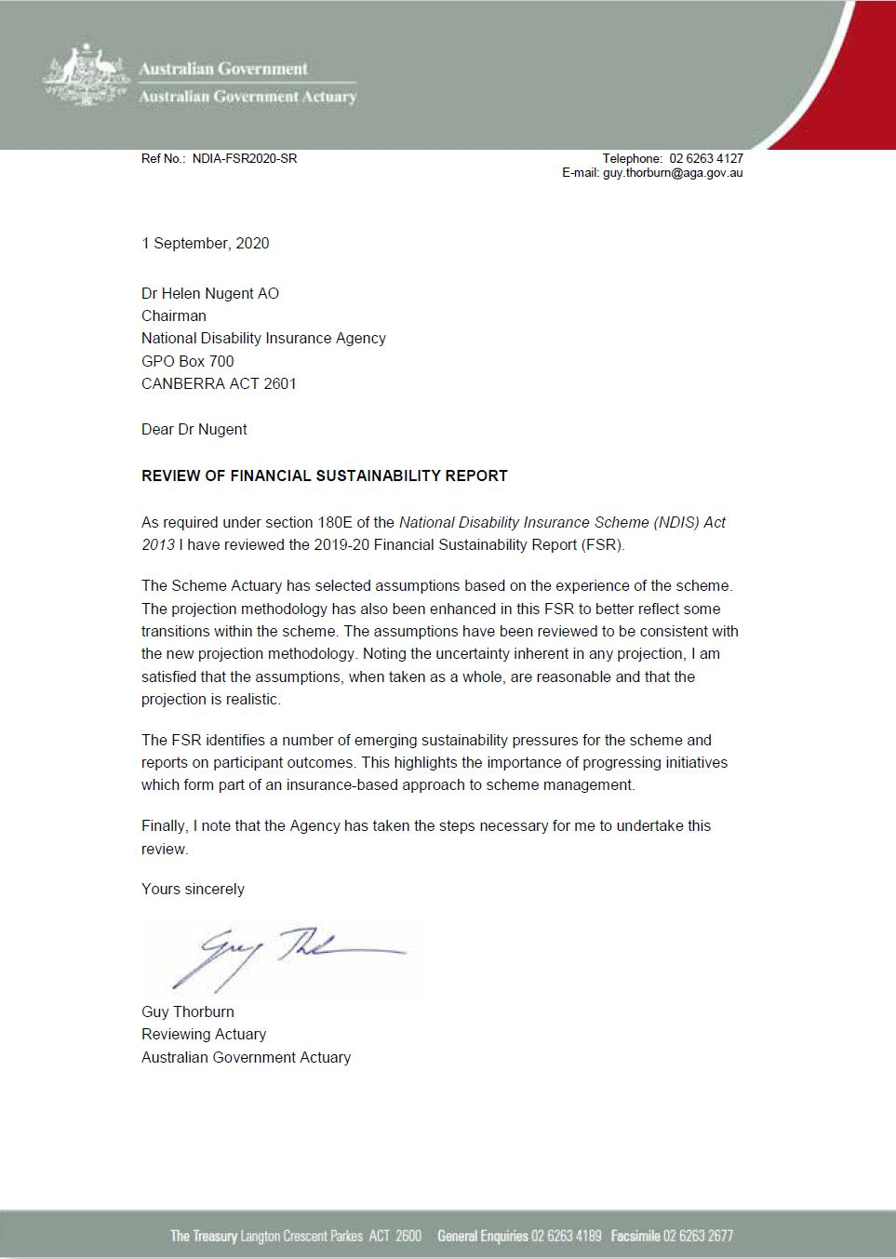

Annual performance statements
National Disability Insurance Agency – performance statement authority
I, Helen Nugent AO, as Chairman of the Accountable Authority of the National Disability Insurance Agency (NDIA), present the NDIA’s 2019–20 annual performance statements, as required under paragraph 39(1)(a) of the Public Governance, Performance and Accountability Act 2013 (PGPA Act).
The performance statements acquit the performance criteria as published in both the NDIA Corporate Plan 2019–2023 and Portfolio Budget Statements 2019–20, Budget Related Paper No 1.15A.
In the opinion of the Board, the annual performance statements have been appropriately prepared and presented in compliance with subsection 39(2) of the PGPA Act and are based on properly maintained records and accurately reflect the performance of the NDIA for 2019–20.
The data included in the annual performance statement should be read in conjunction with the commentary provided in Section 2 of this annual report.
Dr Helen Nugent AO
Chairman, National Disability Insurance Agency

Introduction
The Commonwealth performance framework covers corporate planning and performance reporting for Commonwealth entities including the NDIA.
The annual performance statements are one of three core elements of this performance framework. The NDIA Portfolio Budget Statements 2019–20 (PBS), which are published in Budget Related Paper No 1.15A, and the NDIA’s Corporate Plan constitute the remaining two components.

Structure and content
The annual performance statement identifies the NDIA’s purpose, as described in the NDIA Corporate Plan 2019–2023, which is then cross-referenced to the related outcome published in the PBS.
The report then provides actual results against each performance metric or target, with supporting comments where relevant.

NDIA Purpose
The Agency’s purpose is to support individuals with a significant and permanent disability (participants) to be more independent, and engage more socially and economically, while delivering a financially sustainable NDIS that builds genuinely connected and engaged communities and stakeholders.

Aspirations
- A quality experience and outcomes for participants – facilitate outcomes of economic and social independence and deliver a quality service for participants, their families, carers and providers
- A competitive market with innovative supports – work with participants and other stakeholders to enable the growth of a market of adequate size, quality and innovation
- A connected and engaged stakeholder sector – a strong and engaged stakeholder sector that genuinely collaborates and contributes to the delivery of the Scheme, with confidence in the NDIA
- A financially sustainable scheme – deliver a financially sustainable Scheme within the agreed funding, based on insurance principles and risk-awareness
- A high-performing NDIA – develop a high-performing, operationally excellent NDIA that has an engaged workforce with systems and processes that facilitate service excellence
The 2019–2023 NDIA Corporate Plan uses performance targets to measure achievements against these aspirations.

Aspiration 1: A quality experience and outcomes for participants
A quality experience and outcomes for participants is measured by:
- percentage of participants in work
- percentage of participants involved in community and social activities
- percentage of operational targets met
- percentage of participant plan reviews met
- participant satisfaction rating.
The following two tables provide baseline and age-split data for the first two measures.
Table 3.3.3A: Participants in work in 2019-20 compared with the 2019–20 target
Participants in work | At Scheme entry (baseline) | After three years in the Scheme | 2019–20 target
Aged 15 to 24 years | 13% | 25% | 24%
Aged 25+ | 26% | 24% | 24%
Aged 15+ (average) | 23% | 24% | 24%
Table 3.3.3B: Participants in community and social activities in 2019-20 compared with the 2019–20 target
Participants in community and social activities | At Scheme entry (baseline) | After three years in the Scheme | 2019–20 target
Aged 15 to 24 years | 31% | 45% | 47%
Aged 25+ | 36% | 49% | 47%
Aged 15+ (average) | 35% | 48% | 47%
The following table sets out the 2019–20 performance targets and the results achieved as at 30 June 2020 for Aspiration 1 from the NDIA Corporate Plan 2019–2023.
Table 3.3.3C: Aspiration 1 – A quality experience and outcomes for participants
Metric | Target | Baseline and result | Comment
Participants in work (%) | 24% | Baseline: Scheme actuarial reporting  Result: 24% | Many participants have experienced disruption to work, services and supports during the COVID-19 pandemic. The Agency worked closely with providers of NDIS employment supports to help participants remain connected and supported and encouraged providers to explore innovative ways to deliver this service.
Participants involved in community and social activities (%) | 47% | Baseline: Scheme actuarial reporting  Result: 48% | Community and social participation has continued to increase. The Agency has continued to work with providers during the COVID-19 pandemic to ensure participants have the opportunity to remain connected with their community as much as possible.
Operational targets (% met) | 100% | Baseline: % of Agency operational targets met at 30 June 2020  Result: Rollout complete | The operational bilateral estimate takes into account the number of clients provided to the NDIA by state/territory and Commonwealth governments and the number of people who previously did not receive services approaching the Scheme.  At 30 June 2020 the rollout of the Scheme has been completed and the operational target has been fully met.  At 30 June 2020, 391,999 people with a disability have an approved NDIS plan (excluding ECEI).
Participant plan reviews (% met) | >95% | Baseline: 93% met  Result:  100% completed within 21 days | The percentage of participant-requested review decisions completed within 21 days has improved throughout the year.
Participant satisfaction measured at the time of the plan approval (%) | >90% | Baseline: Internal satisfaction survey reporting  Result: N/A | Since September 2018, the Agency has conducted an enhanced, externally conducted participant satisfaction survey to allow for a comprehensive understanding of the participant experience at each stage of the pathway. It gathers responses at four primary stages of the participant pathway: access, pre-planning, planning, and plan review. Current satisfaction rates are:  Access 81 per cent  Pre-planning 83 per cent  Planning 84 per cent  Plan review 85 per cent  Significant improvements have occurred since this survey commenced in the second quarter of 2018-19.

Aspiration 2: A competitive market with innovative supports
A competitive market with innovative supports is measured by:
- percentage of participants choosing who supports them
- provider sentiment and confidence
- plan utilisation by region
- market concentration.
Table 3.3.3D: Aspiration 2 – A growing and competitive market with innovative supports
Metric | Target | Baseline and result | Comment
% of participants choosing who supports them | 45% | Baseline: Scheme actuarial reporting.  Result: 47% | In partnership with key stakeholders, the Agency developed and implemented a framework for monitoring and responding to a wide range of market issues. The Agency designed actions to support and shape the market to better respond to changing patterns of participant demand.
Provider sentiment and confidence | 5.5 out of 10 | Baseline: Provider Sentiment and Satisfaction Survey  Result: 5.9 out of 10 | The Agency has invested in the development of the NDIS market through continued work with service providers to address key and emerging areas for improvement. Through market engagement activities, market analysis and strategic communications to drive market responses, the Agency implemented a range of programs in 2019–20 to improve the participant and provider experience.
Plan utilisation by region (per cent of regions that are more than 10 percentage points from the national benchmark) | <8% | Baseline: Scheme actuarial reporting. Result: 10% | Utilisation continues to be negatively correlated with remoteness from major metropolitan areas. Further work is ongoing to improve access to services in “thin markets”. Utilisation improves for a given cohort of participants the longer they have been in the Scheme.
Market concentration (per cent of regions where the top 10 providers supply more than 85 per cent of the supports) | <10% | Baseline: Scheme actuarial reporting. Result: 13% | On average across all regions, 62 per cent of payments go to the largest 10 providers. There are 10 regions where 85 per cent or more of payments go to the largest 10 providers (13 per cent) and 18 regions where less than 45 per cent of payments went to the 10 largest providers (23 per cent). All of the 10 regions where more than 85 per cent of payments go to the 10 largest providers are regional and remote areas in the Northern Territory, Western Australia and South Australia.

Aspiration 3: A connected and engaged stakeholder sector
A connected and engaged stakeholder sector is measured by:
- sector sentiment
- number of engagement activities completed
- total unique website users (ndis.gov.au).
Table 3.3.3E: Aspiration 3 – A connected and engaged stakeholder sector
Metric | Target | Baseline and result | Comment
Sector sentiment (rating out of 10) | 5.5 | Baseline: NDIS biannual sector survey  Result: 5.9 | In 2019–20, the Agency continued to build and maintain genuine and collaborative partnerships with a wide range of stakeholders. Relationships developed with participants, their families, carers, providers, the disability sector, community and government have continued to inform the delivery of the Scheme, to help ensure it is fit for purpose.
Number of engagement activities completed | +50 per month | Baseline: Community and sector engagement  Result: 254 (average) engagements per month | The Agency has continued to foster partnerships with key stakeholders, actively engaging with the community and the sector. This has encouraged public debate on issues that matter. Relationships with state and territory governments have also been strengthened.
Total unique website (ndis.gov.au) users | 2,367,000 | Baseline: Website visits as per Google analytics  Result: 3,300,000 unique website users | There were 3.3 million unique users, resulting in over 1.5 million page views per month.

Aspiration 4: A financially sustainable scheme
A financially sustainable scheme is measured by:
- scheme support costs
- community inclusion and capacity development grant costs
- agency operating costs.
Table 3.3.3F: Aspiration 4 – A financially sustainable scheme
Metric | Target | Baseline and result | Comment
Total Scheme, Operating and Grants Costs within budget ($m) | $17,850 million as per the PBS (all programs) | Baseline: Portfolio Budget Statements 2018-19  Result: $19,266 million as per the NDIA Financial Statements | The Scheme experienced strong growth in Scheme costs due to both growing participant numbers and increased spend per participant. This led to a $1,376 million overspend against budget, for which approval was received from the Minister for Finance to use retained earnings to fund the deficit.
Payment errors/ anomalies (% of program outlay) | 5% | Baseline: NDIA Financial Statements  Result: 6.2% | The Agency has a compliance and assurance program aimed at substantiating a statistically selected sample of claims lodged by providers and self-managed plan participants. The results of the review conducted in 2019-20 extrapolated over the total value of provider payments assessed the accuracy rate in total payments made to providers was 93.8 per cent. The estimated potential overall financial impact of the provider error rates is $181.3 million, or 1.2 per cent of total cash payments.
Community inclusion and capacity development grant costs ($m) | $132 million | Baseline: based on PBS 2019–20 (Program 1.2)  Result: $135 million | The ILC program seeks to build the capacity of people with disability and communities to enable people with disability to achieve their goals and be included in all aspects of community life. Delivering ILC activities serves as a catalyst for change and is focused on creating greater inclusion for people with disability.  This program will cease to be managed by the Agency in the 2021 financial year with responsibility transferring to the Department of Social Services.

Aspiration 5: A high-performing NDIA
A high-performing NDIA is measured by:
- employee engagement
- gender balanced leadership
- people with disability employment
- risk culture.
Table 3.3.3G: Aspiration 5 – A high-performing NDIA
Metric | Target | Baseline and result | Comment
Employee engagement | 76% | Baseline: NDIA pulse survey 2020  Result: 80% | The Agency’s Engagement Index increased by 4 per cent to 80 per cent, from the 2019 APS Census result of 76 per cent. This illustrates that its workforce continues to be engaged and committed. The Agency’s continued focus on leadership development, recognition, skill and capability development, clear performance expectations and goal setting and quality decision making has contributed to the level of engagement.
Gender Balanced Leadership | 50% | Baseline: People and Culture Division data  Result: 51% | The Agency recognises the importance of gender-balanced leadership, with 51 per cent of women holding senior leadership roles across the Agency. This represents a one per cent increase on last year. The Agency continues to champion gender inclusion through the celebration of International Women’s Day and investment in leadership development programs that nurture female talent.
People with disability employment | 15% | Baseline: People and Culture Division data  Result: 11.1% | The Agency is committed to its focus on the employment of people with disability (11.1 per cent) through a variety of targeted recruitment approaches including the Indigenous Apprenticeships Program, Indigenous Australian Government Development Program, Australian Network on Disability Stepping Into Program, RecruitAbility and the APSC’s affirmative measures disability and Indigenous schemes.
Risk culture (% staff agreeing Agency has positive risk culture) | 50% | Baseline: APS Census 2019  Result: 57% | The Agency continues to improve the focus of staff on managing risks. This includes the implementation of Insight and Risk Week, delivering a week of activities focused on risk.

Management and accountability

Governance
The governance model for the Agency is set out in the NDIS Act.
The Agency is a corporate Commonwealth entity under the PGPA Act with statutory authority under the NDIS Act. The NDIS Act sets out the governance model for the Scheme.
Figure 4.1A: Agency governance diagram
Federal Parliament  Commonwealth Minister |  |  |  |  | Ministerial Council
 |  | NDIA Board |  |  |  |  | Independent Advisory Council
NDIA Management

Responsible Minister
The Minister for the NDIS is responsible for administering the NDIS Act and, with the agreement of states and territories, exercises statutory powers, including the power to make delegated legislation in the form of NDIS Rules and the power to direct the Agency. As at 30 June 2020, the Hon Stuart Robert MP was Minister for the NDIS.

Ministerial Council
In 2019–20, the Council of Australian Governments (COAG) Disability Reform Council (referred to as the Ministerial Council) comprised the Australian Government and state and territory treasurers and ministers responsible for disability. The Ministerial Council was the principal decision-maker on significant Scheme policy issues.
In early 2020, the focus of the Ministerial Council shifted towards the immediate response to the COVID-19 pandemic, particularly its potential impact on Scheme participants, providers and the disability workforce. On 29 May 2020, the Prime Minister announced that COAG would cease and that a new National Federation Reform Council would be formed, with National Cabinet at its centre. Information about the National Federation Reform Council is available on the Department of the Prime Minister and Cabinet website at https://pmc.gov.au/.

The Board
The Board:
- ensures the proper, efficient and effective performance of the Agency’s functions, and
- determines objectives, strategies and policies to be followed by the Agency.
Board membership is determined by the responsible Commonwealth Government Minister in consultation with the states and territories.
As part of good corporate governance, the Board undertakes a review of itself and its committees each year. This includes an annual review of the Board committee charters to ensure correct alignment of committee functions in supporting the Board’s responsibility as Accountable Authority of the Agency, and a review of committee memberships, which resulted in changes to committee membership to optimise operations. Board performance is also reviewed annually in accordance with the Board Charter and this year the performance review was undertaken by an external consultant. While COVID-19 posed a challenge to Board processes, the Board remained agile and adjusted its operating patterns to include videoconference meetings.

Directors
Dr Helen Nugent AO (Chairman)  Helen Nugent is an experienced Chairman and Non-Executive Director (NED), with a background in insurance, banking and energy. She gives back to the community in the arts, education and health.  She is currently a NED of IAG, TPG Telecom and the Garvan Institute of Medical Research, and is Chairman of Ausgrid and the National Portrait Gallery. Previously, she was Chairman of Swiss Re (Australia); Chancellor of Bond University; and President of Cranbrook School; and a NED of Macquarie Group and Origin Energy.  Qualifications: MBA (Distinction) from Harvard Business School; PhD and a BA (Hons) from Queensland University; and Honorary Doctorates from Bond and Queensland Universities.  Member: Sustainability Committee; Risk Committee; People and Remuneration Committee; ICT and Digital Committee  Attends: Audit Committee | 
Ms Sandra Birkensleigh  Sandra Birkensleigh is an experienced Non-Executive Director, bringing extensive experience in financial service and insurance industries to the Agency. She currently holds board positions with MLC Insurance Ltd, Auswide Bank Limited, Horizon Oil Limited, 7–11 Holdings Limited (and its subsidiaries) and Sunshine Coast Children’s Therapy Centre. She chairs the Audit Committee for each of these organisations.  She is a member of the Council for the University of the Sunshine Coast and an independent member of the Audit Committee of the Reserve Bank of Australia, and Chair of the Audit and Risk Committee for the Public Trustee of Queensland. Previously, she was a partner with PricewaterhouseCoopers, including its governance, risk and compliance practice.  Qualifications: Bachelor of Commerce from the University of New South Wales; Chartered Accountant  Chair: Audit Committee  Member: People and Remuneration Committee  Attends: Risk Committee | 
Professor Jane Burns  Jane Burns has extensive experience advising government, industry, university and the social enterprise sectors. She is Chair of Open Arms, Veterans Families Counselling Service; STREAT; and the Centre for Mental Health at Swinburne University. She is also the Mental Health and Wellbeing Innovator at Bupa and Professor of Innovation and Chair of the Centre for Mental Health at Swinburne University.  She is the Founder and Non-Executive Director of InnoWell and a Non-Executive Director with the Applied Positive Psychology Learning Institute and Mind Medicines Australia. She was a Commonwealth Fund Harkness Fellow in Health Care Policy at the University of California; a VicHealth Fellow in Health Promotion at Orygen, the National Centre of Excellence in Youth Mental Health and an NHMRC Fellow in Suicide Prevention at the Murdoch Children’s Research Institute.  She won the category of Social Enterprise for the 2015 Australian Financial Review and Westpac Group 100 Women of Influence for her achievements in entrepreneurship and was a Victorian Finalist in the 2017 Telstra Business Women’s Awards.  Qualifications: PhD in Medicine from the University of Adelaide  Member: ICT and Digital Committee | 
Mr Glenn Keys AO  Glenn Keys has been a member of the NDIS Board since inception. He has been involved in efforts to improve the lives of people with disability through involvement in the Special Olympics, the Down Syndrome Association and the disability housing sector. He has a health sector background as co-founder and co-executive Chairman of Aspen Medical, and founder and Chairman of Project Independence, an initiative offering home ownership to people with disability. He was awarded an Officer in the General Division (AO) in the 2017 Queen’s Birthday Honours list for distinguished service to disability, business and commerce and as an advocate for corporate social responsibility. He was named 2015 ACT Australian of the Year and was a board member of the organising committee for the Australian Invictus Games 2018. He has a child with an intellectual disability.  Qualifications: Bachelor of Mechanical Engineering from the University of New South Wales  Member: ICT and Digital Committee; People and Remuneration Committee | 
Ms Robyn Kruk AO  Robyn Kruk has extensive experience as Chief Executive of national and state policy, regulatory and service delivery agencies, including NSW Health and Premier and Cabinet. She established and served as inaugural CEO/Commissioner of the National Mental Health Commission. She is currently Chair, Board Director or member of international, national and state statutory, non-government and private entities in healthcare and emergency services, quality and safety, governance and mental health.  Qualifications: Bachelor of Science, Psychology (Hons) from the University of New South Wales; Master of Administration; Advanced Management Program from the Harvard Business School  Chair: People and Remuneration Committee  Member: Risk Committee.  Principal Member: Independent Advisory Council from 1 July 2020. | 
Mr John Langoulant AO  John Langoulant has extensive experience across many areas of public policy development and implementation from being the Western Australian Under Treasurer, Chairman of a number of government statutory authorities and from leading several government inquiries. He also chairs several private and not-for-profit organisations.  Qualifications: Bachelor of Economics (Hons) from the University of Western Australia  Member: Audit Committee; Risk Committee; Sustainability Committee | 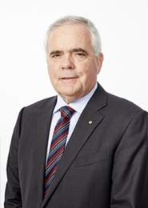
Dr Martin Laverty  Martin Laverty is Secretary General of the Australian Medical Association. He is Deputy Chair of the Australian Charities and Not-for-Profit Commission Advisory Board, a Board Director of Caritas Ltd, and a member of the Charity, Not-for-profit, and Philanthropy Advisory Committee to the National COVID-19 Coordination Commission. He is an Adjunct Professor at the University of Western Australia’s Not-for-Profit Initiative and a former CEO of the Royal Flying Doctor Service of Australia and Catholic Health Australia. He is also a former Board Chair of two disability service organisations, Sunshine and Challenge Southern Highlands, and is a former Director of the NSW Muscular Dystrophy Association.  Qualifications: LLB; PhD in Board Governance  A lawyer by training with a doctorate in board governance, he was a member of the Audit Committee and Risk Committee until he retired from the Board on 30 June 2020. | 
Mr Jim Minto  Jim Minto is Chair of Swiss Re Life & Health Australia Ltd and of Swiss Re Asia Pte. Ltd, Chair of NZ life insurer Partners Life Limited, Deputy Chair of Equity Trustees Ltd and Director of Dai-ichi Life Asia Pacific. He retired as Group Managing Director of life insurer TAL in March 2015 holding that role since 2006, and prior to that was Group CEO of the Trans-Tasman TOWER Limited Group. He had 26 years senior executive experience in the financial services sector. He was previously Chair of the Association of Superannuation Funds of Australia and a panel member of the Australian Government’s Review of Natural Disasters Insurance in 2011.  Qualifications: Chartered Accountant from Massey University  Chair: Risk Committee  Member: Sustainability Committee | 
Mr Paul O'Sullivan  Paul O’Sullivan has been Chairman of Optus since October 2014 and is a member of the Board of Commissioners of Telkomsel–Indonesia’s largest mobile communications company. He is a Director of ANZ, Coca-Cola Amatil Limited and St Vincent’s Health Australia. He is also a Board Member of the St George and Sutherland Medical Research Foundation and is Chairman of the Western Sydney Airport Corporation (WSA Co).  Qualifications: Bachelor of Economics from Trinity College; Advanced Management Program, Harvard Business School  Chair: Information Communication Technology and Digital Committee  Member: Risk Committee; People and Remuneration Committee | 
Ms Estelle Pearson  Estelle Pearson has extensive experience in the insurance and injury compensation sector having worked as an actuary and consultant in this sector since 1989. She is currently a Director of Finity Consulting Pty Limited, and was previously on the Council of the Actuaries Institute, including a term as President in 2015.  Qualifications: BA Hons (Mathematics) from the University of Oxford; FIAA  Chair: Sustainability Committee  Member: Audit Committee | 
Mr John Walsh AM  John Walsh is one of Australia’s leading actuaries. He is a retired Partner of Pricewaterhouse Coopers, where he worked for over 20 years in the areas of social policy and funding across accident compensation, health and disability. He has personal experience of disability, having lived with quadriplegia following a rugby league accident in his early-twenties. He has resigned from the Board effective 31 August 2020.  Qualifications: FIAA  Member: Sustainability Committee; ICT and Digital Committee  Principal Member: Independent Advisory Council until 30 June 2020 | 
Ms Andrea Staines OAM
Andrea Staines OAM is a Non-Executive Director with 13 years’ experience on listed, private, government and for-purpose boards in retail service and transport areas. Specifically in the area of care, Ms Staines is on the Board of UnitingCare Queensland, and was previously on the boards of Goodstart Early Learning and Early Learning Services. Ms Staines’ term on the Board concluded on 31 December 2019.

Board committees
A number of committees, councils and groups are in place to support the Board in ensuring the Agency meets its statutory requirements and manages risk. The following table provides the title and role of each committee and its members as at 30 June 2020.
Table 4.2.3A: Board committees and members as at 30 June 2020
Committee | Role | Members
Audit Committee | The Audit Committee assists the Board in the management and oversight of the quality and integrity of the accounting, auditing and financial reporting of the Agency. It was established in compliance with section 45 of the PGPA Act.  The Australian National Audit Office attends Audit Committee meetings as external auditor, along with the Chief Internal Auditor. | Ms Sandra Birkensleigh (Chair)  Mr John Langoulant AO  Dr Martin Laverty  Ms Estelle Pearson
ICT and Digital Committee | The ICT and Digital Committee assists the Board in the management and oversight of the Agency’s information, communication, technology and digital solutions including providing input to the Board on the design, development, delivery and performance of the information, communication, technology and digital strategy and systems. | Mr Paul O’Sullivan (Chair)  Professor Jane Burns  Mr Glenn Keys AO  Dr Helen Nugent AO  Mr John Walsh AM
People and Remuneration Committee | The People and Remuneration Committee assists the Agency to attract, retain and develop high-performing employees. It oversees strategies, frameworks and programs related to people and remuneration, and provides recommendations to the Board on CEO succession planning. | Ms Robyn Kruk AO (Chair)  Ms Sandra Birkensleigh  Mr Glenn Keys AO  Dr Helen Nugent AO  Mr Paul O’Sullivan
Risk Committee | The Risk Committee assists the Board in the management and oversight of the Agency’s approach to risk management. Its role is to advise the Board on the development and implementation of the Agency’s overall risk management approach. | Mr James Minto (Chair)  Ms Robyn Kruk AO  Mr John Langoulant AO  Dr Martin Laverty  Dr Helen Nugent AO  Mr Paul O’Sullivan
Sustainability Committee | The Sustainability Committee provides advice in assessing, monitoring, reporting on and managing the financial sustainability of the Scheme. | Ms Estelle Pearson (Chair)  Mr John Langoulant AO  Mr James Minto  Dr Helen Nugent AO  Mr John Walsh AM
The Audit Committee Charter can be found at Appendix 5.2.

Board and committee attendance
Table 4.2.4A: Number of meetings attended by Board members in 2019–20
 | NDIA Board |  | Sustainability Committee |  | ICT and Digital Committee |  | Audit Committee |  | Risk Committee |  | People and Remuneration Committee
Board members: | Eligible | Attended | Eligible | Attended | Eligible | Attended | Eligible | Attended | Eligible | Attended | Eligible | Attended
Dr Helen Nugent AO | 12 | 12 | 9 | 9 | 2 | 5 |  | 5 | 4 | 4 | 4 | 4
Mr James (Jim) Minto | 12 | 11 | 9 | 8 |  |  |  | 2 | 4 | 3
Ms Estelle Pearson | 12 | 12 | 9 | 9 |  |  | 5 | 5
Mr Paul O’Sullivan | 12 | 10 |  | 1 | 5 | 5 |  |  | 4 | 4 | 4 | 4
Ms Sandra Birkensleigh | 12 | 12 |  | 1 |  |  | 5 | 5 |  | 1 | 4 | 4
Mr John Langoulant AO | 12 | 11 | 9 | 8 |  |  | 5 | 3 | 1 | 3
Ms Andrea Staines | 7 | 6 |  |  | 2 | 1
Ms Robyn Kruk AO | 12 | 11 |  |  |  |  |  |  | 4 | 2 | 4 | 4
Dr Martin Laverty | 12 | 11 |  |  |  |  | 5 | 4 | 4 | 4
Mr John Walsh AM | 12 | 12 | 9 | 8 | 5 | 3 |  | 2
Mr Glenn Keys AO | 12 | 10 |  | 1 | 5 | 3 |  |  |  |  | 2 | 1
Prof Jane Burns | 5 | 5 |  |  | 3 | 3
Board Directors may attend any Board committee meeting in their capacity as a Director. “Eligible” refers to the number of committee meetings attended by a Director as a formal member of the Committee. “Attended” column includes all attendance at committee meetings, regardless of membership status.

Board membership changes
On 13 December 2019, the Hon Stuart Robert MP, Minister for the NDIS, announced the Board of the NDIA from 1 January 2020, with nine reappointments and one new member. Dr Helen Nugent was reappointed for a two-year term as Chair of the Board. Mr Paul O’Sullivan, Ms Robyn Kruk AO, Mr John Langoulant AO, Ms Estelle Pearson, Ms Sandra Birkensleigh, Mr James Minto, Mr Glenn Keys AO and Mr John Walsh AM were also reappointed to the Board for terms of up to two years. Professor Jane Burns was newly appointed to the Board for two years.
Ms Andrea Staines concluded her term as a Director on 31 December 2019, and Dr Martin Laverty concluded his term as a Director on 30 June 2020. Membership of Board committees changed over the course of the financial year. Current membership is shown at 4.2.2.

The Independent Advisory Council
The Independent Advisory Council (IAC) provides the Board with independent advice, which the Board must consider when performing its duties. The IAC, formally appointed by the Minister, is composed of people with disability, service providers and carers. It brings the crucial perspectives of these stakeholders to the work of the Agency and the design of the Scheme. Further information on the IAC is provided on the IAC's website at https://www.ndis-iac.com.au/.
The IAC plays an integral role in bringing the views of participants, families and disability sector experts to the heart of the NDIS by providing independent advice on the experience of its members and expert advisers, and their networks.
During 2019–20, the IAC continued to engage with a number of Agency business areas to provide both formal and informal advice. Key highlights for the financial year included:
- the endorsement of the IAC’s new operating model, aimed to optimise the role of IAC and expertise of its members in delivering a world leading NDIS. The implementation of the operating model will enable stronger alignment to corporate processes and priorities between the IAC and the Board, helping to translate advice into actionable programs of work, and support the Agency with implementation.
- the provision of formal advice to the Board in the areas of:
- plan support flexibility
- NDIS supports for participants who are parents
- support for decision making
- early childhood intervention
- capacity building.
The Agency will continue to work with the IAC to progress the implementation of the advice.
- the resumption of the IAC’s Intellectual Disability, Self-Management and Contemporary and Innovative Approaches Reference Groups meetings, providing key advice to the Agency in each area of expertise, including on the topics of improving participant’s voice, home and living supports and plan support flexibility.
Membership of the IAC at 30 June 2020 consisted of:
- Mr John Walsh AM (Acting Principal Member from 9 April 2019)
- Ms Kerry Allan-Zinner
- Mr Kevin Cocks AM
- Ms Jennifer Cullen
- Mrs Judy Huett
- Professor Anne Kavanagh
- Ms Sylvana Mahmic
- Mr James Manders
- Ms Janet Meagher AM
- Ms Leah van Poppel
- Ms Liz Reid
- Ms Sue Salthouse.
Ms Sue Salthouse worked in the area of social justice and human rights from 1996, up until her passing in July 2020. A highly respected, passionate advocate for people with disability, she was committed to educating the community about the impact disability has on people’s lives and contributed to the design, delivery and improvement of the NDIS. She made major contributions to both the Agency and the IAC.
The IAC was supported during the year by five advisers, engaged to provide advice from the perspective of key national peak bodies. They are:
- Mr David Moody, National Disability Services
- Ms Ara Cresswell, Carers Australia
- Mr Ross Joyce, Australian Federation of Disability Organisations
- Dr Ben Gauntlett, Disability Discrimination Commissioner
- Ms Jane Flanagan, Disabled People’s Organisations Australia.
Minister for the NDIS, the Hon Stuart Robert MP, announced the new and returning members of the IAC from 1 July 2020: Robyn Kruk AO (Principal Member), Tricia Malowney OAM, Sam Paior, Mark Tonga, Sharon Boyce, Sylvana Mahmic, Liz Reid AM, Kerry Allan-Zinner, Judy Huett, Jennifer Cullen, Leah van Poppel and James Manders. The IAC is supported by Dr Ben Gauntlett, Disability Discrimination Commissioner, in the role of Expert Adviser.
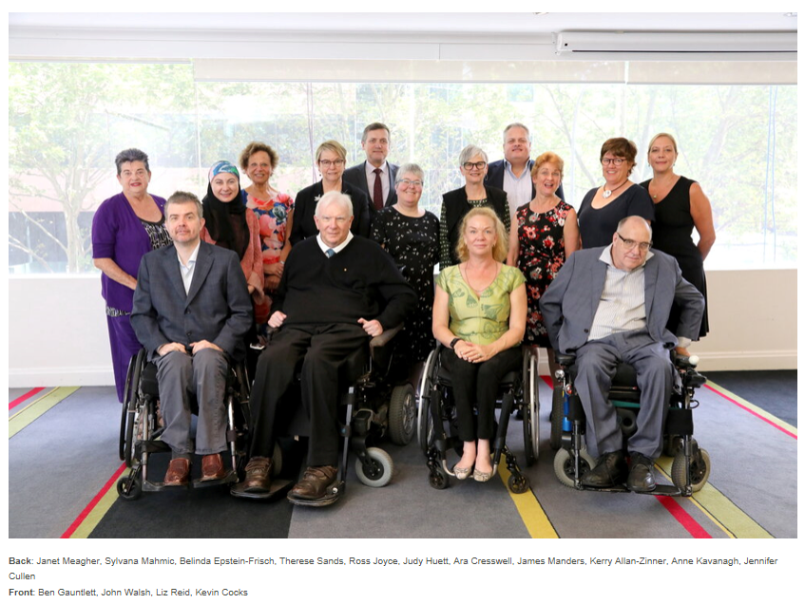

The Chief Executive Officer and Executive Team
The Chief Executive Officer (CEO) is responsible for the day-to-day administration of the Agency under the Act. Supported by the Executive Leadership Team (ELT), the CEO executes the Board-approved strategic objectives and policies, in line with the agreed risk appetite.
Mr Martin Hoffman was appointed CEO of the Agency from 4 November 2019. Before this, Ms Vicki Rundle PSM acted in the position from 30 April 2019.

The Executive Leadership Team

CEO
Martin Hoffman commenced as CEO on 4 November 2019. He has over ten years of senior public sector experience, including as a Deputy Secretary in the Commonwealth government and Secretary in the NSW government, following a CEO-level private sector career primarily in digital technology and media. He holds an MBA (Hons), Bachelor of Applied Finance and Bachelor of Economics degrees, and is a Fellow of the Institute of Public Administration Australia. Mr Hoffman was awarded the James Wolfensohn Public Service Scholarship to study at the Harvard Kennedy School in 2013. | 

Executive Leadership Team
Mr Hamish Aikman, Chief People Officer  Hamish Aikman joined the Agency in April 2018. Prior to joining the Agency, he held senior executive level human resources roles with Coles Supermarkets and led the People Culture function at Kmart Australia, under the ownership of Wesfarmers Ltd. Prior to his ten years in retail, he held key operations roles in supply chain management and previously with Ernst & Young. | 
Mr Oliver Bladek, Deputy CEO Design, Digital & Strategy  Oliver Bladek joined the Agency in October 2019 and leads the Agency's work in designing and delivering improvements to participant experience, increasing the use of technology in how the Agency services participants, and leading the Agency's strategy, priorities and research work. Prior to joining the Agency, he supported Westpac in their agile transformation and spent 15 years with McKinsey & Company, serving global clients on strategic, cultural and transformation topics. He also led the firm's organisation practice in Australia and New Zealand. | 
Mr Jeremy Dean, Deputy CEO Participant Experience Delivery  Jeremy Dean joined the Agency in December 2019 and is accountable for the end-to-end delivery and improvement of all the Agency's planning and service experiences for participants. His remit encompasses the operational arms of the Agency, including Local Area Coordinators and Early Childhood Early Intervention partners. He was previously Chief Operating Officer for ANZ Banking Group's Australian business and has held a number of national sales and service and operational leadership positions over 30+ years in the financial services industry in Australia and New Zealand. | 
Mr Ian Frew, Chief Information Officer  Ian Frew joined the Agency in early January 2018 after a 16-year career in General Insurance working for Suncorp, Allianz and IAG. While at IAG he was the Chief Information Officer for CGU Insurance and at both IAG and Allianz, he had deep involvement in workers compensation across Australia. He is a qualified chemical engineer, spending the first half of his career in global industrial automation roles, where he worked in a variety of industries from refining and manufacturing through to building automation. | 
Ms Sarah Johnson, Scheme Actuary  Sarah Johnson joined the Agency as Scheme Actuary in 2013. Prior to joining the Agency, she was a Director at PricewaterhouseCoopers. She has worked within the disability sector and broader health and human services sector for the last 15 years. She assisted the Productivity Commission on the Disability Care and Support Inquiry. She has also undertaken extensive actuarial work in accident compensation, housing, child protection, health and aged care. In 2016, she was awarded Actuary of the Year by the Actuaries Institute. | 
Mr Victor Walter, Deputy CEO Corporate Services and Chief Financial Officer  Victor Walter joined the Agency in March 2018. Mr Walter was previously the Group Finance Chief Operating Officer and Chief Financial Officer for Australia and New Zealand for the QBE Insurance Group. He was previously the Chief Financial Officer of the Metropolitan Ambulance Service. He is an experienced Chief Finance Officer with more than 20 years in the financial services industry. He has successfully implemented a number of finance transformation and large technology projects to deliver efficient systems, processes and controls. | 
Ms Vicki Rundle, Deputy CEO Markets, Government & Engagement  Vicki Rundle was the Deputy CEO Markets, Government and Engagement with the Agency throughout 2019–20 until 5 June 2020.  She has worked in Commonwealth and state government across a range of health and human services areas in her career, primarily in social policy, service delivery reform and in corporate enabling roles.  She left the Agency on 5 June 2020 following her appointment as Deputy Secretary with the Department of Veterans’ Affairs. | 
Ms Melissa Woodburn, Chief Risk Officer  Melissa Woodburn joined the Agency in July 2018 as the General Manager of Finance and Corporate Services. She took up the role of Chief Risk Officer in March 2020. Prior to this, she held senior leadership positions at large professional services firms.  She is a highly experienced chartered accountant with over 16 years' experience with Commonwealth government. She has extensive experience in financial management, performance improvement and organisational and public sector reform. | 

Organisation structure
On 2 March 2020, the CEO announced a new organisational structure which had been developed in consultation with the Board. The new structure reduced internal complexity and allows the Agency to deliver improved service for participants. As at 30 June 2020 there were four groups, three divisions and the Scheme Actuary represented on the ELT.

Figure 4.4.2A: Agency organisational structure as at 30 June 2020
 |  |  |  |  |  |  |  |  |  | CEO
DCEO  Participant Experience Delivery Group |  |  | DCEO  Design, Digital and Strategy Group |  |  | DCEO  Markets, Government and Engagement Group |  |  | DCEO  Corporate Services and Chief Financial Officer Group |  |  | Chief Risk Officer Division |  |  | People and Culture Division |  |  | Chief Information Officer Division |  |  | Office of Scheme Actuary
Areas of responsibility are structured as follows:

Participant Experience Delivery Group
The Participant Experience Delivery (PED) Group is responsible for all aspects of engagement with participants and their carers/families, including Scheme access, planning, reviews and complaints. The group also includes the PiTC network and the NCC. It is made up of four divisions:
- National Delivery Division is responsible for engagement with participants, including Scheme access, planning and the Complex Support Needs Team. The Division operationalises the end-to-end strategy and controls for access and planning and continuous improvement across the Agency.
- Operations and Support Division is responsible for providing systemic resolutions to complex National Delivery issues through leading root cause analysis and driving operational change. It develops and delivers significant technical, clinical and operational advice that informs, supports and improves the outcomes of the PED Group. Operations and Support assists PED teams with compliance of the NDIA policies, procedures, quality and risk management controls and delivers services and projects.
- Reviews and Complaints Division creates a positive participant experience by delivering on requests for action made through participants’ complaints, escalations, participant critical incidents or reviews. It makes decisions on reviews requested by participants and responds to queries from Members and Senators. The Division also manages Administrative Appeals Tribunal (AAT) applications.
- Partner and Contact Centre Division is responsible for the NDIA’s PITCPiTC network and the NCC, including strategic planning and sourcing, and contract and performance management. The Division maintains quality standards to ensure the highest performing partner and contact centre network.

Design, Digital and Strategy Group
The Design, Digital and Strategy Group brings expertise, technology, structure and pace to design and improve how the Agency serves and empowers participants. It is made up of five divisions:
- Participant Advocacy amplifies the participant's voice inside the Agency by using their feedback to increase participant satisfaction outcomes.
- Participant Experience Design designs and delivers large-scale improvements and enhancements to improve the participant experience and support how the Agency's front-line staff operates.
- Strategy and Priorities plans, leads, supports and delivers highly complex and significant outcomes, projects and work programs that have strategic and operational impact to the Agency.
- Advice, Research and Evaluation provides thought leadership, content expertise and advice and research effort towards the management of key strategic issues in improving the effectiveness of the NDIS.
- Digital shapes how the Agency uses technology to simplify and strengthen our front-line work in order to continuously improve effectiveness, outcomes and satisfaction.

Markets, Government and Engagement Group
The Markets, Government and Engagement Group is responsible for ensuring engagement and communications with stakeholders is genuine, two-way and effective in building and maintaining a positive reputation. It is made up of three divisions:
- Provider and Markets is responsible for developing and implementing a comprehensive strategic and tactical plan for the stewardship of a market of NDIS providers.
- Government and ILC manages and coordinates the Agency’s work and relationships with state, territory and federal governments. This includes governance committees and policy where other government mainstream services intersect with the ILC program. The ILC program will be transitioned to the Department of Social Services in 2020-21.
- Communications and Engagement supports the internal, external and media-based strategic communication of the NDIA and engagement with participants, the sector and the wider community to support the delivery of the NDIS. The Division is also responsible for coordination, support and advisory services for ministerial offices and parliamentary protocols; and management and decision making for all freedom of information (FOI) requests.

Corporate Services and Chief Financial Officer Group
The Corporate Services and Chief Financial Officer Group is responsible for the management of the Agency’s corporate functions (excluding People and Culture and ICT). This ensures products and services are available to the Agency in a timely, efficient and effective manner. They are accountable for:
- Finance, including financial controls, budgets and forecasts, reporting and funds management.
- Procurement, including managing the procurement process to ensure compliance with relevant legislation and ensuring value for money and ongoing contract management.
- Property, including the provision of suitable accommodation in relevant locations that is secure, safe and meets minimum disability access requirements and the ongoing management of property leases.
- Records management, including the maintenance of Agency records as required by legislation.
- Legal services, including the provision of legal advice across a wide range of legal matters including the operation of the NDIS Act.
- Compensation and recoveries, including the implementation of compensation recovery requirements of the NDIS Act and the recovery of all Agency debts.

Chief Risk Officer Division
The Chief Risk Officer Division is made up of three branches that enable the execution of operational and strategic objectives through activation of best practice risk and governance principles, proactive fraud and compliance monitoring and specialist risk advisory services.
- Scheme Integrity prevents, detects and responds to serious non-compliance, including fraud, against the Agency and/or the Scheme.
- Risk supports the Agency to identify and manage its risks, including maintaining the risk management framework, building internal risk management capability, analysing and reporting prevailing and emerging risks, and providing oversight of material risk exposures.
- Internal Audit provides functionally independent and objective assurance and advisory advice that assists the Board Audit Committee in discharging its duties and responsibilities to the Board.

People and Culture Division
The People and Culture division provides advice and support to staff and managers, throughout the employee lifecycle, and supports the Agency to provide a safe workplace for staff to build capability and foster a positive and inclusive culture to deliver the NDIS. It comprises two branches and three core teams:
- Workforce and Capability Branch determines Agency resource requirements, sources the right people and provides performance solutions to enable an inclusive, capable, and engaged workforce to deliver the NDIS.
- Human Resource (HR) Advisory Services Branch provides accurate advice and guidance on the application of the NDIA Enterprise Agreement and employment conditions, develops HR capability in leaders and ensures the Agency aligns with best practice HR management.
- NDIA Design/SES Unit focuses on shaping the future capability and design of the Agency to ensure its people and functions are aligned to support participant service delivery. This team also supports the Agency’s senior executive cohort and support staff throughout their employee lifecycle.
- Workplace Support and Disability Engagement Team provides staff and managers with the supports required to fully participate in and contribute to the workplace and create an accessible and inclusive environment for everyone.
- The Work Health Safety (WHS) and Wellbeing Team supports the Agency to provide a positive and safe workplace for its people, where WHS risks are minimised and health and wellbeing is optimised, through a robust WHS Management System and wellbeing action plan.

Chief Information Officer Division
The Chief Information Officer Division is primarily responsible for the management of technology-related solutions, as well as the Agency’s protective and cyber security planning and risk management. It comprises three branches:
- ICT Strategic Projects facilitates the delivery of ICT projects across the Agency. This includes technology strategy development, research and analysis of technology options, and development of and advice on delivery of the technical solutions to meet business requirements
- ICT Services manages the provision of ICT services and ICT support to meet the needs of the Agency.
- Protective and Cyber Security provides strategic, Agency-wide oversight of protective security across security governance, information security, personnel security and physical security. This includes offering pragmatic, risk based advice on the secure and reliable operation of information technology systems.

Office of Scheme Actuary
The Office of Scheme Actuary manages NDIA data services, business intelligence and analytics, Scheme monitoring and analysis of outcomes for participants, their families and carers. The group comprises three branches:
- Data and Insurance provides data services, including the delivery of the NDIA’s reporting platforms, and translates insights into measurable business performance improvements.
- Financial Sustainability projects the future cost of the Scheme, identifies key financial risks and their impacts and makes recommendations to manage and address these risks. This team also monitors outcomes for participants and their families/carers.
- Actuarial Monitoring provides detailed monitoring of Scheme performance including quarterly actuarial reports, quarterly reports to the Disability Ministers, and deep dive reports for the data and insights website.

Partners in the community
Our PiTC are experienced and qualified organisations with strong local knowledge and understanding of the needs of people with disability. They work with the Agency to deliver LAC and Early Childhood Early Intervention (ECEI) services to Australians with disability. They are often the first points of contact for participants, making them the face of the Scheme in many communities. The program currently has 27 partner organisations operating in all Australian states and territories, having reached full national coverage in mid-2019. As part of the program, the Agency works with suitably experienced and qualified partner organisations to deliver LAC and ECEI services to Australians with disability.
LAC partners help eligible participants navigate the Scheme and connect with community and other government services. They also provide support in planning and pre-planning activities and work with communities to improve accessibility and inclusion of people with disability.
ECEI Partners support children aged 0 to 6 years with a developmental delay or disability (and their families/carers) to develop the skills they need to participate in daily activities and achieve the best possible outcomes throughout their life.

Workforce management
To deliver the Scheme, the Agency needs a capable and committed workforce that is reflective of the broader Australian society. The type of skills mix that the Agency seeks changes to support an evolving operational environment. It is critical that we attract top talent and retain the required workforce.
As at 30 June 2020, the Agency workforce comprised 4,396 APS employees, 1,742 labour hire contractors and secondees, 4,917 PiTC and 495 NCC partners.

People Strategy
The Agency’s first People Strategy was developed in 2017 to guide us and our PiTC through the early years of the Scheme transition. During this time, the size and composition of the Agency workforce has grown and changed. In 2020, we refreshed our People Strategy as the organisation moves through transition.
To deliver the Scheme, the Agency needs a capable and committed workforce that is reflective of the broader Australian society. The mix of skills needed by the Agency continues to evolve, reflecting the needs of participants, carers and their families. It is critical the Agency attracts talented, knowledgeable and experienced staff as well as providing ongoing investment in building capability and training delivery. In particular, the Agency continues to expand and strengthen its focus on disability and cohort awareness to improve the quality of experience for participants.
The People Strategy 2022 has four key pillars built on the foundation of a solid people infrastructure. The four pillars are:
- Workforce - establish an Agency workforce that reflects the community it serves with the capability and capacity to deliver the NDIS
- Capability - support the Agency workforce to deliver consistent and positive participant experience performance
- Performance - provide clarity of performance expectations and reward for outcomes
- Engagement - build and embed a culture that cares about safety and staff wellbeing and drives for high performance.

Disability and diversity employment
In its second year of operation, the Agency’s Employee with Disability Network continued to play a key role in achieving our goal of being an employer of choice for people with disability and a leader for access and inclusion. The lived experiences of nearly 200 network members enable them to provide advice and guidance across the Agency’s operations. This includes internal operational policies and programs around recruitment, retention and support of workers with disability. The Employee with Disability Network is committed to working in partnership with the Agency to support workers with disability to achieve their career goals and aspirations by ensuring they can effectively and efficiently use their skills and experience to contribute to the Agency’s business outcomes.
In early 2020, the Agency established the Workplace Support and Disability Engagement Team, comprising a range of specialist disability support officers who oversee the implementation of workplace adjustments. During the unprecedented COVID-19 pandemic, the team played a crucial role in ensuring workers with disability, many of whom had to transition to home-based work environments, had all their workplace adjustments and other additional support needs met.
The Agency continues to work with the Australian Network on Disability to ensure it is a Disability Confident Recruiter with training available for hiring managers.
The Agency’s graduate program, designed to build our future leadership capacity, has a strong focus on recruiting people with disability. In the 2020 intake, 60 per cent of the graduates shared that they live with disability.
Since its establishment in 2016, the Aboriginal and Torres Strait Islander Employee Network has continued to provide a forum for Aboriginal and Torres Strait Islander employees to connect with each other on a national basis. The Agency continues to deliver on the actions outlined in its second Reconciliation Action Plan, launched in May 2019. The Agency’s Innovate Reconciliation Action Plan outlines the Agency’s ongoing commitment to develop respectful and inclusive relationships with Aboriginal and Torres Strait Islander peoples and communities. The Agency has also continued to deliver on actions outlined in the Aboriginal and Torres Strait Islander Employment Strategy 2018–20. Key achievements delivered so far include the launch of Aboriginal and Torres Strait Islander cultural awareness training for all employees, the establishment of our Aboriginal and Torres Strait Islander Buddy Program, and continued participation in the Indigenous Apprenticeships Program and the Indigenous Australian Government Development Program.
The Agency is focused on supporting its workforce who identify as part of the LGBTIQA+ community. An LGBTIQA+ Inclusion Plan Working Group has formed to develop the Agency’s first LGBTIQA+ Inclusion Plan, which will outline how the Agency will attract, support and retain LGBTIQA+ people. This plan will be delivered in 2021. Early achievements in its development and design include the establishment of an LGBTIQA+ Employee Network and the appointment of a Senior Executive Service (SES) LGBTIQA+ Champion. The Agency holds membership with the national not-for-profit organisation Pride in Diversity.

Performance management
In 2019–20 the Agency introduced a refreshed Performance Framework for SES. This new framework will assist the Agency to move to a performance process that cascades the Agency Corporate Plan aspirations and goals to every level of the Agency. The move from 100 Day Plans to an annual performance cycle and annual goal setting provides strategic goal alignment, and focuses performance planning and assessment on achieving corporate strategic outcomes.
The new annual performance cycle includes mid-year and annual reviews and two informal check-ins. Mid-year and annual review ratings are based on ‘What’ and ‘How’, measures that align the Agency’s values and behaviours with performance. Regular check-ins and reviews facilitate ongoing quality conversations throughout the performance cycle that allow managers to check in on progress and whether goals and expectations need to be realigned to address changes in priorities. This change will be introduced to the broader Agency in the 2020–21 financial year.

Ethics policies
The Agency promotes ethical standards and behaviours relating to its workplaces and employment. All Agency staff are required to comply with the APS Values and Code of Conduct as set out in section 13 of the Public Service Act 1999. Possible breaches of the Code of Conduct are taken seriously, and action is taken when breaches occur.
The Agency has in place compulsory training programs, staff policies, and guidelines to help staff to understand their obligations and to support good workplace behaviour. Managers and staff have access to a network of officers trained to provide information and support to staff who have concerns about workplace behaviours, including bullying, harassment and discrimination. These officers receive a fortnightly allowance to undertake this role, as set out in the Agency Enterprise Agreement 2016–2019 and 2020–2023.
Material published on the Agency’s (internal) intranet includes information on the APS Values, the APS Employment Principles, the APS Code of Conduct and the Ethics Advisory Service, which is available to all APS employees who wish to discuss or seek advice on ethical issues that occur in the workplace.

Staff engagement
The NDIA continues to build and embed a values-based culture that always puts participants at the heart of everything we do. The Agency seeks to deliver quality participant outcomes, through a safe and inclusive working environment which values the skill, commitment and wellbeing of our people.
We have an engaged workforce which in turn drives high performance. We conducted our own engagement survey given the COVID-19-driven deferral of the full APS Census. The survey was available to all Agency workers from 18 to 29 May 2020. The results indicate a continued strengthening of workforce engagement, with a response rate of 88 per cent and an Engagement Index score of 80 (an increase of 4 points in comparison to the 2019 APS Employee Census). This improvement reflects our team’s attachment to the Agency, and a strong sense of purpose and commitment to the work that they do.

Risk management
The Agency has a structured approach to identifying, managing, escalating and communicating key risks early. This is critical to the effective and efficient delivery of the Scheme. The Agency is committed to ensuring that participant supports, provider services and other critical business functions are maintained or quickly restored in the event of a significant outage, incident or crisis. The proactive use of risk management within the Agency has allowed us to support effective business planning and operations with an evidence-based approach within the appetite and tolerances set by the Board.
The Chief Risk Officer (CRO) assists the Board and the ELT by providing objective risk reviews, oversight, monitoring and reporting.
On an annual basis, the Board determines the strategic risks for the Agency, which are directly aligned to the Corporate Plan. The Board determined 11 strategic risks for 2019–20 in the areas of participant experience and outcomes, provider market growth and quality, stakeholder expectations, Scheme sustainability and Agency operational stability. The strategic risks are monitored against key indicators and performance is reported to the Board on a quarterly basis. The strategic risks are complemented by operational risks and controls which are owned and managed at group level.
In 2019–20, the Agency established and tested a robust Business Continuity Management Framework (most recently during the Victorian and New South Wales bushfire emergency and the COVID-19 pandemic) to ensure the rapid resumption of participant and provider services and critical business activities in emergency situations.
In 2019–20 an Agency-wide review of the prevailing operating risks was undertaken to validate the accuracy and robustness of the Agency risk and control framework. This resulted in the removal of risk, controls and treatment duplication by 40 to 60 per cent. A system-based quarterly risk review process is planned for all critical and high risks in line with the Agency’s risk governance requirements, including strategic and regulatory risk mapping.
In 2019–20 the Agency launched its Integrated Risk Management System - a central repository for capturing and managing strategic and operational risks, regulatory obligations, audit recommendations, incidents and business continuity plans. The system will give accountable executives enhanced awareness of risks and controls. Linkages will provide a holistic view of the Agency risk profile, which will enhance risk-based decision-making.
The Agency’s Risk in Change guide has been integrated into the Agency Change Management Framework. This will facilitate a structured approach to identifying and mitigating risks associated with strategic projects and significant operational change.
In October 2019 the Agency commenced a 12 month Regulatory Assurance Program to deliver risk-based assurance coverage over a number of key regulatory obligations to ensure the Agency’s control environment is effective. Two reviews were completed in 2019–20, on the NDIS Act; and on privacy and freedom of information requirements.
In February 2020 the Agency implemented the SpeakUp platform to raise risk awareness and sustain a strong risk culture across the Agency. Since its launch, the number of incidents and potential process improvements identified and reported has increased - this has enabled us to respond promptly and take remedial action.

Scheme integrity

Internal
The Internal Fraud function is responsible for meeting obligations under the Commonwealth Fraud Control Framework 2017.
During 2019–20 the Internal Fraud function has enhanced the Agency’s effectiveness in dealing with reports of suspected fraud from the public, staff members or other stakeholders. The Agency continued to develop the internal fraud control process, capabilities and targeted detection profiles to manage fraud risks and reports of suspected fraud. The function has improved workflows and efficiencies in detecting, preventing, investigating and responding to internal fraud matters.
The Agency uses specific measures for countering the risk of corruption, including where staff members are targeted by external parties and staff members engage in fraudulent behaviours in order to gain a benefit or cause a loss during or through their employment with the Agency. In 2020–21 the Agency will develop the Staff Integrity Framework, which will enhance our ability to manage internal fraud risk.
Internal fraud practices ensure that our stakeholder sector remains connected and our approach to fraud, corruption and staff integrity is consistent and aligned.

External
The Agency maintains a zero-tolerance approach to fraud and invests heavily in the prevention and detection of fraud. Prevention initiatives include education and awareness raising for internal and external stakeholders. This includes raising awareness of scams, which tend to increase in number during times of crisis.
In 2019–20 the Agency fully implemented its Fraud and Compliance Roadmap, completing a detailed two-year capability-building plan and embedding a more mature capability to support the Agency and the accountable authority to meet its obligations to government.
The Agency also refreshed its Fraud and Corruption Control Plan, strengthening governance and responsibilities and presenting a view of the Agency’s fraud and corruption risks to the ELT and the Board. The Fraud and Corruption Control Plan aligns with the Commonwealth Fraud Control Framework 2017.
In 2019–20 the Agency moved to a rolling program of risk assessment activities to continue to strengthen the fraud and corruption control environment and to further embed fraud risk management in the Agency’s core business. The program prioritises higher risk areas and allows for inclusion of new or emerging risks. Re-prioritisation exercises were conducted to incorporate risks arising from the bushfire crisis and COVID-19 pandemic measures.
The Agency’s fraud and corruption risk register has been improved and feedback and insights from the Australian National Audit Office’s 2019 performance audit on the NDIS Fraud Control Program have been acted upon.
The Agency has recruited and embedded permanent employees who specialise in fraud and corruption control. These experts continue to work with risk and control owners across the business to identify control vulnerabilities, assess control effectiveness and introduce additional mitigating treatments.
The Agency continues to prioritise the effective handling of reports of suspected fraud from the public or other stakeholders. The Agency’s appropriate assessment, investigation and response to allegations of suspected fraud is a key element in maintaining the confidence of stakeholders, including governments and the Australian community.
In 2019–20 the Agency introduced a scams helpline to support participants and other stakeholders who have had their personal information compromised through a scam. The Agency has continued to invest in data analytics and data matching, infrastructure and data and intelligence analysts. More advanced analytics and machine learning has been piloted to complement these current capabilities. These advanced methods and tools will draw upon industry best practice to further extend the Agency’s fraud detection capability and continue to develop our analytics maturity.
In 2019–20, the Scheme Integrity Branch conducted a range of compliance activities, including targeted and proactive engagement, and desk-based reviews, to treat payment risks through opportunistic and non-compliant behaviour from providers, plan management agencies, and participants identified through tip-offs and a diverse range of fraud detection profiles.
The Scheme Integrity Branch has used targeted activities to engage with over 1,800 providers, plan management agencies and participants to reinforce their obligations and responsibilities when claiming payments arising from participant plans.
In 2019–20 the Agency received more than 5,000 tip-offs through the fraud reporting hotline and email. In response to increasing numbers of fraud tip-offs, the Scheme Integrity Branch commenced a Community Engagement Program pilot. The program is designed to increase the awareness of participants, providers and NDIA PITCs of their rights, responsibilities and obligations based on analysis of fraud tip-offs.
The pilot began in outback Queensland, where there had been more than 20 tip-offs about one Scheme provider. The Agency, together with the NDIS Quality and Safeguards Commission, visited the provider, discussed the allegations and reinforced standards and expectations with the provider to ensure participants received the best possible supports. The pilot is assisted by local Agency service delivery staff, who ensure that any emerging issues are identified and addressed.
The NDIS Fraud Taskforce, initially established for two years from July 2018, has assisted the Agency to develop effective detection and response to fraud against the Scheme. The prevention and detection capabilities have now been developed into the standing structure of the Agency’s Scheme Integrity Branch. The investigation function has also matured, with successful investigations completed or currently before the courts and identified risks and business improvement opportunities fed back into the Agency. In June 2020 the Minister for the NDIS, the Hon Stuart Robert MP, approved the extension of the taskforce to 30 June 2021, allowing the joint activity of the Agency, the Australian Federal Police and Services Australia to continue focusing on serious and organised fraud affecting the Scheme.

Case study: NDIS Fraud Taskforce inquiry leads to imprisonment and forfeiture of proceeds of crime
In June and July 2018, the Agency received complaints from a range of sources about the activities and claiming behaviour of Melbourne service provider Langmann Care Pty Ltd. The NDIS Fraud Taskforce, supported by the Agency’s Fraud Intelligence Section, investigated the allegations and gathered evidence that the owner of this company, Mohamed Omar, had claimed $483,000 of Scheme funding for services to participants that had never been delivered. Omar was subsequently arrested and charged with a range of Commonwealth fraud offences.
Omar’s fraud involved NDIS plans of 230 participants. In some cases, the wellbeing of these participants and their families was detrimentally affected. Victim impact statements presented during court proceedings showed the dramatic personal impact the offending had on some of our community’s most vulnerable people.
Omar eventually pleaded guilty to the charges. On 11 July 2019 he was sentenced to four years of imprisonment. Also, as a result of the taskforce inquiry, high-end motor vehicles, luxury items and cash were seized from Omar and forfeited as proceeds of crime.
As at the end of 2019–20, the NDIS Fraud Taskforce has five further criminal prosecutions before the courts and a range of other complex and serious investigations are on foot.

The Agency acknowledges that, in relation to fraud and corruption control, prevention is key. The strongest defence is a sound system of internal controls. The Agency has put in place a number of elements that will bolster effective fraud and corruption prevention - for example, a leadership commitment to effective risk management and an ethical culture, supported by appropriate levels of awareness about fraud-related issues among staff, including contractors and partners. The Agency also has adequate on-boarding and off-boarding processes; clear standards of conduct; and skilled and qualified fraud control, fraud intelligence and fraud investigations personnel.

Internal audit
The Internal Audit function works with the Risk Branch to successfully implement effective risk management and control. It operates as the ‘third line of defence’ within the Agency. Internal Audit provides independent assurance to management and the Board through the Audit Committee and also works with management to improve the risk and control environment, acting as a trusted adviser. It works with stakeholders to ensure they understand the Agency’s strategic direction and risk profile to deliver a fully aligned, risk-focused plan incorporating both assurance and advisory engagements. Through our stakeholder engagement, findings are raised with an understanding of the operating environment and relevant insights are communicated.
In 2019–20, the Internal Audit function delivered an approved internal audit plan to the Board Audit Committee. This plan is constantly updated - a formal review is performed every six months to ensure that it remains relevant and is focused on the key risks facing the Agency. The results of all audits were reported to the Board Audit Committee, and progress on action plans to manage issues was monitored through an online tracking system. The status of these actions was reported to both the ELT and the Board through the Audit Committee.
In addition to raising formal issues, the Internal Audit function also provides an Awareness and Action Rating for each assurance engagement. This rating focuses on the risk management culture of the areas audited. The results are included as part of the report delivered to the ELT and the Board Audit Committee. This method of reporting assists in further maturing the level of risk management culture across the Agency.

External audit
The Agency maintains a close working relationship with the Australian National Audit Office (ANAO), which provides both external auditing services on the annual financial statements and performance audit services. Details of performance audits delivered during the year that have an impact on the Agency are provided in Appendix 5.8. The ANAO’s audit report on the annual financial statements is included in 3.1.
All management actions taken to address recommendations raised by the ANAO are closely tracked, with regular reporting on their status to both the ELT and the Board.
The Auditor-General tabled the ANAO performance audit report on the NDIS Fraud Control Program on 25 June 2019. The ANAO concluded that the Agency is compliant with the requirements of the Commonwealth Fraud Rule and with best-practice directions from the Australian Government Investigations Standards. The audit recognised the Agency’s ongoing investment to improve the response to fraud and non-compliance.
The ANAO made six recommendations, all of which the Agency agreed to. All recommendations have been actioned and closed.

Appendices

Enabling legislation
The National Disability Insurance Agency (the Agency) is established under the National Disability Insurance Scheme Act 2013 (NDIS Act) to deliver the National Disability Insurance Scheme (NDIS or the Scheme). It is a corporate Commonwealth entity under the Public Governance, Performance and Accountability Act 2013 (PGPA Act).
The functions and powers of the Agency are prescribed by the NDIS Act. They include:
- delivering the NDIS
- managing, advising on and reporting on the financial sustainability of the Scheme
- developing and enhancing the disability sector
- building community awareness of disabilities and the social contributors to disabilities
- collecting, analysing and exchanging data about disabilities and supports
- undertaking research relating to disabilities and supports.
The NDIS Act (in conjunction with other laws) gives effect to Australia’s obligations under the United Nations Convention on the Rights of Persons with Disabilities, and its objectives include:
- supporting people with disability to pursue their goals and maximise their independence and social and economic participation
- developing the capacity of people with disability to participate in the community and in employment
- providing reasonable and necessary supports, including early intervention supports, for participants
- supporting people with disability to exercise choice and control in pursuit of their goals and in the planning and delivery of their supports
- building a sustainable Scheme that is based on insurance principles
- raising community awareness about the social and economic participation of people with disability and acting to increase their inclusion in the mainstream of Australian society.
The Agency is overseen by a Board, and is accountable as a corporate Commonwealth entity under the PGPA Act.
The Board is responsible for ensuring the proper, efficient and effective performance of the Agency functions, and for determining the objectives, strategies and policies to be followed by the Agency.

Audit Committee Charter
The Agency’s Board has established the Audit Committee to assist the Board to oversee its responsibilities and legislative obligations as the Agency’s Accountable Authority under:
- section 45 of the PGPA Act
- section 17 of the Public Governance, Performance and Accountability Rule 2014 (PGPA Rule)
- the NDIS Act.
The Charter details the Committee’s purpose, to oversee the appropriateness of the Agency’s:
- management of the internal and external audit processes
- financial reporting processes
- performance reporting processes
- system of risk oversight and management
- system of internal control
- process for monitoring compliance with laws and regulations and the Code of Conduct.
The Audit Committee Charter is available to view at https://www.ndis.gov.au/media/2466/download

Work health and safety
The Agency acknowledges its responsibilities under the Work Health and Safety Act 2011 (WHS Act), the Safety, Rehabilitation and Compensation Act 1988 and anti-discrimination legislation. The Agency takes all reasonably practicable measures to protect the health, safety and welfare of its workers while at work, including providing a safe work environment. The Agency Work Health and Safety Policy, and Health and Safety Management Arrangements 2020 - 2022 promote consultation, prevention and early intervention, and are aligned with a steadfast commitment to safeguard and value Agency employees. In 2019–20, the Agency reported seven incidents to Comcare pursuant to section 38 of the WHS Act. Three incidents were later deemed not notifiable by Comcare, and each incident was closed by Comcare without further action being required of the Agency.
Table 5.3A: Summary of incidents pursuant to section 38 of the WHS Act, 2019–20
Action | Number
Death of a person that required notice to Comcare under s 35 | 0
Serious injury or illness of a person that required notification to Comcare under s 35 | 6
Dangerous incident that required notification to Comcare under s 35 | 1
Investigation conducted under Part 10 | 0
Notice given to Agency under s 90 (provisional improvement notice) | 0
Notice given to Agency under s 191 (improvement notice) | 0
Notice given to Agency under s 195 (prohibition notices) | 0
Directions given to Agency under s 198 (non-disturbance) | 0

Workforce statistics
Table 5.4A: All ongoing employees current reporting period (2019–20)
 | Male |  |  | Female |  |  | Indeterminate |  |  | Total
 | Fulltime | Part time | Total male | Full time | Part time | Total female | Full time | Part time | Total indeterminate
NSW | 172 | 16 | 188 | 495 | 111 | 606 | - | - | - | 794
QLD | 111 | 5 | 116 | 331 | 52 | 383 |  | - |  | 499
SA | 51 | 5 | 56 | 160 | 57 | 217 | - | - | - | 273
TAS | 17 | 2 | 19 | 34 | 12 | 46 | - | - | - | 65
VIC | 294 | 17 | 311 | 656 | 177 | 833 | - | - | - | 1,144
WA | 31 | 2 | 33 | 107 | 17 | 124 | - | - | - | 157
ACT | 70 | 2 | 72 | 100 | 14 | 114 | - | - | - | 186
NT | 19 |  | 19 | 41 | 4 | 45 | - | - | - | 64
Overseas | - | - | - | - | - | - | - | - | - | -
Total | 765 | 49 | 814 | 1,924 | 444 | 2,368 | - | - | - | 3,182
Table 5.4B: All non-ongoing employees current reporting period (2019–20)
 | Male |  |  | Female |  |  | Indeterminate |  |  | Total
 | Fulltime | Part time | Total male | Full time | Part time | Total female | Full time | Part time | Total indeterminate
NSW | 42 | 5 | 47 | 172 | 27 | 199 | - | - | - | 246
QLD | 45 | - | 45 | 142 | 29 | 171 | - | - | - | 216
SA | 18 | 3 | 21 | 60 | 8 | 68 | - | - | - | 89
TAS | 2 | 2 | 4 | 10 | 2 | 12 | - | - | - | 16
VIC | 106 | 3 | 109 | 259 | 59 | 318 | - | - | - | 427
WA | 22 | - | 22 | 89 | 11 | 100 | - | - | - | 122
ACT | 16 | 1 | 17 | 36 | 8 | 44 | - | - | - | 61
NT | 13 | - | 13 | 21 | 3 | 24 | - | - | - | 37
Overseas | - | - | - | - | - | - | - | - | - | -
Total | 264 | 12 | 276 | 789 | 144 | 933 | - | - | - | 1,214
Table 5.4C: All ongoing employees previous reporting period (2018–19)
 | Male |  |  | Female |  |  | Indeterminate |  |  | Total
 | Full time | Part time | Total male | Full time | Part time | Total female | Full time | Part time | Total indeterminate
NSW | 157 | 14 | 171 | 413 | 93 | 506 | - | - | - | 677
Qld | 89 | 4 | 93 | 272 | 53 | 325 | 1 | - | 1 | 419
SA | 45 | 2 | 47 | 129 | 57 | 186 | - | - | - | 233
TAS | 14 | 1 | 15 | 29 | 11 | 40 | - | - | - | 55
VIC | 243 | 16 | 259 | 524 | 161 | 685 | - | - | - | 944
WA | 25 | 2 | 27 | 88 | 12 | 100 | - | - | - | 127
ACT | 32 | 1 | 33 | 57 | 11 | 68 | - | - | - | 101
NT | 8 | - | 8 | 38 | 1 | 39 | - | - | - | 47
Overseas | - | - | - | - | - | - | - | - | - | -
Total | 613 | 40 | 653 | 1,550 | 399 | 1,949 | 1 | - | 1 | 2,603
Table 5.4D: All non-ongoing employees previous reporting period (2018–19)
 | Male |  |  | Female |  |  | Indeterminate |  |  | Total
 | Full time | Part time | Total male | Full time | Part time | Total female | Full time | Part time | Total indeterminate
NSW | 47 | 5 | 52 | 162 | 21 | 183 | - | - | - | 235
QLD | 32 | 1 | 33 | 134 | 15 | 149 | - | - | - | 182
SA | 7 | 3 | 10 | 26 | 1 | 27 | - | - | - | 37
TAS | 3 | 1 | 4 | 7 | 1 | 8 | - | - | - | 12
VIC | 76 | 6 | 82 | 132 | 41 | 173 | - | - | - | 255
WA | 18 | - | 18 | 58 | 8 | 66 | - | - | - | 84
ACT | 7 | - | 7 | 27 | 2 | 29 | - | - | - | 36
NT | 15 | - | 15 | 34 | 2 | 36 | - | - | - | 51
Overseas | - | - | - | - | - | - | - | - | - | -
Total | 205 | 16 | 221 | 580 | 91 | 671 | - | - | - | 892

Executive remuneration policy

Executive remuneration
Outlined below is information on the Agency’s remuneration practices, as well as the remuneration paid to the Agency’s key management personnel, senior executives and other highly paid staff for the year ended 30 June 2020 in accordance with the PGPA Rule.

Remuneration policies, practices and governance arrangements
The CEO of the Agency is remunerated as per the Remuneration Tribunal (Remuneration and Allowances for Holders of Full-time Public Office) Determination 2019 made under subsections 7(3) and (4) of the Remuneration Tribunal Act 1973.
The Chairman and members of the Board of the Agency are remunerated as per the Remuneration Tribunal (Remuneration and Allowances for Holders of Part-time Public Office) Determination 2019 made under subsections 7(3) and (4) of the Remuneration Tribunal Act 1973.
Agency SES employees are offered a remuneration and employment conditions package through an individual determination under the Public Service Act 1999 (section 24.1). Packages follow the principles outlined in the Agencies SES Remuneration and Conditions Policy, which are developed by the People and Culture Division and approved by the CEO. For SES employees, remuneration is based on their classification, with a three increment level structure allocated within each classification.
Remuneration includes salary, superannuation and executive vehicle benefit, and may include additional salary payments and/or other remuneration benefits approved by the CEO. The remuneration and employment conditions at the Agency comply with the requirements of the Executive Remuneration Management Policy issued by the Australian Public Service Commission. The Agency Board established the People and Remuneration Committee (PRC) to assist the Board to fulfil its governance responsibilities for the people and remuneration policies of the Agency, including oversight of remuneration within government policies and frameworks. Other highly paid staff within the Agency, excluding SES employees, are remunerated in line with the Agency Enterprise Agreements 2016–2019 and 2020–2023. This may include payment of a Higher Duties Allowance as a result of an employee performing higher duties, or an Individual Flexibility Arrangement. Remuneration-related policies that underpin the Agency Enterprise Agreements 2016–2019 and 2020–2023 include the Allowances Policy and Individual Flexibility Arrangement Principles.

Executive remuneration

Key management personnel
During the year ended 30 June 2020, in addition to the Board, the Agency had 13 senior executive or equivalent officials who met the definition of key management personnel (KMP). The name and the length of term for each KMP are summarised below.
Table 5.6.1A: Key management personnel
Name | Position | Term as KMP
Dr Helen Nugent AO | Board Chairman | Full year
Ms Sandra Birkensleigh | Board Member | Full year
Professor Jane Burns | Board Member | Part year – appointed 1 January 2020
Mr Glenn Keys AO | Board Member | Full year
Ms Robyn Kruk AO | Board Member | Full year
Mr John Langoulant AO | Board Member | Full year
Dr Martin Laverty | Board Member | Full year
Mr James Minto | Board Member | Full year
Mr Paul O’Sullivan | Board Member | Full year
Ms Estelle Pearson | Board Member | Full year
Ms Andrea Staines OAM | Board Member | Part year – term ended 31 December 2019
Mr John Walsh AM | Board Member | Full year
Mr Martin Hoffman | Chief Executive Officer | Part year – appointed 4 November 2019
Ms Vicki Rundle PSM | Acting Chief Executive Officer | Part year – to 3 November 2019
Ms Vicki Rundle PSM | DCEO Participants and Planning Experience | Part year – from 14 November 2019 to 20 December 2019
Ms Vicki Rundle PSM | DCEO Government, Communications and Stakeholder Engagement | Part year – from 4 November to 13 November 2019 and from 21 December 2019 to 1 March 2020
Ms Vicki Rundle PSM | DCEO Markets, Government and Engagement | Part year – from 2 March to 12 June 2020
Mr Hamish Aikman | Chief People Officer | Full year
Mr Oliver Bladek | DCEO Strategy Development and Chief Risk Officer | Part year – from 29 September 2019 to 1 March 2020
Mr Oliver Bladek | DCEO Design, Digital and Strategy | Part year – from 2 March 2020
Mr Jeremy Dean | DCEO Participants and Planning Experience | Part year – from 9 December 2019 to 1 March 2020
Mr Jeremy Dean | DCEO Participant Experience Delivery | Part year – from 2 March 2020
Mr Michael Francis | DCEO Participants and Planning Experience | Part year – to 6 September 2019
Mr Ian Frew | Chief Information Officer | Full year
Ms Sarah Johnson | Scheme Actuary | Full year
Mr Scott McNaughton | Acting DCEO Government, Communications and Stakeholder Engagement | Part Year – to 5 January 2020
Ms Tracey Muddle | Head of Participant Focus | Part Year – to 1 March 2020
Ms Liz Neville | Acting Head of Markets, Provider and Sector Development | Part Year – from 4 July 2019 to 1 March 2020
Mr Victor Walter | DCEO Strategy Development and Chief Risk Officer | Part Year – to 19 September 2019
Mr Victor Walter | DCEO Participants and Planning Experience | Part Year – from 20 September to 8 December 2019
Mr Victor Walter | DCEO Corporate Services and Chief Financial Officer | Part year – from 9 December 2019
Ms Melissa Woodburn | Acting DCEO Corporate Services and CFO | Part Year – from 4 July to 8 December 2019
Ms Melissa Woodburn | Chief Risk Officer | Part Year – from 2 March 2020

Information about remuneration of key management personnel
The remuneration received or due to be received for each of the Agency’s KMP for 2019–20 is summarised in the table below.
Table 5.6.2A: Key management personnel remuneration
Key management personnel remuneration |  | Short-term benefits |  |  | Post-employment benefits | Other long-term benefits |  | Termination benefits | Total remuneration
Name | Position title | Base salary | Bonuses | Other benefits and allowances | Superannuation contributions | Long service leave | Other long-term benefits
Dr Helen Nugent AO | Board Chairman | 141,433 | - | - | 21,781 | - | - | - | 163,214
Ms Sandra Birkensleigh | Board Member | 87,107 | - | - | 13,451 | - | - | - | 100,558
Professor Jane Burns | Board Member | 35,092 | - | - | 5,404 | - | - | - | 40,496
Mr Glenn Keys AO | Board Member | 70,716 | - | - | 10,716 | - | - | - | 81,432
Ms Robyn Kruk AO | Board Member | 70,716 | - | - | 10,890 | - | - | - | 81,606
Mr John Langoulant AO | Board Member | 85,048 | - | - | 13,097 | - | - | - | 98,145
Dr Martin Laverty | Board Member | 78,912 | - | - | 12,012 | - | - | - | 90,924
Mr James Minto | Board Member | 76,853 | - | - | 11,835 | - | - | - | 88,688
Mr Paul O’Sullivan | Board Member | 70,716 | - | - | 10,904 | - | - | - | 81,620
Ms Estelle Pearson | Board Member | 91,175 | - | - | 14,041 | - | - | - | 105,216
Ms Andrea Staines OAM | Board Member | 35,624 | - | - | 5,486 | - | - | - | 41,110
Mr John Walsh AM | Board Member | 102,622 | - | - | 13,846 | - | - | - | 116,468
Mr Martin Hoffman | Chief Executive Officer | 437,348 | - | 36,367 | 15,910 | 11,786 | - | - | 501,411
Ms Vicki Rundle PSM | Acting Chief Executive Officer, DCEO Participants and Planning Experience, DCEO Government, Communications and Stakeholder Engagement and DCEO Markets, Government and Engagement | 374,660 | - | 48,735 | 52,674 | 10,178 | - | - | 486,247
Mr Hamish Aikman | Chief People Officer | 379,432 | - | 57,616 | 50,515 | 9,751 | - | - | 497,314
Mr Oliver Bladek | DCEO Strategy Development and Chief Risk Officer and DCEO Design, Digital and Strategy | 358,298 | - | 22,429 | 26,594 | - | - | - | 407,321
Mr Jeremy Dean | DCEO Participants and Planning Experience and DCEO Participant Experience Delivery | 284,779 | - | 40,267 | 14,090 | 7,843 | - | - | 346,979
Mr Michael Francis | DCEO Participants and Planning Experience | 58,126 | - | 12,493 | 9,978 | 1,729 | - | - | 82,326
Mr Ian Frew | Chief Information Officer | 374,457 | - | 22,823 | 40,464 | - | - | - | 437,744
Ms Sarah Johnson | Scheme Actuary | 462,714 | - | - | - | - | - | - | 462,714
Mr Scott McNaughton | Acting DCEO Government, Communications and Stakeholder Engagement | 126,188 | - | 26,803 | 23,870 | 3,514 | - | - | 180,375
Ms Tracey Muddle | Head of Participant Focus | 182,015 | - | 34,756 | 35,778 | 4,976 | - | - | 257,525
Ms Liz Neville | Acting Head of Markets, Provider and Sector Development | 130,219 | - | 56,941 | 25,679 | 3,643 | - | - | 216,482
Mr Victor Walter | DCEO Strategy Development and Chief Risk Officer, DCEO Participants and Planning Experience and DCEO Corporate Services and Chief Financial Officer | 402,117 | - | 61,889 | 21,175 | 10,536 | - | - | 495,717
Ms Melissa Woodburn | Acting DCEO Corporate Services and CFO and Chief Risk Officer | 195,451 | - | 37,248 | 28,751 | 5,032 | - | - | 266,482
Total |  | 4,711,818 | - | 458,367 | 488,941 | 68,988 | - | - | 5,728,114
Notes
1. All data is calculated on an accrual basis.
2. Where senior executives have acted in key management personnel positions their remuneration for the remainder of the year has been included in the senior executive remuneration.
3. The Agency engages some senior executives through contract arrangements that may include superannuation and long service leave entitlements. All other contract-engaged senior executives’ total contract costs are included as short-term employee benefits.

Senior executives
The Agency’s senior executives comprise:
- any official classified as either a Senior Executive Band 1, Band 2 or Band 3 under the Public Service Classification Rules 2000
- any official with a position equivalent to a Senior Executive Band 1, Band 2 or Band 3, including contractors and consultants prescribed as officials.
The average remuneration received or due to be received for each of the Agency’s senior executives who are not KMP for the year ended 30 June 2020 is summarised in the table below.
Table 5.6.3A: Average remuneration for senior executives who are not key management personnel
Senior executive remuneration |  | Short-term benefits |  |  | Post-employment benefits | Other long-term benefits |  | Termination benefits | Total remuneration
Total remuneration bands | Number of senior executives | Average base salary | Average bonuses | Average other benefits and allowances | Average superannuation contributions | Average long service leave | Average other long-term benefits | Average termination benefits | Average total remuneration
$0 - $220,000 | 36 | 101,254 | - | 20,391 | 15,399 | 2,66 | - | - | 139,210
$220,001 - $245,000 | 6 | 168,020 | - | 34,012 | 25,104 | 2,906 | - | - | 230,042
$245,001 - $270,000 | 13 | 190,713 | - | 36,474 | 30,085 | 3,874 | - | - | 261,146
$270,001 - $295,000 | 14 | 196,579 | - | 50,973 | 31,656 | 4,026 | - | 8,402 | 291,636
$295,001 - $320,000 | 13 | 217,118 | - | 40,670 | 30,299 | 3,377 | - | 13,789 | 305,253
$320,001 - $345,000 | 6 | 234,217 | - | 33,401 | 31,167 | 2,660 | - | 28,600 | 330,045
$345,001 - $370,000 | 4 | 311,161 | - | 21,555 | 25,476 | - | - | - | 358,192
$370,001 - $395,000 | 2 | 210,991 | - | 27,270 | 34,829 | 1,598 | - | 108,196 | 382,884
$395,001 - $420,000 | 2 | 276,496 | - | 14,026 | 15,311 | 1,807 | - | 105,236 | 412,876
$420,001 - $445,000 | - | - | - | - | - | - | - | - | -
$445,001 - $470,000 | - | - | - | - | - | - | - | - | -
$470,001 - $495,000 | 1 | 391,983 | - | 30,239 | 60,365 | - | - | - | 482,587
Notes:
- The Agency engages some senior executives through third party contract arrangements that include superannuation entitlements. All direct contract-engaged senior executives’ total contract costs are included as short-term employee benefits.
- The ‘Termination benefits’ column includes, but is not limited to, termination amounts (if any) pursuant to section 29 of the Public Service Act 1999 (Cth) and amounts for acceptance of an Incentive to Retire (if any) under section 37 of that Act.

Other highly paid staff
Other highly paid staff are officials, including contractors and consultants prescribed as officials:
- who are neither KMP nor senior executives
- whose total remuneration exceeds $225,000.
The average remuneration received or due to be received for each of the Agency’s other highly paid staff for the year ended 30 June 2020 is summarised in the table below.
Table 5.6.4A: Average remuneration for other highly paid staff
 |  | Short-term benefits |  |  | Post-employment benefits | Other long-term benefits |  | Termination benefits | Total remuneration
Total remuneration bands | Number of other highly paid staff | Average base salary | Average bonuses | Average other benefits and allowances | Average superannuation contribution | Average long service leave | Average other long-term benefits | Average termination benefits | Average total remuneration
$225,000-$250,000 | 2 | 102,379 | - | 57,514 | 23,164 | 2,826 | - | 46,231 | 232,114
$250,001-$275,000 | 1 | 124,761 | - | 104,305 | 29,873 | 3,175 | - | - | 262,114
$275,001-$300,000 | 2 | 117,454 | - | 55,346 | 33,585 | 3,288 | - | 70,230 | 279,903

Reports by parliamentary committees

Joint Standing Committee on the National Disability Insurance Scheme
In 2019–20, the Agency was involved in two inquiries by the Parliamentary Joint Standing Committee on the National Disability Insurance Scheme: Inquiry into NDIS Planning, and Inquiry into Supported Independent Living.
The Joint Standing Committee on the National Disability Insurance Scheme is tasked with inquiring into:
- the implementation, performance and governance of the NDIS
- the administration and expenditure of the NDIS
- such other matters in relation to the NDIS as may be referred to it by either House of the Parliament.
The Agency attended three public hearings with the Joint Standing Committee on the National Disability Insurance Scheme on 19 November 2019, 21 November 2019 and 13 February 2020. The Agency also made submissions to the two Joint Standing Committee inquiries; both submissions were made on 11 September 2019.
On 3 December 2019, the committee tabled the Inquiry into NDIS Planning (Interim Report), listed in table 5.7A. The report and Government response are published on the Australian Parliament House website.
On 13 May 2020, the committee tabled the Inquiry into Supported Independent Living Report, listed in table 5.7A. The report is published on the Australian Parliament House website. The Government response will be tabled in August 2020.
Table 5.7A: Joint Standing Committee on the NDIS inquiry reports tabled in 2019–20
Inquiry | Date report tabled
Inquiry into NDIS Planning (Interim Report) | 3 December 2019
Inquiry into Supported Independent Living | 13 May 2020

Senate Select Committee on COVID-19
On 8 April 2020, the Senate established the Select Committee on COVID-19. The committee is tasked with inquiring into the Australian Government's response to the COVID-19 pandemic and any related matters. The committee is to present its final report on or before 30 June 2022.
The Agency appeared at one public hearing before the Select Committee on COVID-19 on 30 April 2020.

Senate Standing Committee on Community Affairs – References Committee
On 9 September 2019, the Senate referred an inquiry into effective approaches to prevention and diagnosis of Fetal Alcohol Spectrum Disorder (FASD) and strategies for optimising life outcomes for people with FASD to the Senate Community Affairs References Committee for inquiry and report. The Senate Community Affairs References Committee is made up of six Senators. The committee is due to report on 2 December 2020.
The Agency appeared at one public hearing before the committee on 24 June 2020 and made a submission to the inquiry on 15 June 2020.

Judicial decisions and external reviews
The operations of the Agency and decisions made in the delivery of the NDIS are subject to scrutiny by external entities.

The Australian Human Rights Commission
The Australian Human Rights Commission (AHRC) is an independent third party which investigates complaints about discrimination and human rights breaches.
In 2019–20, the AHRC received four applications relating to employment in the Agency. Applications were made by two labour hire contractors and two Australian Public Service employees. Three applications are closed and one was awaiting formal closure by the AHRC as at 30 June 2020.

Administrative Appeals Tribunal reviews
The Administrative Appeals Tribunal (AAT) is responsible for independently reviewing a range of decisions made under the NDIS Act, including decisions about whether a person meets the access criteria to become a participant in the Scheme, and the supports provided under the Scheme. In 2019–20, 1,744 applications for review were received. The majority were finalised without a substantive hearing required. At 30 June 2020, 960 matters remained open.
The AAT handed down 30 hearing decisions in 2019–20. The AAT affirmed five decisions, varied four decisions, and set aside eight decisions. Eight decisions related to jurisdictional issues, four decisions related to practice and procedural issues and one related to an extension of time application. A summary of AAT decisions for 2019-20 that have had, or may have had, a significant effect on the operations of the Agency is included at Appendix 5.9.

Federal Court of Australia – Administrative Appeals Tribunal appeals
A large number of the Agency’s decisions are subject to merit review by the AAT. In 2019–20, there were three Full Federal Court appeals from AAT decisions. The appeal in National Disability Insurance Agency v WRMF ([2020] FCAFC 79) concerned the AAT’s decision to approve ‘sex therapy’ as a reasonable and necessary support. The Full Federal Court dismissed the Agency’s appeal. There have been two appeals filed in the matter of Klewer and the National Disability Insurance Agency (NSD2077/2019 and NSD216/2020). Both appeals are in relation to the AAT’s decision to make interlocutory orders requiring the appointment of a litigation guardian. The Federal Court dismissed the applicant’s first application and recommended the applicant apply under section 39B of the Judiciary Act 1903 ([2020] FCA 161). The applicant filed an application under section 39B of the Judiciary Act 1903 on 2 March 2020, which was ongoing as at 30 June 2020.

Reports by Australian National Audit Office
The ANAO conducts performance audits of the efficiency and effectiveness of the Agency’s operations and financial audits of Agency financial statements. In 2019–20, the ANAO released one performance audit report involving the Agency. This was the audit of the Bilateral Agreement Arrangements between Services Australia and Other Entities, tabled in Parliament in April 2020. The Agency agreed with all three recommendations which were directed at Services Australia and the other audited entities
All ANAO recommendations, from both the performance and financial audits, are actively monitored and addressed within the necessary timelines with both executive and Board oversight.

Commonwealth Ombudsman
The Agency is a prescribed authority for the purposes of the Ombudsman Act 1976. Accordingly, the Office of the Commonwealth Ombudsman (OCO) may investigate complaints from individuals, groups or organisations about the administrative actions of the Agency. There are four types of primary contact that the Agency will generally receive from the OCO: complaint transfers, section 7A preliminary inquiries, section 8 investigations, and section 12 finalisations of investigation. More detail on these is provided below.
In some cases, the OCO will decline to investigate a complaint and will transfer it to the Agency. This decision is made where the OCO believes the matter can be better dealt with by the Agency and where the complainant needs OCO assistance in raising the matter with the Agency. In 2019–20, there were 150 complaint transfers from the Commonwealth Ombudsman to the Agency.
Section 7A of the Ombudsman Act enables the OCO to conduct preliminary inquiries and request information from the Agency. The information requested as part of a preliminary inquiry assists the OCO to determine if the matter needs to be investigated or can be resolved in another way. During 2019–20, there were 131 section 7A preliminary investigations received by the Agency.
A section 8 investigation occurs when the OCO initiates an investigation. The OCO will provide the Agency with background to the complaint, and request that the Agency respond to a number of questions. The OCO investigated 138 complaints about the Agency during 2019–20. As at 30 June 2020, 134 of these investigations have been closed.
In 2019–20, the Agency continued to provide the OCO with information regarding recommendations arising from the OCO report on the Agency’s handling of reviews, which was published in May 2018. A new report was published by the OCO in February 2020 following an investigation of the actions of the Agency in relation to Mr C. This report notes improvements already made by the Agency as well as five recommendations for further improvement.

New South Wales Ageing and Disability Commission
From July 2016, the NSW Ombudsman’s office has had a standing inquiry into allegations of abuse and neglect of adults with disability in the community, such as in the family home. The NSW Ageing and Disability Commission has now been established, and from 1 July 2019 has been the appropriate oversight body to better protect adults with disability and older people from abuse, neglect and exploitation in home and community settings. In 2019–20, the Agency received 73 requests from the NSW Ageing and Disability Commission.

NDIS Quality and Safeguards Commission
From 1 July 2019, the NDIS Quality and Safeguards Commission expanded operations from NSW and SA to include Vic, Tas, ACT, Qld and NT. It is now the appropriate oversight body for concerns raised about disability service providers in all states except WA. In 2019–20, the Agency received 93 enquiries from the NDIS Quality and Safeguards Commission across these jurisdictions.

Freedom of information
Under the Freedom of Information Act 1982 (FOI Act), a person may request access to information that is held by the Agency. In 2019–20, the Agency received 1,517 primary requests under the FOI Act. There were 30 requests for internal review of an access decision. The Agency received notification that 12 requests were subject to a review by the Office of the Australian Information Commissioner.

Administrative Appeals Tribunal reviews and decisions
Table 5.9A: Decisions of the Federal Court of Australia: AAT appeals in 2019–20
Matter | Decision under review | Federal Court decision
National Disability Insurance Agency v WRMF [2020] FCAFC 79  (12 May 2020) | Whether the AAT had erred in its decision that a sex therapist was a reasonable and necessary support, particularly whether the AAT had failed to accord the applicant procedural fairness, failed to perform its statutory task, made findings of fact that were not open to it, erred in construing and applying provisions of the Act and/or failed to provide adequate reasons. | The Full Federal Court dismissed the appeal.
Table 5.9B: Decisions in the AAT, NDIS Division, in 2019–20
Matter | Decision under review | Administrative Appeals Tribunal decision.
NNXF and the National Disability Insurance Agency [2019] AATA 5552 (23 December 2019) | Jurisdiction | A three-member panel (the Hon. Justice D G Thomas; Deputy President S A Forgie; Deputy President Britten-Jones) of the AAT considered whether the AAT has jurisdiction in circumstances where the Agency has not made a reviewable internal review decision as soon as ‘reasonably practicable’.  A majority of the three-member panel found that the AAT had jurisdiction, on the basis that the Agency was ‘deemed’ to have made a reviewable decision by operation of section 25 of the Administrative Appeals Tribunal Act 1975 (AAT Act).
WRMF and National Disability Insurance Agency [2019] AATA 1771 (8 July 2019)  Deputy President  BW Rayment OAM QC | Planning: whether the services of a sex therapist is a reasonable and necessary support (section 34). | Agency decision set aside.  Sexual therapy services provided once a month is a reasonable and necessary support. The AAT distinguished ‘sex therapist’ from ‘sex worker’. The AAT found the support would help the applicant ‘realise her potential for social and emotional development and to participate in social life’ (section 4(1)) which goes to whether the support is reasonable and necessary.
Klewer and National Disability Insurance Agency [2019] AATA 4974 (25 November 2019)  Deputy President John Pascoe | Decision: whether to appoint a Guardian Ad Litem. | The decision was to hold the matter in abeyance pending the appointment of a Guardian Ad Litem for the applicant. The AAT relied on the wide powers set out in paragraph 33(1)(a) of the AAT Act.
Williamson and National Disability Insurance Agency [2019] AATA 2944 (20 August 2019)  Deputy President S A Forgie | Issue: whether power to make a decision in relation to the terms agreed upon by the parties was effective by means of section 26 of the AAT Act, sections 42C(1) and (3) or 42D of the AAT Act. | Sections 42C(1) and (3) do not provide the appropriate vehicle to achieve the result that the parties seek. The most appropriate vehicle is provided by section 42D.

Other PGPA reportable items

Ministerial directions and government policy orders
The Agency did not receive any government policy orders or ministerial directions from the Minister for the NDIS in 2019–20.
No instances of significant non-compliance with finance law were reported to the responsible Minister under paragraph 19(1)(e) of the PGPA Act in 2019–20.

17BE (l) - Outline of the location of major activities or facilities
The Agency has completed the rollout of service delivery sites across Australia. As at 30 June 2020, the Agency has staff members located in 188 sites, of which 83 sites are managed directly by the Agency and 105 sites are managed through co-location arrangements with other government entities.
The Minister for Government Services and the NDIS (Hon Stuart Robert MP) has advised that entities within the Social Services portfolio should consolidate and standardise service delivery sites where possible to achieve an alignment of whole-of-government service offerings. This is included as a strategic objective in the 2019–2025 Agency Strategic Property Plan.

Related entity transactions
Are addressed in the NDIA Financial Statements.

Obtaining information from subsidiaries
Not applicable - the Agency has no subsidiaries.

Indemnities and insurance premiums
The Agency purchased directors’ and officers’ liability cover from Comcover (the Commonwealth’s self-insurance fund). The premium paid in 2019–20 for this cover was $603,950.50.

Advertising and market research
The following information is provided in accordance with section 311A of the Commonwealth Electoral Act 1918, and discloses payments above $14,000.00 (including GST) for advertising and market research services provided during 2019–20.
Table 5.11A: Payments to media advertising organisations in 2019–20
Organisation | Service provided | Amount paid  $ (including GST)
Big Fat Productions Pty Ltd | Creation of Agency participant story in animation for Indigenous communities for easy translation into language | $110,000.00
Universal McCann | Advertising services | $274,838.24
Universal McCann | Recruitment advertising | $73,501.48
Universal McCann | Recruitment advertising | $101,982.74
Wellmark Pty Ltd | Campaign consultancy and resources | $112,716.80
Table 5.11B: Payments to market research organisations in 2019–20
Organisation | Service provided | Amount paid  $ (including GST)
National Ethnic Disability Alliance | Phase One and Phase Two deliverables of a joint community radio campaign project | $187,000.00
Newgate Communications Pty Ltd | Social media audit | $37,620.00
Hall and Partners | Qualitative research | $243,839.86
Australia and New Zealand School of Government | Specialist research and design support for the ILC Individual Capacity Building program and Technical Specialist Hub | $32,472.00
Australia and New Zealand School of Government | Specialist research and design support for the ILC Individual Capacity Building program and Technical Specialist Hub | $59,300.00  (GST free)
Australian Centre for Social Innovation | Research and policy development for Individual Living Options Co-design | $224,859.37
Australian Centre for Social Innovation | Research and policy development for Individual Living Options Co-design | $71,535.00  (GST free)
Essence Communications Pty Ltd | Industry and Participant surveys and Strategy and Summary document, including facilitation and presentation materials | $26,950.00
McNair yellowSquares Pty Ltd | National Contact Centre - Customer Satisfaction Survey | $284,849.66
Table 5.11C: Payments to polling organisations in 2019–20
Organisation | Service provided | Amount paid  $ (including GST)
Nil
Table 5.11D: Payments to direct mail organisations in 2019–20
Organisation | Service provided | Amount paid  $ (including GST)
National Mailing and Marketing | Warehousing and distribution | $247,186.32
Table 5.11E: Payments to direct media advertising organisations in 2019–20
Organisation | Service provided | Amount paid  $ (including GST)
Nil

Ecologically sustainable development and environmental performance
In March 2019, the Agency opened its national office in Geelong. This state-of-the-art building leads the way in ecologically sustainable development and environmental performance.
Some examples of these initiatives include:
- rain water harvesting systems and grey water systems, which support amenities. In addition, all taps throughout the building have sensors installed for increased efficiency
- grid power to supplementary systems through solar panels on the roof; this is further assisted by co-generation of power by the lift car/elevator system
- thermochromic glass that utilises light harvesting to assist with temperature control throughout.
Across the Agency property portfolio, the following features are installed:
- energy-efficient T5 fluorescent lights and light emitting diode (LED) lighting in all open-plan areas and meeting rooms, coupled with sensor controls
- energy-efficient variable refrigerant flow air-conditioning systems that are operated via time clock
- low-flow sanitary fixtures
- general waste and recyclable bins to suit the size of the tenancy.
In addition to the above, the Agency has been proactive in introducing ecologically sustainable measures to its fleet portfolio, with a view to move to a wholly hybrid passenger vehicle base. Fleet management have introduced a program under which the current model of sport utility vehicles (Nissan X-Trail) will be replaced by a hybrid counterpart. Currently, the four-wheel drive market is limited to petrol and diesel options; however, the Agency continues to endeavour to take sustainable action where possible.
As of 30 June 2020, hybrid vehicles make up 65 per cent of the Agency’s fleet portfolio.
Table 5.12A: Breakdown of the 2019–20 Agency fleet portfolio
2019–20 Agency fleet portfolio
Fleet Vehicle Type | Number
Toyota Corolla Hybrid | 140
Toyota Camry Hybrid | 2
Toyota Rav-4 Hybrid | 1
Toyota Landcruiser Prado | 40
Nissan X-Trail | 37
TOTAL | 220

Compliance with Carer Recognition Act
Through the Carer Recognition Act 2010, the Australian Government recognises the exceptional contribution made by unpaid carers. The Carer Recognition Act 2010 stipulates that carers should have the same rights, choices and opportunities as other Australians.
To help achieve this, the Carer Recognition Act 2010 sets out reporting and consultation obligations for Australian Public Service agencies with responsibilities towards carers. The following information has been prepared in accordance with Carer Recognition Act 2010 requirements.

Subsection 7(1) – each public service agency is to take all practicable measures to ensure that its employees and agents have an awareness and understanding of the Statement for Australia’s Carers.
The Agency promotes staff awareness and understanding of the principles contained within the Carer Recognition Act 2010 and the Statement through online tools and resources, including guides on the support available to employees with caring responsibilities and also those who support people with caring responsibilities.

Subsection 7(2) – each public service agency’s internal human resources policies, so far as they may significantly affect an employee’s caring role, are to be developed having due regard to the Statement for Australia’s Carers.
The Agency complies with its obligations under the Carer Recognition Act 2010 and adheres to the principles of the Statement for Australia’s Carers. The Agency Enterprise Agreements (2016–2019 and 2020–2023) and internal human resources policies are also developed with due regard to the Statement for Australia’s Carers, in areas that may significantly affect an employee’s caring role.
The Agency supports carers in the workplace through its employment policies, including flexible hours and access to carers leave. Flexible working arrangements have increased significantly in the last 12 months. The types of flexible working arrangements available to Agency staff to support carers include:
- part-time work agreements
- work from home/remote work arrangements
- job share arrangements
- individual flexibility arrangements
- purchased leave schemes
- flex leave.

Subsection 8(1) – each public service care agency is to take all practicable measures to ensure that it, and its employees and agents, take action to reflect the principles of the Statement for Australia’s Carers in developing, implementing, providing or evaluating care supports.
The role of carers is recognised by the Agency as an important factor in developing participant plans. Carers are included in the planning process, and are recognised in participant plans through the informal care sections of plans. Participant plans are developed with a focus on capacity building and social and economic inclusion for participants.
At the request of the person they care for, carers can help with goal setting, assessment and the planning process. Carers can include a carer statement as part of the participant’s plan development, and this statement is recorded in the plan.
Increasing the capacity of the community to help people with disability, and increasing the social and economic participation of people with disability, improves the situation of carers. The Agency encourages feedback from carers to inform improvements to the way the Scheme supports their needs.

Subsection 8(2) – each public service care agency is to consult carers, or bodies that represent carers, when developing or evaluating care supports.
As a respected stakeholder of the Agency, Carers Australia is consulted and engaged through the Agency’s Stakeholder Engagement Management model, as a member of the Agency’s CEO Forum, as an Expert Advisor to the IAC, and through a variety of key projects as a trusted expert.
Carers Australia was one of several stakeholders consulted in the development of a series of ‘disability snapshots’, including one specifically focused on carers. The carer snapshot aims to improve staff and partner awareness of carers, and ultimately improve the participant experience through the planning process. The snapshot series contains a concise summary of information to support LAC Partners and ECEI Partners and planners, and provides a list of references to further detailed information.
The Agency acknowledges the importance of providing carers, like all families, with the opportunity to take a break from time to time, and continues to work with Carers Australia on the implementation of this advice to planners.

Information on other specific statutory provisions
The following information addresses other reportable items required by specific statutory provisions.

National Disability Insurance Scheme Act 2013
No directions or ministerial statements were given to the Agency under sections 121 and 125 of the NDIS Act, and no legislative instruments were made during 2019–20.

Privacy Act 1988
The Agency complies with its privacy obligations as required under both the Privacy Act 1988 and the NDIS Act.
Compliance includes the Agency ensuring its practices and procedures are consistent with requirements under the Australian Privacy Principles, the Notifiable Data Breaches Scheme and the Australian Government Agencies Privacy Code, such as having an established privacy policy and privacy management plan, and maintaining privacy incident and privacy impact assessment registers.
The Agency actively promotes privacy awareness through the appointment of a Privacy Champion and Privacy Officer, and through the ongoing development of training materials for Agency staff. Advice is also provided to staff regarding the Agency’s privacy obligations under law, particularly as it relates to ensuring promotion of one of the general principles guiding actions under the NDIS Act, which is to ensure that people with disability have their privacy and dignity respected.
In 2019–20, the Agency received six privacy complaints lodged with the Office of the Australian Information Commissioner, and seven complaints were resolved during that period.

Freedom of Information Act 1982
Agencies subject to the FOI Act are required to make information publicly available as part of the Information Publication Scheme.
Each agency must display on its website a plan showing what information it publishes in accordance with the Information Publication Scheme requirements. To see the Agency’s plan, go to www.ndis.gov.au.

Glossary

Definitions
Term | Definition
Administrative Appeals Tribunal (AAT) | An independent body that conducts reviews of administrative decisions made under Commonwealth laws.
Bilateral Agreement | An agreement between the Commonwealth and a state or territory that formalises the commitments of each party during Scheme rollout.
Bilateral estimates | Estimates for the number of people expected to enter the NDIS by quarter in each state and territory over the next three years. These figures are estimates only.
Disability sector | Refers to organisations and sole traders who deliver disability support services and the peak bodies that represent them.
Early Childhood Early Intervention (ECEI) Approach | This is the approach delivered by the NDIS to support children aged under seven years with developmental delay or disability and their families/carers to achieve better long-term outcomes through support services in their local community, regardless of diagnosis. The ECEI Approach is based on the principles of best practice in early childhood intervention and allows for access to timely, targeted and individualised early childhood intervention supports for children.
Individual living options (ILOs) | Living arrangements that focus on the individual. They include living alone, co-residency, host arrangements and living together options. They are an alternative to group home services.
Information, Linkages and Capacity Building (ILC) | The part of the NDIS that provides information, linkages and referrals to connect people with disability, their families and carers, with broader systems of support.
Insurance approach | Sharing the costs of disability services and supports across the community. Placing emphasis on making up-front investments that reduce participants’ calls on the Scheme into the future, including investments in measuring lifetime costs, research and innovation, and community capability development.
Local Area Coordinators /Coordination (LACs/LAC) | Local organisations working in partnership with the Agency, to help participants, their families and carers access the NDIS.
Partners in the Community (PITC) | Community-based organisations who work with the NDIA to deliver the NDIS. People between the ages of 7 and 64 years of age will work with the local area coordinator partner in their local government area. Children under 7 years of age who have a developmental delay or disability will work with the early childhood partner in their local government area.
Plan | A written agreement worked out with the participant, stating their goals and needs, and the reasonable and necessary supports the NDIS will fund for them. Each participant has their own individual plan.
Specialist disability accommodation (SDA) | A range of housing designed for people with extreme functional impairment or very high needs.
Supported independent living (SIL) | One type of help or supervision with daily tasks to help participants live as independently as possible, while building your skills.

Acronyms
AAG – Autism Advisory Group
AAT – Administrative Appeals Tribunal
AAT Act – Administrative Appeals Tribunal Act 1975
Agency – National Disability Insurance Agency
AHRC – Australian Human Rights Commission
AM – Member of the Order of Australia
ANAO – Australian National Audit Office
AO – Order of Australia, Officer in the General Division
APIs – Application Programming Interfaces
APS – Australian Public Service
APSC – Australian Public Service Commission
CALD – culturally and linguistically diverse
CEO – Chief Executive Officer
COAG – Council of Australian Governments
CRO – Chief Risk Officer
DSS – Department of Social Services
ECEI – Early Childhood Early Intervention
ELT – Executive Leadership Team
FASD – Fetal Alcohol Spectrum Disorder
FOI – freedom of information
FOI Act – Freedom of Information Act 1982
FTE – full time equivalent
GDP – Gross Domestic Product
GST – Goods and Services Tax
HR – human resources
IAC – Independent Advisory Council
ICT – information and communications technology
ILC – Information, Linkages and Capacity Building
ILOs – Individual Living Options
IRG – Industry Reference Group
KMP – key management personnel
LAC – Local Area Coordinator
LED – light emitting diode
NCC – National Contact Centre
NDIA – National Disability Insurance Agency
NDIS – National Disability Insurance Scheme
NDIS Act – National Disability Insurance Scheme Act 2013
NED – Non-Executive Director
NMHSRG – National Mental Health Sector Reference Group
OCO – Office of the Commonwealth Ombudsman
PBS – Portfolio Budget Statements 2019–20
PED – Participant Experience Delivery
PGPA Act – Public Governance, Performance and Accountability Act 2013
PGPA Rule – Public Governance, Performance and Accountability Rule 2014
PITC – partners in the community
PPE – personal protective equipment
PRC – People and Remuneration Committee
PRG – Participant Reference Group
PSPF – Protective Security Policy Framework
RoRDs – review of reviewable decisions
Scheme – National Disability Insurance Scheme
SDA – specialist disability accommodation
SES – Senior Executive Service
SIL – supported independent living
TTP – Temporary Transformation Payment
WHS – work health and safety
WHS Act – Work Health and Safety Act 2011

Index

Compliance index
The purpose of this Schedule is to set out, for the purposes of paragraph 17BE(u), the list of requirements to be included in a corporate Commonwealth entity’s annual report for a reporting period. This Schedule is made for the purposes of subsection 46(3) of the Act and Public Governance, Performance and Accountability Amendment (Annual Reporting) Rules 2019.
PGPA Rule Reference | Part of Report | Description | Requirement
17BE | Contents of annual report
17BE(a) | 5.1 | Details of the legislation establishing the body | Mandatory
17BE(b)(i) | 3.3, 5.1 | A summary of the objects and functions of the entity as set out in legislation | Mandatory
17BE(b)(ii) | 1.5, 3.3.2 | The purposes of the entity as included in the entity’s corporate plan for the reporting period | Mandatory
17BE(c) | 4.1.1 | The names of the persons holding the position of responsible Minister or responsible Ministers during the reporting period, and the titles of those responsible Ministers | Mandatory
17BE(d) | 5.10 | Directions given to the entity by the Minister under an Act or instrument during the reporting period | If applicable, mandatory
17BE(e) | 5.10 | Any government policy order that applied in relation to the entity during the reporting period under section 22 of the Act | If applicable, mandatory
17BE(f) | 5.10 | Particulars of non-compliance with:  (a) a direction given to the entity by the Minister under an Act or instrument during the reporting period, or  (b) a government policy order that applied in relation to the entity during the reporting period under section 22 of the Act | If applicable, mandatory
17BE(g) | 3.3 | Annual performance statements in accordance with paragraph 39(1)(b) of the Act and section 16F of the rule | Mandatory
17BE(h), 17BE(i) | 5.10 | A statement of significant issues reported to the Minister under paragraph 19(1)(e) of the Act that relates to non-compliance with finance law and action taken to remedy non-compliance | If applicable, mandatory
17BE(j) | 4.2.2 | Information on the accountable authority, or each member of the accountable authority, of the entity during the reporting period | Mandatory
17BE(k) | 4.4.2 | Outline of the organisational structure of the entity (including any subsidiaries of the entity) | Mandatory
17BE(ka) | 5.4 | Statistics on the entity’s employees on an ongoing and non-ongoing basis, including the following:  (a) statistics on full time employees  (b) statistics on part time employees  (c) statistics on gender  (d) statistics on staff location | Mandatory
17BE(l) | 5.10 | Outline of the location (whether or not in Australia) of major activities or facilities of the entity | Mandatory
17BE(m) | 4.1, 4.2.3, 4.6 | Information relating to the main corporate governance practices used by the entity during the reporting period | Mandatory
17BE(n), 17BE(o) | 3.1 | For transactions with a related Commonwealth entity or related company where the value of the transaction, or if there is more than one transaction, the aggregate of those transactions, is more than $10,000 (inclusive of GST):  (a) the decision-making process undertaken by the accountable authority to approve the entity paying for a good or service from, or providing a grant to, the related Commonwealth entity or related company, and  (b) the value of the transaction, or if there is more than one transaction, the number of transactions and the aggregate of value of the transactions | If applicable, mandatory
17BE(p) | 4.4 | Any significant activities and changes that affected the operation or structure of the entity during the reporting period | If applicable, mandatory
17BE(q) | 5.8, 5.9 | Particulars of judicial decisions or decisions of administrative tribunals that may have a significant effect on the operations of the entity | If applicable, mandatory
17BE(r) | 5.7, 5.8, 5.14 | Particulars of any reports on the entity given by:  (a) the Auditor-General (other than a report under section 43 of the Act), or  (b) a Parliamentary Committee, or  (c) the Commonwealth Ombudsman, or  (d) the Office of the Australian Information Commissioner | If applicable, mandatory
17BE(s) | 5.10 | An explanation of information not obtained from a subsidiary of the entity and the effect of not having the information on the annual report | If applicable, mandatory
17BE(t) | 5.10 | Details of any indemnity that applied during the reporting period to the accountable authority, any member of the accountable authority or officer of the entity against a liability (including premiums paid, or agreed to be paid, for insurance against the authority, member or officer’s liability for legal costs) | If applicable, mandatory
17BE(ta) | 5.6 | Information about executive remuneration | Mandatory

The NDIS Act
NDIS Act  Part 5, subsection 172 | Part of Report | Description | Requirement
(2)(a) | 5.10 | Details of any directions given under section 121 in the period | Mandatory
(2)(b) | 5.14 | Details of any statements given under section 125 in the period | Mandatory
(2)(c) | 3.3 | Information (including statistics) and analysis that relates to either or both of the following in the period:  (i) participants;  (ii) funding or provision of supports by the Agency. | Mandatory
(3) | 5.14 | Any particular information or analysis to be included in the annual report as prescribed by the Minister in legislative instruments | Mandatory
(4)(a) | 3.2 | The summary, that was prepared under section 180B when the annual report was being prepared, of the annual financial sustainability report | Mandatory
(4)(b) | 3.2 | The report of the reviewing actuary’s review under subsection 180E(2) of the summary mentioned in paragraph (4)(a). | Mandatory

Information provided in compliance with other statutory provisions
Act | Part of report | Reference and description | Requirement
Work Health and Safety Act 2011  Schedule 2 | 5.3 | 4(1) — Work Health and Safety  4(2) — Summary of incidents pursuant to section 38 of the WHS Act | Mandatory
Commonwealth Electoral Act 1918 | 5.11 | 311A — Advertising and Market Research | Mandatory
Environment Protection and Biodiversity Conservation Act 1999 | 5.12 | 516A — Ecologically sustainable development and environmental performance | Mandatory
Carer Recognition Act 2010 | 5.13 | 4 — Statement of compliance with Carer Recognition Act | Mandatory
Freedom of Information Act 1982 | 5.14 | 8 — Information Publication Scheme Statement | Mandatory
Privacy Act 1988 | 5.14 | Statement of Compliance | Mandatory

Tables index
Tables |  | Page
2.2.3A | Committed supports ($m) and payments | 31
3.3.3A | Participants in work in 2019-20 compared with the 2019–20 target | 83
3.3.3B | Participants in community and social activities in 2019-20 compared with the 2019–20 target | 83
3.3.3C | Aspiration 1 – A quality experience and outcomes for participants | 84
3.3.3D | Aspiration 2 – A growing and competitive market with innovative supports | 85
3.3.3E | Aspiration 3 – A connected and engaged stakeholder sector | 86
3.3.3F | Aspiration 4 – A financially sustainable scheme | 87
3.3.3G | Aspiration 5 – A high-performing NDIA | 88
4.2.3A | Board committees and members as at 30 June 2020 | 94
4.2.4A | Number of meetings attended by Board members in 2019–20 | 95
5.3A | Summary of incidents pursuant to section 38 of the WHS Act, 2019–20 | 113
5.4A | All ongoing employees current reporting period (2019–20) | 113
5.4B | All non-ongoing employees current reporting period (2019–20) | 114
5.4C | All ongoing employees previous reporting period (2018–19) | 115
5.4D | All non-ongoing employees previous reporting period (2018–19) | 115
5.6.1A | Key management personnel | 117
5.6.2A | Key management personnel remuneration | 119
5.6.3A | Average remuneration for senior executives who are not key management personnel | 123
5.6.4A | Average remuneration for other highly paid staff | 124
5.7A | Joint Standing Committee on the NDIS inquiry reports tabled in 2019–20 | 125
5.9A | Decisions of the Federal Court of Australia: AAT appeals in 2019–20 | 128
5.9B | Decisions in the AAT, NDIS Division, in 2019–20 | 128
5.11A | Payments to media advertising organisations in 2019–20 | 130
5.11B | Payments to market research organisations in 2019–20 | 130
5.11C | Payments to polling organisations in 2019–20 | 131
5.11D | Payments to direct mail organisations in 2019–20 | 131
5.11E | Payments to direct media advertising organisations in 2019–20 | 131
5.12A | Breakdown of the 2019–20 Agency fleet portfolio | 132

Figures index
Figures |  | Page
2.1A | The number of active participants has increased from around 30,000 after three years of Trial, to nearly 392,000 four years later | 11
2.1B | The increase in participant numbers has led to an increase in the number of plan reviews | 12
2.1C | Reported participant outcomes | 12
2.1D | Reported family and carer outcomes | 14
2.1E | Over the last three years, the Scheme has grown by more than seven times | 16
2.1F | The number of providers actively supporting participants has grown by almost four times since 2017 | 16
2.1G | The NDIA staff and partner workforce has increased 2.5 times over the last three years | 17
2.2.1A | NDIA Purpose and Aspirations (2019-2023) | 18
2.2.2A | National Disability Insurance Agency Values | 18
2.2.3A | The average number of days taken to complete an access decision (within the month) | 21
2.2.3B | The average number of days taken to complete and approve a first plan | 21
2.2.3C | RoRDs received and closed during the March quarter and open as at 30 June 2020 | 21
2.2.3D | Trend of satisfaction across the pathway (% very good/good) | 22
2.2.3E | Participant complaints received as a proportion of access requests | 22
2.2.3F | Number of enrolled dwellings (excluding in-kind) | 27
2.2.3G | Utilisation of committed supports by SIL status from 1 October 2019 to 30 June 2020 | 28
2.2.3H | Utilisation of committed supports by plan number from 1 October 2019 to 30 June 2020 | 28
2.2.3I | Average annualised payments per participant by quarter – SIL participants | 32
2.2.3J | Average annualised payments per participant by quarter – non-SIL participants | 32
2.2.3K | National Contact Centre telephony performance July 2018 to June 2020 | 36
4.1A | Agency governance diagram | 89
4.4.2A | Agency organisational structure as at 30 June 2020 | 102

Back cover
The material in this document, with the exception of logos, trademarks, third party materials and other content as specified is licensed under Creative Commons CC-BY-NC-ND licence, version 4.0 International. You may share, copy and redistribute the document in any format. You must acknowledge the National Disability Insurance Agency as the owner of all intellectual property rights in the reproduced material by using ‘© National Disability Insurance Scheme Launch Transition Agency 2019’ and you must not use the material for commercial purposes.
If you remix, transform or build upon the material contained in this document, you must not distribute the modified material.

For more information about this report, please contact:
National Disability Insurance Agency:
- telephone 1800 800 110
For people with hearing or speech loss:
- TTY 1800 555 677
For speak and listen:
- telephone 1800 555 727 then ask for 1800 800 110
For people who need help with English:
- for a free-of-charge translator, interpreter or other assistance, phone 1800 800 110
If you are an internet relay user:
- visit the National Relay Service website (external) and ask for 1800 800 110
This report can be accessed online at NDIS website
Find us on Facebook/NDISAus
Follow us on Twitter@NDIS

Note: these relate to when the cash payment was made, rather than when the support was provided. This also includes supports provided on an in-kind basis by the State/Territory and Commonwealth governments.
By the end of June 2020, about $70 million was paid in respect of the COVID loading.
This is the point in time when participant intake primarily represents participants with new incidence of disability, as opposed to participants transferring into the Scheme with existing disabilities.
Participants aged over 65 years exit the Scheme either through mortality or by entering residential aged care (which is no longer funded by the NDIS). As the Scheme continues to mature, the number of participants aged over 65 years who remain in the Scheme increases, which contributes to the increasing cost over time.
https://www.pc.gov.au/inquiries/completed/disability-support
The review was undertaken by Mr David Tune AO PSM. See https://www.dss.gov.au/disability-and-carers-programs-services-for-people-with-disability-national-disability-insurance-scheme/2019-review-of-the-ndis-act-and-the-new-ndis-participant-service-guarantee
Measures people aged 15 years and over who have been participants for three years or more. Data collection commenced 1 July 2016 for people entering the Scheme. From 1 July 2016 to 31 March 2017, the baseline was 21 per cent (from Scheme actuarial reporting). The 2019–20 target is from the 2019–2023 Corporate Plan (p.42). Although the target was met, the number of participants in work has been negatively impacted by the COVID-19 pandemic.
Measures people aged 15 and over who have been participants for three years or more. Data collection commenced 1 July 2016 on people entering the Scheme. From 1 July 2016 to 31 March 2017, the baseline is 35 per cent (Scheme actuarial reporting). The participation rate in community and social activities for people without a disability is 65 per cent (Australian Bureau of Statistics General Social Survey, 2010). Forecasts are based on this benchmark target. The 2019–20 target is from the 2019–2023 Corporate Plan (p.42). Although the target was met, the number of participants involved in community and social activities has been negatively impacted by the COVID-19 pandemic.
The previous participant satisfaction survey has been replaced. The new version provides an enhanced understanding of the participant experience and outcomes by surveying participants at each point of the pathway. Targets for these survey results are not directly comparable with the 2019–2023 Corporate Plan targets.
Baseline is Scheme actuarial reporting (outcomes report). Result is from the latest survey outcome result as at 30 June 2020. Measures people who have been participants for three years or more. The 2019–20 target is from the 2019–2023 Corporate Plan (p.43). For participants who have been in the Scheme for at least two years, the result is 50 per cent.
Baseline is the Provider Sentiment and Satisfaction Survey. Result is from the survey outcomes in September 2019. The 2019–20 target is from the 2019–2023 Corporate Plan (p.43).
The 2019–2020 target is from the 2019–2023 Corporate Plan (p.43).
The 2019–2020 target is from the 2019–2023 Corporate Plan (p.43).
Result is for the survey outcomes in March 2020. The 2019– 20 target is from the 2019–2023 Corporate Plan (p.43).
Percentage of employees positive about working at the NDIA.
Chairman of the NDIA Board. Dr Nugent appointed to the ICTD Committee 17 February 2020.
Chairman of the Risk Committee.
Chairman of the Sustainability Committee.
Chairman of the ICTD Committee.
Chairman of the Audit Committee.
Mr Langoulant appointed to the Risk Committee 17 February 2020.
Ms Staines’ term with the NDIA Board was not renewed after December 2019. Ms Staines’ term ended on 31 December 2019.
Chairman of the People and Remuneration Committee.
Dr Laverty’s term with the NDIA Board was not renewed after June 2020. Dr Laverty’s term ended on 30 June 2020.
Mr Keys appointed to the People and Remuneration Committee 17 February 2020.
Professor Burns commenced with the NDIA Board January 2020.
The three-year term of the current council expired on 30 June 2020
Engagement Index definition - the index measures the emotional connection and commitment employees have to working for their organisation. It comprises three elements: - Say - the extent to which team members are advocates of the organisation. - Stay - the extent to which team members are committed to the organisation and want to stay. - Strive - the extent to which team members are willing to put in discretionary effort to excel in their jobs and help the organisation succeed.

