
Early Childhood Early Intervention (ECEI) Implementation Reset

Project Consultation Report

National Disability Insurance Agency (NDIA)
November 2020
Table of contents
Glossary 3
Executive Summary 8
Introduction 8
Areas for improvement 10
Future state intent and best practice 13
Recommendations 14
Impact assessment for young children and families 16
1. Introduction 20
1.1 The need for an ECEI implementation reset 20
1.2 Scope of the Early Childhood Early Intervention (ECEI) reset 22
1.3 Methodology and consultation activities 23
2. Background and context 26
2.1 NDIS Legislation and other guidance documents relevant to ECEI 26
2.2 The national early childhood sector 27
2.3 The NDIS and ECEI Approach within the national early childhood sector 28
2.4 Impact of the NDIS rollout on national early childhood sector 29
2.5 Overview of current ECEI Approach 29
2.6 Impact of NDIS rollout on performance of the ECEI Approach 34
2.7 Trends in numbers of children and families supported 36
2.8 Participant experience 40
2.9 Expenditure on the ECEI Approach 41
3. Areas for improvement 43
3.1 Overarching 43
3.2 Early support (including access to the NDIS) 46
3.3 Planning and implementation 50
3.4 Transition 57
4. Future state intent and best practice 59
4.1 Early childhood intervention best practice 59
4.2 International best practice promotes family, inclusion and teamwork as key principles for intervention 61
4.3 System-wide alignment is needed to create the conditions for best practice and improved outcomes for children 66
4.4 The future state intent 68
5. Recommendations 70
5.1 Overarching recommendations and enablers 72
5.2 Recommendations for early support (including NDIS access) 77
5.3 Recommendations for planning and implementation 85
5.4 Recommendations for transition 89
6. Impact assessment for young children and families 92
6.1 An improved experience for all children and families 95
6.2 Better short and long term outcomes for all children and families 96
6.3 System-wide benefits for the national early childhood sector 97
6.4 Validating the impact on young children and families will be a key focus of the consultation 97

Glossary
Term | Definition
Access | Term used when eligibility for the NDIS is confirmed as a result of meeting the Access criteria set out in the Act and Rules.
Applied Tables of Support (APTOS) | Applied principles that have been developed in a range of other service systems to assist governments to further define the funding responsibilities of the NDIS.
Autism Spectrum Disorder (ASD) | A condition that affects how a person thinks, feels, interacts with others, and experiences their environment. It is a lifelong disability that starts when a person is born and stays with them into old age. Every Autistic person is different to every other and hence why it is described as a ‘spectrum’.
Culturally and Linguistically Diverse (CALD) | People from other cultures outside Australia, or people who speak a language other than English.
Delegate / NDIA Planner | An NDIA staff member who can exercise or perform legislative powers and functions, such as making Access decisions or Plan approvals, according to the particular level of delegation they hold. To approve an ECEI plan, a Delegate must be ECEI skill tagged by completing ECEI training delivered by the ECS Learning & Development team.
Developmental Delay (DD) | A specific description under the NDIS Act (s.9) for a delay in the development of a child under 6 years of age that:  - is attributable to a mental or physical impairment or a combination of mental and physical impairments; and  - results in substantial reduction in functional capacity in one or more of the following areas of major life activity:  (i) self-care;  (ii) receptive and expressive language;  (iii) cognitive development;  (iv) motor development; and  - results in the need for a combination and sequence of special interdisciplinary or generic care, treatment or other services that are of extended duration and are individually planned and coordinated.
Early Childhood Early Intervention (ECEI) Approach | This is the approach delivered by the NDIS to support children aged under 7 years with developmental delay or disability and their families/carers to achieve better long-term outcomes through support services in their local community, regardless of diagnosis. The ECEI Approach is based on the principles of best practice in ECI and allows for access to timely, targeted and individualised early childhood intervention supports for children.
Early Childhood Intervention (ECI) | The services and supports that children with developmental delay or disability and their families receive during the early years, when the child is developing most rapidly. ECI is delivered for children and families by qualified early childhood intervention teams of allied health professionals and early childhood educators. These teams will usually include allied health professionals such as speech pathologists and occupational therapists but don’t usually name the therapy type as child development needs have to be supported holistically.
Early Childhood Partners  (EC Partners) | Early Childhood Partners (or EC Partners) deliver services and supports on behalf of the NDIA as Partners in the Community (PiTC) to participants and non-participants under 7 years old and their families/carers. EC Partners have teams of allied health professionals and early childhood educators who are contracted to deliver the ECEI Approach for children and families in the community. The term EC Partner may refer to either the Partner organisation or the staff working within that organisation.
Eligibility Reassessment | An NDIS process undertaken where it is identified that a participant may not meet the eligibility requirements; may need their access status changed from early intervention to disability; or may need their access status changed from disability to early intervention. An EC Partner or NDIA planner completes an Eligibility Reassessment Checklist at every plan review, to determine if a referral for an Eligibility Reassessment is required.
General Scheme | Reference to the approach for participants outside of the ECEI cohort
Goals | Statements to describe the objectives and aspirations of the participant and/or their parent /carer.
Independent Advisory Council (the Council) | The Independent Advisory Council (thereafter referred to as ‘the Council’) advises the Board of the National Disability Insurance Agency (NDIA) on the most important issues affecting participants, carers and families. The NDIA Board must consider all advice provided by the Council when performing its duties as a governing body of the NDIS.
Independent Assessment (IA) | The NDIA will introduce Independent Assessments in 2021 that will provide measurable insights into a person's capacity to manage daily tasks and activities, through the use of internationally recognised and accepted assessment tools. Independent Assessments use a combination of informal observations and standardised questionnaire assessments to gain a holistic view of the individual’s functional capacity as well as personal circumstances (including environment) across different settings and times.
Information, Linkages and Capacity Building (ILC) | A component of the National Disability Insurance Scheme that aims to build the capacity of people with disability in Australia to achieve their goals and for them to be included in all aspects of community life.
Initial Supports | Initial Supports are provided by EC Partners at the first point of contact with families/carers of children under 7 years of age. The intention of Initial Supports is to assist children with delayed development or disability and their family/carers to access support to learn and develop to their full potential, including to connect with mainstream and community services or to request access to the NDIS if required.
Key Worker | A Key Worker is an early childhood intervention professional such as an Early Childhood Special Educator, Speech Pathologist, Occupational Therapist, Psychologist or other paediatric allied health professional. The Key Worker is the main person who is working alongside the family/carer to support the child’s progress towards plan goals. The Key Worker liaises with their team in the child’s life (which can include the parent/carers as well as occupational therapists, speech therapists, physiotherapists, psychologists, social workers and specialist early childhood educators) and other services (e.g. Early Childhood Education and Care centres) working together when working with the family/carer to support the child.
Local Area Coordinator (LAC) | Local Area Coordinators (or LACs) deliver services and supports on behalf of the NDIA as Partners in the Community (PiTC) to participants and non-participants aged 7 years old and above. LACs supports people with a disability, both participants and non-participants to engage in their community by linking to mainstream and funded supports. An LAC assists people with a disability to actively connect and participant as a valued member of their community. The term LAC may refer to either the Partner organisation or the staff working within that organisation.
Mainstream Services | Goods, services, supports and assistance available to the Australian population, for example, health, mental health, early childhood development, school education, justice, housing, child protection and family support and employment services. Mainstream services are the first option for service provision for all NDIS participants. For children mainstream services include child health services, playgroup, childcare, early childhood education centres (pre-school, kindergarten).
Natural Settings | Places where children learn and develop everyday abilities and skills, including the home, community, and early childhood education settings.
National Disability Insurance Agency (NDIA or the Agency) | An independent Commonwealth entity that is responsible for implementing and managing the NDIS.
National Disability Insurance Scheme (NDIS or the Scheme) | An insurance support scheme of the Australian Government that funds costs associated with disability.
NDIS Act | The National Disability Insurance Scheme Act 2013 (NDIS Act) is the legislation which establishes the National Disability Insurance Scheme, and the National Disability Insurance Agency (NDIA).
NDIS Rules | The NDIS Rules are legislative instruments made under the NDIS Act. They set out the more detailed operation of the NDIS and accompany - and should be read in conjunction with - the NDIS Act.
Operational Guidelines (OGs) | Public facing documents that guide the way the NDIA make decisions.
Participants | People who have met the access requirements for the NDIS.
Peak Bodies | Advocacy groups or community organisations with the purpose of developing standards and processes, or to act on behalf of all members when promoting the interests of the members. These organisations represent the interests of these consumers and their sector or the industry as a whole at a state or national level.
Provider (NDIS Registered) | NDIS providers are individuals or organisations that deliver a support or service to a participant of the NDIS. A Registered NDIS Provider has demonstrated compliance with the specific quality and safeguards requirements for early childhood intervention supports, as required by the NDIS Quality and Safeguards Commission. Delivery of Early Intervention supports for Early Childhood attracts the requirement for a certification audit.
Reasonable and Necessary (R&N) supports | Supports funded under the NDIS Act. The NDIS Act (section 34) defines what is considered reasonable and necessary. NDIS Act Rules and NDIA Operational Guidelines, assist the Agency on how to make decisions.
Short Term Early Intervention (STEI) | Short term early intervention is provided to a child under six years by an EC Partner as part of the ECEI Approach. An EC Partner may provide short term early intervention to support outcomes and further understand the functional impact of the child’s developmental delay. These supports can be provided in an individual or group setting and are be aligned with the principles of best practice as outlined in the Early Childhood Intervention Australia (ECIA) National Guidelines: Best Practice in Early Childhood Intervention.
Standard Operating Procedures (SOPs) | An internal document which describes the process agency staff and partners should follow in the NDIS business system.

Executive Summary

Introduction
The National Disability Insurance Scheme (NDIS or the Scheme) has been established to support people with disability to pursue their goals, to help them realise their full potential, to participate in and contribute to society, and to exercise choice and control over their lives and futures.
The National Disability Insurance Agency (NDIA or the Agency) was established to implement and manage the Scheme. The Agency’s purpose is to:
Support individuals with a significant and permanent disability (participants) to be more independent, and engage more socially and economically, while delivering a financially sustainable NDIS that builds genuinely connected and engaged communities and stakeholders.
It was recognised from the beginning of the Scheme that a different approach was required to support young children with developmental delay or disability, and their families or carers. This led to the establishment of the Early Childhood Early Intervention (ECEI) Approach for children under the age of 7 in 2016 based on the best-practice principles of prevention, early intervention and a family-centred model of care.
The ECEI Approach has made significant strides since its launch four years ago. A National Early Childhood (EC) Partners network has been rapidly established around Australia to support families as early as possible and represents a record investment in early intervention. As at June 2020, the Scheme was supporting around 70,000 young children and their families or carers throughout Australia, many of whom are receiving assistance for the very first time.
Despite these achievements, recent reviews, including the Tune Review of the NDIS Act (December 2019) and Independent Advisory Council (thereafter referred to as ‘the Council’) the Council) report on Promoting best practice in early childhood early intervention (March 2020) have highlighted challenges (such as providing timely support to children, improving functional outcomes, building skills and confidence in young children and their families) in the implementation of the ECEI Approach and made recommendations to help it fully achieve its strategic intent. This was to deliver greater inclusion for children by building on family strengths and growing the capacity of mainstream and community services to support children with developmental delay/disability.
The Agency launched the ECEI Implementation Reset project in May 2020 to address the identified challenges and implement these recommendations. The objectives of the ECEI reset are to:
- Improve outcomes for young children and their families/carers
- Enable the right children receive the right support at the right time, and
- Develop short and long term solutions for identified pain points, challenges and gaps.
Between May and September 2020, extensive analysis and engagement was undertaken to understand the root causes of the challenges and to develop options to address them. This external engagement covered EC Partners, families / carers of participants, sector experts, the Council ECEI subgroup and two surveys (launched July 2020) targeting 60 Peak bodies and 3,500 Providers.
Outcomes related to ECEI are influenced by multiple factors, including: (1) legislation (i.e., the NDIS Act); (2) government policy; (3) interfaces with mainstream services; and (4) the Agency’s implementation of its responsibilities under the NDIS Act, which are codified in various Operational Guidelines (OGs), processes and procedures.
The scope of the Reset project was primarily focused on reforming (4) the Agency’s implementation of the ECEI approach as this is the main lever that is primarily within the Agency’s control.
In developing its recommendations, the project team was guided by two key factors: the NDIS Act (2013), including proposed amendments made by the Tune Review, and evidence of best practice.
This report outlines the findings and recommendations from the ECEI Reset and is published to serve as the basis of a second broader phase of public consultation with families/carers and the early childhood sector from November 2020 to early 2021.
The reset of the Early Childhood Early Intervention (ECEI) approach and this Report is the first step in how we plan to improve the support families and children receive through the NDIS. By 2022 we aim to build on the existing national approach to deliver a world leading model that delivers evidence based, high quality and timely supports to children and families.
Stage | Description | Timeline
1 | Release and consult on ECEI Implementation Reset | November 2020 to  early 2021
2 | Release and consult on interventions for children on the autism spectrum paper | December 2020 or January 2021 to  early 2021
3 | Commence implementation planning and service design of recommendations relating to improved guidance on developmental delay definitions and autism supports | December 2020 to  early 2021
4 | Implement changes relating to improved guidance on developmental delay definitions and autism supports | Early 2021
5 | Finalise remaining ECEI recommendations | Mid 2021
6 | Commence implementation planning and service design of new Early Childhood approach | Mid to late 2021
7 | Commence implementation of new Early Childhood approach | Late 2021 into 2022
The NDIA will work with families and carers, members of the early childhood sector and key stakeholders over the coming six months to consult, design and implement a range of improvements including:
- The commencement of consultation in late 2020 on how Independent Assessments (IAs) will be tailored to children under 7 years of age, noting the selected tools have been identified in an updated Tools paper Appendix. Many of our EC partners already undertake assessments with young children, however, we need to understand how their role will change when using independent assessments to support decisions on access to the Scheme and developing plans with funded personalised budgets.
- A consultation paper will be released in December 2020 or January 2021 with new guidance about what is considered 'reasonable and necessary' when making decisions around support for children on the autism spectrum. This guidance and paper will be based on evidence found in the Autism Cooperative Research Centre (CRC) 2020 report. The Agency will undertake specific consultation with the Autism community and sector to inform the future approach.
- The Agency has commenced work with sector experts to develop improved guidance on thresholds for developmental delay. An information paper outlining the outcomes of this work will be released in early 2021.

Areas for improvement
The analysis of the current state identified 9 key areas for improvement, including three overarching and six along the three main stages of the ECEI Approach: early support (including access to Scheme); planning and implementation; and transition.
- Overarching
Improvement area 1: The ECEI Approach needs to reconnect with and better communicate the original clear vision, and should be adequately differentiated from the general, more adult-centric, Scheme
- Stakeholder consultations and 57% of peak bodies surveyed reported that the vision of the ECEI Approach is unclear.
- There are limited official guidance materials specific to the ECEI Approach or externally published. The NDIS Act and Rules have limited detail on how the Scheme is intended to be delivered for young children. Current Agency operating guidelines are integrated for young children and adults.
- The needs of young children and families are very different to other Scheme participants, however, NDIA delegates and planners make decisions for both young children and adults, which carries the risk that planners/delegates may impose an adult-centric view on access and planning decisions for young children.
Improvement area 2: There needs to be a more clearly articulated Agency position on what constitutes best practice in Early Childhood Intervention (ECI)
- While the international evidence on best practice early childhood intervention is compelling, the early childhood, disability and health sectors requires a full agreement on what constitutes best practice, how it should be delivered, how often and by whom. While there is broad agreement regarding the national best practice principles for ECI, approaches to operationalise the principles and translate them into current practice remain variable.
- Consistent with this broader uncertainty, the Agency needs to have a more clearly agreed externally facing position or policy on the expectations of ECI and what it is intended to achieve, and how the Agency works within the national early childhood sector to support best practice. The NDIA requires a more structured vision and framework for implementation of ECI within the broader system and to promote a consistent understanding of the ECEI Approach across the Agency. This is especially true and necessary for interventions requiring a high level of intensity for a period of time related to specific disability types.
- Transparency on which providers are following ECI best practice standards can be improved. 80% of families/carers of young children are either self-managed or plan-managed and therefore have a choice of using either NDIS registered providers or non-registered providers. Although non-registered providers are regulated by the NDIS Commission and required to comply with the NDIS Code of Conduct, there is no requirement for non-registered providers to complete a certification audit against the NDIS Practice Standards on Early Childhood Supports. Consultations revealed that many in the sector are concerned that some providers may not be following best practice standards. There are currently limited mechanisms to make families aware of which providers are following best practice so that they can make informed choices.
Improvement area 3: The Agency needs improved decision making processes and tools to enable more consistent, fair and equitable decision making around access and planning.
- The NDIS has heard many examples of inconsistent and inequitable access and planning decisions. Currently there isn’t one consistent approach to understanding or providing evidence on, the impact of a person’s disability. This includes how the impact of the environment is considered and how a person’s functional capacity is assessed.
- The Agency is releasing new access and planning policy consultation papers for participants 7-65 years old to deliver a more consistent and fairer experience for all prospective participants applying for the Scheme.
- For young children under the age of 7 with disability or developmental delay, the current process for young children involves families working with their local Early Childhood Partner to get support to gather the evidence of the child’s disability or delay.
- The Agency will commence consultation in late 2021 on how Independent Assessments will be tailored to children under 7 years of age, noting the selected tools have been identified in an updated Tools paper Appendix. Many of our EC partners already undertake assessments with young children, however, we need to understand how their role will change when using independent assessments to support decisions on access to the Scheme and developing plans with funded personalised budgets.
- Early support (including access to Scheme)
Improvement area 4: Children and families need to be more consistently supported through the right pathway
- Current NDIS operational guidelines can be improved to further clarify that early childhood is a time of significant change and development, and therefore that the focus should be on prevention and early intervention through a family-centred approach, as opposed to a drive for diagnosis and treatment of a permanent disability.
- The ECEI Reset identified implementation challenges that could lead to inconsistent support through the right pathway, and highlighted the need for greater emphasis on the value of Initial Supports and Short Term Early Intervention (STEI), the need for more transparent and consistent application of NDIS access criteria, and improved guidance on how to interpret developmental delay criteria as per section 9 of the Act.
- Sector consultations showed that there is a need for an update to EC Partner contracts to refocus their role on providing early support initiatives, as well as broader education of medical general practitioners and other mainstream stakeholders on the ECEI Approach, when, and how, to refer young children to the NDIS, and what constitutes best practice ECI.
Improvement area 5: Children and families need to receive more consistent support at the right time
- Support for some young children and their families should be provided earlier, while for many, assistance through the ECEI Approach may be ending too soon. The under 7 age limit for the ECEI Approach does not support effective transition of young children to primary school, which is a critical life milestone, and which typically begins at the age of six.
- In addition, families report that the pacing of the planning process is too quick and inflexible, which does not allow sufficient time for some families to understand the system and their own situation before they are asked to make decisions.
- Planning and implementation
Improvement area 6: Children and families need to be more consistently receiving the right level of supports
- Consistent with other reports, ECEI Reset identified areas of improvement regarding consistency and equitable decision making during planning and a lack of reference to best practice.
- Current NDIS processes do not encourage consideration of the needs of parents and carers, nor the level of supports required by families to implement their child’s plan. This is consistent with findings from the Tune Review (Recommendation 12).
Improvement area 7: Children and families should be offered greater assistance to understand and select a best-practice mix of supports
- There needs to be clearer guidance (and in some cases a stronger evidence base) on what constitutes a best-practice mix of supports, with improved support for families during plan implementation. Young children and families should receive the right amount of assistance or information tailored to their needs.
- More supports should be provided by EC Partners to help families make decisions on best practice providers, given the plethora of choices available. EC Partners currently are not empowered and not contractually allowed to give advice regarding best practice providers due to conflict of interest and reputational risks.
- More effort needs to be made in supporting families to choose ECI services during early stages as parents may not be well informed or have a clear enough understanding of the needs of the child and family to make good choices. It is unreasonable to expect families to make informed decisions about what their child’s needs may be during their first experience of the NDIS as families may be in a state of distress and/or confusion. As a result, families run the risk of not asking informed questions.
- To help families select the right supports that are most likely to have the greatest impact on improving outcomes for their children, the NDIA will consider how to set plan management types (Agency, Plan, or Self-managed). This has implications for the types of providers a family could access (registered versus unregistered).
Improvement area 8: Young children and families that are vulnerable or disadvantaged are currently under represented and need to receive equity in plan budgets and engagement with supports.
- The NDIA’s ECEI supports need to be more equitable and fair for all families experiencing vulnerability or disadvantage, including those from lower socio-economic backgrounds and those living in remote areas. Families from lower socio-economic backgrounds may have difficulty navigating complex NDIS systems.
- Support for families in remote and very remote areas needs to be improved from the Agency and from providers due to a supply/demand imbalance for allied health professionals.
- Consistent with the Council findings, the ECEI Reset also identified room for improvement with promoting culturally safe and responsive practice for those from Aboriginal or Torres Strait Islander and Culturally and Linguistically Diverse backgrounds and for LGBTIQ families.
- Transition
Improvement area 9: More children should be achieving the desired outcomes and successfully transitioning to the next phase of their life which may or may not require NDIS funded supports.
- The actual number and proportion of ECEI participants transitioning out of the Scheme to date should be higher based on the expected outcomes of best-practice early childhood intervention. Expert consultation and past studies also suggest the transition out rates should be higher. This raises concerns about the efficacy of the transition processes and the ECEI Approach more broadly as well as the risk that some young children may be unnecessarily “institutionalised” into the disability system for life.
- Many families view exit from the scheme as negative, abrupt and final, rather than celebrating their child’s progress in reaching the next stage of their life. Families need to be supported to reflect on their child’s progress toward desired outcomes during plan reviews so that planning conversations are not overly focused on the dollar value of the plan and instead focus more on progress towards the NDIS Plan goals.

Future state intent and best practice
ECI aims to support families to help children develop the skills they need to take part in daily activities and achieve the best possible outcomes throughout their life. Evidence-based research reveals that timely access to best practice ECI can improve the functional capacity and wellbeing of a child with a developmental delay or disability and their family. ECI can also benefit wider society in a variety of ways, including reduced incidence of exclusion from school, longer term increased levels of employment and significantly reduced impacts of social isolation.
The Agency is committed to resetting the implementation of the ECEI Approach so that it fully supports best practice and upholds the central role of parents and caregivers in their children’s lives while supporting children to participate meaningfully in the key environments in their lives. Hence, the overarching intention of the ECEI Reset is to:
Create a distinct ECEI implementation model, differentiated from the general Scheme, which enables the right young children to receive the right level and mix of support for the right period of time (including more pre-access assistance and transition support) through a family centred approach aligned with best practice.
To help the Agency operationalise this vision, the intent of the end-to-end future-state pathway is described below along the three main stages of the ECEI Approach: (A) early support (including access to the NDIS); (B) planning and implementation; and (C) transition.
- Early support (including access to the NDIS): provide time-appropriate (as opposed to permanent) assistance, information and guidance to the right young children and their families/caregivers, including access to the scheme for some, and at the right milestones (e.g., throughout the transition to school) via a pathway that: is longer and expanded to slightly older age groups; has more graduated supports; is more fluid and integrated with mainstream and community supports; and has more consistent and equitable decision-making processes and tools.
- Planning and implementation: enable eligible young children to receive the right level of supports and encourage consumption of a best-practice mix of supports through processes and systems that produce more consistent and equitable planning decisions, promote evidence-based use of funding, and offer enhanced assistance to families to implement their child’s plan.
- Transition: enable more young children to successfully transition via warm handover to the next stage of life at the right time whether that includes the NDIS or other pathways of support.

Recommendations
The proposed package of 23 recommendations to implement the future-state intent is comprised of overarching recommendations as well as recommendations along the three main stages of the ECEI Approach: early support (including access to the NDIS); planning and implementation; and transition.

A. Overarching recommendations and enablers
Recommendation 1: Explain, rename and promote the NDIS Early Childhood Approach – and stop using the term “gateway” – so families understand and follow a clear pathway with a mix of early childhood support options available.
Recommendation 2: Clearly and consistently, communicate the intent of the Early Childhood approach and the Agency’s support for best practice, so families understand how the approach informs positive outcomes for young children.
Recommendation 3: Develop and publish new Early Childhood-specific Operating Guidelines – so our decision-making processes and best practice evidence are transparent and implemented consistently by partners and NDIS planners.
Recommendation 4: Create a distinct delegate/planner workforce that is exclusively focused on young children and their families, to improve the way families are supported.
Recommendation 5: Continue to work with federal, state and territory governments to identify gaps and strengthen the role of mainstream services, so all young children receive support from the appropriate system when they need it.
Recommendation 6: Consider a range of mechanisms that will enhance compliance of providers with the NDIS Practice Standards on Early Childhood Supports and increase awareness by families of providers that adopt that best practice framework.
Recommendation 7: Improve sector wide understanding of how to identify families and young children experiencing disadvantage or vulnerability and tailor culturally appropriate services and resources so they can benefit from early interventions support.
Recommendation 8: Implement tailored methods of delivering supports for young children and their families living in remote and very remote areas to strengthen access to services.
Recommendation 9: Implement a tailored Independent Assessments (IAs) approach for young children to support consistent access and planning decisions.

B. Recommendations for early support (including NDIS access)
Recommendation 10: Increase Early Childhood partner capacity to identify and help young children and families from hard-to-reach communities or those experiencing disadvantage or vulnerability, so they can connect to – and benefit from – early intervention supports.
Recommendation 11: Increase Early Childhood partner capacity to connect families and young children to local support networks and services in their community.
Recommendation 12: Increase Early Childhood partner capacity to provide Short Term Early Intervention (STEI) support to eligible young children and families for longer.
Recommendation 13: Clarify the interpretation of the developmental delay criteria under Section 25 of the NDIS Act (2013) to improve the consistency and equity of Agency decision-making. Establish thresholds for key criteria terms using Independent Assessments.
Recommendation 14: Increase the age limit for children supported under the Early Childhood Approach from ‘under 7’ to ‘under 9’ years of age, to help children and families receive family centred support throughout the transition to primary school.
Recommendation 15: Use the early intervention criteria, under Section 25 of the NDIS Act (2013) to make decisions around access to the NDIS for all young children.

C. Recommendations for planning and implementation
Recommendation 16: Increase Early Childhood partner capacity and flexibility to tailor the level of support provided to families to implement a child’s plan and more quickly connect to the right supports and services.
Recommendation 17: Introduce a ‘capacity building support in natural settings’ item in the NDIS Price Guide to encourage families and early childhood providers to prioritise supports delivered at home or other natural settings.
Recommendation 18: Publish new guidance about what is considered ‘reasonable and necessary’ when making decisions around support for children on the autism spectrum, based on evidence found in the Autism Cooperative Research Centre (CRC) 2020 report.
Recommendation 19: Empower Early Childhood partners to provide families with clear advice about the best providers for their child and situation so families can make more informed choices.
Recommendation 20: Undertake further ongoing research and study on the outcomes of young children after receiving early intervention support, to inform future policy and operational changes.

D. Recommendations for transition
Recommendation 21: Improve the existing annual progress review process for young children, to support families to celebrate the achievement of reaching their goals and outcomes, and transition out of NDIS supports to the next stage of their lives.
Recommendation 22: Ensure providers are using the recently introduced ‘provider outcomes report’, as a mandatory measure to evaluate the effectiveness of their supports and services.
Recommendation 23: Offer families of young children a ‘transition out’ plan for up to three months’ duration, to support them to transition to the next stage of their lives, if they are no longer eligible for the NDIS.

Impact assessment for young children and families
The ECEI Reset has undertaken a preliminary impact assessment on the proposed recommendations in order to understand the way children with developmental delay or disability and their families are likely to experience the changes. Table 1 below summaries the key changes that the recommendations will drive and their expected benefits. The proposed package of recommendations is expected to have a net positive impact via:
- An improved experience for all children and families through a more family-centred and teamwork based approach until age 9; earlier support and outreach; more tailored and graduated pathways of support; greater clarity and transparency; more equity and consistency on access decisions; better supported transitions; and culturally safer practices.
- Better short and long term outcomes for all children and families through greater promotion of best practice, increased community participation for young participants and expanded STEI support
- System-wide benefits for the national early childhood sector through clarity and consistency of the EC Approach, with the NDIS promoting and leading collaboration with all players in the EC sector.
- Validating the impact on young children and families will be a key focus of the consultation.
Table 1: Summary of key changes being recommended
Summary of  recommended change | Current state | Desired future state
1: Explain, rename and promote the new NDIS Early Childhood approach | “Intervention” has negative connotations for some in sector and “gateway” undermines value of early childhood supports | “Early Childhood approach” to support clear communications
2: Clearly and consistently, communicate the intent of the Early Childhood approach and the Agency’s support for best practice | More limited communications and published materials contributes to inconsistent understanding of best practice | Active communications and growing repository of published materials promotes consistent understanding of best practice
3: Develop and publish new Early Childhood-specific Operating Guidelines | Integration of guidance on early childhood into general Scheme materials increases risk of applying adult-centric approaches to young children and makes Early Childhood approach content harder to find | Suite of distinct Early Childhood approach-specific OGs to provide clarity on best practice approaches to young children and make Early Childhood approach content easier to find
4: Create a distinct delegate/planner workforce that is exclusively focused on young children and their families | NDIA workforce serves participants across all ages, increasing risk of applying adult-centric approaches to young children | Distinct NDIA workforce specialised in supporting young children and their families in line with best practice
5: Continue to work with federal, state and territory governments to identify gaps and strengthen the role of mainstream services | Collaboration only occurring with Early Childhood partners at a local level in the communities | A more collaborative and enhanced relationship with health and education services across the early childhood sector
6: Consider a range of mechanisms that will enhance compliance of providers with best practice | Concerns that some providers may not be following best practice standards and that there is limited information to help families choose between providers | Greater compliance with and transparency over which providers are following best practice standards to help families make informed choices about which provider to use
7: Improve sector wide understanding of how to identify families and young children experiencing disadvantage or vulnerability and tailor culturally appropriate services and resources | Culturally safe information and advice is not always available to all families from diverse communities | Improved understanding and tailored culturally safe information and advice available to all families regardless of community
8: Implement tailored methods of delivering supports for young children and their families living in remote and very remote areas | Insufficient level of supports and access to services in some remote and very remote areas | Satisfactory levels of supports and access to services in all remote and very remote areas
9: Implement a tailored Independent Assessments (IAs) approach for young children to support consistent access and planning decisions | No consistent assessment approach; lack of robust tools contributes to inconsistent, unfair and inequitable decision making | IAs administered for young children to support more consistent, fair and equitable decision making
10: Increase Early Childhood partner capacity to identify and help young children and families from hard-to-reach communities or those experiencing disadvantage or vulnerability | Benefits not being realised consistently across vulnerable families | Maximised benefits of early intervention for children in vulnerable families
11: Increase Early Childhood partner capacity to connect families and young children to local support networks and services in their community. | Families not consistently receiving peer support | Families empowered by consistently receiving access to peer support networks
12: Increase Early Childhood partner capacity to provide Short Term Early Intervention (STEI) support to eligible young children and families for longer | Modest service level limits viability and effectiveness of STEI offer | Higher service level enhances viability and effectiveness of STEI offer
13: Clarify the interpretation of the developmental delay criteria under Section 25 of the NDIS Act (2013) | Inadequate definition of ‘substantial delay in functional capacity’ and ‘extended duration’ drives inconsistent decision making | Clear definition of ‘substantial delay in functional capacity’ and ‘extended duration’ to support consistent decision making
14: Increase the age limit for children supported under the Early Childhood approach from ‘under 7’ to ‘under 9’ years of age | Under 7 years of age, ending before school transition is complete | Under 9 years of age to provide continuity of support throughout transition to school
15: Use the early intervention criteria, under Section 25 of the NDIS Act (2013) to make decisions around access to the NDIS for all young children | Children enter through both s.24 and s.25, creating confusion over purpose of EC Approach | Children enter exclusively through s.25, with clearer focus on prevention and early support
16: Increase Early Childhood Partner capacity and flexibility to tailor the level of support provided to families | Limited implementation support for plans | Increased support to help family’s better implement plans.
17: Introduce a ‘capacity building support in natural settings’ item in the NDIS Price Guide | Potential incentive to maximise number of therapy session over best practice sessions in natural settings | Separate line item in price guide to encourage best practice therapy support in natural settings
18: Publish new guidance about what is considered ‘reasonable and necessary’ when making decisions around support for children on the autism spectrum | Unclear R&N guidelines and weak evidence base driving inconsistent plan budget decisions | Published R&N guidelines for children with ASD, backed by evidence, to support consistent plan budget decisions
19: Empower Early Childhood partners to provide families with clear advice about the best providers for their child and situation | EC Partners implicitly discouraged from providing advice to families | EC Partners empowered to provide advice to families based on clear evidence
20: Undertake further ongoing research and study on the outcomes of young children after receiving early intervention support | Minimal evidence contributes to inconsistent decision making and service delivery | Stronger evidence base to guide decisions and service delivery
21: Improve the existing annual progress review process for young children | Required supports for a child take longer to match their needs | Supports needs are quickly matched to the evolving needs of a child
22: Ensure providers are using the recently introduced ‘provider outcomes report’, as a mandatory measure | Not all families receive information from providers on how supports have helped their child | All families receive information from providers on how supports have helped their child
23: Offer families of young children a ‘transition out’ plan for up to three months’ duration | Some families experience unexpected and abrupt termination of funded supports | Optional 3 month transition out plan to promote a warm handover for children transitioning to the next stage of life

Introduction

1.1 The need for an ECEI implementation reset
The National Disability Insurance Scheme (NDIS or the Scheme) was established to support people with disability to achieve their goals, to help them to realise their full potential, to participate in and contribute to society, and to exercise choice and control over their lives and futures. The Scheme is now operational in all states and territories of Australia and is supporting over 400,000 participants.
The National Disability Insurance Agency (NDIA or the Agency) was established to implement and manage the Scheme. The Agency’s purpose is to:
Support individuals with a significant and permanent disability (participants) to be more independent, and engage more socially and economically, while delivering a financially sustainable NDIS that builds genuinely connected and engaged communities and stakeholders.
It was recognised from the beginning of the Scheme that a different approach was required to support young children with developmental delay or disability, and their families or carers. This led to the establishment of the Early Childhood Early Intervention (ECEI) Approach for children under the age of 7. As at June 2020, the Scheme was supporting around 70,000 young children through both early supports and individualised plans.
The ECEI Approach is based on the best-practice principles of prevention, early intervention and a family-centred model of care. It is founded on the principle that early intervention is critical to minimising longer-term impacts of a disability and also delivers on the principles and objectives of the NDIS Act and the UN Convention on the Rights of the Child.
Starting in 2016, the ECEI Approach was implemented in the context of a changing operational and policy environment. ECEI arrangements are operationalised via a national network of 19 Early Childhood Partners (EC Partners), each of which is contracted to deliver services consistent with best practice. The network spans 55 geographical service areas.
The NDIA has initiated a continuous improvement approach to the ECEI Approach and has received positive feedback on the NDIS for very young children and their families on the age-appropriate design of the NDIS for these participants.
The Pathway Review in 2017-18 was a response to feedback from participants and providers that their experience with the NDIS could be further improved. As part of this reform the NDIA undertook extensive consultation in 2018 with key stakeholders (families, carers, providers, ECEI Partners, other government services, ECEI specialist registered providers and peak bodies) to explore and further enhance the existing ECEI pathway for young children.
Key recommendations from the 2017-18 work, some of which have already been implemented, were to:
- Help parents easily access information about the ECEI Approach and provide a consistent point of contact throughout the pathway
- Provide children with profound disabilities, or in need of specialist disability supports, with quick access to the NDIS to enable services start as soon as possible
- Ensure families work with ECEI Partners who have the expertise and experience to undertake evidenced-based assessments and support children to access the right supports at the right time
- Improve ECEI resources to better support the early childhood Partners in undertaking the delivery of the ECEI Approach
- Appoint specialist ECEI Access and Plan delegates with ECEI Partners having access to disability expertise as required
- Establish nationally consistent practices by Partners to monitor, review outcomes and undertake Access assessments in the delivery of early childhood intervention services
Notwithstanding these enhancements, the Agency’s remains committed to continuous improvement to realise the full strategic intent of the ECEI Approach. Recent reports and reviews have highlighted key areas for further work and made recommendations to fundamentally change the implementation approach.
Key challenges identified include:
- ECEI Approach needs a clearer vision and framework for implementation
- Higher volume of children than expected progressing through to funded supports
- Planning needs to be more child focused, family-centred and strengths-based rather than deficit-based
- More support required in helping integrate the child’s supports into family and community settings
- Need for more effective support for decision making
- Duplication or lack of coordination due to services increasingly being centre-based or delivered in offices of sole therapists
- Inadequate linkages between NDIA planners and EC Partners
The Review of the NDIS Act (also referred to as the Tune Review, December 2019) made a number of recommendations specific to ECEI, including:
- Tune Review Recommendation 12. The NDIS Rules are amended to reinforce that the determination of reasonable and necessary supports for children with disability will:
  - 12a. recognise the additional informal supports provided by their families and carers, when compared to children without disability;
  - 12b. provide families and carers with access to supports in the home and other forms of respite; and
  - 12c. build the capacity of families and carers to support children with disability in natural settings such as the home and community.
- Tune Review Recommendation 13. The NDIS Act is amended to provide more flexibility for the NDIA to fund early intervention support for children under the age of 7 years outside a NDIS plan, in order to develop family capacity and ability to exercise informed choice and control.
The Government response to the Tune Review recommendations in August 2020 supported both of these recommendations, with the Government noting that:
- “The NDIA has an important role to assist families and carers of people with disability to identify, and in turn engage with or strengthen the natural relationships that exist within their home and community. The Government supports clarifying that the NDIS has an important role to support families and carers, noting the support they provide their loved one with disability is critical for the facilitation of outcomes of economic and social independence and the pursuit of goals and aspirations.”
- “The Government is focused on ensuring that children with disability are provided early intervention supports in a timely manner, and supports that effectively build the capacity of their families and carers in exercising informed choice and control. The Government agrees with the intent of maximising the benefits of funded supports at a critical time in a child’s development. The detail of this is being considered as part of the NDIA’s current strategic review of the Early Childhood Early Intervention (ECEI) approach…”
In addition, the Independent Advisory Council’s (thereafter referred to as ‘the Council’) Council) report, “Promoting best practice in Early Childhood Intervention in the NDIS” made the following recommendations:
- Refocus the ECEI Approach to:
  - provide information, referral and short-term support for parents concerned about their child’s development with only those requiring long term support becoming NDIS participants
  - redress equity in plans, plan utilisation and rates of self-management.
- Develop effective decision support
- Promote the use of family-centred practice in planning and funding
- Use research and best practice guidance to develop new guidelines for children with ASD
- Strengthen ECI practice including:
  - close the research to practice gap;
  - strengthen emphasis on participation and inclusion;
  - shift to strengths based planning;
  - evaluate innovative approaches; and
  - promote market development.
- Develop and promote a workforce strategy

1.2 Scope of the Early Childhood Early Intervention (ECEI) reset
In the spirit of continuous improvement, the Agency launched the ‘ECEI Implementation Reset’ project in May 2020 to address the identified challenges and recommendations from the Tune Review and the Council.
The objective of the ECEI reset is to:
- Improve outcomes for young children and their families/carers
- Enable the right children receive the right support at the right time
- Develop short and long term recommendation for identified pain points, challenges and gaps
Outcomes related to ECEI are influenced by multiple factors, including: (1) legislation (i.e., the NDIS Act); (2) government policy; (3) interfaces with mainstream services; and (4) the Agency’s implementation of its responsibilities under the NDIS Act, which are codified in various OGs, processes and procedures. The scope of the reset project was primarily focused on reforming (4) the Agency’s implementation of the ECEI Approach as this is the main lever that is primarily within the Agency’s control.
Challenges identified during the project that relate to legislation, government policy or mainstream services were codified and referred to the relevant owner. The Department of Social Services (DSS), has primary responsibilities for legislation, policy and mainstream interfaces. DSS is also currently leading a national effort to develop a new National Disability Strategy (NDS), to replace the existing 2010-2020 NDS. Some of the issues identified through this project that are outside the direct span of control of the Agency will be progressed through that initiative.
Hence, the focus of this package of recommendations developed by the ECEI reset as a basis for consultation is on operational levers managed by the Agency. This is to help the Agency pragmatically address issues within its control as soon as possible, while continuing to work with whole of government colleagues to address broader eco-system issues that may require a longer time horizon.
In developing its recommendations for consultation, two key factors were critical: the NDIS Act (2013), including proposed amendments made by the Tune Review, and evidence of best practice.
The recommendations were required to be cognisant of the objectives and principles of the NDIS, as set out in the NDIS Act 2013, proposed changes and the related powers granted to the Agency. The Act states that the NDIS should:
- support the independence and social and economic participation of people with disability;
- enable people with disability to exercise choice and control in the pursuit of their goals and the planning and delivery of their supports;
- facilitate the development of a nationally consistent approach to the access to, and the planning and funding of, supports for people with disability;
- promote the provision of high quality and innovative supports that enable people with disability to maximise independent lifestyles and full inclusion in the community;
- adopt an insurance-based approach, informed by actuarial analysis, to the provision and funding of supports for people with disability; and
- be financially sustainable.
The recommendations were also guided by national guidelines for best practice in early childhood intervention, developed by Reimagine Australia, formerly known as Early Childhood Intervention Australia (ECIA), with support from the NDIS Sector Development Fund. These guidelines distil three key quality areas of best practice: Family, Inclusion, Teamwork, which are further discussed in Chapter 4.

1.3 Methodology and consultation activities
The ECEI reset consulted with different stakeholders, reviewed best practice literature and public reports, and analysed available data to help inform is findings and recommendations.
Between May and September 2020, extensive analysis and engagement was undertaken to understand the root causes of the challenges and to develop options to address them. This external engagement covered: EC Partners, families / carers of participants, sector experts, the Council ECEI subgroup and two surveys (launched July 2020) targeting 60 Peak bodies and 3,500 Providers.
The review was conducted across three stages; current state diagnostic, develop and test solutions, and develop recommendations and roadmap.
- Current state diagnostic: Review of the current state for ECEI and development of hypothesis themes for solutions
- Review of legislation, Operating Guidelines, practice guidance and EC Partner Statement of Requirement (SORs)
- Analysis of current state data from Office of the Scheme Actuary (OSA)
- Review of best practice literature on early childhood intervention (see appendix for list of literature)
- Review of recent reviews of the Scheme (Tune Review, Council Review)
- Interviews with a small selection of sector experts
- Development and testing of solutions: Iterative development of future state options and testing with key stakeholders
- Weekly engagement with EC Partner reference groups to test solutions. The reference groups included the following organisations:

  - Baptcare
  - Barwon Child Youth & Family
  - Benevolent Society
  - Brotherhood of St Laurence
  - Bushkids
  - Cerebral Palsy Alliance
  - EACH
  - Early Childhood Australia Northern Territory Branch
  - Intereach
  - Kudos
  - LaTrobe Community Health Services
  - Lifestart
  - LINK Health and Community
  - Mackillop Family Services
  - Merri Health
  - Mission Australia
  - Northcott
  - Uniting Care
  - Wanslea

- Engagement with external stakeholders to validate current state analysis and test emerging recommendations, including:
  - In-depth interviews with 10 families of children with developmental delay or disability
  - Interviews with ECEI experts including academics, practitioners, sector peak bodies, mainstream peaks bodies and Service Providers. These included:
    - Alan Smith (AEIOU)
    - Amy Fitzpatrick (Speech Pathology Australia)
    - Andrew Whitehouse (Autism Cooperative Research Centre)
    - Anna McCracken (ReImagine Australia)
    - Fiona May (Play Group Australia)
    - Fiona Sharkie (Amaze)
    - John Forster (Noah’s Ark)
    - Julie Collier (Maternal Child and Family Health Nurses Australia)
    - Kay Turner (Early Learning and Care Council of Australia)
    - Liz Callaghan (Carers Australia)
    - Mary Sayers (Children and Young People with Disability Australia)
    - Sarah Riches (ECIA Vic/TAS)
    - Sylvana Mahmic (Plumtree)
    - Tim Moore (Murdoch Children Research Institute)
    - Yvonne Keane (ReImagine Australia)
  - Consultation with DSS
  - Two surveys launched July 2020 targeting:
    - 60 Peak bodies Survey of ECEI Providers (36 responses received)
    - 2,700 Providers (184 responses received)
- Development and validation of recommendations
- Engagement with CEOs of peak bodies at the NDIA CEO Forum for feedback on emerging recommendations on 4 September 2020
- Engagement with the Agency’s Autism Advisory Group (AAG) on 16 September 2020
- Frequent engagement with the Council ECEI Subgroup for feedback on draft recommendations
- Formal engagement with the full Council on 12 November 2020
- Engagement with the management and Board of the NDIA
- Consultation with DSS and the Minister for the NDIS

Background and context
To support readers to contextualise the issues explored by the Early Childhood Early Intervention (ECEI) reset, this Chapter provides a brief summary of the:
- NDIS legislation and other guidance documents relevant to ECEI
- National early childhood sector
- Overview of current ECEI approach
- Impact of NDIS rollout on ECEI approach performance
- Trends in numbers of children and families supported
- Trends in ECEI expenditure

2.1 NDIS Legislation and other guidance documents relevant to ECEI
The NDIS is established by two tiers of legislation: the NDIS Act 2013 and the NDIS Rules 2013. The NDIS Act and the NDIS Rules guide the Agency’s implementation of the ECEI Approach.
The NDIS Act provides the legal framework for the Scheme and the Agency. The Act embeds several core principles that guide the ECEI approach and have driven the current approach to implementation.
Key sections of the Act that are relevant to the ECEI reset include:
- Section 3 (s.3), which outlines the role of the NDIS in giving effect to key human rights conventions, including the Convention on the Rights of Persons with Disabilities and the Convention on the Rights of the Child.
- Section 4 (s.4), which outlines the principles of the Act including: positive personal and social development; reasonable and necessary supports; choice and control; respecting the role of families and carers; integration with mainstream systems; innovation, quality and contemporary best practice; financial sustainability.
- Section 9 (s.9), which provides a definition of developmental delay.
- Section 13 (s.13), which gives the Agency powers to provide coordination, strategic and referral services to all people with disability (not just participants).
- Section 14 (s.14), which gives the Agency powers to provide funding to all people with disability (not just participants) and to provide funding to organisations.
- Section 24 (s.24), which outlines the requirements for Scheme entry where people have a permanent and significant disability and require lifelong supports.
- Section 25 (s.25), which allows access to supports to a broader group of people, including young children, who have a disability that is likely to be permanent and significant or for children who have a developmental delay. One of the purposes of this section is to provide early support to young children to lessen the long-term impact of their disability or developmental delay. Support is intended to be time limited, but children may subsequently enter the Scheme under s.24 if lifelong support is required.
The legislation allows young children to enter the Scheme under both s.24 and s.25 of the Act depending on the nature of their disability. Exhibit 1 illustrates how the Act applies to different cohorts of young children.

Exhibit 1: How NDIS Act currently applies to children
The NDIS Rules are legislative instruments under the Act, which provide further clarification on its application. Example of ECEI relevant rules are:
- Becoming a participant: further detail on how to meet the early intervention requirements under section 25
- Support for participants: detail on the expectations of reasonable family care specific to children and on the Early Childhood Development supports that should be funded outside the NDIS through the early childhood, child protection schooling and health systems
- Children: outlines arrangements for representatives (i.e. Parents) to make decisions on behalf of their children
- Plan management: outlines arrangements for parents to self-manage and for the CEO to assess risk according to the capacity of the child’s representative
The NDIA also outlines how it will operationalise the NDIS Act in its Operational Guidelines (OGs), which – until recently – have been internal documents. The Agency is currently revising all its OGs and will in future publish them to provide participants with access to the same information available to Agency staff.
- The Agency currently has inadequate externally published position statements or a dedicated internal OG specific to the ECEI Approach. However, there are references to ECEI throughout the existing 12 internal OGs and practice guides.
- Unpublished ECEI-specific practice guides and standard operating procedures (SOPs) outline the purpose of the ECEI Approach, which is to provide timely support to young children, improve their functional outcomes and build skills and confidence in young children and their families. The approach is based on family-centred practices, delivered in a child's natural settings.
- The Agency plans to update all guidance materials relating to ECEI in collaboration with the OG Re-write project currently underway.

2.2 The national early childhood sector
The national early childhood sector comprises many players who need to work together to deliver the desired outcomes for all young children and families. The ECEI reset will require the contribution of all stakeholders to improve the outcomes for young children and their families.
The national early childhood sector is a dynamic interaction between policy-setters, service providers and clients, each with their own role to play and their own objectives and motivations. Across the early childhood sector, various players deliver a range of services to young children and their families or carers, of varied population needs – from the general population to those with complex needs, as Exhibit 2 illustrates.
Exhibit 2: The National Early Childhood SECTOR
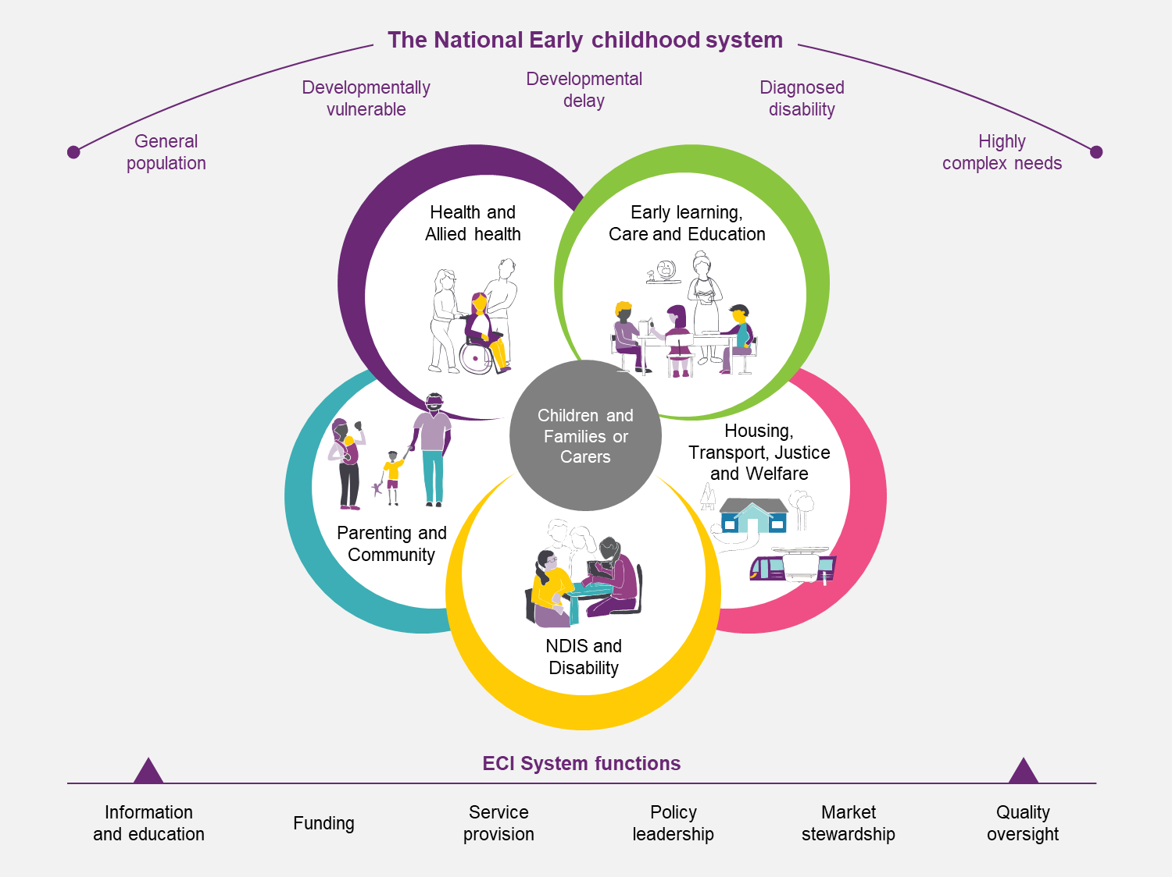

2.3 The NDIS and ECEI Approach within the national early childhood sector
The ECEI Approach was designed within the broader context of the agreed principles to determine the respective responsibilities of the NDIS and other service systems in 2015. These are captured in the COAG Applied Principles and Tables of Support (APTOS). The principles articulate the intended boundaries and responsibilities for different players across early childhood development, child protection and family support and school education.
In early childhood, the agreement specifies that the NDIS is broadly responsible for:
- Early interventions that are likely to increase a child’s level of functioning towards that of other children of a similar age without which the child is likely to require NDIS funded supports in the future.
- Supports required due to a child's impairment, including supports that enable families and carers to sustainably maintain their caring role.
- Disability-specific, carer and parenting education, information, resources, support and training programs both for when the child has a disability or the parent has a disability.
- Post-diagnosis information, linkages, referrals and coordination with community and early childhood mainstream and specialist services.
- Capacity building and general disability supports through Information, Linkages and Capacity Building (ILC) focusing on young children with disability (or developmental delay) where this improves awareness, builds community capacity, creates networks or ‘circles of support’ for children and parents.
- The coordination of NDIS supports with the systems providing child protection, family supports and early childhood supports (including education and health).
State and territory governments remain responsible for:
- Universal parenting programs
- Inclusive early childhood education
- Diagnostic assessment and specific screening for developmental delay and other mental or physical conditions that are likely to lead to a disability
- Support for families and carers to understand and manage the process and outcomes of assessment for diagnosis, including counselling and other family supports
- Learning assistance (this may include teachers’ assistants) and inclusion supports
- General children’s services, including play groups.

2.4 Impact of the NDIS rollout on national early childhood sector
The introduction of the NDIS changed the respective roles and responsibilities of the actors in the system, and the consequences of this are still evolving.
Funding, quality oversight and information functions that were previously the responsibility of State and Territory governments now fall within the remit of the NDIA and the NDIS Quality and Safeguards Commission (the Commission).
The NDIS has also fundamentally changed the provider landscape for disability services, including ECEI, by introducing a market driven approach where young children and families have become direct purchasers of services. In this new market-driven national system, some objectives overlap, but equally, some of the objectives of different players are at cross purposes. Providers are in a competitive relationship with other providers, and families want to maximise the amount of funding available in their plans. At the same time, mainstream service systems (such as kindergartens and schools) need to have the skills, capacity and resources to meet their obligations toward children with disability / developmental delay.

2.5 Overview of current ECEI Approach

2.5.1 Original intent of current ECEI Approach
Consistent with evidence-based practice, the original intent of the NDIA’s ECEI Approach was to deliver greater inclusion for young children by building on family strengths and growing the capacity of mainstream and community services to support young children with developmental delay/disability. The original intent was also to give parents/carers the guidance and assistance they require to provide their child an opportunity to gain and use the functional skills they need to participate meaningfully in key environments in their life.

2.5.2 Design of current ECEI Approach
The current ECEI Approach was designed with 7 key functions.
- Connect early and provide Initial Supports – connect with local communities and build relationships with families to identify need as early as possible
- Engage, understand and assess – understand complexity of needs and direct to longer term support if appropriate
- Deliver Short Term Early Interventions – provide Short Tern Early Intervention (STEI) to eligible children
- Develop plan and goals – determine skilfully the right early childhood supports that applies a best practice approach
- Review plan and outcomes – assess whether current supports continue to be right for the child and family or if changes are required
- Support service transition – determine and support transition from the Scheme for participants with funded plans or to higher level of support participants not on a funded plan (e.g. transition on to Scheme)
- Long-term outcomes monitoring – use outcomes and strengths-based reporting to track and measure progress for the child and the family.
Exhibit 3 shows how the NDIA designed its current ECEI Approach to the target population in the context of the broader national early childhood sector.
Exhibit 3: The current NDIA ECEI Approach within national early childhood sector
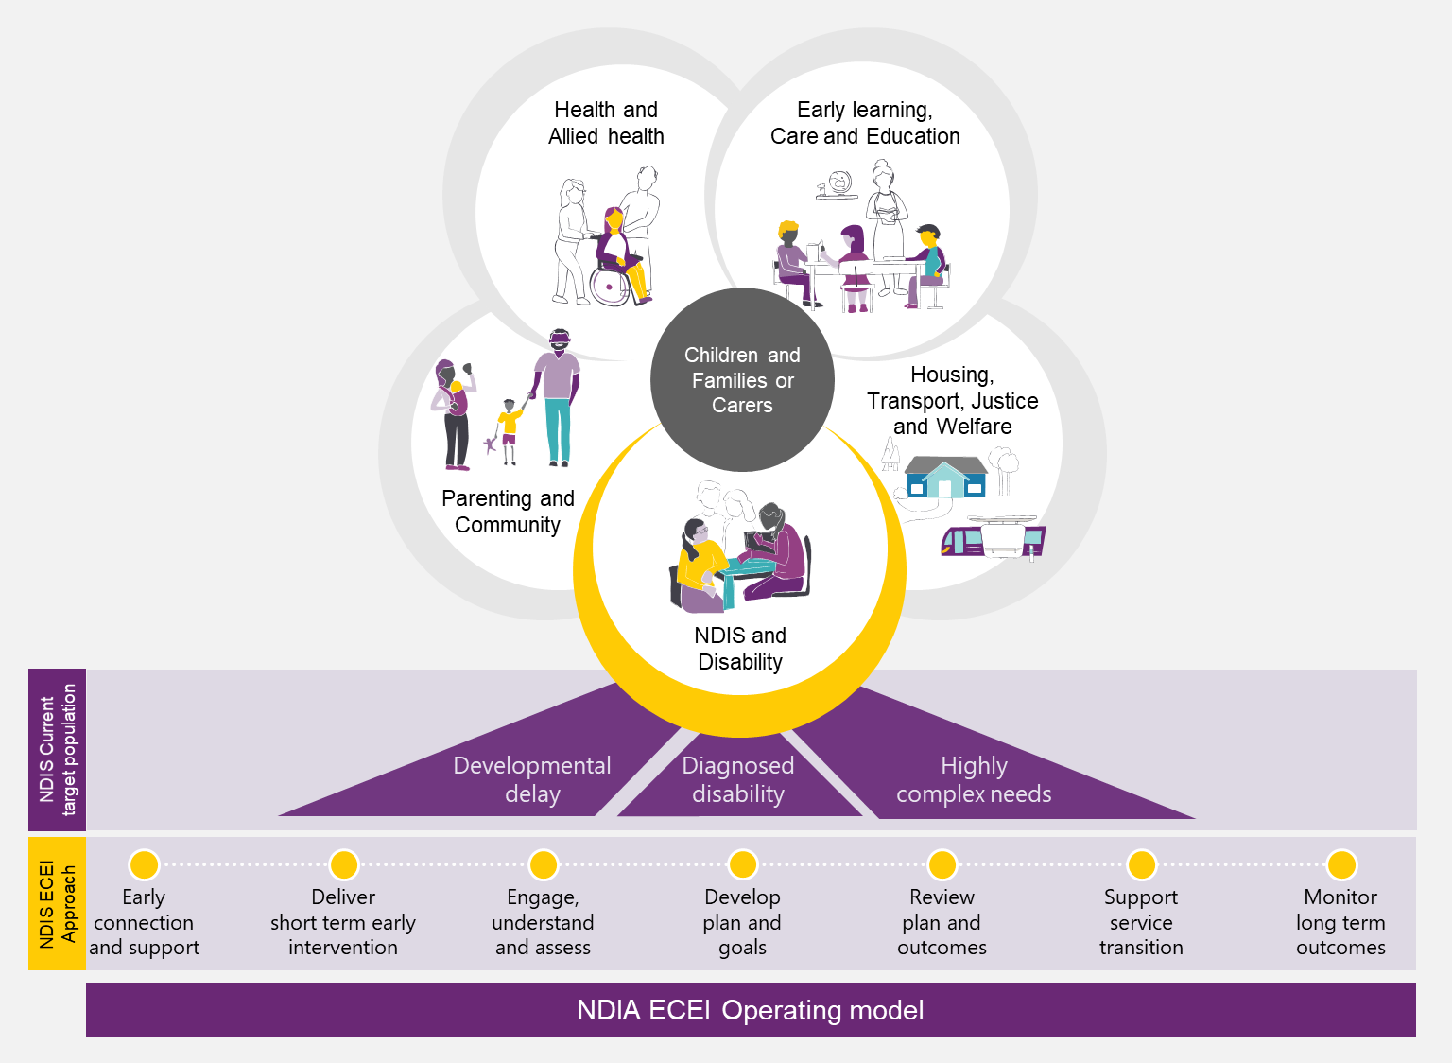
Early childhood intervention exists as part of a broader early childhood sector that supports developmentally vulnerable young children. System-wide alignment is required to create the conditions where all young children can benefit. Mainstream systems such as health, early learning and care, education, and family and community services are vital to support young children with disability and developmental delay and their families.
The ECEI Approach was originally designed to deliver better long-term outcomes for children and their families and aims to contribute to greater NDIS sustainability, reduce lifetime costs and build the capacity of the mainstream system. It emphasises the importance of accurate and timely information from a wide range of sources that forms a consistent best practice message. This enables families to make appropriate decisions and gain more control over their lives.

2.5.3 Tiered levels of support
The Scheme was originally designed to deliver three “tiers” of support:
- Tier 1: Provision of information and connection to mainstream and community services (for participants and non-participants)
- Tier 2: Includes initial supports (for participants and non-participants) and Short Term Early Intervention (STEI) services (for non-participants)
  - Initial supports consists of general capacity building and guidance to the family in child development, information linkages and capacity building from alternate services, navigation and referral support and general public/mainstream education on ECI. Initial supports are also currently used, temporarily, to assist participants who have met access while they are waiting for their first plan.
  - STEI consists of light touch range of ECI including therapy, capacity building and support for the child/family inclusion in mainstream services/settings
- Tier 3: Scheme access and individual plan (for formal participants only)
  - The original design recognised the benefits of early intervention for young children who were not participants since offering no services at all to those who did not meet access requirements could contribute to a young child deteriorating to the point of them needing to enter the Scheme. In addition, EC Partner contracts allowed for 20% of “effort” to be directed towards engaging with non-participants.
The Agency’s ECEI Approach, launched in 2016, supported these three tiers, all of which are incorporated into EC Partner contracts. Tier 2 services have, however, been underemphasised to date for non-participants.
The ECEI Approach was enhanced by the 2017-18 Pathways project, which included recommendations for the Agency to develop an initial supports framework and to promote a greater understanding of initial supports across the early childhood sector. This work culminated in the creation of an EC Practice Guide on Initial Supports. The Agency gave EC Partners access to this practice guide in June 2020, which clarified and codified existing practices. This practice guide includes specific guidance on STEI for non-participants:
- Duration: Generally 3 to 6 months (but no more than 12 months).
- Scope: Access to information, direct provision of early intervention strategies, family-based education and parenting support and supporting linkages to community and mainstream services.
- Next steps: If it is identified, during or after STEI, that a child is most appropriately supported through an individual funded NDIS Plan, a family may be assisted through the access process.
Notwithstanding the above, today’s STEI service is often perceived as a holding pattern for young children waiting to access the full Scheme. Few in the sector perceive it as a standalone service offer that is a genuine alternative to access and an individual plan.

2.5.4 Current implementation and delivery of ECEI Approach
The ECEI approach creates ‘pathways’ to enable young children received the right level of assistance based on their needs. Exhibit 4 illustrates the current ECEI Approach and the graduated levels of supports provided to young children.

Exhibit 4: The current ECEI Approach and examples of support pathways
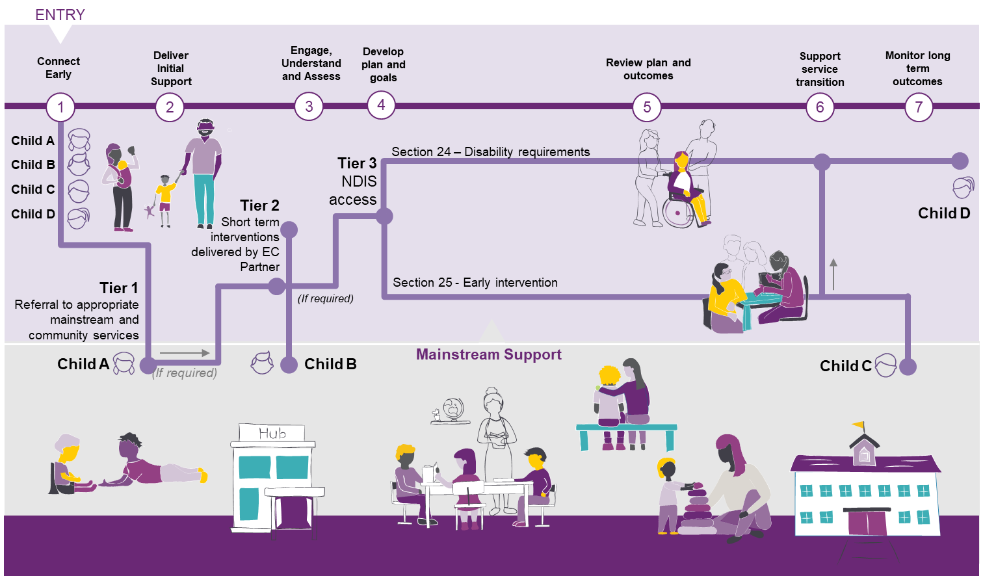
There are five key stakeholders within the national early childhood sector to deliver the ECEI Approach and support the child and family/carer along their journey.
Early Childhood Partners (EC Partners)
- A key feature of the ECEI Approach has been the establishment of a network of Early Childhood Partners (EC Partners) who bring expertise in early childhood development to support children and families, build connections with mainstream and community supports, and provide Initial Supports to children and families. This is part of the Partners in the Community (PiTC) Program.
- EC Partners are contracted to provide supports to young children and families eligible for the NDIS under s.25 and s.24.
- There are currently 19 EC Partners contracted across 55 distinct service areas (Exhibit 5). The number of EC Partners in operation ranges from 6 in both NSW and Victoria, to single providers in the ACT, WA, SA and NT.
Mainstream, community and informal supports
- Mainstream systems (E.g., health and education) interface with the NDIS to support young children with disability. Specialists and general practitioners, maternal and child health nurses, and community health practitioners may identify developmental concerns and delays. Children with developmental delay or disability can also be supported through early childhood education and care settings to identify where a child may have additional needs.
  - A child or family may also receive Informal Supports from family and friends as well as Community Supports (e.g. local playgroups, libraries, community events and sporting clubs).
Early childhood intervention disability service providers
- Providers deliver NDIS funded supports articulated in individual plans for young children and families eligible under s.25 (early intervention) or s.24 (permanent pathway). Providers may also deliver Initial Supports and which are block funded, and connect children and families with broader systems of support.
- As at end FY2019/20, there were 2,687 providers across Australia registered to provide early childhood supports, up 25% from 2,146 as at end FY2018-19.
- The distribution of participant funding between Providers is significantly skewed, with a small proportion of Providers receiving a large share of participant payments. Since 2017/18 the top 10 registered Providers (by payments) received approximately 20% of total payments, with the mix of Providers remaining relatively stable over the period. This represents a higher degree of concentration compared with the Scheme as a whole, in which the top 10 Providers account for 16% of total payments.
NDIA Planners
- NDIA Planners make delegated decisions (on behalf of the NDIA CEO) regarding individualised plans for children, after they have been developed by EC Partners with families. They also work with young children and their parents/carers to develop NDIS Plans for children involved with multiple service systems.
- There are some service areas without an EC Partner, as shown in Exhibit 5. In these regions, families work directly with the NDIA to plan and manage their supports.
Plan managers
- Participants plans may be managed in three ways; Agency managed, plan managed (managed by a registered Provider who the family engage to manage their funding on their behalf) and self-managed (partially or fully managed by participants). Participants managed by the Agency must use NDIS registered Providers, whereas those who self-manage or are plan managed may access both registered and unregistered Providers.
- Historically a greater proportion of ECEI participants, or more accurately their families, have self-managed their plans compared to total Scheme participants. As at 2019-20 (Q4) approximately 50% of ECEI participants self-managed their plans (either partially or fully) compared to 31% for all Scheme participants.
- Since 2016-17 the rate of self-management has increased for both ECEI and all Scheme participants, resulting in significant increases in access to unregistered Providers. The implications of the increased use of unregistered Providers creates challenges for the Agency, including less opportunity for market monitoring, greater risk of price inflation with Providers not being subject to price limits, and less regulatory oversight of early childhood practice.
While there is broad agreement regarding the national best practice principles for ECI, approaches to operationalise the principles and translate them into practice remain variable.
Detailed analysis of implementation challenges of the current ECEI Approach are described in Chapter 3.
Exhibit 5: Map of NDIS Early Childhood Partners
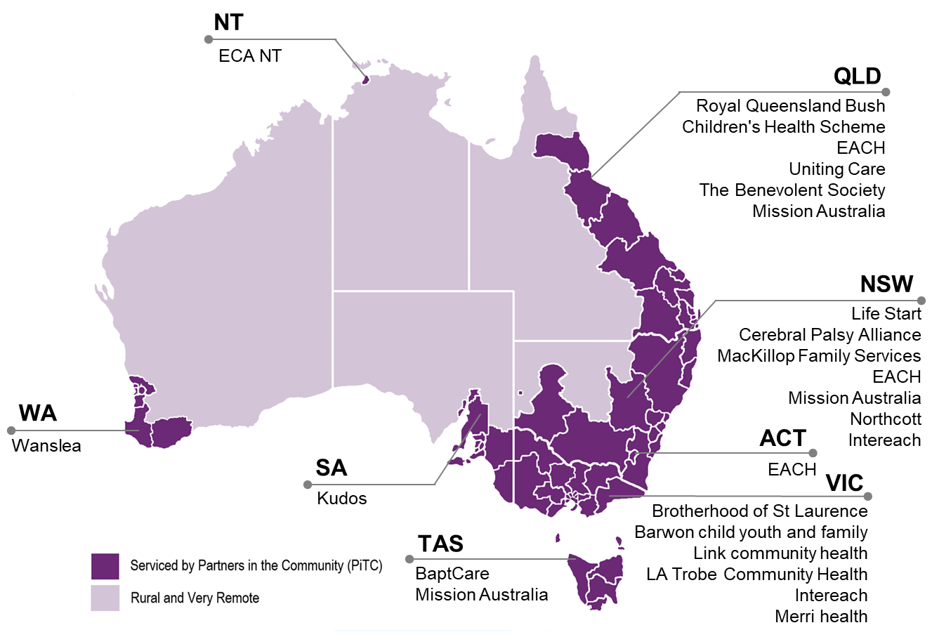

2.6 Impact of NDIS rollout on performance of the ECEI Approach
The NDIS has progressively replaced existing State-based systems of support. Bilateral arrangements, including participation estimates for States and Territories, combined with eligibility policies introduced to facilitate easier access, have shaped the flow of participants into the Scheme. The rate of entry to the Scheme has ebbed and flowed over time.
During the NDIS rollout, major policy decisions related to access and eligibility, and the timing of Scheme establishment by jurisdiction impacted the number of new participants. Exhibit 6 shows the overlap in timings between the NDIS rollout schedule and ECEI-related events.
This report acknowledges that these factors must be considered as part of any retrospective view of the evolution of the Scheme for young children.

Exhibit 6: NDIS rollout schedule and significant ECEI-related events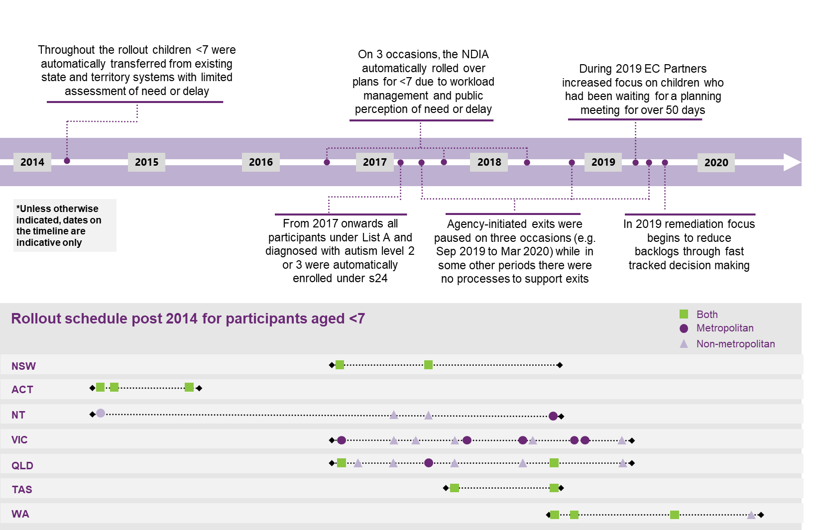
Remote / very remote trials to date
The Agency has been developing and testing different approaches for the delivery of early childhood services in remote and very remote areas since 2017.
As part of this effort, the Agency has:
- Trialled the Remote Early Childhood Services (RECS) program in Western Australia.
  - The RECS program was intended to support local organisations to provide initial supports to participants to address developmental delay.
  - Typically specialised organisations are engaged to deliver the ECEI approach, as Early Childhood Partners, in urban areas, however, few organisations had this level of experience and expertise in remote. Importing the level of knowledge, skill and experience into remote organisations proved very difficult.
  - Early lessons from this program indicated that it was unlikely to be scalable nor sustainable, and is yet to deliver the expected results. Furthermore implementation of this trial was negatively impacted by the onset of COVID-19.
  - Formal evaluation of this trial will be conducted from July 2021.
- Commenced an approach in the Northern Territory that focusses on a whole of community approach to NDIS funding, including early childhood services.
  - This program is in its formative stages and is focused on:
  - testing access for children under s.25 (Early Intervention) of the NDIS Act 2013;
  - developing appropriate plans to provide a culturally appropriate response to support developmental goals of children and families;
  - active engagement with local service providers to develop a sustainable market response; and
  - timely engagement with mainstream supports to assist with transitions as children progress towards meeting age-appropriate developmental milestones.
  - The program will be subject to ongoing evaluation.

2.7 Trends in numbers of children and families supported
This section describes the high-level facts about young children under the age of 7 (and their families) assisted by the ECEI Approach drawing on data collected by the Office of the Scheme Actuary (OSA).
Since its establishment, the number of young children participating in the Scheme has grown rapidly (Exhibit 7) and been largely determined by targets in bilateral agreements between the Commonwealth and the States and the evolution of access and eligibility policies.
As at end of June 2020 (end FY19/20), the Scheme was supporting around 70,000 young children under the age of 7, and their families. Around 62,000 of these young children (88%) were formal Scheme participants with individual plan budgets, an almost threefold increase in just two years (23,000 had individual plans at end FY18). This reflects, in part, an operational imperative to clear backlogs in ECEI applications that began in June 2020.
Exhibit 7: Cumulative number of young children under 7 years old with individual plans
Source: Office of the Scheme Actuary
Young children account for 16% of total Scheme participants, which is up slightly since FY17/18 (Exhibit 7). However, as the transition period from state schemes ends, young children are projected to account for an increasing share of new Scheme entrants, rising from around 43% in FY20 to around 63% in FY24. Children will also account for a larger share of non-mortality exits, rising from around 30% in FY20 to around 34% in FY24. As a result of this greater movement in and out, the net share of young children supported by the Scheme is projected to remain largely steady over the next four years at around 16%.
About 8,200 (12%) young children and their families were receiving Initial Supports delivered directly by EC Partners as at the end of FY20. Initial Supports include short term early interventions delivered by EC Partners for young children with a developmental delay or disability, and their families. These are typically provided to children and families that are assessed as not requiring longer-term support packages or who are awaiting the outcome of an initial eligibility assessment.
However, a deeper analysis on a subset of recent data (as at 6 February 2020, for participants who entered from 1 July 2019) indicates significant variation across EC partners in the prevalence of Initial Supports and diversion of young children to mainstream services. As indicated in Exhibit 8, on average, EC Partners provided Initial Supports to 13.8% of participants in the ECEI ‘Gateway’, the historical term used by the Office of Scheme Actuary (OSA) to classify children participants under the age of 7 who receive early support (excluding those who were in progress in the Gateway or found ineligible for Initial Supports). This proportion however, ranged considerably between a minimum of 1% and a maximum of 32%. Moreover, on average, EC Partners transitioned 3.8% of participants to mainstream services with a minimum of 0.3% and a maximum of 12%. Some of the variation in EC Partner delivery of Initial Supports may be attributable to nascent reporting systems of the period, and inconsistent data entry conventions.
Exhibit 8: Variation in % of participants who received Initial Supports or were transitioned to mainstream services across all EC Partners as at 6 Feb 2020 (for participants who entered the ‘Gateway’ from 1 July 2019)
Source: Office of the Scheme Actuary
Access eligibility rates
Young children and their families who apply for an individual plan budget have a very high acceptance rate (formally ‘access eligibility rate’). The proportion of young children and their families that make an access request to formally join the Scheme and receive an individual plan budget and are assessed as eligible for the Scheme has remained high since the commencement of the Scheme. On average, in the last year, 97% of young children who made an access request were assessed as eligible, compared with 78% across the entire Scheme. In areas serviced by EC Partners, families are supported by the EC Partner to make an access request only if they are thought likely to be eligible based on an initial assessment by the EC Partner.
Access pathway for new Scheme entrants
As described in Section 2.1, young children may be granted an individual package of support via two primary pathways:
  - S.24 provides entry for children who have a permanent and significant disability (which results in substantially reduced functional capacity) who are likely to require lifelong support.
  - S.25 provides early intervention to young children with developmental delay (which results in substantially reduced functional capacity) or an impairment likely to be permanent and are likely to benefit from early intervention to lessen the long-term impact.
The mix between these two entry pathways has shifted towards the s.25 over time (Exhibit 9), potentially indicating that more young children are entering the Scheme prior to a diagnosis of permanent disability to receive early intervention. Entry under the permanent disability pathway (s.24) has decreased from 52% in 2017-18 to 30% in 2019-20, while entry under early intervention (s.25) has increased from 48% to 70% over the same period. This may be the result of increasing awareness of the criticality of early intervention for many young children, and also the remediation focus to reduce backlogs of participants waiting to access the Scheme, as there are lower threshold entry requirements under s.25.
Exhibit 9: Eligible participants aged <7 by financial year, by entry stream
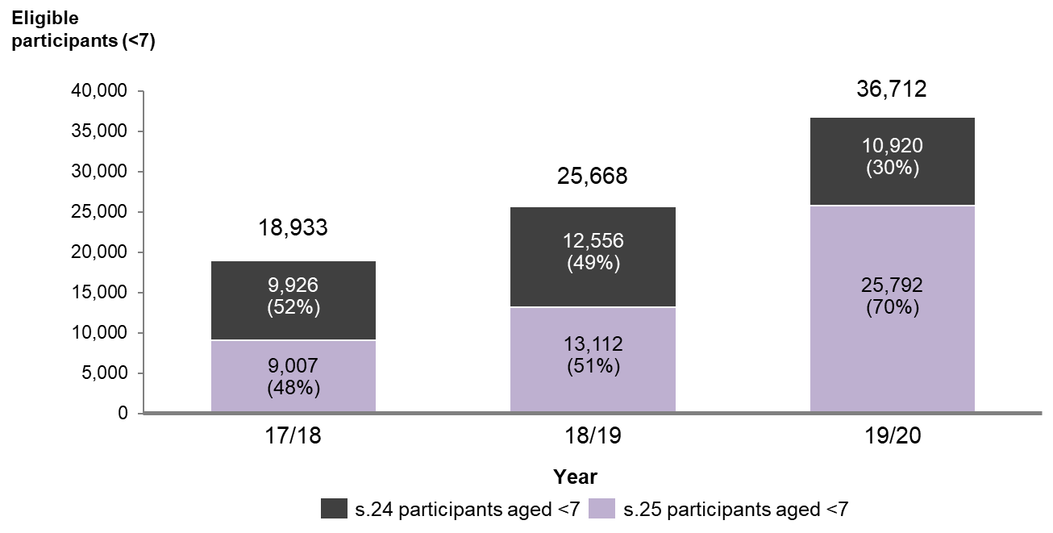

Source: Office of the Scheme Actuary
The average value of individual plans is slightly higher for s.24 compared to s.25, although the difference has been rising over time (Exhibit 10). This reflects that while the number s.24 plans are decreasing as a total proportion of all plans, the average plan size is increasing due to the more complex needs of young children who enter under s.24. It is worth noting however that plan funding is not determined based on a child’s access type.

Exhibit 10: Average annualised committed supports s.24 and s.25 for participants aged <7
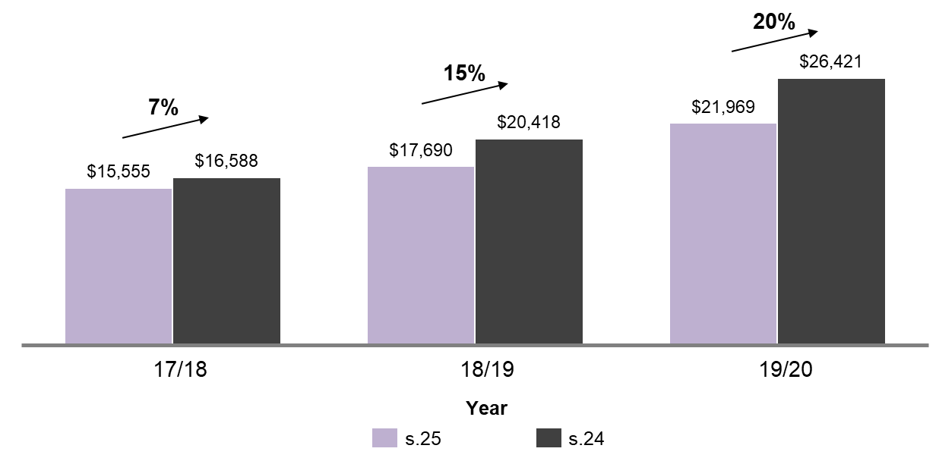
Source: Office of the Scheme Actuary
ECEI participants by primary disability type
Young children with a developmental delay (DD) make up a growing share of ECEI participants (Exhibit 11), reflecting a significantly higher growth rate for DD participants compared to those with a diagnosis of ASD. The vast majority of ECEI participants have either DD (56% in FY19/20) or ASD (31%). Between 2017-18 and 2019-20 the proportion of children deemed eligible at the point of access with developmental delay, increased from 38% to 56% while the proportion of those with autism decreased from 38% to 31%. The increase in the proportion of eligible young children entering the Scheme with developmental delay reflects the fact that the Scheme now includes a higher proportion of new incidence of disability, rather than transfers from existing State and Commonwealth programs who were prioritised for entry. Secondary drivers include increased awareness of symptoms, combined with increasing recognition of the benefits of earlier intervention.
Exhibit 11: New ECEI participants with an approved plan by disability type (under s.24 and s.25)
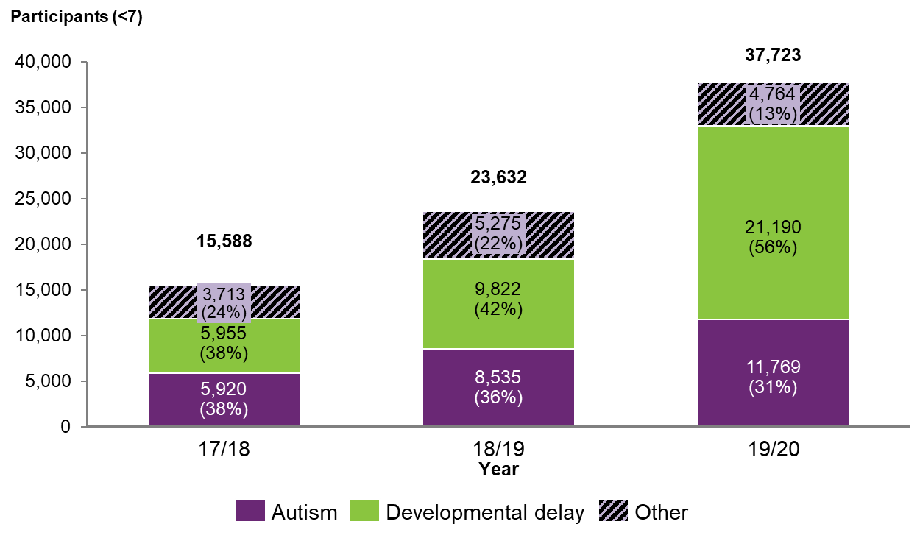
Source: Office of the Scheme Actuary
Exit rates
Over the life of the Scheme, non-mortality exits from the Scheme are 1.8% of participants aged 0-6. Since FY 2017-18, ECEI non-mortality exit rates have averaged only 2.1% (Exhibit 12). During FY18/19 there was a drop in exit rates to a low of 0.5% due to a temporary pause in Agency processes to reassess eligibility for access and, where appropriate, to “exit” or “transition” participants that no longer needed the Scheme. The pause was initiated in September 2019 to allow the eligibility reassessment process to be reviewed. Reassessments formally recommenced in March 2020 with NDIA initiated exits, including the clearance of backlogs. Since the recommencement of NDIA initiated exits, exit rates have increased to 2.0% by Q4 F419/20. This trend of rising exit rates is expected to continue, reflecting the positive impact of successful early intervention.
As a reference point, the 2014 Productivity Commission Inquiry Report - while acknowledging data limitations – noted that exits in the sector had historically averaged around 12% annually (for all participants, including adults), with significantly higher average exist rates for young children.
Exhibit 12: Number and % of non-mortality exits from the Scheme over time for participants aged <7, for s.24 and s.25
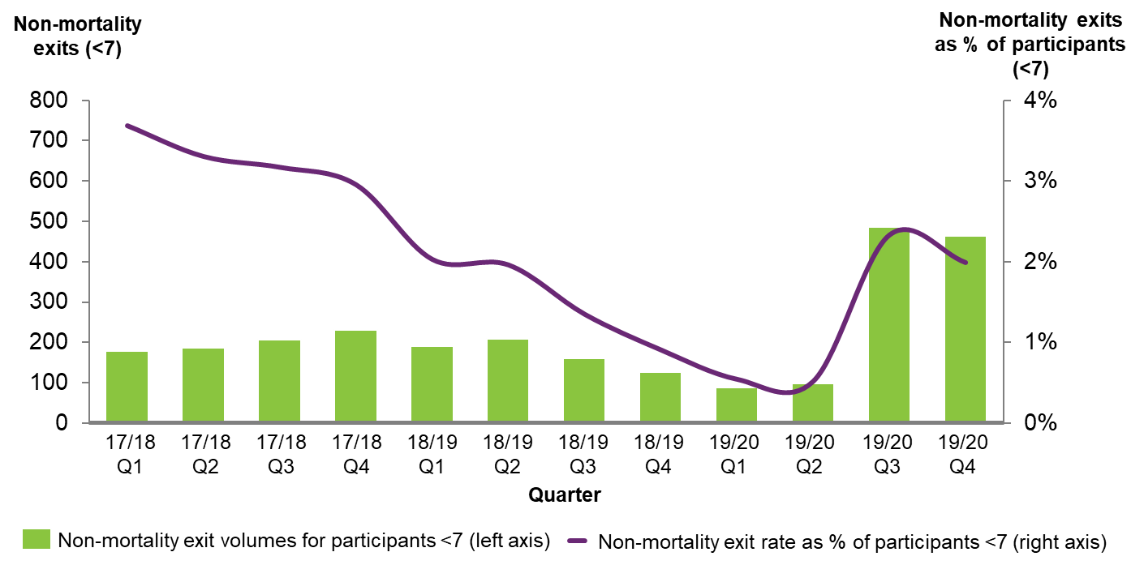
Source: Office of the Scheme Actuary

2.8 Participant experience
Analysis of participant satisfaction
Participants who entered the Scheme since 1 July 2016 were asked ‘Has the NDIS helped?’ after one, two and three years in the Scheme.
For children aged 0 to before starting school:
- 95% of parents and carers thought the NDIS improved their child’s development in their third year of participation, compared to 94% in their second year and 91% in their first year
- 94% felt the NDIS improved their child’s access to specialist services in their third year of participation, compared to 91% in their second year and 89% in their first year.
Waiting times to access the Scheme
Towards the end of 2019-20, NDIA initiated a remediation focus to reduce backlogs of participants waiting to access the Scheme. As a result, waiting times for Access decisions improved, with the share of decisions made within 21 days of an access request increasing from 71% in March 2018 to 100% in June 2020.

2.9 Expenditure on the ECEI Approach
Over the past three years, total payments in ECEI have increased in both absolute terms and as a share of the total Scheme (Exhibit 13), broadly in line with the growing number of ECEI participants outlined above. Since 2017-18, ECEI payments have increased from $186 million to $720 million in 2019-20, representing an increase in share of the total Scheme from 3.4% to 4.2%. The recent increase in the ECEI share of overall Scheme costs has been driven by higher growth in average plan budgets for young children and relatively higher rates of participant growth.
Exhibit 13: Total payments and proportion attributable to participants aged <7
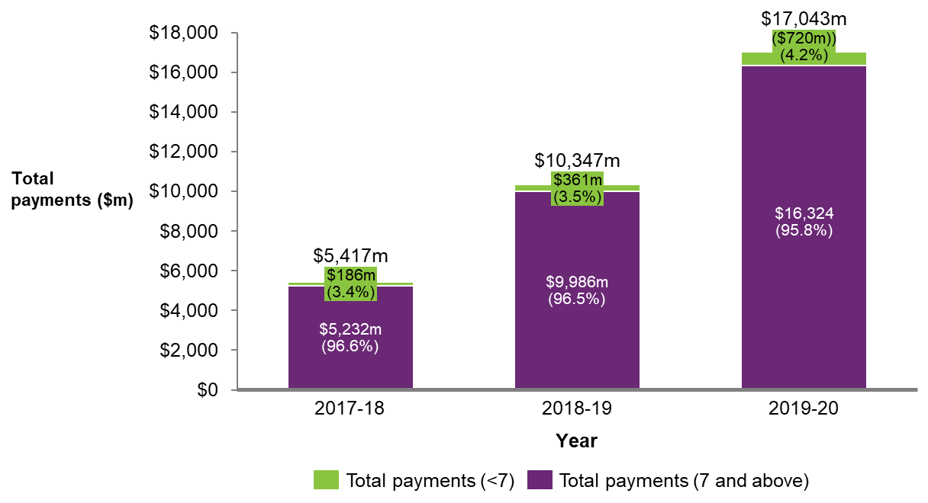
Source: Office of the Scheme Actuary
Between 2017-18 and 2019-20, average annualised payments for ECEI participants increased by 24% from around $11,400 to $14,000. In comparison, average annualised payments over the same period for all Scheme participants increased from around $42,200 to $50,800, an increase of 20%.
Table 2 presents a high-level summary of differences in the average annualised committed supports, utilisation rates and proportion of participants self-managing their plan for young children with specific characteristics and the entire cohort. It shows that annualised committed supports are generally lower for Aboriginal and Torres Strait Islander or Culturally and Linguistically Diverse (CALD) families.
Table 2: Average annualised committed supports, utilisation and level of self-management for different ECEI participant characteristics
Cohort / characteristic | Average annualised committed supports | Utilisation | Proportion of participants self-managing their plan
Indigenous | Lower than non-Indigenous participants | Lower than non-Indigenous participants | Significantly lower than non-Indigenous participants
CALD | Similar to non-CALD participants | Higher than non-CALD participants | Slightly lower than non-CALD participants
Location | Remote locations package sizes are significantly higher | Increases with proximity to major cities | Increases with proximity to major cities
Age | Increases with age | Increases only slightly with age | Decreases with age
Socio economic status (SES) | Increases with socio-economic status | Increases with socio-economic status | Increases with socio-economic status
More broadly, a total of $993 million was spent on the ECEI Approach in FY2019-20 (Table 3). Almost 80% of this was spent on individual participant plans, while 14% was spent on EC Partner costs and 7% was spent on Agency operations (E.g., Delegates/Planners, Reviews and Complaints etc.). There is a sizable difference in the average amount of money spent on the 10% of young children receiving early supports ($2,000 per year), compared to the 90% with an individual support budget ($17,900 per year).
Table 3: Breakdown of total spend on the current ECEI Approach (FY 2019-20)
 |  | By support type
 |  | Early supports | Individual Funded Plans | All supports | % Total supports
Cost element | EC Partner costs  (Program 1.3) | $12m | $124m | $136m | 14%
Cost element | Participant costs  (Program 1.1) | n/a | $786m | $786m | 79%
Cost element | Delegates, planners, reviews, complaints and overheads  (Program 1.3) | $0 | $71m | $71m | 7%
Cost element | Total ECEI costs | $12m | $981m | $993m | 100%
Cost element | % of TOTAL ECEI costs | 1% | 99% | 100%
Average number of children across the year (note: these differ from end of year numbers outlined above) |  | 5,900 | 54,700 | 60,600
Share of total children under 7 years old (%) |  | 10% | 90% | 100%
Approximate ECEI cost per child |  | $2,000 | $17,900 | $16,400

Areas for improvement
This Chapter outlines 9 key areas for improvement across four areas of the ECEI Approach. The four areas are as follows:
- Overarching
- Early support (including access to the NDIS)
- Planning and implementation
- Transition

3.1 Overarching
Improvement area 1: The ECEI Approach needs to reconnect with and better communicate the original clear vision, and should be adequately differentiated from the general, more adult-centric, Scheme
Ways to better improve delivery of the ECEI Approach within a more general, adult-centric, scheme have been identified.
- 57% of peak bodies surveyed reported that the vision of the ECEI Approach was unclear, with this being noted by both families and the broader sector.
- The term ECEI “gateway” – often used interchangeably with the ECEI Approach – has come to have a perverse meaning that is creating a perception among families and mainstream services that ECEI is a soft entry to permanent Scheme access and funded support for life. This undermines the perceived value of short term early intervention supports and capacity building for families.
- Agency operating guidelines are integrated for young children and adults, which means there is an absence of appropriate Agency guidance around family-centred decision making that acknowledges early childhood is a time of opportunity for enhanced learning and development. NDIA delegates/planners make decisions about both young children and adults, which – given that around two-thirds of Scheme participants are above the age range for ECEI – carries the risk that NDIA Planners impose an adult-centric view on planning outcomes. The lack of specialisation may also be contributing to poor participant experience and outcomes (i.e., if the needs of young children and families are not being adequately met due to the specialised skills required for early childhood) as well as inefficiencies and inconsistencies in R&N decision making. The Council recommends the NDIA provides more effective decision-support including ensuring the provision of unbiased and accurate information, peer support and support, from an experienced and skilled planner.
- The Council reported that the original ECEI vision included multiple pathways which recognised the importance of supporting the development of children and the capacity of families, the importance of a whole of government approach with early intervention as part of a network of Partners working within family and community settings and a marketplace of providers delivering best practice outcomes for young children and families. They also reported that the ECEI Approach needed a clearer vision and framework for implementation to remove the perception that the ECEI Approach was a gateway into the Scheme, and consequently its role being limited to a question of funding with a focus on reducing time frames.

Improvement area 2: There needs to be a more clearly articulated Agency position on what constitutes best practice in ECI
There is an absence of agreed sector position on best practice in ECI and, despite very compelling international evidence in support of the best practice principles, several obstacles to being able to fully realise this occur within the current NDIS systems.
- The Council paper makes observations about how the NDIA can improve delivery of a best practice approach and makes clear recommendations about how to get this back on track in the following areas: family-centred, strengths based, culturally responsive, inclusive and participatory practice; engaging the child in natural environments; collaborative teamwork practice; capacity building practice (keyworker backed by a transdisciplinary team considered best practice); evidence based standards, accountability and outcomes based approach. The NDIS Commission’s NDIS Practice Standards on Early Childhood Supports provides a sound basis for developing practice guidance in these areas.
- The early childhood, disability and health sectors need agreement on what constitutes best practice early childhood intervention, how it should be delivered, and how often and by whom. While there is broad agreement regarding the national best practice principles for ECI, approaches to operationalise the principles and translate them into current practice remain variable. As a result, approaches to deliver ECI differ significantly across the national system, and best practice remains contested. Consistent with this broader uncertainty, the Agency needs to have a clearly agreed externally facing position or policy on the expectations of ECI and what it is intended to achieve.
- The NDIA needs a clearly structured vision and framework for implementation of ECI and understanding of how the ECEI Approach varies across the Agency. Differences in interpretation of Reasonable and Necessary decision making in line with best practice principles are evident within the Agency, notably across the internal review and administrative appeals processes.
- The Act does not define what best practice looks like in an ECI context. The Agency has ongoing flexibility to change and adapt the approach over time. While a degree of operational discretion can be helpful, the Agency needs to have a clear position on best practice supports for young children and families to reduce best practice being contestable across the Agency and wider sector, particularly in how it is implemented.
It was also identified that a high proportion of ECEI participants have access to non-registered providers, making quality oversight in ECEI more difficult and adoption of best practice more challenging to determine.
- All NDIS providers are regulated by the NDIS Quality and Safeguards Commission (the Commission) and required to comply with the NDIS Code of Conduct. This Code requires, amongst other things, that providers ensure that supports are provided with care and skill, and with respect for self-determination and decision making.
- Around 80% of families/carers of young children aged 0-6 years old are either self-managed or plan-managed and therefore have a choice of using either NDIS-registered providers or non-registered providers (see Exhibit 14 below). Although non-registered providers are regulated by the NDIS Commission and required to comply with the NDIS Code of Conduct, there is no requirement for non-registered providers to complete a certification audit against the NDIS Practice Standards on Early Childhood Supports. In addition, there are no complementary mechanisms to provide families with information about providers who are following best practice.
- Moreover, consultation with the sector highlighted concerns that some providers may not be following the best practice standards for early childhood intervention.
- This environment reduces the ability of families to be able to differentiate between providers in the market on the basis of best practice, making it harder to make informed choices over which provider to use. This is particularly true for families with children with newly diagnosed disability who are prone to receiving inadequate support because they are still coming to terms with their child’s disability and building their understanding of their child’s needs.

Exhibit 14: DISTRIBUTION OF ACTIVE PARTICIPANTS BY METHOD OF FINANCIAL PLAN MANAGEMENT AND AGE GROUP AS AT 30 SEPTEMBER 2002 - NATIONAL
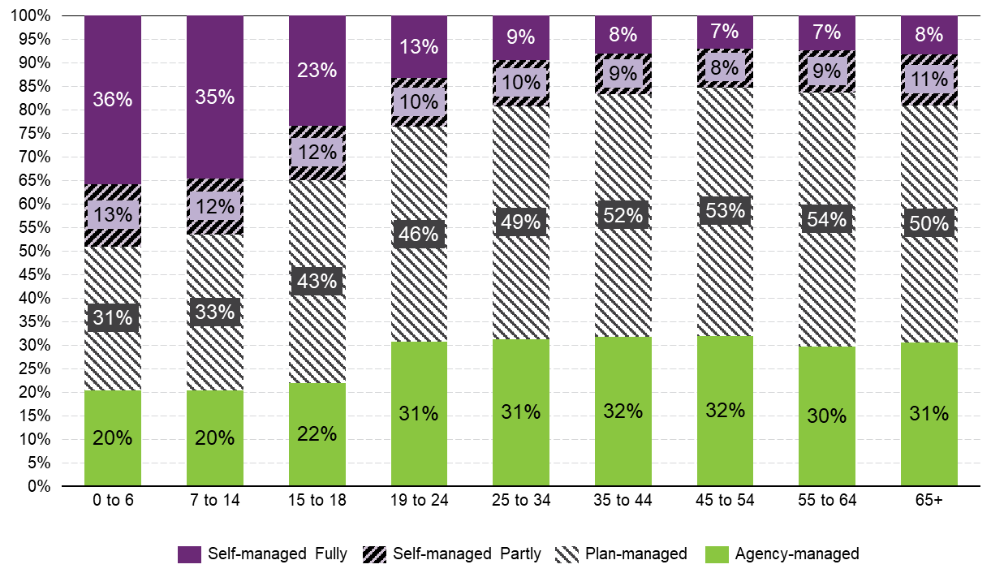
Improvement area 3: The Agency needs better decision making processes and tools to enable more consistent, fairer and more equitable decision making around access and planning.
The NDIA has heard many examples of inconsistent and inequitable access and planning decisions. Currently there is no consistent approach to understanding or providing evidence on the impact of a person’s disability. This includes how the impact of their environment is considered and how the person’s functional capacity is assessed.
The Agency is releasing new access and planning policy consultation papers for participants 7-65 years old with the intent of delivering a more consistent and fairer experience for all prospective participants applying for the Scheme.
For young children under the age of 7 with disability or developmental delay, the current process for young children involves families working with their local Early Childhood Partner to get support to gather the evidence of the child’s disability or delay. However, stakeholder interviews showed inconsistency in access and planning decision-making for children.
Whilst there is a range of functional assessment tools available for young children, there is inconsistency in which tools are used and how they are applied.
A particular concern exists about the reliance on assessment tools by health professionals that rely solely on diagnosis of disability and impairment, or specify therapeutic and assistive technology treatments rather than describing a child’s functional capacity. Holistic, consistent and standardised information is needed on a person’s functional capacity (including environmental factors which affect an individual’s support need) as required under the NDIS Act to inform accurate and timely decision-making.
Hence, clear and consistent guidance is needed to inform the end-to-end decision making approach, including which functional assessment tools to use for young children, the frequency of assessments and how to tailor the approach to meet the needs of young children.

3.2 Early support (including access to the NDIS)
Improvement area 4: Children and families need to be more consistently supported through the right pathway
Implementation challenges that lead to inconsistent support through the right pathway were identified, highlighting the need for greater emphasis on the value of Initial Supports and Short Term Early Intervention (STEI); the need for more transparent and consistent access criteria; and the need for improved guidance on how to measure developmental delay.
Furthermore, stakeholders within the national early childhood sector faced various challenges to supporting the right cohorts. Sector consultations showed a need for an update to EC Partner contracts to refocus their role on providing early support initiatives, as well as broader education of medical general practitioners and other mainstream stakeholders on the ECEI Approach, when, and how, to refer young children to the NDIS, and what constitutes best practice ECI.
Need for improved understanding of the value of Initial Supports and Short Term Early Intervention
Current NDIS processes can better acknowledge that early childhood is a time of significant change and development, and therefore that the focus of the ECEI Approach should be on prevention and early intervention through a family-centred approach, as opposed to a drive for diagnosis of a permanent disability.
Stakeholder consultation indicated that the lack of clear guidance of the ECEI Approach has led to a perception that the ECEI Approach is a “one size fits all model” for all young children to receive permanent lifelong disability support via a personalised plan budget.
- There needs to be more emphasis on early support initiatives, Short-Term Early Intervention (STEI) and Initial Supports. The original intent of these early support initiatives was to provide early intervention for young children and families through a family-centred, prevention-based approach.
- Implementation of the ECEI Approach to date suggests that the perception of STEI and Initial Supports needs to be improved among families and mainstream services, and that these early support initiatives are not a ‘gateway’ to the Scheme and do not represent an inferior support. Consequently, expectations on the NDIS funded plan being a ‘gold standard’ need to change and that receiving early supports does not mean ‘waiting’ for access to the Scheme.
- As at end-June 2020, 88% of young children supported through the ECEI gateway have a personalised plan budget, of which over a third have entered under the permanent disability pathway. In contrast, only 12% of young children supported by the Scheme were receiving initial support and STEI.
- Tune recommended that more flexibility is needed in the ECEI pathway to maximise the benefits of early intervention supports for children with disability.
“New access process is a lot smoother but there is still a gap where earlier support should be better…. I would have liked Initial Supports” - Family in Regional Victoria, three children on the NDIS (DD and ASD)
Need for improved understanding of the complex Access criteria for children under 7
The NDIA needs to better articulate a distinct pathway within the NDIS for children with disability and developmental delay, as well as for their families.
- The NDIS Act enables the Agency to fund early intervention for a wide group of young children for the purpose of lessening the long-term impact of their disability or developmental delay. However, there is significant flexibility for the CEO of the NDIA in how this is intent is achieved operationally.
- The NDIA currently enables young children to enter the Scheme under either Section 24 of the NDIS Act (s.24 – permanent disability) or Section 25 (s.25 – early intervention). Each access pathway has its own evidence requirements and intent, contributing to confusion about the purpose of the NDIA’s approach to young children.
- Tune found that there is significant confusion about the NDIS eligibility criteria, particularly in respect of demonstrating ‘permanency’ and that as a result of the operations guidelines ‘List A’ and ‘List B’, there is a widespread assumption that diagnosis correlates to functional capacity.
Families consulted frequently reported that information about the ECEI Approach, eligibility and access needs to be explained more simply and clearly.
- Families and carers may not have the information and confidence to exercise informed choice, leaving them vulnerable to those with a narrow view or commercial self-interest. This was identified across the access, Initial Supports, planning and implementation processes.
- The Council and Tune reviews highlighted that the Agency’s engagement and early connection with families does not provide adequate support and preparation for the planning process. A vast majority of peak bodies surveyed (82%) agreed that the ECEI Approach is not responsive enough to families’ needs.
- Families need sufficient support to navigate the ECEI Approach and participate in early intervention, as they have reported that access and planning processes can be overwhelming.
- The language and jargon associated with access often do not make sense to families, including terms such as ‘early intervention’ and ‘reasonable and necessary’.
“Families are often new to disability and have no idea what their needs are or will be. They need so much more support than the NDIA is willing to give them in the beginning” – Sensory disability peak body

Need for improved understanding and clear interpretation of developmental delay criteria
More guidance is required on how to interpret the Developmental Delay (DD) criteria in the NDIS legislation to enable more consistent and equitable decisions around access and the appropriate support model.
- The Developmental Delay criteria in the Act (s.9) is subjective and open to variable interpretation. For example, what constitutes a ‘substantial reduction in functional capacity’ is not defined, and no time period for ‘extended duration’ is outlined. This makes it difficult to apply consistent decision making criteria and may mean that more children are deemed eligible for the Scheme than originally intended.
- Children with developmental delay may often go on to be diagnosed with an intellectual disability or Autism. An investment in early intervention for these children may lead to positive long term outcomes for children and families and simultaneously improve scheme sustainability.
- This has impacted volumes and 56% of new ECEI participants in the past year had approved plans on the basis of a developmental delay. Additionally, between 2017-18 and 2019-20 the proportion of children with a new approved plan for developmental delay, increased from 38% to 56%.
Challenges faced by stakeholders
EC Partner contracts and the Key Performance Indicators (KPIs) specified in their contracts are largely focused on Scheme entry and planning outcomes, creating a stronger incentive for them to recommend that young children receive a personalised plan budget and a weaker incentive for them to recommend STEI or mainstream supports.
- EC Partners capacity need to be improved to better fulfil their intended role under the ECEI Approach, including connecting families with mainstream services, promoting community connection and inclusion, and providing Initial Supports and STEI outside of individualised plans.
- Contextual factors such as higher than expected volumes of children entering the Scheme, backlog pressures, defined programs and time intensive planning processes mean EC Partners do not currently have the required capacity to deliver a variety of STEI supports that are responsive to family needs.
- The original intent of the Partners in the Community (PiTC) model conceived of EC Partners supporting the implementation of the NDIS at a local community level by delivering ECEI Services. The objectives of the PITC program included an explicit focus and skills in building capability and capacity within the community for inclusion of people with disability.
- Many EC Partners entered the role with an expectation that they would focus on Initial Supports for families, in accordance with best practice, but workload pressures require them to focus on planning.
One EC Partner reported that “I feel like we have just been playing catch-up the whole time”. Partners noted that it is the first time they have been able to begin applying the intended approach now that “the backlog has been almost cleared”.
Medical general practitioners (GPs) report requiring greater clarity on when to refer young children to the NDIS, and inequitable outcomes for vulnerable children whose parents face more challenges navigating the system.
- Currently more information and resources is required on the purpose of ECEI, the options of service offerings (i.e. STEI) and which children to refer to which service. This includes a lack of consistent and accessible referral form that medical professionals can complete with families.
Some providers and websites are downplaying the role of EC Partners and/or the assistance available outside of an NDIS funded plan; and communicating that clinical therapy always constitutes best practice early intervention.
- EC Partners expressed concerns at the numbers of Providers whose practice more closely aligns with medical models of support, rather than family capacity building in natural settings. (e.g. many see quotes from Providers that include hours of weekly therapy in clinical settings). As families develop relationships of trust with the Provider and follow their recommendations, EC Partners reported that it was challenging to build family capacity to understand evidence for alternate approaches.
Partners also noted too, that many Providers needed more clarity and understanding of best practice ECEI, although this varied based on their maturity in the market. In regions at earlier stages of NDIS roll-out, best practice was more evident, while newer Providers were less likely to recommend supports that aligned with best practice.
Families reported that peer networks were highly valuable, however, access to these networks is variable in the community, and largely informally derived.
- Sector and family consultation frequently raised the issue of receiving different information and answers depending on who in the Agency families speak to, creating distrust and confusion in the Agency and its processes.
- The Council Review highlighted peer support as an important missing piece in the current ECEI system, which offers a trusted and safe forum for information sharing and capacity building.
Improvement area 5: Children and families need to receive more consistent support at the right time
There is a need to be more responsive during the developmental and transitional stages of young children and families to address issues relating to operational pressures and problems with workflow and program design.
Some young children and their families needed to receive more support earlier, while for most, support through the ECEI Approach needed to be extended with more support during critical milestones such as starting school. In addition, some reported that the pacing of the planning process needed to be slower and more flexible, and allowing sufficient time for families to understand the system and their own situation, before making decisions.
Lack of early identification among some communities
EC Partner workloads have been primarily directed towards aiding Scheme entry and planning which has compromised their capacity to engage in outreach to identify vulnerable young children early. EC Partners reported that more focus and NDIA resources (including clear strategies and frameworks) was required to enable them to influence, educate, build capacity and work with community networks before the child is identified.
- EC Partners are only funded for one hour of implementation supports, which means that time spent on educating and promoting best practices with families is often lost. Many families, in their state of grief and feeling overwhelmed, may not be able to take on board all the information that is shared with them at one time. This support is critical as there is a risk that families are lured by quick fixes, clever marketing and promises of outcomes that may or may not be based on evidence.
Consultation with Peak bodies and experts has revealed that some groups and communities (including Aboriginal or Torres Strait Islander, Culturally and Linguistically Diverse (CALD) and remote and very remote families) need more assistance to engage with the Scheme earlier to allow for improved outcomes.
- The NDIS needed more time and resources to build proactive relationships with mainstream and community supports and involving cultural groups.
- Aboriginal Torres Strait Islander, Culturally and Linguistically Diverse families continue to have issues with access and under-utilisation of funded plans
- Stakeholder consultation has revealed that additional challenges are faced by families involved in the child protection or justice systems
The ECEI Approach may be ending too early in the life of a young child
The under 7 age limit for the ECEI Approach does not support effective transition of young children to primary school, which is a critical life milestone, and which typically begins at the age of six. It is also inconsistent with the WHO definition of young children (defined as zero to eight years).
Furthermore, the ECEI Approach age limit of under 7 years of age actually lacks a clear rationale, is not specified in Agency guidelines, and appears to have become the default largely due to a specification in the NDIS Act (2013) that entry under DD is for children zero to six years of age as well as the legacy of state systems where children typically exited when they commenced school.

3.3 Planning and implementation
Improvement area 6: Children and families need to be more consistently receiving the right level of supports
The project identified the need for more consistent and equitable decision making during planning with more references to best practice and acknowledgement of the supports required by families.
Need for more consistent and equitable planning decisions
Families need to be receiving more transparent and consistent decisions during planning, determination of R&N supports and plan review, resulting in more equitable outcomes that provide families’ confidence in the process.
A major thrust of policy and practice within the NDIS and more broadly in human services in recent years has been the implementation of evidence-based practices. However, despite the widespread use of such evidence-based programs and strategies, it is acknowledged in many systems that families are not always getting the kind of results expected applying these practices and strategies in various settings.
This has seen the emergence of the implementation science movement, with its emphasis on ‘implementation fidelity’. The assumption behind the implementation agenda is that, to get better results, we need to be much more thorough about ensuring that practitioners are able to deliver evidence-based interventions/ programs faithfully and consistently.
There is now a consensus that evidence-based practice is broader than this, and involves the integration of three elements:
- Evidence-based programs are interventions that have been experimentally evaluated and deemed efficacious in meeting specified goals
- Evidence-based processes are the skills, techniques, and strategies used by practitioners when interacting with participants
- Client and professional values are the values and beliefs that parents and professionals bring to service relationship
There is widespread inconsistency in the interpretation and application of evidence to inform planning decisions for children with ASD and other disability types requesting an intensive level of supports such as Applied Behaviour Analysis (ABA).
- In 2016 the NDIA funded a research project Autism Spectrum Disorder: Evidence-based/evidence-informed good practice for supports provided to preschool children, their families and carers, as a response to an identified need for better information to support young families. The report, while fulfilling the stated request of the literature review at the time, only did an evaluation of research available at the time.
- The 2016 report suggested up to 20 hours of support per week could be beneficial and appropriate for young children with ASD. The report also indicated that this could be across a range of both therapy and non-therapy supports, including in home routine based support for the child in everyday environments. However, this has subsequently been widely interpreted as 20 hours of direct therapy per week being necessary and appropriate.
- The introduction of NDIS has completely changed the landscape of early intervention in Autism. For example, inclusion and participation in mainstream settings is known to be essential for child development. However, the 2016 report did not report specifically on how mainstream can contribute to the 20 hours of recommended intervention.
- Intensive therapeutic supports for children with ASD are the source of major plan inequities where families have the resources and capacity to request intensive supports and provide evidence of why they are required.
- Funding multiple hours of therapy per week should be considered on an individual basis taking into account the evidence and intended outcomes for the child and family. The NDIS principle of promoting inclusion in mainstream and community settings needs to support interventions that include implementing strategies for children to access the same experiences and opportunities for childhood development and participation as their typically developing peers.
- At high levels of intensity, there is an overlap between the service of therapy for very young children and the service of early childhood education and care, which requires clarification for plan equity and to ensure the Agency is not funding services better funded through universal service systems.
- Plan funding inequities are evident due to some families coming to the planning meeting prepared with quotes and recommendations for intensive level supports as advised by a provider. This leads to inequitable distribution of plan funds because some families are well resourced to advocate for particular levels of funding and others are not. Funding levels are therefore not always related purely to the child’s functional needs, but a direct result of the family’s capacity to advocate.

Sector and family consultation raised the issue of receiving different information and answers depending on who in the Agency they spoke to, creating distrust and confusion in the Agency and its processes.
- NDIS staff who work with children and families need more training, skill and knowledge or access to the best resources to assist them to make decisions in line with family centred best practice.
“There was no one best source of advice because you get different answers from everyone. NDIA need to use easy to read terms. I used to think I was quite bright but not after navigating the NDIS… I am still confused about what you can spend your money on” - Family in Hobart, Tasmania, single mother with 3 children, 2 supported by NDIS
“Families who are able to advocate the loudest get the most funding- it often bears little relation to the child’s needs” – QLD metro Provider

Need to improve attention to ECEI best practice in planning conversations
Reasonable and necessary supports for young children need to better consider the needs and capacity of parents and carers
- Current NDIS processes need to better encourage consideration of the needs of parents and carers. The Council identified that family capacity building is perhaps the core ingredient in shaping a positive future of hope and possibility for the child, but NDIS practice makes parents feel like they ‘rob’ their child of direct intervention to focus their own capacity building during their funded hours with professionals.
- The focus on participant goal setting in the NDIA is appropriate in the adult Scheme but needs to take more account of the critical role that families and carers play in a child’s development. Plans need to consistently include goals for parents and carers, or adequate core supports that may be required to enable the child to be included in family activities.
- Tune recommended the Supports for Participants Rules should be amended to reinforce that the NDIS should provide for supports intended to build the capacity and capability of families and carers, recognising that they play a critical role in maximising the benefits of early intervention. The Supports for Participants Rules should also provide explicit reference to ‘reasonable and necessary’ support providing families and carers with access to supports in the home and other forms of respite as required to assist them in maintaining their caregiving roles.
- Families of young children report that the NDIS has assisted them with their child’s development and access to specialist services, but perceive the NDIS to have been less helpful in assisting the child to fit into family and community life (core principles of a family-centred approach). This suggests that planning, plan implementation and service activity have not sufficiently focused on the priorities of families.
“It’s all about the child / person with disability but the family is the one that is dealing with that… and there’s no support at all for the families… all about the individual”.
Average annualised supports for participant capacity building have increased over time, while most other categories, including capacity building for support coordination, community and relationships, have decreased, as shown in Exhibit 15.

Exhibit 15 | Average annualised committed ECEI supports by participant over time
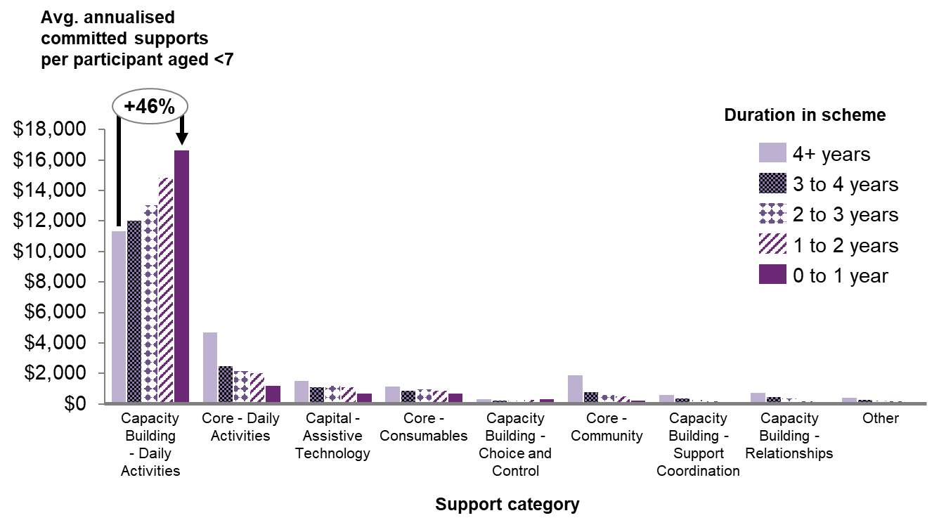
Source: Office of the Scheme Actuary
Improvement area 7: Children and families should be offered greater assistance to understand and select a best-practice mix of supports
EC partners need to invest more time and resources into helping families with plan implementation as well as family capacity building and education required to support informed choice and control.
Need for improved guidance on best practice supports
There needs to be clearer guidance (and in some cases a stronger evidence base) as to what constitutes a best-practice mix of supports or the efficacy of individual supports available in the market. This includes improved support for families during plan implementation. Families should receive the right amount of assistance or information tailored to their needs.
- There is a need for more understanding of best practice among many in mainstream services and the wider community.
- 89% of providers surveyed reported that there were barriers to delivering best practice early childhood intervention under the NDIS.
- 68% of peak bodies surveyed reported that the ECEI Approach is not delivering consistent best practice intervention.
Many children are consistently receiving therapy supports in clinical settings, which is contrary to clear best practice of receiving supports in natural settings like the home or school.
- This may be due to perverse market incentives that maximise the number of billable therapy hours that can be purchased with a plan budget, rather than focusing on the better outcomes that can be achieved by consuming family-centred supports in natural settings.
- Feedback from Providers has cited lack of separated funding for travel, lack of cooperation from mainstream services and cancellation costs as barriers to the delivery of services in natural environments.
- The Council also highlight that funding arrangements, and in some cases Provider marketing and pressure, currently incentivise clinic-based therapies over intervention in natural environments
“Families do not understand [best practice] concepts… and expect a clinical model of therapy e.g. sit my child down at a table and fix them because you are the professional.” – NSW metro Provider

“We do have Providers who come to visit but the money is burned on travel…. They have to travel from Sydney to regional NSW. Travel is an issue. Sometimes we drive to Wagga but it is a 200km round trip” - Family in regional NSW, son with visual impairment

“Families may believe they are buying a cure, not buying a service to help them support their child” – WA metro Provider
Evidence from the Council, a literature review, and interviews indicate that giving parents of young children with developmental disabilities free choice of services does not necessarily lead to effective use of NDIS funding. In the early stages, parents may not be sufficiently well informed or have a clear enough understanding of the needs of the child and family to make good choices.
There is a risk that families will make choices that are not in the best interests of their child, which could compromise the intended outcomes of the ECEI approach, due to the distress and confusion parents may experience when experiencing the NDIS for the first time. The level of parental knowledge and awareness of the NDIS and of best practice affects the choices they are likely to make with families running the risk of not asking informed questions.
To help families select the right supports that are most likely to have the greatest impact on improving outcomes of children, the NDIA will consider how to set plan management types (Agency, Plan, or Self-managed). This has implications for the types of providers a family could access (registered versus unregistered). This includes consideration of the extent and timing for families to self-manage plans, and evaluating the impact of increasing access to unregistered providers on outcomes for participants.
Additionally, supports provided by EC Partners should also help families make decisions on best practice providers, given the plethora of choice available to them. EC Partners currently are not empowered and not contractually allowed to give advice regarding best practice providers due to conflict of interest and reputational risks. Contracts currently state that EC Partners must comply with the Conflict of Interest management strategies agreed with the NDIA.
Need for implementation support
Families need to receive the right amount of assistance or information to make decisions or implement their plans, tailored by the intensity or complexity of their needs.
- EC Partners are currently funded for one hour of implementation support per child, however many families need additional support for troubleshooting problems connecting with providers, managing their supports and coordinating services. Providers utilising a key worker model are generally able to provide the right level of support, however, not all providers use a key worker model and families cannot always access a key worker approach in their area.
- Families increasingly elect to self-manage their child’s funded plan, however, many require more necessary supports to help them navigate the process and service offerings.
- The Council found that in the early stages, parents need to be more sufficiently well informed or have a clear enough understanding of the needs of the child and family to make good choices. Sector consultation, particularly with Providers, highlighted strong concern about the level of system navigation and coordination support the Agency currently offers to families.
- The language and jargon associated with planning often do not make sense to families, including terms such as ‘reasonable and necessary’.
- There is a disconnect between the cost of supports under the NDIS and the value that those supports deliver. Families are often opting for higher intensity supports, which they perceive to be better, and self-management, which costs them less. These misconceptions are reinforced by the health system promoting medical models of service delivery and some Providers who encourage the idea that ‘more is better’.
Improvement area 8: Young children and families that are vulnerable or disadvantaged are currently under represented and need to receive equity in plan budgets and engagement with supports.
There is a need for more equity amongst groups from Aboriginal and Torres Strait Islander, Culturally and Linguistically Diverse, LGBTIQ+ families and families in remote and very remote areas in terms of access, plan values and plan utilisation. Culturally safe and responsive practice is difficult to implement in the market resulting in some families from groups not receiving adequate support. The Council Report raised concerns about the equity of ECEI services.
Need for more equitable access to ECEI services
- Sector consultation highlighted that Agency information about the ECEI Approach needs to be more culturally appropriate, with more support needed to create cultural safety and promote accessibility.
- Consultation also reported barriers for LGBTIQ+ families. For many families, the local EC Partner is a faith-based organisation, which may be perceived is some cases not supportive, thereby deterring some families from seeking access.
- Access to adequate ECEI services often disproportionately favour young children and families in closer proximity to major cities.
  - The NDIA staff are required to be the main point of contact for families in non-EC Partner areas. Exhibit 5 illustrates the current coverage of EC Partners across Australia and highlights the mismatch of adequate support for families in remote and very remote areas by NDIA staff.
  - Stakeholder conversations with experts have highlighted complexities in these regions which will require specific service responses including a tailored approach to benefit from aspects of the reset.

Need for more equity in service delivery, including remote / very remote areas
- The Council highlighted that more equity is required of ECEI service delivery which may disadvantage young children and families from low socio-economic backgrounds, those from Aboriginal or Torres Strait Islander and Culturally and Linguistically Diverse backgrounds who may have difficulty navigating complex NDIS systems, and families from remote and very remote areas.
- Sector consultation also highlighted that access to adequate ECEI services often disproportionately favours young children and families in closer proximity to major cities.
- Children with more complex needs (e.g. challenging behaviour) are reported to be most disadvantaged when it came to exercising choice and control, giving rise to perceived inequalities in service provision. Provider consultations reinforced that these families were consistently being dealt with later.
- Scheme data also shows that committed supports and plan utilisation increase with educational and occupational advantage, which confirms that service delivery favours those with higher socio-economic backgrounds (Exhibit 16).
“I have realised I am lucky to be a white, middle class, educated social worker. I can understand the NDIA language, I know how to advocate for my child. I consistently see that other families can’t communicate, and it is intimidating for them.” – Mother in a regional city, 6 children on NDIS.
- Demand for providers and allied health professionals outweighs supply in remote and very remote markets.
  - Agency data shows the percentage of funded support used as of 30 June 2020 in very remote areas is 34% compared to 62% in major cities. The Council also highlighted workforce supply as an issue in the ECEI approach in remote areas and suggested the need to explore alternative solutions.
  - Provider consultation highlighted burnout in the sector as a major issue, for both overwhelmed new graduates and experienced workers struggling to adjust to the competing demands of administrative burden, billable hours targets and the desire to provide a quality service to families.
  - EC Partner organisations reported difficulties finding and maintaining qualified allied health professionals and other staff. Many reported that the pressures of prioritising access and planning over direct work with families through Initial Supports is a key reason for staff dissatisfaction, resulting in high turnover.
  - An inexperienced workforce coupled with changes in incentives for the existing workforce have compromised best practice. It was also noted that long-established Providers are more likely to deliver best practice than newer Providers.
- Sector consultation highlighted that more can be done to work with a range of other Commonwealth and State Government organisations to develop and deliver an integrated, whole-of-government response as part of a larger sector of supports. For example:
  - How to support remote families focus on the developmental needs of their children, when their needs for food and housing security are not being met.
  - How to develop a market response for timely and cost-effective service provision in a community if suitable accommodation (temporary or long-term) or service delivery infrastructure is not available on community.
  - How to entice allied health therapists to work in remote areas

“If I don’t get my son diagnosed with an issue I’ll lose his funding… this is where it becomes difficult living in a rural community… there’s a 12-18 month waiting list for a paediatrician… we need 12-24 months’ notice to start the ball rolling for diagnosis, we can’t do that within 28 days” - Single mother in rural NSW, child 6 years of age with Developmental Delay

Exhibit 16: Committed ECEI supports and plan utilisation by Index of Education and Occupation
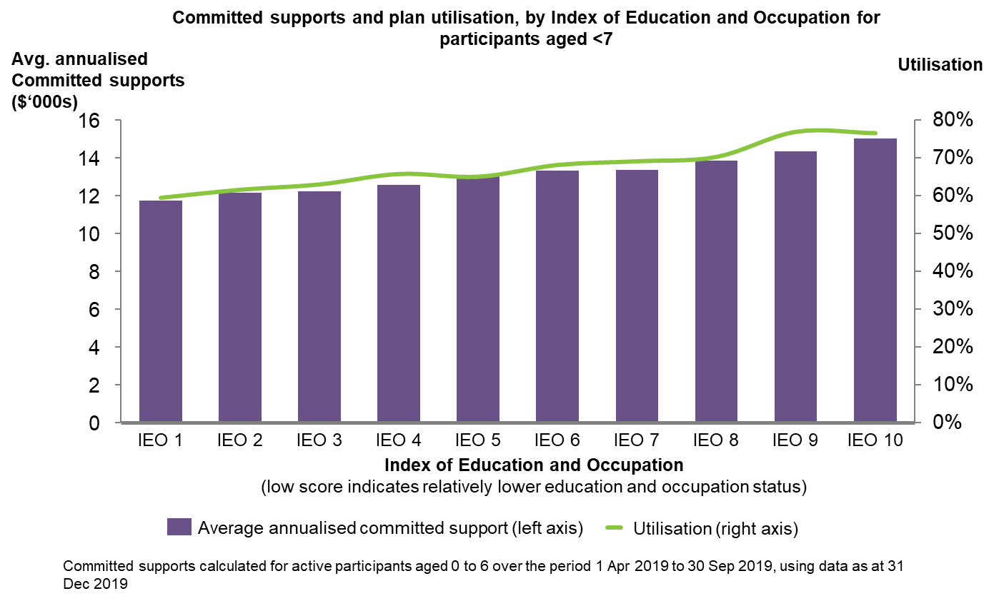
Source: Office of the Scheme Actuary

3.4 Transition
Improvement area 9: More children should be achieving the desired outcomes and successfully transitioning to the next phase of their life which may or may not require NDIS funded supports.
Agency processes and community expectations need to shift to support successful and positive transitions from the Scheme. Current challenges in these areas limit a key original ECEI Approach design feature of focussing on ‘service resolution’.
A lower than anticipated rate of young children are exiting the Scheme
The actual number and proportion of ECEI participants exiting the Scheme to date should be higher based on reports and expert consultation, highlighting concerns about the efficacy of the transition processes and the ECEI Approach more broadly.
- While acknowledging data limitations, the 2014 Productivity Commission Inquiry Report noted that exits in the sector had historically averaged around 12% annually (for all participants, including adults), with significantly higher average exist rates for young children. Moreover, ECEI experts consulted during this review indicated that, provided we are supporting all the right children early enough, we should be seeing exit rates in the range of 18-25%.
- Despite these expectations, in reality only 1.8% of ECEI participants have exited the Scheme over its lifetime (Exhibit 12).
- This large gap between what was anticipated and what has been recorded to date raises concerns about the efficacy of the early intervention supports being funded by the Scheme. Left unaddressed, very low exit rates could increase the risk that children become unnecessarily "institutionalised" into a permanent disability system for life.
- NDIS transition processes have been a barrier to children exiting the scheme until March 2020, when the eligibility reassessment process was established by the National Access Branch. Many children entered the scheme during transition via defined programs as access met under section 24. The NDIA Business System did not have the capability to change disability status nor provide a sound process for revocation of access until 2019.
Families view exits as negative and abrupt
EC Partner interviews highlighted that families view transitions as negative, rather than celebrating their child’s progress.
- This is partly driven by negative terminology around “exits” (referred to as ‘revocations’ in the NDIS Act), a fear of losing supports, and the perception by some families that the timing of “exits” can be unexpected and is abruptly followed by an abrupt cessation of assistance and supports.
- While ECEI pathways are necessarily transient in design, exits from the Scheme can be better communicated to help families clearly understand their purpose to encourage families to celebrate their child leaving the Scheme. Families perceive transitions out of the Scheme as a negative and a failure of the system, instead of celebrating their child’s development and trajectory.
Families need to be more consistently engaged on the progress of their child during plan reviews (and receive consistent individualised information on their child’s progress against key outcomes), to help ensure planning conversation are not overly focused on the dollar value of the plan and instead focus more on intended outcomes of the ECEI Approach.
- The Agency should better specify what information is needed from Providers to enable outcomes to be consistently measured and better hold Providers to account to measure outcomes in a standardised way.
- Provider consultation revealed that some families and Providers themselves had the perception that outcomes reporting, that emphasised progress, would result in funding being decreased or taken away at plan review. This negative correlation between outcomes measurement and funding levels, points to the entrenchment of the deficit model in the current system.

Future state intent and best practice
The desired outcome for the reset is to address the areas for improvement identified in Chapter 3 and, more broadly, to delivery an ECEI Approach that is more closely aligned with best practice.
This Chapter summarises the Agency’s current understanding of best practice principles (and challenges) in ECEI and, guided by those principles, articulates a desired future state intention for the ECEI Approach that upholds the central role of parents and caregivers in their children’s lives while supporting children to participate meaningfully in the key environments in their lives.

4.1 Early childhood intervention best practice
Early Childhood Intervention (ECI) aims to support families to help young children develop the skills they need to take part in daily activities and achieve the best possible outcomes throughout their life. Early intervention in the first 2,000 days (approximately 5 ½ years) of a child’s life can have an enormously positive impact that improves their trajectory. While these early days are a critical period for all young children, greater support for early intervention is needed for those that are developmentally vulnerable, have developmental delay or disability. This involves input from all players across the sector.
Evidence based research reveals that timely access to best practice ECI can improve the functional capacity and wellbeing of a child with a developmental delay or disability and their family. ECI can also benefit wider society in a variety of ways, including reduced incidence of exclusion from school, longer term increased levels of employment and significantly reduced impacts of social isolation.
The NDIS Quality and Safeguards Commission support the ECI best practice through the NDIS Practice Standards. These standards contain an early childhood supports module, which articulate the best practice guidelines as standards. These NDIS Practice Standards apply to NDIS providers who are registered to provide early childhood supports to NDIS participants.
The Australian and international evidence on best practice ECI can be divided into three components: ethos, practices and systems. An overview of best practice is essential to use as a reference point to guide the affirmation of the Agency’s intent for its ECEI Approach as well as to guide the recommendations proposed. Exhibit 17 below outlines a framework for best practice ECI, based on the Early Childhood Intervention Australia (ECIA – now known as ReImagine Australia) national guidelines.

Exhibit 17: Best practice ECI is based on three components – Ethos, Practices and System
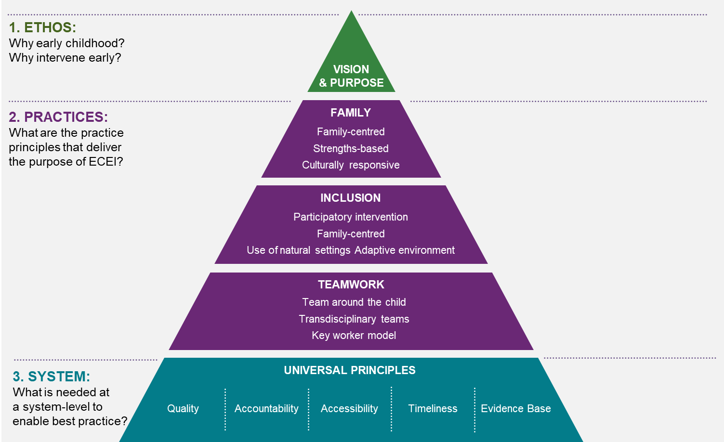

Extensive review of national and international best practice reveals four key insights:
- ECI is a social investment to address long-term outcomes for children with vulnerabilities
- International best practice promotes family, inclusion and teamwork as key principles for intervention
- System-wide alignment is needed to create the conditions for best practice and improved outcomes for children
- There are universal challenges to the implementation of best practice early childhood intervention systems.
Each insight is discussed in turn below.

4.1.1 ECI is a social investment to address long-term outcomes for children with vulnerabilities
The ECI ethos is clear – give children receiving support the best chance of meaningful participation in family, community and society. ECI is a social investment with long-term payoffs.
The early childhood years are important for all children and families, regardless of disability and/or developmental delay. Children’s early experiences establish “critical learning patterns” that shape all their future development. For children identified as having disability and/or developmental delay, early intervention strategies can support the development and use of skills that help them to participate in their natural environments. A growing body of evidence emphasises the role of children’s social and physical environments on development and health outcomes.
Early intervention also serves to equip others in the child’s life such as family, carers and educators who make up their environment. Best practice approaches target those around the child to help foster their development and meet their evolving needs. By setting up the child, family and carers for success, early intervention also provides long-term benefits to communities and society. These benefits are derived from helping to improve the child’s lifelong trajectory and decrease the cost and intensity of lifetime support needs.
Contemporary best practice early childhood intervention for disability is shaped by the broader transition from the deficit model of disability to the social model. A social model moves away from a focus on diagnosis and deficit and focuses intervention to build capability on the basis of functional impact to support meaningful participation in family and community life. Early childhood intervention best practice considers capability as something nurtured (or not) by children’s circumstances and experiences. This ethos translates into unique principles and strategies for early childhood systems, detailed below.

4.2 International best practice promotes family, inclusion and teamwork as key principles for intervention
ReImagine Australia, with support from the NDIS Sector Development Fund, developed national guidelines for best practice in early childhood intervention. These guidelines distil three key quality areas of best practice: Family, Inclusion, and Teamwork and introduce the concept of Universal Principles, which are discussed in the section below and conceptualised as ‘System’ elements. This section focuses on the first three principles, as elements of process in best practice interventions (Exhibit 18).
Exhibit 18: International consensus promotes three key principles for interventions
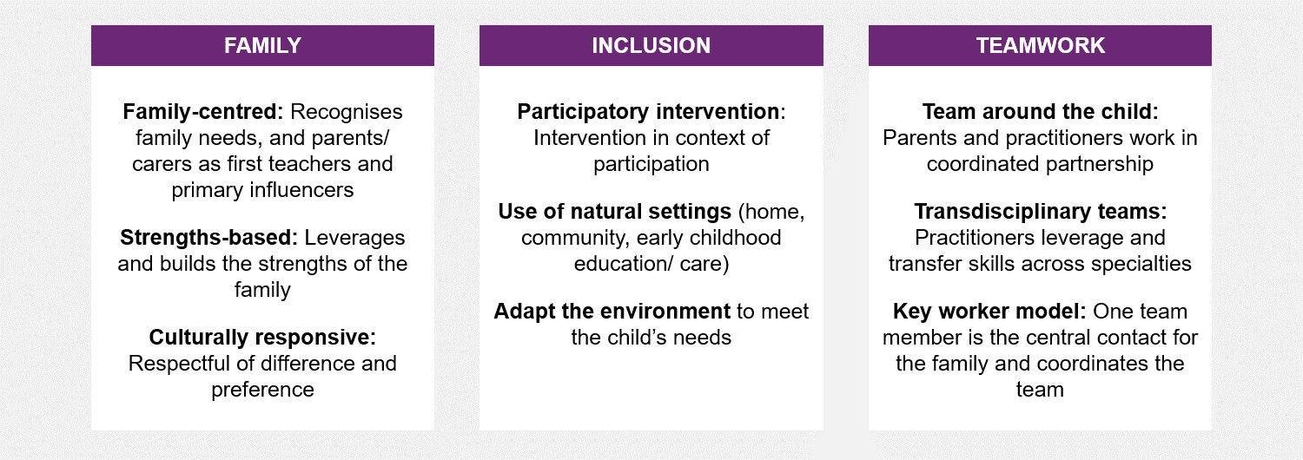
Source: Reimagine Australia (formerly ECIA) National Best Practice Guidelines for Early Childhood Intervention

4.2.1 Family
Leading ECI expert Dr Tim Moore defines the overall aim of ECI as:
“to ensure that the parents or other key caregivers are able to provide young children who have disabilities or developmental delays with experiences and opportunities that promote the children’s acquisition and use of competencies which enable the children to participate meaningfully in the key environments in their lives.”
Intervention strategies focused on the family and/or caregivers is the foundational principle of best practice. Family-centred, strengths-based practice recognises the whole family as the ‘client’ of ECI services, and further recognises the family as an intervention unit.
Family-centred practice considers family strengths, specificities of family life and family priorities to shape interventions. This also recognises the critical role of the family as change agents in children’s lives, and their ability to shape outcomes. Practitioners play an important part in shaping this role, and evidence suggests that parents’ experiences with professionals at the detection/diagnostic stage can have a lasting impact on their ability to cope in the long-term.
Families should be supported to:
  - Recognise and understand best practice
  - Make their own assessments about the right practitioners for their family
  - Develop their own strategies and resources to continue to enhance development
  - Assess the long-term efficacy of the interventions.
Family-centred practice should also be culturally responsive, meaning that practitioners are aware and respectful of diversity, and are responsive to a family’s characteristics.

4.2.2 Inclusion
Inclusive practice centres the child’s right to participate in their family and community as other children would. Children with disability and/or developmental delay may have additional needs that should be recognised and met in the supports that they need.
This goal is best met when:
  - interventions take place in the context of children’s daily activities in natural settings (like at home, or in early childhood care or education settings)
  - children have the best chance to practice their skills
  - intervention focuses on developing the capability of others to include the child.
This principle recognises that the best learning takes place where children spend the most time, not in clinical, therapeutic settings that are removed from their everyday life.

4.2.3 Teamwork
Best practice integrates a ‘team around the child’, including family, relevant ECI professionals such as allied health providers, and other professionals such as early childhood educators and health professionals (Exhibit 20). In contrast, weaknesses of traditional model interventions where multiple health professionals work directly with the child is shown in Exhibit 21.
The ‘team’ is brought together by one member, the “key worker”, who is the central contact for the family, and coordinates the communication and sharing of knowledge and skills between the team. The key worker may use a transdisciplinary approach, enacting interventions technically outside their service specialisation, but with the direction and support of the relevant team members, streamlining the points of contact and intervention for young children and families. The key worker changes to meet the specific needs of the child and family at a certain point in time.
The key worker also contributes to coaching and capability building with other adults around the child. Evidence suggests that within teamwork approaches, the greater the interdependence and cooperation between team members, the better the efficiency and ‘climate’ of the team. These practices focus on fewer, stronger relationships where the family is a true partner, and knowledge can be transferred across disciplines, and from specialists to carers and other important adults in the child’s life. In some exceptional circumstances, the key worker may be an extended family member or other professional in the child’s life.

Exhibit 19: Best practice model for teamwork
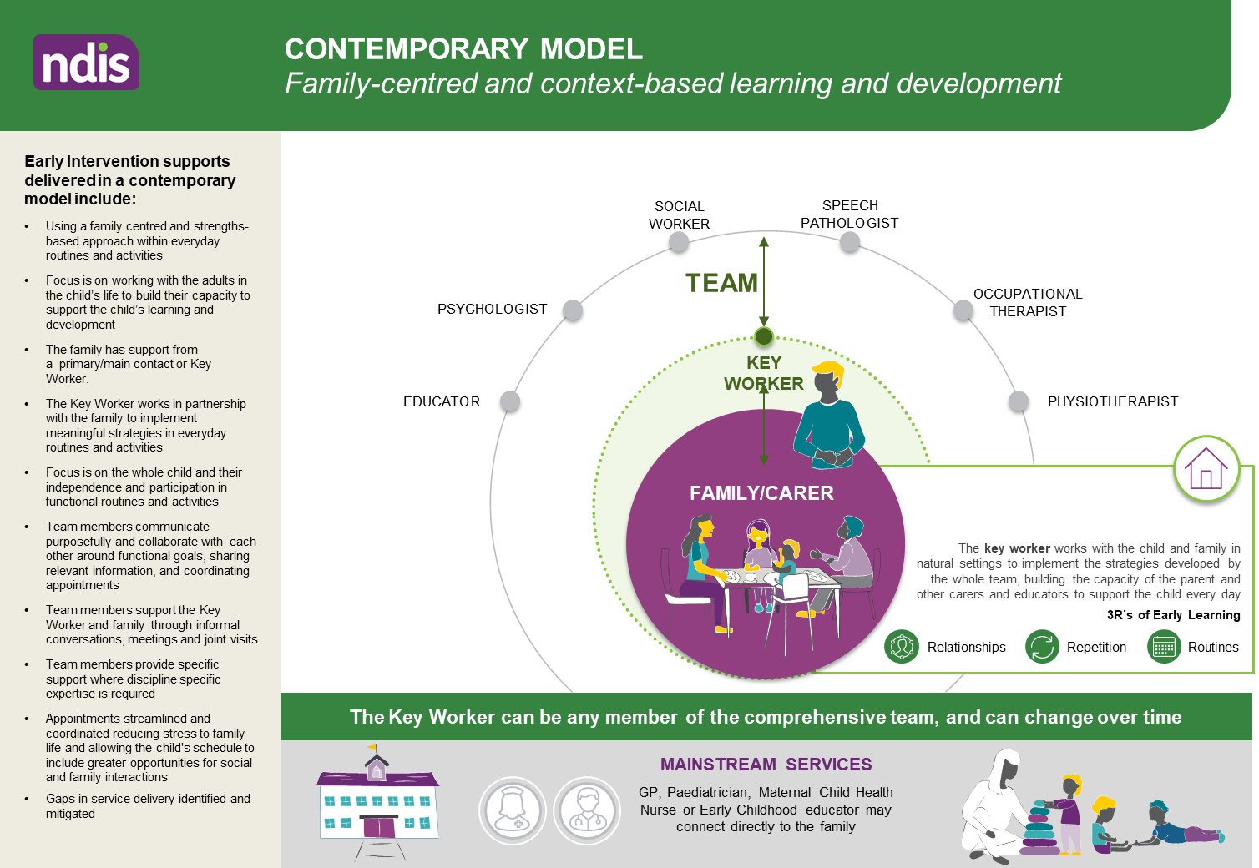

Exhibit 20: Weaknesses of traditional model interventions
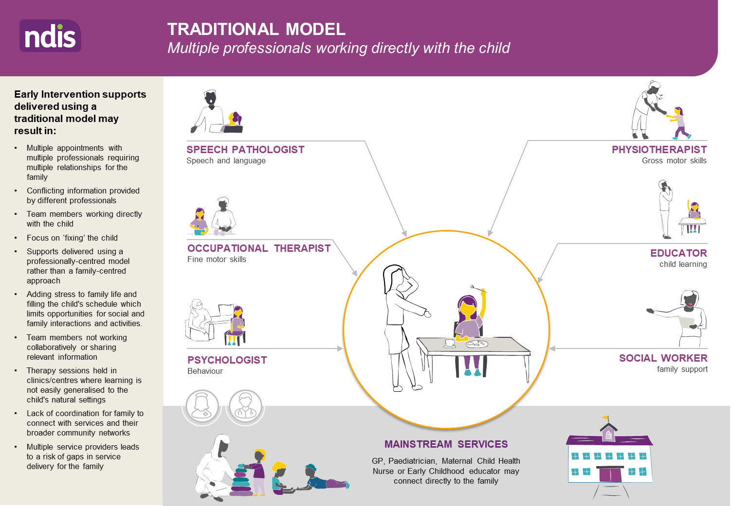

4.3 System-wide alignment is needed to create the conditions for best practice and improved outcomes for children
There are several universal principles that need to be fulfilled from a system-wide level to realise best practice, outlined in Exhibit 21 below.
Exhibit 21: Enablers of best practice Early Childhood Intervention
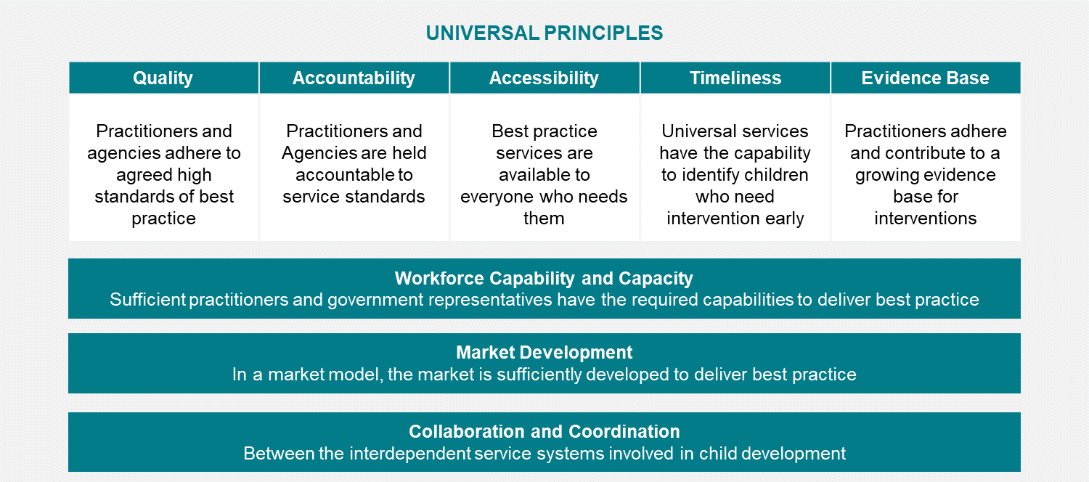
The delivery of ECI services across Provider types and the varied professional types should be required to adhere to:
- Agreed standards of quality to promote best practice
- A framework of accountability for these standards and outcomes measurement
- A consolidated evidence base.
The combination of these factors can create an ‘intelligent system’, defined as one that “collects and uses data to measure the outcomes it is achieving, and which has mechanisms for decision making that are responsive to evidence, data and changing local contexts.”
Across interfaces (intersystem, commercial) services must be:
- Accessible so that geography and other factors do not exclude families from best practice
- Timely in order to realise early intervention benefits.
Bolstered by:
- Workforce development including growing the ECI workforce and Continuing Professional Development (CPD)
- Market Development to promote adequate coverage and maturity
- Collaboration and Coordination between the interdependent service systems involved in child development (e.g. health, education, disability, community services).
Whether it is individual families or services that are being funded, there needs to be an adequate number of Service Providers (Providers) in an adequate geographical distribution for best practice to be accessible to everybody who needs early intervention.
Linked services like health (e.g. GP, maternal health nurse, community health) need to have the capability and capacity to identify young children at the right time for referral to ECI services for children and families to be able to get the most benefit from intervention. Timely identification is increasingly important as evidence grows of the greatest potential impact from intervention in the first 1,000 days of a child’s life (0-2).
These factors should be considered by governments, regulators and industry bodies in setting the conditions for young children with disability and/or developmental delay to be able to benefit from best practice intervention.
There are universal challenges to the implementation of best practice early childhood intervention systems
The ECEI reset highlighted the challenges the NDIA is facing in implementing and maintaining a best practice ECI system in detail. However, it must be noted that some challenges are universal to any jurisdiction trying to operationalise best practice and are acknowledged in best practice literature. The following four challenges are sector-wide:
    - The ability to operationalise the key worker model (and some aspects of the teamwork and family capacity building approach) has represented a challenge for some with regards to the validity of specialist skills. Even if accepted in theory, it is difficult for specialists to know when and why it is right for them to work directly with children, as opposed to through the key worker. More work is needed to clarify the role of specialists who are not the key worker in practice.
    - Training and maintenance of an adequate number of professionals in best practice ECI is difficult, particularly in remote areas
    - Best practice interventions can differ by disability type, or can be symptom specific, and there may be specific guidelines and best practices for particular diagnoses/ conditions. However, this should not undermine the broad consensus on family-centred practice, teamwork and outcomes focus. Broad consensus-building is required to reinforce a commitment to best practice within disability-specific intervention.
    - Systems of market-based individualised funding can create perverse incentives and accessibility issues:
    - a service-oriented understanding of ECI often prevails over outcomes-based because of the emphasis on families as consumers and Providers as vendors.
    - individualised funding puts more emphasis on individual therapies and allied health professionals and can unintentionally mean Providers and families conflate ECI with therapy.
    - in market-based models, areas with thin markets, and particularly remote areas, can be under-serviced, reducing accessibility of best practice Providers.
    - individualised funding can place pressure on families at a time when they are vulnerable and potentially unable to make informed decisions.
    - best practice principles and evidence-based intervention can be hard to translate in an accessible way that families can respond to.
In attempting to solve these challenges, the Agency has an opportunity to contribute significantly to the international evidence base and the ECI sector community of practice.

4.4 The future state intent
The Agency is committed to resetting the implementation of the ECEI approach so that it fully supports best practice. Hence, the overarching intention of the ECEI reset is to:
Create a distinct ECEI implementation model, differentiated from the general Scheme, which enables the right young children to receive the right level and mix of support for the right period of time (including more pre-access assistance and transition support) through a family centred approach aligned with best practice.
Guided by best practice principles, the future state aims to uphold the central role of parents and caregivers in their children’s lives while supporting children to participate meaningfully in the key environments in their lives. The future state also aims to integrate the NDIS in the very early years a seamlessly as possible.
Good support and guidance for decision-making and early intervention under the social model of disability starts early, well before someone makes a claim or decision to ‘need’ the scheme as an individual participant.
To help the Agency operationalise this vision, the intent of the end-to-end future-state pathway is described below along the three main stages of the ECEI Approach: (A) Early support (including access to the NDIS); (B) planning and implementation; and (C) Transition.
- Early support (including access to the NDIS): provide time-appropriate (as opposed to permanent) assistance, information and guidance to the right young children and their families/caregivers prior to access to the scheme, and at the right milestones (e.g., school transitions) via a pathway that is:
- Longer (i.e. expanded to slightly older age groups);
- More fluid (i.e. more movement in and out, rather than ongoing assistance); and
- More graduated (i.e. starts with the nimble provision of pre-access STEI assistance as the default and escalates the intensity and formality of access over time as needed).
- More integrated (i.e., with mainstream and community supports to facilitate proactive and early identification of young children at risk of developmental delay or disability).
- More consistent and equitable (i.e. decisions about support and access are made using more robust processes and tools)
Early support within the pathway has a primary focus on providing support, capacity building and best practice guidance for young children with disability or developmental delay and their families, as well as working alongside GPs, Paediatricians and early childhood supports will best support families to understand how and if the NDIS need to be involved in their life.
- Planning and implementation: enable eligible young children to receive the right level of supports and encourage consumption of a best-practice mix of supports through processes and systems that:
- Produce more consistent and equitable planning decisions (i.e. decisions about the level of funding is made using more robust processes and tools).
- Promote evidence-based use of funding (i.e. remove any disincentives to use of best practice supports and encourage its use through better provision of information)
- Provide better support for families to implement their child’s’ plan (i.e. tailored implementation support to families to enable them to select best practice supports).
- Transition: enable more young children to successfully transition from the Scheme at the right time and celebrate moving to another level of development through:
- Regular progress reviews (i.e. to celebrate success and check whether the child and their family is ready to transition from the EC Approach)
- Warm handovers (i.e. providing time-appropriate “transition” services to make the move to either mainstream and community supports – or another part of the Scheme - as smooth and stress-free as possible for children and their families).
The next chapter outlines a proposed package of recommendations to enable the Agency to operationalise this future-state intent.

5. Recommendations
This Chapter outlines a proposed package of recommendations to help the Agency operationalise and implement the future-state intent. These recommendations will serve the basis of a broader phase of public consultation with families and the early childhood sector from November 2020 to early 2021.
The NDIA will begin the detailed service design work for most ECEI recommendations in mid-2021. The planned rollout and implementation of the full ECEI reset will commence in late 2021.
The package is comprised of 23 ideas grouped into four categories:
A. Overarching recommendations and enablers
B. Recommendations for early support (including access to the NDIS)
C. Recommendations and enablers for planning and implementation
D. Recommendations for transition
The cumulative impact of these recommendations is expected to significantly transform the EC Approach from its current state. An overview of the end-to-end future-state pathway is depicted in Exhibit 22 and further detail are outlined in the next sections.

Exhibit 22: Future end-to-end EC Approach
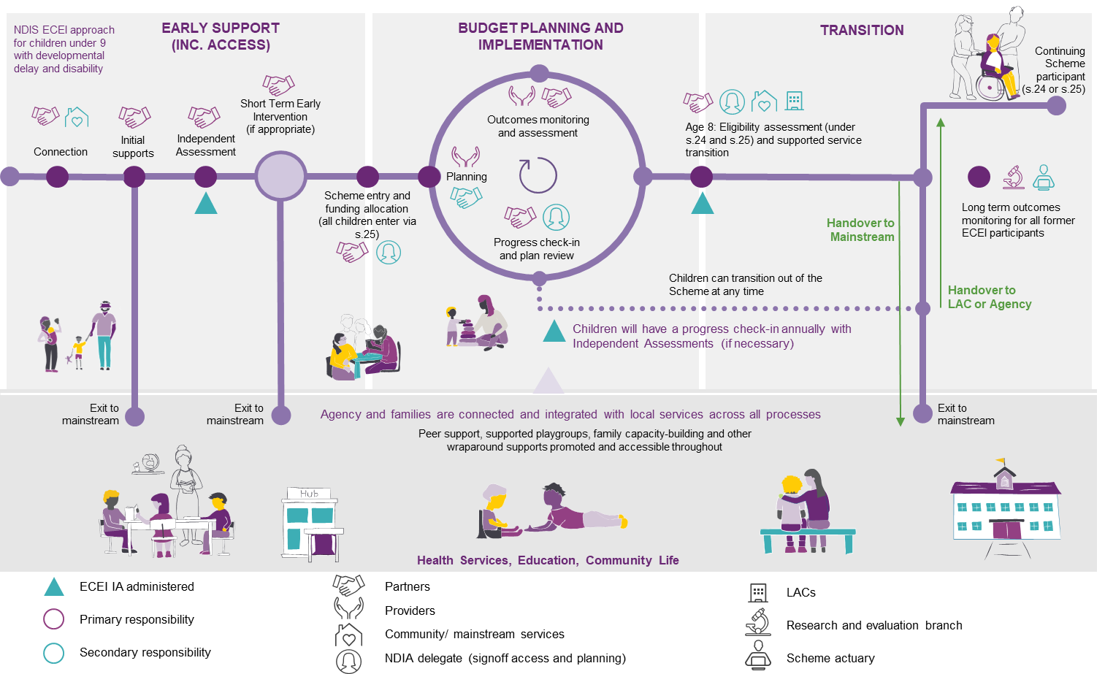

5.1 Overarching recommendations and enablers
Recommendation 1: Explain, rename and promote the NDIS Early Childhood Approach – and stop using the term “gateway” – so families understand and follow a clear pathway with a mix of early childhood support options available.
Rationale: Improving sector-wide communications on the Early Childhood approach and best practice to empower families so that they understand and follow a clear pathway to support with a mix of early childhood support options available.
  - Renaming the Early Childhood Early Intervention approach to the Early Childhood approach offers an opportunity to improve sector-wide communications on best practice in ECI. Renaming the ECEI approach to the Early Childhood approach removes the reference to ‘intervention’ which infers ‘doing to’ rather than ‘doing with’ and has negative connotations for different vulnerable groups.
  - Currently the term “gateway” is used in the sector and within the Agency to vaguely describe the entry point for supports through the ECEI approach, however, there is no official definition of this term. This has led to the term being misconstrued with multiple meanings and has been to the detriment of the intended focus on the social model of disability.
  - Discontinuing the term “gateway” will help counter the perception that the only purpose of the ECEI Approach is to provide a soft entry to permanent Scheme access and funded support for life, and hence reduce the risk of inappropriately institutionalising young children into a system of permanent disability for life.
  - There is a misconception amongst families that Access to the Scheme and a funded NDIS Plan is the ‘golden ticket’. Families often approach the Scheme seeking a medical approach where they want their child to be fixed, as opposed to optimising functional participation and inclusion.
  - To operationalise this recommendation, communication material will need to be developed for the sector (including families) that re-brands the ‘EC Approach and the future state. Internal communications will also need to be developed advising Agency staff to remove ‘gateway’ from its lexicon.
Recommendation 2: Clearly and consistently, communicate the intent of the new Early Childhood approach and the Agency’s support for best practice, so families understand how the approach informs positive outcomes for young children.
Rationale: Increasing sector awareness of the future-state intention of the Early Childhood approach through a strong communications strategy will help promote best practice through sector-wide alignment on the ECEI reset and foundational principles for the recommendations, and will help maximise the benefits of early intervention.
  - Promoting the Agency’s support of best practice, based on evidence based research in early intervention will support families to be better informed, and will support EC Partners and NDIA Planners with consistent decision-making. Families will be more prepared for and informed about the planning process with a clear understanding of what best practice looks like.
  - Increased transparency between families and the Agency in how processes work will allow the opportunity to ‘myth bust’ and reduce confusion and uncertainty for families.
  - The recommendation will help address Tune Review Recommendation 18, that the NDIA works with governments to provide public sources of information on evidence based best practice to help participants exercise informed choice, and Council recommendations for the NDIA to provide better decision support, information and capacity-building.
Recommendation 3: Develop and publish new Early Childhood-specific Operating Guidelines (OGs) – so our decision-making processes and best practice evidence are transparent and implemented consistently by partners and NDIS planners.
Rationale: Providing Early Childhood Partners, providers and families of children with developmental delay or disability with easy-to-access and clear Operational Guidelines (OGs) will support the efficient delivery of supports for young children that are consistent and aligned with best practice and avoids the need to review multiple general OGs that may have a more adult-centric focus.
  - Publishing OG’s will also aid in communicating and helping to set expectations on the future state of the Early Chilhdood approach. It will help educate and inform how early supports, access, planning, implementation and transitions operate. OGs will also help clarify how to consider the goals for the participant.
  - Currently there is inadequate externally published OGs for ECEI with six internal ECEI Practice Guides currently available or in development.
  - This recommendation would require working with the NDIA’s ‘Operational Guidelines’ project team to further develop the ECEI OG framework. OGs would need to be developed and published based on currently available practice guides and future state processes. These OGs documents will be published in accessible formats and easy-to-read English.
  - In addition, the NDIA seeks to add more structure around the decision-making regarding the timing and extent of families of self-managing participant plans
Recommendation 4: Create a distinct delegate/planner workforce that is exclusively focused on young children and their families, to improve the way families are supported.
Rationale: Ensuring that all staff working with children and families, or have delegations to make decisions on ECEI plans (including the Internal Review, National Review and Administrative Reviews teams) are almost exclusively focused on young children, will strongly support the future-state intent. An ECEI-specific workforce across the Agency would also improve the overall experience of the EC Approach and contribute to more consistent Agency decision-making to support best outcomes for children and families. This recommendation acknowledges that early childhood is a significant time of growth and development in a child’s life and that a distinct workforce would better understand the needs and expectations of best practice early childhood supports.
  - Currently delegates/planners work with both young children and adults, which increases the risk that adult-centric approaches are imposed on young children and their families.
  - A specific ECEI workforce across the Agency could be immersed in ongoing capability development related to ECEI.
  - NDIA workforce in remote / very remote areas would have access to specialised advice through the state and jurisdictional Early Childhood Services teams that can provide support and guidance for staff to assist families to connect with appropriate expertise.
  - The role of informal supports provided by families and carers, the contribution of natural settings, and mainstream and community learning opportunities that support a child’s development need to be considered specifically for this cohort, alongside the more formal supports that may be provided through the NDIS.
Recommendation 5: Continue to work with federal, state and territory governments to identify gaps and strengthen the role of mainstream services, so all young children receive support from the appropriate system when they need it.
Rationale: Strengthening and ensuring continuity of mainstream services (such as early childhood education and early childhood care) is critical to achieving the objectives of the EC Approach, which was designed to work alongside with – not independent of – these services.
  - Consultation on the National Disability Strategy commenced in 2019 and is currently in stage 2 of consultations running from October to December 2020 and drafting taking place in early 2021. The NDS is expected to be finalised in mid-2021.
Recommendation 6: Consider a range of mechanisms that will enhance compliance of providers with the NDIS Practice Standards on Early Childhood Supports and increase awareness by families of providers that adopt that best practice framework.
Rationale: Providing greater transparency over which providers, both registered and non-registered, are following best practice as defined by NDIS Practice Standards on Early Childhood Supports will assist families to easily identify providers who are recognised for delivering best practice.
- As at end-September 2020, 80% of families/carers of young children had chosen to either ‘partly self-manage’, ‘fully self-manage’ or ‘plan manage’ their child’s budget plan (this rate of 80% is significantly higher than the average for other age groups in the Scheme). These three financial plan management methods enable families/carers to choose either NDIS-registered providers or non-registered providers. The remaining 20% of families are ‘agency-managed’ and required to use only registered providers.
- Non-registered providers are obligated to comply with the NDIS Commission’s Code of Conduct, but are not obligated to adopt best practice for early childhood intervention as outlined in the Commission’s NDIS Practice Standards on Early Childhood Supports. Moreover, there are no mechanisms currently in place to highlight if they adopt these practices or not. Sector consultation revealed that many in the sector are concerned that some providers may not in fact be following best practice standards. This situation reduces the ability of families to be able to differentiate between providers in the market on the basis of best practice.
- The establishment of additional mechanisms to provide information on which providers in the market are following best practice standards – and to encourage or require greater compliance with best practice standards – could help provide greater transparency, accountability and recognition for providers who commit to best practice in service delivery regardless of whether or not they are registered with the NDIS Commission.
- Mechanisms that could be considered include:
  - Providing greater information to families about the benefits of using registered providers and the standard of practice they can expect from providers who have been certified by the NDIS Commission against the NDIS Practice Standards on Early Childhood Supports.
  - Establishing a complementary industry-led ‘best practice accreditation system’.
  - Establishing a complementary ‘quality feedback / rating system’.
  - Making registration with the NDIS Commission mandatory for all providers working with young children in the early childhood space.
  - Changing policies so that self- and plan-managed participants in the EC Approach are required to use only registered providers.
  - This recommendation aligns with Tune recommendation 18, which suggests the NDIA works with the sector to establish an accessible source of publically available information about evidence-based best practice approaches, to assist participants in exercising informed choice and control.
Recommendation 7: Improve sector wide understanding of how to identify families and young children experiencing disadvantage or vulnerability and tailor culturally appropriate services and resources so they can benefit from early interventions support.
Rationale: Ensuring materials are accessible to all diverse communities will enable vulnerable or disadvantaged families to benefit from early interventions support and empower them to engage confidently with the Scheme via the local EC Partner or the NDIA.
  - Increased cultural safety and reduced barriers to engagement will help all families have access to the required level of support so that their child and family goals can be achieved. NDIS plans will be more equitable and in line with Plans for children whose families are well resourced and have fewer barriers to engagement. Plan utilisation will also improve for groups where it has previously been lower than for families from higher socio economic backgrounds.
  - The Agency has recently developed a Culturally and Linguistically Diverse strategy that prioritises better market choice, engagement and cultural competency and will be used by EC Partners to better meet the needs of families.
  - Improving Operational Guidance, marketing and education materials for the Aboriginal and Torres Strait Islander community will be done in collaboration with Aboriginal Community Controlled Health Organisations (ACCHOs), and other Aboriginal Community Organisations (ACOs) to strengthen engagement.
  - This recommendation aligns with Council intent for the Agency to develop meaningful approaches to overcome barriers to engagement experienced by many families
  - Drawing on existing, community-specific knowledge and practice from relevant EC Partner organisations will help develop OGs and culturally safe inclusive ECEI resources and education materials
Recommendation 8: Implement tailored methods of delivering supports for young children and their families living in remote and very remote areas to strengthen access to services.
Rationale: Using a tailored approach across different remote and very remote areas will assist with developing the right solutions for families that take into account unique local circumstances, are culturally appropriate, engage local service providers and are integrated with local mainstream services.
  - This recommendation will utilise a place- and principles-based approach in order to develop solutions for families in remote / very remote areas
  - Place-based approaches are collaborative, long-term approaches to build services for communities within a defined geographic location. This is usually characterised by partnering and shared design, shared stewardship, and shared accountability for outcomes and impacts
  - Principles-based approaches means that the concept of the NDIS retains primacy over the concept of place-based. This makes it possible to make changes based on local needs and priorities, without implementing something that does not support the core tenets of the Scheme.
  - The Agency will actively identify, encourage and work with providers on community and in surrounding regions to promote / develop a market response. The Agency will also lead the development of culturally safe planning resources and training packages to support planning experiences for Indigenous families/carers and young children.
  - The Agency will continue to work with remote communities to develop scalable and sustainable approaches to the delivery of early childhood supports that reflect the needs of those communities. It will also continue to engage in consultation with the Aboriginal and Torres Strait Islander sector, with the provider sector, and with community leadership to develop culturally appropriate responses across remote Australia.
Recommendation 9: Implement a tailored Independent Assessments (IAs) approach for young children to support consistent access and planning decisions.
Rationale: Implementing a tailored ECEI approach for IAs will help us better understand the functional capacity and environmental circumstances of young children and their families, to support fair and transparent access and planning decisions.
- The Agency has published new access and planning policies with IAs for all participants of the general Scheme aged 7 years or above that will help ensure fairer, more consistent and more equitable access and planning decisions. These policies will apply to young children in future, with a differentiated approach that upholds early intervention best practice and objectives for this cohort. Recommendation 14 proposes to increase the age limit for the EC Approach from under 7 years of age to under 9 years of age. However, until the ECEI reset consultation is finalised and the recommendations approved, independent assessments will be used for general Scheme participants aged 7 years old or above in line with policies outlined in those papers.
- In parallel, the Agency has progressed the thinking on the IA approach for young children and will consult with families/carers and the sector. What factors does the Agency need to consider in ensuring an effective assessment process for young children under 7 or 9 years of age?
- It is proposed to use IAs for young children above the one year of age:
  - Evidence shows that developmental delay and functional issues become more evident from the age of one.
  - The existing research literature indicates that there are assessment tools which are valid for children over the age of one.
- It is proposed that EC Partners be commissioned to administer Independent Assessments for young children:
  - Currently EC Partners already have experience in administering assessment tools for young children in a manner that aligned with best practice.
  - Unlike Local Area Coordinators for participants 7 years and older, EC Partners already have allied health professionals in their workforce that assess young children on behalf of the Agency.
  - EC partners are experts in early childhood assessment in line with their professional training and experience in family centred best practice to deliver consistent standardised assessment results in a more streamlined process for families.
  - Independent Assessments will be administered by an IA Assessor for children that are 7 years old or above (and later, once the ECEI recommendations are finalised, for children that are 9 years old or above).
- The assessment tools intended for use for young children under 7 are included in an addendum to the previously published Independent Assessment Tools Paper. The addendum is available on the NDIS along with the full Independent Assessment Tools paper. The tools are:
  - Ages & Stages Questionnaire (ASQ-3) OR Ages & Stages Questionnaire -Talking About Raising Aboriginal Kids (ASQ-TRAK)
  - PEDI-CAT (Speedy) OR PEDI-CAT ASD (Speedy)
  - Vineland-3 Comprehensive (Interview Form)
  - Young Children's Participation and Environment Measure (YC-PEM) for children under 6 years
  - Participation and Environment Measure - Children and Youth (PEM-CY) for children 5+ years
- The Agency will continue to refine how independent assessments will be implemented with young children and families in advance of their introduction for access and planning commencing after mid-2021.

5.2 Recommendations for early support (including NDIS access)
Recommendation 10: Increase Early Childhood partner capacity to identify and help young children and families from hard-to-reach communities or those experiencing disadvantage or vulnerability, so they can connect to – and benefit from – early intervention supports.
Rationale: Enabling earlier identification of eligible children from families experiencing disadvantage or vulnerability will help maximise the benefits of early intervention and improve current inequities in the access process through a commitment to culturally safe and accessible services for families who need more support to engage.
  - This recommendation will enable EC Partners to be better embedded in all referral pathways and referral channels (outlined in Exhibit 23) including local communities, through EC Partner contracts, KPIs and operational guidance updates. It would require building on current contractual obligations to create clearer contractual incentives for EC Partners to conduct community engagement with particular emphasis on coordination and connection with vulnerable groups.
  - Some EC Partner organisations may have their own engagement/outreach approaches. However, the Agency should set clear expectations for appropriate outreach and community linkage across EC Partners.
  - Partners would establish strong connections with mainstream services to identify children that may need more than the supports available through mainstream systems. Clear expectations would need to be set with mainstream services to do what they can within their limits and that they do not pull back entirely when an NDIS-funded service gets involved.
  - As a complement to outreach activities, the Agency should work with the Community Engagement Branch and the Connectors Branch to develop and maintain a National mainstream program database to help Partners support families to connect with local mainstream and community services.

Exhibit 23: Referral pathways and information channels
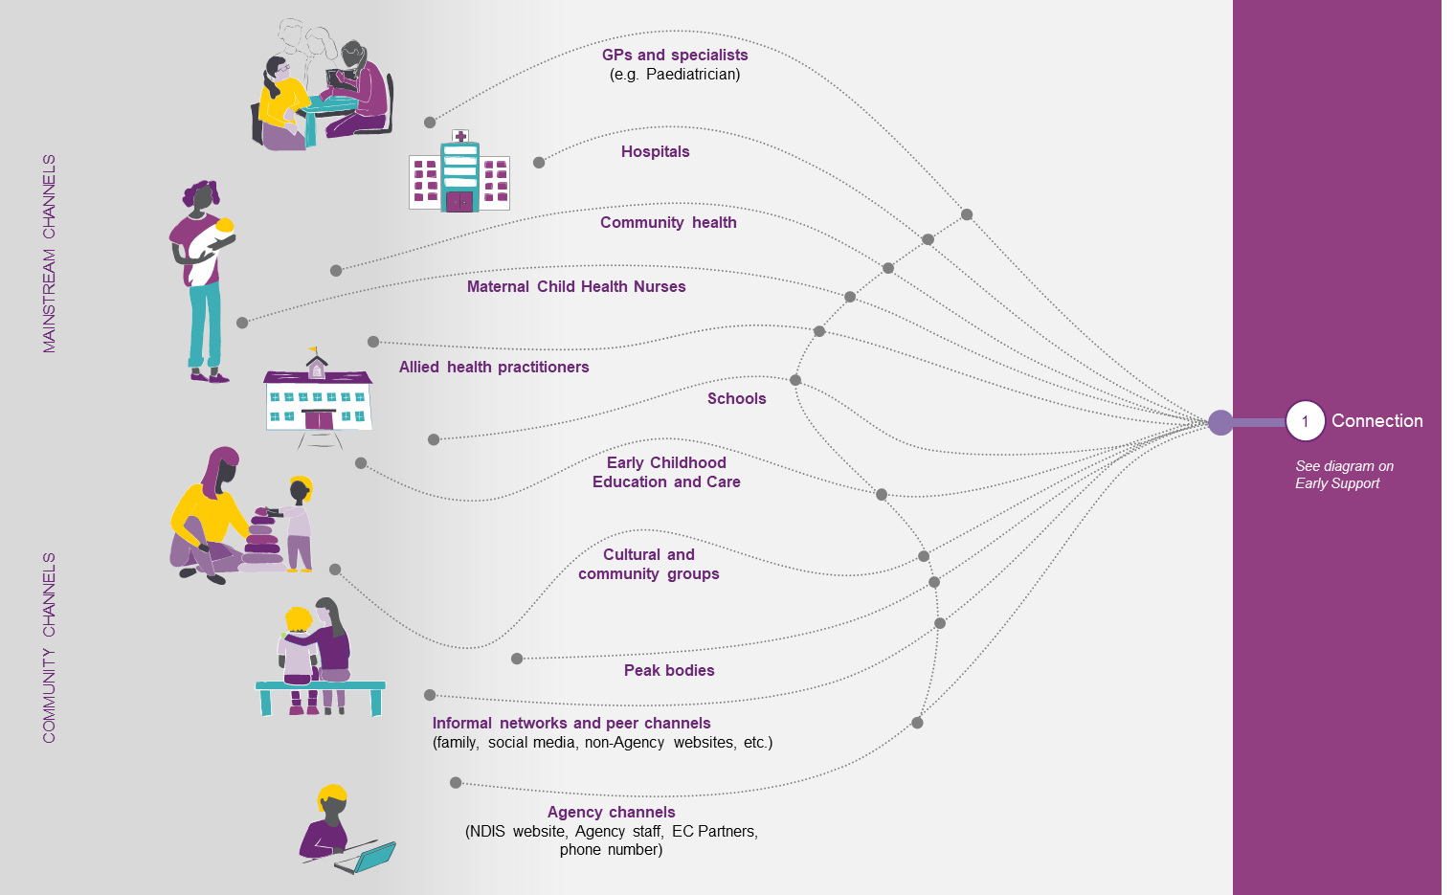

Recommendation 11: Increase Early Childhood partner capacity to connect families and young children to local support networks and services in their community.
Rationale: Promoting peer support networks will provide invaluable support to families in the early stages of navigating the EC Approach. Research has shown that people with disability and families with good peer support networks are happier, more resilient and better informed. Peer support networks enable families to support each other, share information about the NDIS, and help each other with planning.
  - This recommendation aligns with the Council recommendation to strengthen the use of peer support to assist families to make more informed choices about best practice services for their family
  - Peer support programs have been shown to enable parents to identify, pursue and achieve goals for their child, their family and themselves.
  - Peer support will assist families to exercise informed choice and control when selecting providers by sharing stories of success and passing on recommendations based on their experiences
  - Recent sector and family consultations have raised the issue of receiving different information and answers depending on who in the Agency families speak to, creating confusion in relation to the Agency and its processes.
  - Initial Supports and STEI delivered by the EC Partner provided opportunities for peer support networking to commence and family connections to develop. Families in similar situations may be able share their experiences and help each other navigate the supports and services available to them.
  - This recommendation will help address Tune Review Recommendation 12(c): build the capacity of families and carers to support children with disability in natural settings such as the home and community.
  - To operationalise this recommendation, education and support material would need to be developed to help EC Partners promote peer support networks. This would include developing a comprehensive list by location, type of support and level of support.
Recommendation 12: Increase Early Childhood partner capacity to provide Short Term Early Intervention (STEI) support to eligible young children and families for longer.
Rationale: Expanding the amount of STEI supports provided by EC partners for ‘non-participants’ will enable the provision of more regular (up to fortnightly visits) and responsive assistance (e.g. clinical strategies and advice in line with the child’s changing development). This will improve the trajectory of young children such that Scheme support may not be required, or to realise lower funded support needs if and when young children join the Scheme.
  - This recommendation is key to achieving the vision of expanding the use of STEI for non-participants as a complete or interim alternative to access under s.25 when it is not evidenced that a young child requires long term funded support. Not all young children who approach an EC Partner will receive STEI; many will be directly referred to mainstream and others will still need to do an IA and must meet a minimum bar of functional impairment, albeit at a lower threshold than that required for access under s.25.
  - Currently, STEI is available to children for light touch therapy focussed on building the capacity of families. However, EC Partners are constrained both by resourcing and Key Performance Indicators in delivering this as intended.
  - A light touch STEI standalone service offer delivered by EC Partners will include an individualised family service and support plan outlining the child and family goals and focus on opportunities for inclusion and participation. STEI will include a combination of individual and group therapy supports provided in the child’s natural environments to build the capacity of the family and their mainstream support providers to meet the developmental needs of the child.
  - The offer would be limited to children aged under 6 years in line with the developmental delay criteria. The rationale for this is that children of school age and above have different developmental and learning support needs and the main learning environment is no longer the home with the need for school learning to be integrated with peers. It is also expected that school age children may have access to mainstream supports such as allied health interventions (e.g. speech therapy) at school. Children aged 6-8 would receive a tailored Initial Supports offer ensuring appropriate community and mainstream linkages.
  - At the end of the STEI program, outcomes will be measured and children will be supported to transition into mainstream settings or to request Access to the Scheme via the Access request and Independent Assessment process.
  - This recommendation is also in line with Council recommendation 1a to provide short-term early intervention support where appropriate, ensuring that only children needing longer-term early intervention become Scheme participants.
  - It is important to note that Tune Review Recommendation 13 encourages the NDIA to amend the NDIS Act “ to provide more flexibility for the NDIA to fund early intervention support for children under the age of 7 years outside an NDIS plan”. The details of this Tune recommendation make clear that this is referring to directly providing funds to the families of ECEI participants after they have met access, but while waiting to receive their first plan (i.e. this is not about STEI for non-participants). Implementation of this Tune Review recommendation will be part of the package of legislative changes.
Recommendation 13: Clarify the interpretation of the developmental delay criteria under Section 25 of the NDIS Act (2013) to improve the consistency and equity of Agency decision-making. Establish thresholds for key criteria using Independent Assessments.
Rationale: Defining clear thresholds for the criteria ‘substantial delay in functional capacity’ and ‘extended duration’, which are specified in the NDIS Act (2013), will improve the consistency and equity of Agency decision making.
  - This guidance will be particularly relevant to support decision making about which children should enter the NDIS through s.25 and which should receive short term early intervention (STEI). The current definition in the Act would not necessarily need to change and clarification would be provided in OGs.
  - Currently, the Developmental Delay criteria in the Act (s.9) is subjective and open to wide interpretation. For example, what constitutes a ‘substantial reduction in functional capacity’ is not defined, and no fixed time period for ‘extended duration’ is set. This makes it difficult to apply consistent decision making criteria.
  - To operationalise this recommendation, OGs will be developed to better define the definition of DD. In addition, Independent Assessments will be used to set thresholds for the key DD criteria used to make decisions on Access.
Recommendation 14: Increase the age limit for children supported under the Early Childhood Approach from ‘under 7’ to ‘under 9’ years of age, to help children and families receive family centred support throughout the transition to primary school.
Rationale: Expanding the age range from under 7 to under 9 years of age will ensure that young children are supported throughout the transition to primary school (a critical life milestone) and align the Scheme with the World Health Organisation’s definition of young children (zero to eight years)
  - This recommendation is consistent with and will help implement the government’s response to Tune Review recommendations related to ECEI: “The Government agrees with the intent of maximising the benefits of funded supports at a critical time in a child’s development.”
  - Entry would be based on either eligibility against DD criteria for children aged 0-6 (which is consistent with established international definitions of DD) or against the broader provisions in s.25. As a result, entry for children with DD would continue to be for children aged 0-6 years old.
    - For young children zero to eight years, who do not have developmental delay, expanding the age range will enable continuity of support across critical life milestones (i.e. entering primary school) with a family-centred approach. This will also strengthen the mainstream and community interfaces during these times.
    - For young children with DD, the age range would continue to be 0 to 6 years, which is consistent with the Act and international definitions of DD. The intention of support provided over this age is about education and capacity-building while the needs of the child are being understood and the lifelong trajectory is not yet known. It is expected that in most cases children with DD who receive early intervention supports will be able to transition out of the NDIS and have their needs met in the mainstream support.
  - Children aged over 9 would either transition from NDIS supports or transfer to continued support from the Agency through other pathways.
Recommendation 15: Use the early intervention criteria, under Section 25 of the NDIS Act (2013) to make decisions around access to the NDIS for all young children.
Rationale: Differentiating the early intervention EC Approach from the broader general Scheme will help enshrine the principle that early childhood is a time of significant change and development, and that prevention is the focus of early intervention for young children. At age 9, or earlier as required, suitability for continued Scheme access via Section 24 (permanent disability) can be assessed.
  - This approach aims to prevent the Scheme from driving diagnosis and enables a child-centred approach that appreciates the role of development during this period. Treating all young children as an early intervention cohort rather than requiring decisions to be made about their likely lifetime support needs is strengths-based and encourages an optimistic view of the possibilities for every child and their family.
  - Currently the NDIA enables young children to enter the Scheme under either Section 24 (permanent disability) or Section 25 (early intervention). Each Access pathway has its own evidence requirements and intent, contributing to confusion about the purpose of the NDIA’s approach for young children.
  - This means some parts of the Act may not be well-suited to young children. For example, the Act focuses on participant’s goals and aspirations, which in an ECEI context, does not account for more holistic aspirations of the family. Best practice approaches recognise the importance of family capacity building delivered through a family-centred approach.
  - To operationalise this recommendation, OGs would need to be revised to reflect that all children enter under s.25. Communication and training material would also need to be developed to ensure Agency staff and EC Partners understand future state operations
  - For children with profound or severely complex disabilities, there would be assurance that entry to the Scheme will be through an empathetic IA and a straightforward continuation to s.24 at age 9. Additionally, the ECEI prioritisation framework ensures the most disabled children get prioritised support to request Access and get an NDIS plan in place.
Cumulatively, these recommendations will create a new early support and access experience as outlined in Exhibit 24.

Exhibit 24: Focus on early support pathway (including access)
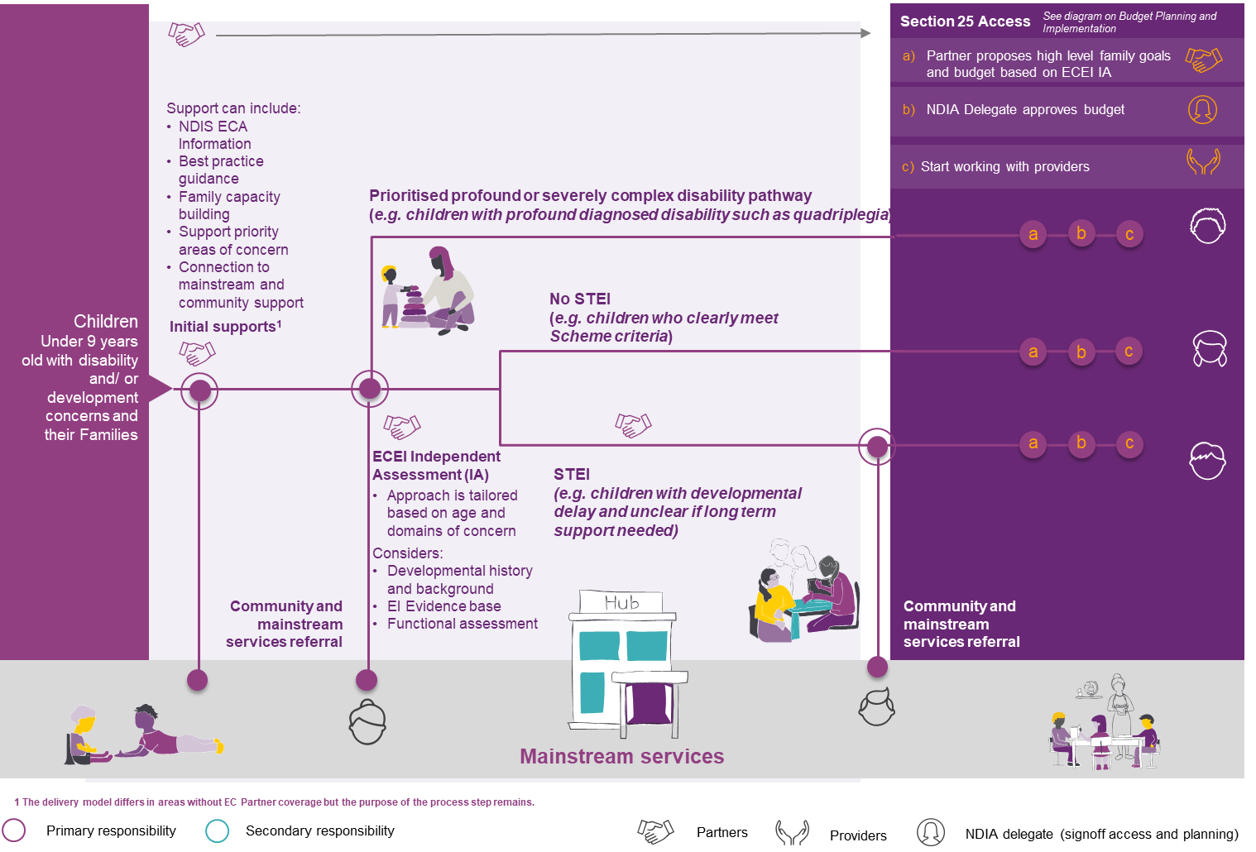

5.3 Recommendations for planning and implementation
Recommendation 16: Increase Early Childhood partner capacity and flexibility to tailor the level of support provided to families to implement a child’s plan and more quickly connect to the right supports and services.
Rationale: Increasing the hours of flexibly applied implementation support would enable EC Partners to build the capability of families to better implement their child’s NDIS Plan based on their needs. Those with Plans developed by an NDIA Planner due to the involvement of multiple service systems could still receive Support Coordination funding as is currently the situation.
- Support coordination funded by the NDIS is intended to ensure connection to disability services and supports. This is best provided by EC Partners for the ECEI cohort due to their specific expertise and system knowledge so they can provide connection with services, build capacity and coordinate supports where required.
- Support coordinators do not necessarily have experience in how to work with young children and families or good knowledge of the early childhood service system in the way that EC Partners do.
- Families with multiple complexities with different government supports involved will likely have a case manager through a relevant government department.
- EC Partners already have established relationships of trust with the child and family, so are well placed to provide system navigation support in a way that gives families better continuity of service.
  - Many EC Partners already spend a lot of time supporting families with plan implementation, but this is not reflected in their contract assumptions, creating conflicts with other role pressures.
  - In future, EC Partners would provide a tiered level of support depending on complexity. EC Partner would stream families into categories correlating to determined standard hours of support.
  - EC Partners could flexibly provide group support (in the form of workshops, information sessions, etc.) and increased individualised support to build system navigation and administrative knowledge as a baseline for all families who receive a funded plan.
  - Contractual arrangements with EC Partners would need to be amended to operationalise this recommendation to enable EC Partners to provide tiered implementation and coordination support.
Recommendation 17: Introduce a ‘capacity building support in natural settings’ item in the NDIS Price Guide to encourage families and early childhood providers to prioritise supports delivered at home or other natural settings.
Rationale: Introducing a new line item will remove the financial disincentive to provide therapy in natural settings and help overcomes situations where families maximise the number of billable therapy hours that can be purchased with a plan budget, rather than focusing on the outcomes that can be achieved by consuming family-centred supports in natural settings.
  - A ‘stated support item’ in a participant budget will encourage a conversation between the EC Partner and the participants’ family about the benefits of best practice early childhood intervention delivered in natural settings. This will provide an opportunity for EC Partners to educate families on what they should expect from best practice Providers, and the benefits of interdisciplinary collaboration.
  - This recommendation aligns with Council recommendation 3g, on promoting multidisciplinary practice as a Provider requirement and making travel a stated support. It is also in line with best practice principles documented in Early Childhood Intervention Australia (ECIA) Best Practice in Early Childhood Intervention Report 2018 on choosing natural settings over clinical settings.
  - This support item will be added to the price catalogue from 1 July 2021, and will need to be considered through the R&N Program in light of planned implementation of independent assessments and greater plan flexibility.
  - Currently many young children are receiving therapy supports in clinical settings, which is contrary to clear best practice of receiving supports in natural settings like the home or preschool. Note that there are a range of interventions apart from therapy that constitute early childhood intervention.
Recommendation 18: Publish new guidance about what is considered ‘reasonable and necessary’ when making decisions around support for children on the autism spectrum, based on evidence found in the Autism Cooperative Research Centre (CRC) 2020 report.
Rationale: Publishing guidance based on the Autism CRC 2020 Report and the “National Guideline for the Assessment and Diagnosis of Autism Spectrum Disorders” will assist with more consistent planning decisions regarding intensive level supports for children on the Autism Spectrum, aligned with evidence and best practice. This will include the types of interventions, their intensity and duration and expected outcomes.
  - The new guidance will establish the link between the National Guideline for the Assessment and Diagnosis of Autism Spectrum Disorders and the NDIS access and planning processes.
  - Highly intensive therapy raises conflict with the NDIS principle of promoting inclusion and implementing strategies for children to access the same experiences and opportunities for childhood development and participation as their typically developing peers.
Recommendation 19: Empower Early Childhood partners to provide families with clear advice about the best providers for their child and situation so families can make more informed choices.
Rationale: Empowering EC Partners to give objective, evidence-based advice will enable them to be more responsive to requests from families and deliver a better experience with specific local knowledge. Families in turn will be more confident and informed to make decisions about the providers with whom they wish to engage. This would help ensure timely connection with required services and supports to commence early intervention as soon as possible.
- EC partners know their communities well and can enable supportive connections to best practice providers so that children and their families can achieve the best outcomes.
- EC partner professionals would be able to provide advice and guidance on the best type of service to support a child / family’s needs and assist in how to search for relevant providers.
- EC partners would also be able to empower families with the types of questions to ask when engaging providers and ensure they know how to determine if a service is right for their family.
- Conflict of interest and other risks would be mitigated by developing a framework to provide objective and evidence based advice and to reduce claims of bias.
Recommendation 20: Undertake further ongoing research and study on the outcomes of young children after receiving early intervention support, to inform future policy and operational changes.
Rationale: Monitoring and evaluating the short and long term outcomes of young children who receive early intervention will inform and improve the service delivery as well as build the evidence base on disability and developmental delay in young children
  - This recommendation aligns with those from the Council and Tune reviews for the NDIA to close the research to practice gap and promote the evidence base for best practice early childhood interventions to the community.
  - Capturing aggregate data on outcomes for young children and their families supported by NDIS supports would improve the understanding and effectiveness of different interventions. Furthermore, it will aid the provision of information, services and resources to drive better outcomes.
  - The Agency’s Research and Evaluation Branch proposes to study outcomes for young children following early intervention to support the evolution of the Agency’s approach, along with its evidence base.
  - Adult plan budget values and other actuarial data could be used to track the impact of early childhood intervention investment on Scheme sustainability for those with lifelong support needs.
  - This research would also provide the evidence base to inform EC Partners and the NDIA on how to support families and participants in setting appropriate goals.
  - Existing measurement tools will be expanded to measure longer term outcomes such as educational attainment, employment, living situation and community inclusion.
Cumulatively, these recommendations will create a new planning experience as outlined in Exhibit 25.

Exhibit 25: Focus on planning and Implementation pathway
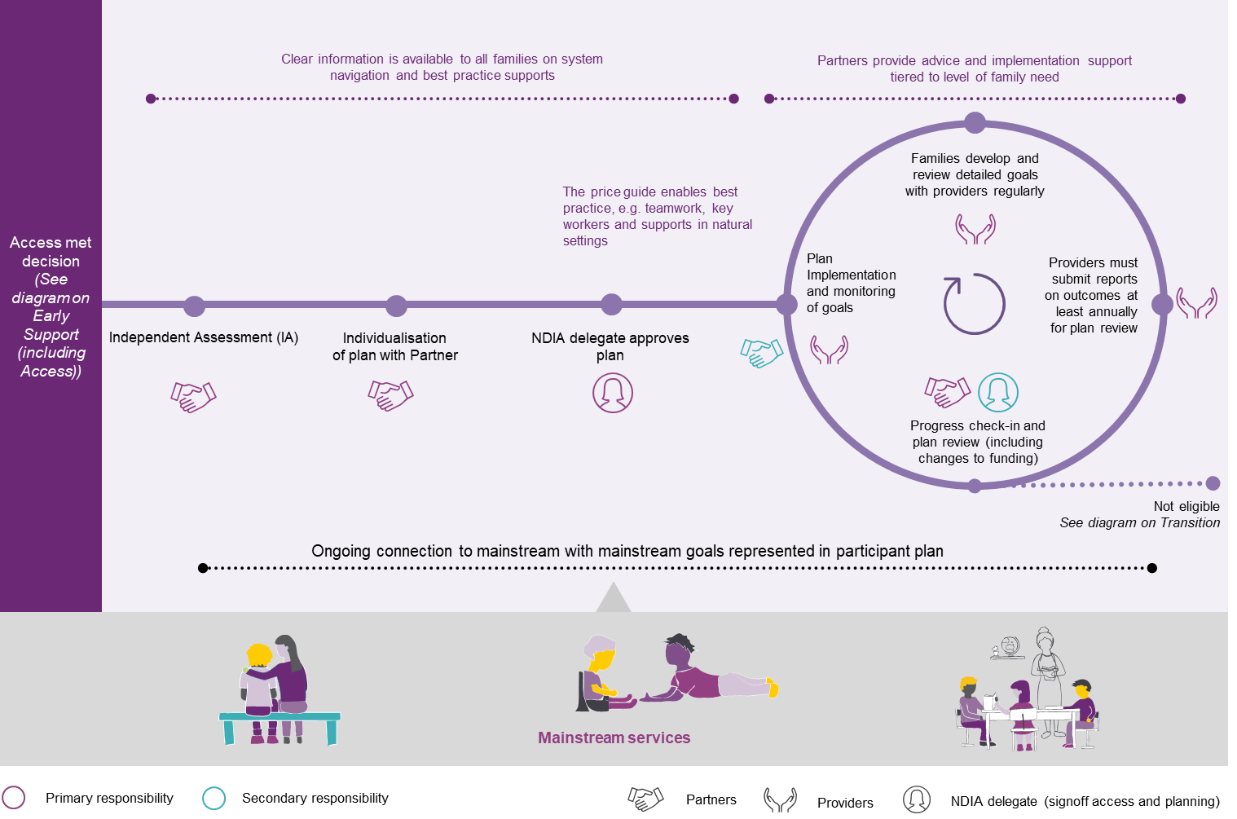

5.4 Recommendations for transition
Intention: To help every child supported by the NDIS to be well supported to transition to the next stage of life whether it be without any further or immediate need for support. The NDIS should assist families to celebrate outcomes and successfully transition out of the Scheme. The desired future state is for the right young children to transition out at the right time, enabled by family and provider progress reporting, outcome measurement, celebrating progress, and providing warm “transition out” services.
Recommendation 21: Improve the existing annual progress review process for young children, to support families to celebrate the achievement of reaching their goals and outcomes, and transition out of NDIS supports to the next stage of their lives.
Rationale: Improving the early messaging about the likelihood of supports from the NDIS ending for many children will help families feel more prepared for and confident about the process of transitioning out. Transitions will occur at the right time for the right child and their family by providing a consistent and equitable process that celebrates moving onto the next stage of life.
  - Currently families do not have advance notice of a decision to transition out and this impacts on their ability to prepare for this event. The ‘cease to be a participant’ process does not invite the family to be part of a celebration of their achievements and outcomes.
  - The EC Partner will support the family to opt out of NDIS supports through a voluntary ‘cease to be a participant’ process. An improved form will be used to agree to the transition out including a notification that the family can approach the EC Partner for support if the child’s circumstances change.
  - The improved process will ensure families are better supported to identify when their child has achieved the desired outcomes and no longer needs NDIS supports. This will be achieved through improved communication in a more family-centred way.
  - If the family does not agree with the recommendation to ‘cease’, a referral for eligibility reassessment will be progressed by the EC partner to the National Access Branch with advance notice for the family of a decision, if at all possible
  - For children with profound or severe disability, Independent Assessments will complement existing information already available and will only be repeated where necessary.
  - An increase in ECEI participant exits alongside improved outcomes and a continued high level of family satisfaction will be expected as a result
Recommendation 22: Ensure providers are using the recently introduced ‘provider outcomes report’, as a mandatory measure to evaluate the effectiveness of their supports and services.
Rationale: Increasing transparency through the provider outcomes report (which requires reporting on best practice outcomes, including efforts to build family capacity) will help focus plan review conversations on best practices outcomes and evaluate the effectiveness of their supports and services.
  - To successfully ensure all providers comply with the new requirement of outcomes report, the Agency will need to educate families to ask for the provider report as evidence of the outcomes that have been achieved with the support of their provider
  - This recommendation will not replace a parent’s report of a child’s function given that parents have expert knowledge of their own child’s functioning, but it will hold providers accountable for the outcomes and quality of their services in line with the child’s plan and their goals.
  - Currently, the provider outcomes report is optional which limits its value because not all providers are following the guidance. Many reviews are completed without access to any provider reports. This is challenging for EC partners and usually delays the review process as they spend time trying to understand what supports have been provided and what outcomes have been achieved.
  - The agency will have better, more consistent data to build an evidence base on the impact of early intervention. More widespread and consistent use of the newly created EC Provider outcomes report form will enable EC Partners to have the right, family-centred conversations about outcomes, future support needs or any recommendation regarding transition out at plan review.
Recommendation 23: Offer families of young children a ‘transition out” plan for up to three months’ duration, to support them to transition to the next stage of their lives, if they are no longer eligible for the NDIS.
Rationale: Offering families an optional “transition out” plan will help promote confidence in the transition out process and help children and families get the assistance and supports they need to successfully “exit”. The transition out plan would include light-touch capacity building supports to allow for connections to be established with appropriate mainstream services. Young children with profound or severe disabilities will be supported to the next stage of their life including moving to permanent access under section 24 of the Act as well as a supported transition to mainstream education.
  - A review of the current exit process demonstrated that rather than celebrating a child’s progress, the current language in the Act is around “revocation” which has negative connotations.
  - The transition out plan will release a standardised package of funding (up to 6 hours of supports over 3 months). However, the EC Partners will have discretion to recommend a shorter timeframe or no transition out plan where the family has a strong existing support network.
  - Providers will be responsible for transition out support, funded by the transition out plan for up to 3 months to prepare the family by providing strong connections to community and mainstream supports.
  - Strong collaboration with the National Access Branch will be required to operationalise this recommendation
  - Children with profound or severe disabilities will be supported to the next stage of their life including moving to section 24 as well as a supported transition to appropriate education.
Cumulatively, these recommendations will help create an improved transition out experience as outlined in Exhibit 26.
Exhibit 26: Focus on Transition pathway
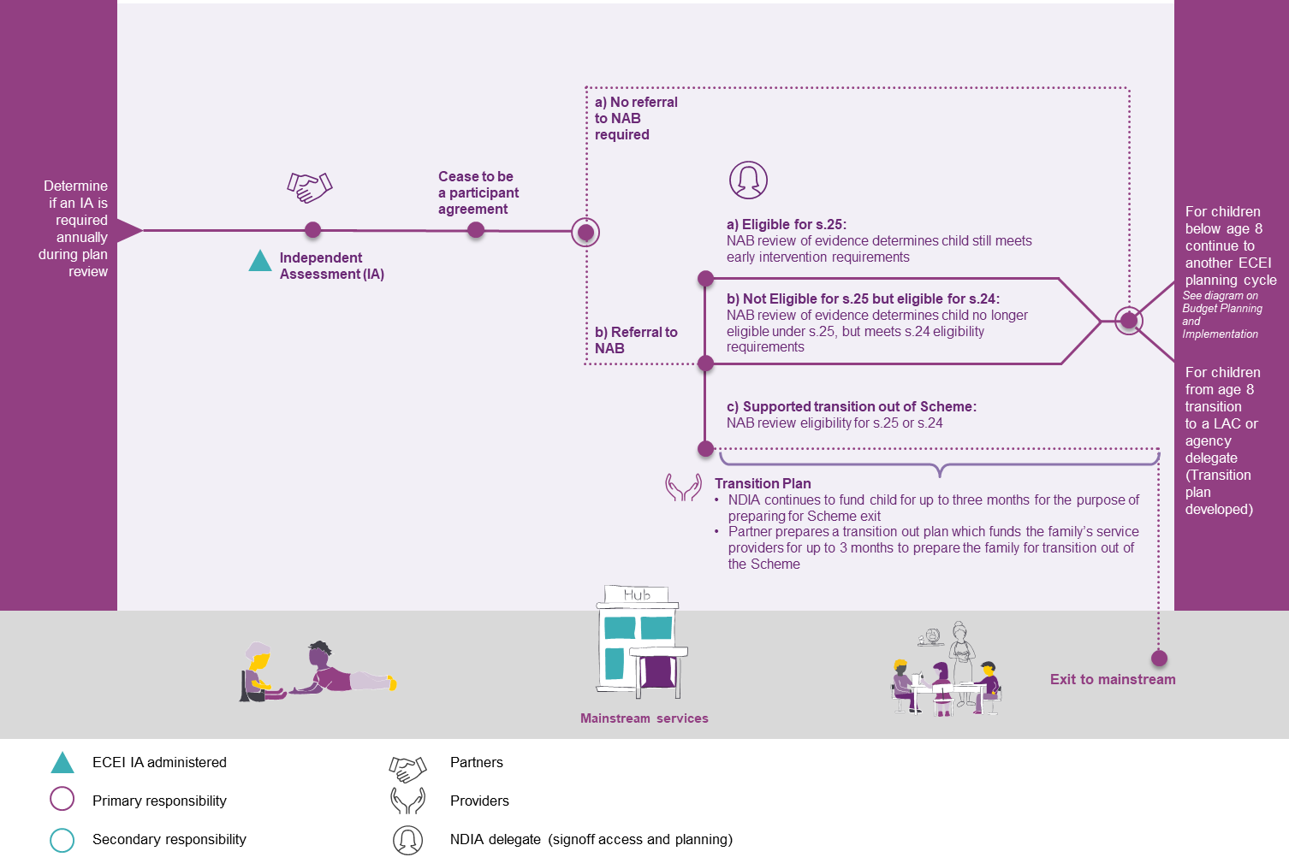

6. Impact assessment for young children and families
The ECEI Reset project has undertaken a preliminary impact assessment on the proposed recommendations to understand the way children with developmental delay or disability and their families are likely to experience the changes. Table 4 below summaries the key changes that the recommendations will drive and their expected benefits, including:
- An improved experience for all children and families
- Better short and long term outcomes for all children and families
- System-wide benefits for the national early childhood sector
- Validating the impact on young children and families will be a key focus of the consultation.
Table 4: Summary of key changes being recommended
Summary of  recommended change | Current state | Desired future state
1: Explain, rename and promote the new NDIS Early Childhood approach | “Intervention” has negative connotations for some in sector and “gateway” undermines value of early childhood supports | “Early Childhood approach”) to support clear communications
2: Clearly and consistently, communicate the intent of the Early Childhood approach and the Agency’s support for best practice | More limited communications and published materials contributes to inconsistent understanding of best practice | Active communications and growing repository of published materials promotes consistent understanding of best practice
3: Develop and publish new Early Childhood-specific Operating Guidelines | Integration of guidance on early childhood into general Scheme materials increases risk of applying adult-centric approaches to young children and makes Early Childhood Early Intervention approach content harder to find | Suite of distinct Early Childhood approach-specific OGs to provide clarity on best practice approaches to young children and make Early Childhood approach content easier to find
4: Create a distinct delegate/planner workforce that is exclusively focused on young children and their families | NDIA workforce serves participants across all ages, increasing risk of applying adult-centric approaches to young children | Distinct NDIA workforce specialised in supporting young children and their families in line with best practice
5: Continue to work with federal, state and territory governments to identify gaps and strengthen the role of mainstream services | Collaboration only occurring with EC partners at a local level in the communities | A more collaborative and enhanced relationship with health and education services across the early childhood sector
6: Consider a range of mechanisms that will enhance compliance of providers with best practice | Concerns that some providers may not be following best practice standards and that there is limited information to help families choose between providers | Greater compliance with and transparency over which providers are following best practice standards to help families make informed choices about which provider to use
7: Improve sector wide understanding of how to identify families and young children experiencing disadvantage or vulnerability and tailor culturally appropriate services and resources | Culturally safe information and advice is not always available to all families from diverse communities | Improved understanding and tailored culturally safe information and advice available to all families regardless of community
8: Implement tailored methods of delivering supports for young children and their families living in remote and very remote areas | Insufficient level of supports and access to services in some remote and very remote areas | Satisfactory levels of supports and access to services in all remote and very remote areas
9: Implement a tailored Independent Assessments (IAs) approach for young children to support consistent access and planning decisions | No consistent assessment approach; lack of robust tools contributes to inconsistent, unfair and inequitable decision making | IAs administered for young children to support more consistent, fair and equitable decision making
10: Increase Early Childhood partner capacity to identify and help young children and families from hard-to-reach communities or those experiencing disadvantage or vulnerability | Benefits not being realised consistently across vulnerable families | Maximised benefits of early intervention for children in vulnerable families
11: Increase Early Childhood partner capacity to connect families and young children to local support networks and services in their community. | Families not consistently receiving peer support | Families empowered by consistently receiving access to peer support networks
12: Increase Early Childhood partner capacity to provide Short Term Early Intervention (STEI) support to eligible young children and families for longer | Modest service level limits viability and effectiveness of STEI offer | Higher service level enhances viability and effectiveness of STEI offer
13: Clarify the interpretation of the developmental delay criteria under Section 25 of the NDIS Act (2013) | Inadequate definition of ‘substantial delay in functional capacity’ and ‘extended duration’ drives inconsistent decision making | Clear definition of ‘substantial delay in functional capacity’ and ‘extended duration’ to support consistent decision making
14: Increase the age limit for children supported under the new Early Childhood approach from ‘under 7’ to ‘under 9’ years of age | Under 7 years of age, ending before school transition is complete | Under 9 years of age to provide continuity of support throughout transition to school
15: Use the early intervention criteria, under Section 25 of the NDIS Act (2013) to make decisions around access to the NDIS for all young children | Children enter through both s.24 and s.25, creating confusion over purpose of EC Approach | Children enter exclusively through s.25, with clearer focus on prevention and early support
16: Increase Early Childhood Partner capacity and flexibility to tailor the level of support provided to families | Limited implementation support for plans | Increased support to help family’s better implement plans.
17: Introduce a ‘capacity building support in natural settings’ item in the NDIS Price Guide | Potential incentive to maximise number of therapy session over best practice sessions in natural settings | Separate line item in price guide to encourage best practice therapy support in natural settings
18: Publish new guidance about what is considered ‘reasonable and necessary’ when making decisions around support for children on the autism spectrum | Unclear R&N guidelines and weak evidence base driving inconsistent plan budget decisions | Published R&N guidelines for children with ASD, backed by evidence, to support consistent plan budget decisions
19: Empower Early Childhood partners to provide families with clear advice about the best providers for their child and situation | EC Partners implicitly discouraged from providing advice to families | EC Partners empowered to provide advice to families based on clear evidence
20: Undertake further ongoing research and study on the outcomes of young children after receiving early intervention support | Minimal evidence contributes to inconsistent decision making and service delivery | Stronger evidence base to guide decisions and service delivery
21: Improve the existing annual progress review process for young children | Required supports for a child take longer to match their needs | Supports needs are quickly matched to the evolving needs of a child
22: Ensure providers are using the recently introduced ‘provider outcomes report’, as a mandatory measure | Not all families receive information from providers on how supports have helped their child | All families receive information from providers on how supports have helped their child
23: Offer families of young children a ‘transition out’ plan for up to three months’ duration | Some families experience unexpected and abrupt termination of funded supports | Optional 3 month transition out plan to promote a warm handover for children transitioning to the next stage of life

6.1 An improved experience for all children and families
The proposed package of recommendations is expected to create an improved experience for all children with developmental delay and disability and their families through:
- A more family-centred and teamwork-based approach until the age of 9 to assist children and their families to transition to the next stage in life
  - EC partners will provide support across key transition points in early childhood and focus on early intervention support through the social model of disability until the child’s lifelong support needs are more fully understood. For children with a clear need for an individualised plan, they and their family will receive timely Access and stronger support for plan implementation.
- Earlier support and better outreach
  - EC partners will have increased focus on early identification of gaps and initiate capacity building of mainstream services, through stronger collaboration and better integration in their communities
  - EC Partners will deliver enhanced information to support for families to connect with appropriate mainstream settings if that is appropriate for their needs. Families will be supported to advocate for their child’s inclusion in mainstream services and work with government funded inclusion services to enable the individual needs of each child to be met.
- More tailored and graduated pathways of support
  - EC Partners will expand and tailor supports to meet the individual needs of young children and families through a strengthening of Short Term Early Intervention (STEI), including family support for children with mild delays.
- Greater clarity and transparency
  - Families will experience more transparent decision making on support through clearer definitions and eligibility requirements with a commitment to enable children and families access the right supports at the right time.
  - Families and the early childhood sector will have clearer requirements and guidance for seeking and demonstrating the need for intensive support (e.g. where this is evidenced for children with Autism Spectrum Disorder or Cerebral Palsy). This will promote a nationally consistent approach and deliver greater equity.
  - Families and the early childhood sector will see greater clarity on the EC Partner provision of ECEI Initial Supports and STEI evidencing the focus on outcomes for children and families within the ECEI Approach.
- More equity and consistency on access decisions for all children who require an individualised NDIS plan which will be made under s.25, promoting the NDIA’s focus on early investment and evidence informed outcomes for children and families
  - There will be no automatic entry via lists or defined programs and more accurate and consistent evidence informed access decisions will be in line with the child’s functional and early intervention needs.
- Culturally safer and more equitable for all young children, particularly from vulnerable groups.
  - Approaches to working with vulnerable communities will be more culturally safe to provide children and their families with appropriate support to access the services and supports they need.
- A seamless and better supported transition out of the Scheme, or transitions to the general scheme at 9 years of age for children who meet s.24 or additional support under s.25 to enable continuity of support services. This will enable the family experience to be well communicated and positively supported.
  - ECI planning for transitions will be warm, empathetic and clear for young children and families
  - Support for transitions out of the Scheme and into the next stage of life will include improved mainstream interface in this area and an approach that prepares families to transition out of the Scheme and results in them feeling more confident and positive about the next steps for their child.

6.2 Better short and long term outcomes for all children and families
The proposed package of recommendations will improve short and long term outcomes for all children with developmental delay and disability and their families through:
- Greater promotion of best practice with EC Partners, families, providers, communities and mainstream services to enable children and families are able to participate meaningfully in their communities
  - greater promotion, understanding and agreement of best practice in early childhood intervention across the NDIA, the ECI market and the early childhood sector will turn families to develop the confidence and skills they need to support their child’s development.
  - EC partners focusing on capacity building for inclusion and participant of children with DD or disability with a stronger emphasis on leveraging reasonable adjustment investments with services to promote inclusion and participation.
  - Strengths based plans focused on capacity building for the child and family tailored to their individual support needs.
- Increased community participation for young participants
- Expanded STEI support which will promote best practice to support young children and families

6.3 System-wide benefits for the national early childhood sector
The proposed package of recommendations will deliver consistency for the EC Approach for children and families, promoting and leading collaboration to support clarity of roles and responsibilities, in an integrated NDIS. Everyone will play their role and families will know where to go to for support when they need it.
- Best practice early childhood intervention will be valued and chosen by families as the most effective and sustainable way to access supports and there will be greater confidence and assuredness in the community about what the EC Approach is for and how if benefits children and families
- The NDIA will continue to collaborate with Mainstream and community services and roles and responsibilities will be clear with a positive approach to collaboration and co-operation
- There will be strong leadership and clarity on best practice in early childhood intervention driven by a strong evidence base provided by NDIS outcome data and research.

6.4 Validating the impact on young children and families will be a key focus of the consultation
The proposed package of recommendations will need sector consultation to validate the expected future impacts. This will help minimise any negative impacts, maximise the expected benefits and operationalise the recommendations. This includes consulting on whether there should be stronger guidance and assistance in helping families new to the NDIS navigate and select effective supports.

The NDIA’s ECEI Approach is currently for young children under the age of 7 years, although the ECEI Reset is proposing to increase the age limit from under 7 to under 9 years of age. However, for the purposes of independent assessments, the age for ECEI remains under 7 years old until the ECEI Reset consultation is finalised and the recommendations approved.
Specifically, establish clear definitions and thresholds for the criteria ‘substantial delay in functional capacity’ and ‘extended duration’.
Tune, D, ‘Review of the National Disability Insurance Scheme Act 2013: Removing Red Tape and Implementing the NDIS Participant Service Guarantee’, Department of Social Services, 2019
Australian Government response to the 2019 Review of the National Disability Insurance Scheme Act 2013 report, August 2020
Independent Advisory Council to the NDIS, ‘Promoting best practice in Early Childhood Intervention in the NDIS’, 2020
NDIS website (https://data.ndis.gov.au/explore-data/simple-market-concentration-tool)
December 2020, ECEI Participant Review_V3_20200309, Office of the Scheme Actuary
Ibid
For more detailed analysis, refer to the Agency report on Young people in the NDIS, June 2020.
NDIS exit analysis Dec19_v3.0, April 2020, Office of the Scheme Actuary
NDIS, Exits model_20200831, Office of the Scheme Actuary
NDIS Quarterly Report to disability ministers – 30 June 2020
Individual funded plans cost allows for accruals and so figures may differ.
These options include partly self-managed, fully self-managed and plan managed.
The term ‘gateway’ is used to refer to Initial Supports and Short Term Early Intervention only, not the whole ECEI Approach.
Fox, S et al, ‘Better Systems, Better Chances: A review of research and practice for prevention and early intervention’, ARACY, 2015, p.9
PwC, ‘The First Thousand Days: A Case for Investment’, 2019, p.8,
Moore, 2012. NB: This observation was made in 2012 on the basis of pre-NDIS programs like Helping Children with Autism that ‘pioneered’ the individualised funding approach, and has been confirmed as relevant to the NDIS by recent reviews (Council).
Ibid
Mahmic, S, Pauline McGregor Address, National Early Childhood Intervention Australia Conference, Melbourne. 2016, available at the Plumtree Community website
In August 2020, the Minister for the NDIS announced the progressive rollout of Independent Assessments (IAs) paid for by the Agency to inform access and planning decision for young children later in 2021. This is consistent with the original Productivity Commission design of the Scheme as well as recommendations from the recent Tune Review and is intended to improve the consistency, fairness and equity of Agency decision-making.
Best practice is that families, working with their EC Partner and Providers, should know well in advance which plan is likely to be their child’s final plan and hence they should not be surprised.

