Aboriginal and Torres Strait Islander Engagement Strategy

Progress Update
July 2021
ndis.gov.au


Contents
Acknowledgement 1
Terminology 1
1. Introduction 2
2. Aboriginal and Torres Strait Islander participant experience and outcomes 3
3. What we’ve done so far 6
4. Priority actions 11

Acknowledgement
The National Disability Insurance Agency (NDIA) acknowledges the traditional custodians of country throughout Australia, and their continuing connection to land, sea and community. We pay our respects to them and their cultures, and to Elders past, present, and emerging.

Terminology
The NDIA respectfully uses the terms ‘Aboriginal and Torres Strait Islander people’ and ‘Indigenous’ in our progress update to refer to Aboriginal and Torres Strait Islander peoples of Australia. We acknowledge that other cultural names may be preferred.

Introduction
The Aboriginal and Torres Strait Islander Engagement Strategy (Strategy) details the National Disability Insurance Agency’s (the Agency or NDIA) approach to working with Aboriginal and Torres Strait Islander communities. The NDIA aims to deliver a collaborative planning and working model to inform practice that meets the needs of Aboriginal and Torres Strait Islander people with disability, their families, carers and communities. The Strategy acknowledges the importance of a community-by-community approach to meeting the diverse needs of Aboriginal and Torres Strait Islander people. The approach involves local solutions and a commitment to maximising opportunities for employment in the implementation of the National Disability Insurance Scheme (NDIS).
The Strategy was released in March 2017. It was developed with extensive engagement with members of the Rural, Remote and Aboriginal and Torres Strait Islander Reference and Working Groups, and with input from Aboriginal and Torres Strait Islander stakeholders.
This progress update details the Agency’s key activities over the past four years against the 10 priority areas identified in the Strategy. The update also identifies additional actions to further drive the implementation of the Strategy over the next 18 months, while the NDIA completes a full refresh of the Strategy.
The NDIA will commence engagement in late 2021 with Aboriginal and Torres Strait Islander stakeholders, including participants, families, carers and the sector to develop the refreshed Strategy, which will be completed in 2022.

Aboriginal and Torres Strait Islander participant experience and outcomes
At 31 March 2021, 30,763 Aboriginal and Torres Strait Islander people with disability were receiving NDIS support. This is an increase of 259 per cent over the past three years.
Number and proportion of Aboriginal and Torres Strait Islander participants over time cumulatively
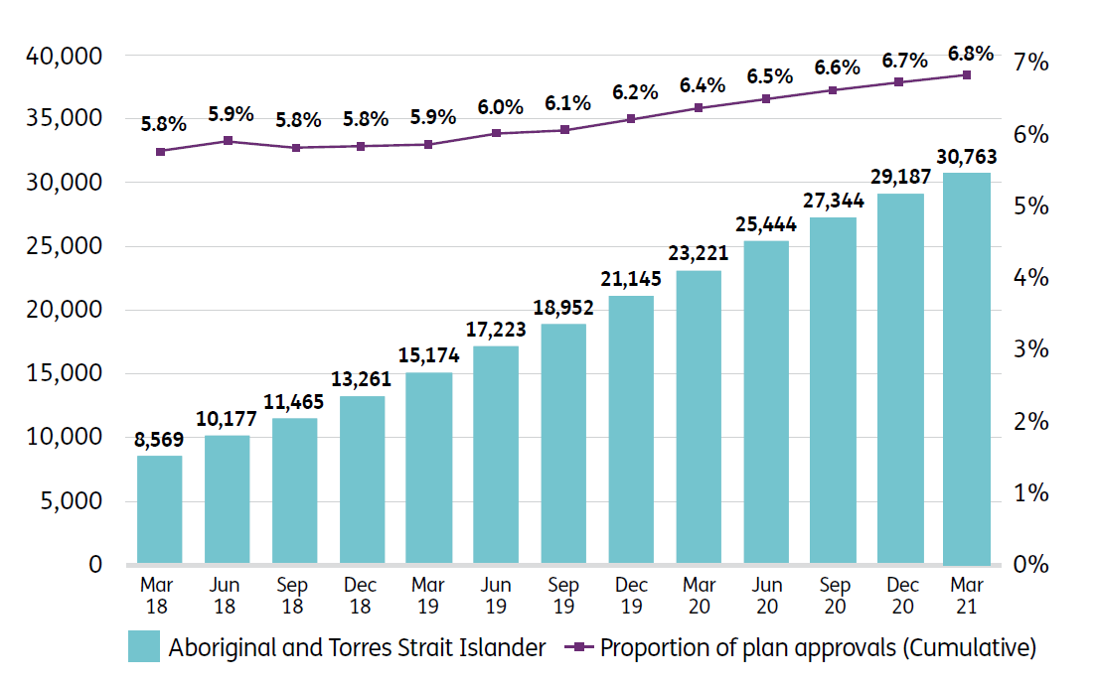
The number of participants engaging in community and social activities is a key measure for ensuring quality experiences and outcomes for participants. Aboriginal and Torres Strait Islander participant outcomes continue to increase.
For Aboriginal and Torres Strait Islander participants aged 25 and over, who entered the Scheme between 1 July 2016 and 30 June 2017, community and social participation increased from 39 per cent to 48 per cent after three years in the Scheme. This significant increase was not evident among Aboriginal and Torres Strait Islander participants aged 15 to 24 during the same period.

Proportion of participants participating in community and social activities
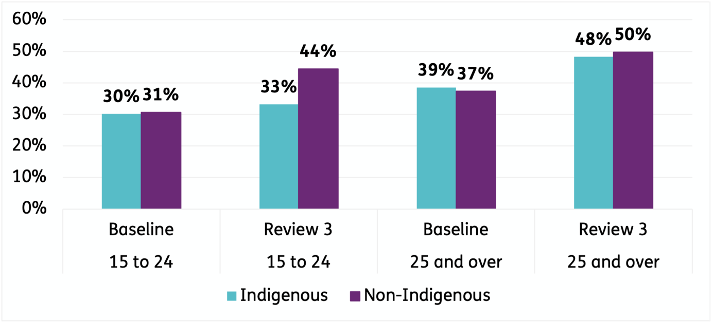
Further, the percentage of Aboriginal and Torres Strait Islander participants aged 15 to 24 in employment increased from 9 per cent to 18 per cent after three years in the Scheme. The same increase in employment was not evident for Aboriginal and Torres Strait Islander participants aged 25 and over during the same period. This is also true for non-Indigenous participants in the Scheme. The NDIA understands the benefits that employment brings to participants, and is committed to supporting more NDIS participants set and achieve their employment goals.
Proportion of participants in paid employment
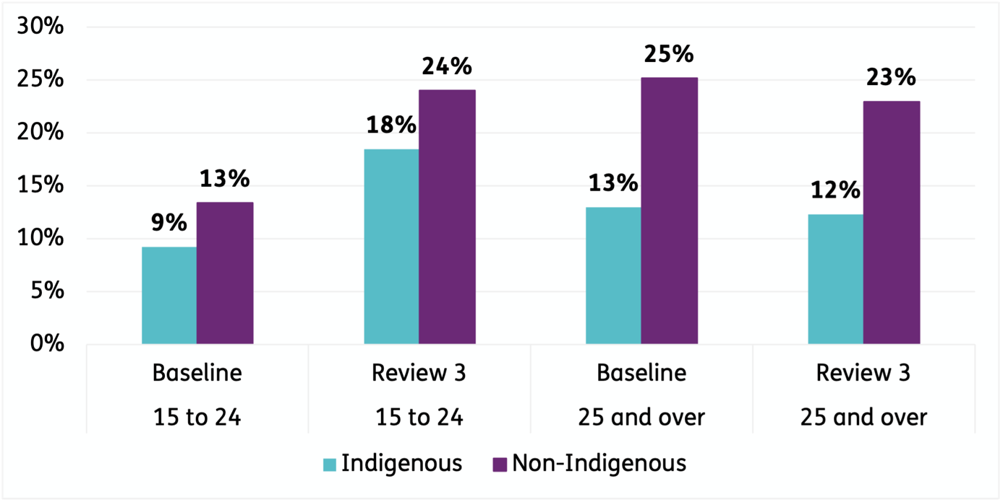

Generally, Aboriginal and Torres Strait Islander participants have similar satisfaction rates as the general NDIS population. In the December 2020 quarter, 84 per cent of Aboriginal and Torres Strait Islander participants rated the planning process as either good or very good. A further 6 per cent rated the experience as neutral.
Rating of experience with the NDIS for Aboriginal and Torres Strait Islander participants (1 October 2020 to 31 December 2020)
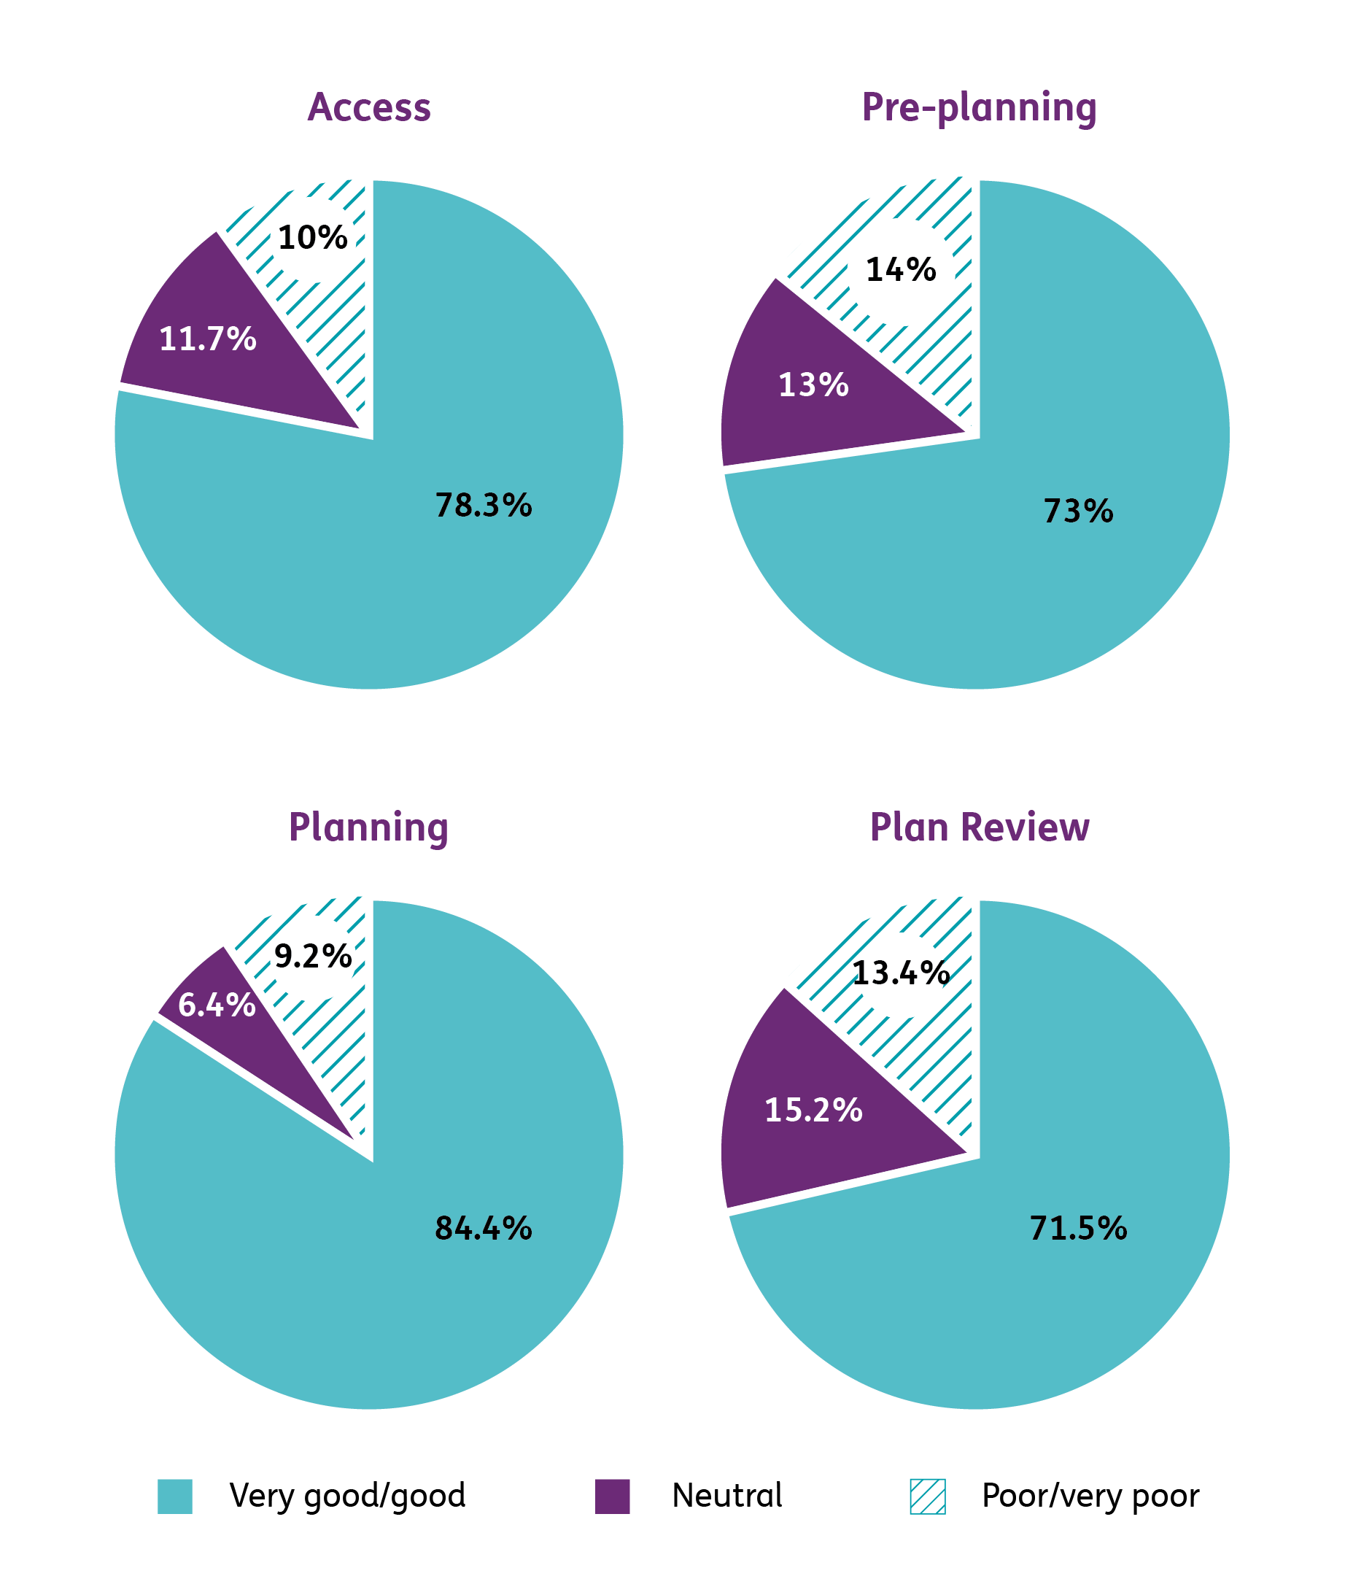

What we’ve done so far
The Agency has delivered a significant number of activities against the 10 priority areas identified in the Strategy. The NDIA will build on these activities to further enhance the NDIS experience and outcomes for Aboriginal and Torres Strait Islander participants.

Priority 1: Communication and sharing of information

Action 1.1: Targeted NDIA community engagement
Since 2013, the NDIA has engaged and worked with Aboriginal and Torres Strait Islander communities in a respectful, inclusive and culturally appropriate way.
This has included establishing and strengthening relationships with key stakeholders in Aboriginal and Torres Strait Islander communities, including Elders and Traditional Owners, hosting community meetings and community BBQs, delivering presentations, and participating in expos and conferences.

Action 1.2: Our Way Planning resource
In 2017, the Agency worked with the First Peoples Disability Network Australia to develop the Our Way Planning resource to support understanding of disability and the NDIS. This resource is used by NDIA Local Area Coordinator (LAC) staff.

Action 1.3: Culturally appropriate communication materials
In 2020, the NDIA developed culturally appropriate communication materials, including NDIS iTalk videos, and culturally appropriate NDIS booklets to help Aboriginal and Torres Strait Islander people understand and apply for the NDIS.

Priority 2: Cultural competency

Action 2.1: Aboriginal and Torres Strait Islander Employment Strategy
In May 2018, the NDIA released its Aboriginal and Torres Strait Islander Employment Strategy 2018–20.
Of the 33 deliverables in the Strategy, 29 have been completed. The Strategy included the following key actions:
- The introduction of mandatory Aboriginal and Torres Strait Islander cultural awareness training for all NDIA staff and partners in 2019. As at April 2021, 85 per cent of NDIA staff and partners had completed the Celebrating Diversity: Aboriginal and Torres Strait Islander Cultural Awareness training.
- Targeted recruitment campaigns to employ more Aboriginal and Torres Strait Islander people into the NDIA workforce. As at April 2021, 125 positions have been filled through Indigenous identified positions and affirmative measures (Aboriginal and Torres Strait Islander).
- Establishment of the Aboriginal and Torres Strait Islander Buddy Program.
- Participation in the Indigenous Apprenticeships Program and the Indigenous Australian Government Development Program. Since 2015, the NDIA has recruited 30 Aboriginal and Torres Strait Islander people into the Australian Public Service (APS) through these programs.

Action 2.2: Aboriginal and Torres Strait Agency and Partner in the Community staff
As at June 2021, 2.5 per cent of NDIA APS staff identified as Aboriginal or Torres Strait Islander.
As at March 2020, 4 per cent of Partner in the Community staff identified as Aboriginal or Torres Strait Islander.

Action 2.3: Reconciliation Action Plan
In 2019, the NDIA released its second Reconciliation Action Plan (Innovate 2019-21). The Plan reaffirms the Agency’s ongoing commitment to develop respectful and inclusive relationships with Aboriginal and Torres Strait Islander people and their communities.

Priority 3: Sharing best practice

Action 3.1: Participant Reference Group
In 2018, the NDIA established the Participant Reference Group (PRG) to provide feedback and input for continuous improvement of the NDIS. As of December 2020, two members identified as Aboriginal and/or Torres Strait Islander.

Action 3.2: NDIA Independent Advisory Council (IAC)
The IAC was established in 2013 through the National Disability Insurance Scheme Act 2013 to bring the views of participants, carers and experts to the heart of the NDIS. The IAC provides the Board with independent advice, which the Board must consider when performing its duties. The IAC has one Indigenous member.

Action 3.3: Participant First Engagement Initiative
In 2020, the NDIA introduced the Participant First Engagement Initiative. This initiative expands the different ways that participants can be involved in the design, development and implementation of NDIA policies, procedures and products.
As at May 2021, more than 2,200 members have registered, including 27 who identify as Aboriginal and Torres Strait Islander.

Action 3.4: Participant pathway reforms
In 2017, the NDIA engaged more than 330 Aboriginal and Torres Strait Islander people and people who live in remote and very remote communities through nine workshops to hear how the participant pathway could be enhanced.
This led to service delivery improvements, including Aboriginal and cultural awareness training for staff and a significant boost to the Community Connector program.

Priority 4: Local solutions

Action 4.1: Remote Community Connectors
As at March 2021, the NDIA employed 173 Remote Community Connectors covering 274 rural and remote communities over 90 Local Government Areas (LGAs) in NT, SA, WA and QLD.
Community Connectors play a critical role in identifying and engaging with people with disability and assisting them to access and benefit from the NDIS.

Action 4.2: National Community Connectors
In 2019, the Australian Government committed $20 million to the National Community Connector Program. This community outreach program increased awareness of the NDIS in four identified cohorts, including in Aboriginal and Torres Strait Islander communities.

Action 4.3: Evidence, Access and Coordination of Planning (EACP)
As at March 2021, 21 Evidence, Access and Coordination of Planning (EACP) staff are working in partnership with Community Connectors and LACs in QLD, NT, WA and SA to help potential participants in remote locations navigate the evidence gathering, access request and planning process.

Action: 4.4: Remote Early Childhood Services
As at March 2021, 28 Remote Early Childhood Services staff are working in partnership with Community Connectors and NDIA staff to approach, engage and provide access to early intervention supports for children aged under 7 with developmental delay or disability.

Priority 5: Participant-centric design

5.1: Access clinics
In 2019 and 2020, the NDIA held Access clinics in Doomadgee, Palm Island, Bamaga, Weipa, Woorabinda, Mornington Island in QLD, and Fitzroy Valley in WA. The clinics provided onsite clinical assessments, access decisions and planning. Approximately 100 people were supported to meet access to the NDIS through these clinics.

Priority 6: Market enablement

Action 6.1: Thin market trials
To ensure participants can access the supports they need, the NDIA is trialing approaches that address different market gaps across Australia.
Project locations in 2020 and 2021 include: WA (Wyndham, East Kimberly & Halls Creek, Kimberly), SA (Anangu Pitjantjatjara Yankunytjatjara (APY) Lands), NSW (Walgett, Bourke), QLD (Cloncurry, Woorabinda, Doomadgee, Palm Island, Mornington Island) NT (West Arnhem, West Daly, Tiwi Islands, Katherine, Alice Springs, Barkly, MacDonnell, Central Desert).
The market intervention approaches currently underway include:
- Market facilitation to improve connections between providers and participants through targeted engagement and market information.
- Coordinated funding packages where multiple participants and their support coordinators work together to purchase services that meet the needs of their group.
- Direct commissioning involving a formal contract between the NDIA and a provider or panel of providers, for longer term service delivery to a group of participants.

Action 6.2: National Aboriginal Community Controlled Health Organisation
In 2020, the Australian Government provided $5.9 million over two years to the National Aboriginal Community Controlled Health Organisation to strengthen NDIS services in Aboriginal and Torres Strait Islander communities.

Priority 7: Leveraging and linking

Action 7.1: Information, Linkages and Capacity Building (ILC)
From 2016 to 2020, the NDIA delivered more than $41 million in ILC grants for projects working with Aboriginal and Torres Strait Islander people. The ILC program transitioned from the NDIA to the Department of Social Services in 2020–21.

Priority 8: Cultural leadership

Action 8.1: NDIA Indigenous Champion
In 2016, the NDIA established an NDIA Indigenous Champion to promote and support all Aboriginal and Torres Strait Islander employees, programs and activities in the Agency. The Indigenous Champion is a member of the APS Indigenous Champions Network, which meets quarterly.

Action 8.2: Jawun secondment program
Since 2016, the NDIA has participated in the Jawun secondment program. The program gives senior NDIA staff the opportunity to undertake secondments to Jawun Indigenous partner organisations. To date, nine staff have participated in this program.

Priority 9: Supporting internal infrastructure

Action 9.1: First-Nations Employee Network
In 2016, the NDIA established the First-Nations Employee Network to provide advice to the Agency about the rollout and operation of the Scheme in Aboriginal and Torres Strait Islander communities. Approximately 90 staff are part of this network.

Action 9.2: Practice Guide
In 2018, the NDIA developed an Aboriginal and Torres Strait Islander Practice Guide for planners and LACs. The Guide provides comprehensive information and principles for staff to engage with Aboriginal and Torres Strait Islander people in a culturally appropriate way.

Priority 10: Tracking progress

Action 10.1: Deep dive
In June 2019, the NDIA released a deep-dive report into Aboriginal Torres Strait Islander participants. This is in addition to comprehensive quarterly reports, and other reports that assist stakeholders to better understand participant characteristics and outcomes.

Priority actions
In addition to continuing many of the activities outlined in Section 3, the Agency will implement the following actions over the next 18 months while the Agency completes a refresh of the Strategy.

Priority 1: Communications and sharing of information

Action 1.1: Trial a place-based partnership engagement approach in remote/very remote communities.
- Develop a partnership plan framework for engagement with Aboriginal and Torres Strait Islander communities to enhance understanding of the Scheme and improve outcomes. To be completed by November 2021.
- Trial the partnership plan framework in select remote/very remote Aboriginal and Torres Strait Islander communities. To be completed by June 2022.
- Evaluate trial. To be completed by December 2022.

Action 1.2: Pilot the ‘Mobile Max Hub’ in NT communities
- Pilot the establishment of digital hubs in two remote NT communities to deliver information about the NDIS in Indigenous language. To be completed by June 2022.
- Evaluate the success of digital hubs in increasing NDIS awareness and access to the Scheme. To be completed by September 2022.

Action 1.3: Deliver in language information
- Review ‘Our Guidelines’ to ensure they consider cultural sensitivities. To be completed by December 2021.
- Review Agency standards for resources in Indigenous languages. To be completed by December 2021.
- Develop a suite of resources to support participants with the NDIS journey, through a user-led design approach with participants. This includes testing the resources with Aboriginal and Torres Strait Islander communities to ensure appropriately tailored products. To be completed by June 2022.

Priority 2: Cultural competency

Action 2.1: Enhance staff knowledge of culturally sensitive approaches to working with Aboriginal and Torres Strait Islander people
- Centralise resources on the NDIA Intranet to support staff and Partners interact respectfully with Aboriginal and Torres Strait Islander people. To be completed by August 2021.

Action 2.2: Develop a new internal Aboriginal and Torres Strait Islander Employment Strategy
- Develop a second internal Aboriginal and Torres Strait Islander Employment Strategy 2021-2024. This will align with deliverables in the APS Aboriginal and Torres Strait Islander Workforce Strategy 2020-24. To be completed by December 2021.

Priority 4: Local solutions

Action 4.1: Trial a whole-of-community approach to delivering the NDIS in Ngukurr, Northern Territory, including the development of participant plans and supply models for disability supports that cater for local needs and environment
- Complete a detailed assessment of existing participant support needs, analysis of supply gaps and initial participant consultation. To be completed by March 2021.
- Consult government agencies working in human services in Ngukurr, and community stakeholders, to identify opportunities and risks, and to design actions to improve outcomes for NDIS participants. To be completed by May 2021.
- Consultation Phase 1 report. To be completed by June 2021.
- Implement the first set of actions in the trial. To be completed by September 2021.

Action 4.2: Gather feedback from people with disability in harder-to-reach communities to continually improve the NDIS
- Establish a panel to hear directly from people with disability, with a focus on harder-to-reach communities. To be completed by September 2021.

Action 4.3: Develop a best practice early childhood strategy for remote and very remote locations.
- Consult with Aboriginal and Torres Strait Islander communities and the early childhood sector to develop a best practice early childhood strategy for remote and very remote locations. To be completed by December 2021.

Priority 5: Participant-centric design

Action 5.1: Implement tailored early childhood services and methods to support Aboriginal and Torres Strait Islander families and children, as part of the Early Childhood Early Intervention (ECEI) reset
- Consult with Aboriginal and Torres Strait Islander communities on the ECEI reset, including:
  - Tailoring culturally appropriate services and resources.
  - Implementing supports for young children and their families living in remote and very remote areas.
  - Increasing Early Childhood partner capacity to identify and help young children and families from hard-to-reach communities.
  - These consultations are to be completed by December 2021.
- Develop, trial and implement approach. This is to be completed by June 2022.

Priority 6: Market enablement

Action 6.1: Implement thin market trials and ensure the market monitoring and intervention operational model reflect consideration of Aboriginal and Torres Strait Islander communities
- Continue to work closely with local communities to build sustainable service markets. This includes developing thin market projects in consultation with stakeholders, relevant to the local context to ensure projects are culturally appropriate, fit-for-purpose and meet local needs. This action is ongoing.

Priority 9: Supporting internal infrastructure

Action 9.1: Update project management processes to ensure engagement and consultation with Aboriginal and Torres Strait Islander people with disability (as appropriate)
- Engagement and consultation with people with disability from Aboriginal and Torres Strait Islander communities will be included in key Agency projects (as appropriate). To be completed by October 2021.

