National Disability Insurance Scheme

2021-22
Annual Pricing Review

Consultation Paper
October 2021
Copyright
© 2021
Copyright of the information contained in this document is owned and protected by the National Disability Insurance Scheme Launch Transition Agency (National Disability Insurance Agency).

Use of National Disability Insurance Agency copyright material
The material in this report, with the exception of logos, trademarks, third party material and other content as specified, is licensed under Creative Commons CC NC licence, version 4.0. With the exception of logos, trademarks, third party material and other content as specified, you may reproduce the material in this document, provided you acknowledge the National Disability Insurance Agency as the owner of all intellectual property rights in the reproduced material by using ‘© National Disability Insurance Scheme Launch Transition Agency 2021’ and do not use the material for commercial purposes.
Reproduction of any Creative Commons material in this document is subject to the CC NC licence conditions available on the Creative Commons site, as is the full legal code for this material.

Terms that we use
NDIA | National Disability Insurance Agency
NDIS, Scheme | National Disability Insurance Scheme
NDIS Commission | National Disability Insurance Scheme Quality and Safeguards Commission

Call for submissions
This Consultation paper is intended to assist you to prepare a submission to the Annual Pricing Review. You do not need to comment on every issue raised in this paper and you are free to raise any other issues or ideas that are relevant to the terms of reference.
Any information that you consider to be of a confidential nature should be clearly marked or identified as confidential. The NDIA will not disclose such confidential information to third parties, without first providing you with notice of its intention to do so, such as where it is compelled to do so by law.
Submissions on this Consultation Paper can be lodged via email to apr@ndis.gov.au.
Submissions must be lodged by midnight AWST Sunday 28 November 2021.

Table of Contents
1 Introduction 5
1.1 Scope of the Review 7
1.2 How you can contribute to this review 8
Consultation Paper 8
Working Groups with Participants and Providers 9
Consultations with other parties 10
Further information 11
2 Pricing in the NDIS 12
2.1 How does the Scheme operate? 13
2.2 Why does the NDIA regulate prices? 14
2.3 How does the NDIA regulate prices? 15
2.4 Price Regulation Framework 15
Characteristics of a well-functioning market 16
Market intervention options 17
Price regulation options 18
3 Simplifying the NDIS Pricing Arrangements 20
3.1 Issues 20
3.2 Call for submissions 21
4 Price limits for 1:1 core supports 22
4.1 Background 22
4.2 Current Arrangements 24
4.3 Issues 24
Changes in the Award Conditions 25
Regulatory Costs 25
Other issues 25
4.4 Call for submissions 26
5 Price limits for group-based core supports 27
5.1 Background 27
5.2 Current arrangements 27
5.3 Issues 28
5.4 Call for submissions 29
6 Temporary Transformation Payment 30
6.1 Background 30
6.2 Current arrangements 30
6.3 Issues 30
6.4 Call for submissions 31
7 Therapy Supports 32
7.1 Background 32
7.2 Issues 34
Nursing 36
7.3 Call for submissions 36
8 Support Coordination 37
8.1 Background 37
8.2 Current arrangements 37
Level 1: Support Connection 37
Level 2: Coordination of Supports 38
Level 3: Specialist Support Coordination 39
8.3 Issues 40
8.4 Call for Submissions 40
9 Plan Management Supports 41
9.1 Background 41
9.2 Current arrangements 41
9.3 Issues 42
9.4 Call for Submissions 43
10 Regional, Remote and Very Remote Areas 44
10.1 Current arrangements 44
10.2 Issues 46
10.3 Call for Submissions 46
11 Western Australia, South Australia and Queensland 47
11.1 Current arrangements 47
11.2 Issues 47
11.3 Call for Submissions 48

Introduction
The National Disability Insurance Scheme (NDIS, Scheme) was established to support people with disability to pursue their goals, to help them to realise their full potential, to assist them to participate in and contribute to society, and to empower them to exercise choice and control over their lives and futures. The Scheme is administered by the National Disability Insurance Agency (NDIA, Agency).
The Scheme has been in operation for eight years, with the first three years being the trial period, followed by a transition phase until 1 July 2020, when the Scheme was operational in all areas of Australia. At 30 June 2016, the Scheme included 30,000 participants. The Scheme has grown significantly since then, with the number of participants increasing by more than ten-fold to 390,000 participants at 30 June 2020. As at 30 June 2021, there were 466,619 participants in the Scheme, including 245,274 participants who were receiving supports for the first time. It estimated that there will be 670,400 participants in the Scheme in 2024-25 and 859,328 participants in the Scheme in 2029-30.
On average, each participant in 2020-21 received supports worth $54,300. This amount has increased, on average, by 11.8% per annum over the last four years (2017-18 to 2020-21).
- Average expenditure on participants in Supported Independent Living was in 2020-21 was $320,800. This amount has increased, on average, by 12.0% per annum over the last four years.
- Average expenditure on other participants in 2020-21 was $38,000. This amount has increased, on average, by 17.1% per annum over the last four years.
A total of 9,145 registered providers delivered supports to NDIA-managed participants in 2020-21. Five of these providers received more than $100 million each in NDIS payments in 2020-21, with the largest registered provider delivering supports worth $291 million.
Total payments by the Scheme in 2020-21 were $23.3 billion, with:
- 56.1% ($13.1 billion) on support for daily activities;
- 17.0% ($3.9 billion) on community participation supports; and
- 12.2% ($2.8 billion) on capacity building supports for daily activities, including therapy.
Total payments by the Scheme are currently projected by the Scheme Actuary to grow to $41.4 billion in 2024-25, and $59.3 billion in 2029-30 (on an accrual basis).
Where possible, the NDIA utilises market mechanisms to deliver the level of supply required to meet participant demand and deliver the required mix of goods and services, produced at market clearing (efficient) prices, to meet the needs of participants. However, in non-existent or underdeveloped markets, reliance on deregulated market mechanisms may not meet participant demands; may not deliver adequate supply; may not deliver the required mix of disability supports and may not produce efficient prices.
To address these issues, the NDIA has a role, as market steward, to create an efficient and sustainable marketplace through a diverse and competitive range of suppliers who are able to meet the structural changes created by a consumer-driven market. As market steward the NDIA has responsibility for:
- empowering people supported by the NDIS to exercise choice and control;
- maintaining and expanding the supply of high quality disability supports;
- driving efficiency and innovation in the market for those supports; and
- supporting the transition of the NDIS over the longer term to a more deregulated outcomes-based approach.
As part of its oversight of the Scheme and its role as market steward for the developing markets for disability goods and services, the NDIA regulates the commercial relationships between providers and participants, including through price regulation. The price control arrangements apply to all supports purchased by NDIA-managed and plan-managed participants. They do not apply to self-managed participants. Of the $23.3 billion spent on supports in 2020-21, some 87% ($20.3 billion) was agency-managed ($12.0 billion) or plan-managed ($8.3 billion) and therefore subject to the price control arrangements. Some 13% ($3.0 billion) was self-managed and not subject to the pricing arrangements.
In the short to medium term, price controls are required for some disability supports because the markets for disability goods and services are not yet fully developed. The longer-term goal of the NDIA is to reduce, as far as possible, the regulatory imposts on the markets for disability supports. The current Pricing Arrangements and Price Limits are set in accordance with the NDIS Pricing Strategy, which reflects the current situation of inefficient supply and growing demand. The key principles underlying the pricing arrangements are to:
- provide value for money for participants;
- deliver fair and consistent participant outcomes;
- support sustainable NDIS market growth; and
- promote the delivery of high quality innovative supports.
The pricing arrangements aim to maintain and increase market supply, and help markets grow to a more mature state in the future, while recognising the need for financial sustainability. The NDIA continually monitors and reviews its price control framework and other market settings to determine whether they are still appropriate. This Annual Pricing Review is an important part of that monitoring and review process.

Scope of the Review
The Terms of Reference of the 2021-22 Annual Pricing Review have been established by the NDIA Board. They require the review to examine, through engagement with participants, providers and community and government stakeholders and targeted research, whether the Scheme’s existing price control framework (pricing arrangements and price limits) continues to be appropriate or should be modified.
In particular, the Review is required to:
- Examine options to simplify, where possible, the NDIS price control framework to better support participants to exercise choice and control, and to reduce, as far as possible, the regulatory burden that the pricing arrangements impose on participants and providers.
- Review the pricing arrangements and price limits for core supports, by:
  - Examining the ongoing appropriateness of the methodology and parameters used in the NDIS Cost Model for Disability Support Worker, including through analysis of the most recent financial benchmarking data, paying particular regard to the outcomes of the Fair Work Commission’s 4 yearly review of modern awards—Social, Community, Home Care and Disability Services Award 2010 (AM2018/26);
  - Identifying any unintended consequences of the new pricing arrangements for group based community participation supports that were introduced on 1 July 2020, including the extent to which the arrangements impact on overhead costs and administrative complexity for providers and participants; and
  - Examining the extent to which the Temporary Transformation Payment arrangements have achieved their purpose and continue to provide value for money.
- Review the pricing arrangements for therapy and nursing supports, including whether the NDIS pricing arrangements are appropriately aligned with those in comparable Australian Government and state schemes, and with the private market for therapy supports, by
  - Examining the nature of the markets for therapy and nursing services, including the extent to which the markets are made up of distinct segments, including in thin and undersupplied markets and in regional and remote areas;
  - Undertaking detailed benchmarking on therapy and nursing supports, including therapy assistants, against both relevant comparable Australian Government and state government schemes and the private mainstream markets; and
  - Examining the extent of competition in the market for therapy services.
- Review the pricing arrangements for support coordination and plan management to encourage innovation, improve quality of service and ensure value for money.
- Review the pricing arrangements that apply to supports delivered in regional, remote and very remote areas to ensure continued access to appropriate supports for participants living in those areas.
- Examine, in line with Recommendation 2 of the 2019 WA Market Review, whether the current economic conditions in states where economic trends are often counter cyclical to the trends in other states and territories (and, in particular, in Western Australia, Queensland and South Australia) are such as to require temporary adjustments to price controls in those states in order to proactively manage any potential impacts on the supply of disability goods and services.
In framing its recommendations, the Review is required to be cognisant of the objects and principles set out in the National Disability Insurance Scheme Act 2013, including that the NDIS should:
- Support the independence and social and economic participation of people with disability;
- Enable people with disability to exercise choice and control in the pursuit of their goals and the planning and delivery of their supports;
- Facilitate the development of a nationally consistent approach to the access to, and the planning and funding of, supports for people with disability;
- Promote the provision of high quality and innovative supports that enable people with disability to maximise independent lifestyles and full inclusion in the community;
- Adopt an insurance based approach, informed by actuarial analysis, to the provision and funding of supports for people with disability; and
- Be financially sustainable.

How you can contribute to this review
The 2021-22 Annual Pricing Review commenced in September 2021 and will deliver updates and recommendations to the NDIA Board, for implementation from 1 July 2022. It is expected that the outcomes of the Review will be announced in March 2022, with the final price limits to be announced after the release of the Fair Work Commission’s Annual Minimum Wage Decision, which usually occurs in the second half of June.

Consultation Paper
This Consultation Paper is intended to assist you to prepare a submission to the Annual Pricing Review. You do not need to comment on every issue raised in this paper and you are free to raise any other issues or ideas that are relevant to the terms of reference.
Submissions may range from a short note outlining your views on a particular topic to a much more substantial document covering a range of issues. Where possible, you should provide evidence, such as relevant data and documentation, to support your views. If you are a provider, then a brief overview of the nature of your organisation, the number of employees and participants, and the types of services you offer, and the locations in which you operate would be helpful.
Any information that you consider to be of a confidential nature should be clearly marked or identified as confidential. The NDIA will not disclose such confidential information to third parties, without first providing you with notice of its intention to do so, such as where it is compelled to do so by law.
Submissions on this Consultation Paper can be lodged via email to apr@ndis.gov.au.
Submissions must be lodged by midnight AWST Sunday 28 November 2021.

Working Groups with Participants and Providers
It is proposed to also engage with participants, providers and other stakeholders through a number of working groups.
- The first working group, of participants and participant representatives, will work with the NDIA to develop options for a plain English guide to pricing arrangements in the scheme and for market empowerment information for participants (e.g. range of prices paid).
- The second working group, of providers and participant representatives, will work with the NDIA to identify options to:
  - Simplify the pricing arrangements;
  - Allow updates to the pricing arrangements to be pushed through more easily to the sector and to provide greater explanatory material FAQs and Examples linked to definitive arrangements) including moving to a web based document and APIs; and
  - Simplify claiming processes as part of the upgrade of the payments system – for example, removing the need for different support items codes to be created for each separate registration group even when the underlying support is identical.
- The third working group, of providers and participant representatives, will work with the NDIA to examine:
  - The design and key parameters use by the NDIS Disability Support Worker Cost Model; and
  - The implications for the cost model and price limits of the outcomes of the Fair Work Commission’s 4 yearly review of modern awards—Social, Community, Home Care and Disability Services Award 2010 (AM2018/26).
- The fourth working group, of providers and participant representatives, will work with the NDIA to examine the extent to which the Temporary Transformation Payment arrangements have achieved their purpose and continue to provide value for money.
- The fifth working group, of providers and participant representatives, will work with the NDIA to examine the extent of competition in the market for therapy supports and options to improve the effectiveness and efficiency of those supports.
- The sixth working group, of providers and participant representatives, will work with the NDIA to examine the extent of competition in the market for the delivery of nursing supports and options to improve the effectiveness and efficiency of those supports.
- The seventh working group, with plan managers, providers and participant representatives, will work with the NDIA to examine the costs of delivering plan management supports and the appropriate pricing arrangements for those supports.
- The eighth working group, with support coordinators, providers and participant representatives, will work with the NDIA to examine the costs of delivering support coordination and the appropriate pricing arrangements for those supports.
- The ninth working group, with provider and participant representatives, will work with the NDIA to examine the costs of delivering supports in regional and remote areas, and arrangements to ensure access to supports for participants living in those areas.
- The tenth working group, with provider and participant representatives, will work with the NDIA and the NDIS Quality and Safeguards Commission to examine whether the costs of registering with the NDIS Quality and Safeguards Commission and the costs associated with ensuring quality and safety of supports for people with disability are appropriately accounted for in the pricing arrangements for core and capacity building supports.
- The final working group, with provider and participant representatives, will work with the NDIA to examine the costs of delivering supports in Western Australia (Queensland and South Australia) relative to other states and territories.
Each working group will consist of up to 25 members and will be chaired by the Chief Economist of the NDIA. The NDIA will appoint provider and participant representatives to the working groups based on the relevance of the expertise and experience of the individuals and their organisations to the matters of discussion of the groups. The working groups will meet by videoconference on several occasions between November 2021 and February 2022. The Review will release further information on the working groups in October 2021.

Consultations with other parties
The NDIA will also discuss pricing arrangements and price setting methodologies for core and capacity building supports with other insurance schemes including:
- New South Wales State Insurance Regulatory Authority (SIRA)
- icare (New South Wales)
- WorkSafe Victoria
- Victorian Transport Accident Commission (TAC)
- WorkCover Queensland
- National Injury Insurance Scheme Queensland
- WorkCover Western Australia
- Catastrophic Injuries Support Scheme (Western Australia)
- Return to Work South Australia
- Lifetime Support (South Australia)
- Motor Accident Insurance Board (Tasmania)
- Lifetime Care and Support Scheme (Australian Capital Territory)
- Territory Insurance Office (Northern Territory)
- Comcare
- Department of Veterans Affairs
The NDIA will also consult with the Governments of Western Australia, South Australia and Queensland on the economic conditions in their states and their implications for the disability sector.

Further information
Further information on the 2021-22 Annual Pricing Review can be found at the NDIS website.

Pricing in the NDIS
The provision of supports for participants in the National Disability Insurance Scheme (NDIS, Scheme) is subject to regulation by the National Disability Insurance Agency (NDIA, Agency) and the NDIS Quality and Safeguards Commission (Commission) through the provisions of the National Disability Insurance Scheme Act 2013 and its subordinate legislation.
The objects of the National Disability Insurance Scheme Act 2013 include to:
- support the independence and social and economic participation of people with disability; and
- provide reasonable and necessary supports, including early intervention supports, for participants in the NDIS; and
- enable people with disability to exercise choice and control in the pursuit of their goals and the planning and delivery of their supports; and
- promote the provision of high quality and innovative supports that enable people with disability to maximise independent lifestyles and full inclusion in the community; and
- protect and prevent people with disability from experiencing harm arising from poor quality or unsafe supports or services provided under the NDIS
The Act further provides that these objects are to be achieved by:
- providing the foundation for governments to work together to develop and implement the NDIS; and
- adopting an insurance‑based approach, informed by actuarial analysis, to the provision and funding of supports for people with disability; and
- establishing a national regulatory framework for persons and entities who provide supports and services to people with disability, including certain supports and services provided outside the NDIS.
In giving effect to its objects, the Act also requires that regard is to be had to:
- the need to ensure the financial sustainability of the National Disability Insurance Scheme; and
- the broad context of disability reform provided for in the National Disability Strategy and the Carer Recognition Act 2010; and
- the provision of services by other agencies, Departments or organisations and the need for interaction between the provision of mainstream services and the provision of supports under the National Disability Insurance Scheme.
Supports are funded by the NDIS if they are reasonable and necessary. That is, according to the NDIS Act, if they:
- assist the participant to pursue the goals, objectives and aspirations included in the participant’s statement of goals and aspirations; and
- assist the participant to undertake activities, so as to facilitate the participant’s social and economic participation; and
- represent value for money in that the costs of the support are reasonable, relative to both the benefits achieved and the cost of alternative support; and
- be, or be likely to be, effective and beneficial for the participant, having regard to current good practice.
The decision to fund a support must also take into account what it is reasonable to expect families, carers, informal networks and the community to provide; and whether the support is most appropriately funded or provided through the National Disability Insurance Scheme, or is not more appropriately funded or provided through other general systems of service delivery or support services.
Exhibit 1 schematises how these objects and principles guide the NDIS pricing arrangements. Underpinning these objects is the principle that a funded support must represent value for money. There are two elements in determining value for money under the NDIS Act, whether the costs of support are reasonable relative to the benefits achieved and the cost of alternative support
Exhibit 1: NDIS objectives and elements for determining value for money
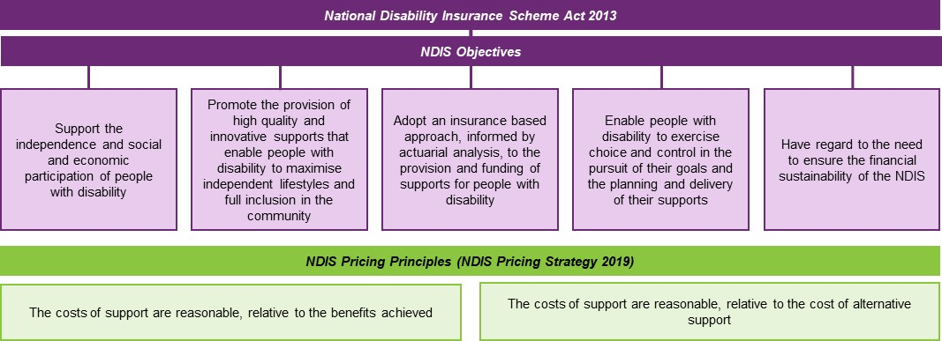

How does the Scheme operate?
The Scheme provides funding to eligible individuals (“participants”) so that they can purchase, in the open market, the disability related goods and services (“supports”) that they need. It is administered by an independent national government agency, which has responsibility for determining whether or not an individual is eligible for assistance, and the level of that assistance – the participant’s personalised budget.
One of the principal objects of the Scheme is that participants have choice and control over how, and with which providers, they spend their available budgets. If the Agency agrees that the participant has the requisite capacity, then the participant can self-manage their budget, in which case they pay providers directly for the services that they receive and are reimbursed by the Agency from their budget. Participants who are not self-managing can choose to appoint (and use some of the funds in their personalised budget to pay for) a plan manager. In this case, the plan manager pays the providers who deliver services to the participants (with the participant retaining choice of service provider) and is reimbursed by the Agency from the participant’s budget. All other participants have their budgets managed by the Agency. In this case, the participant’s providers are paid directly by the Agency from the participant’s budget, while the participant still chooses their providers and the supports that they purchase.
Where a provider is paid directly by the Agency, the provider is required to be registered with the Commission and abide by the pricing arrangements, including price limits. These restrictions do not apply to providers who are paid directly by self-managing participants. Providers who are paid by plan-managers on behalf of participants are not required to be registered but are required to abide by the pricing arrangements, including price limits.

Why does the NDIA regulate prices?
The NDIA has a role, as market steward, to create an efficient and sustainable marketplace through a diverse and competitive range of suppliers who are able to meet the structural changes created by a consumer-driven market. The NDIA has responsibility for:
- empowering people supported by the NDIS to exercise choice and control;
- maintaining and expanding the supply of high quality disability supports;
- driving efficiency and innovation in the market for those supports; and
- supporting the transition of the NDIS over the longer term to a more deregulated outcomes-based approach.
Exhibit 2 demonstrates the NDIS transition strategy for pricing – the stages through which price regulation in supports needs to move in order to achieve deregulation.
Exhibit 2: NDIS Transition strategy for pricing
Strategic Actions | Description
Expand supply and satisfy short term demand during the transition to full scheme | Set price limits at transitional price levels, as the best measure of the average cost of supply, in recognition of the timeframe providers require to adjust to the new market arrangements  Set funding levels in line with sustainable price levels, as the best measure of the efficient cost of supply
Invest in the information infrastructure needed to support the operation of the market | Address information asymmetries by collecting and publishing additional supply and demand information down to a local level, including pricing and high-level financial data  Assist providers to become more efficient by funding a confidential financial benchmarking survey  Incentivise providers to provide information to consumers and innovate by making access to transitional price levels contingent on the provider's participation in data collection
Monitor markets closely for signs of shortages and other market failures | Monitor markets for evidence of both shortages and expansion of supply. If there are shortages and no evidence of increasing supply, then price limits should be maintained at transitional levels. If expansion is meeting demand, price limits can shift from transitional to efficient price levels.  Funding levels should continue to be set in line with sustainable price levels, and indexed in line with movements in the input costs of efficient providers
Deregulate as appropriate, including removing price limits when they are no longer binding | Non-binding price limits indicate that there is sufficient market competition, indicating that the market is a potential candidate for deregulation.  Funding levels should be set at efficient price levels, and indexed in line with movements in the input costs of efficient providers

How does the NDIA regulate prices?
As part of its oversight of the Scheme and its role as market steward for the developing markets for disability goods and services, the NDIA regulates the commercial relationships between providers and participants, including through price regulation. The NDIS pricing arrangements are set out in the following documents:
- NDIS Pricing Arrangements and Price Limits – This document sets out the general pricing arrangements that apply to all supports in the NDIS and the specific arrangements that apply to individual supports.
- NDIS Support Catalogue – This document provides information on the current price limits for each support item and indicates for each price-limited support item the claim types (Travel, non-face-to-face, etc.) that can be used. Requirements specified in the Support Catalogue are part of the pricing arrangements and price limits that the NDIA has determined should apply to NDIS.
- Addenda to the NDIS Pricing Arrangements and Price Limits – These documents allow the NDIA to respond to changing market conditions in an efficient manner. They are used to make temporary changes to some of the support items and arrangements listed in the NDIS Pricing Arrangements and Price Limits. Each Addendum is not a stand-alone document and must be read in conjunction with the NDIS Pricing Arrangements and Price Limits. Requirements specified in Addenda are part of the pricing arrangements and price limits that the NDIA has determined will apply to NDIS.
- NDIS Pricing Arrangements for Specialist Disability Accommodation – This document sets out the specific pricing arrangements that apply for Specialist Disability Accommodation (SDA). Providers of SDA supports are also subject to the general arrangements set out in the NDIS Pricing Arrangements and Price Limits.
- NDIS Assistive Technology, Home Modifications and Consumables Code Guide – This document gives further information on the specific pricing arrangements that apply for these types of support. Providers of these supports are also subject to the general arrangements set out in the NDIS Pricing Arrangements and Price Limits.
These documents are updated from time to time and are published on the NDIS website.
Price controls are in place to ensure that participants receive value for money in the supports that they receive. In the short to medium term, price controls are required for some disability supports because the markets for disability goods and services are not yet fully developed. The longer-term goal of the NDIA is to remove regulatory mechanisms from the markets for disability supports. The NDIA continually monitors and reviews its price control framework and other market settings to determine whether they are still appropriate. Annual Pricing Reviews an important part of that monitoring and review process.

Price Regulation Framework
Where possible, the NDIA utilises market mechanisms to deliver the level of supply required to meet participant demand at market clearing (efficient) prices. In underdeveloped markets (due to factors such as imperfect and asymmetric information or reduced competition), regulating the market is necessary to ensure that participant demand is met, the required mix of supports is supplied by providers, and the Scheme moves towards efficient prices.
A broad suite of levers are available to the NDIA to help to find the demand and supply balance at an efficient price:
- providing information to the market so that participants and providers can make informed choices (market facilitation);
- deepening the supply of providers to improve participant access to supports (market deepening);
- regulating prices (price controls) and market access to signal to the market what is an efficient price and include a suite of options ranging from price setting through to market regulation; and
- considering alternative commissioning models where markets are underserved and carry risk (commissioning).

Characteristics of a well-functioning market
Higher levels of regulation and market intervention are typically used to address inefficiencies in the market and lower intervention is required in a well-functioning market. Therefore, it is critical to determine how well a market is functioning in order to determine what an appropriate level of regulation and market intervention is. Exhibit 3 sets out a schematic of the characteristics that need to be considered in determining how well a market is functioning.
Exhibit 3: Characteristics of a well-functioning market
Demand-side characteristics
Participants are able to exercise  informed choice | Participants are sufficiently incentivised and supported to make purchasing decisions
Participants have the ability to make purchase decisions in their best interests  In cases where participants are unable to make decisions in their best interests, capacity may be provided by a third party who has obligation to act in the participant’s best interests | Participants have appropriate incentives to make decisions that are financially sustainable for themselves and for the Scheme  Includes having the information and support (where needed) to navigate market options  Flexibility in funding within participant plans to allow ease of provider switching where that is practical
Supply-side characteristics
Sufficient availability  of supports | Sufficient competition  between providers
A wide range of support providers should be available to participants, across the spectrum of price  Providers are able to operate sustainably in a price deregulated environment | Competition between suppliers exists to provide discipline to pricing behaviour and drive quality  In some cases, competition may need to be fostered through government led processes – for example in thin markets, or where direct competition and switching is impractical or detrimental to service outcomes
General characteristics
Scheme can maintain stability  while withstanding change | Sufficient safeguards are in place to protect participant outcomes
The NDIA is confident that the Scheme will stay stable and broadly achieve objectives of improving participant outcomes while maintaining financial sustainability | Quality safeguards implemented to ensure participants receive high quality services in a price deregulated environment  Safeguards protect against certain risks associated with price deregulation; e.g. participant budgets are not exhausted leading to critical service gaps.
These characteristics can be used as indicators, whereby all or almost of these indicators being met would indicate that the market is functioning as intended and does not require greater market intervention (or requires less). Similarly, where some or most of these indicators are not met suggests the market is not functioning as intended and requires greater market intervention.
To assist with the assessment of the options, Exhibit 4 provides a summary of the key considerations for the four main stakeholder groups in the market. The emphasis is on the risk of negative impacts of any approach for these stakeholders
Exhibit 4: Key stakeholder considerations in regulating markets
Participants | Providers | Professionals / Workers | Governments / NDIA
Market access  Service quality | Market development  Service quality | Workforce development  Workforce pipeline | Insurance principles and scheme objects  - Market access  - Service quality  - Sustainability

Market intervention options
There is a spectrum of market intervention options available to the NDIA, which are outlined in Exhibit 5. Whether to use each of these options depends on the characteristics of the market and how well it is functioning. A market that is considered well-functioning requires less intervention and the options to the left of the spectrum may be most appropriate. The options to the right of the spectrum may be more appropriate for a market that still has inefficiency and characteristics that suggest it is still not well-functioning.
Exhibit 5: Spectrum of market intervention options
Market  Facilitation | Market  Deepening | Market  Regulation | Alternative Commissioning
Providing more information about demand or options available to participants, or matching supply and demand | Facilitating supply to meet needs by ‘pooling’ demand to create additional economies of scale | Controlling market operations through regulating or setting prices, or controlling market access | Directly funding a provider in return for a service, or delivering services ‘in-house’ with public sector provision
Low | Medium | High | High
Market facilitation: can take the form of information provision; demand-supply matching; and/ or supply partnerships. The rationale/pre-conditions for limiting market intervention to these types of intervention are:
- Participants are able to make well informed choices;
- Current market issues are transitory;
- Participants are willing to engage with trusted platforms;
- Providers are able to accept demand risk;
- Barriers to entry are low; and
- Competition can be sustained in the market.
Market deepening: can be done either through input market deepening – for example, attracting /training workers; or participant-led linking or bundling.
The rationale/pre-conditions for limiting market intervention to these types of intervention are:
- Participants can make well informed choices;
- Current market issues are transitory;
- Workforce deepening required to enhance trusted engagement; and
- Participant pooling required to increase market depth.
Market regulation: can take the form of either or both price regulation; or the regulation of market access. The rationale/pre-conditions for these types of intervention are:
- Monopoly power may drive undesirable pricing outcomes;
- Participants cannot manage certain market risks;
- Market is overly fragmented;
- Market access restrictions are required to ensure engagement and quality;
- Prices do not reflect efficient cost of providing supports;
- Prices need to be increased to generate sufficient market size for providers; and
- Providers willing and able to compete but resulting in perverse outcomes.
Alternative commissioning: which can run alongside other forms of market regulation, can take a number of forms: direct procurement; government provision; and strategic commissioning. The rationale/pre-conditions for these types of intervention are:
- Competition in the market either not possible or appropriate;
- Limited or no choice;
- Participants will only engage with certain trusted providers;
- The individualise model results in risk allocation issues;
- Barriers to entry are high; and
- Higher prices do not overcome a lack of market depth.

Price regulation options
There are two key regulatory options available for markets that require a higher level of regulation to enable it to function more efficiently:
- Market access regulation: The NDIS Commission has primary responsibility for market access regulation for registered providers (responsible for the registration and regulation of these NDIS providers); and
- Price regulation: The NDIA has a range of price regulation tools available to it (see figure below), which can be deployed individually or in combination.
Price regulation can take several forms:
- Price information: This information can help consumers with decision-making and can help with providing discipline on provider pricing behaviour. It is a relatively low level of regulatory intrusion. However, it has limited impact on the level of supply in the market and there are no repercussions for providers who do not act appropriately.
- Price monitoring: Regular monitoring and reporting on actual market transaction prices and market activity can provide more information for stakeholders, but increases the reporting burden on providers. This approach requires less regulatory oversight than price setting and price approval. It also helps to measure progress against expected outcomes without interfering with the market. However, there are limited repercussions for providers who do not act appropriately and high administrative costs.
- Price approval: Under this arrangements, businesses are required to submit their prices to the regulator for approval. Given the existence of thousands of NDIS providers of supports, this form of price regulation is not practical as it would involve high administrative and compliance costs. The advantage of this arrangement is that providers able to charge at a rate that aligns with their cost of service. However, it can be difficult to evaluate the reasonableness of the cost estimates of providers. This approach requires significant oversight and resources to process all applications and has high administrative costs for providers.
- Price setting: This approach directly determines the prices that businesses can charge. This is the most stringent form of price regulation. The advantages of this approach are that it can ensure providers are adequately compensated for their services and simplifies the market for participants. However, it does not allow flexibility for extraordinary circumstances, tends to reduce innovation and has high administrative costs for providers.
- Price limits: This approach involves determining the maximum price that providers can charge. It is a form of price approval – but has some of the advantages of price setting. This is the current approach adopted by the NDIA.
Exhibit 6 examines the pros and cons of the different mechanisms of price approval/setting.
Exhibit 6: Pros and Cons of pricing Approval/Setting options
Price Approval (Soft Price Limit) | Hard Price Limit | Price Setting
Pros:
Price most reflective of specifics of the participant / provider | Providers compete on price, creating downward pressure and better value for money  Price can reflect specifics of the participant / provider | Greatest certainty on price  Ease of budgeting once established
Cons:
Significant administrative burden for NDIA and providers to run the process | Some participants / contexts may be uneconomical to service  Advantages large providers with economies of scale and lower cost bases | Limited downward pressure on price / ensuring value for money  Price doesn’t reflect specifics of the participant / provider

Simplifying the NDIS Pricing Arrangements
The 2021-22 Annual Pricing Review is required by its Terms of Reference to examine options to simplify, where possible, the NDIS price control framework to better support participants to exercise choice and control, and to reduce, as far as possible, the administrative burden that the pricing arrangements impose on participants and providers.

Issues
Two of the fundamental principles underlying the Agency’s approach to price controls are:
- to minimise restrictions on participant choice and control; and
- to minimise complexity and bureaucracy for providers.
The Agency is aware that price control frameworks can impose administrative burdens on providers, and wishes to explore ways to reduce transaction costs through ease and simplicity in the design of price control arrangements. Equally, the Agency must ensure that participants are fully informed and empowered to achieve maximum flexibility to use their budgets to meet their goals as they see fit. Ideally these two principles can work together to improve outcomes for participants. Currently, the NDIS Pricing Arrangements and Price Limits is 111 pages long. Providers regularly report that it can be difficult to understand. Consultations with participants also indicate that the current material is very difficult to understand and that it should be translated into plain English. The Agency is committed to improving the quality and detail of information and guidance that it provides, but needs to ensure at the same time that the information is both sufficiently precise to cover all possible provider situations and sufficiently broad so as to encompass a variety of participant circumstances.
The Agency is also aware that the current arrangements (documents downloadable from the NDIS website) can make it hard for people to find the most recent information – or to be sure that the information that they have is up to date. The current documentation is not easy to update – or to ensure that everyone is aware of the most recent documentation. Moving to a web based system might help address this.
The Agency is interested in understanding whether the current documentation would be improved by moving to a more interactive and automated guide, which might include search functionality and update alerts. What would be the essential features of any new arrangements for participants and providers?
The current pricing arrangements also require providers to distinguish their claims for support items between five broad purposes:
- claiming for the provision of a support in person;
- claiming for the provision of a support by telehealth;
- claiming for non-face to face activity associated with the provision of a support;
- claiming for any provider travel costs associated with the provision of a support;
- claiming for supports that are cancelled without sufficient notice; and
- claiming for the writing of reports requested by the Agency.
Providers also have to claim separately for the non-labour costs of any provider travel and for the participant transport costs associated with the provision of a support.
This can mean providers need to claim more than once for a support – for example, the travel to and from a support is claimed separately to the support. Although there may be some use to the Agency in knowing what funds are being spent on, it is unlikely this information is being provided though the current arrangements.
Many support items are also differentiated by time of day and day of week, the profession of the worker delivering the support or the specifics of the piece of capital equipment,. As a result there are also currently 848 support items in the NDIS Support Catalogue. Many of these items are rarely used and many are duplicates of other support items.
The Agency is interested in examining options to streamline claiming while providing accountability and ensuring participant choice and control.

Call for submissions
The 2021-22 Annual Pricing Review is seeking submissions from stakeholders on the issues raised in this chapter and on any other options to simplify the NDIS pricing arrangements to:
- improve outcomes for participants; and/or
- reduce administrative burden for participants and providers; and/or
- support innovation
while maintaining appropriate levels of accountability.
Guide Question
- What changes could be made to the NDIS pricing arrangements to increase choice and control for participants; and/or reduce transactional costs for providers; and/or support innovation in the delivery of supports.
- How can the content and structure of pricing arrangements be simplified, while maintaining their integrity?
- How can the pricing arrangements be communicated in a simpler way?

Price limits for 1:1 core supports
The 2021-22 Annual Pricing Review is required by its Terms of Reference to review the pricing arrangements and price limits for core supports, by examining the ongoing appropriateness of the methodology and parameters used in the NDIS Cost Model for Disability Support Worker, including through analysis of the most recent financial benchmarking data, paying particular regard to the outcomes of the Fair Work Commission’s four yearly review of modern awards—Social, Community, Home Care and Disability Services Award 2010 (AM2018/26).

Background
The NDIA uses the NDIS Disability Support Worker Cost Model to determine the price limits for most supports in the Activity of Daily Life support category and the Assistance with Social and Community Participation support category. These supports are delivered by providers in the following registration groups:
- 0104 – High Intensity Daily Personal Activities (2,437 active providers in Q4 2020-21);
- 0107 – Daily Personal Activities (3,266 active providers);
- 0115 – Assistance with Daily Life Tasks in a Group or Shared Living Arrangement (2,127 active providers);
- 0125 – Participation in Community, Social and Civic Activities (3553 active providers);
- 0133 – Specialised Supported Employment (826 active providers); and
- 0136 – Group and Centre Based Activities (2,318 active providers).
The Cost Model estimates the efficient cost of delivering supports and is informed by the annual financial benchmarking studies that are undertaken for the NDIA. The Cost Model takes into account all of the costs that providers incur in delivering supports:
- The costs of employing a Disability Support Worker, including
  - Salary-related costs, including base salary, shift loadings and the costs of annual leave, personal leave and long service leave;
  - Salary-related on-costs, including superannuation and workers compensation; and
  - Utilisation costs, as not all the DSW’s work hours are billable hours.
- The costs of employing the DSW’s supervisor, including
  - Salary-related costs, including base salary, shift loadings, and the costs of annual leave, personal leave and long service leave;
  - Salary-related on-costs, including superannuation and workers compensation; and
  - Utilisation costs, as not all of the supervisor’s work hours will be spent directly supervising staff engaged in billable hours;
- Supervision ratio;
- Overheads, including the cost of non-service level staff; insurance premiums (other than workers compensation); non-labour costs associated with the quality and safeguarding requirements, rent and fittings; fleet costs; marketing costs; accounting and audit costs; IT and other costs; depreciation; and interest; and
- Pre-tax margin.
Exhibit 7 sets out the resulting price limits per hour for standard supports for 2021-22.
Exhibit 7: Price limits per hour for standard supports, 2021-22
 | National | Remote | Very Remote
Weekday | $57.10 | $79.94 | $85.65
Weekday Evening | $62.85 | $87.99 | $94.28
Weekday Night | $64.00 | $89.60 | $96.00
Saturday | $80.10 | $112.14 | $120.15
Sunday | $103.11 | $144.35 | $154.67
Public Holiday | $126.11 | $176.55 | $189.17
In brief, the cost model results in a price limit that is 84.5% higher than the base pay rate received by the disability support worker. Exhibit 8 illustrates the theoretic model of efficient providers used by the Cost Model.
Exhibit 8: Theoretic Cost Model of Efficient provider
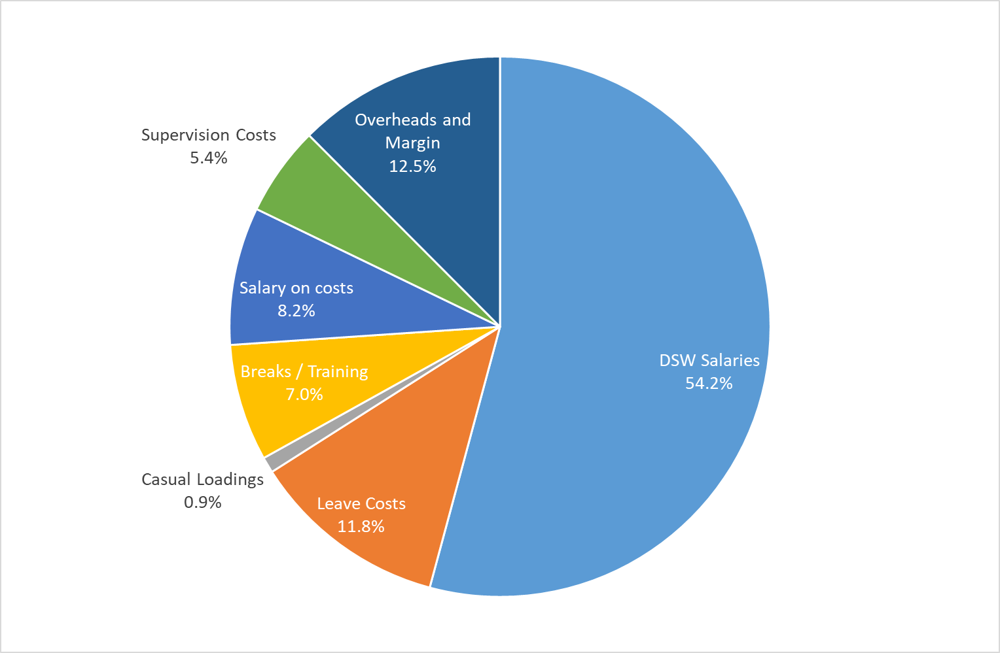
In 2020-21, NDIA-managed and plan-managed participants made 17.3 million claims for core supports whose price limits were determined by the NDIS DSW Cost Model. The total value of these supports was $13.5 billion.

Current Arrangements
The National Disability Insurance Scheme (NDIS) price limits for 1:1 supports delivered by Disability Support Workers (DSWs) and their equivalents in the Assistance with Daily Life (Daily Activities) Support Category and the Assistance with Social and Community Participation (Community Participation) Support Category vary according to several factors.
- Price limits vary according to the intensity of the support. There are different price limits for Standard Intensity supports and High Intensity supports.
  - Providers in Registration Group 0104 (High Intensity Daily Personal Activities) deliver high Intensity supports.
- For High Intensity supports, price limits also vary depending on the level of skills and experience of the worker delivering the support. There are three different High Intensity price limits – Level 1 (Standard), Level 2 (High intensity) and Level 3 (Very High Intensity).
  - The Level 1 (Standard) price limit is the same as the price limit for Standard Intensity supports.
- Price limits also vary according to whether the worker is permitted to sleep when they are not delivering the support.
  - There is a separate price limit for Night-time Sleepover supports. This support applies to any day of the week and on public holidays. Its price limit includes up to two hours of active supports provided to the participant for the duration of the period. Providers may claim for the third or additional hour at Saturday rates on weekdays, or at applicable rates on other days (Saturday, Sunday or Public Holidays).
- For supports where the worker is not permitted to sleep when they are not delivering the support, price limits also vary depending on the time of day and day of week that the support is delivered.
  - There are different price limits for Public Holiday Supports, Saturday Supports, Sunday Supports, Weekday Daytime Supports, Weekday Afternoon Supports and Weekday Active Overnight Supports.
- Price limits also vary depending on whether or not the provider claims Temporary Transformation Payment (TTP), subject to meeting the eligibility criteria.

Issues
The key parameters of the NDIS Disability Support Worker Cost Model are informed by Financial Benchmarking Surveys undertaken for the Agency. The results of these benchmarking studies can be found at on the NDIS website.
The NDIA will be commissioning a further Financial Benchmarking Survey covering the 2020-21 financial year. The results of this survey will be taken into account by the 2021-22 Annual Pricing Review.

Changes in the Award Conditions
The NDIA is aware that changes that are proposed for the Social, Community, Home Care and Disability Services Award 2010 award as a result of the Fair Work Commission’s four yearly review of modern awards—Social, Community, Home Care and Disability Services Award 2010 (AM2018/26) may increase cost for providers and would therefore have to be accounted for in the NDIS Disability Support Worker Cost Model.
The material changes to the Award that require consideration include:
- A 2 hour minimum engagement for part-time employees (previously only for casuals);
- Allowances for broken shifts; and
- Travel time between clients should be paid.

Regulatory Costs
Providers of NDIS supports incur a range of regulatory and other costs, including the cost of registering with the NDIS Quality and Safeguards Commission and costs associated with ensuring quality and safety of supports for people with disability. These include professional registration (in the case of specialised services, like therapeutic supports); working with children checks; third party verification; and police checks. These costs are necessary to ensure safe and high quality supports for NDIS participants.
The Review recognises that providers also incur costs in adjusting and continuously improving their practice in line with the NDIS Practice Standards, including ensuring compliance with the Code by the provider themselves and their workforce. Training, appropriate and adequate supervision, and record keeping are all important to quality and safety. These costs are accounted for in the NDIS Cost Model through the parameters for utilisation provision for training for support workers, supervision costs, and in the general overheads allowance. Some stakeholders have indicated that these costs have substantially increased and that the NDIS Disability Support Worker Cost Model should be adjusted to account for these costs. At the same time, the introduction of a single national system may have reduced compliance costs for some providers operating across multiple jurisdictions.

Other issues
As well as issues with the NDIS Disability Support Worker Cost Model, stakeholders have also reported difficulties in:
- Determining if a support provided to a participant should be classified as High Intensity or Standard Intensity; and for High Intensity Support, when it is appropriate to claim for the Level 1, Level 2 and Level 3 support items.
- Determining whether the Public Holiday, Saturday, Sunday, Weekday Daytime, Weekday Afternoon or Weekday Night price limit applies to a given support.
- Determining what activities can be billed as non-face-to-face supports.
- Determining when a claim for activity based transport can be made, and how the claim should be made.
- Determining when a claim for provider travel can be made, and how the claim should be made. Stakeholders have also argued the current restrictions on when provider travel can be claimed are not in line with the relevant award conditions.
Some providers of supported independent living also report that the current pricing arrangements do not fully account for all of the costs that they face, including costs associated with vacancy management.

Call for submissions
The 2021-22 Annual Pricing Review is seeking the views of stakeholders on:
- the methodology that the Agency uses to set the price limits for core supports; and
- difficulties with the claiming rules of core supports.
Guide Questions
- Are the methodology and key parameters the NDIS Disability Support Worker Cost Model appropriate? If no, why not? Please provide evidence.
- Are any adjustments to the NDIS Disability Support Worker Cost Model required as a result of the changes proposed in the Fair Work Commission’s 4 yearly review of the Social, Community, Home Care and Disability Services Award 2010 (AM2018/26)? If yes, what adjustments are required? Please provide evidence.
- Does the NDIS Disability Support Worker Cost Model properly account for the costs associated with the delivery of high quality and safe services? If no, how should the Cost Model be adjusted to better account for these costs? Please provide evidence.
- Do the claiming rules for:
- Activity Based Transport (NDIS Pricing Arrangements and Price Limits, p.23)
- Centre Capital Costs (p.29)
- Claiming for more than one worker or therapist (p.31)
- High Intensity Supports (p.35)
- Non-face-to-face supports (p.17)
- Programs of support (p.28)
- Provider Travel (p.18)
- Short Notice Cancellations (p.22)
- Telehealth Services (p.17)
- Time and Day of Week (p.15)
require modification? If Yes, why and how? Please provide evidence.
- Are there any other issues with the pricing arrangements for 1:1 core supports?

Price limits for group-based core supports
The 2021-22 Annual Pricing Review is required by its Terms of Reference to review the pricing arrangements and price limits for group based core supports, by identifying any unintended consequences of the new pricing arrangements for group based community participation supports that were introduced on 1 July 2020, including the extent to which the arrangements impact on overhead costs and administrative complexity for providers and participants.

Background
Group-based core supports are delivered by providers in the following registration groups:
- 0104 – High Intensity Daily Personal Activities (2,437 active providers in Q4 2020-21);
- 0136 – Group and Centre Based Activities (2,318 active providers).
In 2020-21, NDIA-managed and plan-managed participants made 2.2 million claims for groups-based supports. The total value of these supports was $726 million. Almost all of these supports (86.7%) were delivered as weekday daytime supports.

Current arrangements
When a support item is delivered to more than one participant at the same time (a group of participants) then, unless the NDIS Pricing Arrangements and Price Limits states otherwise, the price limit for each participant is the applicable price limit set out in the relevant support table divided by the number of participants in the group. Providers should make a claim for each participant using the relevant support item. Each claim should be for the total time of the support but is subject to the lower price limit as set out above.
Providers can only claim for supports that are related to the reasonable and necessary needs of a participant. Where a participant attends a group-based session then a provider should only claim for the time of more than one worker against that participant’s plan if all those workers were involved in the direct support of the participant for the time claimed.
There are transitional arrangements in place for group-based supports in the Assistance with Social, Economic and Community Participation Support Category. The transitional arrangements mean that providers delivering group or centre based supports in the Assistance with Social, Economic and Community Participation Support Category who require time to transition to the new group-based pricing arrangements set out on page 28 can choose to continue to use the pricing arrangements and support items that were in place in 2019-20. The transitional arrangements have price limits that are inclusive of Non-Face-to-Face Support Provision and Centre Capital Costs, and so these components cannot be claimed separately by providers using the transitional support items.
A provider can either continue to use the transitional pricing arrangements for group and centre based supports or they can choose to switch to the new pricing arrangements for group and centre based supports. A provider must use the same approach (transitional or new) for all the group and centre based supports that they deliver. Once a provider commences to use the new pricing arrangements they may no longer use the transitional pricing arrangements.

Issues
Prior to 1 July 2020, the price limits for community-based group supports were based on the price limit of the relevant 1:1 community participation support (for each level of support and time of day and day of week). The price limit for the relevant 1:1 support was P then the price limit P_{n} for the 1:n community based support was:
$$P_{n}=\frac{P+(n-1)×0.12×P}{n}$$
For each additional person in the group (after the first) an additional 12% of the 1:1 price limit (essentially seven minutes) was added to the price limit. This was intended to reflect the time that the provider might need to spend writing a report on each participant in the group after the group has finished. Because of this built-in loading, providers of group based supports were not permitted to bill for non-face-to-face time.
The 2020-21 Review considered that the pricing arrangements that were in place before 1 July 2020 provided an unintended incentive for larger groups. It considered that the “built-in” allowance for non-face to face time, while possibly appropriate for supports that are only one hour long, was not appropriate for longer support. A provider delivering a 1:5 support to five participants for four hours, for example, was effectively paid for 5.9 hours of work, as the pricing arrangements assumed that they had spent 28.8 minutes of non-face-to-face time for every participant in the group (after the first participant).
Stakeholders had expressed concerns that the larger groups that were incentivised by the pricing arrangements were reducing the opportunity for participants to exercise choice and control and to improve outcomes by varying their activities from week to week.
The 2020-21 Annual Pricing Review considered that there was considerable merit in replacing the current group based pricing arrangements with simplified arrangements, whereby providers can claim for both direct service provision and non-face-to-face supports as they are provided. Providers would divide the number of worker hours by the number of participant hours to derive their own fractions of hours to charge participants and would claim for these hours against the 1:1 support item and subject to the standard price limit. For example, one worker to three participants for a one-hour session would be claimed as 1/3 of an hour per participant subject to the 1:1 price limit rather than as currently where the hour is claimed for each participant but subject to a reduced 1:3 price limit. Providers would also be able to bill for any non-face-to-face supports that they actually provided. Providers of centre based care would claim for the fixed capital allowance for each participant through a separate support item.
Since the new arrangements were introduced some providers have raised concerns that the new arrangements had impacted on overhead costs and administrative complexity for providers and participants. Very few providers have transitioned to the new group based pricing arrangements. In 2020-21, only 9.2% of claims for, and 8.6% of expenditure on, group based supports were made under the new arrangements.
Of the supports claimed under the transitional arrangements:
- $191 million was for 1:1 supports – these supports would have been able to be claimed identically under the new arrangements; and
- $59 million was for 1:4 or higher ratio supports.

Call for submissions
The 2021-22 Annual Pricing Review is seeking the views of stakeholders on these issues.
Guide Questions
- Have the new pricing arrangements for group based community participation supports that were introduced on 1 July 2020 increased overhead costs and administrative complexity for providers and participants? If yes, why and by how much? Please provide evidence.
- How well do group programs provide for individual choice and control? How can their pricing arrangements for group supports be changed to improve participant outcomes?
- Are there any other issues with the price limits for group based core supports?

Temporary Transformation Payment
The 2021-22 Annual Pricing Review is required by its Terms of Reference to review the pricing arrangements and price limits for core supports, by examining the extent to which the Temporary Transformation Payment arrangements have achieved their purpose and continue to provide value for money.

Background
The Temporary Transformation Payment (TTP) loading was introduced on 1 July 2019 to assist providers to continue transforming their businesses in the move towards a more competitive marketplace. It applies to 149 support items in the Assistance with Daily Activities and Community Participation Support Categories. It is estimated that these items accounted for about $3.8 billion of Scheme expenditure in 2020-21.

Current arrangements
Providers who meet certain conditions have access to higher price limits than other providers, with the higher price limit for each support item determined by adding the TTP loading to the usual price limit for the support item. The TTP eligibility conditions are that:
- the provider publish their service prices;
- the provider list their business contact details in the Provider Finder and ensure those details are kept up-to-date; and
- the provider participate annually in an approved market benchmarking survey.
The loading was initially set at 7.5%. It was reduced to 6% on 1 July 2020 and to 4.5% on 1 July 2021. It is scheduled to be further reduced to 3% on 1 July 2022 and to 1.5% on 1 July 2023. The loading will not apply from 1 July 2024.

Issues
The NDIS Pricing Strategy is best understood in terms of four different concepts of pricing:
- Efficient price levels – Price levels that represent the long run minimum cost of production. Sufficient supply at efficient price level is only expected to be achievable in the long run in mature markets, with strong competition between providers.
- Sustainable price levels – Price levels that represent, at a given time, the price at which the average current firm is viable (even if inefficient). In the short term, prices at or above sustainable levels are required to ensure that current supply levels remain stable and providers with costs somewhat above the most efficient level remain viable.
- Transitional price levels – Price levels that represent, at a given time, the price necessary to attract new providers to enter the market or to reduce exits from the market. Transitional price levels represent the price required to attract economic resources from other parts of the economy to expand provider supply..
- Price caps – Upper limits on prices, used to reduce the potential exercise of market power.
Schematically, the efficient cost in the Scheme is expected to follow the trajectory of the red arrow in Exhibit 9, while the average cost was expected to follow the green arrow.
Exhibit 9: Transition Path for Efficient Costs
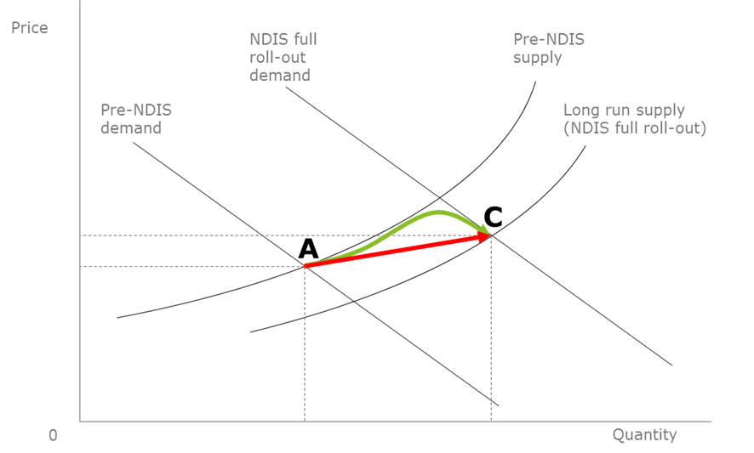
The TTP loading on the price limit was intended to allow the price limit to gradually move from the green path to the red path in order to balance the drive to efficiency and the maintenance of supply. The level of the Loading was initially set at an amount equal to the difference between the estimated efficient cost of delivery and the observed average cost of delivery. It was intended to be reduced over time to provide an incentive for increasing efficiency while recognising that existing supply needed to be maintained and provided an opportunity to become more efficient given the grown nature of the Scheme.
In 2020-21, more than half of all expenditure on supports that are eligible for the Temporary Transformation Payment Loading are being claimed at a price that is at or below the base price limit (without the loading). This suggests that average costs in the sector have reduced significantly in the last few years, as providers no longer need to use the loading to lift their price above the efficient level, or that the cost of accessing the Temporary Transformation Payment loading outweighs the benefit of maintaining eligibility.
It is therefore a matter for discussion as to whether the Temporary Transformation Payment Arrangements, and the eligibility requirements for providers to be able to access the payment set by the NDIA, continue to provide value for money for participants, as supply may be being maintained without access to the loading.

Call for submissions
The 2021-22 Annual Pricing Review is seeking the views of stakeholders on these issues.
Guide Questions
- To what extent have the Temporary Transformation Payment arrangements achieved their purpose?
- Do the Temporary Transformation Payment arrangements continue to provide value for money?

Therapy Supports
The 2021-22 Annual Pricing Review is required by its Terms of Reference to review the pricing arrangements for therapy and nursing supports, including whether the NDIS pricing arrangements are appropriately aligned with those in comparable Australian Government and state schemes, and with the private market for therapy supports.

Background
Therapy services are among the crucial supports available to NDIS participants, including services delivered by Art therapists, Audiologists, Audiometrists, Counsellors, Developmental educators, Dieticians, Exercise Physiologists, Music therapists, Occupational therapists, Orthoptists, Physiotherapists, Podiatrists, Psychologists, Rehabilitation counsellors, Social workers, Speech pathologists, Teachers and Therapy Assistants
Within the NDIS, therapists deliver supports under seven provider registration groups:
- Therapeutic Supports (0128): Provision of a mix of therapies, to assist participants aged from 7 years to apply their functional skills to improve participation and independence in daily, practical activities in areas such as language and communication, personal care, mobility and movement, interpersonal interactions and community living.
- Early Intervention Supports for Early Childhood (0118): Provision of a mix of therapies, and a key worker for the family. Supports children 0-6 years with developmental delay or disability and their families to achieve better long-term outcomes, regardless of diagnosis.
- Specialist Positive Behaviour Support (0110): Includes support items provided by allied health professionals with specialist skills in positive behaviour support including assessment and the development of a comprehensive plan that aims to reduce and manage behaviours of concern.
- Exercise Physiology & Personal Well-being Activities (0126): Physical wellbeing activities promote and encourage physical well-being, including exercise.
- Custom Prostheses and Orthoses (0135): Prescription and manufacture of customised prostheses or orthoses requiring specialist skills.
- Specialised Hearing Services (0119): Specialised hearing services for children and adults with complex needs.
- Hearing Services (0134): Hearing services for children and adults.
In 2019-20, over 300,000 participants received therapy supports through the NDIS at a total cost of $1.9 billion. That is, about 12% of all expenditure by NDIS participants is on therapy supports and about 83% of all participants have some therapy expenditure, with an average expenditure on therapy by those who received therapy support of about $6,494 in 2019-20.
In the trial phase of the NDIS, price limits were in most cases determined using a ‘cost-plus’ inputs-based pricing based on block funding allocations made to providers prior to the NDIS. As the NDIS transitioned towards full rollout, annual pricing reviews were conducted, whereby the unit price limits introduced were indexed annually based on updates to the costing methodology and consultations. As the number of participants in the NDIS grew, the supply requirements rapidly increased. Pricing needed to respond to provide the right market signals to deliver on the Scheme’s objectives and led to the NDIA Board commissioning the Independent Pricing Review (IPR) in 2017. In March 2018, the Board of the NDIA released the IPR Report undertaken by McKinsey & Company with some recommendations from the report subsequently being implemented.
In 2019, through the Pricing Reference Group, the NDIA conducted a review of the price control arrangements and other market settings for therapy services under the NDIS (2019 Review of Therapy Pricing Arrangements). As a consequence, several key recommendations were implemented including increasing the price limit to the 75th percentile of the observed private billing distribution, based on a perceived lack of power to influence prices in the therapy market, and in order to strike a balance between ensuring participants’ ability to choose and fund different providers in the market and delivering value for money.
The 2020 Annual Pricing Review recommended that the price limits for therapy supports should not be indexed on 1 July 2020, pending a comprehensive review of therapy pricing arrangements.
Exhibit 10 provides an overview of the historical price limits for therapy supports in the NDIS.
Exhibit 10: Therapy support price limits by geography from FY16 to FY21
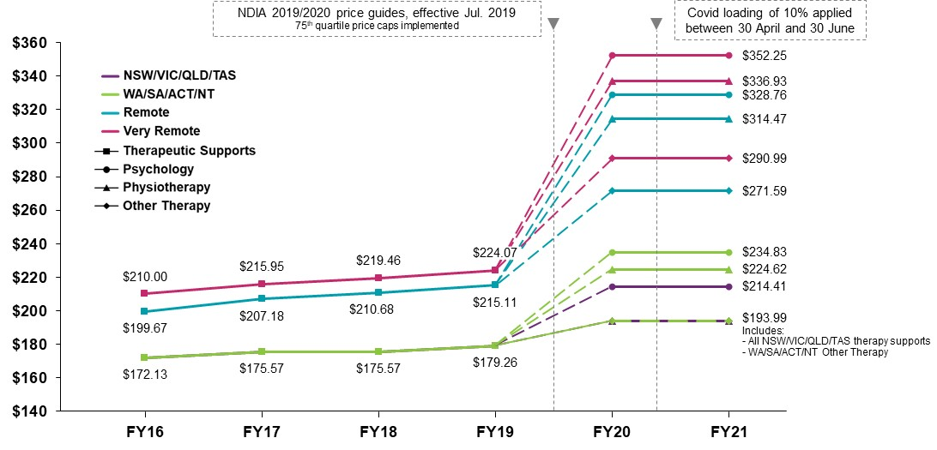

Issues
The Review estimates that Australians spent more than $7.8 billion on therapy supports in 2019-20, including expenditure by the NDIS, the Medical Benefits Scheme and private health insurance (including related out-of-pocket costs). The NDIS accounted for about 24% of this expenditure. Over the two years to 30 June 2020, it is estimated that the allied health services market grew by about 10% per annum, predominantly driven by NDIS therapy spend. Over this period, NDIS therapy spend grew by 106% per annum (see Exhibit 11).
Exhibit 11: Australian Expenditure on Allied Health, FY17 to FY20
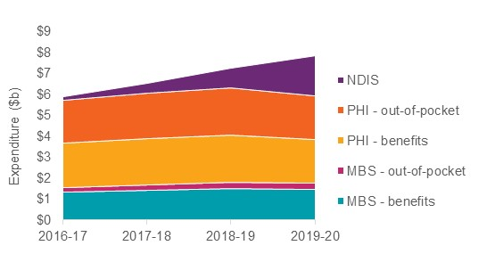
In the NDIS, there has been substantial growth in the number of registered providers delivering therapy supports. This number grew by 29% per annum between 2016-17 and 2019-20. The ratio for therapy participants to suppliers also increased since 2016-17 across all metro, regional and remote areas of Australia. However, despite this growth there remains an undersupply of providers in some areas, particularly in specific geographies as well as for some therapy types.
Moreover, most registered therapy providers (more than 60%) deliver supports to 10 or fewer NDIS participants. This in an indication of a fragmented market, which may impact on economies of scale of a provider and their long-term viability.
There is some concern that the NDIS price limits for therapy supports are not functioning as expected. As Exhibit 12 illustrates, some 48% of direct therapy claims were charged at or close to the price cap and a further 20% of direct therapy claims were charged between 90% and 99% of the price limit. For indirect therapy claims, some 47% were charged at or close to the price cap. Furthermore, only 11% of direct therapy claims were charged at 50% or less of the price cap relative to 14% of indirect therapy claims.
With such a significant proportion of providers charging at or close to the price limit, this suggests that there is limited competition across the market for therapy supports and as a result there is limited incentive within the market to reduce prices organically, and for providers to become more innovative and efficient. The current therapy price limits were set based on the 75th percentile of the observed private market on the assumption that there was a competitive market for these services and that the NDIA only needed to concern itself with ensuring access by participants. The evidence now appears to indicate that the price limit may instead have distorted prices upwards.
Exhibit 12: Price Distribution of NDIS therapy claims as proportion of 2019-20 price cap
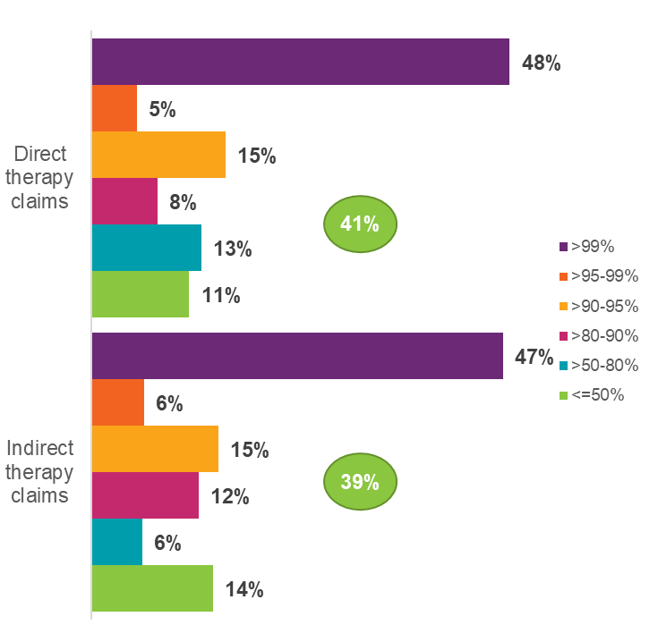
Concerns have also been raised by stakeholders that some providers have differential pricing regimes, with higher prices for NDIS clients than for other clients.
Another important source of information is the approaches taken by other insurance schemes. In general, the average NDIS price limit is higher than comparable insurance schemes for therapy supports (see Exhibit 13).
Exhibit 13: Estimated price per hour across schemes compared to NDIS price Limit
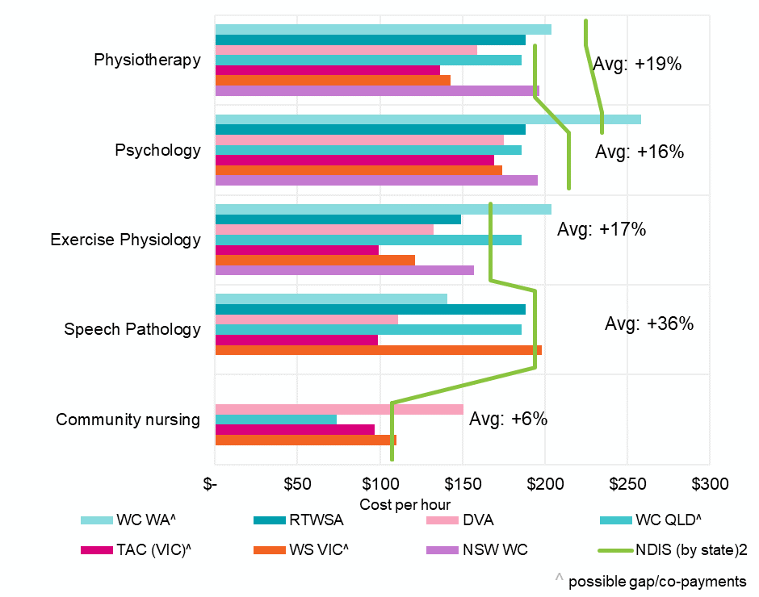
Based on the cost of a standard in-room consultation, the NDIS average price limit in 2019-20 was 36% higher compared to other schemes for speech pathology. It was also higher for physiotherapy (+19%), psychology (+16%) and exercise physiology (+17%). For physiotherapy, psychology and speech pathology, the NDIS is the second highest priced scheme, with the NDIS psychology price for NSW, VIC and QLD being at least 10% higher than other states.
Some difficulties exist in comparing the NDIS with other Schemes as they have different billing and purchasing arrangements. For example, many schemes charge on a “per consultation, rather than a “per hour” basis. Providers may also face different costs under the NDIS.

Nursing
There are 62 nursing supports in the NDIS which together account for $86 million in expenditure in 2020-21. These supports were delivered to 15,883 participants by 443 providers of whom only 121 saw 10 or more participants. Some stakeholders have questioned whether the current arrangements are too complex.

Call for submissions
As part of the 2021-22 Annual Pricing Review, the NDIA is seeking to understand how the market is responding to price regulation and to identify potential changes to price regulation that may be required to address residual challenges affecting the development of an efficient therapy supports market.
The Review is seeking the views of stakeholders on the following issues.
Guide Questions
- Are the current price limits for therapy supports appropriate? If not, why not? Please provide evidence.
- Are the current price limits for nursing supports appropriate? If not, why not? Please provide evidence.
- What considerations should be taken into account when comparing NDIS arrangements for therapy and nursing supports to Australian Government and state government schemes and the private market?
- Are there any other issues with the pricing arrangements for therapy supports? For example, would a “per consultation” billing approach be more appropriate for therapy supports? Are the travel and non-face-for billing arrangements appropriate for therapy supports? Please provide evidence.

Support Coordination
The 2021-22 Annual Pricing Review is required by its Terms of Reference to review the pricing arrangements for support coordination to encourage innovation, improve quality of service and ensure value for money.

Background
In 2019-20, some 140,262 participants made claims for support coordination. These claims totalled $431.7 million. Supports were delivered by 2,171 different providers. On average, each eligible participant received 31.2 hours of support coordination in 2019-20 at an annual cost of $3,078.
In the first nine months of 2020-21, some 166,708 participants made claims for support coordination. These claims totalled $461.3 million. Supports were delivered by 2,433 different providers. On average, each eligible participant received 28.0 hours of support coordination in the nine months (annualised as 37.3 hours) at a cost of $2,767 (annualised as $3,690).
Of the 2,433 providers who delivered supports in the first nine months of 2020-21:
- 522 delivered Level 1: Support Connection (Registration Group 0106);
- 2,380 delivered Level 2: Coordination of Supports (Registration Group 0106); and
- 712 delivered Level 3: Specialist Support Coordination supports (Registration Group 0132) - with only about 300 of these not also delivering Level 1 or Level 2 supports.
The following Table provides more detailed information for 2019-20
 | Level 1 | Level 2 | Level 3
Price Limit (per hour) | $63.21 | $100.14 | $190.54
Share of participants who receive support coordination | 1.7% | 97.8% | 3.9%
Share of hours of support coordination | 0.5% | 95.5% | 4.0%
Share of expenditure on support coordination | 0.3% | 92.7% | 7.0%
Average number of hours per year at this level of support per participant receiving this level of support | 9.1 | 30.5 | 31.8
Average annual cost of this level of support per participant receiving this level of support | $538 | $2,919 | $5,439
Note: The first row adds to more than 100% because a small number of participants receive supports at more than one level.

Current arrangements
There are currently three different support coordination support items

Level 1: Support Connection
This support item assists a participant to implement their plan by strengthening their ability to connect with the broader systems of supports and to understand the purpose of the funded supports. Support Connection assists a participant to understand their NDIS plan, connect participants with broader systems of supports, and provide assistance to connect with providers. Support Connection will assist participants to achieve effective utilisation of their NDIS plan and answer questions as they arise.
Support Connection also increases a participant’s capacity to maintain (or in some cases change) support relationships, resolve service delivery issues, and participate independently in NDIA processes. Support Connection includes, but is not limited to:
- Understand the Plan;
- Connect with Supports and Services;
- Establish Supports;
- Coach, Refine, Reflect; and
- Report to the NDIA.
This support item can be delivered to individual participants subject to the rules set out in this NDIS Pricing Arrangements and Price Limits.
As well as direct service provision, these support items can be used to claim for Non-Face-to-Face Support Provision, Provider Travel, Short Notice Cancellations, NDIA Requested Reports. Providers of this support can also claim for the costs of Provider Travel - Non-Labour Costs. The price limit for this support item is currently $65.09 per hour ($91.13 per hour in remote areas and $97.64 per hour in very remote areas).

Level 2: Coordination of Supports
This support item strengthens a participant’s ability to design and then build their supports with an emphasis on linking the broader systems of support across a complex service delivery environment. Coordination of Supports is to focus on supporting participants to direct their lives, not just their services, and is focussed on assisting participants to build and maintain a resilient network of formal and informal supports. This involves working together with the participant to understand the funding, identify what participants expect from services, and how participants want this designed. Coordination of Supports also includes coaching participants, and working with participants to develop capacity and resilience in their network.
Coordination of Supports includes, but is not limited to
- Understand the Plan;
- Connect with Supports and Services;
- Design Support Approaches;
- Establish Supports;
- Coach, Refine, Reflect;
- Targeted Support Coordination;
- Crisis: Planning, Prevention, Mitigation and Action;
- Build Capacity and Resilience; and
- Report to the NDIA.
This support item can be delivered to individual participants subject to the rules set out in this NDIS Pricing Arrangements and Price Limits.
As well as direct service provision, these support items can be used to claim for Non-Face-to-Face Support Provision, Provider Travel, Short Notice Cancellations, NDIA Requested Reports. Providers of this support can also claim for the costs of Provider Travel - Non-Labour Costs. The price limit for this support item is currently $100.14 per hour ($140.19 per hour in remote areas and $150.21 per hour in very remote areas).

Level 3: Specialist Support Coordination
This support item is delivered utilising an expert or specialist approach, necessitated by specific high complex needs or high level risks in a participant’s situation. Specialist Support Coordination is delivered by an appropriately qualified and experienced practitioner to meet the individual needs of the participant’s circumstances such as a Psychologist, Occupational Therapist, Social Worker, or Mental Health Nurse. Specialist Support Coordination is expected to address complex barriers impacting a participant’s ability to implement their plan and access appropriate supports. Specialist Support Coordinators assist participants to reduce complexity in their support environment, and overcome barriers to connecting with broader systems of supports as well as funded supports.
Specialist Support Coordinators are expected to negotiate appropriate support solutions with multiple stakeholders and seek to achieve well-coordinated plan implementation. Specialist Support Coordinators will assist stakeholders with resolving points of crisis for participants, assist to ensure a consistent delivery of service and access to relevant supports during crisis situations.
Specialist Support Coordination is generally delivered through an intensive and time limited period necessitated by the participant’s immediate and significant barriers to plan implementation. Depending on individual circumstances, a Specialist Support Coordinator may also design a complex service plan that focusses on how all the stakeholders in a participant’s life will interact to resolve barriers and promote appropriate plan implementation. Once developed, a Specialist Support Coordinator will continue to monitor the plan, but it may be maintained by one of the participant’s support workers or other care supports.
Specialist Support Coordination includes, but is not limited to
- Understand the Plan;
- Connect with Supports and Services;
- Design Support Approaches;
- Establish Supports;
- Coach, Refine, Reflect;
- Targeted Support Coordination;
- Crisis: Planning, Prevention, Mitigation and Action;
- Address Complex Barriers;
- Design Complex Service Plan;
- Build Capacity and Resilience; and
- Report to the NDIA.
This support item can be delivered to individual participants subject to the rules set out in this NDIS Pricing Arrangements and Price Limits.
As well as direct service provision, these support items can be used to claim for Non-Face-to-Face Support Provision, Provider Travel, Short Notice Cancellations, NDIA Requested Reports. Providers of this support can also claim for the costs of Provider Travel - Non-Labour Costs. The price limit for this support item is currently $190.54 per hour ($266.75 per hour in remote areas and $285.50 per hour in very remote areas).

Issues
Stakeholders have raised a number of issues with the current arrangements, including whether the price limits for support coordination are reasonable, especially when compared to the price limits for other services? Of particular concern is whether the price limits are appropriate for the skills and experience required to deliver these supports and whether the overheads of support coordinators may be necessarily higher than some other provider.

Call for Submissions
The 2021-22 Annual Pricing Review is seeking the views of stakeholders on these issues and on any other issues that stakeholders wish to raise.
Guide Question
- Are the current pricing arrangements for support coordination appropriate? If not, why not? Please provide evidence.

Plan Management Supports
The 2021-22 Annual Pricing Review is required by its Terms of Reference to review the pricing arrangements that apply to supports delivered in regional, remote and very remote areas to ensure continued access to appropriate supports for participants living in those areas.

Background
As at 30 June 2021, almost half of all participants were using a plan manager for some or all of all of their plan and more than a third of all plan budgets (36%) was plan-managed. In 2020-21, plan mangers were paid $305 million by participants and processed support payments worth $8.3 billion.
As Exhibit 14 illustrates, both the share of participants choosing to be plan-managed (in part or in full) and the share of payments processed by plan mangers increased significantly in the last three years.
Exhibit 14: DistriBution of participants (left hand chart) and Payments (right hand chart) by method of plan management, June 2018 to June 2021
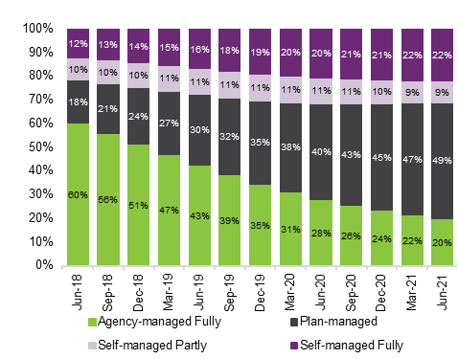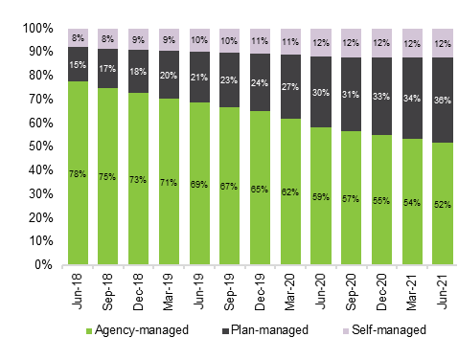

Currently, there are about 1,200 providers delivering plan management services. Of these providers, more than half (57%) also deliver support coordination services and more than a third (37%) also deliver supports other than plan management & support coordination.
The 10 largest plan managers service 42% of all plan-managing participants. Another 200 or so medium-sized plan managers deliver services to 47% participants and close to 1,000 small plan managers deliver services to the remaining 11% of participants. The number of plan managers continues to grow, with 52 new plan management providers commencing operations in 2020-21.

Current arrangements
Participants can choose to have a registered Plan Management provider to manage their funding and budget for the supports in their NDIS plan. Plan Managers are bound to the NDIS Pricing Arrangements and Price Limits and are able to connect participants with both NDIS registered providers and providers that are not registered with the NDIS.
The role of the Plan Manager, as defined by Section 42(1) of the National Disability Insurance Scheme Act, defines managing the funding for supports under a participant’s plan to mean:
- purchasing the supports identified in the plan (including paying any applicable indirect costs, such as taxes, associated with the supports); and
- receiving and managing any funding provided by the Agency; and
- acquitting any funding provided by the Agency.
The NDIA has provided further guidance around the role of a plan manager on the NDIS website. Plan managers can assist participants by:
- claiming directly from the budgets in a participant’s plan to pay providers on their behalf;
- paying providers for the supports participant’s purchase;
- helping participants keep track of their funds;
- taking care of financial reporting for participants; and
- depending on circumstances, they can also help participants choose their providers.
Plan managers are currently able to claim for three types of services. These are:
- A one-off (per plan) establishment fee for setting up of the financial management arrangements for managing of funding of supports – support item 14_033_0127_8_3, with a current price limit of $232.35;
- A monthly fee for the ongoing maintenance of the financial management arrangements for managing of funding of supports – support item 14_034_0127_8_3 with a current price limit of $104.45; and
- Capacity building and training in plan administration and management with a participant to strengthen their ability to undertake tasks associated with the management of their supports – support item 14_031_0127_8_3 with a current price limit of $65.09 per hour.
Currently, plan managers are not permitted to claim for provider travel and non-face-to-face activities with respect to support item 14_031_0127_8_3. They are permitted to claim for short notice cancellations.

Issues
The NDIA is continuing to improve the way participants are able to make claims. The existing portal approach will be augmented over time with a mobile app (currently in extended pilot program) and a POS system which is in the early stages of planning. These new systems would be additions to a participant’s choice and control. Claims could be made through any and all of those means.
The automated process flow for claims initiated by the real time claims solution is expected to change the role that plan managers currently play in the processing of those claims. The introduction of a CPOS system, and the Agency’s broader digital strategy, may therefore impact on the service offerings of plan mangers and the costs of delivering those services.
Stakeholders have also raised a number of issues with the current arrangements, including:
- Whether the price limit for the establishment fee is reasonable?
- Whether the price limit for the monthly fee for the ongoing maintenance of the financial management arrangements is reasonable?

Call for Submissions
The 2021-22 Annual Pricing Review is seeking the views of stakeholders on these issues and on any other issues that stakeholders wish to raise.
Guide Question
- Are the current pricing arrangements for plan management appropriate? If not, why not? Please provide evidence.

Regional, Remote and Very Remote Areas
The 2021-22 Annual Pricing Review is required by its Terms of Reference to review the pricing arrangements that apply to supports delivered in regional, remote and very remote areas to ensure continued access to appropriate supports for participants living in those areas.

Current arrangements
In the NDIS, different pricing arrangements apply depending on whether a support is delivered in a regional, remote or very remote area. To determine whether a support is being delivered in a regional, remote or very remote area the NDIA uses a modification of the Modified Monash Model (MMM). The MMM determines regional, remote and very remote areas using a scale based on population size and locality (see Exhibit 15).
Exhibit 15: Modified Monash Model
Description | Zones | MMM | Inclusion
Metropolitan | MMM1-3 | 1 | All areas categorised as Major Cities of Australia.
Regional Centres | MMM1-3 | 2 | Areas categorised as Inner Regional Australia or Outer Regional Australia that are in, or within 20km road distance, of a town with population >50,000.
Regional Centres | MMM1-3 | 3 | Areas categorised as Inner Regional Australia or Outer Regional Australia that are not in MMM 2 and are in, or within 15km road distance, of a town with population between 15,000 and 50,000.
Regional Areas | MMM4-5 | 4 | Areas categorised as Inner Regional Australia or Outer Regional Australia that are not in MMM 2 or MMM 3, and are in, or within 10km road distance, of a town with population between 5,000 and 15,000.
Regional Areas | MMM4-5 | 5 | All other areas in Inner Regional Australia or Outer Regional Australia.
Remote | MMM6 | 6 | All areas categorised Remote Australia that are not on a populated island that is separated from the mainland and is more than 5km offshore.
Very Remote | MMM7 | 7 | All other areas – that being Very Remote Australia and areas on a populated island that is separated from the mainland in the ABS geography and is more than 5km offshore.
Providers and participants can determine the MMM rating of a location using the Health Workforce Locator tool on the Department of Health’s website.
In general, price limits are 40% higher in Remote areas and 50% higher in Very Remote areas. There is no additional loading applied for supports in Metropolitan areas, Regional Centres or Regional Areas. However, some different pricing arrangements do apply in Regional Areas (MMM4-5) as set out in this NDIS Pricing Arrangements and Price Limits.
The NDIA adjusts the Modified Monash Model classification of some locations. Where a location is surrounded by Remote or Very Remote areas then the NDIA designates the enclave an Isolated Town and classifies that enclave as a Remote area for planning and pricing purposes. Exhibit 16 sets out the enclaves that the NDIA has reclassified.
Exhibit 16: Isolated Towns in the NDIS Adjusted Modified Monash Model
NDIA Enclave | Postcodes | Locations | State | MMM Rating | NDIS Adjusted MMM Rating
Hay | 2711 | Hay  Hay South | NSW | 5 | 6
Balranald | 2715 | Balranald | NSW | 5 | 6
Broken Hill | 2880 | Broken Hill | NSW | 3 | 6
Ravenswood/Warren | 2824 | Ravenswood Warren | NSW | 5 | 6
Roma | 4455 | Blythdale  Euthulla  Orange Hill  Roma | QLD | 4 | 6
Emerald | 4702, 4717, 4720 | Blackwater  Bluff  Comet  Emerald  Jellinbah | QLD | 5 | 6
Moranbah | 4741, 4744 | Coppabella  Moranbah | QLD | 5 | 6
Dysart | 4745 | Dysart | QLD | 5 | 6
Charters Towers | 4820 | Alabama Hill  Breddan  Broughton  Charters Towers  Grand Secret  Millchester  Mosman Park  Queenton  Richmond Hill  Southern Cross  Toll  Towers Hill | QLD | 4 | 6
Merredin | 6415 | Merredin | WA | 5 | 6
Kalgoorlie | 6430, 6432 | Boulder  Broadwood  Hannans  Kalgoorlie  Karlkurla  Lamington  Mullingar  Piccadilly  Somerville  South Boulder  South Kalgoorlie  Victory Heights  West Kalgoorlie  West Lamington  Williamstown | WA | 3 | 6
Kambalda | 6442 | Kambalda West Kambalda East | WA | 5 | 6
Gunbalanya | 0822 | Gunbalanya | NT | 6 | 7
When a support is provided directly to a participant, and the worker delivering the support is at the same location as the participant, the price limit that applies to the support is determined by the location of the participant at the time of service delivery. When a support is provided directly to a participant via telehealth, the price limit that applies to the support should, in general, be the price limit that would apply if the participant was receiving the support at the place that the person who is delivering the support is located at the time of service delivery. When a support is not provided directly (for example, Non-Face-to-Face Support Provision or NDIA Requested Reports) then the price limit that applies to the support is the price limit that would apply if the participant was receiving the support at the place that the person who is delivering the support is located at the time of service delivery.

Issues
The 2019 NDIS Western Australian Market Review found that costs in remote and very remote areas were substantially higher than those in other areas. As a result, the NDIS increased the price limit and plan funding loadings for remote and very remote areas from 20% and 25% to 40% and 50%, respectively. The Western Australian Market Review also found that costs did not suddenly rise when a provider crossed the boundary from an outer regional area, Modified Monash Model (MMM) regions 4 and 5, to a remote area. Rather, costs rose in line with the distance from capital cities – although not necessarily in a linear manner.

Call for Submissions
The NDIA has a broad role as market steward to ensure continued access to appropriate supports for participants in regional, remote and very remote areas. Pricing is one of the levers available to achieve this. The Annual Pricing Review 2021-22 is seeking the views of stakeholders on the relative costs of delivering supports into outer regional, remote and very remote areas (compared to the delivery of supports in metropolitan areas).
Guide Questions
- Are the costs of delivering supports in outer regional, remote and very remote areas higher than in metropolitan areas? If yes, why and by how much? Please provide evidence.
- Are any amendments required to the NDIS pricing arrangements to better recognise the costs of delivering services in regional, remote and very remote areas? If yes, please provide details and evidence.
- Are there any other enclaves that the NDIS should classify as Isolated Towns for planning and pricing purposes? If yes, please identify the enclave(s) and provide evidence of why, and by how much, the cost of delivering supports in the enclave(s) is higher than in other similarly classified areas.

Western Australia, South Australia and Queensland
The 2021-22 Annual Pricing Review is required by its Terms of Reference to examine whether the current economic conditions in states where economic trends are often counter cyclical to the trends in other states and territories (and, in particular, in Western Australia, Queensland and South Australia) are such as to require temporary adjustments to price controls in those states in order to proactively manage any potential impacts on the supply of disability goods and services.

Current arrangements
In 2019, the NDIA undertook a Review to establish if there were any issues in the markets for disability goods and services that so differentiated Western Australia from the other jurisdictions as to require alternative price control arrangements.
The Review found there was:
- little evidence of substantial differences in the markets for delivery of disability goods and services in Western Australia compared to other jurisdictions, in terms of levels of competition, market concentration, and efficient costs;
- no significant evidence that the delivery of disability goods and services was inadequate in urban and regional areas – however, as with other jurisdictions, there was evidence that supply is an issue in remote and very remote areas;
- no evidence of substantial differences in efficient labour costs, labour related regulatory imposts and other costs of delivery in Western Australia relative to other jurisdictions at the time of the Review; and
- no significant evidence that the new national price limits published on 30 March 2019 to take effect from 1 July 2019 would not support the sustainable, efficient delivery of disability supports in metropolitan Western Australia.
The 2019 Review recommended that, from 1 July 2019, the new national price limits for supports other than therapy supports published on 30 March 2019 should apply to Western Australia. For therapy supports, the price limits that apply to South Australia, Tasmania and the Northern Territory should apply to Western Australia.

Issues
Although the 2019 Review found that there was no need at that time for differential price controls for Western Australia, it also found that the Western Australian economy is driven substantially more by commodity exports than the rest of Australia. Commodity exports are volatile, in terms of both volumes and values. Accordingly, Western Australia is more characterised by boom/bust cycles than Australia as a whole. This means that disability providers in Western Australia, compared to the rest of Australia, will more often face boom conditions that may make it more difficult to retain workers. At present, price control changes are reviewed on a national basis. However, the boom and bust cycles experienced in Western Australia raise the question as to whether there should be provision for price control changes to differ across states and territories and for them to be able to be reviewed more rapidly when required.
Moreover, while this volatility arguably affects Western Australia more than other jurisdictions, it is not unique to Western Australia. The other mining states (South Australia and Queensland) also experience boom/bust cycles.
At a broad level, the current NDIA approach of national labour price limits may not fit well with a large and diverse economy. Australia is well known as a “two speed economy” because on occasion some states – Western Australia, Queensland and South Australia – are in a mining boom, while others are languishing; or these states are experiencing a mining bust while the others are enjoying rapid growth.
The 2019 Review therefore recommended that the NDIA should work with the relevant Commonwealth and State/Territory Departments to monitor the economic conditions in Western Australia (and Queensland and South Australia) with a view to making temporary adjustments to price controls when necessary, in order to proactively manage any potential impacts on the supply of disability goods and services from economic trends in those states that were counter cyclical to the trends in other states and territories.

Call for Submissions
The 2021-22 Annual Pricing Review is therefore seeking evidence from stakeholders on labour costs and regulatory imposts (such as workers compensation and leave entitlements) in Western Australia, South Australia and Queensland relative to other jurisdictions.
Guide Questions
- Are the conditions of employment (for example, wages, leave entitlements, shift loadings, breaks, superannuation, minimum shift requirements, minimum weekend callout durations) of workers in the Western Australia, South Australian or Queensland disability sector workforce substantially different from those that apply in other jurisdictions? If yes, why and by how much? Please provide evidence.
- Are there shortages of particular skills in Western Australia, South Australia or Queensland, relative to other jurisdictions? If yes, why? Please provide evidence.
- Do providers of disability goods and services in Western Australia, South Australia or Queensland face higher non-labour input costs (including government charges) than providers in other jurisdictions? If yes, why and by how much? Please provide evidence.

NDIA. (2021). NDIS Report to disability ministers for Q4 of Y8 Full Report, 30 June 2021, p.6.
Ibid. pp.40-1.
Ibid. pp.77-8.
Ibid. p.73.
NDIS Scheme Actuary. (2021). National Disability Insurance Scheme: Annual Financial Sustainability Report 2020-21, p. 14.
NDIA. (2021). NDIS Report to disability ministers for Q4 of Y8 Full Report, 30 June 2021, p.76.
NDIA. (2019). NDIS Pricing Strategy
NDIA. (2019). NDIS Western Australia Market Review.
Details of the Act and the Rules made under the Act can be found on the NDIS website.
NDIA. (2021). NDIS Disability Support Worker Cost Model 2021-22: Assumptions and Methodology.
Copies of the results of the financial benchmarking surveys can be found at the NDIS website.
This includes NDIA-managed, plan-managed and self-managed participants.
McKinsey & Company. (2018). Independent Pricing Review of the NDIS. NDIA. (2018). Response to the Independent Pricing Review.
NDIA. (2019). Review of Therapy Pricing Arrangements in the NDIS.
NDIA. (2020). Annual Review of Pricing Arrangements.

