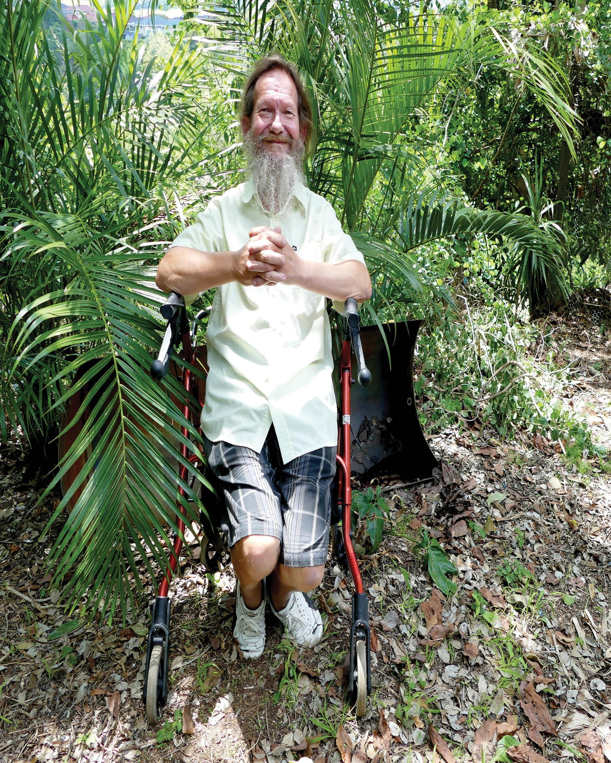
OFFICIAL: SENSITIVE

NDIA Engagement Framework
Strengthening our relationship with the disability community and enabling co- design.

Version 1 (31 March 2022)
National Disability Insurance Agency

ndis.gov.au March 2022 - NDIS Engagement Framework 1

Contents

Foreword from the CEO 3
Purpose 4
Learn by doing 5
The ways we engage and work together 6
Co-design 6
Consult 6
Inform 7
Our engagement principles 8
Deciding the most effective way to engage 9
Our engagement phases 11
Evaluation and reporting 12

Foreword from the CEO
We are committed to working closely with participants, their families and carers, and strengthening our relationship with the disability community. We know listening to, and learning from, participants and the disability community is fundamental to improving the National Disability Insurance Scheme (NDIS).
The NDIA Engagement Framework has been developed to make sure the views and experiences of people with disability underpin the decisions we make. Input from the disability community is critical to addressing the challenges the NDIS faces.
The NDIA Engagement Framework publicly commits the National Disability Insurance Agency (NDIA) to engage and work with the disability community on potential significant changes.
This framework explains what the disability community can expect from the NDIA during these engagement activities, setting out the primary ways we will engage – through co- design, consultation and information sharing – and how each of those processes will work.
Depending on the task at hand, the level and type of engagement may change however, you can expect us to remain honest, transparent and respectful in our engagement. We understand that we must build mutual trust through our actions – actions that are underpinned by this framework.
I know we have a shared goal to improve the NDIS. I care deeply about getting this right for participants, their families and carers, and for generations to come. I believe articulating how we will work together to achieve our goal is an important step in the right direction and we’ll continue to review and refine our processes to get this right.

Martin Hoffman
Chief Executive Officer
National Disability Insurance Agency

Purpose
Our engagement framework is designed to guide, support and strengthen our engagement with the disability community to improve the NDIS and deliver better outcomes for NDIS participants.
We commit to learn by doing, to listen to, understand and respond to advice about how we can improve and adjust our processes to enable improvements.
This includes our commitment to co-design with the disability community.
The foundation of the framework is the belief that the people who are impacted by NDIS processes or decisions have a right to be involved in how those processes are designed and implemented, and how decisions are made.
In this way, the lived experience of participants and families is at the core of NDIS policy design and implementation.
The NDIA will work collaboratively with the disability community to design and implement processes that enable the NDIA to make better decisions. This will improve participant experiences and outcomes and maintain the sustainability of the NDIS.
We will build our co-design and engagement capability and processes to make sure we:
- capture a diverse range of experiences and perspectives
- understand decision-making processes, and
- enable the lived experience of participants and families to remain at the core of all our work.
This framework explains how we will engage with participants and stakeholders based on:
- the different ways we can engage (approach)
- attitudes which underpin our strengthened engagement (principles)
- what we consider when deciding how to engage (decisions)
- what you can expect us to do every time we engage (phases).
This framework is based upon the theories and structures of the:
- International Association for Public Participation (IAP2) and
- Australian Public Service (APS) Framework for Engagement and Participation.
A Co-design Advisory Group (Advisory Group) provides strategic advice to the NDIA on the implementation of co-design and engagement processes with the disability community.
Disability representative and carer organisations (DRCOs) and the NDIS Independent Advisory Council (Council) guide the Co-design Advisory Group.

Learn by doing
The disability community has strongly encouraged the NDIA to take a ‘learn by doing’ approach when co-designing important NDIS projects or initiatives. This enables us to continue to learn as we work with the disability community.
We will continually review our approaches and this framework to make sure we engage in meaningful ways that deliver improved outcomes for people with disability.
As we learn by doing, we will document and publish the processes and lessons we have learned in partnership with the disability community.
It is important participants can contribute to co-design and engagement activities, alongside representative bodies and other key stakeholders.
We will use a spectrum of engagement approaches including co-design and consultation to make sure we hear directly from people with lived experience of disability, including people whose views are not always well represented.

The ways we engage and work together
We engage in a variety of ways with participants, families and carers, the disability sector and other stakeholders, for example, through information sharing and updates or deeper consultative and collaborative engagement that seeks to understand issues from a variety of perspectives and resolve complex problems and meet agreed desired outcomes.
We understand there is a spectrum of participation with many potential engagement approaches. The three main approaches to engagement are:
- Co-design
- Consult
- Inform.
These are not rigid categories with tightly defined exclusive methodologies. But it is helpful to explain what these approaches may look like:

Co-design
‘Co-design’ needs to be understood in its broadest sense that includes various ways of ‘co-working’. We commit to working with the disability community and other stakeholders to use a range of these collaborative ways of working as they align to specific problems, issues or situations that require improvement or change.
Co-work is about making better decisions and creating better change through collaboration between people with lived experience, professionals and using research evidence. It includes the following¹:
- Co-planning: involves making decisions about values, direction, ambition, resources and approach.
- Co-design: involves making decisions about the detailed form of an interaction,
service or policy
- Co-delivery: supports people with lived experience and professionals to collaborate to enable change for others
- Co-evaluate: supports participation in the judgement of existing situations and development of recommendations for action
- Co-governance: involves collaborative oversight, within the legislative framework of
the NDIS
Co-design is most effective when the lived experience of participants and expertise of stakeholders is sought in order to understand experience from a variety of perspectives, to find and test solutions, and to manage competing values or priorities.

Consult
A consultation approach is where the NDIA shares information and listens to views. When we consult, the NDIA poses a question, topic or potential solution/s for stakeholders to consider and provide their views. We will keep them informed, acknowledge concerns and provide feedback on how stakeholders’ input influenced our decisions.

Inform
An inform engagement approach is where communication is one-way, from the NDIA to the stakeholders. People receive factual information to describe an event, new initiative or changes to an existing process. Even when we are informing the community, we are still interested in hearing your views and experiences to help us better understand the impact of changes and reforms.

1 Adapted from The Australian Centre for Social Innovation

Our engagement principles
Our engagement principles are underpinned by the principles in our Participant Service Charter:

Transparent
We will make it easy to access and understand our information and decisions.

Responsive
We will respond to individual needs and circumstances.

Respectful
We will recognise your individual experience and acknowledge you are an expert in your own life.

Empowering
We will make it easy to access information and be supported by the NDIS to lead your life.

Connected
We will support you to access the services and supports you need.

Deciding the most effective way to engage

When considering whether to use a co-design, consult or inform approach to engagement – or combination of approaches – we begin with five key factors:
- Problem/s
- Impact
- Resources
- Solution
- Outcome.

The NDIA collaborates with the disability community and gathers information from a range of sources. Together we decide how we could engage based on these five key factors in Figure 1.

Figure 1: Five key factors
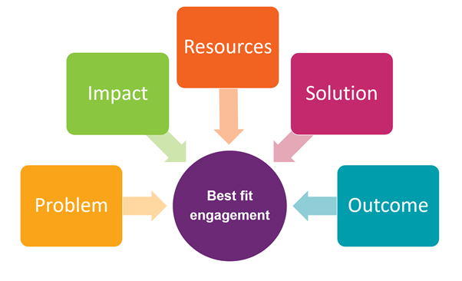
Alt text: Five coloured boxes showing the five key factors surround a circle that says ‘Best fit engagement’. Each of the five key factor boxes has an arrow pointing to the circle.

Problem
The first step is defining the problem and understanding the reasons for the problem. There may be different views based on different experiences.
To make sure solutions are accepted and achieve positive outcomes, it is important to reach a shared understanding of the causes of a problem.
Problems that need a co-design approach are likely to be complex.

Impact
The second step is to identify the impact on participants and stakeholders based on the scope of the problem and the solutions we propose. For example:
- Are there unintended or unfair impacts on some participant groups compared with others?
- What lessons have we learnt from our collective experience?

Resources
Authentic, collaborative engagement that achieves agreed positive outcomes requires resources and time for preparation, development, delivery and evaluation.
Decision-making processes and requirements must be clear. Meaningful engagement with participants with diverse lived experience and communication or other support needs may require additional guidance, resourcing and time.
If the NDIA is required to undertake specific work by a deadline, we will be transparent about these situations and how we will engage and support stakeholder understanding.

Solution
We will be clear about any time limits on our engagement approach. This includes any legislative requirements set out in the National Disability Insurance Scheme Act 2013.
We will always focus on the lived experience of participants.
Sometimes we will need to incorporate subject matter expertise into the design and testing of solutions, as well as the management of competing priorities.

Outcome
The impact of problems and solutions on participants and stakeholders is a significant factor in choosing the most appropriate engagement approach.
We will co-design or consult widely when the problem and potential solutions are likely to have significant impact on participants’ interactions or experiences with the NDIS.
We will also co-design and consult widely when we are trying to solve problems that have long-term importance to the NDIS. For example, financial sustainability or operational matters.
Changes will not always benefit everyone. We will explain why changes are needed and the outcomes we expect.

Our engagement phases
To make sure we consistently plan, deliver and evaluate our engagement, and that our approaches are reliable and repeatable, we will typically undertake our work in 4 phases:
- Prepare
- Discover
- Develop
- Deliver and evaluate.
We understand that sometimes our engagement phases will need to be iterative (or repeated), rather than linear.

Figure 2. Our engagement framework
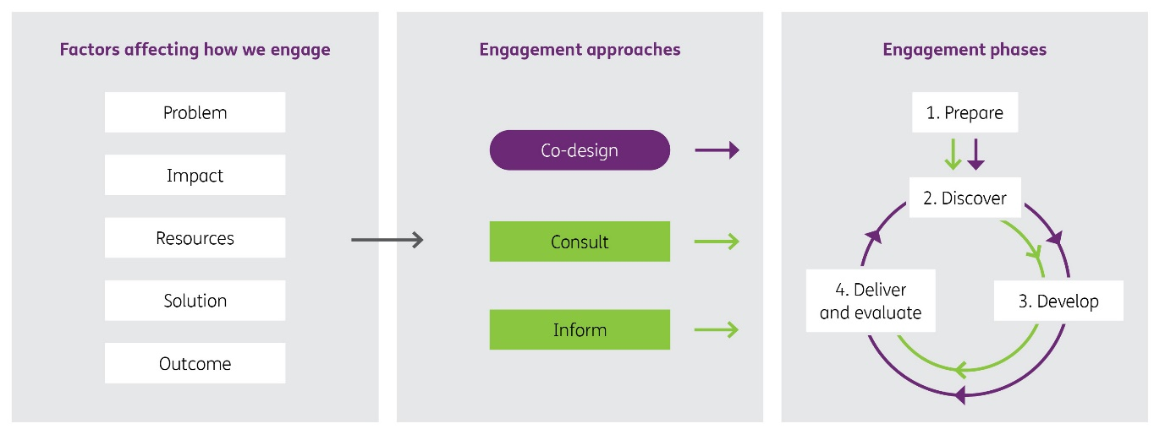

Alt text: Illustration of the NDIA Engagement Framework showing the factors affecting how we engage, our three engagement approaches and our four engagement phases. The NDIA Engagement Framework is represented in three sections:
The first section shows the factors affecting how we engage:
- Problem
- Impact
- Resources
- Solution
- Outcome.
The middle section shows our engagement approaches:
- Co-design(represented with a purple background)
- Consult (with a green background)
- Inform (with a green background)
Each has an arrow pointing across to the third section. The third section shows our engagement phases:
- Prepare
- Discover
- Develop
- Deliver and evaluate.
Each phase is connected by green arrows showing how consult and inform move through each phase in a linear process. They are also connected by a purple arrow showing for co-design, the last three phases can become a cycle.

Evaluation and reporting
We are committed to making sure the views and lived experiences of people with disability inform the design and delivery of our co-design and engagement work.

Reporting
The NDIA Engagement Framework is our commitment to improving our engagement processes. We will report regularly the outcomes of how we are strengthening our engagement approaches and implementing co-processes through our Quarterly and Annual Reports. We will update the Engagement Roadmap every six months.

Evaluation
We will work with the disability community to develop a collaborative evaluation plan to review the Engagement Framework and how we could improve the process of working together. This review will occur annually, based on our ‘learn by doing’ co-design process.

