National Disability Insurance Scheme

Annual Pricing Review 2021-22

Final Report

Copyright
© 2022
Copyright of the information contained in this document is owned and protected by the National Disability Insurance Scheme Launch Transition Agency (National Disability Insurance Agency).
Use of National Disability Insurance Agency copyright material
The material in this report, with the exception of logos, trademarks, third party material and other content as specified, is licensed under Creative Commons CC NC licence, version 4.0. With the exception of logos, trademarks, third party material and other content as specified, you may reproduce the material in this document, provided you acknowledge the National Disability Insurance Agency as the owner of all intellectual property rights in the reproduced material by using ‘© National Disability Insurance Scheme Launch Transition Agency 2021’ and do not use the material for commercial purposes.
Reproduction of any Creative Commons material in this document is subject to the CC NC licence conditions available on the Creative Commons site, as is the full legal code for this material.

Note on data sources
Except where otherwise indicated, any statistics about the NDIS in this report are based on unpublished administrative and financial data held by the NDIA or are drawn from the NDIS Quarterly Report to Disability Ministers that are published on the NDIS website or are drawn from the NDIS data insights website.
Population data drawn from: ABS. (2021). National, State and Territory Population, June 2021; and ABS. (2018). Population Projections, Australia, 2017(base) – 2066. Further information here.
Terms that we use
Agency | National Disability Insurance Agency
ABS | Australian Bureau of Statistics
NDIS Commission | NDIS Quality and Safeguards Commission
DSW | Disability Support Worker
EBA | Enterprise Bargaining Agreement
EBITDA | Earnings Before Interest, Tax, Depreciation and Amortisation
FLS | Front Line Supervisor
NDIA | National Disability Insurance Agency
NDIS | National Disability Insurance Scheme
SCHADS Industry Award | Social, Community, Home Care and Disability Services Industry Award 2010
Scheme | National Disability Insurance Scheme
SIL | Supported Independent Living
TTP | Temporary Transformation Payment

Table of Contents
Executive Summary and Recommendations 7
Pricing Strategy 8
NDIS Disability Support Worker Cost Model 11
General Pricing Arrangements 13
Group Based Core Supports 17
Therapy Supports 19
Nursing Supports 21
Plan Management Supports 23
Support Coordination 25
Regional, Remote and Very Remote Areas 26
Queensland, South Australia, and Western Australia 27
1 Introduction 29
1.1 Terms of Reference of the Review 30
1.2 Consultations 31
1.3 Financial Benchmarking Survey 34
1.4 Desktop Research 35
1.5 Structure of This Report 36
2 Pricing Strategy 38
2.1 Background 38
2.2 Provider Efficiency 47
2.3 Temporary Transformation Payment (TTP) 48
2.4 Macroeconomic Conditions 50
2.5 Employment Statistics and Projections 52
2.6 Discussion 54
2.7 Recommendations 58
3 Disability Support Worker Cost Model 60
3.1 Background 60
3.2 Issues Raised in the Consultations 65
3.3 Cost Impacts of SCHADS Industry Award Changes 66
3.4 Cost Impacts of COVID-19 67
3.5 Quality and Safeguarding Cost 68
3.6 Discussion 75
3.7 Recommendations 79
4 General Pricing Arrangements 83
4.1 High Intensity Supports 83
4.2 Provider Travel 86
4.3 Short Notice Cancellations 89
4.4 Public Holidays 91
4.5 The Goods and Services Tax 92
4.6 Indexation of Price Limits in Longer Plans and on Plan Renewal / Extension 94
4.7 Direct Engagement of Workers by Participants 94
4.8 Recommendations 94
5 Group Based Supports 97
5.1 Current Arrangements 97
5.2 Issues Raised in the Consultations 101
5.3 Financial Performance of Providers 102
5.4 Discussion 103
5.5 Recommendations 105
6 Therapy Supports 106
6.1 Background 106
6.2 Feedback from consultations 112
6.3 NDIS Share of the Market for Therapy 113
6.4 Registration and Employment Statistics 114
6.5 Private Billing Rates 116
6.6 Comparable Schemes 118
6.7 Discussion 119
6.8 Recommendations 124
7 Nursing Supports 126
7.1 Current Arrangements 126
7.2 Issues Raised in the Consultations 131
7.3 Registration and Employment Statistics 131
7.4 Comparisons to Other Schemes and Funding Programs 133
7.5 Discussion 137
7.6 Recommendations 141
8 Plan Management Supports 145
8.1 Current Arrangements 145
8.2 Issues Raised in the Consultations 149
8.3 Financial Performance (Disability Intermediaries Australia Survey) 150
8.4 Discussion 151
8.5 Recommendations 155
9 Support Coordination 157
9.1 Current Arrangements 157
9.2 Issues Raised in the Consultations 160
9.3 Financial Performance (Disability Intermediaries Australia Survey) 161
9.4 Discussion 162
9.5 Recommendations 163
10 Regional, Remote and Very Remote Areas 165
10.1 Current Arrangements 165
10.2 Issues Raised in the Consultations 170
10.3 Financial Performance of Providers 171
10.4 Labour Market Indicators 173
10.5 Discussion 174
10.6 Recommendations 178
11 Queensland, South Australia and Western Australia 179
11.1 Background 179
11.2 Issues Raised in the Consultations 184
11.3 Financial Benchmarking Survey 185
11.4 Labour Market Indicators 188
11.5 Discussion 189
Appendix A – List of Submissions 191
Appendix B – Working Group Members 196
Appendix C – Comparative Analysis of Pricing Arrangements in Government Insurance and Funding Schemes 203
Appendix D – Financial Benchmarking Survey 212
Appendix E - Geographic Classifications 216
Index of Exhibits 225

Executive Summary and Recommendations
The National Disability Insurance Scheme (NDIS) was established in 2013 to support people with disability to pursue their goals, to help them to realise their full potential, to assist them to participate in and contribute to society, and to empower them to exercise choice and control over their lives and futures. The NDIS provides funding to eligible individuals (“participants”) so that they can purchase, in the open market, the disability related goods and services (“supports”) that they need.
In March 2022, there were 518,228 active participants in the NDIS. Total payments by the NDIS in 2020-21 were $23.3 billion, with 56.1% ($13.1 billion) spent on support for daily activities; 17.0% ($4.0 billion) spent on community participation supports; and 12.2% ($2.8 billion) spent on capacity building supports for daily activities, including therapy.
The NDIS is administered by the National Disability Insurance Agency (NDIA). The NDIA has a role, as market steward, to create an efficient and sustainable consumer driven marketplace for the supply of disability supports. It regulates the commercial relationships between providers and participants, including through price regulation. The pricing arrangements aim to maintain and increase market supply, and help markets grow to a more mature state in the future, while recognising the need for financial sustainability.
The NDIA monitors and reviews its price control framework and other market settings to determine whether they are still appropriate. Annual Pricing Reviews are an important part of that process. The Terms of Reference of the 2021-22 Annual Pricing Review were established by the NDIA Board. They required the NDIA to examine, through engagement with participants, providers and community and government stakeholders, and targeted research, whether the NDIS’s existing price control framework (pricing arrangements and price limits) continues to be appropriate or should be modified.
Extensive consultations with participants, providers and other stakeholders were undertaken as part of the Annual Pricing Review, including through:
- The publication of a Consultation Paper and careful analysis of the 254 submissions received in response to the Consultation Paper.
- The establishment of 12 working groups of providers and other stakeholders, and ad hoc meetings with providers and other stakeholders.
- Consultation with the NDIA’s Participant Reference Group.
- Consultations with other insurers and funding schemes.
- Consultations with state and territory governments.
- Consultations with the Department of Social Services, the NDIS Quality and Safeguards Commission (NDIS Commission) and other relevant Australian Government Agencies.
A comprehensive summary of the information received through the consultation processes is published in the 2021-22 Annual Pricing Review Report on Consultations.

Pricing Strategy
The NDIS’s current pricing arrangements are set in accordance with the NDIS Pricing Strategy, which was adopted by the NDIA Board in 2019. The Pricing Strategy reflects the current situation of inefficient supply and growing demand and recognises that in the short to medium term the NDIS’s pricing arrangements have to take into account both the need for value-for-money (and hence for efficiency in provider operations) and the need to ensure access to supports (including the need to rapidly expand supply during the roll-out of the NDIS).This is why the Pricing Strategy recognises that the NDIS’s pricing arrangements and price limits need, during roll-out at least, to be set with regard to transitional price levels, rather than sustainable or efficient price levels. (Transitional price levels represent the price necessary to attract new providers to enter the market or to reduce exits from the market. They represent the price required to attract economic resources to expand supply. Transitional price levels are above sustainable price levels, but should only be adopted where a significant expansion of supply is required.)
It is clear from the results of the latest Financial Benchmarking Study (see Appendix D) that most providers offering services to participants can still make major efficiency gains – especially in terms of their overheads and in terms of the utilisation of their workers.
- On average, overheads account for 30.7% of total costs compared to the level achieved by the 25th percentile of providers at 17.9%.
- On average, providers achieve a utilisation rate – billable hours as a share of available hours (excludes leave) – of 79% compared to the level achieved by the 25th percentile of providers of 90%.
- On average, providers achieve a span of control – disability support workers per front line supervisor – of 10.6 to 1 compared to the level achieved by the 25th percentile of providers of 13.2 to 1.
Given the high levels of inefficiency in the sector and noting the need to further empower participants it is therefore recommended that the current pricing strategy should be maintained and that the Temporary Transformation Payment (TTP) arrangements should stay in place on their current timeline to balance the concerns raised by the significant difference between the cost structures of many providers and the efficient price, and the need to incentivise those providers to find greater efficiencies.
Recommendation 1
The NDIA should maintain the scheduled reduction over the next three years of the Temporary Transformation Payment (TTP) loading to 3.0% on 1 July 2022 and 1.5% on 1 July 2023. The TTP loading should cease to apply from 1 July 2024.
At the same time, and to attract the investment into the sector that is needed for it to be able to innovate to achieve greater efficiency and to improve the quality and safety of the supports that it delivers, the NDIA should provide greater certainty to providers by committing to maintain the real value of the NDIS’s price limits and so maintain the supply of supports for participants (subject to the results of any future review).
Recommendation 2
The NDIA, subject to any specific recommendation arising from the current Annual Pricing Review and any future reviews, should:
Increase the price limits for supports that are determined by the NDIS Disability Support Worker Cost Model on 1 July each year to reflect any changes in the minimum wages specified in the SCHADS Industry Award following the Fair Work Commission’s Annual Wage Review and any change in the Superannuation Guarantee Charge.
Increase the price limits for Capital supports – Support Categories 2 (Transport), 3 (Consumables), 5 (Assistive Technology) and 6 (Home Modifications and Specialised Disability Accommodation) – on 1 July each year in line with the movement in the ABS Consumer Price Index (All Groups, weighted average of eight capital cities) over the 12 months to the March Quarter immediately preceding the indexation date.
Increase the price limits for other supports on 1 July each year in line with the weighted movement over the previous twelve months in the ABS Wage Price Index (Australia, total hourly rates of pay excluding bonuses) and the ABS Consumer Price Index (All Groups, weighted average of eight capital cities) over the 12 months to the March Quarter immediately preceding the indexation date (with an 80/20 weighting).
In the current phase of the NDIS Pricing Strategy, the NDIA, as market steward, needs to invest in the infrastructure needed to address information asymmetries and to assist providers gain access to the information that they need to improve their operations. It also needs to monitor the development of the market closely to identify where particular localised supply shortages need to be addressed.
Providers need to be given the tools to achieve long run efficiencies, by being able to properly understand the performance of their own organisation and to accurately compare their performance to that of their peers. This requires good accounting and governance standards and practices and the ability to compare performance across providers. The NDIA and the NDIS Commission can assist providers do this by encouraging providers to adopt better accounting and governance standards and practices over time as part of provider registration requirements. The NDIA can also support the establishment of independent performance and financial benchmarking services and provider’s participation in those services, especially where providers operate in thinner markets.
In addition to the supply data that it already releases, the NDIA should consider collecting and publishing data from Scheme participants (consumers) to monitor short to medium term outcomes, including rates of participant satisfaction with their providers, the degree to which participants consider they are empowered to choose their own care, and the prices that are paid by participants in local markets.
Going forward, consumer and outcomes data should be collected and published on a regular basis to enable participants to get a detailed view of provider performance and enable future moves towards outcomes based pricing. Information collected could include: satisfaction with individual supports received; outcomes (for example, employment gained and engagement with the community); ease of market access (measuring any potential supply shortages); level of participant empowerment; and prices paid.
Collecting and publishing such additional consumer data can be used to both measure the performance of disability support providers in the longer-term transition to outcomes based pricing, and can help identify any areas where undersupply is occurring in the short term.
The NDIA should also explore options to provide participants with a mechanism to easily compare the prices and services offered by multiple providers to reduce the significant transaction costs on the participant.
Recommendation 3
The NDIA, as part of its ongoing role as Market Steward, should partner with the sector to:
Support an annual financial benchmarking survey to assist providers compare themselves to their peers to identify opportunities for increased efficiency.
Address the information asymmetries facing participants, including by regularly publishing, at a regional level and for specific supports, the range of prices that participants are currently paying for the supports that they receive.
Explore options to encourage or require providers to publish their prices to better inform participant choice. Where providers choose to charge NDIS participants different rates to other clients they should also be open about this.
Price control frameworks can impose administrative burdens on providers. It is important to reduce transaction costs through ease and simplicity in the design of price control arrangements wherever possible. Equally, however, the NDIA must ensure that participants are fully informed and empowered to achieve maximum flexibility to use their budgets to meet their goals as they see fit. Ideally these two principles can work together to improve outcomes for participants. The current arrangements (documents downloadable from the NDIS website) can make it hard for people to find the most recent information – or to be sure that the information that they have is up to date. The current documentation is not easy to update – or to ensure that everyone is aware of the most recent documentation. Moving to a web based system might help address this. It is therefore recommended that the NDIA should explore options to facilitate better access to the pricing arrangements for participants, including through the development of a plain English guide, and to reduce administrative costs for providers by streamlining and automating access to updates to the pricing arrangements and price limits.
Recommendation 4
The NDIA should explore options to facilitate better access to the pricing arrangements for participants, including through the development of a plain English guide, and to reduce administrative costs for providers by streamlining and automating access to updates to the pricing arrangements and price limits.

NDIS Disability Support Worker Cost Model
In setting price limits, the NDIA uses the NDIS Disability Support Worker (DSW) Cost Model to estimate the costs that a reasonably efficient provider would incur in delivering a billable hour of support. The Cost Model takes account of all of the costs associated with every billable hour, including: base pay; shift loadings; holiday pay; salary on costs; supervision costs; utilisation (non-billable activities); employee allowances; corporate overheads and margin. It uses these estimates to set the price limits of supports that are delivered by DSWs, with price limit set at the level that can be achieved by providers who match the benchmarks.
Submissions in response to the Consultation Paper raised a number of concerns with the current Cost Model. Some providers argued that the base pay rate assumptions should be higher as some providers are locked into enterprise bargaining agreements that are difficult to renegotiate. Providers with a large number of shift workers argued that the Cost Model did not sufficiently allow for shift and leave loadings due to a lack of alignment with Social, Community, Home Care and Disability Services Industry Award 2010 (SCHADS Industry Award) conditions. Providers were also concerned about the Cost Model’s assumptions respecting work cover premiums and supervision rates. They also argued that the Cost Model had unrealistically high utilisation rate assumptions and unrealistically low allowance for overheads. Providers were also concerned that the profit margin assumption was too low, and discouraged innovation. For-profit providers noted that they were at a disadvantage to non-profit providers, as the Cost Model makes no allowance for payroll tax.
The complexity of the current Cost Model is coming into conflict with the NDIA’s aim of encouraging providers to be innovative and flexible as some providers are taking the parameters used in the model as targets. It is therefore recommended that the current NDIS Disability Support Worker Cost Model should be replaced by a new Cost Model that groups provider costs into a smaller number of categories in a new Cost Model:
- Direct worker employment costs – wages, shift loadings, leave provisions and allowances, work allowances and superannuation payments.
- Operational overheads – including the costs of supervision, quality and safeguards, training costs, workers compensation costs, and rostering costs including those related to staffing mix, utilisation rates of workers and the use of overtime.
- Corporate overheads – including capital costs, human resource costs, information technology costs and financial management costs.
This approach better reflects the ability of providers to manage a number of levers in each of these cost categories to bring down their overall costs.
Three major “new” cost pressures were identified in the consultations: Quality and safeguarding costs, COVID-19 costs, and forthcoming changes to the SCHADS Industry Award.
Many submissions argued that the NDIS Quality and Safeguarding Commission’s requirements were complex and had substantially increased administrative cost and burden. They also suggested that the NDIS DSW Cost Model does not recognise the full costs associated with implementing the NDIS’s quality and safeguarding requirements. Members of the working groups also reported significant increases in quality compliance costs in recent years. Members reported having had to set up specialised quality assurance teams to carry out the additional compliance requirements of the NDIS Commission. Members argued that NDIS Commission compliance costs were in addition to those of existing State-based bodies and professional associations, and that the NDIS DSW Cost Model did not fully capture all the costs associated with quality and safeguarding.
The NDIA estimates that the introduction of the NDIS Quality and Safeguards Commission, and the improved quality of support flowing from its measures, has increased costs unavoidably for providers by about 0.7% of direct worker costs. These costs are necessary to ensure that the supports received by participants are of high quality and safe. They include the costs of third party auditing against practice standards, reporting and managing serious incidents, managing and resolving complaints including those made about the provider to the NDIS Commission, and the provider’s internal assurance costs to maintain compliance with obligations. They also include the costs providers incur in adjusting and continuously improving their practice in line with the NDIS Practice Standards, and ensuring compliance with the Code of Conduct by the provider themselves and their workforce. Training, appropriate and adequate supervision, and record keeping are also all important to quality and safety. As are appropriate complaints handling and quality assurance processes.
Providers were largely comfortable with the NDIA’s COVID-19 responses. However, some providers argued that the shortage of workers due to COVID-19 had reduced supervision ratios, thus making it harder to cover supervisor costs. Other providers noted that COVID-19 had increased their workers’ compensation premiums as protracted periods of lockdown have resulted in higher levels of psychological injury, along with increased in incidents at work including those caused from having to wear personal protective equipment (PPE). Some providers noted that various COVID-19 border restrictions had exacerbated existing workforce shortages by impeding the free flow of labour. In working groups, providers argued that overheads needed to be increased to address COVID costs such as PPE and vaccinations. They suggested the NDIA should act quickly to ensure these providers are able to receive this additional funding sooner than later.
The NDIA estimates that COVID-19 will continue to increase costs for providers in the medium to long term. Noting that one off interventions to prevent market failure may continue to be necessary, it is estimated that the base costs associated with COVID-19 (PPE, additional overtime or leave usage, etc.) has increased costs unavoidably for providers by about 1.5% to 2.0% of direct worker costs.
Providers were also concerned that the impacts of the forthcoming changes to SCHADS Industry Award could be quite large. They also asked in working groups how the NDIA proposed to amend price limits in response, as the impacts would be immediate, but their magnitude may not be known until providers had been able to adjust.
It is difficult to quantify the long term impact of these changes before providers respond to their implementation. However, the NDIA’s preliminary estimate is that the impact is not likely to be less than 1.5% to 2.0% of direct worker costs.
It is therefore recommended that the new NDIS Disability Support Worker Cost Model, which determines the price limits for assistance with activities of daily living and social, community and economic participation supports should be modified to address the cost pressures on providers arising from quality and safeguarding requirements, COVID-19 and the changes to the SCHADS Industry Award that come into effect on 1 July 2022 and to better reflect the cost structures of efficient providers in the sector by increasing the operational overhead allowance for:
- Standard supports from 19.75% to 24.1%, noting that this increases the average price limit for standard supports by 3.7%.
- High Intensity supports from 24.65% to 29.25%, noting that this increases the average price limit for high intensity supports by 3.8%.
Recommendation 5
The NDIA should simplify the NDIS Disability Support Worker Cost Model, which determines the price limits of assistance with activities of daily living and social, community and economic participation supports (and of some capacity building supports), to address the cost pressures on providers arising from Quality and Safeguarding requirements, ongoing COVID-19 management requirements, and the changes to the SCHADS Industry Award that come into effect on 1 July 2022 (including broken shift allowances and minimum engagement periods) and to better reflect the cost structures of efficient providers in the sector, and as consequence the average price limits for supports should increase in real terms by 3.7% on 1 July 2022.
It is possible that these changes will not address the issues faced by all providers, given the variability of impact of the pandemic and the differing ability of providers to agilely respond to the changes in the SCHADS Industry Award. It is therefore also recommended that the NDIA should continue to work with the sector to monitor the impact of the pandemic on provider costs and the impact on provider costs of the changes in the employment conditions in the SCHADS Industry Award come into effect on 1 July 2022 with a view to further addressing these costs if necessary.
Recommendation 6
The NDIA should continue to work with the sector to monitor the impact of the pandemic on provider costs with a view to making temporary regional adjustments to the pricing arrangements and price limits when necessary.
Recommendation 7
The NDIA should continue to work with the sector to monitor the impact on provider costs of the changes in the employment conditions in the SCHADS Industry Award 2010 that come into effect on 1 July 2022 with a view to further addressing these costs if necessary.

General Pricing Arrangements
In addition to setting price limits, the NDIA defines pricing arrangements that determine when and/or under what circumstances providers may claim payment for supports. These arrangements are set out in the NDIS Pricing Arrangements and Price Limits.

High Intensity Supports
Submissions from providers argued that the pricing arrangements for high intensity supports are confusing for providers and participants and difficult to administer, especially as the definition of high intensity used in the NDIS Pricing Arrangements and Price Limits does not align with the use of the term by the NDIS Commission. Submissions also argued that the current definitions of Level 1, Level 2 and Level 3 supports are too closely aligned to the SCHADS Industry Award and restrict flexibility. They are also complex to administer as a simple change of worker due to sick leave, for example, can require a renegotiation of price with the participant even though the support has essentially not changed. In any case, providers argued that the difference in price limit between the three levels of supports is not sufficient to justify the system costs that are required to track workers and participants.
It is therefore recommended that the NDIA should clarify the definition of High Intensity supports and simplify the current complex pricing arrangements for High Intensity supports.
Recommendation 8
The NDIA should simplify the pricing arrangements for High Intensity supports by:
Amending the NDIS Pricing Arrangements and Price Limits to clarify that a High Intensity support is a support provided to a person:
  - For whom frequent (at least 1 instance per shift) assistance is required to manage challenging behaviours that require intensive positive behaviour support; and/or
  - Who has support needs that require the skills described by the NDIS Commission has High Intensity Daily Personal Activities”, and
Returning to a single price limit for high intensity supports (varying by time of day and day of week) set at the middle of the three current price limits.

Provider Travel
Stakeholders raised concerns about the claiming rules for provider travel, and explained that it was difficult for them to recover costs and also to convince participants to allow them to do so from plan funding. They also argued that the current arrangements were also difficult to apply in relation to administrative on non-billable travel, and instances where travel costs needed to be apportioned between participants, or covered travel one way rather than return.
To address these issues, the changes to pricing arrangements are recommended.
Recommendation 9
The NDIA should amend the NDIS Pricing Arrangements and Price Limits to clarify that providers of core supports to participants in remote and very remote areas should be subject to the same pricing arrangements for provider travel as providers of capacity building supports.
Recommendation 10
The NDIA should explore options to pay for provider travel to participants in remote and very remote areas from the appropriation for Outcome 1.1 rather than from the participant’s plan, noting that this has the potential to simplify the planning process as these costs can often not be estimated at the time the plan is approved as the specific provider for the supports may not have been identified. Expenditure on provider travel in this way should be subject to prior approval by the NDIA as it is in a number of other state insurance schemes.
Recommendation 11
The NDIA should simplify the pricing arrangements for provider travel for core and capacity building providers by amending the Pricing Arrangements and Price Limits to remove the current restriction on providers of core supports that prevents them from claiming for the “return travel” of workers, noting that travel will still only be able to be claimed when the provider pays the worker for the travel time.
Recommendation 12
The NDIA should amend the NDIS Pricing Arrangements and Price Limits to clarify that when a worker is travelling to provide services to more than one participant in a ‘region’ then it is reasonable for the provider to equally apportion all of travel time associated with the trip (including the return journey where applicable) between the participants who received support from the worker.

Short Notice Cancellations
Stakeholders noted that the current arrangements for short notice cancellations did not align with shift cancellation conditions in the SCHADS Industry Award. Providers argued that the current short notice cancellation provisions in the pricing arrangements do not support smart rostering and cause inconsistent charging for the remaining participants. It was suggested the ability to claim short notice cancellation is necessary as there can be participants with high and complex medical needs with unplanned hospital admissions that require funding to be drawn upon. A number of submissions were concerned that the current short notice cancellation arrangements can be unfair to participants as well as result in higher costs for the providers where they are unable to reallocate staff from a cancelled appointment.
From 1 July 2022 the SCHADS Industry Award will impose additional obligations on employers. In particular, when a client cancellation occurs with less than seven days’ notice and the employer cannot redeploy the employee to perform other work during those hours in which they were rostered and has to cancel the rostered shift or the affected part of the shift then the employer will need to pay the employee the amount they would have received had the shift or part of the shift not been changed or cancelled.
This has the potential to increase costs for providers as the current cancellation rules within the NDIS only require participants to give two days’ notice. It is therefore recommended that the NDIA should extend the short notice cancellation period, which allows providers to bill for supports when they are unable to redeploy assigned workers to other billable work following a cancellation to seven (7) days for all supports.
Recommendation 13
The NDIA should extend the short notice cancellation period, which allows providers to bill for supports when they are unable to redeploy assigned workers to other billable work following a cancellation to seven (7) days for all supports – in line with the change in the SCHADS Industry Award that come into effect on 1 July 2022 and that require providers to give greater notice to their workers of any changes in their shifts.
If the support was scheduled to be delivered to a group of participants and if the provider cannot find another participant to attend the group session then, if the other requirements for a short notice cancellation are met, the provider is permitted to bill the participant who has made the short notice cancellation at the rate that they would have billed if the participant had attended the group. All other participants in the group should also be billed as though the participant who has made the short notice cancellation had attended the group.

Public Holidays
The number of public holidays varies between the states and territories and between years. This issue does not have direct implications for the pricing arrangements, as providers are entitled to use up to the Public Holiday price limits on any public holiday. The issue can have planning implications, however, and especially for supported independent living.
It is therefore recommended that the NDIA should ensure that planners appropriately account for the number of public holidays when building plans for participants in supported independent living.
Recommendation 14
The NDIA should ensure that planners appropriately account for the number of public holidays when building plans for participants in supported independent living.

Goods and Services Tax (GST)
Because some goods and services that can be purchased with NDIS funds are GST-free while others are not, planners cannot always accurately determine how much funding to include in a participant’s plan as they cannot know at the time the plan is built whether the purchases made by the participant will be GST-free. The effect is not material for most participants. However, if it were possible to devise a method to pay GST amounts “off plan” but from Scheme funds this would increase participant choice and control and make planning easier. This is the approach adopted in a number of other schemes, where any GST component of a purchase is paid for separately by the NDIS.
Recommendation 15
The NDIA should explore options to simplify the pricing arrangements by paying for the GST component of any support provided to a participant off-plan from the appropriation for Outcome 1.1 rather than from the participant’s plan, noting that this has the potential to simplify the planning process and to ensure price limits are not artificially inflated when some providers of a particular type of support are subject to the GST while others are not. If it is possible to devise a method to pay GST amounts “off plan” then the price limits set by the NDIA should be the GST-exclusive amount.

Indexation of Price Limits in Longer Plans and on Plan Renewal / Extension
A number of providers indicated in their submissions that they had been inadvertently affected by the trend towards the approval of longer plans, because of the way in which stated items are treated in plans – namely that they are created on the basis of the price limit that exists at the time the plan is made and which will not necessarily be the price limit applied over the duration of the plan. A similar problem can arise when a plan is extended or renewed. Namely, that parts of the extended or renewed plan may be made on the basis of the price limits that existed when the plan was first made rather than on the basis of the price limits at the time that the plan is extended or renewed.
It is therefore recommended that the NDIA should explore options to ensure the longer plans, and plans that are extended or renewed, appropriately account for any material changes in price limits that have occurred or might occur during the duration of the plan.
Recommendation 16
The NDIA should explore options, subject to decisions about the indexation of plan values, to ensure the longer plans, and plans that are extended or renewed, appropriately account for any material changes in price limits that have occurred since the plan was first made or might occur during the duration of the plan.

Direct Engagement of Workers
Plan-managed participants can face difficulties when they directly engage support workers because there are no support items in the NDIS Support Catalogue that allow them to pay for the different cost elements of self-employment (for example, the payment to the worker, superannuation payments in respect of the worker and workers compensation premium expenses that they may be required to pay because they are deemed to be the employer of the worker). Moreover, for some of these expenses it is unclear who the “unregistered provider” is who is providing the invoice for these expenses that the plan manager is required to process. Indeed it appears in some cases that the participant is themselves the provider of the supports.
It is recommended that the NDIA should establish a working group of participants, providers and their representatives to further examine and address any issues in the current pricing arrangements that inhibit the direct engagement of workers by participants.
Recommendation 17
The NDIA should further examine issues in the current pricing arrangements that inhibit the direct engagement of workers by participants.

Group Based Core Supports
The 2020-21 Annual Pricing Review recommended changes to group-based supports that improved simplicity and transparency and — recognising the challenges associated with providers understanding and implementing the new arrangements — allowed a transition period from 1 July 2020 to 30 June 2022 for providers to adopt the new pricing arrangements.
A number of submissions argued that group programs are cost effective and provide value for money for both the NDIS and participants by spreading the cost of staffing and infrastructure across multiple individuals while also providing the required level of care and supporting participants’ individual goals (see section 3.1 of the Report on Consultations). Many providers argued that irrespective of the pricing arrangements, group programs require additional resources to deliver and incur greater costs to manage appropriately (see section 3.3 of the Report on Consultations).
In general, stakeholders agreed that the new (post 2020) pricing arrangements enabled providers to charge more accurately for non-face-to-face time, which was considered particularly valuable for complex clients. However, they also agreed that the new arrangements had introduced new challenges for participants and their families alongside increased administrative complexity and costs for both providers and participants (see section 3.2 of the Report on Consultations). Views were mixed on the future of the transitional arrangements. A number of providers recommended that the price limits for group supports should revert to the pricing arrangements that were in place prior to 1 July 2020, while others wanted to retain the new pricing arrangements as they had already transitioned or were transitioning services. Some stakeholders suggested that the transition period should be extended. Others suggested that providers should be able to use the old and new methods indefinitely (see section 3.6 of the Report on Consultations).
Of the 7,206 registered and unregistered providers who delivered group-based core supports to agency-managed and plan-managed participants in 2020-21, more than half (64.8%) are using the new arrangements – this includes 24.8% of providers who claimed under both arrangements. That is, almost two thirds of all providers of group based core supports have either commenced or finished the transition.
However providers of group based core supports have had to deal with a number of external exigencies in the last two years because of the pandemic. This may have delayed their ability of some providers to move to the new arrangements as they dealt with these issues. It is therefore recommended that the transitional pricing arrangements for group based core supports be extended until 30 June 2023 to allow providers more time to adjust to the new pricing arrangements.
Recommendation 18
The NDIA should extend the transitional pricing arrangements for group based core supports until 30 June 2023 to allow providers more time to adjust to the new pricing arrangements.
It is also recommended that the NDIA work closely with those providers who have not yet transitioned to the new arrangements to assist them to make the transition. The NDIA should also develop better guidance material for participants, providers, Plan Managers and Support Coordinators on the new (post 2020) pricing arrangements including better guidance on the billing for non-face-to-face supports.
Recommendation 19
The NDIA should work closely with those providers who have not yet transitioned to the new arrangements to assist them to make the transition.
Recommendation 20
The NDIA should develop better guidance material for participants, providers, Plan Managers and Support Coordinators on the new (post 2020) pricing arrangements including better guidance on the billing for non-face-to-face supports and on the appropriate arrangements for the delivery and billing of programs of support.

Therapy Supports
Therapy supports are important to participants and to the NDIS. They assist participants build capacity to achieve their goals and they have the potential to reduce long term costs in the NDIS as they can assist participants to regain capacity. In the first half of 2021-22, some 271,752 participants (59% of all active participants) purchased therapy supports through their plans. These supports were delivered by 38,573 providers at a cost of $1.125 billion. Expenditure on therapy supports accounted for almost 13% of all expenditure by the NDIS in the first half of 2021-22.
The joint submission on the pricing arrangements for therapy supports from Ability First Australia, Ability WA, Benevolent Society, Cerebral Palsy Alliance, Cootharinga North Queensland, CPL, Montrose, Northcott, Novita, Rocky Bay, Scope, St Giles, Senses WA, Therapy Focus, Xavier and Yooralla argued that the NDIA should not reduce the current price cap and should reintroduce price indexation for therapy supports.
As part of their submission, these providers engaged Deloitte Access Economics to construct a cost model for therapy providers based on a detailed analysis of the financial performance of the various providers. It is important to note that the Deloitte Cost Model is a model of the current average costs of the large therapy providers who took part in the study. The submission from the providers itself identifies that the while the average hourly fully loaded cost for those providers who took part in the study was $201.87, the fully loaded cost of a theoretically efficient provider (one operating at the 25th percentile in each of the key parameters of the cost model) would be $184.57 – which is 8.6% below the modelled average cost and below the current NDIS price limit.
Moreover, it is not clear that even this theoretically efficient provider is truly representative of how efficient therapy providers could be if they had to be. For example, the Deloitte study found that the average utilisation rate for allied health professionals among the reporting providers was 47.8% and that even the more efficient providers were only achieving a utilisation rate of 52.9%. Similarly, the Deloitte study found that the average corporate overhead among the reporting providers was 52.9% (of direct and indirect costs) and that even the more efficient providers were only achieving a corporate overhead of 27% (of direct and indirect costs).
The private billing market data suggests that the average fully loaded hourly cost of therapy supports is $172, which is significantly lower than the current NDIS price limit and 6.8% below the efficient fully loaded cost among the major therapy providers (see above).
This data seems to confirm the anecdotal evidence that therapy providers tend to charge NDIS participants a higher fee than their other clients. However, the industry argues that this is to be expected and that there are a number of reasons why the cost of delivering supports to participants may be higher than the average costs of private services. These arguments, while they have some merit, are not overwhemingly compelling.
The current NDIS price limits are broadly consistent with the effective hourly rates paid by other government insurance schemes and funding programs for therapy, once proper account is taken of duration of service, co-payments and provisions for travel and consumables.
On balance, the available evidence argues for a decrease in the current price limits for therapy supports. However, there is sigificant risk that such a decrease would disrupt the provision of supports to participants in some regions. Moreover, as several Australian Government and state and territory insurance schemes and funding programs fund, and compete, for these services, further discussion is required across government to resolve these issues. It is therefore recommended that no structural change should be made in the pricing arrangements for therapy supports at this time; and that the price limits for therapy supports should not be indexed on 1 July 2022, given the current NDIS price limits are above the rates charged in the private billing market and are above the fully loaded hourly cost of the theoretic efficient provider in the Deloitte Cost Model, which was commissioned by the major therapy providers. It is also important to continue to incentivise the development of more efficient work practices among therapy providers. It is further recommended that the NDIA should work with the Department of Social Services and other relevant Departments across government on the alignment of pricing arrangements across Australian Government and state/territory funding programs and insurance schemes, and on ensuring an adequate supply of therapists going forward.
Recommendation 21
The NDIA should not make any structural adjustment to the pricing arrangements for therapy supports at this time and should not index the price limits for therapy supports on 1 July 2022.
The NDIA should continue to work with the Department of Social Services and other government agencies to understand the differences in pricing arrangements and prices across relevant Australian Government, and state and territory government insurance and funding programs for therapy supports, to inform future price setting and ensure the ongoing adequate supply of therapists.

Simplifying the Pricing Arrangements
To provide greater clarity to participants, it is recommended that the Pricing Arrangements and Price Limits should be updated to include clear definitions of the types of therapists that are able to make claims for therapy support items, including the qualifying criteria for each type of therapist. It is also recommended that separate support items should be created for each type of therapist in both the early childhood and therapy sections of the Pricing Arrangements and Price Limits. This will provide greater clarity to participants and allow the NDIA more granular insight into the types of therapy that participants are choosing to purchase with the funds in their plans. It is not proposed that these support items would be used by planners. Greater consistency should also be adopted in the description of supports in the Pricing Arrangements and Price Limits.
Recommendation 22
To provide greater clarity to participants, the NDIA should amend the Pricing Arrangements and Price Limits to include clear definitions of the types of therapists that are able to make claims for therapy support items, including the qualifying criteria for each type of therapist as set out in this report.
Recommendation 23
To provide greater clarity to participants, the NDIA should create separate support items for each type of therapist in both the early childhood and therapy sections of the Pricing Arrangements and Price Limits.
Recommendation 24
To provide greater clarity to participants, the NDIA should describe the support in a consistent fashion as follows: “Provision to a participant of Assessment, Recommendation, Therapy, or Training supports – TYPE_OF_THERAPY”.

Nursing Supports
The NDIS does not generally fund nursing (or other health services) for participants when those services are generally available in the mainstream health system. As a result, the nursing supports that are funded by the NDIS account for only around 0.4% of expenditure on nursing services in Australia.
In 2020-21, some 14,997 agency-managed and plan-managed participants received NDIS funded nursing supports (3.4% of all participants who made a claim for one or more supports in 2020-21). In total, the NDIS expended $85.8 million on nursing supports in 2020-21. More than 1,600 providers made claims for the delivery of nursing support in 2020-21, the vast majority of these were registered providers. In June 2021, there were some 1,326 (ever active) providers in the Community Nursing Care for High Needs registration group.
The principal concern about the pricing arrangements for nursing supports that was raised in submissions and by members of the working group was that the current price limits for nursing supports do not allow providers to pay the nurses that they employ wages that are competitive with the public hospital system. Noting that nurses employed in the public hospital system were often entitled to additional benefits including COVID-19 incentives, long service leave portability, six weeks of annual leave, and study support. Stakeholders argued that the above issue was becoming more and more acute under COVID-19 with providers needing to pay for PPE for their employees and offer them COVID-19 leave in order to retain them.
While there is considerable evidence that the demand for nurses is increasing and there is some risk that demand will outstrip supply in the short to medium term, it is also the case that the current NDIS price limits for registered nurses equate to an effective hourly rate (taking into account the distribution of when and by whom supports are delivered) of $127.65. This amount is broadly comparable to the effective hourly rates of other schemes.
On balance, it is therefore recommended that there should not be any structural adjustment to the pricing arrangements for nursing supports at this time. Instead, it is recommended that the NDIA should continue to work with the Department of Social Services and other government agencies to understand the differences in pricing arrangements and prices across relevant Australian Government, and state and territory government insurance and funding programs for nursing, to inform future price setting and ensure the ongoing adequate supply of nurses.
Because the fees payable in other funding programs and government insurance schemes are annually indexed it is important that the NDIS price limits for nursing support items should also be adjusted regularly to reflect real changes in the costs doing business. It is therefore also recommended that the price limits for nursing supports should be indexed on 1 July 2022 in line with indexation arrangements set out in this report.
Recommendation 25
The NDIA should not make any structural adjustment to the pricing arrangements for nursing supports at this time.
In line with the general indexation arrangements for NDIS price limits (see Recommendation 2), the price limits for nursing supports should be indexed on 1 July 2022 in line with the weighted movement over the previous twelve months in the ABS Wage Price Index (Australia, total hourly rates of pay excluding bonuses) and the ABS Consumer Price Index (All Groups, weighted average of eight capital cities) over the 12 months to the March Quarter preceding the indexation date (with an 80/20 weighting).
The NDIA should continue to work with the Department of Social Services and other government agencies to understand the differences in pricing arrangements and prices across relevant Australian Government, and state and territory government insurance and funding programs for nursing supports, to inform future price setting and ensure the ongoing adequate supply of nurses.
Stakeholders were generally positive about the other pricing arrangements for nursing supports, including that they recognised different level of nurses and the costs of providing services on different days of the week. However, there were concerns that some of the pricing arrangements were aligned with conditions in the SCHADS Industry Award, and should instead be aligned with the Nurses Award 2010 — particularly the definition of shift timings (see section 7.2 of the Report on Consultations).
The following two recommendations address these issues.
Recommendation 26
The shift definitions for nursing supports in the NDIS Pricing Arrangements and Price Limits should be aligned with those set out in the Nurses Award 2020 by amending them as set out in this Report.
Recommendation 27
The definitions for the different level of nursing supports in the NDIS Pricing Arrangements and Price Limits should be amended as set out in this Report to provide greater clarity to providers and participants.
A number of other recommendations are made to simplify the current pricing arrangements, including by removing some out dated support items and by providing clearer guidance on when it is reasonable and necessary for participants to purchase nursing supports with their NDIS funds.
Recommendation 28
The NDIA should simplify the pricing arrangements for nursing supports by decommissioning the following support items:
15_036_0114_1_3 – Assessment and Support by a Registered Nurse – Provision to a participant of care, training, or supervision of a delegated worker to respond to complex care needs where that care is not the usual responsibility of the health system
15_051_0114_1_3 – Community Nursing Care for Continence Aid – Provision by a Registered Nurse to a participant of continence aids assessment, recommendation, and training support
and providing clear guidance for participants, providers, Plan Managers and Support Coordinators as to when it is reasonable and necessary for a participant to use NDIS funding to purchase these types of services, which they should do using the support items for the provision of nursing support for disability related health supports.
Recommendation 29
The NDIA should publish further guidance for participants, providers, Plan Managers and Support Coordinators on when it is reasonable and necessary for participants to purchase nursing supports with their NDIS funds.
Stakeholders were also concerned with the billing rules for travel, and in particular the limits on the amount of travel time that can be claimed from plans (see section 7.3 of the Report on Consultations), and with planning issues (see section 7.4 of the Report on Consultations). These issues are addressed in Sections 4.2 and 4.6 of this Report.

Plan Management Supports
Participants can choose to have a registered Plan Management provider to manage their funding and budget for the supports in their NDIS plan. Plan Managers are bound to the NDIS Pricing Arrangements and Price Limits and are able to connect participants with both NDIS registered providers and providers that are not registered with the NDIS.
Participants can choose to have a registered Plan Management provider to manage their funding and budget for the supports in their NDIS plan. Plan Managers are bound to the NDIS Pricing Arrangements and Price Limits and are able to connect participants with both NDIS registered providers and providers that are not registered with the NDIS.
In 2020-21, more than half (51.8%) of all active participants (participants who made a claim from their plan in 2020-21) used a Plan Manager for some or all of their plan. As at 30 June 2021, more than a third (35.8%) of all funds in plans were plan-managed. Both the share of participants choosing to be fully plan-managed and the share of funds managed by Plan Managers has increased significantly in the last three years.
It is clear that the roles of, and expectations on, plan managers are still evolving. Neither the service offering nor the market has fully matured and the context within which plan managers deliver their services is also not fully developed. For example, the National Disability Insurance Scheme Amendment (Participant Service Guarantee and Other Measures) Act 2022 which extended the risk assessment process for self-management of funding to those using registered plan management providers was given assent on 1 July 2022. The NDIA is also implementing a number of reforms, including the new Claims at Point of Support (CPOS) system, that have the potential to significantly change either the role or mode of operation of Plan Managers. Some of this Review’s other recommendations, which seek to simplify NDIS pricing arrangements, may also have flow on impacts on the role or mode of operation of Plan Managers.
At the same time as there is uncertainty about the future roles and responsibilities of plan managers, there is little evidence that the current price limits are inadequate, given the health of the market for the delivery of plan management supports – given the combination of relatively high levels of profits among some larger providers and the very high transaction costs for participants in some cases (which raises the issue of value for money).
As many submissions themselves stated, the offerings of Plan Managers and the needs of participants are so diverse as to militate against modelling average costs. Rather the adequacy or otherwise of the current price limit is best judged through an analysis of the health of the market for the delivery of plan management supports.
On balance, a case had not been made out for an increase in price limits for plan management fees. Indeed, given the combination of relatively high levels of profits among some larger providers and the very high transaction costs for participants in some cases, there appears to be considerable scope for further efficiencies in the sector. At the same time, a significant number of plan managers continue to make a loss and any reduction in the price limit might restrict choice and control for participants in the short to medium term.
It is therefore recommended that the price limits for plan management fees should not be increased. For the same reasons, the price limits for plan management fees should not be indexed on 1 July 2022.
It is further recommended that the NDIA undertake an in-depth review of plan management and support coordination in 2022-23, in consultation with participants, providers and other stakeholders, to establish the roles, functions, responsibilities and accountabilities of Plan Managers and Support Coordinators; and further consider the appropriate pricing arrangements for plan management and support coordination.
Recommendation 30
The NDIA should not make any structural adjustment to the NDIS pricing arrangements for plan management at this time and should not index the price limits for plan management fees on 1 July 2022.
The NDIA should undertake a review of plan management and support coordination, in consultation with participants, providers and other stakeholders, to more clearly establish the roles, functions, responsibilities and accountabilities of plan managers; and further consider the appropriate pricing arrangements for plan management. This review should:
Explore options for Plan Managers to have complete access to all parts of a plan that relate to the components of the plan that a participant has appointed them to manage; and
Set out a clear statement of the respective responsibilities of participants, providers and Plan Managers with respect to ensuring that Scheme funds are only spent on supports that are reasonable and necessary and in accordance with the intent of the plan. This advice should set out the liabilities that accrue to each party where Scheme funds are not spent on supports that are reasonable and necessary and in accordance with the plan.
Recommendation 31
The NDIA should simplify the pricing arrangements for plan management supports from 1 July 2022 by decommissioning the Capacity Building and Training in Plan and Financial Management support item, and broadening the scope of the current core support item 01_134_0117_8_1 to Capacity Building and Training in Self-Management and Plan Management. Plan Managers who want to also deliver this support can do so by registering for both the Development of Daily Living and Life Skills and the Management of Funding for Supports in Participants’ Plans registration groups.
Plan Managers can sometimes incur costs after a participant’s death, including processing invoices from providers for supports delivered prior to the participant’s death. It is reasonable that Plan Managers should be able to recover these costs from the NDIS. It is therefore recommended that Plan Managers should be able to bill the agreed monthly fee for up to three months after the participant’s death.
Recommendation 32
The NDIA should allow Plan Managers to bill the agreed monthly plan management fee for up to three months after a participant’s death – so that they can finalise the participant’s outstanding invoices.

Support Coordination
In the first two quarters of 2021-22, some 181,783 participants made claims for support coordination (39.2% of active participants). These claims totalled $367.7 million. The supports were delivered by 4,430 different providers.
The roles of, and expectations on, support coordinators are still evolving. Neither the service offering nor the market has fully matured and the context within which support coordinators deliver their services is also not yet fully developed.
As market steward, the NDIA is currently partnering with the sector to improve the quality and outcomes of support coordination. This includes initiatives to educate support coordinators on their roles; to encourage better engagement with existing quality standards to lift quality; and to assist support coordinators who wish to develop specific expertise to meet specific participant needs. The NDIA is also working with the sector to address conflict of interests that may be impacting participant outcomes.
The market for support coordination is also in a state of flux, highly variable, not yet mature and continuing to grow at a fast pace. Currently, some support coordinators appear to be able to make a reasonable return under the current arrangements while others are reporting losses. According to a survey undertaken by Disability Intermediaries Australia (DIA) some 41% of Support Coordination providers reported that they had made a profit in 2020-21 with a further 39% reporting that they had broken even in 2020-21. There also continues to be a considerable number of new entrants to the market. Some 320 new providers registered as support coordinators in the in the first half of 2021-22.
On balance, it is not considered that an increase in the price limits for Level 2: Coordination of Supports services and Level 3: Specialist Support Coordination services is justified at this time. Most providers appear to be able to make a modest return under the current price limits and it would be more appropriate to first clarify the role of support coordinators in the NDIS before finalising the pricing arrangements for this support. It is therefore recommended that the price limits for support coordination supports should not be changed on 1 July 2022, except for the Level 1: Support Connection support item, which is set by the NDIS DSW Cost Model.
As noted above in the Chapter on Plan Management Supports, in the light of ongoing work that has direct or flow-on impacts to plan managers and support coordinators, it is further recommended that the NDIA should continue an in depth review of plan management and support coordination, in consultation with participants, providers and other stakeholders, to more clearly establish the roles, functions, responsibilities and accountabilities of Plan Managers and Support Coordination; and develop recommendations for the NDIA Board on the appropriate pricing arrangements for plan management and support coordination.
Recommendation 33
The NDIA should not make any structural adjustment to the NDIS pricing arrangements for support coordination at this time and should:
Index the price limits for the Level 1: Support Connection services on 1 July 2022, in line with the indexation of supports determined by the NDIS Disability Support Worker Cost Model in recommendation 2, and
Not index the price limits for the Level 2: Coordination of Supports services and Level 3: Specialist Support Coordination services on 1 July 2022, pending the outcomes of the in depth review of plan management and support coordination.
In line with Recommendation 30, the NDIA should undertake a review of support coordination, in consultation with participants, providers and other stakeholders, to more clearly establish the roles, functions, responsibilities and accountabilities of support coordinators; and further consider the appropriate pricing arrangements for plan management and support coordination. This review should explore options for support coordinators to have complete access to all parts of a plan that relate to the components of the plan that a participant has appointed them to coordinate.
Recommendation 34
In line with Recommendation 8.3, the NDIA should simplify the pricing arrangements for support coordination from 1 July 2022 by decommissioning the Capacity Building and Training in Plan and Financial Management support item, and broadening the scope of the current core support item 01_134_0117_8_1 to Capacity Building and Training in Self-Management and Plan Management. Support Coordinators who want to also deliver this support can do so by also registering for the Development of Daily Living and Life Skills registration group.

Regional, Remote and Very Remote Areas
The NDIA uses the Modified Monash Model (MMM) as a starting point for defining metropolitan areas, regional centres, regional, rural and very remote areas. Where a location is surrounded by Remote or Very Remote areas then the NDIA designates the enclave an Isolated Town and classifies that enclave as a Remote area for NDIS planning and pricing purposes. Price limits are 40% higher in Remote areas and 50% higher in Very Remote areas. There is currently no additional loading applied for supports in metropolitan areas, regional centres or regional areas.
Key topics raised in consultations included the high costs of attracting, training and retaining skilled support workers, nurses and therapists outside of cities; concerns that the DSW Cost Model does not accurately reflect the cost structure of providers’ travel, supervising, and utilisation; and the adequacy of the Modified Monash Model in classifying the remoteness of areas like Geraldton in Western Australia and Caldwell in Queensland.
Providers in remote and very remote areas report significant higher costs than other providers, mainly driven by much higher overhead costs. Efficient remote and very remote report an overhead of 42.0% compared to the sector average for efficient providers of 21.8%. However, Earnings Before Interest, Tax, Depreciation and Amortisation (EBITDA) as a share of total revenue is higher in remote and very remote areas than in other areas. Efficient remote and very remote report an EBITDA of 31.2% compared to the sector average for efficient providers of 21.4%. Indeed, providers in all efficiency quartiles reported a higher EBITDA as a share of total revenue than other providers. The data also shows that providers in Regional Areas (MMM4-5) have a distribution of financial results very similar to those MMM1-3 regions.
The available evidence did not support an increase in the price limit loadings for remote or very remote providers, or the introduction of a loading for regional providers. The analysis of regional, remote and very remote supports found some support of higher costs in regional, remote and very remote areas, but that these issues were either sufficiently addressed by the current higher price limits for remote and very remote supports; or were similar to the challenges faced by providers around the country. Therefore they were able to be addressed by the earlier recommendations around travel and simplification of the DSW Cost Model; or were more effectively addressed through non-pricing, bespoke interventions tailored to the particular circumstances of thin markets outside metro areas, including by building off the back of recent successful trials.
The analysis did support a modification of the NDIA’s current Isolated Town policy to address issues for areas that were not directly linked by road to major cities.
Recommendation 35
The NDIA should extend its isolated town’s policy to reclassify a geographic locality as remote if it is not possible to travel from that locality to a major city (MMM1) or other city of more than 50,000 people (MMM2) without crossing a remote area, noting that this will reclassify Western Australia locations of Geraldton (including Dongara), Greenhead, Horrocks and Leeman, and the Queensland location of Cardwell to remote for NDIS planning and pricing purposes.

Queensland, South Australia, and Western Australia
In 2019, the NDIA undertook a Review to establish if there were any issues in the markets for disability goods and services that differentiated Western Australia from other states and territories as to require alternative price control arrangements. Although the 2019 Review found that there was no need at that time for differential price controls for Western Australia, it also found that the Western Australian economy is driven substantially more by commodity exports than the rest of Australia.
Commodity exports are volatile, in terms of both volumes and values. Accordingly, Western Australia is more characterised by boom/bust cycles than Australia as a whole. This means that disability providers in Western Australia, compared to the rest of Australia, will more often face boom conditions that may make it more difficult to retain workers. Moreover, while this volatility arguably affects Western Australia more than other jurisdictions, it is not unique to Western Australia. The other mining states (South Australia and Queensland) also experience boom/bust cycles.
Key topics raised in consultations included:
- The high costs of attracting, training and retaining skilled support workers, nurses and therapists and the need to compete with the public health sector that could offer much more attractive terms,
- The high costs of back office administrative and clerical staff, who were able to move between this sector and the mining industry, and
- Concerns that the DSW Cost Model does not accurately reflect the cost structure of providers’ travel, supervising, and utilisation.
However, analysis of the Financial Benchmarking Survey 2020-21 results did not surface any evidence that efficient provider costs in Queensland, South Australia or Western Australia were sufficiently higher than efficient providers nationally to warrant differential pricing and they showed that profitability is at as high a level in those states as it is across Australia. Many of the concerns raised about provider travel, utilisation and supervision should be able to be addressed through the proposed changes to the cost model nationally.
There is therefore no reason at this time to impose different pricing arrangements in these states. However, the NDIA should continue to work with the relevant Commonwealth and State/Territory Departments to monitor the economic conditions in Queensland, South Australia and Western Australia with a view to making temporary adjustments to price controls when necessary, in order to proactively manage any potential impacts on the supply of disability goods and services from economic trends in those states that were counter cyclical to the trends in other states and territories.

Introduction
The National Disability Insurance Scheme (NDIS) was established in 2013 to support people with disability to pursue their goals, to help them to realise their full potential, to assist them to participate in and contribute to society, and to empower them to exercise choice and control over their lives and futures. The NDIS provides funding to eligible individuals (“participants”) so that they can purchase, in the open market, the disability related goods and services (“supports”) that they need. The NDIS has been fully operational in all areas of Australia since June 2020.
In March 2022, there were 518,228 active participants in the NDIS, including 297,639 participants who were receiving supports for the first time – that is, who were not receiving disability supports funded by the Australian Government, or a state or territory government, before the commencement of the NDIS in their region.
In the third quarter of 2021-22, some 19,588 participants entered, and 3,333 participants exited, the NDIS. Some 9.1% of new active participants in the third quarter of 2021-22 identified as Indigenous, taking the total number of Indigenous participants to 37,313 (7.2% of all participants). Some 9.2% of new active participants in the third quarter of 2021-22 were from Culturally and Linguistically Diverse (CALD) backgrounds taking the total number of CALD participants to 47,731 (9.2% of all participants).
The NDIS Actuary estimates that the NDIS will be supporting 670,400 participants in 2024-25 and 859,328 participants in 2029-30. The NDIS currently supports 1.6% of the Australian population. This proportion is projected to be 3.3% in 2029-30.
In 2020-21, each participant (on average) purchased disability goods and services worth $54,300 with funds provided to them by the NDIS. This annual per participant amount increased, on average, by 11.8% per annum over the four years from 2017-18 to 2020-21. Average expenditure from NDIS funds by participants in Supported Independent Living (SIL) was $320,800 in 2020-21 – up by 12.0% per annum, on average, over the four years to 2020-21. Average expenditure from NDIS funds by other participants in 2020-21 was $38,000 – up by 17.1% per annum, on average, over the four years to 2020-21.
Total payments by the NDIS in 2020-21 were $23.3 billion, with:
- 56.1% ($13.1 billion) spent on support for daily activities;
- 17.0% ($4.0 billion) spent on community participation supports; and
- 12.2% ($2.8 billion) spent on capacity building supports for daily activities (therapy).
Total payments by the NDIS are currently projected by the NDIS Actuary to grow to $41.4 billion in 2024-25, and then to $59.3 billion in 2029-30. As a share of Gross Domestic Product (GDP), the Parliamentary Budget Office projects that NDIS payments will increase from 0.6% of GDP in 2018-19 to 1.7% of GDP by 2031-32, with significant upside risks.
The NDIS is administered and operated by the National Disability Insurance Agency (NDIA). The NDIA ensures that participants have funds to purchase the supports that they need. The NDIA also has a role, as market steward, to create an efficient and sustainable consumer driven marketplace for the supply of disability supports. As part of its oversight of the NDIS and its role as market steward, the NDIA regulates the commercial relationships between providers and participants, including through price regulation. The pricing arrangements aim to maintain and increase market supply, and help markets grow to a more mature state in the future, while recognising the need for financial sustainability. The NDIA continually monitors and reviews its price control framework and other market settings to determine whether they are still appropriate. Annual Pricing Reviews are an important part of that monitoring and review process.

Terms of Reference of the Review
The Terms of Reference of the 2021-22 Annual Pricing Review were established by the NDIA Board. They required the NDIA to examine, through engagement with participants, providers and community and government stakeholders and targeted research, whether the NDIS’s existing price control framework (pricing arrangements and price limits) continues to be appropriate or should be modified. In particular, the NDIA was required to:
- Examine options to simplify, where possible, the NDIS price control framework to better support participants to exercise choice and control, and to reduce, as far as possible, the regulatory burden that the pricing arrangements impose on participants and providers.
- Review the pricing arrangements and price limits for core supports, by:
  - Examining the ongoing appropriateness of the methodology and parameters used in the NDIS Cost Model for Disability Support Workers, including through analysis of the most recent financial benchmarking data, paying particular regard to the outcomes of the Fair Work Commission’s 4 yearly review of modern awards – Social, Community, Home Care and Disability Services Industry Award 2010 (AM 2018/26).
  - Identifying any unintended consequences of the new pricing arrangements for group-based community participation supports that were introduced on 1 July 2020, including the extent to which the arrangements impact on overhead costs and administrative complexity for providers and participants.
  - Examining the extent to which the Temporary Transformation Payment arrangements have achieved their purpose and continue to provide value for money.
- Review the pricing arrangements for therapy and nursing supports, including whether the NDIS pricing arrangements are appropriately aligned with those in comparable Australian Government and state schemes, and with the private market for therapy supports, by:
  - Examining the nature of the markets for therapy and nursing services, including the extent to which the markets are made up of distinct segments, including in thin and undersupplied markets and in regional and remote areas.
  - Undertaking detailed benchmarking on therapy and nursing supports, including therapy assistants, against both relevant comparable Australian Government and state government schemes and the private mainstream markets.
  - Examining the extent of competition in the market for therapy services.
- Review the pricing arrangements for support coordination and plan management to encourage innovation, improve quality of service and ensure value for money.
- Review the pricing arrangements that apply to supports delivered in regional, remote and very remote areas to ensure continued access to appropriate supports for participants living in those areas.
- Examine, in line with Recommendation 2 of the 2019 WA Market Review, whether the current economic conditions in states where economic trends are often counter cyclical to the trends in other states and territories (and, in particular, in Western Australia, Queensland and South Australia) are such as to require temporary adjustments to price controls in those states in order to proactively manage any potential impacts on the supply of disability goods and services.
In framing its recommendations, the NDIA was required to be cognisant of the objects and principles set out in the National Disability Insurance Scheme Act 2013, including that the NDIS should:
- Support the independence and social and economic participation of people with disability.
- Enable people with disability to exercise choice and control in the pursuit of their goals and the planning and delivery of their supports.
- Facilitate the development of a nationally consistent approach to the access to, and the planning and funding of, supports for people with disability.
- Promote the provision of high quality and innovative supports that enable people with disability to maximise independent lifestyles and full inclusion in the community.
- Adopt an insurance based approach, informed by actuarial analysis, to the provision and funding of supports for people with disability.
- Be financially sustainable.

Consultations
Extensive consultations with participants, providers and other stakeholders were undertaken as part of the Annual Pricing Review, including through:
- The publication of a Consultation Paper and the careful analysis of submissions received in response to the Consultation Paper.
- The establishment of a number of working groups of providers and other stakeholders, and ad hoc meetings with providers and other stakeholders.
- Consultations with the NDIA’s Participant Reference Group,
- Consultations with other government insurance and funding schemes.
- Consultations with state and territory governments.
- Consultations with the Department of Social Services, the NDIS Quality and Safeguards Commission and other relevant Australian Government Agencies.
A comprehensive summary of the information received through the consultation processes is published in the 2021-22 Annual Pricing Review Report on Consultations.

Consultation Paper and Submissions
A Consultation Paper was released on 14 October 2021 to assist stakeholders to prepare a submission to the Annual Pricing Review. Submissions were required to be lodged by Sunday, 28 November 2021, but a number of submissions were accepted after that date. In total, 254 submissions were received. They are listed in Appendix A.
Most submissions were from provider organisations (143) and individual therapists or support workers/providers (77). A small number of submissions (4) were received from participants, their representatives and participant representative organisations. The NDIA also engaged with participants on options to simplify the pricing arrangements and to empower participants as consumers through the Participant Reference Group and other channels. Submissions were also received from provider peak bodies (10), professional peak bodies (13), state and territory governments (4), and unions (3). Submissions addressed a wide variety of topics. The most responded to topics were Therapy (122), Core Pricing Arrangements (90), Support Coordination (88), and Plan Management (69).

Working Groups
Twelve (12) stakeholder working groups were also established.
- Working Group 1 (Core Pricing Arrangements) was established to assist the NDIA to examine the design and key parameters use by the NDIS Disability Support Worker Cost Model to set price limits in the NDIS; with a particular concern for the implications for the cost model and price limits of the outcomes of the Fair Work Commission’s 4 yearly review of modern awards—Social, Community, Home Care and Disability Services Industry Award 2010 (AM2018/26). This Working Group was also tasked with reviewing the general pricing arrangements (including the rules governing billing for non-face-to-face supports, travel and short notice cancellations).
- Working Group 2 (Quality and Safeguard Costs) was established to assist the NDIA to examine the costs of registering with the NDIS Quality and Safeguards Commission and the costs associated with ensuring quality and safety of supports for people with disability are appropriately accounted for in the pricing arrangements for core and capacity building supports.
- Working Group 3 (Group Pricing Arrangements for Core Supports) was established to assist the NDIA to identify any unintended consequences of the new pricing arrangements for group-based community participation supports that were introduced on 1 July 2020, including the extent to which the arrangements impact on overhead costs and administrative complexity for providers and participants.
- Working Group 4 (Temporary Transformation Payment) was established to assist the NDIA to examine the extent to which the Temporary Transformation Payment arrangements have achieved their purpose and continue to provide value for money.
- Working Group 5 (Therapy Supports) was established to assist the NDIA to examine the extent of competition in the market for therapy supports and options to improve the effectiveness and efficiency of those supports.
- Working Group 6 (Nursing Supports) was established to assist the NDIA to examine the extent of competition in the market for nursing supports and options to improve the effectiveness and efficiency of those supports.
- Working Group 7 (Plan Management) was established to assist the NDIA to examine the costs of delivering plan management supports and the appropriate pricing arrangements for those supports.
- Working Group 8 (Support Coordination) was established to assist the NDIA to examine the costs of delivering support coordination and the appropriate pricing arrangements for those supports.
- Working Group 9 (Regional and Remote Supports) was established to assist the NDIA to examine the costs of delivering supports in regional and remote areas, and arrangements to ensure access to supports for participants living in those areas.
- Working Group 10 (Queensland) was established to assist the NDIA to examine the costs of delivering supports in Queensland relative to other states and territories.
- Working Group 11 (South Australia) was established to assist the NDIA to examine the costs of delivering supports in South Australia relative to other states and territories.
- Working Group 12 (Western Australia) was established to assist the NDIA to examine the costs of delivering supports in Western Australia relative to other states and territories.
Some 249 individuals from 136 organisations participated in the working groups (see Appendix B). The working groups each met by videoconference on several occasions between November 2021 and March 2022.
Individual consultations were also held with major providers and peak bodies, including National Disability Services, Ability First Australia, Alliance 20, Council of Regional Disability Services, Disability Intermediaries Australia and Allied Health Professions Australia.

Participant Reference Group
The NDIA’s Participant Reference Group was consulted about the Pricing Arrangements and Price Limits at its April monthly meeting. Members of the Participant Reference Group were asked about whether they had heard of the NDIS Pricing Arrangements and Price Limits, whether they could find all of the pricing information they sought in it, and whether it was useful in their dealings with providers. Members were also asked for suggestions to improve the NDIA’s presentation of the NDIS Pricing Arrangements and Price Limits, as well as suggestions about what other pricing information would be useful and who should provide it.

Consultations with other insurers and funding schemes
Information was also sought from representatives of the following Australian Government and state/territory government statutory insurance schemes to better understand their pricing arrangements and price setting methodologies:
- New South Wales State Insurance Regulatory Authority (SIRA).
- icare (New South Wales).
- WorkSafe Victoria.
- Victorian Transport Accident Commission (TAC).
- Home and Community Care Program for Younger People (Victoria).
- Victims of Crime Assistance Tribunal (VOCAT) (Victoria)
- WorkCover Queensland.
- National Injury Insurance Scheme Queensland.
- WorkCover Western Australia.
- Catastrophic Injuries Support Scheme (Western Australia).
- Return to Work South Australia.
- Lifetime Support (South Australia).
- Motor Accident Insurance Board (Tasmania).
- Lifetime Care and Support Scheme (Australian Capital Territory).
- Motor Accidents Compensation Scheme (Northern Territory).
- Comcare.
Consultations were also held with:
- Officers of the Australian Department of Health to better understand the pricing methodologies used in the Medical Benefits Scheme (MBS).
- Officers of the Australian Department of Health to better understand the pricing methodologies used in the Aged Care Program.
- Officers of the Australian Department of Veterans Affairs (DVA) to better understand the pricing methodologies used in the Community Nursing Program, the Veterans Home Care Program and the DVA’s general allied health fee schedule.
A comparative analysis of the pricing arrangements and price setting methodologies of the NDIS and these insurance schemes and funding programs is at Appendix C.

Consultations with Government
The NDIA also consulted through submissions and the working groups with state and territory governments, including on the economic conditions in their states and their implications for the disability sector.
The NDIA also met with:
- The Chief Allied Health Officer in the Australian Department of Health on whole-of-government initiatives with respect to allied health.
- The National Skills Commission on employment trends and projections for disability workers, nurses and allied health professionals.
- The NDIS Quality and Safeguards Commission on quality and safeguarding costs.
- The Australian Department of Social Services on pricing and scheme policy.

Financial Benchmarking Survey
Deloitte Access Economics were engaged by the NDIA to conduct a financial benchmarking survey of providers and to analyse the results of the survey. This was the sixth annual financial benchmarking study commissioned by the NDIA. Details of the previous financial benchmarking studies are available on the NDIS website.
The survey was sent to all registered providers who were enrolled in one or more of the following registration groups: High Intensity Daily Personal Activities (0104), Daily Personal Activities (0107), Assistance with Daily Life Tasks in a Group of Shared Living Arrangement (SIL) (0115), Assistance to Access Community, Social and Recreational Activities (0125), Employment Supports (0133) and Group and Centre Based Activities (0136).
A total of 6,811 registered providers were invited to take part in the survey. This included 1,580 providers who had claimed for one or more Temporary Transformation Payment support items in 2019-20. These providers were required to take part in the survey as part of the eligibility criteria for the Temporary Transformation Payment.
Over the 10-week fielding period, from 29 November 2021 to 4 February 2022, a total of 1,043 responses were submitted online. These responses were then combined with 46 additional responses received through Ability Roundtable, creating a total survey sample of 1,089 submissions.
A further 1,196 responses were in progress at the closing date of the survey. However, these responses were not included in the analysis as they did not contain sufficient information to add value to the analysis. Of these in-progress responses, 66% did not have any details entered meaning providers exited the survey before completing any questions. A further 10% of responses were a duplicate in that the provider details entered matched a survey return that was already submitted.
Summary results of the Benchmarking Survey are included in Appendix D and are drawn on for the relevant chapters of this report.

Desktop Research
Research was also undertaken into:
- The impact of the changes to the Social, Community, Home Care and Disability Services Industry Award 2010 that will come into effect on 1 July 2022.
- The private market for the provision of therapy supports, including the construction and analysis of a database of private billing rates for allied health.
- The registration and qualification requirements for allied health professionals and therapists.
- The private (aged care) market for the provision of nursing supports.
- The private (aged care) market for the provision of personal care and assistance with daily living supports.
- Detailed labour force and wage data for NDIS occupations and industries, and for related/comparable occupations and industries (for example, aged care).
- Public holiday provisions in the various jurisdictions.
- Workcover rates and legislative arrangements in the various jurisdictions.
- Geographic classification systems.
The research is reported in the relevant chapters of this report.

Pricing Reference Group
The work of the Annual Pricing Review was overseen by the NDIA’s Pricing Reference Group, which provides advice, through the Chief Executive Officer of the NDIA, to the NDIA Board on price control arrangements for the NDIS. This is to ensure price regulation activities and decisions are coordinated to support the best possible outcomes for NDIS participants during the transition to a competitive market place.
The Pricing Reference Group was extensively engaged in framing the research questions for the Annual Pricing Review and framing the proposed response to the review. Some members of the Pricing Reference Group also attended some meetings of the stakeholder working groups.
The current members of the Pricing Reference Group are:
- Ms Deborah Cope, who has a background in economics, price regulation, regulatory processes, and rural and remote service delivery.
- Mr James Cox PSM, who is Deputy Chair of the Australian Energy Regulator and has extensive experience in price regulation, economics, and social policy issues.
- Ms Julie Hulcombe PSM, who has experience in allied health reform and has made significant contributions to improving high quality care access in Queensland.
- Mr Graeme Innes AM, who was the Australian Disability Discrimination Commissioner (2005 – 2014) and brings significant experience in the disability sector.
- Dr Lynne Pezzullo, who brings experience in market development, health economics, price regulation and the disability sector.

Structure of This Report
Chapter 2 examines whether the existing price control framework (pricing arrangements and price limits) for the NDIS, including the Temporary Transformation Payment, continues to be appropriate or should be modified.
Chapter 3 considers the design of the NDIS Disability Support Worker Cost Model, which sets the price limits for many core supports. This chapter carefully considers the implications for provider costs of quality and safeguarding costs, the changes to the Social, Community, Home Care and Disability Services Industry Award 2010 which come into effect on 1 July 2022, and the costs of dealing with COVID-19.
Chapter 4 considers the general pricing arrangements, including the definition of high intensity supports and the claiming rules for short notice cancellations and provider travel.
Chapter 5 considers the pricing arrangements for group-based core supports.
Chapters 6 and 7 respectively examine the pricing arrangements for therapy and nursing supports in the NDIS, including the extent to which they are appropriately aligned with those in comparable schemes, and with the private markets for those services.
Chapters 8 and 9 respectively examine the pricing arrangements that apply to plan management supports and to support coordination in the NDIS, and the extent to which they encourage innovation, improve quality of service and ensure value for money.
Chapter 10 examines the pricing arrangements that apply to supports delivered in regional, remote and very remote areas to ensure continued access to appropriate supports for participants living in those areas.
Chapter 11 examines whether the current economic conditions in Western Australia, Queensland and South Australia are such as to require temporary adjustments to price controls in those states in order to proactively manage any potential impacts on the supply of disability goods and services.
Appendices A and B provide further information on the consultations that were undertaken as part of the Annual Pricing Review.
Appendix C provides a comparative analysis of the pricing arrangements for therapy and nursing supports that operate in several government insurance and funding schemes
Appendix D provides an outline of the key results of the financial benchmarking study that was undertaken as part of the Annual Pricing Review.
Appendix E provides an analysis of the advantages and limitations for pricing regulation of several alternative geographical classifications.

Endnotes

Pricing Strategy
This chapter examines whether the existing price control framework for the National Disability Insurance Scheme (NDIS) continues to be appropriate or should be modified.
- Section 2.1 provides an overview of the NDIS’s current pricing strategy.
- Section 2.2 provides relevant statistics on provider efficiency.
- Section 2.3 provides relevant statistics on the Temporary Transformation Payment.
- Section 2.4 provides relevant statistics on the macroeconomic conditions within which the sector operates.
- Section 2.5 provides relevant employment statistics and projections.
- Section 2.6 draws conclusions from the available evidence and recommends some changes to the NDIS pricing strategy.

Background

Regulatory Arrangements
The NDIS is funded by the Australian Government and by the governments of the states and territories. It is governed by the National Disability Insurance Scheme Act 2013 (the NDIS Act) and by the NDIS Rules, which are legislative instruments made under the NDIS Act. The roles and responsibilities of the Australian Government and the various state and territory governments in relation to the NDIS are set out in the NDIS Act and in the bilateral agreements between the Commonwealth and the various states and territories.
The objects of the NDIS Act include:
- To support the independence and social and economic participation of people with disability.
- To provide reasonable and necessary supports, including early intervention supports, for participants in the NDIS.
- To enable people with disability to exercise choice and control in the pursuit of their goals and the planning and delivery of their supports.
- To promote the provision of high quality and innovative supports that enable people with disability to maximise independent lifestyles and full inclusion in the community.
- To protect and prevent people with disability from experiencing harm arising from poor quality or unsafe supports or services provided under the NDIS.
The Act further provides that these objects are to be achieved by:
- Providing the foundation for governments to work together to develop and implement the NDIS.
- Adopting an insurance‑based approach, informed by actuarial analysis, to the provision and funding of supports for people with disability.
- Establishing a national regulatory framework for persons and entities who provide supports and services to people with disability, including certain supports and services provided outside the NDIS.
In giving effect to its objects, the Act also requires that regard be had to:
- The need to ensure the financial sustainability of the NDIS.
- The broad context of disability reform provided for in the National Disability Strategy and the Carer Recognition Act 2010.
- The provision of services by other agencies, Departments or organisations and the need for interaction between the provision of mainstream services and the provision of supports under the NDIS.
Supports are funded by the NDIS if they are reasonable and necessary. That is, according to the NDIS Act, if they:
- Assist the participant to pursue the goals, objectives and aspirations included in the participant’s statement of goals and aspirations.
- Assist the participant to undertake activities, so as to facilitate the participant’s social and economic participation.
- Represent value for money in that the costs of the support are reasonable, relative to both the benefits achieved and the cost of alternative support.
- Are, or be likely to be, effective and beneficial for the participant, having regard to current good practice.
The decision to fund a support must also take into account what it is reasonable to expect families, carers, informal networks and the community to provide; and whether the support is most appropriately funded or provided through the NDIS or is not more appropriately funded or provided through other general systems of service delivery or support services.

Roles and Responsibilities
The NDIS is administered and operated by the National Disability Insurance Agency (NDIA). The NDIA ensures participants have funds to receive the supports they need and makes sure that participants can access support from providers no matter where they live, including through creating connections between people with disability and the communities they live in. The NDIA also manages, advises and reports on, the financial sustainability of the NDIS. It also has a role, as market steward, to guide the creation of an efficient and sustainable marketplace through a diverse and competitive range of suppliers who are able to meet the structural changes created by a consumer-driven market. The NDIA is overseen by an independent statutory Board, which determines objectives, strategies and policies for the NDIA and ensures its proper, efficient and effective performance. The Board reports to the Minister for the NDIS and to meetings of Disability Reform Ministers (Commonwealth and state and territory ministers) on the operations and activities of the NDIA, and on the outcomes and financial sustainability of the NDIS.
The NDIS Quality and Safeguards Commission is an independent agency established to improve the quality and safety of NDIS supports. Further information on the role of Commission (and the continuing roles of states and territories) in the regulation of providers of NDIS supports is given in the section on quality and safeguarding costs (see page 68).
NDIS providers are also subject to a wide range of general regulation by the Commonwealth and the states and territories and local governments. The regulations and regulators to which providers are subject range from the Australian Taxation Office and the state/territory revenue offices, to the corporations law, to industrial relations law, to work health and safety law, to consumer law and the Australian Competition and Consumer Commission, to local government regulations, including building regulations and fire safety. Not for-profit providers are also subject to regulation by the Australian Charities and Not-for-Profits Commission.
One of the principal objects of the NDIS is that participants have choice and control over how, and with which providers, they spend their available budgets. If the NDIA agrees that the participant has the requisite capacity, then the participant can self-manage their budget, in which case they pay providers directly for the services that they receive and are reimbursed by the NDIA from their budget. Participants who are not self-managing can choose to appoint (and use some of the funds in their personalised budget to pay for) a plan manager. In this case, the plan manager pays the providers who deliver services to the participants and is reimbursed by the NDIA from the participant’s budget. All other participants have their budgets managed by the NDIA. In this case, the participant’s providers are paid directly by the NDIA from the participant’s budget. In all cases, the participant chooses their providers and the supports that they purchase.

Market Stewardship
Where possible, the NDIA utilises market mechanisms to deliver the level of supply required to meet participant demand and deliver the required mix of goods and services, produced at market clearing (efficient) prices, to meet the needs of participants. However, in non-existent or underdeveloped markets, reliance on deregulated market mechanisms may not meet participant demands; may not deliver adequate supply; may not deliver the required mix of disability supports and may not produce efficient prices.
To address these issues, the NDIA has a role, as market steward, to create an efficient and sustainable marketplace through a diverse and competitive range of suppliers who are able to meet the structural changes created by a consumer-driven market. As market steward the NDIA has responsibility for empowering people supported by the NDIS to exercise choice and control; maintaining and expanding the supply of high quality disability supports; driving efficiency and innovation in the market for those supports; and supporting the transition of the NDIS over the longer term to a more deregulated outcomes-based approach.
As part of its oversight of the NDIS and its role as market steward for the developing markets for disability goods and services, the NDIA regulates the commercial relationships between providers and participants, including through price regulation. The price control arrangements apply to all supports purchased by NDIA-managed and plan-managed participants. They do not apply to self-managed participants. Of the $23.3 billion spent on supports in 2020-21, some 87% ($20.3 billion) was either agency-managed ($12.0 billion) or plan-managed ($8.3 billion) and therefore subject to the pricing arrangements. Some 13% ($3.0 billion) was self-managed and not subject to the pricing arrangements.
In the short to medium term, price controls are required for some disability supports because the markets for disability goods and services are not yet fully developed. The longer-term goal of the NDIA is to reduce, as far as possible, the regulatory imposts on the markets for disability supports. The current pricing arrangements are set in accordance with the NDIS Pricing Strategy, which reflects the current situation of inefficient supply and growing demand. The key principles underlying the pricing arrangements are to: provide value for money for participants; deliver fair and consistent participant outcomes; support sustainable NDIS market growth; and promote the delivery of high quality innovative supports. Exhibit 1 schematises how the NDIS’s foundation principles guide the NDIS pricing arrangements.
Exhibit 1: NDIS objectives and elements for determining value for money
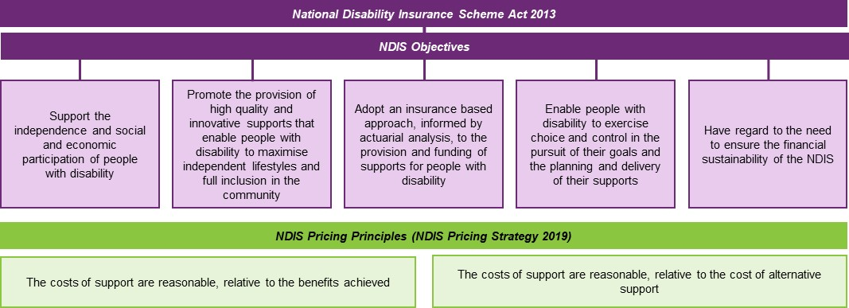
The current priding arrangements for the NDIS are set out in the following documents:
- NDIS Pricing Arrangements and Price Limits – This document sets out the general pricing arrangements that apply to all supports in the NDIS and the specific arrangements that apply to individual supports.
- NDIS Support Catalogue – This document provides information on the current price limits for each support item and indicates for each price-limited support item the claim types (Provider Travel, Non-face-to-face delivery, etc.) that can be used. Requirements specified in the Support Catalogue are part of the pricing arrangements and price limits that the NDIA has determined should apply to NDIS.
- COVID Addendum to the NDIS Pricing Arrangements and Price Limits – This document allows the NDIA to respond to changing market conditions in an efficient manner. It is used to make temporary changes to some of the support items and arrangements listed in the NDIS Pricing Arrangements and Price Limits. The Addendum is not a stand-alone document and must be read in conjunction with the NDIS Pricing Arrangements and Price Limits. Requirements specified in the Addendum are part of the pricing arrangements and price limits that the NDIA has determined will apply to NDIS.
- NDIS Pricing Arrangements for Specialist Disability Accommodation – This document sets out the specific pricing arrangements that apply for Specialist Disability Accommodation (SDA). Providers of SDA supports are also subject to the general arrangements set out in the NDIS Pricing Arrangements and Price Limits.
- NDIS Assistive Technology, Home Modifications and Consumables Code Guide – This document gives further information on the specific pricing arrangements that apply for these types of support. Providers of these supports are also subject to the general arrangements set out in the NDIS Pricing Arrangements and Price Limits.

Pricing Strategy
The pricing arrangements for the NDIS are governed by the NDIS Pricing Strategy, which was adopted by the NDIA Board in 2019. The Strategy recognises that in the short to medium term the NDIS’s pricing arrangements have to take into account both the need for value-for-money (and hence for efficiency in provider operations) and the need to ensure access to supports (including the need to rapidly expand supply during the roll-out of the NDIS).
During the roll out of the NDIS, the markets for disability supports needed to develop at pace, with both significant increases in market supply, improvements in quality and improvements in production efficiency. While improvements to production efficiency (at a given quality level) will, ceteris paribus, reduce costs in the long run, expansion of market supply necessitates higher prices (especially where, as in the case of the NDIS, supply must be maintained to ensure participants can continue to receive critical supports). The NDIS Pricing Strategy therefore recognised higher short-term price limits would be needed to maintain and expand the production of disability supports by providing an incentive for the redirection of resources to the NDIS from other sectors of the economy.
In the long run, the markets for disability supports will mature so that high quality services are delivered at efficient price levels. Efficient price levels represent the long run minimum cost of production of a good or service whose quality is acceptable to the purchasers of the good or service. They are the best representation of the reasonable cost of the provision of a quality support and will, eventually, be the price levels best suited for the development of plans, which are concerned with efficient, effective and appropriate supports. As the market for disability supports becomes stronger it will also be less necessary to impose price controls on the sector, with participants as empowered consumers driving competition and innovation in the markets for disability goods and services. Note, however, that sufficient quality production at efficient price levels is only achievable in mature markets, with strong competition between providers and empowered and informed consumers.
In the short term, sustainable price levels are a better representation of the reasonable cost of the provision of supports. They represent the price at which the average current firm is viable (even if inefficient). In the long run, sustainable price levels will tend towards efficient price levels. However, in the medium term, as the market matures / expands, it is more cost effective and less disruptive to both maintain a significant share of current supply and attract new supply. Setting price caps at sustainable levels helps ensure that supply levels remain stable and providers with costs somewhat above the most efficient level remain viable.
This is why the NDIS Pricing Strategy recognises that the NDIS’s pricing arrangements and price limits need, during roll-out at least, to be set with regard to transitional price levels, rather than sustainable or efficient price levels. Transitional price levels represent the price necessary to attract new providers to enter the market or to reduce exits from the market. They represent the price required to attract economic resources to expand supply. Transitional price levels are above sustainable price levels, but should only be adopted where a significant expansion of supply is required.
In line with the NDIS Pricing Strategy, the base price limits for supports delivered by disability support workers have, since 1 July 2019, been set in line with the estimated efficient costs of delivery. The Temporary Transformation Payment (TTP) loading has been used to adjust these efficient prices to transition levels. The level of the loading was initially set at an amount equal to the difference between the estimated efficient cost of delivery and the estimated average cost of delivery. It was always intended that this amount would decrease over time as providers became more efficient.
Exhibit 2 below summarises the stages through which the NDIS Pricing Strategy envisages price regulation in the NDIS moving as economic forces play out. In the first few phases, price controls are needed to balance the drive for greater efficiency with the need to expand supply. Providers need to be given time to adjust their operations and supply needs to expand significantly, requiring additional investment and roll out costs.
Exhibit 2: Pricing Transition Strategy
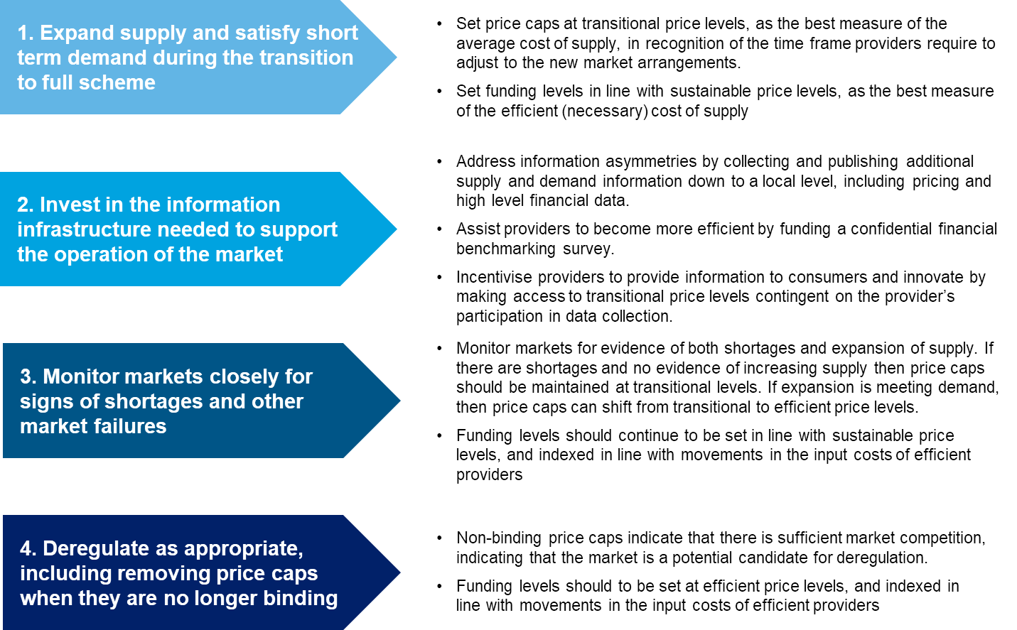

Regulatory Options and the State of the Market
Where possible, the NDIA utilises market mechanisms to deliver the level of supply required to meet participant demand at market clearing (efficient) prices. In underdeveloped markets, regulating the market is necessary to ensure that participant demand is met, the required mix of supports is supplied by providers, and the NDIS moves towards efficient prices.
Higher levels of regulation and market intervention are typically used to address inefficiencies in the market and lower intervention is required in a well-functioning market. Therefore, it is critical to determine how well a market is functioning in order to determine what an appropriate level of regulation and market intervention is.
Exhibit 3 sets out a schematic of the characteristics that need to be considered in determining how well a market is functioning. These characteristics can be used as indicators, whereby all or almost of these indicators being met would indicate that the market is functioning as intended and does not require greater market intervention (or requires less). Similarly, where some or most of these indicators not being met suggests the market is not functioning as intended and requires greater market intervention.
Exhibit 3: Characteristics of a well-functioning market
Demand-side characteristics
Participants are able to exercise informed choice. | Participants are sufficiently incentivised and supported to make purchasing decisions.
Participants have the ability to make purchasing decisions in their best interests.  In cases where participants are unable to make decisions in their best interests, capacity may be provided by a third party who has an obligation to act in the participant’s best interests. | Participants have appropriate incentives to make decisions that are financially sustainable for themselves and for the NDIS. This includes having the information and support (where needed) to navigate market options It also includes flexibility in funding within participant plans to allow ease of provider switching where that is practical.
Supply-side characteristics
Sufficient availability of supports. | Sufficient competition between providers.
A wide range of support providers should be available to participants, across the spectrum of price  Providers are able to operate sustainably in a price deregulated environment. | Competition between suppliers exists to provide discipline to pricing behaviour and drive quality.  In some cases, competition may need to be fostered through NDIA led processes – for example in thin markets, or where direct competition and switching is impractical or detrimental to service outcomes.
General characteristics
NDIS can maintain stability while withstanding change. | Sufficient safeguards are in place to protect participant outcomes,
The NDIA is confident that the NDIS will stay stable and broadly achieve objectives of improving participant outcomes while maintaining financial sustainability. | Safeguards implemented to ensure participants receive high quality services in a price deregulated environment,  Safeguards protect against certain risks associated with price deregulation; e.g. participant budgets are not exhausted leading to critical service gaps.
To assist with the assessment of the options, Exhibit 4 provides a summary of the key considerations for the four main stakeholder groups in the market. The emphasis is on the risk of negative impacts of any approach for these stakeholders
Exhibit 4: Key stakeholder considerations in regulating markets
Participants | Providers | Professionals / Workers | Governments / NDIA
Market access  Service quality | Market development  Service quality | Workforce development  Workforce pipeline | Insurance principles and scheme objects  - Market access  - Service quality  - Sustainability

Market intervention options
There is a spectrum of market intervention options available to the NDIA, which are outlined in Exhibit 5. Whether to use each of these options depends on the characteristics of the market and how well it is functioning. A market that is considered well-functioning requires less intervention and the options to the left of the spectrum may be most appropriate. The options to the right of the spectrum may be more appropriate for a market that still has inefficiency and characteristics that suggest it is still not well-functioning.
Exhibit 5: Spectrum of market intervention options
Market  Facilitation | Market  Deepening | Market  Regulation | Alternative Commissioning
Providing more information about demand or options available to participants, or matching supply and demand. | Facilitating supply to meet needs by ‘pooling’ demand to create additional economies of scale. | Controlling market operations through regulating or setting prices, or controlling market access. | Directly funding a provider in return for a service, or delivering services ‘in-house’ with public sector provision.
Low | Medium | High | High
Market facilitation: can take the form of information provision; demand-supply matching; and/ or supply partnerships. The rationale/pre-conditions for limiting market intervention to these types of intervention are:
- Participants are able to make well informed choices.
- Participants are willing to engage with trusted platforms.
- Providers are able to accept demand risk.
- Barriers to entry are low.
- Competition can be sustained in the market.
Market deepening: can be done either through input market deepening – for example, attracting /training workers; or participant-led linking or bundling. The rationale/pre-conditions for limiting market intervention to these types of intervention are:
- Participants are able to make well informed choices.
- Workforce deepening required to enhance trusted engagement.
- Participant pooling required to increase market depth.
Market regulation: can take the form of either or both price regulation and the regulation of market access. The rationale/pre-conditions for these types of intervention are:
- Monopoly power may drive undesirable pricing outcomes.
- Participants cannot manage certain market risks.
- Market is overly fragmented.
- Market access restrictions are required to ensure engagement and quality.
- Prices do not reflect efficient cost of providing supports.
- Providers willing and able to compete but resulting in perverse outcomes.
Alternative commissioning: which can run alongside other forms of market regulation, can take a number of forms: direct procurement; government provision; and strategic commissioning. The rationale/pre-conditions for these types of intervention are:
- Competition in the market either not possible or appropriate.
- Participants have limited or no choice.
- The individualised model results in risk allocation issues.
- Higher prices do not overcome a lack of market depth.

Price regulation options
There are two key regulatory options available for markets that require a higher level of regulation to enable it to function more efficiently:
- Market access regulation: The NDIS Commission has primary responsibility for market access regulation for registered providers (responsible for the registration and regulation of these NDIS providers).
- Price regulation: The NDIA has a range of price regulation tools available to it (see figure below), which can be deployed individually or in combination.
Price regulation can take several forms:
- Price information: This information can help consumers with decision-making and can help with providing discipline on provider pricing behaviour. It is a relatively low level of regulatory intrusion. However, it has limited impact on the level of supply in the market and there are no repercussions for providers who do not act appropriately.
- Price monitoring: Regular monitoring and reporting on actual market transaction prices and market activity can provide more information for stakeholders, but increases the reporting burden on providers. This approach requires less regulatory oversight than price setting and price approval. It also helps to measure progress against expected outcomes without interfering with the market. However, there are limited repercussions for providers who do not act appropriately and high administrative costs.
- Price approval: Under these arrangements, businesses are required to submit their prices to the regulator for approval. The advantage of this arrangement is that providers are able to charge at a rate that aligns with their cost of service. However, this approach requires significant oversight and resources to process all applications and has high administrative costs for providers. Given the existence of a very large number of providers delivering a large variety of different supports across many locations, this form of price regulation is not practical in the NDIS as it would involve high administrative and compliance costs for providers and the NDIA.
- Price setting: This approach directly determines the prices that businesses can charge. This is the most stringent form of price regulation. The advantages of this approach are that it can ensure providers are adequately compensated for their services and simplifies the market for participants. However, it does not allow flexibility for extraordinary circumstances, tends to reduce innovation and has high administrative costs for providers.
- Price limits: This approach involves determining the maximum price that providers can charge. It is a form of price approval – but has some of the advantages of price setting. This is the current approach adopted by the NDIA.
Exhibit 6 examines the pros and cons of the different mechanisms of price approval/setting.
Exhibit 6: Pros and Cons of pricing Approval/Setting options
Price Approval (Soft Price Limit) | Hard Price Limit | Price Setting
Pros:
Price most reflective of specifics of the participant / provider. | Providers compete on price, creating downward pressure and better value for money.  Price can reflect specifics of the participant / provider. | Greatest certainty on price.  Ease of budgeting once established.
Cons:
Significant administrative burden for NDIA and providers to run the process. | Some participants / contexts may be uneconomical to service.  Advantages large providers with economies of scale and lower cost bases. | Limited downward pressure on price / ensuring value for money.  Price doesn’t reflect specifics of the participant / provider.
Exhibit 7 demonstrates the NDIS transition strategy for pricing – the stages through which price regulation in supports needs to move in order to achieve deregulation.
Exhibit 7: NDIS Transition Strategy for Pricing
Strategic Actions | Description
Expand supply and satisfy short term demand during the transition to full scheme. | Set price limits at transitional price levels, as the best measure of the average cost of supply, in recognition of the timeframe providers require to adjust to the new market arrangements.  Set funding levels in line with sustainable price levels, as the best measure of the efficient cost of supply.
Invest in the information infrastructure needed to support the operation of the market. | Address information asymmetries by collecting and publishing additional supply and demand information down to a local level, including pricing and high-level financial data.  Assist providers to become more efficient by funding a financial benchmarking survey  Incentivise providers to provide information to consumers and innovate by making access to transitional price levels contingent on the provider's participation in data collection.
Monitor markets closely for signs of shortages and other market failures. | Monitor markets for evidence of both shortages and expansion of supply. If there are shortages and no evidence of increasing supply, then price limits should be maintained at transitional levels. If expansion is meeting demand, price limits can shift from transitional to efficient price levels.  Funding levels should continue to be set in line with sustainable price levels, and indexed in line with movements in the input costs of efficient providers.
Deregulate as appropriate, including removing price limits when they are no longer binding. | Non-binding price limits indicate that there is sufficient market competition, indicating that the market is a potential candidate for deregulation.  Funding levels should be set at efficient price levels, and indexed in line with movements in the input costs of efficient providers

Provider Efficiency
The results of the Financial Benchmarking Study for the 2020-21 financial year indicate that the average fully loaded cost of delivering an hour of support by a Disability Support Worker (DSW) during standard business hours (weekday daytime) in the Assistance with Daily Living or Community, Social and Economic Participation support categories was about 68% higher than the base NDIS price limit. The 25th percentile of current performance was about 7% above the base NDIS price limit (see Exhibit 8).
Exhibit 8: Financial Benchmarking Survey – Fully Loaded Hourly Costs
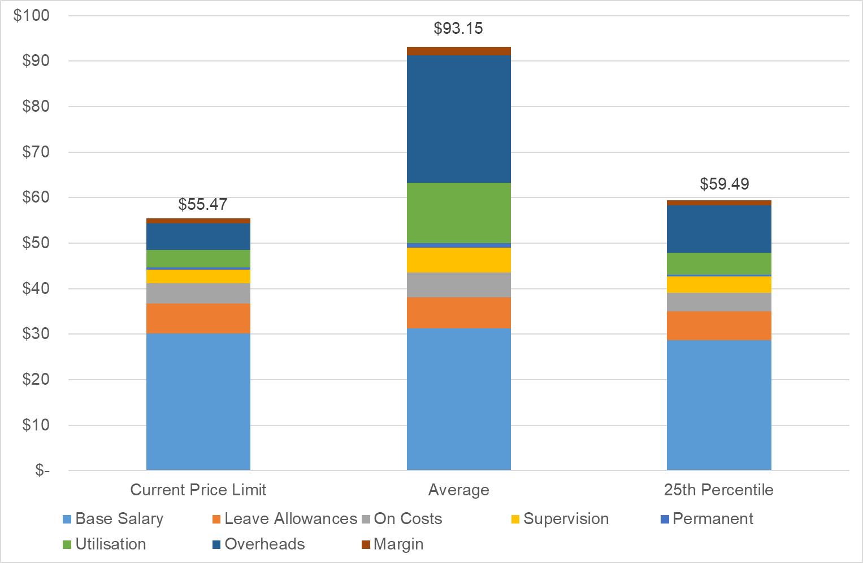
It is clear that most providers can still make major efficiency gains – especially in terms of their overheads and in terms of the utilisation of their workers. In the 2020-21 survey:
- On average, overheads accounted for 30.7% of total costs compared to the level achieved by the 25th percentile of providers at 17.9%.
- On average, providers achieved a utilisation rate – billable hours as a share of available hours (excludes leave) – of 79% compared to the level achieved by the 25th percentile of providers of 90%.
- On average, providers achieved a span of control – disability support workers per front line supervisor – of 10.6 to 1 compared to the level achieved by the 25th percentile of providers of 13.2 to 1.
Further details from the Financial Benchmarking Study can be found in Appendix D.

Temporary Transformation Payment (TTP)
As noted above, a key component of the NDIS Pricing Strategy is the Temporary Transformation Payment (TTP) loading which is used to adjust efficient prices to transition levels. It was always intended that the loading would decrease over time as an incentive to providers to become more efficient. The level of the loading was 7.5% in 2019-20, 6.0% in 2020-21, and 4.5% in 2021-22. It is scheduled to reduce to 3.0% in 2022-23, to 1.5% in 2023-24 and to 0% from 1 July 2024.
A number of supports in the Assistance with Daily Living Support Category and the Social, Economic and Community Participation Support Category are in the scope of the TTP. These supports have two support items, in line with the following example.
01_011_0107_1_1 | Assistance With Self-Care Activities - Standard - Weekday Daytime
01_011_0107_1_1_T | Assistance With Self-Care Activities - Standard - Weekday Daytime - TTP
The price limit for each TTP item is higher than the price limit for the non-TTP item by the amount of the TTP loading.
The TTP items can only be used by providers who are compliant with the TTP conditions (see below). Providers who meet these eligibility criteria are known as TTP providers. All providers who claimed for the TTP in 2021-22 had to:
- Publish their service prices prominently on their website, and make them available to participants, including participants who are not their clients, and the NDIA on request.
- List their business contact details in the Provider Finder in the myplace portal and ensure that those details are kept up-to-date.
- Take part in the Financial Benchmarking Survey that was carried out for the NDIA in 2021-22.
In addition, providers who made a claim for the TTP in 2020-21 could only claim for the TTP in 2021-22 if they also took part in the Financial Benchmarking Survey that was carried out for the NDIA in 2020-21.

Take up of the TTP
Most providers who deliver TTP-able supports do not use the TTP support items (and thereby access the higher price limits). In 2020-21, there were some 18.4 million claims for supports in scope of the TTP. These claims were worth $7.0 billion. The supports were delivered by 62,219 registered and unregistered providers to 198,298 participants. Some 45.1% of all participants who made at least one claim in 2020-21 made a claim for a TTP-able support. About half of all TTP-able supports were claimed using the TTP support items:
- 51.8% of claims for TTP-able supports were for a TTP support item rather than the equivalent non-TTP support item.
- 42.9% of expenditure on TTP-able supports was on TTP support items rather than the equivalent non-TTP support items.
Providers are increasingly less likely to use the TTP support items when they claim for TTP-able supports. Fewer than half of all TTP-able supports were claimed using the TTP support items (and subject to the higher TTP price limits) in the first half of 2021-22:
- 47.3% of claims for TTP-able supports were for a TTP support item rather than the equivalent non-TTP support item.
- 37.8% of expenditure on TTP-able supports was on TTP support items rather than the equivalent non-TTP support items.
The rate at which each TTP support item is used rather than its equivalent non-TTP support item is highly variable (see Exhibit 9 below). However, the supports where more than 50% of all claims for TTP-able supports were made against the TTP support item rather than the non-TTP support item are, in general, the supports that are less used. These supports accounted for only 15.0% of all claims (by expenditure) for TTP-able supports.
Exhibit 9: Share of claims made against the TTP rather than the non-TTP support item
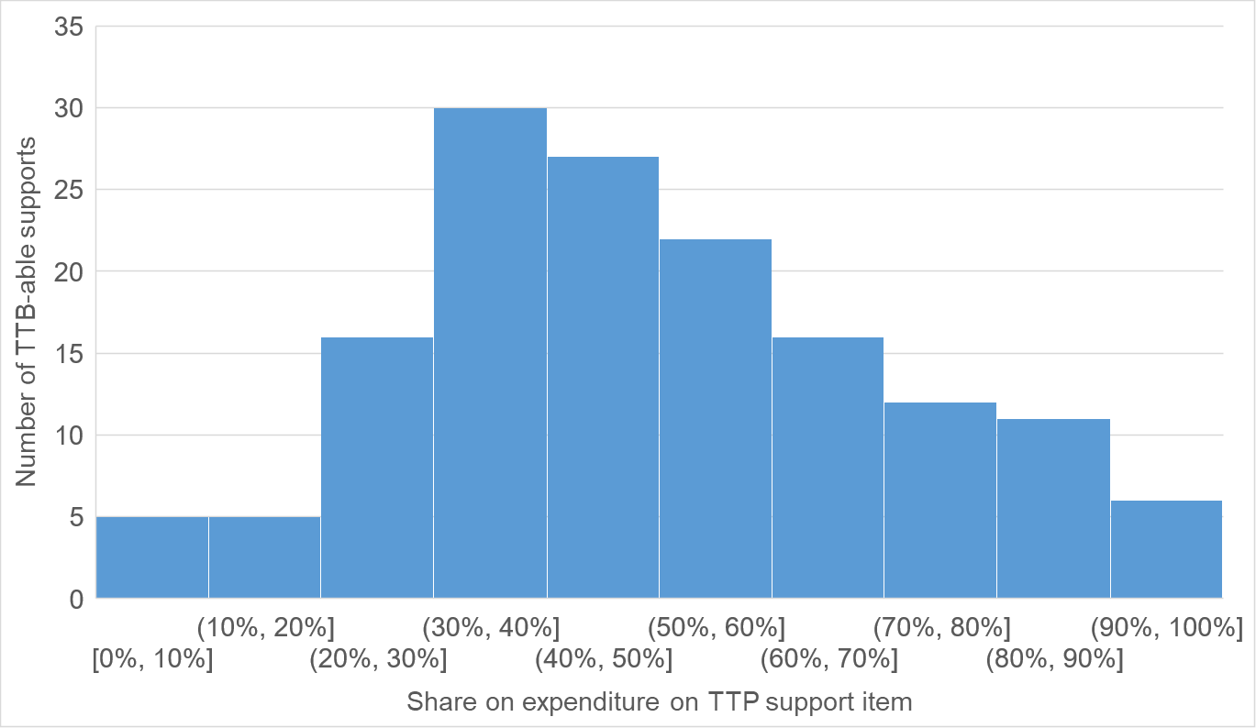
For the two most used support items (by expenditure) in the first half of 2021-22, which together accounted for more than half (52.3%) of all expenditure on TTP-able support items in that period, most claims were for the non-TTP item rather than the TTP item:
- Assistance With Self-Care Activities - Standard - Weekday Daytime, only 27.1% of claims (by expenditure) were for the TTP support item.
- Access Community Social And Rec Activities - Weekday Daytime, only 40.0% of claims (by expenditure) were for the TTP support item.
There is also some variation in the use of TTP by support purpose:
- 29.1% of expenditure on TTP-able supports in the Assistance with Daily Life support category was on TTP support items rather than non-TTP support items.
- 47.3% of expenditure on TTP-able supports in the Community Participation support category was on TTP support items rather than non-TTP support items.
- 64.5% of expenditure on TTP-able Supports in Employment was on TTP support items rather than non-TTP support items.
Of the 69,201 providers who made a claim for the delivery of a TTP-able support item in the first half of 2021-22, the vast majority (89.8%) always claimed for the non-TTP support item –noting that many of these were unregistered providers who are not permitted to claim for the TTP support items. Of the 10.2% of providers who made a claim for at least one support item that was subject to the higher TTP price limit, the vast majority (92.3%) claimed for a mixture of supports (some subject to the TTP price limit and some subject to the lower price limit).
Providers are slightly more likely to seek to access the TTP price limits in regional and remote areas compared to major cities and regional centres. However, it was still the case that in regional areas (MMM4-5) some 87.7% of providers never claimed for a support item at the TTP price limit – 84.4% of providers in remote and very remote areas (MMM6-7).
It is difficult to precisely state the amount of Scheme funds that are spent on the TTP loading because not all supports are delivered at the price limit. However, at most, some $70.1 million was spent on the TTP loading in the first half of 2021-22.

Compliance with the TTP eligibility conditions
A significant number of providers who claim for the TTP are not meeting the TTP eligibility requirements. Only 64.1% of providers who claimed the TTP in 2020-21 completed the benchmarking survey for the 2019-20 financial year, and only 37.1% of providers who claimed TTP in the first half of 2021-22 completed the benchmarking survey for the 2020-21 financial year.
At the same time, 18.9% of registered providers who could have claimed for the TTP in 2020-21, but did not for the claim for the TTP, voluntarily agreed to take part in the benchmarking survey for the 2019-20 financial year. In the benchmarking survey for the 2020-21 financial year, some 15.7% of respondents had not claimed for the TTP.

Macroeconomic Conditions
The Parliamentary Budget Office projects that gross debt for the Commonwealth will peak at around 50% of GDP in 2028-29 before falling slightly towards the end of the medium term. Growth in nominal GDP is projected to exceed the interest rate on debt, resulting in debt as a share of GDP stabilising despite the projected persistence of underlying cash deficits (see Exhibit 10).
Exhibit 10: Australian Government Gross Debt – 1971-72 to 2031-32
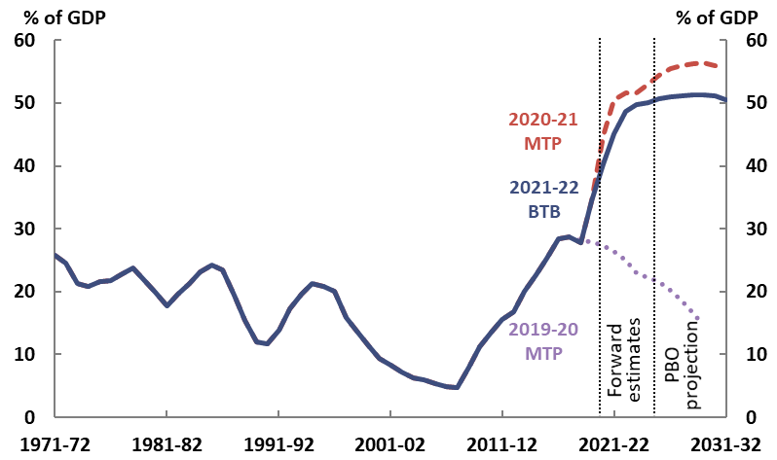
The Parliamentary Budget Office also projects that NDIS payments will increase from 0.6% of GDP in 2018-19 to 1.7% of GDP (base case) by 2031-32, with significant risks on the upside (see Exhibit 11). The average annual growth rate of the payments by the NDIS is projected to be 11.1% from 2018-19 to 2031-32, which is more than four times the average annual growth for all Australian Government expenditure over the same period (2.7%).
Exhibit 11: PBO Scenarios for NDIS Payments
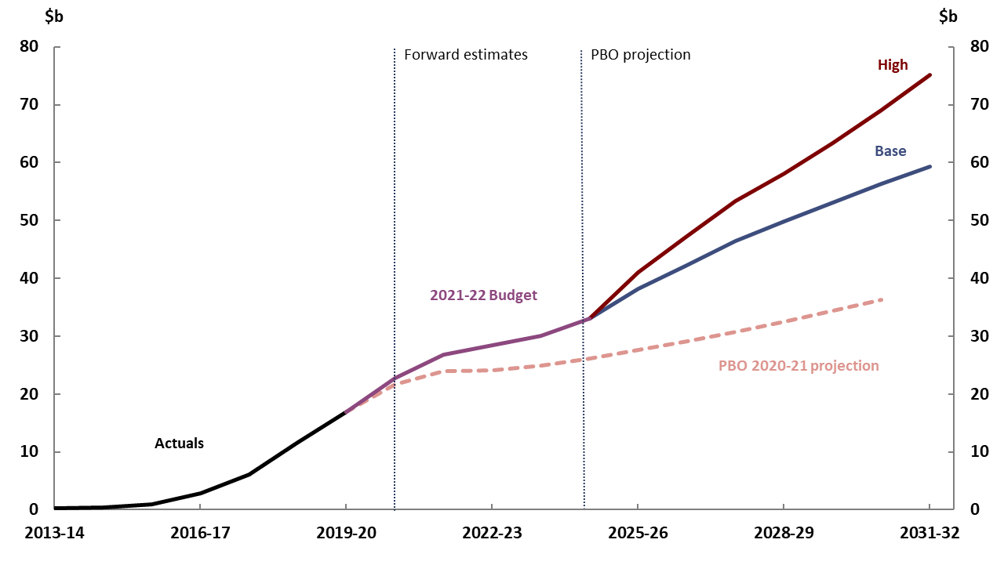
By 2031-32, the NDIS is projected to account for 6.6% of all Australian Government expenditure. That would be slightly less than half what the Australian Government is projected to spend on health care (14.0%) and more than half what the Australian Government is projected to spend on income support for older people, people with disabilities and the unemployed (12.0%). It is more than what the Australian Government is projected to spend on aged care (5.5%) and childcare (1.8%) (see Exhibit 12).
Exhibit 12: Comparison of payments by key program area, 2018-19 to 2031-32
Payments | Nominal payments | Nominal payments | Per cent of GDP | Per cent of GDP | Change in per. points of GDP |  | Annual real growth | Share of total payments
 | 2018-19 | 2031-32 | 2018-19 | 2031-32 | To 31-32 | To 31-32 |  | 2031-32
 | $ billion | $ billion | % | % | % point |  | % | %
Age pension | 47 | 80 | 2.4 | 2.3 | 0.0 |  | 2.0 | 8.9
Aged care | 20 | 50 | 1.0 | 1.5 | 0.4 |  | 4.7 | 5.5
NDIS | 11 | 59 | 0.6 | 1.7 | 1.2 |  | 11.1 | 6.6
Disability support pension | 17 | 23 | 0.9 | 0.7 | -0.2 |  | 0.3 | 2.6
Carer income support | 9 | 16 | 0.5 | 0.5 | 0.0 |  | 2.5 | 1.8
Veterans support | 6 | 4 | 0.3 | 0.1 | -0.2 |  | -5.0 | 0.5
Medicare Benefits Schedule | 24 | 48 | 1.2 | 1.4 | 0.2 |  | 3.1 | 5.4
Public hospitals | 22 | 46 | 1.1 | 1.3 | 0.2 |  | 3.6 | 5.1
Pharmaceutical Benefits Scheme | 13 | 22 | 0.7 | 0.6 | 0.0 |  | 1.9 | 2.5
Private Health Insurance Rebate | 6 | 9 | 0.3 | 0.3 | -0.1 |  | 0.5 | 1.0
Income support for unemployed | 11 | 19 | 0.6 | 0.6 | 0.0 |  | 2.1 | 2.1
Family tax benefit | 18 | 18 | 0.9 | 0.5 | -0.4 |  | -2.2 | 2.0
Child care | 7 | 16 | 0.4 | 0.5 | 0.1 |  | 4.1 | 1.8
Total payments | 478 | 899 | 24.5 | 26.2 | 1.8 |  | 2.7 | 100.0

Employment Statistics and Projections
Over the five years to July 2021, the number of people employed in Australia increased by 1.2 million to 12.72 million. The average annual growth rate over the last five years was 1.9%, which was above the rate of growth recorded over the last decade (1.6%).
Employment growth is not projected to be as strong across the economy over the five years to November 2026 with total employment projected to increase by around 1,176,200 (9.1%) over the period from 13.0 million to 14.1 million. This equates to an average annual growth rate of 1.75%. As Exhibit 13 illustrates, the long-term structural shift in employment towards services industries is projected to continue over the five years to November 2025.
Exhibit 13: Employment levels, past and projected - four largest growing industries
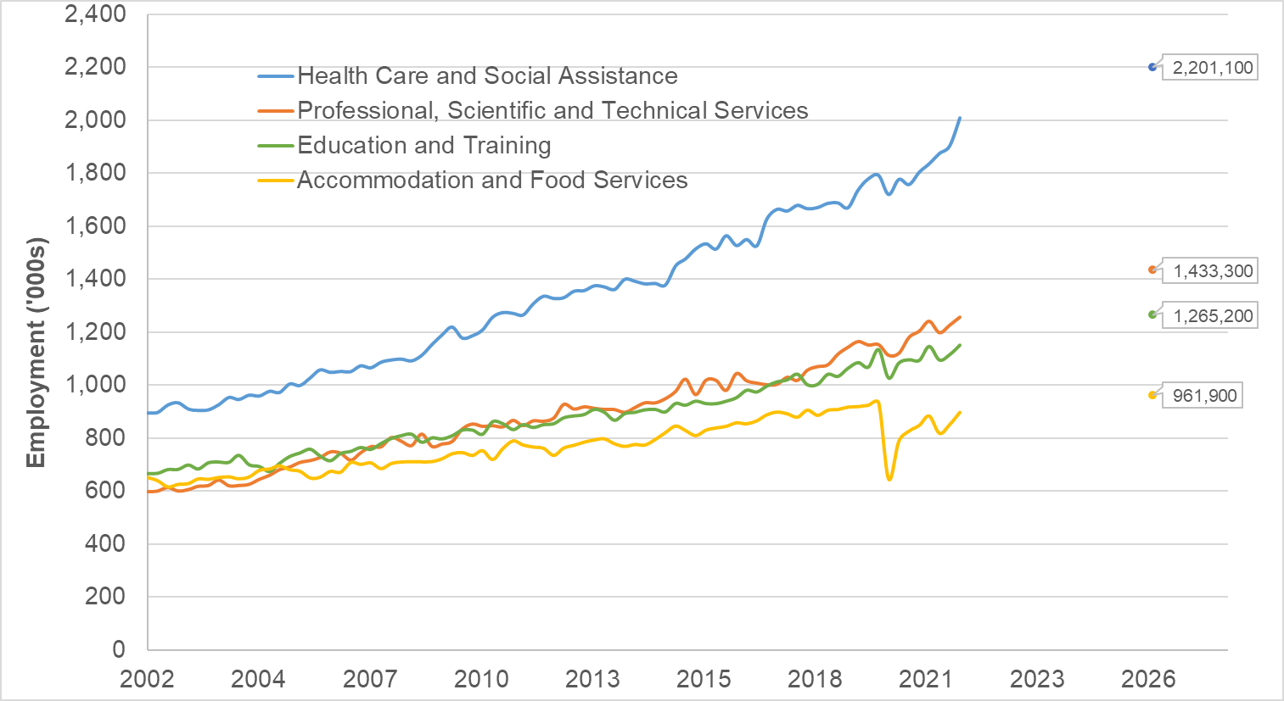

A number of services industries made large contributions to employment growth over the last five years, led by the Health Care and Social Assistance industry – up by 267,900 (17.1%) to 1.8 million. In November 2020, the Health Care and Social Assistance industry accounted for 13.8% of all employment in the Australian economy.
Employment in Health Care and Social Assistance, the primary provider of new jobs in the Australian labour market since the 1990s, is projected to increase by 301,000 (15.8%) over the five years to November 2026 to 2.0 million. The sector is projected to make the largest contribution to employment growth over the period and will account for more than a quarter (25.6%) of all employment growth in the period. By November 2026, the Health Care and Social Assistance industry will account for 15.6% of all employment in the Australian economy.
At a regional level, as Exhibit 14 illustrates, growth in employment over the five years to November 2025 in Health Care and Social Assistance will be greatest in regional Queensland (19.7%) and Greater Perth (17.4%). It will be significantly lower than the national average in regional Tasmania (4.9%), regional Western Australia (5.4%) and regional South Australia (7.6%). Growth will also be significantly lower than the national average in Greater Adelaide. (8.1%).
Exhibit 14: Projected Employment Growth, Health Care and Social Assistance Sector, 2020-2025
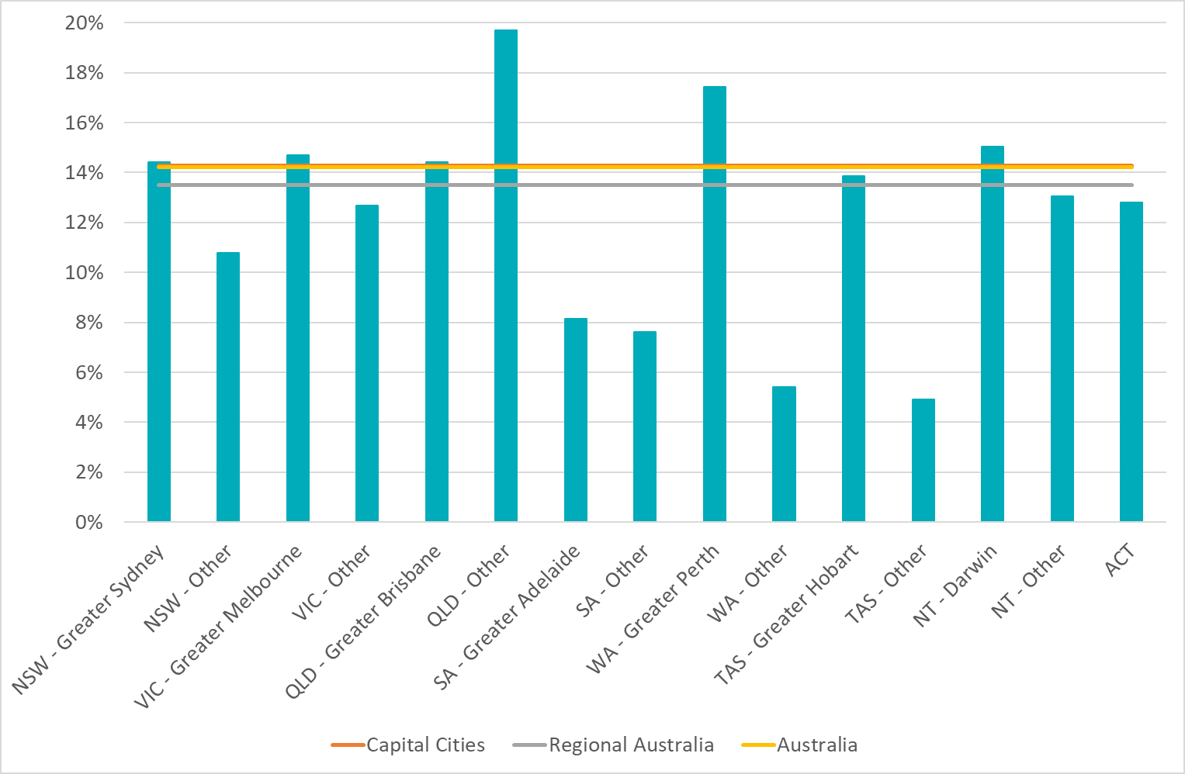
Employment is projected to increase across all eight of the broad occupational groups and all five skill levels over the five years to November 2026. Very strong employment growth is projected to continue for Community and Personal Service Workers (up by 186,900 or 13.5%), consistent with strong projected growth in the service industries that are the leading employers of this occupational group. The strong projected employment growth in Community and Personal Service Workers is, at least in part, a product of the labour market recovery to be made in the occupation group, as this occupation group includes hospitality workers, who were was the most impacted by the COVID-19 pandemic. Community and Personal Service Workers are expected to account for 16.0% of the total growth in employment over the five years to November 2026.
At the micro occupation level, the number of people employed as Personal Carers and Assistants is expected to increase by 87,400 from 401,400 to 488,800 (or 21.8%) over the five years to November 2026. Within this occupation group, the number of Aged or Disabled Carers is expected to increase by 74,900 from 266,900 to 341,800 (or 28.0%) over the same period compared to projected total employment growth over the same period of 9.1%. This occupation has the 12th highest projected growth rate of all 444 occupations modelled by the National Skills Commission and has the highest growth rate among all non-professional occupations.
The ratio of vacancies to employment for Aged and Disabled Carers is currently 14.3, compared to 13.4 one year ago and 10.8 five years ago. The number of vacant positions for Aged and Disabled Carers has grown by 75.0% over the last two years. Similarly, the number of job advertisements for Aged and Disabled Carers has increased significantly over the last two years – up by 67.1% in the last two years and 38.9% in the last year (see Exhibit 40). The number of job advertisements for Nursing Support and Personal Care Workers has also increased significantly over the last two years – up by 126.8%.
Exhibit 15: Growth in Job advertisements for Aged and Disabled Carers, 2011 to 2021
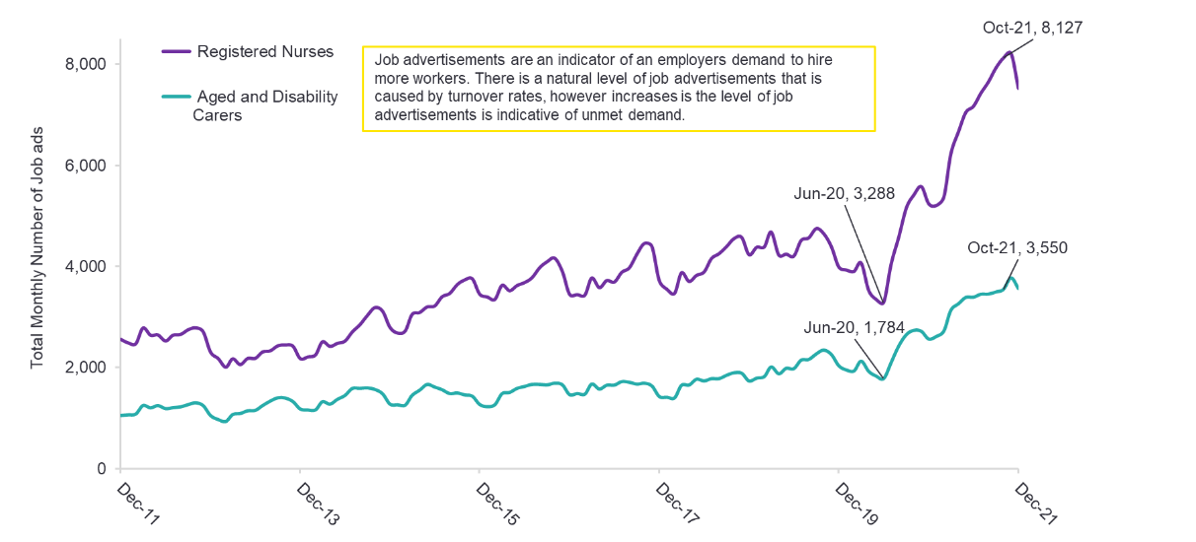

Discussion
A total of 35 submissions about the NDIS Pricing Strategy and the Temporary Transformation Payment were received in response to the Consultation Paper. The working group had 18 members from 17 organisations and met, by video-conference, on two occasions: 2 December 2021 and 3 February 2022.
A detailed report of the consultations is provided in the 2021-22 Annual Pricing Review Report on Consultations, particularly Section 4 (Temporary Transformation Payment).

Pricing Strategy
As noted above, it is clear that most providers can still make major efficiency gains – especially in terms of their overheads and in terms of the utilisation of their workers. In the 2020-21 survey:
- On average, overheads accounted for 30.7% of total costs compared to the level achieved by the 25th percentile of providers at 17.9%.
- On average, providers achieved a utilisation rate – billable hours as a share of available hours (excludes leave) – of 79% compared to the level achieved by the 25th percentile of providers of 90%.
- On average, providers achieved a span of control – disability support workers per front line supervisor – of 10.6 to 1 compared to the level achieved by the 25th percentile of providers of 13.2 to 1.
Given the high levels of inefficiency in the sector and noting the need to further empower participants it is recommended that the current pricing strategy should be maintained and that the TTP arrangements should stay in place on their current timeline to balance the concerns raised by the significant difference between the cost structures of many providers and the theoretic efficient price, and the need to incentivise those providers to find greater efficiencies.
The NDIA should also provide greater certainty to providers by committing to maintain the real value of the NDIS’s price limits and so maintain the supply of supports for participants (subject to the results of any future review). This will help to attract the investment into the sector that is needed for it to be able to innovate to achieve greater efficiency and to improve the quality and safety of the supports that it delivers.
It is therefore recommended that the NDIA, subject to any specific recommendation arising from the current Annual Pricing Review and any future reviews, should:
- Increase the price limits for supports that are determined by the NDIS Disability Support Worker Cost Model on 1 July each year to reflect any changes in the minimum wages specified in the SCHADS Industry Award following the Fair Work Commission’s Annual Wage Review and any increase in the Superannuation Guarantee Charge.
- Increase the price limits for Capital supports – Support Categories 2 (Transport), 3 (Consumables), 5 (Assistive Technology) and 6 (Home Modifications and Specialised Disability Accommodation) – on 1 July each year in line with the movement in the Australian Bureau of Statistics (ABS) Consumer Price (All Groups, weighted average of eight capital cities) over the 12 months to the March Quarter immediately preceding the indexation date.
- Increase the price limits for other supports on 1 July each year in line with the weighted movement over the previous twelve months in the ABS Wage Price Index (Australia, total hourly rates of pay excluding bonuses) and the ABS Consumer Price Index (All Groups, weighted average of eight capital cities) over the 12 months to the March Quarter immediately preceding the indexation date (with an 80/20 weighting).
The number of vacant jobs in the national economy is at an historic high while unemployment and underutilisation rates are low. This is creating increased competition for labour. This national pattern extends to the Healthcare & Social Assistance sector where the number of job vacancies per employed person is more than double the 5-year average rate, indicating that employers are having difficulty in filling open positions.
Between June 2020 and October 2021, the number of job advertisements for Aged & Disability worker job vacancies more than doubled, which is an indicator that there is an increasing level of unmet demand for workers. This trend has also been seen for key NDIS occupations over 1-year, 5-year and 10-year time horizons, where there has been an increasing job advertisement to employment ratio, indicating that it has become more difficult to fill vacant positions in NDIS occupations in recent years.
The National Skills Commission finds that Aged or Disabled Carers are an Occupation in Shortage, and that that workforce will grow by 28.0% over next five years – compared to 9.1% across economy. This occupation has the highest growth rate for all non-professional occupations and the 12th highest growth rate overall.
For some workers, the prospect of higher wages and better working conditions in other industries may be affecting the sector's ability to attract and retain workers. Health Care & Social Assistance workers earn less than other industries, ranking 14th out 19 industries in median weekly earning. Moreover, this statistic understates the issue as the median weekly earnings in the Health Care & Social Assistance sector are inflated by the presence of medical, nursing and allied health professionals.
The Work Value Case of aged care workers that is currently before the Fair Work Commission will be heard from 26 April to 11 May 2022. The case is seeking a 23% increase in minimum wages – which would decrease the competitive advantage of disability employers against aged care providers in the employment market.
The disability sector is also facing immediate cost pressures, whose range and scope of impact are likely to be significant but not entirely predictable, because of quality and safeguarding costs; ongoing and embedded COVID-19 costs; and the cost implications of changes to the SCHADS Industry Award that come into effect on 1 July 2022, in particular the requirement to pay broken shift allowances and a minimum two-hour engagement period for all workers. Another minor increase in costs for some providers from 1 July 2022 is the removal of the $450 per month threshold before superannuation payments are required. These issues are discussed further in the next chapter of this report.

Empowering Consumers and Supporting Providers
In the current phase of the NDIS Pricing Strategy – see phases 2 and 3 in Exhibit 2. The NDIA, as market steward, needs to invest in the infrastructure needed to address information asymmetries and to assist providers gain access to the information that they need to improve their operations. It also needs to monitor the development of the market closely to identify where particular localised supply shortages need to be addressed.
Providers need to be given the tools to achieve long run efficiencies, by being able to properly understand the performance of their own organisation and to accurately compare their performance to that of their peers. This requires good accounting and governance standards and practices and the ability to compare performance across providers. The NDIA and the NDIS Commission can assist providers do this by encouraging providers to adopt better accounting and governance standards and practices over time as part of provider registration requirements. The NDIA can also support the establishment of independent performance and financial benchmarking services and provider’s participation in those services, especially where providers operate in thinner markets.
In addition to the supply data that it already releases, the NDIA should consider collecting and publishing data from consumers (Scheme participants) to monitor short to medium term outcomes, including rates of participant satisfaction with their providers, the degree to which participants consider they are empowered to choose their own support, and the prices that are paid by participants in local markets.
Going forward, consumer and outcomes data should be collected and published on a regular basis to enable consumers to get a detailed view of provider performance and enable future moves towards outcomes based pricing. Information collected could include: satisfaction with individual supports received; outcomes (for example, employment gained and engagement with the community); ease of market access (measuring any potential supply shortages); level of participant empowerment; and prices paid.
Collecting and publishing such additional consumer data can be used to both measure the performance of disability support providers in the longer-term transition to outcomes based pricing, and can help identify any areas where undersupply is occurring in the short term.
A key role of the NDIA as Market Steward is to ameliorate information asymmetries between suppliers of disability supports and participants. The NDIA should provide participants with a mechanism to easily compare the prices and services offered by multiple providers to reduce the significant transaction costs on the participant.
It is therefore recommended that the NDIA, as part of its ongoing role as market steward, should partner with the sector to:
- Support an annual financial benchmarking survey to assist providers compare themselves to their peers to identify opportunities for increased efficiency; and
- Address the information asymmetries facing participants, including by regularly publishing, at a regional level and for specific supports, the range of prices that participants are currently paying for the supports that they receive.
The NDIA should also explore options to encourage or require providers to publish their prices to better inform participant choice. Where providers choose to charge NDIS participants different rates to other clients they should also be open about this.
Price control frameworks can impose administrative burdens on providers. It is important to reduce transaction costs through ease and simplicity in the design of price control arrangements wherever possible. Equally, however, the NDIA must ensure that participants are fully informed and empowered to achieve maximum flexibility to use their budgets to meet their goals as they see fit. Ideally these two principles can work together to improve outcomes for participants. Currently, the NDIS Pricing Arrangements and Price Limits is over a hundred pages long. Providers regularly report that it can be difficult to understand. Consultations with participants also indicate that the current material is very difficult to understand and that it should be translated into plain English. The NDIA is committed to improving the quality and detail of information and guidance that it provides, and needs to ensure at the same time that the information is both sufficiently precise to cover all possible provider situations and sufficiently broad so as to encompass a variety of participant circumstances.
Members of the Participant Reference Group demonstrated a wide range of familiarity and comfort with the Pricing Arrangements and Price Limits. However, some found it difficult to use. Some members of the Participant Reference Group said their Plan Managers or Support Coordinators introduced them to the Pricing Arrangements and Price Limits, and relied on them to help navigate and interpret the document. In general, most members of the Participant Reference Group indicated that the Pricing Arrangements and Price Limits was immensely useful to check prices quoted by providers but felt that the document as currently drafted was very long and not user-friendly. Several members of the Participant Reference Group suggested a Plain English or an ‘easy read’ version of the Pricing Arrangements and Price Limits, and noted this could be particularly useful for participants with intellectual disability.
The current arrangements (documents downloadable from the NDIS website) can also make it hard for people to find the most recent information – or to be sure that the information that they have is up to date. The current documentation is not easy to update – or to ensure that everyone is aware of the most recent documentation. Moving to a web-based system might help address this.
It is therefore recommended that the NDIA should explore options to facilitate better access to the pricing arrangements for participants, including through the development of a plain English guide, and to reduce administrative costs for providers by streamlining and automating access to updates to the pricing arrangements and price limits.

Recommendations
Recommendation 1
The NDIA should maintain its current pricing strategy including the scheduled reduction over the next three years of the Temporary Transformation Payment (TTP) loading to 3.0% on 1 July 2022 and 1.5% on 1 July 2023. The TTP loading should cease to apply from 1 July 2024.
Recommendation 2
The NDIA, subject to any specific recommendation arising from the current Annual Pricing Review and any future reviews, should:
Increase the price limits for supports that are determined by the NDIS Disability Support Worker Cost Model on 1 July each year to reflect any changes in the minimum wages specified in the SCHADS Industry Award following the Fair Work Commission’s Annual Wage Review and any increase in the Superannuation Guarantee Charge,
Increase the price limits for Capital supports – Support Categories 2 (Transport), 3 (Consumables), 5 (Assistive Technology) and 6 (Home Modifications and Specialised Disability Accommodation) – on 1 July each year in line with the movement in the Australian Bureau of Statistics (ABS) Consumer Price (All Groups, weighted average of eight capital cities) over the 12 months to the March Quarter immediately preceding the indexation date.
Increase the price limits for other supports on 1 July each year in line with the weighted movement over the previous twelve months in the ABS Wage Price Index (Australia, total hourly rates of pay excluding bonuses) and the ABS Consumer Price Index (All Groups, weighted average of eight capital cities) over the 12 months to the March Quarter immediately preceding the indexation date (with an 80/20 weighting).
Recommendation 3
The NDIA, as part of its ongoing role as Market Steward, should partner with the sector to:
Support an annual financial benchmarking survey to assist providers compare themselves to their peers to identify opportunities for increased efficiency; and
Address the information asymmetries facing participants, including by regularly publishing, at a regional level and for specific supports, the range of prices that participants are currently paying for the supports that they receive.
Explore options to encourage or require providers to publish their prices to better inform participant choice. Where providers choose to charge NDIS participants different rates to other clients they should also be open about this.
Recommendation 4
The NDIA should explore options to facilitate better access to the pricing arrangements for participants, including through the development of a plain English guide, and to reduce administrative costs for providers by streamlining and automating access to updates to the pricing arrangements and price limits.

Endnotes

Disability Support Worker Cost Model
This chapter examines the ongoing appropriateness of the methodology and parameters used in the NDIS Cost Model for Disability Support Worker, including through analysis of the most recent financial benchmarking data, paying particular regard to:
- The outcomes of the Fair Work Commission’s 4 yearly review of the Social, Community, Home Care and Disability Services (SCHADS) Industry Award 2010.
- Any additional costs faced by providers as a result of the COVID-19 pandemic.
- The costs of registering with the NDIS Quality and Safeguards Commission (NDIS Commission) and the costs associated with ensuring quality and safety of supports for people with disability.
These issues are considered in the remainder of this Chapter.
- Section 3.1 provides an overview of the NDIS Disability Support Worker Cost Model.
- Section 3.2 provides an overview of the issues that were raised in the consultations.
- Section 3.3 analyses the cost implications for providers of the changes to the SCHADS industry Award that are due to commence on 1 July 2022.
- Section 3.4 analyses the impact of the COVID-19 pandemic on the costs of providers.
- Section 3.5 examines quality and safeguarding costs.
- Section 3.6 draws conclusions from the available evidence and recommends some changes to the NDIS Disability Support Worker Cost Model.

Background
The NDIA uses the NDIS Disability Support Worker Cost Model to estimate the costs that a reasonably efficient provider would incur in delivering a billable hour of support. The Cost Model takes account of all of the costs associated with every billable hour, including: base pay; shift loadings; holiday pay; salary on costs; supervision costs; utilisation (non-billable activities); employee allowances; corporate overheads and margin. It uses these estimates to set the price limits of supports that are delivered by Disability Support Workers (DSWs), with price limit set at the level that can be achieved by providers who match the benchmarks.
Base price levels are set with reference to the revealed economics of current providers. They are determined by the outcomes achieved by the most efficient (the 25th percentile) of providers. This means that at least 25% of providers in the sector are currently operating at better than this cost benchmark. The NDIA considers that these benchmarks therefore represent reasonable targets for providers to aim for in the delivery of their services.

Applicable Industrial Award
The national award for DSWs is the Social, Community, Home Care and Disability Services Industry Award 2010 (SCHADS Industry Award). The NDIA recognises that some DSWs are employed under Enterprise Bargaining Agreements (EBAs). However, these EBAs have to leave the worker no worse off overall than they would be under the relevant Award. Any additional benefits offered by EBAs over the Award have been agreed to by providers and are often offset by productivity gains. The NDIA therefore considers the conditions set out in the SCHADS Industry Award to be the appropriate foundation for the Cost Model.

Base Pay
The NDIA recognises that providers have to employ DSWs with different skill levels and levels of experience to meet the different needs of participants. The Cost Model therefore has different sets of cost assumptions for four types of workers (DSW Level A, DSW Level B, DSW Level C and DSW Level D). Table 1 sets out the Cost Model’s assumptions with respect to the base pay of DSWs.
Table 1: Assumed SCHADS Classifications and Pay Rates, 1 July 2021
DSW Level | Assumed SCHADS Classification | Award Hourly Rate
DSW Level A | 2.3 | $30.94
DSW Level B | 2.4/3.1 | $32.16
DSW Level C | 3.2 | $33.48
DSW Level D | 4.4 | $40.39

Shift Loadings
Table 2 sets out the Cost Model’s assumptions with respect to shift loadings. These assumptions are based on the SCHADS Industry Award.
Table 2: Shift Loadings, 1 July 2021
Shift | Permanent Loading | Casual Loading
Weekday | 0.0% | 25.0%
Saturday | 50.0% | 75.0%
Sunday | 100.0% | 125.0%
Public Holiday | 150.0% | 175.0%
Evening Shift | 12.5% | 37.5%
Night Shift | 15.0% | 40.0%

Days Worked Versus Days Paid
The Cost Model recognises that under the SCHADS Industry Award a permanent worker’s ordinary hours of work will be 38 hours per week, and that they will be available to work on 220 days a year, because under the National Employment Standards they must be paid for:
- 20 days of annual leave;
- 10 days of public holidays; and
- Up to 10 days of personal leave.
The Cost Model recognises that providers need to accrue the revenue to meet the costs of these leave accruals during the billable hours of the DSW. The Cost Model also recognises that workers accrue Long Service Leave entitlements when they work and that again providers need to accrue the revenue to meet the costs of this leave accrual during the billable hours of the DSW. The Cost Model assumes that workers accrue 4⅓ days of long service leave each year. In line with the SCHADS Industry Award, the Cost Model also provides a 17.5% loading for annual leave to compensate workers for the shifts they would have otherwise taken.
Table 3: Impact of Leave on the Cost per Worked Hour of a Permanent DSW
Parameters | DSW A | DSW B | DSW C | DSW D
Standard Hourly Rate | $30.94 | $32.16 | $33.48 | $40.39
Allowance for Annual leave
a. No. hours leave accrued in a year (hours/year) | 152 | 152 | 152 | 152
b. Loading | 17.5% | 17.5% | 17.5% | 17.5%
c. Proportion of leave taken | 100.0% | 100.0% | 100.0% | 100.0%
Cost per worked hour | $3.30 | $3.44 | $3.58 | $4.31
Allowance for Personal leave
a. No. hours leave in a year (hours/year) | 76 | 76 | 76 | 76
b. Loading | 0.0% | 0.0% | 0.0% | 0.0%
c. Proportion of leave taken | 100.0% | 100.0% | 100.0% | 100.0%
Cost per worked hour | $1.41 | $1.46 | $1.52 | $1.84
Allowance for Public Holiday leave
a. No. hours leave accrued in a year (hours/year) | 76 | 76 | 76 | 76
b. Loading | 0.0% | 0.0% | 0.0% | 0.0%
c. Proportion of leave taken | 100.0% | 100.0% | 100.0% | 100.0%
Cost per worked hour | $1.41 | $1.46 | $1.52 | $1.84
Allowance for Long Service leave
a. No. hours leave accrued in a year (hours/year) | 32.93 | 32.93 | 32.93 | 32.93
b. Loading | 0.0% | 0.0% | 0.0% | 0.0%
c. Proportion of leave taken | 100.0% | 100.0% | 100.0% | 100.0%
Cost per worked hour | $0.61 | $0.63 | $0.66 | $0.80
Cumulative cost per hour, after leave costs | $37.67 | $39.15 | $40.76 | $49.17
Increase from permanent standard hourly rate | 21.7% | 21.7% | 21.7% | 21.7%

Salary On-costs
The Cost Model recognises that providers incur other costs related to the salaries, including:
- Superannuation at the statutory 9.5% of base salary, including while on leave.
- Workers compensation insurance at 1.7% of base salary, including while on leave.
- Employee allowances at 1.0% of base salary.
Table 4: Impact of Salary On-costs on the Cost per Worked Hour of a Permanent DSW
Parameters | DSW A | DSW B | DSW C | DSW D
Cumulative cost per hour, before on-costs | $37.67 | $39.15 | $40.76 | $49.17
Superannuation
Superannuation Rate (%) | 10.00% | 10.00% | 10.00% | 10.00%
Superannuation ($) | $3.77 | $3.92 | $4.08 | $4.92
Workers Compensation
Premium Rate (%) | 1.7% | 1.7% | 1.7% | 1.7%
Premium Cost ($) | $0.64 | $0.67 | $0.69 | $0.84
Employee Allowances
Allowance Rate (%) | 1.0% | 1.0% | 1.0% | 1.0%
Allowance Cost ($) | $0.31 | $0.32 | $0.33 | $0.40
Cumulative cost per hour, after on-costs | $42.38 | $44.05 | $45.86 | $55.33
Cumulative increase from standard hourly rate | 37.0% | 37.0% | 37.0% | 37.0%

Supervision costs
The Cost Model recognises that DSWs require support and supervision and assumes that supervisors have the same shift loadings, leave entitlements and salary on-costs as the workers they manage, and that higher skilled workers require higher skilled supervisors. The Cost Model also assumes a span of control (ratio of workers per supervisor) of 15 to 1.
Table 5: Impact of Supervision on Cost per Worked Hour of a Permanent DSW
Parameters | DSW A | DSW B | DSW C | DSW D
Cumulative cost per hour, before supervision | $42.38 | $44.05 | $45.86 | $55.33
Supervisor
Level of supervisor (SCHADS Equivalent) | 3.2 | 4.2 | 4.2 | 5.1
Base Salary | $33.48 | $38.52 | $38.52 | $42.94
Leave costs | $7.28 | $8.38 | $8.38 | $9.34
Salary-on costs | $5.10 | $5.87 | $5.87 | $6.55
Span of control
Span of control | 15 | 15 | 15 | 15
Cost of supervision ($) | $3.06 | $3.52 | $3.52 | $3.92
Cumulative cost per hour, after supervision | $45.44 | $47.57 | $49.38 | $59.25
Cumulative increase from standard hourly rate | 46.9% | 47.9% | 47.5% | 46.7%

Permanent v Casual Workers
The Cost Model assumes that 70% of the DSW workforce is permanently employed.
Table 6: Impact of Casual Loading on the Cost per Worked Hour of a DSW
Parameters | DSW A | DSW B | DSW C | DSW D
Cumulative cost per hour, at 100% permanent | $45.44 | $47.57 | $49.38 | $59.25
Cumulative cost per hour, at 70% permanent | $45.98 | $48.14 | $49.97 | $59.96
Effect of casual loading | 1.3% | 1.3% | 1.3% | 1.3%
Cumulative increase from standard hourly rate | 48.6% | 49.7% | 49.2% | 48.4%

Utilisation
The Cost Model recognises that not all worked hours are billable. For example, the SCHADS Industry Award provides that a DSW should have a ten minute paid break from work every four hours. DSWs also need to undertake training and attend to other issues. The Cost Model assumes that higher skilled workers with more responsibilities may require more non-billable hours, to maintain their skills and deal with other issues. Accordingly, the Cost Model sets the utilisation level at 92.0% for DSW A, 89.0% for DSW B; 87.7% for DSW C; and 80% for DSW D. The Cost Model assumes that supervisors have the same rate of non-billable hours as DSWs.
Table 7: Impact of Utilisation on the Cost per Billable Hour of a DSW
Parameters | DSW A | DSW B | DSW C | DSW D
Cumulative cost per hour, before utilisation | $45.98 | $48.14 | $49.97 | $59.96
Utilisation rates
Breaks | 4.17% | 4.17% | 4.17% | 4.17%
Training | 3.29% | 6.58% | 7.89% | 7.89%
Other | 0.54% | 0.25% | 0.24% | 7.94%
Total Utilisation (%) | 92.0% | 89.0% | 87.7% | 80.0%
Cost of utilisation ($) | $4.00 | $5.95 | $7.01 | $14.99
Cumulative cost per hour, after utilisation | $49.98 | $54.09 | $56.98 | $74.95
Cumulative increase from standard hourly rate | 61.5% | 68.2% | 70.2% | 85.6%

Overheads
The Cost Model assumes that corporate overheads are 12.0% of direct costs (all those above).
Table 8: Impact of Overheads on the Cost per Billable Hour of a DSW
Parameters | DSW A | DSW B | DSW C | DSW D
Cumulative cost per hour, before overheads | $49.98 | $54.09 | $56.98 | $74.95
Overhead
Overheads as a share of direct costs (%) | 12.0% | 12.0% | 12.0% | 12.0%
Cost of overheads ($) | $6.00 | $6.49 | $6.84 | $8.99
Cumulative cost per hour, after overheads | $55.98 | $60.58 | $63.81 | $83.94
Cumulative increase from standard hourly rate | 80.9% | 88.4% | 90.6% | 107.8%

Margins
The Cost Model assumes a 2% margin on other costs. This equates to a rate of return of 8% against working capital, equivalent to three month’s wages and entitlements.
Table 9: Impact of Margins on the Cost per Billable Hour of a DSW
Parameters | DSW A | DSW B | DSW C | DSW D
Cumulative cost per hour, before margin | $55.98 | $60.58 | $63.81 | $83.94
Margin
Margin as a share of other costs (%) | 2.0% | 2.0% | 2.0% | 2.0%
Cost of margin ($) | $1.12 | $1.21 | $1.28 | $1.68
Cumulative cost per hour, after margin | $57.10 | $61.79 | $65.09 | $85.61
Cumulative increase from standard hourly rate | 84.5% | 92.1% | 94.4% | 112.0%

Issues Raised in the Consultations
A total of 90 submissions were received about the appropriateness of the methodology and parameters used in the NDIS Cost Model for Disability Support Worker, and quality and safeguarding costs in response to the Consultation Paper. Two working groups of providers and other stakeholders was also established. The working groups each met by video-conference.
- The Core Pricing Arrangements working group comprised 36 members from 26 organisations, and met three times — on 2 December 2021, 3 February 2022 and 28 February 2022.
- The Quality and Safeguarding Costs working group comprised 46 members from 31 organisations, and met three times — on 30 November 2021; 2 February 2022; and 1 March 2022.
A detailed report of the consultations is provided in the 2021-22 Annual Pricing Review Report on Consultations, particularly Sections 2.2 (Cost Model Parameters), 2.3 (Fair Work Commission Review), 4 (Temporary Transformation Payment) and 5 (Quality and Safeguarding Costs).
Submissions in response to the Consultation Paper raised a number of concerns with the current Cost Model. Some providers argued that the base pay rate assumptions should be higher as some providers are locked into enterprise bargaining agreements that are difficult to renegotiate. Providers with a large number of shift workers argued that the Cost Model did not sufficiently allow for shift and leave loadings due to a lack of alignment with SCHADS Industry Award conditions. Providers were also concerned about the Cost Model’s assumptions respecting work cover premiums and supervision rates. They also argued that the Cost Model had unrealistically high utilisation rate assumptions and unrealistically low allowance for overheads. Providers were also concerned that the profit margin assumption was too low, and discouraged innovation. For-profit providers noted that they were at a disadvantage to non-profit providers, as the Cost Model makes no allowance for payroll tax.
Providers were also concerned that the impacts of the forthcoming changes to SCHADS Industry Award could be quite large. They also asked in working groups how the NDIA proposed to amend price limits in response, as the impacts would be immediate, but their magnitude may not be known until providers had been able to adjust.
Many submissions argued that the NDIS Quality and Safeguarding Commission’s requirements were complex and had substantially increased administrative cost and burden. They also suggested that the DSW Cost Model does not recognise the full costs associated with implementing the NDIS’s quality and safeguarding requirements. Members of the working groups also reported significant increases in quality compliance costs in recent years. Members reported having had to set up specialised quality assurance teams to carry out the additional compliance requirements of the Commission. Members argued that Commission compliance costs were in addition to those of existing State-based bodies and professional associations, and that the NDIS DSW Cost Model did not fully capture all the costs associated with quality and safeguarding.
Providers were largely comfortable with the NDIA’s COVID-19 responses. However, some providers argued that the shortage of workers due to COVID-19 had reduced supervision ratios, thus making it harder to cover supervisor costs. Other providers noted that COVID-19 had increased their workers’ compensation premiums as protracted periods of lockdown have resulted in higher levels of psychological injury, along with increased in incidents at work including those caused from having to wear personal protective equipment (PPE). Some providers noted that various COVID-19 border restrictions had exacerbated existing workforce shortages by impeding the free flow of labour. In working groups, providers argued that overheads needed to be increased to address COVID costs such as PPE and vaccinations. They suggested the NDIA should act quickly to ensure these providers are able to receive this additional funding sooner than later.

Cost Impacts of SCHADS Industry Award Changes
In February 2022, the Fair Work Commission announced a number of changes to the SCHADS Industry Award that will commence on 1 July 2022, and that are likely to have an impact on provider costs.
- Minimum engagement period – For casual and part-time workers, each shift (or period of work in a broken shift) will need to be at least 2 hours. This will have most impact on the provision of assistance with activities of daily living and community, social and economic participation. Where a participant has a support need that requires less than 2 hours then the provider may have to pay the worker for more time than they can bill, if they cannot find another nearby participant with a need for supports in the same 2-hour period.
- Broken shifts – Broken shifts will be capped to a maximum of 2 periods of work, unless an employee agrees to a maximum of 3 periods of work. A broken shift allowance must be paid each time a broken shift is worked. The amount of the allowance is $17.53 for broken shifts involving one unpaid break (two portions of work) and $23.20 where the broken shift involves two unpaid breaks (three portions of work). This could equate to up to a 4% increase in the cost of delivering services in a Supported Independent Living environment if, for example, all the supports are delivered in two 4-hour morning and evening blocks.
- On call / remote response work – The existing on call allowance clause will be varied to clarify that it is payable to an employee required to be available for recall to duty not only at the employer’s or client’s premises, but also for remote work. From 1 July 2022, when an employee is required to be available to perform remote work (e.g., responding to telephone calls to handle rostering emergencies or providing phone advice to staff), an “on call” allowance will be payable. Depending upon the timing of when such remote response work is performed, different minimum payments apply for performing such work.
- Client cancellation – When a client cancellation occurs with less than seven days’ notice, the employer can either redeploy the employee to perform other work during those hours in which they were rostered or cancel the rostered shift or the affected part of the shift. In either case the employer will need to pay the employee the amount they would have received had the shift or part of the shift not been changed or cancelled. This has the potential to increase costs for providers as the current cancellation rules within the NDIS only require participants to give two days’ notice.
Given that these largely apply to rostering, it is difficult to quantify the impact of these changes on providers or anticipate how providers may respond to the changes. A confidential submission from a large provider indicated that changes were likely to:
- Increase the costs of delivering supports in Supported Independent Living by between 1% and 2% – mainly driven by the new broken shift allowance provisions. These additional costs are largely unavoidable for providers of Supported Independent Living because these supports are largely delivered in the morning and evening with participants often not being at home in the intervening period.
- Increase the costs of delivering assistance with the activities of daily living supports in the participant’s home by up to 20% – mainly driven by the new minimum engagement period provisions. Many of these additional costs will be avoidable, however, by restructuring the times when participants receive supports or restricting the supports that they receive (for example, fewer longer sessions of support). These changes will have some impact on the choices available to participants.
The impact of the changed Award provisions will also be highly variable depending on how supports are currently structured and the proximity of other participants (to allow efficient rostering by providers). The NDIA’s preliminary estimate is that the impact is not likely to be less than 1.5% of direct worker costs.

Cost Impacts of COVID-19
Providers face a number of additional, or higher, costs as a result of the COVID-19 pandemic. These include:
- Costs of appropriate PPE.
- Additional costs of training in PPE usage and infection control.
- The provision of rapid testing at high-risk client sites.
- Surge workforce costs in a bid to respond to local outbreaks where workforces are required to quarantine including higher overtime costs, agency staff costs and an increased uptake of leave entitlements.
Some of these costs have been addressed through separate payments to providers. These costs are also intermittent and their impact highly variable.
The NDIA is aware of the results of a survey of a number of large disability providers that was undertaken through a collaboration between National Disability Services, Ability First Australia and Alliance 20. The survey is reported to show that the average impact on the net financial position of providers of the outbreak over the December 20021 to January 2022 period was a loss of 12.4% for providers of Supported Independent Living and 23.7% for providers of assistance with activities of daily living and community participation.
As noted above, the impact was variable – reflecting both the variable nature of the pandemic and the differing capacities of providers to manage these costs given their industrial arrangements. It is noted that the survey also found that a quarter of providers of Supported Independent Living reported that they had kept the financial impact of the pandemic over the two-month period to less than 4.75% and a quarter of providers of assistance with activities of daily living and community participation reported that they had kept the financial impact of the pandemic over the two-month period to less than 2.25%

Quality and Safeguarding Cost
Ensuring that supports are safe and meet quality requirements is important to the everyday quality of life of participants, and to the avoidance of harm. It is also important to ensuring that the rights of people with disability are upheld, that the social and economic benefits of the NDIS for individuals and the broader community are realised, that individual outcomes are realised, and that the NDIS is sustainable.

Policies
From the inception of the NDIS, the Commonwealth and states/territories recognised that while the NDIS had the potential to produce major benefits for people with disability, their families and the broader community, it also held some potential risks. The NDIS Quality and Safeguarding Framework (the Framework) was agreed by all Australian governments to ensure that capability was built in the new market-based system, the rights of people with disability were upheld, and the benefits of the NDIS were realised.
Implementation will require a consistent national approach to quality and safeguarding. In addition to advancing the rights of people with disability, a National Quality and Safeguarding Framework is required to support choice and control in the NDIS by empowering individuals and driving quality improvement. Choice and control also mean that participants are able to make decisions about the level of risk they are prepared to take and have the tools and information they require to make informed judgements about the quality and suitability of providers.
The Framework provides protections for people with disability in the NDIS universally, establishing a regulatory and quality assurance model that had largely not existed under previous state and territory arrangements. Regulation of a growing market that had largely not been previously regulated was a further step in the significant reform to disability supports in Australia intended through the introduction of the NDIS.
In the new market-based system that the NDIS allows, participants choose their providers, and the way in which their supports and services are delivered, rather than providers being contracted by government agencies to deliver services through specific programs. This means that quality and safeguarding measures, where they existed in the pre-NDIS arrangements, and which were managed by governments through funding agreements, are not applicable in, or appropriate for, the NDIS. A new system of nationally consistent regulation was needed to reflect the principles and objectives of the NDIS, and to be clear about the responsibilities of providers operating in this new system.
The Framework recognises that many participants need assistance to build their capability to take control of their supports. Without this assistance, they may find it difficult to choose between providers, ensure their supports are delivered in a way that meets their needs, to make or resolve a complaint, or to change providers. The Framework also recognised that a connected approach to quality and safeguarding is needed to empower and support participants to make informed choices about providers, and to equip them to raise issues or make complaints when needed. A system was needed to provide information about rights and options, build participants’ skills and confidence, help them to make connections, and provide decision-making supports when needed.
National consistency is also important so that participants receive the same protections no matter where they live. The Framework also recognised that national consistency would benefit providers:
The duplication of regulatory, contractual and other legislative requirements in current systems increases complexity and costs. Providers who operate nationally have to understand and comply with the different requirements in each jurisdiction. Those that operate across community service sectors are also required to demonstrate compliance with multiple systems.
A nationally consistent system – with mutual recognition of compliance with other equivalent standards when appropriate – will reduce duplication for providers and make it easier for participants to understand what they can expect of workers and providers. It will also make it easier for participants who move interstate or choose to purchase supports (such as equipment) from elsewhere in Australia. Reducing duplication – when possible and appropriate – while maintaining safety and quality standards, should support the growth of a market of providers able to deliver effective supports to participants.
Over the period from 1 July 2018 to 30 November 2020, the provision of supports funded by the NDIS across all Australia transitioned to regulatory oversight by the NDIS Quality and Safeguards Commission, coinciding with the planned completion of transition to the NDIS in each state and territory. The NDIS Commission had national coverage from 1 December 2020, and all functions of the Commission were fully operational from 1 February 2021 with the commencement of national worker screening arrangements in all jurisdictions except the Northern Territory which commenced 1 July 2021.
The NDIS Quality and Safeguards Commission is an independent Commonwealth agency established to improve the quality and safety of NDIS supports and services. It regulates all NDIS providers using a risk-based approach that is proportionate to the scale of organisations and breaches, and responsive to an expanding market that has not previously been subject to regulation or oversight in any systematic way. The NDIS Commission’s focus is on upholding the rights, health, safety and wellbeing of people with disability receiving NDIS supports and services. The functions of the Commissioner include complaints about NDIS supports and services; registration of providers where they are required to be so; behaviour support; reportable incidents, and compliance and enforcement.

Registration
All NDIS providers are regulated, but only some are required to be registered. The NDIS Act requires that providers must be registered to deliver supports to participants whose plans are managed by the NDIA. NDIS Rules (those made in respect of both the NDIA and the NDIS Commission functions) require that providers must additionally be registered where they provide plan management, specialist disability accommodation, behaviour supports, or implement restrictive practices.
The NDIS Commission also monitors and enforces compliance with conditions of registration, including the NDIS Practice Standards, which specify the quality standards to be met by registered NDIS providers and provide guidance to all providers that deliver supports and services to NDIS participants, and with the NDIS Code of Conduct, which applies to all NDIS providers and their employees whether they are registered or not. The requirements for NDIS providers are intended to be nationally consistent.
When applying to be registered, providers must complete an application, which includes an independently audited assessment against the NDIS Practice Standards that are relevant to the supports and services they are registering to deliver. The Commission assesses each application and also the suitability of the provider and the key personnel to operate in the NDIS. Suitability assessments include, amongst other things, consideration of any adverse findings against the provider or key personnel made by other bodies.
The independent quality audit arrangements in the NDIS regulatory approach are an important design feature established through the NDIS Quality and Safeguarding Framework. The provider-based requirement to engage third party auditors places the responsibility for quality with providers as a mechanism to support an application for, and to maintain registration. Auditors engaged by providers assess compliance against Practice Standards. These Practice Standards are designed to focus on the NDIS participant experience and to improve the quality of supports and services over time. The audit requirements are proportionate, with the scale of an audit determined by the breadth, scale, and complexity of both the provider and the supports that they propose to deliver in the NDIS. Where a provider is seeking to register to provide higher risk services, audits involve direct engagement with people with disability and the workers who deliver their supports and services.
Auditors are approved by the Commissioner and are required to operate in accordance with detailed guidelines. The guidelines are underpinned by the United Nations Convention on the Rights of Persons with Disabilities to prevent exploitation, violence, and abuse of people with disability and is intended to uphold the rights of people with disability. To support this, they make consumer technical experts, or people with disability, part of the audit process. The guidelines provide discretion of auditors and providers to undertaken audits remotely, or to limit the size of an auditor team engaged to undertake an audit where excessive costs may be incurred in travel due to remoteness of a provider for example. Auditor performance and compliance with the guidelines is assessed by the Joint Accreditation System of Australia and New Zealand (JAS-ANZ), which accredits all auditors.
Providers who seek to deliver supports that are lower risk, or have regulatory oversight by other bodies, such as allied health professionals, undertake a verification style audit that considers how the provider will support people with disability in complaints, incidents, and to verify the qualifications of the professional employed by the provider to deliver the services.
The NDIS Commission monitors the cost of audits. On the basis of surveys it undertakes of providers completing the registration process, the NDIS Commission reports that the median cost of a verification audit is $1,000, and the median cost of a certification audit is $6,000. (Note, these costs do not include costs incurred internally by providers in preparing for audit.) Certification audits vary greatly depending on the scale of a provider and the number of participants and workers that are involved. Generally, registration periods are three years, and include a mid-term review.
The NDIS Commission has made a series of changes to auditing guidelines and rules relating to registration since it commenced operations in 2018 to address, for example, disproportionate burdens on small business. The NDIS Commission does not require providers to engage other bodies to develop policies and procedures, and actively communicates this.

Reporting and Complaints
Registered NDIS providers are required to notify the NDIS Commission of any reportable incidents (including alleged reportable incidents) that occur in connection with the provision of NDIS supports. Reportable incidents are serious events that affect the rights, safety or wellbeing of a person with disability. These include the death or serious injury of a person with disability; abuse or neglect of a person with disability; unlawful sexual or physical contact with, or assault of, a person with disability; sexual misconduct, committed against, or in the presence of, a person with disability; and the use of a restrictive practice where the use is not in accordance with an authorisation of a state or territory, or not in accordance with a behaviour support plan. Reportable incidents must be reported within 24 hours, except for reportable incidents related to restrictive practices which must be reported within five business days.
The NDIS Commission also works with NDIS participants and others in response to complaints about NDIS supports and services. Providers must have a complaint management system, and participants are encouraged to raise complaints directly with the providers who support them. The NDIS Commission works with complainants and providers to manage and resolve complaints when a person cannot have their issue resolved by the provider. The NDIS Commission may take compliance action when the complaints raised indicate issues in complying with the Code or other obligations.
The NDIS Commission also provides education, guidance and best practice information to NDIS providers and workers on how to comply with their responsibilities, whether registered or not. All registered providers are required to include the interactive online course Worker Orientation Module – Quality, Safety and You in their induction process for workers. They are also required to encourage existing workers to undertake the module over time, as part of their ongoing learning and to support compliance with the NDIS Code of Conduct. More than 500,000 people have completed this training.

Transitioning to the NDIS Quality and Safeguarding arrangements
During the transition to the NDIS, every state and territory had arrangements to continue with safeguarding systems as transition occurred. As the NDIS Commission commenced in each state and territory, regulatory arrangements, where they existed, were largely concluded, except in areas where state and territory obligations continued, such as authorising practices that would restrict the rights of a person, or screening workers.
The NDIS Commission monitors compliance of providers with the laws in their state and territory for the screening of workers supporting people with disability. Workers, key personnel and other people engaged by a NDIS provider must have a check that meets state and territory requirements before they can provide supports to participants. In maintaining the NDIS Worker Screening Database, which holds a register of people who have applied for a NDIS Worker Screening Check, the NDIS Commission provides a service to NDIS providers and self-managing participants to enable them to be aware of the status of people they employ or are considering employing. State and territory governments are responsible for undertaking NDIS Worker Screening Checks. The relevant state/territory Worker Screening Unit also decides whether a person is cleared for or excluded from performing specified roles in the delivery of disability supports.
The NDIS Commission also shares responsibility with states and territories for the regulation of behaviour support and restrictive practices. States and territories are responsible for the authorisation of restrictive practices and have taken a variety of approaches. There is agreement from most states and territories to move to national consistent arrangements for authorisation against nationally agreed principles, and all jurisdictions have a plan to progress this work over varying time periods. The NDIS Commission is responsible for advising disability ministers on progress by states and territories towards nationally consistent arrangements which are designed to provide equal protection of rights and safeguards for any person with disability subject to restrictive practices, and to reduce complexity for providers in obtaining authorisation. For example:
- In New South Wales, NDIS providers are required to appoint a Restrictive Practices Authorisation Panel, which includes a senior manager familiar with the operational considerations around the use of a restrictive practice in the intended service setting, a specialist with expertise in Behaviour Support, and a person who is independent of the service provider. A properly constituted Panel can authorise any restrictive practice allowable under the relevant legislation. This is a longstanding practice but may change as New South Wales moves to design and implement new legislation.
- In Victoria, some regulated restrictive practices can be authorised (subject the relevant regulations) by an Authorised Program Officer appointed by the provider. The Authorised Program Officer must provide the NDIS behaviour support plan and supporting information to a state government official (the Victorian Senior Practitioner). Additional approval by the Victorian Senior Practitioner is required for physical restraint, mechanical restraint, seclusion, and other practices as directed by the Victorian Senior Practitioner.
States and territories continue to have responsibility for the protection of the rights of citizens with disability outside the NDIS, this may include quality-related regulatory arrangements related to the provision of supports to NDIS participants. These regulatory arrangements differ between states and territories.
- In New South Wales, the Official Community Visitors Scheme has within its scope NDIS participants living in supported accommodation. Official Community Visitors are empowered to enter and inspect a service at any reasonable time, without notice; and to inspect any document that relates to the operation of the service.
- In Victoria, the Human Services Regulator regulates a range of services that also provide supports to NDIS Participants. The Victorian Disability Worker Regulation Scheme regulates all disability workers in Victoria using the same Code as the NDIS Code of Conduct. Community Visitors, through a scheme administered by the Victorian Public Advocate, can visit and inspect NDIS funded Specialist Disability Accommodation dwellings and Short-term Accommodation Assistance dwellings. They can inquire into the standard and appropriateness of premises for the accommodation; the adequacy of opportunities for inclusion and participation in the community; whether the accommodation is being provided in accordance with the applicable Acts; whether information is being provided to residents as required by the applicable Acts; any case of suspected abuse or neglect of a resident; the use of restrictive practices and compulsory treatment; any complaint made to a Community Visitor and any failure of a provider to comply with the applicable Acts. Community Visitors can inspect any document relating to any participant other than medical records.
- In Queensland, the Community Visitor Program has jurisdiction over disability accommodation funded by the NDIS. Community visitors are permitted to conduct announced and unannounced visits to sites between 8am and 6pm any day of the week, including weekends. In addition, every death in care is required to be reported to the police or coroner regardless of the circumstances or cause of death.
- In South Australia, the Community Visitors Scheme has within its scope people who are under guardianship of the Public Advocate who are participants of the NDIS.

Statistics
In 2020-21, the NDIS Commission:
- Registered 8,061 providers – including new, transitioned, or renewed registrations. Some 3,699 registrations expired in 2020-21, of which 91% were not active.
- Received 7,231 complaints.
- Was notified of 1,044,851 reportable incidents, including 1,032,064 reports of unauthorised use of restrictive practices. These reports concerned 7,862 participants and 788 providers of NDIS supports and services.
- Undertook compliance activity with respect to 2,711 providers, including 22 Banning Orders, 3 Registration revocations, 7 Registration suspensions, 49 Registration refusals, 19 Infringement Notices, 9 Compliance Notices and 121 Warning Letters.
- Supported 459,352 workers to undertake the Worker Orientation Module.

Cost Implications
Providers of NDIS supports incur a range of regulatory and other costs associated with ensuring the quality and safety of supports that they provide for people with disability, including the cost of registering with the NDIS Quality and Safeguards Commission. These costs are necessary to ensure that the supports received by participants are of high quality and safe. They include the costs of third-party auditing against practice standards, reporting and managing serious incidents, managing and resolving complaints including those made about the provider to the Commission, and the provider’s internal assurance costs to maintain compliance with obligations. They also include the costs providers incur in adjusting and continuously improving their practice in line with the NDIS Practice Standards, and ensuring compliance with the Code of Conduct by the provider themselves and their workforce. Training, appropriate and adequate supervision, and record keeping are also all important to quality and safety – as are appropriate complaints handling and quality assurance processes.

Cost Impact for Core Supports
Provider costs relating to quality and safeguarding have, in general and on average, increased since the NDIS was established. It is, however, difficult to quantify how large these changes have been – noting that these types of costs would have been a component of provider costs prior to the NDIS, although they may have been directly paid for through state/territory (block) funding arrangements. It is also difficult to quantify the extent to which these additional costs have been offset, ameliorated, or intensified by other changes in the work practices of providers, including the cost offset of improved practice arising from regulatory compliance. It is also unclear whether all of these increases will be ongoing or may be offset over time by changes in practice (quality improvement) by providers, adjustments by the NDIS Commission as its intelligence about the performance of the market grows, or other developments.
On balance, the evidence presented justifies an increase in the overheads allowance in the NDIS DSW Cost Model. There was relative agreement between many core-related provider submissions on the current level of overhead costs attributable to quality and safeguarding requirements. Ability First Australia reported that the average overhead attributable to quality and safeguarding among its members was 1.3% of revenue. This was very similar to the levels reported by Cara (1.43%), genU (1.4%), and Sylvanvale (1.23%). There was less consistency in providers estimates of the extent to which these costs were higher than they had been prior to the NDIS. For example, Cara reported that their overhead costs had increased from 0.36% of revenue to 1.43% of revenue between 2017-18 and 2020-21, whereas Sylvanvale reported that their overhead costs had increased from 0.9% of revenue to 1.23% of revenue between 2014-15 and 2020-21.
From the evidence available, a 0.75% increase in direct worker costs is considered to be a reasonable estimate of the additional overhead costs that core providers now face as a result of the higher quality and safeguarding standards to which they are expected to deliver.
The evidence presented does not justify a decrease in the utilisation rates for disability support workers in the NDIS DSW Cost Model on top of an increase in the overhead allowance. The data on support worker utilisation from recent financial benchmarking studies indicates that any increases in quality and safeguarding requirements by the NDIS Commission has had little effect on the utilisation rate of disability support workers (see Exhibit 16).
Exhibit 16: Disability Support Worker Utilisation Rates, 2018-19 to 2020-21
Statistic | 2020-21 | 2019-20 | 2018-19
25th percentile | 90% | 91% | 90%
Median | 83% | 83% | 80%
75th percentile | 75% | 75% | 71%
Average | 81% | 82% | 80%
The claims made by providers that workers are now spending more time on unbillable quality and safeguarding activities than they did under previous arrangements and that this has reduced their overall utilisation rate are not supported by these benchmarking results. Given that the overall utilisation rates of workers have not declined this can only have happened if these workers have ceased doing some other non-billable activities. That is, if providers have become more efficient in the utilisation of their employees on other tasks. It is therefore not appropriate to further decrease the utilisation parameter in the NDIS DSW Cost Model.
With respect to supervision costs, the contention of some providers that front line supervisors should be classified at a higher level under the SCHADS Industry Award than is currently assumed in the NDIS DSW Cost Model is also not supported by the evidence. Section B.3.1 of the Award includes supervision among the characteristics of a Level 3 worker (the current assumption):
(d) At this level, employees may be required to supervise lower classified staff or volunteers in their day-to-day work. Employees with supervisory responsibilities may undertake some complex operational work and may undertake planning and co-ordination of activities within a clearly defined area of the organisation including managing the day-to-day operations of a group of residential facility for persons with a disability.
(e) Employees will be responsible for managing and planning their own work and that of subordinate staff or volunteers and may be required to deal with formal disciplinary issues within the work area.
(f) Those with supervisory responsibilities should … be able to assist subordinate staff or volunteers with on-the-job training. They may be required to supervise more than one component of the work program of the organisation.
At the same time, Section B.4.3(b) of the Award sets the prerequisites for classification as a Social and community services employee level 4 at a relatively high level:
(i) relevant four year degree with one years relevant experience;
(ii) three year degree with two years of relevant experience;
(iii) associate diploma with relevant experience;
(iv) lesser formal qualifications with substantial years of relevant experience; or
(v) attained through previous appointments, service and/or study, an equivalent level of expertise and experience to undertake a range of activities,

Cost Impact on Capacity Building Supports
The evidence that the price limits for capacity building supports also need to be increased as a result of the increased quality and safeguarding standards that now operate in the NDIS is much less compelling. Many providers of capacity building supports, and in particular therapy supports, have always been subject to stringent requirements through their professional bodies and the NDIS Commission’s requirements pay due deference to those requirements. It should also be noted that a significant and increasing share of capacity building, and in particular therapy providers, are not registered, although registration of these support classes also continues to rise.

Other Pricing Issues
The proposal that a separate support item should be created that would allow them to bill against a participant’s plan for compliance activity with respect to that participant is also not accepted. It is not appropriate for participants to have to pay for any investigations undertaken as a result of complaints that they have made, or incidents that affect them, particularly where such incidents or complaints arise from the actions of workers, or the violation of their rights, safety and general wellbeing. The current arrangements, whereby quality and safeguarding costs need to be met by providers from their overheads provides an incentive for them to minimise the costs of responding to complaints and incidents by improving the quality of the supports that they deliver. This is the desired outcome from the NDIS regulatory model which aligns with the intended market configuration necessary for the NDIS to be fully effective in delivering choice and control for people with disability.

Discussion

Simplify the NDIS Disability Support Worker Cost Model
The NDIS DSW Cost Model is used by the NDIA to estimate the efficient cost of delivery of supports. It is complex and driven by a number of key parameters that are known to correlate well with efficient practice. However, the fact that the Cost Model is so detailed is coming into conflict with the NDIA’s aim of encouraging providers to be innovative and flexible as some providers are taking the parameters used in the model as targets. The Cost Model therefore faces the well-known difficulties expressed in Goodhart’s Law:
Any observed statistical regularity will tend to collapse once pressure is placed upon it for control purposes.
One option discussed in the working group was to group providers costs into a smaller number of categories in a new Cost Model:
- Direct worker employment costs – wages, shift loadings, leave provisions and allowances, work allowances and superannuation payments.
- Operational overheads – including the costs of supervision, quality and safeguards, training costs, workers compensation costs, and rostering costs including those related to staffing mix, utilisation rates of workers and the use of overtime.
- Corporate overheads – including capital costs, human resource costs, information technology costs and financial management costs.
This approach better reflects the ability of providers to manage a number of levers in each cost category to bring down their overall costs. It is therefore recommended that the current NDIS DSW Cost Model should be replaced by a new Cost Model as set out in Exhibit 17.
Exhibit 17: Proposed New Cost Model for Price Limits (using 2021-22 Costs) – Weekday Daytime
Parameters | Level 1 |  | Level 2 |  | Level 3 |  | Level 4
DSW Worker Hourly Wage | SCHADS 2.3 | $30.94 | SCHADS 2.4/3.1 | $32.16 | SCHADS 3.2 | $33.48 | SCHADS 4.4 | $40.39
Direct on costs, including shift loadings, leave provisions and allowances, work allowances and superannuation payments | 34.91% | $10.80 | 34.91% | $11.23 | 34.92% | $11.69 | 34.92% | $14.10
Operational Overheads, including the costs of supervision, quality and safeguards, training costs, workers compensation costs, and rostering costs including those related to staffing mix, utilisation rates of workers and the use of overtime | 19.74% | $8.24 | 24.65% | $10.70 | 26.13% | $11.81 | 37.54% | $20.46
Corporate Overheads, including capital costs, human resource costs, information technology costs and financial management costs | 12.00% | $6.00 | 12.00% | $6.49 | 12.00% | $6.84 | 12.00% | $8.99
Margin | 2.00% | $1.12 | 2.00% | $1.21 | 2.00% | $1.28 | 2.00% | $1.68
Price Limit (using 2021-22 prices) |  | $57.10 |  | $61.79 |  | $65.09 |  | $85.62

Increasing Price Limits to Address Immediate Cost Pressures
As discussed above, providers are also currently facing several cost pressures that are unaccounted for in the NDIS DSW Cost Model.

Quality and Safeguarding Costs
It is estimated that the introduction of the NDIS Quality and Safeguards Commission, and the improved quality of support flowing from its measures, has increased costs unavoidably for providers by about 0.7% of direct worker costs. These costs are necessary to ensure that the supports received by participants are of high quality and safe. They include the costs of third-party auditing against practice standards, reporting and managing serious incidents, managing and resolving complaints including those made about the provider to the NDIS Commission, and the provider’s internal assurance costs to maintain compliance with obligations. They also include the costs providers incur in adjusting and continuously improving their practice in line with the NDIS Practice Standards, and ensuring compliance with the Code of Conduct by the provider themselves and their workforce. Training, appropriate and adequate supervision, and record keeping are also all important to quality and safety. As are appropriate complaints handling and quality assurance processes.

COVID-19 Costs
It is estimated that COVID-19 will continue to increase costs for providers in the medium to long term. Noting that one off interventions to prevent market failure may continue to be necessary, it is estimated that the base costs associated with COVID-19 (PPE, additional overtime or leave usage etc.) has increased costs unavoidably for providers by about 1.5% to 2.0% of direct worker costs.

Changes to the SCHADS Industry Award
It is difficult to quantify the long-term impact of these changes before providers respond to their implementation. However, the preliminary estimate is that the impact is not likely to be less than 1.5% to 2.0% of direct worker costs.

Conclusion
It is therefore recommended that the new NDIS Disability Support Worker Cost Model, which determines the price limits for assistance with activities of daily living and social, community and economic participation supports should be modified to address the cost pressures on providers arising from Quality and Safeguarding requirements, COVID-19 and the changes to the SCHADS Industry Award that come into effect on 1 July 2022 and to better reflect the cost structures of efficient providers in the sector by increasing the operational overhead allowance for:
- Standard (Level 1) supports from 19.74% to 24.0%, noting that this increases the average price limit for standard supports by 3.7%.
- Level 2 Supports from 24.65% to 29.25%, noting that this increases the average price limit for Level 2 supports by 3.8%.
- Level 3 Supports from 26.14% to 30.75%, noting that this increases the average price limit for Level 3 supports by 3.8%.
- Level 4 Supports from 37.54% to 42.75%, noting that this increases the average price limit for Level 4 supports by 3.8%.
It is possible that these changes will not address the issues faced by all providers, given the variability of impact of the pandemic and the differing ability of providers to agilely respond to the changes in the SCHADS Industry Award. It is therefore also recommended that the NDIA should continue to work with the sector to:
- Monitor the impact of the pandemic on provider costs with a view to making temporary regional adjustments to the pricing arrangements and price limits when necessary.
- Monitor the impact on provider costs of the changes in the employment conditions in the Social, Community, Home Care and Disability Services Industry Award 2010 that come into effect on 1 July 2022 with a view to further addressing these costs if necessary.

Other issues

Quality and Safeguarding Costs
Providers made several suggestions that they argued would lower their quality and safeguarding costs, and in particular their incident management costs. These included investment by the Commission in new information technology (IT) systems that were able to better interface with other systems and the development and applications of a triage and tiered approach to how it deals with reported incidents and alleged incidents.
Providers were also concerned that the NDIS Commission has sometimes imposed new requirements that in some circumstances has required additional expertise within an organisation to fully implement. However, these changes have generally been made in response to matters that have been identified by the NDIS Commission as having a direct impact on participant safety, such as the COVID-19 pandemic, or the use of sole workers to support people in their own home, where additional direction to providers is required to minimise the potential for harm. Nevertheless, there could be value in ensuring that, where possible, a regulation impact assessment type process is undertaken jointly by the NDIA and the NDIS Commission before the implementation of any significant measures to ensure that impacts and amelioration strategies are identified to enable providers to effectively implement changes.
These matters are not within the Terms of Reference of Annual Pricing Review. They are commended to the relevant parts of the NDIA and the NDIS Commission for consideration.

Payroll Tax
Disability supports that are funded by the NDIS are delivered by for-profit and by not-for-profit providers. The NDIA estimates that in 2020-21 for-profit providers delivered 43.0% ($10.0 billion) of the supports that were funded by the NDIS. Currently the price limits that apply to disability supports do not take into account the profit status of providers, even though a range of taxes (including payroll taxes and fringe benefit tax concessions) differentially impact for-profit and not-for-profit providers.
From an economic perspective, payroll taxes are equivalent in direct effect to income taxes on employees, insofar as they add to the total cost of employment. However, they are wage-inflationary in a marginally less-productive way because they do not increase income to workers at the marginal tax rate, as they are a tax on overall payroll, not individual income; and they are progressive in a different way from personal income tax: instead of increasing in incidence with individual capacity to contribute; they are a tax on scale across a business.
There are a number of consequences to this structure. The most important is the increase in the marginal excess burden of taxation (deadweight loss), which is the distortion to the allocation of capital caused by selective taxation. This has three consequences for for-profit disability service providers:
- It increases labour costs without any increase in benefits to the firm or its clients;
- It provides an incentive for commercial providers to reduce employment, either directly, or by replacing employees with technology solutions; and
- While the substitute of technology for labour is a long-term growth pathway, the deadweight loss of the tax means this will only occur inefficiently, because the labour/capital trade-off is incorrectly priced due to the incentive to reduce tax.
In summary, what this means is that for-profit and not-for-profit disability service operators operate at different productive horizons; and there is a particular inefficiency of the commercial operators’ horizon due to the tax. From the NDIA’s perspective, this distortion may have broader, sector-wide impacts. However, it is not entirely clear how differential costs such as the payroll tax can be recognised in NDIS pricing arrangements. This is also an issue that has implications across government. A further complexity to this issue is that different payroll tax arrangements apply in the different states and territories.

Recommendations
Recommendation 5
The NDIA should simplify and modify the NDIS Disability Support Worker Cost Model, which determines the price limits of assistance with activities of daily living and social, community and economic participation supports (and of some capacity building supports), to address the cost pressures on providers arising from Quality and Safeguarding requirements, ongoing COVID-19 management requirements, and the changes to the SCHADS Industry Award that come into effect on 1 July 2022 (including broken shift allowances and minimum engagement periods) and to better reflect the cost structures of efficient providers in the sector, and that as consequence the average price limits for supports should increase in real terms by 3.7% on 1 July 2022.
Recommendation 6
The NDIA should continue to work with the sector to monitor the impact of the pandemic on provider costs with a view to making temporary regional adjustments to the pricing arrangements and price limits when necessary.
Recommendation 7
The NDIA should continue to work with the sector to monitor the impact on provider costs of the changes in the employment conditions in the SCHADS Industry Award 2010 that come into effect on 1 July 2022 with a view to further addressing these costs if necessary.

Endnotes

General Pricing Arrangements
This Chapter examines some of the pricing arrangements, other than price limits, that apply to the provision of supports in the National Disability Insurance Scheme (NDIS).
- Section 4.1 examines the pricing arrangements for High Intensity supports.
- Section 4.2 examines the pricing arrangements that apply to provider travel.
- Section 4.3 examines the pricing arrangements that apply to short notice cancellations.
- Section 4.4 examines the pricing arrangements that apply to public holidays.
- Section 4.5 examines the treatment of the Goods and Services Tax in the pricing arrangements.
- Section 4.6 examines the indexation of longer plans.
- Section 4.7 examines whether there are any barriers in the current pricing arrangements to the direct employment of workers by plan-managed participants.
The Review received 90 submissions from stakeholders on the pricing arrangements for core supports in response to the Consultation Paper (including Key Parameters of the Cost Model and Claiming Rules, but not including group core supports). Working group meetings addressing primarily core support issues (mainly NDIS Disability Support Worker (DSW) Cost Model) were attended by 36 members from 28 organisations and met on three occasions.
The issues raised by stakeholders are discussed in the appropriate sections of this chapter. A detailed report of the consultations is provided in the 2021-22 Annual Pricing Review Report on Consultations, particularly Sections 2.4 (Claiming Rules), 2.5 (Consideration by Participants) and 2.6 (Planning and Other Issues).

High Intensity Supports
Currently, a support is considered to be a High Intensity Support if the participant requires assistance from a support worker with additional qualifications and experience relevant to the participant’s complex needs. The high intensity price limits may be considered when:
- Frequent (at least 1 instance per shift) assistance is required to manage challenging behaviours that require intensive positive behaviour support; and/or
- Continual active support is required due to high medical support needs (such as unstable seizure activity or respiratory support).
Some high intensity supports have differential price limits that depend on the skills and experience of the DSW who delivers the support.
- Level 1 worker support items should be used if the worker who delivers the support is someone who has the skills and experience that would mean that they would be classified as a Social and Community Services Employee level 2 (below the maximum pay point) if they were employed under the Social, Community, Home Care and Disability Services Industry Award 2010 (SCHADS Industry Award).
- Level 2 worker support items should be used if the worker who delivers the support is someone who has the skills and experience that would mean that they would be classified as a Social and Community Services Employee level 2 (at the maximum pay point) or as a Social and Community Services Employee level 3 (at the minimum pay point) if they were employed under the SCHADS Industry Award.
- Level 3 worker support items should be used if the worker who delivers the support is someone who has the skills and experience that would mean that they would be classified above a Social and Community Services Employee level 3 (at the minimum pay point) if they were employed under the SCHADS Industry Award.
In general, the Level 2 price limit applies to most high intensity supports. However, if the particular instance of support is delivered by a worker who does not have the skills and experience to deliver a high intensity support then the Level 1 price limit should be applied. If the particular instance of the support is delivered by a more highly skilled or experienced worker then the provider can consider applying the Level 3 price limit, with the participant’s prior agreement.
Providers report that the pricing arrangements for high intensity supports are confusing for providers and participants and difficult to administer. This is for two main reasons:
- The definition of high intensity used in the NDIS Pricing Arrangements and Price Limits does not align with the use of the term by the NDIS Quality and Safeguards Commission (NDIS Commission).
- The criteria that determine if a provider should bill for the support at Level 1, Level 2 or Level 3 are difficult to understand and complex to audit.

Definitions
The NDIS Commission uses the term “high intensity daily personal activity” to refer to:
- Complex Bowel Care
- Enteral Feeding and Management
- Severe dysphagia management
- Tracheostomy care
- Urinary catheters
- Ventilation
- Subcutaneous injection
- Manage diabetes
- High risk of seizure
- Pressure care and wound management
- Mealtime preparation and delivery
- Stoma care.
The NDIS Pricing Arrangements and Price Limits, on the other hand, says the high intensity price limits can be used (if they are available) whenever:
- Frequent (at least 1 instance per shift) assistance is required to manage challenging behaviours that require intensive positive behaviour support; and/or
- Continual active support is required due to high medical support needs (such as unstable seizure activity or respiratory support).
The second dot point is intended to refer to high intensity daily personal activities as defined by the NDIS Commission.
To address the definitional confusion that arises from the dual use of the term “high intensity”, it is proposed that the NDIA adopt the following terminology in describing assistance with activities of daily living and community participation supports in the NDIS Pricing Arrangements and Price Limits:
A High Intensity support is a support provided to a person:
- For whom frequent (at least 1 instance per shift) assistance is required to manage challenging behaviours that require intensive positive behaviour support; and/or
- Who has support needs that require the skills described by the NDIS Commission as High Intensity Daily Personal Activities.
Note, under this definition (as currently) all assistance with activities of daily living and community participation supports provided to a person who meets either of these criteria is considered to be a high intensity support, not just those supports that specifically address the challenging behaviours of the participant, or that require the skills described by the NDIS Commission as High Intensity Daily Personal Activities. It would not be efficient, or good practice, for separate workers to be engaged to carry out the High Intensity Daily Personal Activities and the other Daily Personal Activities for the same participant at the same time.

Price Limits
Submissions from providers have made clear that the current definitions of Level 1, Level 2 and Level 3 supports are too closely aligned to the SCHADS Industry Award and restrict flexibility. They are also complex to administer as a simple change of worker due to sick leave, for example, can require a renegotiation of price with the participant even though the support has essentially not changed. In any case, providers argue that the difference in price limit between the three levels of supports is not sufficient to justify the system costs that are required to track workers and participants – the standard price limit for Level 1 supports is only 7.5% less than the standard price limit for Level 2 supports and the standard price limit for Level 3 supports is only 5.3% higher than the standard price limit for Level 2 supports.
Note, in 2020-21, 33.1% of high intensity supports were claimed as Level 1 supports; 47.5% of high intensity supports were claimed as Level 2 supports; and 19.4% of high intensity supports were claimed as Level 3 supports.
It should also be noted that prior to 2019, the NDIS had only one price limit for High Intensity supports (equivalent to the current Level 2) and the use of supports with that price limit was conditional solely on the needs of the participant rather than the skills and experience of the worker delivering the support. Providers have indicated that this arrangement was far simpler to implement and easier for participants to understand.
It is therefore recommended that the NDIA should simplify the current complex pricing arrangements for High Intensity supports by:
- Amending the NDIS Pricing Arrangements and Price Limits to clarify that a High Intensity support is a support provided to a person:
  - For whom frequent (at least 1 instance per shift) assistance is required to manage challenging behaviours that require intensive positive behaviour support; and/or
  - Who has support needs that require the skills described by the NDIS Commission has High Intensity Daily Personal Activities”
- Returning to a single price limit for high intensity supports (varying by time of day and day of week) set at the middle price limit in the current complex and difficult to interpret and administer three price limit arrangement.

Provider Travel
Stakeholders discussed concerns about the claiming rules for provider travel, and explained that it was difficult for them to recover costs and also to convince participants to allow them to do so from plan funding. The current arrangements were also difficult to apply in relation to administrative on non-billable travel, and instances where travel costs needed to be apportioned between participants, or covered travel one way rather than return.
A number of submissions also argued against the maximum provider travel time limit, suggesting that these limits are insufficient, inflexible and create unintended consequences. For example, providers need to absorb travel costs where a worker needs a minimum of an hour to travel between locations, but may only be claim for fifteen minutes.
Currently, a provider can only claim from a participant’s plan for travel costs in respect of the delivery of a support item if all of the following conditions are met:
- The NDIS Pricing Arrangements and Price Limits indicates that providers can claim for Provider Travel in respect of that support item; and
- The proposed charges for the activities comply with the NDIS Pricing Arrangements and Price Limits, and
- The activities are part of delivering a specific disability support item to that participant; and
- The support is delivered directly (face-to-face) to the participant; and
- The provider explains the activities to the participant, including why they represent the best use of the participant’s funds (that is, the provider explains the value of these activities to the participant); and
- The provider has the agreement of the participant in advance (that is, the Agreement between the participant and provider should specify the travel costs that can be claimed); and
- The provider is required to pay the worker delivering the support for the time they spent travelling as a result of the agreement under which the worker is employed; or the provider is a sole trader and is travelling from their usual place of work to or from the participant, or between participants.
There are also limits on the amount of provider travel time that can be claimed. The NDIS Pricing Arrangements and Price Limits state that:
Where a provider claims for travel time in respect of a support then the maximum amount of travel time that they can claim for the time spent travelling to each participant (for each eligible worker) is 30 minutes in MMM1-3 areas and 60 minutes in MMM4-5 areas. (Note the relevant MMM classification is the classification of the area where the participant is when the support is delivered.)
In addition to the above travel, capacity-building providers who are permitted to claim for provider travel in respect of a support item can also claim for the time spent travelling from the last participant to their usual place of work. The maximum amount of travel time that they can claim for the time spent on return travel (for each eligible worker) is 30 minutes in MMM1-3 areas and 60 minutes in MMM4-5 areas. (Note the relevant MMM classification is the classification of the area where the participant is when the support is delivered.)
Where a worker is travelling to provide services to more than one participant in a ‘region’ then the provider should apportion that travel time (including the return journey where applicable) between the participants, with the agreement of each participant in advance.
Claims for travel in respect of a support must be made separately to the claim for the primary support (the support for which the travel is necessary) using the same line item as the primary support and the “Provider Travel” option in the myplace portal. When claiming for travel in respect of a support, a provider should use the same hourly rate as they have agreed with the participant for the primary support (or a lower hourly rate for the travel if that is what they have agreed with the participant) in calculating the claimable travel cost.
Special rules apply for provider travel to support participants in remote and very remote areas. The NDIS Pricing Arrangements and Price Limits state that:
In remote areas, capacity-building providers may enter specific arrangements with participants to cover travel costs, up to the relevant hourly rate for the support item. Providers should assist participants to minimise the travel costs that they need to pay (for example, by co-ordinating appointments with other participants in an area, so that travel costs can be shared between participants, or by considering the delivery of the support by telehealth where appropriate).

Provider Travel in Remote and Very Remote Areas for Core Supports
Greater clarity is needed about the pricing arrangements for Provider Travel in remote and very remote areas for travel associated with core supports rather than capacity building supports. Currently, time limits are specified for travel is MMM1-5 regions for core and capacity building supports and the pricing arrangements also permit capacity-building providers to enter into specific arrangements with participants to cover travel costs, up to the relevant hourly price limit for the support item, without any time limit.
It is reasonable, and likely to encourage the provision of support, that providers of core supports should also not be subject to time limits with respect to provider travel in order to deliver supports in remote and very remote areas. Providers should assist participants to minimise the travel costs that they need to pay (for example, by co-ordinating appointments with other participants in an area, so that travel costs can be shared between participants, or by considering the delivery of the support by telehealth where appropriate).
It is therefore recommended that the NDIA should amend the NDIS Pricing Arrangements and Price Limits to clarify that providers of core supports to participants in remote and very remote areas should be subject to the same pricing arrangements for provider travel as providers of capacity building supports.
It is further recommended that the NDIA should explore options to pay for provider travel to participants in remote and very remote areas from the appropriation for Outcome 1.1 rather than from the participant’s plan, noting that this has the potential to simplify the planning process as these costs can often not be estimated at the time the plan is approved as the specific provider for the supports may not have been identified. Expenditure on provider travel in this way should be subject to prior approval by the NDIA as it is in a number of other state insurance schemes.

Time Limits on Provider Travel
A number of submissions argued that the time limits that are placed on provider travel in metropolitan and regional areas are inadequate and necessary. It was argued that the time limits were inadequate in metropolitan areas because of congestion and inadequate in regional areas because of the large distances that need to be travelled in those areas. It was also argued that this should be a matter of participant choice and control (within their budget). There is some merit in these arguments. However, there are also risks. On balance, it is not considered to be appropriate to remove the time-limit restrictions on provider travel at this time as they provide a useful signal to participants about value for money while the market continues to develop.
A number of submissions also argued that it was unreasonable that providers of core supports could not bill for return travel even in those cases where they are required to pay the worker delivering the support for the time they spent on the return travel as a result of the agreement under which the worker is employed; or the provider is a sole trader and is travelling from their usual place of work to or from the participant, or between participants. This issue is expected to become more acute with the introduction of the two-hour minimum engagement period into the SCHADS Industry Award from 1 July 2022 as more providers will need to pay workers for time after the support has been delivered.
It is therefore recommended that the NDIA should simplify the pricing arrangements for provider travel for core and capacity building providers to remove the restrictions on return travel by requiring that providers can bill for provider travel when, and only when:
- The NDIS Pricing Arrangements and Price Limits indicates that providers can claim for Provider Travel in respect of that support item; and
- The proposed charges for the activities comply with the NDIS Pricing Arrangements and Price Limits, and
- The activities are part of delivering a specific disability support item to that participant; and
- The support is delivered directly (face-to-face) to the participant; and
- The provider explains the activities to the participant, including why they represent the best use of the participant’s funds (that is, the provider explains the value of these activities to the participant); and
- The provider has the agreement of the participant in advance (that is, the Agreement between the participant and provider should specify the travel costs that can be claimed); and
- The provider is required to pay the worker delivering the support for the time they spent travelling as a result of the agreement under which the worker is employed; or the provider is a sole trader and is travelling from their usual place of work to or from the participant, or between participants.

Supporting more than one participant
Providers have asked that clearer advice be provided to participants about the billing arrangements that apply when a worker is travelling to provide services to more than one participant in a ‘region’. Some participants argue that they should only pay for the travel specifically related to their support, which can mean that the first participant of the day is charged a much higher travel cost (for example, the between-town travel cost) as the second participant only wants to pay the within-town travel cost after the first participant. A better view is that each participant would only receive the support that they need because the between-town travel happened and so the cost of this travel should be shared between both participants.
It is therefore recommended that the Pricing Arrangements and Price Limits should be amended to include the following:
Where a worker is travelling to provide services to more than one participant in a ‘region’ then it is reasonable to equally apportion all of travel time associated with the trip (including the return journey where applicable) between the participants who received support from the worker.

Short Notice Cancellations
Stakeholders noted that the current arrangements for short-notice cancellations did not align with shift cancellation conditions in the SCHADS Industry Award. Providers argued that the current short notice cancellation provisions in the pricing arrangements do not support smart rostering and cause inconsistent charging for the remaining participants. It was suggested the ability to claim short notice cancellation is necessary as there can be participants with high and complex medical needs with unplanned hospital admissions that require funding to be drawn upon. A number of submissions were concerned that the current short notice cancellation arrangements can be unfair to participants as well as result in higher costs for the providers where they are unable to reallocate staff from a cancelled appointment.
Where a provider has a Short Notice Cancellation, they are able to claim 100% of the agreed fee associated with the activity from the participant’s plan, subject to the NDIS Pricing Arrangements and Price Limits and the terms of the service agreement with the participant.
A cancellation is a short notice cancellation if the participant:
- Does not show up for a scheduled support within a reasonable time, or is not present at the agreed place and within a reasonable time when the provider is travelling to deliver the support; or
- Has given less than two (2) clear business days’ notice for a support that meets both of the following conditions:
  - The support is less than 8 hours continuous duration; AND
  - The agreed total price for the support is less than $1000; or
- Has given less than five (5) clear business days’ notice for any other support.
Providers can only claim from a participant’s plan for a Short Notice Cancellation of the delivery of a support item to the participant if all of the following conditions are met:
- The NDIS Pricing Arrangements and Price Limits indicates that providers can claim for Short Notice Cancellations in respect of that support item; and
- The proposed charges for the activities comply with the NDIS Pricing Arrangements and Price Limits; and
- The provider has the agreement of the participant in advance (that is, the service agreement between the participant and provider should specify that Short Notice Cancellations can be claimed); and
- The provider was not able to find alternative billable work for the relevant worker and are required to pay the worker for the time that would have been spent providing the support.
Claims for a short notice cancellation are made using the same support item as would have been used if the support had been delivered, using the “Cancellation” option.
There is no hard limit on the number of short notice cancellations (or no shows) for which a provider can claim in respect of a participant. However, providers have a duty of care to their participants and if a participant has an unusual number of cancellations, then the provider should seek to understand why they are occurring.
From 1 July 2022 the SCHADS Industry Award will impose additional obligations on employers. In particular, when a client cancellation occurs with less than seven days’ notice and the employer cannot redeploy the employee to perform other work during those hours in which they were rostered and has to cancel the rostered shift or the affected part of the shift then the employer will need to pay the employee the amount they would have received had the shift or part of the shift not been changed or cancelled.
This has the potential to increase costs for providers as the current cancellation rules within the NDIS only require participants to give two days’ notice. It is therefore recommended that the NDIA should extend the short notice cancellation period, which allows providers to bill for supports when they are unable to redeploy assigned workers to other billable work following a cancellation to seven (7) days for all supports.
Providers should continue to exert their best efforts to find alternative work for rostered workers whenever a short notice cancellation occurs and can only bill for a support that is cancelled with insufficient notice if the provider has the agreement of the participant in advance (that is, the service agreement between the participant and provider should specify that Short Notice Cancellations can be claimed); and the provider was not able to find alternative billable work for the relevant worker and are required to pay the worker for the time that would have been spent providing the support.
If the support was scheduled to be delivered to a group of participants, then the provider cannot technically find “alternative billable work” for the relevant worker as that worker is still required to deliver the planned support to the remaining members of the group. In these cases, if the provider cannot find another participant to join the group session than they are permitted to bill the participant who has made the short notice cancellation at the rate that they would have billed if the participant had attended the group. All other participants in the group should also be billed as though the participant who has made the short notice cancellation had attended the group.

Public Holidays
There are eight public holidays specifically prescribed in the National Employment Standards. These eight holidays apply to all states and territories, although the date of effect may differ between jurisdictions. For example, in South Australia if the first of January is a Saturday, then the public holiday is on the Monday and the Saturday is not a public holiday. Similarly for all jurisdictions, except South Australia, if Australia Day is on a Sunday, then the public holiday is on the Monday.
There are also a number of public holidays that are prescribed by the states and territories, for example:
- If the first of January is a Saturday, then all jurisdictions, except South Australia and Tasmania, prescribe that the following Monday is an additional public holiday (noting that in South Australia it is the substitute public holiday).
- If the first of January is a Sunday, then all jurisdictions, except Tasmania, prescribe that the following Monday is an additional public holiday.
- If Australia Day is on Sunday, then in South Australia that day is still a public holiday and the following Monday is an additional public holiday, whereas in all other jurisdictions the Monday is the substitute public holiday.
There are also state or regional public holidays.
As a result the number of public holidays can vary between jurisdictions and years (see Exhibit 18). For example:
- In Tasmania, there are ten public holidays in most years and eleven when Christmas Day is on a Saturday or a Sunday.
- In South Australia, there can be up to 15 public holidays and, in addition, Christmas Eve (7pm to midnight) and New Year’s Eve (7pm to midnight) are also public holidays.
Exhibit 18: Number of Public Holidays By Location, 2021-22 to 2024-25
Time of Day and Day of Week | 2021-22 | 2022-23 | 2023-24 | 2024-25
ACT | 16 | 15 | 13 | 14
NSW | 14 | 13 | 11 | 12
NT | 13.5 | 13.5 | 11.5 | 12.5
QLD | 14.25 | 13.25 | 11.25 | 12.25
SA | 13.5 | 13.5 | 11.5 | 12.5
TAS | 11 | 11 | 10 | 10
VIC | 16 | 15 | 13 | 14
WA | 13 | 13 | 11 | 12
Note: Evening-only public holidays are treated as quarter public holidays.
This issue does not have direct implications for the pricing arrangements, as providers are entitled to use the Public Holiday price limits on any public holiday. The issue can have planning implications, however, and especially for Supported Independent Living supports.
The number of public holidays in a year can vary between ten public holidays, such as in Tasmania in 2024-25 and 16 public holidays such as in Victoria in 2021-22. The weighted average (permanent) shift loading across regular days is 28% (Exhibit 19). The (permanent) shift loading for public holidays (150%) is sufficiently large that a difference of six days has a material effect on average loadings. With ten public holidays, the average loading is 31.3%; with 16 public holidays, it is 33.3% (Exhibit 20). To put this in perspective, the Cost Model allows a 2% loading for margins.
Exhibit 19: Weighted Average Shift Loading (Permanent Workers)
Shift | Hours per week | SCHADS Industry Award Loading (permanent)
Daytime | 40 | 0.0%
Evening | 40 | 12.5%
Night | 40 | 15.0%
Saturday | 24 | 50.0%
Sunday | 24 | 100.0%
Total / Weighted Average | 168 | 28.0%
Exhibit 20: Impact of Public Holidays (Common Years)
 | Minimum Public Holidays | Maximum number of Public Holiday | Average Shift Loading
Public Holidays | 10 | 16 | 150%
Regular Days | 355 | 349 | 28%
Total | 365 | 365
Weighted Average Loading | 31.3% | 33.3%
It is therefore recommended that the NDIA should consider options to ensure that planners appropriately account for the number of public holidays when building plans for participants in supported independent living.

The Goods and Services Tax
Goods and services purchased by participants are not subject to the Goods and Services Tax (GST) if all the following requirements are met:
- The participant has a NDIS plan in effect.
- The supply is of reasonable and necessary supports that are specified in the statement of supports in the participant's NDIS plan.
- There is a written agreement between the provider and the participant (or another person).
- It is a supply covered by one of the tables in the A New Tax System (Goods and Services Tax) (GST free Supply—National Disability Insurance Scheme Supports) Determination 2021 (the NDIS Determination).
The NDIS Determination says that the following supplies of support are GST-free:
- Specialist disability accommodation and accommodation or tenancy assistance.
- Assistance in coordinating or managing life stages, transitions, and supports, including daily tasks in a group or shared living arrangement.
- Household tasks.
- Assistance with and training in travel or transport arrangements, excluding taxi fares.
- Interpreting and translation.
- Assistance to access and maintain education and employment.
- Assistive equipment for recreation.
- Early intervention supports for early childhood.
- Management of funding for supports in a participant’s plan.
The NDIS Determination also lists five types of supplies of support that are GST-free if they are listed in any one of three other determinations:
- Schedule 1 to the GST-free Supply (Care) Determination 2017.
- Section 6 of the A New Tax System (Goods and Services Tax) (GST-free Supply–Residential Care–Government Funded Supplier) Determination 2015.
- Sections 6 or 7 of the GST-free Supply (Health Services) Determination 2017.
The supplies of support that are GST-fee subject to this condition are:
- Assistance with daily personal activities.
- Specialised assessment and development of daily living and life skills, including community participation.
- Assistive equipment for general tasks and leisure, including assistive technology specialist assessment, set up and training.
- Behavioural support and therapeutic supports.
- Home modifications.
In 2020-21, participants paid a total of $14.9 million in GST on the supports that they purchased from funds in their NDIS plans. Goods and services on which GST was paid accounted for 0.7% of all expenditure from NDIS plans. Of the 1,400 different types of supports purchased by participants in 2020-21, only 384 (28.2%) were always billed by all providers as GST-free.
Because some goods and services that can be purchased with NDIS funds are GST-free while others are not, planners cannot always accurately determine how much funding to include in a participant’s plan as they cannot know at the time the plan is built whether the purchases made by the participant will be GST-free. The effect is not material for most participants. However, if it were possible to devise a method to pay GST amounts “off plan” from Scheme funds, this would increase participant choice and control and make planning easier. This is the approach adopted in a number of other schemes, where any GST component of a purchase is paid for separately by the NDIS.
It is therefore recommended that the NDIA should examine options to simplify the pricing arrangements by paying for the GST component of any support provided to a participant off-plan from the appropriation for Outcome 1.1 rather than from the participant’s plan, noting that this has the potential to simplify the planning process and to ensure price limits are not artificially inflated when some providers of a particular type of support are subject to the GST while others are not. If it is possible to devise a method to pay GST amounts “off plan” then the price limits set by the NDIA should be the GST-exclusive amount.

Indexation of Price Limits in Longer Plans and on Plan Renewal / Extension
A number of providers indicated in their submissions that they had been inadvertently affected by the trend towards the approval of longer plans, because of the way in which stated items are treated in plans – namely that they are created on the basis of the price limit that exists at the time the plan is made and which will not necessarily be the price limit applying over the duration of the plan. A similar problem can arise when a plan is extended or renewed. Namely, that parts of the extended or renewed plan may be made on the basis of the price limits that existed when the plan was first made rather than on the basis of the price limits at the time that the plan is extended or renewed.
It is therefore recommended that the NDIA should explore options to ensure the longer plans, and plans that are extended or renewed, appropriately account for any material changes in price limits that have occurred or might occur during the duration of the plan.

Direct Engagement of Workers by Participants
Plan-managed participants can face difficulties when they directly engage support workers because there are no support items in the NDIS Support Catalogue that allow them to pay for the different cost elements of self-employment (for example, the payment to the worker, super payments in respect of the worker and workers compensation premium expenses that they may be required to pay because they are deemed to be the employer of the worker). Moreover, for some expenses it is unclear who the “unregistered provider” is who is providing the invoice for these expenses that the plan manager is required to process. Indeed, it appears in some cases that the participant is themselves the provider of the supports.
It is recommended that the NDIA should establish a working group of participants, providers, and their representatives to further examine and address any issues in the current pricing arrangements that inhibit the direct engagement of workers by participants.

Recommendations
Recommendation 8
The NDIA should simplify the currently over complex pricing arrangements for High Intensity supports by:
Amending the NDIS Pricing Arrangements and Price Limits to clarify that a High Intensity support is a support provided to a person:
  - For whom frequent (at least 1 instance per shift) assistance is required to manage challenging behaviours that require intensive positive behaviour support; and/or
  - Who has support needs that require the skills described by the NDIS Commission has High Intensity Daily Personal Activities”
Returning to a single price limit for high intensity supports (varying by time of day and day of week) set at the middle price limit in the current complex and difficult to interpret and administer three price limit arrangement.
Recommendation 9
The NDIA should amend the NDIS Pricing Arrangements and Price Limits to clarify that providers of core supports to participants in remote and very remote areas should be subject to the same pricing arrangements for provider travel as providers of capacity building supports.
Recommendation 10
The NDIA should explore options to pay for provider travel to participants in remote and very remote areas from the appropriation for Outcome 1.1 rather than from the participant’s plan, noting that this has the potential to simplify the planning process as these costs can often not be estimated at the time the plan is approved as the specific provider for the supports may not have been identified. Expenditure on provider travel in this way should be subject to prior approval by the NDIA as it is in a number of other state insurance schemes.
Recommendation 11
The NDIA should simplify the pricing arrangements for provider travel by removing the current restriction on providers of core supports that prevents them from claiming for the “return travel” of workers, noting that travel will still only be able to be claimed when the provider pays the worker for the travel time.
Recommendation 12
The NDIA should amend the NDIS Pricing Arrangements and Price Limits to clarify that when a worker is travelling to provide services to more than one participant in a ‘region’ then it is reasonable for the provider to equally apportion all of travel time associated with the trip (including the return journey where applicable) between the participants who received support from the worker the following paragraph in the section on Provider Travel:
Recommendation 13
The NDIA should extend the short notice cancellation period, which allows providers to bill for supports when they are unable to redeploy assigned workers to other billable work following a cancellation to seven (7) days for all supports – in line with the change in the SCHADS Industry Award that come into effect on 1 July 2022 and that require providers to give greater notice to their workers of any changes in their shifts.
If the support was scheduled to be delivered to a group of participants and if the provider cannot find another participant to attend the group session then, if the other requirements for a short notice cancellation are met, the provider is permitted to bill the participant who has made the short notice cancellation at the rate that they would have billed if the participant had attended the group. All other participants in the group should also be billed as though the participant who has made the short notice cancellation had attended the group.
Recommendation 14
The NDIA should consider options to ensure that planners appropriately account for the number of public holidays when building plans for participants in supported independent living.
Recommendation 15
The NDIA should examine options to simplify the pricing arrangements by paying for the GST component of any support provided to a participant off-plan from the appropriation for Outcome 1.1 rather than from the participant’s plan, noting that this has the potential to simplify the planning process and to ensure price limits are not artificially inflated when some providers of a particular type of support are subject to the GST while others are not. If it is possible to devise a method to pay GST amounts “off plan” then the price limits set by the NDIA should be the GST-exclusive amount.
Recommendation 16
The NDIA should explore options to ensure the longer plans, and plans that are extended or renewed, appropriately account for any material changes in price limits that have occurred since the plan was first made or might occur during the duration of the plan.
Recommendation 17
The NDIA should further examine issues in the current pricing arrangements that inhibit the direct engagement of workers by participants.

Endnotes

Group Based Supports
This chapter examines the National Disability Insurance Scheme (NDIS) pricing arrangements and price limits for group-based core supports to identify if there are any unintended consequences of the pricing arrangements for group-based core supports that were introduced on 1 July 2020, including the extent to which those arrangements impact on overhead costs and administrative complexity for providers and participants.
- Section 5.1 provides an overview of the current pricing arrangements for group-based core supports and participant and provider statistics on the use of group based core supports in the NDIS, including data on the uptake of the new (post 2020) pricing arrangements.
- Section 5.2 provides an outline of the issues that were raised about the pricing arrangements for group-based core support in the consultations.
- Section 5.3 provides information on the relative financial performance of providers of group-based core supports.
- Section 5.4 draws conclusions from the available evidence and recommends some changes to the pricing arrangements for group-based core supports.

Current Arrangements
Group-based core supports are delivered by providers in the following registration groups:
- High Intensity Daily Personal Activities (2,437 active providers in Q4 2020-21); and
- Group and Centre Based Activities (2,318 active providers in Q4 2020-21).
There are currently 112 support items for group-based core supports.

Current Pricing Arrangements
When the NDIS was first established, the price limit per participant for group-based community participation activities (in the community) was inversely proportional to the number of participants in a group. For example, the price limit per participant for a group of 1 support worker to 2 participants was half the price limit for the equivalent 1:1 support. Where there were more than three participants in a group the provider was permitted to charge the 1:3 rate for each participant. There were separate price limits for Weekdays, Evenings, Saturdays and Sundays, and separate price limits for standard and high intensity supports. The pricing arrangements for group centred-based supports were different. There was no differentiation in price limit according to support intensity or support ratio. A single price limit (a weighted average of the relevant standard and high intensity price limits) applied to all centred-based supports. (There were still separate price limits for Weekdays, Evenings, Saturdays, and Sundays). There was no capital allowance included in the centre-based price limits. The average approach to setting the price limit reflected the volatility of attendance at centre-based groups and was a reasonable compromise between precision and practicality.
The Independent Pricing Review (IPR), which was undertaken for the National Disability Insurance Agency (NDIA) Board by McKinsey & Company, found that the pricing arrangements for group-based supports did not adequately account for the incremental fixed costs that providers incurred when an additional participant is added to a group, such as the costs for scheduling and invoicing, and the costs associated with completing case notes for each participant (IPR Recommendation 16). McKinsey and Company argued that in a 1:1 setting it is possible to complete case notes during a consultation, however in group sessions this can be difficult given the greater demands on a worker’s time due to the number of participants that they are supporting. McKinsey and Company also recommended that the NDIA should consider including a capital allowance in the price limit for centre-based supports based on whether there is demand to increase the number of centres (IPR Recommendation 16) and that separate pricing arrangements should be in place for high-intensity centre-based supports (IPR Recommendation 9).
In response to the IPR’s recommendation, the calculation for the price limits of community-based group supports was changed from 1 July 2018. If the hourly price limit for the relevant 1:1 support was P then, under the new arrangement, the hourly price limit P_{n} for the 1:n community based support was set at:
$$P_{n}=\frac{P+(n-1)×0.12×P}{n}$$
That is, for each additional person in the group (after the first) an additional 12% of the 1:1 hourly price limit (essentially seven minutes) was added to the hourly price limit. This was intended to reflect the time that the provider might need to spend writing a report on each participant in the group after the group has finished and to allow for other additional administrative tasks. Because of this built-in loading, providers of group-based supports were not permitted to bill for non-face-to-face time.
There were separate support items for community based and centre-based supports, with the price limits for centre-based supports including a capital allowance (which was set at $2.00 per participant per hour). There were also separate price limits for standard and high intensity supports for both community based and centre-based supports.
Separate sets of price limits were published for 1:1, 1:2, 1:3, 1:4 and 1:5 supports. Where a group was run at a different support ratio from those published (for example, 2:3 or 1:6) providers were required to agree with participants the most appropriate line item to be used for payments, and the appropriate price to be paid (which might be lower than the price limit for that line item).
In 2019-20, these arrangements were reviewed in the Annual Pricing Review for 2020-21. That review considered that they provided an unintended incentive for larger groups. It argued that the “built-in” allowance for non-face to face time, while possibly appropriate for supports that are only one hour long, was not appropriate for longer support. A provider delivering a 1:5 support to five participants for four hours, for example, was effectively paid for 5.9 hours of work, as the pricing arrangements assumed that they had spent 28.8 minutes of non-face-to-face time for every participant in the group (after the first participant). Some stakeholders had also expressed concerns that the larger groups that were incentivised by the pricing arrangements were reducing the opportunity for participants to exercise choice and control and to improve outcomes by varying their activities from week to week.
The Annual Pricing Review for 2020-21 considered that there was considerable merit in replacing the then current group-based pricing arrangements with simplified arrangements, whereby providers can claim for both direct service provision and non-face-to-face supports as they are provided, with the previous arrangement by which providers would divide the number of worker hours by the number of participant hours to derive their own fractions of hours to charge participants and would claim for these hours against the 1:1 support item and subject to the standard price limit. For example, one worker to three participants for a one-hour session would be claimed as 1/3 of an hour per participant subject to the 1:1 price limit rather than as currently where the hour is claimed for each participant but subject to a reduced 1:3 price limit.
The Annual Pricing Review for 2020-21 also recommended that providers should also be able to bill for any non-face-to-face supports that they actually provided; and that providers of centre-based support should be able claim for a fixed capital allowance for each participant through a separate support item.
Since 1 July 2020, the NDIS Pricing Arrangements and Price Limits have stated that when a support item is delivered to more than one participant at the same time then, in general, the price limit for each participant is the applicable price limit for the relevant support item divided by the number of participants in the group. Providers are required to make a claim for each participant using the relevant support item. Each claim should be for the total time of the support but is subject to the lower price limit as set out above.
At the same time, greater clarity was given to providers about the ability to claim for non-face-to-face supports – so that they could claim for the costs of any necessary note writing etc. outside of the face-to-face support item. Providers of group supports were also permitted to enter into an agreement with a participant for a “program of support”, especially where the program was directed towards the achievement of a specified outcome. Under this approach, providers claim against the plans of all the participants who had agreed to attend an instance of support in the program of support as though they had attended (whether or not they did) – as long as the provider had the capacity to deliver the support. Programs of support can only be offered if the duration of the program is no longer than 12 weeks; and participants are able to exit from the program without cost, subject to a notice period of no more than two (2) weeks. Providers and participants can agree to a new program of support at any time.
The practice of having separate support items for community based and centre-based supports was also discontinued. When a support item (“the primary support”) in the Assistance with Social, Economic and Community Participation Support Category is delivered in a facility (centre) then the provider can now claim an additional amount for the costs of running and maintaining the facility through the relevant Centre Capital Cost support item. The current price limit for the Centre Capital Cost support item is $2.17 per hour ($3.04 in remote areas and $3.24 in very remote areas).

Transitional arrangements
There are transitional arrangements in place for group-based supports in the Assistance with Social, Economic and Community Participation Support Category. The transitional arrangements mean that providers delivering group or centre-based supports in the Assistance with Social, Economic and Community Participation Support Category who require time to transition to the new group-based pricing arrangements can choose to continue to use the pricing arrangements and support items that were in place in 2019-20. The transitional arrangements have price limits that are inclusive of Non-Face-to-Face Support Provision and Centre Capital Costs, and so these components cannot be claimed separately by providers using the transitional support items.
A provider can either continue to use the transitional pricing arrangements for group and centre-based supports or they can choose to switch to the new pricing arrangements for group and centre-based supports. A provider must use the same approach (transitional or new) for all the group and centre-based supports that they deliver. Once a provider commences using the new pricing arrangements, they may no longer use the transitional pricing arrangements.
The transitional pricing arrangements were initially put in place for 2020-21. They were then extended to 2021-22 at the request of providers.

Scheme Statistics

Participants
In 2020-21, some 64,388 NDIA-managed and plan-managed participants made 3.2 million claims for group-based supports. This equates to 14.7% of all NDIA-managed and plan-managed participants who made a claim for a support in 2020-21. The total value of group-based supports funded by the NDIS in 2020-21 was $754.3 million.
On average, each NDIA-managed or plan-managed participant who received group-based supports in 2020-21, expended $11,714 from their plan on those supports. One in four participants who received group-based supports spent less than $834 from their plan on those supports and one in four participants who received group-based supports spent more than $16,666 from their plan on those supports. Some 2,638 participants spent more than $50,000 on group-based supports in 2020-21, and some 166 participants spent more than $100,000 on group-based supports in 2020-21.
As Exhibit 21 shows, almost all of group-based core supports (91.5% by value) were delivered as weekday daytime supports – 95.7% for community-based supports and 80.9% for centre-based supports. More than three quarters of group-based core supports (78.6%) were delivered as centre-based supports and about 15.5% of were delivered as high intensity supports. High intensity supports were slightly more likely to be delivered on weekdays compared to standard supports (95.5% versus 90.8%).
Exhibit 21: Distribution of Expenditure of Group Based Support, by Intensity and by Location
Time of Day and Day of Week | Community Standard | Community  High Intensity | Centre Standard | Centre High Intensity | Total
Weekday | $150.4 m | $21.3 m | $428.1 m | $90.4 m | $690.2 m
Weekday Evening | $6.2 m | $0.4 m | $4.9 m | $0.8 m | $12.4 m
Saturday | $20.6 m | $0.8m | $10.0 m | $1.4 m | $32.8 m
Sunday | $9.4 m | $0.5 m | $4.0 m | $0.8 m | $14.7 m
Public Holiday | $2.4 m | $0.3 m | $1.2 m | $0.3 m | $4.2 m
Total | $189.1 m | $23.2 m | $448.2 m | $93.7 m | $754.3 m

Providers
In 2021-22, some 7,206 registered and unregistered providers delivered group-based core supports to agency-managed and plan-managed participants. Some 4,318 providers claimed using the transitional arrangements compared to 4,672 providers who claimed using the new arrangements – this includes 1,784 providers who claimed under both arrangements.
The average amount claimed by a provider in 2020-21 for group-based supports was $84,119. As Exhibit 22 illustrates, the largest 10 providers accounted for 18.3% of all expenditure on group-based supports – with an average revenue from group-based supports in 2020-21 of $11.1 million. At the other end of the scale, the smallest 5,178 providers (72.6% of all providers of group-based supports) accounted for only 1% of all expenditure on group based supports – with an average revenue from group supports in 2020-21 of $1,171.
Exhibit 22: Distribution of Expenditure of Group Based Support, by Provider
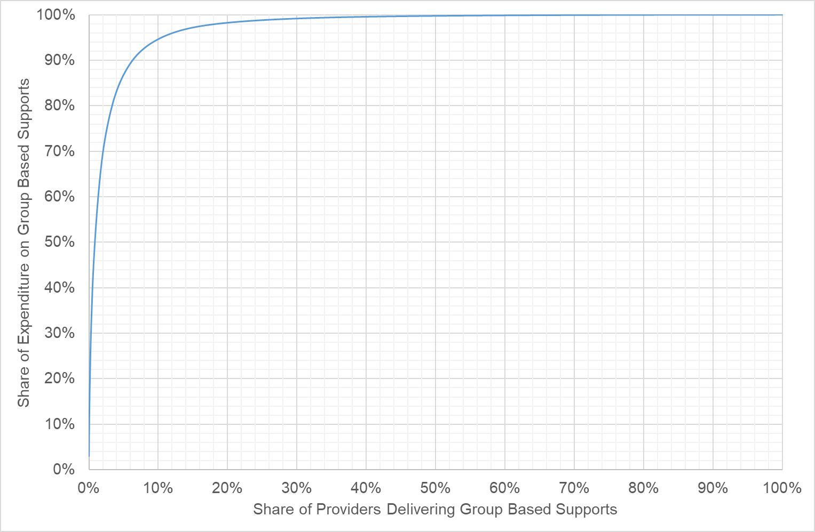

Uptake of the New Arrangements
Most providers have not yet transitioned to the new group-based pricing arrangements, but there has been a gradual increase in the use of transitional arrangements.
- In 2020-21, only 7.8% of claims for, and 8.6% of expenditure on, group-based supports were made under the new arrangements.
- In the first half of 2021-22, by contrast, more than a quarter (29.2%) of claims for, and almost a quarter (24.3%) of expenditure on, group-based supports were made under the new arrangements.
Of the expenditure on group-based supports made under the transitional arrangements in the first half of 2021-22: 30.4% was for 1:1 supports; 26.8% was for 1:2 supports; 33.2% was for 1:3 supports; and 9.6% was for 1:4 or higher ratio supports.

Issues Raised in the Consultations
A total of 41 submissions about the pricing arrangements for group-based core supports were received in response to the Consultation Paper. A working group of providers and other stakeholders was also established. The working group had 26 members from 20 organisations and met, by video-conference, on two occasions: 2 December 2021 and 3 February 2022. A detailed report of the consultations is provided in Chapter 3 of the 2021-22 Annual Pricing Review Report on Consultations.
A number of submissions argued that group programs are cost effective and provide value for money for both the NDIS and participants by spreading the cost of staffing and infrastructure across multiple individuals while also providing the required level of care and supporting participants’ individual goals (see section 3.1 of the Report on Consultations). Many providers argued that irrespective of the pricing arrangements, group programs require additional resources to deliver and incur greater costs to manage appropriately (see section 3.3 of the Report on Consultations).
In general, stakeholders agreed that the new (post 2020) pricing arrangements enabled providers to charge more accurately for non-face-to-face time, which was considered particularly valuable for complex clients. However, they also agreed that the new arrangements had introduced new challenges for participants and their families alongside increased administrative complexity and costs for both providers and participants (see section 3.2 of the Report on Consultations).
Views were mixed on the future of the transitional arrangements. A number of providers recommended that the price limits for group supports should revert to the pricing arrangements that were in place prior to 1 July 2020, while others wanted to retain the new pricing arrangements as they had already transitioned or were transitioning services. Some stakeholders suggested that the transition period should be extended. Others suggested that providers should be able to use the old and new methods indefinitely (see section 3.6 of the Report on Consultations).
Stakeholders welcomed the addition of programs of support to the pricing arrangements, and acknowledged that they have been useful to secure financial viability of group activities and helped manage cancellation risk. Some providers suggested that the maximum length of the programs of support should be increased (see section 3.4 of the Report on Consultations),
Some stakeholders also argued that capital and infrastructure costs associated with running group-based core supports were significantly higher than allowed for in the NDIS pricing arrangements (see section 3.5 of the Report on Consultations).

Financial Performance of Providers
Exhibit 23 compares the key financial performance benchmarks of group-based providers with general providers of core supports. The data is from the 2020-21 Annual Financial Benchmarking Survey.
The benchmarking survey results do not support the claims made by some providers in their submissions that the costs of delivering group-based core supports are higher than the costs of delivering other core supports. Indeed, efficient providers of group-based core supports have a significantly lower overheads ratio (18.0%) than efficient providers of other core supports (21.8%). While wages appear to be slightly higher for workers delivering group-based core supports (increasing provider costs), supervision ratios are also higher (decreasing costs) and workers compensation premiums are lower (decreasing costs).
While profit levels (Earnings Before Interest, Tax, Depreciation and Amortisation (EBITDA)) are slightly lower for providers of group-based core supports, a quarter of all providers of group supports are still achieving an EBITDA of at least 16.8%.
Exhibit 23: Financial Benchmarking 2020-21: Group-Based supports
 | Mean | Q1 | Median | Q3
Disability Support Worker Hourly Rate
All providers | $31.28 | $28.75 | $30.67 | $33.43
Group support providers | $30.46 | $29.04 | $30.93 | $33.06
Supervisor Worker Hourly Rate
All provider | $41.09 | $35.00 | $39.37 | $45.00
Group support providers | $42.02 | $36.25 | $42.50 | $47.18
Supervision Ratio (Head Count)
All providers | 10.6 | 13.2 | 7.5 | 4.0
Group support providers | 8.0 | 16.8 | 6.3 | 4.0
Utilisation Rate
All providers | 78.9% | 90.0% | 82.0% | 72.0%
Group support providers | 74.4% | 89.0% | 80.0% | 70.0%
Permanent Share of Workforce (FTE)
All provider | 60.0% | 94.5% | 63.8% | 28.7%
Group support providers | 64.1% | 94.4% | 75.0% | 39.1%
Workers Compensation Premium
All providers | 3.2% | 2.0% | 2.5% | 4.0%
Group support providers | 2.0% | 0.9% | 1.7% | 2.5%
Overheads
All providers | 44.2% | 21.8% | 35.9% | 56.3%
Group support providers | 45.2% | 18.0% | 39.9% | 60.7%
EBIDTA as a share of total revenue
All providers | 13.3% | 21.4% | 10.9% | 3.9%
Group support providers | 9.3% | 16.8% | 9.5% | 0.9%

Discussion

Transitional Arrangements
The new pricing arrangements for group-based core supports (introduced on 1 July 2020) provide participants with a more accurate link between costs and individual participants than the previous arrangements. Programs of support will also drive better outcomes for people and improve the quality of the support delivered, including through the inclusion of goal reporting as part of a program of support.
However, since the current pricing arrangements for group-based core supports were introduced on 1 July 2020 some providers have raised concerns that the new arrangements have increased their overhead costs and administrative complexity for providers and participants. As noted above, these concerns are not reflected in the results of the financial benchmarking survey, which confirm that efficient providers of group-based core supports have, if anything, lower overheads costs than efficient providers of other supports. Moreover, a significant number of others have successfully moved to the new arrangements. As noted above, of the 7,206 registered and unregistered providers who delivered group-based core supports to agency-managed and plan-managed participants in 2020-21, more than half (64.8%) are using the new arrangements – this includes 24.8% of providers who claimed under both arrangements. That is, almost two thirds of all providers of group-based core supports have either commenced or finished the transition.
However, providers of group-based core supports have had to deal with a number of external exigencies in the last two years because of the pandemic. This may have delayed their ability of some providers to move to the new arrangements as they dealt with these issues. It is therefore recommended that the transitional pricing arrangements for group-based core supports be extended until 30 June 2023 to allow providers more time to adjust to the new pricing arrangements.
It is also recommended that the NDIA work closely with those providers who have not yet transitioned to the new arrangements to assist them to make the transition. The NDIA should also develop better guidance material for participants, providers, Plan Managers and Support Coordinators on the new (post 2020) pricing arrangements including better guidance on the billing for non-face-to-face supports.

Price limits
The benchmarking survey results (see Exhibit 23) do not support the claims made by some providers in their submissions that the costs of delivering group-based core supports are higher than the costs of delivering other core supports. Indeed, efficient providers of group-based core supports have a significantly lower overheads ratio (18.0%) than efficient providers of other core supports (21.8%). While wages appear to be slightly higher for workers delivering group-based core supports (increasing provider costs), supervision ratios are also higher (decreasing costs) and workers compensation premiums are lower (decreasing costs).

Programs of Support
The suggestion made by some providers that the 12-week timespan for programs of support is restrictive and causes administrative burden is not accepted. Choice and control by participants is fundamental to the design of the NDIS. It is therefore very reasonable to expect that a provider will regularly discuss with a participant the extent to which a program of support continues to be appropriate for the participant. The current 12-week limit on the duration of program of support is considered to strike the right balance between reducing administrative complexity for providers and ensuring choice and control for participants.
However, it is clear from the submissions received in response to the Consultation Paper that some participants and providers require more guidance on the appropriate arrangements for the delivery and billing of programs of support. It is therefore recommended that the NDIA should develop better guidance material for participants, providers, Plan Managers and Support Coordinators on the on the appropriate arrangements for the delivery and billing of programs of support.

Recommendations
Recommendation 18
The transitional pricing arrangements for group-based core supports should be extended until 30 June 2023 to allow providers more time to adjust to the new pricing arrangements.
Recommendation 19
The NDIA should work closely with those providers who have not yet transitioned to the new arrangements to assist them to make the transition.
Recommendation 20
The NDIA should develop better guidance material for participants, providers, Plan Managers and Support Coordinators on the new (post 2020) pricing arrangements including better guidance on the billing for non-face-to-face supports and on the appropriate arrangements for the delivery and billing of programs of support.

Endnotes

Therapy Supports
This chapter examines the pricing arrangements for therapy supports in the National Disability Insurance Scheme (NDIS), including the extent to which they are appropriately aligned with those in comparable schemes, and with the private market for therapy supports.
- Section 6.1 provides an overview of the current and historical pricing arrangements for therapy supports in the NDIS, and participant and provider statistics on the use of therapy supports in the NDIS.
- Section 6.2 provides an outline of the issues that were raised about the pricing arrangements for therapy supports in the consultations.
- Section 6.3 examines the extent of the NDIS market for therapy supports
- Section 6.4 examines the private market for therapy services.
- Section 6.5 compares the current NDIS pricing arrangements with those that operate in other insurance schemes and funding programs.
- Section 6.6 provides relevant employment statistics.
- Section 6.7 draws conclusions from the available evidence and recommends some changes to the pricing arrangements for therapy supports in the NDIS.

Background
Therapy services are among the crucial supports available to NDIS participants. These supports are delivered by Art Therapists, Audiologists, Counsellors, Developmental Educators, Dietitians, Exercise Physiologists, Music Therapists, Occupational Therapists, Orthoptists, Physiotherapists, Podiatrists, Psychologists, Rehabilitation Counsellors, Social Workers, and Speech Pathologists.
For Scheme purposes:
- An Art Therapist is defined to be a person who is a Professional Member with the Australian, New Zealand and Asian Creative Arts Therapy Association (ANZACATA).
- An Audiologist is defined to be a person who is either currently certified as an Audiology Australia Accredited Audiologist by Audiology Australia or as a Full Member as an audiologist with the Australian College of Audiology.
- A Counsellor is defined to be a person who is either a member of the Australian Counselling Association or an accredited PACFA Registrant with the Psychotherapy and Counselling Federation of Australia.
- A Developmental Educator is defined to be a person who is a Full Member of Developmental Educators Australia Inc.
- A Dietitian is defined to be a person who is an Accredited Practising Dietitian with the Dietitians Association of Australia.
- An Exercise Physiologist is defined to be a person who is an Accredited exercise physiologist with Exercise and Sports Science Australia
- A Music Therapist is defined to be a person who is an Active Registered Music Therapist with the Australian Music Therapy Association.
- An Occupational Therapist is defined to be a person who has a Current AHPRA Registration as an Occupational Therapist.
- An Orthoptist is defined to be a person who has a current registration with the Australian Orthoptic Board.
- A Physiotherapist is defined to be a person who has a Current AHPRA Registration as a Physiotherapist.
- A Podiatrist is defined to be a person who has a Current AHPRA Registration as a Podiatrist.
- A Psychologist is defined to be a person who has a Current AHPRA Registration as a Psychologist.
- A Rehabilitation Counsellor is defined to be a person who is member of the Australian Society of Rehabilitation Counsellors Inc. or equivalent.
- A Social Worker is defined to be a person who is a member of the Australian Association of Social Workers.
- A Speech Pathologist is defined to be a person who is a Certified Practising Speech Pathologist (CPSP) as approved by Speech Pathology Australia.
Therapy services can also be delivered by Therapy Assistants working under the delegation and direct supervision at all times of a therapist. Where a support is delivered by a therapy assistant, the therapy assistant must be covered by the professional indemnity insurance of the supervising therapist (or the therapist's or therapy assistant's employing provider).
Within the NDIS, most therapy is delivered under three provider registration groups:
- Therapeutic Supports (0128): Provision of a mix of therapies, to assist participants aged from 7 years to apply their functional skills to improve participation and independence in daily, practical activities in areas such as language and communication, personal care, mobility and movement, interpersonal interactions and community living.
- Early Intervention Supports for Early Childhood (0118): Provision of a mix of therapies, and a key worker for the family. Supports children 0-6 years with developmental delay or disability and their families to achieve better long-term outcomes, regardless of diagnosis.
- Exercise Physiology & Personal Well-being Activities (0126): Physical wellbeing activities promote and encourage physical well-being, including exercise.
Therapists also deliver supports under the following registration groups:
- Specialist Positive Behaviour Support (0110): Includes support items provided by allied health professionals with specialist skills in positive behaviour support including assessment and the development of a comprehensive plan that aims to reduce and manage behaviours of concern.
- Custom Prostheses and Orthoses (0135): Prescription and manufacture of customised prostheses or orthoses requiring specialist skills.
- Specialised Hearing Services (0119): Specialised hearing services for children and adults with complex needs.
- Hearing Services (0134): Hearing services for children and adults.

Current Pricing Arrangements
There are currently 14 different therapy support items in the Capacity Building Support Categories. These supports can be delivered to individual participants or to groups of participants. Where supports are delivered to groups of participants the hourly price limit is divided by the number of participants in the group. Price limits do not vary according to the Time of Day / Day of Week that the support is delivered. However, they do vary by state/territory and according to the Type of Therapist that delivers the support.
As well as direct service provision, therapists can claim for Non-Face-to-Face Support Provision, Provider Travel, Short Notice Cancellations and NDIA Requested Reports. They can also claim for any non-labour costs associated with claimable Provider Travel.

Early Childhood Intervention Supports (under 7 years)
The support items provide capacity building supports, including key worker, to assist a child (under 7 years of age) with developmental delay or disability and their family or carers in home, community and early childhood education settings, to work towards increased functional independence and social participation.
Exhibit 24: Therapy Price Limits – Early Childhood Intervention Supports (under 7 years)
Item Number | Item Name and Notes | Unit | NSW  VIC  QLD  ACT | WA  SA  TAS  NT | Remote | Very Remote
15_001_0118_1_3 | Capacity Building Supports for Early Childhood Interventions - Psychology | Hour | $214.41 | $234.83 | $328.76 | $352.25
15_003_0118_1_3 | Capacity Building Supports for Early Childhood Interventions - Physiotherapy | Hour | $193.99 | $224.62 | $314.47 | $336.93
15_005_0118_1_3 | Capacity Building Supports for Early Childhood Interventions - Other Therapy  - Support must be delivered by a suitably qualified allied health professional or early childhood educator. | Hour | $193.99 | $193.99 | $271.59 | $290.99
15_007_0118_1_3 | Capacity Building Supports for Early Childhood - Allied Health Assistant - Level 1  - Support must be delivered by an allied health assistant working under the delegation and direct supervision at all times of a therapist. | Hour | $56.16 | $56.16 | $78.62 | $84.24
15_008_0118_1_3 | Capacity Building Supports for Early Childhood - Allied Health Assistant - Level 2  - Support must be delivered by an allied health assistant working under the delegation and supervision of a therapist, where the therapist is satisfied that the allied health assistant is able to work independently without direct supervision at all times. | Hour | $86.79 | $86.79 | $121.51 | $130.19
NOTE: Where a support is delivered by an allied health assistant, the allied health assistant must be covered by the professional indemnity insurance of the supervising therapist (or the therapist's or allied health assistant's employing provider).

Therapy Supports (over 7 years)
These support items provide therapeutic services to participants (over 7 years). In the NDIS, therapy supports are for participants with an established disability, where maximum medical improvement has been reached, to facilitate functional improvement. For people who access the NDIS as ‘early intervention’ NDIS participants, reasonable and necessary supports are likely to be a blend of medical and disability therapies, but should be predominantly disability therapy supports. Therapy in this context must be aimed at adjustment, adaption, and building capacity for community participation.
Maintenance care can be claimed against a participant’s plan, where the primary purpose is to provide ongoing support for a participant in order to maintain a level of functioning including long term therapy/support required to achieve small incremental gains or to prevent functional decline. In general, maintenance therapy that is reasonable and necessary should be delivered by carers who are or can be trained in this if required. Where a participant has a medical condition or disability that requires a particular regime to maintain functioning of a body part, or to slow the deterioration of a medical condition or body part, then these support items can be used to deliver reasonable and necessary training for non-qualified personnel to assist a participant, as part of usual daily care.
Exhibit 25: Therapy Price Limits – Therapy Supports (over 7 years)
Item Number | Item Name and Notes | Unit | NSW  VIC  QLD  ACT | WA  SA  TAS  NT | Remote | Very Remote
15_043_0128_1_3 | Counselling  - Provision to a participant of a support to facilitate self-knowledge, emotional acceptance and growth, and the optimal development of personal resources, to help the participant work towards their personal goals and gain greater insight into their lives. | Hour | $156.16 | $156.16 | $218.62 | $234.24
15_052_0128_1_3 | Therapy Assistant - Level 1  - Provision to a participant of a therapeutic support by an allied health assistant working under the delegation and direct supervision at all times of a therapist. | Hour | $56.16 | $56.16 | $78.62 | $84.24
15_053_0128_1_3 | Therapy Assistant - Level 2  - Provision to a participant of a therapeutic support by an allied health assistant working under the delegation and supervision of a therapist, where the therapist is satisfied that the allied health assistant is able to work independently without direct supervision at all times. | Hour | $86.79 | $86.79 | $121.51 | $130.19
15_054_0128_1_3 | Assessment, Recommendation, Therapy or Training (including Assistive Technology) - Psychology | Hour | $214.41 | $234.83 | $328.76 | $352.25
15_055_0128_1_3 | Assessment, Recommendation, Therapy or Training (including Assistive Technology) - Physiotherapy | Hour | $193.99 | $224.62 | $314.47 | $336.93
15_056_0128_1_3 | Assessment, Recommendation, Therapy or Training (including Assistive Technology) - Other Therapy | Hour | $193.99 | $193.99 | $271.59 | $290.99
15_062_0128_3_3 | Dietitian Consultation And Diet Plan Development  - Provision of advice to a participant on managing diet for health and well-being due to the impact of their disability | Hour | $193.99 | $193.99 | $271.59 | $290.99
15_200_0126_1_3 | Exercise Physiology  - Provision of advice to a participant regarding exercise required due to the impact of their disability to a participant. | Hour | $166.99 | $166.99 | $233.79 | $250.49
15_200_0128_1_3 | Exercise Physiology | Hour | $166.99 | $166.99 | $233.79 | $250.49
Note: Where a support is delivered by a therapy assistant, the therapy assistant must be covered by the professional indemnity insurance of the supervising therapist (or the therapist's or therapy assistant's employing provider).
As Exhibit 26 illustrates, there are separate price limits for supports delivered by:
- Psychologists
- Physiotherapists
- Dietitians
- Exercise Physiologists
- Counsellors
- Other Therapists – Art therapists, Audiologists, Developmental Educators, Music Therapists, Occupational Therapists, Orthoptists, Podiatrists, Social Workers, and Speech Pathologists
- Therapy Assistants.
Exhibit 26: 2021-22 Price Limits for Therapy Supports
Type of Therapist | NSW / VIC / QLD / ACT | SA / WA / TAS / NT | Remote | Very Remote
Psychology | $214.41 | $234.83 | $328.76 | $352.25
Physiotherapy | $193.99 | $224.62 | $314.47 | $336.93
Art Therapy | $193.99 | $193.99 | $271.59 | $290.99
Audiology
Dietetics
Music Therapy
Occupational Therapy
Orthoptics
Podiatry
Social Work
Speech Pathology
Exercise Physiology | $166.99 | $166.99 | $233.79 | $250.49
Counselling | $156.16 | $156.16 | $218.62 | $234.24
Therapy Assistant Level 1 | $56.16 | $56.16 | $78.62 | $84.24
Therapy Assistant Level 2 | $86.79 | $86.79 | $121.51 | $130.19

Historical Development of the Current Pricing Arrangements
In the trial phase of the NDIS (which had limited participant numbers) markets were regulated using unit price caps. These caps were in most cases determined using ‘cost-plus’ inputs-based pricing based on block funding allocations made to providers prior to the NDIS. As the NDIS transitioned towards full rollout, annual price reviews were undertaken, whereby the unit price caps introduced were indexed annually based on updates to the costing methodology and consultations.
Exhibit 27: Therapy Pricing Review, 2018 to 2021
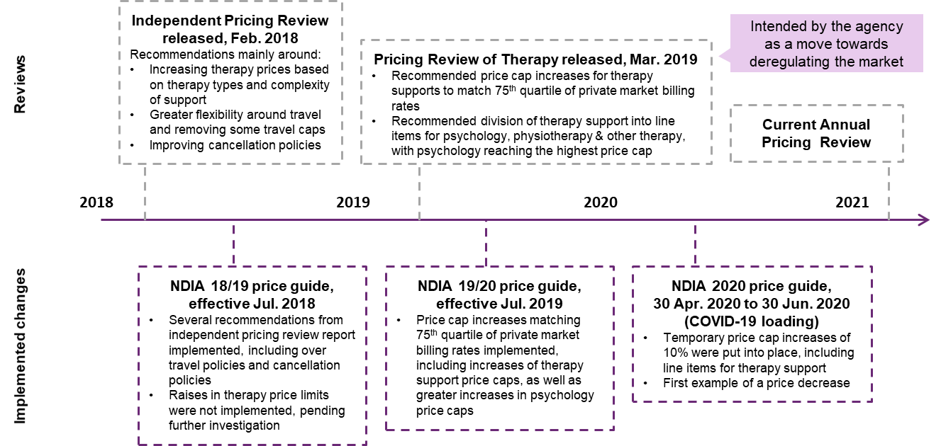
In 2019, the National Disability Insurance Agency (NDIA) conducted a review of the price control arrangements and other market settings for therapy services under the NDIS (2019 Review of Therapy Pricing Arrangements). As a consequence, several key recommendations were implemented including increasing the price limit to the 75th percentile of the observed private billing distribution, based on a perceived lack of power to influence prices in the therapy market, and in order to strike a balance between ensuring participants’ ability to choose and fund different providers in the market and delivering value for money. The new price limits for therapy supports were introduced on 1 July 2019. They have not been increased since then.
Exhibit 28 illustrates the historical price limits for therapy supports in the NDIS (other than exercise physiology and counselling).
Exhibit 28: Therapy support price limits by geography from FY16 to FY21
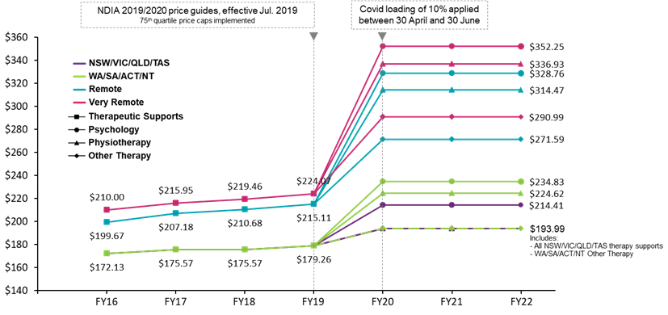

Scheme Statistics
In the first half of 2021-22, some 271,752 participants (59% of all active participants) purchased therapy supports through their plans. These supports were delivered by 38,573 providers at a cost of $1.125 billion. Expenditure on therapy supports accounted for almost 13% of all expenditure by the NDIS in the first half of 2021-22.
On average, each participant who received therapy supports in the first half of 2021-22 received supports worth $4,140 over the six-month period. The average revenue per provider over that six-month period was $28,971. Exhibit 29 provides further detail by type of therapy.
Exhibit 29: Scheme Expenditure by Type of Therapy, First Half of 2021-22
Type of Therapist | Number of Participants | Total Amount Claimed | Average Spend per Participant | Number of Providers | Average Spend per Provider
Psychology | 72,058 | $122.8 m | $1,704 | 10,483 | $11,549
Physiotherapy | 74,814 | $139.6 m | $1,866 | 8,437 | $16,439
Other Therapy | 240,708 | $745.1 m | $3,095 | 27,249 | $27,190
Audiology | 427 | $170,063 | $398 | 92 | $1,803
Dietitian | 15,029 | $11.5 m | $772 | 1,771 | $6,506
Exercise | 28,787 | $48.2 m | $1,674 | 4,314 | $11,080
Counselling | 16,641 | $22.5 m | $1,353 | 3,848 | $5,804
Therapy Assistant | 30,490 | $35.1 m | $1,153 | 3,205 | $10,929
TOTAL IN FY21-22H1  (unique participants/providers) | 271,752 | $1.125 b | $4,140 | 38,573 | $28,971

Participants of Therapy Supports (0128)
Some 30 participants spent more than $50,000 from their NDIS plan in the first half of 2021-22 and 5% of participants spent more than $10,000 from their NDIS plan in the first half of 2021-22 on therapy supports. At the other end of the scale, 25% of participants spent less than $1,400 from their NDIS plan in the first half of 2021-22 on therapy supports and 10% of participants spent more than $600 from their NDIS plan in the first half of 2021-22 on therapy supports.

Providers of Therapy Supports (0128)
The provision of therapy supports is dominated by a few large providers. The largest five providers each had revenue from the NDIS in the first half of 2021-22 of more than $10 million. These providers accounted for 8.5% of all expenditure on therapy by the NDIS. A total of 96 providers had revenue from the NDIS in the first half of 2021-22 of more than $1 million. These providers accounted for more than quarter (28.6%) of all expenditure on therapy by the NDIS. At the other end of the scale, 17,341 providers (about half of all therapy providers) had revenue from the NDIS in the first half of 2021-22 of less than $2000. These providers accounted for less than 1.3% of all expenditure on therapy by the NDIS

Feedback from consultations
A total of 122 submissions were received about the pricing arrangements for therapy supports in response to the Consultation Paper. A working group of providers and other stakeholders was also established. The working group had 61 members (from 41 organisations) and met, by video-conference, on three occasions: 3 December 2021, 4 February 2022 and 1 March 2022. A detailed report of the consultations is provided in Chapter 6 of the 2021-22 Annual Pricing Review Report on Consultations.
A number of submissions, and working group members, argued that the current price limits for therapy supports were too low, and that the principal reason advanced for an increase to the price limits was the need to pay higher wages because of a shortage of existing and future therapists (see section 6.1 of the Report on Consultations). Therapy support providers argued that there were high compliance costs associated with the NDIS Quality and Safeguards Commission (NDIS Commission) and related audits, which were in many cases unnecessary given the profession-specific regulation of the Australian Health Practitioner Regulation Agency (see section 6.2 of the Report on Consultations).
Consultations indicated that there was strong demand for therapy outside the NDIS, and by other public and publicly funded schemes; however, comparisons to other therapy arrangements were not straightforward and needed to be made with care, even recognising that therapists charged NDIS participants more than other patients for what sometimes appeared to be the same service (see section 6.3 of the Report on Consultations).
It was argued that some of the issues currently experienced by providers could be due to insufficient hours for therapy, travel, non-face to face time and non-billable time being included in a participant’s plan, rather than the price limit being too low (see section 6.4 of the Report on Consultations).
The submissions to this topic included a major joint submission from providers that together account for about 20% of all NDIS expenditure on therapy supports (see section 6.5 of the Report on Consultations). Among other things, the joint submission made the following recommendations to the NDIA:
- Reintroduce price indexation for therapy supports, with an immediate increase recommended to make up for the lack of indexation in previous years, and look to removing price limits in more mature markets in the medium term if not sooner.
- Broaden the definition of billable time to reflect the true productivity of therapy support providers, and work with the providers who made the joint submission to better understand the cost of services, and to develop a mature costing model to help identify the true cost of therapy supports.
- Provide more certainty for the future, as providers need to make decisions around services and infrastructure based on forecasts for the next 5-10 years, and give adequate notice of future changes — for example, the 2022-23 pricing framework would ideally be provided by February 2022 to align with budget and planning cycles.

NDIS Share of the Market for Therapy
The NDIS accounts for a significant share of the therapy market. In 2019-20, the last year for which complete data exists, the total spend on allied health services from the Medicare Benefits Scheme (MBS), NDIS and private health insurance including related out-of-pocket costs is estimated to have been $10.2 billion. In that period the NDIS spent $1.92 billion on therapy supports for participants, representing about a quarter (19%) of the total spend on allied health services from the MBS, NDIS and private health insurance (see Exhibit 30).
Exhibit 30: Expenditure on Therapy by Funding Source, 2019-20
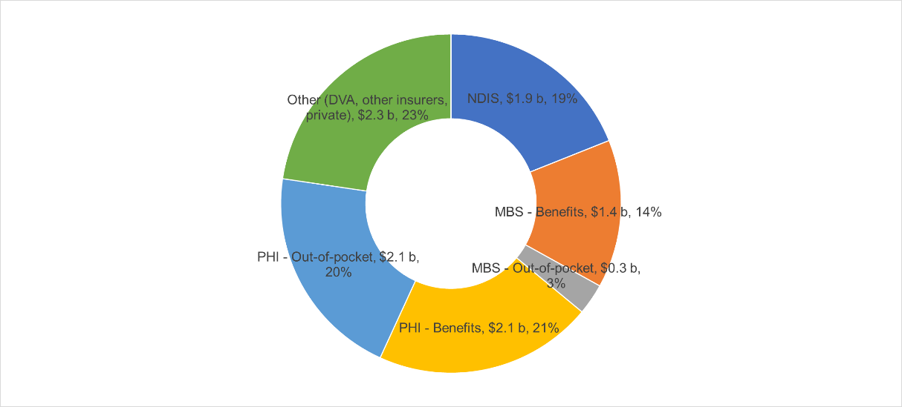
As Exhibit 31 illustrates, total expenditure on therapy supports across Australia is estimated to have grown by $2.6 billion (or 34%) in the period from 2016-17 to 2019-20. Over the same period, the non-NDIS segment of the therapy market grew by $869 million (12%). That is, the NDIS is both increasing the demand for therapy supports and increasing that demand at a faster rate than supply is growing.
Exhibit 31: Growth in Expenditure on Therapy by Funding Source, 2016-17 to 2019-20
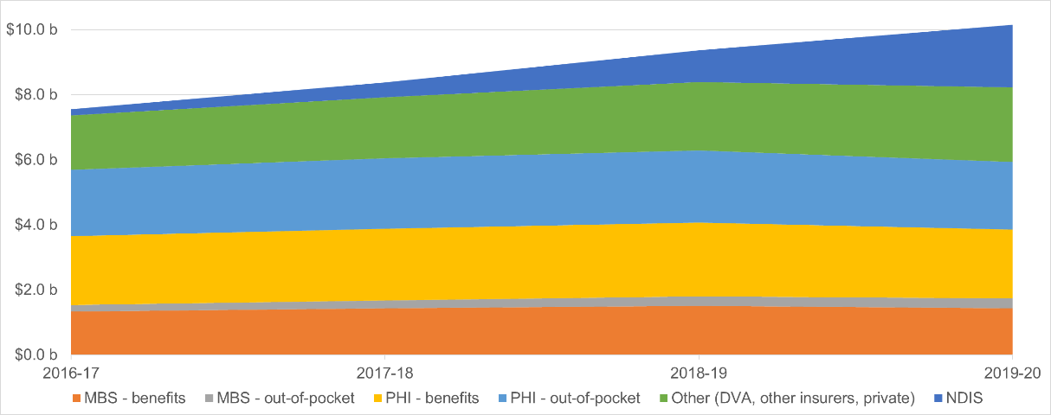

Registration and Employment Statistics
As of 2020-21, there were:
- 41,817 Psychologists registered with the Australian Health Practitioners Registration Agency (AHPRA). The number of registrations grew by 19.6% between 2016-17 and 2020-21.
- 37,650 Physiotherapists registered with AHPRA. The number of registrations grew by 24.0% between 2016-17 and 2020-21.
- 25,632 Occupational Therapists registered with AHPRA. The number of registrations grew by 31.3% between 2016-17 and 2020-21.
- 5,783 Podiatrists registered with AHPRA. The number of registrations grew by 17.4% between 2016-17 and 2020-21.
The number of therapists in Australia has grown significantly in the last five years (see Exhibit 32).
Exhibit 32: Number of Therapists, FY2016-17 to FY2020-21
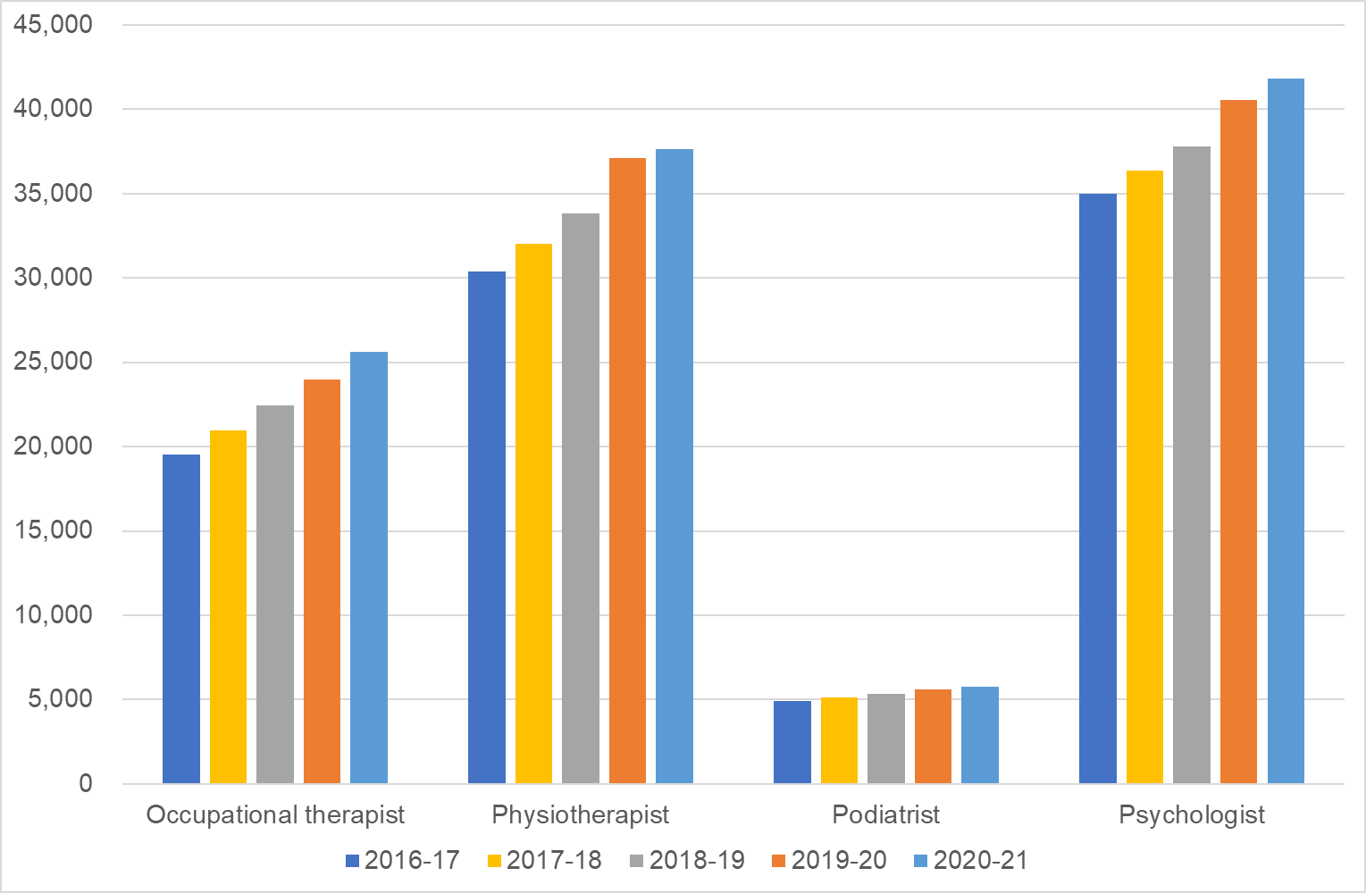
The National Skills Commission projects that this trend will continue over the next five years. Indeed, therapists make up three of the 11 fastest growing occupations among the 444 occupations whose employment growth projected by the National Skills Commission.
- The number of employed Audiologists and Speech Pathologists is projected to grow by 34.7% between 2021 and 2026, which is more than three times the projected rate of growth of the entire Australian workforce over that period (9.1%). The projected employment growth for Audiologists and Speech Pathologists is the sixth highest of all of the 444 occupations projected by the National Skills Commission.
- The number of employed Podiatrists is projected to grow by a further 31.8% between 2021 and 2026. The projected employment growth for Podiatrists is the eighth highest of all of the 444 occupations projected by the National Skills Commission.
- The number of employed Physiotherapists is projected to grow by a further 28.7% between 2021 and 2026. The projected employment growth for Physiotherapists is the eleventh highest of all of the 444 occupations projected by the National Skills Commission.
- The number of employed occupational therapists is projected to grow by a further 7.4% between 2021 and 2026.
Orthotists (Prosthetists) and Social Workers are two of the 44 occupations listed on the Priority Migration Skilled Occupation List, which identifies the occupations that fill critical skills needs to support Australia’s economic recovery from COVID-19.

Private Billing Rates
This section analyses a data set of 7,055 private billing rates for therapy services, including 4,014 billing rates for weekday services. These billing rates were converted to effective hourly rates based on the length of consultation. The average effective hourly rate for weekday supports in the survey sample was $162 (median $165). The smallest effective hourly rate that was observed in the data set was $50 and the largest was $290. There was a wide distribution of billing points for all types of therapies (see Exhibit 33).
Exhibit 33: Distributional Statistics of Private Billing Rates, by Therapy Type
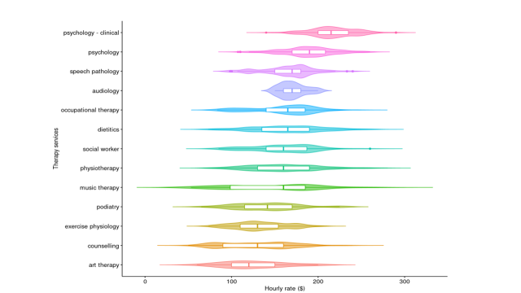
Statistic | Art Therapy | Audiology | Counselling | Dietetics | Exercise Physiology | Music Therapy | Occupational Therapy
Observations | 54 | 104 | 277 | 465 | 346 | 63 | 260
Mean | $126.00 | $171.00 | $130.00 | $165.00 | $134.00 | $145.00 | $160.00
Standard deviation | 35.3 | 14.7 | 40.6 | 40.4 | 29.7 | 53.0 | 35.4
Minimum | $60.00 | $150.00 | $50.00 | $73.00 | $73.00 | $53.00 | $83.30
25th percentile | $100.00 | $160.00 | $90.00 | $135.00 | $110.00 | $98.50 | $140.00
Median | $120.00 | $170.00 | $130.00 | $165.00 | $130.00 | $160.00 | $165.00
75th percentile | $150.00 | $180.00 | $160.00 | $190.00 | $154.00 | $185.00 | $185.00
Maximum | $200.00 | $200.00 | $240.00 | $267.00 | $207.00 | $270.00 | $250.00

Statistic | Physiotherapy | Podiatry | Psychology | Psychology – Clinical | Social Worker | Speech Pathology | Overall
Observations | 1051 | 242 | 476 | 2997 | 105 | 274 | 4,014
Mean | $160.00 | $141.00 | $188.00 | $217.00 | $159.00 | $166.00 | $162.00
Standard deviation | 39.8 | 6.5 | 39.9 | 26.3 | 35.2 | 29.7 | 42.0
Minimum | $67.00 | $65.00 | $107.00 | $140.00 | $85.00 | $98.00 | $50.00
25th percentile | $130.00 | $115.00 | $170.00 | $200.00 | $140.00 | $150.00 | $130.00
Median | $160.00 | $141.00 | $190.00 | $215.00 | $160.00 | $170.00 | $165.00
75th percentile | $190.00 | $170.00 | $208.00 | $235.00 | $187.00 | $180.00 | $190.00
Maximum | $280.00 | $225.00 | $260.00 | $290.00 | $260.00 | $240.00 | $290.00
A statistical model was built on private billing data set (see Exhibit 34). The modelling began with indicator variables for each state/territory, each type of therapy, a regional indicator, and a full set of interaction terms. The model was then sequentially collapsed and rerun whenever the cooefficient of an indicator variable was not statistically different from zero.
Exhibit 34: Statistical Models of Private Billing Rates
Variable | (1) | (2) | (3) | (4)
Constant | 167.00*** | 172.00*** | 172.00*** | 170.00***
A. Queensland / Western Australia | 0.47 | -1.40 | -4.50*** | -1.60
B. Victoria / South Australia | -12.00*** | -15.00*** | -15.00*** | -13.00***
C. Regional |  | -12.00*** | -8.90*** | -8.80***
D. Art Therapist, Counsellors, Exercise Physiologists and Music Therapists |  |  | -29.00*** | -28.00***
E. Podiatrists |  |  | -18.00*** | 7.10
F. Psychologists |  |  | 26.00*** | 28.00***
G. Clinical Psychologists |  |  | 54.00*** | 57.00***
Interaction A x D |  |  |  | -0.81
Interaction B x D |  |  |  | -3.10
Interaction A x E |  |  |  | -45.00***
Interaction B X E |  |  |  | -27.00***
Interaction A x F |  |  |  | -3.90
Interaction B x F |  |  |  | -1.20
Interaction A X G |  |  |  | -5.10
Interaction A X G |  |  |  | -1.40
Adjusted R² | 0.02 | 0.03 | 0.30 | 0.31
Residual Standard Error | 42.00 | 41.00 | 35.00 | 35.00
Degrees of Freedom | 4,011 | 4,010 | 4,003 | 3,998
F Statistic | 38.00*** | 48.00*** | 246.00*** | 118.00***
(*** = p < 0.01)
The final model (Model 3 in Exhibit 34) is as follows:
- Five groups of therapists:
  - Audiologists, Dietitians, Occupational Therapists, Physiotherapists, Social Workers, Speech Pathologists (base case);
  - Art Therapist, Counsellors, Exercise Physiologists and Music Therapists;
  - Podiatrists;
  - Psychologists; and
  - Clinical Psychologists;
- Three groups of states/territories:
  - New South Wales, Tasmania, Australian Capital Territory (ACT) and the Northern Territory (base case);
  - Queensland and Western Australia; and
  - Victoria and South Australia; and
- Regional Indicator (metropolitan being the base case).
Model 3 is preferred to Model 4 as the small increase in R² between Model 3 and Model 4 doesn’t adequately compensate for the increased complexity of the model. The model indicates:
- the average effective hourly rates in New South Wales, Tasmania, ACT and the Northern Territory metroplitan areas were:
  - $226 for Clinical Psychologists (compared to $214 in the NDIS);
  - $198 for Psychologists ($214 in NDIS);
  - $172 for Audiologists, Dietitians, Occupational Therapists, Physiotherapists, Social Workers, Speech Pathologists ($194 in NDIS);
  - $154 for Podiatrists ($194 in NDIS); and
  - $143 for Exercise Physioologists, Counsellors, Art/Music Therapists ($156-$194 NDIS);
- that for metropolitan areas average effective hourly rates were lower in:
  - Queenland and Western Australia – by $4.50 per hour; and
  - Victoria and South Australia – by $15.00 per hour; and
- that average effective hourly rates in non-metropolitan areas in each state/territory are $8.90 lower than in metropolitan areas in the same state/territory.
It is important to note that these are averages – and that all the distributions are widely dispersed and have significant overlaps with each other. The explanatory power of model is only 31%. The histograms of effective hourly rates in Exhibit 35 illustrate this clearly.
Exhibit 35: Histograms of Private Billing Rates
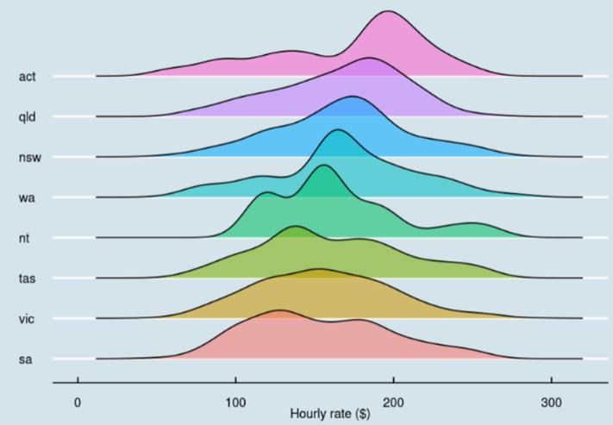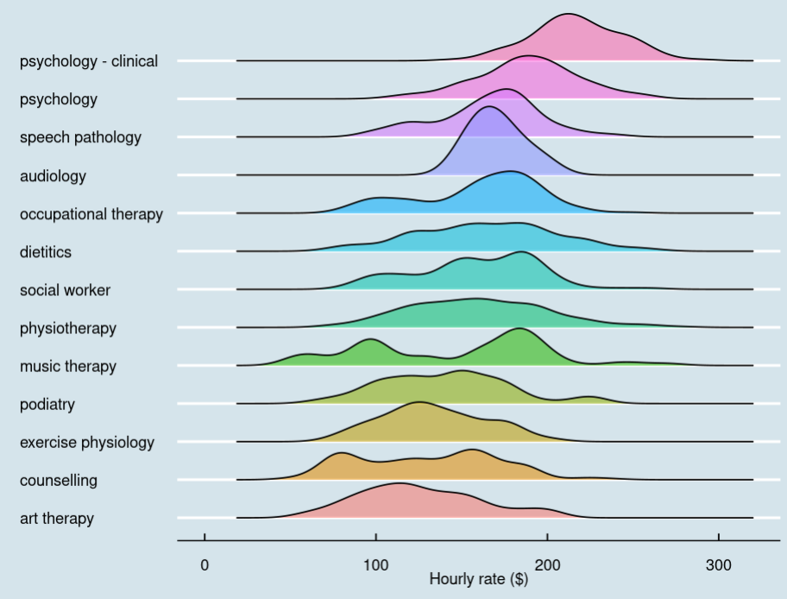
It is also important to note the bi-modal distribution for music therapists. This aligns with the submission from the Australia Music Therapy Association (AMTA) which pointed out that a number of “music therapists” in the private market are not registered members of the Association, which is a requirement imposed by the NDIS Commission for practice as a music therapist in the NDIS. The AMTA argues that the more appropriate comparator from the private billng market would be the second peak in the statistical distribution (around $190).

Comparable Schemes
The main MBS items for allied health have a scheduled fee of $64.80 per 20 minutes session. This equates to an effective hourly rate of $194.40 which is almost identical to the NDIS hourly price limit. Note, the Commonwealth funding (MBS benefit) for the hour is $165.30, but co-payments are common in the MBS and the scheduled fee is a better estimate of the total cost of the support – or at least of the Australian Government’s public position on the appropriate cost of the support.
Other important comparators are the pricing arrangements adopted in comparable schemes. As Exhibit 36 illustrates, the current NDIS price limits are broadly consistent with the effective hourly rates paid by other schemes, once proper account is taken of duration of service, co-payments and provisions for travel and consumables. The NDIS price limits for therapies are higher than those allowed in some schemes and lower than those allowed in other schemes.
Exhibit 36: Billing Rates in Other Government Funding Programs and Insurance Schemes
Further details on the comparison with other schemes is given in Appendix C.

Discussion
Therapy supports are important to participants and to the NDIS. They assist participants build capacity to achieve their goals and they have the potential to reduce long term costs in the NDIS as they can assist participants to regain capacity. Currently about 13% of all Scheme expenditure is on therapy supports and so it is important that the NDIS ensure that participants are receiving value for money.

Price Limits

Joint Submission by Large Therapy Providers
The joint submission on the pricing arrangements for therapy supports from Ability First Australia, Ability WA, Benevolent Society, Cerebral Palsy Alliance, Cootharinga North Queensland, CPL, Montrose, Northcott, Novita, Rocky Bay, Scope, St Giles, Senses WA, Therapy Focus, Xavier and Yooralla argued that the NDIA should not reduce the current price cap and should reintroduce price indexation for therapy supports.
As part of their submission, these providers engaged Deloitte Access Economics to construct a cost model for therapy providers based on a detailed analysis of the financial performance of the various providers. Exhibit 37 provides some detail of the cost modelling undertaken by Deloitte Access Economics (Exhibit E.1 in the Deloitte report to the major therapy providers).
Exhibit 37: Deloitte Access Economics Estimate Cost per Hour of Allied Health Services Under the NDIS

The submission from the major therapy providers stated that:
The Cost Model shows that the actual cost of service delivery in 2021 for the organisations surveyed was $226.43 per hour for psychology staff and $200.79 per hour of the other allied health disciplines [Occupational Therapy, Physiotherapy, Speech Pathology, Social Work, and Psychology]. When disaggregated by regionality, the result for metropolitan regions was $224.38 per hour for psychology staff and $197.04 for other allied health staff.
This analysis demonstrates that the majority of providers surveyed operate at, or slightly below, break-even against the current NDIS prices caps.
It is important to note that the Deloitte Cost Model is a model of the current average costs of the large therapy providers who took part in the study. The submission itself identifies that the while the average hourly fully loaded cost for those providers who took part in the study was $201.87, the fully loaded cost of a theoretically efficient provider (one operating at the 25th percentile in each of the key parameters of the cost model) would be $184.57 – which is 8.6% below the modelled average cost and below the current NDIS price limit.
Moreover, it is not clear that even this theoretically efficient provider is truly representative of how efficient therapy providers could be if they had to be. For example, the Deloitte study found that the average utilisation rate for allied health professionals among the reporting providers was 47.8% and that even the more efficient providers were only achieving a utilisation rate of 52.9%. Similarly, the Deloitte study found that the average corporate overhead among the reporting providers was 52.9% (of direct and indirect costs) and that even the more efficient providers were only achieving a corporate overhead of 27% (of direct and indirect costs).
It is also important to note that the providers in this study together only account for about 20% of all NDIS expenditure on therapy supports and have a significantly different cost structure to the vast majority of therapy providers, who are typically much smaller and operating across multiple revenue sources.

Private billing data
The private billing market data suggests that the average fully loaded hourly cost of therapy supports is $172, which is significantly lower than the current NDIS price limit and 6.8% below the efficient fully loaded cost among the major therapy providers (see above).
This data seems to confirm the anecdotal evidence that therapy providers tend to charge NDIS participants a higher fee than their other clients. However, the industry argues that this is to be expected and that there are a number of reasons why the cost of delivering supports to participants may be higher than the average costs of private services. These arguments, while they have some merit, are not overwhemingly compelling.
- The industry argues that there are higher training requirements for therapists dealing with people with a disabiity, with providers reporting very low utilisation rates and high supervison costs for new therapists as they bring them up to speed on “less common” conditions. However, given the NDIS accounts for more than a quarter of all expenditure on therapy in Australia these “less common” services are not “rare”.
- The industry also argues that the additional quality and safety overlay for providers dealing with people with a disability imposes additional costs on them that other therapy providers do not have. However, these costs should not be overly high as the NDIS Commission has determined that therapy providers are only subject to verification rather than certification audit, and they should already be meeting many of the more general NDIS registration requirements as part of their professional accreditation.
- Finally, the industry also argues that there is a relatively high administrative burden/cost dealing with the NDIA’s payment system compared to cash payments by clients. However, these costs are decreasing as the NDIA’s systems become more sophisticated.

Other Schemes
As illustrated in Exhibit 36 above and discussed further in Appendix C, the current NDIS price limits are broadly consistent with the effective hourly rates paid by other government insurance schemes and funding programs for therapy, once proper account is taken of duration of service, co-payments and provisions for travel and consumables.

Conclusion
On balance, the available evidence argues for a decrease in the current price limits for therapy supports. However, there is sigificant risk that such a decrease would disrupt the provision of supports to participants in some regions. Moreover, as several Australian Government and state and territory insurance schemes and funding programs fund, and compete, for these services further discussion is required across government to resolve these issues. It is therefore recommended that no structural change should be made in the pricing arrangements for therapy supports at this time; and that the price limits for therapy supports should not be indexed on 1 July 2022, given the current NDIS price limits are above the rates charged in the private billing market and are above the fully loaded hourly cost of the theoretic efficient provider in the Deloitte Cost Model, which was commissioned by the major therapy providers. It is also important to continue to incentivise the development of more efficient work practices among therapy providers. It is further recommended that the NDIA should work with the Department of Social Services and other relevant Departments across government on the alignment of pricing arrangements across Australian Government and state/territory funding programs and insurance schemes, and on ensuring an adequate supply of therapists going forward.

Other Issues

Exercise Physiology
Most goods and services purchased by participants are not subject to the Goods and Services Tax (GST). However, a support delivered by an Art Therapist, a Music Therapist or an Exercise Physiologist to a participant is likely to only be GST free if the participant is an early childhood aged participant or in a residential care setting. Note, a provider is also not required to register for the GST and is not required to levy the GST if their business has a GST turnover of $75,000 or more ($150,000 for a non-profit organisation).
With respect to Exercise Physiologists, in the first half of 2021-22 only 10.9% of the claims for payment made against participant plans included a GST amount. About 82% of businesses which made a claim for the provision of exercise physiologists to a participant did not include a GST amount in their claim.
Similar statistics are not available for Art Therapists and Music Therapists as they currently make payment claims using the general “Other Therapy” support items. Only 0.4% of claims made using the “Other Therapy” support items include a GST amount and this is probably attributable to Art Therapists and Music Therapists, but it is not possible to determine what proportion of claims by Art Therapists and Music Therapists include a GST amount. It is likely to be similar to the result for Exercise Physiologists.
Given how few Exercise Physiologists currently include a GST amount in their claims for payment it is not necessary to adjust the price limits for Exercise Physiologists at this time for the GST effect. However, as discussed in Chapter 4: Pricing Arrangements the NDIA should examine options to pay any GST amounts correctly included in payment requests for supports delivered to participants “off-plan” but from Scheme funds rather than from the plan of the participant. This would provide participants with greater choice and control over their plans as they would not need to factor any GST cost into their decision as to which therapist best meets their needs. If it is possible to devise a method to pay GST amounts “off plan” then the price limits set by the NDIA should be the GST-exclusive amount. This aligns with the approach taken in other insurance schemes where the published fee is the GST-exclusive amount, and an additional payment is made if GST is applicable.

Simplifying the Pricing Arrangements
To provide greater clarity to participants, it is recommended that the NDIS Pricing Arrangements and Price Limits should be updated to include clear definitions of the types of therapists that are able to make claims for therapy support items, including the qualifying criteria for each type of therapist (as set out below).
An Art Therapist is defined to be a person who is a Professional Member with the Australian, New Zealand and Asian Creative Arts Therapy Association (ANZACATA).
An Audiologist is defined to be a person who is either currently certified as an Audiology Australia Accredited Audiologist by Audiology Australia or as a Full Member as an audiologist with the Australian College of Audiology.
A Counsellor is defined to be a person who is either a member of the Australian Counselling Association or an accredited PACFA Registrant with the Psychotherapy and Counselling Federation of Australia.
A Developmental Educator is defined to be a person who is a Full Member of Developmental Educators Australia Inc.
A Dietitian is defined to be a person who is an Accredited Practising Dietitian with the Dietitians Association of Australia.
An Exercise Physiologist is defined to be a person who is an Accredited Exercise Physiologist with Exercise and Sports Science Australia
A Music Therapist is defined to be a person who is an Active “Registered Music Therapist” with the Australian Music Therapy Association.
An Occupational Therapist is defined to be a person who has a Current AHPRA Registration as an Occupational Therapist.
An Orthoptist is defined to be a person who has current registration with the Australian Orthoptic Board.
A Physiotherapist is defined to be a person who is has a Current AHPRA Registration as a Physiotherapist.
A Podiatrist is defined to be a person who is has a Current AHPRA Registration as a Podiatrist.
A Psychologist is defined to be a person who is has a Current AHPRA Registration as a Psychologist.
A Rehabilitation Counsellor is defined to be a person who is member of the Australian Society of Rehabilitation Counsellors Inc. or equivalent.
A Social Worker is defined to be a person who is a member of the Australian Association of Social Workers.
A Speech Pathologist is defined to be a person who is a Certified Practising Speech Pathologist (CPSP) as approved by Speech Pathology Australia.
It is also recommended that separate support items should be created for each type of therapist in both the early childhood and therapy sections of the NDIS Pricing Arrangements and Price Limits. This will provide greater clarity to participants and allow the NDIA more granular insight into the types of therapy that participants are choosing to purchase with the funds in their plans. It is not proposed that these support items would be used by planners.
Greater consistency should also be adopted in the description of supports in the NDIS Pricing Arrangements and Price Limits. Currently,
- The Exercise Physiology support items describe the support as “Exercise Physiology – Provision of advice to a participant regarding exercise required due to the impact of their disability to a participant.”
- The Dietetics support items describe the support as “Dietitian Consultation and Diet Plan Development – Provision of advice to a participant on managing diet for health and well-being due to the impact of their disability.”
- The Counselling support items describe the support as “Counselling – Provision to a participant of a support to facilitate self-knowledge, emotional acceptance and growth, and the optimal development of personal resources, to help the participant work towards their personal goals and gain greater insight into their lives.”
- All other therapy support items describe the support as “Provision to a participant of Assessment, Recommendation, Therapy, or Training (including in assistive technology) supports – TYPE_OF_THERAPY”.
It is therefore recommended that all therapy support items should describe the support in a consistent fashion as follows: “Provision to a participant of Assessment, Recommendation, Therapy, or Training supports – TYPE_OF_THERAPY”.

Recommendations
Recommendation 21
The NDIA should not make any structural adjustment to the pricing arrangements for therapy supports at this time and should not index the price limits for therapy supports on 1 July 2022.
The NDIA should continue to work with the Department of Social Services and other government agencies to understand the differences in pricing arrangements and prices across relevant Australian Government, and state and territory government insurance and funding programs for therapy supports, to inform future price setting and ensure the ongoing adequate supply of therapists.
Recommendation 22
To provide greater clarity to participants, the NDIA should amend the NDIS Pricing Arrangements and Price Limits to include clear definitions of the types of therapists that are able to make claims for therapy support items, including the qualifying criteria for each type of therapist as set out in this report.
Recommendation 23
To provide greater clarity to participants, the NDIA should create separate support items for each type of therapist in both the early childhood and therapy sections of the NDIS Pricing Arrangements and Price Limits.
Recommendation 24
To provide greater clarity to participants, the NDIA should describe the support in a consistent fashion as follows: “Provision to a participant of Assessment, Recommendation, Therapy, or Training supports – TYPE_OF_THERAPY”.

Endnotes

Nursing Supports
This Chapter examines the pricing arrangements for nursing supports in the National Disability Insurance Scheme (NDIS), including the extent to which they are appropriately aligned with those in comparable schemes, and with the private market for nursing supports.
- Section 7.1 provides an overview of the current pricing arrangements for nursing supports, including relevant statistics on the use of nursing supports in the NDIS.
- Section 7.2 provides relevant economic and workforce statistics on nursing in the Australian economy.
- Section 7.3 compares the current NDIS pricing arrangements with those that operate in other insurance schemes and funding programs.
- Section 7.4 draws conclusions from the available evidence and recommends some changes to the pricing arrangements for nursing supports.

Current Arrangements
In general, the NDIS does not fund nursing (or other health services) for participants when those services are generally available in the mainstream health system. However, there are some nursing supports that are generally funded by the NDIS (provided they are reasonable and necessary) and other nursing supports that, dependent on their purpose, may be funded by the NDIS. These include disability related health supports – supports a participant may need to help them manage a health condition directly because of their disability, or to help them to manage their health if their disability means they cannot do this on their own.

Current Pricing Arrangements
There are currently 32 nursing support items in the Capacity Building – Improved Daily Living Support Category. These supports can be delivered to individual participants subject to the rules set out in the NDIS Pricing Arrangements and Price Limits. They cannot be delivered to groups of participants. Exhibit 38 sets out the price limits for these supports. Different price limits apply depending on the Time of Day / Day of Week that the support is delivered and on the Type of Nurse that delivers the support (see definitions on pages 128 and 128 below).
Exhibit 38: Price Limits for Nursing Supports (1 July 2021 to 30 June 2022)
Item Number | Item Name and Notes | Unit | Non-Remote | Remote | Very Remote
15_036_0114_1_3 | Assessment and Support by a Registered Nurse  - Provision to a participant of care, training, or supervision of a delegated worker to respond to complex care needs where that care is not the usual responsibility of the health system. | Hour | $124.05 | $173.67 | $186.08
15_051_0114_1_3 | Community Nursing Care For Continence Aid  - Provision by a Registered Nurse.to a participant of continence aids assessment, recommendation, and training support. | Hour | $124.05 | $173.67 | $186.08
15_400_0114_1_3 | Delivery of Disability Related Health Supports by an Enrolled Nurse - Weekday Daytime | Hour | $86.62 | $121.27 | $129.93
15_401_0114_1_3 | Delivery of Disability Related Health Supports by an Enrolled Nurse - Weekday Evening | Hour | $95.55 | $133.77 | $143.33
15_405_0114_1_3 | Delivery of Disability Related Health Supports by an Enrolled Nurse - Weekday Night | Hour | $97.33 | $136.26 | $146.00
15_402_0114_1_3 | Delivery of Disability Related Health Supports by an Enrolled Nurse - Saturday | Hour | $123.57 | $173.00 | $185.36
15_403_0114_1_3 | Delivery of Disability Related Health Supports by an Enrolled Nurse - Sunday | Hour | $142.05 | $198.87 | $213.08
15_404_0114_1_3 | Delivery of Disability Related Health Supports by an Enrolled Nurse - Public Holiday. | Hour | $160.52 | $224.73 | $240.78
15_406_0114_1_3 | Delivery of Disability Related Health Supports by an Registered Nurse - Weekday Daytime | Hour | $107.25 | $150.15 | $160.88
15_407_0114_1_3 | Delivery of Disability Related Health Supports by an Registered Nurse - Weekday Evening | Hour | $118.31 | $165.63 | $177.47
15_411_0114_1_3 | Delivery of Disability Related Health Supports by an Registered Nurse - Weekday Night | Hour | $120.51 | $168.71 | $180.77
15_408_0114_1_3 | Delivery of Disability Related Health Supports by an Registered Nurse - Saturday | Hour | $153.05 | $214.27 | $229.58
15_409_0114_1_3 | Delivery of Disability Related Health Supports by an Registered Nurse - Sunday | Hour | $175.95 | $246.33 | $263.93
15_410_0114_1_3 | Delivery of Disability Related Health Supports by an Registered Nurse - Public Holiday | Hour | $198.85 | $278.39 | $298.28
15_412_0114_1_3 | Delivery of Disability Related Health Supports by an Clinical Nurse - Weekday Daytime | Hour | $124.05 | $173.67 | $186.08
15_413_0114_1_3 | Delivery of Disability Related Health Supports by an Clinical Nurse - Weekday Evening | Hour | $136.84 | $191.58 | $205.26
15_417_0114_1_3 | Delivery of Disability Related Health Supports by an Clinical Nurse - Weekday Night | Hour | $139.40 | $195.16 | $209.10
15_414_0114_1_3 | Delivery of Disability Related Health Supports by an Clinical Nurse - Saturday | Hour | $177.03 | $247.84 | $265.55
15_415_0114_1_3 | Delivery of Disability Related Health Supports by an Clinical Nurse - Sunday | Hour | $203.53 | $284.94 | $305.30
15_416_0114_1_3 | Delivery of Disability Related Health Supports by an Clinical Nurse - Public Holiday | Hour | $230.02 | $322.03 | $345.03
15_418_0114_1_3 | Delivery of Disability Related Health Supports by an Clinical Nurse Consultant - Weekday Daytime | Hour | $146.72 | $205.41 | $220.08
15_419_0114_1_3 | Delivery of Disability Related Health Supports by an Clinical Nurse Consultant - Weekday Evening | Hour | $161.86 | $226.60 | $242.79
15_423_0114_1_3 | Delivery of Disability Related Health Supports by an Clinical Nurse Consultant - Weekday Night | Hour | $164.88 | $230.83 | $247.32
15_420_0114_1_3 | Delivery of Disability Related Health Supports by an Clinical Nurse Consultant - Saturday | Hour | $209.47 | $293.26 | $314.21
15_421_0114_1_3 | Delivery of Disability Related Health Supports by an Clinical Nurse Consultant - Sunday | Hour | $240.84 | $337.18 | $361.26
15_422_0114_1_3 | Delivery of Disability Related Health Supports by an Clinical Nurse Consultant - Public Holiday | Hour | $272.21 | $381.09 | $408.32
15_424_0114_1_3 | Delivery of Disability Related Health Supports by an Nurse Practitioner - Weekday Daytime | Hour | $153.39 | $214.75 | $230.09
15_425_0114_1_3 | Delivery of Disability Related Health Supports by an Nurse Practitioner - Weekday Evening | Hour | $169.21 | $236.89 | $253.82
15_429_0114_1_3 | Delivery of Disability Related Health Supports by an Nurse Practitioner - Weekday Night | Hour | $172.37 | $241.32 | $258.56
15_426_0114_1_3 | Delivery of Disability Related Health Supports by an Nurse Practitioner - Saturday | Hour | $219.00 | $306.60 | $328.50
15_427_0114_1_3 | Delivery of Disability Related Health Supports by an Nurse Practitioner - Sunday | Hour | $251.81 | $352.53 | $377.72
15_428_0114_1_3 | Delivery of Disability Related Health Supports by an Nurse Practitioner - Public Holiday | Hour | $284.61 | $398.45 | $426.92
As well as direct service provision, these support items can be used to claim for Non-Face-to-Face Support Provision, Provider Travel, Short Notice Cancellations and National Disability Insurance Agency (NDIA) Requested Reports. Providers of these supports can also claim for any non-labour costs associated with claimable Provider Travel.

Current Definitions – Type of Nurse
The following definitions appear in the NDIS Pricing Arrangements and Price Limits. They are drawn from the Nurses Award 2020, which is the relevant national award for the nursing profession.
An enrolled nurse is a person who provides nursing care under the direct or indirect supervision of a registered nurse. They have completed the prescribed education preparation, and demonstrated competence to practice under the Health Practitioner Regulation National Law as an enrolled nurse in Australia. Enrolled nurses are accountable for their own practice and remain responsible to a registered nurse for the delegated care.
A registered nurse is a person who has completed the prescribed education preparation, demonstrates competence to practice, and is registered under the Health Practitioner Regulation National Law as a registered nurse in Australia.
A clinical nurse is a more experienced and skilled registered nurse. Duties of a clinical nurse will substantially include, but are not confined to, delivering direct and comprehensive nursing care and individual case management to a specific group of patients or clients in a particular area of nursing practice.
A clinical nurse consultant is a nurse practicing in the advanced practice role. Advanced practice nursing is a qualitatively different level of nursing practice to that of a registered nurse due to the additional legislative functions and the regulatory requirements. The requirements include a prescribed educational level, a specified advanced nursing practice experience, and continuing professional development.
A nurse practitioner is an advanced practice nurse endorsed by the Nursing and Midwifery Board of Australia who has direct clinical contact and practices within their scope under the legislatively protected title ‘nurse practitioner’ under the Health Practitioner Regulation National Law.

Current Definitions – Claiming for Time of Day and Day of Week
The following definitions appear in the NDIS Pricing Arrangements and Price Limits. They are based on provisions in the Social, Community, Home Care and Disability Services Industry Award 2010.
In determining which price limit is applicable to a support, the important consideration is when the support is provided to the participant, not the shift of the worker used to deliver that support as determined by the relevant Industry Award or Enterprise Bargaining Agreement. For NDIS claiming purposes, the provider must first determine the day of the week on which the support was provided on and then the time of the day during which the support was delivered. (Note: Weekday means Monday, Tuesday, Wednesday, Thursday, or Friday).
- A Public Holiday Support is any support to a participant that starts at or after midnight on the night prior to a Public Holiday and ends before or at midnight of that Public Holiday (unless it is a Night-time Sleepover Support).
- A Saturday Support is any support to a participant that starts at or after midnight on the night prior to a Saturday and ends before or at midnight of that Saturday (unless it is a Public Holiday or Night-time Sleepover Support).
- A Sunday Support is any support to a participant that starts at or after midnight on the night prior to a Sunday and ends before or at midnight of that Sunday (unless it is a Public Holiday or Night-time Sleepover Support).
- A Weekday Support is any other support, and is either:
  - A Weekday Daytime Support is any support to a participant that starts at or after 6:00 am and ends before or at 8:00 pm on a single weekday (unless it is a Public Holiday or Night-time Sleepover Support).
  - A Weekday Evening Support is any support to a participant that starts after 8:00 pm and finishes at or before midnight on a single weekday (unless it is a Public Holiday or Night-time Sleepover Support).
  - A Weekday Night Support is any support to a participant that commences at or before midnight on a weekday and finishes after midnight on that weekday, or commences before 6:00 am on a weekday and finishes on that weekday (unless it is a Public Holiday, Saturday, Sunday or Night-time Sleepover Support).

Scheme Statistics
In 2020-21, some 14,997 agency-managed and plan-managed participants received NDIS funded nursing supports (3.4% of all participants who made a claim for one or more supports in 2020-21). In total, the NDIS expended $85.8 million on nursing supports in 2020-21. More than 1,600 providers made claims for the delivery of nursing support in 2020-21, the vast majority of these were registered providers. In June 2021, there were some 1,326 (ever active) providers in the Community Nursing Care for High Needs registration group.

Participants
Each participant who received nursing supports in the first six months of 2021-22 claimed, on average, $4,554 for those supports from their plan.
Nine participants each claimed more than $500,000 for nursing supports in the first six months of 2021-22. This accounted for 10.1% of all claims for nursing support. Some 222 participants (1.8% of all participants who made a claim for nursing supports in the first six months of 2021-22 accounted for half (50.0%) all claims for nursing support over that period. The claim over the period for these participants was, on average, $128,139. The 25% of participants with the smallest claims for nursing supports claimed, on average, $218 for nursing supports over the six-month period and together accounted for only 1.2% of Scheme expenditure on nursing supports.
Participants in remote and very remote areas (MMM6-7) are slightly less likely to receive nursing supports than other participants – 2.3% of all active participants, compared to 2.4% in MMM4-5 regions and 2.7% in MM1-3 regions. The average expenditure on nursing supports per participant who receives nursing supports is slightly lower in MMM4-5 regions ($3100) compared to MMM1-3 regions ($4,689). In remote areas (MMM6-7) the average amount is $6,183, which is comparable to the average across Australia (taking into account the remote and very remote loadings).

Providers
In the first half of 2021-22, each provider (registered and unregistered providers) who delivered nursing supports to agency-managed and plan-managed participants claimed, on average, $31,729 from the NDIS for those supports.
The three largest providers of nursing supports to agency-managed and plan-managed participants in the first half of 2021-22 (Yooralla, Achieve Australia Limited and Intensive Care at Home Pty Ltd) accounted for 10.3% of all claims for nursing supports. The ten largest providers in the same period accounted for more than a quarter 26.5% of all expenditure on nursing supports. Three quarters of all providers of nursing supports claimed for less than $16,500 in the first six months of 2021-22, with an average claim of $3,200 over the period. The smallest 1,000 providers together accounted for only 2.3% of NDIS expenditure on nursing supports in the period, with an average claim over the period of $1,312. Some 70 providers claimed less than $100 for the delivery of nursing supports in the six-month period.

Type of Nurse
As Exhibit 39 illustrates, most nursing supports are delivered by Registered Nurses (68.3% by value of support) and by Enrolled Nurses (19.0%). Some supports are delivered by Clinical Nurses (6.6%) and Clinical Nurse Consultants (5.5%). A small number of supports (0.6%) are delivered by Nurse Practitioners.
Exhibit 39: Distribution of Claims for Nursing Supports, by Type of Nurse, by Day/Time (2020-21)
Type of Nurse | Weekday Daytime | Weekday Evening | Weekday Night | Saturday | Sunday | Public Holiday | Total
Enrolled Nurse | 10.2% | 2.1% | 1.6% | 2.3% | 2.1% | 0.7% | 19.0%
Registered Nurse | 42.4% | 4.9% | 4.9% | 6.8% | 6.9% | 2.4% | 68.3%
Clinical Nurse | 4.2% | 0.6% | 0.4% | 0.6% | 0.6% | 0.2% | 6.6%
Clinical Nurse Consultant | 5.0% | 0.1% | 0.0% | 0.2% | 0.2% | 0.1% | 5.5%
Nurse Practitioner | 0.4% | 0.1% | 0.0% | 0.0% | 0.0% | 0.0% | 0.6%
Total | 62.1% | 7.7% | 6.9% | 10.0% | 9.9% | 3.4% | 100.0%
During non-standard hours, the share of nursing supports delivered by Enrolled Nurses is slightly higher (23.3%) and share of nursing supports delivered by Clinical Nurse Consultants is much lower (1.4%).

Time of Day / Day of Week
Most nursing supports are delivered during standard week-day hours (62.1% by value of support). Some 10.0% of nursing supports are delivered on Saturdays (9.9% on Sundays). Note, given the higher prices paid per support on Saturdays and Sundays, some 7.0% of supports (by hours of supports) are delivered on Saturdays and 6.1% on Sundays. That is, nursing supports are considerably less likely to be delivered on Saturdays and Sundays than on weekdays, noting that Saturdays and Sundays each make up 14.3% of total days.
Clinical Nurse Consultants and Nurse Practitioners are less likely than other nurses to deliver supports outside standard week-day hours. Some 90.1% (by value) of supports delivered by Clinical Nurse Consultants are delivered during standard week-day hours. This compares to 62.1% for Registered Nurses and 53.7% of Enrolled Nurses.

Issues Raised in the Consultations
A total of seven (7) submissions about the pricing arrangements for nursing supports were received in response to the Consultation Paper. A working group of providers and other stakeholders was also established. The working group had 15 members (from 13 organisations) and met, by video-conference, on two occasions: 3 December 2021 and 4 February 2022. A detailed report of the consultations is provided in Chapter 7 of the 2021-22 Annual Pricing Review Report on Consultations.
The principal claim that was made in submissions and by members of the working group was that the current price limits for nursing supports do not allow providers to pay the nurses that they employ wages that are competitive with the public system, noting that nurses employed in the public system were often entitled to additional benefits including COVID-19 incentives, long service leave portability, six weeks of annual leave, and study support. Stakeholders argued that the above issue was becoming more and more acute under COVID-19 with providers needing to pay for personal protective equipment for their employees and offer them COVID-19 leave in order to retain them.
Stakeholders were generally positive about the other pricing arrangements for nursing supports, including that they recognised different level of nurses and the costs of providing services on different days of the week. However, there were concerns that some of the pricing arrangements were aligned with conditions in the Social, Community, Home Care and Disability Services Industry Award 2010 (SCHADS Industry Award), and should instead be aligned with the Nurses Award 2020 — particularly the definition of shift timings (see section 7.2 of the Report on Consultations).
Stakeholders were also concerned with the billing rules for travel, and in particular the limits on the amount of travel time that can be claimed from plans (see section 7.3 of the Report on Consultations), and with planning issues (see section 7.4 of the Report on Consultations).

Registration and Employment Statistics

Employment Data
In 2020, almost 350,000 registered nurses and midwives were employed in Australia (about 306,000 full time equivalent). The most recent data shows that a quarter of active nurses (26%) are employed in the clinical practice areas of medical and surgical nursing; 14.3% in aged care; 12.4% in critical care and emergency; 9% in operating theatres; 7% in mental health; 4.6% in general and medical practice nursing and 4.2% in community nursing.
The ratio of vacancies to employment for nursing is currently 28.65, compared to 22.86 one year ago and 16.29 five years ago. The number of vacant positions has grown by 88.8% over the last two years. Similarly, the number of job advertisements for nurses has increased significantly over the last two years – up by 87.2% in the last two years (see Exhibit 40).
The National Skills Commission projects that the number of registered nurses employed in Australia will increase by 13.9% over the five years to end 2026, compared to projected total employment growth over the same period of 9.1%.
Registered nurses account for six of the 44 occupations listed on the Priority Migration Skilled Occupation List, which identifies the occupations that fill critical skills needs to support Australia’s economic recovery from COVID-19.
Exhibit 40: Growth in Job advertisements for Nurses, 2011 to 2021

Wage Comparison – Aged Care, Private Hospitals and Public Hospitals
Exhibit 41 illustrates the estimated hourly rates of pay paid in June 2021 to registered nurses (top pay point) in each state and territory for public and private hospitals, and residential aged care. In general, wages are significantly higher than the minimum wage set in the Nurses Award 2020 – about 50% higher in hospitals and 25% higher in residential aged care.
Exhibit 41: Nursing Hourly Basic Wage (RN1 Top Pay Point), by Jurisdiction, by Sector, June 2021
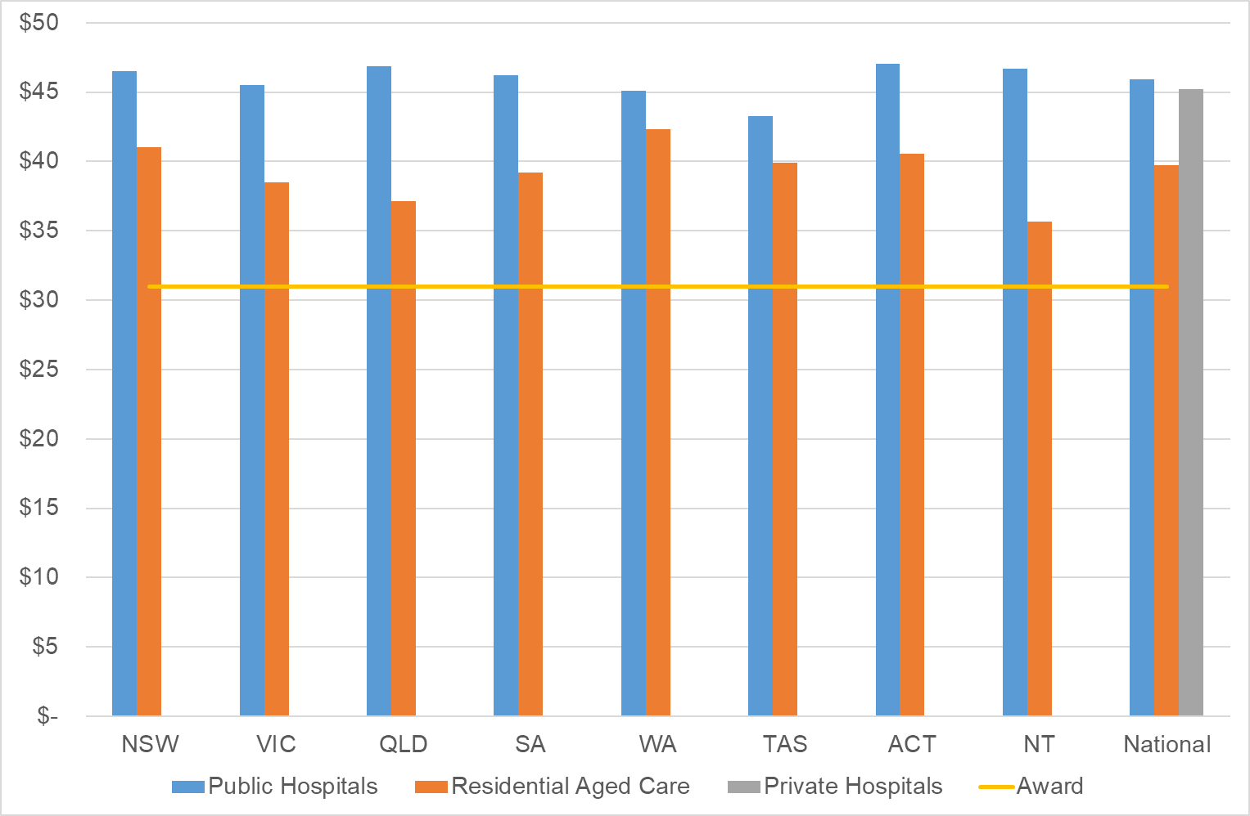

Wage Comparison to Allied Health Professionals
Exhibit 42 illustrates the range of wages (in December 2020 prices) paid to registered nurses and allied health professionals across Australia based on an analysis of the conditions in 22 awards / state government agreements and 15 disability provider enterprise agreements.
The Charts in Exhibit 42 show the best estimate of the “likely range” of salaries paid to allied health professionals and nurses by NDIS providers. The “likely range” is estimated by examining the base hourly salaries listed in the various awards and agreements for full time employees, without allowances for leave or other loadings such as shift, casual loadings, or superannuation. Where necessary, the reported wages were converted to an hourly rate and indexed to 31 December 2020 using the indexation rates in each award/Enterprise Bargaining Agreements (EBAs).
The likely range of wages for registered nurses for NDIS providers appears to lie between about $34 and $49. The likely range of wages for allied health professionals for NDIS providers appears to lie between about $37 and $55. That is, although there is considerable overlap between the two likely ranges there is some evidence that, on average, the wages of allied health professionals tend to be higher than those of registered nurses. Note also, that wages are only one component of the costs of service provision. Other key cost drivers are the utilisation rate that can be expected of workers – billable hours as share of total available (non-leave) hours – and the overheads of operating the business. It is likely that these cost drivers also differ between nursing and allied health providers.
Exhibit 42: Comparative Analysis of Nursing and Allied Health Wages by Jurisdiction, by Sector, December 2020
Allied Health wages
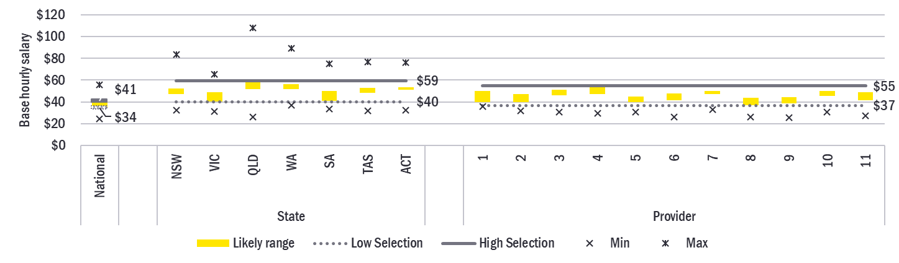
Nurse Wages
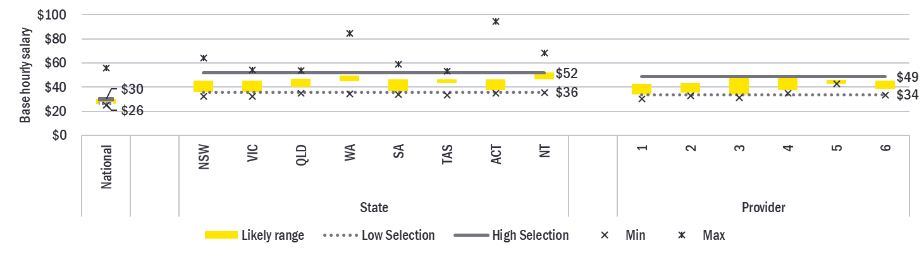

Comparisons to Other Schemes and Funding Programs

Comparison to the Private Market (Home Care Providers)
Aged Care providers are significant providers of nursing supports in the community. As Exhibit 43 shows, the average hourly rate charged by Home Care providers for the provision of nursing (by a registered nurse) during standard weekday hours was $100. A quarter of prices were above $107 per hour and a quarter of prices were below $92 per hour.
Note, these prices are not directly comparable to the prices charged by disability providers. Home Care Providers can also charge separate package and care management fees on top of the hourly rate. These fees account for about 25% of the costs incurred by a home care package recipient. However, not all of these fees can be thought of as overheads on top of service fees. Care management fees, for example, are best not conceptualised as an administration fee but rather as a separate payment for a care management service.
Exhibit 43: Statistical Distribution of Weekday Hourly Rate for Home Care Nursing, By Remoteness
Statistic | Metro | Regional Centre | Large Rural Towns | Medium Rural Towns | Small Rural Towns | Remote | Very Remote | Australia
MMM Region | 1 | 2 | 3 | 4 | 5 | 6 | 7 | All
Number of observations | 2,611 | 2,116 | 1,913 | 1,771 | 2,180 | 890 | 608 | 12,092
Mean | $98.70 | $99.70 | $100.00 | $100.00 | $99.60 | $101.00 | $102.00 | $99.90
Standard deviation | 13.2 | 12.9 | 12.6 | 12.7 | 12.8 | 11.4 | 9.3 | 12.6
Minimum | $63.00 | $64.20 | $63.00 | $63.00 | $63.00 | $64.20 | $66.00 | $63.00
25th percentile | $90.00 | $91.10 | $93.20 | $92.80 | $92.00 | $93.60 | $98.50 | $92.00
Median | $99.00 | $99.80 | $100.00 | $100.00 | $99.50 | $101.00 | $101.00 | $100.00
75th percentile | $106.00 | $108.00 | $110.00 | $110.00 | $108.00 | $105.00 | $105.00 | $107.00
Maximum | $130.00 | $130.00 | $130.00 | $130.00 | $130.00 | $126.00 | $120.00 | $130.00
Exhibit 44: Distribution of Weekday Hourly Rate for Aged Care Nursing, by Remoteness
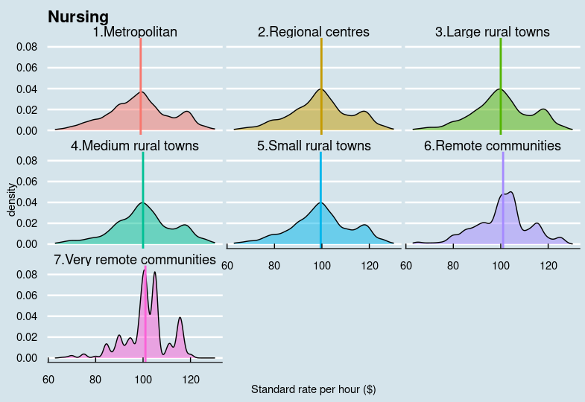
As Exhibit 43 and Exhibit 44 show, remoteness appears to have little effect on average price. In most regions, the distribution is essentially normal, but with a small second higher peak around a higher price point (perhaps representing the use in some cases of more highly qualified nurses). There are three peaks in the price distribution for very remote communities.
Exhibit 45 provides an analysis of the percentage loading that Home Care providers apply for work done other than during weekday daytime shifts. The average hourly rates for nursing during non-standard daytime shifts, and on Saturdays, Sundays and Public Holidays, were respectively 15.3%, 35.6%, 59.7% and 99.6% higher than the standard hourly rate.
These relativities are broadly consistent with the relativities with NDIS price limits, where:
- The price limit for weekday evenings is 10.3% higher than the weekday daytime limit;
- The price limit for weekday nights is 12.4% higher than the weekday daytime limit;
- The price limit for Saturdays is 42.7% higher than the weekday daytime limit;
- The price limit for Sundays is 64.1% higher than the weekday daytime limit; and
- The price limit for Public Holidays is 85.4% higher than the weekday daytime limit.
Exhibit 45: Percentage difference between non-standard and Standard Rates, by Remoteness
Statistic | Metro | Regional Centre | Large Rural Towns | Medium Rural Towns | Small Rural Towns | Remote | Very Remote | Australia
MMM Region | 1 | 2 | 3 | 4 | 5 | 6 | 7 | All
Percentage Difference between the Non-Standard Weekday Rate and the Standard Weekday Rate
Number of observations | 1,989 | 1,645 | 1,514 | 1,340 | 1,665 | 775 | 554 | 9,482
Mean | 15.7% | 15.7% | 15.0% | 14.9% | 15.8% | 15.0% | 13.2% | 15.3%
Standard deviation | 13.6 | 14.3 | 12.7 | 11.6 | 13.8 | 11.9 | 7.2 | 13.0
Minimum | 0% | 0% | 0% | 0% | 0% | 0% | 0% | 0%
25th percentile | 9.1% | 8.9% | 8.9% | 8.9% | 9.1% | 8.9% | 8.9% | 8.9%
Median | 11.8% | 10.8% | 10.7% | 10.4% | 11.3% | 9.5% | 9.5% | 10.8%
75th percentile | 19.1% | 17.6% | 17.9% | 17.2% | 20.2% | 17.7% | 17.2% | 17.9%
Maximum | 103.0% | 103.0% | 103.0% | 84.6% | 103.0% | 50.9% | 50.0% | 103.0%
Percentage Difference between the Saturday Rate and the Standard Weekday Rate
Number of observations | 2,135 | 1,760 | 1,588 | 1,471 | 1,790 | 800 | 560 | 10,104
Mean | 36.8% | 36.3% | 35.6% | 35.0% | 36.8% | 33.4% | 30.5% | 35.6%
Standard deviation | 15.0 | 15.6 | 14.3 | 13.5 | 15.1 | 11.0 | 8.0 | 14.3
Minimum | 0% | 0% | 0% | 0% | 0% | 0% | 0% | 0%
25th percentile | 27.7% | 27.7% | 27.7% | 27.7% | 27.7% | 27.7% | 27.7% | 27.7%
Median | 35.9% | 33.3% | 32.3% | 31.6% | 35.9% | 28.6% | 28.6% | 31.7%
75th percentile | 47.1% | 47.1% | 46.4% | 46.4% | 47.1% | 38.1% | 31.6% | 46.4%
Maximum | 124.0% | 124.0% | 109.0% | 109.0% | 124.0% | 97.0% | 62.1% | 124.0%
Percentage Difference between the Sunday Rate and the Standard Weekday Rate
Number of observations | 2,133 | 1,740 | 1,572 | 1,452 | 1,769 | 796 | 560 | 10,022
Mean | 60.4% | 59.7% | 58.6% | 57.9% | 60.1% | 55.2% | 51.9% | 58.7%
Standard deviation | 21.0 | 14.4 | 19.1 | 18.5 | 20.3 | 19.2 | 11.7 | 19.7
Minimum | 0% | 0% | 0% | 0% | 0% | 0% | 0% | 0%
25th percentile | 48.5% | 48.0% | 47.2% | 46.7% | 50.0% | 40.6% | 43.8% | 46.7%
Median | 57.1% | 57.1% | 57.1% | 57.1% | 57.1% | 56.3% | 55.0% | 57.1%
75th percentile | 73.9% | 72.5% | 71.0% | 72.0% | 73.3% | 60.0% | 57.1% | 71.9%
Maximum | 166.0% | 143.0% | 143.0% | 115.0% | 143.0% | 115.0% | 100.0% | 166.0%
Percentage Difference between the Public Holiday Rate and the Standard Weekday Rate
Number of observations | 2,206 | 1,811 | 1,643 | 1,500 | 1,846 | 815 | 558 | 10,379
Mean | 101.0% | 99.8% | 99.3% | 100.0% | 101.0% | 97.6% | 91.4% | 99.6%
Standard deviation | 37.8 | 38.3 | 37.9 | 35.7 | 38.2 | 37.9 | 30.4 | 37.4
Minimum | 0% | 0% | 0% | 0% | 0% | 0% | 0% | 0%
25th percentile | 77.2% | 76.2% | 75.7% | 77.2% | 77.2% | 69.3% | 71.5% | 75.7%
Median | 98.8% | 95.2% | 95.9% | 95.2% | 99.9% | 95.2% | 95.2% | 95.2%
75th percentile | 124.0% | 124.0% | 123.0% | 123.0% | 125.0% | 132.0% | 100.0% | 123.0%
Maximum | 250.0% | 248.0% | 248.0% | 248.0% | 248.0% | 242.0% | 154.0% | 250.0%

State Insurance Schemes
Four state government insurance schemes have been identified that publish fees for the provision of nursing supports.
The Victorian Transport Accident Commission (TAC) has a number of different fees for nursing services. Note, if the nurse’s fee is higher than the TAC fee, then the nurses may choose to charge the client the difference in the form of a gap payment.
- An episodic fee of $94.45 (GST free) is payable for each visit by the Community Nurse to a TAC client. This is not an hourly rate. It is inclusive of all penalties and allowances, consumables and travel associated with the nursing episode.
- A per hour fee of $104.00 (GST inclusive) applies for specialist assessment by a nurse. Travel can also be claimed to and from the nurse's practice address and the client's residence at the same rate. Report writing is billed at the same rate. However, training provided by the nurse is billable at $94.45 per hour (GST inclusive). Lower rates are payable for services that are not registered for the GST.
- General nursing (long term) that is provided during the daytime only is billable at $96.83 per hour if Nursing Care Coordination is also being paid and at $99.39 if Nursing Care Coordination is not also being paid.
- General nursing (long term) that is provided 24/7 is billable at $101.79 per hour if Nursing Care Coordination is also being paid and at $104.33 if Nursing Care Coordination is not also being paid.
WorkSafe Victoria has two different fee arrangements for nursing services. If GST is applicable, then WorkSafe Victoria pay the GST component in addition to normal fee.
- A fee of $111.58 per hour is payable for nursing services. This fee is inclusive of travel and consumables.
- A fee of $113.65 per hour is paid for a continence assessment. In this case, a travel fee of $1.00 per kilometre is also payable.
Workcover Queensland has a number of different fee arrangements for nursing.
- An episodic fee of $41 is payable when a patient is seen by an advanced practice registered nurse (that is, a nurse practitioner or rural and isolated practice nurse) and performs straightforward medical procedures that would normally be payable as part of a doctor's MBS attendance fee. This fee is also payable when a nurse assists a doctor in minor surgery if the procedure attracts an MBS assistance fee.
- An hourly fee of $75 is payable for Home Nursing Services by a Registered Nurse for weekday daytime appointments. The same fee applies to day and evening supports. A fee of $97 per hour applies to services delivered on weekends.
- Nurses can also be paid an episodic fee for time spent in communication between treating provider and insurer, employer, insurer referred allied health provider and doctors. The fee is $32 if the communication between 3 and 10 minutes and $63 if the communication is between 11 and 20 minutes.
- An hourly fee of $189 is payable for attendance at a case conference or the preparation of a comprehensive report.
- Travel can be billed at $134 per hour, but only when the provider is required to leave their normal place of practice to treat a worker at a: rehabilitation facility; hospital; workplace, or their place of residence (worker must be certified unable to travel). Where multiple workers are being treated in the same visit to a facility, or in the same geographical area on the same day, travel must be divided evenly between the workers. Travel above one hour requires prior approval.
- Nurses can also make a claim for up to $58 for incidental items required by the worker to assist in their recovery and which they take home with them.
The Tasmanian Motor Accident Insurance Board permits nurses to claim $90.26 for each professional consultation that is less than an hour in length.

Department of Veterans’ Affairs (DVA) Community Nursing
The fee that is payable by DVA to Community Nursing providers in respect of a veteran depends on: the number of visits made to deliver support to the veteran in a 28 day period; the average length of those visits; and whether the majority of the visits were for clinical care (by a registered nurse or an enrolled nurse) or personal care (by a registered nurse or an enrolled nurse or a personal care worker). For example, if a veteran were to receive:
- 58 visits in a 28-day period that were mainly clinical care and were, on average, less than 20 minutes each then the total fee would be $3,236.50 or $57.79 per visit.
- 14 visits in a 28-day period that were mainly clinical care and were, on average, more than 20 minutes each then the total fee would be $757.75 or $54.13 per visit.
DVA also pays some one-off episodic fees for Community Nursing providers, including: $186.60 for initial care coordination; $93.35 for subsequent care coordination; $128.70 for assessment; and $184.95 for bereavement follow-up.
All fees are GST-exclusive. Where GST is payable then an additional GST component is also paid. Travel is included in the fee, but providers can claim separately for consumables used by nurses in the provision of services.

Medical Benefits Schedule (MBS)
A number of MBS items are also claimable by registered nurses. For example, an MBS benefit of $64.70 is payable for item 93026 (non-directive pregnancy support counselling provided by a mental health nurse where the service is at least 30 minutes duration).
Exhibit 46 details the MBS benefit payable to nurse practitioners for each professional attendance that includes any of the following: taking a history; undertaking clinical examination; arranging any necessary investigation; implementing a management plan; providing appropriate preventive health care, with appropriate documentation.
Exhibit 46: MBS Items for Nurse Practitioners
Item | Description | Scheduled Fee | MBS Benefit
822000 | Attendance is for an obvious problem (a straightforward task) that requires a short patient history and, if required, limited examination/ management. | $10.00 | $8.50
822005 | Attendance lasts less than 20 minutes. | $21.80 | $18.55
822010 | Attendance at least 20 minutes. | $41.35 | $35.15
822015 | Attendance at least 40 minutes. | $60.95 | $51.85

Discussion

Price limits
The NDIS is not a major purchaser of nursing services in Australia. It is estimated that NDIS funds make up only about 0.4% of all expenditure on nursing services provided in Australia. Australian Government spending on nursing is much greater in other programs, including the MBS, the aged care program and the Department of Veterans’ Affairs Community Nursing Program. It is important that the NDIS’s pricing arrangements take this into consideration.
While there is considerable evidence that the demand for nurses is increasing and there is some risk that demand will outstrip supply in the short to medium term, it is also the case that the current NDIS price limits for registered nurses equate to an effective hourly rate (taking into account the distribution of when and by whom supports are delivered) of $127.65 which is broadly comparable with the effective hourly rates of other schemes.
- The MBS benefits for mental health nurses (item 93026) equate to an effective hourly rate between $64.70 and $129.40, noting that co-payments can also be sought.
- The episodic fees paid by the DVA Community Nursing Program equate to an hourly fee in the range of $150 and $180. Note, however, that these fees include an allowance for travel – which is billable separately in the NDIS.
- The hourly fee paid by Workcover Queensland varies between $75 and $189.
- The hourly fees (GST exclusive) paid by the Victorian TAC and Worksafe Victoria vary between $95 and $115, noting again that co-payments can also be sought.
With respect to aged care, the NDIS’s standard weekday price limit for services provided by a registered nurse ($107.25) is higher than the average weekday headline price charged by home care providers, which is $99.90. Even taking into account the fact that home care providers can also bill their clients an additional administrative fee, the prices in the two schemes are broadly comparable.
On balance, it is therefore recommended that there should not be any structural adjustment to the pricing arrangements for nursing supports at this time. The NDIA should continue to work with the Department of Social Services and other government agencies to understand the differences in pricing arrangements and prices across relevant Australian Government, and state and territory government insurance and funding programs for nursing supports, to inform future price setting and ensure the ongoing adequate supply of nurses

Indexation
Because the fees payable in other funding programs and government insurance schemes are annually indexed it is important that the NDIS price limits for nursing support items should also be adjusted regularly to reflect real changes in the costs doing business. It is therefore also recommended that the price limits for nursing supports should be indexed on 1 July 2022 in line with indexation arrangements for ‘other supports’ as discussed in Chapter 2.6 above (see page 54).
That is, that the price limits for nursing supports should be increased on 1 July 2022 in line with the weighted movement over the previous twelve months in the ABS Wage Price Index (Australia, total hourly rates of pay excluding bonuses) and the ABS Consumer Price Index (All Groups, weighted average of eight capital cities) over the 12 months to the March Quarter preceding the indexation date (with an 80/20 weighting).

Definitions
The current definition of time of day (shift) used in the NDIS Pricing Arrangements and Price Limits is drawn from the SCHADS Industry Award and does not align with the shift definitions in the Nurses Award. It is therefore recommended that the NDIS Pricing Arrangements and Price Limits should be amended to align the shift definitions for nursing supports with those set out in the Nurses Award 2020 as follows:
In determining which price limit is applicable to a support, the important consideration is when the support is provided to the participant, not the shift of the worker used to deliver that support as determined by the relevant Industry Award or Enterprise Bargaining Agreement. For NDIS claiming purposes, the provider must first determine the day of the week on which the support was provided on and then the time of the day during which the support was delivered. (Note: Weekday means Monday, Tuesday, Wednesday, Thursday, or Friday).
A Public Holiday Support is any support to a participant that starts at or after midnight on the night prior to a Public Holiday and ends before or at midnight of that Public Holiday.
A Saturday Support is any support to a participant that starts at or after midnight on the night prior to a Saturday and ends before or at midnight of that Saturday (unless it is a Public Holiday Support).
A Sunday Support is any support to a participant that starts at or after midnight on the night prior to a Sunday and ends before or at midnight of that Sunday (unless it is a Public Holiday Support).
A Weekday Afternoon Support is any support to a participant that commences not earlier than 12.00 noon on a Weekday and finishes after 6.00 pm on the same day (unless it is a Public Holiday Support).
A Weekday Night Support is any support to a participant that commences on or after 6.00 pm on a Weekday and finishes before 7.30 am on the following day (unless it is a Public Holiday Support).
A Weekday Daytime Support is any support to a participant that commences before 12.00 noon on a Weekday and finishes on the same day (unless it is a Public Holiday, Weekday Afternoon, or Weekday Night Support).
If a support to a participant does not meet one of the above criteria then it needs to be billed as two or more separate supports. An exception to this general rule occurs when a particular support crosses a shift boundary and the same nurse delivers the entire support. In this case, the higher of the relevant price limits applies to the entire support and the provider should make the claim against the relevant support item. Providers are required to discuss this billing arrangement with the participant.
It is also recommended that the definitions of the different types of nurses should be clarified by linking them more closely to the provisions of the Nurses Award 2020 as follows:
An enrolled nurse is a person who provides nursing care under the direct or indirect supervision of a registered nurse. They have completed the prescribed education preparation, and demonstrated competence to practice under the Health Practitioner Regulation National Law as an enrolled nurse in Australia. Enrolled nurses are accountable for their own practice and remain responsible to a registered nurse for the delegated care.
- The enrolled nurse support items should be used when the nurse who delivered the support would be classified as an Enrolled nurse under the Nurses Award 2020 (A.4) if they were classified under that Award.
A registered nurse is a person who has completed the prescribed education preparation, demonstrates competence to practice, and is registered under the Health Practitioner Regulation National Law as a registered nurse in Australia.
- The registered nurse support items should be used when the nurse who delivered the support would be classified as a Registered nurse – level 1 (RN1) under the Nurses Award 2020 (A.5.1) if they were classified under that Award.
A clinical nurse is a more experienced and skilled registered nurse. Duties of a clinical nurse will substantially include, but are not confined to, delivering direct and comprehensive nursing care and individual case management to a specific group of patients or clients in a particular area of nursing practice.
- The clinical nurse support items should be used when the nurse who delivered the support would be classified as a Registered nurse – level 2 (RN2) under the Nurses Award 2020 (A.5.2) if they were classified under that Award.
A clinical nurse consultant is a nurse practicing in the advanced practice role. Advanced practice nursing is a qualitatively different level of advanced nursing practice to that of the registered nurse due to the additional legislative functions and the regulatory requirements. The requirements include a prescribed educational level, a specified advanced nursing practice experience, and continuing professional development.
- The clinical nurse consultant support items should be used when the nurse who delivered the support would be classified as a Registered nurse – level 3 (RN3) or higher under the Nurses Award 2020 (A.5.3) if they were classified under that Award.
A nurse practitioner is an advanced practice nurse endorsed by the Nursing and Midwifery Board of Australia who has direct clinical contact and practices within their scope under the legislatively protected title ‘nurse practitioner’ under the Health Practitioner Regulation National Law.
- The nurse practitioner support items should be used when the nurse who delivered the support would be classified as a Nurse Practitioner under the Nurses Award 2020 (A.7) if they were classified under that Award.

Simplifying the pricing arrangements
The following two support items predate the inclusion in the support catalogue of the 30 support items for the provision of nursing support for disability related health supports:
- 15_036_0114_1_3 – Assessment and Support by a Registered Nurse – Provision to a participant of care, training, or supervision of a delegated worker to respond to complex care needs where that care is not the usual responsibility of the health system.
- 15_051_0114_1_3 – Community Nursing Care for Continence Aid – Provision by a Registered Nurse to a participant of continence aids assessment, recommendation, and training support.
They are arguably no longer necessary. Clear guidance could instead be provided in the relevant Operational Guidelines as to when it is reasonable and necessary for a participant to use NDIS funding to purchase these types of services. The support items for the provision of nursing support for disability related health supports could then be used to claim for these supports. It is therefore recommended that the NDIA should simplify the pricing arrangements for nursing supports by decommissioning these two support items.
Currently the 30 support items for the provision of nursing support for disability related health supports in the Improved Daily Living Skills capacity building support category are duplicated in the Assistance with Daily Life core support category. The NDIA has considered whether it should simplify the pricing arrangements for nursing supports by decommissioning the 30 support items for the provision of nursing support for disability related health supports in the Improved Daily Living Skills capacity building support category. However, supports delivered by nurses can be either direct care (core supports) or assessment and training (capacity building supports) and so it remains appropriate for the supports to be duplicated across the two support categories.
It is also recommended that the NDIA should address concerns raised in submissions to the 2021-22 Annual Pricing Review by publishing further guidance for participants, providers, Plan Managers and Support Coordinators on when it is reasonable and necessary for participants to purchase nursing supports with their NDIS funds.

Planning Issues
Several members of the working group and some submissions raised a concern that planners may not always understand the skills and scope of practice of the different levels of nurses, and so may inadvertently not provide sufficient funding in a plan to allow providers to engage a nurse with the necessary higher qualifications, or may not provide sufficient funding in a plan to allow a nurse to provide clinically appropriate care. This matter is outside the Terms of Reference of the Annual Pricing Review. It is commended to the relevant areas of the NDIA for further attention.

Recommendations
Recommendation 25
The NDIA should not make any structural adjustment to the pricing arrangements for nursing supports at this time.
In line with the general indexation arrangements for NDIS price limits (see Recommendation 2), the price limits for nursing supports should be indexed on 1 July 2022 in line with the weighted movement over the previous twelve months in the ABS Wage Price Index (Australia, total hourly rates of pay excluding bonuses) and the ABS Consumer Price Index (All Groups, weighted average of eight capital cities) over the 12 months to the March Quarter preceding the indexation date (with an 80/20 weighting).
The NDIA should continue to work with the Department of Social Services and other government agencies to understand the differences in pricing arrangements and prices across relevant Australian Government, and state and territory government insurance and funding programs for nursing supports, to inform future price setting and ensure the ongoing adequate supply of nurses.
Recommendation 26
The shift definitions for nursing supports in the NDIS Pricing Arrangements and Price Limits should be aligned with those set out in the Nurses Award 2020 by amending them as set out in this Report.
Recommendation 27
The definitions for the different level of nursing supports in the NDIS Pricing Arrangements and Price Limits should be amended as set out in this Report to provide greater clarity to providers and participants.
Recommendation 28
The NDIA should simplify the pricing arrangements for nursing supports by decommissioning the following support items:
15_036_0114_1_3 – Assessment and Support by a Registered Nurse – Provision to a participant of care, training, or supervision of a delegated worker to respond to complex care needs where that care is not the usual responsibility of the health system
15_051_0114_1_3 – Community Nursing Care for Continence Aid – Provision by a Registered Nurse to a participant of continence aids assessment, recommendation, and training support
and providing clear guidance in the relevant Operational Guidelines as to when it is reasonable and necessary for a participant to use NDIS funding to purchase these types of services, which they should do using the support items for the provision of nursing support for disability related health supports.
Recommendation 29
The NDIA should publish further guidance for participants, providers, Plan Managers and Support Coordinators on when it is reasonable and necessary for participants to purchase nursing supports with their NDIS funds.

Endnotes

Plan Management Supports
This chapter examines the pricing arrangements that apply to plan management supports in the National Disability Insurance Scheme (NDIS) and the extent to which they encourage innovation, improve quality of service, and ensure value for money.
- Section 8.1 provides an overview of the current pricing arrangements for plan management supports in the NDIS, and participant and provider statistics on the use of plan management supports in the NDIS.
- Section 8.2 provides an overview of the issues about the current pricing arrangements for plan management supports that were raised by stakeholders during consultations.
- Section 8.3 provides information on the financial performance of plan management providers based on a survey conducted by Disability Intermediaries Australia.
- Section 8.4 draws conclusions from the available evidence and recommends some changes to the pricing arrangements for plan management supports.

Current Arrangements
The funding for supports that is provided by the NDIS under a participant’s plan can be managed wholly or in part by the participant; or by a registered plan management provider (“Plan Manager”); or by the National Disability Insurance Agency (NDIA); or by a plan nominee (if one has been appointed).
Currently, participants can choose (subject to the terms of any plan nominee appointment) to engage a registered Plan Manager to manage some or all of the funding for supports in their plan. If a participant makes this choice, then the NDIA is currently required to give effect to the participant’s choice. The NDIA also then includes funding in the participant’s plan so that they can engage their preferred registered Plan Manager.
The NDIS Act requires Plan Managers to be registered with the Commission in order to be able to manage the funding of supports under a participant’s plan. As a result, they are required to: demonstrate compliance with the Core Module of the NDIS Practice Standards; comply with the NDIS Code of Conduct; have an in-house complaints management and resolution system to record and manage complaints, and support NDIS participants or other relevant parties to make a complaint; have an in-house incident management system, and notify the NDIS Quality and Safeguards Commission (NDIS Commission) should a reportable incident occur (including alleged reportable incidents); and fulfil the worker screening requirements where relevant.
Plan Managers are also bound by the NDIS Pricing Arrangements and Price Limits. Plan-managed participants can only purchase supports that are listed in the NDIS Support Catalogue and are subject to the same billing rules and price limits as agency-managed participants. However, plan-managed participants can purchase supports from registered and/or unregistered providers (except where the NDIS Commission has determined that providers must be registered in order to deliver a particular type of support).
Plan Managers receive funds from the NDIS and disburse funds on behalf of a participant to providers of other services received by the participant. They can assist a participant by: claiming directly from the funds in the participant’s plan to pay providers on behalf of the participant; paying providers for the supports that the participant purchases; helping the participant keep track of their funds; and taking care of financial reporting for the participants. In some cases, Plan Managers also help participants choose their providers.
Plan Managers must provide the Australian Business Number (ABN) of the service provider who delivers the support for all payment requests, except where the service provider is exempt from quoting an ABN under Australian Taxation Office (ATO) rules. Exempt providers must complete the ATO’s Statement by a Supplier form. Plan Managers are expected to keep a copy of the completed form. Plan Managers must always ensure that a valid tax invoice is included with each payment request and that the tax invoice includes relevant information about the goods and/or services purchased. A Plan Manager may be liable to pay back any amount not spent in accordance with a participant’s plan.

Current Pricing Arrangements
Plan Managers are able to claim for three types of services:
- A one-off (per plan) establishment fee for setting up the financial management arrangements for a participant;
- A monthly fee for the ongoing maintenance of the financial management arrangements for a participant; and
- Ad hoc capacity building and training in plan administration and management support to strengthen a participant’s ability to undertake tasks associated with the management of their supports.
The price limits for these supports are set out in Exhibit 47 below.
Exhibit 47: Price Limits for Plan Management Supports
Item Number | Item Name and Notes | Unit | Non-Remote | Remote | Very Remote
14_033_0127_8_3 | Plan Management - Set Up Costs  - A one-off (per plan) fee for setting up the financial management arrangements. | Each | $232.35 | $325.29 | $348.54
14_034_0127_8_3 | Plan Management - Monthly Fee  - A monthly fee for the ongoing maintenance of the financial management arrangements. | Month | $104.45 | $146.23 | $156.67
14_031_0127_8_3 | Capacity Building and Training in Plan and Financial Management by a Plan Manager | Hour | $65.09 | $91.13 | $97.64
If a Plan Manager is engaged to deliver the Capacity Building and Training in Plan and Financial Management support (14_031_0127_8_3) to a participant then they are also permitted, subject to the rules set out in the NDIS Pricing Arrangements and Price Limits, to claim for provider travel (labour and non-labour costs); non-face-to-face activities and short notice cancellations.

Scheme Statistics
In 2020-21, some 1,158 Plan Managers were paid $305.3 million by 227,596 participants for plan management services and processed support payments worth $8.3 billion through about 26.3 million transactions (including 2.6 million transaction for plan management fees).

Participants
In 2020-21, more than half (51.8%) of all active participants (participants who made a claim from their plan in 2020-21) used a Plan Manager for some or all of their plan. As at 30 June 2021, more than a third (35.8%) of all funds in plans was plan-managed. As Exhibit 48 illustrates, both the share of participants choosing to be fully plan-managed and the share of funds managed by Plan Managers has increased significantly in the last three years. Of plans approved in the second Quarter of 2021-22, some 58.5% of participants had a Plan Manager for all of their plan and 52.2% of all funds in plans approved in the Quarter were plan-managed.
Exhibit 48: Distribution of Participants (left hand chart) and Plan Budgets (right hand chart)
by Method of Plan Management, June 2018 to December 2021
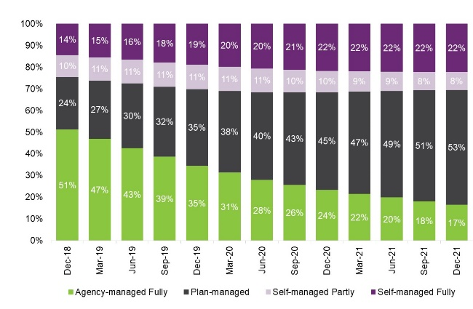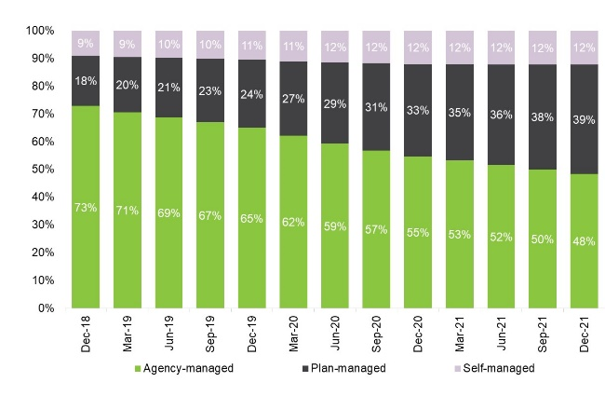
As Exhibit 49 shows, the share of participants who have a Plan Manager (and the share of funds in plans that are plan managed) varies considerably by state/territory.
Exhibit 49: Plan Managed Share of Participants and Plan Budgets, by Jurisdiction, December 2021
 | NSW | VIC | QLD | WA | SA | TAS | ACT | NT | AUS
% of active participants who are wholly plan managed | 48% | 57% | 57% | 39% | 65% | 56% | 44% | 67% | 53%
% of funds in plans that are plan managed | 33% | 48% | 44% | 27% | 46% | 27% | 45% | 30% | 39%
Participants are considerably more like to be plan managed in South Australia and the Northern Territory than in other jurisdictions; and considerably less likely to be plan managed in Western Australia. Note, the relatively low share of participants who are plan managed in the Australian Capital Territory is largely an artefact of the larger share of self-managing participants in the territory.
The share of Scheme funds that are plan managed is well below average in Tasmania, Western Australia and the Northern Territory. It is also interesting that the distribution of the share of funds that is plan managed is not well correlated with the distribution of the participants who are plan managed. Although a very high share of participants in the Tasmania and the Northern Territory have a Plan Manager, those Plan Managers are managing a lower than average share of funds.
Participants appear to make greater use of Plan Managers in regional and remote areas than in major cities and regional centres. In the first half of 2021-22:
- Slightly more than half (53.9%) of active participants in major cities and regional centres (MMM1-3) engaged a Plan Manager to manage some or all of their supports.
- More than two third (68.7%) of active participants in regional areas (MMM4-5) engaged a Plan Manager to manage some or all of their supports.
- Almost three quarters (73.5%) of active participants in remote and very remote areas (MMM6-7) engaged a Plan Manager to manage some or all of their supports.

Providers
The number of Plan Managers continues to grow, with 251 plan management providers commencing operations in 2020-21 and 129 plan management providers commencing operations in the first two quarters of 2021-22. More than half (57%) of all providers who supply plan management services also provide support coordination services. More than a third (37%) of them also deliver other NDIS services (other than support coordination).
The Plan Management provider sector is very diverse. In the final quarter of 2020-21:
- The five largest Plan Managers together serviced 30% of all plan-managed participants.
- The next five largest providers together serviced a further 12% of all plan-managed participants.
- Another 219 Plan Managers each assisted more than 100 participants. These medium sized providers delivered services to 47% of all plan-managed participants.
- Some 971 Plan Managers each assisted fewer than 100 participants each. These small sized providers delivered services to the remaining 11% of plan-managed participants.
In the first half of 2021-22, just four Plan Managers received a quarter of all plan fees paid by participants – with an average income for plan management fees over the six months of $12.8 million. The largest twenty Plan Managers received half of all plan fees paid by participants – with an average income for plan management fees over the six months of $1.5 million. At the other end of the scale, the smallest 50% of Plan Managers together received only 1.5% of all plan management fees – with an average income for plan management fees over the six months of $5,294 (see Exhibit 50).
Exhibit 50: Distribution of Plan Managers by Share of Plan Management Fees
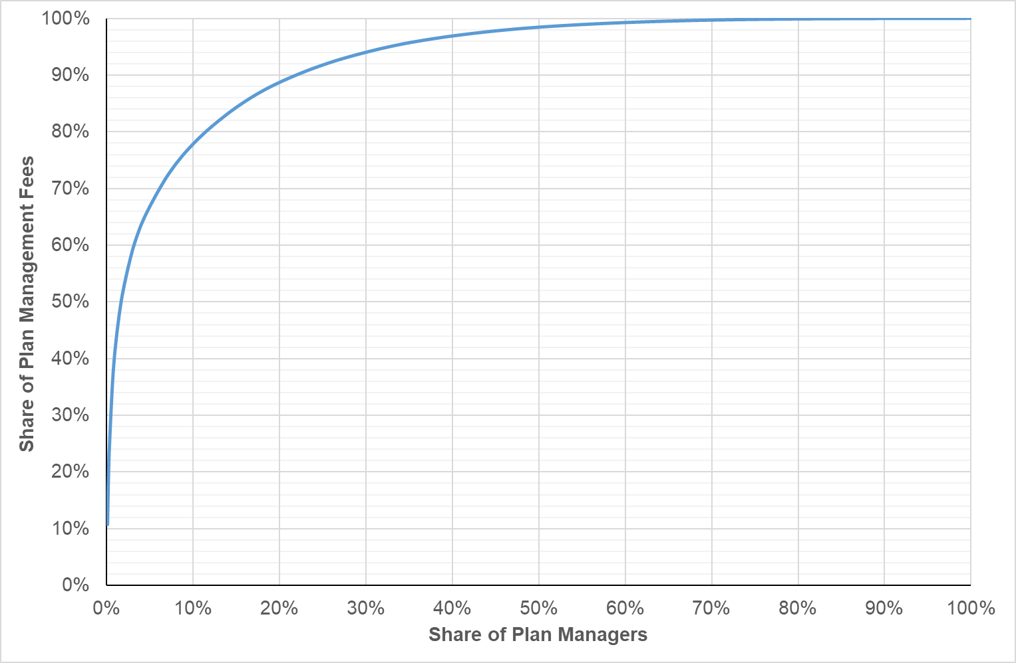
In 2020-21, Plan Managers processed, on average, 101 transactions with the NDIS payment system for each participant they managed. The number of transactions per participant is highly variable. One in ten plan-managed participants required more than 236 transactions to be processed; and one in ten required fewer than 8 transactions to be processed.
The average amount paid to Plan Managers for each transaction they processed with the NDIS payment system in 2020-21 was $53.98. However, there are a small number of plan managers with relatively high transaction costs (often because they process very few transactions per participant). Half of all transactions were processed for less than $20.08 per transaction. One in four transactions were processed for less than $9.98 per transaction. One in ten transactions were processed for less than $5.67 per transaction.
The average funds management ratio (the ratio of the cost of monthly plan management fee to the cost of the supports purchased through the plan manager) was, on average, 28.5% in 2020-21. Again, this number is highly variable and is skewed by some very high fund management ratios. Three in four plan manager/participant pairs had a funds management ratio more than 20.4% and one in four plan manager/participant pairs had a funds management ratio less than 3.5%. The median funds management ratio was 8.7% and one in ten plan manager/participant pairs had a funds management ratio less than 1.6%.

Changing Plan Managers
In 2020-21, almost all (91.6%) participants who engaged a Plan Manager only had dealing with one Plan Manager. Some 8.4% of all participants who engaged a Plan Manager at some time during the year changed Plan Managers during the year. Of these, some 95.3% engaged two Plan Managers over the course of the year, some 4.5% engaged three Plan Managers over the course of the year, and 0.2% engaged more than three Plan Managers over the course of the year.

Issues Raised in the Consultations
A total of 69 submissions about the pricing arrangements for plan management were received in response to the Consultation Paper. A working group of providers and other stakeholders was also established. The working group had 22 members from 20 organisations and met, by video-conference, on two occasions: 6 December 2021 and 7 February 2022. A detailed report of the consultations is provided in Chapter 8 of the 2021-22 Annual Pricing Review Report on Consultations.
A major submission was received from Disability Intermediaries Australia (DIA) — the industry group for providers of Intermediary supports (plan management and support coordination). That submission included summary results of a survey of plan management and support coordination providers on the costs of providing service. The submission also included a proposed cost model for plan managers (see section 8.1 of the Report on Consultations).
The DIA submission argued for significant increases in the price limits that apply to plan management supports and for the annual indexation of those price limits. These calls were echoed in a number of other submissions to the Review, including statement of supports. A number of submissions argued that Plan Managers undertake additional work beyond processing invoices that is not adequately factored into the current monthly fee, including providing a de facto support coordination role, educating and fielding enquiries from participants about the use of funds in their plans. Further, a number of submissions were concerned with the “one size fits all” nature of the price limit for the monthly fee. They stated that the current flat monthly fee was insufficient to cover the increased workload and transactions associated with larger participant plans (see sections 8.2 and 8.3 of the Report on Consultations).
Many submissions were concerned that the NDIS did not increase the price limits for plan management supports in-line with other disability supports as part of the 1 July 2021 price limit increases. They proposed that the price limits of plan management supports should always be increased in line with an index such as the Consumer Price Index (see section 8.4 of the Report on Consultations).
A number of submissions acknowledged the potential efficiency benefits of the NDIA implementing the new Claims at Point of Support (CPOS) system. However, this raised concerns about the potential impact of the CPOS system and how it will affect the costs and role of Plan Managers and participants. Members of the Working Group felt that a major difficulty facing Plan Managers was that the roles of Support Coordinators and Plan Managers were blurred and poorly defined. This lack of role clarity inhibited participants from clearly understanding the differences in services between plan managers and support coordinators and the associated fees. (See section 8.5 of the Report on Consultations).

Financial Performance (Disability Intermediaries Australia Survey)
In its submission to the 2021-22 Annual Pricing Review, DIA reported on a survey that it undertook of Plan Managers and Support Coordinators (see 2021-22 Annual Pricing Review Report on Consultations). Some 430 Plan Managers responded to the survey.
The DIA submission reported that 54% of Plan Managers who responded to the survey indicated that they had made a profit in 2020-21 with a further 15% indicating that they had broken even in 2020-21. Some 86% of responses to the survey by “large” Plan Managers reported a surplus in 2020-21 compared to 52% for “medium” Plan Managers and 56% of “small” Plan Managers. At the same time, only 14% of responses to the survey by “large” Plan Managers reported a loss in 2020-21 compared to 32% for “medium” Plan Managers and 27% of “small” Plan Managers. The survey found no statistical differences between for-profit, profit-for-purpose and not-for-profit Plan Managers.
With respect to the size of the profits being made by Plan Managers, the DIA submission reported that the survey found an average Earnings Before Interest, Tax, Depreciation and Amortisation (EBITDA) (as a percentage of total costs) across respondents of 24%, with 46% of Plan Managers achieving a 2020-21 EBITDA above 10%.
The DIA submission also reported that “large” Plan Managers achieved higher returns, on average, than smaller Plan Managers. The average EBITDA (as a percentage of total costs) for “large” Plan Managers was 30%, compared to 25% for “medium” Plan Managers and 21% for “small” Plan Managers. Almost two-thirds (64%) of “large” Plan Managers achieved an EBITDA of more than 10% in 2020-21, compared to 46% for “medium” Plan Managers and 38% for “small” Plan Managers. The survey again found no statistical differences between for-profit, profit-for-purpose and not-for-profit Plan Managers.

Discussion
It is clear that the roles of, and expectations on, plan managers are still evolving. Neither the service offering nor the market has fully matured and the context within which plan managers deliver their services is also not fully developed. For example, the National Disability Insurance Scheme Amendment (Participant Service Guarantee and Other Measures) Act 2022 which extended the risk assessment process for self-management of funding to those using registered plan management providers was given assent on 1 July 2022. In addition, DIA has recently developed and published a set of Professional Standards of Practice for Plan Management and Support Coordination. In 2022, it is intending to implement a Service Accreditation Model that will sit over these Professional Standards of Practice. It is proposed that this accreditation model would examine and set how providers are able to demonstrate the quality of their service offering including the minimum expected qualifications, service experience, lived experience and training / development pathways for the Plan Management Workforce. While these Professional Standards of Practice are not mandatory for the sector, they do have the potential to change the way in which plan management services are delivered (and the costs of those services) going forward.
The NDIA is also implementing a number of reforms, including the new CPOS system, that have the potential to significantly change either the role or mode of operation of Plan Managers. Some of this Review’s other recommendations, which seek to simplify NDIS pricing arrangements, may also have flow on impacts on the role or mode of operation of Plan Managers.
The market for plan management supports is also in a state of flux, highly variable and not yet mature.
- The largest ten Plan Managers together account for 42% of all plan managed participants, while the smallest 1,000 Plan Managers each service less than 100 participants each and together account for only 11% of all plan managed participants.
- Significant numbers of new Plan Managers continue to enter the market each quarter – with 251 plan management providers commencing operations in 2020-21 and 129 plan management providers commencing operations in the first two quarters of 2021-22.
- The average cost per plan management transaction in 2020-21 was $53.98, with one in ten transactions costing more than $105.52 to process and one in ten transactions costing less than $5.67 to process.
- The average funds management ratio (the ratio of the cost of monthly plan management fee to the cost of the supports purchased through the plan manager) was, on average, 28.5% in 2020-21. Three in four plan manager/participant pairs had a funds management ratio greater than 20.4% and one in four plan manager/participant pairs had a funds management ratio less than 3.5%. The median funds management ratio was 8.7% and one in ten plan manager/participant pairs had a funds management ratio less than 1.6%.
It should be noted that these ratios compare poorly to those achieved by account managers in other sectors (noting that the comparisons are not perfect) which raises the issue of value for money. For example, the merchant transaction fee for Visa/MasterCard Debit transactions is between 0.2% and 0.3%, the median management fee for superannuation funds is in the order of 1.0%, and the average accounts payable fees for healthcare markets (globally) are about 0.3%.
- According to the survey undertaken by DIA, 54% of the 430 Plan Managers who responded to it indicated that they had made a profit in 2020-21 with a further 15% indicating that they had broken even in 2020-21. Moreover, the average EBITDA (as a percentage of total costs) across respondents was 24%, with 46% of Plan Managers achieving a 2020-21 EBITDA above 10%.

Price Limits and Indexation
At the same time as there is uncertainty about the future roles and responsibilities of plan managers, there is little evidence that the current price limits are inadequate, given the health of the market for the delivery of plan management supports – given the combination of relatively high levels of profits among some larger providers and the very high transaction costs for participants in some cases (which raises the issue of value for money).
As many submissions themselves stated, the offerings of Plan Managers and the needs of participants are so diverse as to militate against modelling average costs. Rather the adequacy or otherwise of the current price limit is best judged through an analysis of the health of the market for the delivery of plan management supports.
On balance, a case had not been made out for an increase in plan management fees. Indeed, given the combination of relatively high levels of profits among some larger providers and the very high transaction costs for participants in some cases there appears to be considerable scope for further efficiencies in the sector. At the same time, a significant number of plan managers continue to make a loss and any reduction in the price limit might restrict choice and control for participants in the short to medium term.
It is therefore recommended that the price limits for plan management fees should not be changed. For the same reasons, the price limits for plan management fees should not be indexed on 1 July 2022.
It is further recommended that the NDIA undertake an in-depth review of plan management and support coordination in 2022-23, in consultation with participants, providers and other stakeholders, to establish the roles, functions, responsibilities and accountabilities of Plan Managers and Support Coordinators; and further consider the appropriate pricing arrangements for plan management and support coordination.

Capacity Building and Training in Plan and Financial Management
Of the 258,981 participants who made a claim for a plan management support item in the first half of 2021-22, only 251 (0.1%) made a claim for the Capacity Building and Training in Plan and Financial Management by a Plan Manager support item. These supports were delivered by 96 Plan Managers and total expenditure on this support item in the first half of 2021-22 was $81,204.
The lack of uptake of this support item is in part at least due to restrictions in current planning arrangements. In brief, specific funding for this support is rarely determined to be reasonable and necessary and limitations in the fungibility of funds in plans means that participants cannot use other funds in their plan, including core funding, to access this support.
There is an identical item in the Support Coordination support category – namely, 07_003_0117_8_3 Capacity Building and Training in Plan and Financial Management by a Support Coordinator. There is also a support item in core with the same price limit as this support item – namely, 01_134_0117_8_1 (Self-Management Capacity Building). Both these supports can be delivered by providers registered for the Development of Daily Living and Life Skills registration group. It is intended to provide participants with flexibility to purchase services to strengthen their abilities and assistance to self-manage their funds and supports by developing skills to have choice and control over their plan. (Note, the support item entitled Capacity Building and Training in Plan and Financial Management by a Support Coordinator cannot in fact be delivered by either of the support coordination registration groups.)
It is recommended that these three support items should be consolidated into the existing core support item 01_134_0117_8_1 and renamed Capacity Building and Training in Self-Management and Plan Management. The support item should continue to be delivered by providers in the Development of Daily Living and Life Skills registration group. Plan Managers and Support Coordinators who wish to deliver this support can also register for that registration group. Placing this support item in core will make it easier for participants to use their funding to develop the capacity to better use their funding.

Other issues

Plan Visibility and the Responsibilities of Plan Managers
Concerns were raised in submissions and by members of the working group that the current privacy arrangements that require Plan Managers to request a copy of the participant’s plan from the participant (a request that can be denied) leaves Plan Managers exposed to a situation where they do not have full visibility of the plan and may not be sure of funding limitations, budgets and the allocation of Agency and plan-managed supports within the plan, and may therefore not have full knowledge of the intent of the plan.
Lack of visibility of the plan by Plan Managers contributes to administrative and payment problems that can weaken relationships with providers and participants when funding is unexpectedly or suddenly exhausted and providers can’t be paid. Plan Managers would also be better able to forecast and update participants on plan spend and avoid situations where providers deliver supports that can’t be paid for, if they were automatically given visibility of the plan. A lack of visibility of the participant’s plan could also make it difficult for the Plan Manager to meet their obligation to ensure that the participant spends the funding in their plan on reasonable and necessary supports in line with the intent of the plan. This can be particularly problematic if compliance teams in the NDIA are relying on information in a plan that is not available to the Plan Manager.
This is a particularly important issue as Section 46(1) of the NDIS Act requires that:
A participant who receives an NDIS amount, or a person who receives an NDIS amount on behalf of a participant, must spend the money in accordance with the participant’s plan.
Moreover, all providers, including Plan Managers, attest that they have complied with the NDIS Pricing Arrangements and Price Limits whenever they make claim for payment from the NDIA. The NDIS Pricing Arrangements and Price Limits provide that:
Providers should not claim for supports from a participant’s plan where the support is not in line with the participant’s goals, objectives and aspirations as set out in their plan or where the support is not reasonable and necessary.
Under Section 182 of the NDIS Act, funds received from the NDIS as a result of their making a false or misleading statement or a misrepresentation are a debt due to the NDIA. As the NDIS Guide to Plan Management clearly states:
Inappropriate use of government funds or fraud are serious matters. A Plan Manager may be liable to repay any amounts [claimed from a participant’s plan] which have not been spent in accordance with a participant’s plan.
Clearly, therefore, Plan Managers need to understand the intent of a participant’s plan before they can make the attestations required for payment. At the same time, it must be recognised that the plan is the participant’s plan. However, it is considered that it is a reasonable inference from a participant’s decision to ask a Plan Manager to assist them to manage their plan that the participant would ensure that the Plan Manager would have access to all of the information necessary to manage the plan.
It is therefore recommended that the NDIA should explore options to ensure that Plan Managers have complete access to all parts of a plan that relate to the components the plan that the participant has appointed them to manage, including any relevant information on the intent of the plan. One option would be that access was automatically granted by the NDIA once the participant had engaged the plan manager. Planners could inform participants who make a request for parts of their plan to be self-managed that the NDIA will as a consequence provide a copy of the relevant parts of the plan to the Plan Manager that the participant engages.
It is also recommended that the NDIA should publish a clear statement of the respective responsibilities of participants, providers, and Plan Managers with respect to ensuring that Scheme funds are only spent on supports that are reasonable and necessary and in accordance with the intent of the plan. This advice should also clearly set out the liabilities that accrue to each party where Scheme funds are not spent on supports that are reasonable and necessary and in accordance with the intent of the plan.

Death of a participant
Plan Managers can sometimes incur costs after a participant’s death, including processing invoices from providers for supports delivered prior to the participant’s death. It is reasonable that Plan Managers should be able to recover these costs from the NDIS. It is therefore recommended that Plan Managers should be able to bill the agreed monthly fee for up to three months after the participant’s death.
There are other circumstances in which providers can incur costs after a participant’s death. For example, a provider may have delivered a scheduled gardening service or linen service after a participant’s death because they had not been informed of the death – noting that these services do not necessarily require contact with the participant. It may also be the case that a therapy provider, for example, might incur costs because they had a scheduled appointment with the participant, but they had not been advised of a participant’s death and so did not have the opportunity to offer the session to another client. Assistive technology providers may also incur costs that are not currently billable because of a participant’s death – for example, in the construction of a participant-specific device that is not delivered before the participant’s death. The NDIA is currently reviewing its bereavement processes with a view to developing a more consistent and transparent process to deal with these types of situations.

Recommendations
Recommendation 30
The NDIA should not make any structural adjustment to the NDIS pricing arrangements for plan management at this time and should not index the price limits for plan management fees on 1 July 2022.
The NDIA should undertake a review of plan management and support coordination, in consultation with participants, providers and other stakeholders, to more clearly establish the roles, functions, responsibilities and accountabilities of plan managers; and further consider the appropriate pricing arrangements for plan management. This review should:
Explore options for Plan Managers to have complete access to all parts of a plan that relate to the components of the plan that a participant has appointed them to manage; and
Set out a clear statement of the respective responsibilities of participants, providers and Plan Managers with respect to ensuring that Scheme funds are only spent on supports that are reasonable and necessary and in accordance with the intent of the plan. This advice should set out the liabilities that accrue to each party where Scheme funds are not spent on supports that are reasonable and necessary and in accordance with the plan.
Recommendation 31
The NDIA should simplify the pricing arrangements for plan management supports from 1 July 2022 by decommissioning the Capacity Building and Training in Plan and Financial Management support item, and broadening the scope of the current core support item 01_134_0117_8_1 to Capacity Building and Training in Self-Management and Plan Management. Plan Managers who want to also deliver this support can do so by registering for both the Development of Daily Living and Life Skills and the Management of Funding for Supports in Participants’ Plans registration groups.
Recommendation 32
The NDIA should allow Plan Managers to bill the agreed monthly plan management fee for up to three months after a participant’s death – so that they can finalise the participant’s outstanding invoices.

Endnotes

Support Coordination
This chapter examines the pricing arrangements that apply to support coordination in the National Disability Insurance Scheme (NDIS) and the extent to which they encourage innovation, improve quality of service and ensure value for money.
- Section 9.1 provides an overview of the current pricing arrangements for support coordination in the NDIS and participant and provider statistics on the use of support coordination in the NDIS.
- Section 9.2 provides an overview of the issues about the current pricing arrangements for support coordination that were raised by stakeholders during consultations.
- Section 9.3 provides information on the financial performance of support coordination providers based on a survey conducted by Disability Intermediaries Australia.
- Section 9.4 draws conclusions from the available evidence and recommends some changes to the pricing arrangements for support coordination in the NDIS.

Current Arrangements
Support coordination is a capacity building support that is funded by the NDIS. It plays an important role in helping participants to make the most of their NDIS plans and to pursue their goals. Support Coordinators help participants with different things depending on what the individual participant’s goals, needs and circumstances are. This can include helping a participant connect to NDIS funded supports and to mainstream supports, including by brokering supports and services in line with a participant’s wishes and their plan budget. Support Coordinators can also help build a participant’s capacity and capability to understand their plan, navigate the NDIS and make their own decisions. They also monitor plan budgets and support effectiveness.
Support Coordinators need to have a detailed understanding of what service offerings are available in a participant’s local market, and to actively help participants to find service providers who meet their needs and preferences. This can include sourcing and connecting participants to alternative service providers, which can be integral for participants to maintain continuity of supports and services. Support Coordinators also need to be able to link participants to mainstream, community and informal supports where appropriate. They also need to be innovative and to take initiative when helping participants to broker supports and services in line with their support preferences and plan budgets.
Support Coordinators should also regularly monitor the implementation of a participant’s plan to ensure the participant is connected to providers and to evaluate the effectiveness of those supports in helping the participant to pursue their goals. This includes, regularly engaging with participants to understand their individual circumstances, disability-related support needs and goals, including any potential changes. In doing so, Support Coordinators should work with the participant to prepare for unexpected events or interruptions in supports. As with all providers and workers, concern for the safety and wellbeing of the participant should underpin everything that a Support Coordinator does.
All Support Coordinators must comply with the NDIS Code of Conduct, which requires, among other things, that supports, and services are provided in a safe and competent manner, with care and skill. Support Coordinators are not required to be registered. However, Support Coordinators who are registered to deliver supports in registration group 106 (Assistance in coordinating or managing life stages, transitions, or supports) must comply with the Core module of the NDIS Practice Standards. The Core module includes standards for the rights of participants and responsibilities of providers, provider governance and management and the way that support is provided. Support Coordinators registered to deliver supports in registration group 132 (Specialised support coordination), must also comply with Module 4 of the NDIS Practice Standards. Module 4 includes additional standards for the provision of support and management of conflict of interest.

Current Pricing Arrangements
Support Coordinators are currently able to claim for the following four types of services subject to the price limits set out in Exhibit 51:
- Level 1: Support Connection, which assists a participant to implement their plan by strengthening their ability to connect with the broader systems of supports and to understand the purpose of the funded supports.
- Level 2: Coordination of Supports, which strengthens a participant’s ability to design and then build their supports with an emphasis on linking the broader systems of support across a complex service delivery environment.
- Level 3: Specialist Support Coordination, which utilises an expert or specialist approach, necessitated by specific high complex needs or high level risks in a participant’s situation.
- Ad hoc capacity building and training in plan administration and management support, which assists the participant to build capacity to administer and manage their plan, including: engaging providers; developing service agreements; maintaining records; paying providers; and claiming payments from the NDIA.
Exhibit 51: Price Limits for Support Coordination Supports
Item Number | Item Name and Notes | Unit | Non-Remote | Remote | Very Remote
07_001_0106_8_3 | Support Coordination Level 1: Support Connection | Hour | $65.09 | $91.13 | $97.64
07_002_0106_8_3 | Support Coordination Level 2: Coordination of Supports | Hour | $100.14 | $140.19 | $150.21
07_004_0132_8_3 | Support Coordination Level 3: Specialist Support Coordination | Hour | $190.54 | $266.75 | $285.80
07_003_0117_8_3 | Capacity Building and Training in Plan and Financial Management by a Support Coordinator | Hour | $65.09 | $91.13 | $97.64
Support Coordinators are also permitted, subject to the rules set out in the NDIS Pricing Arrangements and Price Limits, to claim for provider travel (labour and non-labour costs); non-face-to-face activities, National Disability Insurance Agency (NDIA) requested reports and short notice cancellations.

Scheme Statistics
In the first two quarters of 2021-22, some 181,783 participants made claims for support coordination (39.2% of active participants). These claims totalled $367.7 million. The supports were delivered by 4,430 different providers.

Participants
It is estimated that, on average, each participant who received support coordination services in 2020-21 received 37 hours of support coordination at a cost of $3,610. (Note: not all these participants were in the NDIS for all of 2020-21 and so this should not be interpreted as the annual expenditure per participant receiving support coordination.) Exhibit 52 provides more detailed information for 2020-21, subject to the same caveat.
Exhibit 52: Support Coordination statistics, 2020-21
 | Level 1 | Level 2 | Level 3
Share of participants who receive support coordination  (Note: 2.3% of participants who receive support coordination receive more than of level of support.) | 1.1% | 94.7% | 4.3%
Share of hours of support coordination | 0.5% | 94.1% | 5.4%
Share of expenditure on support coordination | 0.2% | 90.7% | 9.0%
Estimated average number of hours per year at this level of support per participant receiving this level of support | 10 | 36 | 40
Average annual cost of this level of support per participant receiving this level of support | $660 | $3,490 | $7,560

Providers
A total of 4,430 providers delivered support coordination in the first half of 2021-22. Of these:
- 10.7% delivered Level 1: Support Connection services;
- 97.6% delivered Level 2: Coordination of Supports services; and
- 19.8% delivered Level 3: Specialist Support Coordination services.
Exhibit 53: Distribution of Support Coordination Providers, by Type of Support
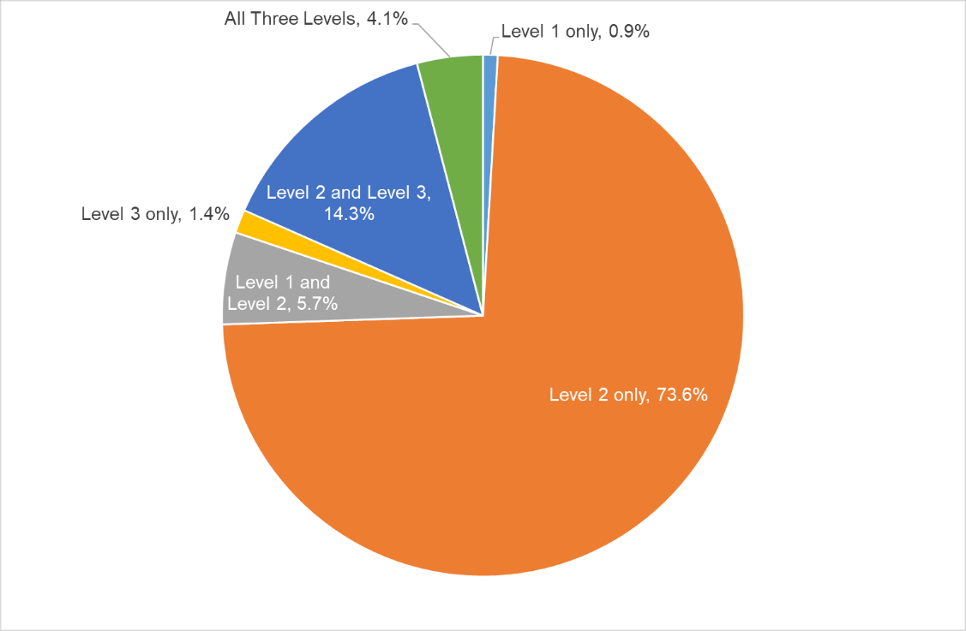
As Exhibit 53 illustrates, most support coordination providers (73.6%) only deliver Level 2 services and very few support coordination providers only deliver Level 1 services (0.9%) and Level 3 services (1.4%).
Almost a quarter of support coordination providers (24.1%) deliver more than one level of support coordination services. Of these providers:
- 23.7% delivered both Level 1: Support Connection services and Level 2: Coordination of Supports services;
- 59.3% delivered both Level 2: Coordination of Supports services Level 3: Specialist Support Coordination services; and
- 17.0% delivered all three level of support coordination services
The vast majority of support coordination providers are very small. Half of all providers accounted for only 2.2% of all claims for support coordination in the first six months of 2021-22, with an average claim of $3,625 over the period. At the other end of the scale, the forty largest support coordination providers account for 25% of all claims for support coordination in the first six months of 2021-22, with an average claim of $2.3 million over the period.
There continues to be a considerable number of new entrants to the market. In the first half of 2021-22, some 320 new providers registered for the Assistance in Coordinating or Managing Life Stages, Transitions and Supports registration group and 147 new providers registered for the Specialised Support Coordination registration group.

Capacity Building and Training Support Item
Less than 0.1% of participants who received support coordination services in 2020-21 also claimed for Capacity Building and Training in Plan and Financial Management by a Support Coordinator, with total claims of $71,842 against this support item in 2020-21.
Note, support coordinators who want to deliver the Capacity Building and Training in Plan and Financial Management by a Support Coordination support item have to register for the Development of Daily Living and Life Skills registration group as well as for one or both of the support coordination registration groups.

Issues Raised in the Consultations
A total of 88 submissions about the pricing arrangements for support coordination were received in response to the Consultation Paper. A working group of providers and other stakeholders was also established. The working group had 27 members from 16 organisations and met, by video-conference, on two occasions: 6 December 2021 and 7 February 2022. A detailed report of the consultations is provided in Chapter 9 of the 2021-22 Annual Pricing Review Report on Consultations.
A major submission was received from Disability Intermediaries Australia (DIA) — the industry group for providers of Intermediary supports (plan management and support coordination). That submission included summary results of a survey of plan management and support coordination providers on the costs of providing service. The submission also included a proposed cost model for support coordinators (see section 8.1 of the Report on Consultations).
A key theme through consultations was the need for a tighter definition of the role of Support Coordinators. Stakeholders identified the benefits of support coordination with greater efficiency, capacity building, and relationships and networks for participants. There was also a range of varied activities undertaken and expectations of support coordinators and stakeholders generally supported the need to establish quality and professional standards of practice to support registration and audit structures (see section 9.2 of the Report on Consultations).
The DIA submission contained a detailed proposal for support coordination pricing. Other submissions noted that prices limits for support coordination were not increased in-line with other disability support price limits implemented on 1 July 2021, despite increasing cost pressures. Submissions proposed price limits for support coordination to be indexed in line with the Consumer Price Index as well as changes to superannuation, Social, Community, Home Care and Disability Services Industry Award 2010 (SCHADS Industry Award), and fair work minimum wage increases. (See section 9.3 of the Report on Consultations)
Several submissions raised concerns about unregistered providers compromising the quality of supports being delivered through the NDIS by creating confusion amongst participants and skewing the market away from registered staff. Providers considered capacity building to be a crucial element to support coordination, but not adequately recognised in the current pricing arrangements. Support Coordinators were also suggested to undertake unfunded work following the death of a participant. There was a number of submissions that stated that Plan Managers, Support Coordinators, and disability support providers should be independent and that the provision of both types of services creates an opportunity for conflict of interest. (See section 9.4 of the Report on Consultations).

Financial Performance (Disability Intermediaries Australia Survey)
In its submission to the 2021-22 Annual Pricing Review, DIA reported on a survey that it has undertaken of Plan Managers and Support Coordinators (see 2021-22 Annual Pricing Review Report on Consultations). Some 373 Support Coordinators responded to the survey.
The DIA submission reported that 41% of Support Coordinators who responded to the survey indicated that they had made a profit in 2020-21 with a further 39% indicating that they had broken even in 2020-21. At the same time, 20% of Support Coordinators reported a loss in 2020-21.
Some 39% of responses to the survey by “large” Support Coordinators reported a surplus in 2020-21 compared to 42% for “medium” Support Coordinators and 45% of “small” Support Coordinators. Around one-fifth of responses to the survey by “large” and “medium” Support Coordinators reported a loss in 2020-21 compared to 17% for “small” Support Coordinators. The survey found that financial results were similar between for-profit, profit-for-purpose and not-for-profit Support Coordinators.
With respect to the size of the profits being made by Support Coordinators, the DIA submission reported that the survey found an average Earnings Before Interest, Tax, Depreciation and Amortisation (EBITDA) (as a percentage of total costs) across respondents of 3%, with 60% of Support Coordinators achieving a 2020-21 EBITDA below 3%. The DIA submission also reported 6% EBITDA as a share of total costs for “small” operators compared to 3% for both “medium” and “large” operators. The survey again found no differences between for-profit and not-for-profit Support Coordinators.

Discussion
The roles of, and expectations on, support coordinators are still evolving. Neither the service offering nor the market has fully matured and the context within which Support Coordinators deliver their services is also not yet fully developed. As market steward, the NDIA is currently partnering with the sector to improve the quality and outcomes of support coordination. This includes initiatives to educate support coordinators on their roles; to encourage better engagement with existing quality standards to lift quality; and to assist support coordinators who wish to develop specific expertise to meet specific participant needs. The NDIA is also working with the sector to address conflict of interests that may be impacting participant outcomes. At the same time, DIA has recently developed and published a set of Professional Standards of Practice for Plan Management and Support Coordination. In 2022, DIA are intending to implement a Service Accreditation Model that will sit over these Professional Standards of Practice. DIA proposes that this accreditation model would examine and set how providers are able to demonstrate the quality of their service offering including the minimum expected qualifications, service experience, lived experience and training / development pathways for the Plan Management and Support Coordination Workforce. While these Professional Standards of Practice are not mandatory for the sector, they do have the potential to change the way in which support coordination services are delivered and the costs of those services.
The market for support coordination is also in a state of flux, highly variable, not yet mature and continuing to grow at pace. Currently, some Support Coordinators appear to be able to make a reasonable return under the current arrangements while others are reporting losses. According to a survey undertaken by DIA some 41% of Support Coordination providers reported that they had made a profit in 2020-21 with a further 39% reporting that they had broken even in 2020-21. There also continues to be a considerable number of new entrants to the market. Some 320 new providers registered as Support Coordinators in the in the first half of 2021-22.
On balance, it is not considered that an increase in the price limits for Level 2: Coordination of Supports services and Level 3: Specialist Support Coordination services price limit is justified at this time. Most providers appear to be able to make a modest return under the current price limits and it would be more appropriate to first clarify the role of Support Coordinators in the NDIS before finalising the pricing arrangements for this support. It is therefore recommended that the price limits for support coordination supports should not be changed on 1 July 2022, except for the Level 1: Support Connection support item, which is set by the NDIS Disability Support Worker (DSW) Cost Model.
As noted above in the chapter on Plan Management Supports, in the light of ongoing work that has direct or flow-on impacts to Plan Managers and Support Coordinators, it is further recommended that the NDIA should continue an in depth review of plan management and support coordination, in consultation with participants, providers and other stakeholders, to more clearly establish the roles, functions, responsibilities and accountabilities of Plan Managers and Support Coordinators; and develop recommendations for the NDIA Board on the appropriate pricing arrangements for plan management and support coordination.
In line with the recommendations in the chapter on Plan Management Supports it is further recommended that the NDIA should:
- Simplify the pricing arrangements for support coordination from 1 July 2022 by decommissioning the Capacity Building and Training in Plan and Financial Management support item, and broadening the scope of the current core support item 01_134_0117_8_1 to Capacity Building and Training in Self-Management and Plan Management. Support Coordinators who want to also deliver this support can do so by also registering for the Development of Daily Living and Life Skills registration group (see Recommendation 8.3).
- Explore options to ensure that Support Coordinators have complete access to all parts of a plan that relate to the components the plan that a participant has appointed them to coordinate, including any relevant information on the plan.

Recommendations
Recommendation 33
The NDIA should not make any structural adjustment to the NDIS pricing arrangements for support coordination at this time and should:
Index the price limits for the Level 1: Support Connection services on 1 July 2022, in line with the indexation of supports determined by the NDIS Disability Support Worker Cost Model in recommendation 2, and
Not index the price limits for the Level 2: Coordination of Supports services and Level 3: Specialist Support Coordination services on 1 July 2022, pending the outcomes of the in depth review of plan management and support coordination.
In line with Recommendation 30, the NDIA should undertake a review of support coordination, in consultation with participants, providers and other stakeholders, to more clearly establish the roles, functions, responsibilities and accountabilities of support coordinators; and further consider the appropriate pricing arrangements for plan management and support coordination. This review should explore options for support coordinators to have complete access to all parts of a plan that relate to the components of the plan that a participant has appointed them to coordinate.
Recommendation 34
The NDIA should simplify the pricing arrangements for support coordination from 1 July 2022 by decommissioning the Capacity Building and Training in Plan and Financial Management support item, and broadening the scope of the current core support item 01_134_0117_8_1 to Capacity Building and Training in Self-Management and Plan Management. Support Coordinators who want to also deliver this support can do so by also registering for the Development of Daily Living and Life Skills registration group.

Endnotes

Regional, Remote and Very Remote Areas
This chapter examines the pricing arrangements that apply to National Disability Insurance Scheme (NDIS) supports delivered in Regional, Remote and Very Remote areas to ensure continued access to appropriate supports for participants living in those areas.
- Section 10.1 outlines the current special pricing arrangements that apply in regional, remote and very remote areas and provides relevant participant and provider statistics.
- Section 10.2 summaries the feedback that was received on these pricing arrangements through the consultations.
- Section 10.3 examines the relative financial performance of providers in regional, remote and very remote areas.
- Section 10.4 examines the labour market conditions in regional, remote and very remote areas.
- Section 10.5 draws conclusions from the available evidence and recommends some changes to the pricing arrangements for regional, remote and very remote areas.

Current Arrangements
Within states and territories, different pricing arrangements and price limits apply depending on whether a support is delivered in a Metropolitan or Regional, Remote or Very Remote area. Definitions are based on the Modified Monash Model (MMM), which defines remote and very remote areas using a scale based on population size and locality (see Exhibit 54).
Exhibit 54: Modified Monash Model Geographical Classification
Description | Zones | MMM | Inclusion
Metropolitan | MMM1-3 | 1 | All areas categorised as Major Cities of Australia.
Regional Centres | MMM1-3 | 2 | Areas categorised as Inner Regional Australia or Outer Regional Australia that are in, or within 20km road distance, of a town with population >50,000.
Regional Centres | MMM1-3 | 3 | Areas categorised as Inner Regional Australia or Outer Regional Australia that are not in MMM 2 and are in, or within 15km road distance, of a town with population between 15,000 and 50,000.
Regional Areas | MMM4-5 | 4 | Areas categorised as Inner Regional Australia or Outer Regional Australia that are not in MMM 2 or MMM 3, and are in, or within 10km road distance, of a town with population between 5,000 and 15,000.
Regional Areas | MMM4-5 | 5 | All other areas in Inner Regional Australia or Outer Regional Australia.
Remote | MMM6 | 6 | All areas categorised Remote Australia that are not on a populated island that is separated from the mainland and is more than 5km offshore.
Very Remote | MMM7 | 7 | All other areas – that being Very Remote Australia and areas on a populated island that is separated from the mainland in the ABS geography and is more than 5km offshore.
In general, price limits are 40% higher in Remote areas and 50% higher in Very Remote areas. There is no additional loading applied for supports in Metropolitan areas, Regional Centres or Regional Areas. The plans of participants who live in Remote or Very Remote areas are similarly adjusted.

Isolated Towns
The NDIA further adjusts the Modified Monash Model classification of some locations. Where a location is surrounded by Remote or Very Remote areas then the National Disability Insurance Agency (NDIA) designates the enclave an Isolated Town and classifies that enclave as a Remote area for NDIS planning and pricing purposes. Exhibit 55 sets out the enclaves that the NDIA has reclassified.
Exhibit 55: Isolated Towns in the NDIS Adjusted Modified Monash Model
NDIA Enclave | Postcodes | Locations | State | MMM Rating | NDIS Adjusted MMM Rating
Hay | 2711 | Hay, Hay South | NSW | 5 | 6
Balranald | 2715 | Balranald | NSW | 5 | 6
Broken Hill | 2880 | Broken Hill | NSW | 3 | 6
Ravenswood/Warren | 2824 | Ravenswood, Warren | NSW | 5 | 6
Roma | 4455 | Blythdale, Euthulla, Orange Hill, Roma | QLD | 4 | 6
Emerald | 4702, 4717, 4720 | Blackwater, Bluff, Comet, Emerald, Jellinbah | QLD | 5 | 6
Moranbah | 4741, 4744 | Coppabella, Moranbah | QLD | 5 | 6
Dysart | 4745 | Dysart | QLD | 5 | 6
Charters Towers | 4820 | Alabama Hill, Breddan, Broughton, Charters Towers, Grand Secret, Millchester, Mosman Park, Queenton, Richmond Hill, Southern Cross, Toll, Towers Hill | QLD | 4 | 6
Merredin | 6415 | Merredin | WA | 5 | 6
Kalgoorlie | 6430, 6432 | Boulder, Broadwood, Hannans, Kalgoorlie, Karlkurla, Lamington, Mullingar, Piccadilly, Somerville, South Boulder, South Kalgoorlie, Victory Heights, West Kalgoorlie, West Lamington, Williamstown | WA | 3 | 6
Kambalda | 6442 | Kambalda West Kambalda East | WA | 5 | 6
Gunbalanya | 0822 | Gunbalanya | NT | 6 | 7

Pricing arrangements for supports in regional, remote and very remote areas
When a support is provided directly to a participant, and the worker delivering the support is at the same location as the participant, the price limit that applies to the support is generally determined by the location of the participant at the time of service delivery. When a support is not provided directly (for example, Non-Face-to-Face Support Provision or NDIA Requested Reports) then the price limit that applies to the support is the price limit that would apply if the participant was receiving the support at the place that the person who is delivering the support is located at the time of service delivery.
When a support is provided directly to a participant via telehealth, the price limit that applies to the support should, in general, be the price limit that would apply if the participant was receiving the support at the place that the person who is delivering the support is located at the time of service delivery. However, participants in Remote or Very Remote areas can agree that the price limit that would have applied if they had received the support when they live should apply to the support if they are satisfied that the support provides value for money.

Provider Travel
Providers can claim from a participant’s plan for travel costs in respect of the delivery of a support item under certain circumstances. Where a provider of core supports bills for travel time in respect of a support that they have delivered to a participant then the maximum amount of travel time that they can bill for travelling to the participant (for each eligible worker) is 30 minutes in MMM1-3 areas.
This travel limit is increased to 60 minutes in MMM4-5 areas. As long as the conditions specified in the NDIS Pricing Arrangements and Price Limits are met, then providers of core supports can bill for travel undertaken by the support worker to the participant (including travel between participants). As with all other areas, providers of core supports cannot bill for any travel costs after the last participant has been supported. Where a worker is travelling to provide services to more than one participant in a ‘region’ then the provider is required to apportion that travel time between the participants, with the agreement of each participant in advance.
Capacity-building providers are subject to the same travel billing rules as providers of core supports, except that capacity-building providers can also bill for return travel after the participant has been supported. Again, the maximum amount of time that they can bill for return travel (for each eligible worker) is 30 minutes in MMM1-3 areas and 60 minutes in MMM4-5 areas. The same “apportionment” arrangements apply as for core supports.
In remote and very remote areas, capacity-building providers may enter into specific arrangements with participants to cover any labour related travel costs, up to the relevant hourly rate for the support item. Providers should assist participants to minimise the travel costs that they need to pay (for example, by co-ordinating appointments with other participants in an area, so that travel costs can be shared between participants, or by considering the delivery of the support by telehealth where appropriate).
Providers of core supports and capacity building supports are also permitted to bill for the non-labour costs of travel. If a provider incurs costs, in addition to the cost of a worker’s time, when travelling to deliver face-to-face supports to a participant (such as road tolls, parking fees, the running costs of the vehicle or airfares and accommodation costs), they may negotiate with the participant for them to make a reasonable contribution towards these costs from their plan. There is no limit on the amount that can be billed for these costs, but providers must have incurred the costs and the participant must agree to the amounts being billed against their plan.

Other Market Interventions
In 2020 the NDIA launched a range of trials of non-price interventions in 18 very remote Local Government Areas. Interventions included: market facilitation, coordinated funding and direct commissioning.
- Market facilitation involves specific actions to improve connections between providers and participants, such as focused engagement and sharing targeted information with the market.
- Coordinated funding proposals are a way for multiple participants and their Support Coordinators to purchase services as a group. The coordinated funding proposal model empowers group purchasing and provides a pool of funding to attract providers into a market.
- Direct commissioning is a way for the NDIA to arrange for services to be available for participants. Direct commissioning involves a formal contract between the NDIA and a provider or panel of providers, for longer term service delivery to a group of participants. This lever requires the NDIA to specify, procure and manage the service arrangements with providers over the life of the contract.

Scheme Statistics

Participants
As at 31 December 2021, about 19.2% of all participants (95,548) were living in Regional Centres (MMM2-3) and 11.1% of all participants (55,807) were living in Regional Areas (MMM4-5). Only 0.9% of participants (4,613) were living in remote areas (MMM6) and 0.6% of participants (3,080) were living in very remote areas.
The share of active participants living in Regional Centres (MMM2-3) varies significantly by state/territory. The share is significantly higher than the national average in Tasmania (83.8% of active participants) and in the Northern Territory (57.3%). It is significantly lower than the national average in the Australian Capital Territory (0.0%), South Australia (10.5%) and Western Australia (11.2%)
The share of active participants living in Regional Areas (MMM4-5) also varies significantly by state/territory. It is highest in Tasmania (14.8%) and significantly lower than the national average in the Australian Capital Territory (0.0%), the Northern Territory (1.1%) and Western Australia (5.6%). The shares in New South Wales (13.0%), Victoria (11.6%), South Australia (11.4%) and Queensland (10.8%) are all close to the national average (11.1%).
The share of participants living in Remote or Very Remote areas also varies significantly by state/territory. More than four in ten participants in the Northern Territory (41.6%) live in remote or very remote areas. The share of participants in Western Australia who live in remote or very remote areas (4.5%) is three times the national share (1.5%). The share in South Australia (2.6%) is also significantly higher than the national average. The shares in Queensland (1.8%) and Tasmania (1.3%) are close to the national average, while the shares in New South Wales (0.4%) and Victoria (0.04%) are well below the national average.
The length of time that elapses between a participant’s plan being approved and the first support purchased from the plan, is another partial indicator of the adequacy of the current pricing arrangements for regional and remote participants (see Exhibit 56).
Exhibit 56: Duration to plan activation for active participants
Plan activation | MMM1 | MMM2 | MMM3 | MMM4 | MMM5 | MMM6 | MMM7 | AUS
Less than 30 days | 69% | 66% | 70% | 68% | 65% | 67% | 60% | 68%
30 to 59 days | 12% | 12% | 12% | 12% | 12% | 11% | 12% | 12%
60 to 89 days | 5% | 6% | 5% | 5% | 6% | 6% | 6% | 5%
90 to 119 days | 3% | 4% | 3% | 3% | 3% | 3% | 4% | 3%
120 days and over | 8% | 9% | 9% | 9% | 10% | 10% | 15% | 9%
No payments | 2% | 3% | 2% | 2% | 3% | 3% | 4% | 2%
Total plans approved | 100% | 100% | 100% | 100% | 100% | 100% | 100% | 100%
For participants in Regional Centres (MMM2-3) and Regional Areas (MMM4-5), plan activation appears to occur at the same rate as in metropolitan areas.
For participants in Remote areas, two thirds (67%) activate their plan within a month (two percentage points below metropolitan participants) and about 13% do not activate their plan in the first four months (three percentage points above metropolitan participants).
For participants in Very Remote areas, some 60% activate their plan within a month (nine percentage points below metropolitan participants) and about 19% do not activate their plan in the first four months (nine percentage points above metropolitan participants).
Plan utilisation is also affected by remoteness (see Exhibit 57 and Exhibit 58).
Exhibit 57: Plan Utilisation by Service District, December 2021

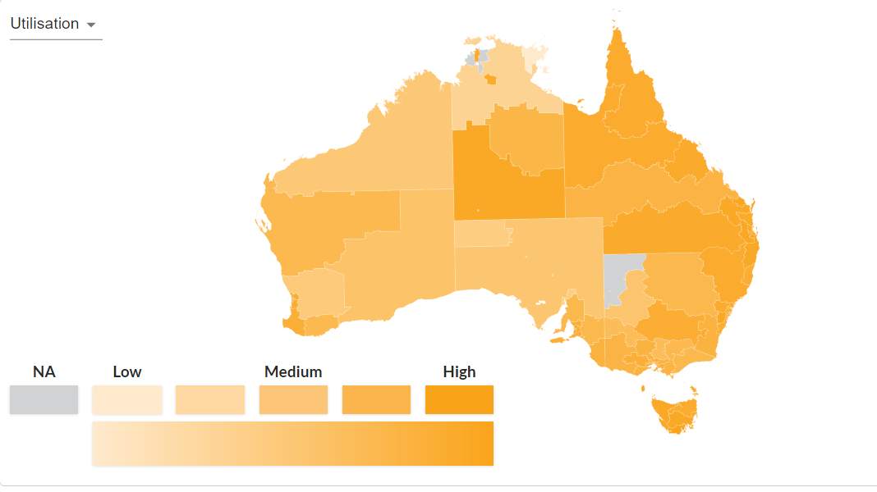
Exhibit 58: Annualised Committed Supports and Payments, by Remoteness Region, December 2021
 | Annualised committed support |  | Annualised payments |  | Utilisation
Remoteness Rating / SIL | No-SIL | SIL | No-SIL | SIL | No-SIL | SIL
MMM1 | $54,076 | $342,844 | $34,832 | $290,961 | 66% | 82%
MMM2 | $53,396 | $369,338 | $33,056 | $318,413 | 65% | 84%
MMM3 | $53,313 | $339,766 | $32,582 | $284,699 | 62% | 80%
MMM4 | $52,470 | $318,447 | $31,923 | $255,784 | 61% | 76%
MMM5 | $50,209 | $295,842 | $29,066 | $240,367 | 60% | 78%
MMM6 | $67,886 | $561,147 | $35,827 | $481,267 | 54% | 81%
MMM7 | $65,728 | $423,106 | $27,596 | $335,030 | 42% | 75%
Australia | $53,808 | $345,463 | $33,896 | $292,554 | 64% | 81%
Regression analysis indicates that around 75% of the variation in plan utilisation can be ‘explained’ by increasing remoteness. However, plan utilisation only decreases slowly with distance from capital cities, with utilisation in Regional Areas (MMM4-5) still around nine-tenths of that in major cities (MMM1). There is a significant (10%) drop in utilisation rates in remote areas (between MMM5 and MMM6) and a further larger drop (22%) in utilisation rates in very remote areas (between MMM6 and MMM7).
Utilisation is also affected by local factors other than remoteness (or perhaps more correctly as well as remoteness). The five service districts with the lowest overall utilisations rates are:
- East Arnhem (38%) and Darwin Remote (52%) in the Northern Territory;
- Far North (56%) in South Australia; and
- Wheat Belt (58%) and Kimberley-Pilbara (59%) in Western Australia.

Providers
Market concentration (measured by the share of each market captured by the largest ten providers servicing the market) is also high in remote and very remote areas and in some regional areas (see Exhibit 59). In 12 service districts, the largest 10 providers in that district are responsible for 80% or more of all supports delivered in that district:
- East Arnhem (MMM7) (90%), Barkly (MMM7) (83%) and Central Australia (MMM7) (80%) in the Northern Territory;
- Great Southern (90%), Midwest-Gascoyne (90%) and Goldfields-Esperance (88%) in Western Australia;
- Far North (87%), Limestone Coast (86%) and Eyre and Western (85%) in south Australia;
- Far West (83%) in New South Wales;
- Bundaberg (MMM2) (80%) in Queensland; and
- Mallee (80%) in Victoria.
Exhibit 59: Market Concentration by Service District, December 2021
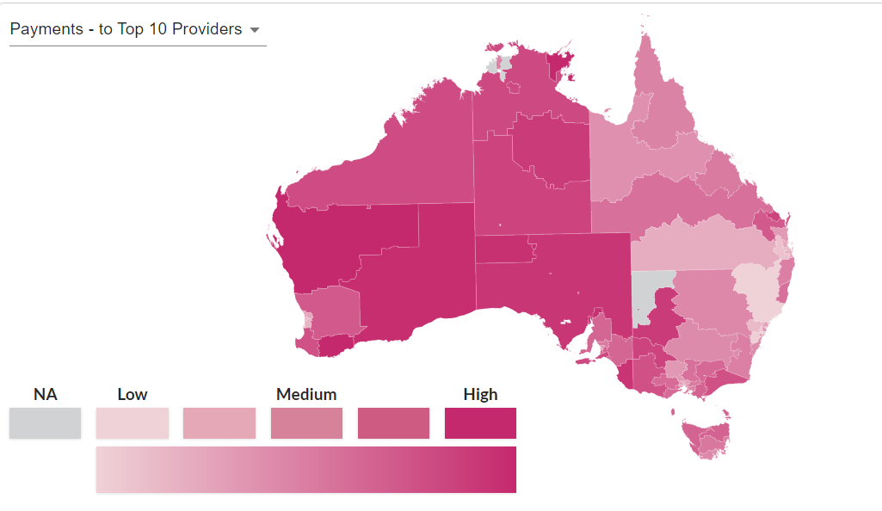

Issues Raised in the Consultations
A total of 34 submissions were received on the pricing arrangements for supports delivered in Regional, Remote and Very Remote Australia in response to the Consultation Paper. A working group of providers and other stakeholders was also established. The working group had 24 members from 19 organisations. It met twice by video-conference, on 7 December 2021 and 8 February 2022. A detailed report of the consultations is provided in Chapter 10 of the 2021-22 Annual Pricing Review Report on Consultations.
A number of stakeholders argued that the NDIS Disability Support Worker (DSW) Cost Model does not sufficiently take into account of the higher costs associated with attracting and maintaining a workforce outside metropolitan areas. Submissions stated that while workforce shortages were a significant issue affecting providers nationally, these issues are more pronounced in regional and remote areas.
Working group members also argued that NDIS providers had to compete harder for staff in some parts of the country. Members flagged that providers needed to compete with local health providers who could often offer more attractive salary packages and were better able to compensate for travel and other expenses.
Submissions also stated that participants in parts of the country were disadvantaged as a result of ‘thin markets, where allied health professionals and other specialists are dispersed and provide inconsistent supports’. This led to less choice of providers and difficulties with accessibility.
Regarding allied health professionals, submissions reported these costs were increasing, exacerbated by providers’ inability to fully recoup travel costs. This further discouraged specialists and allied health providers relocating to regional, remote areas and very remote areas.
Several submissions stated that the current arrangements provide insufficient funding to cover the additional cost of providing fly-in-fly out services in remote and very remote communities where flights, accommodation, translators and infrastructure are required. Submissions stated that as a consequence of insufficient funding for travel in plans and the time limits, providers typically lose money delivering supports to participants in remote locations, due to the extra time spent attracting staff that are willing to travel, or subsidising travel/transport for the employee.
A number of submissions and members of working groups requested that Geraldton in Western Australia be reclassified as an “Isolated Town” by the NDIA for NDIS planning and pricing purposes (effectively treating it as remote / MMM6).

Financial Performance of Providers
Exhibit 60 compares the key financial performance benchmarks of providers delivering supports by degree of remoteness based on the results of the latest Financial Benchmarking Survey (see Appendix D). Given the small number of people who live in remote and very remote areas, and the small sample size of survey respondents, the results are presented grouped into metropolitan areas and regional centres (MMM 1 to 3), regional areas (MMM 4 to 5) and remote and very remote areas (MMM 6 to 7).
Providers in remote and very remote areas report significant higher costs than other providers, mainly driven by much higher overhead costs. Efficient remote and very remote report an overhead of 42.0% compared to the sector average for efficient providers of 21.8%. However, Earnings Before Interest, Tax, Depreciation and Amortisation (EBITDA) as a share of total revenue is higher in remote and very remote areas than in other areas. Efficient remote and very remote report an EBITDA of 31.2% compared to the sector average for efficient providers of 21.4%. Indeed, providers in all efficiency quartiles report a higher EBITDA as a share of total revenue than other providers. The data also shows that providers in Regional Areas (MMM4-5) have a distribution of financial results very similar to those MMM1-3 regions.
Exhibit 60: Financial Benchmarking 2020-21: by Degree of Remoteness
 | Mean | Q1 | Median | Q3
Disability Support Worker Hourly Rate
All providers | $31.28 | $28.75 | $30.67 | $33.43
MMM ≤3 | $30.88 | $28.59 | $30.44 | $33.21
MMM 4-5 | $31.40 | $28.48 | $30.21 | $33.08
MMM ≥6 | $33.73 | $28.03 | $32.20 | $36.39
Supervisor Worker Hourly Rate
All provider | $41.09 | $35.00 | $39.37 | $45.00
MMM ≤3 | $40.91 | $35.00 | $39.30 | $45.00
MMM 4-5 | $42.30 | $35.93 | $40.55 | $45.62
MMM ≥6 | $42.78 | $37.56 | $42.27 | $47.50
Supervision Ratio (Head Count)
All provider | 10.6 | 13.2 | 7.5 | 4.0
MMM ≤3 | 11.6 | 14.3 | 8.4 | 4.6
MMM 4-5 | 10.5 | 13.5 | 7.0 | 5.0
MMM ≥6 | 6.8 | 10.1 | 6.0 | 2.0
Utilisation Rate
All provider | 78.9% | 90.0% | 82.0% | 72.0%
MMM ≤3 | 79.0% | 90.0% | 82.0% | 72.0%
MMM 4-5 | 82.3% | 90.0% | 84.0% | 77.8%
MMM ≥6 | 73.1% | 84.5% | 76.0% | 60.0%
Permanent Share of Workforce (FTE)
All provider | 60.0% | 94.5% | 63.8% | 28.7%
MMM ≤3 | 57.0% | 89.4% | 58.3% | 26.6%
MMM 4-5 | 64.5% | 94.6% | 67.6% | 36.9%
MMM ≥6 | 73.0% | 100.0% | 89.7% | 54.2%
Workers Compensation Premium
All provider | 3.2% | 2.0% | 2.5% | 4.0%
MMM ≤3 | 3.2% | 1.9% | 2.5% | 4.0%
MMM 4-5 | 3.0% | 2.0% | 2.4% | 3.4%
MMM ≥6 | 4.4% | 2.5% | 2.9% | 6.0%
Overheads
All provider | 44.2% | 21.8% | 35.9% | 56.3%
MMM ≤3 | 42.5% | 21.1% | 35.6% | 56.0%
MMM 4-5 | 46.2% | 21.5% | 36.0% | 60.3%
MMM ≥6 | 70.3% | 42.0% | 51.3% | 104.3%
EBIDTA as a share of total revenue
All provider | 13.3% | 21.4% | 10.9% | 3.9%
MMM ≤3 | 13.5% | 21.9% | 11.2% | 3.9%
MMM 4-5 | 14.4% | 21.1% | 13.2% | 4.4%
MMM ≥6 | 16.4% | 31.2% | 20.4% | 7.4%

Labour Market Indicators
The National Skills Commission publishes indexes of vacancies advertised on line, by both (high level) occupation, and by 37 regions across the nation. Over the last decade or so, total vacancies (all occupations) had been generally rising in both capital cities and the regions, albeit slightly faster in the former. Conversely, vacancies fell faster under COVID-19 in capitals than in country areas. In the initial post-COVID-19 recovery, vacancies rose faster in regional areas than in capitals. However, currently both city and country vacancies are equally far above long-term averages (see Exhibit 61 and Exhibit 62).
Exhibit 61: Total Job Vacancies of Capital Cities vs Non-Capital (Country) Areas
Exhibit 62: Health and Welfare Support Job Vacancies of Capital Cities vs Non-Capital (Country) Areas

Discussion

Geographic Classification
In consultations, some providers questioned whether MMM is the best way of determining location for location-specific prices. The differences between MMM regions are mathematically determined by distances from centres of varying sizes. States and Service Districts are not defined in the same way, making one state or service district less comparable with others. Yet there is still little variation in plan utilisation between states and much plan variation between Service Districts. This implies either that greater granularity could be advantageous to define areas to receive location specific considerations, or that a different index of remoteness could be more suitable than MMM.
A detailed study of the currently available geographical classification system is provided in Appendix E, each of which have strengths and weaknesses. On balance, the MMM is the ‘least worst’ of the currently available geographical classification systems. It is the only indicator designed specifically to take account of workforce needs, albeit health rather than disability related. Further, as it includes the size of the Urban Centres / Localities in its formula, MMM is more dynamic. As rural populations shrink, more towns will be directly classified as remote.
It is therefore recommended that the NDIA should continue to use the Modified Monash Model geographical classification.

Price Limits (Loadings)
As noted above, the financial performance results shows:
- Remote and Very Remote providers in all efficiency quartiles report a higher EBITDA as a share of total revenue than other providers.
- Providers in Regional Areas (MMM4-5) have a distribution of financial results very similar to those MMM1-3 regions.
This is strong evidence that the current price limit loadings for remote and very remote supports do not need to be increased at this time and that it is not necessary to introduce a price limit loading for regional areas.
In July 2019, the NDIA doubled the loadings for remote areas (from 20% to 40%) and for very remote areas (from 25% to 50%). This had the effect of increasing the price limits in remote areas by 16.7% and in very remote areas by 20%.
Since 2019, as Exhibit 63 shows, plan utilisation have increase in all geographic regions.
Exhibit 63: Variation in Plan Utilisation and Price by Remoteness, June 2019-Dec 2021
 | Price Limit  June 2019 | Price Limit  Dec-2021 | Nominal  Increase in price limit (%) | Utilisation June 2019 | Utilisation December 2021) | Increase in utilisation (%)
MMM 1 | $45.54 | $57.23 | 25.7% | 69% | 75% | 9.1%
MMM 2 | $45.54 | $57.23 | 25.7% | 69% | 76% | 9.8%
MMM 3 | $45.54 | $57.23 | 25.7% | 67% | 73% | 8.7%
MMM 4 | $45.54 | $57.23 | 25.7% | 65% | 70% | 8.0%
MMM 5 | $45.54 | $57.23 | 25.7% | 58% | 67% | 14.7%
MMM 6 | $54.65 | $80.12 | 46.6% | 63% | 67% | 6.6%
MMM 7 | $56.93 | $85.85 | 50.8% | 39% | 50% | 28.5%
In very remote areas, utilisation rates have increased by significantly more than in other regions, which is likely the effect of both the 20% real increase in the price limit and other non-pricing intervention that the NDIA has made in these regions.
More worrying, is the result of remote areas, where the growth in the utilisation rate is below that in all other areas. Here the 16.7% real increase in the price limit has made in price limits for these regions appears to have had no impact on utilisation. This could be evidence that the increase was not large enough, although that does not align well with the financial performance data discussed above.
As discussed above, the financial performance data for regional areas and the utilisation data do not support the case for a regional price loading.
On balance, it is recommended that the NDIA should maintain the current remote and very remote loadings (40% and 50% respectively) for pricing and planning purposes and should not introduce a price limit loading for Regional Areas at this time.

Non-price interventions
While the NDIA’s doubling of remote and very remote loadings in 2019 may have been necessary, it also appears that it was not sufficient. As shown by their profitability, remote/very remote providers are at least now able to cover costs of such services as they provide. But this alone does not solve the thin market problems of getting the right services to the right participants at the right time.
As Exhibit 64 shows, price interventions have not always effectively translated into plan utilisation increases. Over the last three years, average price limits have increased in nominal terms by 25.7% in non-remote areas and plan utilisation has increased by slightly more than 9.0%. There were significantly higher nominal increases in price limits in remote and very remote areas (by 46.6% and 50.8% respectively). In very remote areas there has been a significant increase in plan utilisation rates. However, in remote areas, plan utilisation has not even grown as strongly as in metropolitan areas, despite the much higher nominal increase in price limits.
Exhibit 64: Increases in plan utilisation and Price by remoteness, June 2019-Dec 2021
Price of an hour of standard care | Price June 2019 | Price Dec-2021 | Increase in price (%) | Utilisation June 2019 | Utilisation December 2021) | Increase in utilisation (%)
MMM 1 | $45.54 | $57.23 | 25.7% | 69% | 75% | 9.1%
MMM 2 | $45.54 | $57.23 | 25.7% | 69% | 76% | 9.8%
MMM 3 | $45.54 | $57.23 | 25.7% | 67% | 73% | 8.7%
MMM 4 | $45.54 | $57.23 | 25.7% | 65% | 70% | 8.0%
MMM 5 | $45.54 | $57.23 | 25.7% | 58% | 67% | 14.7%
MMM 6 | $54.65 | $80.12 | 46.6% | 63% | 67% | 6.6%
MMM 7 | $56.93 | $85.85 | 50.8% | 39% | 50% | 28.5%
The NDIA has conducted a large range of direct intervention trial (e.g., commissioning, market facilitation, coordinated funding) in very remote areas. While there has been a considerable range of outcomes, on the whole these trials have been quite successful. These targeted solutions have the ability to tackle granular market failures that pricing solutions cannot address and should be expanded and continued.
There may also be some value in exploring opportunities to increase scale and improve scheduling to lower costs per support through demand aggregators (especially in the provision of therapy supports). A demand aggregator cumulates a number of dispersed consumers (and, at times, producers) and acts as a liaison between these agents and wholesale markets. Aggregation creates value within industry markets by leveraging on economies of scale and scope and by helping consumers manage uncertainty. Aggregation alleviates uncertainty by assembling all data relevant to potential demand and interpreting this data into quantity bids in a marketplace. Such a task can be done by a number of small aggregators or by a single aggregator for all uncertain variables in a market (e.g., the output of variable generators or the behaviour of a number of consumers).
CheckUP is a not-for-profit organisation based in Queensland commissioned by the Department of Health to facilitate the delivery of Outreach Programs through the Rural Health Outreach Fund. CheckUP increases access to Medical Specialists, General Practitioners (GPs), and Allied Health Professionals for those living in rural, remote, regional, and select urban Queensland communities. CheckUP enables participants to browse the on-line portal to identify and book services. For example, a patient who experienced heart failure or a heart attack and needs rehabilitation can go onto the CheckUP website, click Find an Outreach service, select ‘Physiotherapy’, and choose a service from drop down list, such as ’Cardiac Rehabilitation’. CheckUP assists in helping to address the demand uncertainty and financial barriers to service delivery in rural and remote areas in three key ways:
- CheckUP pays health care providers’ out-of-pocket expenses such as travel, accommodation, meals as well as administrative support and training, which reduces the cost of travel as well as the opportunity cost of travelling to service participants in rural and remote areas;
- CheckUP identifies demand for services in rural and remote areas through an annual needs assessment planning process, which is undertaken in consultation with local health services, Aboriginal Controlled Community Health Organisations (ACCHOs), Primary Health Networks (PHNs) and community groups and signed off by the State Advisory Forum and the Department of Health; and
- CheckUP aggregates demand and provides a forward calendar of services to be delivered in each town or community for the coming year, enabling participants to identify and book services on-line reducing the uncertainty of when services will be delivered.

Isolated Towns
A number of providers, both in the working groups and through submissions, have argued that Geraldton in Western Australia should be reclassified as remote (MMM6).
Currently Geraldton, which had a population of 38,109 at the 2016 Census is classified as MMM3). It does not currently meet the NDIS’s criterion for reclassification as it is neither directly surrounded by remote areas like Kalgoorlie (reclassified from MMM3 to MMM6) or an enclave of Regional Areas (MM4, MMM5) like Emerald in Queensland (reclassified from MMM4 to MMM6.)
On reflection, the definition of “surrounded” that the NDIA currently uses to reclassify towns as remote should be refined. It is recommended that a town should be considered to be “surrounded” if it is not possible to travel from a (mainland) town to a Major City (MMM1) or a Regional Centre with a population of 50,000 or more (MMM2) without crossing a remote area (MMM6).
This change in the isolated town definition would mean that the contiguous enclave of MMM3, MMM4 and MMM5 stretching up and down the Western Australian coast for a couple of hundred kilometres near Geraldton (including Dongara) would also be reclassified as remote (see the Green region near Geraldton in Exhibit 65). This includes other small enclaves in Western Australia, near Geraldton, of Greenhead, Leeman and Horrocks.
Exhibit 65: Geraldton and Surrounding Regions
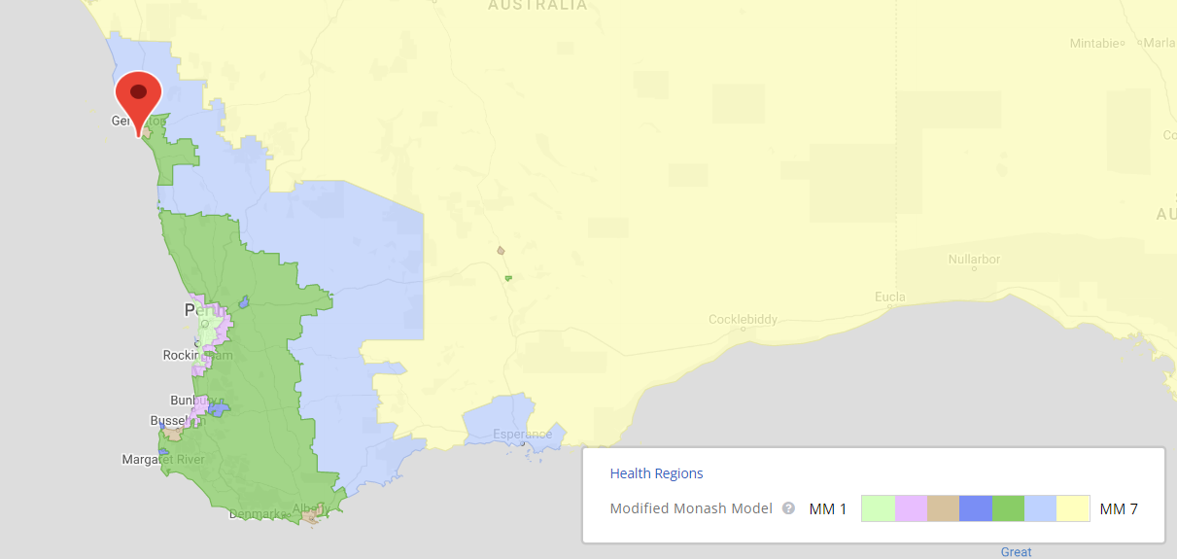
This change in the isolated town definition would also mean that the region of Cardwell in Queensland would be reclassified as remote (see green region in Exhibit 66). Cardwell had a population of 1,309 at the 2016 Census.
Exhibit 66: Cardwell Region
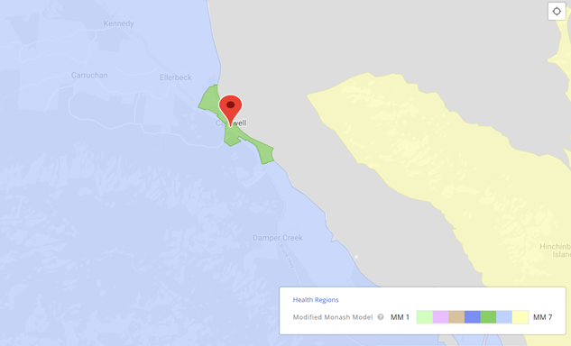

Recommendations
Recommendation 35
The NDIA should extend its isolated town’s policy to reclassify a geographic locality as remote if it is not possible to travel from that locality to a major city (MMM1) or other city of more than 50,000 people (MMM2) without crossing a remote area, noting that this will reclassify Western Australia locations of Geraldton, Greenhead, Horrocks and Leeman and the Queensland location of Cardwell to remote for NDIS planning and pricing purposes.

Endnotes

Queensland, South Australia and Western Australia
This chapter examines whether the current economic conditions in states where economic trends are often counter cyclical to the trends in other states and territories (and, in particular, in Western Australia, Queensland and South Australia) are such as to require temporary adjustments to price controls in those states in order to proactively manage any potential impacts on the supply of disability goods and services.
- Section 11.1 provides background on how the current pricing arrangements differ by state and territory.
- Section 11.2 provides an overview of the issues that were raised by stakeholders during the consultations.
- Section 11.3 examines the relative performance of providers in regional, remote and very remote area using the Financial Benchmarking Survey data.
- Section 11.4 examines the labour market statistics for each of the states.
- Section 11.5 draws conclusions from the available evidence.

Background
In 2019, the National Disability Insurance Agency (NDIA) undertook a review to establish if there were any issues in the markets for disability goods and services in Western Australia that so differentiated those markets from the markets in other jurisdictions as to require alternative pricing arrangements. The NDIA found that there was:
- Little evidence of substantial differences in the markets for delivery of disability goods and services in Western Australia compared to other jurisdictions, in terms of levels of competition, market concentration, and efficient costs;
- No evidence of substantial differences in efficient labour costs, labour related regulatory imposts and other costs of delivery in Western Australia relative to other jurisdictions at the time of the Review; and
- No significant evidence that the new national price limits published on 30 March 2019 to take effect from 1 July 2019 would not support the sustainable, efficient delivery of disability supports in metropolitan Western Australia.
Although the 2019 Review found that there was no need at that time for differential price controls for Western Australia, it also found that the Western Australian economy is driven substantially more by commodity exports than the rest of Australia. Commodity exports are volatile, in terms of both volumes and values. Accordingly, Western Australia is more characterised by boom/bust cycles than Australia as a whole. This means that disability providers in Western Australia, compared to the rest of Australia, will more often face boom conditions that may make it more difficult to retain workers. At present, price control changes are reviewed on a national basis. However, the boom and bust cycles experienced in Western Australia raise the question as to whether there should be provision for price control changes to differ across states and territories and for them to be able to be reviewed more rapidly when required. Moreover, while this volatility arguably affects Western Australia more than other jurisdictions, it is not unique to Western Australia. The other mining states (South Australia and Queensland) also experience boom/bust cycles.
The NDIA has therefore worked with the relevant Commonwealth and State/Territory Departments to monitor economic conditions, and the state of the markets for disability goods and services, in Queensland, South Australia and Western Australia with a view to making temporary adjustments to price controls when necessary, in order to proactively manage any potential impacts on the supply of disability goods and services from economic trends in those states that were counter cyclical to the trends in other states and territories.

Scheme Statistics

Participants
As at 31 December 2021, 38% of all National Disability Insurance Scheme NDIS) participant plans (189,896) were for participants in Queensland (20%), South Australia (9%) and Western Australia (9%).
Exhibit 67 provides information, as at 31 December 2021, for each state and territory on: Average annualised committed supports in participants’ plans; Average annualised payments from participants’ plan; and Average utilisation rates for the funds in participants’ plans.
Exhibit 67: Annualised participant committed supports, payments and utilisation as at 31 December 2021
State | Average Annualised Committed Support - No SIL | Average Annualised Committed Support - SIL | Average Annualised Payments - No SIL | Average Annualised Payments - SIL | Average Utilisation Rate - No SIL | Average Utilisation Rate - SIL
NSW | $52,300 | $343,300 | $39,400 | $321,700 | 69% | 88%
VIC | $52,900 | $344,300 | $37,800 | $294,300 | 68% | 84%
QLD | $56,400 | $349,700 | $43,300 | $351,500 | 71% | 94%
WA | $55,300 | $318,200 | $39,500 | $280,300 | 69% | 87%
SA | $48,800 | $336,700 | $35,300 | $347,700 | 68% | 87%
TAS | $53,100 | $375,900 | $38,500 | $346,100 | 69% | 89%
ACT | $47,000 | $348,700 | $34,500 | $323,900 | 69% | 87%
NT | $71,400 | $534,800 | $50,800 | $533,600 | 62% | 88%
AUST | $53,300 | $346,100 | $39,400 | $324,600 | 69% | 88%
Plan utilisation (how much of their plan a participant spends) is useful partial indicator of the extent to which the market for disability goods and services is well functioning and able to meet the needs of participants. For non-Supported Independent Living (SIL) participants, the average utilisation rate of available funds is reasonably consistent across states and territories. Indeed, it is slightly higher than the national average in Queensland, equal to the national average in Western Australia and slightly below the national average in South Australia. For SIL participants, the average utilisation rate of available funds is again reasonably consistent across states and territories, and is slightly higher than the national average in Queensland and slightly lower than the national average in South Australia and Western Australia.
The length of time that elapses between a participant’s plan being approved and the first support purchased from the plan, is another partial indicator of the health of the markets for disability goods and services (and the adequacy of the current pricing arrangements) across jurisdictions. As Exhibit 68 shows, the proportion of participants who activate their plan (first purchase a support with their plan) is above the national average in Queensland and Western Australia and equal to the national average in South Australia. Similarly, the proportion of participants having to wait four months or more for their plans to be activated is below the national average in Queensland and Western Australia and equal to the national average in South Australia.
Exhibit 68: Duration to plan activation for active participants by State and Territories as at 31 December 2021
Plan activation | NSW | VIC | QLD | WA | SA | TAS | ACT | NT | AUS
Less than 30 days | 69% | 67% | 69% | 70% | 68% | 68% | 59% | 65% | 68%
30 to 59 days | 12% | 12% | 12% | 11% | 11% | 11% | 15% | 12% | 12%
60 to 89 days | 5% | 6% | 5% | 5% | 6% | 5% | 7% | 6% | 5%
90 to 119 days | 3% | 3% | 3% | 3% | 3% | 3% | 3% | 4% | 3%
120 days and over | 8% | 9% | 8% | 8% | 9% | 10% | 12% | 11% | 9%
No payments | 2% | 3% | 2% | 3% | 2% | 2% | 3% | 2% | 2%
Total plans approved | 100% | 100% | 100% | 100% | 100% | 100% | 100% | 100% | 100%
In brief, these partial indicators do not provide any strong evidence that the markets for disability goods and services are under greater stress in Queensland, South Australia, and Western Australia than in the rest of Australia.

Providers
In brief, the market for disability goods and services in 2020-21 in:
- Queensland was $5.4 billion or 1.3% of Gross State Product (GSP).
- South Australia was $2.0 billion or 1.7% of GSP.
- Western Australia was $1.9 billion or 0.6% of GSP.
Exhibit 69 illustrates the relative sizes of the markets for disability goods and services in the various states and territories by analysing the payments made from participants’ plans for supports in 2020-21 and 2021-22 (year to date). Again, the distribution is largely driven by the relative populations of the jurisdictions.
Exhibit 69: Payments by State and Territory, 2020-21 and 2021-22 H1
Exhibit 70 shows the number of active providers by state/territory as at 31 December 2021. The number of active providers is reasonably proportional to the populations of the states and territories.
Exhibit 70: Active number of providers by State and Territory as at 31 December 2021
A significant partial indicator of the extent to which the markets for disability goods and services is well functioning and able to meet the needs of participants, and hence of the appropriateness and adequacy of the current pricing arrangements, is the rate at which new providers enter the markets for disability goods and services in the various states. Exhibit 71 shows, by registration group, the rates of new entrants to the markets in Australia, Queensland, South Australia and Western Australia in the first two quarters of 2021-22.
In general, the rate of growth of providers in the Queensland, South Australia and Western Australia is at least as high as across Australia. There are only four registration groups where the rate of growth in one of the three states is below the national average for two consecutive quarters.
- Assistance Animals – in Queensland and Western Australia, noting that there are 49 providers in this registration group active in Queensland and 15 in Western Australia.
- Hearing Equipment – in South Australia, noting that there are 32 providers in this registration group active in South Australia.
- Specialised Driving Training – in Western Australia, noting that there are 25 providers in this registration group active in Western Australia.
- Support Coordination – in South Australia and Western Australia, noting that there are 121 providers in this registration group active in South Australia and 120 in Western Australia.
Supports provided by the first three are not subject to price regulation in the NDIS. With respect to support coordination, it is noted that growth in the number of active providers was still reasonably strong (above 7%) in this registration group in South Australia and Western Australia. That is, this partial indicator does not provide any strong evidence that the markets for disability goods and services are under greater stress in Queensland, South Australia, and Western Australia than in the rest of Australia.
Exhibit 71: New Provider Entrants by Registration Group by State
Registration Group | % active for the first time in 2021-22 Q2 |  |  |  | % active for the first time in 2021-22 Q1
 | QLD | SA | WA | AUS | QLD | SA | WA | AUS
Assistance services
Accommodation / Tenancy Assistance | 13% | 33% | 27% | 25% | 25% | 33% | 0% | 22%
Assistance Animals | 4% | 14% | 7% | 8% | 4% | 5% | 0% | 7%
Assistance with daily life tasks in a group or shared living … | 11% | 12% | 9% | 12% | 10% | 10% | 10% | 8%
Assistance with travel/transport arrangements | 10% | 5% | 8% | 8% | 9% | 10% | 5% | 8%
Daily Personal Activities | 8% | 3% | 7% | 8% | 10% | 8% | 9% | 8%
Group and Centre Based Activities | 6% | 5% | 8% | 6% | 8% | 9% | 7% | 7%
High Intensity Daily Personal Activities | 7% | 7% | 7% | 5% | 10% | 9% | 9% | 6%
Household tasks | 6% | 4% | 4% | 6% | 5% | 10% | 11% | 6%
Interpreting and translation | 12% | 10% | 5% | 10% | 9% | 7% | 16% | 8%
Participation in community, social and civic activities | 8% | 5% | 7% | 8% | 10% | 9% | 10% | 8%
Assistive Technology
Assistive equipment for recreation | 24% | 20% | 20% | 23% | 21% | 33% | 16% | 16%
Assistive products for household tasks | 25% | 0% | 14% | 18% | 16% | 38% | 29% | 18%
Assistance products for personal care and safety | 4% | 8% | 4% | 4% | 6% | 8% | 9% | 6%
Communication and information equipment | 11% | 10% | 11% | 7% | 9% | 20% | 13% | 12%
Customised Prosthetics | 6% | 7% | 9% | 6% | 4% | 14% | 12% | 7%
Hearing Equipment | 9% | 6% | 16% | 11% | 14% | 10% | 27% | 14%
Hearing Services | 33% | 33% | 42% | 34% | 65% | 40% | 0% | 41%
Personal Mobility Equipment | 5% | 7% | 10% | 5% | 5% | 16% | 5% | 7%
Specialised Hearing Services | 31% | 0% | 25% | 19% | 21% | 30% | 14% | 30%
Vision Equipment | 15% | 11% | 10% | 12% | 10% | 13% | 39% | 13%
Capacity Building Services
Assistance in coordinating or managing life stages … | 8% | 8% | 9% | 7% | 10% | 12% | 9% | 9%
Behaviour Support | 6% | 13% | 9% | 7% | 14% | 14% | 9% | 10%
Community nursing care for high needs | 13% | 4% | 7% | 10% | 11% | 12% | 17% | 11%
Development of daily living and life skills | 7% | 10% | 9% | 8% | 10% | 15% | 8% | 9%
Early Intervention supports for early childhood | 7% | 3% | 8% | 6% | 8% | 11% | 7% | 7%
Exercise Physiology and Physical Wellbeing activities | 5% | 8% | 5% | 5% | 6% | 13% | 14% | 7%
Innovative Community Participation | 15% | 9% | 23% | 13% | 15% | 12% | 21% | 14%
Specialised Driving Training | 12% | 0% | 4% | 13% | 9% | 16% | 5% | 8%
Therapeutic Supports | 4% | 3% | 6% | 3% | 6% | 8% | 7% | 5%
Capital services
Home modification design and construction | 7% | 14% | 14% | 10% | 10% | 20% | 17% | 12%
Specialist Disability Accommodation | 12% | 14% | 10% | 5% | 11% | 11% | 14% | 6%
Vehicle Modifications | 15% | 19% | 14% | 14% | 5% | 26% | 16% | 16%
Choice and control support services
Management of funding for supports in participants plan | 4% | 4% | 8% | 5% | 8% | 12% | 6% | 7%
Support Coordination | 14% | 7% | 8% | 10% | 16% | 12% | 9% | 13%
Employment and Education support services
Assistance to access/maintain employment and/or education | 7% | 15% | 9% | 8% | 16% | 19% | 7% | 12%
Specialised Supported Employment | 9% | 9% | 7% | 5% | 10% | 13% | 14% | 9%
Total | 5% | 4% | 6% | 5% | 7% | 8% | 7% | 6%

Issues Raised in the Consultations
A total of 16 submissions about the pricing arrangements for supports delivered in Queensland, South Australia or Western Australia were received in response to the Consultation Paper. Three working groups of providers and other stakeholders were also established. Each working group met twice by video-conference, on 7 December 2021 and 8 February 2022. A detailed report of the consultations is provided in Chapter 10 of the 2021-22 Annual Pricing Review Report on Consultations.
- The Queensland working group comprised 9 members from 8 organisations.
- The South Australia working group comprised 9 members from 8 organisations.
- The Western Australia working group comprised 17 members from 12 organisations.
With respect to Western Australia, working group members argued that the population is more transient, which results in higher costs for the organisation. A study conducted by the University of Western Australia of nine disability service providers operating in Western Australia indicated that this high turnover of staff resulted in recruitment costs increasing by 12% in 2019-20 and 28% in 2020-21. In total, direct labour costs increased by 9% in 2019-20 and a further 16% in 2020-21.
Working group members argued that competition for staff in Western Australia continues to increase, driven by the expanding mining sector. One large provider (Rocky Bay) stated that its current vacancy rate was 15%. Equally however, working group members recognised that Western Australia’s hard border and strict reopening strategy meant that there were a limited number of workforce candidates overall.
Some Western Australian providers advocated that the Cost Model should allow temporary price increases in any year where economic data warrants such.
With respect to Queensland, submissions noted that delivering training and supervision to workers in regional areas of Queensland can be logistically difficult and a costly exercise. Further, attempts to deliver training and supervision virtually or remotely to staff in regional Queensland are not effective in supporting staff and meeting their needs. For example, one working group member stated that in Mt. Isa there are no available people who want to work in disability.
Members of the South Australia working group said that WorkCover and worker compensation levies were more expensive in South Australia than other states. They further argued that Workcover rates of 2% and 3.9% were not appropriately reflected in the NDIS Disability Support Worker (DSW) Cost Model, which was set at 1.7%.
Members of the South Australian and Western Australian working groups argued that their State had the highest costs of compliance and reporting. Similarly, members of the South Australia and Queensland also argued that their State had the highest number of public holidays.
Members of all three working groups agreed on the need for greater education and awareness of participants about travel costs, and noted the current hesitancy by participants to pay for provider travel. Participants had not had to pay for provider travel under the previous block funding arrangements, and did not understand why providers were now charging for travel.

Financial Benchmarking Survey

Disability Support Worker base rate of pay
As Exhibit 72 shows, Queensland providers report the same average hourly rate of pay for the disability support workers they employ as the national average ($31.28). Western Australian providers ($30.99) report an average rate of pay slightly below the national average. South Australian providers ($30.03) report the lowest average rate of pay of all states and territories. For the efficient (Quartile 1) provider comparison, Western Australian providers ($28.75) report the same rate of pay as the national efficient benchmark while Queensland ($28.38) and South Australian ($27.46) providers report a slightly lower rate of pay than the national efficient benchmark. This data does not support a finding that the labour market for disability support workers is tighter in Queensland, South Australia or Western Australia than in other states and territories.
Exhibit 72: Financial Benchmarking 2020-21: Disability Support Worker Hourly Rate ($) by state and territory
State/Territory | Mean | Q1 | Median | Q3
New South Wales | $30.84 | $28.75 | $30.45 | $32.93
Queensland | $31.28 | $28.38 | $30.09 | $33.75
Victoria | $30.85 | $28.70 | $30.64 | $33.09
Western Australia | $30.99 | $28.75 | $30.57 | $31.93
South Australia | $30.03 | $27.46 | $29.78 | $33.21
Tasmania | $31.57 | $28.75 | $30.84 | $33.81
Australian Capital Territory | $33.51 | $29.86 | $32.18 | $35.42
Northern Territory | $32.30 | $28.74 | $32.97 | $36.67
Australia | $31.28 | $28.75 | $30.67 | $33.43

Front-line supervisor base rate of pay
As Exhibit 73, shows, Queensland providers ($41.71) report, on average, a rate of pay for front-line supervisors that is slightly higher the national average ($41.09). South Australian ($39.50) and Western Australian ($40.71) providers report an average rate of pay below the national average. For the efficient (Quartile 1) provider comparison, Queensland ($36.25) and Western Australian ($36.25) providers report a higher rate of pay than the national efficient provider benchmark ($35.00). South Australian ($33.75) providers report a rate of pay below the national efficient provider benchmark.
Exhibit 73: Financial Benchmarking 2020-21: Supervisor Worker Hourly Rate ($) by state and territory
State/Territory | Mean | Q1 | Median | Q3
New South Wales | $41.43 | $34.97 | $39.82 | $46.61
Queensland | $41.71 | $36.25 | $41.54 | $46.16
Victoria | $40.49 | $34.19 | $38.78 | $44.81
Western Australia | $40.71 | $36.25 | $40.62 | $44.16
South Australia | $39.50 | $33.75 | $37.75 | $43.38
Tasmania | $39.28 | $35.03 | $39.62 | $42.77
Australian Capital Territory | $44.00 | $39.24 | $42.18 | $46.09
Northern Territory | $44.36 | $37.03 | $44.50 | $51.37
Australia | $41.09 | $35.00 | $39.37 | $45.00

Front-line supervisor to support worker ratio (span of control)
As Exhibit 74 shows, Queensland, South Australian and Western Australian providers all have average supervision ratios above the national average. This is also true for the efficient (Quartile 1) provider comparison. This indicates that supervisors in these states are overseeing a greater number of disability support workers, decreasing span of control costs.
Exhibit 74: Financial Benchmarking 2020-21: Supervision Ratio (Head Count) by state and territory
State/Territory | Mean | Q1 | Median | Q3
New South Wales | 11.5 | 13.5 | 7.6 | 4.0
Queensland | 11.0 | 15.0 | 9.0 | 5.0
Victoria | 10.6 | 13.3 | 7.5 | 5.0
Western Australia | 11.9 | 17.0 | 9.4 | 5.2
South Australia | 13.6 | 15.5 | 7.8 | 4.3
Tasmania | 11.9 | 16.9 | 8.8 | 6.3
Australian Capital Territory | 11.3 | 14.3 | 9.3 | 6.6
Northern Territory | 10.5 | 12.3 | 7.4 | 5.2
Australia | 10.6 | 13.2 | 7.5 | 4.0
Taken together with the results for supervisor rates of pay, these results do not support an argument that the costs of supervision are higher in Queensland, South Australia and Western Australian than in the rest of Australia.

Utilisation rate
As Exhibit 75 illustrates, Queensland (80.0%) and Western Australia (80.1%) providers report a higher average utilisation rate for disability support workers than the national average (78.9%), while South Australian (77.0%) providers report a lower average utilisation rate. For the efficient (Quartile 1) provider comparison, there is essentially no difference between the utilisation rates in Queensland, South Australia and Western Australia and the national utilisation rate.
Exhibit 75: Financial Benchmarking 2020-21: Utilisation Rate (%) by state and territory
State/Territory | Mean | Q1 | Median | Q3
New South Wales | 78.3% | 90.0% | 82.5% | 70.3%
Queensland | 80.0% | 90.0% | 83.0% | 74.5%
Victoria | 80.3% | 90.0% | 83.0% | 75.0%
Western Australia | 80.1% | 88.5% | 83.0% | 75.0%
South Australia | 77.0% | 89.9% | 80.0% | 70.0%
Tasmania | 79.9% | 90.0% | 81.5% | 70.0%
Australian Capital Territory | 80.3% | 88.3% | 84.5% | 72.3%
Northern Territory | 74.4% | 83.0% | 76.0% | 63.5%
Australia | 78.9% | 90.0% | 82.0% | 72.0%

Workers’ compensation premium
As Exhibit 76 shows, Western Australian (3.6%) providers reported a higher average workers’ compensation premium than the national average (3.2%), whilst South Australian (3.1%) and Queensland (2.7%) providers reported a lower average workers’ compensation premium than the national average. For the efficient (Quartile 1) provider comparison, Queensland (1.3%) providers reported a lower premium than the national efficient provider benchmark (2.0%). The insurance premium reported by South Australian efficient providers was equal to the national efficient benchmark. Western Australian efficient providers reported a higher premium (2.3%) than the national efficient provider benchmark.
Exhibit 76: Financial Benchmarking 2020-21: Workers Compensation Premium (%) by state and territory
State/Territory | Mean | Q1 | Median | Q3
New South Wales | 3.7% | 2.2% | 3.0% | 4.5%
Queensland | 2.7% | 1.3% | 2.0% | 3.0%
Victoria | 3.0% | 1.7% | 2.1% | 3.0%
Western Australia | 3.6% | 2.3% | 3.0% | 4.0%
South Australia | 3.1% | 2.0% | 2.5% | 4.0%
Tasmania | 3.5% | 2.6% | 3.0% | 4.1%
Australian Capital Territory | 4.0% | 3.1% | 3.8% | 4.8%
Northern Territory | 2.5% | 1.6% | 2.6% | 3.3%
Australia | 3.2% | 2.0% | 2.5% | 4.0%

Overheads and Earnings Before Interest, Taxes, Depreciation, and Amortization (EBITDA)
As Exhibit 77 shows, Western Australian providers reported average overheads that were slightly higher than the national average (45.0% compared to 44.2%). Queensland (43.8%) and South Australian (43.4%) providers reported overheads that were lower than the national average. For the efficient (Quartile 1) provider comparison, Queensland (20.3%) and South Australian (21.7%) providers reported overhead lower than the national efficient provider benchmark (21.8%). Western Australian (23.5%) efficient providers reported over heads greater than the national efficient provider benchmark.
Exhibit 77: Financial Benchmarking 2020-21: Overheads as a share of direct costs (%) by state and territory
State/Territory | Mean | Q1 | Median | Q3
New South Wales | 44.5% | 22.0% | 37.3% | 58.4%
Queensland | 43.8% | 20.3% | 35.6% | 62.5%
Victoria | 40.7% | 16.2% | 31.4% | 55.2%
Western Australia | 45.0% | 23.5% | 37.0% | 55.2%
South Australia | 43.4% | 21.7% | 37.8% | 58.0%
Tasmania | 43.3% | 34.0% | 40.0% | 52.2%
Australian Capital Territory | 37.0% | 17.4% | 32.2% | 37.8%
Northern Territory | 40.8% | 23.6% | 27.8% | 44.6%
Australia | 44.2% | 21.8% | 35.9% | 56.3%
As Exhibit 78 shows, Queensland (13.6%) and South Australian (17.9%) providers report a higher average EBITDA than the national average (13.3%). Western Australian (12.9%) providers report an EBITADA that is slightly below the national average. For the efficient (Q1) provider comparison, Queensland (22.4%) and South Australian (25.2%) efficient providers again report a higher EBITDA than the national efficient provider benchmark (21.4%). Western Australian (20.1%) efficient providers again report an EBITDA that is slightly below the national efficient provider benchmark.
The differences between the states are not significant enough, however, to support a conclusion that cost structures are significantly different in any state compared to the national average.
Exhibit 78: Financial Benchmarking 2020-21: EBITDA as a share of total expenses (%) by state and territory
State/Territory | Mean | Q1 | Median | Q3
New South Wales | 12.1% | 20.1% | 10.2% | 3.0%
Queensland | 13.6% | 22.4% | 10.8% | 4.7%
Victoria | 13.8% | 22.9% | 11.8% | 4.0%
Western Australia | 12.9% | 20.1% | 10.5% | 2.6%
South Australia | 17.9% | 25.2% | 14.1% | 6.4%
Tasmania | 13.3% | 24.7% | 10.1% | 5.1%
Australian Capital Territory | 19.8% | 21.9% | 14.7% | 12.6%
Northern Territory | 14.4% | 34.6% | 11.1% | 5.6%
Australia | 13.3% | 21.4% | 10.9% | 3.9%

Labour Market Indicators
As Exhibit 79 indicates, in recent years the unemployment rate in Queensland and South Australia has generally been around or above the national unemployment rate. For Western Australian, the unemployment rate was consistently lower than the rest of Australia in the period from 2010 to 2015 (that is, during the previous mining boom) and then above the national average until 2020. More recently it has again moved below the national average, but is more closely tracking the national average now than in the previous mining boom.
Exhibit 79: Unemployment Rate for Queensland, South Australia and Western Australia, June 2010 to March 2022
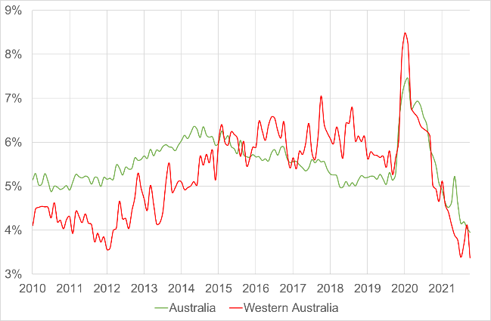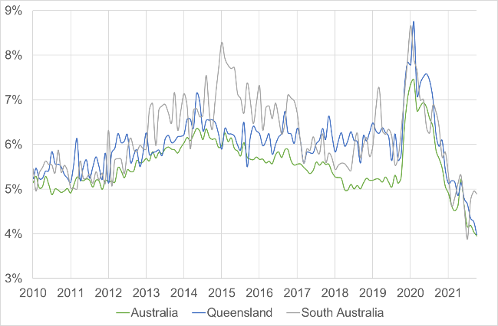
As Exhibit 80 indicates, that the participation rate in Western Australia is consistently higher than in the rest of Australia, and that (if anything) it is currently growing slightly faster in Western Australia than in the rest of Australia. The participation rate in Queensland continues to closely track that in the rest of Australia. The participation rate in South Australia is consistently lower than in the rest of Australia, but is tracking those general trends.
Exhibit 80: Participation Rate for Queensland, South Australia and Western Australia, June 2010 to March 2022
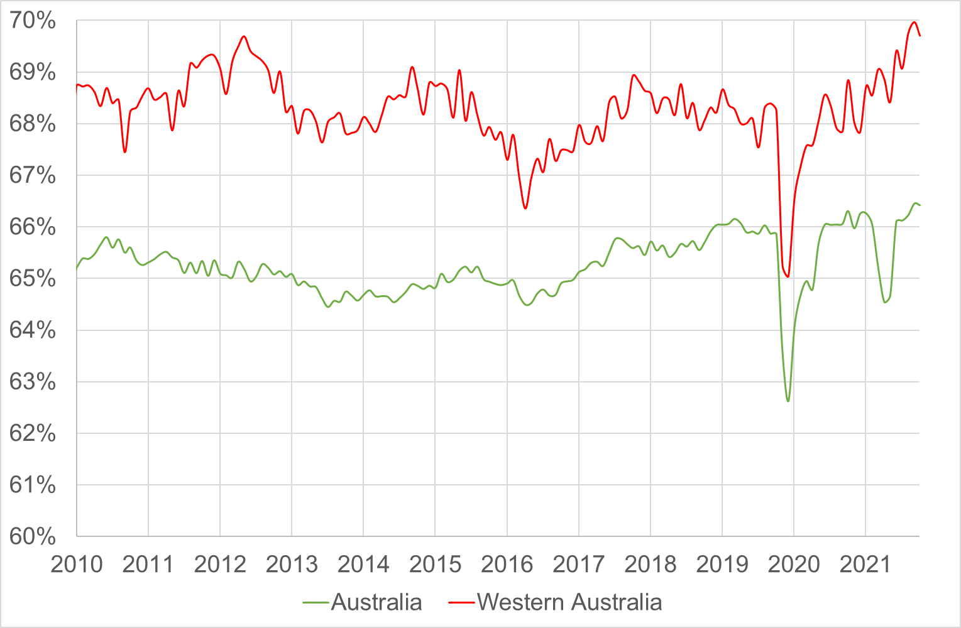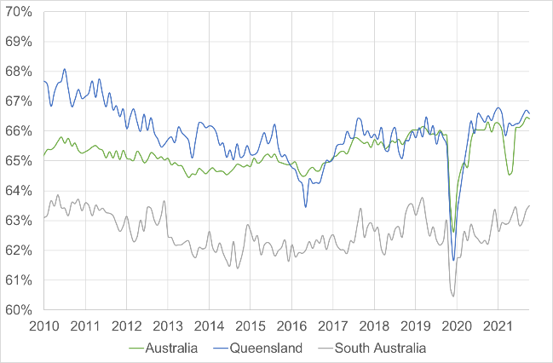
That is, from a macro employment perspective there is no evidence that the labour markets in Queensland, South Australia and Western Australia are behaving differently to those in the rest of Australia.

Job vacancies
Exhibit 81 uses the Internet Vacancy Index (IVI) reported by the National Skills Commission to look at the demand for labour in the disability sector. There has been significant increase in the number of job vacancies for Aged and Disabled Carers since July 2020.
Exhibit 81: Internet Vacancy Index for Aged and Disabled Carers from July 2016 to February 2022
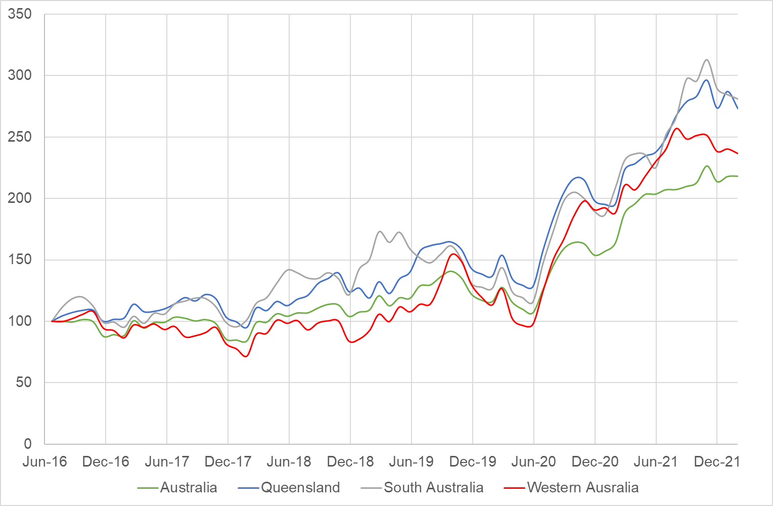
Between June 2020 and February 2022, the average number of internet vacancies for Aged and Disabled Carers across Australia grew by 73.4%. Over the same period, it grew at almost exactly the same rate in Queensland (73.5%). The rate of growth over the period was higher in South Australia (91.3%) and Western Australia (90.5%).

Discussion
The available evidence, as discussed above, does not support a finding that labour market conditions are materially tighter for disability service providers in Queensland, South Australia and Western Australia when compared nationally. In particular, the Financial Benchmarking Survey results confirms that profitability is at as high a level in those states as it is across Australia. There is therefore no reason at this time to impose different pricing arrangements in these states.
However, the NDIA should continue to work with the relevant Commonwealth and State/Territory Departments to monitor the economic conditions in Queensland, South Australia and Western Australia with a view to making temporary adjustments to price controls when necessary, in order to proactively manage any potential impacts on the supply of disability goods and services from economic trends in those states that were counter cyclical to the trends in other states and territories.

Endnotes

Appendix A – List of Submissions
Reference | Type of Respondent | Respondent
S001 | Provider | With Care Plan Managers
S002 | Individual Support Worker/Therapist | Continence Specialist Services
S003 | Provider | Sunflower Services
S004 | Provider | First Service Inc.
S005 | Individual Support Worker/Therapist | Support Care Management Services
S006 | Individual Support Worker/Therapist | Jibber Jabber Allied Health
S007 | Individual Support Worker/Therapist | I Support Disability Services
S008 | Individual Support Worker/Therapist | Forman's Business Services
S009 | Individual Support Worker/Therapist | Sole Trader
S010 | Individual Support Worker/Therapist | Not provided
S011 | Individual Support Worker/Therapist | BE Physiology
S012 | Individual Support Worker/Therapist | BE Physiology
S013 | Individual Support Worker/Therapist | CPS Choice Plan Services
S014 | Individual Support Worker/Therapist | Made To Measure Services
S015 | Individual Support Worker/Therapist | Meaningful Movement
S016 | Individual Support Worker/Therapist | HWO
S017 | Individual Support Worker/Therapist | HWO
S018 | Individual Support Worker/Therapist | HWO
S019 | Individual Support Worker/Therapist | HWO
S020 | Individual Support Worker/Therapist | HWO
S021 | Professional Peak Body | Osteopathy Australia
S022 | Provider | Beacon Support
S023 | Individual Support Worker/Therapist | Forman's Business Services
S024 | Individual Support Worker/Therapist | Hall and Prior
S025 | Provider Peak Body | Australian Community Industry Alliance
S026 | Individual Support Worker/Therapist | Tropics Occupational Therapy
S027 | Government | WA Department of Justice
S028 | Provider | Ocean Physio
S029 | Provider | Tulgeen
S030 | Individual Support Worker/Therapist | Active Ability
S031 | Individual Support Worker/Therapist | Active Ability
S032 | Individual Support Worker/Therapist | Active Ability
S033 | Individual Support Worker/Therapist | Move and Empower
S034 | Individual Support Worker/Therapist | Active Ability
S035 | Individual Support Worker/Therapist | Active Ability
S036 | Individual Support Worker/Therapist | Active Ability
S037 | Individual Support Worker/Therapist | Active Ability
S038 | Individual Support Worker/Therapist | Sole Trader
S039 | Individual Support Worker/Therapist | Sole Trader
S040 | Individual Support Worker/Therapist | Help at Hand Support
S041 | Individual Support Worker/Therapist | Active Ability
S042 | Individual Support Worker/Therapist | Active Ability
S043 | Individual Support Worker/Therapist | Active Ability
S044 | Individual Support Worker/Therapist | Active Ability
S045 | Individual Support Worker/Therapist | Total Rehab Solutions
S046 | Individual Support Worker/Therapist | Sole Trader
S047 | Provider | Interaction Disability Services
S048 | Provider | Greenacres
S049 | Individual Support Worker/Therapist | Hunter Rehabilitation and Health
S050 | Individual Support Worker/Therapist | Active Ability
S051 | Individual Support Worker/Therapist | The Active Studio
S052 | Individual Support Worker/Therapist | Lane Cove Physio
S053 | Provider Peak Body | Specialist Disability Accommodation Alliance
S054 | Provider | At Home Care
S055 | Provider | Action on Disability within Ethnic Communities
S056 | Provider | Lizard Centre
S057 | Individual Support Worker/Therapist | NeuroRehab Allied Health Network
S058 | Individual Support Worker/Therapist | NeuroRehab Allied Health Network
S059 | Individual Support Worker/Therapist | NeuroRehab Allied Health Network
S060 | Provider | We are Vivid
S061 | Provider | NDIS Services
S062 | Individual Support Worker/Therapist | Thomas Nicholas (sole trader)
S063 | Individual Support Worker/Therapist | NeuroRehab Allied Health Network
S064 | Professional Peak Body | The Australian Orthotic Prosthetic Association
S065 | Provider | Empowered Futures
S066 | Provider | Autism Spectrum Australia (Aspect)
S067 | Provider | Community Support Inc.
S068 | Provider | NeuroRehab Allied Health Network
S069 | Provider | MED-EL
S070 | Professional Peak Body | Exercise & Sports Science Australia (ESSA)
S071 | Participant Representative | NDIS Participant's Father
S072 | Provider Peak Body | Council of Regional Disability Services (CORDS)
S073 | Individual Support Worker/Therapist | RE Physiology
S074 | Individual Support Worker/Therapist | The EP Clinic
S075 | Individual Support Worker/Therapist | Active Ability
S076 | Individual Support Worker/Therapist | Flex Out
S077 | Individual Support Worker/Therapist | Clinical Health Rehabilitation
S078 | Individual Support Worker/Therapist | Ability Action Australia
S079 | Individual Support Worker/Therapist | Active Ability
S080 | Individual Support Worker/Therapist | The Active Studio
S081 | Individual Support Worker/Therapist | All Abilities Allied Health
S082 | Provider | Australian Community Support Organisation (ACSO)
S083 | Provider | Abacus Learning Centre
S084 | Provider | NeuroRehab Allied Health Network
S085 | Provider | Helping Minds
S086 | Professional Peak Body | Occupational Therapy Australia
S087 | Provider | Carers NSW
S088 | Provider | First Voice
S089 | Individual Support Worker/Therapist | Chorus Music Therapy Clinic
S090 | Provider | PC Ability
S091 | Provider | Can Do Group
S092 | Provider | Sylvanvale
S093 | Provider | First2Care
S094 | Provider | Kurrajong
S095 | Provider | Plumtree
S096 | Provider | Ngaanyatjarra Pitjantjatjara Women’s Council
S097 | Provider | One Door Mental Health
S098 | Professional Peak Body | Australian Physiotherapy Association
S099 | Provider | Queensland Alliance for Mental Health
S100 | Provider | Continence Foundation of Australia
S100a | Provider | Continence Foundation of Australia
S101 | Provider | Community Living Options
S102 | Provider | Job Centre Australia
S103 | Provider | Community Assist
S104 | Provider | Illawarra Disability Alliance
S105 | Provider | Mind Australia
S106 | Provider | Mercy Connect
S107 | Provider | HireUp
S108 | Provider | Marathon Health
S109 | Provider | Vision Australia
S110 | Participant Representative Organisation | Queensland Advocacy Incorporated
S111 | Professional Peak Body | Allied Health Professions Australia
S111a | Professional Peak Body | Allied Health Professions Australia
S112 | Provider | Avivo
S113 | Individual Support Worker/Therapist | Active Ability
S114 | Individual Support Worker/Therapist | Move 2 Thrive
S115 | Individual Support Worker/Therapist | Optimum Health Services
S116 | Individual Support Worker/Therapist | Optimum Health Solutions
S117 | Individual Support Worker/Therapist | Better Exercise Physiology
S118 | Individual Support Worker/Therapist | Optimum Health Solutions
S119 | Individual Support Worker/Therapist | Uplift Exercise Physiology
S120 | Provider | Living My Way
S121 | Provider | Flourish Australia
S122 | Union | Australian Services Union
S123 | Union | United Workers Union
S124 | Provider | Oncall Accommodation Services
S125 | Provider | IOTAH
S126 | Provider | Activ
S127 | Provider | Connect Plan Management
S128 | Provider | Down Syndrome Australia
S129 | Provider | Jobs Are Us
S130 | Participant Representative Organisation | Gippsland Disability Advocacy
S131 | Provider | NeuroRehab Allied Health Network
S132 | Individual Support Worker/Therapist | Life in Action
S133 | Individual Support Worker/Therapist | Hunter Rehabilitation and Health
S134 | Individual Support Worker/Therapist | Effect Exercise Physiology
S135 | Individual Support Worker/Therapist | Active Ability
S136 | Individual Support Worker/Therapist | o2 active
S137 | Individual Support Worker/Therapist | KG Exercise Physiology
S138 | Individual Support Worker/Therapist | Active Ability
S139 | Provider | North East Exercise Solutions
S140 | Individual Support Worker/Therapist | UniquePhysio
S141 | Provider | Rocky Bay
S142 | Provider | Supporting Independent Living Co-Operative (SILC)
S143 | Provider | Minimbah
S144 | Provider | Autism Queensland
S145 | Provider | Bedford
S146 | Individual Support Worker/Therapist | Darling Downs Therapy Services
S147 | Provider | Carers ACT
S148 | Provider | Royal District Nursing Service of South Australia
S149 | Participant Representative | NDIS Participant Carer
S150 | Provider | National Aboriginal Community Controlled Health Organisation
S151 | Provider | Galway Trading
S152 | Provider Peak Body | National Disability Services (NDS)
S153 | Provider | Mental Illness Fellowship of Australia
S154 | Provider | Novita
S155 | Individual Support Worker/Therapist | Extra Mile PT
S156 | Provider | Therapy Pro
S157 | Provider | Lime Therapy
S158 | Provider | Hunter Valley Children's Therapy
S159 | Provider | The Disability Trust
S160 | Provider | Mia's Health
S161 | Provider Peak Body | Disability Intermediaries Australia
S162 | Provider | Knapp Connections
S163 | Provider | iAssist Plan Management
S164 | Provider | Jigsaw Plan Management Pty Ltd
S165 | Provider | My Plan Manager
S166 | Provider | Slater Coordinator
S167 | Provider | Leisure Networks Association Inc.
S168 | Provider | JRA Plan Management
S169 | Provider | Plan Partners
S170 | Provider | JD Coordination & Support Services
S171 | Provider | The Growing Space
S172 | Provider | Pathways to Care Pty Ltd
S173 | Provider | Leap In! Australia
S174 | Provider | EMMJ Disability Services TA Rise and Shine Plan Management
S175 | Provider | Ablelink Pty Ltd
S176 | Provider | Shoalhaven Plan Management
S177 | Provider | Peak Plan Management
S178 | Provider | Total Plan Management
S179 | Provider | Ethical Coordination of Supports
S180 | Provider | P. Fernandez Support Coordination
S181 | Provider | My Integra
S182 | Provider | NDSP Plan Managers
S183 | Provider | Valued Lives
S184 | Provider | Gregg Fitzgerald Support Coordination
S185 | Provider | Connect Plan Management Pty Ltd
S186 | Provider | 1 Call Plan Management
S187 | Provider | The Carers Place Pty Ltd
S188 | Provider | Sole Trader
S189 | Provider | IDEAL Plan Management
S190 | Provider | #1 Answer Plan Management
S191 | Provider | Empowrd
S192 | Provider | Sole Trader
S193 | Provider | Claire Coordination of Supports
S194 | Provider | Sole Trader
S195 | Provider | myCSN Disability Pty Ltd
S196 | Provider | Monica Mckee Support Coordination
S197 | Provider | Your Plan Manager
S198 | Provider | Burke Support Coordination
S199 | Provider | PMCSS Specialist Support Coordination
S200 | Provider | All Disability Plan Management
S201 | Provider | Amelia Edmonds Support Coordination
S202 | Provider | Canny Plan Management
S203 | Provider | Roy Co.
S204 | Provider | Balanced Account Bookkeeping
S205 | Professional Peak Body | Australian Podiatry Association
S206 | Provider | Nganana Inc.
S207 | Provider | AEIOU Foundation
S208 | Provider | Paragon Support Limited
S209 | Provider | Veritable
S210 | Provider | Multicultural Services Centre of WA
S211 | Professional Peak Body | Australian Music Therapy Association
S212 | Individual Support Worker/Therapist | Sole Trader
S213 | Professional Peak Body | Australian Association of Psychologists Inc.
S214 | Individual Support Worker/Therapist | Integrated Children's OT
S215 | Individual Support Worker/Therapist | NeuroRehab Allied Health Network
S216 | Provider | Mpower You
S217 | Provider | Crosslinks Disability Support Services
S218 | Provider | Ability Options
S219 | Provider | Gen U
S220 | Individual Support Worker/Therapist | Not provided
S221 | Provider | Living Right
S222 | Provider | Wellways Australia
S223 | Provider | MerriWA
S224 | Provider | Made to Measure Bookkeeping Pty Ltd
S225 | Provider | Bespoke Lifestyles & Made to Measure Services
S226 | Provider | Kyeema Support Services
S227 | Provider | Life Without Barriers
S228 | Provider | Community Living Australia
S229 | Provider Peak Body | Ability First Australia
S230 | Professional Peak Body | Australian Psychological Society
S231 | Government | Department of Communities WA
S232 | Provider | MJD Foundation
S233 | Provider | New Horizons
S234 | Provider Peak Body | Vision 2020 Australia
S235 | Provider Peak Body | Spinal Cord Injuries Australia (SCIA)
S236 | Provider | Leisure Networks
S237 | Provider | Xavier
S238 | Provider Peak Body | Alliance20
S239 | Professional Peak Body | Dietitians Australia
S240 | Government | Queensland Government
S241 | Provider Peak Body | Ability First Australia
S242 | Professional Peak Body | Speech Pathology Australia (SPA)
S243 | Union | Australian Services Union
S244 | Provider | Minda
S245 | Government | Heads of Workplace Safety Authorities Australia & NZ (Confidential)
S246 | Provider | Minda
S247 | Provider | At Home Care
S248 | Provider | Cerebral Palsy Alliance
S249 | Provider | Cara
S250 | Provider | Sylvanvale
S250a | Provider | Sylvanvale
S251 | Provider | KB NeuroPhysiotherapy

Appendix B – Working Group Members

Working Group 1 – Core Pricing Arrangements
Organisation represented | Attendee to at least one session
Ability First Australia | Andrew Rowley
Ability First Australia | Michael Bink
Achieve Australia | Lorraine Salloum
Autism Spectrum Australia (Aspect) | Nikki Lui
Avivo | Lynsey McDonnell
Bedford | Rachael Griffiths
Cerebral Palsy Alliance | Shaun Curry
Cerebral Palsy Alliance | Tim Pines
Challenge Community Services | Dino Santos
Challenge Community Services | Tania Mills
Civic Disability Services Ltd | Ethan Chishty
Civic Disability Services Ltd | Kimberley Rathmanner
Community Living Options | Lauren Cronin
Community Living Options | Tiff Hodge
CPL - Choice Passion Life | Murray Sandon
Fighting Chance | Laura O'Reilly
Golden City Support Services | Shelley Moore
Greenacres | Chris Christodoulou
HireUp | Lliam Caulfield
Life Without Barriers | Steve Sloan
Macarthur Disability Services | Brenda Odewahn
Mambourin | Alma Zulovic
Mind Australia | Anath Dissanayake
Minda | Antony Sellentin
Minda | Nathan Thompson
National Disability Services | Kerrie Langford
National Disability Services | Philippa Angley
Northcott | Pat Buick
Oak Possability | John Rowland
Oak Possability | Jon Anning
Rocky Bay | Adam Maxwell
Stride | Emma Thomas
Sylvanvale | Oliver Parker
The Disability Trust | Suze Mandicos
The Housing Connection | Nicola Hayhoe
Unisson | Rayni Gauci

Working Group 2 – Quality and Safeguard Costs
Organisation represented | Attendee to at least one session
Ability First Australia | Andrew Rowley
Ability First Australia | Jennifer Luff
Ability First Australia | Michael Bink
Achieve Australia | Ranita Chatterjee
Achieve Australia | Tina McManus
ACT Government | Michelle Waterford
Allied Health Professions Australia | Erin West
Australian Physiotherapy Association | Carole Sarasa
Australian Physiotherapy Association | Carolyn OMahoney
Australian Physiotherapy Association | Dan Miles
Autism Association of Western Australia | Nicola Abernethy
Avivo | Dannielle Wenn
Avivo | Denver Forsdike
Avivo | Janine Croker
Avivo | Lisa Davies
Bedford | Taryn Alderdice
Better Rehabilitation | David Pettersson
Cara | Todd Williams
Carpentaria Disability Services | Annie Rily
Cerebral Palsy Alliance | Elise Taylor
Choice Passion Life | Amelia Rowell
Choice Passion Life | Robert Irvin
Civic Disability Services Ltd | Carrie Voysey
Endeavour Foundation | Eric Teed
Endeavour Foundation | Jaime Zischke
Endeavour Foundation | Jennifer Knight
HireUp | Lliam Caulfield
Life Without Barriers | Greg Reynolds
Macarthur Disability Services | Brenda Odewahn
Minda | Amy Ambagtsheer
NDIS Commission | Samantha Taylor
National Disability Services | Carmen Pratts-Hincks
National Disability Services | Kerrie Langford
National Disability Services | Philippa Angley
Northcott | Aleta Carpenter
Novita | Andrea Collett
Novita | Tara Richards
Nulsen Group | Gordon Trewern
Oak Possability | John Rowland
Oak Possability | Jon Anning
Occupational Therapy Australia | Madison Silver
Occupational Therapy Australia | Michael Barrett
Occupational Therapy Australia | Samantha Hunter
Scope (Aust) Ltd | Ian Morgan
Scope (Aust) Ltd | Richard Drew
Stride | Emma Thomas
Sylvanvale | Leanne Fretten
Sylvanvale | Tammy Sargeant
Therapy Focus | Danelle Milward
VIC Department of Families, Fairness and Housing | Christopher Brophy
VIC Department of Families, Fairness and Housing | Heidi Tarjani
VIC Department of Families, Fairness and Housing | Shaun Nicholson
WA Department of Communities | Susan Quin

Working Group 3 - Group Pricing Arrangements for Core Supports
Organisation represented | Attendee to at least one session
Ability First Australia | Andrew Rowley
Ability First Australia | Michael Bink
Allevia | Philip Petrie
Autism Spectrum Australia (Aspect) | Ben James
Bedford | Stefanie Veitch
Centacare | Kaylene Moore
Central Bayside CHS | Amrita Ahluwalia
Cerebral Palsy Alliance | Anne-Marie Bell
Cerebral Palsy Alliance | Paul Henderson
Cerebral Palsy Alliance | Shaun Curry
Disability Services Australia | Heath Dickens
Flourish Australia | James Herbertson
Greenacres | Chris Christodoulou
HireUp | Peter Willis
Life Without Barriers | Steve Sloan
National Disability Services | Graeme West
National Disability Services | Philippa Angley
Nexus Inc. | Mark Jessop
Northcott | John Preston
Novita | Greg Ward
Novita | Jeremy Brown
Rocky Bay | Adam Maxwell
Stride | Emma Thomas
Sunnyfield | Belinda Gannon
Sunnyfield | Matt Parrott
The Disability Trust | Suze Mandicos

Working Group 4 – Temporary Transformation Payment
Organisation represented | Attendee to at least one session
Ability First Australia | Jennifer Luff
Autism Spectrum Australia (Aspect) | Nghi Hua
Avivo | Lynsey McDonnell
Bedford | Tahlia Gradara
CareChoice | Michelle Eriksen
Centacare | Derek Millar
Community Living Australia | Mark Kulinski
Dared Disability | Andrew Daly
Ermha | Michael Bowers
Flourish Australia | Megan Hancock
HireUp | Lliam Caulfield
Life Without Barriers | Nelson Contador
National Disability Services | Henry Newton
National Disability Services | Karen Stace
Nextt | Simon Wright
Northcott | John Preston
Rocky Bay | Adam Maxwell
Sunnyfield | Peter Dixon

Working Group 5 – Therapy supports
Organisation represented | Attendee to at least one session
Ability First Australia | Andrew Rowley
Ability First Australia | Michael Bink
Allied Health Professions Australia | Dr Chris Atmore
AMTA | Helen Cameron
Autism Spectrum Australia (Aspect) | Maryanne Pease
Autism Spectrum Australia (Aspect) | Rachel Kerslake
Autism Spectrum Australia (Aspect) | Rebecca Keane
Audiology Australia | Feiya Zhang
Australian Association of Social Workers | Sharon Paetzold
Australian Association of Social Workers | Sophie Staughton
Australian Clinical Psychology Association | Caroline Hunt
Australian Clinical Psychology Association | Dr Paul Gertler
Australian Clinical Psychology Association | Monique Shipp
Australian Orthoptic Board | Sue Silveira
Australian Physiotherapy Association | Carole Sarasa
Australian Physiotherapy Association | Dan Miles
Australian Physiotherapy Association | Julienne Locke
Australian Physiotherapy Association | Simon Tatz
Australian Psychological Society | Tamara Cavenett
Autism Association Of Western Australia | Nicola Abernethy
Autism Queensland | Valerie Preston
Better Rehabilitation | David Pettersson
Carpentaria Disability Services | Fiona Tipping
Cerebral Palsy Alliance | Alison O’Toole
Cerebral Palsy Alliance | Jo Ford
Cerebral Palsy Alliance | Paul Henderson
Dietitians Australia | Aimee McLeod
Dietitians Australia | Carmel Curlewis
Dietitians Australia | Jodie Sheraton
Early Start Australia | Karen Brown
Endeavour Foundation | Jenny Madden
Exercise & Sports Science Australia (ESSA) | Carla Vasoli
Firstchance | Darleen Taylor
Macarthur Disability Services | Brenda Odewahn
Melbourne City Mission | Ben Spooner
Melbourne City Mission | Sally Moore
Montrose Therapy & Respite Services | Kerrie Mahon
National Disability Services | Philippa Angley
NeuroRehab Allied Health Network | Steve Woollard
NextSense | Andrew Steen
NextSense | Sharon Nann
NextSense | Shy Bastianpillai
Noah's Ark | Roxanne Higgins
Northcott | Danielle Coogan
Novita | Jeremy Brown
Occupational Therapy Australia | Sarah Jones
Physio Inq | David Shearer
Rocky Bay | Adam Maxwell
Rocky Bay | Mia Huntley
Scope (Aust) Ltd | Andrew Hanson
Scope (Aust) Ltd | Richard Drew
Speech Pathology Australia | Erin West
Spinal Cord Injuries Australia | Sam Mitchell
St Giles | Andrew Billing
Stride | Emma Thomas
The Australian Orthotic Prosthetic Association | Dr Emily Ridgewell
The Australian Orthotic Prosthetic Association | Natasha Korbut
Therapy Pro | Phil Laidlaw
Vision Australia | Caitlin McMorrow
Vision Australia | Chris Edwards
Yooralla | Cassie Kenyon

Working Group 6 – Nursing supports
Organisation represented | Attendee to at least one session
Achieve Australia | Tina McManus
At Home Care | Christian Lenzarini
Australian Primary Health Care Nurses Association (APNA) | Jayne Lehmann
Blue Care | Jo Martinaglia
Blue Care | Sue Macgregor
Canberra Health Services | Barbara Bolton
CareChoice | Michelle Eriksen
Civic Disability Services Ltd | Rebecca VanLierop
Continence Foundation of Australia | Janie Thompson
Eskleigh Foundation | Sharlene Knight
Home Care Nurses Australia | Busi Faulkner
Intensive Care at Home | Patrik Hutzel
NNA Direct Support Service | Ellen Banks
NNA Direct Support Service | Joanne Kernot
Yooralla | Kristy McMurray

Working Group 7 – Plan Management
Organisation represented | Attendee to at least one session
AIIM Choices | Sandy Powell
All Disability Plan Management | Jo Hollis
Avivo | Emer Hickey
Avivo | Gareth Rees
Budget Net | Michael Coyne
Connect Plan Management | Anthony Oostenbroek
Disability Intermediaries Australia | Jess Harper
Disability Intermediaries Australia | Nicolas Phipps
Ermha | Jackie Ashmore
First2Care | Peter Whitey
Leisure Networks Association | Paul Davies
Manage it | Colin Andison
Maple Plan | Christopher Holt
Moira | Fahmy Singh
National Disability Services | Jim Vanopoulos
NDSP Plan Managers | Graham Oades
Nexia Canberra | Billy Kang
Parent to Parent Association Qld | Kevin Reilly
Plan Partners | Sean Dempsey
Scorpion Business Services | Karen Frost
Tweed Coast Plan Management | Jude McColm
Your Plan Manager | Tanya Walford

Working Group 8 – Support Coordination
Organisation represented | Attendee to at least one session
Avivo | Emer Hickey
Avivo | Gareth Rees
Disability Intermediaries Australia | Jess Harper
Disability Intermediaries Australia | Nicolas Phipps
Each | Kerry Boyd
Each | Lisa Gort
Facilitatrix | Caitriona Byrne
Facilitatrix | Caroline Marshall
genU | Brandon Howard
genU | Schree Barry
Golden City Support Services | Shelley Moore
Life Without Barriers | Nelson Contador
Life Without Barriers | Nicole Harrop
Macarthur Disability Services | Brenda Odewahn
Melbourne City Mission | Ben Spooner
Melbourne City Mission | Julia Henning
Mercy Community | Kimberley Dillon
Mind Australia | Elena Slodecki
Mind Australia | Nicola Ballenden
National Disability Services | Karen Stace
Stride | Emma Thomas
Stride | Juliet Middleton
Support Coordination Academy | Mary Ingerton
Wellways Australia | Laura Collister
Wellways Australia | Michael Ashenden
Wellways Australia | Nikki Wynne
Your Plan Manager | Tanya Walford

Working Group 9 – Regional and Remote
Organisation represented | Attendee to at least one session
Avivo | Christine Gibson
Avivo | Nichole Kostal
Council of Regional Disability Organisations | Kathy Hough
Department of Communities Tasmania | Ingrid Ganley
Department of Communities Tasmania | Wendy Yardy
Department of Seniors and Disability Services and Aboriginal and Torres Strait Islander Partnerships | Elizabeth Rowe
Department of Seniors and Disability Services and Aboriginal and Torres Strait Islander Partnerships | Melissa Fallon
East Kimberly Job Pathway | Laura Little
HireUp | Lliam Caulfield
HireUp | Larissa Silva
Ingham Disability Support Services | Liz Sutton
Life Without Barriers | Scott Ferguson
Midway Community Care | Heath Flanagan
MJD Foundation | Nadia Lindop
National Disability Services | Ian Montague
Novita | Cathryn Blight
NSW Disability Secretariat | Amanda Viner
NSW Disability Secretariat | Brian Woods
Occupational Therapy Australia | Michael Barrett
Office of Disability | Michelle McColm
Speech Pathology Australia | Erin West
St Giles | Andrew Billing
Through Life Physio | Helen
WA Department of Communities | Suzanne Velarde

Working Group 10 – Queensland
Organisation represented | Attendee to at least one session
121 Care | Kym Chomley
CPL - Choice Passion Life | Murray Sandon
Department of Employment, Small Business, and Training | Tim Maloney
Endeavour Foundation | Eric Teed
Endeavour Foundation | Jennifer Knight
Ingham Disability Support Services | Liz Sutton
National Disability Services | Ian Montague
Xavier | Richard Littler
Yumba Bimbi Support Services | Rachel Freeman

Working Group 11 – South Australia
Organisation represented | Attendee to at least one session
Bedford | Rebecca Greenfield
Benevolent Society | Josie Kitch
Cocoon SDA Homes | Donna Maidment
HCO | Sue Horsnell
HireUp | Eliza Wallace
Lutheran Disability Services Inc | John Van Ruth
National Disability Services | Janine Lenigas
Novita | Cathryn Blight
Novita | Greg Ward

Working Group 12 – Western Australia
Organisation represented | Attendee to at least one session
Avivo | Lyn-Lee The
Avivo | Lynsey McDonnell
Cocoon SDA Homes | Donna Maidment
East Kimberly Job Pathway | Laura Little
Far North Community Services | Kathy Hough
HireUp | Eliza Wallace
Midway Community Care | Heath Flanagan
National Disability Services | Coralie Flatters
National Disability Services | Jim Vanopoulos
Nulsen Group | Gordon Trewern
SensesWA | Sarah Love
St Jude's Health Care Services | Binu Joseph
St Jude's Health Care Services | Danyel Zalsman
WA Department of Communities | Marion Hailes-MacDonald
WA Department of Communities | Suzanne Velarde
Western Australian Association for Mental Health (WAAHM) | Tabetha McCallum
Western Australian Association for Mental Health (WAAHM) | Nicole Fitch

Appendix C – Comparative Analysis of Pricing Arrangements in Government Insurance and Funding Schemes
The NDIS is not the only government insurance or funding scheme that pays for therapy supports. The comparison of therapy price limits across public schemes discussed in this report is based on the NDIA’s calculations using: information published by other schemes as at 31 March 2022; and additional information obtained directly through engagement with other schemes. Seventeen Schemes were reached out to and provided information:
National
- ComCare
- Department of Veterans’ Affairs (DVA)
- Disability Support for Older Australians (DSOA) Program
- Medicare Benefit Scheme (MBS)
New South Wales
- State Insurance Regulatory Authority (SIRA)
Victoria
- Home and Community Care Program for Younger People (HACC-PYP)
- Victims of Crime Assistance Tribunal (VOCAT)
- Victorian Transport Accident Commission (TAC)
- WorkSafe VIC
Queensland
- National Injury Insurance Scheme Queensland (NIISQ)
- WorkCover QLD
South Australia
- Lifetime Support Scheme (LSS)
- Return To Work SA (RTWSA)
Western Australia
- Lifetime Care and Support Scheme (LTCSS)
- WorkCover WA
Tasmania
- Motor Accidents Insurance Board (MAIB)
Australian Capital Territory
- Catastrophic Injuries Support (CIS) Scheme
The tables below show the price for a therapy session as published by other schemes, as well as the effective hourly price calculated by the NDIA. The DSOA Program indicated that their arrangements are aligned with NDIS definitions and price limits. They are therefore not included in the tables. The NIISQ similarly indicated that it uses the NDIS pricing arrangements as a benchmark. They are therefore not included in the tables. The CIS Scheme indicated that they sometimes used the NDIS price limits and sometimes set their own price limits. Their data is included in the tables.
To calculate the effective hourly price limit, NDIA looked for information about the regulated length of therapy sessions (for example, the NDIS’ price limits for therapy are per hour). Where this was not already available, we asked for this information from other schemes. For comparability, the NDIA generally used standard or subsequent consultations where possible whilst noting many Schemes have differentiated items and/or pricing for initial consultations and standard/extended consultations.
The NDIA were able to calculate the effective hourly price where the length of a session was provided as a required length (for example, price per 20 minutes); as a required minimum length (for example, price for at least 20 minutes); or as an average session time based on the observed length of sessions. In all other cases, the NDIA were unable to calculate the effective hourly price.
The analysis below improves the comparability of the NDIS’ price limits for therapy with that of other schemes; however it does not allow for a full comparison of pricing arrangements. To do so, it is necessary to understand the arrangements that other schemes make for non-face-to-face delivery, travel, non-attendance or short-notice cancellations, what quality and safety regulation is imposed on providers, and finally whether the price is intended to cover the entire cost of the support or if the client can be asked to make a co-contribution.
Exhibit 82: Comparison of pricing across public schemes — Audiologist
Scheme | Location | Length of session if regulated (minutes) | Average length of session if known (minutes) | Published Price of a Session | Effective Hourly Price of a Session
MBS | National | 20 (at least) |  | $64.80 | $194.40
NDIS – Non-Remote | National | 60 |  | $193.99 | $193.99
NDIS - Remote | National | 60 |  | $271.59 | $271.59
NDIS - Very Remote | National | 60 |  | $290.99 | $290.99
RTWSA | SA | Flat fee |  | $198.20
WorkCover QLD | QLD | Flat fee |  | $245.00
WorkSafe VIC | VIC |  | 60 | $187.00 | $187.00
Exhibit 83: Comparison of pricing across public schemes — Counsellor
Scheme | Location | Length of session if regulated (minutes) | Average length of session if known (minutes) | Published Price of a Session | Effective Hourly Price of a Session
CIS Scheme | WA | 60 |  | $262.35 | $262.35
HACC-PYP | VIC |  |  |  | $108.36
MAIB | TAS | 60 | 60 | $240.00 | $240.00
NDIS – Non-Remote | National | 60 |  | $156.16 | $156.16
NDIS - Remote | National | 60 |  | $218.62 | $218.62
NDIS - Very Remote | National | 60 |  | $234.24 | $234.24
SIRA | NSW | 30 |  | $79.40 | $158.80
VOCAT | VIC |  |  | $150.00
WorkCover QLD | QLD | 60 |  | $140.00 | $140.00
WorkSafe VIC | VIC | 30 |  | $68.59 | $137.18
Exhibit 84: Comparison of pricing across public schemes — Dietitian
Scheme | Location | Length of session if regulated (minutes) | Average length of session if known (minutes) | Published Price of a Session | Effective Hourly Price of a Session
CIS Scheme* | WA | 60 |  | $193.99 | $193.99
DVA | National | 30 |  | $66.90 | $133.80
HACC-PYP | VIC |  |  |  | $108.36
MBS | National | 20-30 |  | $90.00 | $270.00
MAIB | National | 20 (at least) |  | $64.80 | $194.40
NDIS – Non-Remote | National | 60 |  | $193.99 | $193.99
NDIS - Remote | National | 60 |  | $271.59 | $271.59
NDIS - Very Remote | National | 60 |  | $290.99 | $290.99
TAC | VIC | 45-60 |  | $100.12 | $133.49
WorkCover QLD | QLD |  |  | $115.00
WorkSafe VIC | VIC | 30 |  | $49.35 | $98.70
NOTE: CIS Scheme reported that they typically used the NDIS price limit as their rate.
Exhibit 85: Comparison of pricing across public schemes — Exercise Physiologist
Scheme | Location | Length of session if regulated (minutes) | Average length of session if known (minutes) | Published Price of a Session | Effective Hourly Price of a Session
CIS Scheme | WA | 60 |  | $207.05 | $207.05
DVA | National | 30 |  | $66.90 | $133.80
HACC-PYP | VIC |  |  |  | $108.36
LSS | SA | 60 |  | $150.90 | $150.90
MBS | TAS | 50 (at least) | 50 (at least) | $93.09 | $111.71
MAIB | National | 20 (at least) |  | $64.80 | $194.40
NDIS – Non-Remote | National | 60 |  | $166.99 | $166.99
NDIS - Remote | National | 60 |  | $233.79 | $233.79
NDIS - Very Remote | National | 60 |  | $250.49 | $250.49
RTWSA | SA | 60 |  | $150.90 | $150.90
TAC | VIC | 60 |  | $100.60 | $100.60
WorkCover QLD | QLD | 60 |  | $189.00 | $189.00
WorkCover WA | WA | 60 |  | $207.05 | $207.05
WorkSafe VIC | VIC | 30 |  | $61.41 | $122.82
Exhibit 86: Comparison of pricing across public schemes — Occupational Therapist
Scheme | Location | Length of session if regulated (minutes) | Average length of session if known (minutes) | Published Price of a Session | Effective Hourly Price of a Session
CIS Scheme | WA | 30-44 |  | $102.40 | $204.80
ComCare (SA) | SA | 60 |  | $190.30 | $190.30
ComCare (QLD) | QLD |  |  | $80.00
ComCare (VIC) | VIC | up to 30 |  | $50.77
ComCare (WA) | WA | 30-45 |  | $102.40 | $204.80
DVA | National | 30 |  | $116.70 | $233.40
HACC-PYP | VIC |  |  |  | $108.36
LSS | SA | 60 |  | $190.30 | $190.30
MBS | National | 20 (at least) |  | $64.80 | $194.40
NDIS – Non-Remote | National | 60 |  | $193.99 | $193.99
NDIS - Remote | National | 60 |  | $271.59 | $271.59
NDIS - Very Remote | National | 60 |  | $290.99 | $290.99
RTWSA | SA | 60 |  | $190.30 | $190.30
TAC | VIC | 31-45 |  | $74.92 | $145.01
WorkCover QLD | QLD |  |  | $80.00
WorkCover WA | WA | 60 (at least) |  | $204.95 | $204.95
WorkSafe VIC | VIC | 30-45 |  | $75.46 | $127.83
Exhibit 87: Comparison of pricing across public schemes — Orthoptist
Scheme | Location | Length of session if regulated (minutes) | Average length of session if known (minutes) | Published Price of a Session | Effective Hourly Price of a Session
MBS | National | 50 (at least) |  | $91.50 | $109.80
NDIS – Non-Remote | National | 60 |  | $193.99 | $193.99
NDIS - Remote | National | 60 |  | $271.59 | $271.59
NDIS - Very Remote | National | 60 |  | $290.99 | $290.99
TAC | VIC |  |  | $49.11
Exhibit 88: Comparison of pricing across public schemes — Physiotherapist
Scheme | Location | Length of session if regulated (minutes) | Average length of session if known (minutes) | Published Price of a Session | Effective Hourly Price of a Session
CIS Scheme | WA | Flat fee |  | $72.95
ComCare (ACT) | ACT |  |  | $123.50
ComCare (NT) - Level 2 | NT | 60 |  | $227.49 | $227.49
ComCare (NT) - Level 1 | NT | 60 |  | $181.98 | $181.98
ComCare (NSW) | NSW |  |  | $125.50
ComCare (QLD) | QLD |  |  | $153.00
ComCare (SA) | SA |  |  | $79.30
ComCare (TAS) | TAS | 45 (at least) |  | $181.59 | $242.12
ComCare (VIC) | VIC |  |  | $60.26
ComCare (WA) | WA |  |  | $92.20
DVA | National | 30 |  | $66.90 | $133.80
HACC-PYP | VIC |  |  |  | $108.36
LSS | SA | 60 |  | $190.30 | $190.30
MAIB | TAS | up to 45 | up to 45 | $72.68
MBS | National | 20 (at least) |  | $64.80 | $194.40
NDIS – Non-Remote | NSW | 60 |  | $193.99 | $193.99
NDIS – Non-Remote | VIC | 60 |  | $193.99 | $193.99
NDIS – Non-Remote | QLD | 60 |  | $193.99 | $193.99
NDIS – Non-Remote | ACT | 60 |  | $193.99 | $193.99
NDIS – Non-Remote | WA | 60 |  | $224.62 | $224.62
NDIS – Non-Remote | SA | 60 |  | $224.62 | $224.62
NDIS – Non-Remote | TAS | 60 |  | $224.62 | $224.62
NDIS – Non-Remote | NT | 60 |  | $224.62 | $224.62
NDIS - Remote | National | 60 |  | $314.47 | $314.47
NDIS - Very Remote | National | 60 |  | $336.93 | $336.93
RTWSA | SA | Flat fee |  | $79.30
SIRA | NSW | 5 |  | $16.40 | $196.80
TAC | VIC | 20-30 |  | $57.48 | $172.44
WorkCover QLD | QLD |  |  | $80.00
WorkCover WA – EBPP* | WA | 60 |  | $207.05 | $207.05
WorkCover WA | WA | Flat fee |  | $72.95
WorkSafe VIC | VIC | 20 |  | $60.26 | $180.78
NOTE: *WorkCover WA EBPP = WorkCover WA - Exercise Based Programs Physiotherapist
Exhibit 89: Comparison of pricing across public schemes — Podiatrist
Scheme | Location | Length of session if regulated (minutes) | Average length of session if known (minutes) | Published Price of a Session | Effective Hourly Price of a Session
CIS Scheme | WA |  |  | Agreed rate
DVA | National | 30 |  | $84.30 | $168.60
HACC-PYP | VIC |  |  |  | $108.36
MAIB | National |  |  | $90.00
MBS | National | 20 (at least) |  | $64.80 | $194.40
NDIS – Non-Remote | National | 60 |  | $193.99 | $193.99
NDIS - Remote | National | 60 |  | $271.59 | $271.59
NDIS - Very Remote | National | 60 |  | $290.99 | $290.99
TAC | VIC | 31-45 |  | $75.07 | $145.30
WorkCover QLD | QLD |  |  | $80.00
WorkSafe VIC | VIC | 30 |  | $50.17 | $100.34
Exhibit 90: Comparison of pricing across public schemes — Psychologist
Scheme | Location | Length of session if regulated (minutes) | Average length of session if known (minutes) | Published Price of a Session | Effective Hourly Price of a Session
CIS Scheme | WA | 60 |  | $262.35 | $262.35
ComCare | National | 46-60 |  | $218.00 | $284.35
DVA | National | 50 |  | $145.65 | $174.78
DVA (Clinical Psych.) | National | 50 |  | $213.90 | $256.68
LSS | SA | 60 |  | $190.30 | $190.30
MAIB | National | 45-60 | >45 | $267.00 | $356.00
MBS | National | 30-50 |  | $103.80 | $207.60
NDIS – Non-Remote | NSW | 60 |  | $214.41 | $214.41
NDIS – Non-Remote | VIC | 60 |  | $214.41 | $214.41
NDIS – Non-Remote | QLD | 60 |  | $214.41 | $214.41
NDIS – Non-Remote | ACT | 60 |  | $214.41 | $214.41
NDIS – Non-Remote | WA | 60 |  | $234.83 | $234.83
NDIS – Non-Remote | SA | 60 |  | $234.83 | $234.83
NDIS – Non-Remote | TAS | 60 |  | $234.83 | $234.83
NDIS – Non-Remote | NT | 60 |  | $234.83 | $234.83
NDIS - Remote | National | 60 |  | $328.76 | $328.76
NDIS - Very Remote | National | 60 |  | $352.25 | $352.25
RTWSA | SA | 60 |  | $190.30 | $190.30
SIRA | NSW | 30 |  | $99.55 | $199.10
TAC | VIC | 60 |  | $171.63 | $171.63
TAC (ARSA Psychologist) | VIC | 60 |  | $210.00 | $210.00
VOCAT | VIC | 60 |  | $185.00 | $185.00
WorkCover QLD | QLD | 60 |  | $189.00 | $189.00
WorkCover WA (Clinical Psychologist) | WA | 60 |  | $262.35 | $262.35
WorkCover WA (Counselling Psychologist) | WA | 60 |  | $262.35 | $262.35
WorkSafe VIC | VIC | 60 |  | $176.42 | $176.42
Exhibit 91: Comparison of pricing across public schemes — Rehabilitation counsellor
Scheme | Location | Length of session if regulated (minutes) | Average length of session if known (minutes) | Published Price of a Session | Effective Hourly Price of a Session
ComCare | National | 60 |  | $189.66 | $189.66
NDIS – Non-Remote | National | 60 |  | $193.99 | $193.99
NDIS - Remote | National | 60 |  | $271.59 | $271.59
NDIS - Very Remote | National | 60 |  | $290.99 | $290.99
RTWSA | SA | 60 | Varies | $190.30 | $190.30
WorkCover QLD | QLD | 60 |  | $189.00 | $189.00
Exhibit 92: Comparison of pricing across public schemes — Social worker
Scheme | Location | Length of session if regulated (minutes) | Average length of session if known (minutes) | Published Price of a Session | Effective Hourly Price of a Session
CIS Scheme | WA |  |  | $193.99 | $193.99
DVA – MHSW | National | 50 |  | $117.20 | $140.64
DVA | National | 30 |  | $82.95 | $165.90
MAIB | TAS | 60 | 60 | $240.00 | $240.00
MBS | National | 50 (at least) |  | $91.50 | $109.80
NDIS – Non-Remote | National | 60 |  | $193.99 | $193.99
NDIS - Remote | National | 60 |  | $271.59 | $271.59
NDIS - Very Remote | National | 60 |  | $290.99 | $290.99
TAC | VIC | 31-45 |  | $74.92 | $145.01
VOCAT | VIC | 60 |  | $150.00 | $150.00
VOCAT – MHSW | VIC | 60 |  | $165.00 | $165.00
WorkCover QLD | QLD | 60 |  | $189.00 | $189.00
WorkSafe VIC - MHSW | VIC | 60 |  | $155.56 | $155.56
WorkSafe VIC | VIC | 30 |  | $52.05 | $104.10
NOTE: MHSW = Mental Health Support Worker
Exhibit 93: Comparison of pricing across public schemes — Speech pathologist
Scheme | Location | Length of session if regulated (minutes) | Average length of session if known (minutes) | Published Price of a Session | Effective Hourly Price of a Session
CIS Scheme | WA | 30-60 |  | $107.25 | $214.50
DVA | National | 60 |  | $111.80 | $111.80
HACC-PYP | VIC |  |  |  | $108.36
LSS | SA | 60 |  | $190.30 | $190.30
MBS | National | 20 (at least) |  | $64.80 | $194.40
NDIS – Non-Remote | National | 60 |  | $193.99 | $193.99
NDIS - Remote | National | 60 |  | $271.59 | $271.59
NDIS - Very Remote | National | 60 |  | $290.99 | $290.99
RTWSA | SA | 60 |  | $190.30 | $190.30
TAC | VIC | 60 |  | $100.12 | $100.12
WorkCover QLD | QLD | 60 |  | $189.00 | $189.00
WorkCover WA | WA | 30-60 |  | $107.25 | $107.25
WorkSafe VIC | VIC | 30 (at least) |  | $100.29 | $100.29
Exhibit 94: Comparison of pricing across public schemes — Therapy / Allied health assistants
Scheme | Location | Length of session if regulated (minutes) | Average length of session if known (minutes) | Published Price of a Session | Effective Hourly Price of a Session
CIS Scheme - Level 1 | WA |  |  | $56.16
CIS Scheme - Level 2 | WA |  |  | $86.79
HACC-PYP | VIC |  |  |  | $108.36
MAIB | TAS | up to 60 |  | $73.80
NDIS – Non-Remote – L1 | National | 60 |  | $56.16 | $56.16
NDIS – Remote - L1 | National | 60 |  | $78.62 | $78.62
NDIS - Very Remote – L1 | National | 60 |  | $84.24 | $84.24
NDIS – Non-Remote – L2 | National | 60 |  | $86.79 | $86.79
NDIS – Remote – L2 | National | 60 |  | $121.51 | $121.51
NDIS - Very Remote – L2 | National | 60 |  | $130.19 | $130.19
TAC | VIC |  |  | $39.91

Exhibit 95: Summary of other pricing arrangements
Scheme | Location | Allowance for provider travel time | Allowance for provider travel costs | Allowance for non-attendance/ cancellation fees | Co-payment / Out-of-pocket
CIS Scheme | WA | Yes (time limited).  Note: Up to 60 minutes in Perth metropolitan area and as negotiated with Insurance Commission of Western Australia (ICWA) for regional and remote areas. | No – included in hourly travel rate. | Limited occasions | Yes (unlimited).  Note: Participants of the CIS Scheme can choose their providers but are informed that ICWA will only pay for services in accordance with fees. If a client chooses a provider that charges above NDIA price limits or other relevant schedule, the ‘gap’ payment remains the responsibility of the client.
ComCare | National | Yes (time limited) - only applicable to workplace rehabilitation providers.  Note: There is nothing preventing a provider from charging for travel. | No | No | There is nothing preventing a provider asking for a further contribution/co-payment
DSOA | National | Yes (unlimited). | No | Yes | Yes (unlimited).
DVA | National | Yes, only with prior approval by the NDIA (where travel time exceeds 60 minutes). | $0.76/km after the first 10km. | No | No
HACC-PYP | VIC | No | No | No | Yes - subject to limits they can ask for.  Note: Victorian HACC-PYP has a fees policy that provides advice on activities that are in scope for a co-payment. The policy provides guidelines on when to apply a low, medium or high level of fee. Agencies can waive some or all of the fee depending on individual client circumstances.
LSS | SA | Yes - only with prior approval (separate code). | No | No | Yes, although this has not occurred in the past for therapy/allied health services.
MAIB | TAS | Yes, for out of rooms treatment | Yes | 50% of first non-attendance, no further allowance | No
MBS | National | No | No | No | Yes (unlimited).  Note: Practitioners are free to set their own value on their services, and the actual fee charged is a matter for practitioner and patient.
NDIS – Non-Remote | National | Yes (time limited). | $0.85/km | Yes | No
NDIS - Remote | National | Yes | $0.85/km | Yes | No
NDIS - Very Remote | National | Yes | $0.85/km | Yes | No
RTWSA | SA | Yes (unlimited).  Note: For exercise physiology, only for the purpose of a case conference unless otherwise approved by the claims manager.  Note: No travel is permitted for audiology services. | Yes | No | No
SIRA | NSW | No | $0.72/km | No | No
TAC | VIC | Yes (time limited) and with prior approval.  Note: Can be different based on the service provided. | $0.80/km, or alignment to the appropriate award rate. | No | No
VOCAT | VIC | Yes, when approved by the Decision Maker. | Upon consideration | Upon consideration | No
WorkCover QLD | QLD | Yes (time limited).  Note: Covers travel time (hourly rate) and the cost of the actual service delivery (fixed or hourly rate). Various rules are in place for specific services (e.g., insurer approval for travel time greater than one hour, number of sessions pre-approved, etc.). | No | No | Yes.
WorkCover WA | WA | Yes - only with prior approval by the insurer for travel in excess of an hour.  Note: subject to conditions. (E.g., for Exercise Based Programs and Physiotherapy services, as per the fee schedule, the ‘Travel’ item may be used when the most appropriate management of the patient requires travel away from the provider’s normal practice. The insurer must provide pre-approval for travel in excess of one hour. | No | No | No
WorkSafe VIC | VIC | No | Yes – rate varies based on the service provided. | No | No

Appendix D – Financial Benchmarking Survey
The key findings from the analysis of the Financial Benchmarking Survey for several key parameters are summarised below.

Base Rate of Pay for Disability Support Workers
 | Mean | 25th PC | 50th PC | 75th PC
Base pay DSW ($) | 31.28 | 28.75 | 30.67 | 33.43
The weighted average wage rates for Disability Support Workers (DSWs) displayed a full range of $22.42 to $65.00 per hour, although results revealed a narrow interquartile range of $4.68 per hour.
Across all survey respondents, the average estimated base wage paid to DSWs was $31.28 per hour. The average base pay for DSWs was higher where:
- Each DSW supported a higher number of participants, on a fulltime equivalent basis.
- Service providers paid a higher average wage to their frontline supervisors.
- Service providers offered Supported Independent Living services.
Over three quarters of all survey respondents paid their employees under a recognised Award and 70.0% specifically reported using the Social, Community, Home Care and Disability Services Industry Award (SCHADS Industry Award).

Supervision costs
 | Mean | 25th PC | 50th PC | 75th PC
Span of control (HC) | 10.6x | 13.2x | 7.5x | 4.0x
Front Line Supervisor base rate of pay ($) | 41.09 | 35.00 | 39.37 | 45.00
The span of control (by headcount) reported by service providers exhibited a wide variation which reflected the variety of service provider types captured by the survey from small to large organisations. The survey results indicated that on average, each Front Line Supervisor (FLS) oversaw 10.6 DSWs.
Survey analysis also found the number of DSWs supervised by each FLS increased as organisation size by revenue or organisation size by participant count increased. The average span of control also varied by the service type offered by service providers, as those offering Employment Services were associated with a lower span of control whereas SIL service providers were associated with higher span of control.
In relation to the costs of supervision, the survey results revealed an average base rate of pay of $41.09 per hour for FLSs. Analysis revealed that the average base pay for FLSs:
- Decreased as the participant count of service providers increased.
- Was higher among service providers offering Group and Centre Based Activities.

Permanent and casual employment arrangements
 | Mean | 25th PC | 50th PC | 75th PC
Permanent employment rate – All staff (%) | 48.1 | 77.6 | 44.6 | 16.7
Permanent employment rate – DSW (%) | 36.5 | 66.7 | 28.3 | 3.0
Permanent employment rate - FLS (%) | 91.9 | 100.0 | 100.0 | 100.0
Of all survey respondents, 85.7% reported they employed a mix of permanent and casual staff. Of these service providers, the average proportion of DSW and FLS staff within each organisation who were permanently employed was 48.1%. The permanent employment rate varied by staff type and FLSs on average had a higher proportion of permanent staff compared to DSWs at 91.9% and 36.5% respectively.
Survey analysis revealed the permanent employment rate of the total workforce (for DSWs and FLSs) was higher for service providers:
- Located in remote regions.
- Supporting a higher number of participants.
- Classified as small or large by employment size (by FTE).
- Offering Supported Independent Living services.
Service providers who employed both permanent and casual staff were also asked to report the shift loadings paid to each group on afternoon, night, weekend and public holiday shifts. The results revealed that the highest shift loading for both permanent and casual staff was paid on public holidays, with an average loading above the standard hourly rate of 123.0% and 138.4% respectively. Public holidays also exhibited the most pronounced difference between permanent and casual staff where the average loading for casual staff was 15.3% higher than permanent staff.
Survey results also revealed that service providers were more likely to employ more casual staff than permanent staff on night, weekend and public holiday shifts. Across all shift categories, 39.3% of service providers employed more casual staff, 20.6% employed more permanent staff and 29.5% employed approximately the same amount of casual and permanent staff.

Salary on-costs
 | Mean | 25th PC | 50th PC | 75th PC
Superannuation (%) | 9.5 | 9.5 | 9.5 | 9.5
Workers compensation premium (%) | 3.2 | 2.0 | 2.5 | 4.0
The majority of survey respondents reported paying the mandated minimum rate of superannuation at 9.5% of base salary including leave. Of all survey respondents, 21.5% reported a superannuation rate above 9.5%, with the maximum value, being 15.5% of base salary including leave.
In relation to workers compensation, 3.1% of all survey respondents reported they self-insure with insurance against excess loss and 1.9% reported they self-insure without reinsurance against excess loss. The remaining 95.0% of survey respondents reported paying a workers compensation premium to an insurer.
Of the service providers who pay to an insurer, the average premium amount paid was 3.2%. The responses for workers compensation premium were also positively skewed, with the majority of responses sitting below 3.0%.

Standard hours of work
The survey results revealed that an average working day for full time DSWs and FLSs is 7.5 hours. This suggests the average working week for full time DSWs and FLSs is 37.5 hours, which in line with most recognised Awards that set a 38-hour work week.

Utilisation
 | Mean | 25th PC | 50th PC | 75th PC
Total billable utilisation - DSW (%) | 78.9 | 90.0 | 82.0 | 72.0
Total billable utilisation - FLS (%) | 25.5 | 45.0 | 20.0 | 5.0
The survey asked respondents to report the utilisation of DSWs and FLSs by estimating the proportion of their time spent on various billable and non-billable tasks.
The total billable utilisation of DSWs refers to the proportion of time spent on billable support to participants and billable travel time. On average, DSWs had a total utilisation of 78.9%. Further analysis revealed this average increased:
- As organisation size by revenue increased.
- As organisation participant count increased (where service providers already had a high utilisation rate).
- For not-for-profit organisations.
Although service providers were also asked to estimate the proportion of time FLSs spent on various activities, the utilisation rate of FLS should not be directly compared the utilisation rate of DSWs, as the focus of each role differs. However, the survey results revealed that FLSs do spend a portion of their total time on billable tasks in many organisations. Services providers reported a wide range of responses for total FLS utilisation but on average, FLSs spent 25.5% of their time on providing billable support to participants and billable travel. The primary non-billable tasks for FLS on average were client-related administration (29.3%) and supervising and training other staff (18.4%).

Overheads as a percentage of direct labour costs
 | Mean | 25th PC | 50th PC | 75th PC
Overheads (excluding interest and depreciation) as a share of direct labour costs (%) | 44.2 | 21.8 | 35.9 | 56.3
The survey results revealed that on average, service providers’ overheads (excluding interest and depreciation) were 44.2% of direct labour costs of DSW and FLS staff. It should be noted that these results relate to service providers’ entire organisation, as service providers’ responses were not limited to NDIS-funded activities only. The results exhibited a wide range of responses with a positively skewed distribution. This was expected given that providers reported in the context of their entire organisation and the survey cohort exhibited a wide range of organisation sizes.
Further analysis revealed the average share of overheads (excluding interest and depreciation) as a proportion of direct labour costs increased where service providers:
- Were categorised as a ‘smaller’ organisation by revenue.
- Supported a higher number of participants.
- Offered Group and Centre Based Activities.

Earnings Before Interest, Tax, Depreciation and Amortisation (EBITDA) as a percentage of total costs
 | Mean | 25th PC | 50th PC | 75th PC
EBITDA as a share of total costs (%) | 13.3 | 21.4 | 10.9 | 3.9
The survey results also examined EBITDA as a share of total expenses. The results revealed that on average, EBITDA was 13.3% of total expenses. The results also exhibited a relatively normal distribution and a wide range of results from -21.0% to 47.0%, being a range of 68.0% with outliers removed. The average share of EBITDA as a proportion of total expenses was higher where service providers:
- Offered Employment services.
- Received a balance of revenue from the NDIA and other sources.

Endnotes

Appendix E - Geographic Classifications
This Appendix analyses alternative classification systems against the NDIA’s current geographical classification model (MMM) and assess their strengths and limitations in appropriately classifying regions. Five systems are reviewed:
- Rural, Remote, and Metropolitan Areas (RRMA);
- Accessibility/Remoteness Index of Australia (ARIA);
- Australian Standard Geographical Classification (ASGC);
- Modified Monash Model (MMM); and
- Index of Access.
The Rural, Remote and Metropolitan Areas Classification (RRMA) is the oldest of the studied geographic classification systems developed in 1994 by the Commonwealth Department of Primary Industries and Energy, and the then Department of Human Services and Health. It differentiated Australia in to seven categories.
The Accessibility/Remoteness Index of Australia (ARIA) is a geographic classification developed in 1997 by the then Department of Health and Ageing to overcome identified shortcomings with RRMA. It focuses on mapping accessibility, based on the distance from major centres and the size of the local population and includes five categories of remoteness. It has been updated to include ARIA+ (2011) and ARIA ++ (2016).
The Australian Statistical Geography Standard (ASGS) was developed by the Australian Bureau of Statistics (ABS) in 2001 and is updated after each Census. It is based on an extended version of ARIA+ by overlaying ASGS Statistical Area Level 1 (SA1) boundaries and includes five categories of remoteness. It is widely used for health mapping, by the Department of Infrastructure, Regional Development and Cities as well as by the National Schools Resourcing Board to apply student and school loadings to funding.
The Modified Monash Model (MMM) was developed by the Department of Health in 2015 to determine eligibility for a range of health workforce programs, such as rural Bulk Billing Incentives, Workforce Incentive Program, and Bonded Medical Program to attract health professionals to more remote and smaller communities. While ASGS is an index of accessibility/remoteness based on the distance to the nearest service centre, the MMM uses geographical remoteness (ABS definition) and town size to classify metropolitan, regional, rural, and remote areas. MMM takes into account the size and isolation of a town based on the latest Census data and is used to incentivise medical professionals to move to smaller communities.
The Index of Access was developed in 2015 by the same authors whose research informed the development of MMM as part of a project of the Australian Primary Health Care Research Institute. It is a “fit-for-purpose” classification focusing on access to primary health care services from a “patient’s perspective”. It was specifically designed to provide an improved basis for rural health service planning and resource allocation decisions. However, this classification has not been implemented to date.

Rural, Remote, and Metropolitan Areas (RRMA)
RRMA classifies Statistical Local Areas (SLAs) of Australia into a total of seven categories across three zones (metropolitan, rural, and remote) (see Exhibit 96 and Exhibit 97)
Exhibit 96: Geographical dispersion of Australia under RRMA
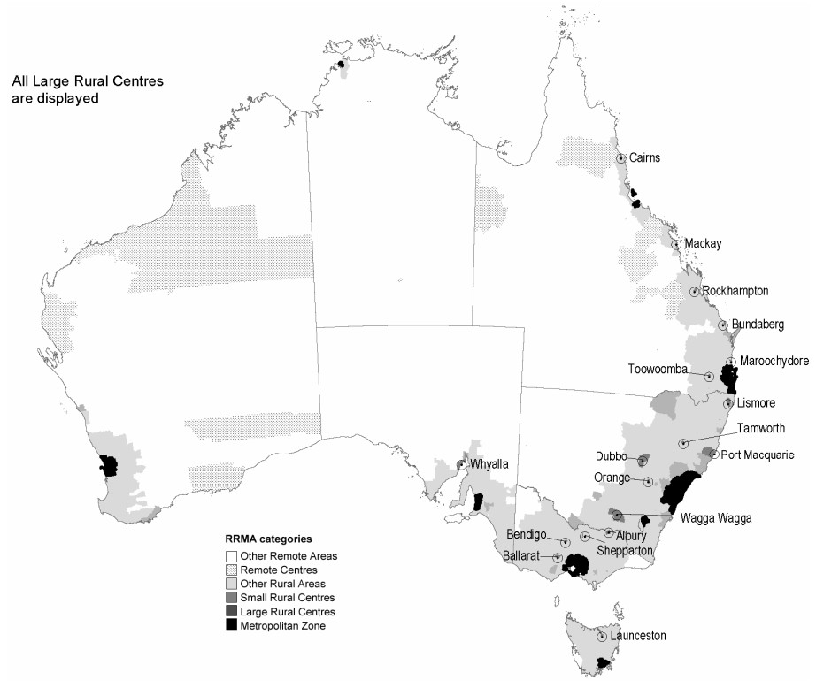
Exhibit 97: Structure of RRMA Classification
Zone | Class | Abbreviation
Metropolitan Zone | Capital Cities | M1
Metropolitan Zone | Other Metropolitan Centres (urban centre population > 100,000) | M2
Rural Zone | Large Rural Centres (urban centre population 25,000–99,999) | R1
Rural Zone | Small Rural Centres (urban centre population 10,000–24,999) | R2
Rural Zone | Other Rural Areas (urban centre population < 10,000) | R3
Remote Zone | Remote Centres (urban centre population > 5,000) | Rem1
Remote Zone | Other Remote Areas (urban centre population < 5,000) | Rem2

Accessibility/Remoteness Index of Australia (ARIA)
ARIA was developed the Department of Health and Aged Care in 1998 with the National Key Centre for Social Applications of Geographical Information Systems (GISCA) at the University of Adelaide. It was later updated to ARIA+ (2011) and ARIA++ (2016).
ARIA defines a scale that is not restricted to using pre-defined spatial units (e.g., SLAs) because it utilises a one square kilometre grid that covers all of Australia. The ARIA classification is calculated using road distances separating localities from five levels of service centres distinguished by population size (see Exhibit 98).
Exhibit 98: Classification of service centres
Service Centre Category | Urban Centre Population
A | 250,000 persons or more
B | 48,000 - 249,999 persons
C | 18,000 - 47,999 persons
D | 5,000 - 17,999 persons
E | 1,000 - 4,999 persons
F (ARIA++ only) | 200 - 999 persons
The final ARIA score is determined by aggregating these measures of remoteness, which are then separated into five hierarchical ('natural break') categories (see Exhibit 99 and Exhibit 100). The five categories are outlined in Table 3. Each ARIA classification (i.e., highly accessible) is further categorised by a range of ARIA index values from 0 to 12 assigned to populated localities, where a zero value means that the location has the highest level of access to services while a value of 12 indicates the location has the lowest level of access to services (and correspondingly the highest measure of remoteness from services).
Exhibit 99: Structure of ARIA classification
Class | Abbreviation | Index Value Range | Description
Highly Accessible | HA | 0–1.84 | Relatively unrestricted accessibility to a wide range of goods and services and opportunities for social interaction
Accessible | A | >1.84–3.51 | Some restrictions to accessibility of some goods, services, and opportunities for social interaction with population
Moderately Accessible | MA | >3.51–5.80 | Significantly restricted accessibility of goods, services, and opportunities for social interaction
Remote | R | >5.80–9.08 | Very restricted accessibility of goods, services, and opportunities for social interaction
Very Remote | VR | >9.08–12 | Very little accessibility of goods, services, and opportunities for social interaction
The following example below shows how the ARIA+ methodology is applied to classifying Pine Creek. The locality of Pine Creek in the Northern Territory is:
- 2,858 km from the nearest Category A Service Centre (Adelaide);
- 206 km from the nearest Category B Service Centre (Darwin);
- 206 km from the nearest Category C Service Centre (Darwin);
- 92 km from the nearest Category D Service Centre (Katherine); and
- 92 km from the nearest Category E Service Centre (Katherine).
Next, divide by national average for each category:
- Category A score is 2,858 / 422 = 6.77 {exceeds threshold so score = 3.00};
- Category B score is 206 / 217 = 0.95;
- Category C score is 206 / 134 = 1.54;
- Category D score is 91 / 88 = 1.03; and
- Category E score is 91 / 47 = 1.94.
The ARIA score is thus 3.00 + 0.95 + 1.54 + 1.03 + 1.94 = 8.46
Exhibit 100: Geographical dispersion of Australia under ARIA
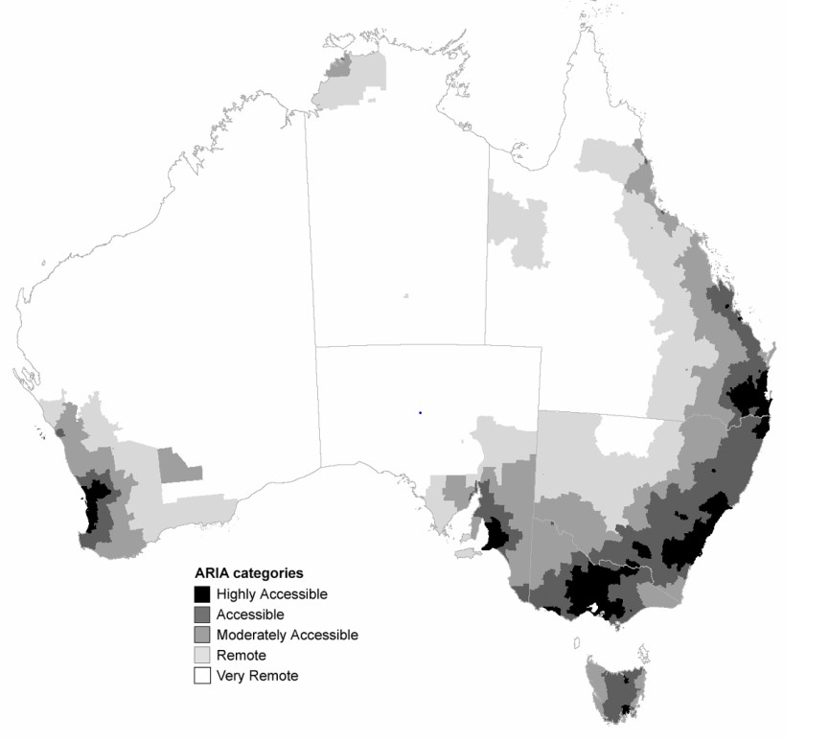
ARIA has the following benefits:
- It is a purely geographic measure of remoteness, which excludes any consideration of socio-economic status, 'rurality' and populations size factors (other than the use of breaks in the population distribution of Urban Centres to define the Service Centre categories).
- It is flexible and can be used to generate a remoteness score for any existing statistical, administrative, or user-defined boundary area. In contrast, the RRMA classification only exists at the SLA level.
- It aligns with Australian census data and as such, is capable of being updated over time as populations change consistent.
- The ARIA index value of a populated locality will only change when the population in one or more of the four service centres changes significantly, resulting in a reclassification to a different service category.
- It differentiates between geographical areas based on levels of accessibility /remoteness (i.e., moderately accessible areas are less accessible than accessible areas but more accessible than remote areas).
ARIA has several limitations including:
- It potentially results in highly dissimilar areas being given the same remoteness score.
- It defines 81% of the population as living in the most accessible class (Highly Accessible areas) resulting in 19% of the population to be shared between the other four areas, making statistical comparisons less reliable because of small population sizes in these areas.
- Access to transport and road quality are also not addressed.

Australian Statistical Geographical Standard – Remoteness Areas (ASGS - RA)
The Australian Statistical Geography Standard (ASGS) is a classification of Australia into a hierarchy of statistical areas. The Australian Bureau of Statistics describes it as “a social geography, developed to reflect the location of people and communities”. The classification is used for the publication and analysis of official statistics and other data and is updated every 5 years to account for growth and change in Australia’s population, economy, and infrastructure. The ASGS includes Remoteness Areas (ASGS- RA), which are based on ARIA+ methodology.
The ASGS-RA includes five classes of remoteness (Exhibit 101) which are determined using a process that provides a consistent definition across Australia and over time. This allows statistical data to be classified in a consistent way that allows users to analyse changes in data for different remoteness categories over time.
Exhibit 101: Structure of ASGS Classification
Class | Abbreviation | Index value range
ASGS 1 - Major Cities of Australia | MC | 0–0.2
ASGS 2 - Inner Regional Australia | IR | >0.2–2.4
ASGS 3 - Outer Regional Australia | OR | >2.4–5.92
ASGS 4 - Remote Australia | R | >5.92–10.53
ASGS 5 - Very Remote Australia | VR | >10.53–15
Migratory | N/A | N/A
Notre: The Migratory Class is composed of offshore, shipping, and migratory CDs. In allocating an ASGC Remoteness Areas class to an area of land, only the first five classes are applicable.
Relative remoteness is measured using the Accessibility and Remoteness Index of Australia (ARIA+). The University of Adelaide supplies ARIA+ data to the ABS as a one-kilometre grid which covers all of geographic Australia. Each grid point contains a value representing its relative remoteness. For example, the ASGS Statistical Area Level 1 (SA1) boundaries are overlayed onto the ARIA+ grid and an average score is calculated based on the grid points that are contained within each SA1. The resulting average score determines which remoteness category is allocated to each SA1 (see Exhibit 102).
Exhibit 102: Geographical dispersion of Australia under ASGS
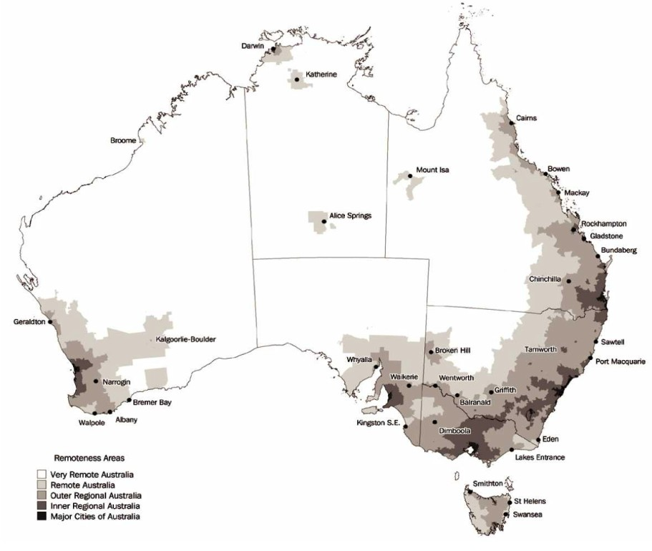
The key benefits of the ASGS-RA classification include:
- It defines the least remote areas more tightly than the ARIA classification because it has a lower cut-off index value for the least remote area and acknowledges the likelihood that outer suburban areas would have lower levels of access to goods and services than areas closer to the Central Business District.
- It does not include the least accessible of the capital cities in the least remote class (i.e., Darwin =/= Sydney).
Although ASGS-RA defines the least remote classes more closely than the RRMA and ARIA classifications, the cut-off index values used to distinguish between each ASGS Remoteness Areas are “relatively arbitrary”.

Modified Monash Model (MMM)
The MMM classifies metropolitan, regional, rural, and remote areas according to geographical remoteness, with MMM 1 denoting a major city and MMM 7 equating to an area that is very remote (see Exhibit 103 and Exhibit 104). The MMM is based on the Australian Statistical Geographic Standard Remoteness Areas (ASGS-RA). The Department of Health uses MMM to assist in distributing workforce in rural and remote areas, while some other Departments use the MMM to define a programs eligibility.
Exhibit 103: Structure of MMM Classification
Category | Description (including the Australian Statistical Geography Standard –  Remoteness Area (2016)
MMM 1 | Metropolitan areas: Major cities accounting for 70% of Australia’s population. All areas categorised ASGS-RA1.
MMM 2 | Regional centres: Inner (ASGS-RA 2) and Outer Regional (ASGS-RA 3) areas that are in, or within a 20km drive of a town with over 50,000 residents. For example: Ballarat, Mackay, Toowoomba, Kiama, Albury, Bunbury.
MMM 3 | Large rural towns: Inner (ASGS-RA 2) and Outer Regional (ASGS-RA 3) areas that are not MM 2 and are in, or within a 15km drive of a town between 15,000 to 50,000 residents. For example: Dubbo, Lismore, Yeppoon, Busselton.
MMM 4 | Medium rural towns: Inner (ASGS-RA 2) and Outer Regional (ASGS-RA 3) areas that are not MM 2 or MM 3, and are in, or within a 10km drive of a town with between 5,000 to 15,000 residents. For example: Port Augusta, Charters Towers, Moree.
MMM 5 | Small rural towns: All remaining Inner (ASGS-RA 2) and Outer Regional  (ASGS-RA 3) areas. For example: Mount Buller, Moruya, Renmark, Condamine.
MMM 6 | Remote communities: Remote mainland areas (ASGS-RA 4) AND remote islands less than 5kms offshore. For example: Cape Tribulation, Lightning Ridge, Alice Springs, Mallacoota, Port Hedland. Additionally, islands that have an MM 5 classification with a population of less than 1,000 without bridges to the mainland will now be classified as MM 6 for example: Bruny Island.
MMM 7 | Very remote communities: Very remote areas (ASGS-RA 5). For example: Longreach, Coober Pedy, Thursday Island, and all other remote island areas more than 5kms offshore.
Exhibit 104: Distribution of MMM classifications across Australia
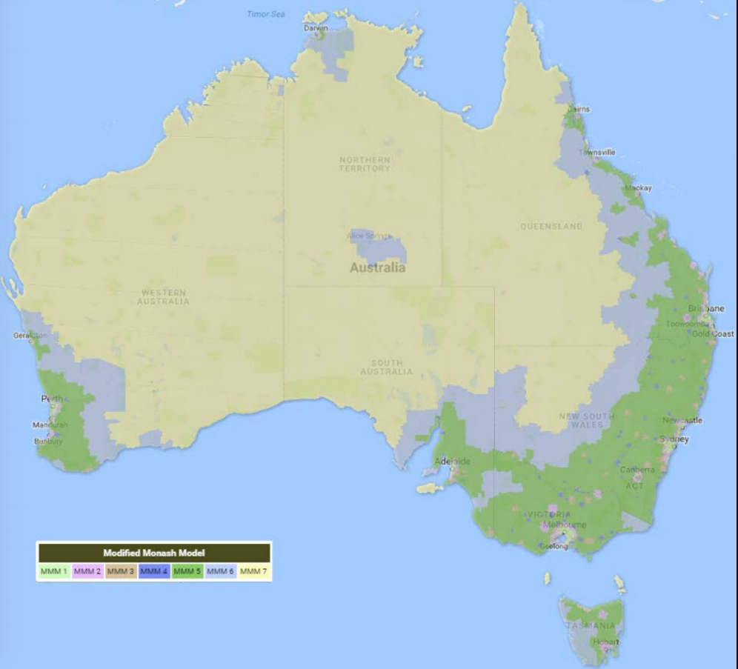
The MMM aligns with Australian census data and, as such, is capable of being updated over time as populations change. It is also able to highlight areas that have both a critical mass of residents and differing levels of socio-economic advantage and disadvantage.
The MMM has the following limitations:
- There is disparity in the geographic treatment of some towns, for example towns with larger populations that are geographically isolated from other population centres such as Kalgoorlie.
- The classification of towns into regional, remote, or very remote is not based on local evidence or the real cost structures in those localities.
- The classification does not always reflect actual supply in markets, particularly where participants require more experienced therapists, or where therapists operate in thin markets, such as rural and remote areas.

Index of Access
The Index of Access improves the empirical basis for rural health service planning and resource allocation decisions (see Exhibit 105).
Exhibit 105: Index of Access' scores across Australia
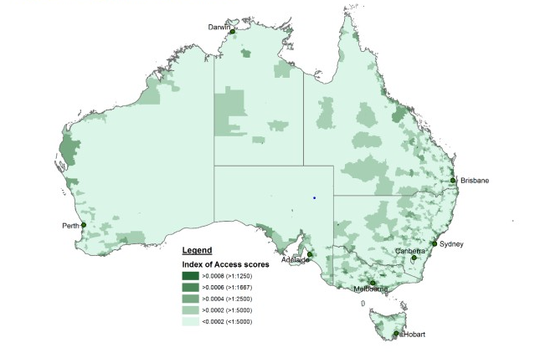
It provides an indication of the extent to which access differs across rural and remote categories. For example, areas with an Index of Access score in category 1 have access to more than 1 GP per 1250 population after adjustments:
- >0.0008 (above 8*10-4) (>1:1250);
- >0.0006 and 1:1667);
- >0.0004 and 1:2500);
- >0.0002 and 1:5000); and
- <1:5000.
The Index of Access produces an outcome measure of access to provider-to-population ratios (PPRs). It considers three major dimensions that account for a person’s ability to access PHC services, namely:
- Service availability to primary health care
- Proximity to services
- Variation in the health needs of the population.
The Index of Access has the following benefits:
- It provides a useful indication in relation to the extent to which access differs across rural and remote communities.
- It is designed to consider barriers (service availability, proximity, health needs and mobility) which together differentiate access to primary care in regional and remote areas.
- It provides a good baseline, enabling inequities of access to be identified; and therefore indicates where best to respond with service provision support.
- It identifies inadequate access areas which will enable better targeting of workforce recruitment and retention programs.
The Index of Access has the following limitations:
- It has not been externally validated as an improved measure of access in rural areas.
- Its datasets are derived from services billed under Medicare and hence, there is a likelihood that some areas may be underscored as well as a risk of data corruption due to inadequate Medicare recording.

Endnotes

Index of Exhibits
Exhibit 1: NDIS objectives and elements for determining value for money 41
Exhibit 2: Pricing Transition Strategy 43
Exhibit 3: Characteristics of a well-functioning market 44
Exhibit 4: Key stakeholder considerations in regulating markets 44
Exhibit 5: Spectrum of market intervention options 44
Exhibit 6: Pros and Cons of pricing Approval/Setting options 46
Exhibit 7: NDIS Transition Strategy for Pricing 47
Exhibit 8: Financial Benchmarking Survey – Fully Loaded Hourly Costs 47
Exhibit 9: Share of claims made against the TTP rather than the non-TTP support item 49
Exhibit 10: Australian Government Gross Debt – 1971-72 to 2031-32 51
Exhibit 11: PBO Scenarios for NDIS Payments 51
Exhibit 12: Comparison of payments by key program area, 2018-19 to 2031-32 52
Exhibit 13: Employment levels, past and projected - four largest growing industries 52
Exhibit 14: Projected Employment Growth, Health Care and Social Assistance Sector, 2020-2025 53
Exhibit 15: Growth in Job advertisements for Aged and Disabled Carers, 2011 to 2021 54
Exhibit 16: Disability Support Worker Utilisation Rates, 2018-19 to 2020-21 74
Exhibit 17: Proposed New Cost Model for Price Limits (using 2021-22 Costs) – Weekday Daytime 76
Exhibit 18: Number of Public Holidays By Location, 2021-22 to 2024-25 91
Exhibit 19: Weighted Average Shift Loading (Permanent Workers) 92
Exhibit 20: Impact of Public Holidays (Common Years) 92
Exhibit 21: Distribution of Expenditure of Group Based Support, by Intensity and by Location 100
Exhibit 22: Distribution of Expenditure of Group Based Support, by Provider 101
Exhibit 23: Financial Benchmarking 2020-21: Group-Based supports 103
Exhibit 24: Therapy Price Limits – Early Childhood Intervention Supports (under 7 years) 108
Exhibit 25: Therapy Price Limits – Therapy Supports (over 7 years) 109
Exhibit 26: 2021-22 Price Limits for Therapy Supports 110
Exhibit 27: Therapy Pricing Review, 2018 to 2021 111
Exhibit 28: Therapy support price limits by geography from FY16 to FY21 111
Exhibit 29: Scheme Expenditure by Type of Therapy, First Half of 2021-22 112
Exhibit 30: Expenditure on Therapy by Funding Source, 2019-20 114
Exhibit 31: Growth in Expenditure on Therapy by Funding Source, 2016-17 to 2019-20 114
Exhibit 32: Number of Therapists, FY2016-17 to FY2020-21 115
Exhibit 33: Distributional Statistics of Private Billing Rates, by Therapy Type 116
Exhibit 34: Statistical Models of Private Billing Rates 117
Exhibit 35: Histograms of Private Billing Rates 118
Exhibit 36: Billing Rates in Other Government Funding Programs and Insurance Schemes 119
Exhibit 37: Deloitte Access Economics Estimate Cost per Hour of Allied Health Services Under the NDIS 120
Exhibit 38: Price Limits for Nursing Supports (1 July 2021 to 30 June 2022) 126
Exhibit 39: Distribution of Claims for Nursing Supports, by Type of Nurse, by Day/Time (2020-21) 130
Exhibit 40: Growth in Job advertisements for Nurses, 2011 to 2021 132
Exhibit 41: Nursing Hourly Basic Wage (RN1 Top Pay Point), by Jurisdiction, by Sector, June 2021 132
Exhibit 42: Comparative Analysis of Nursing and Allied Health Wages by Jurisdiction, by Sector, December 2020 133
Exhibit 43: Statistical Distribution of Weekday Hourly Rate for Home Care Nursing, By Remoteness 134
Exhibit 44: Distribution of Weekday Hourly Rate for Aged Care Nursing, by Remoteness 134
Exhibit 45: Percentage difference between non-standard and Standard Rates, by Remoteness 135
Exhibit 46: MBS Items for Nurse Practitioners 137
Exhibit 47: Price Limits for Plan Management Supports 146
Exhibit 48: Distribution of Participants (left hand chart) and Plan Budgets (right hand chart) by Method of Plan Management, June 2018 to December 2021 147
Exhibit 49: Plan Managed Share of Participants and Plan Budgets, by Jurisdiction, December 2021 147
Exhibit 50: Distribution of Plan Managers by Share of Plan Management Fees 148
Exhibit 51: Price Limits for Support Coordination Supports 158
Exhibit 52: Support Coordination statistics, 2020-21 159
Exhibit 53: Distribution of Support Coordination Providers, by Type of Support 159
Exhibit 54: Modified Monash Model Geographical Classification 165
Exhibit 55: Isolated Towns in the NDIS Adjusted Modified Monash Model 166
Exhibit 56: Duration to plan activation for active participants 168
Exhibit 57: Plan Utilisation by Service District, December 2021 169
Exhibit 58: Annualised Committed Supports and Payments, by Remoteness Region, December 2021 169
Exhibit 59: Market Concentration by Service District, December 2021 170
Exhibit 60: Financial Benchmarking 2020-21: by Degree of Remoteness 172
Exhibit 61: Total Job Vacancies of Capital Cities vs Non-Capital (Country) Areas 173
Exhibit 62: Health and Welfare Support Job Vacancies of Capital Cities vs Non-Capital (Country) Areas 173
Exhibit 63: Variation in Plan Utilisation and Price by Remoteness, June 2019-Dec 2021 174
Exhibit 64: Increases in plan utilisation and Price by remoteness, June 2019-Dec 2021 175
Exhibit 65: Geraldton and Surrounding Regions 177
Exhibit 66: Cardwell Region 177
Exhibit 67: Annualised participant committed supports, payments and utilisation as at 31 December 2021 180
Exhibit 68: Duration to plan activation for active participants by State and Territories as at 31 December 2021 181
Exhibit 69: Payments by State and Territory, 2020-21 and 2021-22 H1 181
Exhibit 70: Active number of providers by State and Territory as at 31 December 2021 182
Exhibit 71: New Provider Entrants by Registration Group by State 183
Exhibit 72: Financial Benchmarking 2020-21: Disability Support Worker Hourly Rate ($) by state and territory 185
Exhibit 73: Financial Benchmarking 2020-21: Supervisor Worker Hourly Rate ($) by state and territory 185
Exhibit 74: Financial Benchmarking 2020-21: Supervision Ratio (Head Count) by state and territory 186
Exhibit 75: Financial Benchmarking 2020-21: Utilisation Rate (%) by state and territory 186
Exhibit 76: Financial Benchmarking 2020-21: Workers Compensation Premium (%) by state and territory 187
Exhibit 77: Financial Benchmarking 2020-21: Overheads as a share of direct costs (%) by state and territory 187
Exhibit 78: Financial Benchmarking 2020-21: EBITDA as a share of total expenses (%) by state and territory 188
Exhibit 79: Unemployment Rate for Queensland, South Australia and Western Australia, June 2010 to March 2022 188
Exhibit 80: Participation Rate for Queensland, South Australia and Western Australia, June 2010 to March 2022 188
Exhibit 81: Internet Vacancy Index for Aged and Disabled Carers from July 2016 to February 2022 189
Exhibit 82: Comparison of pricing across public schemes — Audiologist 204
Exhibit 83: Comparison of pricing across public schemes — Counsellor 204
Exhibit 84: Comparison of pricing across public schemes — Dietitian 205
Exhibit 85: Comparison of pricing across public schemes — Exercise Physiologist 205
Exhibit 86: Comparison of pricing across public schemes — Occupational Therapist 206
Exhibit 87: Comparison of pricing across public schemes — Orthoptist 206
Exhibit 88: Comparison of pricing across public schemes — Physiotherapist 206
Exhibit 89: Comparison of pricing across public schemes — Podiatrist 207
Exhibit 90: Comparison of pricing across public schemes — Psychologist 207
Exhibit 91: Comparison of pricing across public schemes — Rehabilitation counsellor 208
Exhibit 92: Comparison of pricing across public schemes — Social worker 208
Exhibit 93: Comparison of pricing across public schemes — Speech pathologist 209
Exhibit 94: Comparison of pricing across public schemes — Therapy / Allied health assistants 209
Exhibit 95: Summary of other pricing arrangements 210
Exhibit 96: Geographical dispersion of Australia under RRMA 217
Exhibit 97: Structure of RRMA Classification 217
Exhibit 98: Classification of service centres 218
Exhibit 99: Structure of ARIA classification 218
Exhibit 100: Geographical dispersion of Australia under ARIA 219
Exhibit 101: Structure of ASGS Classification 220
Exhibit 102: Geographical dispersion of Australia under ASGS 221
Exhibit 103: Structure of MMM Classification 222
Exhibit 104: Distribution of MMM classifications across Australia 222
Exhibit 105: Index of Access' scores across Australia 223

NDIS Scheme Actuary. (2021). NDIS Annual Financial Sustainability Report 2020-21, p. 14.
Parliamentary Budget Office. (2021). Beyond the budget 2021-22, pp. 34-7. Download here.
The decision by the Fair Work Commission can be found here.
NDIA. (2019). NDIS Western Australia Market Review. Download here.
Copies of SIRA’s Workers Compensation Fees Orders can be found here.
icare’s guidelines and policies for the Lifetime Care and Support Scheme can be found here.
Worksafe Victoria’s Fee Schedules and policy documents can be found here.
The Transport Accident Commission’s Fee Schedules can be found here.
Information on the Victoria Home and Community Care Program for Younger People can be found here.
Information on the Victims of Crime Assistance Tribunal session and report fees can be found here.
WorkCover Queensland’s Fee Schedules can be found here.
Information on the National Injury Insurance Scheme Queensland can be found here.
Information on WorkCover WA’s fees can be found here.
Information on the West Australian Catastrophic Injuries Support Scheme can be found here.
The Return to Work South Australia Fee Schedules can be found here.
Information on the South Australian Lifetime Support Scheme can be found here.
Information on the Tasmanian Motor Accident Board’s insurance arrangements can be found here.
Information on the ACT’s Lifetime Care and Support Scheme can be found here.
Information on the Northern Territory’s Motor Accident Compensation Scheme can be found here.
Information on the Comcare’s pricing arrangements can be found here.
Information on the pricing arrangements in the Medical Benefits Scheme (MBS) can be found here.
Information on the Department of Health’s pricing arrangements for aged care can be found here.
Information on the Department of Veterans’ Affairs Community Nursing Program can be found here. Information on the Department of Veterans’ Affairs Veterans Home Care Program can be found here. The Department of Veterans’ Affairs Veterans Allied Health Fee Schedules can be found here.
Information on the NDIA’s Pricing Reference Group can be found here.
A copy of the NDIS Act can be found here. Copies of the NDIS Rules can be found here. Copies of the bilateral agreements can be found here.
Further information on the governance arrangements for the NDIS can be found here.
Where a provider is paid directly by the NDIA, the provider is required to be registered with the Commission and abide by the pricing arrangements, including price limits. These restrictions do not apply to providers who are paid directly by self-managing participants. Providers who are paid by plan-managers on behalf of participants are not required to be registered but are required to abide by the pricing arrangements, including price limits.
NDIA. (2019). NDIS Pricing Strategy. Download here.
Ibid., Figure 10, p. 39.
Parliamentary Budget Office. (2021). Beyond the budget 2021-22: Fiscal outlook and scenarios, p.8.
Ibid., pp.34-7. The base case scenario assumes that the number of participants would grow towards the level in 2027-28 projected by the NDIS Actuary, with growth then converging to population growth by 2032-33. Participant numbers would exceed 800,000 by the end of the medium term. Average costs per participant are assumed to be consistent with the 2021-22 Budget over the forward estimates; over the medium term they are grown by a weighted average of wage and price growth, plus an allowance for participants’ increasing use of their budgets as they become more familiar with the options available to them. Average costs per participant reach around $70,000 per year by 2031-32.
Ibid., p.43.
The data in this section is drawn from the National Skills Commission’s 2021 Employment Projections - for the five years to November 2026. Available here.
National Skills Commission. (2022). Occupation Projection – five years to November 2026. Download here.
Based on an analysis of data from the Labour Market Information Portal Vacancy Report (link) and from the ABS Labour Force survey (link).
The NDIA considers that it is appropriate to estimate the cost structure of overall efficient (25th percentile) providers by reference to the 25th percentile of all providers’ performance against each of the key parameters because there is little collinearity observed between the parameters in the TTP Benchmarking Survey results. The determinant of the Pearson product-moment correlation coefficient matrix (see below) is 87.1%. A = Permanent Share of Workforce B = Supervision Ratio C = Non travel allowances D = Workers Compensation Premium E = Utilisation percentage F = Overheads percentage A 1.00 -0.09 -0.13 0.06 -0.04 0.08 B -0.09 1.00 -0.07 0.00 0.19 0.08 C -0.13 -0.07 1.00 -0.02 -0.14 -0.18 D 0.06 0.00 -0.02 1.00 -0.02 0.02 E -0.04 0.19 -0.14 -0.02 1.00 0.09 F 0.08 0.08 -0.18 0.02 0.09 1.00 See p.58 of the Annual Pricing Review 2020-21.
Fair Work Commission. Social, Community, Home Care and Disability Services Industry Award 2010, incorporating all amendments up to and including 30 June 2021. Fair Work Commission. Equal Remuneration Order 2010, (C2010/3131).
Calculated as 1/38th of the relevant ERO adjusted minimum wage.
SCHADS Industry Award: Clauses 10.4(b), 26 and 29.3.
SCHADS Industry Award: Clause 25.1.
The National Employment Standards (NES) govern leave and several other conditions in Awards, and also may not be reduced by EBAs. Information on the NES can be found at the Fair Work Ombudsman’s website.
Information on the annual leave provisions in the NES can be found at the Fair Work Ombudsman’s website.
Information on the public holiday provisions in the NES can be found at the Fair Work Ombudsman’s website. Note: The NDIA recognises that there are more than 10 public holidays in each year, and that the number of public holidays varies by jurisdiction. However, some public holidays occur on weekends and it is unlikely that any worker in their ordinary working hours would be rostered to have worked on more than 10 public holidays. This is the appropriate number for the Cost Model to use to calculate the accrual cost of the leave, rather than the payment rate for public holidays.
Information on the annual leave provisions in the NES can be found at the Fair Work Ombudsman’s website. Note: The Cost Model slightly overestimates provider’s cost with respect to this parameter as it assumes all workers utilise all of their personal leave entitlement each year even though some workers may not use their entitlement.
Information on long service leave can be found at the Fair Work Ombudsman’s website. Note: The Cost Model overestimates provider’s cost with respect to this parameter as it assumes all permanent workers and casual workers qualify for LSL accruals and that all workers will eventually access their long service leave entitlement. This reflects the rollout of portable long service leave schemes in some jurisdictions.
SCHADS Industry Award: Clause 31.3
Information on superannuation can be found at the Australian Taxation Office’s website,
The Annual Pricing Review 2020-21 (page 54) found that, averaged over 2010-11 to 2014-15, the standardised Australian average workers compensation premium rate was 1.5% for all industries and 1.7% for the Health and Community Services sector. The Benchmarking Study undertaken as part of the Annual Pricing Review 2020-21 found that the average workers compensation premium among respondents in the disability sector was 2.6%, with a median of 2.3% and a 25th percentile of 1.7%. In line with the NDIS Pricing Strategy, this Cost Model parameter has been set at the level achieved by efficient (25th percentile) providers.
The Annual Pricing Review 2020-21 (page 57) found that allowances in the sector were typically in the order of 1.0% of the base salary payable to the worker.
The Benchmarking Study undertaken as part of the Annual Pricing Review 2020-21 (page 52) found that the average span of control among respondents in the disability sector was 11.8:1 with a 25th percentile of 15:1. In line with the NDIS Pricing Strategy, this Cost Model parameter has been set at the level achieved by efficient (25th percentile) providers.
The Benchmarking Study undertaken as part of the Annual Pricing Review 2020-21 (page 52) found that the average casual employment share among respondents in the disability sector was 43.8% with a 25th percentile of 71.7%. In line with the NDIS Pricing Strategy, this Cost Model parameter has been set at the level achieved by efficient (25th percentile) providers.
The Benchmarking Study undertaken as part of the Annual Pricing Review 2020-21 (page 52) found that the average utilisation among respondents in the disability sector was 79.8% with a 25th percentile of 90.0%. In line with the NDIS Pricing Strategy, this Cost Model parameter has been set at the level achieved by efficient (25th percentile) providers. Because the Benchmarking Study did not disaggregate its results between DSWs 1, 2 and 3 the efficient utilisation rates have been estimated for each DSW Level around the sector wide 25th percentile with the utilisation rate decreasing slightly with the seniority of the worker. The utilisation rate for DSW Ds was set after consultations with providers who were currently employing workers in the role of a psychosocial recovery coach. These providers indicated that these staff were appropriately classified at the SCHADS pay point 4.4. They also indicated that workers who supported participants with psychosocial disabilities often needed to debrief and be supported at the end of their shifts to support their own mental well-being, which lowered their own and their supervisors’ utilisation rates.
The Annual Pricing Review 2020-21 (page 58) found that the overheads percentage should be increased to 12.0% to better align with the estimated overheads of efficient providers in the sector, as observed in the Benchmarking Study adjusted for that survey’s unrepresentativeness and that other recommendations being made by the Review would directly address some of the costs that providers are currently carrying in their overheads
The objects of the NDIS Act include (Sections 3(1)(a); 3(1)(g) and 3(1)(ga)): - Giving effect to Australia’s obligations under the United Nations Convention on the Rights of Persons with Disabilities. The Convention can be found here. - Promoting the provision of high quality and innovative supports that enable people with disability to maximise independent lifestyles and full inclusion in the community. - Protecting and preventing people with disability from experiencing harm arising from poor quality or unsafe supports or services provided under the National Disability Insurance Scheme.
Australia. Department of Social Services. (2016). NDIS Quality and Safeguarding Framework, p. 6. Download here.
Ibid., p. 8.
The Commission commenced operating in New South Wales and South Australia on 1 July 2018. It commenced operation in the Australian Capital Territory, the Northern Territory, Queensland, Tasmania and Victoria on 1 July 2019; and in Western Australia on December 2020. The NDIS Practice Standards can be found here. The NDIS Code of Conduct can be found here.
The Guidelines are a legislative instrument made by the Commissioner of the NDIS Quality and Safeguards Commission. National Disability Insurance Scheme (Approved Quality Auditors Scheme) Guidelines 2018. Download here.
The NDIS Approved Quality Auditors Scheme invokes ISO/IEC 17065:2012 – Conformity assessment - Requirements for bodies certifying products, processes and services as a normative reference as a normative reference for conformity assessment bodies (auditors) seek to be recognised by the NDIS Commission.
Further information on reportable incidents can be found here.
Note, in Queensland, people who work with children require a Working with Children Check (Blue Card) as well as the NDIS Worker Screening Check. Further information can be found here.
All states and territories have agreed to nationally consistent principles, except Queensland which has agreed ‘in principle’.
New South Wales. Department of Communities and Justice. Restrictive Practice Authorisation Policy. Download here.
Victoria. Department of Families, Fairness and Housing. Information for Authorised Program Officers appointed by registered NDIS providers. Download here.
New South Wales Community Services (Complaints, Reviews and Monitoring) Act 1993. Download here.
Victoria Disability Act 2006. Download here.
Queensland Public Guardian Act 2014 and Queensland Coroners Act 2013. Download here.
South Australia Mental Health Act 2009 and South Australia Disability Services (Community Visitor Scheme) Regulations 2013. Download here.
NDIS Commission. (2021). Activity report: 1 July 2020 to 30 June 2021. Download here.
Goodhart C. (1975). Problems of Monetary Management: The U.K. Experience. In Courakis AS. (ed.). Inflation, Depression, and Economic Policy in the West. Totowa, New Jersey: Barnes and Noble Books (published 1981). p. 116.
NDIS Commission. (2021). Fact sheet: NDIS Practice Standards: skills descriptors (High Intensity Skills Descriptors). Download here.
Source: Australian Public Holidays Dates Machine Readable Dataset
As well as the right public holidays enumerated in the National Employment Standards, Tasmania also has a public holiday in March for Eight Hours Day. All of Tasmania also gets either Regatta Day or Recreation Day. Source: Worksafe Tasmania Public Holidays
It is possible that the disparity could be greater, depending on which day of the week New Year’s Day falls on in future years, and whether the year is common or leap. This is not possible to calculate accurately. For example, the next leap year starting on a Tuesday will not be until 2038, but the exact dates of some Public Holidays are only proclaimed a year or two in advance. (For example, Day Before Grand Final Day in Victoria.)
Further information can be found at the website of the Australian Taxation Office.
NDIA. (2015). NDIS Price Guide and Support Catalogue 2015-16.
McKinsey & Co. (2018). Report of the Independent Pricing Review, p. 76-9. Download here.
NDIA. (2018). NDIS Price Guide and Support Catalogue 2018-19. Download here.
NDIA. (2020). NDIS Price Guide and Support Catalogue 2020-21. Download here.
Seven (7) of these therapy supports are duplicated in the Activities of Daily Living Core Support Category. The Exercise Physiology and Dietitian supports are also duplicated in the Improved Health and Wellbeing Capacity Building Support Category.
NDIA. (2019). Review of Therapy Pricing Arrangements in the NDIS. Download here.
Australian Health Practitioners Registration Agency. (2021). Annual Report 2020-21, Supplementary Data Tables. Download here.
National Skills Commission. (2022). Occupation Projection – five years to November 2026. Download here.
Further information on the Priority Migration Skilled Occupation List can be found here.
The data set was compiled by the NDIA by scanning websites across Australia. The geographic distribution of the observations was slightly skewed towards Victoria (32% of the sample) and Queensland (30%) with New South Wales underrepresented (19%). There were at least 30 observations from each state and territory. Some 30% of the observed billing rates for weekday services were from non-metropolitan providers. Among therapy services, the top three therapy services were physiotherapy (26%), psychology (12%) and dietetics (12%). Art therapy and music therapy assistant each accounted for less than 2% of total therapy fee items. There were at least 50 observations for each type of therapy. The analysis excluded outliers where the value of the effective hourly rate was either greater than Quartile 3 + 1.5 Interquartile Range; or smaller than Quartile 1 – 1.5*Interquartile Range.
Further information can be found at the website of the Australian Taxation Office.
Reasonable and necessary nursing supports that are generally funded by the NDIS include training of NDIS funded support staff on a participant’s individual needs by nurses, including training for new providers and retraining as a participant’s needs change (with service providers being responsible for training new staff). Reasonable and necessary nursing supports that, dependent on their purpose, may be funded by the NDIS, include care and supervision by clinically trained staff, including delegated care, where they are required because of the participant’s functional impairment and integrally connected to the participant’s support needs to live independently and to participate in education and employment. Noting that not all disability related health supports are delivered by nurses, the types of health supports that may be fundable by the NDIS when they are directly related to the functional impacts of a participant’s disability (and are reasonable and necessary) include: - Dysphagia supports: if the participant has trouble eating, drinking or swallowing on a daily basis. - Respiratory supports: if the participant needs support, care and planning to help them breathe and maintain respiratory health where this is compromised. - Nutrition supports: if the participant need help with the way they eat or understanding the food they need. - Diabetes management supports: if the participant need extra help to manage their diabetes, for example, testing their blood sugar level because they are unable to do this on their own due to the functional impact of their disability. - Continence supports: if the participant need products to maintain their continence or someone to help them with toileting on a daily basis. - Wound and pressure care supports: if the participant has slow to heal wounds, a condition that results in swollen arms or legs, or ongoing loss of feeling in their body or arms or legs, and they need regular skin, wound and pressure care. - Podiatry supports: if the participant needs assessment and development of a care plan to help look after their feet, ankles and lower limbs. - Epilepsy supports: if the participant needs help to monitor and manage seizures when they occur Further guidance is available in the Planning Operational Guideline Appendix 1 - Table of guidance on whether a support is most appropriately funded by the NDIS. Download here.
30 of these nursing supports, those related to the Delivery of Disability Related Health Supports, are currently duplicated in the Activities of Daily Living Support Category to ensure that participants who do not have a capacity building budget can access nursing supports when it is reasonable and necessary for them so to do.
Nurses Award 2020 [MA000034]. Download here.
The Health Practitioner Regulation National Law refers to the set of nationally consistent law passed by each state and territory parliament that government the National Registration and Accreditation Scheme that is administered by the Australian Health Practitioner Regulation Agency. Further information can be found here.
The Nursing and Midwifery Board of Australia: - Registers nursing and midwifery practitioners and students; - Develops standards, codes and guidelines for the nursing and midwifery profession; - Handles notifications, complaints, investigations and disciplinary hearings; - Assesses overseas trained practitioners who wish to practise in Australia; and - Approves accreditation standards and accredited courses of study. Further information on the Nursing and Midwifery Board of Australia can be found here.
Note, nurses do not deliver Night-time Sleepover Supports.
In the first two quarters of 2021-22, some 12,474 agency-managed and plan-managed participants received NDIS funded nursing supports (2.7% of all participants who made a claim for one or more supports in this period). In total, the NDIS expended $56.6 million on nursing supports in first two quarters of 2021-22 and some 1,785 providers made claims for nursing supports delivered in the period.
Australia. Department of Health. (2021). Summary Statistics, Nursing. Download here.
Data derived from the National Health Workforce Dataset. Further information can be found here.
Based on an analysis of data from the Labour Market Information Portal Vacancy Report (link) and from the ABS Labour Force survey (link).
National Skills Commission. (2022). Occupation Projection – five years to November 2026. Download here.
Further information on the Priority Migration Skilled Occupation List can be found here.
Australian Nursing & Midwifery Federation. (2021). Nurses and Midwives’ Paycheck, June – August 2021.
Awards and state government agreements used in the analysis - National – Health Professionals and Support Services Award 2020. Download here. - National – Nurses Award 2010. Download here. - New South Wales – NSW Health Service Health Professionals (State) Award 2019. Download here. - New South Wales – Health Employees Conditions of Employment (State) Award 2019. Download here. - New South Wales – Public Health System Nurses’ and Midwives’ (State) Award 2019. Download here. - Victoria – Allied Health Professionals (Victorian Public Health Sector) Single Interest Enterprise Agreement 2016-2020. Download here. - Victoria – Nurses and Midwives (Victorian Public Health Sector) (Single Interest Employers) Enterprise Agreement 2016-2020. Download here. - Queensland – Health Practitioners and Dental Officers (Queensland Health) Certified Agreement (No.3) 2019. Download here. - Queensland – Nurses and Midwives (Queensland Health and Department of Education) Certified Agreement (EB10) 2018. Download here. - South Australia – Modern Public Sector Enterprise Agreement: Salaried 2017. Download here. - South Australia – Public Sector Employees - 2019. Download here. - South Australia – Enterprise Agreement Nursing/Midwifery (South Australian Public Sector) Enterprise Agreement 2020. Download here. - South Australia – Nurses (South Australian Public Sector) Award 2002. Download here. - Western Australia – WA Health System – HSUWA – PACTS Industrial Agreement 2020. Download here. - Western Australia – WA Health System – Australian Nursing Federation – Registered Nurses, Midwives, Enrolled (Mental Health) and Enrolled (Mothercraft) Nurses – Industrial Agreement 2018. Download here. - Tasmania – Allied Health Professionals Public Sector Unions Wages Agreement 2019. Download here. - Tasmania – Tasmanian State Service Award No. 1 of 2021. Download here. - Tasmania – Nurses and Midwives (Tasmanian State Service) Agreement 2019. Download here. - Tasmania – Nurses and Midwives (Tasmanian State Service) Award No. 1 of 2020. Download here. - Australian Capital Territory – ACT Public Sector Health Professional Enterprise Agreement 2018-2021. Download here. - Australian Capital Territory – ACT Public Sector Nursing and Midwifery Enterprise Agreement 2017-2019. Download here. - Northern Territory – Public Sector Nurses and Midwives’ 2018-2022 Enterprise Agreement. Download here. Disability Provider Enterprise Agreements used in the analysis - AEIOU Enterprise Agreement 2016. Download here. - Autism Association of South Australia Enterprise Agreement 2020. Download here. - Autism Queensland Limited Employee Agreement 2020. Download here. - Cerebral Palsy Alliance Allied Health & Related Practitioners' Enterprise Agreement 2015. Download here. - Early Links Inclusion Support Service Inc. Employees Collective Agreement 2011. Download here. - Integratedliving Australia Ltd - Ballarat Nursing Site Enterprise Agreement 2019-2022. Download here. - Noah’s Ark Enterprise Agreement 2018. Download here. - Northcott Enterprise Agreement 2016-2018. Download here. - Novita Enterprise Agreement 2017. Download here. - Nurses on Wheels Australia Ltd. Trading As Clever Care Now and the NSWNMA / ANMF NSW Branch Enterprise Agreement 2020-2021. Download here - Ozcare Enterprise Agreement 2018. Download here. - Royal Institute for Deaf and Blind Children Therapy and Early Childhood Employees Enterprise Agreement 2017-2020. Download here. - Southern Cross Care (WA) Inc. Registered Nurses Enterprise Bargaining Agreement 2019. Download here. - St Vincent’s Care Services Queensland Enterprise Agreement 2018 – 2021. Download here. - Yooralla Allied Services Agreement 2018. Download here.
The selection of the “likely range” for NDIS providers in each award/EBA as follows. For allied health professionals: the bottom of the likely range was the highest pay point within the minimum experience level where practitioners are expected to be performing routine treatments without consultation or supervision; and the top of the likely range was the highest pay point in the level above. For nurses: the bottom of the likely range was the weekday pay point for a registered nurse with three years’ experience; and the top of the likely range was the highest pay point before progression to clinical nurse or a management role.
Home Care Providers are required to publish the prices of the supports that they deliver. The analysis in this section is based on data received from the Australian Department of Health that included all of these prices and the regions in which each provider operated. There were 69,505 separate entries in the data set.
Australia. Department of Health. (2021). National summary of home care prices – May 2021. Download here.
These results are broadly consistent with those found in: Stewart Brown. (2020). Home Care Provider Survey: Analysis of Data Collected, April 2020, p. 91. Download here.
Victoria. Transport Accident Commission. (2021). Nursing Fees, Effective 1 July 2021. Download here.
WorkSafe Victoria. (2021). Community nursing services fee schedule, Effective 1 July 2021. Download here.
WorkCover Queensland. (2021). Nursing Services Table of Costs, Effective 1 July 2021. Download here.
Email from Tasmanian Motor Accident Insurance Board dated 7 March 2022.
Further information on the Department of Veterans’ Affairs’ Community Nursing Program can be found here.
Australia. Department of Health. (2022). Medical Benefits Schedule, March 2022. Download here. Australia. Services Australia (2022). Medicare Benefits Schedule Item Statistics. Download here.
Section 42(1) of the NDIS Act defines managing the funding of supports in a participant’s plan as: - Purchasing the supports identified in the plan (including paying any applicable indirect costs, such as taxes, associated with the supports); and - Receiving and managing any funding provided by the NDIA; and - Acquitting any funding provided by the NDIA.
See Section 42(3) of the NDIS Act. The National Disability Insurance Scheme Amendment (Participant Service Guarantee and Other Measures) Act 2022 extended the risk assessment process for self-management of funding to those using registered plan management providers, acknowledging there may be similar risks inherent in engaging an unregistered provider to deliver NDIS supports or services. The Bill for the Act and its Explanatory Memorandum together with the Minister’s second reading speech can be downloaded here. This change is in line with Recommendation 19 of the 2019 Review of the NDIS Act that was undertaken by Mr David Tune AO PSM. A copy of the Tune Report can be downloaded here.
In the first two quarters of 2021-22, some 1,183 Plan Managers were paid $199.9 million by 258,975 participants for plan management services. They processed support payments worth $5.6 billion through about 18.7million transactions (including 1.9 million transaction for plan management fees).
Note, some participants who are categorised as partly-self managed may also have some the funds in their plan managed by a Plan Manager, so the share of participants who use a Plan Manager is likely to be slightly higher than reported in Exhibit 48 and Exhibit 49.
Disability Intermediaries Australia, (2021). Professional Standards of Practice for Plan Management. Download here.
Note, Plan Managers are persons who receive NDIS amounts on behalf of participants.
NDIA. (2021). NDIS Pricing Arrangements and Price Limits, p.32.
NDIA. (2020). NDIS Guide to Plan Management, p.16. Download here.
The Level 1 support is intended to assist a participant to understand and better utilise their plan, connect with broader systems of supports, and connect with providers. It is also intended to increase a participant’s capacity to maintain (or in some cases change) support relationships, resolve service delivery issues, and participate independently in NDIA processes.
The Level 2 support is intended to strengthen a participant’s ability to design and then build their supports with an emphasis on linking the broader systems of support across a complex service delivery environment. This includes a focus on supporting participants to direct their lives, not just their services, and on assisting participants to build and maintain a resilient network of formal and informal supports. This includes coaching participants, and working with participants to develop capacity and resilience in their network.
Level 3 support is delivered by an appropriately qualified and experienced practitioner, such as a Psychologist, Occupational Therapist, Social Worker, or Mental Health Nurse, to meet the individual needs of the participant’s circumstances. The support is expected to address complex barriers impacting a participant’s ability to implement their plan and access appropriate supports, and to assist participants to reduce complexity in their support environment, and overcome barriers to connecting with broader systems of supports as well as funded supports. Specialist Support Coordinators are expected to negotiate appropriate support solutions with multiple stakeholders and seek to achieve well-coordinated plan implementation. They are also expected to assist stakeholders with resolving points of crisis for participants, assist to ensure a consistent delivery of service and access to relevant supports during crisis situations. Specialist Support Coordination is generally delivered through an intensive and time limited period necessitated by the participant’s immediate and significant barriers to plan implementation. Depending on individual circumstances, a Specialist Support Coordinator may also design a complex service plan that focusses on how all the stakeholders in a participant’s life will interact to resolve barriers and promote appropriate plan implementation. Once developed, a Specialist Support Coordinator will continue to monitor the plan, but it may be maintained by one of the participant’s support workers or other care supports.
Further information on initiatives to improve quality and outcomes of support coordination can be found here.
Details are available on the NDIA’s Market Monitoring and Intervention webpage here.
National Skills Commission. (2022). Internet Vacancy Index. Available here.
Estimated population is currently over 40,000 https://www.cgg.wa.gov.au/
NDIA. (2019). NDIS Western Australia Market Review. Download here.
Gross State Product data is taken from ABS. (2021). 5220.0 Australian National Accounts: State Accounts. Table 1. Available here.
Australian Bureau of Statistics. (2022). Labour Force, Australia, March 2022. (seasonally adjusted rates) Available here.
National Skills Commission. (2022). Internet Vacancy Index. Available here.
The weighted average base rate of pay for Disability Support Workers (DSWs) is calculated by multiplying the midpoint of each pay bracket by the proportion of staff being paid within each pay bracket. The average is then taken across each calculation to give an average base rate of pay that is adjusted for the proportion of staff working at each pay level.
Note that these proportions do not total 100%, as 10.6% of survey respondents indicated they did not offer support on these shifts.
Australian Institute of Health and Welfare. (2004). Rural, regional, and remote health: a guide to remoteness classifications. Canberra: Australian Institute of Health and Welfare. DPIE (Department of Primary Industries and Energy) & DHSH (Department of Human Services and Health). (1994). Rural, Remote and Metropolitan Areas classification. 1991 Census edition. Canberra: Australian Government Publishing Service.
Commonwealth Department of Health and Aged Care. (2001). Measuring Remoteness: Accessibility/Remoteness Index of Australia (ARIA). Canberra: Department of Health and Aged Care. Available here.
Australian Bureau of Statistics. (2022). Australian Statistical Geography Standard (ASGS). Available here. Department of Education, Skills, and Employment. (2022). Regional and Remote - Australian Statistical Geography Standard (ASGS) measure | HEIMSHELP. Available here.
Fitzgerald D. (2016). Adding the Modified Monash Model Variable for Remoteness Classification. Available here. Department of Health. (2022). Modified Monash Model. Available here. Versace VL, Skinner TC, Bourke L, Harvey P. and Barnett T. (2021). National analysis of the Modified Monash Model, population distribution and a socio‐economic index to inform rural health workforce planning. Australian Journal of Rural Health, 29(5), pp.801–810.
McGrail MR & Humphreys JS. (2015). Discussion paper: Development of a national Index of Access for primary health care in Australia: Centre of Research Excellence in Rural and Remote Primary Health Care, Monash University School of Rural Health.

