my NDIS provider portal
Request for service and
My Participants
Step-by-step guide

April 2023

Table of Contents
Changes from the last version 3
Introduction 3
What can I do in my NDIS provider portal? 4
Minimum browser requirements 4
How to contact NDIS 5
Access my NDIS provider portal 6
Selecting an organisation 7
my NDIS provider portal navigation 9
My Participants 10
Search for and select a participant 10
View Participant Details 12
About Me 13
Goals 13
Budget 13
Funded Supports 13
Informal community and mainstream supports 13
Participant nominee details 13
Provider roles 14
Request for Service 15
View Support Coordination Requests for Service 15
Respond to a Request for service 18
To Accept 18
To Decline 19
View the details of an accepted Request for service 21
Contact Details 22
Participant context 22
Reporting tasks 22
Submitted reports 22
Reporting tasks 23
Uploading reports for a Request for service 24
Organisation 25
View Organizations details 25
View Bank account details 26
View Employee details 27

Changes from the last version

The following updates have been made to the last published version of the my NDIS provider portal step by step guide.

As of April 2023:

Updated text in the following sections:

- What can I do in my NDIS provider portal (page 4)
- Access my NDIS provider portal (page 6)
- My NDIS provider portal navigation (page 9)
- About me (page 14)
- Request for Service (pages 15 and 16)

Included new Section

- Organisation (pages 25, 26 and 27)

Introduction
The my NDIS provider portal is a new business system for providers.
This is a separate business system to the myplace provider portal where you currently – and will continue to – manage your transactions with NDIS, and view and manage your services with Participants.
If you are a Specialist Disability Accommodation (SDA) provider, you will already be using the my NDIS provider portal to manage your SDA enrolments.
Registered and unregistered Support Coordinators and Psychosocial Recovery Coaches will be the first to use the new Request for Service function in the my NDIS provider portal.
Registered providers, Plan managers, Registered and unregistered Support Coordinators and Psychosocial Recovery Coaches will be able to view PACE approved participant’s plans and budgets.
Gradually, additional myplace provider portal functionality will be introduced in my NDIS provider portal.

What can I do in my NDIS provider portal?

The my NDIS provider portal currently offers functionality to:
- Select and switch between active organisations,
- Review, accept and decline Request for Service requests,
- View participant details,
- Review and submit your reporting requirement for Request for Service.
- View participant plan and budget, where a participant has given consent.
- Plan managers can view the Provider roles for participant
- View Organisation details
- View Bank account details
- View Employee details
- View the SDA Tab.

Minimum browser requirements

To access the my NDIS provider portal. Please use one of following browsers:
- Google Chrome
- Microsoft Edge
- Mozilla Firefox
- Safari on Mac OSX

How to contact NDIS

Contact the NDIS by
NDIS Live Webchat  Webchat | Phone  1800 800 110 | Provider Portal Enquiry  myplace provider portal
You can live chat with us about:  - myplace provider portal  - Service bookings  - Payment requests  - Quotes  - Referrals  - Request for service  - Searching for a registered provider | You can call us about:  - myplace provider portal  - Service bookings  - Payment requests  - Quotes  - Referrals  - Request for service  - Searching for a registered provider  - Submitting a general enquiry, feedback, compliment, or a complaint | You can use the provider portal to:  - Submit a payment enquiry  - Submit a general enquiry, feedback, compliment, or a complaint  - Search for a provider  - Upload documents
Email  enquiries@ndis.gov.au | Contact and Feedback Form  NDIS Online Form | Mail  National Disability Insurance Agency  PO Box 700  Canberra ACT 2601
You can email use about:  - Submit a general enquiry, feedback, compliment, or complaint  - Email a document, form report or letter | You can use the online form to:  - Submit a general enquiry, feedback, compliment, or a complaint  - Request a call back | You can mail us to:  - Send a compliment, complaint or provide feedback,  - Document, form, report or letter

Access my NDIS provider portal
Users can access my NDIS provider portal from the link on the NDIS home page (www.ndis.gov.au).

- Click the Find out more about the test in Tasmania button on the We’re improving the way we deliver the NDIS banner on the NDIS home page.
Figure 1: NDIS Home page showing a link to the Tasmanian test page

- From this page click the my NDIS provider portal link.

- You will be taken to the PRODA log in page. Enter your username and password and click the Login button. You will then be taken to my NDIS provider portal.
- You will need to read and accept the Terms and Conditions.

Notes
If you have already signed in to PRODA you will skip the PRODA sign in page.
Once you have logged in you can save the my NDIS provider portal homepage page to your browser favourites.

Selecting an organisation
If you work on behalf of more than one provider organisation you can switch between those organisations in the my NDIS provider portal.

When you launch the my NDIS provider portal, you will be prompted to select the organisation you are representing. Click the name of organisation you wish to represent, and you will be taken to the default tab.

Note
If you only work for one provider organisation you will not see the organisation selection page.

Figure 2: Organisation selector interface

You can change the active organisation while using the portal. Select the dropdown menu by clicking the Acting As button on the top left side of the interface.

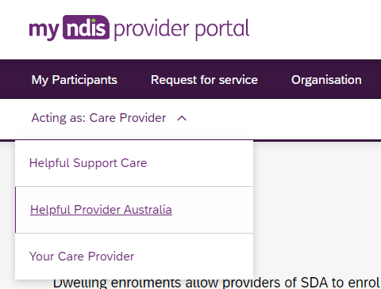
Figure 3: Organisation selector drop-down menu

my NDIS provider portal navigation
Depending on your organisation’s role you will see up to three tabs in the my NDIS provider portal.
My participants: allows you to search for a participant associated with your organisation and view certain details about them and their plan.
Requests for service: allows you to manage requests for service, respond to requests and submit reports for requests.
Organisation: allows providers to view information about your Organisation, Bank account details and Employees
SDA: allows providers to manage Specialist Disability Accommodation (SDA) dwelling enrolments.
Notes
Instructions for using the SDA functions in the my NDIS provider portal are provided in a separate guide: my NDIS provider portal: Specialist Disability Accommodation (SDA) Dwelling Enrolment (Step-by-step guide).

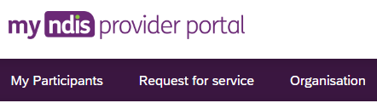
Figure 4: my NDIS provider portal navigation tabs

My Participants
My Participants tab allows you to search for a participant to view their plan when the participant has given the NDIA consent to share their plan with you.
The NDIA requires consent from participants to share their plans with providers. Only participants and their nominees can provide the NDIA with the consent to share their plans with providers. Participants have the choice to either share, or not share their plans with you and can withdraw consent at any time.

Search for and select a participant
To search for a participant:
- Select the My Participants tab.
- A list of your active participants will be displayed.
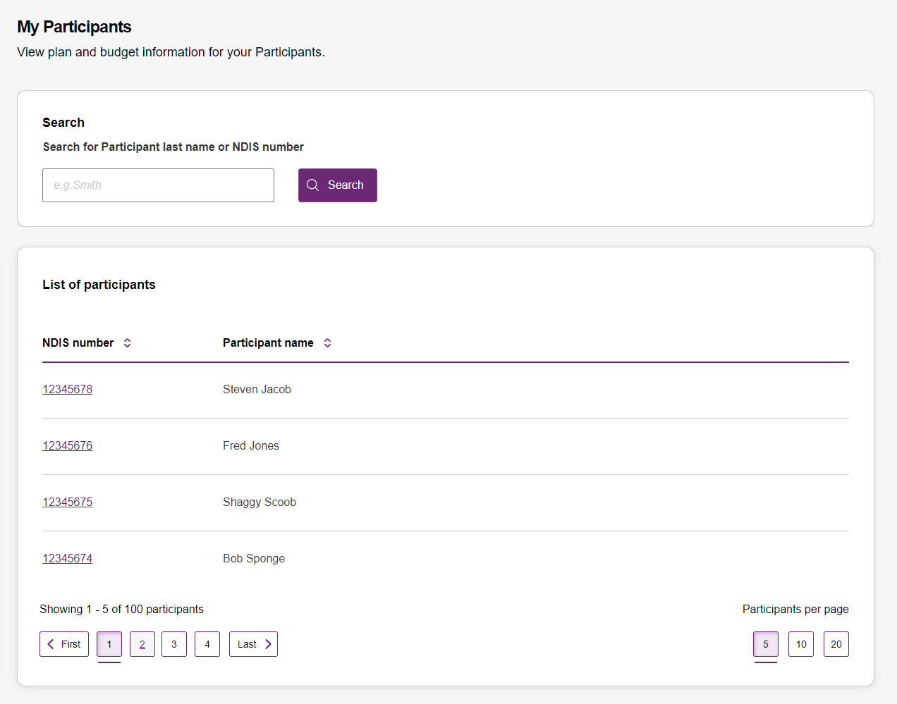

Figure 5: My Participants page
- To search for a participant, enter either the last name or NDIS number of a participant in the search box and click Search.
Figure 6: Participant search box.
- To view the participant’s plan, click on their NDIS number
Figure 7: My participants home tab, showing link to participant details page.

View Participant Details

The My Participants page shows the participant’s basic details, including their name, NDIS number, date of birth and contact details.
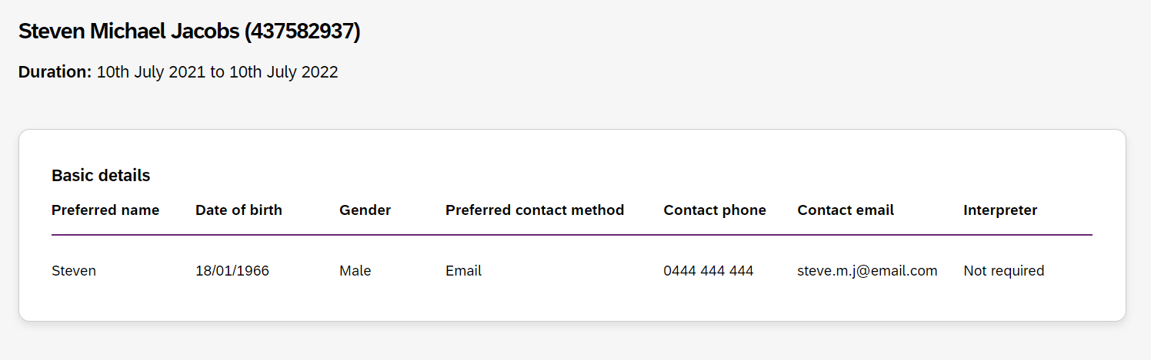
Figure 8: My Participants page showing links to sections with further information.
Depending on your organisation’s registration the information which is displayed will vary. The following sections may be available:
About me
Goals
Budget
Funded Supports
Informal community and mainstream supports, and
Participant nominee details.
To open each section, click on the relative tab.

About Me
The About me section shows details about the participant's daily life, living arrangements and strengths.
This section is only displayed where a provider is the participant’s support coordinator or psychosocial recovery coaches.

Goals
The Goals section outlines a participant's goals and how they will reach them.
This section is displayed for all providers.

Budget
The Budget section may include details of each category of funds include in a participant’s plan, including:
Core flexible: Self-managed funds
Core flexible: Registered plan managed
Core flexible: Agency managed
Stated supports
Periodic payments
Support coordinators or psychosocial recovery coaches may view all details. Plan managers can only view the plan managed budget details. Registered providers cannot view any budget details.

Funded Supports
The Funded supports section shows total funded supports for each support category, and details of the funding available in each category.
This section is only displayed where a provider is the participant’s plan manager, support coordinator or psychosocial recovery coach.

Informal community and mainstream supports
The informal community and mainstream supports sections shows information around current supports and new supports for a participant. There are lists for my current supports and new support I want to find.
This section is only displayed where a provider is the participant’s support coordinator or psychosocial recovery coach.

Participant nominee details
The participant nominee detail section shows details for each nominee, the relationship type for a participant and contact details.
This section is displayed for all providers.

Provider roles
The provider roles section shows the role that you has been assigned in the participants plan.
This section displays for all providers.

Request for Service
The Request for service tab allows you to manage requests for service, respond to requests and submit reports for requests.

View Support Coordination Requests for Service

To view Support Coordination Requests for Service submitted to your organisation:
- Select the Request for service tab.

- This will display the Request for service page, and links for sections for:
Pending requests: view any pending requests for support coordination services sent to your provider organisation by the Agency. Allows you to review a pending request and either accept or reject the request.
Accepted Requests: view any previously accepted requests for service.
You can now search by:
- Request ID
- NDIS number
- Participant last name
Reporting Tasks: view and complete reporting tasks associated with requests.
Request History: view a history of requests.
You can now Search by:
- Request ID
- Participants full name
- Participants first name
- Participants last name
You can now Filter by:
- Disability
- Status
- Date From
- Date to

The encircled number beside Pending requests link shows the number of outstanding, pending requests for service for your organisation.
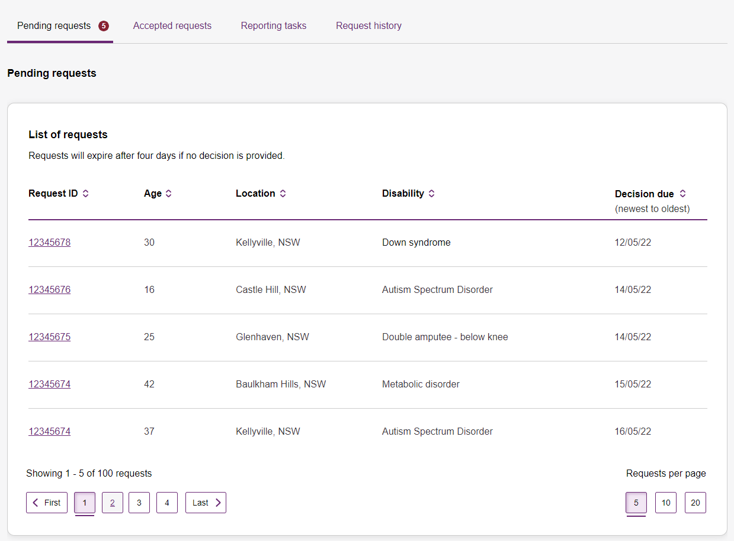
Figure 9: Requests for service page, showing links to sections
- The Pending requests section will display a list of pending requests for service for your organisation. The following details are included for each request:
Request ID: A unique ID for each request.
Age: The participant’s current age.
Location: The participant’s suburb.
Disability: The main disability experienced by the participant.
Decision due: The due date for a response to the request.
This list can be sorted by column, toggle between ascending and descending sort-order by clicking the column heading.
- To review the details of a pending request, click the link under the Request ID column.
Figure 10: Link to Review pending request page.

- The Review pending request page shows some additional details:
Basic details: including the support budget and NDIS contact, as well as limited, anonymised details about the participant.
About Participant: further details about the participant’s disability and whether they require an interpreter.
Additional information section shows further detail about the support being requested.
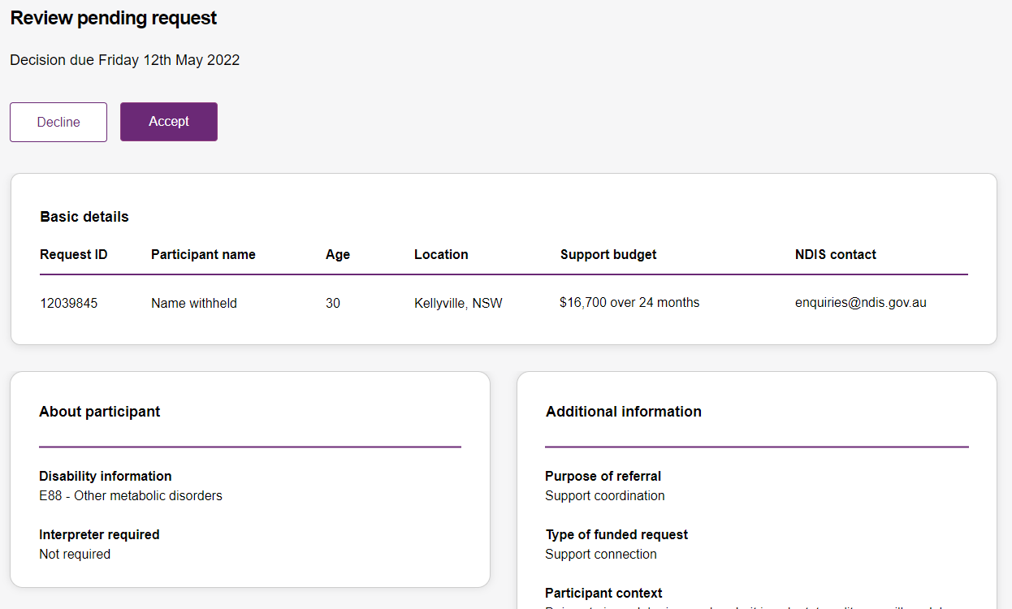
Figure 11: Review pending request page, showing request details.

Respond to a Request for service

Once you have reviewed the information and made a decision you may either accept or decline a request for service before the decision due date.
Figure 12: Decline and accept request buttons.

To Accept
- To accept the Pending request, click the Accept button near the top of the page.
- You will be prompted to confirm that you have read all the available information, click the Accept request to do so.
- Your acceptance will be confirmed in a banner displayed across the top of the page.
Figure 13: Prompt to confirm acceptance of a request for service.
Figure 14: Confirmation of successfully accepting of a request for service.

To Decline

- To decline the Pending request, click the Decline button near the top of the page.
- You will be prompted to provide a reason for declining the request for service
Figure 15: Declining a request for service
- Select the appropriate reason from the dropdown box, the options are:
- No capacity to accept referral
- No capability to accept referral
- Insufficient participant budget to accept referral
- Other
- You may leave additional comments about why you declined the request in the textbox. If you selected Other this field is mandatory and you must provide additional comments.
- Click Decline request to complete.
- The decline will be confirmed in a banner displayed across the top of the page.

View the details of an accepted Request for service

After accepting a request for service, you will be to view to additional details about the participant and the request. This includes:
Participant name,
Participant and participant representative contact details,
Participant context,
Reporting tasks, and
Submitted reports.
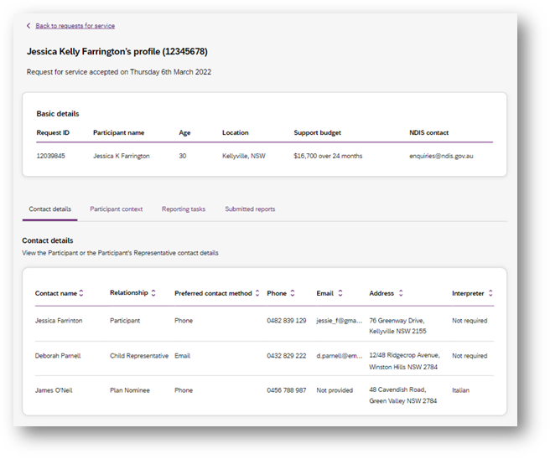
Figure 16: Request for service details page, available after accepting a request.

To navigate the details of an accepted request for service use the links on the page

Figure 17: Request for service details page, details links.

Contact Details
Contact details of the participant and/or the participant’s representative contact details.

Participant context
Participant context includes additional information about the participant and their disability, including:
- Disability information.
- Whether the participant requires an interpreter, and what language they use.
- Purpose of the referral and type of funded request.
- Report frequency.

Reporting tasks
Reporting tasks shows how often progress reports must be uploaded, and when the next report is due. It also allows for reports to be uploaded.

Submitted reports
Submitted reports shows a history of previously submitted reports for the selected request for service.

Reporting tasks

This tab displays all the reports that are due for your participants in the next 60 days.
- Select the Request for service tab.
- This will display the Request for service page, select the link to the Reporting tasks section.
- This will display a list of reporting tasks for all the organisation’s participants, with columns for:
Request ID: The unique ID for each request.
Participant name: The participant’s current age.
NDIS Number: The participant’s suburb.
Report Type: The main disability experienced by the participant.
Due in: The number of days until the listed report is due, or Overdue if the report is past its due date.
Figure 18: Reporting tasks for accepted requests.

- Click the link on the Participant name to access the upload report page.

Uploading reports for a Request for service

- To upload a report, access the Reporting tasks section of the relevant Request for service details page.
- On the Reporting tasks page, check the type of report required, the due date and click the Upload report button.
- You will be prompted to select a report file, files can be uploaded in the following formats and limitations:
File name: 30 characters long
File types: doc, docx, xls, xlsx, csv, pdf, jpeg, jpg, jpe, gif, bmp, png, xml, txt
Document size: 10 MB
- Click Upload to start the upload and submit the report.
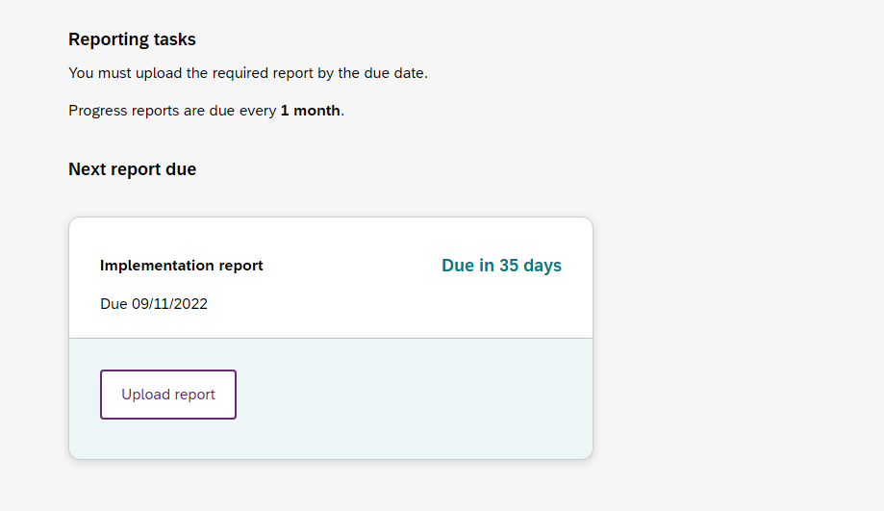
Figure 19: Request for service, report upload page
- Once complete a banner will appear at the top of the page confirming that you have successfully uploaded a report.
- You can review previously submitted reports in the previously submitted reports section of the request for service detail page.

Organisation

The Organisation tab allows you to view your Organisation details, Bank account details and Employees

View Organisation details
To view your Organisation details select the Organisation tab. You should be able to view your:
- Organisation ID number
- Trading name
- ABN
- Address
- Email address
- Phone number
- Website address
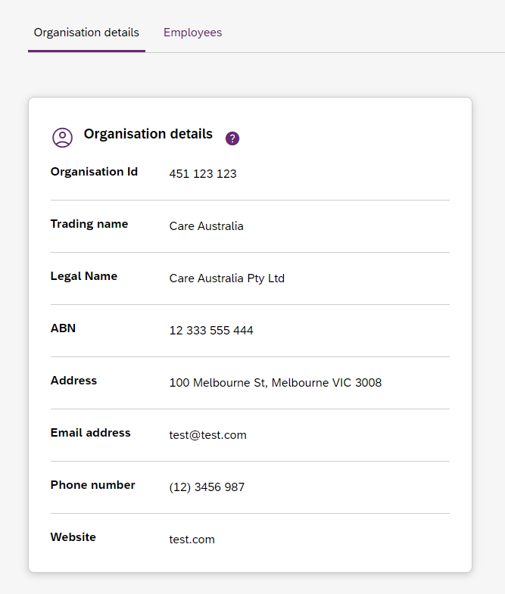
Figure 20 Organisation details

View Bank account details

To view you Bank account details select the Organisation tab. You should be able to view your:
- Account name
- BSB
- Account number
- Last updated
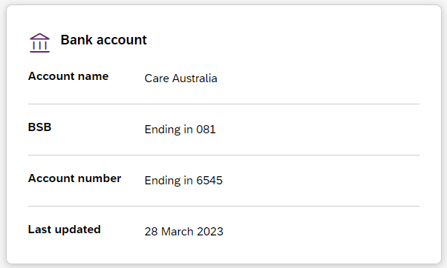
Figure 21 Bank account details

View Employee details

To view your Employee details select the Employees tab.
The Employees page shows a list of your employes name, role, start date and end date.
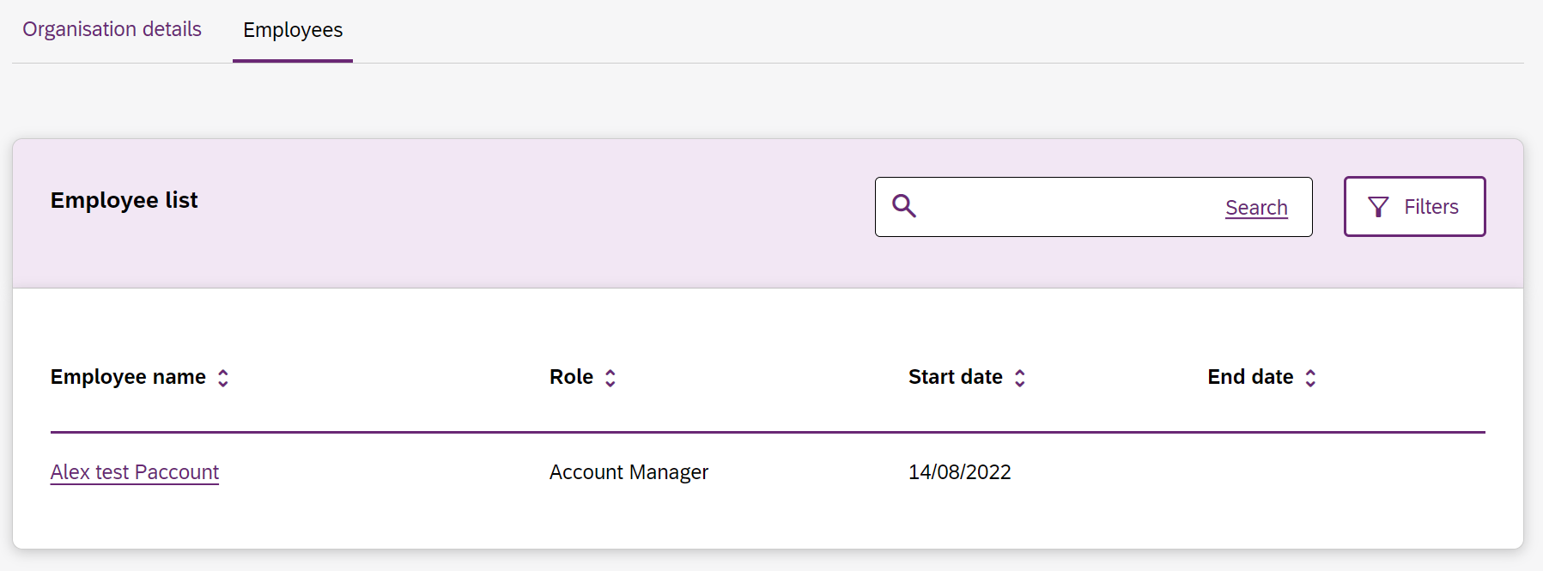
Figure 22 Employee list
To view the Employees history, select the hyperlink on the employee’s name and the role history page will list the employee’s role, start date and end date.

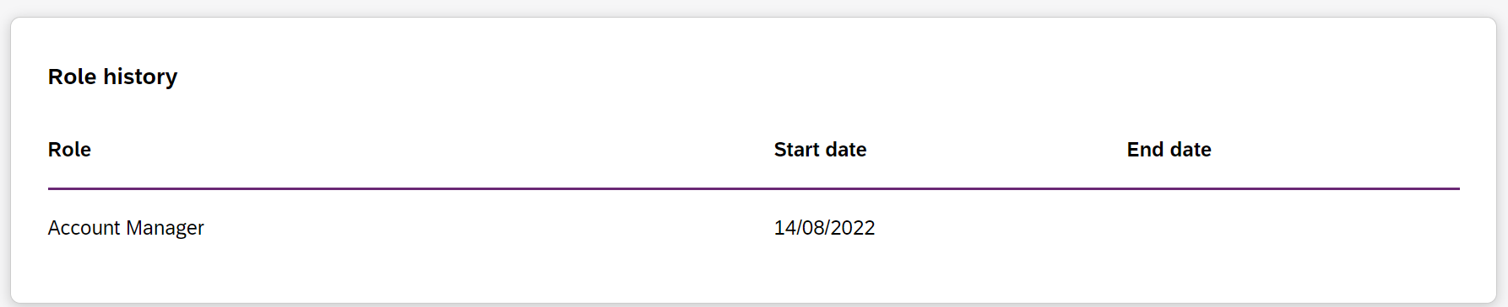
Figure 23 Employee list, Role history

