National Disability Insurance Scheme

2022-23

Annual Pricing Review

Report
June 2023

Acknowledgement
The NDIA acknowledges and pays respect to the past, present and future Traditional Custodians and Elders of this nation and the continuation of cultural, spiritual and educational practices of Aboriginal and Torres Strait Islander peoples.
Copyright and use of the material in this document
Copyright of the material in this document, with the exception of third-party material, is owned and protected by the National Disability Insurance Agency.
The material in this document, with the exception of logos, trademarks, third party material and other content as specified is licensed under Creative Commons Attribution Non-Commercial No Derivatives (CC BY NC ND) licence, version 4.0 International. You may share, copy and redistribute the document in any format. You must acknowledge the National Disability Insurance Agency as the owner of all intellectual property rights in the reproduced material by using ‘© National Disability Insurance Agency 2023’ and you must not use the material for commercial purposes.
Reproduction of any material contained in this document is subject to the CC BY NC ND licence conditions available on the Creative Commons Australia site, as is the full legal code for this material.
The National Disability Insurance Agency expects that you will only use the information in this document to benefit people with disability.
Terms that we use
Acronym | Meaning
ABS | Australian Bureau of Statistics
APR | Annual Pricing Review
CPI | Consumer Price Index
DSW | Disability Support Worker
FWC | Fair Work Commission
NDIA or Agency | National Disability Insurance Agency
NDIS or Scheme | National Disability Insurance Scheme
NDIS Commission | National Disability Insurance Scheme Quality and Safeguards Commission
SCHADS Award | Social, Community, Home Care and Disability Services Industry Award 2010
SDA | Specialist Disability Accommodation
SIL | Supported Independent Living
WPI | Wage Price Index

Table of Contents

1 Executive summary 4
2 Introduction 14
3 Domestic economic conditions and the care economy 21
4 Disability Support Worker related supports 28
5 Therapy supports 42
6 Support coordination 57
7 Plan management supports 66
8 NDIS Pricing 74
Appendix A – Feedback from the Consultation Paper…………………….………………..79
Appendix B – Domestic and family violence research………….………………………….94
Appendix C – Non-wage Aged Care reforms…………………….…………………………...95

Executive summary
The National Disability Insurance Scheme (NDIS) was established in 2013 to support people with disability to pursue their goals, to help them to realise their full potential, to assist them to participate in and contribute to society, and to empower them to exercise choice and control over their lives and futures. The NDIS provides funding to eligible individuals (“participants”) so that they can purchase, in the open market, the disability related goods and services (“supports”) that they need.
The National Disability Insurance Agency (NDIA) monitors and reviews its price control framework and other market settings to determine whether they are still appropriate and reflect the current market conditions.
Annual Pricing Reviews (APRs) are an important part of the monitoring and review process. The NDIA Board developed a Terms of Reference of the 2022-23 APR to guide the approach. This requires the NDIA to examine, through engagement with participants, providers and community and government stakeholders, and targeted research, whether the NDIS’s existing price control framework (pricing arrangements and price limits) continues to be appropriate or should be modified.
As part of the 2022-23 APR, extensive consultations with participants, providers and other stakeholders were completed, including:
- Publishing a Consultation Paper and completing analysis of the 304 submissions received.
- Consultations with other government insurance and funding schemes.
- Consultations with the Pricing Arrangements Reference Group.
- Consultations with the Pricing Interdepartmental Committee.
- Consultations with the Department of Veterans' Affairs and the Chief Allied Health Officer.
A summary of submissions to the Consultation Paper can be found in Appendix A.

Disability Support Worker (DSW) related supports
In setting price limits, the NDIA uses the NDIS DSW Cost Model to estimate the costs that a reasonably efficient provider would incur in delivering a billable hour of support. The Cost Model takes account of all the costs associated with every billable hour, including base pay; shift loadings; salary on costs; operational overheads such as supervision costs and utilisation; corporate overheads and margin. It uses these estimates to set the price limits of supports that are delivered by DSWs, with price limit set at the level that can be achieved by providers who match the benchmarks. The outputs from the Cost Model considers minimum employment standards and efficient costs to provide DSW-related supports in Australia.
Growth in the total number of DSW participants (15%), providers (28%) and payments (34%) continued over the six months to December 2022 compared to the six months to December 2021.
A total of 59 submissions on DSW-related supports were received through Public Consultation. One of main themes raised was that adjustments for many providers on costs continue to relate to quality, safeguards, and compliance, COVID and Social, Community, Home Care and Disability Services Industry Award 2010 (SCHADS Award) changes. Reponses from participants raised the concern of varying skills of support workers who were providing supports, but generally still charging at the NDIS price limit.
In determining the price limit for DSW-related supports, analysis using data of the Health Care and Social Assistance (HCSA) industry was undertaken to understand the sector which disability support workers operate in. The analyses suggest that the labour market for the care sector remains tight. These conditions could potentially intensify competition in terms of labour with other care sectors, which could put more pressure on supply going forward.
Despite the overall sector growth, the sector is still being impacted by COVID. The results from the 2022-23 Ability Roundtable survey shows that most surveyed providers (71%) reported that COVID was still impacting on their costs in 2022. The average percentage increase in costs due to COVID was reported at 1.5%, in line with the 1.5% cost impact estimate in the 2021-22 APR. This data is based on survey responses from 24 providers, with an average revenue of between $50 and $100 million.
Similarly, the impact of the SCHADS Award changes from 1 July 2022 included changes to minimum shift time, broken shift allowances and cancelled shift policies. The Ability Roundtable survey found 62% of respondents reported an increase in staffing numbers to deal with the rostering impact. Two-thirds of respondents reported that their bottom-line costs had increased as a result with the average cost increase reported by all respondents at 1.5%, aligned to estimated cost impact from the 2021-22 APR. However, most reported that those increases in costs had been one-offs in nature, including purchasing new software and changing rosters.
The 2% temporary loading introduced from 1 July 2022 in the DSW Cost Model was intended to be a temporary measure to assist providers adjust to costs associated from ongoing COVID management and SCHADS Award changes. Analysis and data suggest that there are merits in favour of retaining the loading at a reduced rate to ease providers’ transition. The following considerations have been given:
- It should be recognised that COVID related restrictions in the economy have been wound back. However, COVID is still active and is disrupting supports being delivered to NDIS participants. Providers incur some costs when these arise (such as PPE and RAT tests). The NDIS sector also represents some of the most vulnerable groups in the community and the adjustments from COVID has been somewhat slower than the rest of the nation.
- It appears many of the adjustments needed for the SCHADS Award changes were one-off costs for providers. It is considered that there is still ongoing adjustment being made by the sector as these major Award changes are still relatively recent. The NDIA recognises there is some cost impact that can still be borne by providers as it takes time for a sector to fully adjust systems and processes to major Award changes.
The NDIA considers that the majority of these costs have been addressed and/or wound back over the past year. COVID costs are reducing post pandemic and many of the costs from the changes to the SCHADS Award were one-off adjustments. However, the NDIA acknowledges there remains the potential to impact participant safety as some providers are still facing transition costs associated with both.
Evidence suggests that many providers have already adjusted, but some are still implementing adjustments associated with COVID and SCHADS Awards changes. On balance, the NDIA considers it necessary to extend the temporary loading for a further 12 months at 1% from 1 July 2023 with this ceasing on 1 July 2024, to allow providers more time for the transition.
Recommendation 1
The NDIA, subject to any specific recommendation arising from the current Annual Pricing Review, should increase the price limits for supports that are determined by the NDIS Disability Support Worker Cost Model from 1 July 2023 to reflect any changes in the minimum wages specified in the Social, Community, Home Care And Disability Services Industry Award 2010 (SCHADS Award) following the Fair Work Commission’s Annual Wage Review and any increase in the Superannuation Guarantee Charge.
Recommendation 2
The NDIA should extend the temporary loading for a further 12 months at 1% from 1 July 2023 with this ceasing on 1 July 2024.

DSW Cost Model changes
The DSW Cost Model is updated annually alongside any changes to the superannuation contribution, which will increase from 10.5% to 11% from 1 July 2023. This increase will be passed on in full to the DSW Cost Model.
An additional consideration this year is the new paid family and domestic violence leave introduced by the Fair Work Commission. Based on previous surveys and studies, the NDIA estimates an upper bound number of workers accessing family and domestic violence leave to be 2.3%, with those accessing the leave assumed to be accessing the entire minimum entitlement. Incorporating this into the 2022-23 DSW Cost Model, holding everything else constant, this equates to a 0.1% increase to an hour of the standard, weekday daytime disability support worker. The NDIA acknowledges this may be an overestimation of the actual uptake of this leave in the sector as it is implemented and will continue monitoring its impact into the future.
Recommendation 3
The NDIA should include the paid family and domestic violence leave into the Disability Support Worker Cost Model - an increase of 0.1% from 1 July 2023 to reflect the new entitlements for workers in the industry.

Aged Care Award changes
The Fair Work Commission has lifted the aged care worker wages in relevant Awards by 15% from July 2023. The Award rates for DSWs are still estimated to be higher than comparable aged care workers. However, there could be greater attraction of workers to the aged care workforce as the disability sector and aged care sector share the same pool of workers. Although the NDIA expects the impact of these changes to be limited, the NDIA should continue to monitor the impact of these changes.
Recommendation 4
The NDIA should continue to work with the sector to monitor the impact of changes to the Aged Care Award that come into effect on 1 July 2023 with a view to further addressing these costs in the future if necessary.

Temporary Transformation Payment loading
The Temporary Transformation Payment (TTP) was initially setup to allow providers time to assist transitioning to more efficient systems and prices. The NDIA has conducted extensive financial benchmarking over the last six years, and consequently, the NDIA did not consider it necessary to conduct a financial benchmarking survey in 2022-2023.
As per the initial pricing strategy framework, the NDIA does not see a need to change the timeline of the TTP to ensure balance is maintained between incentivising providers to achieve greater efficiencies while considering differing cost structures of providers. In the absence of a NDIS Financial Benchmarking Survey, is it reasonable to assume those who were accessing the TTP in FY2022-23 may continue to need access to assist transitioning systems.
The NDIA will continue to work closely with the sector in monitoring market conditions and cost structures.
Recommendation 5
The NDIA should maintain its current pricing strategy including the scheduled reduction over the next year of the Temporary Transformation Payment (TTP) loading to 1.5% on 1 July 2023. The TTP loading should cease to apply from 1 July 2024.
The NDIA should allow registered providers who have been claiming for the TTP in financial year 2022-23 to continue to do so in financial year 2023-24 until cessation.

Therapy supports
In the six months to December 2022, 325,319 participants (57% of active participants in the same period) purchased therapy supports through their NDIS plans. These service supports were delivered by 46,434 providers, a 14% increase to provider numbers compared to the six months to December 2021. Expenditure on therapy supports over the six months to December 2022 equated to $1.6 billion, accounting to almost 10% of all expenditure by the NDIS ($16.8 billion), an increase of 26% compared to the six months to December 2021.
In terms of employment, as of February 2023, the Department of Health and Aged Care reported that the total number of several Allied Health professionals registered with Australian Health Practitioners Registration Agency (AHPRA) grew significantly, by 26%, from 2017 to 2021. This trend is set to continue with Jobs and Skills Australia forecasting growth for several types of Allied Health professionals of between 7% to 35% in the next five years.
As with the 2021-22 APR, the NDIA conducted a comparison of therapy pricing to 16 other government insurance and funding schemes to understand where the NDIS price stands against other funding sources. Overall, current NDIS price limits are broadly consistent with the effective hourly rates paid by other government insurance and funding schemes for therapy, once account is taken of duration of service, co-payments and provisions for travel and consumables. Although the results this year indicate that many types of therapies have been indexed by other schemes over the past year, the NDIS price limits remain in the middle or upper range for most therapies.
Another key aspect of the therapy analysis is the comparison to the private billing rates. A sample of 2,857 billing rates were used across all types of NDIS therapy supports and several regression models were run to analyse private therapy billing rates. The private billing market data suggests that the average fully loaded hourly cost of most types of therapy professionals is $189, still slightly lower than the current NDIS price limit of $193.99.
There were 174 public consultation submissions related to therapy supports. Many providers noted the biggest cost driver has been the increasing supply costs and wages. Other costs involved attracting, training and retaining staff, as well as quality, safeguarding and compliance costs. Many participants and their representatives who responded to the Consultation Paper suggested that they were charged more than non-NDIS clients and generally supported no further price increase at this time.
On balance, available therapy data inputs suggests that the current NDIS therapy price limits should be maintained. Some comparable government insurance schemes have revised their price limits, and the average fully loaded hourly cost of most types of therapy professionals in the private billing market is estimated to be $189, which remains below the current NDIS price limits. Data analysis suggests that price limits of certain therapy supports could be decreased slightly. However, a decrease is likely to disrupt the provision of supports to participants in some regions and impact professionals considering moving into the sector to support NDIS participants.
What is evident is the vast and diverse nature of the therapy market. As the NDIS Review is currently examining non-price related solutions, the NDIA should consider structural changes to therapy pricing arrangements after any relevant recommendations from the NDIS Review.
Recommendation 6
The NDIA should not make any structural adjustment to the pricing arrangements for therapy supports at this time and should not index the price limits for therapy supports on 1 July 2023.
Recommendation 7
The NDIA should consider the structure of therapy support pricing arrangements after any relevant recommendations from the NDIS Review. This is intended to better incentivise quality service provision to NDIS participants and create greater market efficiencies.

Support coordination
When comparing the six months to December 2022 to the six months to December 2021, the number of participants receiving support coordination and the payments claimed from participant plans both increased, by 15% (to 210,909 participants and $428.4 million in payments, respectively). Over the six months to December 2022 compared to the six months to December 2021, the number of active providers has increased significantly by 34% to 7,023 providers, demonstrating a steady increase to the supply of support coordination to NDIS participants.
Considering these changes over time, the average number of participants being serviced per provider has reduced from 48 participants per provider to 32 participants per provider between December 2020 and December 2022. This ratio of providers servicing participants has decreased largely due to the 29% overall growth of provider numbers in the same period, including 31% growth rate in unregistered providers.
A total of 99 submissions received during the consultation process addressed support coordination. Providers raised concerns about NDIS price limits relating to support coordination and the fragmented nature of supports offered and unbillable hours associated with their work.
A key theme from both participants and representatives and providers is that greater clarity is needed for the roles of support coordinator and plan managers. In line with previous recommendations from the 2021-22 APR, these will be considered by the NDIS Review. The NDIA should consider any appropriate structural changes after recommendations are received from the NDIS Review.
Data analysis and evidence suggest that there are new entrants to the market and the current price limits remain viable for most providers to deliver the service. Given the market for support coordination is still not yet mature and continuing to grow, on balance, an increase in price limits for Level 2: Coordination of Supports services and Level 3: Specialist Support Coordination services is not recommended at this time.
Recommendation 8
The NDIA should not make any structural adjustment to the NDIS pricing arrangements for support coordination at this time and should:
- Index the price limits for the Level 1: Support Connection services on 1 July 2023, in line with the indexation of supports determined by the NDIS Disability Support Worker Cost Model in recommendation 1 and
- Not index the price limits for the Level 2: Coordination of Supports services and Level 3: Specialist Support Coordination services on 1 July 2023.

A major submission was again received from Disability Intermediaries Australia (DIA), the industry group for providers of Intermediary supports (plan management and support coordination). This submission included summary results of a survey of plan management and support coordination providers on the costs of providing service. The NDIA sees merit in the benchmarking survey conducted by DIA in better capturing the specific cost drivers faced by support coordination providers. This is considering 92% of respondents for support coordination reported to have employees under the SCHADS Award.
Recommendation 9
After the outcomes of the NDIS Review are announced, the NDIA should work with the sector and other appropriate stakeholders to develop Cost Models for Level 2: Coordination of Supports and Level 3: Specialist Support Coordination.

The NDIA also considers that there may be instances where support coordinators could be required to undertake work following the death of a participant or including the administrative work associated with gathering information, returning equipment, and completing forms. In addition, other significant changes or situations (such as interactions with justice or health services) may require additional administrative work including responding to subpoenas or providing critical details where required. As such, the NDIA should examine options to allow support coordinators to claim for reasonable payments related to these events.
Recommendation 10
The NDIA should examine options on billable work required by support coordinators that is required after a participant’s death or other key events.

Plan management supports
Participants can choose to have a registered plan management provider to manage their funding and budget for the supports in their NDIS plan. Plan managers are bound to the NDIS Pricing Arrangements and Price Limits and can connect participants with both NDIS registered providers and providers that are not registered with the NDIS.
The proportion of participants using plan management has increased as the preferred method over several years, from 45% in the December 2020 quarter to 58% in the December 2022 quarter.
In the six months to December 2022, 333,077 participants used a plan manager for some or all their NDIS plan, a 26% growth compared to 262,915 participants in the six months to December 2021. In the six months to December 2022, payments were made to 1,797 plan managers, a 13% rise compared to the six months to December 2021.
In the six months to December 2022, $8.1 billion, that is, 48% of NDIS funds spent was through plan managers, consisting of $228 million for plan management fees. The largest five plan managers received more than a quarter (27%) of this.
As participant numbers have increased relative to provider numbers, the average number of participants being serviced per provider has increased from 178 to 214 participants between December 2020 quarter and December 2022 quarter.
In total, 81 submissions were received through the Public Consultation on plan management. Most respondents suggested the monthly fee for plan management is insufficient for the work they are doing, which is said to encompass activities outside of what they believe is expected of them. There were also suggestions of clearer guidelines on the role of plan managers which was a common sentiment raised in the 2021-22 APR and is anticipated to be in the scope of the NDIS Review.
As the market continues to mature, it is clear that the roles and expectations of plan managers are still evolving. In line with previous recommendations from the 2021-22 APR, the role of plan managers is to be considered by the NDIS Review and the NDIA should consider any appropriate structural changes after recommendations from the NDIS Review.
Further, available data signals growth in both participants accessing, and providers delivering, plan management supports over the past two years. The growth of providers seen over this period signals economic feasibility in delivering these services for most providers, with increasing number of participants accessing these supports ensuring growing demand for plan management services if this remains as is.
Considering available information, on balance, the growth of plan management participants and providers over the past two years suggests this market is still viable and does not support an increase to plan management supports until the roles and expectations of plan managers are further defined. The NDIA should continue to monitor the movement of providers claiming for plan management supports in future quarters if this becomes a trend.
Recommendation 11
The NDIA should not make any structural adjustment to the NDIS pricing arrangements for plan management supports at this time and should not index the price limits for plan management fees on 1 July 2023.

Other supports
In the absence of specific focus within the APR cycle, the NDIA considers the need to maintain the real value of NDIS price limits for support to maintain the supply of supports to NDIS participants. Furthermore, there is also a need to allow further innovation of providers to achieve greater efficiencies and improve the quality and safety of supports delivered.
The NDIA acknowledges there are a range of supports that are not under scope of the 2022-23 APR and are not linked to the DSW Cost Model, which are not price limited or benchmarked.
Nursing supports are considered as part of this category. Examples of supports in this category include several within the core and capacity building support categories such as personal domestic cleaning, house and/or yard maintenance. There is the need to maintain the real value of NDIS price limits for support to maintain the supply of these supports to NDIS participants.
This is particularly relevant for nursing supports, with aged care reforms including a 15% wage increase for those working in aged care as well as other potential increases to the Nursing Award. It is imperative that the NDIA ensures these supports remain competitive to other markets. It may pose a risk to participants receiving these supports if there is no pricing increase, and thus is deemed necessary to increase the price limits of these supports in line with previous year’s indexation methodology.
It noted that prices for capital items are not in scope for this review and will be the subject of a separate review process.
Recommendation 12
The NDIA, subject to any specific recommendation arising from the current Annual Pricing Review, should:
- Increase the price limits for supports other than capital items and those covered by previous recommendations, on 1 July 2023 in line with the weighted movement over the previous twelve months in the ABS Wage Price Index (Australia, total hourly rates of pay excluding bonuses) and the ABS Consumer Price Index (All Groups, weighted average of eight capital cities) over the 12 months to the March Quarter immediately preceding the indexation date (with an 80/20 weighting).

NDIS cancellation policy
The 2021-22 APR changed the NDIS cancellation policy from 2 days to 7 days to aligning to changes to the SCHADS Award from 1 July 2022. The policy was updated to ensure staff are protected from any impact of short notice cancellations. Following the implementation of this change, feedback received from participants and their representatives reflected that the 7 days is too long to account for sudden illnesses or events outside of a participant’s control. It is important to note that the 7-day cancellation policy is the maximum allowable cancellation length by the NDIA, providers can include shorter cancellation periods.
Analysis of NDIA claims data from July 2020 to December 2022 shows that cancellations accounted for around 0.6% of DSW claims over this period. This has remained stable throughout this period with no significant change since the policy update.
It is too early to understand the impact of the changes to the NDIS cancellation policy to NDIS participants based on current data. The NDIA should continue to work closely with the sector to investigate the appropriateness of the current NDIS cancellation policy post the 2022-23 APR. The NDIA should also consider relevant Industry Awards, employment standards and other relevant industry legislation when setting pricing policy.
Recommendation 13
The NDIA should work with the sector to investigate the appropriateness of the NDIS cancellation policy for NDIS supports post the 2022-23 APR.

The NDIS Review
The Minister for the NDIS, the Hon Bill Shorten MP, announced the NDIS Review in October 2022. The NDIS Review is likely to have significant strategic implications for NDIS pricing arrangements in the future.
As the NDIS Review is running concurrently with the 2022-23 APR, the NDIA is committed to working with the NDIS Review Team throughout the NDIS Review process. The NDIA acknowledges this may impact some supports and outcomes under the scope of the APR, which should be considered in line with upcoming recommendations from the NDIS Review expected in October 2023.
Recommendation 14
The NDIA should continue to work with the NDIS Review team on relevant topics and issues involving structural changes to the current NDIS pricing arrangements.

NDIS Pricing Strategy refresh
The pricing arrangements for the NDIS are governed by the NDIS Pricing Strategy, which was adopted by the NDIA Board in 2019. Since the release of the NDIS Pricing Strategy in 2019, there has been rapid growth in the provision of supports across many types of support markets delivering supports to NDIS participants, which was needed in the roll-out of the NDIS.
Other changes include:
- The growth in size and scope of the NDIS,
- number of participants supported by the Scheme has grown,
- increase in registered and unregistered providers offering supports and services in the market,
- shifting support market dynamics facilitated by external events and changes to economic drivers.
Given the extent of the changes to the NDIS and the people it supports, a refresh of the 2019 NDIS Pricing Strategy is appropriate so that any future reviews can accommodate these factors and is better placed to consider what market interventions would be effective.
There is a spectrum of market intervention options available to the NDIA, such as market facilitation, market regulation or alternative commissioning. Which intervention to use depends on the characteristics of the market and how it is functioning. A market that is considered well-functioning requires less intervention.
Therefore, the NDIA should examine what might be the most appropriate measures to apply across different markets delivering NDIS supports based on the current market maturity, economic conditions as well as Scheme trajectory.
Recommendation 15
The NDIA should refresh its NDIS Pricing Strategy to ensure its appropriateness given the current state of NDIS support markets, giving consideration to the outcomes from the NDIS Review.

Financial reporting by NDIS providers
The NDIA believes it is imperative that as a market steward, it is important to monitor and track the financial performance of providers within the sector to ensure that they remain financially viable.
Previous attempts to conduct surveys to gauge providers’ financial bottom lines have resulted in poor response rates and therefore the survey results are not considered to be representative of the entire provider sector.
While a financial benchmarking survey of the provider market is not part of the scope of the 2022-23 APR, it is important to note that the NDIA is beginning to work with the sector to introduce financial benchmarking activity to support providers to better understand their financial position when compared to their peers in the market.
An effective price setting mechanism is critically underpinned by the Agency’s ability to track, monitor, and benchmark the financial performance of the sector, which helps with Government policy planning and development. This ensures there is representation across a range of organisations with different cost bases, sizes, and locations. Moving forward, a model to consider is the current mandatory financial reporting requirements in the aged care sector.
The NDIA should explore options with the NDIS Review on the possibility of creating mandatory financial requirements. This is to ensure the NDIA has sufficient information available on the financial position of providers to assist in its role as market steward and inform its pricing review process.
Recommendation 16
The NDIA should explore options with the NDIS Review on the potential for mandatory financial reporting from NDIS providers on certain financial metrics.

Introduction

2.1 General
The National Disability Insurance Scheme (NDIS, Scheme) was established to support people with disability to pursue their goals, to help them to realise their full potential, to assist them to participate in and contribute to society, and to empower them to exercise choice and control over their lives and futures. The Scheme is administered by the National Disability Insurance Agency (NDIA, Agency).
The Scheme has been in operation for 9 years, with the first three years being the trial period, followed by a transition phase until 1 July 2020, when the Scheme became operational in all areas of Australia. At the end of the trial period, 30 June 2016, the Scheme included 29,719 participants. The Scheme has grown significantly since, with 573,342 participants as of 31 December 2022.
Total payments have increased over the last three years, from $10.5 billion in the year to 30 June 2019 to $28.6 billion in the year to 30 June 2022. Payments in the six months to December 2022 were $16.8 billion.
The average payments for twelve months to December for all participants have increased from $47,800 in 2019 to $57,600 in 2022, a 6.4% increase per annum. Specifically, average payments are much higher for participants in Supported Independent Living (SIL) than those not in SIL ($357,300 versus $41,000 respectively, in the twelve months to December 2022). Average payments are also higher for adults compared with children ($64,400 for participants not in SIL aged 25 to 64 versus $18,900 for those aged 0 to 14 years, in the twelve months to December 2022).
$31 billion in support has been provided in the twelve months to December 2022. The largest support categories by expenditure are:
    - 54% ($16.7 billion) on core daily activities
    - 20% ($6.1 billion) on social and community participation
    - 13% ($3.9 billion) on capacity building daily activities (therapy services).

2.2 Terms of Reference of the Review
The Terms of Reference of the 2022-23 Annual Pricing Review (APR) require the NDIA to examine, through engagement with participants, providers and community and government stakeholders and targeted research, whether the NDIS’s existing price control framework (pricing arrangements and price limits) continues to be appropriate or should be modified.
In framing its recommendations, the APR will be cognisant of the objects and principles set out in the National Disability Insurance Scheme Act 2013, including that the NDIS should:
- Support the independence and social and economic participation of people with disability.
- Enable people with disability to exercise choice and control in the pursuit of their goals and the planning and delivery of their supports.
- Facilitate the development of a nationally consistent approach to the access to, and the planning and funding of, supports for people with disability.
- Promote the provision of high quality and innovative supports that enable people with disability to maximise independent lifestyles and full inclusion in the community.
- Adopt an insurance-based approach, informed by actuarial analysis, to the provision and funding of supports for people with disability.
- Be financially sustainable.
Considering this, the APR will review the pricing arrangements and price limits:
- that apply to supports delivered by disability support workers by updating the NDIS Cost Model for Disability Support Worker, with a particular emphasis on the Temporary Loading of 2.0% and the impact of the changes that were made to the Social, Community, Homecare and Disability Services Industry Award 2010 (SCHADS Award) in 2022 (AM2018/26).
- for therapy supports to ensure participants receive value for money, while providers strive to improve quality of service and increase efficiency.
- for support coordination to encourage innovation, improve quality of service and ensure value for money.
- for plan management to encourage innovation, improve quality of service and ensure value for money.
Moreover, the 2022-23 APR encompasses a comprehensive examination of contextual factors that have emerged from the NDIS Review, the 2021-22 APR, the projections outlined in the most recent Annual Financial Sustainability Report (AFSR), and the aged care minimum wage review.

The NDIS Review
The Minister for the NDIS, the Hon Bill Shorten MP, announced the NDIS Review (Review) in October 2022. There will be two parts to the Review.
- Part 1 will examine the design, operations and sustainability of the NDIS covering issues outlined in the full-Scheme bilateral agreements between the Commonwealth and jurisdictions.
- Part 2 will examine ways to build a more responsive, supportive, and sustainable market and workforce.
Each of these parts, as well as other matters likely to be considered by the Review, have the potential to have significant strategic implications for pricing arrangements in the future, noting the Review is expected to report in October 2023.
As the Review is running concurrently with the 2022-23 APR, the scope of the APR has been carefully defined to limit any potential overlap with the Review or the prejudging of the Review’s recommendations.

The extensive 2021-22 APR
The previous APR took place over the 2021-22 financial year and was implemented from 1 July 2022. It incorporated extensive consultations through public consultation, regular industry engagement and numerous workshops.
The recommendations included tailored pricing changes to disability supports totalling 9%, comprising wage increases under the SCHADS Award, plus allowance for increases in compulsory superannuation, a 2% temporary loading and a 1.7% increase to base price limits. The disability support worker support cohort receiving the 9% price limit increase included SIL. The Temporary Transformation Payment was also reduced for eligible supports from 4.5% to 3% for FY2022-23.
No changes in price limits were made for therapy supports, support coordination or plan management. Prices for capital items were increased by Consumer Price Index (CPI).

2021-22 Annual Financial Sustainability Report (AFSR)
The AFSR is an annual report that provides an assessment of the financial sustainability of the National Disability Insurance Scheme using data as of 30 June each year.
Using data as of 30 June 2022, the AFSR projected that the total Scheme expense on an accrual basis is $34.0 billion in 2022-23 increasing to $89.4 billion in 2031-32. This represents 1.48% of Gross Domestic Product (GDP) in 2022-23 before increasing to 2.55% of GDP in 2031-32 in the baseline forecasts. Additionally, the number of scheme participants is projected to almost double to 1,017,522 at the end of June 2032. The upward growth in Scheme expenses means any further price increase for 2022-23 APR will further impact sustainability.

Aged care worker minimum wage review
On 4 November 2022, the Fair Work Commission (FWC) announced a 15% increase to the minimum wages of the direct care classifications in the Aged Care Award, SCHADS Award and for nurses working in aged care covered by the Nurses Award. It has since been decided by the FWC to provide this 15% increase to workers in the Aged Care sector from July 2023 onwards.
There are other non-wage related reforms being undertaken in the Aged Care sector which also need to be considered for aged care worker conditions. More details are discussed in disability support worker-related supports section of the report.

2.3 Consultations
Consultations involved advocacy groups, carers, employees, government, participants/representatives, plan managers, professional bodies, providers, provider peak bodies, researchers as well as workers’ unions, through:
- The publication of a Consultation Paper and the careful analysis of submissions received.
- Consultations with other government insurance and funding schemes.
- Consultations with the Pricing Arrangements Reference Group.
- Consultations with the Pricing Interdepartmental Committee.
- Consultations with the Department of Veterans’ Affairs and the Chief Allied Health Officer.

Consultation Paper and submissions
A Consultation Paper was released on 17 March 2023 to assist stakeholders in preparing submission to the APR. Submissions were required to be lodged by AEST 11:59pm Thursday 13 April 2023. In total, 304 submissions were received including those submitted after the deadline.
Most submissions were from provider organisations (165) and employees/workers (96). A small number of submissions (15) were received from participants and their representatives. Submissions were also received from professional bodies (15), provider peak bodies (9), state and territory governments (3), advocacy groups (3) and worker unions (1). The number of responses providing feedback on each topic is shown in Figure 1. Appendix A includes a summary of the public submissions.
Figure 1: Number of Submissions Received to the Public Consultation and Topics Covered
Source: Submissions to the APR received by the NDIA, NDIS internal data, April 2023

Consultations with other government insurance and funding schemes
The NDIA has reached out and worked with sixteen other government insurance and funding schemes to update the analysis done in the 2021-22 APR.
Schemes that assisted with information were:
- Catastrophic Injuries Support (CIS) Scheme,
- ComCare,
- Department of Veterans’ Affairs (DVA),
- Home and Community Care Program for Younger People (HACC-PYP),
- Lifetime Support Scheme (LSS),
- Lifetime Care and Support Scheme (LTCSS),
- Motor Accidents Insurance Board (MAIB),
- Medicare Benefit Scheme (MBS),
- National Injury Insurance Scheme Queensland (NIISQ),
- Return To Work SA (RTWSA),
- State Insurance Regulatory Authority (SIRA),
- Victorian Transport Accident Commission (TAC),
- Victims of Crime Assistance Tribunal (VOCAT),
- WorkCover QLD,
- WorkSafe VIC, and
- WorkCover WA.

Pricing Arrangement Reference Group
The work of the APR was overseen by the NDIA’s Pricing Arrangement Reference Group, which provides advice, through the Chief Executive Officer of the NDIA, to the NDIA Board on price control arrangements for the NDIS. This is to ensure price regulation activities and decisions are coordinated to support the best possible outcomes for NDIS participants during the transition to a competitive marketplace. The current members of the Pricing Arrangement Reference Group are:
- Ms Deborah Cope, who has a background in economics, price regulation, regulatory processes, and rural and remote service delivery.
- Mr James Cox PSM, who is Deputy Chair of the Australian Energy Regulator and has extensive experience in price regulation, economics, and social policy issues.
- Ms Julie Hulcombe PSM, who has experience in allied health reform and has made significant contributions to improving high quality care access in Queensland, and
- Dr Lynne Pezzullo, who brings experience in market development, health economics, price regulation and the disability sector.

Pricing Interdepartmental Committee
The Pricing Interdepartmental Committee was established in November 2022 to discuss strategic matters related to pricing in the NDIS and its wider implications within the current economic environment. This forum allows the NDIA to proactively work with key Australian Public Service stakeholders with broader Government considerations to NDIS pricing-related matters.
The committee consists of representatives from Department of Social Services, Department of Finance, NDIS Quality and Safeguards Commission (NDIS Commission) and the Commonwealth Treasury.

2.4 Annual Pricing Review (APR) decision making framework
The NDIA monitors and reviews its price control framework and other market settings to determine whether they are still appropriate. The APR is an important part of that process. Figure 2 outlines the APR conceptual framework that leads to the final recommendations.
Figure 2: APR Conceptual framework
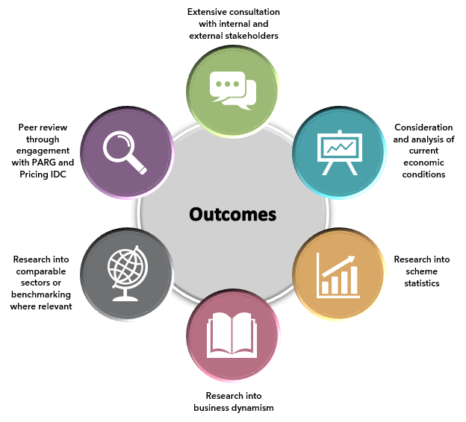
Research into the following areas provided the quantitative and qualitative aspects of evidence to inform the APR decisions:
- The current Australian economic climate including the healthcare and disability sectors. Detailed labour force and wage data for NDIS occupations and industries, and for comparable occupations and industries.
- Extensive consultations with a range of internal and external stakeholders through the Public Consultation, Pricing Arrangement Reference Group, Pricing Interdepartmental Committee as well as other government engagements.
- Impact from the global pandemic, impact of the SCHADS Award changes, the Aged Care Award reforms and the newly introduced family and domestic violence leave. All these form part of the DSW-related supports research.
- Scheme statistics for each of the topic in scope (DSW-related supports, therapy, plan management and support coordination). The statistics include the movements in terms of participant numbers and payments made.
- Analysing business dynamism of topics in scope, examining the number of provider entrants and exits as well as the general market dynamics.
- Additional benchmarking analysis for therapy in terms of comparison to other government insurance and funding schemes and private market billing rates.
All these factors were considered in developing the 2022-23 APR recommendations to ensure the decisions are robust and evidence based.

Domestic economic conditions and the care economy

3.1 Outlook
While Australia has withstood the impacts of the global pandemic, it is not immune to the intensifying global challenges. While the national economy is forecast to grow by 3.25% in 2022–23, the weaker global outlook, high inflation, cost-of-living pressures, and higher interest rates are expected to slow growth to 1.5% in 2023–24.
The National Disability Insurance Scheme (NDIS) exists within the broader care economy, which includes services that provide support to people with disabilities across various ages, as well as early childhood and aged care. Care economy services are delivered by a complex network of businesses, Government and Non-Government Organisations (NGOs), and individual workers. Care economy workers are employed across a diverse set of occupations at different skill levels. Often different segments of the care economy compete for workers.
Expenditure on the NDIS has grown rapidly since 2016. As of 2021-22, the NDIS had outstripped expenditure on Medicare and Aged Care. In 2022-23 the NDIS spend was $36.6 billion (or 1.44% of Gross Domestic Product (GDP). The 2023-24 Federal budget projects expenditure on the NDIS will reach $55.9 billion in 2026-27 (or 1.91% of GDP). Total NDIS expenditure is expected to grow at a faster rate than Government spending on the Pension, Medicare, Aged Care, and the Pharmaceutical Benefits Scheme (PBS) (Figure 3).
Figure 3: Federal Government Expenditure on Healthcare and Social Service industries from 2016-17 to projected 2026-27.
Internationally, Australian public spending on disability, as captured by the Organization for Economic Cooperation and Development (OECD), sits at 2.9% of GDP, the 8th highest of 38 OECD countries. The OECD captures this information under “spending on incapacity”, which refers to public spending due to sickness, disability, and occupational injury. The highest public spending in this category is in Denmark and Norway, which each spend 4.5% of GDP. This is above Australia’s ranking of 11th on health expenditure out of 28 OECD countries.
Gross Value Add (GVA) measures the economic output of an industry or sector, where the Healthcare and Social Assistance (HCSA) sector consistently outperforms the rest of the economy over recent years in term of annual average growth (Figure 4). Due to their ‘non-discretionary’ nature, the demand for health care and social assistance is relatively inelastic, meaning the HCSA industry is less likely to be as heavily impacted by economic shocks. Whilst output and employment growth did not turn negative during the pandemic for the HCSA sector, they are not fully immune to the general economic downturn.
Figure 4: Moving Annual Average Growth of gross value add for healthcare and social assistance sector compared to Average of all industries
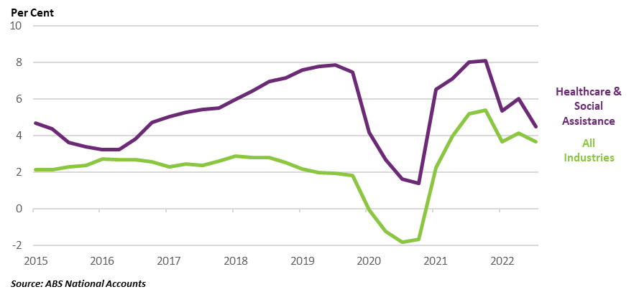

3.2 Inflationary pressures
One of the key challenges facing the economy is inflationary pressures where the Australian economy has experienced a sharp rise in the cost of living, with inflation rising to a multi-decade high post pandemic. This can lead to increasing cost pressures on providers delivering supports to NDIS participants, such as energy, supply chain, logistics, increased interest rates and property costs. This could negatively impact the availability and quality of goods and services provided as the cost of providing goods and services increases.
The health component of Consumer Price Index (CPI) in Australia has generally run above the economy wide CPI rate over the past seven years (Figure 5). This trend ended in 2022, with total CPI outstripping the health component of CPI. However as of the March quarter 2023, the health component has risen 5.3% through the year, and the gap between all industries and health CPI appears to be closing.
Figure 5: Overall and health specific cpi

3.3 Labour market conditions
Australia’s labour market has been resilient with a record low unemployment rate of 3.5% recorded in February 2023. The HCSA industry is the largest employing industry in the economy, employing 2.13 million persons in February 2023. Overall, by employment, the HCSA industry has been one of the fastest growing industries of the last ten years¹³, growing at 4.1% per annum on average, compared to an average of 1.7% per annum for all industries (Figure 6).
While quarterly employment did fall on two occasions over 2020 and 2021 coupled with a spike in underemployment, in general, the pandemic and associated restrictions did not impact the industry as much as other parts of the economy. Over 2022, employment in Healthcare & Social Assistance industry grew at its fastest rate on record¹⁵. On average, there were 9.9% more persons employed in HCSA than the number employed in 2021.
Figure 6: Moving Annual Average employment growth
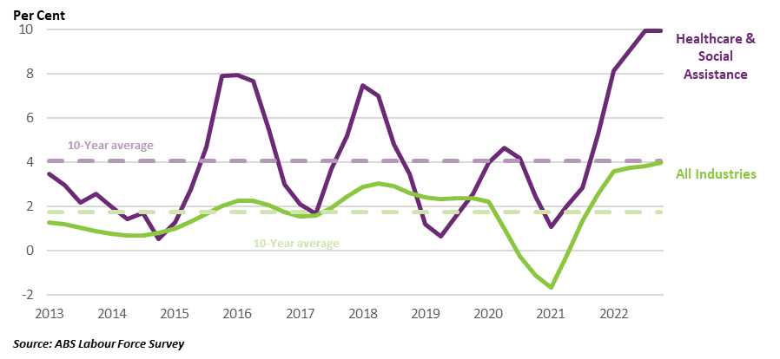
Strong employment growth is a key feature of the HCSA sector – it is observed that the proportion of persons that work in the HCSA sector has lifted from 11.9% of total employment in 2012 to 14.0% in 2022 (Figure 7). Factors that may have contributed to this growth are:
- The build-up of unmet demand for care services
- Growing demand underpinned by an aging population
- The continued expansion of the NDIS, and
- Strong demand for mental healthcare services.
Figure 7: Percentage of the workforce in the healthcare and social assistance sector
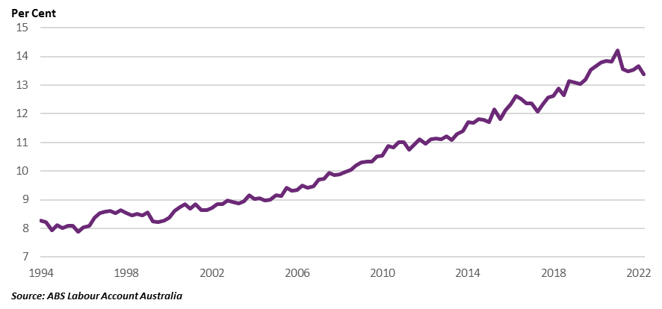

Analysis of ABS Census data shows strong employment growth between the 2016 and 2021. This includes Aged and Disabled Carers (227,535 in 2021, an increase of 72% since 2016), Occupational therapists (19,429 in 2021, an increase of 57%) and Speech Professionals & Audiologists (13,613 in 2021, an increase of 49%) see (Figure 8).
Figure 8: Growth in NDIS related occupations between 2016 and 2021 Censuses.
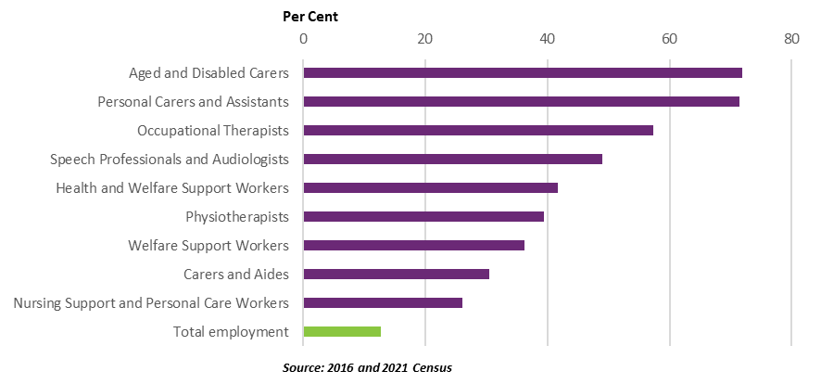
Mirroring this trend, the number of vacant positions in NDIS related occupations sector is also at record highs, indicating strong demand for workers in the sector (Figure 9). This further highlights the demand for workers in the HCSA industry and NDIS more specifically, with job vacancies in the industry doubling compared to pre-pandemic levels, averaging 66,000 over 2022, and the underemployment rate falling to 6.7%, the lowest rate since 2008.
Figure 9: Job vacancies in NDIS related occupations

Over the 4 years prior to the pandemic, nominal wages in HCSA industry were the fastest growing of all industries. Despite this, wages for those in the sector have also been growing at a slower rate than the price of goods and services meaning real wages have declined. However, relative to 2004 real wage growth in the HCSA sector remains above that of total real wage growth. This trend has made it challenging for some organisations to attract and retain staff as workers seek higher wages to compensate. This is an issue that all industries across Australia may be facing, not just within the disability and broader HCSA industry.
Figure 10: Index of real waGe growth in the HCSA sector and all INDUSTRIES (2004 = base of 100)
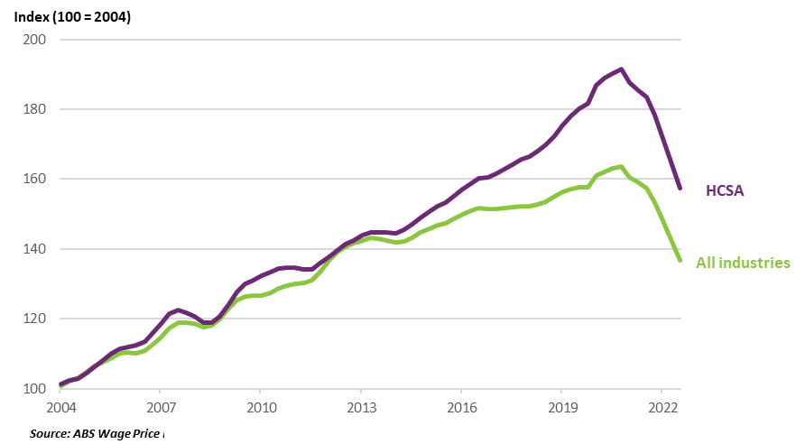

3.4 Future sector demand for support and workforce growth
As the Scheme continues to grow, the importance of a strong workforce to support the growing demand for services is highlighted. The Australian Government projects employment in HCSA sector to grow by 301,000 (or 15.8%) over the five years to November 2026, the second fastest growth of all 19 Australian and New Zealand Standard Industrial Classification (ANZSIC) industries. The Care Workforce Labour Market Study predicts that the care and support workforce will reach 3.9% of total employment by 2049-50, up from 2.9% in 2019-20¹⁸.
The National Skills Commission (now Jobs and Skills Australia) published the 2022 Skills Priority List Key Findings Report in October 2022. Many of the largest care related occupations by employment were found to be in shortage, including Aged or Disabled Carer, Nursing Support Worker and Personal Care Assistant.
Several reports project persistent skills shortages in the care economy into the future. The Care Workforce Labour Market Study from the National Skills Commission (Jobs and Skills Australia) forecasts a shortfall of about 100,000 care workers across the aged, disability and mental health care sectors by 2027-28, blowing out to 212,000 by 2050. A Centre for Economic Development (CEDA) report warns of a cumulative shortfall of 110,000 direct age care workers by 2030.
Migration is an important pillar supporting the growth in the care economy workforce. Overseas-born workers comprise around 40% of the care and support workforce in Australia. For this reason, the pandemic and associated restrictions on migration could have exacerbated labour shortages in the care economy. However, migration has rebounded strongly and is likely to alleviate some of the existing shortages.
In summary, these conditions suggest a strong demand going forward and a very tight labour market, which could pose challenges for businesses in finding workers to fill open positions.

Disability Support Worker related supports

4.1 Context
The National Disability Insurance Agency (NDIA) uses the National Disability Insurance Scheme (NDIS) Disability Support Worker (DSW) Cost Model 2022-23 to estimate the costs that a reasonably efficient provider would incur in delivering a billable hour of support. The Cost Model takes account of all the costs associated with a billable hour of support.
Parameters of the DSW Cost Model
The NDIS DSW Cost Model was simplified in 2022. No significant revisions to the Cost Model were undertaken this year given the scope of the current APR. The inputs to the current model are outlined below:
- Base salary and shift loading costs, including shift loadings. Note that in the Cost Model, costs are based on permanent worker costs. These are linked to Social, Community, Home Care and Disability Services Industry Award 2010 (SCHADS Award) wage levels 2.3, 2.4/3.1, 3.2 and 4.4.
- Direct on-costs, which covers those costs of employment associated with Superannuation entitlements, Annual Leave entitlements (20 days), Personal Leave entitlements (10 days), Long Service Leave entitlements (4.3 days) and Employee Allowances.
- Operational overheads, which covers those costs that are in the operational control of the provider and include supervision costs, quality and safeguarding costs, utilisation costs (billable versus unbillable hours), training costs, workers compensation costs, and workforce rostering costs including those related to share of the workforce that is permanent or casual, and the extent to which overtime is used.
- Corporate overheads, which covers those costs incurred to run the administrative side of a business. These costs include the accounting, human resources, legal, marketing, and information technology functions.
- Margin, which represents the return that the provider makes because of the provision of working capital to the business.
- Temporary loading introduced on 1 July 2022 to recognises the variable costs of COVID and of adjusting to the new provisions in the SCHADS Award.
The DSW Cost Model is driven by relevant DSW wages from the SCHADS Award, with the DSW Cost Model being multiplicative after salary and direct on-costs are calculated. What this means is that any changes to DSW wage inputs will have a flow on effect throughout the Cost Model’s calculations. That is, Overheads (Operational and Corporate) are calculated as a percentage of direct costs in the Cost Model. Margin is applied as a percentage of all costs to that point, with the Temporary Loading applied as a percentage of all costs at the end of calculations.
The DSW Cost Model is one factor considered in NDIS price setting along with other factors such as market conditions, the SCHADS Award, minimum wage conditions and mandatory superannuation contributions.
Proposed changes are suggested to incorporate the new family and domestic violence leave reforms, which were introduced from February 2023, see section 4.9.
Applicable industrial award
The national award for DSWs is the SCHADS Award. The NDIA recognises that some DSWs are classified as Home Care Employees and others are classified as Social and Community Services Employees under the SCHADS Award. The Cost Model take its parameters from the Social and Community Services Employees section for the SCHADS Award, which covers those costs that are in the operational control of the provider.
The NDIA recognises that providers can employ DSWs with different skill levels and levels of experience to meet the different needs of participants. The Cost Model therefore has different sets of cost assumptions for four types of workers (DSW Level 1, DSW Level 2, DSW Level 3 and DSW Level 4). This does not mean these are the only types of workers who can deliver NDIS supports through DSW-related supports.

4.2 Market overview
DSWs sit within the Healthcare and Social Assistance (HCSA) sector. In terms of employment, the HCSA has been the fastest growing industry of the last 30 years. As of February 2023, the HCSA industry accounted for 15.0% of employment and 7.6% of Australia’s total Gross Value Add (GVA). The industry is Australia’s largest, with over 2 million people and contains broad range of occupations, from surgeons to child carers. For this reason, caution should be used drawing parallels between changes in the growth of the HCSA industry and the DSW workforce.
The Department of Social Services and AlphaBeta provides the most recent direct estimate of the size of DSW workforce; as 241,000 disability support workers in 2020. This represented 13% of total HCSA employment at the time. Assuming DSW growth has been in line with growth of the HCSA industry, there would be roughly 280,000 DSW by the start of 2023. This is likely a lower bound estimate, evidence suggests the number of DSW workers likely grew faster than total HCSA employment in recent years.
Given that skills and qualifications are transferable between disability support, aged care and childcare support position, the NDIS providers compete for workers with aged care and childcare providers and changes in demand and wages for one care occupation can impact worker availability in the other care occupations.
Analysis of the wages offered by the major job platforms as at April 2023 shows that DSW wages are above that of aged care and childcare workers (Table 1). Analysis on major online employment platforms as of April 2023 suggests that the average hourly pay of DSW workers ($28.80 to $40.00) is higher than average hourly pay of aged care workers ($24.20 to $35.00) and childcare workers ($24.40 to $30.00). However, the NDIA acknowledges there are several non-monetary factors could influence workers decisions choosing one occupation over another, such as the trials and challenges of the specific type of work, leave benefits and job stability.
Table 1: Relative Advertised Wages of DSW, Child and Aged Carers as at April 2023 (Australian Average Wages $/hour)
Occupation | Employment | Seek | Indeed | PayScale
DSW | 241,000 (2020) | $30 - $40 | $35.43 | $28.80
Aged carer | 195,000 (2020) | $25 - $35 | $32.12 | $24.20
Child carer | 216,619 (2021) | $25 - $30 | $31.04 | $24.40
Source: NDIS Workforce Plan, CEDA, ECEC National Workforce Census. Estimates exclude nurses and allied health professionals. Wages from Seek; Indeed; PayScale

4.3 Scheme Statistics
As shown in Table 2, in the six months to December 2022, the NDIS had 252,637 participants receiving DSW-related supports from 97,608 providers. This is an increase of 15% and 28% respectively compared to the six months to December 2021. Additionally, the total amount claimed in the six months to December 2022 equates to $10.2 billion, an increase of 34% compared to the six months to December 2021. This represents a healthy growth to the demand and supply of the DSW market.
Table 2: DSW-Related Support Scheme Statistics
Statistics | July – December 2021 | July – December 2022 | Percentage Change
Total number of NDIS participants | 219,083 | 252,637 | +15%
Total number of active providers (includes registered and unregistered providers) | 76,064 | 97,608 | +28%
Total amount claimed | $7.6 billion | $10.2 billion | +34%
Source: NDIS internal administrative data
Table 3 shows a breakdown of the type of supports related to DSW and the number of active registered providers for each category. Over the six months to December 2022 compared to the six months to December 2021, all categories increased except one. The categories that experienced the largest supply growth were High Intensity Daily Personal Activities (21%), Assistance with Daily Life Tasks in a Group or Shared Living Arrangement (21%) and Participation in Community, Social and Civic Activities (17%). This demonstrates strong growth in most of the relevant registration groups with DSW-related supports.
Table 3: Number of Active Registered Providers by Category from which they Purchased DSW Supports, 31 December 2022
Category | Support | Number of active providers  July – December 2021 | Number of active providers  July – December 2022 | Percentage Change
0104 | High Intensity Daily Personal Activities | 3,111 | 3,759 | +21%
0115 | Assistance with Daily Life Tasks in a Group or Shared Living Arrangement | 2,721 | 3,302 | +21%
0125 | Participation in Community, Social and Civic Activities | 5,080 | 5,965 | +17%
0107 | Daily Personal Activities | 6,056 | 6,760 | +12%
0106 | Assistance in Coordinating or Managing Life Stages, Transitions and Supports | 3,005 | 3,341 | +11%
0102 | Assistance to Access and Maintain Employment or Higher Education | 333 | 364 | +9%
0136 | Group and Centre Based Activities | 2,510 | 2,642 | +5%
0117 | Development of Daily Living and Life Skills | 2,938 | 3,053 | +4%
0133 | Specialised Supported Employment | 611 | 578 | -5%
Source: NDIS internal administrative data
Note: The data is not collected from unregistered providers. Providers are duplicated where more than one service is provided.

4.4 Business Dynamism
To supplement the Scheme statistics, the NDIA has analysed registered provider payment activity. That is, payments made against Agency and Plan Managed plans are considered to be made by registered providers.
Figure 11 shows the number of registered DSW providers with the payments between July 2020 and December 2022, split by the number of half-year periods in which each provider received a payment. Half-years are defined as the six-month interval from January to June and July to December. As seen in Figure 11, 4,096 out of 12,636 (32%) registered providers have payments in all five half-years between July 2020 and December 2022. These providers account for 93% of the total payments across the two-and-a-half-year period.
Figure 11: REGISTERED DSW PROVIDER HALF-YEARLY PAYMENTS HISTOGRAM, JUNE 2020 – DECEMBER 2022
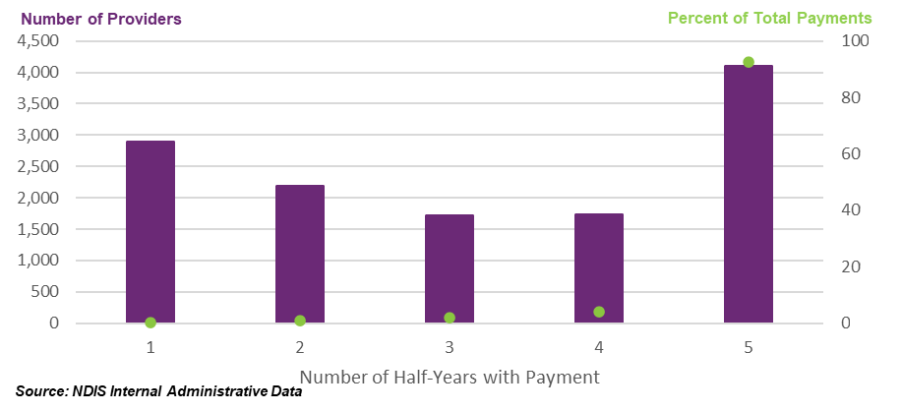
To further assess the current state of the provider market, payment activities of registered providers across the two-year period from January 2021 to December 2022 were analysed. Providers with New Activity in a half-year are defined as providers with payments who did not have payments in the prior half-year. Similarly, Inactivity in the half-year is defined as providers without a payment who had payments in the prior half-year. Activity for each provider is expressed as a percentage of the total payments for that half-year (for New Activity) or prior half-year (for Inactivity). The NDIA acknowledges that this is not a perfect measure of market exits but the closest approximation given available data.
Results suggest that over the past two years, inactive registered providers in each half-year contributed to less than 0.3% of total payments. In contrast, providers with new activity in a half-year have contributed between 1.1% and 1.5% of total payments over the same period.
Figure 12: DSW REGISTERED PROVIDER activity MOVEMENTS, january 2021 – DECEMBER 2022
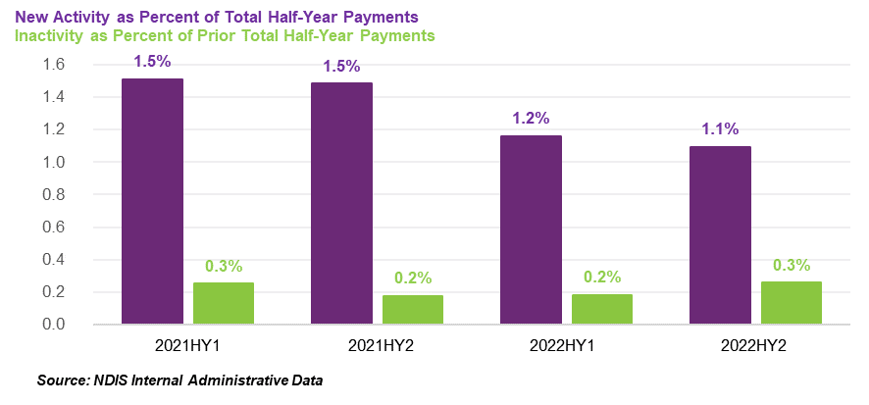
Further analyses indicate that on average, inactive registered providers received $11,932 in payments in the half-year prior to becoming inactive, with 86% of registered providers receiving less than $5,000 in the half-year prior to becoming inactive. In contrast, active registered providers received on average $786,138 of payments in each half-year period, highlighting that inactive registered providers have been claiming lesser amounts on average relative to new and existing registered providers.

4.5 Ability Roundtable benchmarking survey
Ability Roundtable conducts a comprehensive benchmarking survey. In 2023, 24 providers responded to the survey with data from the 2021-22 financial year. Not all respondents answered every question available in the survey, so the useable sample size was slightly smaller on each topic (SCHADS Award changes, COVID impacts, and Quality, Safeguarding and Compliance costs). Although the total sample of providers is small, these providers service a large part of the disability market which should be considered when interpreting the results. The collective revenue in 2022 was over $2.7 billion, with the average respondent reporting an operating loss of 3.7% in 2022.
Information received from the Ability Roundtable survey will be discussed further in this chapter. In summary, the Ability Roundtable survey reported uncertainties such as COVID and SCHADS related adjustments driving up costs with the magnitude very similar to the considerations that informed the 2% temporary loading that was granted from the 2021-22 APR.

4.6 Cost Impact of COVID
The impact of COVID was analysed through economic research as well as the Ability Roundtable survey.
In the 2021-22 APR, the impact of COVID was estimated to continue to increase for providers in the medium to long term. It was estimated that the base costs associated with COVID including PPE, additional overtime or leave usage at the time would increase for providers by 1.5%. This was considered in the 9% price rise to DSW from the 2021-22 APR.
In terms of domestic economic research on the impact of COVID since the last APR, the HCSA sector, the best proxy for the disability sector, performed relatively well during the pandemic compared to other sectors in Australia. Businesses in this industry were largely classified as essential, and as such, many workers in this industry continued working to provide critical healthcare and support services to the community. While there were challenges and disruptions to service delivery due to lockdowns and restrictions, the sector was able to adapt relatively quickly to new ways of working, such as telehealth and virtual consultations.
That said, during the pandemic, businesses operating in the care economy faced increasing COVID related costs. Temporary costs included those associated with PPE mandates, testing requirements, establishing new ways of working, such as telehealth, associated overtime and greater utilization of sick leave. However, all States and Territories have now lifted COVID public health orders, restrictions, directives, and mandates on businesses, with the majority ending in late 2022 or early 2023. Accordingly, some of the costs associated with Government COVID orders, such as PPE gear, and testing, have now dissipated. Nevertheless, an ongoing cost, referred to in several submissions from the public consultation is the cost of sick leave associated with staff contracting COVID and rostering to cover sick staff.
Although some providers experienced supply chain disruptions, the majority of NDIS services are labour intensive (that is, not reliant upon goods and capital equipment), hence a modest 11% of Healthcare & Social Assistance businesses reported supply chain disruptions, compared to 41% of all businesses. However, many care economy businesses reported having difficulty finding staff, 26% at both June 2021 and June 2022. The most common factors were lack of job applicants (79%) and applicants not having the relevant experience and qualifications (59%). This trend was likely driven by the decrease in migration over 2020 and 2021, which is an important source of disability workers, but also the decline in workforce participation. However, both migration and participation have since rebounded close to pre-pandemic levels.

Ability Roundtable survey on continuing impact of COVID on provider costs.
Most providers responding to the Ability Roundtable survey (71%) reported that COVID was still impacting on their costs in 2022. The other 29% reported that COVID was no longer affecting their businesses.
For providers who were reporting COVID was still impacting their costs, the average increase was 2.5% (median 2.0%). However, across all respondents providing estimates of cost impacts, the average increase in costs was 1.7%, and the median was 1.0%.
Unlike the impacts of SCHADS Award changes and Quality and Safeguarding compliance costs, which are more likely to be ongoing, qualitative responses indicated that COVID impacts are mostly temporary.
The most common reported cause of cost increases (30%) was PPE, RATs and other consumables. This was closely followed by staff sick leave costs (20%). Administrative, cleaning, agency staff, allowances and penalties accounted for 5 to 10%. Around another 10% was accounted for in commentary on training, quality and safeguarding and reporting costs, which are more likely to be ongoing.
In summary, the estimated cost impacts of COVID in 2022 by these providers surveyed was 1.7%. This is slightly higher than the last APR’s estimate of 1.5%.
It appears that many costs associated with COVID are fading post-pandemic and have more likely been temporary in nature. However, it should be acknowledged that COVID is still present in Australian but to a lesser degree than what it was this time last year.

4.7 Impact of SCHADS Award changes
On 1 July 2022, several significant changes to the SCHADS Award were implemented. In particular, casual and part-time workers were granted a minimum two-hour shift with other changes including increases in broken shift allowances, and on call and remote allowances. Information on the impacts of the SCHADS Award changes are still currently limited outside of qualitative feedback received and the benchmarking survey conducted by Ability Roundtable.
Most respondents to the survey (62%) reported that responding to the SCHADS Award changes had necessitated staffing number increases. However, a minority (24%) reported that the changes had resulted in decreased staffing.
Two thirds of respondents reported that their bottom-line costs had increased because of the SCHADS Award changes. Although it is worth noting that one third also reported that their costs had not increased as a result of the changes.
For those respondents reporting cost increases from the SCHADS Award changes, the average cost increase was 2.4%, and the median 2.0%. (One statistical outlier was removed.)
Across all respondents, the average cost increase was 1.5% (median 0.5%). It should be considered in the context of these survey respondents, as they may not be an accurate representation of the overall NDIS market. However, this information is still valuable for the Agency to understand the cost drivers, and how this might impact providers in general.
40% of those who said their staff numbers had decreased also reported that their costs had increased. This implies that the SCHADS Award changes also increased costs other than those directly related to staff costs. For example, a few respondents indicated having to spend more on software for new rostering systems.
A total of 60% of those who reported that staffing numbers had decreased also reported that bottom line costs had not increased. However, it is not possible to determine whether decreased staffing numbers translated into net cost savings, as the survey question only asked if costs had increased, not whether they had decreased.
It is important to distinguish between one-off adjustment costs from implementing a change, and on-going costs incurred thereafter. The most common comment (33%) on why costs had increased following the SCHADS Award changes were one-offs. These included matters such as purchasing new software, retraining current employees on the new rules, and changing rosters. Conversely, only a small minority (18%) of explanations of cost increases mentioned the new minimum two-hour shift requirement, which is a permanent change.
In summary, data-based analysis from Ability Roundtable indicates that the estimated impact of SCHADS Award changes on provider costs, average impact is 1.5% of total costs, was similar to what was anticipated by the 2021-22 APR. It is also considered that much of these costs borne by providers are likely one-off adjustments to the SCHADS Award changes.

4.8 Increases to superannuation contributions
From 1 July 2023, employer superannuation contributions will rise from 10.5% of wages to 11.0%.
Using the 2022-23 DSW Cost Model, the NDIA estimates this superannuation contribution increase to be, holding everything else constant, a raise to the cost of a standard hour of disability support worker supports from $62.17 to $62.45, or an increase of 0.45%

4.9 Impact of the new domestic and family leave reforms
The Australian Government has introduced paid family and domestic violence leave for all employees. Across Australia from 1 February 2023, employees of non-small business employers (15 or more employees) can access a minimum of 10 days of paid family and domestic violence leave in a 12-month period. Employees of small businesses will be able to access the same family and domestic violence leave entitlements from 1 August 2023. This is available to full-time, part-time and casual employees but will not be pro-rated for part-time or casual employees. For more information see the Fair Work Ombudsman’s Family and Domestic Violence Leave page.
Previous surveys and studies provide a useful reference point, with an estimate take up of family and domestic violence leave of 0.05% to 0.8% of employees. See Appendix B for more information on NDIA review of information on prevalence of domestic violence and surveys conducted on the utilisation of this leave in Australia.
In their submission the Australian Services Union suggested the use of a take up rate of 0.05% of employees, referencing the Fair Work Commission’s Survey. Note, this figure considers the take-up of unpaid leave, which may not be reflective of take-up for paid leave.
There is consideration that reported figures may be an underestimate of future adoption of the family and domestic violence leave by workers. Country wide adoption of family and domestic violence leave will likely result in Domestic and Family Violence leave being more widely known and better understood, which may reduce the stigma associated with accessing this type of leave.
Additionally, given the NDIS workforce is highly skewed toward female employees (77% from the 2021 Australian Census survey), consideration is given to the higher likelihood of those identifying as women experiencing violence and/or abuse.
On balance, the NDIA estimates an upper bound on the average number of workers accessing family and domestic violence leave to be 2.3%, with those accessing the leave assumed to be accessing the entire minimum entitlement.
Using the 2022-23 DSW Cost Model, the NDIA estimates this to be, holding everything else constant, an increase of 7 cents, or a 0.1% increase to the hourly standard, weekday daytime disability support.
The NDIA acknowledges this may be an overestimation of the actual up-take of this leave in the sector as it is implemented and will continue monitoring this into the future.

4.10 Anticipated Impact of Aged Care Award Change
The Fair Work Commission’s decision to lift the Aged Care Award and relevant workers’ wages by 15% will impact wages to workers in the Aged Care sector from July 2023 onwards. Given there are some skills overlaps between aged care and disability support, the NDIA anticipates a flow-on impact to the cost of disability support workers in the disability sector, and the NDIS. However, we expect the impact to limited.
The Award system is a substantial driver of wages, and thus the cost of support in the sector, by setting the minimum wages for the relevant industry. Many of the disability support workers delivering NDIS supports are paid under Schedule B of the SCHADS Award, which is a higher rate than aged care workers (even with the 15% increase). The NDIA’s DSW Cost Model uses a SCHADS Award, social and community services employee, Level 2, pay point 3 as the basis of setting the Standard disability support worker.
It is reasonable to consider this to be appropriately matched with the Aged Care Award Level 4 worker. The NDIA does acknowledge some supports delivered to NDIS participants could be delivered by other types of workers classified across other types of aged care employees, such as level 3 or level 5.
This matching is based on the type of work generally performed by this type of worker (personal care tasks by a “personal care worker grade 3”) and personal care support provided require working under limited supervision. Further the Aged Care Award level 4 worker can require a Certificate 3 or higher, while the SCHADS Award Level 2 worker requires a certificate 4 or higher.
Comparison of these Award worker wages highlights the difference that exists between the two Awards. From 1 July 2022, for a weekday daytime hourly wage, the full and part time SCHADS Award Level 2, pay point 3 is $32.37 per hour while the full and part time Aged Care Award Level 4 is $24.76 per hour. This currently equates to a difference of $7.61 per hour, or the SCHADS Level 2.3 worker rate to being 31% higher.
This current wage differential means with the 15% increase to the Aged Care workers, it will likely see the gap narrow between the two sectors with disability workers still higher by $3.90 per hour or 14%.
There are also non-wage reforms ongoing in the Aged Care sector aimed at improving the quality of care. These may have flow on impacts upon the available workforce for NDIS participants and the disability sector more broadly, but again the NDIA expects the impact to be limited. More information about these potential impacts on the NDIS can be found in Appendix C.
Overall, the NDIA acknowledges that the 15% increase to Aged Care worker wages and other reforms being undertaken in aged care are expected to make working in the aged care sector relatively more attractive than previously. On balance, the NDIA anticipates this is unlikely to have a major impact on the cost of similarly skilled workers, but workforce availability should continue to be monitored as these reforms are rolled out.

4.11 Impact of quality, safeguarding and compliance costs
The Ability Roundtable survey asked whether ‘the costs of complying with NDIS Quality and Safeguards Commission (NDIS Commission) regulations increased over the last 12 months and if so, by approximately what percent’. The majority (80%) of respondents reported that operating under the NQSC had raised their compliance costs over the past year.
For respondents reporting an increase in compliance costs, the average increase was 24% (median 21%). Across all respondents providing numerical estimates of cost increases, the average increase was 18% (median increase was 10%).
In summary, evidence from the Ability Roundtable indicates that compliance related costs are not a one-off and have been increasing over time.

4.12 Temporary Transformation Payment
The Temporary Transformation Payment (TTP) for many disability support worker-related supports was introduced 1 July 2019 to assist providers with transitioning their businesses into the NDIS. Transitional price levels represent the price necessary to attract new providers to enter the market or to reduce exits from the market. They represent the price required to attract economic resources to expand supply. Transitional price levels are above sustainable price levels but should only be adopted where a significant expansion of supply is required.
In line with the NDIS Pricing Strategy, the base price limits for supports delivered by disability support workers have, since 1 July 2019, been set in line with the estimated efficient costs of delivery. The TTP loading has been used to adjust these efficient prices to transition levels. The level of the loading was initially set at an amount equal to the difference between the estimated efficient cost of delivery and the estimated average cost of delivery. It was always intended that this amount would decrease over time as providers became more efficient.
Providers can claim for TTP under following groups of supports:
- Access Community Social and Recreational Activities
- Assistance With Self-Care Activities
- Group Activities
- Supports in Employment.
Given there are more than 150 different lines of supports related to TTP, more information on the specific price limits for the TTP loadings can be found in the current version of the Pricing Arrangements and Price Limits published on the NDIS website.
Scheme statistics
In the six months to December 2022, there were 8,287 active providers servicing over 107,480 participants (19% of the 573,342 active participants as of 31 December 2022), claiming over $1.84 billion in funding. Over the six months to December 2021, payments were made to 7,189 providers (15% less compared to the six months to December 2022) and amounted to $1.7 billion to pay services of 107,067 participants. The average amount claimed per provider decreased from $230k in the six months to December 2021 to $222k per provider in the six months to December 2022.
Table 4 below illustrates TTP Scheme statistics.
Table 4: TEMPORARY TRANSFORMATION PAYMENT SCHEME STATISTICS
Statistics | July – December 2021 | July – December 2022 | Percentage Change
Total number of NDIS participants | 107,067 | 107,480 | +0%
Total number of active providers | 7,189 | 8,287 | +15%
Total amount claimed | $1.65 billion | $1.84 billion | +11%
Average amount claimed per provider | $229,617 | $221,540 | -4%
Source: NDIS internal administrative data
As reported in the 2021-22 APR report, a significant number of providers who claimed for the TTP did not meet the TTP eligibility requirements. Only 64.1% of providers who claimed the TTP in 2020-21 completed the benchmarking survey for the 2019-20 financial year, and only 37.1% of providers who claimed TTP in the first half of 2021-22 completed the benchmarking survey for the 2020-21 financial year.
These numbers signalled there was a low response rate. The results suggest that using TTP in current form to encourage take up of the financial benchmarking survey has not been as successful as anticipated to collate information on providers’ financial bottom line.

4.13 Feedback from consultations
Of 304 submissions received, 19% (59) discussed disability support worker related supports. One of main themes raised was that there is still ongoing adjustment for many providers on costs related to quality, safeguards, and compliance, COVID and SCHADS Award changes. Participants also felt that there was a wide variance of skills among support workers delivering supports, and that these workers were generally paid at the NDIS price limit.
See Appendix A for more details on common themes raised in submissions to the 2022-23 APR Consultation Paper.

4.14 Recommendations
In determining the price limit for DSW-related supports, analyses suggest that the labour market for the care sector remains tight. These conditions could potentially intensify competition in terms of labour with other care sectors, which could put more pressure on supply going forward.
To ensure NDIS participant’s wellbeing and safety, it is considered appropriate to pass on minimum Award wages and national employment standard changes to superannuation for this to occur.
Recommendation 1
The NDIA, subject to any specific recommendation arising from the current Annual Pricing Review, should increase the price limits for supports that are determined by the NDIS Disability Support Worker Cost Model from 1 July 2023 to reflect any changes in the minimum wages specified in the Social, Community, Home Care and Disability Services Industry Award 2010 (SCHADS Award) following the Fair Work Commission’s Annual Wage Review and any increase in the Superannuation Guarantee Charge.
The 2% temporary loading introduced from 1 July 2022 in the DSW Cost Model was intended to be a temporary measure to assist providers adjust to costs such as COVID and SCHADS Award changes. The following considerations have been given:
- It should be recognised that COVID related restrictions in the economy have been wound back. However, COVID is still active in Australia and is likely to continue to disrupt supports being delivered to NDIS participants. Providers incur some costs when these arise (such as PPE and RAT tests). The NDIS sector also represents some of the most vulnerable groups in the community and the adjustments from the impacts of COVID has somewhat been slower than the rest of the nation.
- It appears many of the adjustments needed for the SCHADS Award changes were one-off costs for providers. It is considered that there is still ongoing adjustment being made by the sector as these major Award changes are still relatively recent. The NDIA recognises there is some cost impact that can still be borne by providers as it takes time for a sector to fully adjust systems and processes to major Award changes.
The NDIA considers that the majority of these costs have been addressed and/or winding back over the past year. COVID costs have been reducing post pandemic and many of the costs from the changes to the SCHADS Award were one-off adjustments. However, the NDIA acknowledges these have the potential to impact participant safety as some providers are still facing transition costs associated with both. Therefore, the NDIA considers it necessary to extend the temporary loading for a further 12 months at 1% from 1 July 2023 with this ceasing on 1 July 2024, to allow providers more time to adjust to these.
Recommendation 2
The NDIA should extend the temporary loading for a further 12 months at 1% from 1 July 2023 with this ceasing on 1 July 2024.
An additional consideration this year is the new paid family and domestic violence leave introduced by the Fair Work Commission. Based on previous surveys and studies, the NDIA estimates an upper bound number of workers accessing family and domestic violence leave to be 2.3%, with those accessing the leave assumed to be accessing the entire minimum entitlement.
The NDIA acknowledges this may be an overestimation of the actual up-take of this leave in the sector as it is implemented and will continue monitoring this into the future.
Recommendation 3
The NDIA should include the paid family and domestic violence leave into the Disability Support Worker Cost Model - an increase of 0.1% from 1 July 2023 to reflect the new entitlements for workers in the industry.
The Fair Work Commission has lifted the Aged Care Award wages by 15% from July 2023. The DSW Award rates are still estimated to be higher than the comparable Aged Care Award rates. However, there could be greater attraction of workers to the aged care workforce as the disability sector and aged care sector share the same pool of workers. Although the NDIA expects the impact of these changes to be limited, the NDIA should continue to monitor their impact.
Recommendation 4
The NDIA should continue to work with the sector to monitor the impact of changes to the Aged Care Award that come into effect on 1 July 2023 with a view to further addressing these costs in the future if necessary.
The TTP loading was initially setup to allow providers time to assist transitioning to more efficient systems and prices. The NDIA has conducted extensive financial benchmarking over the last six years to monitor this, and consequently, the NDIA does not consider that it is necessary to conduct a financial benchmarking survey in 2022-2023.
As per the initial pricing strategy framework, the NDIA does not see a need to change the timeline of the TTP to ensure balance is maintained between incentivising providers to achieve greater efficiencies while considering differing cost structures of providers. In the absence of a NDIS Financial Benchmarking Survey, is it reasonable to assume those who were accessing the TTP in FY2022-23 may continue to need access to assist transitioning systems.
Therefore, the NDIA considers it reasonable to continue reducing the TTP loading in the future as planned, from the current 3.0% to 1.5% on 1 July 2023 and then 0% from 1 July 2024. The NDIA will continue to work closely with the sector in monitoring market conditions and cost structures in the absence of a NDIS Financial Benchmarking Survey.
Recommendation 5
The NDIA should maintain its current pricing strategy including the scheduled reduction over the next year of the Temporary Transformation Payment (TTP) loading to 1.5% on 1 July 2023. The TTP loading should cease to apply from 1 July 2024.
The NDIA should allow registered providers who have been claiming for the TTP in financial year 2022-23 to continue to do so in financial year 2023-24 until cessation.

Therapy supports

5.1 Context
Therapy supports are important to participants and to the NDIS. They assist participants to build capacity to achieve their goals and they have the potential to reduce long term costs in the NDIS as they can support participants to improve capacity over time.
Therapy services are among the important supports available to NDIS participants. These supports are mainly delivered by Art Therapists, Audiologists, Counsellors, Developmental Educators, Dietitians, Exercise Physiologists, Music Therapists, Occupational Therapists, Orthoptists, Physiotherapists, Podiatrists, Psychologists, Rehabilitation Counsellors, Social Workers, and Speech Pathologists.
Therapy services can also be delivered by Therapy Assistants working under the delegation and direct supervision at all times of a therapist. Where a support is delivered by a therapy assistant, the therapy assistant must be covered by the professional indemnity insurance of the supervising therapist (or the therapist’s or therapy assistant’s employing provider).
Within the NDIS, most therapy is delivered under three provider registration groups:
- Therapeutic Supports (0128): Provision of a mix of therapies, to assist participants aged from 7 years to apply their functional skills to improve participation and independence in daily, practical activities in areas such as language and communication, personal care, mobility and movement, interpersonal interactions and community living.
- Early Intervention Supports for Early Childhood (0118): Provision of a mix of therapies, and a key worker for the family. Supports children 0-6 years with developmental delay or disability and their families to achieve better long-term outcomes, regardless of diagnosis.
- Exercise Physiology & Personal Well-being Activities (0126): Physical wellbeing activities promote and encourage physical well-being, including exercise.
Therapists also deliver supports under the following registration groups:
- Specialist Positive Behaviour Support (0110): Includes support items provided by allied health professionals with specialist skills in positive behaviour support including assessment and the development of a comprehensive plan that aims to reduce and manage behaviours of concern.
- Custom Prostheses and Orthoses (0135): Prescription and manufacture of customised prostheses or orthoses requiring specialist skills.
- Specialised Hearing Services (0119): Specialised hearing services for children and adults with complex needs.
- Hearing Services (0134): Hearing services for children and adults.
There are currently 14 different therapy support items within the Capacity Building Support Categories. These supports can be delivered to individual participants or to groups of participants. Where supports are delivered to groups of participants the hourly price limit is divided by the number of participants in the group. Price limits do not vary according to the Time of Day / Day of Week that the support is delivered. However, they do vary by state/territory and according to the Type of Therapist that delivers the support.
As well as direct service provision, therapists can claim for Non-Face-to-Face Support Provision, Provider Travel, Short Notice Cancellations and NDIA Requested Reports. They can also claim for any non-labour costs associated with claimable Provider Travel.
As Table 5 included below shows, there are separate price limits for supports delivered by:
- Art therapists, Audiologists, Dietitians, Developmental Educators, Music Therapists, Occupational Therapists, Orthoptists, Podiatrists, Social Workers, Speech Pathologists and Other Professionals
- Counsellors
- Exercise Physiologists
- Psychologists
- Physiotherapists
- Therapy Assistants.
Table 5: 2022-23 Price Limits for Therapy Supports
Type of Therapist | NSW / VIC / QLD / ACT | SA / WA / TAS / NT | Remote | Very Remote
Art Therapists | $193.99 | $193.99 | $271.59 | $290.99
Audiologists | $193.99 | $193.99 | $271.59 | $290.99
Dietitians | $193.99 | $193.99 | $271.59 | $290.99
Developmental Educators | $193.99 | $193.99 | $271.59 | $290.99
Music Therapists | $193.99 | $193.99 | $271.59 | $290.99
Occupational Therapists | $193.99 | $193.99 | $271.59 | $290.99
Orthoptists | $193.99 | $193.99 | $271.59 | $290.99
Podiatrists | $193.99 | $193.99 | $271.59 | $290.99
Social Works | $193.99 | $193.99 | $271.59 | $290.99
Speech Pathologists | $193.99 | $193.99 | $271.59 | $290.99
Other Professionals | $193.99 | $193.99 | $271.59 | $290.99
Counsellors | $156.16 | $156.16 | $218.62 | $234.24
Exercise Physiologists | $166.99 | $166.99 | $233.79 | $250.49
Physiotherapists | $193.99 | $224.62 | $314.47 | $336.93
Psychologists | $214.41 | $234.83 | $328.76 | $352.25
Therapy Assistants – Level 1 | $56.16 | $56.16 | $78.62 | $84.24
Therapy Assistants – Level 2 | $86.79 | $86.79 | $121.51 | $130.19
This chapter examines the pricing arrangements for therapy supports in the NDIS, including the extent to which they are appropriately aligned with those in comparable schemes, and with the private market for therapy supports.

5.2 Scheme Statistics
In the six months to December 2022, 325,319 participants (57% of the 573,342 active participants as of 31 December 2022) purchased therapy supports through their plans. These supports were delivered by 46,434 providers who received a payment in the six months to December 2022, a 14% increase to provider numbers compared to six months to December 2021.
The amount claimed rose by 26% to $1.6 billion over the six months to December 2022 compared to the six months to December 2021. More therapy support statistics can be seen in Table 6.
Table 6: THERAPY Supports SCHEME STATISTICS
Statistics | July – December 2021 | July – December 2022 | Percentage Change
Total number of NDIS participants | 279,098 | 325,319 | +17%
Total number of active providers | 40,744 | 46,434 | +14%
Total amount claimed by active providers of Therapy supports | $1.3 billion | $1.6 billion | +26%
Number of active registered providers of Therapy supports | 8,833 | 8,900 | +1%
Number of active unregistered providers of Therapy supports | 32,133 | 38,114 | +19%
Average amount claimed by all active providers of Therapy supports | $31,627 | $34,947 | +10%
Total amount claimed by registered providers of Therapy supports | $0.99 billion | $1.16 billion | +18%
Average amount claimed by registered providers of Therapy supports | $112,093 | $130,738 | +17%
Total amount claimed by unregistered providers of Therapy supports | $0.29 billion | $0.45 billion | +55%
Average amount claimed by unregistered providers of Therapy supports | $9,043 | $11,790 | +30%
Source: NDIS internal administrative data
Note: Please note the number of ‘active registered providers of Therapy supports and number of ‘active unregistered providers of Therapy supports’ do not align with the total number of ‘active providers’. There are two reasons for this; 1) One provider can provider multiple supports with being registered for some types of support provided and unregistered for others (different registration groups) in the same period so they are accounted for in both groups of providers; 2) Providers with the unknown registration are captured in total amounts but not presented in this table as they make up less than 1% of total payments.
Figure 13 below shows the quarterly breakdown of Scheme expenditure on therapeutic supports and proportion of the overall Scheme expenditure. Therapeutic supports make 9.7% or $817.1 million of total scheme costs in the three months to December 2022. As shown on the chart above, these supports hover around 9.4% of the total Scheme costs for the last 9 quarters.
Figure 13: NDIS expenditure on Therapy supports since December 2020 quarter relative to total NDIS expenditure
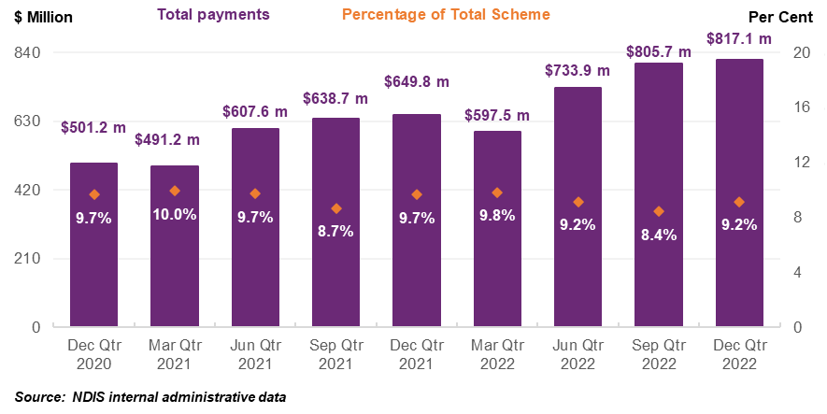
Participants
From the 325,319 participants with a claim for therapy supports from their plan in the six months to December 2022, the most common therapist support is for “Other Professionals” ($254.4 million claimed), followed by Occupational Therapists (for $280.9 million claimed) and Physiotherapy ($248.0 million). Noting participants can use and claim more than one type of therapist/therapy. A more detailed breakdown can be seen in Table 7.
The overall average payment for a participant receiving therapy supports in the six months to December 2022 was $4,988, up 8% compared to $4,617 in the six months to December 2021. The average amount claimed per provider over the six months to December 2022 was $34,947, up 10% compared to the six months to December 2021 ($31,627).
Table 7: SCHEME EXPENDITURE BY TYPE OF THERAPY, july to december 2022
Type of Therapist | Number of Participants | Number of Providers | Total Amount Claimed
Occupational Therapists | 162,532 | 7,279 | $280.9 m
Other Professionals | 179,476 | 25,544 | $254.4 m
Early Childhood | 69,250 | 10,362 | $248.0 m
Behavioural Therapists | 42,385 | 1,290 | $207.7 m
Physiotherapists | 85,965 | 10,249 | $166.5 m
Psychologists | 82,372 | 11,631 | $138.7 m
Speech Therapists | 89,033 | 5,896 | $135.4 m
Exercise Physiologists | 36,197 | 4,704 | $64.9 m
Therapy Assistants | 35,066 | 3,576 | $35.5 m
Counsellors | 20,043 | 4,552 | $26.9 m
Dietitians | 19,875 | 2,052 | $15.9 m
Social Workers | 8,101 | 1,356 | $11.4 m
Travel | 50,863 | 7,596 | $8.9 m
Miscellaneous | 4,628 | 2,777 | $7.4 m
Podiatrists | 20,111 | 2,483 | $6.4 m
Music Therapists | 3,907 | 819 | $5.2 m
Art Therapists | 3,539 | 1,033 | $4.2 m
Development Educators | 2,132 | 333 | $3.4 m
Orthoptists | 1,206 | 280 | $0.6 m
Rehabilitation Counsellors | 443 | 280 | $0.3 m
Audiologists | 729 | 181 | $0.3 m
TOTAL  July-December 2022 | 325,319 | 46,434 | $1.6 b
Source: NDIS internal administrative data
Note: Please note the above totals for number of participants and number of providers are based on unique participants and providers over the six months to December 2022. The group of “Other Professionals” delivering therapy encapsulate assessments, recommendations, and group therapies which could have been delivered by a range of therapists not otherwise listed.
This section has highlighted the growing demand of participants accessing therapy supports in the NDIS (up 14% in the six months to December 2022 compared to six months to December 2021). Many of whom require access to a wide range of therapy services delivered in the NDIS to support different participant needs. As such, the NDIS requires a diverse range and stable supply of therapists to best support participants and ensure they receive quality outcomes.
Providers
As seen in Table 7 above, were 46,434 providers who claimed for therapy services in the six months to December 2022. The therapist supports with the highest number of providers claiming these supports were for “Other Professionals” (25,544), Psychologists (11,631), Professionals delivering Early Childhood supports (10,362) and Physiotherapists (10,249).
In the six months to December 2022, there were 8,900 registered providers who delivered therapy services compared to 8,833 in the six months to December 2021. However, of the $1.6 billion claimed by providers in the six months to December 2022, $1.2 billion was made to registered providers, up from $990 million in the six months to December 2021.
This, however, represents a drop in the proportion of therapy payments being made to registered providers compared to the same period in the previous year (77% compared to 72%). This was due to the number of payments being made to unregistered providers increasing from 23% to 28% across these periods. A monthly breakdown can be seen in Figure 14.
Figure 14: TOTAL PAYMENTS FOR THERAPY SUPPORT ITEMS BY PROVIDER REGISTRATION, 2021 – 2022
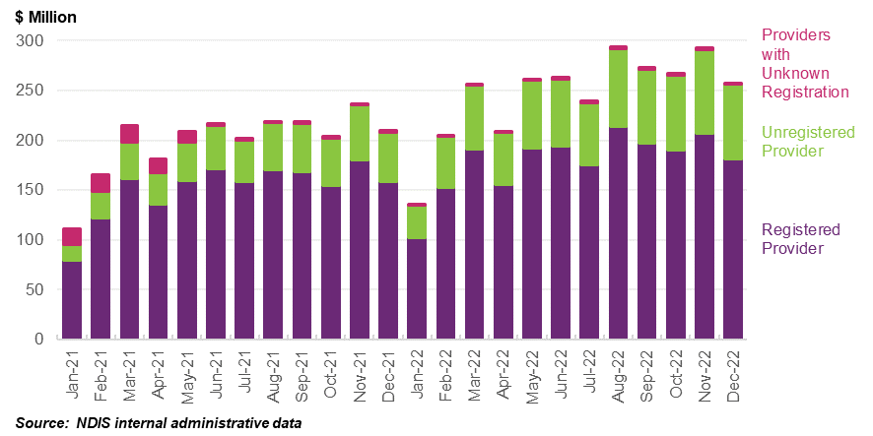
In the six months to December 2022, the top five types of therapists (excluding “Other Professionals”) claimed against in the NDIS, based on total payments, were Occupational Therapist ($280.9 million), Professionals delivering Early Childhood ($248.0 million), Behavioural Therapists ($207.7 million), Physiotherapists ($166.5 million) and Psychologists ($138.7 million). These five types of therapists accounted for $1.0 billion worth of claims, comprising 64%, close to two thirds of the $1.6 billion NDIS expenditure on therapy.
It should be noted that prior to 1 July 2022, many types of therapists were not categorised into individual support items and were included in the “Other Therapy” support. The breakdown of these types of therapists were not captured until after this date. Since 1 July 2022, it can be reasonably assumed that many of the supports delivered under “Other Professionals” were likely through Occupational Therapists and Speech Pathologists. The other most claimed types of therapies delivered appear to be relatively stable since December 2020 quarter. These are shown in Figure 15.
Figure 15: largest ten therapy types based on total payments, OCTOBeR 2020 – DECEMBER 2022
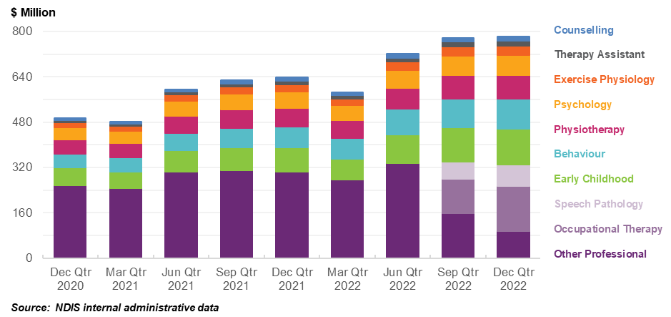
Note: Please note in the above chart Occupational Therapy and Speech therapy are introduced as standalone lines of supports from July 2022. Before July 2022 these lines of supports were claimed by providers under other groups of therapy without clear indicators of supports provided.
This section has shown the increase in supply of providers delivering therapy supports to NDIS participants. However, with the growing number of NDIS participants receiving therapy supports, this may put pressure on the number of therapists needed to continue supporting NDIS participants.

5.3 Employment Statistics
On current reported data through Australian Health Practitioners Registration Agency (AHPRA), as of February 2023, the Department of Health and Aged Care’s Allied Health Factsheets Dashboard stated there are:
    - 41,791 Psychologists registered with AHPRA. The number of registrations grew by 20.3% between 2017 (34,752) and 2021.
    - 38,882 Physiotherapists registered with AHPRA in 2021, up by 25.8% from 30,916 in 2017.
    - 26,904 Occupational Therapists registered with AHPRA. The number of registrations grew by 33.6% between 2017 (20,145) and 2021 (26,904).
    - 5,819 Podiatrists registered with AHPRA, up by 18.8% from 4,900 in 2017.
The total number of Psychologists, Physiotherapists, Occupational Therapists and Podiatrists registered with AHPRA has grown significantly in the last five years, up 26% from 90,713 in 2017 to 113,396 in 2021, whilst those registered with AHPRA and are employed has increased by 26% from 73,350 in 2017 to 92,406 in 2021 (see Figure 16).
Figure 16: NUMBER OF REGISTERED THERAPISTs, 2017 TO 2021
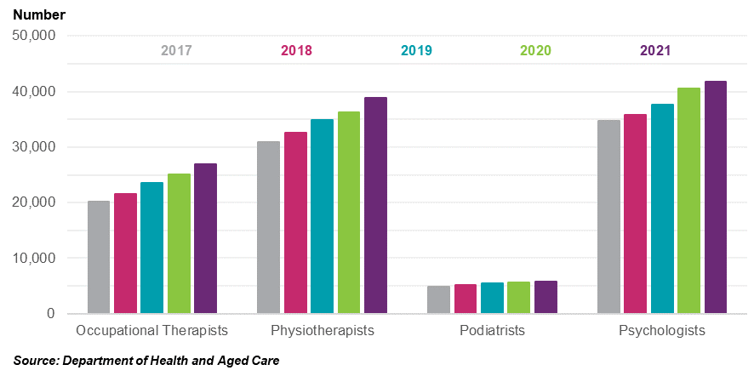
Jobs and Skills Australia (formerly known as National Skills Commission) projects employment growth of the entire Australian workforce for five years to November 2026 at 9.1%. The growth in the therapy space will continue over this period with therapists making up three of the 11 fastest growing occupations, those being Audiologists and Speech Pathologists (34.7%, close to four times the projected rate of growth of the entire Australian workforce over that period), Podiatrists (31.8%) and Physiotherapists (28.7%), as shown in Table 8.
Table 8: GROWTH IN EXPENDITURE ON THERAPY BY FUNDING SOURCE, 2016-17 TO 2019-20
Occupation Code | Occupation | Employment level – November 2021 | JSA Projected employment level – November 2026 | JSA Projected employment growth – five years to November 2026 | JSA Projected employment growth – five years to November 2026
2527 | Audiologists and Speech Pathologists/Therapists | 12,300 | 16,600 | 4,300 | 34.7%
2526 | Podiatrists | 6,400 | 8,500 | 2,100 | 31.8%
2525 | Physiotherapists | 32,800 | 42,200 | 9,400 | 28.7%
2522 | Complementary Health Therapists | 6,300 | 8,000 | 1,800 | 27.9%
2721 | Counsellors | 24,400 | 27,800 | 3,500 | 14.2%
2723 | Psychologists | 31,000 | 35,100 | 4,100 | 13.3%
2524 | Occupational Therapists | 23,900 | 25,600 | 1,800 | 7.4%
2511 | Nutrition Professionals | 7,900 | 8,500 | 600 | 7.2%
Source: Employment Projections | National Skills Commission (now Job and Skills Australia)
These projections highlight strong future demand for therapists in Australia, with the NDIS being one of the contributors to this demand.

5.4 Business Dynamism
To supplement the Scheme statistics, the NDIA has analysed registered provider payment activity. That is, payments made against Agency and Plan Managed plans are considered to be made by registered providers.
Figure 17 shows the number of registered Therapy providers with the payments between July 2020 and December 2022, split by the number of half-year periods in which each provider received a payment. Half-years are defined as the six-month time intervals from January to June and July to December. As seen in Figure 17 below, 5,219 out of 12,112 (43%) registered providers have received payments in all five half-years between July 2020 and December 2022. These providers account for 92% of the total payments across the two-and-a-half-year period.
Figure 17: registered therapy provider half-yearly payments histogram, june 2020 – december 2022
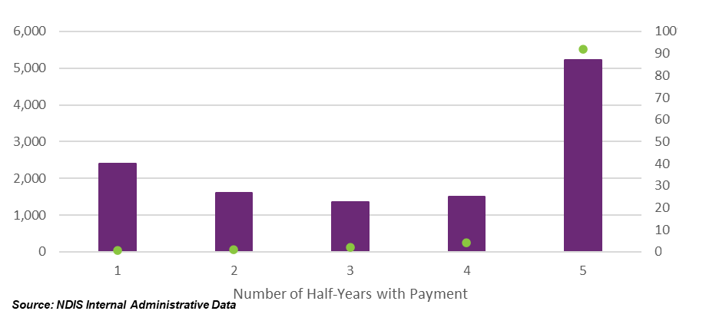
To further assess the current state of the provider market, payment activities of registered providers across the two-year period from January 2021 to December 2022 were analysed. Providers with New Activity in a half-year are defined as providers with payments who did not have payments in the prior half-year. Similarly, Inactivity in the half-year is defined as providers without a payment who had payments in the prior half-year. Activity for each provider is expressed as a percentage of the total payments for that half-year (for New Activity) or prior half-year (for Inactivity). The NDIA acknowledges that this is not a perfect measure of market exits but the closest approximation given available data.
Results suggest that over the past two years, inactive registered providers in each half-year contributed to less than 0.7% of total payments. In contrast, registered providers with new activity in a half-year have contributed between 1.4% and 1.9% of total payments for that same period.
Figure 18: therapy REGISTERED PROVIDER activity MOVEMENTS, january 2021 – DECEMBER 2022
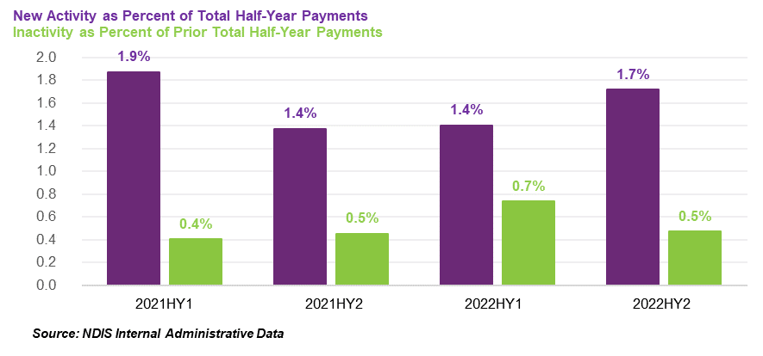
Further analyses indicate that on average, inactive registered providers received $4,234 in payments in the half-year prior to becoming inactive, with 84% of registered providers receiving less than $5,000 in the half-year prior to becoming inactive. In contrast, active registered providers received on average $107,199 of payments in each half-year period, highlighting that inactive registered providers have been claiming lesser amounts on average relative to new and existing registered providers.

5.5 Comparable Government Insurance and Funding Schemes
The NDIA conducted a comparison of therapy price limits and arrangements across other comparable public schemes. This is based on the NDIA’s calculations using information published by other schemes as of 31 March 2023; and additional information obtained directly through engagement with other schemes. The NDIA has engaged with sixteen Commonwealth and State Schemes to obtain their therapy pricing as comparison to NDIS limits.
The main Medicare Benefits Schedule (MBS) items for allied health have a scheduled fee of $65.85 per 20 minutes session. This equates to an effective hourly rate of $197.55 which is slightly higher than the NDIS hourly price limit. Note, the Commonwealth funding (MBS benefit) for the hour is $167.92, but co-payments are common in the MBS and the scheduled fee is a better estimate of the total cost of the support – or at least of the Australian Government’s public position on the appropriate cost of the support.
To calculate the effective hourly price limit, NDIA sought information about the regulated length of therapy sessions (for example, the NDIS’ price limits for therapy are per hour). Where this was not already available, this information was requested directly from other schemes. For comparability, the NDIA generally used standard or subsequent consultations where possible whilst noting many Schemes have differentiated items and/or pricing for initial consultations and standard/extended consultations.
The NDIA were able to calculate the effective hourly price where the length of a session was provided as a required length (for example, price per 20 minutes); as a required minimum length (for example, price for at least 20 minutes); or as an average session time expected based on the observed length of sessions. In all other cases, the NDIA were unable to calculate the effective hourly price, and not able to directly compare these prices, so these do not appear in Figure 19 below.
Overall, NDIS prices are in line for most types of therapies. As Figure 19 illustrates, the current NDIS price limits are broadly consistent with the effective hourly rates paid by other schemes, once proper account is taken of duration of service, co-payments and provisions for travel and consumables.
However, results this year indicate that many types of therapies have been indexed by other schemes over the past year. This appears to have put NDIS into the middle/lower range for some therapies offered by Professionals, such as Counsellors, Occupational Therapists and Rehabilitation Counsellors.
Figure 19: OTHER SCHEME PRICING COMPARED TO NDIS, 2022-23
Source: Data from other schemes with NDIA internal calculations

5.6 Private Billing Rates
This section analyses a data set of 6,053 private billing rates for therapy services, including 2,857 billing rates for weekday in-room services.
The private billing dataset was compiled by the NDIA by scanning provider websites across Australia. Prices for weekend, initial and telehealth consultations were excluded from the dataset. Outliers were also removed from the dataset as well as some therapy services, including Teachers, Personal training, Osteopathy, and Therapy assistants. The billing rates were converted to effective hourly rates based on the length of consultation. Some 34% of the sample observed billing rates were from non-metropolitan areas.
Among therapy services, the top four therapists in the sample were Physiotherapists (17.6%), Psychologists (15.2%), Clinical Psychologists (10.2%) and Dietitians (10.0%). Art Therapists and Music Therapists each accounted for less than 3% of the sample. There were at least 80 observations for each type of therapists besides Art Therapists (33). Figure 20 shows the distribution of the sample for types of therapies, some of which have widely dispersed and significant overlap in pricing.
Figure 20: Distribution of PRVIATE BILLING rates by therapy type
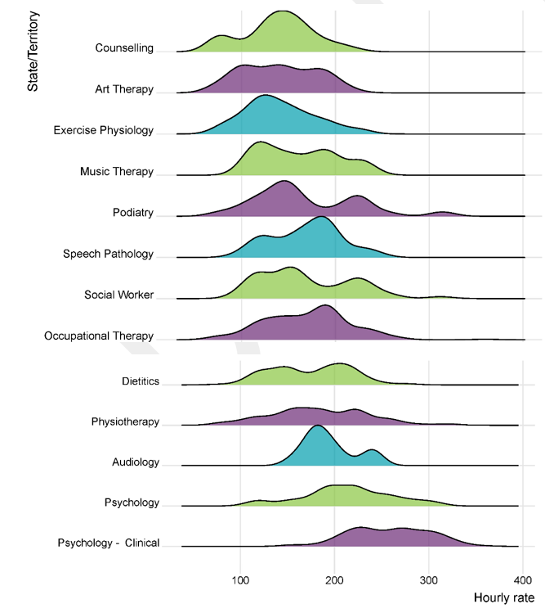
The geographic distribution of the sample observations was slightly skewed towards Victoria (30% of the sample) and Queensland (32%) with New South Wales underrepresented (15%). Australian Capital Territory was the only state or territory with less than 30 observations (18). Figure 21 for the distribution of private billing rates across states, which show significant overlap in dispersion and overlap. It is also clear some states and territories show multi-model distribution in pricing (such as the Northern Territory and Tasmania), which aligns to different pricing for different therapies in the sample.
Figure 21: Distribution of Private Billing rates by State
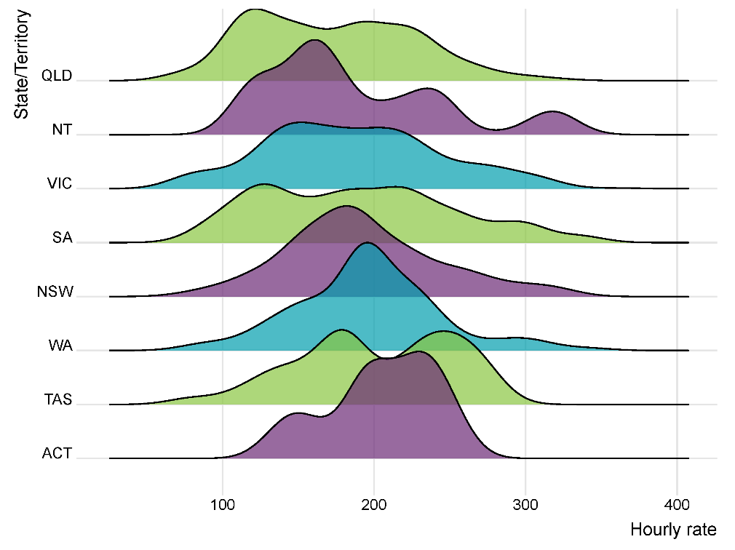
Table 9 displays summary distributional statistics of the sample of private billing rates. The average effective hourly rate for weekday in-room therapists in the sample was $184 (median $185). The smallest effective hourly rate that was observed in the data set was $73 and the largest was $360.
Table 9: SUMMARY STATISTICS OF PRIVATE BILLING RATE SAMPLE, BY THERAPY TYPE
Type of Therapy | Count | Mean | Standard Deviation | Minimum | 25th percentile | Median | 75th percentile | Maximum
Art Therapists | 33 | $140.2 | 39 | $73.3 | $100.0 | $135.0 | $177.5 | $216.0
Audiologists | 90 | $194.6 | 26 | $156.7 | $175.0 | $187.5 | $210.0 | $240.0
Counsellors | 186 | $138.8 | 36 | $75.0 | $120.0 | $140.0 | $160.0 | $220.0
Dietitians | 287 | $174.9 | 41 | $80.0 | $140.0 | $180.0 | $210.0 | $280.0
Exercise Physiologists | 190 | $140.7 | 36 | $73.3 | $119.0 | $134.2 | $167.0 | $227.0
Music Therapists | 81 | $161.1 | 41 | $100.0 | $119.0 | $154.0 | $194.0 | $240.0
Occupational Therapists | 237 | $169.3 | 42 | $75.0 | $140.0 | $172.0 | $194.0 | $264.0
Physiotherapists | 502 | $183.9 | 51 | $75.0 | $150.0 | $180.0 | $220.0 | $322.0
Podiatrists | 184 | $168.4 | 55 | $75.0 | $130.0 | $150.0 | $220.4 | $313.5
Psychologists | 434 | $212.8 | 47 | $108.0 | $189.8 | $215.5 | $246.5 | $312.0
Psychologists – Clinical | 292 | $258.4 | 42 | $150.0 | $228.0 | $260.4 | $291.6 | $360.0
Social Workers | 107 | $169.2 | 49 | $93.3 | $120.0 | $156.2 | $216.0 | $312.0
Speech Pathologists | 234 | $169.0 | 36 | $95.0 | $140.0 | $174.2 | $193.3 | $250.0
Total Sample | 2,857 | $184.4 | 55 | $73.3 | $140.0 | $185.0 | $220.0 | $360.0
Statistical models were built for the private billing data set (see Table 10). A series of Tukey’s range tests were undertaken to group therapy types with similar private billing means. The test found that Audiologists, Dietitians, Music Therapists, Occupational Therapists, Physiotherapists, Podiatrists, Social Workers, Speech Pathologists (group 1 – base case) had similar means, while Counsellors, Exercise Physiologists and Art Therapists (group 2), also had similar means. The modelling began with indicator variables for each state/territory (model 1), plus a regional indicator variable (model 2) and one including the aforementioned variables and groups of therapies (model 3). Model 4 was also run that includes all states, a regional indicator and all therapy types individually, with New South Wales and Occupational Therapists as the base case. Sensitivity testing was also run on various interaction terms between the States and Territories, regional indicator and therapy types were also investigated, many of which were insignificant.
Table 10: STATISTICAL MODELS OF PRIVATE BILLING RATES
Variable | (1) | (2) | (3) | (4)
Constant | 193.1*** | 202.2*** | 188.9*** | 183.8***
Victoria | -6.1 | -12.1*** | -8.9*** | -11.0***
Queensland | -20.6*** | -20.8*** | -19.2*** | -18.4***
South Australia | -3.3 | -9.2 | -10.9** | -12.4**
Western Australia | 3.0 | -3.4 | -7.5* | -7.6*
Northern Territory | -6.0 | -0.7 | -6.9** | 9.0*
Australian Capital Territory | 12.0 | 2.9 | -7.9 | -6.5
Tasmania | 8.2 | 12.9 | 19.2** | 13.7*
Regional | N/A | -19.5*** | -11.9*** | -12.5**
Exercise Physiologists, Counsellors & Art Therapists | N/A | N/A | -34.9*** | N/A
Psychologists | N/A | N/A | 38.7*** | 44.5***
Clinical Psychologists | N/A | N/A | 80.7*** | 85.6***
Art Therapists | N/A | N/A | N/A | -30.4***
Audiologists | N/A | N/A | N/A | 25.9***
Counsellors | N/A | N/A | N/A | -32.5***
Dietitians | N/A | N/A | N/A | 5.4
Exercise Physiologists | N/A | N/A | N/A | -25.3***
Music Therapists | N/A | N/A | N/A | -3.9
Physiotherapists | N/A | N/A | N/A | 12.8***
Podiatrists | N/A | N/A | N/A | -1.1
Social Workers | N/A | N/A | N/A | 3.5
Speech Pathologists | N/A | N/A | N/A | -1.3
Adjusted R² | 0.024 | 0.048 | 0.369 | 0.38
F Statistic | 11.03 | 19.04 | 152.8 | 87.9
Observations | 2,857 | 2,857 | 2,857 | 2,857
(* = p <0.05, ** = p < 0.01, *** = p<0.001)
Model 3 is preferred to Model 4 as the small increase in R-squared between Model 3 and Model 4 does not adequately compensate for many variables in Model 4 being insignficant at the 5% level.
The explanatory power of model is only 37%, which suggest that there are many other factors affecting therapy pricing that are not currently captured in the model.
The results suggests the average hourly price of $189 for the majority of therapists in New South Wales, with most other states and territories suggested to be at lower price. This suggests that the NDIS price limits are still adequate for most therapists. Results also show that price limits of non-clinical Psychologists, Counsellors and Exercise Physiologists appear on par with NDIS price limits.

5.7 Consultation feedback
The topic of therapy supports received the most feedback through public consultation, with 174 submissions out of 304 (57%) documenting concerns and commentary. Many providers suggested the biggest cost driver has been the increasing supply costs and wages. Other costs involved attracting, training, and retaining staff, as well as quality, safeguarding and compliance costs. Many participants and their representatives who responding through the consultation process suggested that they were charged more than non-NDIS clients and generally supported no further price increase at this time.
See Appendix A for more details on common themes raised in submissions to the 2022-23 APR Consultation Paper.

5.8 Recommendations
On balance, available therapy data suggest that NDIS price limits for therapy supports are currently adequate. Available evidence from comparable government insurance and funding schemes and private market billing rates supports this.
The recommendations also consider the growing demand of NDIS participants claiming for therapy supports (17%) is being met to an extent by growth in the providers claiming for therapy supports (14%). There has been growth in several Therapy Professionals in the past few years, and further supply growth is anticipated in a number of therapists in the coming years which should assist with potential easing of workforce shortages that may exist in certain regions.
It is also evident that the therapy market is vast and diverse in nature as are the needs of NDIS participants. As the NDIS Review is currently examining non-price related solutions, the NDIA should consider structural changes to therapy pricing arrangements after any relevant recommendations from the NDIS Review.
Recommendation 6
The NDIA should not make any structural adjustment to the pricing arrangements for therapy supports at this time and should not index the price limits for therapy supports on 1 July 2023.
Recommendation 7
The NDIA should consider the structure of therapy support pricing arrangements after any relevant recommendations from the NDIS Review. This intends to better incentivise quality service provision to NDIS participants and create greater market efficiencies.

Support coordination

6.1 Context
Support coordination is a capacity building support that is funded by the NDIS. It plays an important role in helping participants to make the most of their NDIS plans and to pursue their goals. Support coordinators help participants in various ways depending on what the individual participant’s goals, needs and circumstances are.
This can include helping a participant connect to NDIS funded and mainstream supports, by brokering supports and services in line with a participant’s wishes and their plan budget. Support coordinators can also help with building a participant’s capacity and capability to understand their plan, navigate the NDIS and make their own decisions. In addition, they monitor plan budgets and support effectiveness.
Support coordinators require a detailed understanding of what service offerings are available in a participant’s local market, and to actively help participants to find service providers who meet their needs and preferences. This can include sourcing and connecting participants to alternative service providers, which can be integral for participants to maintain continuity of supports and services. Support coordinators also need to be able to link participants to mainstream, community and informal supports where appropriate. They should be innovative and take initiative when helping participants to broker supports and services in line with their support preferences and plan budgets. Support coordinators must comply with the NDIS Code of Conduct, which requires, among other things, that supports and services are provided in a safe and competent manner, with care and skill. Support coordinators are not required to be registered. However, support coordinators who are registered to deliver supports in registration group 106 (Assistance in coordinating or managing life stages, transitions, or supports) must comply with the Core module of the NDIS Practice Standards. The Core module includes standards for the rights of participants and responsibilities of providers, provider governance and management and the way that support is provided. Support coordinators registered to deliver supports in registration group 132 (Specialised Support Coordination), must also comply with Module 4 of the NDIS Practice Standards. Module 4 includes additional standards for the provision of support and management of conflict of interest.
The NDIA has developed a pricing framework that considers the different levels of support coordination required by participants, ranging from support connection to high-level Specialist support coordination. The pricing arrangement for support coordinators in the NDIS intends to offer a fair and sustainable funding model for the delivery of support coordination services, allowing participants to receive the assistance they need to lead fulfilling lives.
Support coordinators are currently able to claim for the following four types of services:
- Level 1: Support Connection assists a participant to implement their plan by strengthening their ability to connect with the broader systems of supports and to understand the purpose of the funded supports.
- Level 2: Coordination of Supports strengthens a participant’s ability to design and then build their supports with an emphasis on linking the broader systems of support across a complex service delivery environment.
- Level 3: Specialist Support Coordination utilises an expert or specialist approach, necessitated by specific high complex needs or high-level risks in a participant’s situation.
- Capacity Building and Training in Self-Management and Plan-Management support assists the participant to build capacity to administer and manage their plan.
The price limits for these supports are set out in Table 11 below.
Table 11: PRICE LIMITS FOR SUPPORT COORDINATION SUPPORTS
Item Number | Item Name and Notes | Unit | Non-Remote | Remote | Very Remote
07_001_0106_8_3 | Support Coordination Level 1: Support Connection | Hour | $70.87 | $99.22 | $106.31
07_002_0106_8_3 | Support Coordination Level 2: Coordination of Supports | Hour | $100.14 | $140.19 | $150.21
07_004_0132_8_3 | Support Coordination Level 3: Specialist Support Coordination | Hour | $190.54 | $266.75 | $285.80
01_134_0117_8_1 | Capacity Building and Training in Self-Management and Plan Management | Hour | $70.87 | $99.22 | $106.31

Support coordinators are also permitted, subject to the rules set out in the NDIS Pricing Arrangements and Price Limits, to claim for provider travel (labour and non-labour costs); non-face-to-face activities, NDIA requested reports and short notice cancellations.
This chapter analyses the pricing arrangements for support coordination, with a focus on their effectiveness in promoting innovation, enhancing service quality, and ensuring value for money. It examines current pricing arrangements, usage statistics, providers and markets, stakeholder concerns, and draws conclusions on potential changes to the pricing framework. The objective is to provide a comprehensive understanding of the pricing framework and its impact on NDIS participants.

6.2 Scheme Statistics
Some 7,023 unique providers delivered support coordination supports (including capacity building and training support and provider travel items) to 210,909 participants in the six months to December 2022, 37% of active participants. This equated to payments amounting to $428.4 million in payments (3% of total scheme spend), an increase of 15% compared to the six months to December 2021 ($372.4 million). Table 12 below displays the change in some of these statistics the six months to December 2021 and the six months to December 2022.
Table 12: SUPPORT COORDINATION SCHEME STATISTICS
Statistics | July – December 2021 | July – December 2022 | Percentage Change
Total number of NDIS participants | 182,938 | 210,909 | +15%
Total number of active providers | 5,232 | 7,023 | +34%
Total amount claimed | $372 million | $428 million | +15%
Source: NDIS internal administrative data
Participants
Most of the 210,909 participants used Level 2: Coordination of Supports (203,847 participants). There were 8,446 participants that used Level 3 Specialist Support Coordination and 777 participants using Level 1 Support Connection in the six months to December 2022, as shown in Figure 22 below.
Noting one participant can receive multiple levels of support coordination at the same time.
Figure 22: PARTICIPANTS USING SUPPORT COORDINATORS BY LEVELS
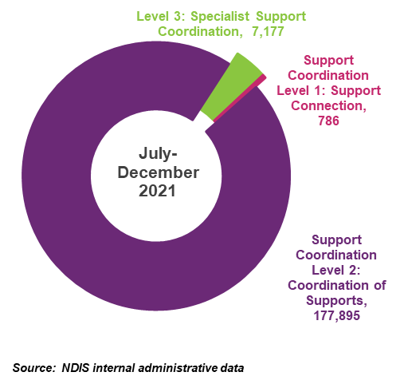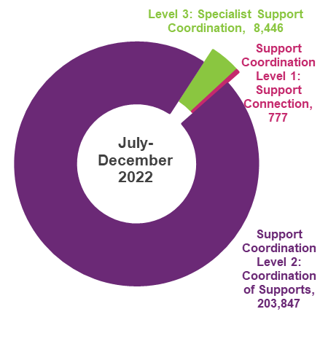
During the period between December 2020 quarter to December 2022 quarter, the number of participants being supported by support coordinators increased from 138,665 to 196,328 – a quarterly average increase of 4.5%. This is based on active claiming in each quarter.
Providers
The number of unique providers delivering support coordination supports increased from 2,998 in the six months to December 2020 to 7,023 in the six months to December 2022, an overall six-month average increase of 24%. This represents providers who have claimed for support coordination supports (including capacity building and training support and provider travel items. As shown in Figure 23, results suggest that the number of support coordinators has been increasing over time. Despite the ratio of registered providers to total number of providers dropping from 71% to 49%, registered providers delivering support coordination supports still make close to 90% of total cost of claims for support coordination supports.
Figure 23: DISTRIBUTION OF PARTICIPANTS AND PROVIDERS CLAIMING SUPPORT COORDINATION SUPPORTS, DECEMBER 2020 – DECEMBER 2022
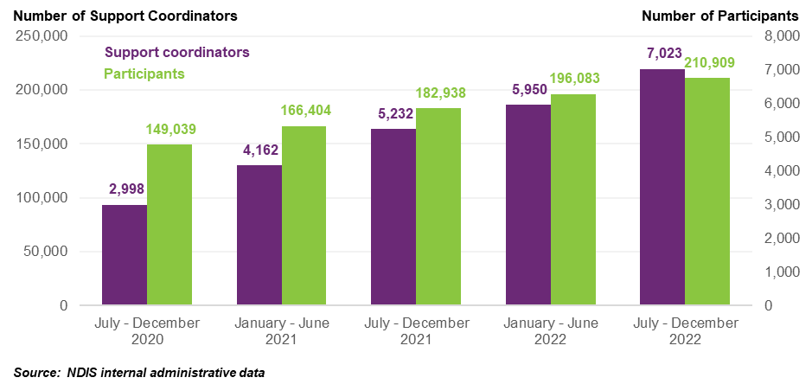
Figure 24 shows the split of providers delivering different levels of support coordination supports. Please note there is potential for a provider to appear in multiple categories, that is providers can deliver different levels of support coordination in the same period of time.
Providers delivering Level 2: Coordination of Supports continues to grow at a rapid pace, more than doubling over the two-year period to December 2022. Providers delivering Level 1 and Level 3 are growing at a slower pace over the same time frame.
Figure 24: support coordination by level of support, DECEMBER 2020 – DECEMBER 2022
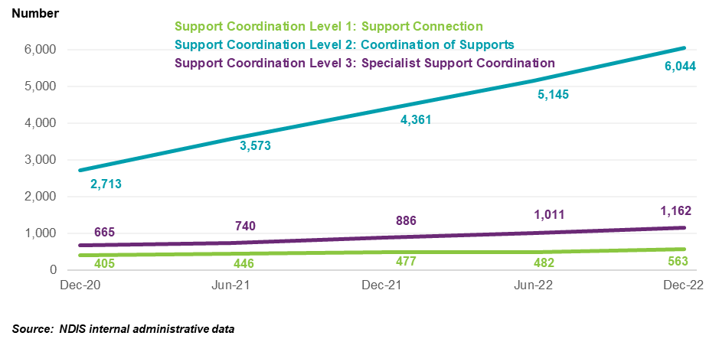
As provider numbers have increased relative to participant numbers, the average number of participants being serviced per provider has reduced over the two-year period to December 2022 from 50 participants per support coordination provider, in the same six months period, to 30 participants per support coordination provider. This ratio of servicing per providers has decreased largely due to overall growth of providers (mainly driven by unregistered providers).

6.3 Business Dynamism
To supplement the Scheme statistics, the NDIA has analysed registered provider payment activity. That is, payments made against Agency and Plan Managed plans are considered to be made by registered providers.
Figure 25 shows the breakdown of registered providers by the number of participants they have been servicing and the percentage claimed of their services, where the general profile of the registered support coordinators appears to have not changed significantly from the first half of 2020 to second half of 2022. Half-years are defined as the six-month time intervals from January to June and July to December.
Figure 25: Registered Providers of Support Coordination and Number of Participants claimed, january 2020 – DECEMBER 2022
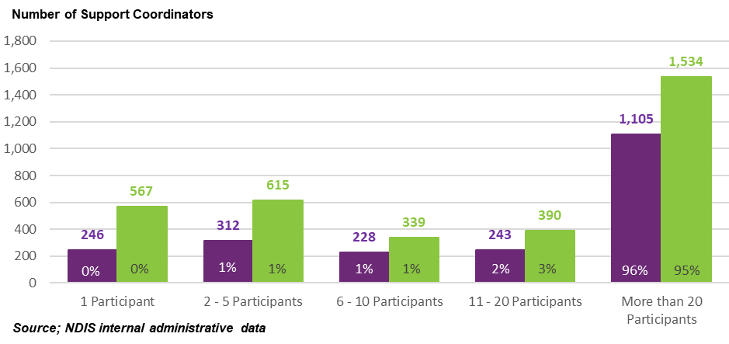
Figure 26 below shows the number of registered support coordination providers with payments between July 2020 and December 2022, split by the number of half-year periods in which each provider received a support coordination payment. Half-years are defined as the six-month time intervals from January to June and July to December. As seen in Figure 26, 1,620 out of 4,407 (37%) registered providers have payments in all five half-years between July 2020 and December 2022. These providers account for 89% of the total payments across the two-and-a-half-year period.
Figure 26: registered support coordination provider half-yearly payments histogram, june 2020 – december 2022
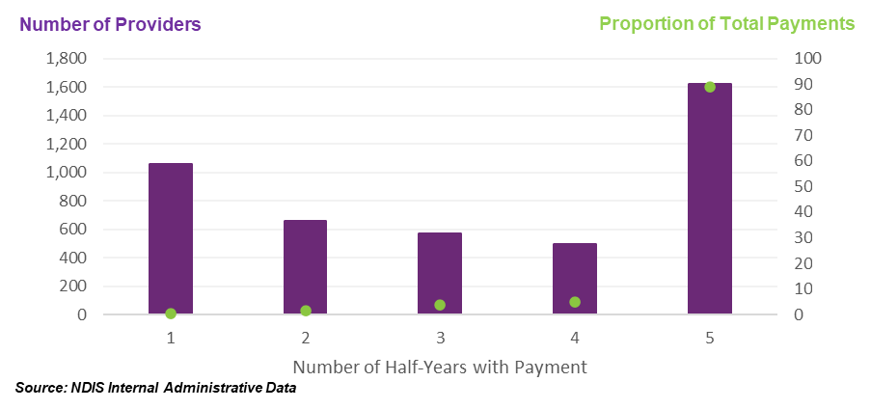
To further assess the current state of the provider market, payment activities of registered providers across the two-year period from January 2021 to December 2022 were analysed. Providers with New Activity in a half-year are defined as providers with payments who did not have payments in the prior half-year. Similarly, Inactivity in the half-year is defined as providers without a payment who had payments in the prior half-year. Activity for each provider is expressed as a percentage of the total payments for that half-year (for New Activity) or prior half-year (for Inactivity). The NDIA acknowledges that this is not a perfect measure of market exits but the closest approximation given available data.
Results suggest that over the past two years, inactive registered support coordination providers in each half-year contributed to less than 1% of total payments. In contrast, registered support coordination providers with new activity in a half-year have contributed between 1.8% and 2.7% of total payments for that same period.
Additionally, on average, inactive registered providers in the half-year period prior to becoming inactive were servicing 7 participants. However, 60% of these inactive registered providers were only servicing 1 participant prior to becoming inactive, another 8% of inactive registered providers serviced more than 20 participants prior to becoming inactive.
In contrast, in half-year period up to December 2022, 16% of active registered providers were servicing only 1 participant, whereas there were 45% of active registered providers servicing more than 20 participants, who account for 97% of the total payments made to registered support coordination providers in the half-year period to December 2022. This shows that registered providers that are becoming inactive have different distribution of participants they are servicing when compared to active registered providers that service 60 participants on average.
Figure 27: support coordination REGISTERED PROVIDER activity MOVEMENTS, january 2021 – DECEMBER 2022
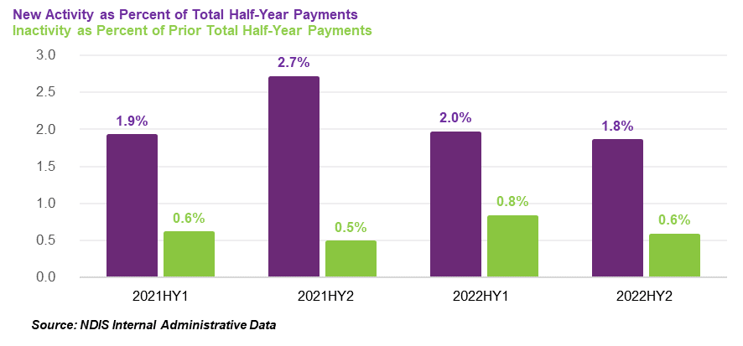
Further results indicate that on average, inactive registered support coordination providers received $6,790 in payments in the half-year prior to becoming inactive, with 79% of support coordination providers receiving less than $5,000 in the half-year prior to becoming inactive. In contrast, active registered providers received on average $116,328 of payments in each half-year period, highlighting that inactive registered providers have been claiming for lesser amounts on average relative to new and existing registered providers.

6.4 Consultation feedback
Of 304 submissions received, 33% (99) discussed support coordination. The most raised concern was suggestions that the NDIS price limits of support coordination were insufficient. Another common sentiment was the fragmented nature of supports offered and suggested that there are additional unbillable hours associated with their work.
See Appendix A for more details on common themes raised in submissions to the 2022-23 APR Consultation Paper.
Disability Intermediaries Australia (DIA) submission
In its submission to the 2022-23 APR, DIA reported on a survey of plan managers and support coordinators raising concerns of financial viability of these providers. Some 454 support coordinators responded to the survey. The NDIA also received a number of letters of support by stakeholders in support of DIA’s submission.
From the Survey responses, 91% of respondents were For-Profit providers, with at least 30 respondents from each state and territory. Almost half of the respondents were “Medium” sized providers.
The DIA submission reported that 20% of support coordinators who responded to the survey indicated that they had made a profit in 2021-22 with a further 18% indicating that they had broken even in 2021-22. At the same time, 62% of support coordinators reported a loss in 2021-22. This was reported at a higher proportion for larger organisations (65%) compared to medium and small organisations (61% and 55%, respectively).
There was also an increase in the number of support coordinators reporting to be paying workers under the SCHADS Award from 89% to 92% (up by 3%).
DIA’s submission suggested that providers delivering support coordination appear to be considerably less than NDIA reported numbers, suggesting two different registration groups may conflate these figures. They also commented that the relative growth of support coordination providers is overall less than that of other types of supports delivered in the NDIS.
Another point raised was that perceived growth of providers may capture the potential situation where, for example, one provider of support coordination exits NDIS services, but there are entrants of new, smaller providers claiming for support coordination from the staff of the exited provider. DIA suggested an estimate of 80% of ‘new providers’ entering the market are employees of exited providers.
DIA also raised concerns on unfunded work undertaken by support coordinators, as well as the bereavement cost of support coordinators delivering supports after the death of a participant.

6.5 Recommendations
The NDIA considers that there is still growth occurring in the supply of providers delivering support coordination, with the main growth being driven by unregistered providers delivering these services (this is approximately a 50/50 split between number of registered providers and unregistered providers).
The ratio of participants serviced per providers of support coordination has decreased over the two-year period to December 2022, largely due to 29% overall growth in provider numbers, which has outpaced the growth rate of participants receiving these supports in the same period. This signals a healthy market metric. The NDIA notes the claim by DIA that the growth of providers may be due to the staff of exited providers now delivering the supports and will continue to monitor any further development in this space.
Further, a theme that continued to be echoed by both participants and representatives and providers is that greater clarity is needed for the roles of support coordinator to plan managers in the NDIS. In addition, there is the fragmented nature of the supports offered by support coordinators, some of which are unfunded to best support participants.
The NDIS Review is currently considering the role of intermediaries, which is in line with recommendations 30 and 33 from the 2021-22 APR. As such, the NDIA should consider any appropriate structural changes to support coordination support pricing arrangements after outcomes from the NDIS Review are delivered.
On balance, the NDIA does not consider that an increase in the price limits for Level 2: Coordination of Supports services and Level 3: Specialist Support Coordination services price limit is required. Paired with the NDIS Review still underway; the NDIA has considered the increase in provider numbers in delivering support coordination supports to NDIS participants. It is therefore recommended that the price limits for support coordination should not be changed on 1 July 2023, except for the Level 1: Support Connection support item. This is because Level 1: Support Connection is set by the NDIS DSW Cost Model and should continue to align to this Cost Model.
Recommendation 8
The NDIA should not make any structural adjustment to the NDIS pricing arrangements for support coordination at this time and should:
- Index the price limits for the Level 1: Support Connection services on 1 July 2023, in line with the indexation of supports determined by the NDIS Disability Support Worker Cost Model in recommendation 1, and
- Not index the price limits for the Level 2: Coordination of Supports services and Level 3: Specialist Support Coordination services on 1 July 2023.
The NDIA sees merit in the benchmarking survey conducted by DIA to be able to better capture the specific cost drivers faced by support coordination providers. This also considers that 92% of respondents for support coordination reported to have employees under the SCHADS Award. This makes it reasonable to justify having a Cost Model for Level 2: Coordination of Supports and Level 3: Specialist Support Coordination, after the outcomes of the NDIS Review, which is looking at the roles of intermediaries in the NDIS, are received.
Recommendation 9
After the outcomes of the NDIS Review are announced, the NDIA should work with the sector and other appropriate stakeholders to develop Cost Models for Level 2: Coordination of Supports and Level 3: Specialist Support Coordination.
The NDIA also considers that there may be instances where support coordinators could be required to undertake work following the death of a participant or including the administrative work associated with gathering information, returning equipment, and completing forms. In addition, other significant changes or situations (such as interactions with justice or health services) may require additional administrative work including responding to subpoenas or providing critical details where required. As such, the NDIA should examine options to allow support coordinators to claim for reasonable payments.
Recommendation 10
The NDIA should examine options on billable work required by support coordinators that is required after a participant’s death or other key events.

Plan management supports

7.1 Context
Plan managers play a crucial role in the NDIS ensuring a sustainable and efficient system, whilst assisting participants manage their NDIS plan funding. This chapter closely examines the extent to which these arrangements promote innovation, enhance service quality, and ensure value for money for participants.
The funding for supports that is provided by the NDIS under a participant’s plan can be managed wholly or in part by the participant; or by a registered plan management provider (“plan manager”); or by the NDIA; or by a plan nominee (if one has been appointed).
Currently, participants can choose (subject to the terms of any plan nominee appointment) to engage a registered plan manager to manage some or all the funding for supports in their plan. If a participant makes this choice, then the NDIA is currently required to give effect to the participant’s choice. The NDIA also then includes funding in the participant’s plan so that they can engage their preferred registered plan manager.
The NDIS Act requires plan managers to be registered with the NDIS Quality and Safeguards Commission (NDIS Commission) in order to manage the funding of supports under a participant’s plan. As a result, they are required to: demonstrate compliance with the Core Module of the NDIS Practice Standards; comply with the NDIS Code of Conduct; have an in-house complaints management and resolution system to record and manage complaints, and support NDIS participants or other relevant parties to make a complaint; have an in-house incident management system, and notify the NDIS Commission should a reportable incident occur (including alleged reportable incidents); and fulfil the worker screening requirements where relevant.
Plan managers are also bound by the NDIS Pricing Arrangements and Price Limits. Plan-managed participants can only purchase supports that are listed in the NDIS Support Catalogue and are subject to the same billing rules and price limits as agency-managed participants. However, plan-managed participants can purchase supports from registered and/or unregistered providers (except where the NDIS Commission has determined that providers must be registered in order to deliver a particular type of support).
Plan managers receive funds from the NDIS and disburse funds on behalf of a participant to providers of other services received by the participant. They can assist a participant by: claiming directly from the funds in the participant’s plan to pay providers on behalf of the participant; paying providers for the supports that the participant purchases; helping the participant keep track of their funds; and taking care of financial reporting for the participants. In some cases, plan managers also help participants choose their providers.
Plan managers must provide the Australian Business Number (ABN) of the service provider who delivers the support for all payment requests, except where the service provider is exempt from quoting an ABN under Australian Taxation Office (ATO) rules. Exempt providers must complete the ATO’s Statement by a Supplier form. Plan managers are expected to keep a copy of the completed form. Plan managers must always ensure that a valid tax invoice is included with each payment request and that the tax invoice includes relevant information about the goods and/or services purchased. A plan manager may be liable to pay back any amount not spent in accordance with a participant’s plan.
Plan managers can claim for three types of services:
- A one-off (per plan) establishment fee for setting up the financial management arrangements for a participant
- A monthly fee for the ongoing maintenance of the financial management arrangements for a participant and
- Ad hoc capacity building and training in plan administration and management support to strengthen a participant’s ability to undertake tasks associated with the management of their supports.
The price limits for these supports are set out in Table 13 below.
Table 13: PRICE LIMITS FOR PLAN MANAGEMENT SUPPORTS
Item Number | Item Name and Notes | Unit | Non-Remote | Remote | Very Remote
14_033_0127_8_3 | Plan Management – Set Up Costs  - A one-off (per plan) fee for setting up the financial management arrangements | Each | $232.35 | $325.29 | $348.54
14_034_0127_8_3 | Plan Management – Monthly Fee  - A monthly fee for the ongoing maintenance of the financial management arrangements | Month | $104.45 | $146.23 | $156.67
01_134_0117_8_1 | Capacity Building and Training in Self-Management and Plan Management | Hour | $70.87 | $99.22 | $106.31
If a plan manager is engaged to deliver the Capacity Building and Training in Self-Management and Plan Management support (01_134_0117_8_1) to a participant then they are also permitted, subject to the rules set out in the NDIS Pricing Arrangements and Price Limits, to claim for provider travel (labour and non-labour costs); non-face-to-face activities and short notice cancellations.
This chapter analyses the pricing arrangements for plan managers, with a focus on their impact on service quality and cost-effectiveness. It examines current pricing arrangements, usage statistics, providers and markets, stakeholder concerns, and draws conclusions on potential changes to the pricing framework. The objective is to provide a comprehensive understanding of the pricing framework and its impact on NDIS participants.

7.2 Scheme Statistics
In the six months to December 2022, payments were made to some 1,797 plan managers that were registered at the time of providing the service according to the requirement of NDIS Commission. This amounted to $8.1 billion, 48% of Scheme spend, and consisted of $227.7 million for plan management services, and the remainder of the $7.8 billion was for plan managers to pay service providers on behalf of the 333,077 participants (58% of the 573,342 active participants as of 31 December 2022). Table 14 below shows the change in some of these statistics in the six months to December 2021 and in the six months to December 2022.
Table 14: PLAN MANAGEMENT SCHEME STATISTICS
Statistics | July – December 2021 | July – December 2022 | Percentage Change
Total number of NDIS participants | 262,915 | 333,077 | +27%
Total number of active providers | 1,588 | 1,797 | +13%
Total plan management fees claimed | $200 million | $228 million | +14%
Total number of active providers claiming fees | 1,185 | 1,318 | +11%
Average amount claimed fees per provider | $168,605 | $172,793 | +1%
Source: NDIS administrative data
Note figures above are based on payments made for relevant plan management supports. Therefore, the figures above may differ from the actual number of plan managers registered with NDIS Commission to deliver plan management supports. The total number of NDIS active participants who are partly or fully plan-managed may differ to number of participants that used plan management services in the time periods presented above.
Participants
Over half of all participants used a plan manager (58%) during December quarter 2022, and nearly half of payments made from NDIS plan budgets were claimed by a plan manager (49%). These have increased from 45% and 35%, respectively, since the December 2020 quarter.
Figure 28 below illustrates the share of participants plan-managed and Figure 29 shows the share of payments processed by plan mangers increased significantly in the last two years.
Figure 28: Distribution of participants by method of plan management OCTOBeR 2020 – DECEMBER 2022
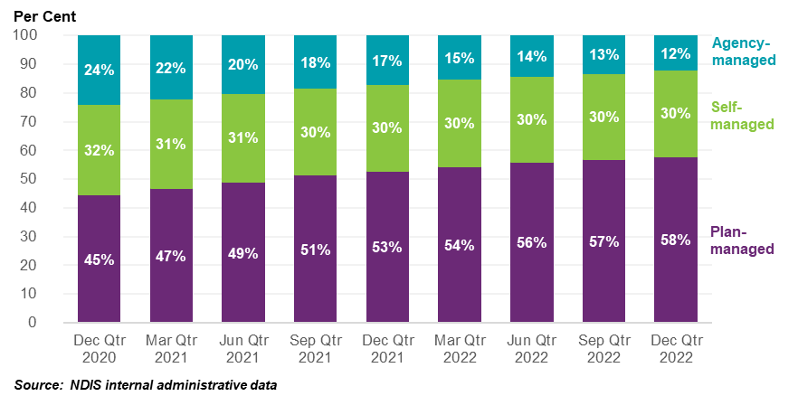
Figure 29: Distribution of Payments by method of plan management OCTOBeR 2020 – DECEMBER 2022
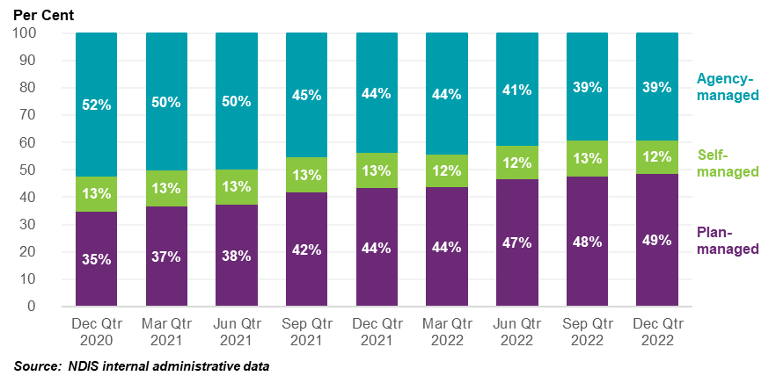
Providers
During the period December 2020 to December 2022, the number of plan managers increased from 1,098 in the six months to December 2020 to 1,797 in the six months to December 2022, an average six-month increase of 14%. Aside from most recent six months, there has been growth in providers of plan management supports. See Figure 30 for the trend over this period. Data suggests a slight reduction in the number of plan managers in the six months to December 2022 and the NDIA will continue to monitor the health of the plan management market.
Over the same time, the number of participants partly or fully plan-managed increased from 189,229 to 333,077 – an average six-month increase of 15%. This indicates that while new plan managers are entering the market and increasing participant choice, many plan managers are also expanding as the ratio of participants to providers has increased. The participant to provider ratio in the six months to December 2022 is 185 participants per provider of plan management supports.
Figure 30: Distribution of participants and providers with a plan manager, December 2020 – DECEMBER 2022
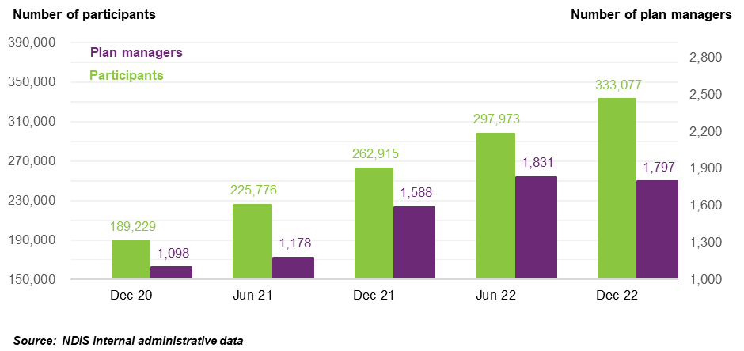
Market health indicators
To understand the current health of the plan manager market within the above context, NDIS payment data of the top five plan managers were also analysed.
The top five plan managers processed 28 million transactions during the July to December 2022 period, including 2 million transactions for plan management fees. In the six months to December 2022, the average amount claimed by provider, per participant, was $126,734.
Out of the 1,797 providers that have claimed for plan management supports during the six months to December 2022, the largest five plan managers received $2.2 billion in payments, more than a quarter (27%) of the $8.1 billion of plan-managed payments (inclusive of fees). These top five plan managers have dominated the market over the past nine quarters having consistently stayed in the top ten, with payments processed in Figure 31.
Figure 31: scheme expenditure for largest five plan managers (based on total payments) October 2020 – DECEMBER 2022
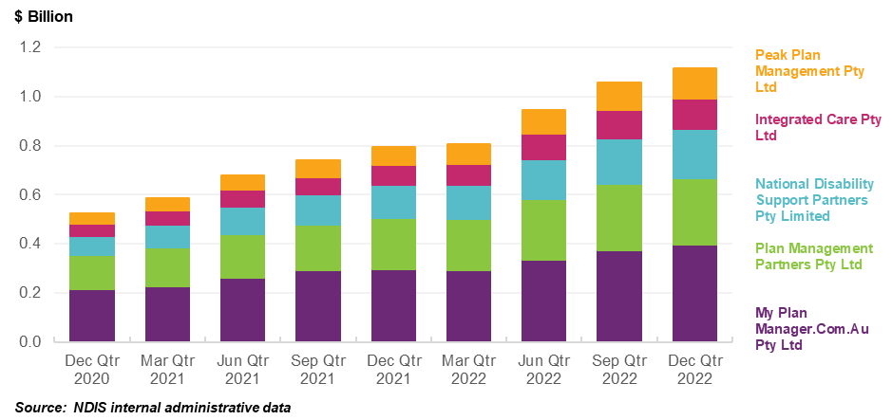
Participant to providers of plan management support ratios have also seen a larger number of participants, on average, being covered by a provider of plan management supports. As participant numbers have increased relative to provider numbers, the average number of participants being serviced per provider has increased from 178 to 214 participants between December 2020 quarter and December 2022 quarter. This ratio of servicing per providers has increased largely due to overall growth of provider numbers by 64% being more than offset by the 76% growth in participant numbers.
However, in the six months to December 2022 the number of providers claiming for plan management decreased by 2%, which contrasts the previous 35% growth seen in the six months to December 2021. The NDIA should continue to monitor the movement of providers claiming for plan management supports in future quarters to determine if this is a trend.
Further, the average funds management ratio (the ratio of the total costs of monthly plan management fees to the costs of the supports purchased through the plan managers) was, on average, 3.6% in FY2021-22. This is a decrease from the FY2020-21 where the average management ratio to the total costs purchased was 3.9%. This means the total cost of monthly plan management fees claimed has decreased in proportion to the cost of supports purchased through plan managements. This may be due to a range of reasons such as the increase in number of participants and higher volume of NDIS funds being plan-managed, potential efficiencies being made by providers of plan management supports or other reasons.

7.3 Business Dynamism
To supplement the Scheme statistics, the NDIA has analysed registered provider payment activity. That is, payments made against agency-managed and plan-managed plans are considered to be made by registered providers.
Figure 32 below shows the number of registered plan managers with payments between July 2020 and December 2022, split by the number of half-year periods in which each plan manager received a payment. Half-years are defined as the six-month time intervals from January to June and July to December. As seen in Figure 32, 872 out of 2,491 (35%) plan managers have payments made in all five half-year periods between July 2020 and December 2022. These plan managers account for 95% of the total payments across the two-and-a-half-year period.
Figure 32: plan manager provider half-yearly payments histogram, june 2020 – december 2022
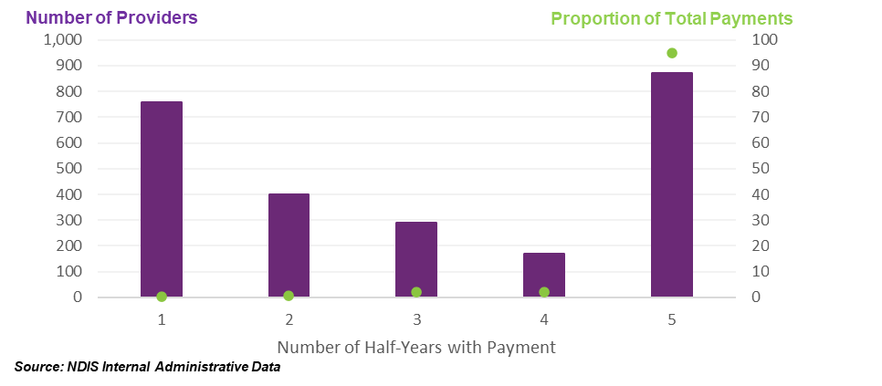
To further assess the current state of the plan manager market, payment activities of registered plan managers across the two-year period from January 2021 to December 2022 were analysed. Providers with New Activity in a half-year are defined as providers with payments who did not have payments in the prior half-year. Similarly, Inactivity in the half-year is defined as providers without a payment who had payments in the prior half-year. Activity for each provider is expressed as a percentage of the total payments for that half-year (for New Activity) or prior half-year (for Inactivity). The NDIA acknowledges that this is not a perfect measure of market exits but the closest approximation given available data.
Results suggest that over the past two years, inactive plan managers in each half-year contributed to 0.1% of total payments. In contrast, plan managers with new activity in a half-year have contributed between 0.5% and 1.5% of total payments for that same period.
Figure 33: plan manager activity MOVEMENTS, january 2021 – DECEMBER 2022
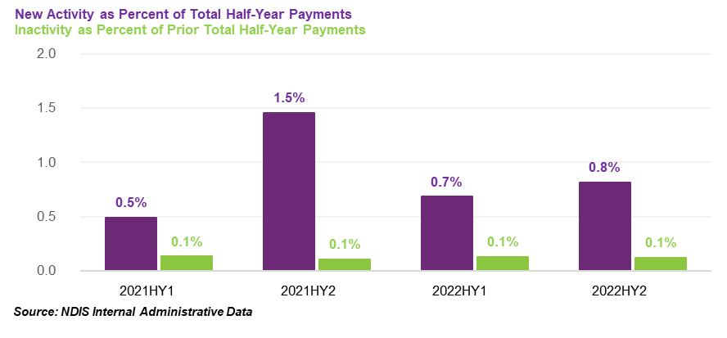
Further results indicate that on average, inactive registered plan managers claimed for $32,526 in payments in the half-year prior to becoming inactive, with 59% of registered providers claiming for less than $5,000 in the half-year prior to becoming inactive. In contrast, active registered plan managers have claimed for $3,839,694 in payments, on average, in each half-year period, highlighting that inactive registered providers have been claiming for lesser amounts on average relative to new and existing registered providers.

7.4 Consultation feedback
In total, 81 submissions out of 304 (27%) were received through the Public Consultation process responding to the topic of plan management supports. Most respondents suggested the monthly fee for plan management is insufficient for the work they are doing, said to encompass activities outside of what they believe is expected of them. There were also suggestions of clearer guidelines on the role of plan managers which was also frequently raised in the 2021-22 APR and is anticipated to be covered by the NDIS Review.
See Appendix A for more details on common themes raised in submissions to the 2022-23 APR Consultation Paper.
Disability Intermediaries Australia (DIA) submission
In its submission to the 2022-23 APR, DIA reported on a survey that it has undertaken of plan managers and support coordinators raising concerns about the financial viability of these providers. Some 511 plan managers responded to the survey. The NDIA also received several letters of support by stakeholders in support of DIA’s submission.
From the survey responses received by DIA, 77% of respondents were For-Profit providers, with at least 50 respondents from each state and territory. 79% of respondents were “Medium” sized providers, with only 4% considered “Large”. There has been a move of respondents towards the SCHADS Award, however, almost half of respondents still use other Awards or Industrial Agreements.
The DIA submission reported that 45% of plan managers who responded to the survey indicated that they had made a profit in 2021-22 with a further 17% indicating that they had broken even in 2021-22. At the same time, 38% of plan managers reported a loss in 2021-22. DIA suggested the organisation structure/size played only a minor factor in determining financial outcome.
DIA raised concerns on the clarification of the NDIA in the 1 July 2022 Pricing Arrangements and Price Limits where plan management set up fees were not claimable for NDIS plans that were extended. In addition to this, concerns were also raised on the technological transition costs associated with NDIS’ new PACE system and the increased requirement of cyber security and its cost to plan managers.

7.5 Recommendations
The available information suggests that the market of supports for plan management is relatively healthy.
Besides the December 2022 quarter, there was strong growth in providers of plan management supports in the previous 9 quarters to keep pace with participant demand. The NDIA acknowledges the increase in the average number of participants being serviced per provider of plan management supports. This number should consider that it includes participants who are both fully and partly plan-managed.
Through feedback received through public consultations, there was suggestions of clearer guidelines on the role of plan managers which was a common sentiment raised in the previous 2021-22 APR, from both participants and providers.
In line with previous recommendations from the 2021-22 APR, the role of plan managers is to be considered by the NDIS Review and the NDIA should consider any appropriate structural changes after recommendations from the NDIS Review.
On balance, the NDIA believes there is insufficient evidence to support an increase to plan management supports currently. The growth of participants and providers of plan management supports over the past two years suggests this market is still viable and does not support an increase to plan management supports until the roles and expectations of plan managers are further defined. The NDIA should continue to monitor the movement of providers claiming for plan management supports in future quarters to see if this decrease was a one-off or the start of a trend.
Recommendation 11
The NDIA should not make any structural adjustment to the NDIS pricing arrangements for plan management supports at this time and should not index the price limits for plan management fees on 1 July 2023.

NDIS Pricing
The National Disability Insurance Agency (NDIA) acknowledges this Annual Pricing Review (APR) has a targeted scope of supports as outlined in the Terms of Reference. Some of the recommendations within this chapter are outside the scope of the current APR but forms an important part of the overarching pricing considerations for the NDIA. These recommendations have the potential to improve future pricing review processes and promotes greater transparency.

8.1 Non-SCHADS Labour Supports, particularly Nursing supports
In the absence of specific review within the APR cycle, the NDIA considers the need to maintain the real value of NDIS price limits for support to maintain the supply of supports to NDIS participants. Further innovation by providers is encouraged to achieve greater efficiencies and improve the quality and safety of supports delivered.
The NDIA acknowledges there are a range of supports that are not under scope of the 2022-23 APR and are not linked to the DSW Cost Model (non-Social, Community, Home Care and Disability Services Industry Award 2010 (SCHADS Award), are not price limited or benchmarked.
Nursing supports are considered as part of this category. Examples of supports in this category include several within the core and capacity building support categories such as personal domestic cleaning, house and/or yard. There is the need to maintain the real value of NDIS price limits for support to maintain the supply of supports to NDIS participants.
This is particularly the case for nursing supports, considering the aged care reforms including wage increases through the 15% increase to aged care workers and other potential increases to the Nursing Award. It is imperative that the NDIA ensures these supports remain competitive to other markets.
It may pose a risk to participants receiving these supports if there is no pricing increase, and thus is deemed necessary to increase the price limits of these supports in line with previous year’s indexation methodology.
Recommendation 12
The NDIA, subject to any specific recommendation arising from the current Annual Pricing Review and any future reviews, should:
- Increase the price limits for other supports, not covered by Disability Support Worker-related supports or Capital supports, on 1 July 2023 in line with the weighted movement over the previous twelve months in the ABS Wage Price Index (Australia, total hourly rates of pay excluding bonuses) and the ABS Consumer Price Index (All Groups, weighted average of eight capital cities) over the 12 months to the March Quarter immediately preceding the indexation date (with an 80/20 weighting).

8.2 NDIS Cancellation Policy
The 2021-22 APR changed the National Disability Insurance Scheme (NDIS) cancellation policy from 2 days to 7 days to align to the change made by the SCHADS Award from 1 July 2022. The policy was updated to ensure staff are protected from any impact of short notice cancellations of their shifts. Since the change was implemented, the NDIA have received feedback from stakeholders regarding the matter.
The current NDIS policy states that providers should find alternative billable work for the staff at first instance. The alternative work can be for multiple participants across multiple locations. If no alternative work is found, and if Short Notice Cancellations are agreed with the participant in the Service Agreement in advance, only then can the providers claim the amount. This is to allow providers to pay the staff the amount they would have received had the shift not been cancelled as mandated by the SCHADS Award. It is also important to note that the 7-day cancellation policy is the maximum allowable cancellation length by the NDIA, providers can include shorter cancellation periods subject to establishing service agreement with participants.
Following the implementation of this change, feedback received from participants and their representatives reflected that the 7 days is too long to account for sudden illnesses or events outside of a participant’s control. It is important to note that the 7-day cancellation policy is the maximum allowable cancellation length by the NDIA, providers can include shorter cancellation periods.
Analysis of NDIA claims data from July 2020 to December 2022 indicates that cancellations accounted around 0.6% of DSW claims over this period. This has remained stable throughout this period with no significant change since the policy update.
The NDIA should consider relevant Industry Awards, employment standards and other relevant industry legislation when setting pricing policy. The NDIA understands not all supports are delivered under the SCHADS Award, and many providers may not have the same obligations to their workers for cancelled shifts. On the other hand, careful consideration needs to be given if the NDIA policy is to deviate from the SCHADS Award as it may create inconsistency and confusion.
It is too early to understand the impact of the changes to the NDIS cancellation policy to NDIS participants based on current data. The NDIA should continue to work closely with the sector to investigate the appropriateness of the current NDIS cancellation policy post the 2022-23 APR. This includes exploring the possibility of undertaking a survey to gauge the impact of current settings.
Recommendation 13
The NDIA should work with the sector to investigate the appropriateness of the NDIS cancellation policy for NDIS supports post the 2022-23 APR.

8.3 NDIS Review
The Minister for the NDIS, the Hon Bill Shorten MP, announced the NDIS Review in October 2022. The NDIS Review is likely to have significant strategic implications for NDIS pricing arrangements in the future., noting the NDIS Review is expected to report in October 2023.
As the NDIS Review is running concurrently with the 2022-23 APR, the NDIA is committed to working with the NDIS Review Team throughout the NDIS Review process. The NDIA acknowledges this may impact some supports and outcomes under the scope of the APR, which should be considered in line with upcoming recommendations from the NDIS Review expected in October 2023.
Recommendation 14
The NDIA should continue to work with the NDIS Review on relevant topics and issues involving structural changes to the current NDIS pricing arrangements.

8.4 NDIS Pricing Strategy Refresh
The pricing arrangements for the NDIS are governed by the NDIS Pricing Strategy, which was adopted by the NDIA Board in 2019. The Strategy recognises that in the short to medium term the NDIS’s pricing arrangements must consider both the need for value-for-money (and hence for efficiency in provider operations) and the need to ensure continued access to supports (including the need to rapidly expand supply during the roll-out of the NDIS).
During the roll out of the NDIS, the market for disability supports needed to develop at pace, with both significant increases in market supply, improvements in quality and improvements in production efficiency. While improvements to production efficiency (at a given quality level) will, all other things being equal, reduce costs in the long run, expansion of market supply in the short term necessitates higher prices (especially where, as in the case of the NDIS, supply must be maintained to ensure participants can continue to receive critical supports). The NDIS Pricing Strategy therefore recognised higher short-term price limits would be needed to maintain and expand the production of disability supports by providing an incentive for the redirection of resources to the NDIS from other sectors of the economy.
In the long run, the market for disability supports will mature so that high quality services are delivered at efficient price levels. Efficient price levels represent the long run minimum cost of production of a good or service whose quality is acceptable to the purchasers of the good or service. They are the best representation of the reasonable cost of the provision of a quality support and will, eventually, be the price levels best suited for the development of plans, which are concerned with efficient, effective, and appropriate supports.
Since the release of the NDIS Pricing Strategy in 2019, there has been rapid growth in the provision of supports across many types of support markets delivering supports to NDIS participants which was needed in the roll-out of the NDIS. This has been accompanied with growth in some innovative service delivery models, such as online platforms for disability support worker-related supports. Such innovations encourage competition between providers, and new service delivery models can also facilitate transparent and accessible communication to participants. At the same time, the NDIA has been working to better inform participants to make more informed decisions.
There has been a significant change in size of the NDIS, number of participants and providers and a change in various support market dynamics since the initial publication of the NDIS Pricing Strategy in 2019. There is a spectrum of market intervention options available to the NDIA, such as market facilitation, market regulation or alternative commissioning. Which intervention to use depends on the characteristics of the market and how it is functioning. A market that is considered well-functioning requires less intervention. Therefore, the NDIA should examine what might be the most appropriate measures to apply across different markets delivering NDIS supports based on the current market maturity, economic conditions as well as Scheme trajectory.
Recommendation 15
The NDIA should refresh its NDIS Pricing Strategy to ensure its appropriateness on the current state of NDIS support markets, in consideration to the outcomes from the NDIS Review.

8.5 Financial Reporting by NDIS providers
The NDIA believes it is imperative that as a market steward, it is important to monitor and track the financial performance of providers within the sector to ensure that they remain financially viable.
As noted in section 4.12, previous attempts to conduct surveys to gauge providers financial bottom line has resulted in poor response rates and therefore the survey results are not considered to be representative of the entire provider sector. The NDIA does not consider that it is necessary to conduct a financial benchmarking survey in 2022-2023 given the current APR has a tailored scope. Moreover, the NDIA has begun to work with the sector to support financial benchmarking surveys to assist providers to compare themselves to their peers. The current partnerships include the surveys by the National Disability Services (NDS), partnering with StewartBrown, and the Ability Roundtable.
There are some data limitations when it comes to gauging the health of the provider market such as a full picture of provider financials. This has the potential impact the supply of services to participants. These data limitations can lead to feedback through public consultation and other channels that doesn’t always necessarily align with analyses undertaken.
An effective price setting mechanism is critically underpinned by the Agency’s ability to track, monitor, and benchmark the financial performance of the sector. Ideally, there would be more information available for the NDIA on the true financial position of the providers delivering services within the sector, which helps with Government policy planning and development. This ensures there is representation across a range of organisations with different cost bases, sizes, and locations. The NDIA’s ability to gauge the health of the market is greatly reduced in the absence of these information.
One model to consider is the mandatory financial reporting requirements in the aged care sector. Aged care businesses are legally bound by the Aged Care Act 1997 and Aged Care Quality and Safety Commission Act 2018 which stipulate the financial reporting obligations. This means that an approved provider is deemed non-compliant if it fails to provide information on its financial position. These laws establish the standards and guidelines that businesses must adhere to when preparing and submitting financial reports.
The NDIA should explore options with the NDIS Review on the possibility of creating a new mandatory financial requirements. As a start, pilots should be undertaken in areas such as disability support worker-related supports. This is to ensure the NDIA has sufficient information available on the financial position of providers to assist in its role as market steward and inform its pricing review process.
Recommendation 16
The NDIA should explore options with the NDIS Review on the potential for mandatory financial reporting from NDIS providers on certain financial metrics to assist the NDIA in its market steward role.

Appendix A – Feedback from the Consultation Paper

Overview
A Consultation Paper was released on 17 March 2023 to assist stakeholders to prepare a submission to the APR. Submissions closed on AEST 11:59pm Thursday 13 April 2023 with 304 submissions received in total.
Most submissions were from provider organisations (165) and employees/workers (96). A small number of submissions (12) were received from participants and their representatives. Submissions were also received from professional bodies (15), provider peak bodies (9), government entities (3), advocacy groups (3) and workers unions (1).

Labour market
Of 304 submissions received, 76 related to the labour market. These responses were submitted by providers of various supports, plan managers, employees/workers, professional bodies, and provider peak bodies with one submission from an advocacy group and one from a government body.
Providers
It was widely recognised by providers that the labour market, not just in the disability and NDIS sectors, but also in the broader economy, has become increasingly tight in recent years. This observation has been repeatedly highlighted in various submissions, where employers have expressed difficulties in attracting and retaining staff due to the ongoing escalation of the cost of living. This situation has led to a situation where wages have not kept in pace with the increasing expenses, creating an unsustainable environment for both employees and employers.
An exercise physiologist stated in a submission that:
The lack of indexing fees against CPI has eroded the sustainability of providing high level support to NDIS patients through more experienced professionals and resulted in them being serviced by less experienced physiologists.
Providers noted on several occasions that experienced professionals are taking up higher paid jobs elsewhere and in different sectors as there has been a disconnect between pricing arrangements and wages.
Multiple Sclerosis Australia in their submission stated:
Staff turnover is primarily driven by staff moving to higher paid positions. To offer competitive wages results in a significant loss.
One provider noted that the NDIS pricing arrangements and price limits have not assisted them to hire and retain workers compared to other sectors and the private market.
It was noted by providers that the current mandatory requirements for working in the sector can be complex and difficult to navigate, which can create barriers for workers looking to move between different roles or providers. To address this, it has been suggested that efforts be made to simplify these requirements, and to ensure that skills and training obtained in one setting are recognised and transferable to others.
One provider in their submission recommended that:
Support work should be made a career and not a job with pay to reflect a job; and to simplify the mandatory requirements so that skills and training are transferable.
Provider peak bodies
Provider peak bodies held similar sentiment that workforce turnover was high and that there needs to be a particular focus on how to attract, retain and enhance workers capabilities for the disability sector over the long term.
It was highlighted that a significant proportion of disability support workers lack formal qualifications, with many instead opting to attend TAFE courses to obtain certification before entering the workforce. However, it has been noted that many workers will subsequently leave their roles with providers after only a few months, to establish themselves as independent practitioners.
Ability Roundtable stated that:
Roundtable data provides clear evidence that many employees recruited and trained within the disability workforce are leaving the workforce, particularly employees under 30 years of age and those who have been in the NDIS workforce for less than 3 years.
This was supported by National Disability Services who advised that the impact of labour shortages and wage growth directly influences a provider’s bottom line, and the Aged Care Award increase will make it more difficult to attract DSW workers.
Professional bodies
The shortage of skilled labour in the disability support sector was also echoed by professional bodies, particularly as many qualified workers can command higher rates by working independently due to their lower overhead costs.
Several submissions have put forward a proposal to address the labour shortage in the disability sector by investing more efforts to attract students who might be interested in pursuing careers in allied health. To achieve this, it has been suggested that practical and relevant experience be integrated into the curricula of relevant courses, to demonstrate the viability of a career in this industry.
By providing students with the opportunity to gain practical experience in the disability sector, it is hoped that they will be better equipped to make informed decisions about their future career pathways. Moreover, the development of such opportunities can also help to address the current shortage of skilled labour in the sector by nurturing a pipeline of talent that is well-versed in the specific needs and challenges faced by the industry.

Registration costs
There were 66 submissions relating to registration costs including quality and safeguarding. These came from providers of various supports, plan managers, employees/workers, professional bodies and provider peak bodies and an advocacy group.
Providers
Numerous providers indicated that the registration process is perceived as both time-consuming and costly for businesses, irrespective of the size of the business. Providers stated that they face a significant administrative burden as they dedicate resources to monitor and ensure compliance, onboard new staff, and implement complex administration systems, which detracts from their core business activities. Several submissions highlight the need for businesses to hire additional staff to manage the compliance and registration requirements and propose for simpler and a more streamlined registration and compliance process.
The submission from Spinal Cord Injuries Australia stated that:
The administration tasks associated with compliance obligations, registration and managing the Clinical Governance Committee are complex, time consuming and costly. The high costs associated with registration are not currently reflected in the pricing structure of the NDIS. This creates challenges for registered providers to remain financially sustainable in the long term.
Another provider noted that:
Generally the time spent on NDIS administrative/registration tasks have increased over the last year. While worker and participant numbers have largely remained stable during this period; compliance tasks have increased.
A common theme seen in many submissions from providers surrounded the confusion caused by changes to the NDIS price guide due to the changes in SCHADS award.
One provider in their submission stated that:
The complexity of this inter-relationship is a high cost to any business trying to navigate a compliant approach with multiple agencies.
Although stakeholders raised many concerns about the lengthy and costly nature of the administration and registration process, some have noted that it has motivated them to enhance their service standards. This is due to the regulatory requirement for each provider to formally review their processes on a semi-regular basis. Overall, there was a positive sentiment expressed towards these processes as they provided participants and providers with a sense of assurance that they were complying with relevant standards and regulations, despite the associated costs. One provider noted:
It is beneficial for our organisation to be a registered NDIS provider. Registration ensures compliance and safeguarding for participants. Audits should be something that are welcome in the sector, but they come as an additional cost burden for registered providers.
Professional bodies
Many provider peak bodies observed that the benefits of being a registered provider are decreasing due to a decline in the number of agency-managed participants. The associated costs, time, and uncertainty around the future of agency-managed participants pose significant challenges for providers. Additionally, registered providers perceive themselves to be at a disadvantage when competing with unregistered providers who are not burdened with the same costs and time constraints. This creates an uneven playing field in the market, which can lead to further challenges for registered providers.
The submission from Speech Pathology Australia (SPA) stated that:
The process of registering as a NDIS provider is felt by speech pathologist to be out of reach for many, both in terms of financial costs and time burden to fulfill all the requirements.
This was supported by many other bodies including Australian Physiotherapy Association who had questions about the benefits of registration, with some physiotherapists feeling that the cost of registration is high and that there is little evidence to suggest that registration increased quality or safety for participants.
Another challenge that many provider peak bodies note is the complexity of compliance. The frequent changes in NDIS Quality and Safeguards Commission (NDIS Commission) standards and the lack of consistency of the standard of service amongst registered providers were identified as a major issue that require substantial time and effort to comprehend. The intricate interplay between these factors was noted to be a significant cost for businesses seeking to navigate a compliant approach with multiple agencies.
According to several business managers, the past year has seen an increase in registration and administrative tasks, leading many businesses to hire additional staff to handle the workload. One of the primary reasons for this increased burden was the shift of NDIS participants to plan management, which resulted in an escalation of administrative tasks required to cater to these participants.
Occupational Therapy Australia in their submission stated that:
Some registered providers are concerned about inequity in the scheme because they undergo stringent registration requirements and bear registration costs, when compared to non-registered providers. There are also concerns that the presence of unregistered providers across the scheme, who can charge variable rates, also erodes public trust in the scheme, and impacts the public expectation that participants are accessing quality, trusted, regulated services.

DSW-related supports
A total of 57 submissions on the DSW-related supports, including the DSW Cost Model and the SCHADS award, were received in response to the Consultation Paper. Submissions were made by providers, plan managers, the Australian Workers Union and a number of participants and/or their representatives.
Providers
Several providers stated that the new DSW Cost Model was easier to comprehend, more transparent and simplified internal budget calculations. Some also felt that the ability to pay staff at a higher rate impacted their business positively. Other aspects of the DSW Cost Model such as the full increase in superannuation guarantee was also considered positive.
On the other hand, some providers thought the DSW Cost Model was not clear enough, made it more difficult to benchmark their prices and was inflexible in allowing staff to negotiate their own rates. Several noted that the DSW Cost Model does not account for the complexity of some participants, especially in regional and remote areas. One provider stated:
The impact of the simplified DSW Cost Model has been mixed. On one hand, the model has provided greater transparency and predictability around funding, which has helped to better plan and budget for services. The simplified model has also reduced some of the administrative burden, which has freed up resources that can be used to improve the quality of services. On the other hand the model does not adequately account for the complexity of the services being provided or the needs of the participants we support. This has led to some participants receiving less funding than they require which can result in a reduction in the quality of care provided.
Many providers felt that the DSW Cost Model is insufficient to cover the costs of all tasks involved. These include costs associated with legislative and compliance requirements, insurance, recruitment and ongoing workforce training. The DSW Cost Model does not allow for capital investment in IT infrastructure and vehicles. Providers stated that these factors result in a lower profit margin than one being assumed in the DSW Cost Model.
It was noted that the 2021-22 DSW Cost Model separately identified the contribution of workers compensation costs, utilisation costs, supervision costs and measures in relation to the share of permanent or casual staff. The simplified DSW Cost Model covers these items in the operational overheads category. Some providers felt that they no longer have visibility of how the broader cost categories are calculated.
Allowances for annual leave, accumulated leave, long service leave and public holidays were felt to be insufficient by several providers. For example, several submissions pointed out that the DSW Cost model of 20 annual leave days does not accommodate the five-week shift worker allowance. Additionally, long service leave is different between states, as are the number of public holidays.
Providers spoke of challenges with the rostering of staff for overnight and split shifts which some believe are not adequately covered by the DSW Cost Model loading and added complexities to administration. A provider mentioned:
The split shift allowance has added a considerable amount to the payroll. This made it hard to be able to roster, including trying to eliminate the split shifts. If someone calls in sick, it is a lot harder to fill. With the extra administration time as well as the extra costs, doing smaller shifts is becoming harder to keep viable.
Several providers felt that changes to the SCHADS Award and cost-of-living pressures along with worker shortages have created an environment where workers have and want greater control over their working conditions. As a result, more workers are choosing to work on a casual basis because the take home pay is higher. In addition, workers can now decline shifts on public holidays. As one provider stated:
The provider must pay them for a shift worked as well as the second staff member to replace the shift not worked by the original staff member.
Workforce recruitment and retention along with training and development was a recurring theme in the feedback, with several providers stating that the DSW Cost Model does not consider the increased cost of these activities.
Provider peak bodies
A Financial and Workforce Benchmarking was conducted by Ability Roundtable with 24 DSW provider organisations, noting not all respondents answered every question available in the survey. Thus, the useable sample size was slightly smaller on each topic (SCHADS Award changes, COVID impacts, and Quality, Safeguarding and Compliance costs). Albeit the total sample of providers is small, their collective revenue in 2022 was over $2.7 billion, with the average respondent reporting an operating loss of 3.7% in 2022.
Data captured in the benchmarking also indicates that the estimated impact of SCHADS Award changes on provider costs, was on average is 1.5% of total costs.
The Australian Services Union also addressed training and workforce development:
The NDIS DSW Cost Model has had significant consequences for training and development in the sector and for the capacity of providers to participate actively in providing a high standard of training and supervision. There have been cutbacks in the time allocated for training; team meetings have all but disappeared; supervision has been severely curtailed; and large numbers of casual workers are being newly employed with almost no supervision at all.
Increased competition and staff mobility had contributed to the difficulty in attracting skilled staff under the SCHADS award. This was suggested to have been intensified in thin markets and rural and regional areas.
Participants
Several participants or their representatives felt that there was a wide variance of skills among support workers even though they were paid at the same rate.
The 7-day cancellation rules were also of concern for some providers and participants alike. When appointments are cancelled, there are additional costs to the provider through overtime and the casual loadings.
A participant said:
I lost a good support worker because the hospital kept altering their appointments on me which in turn messed with her own timetable until she was essentially required to seek other more reliable work.

Impact of COVID
COVID has continued in the past year to create challenges for some providers. This includes costs due to increased absenteeism. It was reported that agency staff and additional casual staff are required to backfill shifts and that sick leave was being exhausted. This is exacerbated for providers of Supported Independent Living and Specialised Disability Accommodation.
Several providers mentioned the ongoing cost of staff training, infection control methods and the maintenance of PPE stockpiles are difficult to account for under the DSW Cost Model. Furthermore, cancellations due to COVID were said to have increased.
Other providers reported that COVID costs had been absorbed into current business arrangements. The Australian Psychosocial Alliance stated that overall, their members had reported a reduction in COVID associated costs over the past six months. However, there remained an overhead burden in planning COVID responses across all areas of a business.

Impact of Aged Care Award increases
Some providers feel that increases to the Aged Care Award will not have a direct impact on the disability workforce demands and costs. One provider of both aged care and disability support services stated:
We do not anticipate there will be any marked shift of disability support staff wanting to exit to Aged Care services.

Therapy supports
There were 173 submissions related to Therapy supports. These were received from all stakeholder groups including, providers of both therapy and other supports, plan managers and other workers/employees, participants and/or their representatives, provider peak bodies, professional bodies, an advocacy group, and a government organisation.
Providers
Many providers claim the hourly rate for therapy services has not increased for three years and the cost of living has increased significantly, resulting in a rise in operational costs, rising material costs, and other associated costs. Time spent on administration, audit and liaising with support coordinators, families, and carers of participants is under-costed, and administration costs around intake are high but not claimable. There is the added problem of staff shortages with ongoing issues in retention and recruitment across the labour market in general.
Some providers argued that they charge a higher price for NDIS participants than non-NDIS clients due to the greater complexity in assisting them. On the other hand, some claimed there is no difference between the rates charged to NDIS and non-NDIS clients. A provider stated:
Our pricing rates for NDIS participants is slightly higher when compared to non-NDIS participants $150 per hour however does not consider travel and the increased complexity clients with disability versus private clientele.
Several providers who responded stated that they charge NDIS price limits for exercise physiotherapy is less than other comparable schemes and stated that the NDIS price limit should be increased in line with other types of therapies.
Varying responses were received from providers regarding the proportion of therapy revenue that is derived from NDIS compared to other funding sources, ranging from 5% to 100%. Many providers reported approximately 80-95% of their revenue comes from NDIS participants, however, there are some providers who reported lower percentages, such as 5%, 20% or 33%. Providers of children supports were amongst those that reported 100%, whilst a psychologist reported as little as 5-10% comes from NDIS funding. The range in percentages highlights the diversity of therapy supports and the different ways in which providers rely on NDIS funding to support their services. Other sources of provider’s funding include private funding, MBS, My Aged Care and iCare.
Provider peak bodies
A major submission on the pricing arrangements for therapy supports was received from Ability Roundtable. They provided a report from Deloitte Access Economics who, in partnership with 13 participating organisations, updated their Allied Health Cost Model. The participating organisations collectively represent around 20% of NDIS therapy supports revenue. It is important to note that the providers in this study have a significantly different cost structure to many other therapy providers, who are typically much smaller.
Their Cost Model (as at 31 December 2022) identifies the baseline costs of service delivery for therapy supports under the NDIS, with a particular focus on large clinical training organisations. The report also draws on data from the Ability Roundtable’s Allied Health benchmarking group. Figure 34 provides some detail of the cost modelling undertaken by Deloitte Access Economics.
Figure 34: Deloitte access economics estimated cost per hour of allied health services under the NDIS, 2021 (left hand side) compared to 2022 (right hand side)
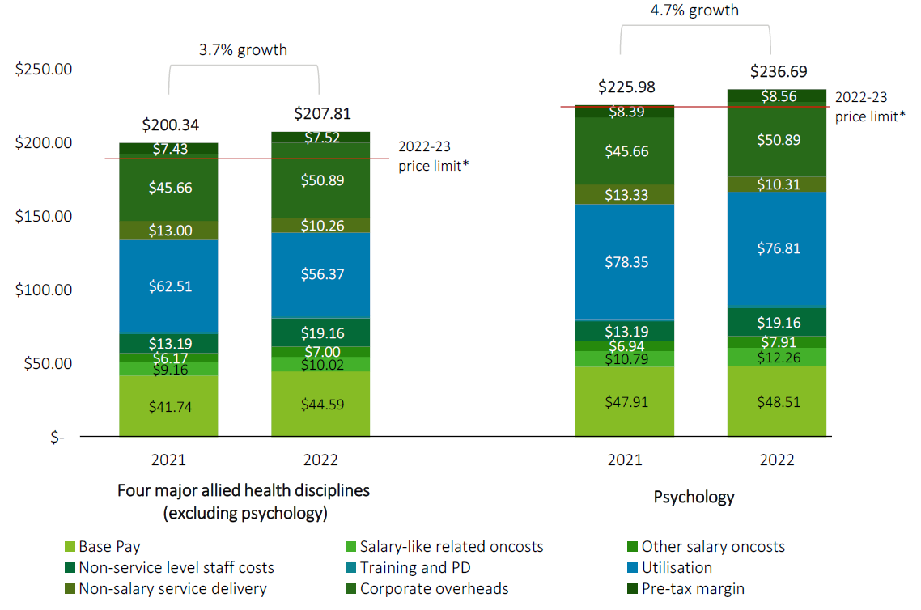
Source: Deloitte Access Economics estimates based on information provided by the 13 organisations surveyed
Notes: Four major allied health disciplines (excluding psychology) are the weighted average of social worker, speech pathologist, occupational therapist and physiotherapist. *2022-23 price limits are the calculated weighted average price limit for each group based on the location and allied health disciplines of organisations within the sample, using NDIS Pricing Arrangements and Price Limits 2022-23.
The key findings of the Deloitte Access Economics Report include:
- At an overall level, the Cost Model shows that the fully loaded cost of service delivery in 2022 increased by approximately 3.7% for the four major allied health disciplines (excluding psychology) and 4.7% for psychology.
- Labour-related costs increased by 15% for the four major allied health disciplines and 12% for psychology, primarily attributed to growth in wages and salary oncosts and investment in recruitment and training of new staff.
- Overhead costs increased by 11% across all major allied health disciplines, primarily driven by growth in IT costs, HR costs and quality compliance costs.
- To offset these impacts, providers found savings through operational efficiencies with improved utilisation rates, reduced spend on non-labour costs such as training and supervision, and back-office restructures.
Most providers surveyed suggest they are unable to break even as they are operating at costs above the current NDIS prices limits for therapy supports in 2022.
A peak body for early childhood intervention stated unfunded activities that are not billable include child protection referrals, involvement in subpoenas and family law court proceedings and mandatory reporting requirements.
Based on a small survey conducted by the National Disability Services (NDS), there are significant price gaps between NDIS price limits and the real costs of service delivery in various support categories. They mentioned:
The NDS State of the Sector (2022) report based on our Annual Market Survey shows that the past year has been a difficult one for providers. Operating conditions have generally worsened, and less than half of those responding to the Annual Market Survey recorded a surplus in the previous year.
Professional bodies
Several professional bodies reported pricing arrangements for therapeutic supports under the NDIS are not reflective of true costs for providers especially when considering inflation, workforce shortages, impact of COVID and NDIS client complexity. These costs are felt more acutely in rural and regional areas due to factors such as competition around wages, housing shortages and increased costs of travel and consumables.
Many professional bodies suggested the increase in NDIS therapy support payments may be the result of increasing provider numbers and participants having more knowledge, choice and control over how they invest their funds. NDIS providers often provide unpaid or underpaid labour to subsidise a participant’s plan, which can impact their business and result in higher costs.
Allied Health Professions Australia (AHPA), who represents some 200,000 allied health professionals, stated data recently gathered from more than 700 speech pathologists, showed that less than a quarter report charging a higher rate for NDIS participants, with the majority charging all clients the same fee. Some therapy providers, particularly physiotherapists, report charging non-NDIS clients a higher fee, as it reflects the true costs of the service. The reasons given for charging higher fees include the complexity of the supports being offered, the level of skill involved and experience of the provider, and additional supervision and professional development requirements. Their submission states:
Therapy providers are overwhelmingly de-registering and choosing to see only self-managed and plan-managed clients due to the untenable burden.
Of those who are not registered, just under 95% indicated that they were not intending to register.
This was concurred by another peak body Speech Pathology Australia who also stated for those who do have differentiated prices, this was frequently referred to in terms of offering a discount to people and families who are unable to access any funding, and for whom therapy would therefore be out of reach.
The Australian Association of Psychologists Incorporated performed a survey in November 2022, with results indicating there has been a significant increase in demand for services in the disability sector. The psychologists’ recommended fees are considerably higher than the price caps for NDIS therapy items, suggesting that psychology is funded at levels that are low, given the education, training, and business costs associated with registration and practice as a psychologist.
Australian, New Zealand and Asian Creative Arts Therapies Association (ANZACATA), a professional body on creative arts therapies, stated that group Art Therapy services under the NDIS is not viable due to the use of more materials, time spent writing more case notes, and the expertise required to facilitate and keep participants safe. The episodic nature of psycho-social disability and its impact on service provision also poses a challenge as participants often have irregular attendance patterns, making it hard to support regular work conditions and contracts and attract staff.
Participants
More than half of the participants that responded stated they are charged more than non-NDIS clients by their providers. A participant who receives supports from both Disability Support Workers and Therapists responded:
However, regarding therapy supports, as soon as you advise the provider you are NDIS client you automatically get charged the maximum NDIS price no matter which provider I went to ask about cost per hour of service.
Meanwhile members of the public who are not NDIS clients receiving the same length of time and service for a Physiotherapist or Exercise Physiologist are charged less than myself.
Whilst another, who was self-managed, stated that now they are plan-managed they are charged double the hourly rate for podiatry and physiotherapy sessions under the plan-managed system.
A respondent suggested not to increase the maximum amount an Occupational Therapist can charge for their service as the respondent believes Occupational Therapists are currently overcharging.
Another participant’s response follows:
NDIS Participants are forced to pay higher prices than other customers/patients because providers tend to charge the maximum price limit. Regrettably, this is what happens when demand for services exceeds the supply of providers so that there is no competition among providers for services to Participants and no incentive to charge them less than the NDIS Pricing Arrangements and Price Limits stipulated maximum amounts.
Advocacy groups
An advocacy group stated the current pricing system for therapy services is inconsistent and does not align with the true costs of hiring allied health professionals. Providers may also face increased after-hours staffing costs and travel expenses for clients in rural and remote locations, which are not currently covered under the NDIS. This, coupled with increased administrative requirements, has led to an increased workload for providers.

Support coordination
A total of 99 submissions addressed support coordination. Submissions were made by participants, providers, plan managers, employees/workers, provider peak bodies and an advocacy group.
Providers
A common theme raised by providers is the lack of price limit increase in support coordination level 2 and 3 by the NDIA, combined with SCHADS Award increases have reduced margins for providers prompting considerations on the financial sustainability for their businesses.
Cost increases, such as Workcover, registration, audits, portable long service leave, COVID related leave, superannuation, utilities and rent are all impacting support coordination’s sustainability amongst providers.
In addition, the pricing model does not adequately consider the fragmented nature of support coordination. Unbillable hours spent on phone calls, emails, invoicing, and filing are impacting providers, with an average of 20 hours of unpaid work per week. One provider suggested they:
work on average 20 hours of paid work per week, with another 20 hours of unpaid work, which is spent on the following activities: Phone calls, emails, invoicing, and filing. Travel time is not claimed but is an expense incurred by the provider (up to 6 of the 20 additional hours per week).
Support coordinators also suggested they undertake unfunded work following the death of a participant, including the administrative work associated with gathering information, returning equipment and completing forms. Submission asked whether these services can be claimed. This is currently being investigated by the NDIA.
Providers raised that further investment in support coordination can be made by the NDIA. Some poor standards of service in support coordination may result in potential fraud. Other concerns are that some participants are not receiving necessary supports either due to limited hours in their plan for more complex needs or through ineffective operators. One provided suggested:
When participants don’t have support coordination built into their plans, they rely on service delivery and plan management to answer their questions around NDIS funding.
High turnover, the ability to attract and retain staff has been a challenge for support coordination and the price limit has not increased since 2020 whilst all other organisational costs have increased. An increase in the unit price is suggested to continue the high-quality support.
Participants
A theme echoed by both participant and provider is the need for more standards in the provision of support coordination. The clarity of role of support coordinator compared to a plan manager was a recurring theme since the last APR and one which may be considered by the NDIS Review. One participant suggested:
Support coordinators must have experience, they must be appropriately qualified and registered accordingly (or with a relevant professional body). They should not be given as much money as they do.

Plan management supports
In total, 81 submissions addressed plan management supports. These were received from providers of plan management supports, providers of other supports, plan managers and other workers/employees, participants as well as an advocacy group and two provider peak bodies.
Providers
Plan management providers reported that the biggest cost drivers have been due to increased participant and provider communication and invoicing. Labour costs also contributed to the increase in costs including increased wages, superannuation and long service leave, compliance and registration costs, training and IT.
One provider stated:
The fact that the fees we receive from NDIS for providing plan management services have not increased for the past couple of years, along with the corresponding increased costs of providing service has resulted in a real reduction of available funds each year for direct service.
Some providers detailed the work required by plan managers and the challenges of an increased demand in services. This involves briefing participants/carers and support coordinators in understanding and applying NDIS price guidelines. They also report that participants with complex and diverse physical and mental health needs tend to require more time in dealing with their NDIS claims issues.
Spinal Cord Injuries Australia reported:
The current pricing structure does not adequately cover the increased time required to manage complex clients, leading to higher levels of staffing. Plan managers are required to implement plans, process invoices, provide budget reports, assist in gathering information for planning meetings, and ensure prompt payments to service providers. The increase in invoice requests has led to the employment of additional resources in frontline and support staff as well as technology.
Like providers of other support services, plan managers are finding it increasingly difficult to attract and retain suitable staff. They also reported an increase in competition among providers which impacts the ability to recruit qualified staff. In some cases, maturing client tenure has led to increased service expectations. High staff turnover was also reported by several providers with the Australian Workers Union stating:
The DSW industry is characterised by short term tenure with multiple employers but, paradoxically, long-term service within the industry. This contributes to staff turnover.
A provider of plan management supports stated:
Plan management is not a skill set easily found in the existing job market. Although it is primarily a clerical function, we have found that it takes a plan manager 3 months to 6 months to acquire enough NDIS knowledge to enable the application of the NDIS price guide to be effective.
Changes to set up fees were also addressed by some respondents, particularly regarding the 12-month duration of participant plans and the automatic extension arrangement. Some providers reported that the workload per participant has increased when setting up plans and that additional work is created when a participant completes their current plan, and a renewed plan is in place. It was said that plan managers are not notified when a review occurs and sometimes, the participant is not aware of the new plan. This creates delays in processing invoices and supports. Plan managers reported that invoice payment could be slow, with some claims taking months to be processed.
Plan managers felt there was no recognition of the work involved in preparing larger plans, especially if those plans involve Supported Independent Living or Specialist Disability Accommodation. They felt that there could be an excessive amount of invoicing for some participants. Plan managers also said that they do not have the authority to control the ad hoc supports that participants request and only learn of them when an invoice is received.
Providers reported IT and software issues and the time it took to resolve issues. There were also increased training demands not only in systems and software and verification requirements, but on how to manage and detect potential instances of fraud, responding to customer conflicts of interest and responding to privacy related matters. In addition, training is needed to maintain certification in first aid and mental health first aid, understanding child safety indicators, cultural awareness training and training in NDIS processes and the NDIS Pricing Arrangements and Price Limits framework. Several plan management providers noted they would like clearer guidelines on the role of plan managers to assist in reducing administrative burden as well as help in the understanding of fraud prevention. More clearly defined roles for plan managers may be in scope of the NDIS Review.
Participants
One participant, who was previously self-managed, stated that the fee for group therapy doubled with the introduction of a plan manager. They also felt they lost the independence in running their own affairs. The participant stated:
My physiotherapist charged me $50 to be a part of a group hydrotherapy session when I self-managed my NDIS plan. This group included aged care and injury recovery clients. It was held in a sectioned off part of the pool. Now that my plan has a plan manager, the group hydrotherapy session is just NDIS clients, is in the public side of the pool, and now costs my NDIS Plan $100.
This participant also believed that Plan reviews should take place over a longer period to ‘make for a smoother and more timely running of the NDIS plan’:
Plan Reviews could include a meeting between the NDIS participant, family/carers, the Local Area Co-ordinator, the Occupational Therapist and the NDIS so the plan is comprehensive and meets all needs of the person with the disability. To save time and money, these meetings could happen via the internet.

Other commentary
Providers
Travel continues to be a commonly raised topic across stakeholders. Concerns were raised by providers around the cost of travel increasing, particularly in regional and remote areas.
One provider queried that the Modified Monash Model (MMM) classification often does not reflect the actual distance travelled. This leads to situations where potentially travel is undertaken but is unable to be claimed due to NDIS pricing arrangements but is still an expense incurred by the provider.
Nexus Support Coordination provided an example, suggesting consideration be given to remote areas surrounded by very remote areas:
For example, Geraldton (MMM3) has been given the NDIS MMM 6 Rating purely based on only being surrounded by Remote (MMM6) areas. Geraldton is a large regional centre with a population of nearly 40,000 and only around 4 hours’ drive to travel the 420km between Perth and Geraldton. In comparison, Karratha has an estimated population of 22,000, although this figure varies significantly given the transient nature of the town. Karratha is over 1,530km drive or a 2-hour flight from Perth. This covers significant stretches of Very Remote areas and requires 2 days drive when avoiding travelling at night due to livestock and fatigue. The flights have been capped due to the WA State Government’s Regional Airfare Zone Cap with $299 per person one way. These capped flights only exist for local residents, so even if the NDIA was trying to build the therapy services market, the sheer cost of flights to get to the northwest is not affordable.
Another provider raised concerns that NDIS processes and systems can lead to barriers in claiming, such as the time it takes for plan reviews/renewals or how plans have been built.
There were concerns raised by a few providers over participants and their representatives who are self-managing NDIS funds around getting paid in a timely manner for supports delivered.
Provider peak bodies
Ability Roundtable provided a submission around Supported Independent Living (SIL) supports from their benchmarking survey, with one of the main concerns raised around vacancy management. The submission by Ability Roundtable reported that from their benchmarking survey:
This reveals a startling increase in SIL vacancies over the past two years, with vacancies increasing from a median of 7.3% to 10% in 2021-22 (see Figure 2.1). This trend therefore highlights a growing problem of lost accommodation options for SIL participants as well as lost revenue generation opportunities for service providers annually.
Professional bodies
NDIS price limits being inclusive of GST had a few professional bodies raising concerns around this including Exercise and Sport Scientists Australia (ESSA).
ANZACATA’s submissions raised that:
Services such as Art Therapy have the same price limits as Audiology, Dietitians, Physiotherapy, and Social Work services in the NDIS Therapy Supports. However, the supply of their services is GST taxable and is included in the price limit. This decreases the effective hourly rate that ANZACATA members earn.
Suggesting that:
The NDIS Annual Pricing Review 2021-2022 final report recognised the problem and recommended an “off-plan” GST payment approach to ensure the NDIS price limits are set GST-exclusive
There were suggestions raised that NDIS price limits should consider the increased measures taken to bolster cyber security scheme-wide as well ongoing system transition to PACE.
Another stakeholder raised concerns that is a need for greater clarity around participant plans and funding, particularly regarding non-face to face, travel, and cancellations, to avoid tensions and misunderstandings between both parties (providers and participants).
Participants
A participant raised concerns over the NDIS pricing arrangements for provider travel report-writing, suggesting current arrangements were too high and negatively impacting plan budgets.
One participant suggested that the NDIS pricing arrangements and price limits document is a useful resource for them, but they have difficulty navigating it:
As someone who is blind and needs to use a screen reader app to read digital content, I have found the NDIS price limits document difficult to navigate. As a self-managed participant I am not subject to the pricing caps, but it is nevertheless useful to consult the current pricing caps in the NDIS marketplace.
Another participant also suggested that the NDIA should consider that competitive markets may not be feasible for all supports, and some regulatory mechanisms should remain.

Appendix B – Domestic and family violence

10.1 Research
Australian Bureau of Statistics’ (ABS’s) Personal Safety Report (2021) provides insights into the prevalence of domestic violence and/or emotional abuse in Australia. The data shows that in the 12 months before the survey, 5.0% of women and 2.6% of men experienced violence or emotional abuse or economic abuse by a cohabiting partner.
Table 15 provides a summary of surveys on the current utilisation of domestic violence leave in Australian companies with existing family and domestic violence leave entitlements.
Table 15: Current Utilisation of Domestic Violence Leave
Company (Year of survey) | Unique aspects of survey | Average leave usage by employees | Other Data
Fair Work Commission (2021) | Survey of employers across multiple industries in 2021 | 0.05% of employees | 7.3 employers responded that they had provided DV unpaid leave in the past 12 months to at least one employee
Bank of Queensland (2021) | 856 employees are entitled to 10 days of paid and 10 days of unpaid leave | Over the 3 years from 2018-2021, 21 employees had taken up the leave (2.5% of employees or 0.8 per cent of employees per year) | 3 days was the average number of days claimed with only one employee claiming the full 10 days.
Western Australian Government (2021) | 155,000 staff in the government were entitled up to 10 days of paid leave and 2 days of unpaid leave | 0.5% of employees took up some form of leave | In the 12 months from August 2020 to August 2021, a total of 869 days of leave was taken by all employees
Victorian Government (2022) | Up to 20 days of paid domestic violence leave is provided to all employees | 0.3% of employees took up some DV leave | An average of 8.56 out of the total 20 days of leave was taken
New Zealand Government Survey (2021) | The New Zealand government has legislated domestic violence leave for a couple of years. An informal survey of 19,000 employees was taken in 2021 to assess the take up rate of the leave. | 0.5% of employees took up some form of the leave | The average usage was under 5 days out of the 10 days that each employee was eligible for.
Source: Fair Work Commission (Domestic and violence leave review 2021) published 16 May 2022, DVFREE
Stanford (2016) conducted a study that estimated the likelihood of taking leave if a person is experiencing violence or abuse to be approximately 53.8% for women and 29.3% for men. A potential reason provided was that for the companies surveyed, domestic violence and family leave might not have been widely known or understood by all employees, or there may have been a stigma associated with the use of the leave.

Appendix C – Non-wage Aged Care reforms
In addition to the 15% increase to relevant wages in Aged Care-related Awards, there are other reforms being introduced to improve the quality of care of those receiving aged care supports.
Specifically, the Government has committed to introducing:
- mandatory 200 minutes of care time, per resident, per day (including 40 minutes by a Registered Nurse) from October 2023.
- mandatory 215 minutes of care time, per resident, per day (including 44 minutes by a Registered Nurse) from October 2024.
A recent study by CSIRO in 2021 found one in ten Australian Residential Aged Care Facilities met this recommended number of care time suggested by the Royal Commission.
What this will mean is that many aged providers would likely need to hire additional staff to meet these new, mandatory requirements. There is the potential for these changes to have flow on implication to the current and potential future worker pool of support workers to deliver supports to NDIS participants.
Additionally, the Federal Government has an ongoing review into Aged Care Quality Standards and are currently consulting on a new model for regulating Aged Care will likely spur further reforms aimed at improving the quality-of-service provision to participants receiving aged care supports. These reforms are expected to further impact demand for aged care staff, which again may have flow on impacts on the current and potential pool of disability support workers.
These non-wage reforms are expected to have workforce impacts to the disability sector, but they should be monitored over the following years to see the real impacts with worker mobility and total workforce numbers. The NDIA also acknowledges that there is expected to be assistance provided by the Government to assist aged care providers with these proposed aged care reforms.
The 2023/24 budget projects expenditure on Aged Care services to rise by 21% in 2023-24 to $32.7 billion, followed by a 9.9% jump in 2023-24. Driving the large growth in 2023-24 is the implementation of the Fair Work Commission’s decision on the Aged Care Work Value Case which increased minimum award wages by 15 per cent from 30 June 2023 for many aged care workers.

NDIS Quarterly Report to Ministers found here.
Information on the NDIA’s Pricing Reference Group can be found here.
2023/24 Federal Budget Estimates
The Australian and New Zealand Standard Classification of Occupations (ANZSCO) classification can be accessed here
2023/24 Federal Budget Estimates
OECD data on public spending on incapacity can be accessed here
ABS Labour Force Survey, February 2023
There are other professions in the ANZSIC Healthcare & Social Assistance industry that are not directly involved with the provision of care, such as accountants and administration workers.
Productivity Commission Inquiry Report – Mental Health, 2020
Labour Market Insights webpage for Healthcare and Social Assistance
Duty of Care: Meeting the Age Care Workforce Challenge, CEDA, 2021
Care Workforce Labour Market Study, 2022, National Skills Commission
NDIA. (2022). NDIS Disability Support Worker Cost Model 2022-23
SCHADS award can be accessed here (incorporating all amendments up to and including 15 March 2023.)
NDIS National Workforce Plan: 2021 – 2025
Aged and disabled carers occupation grew faster between the 2016 and 2021 census than the HCSA industry over the same period.
Disability support worker wages can been found here for Seek, Indeed, PayScale (Accessed March 2023)
Public health order can be accessed here: NSW, VIC, QLD, WA, SA, TAS, ACT, NT.
ABS Business Conditions Survey 2022
As determined by the Australian Tax Office
Fair Work Commission Survey Analysis for the Family and Domestic Violence Leave Review 2021, view here.
SCHADS award can be accessed here (incorporating all amendments up to and including 15 March 2023.)
Fair Work Ombudsman pay guides
For example, improvements to the Aged Care Quality Standards, which can be found here
Seven (7) of these therapy supports are duplicated in the Activities of Daily Living Core Support Category
The Exercise Physiologist and Dietitian supports are also duplicated in the Improved Health and Wellbeing Capacity Building Support Category.
Found at Allied Health factsheets and Department of Health and Aged Care Dashboards
Found at www.nationalskillscommission.gov.au/topics/employment-projections
The study excluded outliers where the value of hour rate was either greater than Quartile 3 +1.5*Interquartile or was smaller than Quartile 1 – 1.5*Interquartile.
Found at Making pricing decisions | NDIS
The ABS Personal Safety survey 2021 can be accessed here
Personal Safety Australia, 2021-22, Table 2.3 of National prevalence and time series (Tables 1 to 8)
Jim Stanford, Economic Aspects of Paid Domestic Violence Leave Provisions, 2016.
Considering the new minimum staffing standards for Australian residential aged care (csiro.au)
Review of the Aged Care Quality Standards | Australian Government Department of Health and Aged Care
2023-24 Federal Budget (Statement 6: Expenses and Net Capital Investment)

