
National Disability Insurance Scheme

SDA Pricing Review 2022-23

Final Report
Author: SDA Pricing Review, Home & Living Branch

June 2023


ndis.gov.au

Copyright
© 2023
Copyright of the information contained in this document is owned and protected by the National Disability Insurance Scheme Launch Transition Agency (National Disability Insurance Agency).

Use of National Disability Insurance Agency copyright material
The material in this report, with the exception of logos, trademarks, third party material and other content as specified, is licensed under Creative Commons CC NC licence, version 4.0. With the exception of logos, trademarks, third party material and other content as specified, you may reproduce the material in this document, provided you acknowledge the National Disability Insurance Agency as the owner of all intellectual property rights in the reproduced material by using ‘© National Disability Insurance Scheme Launch Transition Agency 2021’ and do not use the material for commercial purposes.
Reproduction of any Creative Commons material in this document is subject to the CC NC licence conditions available on the Creative Commons site, as is the full legal code for this material.

Table of Contents
Introduction 5
Overview of the SDA Sector 5
Legislative and Policy Framework 6
Scope of the SDA Pricing Review 8
Process of the Review 10
2016-17 Pricing Methodology for New Builds 14
Basic Methodology 14
Special Cases 24
Changes to the Pricing Methodology of New Builds 26
Basic Methodology 26
Weighted Average Cost of Capital 27
Vacancy Rates 28
Tax Rate 29
Acquisition Costs 29
Geographic Variation in Costs 39
Fire Sprinklers 41
Ownership Costs 44
Residual Value 44
Rent paid by residents 45
Impact 45
Recommendations 49
Annual SDA Amounts 49
Other Changes to the NDIS Pricing Arrangements for SDA 50
SDA Design Standards 51
Supporting Innovation and Encouraging the Provision of SDA 52
Market Stewardship 52
Appendix A – Annual SDA Benchmark Amounts for 2023-24 for New Builds first enrolled on or after 1 July 2023. 54
Appendix B – Location Factors for New Builds first enrolled on or after 1 July 2023. 57
Appendix C – Annual SDA Benchmark Amounts for 2023-24 for dwellings that are enrolled as Legacy Stock 64
Appendix D – Annual SDA Benchmark Amounts for 2023-24 for dwellings that are enrolled as Existing Stock 65
Glossary 66

Introduction
The National Disability Insurance Scheme (NDIS) was established in 2013 to support people with disability to pursue their goals, to realise their full potential, to assist them to participate in and contribute to society, and to empower them to exercise choice and control over their lives and futures. The NDIS provides funding to eligible individuals (“participants”) so that they can purchase, in the open market, the disability related goods and services (“supports”) that they need.
The NDIS is administered by the National Disability Insurance Agency (NDIA). The NDIA has a role, as market steward, to create an efficient, sustainable, consumer driven market for the supply of disability supports. It also has a role in regulating the commercial relationships between providers and participants, including through price regulation. The NDIS pricing arrangements seek to support a sustainable market that fosters choice and control, encourages innovation, provides options for participants, continuity of supply and financial sustainability for governments, participants, providers and taxpayers.
Specialist Disability Accommodation (SDA) is one of the supports that may be funded under the NDIS for some participants. SDA funding is provided to participants who require a specialist dwelling that reduces their need for person-to-person supports, or that improves the efficiency of the delivery of the person-to-person supports that they receive. SDA funding is only provided for participants who meet strict eligibility criteria. Participants who meet the eligibility criteria will have an extreme functional impairment and/or very high support needs.

Overview of the SDA Sector
On 31 March 2023, some 22,680 active participants had SDA supports in their NDIS plans (3.8% of all active participants). The annualised growth rate for the number of active participants with SDA supports in their NDIS plans has been 18% over the last three years. The average plan budget for SDA supports has also increased by around 12% per annum over the last three years, from $11,182 on 31 March 2020 to $15,583 on 31 March 2023. This has led to a significant increase in total SDA supports in participant plans from $156 million on 31 March 2020 to $353 million on 31 March 2023 – an annualised growth rate of around 31%. SDA supports currently account for 0.8% of all committed supports in NDIS plans.
A total of $228 million was paid to SDA providers in the year ending 31 March 2023, compared to $90 million in the year ending 31 March 2020. The annualised growth rate for expenditure on SDA has been 36% over the last three years. SDA payments accounted for 0.7% of all payments made through the NDIS in the year ending 31 March 2023.
Some 7,720 dwellings were enrolled for SDA as of 31 March 2023. These dwellings had the capacity to support 20,400 participants. A further 203 dwellings owned by the Tasmanian Government with the capacity to support 538 participants were offering SDA on an in-kind basis. Some 3,378 dwellings, with capacity to support 5,954 participants, were SDA Design Standard certified but not yet operational. The dwellings in this development pipeline were either built but not yet enrolled, or under construction or designed but not yet contracted for development.
Some 349 providers received SDA payments in respect of one or more participants in the third quarter of 2022-23. Some 106 providers who had been active in the provision of SDA in at least one previous quarter were not active in the third quarter of 2022-23. The largest ten (10) SDA providers accounted for more than a quarter (27%) of all SDA expenditure in the year ending 31 March 2023.

Legislative and Policy Framework
The legislative framework for providing SDA to participants under the NDIS, including the criteria for when a participant will have SDA included in their NDIS plan, the dwellings that can be used for SDA and the payments that will be paid to providers of SDA are set out in the National Disability Insurance Scheme 2013 (“the NDIS Act”) and the Rules made under the Act, including the NDIS (Specialist Disability Accommodation) Rules 2020 and the NDIS (Specialist Disability Accommodation Conditions) Rule 2018 (“the NDIS Rules”).
Some people living with disability have very high support needs. This could mean they need to live in a specially designed dwelling. Most participants don’t need to live in SDA dwellings and there may be other home and living supports that are more suitable. To be eligible for SDA, a participant must have an extreme functional impairment or very high support needs. In addition, the NDIA needs to be satisfied that the combination of SDA with the participant’s other supports will lead to better outcomes by, for example:
- Improving or maintaining the participant’s functional capacity, or preventing the participant’s functional capacity from getting worse; or
- Reducing the participant’s future support needs; or
- Creating better connections with the participant’s family, community, health services, education, and employment.
Further information on eligibility for SDA can be found in the SDA Operational Guideline.
When a participant has been determined to be eligible for SDA then funding is included in their plan for this support, and they can use this funding to purchase SDA supports from an eligible provider. That is, the participant can move into a dwelling operated by the provider. The provider can also ask the participant to pay rent from their own funds up to maximums specified in the NDIS Pricing Arrangements for Specialist Disability Accommodation 2022-23
In brief, an SDA provider can receive SDA payments from the NDIS in respect of a participant living in a dwelling only if all the following criteria are met:
- The NDIA has determined that SDA is a reasonable and necessary support for the participant.
- The participant is living in the dwelling and has agreed to purchase their SDA supports from the provider.
- The provider is a registered NDIS provider with the NDIS Quality and Safeguards Commission.
- The provider is approved for the SDA Registration Group by the NDIS Quality and Safeguards Commission.
- The provider has enrolled the dwelling with the NDIA. Note, apart from limited transitional provisions that can no longer be applied for, a dwelling can only be enrolled with the NDIA if an accredited third party SDA assessor has certified that it meets the minimum design requirements specified in the NDIS Pricing Arrangements for Specialist Disability Accommodation 2022-23 and in the SDA Design Standard.
The maximum (per SDA-eligible participant) amount of the SDA payment for a participant living in an enrolled dwelling is determined by the NDIA based on the age, location and features of the dwelling. The benchmark amounts for SDA are set out in the NDIS Pricing Arrangements for Specialist Disability Accommodation 2022-23.
Note, when claiming payment for SDA from an individual participant’s plan, a provider is only able to claim the lesser of:
- The maximum per participant SDA amount for which the dwelling is enrolled; and
- The amount of SDA funding for which a participant has been assessed – that is, the amount of SDA in the participant’s plan. For example, if a participant has been assessed as needing a dwelling that is Fully Accessible but is living in a dwelling that is enrolled as High Physical Support the amount of funding in the participant’s plan and the maximum amount that the provider can claim will be set at the amount for an equivalent Fully Accessible dwelling.
The pricing and payments framework for the funding of the land and built elements of SDA under the NDIS is set out in the Specialist Disability Accommodation Pricing and Payments Framework (“the SDA Pricing Framework”), which was approved by the Commonwealth and all state and territory ministers in 2020. Under the Framework, the NDIA is responsible for setting the pricing arrangements for SDA.
The SDA Pricing Framework requires that the level of SDA funding, when combined with resident contributions and land price inflation, is sufficient to cover the efficient cost of providing accommodation over its full lifecycle (that is, establishing, operating and replacing the accommodation), and therefore should allow providers to attain finance (debt and equity) in the private market to meet these lifecycle costs. The SDA Pricing Framework also requires that the pricing and payment arrangements adopted by the NDIA should provide certainty on the payment amount and the period for which this is specified, such that an SDA provider could raise finance for the development and/or redevelopment of appropriate dwelling stock.

Scope of the SDA Pricing Review
The NDIA is required by the SDA Pricing Framework to undertake a review every five years of the specific underlying assumptions within the methodology that the NDIA uses to determine SDA Amounts. The current review is the first comprehensive review of the underlying assumptions and methodology that are used to calculate SDA Amounts.
In undertaking the SDA Pricing Review, the NDIA has examined, through submissions, consultations, research, and analysis, whether the existing assumptions that underpin the current SDA Amounts will continue to support a sustainable SDA market that fosters choice and control, encourages innovation, provides options for participants, continuity of supply and financial sustainability for governments, participants, investors and providers.
In developing the new SDA Amounts presented in this report, the NDIA has been cognisant of the need to both attract investment to meet current demand and support investment to meet changing demand on a regional basis. The NDIA has also developed supply and demand projections for SDA and examined the extent to which, and the manner in which, the mix of SDA that is demanded is likely to change in the medium to long term.
The NDIA, with the assistance of technical experts and stakeholders, has:
- Developed benchmark estimates of the efficient construction cost in a benchmark Region (excluding the cost of land) for each of the 92 allowable combinations of Building Type and Design Category that are funded as SDA by the NDIS.
- Developed statistical estimates of the cost per square metre of undeveloped and vacant land in each of the 88 Statistical Local Area Level 4 (SA4) regions, where the land is valued based on its highest and best permitted use.
- Estimated the future rate of growth in the cost per square metre of undeveloped and vacant land, including the extent to which different future growth rates are likely to apply to different SA4 regions.
- Reviewed the current methodology by which the NDIA accounts for the differences in construction costs between geographic locations and the assumptions in that methodology, including whether it is appropriate to use the same relative construction cost multiplier for all Building Types and Design Categories in a given region.
- Reviewed the current methodology by which the NDIA accounts for the presence of sprinklers in estimating the construction cost of a New Build, including whether it is appropriate to use the same adjustment for all Building Types, Design Categories and Regions. The NDIA also examined whether the pricing arrangements provide an appropriate incentive for the installation of fire sprinklers (sprinklers) given the mobility needs of some participants and test if it might not be more appropriate to require the installation of sprinklers in all New Builds.
- Estimated the loss in value that can be expected to occur on the conversion of SDA property to general property at the end of an investment, including the extent to which this varies by Building Type and Size, Design Category and Region.
- Estimated the fees that are incurred on the sale of SDA properties, including the extent to which these fees vary by Building Type and Size, Design Category and Region.
- Estimated the vacancy rates that efficient SDA providers can expect to encounter, including the extent to which these rates vary by Building Type and Size, Design Category and Region.
- Estimated the efficient costs of ownership, including maintenance, property management and vacancy management, and examine whether these costs significantly vary by Design Category, Building Type and Size, and Region.
- Estimated the key parameters of a Capital Assets Pricing Model for SDA investments, including:
- The Equity Beta for SDA investments;
- The efficient Gearing Ratio for SDA investments; and
- The extent to which the typical equity investor in SDA can use the franking credits attached to its dividends because of the payment of company tax.
- Examined other factors that have the potential to impact on the ability of the Scheme to attract the required level of investment over the next twenty years across the range of SDA to meet the reasonable and necessary support needs of participants, including:
- The implications for SDA pricing of the decision on 30 April 2022 by Building Ministers to include minimum accessibility standards in the 2022 National Construction Code (NCC). NCC 2022 commenced on 1 May 2023, with a transition period to 1 October 2023.
- The provisions in paragraphs 99-101 of the SDA Pricing Framework, which provide that the NDIA can make other payments in respect of housing or accommodation arrangements that are consistent with the NDIS Act, including funding arrangements to facilitate the supply of SDA where the market is not responding appropriately to the demand for places, and/or where innovative built forms or financing arrangements are needed.
In undertaking the SDA Pricing Review, the NDIA has also been cognisant of the objectives and principles of the NDIS, as set out in the NDIS Act, including that the NDIS should:
- Support the independence and social and economic participation of people with disability.
- Enable people with disability to exercise choice and control in the pursuit of their goals and the planning and delivery of their supports.
- Facilitate the development of a nationally consistent approach to the access to, and the planning and funding of, supports for people with disability.
- Promote the provision of high quality and innovative supports that enable people with disability to maximise independent lifestyles and full inclusion in the community.
- Adopt an insurance-based approach, informed by actuarial analysis, to the provision and funding of supports for people with disability.
- Be financially sustainable.

Process of the Review

Expert Panel
In accordance with the Framework, the SDA Pricing Review was undertaken by the NDIA with the assistance of a panel of independent experts with relevant skills and expertise in pricing (“the Expert Panel”). The role of the Expert Panel was to provide advice to the NDIA on the conduct of the SDA Pricing Review; and to provide advice to the Board of the NDIA, through the NDIA’s Chief Executive Officer, on the options and recommendations that were developed by the NDIA as part of the SDA Pricing Review.
The Expert Panel met on five occasions: 2 December 2022, 20 February 2023, 4 April 2023, 22 May 2023 and 1 June 2023. Information on the members of the Expert Panel is set out in Exhibit 1.
Exhibit 1: Membership of the Expert Panel
Member | Expertise
Mr Russell Cocks | Property lawyer, specialising in all aspects of property law and conveyancing
Ms Wendy Hayhurst | CEO, Community Housing Industry Association
Ms Keran Howe OAM | Former Executive Director, Women with Disabilities Victoria
Ms Tricia Malowney OAM | Member of the NDIS Independent Advisory Council  Chief Accessibility Advocate, Department of Transport, Victoria
Professor Flavio Menezes | Director, Australian Institute of Business & Economics, University of Queensland  Chair, Queensland Competition Authority
Ms Leanne Pilkington | Deputy President, Real Estate Institute of Australia
END OF EXHIBIT 1
At its meeting on 1 June 2023, the Expert Panel endorsed the recommendations set out in this report.
During the term of their engagement the Expert Panel members raised additional policy like issues to be considered by the Agency and the Independent Review. These observations and insightful contributions were noted, highly valued and extended to SDA participant outcomes, quality, governance, and considerations in respect of complexities between different sector subsets.

Technical Advisors
The NDIA appointed Ernst & Young (EY) to produce eight technical reports to assist the NDIA undertake the SDA Pricing Review. EY was assisted in the development of these reports by architectural expertise from Kennedy Associates Architects and quantity surveying expertise from MBMpl. The technical reports will be available on the NDIS website. The views expressed in EY’s technical reports are not necessarily those of the NDIA. In forming its conclusions, the NDIA has carefully considered the material in the technical reports together with all the other information that was obtained during the SDA Pricing Review. Exhibit 2 below provides information on each of the technical reports that were developed by EY.
Exhibit 2: EY Technical Reports
Report | Scope
Benchmark Construction Costs | This report presents benchmark estimates of the efficient construction cost (excluding the cost of land) in 2023-24 in an agreed benchmark Region for each of the 92 allowable combinations of Building Type and Design Category that are funded as SDA by the NDIS.  This report also estimates the future rate of growth in efficient construction costs (over the five years commencing in 2023-24) and provides advice on whether the future rate of growth can be expected to significantly vary by Design Category, Building Type and Size, and Region. It also includes estimates of any implications for construction costs that would flow from different GST treatments of the owner of the SDA dwelling.  The report includes, as attachments, the Reference Designs that were produced for EY by Kennedy and Associates and the detailed capital estimates that were produced for EY by MBMpl.
Land Costs | This report presents statistical estimates of the cost per square meter of land in each of the 88 SA4 regions, where the land is valued based on its highest and best permitted use.  It also estimates the future annual rate of growth over the next forty years in the cost per square meter of undeveloped and vacant land, including the extent to which different future growth rates are likely to apply to different regions.
Geographic Variation in Construction Costs | This report estimates the differences in construction costs between geographic regions.  It also provides advice on whether it is appropriate to use the same relative construction cost multiplier for all Building Types and Design Categories in a given region.  It also examines the extent to which the geographic variation in construction costs can be expected to change over the next twenty years.
Sprinkler Costs | This report reviews the current methodology by which the NDIA accounts for the presence of sprinklers in estimating the construction cost of a New Build SDA dwelling.  It also provides advice on whether it is appropriate to use the same adjustment for all Building Types, Design Categories and Regions.
Exit Costs | This report estimates the loss in value that can be expected to occur on the conversion of an SDA property to general property at the end of an investment, including the extent to which this varies by Building Type and Size, Design Category and Region.  It also estimates the fees that are incurred on the sale of SDA properties, including the extent to which these fees vary by Building Type and Size, Design Category and Region.
Vacancy Rates | This report estimates the vacancy rates that efficient SDA providers can expect to encounter, including the extent to which these rates vary by Building Type and Size, Design Category and Region.
Ownership Costs | This report estimates the efficient costs of ownership, including maintenance, property management and vacancy management, and examines whether these costs significantly vary by Design Category, Building Type and Size, and Region.
Capital Asset Pricing Model | This report estimates the key parameters of a Capital Assets Pricing Model for SDA investments, including:  - The Equity Beta for SDA investments.  - The efficient Gearing Ratio for SDA investments.  - The extent to which the typical equity investor in SDA can use the franking credits attached to its dividends because of the payment of company tax.  It also provides advice on whether these parameters significantly vary by Design Category, Building Type and Size, and Region.
END OF EXHIBIT 2

Consultations
The NDIA sought the views of stakeholders through three methods: submissions in response to a consultation paper that was released by the NDIA, discussions with Consultation Groups and individual consultations. Each of these methods are explained further below. The NDIA acknowledges the quality of the submissions received and is grateful to all the individuals and organisations who brought their considerable experience and expertise to the consultations. A summary of the issues raised in the consultations, the SDA Pricing Review 2022-23 Report on Consultations, will be on the NDIS website. The views expressed in that report are not necessarily those of the NDIA.

Consultation Paper
The NDIA published the SDA Review Consultation Paper (“the Consultation Paper”) on 27 October 2022. Interested parties including participants, builders and developers of SDA, institutional investors, SDA providers, and governments were asked to make submissions in response to 29 questions (grouped in 10 themes). Submissions were required to be lodged by 9 December 2022. Some late submissions were accepted. A total of 46 written submissions were received, of which six were confidential submissions. Submissions were received from a diverse range of stakeholders, including participants (10), peak bodies (9), builders and developers of SDA (7), institutional investors, including major banks and social impact investment funds (7), SDA providers (11), and governments (2).
A list of the submissions received can be found at Appendix A of the SDA Pricing Review 2022-23 Report on Consultations. The NDIA has published the report of the issues raised, and evidence provided, by stakeholders during the SDA Pricing Review to ensure greater transparency of its decision-making processes.

Stakeholder Consultation Groups
Eleven (11) stakeholder Consultation Groups were established to garner feedback from stakeholders on the issues raised in the Consultation Paper and to allow stakeholders the opportunity to raise other issues:
- Consultation Group 1 (Participants and SDA Self-Providers): SDA participants / and or family members who own SDA for their own personal use or for their family.
- Consultation Group 2 (New South Wales and Australian Capital Territory): SDA stakeholders, including developers, investors, owners and providers, with operations and interests predominately based in New South Wales and the ACT.
- Consultation Group 3 (Victoria): SDA stakeholders, including developers, investors, owners and providers, with operations and interests predominately based in Victoria.
- Consultation Group 4 (Queensland): SDA stakeholders, including developers, investors, owners and providers, with operations and interests predominately based in Queensland.
- Consultation Group 5 (South Australia and Northern Territory): SDA stakeholders, including developers, investors, owners and providers, with operations and interests predominately based in South Australia and/or the Northern Territory.
- Consultation Group 6 (Western Australia): SDA stakeholders, including developers, investors, owners and providers, with operations and interests predominately based in Western Australia.
- Consultation Group 7 (Tasmania): SDA stakeholders, including developers, owners, investors, and providers, with operations and interests predominately based in Tasmania.
- Consultation Group 8 (Large SDA Providers): SDA stakeholders that have a large number of Existing and/or Legacy assets from state governments, operating across a range of states.
- Consultation Group 9 (SDA Builders and Developers): Builders and developers of SDA, operating across a range of states.
- Consultation Group 10 (SDA Institutional Investors): Institutional investors providing finance to developers and owners of SDA.
- Consultation Group 11 (SDA Banks and Funds): Banks and funds providing finance to developers and owners of SDA.
A total of 83 individuals and organisations took part in the Consultation Groups, which were convened in November and December 2022. Details of the membership of consultation groups can be found at Appendix A of the SDA Pricing Review 2022-23 Report on Consultations.

Individual Consultations
Some 130 stakeholders were engaged individually to provide specialised, technical evidence to the NDIA as part of the NDIA Pricing Review. Details of these individual consultations can be found at Appendix A of the SDA Pricing Review 2022-23 Report on Consultations.

Consultations with Australian and State and Territory Governments
Consultations were also held with the Australian Department of Social Services, and relevant state/territory departments.

2016-17 Pricing Methodology for New Builds
This chapter sets out the detailed methodology and assumptions that the NDIA used in 2016-17 to determine the initial Annual SDA Amounts for dwellings that were New Builds.
The basic methodology set out in this chapter applied when:
- The dwelling was not an apartment with Onsite Overnight Accommodation; and
- The dwelling was not enrolled as multi-design category dwelling; and
- All occupants of the SDA dwelling were SDA-eligible participants, and each occupant had a separate bedroom.

Basic Methodology
The initial methodology assumed that the SDA provider was making an investment over 20 years.
The annual amount (“the SDA Amount”) that the SDA provider was permitted to draw from the NDIA plan of each participant living in the dwelling each year, and which was indexed each year by the CPI, was set so that the following two amounts were equal:
- The after-tax net present value of the income stream generated by the SDA Amounts of all participants in the dwelling over the investment period.
- The after-tax net present value to the provider of the expenditure that they make on the dwelling and the income that they derive from the dwelling (other than from SDA Amounts), over the investment period (“the NPV Cash Flow”).

Net Present Value Calculation
The net present value calculation used as its discount rate the Weighted Average Cost of Capital for an efficient SDA provider, as this represented the opportunity cost of the capital provided by the SDA provider.
The Nominal After Tax Weighted Average Cost of Capital (NATWACC) and the Real After Tax Weighted Average Cost of Capital (RATWACC) were computed as straightforward weighted averages of the costs of debt and equity capital, weighted by the relative proportions of each and by the tax effects:
$$NATWACC=r_{e}*\frac{E}{V}*\frac{\left[1-Tax.Rate\right]}{\left[1-Tax.Rate*\left\{1-Gamma\right\}\right]}+r_{d}*\frac{D}{V}*\left[1-Tax.Rate\right]$$
$$RATWACC=\frac{1+NATWACC}{\left[1+CPI\right]}-1$$
Where:
- $r_{e}$ represented the return on investment that investors would expect to receive to commit equity capital to a firm.
- $r_{d}$ represented the return on investment that investors would expect to receive to lend debt capital to a firm.
- $\frac{E}{V}$ represented the relative proportion of equity finance.
  - This was assumed to be 40% when the initial SDA amounts were set.
- $\frac{D}{V}$ represented the relative proportion of debt finance.
  - This was assumed to be 60% when the initial SDA amounts were set.
- Tax Rate was the rate of tax payable by the provider.
  - This was assumed to be 30% when the initial SDA amounts were set.
- Gamma was a parameter between 0 and 1 which represents the extent to which imputation credits on tax paid by the company can be used elsewhere.
  - This was assumed to be zero when the initial SDA amounts were set.
- CPI was the annual increase in the Consumer Price Index.
  - This was assumed to be 2.5% per annum when the initial SDA amounts were set.
The initial pricing model used a Capital Asset Pricing Model to estimate the required return on equity:
$$r_{e}=r_{f}+ β*MRP$$
$$r_{d}=r_{f}+ DRP$$
Where:
- $r_{f}$ represented the nominal risk-free rate of return. This is the return that is available to investors on an investment that is completely free of risk.
  - This was assumed to be 2.7% when the initial SDA amounts were set.
- $β$ represented the equity beta, which indicates the extent to which the particular investment has more or less risk than average.
  - This was assumed to be 0.9 when the initial SDA amounts were set.
- $MRP$ represented the nominal market risk premium, which is the amount of extra return (over and above the nominal return on a risk-free asset) that investors would require for investing in the asset.
  - This was assumed to be 6.0% when the initial SDA amounts were set.
- $DRP$ represented the nominal debt margin, which is the amount of extra return (over and above the nominal return on a risk-free asset) that investors would require for lending to an investor in the asset.
  - This was assumed to be 2.5% when the initial SDA amounts were set.
These assumptions together gave a NATWACC of 5.42% and a RATWACC of 2.85%.

After-tax Net Present Value of the Income Stream Generated by SDA Amounts
The total value of the SDA Amounts the provider would receive from all participants in the dwelling over the investment period, in net present value terms, is equal to:
$$\left(Number.of.Beds\right)*\left(1-Vacancy.Rate\right)*SDA.Amount*\left(1-Tax.Rate\right)*\sum_{i=1}^{20}{\frac{{(1+CPI)}^{i-1}}{{[1+NATWACC]}^{i-1}}}$$
Where:
- Number of Beds is the number of bedrooms in the dwellings. This variable accounts for the fact that the provider receives an SDA payment in respect of each eligible participant.
- Vacancy Rate is the expected vacancy rate for the dwelling. This variable accounts for the fact that the provider only receives SDA Payments in respect of the number of participants actually residing in the dwelling.
  - Exhibit 3 sets out the assumptions that were made in the initial calculations.
Exhibit 3: Vacancy Rates
Building Type | Vacancy Rate
Apartment, 1 bedroom, 1 SDA eligible resident | 3.0%
Apartment, 2 bedrooms, 1 SDA eligible resident | 3.0%
Apartment, 2 bedrooms, 2 SDA eligible residents | 3.0%
Apartment, 3 bedrooms, 2 SDA eligible residents | 3.0%
Villa/Duplex/Townhouse, 1 bedroom, 1 SDA eligible resident | 3.0%
Villa/Duplex/Townhouse, 2 bedrooms, 2 SDA eligible residents | 5.0%
Villa/Duplex/Townhouse, 3 bedrooms, 3 SDA eligible residents | 7.5%
House, 2 bedrooms, 2 SDA eligible residents | 5.0%
House, 3 bedrooms, 3 SDA eligible residents | 7.5%
Group home, 4 bedrooms, 4 SDA eligible residents | 8.5%
Group home, 5 bedrooms, 5 SDA eligible residents | 10.0%
END OF EXHIBIT 3
If the after-tax net present value of the income stream generated by the SDA Amounts is equal to the net present value of the SDA provider’s cash flow from operations over the period of the investment, NPV Cash Flow, then:
$$SDA.Amount=\frac{NPV.Cash.Flow}{\left(1-Tax.Rate\right)*\left(Number.of.Beds\right)*\left(1-Vacancy.Rate\right)*\left(\frac{1+CPI}{1+NATWACC}\right)*\frac{1-{\left(\frac{1+CPI}{1+NATWACC}\right)}^{20}}{1-\frac{1+CPI}{1+NATWACC}}}$$
That is,
$$SDA.Amount=\frac{\left(1-\frac{1+NATWACC}{1+CPI}\right)*NPV.Cash.Flow}{\left(1-Tax.Rate\right)*\left(Number.of.Beds\right)*\left(1-Vacancy.Rate\right)*(1-{\left(\frac{1+CPI}{1+NATWACC}\right)}^{20})}$$

Net Present Value of the Cash Flow Generated by the SDA Provider
The NPV Cash Flow is equal to:
$$NPV.Residual.Value+NPV.Rent-NPV.Ownership.Cost- NPV.Tax.Cost- Aquisition.Cost$$
Where:
- Acquisition Cost is the initial efficient cost of purchasing the SDA property. This cost occurs in year zero and so its value is not discounted.
- NPV Residual Value is the net present value of the net resale value of the dwelling and land at the end of the investment period, discounted by the NATWACC, taking into account any exit costs that may be payable.
- NPV Rent is the net present value of the rent received from participants living in the dwelling over the investment period, discounted by the NATWACC.
- NPV Ownership Cost is the net present value of ownership costs incurred in respect of the dwelling over the investment period, discounted by the NATWACC.
- NPV Tax Cost is the net present value of tax costs incurred in respect of the cash flow from the dwelling over the investment period, discounted by the NATWACC.

Acquisition Cost
The Acquisition Cost parameter represents the initial efficient cost of purchasing the SDA property and is the sum of two components Build Cost and Land Cost.
$$Acquisition.Cost=Build.Cost+Land.Cost$$

Cost of Building
The Build Cost parameter represents the initial (all inclusive) efficient costs of building the property in 2015-16.
$$Build.Cost=Build.Baseline*Build.Multiplier.Location*Build.Multiplier.Cyclone$$
Where:
- Build Baseline represents the initial (all inclusive) efficient cost of building a property in Melbourne.
  - The initial assumptions are in Exhibit 4 and Exhibit 5
- Build Multiplier Location adjusts the build cost for the geographic location of the dwelling.
  - The initial assumptions are set out in Exhibit 6.
- Build Multiplier Cyclone adjusts the build cost of the dwelling for regions that are prone to cyclones.

Baseline Building Costs
The value of Build Baseline varies by Type of dwelling, Number of Bedrooms in the dwelling, the Design Category of the dwellings and whether the dwelling has an additional Breakout Room. Exhibit 4 sets out the current assumptions for dwellings that do not include Onsite Overnight Accommodation.
Exhibit 4: Build Cost without OOA
Building Type | Bedrooms | Improved Liveability | Fully Accessible | Robust | Robust with Breakout Room | High Physical Support
Apartment | 1 | $380,330 | $574,959 | n/a | n/a | $838,715
Apartment | 2 | $469,202 | $716,527 | n/a | n/a | $1,060,239
Apartment | 3 | $600,448 | $928,588 | n/a | n/a | $1,406,490
Villa / Duplex / Townhouse | 1 | $222,357 | $334,942 | $402,669 | n/a | $519,682
Villa / Duplex / Townhouse | 2 | $284,505 | $420,954 | $509,654 | $543,483 | $668,640
Villa / Duplex / Townhouse | 3 | $371,798 | $552,033 | $674,227 | $707,149 | $890,075
House | 2 | $308,593 | $445,554 | $545,529 | $579,358 | $705,540
House | 3 | $425,098 | $625,833 | $755,715 | $792,099 | $1,070,988
Group Home | 4 | $586,065 | $830,719 | $992,352 | $1,028,727 | $1,367,945
Group Home | 5 | $636,543 | $917,417 | $1,094,956 | $1,130,278 | $1,523,852
END OF EXHIBIT 4
Separate Build Baseline values exist for dwellings that include Onsite Overnight Accommodation (OOA). The current assumptions for these dwellings are set out in Exhibit 5.
Exhibit 5: Build Cost with OOA
Building Type | Bedrooms | Improved Liveability | Fully Accessible | Robust | Robust with Breakout Room | High Physical Support
Villa / Duplex / Townhouse | 1 | $254,890 | $369,184 | $445,260 | n/a | $564,743
Villa / Duplex / Townhouse | 2 | $315,454 | $453,528 | $549,877 | $583,706 | $711,092
Villa / Duplex / Townhouse | 3 | $402,033 | $583,853 | $713,371 | $746,293 | $931,343
House | 2 | $339,541 | $478,128 | $585,752 | $619,581 | $747,992
House | 3 | $458,981 | $661,484 | $798,970 | $835,354 | $1,120,945
Group Home | 4 | $620,164 | $866,596 | $1,035,595 | $1,071,970 | $1,417,556
Group Home | 5 | $669,757 | $952,367 | $1,136,948 | $1,172,270 | $1,571,895
End of Exhibit 5

Note: There is no separate “with OOA” building cost for Apartments. The SDA amount for Apartments with OOA is calculated by adding a specified fraction of the SDA Amount of an equivalent dwelling without OOA.

Adjusting Build Costs for Geographic Location
This parameter varies by state and degree of remoteness. The initial assumptions are set out in Exhibit 6.
Exhibit 6: Building Cost Location Multiplier
State | Major city | Inner regional | Outer regional | Remote
NSW | 1.03 | 1.08 | 1.13 | 1.24
Vic | 1.00 | 1.05 | 1.10 | 1.20
QLD | 0.97 | 1.02 | 1.07 | 1.16
SA | 1.02 | 1.07 | 1.12 | 1.22
WA | 1.07 | 1.12 | 1.18 | 1.28
Tas | 1.04 | 1.09 | 1.14 | 1.25
ACT | 1.06 | 1.11 | 1.17 | 1.27
NT | 1.26 | 1.32 | 1.39 | 1.51
End of Exhibit 6

Further Adjusting Build Costs for Cyclonic Conditions
The Build Multiplier Cyclone parameter further adjusts the build cost of the dwelling for regions that are prone to cyclones and applies in five regions. It is currently assumed to be 1.015 and applies to dwellings in the Cairns, Fitzroy, MacKay and Townsville regions of Queensland and in the Darwin region of the Northern Territory.

Cost of Land
The Land Cost parameter represents the purchase price of the land on which the dwelling is situated. It is calculated by the following formula:
$$Land.Cost=Area*Cost.Per.Square.Metre$$
Where:
- Area is the size of the footprint of the dwelling and surrounding area.
  - The current assumptions are in Exhibit 7.
- Cost Per Square Metre (m²) is the average cost per square metre to purchase land by region.
  - The current assumptions are in Exhibit 8.
Exhibit 7: Area of Dwellings
Building Type | Bedrooms | Area (m²)
Apartment | 1 | 50
Apartment | 2 | 50
Apartment | 3 | 50
Villa / Duplex / Townhouse | 1 | 180
Villa / Duplex / Townhouse | 2 | 360
Villa / Duplex / Townhouse | 3 | 540
House | 2 | 360
House | 3 | 540
Group Home | 4 | 720
Group Home | 5 | 900
End of Exhibit 7
Exhibit 8: Land Cost per Square Metre
State | Region | Cost per M² | Geographical Classification
n/a | Median Capital City | $552.00 | n/a
NSW | Capital Region | $180.59 | Outer regional
NSW | Central Coast | $399.74 | Inner regional
NSW | Central West | $98.88 | Outer regional
NSW | Coffs Harbour - Grafton | $187.09 | Outer regional
NSW | Far West and Orana | $61.90 | Remote
NSW | Hunter Valley excl Newcastle | $198.08 | Outer regional
NSW | Illawarra | $435.19 | Outer regional
NSW | Mid North Coast | $208.65 | Outer regional
NSW | Murray | $85.09 | Outer regional
NSW | New England and North West | $86.61 | Outer regional
NSW | Newcastle and Lake Macquarie | $443.41 | Outer regional
NSW | Richmond - Tweed | $285.47 | Outer regional
NSW | Riverina | $95.82 | Outer regional
NSW | Southern Highlands and Shoalhaven | $212.85 | Outer regional
NSW | Sydney - Baulkham Hills and Hawkesbury | $778.32 | Inner regional
NSW | Sydney - Blacktown | $639.56 | Major city
NSW | Sydney - City and Inner South | $4,592.34 | Major city
NSW | Sydney - Eastern Suburbs | $3,911.45 | Major city
NSW | Sydney - Inner South West | $1,327.46 | Major city
NSW | Sydney - Inner West | $2,443.19 | Major city
NSW | Sydney - North Sydney and Hornsby | $1,678.76 | Inner regional
NSW | Sydney - Northern Beaches | $1,504.50 | Major city
NSW | Sydney - Outer South West | $410.36 | Inner regional
NSW | Sydney - Outer West and Blue Mountains | $398.06 | Inner regional
NSW | Sydney - Parramatta | $977.53 | Major city
NSW | Sydney - Ryde | $1,475.86 | Major city
NSW | Sydney - South West | $685.99 | Major city
NSW | Sydney - Sutherland | $1,250.41 | Major city
VIC | Ballarat | $148.36 | Outer regional
VIC | Bendigo | $165.32 | Outer regional
VIC | Geelong | $284.14 | Inner regional
VIC | Hume | $115.56 | Outer regional
VIC | Latrobe - Gippsland | $131.34 | Inner regional
VIC | Melbourne - Inner | $1,342.88 | Major city
VIC | Melbourne - Inner East | $993.61 | Major city
VIC | Melbourne - Inner South | $1,041.78 | Major city
VIC | Melbourne - North East | $449.46 | Major city
VIC | Melbourne - North West | $256.47 | Inner regional
VIC | Melbourne - Outer East | $345.33 | Major city
VIC | Melbourne - South East | $445.18 | Inner regional
VIC | Melbourne - West | $389.21 | Major city
VIC | Mornington Peninsula | $327.94 | Major city
VIC | North West | $69.03 | Outer regional
VIC | Shepparton | $112.29 | Outer regional
VIC | Warrnambool and South West | $117.51 | Outer regional
QLD | Brisbane - East | $449.56 | Major city
QLD | Brisbane - North | $537.86 | Major city
QLD | Brisbane - South | $624.32 | Major city
QLD | Brisbane - West | $666.69 | Major city
QLD | Brisbane Inner City | $902.09 | Major city
QLD | Cairns | $161.29 | Outer regional
QLD | Darling Downs - Maranoa | $67.20 | Outer regional
QLD | Fitzroy | $150.06 | Outer regional
QLD | Gold Coast | $356.48 | Inner regional
QLD | Ipswich | $141.14 | Inner regional
QLD | Logan - Beaudesert | $232.21 | Inner regional
QLD | Mackay | $173.48 | Outer regional
QLD | Moreton Bay - North | $281.25 | Inner regional
QLD | Moreton Bay - South | $281.25 | Inner regional
QLD | Queensland - Outback | $82.67 | Remote
QLD | Sunshine Coast | $281.14 | Inner regional
QLD | Toowoomba | $169.86 | Outer regional
QLD | Townsville | $177.46 | Outer regional
QLD | Wide Bay | $89.52 | Outer regional
SA | Adelaide - Central and Hills | $657.50 | Major city
SA | Adelaide - North | $313.71 | Inner regional
SA | Adelaide - South | $381.75 | Major city
SA | Adelaide - West | $558.79 | Major city
SA | Barossa - Yorke - Mid North | $81.17 | Inner regional
SA | South Australia - Outback | $93.03 | Remote
SA | South Australia - South East | $88.01 | Inner regional
WA | Bunbury | $198.38 | Outer regional
WA | Mandurah | $230.89 | Inner regional
WA | Perth - Inner | $1,561.68 | Major city
WA | Perth - North East | $441.14 | Major city
WA | Perth - North West | $590.99 | Major city
WA | Perth - South East | $501.56 | Inner regional
WA | Perth - South West | $520.73 | Major city
WA | Western Australia - Outback | $127.74 | Remote
WA | Western Australia - Wheat Belt | $85.68 | Outer regional
TAS | Hobart | $215.19 | Major city
TAS | Launceston and North East | $116.29 | Outer regional
TAS | South East | $71.16 | Outer regional
TAS | West and North West | $97.25 | Outer regional
ACT | Australian Capital Territory | $358.44 | Major city
NT | Darwin | $346.92 | Major city
NT | Northern Territory - Outback | $103.55 | Remote
End of Exhibit 8

Net Present Value of Ownership Costs
The NPV Ownership Cost variable represents the net present value of ownership costs incurred in respect of the dwelling over the investment period, discounted by the NATWACC.
The ownership cost in year “i” of the investment period (${Ownership.Cost}_{year=i}$) is given by:
$$\left[{Maintenance.Cost}_{0}+{Property.Management.Cost}_{0}+{Vacancy.Management.Cost}_{0}\right]*{\left[1+CPI\right]}^{i}$$
Where:
- ${Maintenance Cost}_{0}$ is the annual maintenance cost for the dwelling expressed in 2015-16 prices and varies by Building Type.
  - The current assumptions about maintenance costs are set out in Exhibit 9.
Exhibit 9: Maintenance Cost (2015-16)
Building Type | Bedrooms | Maintenance Cost
Apartment | 1 | $13,000
Apartment | 2 | $13,000
Apartment | 3 | $14,000
Villa / Duplex / Townhouse | 1 | $11,000
Villa / Duplex / Townhouse | 2 | $17,000
Villa / Duplex / Townhouse | 3 | $20,000
House | 2 | $28,000
House | 3 | $29,500
Group Home | 4 | $30,500
Group Home | 5 | $31,500
End of Exhibit 9
- ${Property.Management.Cost}_{0}$ was assumed to be 0.4% of Acquisition Cost.
- ${Vacancy.Management.Cost}_{0}$ was assumed to be $333 per annum (2015-16 prices).
- $CPI$ was assumed to be 2.5% each year.

Net Present Value of the Residual Value of the Dwelling
The NPV Residual Value variable represents the net present value of the resale value of the dwelling and land (after fees) at the end of the investment period, discounted by the NATWACC. Because the resale occurs at the end of year 20 and there are no other cash flow transactions relating to the residual value over the investment period, we have that:
$$NPV.Residual.Value= \frac{{Residual.Value}_{year=20}}{{[1+NATWACC]}^{20}}$$

Where:
- ${Residual.Value}_{year=20}$ is the residual value of the land and building at the end of year 20 and is equal to:
$$\left[{Residual.Land.Value}_{year=20}+{Residual.Build.Value}_{year=20}\right] \left[1-Fees\right]$$
Where:
- ${Residual.Land.Value}_{year=20}$ is the value of the land year 20:
$${Land.Value}_{year=0}*{\left[1+CPI\right]}^{20}*{\left[1+Real.Land.Inflation\right]}^{20}$$
- ${Residual.Build.Value}_{year=20}$ is the estimated value of the building in the general real estate market at year 20 and is equal to:
$${Adjusted.Build.Value}_{year=0}*{\left[1+CPI\right]}^{20}*\frac{Useful.Life-20}{Useful.Life}*\left[1-Value.Loss\right]$$
- ${Adjusted.Build.Value}_{year=0}$ is equal to the standard ${Build.Value}_{year=0}$ for dwellings that are in the Improved Liveability Design Category. For all other dwellings it is equal to the standard ${Build.Value}_{year=0}$ for the equivalent dwelling in the Fully Accessible Design Category.
- $Fees$are the fees on the sale of the property as a share of the sale price. This was assumed to be 7.3%.
- $CPI$was assumed to be 2.5% each year.
- $Real.Land.Inflation$was assumed to be 2.4% each year.
- $Useful.Life$was assumed to be 60 years.
- $Value.Loss$is loss in value on sale because of change in use.
  - The initial assumptions are set out in Exhibit 10.
Exhibit 10: Building Value Loss on Sale
Building Type | Bedrooms | Loss
Apartment | 1 | 20%
Apartment | 2 | 20%
Apartment | 3 | 20%
Villa / Duplex / Townhouse | 1 | 40%
Villa / Duplex / Townhouse | 2 | 30%
Villa / Duplex / Townhouse | 3 | 35%
House | 2 | 30%
House | 3 | 35%
Group Home | 4 | 30%
Group Home | 5 | 40%
End of Exhibit 10

Net Present Value of Rent Paid by Participants
The NPV Rent variable represents the net present value of the revenue stream from rent paid by participants (over and above the payments by the NDIS) in respect of the dwelling over the investment period, discounted by the NATWACC.
In the base case where all residents are SDA-eligible participants, the rent in year “i” of the investment period (${Rent}_{year=i}$) is given by:
$${RRC}_{year=0}*Number.Bedrooms*\left[1-Vacancy.Rate\right]*{\left[1+CPI\right]}^{i}*{\left[1+Real.Growth\right]}^{i}$$

Where:
- ${RRC}_{year=0}$is the reasonable rent contribution for an SDA-eligible participant – this was assumed to be $8,580 in 2015-16 prices.
- $Number.Bedrooms$ is the number of bedrooms in the dwelling.
- $Vacancy.Rate$ is the assumed vacancy rate for this type of dwelling - see Exhibit 3.
- $CPI$ was assumed to be 2.5% per annum.
- $Real.Growth$ represents the annual increase in rent from participants above CPI.
  - This was assumed to be 0% in all cases.

Net Present Value of Tax Costs Incurred
The NPV Tax Cost variable represents the net present value of tax costs incurred in respect of the cash flow from the dwelling over the investment period, discounted by the NATWACC.
In general, the Tax Cost (Benefit) in year “i” of the investment period (${Tax.Cost}_{year=i}$) is given by:
$$\left[{Rent}_{i}- {Ownership.Cost}_{i}-\frac{{Build.Value}_{0}}{Tax.Life}\right]*Tax.Rate$$
and in final year of the investment (year = IP), the Tax Cost (Benefit) is given by:
$$\left[{Rent}_{IP}{-Ownership.Cost}_{IP}-\frac{{Build.Value}_{0}}{Tax.Life}+{Residual.Value}_{IP}-\left\{Acquisition.Cost-\frac{{Build.Value}_{0}*IP}{Tax.Life}\right\}\right]*Tax.Rate$$
Where:
- ${Rent}_{i}$ is the rent from participants in year “i” and is defined on page 23.
- ${Ownership.Cost}_{i}$ is the cost of ownership in year “i” and is defined on page 21.
- ${Residual.Value}_{IP}$ is the residual value of the property (building and land) at the end of the investment period is as defined on page 22.
- $Acquisition.Cost$ is as defined on page 17.
- ${Build.Value}_{0}$ is the initial cost of the building.
- $IP$is the number of years in the investment period.
  - This was assumed to be 20.
- $Tax.Life$ is the life of the building for depreciation purposes.
  - This was assumed to be 40 years in all cases.
- $Tax.Rate$ is the rate of tax payable by the provider.
  - This was assumed to be 30% in all cases.
Note, the last two terms in the brackets in final year equation equate to the capital gain on the building and land over the investment period, with the last term in the brackets in final year equation equating to the amount of value already written off for depreciation in earlier year tax costs over the life of the investment.

Special Cases

The Dwelling is not an apartment with Onsite Overnight Accommodation
As an exception to the general rule, the amount of the SDA Amount for apartments with onsite overnight assistance is determined by the following formula:
$$SDA.Amount.WithoutOOA*\left[1+ \frac{1}{Number.of.Apartments}\right]$$
Where:
- SDA Amount Without OOA is the SDA Amount that would apply if the dwelling did not have onsite overnight assistance.
- Number of Apartments is the number of apartments which share the onsite overnight assistance.
  - This was assumed to be six (6) in all cases.

The Dwelling is enrolled as Multi-Design Category Dwelling
The SDA Amounts for an SDA dwelling with multiple design categories reflects a maximum price per participant, for each design category. Individual bedrooms are costed separately taking into account the total number of residents/bedrooms in the dwelling.
For example, in a group home of 4 residents (each with their own bedrooms), where two bedrooms meet the High Physical Support design category and two bedrooms meet the Improved Liveability design standard:
- The two Improved Liveability bedrooms are each eligible for the per participant, Group Home, 4 resident, Improved Liveability SDA Amount; and,
- The two High Physical Support bedrooms are each eligible for the per participant, Group Home, 4 resident, High Physical Support SDA Amount.
If an SDA provider has enrolled a multi-design category dwelling that includes Robust category bedrooms and a Breakout Room, then the SDA Amount for a Robust Dwelling with Breakout Room is used as the SDA Amount for the participants in the bedrooms of the Robust design category.

Not all Occupants are SDA-eligible Participants, or Two Occupants Share a Bedroom
The SDA Amounts payable in these situations are derived from the baseline case SDA Amounts. The adjustment methodology is set out in Appendix G of the SDA Pricing Arrangements 2022-23.

Changes to the Pricing Methodology of New Builds
This chapter sets out the changes that the NDIA proposes to make to the detailed methodology that the NDIA uses to determine the Annual SDA Amounts for dwellings that are New Builds and that are first enrolled as New Builds on or after 1 July 2023.

Basic Methodology
The Specialist Disability Accommodation Pricing and Payments Framework requires the NDIA to:
‘…set the funding amounts for SDA at a level sufficient to cover the full lifecycle costs of appropriate accommodation, after accounting for a reasonable rent contribution from the participant and land price inflation (paragraph 18).’
It also requires that the pricing and payment arrangements adopted by the NDIA should:
‘… provide certainty on the payment amount and the period for which this is specified, such that an SDA provider could raise finance for the development and/or redevelopment of appropriate dwelling stock (paragraph 19).’
and that
‘… benchmark prices [should] be determined on the basis that prices will provide appropriate long-term risk weighted returns to investors over the life of the asset given their long-term nature, the need to encourage supply and the associated risks of investing in SDA (paragraph 21).’
and that
‘… prices [should] not assume the provider is a charity or not-for-profit, and so [should] not be discounted to assume any related tax concessions or access to reduced capital costs (paragraph 28).’
The Framework further provides that the pricing for SDA should be based on an efficient provider, with representative configurations of dwelling stock and that prices should take account of (paragraph 27):
- Consumption Costs – the cost of any capital consumed during the period of the investment.
- Opportunity Costs of Capital – a reasonable return to the investor for the investment they make in the purchase / construction of the SDA dwelling.
- Ownership Costs – including maintenance and management costs.
- Land Price Inflation – that is, properly account for any capital gain made by the investor because the value of the land on which the dwelling is located increases in real terms.
- Rent contributions made by the people living in the dwelling.
- The number of people expected to live in the dwelling.
In addition, the Framework provides that the method to determine benchmark prices can also have additive and/or multiplicative factors or weights for classes of dwellings (determined by the NDIA) that can be applied by the NDIA as necessary including for:
- Geographical location (recognising – for example – that land costs, building costs and maintenance costs can be higher or lower in various locations).
- Number of SDA bedrooms (recognising that the size of a dwelling affects costs).
- Specific building/dwelling features requiring additional build costs to address disability requirements.
- Price inflation in the second and subsequent years of an established benchmark price.
- Any other factor the NDIA determines to be necessary.
Stakeholders were generally happy with the methodology used to generate the SDA Amounts but considered that many of the key parameters in the pricing model needed to be updated.
The NDIA does not propose to make any changes to the underlying methodology for determining the SDA amounts for enrolled dwellings, except in the manner in which it accounts for the presence fire sprinklers in calculating the SDA Amounts for dwellings. The NDIA does propose to make significant changes to the key parameters in the pricing model as discussed in the remainder of this chapter.

Weighted Average Cost of Capital
The costs of debt and equity are currently higher than the assumptions in the current SDA pricing model. For example, The Indicator rate for the Risk Free rate – the 10-year Commonwealth Bond rate – has increased from 2.70% when the initial SDA Amounts were determined to 3.57% currently. At the same time, the Indicator rate for the Market Risk premium – the long run average of the Non-financial corporate BBB-rated bonds – Spread to AGS, 10 year target tenor – has decreased from 305 basis points when the initial SDA Amounts were determined to 222 basis points currently.
Stakeholders were concerned about the ongoing appropriateness of many of the key assumptions in the Capital Asset Pricing Model (CAPM) that underpins the pricing methodology.
- All stakeholders agreed that the risk-free rate assumptions and the cost of debt assumptions needed to be updated for current economic conditions.
- Some stakeholders argued for a reduction in the gearing ratio assumption in the CAPM. However, the Review’s Technical Advisors found that the current model assumption (based on 60% debt to total development cost) remains reasonable on the basis this gearing is explicit of any Market Value uplift attributed to the completed SDA property.
- Some stakeholders argued for a higher Equity Beta, but there were competing views, including that the current assumption of an Equity Beta of 0.9 would be appropriate in the longer term but was not appropriate now given the new and evolving nature of the asset class.
The NDIA considers that there is considerable evidence that in the long term, the Equity Beta for SDA investments will be significantly lower than 1, given the length of tenure of residents and the security offered by NDIS funding. The NDIA notes that Frontier Economics in analysis undertaken for the Royal Commission into Aged Care Quality and Safety found that the mean equity beta for real estate investment trusts in Australia, the United Kingdom, and the United States was 0.85. However, the NDIA also recognises that the SDA market is still evolving, and that knowledge of its relative risk status will only develop over time. At the moment, several factors support a modest increase in the assumed Equity Beta: the immaturity of the market, particularly in comparison to other related asset classes (such as the aged care market); the size and scale of the market; the level and types of risks present in the market; the nascency of the market; and a lack of available and accurate information.
The NDIA therefore proposes to make the changes to the key parameters of the Capital Asset Pricing Model that it uses to price SDA that are set out in Exhibit 11 below.
Exhibit 11: Comparison of 2016-17 and 2023-24 Financing Assumptions
 | Proposed  Pricing Model | Initial  Pricing Model
Nominal risk-free rate of return (10-year Australian Government bond rate) | 3.57% | 2.70%
Market Risk Premium | 6.00% | 6.00%
Equity Beta | 0.94 | 0.90
Debt margin (Non-Financial BBB 10-year bond spread to AGS) | 2.22% | 2.50%
Gearing Ratio (Debt as share of total development costs) | 60% | 60%
Imputation Credits | Zero | Zero
Required pre-tax return on equity | 13.16% | 11.57%
Cost of Debt | 5.79% | 5.20%
Nominal Pre-tax Weighted Average Cost of Capital | 8.74% | 7.75%
End of Exhibit 11
Together the proposed changes will increase:
- The assumed pre-tax return on equity from 11.57% to 13.16%.
- The Nominal Pre-tax Weighted Average Cost of Capital from 7.78% to 8.74%.

Vacancy Rates
Stakeholders acknowledged that some vacancy within the SDA market was attributable to oversupply in some areas and may reflect poor investment decisions that should not be incentivised. However, there was broad consensus that the 3% -10% vacancy rates assumed in the current SDA pricing model were too low. Stakeholders stated that vacancy assumptions within these assumptions did not allow for periods of higher vacancy in the early stages of an SDA’s lifecycle.
The NDIA proposes to increase the vacancy assumptions in the pricing model as set out in Exhibit 12 in line with the recommendations of the Review’s Technical Advisors.
Exhibit 12: Comparison of 2016-17 and 2023-24 Vacancy Assumptions
Building Type | Proposed  Vacancy Rate | Initial  Vacancy Rate
Apartment, 1 bedroom, 1 SDA eligible resident | 7.75% | 3.0%
Apartment, 2 bedrooms, 1 SDA eligible resident | 7.75% | 3.0%
Apartment, 2 bedrooms, 2 SDA eligible residents | 7.75% | 3.0%
Apartment, 3 bedrooms, 2 SDA eligible residents | 7.75% | 3.0%
Villa/Duplex/Townhouse, 1 bedroom, 1 SDA eligible resident | 7.75% | 3.0%
Villa/Duplex/Townhouse, 2 bedrooms, 2 SDA eligible residents | 9.75% | 5.0%
Villa/Duplex/Townhouse, 3 bedrooms, 3 SDA eligible residents | 11.25% | 7.5%
House, 2 bedrooms, 2 SDA eligible residents | 9.75% | 5.0%
House, 3 bedrooms, 3 SDA eligible residents | 11.25% | 7.5%
Group home, 4 bedrooms, 4 SDA eligible residents | 13.0% | 8.5%
Group home, 5 bedrooms, 5 SDA eligible residents | 13.0% | 10.0%
End of Exhibit 12
The NDIA also proposes to amend the NDIS Pricing Arrangements for SDA so that the 20-year period during which New Build SDA amounts are payable in respect of an eligible dwelling commences on the first date on which a provider is eligible to claim an SDA amount in respect of an SDA eligible participant rather than the date the certificate of occupancy (or equivalent) of the dwelling was issued.
Over the longer term, the NDIA considers that vacancy rates should decrease across the sector and that the next five-yearly review should further consider this issue, including the extent to which the change in the start date of the 20-year period during which New Build SDA amounts are payable has on the effective vacancy rates of SDA dwellings.

Tax Rate
The NDIA does not propose to make any change to the 30% tax rate assumption in the pricing model.
It may be appropriate at the next five-yearly review to consider whether different tax rate assumptions should be made in the pricing model for different types of SDA providers, including not-for-profit organisations and participants seeking to self-provide.

Acquisition Costs
Land and building costs are higher in real terms than they were when the current SDA prices were set. The NDIA has also identified that there are several other costs that are incurred in the development of SDA dwellings that need to be better accounted for in the pricing model’s cost estimates.

Land Costs
As Exhibit 13 illustrates, the median price per m² of unimproved land (median of the price in each SA3 region) increased in nominal terms, on average, by 65.7% between April 2015 and April 2023. This equates to a real increase, above inflation, of 41.1% over the same period.
Exhibit 13: Total Increase in the Price per m² for Unimproved Land From 2015 to 2023
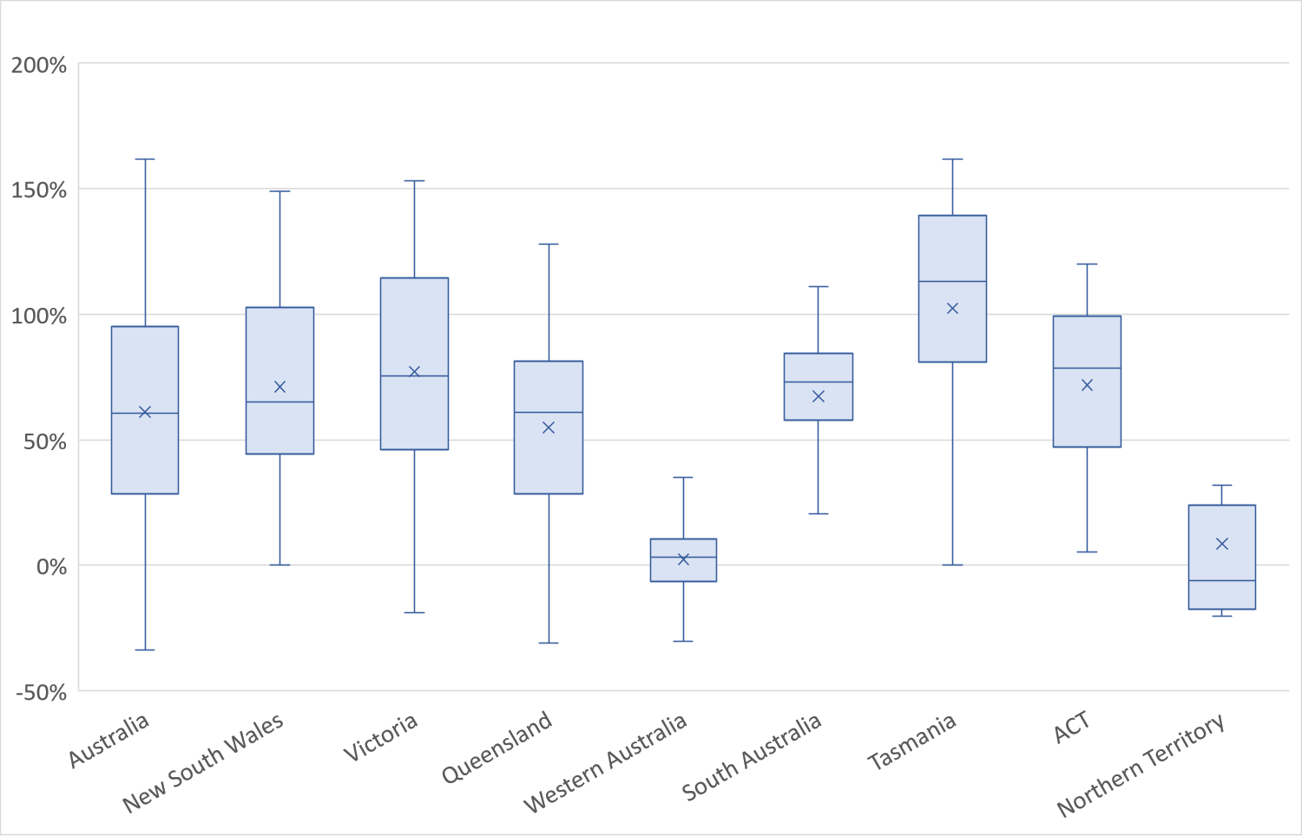
End of Exhibit 13
The average increase was reasonably consistent across states, with the exception that there was very little nominal increase in the median price of land between 2015 and 2023 in Western Australia and the Northern Territory.
Many stakeholders were concerned with the approach taken in the current pricing model which assumes that vacant undeveloped land can be purchased in all locations. They indicated that participants preferred to live in locations where they have long-established relationships with the service-providers, specialists and supports, and that vacant land was often not available in those locations. Noting the constrained supply of suitable greenfield land in urban SA4 regions, several stakeholders argued for the use of established land prices in the SDA pricing methodology.
Current SDA prices are based on the assumption that the average cost of undeveloped land in metropolitan Australia is $648 per square metre (in 2022-23 prices). In fact, based on data provided by CoreLogic, the 25th percentile of land costs in metropolitan Australia in 2022-23 was $1,136 per square metre. The NDIA also considered that this is a more realistic estimate because most developments in metropolitan areas that are close to services are brownfield rather than greenfield developments and so the “undeveloped land price” is no longer a useful indicator of the costs faced by SDA developer.
Exhibit 14 sets out the assumptions of the cost of land per square metre, by SA4 Region, that the NDIA has used in determining the prices set out in this report.
Exhibit 14: Pricing Model Assumptions re Cost per m2, by SA4 Region, 2023-24 prices
State | SA4 | $/sqm
n/a | Median Capital City | $1,136.00
New South Wales | Capital Region | $355.72
New South Wales | Central Coast | $896.99
New South Wales | Central West | $198.94
New South Wales | Coffs Harbour - Grafton | $289.10
New South Wales | Far West and Orana | $92.61
New South Wales | Hunter Valley exc Newcastle | $355.77
New South Wales | Illawarra | $1,235.34
New South Wales | Mid North Coast | $306.60
New South Wales | Murray | $169.79
New South Wales | New England and North West | $136.62
New South Wales | Newcastle and Lake Macquarie | $978.50
New South Wales | Richmond - Tweed | $536.18
New South Wales | Riverina | $151.62
New South Wales | Southern Highlands and Shoalhaven | $409.30
New South Wales | Sydney - Baulkham Hills and Hawkesbury | $1,236.47
New South Wales | Sydney - Blacktown | $1,276.88
New South Wales | Sydney - City and Inner South | $6,382.15
New South Wales | Sydney - Eastern Suburbs | $6,231.36
New South Wales | Sydney - Inner South West | $1,903.70
New South Wales | Sydney - Inner West | $3,774.45
New South Wales | Sydney - North Sydney and Hornsby | $2,579.67
New South Wales | Sydney - Northern Beaches | $2,880.33
New South Wales | Sydney - Outer South West | $725.74
New South Wales | Sydney - Outer West and Blue Mountains | $628.71
New South Wales | Sydney - Parramatta | $1,770.75
New South Wales | Sydney - Ryde | $2,217.13
New South Wales | Sydney - South West | $1,149.40
New South Wales | Sydney - Sutherland | $1,945.98
Victoria | Ballarat | $330.26
Victoria | Bendigo | $350.38
Victoria | Geelong | $779.53
Victoria | Hume | $147.61
Victoria | Latrobe - Gippsland | $205.56
Victoria | Melbourne - Inner | $3,247.99
Victoria | Melbourne - Inner East | $2,052.18
Victoria | Melbourne - Inner South | $1,949.82
Victoria | Melbourne - North East | $624.52
Victoria | Melbourne - North West | $332.37
Victoria | Melbourne - Outer East | $541.21
Victoria | Melbourne - South East | $774.86
Victoria | Melbourne - West | $1,041.60
Victoria | Mornington Peninsula | $643.12
Victoria | North West | $107.95
Victoria | Shepparton | $192.40
Victoria | Warrnambool and South West | $245.37
Queensland | Brisbane - East | $790.56
Queensland | Brisbane - North | $1,153.91
Queensland | Brisbane - South | $1,302.86
Queensland | Brisbane - West | $1,174.09
Queensland | Brisbane Inner City | $2,305.25
Queensland | Cairns | $246.45
Queensland | Darling Downs - Maranoa | $59.25
Queensland | Central Queensland | $201.72
Queensland | Gold Coast | $714.66
Queensland | Ipswich | $362.22
Queensland | Logan - Beaudesert | $360.74
Queensland | Mackay - Isaac - Whitsunday | $286.67
Queensland | Moreton Bay - North | $521.96
Queensland | Moreton Bay - South | $564.98
Queensland | Queensland - Outback | $121.54
Queensland | Sunshine Coast | $425.69
Queensland | Toowoomba | $259.40
Queensland | Townsville | $256.06
Queensland | Wide Bay | $166.56
Western Australia | Bunbury | $305.05
Western Australia | Mandurah | $345.26
Western Australia | Perth - Inner | $2,311.18
Western Australia | Perth - North East | $541.82
Western Australia | Perth - North West | $898.80
Western Australia | Perth - South East | $622.95
Western Australia | Perth - South West | $770.67
Western Australia | Western Australia - Outback (North) | $329.60
Western Australia | Western Australia - Outback (South) | $102.36
Western Australia | Western Australia - Wheat Belt | $124.68
South Australia | Adelaide - Central and Hills | $1,074.60
South Australia | Adelaide - North | $524.45
South Australia | Adelaide - South | $818.64
South Australia | Adelaide - West | $1,071.58
South Australia | Barossa - Yorke - Mid North | $128.08
South Australia | South Australia - Outback | $98.98
South Australia | South Australia - South East | $139.40
Tasmania | Hobart | $437.88
Tasmania | Launceston and North East | $155.57
Tasmania | South East | $74.21
Tasmania | West and North West | $219.66
ACT | Australian Capital Territory | $845.91
Northern Territory | Darwin | $593.95
Northern Territory | Northern Territory - Outback | $154.69
End of Exhibit 14
The maps in Exhibit 15, Exhibit 16 and Exhibit 17 further illustrate how the cost of land varies considerably across Australia and within cities.
Exhibit 15: Variation in the Cost of Land, Australia
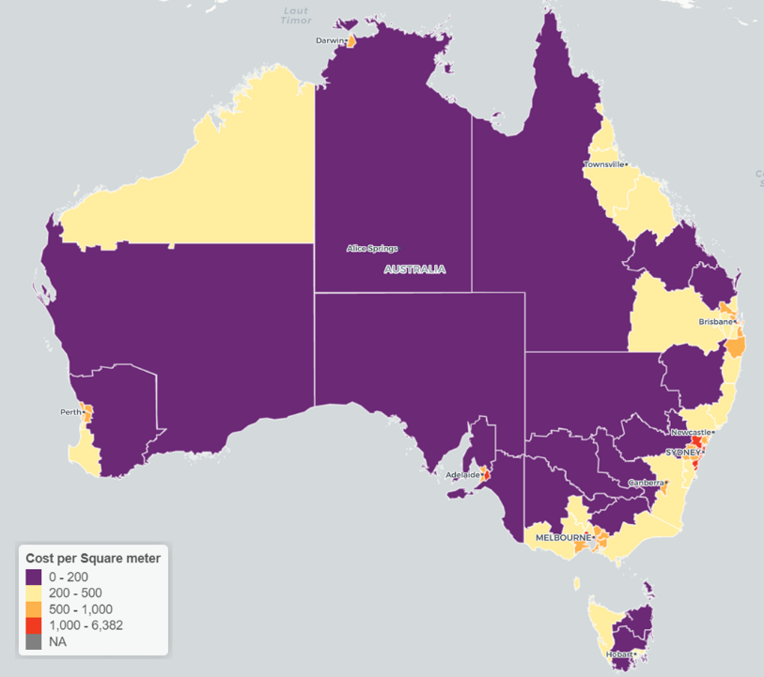
End of Exhibit 15

Exhibit 16: Variation in the Cost of Land, Greater Sydney
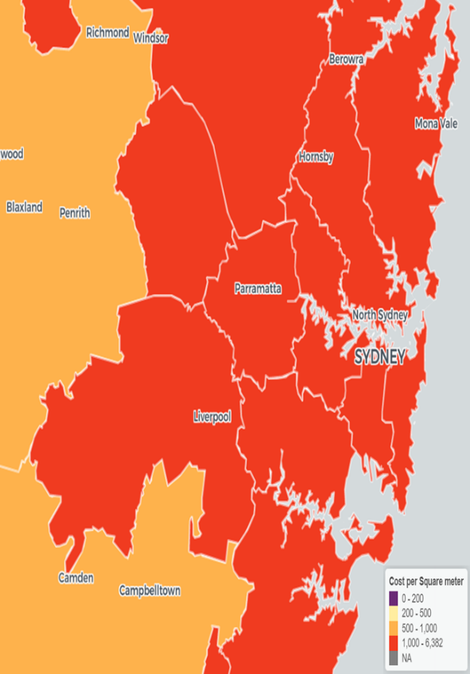
End of Exhibit 16

Exhibit 17: Variation in the Cost of Land, Greater Melbourne
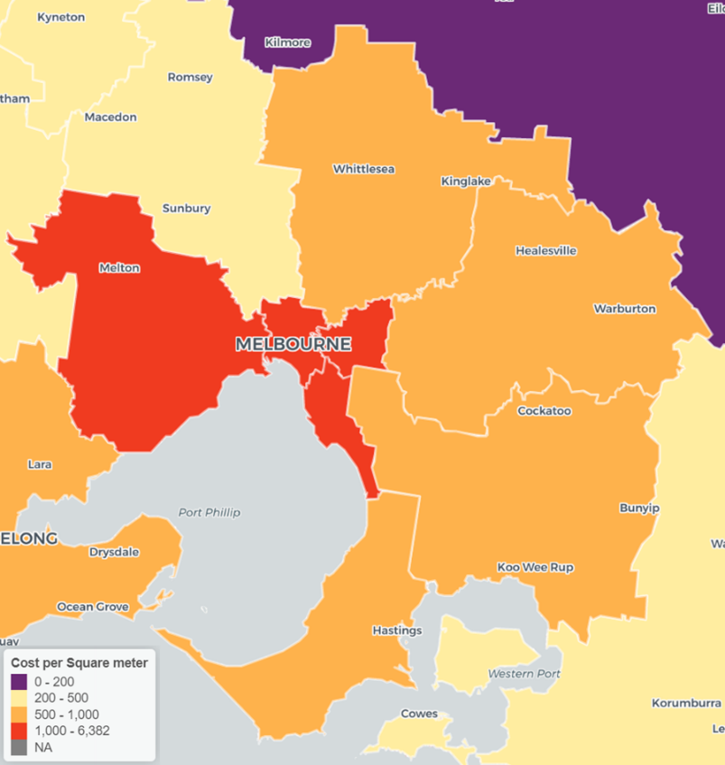
End of Exhibit 17

On average, the new land cost assumptions are 74.9% higher than the previous land cost assumptions, in nominal terms. However, the new median capital city cost assumption is 110.9% higher than previously in nominal terms. That is, land costs outside metropolitan areas have increased at a slower rate than in metropolitan areas. These differences are reflected in changes in the Location Factor multipliers that are discussed below.

Build Costs
The Australian Bureau of Statistics’ Producer Price Index of input costs for the house construction industry indicates that input costs for SDA developers are 18% higher in real terms than when the current SDA prices were set. In real terms, the cost of timber is up 31.8%, bricks are up 19.1% and steel is up 30.3%. Building costs are also expected to rise in the short to medium term because of the shortage of skilled labour in the Australian economy.
The Review’s Technical Advisor engaged Kennedy and Associates, who are experienced in the design of SDA dwellings, to design exemplar dwellings for each SDA dwelling type that were aligned to contemporary practice and that met the minimum requirements of:
- Specialist Disability Accommodation Design Standard; and
- Building Code of Australia and National Construction Code; and
- All relevant Australian Standards (including but not limited to AS 1428.1 Design for access and mobility and AS/NZS 1428.4.1 Design for access and mobility).
Where the standards were not specific enough, overarching design assumptions were developed post the instructions. These included:
- All buildings were to be consistent with the Building Code of Australia Class 3 residential care building classification.
- Where the requirements of the SDA Design Standard and the Building Code of Australia differ, the higher compliance standard were to be adopted.
- Four- and five-bedroom group homes were to have two living areas (one big and one smaller).
- The plans should not have to provide ensuites for participants, but no more than two residents were to share a common bathroom.
- Houses and Group Homes to include an office for the use of support staff that would contain space for common services in addition to space for a desk.
- Garage car parking was to be provided.
- Laundry was to be provided as a room rather than a cupboard accessed via a hallway when there are more than two residents.
- Kitchens were to be reduced proportionally as the number of bedrooms decreased noting that there would be a practical minimum based upon compliance with the SDA Design Standard.
- Covered outdoor area was to be provided adjacent to rear living area.
- Victorian planning controls, which are the most comparable with other States, were to be used in the development of the reference designs.
- The Robust villas reference design layout should avoid corridors to reduce places for entrapment. Access should be via open air walkways that are not enclosed, while other design categories can have internal corridor access which allows for a more compact built form. Robust villas would also require the provision for two forms of egress (other design categories would only require one) from every villa for staff safety.
- Robust villas require private open space to all villas to be observable from the common areas, whereas all other design categories can have open space within the side setback which reduces the land area required.
- Participant storage should be allowed for within the laundry room and at the rear of the garage.
- All rooms should be accessible (meeting the SDA Design Standard) including office and OOA.
- Apartment, villa, townhouse and duplex detailed estimates should include the cost of communal facilities to satisfy planning controls as they do not exist in isolation. Communal facilities include but are not limited to common areas, support areas (fire stairs, bin rooms, plant areas, lobbies), pathways, fencing, external works and landscaping.
MBMpl, who has extensive experience in Quantity Surveying including of SDA properties, was then engaged by the Review’s Technical Advisors to provide cost estimates for each of the exemplar designs on the assumption that they were being built in an area facing median capital city costs.
Exhibit 18 sets out the assumptions of the cost of building dwellings, without a contingency allowance, in the benchmark region, that the NDIA has used in determining the prices set out in this report.
Exhibit 18: Pricing Model Assumptions re Building Costs, Without Contingency Allowance, 2023-24 prices
Building Type | Improved Liveability | Fully Accessible | Robust | High Physical Support
Dwellings Without Onsite Overnight Accommodation
Apartment, 1 bedroom, 1 SDA eligible resident | $613,853 | $639,032 | n/a | $696,103
Apartment, 2 bedrooms, 1 SDA eligible resident | $652,010 | $669,999 | n/a | $728,832
Apartment, 2 bedrooms, 2 SDA eligible residents | $653,961 | $670,986 | n/a | $730,641
Apartment, 3 bedrooms, 2 SDA eligible residents | $720,319 | $746,304 | n/a | $811,054
Villa/Duplex/Townhouse, 1 bedroom, 1 SDA eligible resident | $327,005 | $355,169 | $358,582 | $410,322
Villa/Duplex/Townhouse, 2 bedrooms, 2 SDA eligible residents | $377,891 | $417,922 | $451,038 | $472,010
Villa/Duplex/Townhouse, 3 bedrooms, 3 SDA eligible residents | $475,603 | $542,680 | $575,304 | $611,786
House, 2 bedrooms, 2 SDA eligible residents | $768,933 | $789,208 | $886,339 | $978,788
House, 3 bedrooms, 3 SDA eligible residents | $855,862 | $871,760 | $939,854 | $1,072,323
Group home, 4 bedrooms, 4 SDA eligible residents | $980,273 | $1,007,984 | $1,090,641 | $1,208,175
Group home, 5 bedrooms, 5 SDA eligible residents | $1,075,885 | $1,120,017 | $1,219,334 | $1,327,579

Dwellings With Onsite Overnight Accommodation
Villa/Duplex/Townhouse, 1 bedroom, 1 SDA eligible resident | $347,000 | $376,886 | n/a | $435,412
Villa/Duplex/Townhouse, 2 bedrooms, 2 SDA eligible residents | $427,024 | $472,260 | $493,718 | $533,379
Villa/Duplex/Townhouse, 3 bedrooms, 3 SDA eligible residents | $537,431 | $613,228 | $639,275 | $679,082
House, 2 bedrooms, 2 SDA eligible residents | $879,825 | $895,402 | $989,899 | $1,094,960
House, 3 bedrooms, 3 SDA eligible residents | $933,264 | $958,348 | $1,042,800 | $1,162,454
Group home, 4 bedrooms, 4 SDA eligible residents | $1,053,509 | $1,079,727 | $1,179,502 | $1,297,451
Group home, 5 bedrooms, 5 SDA eligible residents | $1,140,646 | $1,220,217 | $1,259,226 | $1,404,859
End of Exhibit 18
Note: There is no separate “with OOA” building cost for Apartments. The SDA amount for Apartments with OOA is calculated by adding one sixth of the SDA Amount of an Improved Liveability, Apartment, 1 bedroom, without OOA.
The building costs used in the pricing model are increased by a contingency allowance as follows:
- The building costs of apartments were inflated by 13.5% for contingencies.
- The building costs of other dwellings were inflated by 15% for contingencies.

Other Acquisition Costs
Several stakeholders were concerned that the current SDA pricing model was flawed in that it failed to account for other acquisition costs, which can be significant, such as Stamp Duty, Conveyancing Costs, Mortgage Registration Fees, and Government Transfer Fees. These costs vary considerably by jurisdiction and by the size of the property.
The NDIA therefore proposes to adjust the pricing methodology by including an acquisition costs based on the value of the land purchased for the dwelling by including an acquisition cost based on the jurisdiction and the cost of the land on which the dwelling is built as set out in Exhibit 19.
Exhibit 19: Pricing Model Assumptions re Other Acquisition Costs
Land Value | Below $250K | $250K-$500K | $500K-  750K | $750K-$1,000K | $1,000K-$1,250K | $1,250K-$1,500K | $1,500K-$1,750K | Above  $1,750k
Median capital city | 3.6% | 3.9% | 4.2% | 4.4% | 4.7% | 4.8% | 4.9% | 5.0%
NSW | 3.4% | 3.8% | 4.1% | 4.2% | 4.4% | 4.6% | 4.7% | 4.8%
VIC | 4.8% | 5.5% | 5.8% | 5.9% | 5.9% | 5.9% | 5.8% | 5.8%
QLD | 3.5% | 3.7% | 4.1% | 4.3% | 4.7% | 5.0% | 5.1% | 5.3%
WA | 3.3% | 3.8% | 4.2% | 4.5% | 4.6% | 4.7% | 4.8% | 4.8%
SA | 4.9% | 5.4% | 5.8% | 6.0% | 6.1% | 6.1% | 6.2% | 6.2%
TAS | 3.7% | 3.9% | 4.1% | 4.2% | 4.3% | 4.3% | 4.4% | 4.4%
ACT | 2.0% | 2.6% | 3.2% | 3.9% | 4.4% | 4.7% | 4.7% | 4.7%
NT | 3.7% | 5.0% | 5.2% | 5.1% | 5.1% | 5.1% | 5.1% | 5.1%
End of Exhibit 19

Updated Acquisition Costs
This extensive work has confirmed that, even taking into account the higher input costs discussed above, the acquisition costs for some types of dwellings are lower in real terms than were previously assumed. They are also significantly higher for other dwelling types (see Exhibit 20).
Exhibit 20: Real Change in Benchmark Acquisition Costs between 2016-17 and 2023-24 (ex GST)
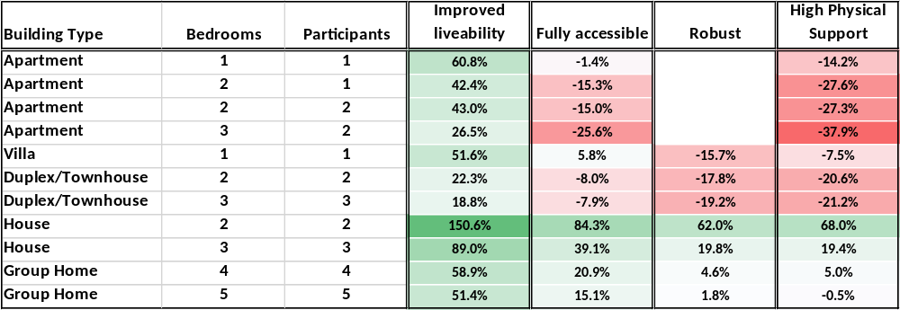
End of Exhibit 20
Acquisition costs for apartments (except Improved Liveability), villas, and High Physical Support dwellings are lower in real terms than is assumed in the current pricing model. Acquisition costs for houses (especially two- and three-bedroom houses) and for Improved liveability dwellings are significantly higher than is assumed in the current pricing model. These differences explain, in large part, why recent construction activity has concentrated on apartments and high physical support dwellings.
One of the drivers of the decrease in the cost estimate is that the assumptions about the land area required for each SDA development have been decreased (see Exhibit 21). Note, the NDIA does not mandate the size of blocks on which SDA dwellings are built. Within the SDA pricing model, land is assumed to appreciate in value over time. The inclusion of more land in the initial assumption therefore lowers the overall price because it discounts the price for the capital gain made on the land at the end of the investment period. The NDIA therefore considers that the fairest approach is to include only the minimum land requirement in the costing assumptions.
Exhibit 21: Comparison of 2016-17 and 2023-24 Land Requirement Assumptions
Building Type | Bedrooms | Proposed  Area (m²)  Improved Liveability | Proposed  Area (m²)  Fully Accessible | Proposed  Area (m²)  Robust | Proposed  Area (m²)  High Physical Support | Initial  Area (m²)
Apartment | 1 | 30 | 31 | n/a | 31 | 50
Apartment | 2 | 40 | 42 | n/a | 42 | 50
Apartment | 3 | 57 | 58 | n/a | 58 | 50
Villa / Duplex / Townhouse | 1 | 150 | 150 | 120 | 150 | 180
Villa / Duplex / Townhouse | 2 | 200 | 200 | 200 | 200 | 360
Villa / Duplex / Townhouse | 3 | 300 | 300 | 300 | 300 | 540
House | 2 | 464 | 490 | 464 | 493 | 360
House | 3 | 468 | 508 | 468 | 511 | 540
Group Home | 4 | 534 | 584 | 534 | 587 | 720
Group Home | 5 | 585 | 619 | 585 | 609 | 900
End of Exhibit 21

Goods and Services Tax
A significant flaw in the initial pricing arrangements was that it assumed that all SDA providers would be able to claim input tax credits on the GST paid on the purchase costs, or construction costs, of the dwelling. In fact, this is only possible when the SDA provider owns the dwelling rather than operates it through a head lease arrangement with an investment company that owns the dwelling. It is estimated the fewer than half of all new dwellings are owned by the provider. The NDIA therefore proposes to amend the pricing model to determine different SDA amounts for a dwelling based on two cases:
- Dwellings where the owner of the property paid GST on the purchase cost, or the construction cost, of the dwelling and was not able to claim input tax credits for those GST payments.
- Dwellings where the owner of the property did not pay GST on the purchase cost, or the construction cost, of the dwelling; or did pay GST on the purchase cost, or the construction cost, of the dwelling and was able to claim input tax credits for those GST payments.
Although the proposed changes increase the complexity of the SDA pricing arrangements, they ensure the SDA Amount payable in respect of a dwelling better reflects the unavoidable cost structures of the various developers, investors, and providers who are delivering SDA dwellings. A simpler approach would either significantly overcompensate some providers or undercompensate other providers.
The NDIA also proposes to recommend to the Australian Government that it consider amending the A New Tax System (Goods and Services Tax) (GST-free Supply—National Disability Insurance Scheme Supports) Determination 2021 to clarify that the intention of the Determination that input taxes should be creditable for all SDA developments (whether or not the dwelling is developed and/or owned by an entity other than the SDA Provider responsible for the dwelling’s ongoing management).

Geographic Variation in Costs
The pricing model uses Location Factors to convert the benchmark SDA Amount for a dwelling into the SDA Amount for the dwelling in a given region. These location factors account for the differences in land cost (discussed above) and the differences in building costs, including material prices, labour costs and shipping costs to regional and remote areas.
Based on the advice of the Review’s Technical Advisors, the NDIA proposes to use the more granular construction cost relativities that are outlined in the Technical Report on the Geographic Variation in Construction Costs. Those relativities are drawn from historical construction costs in a database maintained my MBMpl.
It is also proposed that the Location Factors should continue to account for the additional costs associated with the design and engineering requirements for dwellings are prone to cyclone level winds. The cost premium relates to additional works including window protection, increased specification to various construction elements, increase in structural requirements and additional roof framing. The additional 15% cyclone cost loading currently applies to four SA 4 Regions: Cairns, Townsville, Mackay Isaac Whitsunday, Central Queensland, and Darwin. It is also proposed to extend the additional 15% cyclone cost loading to four new SA4 Regions: WA Outback (North), WA Outback (South), NT Outback and QLD Outback.
The variation in building costs across Australia is illustrated in Exhibit 22, Exhibit 23 and Exhibit 24.
Exhibit 22: Variation in Construction Costs, Australia
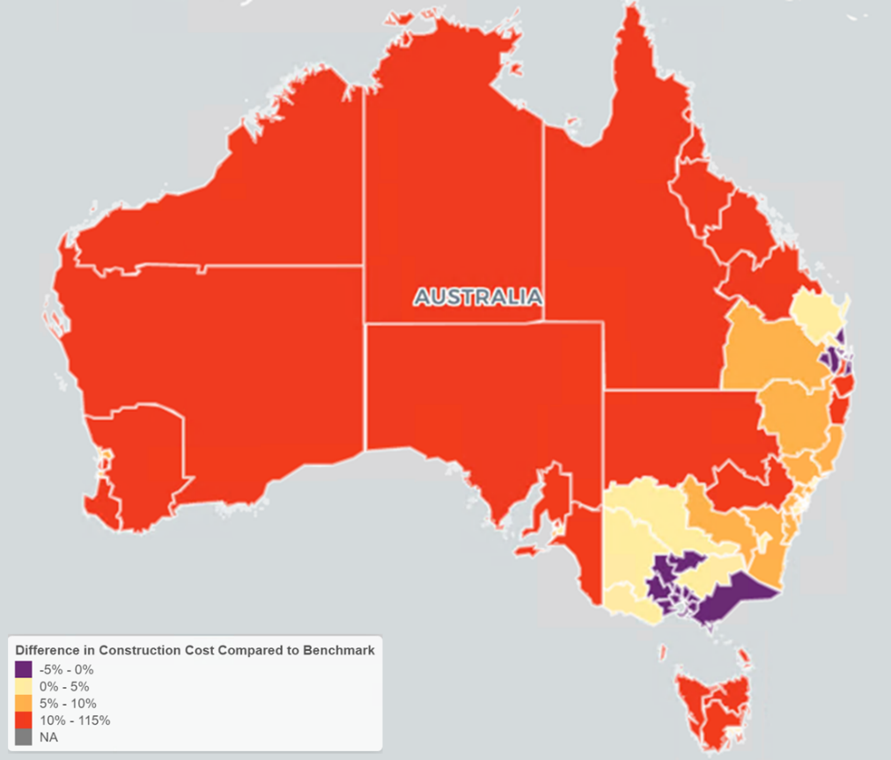
End of Exhibit 22

Exhibit 23: Variation in Construction Costs, Greater Sydney
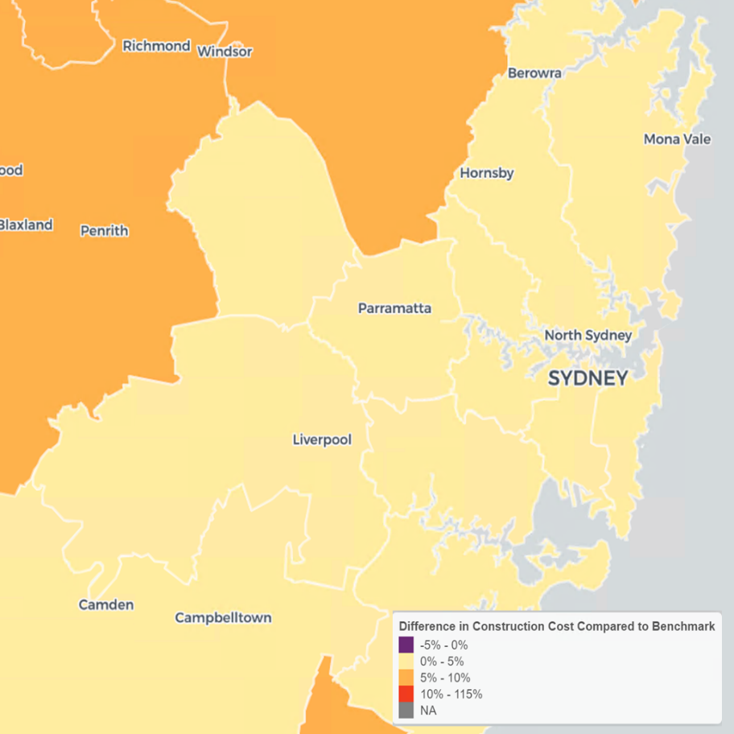
End of Exhibit 23
Exhibit 24: Variation in Construction Costs, Greater Melbourne
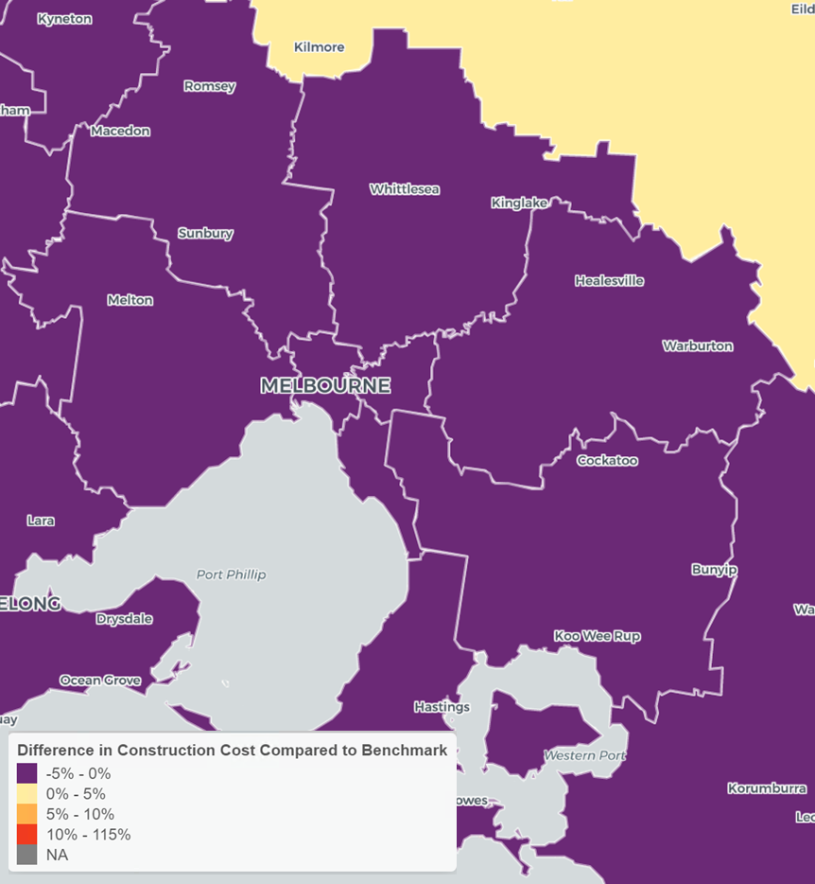
End of Exhibit 24

Some stakeholders suggested the location factors should also be adjusted to take account of the costs associated with building on bushfire prone land, flood hazard areas or other locations impacted by specific environmental issues, as this often also requires modification of construction material used, design, different height requirements, geotechnical advice, development approval requirements and other considerations above that of a standard development.
The NDIA does not currently propose to provide any additional cost allowance for sites with environmental requirements as the intent of the NDIS Pricing Arrangements for SDA is to provide a fair price to providers to develop, maintain and hold SDA assets nationally to ensure support for the SDA market. The pricing ensures SDA providers can develop SDA within a SA4 area but does not assume that all parcels of land are suitable for SDA.

New Location Factors
The NDIA proposes to update the Location Multipliers it uses to convert the SDA Amount for a type of dwelling in the benchmark Region to the SDA amount for the same type of dwelling in another region using a new set of Location Multipliers based on these new land cost and built cost variations. The multipliers are derived by calculating the SDA Amount for a fully accessible dwelling of the appropriate type in the region of interest and dividing that amount by the benchmark SDA Amount. It would have been possible to create different Location Factors for each Design Category, but the Fully Accessible Location Factors are considered a reasonable proxy for the other design categories.
The Location Factors that the NDIA proposes to use for New Builds that are enrolled on or after 1 July 2023 are set out in Appendix B.

Fire Sprinklers

Capital Costs
The current SDA pricing arrangements increases the Benchmark SDA Amount for a dwelling when the dwelling has a sprinkler system by 1.2% if the dwelling is an apartment and by 1.9% if the dwelling is not an apartment.
Stakeholders generally agreed that the costs of installing and maintaining sprinklers are not accurately reflected in the current pricing arrangements. Various submissions included information of the costs that had been incurred in installing sprinklers in recent developments.
The NDIA engaged EY (and its partners Kennedy Associates Architects and MBMpl Quantity Surveys) to provide technical advice to the SDA Pricing Review on the costs of installing and maintaining sprinkler systems in SDA dwellings. These costs were assessed costs in accordance with AS 2118.1.
The report of the Review’s Technical Advisors indicated that the cost to install fire sprinklers in SDA dwellings varies in relation to both Build Type and Gross Floor Area but does not otherwise vary by Design Category. It further advised that:
- Because detached dwellings (villas, houses and group homes) require an individual sprinkler system with the total cost of infrastructure attributed to a single dwelling, the Review’s Technical Advisors have estimated the sprinkler system capital cost for detached dwellings using a lump sum approach. The system has been costed to include a storage tank and pump as redundancy for the mains water supply.
- Because apartment developments often share one sprinkler system across the entire building, resulting in a higher level of efficiency for the infrastructure required, the Review’s Technical Advisors have estimated the sprinkler system capital cost for apartments on a rate per square meter. The apartment sprinkler system has been costed to include a water storage tank along with a booster pump and kerb side valve assembly, pipework through risers to units and recessed sprinklers on flexible pipework. This resulted in an estimate of $120 per sqm of internal area capital cost for apartments.
- For all Build Types, the gross floor area impacts the material costs and infrastructure requirements of the sprinkler system to be installed. Therefore, the number of bedrooms and addition of an OOA impact the sprinkler system cost.
Because the capital costs of installing sprinklers do not vary by Design Category for detached dwellings and only slightly vary by Design Category for apartments, it is not appropriate to continue to provide for these additional costs through a percentage of the total building costs. The NDIA therefore proposes to change the pricing methodology by replacing the current Sprinkler Multiplier approach with an approach that adds a variable amount the construction cost of each type of dwellings as set out in Exhibit 25.
Exhibit 25: Pricing Model Assumptions re Building Costs of Sprinklers, 2023-24 prices
Building Type | Improved Liveability | Fully Accessible | Robust | High Physical Support
Dwellings Without Onsite Overnight Accommodation
Apartment, 1 bedroom, 1 SDA eligible resident | $7,560 | $7,800 | n/a | $7,800
Apartment, 2 bedrooms, 1 SDA eligible resident | $9,960 | $10,440 | n/a | $10,440
Apartment, 2 bedrooms, 2 SDA eligible residents | $10,200 | $10,800 | n/a | $10,800
Apartment, 3 bedrooms, 2 SDA eligible residents | $14,280 | $14,520 | n/a | $14,640
Villa/Duplex/Townhouse, 1 bedroom, 1 SDA eligible resident | $18,377 | $18,377 | $18,377 | $18,377
Villa/Duplex/Townhouse, 2 bedrooms, 2 SDA eligible residents | $24,483 | $24,483 | $24,483 | $24,483
Villa/Duplex/Townhouse, 3 bedrooms, 3 SDA eligible residents | $30,588 | $30,588 | $30,588 | $30,588
House, 2 bedrooms, 2 SDA eligible residents | $47,424 | $47,424 | $47,424 | $47,424
House, 3 bedrooms, 3 SDA eligible residents | $53,352 | $53,352 | $53,352 | $53,352
Group home, 4 bedrooms, 4 SDA eligible residents | $59,280 | $59,280 | $59,280 | $59,280
Group home, 5 bedrooms, 5 SDA eligible residents | $62,244 | $62,244 | $62,244 | $62,244
Dwellings With Onsite Overnight Accommodation
Villa/Duplex/Townhouse, 1 bedroom, 1 SDA eligible resident | $21,877 | $21,877 | n/a | $21,877
Villa/Duplex/Townhouse, 2 bedrooms, 2 SDA eligible residents | $27,983 | $27,983 | $27,983 | $27,983
Villa/Duplex/Townhouse, 3 bedrooms, 3 SDA eligible residents | $34,088 | $34,088 | $34,088 | $34,088
House, 2 bedrooms, 2 SDA eligible residents | $53,352 | $53,352 | $53,352 | $53,352
House, 3 bedrooms, 3 SDA eligible residents | $59,280 | $59,280 | $59,280 | $59,280
Group home, 4 bedrooms, 4 SDA eligible residents | $62,244 | $62,244 | $62,244 | $62,244
Group home, 5 bedrooms, 5 SDA eligible residents | $65,208 | $65,208 | $65,208 | $65,208
End of Exhibit 25
Note: There is no separate “with OOA” building cost for Apartments. The SDA amount for Apartments with OOA is calculated by adding one sixth of the SDA Amount of an Improved Liveability, Apartment, 1 bedroom, without OOA.

Ongoing Costs
The report of the Review’s Technical Advisors also indicated that the standard AS2118.1 also specifies regular testing requirements for fire sprinkler systems, including annual inspections, pressure switch testing, sprinkler tank and pipes flushing, and sprinkler heads testing. The report of the Review’s Technical Advisors noted that this testing comes at a cost to the SDA provider and that it should therefore be accounted for in the SDA Benchmark Price for dwellings with sprinklers.
The report of the Review’s Technical Advisors also indicated that for detached dwellings the inspection activities do not materially change with the size of the dwelling. It further advised that apartments have a lower unit maintenance cost due to the efficiency of multiple dwellings sharing a system. The annual maintenance cost estimates provided by the Review’s Technical Advisors are set out in Exhibit 26.
Exhibit 26: Annual Maintenance Costs for Sprinkler Systems (2023-24 prices)
Building Type | Low Estimate | Median Estimate | High Estimate
Apartments | $600 | $800 | $1,000
All other Building Types | $2,380 | $2,800 | $3,220
End of Exhibit 26
The NDIA proposes that the additional operational costs associated with maintaining the sprinkler system should be recognised as ownership costs in the pricing model.

Appropriateness of Sprinklers
Stakeholders expressed varying views about the need for sprinklers in SDA, with strong views both for and against sprinklers. Several stakeholders argued that sprinklers should be mandated in all new SDA dwellings because of the importance of sprinklers for participant safety. Other stakeholders disputed the necessity of sprinklers in SDA, especially when their additional cost and their impact on a dwelling’s amenity were considered. They were concerned that sprinkler systems created an institutional feel to SDA dwellings. There was also some dispute between stakeholders about the effectiveness of sprinklers in preventing deaths of SDA residents. The submission from the Home Fire Sprinkler Coalition Australia stated that sprinklers are effective in reducing the risks posed by typical modern home fires and referred to several Australian and international studies that indicated that there was a 90% improvement in occupant survivability for sprinklered buildings.
Conversely, a submission from a sector stakeholder stated that, based on conversations with the industry, there was a view that sprinklers would not necessarily save lives. The submission further stated that sprinklers may be more about protecting property than the person. However, the submission also pointed out that sprinklers may have other benefits such as personal safety and reducing the spread of fire damage. It also noted that while a sprinkler may not save the occupant, it could save the person next door by stopping the spread of the fire. Another stakeholder suggested that the presence of 24-hour support workers on site reduced the need for sprinklers in SDA, saying that “sprinklers don’t save lives in a fire – people do”.
The current SDA Design Standards do not mandate the inclusion of sprinkler systems in new SDA dwellings. However, they do state that “it is desirable for fire sprinklers to be provided”. There is also some disagreement between stakeholders as to whether the National Construction Code does not, in effect, require all SDA dwellings to be classified as Class 3 buildings, in which case (because they are for residential care buildings) sprinklers would be mandatory. It is not appropriate for the SDA Pricing Review to determine these issues. However, it is recommended that the NDIA should work with SDA developers and with the Australian Building Codes Board, which is responsible for the National Construction Code, to provide greater clarity to SDA developers and building certifiers as to the appropriate classification of SDA dwellings.

Ownership Costs
The Review’s Technical Advisors found that the costs of maintenance and property and tenancy management, including rates and land taxes, are (in real terms) about 50% higher than allowed for in the current pricing arrangements for apartments (70% higher for villas, duplexes, and townhouses; and 40% higher for houses).
These increases are driven by higher maintenance charges than previous estimated (including ongoing costs of maintaining and certifying fire sprinkler systems and higher insurance costs), insufficient provision in the current pricing arrangements for rates and taxes, and higher tenancy management costs, including reporting requirements to the NDIS Quality and Safeguards Commission.
The NDIA proposes to increase the allowance for maintenance, property management and tenant managements costs per dwelling as set out Exhibit 27.
Exhibit 27: Pricing Model Assumptions re Ownership Costs per Dwelling, 2023-24 prices
Building Type | Maintenance and Outgoing | Property management costs (Includes tenancy management costs)
Apartment, 1 bedroom, 1 SDA eligible resident | $16,050 | $9,630
Apartment, 2 bedrooms, 1 SDA eligible resident | $16,050 | $9,630
Apartment, 2 bedrooms, 2 SDA eligible residents | $16,050 | $9,630
Apartment, 3 bedrooms, 2 SDA eligible residents | $20,330 | $13,910
Villa/Duplex/Townhouse, 1 bedroom, 1 SDA eligible resident | $14,980 | $9,630
Villa/Duplex/Townhouse, 2 bedrooms, 2 SDA eligible residents | $20,330 | $13,910
Villa/Duplex/Townhouse, 3 bedrooms, 3 SDA eligible residents | $24,610 | $17,655
House, 2 bedrooms, 2 SDA eligible residents | $29,960 | $13,910
House, 3 bedrooms, 3 SDA eligible residents | $32,100 | $17,655
Group home, 4 bedrooms, 4 SDA eligible residents | $43,424 | $20,330
Group home, 5 bedrooms, 5 SDA eligible residents | $36,380 | $22,738
End of Exhibit 27

Residual Value
In determining the SDA Amount for a dwelling, the pricing model takes into account the net present value to the SDA provider of the residual value of the dwelling at the end of the investment period. This residual value is dependent on the useful life of the dwelling and the residual value of the dwelling, discounted for any exit costs incurred.

Useful Life of the Dwelling
The 2016-17 pricing arrangements assumed that the useful life of an SDA dwelling is 60 years. At the same time, however, they required providers to make an investment equal to half the value of the property each 20 years in order to maintain eligibility for New Build funding.
The NDIA proposed to amend the pricing model so the assumed useful life of an SDA dwelling is 40 years, which better aligns both with the refurbishment policy and with reported life of these dwellings given their higher maintenance requirements. This has the effect of better accounting for the depreciation in the asset over the investment period.

Residual Value
The 2016-17 pricing arrangements assumed that the residual value of all buildings should be calculated as though the building was an Improved Liveability dwelling. That is, it assumed that the dwelling would cease to be used for SDA, even after refurbishment, and that the general rental market would not pay a premium for SDA design features. This has the effect of significantly discounting the residual value of the dwelling.
Based on the advice of the Review’s Technical Advisors, the NDIA proposes to apply the following discounts when calculating the residual value of a dwelling:
- 10% if the dwelling is an apartment in the High Physical Support Design Category.
- 20% if the dwelling is not an apartment and is in the High Physical Support Design Category.
- 30% if the dwelling is in the Robust Design Category.

Exit Costs
Based on the advice of the Review’s Technical Advisors, the NDIA proposes to reduce the assumption in the pricing model about the fees paid on the sale of a property from 7.3% to 3%. It is important to note, however, that some of the costs that were previously recognised as exit costs in the pricing model are now recognised as acquisition costs in the new pricing model.

Rent paid by residents
No changes are proposed to the level of rent paid by residents of SDA dwellings.

Impact
Exhibit 28 illustrates the percentage changes in the Benchmark SDA Amounts (the SDA Amounts for the Benchmark Region), by Design Category and Building Type, that result from the proposed changes in the key parameters of the pricing model.
Exhibit 28: Percentage Change in Benchmark SDA Amount
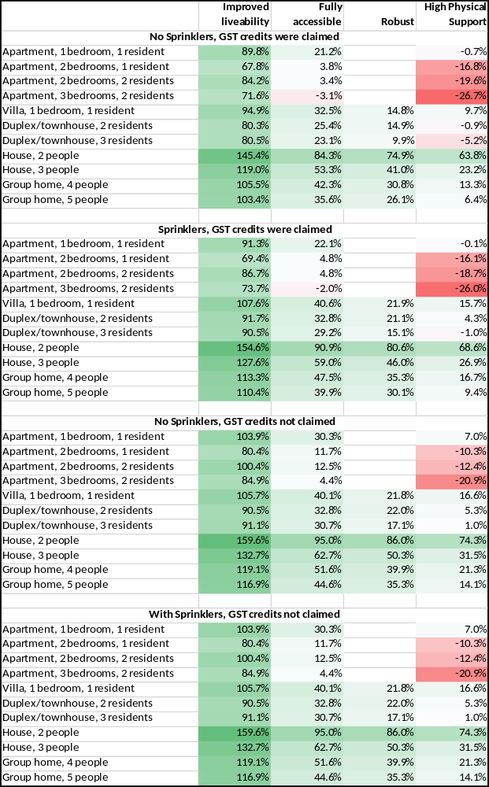
End of Exhibit 28

In brief, the highest increases are for Improved Liveability dwellings and for 2-bedroom houses. The lowest increases are for High Physical Support dwellings, with decreases for some High Physical Support apartments. These changes are in line with the comments received from stakeholders and explain, at least in part, why the sector has been building mainly apartments and High Physical Support dwellings in recent years, as these were overpriced by the initial pricing arrangements.
The proposed changes for New Builds will increase the average SDA National Benchmark Amount on 1 July 2023 by 18.5% in nominal terms (11.5% in real terms). The average increase will be higher for dwellings with sprinklers and for dwellings where GST input tax credits were not able to be claimed.
Exhibit 29: Average Percentage Change in Benchmark SDA Amount
 | Without Sprinklers | With Sprinklers
GST input tax credits claimed | 13.0% | 16.1%
GST input tax credits not claimed | 20.9% | 24.1%
End of Exhibit 29
It is also proposed to further increase the SDA National Benchmark Amounts for New Builds in line with the CPI on 1 July 2024, 1 July 2025, 1 July 2026, and 1 July 2027 and to use the new Location Factors set out in Attachment B (Recommendation 11) to determine the actual SDA Amount for all New Builds from these National Benchmark Amounts.
These changes will maintain the real value of SDA Amounts over the next five years to give certainty to investors and ensure that SDA can be developed in all regions of Australia.
Over the longer term, the proposed changes in the relativities of the SDA amounts payable for the different types of dwellings will incentivise the construction of new dwellings more in line with demand. This will have the effect over the very long term of decreasing average SDA National Benchmark amounts in real terms as more expensive SDA apartments and high physical support dwellings are replaced by Improved Liveability and Fully Accessible dwellings. When all SDA stock has been completely replenished then these pricing changes will mean that the average SDA Amount is about 4% lower than it currently is (before these increases) in real terms. At the same time, the stock will more closely match participant demand and be better located across Australia.
SDA is also a crucial support as it helps with Scheme sustainability. SDA is only meant to be included in a participant’s plan if it represents value for money compared to costs of supports that would be required if SDA was not included in the plan. That is, SDA is a capital investment by the Scheme that is intended to reduce the lifetime support costs of an individual. Investment in SDA is, over the long term, intended to lower costs in the Scheme.
SDA is also a key enabler for the Agency to meet the Government’s commitments with respect to reducing bed blockage in hospitals by people with disability and assisting younger people with disability to exit residential aged care, as the provision of suitable alternative accommodation is crucial in both these cases.
Moreover, SDA should be considered as an investment in Scheme sustainability rather than only as an expenditure by the Scheme. That is, the expenditure on SDA is offset by savings elsewhere in the Scheme rather than being additional expenditure by the Scheme.
The following Chart illustrates how the increase in prices proposed by the SDA Pricing Review will reduce unmet demand, and the number of people living in dwellings that are not fit for purpose, over the next decade.
Exhibit 30: Long Term Supply and Demand projections for SDA
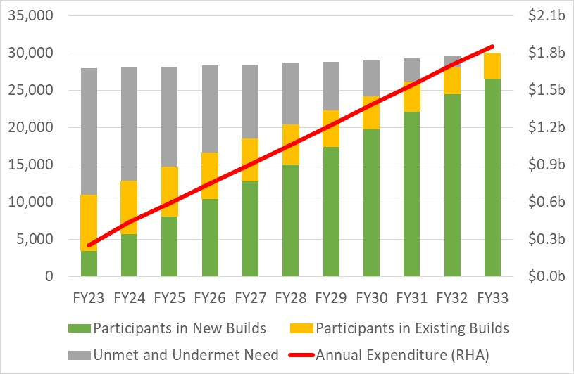
End of Exhibit 30
The following Table compares the expenditure and unmet need profiles of three scenarios:
- The initial costing for the inclusion of SDA in the Scheme made in 2016-17, which indicate roughly what funds can be considered to already be in the forward estimates for SDA.
- The likely outcome of freezing prices at the current level (CPI indexation).
- The outcome of accepting the recommendations of the SDA Pricing Review.
Exhibit 31: Medium Term Supply and Demand projections for SDA
 | FY24 | FY25 | FY26 | FY27
Expenditure | n/a | n/a | n/a | n/a
2015-16 Projections | $652m | $693m | $733m | $774m
Under current prices | $405m | $551m | $704m | $864m
Under new prices | $442m | $594m | $749m | $905m
Difference from 2015-16 Projections | -$113m | -$99m | $16m | $131m
Difference from current prices | $37m | $43m | $45m | $41m
Unmet Need | n/a | n/a | n/a | n/a
Under current prices | 16,560 | 16,331 | 16,314 | 16,508
Under new prices | 15,223 | 13,458 | 11,704 | 9,962
Difference | 1,337 | 2,873 | 4,610 | 6,546
End of Exhibit 31

If, alternatively, SDA prices are not increased then unmet need for SDA will significantly increase and by 2032-33 approximately 20,131 participants will not be able to access the SDA that is reasonable and necessary for them. Moreover, as a result they will have additional recurrent expenditure needs, the cost of which would be higher than the additional cost of the SDA not provided to them.

Recommendations

Annual SDA Amounts
Recommendation 1: Annual SDA Amounts for 2023-24 for New Builds that were first enrolled as a New Build on or after 1 July 2023
The Annual SDA Amount for 2023-24 for an enrolled dwelling that is a New Build and that was first enrolled as a New Build on or after 1 July 2023 should depend on:
  - The Building Type of the dwelling; and
  - The Design Category of the dwelling; and
  - The number of bedrooms in the dwelling; and
  - Whether or not the dwelling includes Onsite Overnight Accommodation; and
  - Whether or not the dwelling has a Breakout Room; and
  - Whether or not the dwelling has fire sprinklers; and
  - Whether or not the owner of the dwelling paid GST on the purchase price, or on the construction costs, of the dwelling and did not claim a GST input tax credit for those GST payments; and
  - The SA4 Region in which the dwelling is located.
The Annual SDA Amount for 2023-24 should be calculated as follows:
$$Annual.Benchmark.SDA.Amount×Location.Factor$$
Where:
  - The Annual Benchmark SDA Amount is as set out in Appendix A.
  - The Location Factor is determined by the SA4 Region in which the dwelling is located, and the Building Type of the dwelling, and the Design Category of the dwelling, as set out in Appendix B.
Recommendation 2: Annual SDA Amounts for 2023-24 for New Builds that were first enrolled as a New Build before 1 July 2023
The Annual SDA Amount for 2023-24 for a dwelling that is a New Build and that was first enrolled as a New Build before 1 July 2023 should be determined in the same way as the Annual SDA Amount for 2023-24 for a dwelling that is a New Build and that was first enrolled on or after 1 July 2023, except that it should be assumed that the owner of the dwelling claimed GST Input tax credits for the GST paid on the purchase price, or on the construction costs, of the dwelling.
Recommendation 3: Annual SDA Amounts for 2023-24 for Legacy Stock and Existing Stock
The Annual SDA Amount for 2023-24 for a dwelling that is Legacy Stock or Existing Stock should depend on:
  - The number of bedrooms in the dwelling; and
  - Whether or not the dwelling includes Onsite Overnight Accommodation; and
  - Whether or not the dwelling has fire sprinklers; and
  - The SA4 Region in which the dwelling is located.
The Annual SDA Amount for 2023-24 should be calculated as follows:
$$Annual.Benchmark.SDA.Amount×Location.Factor×Sprinkler.Allowance.Factor$$
Where:
  - The Annual Benchmark SDA Amount is as set out in Appendix C for Legacy Stock and in Appendix D for Existing Stock.
  - The Location Factor is determined by the SA4 Region in which the dwelling is located, and the Building Type of the dwelling, and the Design Category of the dwelling, as set out in Appendix E of the NDIS Pricing Arrangements for Specialist Disability Accommodation 2022-23.
  - The Sprinkler Factor is equal to:
    - 1.000 if the dwelling does not have sprinklers.
    - 1.012 if the dwelling has fire sprinklers and is an apartment.
    - 1.019 if the dwelling has fire sprinklers and is not an apartment.
Recommendation 4: Annual Indexation of Annual Benchmark SDA Amounts
The Annual Benchmark SDA Amounts for 2023-24 that are set out in Appendix A, Appendix C and Appendix D should be increased on 1 July 2024, 1 July 2025, 1 July 2026, and 1 July 2027 by the annual increase in the Consumer Price Index (CPI) to the 31 March immediately preceding the indexation date.

Other Changes to the NDIS Pricing Arrangements for SDA
Recommendation 5: Initial Vacancies
The NDIA should amend the NDIS Pricing Arrangements for SDA so that the 20-year period during which New Build SDA amounts are payable in respect of an eligible dwelling commences on the first date on which a provider is eligible to claim an SDA amount in respect of an SDA eligible participant rather than the date the certificate of occupancy (or equivalent) of the dwelling was issued.
Recommendation 6: Indexation of Participant Plans
- Where necessary, the NDIA should amend the plans of participants who have SDA in their plans on 1 July 2023 to increase the unspent SDA funds in each participant’s plan in line with the adjustment to the Annual SDA amount that applies to that participant from 1 July 2023 as a result of Recommendations 1-3.
- Where necessary, the NDIA should further amend the plans of participants who have SDA in their plans on 1 July 2024, 1 July 2025, 1 July 2026, and 1 July 2027, to increase the unspent SDA funds in each participant’s plan in line with the adjustment to the Annual SDA amount that applies to that participant on that date as a result of Recommendation 4.

SDA Design Standards
Recommendation 7: Linking SDA Pricing to the Design Standard
The NDIA should undertake a limited price review whenever the SDA Design Standard is revised.
Recommendation 8: Fire Sprinklers
The NDIA should examine, in consultation with participants and providers, the costs and benefits to participants and to Scheme sustainability of amending the SDA Pricing Arrangements to make fire sprinklers mandatory in any new SDA dwelling.
Recommendation 9: National Construction Code
The NDIA and the Department of Social Services should work with the Australian Building Codes Board and other relevant government and industry stakeholders to:
- Provide greater clarity to the sector as to whether the National Construction Code (NCC) prevents SDA dwellings from being classified as Class 1 Buildings; and
- Develop a long-term approach to the classification of SDA dwellings in the NCC that protects the human rights of people with disability to housing choice, appropriately protects SDA resident participants against fire risks, and provides for a more ordinary home-like environment than that required under Class 3 in the NCC.
Recommendation 10: Ongoing Appropriateness of Group Homes
The NDIA should examine, in consultation with participants and providers, the costs and benefits to participants and to Scheme sustainability of amending the SDA Pricing Arrangements to phase out the ability of new 4- or 5-bedroom Group Homes to be enrolled as SDA dwellings.
Recommendation 11: Sustainable Development Practices
The NDIA should examine, in consultation with participants and providers, the costs and benefits to participants and to Scheme sustainability of amending the SDA Pricing Arrangements to encourage:
- The installation of solar panels and batteries in new SDA dwellings, noting that these have the capacity to reduce ongoing costs for participants; and
- The use of sustainable, carbon-neutral build materials during the construction of new dwellings.

Supporting Innovation and Encouraging the Provision of SDA
Recommendation 12: Supporting Innovation
The NDIA should create a formal mechanism to assist participants whose needs are unable to be adequately met by the current SDA Design Standard and pricing arrangements to have their housing needs met, via establishing regular rounds of funding for demonstration/pilot/bespoke projects to spark ongoing evolution of SDA in the NDIS, serve participants with specific needs and enable projects that enhance Scheme sustainability.
Recommendation 13: Encouraging Self-Provision
The NDIA and Department of Social Services should work with other relevant Commonwealth and state/territory agencies that have responsibility for existing government-sponsored home loan schemes to examine options to modify the rules of those schemes to enable fair and equitable access by NDIS participants who wish to be SDA self-providers.
Recommendation 14: Tax Incentives for Specialist Disability Accommodation
- The Australian Government should consider amending the A New Tax System (Goods and Services Tax) (GST-free Supply—National Disability Insurance Scheme Supports) Determination 2021 to clarify that the intention of the Determination is that input taxes should be creditable for all SDA developments (whether or not the dwelling is developed and/or owned by an entity other than the SDA Provider responsible for the dwelling’s ongoing management).
- The Australian Government should consider seeking the agreement of the States and Territories to a consistent national exemption from stamp duty and land tax for SDA dwellings.
Recommendation 15: State and Territory Legacy and Existing SDA
The Australian Government should work with the states and territories which continue to own SDA stock to develop options and timelines for the refurbishment and/or redevelopment of that stock as New Build SDA.

Market Stewardship
Recommendation 16: Census of SDA Dwellings
The NDIA should undertake a census of all currently enrolled SDA dwellings to ascertain the ownership structure and tax status of each enrolled dwelling; the vacancy history of each enrolled dwelling; and the provider’s intentions in the short to medium term in respect of each dwelling.
Recommendation 17: Active Management of Mismatches in Supply and Demand
The NDIA should monitor the availability of SDA, by location and design category, to ensure that any residual or emerging problems with location factors or cost assumptions are identified and appropriate actions taken, including, if necessary, through limited price reviews.
Recommendation 18: Better Information for the Market
The NDIA should enhance the information provided through the NDIS SDA Quarterly Report and should provide supply and demand forecast data to inform and support development decisions, valuation assumptions, and investor confidence.
Recommendation 19: Better Regulating SDA
The NDIA and the NDIS Quality and Safeguards Commission, together with other relevant regulatory bodies, should work with the sector to develop a program of work to better understand and coordinate the regulation of the SDA industry, to better enable the growth of best practice SDA, coordinate education to reduce poor practice, and taking other action to remove unsuitable players and inappropriate business models from the SDA market.

Appendix A – Annual SDA Benchmark Amounts for 2023-24 for New Builds first enrolled on or after 1 July 2023.
No Sprinklers, GST was paid and GST Input Tax Credits were claimed
Building Type | Improved Liveability | Fully Accessible | Robust | Robust with Breakout Room | High Physical Support
Dwellings Without Onsite Overnight Accommodation
Apartment, 1 bedroom, 1 SDA eligible resident | $73,369 | $75,657 | n/a | n/a | $82,230
Apartment, 2 bedrooms, 1 SDA eligible resident | $77,260 | $78,959 | n/a | n/a | $85,759
Apartment, 2 bedrooms, 2 SDA eligible residents | $33,134 | $33,941 | n/a | n/a | $37,379
Apartment, 3 bedrooms, 2 SDA eligible residents | $41,238 | $42,418 | n/a | n/a | $46,169
Villa/Duplex/Townhouse, 1 bedroom, 1 SDA eligible resident | $53,073 | $55,609 | $56,767 | n/a | $62,368
Villa/Duplex/Townhouse, 2 bedrooms, 2 SDA eligible residents | $30,729 | $32,571 | $35,606 | $37,683 | $36,115
Villa/Duplex/Townhouse, 3 bedrooms, 3 SDA eligible residents | $25,123 | $27,216 | $29,540 | $31,652 | $30,298
House, 2 bedrooms, 2 SDA eligible residents | $61,092 | $62,698 | $69,465 | $74,405 | $73,686
House, 3 bedrooms, 3 SDA eligible residents | $42,852 | $44,050 | $47,607 | $51,249 | $51,984
Group home, 4 bedrooms, 4 SDA eligible residents | $35,425 | $36,758 | $39,955 | $42,381 | $42,976
Group home, 5 bedrooms, 5 SDA eligible residents | $29,542 | $30,750 | $33,976 | $34,927 | $35,944
Dwellings With Onsite Overnight Accommodation
Apartment, 1 bedroom, 1 SDA eligible resident | $85,597 | $87,885 | n/a | n/a | $94,458
Apartment, 2 bedrooms, 1 SDA eligible resident | $89,488 | $91,187 | n/a | n/a | $97,987
Apartment, 2 bedrooms, 2 SDA eligible resident | $39,248 | $40,055 | n/a | n/a | $43,493
Apartment, 3 bedrooms, 2 SDA eligible resident | $47,352 | $48,532 | n/a | n/a | $52,284
Villa/Duplex/Townhouse, 1 bedroom, 1 SDA eligible resident | $55,373 | $58,064 | $61,020 | n/a | $65,237
Villa/Duplex/Townhouse, 2 bedrooms, 2 SDA eligible residents | $33,348 | $35,430 | $38,071 | $40,148 | $39,434
Villa/Duplex/Townhouse, 3 bedrooms, 3 SDA eligible residents | $27,418 | $29,783 | $32,047 | $34,159 | $32,865
House, 2 bedrooms, 2 SDA eligible residents | $66,946 | $68,336 | $75,328 | $80,268 | $80,043
House, 3 bedrooms, 3 SDA eligible residents | $46,145 | $47,278 | $51,930 | $55,572 | $55,458
Group home, 4 bedrooms, 4 SDA eligible residents | $37,777 | $38,859 | $42,834 | $45,260 | $45,586
Group home, 5 bedrooms, 5 SDA eligible residents | $31,090 | $33,170 | $35,105 | $36,056 | $37,997
with Sprinklers, GST was paid and GST Input Tax Credits were claimed
Building Type | Improved Liveability | Fully Accessible | Robust | Robust with Breakout Room | High Physical Support
Dwellings Without Onsite Overnight Accommodation
Apartment, 1 bedroom, 1 SDA eligible resident | $74,850 | $77,156 | n/a | n/a | $83,744
Apartment, 2 bedrooms, 1 SDA eligible resident | $78,929 | $80,665 | n/a | n/a | $87,485
Apartment, 2 bedrooms, 2 SDA eligible residents | $33,978 | $34,808 | n/a | n/a | $38,257
Apartment, 3 bedrooms, 2 SDA eligible residents | $42,242 | $43,431 | n/a | n/a | $47,201
Villa/Duplex/Townhouse, 1 bedroom, 1 SDA eligible resident | $57,623 | $60,159 | $61,422 | n/a | $66,988
Villa/Duplex/Townhouse, 2 bedrooms, 2 SDA eligible residents | $33,299 | $35,141 | $38,247 | $40,324 | $38,732
Villa/Duplex/Townhouse, 3 bedrooms, 3 SDA eligible residents | $27,031 | $29,123 | $31,508 | $33,620 | $32,246
House, 2 bedrooms, 2 SDA eligible residents | $64,580 | $66,186 | $73,091 | $78,031 | $77,266
House, 3 bedrooms, 3 SDA eligible residents | $45,378 | $46,576 | $50,238 | $53,880 | $54,579
Group home, 4 bedrooms, 4 SDA eligible residents | $37,480 | $38,813 | $42,099 | $44,525 | $45,091
Group home, 5 bedrooms, 5 SDA eligible residents | $31,235 | $32,443 | $35,745 | $36,696 | $37,687
Dwellings With Onsite Overnight Accommodation
Apartment, 1 bedroom, 1 SDA eligible resident | $87,325 | $89,631 | n/a | n/a | $96,219
Apartment, 2 bedrooms, 1 SDA eligible resident | $91,404 | $93,140 | n/a | n/a | $99,960
Apartment, 2 bedrooms, 2 SDA eligible resident | $40,215 | $41,045 | n/a | n/a | $44,494
Apartment, 3 bedrooms, 2 SDA eligible resident | $48,479 | $49,668 | n/a | n/a | $53,438
Villa/Duplex/Townhouse, 1 bedroom, 1 SDA eligible resident | $60,197 | $62,888 | $65,968 | n/a | $70,144
Villa/Duplex/Townhouse, 2 bedrooms, 2 SDA eligible residents | $36,058 | $38,139 | $40,863 | $42,940 | $42,198
Villa/Duplex/Townhouse, 3 bedrooms, 3 SDA eligible residents | $29,421 | $31,785 | $34,117 | $36,229 | $34,913
House, 2 bedrooms, 2 SDA eligible residents | $70,671 | $72,061 | $79,208 | $84,148 | $83,871
House, 3 bedrooms, 3 SDA eligible residents | $48,831 | $49,964 | $54,734 | $58,376 | $58,223
Group home, 4 bedrooms, 4 SDA eligible residents | $39,894 | $40,976 | $45,045 | $47,471 | $47,766
Group home, 5 bedrooms, 5 SDA eligible residents | $32,833 | $34,912 | $36,926 | $37,877 | $39,792
No Sprinklers, GST was not paid OR GST Input Tax Credits were not claimed
Building Type | Improved Liveability | Fully Accessible | Robust | Robust with Breakout Room | High Physical Support
Dwellings Without Onsite Overnight Accommodation
Apartment, 1 bedroom, 1 SDA eligible resident | $78,824 | $81,336 | n/a | n/a | $88,566
Apartment, 2 bedrooms, 1 SDA eligible resident | $83,054 | $84,913 | n/a | n/a | $92,393
Apartment, 2 bedrooms, 2 SDA eligible residents | $36,040 | $36,922 | n/a | n/a | $40,704
Apartment, 3 bedrooms, 2 SDA eligible residents | $44,439 | $45,734 | n/a | n/a | $49,861
Villa/Duplex/Townhouse, 1 bedroom, 1 SDA eligible resident | $56,017 | $58,807 | $60,231 | n/a | $66,242
Villa/Duplex/Townhouse, 2 bedrooms, 2 SDA eligible residents | $32,468 | $34,495 | $37,833 | $40,088 | $38,392
Villa/Duplex/Townhouse, 3 bedrooms, 3 SDA eligible residents | $26,607 | $28,909 | $31,466 | $33,758 | $32,299
House, 2 bedrooms, 2 SDA eligible residents | $64,631 | $66,330 | $73,841 | $79,211 | $78,409
House, 3 bedrooms, 3 SDA eligible residents | $45,522 | $46,770 | $50,753 | $54,685 | $55,491
Group home, 4 bedrooms, 4 SDA eligible residents | $37,765 | $39,164 | $42,747 | $45,365 | $46,000
Group home, 5 bedrooms, 5 SDA eligible residents | $31,596 | $32,889 | $36,474 | $37,494 | $38,602
Dwellings With Onsite Overnight Accommodation
Apartment, 1 bedroom, 1 SDA eligible resident | $91,962 | $94,473 | n/a | n/a | $101,703
Apartment, 2 bedrooms, 1 SDA eligible resident | $96,192 | $98,050 | n/a | n/a | $105,530
Apartment, 2 bedrooms, 2 SDA eligible resident | $42,609 | $43,491 | n/a | n/a | $47,273
Apartment, 3 bedrooms, 2 SDA eligible resident | $51,008 | $52,303 | n/a | n/a | $56,429
Villa/Duplex/Townhouse, 1 bedroom, 1 SDA eligible resident | $58,498 | $61,458 | $64,869 | n/a | $69,348
Villa/Duplex/Townhouse, 2 bedrooms, 2 SDA eligible residents | $35,313 | $37,603 | $40,509 | $42,764 | $42,007
Villa/Duplex/Townhouse, 3 bedrooms, 3 SDA eligible residents | $29,095 | $31,696 | $34,187 | $36,479 | $35,087
House, 2 bedrooms, 2 SDA eligible residents | $70,995 | $72,456 | $80,215 | $85,585 | $85,326
House, 3 bedrooms, 3 SDA eligible residents | $49,056 | $50,268 | $55,420 | $59,352 | $59,261
Group home, 4 bedrooms, 4 SDA eligible residents | $40,292 | $41,437 | $45,855 | $48,473 | $48,833
Group home, 5 bedrooms, 5 SDA eligible residents | $33,268 | $35,500 | $37,685 | $38,705 | $40,810
with Sprinklers, GST was not paid OR GST Input Tax Credits were not claimed
Building Type | Improved Liveability | Fully Accessible | Robust | Robust with Breakout Room | High Physical Support
Dwellings Without Onsite Overnight Accommodation
Apartment, 1 bedroom, 1 SDA eligible resident | $80,364 | $82,896 | n/a | n/a | $90,143
Apartment, 2 bedrooms, 1 SDA eligible resident | $84,801 | $86,701 | n/a | n/a | $94,203
Apartment, 2 bedrooms, 2 SDA eligible residents | $36,924 | $37,832 | n/a | n/a | $41,625
Apartment, 3 bedrooms, 2 SDA eligible residents | $45,498 | $46,804 | n/a | n/a | $50,951
Villa/Duplex/Townhouse, 1 bedroom, 1 SDA eligible resident | $60,711 | $63,501 | $65,040 | n/a | $71,013
Villa/Duplex/Townhouse, 2 bedrooms, 2 SDA eligible residents | $35,136 | $37,162 | $40,579 | $42,834 | $41,112
Villa/Duplex/Townhouse, 3 bedrooms, 3 SDA eligible residents | $28,598 | $30,899 | $33,523 | $35,815 | $34,334
House, 2 bedrooms, 2 SDA eligible residents | $68,308 | $70,008 | $77,670 | $83,040 | $82,188
House, 3 bedrooms, 3 SDA eligible residents | $48,192 | $49,440 | $53,539 | $57,471 | $58,239
Group home, 4 bedrooms, 4 SDA eligible residents | $39,943 | $41,342 | $45,024 | $47,642 | $48,244
Group home, 5 bedrooms, 5 SDA eligible residents | $33,393 | $34,685 | $38,354 | $39,374 | $40,454
Dwellings With Onsite Overnight Accommodation
Apartment, 1 bedroom, 1 SDA eligible resident | $93,758 | $96,290 | n/a | n/a | $103,537
Apartment, 2 bedrooms, 1 SDA eligible resident | $98,195 | $100,095 | n/a | n/a | $107,597
Apartment, 2 bedrooms, 2 SDA eligible resident | $43,621 | $44,529 | n/a | n/a | $48,322
Apartment, 3 bedrooms, 2 SDA eligible resident | $52,195 | $53,501 | n/a | n/a | $57,648
Villa/Duplex/Townhouse, 1 bedroom, 1 SDA eligible resident | $63,493 | $66,453 | $70,001 | n/a | $74,434
Villa/Duplex/Townhouse, 2 bedrooms, 2 SDA eligible residents | $38,135 | $40,425 | $43,420 | $45,675 | $44,889
Villa/Duplex/Townhouse, 3 bedrooms, 3 SDA eligible residents | $31,190 | $33,791 | $36,356 | $38,648 | $37,231
House, 2 bedrooms, 2 SDA eligible residents | $74,933 | $76,395 | $84,325 | $89,695 | $89,378
House, 3 bedrooms, 3 SDA eligible residents | $51,903 | $53,115 | $58,396 | $62,328 | $62,194
Group home, 4 bedrooms, 4 SDA eligible residents | $42,538 | $43,682 | $48,204 | $50,822 | $51,148
Group home, 5 bedrooms, 5 SDA eligible residents | $35,119 | $37,350 | $39,622 | $40,642 | $42,719

Appendix B – Location Factors for New Builds first enrolled on or after 1 July 2023.
Apartments
Building Type | Apartment | Apartment | Apartment | Apartment
Bedrooms | 1 | 2 | 2 | 3
SDA Eligible Participants | 1 | 1 | 2 | 2
ACT - Australian Capital Territory | 0.99 | 0.99 | 0.99 | 0.99
NSW - Capital Region | 1.06 | 1.05 | 1.06 | 1.05
NSW - Central Coast | 1.05 | 1.05 | 1.06 | 1.05
NSW - Central West | 1.12 | 1.12 | 1.14 | 1.11
NSW - Coffs Harbour - Grafton | 1.07 | 1.07 | 1.08 | 1.06
NSW - Far West and Orana | 1.23 | 1.22 | 1.26 | 1.22
NSW - Hunter Valley excl Newcastle | 1.03 | 1.02 | 1.02 | 1.01
NSW – Illawarra | 1.04 | 1.04 | 1.05 | 1.04
NSW - Mid North Coast | 1.05 | 1.04 | 1.05 | 1.04
NSW – Murray | 1.01 | 1.01 | 1.01 | 1.00
NSW - New England and North West | 1.04 | 1.03 | 1.04 | 1.02
NSW - Newcastle and Lake Macquarie | 1.03 | 1.03 | 1.03 | 1.03
NSW - Richmond - Tweed | 1.08 | 1.08 | 1.09 | 1.08
NSW – Riverina | 1.05 | 1.05 | 1.05 | 1.04
NSW - Southern Highlands and Shoalhaven | 1.05 | 1.05 | 1.05 | 1.04
NSW - Sydney - Baulkham Hills and Hawkesbury | 1.04 | 1.04 | 1.05 | 1.04
NSW - Sydney - Blacktown | 1.00 | 1.00 | 1.00 | 1.00
NSW - Sydney - City and Inner South | 1.08 | 1.11 | 1.13 | 1.16
NSW - Sydney - Eastern Suburbs | 1.08 | 1.11 | 1.13 | 1.15
NSW - Sydney - Inner South West | 1.01 | 1.02 | 1.02 | 1.02
NSW - Sydney - Inner West | 1.04 | 1.06 | 1.06 | 1.08
NSW - Sydney - North Sydney and Hornsby | 1.03 | 1.04 | 1.04 | 1.05
NSW - Sydney - Northern Beaches | 1.04 | 1.04 | 1.05 | 1.06
NSW - Sydney - Outer South West | 1.01 | 1.01 | 1.01 | 1.00
NSW - Sydney - Outer West and Blue Mountains | 1.04 | 1.03 | 1.04 | 1.03
NSW - Sydney - Parramatta | 1.01 | 1.01 | 1.01 | 1.02
NSW - Sydney – Ryde | 1.02 | 1.02 | 1.03 | 1.03
NSW - Sydney - South West | 1.00 | 1.00 | 1.00 | 1.00 !
NSW - Sydney - Sutherland | 1.01 | 1.02 | 1.02 | 1.02
NT – Darwin | 1.36 | 1.36 | 1.42 | 1.36
NT - Northern Territory - Outback | 1.87 | 1.87 | 2.00 | 1.87
QLD - Brisbane – East | 0.97 | 0.97 | 0.96 | 0.97
QLD - Brisbane – North | 0.98 | 0.98 | 0.97 | 0.98
QLD - Brisbane – South | 0.98 | 0.98 | 0.98 | 0.98
QLD - Brisbane – West | 0.98 | 0.98 | 0.97 | 0.98
QLD - Brisbane Inner City | 1.00 | 1.00 | 1.00 | 1.01
QLD – Cairns | 1.14 | 1.14 | 1.16 | 1.14
QLD - Central Queensland | 1.23 | 1.23 | 1.26 | 1.22
QLD - Darling Downs - Maranoa | 1.04 | 1.03 | 1.03 | 1.02
QLD - Gold Coast | 0.97 | 0.97 | 0.96 | 0.96
QLD – Ipswich | 0.96 | 0.96 | 0.95 | 0.95
QLD - Logan - Beaudesert | 1.08 | 1.08 | 1.09 | 1.07
QLD - Mackay - Isaac - Whitsunday | 1.21 | 1.20 | 1.23 | 1.20
QLD - Moreton Bay - North | 1.00 | 0.99 | 0.99 | 0.99
QLD - Moreton Bay - South | 0.98 | 0.98 | 0.98 | 0.97
QLD - Queensland - Outback | 1.67 | 1.67 | 1.77 | 1.67
QLD - Sunshine Coast | 0.97 | 0.97 | 0.96 | 0.96
QLD – Toowoomba | 0.98 | 0.97 | 0.97 | 0.96
QLD – Townsville | 1.18 | 1.18 | 1.20 | 1.17
QLD - Wide Bay | 1.01 | 1.00 | 1.00 | 0.99
SA - Adelaide - Central and Hills | 1.01 | 1.01 | 1.02 | 1.01
SA - Adelaide – North | 1.11 | 1.11 | 1.13 | 1.11
SA - Adelaide – South | 1.06 | 1.05 | 1.06 | 1.05
SA - Adelaide – West | 1.09 | 1.09 | 1.11 | 1.09
SA - Barossa - Yorke - Mid North | 1.22 | 1.22 | 1.25 | 1.21
SA - South Australia - Outback | 1.40 | 1.39 | 1.45 | 1.39
SA - South Australia - South East | 1.11 | 1.11 | 1.13 | 1.10
TAS – Hobart | 1.02 | 1.02 | 1.02 | 1.01
TAS - Launceston and North East | 1.06 | 1.06 | 1.06 | 1.05
TAS - South East | 1.14 | 1.13 | 1.15 | 1.12
TAS - West and North West | 1.12 | 1.12 | 1.14 | 1.11
VIC – Ballarat | 0.97 | 0.97 | 0.96 | 0.96
VIC – Bendigo | 0.97 | 0.97 | 0.96 | 0.96
VIC – Geelong | 0.98 | 0.98 | 0.97 | 0.97
VIC – Hume | 1.00 | 0.99 | 0.99 | 0.99
VIC - Latrobe - Gippsland | 0.98 | 0.97 | 0.97 | 0.96
VIC - Melbourne – Inner | 1.02 | 1.03 | 1.04 | 1.05
VIC - Melbourne - Inner East | 1.00 | 1.00 | 1.01 | 1.01
VIC - Melbourne - Inner South | 1.00 | 1.00 | 1.00 | 1.01
VIC - Melbourne - North East | 0.98 | 0.97 | 0.97 | 0.97
VIC - Melbourne - North West | 0.97 | 0.97 | 0.96 | 0.96
VIC - Melbourne - Outer East | 0.97 | 0.97 | 0.97 | 0.97
VIC - Melbourne - South East | 0.98 | 0.98 | 0.97 | 0.97
VIC - Melbourne – West | 0.98 | 0.98 | 0.98 | 0.98
VIC - Mornington Peninsula | 0.98 | 0.97 | 0.97 | 0.97
VIC - North West | 1.01 | 1.01 | 1.01 | 1.00
VIC – Shepparton | 0.98 | 0.97 | 0.97 | 0.96
VIC - Warrnambool and South West | 0.99 | 0.99 | 0.99 | 0.98
WA – Bunbury | 1.24 | 1.24 | 1.27 | 1.23
WA – Mandurah | 1.04 | 1.04 | 1.04 | 1.03
WA - Perth – Inner | 1.07 | 1.08 | 1.09 | 1.09
WA - Perth - North East | 1.04 | 1.04 | 1.05 | 1.04
WA - Perth - North West | 1.05 | 1.05 | 1.06 | 1.05
WA - Perth - South East | 1.20 | 1.20 | 1.23 | 1.20
WA - Perth - South West | 1.10 | 1.10 | 1.11 | 1.10
WA - Western Australia - Outback (South) | 1.67 | 1.67 | 1.77 | 1.67
WA - Western Australia - Outback (North) | 1.68 | 1.67 | 1.78 | 1.68
WA - Western Australia - Wheat Belt | 1.18 | 1.18 | 1.20 | 1.17
Villas / Duplexes / Townhouses
Building Type | Villa | Duplex/townhouse | Duplex/townhouse
Bedrooms | 1 | 2 | 3
SDA Eligible Participants | 1 | 2 | 3
ACT - Australian Capital Territory | 0.96 | 0.96 | 0.95
NSW - Capital Region | 0.97 | 0.95 | 0.93
NSW - Central Coast | 1.01 | 1.01 | 1.00
NSW - Central West | 1.00 | 0.99 | 0.97
NSW - Coffs Harbour - Grafton | 0.97 | 0.96 | 0.93
NSW - Far West and Orana | 1.07 | 1.06 | 1.04
NSW - Hunter Valley excl Newcastle | 0.94 | 0.93 | 0.91
NSW – Illawarra | 1.04 | 1.04 | 1.04
NSW - Mid North Coast | 0.95 | 0.94 | 0.92
NSW – Murray | 0.91 | 0.90 | 0.87
NSW - New England and North West | 0.93 | 0.91 | 0.89
NSW - Newcastle and Lake Macquarie | 1.00 | 1.00 | 1.00
NSW - Richmond - Tweed | 1.00 | 0.99 | 0.98
NSW – Riverina | 0.94 | 0.93 | 0.90
NSW - Southern Highlands and Shoalhaven | 0.96 | 0.95 | 0.93
NSW - Sydney - Baulkham Hills and Hawkesbury | 1.04 | 1.04 | 1.04
NSW - Sydney - Blacktown | 1.01 | 1.02 | 1.02
NSW - Sydney - City and Inner South | 1.58 | 1.68 | 1.83
NSW - Sydney - Eastern Suburbs | 1.56 | 1.66 | 1.81
NSW - Sydney - Inner South West | 1.08 | 1.10 | 1.12
NSW - Sydney - Inner West | 1.29 | 1.34 | 1.41
NSW - Sydney - North Sydney and Hornsby | 1.16 | 1.19 | 1.23
NSW - Sydney - Northern Beaches | 1.20 | 1.23 | 1.28
NSW - Sydney - Outer South West | 0.96 | 0.96 | 0.94
NSW - Sydney - Outer West and Blue Mountains | 0.98 | 0.97 | 0.95
NSW - Sydney - Parramatta | 1.07 | 1.08 | 1.10
NSW - Sydney – Ryde | 1.12 | 1.14 | 1.17
NSW - Sydney - South West | 1.00 | 1.00 | 1.00
NSW - Sydney - Sutherland | 1.09 | 1.10 | 1.12
NT – Darwin | 1.23 | 1.22 | 1.22
NT - Northern Territory - Outback | 1.58 | 1.58 | 1.58
QLD - Brisbane – East | 0.94 | 0.93 | 0.92
QLD - Brisbane – North | 0.98 | 0.98 | 0.98
QLD - Brisbane – South | 1.00 | 1.00 | 1.00
QLD - Brisbane – West | 0.98 | 0.98 | 0.98
QLD - Brisbane Inner City | 1.11 | 1.13 | 1.16
QLD – Cairns | 1.02 | 1.01 | 0.99
QLD - Central Queensland | 1.09 | 1.08 | 1.06
QLD - Darling Downs - Maranoa | 0.92 | 0.90 | 0.87
QLD - Gold Coast | 0.93 | 0.92 | 0.91
QLD – Ipswich | 0.89 | 0.88 | 0.86
QLD - Logan - Beaudesert | 0.98 | 0.97 | 0.95
QLD - Mackay - Isaac - Whitsunday | 1.08 | 1.06 | 1.05
QLD - Moreton Bay - North | 0.94 | 0.92 | 0.91
QLD - Moreton Bay - South | 0.93 | 0.92 | 0.90
QLD - Queensland - Outback | 1.42 | 1.42 | 1.42
QLD - Sunshine Coast | 0.91 | 0.89 | 0.87
QLD – Toowoomba | 0.89 | 0.88 | 0.85
QLD – Townsville | 1.05 | 1.04 | 1.02
QLD - Wide Bay | 0.91 | 0.89 | 0.86
SA - Adelaide - Central and Hills | 1.01 | 1.00 | 1.00
SA - Adelaide – North | 1.03 | 1.02 | 1.01
SA - Adelaide – South | 1.01 | 1.01 | 1.00
SA - Adelaide – West | 1.07 | 1.07 | 1.07
SA - Barossa - Yorke - Mid North | 1.07 | 1.06 | 1.04
SA - South Australia - Outback | 1.21 | 1.20 | 1.18
SA - South Australia - South East | 0.99 | 0.97 | 0.95
TAS – Hobart | 0.94 | 0.93 | 0.91
TAS - Launceston and North East | 0.95 | 0.93 | 0.91
TAS - South East | 1.00 | 0.98 | 0.96
TAS - West and North West | 1.00 | 0.99 | 0.97
VIC – Ballarat | 0.90 | 0.88 | 0.86
VIC – Bendigo | 0.90 | 0.89 | 0.86
VIC – Geelong | 0.95 | 0.94 | 0.93
VIC – Hume | 0.90 | 0.88 | 0.86
VIC - Latrobe - Gippsland | 0.89 | 0.87 | 0.85
VIC - Melbourne – Inner | 1.23 | 1.27 | 1.33
VIC - Melbourne - Inner East | 1.09 | 1.11 | 1.14
VIC - Melbourne - Inner South | 1.08 | 1.10 | 1.12
VIC - Melbourne - North East | 0.93 | 0.92 | 0.91
VIC - Melbourne - North West | 0.90 | 0.88 | 0.86
VIC - Melbourne - Outer East | 0.92 | 0.91 | 0.89
VIC - Melbourne - South East | 0.95 | 0.94 | 0.93
VIC - Melbourne – West | 0.98 | 0.98 | 0.97
VIC - Mornington Peninsula | 0.93 | 0.92 | 0.91
VIC - North West | 0.91 | 0.89 | 0.86
VIC – Shepparton | 0.89 | 0.87 | 0.84
VIC - Warrnambool and South West | 0.91 | 0.89 | 0.86
WA – Bunbury | 1.10 | 1.09 | 1.08
WA – Mandurah | 0.95 | 0.94 | 0.92
WA - Perth – Inner | 1.17 | 1.19 | 1.23
WA - Perth - North East | 0.97 | 0.96 | 0.95
WA - Perth - North West | 1.01 | 1.01 | 1.00
WA - Perth - South East | 1.10 | 1.10 | 1.09
WA - Perth - South West | 1.04 | 1.04 | 1.03
WA - Western Australia - Outback (South) | 1.42 | 1.42 | 1.41
WA - Western Australia - Outback (North) | 1.45 | 1.44 | 1.45
WA - Western Australia - Wheat Belt | 1.04 | 1.03 | 1.01
Houses and Group Homes
Building Type | House | House | Group home | Group home
Bedrooms | 2 | 3 | 4 | 5
SDA Eligible Participants | 2 | 3 | 4 | 5
ACT - Australian Capital Territory | 0.94 | 0.94 | 0.94 | 0.94
NSW - Capital Region | 0.92 | 0.92 | 0.92 | 0.92
NSW - Central Coast | 1.00 | 1.00 | 1.00 | 1.00
NSW - Central West | 0.95 | 0.96 | 0.96 | 0.96
NSW - Coffs Harbour - Grafton | 0.92 | 0.93 | 0.92 | 0.93
NSW - Far West and Orana | 1.02 | 1.03 | 1.03 | 1.04
NSW - Hunter Valley excl Newcastle | 0.90 | 0.90 | 0.89 | 0.89
NSW – Illawarra | 1.04 | 1.04 | 1.05 | 1.05
NSW - Mid North Coast | 0.91 | 0.91 | 0.91 | 0.91
NSW – Murray | 0.86 | 0.86 | 0.86 | 0.86
NSW - New England and North West | 0.87 | 0.88 | 0.87 | 0.87
NSW - Newcastle and Lake Macquarie | 0.99 | 0.99 | 0.99 | 1.00
NSW - Richmond - Tweed | 0.97 | 0.97 | 0.97 | 0.98
NSW – Riverina | 0.89 | 0.89 | 0.89 | 0.89
NSW - Southern Highlands and Shoalhaven | 0.92 | 0.93 | 0.92 | 0.93
NSW - Sydney - Baulkham Hills and Hawkesbury | 1.04 | 1.04 | 1.05 | 1.05
NSW - Sydney - Blacktown | 1.02 | 1.02 | 1.02 | 1.02
NSW - Sydney - City and Inner South | 1.87 | 1.87 | 1.91 | 1.92
NSW - Sydney - Eastern Suburbs | 1.85 | 1.84 | 1.89 | 1.90
NSW - Sydney - Inner South West | 1.12 | 1.12 | 1.13 | 1.13
NSW - Sydney - Inner West | 1.44 | 1.44 | 1.46 | 1.46
NSW - Sydney - North Sydney and Hornsby | 1.24 | 1.24 | 1.26 | 1.26
NSW - Sydney - Northern Beaches | 1.29 | 1.29 | 1.31 | 1.31
NSW - Sydney - Outer South West | 0.94 | 0.94 | 0.94 | 0.94
NSW - Sydney - Outer West and Blue Mountains | 0.95 | 0.95 | 0.95 | 0.95
NSW - Sydney - Parramatta | 1.10 | 1.10 | 1.11 | 1.11
NSW - Sydney – Ryde | 1.17 | 1.17 | 1.18 | 1.19
NSW - Sydney - South West | 1.00 | 1.00 | 1.00 | 1.00
NSW - Sydney - Sutherland | 1.13 | 1.13 | 1.14 | 1.14
NT – Darwin | 1.20 | 1.22 | 1.23 | 1.25
NT - Northern Territory - Outback | 1.53 | 1.57 | 1.60 | 1.65
QLD - Brisbane – East | 0.92 | 0.92 | 0.91 | 0.91
QLD - Brisbane – North | 0.98 | 0.98 | 0.98 | 0.98
QLD - Brisbane – South | 1.00 | 1.00 | 1.00 | 1.00
QLD - Brisbane – West | 0.98 | 0.98 | 0.98 | 0.98
QLD - Brisbane Inner City | 1.17 | 1.17 | 1.18 | 1.18
QLD – Cairns | 0.97 | 0.98 | 0.98 | 0.99
QLD - Central Queensland | 1.04 | 1.05 | 1.05 | 1.06
QLD - Darling Downs - Maranoa | 0.86 | 0.86 | 0.86 | 0.86
QLD - Gold Coast | 0.91 | 0.91 | 0.90 | 0.90
QLD – Ipswich | 0.85 | 0.85 | 0.84 | 0.84
QLD - Logan - Beaudesert | 0.94 | 0.94 | 0.94 | 0.95
QLD - Mackay - Isaac - Whitsunday | 1.03 | 1.04 | 1.04 | 1.05
QLD - Moreton Bay - North | 0.90 | 0.90 | 0.90 | 0.89
QLD - Moreton Bay - South | 0.89 | 0.89 | 0.89 | 0.89
QLD - Queensland - Outback | 1.37 | 1.40 | 1.43 | 1.46
QLD - Sunshine Coast | 0.87 | 0.87 | 0.86 | 0.86
QLD – Toowoomba | 0.84 | 0.84 | 0.84 | 0.84
QLD – Townsville | 1.00 | 1.01 | 1.01 | 1.02
QLD - Wide Bay | 0.85 | 0.86 | 0.85 | 0.85
SA - Adelaide - Central and Hills | 1.00 | 1.00 | 1.00 | 1.01
SA - Adelaide – North | 0.99 | 1.00 | 1.00 | 1.01
SA - Adelaide – South | 1.00 | 1.00 | 1.00 | 1.00
SA - Adelaide – West | 1.06 | 1.07 | 1.07 | 1.08
SA - Barossa - Yorke - Mid North | 1.02 | 1.03 | 1.03 | 1.04
SA - South Australia - Outback | 1.15 | 1.17 | 1.18 | 1.20
SA - South Australia - South East | 0.93 | 0.94 | 0.94 | 0.94
TAS – Hobart | 0.90 | 0.91 | 0.90 | 0.90
TAS - Launceston and North East | 0.89 | 0.90 | 0.89 | 0.90
TAS - South East | 0.94 | 0.95 | 0.95 | 0.95
TAS - West and North West | 0.95 | 0.96 | 0.96 | 0.96
VIC – Ballarat | 0.85 | 0.85 | 0.84 | 0.84
VIC – Bendigo | 0.86 | 0.85 | 0.85 | 0.85
VIC – Geelong | 0.93 | 0.93 | 0.92 | 0.92
VIC – Hume | 0.85 | 0.85 | 0.84 | 0.84
VIC - Latrobe - Gippsland | 0.84 | 0.84 | 0.83 | 0.83
VIC - Melbourne – Inner | 1.35 | 1.35 | 1.36 | 1.37
VIC - Melbourne - Inner East | 1.15 | 1.15 | 1.15 | 1.15
VIC - Melbourne - Inner South | 1.13 | 1.13 | 1.13 | 1.14
VIC - Melbourne - North East | 0.90 | 0.90 | 0.90 | 0.90
VIC - Melbourne - North West | 0.85 | 0.85 | 0.84 | 0.84
VIC - Melbourne - Outer East | 0.89 | 0.89 | 0.88 | 0.88
VIC - Melbourne - South East | 0.93 | 0.93 | 0.92 | 0.92
VIC - Melbourne – West | 0.97 | 0.97 | 0.97 | 0.97
VIC - Mornington Peninsula | 0.91 | 0.91 | 0.90 | 0.90
VIC - North West | 0.85 | 0.85 | 0.85 | 0.85
VIC – Shepparton | 0.83 | 0.83 | 0.83 | 0.82
VIC - Warrnambool and South West | 0.86 | 0.86 | 0.85 | 0.85
WA – Bunbury | 1.06 | 1.07 | 1.07 | 1.09
WA – Mandurah | 0.91 | 0.91 | 0.91 | 0.91
WA - Perth – Inner | 1.23 | 1.24 | 1.25 | 1.25
WA - Perth - North East | 0.94 | 0.94 | 0.94 | 0.94
WA - Perth - North West | 1.00 | 1.00 | 1.00 | 1.00
WA - Perth - South East | 1.07 | 1.08 | 1.09 | 1.10
WA - Perth - South West | 1.02 | 1.02 | 1.03 | 1.03
WA - Western Australia - Outback (South) | 1.37 | 1.40 | 1.42 | 1.46
WA - Western Australia - Outback (North) | 1.40 | 1.44 | 1.46 | 1.50
WA - Western Australia - Wheat Belt | 0.99 | 1.00 | 1.00 | 1.01

Appendix C – Annual SDA Benchmark Amounts for 2023-24 for dwellings that are enrolled as Legacy Stock
Legacy Stock Without Overnight Accommodation
Bedrooms | SDA Eligible Participants | Basic | Improved Liveability | Fully Accessible | Robust | High Physical Support
6 | 6 | $4,131 | $4,292 | $8,275 | $10,793 | $16,877
7 | 7 | $3,107 | $3,259 | $6,964 | $9,307 | $14,966
8 | 8 | $2,275 | $2,414 | $5,894 | $8,092 | $13,406
9 | 9 | $1,588 | $1,722 | $5,011 | $7,093 | $12,120
10 | 10 | $1,015 | $1,144 | $4,279 | $6,263 | $11,052
Legacy Stock With Overnight Accommodation
Bedrooms | SDA Eligible Participants | Improved Liveability | Fully Accessible | Robust | High Physical Support
6 | 6 | $4,763 | $8,772 | $11,391 | $17,560
7 | 7 | $3,697 | $7,426 | $9,860 | $15,600
8 | 8 | $2,826 | $6,326 | $8,614 | $14,001
9 | 9 | $2,108 | $5,423 | $7,586 | $12,683
10 | 10 | $1,515 | $4,669 | $6,730 | $11,589

Appendix D – Annual SDA Benchmark Amounts for 2023-24 for dwellings that are enrolled as Existing Stock
Building Type | Basic | Improved Liveability | Fully Accessible | Robust | Robust with Breakout Room | High Physical Support
Dwellings Without Onsite Overnight Accommodation
Apartment, 1 bedroom, 1 resident | $23,068 | $23,579 | $40,029 | n/a | n/a | $62,323
Apartment, 2 bedrooms, 1 resident | $30,466 | $31,092 | $51,996 | n/a | n/a | $81,048
Apartment, 2 bedrooms, 2 residents | $9,815 | $10,130 | $20,581 | n/a | n/a | $35,109
Apartment, 3 bedrooms, 2 residents | $15,272 | $15,677 | $29,544 | n/a | n/a | $49,741
Villa/Duplex/Townhouse, 1 bedroom, 1 resident | $11,663 | $11,971 | $20,022 | $24,867 | n/a | $33,234
Villa/Duplex/Townhouse, 2 bedrooms, 2 residents | $6,169 | $6,373 | $11,355 | $14,593 | $15,829 | $20,397
Villa/Duplex/Townhouse, 3 bedrooms, 3 residents | $4,992 | $5,170 | $9,677 | $12,731 | $13,554 | $18,127
House, 2 bedrooms, 2 residents | $7,103 | $7,251 | $12,253 | $15,903 | $17,139 | $21,745
House, 3 bedrooms, 3 residents | $5,451 | $6,503 | $11,521 | $14,769 | $15,679 | $22,650
Group home, 4 bedrooms, 4 residents | $6,725 | $6,940 | $11,576 | $14,641 | $15,331 | $21,761
Group home, 5 bedrooms, 5 residents | $5,401 | $5,576 | $9,905 | $12,641 | $13,186 | $19,254
Dwellings With Onsite Overnight Accommodation
Apartment, 1 bedroom, 1 resident | n/a | $27,511 | $46,702 | n/a | n/a | $72,712
Apartment, 2 bedrooms, 1 resident | n/a | $36,274 | $60,663 | n/a | n/a | $94,555
Apartment, 2 bedrooms, 2 residents | n/a | $11,818 | $24,012 | n/a | n/a | $40,960
Apartment, 3 bedrooms, 2 residents | n/a | $18,290 | $34,468 | n/a | n/a | $58,030
Villa/Duplex/Townhouse, 1 bedroom, 1 resident | n/a | $14,296 | $22,470 | $27,912 | n/a | $36,458
Villa/Duplex/Townhouse, 2 bedrooms, 2 residents | n/a | $7,503 | $12,545 | $16,060 | $17,296 | $21,948
Villa/Duplex/Townhouse, 3 bedrooms, 3 residents | n/a | $5,926 | $10,472 | $13,710 | $14,533 | $19,160
House, 2 bedrooms, 2 residents | n/a | $8,383 | $13,443 | $17,371 | $18,607 | $23,294
House, 3 bedrooms, 3 residents | n/a | $7,349 | $12,413 | $15,850 | $16,760 | $23,901
Group home, 4 bedrooms, 4 residents | n/a | $7,585 | $12,257 | $15,460 | $16,150 | $22,702
Group home, 5 bedrooms, 5 residents | n/a | $6,085 | $10,443 | $13,292 | $13,837 | $19,995

Glossary
Term | Definition
Apartment | Apartments are self-contained units occupying only part of a larger residential building.  Apartments are typically built above or below another dwelling. Self-contained dwellings that are separated from other dwellings by walls alone are not apartments but are likely to be a villa, duplex or townhouse.
Basic Design Category | Housing without specialist design features but with a location or other features that cater for the needs of people with disability and assist with the delivery of support services. Note that Basic SDA cannot be enrolled in the New Build category
Brownfield | Denoting or relating to land or premises that are located in an area that previous has been subject to development.
CAPM | Capital Asset Pricing Model
Class 1b | A class of building defined by the National Construction Code that is used for boarding houses, guest houses or hostels (or the like) that have a total floor area less than 300m² and ordinarily has less than 12 residents.
Class 2 | A class of building defined by the National Construction Code that is used for buildings containing 2 or more sole-occupancy units, each being a separate dwelling.
Class 3 | A class of building defined by the National Construction Code that is used for a residential building, other than a building of Class 1 or Class 2, that is a common place of long term or transient living for a number of unrelated people. This may include:  - A boarding house, guest house, hostel, lodging house or backpackers’ accommodation;  - A residential part of a hotel or motel;  - A residential part of a school;  - Accommodation for the aged, children or people with disabilities;  - A residential part of a health-care building which accommodates members of staff; or  - A residential part of a detention centre.
CPI | Consumer Price Index – Consumer Price Index, Australia, December Quarter 2022 | Australian Bureau of Statistics (abs.gov.au)
Duplex | Villas, duplexes and townhouses are dwellings for three or less residents.  Villas, duplexes and townhouses are generally separate but semi-attached properties within a single land title or strata titled area.  Dwellings will be separated from other villas/duplexes/townhouses by a fire-resisting wall (although fire resistance is not required for Existing Stock).  Each villa, duplex or townhouse must have a separate and reasonably accessible entry to/exit from the property, and participants must not be able to internally travel between dwellings. That is, participants must be required to exit one dwelling in order to enter another. Restricted internal access between dwellings may be provided for support staff only.  Villas, duplexes and townhouses may also be ancillary dwellings that are located on the same parcel of land as another dwelling (for example fully self-contained ‘granny flats’).
Equity Beta | A measure of the volatility, or systematic risk, of a security or portfolio in comparison to the market as a whole.
Existing Stock | An SDA dwelling that is enrolled to house five or fewer long-term residents and that was built before 1 April 2016 and that was used as disability related supported accommodation under a previous state, territory, or Commonwealth scheme. Existing dwellings must comply with the requirements of a New Build.
Fully Accessible Design Category | Housing that has been designed to incorporate a high level of physical access provision for people with significant physical impairment.
Gearing Ratio | A measure of how much of a company’s operations are funded using debt vs funding received from shareholders as equity.
Greenfield | Denoting or relating to land or premises that is located in an area that has not previously been subject to development.
Group Homes | Group homes are distinguished from other houses by the larger number of residents (four or five long-term residents).
GST | Goods and Services Tax
House | A House is a detached low-rise dwelling with garden or courtyard areas.  To be a house (rather than a villa/duplex/townhouse) the dwelling must be located on a clearly separated land area (for example separated by a fence, hedge or other form of delineation that is in keeping with the character of the neighbourhood).  It must not share a wall, roof, entry area, driveway, car parking or outdoor area with any dwelling other than an ancillary villa/duplex/townhouse with no more than one resident.  A house is not to have more than two ancillary villa/duplex/townhouses, otherwise the primary dwelling is likely to be considered a villa/duplex/townhouse.  Each house must have a land area that is proportional with the number of residents and keeps with similar properties in the neighbourhood.
High Physical Support Design Category | Housing that has been designed to incorporate a high level of physical access provision for people with significant physical impairment and requiring very high levels of support.
Improved Liveability Design Category | Housing that has been designed to improve ‘liveability’ by incorporating a reasonable level of physical access and enhanced provision for people with sensory, intellectual or cognitive impairment.
Interest Cover Ratio | A debt and profitability ratio used to determine how easily a company can pay interest on its outstanding debt.
Legacy Stock | An SDA dwelling that meets the SDA Existing Stock requirements except that it houses more than 5 residents.
LVR | Loan to Value Ratio
m² | Metres squared
New Build Dwelling | An SDA dwelling that is enrolled to house five or fewer long-term residents and that was issued its first certificate of occupancy, or equivalent, on or after 1 April 2016. All its shared areas, and any bedrooms for use by SDA-eligible participants must comply with the Minimum Requirements for a Design Category other than Basic.
New Build (refurbished) Dwelling | An SDA dwelling that was built before 1 April 2016 but that has been significantly refurbished since 1 April 2016 and now meets all of the requirements for an SDA New Build.
NDIA | National Disability Insurance Agency
NDIS | National Disability Insurance Scheme
Onsite Overnight Accommodation | Onsite Overnight Assistance
Robust Design Category | Housing that has been designed to incorporate a high level of physical access provision and be very resilient, while reducing the likelihood of reactive maintenance and reducing the risk to the participant and the community.
SA3 | Statistical Area Level 3 – see Australian Statistical Geography Standard (ASGS) Edition 3, July 2021 - June 2026 | Australian Bureau of Statistics (abs.gov.au)
SA4 | Statistical Area Level 4 – see Australian Statistical Geography Standard (ASGS) Edition 3, July 2021 - June 2026 | Australian Bureau of Statistics (abs.gov.au)
SDA | Specialist Disability Accommodation
SDA Design Standard | Documents the detailed design requirements for newly built SDA seeking enrolment under the NDIS.
Strata | A model of property ownership in Australia that allows individuals to buy ownership in a larger property or building. Owners of a ‘lot’ within a strata complex own their own lot as well as a share in the ‘common property’.
SIL | Supported Independent Living
Townhouse | Refer to the definition for Duplex
Villas | Refer to the definition for Duplex

Except where otherwise indicated, statistics about the NDIS quoted in this report are taken from the NDIS Quarterly Reports to Disability Ministers, which can be downloaded at Quarterly Reports | NDIS. Pricing information is taken from the NDIS Pricing Arrangements for Specialist Disability Accommodation 2022-23.
Note, the current average funding amount reflects the fact that most current dwellings existed prior to the commencement of the NDIS. As these dwellings are replaced by newer dwellings built in line with new design standards the average annual cost of SDA is expected to increase considerably. For example, the SDA amount payable in respect of each SDA-eligible participant in a newly built three-bedroom High Physical Support house in the inner south of Sydney in 2022-23 is $82,728 per annum.
The Annual Benchmark SDA Amount specified in the NDIS Pricing Arrangements for Specialist Disability Accommodation 2022-23 is the SDA amount that applies in the benchmark region. The Annual SDA amounts for other regions are calculated by multiplying the relevant Benchmark SDA Amount by a location factor. These location factors are set out in Appendix E of the NDIS Pricing Arrangements for Specialist Disability Accommodation 2022-23. Annual SDA Amounts are also adjusted if the dwelling has fire sprinklers. The location and sprinkler adjusted Annual SDA Amount is the amount that applies when all occupants of the SDA dwelling are SDA-eligible participants, and each occupant has a separate bedroom. Further adjustments are made in other cases, such as when two SDA-eligible participants share a bedroom or when some of the residents in the dwelling are not eligible for SDA. These adjustments are set out in Appendix G of the NDIS Pricing Arrangements for Specialist Disability Accommodation 2022-23.
Frontier Economics. (2020). The required return for aged care service providers. Paper commissioned by the Royal Commission into Aged Care Quality and Safety.
Data sourced from CoreLogic of the median unimproved land value in each SA3 region from 2015 to 2023.
Australian Bureau of Statistics. (2023). Producer Price Indexes, Australia, March 2023. Table 18. Input to the House construction industry.

