Provider instruction to transfer quarterly reporting tool data
This leaflet provides instructions to transfer participant data from your existing reporting tool to the new Provider Reporting Tool for use from July 2023. To avoid overwriting formulas the data should be pasted in 4 sections as per the steps below.
Step One:
- In your current tool select data from Cell B12 across to Cell AE12 and down to the final row containing participant information
- Press Ctrl C to copy the data
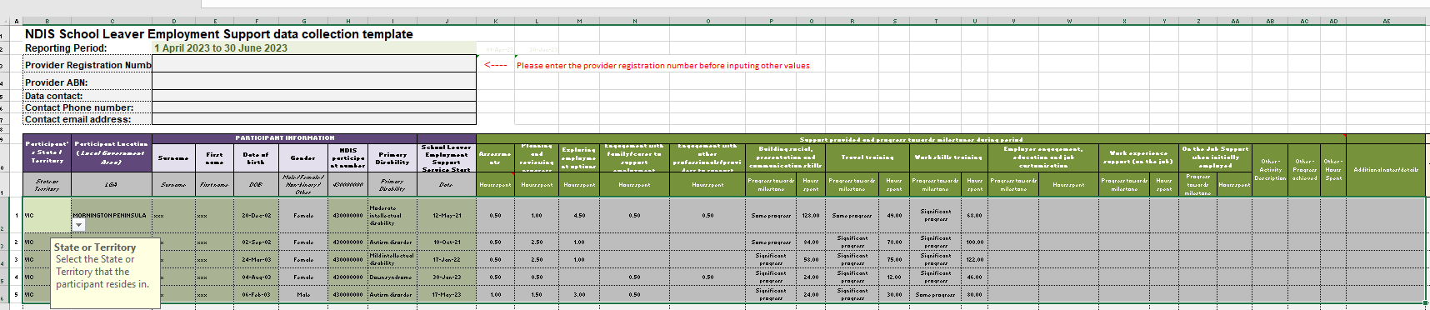

- In the new tool Select Cell B12
- Right click and select Paste Option 123

Step Two:
- In your current tool select Cell AG12 across to Cell AI12 and down to the last row containing participant information
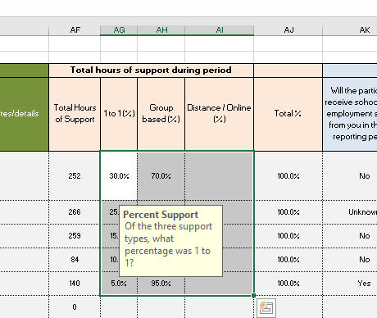

- Press Ctrl C to copy the data
- In the new tool select Cell AG12
- Right click and select Paste Option 123

Step Three:
- In your current tool select data from Cell AK12 across to Cell AM12 and down to the final row containing participant information
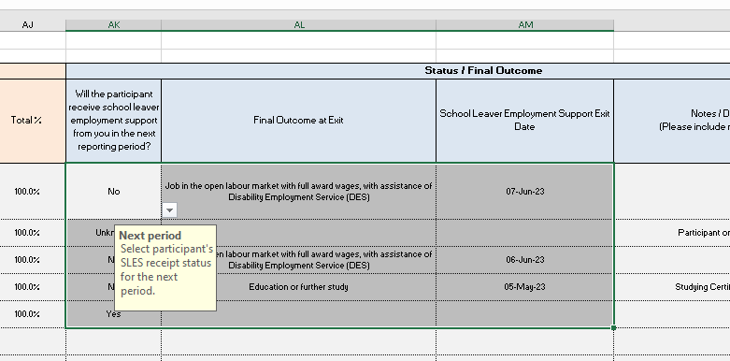

- Press Ctrl C to copy the data
- In the new tool select Cell AK12
- Right click and select Paste Option ‘123’
- Notes should be entered manually at Column AN to ensure formulas are not overwritten.

Step Four:
- In your current tool select data from Cell AO12 across to Cell AV12 and down to the final row containing participant information.
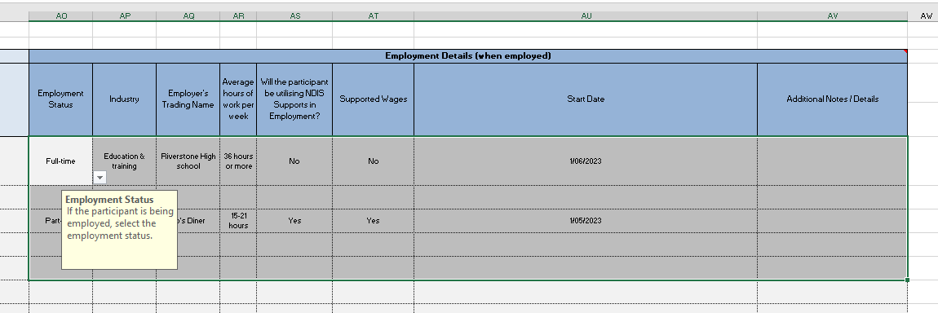

- Press Ctrl C to copy the data
- In the new tool Select Cell AO12
- Right click and select Paste Option ‘123’

If you need support, please contact us at participant.employment@ndis.gov.au.

