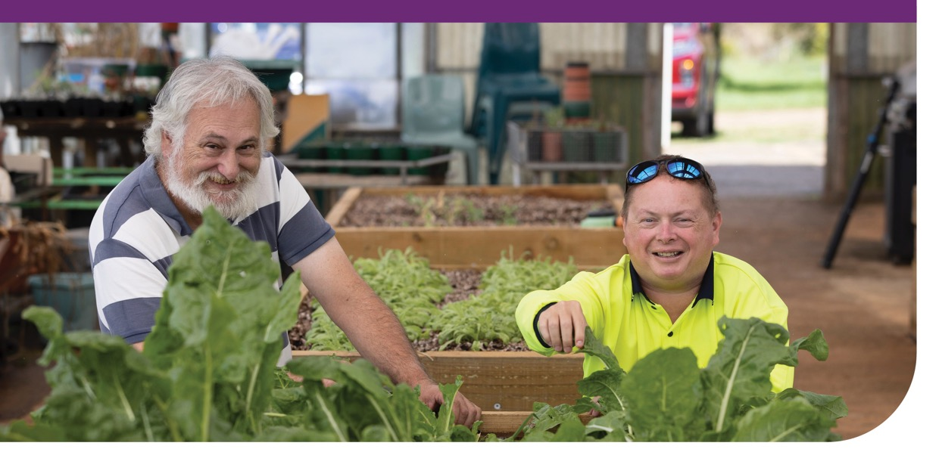

Information for participants who access social and community participation supports in a group or at a centre.

The NDIA has changed how providers claim for supports delivered in a group.
From 1 January 2024 all providers will need to change how they claim these supports from your plan. The new pricing for group and centre based activities allows providers to claim for the actual cost of the supports provided to you, as well as the time spent preparing for activities. If the support is delivered at a centre, they can also claim costs to run this facility. Your provider will work with you to agree how supports will be provided and explain how supports will be claimed. They will develop a new service agreement and/or a program of support.

What does this mean for you?
If your provider has not started using the new pricing yet, the cost of your group or centre based supports may change and look different. There are different types of costs that are part of delivering these supports. The old pricing arrangement bundled these costs into a maximum hourly rate per participant.
In the new pricing arrangement, the costs are agreed and claimed individually. This means that the cost of your support will reflect your support needs.
The different costs are:
- Direct support costs are for the time you attend the group or centre based support. This will be worked out based on how many people are in the group.

- Non-face-to-face costs are for the things a provider does when you aren’t there, to make sure you can join in. They should be specific to you and reflect the support you need.
Non-face-to-face costs are not for general business tasks like preparing your service agreement or invoices, or rostering staff.

- Centre capital costs contribute to the cost of running and maintaining a centre.

There might be other costs related to your support, like activity based transport or provider travel. The way those costs are worked out isn’t changing. However, where they are based on the direct support costs, your provider may need to adjust them to use the line items in the new pricing arrangement.

Programs of Support
Programs of support are an option, to organise and agree to your group or centre based supports. They map out the costs of your support for the length of a program, up to a maximum of 6 months. Once agreed to, the costs for your program will not change. This can give you certainty about the cost of your supports. Programs of support may not be appropriate for everyone, and they are not mandatory.
It’s important to note that if you don’t attend a session, you might still need to pay for your supports. However we know that things can change, therefore you and your provider can change or cancel your program of support at any time, with notice.

What happens now?
If your provider has not yet changed to the new pricing, they are likely to talk about this with you soon. Any changes that are suggested, must follow the new pricing arrangement which is available at this link: NDIS Pricing Arrangements and Price Limits.
Your provider should allow you enough time to think about any changes before agreeing. If you need more help understanding the changes, there are other places you can get help, including your:
- support coordinator or plan manager if you have them;

- Local Area Co-ordinator (LAC) or Early Childhood Partner organisation; or

- NDIA Planner

