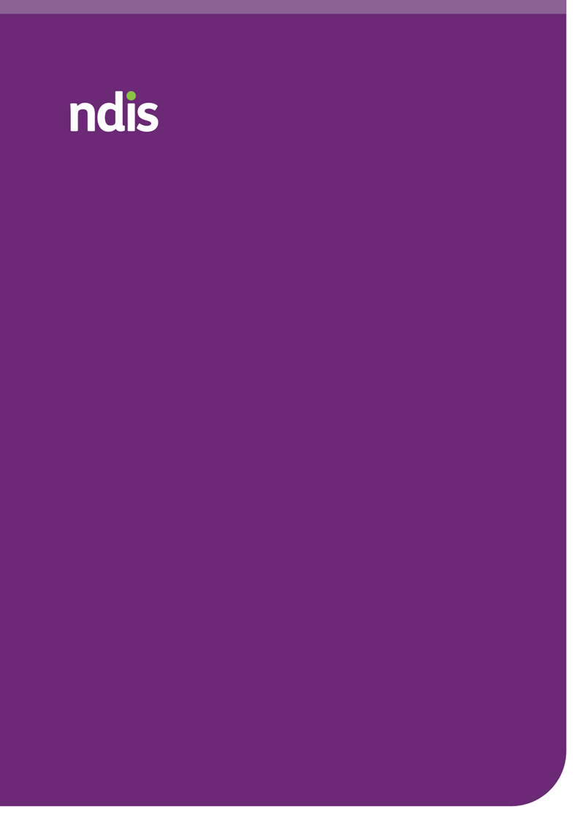
2023-24 Annual Pricing Review Report
June 2024
ndis.gov.au

Acknowledgement
The National Disability Insurance Agency (NDIA) acknowledges the Aboriginal and Torres Strait Islander people of this nation and the Traditional Custodians of the lands across which our Agency conducts our business. We pay our respects to the custodians of the land on which we work as well as their ancestors and Elders, past, present and emerging.
The NDIA is committed to honouring Aboriginal and Torres Strait Islander Peoples’ unique cultural and spiritual relationships to the land, waters, and seas and their rich contribution to society.

Copyright and use of the material in this document
Copyright in the material in this document, with the exception of third-party material, is owned and protected by the National Disability Insurance Agency
The material in this document, with the exception of logos, trademarks, third party material and other content as specified is licensed under Creative Commons Attribution Non-Commercial No Derivatives (CC BY NC ND) licence, version 4.0 International. You may share, copy and redistribute the document in any format. You must acknowledge the National Disability Insurance Agency as the owner of all intellectual property rights in the reproduced material by using ‘© National Disability Insurance Agency 2024’ and you must not use the material for commercial purposes.
Reproduction of any material contained in this document is subject to the CC BY NC ND licence conditions available on the Creative Commons Australia site, as is the full legal code for this material.
The National Disability Insurance Agency expects that you will only use the information in this document to benefit people with disability.

Terms that we use
Acronym | Meaning
ABS | Australian Bureau of Statistics
APR | Annual Pricing Review
CPI | Consumer Price Index
DRC | The Royal Commission into Violence, Abuse, Neglect and Exploitation of People with Disability
DSW | Disability Support Worker
FWC | Fair Work Commission
NDIA or Agency | National Disability Insurance Agency
NDIS or Scheme | National Disability Insurance Scheme
NDIS Commission | National Disability Insurance Scheme Quality and Safeguards Commission
SCHADS Award | Social, Community, Home Care and Disability Services Industry Award 2010
SIL | Supported Independent Living
WPI | Wage Price Index

Table of Contents
2023-24 Annual Pricing Review Report 1
1. Executive summary 6
2. Introduction 15
3. Domestic economic conditions and the care economy 20
4. Disability Support Worker related supports 35
5. Therapy Supports 58
6. Support Coordination 87
7. Short Notice Cancellation Policy 104
8. Feedback from the Participant Consultation Paper 117
9. Appendix A - Feedback from the Provider Consultation Paper 127

Executive summary
The National Disability Insurance Agency (NDIA) monitors and reviews National Disability Insurance Scheme (NDIS) price control framework and other market settings to determine whether they are appropriate and reflect the current market conditions.
Annual Pricing Reviews (APRs) are an important part of the monitoring and review process. This requires the NDIA to examine, through engagement with participants, providers and community and government stakeholders, and targeted research, whether the NDIS’ existing price control framework (pricing arrangements and price limits) continues to be appropriate or should be modified.
As part of the 2023-24 APR, extensive consultations with participants, providers and other stakeholders were completed, including:
- Publishing a Consultation Paper and completing analysis of the 912 submissions received.
- Consultations with other government insurance and funding schemes.
- Consultations with the Pricing Arrangements Reference Group.
- Consultations with the Pricing Interdepartmental Committee.
- Consultations with the Department of Veterans' Affairs and the Chief Allied Health Officer.
A summary of submissions to the Consultation Paper can be found in Appendix A and throughout the report.

NDIS Review
On 7 December 2023, the Minister for the NDIS released the independent NDIS Review. The report maps out 26 recommendations with 139 actions to help restore trust, ensure the Scheme’s sustainability, and deliver a better NDIS experience for participants. Together with the Government, the NDIA will take the time to carefully consider all recommendations and ensure that reforms are done in a measured and considered way.

The Royal Commission into Violence, Abuse, Neglect and Exploitation of People with Disability
The Royal Commission into Violence, Abuse, Neglect and Exploitation of People with Disability (DRC) was established in April 2019 in response to community concern about widespread reports of violence against, and the neglect, abuse and exploitation of people with disability. The final report was tabled on 29 September 2023. The report consists of 12 volumes outlining 222 recommendations. It contains recommendations on how to improve laws, policies, structures, and practices to create a more inclusive and just society. A Government taskforce has been established to consider the recommendations, with the NDIA represented within this group.

Disability Support Worker related supports
The provider market has demonstrated significant growth and flexibility to meet increasing demand. In the six months to December 2023, 44% (283,406) of active NDIS participants accessed Disability Support Worker (DSW) related supports, a 12% increase from the same period in 2022. This period also saw a 21% increase in the number of active providers, totalling 122,857. Financially, payments for DSW-related supports during this timeframe amounted to $13 billion, accounting for 64% of the total $20.4 billion in payments made to providers, which reflects a 27% growth in DSW-related support payments year-over-year.
This significant growth within the market is underscored by the performance between different provider categories: registered providers experienced a slight decline in their numbers but an increase in payment amounts, while unregistered providers saw a substantial increase in both numbers and payment amounts. This highlights a growing market that continues to meet increasing demand.
The NDIA uses the DSW Cost Model to set price limits for DSW-related supports. This model is designed to reflect the costs of a reasonably efficient provider would likely incur per billable hour of support. It includes base salary and shift loadings aligned with the Social, Community, Home Care and Disability Services Industry Award 2010 (SCHADS Award), direct on-costs such as superannuation and leave entitlements, operational overheads like supervision and training, and corporate overheads which account for essential Human Resources and Information Technology.
The SCHADS Award sets the minimum standards for DSWs, stipulating wage levels and conditions that are foundational in establishing NDIS price limits for DSW-related supports in conjunction with broader market trends and regulatory requirements. The multiplicative nature of the model means that when the NDIA passes on increases to minimum wages, as set by the Fair Work Commission through the SCHADS Award, it flows through to the final output of the model. This implies that wage changes and other cost components flow through the model, partially reflecting challenges of doing business in the current economic environment even in the absence of direct adjustment to the overhead and margin parameters.
Feedback received from the sector and peak bodies highlights challenges in alignment to evolving economic conditions and provider realities. Stakeholder feedback has suggested a potential underestimation of corporate and operational overheads, such as insurance and compliance costs given the model is currently based on previous benchmarking survey results. The feedback received through the APR consultation and ministerial correspondence, has raised concerns that the current price limits may not fully accommodate the delivery of more specialised and complex supports for some NDIS participants, which may restrict providers’ ability to recover adequate costs.
The NDIA is actively enhancing the DSW Cost Model by integrating more robust and diverse data sources. This includes partnerships with industry stakeholders on benchmarking surveys and leveraging mandatory financial reports submitted to the Australian Charities and Not-for-profits Commission (ACNC). On balance, these new data offer insights into providers financial performances from different perspectives, which ultimately enriches the decision-making process. This is important so that the varied and evolving conditions of the NDIS provider market are considered. The NDIA should work with the sector, providers, and other stakeholders to consider options for setting prices for Disability Supports, including but not limited to exploration of a new pricing approach. This should include exploration of methods to obtain objective information to inform potential approaches.
Analyses in this report highlight that there is considerable variability in financial performance among organisations and the persistent tightness in the care and support workforce. In the absence of representative data of the NDIS provider population, the NDIA does not have sufficient evidence to support a structural change to the DSW Cost Model currently.
It is noted that pricing reform work is happening across the Australian Government. This includes the Department of Social Services’ led ‘Pricing and Payments Framework’ and the work to be undertaken by the Independent Health and Aged Care Pricing Authority (IHACPA) to reform NDIS pricing arrangements, including reviewing existing pricing approaches and developing a pricing data strategy.
Therefore, it is considered appropriate to pass on minimum Award wages and national employment standard changes to superannuation at this time, which include an increase in employer superannuation contributions from 11% to 11.5%, effective from 1 July 2024.
Recommendation 1
The NDIA, subject to any specific recommendation arising from the current Annual Pricing Review, should increase the price limits for supports that are determined by the NDIS Disability Support Worker Cost Model from 1 July 2024 to reflect any changes in the minimum wages specified in the Social, Community, Home Care and Disability Services Industry Award 2010 (SCHADS Award) following the Fair Work Commission’s Annual Wage Review and any increase in the Superannuation Guarantee Charge.

Temporary Loading
The temporary loading of 2% was introduced on 1 July 2022 to the DSW Cost Model as a short-term measure to assist providers in managing the increased costs associated with COVID-19 and changes stemming from the SCHADS Award changes. As COVID specific supports continue to wane in other sectors in the economy, it is recommended that this temporary measure ends as scheduled and as recommended in the 2022-23 APR.
Recommendation 2
The NDIA should cease the temporary loading applied to the NDIS Disability Support Worker Cost Model from 1 July 2024.

Other labour related supports
The NDIA recognises there are supports that are not within the scope of the 2023-24 APR, nor tied to the DSW Cost Model and are neither price limited nor benchmarked. Notably, nursing supports fall into this category, alongside other core and capacity-building supports like personal domestic cleaning and house or yard maintenance.
Given the recent aged care reforms, which include up to a 25% wage increase for aged care workers and potential future adjustments to the Nursing Award, it is crucial that these supports remain in line with their applicable markets. Failing to adjust the price limits, particularly nursing supports, could risk the adequacy of support for NDIS participants. Therefore, it is proposed that the price limits for these supports be increased, following the methodology used in previous years’ indexation. It should be noted that capital items are excluded from the APR and are addressed by a separate process.
Recommendation 3
The NDIA, subject to any specific recommendation arising from the current Annual Pricing Review and any future reviews, should increase the price limits for nursing and other supports, not covered by Disability Support Worker-related supports or Capital supports, on 1 July 2024 in line with the weighted movement over the previous twelve months in the ABS Wage Price Index (Australia, total hourly rates of pay excluding bonuses) and the ABS Consumer Price Index (All Groups, weighted average of eight capital cities) over the 12 months to the March Quarter immediately preceding the indexation date (with an 80/20 weighting). This recommendation does not include Plan Management.

Therapy supports
The Australian therapy market encompasses a wide array of services provided by allied health professionals, who are typically university-educated with specialised expertise in preventing, diagnosing, and treating various conditions and illnesses. While the NDIS forms an important part of this landscape, allied health services extend beyond NDIS funding. These services are also accessed through various other arrangements, including Medicare subsidies, private health insurance, where it is common for out-of-pocket payments to be made by the consumer, other government schemes, and the Department of Veterans Affairs (DVA).
The NDIS therapy market continues to expand significantly. In the six months to December 2023, 59% (379,296) of the total 646,449 active participants, received therapy supports through their plans. During this period, the number of providers delivering therapy supports grew to 52,736, reflecting a 14% increase from the same period in 2022. Notably, payments made to unregistered providers increased by 60%, although registered providers still received the majority of payments - 65% or $1.3 billion of total payments. This demonstrates growth in both the provider base and financial volume within the therapy sector.
The NDIS therapy market operates in a manner that closely aligns with the characteristics of a deregulated, or private market, more so than other NDIS sub-markets. These price limits are closely linked to the dynamics of the private market, ensuring that NDIS pricing remains competitive and reflective of current service costs. Accordingly, other government schemes and the private billing market serve as suitable comparators to assess the appropriateness of the NDIS price limits.
The 2023-24 APR analysis of other schemes showed that while some have increased their pricing or funding levels, NDIS price limits remain consistent with the majority of therapies provided across these schemes. It is important to note, that there is significant variation in therapy pricing and funding levels among different schemes.
The analysis of private billing rates for NDIS-related weekday in-room therapy services in the 2023-24 period offers detailed insights into the therapy market. The dataset, consisting of 1,791 observations, was compiled by the NDIA from provider websites across Australia. This sample size is derived from previous annual pricing reviews, ensuring continuity and comparability over time.
The sample reveals a wide distribution of therapy types, with physiotherapists, psychologists, clinical psychologists, and dietitians the most common observation. This diversity highlights the varied therapeutic needs catered to by the NDIS, reflecting the scheme's comprehensive coverage. Such insights are vital for the NDIA as it aims to ensure that the NDIS price limits are competitive and equitable, aligning closely with the market rates to adequately support providers while ensuring affordability for participants.
Overall, the private billing rates analysis provides a crucial benchmarking tool for the NDIA, helping to align NDIS pricing structures with the market and ensuring the sustainability of therapy services under the scheme. This analysis indicates that NDIS price limits generally match or exceed the rates for most therapies nationwide. However, regression analysis highlights statistically significant variances among therapies, which could correspond to differences among therapy professionals such as in qualifications, skills, and experience.

Psychology
After reviewing the current price limits for Psychologists against private billing rates and other comparable government schemes, it is apparent that the current limits generally sit below the prevailing market rates.
Analysis reveals that the mean billing rate for psychologists exceeds the NDIS price limits in both state groupings, with a mean rate of $228.6 and $260.3 for Psychologists and Clinical Psychologists, respectively. Similarly, median billing rates for these professionals surpass NDIS limits, standing at $228.0 and $255.0. Moreover, the 75th percentile billing rates indicate that a significant portion of appointments exceed NDIS price limits, highlighting a clear difference between market rates and NDIS price limits. This suggests that it is appropriate for the NDIS to increase price limits to better align with prevailing market rates and ensure fair compensation for psychology services.
Recommendation 4
The NDIA should increase the price limits for supports delivered by a Psychologist on 1 July 2024 in line with the weighted movement over the previous twelve months in the ABS Wage Price Index (Australia, total hourly rates of pay excluding bonuses) and the ABS Consumer Price Index (All Groups, weighted average of eight capital cities) over the 12 months to the March Quarter immediately preceding the indexation date (with an 80/20 weighting). Specifically, this should be for support line items: ‘Assessment Recommendation Therapy or Training – Psychologist (15_054_0128_1_3), ‘Early Childhood Supports – Psychologist (15_001_0118_1_3)’, and ‘Specialist Behaviour Intervention Support (11_022_0110_7_3)’.

Other Therapists
Review of the alignment of the NDIS price limits for other therapists against the private billing rates and other comparable schemes suggests a general compatibility between the NDIS price limits and prevailing market rates. In general, for most therapists, mean and median billing rates closely mirror the NDIS hourly price limits, which are set at $193.99 in most regions, suggesting that the current NDIS price limits adequately reflect market norms. Even when considering some therapies at the mean, median and 75th percentile, billing rates exceed NDIS price limits, the frequency of such instances does not indicate a systemic pricing concern that hinder participants from accessing these services relative to other clientele.
Recommendation 5
The NDIA should not make any further structural adjustments to the pricing arrangements for therapy supports at this time and should not index the price limits for all other therapy-related supports on 1 July 2024.

Support coordination
Support coordinators play a pivotal role in the NDIS by helping participants understand, navigate, and effectively use their NDIS plans to achieve their personal goals. These professionals tailor services to individual needs within the framework of participants' plan budgets. Support coordination is categorised into three levels based on complexity and participant needs, with corresponding price limits set to ensure a balanced pricing model.
The support coordination market is experiencing significant growth, reflected in the number of providers and the volume of payments. From the first half of 2022 to the same period in 2023, there was an 18% increase in payments amounting to $531 million, demonstrating a growth in demand for support coordination. The market is characterised by a mix of registered and unregistered providers, underscoring a market that is decreasing in concentration.
Providers report a range of challenges, including the financial implications of compliance and registration, which influence their operational costs and pricing strategies. On the participant side, there is a spectrum of satisfaction levels with support coordination services. Positive feedback often highlights the crucial support in navigating NDIS processes, while criticisms tend to focus on issues like the high turnover of coordinators and inconsistency in service quality.
Feedback through the APR captured the complexities of the support coordination sector, reflecting both its critical role in enabling participant outcomes and the operational challenges faced by providers. The dynamic growth of the market, coupled with the feedback from stakeholders, suggests ongoing adjustments and evaluations are necessary to align the services with the evolving needs of participants and the operational realities of providers.
It is considered reasonable that Level 1 support coordination supports currently determined by the DSW Cost Model, continue to be done so, including any applicable changes that occurs for DSW supports.
Recommendation 6
The NDIA should index the price limits for Level 1: Support Connection services and Psychosocial Recovery Coaches services in line with the indexation of supports determined by the Disability Support Worker Cost Model in recommendation 1 on 1 July 2024.
Analyses in the chapter highlights that whilst the market for support coordination continues to evolve, there is no evidence to suggest that supply is not meeting demand. In light of significant upcoming reforms recommended by the NDIS Review, which aim to enhance service integration and improve participant outcomes, there is a strong rationale to mitigate potential market disruptions during this transformative period. Any changes to pricing at this point of time would be up for further changes until the reforms in the intermediary sector settle. On balance, it is not recommended to change the price limits of Level 2 and Level 3 support coordinators to ease undue disruption.
Recommendation 7
In alignment with strategic outcomes from the NDIS Review and recognising the current period of significant reform, it is recommended that the NDIA maintain existing price limits for Level 2: Coordination of Supports and Level 3: Specialist Support Coordination.

NDIS short notice cancellation policy
The NDIS short-notice cancellation policy is designed to protect service providers from financial losses when participants cancel appointments within a 7-day window. Providers can claim up to 100% of the agreed fee if a participant cancels late or fails to show, provided certain conditions are met. These include having a pre-existing agreement with the participant, adherence to the NDIS Pricing Arrangements and Price Limits, and the inability of the provider to find alternative billable work for the affected staff. This policy aligns with the SCHADS Award, which supports fair labour practices and helps manage financial risks for providers.
There is a need to consider a balance in the short-notice cancellation policy for the market. One that allows providers sufficient ability to recover costs with incentives to work with the participants they are supporting to minimise the number of short notice cancellations that occur. Meanwhile, participants are given reasonable time to provide notice for cancellations considering unforeseen circumstances to minimise using NDIS funding to pay for supports they do not receive. This includes unexpected illness, urgent appointments, or changes in personal circumstances.
In the three years from 2020-21 to 2022-23, the costs linked to short notice cancellations nearly doubled, increasing from about $60 million to just under $120 million. This rise highlights the need for effective management of such cancellations. Additionally, therapeutic, and early childhood supports, which account for 37% of all claims, are identified as the categories most affected by cancellations.
Feedback on the cancellation policy from providers and participants indicates varying experiences. Providers note a diverse range of cancellation policies within the NDIS market, which can lead to confusion among participants, some of whom only understand the financial implications after being charged for a cancelled service. The diversity in policies reflects varying levels of understanding and implementation across providers. Participants have expressed concerns about the sudden need to cancel due to unpredictable circumstances such as illness or emergencies, leading to calls for more flexible cancellation practices that consider the unpredictable nature of participants' lives.
Providers delivering DSW-related supports, may incur such costs when unable to redeploy employees to other work or set up a make-up shift for the employee. This is as these workers are generally under the SCHADS Award, which has a legislative requirement regarding client cancellations. This requirement is unique for employees engaged under the SCHADS Award in the care sector.
On balance, these observations underscore the operational and financial challenges presented by the NDIS short-notice cancellation policy. The policy aims to balance provider and participant interests, but the required costs and varied experiences suggest a need for continuous evaluation and adaptation to ensure it achieves its goals effectively and fairly.
Recommendation 8
The NDIA should retain the existing 7-day short notice cancellation policy for applicable supports determined by or derived from the Disability Support Worker Cost Model from 1 July 2024. Providers of Disability Support Worker supports must continue to make reasonable effort to find alternative billable work for the staff involved.
For non-DSW related supports (non-SCHADS related), such as therapy services, lack a standardised legislative or Award requirement for client cancellations. Through consultation and research conducted, there is a case that the maximum of 7-day policy may not be necessary for non-DSW supports. There appears to be a greater usage of a 2-day cancellation policy in the sector, particularly among therapy providers, which supports a potential for a shorter cancellation policy.
On balance, the NDIA believes there to be mechanisms and methods already being utilised by the sector to assist participants limiting cancellations which could make the reduction in notice period feasible.
Recommendation 9
The NDIA should adjust the 7-day short-notice cancellation policy for non-Disability Support Worker-related supports to two clear business days from 1 July 2024.

Introduction

Context
The NDIS was established in 2013 to support people with disability to pursue their goals, to help them to realise their full potential, to assist them to participate in and contribute to society, and to empower them to exercise choice and control over their lives and futures. The NDIS provides funding to eligible individuals (“participants”) so that they can purchase, in the open market, the disability related goods and services (“supports”) that they need.
The National Disability Insurance Agency (NDIA) monitors and reviews its price control framework and other market settings to determine whether they are still appropriate and reflect the current market conditions.

NDIS Review
On 7 December 2023, the Minister for the NDIS released the independent NDIS Review. The report maps out 26 recommendations with 139 actions to help restore trust, ensure the Scheme’s sustainability, and deliver a better NDIS experience for participants.
The Review’s recommendations included legislative reform to return the Scheme to its original intent and improve the experience of participants. This included legislation to improve eligibility and access as well as an early intervention pathway for children. Changes will be guided by good legislation and good plans for implementation – developed in partnership with people with disability and the disability community.
Together with government, the NDIA will take the time to carefully considered all recommendations of the NDIS Review including the development of legislation, NDIS process reform – all the way through to implementation.

The Royal Commission into Violence, Abuse, Neglect and Exploitation of People with Disability
The Royal Commission into Violence, Abuse, Neglect and Exploitation of People with Disability (DRC) was established in April 2019 in response to community concern about widespread reports of violence against, and the neglect, abuse and exploitation of people with disability.
The final report was tabled on 29 September 2023. The report consists of 12 volumes outlining 222 recommendations. It contains recommendations on how to improve laws, policies, structures, and practices to create a more inclusive and just society. A Government taskforce has been established to consider the recommendations, with the NDIA represented within this group.

Pricing Reform
In the financial year 2024–25, the Australian Government has allocated $5.3 million to the Independent Health and Aged Care Pricing Authority (IHACPA), to work with Department of Social Services (DSS) and the National Disability Insurance Agency (NDIA), to undertake the initial work to reform the National Disability Insurance Scheme (NDIS) pricing arrangements.
The primary objective of this initiative is to enhance the efficiency and effectiveness of NDIS pricing structures. The initial work expected to conduct a comprehensive review of current NDIS pricing mechanisms, as well as develop a new pricing data strategy.

Annual Pricing Review decision making framework
The NDIA conducts regular, thorough assessments of its pricing framework and market dynamics through the Annual Pricing Review (APR), which integrates insights from the evolving Australian economic landscape, labour market statistics, and sector-specific conditions. This process is reinforced by stakeholder consultations and analyses of impacts from legislative changes, and market movements, ensuring data-driven and relevant pricing strategies for NDIS-related supports.
Figure 1: APR Conceptual Framework
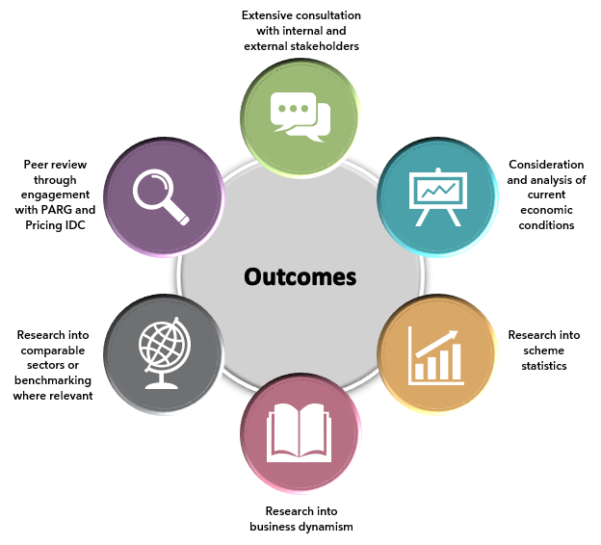

Terms of Reference for the Annual Pricing Review
The APR acknowledges the comprehensive insights from the Independent NDIS Review and the Royal Commission into Violence, Abuse, Neglect and Exploitation of People with Disability (DRC). While these reviews offer extensive recommendations for systemic reform, this APR focusses specifically on non-structural adjustments to the current price settings. It aims to implement immediate, impactful improvements with the existing framework of pricing established in the NDIS Pricing Strategy 2019, ensuring ongoing supply of support and continuity of access to services for NDIS participants, while broader structural reforms are considered for future implementation by the Australian Government.
The APR will examine, through engagement with participants, providers and community and government stakeholders and targeted research, whether the Scheme’s existing price control framework (pricing arrangements and price limits) continue to be appropriate or if modification is required.
The APR will have an increased focus on participants, with a dedicated consultation paper to gather participants’ perspectives. This participant engagement will ensure that the APR is inclusive of the voices of both providers and participants.
In particular, the APR will review the pricing arrangement and price limits:
- that apply to supports delivered by disability support worker (DSW) by updating the NDIS Cost Model for Disability Support Workers;
- for therapy supports to ensure participants receive value for money, while providers strive to improve quality of service and increase efficiency, with a particular emphasis on pricing benchmarks;
- for support coordination to promote service quality and value for money, with a focus on participants experiences when utilising support coordinators to oversee their supports;
- in relation to the NDIS Cancellation policy, which changed from two days to seven days in line with the Social, Community, Home Care and Disability Services (SCHADS) Award. The analysis will examine the impact on participants choice and control.

Consultation overview
The 2023-24 APR consultation commenced on 25th January 2024 and concluded on 10 March 2024 for providers and 17 March 2024 for participants. This year’s consultation featured the publication of two key documents: a Provider Consultation Paper and a Participant Consultation Paper. These papers invited a wide range of stakeholders, including providers, participants, community members, and government entities, to contribute their perspectives and expertise. The robust response, especially from participants via the Form.io survey, underscores the community's active participation and the effectiveness of using varied submission formats to accommodate diverse needs. A total of 912 submissions were recorded, a significant increase from the previous APR's 304 submissions.
Submissions were categorised as follows:
- Providers: Contributed 353 submissions, offering insights and feedback from a service delivery perspective.
- Participants: Contributed 559 submissions, broken down as:
  - 546 submissions received through the Form.io platform
  - 11 submissions were made through traditional paper forms.
  - 2 submissions were presented in an easy read format.
A summary of submissions to the Consultation Paper can be found in Appendix A and throughout the report.

Consultations with other government insurance and funding schemes
The NDIA collaborated with 16 Commonwealth and State Schemes to obtain their therapy pricing. Responses from 13 schemes were received. Schemes that assisted with information were:
- Catastrophic Injuries Support (CIS) Scheme,
- ComCare,
- Department of Veterans’ Affairs (DVA),
- Home and Community Care Program for Younger People (HACC-PYP),
- Lifetime Support Scheme (LSS),
- Motor Accidents Insurance Board (MAIB),
- Medicare Benefit Scheme (MBS),
- National Injury Insurance Scheme Queensland (NIISQ),
- Return To Work SA (RTWSA),
- State Insurance Regulatory Authority (SIRA),
- Victorian Transport Accident Commission (TAC),
- WorkSafe VIC, and
- WorkCover WA.

Pricing Arrangement Reference Group
The work of the APR was overseen by the NDIA’s Pricing Arrangement Reference Group, which provides advice, through the Chief Executive Officer of the NDIA, to the NDIA Board on price control arrangements for the NDIS. This is to ensure price regulation activities and decisions are coordinated to support the best possible outcomes for NDIS participants during the transition to a competitive marketplace. The current members of the Pricing Arrangement Reference Group are:
- Flavio Menezes is a leading economist in market design, auction theory, competition, regulation, and incentives. He is a Professor of Economics and the Director of the Australian Centre of Business and Economics at the University of Queensland. He is also the Chair of the Queensland Competition Authority. As a highly regarded expert, he is sought after for his economic counsel by various private and public organisations.
- Matthew Clarke works as an Associate Director at Marsden Jacob specialising in price regulation, cost recovery and funding. He has a proven track record of conducting complex pricing reviews for state, territory, and federal government agencies across sectors.
- Felicity McNeil PSM has a track record of managing complex healthcare budgets including such as the Pharmaceutical Benefits Scheme (PBS) and other subsidy national programs, both within the Health and Finance portfolios., which she has since channelled into her volunteer work helping patient and clinical groups to participate in government processes.
- Deborah Cope brings over 35 years of experience in analysing, reforming, and implementing social, economic, and environmental policies across all levels of government. She was a member of the New South Wales (NSW) Independent Pricing and Regulatory Tribunal (IPART), and the Principal of PIRAC Economics.
- Jim Cox, PSM is Deputy Chair of the Australian Energy Regulator. He contributes advice from his experience in price regulation, economics, and social policy issues.

Pricing Interdepartmental Committee
The Pricing Interdepartmental Committee was established in November 2022 to discuss strategic matters related to pricing in the NDIS and its wider implications within the current economic environment. This forum allows the NDIA to proactively work with key Australian Public Service stakeholders with broader Government considerations to NDIS pricing-related matters.
The committee consists of representatives from Department of Social Services, Department of Finance, NDIS Quality and Safeguards Commission (NDIS Commission) and the Commonwealth Treasury.

Domestic economic conditions and the care economy

Pricing regulation in the current economic environment
Australian economic conditions can impact the efficiency and sustainability of the market for disability goods and services and therefore influence whether the NDIS price control framework continues to be appropriate or if modification is required.
The NDIS is part of the care and support economy and the broader Healthcare and Social Assistance (HCSA) sector. Economic trends in these sectors could potentially affect the efficiency and sustainability of the disability market. The NDIS both impacts, and is impacted by, the care and support economy and the HCSA sector, particularly the care and support economy as the NDIS comprises a greater proportion of this sector relative to the HCSA sector. However, given the diversity of the care and support economy and the HCSA sector, it is important to exercise caution when drawing comparisons between trends in the HCSA sector and the specific trends within the NDIS workforce.
Data on economic conditions suggest strong demand for health and disability services, a tight labour market for health and disability related workers, as well as higher costs given high general inflation and wage inflation.
Businesses in the care and support economy are reporting strong confidence in the outlook for their industry. Despite the slowing in Australian economic growth, the HCSA sector is resilient due to the ‘non-discretionary’ nature of the services provided (generally necessities) and continued demand from population growth and an ageing population. The HCSA is also heavily reliant on funding from the public sector and the NDIS is a major and fast-growing item of government expenditure.
High inflationary environment can increase cost pressures on providers delivering supports to NDIS participants such that these providers may then be under pressure to raise prices for their services. The HCSA sector had significant inflation and wage growth in the year to December 2023, above the all-industries’ growth rates, suggesting strong upward pressure on input costs and wages. One of the reasons for wage inflation in the sector has been increases in Award wages, such as a 15% increase in minimum wages for direct care employees working in aged care.
Jobs and Skills Australia considers many NDIS-related occupations to be in “shortage”. This includes aged and disabled carers, personal care and special care workers, physiotherapists, speech professionals and audiologists, occupational therapists, and psychologists. Some of these occupations have vacancy numbers that are high compared with their total occupational employment levels (i.e., speech professionals and audiologists, occupational therapists, and physiotherapists).

NDIS supports
Disability Support Workers (DSWs) are an essential part of the NDIS, bridging the gap between healthcare services and daily living assistance for individuals with disabilities. DSWs provide personalised support that enhances the independence of NDIS participants.
Therapy supports, including early childhood interventions, are also an essential part of the NDIS by playing an important role in assisting participants to achieve their personal goals. These supports are delivered by a diverse range of professionals, such as Occupational Therapists (OT), Speech Pathologists (SP), Physiotherapists, Psychologists, and many others.

Economic outlook
Economic growth, as measured by real Gross Domestic Product (GDP), has been slowing from above average rates, given lower household consumption from high inflation and increased interest rates. The Commonwealth Treasury projects real GDP growth to be 1.75% for 2023–24 before rising in the following year. See Figure 2 for historical and forecast GDP growth outlook.
Figure 2: Australian Real GDP Growth from 2000 to Forecasted 2024
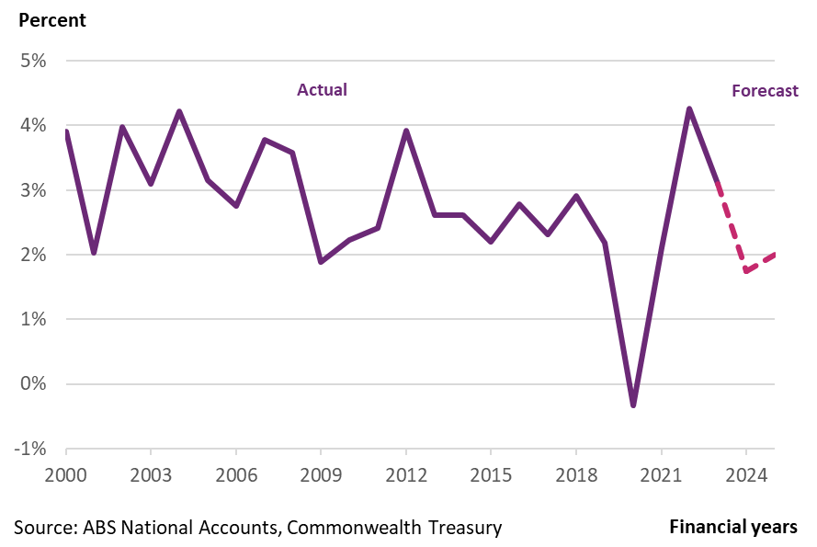
Businesses in the care and support economy are reporting positive business confidence in the outlook for their industry. According to the Roy Morgan Business Confidence survey in April 2024, general business confidence is still below the neutral level and the average tracked since December 2010 but the community services industry’s confidence is positive. The HCSA sector is resilient to slowdowns in Australian economic activity due to the ‘non-discretionary’ nature of the services provided (generally necessities) and continued demand from population growth and an ageing population. The HCSA is also heavily reliant on funding from the public sector.

Inflation
High inflation has had widespread impacts across the economy over the past three years. High inflationary environment can increase cost pressures on providers delivering supports to NDIS participants, such as energy, logistics, increased interest rates and property costs. These providers may then be under pressure to raise prices for their services.
Moreover, headline inflation, as measured by the Consumer Price Index (CPI) (changes in the price of a fixed basket of goods and services that are representative of items bought by households), was 3.6% in the year to March 2024, above the Reserve Bank of Australia (RBA) target of 2% to 3% . The RBA predicts inflation to fall to be within the target range by December 2025, given easing supply constraints and a slowing of domestic activity from high interest rates.
Inflation in the health industry (‘Health CPI’) has run above the economy wide (all-industries) rate for most of the past decade, suggesting relatively strong cost pressures in the HCSA sector. Between December 2021 and June 2023, all industries CPI outpaced Health CPI given significant inflationary pressures across the economy, but Health CPI has returned to being higher than the all-industries CPI (see Figure 3) .
Figure 3: All Industries CPI and Health Specific CPI Growth from 2016 to 2023
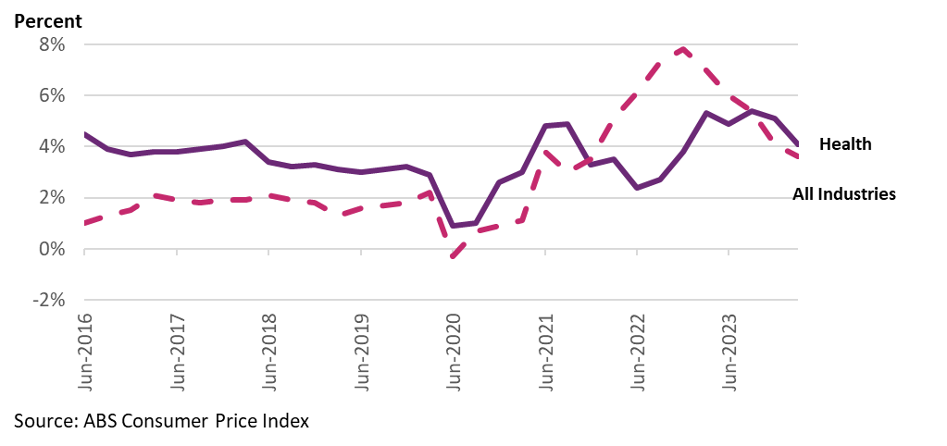

Labour market conditions
The labour market has been strong relative to historical averages. The seasonally adjusted unemployment rate in March 2024 was 3.8%, lower than the ten-year historical average of 5.3%. About 336,900 additional people became employed over the year to March 2024 (seasonally adjusted, 2.4% year-on-year growth). The labour market is still forecast to remain strong relative to historical averages over the coming years as economic conditions relax. The unemployment rate is expected to rise to 4% in the June quarter 2024 and then is forecasted to peak at 4.5% in the June quarter 2025.
The HCSA sector is the largest employing sector in the economy and employment in the sector is growing quickly. The sector had 2.23 million workers in February 2024, equating to 15.6% of total Australian employment. The sector has grown at a higher average rate over the past ten years compared to all other sectors (see Figure 4). In the year to February 2024, the number of new entrants was 112,940 persons (about 5% of the total HCSA workforce).
Figure 4: Employment Growth in All Industries and HCSA Sector from 2015 to 2024
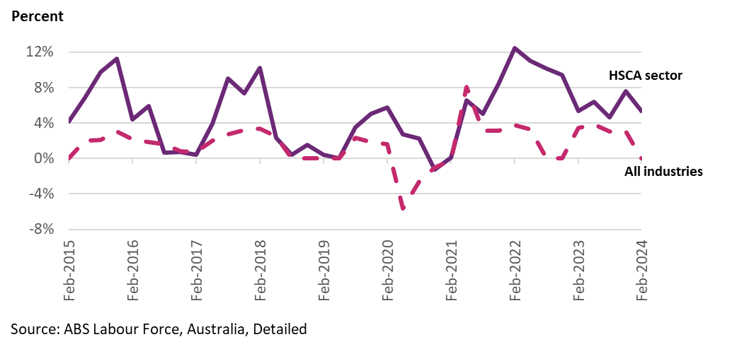

It is estimated that total DSW employment is currently about 300,000 persons. As published in the NDIS Review in December 2023, there were an estimated 280,000 DSWs as of 2021-22, representing about 14% of total HCSA employment.
There are about 170,000 therapists in Australia. The most recent data from the Australian Health Practitioners Registration Agency (AHPRA), shows an increase in registered therapists from 2018 to 2022, with Psychologists, Physiotherapists, Occupational Therapists, and Podiatrists collectively growing by 27% (see Figure 5). Specifically, Psychologists saw a 24.3% increase, and Physiotherapists increased by 25.9%, reflecting a growing workforce responding to heightened healthcare demands, including from NDIS participants.
Figure 5: Number of Registered Therapists from 2018 to 2022
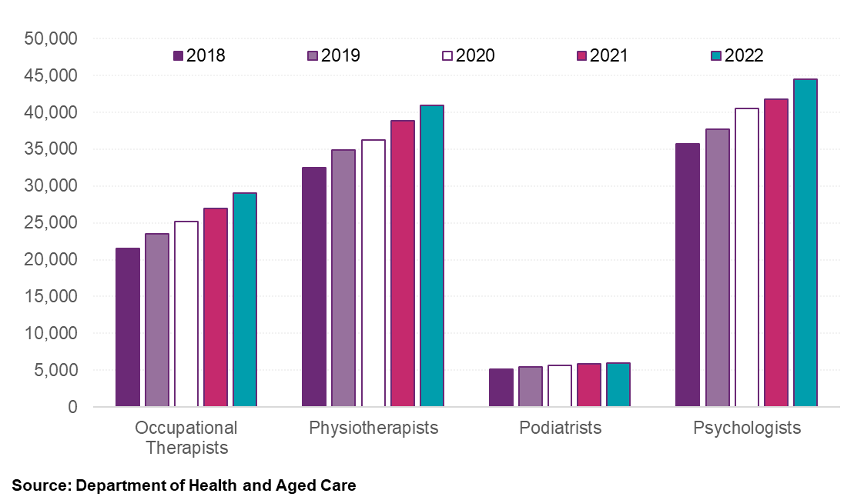

Jobs and Skills Australia considers many NDIS-related occupations (relevant for the broader HCSA too) to be in shortage - aged and disabled carers, personal care and special care workers, physiotherapists, speech professionals and audiologists, occupational therapists, and psychologists, supported by record high numbers of vacant positions in NDIS-related occupations. There were 13,000 vacant positions in March 2024 for these NDIS-related occupations (see Figure 6). The occupations with the highest number of vacancies were aged and disabled carers, nursing support and personal care workers and occupational therapists. Figure 7 shows the comparison between job vacancies and total employees for each occupation in the NDIS-related occupations. The occupations with the highest proportion of vacancies relative to their total occupational employment levels are speech professionals and audiologists, occupational therapists, and physiotherapists.
Figure 6: Job Vacancies in NDIS-related Occupations from 2015 to 2023
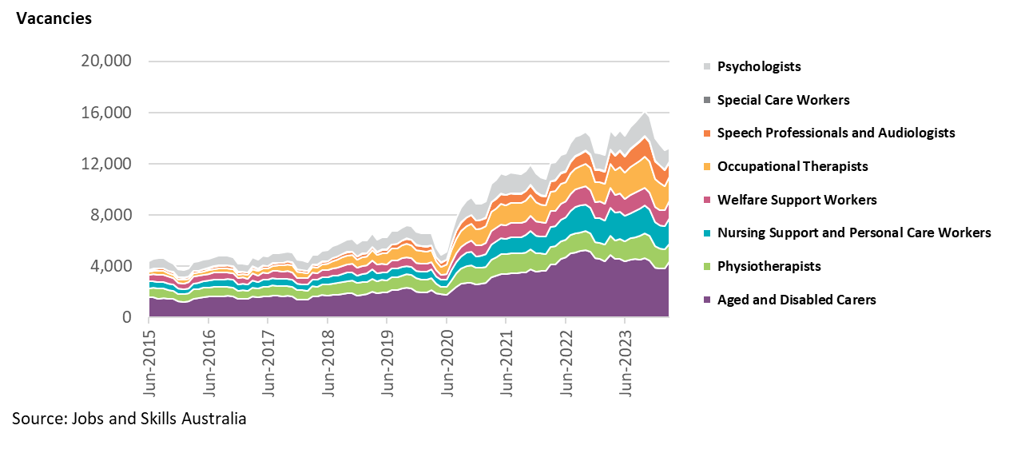

Figure 7: Job Vacancies compared to Total Occupational Employment at November 2023
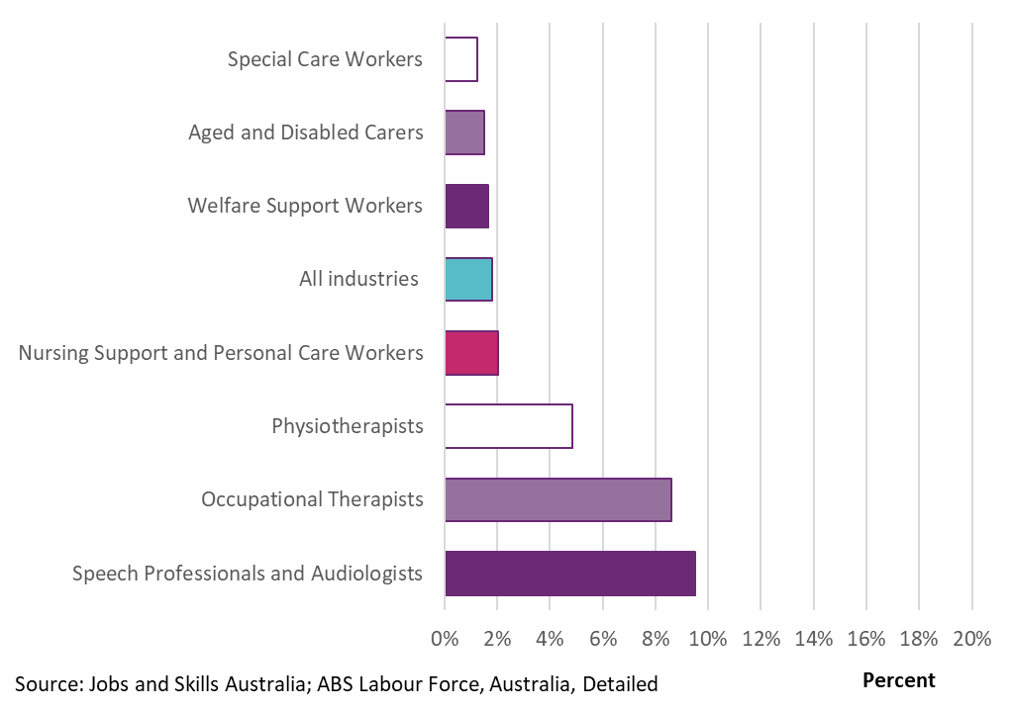

Data from Jobs and Skills Australia in December 2023 indicates that there may have been an improvement in matching community and personal service workers to vacancies, in line with a softening of tight labour market conditions. Over the quarter, fill rates (percentage of advertised vacancies filled by occupation) for vacant positions, applicants per vacancy, qualified applicants per vacancy, and suitable applicants per vacancy improved, particularly in regional areas. This trend is the same for all occupations.
Continued net immigration could alleviate some of the current labour supply pressures in the care and support economy workforce, as could growth in the education and training for these occupations. Overseas-born workers comprise a large and growing proportion of the care and support workforce in Australia (40%). Migration levels have recovered strongly since 2020-21 (COVID-19 related border closures), although levels are forecast to reduce significantly due to migration reforms. Those studying health-related subjects (all students studying at higher education institutions) increased by 4.2% per annum on average between 2012 and 2022.
The disability workforce is expected to increase significantly to support the forecast growth in the NDIS and the HCSA sector. The Australian Government projects employment in the HCSA sector to grow by 257,300 people (or 12.1%) over the five years to May 2028, the fastest growth of all 19 Australian and New Zealand Standard Industrial Classification (ANZSIC) industries and more than double the next closest sector in the economy (Professional, scientific, and technical services) (Figure 8). Employment growth for aged and disabled carers is expected to be 42,600 people between May 2023 and May 2028, equating to a total growth rate of 14.3%. Employment projections show a 17.2% growth for therapy professionals by 2028 (see Table 1).
Figure 8: Projected Employment Growth for Five Largest Sectors from May 2023 to May 2028
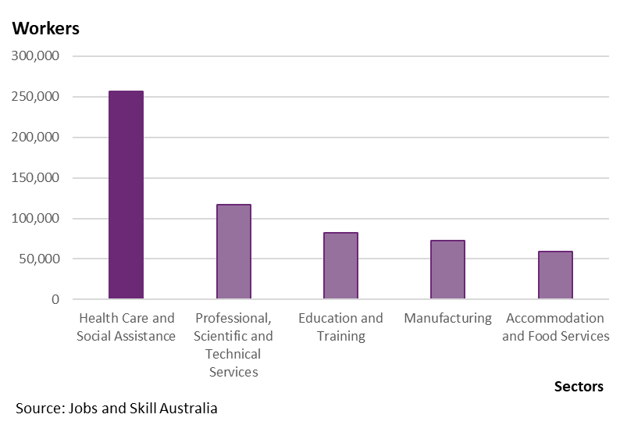

Table 1: Employment Numbers and Projected Employment Growth for Therapy Sector
Occupation Code | Occupation | Employment Level – May 2023 ('000) | Projected employment level – May 2028 ('000) | Projected employment growth – five years to May 2028 | Projected employment growth – five years to May 2028 (%)
2527 | Audiologists and Speech Pathologists/Therapists | 15,100 | 17,600 | 2,500 | 16.6%
2522 | Complementary Health Therapists | 8,400 | 9,800 | 1,400 | 17.0%
2721 | Counsellors | 29,700 | 34,200 | 4,500 | 15.1%
2511 | Nutrition Professionals | 8,200 | 9,500 | 1,200 | 15.1%
2524 | Occupational Therapists | 26,000 | 30,400 | 4,400 | 16.9%
2525 | Physiotherapists | 37,300 | 43,900 | 6,500 | 17.5%
2526 | Podiatrists | 5,900 | 7,000 | 1,000 | 17.6%
2723 | Psychologists | 41,800 | 48,600 | 6,800 | 16.3%
Source: Job and Skills Australia

Wage growth
The rate of wage growth in the economy has been increasing since June 2020. Wage growth (as measured by the all-industries’ Wage Price Index excluding bonuses) rose to 4.1% in the year to March 2024. The Commonwealth Treasury projects wage growth to be 4% in 2023-24 before decreasing in the following two years.
The HCSA sector had significant wage growth of 5.3% in the year to March 2024, above the all-industries’ growth rate, suggesting strong upward pressure on wages for care and support sector workers (see Figure 9).
One of the reasons for wage inflation in the sector has been increases in Award wages, such as a 15% increase in minimum wages for direct care employees working in aged care (Social, Community, Home Care and Disability Services (SCHADS) Industry Award, Aged Care Award, and Nurses Award) from 1 July 2023, an increase in the national minimum award wages of 5.75% from 1 July 2023, and an increase in the minimum wage from 1 July 2023.
The transferability of skills and qualifications across the care and support economy and the HCSA sector means that NDIS providers need to compete for workers with aged care, health care and childcare services. This competition is influenced by various factors such as relative wages.
Figure 9: All Industries and HCSA Sector Wage Price Index from 2015 to Forecasted 2027
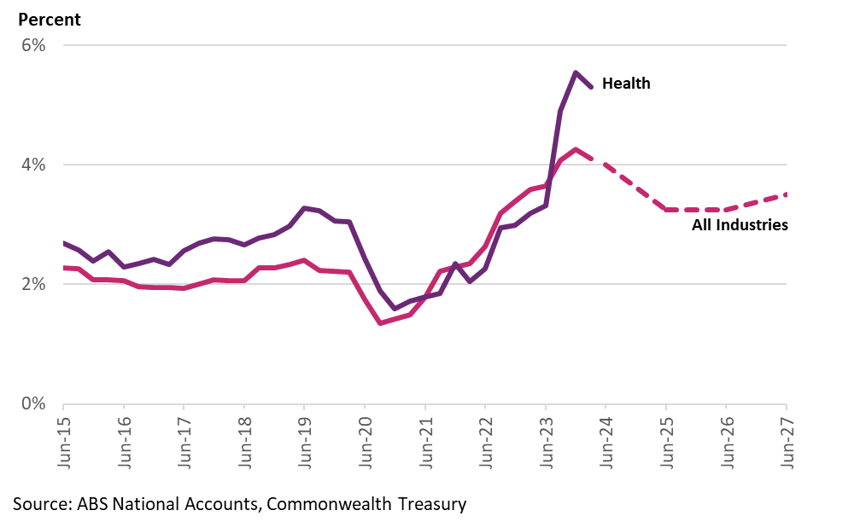

Disability support worker wage
The Award wage system is one of the determinants of wages for disability support workers (DSWs), and thus the cost of many related NDIS supports. Many DSWs delivering NDIS supports are paid under Schedule B of the SCHADS Award.
Minimum weekly payments for DSWs continue to be above the comparable industries in the care and support economy when considering a similar type of worker (Figure 10). Note, it is considered reasonable to match a DSW with the Aged Care Award Level 4 worker. The NDIA does acknowledge some supports delivered to NDIS participants could be delivered by other types of workers classified across other types of aged care employees, such as level 3 or level 5. This matching is based on the type of work generally performed by this type of worker (personal care tasks by a “personal care worker grade 3”) and personal care support provided require working under limited supervision. Further the Aged Care Award level 4 worker can require a qualification at Certificate 3 or higher, while the SCHADS Award Level 2 worker requires a Certificate 4 or higher.
Figure 10: Weekly Minimum Wage for SCHADS Award, Aged Care Award, Children Services Award for Comparable Workers
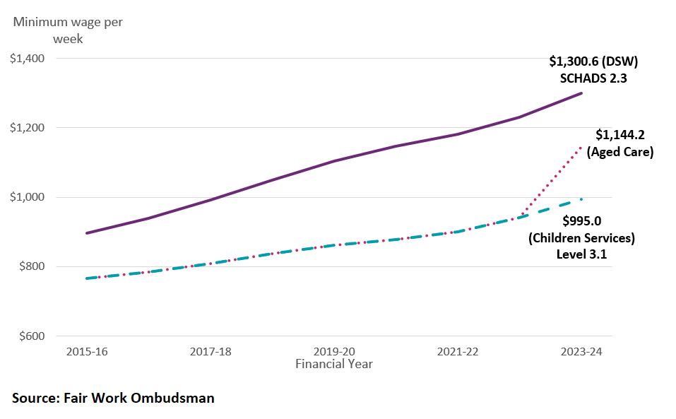

Table 2 displays a comparison of wage data from major job platforms as of February 2024, demonstrating that DSWs earn, on average, higher hourly wages compared to aged care and children services workers.
Table 2: Relative Advertised Wages of Disability, Aged Care and Children Services Workers as at February 2024 (Australian Average Wages, dollars per hour)
Occupation | Employed | Seek | Indeed | PayScale
Disability support worker | 280,000 (2021-22) | $35 - $40 | $36.79 | $29.37
Aged care worker | 195,000 (2020) | $20 - $30 | $33.69 | $24.83
Children services worker | 216,000 (2021) | $25 - $30 | $31.29 | $24.47
Source: NDIS Review, Department of Education, Committee for Economic Development of Australia (CEDA). Estimates exclude nurses and allied health professionals. Wages from Seek, Indeed and PayScale

Aged Care Award wage changes
On 15 March 2024, the Fair Work Commission (FWC) made the decision for further adjust wages for direct care and indirect care employees in the aged care sector of between 18.2% to 28.5%, inclusive of the interim 15% increase already awarded from 1 July 2023. It is still too early to determine the impacts of this decision on wage increases for aged care workers, which brings aged care workers roughly on par with disability workers, but this warrants ongoing monitoring. The NDIA’s DSW Cost Model uses the SCHADS Award, social and community services employee, Level 2, pay point 3 as the basis of setting the standard disability support worker. The 2022-23 Annual Pricing Review considered this to be appropriately matched with the Aged Care Award Level 4 worker.
In the proposed amendments to the Aged Care Award classifications and definitions found in Schedule I (page 68) of the draft determination and award mark-up, the current “Aged care employee – direct care – level 4” will translate into the proposed classification of “Aged care employee – direct care – level 3 - Qualified”.
This matching is based on the type of work generally performed by this type of worker, personal care tasks and personal care support requiring working under limited supervision. Further, the proposed Aged Care Award “Aged care employee – direct care – level 3 – Qualified” requires a Certificate III in Individual Support (Ageing) or equivalent, while the SCHADS Award Level 2 worker requires a certificate 4 or higher.
The NDIA does acknowledge some supports delivered to NDIS participants could be delivered by other types of workers classified across other Schedules or Awards. For instance, the proposed new classifications for aged care employee – direct care - level 2 or level 4.
Comparison of these Award worker minimum wages shows the wage difference between comparable workers continues to narrow between the disability and aged care sector. From 1 July 2023, the weekly pay rate for the full and part time SCHADS Award Level 2, pay point 3 was $1,300.60 ($34.23 per hour). The equivalent to the full and part time Aged Care Award “Aged care employee – direct care – level 4” from 1 July 2023 was $1,144.20 ($30.11 per hour).
The proposed increase to the full and part time Aged Care Award “Aged care employee – direct care – level 3 – Qualified” is expected to raise the minimum wage for this worker to $1223.90 ($32.21 per hour), a proposed pay increase of 23% from prior to these Aged Care reform, inclusive of the previous 15% interim increase. This would equate to a difference of $76.7 (approximately $2.02 per hour), with the SCHADS Level 2.3 worker wage rate to being 6.7% higher.
Overall, the NDIA acknowledges that adjustments to Aged Care worker wages and other reforms being undertaken in aged care. However, given the pay of disability support workers still considered being competitive, on balance the NDIA expects the impact of these changes to the cost of similarly skilled workers to be limited in the short run. Moreover, these changes may impact workforce availability across the broader care sector, so the NDIA should continue to monitor these reforms as suggested in 2022-23 APR.

Disability Support Worker related supports
Disability Support Workers (DSWs) are an essential part of Australia’s care and support workforce, bridging the gap between healthcare services and daily living assistance for individuals with disabilities. DSWs represent the sector’s diversity, working across various settings, from private homes to community-based programs, providing personalised support that enhances the independence of NDIS participants.

DSW Cost Model
The NDIA uses the Disability Support Worker Cost Model (DSW Cost Model) to estimate the cost that a reasonably efficient provider would incur in delivering a billable hour of support. Its primary aim is to ensure that pricing reflects the cost-of-service delivery.

Parameters of the DSW Cost Model
In 2022, the NDIA simplified the DSW Cost Model. The simplification was prompted by a recognition that the model’s specificity could inadvertently encourage rigid adherence to its parameters as de facto targets, potentially restricting innovation, and adaptability of providers. By consolidating the cost categories into direct worker employment costs, operational overheads, and corporate overheads, the NDIA aimed to reflect the nuanced ways providers manage their resources. The current parameters of the cost model are outlined below:
- Base salary and shift loadings: The cost model is based on permanent worker costs. These are linked to Social, Community, Home Care and Disability Services Industry Award 2010 (SCHADS Award) wage levels 2.3, 2.4/3.1, 3.2 and 4.4.
- Direct on-costs: Includes Superannuation entitlements (currently 11%, 11.5% from 1 July 2024), Annual Leave entitlements (20 days), Personal Leave entitlements including domestic and family violence leave (10.3 days), Long Service Leave entitlements (4.3 days), and Employee Allowances.
- Operational overheads: Covers supervision, quality and safeguarding, training, and workforce rostering costs, alongside provisions for utilisation rates and the mix of permanent versus casual staff and the extent to which overtime is utilised.
- Corporate overheads: Accounts for essential business functions such as accounting, human resources, information technology, legal, and marketing.
- Margin: Which represents the return that the provider makes because of the provision of working capital to the business.
- Temporary loading: Acknowledges additional costs arising from COVID and SCHADS Award adjustments, introduced on 1 July 2022.
The DSW Cost Model is driven by the relevant SCHADS Award wage movements, operates on a multiplicative basis where operational and corporate overheads, as well as profit margins, are determined as a percentage of the direct costs, including wages and on-costs. Any changes in the wage rates directly affects the entire model’s cost structures. Moreover, temporary adjustments, applied as a percentage of all costs at the end of calculations, recognise additional variables like COVID-19 impacts and SCHADS Award updates.
In setting NDIS price limits for DSW related supports, the model is an important approximation, considered alongside market dynamics, award conditions, and regulatory requirements such as minimum wages and superannuation contributions.

Applicable industrial award
The national award for DSWs is the SCHADS Award. The NDIA recognises that some DSWs are classified as Home Care Employees and others are classified as Social and Community Services Employees under the SCHADS Award, and some DSWs are employed under Enterprise Bargaining Agreements (EBAs). However, these EBAs must leave the worker no worse off than they would be under the applicable industry Award. The NDIA therefore considers the conditions set out in the SCHADS Award to be the appropriate foundation of the DSW Cost Model.
The NDIA recognises that providers can employ DSWs with different skill levels and levels of experience to meet the different needs of participants. The Cost Model therefore has different sets of cost assumptions for four types of workers (DSW Level 1, DSW Level 2, DSW Level 3 and DSW Level 4). This does not mean these are the only types of workers who can deliver NDIS supports through DSW-related supports.

DSW price limit growth
Standard DSW-related supports in the Cost Model use the SCHADS Award, at Schedule B, level 2.3. Level 2.3 has seen, on average, an annual increase of 6.1% since 2013, outpacing the Wage Price Index (WPI) by over 2% (see Figure 11). These rises, mandated by the FWC through the Award system, account for approximately 80% of the increase in NDIS DSW price limits.
The Equal Remuneration Order (ERO), issued by the FWC in 2012, has significantly influenced the SCHADS Award growth. The ERO addressed gender-based pay disparities in community service roles, mandating special pay rises in addition to the regular annual increases through the Award System until 2020. As a result, the SCHADS Award’s minimum pay rate for level 2.3 is now 23% higher than it would have been without the ERO. With the ERO fully phased in, future growth in the SCHADS Award is likely to align with national minimum wage determinations.
Figure 11: NDIS DSW Price Limit Compared to SCHADS Award and ERO Growth Since 2013
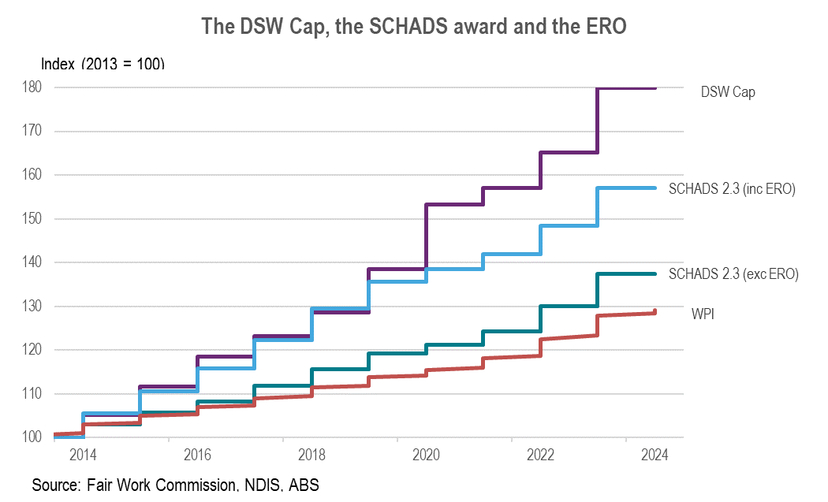

Scheme statistics
In the six-months to December 31, 2023, a total of 283,406 participants, which represents 44% of the 646,449 active participants as of December 31, 2023, received DSW-related supports through their plans. This is an increase from the previous period (July to December 2022), with the number of participants rising by 12%. Active providers also saw growth, with a 21% increase from 101,459 to 122,857.
Payments on DSW-related supports during this period reached $13 billion, accounting for 64% of all NDIS payments, which totalled $20.4 billion. This is a 27% increase in DSW-related support payments compared to the same period in the previous year, indicating growing market for DSW-related supports and services. Table 3, Table 4, Table 5 and Figure 12 further illustrate this growth.

Table 3: DSW-Related Supports Scheme Statistics – All Providers
Statistics | July – December 2022 | July – December 2023 | Percentage Change
Number of NDIS participants | 253,558 | 283,406 | +12%
Number of active providers | 101,459 | 122,857 | +21%
Amount claimed by active providers of DSW-related supports ($ billion) | $10.3 | $13.0 | +27%
Average amount claimed by all active providers of DSW-related supports | $101,324 | $106,180 | +5%
Table 4: DSW-Related Supports Scheme Statistics – Registered Providers
Statistics | July – December 2022 | July – December 2023 | Percentage Change
Number of active registered providers of DSW-related supports | 9,286 | 8,697 | -6%
Amount claimed by registered providers of DSW-related supports ($ billion) | $7.9 | $9.4 | +19%
Average amount claimed by registered providers of DSW-related supports ($ million) | $0.9 | $1.1 | +27%
Table 5: DSW-Related Supports Scheme Statistics – Unregistered Providers
Statistics | July – December 2022 | July – December 2023 | Percentage Change
Number of active unregistered providers of DSW-related supports | 92,490 | 114,777 | +24%
Amount claimed by unregistered providers of DSW-related supports ($ billion) | $2.3 | $3.6 | +54%
Average amount claimed by unregistered providers of DSW-related supports | $25,340 | $31,348 | +24%
Source: NDIS internal administrative data
Note: The totals for registered and unregistered DSW-related providers don’t match the overall active provider count due to two factors: 1) Some providers offer both registered and unregistered supports within the same period, 2) A small fraction of providers with unspecified registration status are included in the total count but not detailed in the table.
Figure 12: NDIS Expenditure on DSW-related Supports since January 2021 Relative to Total NDIS Expenditure
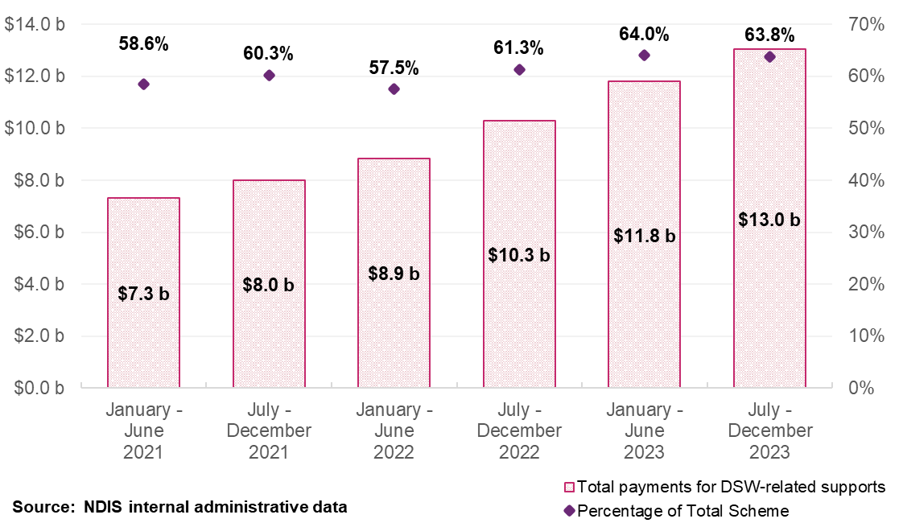
Over the past three years, providers offering DSW-related supports have shown a diversified approach to generating revenue, often billing for services across multiple registration groups within the NDIS. Specifically, DSW-related supports have accounted for approximately 77% of the total NDIS payments received by registered providers and about 83% for unregistered providers. In 2023, the primary sources of payments for registered providers delivering DSW-related supports concentrated in three areas:
- Daily Activities (56% of payments)
- Social Community and Civic Participation (22% of payments)
- Capacity Building Daily Activity (10% of payments)

Temporary Transformation Payment (TTP)
The TTP for many DSW-related supports was introduced on 1 July 2019 to assist registered NDIS providers with transitioning their businesses into the NDIS. Transitional price levels represented the price necessary to attract new providers to enter the market or to reduce exits from the market. They represented the price required to attract economic resources to expand supply. Transitional price levels were above sustainable price levels at the time, and those price limits were adopted where a significant expansion of supply was required.
In line with the NDIS Pricing Strategy, the base price limits for supports delivered by disability support workers have, since 1 July 2019, been set in line with the estimated efficient costs of delivery at the time of updates. The TTP loading has been used to adjust these efficient prices to transitional levels. The level of the loading was initially set at an amount equal to the difference between the estimated efficient cost of delivery and the estimated average cost of delivery. It was always intended that this amount would decrease over time as providers became more efficient.
Given there are more than 150 different lines of supports related to TTP, more information on the specific price limits for the TTP loadings can be found in the Pricing Arrangements and Price Limits published on the NDIS website.
Figure 13 displays the number of providers claiming TTP items has been relatively steady between the half-years starting January to June 2022 and ending July to December 2023. In addition, it shows that additional amount from the TTP loading has been reducing, driven by the 1.5% rate reduction deployed at the beginning of each financial year. The TTP loading is due to be phased out on 1 July 2024.
Figure 13: Expenditure on Temporary Transformation Payment (TTP) supports and provider numbers for DSW-related supports, January 2021 to December 2023
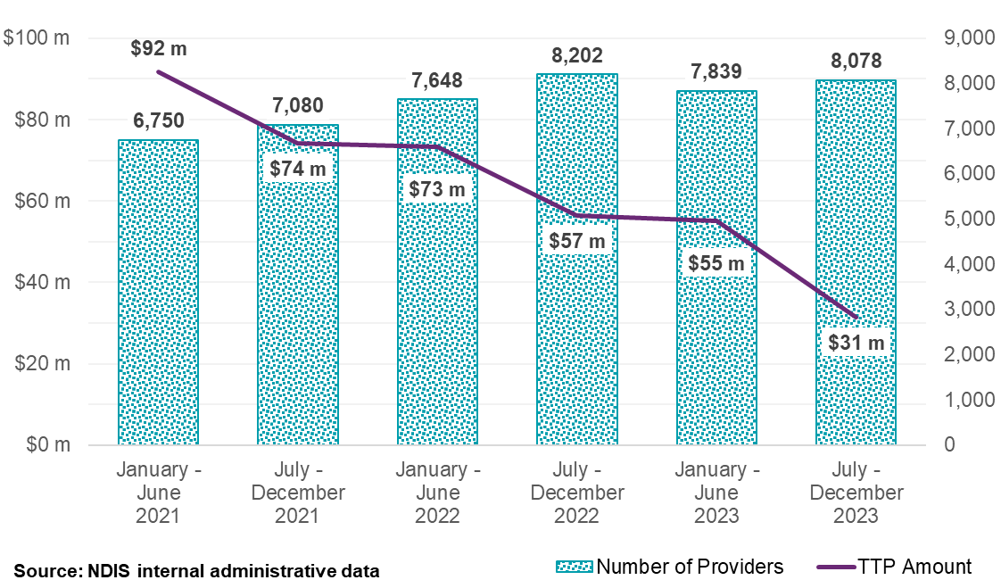

Participants
In the six months to 31 December 2023, a total of 283,406 participants accessed DSW-related supports. The most common DSW-related supports accessed by participants are for:
- Access Community Social and Recreational Activities Standard: utilised by 179,356 participants, with 77,568 providers claiming $2.2 billion in payments.
- Assistance with Self-Care Activities Standard: utilised by 123,248 participants, with 73,555 providers claiming $2.7 billion in payments.
- Group Activities Standard: Utilised by 38,617 participants, with 8,773 providers claiming $204.9 million.
- Activity Based Transport: utilised by 141,551 participants, with 30,664 providers claiming $175.7 million in payments.
- Capacity Building and Training: utilised by 54,834 participants, with 24,223 providers claiming $168.8 million in payments.
- Provider Travel: utilised by 123,248 participants, with 37,139 providers claiming $113.6 million in payments.
Further detail is found in Table 6.
The average payments per participant between 1 January 2020 and 31 December 2023 have increased from $52,300 in 2020 to $62,700 in 2023, a 6.2% increase per annum. Specifically, average payments are nine times higher for participants in Supported Independent Living (SIL) than those not in SIL ($405,400 versus $43,700 respectively, in the year to 31 December 2023). Average payments are also higher for adults compared with children ($71,400 for participants not in SIL aged 25 to 64 versus $20,100 for those aged 0 to 14 years, in the year to 31 December 2023), by a factor of almost 4 times.
Table 6: Top 10 largest DSW-related supports, July to December 2023
Support Delivered | Total payments ($ million) | Number of Participants | Number of Providers
Assistance in Supported Independent Living Standard | $3,861 | 33,198 | 4,559
Assistance With Self-Care Activities Standard | $2,740 | 123,248 | 73,555
Access Community Social and Recreational Activities Standard | $2,239 | 179,356 | 77,568
Access Community Social and Rec Activities Standard – TTP | $761 | 68,867 | 4,585
Short Term Accommodation (STA) And Assistance | $537 | 37,365 | 14,438
Assistance in Supported Independent Living High Intensity | $509 | 4,918 | 1,122
Assistance With Self-Care Activities Standard – TTP | $496 | 29,660 | 3,935
Group Activities Standard – TTP | $370 | 35,066 | 1,653
Assistance With Self-Care Activities High Intensity | $294 | 6,092 | 4,692
Source: NDIS internal administrative data

Providers
In the six months to 31 December 2023 the number of active registered providers of DSW-related supports decreased by 6%, from 9,286 to 8,697. The amount claimed by these registered providers rose by 19% to $9.4 billion, and the average amount claimed per registered provider grew by 27%, from $850,843 to $1,081,264.
On the other hand, active unregistered providers of DSW-related supports increased by 24%, from 92,490 to 114,777, with the amount claimed by these providers experiencing a significant 54% increase, from $2.3 billion to $3.6 billion. Consequently, the average amount claimed by unregistered providers also rose by 24%, from $25,340 to $31,348.
In the same six-month period to December 2023, 283,406 providers submitted claims for DSW-related services. Among these, the supports most frequently claimed included Access Community Social and Recreational Activities Standard by 77,568 providers, Assistance With Self-Care Activities Standard by 73,555 providers, followed by Provider Travel (37,139), Activity Based Transport (30,664), Capacity Building and Training (24,223), STA And Assistance (14,438), and Group Activities Standard (8,773).

Providers market share
Figure 14 shows that between January 2021 and December 2023, the market share attributed to the top 10 providers, in terms of DSW-related support payments, has seen a decrease from 10.8% to 7.2%. Over this period, it is also observed the number of unregistered providers continues to grow and therefore there is a corresponding decrease in market share among registered providers (from 80% to 72%).
Figure 14: Top 10 Providers’ Market Share Against Overall Provider Growth on DSW-related Supports, January 2021 to December 2023
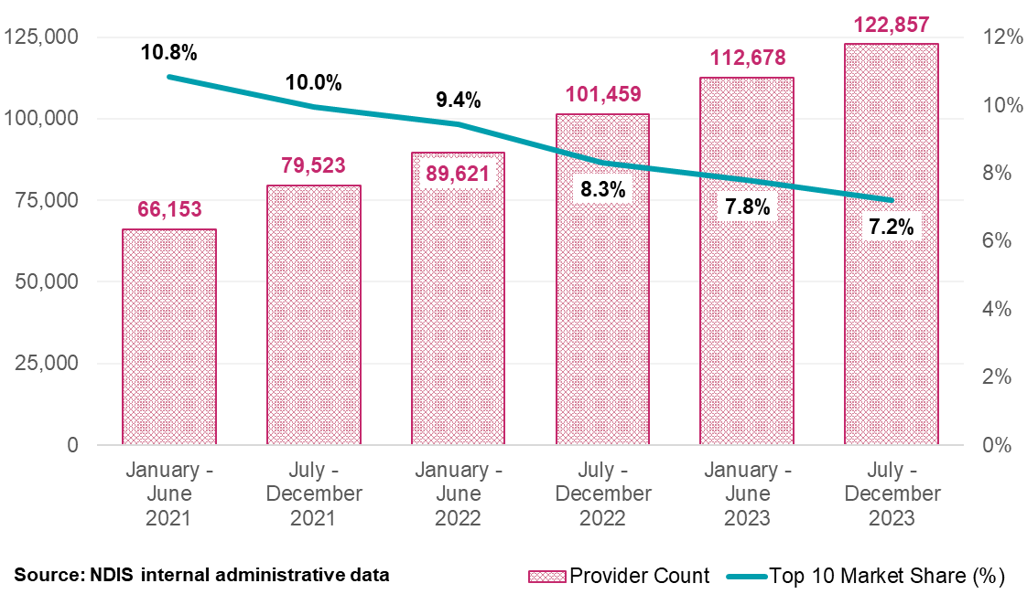
Further analyses demonstrates that the share of top ten providers by payment amounts received across very remote, remote, and non-remote areas all have a steady downward trend (Figure 15).
Figure 15: Top 10 Providers’ Market Share by Remoteness for DSW-related Supports, January 2021 to December 2023
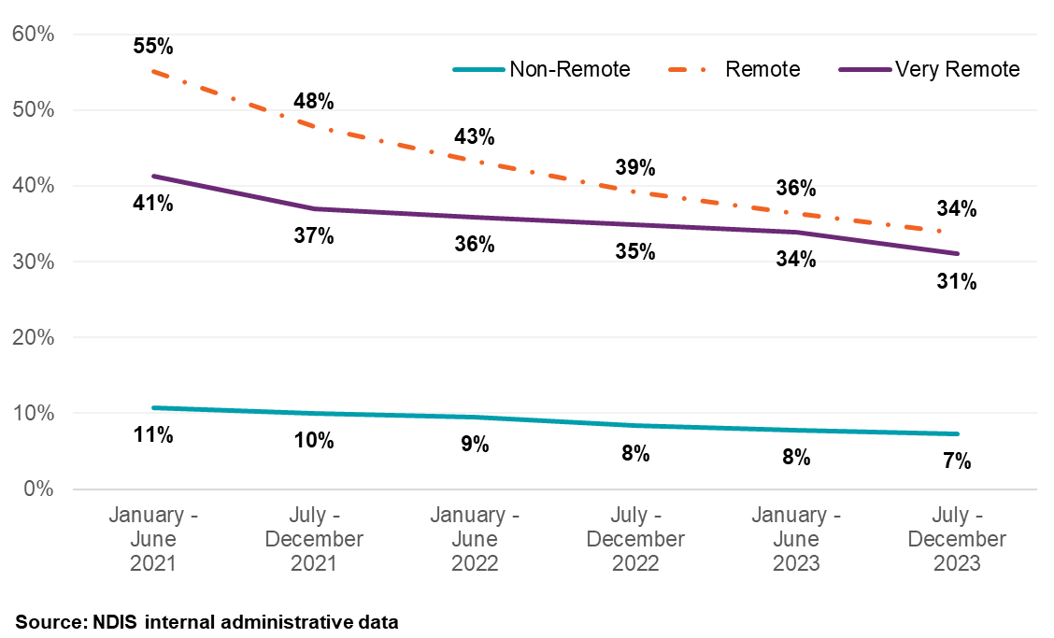

Providers distribution by geographic areas
Table 7 shows in the second half of 2023, there was a continued decrease in the number of registered providers in non-remote areas, contrasted with Table 8 showing the growth of unregistered providers across all geographic areas. When comparing the half-year ending December 2022 with the half-year ending December 2023, the number of active registered providers of DSW-related supports decreased by 6%, from 9,286 to 8,697. In contrast, the amount claimed by the registered providers rose by 19% to $9.4 billion, and the average amount claimed increased by 27%, from $850,843 to $1,081,264.
On the other hand, the active unregistered providers of DSW-related supports increased by 24%, from 92,490 to 114,777 providers, with the amount claimed by these providers increasing by 54%, from $2.3 billion to $3.6 billion. Consequently, the average amount claimed by unregistered providers rose a comparable percentage of 24% (from $25,340 to $31,348).
Table 7: Registered Providers by Remoteness for DSW-related Supports, January 2021 to December 2023
Remoteness | January – June  2021 | July – December 2021 | January – June  2022 | July – December 2022 | January – June  2023 | July – December 2023
Non-Remote | 7,686 | 8,406 | 8,745 | 9,196 | 8,807 | 8,612
Remote | 369 | 416 | 430 | 420 | 380 | 388
Very Remote | 206 | 241 | 224 | 233 | 227 | 236
Total for Registered | 7,748 | 8,474 | 8,814 | 9,286 | 8,893 | 8,697
Table 8: Unregistered Providers by Remoteness for DSW-related Supports, January 2021 to December 2023
Remoteness | January – June  2021 | July – December 2021 | January – June  2022 | July – December 2022 | January – June  2023 | July – December 2023
Non-Remote | 58,047 | 70,522 | 80,125 | 91,417 | 103,028 | 113,419
Remote | 679 | 864 | 1,020 | 1,093 | 1,199 | 1,374
Very Remote | 379 | 438 | 473 | 530 | 582 | 622
Total for Unregistered | 58,770 | 71,391 | 81,152 | 92,490 | 104,263 | 114,777
Source: NDIS internal administrative data
Note: The totals for registered and unregistered DSW-related providers do not match the overall provider count due to providers offering multiple support types under different registration statuses, a small proportion of providers with indeterminate registration status not detailed in the table, and the unavailability of participant location data at the time of transactions which affects the determination of provider remoteness.

Herfindahl-Hirschman Index
The Herfindahl-Hirschman Index (HHI) is a metric that assesses the level of concentration in a market by examining the market share among businesses. A higher HHI points to a market with less competition, whereas a HHI under 1,500 signals a competitive marketplace. A HHI which is low, potentially indicates a healthy market where no single provider can disproportionately influence market conditions.
Over the period from January 2021 to December 2023, the HHI for DSW supports across varying degrees of remoteness has been on a downward trajectory, revealing a decrease in concentration. As shown in Figure 16, the HHI has dropped from nearly 500 for very remote areas and about 300 for remote areas to below 200 for providers in both remote and very remote areas by the end of December 2023. This suggests a significant decrease in market concentration over the past three years, in line with the observed decrease in market share held by the top ten providers.
Figure 16: Herfindahl-Hirschman Index by Remoteness for DSW-related Supports, January 2021 to December 2023

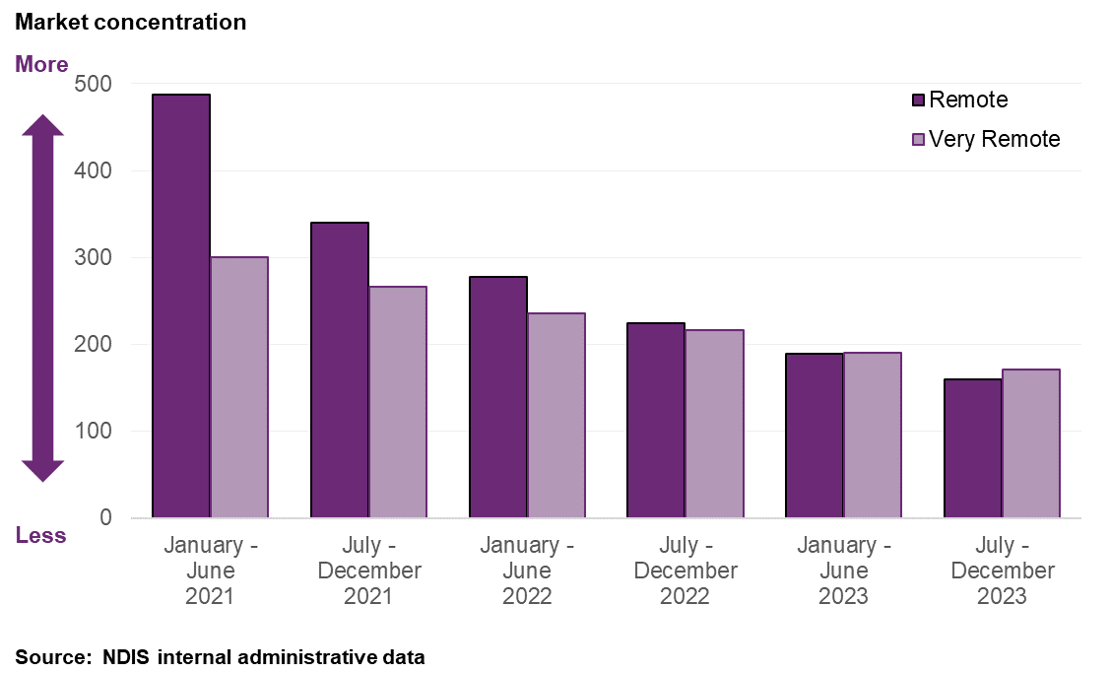
Note: Adjustments were made to HHI as the overall size of the Australian market and providers’ financial statements are unknown at the time of the analysis. Therefore, the NDIA assumed that the size of the market is equal to the total amount of payments made to providers for DSW-related supports.

Providers claiming below the price limit
Approximately 36% of DSW-related supports were claimed below the price limit. Table 9 provides a detailed comparison of pricing below the limit for both registered and unregistered providers. Over the past three years, there has been a decrease in the percentage of DSW support claims below the price limit for both registered and unregistered provider. The period to December 2023 observed a significant shift in this pattern, especially amongst unregistered providers. The overall pricing behaviour of providers in relation to price limits has demonstrated a consistent trend, noting a decrease in the proportion of claims by registered providers from 82% in the period from July to December 2021 to 68% in the same period in 2023.
Table 9: Claiming Patterns at Price Limit Analysis for DSW-related Supports January 2021 to December 2023
Claiming patterns – At price limit | January – June  2021 | July – December 2021 | January – June  2022 | July – December 2022 | January – June  2023 | July – December 2023
Registered | 68% | 66% | 71% | 71% | 73% | 69%
Unregistered | 37% | 38% | 51% | 47% | 56% | 50%
All Providers | 63% | 61% | 67% | 65% | 68% | 63%
Source: NDIS internal administrative data
Note: All Providers above are inclusive of providers with the unknown registration status at the time of the transaction.

Business dynamism of registered providers
This section looks at the dynamics of the DSW market among registered providers, given registered providers account for 72% of the total value of payments in the six months leading to December 2023. Business dynamism, characterised by the entry and exit of businesses, as well as the capacity of service providers to adapt to changing market conditions. This dynamism serves as an important indicator of the market’s health.
Figure 17 shows the number of registered and unregistered DSW providers with payments between January 2021 and December 2023 respectively, split by the number of half-year periods in which each provider received a payment. As seen in this figure, 5,335 out of 14,016 (38%) registered providers have received payments in all six half-years between January 2021 and December 2023. These providers account for almost 75% of total DSW support payments across the three-year period. In contrast, only 11% of unregistered providers received payments in the six half-years, implying that registered providers exhibit greater continuity of activity.
Figure 17: Provider Continuity by Registration Status and Percentage of Total Payments. Registered Providers (Left) and Unregistered Providers (Right), January 2021 to December 2023
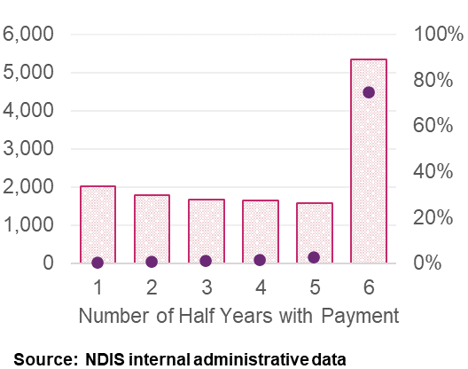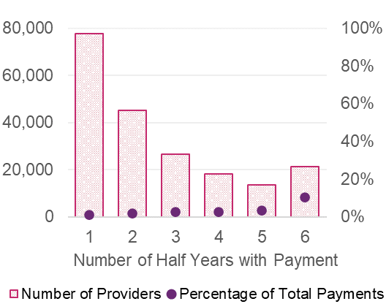
Despite a slight decrease in the number of registered DSW-related support providers, they still accounted for a significant 72% of total DSW payments in the latter half of 2023. The following section will focus specifically on registered providers.
In the six months to 31 December 2023, 1,202 registered DSW providers stopped claiming payments for DSW services. Among these providers, 78% continued to receive payments for other types of support within the same timeframe. It's also notable that 73% of these inactive DSW providers had historically received less than $10,000 per half-year in payments for the last three years.
Figure 18 presents a breakdown of registered providers based on the number of participants they serve and the percentage of their claimed services. This figure highlights a trend towards registered providers serving more participants from the first half of 2021 to the second half of 2023. In particular, the proportion of providers supporting 11 or more participants increased from 37% to 44% among registered DSW providers over this period, indicating a shift towards providers catering to a larger number of participants.
Figure 18: Registered Providers of DSW-related Supports and Number of Participants that Claimed, January 2021 to December 2023
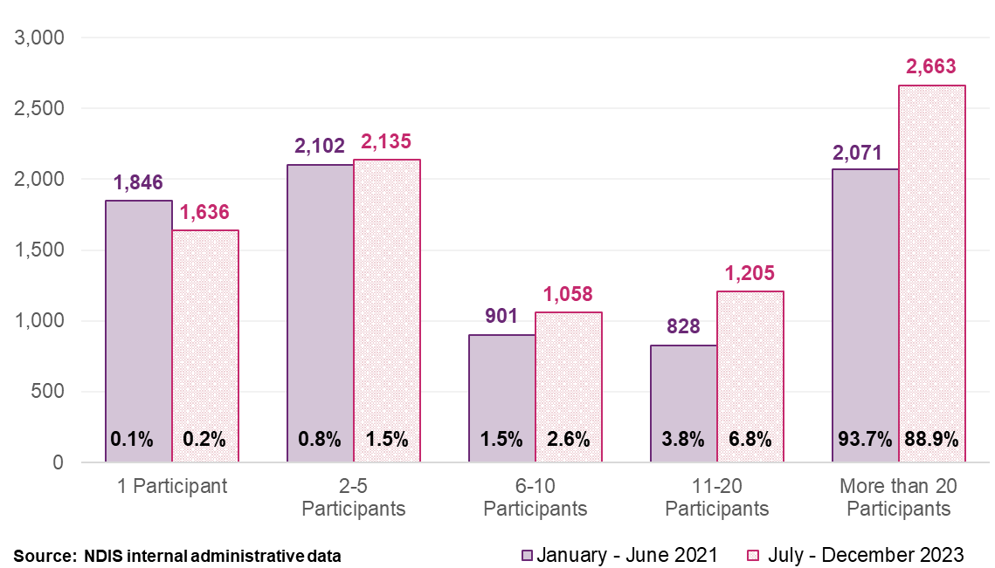
An analysis of payment activity for registered providers from January 2021 to December 2023 shows an evolving provider market. ‘New Activity’ within a half-year period is identified when providers who were inactive in the previous half-year begin to receive payments. Conversely, ‘Inactivity’ is noted when providers that received payments in one half-year do not in the subsequent one. These fluctuations are measured as a percentage of the total payments made within that half-year, or the previous one, in the case of inactivity. While the NDIA recognises that this methodology may not perfectly capture market exits, it serves as the best available proxy.
Figure 19 shows that inactive registered providers account for 0.2% or less of the total payments in any half-year period. In comparison, newly active registered providers account for 0.3% to 1.3% of total payments for the corresponding timeframe, with a notable decline in 2023.
Figure 19: DSW-related Registered Provider Activity Movements, January 2021 to December 2023
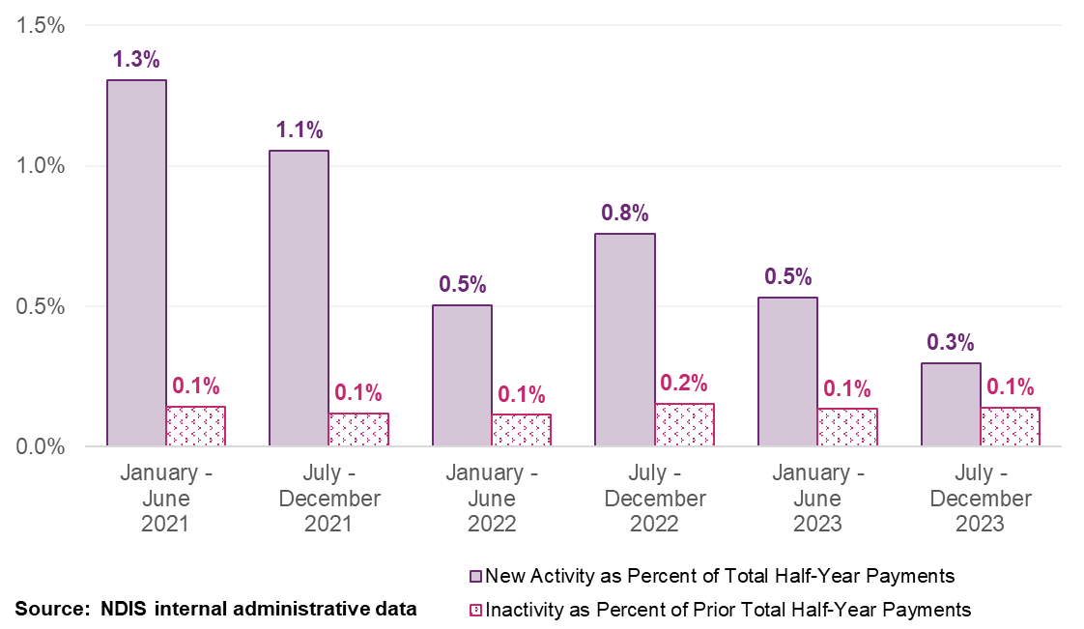
Further analysis indicates that 87% of inactive registered providers received less than $5,000 in DSW related payments in the half-year prior to becoming inactive. In contrast, active registered providers received on average $999,749 of payments in each half-year period, highlighting the substantial difference in activity between providers that are on the verge of become inactive and those that remain active.

The Ability Roundtable Benchmarking Survey
The Ability Roundtable has provided the Agency with workforce and financial data from 55 organisations, of which 54 disclosed that they were registered with the Australian Charities and Not-For-Profits Commission (ACNC), for analysis of key metrics. The sample represents organisations with a combined revenue of over $6.0 billion for the 2022-23 financial year, of which NDIS revenue represented $4 billion, and with a workforce exceeding 55,000 personnel. Collectively, these organisations delivered services to over 65,000 unique NDIS participants. More information on this survey and its results are available on The Ability Roundtable’s website.
The analysis of the survey results provided by Ability Roundtable reveals several key insights into the financial performance and workforce dynamics of registered NDIS providers across Australia. For the analysis, the organisations were grouped into one of five bands, with organisations increasing in size from Band 1 to Band 5.
Larger organisations appeared to benefit from economies of scale and lower operating expense ratios, with Band 5 organisations’ operational expenses equating to 19% of their total revenue compared with Band 3 organisations’ 30% of their total revenue. The largest organisations also appeared to have lower permanent staff turnover and are more likely to pay above Award rates (Table 10). Note, approximately 50% of participating organisations pay their staff under Enterprise Bargaining Agreements (EBAs).
Table 10: Turnover Percentage of Permanent Casual Workers, as well as Percentage of Organisations that Pay DSW Staff Above the Award Rate
Band Number | Permanent Staff Turnover | Casual Staff Turnover | Percentage paying above Award
Band 1 | 26% | 32% | 60%
Band 2 | 22% | 49% | 45%
Band 3 | 23% | 32% | 55%
Band 4 | 21% | 43% | 27%
Band 5 | 16% | 34% | 74%
Average | 21% | 38% | 50%
Source: NDIA analysis
The organisations showed general increases in non-current assets alongside increases in non-current liabilities. It is difficult to determine why there was an increase from data alone. This may come from a range of reasons, such as the increasing value of non-current assets. However, it was seen that of those surveyed, only Band 1 (organisations with the smallest revenue size) and Band 5 (organisations with the largest revenue size) reported increases in total equity levels in 2022-23.
In 2022-23, Ability Roundtable’s submission to the APR suggested 36% of sampled organisations recorded a profit. This is a 4.4 percentage points increase from 2021-22. Of all sampled organisations, the data showed the median profitability result to be -2.1% in 2022-23, 0.5 percentage points higher than the result in 2021-22. Of the sampled organisations that made a loss, the data shows a median loss of -5.9% in 2021-22 and -4.9% in 2022-23.

Disability Services Financial Benchmark Report
StewartBrown conducts a Disability Services Financial Benchmark Report that provides an overview of the financial performance of the disability services sector in Australia. It is based on the results of the 51 participating organisations for the 12 months to 30 June 2023. This report can be found on StewartBrown’s website.
The sample represents a combined revenue of $2.5 billion for 2022-23, delivering services to over 26,500 NDIS participants. This survey extends beyond DSW supports, also including Allied Health (Therapy) and Support Coordination supports.
The analysis of the survey results suggests that in 2022-23, 45% of sampled organisations recorded a profit, an increase from 43% in FY21-22. The sample, of those providers who recorded an operating deficit of $0.91m for 2021-22 per provider to an average operating deficit of $1.26m per provider for 2022-23.
The survey also delved into the operating result at the service level, where for the sample, four out of the six services covered were operating at a loss. Supports with an operating profit were Supported Independent Living (SIL) (3.1%) and Daily Living non-SIL (2.2%) supports, whereas operating at a loss were Social, Community Participation (-0.3%), Supported Employment (-4.1%), Allied Health (-4.6%) and Support Coordination (-10%).

Australian Charities and Not for Profit Commission (ACNC)
Charities and not-for-profit (NFP) organisations represent a significant segment of the provider market delivering supports to NDIS participants. All entities classified as charities or NFPs are legally required to disclose their annual financial statements. This financial data is made available by the ACNC.
To assess the financial health of charitable and not-for-profit NDIS providers, the Agency undertook an analysis of the financial data from 100 such organisations that have claimed a NDIS payment for at least six months in each of the last four fiscal years. These organisations generated around $2 billion in total revenue in 2022-23, of which around 50 percent of this was generated by claiming for NDIS services.
To conduct the analysis, the 100 organisations were separated into four bands based on their total revenue collected in 2021-22 (the middle year of the data collected). Band 1 consists of the 25 organisations with the lowest total revenue base, with Band 2 consisting of the next 25 smallest organisations by revenue, and so on.
It is acknowledged that assessing the financial health of charitable and not-for-profit NDIS providers is challenging. Financial reports do not distinguish between NDIS and non-NDIS activities. This complicates analysis as many organisations serve a wide array of sectors, not solely NDIS participants. The distinct financial characteristics of not-for profit organisations also hinder comparisons and inferences with for-profit organisations’ financial health. For example, for-profit organisations typically do not use volunteer staff to fulfill operational demands and have different tax obligations.

Summary of results
From 2020-21 to 2022-23, of the organisations sampled, there was almost a doubling in the number of NDIS payments that were made, with a 33% increase in the total amount of NDIS revenue claimed over that period. There has also been an increase in the number of NDIS claims made by each organisation. Only 4% of organisations sampled reported a loss in each of the three financial years. Among the organisations analysed, 65% reported a profit in the 2022-23 financial year, marking an increase from the previous year, where only 60% achieved profitability. This is a decline in terms of profits from the 2020-21 financial year, during which a notable 88% of sampled organisations recorded a profit. The result in 2020-21, however, can be largely explained by the temporary increase in price limits given to NDIS providers and wage supplements and government support during the COVID-19 pandemic.
Table 11 details the profitability of the sampled organisations across the three financial years. The average financial performance across the three financial years was healthy with positive average and median profits across the sample size in each year.
Table 11: Financial performance across 2020-21 to 2022-23
Financial Year | Number that recorded a loss | Number that recorded a profit | Average Profit/Loss | Median Profit/Loss
2020-21 | 12 | 88 | $1,505,156 | $476,943
2021-22 | 40 | 60 | $565,434 | $76,974
2022-23 | 35 | 65 | $580,586 | $76,831
Source: NDIA analysis using ACNC data.
There are other indicators showing the financial health of the NFP industry. Organisations across all revenue bands reported a working capital ratio above the industry benchmark (1.5) and consistently maintained debt ratios below 0.5 (a ratio below 0.5 suggests that organisations hold at least double the amount of assets as it does liabilities). The data also suggests that despite the varying scales of operation, the NFP sector has seen growing levels of average revenue generated per Full Time Employee (FTE) over time (Figure 20).
Figure 20: Average Revenue per FTE Across 2020-21 to 2022-23
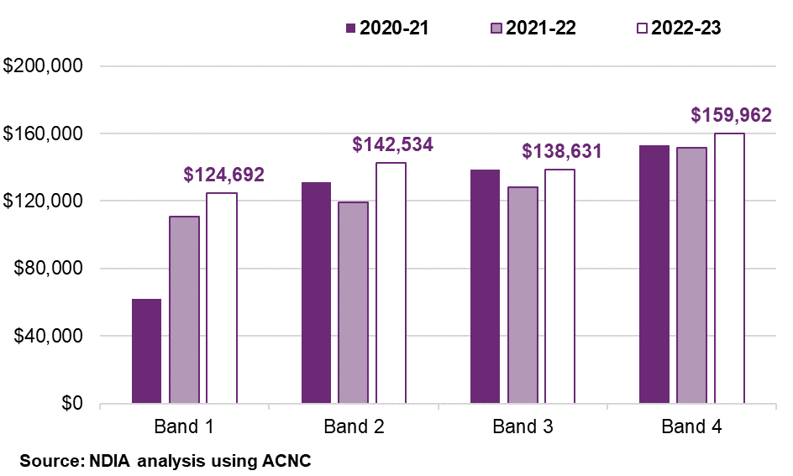

As was seen in the analysis of the Ability Roundtable survey, there were increases in equity for most organisations, with all bands recording improvements. It was found that despite there not being as many profitable organisations in 2022-23 as there were in 2020-21 (the latter being due to additional financial support provided to providers during the pandemic), all bands saw substantial growth in assets over the 2021-22 and 2022-23 (Table 12). This growth was particularly notable among organisations in the Band 4 (top 25 organisations by revenue size), where on average, total equity levels rose by over $4 million over the period.
Table 12: Asset, Liability and Equity Change from 2020-21 to 2022-23
Band Number | Assets | Liabilities | Equity
Band 1 | $87,510 | $1,367 | $86,143
Band 2 | $454,496 | -$54,670 | $509,166
Band 3 | $415,590 | -$230,466 | $646,055
Band 4 | $6,966,584 | $2,651,625 | $4,314,959
Median | $325,819 | $44,571 | $344,806
Source: NDIA analysis

Feedback from consultations
A total of 79 provider submissions were received regarding the suitability of the methodology and parameters used in the DSW Cost Model. The majority of feedback received from stakeholders regarding the DSW Cost Model raised concerns about its alignment with the actual costs and complexities faced by the sector in delivering disability support services. It was suggested that the DSW Cost Model may not fully account for the real-world operational and corporate overheads, suggesting a possible underestimation of the financial requirements necessary for service provision.
Concerns raised about the accuracy of assumed overhead costs within the DSW Cost Model are suggested to be a discrepancy between theoretical assumptions and the operational realities experienced by providers. This misalignment extends to the costs associated with ensuring service quality and meeting regulatory compliance, which stakeholders suggest are not sufficiently considered in the current model. The sector called for a revised approach that more accurately reflects the varied and significant needs of service delivery in the disability support sector.
There were also challenges raised regarding workforce management. Particularly in recruiting and retaining skilled personnel for complex care needs and recognising the recent Aged Care Award wage increases, both claimed to have impacts on providers.
See Appendix A for more details on common themes raised in submissions to the 2023-24 APR Consultation Paper.

Discussion

Acknowledgment of concerns raised on the DSW Cost Model
The NDIA acknowledges the complexities of updating the DSW Cost Model, particularly in ensuring that data are recent, reliable, and representative. The last Financial Benchmarking Survey conducted for the 2021-22 financial year is due for an update to better reflect current economic conditions. Stakeholders have raised several issues with the DSW Cost Model:
- Potential underestimation of corporate overheads and operational costs, such as insurance premiums and regulatory compliance.
- The model lacks differentiation and may not fully account for the services or staff needed by clients with higher or specialised needs.
- Setting parameters at the 25th percentile for 'efficient' levels may not cover current providers' costs adequately.
In response to these critiques, the NDIA has incorporated more comprehensive and representative data sources in the current report, including surveys by Ability Roundtable and StewartBrown. Despite challenges with sample size and representativeness, these efforts aim to better capture the financial experiences of organisations.
The new data provide valuable insights into providers' financial performances from various perspectives, enriching the NDIA's decision-making process. As a market steward, the NDIA actively monitors and tracks the financial health of providers to ensure that the diverse and evolving conditions of the NDIS provider market are considered.
Building on the insights from previous surveys, the NDIA has expanded its data analysis this year to include mandated data from not-for-profit organisations, as reported to the ACNC. However, differentiating financials between NDIS-specific activities and broader organisational functions remains complex, particularly given the differing financial structures of for-profit and not-for-profit entities.
The NDIA is committed to continue to collaborate with the sector, providers, and other stakeholders to refine pricing arrangements for Disability Supports. This includes exploring methods to obtain objective information to inform potential approaches.
The NDIA's ongoing pricing work aligns with broader pricing reform initiatives across the Australian Government. This includes the Department of Social Services' 'Pricing and Payments Framework' and the Independent Health and Aged Care Pricing Authority (IHACPA)'s planned work for 2024-25, aimed at reforming NDIS pricing arrangements, reviewing existing pricing approaches, and developing a pricing data strategy.

Recommendations
Analyses suggest significant variability in the financial performance and growth potential of organisations providing DSW-related supports. Additionally, the labour market for the health and care sector remains tight, which could continue to put upward pressure on the supply of DSWs.
In the financial year 2024–25, the Australian Government has allocated $5.3 million to the Independent Health and Aged Care Pricing Authority (IHACPA), to work with Department of Social Services (DSS) and the National Disability Insurance Agency (NDIA), to undertake the initial work to reform the National Disability Insurance Scheme (NDIS) pricing arrangements. The primary objective of this initiative is to enhance the efficiency and effectiveness of NDIS pricing structures. The initial work is expected to conduct a comprehensive review of current NDIS pricing mechanisms, as well as develop a new pricing data strategy.
On balance, it is considered appropriate to pass on minimum Award wages and national employment standard changes to superannuation at this time. This includes employer superannuation contributions, which will rise from 11% to 11.5% from 1 July 2024.
Recommendation 1
The NDIA, subject to any specific recommendation arising from the current Annual Pricing Review, should increase the price limits for supports that are determined by the NDIS Disability Support Worker Cost Model from 1 July 2024 to reflect any changes in the minimum wages specified in the Social, Community, Home Care and Disability Services Industry Award 2010 (SCHADS Award) following the Fair Work Commission’s Annual Wage Review and any increase in the Superannuation Guarantee Charge.
The temporary loading of 2% was introduced on 1 July 2022 to the DSW Cost Model as a short-term measure to assist providers in managing the increased costs associated with COVID-19 and changes stemming from the SCHADS Award changes. As COVID specific supports continue to wane in other sectors in the economy, it is recommended that this temporary measure ends as scheduled and as recommended in the 2022-23 APR.
Recommendation 2
The NDIA should cease the temporary loading applied to the NDIS Disability Support Worker Cost Model from 1 July 2024.
The NDIA recognises there are supports that are not within the scope of the 2023-24 APR, nor tied to the DSW Cost Model and are neither price limited nor benchmarked. Notably, nursing supports fall into this category, alongside other core and capacity-building supports like personal domestic cleaning and house or yard maintenance.
Given the recent aged care reforms, which include up to a 25% wage increase for aged care workers and potential future adjustments to the Nursing Award, it is crucial that these supports remain in line with their applicable markets. Failing to adjust the price limits, particularly nursing supports, could risk the adequacy of support for NDIS participants. Therefore, it is proposed that the price limits for these supports be increased, following the methodology used in previous years’ indexation. It should be noted that capital items are excluded from the APR and is addressed by a separate process.
Recommendation 3
The NDIA, subject to any specific recommendation arising from the current Annual Pricing Review and any future reviews, should increase the price limits for nursing and other supports, not covered by Disability Support Worker-related supports or Capital supports, on 1 July 2024 in line with the weighted movement over the previous twelve months in the ABS Wage Price Index (Australia, total hourly rates of pay excluding bonuses) and the ABS Consumer Price Index (All Groups, weighted average of eight capital cities) over the 12 months to the March Quarter immediately preceding the indexation date (with an 80/20 weighting). This recommendation does not include Plan Management.

Therapy Supports

Context
Therapy supports play an important role in assisting participants to achieve their personal goals. Early therapeutic interventions enhance participant outcomes and reduce long-term cost by building capacity and independence. These supports are delivered by a diverse range of professionals, such as Occupational Therapists (OT), Speech Pathologists (SP), Psychologists, Physiotherapists, and many others, including therapy assistants who operate under the supervision of therapists. This ensures a broad and inclusive delivery of therapeutic interventions, that meet the diverse needs of the NDIS participants.
Therapy supports are organised into several registration groups, with the majority of therapy supports delivered under three main categories - Therapeutic Supports for improving functional skills (0128), Early Intervention Supports for Early Childhood for children with developmental delays (0118), and Exercise Physiology & Personal Wellbeing Activities for physical health (0126). There are other additional categories which provide supports for specific needs like behaviour management and hearing services.
Pricing for therapy services under the NDIS varies by service type, delivery method, location, and whether the services are provided to individuals or groups (see Table 13). The Scheme also allows for claiming of non-face-to-face supports, travel and cancellations. This structure supports the delivery of personalised, effective therapy services to NDIS participants, aiming to improve their independence and participation in daily activities. Additional information on the Pricing Arrangements and Price Limits for therapy supports can be found here.
This chapter reviews the pricing arrangements for therapy supports in the NDIS, assessing their alignment to comparable schemes, and with the private therapy support market.

Table 13: Price Limits for Therapy Supports as at 1 January 2024
Type of Therapist | NSW / VIC / QLD / ACT | SA / WA / TAS / NT | Remote | Very Remote
Art Therapist, Audiologist, Developmental Educator, Dietitian, Music Therapist, Occupational Therapist, Orthoptist, Podiatrist, Rehabilitation Counsellor, Social Worker, Speech Pathologist, and Other Professional | $193.99 | $193.99 | $271.59 | $290.99
Counsellor | $156.16 | $156.16 | $218.62 | $234.24
Exercise Physiologist | $166.99 | $166.99 | $233.79 | $250.49
Physiotherapist | $193.99 | $224.62 | $314.47 | $336.93
Psychologist | $214.41 | $234.83 | $328.76 | $352.25
Therapy Assistant - Level 1 | $56.16 | $56.16 | $78.62 | $84.24
Therapy Assistant - Level 2 | $86.79 | $86.79 | $121.51 | $130.19
Source: NDIS Pricing Arrangements and Price Limits 2023-24

Scheme statistics

The number of therapy providers continues to grow
In the six months to 31 December 2023, 379,296 participants, representing 59% of the total 646,449 active participants, as of 31 December 2023, purchased therapy supports through their plans. Table 2 shows that the number of providers delivering therapy supports increased during this period, with 52,736 providers receiving payments, a 14% rise compared to the year before. The total amount claimed by unregistered providers in the six months to 31 December 2023 grew by 60% compared to the same time the previous year. However, most of the total amount claimed for provision of therapy supports is still through registered providers (65%, or $1.3 billion, of therapy supports claimed).
Refer to Table 14, Table 15 and Table 16 for further breakdown of the number of registered and unregistered providers delivering supports to NDIS participants.

Table 14: Therapy Supports Schemes Statistics – All Providers
Statistics | July – December 2022 | July – December 2023 | Percentage Change
Total number of NDIS participants | 325,319 | 379,296 | +17%
Total number of active providers | 46,326 | 52,736 | +14%
Total amount claimed by active providers of Therapy supports | $1.6 billion | $2.1 billion | +28%
Average amount claimed by all active providers of Therapy supports | $35,028 | $39,257 | +12%
Table 15: Therapy Supports Scheme Statistics – Registered Providers
Statistics | July – December 2022 | July – December 2023 | Percentage Change
Number of active registered providers of Therapy supports | 8,778 | 7,392 | -16%
Total amount claimed by registered providers of Therapy supports | $1.2 billion | $1.3 billion | +15%
Average amount claimed by registered providers of Therapy supports | $132,541 | $180,913 | +36%
Table 16: Therapy Supports Scheme Statistics – Unregistered Providers
Statistics | July – December 2022 | July – December 2023 | Percentage Change
Number of active unregistered providers of Therapy supports | 38,206 | 45,961 | +20%
Total amount claimed by unregistered providers of Therapy supports | $0.4 billion | $0.7 billion | +60%
Average amount claimed by unregistered providers of Therapy supports | $11,764 | $15,651 | +33%
Source: NDIS internal administrative data
Please note a discrepancy in the total number of ‘active’ therapy providers, attributable to two factors. 1) some providers offer a mix of registered and unregistered supports, leading to their classification in both categories. 2) a small fraction of providers with undetermined registration status contributes to total payment figures but is excluded from detailed tabulation, representing less than 1% of the overall financial transactions.
Figure 21 shows NDIS payments on therapy supports in the six months to December 2023, which amounted to $2.1 billion. This expenditure accounts for just over 10% of the NDIS’s total expenditure of $20.4 billion during this six-month period, reflecting a 28% increase from the previous year’s spending on therapy supports.
Figure 21: NDIS Expenditure on Therapy Supports Since January 2021 Relative to Total NDIS Expenditure
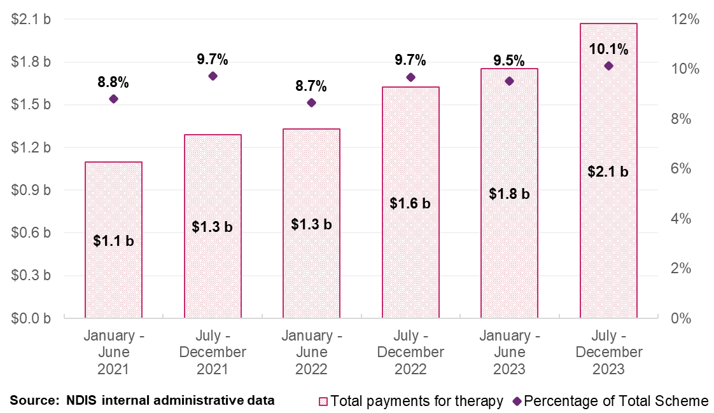
Over the last three years payments for therapeutic supports have comprised about 14% of total NDIS payments to registered therapy support providers and about 37% of payments to unregistered therapeutic providers. From January to December 2023, the top three payment support categories for registered providers for therapy supports were:
- Daily Activities (51% of payments)
- Social Community and Civic Participation (22% of payments)
- Capacity Building Daily Activity (13% of payments)

Participants
Participants access a broad range of therapies. In the six months to 31 December 2023, participants claimed therapy supports, predominantly from Occupational Therapists ($441.6 million from 214,271 participants), followed by Early Childhood Professionals ($357.9 million from 93,154 participants), Behavioural Therapists ($287.7 million from 53,064 participants), Physiotherapists ($202.2 million from 95,095 participants) and Speech Pathologists ($198.2 million from 109,829 participants). See Table 17 for more information.
The average payment for a participant receiving therapy supports was $5,458, a 9% increase from the previous period, while the average claim per provider was $39,257, up 12%. This data underlines the significant role of therapy supports in the NDIS, highlighting both the extensive use of these services by participants and the corresponding financial investment by the Scheme.
Table 17: Scheme Expenditure by Type of Therapy, July to December 2023
Type of Therapist | Total Payments ($ million) | Number of Participants | Number of Providers
Occupational Therapist | $441.6 | 214,271 | 8,633
Early Childhood | $357.9 | 93,154 | 13,881
Behavioural Therapist | $287.7 | 53,064 | 1,454
Physiotherapist | $202.2 | 95,095 | 10,134
Speech Pathologist | $198.2 | 109,829 | 5,733
Psychologist | $173.9 | 99,042 | 12,660
Other Professional | $156.0 | 101,727 | 24,139
Exercise Physiologist | $76.9 | 41,765 | 4,712
Therapy Assistant | $42.5 | 40,393 | 4,045
Counsellor | $27.4 | 19,966 | 4,364
Social Worker | $22.9 | 13,842 | 2,141
Dietitian | $20.4 | 23,672 | 2,053
Travel | $20.1 | 104,182 | 11,146
Podiatrist | $10.7 | 28,251 | 2,738
Miscellaneous | $9.4 | 5,135 | 2,914
Music Therapist | $8.1 | 5,208 | 1,039
Art Therapist | $6.9 | 4,787 | 1,272
Development Educator | $5.9 | 3,316 | 440
Orthoptist | $0.7 | 1,250 | 234
Rehabilitation Counsellor | $0.7 | 724 | 314
Audiologist | $0.4 | 840 | 152
TOTAL | $2,070.3 | 379,296 | 52,736
Source: NDIS internal administrative data
Note: The total for both the number of participants and providers represent unique counts with the July to December 2023 period. ‘Other Professional’ refers to a diverse group of therapy providers offering services such as assessments, recommendations, and group therapies, which may encompass a variety of therapy disciplines not individually listed.

Providers
Market growth ensures diverse therapy options for expanding participant demand
In the six months to 31 December 2023, as shown in Table 3, 52,736 providers received payments for therapy supports. Most claims were made by ‘Other Professionals’ (24,139 providers), Early Childhood Professionals (13,881 providers), Psychologists (12,660 providers), Physiotherapists (10,134 providers) and Occupational Therapists (8,633 providers).
Registered provider numbers decreased by 16% from 8,778 to 7,392 providers in the six months to 31 Dec 2023. Of the $2.1 billion paid to providers, $1.3 billion was paid to registered providers (Table 15). This is an increase of $174 million from the six months to 31 December 2022. The decline in registered providers, as shown in Figure 22, is attributed to 1,562 providers switching to unregistered status and 1,470 registered providers no longer receiving therapy related payments in the six months to 31 December 2023. In contrast to the decline, 1,327 new providers registered to deliver therapeutic supports in the NDIS in the six months to 31 December 2023 compared to the same period in the previous year.
Figure 22: Registered Therapy Provider Volume Change Between July to December 2022 and July to December 2023
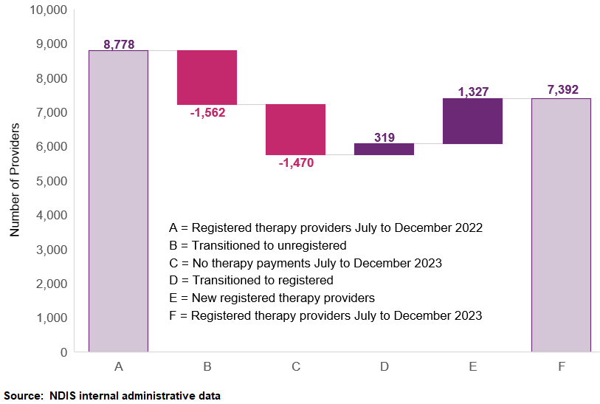
Figure 23 shows the distribution of NDIS therapy payments by provider registration status for half-year periods from January 2021 to December 2023. Over this period, therapy payments made to unregistered providers has increased from 18% to 35%. Moreover, payments made to registered providers still accounts for 65% of the totally payment for therapy supports six months to 31 December 2023.
Figure 23: Total Payments for Therapy Support Items by Provider Registration Status, January 2021 to December 2023
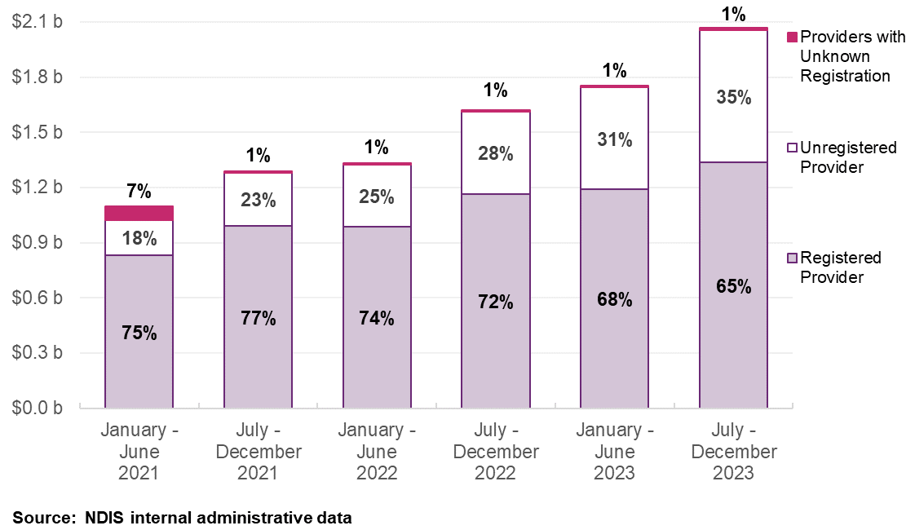
In the six months to 31 December 2023, the five leading therapy categories by total NDIS payments, excluding ‘Other Professionals’, were Occupational Therapists ($441.6 million), Early Childhood Professionals ($357.9 million), Behavioural Therapists ($287.7 million), Physiotherapists ($202.2 million), and Speech Pathologists ($198.2 million). Together, these categories represented $1.5 billion in claims, accounting for approximately 72% of the NDIS’s $2.1 billion expenditure during this period as detailed in Figure 24.

Figure 24: Largest Ten Therapy Types Based on Total NDIS Payments, January 2021 to December 2023
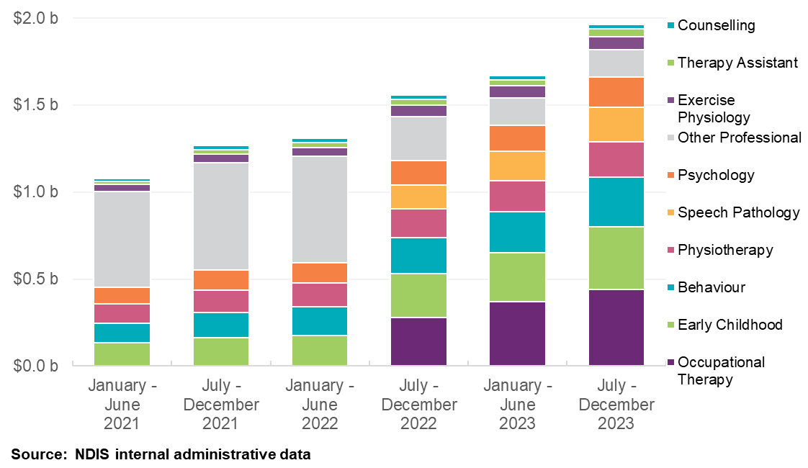
Note: Before July 2022, the NDIS grouped various therapies under ‘Other Therapy’ support. Post-categorisation changes, expenditure on specific therapies like Occupational Therapy and Speech Pathology were more distinctly tracked.

Top 10 providers sustain market share despite a drop in market share
As detailed in Figure 25 and Figure 26, the market share of the top ten registered therapy providers has seen a modest decline, from 14% to just under 11% from January to December 2023. This shift occurred alongside an expansion of the therapy market, with an overall increase of $174 million in payments to registered providers in the six months to December 2023 compared to the same period in the previous year. Although there has been a notable increase in unregistered providers, this does not necessarily indicate a downturn for registered providers, who are still experiencing substantial business growth. The rising number of unregistered providers suggests a broadening of the market landscape rather than a displacement of the existing registered providers’ activities, as the total payments to and number of participants serviced by registered providers continue to grow, demonstrating an expanding and robust NDIS therapy provider market.

Figure 25: Top 10 Providers’ Market Share Against Overall Provider Growth for Therapy Supports, January 2021 to December 2023
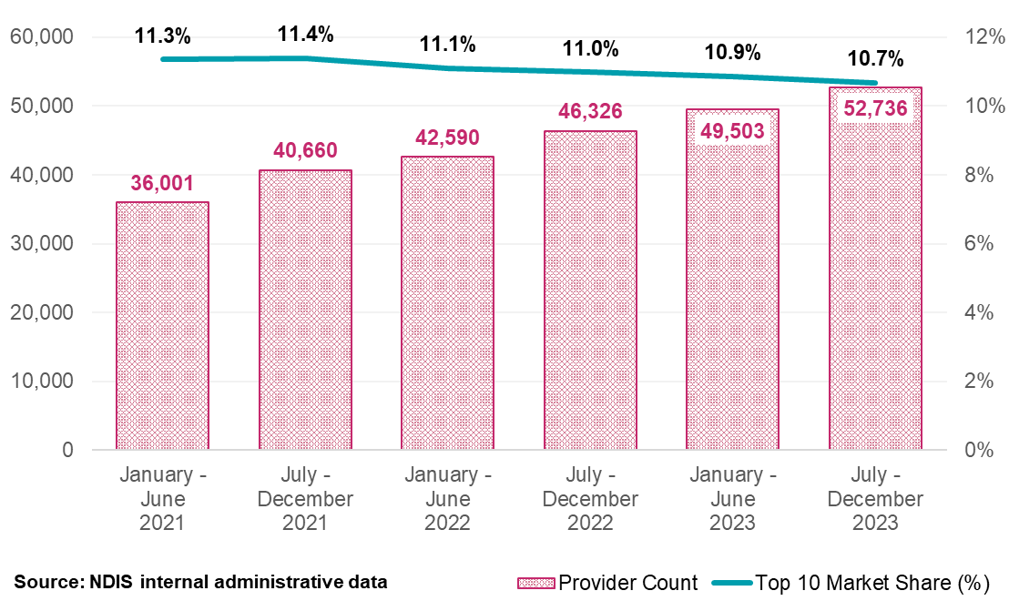

Figure 26: Top 10 Providers’ Market Share by Remoteness for Therapy Supports, January 2021 to December 2023
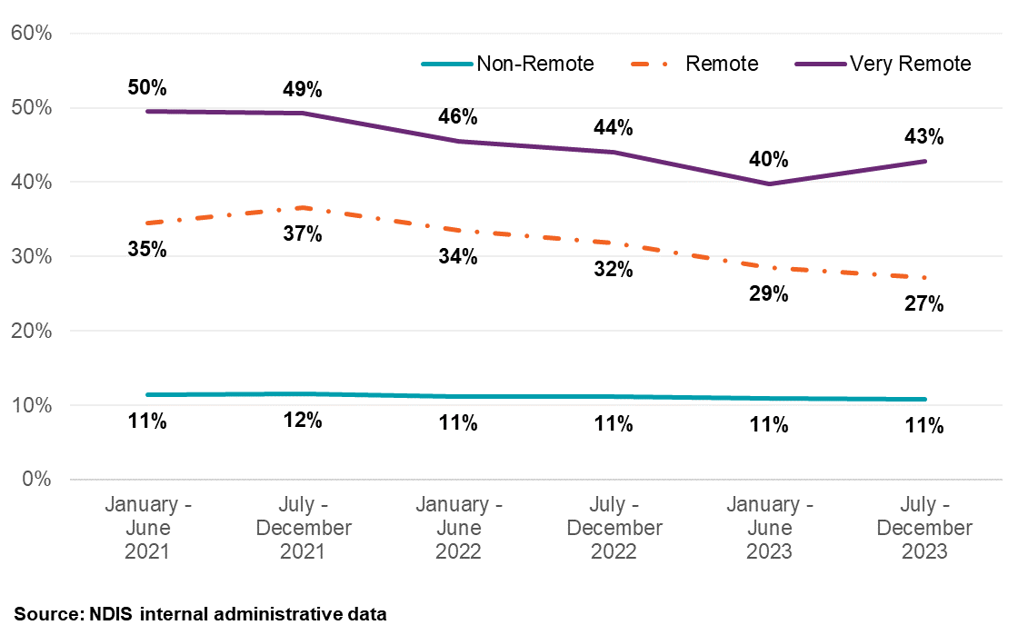

The increase in unregistered providers is common for all areas
Table 18 highlights a decrease in the number of registered therapy support providers in non-remote areas, with a drop from 8,509 providers in the six months to 30 June 2021 to 7,326 in the six months to 31 December 2023. Conversely, unregistered providers have risen in all areas, growing from 27,528 to 45,543 in non-remote areas within the same periods (Table 19). This growth in unregistered providers contributes to the declining market power of the top ten providers which may signal increasing a less concentrated market. This is further explored in the market concentration section with the Herfindahl-Hirschman Index (HHI).
Table 18: Registered Providers by Remoteness for Therapy Supports, January 2021 to December 2023
Remoteness | January – June  2021 | July – December 2021 | January – June  2022 | July – December 2022 | January – June  2023 | July – December 2023
Non-Remote | 8,509 | 8,695 | 8,552 | 8,735 | 8,252 | 7,326
Remote | 537 | 553 | 534 | 520 | 522 | 519
Very Remote | 268 | 288 | 282 | 300 | 298 | 324
Total for Registered | 8,552 | 8,745 | 8,595 | 8,778 | 8,302 | 7,392
Table 19: Unregistered Providers by Remoteness for Therapy Supports, January 2021 to December 2023
Remoteness | January – June  2021 | July – December 2021 | January – June  2022 | July – December 2022 | January – June  2023 | July – December 2023
Non-Remote | 27,528 | 31,964 | 34,090 | 37,940 | 41,938 | 45,543
Remote | 407 | 511 | 583 | 660 | 775 | 944
Very Remote | 169 | 209 | 250 | 299 | 346 | 427
Total for Unregistered | 27,740 | 32,205 | 34,350 | 38,206 | 42,260 | 45,961
Source: NDIS internal administrative data
Note: The total for registered providers of therapy supports and total for unregistered providers of therapy supports does not align with the total number of therapy support providers. The reasons for this are: 1) One provider can provide multiple supports, being registered for some supports and unregistered for others (different registration groups) in the same period, so they are accounted for in both groups of providers; 2) Providers with unknown registration are captured in total amounts but not presented in this table as they make up a very small percentage of total payments; and 3) Some participant location details at the time of transaction were not available, so provider remoteness could not be determined.

Herfindahl-Hirschman Index - Increasing provider diversity signals less concentration in the therapy market
The Herfindahl-Hirschman Index (HHI) measures market concentration and offers insight into the competitive dynamics of therapy support providers within the NDIS from January 2021 to December 2023. A HHI below 1500 signals a concentrated market, and the observed decrease in the HHI during this timeframe indicates a growing level of concentration. This trend has correlated with the diminishing market share of the top ten providers, which has dropped to just under 11%, and the growth in the market share of unregistered providers, which has almost doubled from 18% to 35%.
Adjustments to the HHI have been made, assuming the total market is equivalent to the sum of payments made to providers for therapy supports, due to the absence of comprehensive financial data for the Australian market and individual providers’ financial statements. This approach offers a practical snapshot of the market’s competitive environment, as visually represented in Figure 27.
The adjusted HHI index has remained low for non-remote areas between the observation period of six months to June 2021 and six months to December 2023. The perceived lack of concentration of providers has been most pronounced in the very remote areas; however, this situation has improved over the observation period. This is one metric to assist the Agency understand the health of the therapy market, with this trend suggesting an increasing diversity in provider options and potential benefits for NDIS participants in the therapy market.
Figure 27: Herfindahl-Hirschman Index for Therapy Supports, January 2021 to December 2023
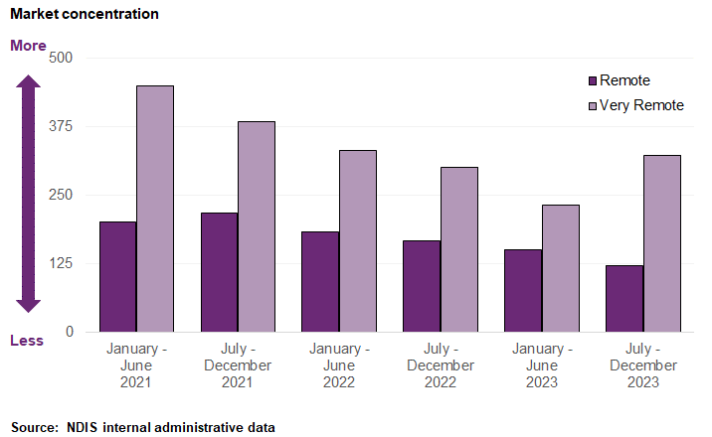
Note: Adjustments were made to HHI as the overall size of the Australian market and providers’ financial statements are unknown at the time of the analysis. Therefore, the NDIA assumed that the size of the market is equal to the total amount of payments made to providers for DSW-related supports.

Provider claiming analysis – Unregistered providers are more likely to be charging below price limits
Approximately 34% of services are paid under the published price limit, showing a slight decrease over recent periods across all providers. These claiming patterns are shown in Table 20 that distinguish between services priced at the price limit for both provider types. This shows a consistent increase in the proportion of services billed at the price limit across all providers, with registered providers more likely to charge at the limit compared to unregistered ones.
While this trend is common to both registered and unregistered providers, unregistered providers more frequently offer services below the price limit (57% claimed at the price limit compared to registered providers’ 70% in the six months to December 2023). Compared to total claims, the share of payment claims by unregistered providers has almost doubled from 18% to 35% from the first half of 2021 to the end of the 2023.
Table 20: Claiming Patterns at Price Limit Analysis for Therapy Supports, January 2021 to December 2023
Claiming patterns – At price limit | January – June  2021 | July – December 2021 | January – June  2022 | July – December 2022 | January – June  2023 | July – December 2023
Registered | 64% | 66% | 68% | 69% | 70% | 70%
Unregistered | 41% | 45% | 49% | 52% | 56% | 57%
All Providers | 59% | 61% | 63% | 64% | 65% | 66%
Source: NDIS internal administrative data
Note: All Providers above are inclusive of providers with the unknown registration status at the time of the transaction.

Business dynamism in the NDIS therapy support market
This section assesses the activity and change among providers in the therapy market. Business dynamism is gauged by the frequency of new providers joining and existing ones becoming inactive in the market, which serves as an indicator of the market’s overall health, and market competition.
To further assess the market dynamics, the NDIA reviewed the payment activities of registered providers over a three-year period from January 2021 to December 2023. ‘New activity’ is characterised by providers receiving payments in the half-year who did not receive payments in the preceding half-year. Conversely, ‘inactivity’ refers to providers not receiving payments in a half-year after having received payments in the previous one. Each provider’s activity is quantified as a percentage of the total payments within that half-year for new activity, of the prior half-year for inactivity. The NDIA recognises that this method does not perfectly measure market exits but provides the best estimation with the data available.
Despite a decrease in the number of registered therapy providers, they still accounted for 65% of total payments in the six months to 31 December 2023. This, in conjunction with the HHI findings, suggests that while the market is contracting in registered provider numbers, it continues to remain an important part of the therapy market.
Among registered therapy providers, 1,086 providers became inactive during this period; however, just under 840 providers of this group remained financially active by receiving payments for other services. Further analysis shows that 78% of these inactive therapy support providers had consistently received payments under $10,000 every six months, indicating that smaller providers could have contributed to the NDIS therapy market’s fluctuation.
Figure 28 displays the change in registered provider activity between January 2021 to December 2023. Over the past three years, inactive registered providers in each half-year contributed to less than 0.4% of total payments. In contrast, registered providers with new activity in a half-year have contributed between 0.5% and 1.2% of total payments for that same period. The trend in the chart shows new providers receiving a smaller portion of total therapy support payments in 2023.
Figure 28: Registered Therapy Provider Activity Movements, January 2021 to December 2023
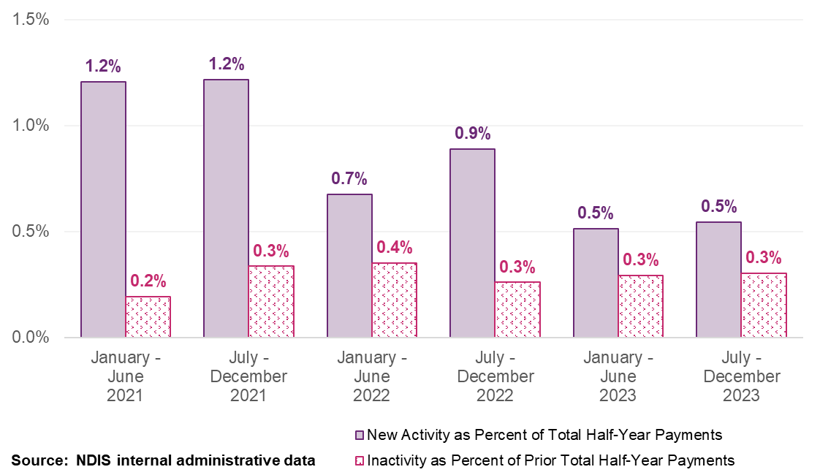
Additional analysis reveals that inactive registered providers had relatively smaller claims averaging $3,129 in each half-year before becoming inactive, of which 88% received less than $5,000. This contrasts sharply with active registered providers, who claimed an average of $139,542 each half-year. This difference in payments underscores the extent of market diversification and the relative financial weight of new versus established providers.
Figure 29 offers a more granular look at the number of participants supported by registered providers, showing a trend towards a larger client base in the period between January to June 2021 and July to December 2023. Despite a reduction in the number of registered therapy support providers over this period, the number of providers servicing more than 20 participants increased, with these providers receiving 96.2% of payments in July to December 2023.
Figure 29: Registered Providers of Therapy Supports and Number of Participants that Claimed, January 2021 to December 2023
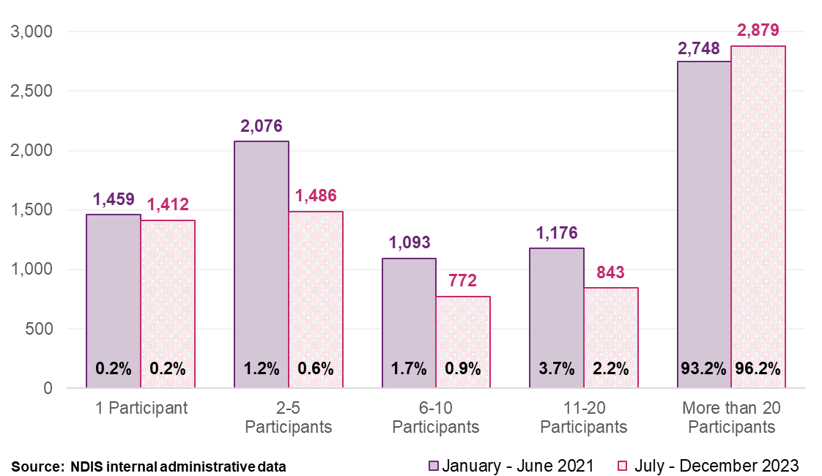
Figure 30 shows the number of registered therapy providers receiving payments from January 2021 to December 2023. Notably, 6,342 (48%) of 13,239 registered providers consistently received payments in all six half-year periods, which made up 94% of total payments. This data points to a common operating model adopted by large, registered providers which serves more participants.
Figure 30: Provider Continuity by Registration Status and Percentage of Total Payments. Registered Providers (Left) and Unregistered Providers (Right), January 2021 to December 2023
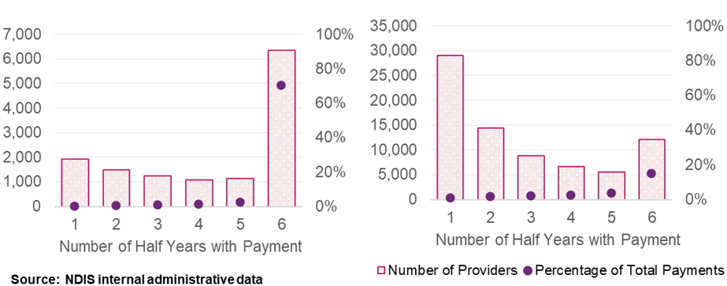

Comparable government and funding schemes
The NDIA compared therapy price limits and arrangements across other comparable government schemes and funding. Overall, the analysis shows that NDIS price limits are broadly in line with other comparable schemes for most types of therapies.
The NDIA collaborated with 16 Commonwealth and State Schemes to obtain their therapy pricing. Responses from 13 schemes were received. For a complete overview of participating schemes, see section 2.4 Consultation overview.
To calculate the effective hourly price limit, the NDIA sought information about the regulated length of therapy sessions (for example, the NDIS price limits for therapy are per hour). For comparability, the NDIA generally used standard or subsequent consultations where possible, noting that many schemes have differentiated items and/or pricing for initial consultations and standard/extended consultations.
The NDIA were able to calculate the effective hourly price where the length of a session was provided (for example, price per 20 minutes) or as an average session time, based on the observed length of sessions. In some cases, the length of a session was based on a minimum or maximum length (for example, price for at least 20 minutes). In these situations, some assumptions were made by the NDIA to calculate an hourly price, based on available information. If the length of a session (or an approximation) was not provided, the NDIA were unable to calculate the effective hourly price, and not able to directly compare prices, so these were excluded from the analysis.
As Figure 31 shows, the current NDIS price limits (shown as orange dots) are broadly within the range of the effective hourly rates paid by other schemes for the most common therapy supports, after considering duration of service. Information received indicates that over the past year, most schemes have increased prices for the therapy supports that they provide. Price changes vary by scheme and therapy support, but typically fall between 2% and 8%. This appears to have put NDIS into the middle range for some therapies, such as Audiologists, Counsellors, Exercise Physiologists and Psychologists, acknowledging ranges can be quite broad once scheme prices are turned into a comparable hourly price.
The main Medicare Benefits Schedule (MBS) items for allied health have a scheduled fee of $68.55 per 20 minutes session. This equates to an effective hourly rate of $205.65 which is higher than the NDIS hourly price limit. The Commonwealth funding (MBS benefit) for the hour is 85% ($174.80), but co-payments are common in the MBS and the scheduled fee is a better estimate of the total cost of the support.
Figure 31: Comparison of NDIS price limits to other government schemes
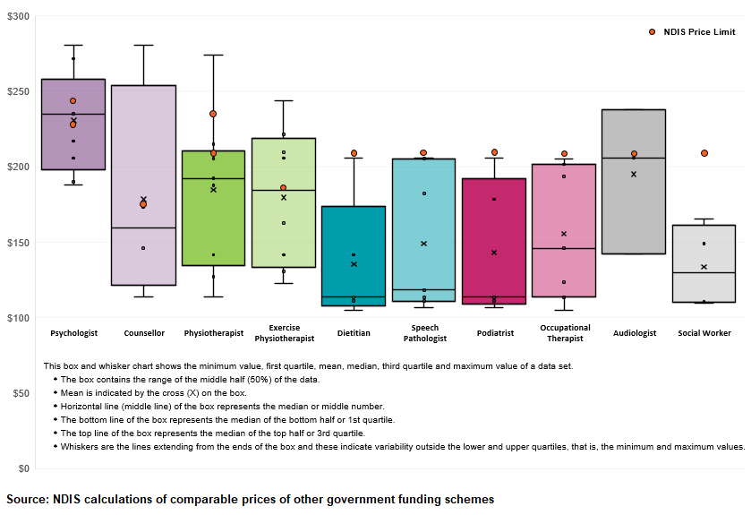
Note: NDIS price limits are shown by orange dots. For some therapy supports, the NDIS has two different price limits. One price limit is for the eastern states (NSW, VIC, QLD, ACT) and the other is for all other states (WA, SA, TAS, NT).

Private billing rates
This section analyses a data set of 1,791 private billing rates for several NDIS-related weekday in-room therapy services. The private billing dataset was compiled by the NDIA by scanning provider websites across Australia. Prices for weekend, initial consultations and telehealth consultations were excluded from the dataset, as well as some outliers.
The sample has been derived from the private billing analysis conducted in the 2021-22 Annual Pricing Review (4,014 in-scope observations). The NDIA tried to replicate the same sample during the 2022-23 Annual Pricing Review (2,857 in-scope observations). For reference to last year’s analysis, 1,167 observations dropped out of the last years sample of 2,857.
For greater representation in certain segments of the sample, observations were expanded in certain states (NSW, SA, NT and ACT) to ensure there were enough observations for significant results. This led to over 200 provider websites randomly sampled for relevant pricing, with many not having available or comparable pricing. In total, this provided a sample size of 1,791 observations for the 2023-24 period. The sample size is still considered sufficient for the purpose of pricing benchmarking. In the absence of a requirement to publish pricing or a database of comparable, time-based therapeutic sessions, these hinder the long-term viability of this sampling method. The NDIA intends to consider measures to improve this process in coming years.
The private billing rates were converted to effective hourly rates based on the length of consultation, for more direct comparison to the applicable NDIS price limit. About 30% of the sample included billing rates from non-metropolitan areas (considered as Modified Monash Model (MMM) areas 4 to 7).
In the analysed sample of therapy services, the most frequently represented therapists were Physiotherapists, making up 20.5% of the dataset, followed by Psychologists at 15.4%, Clinical Psychologists at 10.1%, and Dietitians at 8.9%. For most therapy types, the dataset includes at least 80 observations, with the exceptions being Art Therapists (26 observations), Music Therapists (39 observations), and Social Workers (45 observations).
The diversity and overlap in pricing across different therapy types are illustrated in Figure 32, showing the range and commonalities in billing rates among the various services. There appears to be some multi-modal distributions for several types of therapies, where there is a cluster of prices in the sample around different price points.
Figure 32: Distribution of Private Billing Rates by Therapy Types
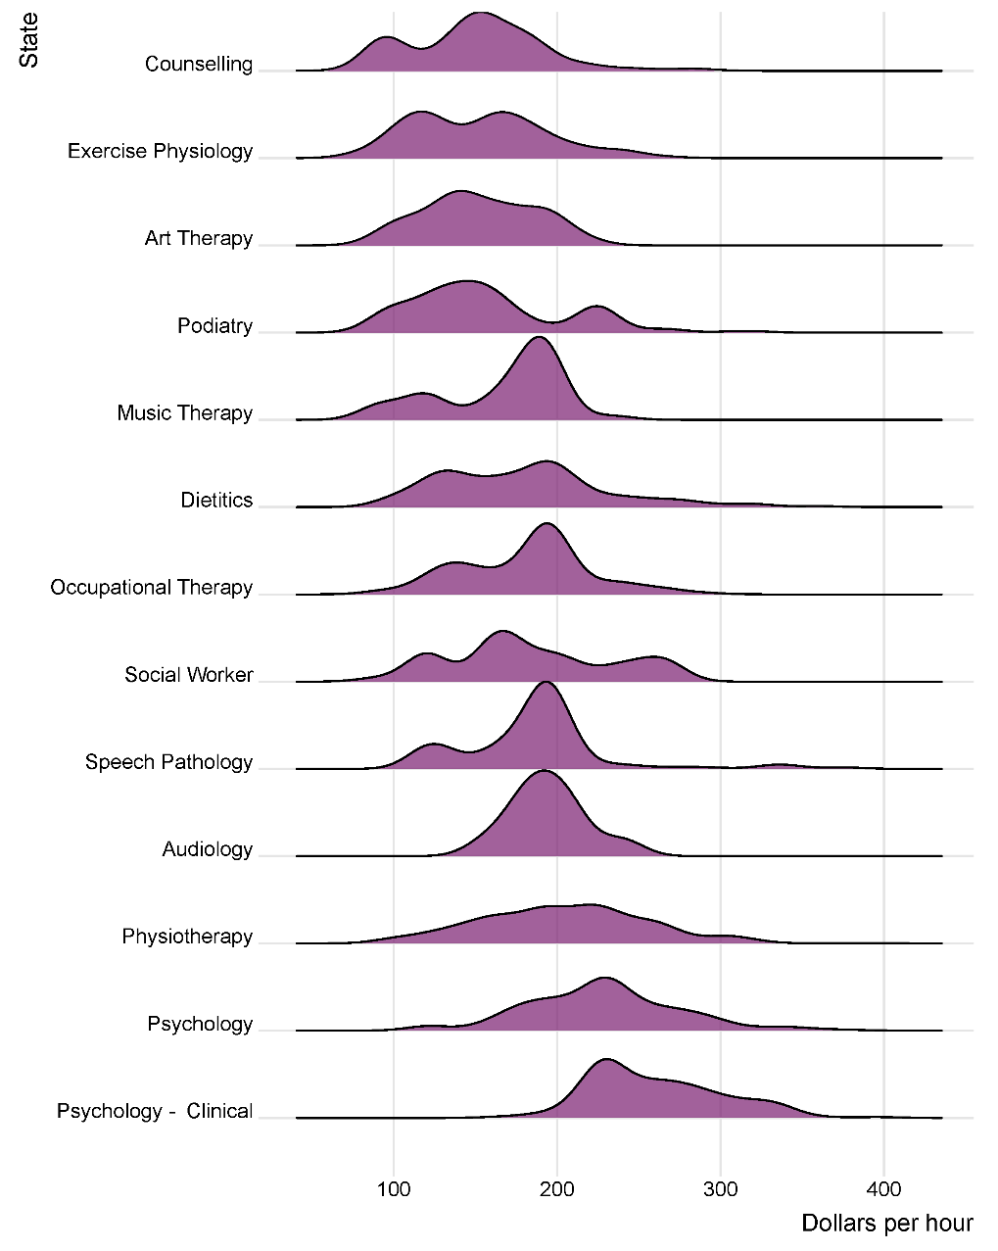
The distribution of sample observations geographically leaned more towards VIC, 34% of the sample, and QLD, with 27%, indicating an underrepresentation of therapists from NSW, which accounted for only 20%, compared to its share of the NDIS market (31% of total NDIS therapy claims in the six months to December 2023). The NT was the only state or territory with fewer than 30 observations (12).
Figure 33 shows the distribution of private billing rates across different states and territories, revealing substantial overlap and variance. From the analysis, certain states, and territories, including the NT and TAS, exhibited a variety of trends in pricing distribution.
Figure 33: Distribution of Private Billing Rates by State and Territory
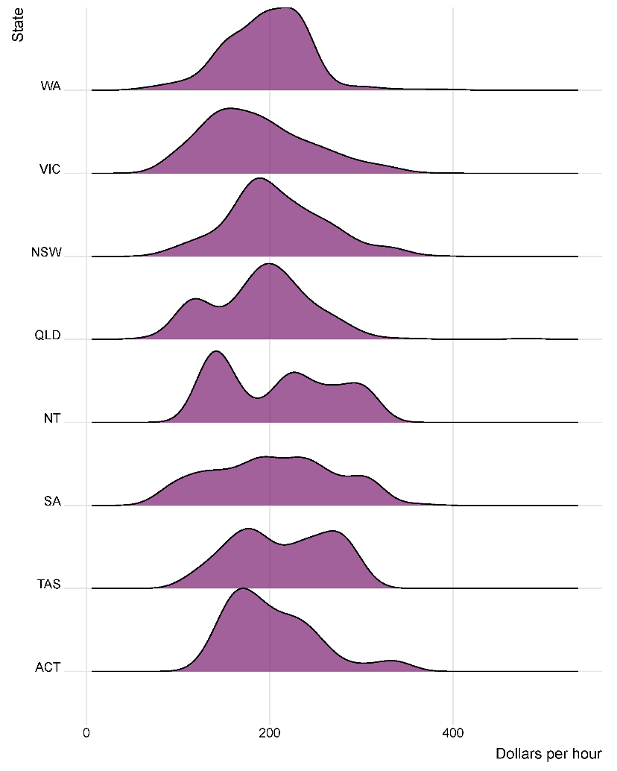
Table 21 shows an overview of the distribution statistics for the private billing rates sampled. On average, the effective hourly rate for therapists providing in-room services on weekdays was $195.6, with a median rate closely following at $194. The data set revealed a wide range of billing rates, from a minimum of $85 to a maximum of $396.
Table 21: Summary Statistics of Private Billing Rate Sample, by Therapy Type
Type of Therapy | Count | Mean | Standard Deviation | Min | 25th percentile | Median | 75th percentile | Max | NDIS price limit
Art Therapy | 26 | $154.5 | $30.6 | $100.0 | $135.0 | $147.5 | $178.8 | $216.0 | $193.99
Audiology | 86 | $194.5 | $21.7 | $156.7 | $180.0 | $190.0 | $210.0 | $240.0 | $193.99
Counselling | 161 | $153.1 | $41.2 | $85.0 | $120.0 | $150.0 | $179.5 | $305.5 | $156.16
Dietetics | 165 | $175.3 | $51.2 | $92.5 | $132.0 | $170.0 | $200.0 | $320.0 | $193.99
Exercise Physiology | 115 | $154.1 | $39.2 | $93.3 | $120.0 | $159.0 | $180.0 | $265.3 | $166.99
Music Therapy | 39 | $166.0 | $36.7 | $90.4 | $120.0 | $180.8 | $194.0 | $233.3 | $193.99
Occupational Therapy | 128 | $181.0 | $38.4 | $93.3 | $150.0 | $194.0 | $194.0 | $291.0 | $193.99
Physiotherapy | 364 | $202.7 | $50.2 | $90.0 | $165.0 | $200.0 | $240.0 | $324.0 | $193.99*/ $224.62**
Podiatry | 86 | $157.9 | $46.8 | $90.0 | $120.0 | $150.0 | $180.0 | $315.0 | $193.99
Psychology | 281 | $228.6 | $45.7 | $120.0 | $196.5 | $228.0 | $254.2 | $380.0 | $214.41*/ $234.83**
Psychology - Clinical | 179 | $260.3 | $39.6 | $165.3 | $230.0 | $255.0 | $284.4 | $396.0 | $214.41*/ $234.83**
Social Worker | 47 | $184.8 | $48.0 | $90.0 | $160.0 | $180.0 | $218.2 | $270.0 | $193.99
Speech Pathology | 113 | $192.7 | $65.6 | $95.0 | $163.3 | $193.3 | $194.0 | $380.0 | $193.99
Total | 1,791 | $195.6 | $56.0 | $85.0 | $158.0 | $194.0 | $230.0 | $396.0 | Varies
Note: * VIC, NSW, QLD, ACT. ** WA, SA, TAS, NT
Figure 34 and Figure 35 compare the average private billing rates for various therapy types to the current NDIS price limits. The findings indicate:
The average billing rates for clinical psychology and psychology in all states and territories exceed the NDIS price limits.
Therapies such as Speech Pathology, Audiology, Occupational Therapy, Dietetics, Social Work, Exercise Physiology, and Counselling have billing rates that are 90% or more of their NDIS price limits.
Conversely, Art Therapy (78.7%), Podiatry (81.4%), and Music Therapy (85.6%) show average billing rates that fall significantly below their NDIS price limits.
Figure 34: Average Private Billing Rate Compared to the NDIS Price Limit (Dollar Value)
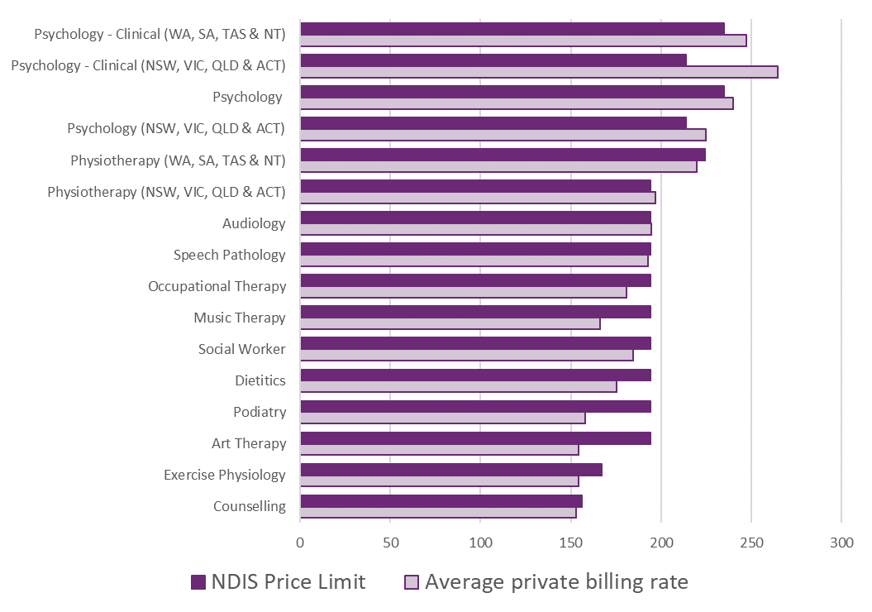
Figure 35: Average Private Billing Rate as a percentage of NDIS price limit
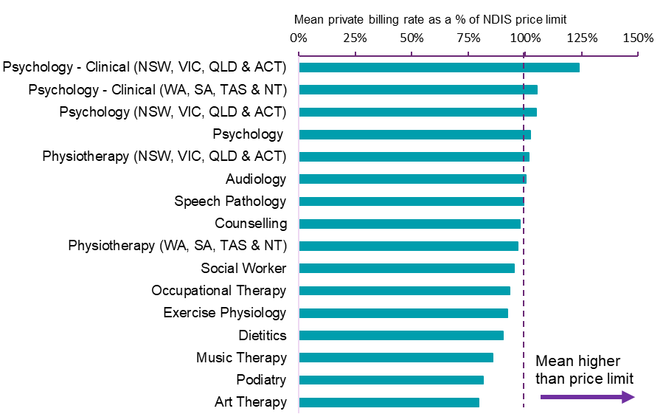

Mean, Median and 75th percentile billing rates
Comparing the NDIS price limits with the mean, median, and 75th percentile billing rates for therapy types reveals important insights into the alignment between NDIS price limits and market-driven billing practices.

Psychology
The relevant NDIS price limits for Psychologists are set at $214.41 for VIC, NSW, QLD, and ACT (state grouping 1), and $234.83 for WA, SA, TAS, and NT (state grouping 2).
The statistical analysis shows that Psychologists have an average billing rate of $228.6, and Clinical Psychologists have a higher mean rate of $260.3. These amounts for this sample exceed the NDIS hourly price limits for Psychology supports, for both different state and territory groupings.
The median billings rates for Psychologists and Clinical Psychologists were at $228.0 and $255.0, respectively, which exceed the NDIS hourly price limits for Psychology supports, for most state and territory groupings.
The 75th percentile billing rates for psychologists and clinical psychologists are $254.2 and $284.4 respectively, indicating that a significant portion of billed appointments exceed the NDIS price limits.
This upper quartile of billing rates suggests that the private billing rates are frequently higher than the NDIS price limits. The benchmarking results indicate that the market rates for Psychology services, at the mean, medians and 75th percentile are now higher than the NDIS price limits.

Other therapy types
The following section discusses Audiology, Physiotherapy and Speech Pathology (selected due to sample being the next closest to the NDIS price limits). Note, $193.99 is the NDIS price limit for Audiology (national), Speech Pathology (national) and Physiotherapy (VIC, NSW, QLD, and ACT – state grouping 1). It is $224.62 for Physiotherapy in WA, SA, TAS, and NT (state grouping 2)
The means of private billing rates for Audiologists, Physiotherapy, and Speech Pathologists are $194.5, $202.7, and $192.7, respectively. For Physiotherapy, it has means of $197.0 and $220.9 for state groupings 1 and 2, respectively.
This is compared to the median billing rates for Audiology, Physiotherapy and Speech Pathology of $190.0, $200.0 and $193.3, respectively. For Physiotherapy, when considering the state groupings, the medians are $194.0 and $224.6 for state groupings 1 and 2, respectively.
At the 75th percentile, observed rates within the private market for these supports is $210.0 for Audiology, $240.0 for Physiotherapy, and $194.0 for Speech Pathology, suggesting the top 25th percentile of market rates are above NDIS price limits for Audiology and Physiotherapy.
The NDIS hourly price limits appear broadly in line with these measures, suggesting a general compatibility with the current private billing rates, particularly with mean and median rates aligning with the applicable NDIS price limits.

Regressions
Regression analyses were undertaken to understand the relationship between therapy types, geographic regions, and billing rates, and to determine how these variables influence the price variability within the private therapy market. Table 22 details the results of the regression analysis. The dependent variable in all model regression models is the hourly private billing rate in dollars.
The analysis explores the similarities between some of the therapy groups. A series of Tukey’s range tests were undertaken to group therapy types with similar means of private billing rates. The test found that Audiology, Dietetics, Occupational Therapy, Physiotherapy, Speech Pathology, and Social Work share comparable billing averages (Group 1); while Art Therapy, Counselling, Exercise Physiology, Music Therapy, and Podiatry share similar means. Group 3 comprises of both Psychology and Clinical Psychology, which are distinct but are considered together for analytical simplicity. These grouping forms the basis of Model 3, which will be explained further below.
Table 22: Statistical Models of Private Billing Rates
Variable | (1) | (2) | (3)
Constant | 180.6*** | 178.1*** | 192.5***
Art Therapy | -25.5** | -23.3**
Audiology | 13.1* | 20.4*
Counselling | -30.6** | -32.7**
Dietetics | -0.7 | -2.9
Exercise Physiology | -29.5*** | -27.6***
Music Therapy | -14.8** | -20.1**
Physiotherapy | 23.8*** | 20.4***
Podiatry | -22.7*** | -21.5***
Psychology | 47.1*** | 47.6***
Psychology – Clinical | 90.1*** | 78.3***
Social Work | 5.1 | 4.7
Speech Pathology | 23.2*** | 22.4***
Counselling, Exercise Physiology, Art & Music Therapy & Podiatry |  |  | -40.2***
All Psychology |  |  | 46.7***
Regional |  | -11.4*** | -12.57***
NSW |  | 23.2*** | 22.9***
QLD |  | 2.8 | 0.2
SA |  | 12.3** | 11.5**
WA |  | 0.2 | -0.4
Tas |  | 2.4** | 3.5**
ACT |  | 22.6** | 19.1**
NT |  | 53.7** | 52.1**
Adjusted R2 | 0.321 | 0.352 | 0.315
F Statistic | 70.76 | 51.2 | 92.01
Observations | 1,791 | 1,791 | 1,791
(* = p <0.05, ** = p < 0.01, *** = p<0.001)
Note: The baseline (Constant) for Model 1 is Occupational Therapy. The baseline in Model 2 is Occupational Therapy in Metropolitan Victoria and in Model 3 it is Group 1 therapies (Audiology, Dietetics, Occupational Therapy, Physiotherapy, Speech Pathology, and Social Work) in Metropolitan Victoria.
Regression results of three specifications are presented in this section. The modelling begins with each therapy type as variables, (Model 1). The base (or omitted) variable is Occupational Therapy, meaning the constant coefficient reflects the mean Occupational Therapy private billing fee. The coefficients attached to each therapy type reflects the fee relative to Occupational Therapy (for example, the coefficient attached to Art Therapy is -25.5 and hence the average billing rate for Art Therapy is $155.1 (180.6 minus 25.5).
Model 2 builds upon Model 1 by including state/territory and regional indicators, with Occupational Therapy, Metropolitan and Victoria being the base variables that reflect the coefficient on the constant term. Model 3 keeps the geographical indicators but replaces the individual therapy variables with the groupings found using the Tukey difference in means tests discussed previously.
Model 2 is preferred over Models 1 and 3 for its slightly higher explanatory power, with an adjusted R-squared of 0.352, indicating it explains 35.2% of the variations in private billing rates. The results suggest that the average hourly rate of $178 for Occupational Therapists in Metropolitan Victoria (Model 2), with Audiologists, Psychologists, Physiotherapists and Speech Pathologists appear to have exceeded the applicable NDIS price limits (statistically significant at 0.05 level).
A deep dive into the regression results revealed a meaningful statistical difference between both Clinical and Non-Clinical Psychology nation-wide. The results showed significant statistically difference consistent across applicable states and above its price limits. This adds significance to the previously discussed means, medians and 75th percentiles comparisons between the different types of therapies.
The NDIA acknowledges that there are many uncaptured variables that would assist a greater explanation of private billing rates. This, however, is difficult to obtain through website scrapping alone.

Consultation feedback
The APR received 178 provider submissions, feedback from 13 professional bodies, one union, and 142 participants on therapy support services. A predominant theme was the suggested increase in the costs of delivering therapy support services, cited by approximately 87% of providers. These cost increases spanned across wages (including adjustments to meet Allied Health Awards and professional development), business expenses such as rent, utilities, office supplies, and insurance, as well as recruitment and retention challenges. The Ability Roundtable, incorporating an Allied Health Cost Model by Deloitte Access Economics, suggested a large difference, with a 12.9% variance between projected costs and the current NDIS Price Limit for major allied health disciplines. Professional bodies advocated for a price limit increase reflective of cumulative indexation since 2019 and suggested automatic indexation from 2025, claiming thin margins on which many small-scale therapy support businesses operate.
Regarding the provision of therapy and early childhood supports to both NDIS and non-NDIS participants, most providers catered to a mix of clients, with the proportion of NDIS participants ranging from 25% to nearly 100%. Despite the varied client base, appointment durations were often standardised, tailored to client needs rather than funding source, although complexities associated with NDIS participants sometimes necessitated longer sessions. Pricing approach varied, with most providers charging at the NDIS price limit, yet some reported differences in charges between NDIS and non-NDIS clients, attributed to the complexity of NDIS participants or additional administrative burdens. Unique costs associated with early childhood supports for NDIS participants were identified, including the need for team-based approaches, specialised skills, and extended appointments, which highlighted the complexity and intensity of services required. Professional bodies echoed these sentiments, emphasising the need for specialised training and resources, particularly for providers catering to young children with disabilities.
See Appendix A for more details on common themes raised in submissions to the 2023-24 APR Consultation Paper.

Discussion
The Australian therapy market encompasses a wide array of services provided by allied health professionals, who are typically university-educated with specialised expertise in preventing, diagnosing, and treating various conditions and illnesses. While the NDIS forms an important part of this landscape, allied health services extend beyond NDIS funding. These services are also accessed through various other arrangements, including Medicare subsidies, private health insurance, where it is common for out-of-pocket payments to be made by the consumer, other government schemes, and the Department of Veterans Affairs (DVA).
In the 2022-23 financial year, 39% or approximately 10,389,000 individuals accessed allied health services. For comparison, 379,296 participants, representing 59% of the total 646,449 Scheme participants in the six months to 31 December 2023, accessed allied health supports using NDIS funding.
The NDIS therapy provider market has continued to demonstrate strong growth (14% growth for the six-month comparison to 31 December 2023 to same period the previous year), with a notable trend away from registered providers to a diversified unregistered provider market. The proxies the NDIA has used as an overview for market health and competition include the HHI, provider entry, periods of activity and inactivity and share of total NDIS therapy payments has suggested the market continues to mature and continues to meet increasing demand in most areas.
The NDIS therapy market operates in a manner that closely aligns with the characteristics of a deregulated, or private market, more so than other NDIS sub-markets. Despite its market-like behaviour, the NDIS therapy market includes regulatory mechanisms, specifically price limits, to assist participants to receive value for money. These price limits are closely linked to the dynamics of the private market, ensuring that NDIS pricing remains competitive and reflective of current service costs.
Accordingly, other government schemes and the private billing market serve as suitable comparators to assess the appropriateness of the NDIS price limits. Feedback from consultations and discussions with various government funding schemes has indicated that, despite the relative smallness of users of the NDIS therapy market, it could act as a ‘price setter.’ Evidence of this may be seen in private billing rates, where the median and 75th percentile rates pricing for certain therapies align closely with the corresponding NDIS price limits.
Although benchmarking NDIS price limits against other comparable government funding schemes may introduce certain inaccuracies, it remains an important process. This ensures that government funding mechanisms do not inadvertently compete against each other for therapy professionals. Key factors to consider when comparing NDIS to other schemes include:
- Risk assessment and pricing models: Some schemes often base pricing on risk assessments and pooled resources, which does not always reflect the costs of individualised support required by individuals, such as NDIS participants compared to the general population.
- Contractual and volume discounts: Prices in other government schemes may be influenced by contractual agreements or volume discounts that are not applicable in the context of the NDIS service delivery that can lead to lower benchmarks.
The 2023-24 APR analysis of other schemes showed that while some have increased their pricing or funding levels, NDIS price limits remain consistent with the majority of therapies provided across these schemes. It is important to note, that there is significant variation in therapy pricing and funding levels among different schemes. Additionally, certain therapies such as Audiology, Art Therapy, and Music Therapy, which are covered by the NDIS, are not typically funded by other insurance schemes, including private health.
The analysis of private billing rates offers a comprehensive view of the diverse range of therapy supports available to NDIS participants, reflecting market-driven costs influenced by direct service delivery, provider expertise and current demand. By gathering a broad dataset of private billing rates from provider websites and adjusting them to effective hourly rates, the NDIA ensures a fair comparison across different therapies and geographic areas. This standardisation is important for assessing whether NDIS price limits align with market rates, thereby maintaining fairness and relevance within the private therapy sector.
The analysis indicates that NDIS price limits generally match or exceed the rates for most therapies nationwide. However, regression analysis highlights statistically significant variances among therapies, which could correspond to differences among therapy professionals such as in qualifications, skills, and experience.
Examining the statistically significant differences and general market pricing metrics, including the mean, median, and 75th percentiles, showed that rates for Psychologists often met or exceeded the NDIS price limits. Additionally, when compared with other government schemes, the NDIS price limits for Psychologists are not at the higher end of the spectrum. This information together suggests there is stronger evidence supporting adjustment to NDIS price limits for Psychologists compared to other types of therapists.

Recommendations
After reviewing the current price limits for Psychologists against private billing rates and other comparable government schemes, it is apparent that the current limits generally sit below the prevailing market rates. The mean billing rate for psychologists is $228.6, with clinical psychologists at a higher rate of $260.3, both exceeding the NDIS hourly limits. The difference is further highlighted at the 75th percentile billing rates, where a significant portion of billed services are charged at higher rates, than current price limits. This gap between market rates and the current NDIS price limits suggests that the NDIA should increase the hourly price limits, with the proposal being to use an indexation methodology of 80/20 split between the Australian Bureau of Statistics (ABS) Wage Price Index (WPI) and ABS Consumer Price Index (CPI).
Recommendation 4
The NDIA should increase the price limits for supports delivered by a Psychologist on 1 July 2024 in line with the weighted movement over the previous twelve months in the ABS Wage Price Index (Australia, total hourly rates of pay excluding bonuses) and the ABS Consumer Price Index (All Groups, weighted average of eight capital cities) over the 12 months to the March Quarter immediately preceding the indexation date (with an 80/20 weighting).
Specifically, this should be for support line items: ‘Assessment Recommendation Therapy or Training – Psychologist (15_054_0128_1_3), ‘Early Childhood Supports – Psychologist (15_001_0118_1_3)’, and ‘Specialist Behaviour Intervention Support (11_022_0110_7_3)’.
Review of the alignment of the NDIS price limits for other therapists against the private billing rates and other comparable schemes suggests a general compatibility between NDIS price limits and prevailing market rates. In general, for most therapists, mean and median billing rates closely mirror the NDIS hourly price limits, which are set at $193.99 in most regions, suggesting that the current price limits adequately reflect market norms. Even when considering some therapists which means, medians and 75th percentile billing rates exceed NDIS price limits, the frequency of such instances does not indicate a systemic pricing concern that hinders participants from accessing these services relative to other clientele.
Recommendation 5
The NDIA should not make any further structural adjustments to the pricing arrangements for therapy supports at this time and should not index the price limits for all other therapy-related supports on 1 July 2024.

Support Coordination

Context
Support coordination, funded by the NDIS, is important for supporting participants to utilise their NDIS plans and achieve their goals. Support coordinators assist participants by connecting them to NDIS funded and mainstream supports, tailoring services and supports to individual participant wishes and plan budgets. They are also instrumental in enhancing participants’ abilities to understand and navigate the NDIS, empowering them to make informed decisions. This includes monitoring plan budgets and the effectiveness of supports, ensuring they align with participants’ needs, preferences, and goals.
To be effective in their roles, support coordinators need an in-depth understanding of the service offerings within a participant’s local market, identifying providers who can meet their needs and preferences. This often involves sourcing alternative providers to ensure continuity of support.
Registration is not mandatory for support coordinators. However, registered support coordination providers in groups: 0106: Assistance in coordinating or managing life stages, transitions, or supports, and 0132: Specialised Support Coordination must adhere to the NDIS Practice Standards. These standards cover participant rights, provider governance, and conflict of interest management.
The NDIS has an established pricing framework to cater to varying levels of support coordination, from basic Support Connection to Specialist Support Coordination for participants with higher support needs. This framework aims to provide a balanced pricing model, facilitating quality support for participants. The three levels – support connection (level 1), coordination of supports (level 2), and Specialist Support Coordination (level 3) – reflect the spectrum of assistance participants might require, each with designated price limits (Table 23). Additional information on the Price Limits and Pricing Arrangements for support coordination can be found on the NDIS website.
This chapter reviews the appropriateness of the current pricing arrangements for Support Coordination.

Table 23: NDIS Price Limits for Support Coordination Supports
Item Number | Item Name and Notes | Unit | Non-Remote | Remote | Very Remote
07_001_0106_8_3 | Support Coordination Level 1: Support Connection | Hour | $74.63 | $104.48 | $111.95
07_002_0106_8_3 | Support Coordination Level 2: Coordination of Supports | Hour | $100.14 | $140.19 | $150.21
07_004_0132_8_3 | Support Coordination Level 3: Specialist Support Coordination | Hour | $190.54 | $266.75 | $285.80

The NDIS Review
The final report from the Independent NDIS Review addressed foundational aspects of the current support system, making recommendations on the need to introduce a new navigation function. It acknowledges the essential role of support coordination in aiding participants to manage and implement their NDIS plans effectively but also suggests inconsistencies in its delivery and effectiveness.
Due to the proposed reforms recommended by the NDIS Review, developing a support coordination specific cost model at this point of time involves significant risk of having an outdated pricing model while the sector is undergoing significant evolution. On balance, it is not recommended for the NDIA to develop a specific cost model for Level 2: Coordination of Supports and Level 3: Specialist Support Coordination (Recommendation 9 from the 2022-23 Annual Pricing Review) now. A stable and predictable pricing framework over the transition period is important to allow participants and providers to plan with greater certainty and minimise disruption.

Scheme Statistics
Table 24 and Figure 36 show that in the six-month period to December 2023, 8,823 unique providers delivered support coordination to 245,696 participants, which accounts for 38% of all active participants in the Scheme. This activity represents $531 million in payments, or 3% of the total scheme spend. This is an 18% increase from the same period in the previous year, which saw $451 million in payments.

Table 24: Summary of Changes in Support Coordination Participants, Total Providers and Total Claims
Statistics | July – December 2022 | July – December 2023 | Percentage Change
Total number of NDIS participants | 215,817 | 245,696 | +14%
Total number of active providers | 6,802 | 8,823 | +30%
Total amount claimed | $451 million | $531 million | +18%
Figure 36: Number of Participants and Providers Claiming Support Coordination Supports, January 2021 to December 2023
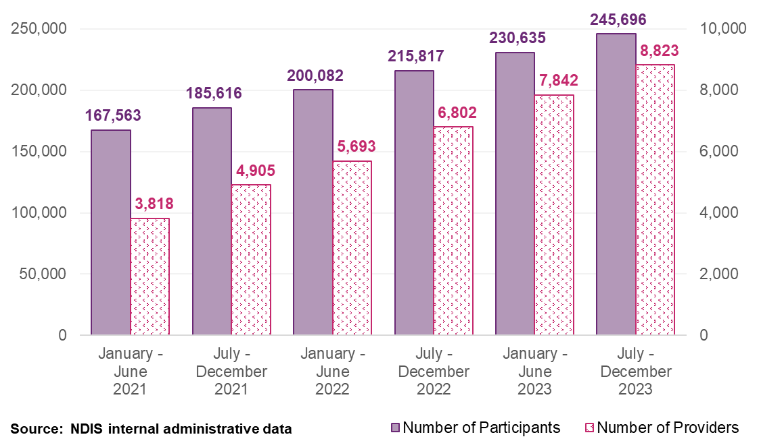

Participants
From July to December 2023, 230,621 participants used Level 2: Coordination of Supports. There were 10,354 participants who used Level 3: Specialist Support Coordination and 19,064 participants who used other support coordination supports (Level 1: Support Connection and Psychosocial Recovery Coach supports). Figure 37 illustrates the distribution of participants using different levels of support coordination compared to the previous year.
Figure 37: Participants Using Different Levels of Support Coordination Supports
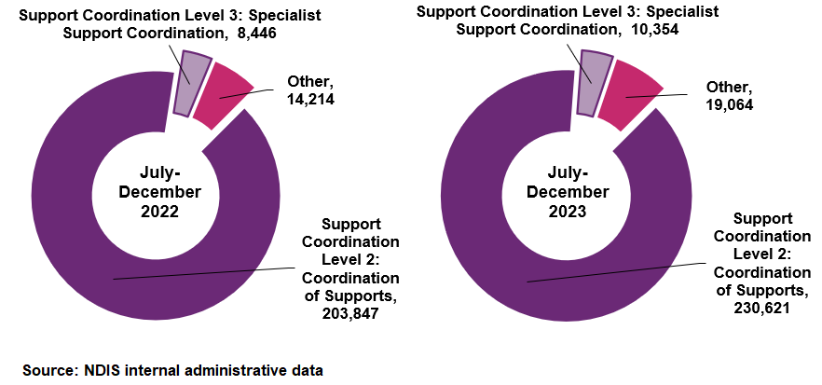

Providers

The number of providers continues to grow, especially unregistered providers
Figure 38 examines the growth of NDIS support coordination service providers between January 2021 and December 2023, showing differences in how fast different levels are expanding. The provider landscape has seen considerable growth, with the number of unique providers delivering Level 2 Support Coordination increasing from 3,445 to 7,799 over the period, an average six-month growth rate of 18%. The proportion of registered to unregistered providers has decreased from 79% to 42%, although registered providers still accounted for 82% of the total claims for these services in the six months to December 2023.
Notably, the number of providers for Level 2: Coordination of Supports has tripled over the observation period, showing a much faster growth rate compared to providers of Level 3: Specialist Support Coordination and other support coordination supports, which have grown at a slower pace.
Figure 38: Number of Providers by Support Coordination Level, January 2021 to December 2023
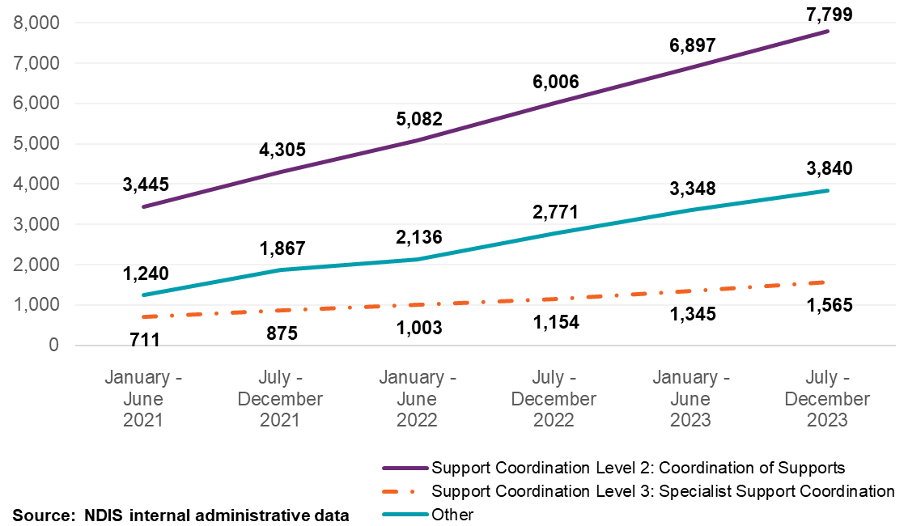

The increasing number of unregistered providers has led to changes in market share
From January 2021 to December 2023, the market dynamics in the support coordination sector changed considerably. The period saw a 50% increase in the number of registered providers, alongside a four times increase in unregistered providers. During this time, the market share of unregistered providers grew from 75% to nearly 18%.
Concurrently, the market share held by the top ten providers diminished from 11% to 7% (Figure 39), a trend observed consistently across different geographical settings; non-remote, remote and very remote areas (shown in Figure 40, Table 25 and Table 26). This decrease in concentration among the largest providers highlights the changing dynamics across the sector.
Figure 39: Changes in Top Ten Provider Market Share Compared to Growth in Support Coordination Providers, January 2021 to December 2023
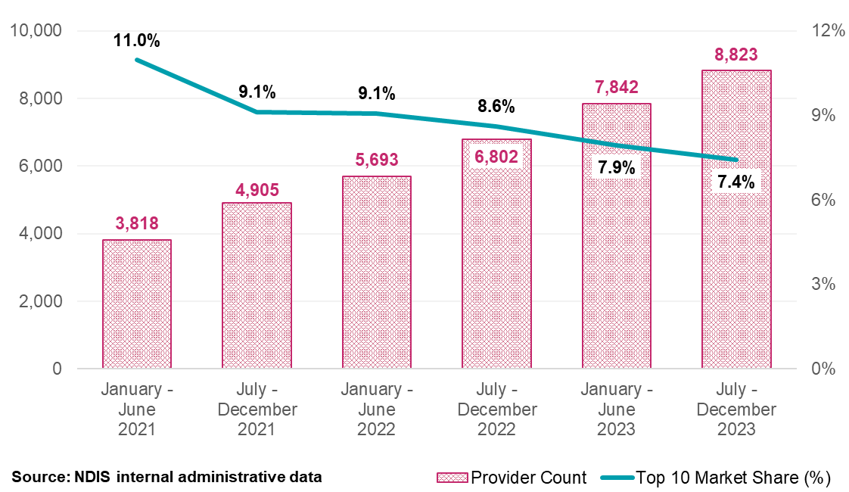
Figure 40: Top Ten Provider Market Share by Remoteness for Support Coordination Supports, January 2021 to December 2023
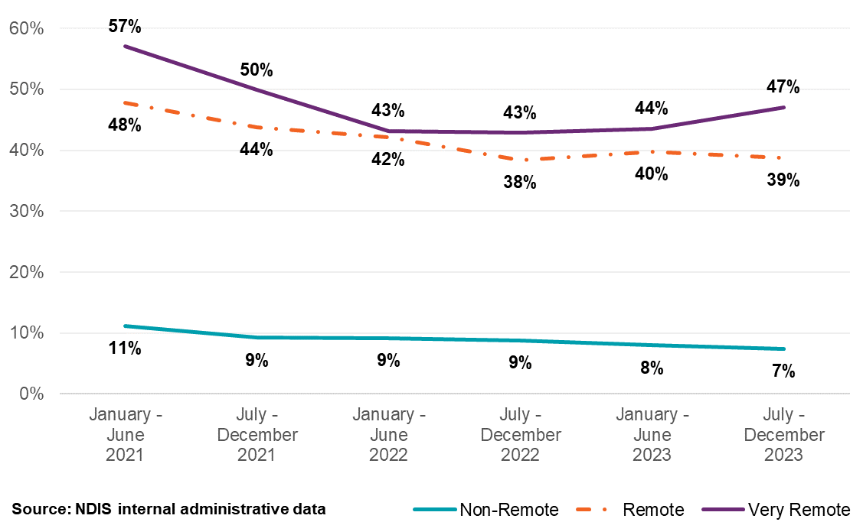
Note: the chart shows market share for both registered and unregistered providers.
Table 25: Registered Providers by Remoteness for Support Coordination Supports, January 2021 to December 2023
Remoteness | January – June  2021 | July – December 2021 | January – June  2022 | July – December 2022 | January – June  2023 | July – December 2023
Non- remote | 2,444 | 2,787 | 3,026 | 3,294 | 3,469 | 3,647
Remote | 280 | 299 | 299 | 308 | 324 | 362
Very remote | 168 | 182 | 175 | 187 | 199 | 212
Total for registered | 2,467 | 2,810 | 3,044 | 3,332 | 3,503 | 3,686
Table 26: Unregistered Providers by Remoteness for Support Coordination Supports, January 2021 to December 2023
Remoteness | January – June  2021 | July – December 2021 | January – June  2022 | July – December 2022 | January – June  2023 | July – December 2023
Non- remote | 1,437 | 2,147 | 2,712 | 3,472 | 4,366 | 5,242
Remote | 36 | 71 | 85 | 121 | 160 | 197
Very remote | 23 | 35 | 47 | 69 | 80 | 98
Total for unregistered | 1,455 | 2,174 | 2,739 | 3,518 | 4,420 | 5,300
Source: NDIS internal administrative data
Please note a discrepancy in the total number of ‘active’ therapy providers, attributable to two factors: firstly, some providers offer a mix of registered and unregistered supports, leading to their classification in both categories. Secondly, a small fraction of providers with undetermined registration status contributes to total payment figures but is excluded from detailed tabulation, representing less than 1% of the overall financial transactions.

Market share reduction of leading providers shows signs of a less concentrated market
There are a number of indicators which can be used to assess whether there is healthy competition in a market. While no single measure is a perfect indicator of the level of competition, the Herfindahl-Hirschman Index (HHI) measures market concentration and offers some insight into the health of the support coordination sector. A HHI under 1,500 indicates a market with many competitors and a lack of dominance by any single provider, which typically results in more choices. Conversely, a rise in the HHI indicates a rise in market concentration, suggesting less competition among providers.
In the period from January 2021 to December 2023, the adjusted HHI for support coordination in metro areas has been low and is currently at 16, indicating a less concentrated market. This is contrasted by a much higher adjusted HHI in the remote (250) and very remote areas (371) which is consistent with a prior expectation (Figure 41). Moreover, the adjusted HHI for very remote areas has been decreasing until six months to December 2022. Since then, the adjusted HHI for very remote areas has increased again but not back to the levels from two to three years ago.
Figure 41: Herfindahl-Hirschman Index for Support Coordination Supports, January 2021 to December 2023
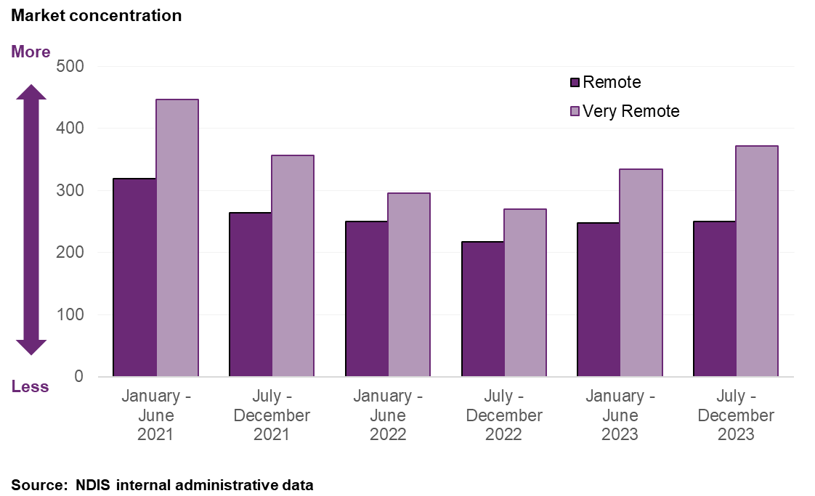

The unregistered support coordination market appears to be structured differently
Submissions to the APR from registered support coordinators and peak bodies suggest differences in cost structures between registered and unregistered providers. It is claimed that registered providers face additional financial imposts stemming from the registration process and ongoing compliance obligations, expenses not shared by their unregistered counterparts. This difference in operational costs potentially influences pricing strategies, where registered providers may price their services at or near the NDIS price limit to offset costs associated with regulatory compliance.
Figure 42 and Figure 43 show the distribution of support coordination providers by registration and entity type for the six months to December 31, 2023. Figure 42 shows that registered providers are mostly companies providing significant NDIS supports, while Figure 43 shows that unregistered providers are mostly sole traders especially those with lower turnover.
Registered providers claimed 82% of the support coordination payments made to all providers. This demonstrates that registered providers, although representing a smaller proportion of the total providers count (5,300 unregistered providers to 3,686 registered providers), are responsible for the majority of payments in terms of service delivery.
Figure 42: Registered Providers of Support Coordination Supports by Entity Type and Total Payments, July to December 2023
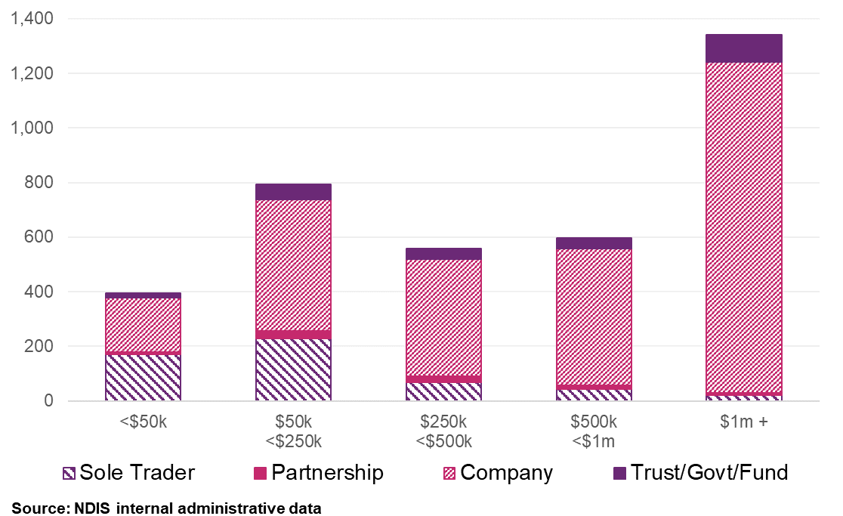
Figure 43: Unregistered Providers of Support Coordination Supports by Entity Type and Total Payments, July to December 2023
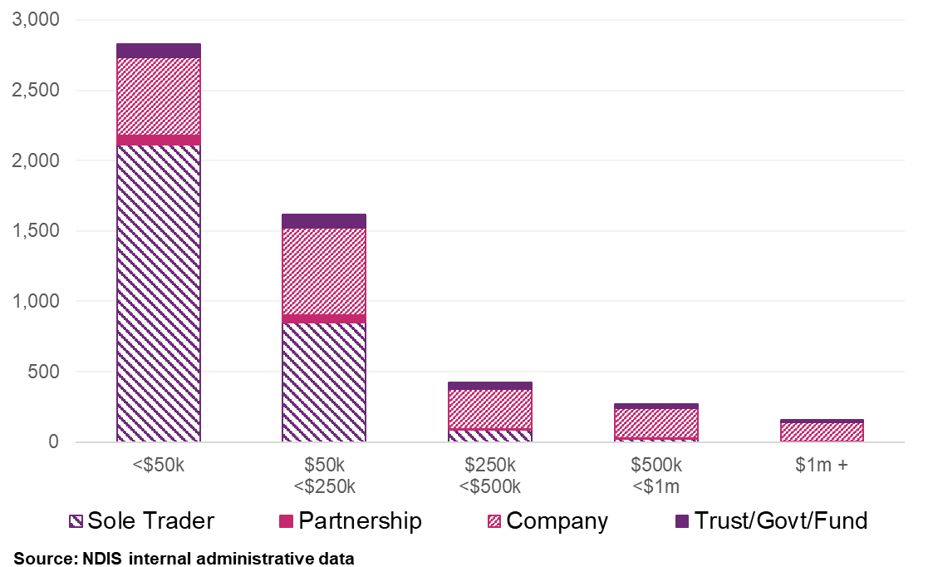
These above figures highlight a contrast in the type of markets across unregistered and registered support coordinators. That is the make-up of markets, payment wise, the unregistered support coordinator market seems to be dominated by smaller sole traders, compared to the registered support coordinator market that is predominantly larger companies.
Table 27 shows that approximately 13% of support coordination services were delivered at rates below the NDIS price limits. This trend has been driven by activities of unregistered providers, who are more likely to claim below the price limits. Unregistered providers have seen their share of total transactions increase from 2% in the six-month period from January to June 2021 to 12% in the six-month period from July to December 2023, underscoring their growing presence and competitive pricing strategies within the NDIS market.

Table 27: Claiming Patterns at Price Limit Analysis for Support Coordination Supports, January 2021 to December 2023
Claiming patterns – At price limit | January – June  2021 | July – December 2021 | January – June  2022 | July – December 2022 | January – June  2023 | July – December 2023
Registered | 91% | 93% | 93% | 92% | 90% | 89%
Unregistered | 66% | 72% | 75% | 74% | 74% | 72%
All Providers | 91% | 92% | 92% | 91% | 89% | 87%
Source: NDIS internal administrative data
Note: All Providers above are inclusive of providers with the unknown registration status at the time of the transaction.

Business dynamism in the NDIS support coordination market
This section examines the vitality and changes within the market for support coordination of registered providers. The analysis in this section focuses on registered providers as it reflects the majority of the payments (82% in the six months leading to December 2023). Business dynamism refers to the rate at which new providers enter the market and existing providers exit. This is one of many indicators of the market’s health, competitiveness, and its capacity to innovate and meet participants needs.

Comparison of provider payments for “new” activity and inactivity
To further assess the market dynamics, the NDIA reviewed the payment activities of registered providers over a three-year period from January 2021 to December 2023. ‘New activity’ is characterised by providers receiving payments in the half-year who did not receive payments in the preceding half-year. Conversely, ‘inactivity’ refers to providers not receiving payments in a half-year after having received payments in the previous one. Each provider’s activity is quantified as a percentage of the total payments within that half-year for new activity, of the prior half-year for inactivity. The NDIA recognises that this method does not perfectly measure market exits but provides the best estimation with the data available.
The data indicate that over the three years, providers who became inactive in any half-year accounted for 0.4% to 0.6% of the total payments. On the other hand, providers with new activity in any half-year contributed to 1.1% to 2.2% of the total payments.
Figure 44 displays the change in registered provider activity between January 2021 to December 2023. Payments made to “new” active providers are consistently higher than payments made to providers in the six-month period before they became inactive.
Figure 44: Registered Support Coordination Provider Activity Movements, January 2021 to December 2023
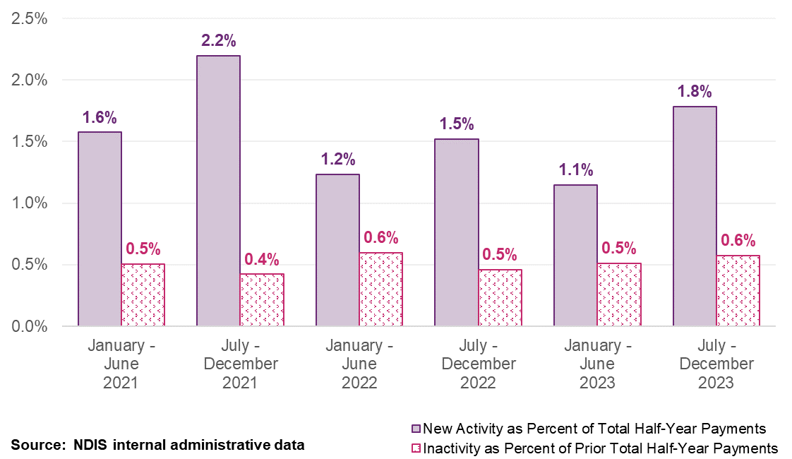

The number of providers continues to grow, driven by unregistered providers
Figure 45 illustrates a comparison of new support coordination provider volumes by registration type from January to July 2021 to July to December 2023. It shows a consistent trend where the growth of new unregistered providers outpaces that of registered ones throughout the observed period.
Figure 45: New Support Coordination Provider Counts, January 2021 to December 2023
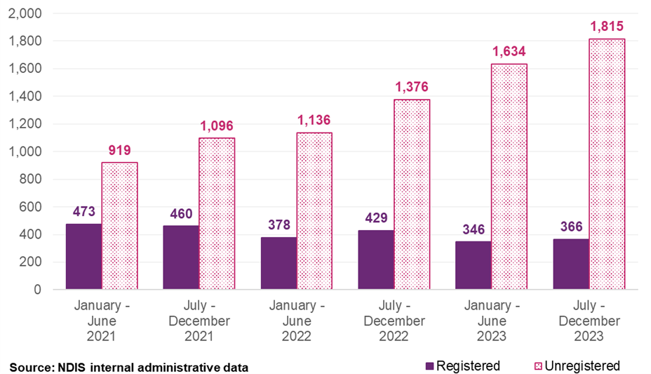

Registered providers show more payment stability than unregistered providers
Assessing the stability of support coordination providers, there is a pronounced distinction between the registered and unregistered provider market. Figure 46 shows the number of half years with payments, with providers split up by registration status. It also shows the percentage of total support coordination payments for each grouping as a portion of total registered and unregistered payments combined. This figure shows that approximately 38% of registered providers have consistently been active across the last six half-year periods, receiving 78.3% of total payments in the six months to December 2023, indicating a high degree of payment stability. Conversely, only about 6% of unregistered providers have maintained the same level of payment activity, accounting for 3.3% of total payments.
Figure 46: Provider Continuity by Registration Status and Percentage of Total Payments. Registered Providers (Left) and Unregistered Providers (Right), January 2021 to December 2023
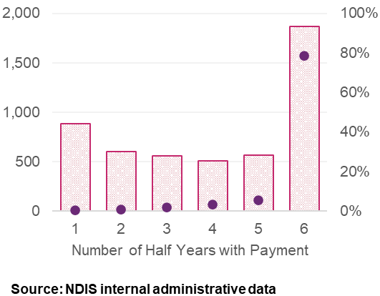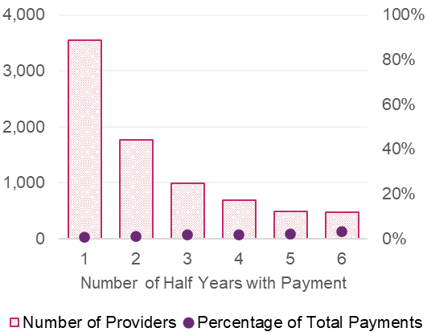

Providers with uninterrupted payment history support more participants
A distribution analysis (Figure 47) categorises providers by the number of participants they support, and the proportion of services claimed. Over the timeframe from January 2021 to December 2023, segmented into six-month intervals, the profile of registered providers has remained consistent, suggesting a stability in the scale at which providers operate. In the six months leading to December 2023, 15% (558) of active registered providers were supporting a single participant. Meanwhile, 46% (1,702) of active registered providers were servicing more than 20 participants, contributing to 95% of the total payments to registered support coordination providers within this period.
Figure 47: Registered Providers of Support Coordination Supports and Number of Participants Claimed from, January 2021 to December 2023
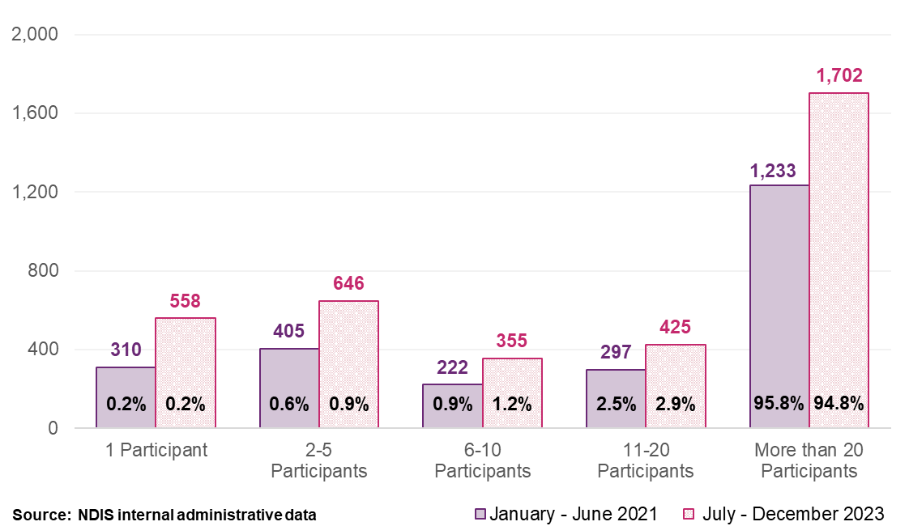

Providers who become inactive typically claimed less and supported fewer participants
Inactive registered support coordination providers received an average of $6,438 in payments during the half-year before ceasing activity. A majority (78%) of these providers claimed less than $5,000 in the same timeframe. Conversely, active registered providers averaged $137,842 in payments per half-year, indicating that inactive providers were claiming for lower amounts on average relative to new and existing registered providers. The payments data also suggests a variance in participant distribution between providers who continued to be active and those who became inactive. Active registered providers over the last three years serviced an average of 74 participants, while inactive registered providers serviced an average of 6 participants during the half-year period before becoming inactive.

Disability Intermediaries Australia Benchmarking Survey
Disability Intermediaries Australia (DIA) submitted a benchmarking survey to the Annual Pricing Review (APR), gathering data from 1,386 intermediary service providers, including both Plan Managers and Support Coordination providers, categorised as registered and unregistered. Among these, 865 submissions were from support coordination providers, with 91% identified as for-profit organisations and the remainder as not-for-profit. It was a noted a 24% increase in smaller providers participating in the survey compared to the previous year.
The benchmarking survey highlights concerns regarding static NDIS price limits since July 1, 2020, which have reportedly led some providers to cease operations or deregister, primarily affecting Level 2 and Level 3 support coordination. Despite these challenges, the broader data presented in the report indicates a substantial and continuous growth in the support coordination market. From 2021 to 2023, the number of providers significantly increased from 2,637 to 8,823.
Regarding employment conditions, most staff, including those interacting directly with participants and their supervisors, are reported to be compensated according to the SCHADS Award, covering 92% and 91% of the workforce, respectively. The survey reported a 10% increase in losses and a 24% decrease in profits from the previous year among providers. It documented mean operational overhead costs per hour at $19.34 for Level 1, $38.17 for Level 2, and $90.70 for Level 3 support coordination. This is suggested to 37.2%, 55.3% and 93.3% for Support Coordination Level 1, Level 2, and Level 3, respectively (operational overheads divided by cumulative cost per hour before operational overheads).
The survey also reported other additional employment-related expenses include a 17.5% annual leave loading, accrual of 76 hours of personal leave annually, and an increase in the superannuation guarantee from 10.5% to 11% for the 2023-24 financial year. The survey indicated that the diversity in organisational structures among service providers does not correspond to significant differences in cost structures.

Provider Consultation Feedback
The NDIA received 55 submissions from providers responding to the consultation questions regarding support coordination. Approximately 75% of submissions indicated significant changes in service delivery costs over the past year. Submissions highlight a discrepancy between rising operational expenses—such as audit costs, wages, rent, and fuel—and the static NDIS price limits for support coordination. Providers emphasise the financial strain from increased audit expenses and operational costs without corresponding price adjustments.
Concerns over sustainability and the viability of services underscore the discussions, with fears that the quality and diversity of support coordination services may dwindle, potentially undermining the NDIS’ goal of ensuring participant choice and control. Additionally, providers report a marked increase in the effort required to navigate NDIA regulatory processes. This, coupled with funding inadequacies and workforce instability, including high turnover and the added stress of billable Key Performance Indicators (KPIs), compounds the operational difficulties facing the sector.

Participant Consultation Feedback

Feedback from NDIS participants on their experiences with support coordination services reveals a wide spectrum of satisfaction. According to responses to the APR online form, 63% of participants expressed satisfaction, appreciating their coordinators for effectively connecting them with suitable providers and enhancing their access to necessary services. These participants valued the coordinators' ability to navigate the complexities of NDIS services. However, 22% of participants reported dissatisfaction, attributing their discontent to the high costs, frequent changes in coordinators, and a lack of responsiveness, which sometimes led them to consider changing providers.

Discussion
This chapter has explored the growth and evolving landscape of the support coordination market from July to December 2023, marked by a significant increase in both the number of providers and participants utilising support coordination services. Notably, the market has seen a substantial rise in unregistered providers, growing from 2,637 to 8,823 over the past three years. Despite this influx of new entrants, registered providers still accounted for 82% of total claims, highlighting their important role in the ecosystem even as the number of registered providers has declined.
The market is undergoing a transformation towards less concentration, evidenced by unregistered providers gaining a greater market share and the top ten providers experiencing a reduction. This shift is further supported by data from the HHI, indicating a decrease in market concentration.
Provider submissions and participant feedback underscore the rising costs of service delivery and the challenges in maintaining service quality under the current financial model. Such feedback highlights the complex interplay between cost management and service quality, particularly for Level 2: Coordination of Supports and Level 3: Specialist Support Coordination. These levels are crucial for detailed planning, case management, and crisis resolution, requiring providers to possess extensive knowledge and the ability to integrate supports across various sectors.

Recommendations
It is considered reasonable that support coordination supports currently determined by the Disability Support Worker (DSW) Cost Model, continue to be done so, including any applicable changes that occurs for DSW supports.
Recommendation 6
The NDIA should index the price limits for Level 1: Support Connection services and Psychosocial Recovery Coaches services in line with the indexation of supports determined by the Disability Support Worker Cost Model in recommendation 1 on 1 July 2024.
Analyses in the chapter highlights that whilst the market for support coordination continues to evolve, there is no evidence to suggest that supply is not meeting demand. In light of significant upcoming reforms recommended by the NDIS Review, which aim to enhance service integration and improve participant outcomes, there is a strong rationale to mitigate potential market disruptions during this transformative period. Any changes to pricing at this point of time would be up for further changes until the reforms in the intermediary sector settle. On balance, it is not recommended to change the price limits of Level 2 and Level 3 support coordinators to ease undue disruption.
Recommendation 7
In alignment with strategic outcomes from the NDIS Review and recognising the current period of significant reform, it is recommended that the NDIA maintain existing price limits for Level 2: Coordination of Supports and Level 3: Specialist Support Coordination.

Short Notice Cancellation Policy

Context
The NDIS short-notice cancellation policy intends to allow providers to recover costs faced from participant cancellations where costs are incurred within a reasonable timeframe. The existing policy, while designed to ensure providers meet their legal obligations to workers without financial detriment, may not fully reflect the varied and fluid operational landscapes in which these services are delivered.
In July 2022, the NDIA updated its short notice cancellation policy from 2 days to 7 days, for applicable NDIS supports, in line with the Social, Community, Homecare and Disability Services Industry Award 2010 (SCHADS Award). The policy allows service providers to claim up to 100% of the agreed fee for a scheduled appointment if it is cancelled on short notice. Short notice is defined in two main scenarios: if the participant does not show up within a reasonable time for the scheduled support, or if the participant cancels with less than 7 days’ notice. Furthermore, for supports intended for a group, if a participant cancels and cannot be replaced, the provider may bill for the cancelled attendance at the agreed rate.
Providers can claim for these cancellations directly from the participant’s plan, provided several conditions are met. These include:
- the support item being eligible for short notice cancellation claims as per the NDIS Pricing Arrangements and Price Limits,
- the charges comply with these pricing arrangements and limits,
- there is a pre-existing agreement with the participant allowing for such claims; and
- the provider was unable to find alternative billable work for the staff involved.
Claims for short notice cancellations must be submitted using the ‘cancellation’ option in the NDIS Myplace portal, using the same support item used for the actual service delivery.

The short notice cancellation policy aligns with the SCHADS Award
The NDIS short-notice cancellation policy aims to balance the costs incurred by service providers with value for money for participants. It recognises the financial and operational impacts of cancellations on providers, ensuring they can recover costs when services are cancelled without sufficient notice. The policy encourages participants to give timely cancellation notice, allowing for providers to effectively manage their resources.
Additionally, the policy aims to safeguard participants’ flexible needs by setting clear expectations around cancellations. By establishing a fair and transparent framework, it fosters a cooperative relationship between participants and providers. It also includes provisions for monitoring and addressing frequent cancellations, emphasising the provider’s duty of care.
FWC updated the client cancellation requirements for workers under the SCHADS Award starting 1 July 2022. Clause 25.5(f)(v-vi) requires employers to handle client cancellations within seven days of the scheduled date, applying only to employees covered by the SCHADS Award. Employers can either reassign employees to other tasks or cancel the shift entirely.
When a client cancels, employers must compensate employees for the scheduled hours or arrange make-up time, provided the employee was notified at least 12 hours before their shift. Make-up time should be arranged within six weeks of the cancellation, in consultation with the employee, potentially involving work in other business areas. This provision is designed to be flexible for both employers and employees, ensuring fair compensation while adjusting work schedules.
In practice, providers often rearrange worker shifts under the SCHADS Award, even with less than seven days’ notice. This flexibility helps reduce the financial consequences of client-initiated cancellations. However, there can still be additional costs for make-up shifts, especially if the shift changes from daytime to evening/weekend work, potentially leading to financial loss.
The current NDIS short-notice cancellation policy also applies to supports not delivered by DSWs under the SCHADS Award, even though they do not have the same legislative requirements.
No legislative requirements exist for similar sectors under the Aged Care Award 2010 and Children Services Award 2010. For therapy providers, the Health Professionals and Support Services Award 2020 doesn’t include requirements for client cancellations. This serves as the minimum award for many types of therapists delivering NDIS supports.

Scheme Statistics

The number of short notice cancellations claims has grown
Since the revision of the NDIS short notice cancellation policy from July 2022, there has been significant increase in the number of claims and corresponding Scheme expenditure associated with short notice cancellations. From the financial year 2020-21 to 2022-23, Scheme expenditure has nearly doubled (97%), from around $60 million to just under $120 million. Figure 48 shows this increase on a half yearly basis, comparing the total expenditure on cancellation claims against the overall expenditure for all supports delivered by registered providers.
Figure 48: Scheme Expenditure of Cancellation Claims Compared to Total Scheme Expenditure from July 2020 to December 2023
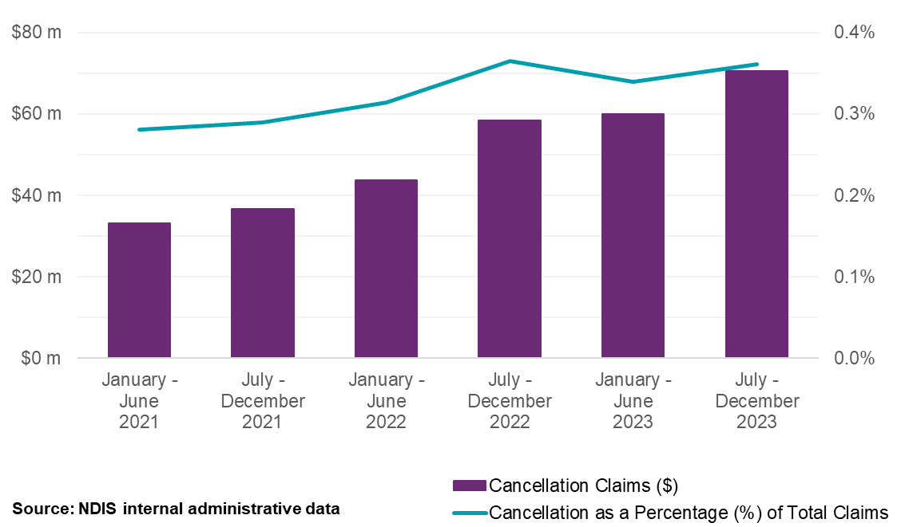

The NDIA also analysed Scheme data by Modified Monash Model areas (MMM) that revealed no significant difference in cancellation rates between metropolitan and remote/very remote locations. This finding suggests that geographical factors may not be major determinant of cancellations, and thus does not warrant a policy consideration focussed on location.

Therapeutic supports account for more than one third of all cancellation claims
Figure 49 breaks down the cancellation claims by the top 4 registration groups, with ‘0128: Therapeutic Supports’ and ‘0118: Early Childhood Supports’ together accounting for 37% of the total in the six-months to December 2023. These two registration groups, generally with workers not covered by the SCHADS Award, contrast with other registration groups such as ‘0136: Group and Centre Based Activities’ and ‘0125: Participant in the Community, Social and Civic Activities’. The latter comprises 31% of cancellation claims and have workers under the SCHADS Award requirements.
Other supports spread across fifteen other registration groups represent 32% of claims, indicating cancellations are common across various NDIS services. Frequency of cancellation claims of other registration groups are also rising over the observed period at a less rapid rate.
Figure 49: Trend in Cancellation Claims by Top 4 Registration Groups from July 2020 to December 2023
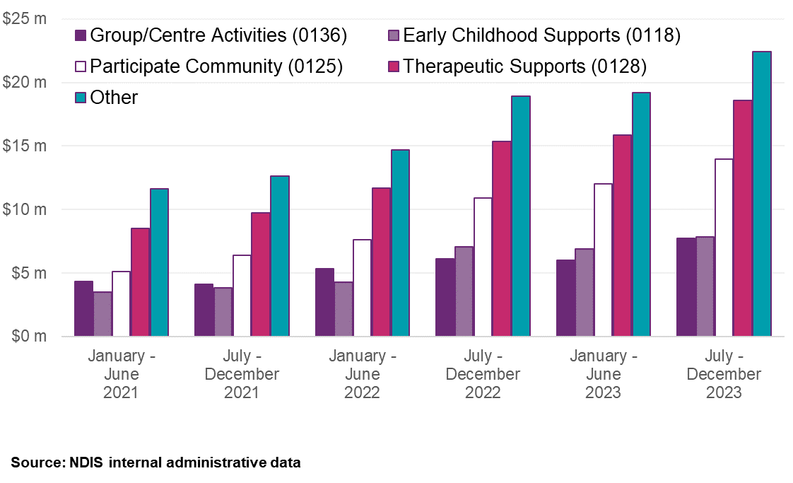

Consultation Feedback

The lack of unity in cancellation policies
Since the NDIA revised the short notice cancellation policy, participants and stakeholders have shared feedback through ministerial correspondence and the public APR consultation. They emphasised the wide variety of cancellation policies used by NDIS providers. Participants highlighted varying levels of understanding regarding these policies, with some discovering the provider’s rules after being charged for the cancelled appointment. According to participant consultation responses, 78% of participants knew their provider had a cancellation policy, and 45% noted different rules applied to different services. This diversity illustrates the complexity of the marketplace.
Among providers who responded to the consultation, the majority delivering DSW supports (52%) and support coordination (53%) followed the seven-day cancellation policy. In contrast, 76% of therapy providers reported following a policy of less than 48 hours (Figure 50). One provider explained:
“We follow a seven-day policy for DSW services, but therapy services are cancelled within 48 hours due to their nature.”
Figure 50: Provider Submission Responses to Short Notice Cancellation Policies
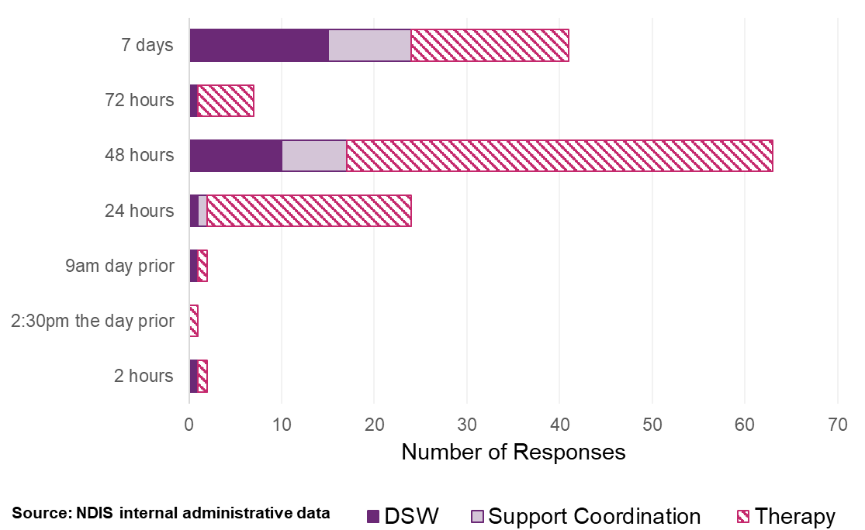
One provider noted the difference in how cancellation policies are applied between NDIS and non-NDIS participants. This is discussed further in section 4 of this chapter.
“This is different to non-NDIS participants and I will explain why. We are unable to charge for cancellations under HCP, workcover or DVA so don’t charge those clients. Our private clients we can charge up to 100% of the appointment cost if they fail to attend or cancel late notice if there is not a reasonable explanation for the failure to attend.”

Discrepancies and confusion
Providers noted discrepancies in the interpretation of cancellation policies, leading to confusion and frustration among participants. One provider shared:
“Clients often don’t realise the financial impact their late cancellation has on our operations.”
The lack of understanding often results from insufficient education on cancellation fees and participant awareness of the policy’s effects. Strictness in policy enforcement further contributes to the perception of unfairness. Some participants claimed they were charged for cancellations even when emergencies occurred, causing dissatisfaction, and leading to calls for more empathetic practices.

Mitigation strategies
Providers have highlighted various strategies to minimise the impact of short notice cancellations on NDIS participants. These include flexible appointment rescheduling, sliding scale fees, and telehealth services. One provider explained:
"As an alternative to a short notice cancellation, we offer telehealth appointments, or offer non-face to face services (if required) such as resource development or report writing. If these strategies are accepted, the cancellation charge is not applied…. We support Participants to achieve attendance at their appointments by providing SMS and/or phone call and/or email reminders, and implement various appointment scheduling strategies (for example, scheduling consistent times to reduce change)."
Another provider suggested sending appointment reminders 48 hours before to allow participants to adjust their schedules or cancel with enough notice:
“We send reminder text messages, we work with scheduling to ensure we are able to provide flexible appointment times that suit the participant needs.”
These strategies reflect a shift toward flexible service models designed to maintain continuity and adapt to participant’s evolving needs.

Flexibility and tailored engagement
Providers emphasised the importance of tailoring engagement with participants to prevent cancellations. For instance, a psychology provider emphasised the need for effective communication with care managers or house managers in cases of frequent cancellations to understand underlying issues:
“We tailor our approach to each individual participant based on their living or travelling circumstances. In instances of frequent cancellations, we typically engage in communication with the care manager or house manager to address the situation effectively.”
Similarly, an Occupational Therapy provider highlighted the role of reminders and personalised communication through text, phone, or email:
“We have multiple reminders automated on software via email and SMS.
A peak body highlighted the most common approaches for their members:
“Telehealth is the most mentioned alternative to short notice cancellations; other alternatives include home exercise programs. Some respondents also mention using the time allocated for cancelled appointments for billable non –face-to-face supports such as administrative tasks or report writing, assistive technology trials, liaison with care team, updating a home program, etc.”
These personalised approaches help identify and overcome barriers to attendance, keeping services flexible and participant centred.

Understanding reasons for cancellations
Short notice cancellations occur for various reasons, including logistical challenges and sudden illness. Participant feedback revealed frustration with some notice periods, as many find it unreasonable to predict their availability seven days in advance. One participant shared:
"For Physiotherapy, it is 7 working days or full price is charged. (Honestly, how do you know 7 days out if you are going to be sick?"
Participants often cancel appointments due to unpredictable factors like illness, hospitalisations, or caring for sick children, calling for policies that balance predictability with fairness. They expressed the need for more empathetic practices, particularly for emergencies. Some providers understood this and showed flexibility:
"My solo provider doesn't charge for cancellations due to sickness or emergencies even if I let her know that morning. She requires 48 hrs notice for cancellation if it's due to change of plan or something I know about beforehand."

Technology and scheduling systems
Providers noted that integrating technology into scheduling systems plays a crucial role in minimising cancellations. Automated reminders via email or SMS help participants stay informed about appointments. A therapy provider emphasised:
“we send reminder text messages and use flexible scheduling to accommodate participant needs”
Technology also helps coordinate mobile appointments:
“For mobile appointments, I privately SMS all clients if not meeting at homes to arrange locations. This minimizes no shows, but not short notice cancellations.”
Beyond reminders, some providers employ technology to delve into the reasons for frequent cancellations, engaging directly with participants to understand the underlying barriers. They offer solutions like telehealth or non-face-to-face supports, including administrative tasks and report writing.

Participant experiences with cancellation policies vary depending on their service provider
Navigating cancellation policies presents challenges for participants due to the wide variation in provider requirements. Notice periods can range from as little as 24 hours to as long as two months, creating confusion for those relying on multiple services. One participant explained:
"Can be anywhere from 2 weeks to 24 hrs and has to be in writing which is not good for some."
This inconsistency makes it difficult for those managing complex situations, who may need to cancel due to sudden illness or emergencies. Participants often find themselves penalised for cancelling on short notice.
Rules also differ depending on the reason for cancellation. Planned absences like holidays or medical appointments and unplanned absences like illness are treated with distinct rules, which many consider arbitrary or unfair. One participant noted:
"Different rules for planned reasons to miss a session (eg holiday, medical appointment, etc) versus if I am sick (which has a much shorter notice period)."
Discrepancies between participant and provider cancellations exacerbate the confusion. One participant expressed concern:
" With current services, if I cancel the service less than 48 hours before the support worker is due, I pay the full amount, but if they cancel or don’t show up, that is supposed to be ok."
Some participants feel unable to seek clarification or negotiate their terms of support, citing a lack of transparency and flexibility from providers. One participant said:
"Eight hours for OT and psychologist. The OT only requires 24 hours for private patients and has not responded to my email enquiry questioning the reason for the difference for participants."
Participants believe that short notice cancellation policies should account for their circumstances, ensuring they’re not penalised unfairly. Improving communication and transparency would help alleviate confusion and frustration.

Discussion
Analyses on NDIA-related short-notice cancellation claims does have its limitations. While some insights can be observed from NDIS cancellation claim data, there are limitations that prevent a comprehensive deep dive. These are:
- Notice period: The NDIA system does not currently capture the advanced notice period provided by a participant for cancellation claims (i.e., one day before or 5 days before).
- Limited reasons: The NDIA system prompts providers to select a cancellation reason from a list though this is not an exhaustive list of potential reasons. However, a significant portion of cancellations claims (70%) are classified as “Not Defined” or “Other”. This lack of specificity makes it difficult to understand the true driver behind most cancellation claims in the NDIS.
- No free-text field: The system does not offer a free-text field for providers to explain cancellation reasons beyond the predefined options.
Due to the lack of current NDIS administrative data for analysis, it is more reasonable to consider analysis of the marketplace and current practices for this policy.

Market analysis and efficiencies
This section examines cancellation policies across various government schemes in Australia, focusing on their similarities and differences with the NDIS.

Aged Care: A mature market with different practices
The most comparable sector for DSW supports is Aged Care, specifically the Home Care Package program within Aged Care. Home Care providers must be registered with the Australian Aged Care Quality and Safety Commission and can charge additional fees beyond hourly rates, such as care management and package management fees.
Thus, providers delivering this program have more flexibility in setting prices, allowing them to potentially absorb some costs associated with cancellations. This is reflected in a sampling of Home Care Package providers cancellation policies, acknowledging this sample is not representative of the entire aged care sector. From a sample of 50 randomly selected Home Care Package providers that listed clear cancellation policies, 96% (48 providers) did not charge for cancellations if given more than 2 business days’ notice (Table 28). Most providers charged the full fee if the cancellation was within the notice period.
Table 28: Review of 50 Aged Care Providers Delivering Home Care Package Supports Cancellation Notice Periods
Required Notice to avoid cancellation charges | 24 Hours or Day Prior | 2 business days or less | More than 2 business days
Number of providers with this policy | 41 | 7 | 2
Percentage of providers | 82% | 14% | 4%

Other Government Funding Schemes
Table 29 compares cancellation policies against other government schemes, such as Medicare and Department of Veterans Affairs (DVA). Many other Government Schemes offer limited or no ability for providers to claim for cancellations. While some, like Medicare allow participant charges for non-attendance, this approach may not be feasible for NDIS participants due to the NDIS required to cover the reasonable and necessary support needs of participants and considering reasonable costs associated with service delivery.
However, it is important to note that unlike the NDIS, these schemes generally do not prohibit providers from charging cancellation fees directly to participants.
Table 29: Comparison of Other Comparable Government Funding Schemes and their Cancellation Policies
Scheme | Cancellations
Medicare | Not covered
DVA | Not covered
Transport Accident Commission (TAC) | Not covered unless fee schedule has specific items
ComCare | Not covered (except for Medical Practitioners)
Return To Work South Australia (RTWSA) | Not covered (except for Medical Practitioners)
Victims of Crime Assistance Tribunal (VOCAT) | Not covered for no-shows by clients
Worksafe Vic | Not covered (except for Medical Practitioners)
WorkCover Qld | Not covered (except for Medical Practitioners)
As part of the APR’s Therapy Analysis, the NDIA received responses from 13 Commonwealth and State Schemes on their therapy pricing and arrangements such as cancellation policies. From these Scheme responses, only 2 of the 13 responses mentioned they allow for cancellation claims for some of their therapy supports. For further information on the schemes that participated, please refer to the Therapy Chapter of this report.

Market Cancellation Data through Website Scrapping
Following consultation feedback that suggested there was a segment of participants that were not be aware of their provider’s cancellation policy, the NDIA conducted a website analysis of 300 NDIS providers who claimed for a cancellation in Financial Year 2022-23. These providers were randomly selected from 1,700 NDIS providers who made over $10,000 worth of claims for short-notice cancellation in 2022-23. Noting, the NDIA does not mandate providers to publicly display their cancellation policies.
Findings from this sample of providers suggested a potential lack of transparency:
- Only 16% of providers had a clear cancellation policy directly accessible on their website. This means 84% had no explicit mention of their cancellation policy.
- 12% offered downloadable terms and conditions, where only some included a clear cancellation clause.
Among the 49 providers with published policies:
- 80% did not claim up to the 7-day notice period, the majority of whom offered a 48-hour notice period.
- 16% had a 7-day cancellation policy.
- 4% differentiated policies between private clients and NDIS participants.
These findings suggest from the sample with published cancellation policies, there are many providers who offer a shorter notice period (48 hours) than the maximum allowable 7-day period. This supports a market that could potentially sustain a shorter notice period than the current NDIS short notice cancellation policy.
From this exercise, the NDIA consider there is a need for potential improved transparency regarding cancellation policies within the NDIS system. There is evidence from submissions to the APR that participants are only made aware of a provider’s cancellation policy after the fact. There is a need for clear cancellation policy that is not only balancing the needs of participants and costs of providers, but that is also communicated between both parties.

Use of Diverse Models and Technology
The NDIA operates in a diverse environment with a huge range of providers in terms of size, support coverage, access to technology, and levels of efficiency. This diversity has a clear impact on the application of cancellation policies and the management of scheduling and rostering systems.

Mitigation strategies
APR consultation respondents suggested mitigation strategies like reminder messages, telehealth options, and reallocating staff to other work or training. There is general support amongst providers of the efficacy of reminders (via SMS, phone, etc.) in reducing no-shows, although no single method consistently outperforms others. These approaches could limit the need to claim for cancellations, with providers using innovative practices to maximise support time.

Understanding reasons for cancellations
Non-attendance reasons vary from transport issues and childcare needs to opportunity costs like time and money. Lead time between bookings is a good predictor of no-shows, and prior history often indicates future cancellations. However, situations like sudden illness may necessitate a more flexible cancellation policy to accommodate participants’ diverse and unpredictable needs.

Recommendations
The NDIA operates within a diverse landscape of providers varying in size, support coverage, technological access, and efficiency. This diversity significantly influences cancellation policy applications, scheduling, and rostering systems.
In therapeutic and nursing supports, a worker may assist multiple participants per shift, meaning that the cancellation of one appointment won’t usually lead to a cancelled shift. However, for longer-duration supports like Supported Independent Living (SIL), the rostered shift might align more closely with scheduled support.
The NDIA acknowledges that providers have the right to recoup costs from cancellations affecting their operations, but emphasises the need for fairness to participants, providers, and taxpayers. While the current cancellation policy applies to all NDIS supports, it deviates from the original intent of the SCHADS Award (which covers the cost of a support worker’s shift) and differs from the private therapy market (typically operating with 24 to 48-hour notice periods).
Consultations with stakeholders, including service providers, participants, and peak bodies, revealed a clear demand for a short-notice cancellation policy adaptable enough to reflect the realities of service delivery while ensuring participants continue to receive the supports they need.
The NDIA recognises that there is a need to strike a balance in its short-notice cancellation policy to allow providers sufficient ability to recover costs while incentivising them to work with participants to reduce the number of short-notice cancellations. Participants, in turn, must be given reasonable period to provide notice, considering unforeseen circumstances like illness, urgent appointments, or changes in personal circumstances, to minimise using NDIS funds on services they do not receive.
Providers delivering DSW-related supports can incur costs if they cannot redeploy employees to other work or set up make-up shifts for the staff, as these employees are generally covered by the SCHADS Award. This requirement is unique to the care sector for workers under the SCHADS Award.
The NDIA believes that NDIS providers should generally be able to reschedule staff according to the SCHADS Award to minimise claims for cancellations from NDIS participants, though this might not be feasible in all situations (e.g. SIL supports). Providers who reschedule or find alternative work for their employees should not claim short-notice cancellation fees from the affected participant, as alternative arrangements have been made for the worker.
On balance, the NDIA recognises the diversity of operational contexts in which providers operate, which includes potential costs that could be faced by providers to meet legislative requirements to their workers in instances beyond their control. It is important that the cancellation policy incentivises providers to minimise the cost of cancellations, while also signalling to participants that they should provide as much notice as possible when cancelling their services and supports. This recognition forms the basis for the recommendations aimed at refining the NDIS cancellation policy to better align with Service Delivery.
Recommendation 8
The NDIA should retain the existing 7-day short notice cancellation policy for applicable supports determined by or derived from the Disability Support Worker Cost Model from 1 July 2024. Providers of Disability Support Worker supports must continue to make reasonable effort to find alternative billable work for the staff involved.
Non-DSW related supports (non-SCHADS related), such as therapy services, lack a standardised legislative or Award requirement for client cancellations. This is the case for other comparable care and support services such as Aged Care and Children’s Services. There are also limited cancellation policies in other Government funding schemes.
Through consultation and research conducted, there is a case that the maximum of 7-day policy may not be necessary for non-DSW supports. There appears to be a greater usage of a 2-day cancellation policy in the sector, particularly among therapy providers, which supports a potential for a shorter cancellation policy. 76% of provider respondents delivering therapy supports to NDIS participants suggest they already have a short-notice cancellation policy of 48 hours or less. This is also supported by the website data analysis conducted by the NDIA, acknowledging the limited sample that had available data for analysis. The NDIA believes there to be mechanisms and methods already being utilised by the sector to assist participants limiting cancellations, which could make the reduction in notice period feasible.
Recommendation 9
The NDIA should adjust the 7-day short-notice cancellation policy for non-Disability Support Worker-related supports to two clear business days from 1 July 2024.

Feedback from the Participant Consultation Paper

Context
The 2023-24 APR has an increased focus on participants to ensure that it includes the voices of both providers and participants. For the first time, the NDIA published a dedicated consultation paper to gather participants’ perspectives and sought participant feedback via an online form.
During the 2022-23 APR consultation process, the NDIA received 12 submissions from participants and their representatives. To improve the options available for participant engagement, the NDIA undertook a broader consultation campaign for the 2023-24 APR. This approach recognises that the NDIA puts participants at the centre of everything we do and that many of the ideas about how to make the NDIS better have come from the disability community.
The consultation questions asked participants about:
- How much they know about the current price limits.
- Their experiences in finding the best price for supports and services within these limits.
- How the price limits affect the quality of supports they receive.
The NDIA received 559 responses to the participant consultation questions, with most providing feedback through the online form.
This chapter summaries the feedback received from participants throughout the APR consultation process.

Overview of participant responses
The NDIA invited any participants, family members of participants, carers, and participant advocacy groups with an interest in NDIS pricing arrangements and price limits to make a submission to the APR. Consultation took place between 25 January and 17 March 2024. The participant consultation paper included a Plain English paper, an accessible easy-read paper, and an online form. The NDIA received 546 responses to the online form, 11 responses to the Plain English paper and 2 responses to the easy-read paper. The selection of respondents was not randomised and participants could choose which questions they responded to.
The NDIA promoted the participant consultation options through several channels including:
- NDIA website
- NDIA news update
- NDIS social media
- NDIS newsletter
- Participant First newsletter.
There are over 640,000 NDIS participants across the Scheme. The number of participants who responded to the survey represents less than 1% of all participants. Despite this, the responses provide important insights into participant experiences with pricing.
Table 30 shows the proportion of participants who responded to the consultation questions and how they choose to manage their NDIS funding. It includes a comparison to Agency data on how total Scheme participants manage their funding. Over 85% of participants who responded were self-managed or plan-managed, and a small number were Agency-managed participants. 8% of respondents were mixed-managed and 2% reported that they were not sure how they manage their NDIS funding.

Table 30: APR Online Form Participant Respondents and How They Manage Their Funding
Ways to manage funding | Description | Percentage of online form respondents | Percentage of NDIS participants
Plan-managed | The NDIA provides funding in the participant’s plan to pay for a Plan Manager who pays providers, helps keep track of funds and takes care of financial reporting for the participant. | 52% | 62%
Self-managed | The NDIA provides the participant with funding so they can access the supports that will best help them pursue their goals. | 34% | 29%
Agency-managed | The NDIA pays providers on the participant’s behalf. | 4% | 9%
Mixed-managed | The participant can choose a combination of the three options above. For example, they may choose to self-manage one part of the plan and have the rest managed by the NDIA. | 8% | Not available
Source: Participant responses to APR online form; NDIS, NDIS Quarterly report to disability ministers 31 December 2023, p 49.
Note: 2% of respondents reported that they were not sure how they manage their NDIS funding.

Participant awareness and perception of prices

Participants were asked about their awareness of prices
The NDIA is responsible for empowering participants to exercise choice and control. A key component of empowerment for participants is having access to information and tools to make an informed decision about the services they use, including the prices for those services. For this reason, the NDIA asked participants about their awareness of prices.
A high proportion of participants who responded to the online form reported that they are aware of prices and how to access information about NDIS price limits:
- 94% of participants reported that they know the price they pay for NDIS services and supports.
- 90% reported that they are familiar with the NDIS Pricing Arrangements and Price Limits (PAPL). This document assists participants and disability support providers in understanding how price controls for supports and services work in the NDIS.

Participants were asked if they pay the same price as a person who is not an NDIS participant
The NDIA asked participants whether they pay the same prices for their services and supports as people who are not NDIS participants. Around 26% of participants reported that they pay the same price as non-NDIS participants, while 41% reported that they do not, and around 33% were not sure.
Participants who said that they do not pay the same price, were then asked to provide examples of the different prices their provider charges.
Most participants who reported that they do not pay the same price as non-NDIS participants provided examples of the prices they pay being higher:
“I go to the OT, on a sign it states $95 first consultation, $90 thereafter. I am charged $193.99 because I am on NDIS.”
“If I tell a cleaning provider that it is NDIS they charge me about 40% more supposedly for administration. If I pay direct and claim reimbursement it is about 40% cheaper per hour.”
“At a previous Physiotherapy clinic I was paying $105 for a 45 minute appointment, when they found out I was self-managed with NDIS for physiotherapy their price went to the full $193.99 and they stated they needed extra time to write notes and it was more complex to treat someone on the NDIS - yet for 6 months prior they had been treating me for the same issue.”
A relatively small number of participants provided examples of the prices they pay being lower than non-NDIS participants:
“Services are cheaper if I am using NDIS. As a result, my provider is thinking of no longer treating NDIS clients.”
“I pay less than someone who is privately charged for similar supports.”

Feedback on whether prices are reasonable was mixed
The NDIA often receives feedback from participants through Ministerial Correspondence and other channels about concerns about pricing. To better understand participant views on and experiences with pricing, participants were asked whether they consider prices are reasonable. Participants were then asked to explain why they chose this answer.
Participant views varied considerably on whether the prices they pay for their services and supports are reasonable. About 42% of respondents reported that they agree or strongly agree that prices are reasonable, while 51% reported that they disagree or strongly disagree and 7% were not sure.
Figure 51 shows that agency-managed participants were slightly more likely to agree that prices are reasonable, while mixed-managed and self-managed participants were slightly more likely to disagree that prices are reasonable. Overall, there was relatively little difference in perceptions of reasonableness across the different types of funding management for participants.
Figure 51: Summary of Online Form Participant Responses on Whether Their Prices are Reasonable
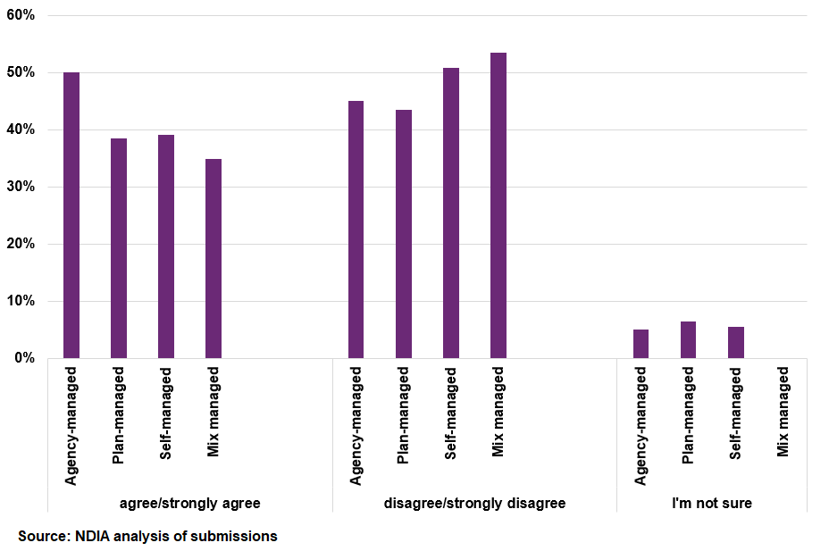
Participants who agree that prices are reasonable often stated that they are able to shop around and negotiate prices. For example:
“I live in a very rural town. I pay the best prices I can for the services I need. I pay below the NDIS price caps but only because I plan manage my funding.”
“I am charged much less than the NDIS price guide and the same rate as non-participants.”
“I am self-managed so set a reasonable rate that is below the maximum rate.”
“I am self-managed, have the capacity to shop around, negotiate and choose not to support providers who overcharge or use the NDIS price guide to set their prices.”
Participants who disagree that prices are reasonable often reported that they have different views about the reasonableness of prices, depending on the specific service or support. For example:
“Some prices are reasonable and others aren’t.”
“I think the maximum price for some services is far to generous. For example to employ a support worker day time weekday to help me access community and social activities can cost about $65 per hour. I think $65 is far too much for unskilled work to drive me to an event, wait and drive me home afterwards.”
Many participants also reported that they consider extra charges for travel or administrative activities to be unnecessary or too expensive:
“The price would be reasonable if travel and paperwork were included, not charged separately.”
“$200/hour (near enough) for allied health services + travel on top seems excessive.”
“Providers charge ridiculous amounts of money. Everything is charged, even note writing 15 minutes after every therapy.”

How participants manage their funding and engage with providers on pricing

Many participants choose to self-manage or plan-manage to have more flexibility and control
The NDIA asked participants how they manage their NDIS funding for core supports and therapy supports and why they chose to manage their funding this way. Over 85% of participants who responded to the online form plan-manage or self-manage their NDIS funding. A key theme from participants who self-manage or plan-manage their NDIS funding is that they state they have choice and flexibility to negotiate reasonable prices from providers that meet their needs. At least 20 participants reported that they prefer to have the flexibility to use unregistered providers.
Comments from participants who self-manage include:
“Full control over who I employ or hire, much better value for money, ability to negotiate rates and conditions.”
“Because I can stretch my funding further in core supports by still paying a fair price, but I'm not governed by a "price guide". My support workers are privately hired by me.”
Comments from participants who plan-manage include:
“To ensure that I have choice and control over providers but have the insurance that all my invoices are paid on time and I have guidance around my budget.”
“I can determine who I want and the price paid is fair and reasonable with some guidance from the plan manager.”
Around a third of participants who are agency-managed suggested convenience as a reason for choosing to manage their funding this way and four participants noted they prefer using registered providers. Three participants said that they agency-manage their funding because they would have difficulty with the other options.

Only 23% of participants say they discuss and agree on prices with their provider
Price regulation is in place for NDIS services and supports to ensure that participants get value for money in the supports that they receive. The NDIA sets price limits, which are the maximum prices that registered providers can charge NDIS participants for specific supports. Participants and providers can negotiate lower prices.
To understand whether providers give participants accurate information about the role of the price limits and the scope for negotiating prices, participants were asked how their provider sets prices for their services and supports:
- 38% said their provider tells them the NDIA decides what prices they have to charge.
- 30% said their provider has a price list with fixed prices to pay if buying services from them.
- 23% said they discuss the price with their provider and agree on the price they will pay.
- 9% were not sure.
Based on participant responses, it appears that participants are sometimes given incorrect information about the purpose of the price limits the NDIA sets. While providers are not required to charge at the price limits set by the NDIA, it appears that more than a third of participants have been told this is the case.
Participants who discuss and agree on prices with their provider were much more likely to agree or strongly agree that prices are reasonable (71%). Participants who said their provider tells them the NDIA decides what prices they have to charge were much less likely to agree or strongly agree that prices are reasonable (20%).
The NDIA also asked participants how their provider tells them about price changes and policy changes for their services and supports. The most common reported method for communicating these changes was email, followed by letter, plan manager, SMS/text message and in-person.

Information and education for participants about the NDIS market
As discussed above, a key component of empowerment for participants is having access to information and tools to make more informed decisions about the services they use. The NDIA considers there is benefit in improving the tools available to participants to ensure they have access to accurate information about their rights as consumers.
Several participants described how they benefit from shopping around to find providers that best meet their needs and negotiating prices and service conditions that work for them. However, not all participants have been able to do this. Participants reported that some providers are not willing to negotiate and, in some cases, provide them with incorrect information about the role of the price limits. For example:
"All supports and services I come across that deal with mainly NDIS participants charge the maximum rate and they say that is the price that NDIS say they HAVE TO CHARGE, they don't get that is the maximum rate and that NDIS really want them to charge less. A friend tried to negotiate with the same provider that I use and she told me that she thought it was rude of the participant to devalue her time.”
"Many support workers charge the top rate listed in the pricing arrangement and think that is what NDIS says they should be paid. Many of them don't understand that it is a suggestion/ maximum price one can charge and they DO NOT allow negotiations."
“As a self-managing participant I am supposed to be able to negotiate with providers. I am never given this opportunity. I am charged the highest amount possible. The idea of negotiation, particularly in areas where service providers are limited to a few, is just not realistic. Providers know there is an upper limit to what they can pay and they charge accordingly.”
Providers are allowed to charge up to the price limits. However, when providers do so, the NDIA considers that they should clearly communicate to participants that charging at the price limit is a business decision, not a requirement imposed by the NDIA. The PAPL states that “providers should not indicate in any way to participants that the prices that they charge are set by the NDIA”. Similarly, the PAPL notes that “the NDIA does not set the prices that providers charge”. When providers give incorrect information to participants about the role of the price limits, this may mislead participants and discourage them from attempting to negotiate prices for their services and supports in future.
For this reason, the NDIA considers it is important that participants are well equipped with accessible information about the price limits and their rights to negotiate with providers. A targeted capacity-building education campaign for both participants and providers about these rights, with relevant information published on the NDIS website in an accessible format could help to achieve this. Ultimately, timely and reliable information sharing will empower participants to make informed decisions and ease information asymmetries.
Multiple cross-agency initiatives have been established to improve outcomes for participants and to ensure that providers are doing the right thing:
- The Fraud Fusion Taskforce started in November 2022. It is a partnership between the NDIA, Services Australia and 14 other government agencies including the NDIS Quality and Safeguards Commission, the Australian Federal Police and the Australian Criminal Intelligence Commission. The Taskforce aims to improve how government agencies work together to quickly detect, resolve and prevent fraud, while reducing the impacts of fraud on NDIS participants.
- The NDIS Provider and Worker Registration Taskforce will provide expert advice to Government on the best approach to overhaul the current registration system for providers, while maintaining choice and control for participants - as recommended by the NDIS Review.
- The Fair Price Taskforce to crackdown on unfair price hikes for NDIS participants is now operational. The ACCC will chair the taskforce, together with the NDIS Quality and Safeguards Commission and the National Disability Insurance Agency. The NDIS Commission will tackle illegal overcharging of NDIS participants. The ACCC will focus on investigating and clamping down on misleading conduct, unfair contract terms and anti-competitive agreements that might impact NDIS participants, while supporting the taskforce’s work.
Learnings from the participant consultation will be shared with the relevant taskforces to ensure that providers are giving correct information to participants about their rights and the role of the NDIS price limits.

How the NDIA has considered participant feedback throughout the APR
The NDIA has considered feedback from both participants and providers when making recommendations about the NDIS’s price control framework. Other chapters in this report include summaries of feedback received from participants and providers, and explain how we have considered this feedback when making recommendations. Two key areas that participants were consulted on include:
- Support coordination - The NDIA asked participants about their experiences with support coordination, including their level of satisfaction with their support coordinator. Participant responses to these questions are discussed in Chapter 6.
- Cancellation policies - To better understand participant experiences with provider cancellation policies, the NDIA asked participants about their awareness of cancellation policies, as well as how these policies vary across their services supports. Chapter 7 discusses participant feedback on these issues in more detail and recommendations resulting from that feedback.

Appendix A - Feedback from the Provider Consultation Paper

Overview
The 2023-24 APR consultation commenced on 25 January 2024. Provider submissions closed AEST 11:59pm on 10 March 2024 and participant submissions closed AEST 11:59pm on 17 March 2024. The Provider and Participant Consultation Papers included a series of guiding questions.
A total of 912 submissions were received in response to the consultation papers. Of these, 559 submissions were in response to the Participant Consultation. Participant submissions are discussed in detail in Chapter 8.
The remaining 353 submissions were in response to the Provider Consultation Paper and were received from a range of stakeholders:
- 259 from a range of provider organisations
- 60 from employees/workers
- 15 from professional associations
- 13 from provider peak bodies
- 3 from advocacy groups
- 2 from workers unions
- 1 from an educational institution

Market environment and influences: changing economic conditions, business risks and vacancies

Adapting to changing economic conditions
The Provider Consultation Paper sought to understand the segment of the care and support sector provider organisations operate in. It also undertook to inform the NDIA’s understanding of the impact of recent economic conditions (e.g. inflation and rising interest rates) on providers, the primary business risks faced by them and how these risks are being managed, as well as vacancy rates (as a proportion of total planned workforce).

Providers
A total of 217 provider submissions responded to the questions about economic conditions, business risks and staff vacancies.
Almost all providers reported increases in costs. Providers highlighted general increases in wage costs in a highly competitive labour market, as well increases in insurances, rent, travel costs, utilities, and other operating expenses. Several providers attributed these increasing costs to reduced profit margins, and expressed concern about their ongoing financial viability as NDIS providers. Many providers noted that the NDIS price limits have not increased for a number of years.
Providers reported a range of approaches to adapting their businesses in response to these changing economic conditions, including:
- increasing prices to the NDIS price limit for NDIS participants
- increasing prices for non-NDIS clients
- adapting billing practices e.g. charging NDIS participants for services previously not charged for, such as preparation and travel
- adapting the services they deliver e.g. limiting the geographic area(s) in which they operate, reducing the frequency and types of supports delivered, providing services differently (e.g. use of tele-health), through to ceasing to provide select services altogether
- pursuing efficiencies from organisational restructures or increasing expectations of billable hours (i.e. increased utilisation rates)
- reducing investment, by deferring capital expenditure
- absorbing cost increases e.g. through salary freezes
- operating at a loss and/or cross subsidising losses through other revenue streams.
One provider stated that:
“Inflation and rising interest rates have impacted my business by a 20% rise, and I have had to respond by increasing my client intake, working before and after school and longer than 10 hours days, since increasing the rate for therapy has NOT been an option.”

Provider peak bodies
Provider peak bodies raised similar themes about challenging economic conditions where costs have increased, and profitability is reduced. Respondents noted that these challenges are likely to impact the quality of services offered by providers, with less investment in staff training and other quality-enhancing initiatives. It was also noted that many businesses are operating at a loss, which may lead to market exits.

Professional bodies
Professional bodies also reported rising costs and financial pressures. It was noted that some providers who previously charged below the NDIS price limits, are now increasing their prices up to the price limits. Professional bodies reported instances where providers are considering moving to self-managed participants so they can charge above the price limits to cover their costs. A professional body reported that many providers are conscious of the impact of a challenging economic environment on participants and have sought to minimise any price increases by bearing the cost themselves.

Primary business risks

Providers
Financial sustainability was identified as the primary business risk by 64% of provider responses. This was raised when responding to questions about changing economic conditions.
Providers also raised challenges with staff recruitment and retention as a key business risk. Providers reported a shortage of practitioners, increasing wage costs and challenges with retaining staff due to competition from other sectors, as well as staff leaving to become unregistered sole-trader providers:
“The biggest risk to my business is that I will be unable to sustain a workforce to support NDIS participants due to the rise in expenses namely practitioner wages (including superannuation increases) and the cost to recruit quality candidates, whilst also holding onto quality employees.”
Providers also raised a wide range of other themes, including risks arising from the amount of time spent on NDIS administrative tasks, registration costs and uncertainty about ongoing reforms to the NDIS.

Provider peak bodies
Peak bodies raised concerns about the costs of NDIS registration and noted that some members report considering de-registering.

Professional bodies
Similarly, professional bodies also stated the administrative burden of NDIS registration as a business risk, as well as financial sustainability and uncertainty about broader changes within the NDIS. Professional burnout and delays in receiving payment for services relating to assistive technology were also raised as business risks.

Staff Vacancies

Providers
Many provider submissions indicated they currently have vacancies. Reported vacancy rates varied considerably, ranging from less than 5% to more than 50%.
High staff turnover was reported in many submissions, as well as broader challenges with recruitment and retention. Several providers reported an operating environment where staff leave to become independent/sole-trader providers or take up work in other sectors where they may receive higher wages. A number of providers reported increasing costs associated with salaries and wages to retain staff, or additional costs associated with recruitment (e.g. advertising and recruitment agency costs). For example:
“We have experienced a significant staffing shortage over the past 18 months. Our workforce operating across disability support and community aged care support has reduced from 70 staff to 50 staff over this time. Like many other industries the disability and aged care sector has been hit hard by staffing shortages, the impact of this has been harder still in rural areas where there is a smaller population to draw from and a lack of transport and housing to attract people from out of the area.”

Professional bodies
Professional bodies reported a wide range of vacancies among their members, ranging from no vacancies to up to 80%. It was also noted that in some cases, even though their members have vacancies, they have ceased recruiting due to difficulties with finding staff.

Disability Support Worker (DSW) Cost Model
The Provider Consultation Paper sought stakeholder views on the DSW Cost Model assumptions about organisational overheads and operating costs. Providers were also asked about impacts of the 15% wage increase under the Aged Care Award that took effect from 30 June 2023. A total of 79 provider submissions, five provider peak bodies and one union organisation responded to questions about the DSW Cost Model.

Alignment of Disability Support Worker Cost Model assumptions with provider’s corporate and operational overheads.

Providers
Almost all provider submissions to the DSW questions noted that the assumptions in the DSW Cost Model do not reflect their actual costs. Only 2 of the 79 submissions from providers indicated that the model’s assumptions align with their costs.
Provider submissions raised concerns about financial viability under the model’s costings, suggesting it does not reflect actual costs and requires providers to absorb cost increases.
“The cost model does not fully account for the complete cost of a billable hour of support, considering base pay, shift loadings, leave entitlements, salary on costs, employee allowances, operational overheads (including supervision costs, utilisation costs, and workers' compensation costs), corporate overheads, and margin.”
Many providers reported that their operational and corporate overheads are generally higher than the percentage assumed in the DSW Cost Model. Key reported differences include:
- worker’s compensation rates and insurances
- costs associated with utilisation rates, a casualised workforce and in some cases, a reliance on agency staff
- general operational overhead percentages exceeding levels assumed in the DSW Cost Model
- quality and safeguarding activities, including registration and audit costs.
“The one size fits all approach does not recognise the different living environments, diversity, and complexity of supports across participants in the scheme. The price limit is the same for a sole trader delivering in-home support as it is to for a shared 24/7 living arrangement irrespective of the number of people and their needs, and the complexity of support.”

Provider peak bodies
Ability Roundtable provided its Financial and Workforce Benchmarking analysis, which was undertaken in conjunction with 63 DSW registered NDIS providers. A mix of for-profit and not-for-profit providers participated, from both metropolitan and regional areas.
For the organisations included in the benchmarking analysis:
- average profitability was reported at -2.1%.
- over 60% of respondents reported three years of consecutive losses since the 2021-22 financial year (data showed a median loss of 5.9% in 2021-22 and 4.9% in 2022-23).
- there is a 10.9% variance between the DSW Cost Model and actual reported costs to deliver support.
“there is a growing gap between the NDIA DSW Cost Model assumptions and the actual cost of service provision”.
Other peak bodies reiterated that the DSW Cost model does not align with operational and organisational overheads, calling for increases in core supports delivered by DSW.
“Cost model does not take into account the funding nature with donations or reserves, complexity of services provided, provider organisation size or quality and safeguarding requirements.”

Unions
The Australian Services Union stated there needs to be clearer rules regarding pay and classifications, portable entitlements to paid and other types of leave and sufficient paid time in rosters for training. Similarly, the Health Services Union highlighted a lack of clarity in the current model for how the NDIS price limits for work performed before and after a sleepover.

Range of SCHADS Award classifications under which staff are employed and distribution of permanent full time, part time and casual employment
The Provider Consultation Paper asked about the range of SCHADS Award classifications under which provider organisations employ DSWs and how they are distributed across permanent full-time, permanent part-time and casual employment.
Providers reported a wide range of SCHADS Award classifications from Level 1 to Level 8. For example:
“We have SCHADS employees from level 2 through to level 6, with one manager at level 8.”
“In our organisation DSW are generally paid at level 2.4 or Level 3. Service coordinators at level 4.2.”
The proportion of reported DSWs employed casually ranged from 12% to 100%. About half of provider submissions reported that 70% or more of their DSW workforce is employed casually. Several providers responded that DSWs prefer to work casually, as they get paid more and have more flexibility, even if it is at the cost of paid leave.
Several responses highlighted the need for the cost model to reflect the actual costs related to shift work, leave loading and public holidays.
“Reasons cited for [DSWs preferencing casual employment conditions]: pursuit of higher salaries, more flexibility. This also comes with additional cost overheads associated with re-rostering required for a more transient workforce. The assumptions of the DSW cost model are based on a permanent worker in a highly casualised workforce.”

Impacts of the Aged Care Award 15% wage increase from June 2023 on recruitment and retention of Disability Support Workers

Providers
Provider submissions reported mixed impacts from the 15% increase to the Aged Care award, with some providers describing no tangible impact and others experiencing significant workforce challenges. Many providers reported general challenges with finding suitable workers with the right skills and experience. Other providers reported that the Aged Care Award increase has put upward pressure on wages, with many of these providers reporting paying above-award wages to attract DSWs. It was reported that the upward pressure on wages contributes to existing workforce challenges with high turnover rates and associated recruitment costs, as well as competition from staff becoming independent DSWs.
“The increased wage and subsequent increased appeal of the Aged Care sector has made it even more difficult to attract employees to the Disability sector. There are greater opportunities for them to gain Permanent F/T employment in the Aged Care sector.”
“Competitiveness in wages has notably increased since the 15% wage increase in Aged Care in July 2023.”

Therapy Supports
The Provider Consultation Paper asked several questions about providing therapy supports, including changes in the costs of delivering services and questions about the differences between providing therapy supports to NDIS and non-NDIS clients.
There were 178 provider submissions received relating to therapy supports, 13 from professional bodies, one from a union and a small number from provider peak bodies. Through the APR online form and Participant consultation paper, 142 participants also provided feedback on therapy supports.

Changes in the costs of delivering services
The Provider Consultation Paper asked providers about significant changes in the costs of delivering Therapy support services.

Providers
About 87% of provider submissions reported increases in the costs of delivering therapy supports and services. Providers noted increases in wage costs (including increasing staff wages, keeping up with Allied Health awards and professional development costs) and costs associated with recruitment and retention. Providers also reported increases in business expenses such as rent, utilities, office supplies, insurance, workers compensation premiums and travel expenses.

Provider peak bodies
Ability Roundtable responded to the consultation questions on therapy supports and included an updated Allied Health Cost Model for NDIS-funded services from Deloitte Access Economics. The model estimates the respective services costs of 13 large therapy providers. The model indicates that the current NDIS price limits are lower than the actual and projected costs of delivering therapy supports:
- There is a 12.9% difference between the projected fully loaded cost to deliver an hour of therapy supports and the current NDIA Price Limit for the 2024-25 financial year for the four major allied health disciplines.
- For Psychology Services, there is a 16.6% difference between the fully loaded cost to deliver an hour of Psychology supports, when compared to the current NDIA Price Limit for the 2024- 25 financial year.

Professional bodies
Allied Health Professionals Australia submitted that the price limits for therapy should be raised to reflect cumulative indexation since 1 July 2019 and suggested that from 2025, price limits for therapy supports should be automatically indexed.
Allied Health Professions Australia described rising business costs (e.g. wage market rates, rent and utilities, supplies, fuel, consumables and equipment, travel, insurance and other operational expenses).
“Our members’ therapy support businesses tend to operate at a small scale, and they therefore have limited infrastructure and resources and operate on thin margins. There is little possibility of further ‘efficiencies’ within small and solo practices, without compromising on the amount or quality of service.”
Similarly, Australian Physiotherapy Association noted that its members find themselves struggling to balance the need to support their staff in a context of rising cost of living by increasing wages while trying to keep their own costs under control.

NDIS providers offering support for early childhood supports and to non-NDIS clients – prices, appointment durations and fee-setting considerations
The Provider Consultation Paper asked providers if they offer therapy supports/early childhood supports to non-NDIS participants. Providers were asked about the proportion of NDIS participants and non-NDIS participants they service, the typical duration of appointments, and if there are variations in prices. Providers were also asked how they determine the hourly rate charged for NDIS participants and what factors they consider when setting different rates.

Providers
The majority of provider submissions responding to this topic reported providing therapy support services to NDIS clients and other segments of the care and support economy (such as private clients or other insurance schemes). The proportion of NDIS participants serviced by these participants ranged from 25% to almost 100%, with more than half of these providers having a client base that was 70% or more NDIS participants.
Appointment durations reported by providers were in many cases the same for NDIS participants as non-NDIS clients. Many providers explain that appointment durations are tailored to the needs of a client, regardless of whether they are an NDIS participant or not. Other providers reported differences in appointment duration due to the complexity or reporting requirements for NDIS participants, and a small number of providers indicated that they billed NDIS participants for this non-face-to-face time.
“Our appointment length is determined in accordance with the principles of evidence-based practice, considering a client’s needs/goals, family commitments and research evidence as to the intensity and frequency of intervention. Therefore, there is no distinction in appointment duration based on whether a client is an NDIS participant or private client.”
“30 or 60 minutes non-NDIS. 60 minutes for NDIS clients who are usually more complex with multiple co-morbidities and increased liaison time with involved parties including other therapists, SC, equipment suppliers, builders etc.”
Provider submissions outlined a range of pricing practices. Most providers reported charging NDIS participants at the price limit, while a small number reported charging below the price limit.
Many of these providers charge non-NDIS participants the same fees as NDIS participants. Other providers reported a price difference between NDIS participants and non-NDIS clients, with some charging more for NDIS participants and some charging less. Reasons for charging different prices varied widely. For example, some providers reported:
- NDIS participant complexity or additional administrative costs associated with providing services to NDIS participants as a reason for charging NDIS participants more.
- The lack of change in NDIS therapy support price limits over the last five years as a reason for charging non-NDIS clients more than NDIS participants.

Professional bodies
Feedback from professional bodies relating to differences in appointment durations was mixed. For example, the Australian Psychological Society stated the median duration of psychological appointments for its members is 60 minutes for both NDIS participants and non-NDIS clients.
The Australian Orthotic Prosthetic Association noted that while some considerations for fee-setting are the same, there are also NDIS-specific aspects:
“The main difference is the report writing component for NDIS participants which is significantly more time burdensome and almost triple what is required by most non-NDIS clients.”

Unique costs in providing early childhood supports for NDIS participants
The Provider Consultation Paper asked providers about unique costs of providing early childhood supports for NDIS participants.

Providers
Providers outlined a range of unique costs of providing early childhood supports, with 85 (or 33%) of provider submissions responding to this question. Most providers describe this group of NDIS participants as more complex, compared to other early childhood clients who are not eligible for supports under the NDIS.
When describing early childhood supports for NDIS participants as more intensive and requiring more time, the following additional activities and costs were noted:
- collaboration and liaison as part of team-based approaches, with an appointed ‘Key Worker’
- delivering supports in natural environments, such as at home or in school settings, which requires travel that can exceeds established caps
- specialist skills and professional development needs, often resulting in a need to pay higher salaries
- mandatory reporting obligations, such as writing reports related to funding allocation decisions, risk assessments, reporting to the NDIS Safeguards Commission and making Child Safe notifications.

Professional bodies
Professional bodies noted similar costs of providing early childhood supports for NDIS participants. For example, the Australian Physiotherapy Association described liaison and communication with the care network, support to the family, the expertise and complexity required, extended appointments, the service environment and administrative load.
Dietitians Australia also noted other unique considerations when providing early childhood supports, such as the requirement for specialised training materials and resources, and tools designed specifically for young children with disability:
“Many children with disability (…) require specialised nutrition and dietetic support. The progression can be significantly prolonged (…) with some requiring lifelong assistance. This necessitates a flexible and long-term funding approach, acknowledging complex feeding needs [of each individual child].”

Support Coordination
The Provider Consultation Paper asked support coordinators if there have been significant changes to the costs of delivering services over the past 12 months.
About 55 (or 21%) of providers made submissions relating to support coordination, as did a small number from provider peak bodies and professional bodies.

Providers
Most support coordination providers reported increases in the costs of delivering services. Common themes from those submissions include that operating costs have increased (such as wages and salaries, rent, fuel and insurance), while NDIS price limits for support coordination have been held constant for several years.
Many providers noted that they face difficulties in attracting and retaining suitable staff, reporting that there is pressure to increase wages to keep up with the rising cost of living and to remain competitive with comparable positions in similar industries. Several providers described doing work that is often unbilled but necessary, which they consider is not sufficiently accounted for in the current price limits for support coordination, including:
- activities related to onboarding new clients for support coordination (contacting the NDIA, accessing portals, understanding the client's needs, executing service agreements and doing risk assessments).
- activities associated with transitioning to the new PACE portal.
- administrative activities when a participant dies.
Other providers noted that because the price limits have not kept pace with rising costs, their financial sustainability is under pressure.

Provider peak bodies
Peak bodies raised concerns about the current price limits constraining the quality of support coordination services and noted that the price limits have not increased in recent years. Peak bodies also raised concerns about the price limits not sufficiently accounting for the amount of non-face to face time support coordinators incur.

Unions
The Health Services Union noted that the NDIS Review has recommended phasing out support coordination and introducing navigators. Until navigators are introduced, the Health Services Union suggests that transitional increases to support coordination price limits are critical to ensure support coordinator wages keep up with inflation and increased costs.

Cancellation Policies
The Provider Consultation Paper asked several questions about provider cancellation policies, including:
- What is your cancellation policy for NDIS participants? Is it different for non-NDIS clients? If so, why?
- How often do you face short-notice cancellations or no shows and on average and how frequently do you claim for these instances monthly? What approach does your organisation take when a participant has an unusually high frequency of cancellations?
- What service offering does your business have as an alternative to short notice cancellations?
Of the 353 provider submissions received, 121 (or 34%) responded to questions relating to cancellation policies, frequency of short-notice cancellations and alternative service offerings aimed at reducing cancellations.

Provider variances in cancellation policies for NDIS participants and non-NDIS clients

Providers
Most provider submissions reported that they have no differences in their cancellation policies for NDIS and non-NDIS clients, with a small number of providers reporting that their cancellation policy is different.
The majority of therapy support providers described adopting a 2-day cancellation, policy rather than the 7-day policy. Providers noted that 48-hours is an industry standard across the Allied Health sectors, and that they do not want to lose clients by adopting a different policy. In general, there was wide variation in reported cancellation policies, with the most commonly cited cancellation policies being 2-hours, 24-hour or 72-hours.
“Our cancellation policy has a notification period of 48 hours and charges 90% of fee for NDIS participants. It is not different for non-NDIS participants, except in exceptional circumstances (family emergencies eg, hospitalisation, natural disasters, extreme weather events, significant financial hardship).”

Provider peak bodies
Provider peak bodies reported favouring retention of the current 7-day cancellation policy arrangements. Peak bodies noted that under the current SCHADS Award, payment to employees is required for cancellations within 7 days. Peak bodies noted that providers try to find alternative work for the employee, but often this work is administrative and unbillable because existing billable services are usually already rostered to other employees.

Professional bodies
Provider professional bodies described the diversity of cancellation policies across the sector. A large peak body reported that a third of their members adopt a 24-hour or 48-hour cancellation policy. About 15% of their members stated they do not have a cancellation policy, as cancellations are very infrequent.

Unions
Submissions from Union organisations representing the DSW workforce suggested the 7-day cancellation policy helps ensure retention of the workforce and assists to increase participants’ choice of workers.

Frequency and average of short-notice cancellations and monthly claim averages

Providers
There was considerable variation in reported frequencies of short notice cancellations and monthly claim averages. It was noted that seasonal weather impacts the frequency of cancellations (e.g. the winter flu season brings a higher rate of cancellations).

Provider peak bodies
The Australian Psychological Society noted that cancellations by NDIS participants were relatively infrequent, with two-thirds of members reporting that they occurred in less than 10% of scheduled appointments. A further 29% noted that they occurred occasionally, between 10–30% of scheduled appointments.
Other provider peak bodies also noted that short notice cancellations are relatively infrequent, with some reporting less than 10% frequency.

Provider approaches for unusually high frequency of cancellations and alternative service offerings to reduce cancellations

Providers
Most providers reported that they try to provide participants with a range of alternative service offerings when they need to cancel their appointment, such as telehealth, arranging a home visit or re-booking the appointment. Several providers also describe sending SMS text messages and appointment calendar reminders to participants the day before an appointment to help reduce the frequency of cancellations. In addition, most provider submissions acknowledged that the unique needs of each client need to be considered when determining a suitable alternative.
“Alternatives MUST relate to the best practice for that family and child…switch to telehealth. In the early years, children getting sick is a regular reason for cancellations. Telehealth may not be an option…We offer other non-client facing activities in the same timeslot, development of program materials, complete upcoming service summaries and reports for funding reviews, create supporting therapy resources for the school or home or use the time to collaborate with other team members, teachers etc.”

Professional bodies
Provider professional bodies stated their members offer telehealth services, phone services, or other non-face-to-face services as an alternative to charging a cancellation fee. These alternatives include using the cancelled appointment time to develop resources (e.g. visual aids and materials), write reports, reach out to the family to offer support, liaise with stakeholders and arrange meetings.

National Disability Insurance Agency
ndis.gov.au
Telephone 1800 800 110
Webchat ndis.gov.au
Follow us on our social channels
Facebook, Twitter, Instagram, YouTube, LinkedIn
For people who need help with English
TIS: 131 450
For people who are deaf or hard of hearing
TTY: 1800 555 677
Voice relay: 1800 555 727
National Relay Service: relayservice.gov.au

This does not include Plan Management supports.
This comprises the paid provision of disability support services, early childhood education and care, veterans’ care, and aged care. Department of the Prime Minister and Cabinet. (2023). Draft National Strategy for the Care and Support Economy. https://www.pmc.gov.au/resources/draft-national-strategy-care-and-support-economy/summary
The Health Care and Social Assistance sector includes organisations mainly engaged in providing human health care and social assistance such as hospitals, General Practitioners and specialists, allied health, diagnostics, aged and other residential care, child care and disability care.
Commonwealth Treasury. (2024). Budget 2024-25: Budget Strategy and Outlook Budget Paper No. 1. https://budget.gov.au/content/bp1/download/bp1_2024-25.pdf
ibid
Roy Morgan. (2024). Roy Morgan Business Confidence improves marginally in April – up 1.3pts to 99.3 before next week’s pre-election Federal Budget. https://www.roymorgan.com/findings/roy-morgan-business-confidence-april-2024
ibid
Australian Bureau of Statistics. (2024). Consumer Price Index, Australia March Quarter 2024: 6401.0 Consumer Price Index, Australia, TABLES 1 and 2. CPI: All Groups, Index Numbers and Percentage Changes and TABLE 7. CPI: Group, Sub-group and Expenditure Class, Weighted Average of Eight Capital Cities, Original. https://www.abs.gov.au/statistics/economy/price-indexes-and-inflation/consumer-price-index-australia/latest-release
Reserve Bank of Australia. (2024). Statement on Monetary Policy – May 2024. https://www.rba.gov.au/publications/smp/2024/may/
The health industry includes the health care and social assistance sector.
Australian Bureau of Statistics. (2024). Consumer Price Index, Australia March Quarter 2024: 6401.0 Consumer Price Index, Australia, TABLES 1 and 2. CPI: All Groups, Index Numbers and Percentage Changes and TABLE 7. CPI: Group, Sub-group and Expenditure Class, Weighted Average of Eight Capital Cities, Original. https://www.abs.gov.au/statistics/economy/price-indexes-and-inflation/consumer-price-index-australia/latest-release
ibid
Australian Bureau of Statistics. (2024). Labour Force, Australia March 2024: Unemployment rate, Australia, August 1966 to March 2024, seasonally adjusted. https://www.abs.gov.au/statistics/labour/employment-and-unemployment/labour-force-australia/mar-2024
Australian Bureau of Statistics. (2024). Labour Force, Australia March 2024: 6202.0 Labour Force, Australia Table 1. Labour force status by Sex, Australia - Seasonally adjusted https://www.abs.gov.au/statistics/labour/employment-and-unemployment/labour-force-australia/mar-2024
Commonwealth Treasury. (2024). Budget 2024-25: Budget Strategy and Outlook Budget Paper No. 1. https://budget.gov.au/content/bp1/download/bp1_2024-25.pdf
Australian Bureau of Statistics. (2024). Labour Force, Australia, Detailed February 2024, seasonally adjusted. https://www.abs.gov.au/statistics/labour/employment-and-unemployment/labour-force-australia-detailed/latest-release#about-this-release
ibid
ibid
Australian Government. (2023). Employment Projections. https://labourmarketinsights.gov.au/our-research/employment-projections/
Jobs and Skills Australia. (2024). Jobs and Skills Atlas. https://www.jobsandskills.gov.au/jobs-and-skills-atlas-dashboard?nav=state&region=aus&tab=state-occupations; an occupation is in shortage when employers are unable to fill or have considerable difficulty filling vacancies for an occupation or cannot meet significant specialised skill needs within that occupation, at current levels of remuneration and conditions of employment and in reasonably accessible locations.
Nowcast of Employment by Region and Occupation. https://www.jobsandskills.gov.au/data/nero/nero-dashboard
ibid
Note psychologists have not been included as the employment data available also includes psychotherapists.
Qualified applicants are the applicants who are assessed by employers as meeting the required qualification criteria of an advertised vacancy.
Suitable applicants are those who are deemed by employers to be suitable for the job advertised.
Jobs and Skills Australia. (2024). Skills Shortage Quarterly Report - December 2023. https://www.jobsandskills.gov.au/publications/skills-shortage-quarterly-december-2023
ibid
Jobs and Skills Australia. (2021). Care Workforce Labour Market Study Report Summary. https://www.jobsandskills.gov.au/sites/default/files/2023-11/care_workforce_labour_market_study_-_report_summary.pdf
Australian Bureau of Statistics. (2023). National, state and territory population June 2023. https://www.abs.gov.au/statistics/people/population/national-state-and-territory-population/latest-release; Commonwealth Treasury. (2024). Budget 2024-25: Budget Strategy and Outlook Budget Paper No. 1. https://budget.gov.au/content/bp1/download/bp1_2024-25.pdf; Commonwealth Treasury. (2023). Mid-Year Economic and Fiscal Outlook 2023–24. https://budget.gov.au/content/myefo/download/myefo2023per centE2per cent80per cent9324.pdf; Crowe, D. (2023, December 11). Australia’s migrant intake blew out to 510,000. Students are central to the plan to halve that. Sydney Morning Herald. https://www.smh.com.au/politics/federal/australia-s-migrant-intake-blew-out-to-510-000-students-are-central-to-the-plan-to-halve-that-20231210-p5eqcg.html
Department of Education. (2024) Student Data. https://www.education.gov.au/higher-education-statistics/student-data
Australian Government. (2023). Employment Projections. https://labourmarketinsights.gov.au/our-research/employment-projections/
Australian Government. (2023b). Employment Projections. https://www.jobsandskills.gov.au/data/employment-projections
Australian Government. (2023). Employment Projections. https://labourmarketinsights.gov.au/our-research/employment-projections/
Australian Bureau of Statistics. (2024). Wage Price Index, Australia March 2024, All Industries Excluding Bonuses Original. https://www.abs.gov.au/statistics/economy/price-indexes-and-inflation/wage-price-index-australia/mar-2024
Commonwealth Treasury. (2024). Budget 2024-25: Budget Strategy and Outlook Budget Paper No. 1. https://budget.gov.au/content/bp1/download/bp1_2024-25.pdf
Australian Bureau of Statistics. (2024). Wage Price Index, Australia March 2024, Excluding Bonuses Original. https://www.abs.gov.au/statistics/economy/price-indexes-and-inflation/wage-price-index-australia/latest-release#industry-wage-growth
Also the most senior food services employees.
Fair Work Commission. (2023). 15% wage increase for aged care sector. https://www.fairwork.gov.au/newsroom/news/awr-2023#:~:text=Awards%20are%20legal%20documents%20that%20outline%20the%20minimum,period%20starting%20on%20or%20after%201%20July%202023
Fair Work Commission. (2024). Summary of Decision 15 March 2024: Work value case – Aged care industry – Stage 3. https://www.fwc.gov.au/documents/decision-summaries/2024fwcfb150-summary.pdf
Draft determination and award mark-up - Aged Care Award 2010 (fwc.gov.au)
Social, Community, Homecare And Disability Services Industry Award 2010 pay guide effective 1 July 2023 found at Pay guides - Fair Work Ombudsman.
Aged Care Award 2010 pay guide effective 1 July 2023 found at Pay guides - Fair Work Ombudsman.
Draft determination and award mark-up - Aged Care Award 2010 (fwc.gov.au)
To be eligible for the population, a provider must have received a payment for six months, every year for the past four fiscal years from 2019-20 to 2022-23.
2021-22 was chosen as the base year, as total revenue of organisation moved in such a way that organisations saw movement between bands far more frequently if 2020-21 or 2022-23 were used as base years.
National Disability Services Financial Ratio Tool
Commonwealth Treasury. (2024). Budget 2024-25: Budget Strategy and Outlook Budget Paper No. 2, page 173. https://budget.gov.au/content/bp2/download/bp2_2024-25.pdf
As determined by the Australian Tax Office
This does not include Plan Management supports.
The study excluded outliers where the value of hourly rate was either greater than Quartile 3 +1.5*Interquartile or was smaller than Quartile 1 – 1.5*Interquartile.
A Tukey range test is a statistical tool used to compare the means of different groups to determine if they are significantly different from each other, while accounting for the fact that multiple comparisons are being made.
R-squared is a statistical measure that represents the proportion of the variance for a dependent variable that is explained by an independent variable or variables in a regression model.
Australian Institute of Health and Welfare (2022), Australia’s health 2022: in brief, catalogue number AUS 241. Australia’s health series number 18, AIHW, Australian Government.
Data analysis of registered provider payment activity by the NDIA includes payments made against Agency managed plans, which are attributed to registered providers, and payments for plan management services. Providers with an unclear status at the time of transaction or those providing an invalid ABN have been excluded from this analysis.
Homepage | Aged Care Quality and Safety Commission
Provider Guidance - Home Services Pricing and Agreements | Aged Care Quality and Safety Commission
Plain English presents information in a way that helps others to understand the message the first time they read or hear it.
Easy Read combines text with layout and imagery to simplify and explain information.
Participant First offers an opportunity for participants, families, carers and people within the disability community to share their views about the best ways to improve the NDIS through completing surveys, joining focus groups or taking part in interviews.
NDIS Pricing Arrangements and Price Limits 2023-24, p 10.
NDIS, Explaining the NDIS Pricing Arrangements and Price Limits (PAPL), p 1.
NDIS, Fraud Fusion Taskforce, accessed 3 April 2024.
NDIS, New Taskforce to help improve NDIS registration, accessed 3 April 2024.
Ministers for the Department of Social Services, Cracking down on overcharging of NDIS participants, 24 March 2024.
In March 2024, it was announced that aged care workers will receive a further increase of between 18.2% and 28.5%, inclusive of the 15% already ordered, depending on their skill and qualification level.
These participating provider organisations represent an equivalent of 18% revenue across the therapy supports market.
Noting that some providers support only NDIS participants.
Under the eight principles of best-practice early childhood intervention, a family works together with professionals to form a team around the child, communicating and sharing information, knowledge and skills. One main person, called a key worker, works with the family. NDIS, Early Childhood Approach – a guide for professionals, p 4.

