
NDIS myplace provider portal

Bulk payment requests
Self-help guide for providers

December 2025
Table of contents
Changes from last version 3
Introduction 4
How to contact NDIS 5
Part 1: Submitting bulk payment requests 6
Accessing the Bulk Upload screen 6
Reference files 7
Creating the file 8
Completing the Bulk Upload File Template 9
Upload document 14
Successful file upload 15
Unsuccessful file upload 16
Verifying the bulk upload and correcting the error 17
Payment reconciliation of a bulk payment request upload 21
Searching for payments that have not yet been paid 23
Raise a payment enquiry from an existing payment request 28
Receiving payment 29
Part 2: Warnings and error messages 30
Screen name: Bulk Upload 31
Screen name - Bulk Payment Request CSV Messages 36
Part 3: Bulk payment rejections 43
Bulk payment request rejections 44

Changes from last version
The following updates have been made to the last published version of the Bulk payment request guide:
As of December 2025:
- General formatting updates throughout the document
- Added V01 error message and content (Page 52)
- Link to NDIS Quality and Safeguards Commission added (Page 52)

Introduction
The bulk payment request functionality within the myplace provider portal enables you to submit multiple requests for payment in a single file uploaded through the myplace provider portal, rather than submitting individual requests for each service booking for each participant (see scenarios below).
Scenario 1:
- 1 Participant, 1 service booking per week, for a month.
- With Create Payment Request, you will need to lodge 4 individual requests.
- With Bulk Payment Request, you only upload 1 request (1 Participant x 4 times x unit price for the service)
Scenario 2:
- 10 Participants, each one has 1 service booking per week, for a month.
- With Create Payment Request, you will have to lodge 40 requests (4 per Participant).
- With Bulk Payment Request, you upload one file with 10 requests (10 Participants x 4 times x unit price) i.e. a request per Participants.
The purpose of the Bulk Payment Requests guide is to guide you in:
- how to submit Bulk Payment Requests (Part 1)
- understanding warning and error messages (Part 2)
- how to action bulk payment request rejections (Part 3).
This guide replaces the Bulk Payment Request step by step guide and bulk upload information contained in the Provider portal system messages and error code guide.
For more detailed guidance on using the myplace provider portal, please refer to the Complete version - Using the myplace provider portal step by step guide available in the NDIS website.

How to contact NDIS
Contact the NDIS by
  NDIS Webchat  You can live chat with us about:  - myplace provider portal  - Service bookings  - Payment requests  - Quotes  - Referrals  - Request for service  - Searching for a register provider |   Phone  1800 800 110  You can call us about:  - myplace provider portal  - Service bookings  - Payment requests  - Quotes  - Referrals  - Request for service  - Searching for a register provider  - Submitting a general enquiry, feedback, compliment or a complaint |   provider portal  You can use the provider portal to:  - Submit a payment enquiry  - Submit a general enquiry, feedback, compliment or a complaint  - Search for a provider  - Upload documents
  Email us  enquiries@ndis.gov.au  You can email us about:  - Submitting a general enquiry, feedback, compliment or a complaint  - Emailing a document, form report or letter |   Contact and Feedback form  NDIS Online Form  You can use the Online form to:  - Submit a general enquiry, feedback, compliment or a complaint  - Request a call back |   Mailing address  National Disability  Insurance Agency  GPO Box 700  Canberra ACT 2601  You can mail us:  - Compliment, complaint or provide feedback,  - Document, form, report or letter

Part 1: Submitting bulk payment requests
This part of the guide lists step by step instructions in how to upload a Bulk Payment Request on the myplace provider portal.

Accessing the Bulk Upload screen
To create a Bulk Payment Request:
- From the Home screen, select the Payment Request tile and from the Payment Request screen,
- Select the Bulk Payment Request Upload tile.
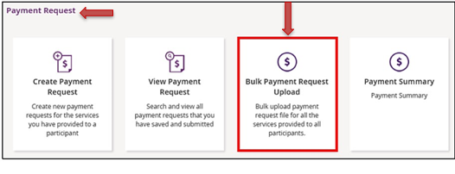
- The Bulk Upload screen appears.
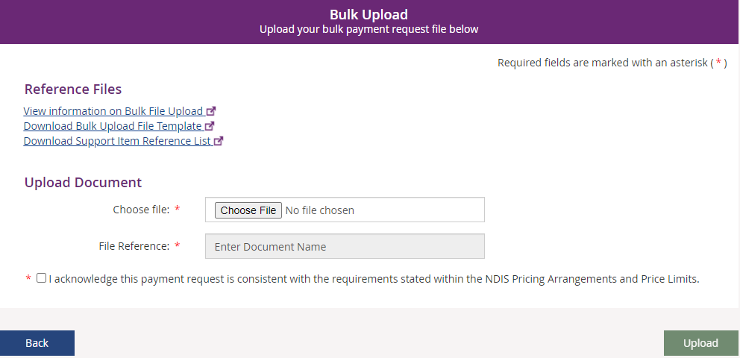

Reference files
This screen has three reference files:
- View Information on Bulk File Upload: is a guide for providers on what and how to record information within the Bulk Upload File Template.
- Bulk Upload File Template: is the bulk payment request template that the provider will need to complete and upload to make the bulk payment request.
- Support Item Reference List: is an excel document that can be downloaded to view all support items (names and codes) that are currently active in service bookings with participants. The Support Item Reference List gives you the support number “code” to put into the CSV file when using bulk upload. For example, to claim for a Daily Activity support for Linen service, you will need to put 01_021_0120_1_1 in the SupportNumber field of the CSV file.
This helps you understand what support items are eligible for payment with your current participants with active service bookings.

Creating the file
You will need to download the bulk upload template to create your bulk upload file from the Bulk Upload screen.
Note: Do not delete any columns from the bulk upload template.
Bulk Upload File Rule | Comments
Download the Excel template as a .csv. | Save the file as ‘comma delimited’.
The filename must not exceed 20 characters in length. | This includes the extension (.CSV) and all characters used in the filename, including the ‘.’ (dot) (e.g., BULKUPLOAD2.CSV is 15 characters.
Do not use special characters in the filename. | This includes \, ?, /, :, *, <, >, | and “.
Line items within the bulk upload file should directly correspond to the number of payment requests. | e.g., 100 rows/lines (excluding the header row) will create 100 payment requests.
There can be up to 5000 rows uploaded using a bulk file. Check there are no extra characters in columns or rows that are beyond the viewable section of the worksheet. | There should be no characters in rows or columns that are beyond the claim data you are entering (e.g., you claims end on row 47, but there is a character in a cell row 102) as this will result in the whole file not loading.
CSV files can be uploaded using the US data format | i.e., YYYY/MM/DD

Completing the Bulk Upload File Template
The following table describes the data required in the Bulk Upload File.
Note: This information is also available in the View Information on Bulk File Upload document located in the Reference files (see page 6). We recommend reviewing that document from time to time for any updates.
Note: Assistive Technology and Home Modification providers should refer to the Assistive Technology, Home Modifications and Consumables Code Guide on the NDIA Pricing arrangements | NDIS page for general claiming rules including AT Supplementary Charge codes and claiming for support items where notional unit prices apply.
Note: Provider travel non-labour costs should be claimed as a Direct Service.
Template Field Name: | Required Data/Information: | Required Format: | Mandatory?
RegistrationNumber | The Provider’s registration number shown in your Profile as Organisation ID. | Number only, no spaces and up to 30 numeric characters.  Organisation ID number will start with ‘405’ and consists of a total of nine digits. | Mandatory
NDISNumber | Participant NDIS Number | Number only, no spaces and up to 20 numeric characters.  Participant NDIA number will start with numbers ‘43’ and consists of a total of nine digits. | Mandatory
SupportsDeliveredFrom | Start date of the support provided | Accepts YYYY-MM-DD or DD-MM-YYYY date format.  Note: Also accepts instead of dashes (-) any of the following:  - Forward Slash ( / )  - Back Slash ( \ )  - Full stop ( . )  - Colon (:)  - Semicolon (;)  - Logical (||) | Mandatory
SupportsDeliveredTo | End date of the support provided | Accepts YYYY-MM-DD or DD-MM-YYYY date format.  Note: Also accepts instead of dashes (-) any of the following:  - Forward Slash ( / )  - Backlash ( \ )  - Full stop ( . )  - Colon (:)  - Semicolon (;)  - Logical (||) | Mandatory
SupportNumber | Support Item number of the service provided from the NDIS Support Catalogue 2019-20. | Up to 60 characters - underscore acceptable. | Mandatory
ClaimReference | The Provider’s own Invoice reference for the payment. | Up to 50 characters, which includes:  - Forward Slash ( / )  - Underscore ( _ )  - Hyphen ( - )  - Alphanumeric | Optional but recommended
Quantity | Number of units. | Up to 5 Numeric characters  Accepts NNNNN OR NNN.NN format.  Can be used to represent hours (e.g. 2.5 hours = 2 hours 30 minutes) but cannot be in hour format (e.g. 2: 30 = 2 hours 30 minutes).  Note: you cannot use both hour and quantity formats for the same claim (i.e. A claim for one session of 2 hours 30 minutes should be either Quantity = 1 Hours = 2:30 or Quantity = 2.5 and Hours = 1). | Mandatory IF Hours are not entered
Hours | Actual duration of the service provided. For example, if the service was provided for 2 hours 15 minutes then enter 2:15 | Hours format:  HHH:MM e.g. 2: 30 = 2 hours 30 minutes.  Cannot use decimal format (e.g. 2.5 hours = 2 hours 30 minutes).  Note: you cannot use both hour and quantity formats for the same claim (i.e. A claim for one session of 2 hours 30 minutes should be either Quantity = 1 Hours = 2:30 or Quantity = 2.5 and Hours = 1). | Mandatory IF Quantity is not entered
UnitPrice | Price per unit sold or the hourly price of the service provided. | Up to 8 Numeric and 2 decimal digits, e.g.: NNNNNNN.NN | Mandatory
GSTCode | GST as applicable to the item or service.  P1 = Tax Claimable (10%)  P2 = GST Free  P5 = GST out of Scope | P1 or P2 or P5 | Mandatory
AuthorisedBy | Legacy data can be left blank | Not Applicable | Not Applicable
Participant  Approved | Legacy data, can be left blank | Not Applicable | Not Applicable
InKind  Funding  Program | Not Applicable | Not Applicable | Not Applicable
ClaimType | Claim type of the service provided:  “(Blank)” Direct Service. You must leave field blank.  CANC: Cancellation Charges – Short Notice Cancellation  REPW: NDIA Required Report  TRAN: Provider Travel.  NF2F: Non-Face-to-Face Services  THLT: Telehealth Supports  IRSS: Irregular SIL Supports | “(Blank)” or CANC or REPW or TRAN or NF2F or THLT or IRSS  Note this must be capitalised. | Mandatory
CancellationReason | Reason of the cancellation type:  NSDH: No show due to health reason.  NSDF: No show due to family issues.  NSDT: No show due to unavailability of transport.  NSDO: Other. | NSDH or NSDF or NSDT or NSDO  Note this must be capitalised. | Conditional (only applicable to Short Notice Cancellations)
ABN of Support Provider | It is the unique Australian Business Number (ABN) of the provider who provided this support or service.  The ABN is documented on the tax invoice, regular invoice or receipt issued by the support provider.  If ABN is not available, then any one of the exemption reason codes can be used:  REIMB: Participant Reimbursement – You are declaring that this payment request is a reimbursement to a participant for services and goods purchased in accordance with the funded supports outlined in the participants NDIS plan. By selecting this, you must be able to provide the tax invoice and other relevant documentation should the NDIA request it.  EXCLS:ATO Excluded Supply – You are declaring that this payment request is being made to a supplier in connection with a supply that is excluded from the withholding tax rules. By selecting this, you are declaring that the supplier has provided you with the completed ATO form ‘Statement by Supplier’ and you are able to provide the completed form on request. | A valid ABN has 11 digits or REIMB or EXCLS. | Conditional.  Complete this field when claiming against plan managed service bookings.  If the ABN of the support provider is available, enter it in the field.  If the ABN of the support provider is unavailable, then enter any one of the following reason codes in this field:  - EXCLS  - REIMB  Any other value, including blank, is not accepted, when claiming against plan managed service bookings.  If you are making a claim against a standard service booking, leave the field blank.

Upload document
- From the Home screen, click the Payment Request tile.
The Payment Request screen displays.
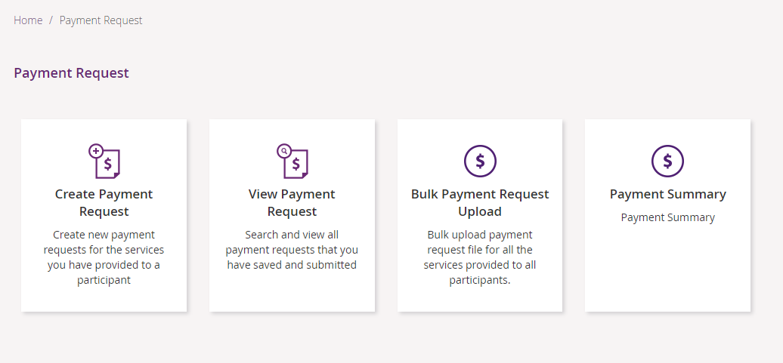
- From the Payment Request screen, select the Bulk Payment Request Upload tile.
The Bulk Upload screen displays.
- From the Bulk Upload screen, complete the following:
  - In the Choose File field, click the button to upload your Bulk Payment Request file.
  - In the File Reference field, enter a file reference number.
  - Check the acknowledgement that this payment request is consistent with the requirements stated within the NDIS Pricing Arrangements and Price Limits.
! Warning !: Once you have saved the ‘Bulk payment request’ file, you must keep it open and upload the document. Do not close the ‘Bulk payment request’ file to upload the document as you will receive an error message.
- Select Upload.

Successful file upload
If the Bulk Payment Request file meets the upload validation requirements, a message will be displayed advising that the file has been submitted and is pending payment validation. Note that file processing may not be immediate.
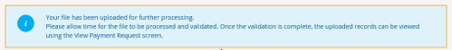
To verify that the bulk payment request has been processed and ensure the individual payment requests are valid, proceed as follows:
- From the Home screen, click the Payment Request tile.
The Payment Request screen displays.
- From the Payment Request screen, select the View Payment Request tile.
The Find screen displays.
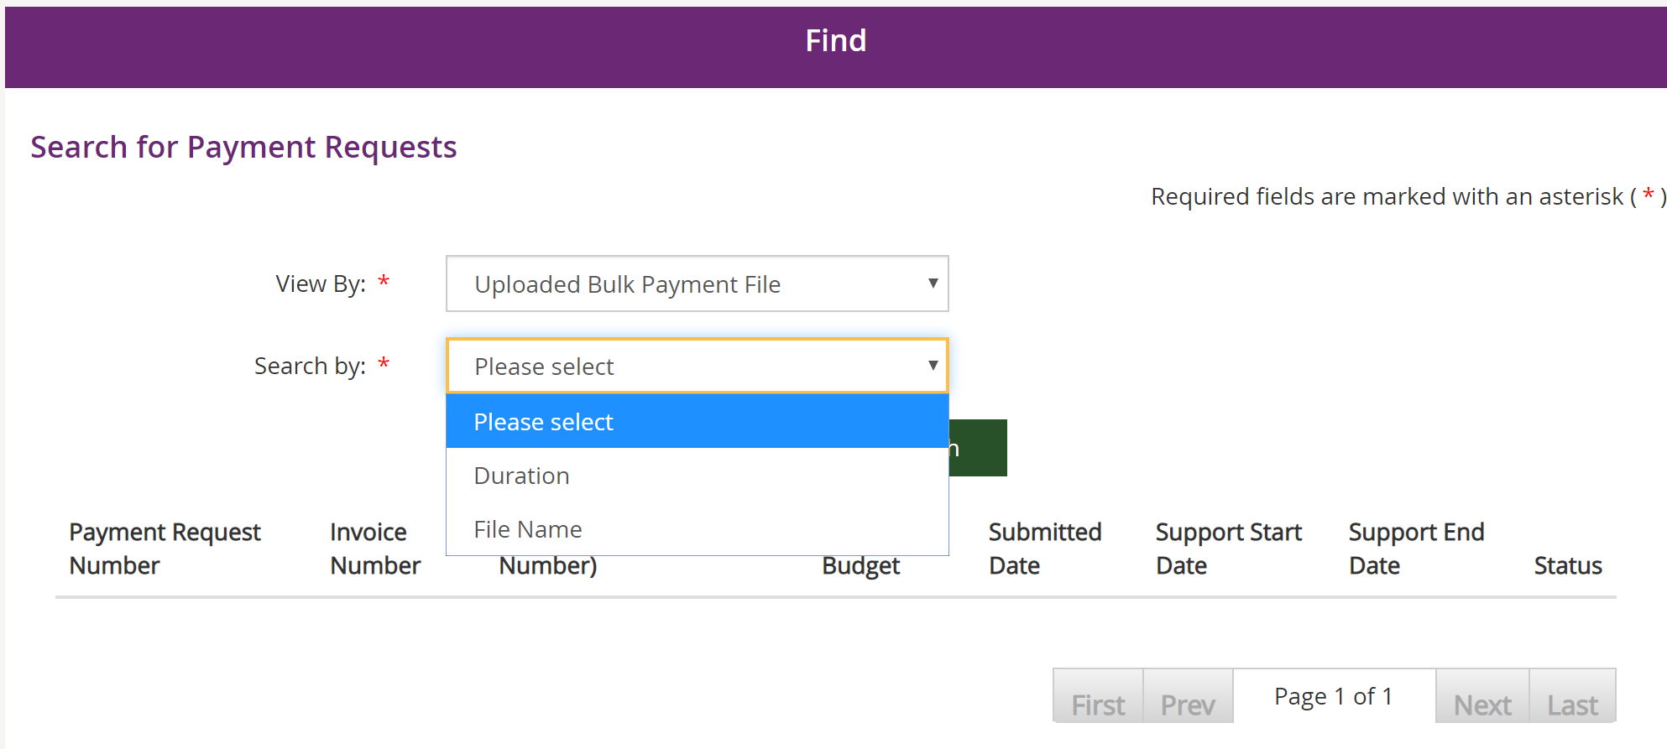
- In the Find screen, complete the following:
  - From the View By drop-down, select Uploaded Bulk Payment File.
  - From the Search by drop-down, select search criteria as required:
    - If you select File name, enter the bulk file name.
    - If you select Duration, enter the ‘From Date’ and ‘To Date’.
- Click Get Files.
The results display in the lower half of the Find screen.
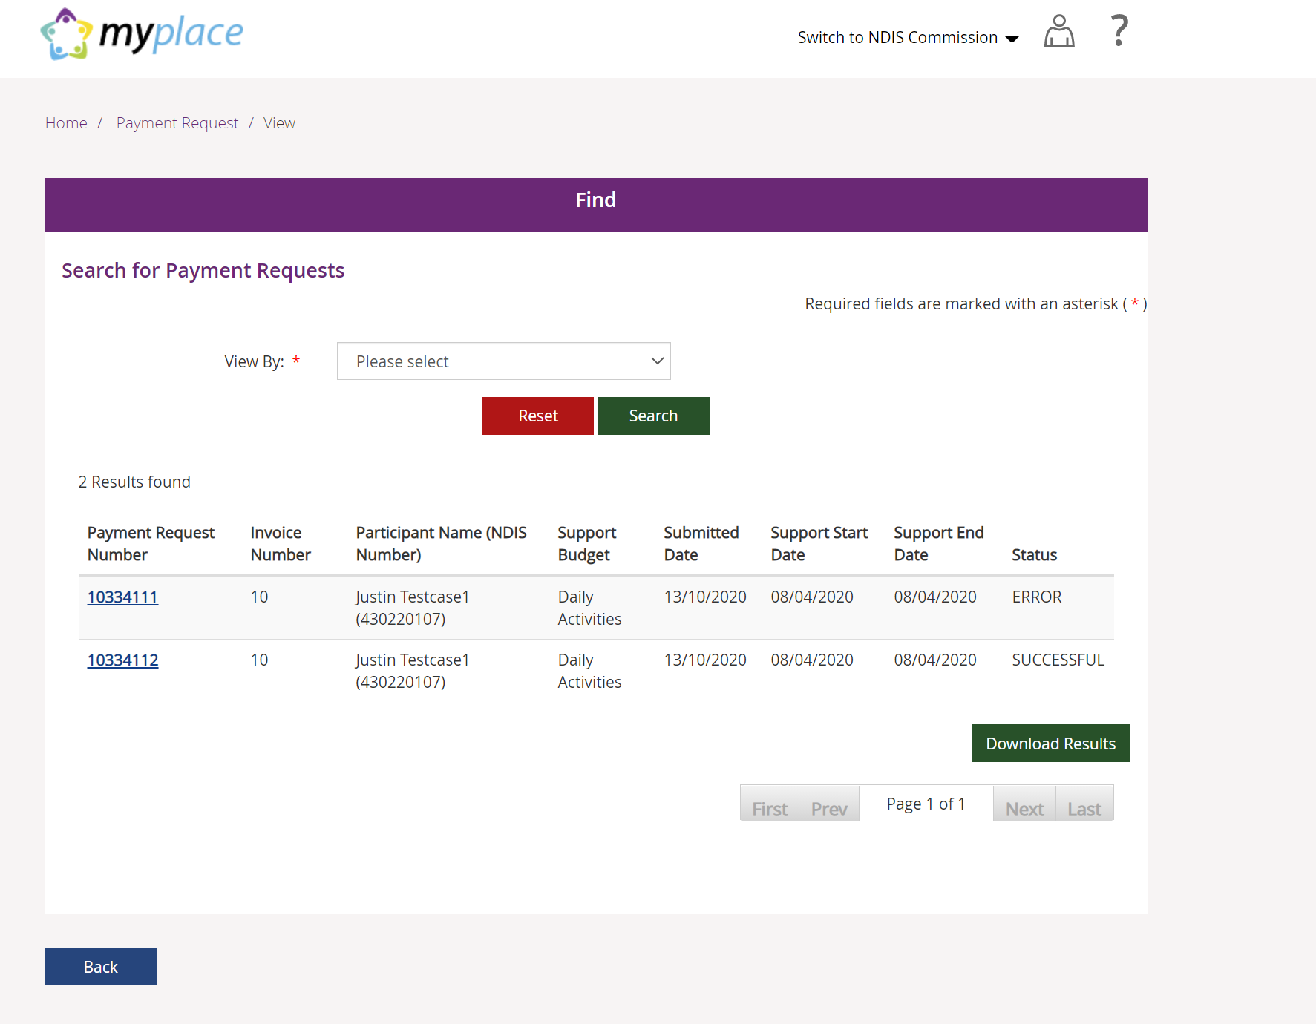
The table below explains what the different statuses mean.
Status | Definition
SUCCESSFUL | The payment request has been submitted successfully
ERROR | The payment request has not been submitted successfully and further action needs to be taken.

Unsuccessful file upload
If the bulk payment request file does not meet the upload validation requirements, a message will be displayed advising that the file validation has failed.
In addition, an error file specifying the errors (column A) in the file will be available to download and view so you can make the required changes to the original file.
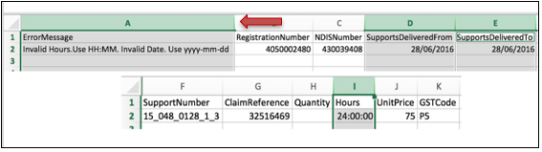
Note: When uploading the corrected bulk upload file, please ensure that the file is renamed, as it cannot be the same name as a file previously uploaded (successful or unsuccessful).

Verifying the bulk upload and correcting the error
- From the results area of the Find screen, select the Payment Request Number with an ERROR status to see the type of error.
- Click the Payment Request Number link of the file with the ERROR status.
The Payment Request Details screen displays.
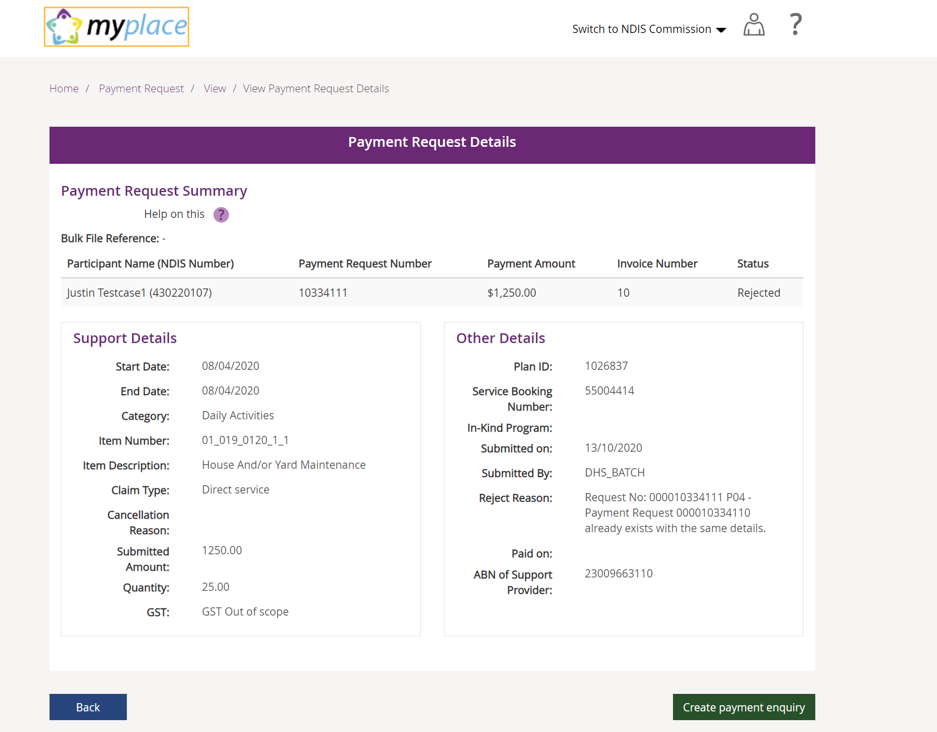

- Read the message in the Reject Reason field, then select Back.
The Find screen displays.
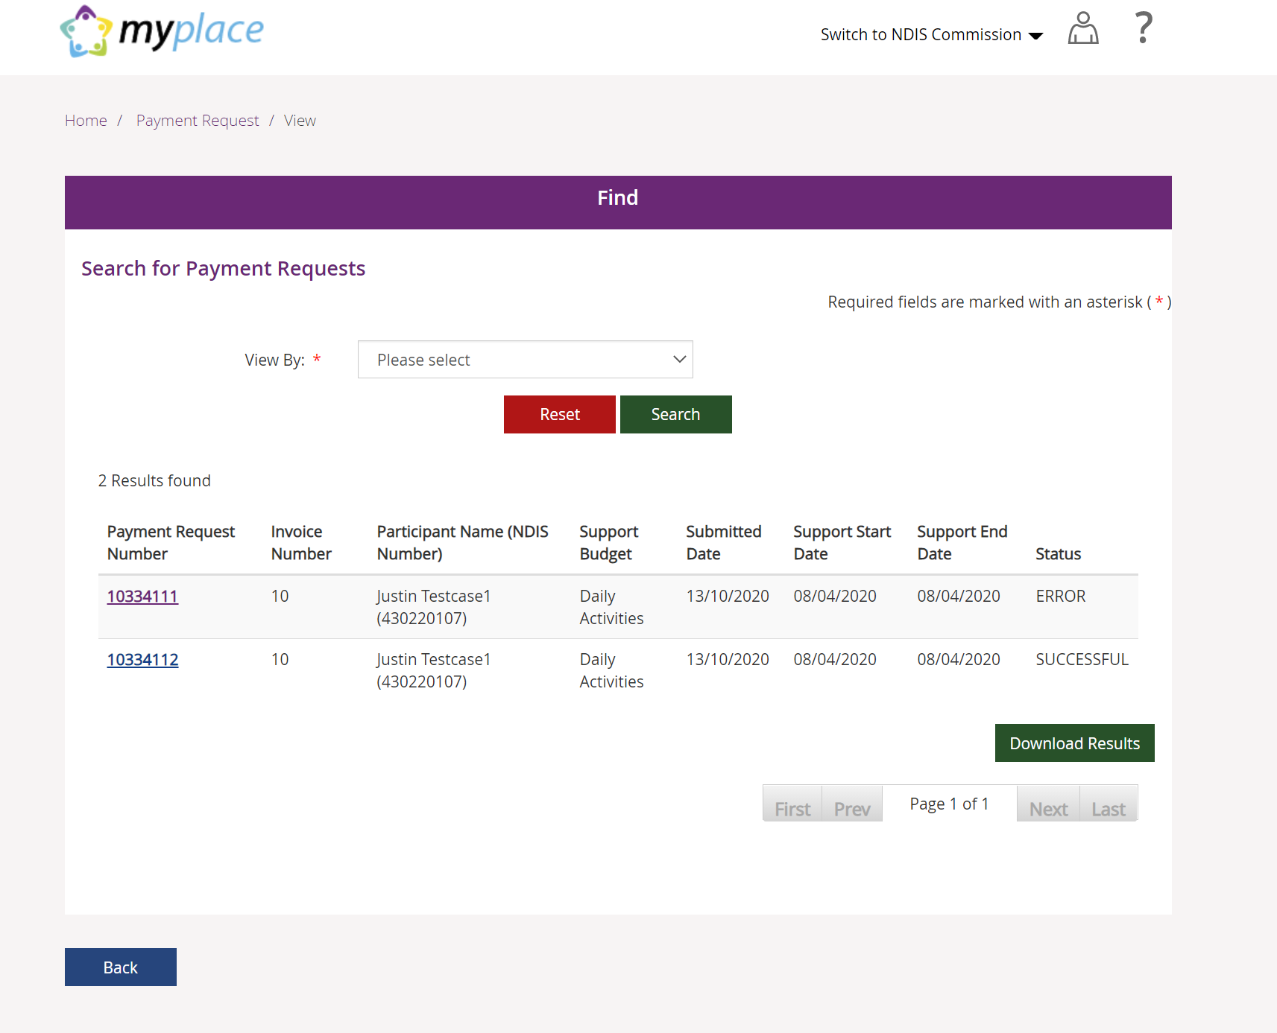
4. In the Find screen, click Download Results to open the bulk upload file and correct any errors.

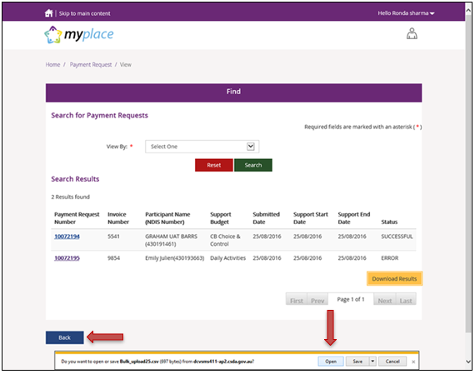
The CSV file can be opened with Microsoft Excel and edited to correct the error. In the example below, the quantity had been exceeded (2.0) but has now been corrected to 1.
Make sure to only edit the record(s) with an error. You can keep the same Claim Reference number.
- Save the CSV file with a different name, only including the edited records, and re-upload using the Bulk Upload function. In a situation where you may have several errors, the new CSV file would include as many line items as there are errors, and the header line.
Note: Where the payment amount entered is greater than maximum per unit catalogue price for that item, the system will only pay up to the maximum catalogue price, refer to the NDIS Pricing Arrangements and Price Limits.
In such scenarios the claimed amount will be different to the paid amount and it will be marked in the bulk reconciliation file downloaded by the user (see Payment Reconciliation section below). The field Capped will be populated with a value of YES or NO based on the following:
- Where the amount paid is different than the amount claimed, then
Capped = YES.
- Where the amount paid is same as amount claimed, then
Capped = NO.

Payment reconciliation of a bulk payment request upload
You can check the submission status of each Payment Request in the View Payment Request tile to compare this against the uploaded file.
You can check the reason for each incomplete Payment Request by selecting the payment request number once you have selected Uploaded Bulk Payment file.
- From the Home screen, click the Payment Request tile.
The Payment Request screen displays.
- From the Payment Request screen, select the View Payment Request tile.
The Find screen displays.
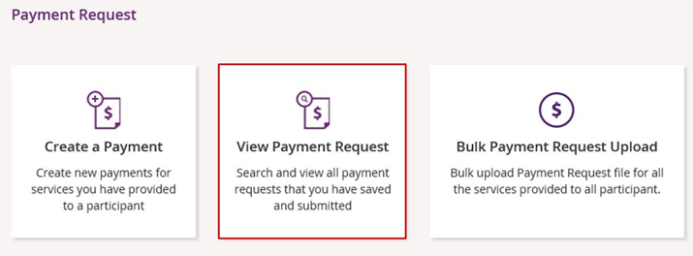
- In the Find screen, from the View By drop-down, select Uploaded Bulk Payment File.
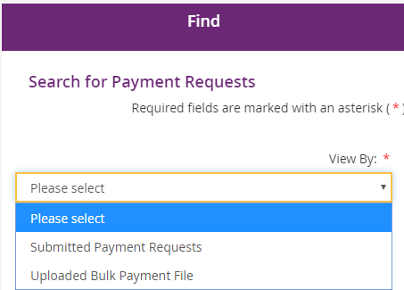

- Select the search criteria from the Search by: drop-down:
- If you select File name, enter the name of the bulk upload file.
- If you select Duration, enter the ‘From Date’ and ‘To Date’.
- Select Get Files then choose the file from the File Name drop-down list.
- The relevant payment requests will display in the bottom half of the Find screen.
- Payment Requests with a status of Rejected have failed due to some type of validation error (e.g. the support item price is not valid for the service dates being claimed).
- Payment Requests that have been Rejected (or claims that do not create a Payment Request), must be rectified and reloaded. A ‘Rejected’ claim cannot be fixed in the portal, it will remain in ‘Rejected’ status forever, and a new request needs to be created.
- If your bulk upload results in Rejected Payment Requests or fails to create some requests, you should NOT reload the whole file. Create a new file with only those line items that failed and fix the issues before attempting to reload.
Note: Payment Requests will not appear in the View Payment Request tile on the portal.
The Bulk Payment request outcomes are:
Status | Outcome
Pending Payment | View in Payment Request Tile
Rejected | Not Available in Payment Request Tile

Searching for payments that have not yet been paid
To identify payments that were made in bulk and have not yet been paid, you are able to utilise the search function.
- From the Home screen, select the Payment Request tile.
The Payment Request tile displays.
- Select the View Payment Request tile.
The Find screen displays.
- In the Find screen, from the View By drop-down, select Submitted Payments Request from the drop-down list.
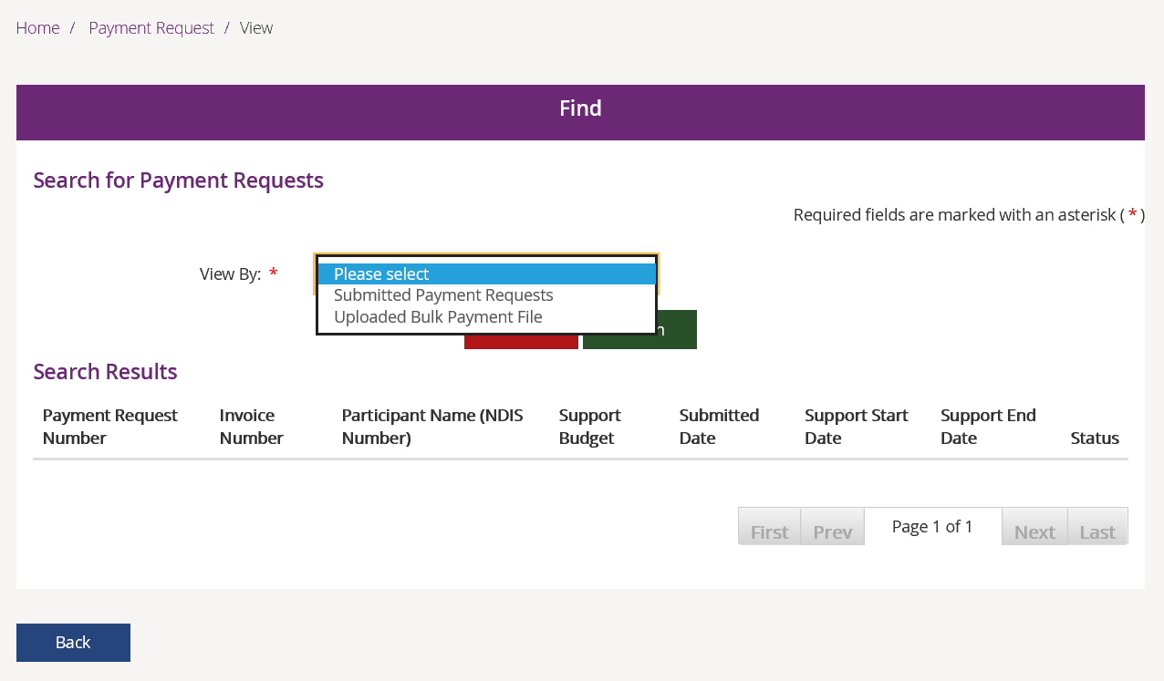

- From the Search by drop-down select submitted date.
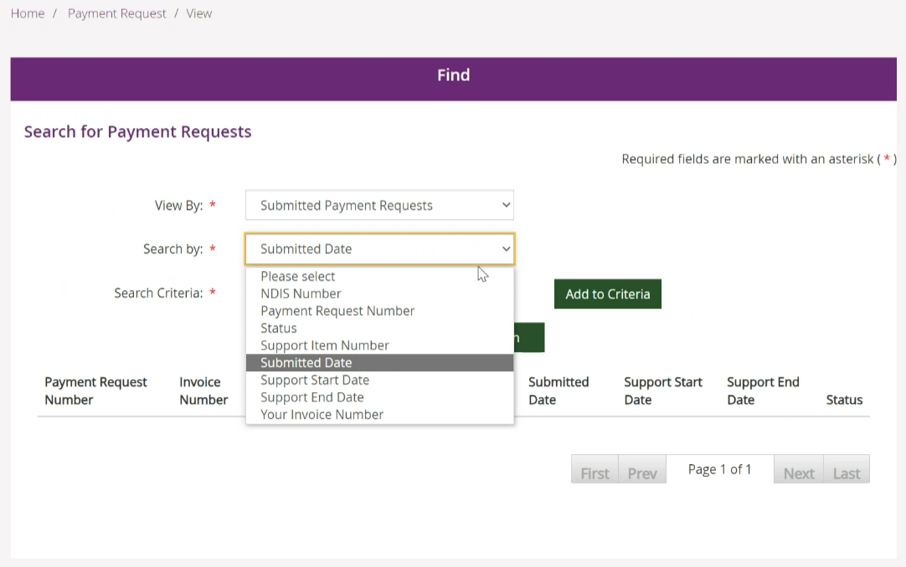
- Select the date that you submitted the bulk file.
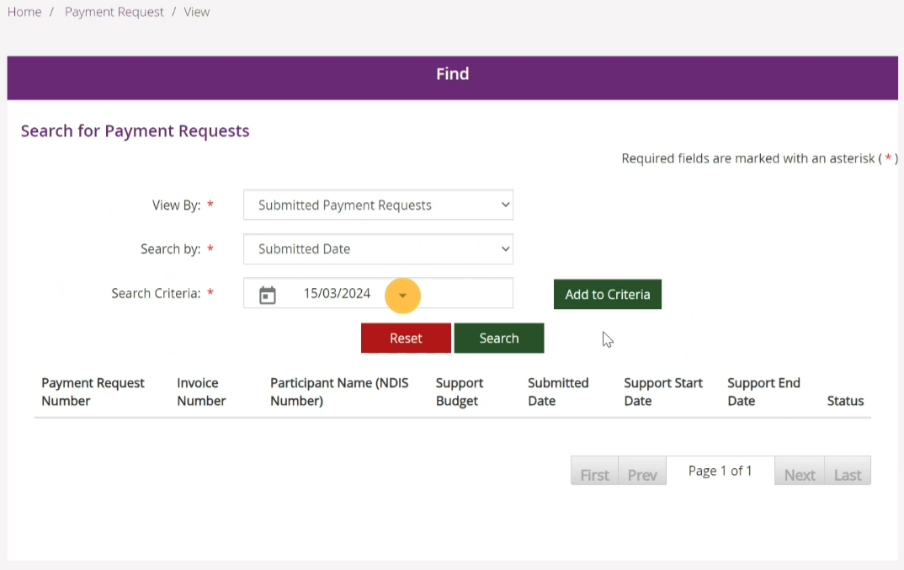

- Select Add to Criteria.
Select the Search by drop-down and select Status.
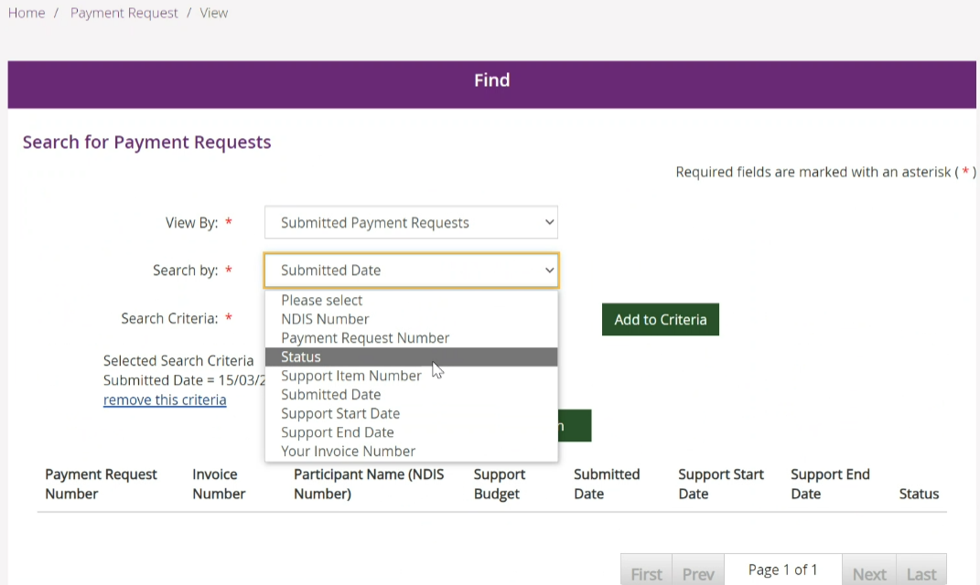

- Select the Search Criteria drop-down and select Pending Payment.
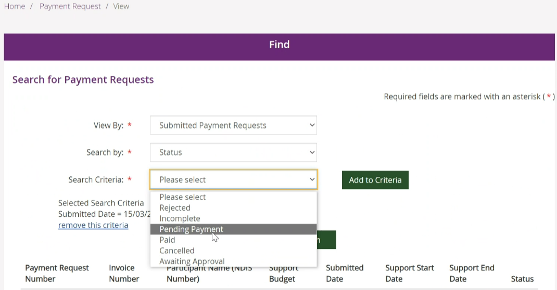
- Select Add to Criteria.
The search criteria are added.
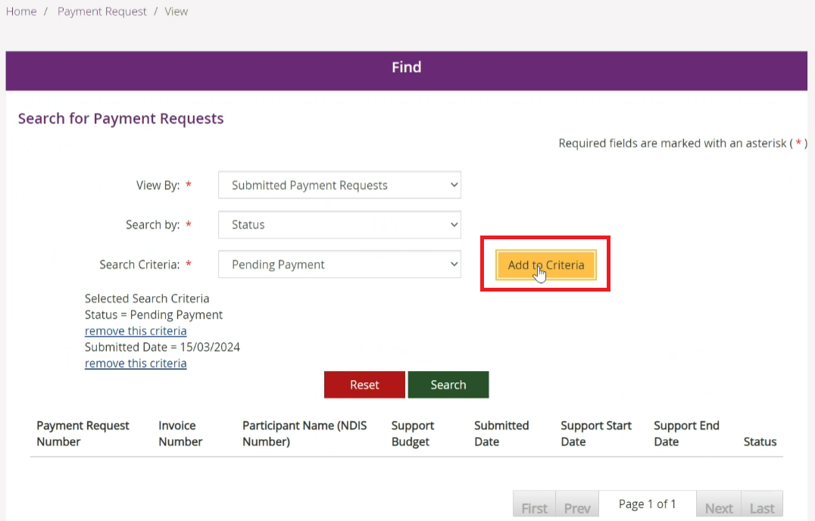

- Select Search. Your search results display in the bottom half of the Find screen.
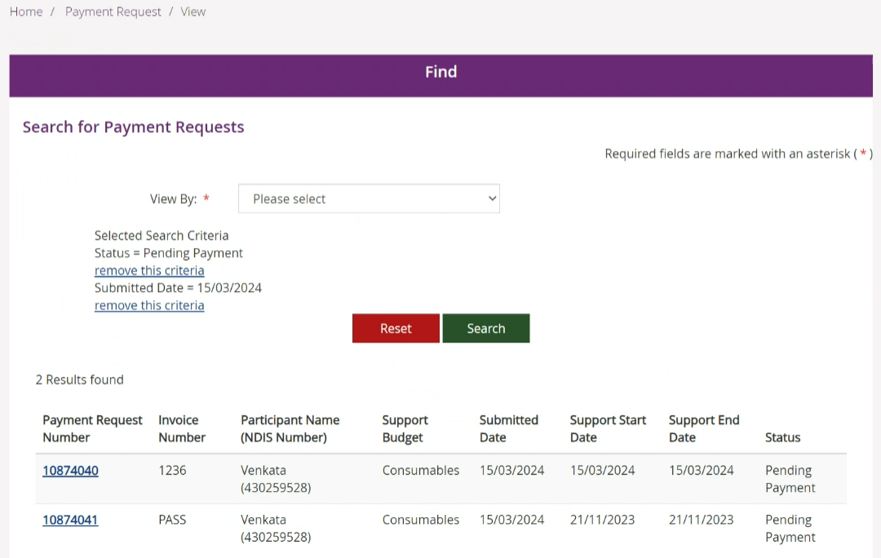

Raise a payment enquiry from an existing payment request
- Select the relevant payment request and the payment request displays in the Payment Request Details screen.
- Select Create payment enquiry.
- Upon selecting Create Payment Enquiry you will be redirected to the my NDIS provider portal to submit your payment enquiry. For further instructions, please refer to my NDIS provider portal step by step Guide located in the myplace provider portal and resources | NDIS.

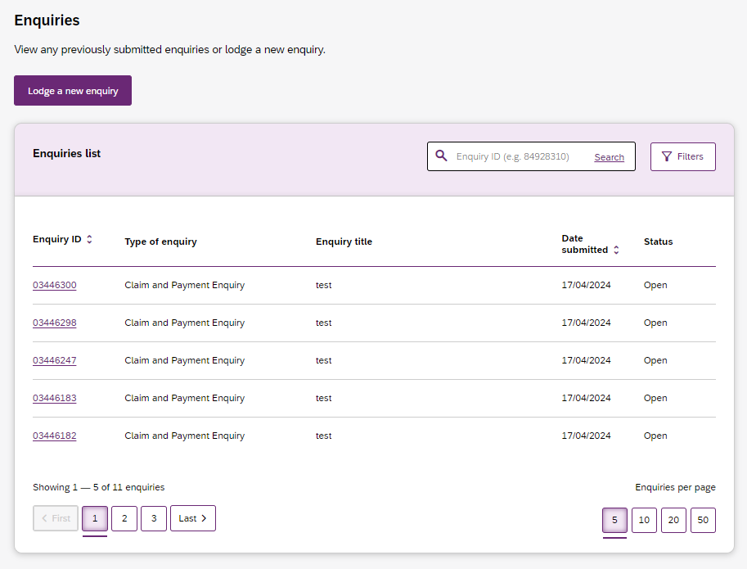

Receiving payment
Payment requests that are created with a status of Pending will be paid after the next payment run cycle. This occurs at least once a day, Monday to Friday.
A status of Pending will usually change to Paid following the completion of a payment run cycle.
Payment Requests created after the last payment run cycle on a Friday will be picked-up in the payment run cycle of the next business day – typically the next Monday.

Part 2: Warnings and error messages
This part of the guide is to help you understand:
- The meaning of the warnings and error messages in the myplace provider portal when you upload the bulk payment files.
- What to do when each error message is displayed
The following tables describe the error messages displayed in the NDIS myplace provider portal when submitting a bulk payment file. The tables include:
- Screen Name – the heading at the top of the screen on which the message appears
- Message Displayed – the wording of the message itself, which may be in a pop-up box, at the top of the screen, or near the field in error
- Type of Message – whether the message is for an error which prevents you progressing, for confirmation to warn you of the consequences, or for information
- What does it mean? – an explanation of why you got the message
- What should you do? – describes suggested response(s) to the message.
If you need further information on how to manage a particular message, search the ‘Message Displayed’ column for a few words from the message, or search the ‘Screen Name’ column for the screen. Once you have located the message, check the last two columns for more detail of what occurred, and how to proceed.

Screen name: Bulk Upload
Message displayed | Type of message | What does it mean? | What should you do?
Use your new provider registration number for the new system. You can find it in your profile details.  The In-Kind item is not yet available to claim. | Warning | Advising you that you need to use your new provider registration number.  Advising you that you must not include ‘in-kind’ items in your payment requests. | Check when you create your bulk upload file that the provider registration number matches your organisation Id in your profile (Select Home, Profile, My Organisation Details to check).  You must not include ‘in kind’ items in your bulk upload request.
You have not selected a file, or have selected a file that does not have a CSV or XML extension. Check that you have selected a file and that it is a valid CSV or XML file. Refer to the Bulk Payment self help guide if you have any issues. | Error | You have either not selected a file, or have selected a file that does not have a CSV or XML extension. | Check that you saved the Bulk Payment Request file as a .CSV or .XML and retry.  Open the file, ensure the date formats are correct (YYYY-MM-DD), and save as a CSV. Refer to the Bulk Payment self help guide.
The document size exceeds the maximum upload limit of 10MB. Please amend the document and try uploading it again. | Error | The file you are trying to upload is too large. | Bulk upload will not allow a file larger than 10MB. Sometimes a file larger than 10MB but smaller than 11MB will display as 10MB in size.  Open the bulk upload file and save as two files (half the records in each file), making sure you check that the date formats are correct (YYYY-MM-DD).
You have attempted to upload a file that exceeds 10MB in size. Open the bulk upload file and save it as 2 or more files (splitting the records across the files). Check that the date formats are correct (YYYY-MM-DD). Then try uploading it again. | Error | The file you are trying to upload is too large. | You have attempted to upload a file that exceeds 10MB in size. Open the bulk upload file and save it as 2 or more files (splitting the records across the files). Check that the date formats are correct (YYYY-MM-DD). Then try uploading it again. The document size exceeds the maximum upload limit of 10MB. Please amend the document and try uploading it again.
You have attempted to upload a file with a file name (including the file extension) that exceeds 20 characters in length. Resave the file with a shorter filename, check that the date formats are still correct (YYYY-MM-DD). Then try uploading it again. | Error | The file name including the extension (.CSV or .XML) is more than 20 characters. | Resave the file with a filename (including extension) of less than 20 characters, check that the date formats are still correct (YYYY-MM-DD). Then resubmit.
You tried to upload a file that includes more than 5000 payment references. This volume of data exceeds our system limits. Open the file and save as two or more files, each containing a subset of the data. Then try uploading it again. | Error | Bulk upload will not allow a file larger than 5000 rows. Your file contains more than that. | Open the file and save as two or more files each containing a subset of the data, then resubmit.
The file you tried to upload is missing the first row (header) or it has incorrect data. Download the template again into a new file and copy the data into the new file. Check you have retained the header row and that all columns are correctly formatted (including dates). Then try uploading it again. | Error | The first row (header) of your file is missing or has incorrect data. | Download the template again into a new file, copy the data into the new file ensuring you retain the header row and that all columns are correctly formatted (including dates), then resubmit.
Your file could not be uploaded as one or more records are in error. Select the download link to access the error file. The error file is the same as the file you uploaded, but with an extra column at the beginning listing the errors in that payment request. Correct the errors and save the file with a new file name. Then try uploading it again. | Error | Errors were found in one or more rows in the file. | Select the download link to access the error file. The error file is the same as the file you uploaded, but with an extra column at the beginning listing the errors in that payment request. Correct the errors, save the file with a new file name and retry upload.
To upload you need to accept the price guide declaration. | Error | You selected then deselected the mandatory NDIS Pricing Arrangements and Price Limits declaration. | Tick the mandatory NDIS Pricing Arrangements and Price Limits declaration box and then select Submit.
There are some technical issues, we are unable to process your request. Please try again later. | Error | An internal system error has occurred. | Wait for a short time then try again, or contact NDIS to report the problem and have it investigated.
A system error occurred. Try again later, or call the NDIS to report the problem. | Error | An internal system error has occurred. | Wait for a short time then try again, or contact NDIS to report the problem and have it investigated.
You have successfully uploaded your file for further processing. Wait a day or so for the file to be processed and validated. Once the validation is complete, you will be able to view the uploaded records using the View Payment Request screen. | Confirmation | Your payment requests file has been uploaded for processing. | Wait for a day or so, then use the ‘View Payment Requests’ screen to check the status of the individual payment requests.  Select ‘Home’, ‘Payment Request’, ‘View Payment Requests’. Select ‘View’ by ‘Uploaded Bulk Payment File’.
Multiple business validations failed. | Error | The payment request record has more than one validation rule that failed. | Check all the details submitted for each failed payment request to determine what caused the failures.  Make the required changes to the original file, save, rename file and upload the corrected bulk upload file.

Screen name - Bulk Payment Request CSV Messages
Messages displayed | Type of message | What does it mean? | What should you do?
Empty Registration No. | Error | This payment request is missing your provider registration number. | Enter your provider registration number, it must be numbers only and can be found under ‘My Organisation Details’ on the Profile page.
Invalid Registration No. | Error | Your provider registration number is not valid on this payment request. | Check that your provider registration number is correct, it must be numbers only and can be found under ‘My Organisation Details’ on the Profile page.
Empty NDIS No. | Error | This payment request is missing the Participant’s NDIS Number. | Check the NDIS number for the participant. Enter as 9 digits, no spaces, starting with ‘43’.
Invalid NDIS No. | Error | The participant’s NDIS Number is invalid on this payment request. | Check the NDIS number for the participant. Enter as 9 digits, no spaces, starting with ‘43’.
Empty Start Date. | Error | The start (From) date on this payment request is empty. | Enter the start date for the support in the format YYYY-MM-DD. You need to ensure that the date fields are correctly formatted before you upload the file. Excel will reformat them if you open and edit anything in the file.
Invalid Start Date format. Enter as YYYY-MM-DD. | Error | The start (From) date on this payment request is not in the required format, or is before 1900. | Enter the start date for the support in the format YYYY-MM-DD. Start date must be no earlier than the start date of the service booking, and cannot be in the future. You need to ensure that the date fields are correctly formatted before you upload the file. Excel will reformat them if you open and edit anything in the file.
Empty End Date. | Error | The end (To) date on this payment request is empty. | Enter the end date for the support in the format YYYY-MM-DD. You need to ensure that the date fields are correctly formatted before you upload the file. Excel will reformat them if you open and edit anything in the file.
Invalid End Date format. Enter as YYYY-MM-DD. | Error | The end (To) date on this payment request is not in the required format, or is before 1900. | Enter the end date for the support in the format YYYY-MM-DD. End date must be the same as or later than the start date. End date must be no earlier than 90 days prior to today. You need to ensure that the date fields are correctly formatted before you upload the file. Excel will reformat them if you open and edit anything in the file.
Empty Item Number. | Error | The item number on this payment request is empty | If the service booking specifies support item enter the support item number.  If the service booking was not at item level, enter the item number of the support category.
Invalid Item Number. | Error | The Item number on this payment request is too long (more than 60 characters). | Copy the item number from the service booking to ensure it is correct.
Empty GST Value. | Error | The GST code on this payment request is empty. | Enter the appropriate GST value for the support item. P1=10%GST, P2=GST Free, P5=GST Out of Scope.
Invalid GST Value. | Error | The GST code value on this payment request is not valid. | Enter the appropriate GST value for the support item. P1=10%GST, P2=GST Free, P5=GST Out of Scope.
Invalid Claim Reference. | Error | The invoice number/claim reference on this payment request is too long (more than 50 characters) or contains invalid characters. | Enter your organisation’s invoice or reference number. It must be no more than 50 characters and contain letters, numbers and spaces only.
Empty Quantity and Hours. | Error | Both quantity and hours are empty on this payment request. | Enter either hours (in the format HHH:MM without leading zeros) or Quantity (in whole numbers), but not both, for each payment request (row).
Invalid Quantity Value. | Error | The quantity specified in this payment request is not in the required format. | Enter the quantity as a whole number, i.e. without decimal points.
Invalid hours. Use HH:MM format. For e.g.: 2 hours 30 minutes as 2:30. | Error | The hours specified in this payment request is not in the required format. | Enter the hours in the format HHH:MM without leading zeros. E.g. two and a half hours is 2:30, thirteen hours is 13:00.
Both duration and quantity cannot co-exist. Input relevant value. | Error | You have specified both hours and quantity in the same payment request, it cannot include both. | Enter either Hours (in the format HHH:MM without leading zeros) or Quantity (in whole numbers), but not both, for each payment request (row).
Empty Unit Price. | Error | The unit price on this payment request is empty. | Enter the unit price. The unit price applies either to the hours or the quantity, whichever is relevant for this row. Unit price must be in dollars and cents without the $.  The unit price should be formatted as 0.00
Invalid Price. | Error | The unit price on this payment request is not a valid price. | Enter the unit price in dollars and cents without the $.  The unit price should be formatted as 0.00
Start date of support cannot be after support end date. | Error | The start date for this payment request is after End date. | Enter the start date for the support in the format YYYY-MM-DD.  Enter the end date for the support in the format YYYY-MM-DD. End date must be the same as or later than the start date. End date must be no earlier than 90 days prior to today. You need to ensure that the date fields are correctly formatted before you upload the file. Excel will reformat them if you open and edit anything in the file.
Start date of support cannot be in future. | Error | The start date for this payment request is after today. Payments cannot be made prior to services being delivered. | Enter the start date for the support in the format YYYY-MM-DD. Start date must be no earlier than the start date of the service booking, and cannot be in the future. You need to ensure that the date fields are correctly formatted before you upload the file. Excel will reformat them if you open and edit anything in the file.
End date of support cannot be in future. | Error | The end date for this payment request is after today. Payments cannot be made prior to services being delivered. | Enter the end date for the support in the format YYYY-MM-DD. End date must be the same as or later than the start date. End date must be no earlier than 90 days prior to today, and cannot be in the future. You need to ensure that the date fields are correctly formatted before you upload the file. Excel will reformat them if you open and edit anything in the file.
Invalid ABN (Australian Business Number) | Error | An ABN has been entered incorrectly and is not a valid ABN number. | Review the ABN entered and re-enter a valid ABN.
ABN exemption reason is invalid | Error | The ABN exemption reason has been entered incorrectly. | Review the ABN exemption reason entered and re-enter a valid ABN exemption reason.
Invalid Claim Reason. | Error | Your organisation’s invoice or reference number (Claim reason) in this payment request is not valid. | Enter your organisation’s invoice or reference number. It must be no more than 50 characters and contain letters, numbers and spaces only.
Invalid Date Format. | Error | Either one or both of the Start (From) and End (To) dates on this payment requests is not in the format YYYY-MM-DD. | Ensure both start and end date are in the format YYYY-MM-DD, are not in the future, are within the service booking dates, and that end date is no earlier than start date.
Invoice Date outside Service Booking. | Error | The dates you have entered do not fit entirely within the service booking dates. | Re-enter the dates ensuring they are within your existing service booking.

Part 3: Bulk payment rejections
This part of the guide is to help you understand:
- The meaning of the Bulk Upload payment rejection
- What to do when a bulk payment rejection is displayed
The following tables describe the rejected messages that are displayed in the bulk payment spreadsheet and can be viewed in View Payment Request tile, Uploaded Bulk Payment File.
  - Message Displayed – The message displayed against a payment request rejection.
  - What does it mean? – An explanation of what may have caused the rejection.
  - What should you do? – Describes the suggested actions or next steps.
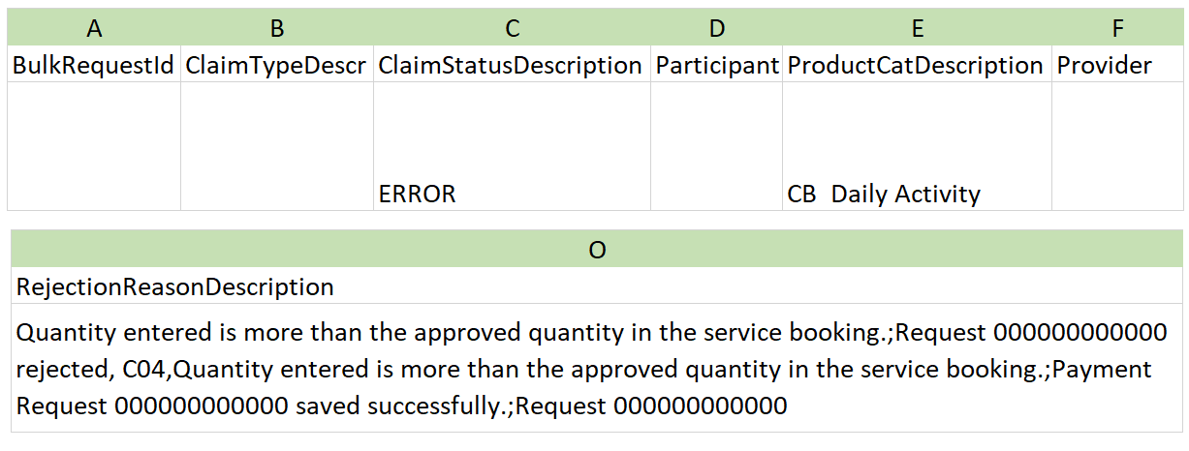

The message displayed column lists the rejections in order of most common rejection.
If you need further information on how to manage a particular message, search the ‘Message Displayed’ column for a few words from the message, or search the ‘Screen Name’ column for the screen. Once you have located the message, check the last two columns for more detail of what occurred, and how to proceed.

Bulk payment request rejections
NOTE: The codes that are displayed in red are newly added.
Validation Code | Message displayed | What does it mean? | What should you do?
MB1 | Claim can’t be processed. There are multiple fields which need checking. Please check all information and resubmit or contact the NDIS for help. | The payment request record has more than one error. | Check all the details submitted for each failed payment request to verify the information that you have entered is accurate.
M01 | Support start and/or end dates are not valid | The support start and/or end dates are not valid. | Enter the start and end dates for the service delivered.  Create a service booking with the correct start date and end date and then request payment for services.  The start and end dates must be in the format YYYY-MM-DD.
M02 | Product selected is incorrect. | You tried to create a payment request for a support line item that is not in the selected support category. | Check that you have entered the correct support line item for this service booking.
M03 | Insufficient evidence or authorisation provided | Correct documentation is not held by NDIS | Upload the correct documentation that is required to complete the payment request.
M04 | Incorrect participant, service booking or provider selected | You have selected an incorrect participant, service booking or provider | Check that you have selected the correct participant, service booking and provider.  You will need to create a service booking with the correct details and then request payment for services.  You might be unable to create a service booking within the relative plan as it has expired. You will need to contact NDIS for help
M05 | Selected quantity or unit price is incorrect. | The quantity and unit price specified in this payment request is not correct. | Enter the quantity as a whole amount, i.e. 1  Enter the unit price for the payment request.  The unit price must be in dollars and cents without the ‘$’ symbol, i.e., 98.06.  The unit price should be formatted as 0.00.
M06 | GST code selected is incorrect | The GST code selected is not valid. | Enter the appropriate GST value for the support item. P1=10%GST, P2=GST Free, P5=GST Out of Scope
M07 | Payment request could not be successfully submitted due to some reason. Contact customer service centre for further information. | Payment request was unsuccessful. | Contact NDIS for help.
P03 | Requested amount of [$amount] is more than the participant budget amount of [$amount] | The payment amount you have requested is more than the available budget. | Contact the Participant and advise that there is no support budget available in the service booking.
P04 | Payment Request [Payment request number] already exists with the same details | You have created a payment request with the same details as another payment request | You will need to cancel the paid payment request for the same support line item and consolidate the multiple support line items for the same day under one payment request.  Or  Contact the NDIS for help.
P05 | Maximum allowed claims for given Claim Reference Number reached. | You have claim more than twice for the same Claim Reference number. | Check that you have entered the correct claim reference number.  OR  Check your records that you have been paid twice for the same reference number.  You cannot claim for the same claim reference number twice.
S01 | We couldn't find a plan that matches the NDIS number you provided. Check the NDIS number and resubmit with the correct NDIS number for the participant. | The NDIS number you have provided does not match the plan.  You could have entered a parent or nominee NDIS number and not the NDIS number for the participant. | Check the NDIS number and resubmit with the correct NDIS number for the participant.
S02 | Error occurred when creating claim. Check all details in the claim and then resubmit or contact NDIS for help. | The claim line-item record cannot be created due to an unexpected error. | Check all your details in the claim and then resubmit  Or  contact the NDIS for help.
C01 | Service booking does not exist. | The participant does not have a service booking created within this plan period. | Create a service booking within the relevant plan period.
C02 | Service booking for the product entered is still awaiting approval. | The provider is required to tick the ‘Service Booking Declaration’  Or  The provider has not approved the service booking created by the participant. | Check the service booking and tick the ‘Service Booking Declaration’ check box.  Or  Approve the service booking created by the participant.
C03 | Support start/end dates entered are outside the service booking dates. | The support start and/or end dates are not within the service booking period. | Enter the start and end dates for the service delivered. Create a service booking with the correct start date and end date and then request payment for services.  The start and end dates must be in the format YYYY-MM-DD.
C04 | Quantity entered is more than the approved quantity in the service booking. | The quantity you have entered is above the quantity in the service booking. | Check the plan and confirm the quantity is listed in the relevant service booking. You may need to create a new service booking.  Alternatively, contact the participant and advise them that there may be no support funding available in their plan.
C05 | No approved service booking exists for the selected product within the selected start/end dates. | You have tried to create a payment request without an approved service booking within the start and end dates of the plan. | You are unable to create a service booking within the relevant plan period, as the plan has expired. You need to contact the NDIS for help.
C06 | The price entered exceeds the price of the product approved in the selected service booking. | The unit price entered on this payment request is not a valid price. This is because it exceeds the price of the support line item approved in the selected service booking. | Check that you have entered the correct unit price in the relevant service booking and amend accordingly.  The unit price should be formatted as 0.00.
C07 | Participant does not exist in the selected service booking. | The person you have searched for does not have a service booking with your organisation, or is not a participant of the NDIS. | Check that you have entered the search criteria correctly (First and Last Name, or NDIS number). Check the entered participant information. The individual must be a participant in the NDIS, not a nominee or a child representative.
C09 | A payment request can only be submitted until 90 days from the service booking end date. | Once a service booking expires, payment requests can continue to be made against that service booking for up to 90 days post expiry to allow registered providers to reconcile their participant accounts. An alert will appear when viewing service bookings within 90 days after the plan has expired. | You are encouraged to request payment for services provided to participants within 90 days of service.  Payment requests made after 90 days may not be paid and you will need to contact the NDIS for help.
C10 | The support start and/or end date is missing from the claim. | The claim is missing the support start date, support end date, or both. These dates are required to process the claim. | Check the claim and enter the missing start and/or end date. Ensure the dates are accurate and in the required format before resubmitting. When uploading your file, keep it open on your device during the upload process, as uploading a closed file may alter the date formatting in the .csv file, potentially causing further validation issues.
C11 | Support start and/or end dates entered are after the recorded date of death for the participant. | You tried to create a payment request on or after the recorded date of death. | Check the start and end dates for the service delivered are before the recorded date of death. Where services have been provided on or after the date of death, please contact the NDIS.
C15 | Provider is not registered for this support item. Please review the claim. | Your organisation is not registered to deliver the selected support item. | Check the claim and ensure the selected support item is one your organisation is registered and authorised to deliver. If you are a plan manager, confirm the fund management type of this support.
C16 | The support is not available for the dates entered. Please review and try again. | The support item being claimed is not available for the dates entered, as the claim dates fall outside the support item’s valid period. | Each support item has a start and end date. Please review the Pricing Arrangements and Price Limits to ensure the correct line item is selected for the claim period.
C18 | Selected participant is not self-managed. Provide product level details for such payment requests to process. | You have selected a support category instead of a support line-item code. | Select the support line item for the services that have been provided.
C20 | Claim amount must be greater than 0.00. | A claim cannot be submitted with an amount of $0.00 or less. | Check the claim details and ensure a valid amount greater than $0.00 is entered before resubmitting.
C21 | Selected product is not relevant for the payment request submitted. | You have selected an incorrect support line item in the payment request. | Check the service booking and select the correct support line item.
C22 | No plan found for participant [participant number] within the start and end dates [date][date]. | You have selected a participant’s plan that is not within the start date and end date. | Check the start date and the end date for the payment request is valid and must fit wholly within the plan period.  Create a service booking within the correct start date and end date of the plan and then request payment for services.  The start and end dates must be in the format YYYY-MM-DD.
C23 | Service booking could not be generated as no budget is available in participant’s plan. | There is no support budget in the service booking. | Contact the participant and advise that there is no support budget available for the service booking.
C25 | Service booking could not be generated as no fund-management agreement exists for this participant. | The participant may be self-managed or have a plan manager in place. | You may be required to forward a tax invoice for your supports/services to the participant or plan manager.
C27 | Claims can not be made for a future date. | Claims can only be submitted for past or current dates, not for future dates. | If the support has been provided, enter a valid date that is, today or in the past, before resubmitting.
C28 | Claim is outside the plan dates. | You have selected a payment request outside the Participant’s plan dates. | Check the start date and the end date for the payment request is valid and within the service booking dates.  Create a service booking with the correct start date and end date and then request payment for services.  The start and end dates must be in the format YYYY-MM-DD.
C29 | This support item is not allowed for this claim type selection. | The claim type identifies the purpose of the claim and determines which support items are allowed. In this case, the selected claim type does not match the support item listed in the Price Arrangements and Pricing Limits. | Review the Pricing Arrangements and Price Limits to confirm that the selected claim type is valid for the support item.
C32 | Payment request Start and End dates must be within the Registration start and end dates, of the applicable registration groups. | The start and end dates entered are not within Registration Group start and end dates. | Check the dates against your registration start and end dates. You can view your registration details in the Provider Portal, Registration details tile.  You may need to contact the NDIS Quality and Safeguards Commission regarding your registration.
C33 | Please provide a valid service provider ABN number / exemption reason. | The plan manager has not provided a valid ABN or an ABN exemption reason for the service provider who delivered the support. | Ensure that either a valid provider ABN is entered, or a valid ABN exemption reason is recorded before resubmitting.
C34 | Provided ABN Number/ Exemption reason is not valid | You have entered an invalid ABN number or exemption reason. | Check that the ABN number is a valid 11digit number. If it is an invalid ABN, you may need to contact the supporting provider or participant for clarification  OR  Check that the Exemption reason is valid.
C35 | Please provide Claim Reference Number for Covid-19 related special claims. | You have not entered a Claim Reference number in the Bulk upload template. | Enter a Claim Reference number in the Bulk Upload Template.
C36 | Quantity should only be 1 for Covid-19 related special claims | You have entered an incorrect quantity. | Enter the quantity as a whole amount, i.e. 1
C37 | Payment requests cannot be processed while your account is undergoing a review. | The payment request you have submitted cannot be processed by the Payments team while your account is being reviewed. | Contact the NDIS for help.
C39 | Claim must be submitted within 2 years of the support start date | The support start date is greater than 2 years in the past. | Claims greater than 2 years since the support start date may be considered against the exceptional circumstances criteria. For payment to be considered, submit a payment enquiry with supporting evidence.
V01 | The NDIA is unable to pay this claim. The service provider who delivered these supports was under a banning order issued by the NDIS Quality and Safeguards Commission at the time these supports were provided. | The NDIS Quality and Safeguards Commission has stopped or restricted a provider from providing specific supports or to a person with disability either permanently, temporarily or conditionally. | Contact the NDIS Quality and Safeguards Commission.
V03 | The support start date for the claim cannot be after the support end date. | The start date of the support claim must be on or before the end date. | Check the entered dates and ensure the start date is earlier than or equal to the end date before resubmitting.
V04 | This claim has been identified as a duplicate. Please review the claim history. | The details of this claim match a previous claim that has already been paid or is waiting for payment after passing all validation checks. | Review previously submitted claims to confirm whether this claim has already been submitted, paid, or is still being processed. If corrections are needed, update the claim before resubmitting. If the claim details match a previous claim but it is not a duplicate, submit a payment enquiry with supporting evidence (e.g. previous and current invoices).
V10 | The support item selected can not be claimed. | The selected support item is not valid for this claim. | Review the Pricing Arrangements and Price Limits and select a valid support item before resubmitting.
V11 | The service provider is either not listed under the participant's my providers for the specific support category, or they are on the list but not for the support dates. | You have tried to create a payment request for a support that you are not recorded in the participants my providers list. | Contact the participant to discuss that you are not recorded as the allocated service provider during the support period.  Or  Contact NDIS for help
V14 | This service provider is not recorded as the Support Coordinator or Recovery Coach for the support period. The support selected cannot be claimed by this service provider. | Your organisation does not have the role of a support coordinator or recovery coach to make a payment request for this specific support period. | Check that you have selected the correct support period and that your role details are correct.  Or  Contact NDIS for help
V15 | This service provider is not recorded as the Plan Manager for the support period. The support selected cannot be claimed by this service provider. | The provider is not recorded as the plan manager for the support period. | Review the plan management arrangements for the support period and ensure the claim is submitted by the correct plan manager. For more information, visit the My providers | NDIS.
V16 | The NDIS support selected was not funded in the plan when the support was delivered. Please review the support item selected. | The selected item is not funded in the plan for the date the services were delivered. | Check the selected support item and confirm whether it was funded in the participant’s plan for the date of service. Contact the participant or their nominee to confirm their plan details if needed.
V17 | There are insufficient funds. Please review the claim. | There are not enough stated funds to cover the support item in this claim. | Check the claim amount and contact the participant or their nominee to confirm whether sufficient funds are available in the plan for the claim.
V18 | There are insufficient funds. Please review the claim. | There are not enough flexible funds to cover the support item in this claim. | Check the claim amount and contact the participant or their nominee to confirm whether sufficient funds are available in the plan for the claim.
V19 | NDIS reviewed and rejected the claim as participant disputed receiving support. | The NDIA has reviewed and rejected the claim because the participant did not receive the support. | If submitting via the single claim API, you must have a my provider relationship in place. If using another channel, please confirm the support was delivered. If it was delivered, ensure all claim requirements are met before resubmitting.  For guidance on provider responsibilities, refer to My providers | NDIS.
V20 | Claim rejected after review by NDIS | The claim that you have submitted has been reviewed and rejected by the NDIS. | Contact the NDIS for help.
V21 | Only registered providers can provide this support. ABN must be provided in the claim. | Only registered providers can deliver this support, and the plan manager must supply the provider’s ABN. | Ensure the provider is registered for this support and include a valid ABN in the claim before resubmitting.
V23 | The claimed support is self-managed for the claim period and can't be claimed by providers. | The support for this claim period is self-managed, which means providers are not eligible to submit claims on behalf of the participant. | Contact the participant or their nominee to verify the participant’s fund management arrangements and how payments can be received.
V26 | The support start and end dates run across multiple plans. Please review the support dates and ensure claims are separated into a single plan period. | The support start and end dates span multiple plan periods, which is not allowed for a single claim. | Check the support date and ensure the claim is submitted separately for each relevant plan period.
V27 | There are insufficient funds in the funding period for the NDIS support. Please review the claim. | There are not enough stated funds available in the funding period to cover the claim. | Check the claim and ensure there are sufficient funds in the funding period before submitting.
V28 | There are insufficient funds in the funding period for the NDIS support. Please review the claim. | There are not enough flexible funds available in the funding period to cover the claim. | Check the claim and ensure there are sufficient funds in the funding period before submitting.
V31 | The unit price claimed is above the NDIS price limit. | The unit price claimed exceeds the maximum price allowed for the support item, as set out in the Pricing Arrangements and Price Limits. | Ensure the unit price complies with the NDIS Pricing Limits before resubmitting the claim. Please refer to the Pricing Arrangements and Price Limits and NDIS Support Catalogue for guidance.
V33 | The claimed support is plan managed for the claim period and the provider does not have the plan manager role. | The support being claimed is plan-managed for this period. | This claim can only be submitted by the participant’s plan manager, as it was plan managed for this period. Contact the participant or their nominee to arrange how payment can be received.
V36 | The support start or end date falls outside the participant's plan period. Please review the support dates and ensure they are within a single plan period. | The support start or end date is not within the participant’s plan period. | Review the support dates to ensure claims are submitted only for supports delivered within the participant’s plan period. Claims cannot include dates that cross multiple plan periods.
V46 | The support was delivered after the participant left the scheme. Please review the support dates. | The support start or end date is not within the participant’s approved plan period. | Please submit a Payment Enquiry to confirm whether this support item can be claimed after the participant has exited the scheme.

