Annual Pricing Review 2023-24
  - Plain English summary report

Contents
1. Executive summary 3
2. Context for the APR and the economic environment 8
3. Participant feedback on pricing 11
4. Disability Support Worker related supports 15
5. Therapy supports 20
6. Support coordination 26
7. Cancellations 31
8. Appendix A – detailed list of APR recommendations 34

Executive summary
The National Disability Insurance Agency (NDIA) runs the National Disability Insurance Scheme (NDIS). The NDIS helps people with disabilities pursue their goals, be a part of society and have control over their lives. Providers offer supports and services that NDIS participants need.
The NDIA is the market steward for disability support services in Australia. We work to ensure that providers offer reliable and fair supports and services for people with disability.
Supports and services delivered to NDIA-managed or plan-managed participants must follow a set of rules. The NDIS Pricing Arrangements and Price limits (PAPL) document sets out these rules, sometimes it is referred to as the the NDIS Price Guide.
Price regulation is in place to make sure that participants get value for the support they receive. Price limits are the highest prices that registered providers can charge NDIS participants for specific supports. Providers can charge less than the price limits and participants and providers can negotiate prices together.
The NDIA checks its pricing rules to make sure they are still right. This is called the Annual Pricing Review (APR). The APR for this year (2023-24) looked at the current pricing and price limits for the following services and supports:
- Disability support worker supports
- Therapy supports
- Support coordination
- Cancellations.
This report sets out our recommendations for the price limits and rules for these services and supports. The new price limits and rules will apply from 1 July 2024.
This report also explains the steps we took to arrive at these recommendations, including:
- Talking to participants and providers about their experiences with pricing
- Hearing what participants think works well or should change
- Doing research on changes in the business environment that providers are working in, such as whether costs have gone up
- Looking at changes in the number and types of providers offering services and supports to participants
- Looking at changes in the number of registered and unregistered providers and the amount of money they claim.

Our recommended changes to the price limits
We have made several recommendations on pricing. Some prices will stay the same, while others will go up on 1 July 2024:
- Disability support worker (DSW) price limits should go up to match any mandatory increases in staff wages and superannuation.
- Price limits for nursing and other supports should go up by inflation. Inflation is a calculation that includes increases in wages and increases in the general cost of living.
- Therapy supports price limits will not change for most therapy supports, except for supports delivered by psychologists, which will also go up by inflation.
- Level 1 support coordination price limits will go up to match any mandatory increases in staff wages and superannuation. Level 2 and Level 3 support coordination price limits will not change.
- All non-DSW-related services and supports (such as therapy supports and support coordination) will not be able to apply up to a 7-day cancellation policy anymore. Instead, they will be able to charge participants who cancel their appointment within 2 business days.
- DSW-related supports will still be able to apply up to the 7-day cancellation policy.
The sections below explain each recommendation.

Disability support worker - related supports
Disability support workers (DSWs) provide a range of services including care, emotional support, physical assistance and supervision for people with disability.
We set the price limits for DSW-related supports based on what it costs DSW providers to provide supports to participants using the DSW Cost Model. It includes wages, superannuation, leave entitlements and other costs of operating a business.
Most DSWs are employed under the Social, Community, Home Care and Disability Services Industry Award 2010 (SCHADS Award). The SCHADS Award covers working conditions for DSWs and the minimum wages they are paid. Each year, the Fair Work Commission reviews both the National Minimum Wage and minimum pay rates under awards. Most changes to these wages happen on 1 July.
All employers must increase the superannuation contributions they make for their employees from 11% to 11.5% from 1 July 2024.
We recommended that DSW price limits go up to match the mandatory increases in minimum wages and superannuation. This will help DSW providers cover the higher costs that will result from these changes.
A temporary loading of 2% was introduced on 1 July 2022 to the DSW Cost Model to help providers manage higher costs from COVID-19 and other SCHADS Award changes in the short-term. The loading was reduced on 1 July 2023 to 1%. We consider the 1% loading is not needed anymore and should be removed from 1 July 2024. This is the same as what we recommended in last year’s APR.

Nursing and other supports
Some supports are not considered in the APR, like nursing, house and yard maintenance and cleaning. If the NDIS price limits for nursing and these other supports do not keep up with the changes in the economy, providers may choose to work in other industries instead. This includes considerations for wages for aged care workers and potential future changes for nurses.
We have recommended that the price limits for nursing and other supports increase by inflation. This will ensure that nursing and other supports continue to attract staff to provide support to NDIS participants.

Therapy supports
Most NDIS funded therapy supports are provided by a qualified professional such as an occupational therapist, physiotherapist, dietitian or speech pathologist.
These services are also used by people who are not NDIS participants through Medicare, private health insurance and other government schemes.
To test if the NDIS therapy supports price limits are reasonable, we compared them against the prices that people who are not NDIS participants pay for these services.
We found that the NDIS price limits for most therapy supports are similar to, or higher than prices for these services, except for psychology.
For psychology, the rates that people who are not NDIS participants pay are higher on average than the NDIS price limits. We also found that some other government schemes have higher prices for psychologists.
We have recommended that the NDIS price limits for psychology should increase by inflation. This will help to encourage psychologists to continue to provide services to NDIS participants.
We have not recommended any changes to the price limits for other therapy supports, as they are similar to, or higher than prices for similar services.

Support coordination
A support coordinator is a type of provider that can help NDIS participants to understand and use the supports in their NDIS plan. There are 3 levels of support coordination, with different price limits.
The price limits for Level 1 support coordination are set by the DSW Cost Model. We think this is still suitable and should continue. We have recommended that the price limits for Level 1 support coordination increase by the same amount as the DSW Cost Model (see section 1.1.1 above).
We have not recommended any other changes to the price limits for Level 2 or Level 3 support coordination. This is because there are many new providers entering the market, and participants continue to receive this support. This shows that the price limits are high enough to encourage new providers to offer services.
The NDIS Review has also recommended changes to support coordination. We do not think it is the right time to make more changes to the price limits. It is likely that there will be a lot of change in the support coordination industry in the next few years.

Cancellations
The NDIS short-notice cancellation policy ensures that providers can claim the whole appointment fee if a participant cancels late or fails to show, if certain conditions are met.
This policy was introduced to match the SCHADS Award which requires DSW providers to pay their staff if their shift is cancelled at short notice and they cannot find other work for them to do during that time.
Participants told us that the 7-day cancellation policy is not flexible enough and does not recognise that it is not always possible to give 7 days’ notice. For example, it can be difficult to give 7 days’ notice when a participant is unwell or has a sudden change in plans outside their control.
We also received feedback that many providers have chosen not to apply the 7-day cancellation policy. They are more likely to adopt a 48-hour or 24-hour cancellation policy. This shows that many providers can successfully run their business with a shorter cancellation notice period.
We think that the 7-day cancellation policy is still suitable for DSW-related supports because it matches the requirements in the SCHADS Award where staff must be paid if their shift is cancelled.
However, the SCHADS Award does not apply to other supports, like therapy and other non-DSW supports. A 2-business day cancellation policy is more appropriate for these supports and we have recommended the cancellation policy be changed to up to 2-business days for non-disability support worker-related supports.
All providers should do their best to manage cancellations and try to find other work for their staff when a participant cancels their appointment at short notice.

What information does the rest of this report cover?
The rest of this report explains how we arrived at these recommendations in more detail, including:
- what we looked at to understand what is happening in the NDIS market.
- what feedback participants and providers gave us.
The detailed list of APR recommendations is at the end of this report at Appendix A.

Context for the APR and the economic environment
The NDIS was set up in 2013 to:
- support people with disability to pursue their goals
- help them realise their full potential
- assist them to participate in and contribute to society
- empower them to exercise choice and control over their lives and futures.
The NDIS provides funding to eligible people (participants), so they can buy the disability-related goods and services (supports) they need from providers that they choose. There are two types of providers: registered providers and unregistered providers.
Price regulation is in place to make sure that participants receive good value for the support they receive. Price limits are the highest prices that registered providers can charge NDIS participants for specific supports. Providers can charge less than the price limits and participants and providers can negotiate prices together.
The NDIA monitors and reviews its pricing rules to decide whether they are still right and reflect the current market conditions.
This chapter explains the context for the APR and changes in the environment that the NDIS operates in, which are important to think about when making recommendations about the NDIS price limits.

Recent reviews related to the NDIS
There have been 2 recent reviews related to the NDIS that are likely to affect some aspects of the way the NDIS runs:
The NDIS Review
- In December 2023, the Minister for the NDIS released the independent NDIS Review.
- The review maps out 26 recommendations with 139 actions to help ensure that the NDIS is sustainable and delivers a better NDIS experience for participants.
- The NDIS Review’s recommendations include many changes to restore trust and return the NDIS to its original goals.
- Changes will be developed with people with disability and the disability community.
- Together with government, the NDIA will carefully consider all recommendations from the NDIS Review.

The Royal Commission into Violence, Abuse, Neglect and Exploitation of People with Disability
- The final report for the Royal Commission into Violence, Abuse, Neglect and Exploitation of People with Disability was released in September 2023.
- The report includes 222 recommendations on how to improve laws, policies, structures, and practices to create a more inclusive and just society.
- A Government taskforce will consider the recommendations, with the NDIA included in this group.

Consultation for the APR
As part of the 2023-24 APR, we consulted with participants, providers and other stakeholders. For the first time, we published different consultation papers for participants and providers.
We received 912 responses:
- 559 responses were from participants.
- 353 responses were from providers.
We asked participants and providers about their experiences with pricing.
Participants were asked about how much they know about the price limits and whether they think prices are reasonable.
Providers were asked different questions, depending on the type of supports they offer. The consultation papers and the questions we asked are available on our website.

The economic environment for the APR
The NDIS is part of the care and support economy and the healthcare industry. This includes paid disability support services, early childhood education and care, veterans’ care, hospitals, specialists, Allied Health and aged care.
When looking at how these industries are currently working, we found that:
- There is high demand for health and disability services because people rely on these essential services.
- Businesses in the care and support economy believe there will be increases in demand for their services in the future.
- There is high demand for health and disability-related workers, so staff wages are increasing.
- Costs for service providers are going up due to high inflation and higher wages.
- Providers of these services may need to raise prices for their services so they can cover these higher costs.

The economic environment providers work in
As part of the APR consultation, we asked providers of NDIS services and supports about the economic environment they are working in, including how costs have changed and whether they have job vacancies in their business.
Providers told us that:
- Costs like rent, electricity bills, office supplies, insurance and vehicle costs have gone up a lot recently.
- They find it hard to employ new staff because it costs a lot to advertise a job and it is hard to find the right people for the job.
- They need to pay higher wages to get new staff and keep their current staff.
- They would like the NDIA to increase the price limits, so they can cover these higher costs.
- They have tried to find other ways to manage these higher costs, such as increasing prices for their NDIS and non-NDIS clients.
- Some providers say that they feel they cannot afford to keep providing services to NDIS participants, because they think the price limits are too low.
We have used this feedback, along with our own analysis and research, to make recommendations about the price limits.

Participant feedback on pricing
Participants are responsible for choosing the providers they want to work with.
We invited participants, family members of participants, carers, and participant advocacy groups to make a submission to the APR. We published a consultation paper for participants in Plain English and Easy Read formats. We also provided an option for participants to respond through an online form.
This chapter explains what participants told us about their experiences with pricing and how they find information about prices.

Which participants provided feedback?
Most participants used the online form to give feedback on the APR. Figure 1 shows that about 85% of participants who used the online form were either self-managed or plan managed. 8% of participants had more than one management type, 4% were Agency-managed and 2% were not sure how they manage their NDIS funding.
Participants who self-manage or plan-manage their NDIS funding said they wanted choice and flexibility to negotiate prices with providers that meet their needs. Around a third of participants who are Agency-managed said it was convenient to manage their funding this way.
Figure 1: How participants who responded to the APR online form manage their NDIS funding
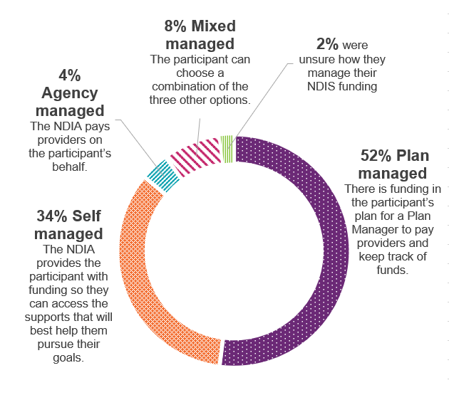
Source: Responses to the APR online form

The participant experience with pricing
Most participants told us that they are aware of prices for supports and how to find information about NDIS price limits:
- 94% of participants said that they know the price they pay for NDIS services and supports.
- 90% said that they are familiar with the NDIS Pricing Arrangements and Price Limits. This document helps participants and providers understand how price limits for supports and services work.
Participants had mixed views on whether the prices they pay for their services and supports are reasonable. About 42% said that they agree or strongly agree that prices are reasonable, while 51% said that they disagree or strongly disagree and 7% were not sure.
We asked participants whether they pay the same prices for their services and supports as people who are not NDIS participants. Around 26% of participants said they pay the same price as non-NDIS participants, while 41% said they do not, and around 33% were not sure.
Most participants who said that they do not pay the same price as non-NDIS participants gave examples of paying higher prices:
“I go to the OT, on a sign it states $95 first consultation, $90 thereafter. I am charged $193.99 because I am on NDIS.”
“If I tell a cleaning provider that it is NDIS they charge me about 40% more supposedly for administration. If I pay direct and claim reimbursement it is about 40% cheaper per hour.”

Some participants told us they are not able to negotiate prices with their providers
We asked participants how their provider sets prices for their services and supports:
- 38% said their provider tells them the NDIA decides what prices they have to charge.
- 30% said their provider has a price list with fixed prices to pay if buying services from them.
- 23% said they discuss the price with their provider and agree on the price they will pay.
- 9% were not sure.
Participants told us they are sometimes given the wrong information about the price limits the NDIA sets. Providers set their own prices and can charge less than the NDIA price limits.
However, it appears that more than a third of participants have been told by their provider that they cannot charge less than the price limits. This is not correct, and the Pricing Arrangements and Price Limits document says that providers should not say this.
Participants described when they have been told the wrong information about the price limits:
“All supports and services I come across that deal with mainly NDIS participants charge the maximum rate and they say that is the price that NDIS say they HAVE TO CHARGE, they don't get that is the maximum rate and that NDIS really want them to charge less. A friend tried to negotiate with the same provider that I use and she told me that she thought it was rude of the participant to devalue her time.”
"Many support workers charge the top rate listed in the pricing arrangement and think that is what NDIS says they should be paid. Many of them don't understand that it is a suggestion/ maximum price one can charge and they DO NOT allow negotiations."
It is important that participants have access to good quality information about the price limits and their rights to negotiate with providers. An education campaign for both participants and providers about these rights could help to improve participant experiences with pricing.

Disability Support Worker related supports
Disability Support Workers (DSWs) provide many services including care, emotional support, physical assistance and supervision for people with disability.
The NDIA sets the price limits for DSW-related supports by working out how much it costs DSW providers to provide supports to participants. We call this the DSW Cost Model. The DSW Cost Model includes wages, superannuation, leave entitlements and other business costs.
Most DSWs are employed under the Social, Community, Home Care and Disability Services Industry Award 2010 (SCHADS Award). The SCHADS Award sets out working conditions for DSWs and the minimum wages they must be paid. The Fair Work Commission reviews minimum wages every year.
From 1 July 2024, employers must also increase the superannuation contributions they make for their employees from 11% to 11.5%.
We recommended that DSW price limits go up to match the mandatory increases in minimum wages and superannuation.
We also recommended the 1% temporary loading be removed from 1 July 2024. This was a short-term measure to help providers manage higher costs from the COVID-19 pandemic and other SCHADS Award changes.
This chapter explains our recommendations in more detail.

Costs included in the DSW Cost Model
We use the DSW Cost Model to work out what it costs a provider to deliver an hour of support. Our goal is for DSW pricing to cover the cost of delivering services and allow participants to receive good value for money.
Table 1 explains the cost items we currently include in the DSW Cost Model.
Table 1: Cost items in the DSW Cost Model
Cost item | Description
Salaries (including shift loadings) | These are based on the Social, Community, Home Care and Disability Services Industry Award 2010 (SCHADS Award) for wage levels 2.3, 2.4/3.1, 3.2 and 4.4.
On-costs | This includes Superannuation entitlements (which increased from 11% to 11.5% on 1 July 2024), Annual Leave entitlements (20 days), Personal Leave entitlements including domestic and family violence leave (10.3 days), Long Service Leave entitlements (assumed at 4.3 days a year), and Employee Allowances.
Operational overheads | These include supervision, training, quality controls and workforce rostering costs, usage rates, the mix of permanent and casual staff and the amount of overtime paid.
Corporate overheads | This includes a share of costs for accounting, human resources, information technology, legal, and marketing.
Margin | The margin allows for providers to make a reasonable profit on their investment in their business.
Temporary loading | This was included due to higher costs from COVID-19 and SCHADS Award adjustments, introduced on 1 July 2022.

Our research on the DSW market
We looked at whether there have been changes in the number and types of providers offering DSW supports to participants. In the last 6 months of 2023:
- Around 44% of participants used DSW supports, this is an increase from the same time last year.
- Payments to DSW providers make up around 64% of the total amount of money the NDIS spends on supports.
- The number of active DSW providers increased by around 21%. There are now almost 123,000 DSW providers.
- The number of registered providers went down by about 6%, but the overall payments received by registered providers went up by about 19%.
- The number of unregistered providers went up by about 24%, and the overall payments received by unregistered providers went up by about 54%.
Figure 2 shows this information.
Figure 2: Summary of the DSW market (July- December 2023)
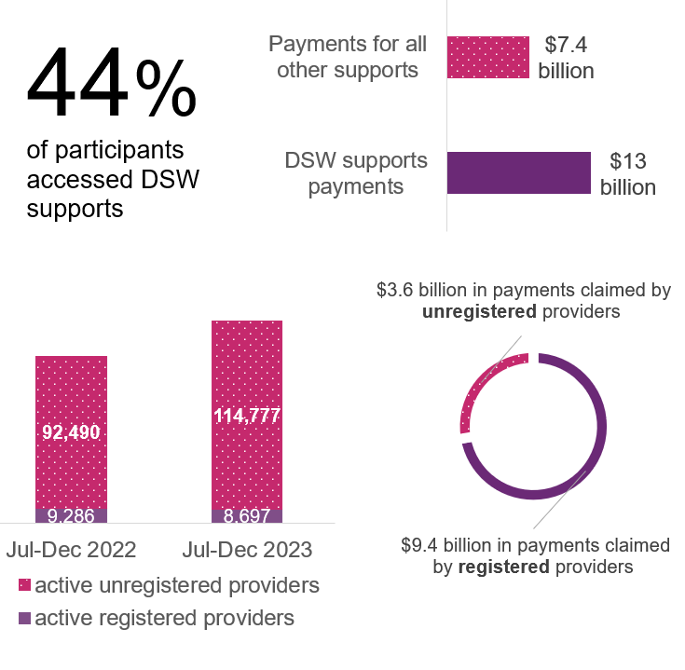
Source: NDIA analysis of scheme statistics.
Note: We analysed data from July-December 2023 and compared it to the same period from the previous year.

Summary of feedback through consultation
The Provider Consultation Paper asked if the DSW Cost Model matches the costs providers incur. We received feedback from 79 providers, 5 provider peak bodies and one union about the DSW Cost Model.
They told us that the NDIA needs to improve the way it calculates the cost of providing DSW supports. 77 providers said that the amounts in the DSW Cost Model do not match their costs. They said that the following costs are higher than what the DSW Cost Model allows for:
- worker’s compensation rates and insurances
- cost of having lots of casual staff
- general operational overheads, including insurance costs
- quality and safeguarding activities, including registration and audit costs.
We asked providers about the recent increase to wages under the Aged Care Award and whether this has impacted their business. Some providers said there was no impact and others said they are competing with increasing wages in Aged Care. Many of these providers reporting paying more than the Award wage to attract DSWs.
We will work with providers and other industry stakeholders to refine pricing for DSW supports. This includes exploring ways to collect better information about DSW pricing. In 2024–25, the NDIA will work with the Independent Health and Aged Care Pricing Authority and the Department of Social Services to make improvements to the NDIS pricing arrangements.

Recommendations
We have reviewed feedback through submissions and our own analysis of changes in the DSW market. We have recommended that the price limits for DSWs increase to pass on any changes to minimum wages under the SCHADS Award and changes to mandatory superannuation contributions in full.
A temporary loading of 2% was introduced on 1 July 2022 to the DSW Cost Model to help providers manage higher costs from COVID-19 and other SCHADS Award changes in the short-term. The loading was reduced on 1 July 2023 to 1%. We think the 1% loading is not needed anymore and should be removed from 1 July 2024. This is the same as what we recommended in last year’s APR.
Wages for aged care workers will soon increase by up to 25%. This may affect nursing and other supports like personal domestic cleaning and house or yard maintenance. These are not covered by the DSW Cost Model.
For example, if the NDIS price limits for nursing and other supports do not keep up with these changes, nurses and other support providers may choose to work in the aged care industry instead of working with NDIS participants.
For this reason, we recommended that the price limits for nursing and other supports increase by inflation. This will ensure that nursing and other supports continue to attract staff to provide support to NDIS participants.

Therapy supports
Most NDIS funded therapy supports are provided by a qualified professional such as an occupational therapist, physiotherapist, dietitian or speech pathologist. People who are not NDIS participants also use similar services through Medicare, private health insurance and other government schemes.
To test if the NDIS therapy supports price limits are reasonable, we compared them against the prices that people who are not NDIS participants pay for these services.
We found that the NDIS price limits for most therapy supports are similar to, or higher than these other services. We have not recommended any changes to the price limits for therapy supports, except for psychologists.
The rates that people who are not NDIS participants pay for psychologists are higher on average than the NDIS price limits. We also found that other government schemes have higher prices for psychologists.
We have recommended that the NDIS price limits for psychologists should increase by inflation. This will help psychologists continue to provide services to NDIS participants.
This chapter explains our recommendations in more detail.

Comparing the NDIS price limits for therapy supports with private rates
We compared the current NDIS price limits to the rates that therapy support providers charge their non-NDIS clients (private rates). We wanted to know if there was a gap between these private rates and the NDIS price limits, and if so, whether the NDIS price limits are too high or too low.
Figure 3 shows NDIS price limits for most therapy supports are similar to, or higher than private rates, except for psychology.
For psychology, the private rates are higher on average than the NDIS price limits. We also found that some other government insurance schemes have higher prices for psychologists, compared to the NDIS price limits.
Figure 3: NDIS price limits for therapy supports compared to private rates
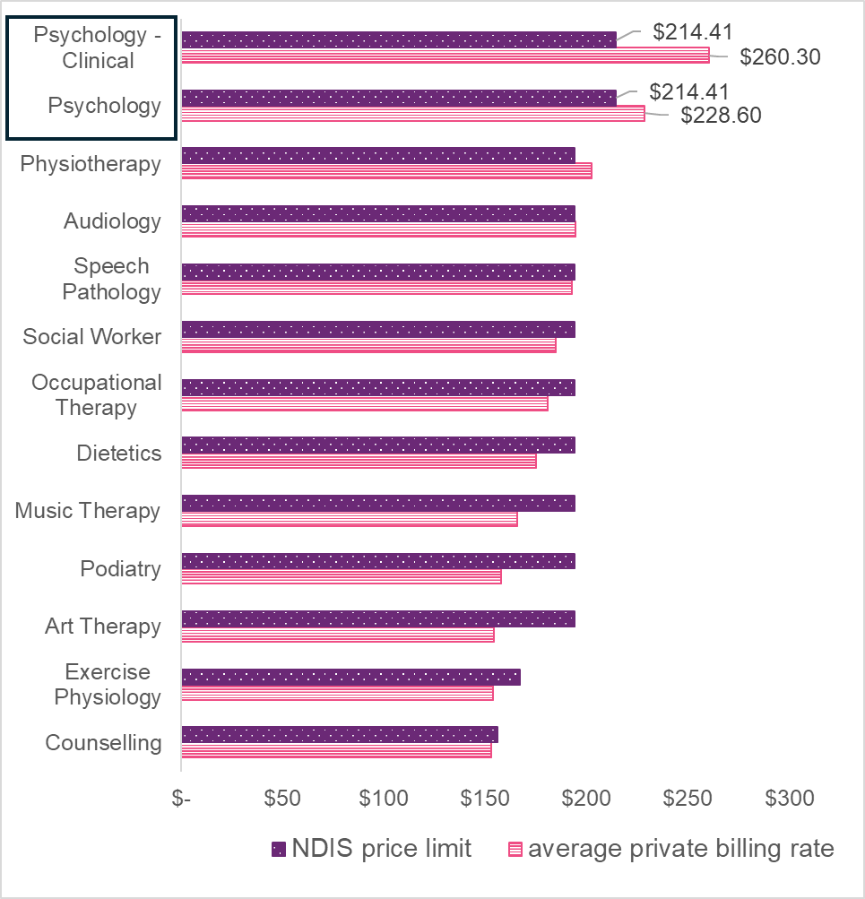
Source: NDIA analysis of 1,791 private billing rates for several NDIS-related weekday in-room therapy services. The private billing dataset was compiled by scanning provider websites across Australia.
Note: This chart shows NDIS national price limits and price limits for VIC, NSW, QLD, ACT, where applicable. It does not show prices for WA, SA, TAS, NT.

Our research on the therapy supports market
We looked at changes in the number and types of providers offering therapy supports to participants. We found that in the last 6 months of 2023:
- Around 59% of participants used therapy supports. This is an increase of 17% from the same time last year.
- Payments to therapy support providers make up around 10% of the total amount of money the NDIS spends on supports.
- The number of active therapy support providers increased by around 14%. There are now almost 53,000 therapy support providers.
- The number of registered providers went down by about 16%, but overall payments received by these registered providers went up by about 15%.
- The number of unregistered providers went up by about 20%, and the overall payments received by unregistered providers went up by about 60%.

Figure 4 shows this information.

Figure 4: Summary of the therapy supports market (July- December 2023)
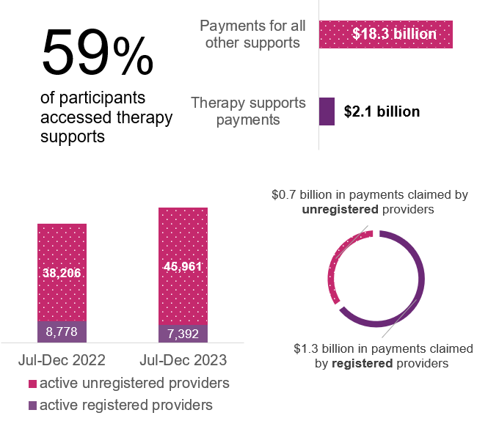
Source: NDIA analysis of scheme statistics
Note: We analysed data from July-December 2023 and compared it to the same period from the previous year.

Summary of feedback through consultation
We asked providers of therapy supports about changes in the costs of delivering services. We also asked about the differences in providing therapy supports to NDIS and non-NDIS clients.
We received 178 responses from providers about therapy supports. 13 were from professional bodies, one was from a union and a small number were from provider peak bodies.
About 87% of providers reported increases in the costs of delivering therapy supports and services.
Most providers said that they provide therapy support services to NDIS clients and non-NDIS clients. Many of these providers charge non-NDIS participants the same prices as NDIS participants. Some told us that they charge more for NDIS participants. Others charge less.
Most providers reported charging NDIS participants at the price limit, while a small number reported charging below the NDIS price limit.

Recommendations
Our analysis showed that the prices paid for psychologists in the private market and by other government schemes are typically higher than the NDIS price limits. For this reason, we recommended that the price limits for psychologists should go up by inflation.
We did not find the same evidence for other therapy supports and have not recommended any changes to the price limits for any other therapy supports.

Support coordination
A support coordinator is a type of provider that can help NDIS participants to understand and use the supports in their NDIS plan. There are 3 levels of support coordination (shown below).
Each level of support coordination has a different price limit. Level 3 has the highest price limit.
The price limits for Level 1 support coordination are set by the DSW Cost Model. We recommended that the price limits for Level 1 support coordination increase by the same amount as the DSW Cost Model.
We have not recommended any other changes to the price limits for Level 2 or Level 3 support coordination.

Support coordination levels
Level 1: Support to help a participant understand their plan, connect with NDIS providers and community, mainstream and other supports to get the most out of their NDIS plan.
Level 2: Support to put in place a mix of supports to increase a participant’s capacity to maintain relationships, manage tasks, live more independently and be included in their community.
Level 3: A higher level of support for participants whose situations are more complex and who need specialist support. A specialist support coordinator will assist participants to manage challenges in their support environment and ensure a consistent delivery of service.
This chapter explains our recommendations on support coordination in more detail.

Our research on the support coordination market
We looked at whether there have been changes in the number and types of providers offering support coordination to participants. We found that in the last 6 months of 2023:
- Around 38% of participants used support coordination. This is an increase from the same time last year.
- Payments to support coordination providers make up around 3% of the total amount of money the NDIS spends on supports.
- The number of active support coordination providers increased by around 30%. There are now around 8,800 support coordination providers.
- There are more unregistered providers entering the support coordination market than registered providers.
- Registered providers provide services to more participants and claim more payments than unregistered providers.

Figure 5 shows this information.

Figure 5: Summary of the Support coordination market (July- December 2023)
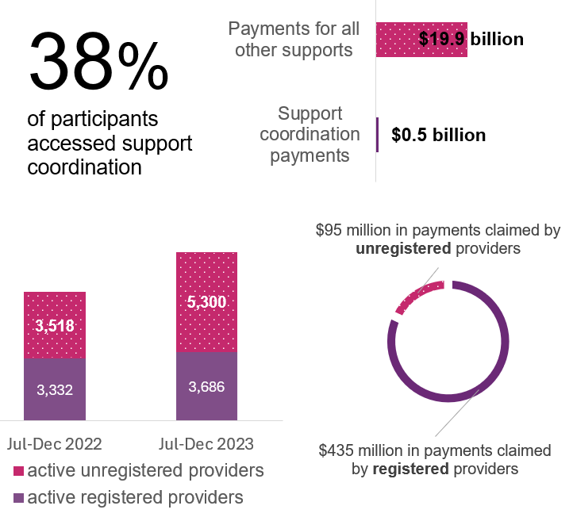
Source: NDIA analysis of scheme statistics
Note: We analysed data from July-December 2023 and compared it to the same period from the previous year.

Summary of feedback through consultation
We received 55 submissions from providers on support coordination. Around 75% of providers said that the costs of delivering support coordination have increased in the past year.
Providers also said they do work that is often not billed but necessary. For example, onboarding new clients, moving to the new PACE portal and doing administrative activities when a participant dies. They said the current price limits for support coordination are not high enough to cover the cost of doing these tasks.

We asked participants about how satisfied they are with their support coordinator:
- 63% of participants said that they are satisfied or very satisfied with their support coordinator.
- 22% of participants said that they were dissatisfied or very dissatisfied with their support coordinator.
- 15% were unsure.
We also asked participants what works well with their support coordinator and what could be improved. Common responses to things that work well included that their support coordinator helps them to make the most of their NDIS services and supports, find good quality providers and negotiate lower prices.
Common responses to things that do not work well included when their support coordinator is hard to reach, does not communicate well, or provides inconsistent service.

Recommendations
The price limits for Level 1 support coordination are set by the DSW Cost Model. We have recommended that the price limits for Level 1 support coordination increase by the same amount as the DSW Cost Model.
We have not recommended any other changes to the price limits for Level 2 or Level 3 support coordination. This is because there are many new providers coming into the market, and participants continue to receive this support. This shows that the price limits are high enough to encourage new providers to offer services.
The NDIS Review has also recommended many changes to support coordination. The NDIS Review recognises the important role support coordinators play in helping participants manage and implement their NDIS plans. It also suggests improvements, including introducing a new navigator role.
We do not think it is the right time to introduce more changes to the price limits, as there is already likely to be a lot of change in the support coordination industry in the next few years.

Cancellations
The NDIS short-notice cancellation policy ensures that providers can claim up to the whole appointment fee if a participant cancels late or fails to show, if certain conditions are met.
This policy was introduced to consider the SCHADS Award which requires DSW providers to pay their staff if their shift is cancelled at short notice and they cannot find other work for them to do during that time or at a future point in time.
We think that the 7-day cancellation policy is still suitable for DSW-related supports because it matches the SCHADS Award, where staff must be paid if their shift is cancelled, and other work cannot be found.
However, the SCHADS Award does not apply to all other supports. For example, therapy and support coordination do not have the same requirements. A 2-business day cancellation policy is more appropriate for these supports.
We have recommended that the cancellation policy be changed to 2-business days for non-disability support worker related supports. This chapter explains why we recommended this change to the cancellation policy.

The NDIS cancellation policy
In July 2022, the NDIA updated the short notice cancellation policy from 2 days to 7 days, considering the SCHADS Award changes. Since that time, the number of short notice cancellation claims made by providers has increased. The cost of these claims has nearly doubled from around $60 million to just under $120 million between 2020-21 and 2022-23.
We compared the cancellation policies in similar industries to see if the NDIS cancellation policy matches these other industries. We looked at:
- The Home Care Package program in the Aged Care industry. From a sample of 50 Home Care Package providers, 96% did not charge for cancellations if given more than 2 business days’ notice. Most providers charge the full fee if the cancellation is within the notice period.
- Other government schemes, such as Medicare and Department of Veterans Affairs. Many other government schemes offer little or no ability for providers to claim cancellation fees.
From our analysis, it appears that there is less opportunity for providers to claim the cost of short notice cancellations in these other industries.

Summary of feedback through consultation
We asked both providers and participants about the NDIS cancellation policy:
- Many providers told us they have not adopted the 7-day cancellation policy. Instead, they typically have a 24-hour, 48-hour or 72-hour cancellation policy (see Figure 6). This shows that many providers can successfully run their business with a shorter cancellation notice period.
- Most providers said that they have no differences in their cancellation policies for NDIS and non-NDIS clients. A small number of providers reported that their cancellation policy is different.
- Providers described how they offer other options when a participant cancels their appointment. These include appointment rescheduling or telehealth services. Providers also try to reduce cancellations by sending participants reminders (e.g. through email or SMS).
- Participants told us there are often different cancellation policies for each of their services and supports, which can be confusing. Sometimes they do not know what the cancellation policy is until after they are charged a fee for the cancelled appointment.
Participants say it can be hard to give 7-days’ notice, especially if they are unwell or have a sudden change in plans outside their control. Participants would like more flexibility when this happens.
Figure 6: Provider responses to questions about cancellation policies
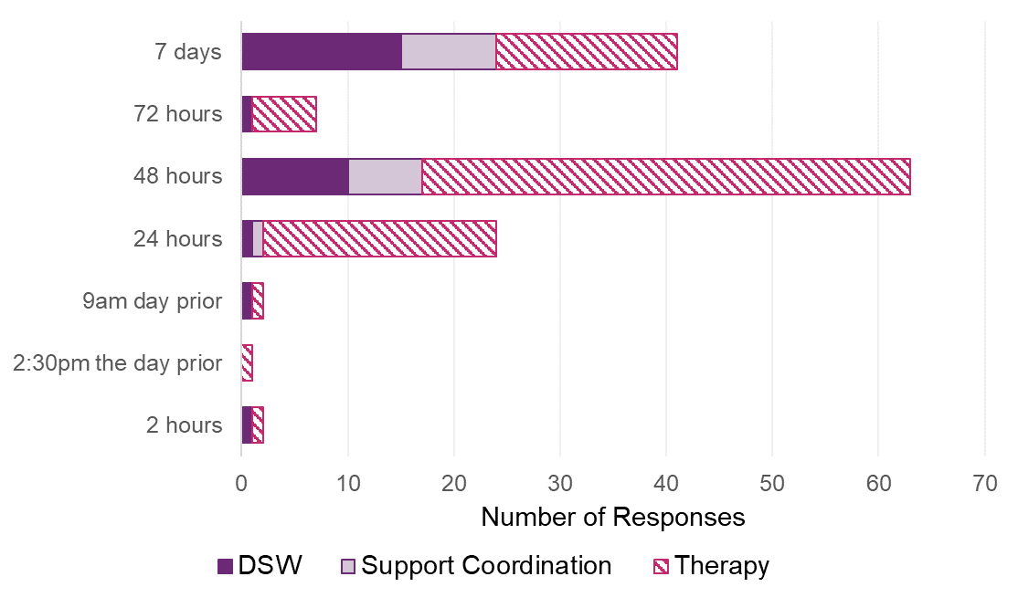
Source: Provider submissions to the APR.

Recommendations
The short-notice cancellation policy should allow providers to cover their costs from cancelled appointments. It should also encourage them to reduce the number of short-notice cancellations.
Participants must also be given enough time to give notice, allowing for situations outside their control, like illness.
We think that the maximum 7-day cancellation policy is still suitable for DSW-related supports. It considers the SCHADS Award, where staff must be paid if their shift is cancelled, and other work cannot be found.
However, other supports, like therapy and support coordination, are not covered by the SCHADS Award and do not have the same requirements. A 2-business day cancellation policy is more appropriate for these supports. We recommended that the cancellation policy be changed to up to 2-business days for non-disability support worker-related supports.
All providers should do their best to manage cancellations and try to find other work for their staff when a participant cancels their appointment at short notice.

Appendix A – detailed list of APR recommendations
Recommendation 1: The NDIA, subject to any specific recommendation arising from the current Annual Pricing Review, should increase the price limits for supports that are determined by the NDIS Disability Support Worker Cost Model from 1 July 2024 to reflect any changes in the minimum wages specified in the Social, Community, Home Care and Disability Services Industry Award 2010 (SCHADS Award) following the Fair Work Commission’s Annual Wage Review and any increase in the Superannuation Guarantee Charge.
Recommendation 2: The NDIA should cease the temporary loading applied to the NDIS Disability Support Worker Cost Model from 1 July 2024.
Recommendation 3: The NDIA, subject to any specific recommendation arising from the current Annual Pricing Review and any future reviews, should increase the price limits for nursing and other supports, not covered by Disability Support Worker related supports or Capital supports, on 1 July 2024 in line with the weighted movement over the previous twelve months in the ABS Wage Price Index (Australia, total hourly rates of pay excluding bonuses) and the ABS Consumer Price Index (All Groups, weighted average of eight capital cities) over the 12 months to the March Quarter immediately preceding the indexation date (with an 80/20 weighting). This recommendation does not include Plan Management.
Recommendation 4: The NDIA should increase the price limits for supports delivered by a Psychologist on 1 July 2024 in line with the weighted movement over the previous twelve months in the ABS Wage Price Index (Australia, total hourly rates of pay excluding bonuses) and the ABS Consumer Price Index (All Groups, weighted average of eight capital cities) over the 12 months to the March Quarter immediately preceding the indexation date (with an 80/20 weighting). Specifically, this should be for support line items: ‘Assessment Recommendation Therapy or Training – Psychologist (15_054_0128_1_3), ‘Early Childhood Supports – Psychologist (15_001_0118_1_3)’, and ‘Specialist Behaviour Intervention Support (11_022_0110_7_3)’.
Recommendation 5: The NDIA should not make any further structural adjustments to the pricing arrangements for therapy supports at this time and should not index the price limits for all other therapy-related supports on 1 July 2024.

Recommendation 6: The NDIA should index the price limits for Level 1: Support Connection services and Psychosocial Recovery Coaches services in line with the indexation of supports determined by the Disability Support Worker Cost Model in recommendation 1 on 1 July 2024.
Recommendation 7: In alignment with strategic outcomes from the NDIS Review and recognising the current period of significant reform, it is recommended that the NDIA maintain existing price limits for Level 2: Coordination of Supports and Level 3: Specialist Support Coordination.
Recommendation 8: The NDIA should retain the existing 7-day short notice cancellation policy for applicable supports determined by or derived from the Disability Support Worker Cost Model from 1 July 2024. Providers of Disability Support Worker supports must continue to make reasonable effort to find alternative billable work for the staff involved.
Recommendation 9: The NDIA should adjust the 7-day short-notice cancellation policy for non-Disability Support Worker-related supports to two clear business days from 1 July 2024.

National Disability Insurance Agency
- Website: ndis.gov.au
- Telephone: 1800 800 110
- Webchat: ndis.gov.au
Follow us on our social channels
- Facebook
- Instagram
- YouTube
- LinkedIn
For people who need help with English
- TIS: 131 450
For people who are deaf or hard of hearing
- TTY: 1800 555 677
- Voice relay: 1800 555 727
- National Relay Service: accesshub.gov.au
End of document

Registered providers are regulated by the NDIS Quality and Safeguards Commission. They have to meet strict conditions for the quality and safety of their services. Unregistered providers are not regulated by the NDIS Quality and Safeguards Commission.
This calculation includes changes in the ABS Wage Price Index and the ABS Consumer Price Index, with an 80/20 weighting.
A peak body is a representative non-government organisation that provides information, membership support, advocacy and representation, relevant research, policy and sector development services for its members and other interested parties.
These include: the support item being eligible for short notice cancellation claims as per the NDIS Pricing Arrangements and Price Limits; the charges comply with these pricing arrangements and limits; there is a pre-existing agreement with the participant allowing for such claims and the provider was unable to find alternative billable work for the staff involved.

