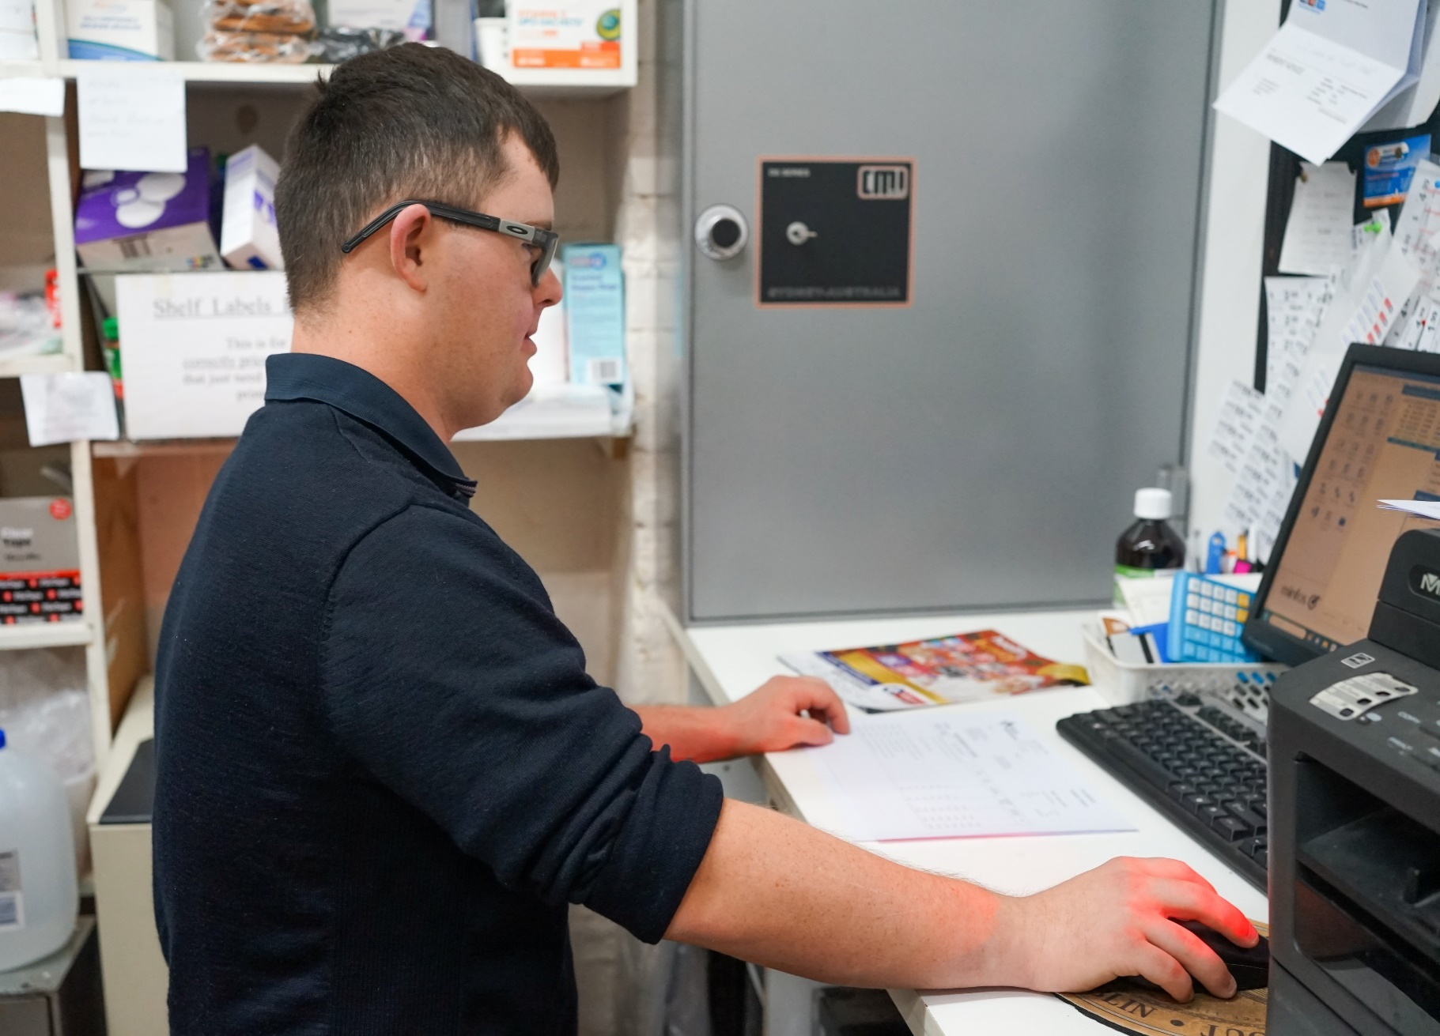


School leaver employment support
Provider reporting services
January to December 2023

Report produced August 2024
Market Innovation & Employment Branch

ndis.gov.au

Patrick’s story
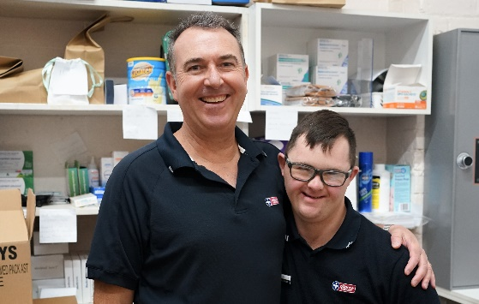
When Patrick got a job at his local pharmacy, Mum Rebecca was overwhelmed with emotion as she drove them home after picking up his new uniform before his first day on the job.
‘Here’s Patrick who has Down syndrome with very limited speech saying as clear as a bell, ‘I’m the same as dad, I’ve got a uniform just like dad, a uniform just like Harry (his younger brother). I actually struggled to drive home,’ she said.
‘I don’t usually get emotional, but I thought golly, I didn’t realise a job and a uniform were going to be so important to you.
‘My husband wears a uniform to work every day; Harry wears a uniform too. I’m sure they’d rather wear casual, but Patrick couldn’t wait to wear his new uniform.
‘It’s something you don’t think about, you just do it. But for Patrick, it’s given him purpose – he has a job! He’s part of a team and he feels valued and included like everyone else.’
Growing up in Wellington, in regional New South Wales, Patrick, 20, joined the NDIS when it first rolled out in July 2017. He was funded for speech, physiotherapy and occupational therapies.
Rebecca said when Patrick left school, she was encouraged to get employment assistance funding included in his plan, so she did.
A local disability provider, Bamara, was engaged and Patrick met his job coach, Piper. She began working with him to build on his employment, social and communication skills, to help him get job ready.
Piper helped find the pharmacy position, which involves unpacking deliveries and sorting and labelling stock. After talking about it, with Piper’s help Patrick put together his resume and applied for the job.
‘I took Patrick to hand in his resume. He introduced himself and I supported him in case they needed clarification on what he said. He got the job. He was so excited,’ Piper said.
‘The best part is going to work, unpacking boxes and putting labels on things,’ Patrick said.
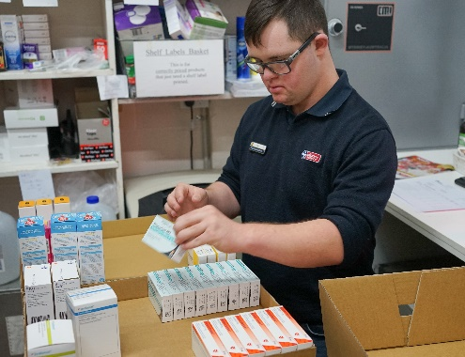
‘I also like seeing all the customers and helping Mick, Sim and Pop (Roger) too,’ he added.
Piper said Patrick’s skills have really improved since he started. Shown what to do, he took it all in and now he has a good routine down pat, and he does the job well.
‘Patrick’s speech has improved a lot since he started, but we are still working on it,’ she said. ‘He’s clearer now saying good morning; how are you and can I help you.’
Piper has also got Patrick doing ‘Pat’s Pick of the Week’ where he picks out a store item and recommends it and she posts it on Instagram.
‘He loves it. Every week he lets me know what item he wants to feature. He always gets lots of likes and now he’s a bit of a celebrity around town,’ she added.
‘Employment has been the best thing for Patrick. You can see improving his work and social skills has really lifted his mood. It’s also helped lift the mood of pharmacy staff and customers too, they all look forward to seeing him.
‘I think Patrick’s success highlights people with disability can do what anyone else can do, they just need some additional supports,’ Piper said.

Contents
School leaver employment support 1
Contents 4
1. Executive summary 6
1.1 Introduction 6
1.2 Employment support provider reporting 6
1.3 Report enhancements 6
1.4 Key findings 7
2. Provider and participant count 9
2.1 Provider count 9
2.2 Participant count 10
3. Participant demographics 10
3.1 Employment support recipients 10
3.2 Location 11
3.3 Primary disability 11
3.4 Age 12
3.5 Gender 12
3.6 Aboriginal or Torres Strait Islanders Status 12
3.7 Culturally and Linguistically Diverse status 13
4. Supports & milestones 13
4.1 Support type hours 13
4.2 Support delivery method 14
4.3 Progress towards milestones – snapshot at each reporting period 14
4.4 Progress towards milestones – cumulative for the year 16
5. Final outcomes 19
6. Final employment outcomes 22
6.1 Employment type 22
6.2 Hours worked 23
6.3 Industry of employment 24
6.4 NDIS supports in employment 25
6.5 Supported wages 25
7. Intermediate employment outcomes 26
7.1 Employment outcomes (January to December 2023) 26
7.2 Employment type 26
7.3 Hours worked 27
7.4 Industry of employment 28
7.5 NDIS supports in employment 29
7.6 Supported wages 29
8. Model summary 30
8.1 Modelling approach 30
8.2 What helps (or hinders) finding paid employment 31
8.3 Differences in modelled predictors between reporting period ending June 2023 versus the period ending December 2023 32
9. Appendix 33
9.1 Appendix 1 – Methodology for the section titled “Progress towards milestones – cumulative for the year” 33
9.2 Appendix 2 – Model accuracy 35

Executive summary

Introduction

The Agency is committed to ensuring participants have the same opportunities to work as other Australians and the confidence, support, and skills to achieve their work goals.

The NDIS can make a significant difference for young participants by supporting them early to aspire to work, develop skills and connect to the right job role and employer.
School leaver employment support is an individualised early intervention support intended to smooth the transition from school to employment by building a young participant’s skills, confidence, and capacity for work.

This fifth edition of the School Leaver Provider Quarterly Report analyses the supports provided to participants, their progress and the outcomes they’ve achieved, allowing us to share insights on best practice and the factors that lead to successful employment outcomes.

Employment support provider reporting

Employment support providers submit data through the provider reporting tool (the tool) to the NDIA each quarter. The data submitted includes participants’ demographic details, activities, progress towards milestones, the method of delivery, outcomes achieved, and employment details. The provider confirms the details they are including, particularly the outcomes achieved, with the participant prior to submitting the report to the NDIA.

This report provides insights on the data submitted through the tool, aggregated across all Providers’ that contributed from January to December 2023.

Report enhancements

New providers reported on participant activity in Q3 and Q4 2023. The additional number of participants are now included in those quarters' totals. This might result in Q1 and Q2 2023 numbers being slightly different to the same periods published in the fourth edition of the report for financial year 2023.

In section 8, the predictive model has been updated to a machine learning model to improve both model accuracy and ease of selecting and including significant drivers of finding employment.

We encourage participants to discuss the available information with providers when considering selecting or changing providers. Additional questions that participants can ask providers about their service are available here.

The report will feature a participant story, like Patrick’s, in each release to showcase a positive employment outcome. Participants, or providers with the consent of the participant, are invited to forward stories to participant.employment@ndis.gov.au.

If you have general feedback or questions about this report, please email participant.employment@ndis.gov.au.

Key findings

The information contained in this report represents data submitted to the Agency by providers of school leaver employment supports delivered to participants from January to December 2023.

For the 12 months ending December 2023, 7,688 young participants aged 15 to 24 had claimed school leaver employment supports or employment assistance. This report includes only participants whose providers submitted data to the Agency.

In the previous report, covering the 12 months ending June 2023, the figure reported was 8,323 participants. This number included not only participants who had claimed employment support for school leavers but those who had this support included in their plan. Participants with funding included in their plan but no claims have been excluded from the current report figure to more accurately reflect those who are utilising this support.

For January to December 2023, providers report:

Demographics
- 6,606 unique participants received school leaver employment supports of which 2,716 commenced during the year.
- Commencement varies across quarters with the highest number starting in the January to March quarter after leaving school. 1,132 participants commenced receiving school leaver employment supports in January to March 2023, 590 commenced in April to June 2023, 505 commenced in July to September 2023, and 489 commenced in October to December 2023.
- Participants receiving school leaver employment supports predominantly have autism (58%) or intellectual disability (32%), with 66% being male.
- The majority of employment support recipients are in N S W (35%), followed by V I C (23%), and Q L D (16%).
- 7% of employment support recipients identified as Aboriginal or Torres Strait Islander people. While this is slightly lower than the 9% of all NDIS participants aged 15-24 who identify as Aboriginal or Torres Strait Islander, this gap has been slowly closing over time.
- 7% of employment support recipients identified as being from a Culturally and Linguistically Diverse community. This is slightly higher than the 6% of all NDIS participants aged 15 to 24 who identified as being from these communities.
Time spent in training
- 46% of the training time was spent building participants social, presentation, communication and work skills.
- Participants receive supports via group-based activities (53% of support time), one to one support (45% of support time) and via distance or online methods (1%) in the latest quarter.

Exits from school leaver employment
- 1,831 participants were reported to exit school leaver employment supports during the four quarters.
- Of the 1,831 participants who exited employment supports:
  - 56% (1,033 out of 1,831) exited without an employment outcome compared to 49% (765 out of 1,538) in the previous report (1 year to 30 June 2023).
  - 11% (203 out of 1,831) went on to further study or volunteer work.
  - 25% (464 out of 1,831) achieved open employment outcomes compared to 30% (457 out of 1,548) in the previous report (1 year to 30 June 2023).
  - 5% (92 out of 1,831) achieved supported employment outcomes (in ADE), and this proportion remained unchanged from the report of June 2023 (75 out of 1,548).
  - 2% (39 out of 1,831) did not have an outcome reported.
- Despite the increase in open employment outcomes from 457 to 464, the total exits increased considerably from 1,548 to 1,831 which caused a reduction in the open employment outcome percentage from 30% to 25%. The agency will continue to monitor and investigate potential reasons for this.
- Of the participants who achieved open and supported employment outcomes over the four quarters, 40% were employed on a part time basis while 37% were employed casually, 11% were employed full time.
- Of participants who started employment, 81% worked up to 21 hours per week.
- Of participants who finished employment support with paid employment, 65% worked in retail, hospitality, tourism, trades, manufacturing or operations.
- Of participants who started employment, 36% said they will be using NDIS supports in employment to maintain their employment (an increase of 3% from the June 2023 report).
- Of participants who finished employment support with paid employment, 21% of employers said they will use supported wages for the participants’ employment.

Interventions compared to outcomes
- More time receiving skill specific training was associated with a higher chance of making significant progress towards, or fully gaining the specific skills.
- Participants who made significant progress or fully achieved their goals in relation to developing the following milestones were more likely to gain paid employment:
  - Employer engagement and job customisation
  - Work skills
  - Work experience
  - Travel
- Participants where more time was spent in work experience support were more likely to gain paid employment.

Note: Figures in this report have been rounded to the nearest whole percentage.

Provider and participant count

Provider count

Figure 1. Providers represented in reporting – October to December 2023
Provider Size by Participants Supported | Providers | % Who submitted the reporting tool | % Who did not submit the reporting tool
101+ | 5 | 100% | 0%
51-100 | 19 | 100% | 0%
11-50 | 68 | 85% | 15%
2-10 | 224 | 41% | 59%
1 | 442 | 10% | 90%

From October to December 2023 (Figure 1), there were 758 providers delivering school leaver employment support across the country, with 24 providers delivering to 51 or more participants. 68 providers delivered services to 11 to 50 participants and 666 providers delivered supports to 10 or fewer participants. The largest 24 providers delivered support to 44% of participants and were able to report on them all during the year. Across all providers, data was submitted for 80% of participants.

For January to December 2023 (Figure 2), providers who have 10 or fewer participants have lower submission rates. For these providers, the proportion of providers that submitted data over the 4 quarters has been roughly stable. Providers with small numbers of participants and those claiming large amounts from participant budgets continue to be the focus of further investigation.

Figure 2. Percentage of providers who submitted the reporting tool – January to December 2023
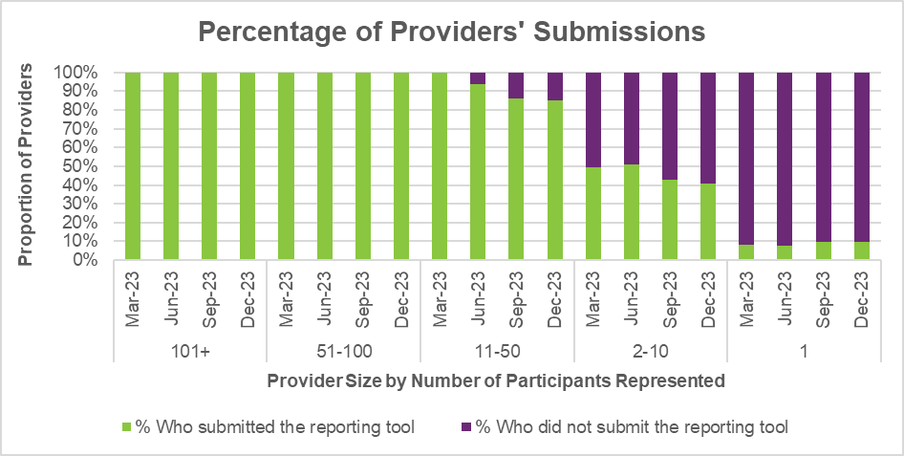

Participant count

Figure 3. Participants represented in reporting – October to December 2023
Provider Size by Participants Supported | % of participants in provider tool | % of participants not in provider tool
101+ | 100% | 0%
51-100 | 100% | 0%
11-50 | 90% | 10%
2-10 | 51% | 49%
1 | 10% | 90%

Overall, 20% of participants who received school leaver employment supports in the last quarter were not represented in the reporting submitted by providers. The Agency is investigating potential reasons for this.

Participant demographics

Employment support recipients

The Provider Reporting Tool data provides information on participants receiving employment support during the year. Participants that started employment support during a previous period and continue to be recipients in the current period are included in the ‘Existing’ numbers, and those that started receiving employment support during the current period are included in the ‘New’ numbers. While participants that exited employment support during the current period are included in the ‘Exited’ numbers.

Note, if the participant exits employment support in a quarter, they will be counted in the "Exit" numbers for that quarter. If that same participant re-enters employment support a few quarters later, they will be counted in the "New" numbers again.

Figure 4. Number of participants
Group | Jan to Mar 2023 | Apr to Jun 2023 | Jul to Sep 2023 | Oct to Dec 2023
Existing | 3,890 | 4,701 | 4,904 | 4,891
New | 1,132 | 590 | 505 | 489
Total | 5,022 | 5,291 | 5,409 | 5,380
Exit | 321 | 387 | 518 | 605

The number of participants receiving employment supports reported by the Provider Reporting Tool (the Tool) has steadily increased over the first 3 quarters, with a slight decrease in the fourth quarter.

Please note that the number of participants reported in this report for the January to March 2023 quarter and the April to June 2023 quarter differs from the previous fourth edition report due to late reporting. Participants who were not reported when the report to June 2023 was compiled but were then reported as having received employment support during the January to March 2023 or April to June 2023 quarters are counted as new in those respective quarters in this report.

Location

Figure 5. State or Territory of residence – number of participants
State or Territory | Jan to Mar 2023 | Apr to Jun 2023 | Jul to Sep 2023 | Oct to Dec 2023
NSW | 1,888 | 1,917 | 1,897 | 1,858
VIC | 1,215 | 1,262 | 1,285 | 1,245
QLD | 747 | 814 | 860 | 880
SA | 489 | 550 | 582 | 595
WA | 472 | 530 | 557 | 578
TAS | 122 | 127 | 125 | 125
ACT | 71 | 73 | 83 | 81
NT | 18 | 18 | 20 | 18

The majority of employment support recipients were in N S W (35%), followed by V I C (23%), and Q L D (16%). For comparison, the top 3 states for all NDIS participants aged 15-24 are
N S W (29%), V I C (24%) and Q L D (22%). The over-representation in N S W is partly due to the earlier roll out to full scheme in that state and the influence of the legacy N S W Transition to Work program which involved transition teachers helping students to consider post school options and connecting many with employment providers.

Primary disability

Figure 6. Primary disability – number of participants
Primary disability | Jan to Mar 2023 | Apr to Jun 2023 | Jul to Sep 2023 | Oct to Dec 2023
Autism | 2,851 | 3,044 | 3,157 | 3,182
Intellectual Disability | 1,634 | 1,700 | 1,710 | 1,654
Down Syndrome | 151 | 157 | 157 | 156
Cerebral Palsy | 127 | 131 | 126 | 128
Other Neurological | 52 | 49 | 49 | 46
Hearing impairment | 55 | 56 | 52 | 60
Psychosocial Disability | 34 | 35 | 36 | 33
Acquired Brain Injury | 46 | 45 | 45 | 43
Visual Impairment | 29 | 33 | 37 | 37
Other or Not populated | 43 | 41 | 40 | 41
Total | 5,022 | 5,291 | 5,409 | 5,380

The top primary disabilities experienced by participants utilising these supports were autism (59%), followed by intellectual disability (31%). For comparison, 61% and 22% of all NDIS participants aged 15-24 report having autism and intellectual disability, respectively.

Age

Figure 7. Age – percentage of participants
Age | Jan to Mar 2023 | Apr to Jun 2023 | Jul to Sep 2023 | Oct to Dec 2023
up to 14 | 0% | 0% | 0% | 0%
15 to 17 | 8% | 7% | 7% | 7%
18 | 22% | 21% | 18% | 16%
19 | 30% | 29% | 28% | 28%
20 | 22% | 22% | 24% | 25%
21 to 24 | 17% | 20% | 22% | 24%
25+ | 0% | 0% | 0% | 1%
Not populated | 0% | 0% | 0% | 0%
Total | 100% | 100% | 100% | 100%

Participants aged 18 to 20 accounted for 68% of employment support recipients. Recipients aged 21 to 24 has steadily grown in proportion over the 4 quarters, while those aged 18 have steadily reduced.

Gender

Figure 8. Gender – percentage of participants
Gender | Jan to Mar 2023 | Apr to Jun 2023 | Jul to Sep 2023 | Oct to Dec 2023
Female | 32% | 31% | 31% | 31%
Male | 66% | 66% | 66% | 66%
Other | 2% | 2% | 2% | 2%
Prefer not to say | 0% | 0% | 0% | 0%
Not populated | 0% | 0% | 0% | 0%
Total | 100% | 100% | 100% | 100%

In the most recent period, employment support recipients were 31% female and 66% male. In comparison to all NDIS participants aged 15 to 24, 35% were female and 63% were male. This is in line with the high proportion of employment supports recipients reporting autism as the primary disability, as the majority of participants who report autism are males.

Aboriginal or Torres Strait Islanders Status

Figure 9. Aboriginal and Torres Strait Islanders – percentage of participants
Aboriginal or Torres Strait Islanders status | Jan to Mar 2023 | Apr to Jun 2023 | Jul to Sep 2023 | Oct to Dec 2023
Yes | 6% | 7% | 7% | 7%
No | 76% | 77% | 77% | 77%
Not Stated | 17% | 17% | 16% | 16%
Not populated | 0% | 0% | 0% | 0%
Total | 100% | 100% | 100% | 100%

In the most recent period, 7% of employment support recipients identified as Aboriginal or Torres Strait Islander people. This is slightly lower than the 9% of all NDIS participants aged 15-24 who identified as Aboriginal or Torres Strait Islander.

Culturally and Linguistically Diverse status

Figure 10. Culturally and linguistically diverse – percentage of participants
Culturally and Linguistically Diverse status | Jan to Mar 2023 | Apr to Jun 2023 | Jul to Sep 2023 | Oct to Dec 2023
Yes | 7% | 7% | 7% | 7%
No | 89% | 89% | 89% | 89%
Not Stated | 4% | 4% | 4% | 4%
Not populated | 0% | 0% | 0% | 0%
Total | 100% | 100% | 100% | 100%

In the most recent period, around 7% of employment support recipients identified as being from a Culturally and Linguistically Diverse community. This is slightly higher than the 6% of all NDIS participants aged 15 to 24 who identified as being from a Culturally and Linguistically Diverse community.
The counts and percentages for this report had been affected by the new computer system and integration of new processes. The counts and percentages are likely to be slightly understated for “Yes” and “No” classes, and slightly overstated for “Not stated”.

Supports & milestones

Support type hours

Figure 11. Support type provided – percentage of average hours per participant
Support type provided | Jan to Mar 2023 | Apr to Jun 2023 | Jul to Sep 2023 | Oct to Dec 2023
Assessments | 4% | 3% | 3% | 3%
Planning and reviewing progress | 5% | 5% | 5% | 6%
Exploring employment options | 7% | 7% | 7% | 8%
Engagement with family / carer to support employment directions | 4% | 3% | 3% | 3%
Engagement with other professionals / providers to support employment goals | 3% | 3% | 3% | 3%
Building social, presentation and communication skills | 23% | 22% | 22% | 23%
Travel training | 5% | 6% | 6% | 6%
Work skills training | 25% | 24% | 24% | 22%
Employer engagement education and job customisation | 5% | 5% | 5% | 5%
Work experience support (on the job) | 14% | 15% | 16% | 15%
On the Job Support | 1% | 1% | 1% | 1%
Other (Field 1) | 4% | 4% | 4% | 4%
Other (Field 2) | 0% | 0% | 0% | 0%
Total | 100% | 100% | 100% | 100%

Almost half (46%) of the training time was spent building the participant’s social, presentation, communication, and work skills. The amount of time dedicated to work experience support (on the job) has been steady and accounted for 15% of the total training time. From a separate analysis (NDIS Outcomes Framework Employment Deep Dive 31 December 2022), engaging in job seeking or other informal employment activities (such as work experience) was listed as the top positive driver of getting a job for participants aged 15 to 24.

Support delivery method

Figure 12. Delivery method – percentage of hours
Delivery method | Jan to Mar 2023 | Apr to Jun 2023 | Jul to Sep 2023 | Oct to Dec 2023
One to One | 44% | 43% | 45% | 45%
Group Based | 55% | 56% | 54% | 53%
Distance or online | 1% | 2% | 1% | 1%
Total | 100% | 100% | 100% | 100%

Participants have been excluded from this section where the sum of One to One, Group based, Distance or Online percentages did not equal 100%.

The percentage of one-to-one support has slightly increased over the period, at the expense of group-based support.

Progress towards milestones – snapshot at each reporting period

This section looks at the distribution of progress for participants who worked on a particular milestone (where there are training hours reported for that specific skill), for each reporting period in isolation (non-cumulative).

Social, presentation and communication skill

Figure 13. Social, presentation and communication skill milestone – percentage of participant progress
Social, presentation and communication skill milestone | Jan to Mar 2023 | Apr to Jun 2023 | Jul to Sep 2023 | Oct to Dec 2023
No progress | 6% | 5% | 6% | 6%
Some progress | 72% | 73% | 72% | 69%
Significant progress | 21% | 21% | 21% | 23%
Current goals fully achieved | 1% | 1% | 1% | 2%
Total | 100% | 100% | 100% | 100%

For participants who worked on this specific milestone, 69% reported some progress and 23% reported significant progress. There was a 2% increase in those who achieved significant progress in the last quarter.

Travel skill

Figure 14. Travel skill milestone – percentage of participant progress
Travel skill milestone | Jan to Mar 2023 | Apr to Jun 2023 | Jul to Sep 2023 | Oct to Dec 2023
No progress | 8% | 6% | 8% | 6%
Some progress | 66% | 69% | 67% | 66%
Significant progress | 22% | 20% | 20% | 22%
Current goals fully achieved | 5% | 5% | 5% | 6%
Total | 100% | 100% | 100% | 100%

For participants who worked on this specific milestone, 66% reported some progress and 22% reported significant progress.

Work skill

Figure 15. Work skill milestone – percentage of participant progress
Work skill milestone | Jan to Mar 2023 | Apr to Jun 2023 | Jul to Sep 2023 | Oct to Dec 2023
No progress | 6% | 6% | 5% | 6%
Some progress | 72% | 73% | 72% | 69%
Significant progress | 21% | 20% | 21% | 23%
Current goals fully achieved | 1% | 1% | 1% | 2%
Total | 100% | 100% | 100% | 100%

For participants who worked on this specific milestone, 69% reported some progress and 23% reported significant progress. The last quarter saw a slight decrease in those making some progress, and a slight increase in those making significant progress.

Employer engagement, education, and job customization

Figure 16. Employer engagement, education, and job customisation milestone – percentage of participant progress
Employer engagement, education, and job customisation milestone | Jan to Mar 2023 | Apr to Jun 2023 | Jul to Sep 2023 | Oct to Dec 2023
No progress | 7% | 8% | 9% | 7%
Some progress | 72% | 71% | 68% | 71%
Significant progress | 20% | 19% | 21% | 20%
Current goals fully achieved | 1% | 1% | 1% | 2%
Total | 100% | 100% | 100% | 100%

Providers who reported activities as “engaging with employers, educating and customising jobs” for participants reported that 71% made some progress and 20% made significant progress. Percentages have remained consistent over the 4 quarters.

Work experience

Figure 17. Work experience milestone – percentage of participant progress
Work experience milestone | Jan to Mar 2023 | Apr to Jun 2023 | Jul to Sep 2023 | Oct to Dec 2023
No progress | 9% | 8% | 7% | 6%
Some progress | 57% | 58% | 59% | 59%
Significant progress | 33% | 31% | 32% | 32%
Current goals fully achieved | 1% | 2% | 2% | 2%
Total | 100% | 100% | 100% | 100%

Of the participants engaging in work experience in the most recent quarter, 59% were reported as making some progress, and 32% were reported as making significant progress.

In the fourth edition of the report for financial year 2023, a decreasing trend was observed among employment supports recipients engaging in work experience, with the percentage achieving significant progress declining from 36% to 31% over the four quarters. However, the data for the calendar year 2023 indicates a slight recovery and stabilisation, with the percentage increasing to 32% for the past two quarters. This recovery is a positive development, considering the strong association between work experience and achieving employment outcomes.

Progress towards milestones – cumulative for the year

The following sections show that more time receiving supports or training is associated with better progress towards mastering specific skills. For each participant, the best progress (across 4 quarters) towards mastering the specific skills is used for this analysis, and compared against the cumulative time receiving employment supports, and training for the specific skills.

Appendix 1 includes more detail on the methodology used in this section.

Social, presentation and communication skill

Figure 18. Social, presentation and communication skill milestone – percentage of participant progress
Cumulative training hours | No progress | Some progress | Significant progress | Current goals fully achieved | Total
0-9 | 35% | 51% | 11% | 3% | 100%
10-49 | 3% | 61% | 34% | 2% | 100%
50-99 | 1% | 56% | 41% | 2% | 100%
100+ | 0% | 60% | 38% | 2% | 100%

Of the participants who received up to 9 hours of training on social, presentation, and communication skills, around 11% were able to make significant progress towards mastering these skills. This proportion increased to 38% for those who received 100+ hours of the skill-specific training.

Travel skill

Figure 19. Travel skill milestone – percentage of participant progress
Cumulative training hours | No progress | Some progress | Significant progress | Current goals fully achieved | Total
0-9 | 56% | 26% | 6% | 12% | 100%
10-49 | 3% | 60% | 25% | 11% | 100%
50-99 | 0% | 47% | 44% | 9% | 100%
100+ | 1% | 35% | 54% | 9% | 100%

While 12% participants were able to fully achieve their goal within 0-9 hours of training, more than half (56%) did not make any progress. This suggests that for some participants, travel skills may be a primary area of focus and that they need only a few hours of personalised support to fully achieve their goals, while others need more than 10 hours of training to start making progress towards their goals.

Note that the unusually decreasing percentage of participants with current goals fully achieved as cumulative training hours increase is due to small numbers in this category.

Work skill

Figure 20. Work skill milestone – percentage of participant progress
Cumulative training hours | No progress | Some progress | Significant progress | Current goals fully achieved | Total
0-9 | 43% | 45% | 10% | 2% | 100%
10-49 | 3% | 62% | 32% | 3% | 100%
50-99 | 2% | 60% | 36% | 3% | 100%
100+ | 0% | 57% | 40% | 2% | 100%

Attaining significant progress in work skills was achieved through more cumulative hours of training demonstrating the need for tailoring this support for the individual.

Employer engagement, education, and job customization

Figure 21. Employer engagement, education, and job customisation milestone – percentage of participant progress
Cumulative training hours | No progress | Some progress | Significant progress | Current goals fully achieved | Total
0-9 | 52% | 36% | 10% | 2% | 100%
10-49 | 2% | 63% | 32% | 4% | 100%
50-99 | 1% | 54% | 41% | 4% | 100%
100+ | 1% | 55% | 44% | 0% | 100%

Making significant progress towards employer engagement, education, and job customisation milestones increased markedly with more hours spent on these activities.

However, the increase in the percentage of participants making significant progress is less pronounced in this report compared to the previous one (year to June 2023). In the current report, the percentage increased to 44%, whereas in the previous report, it rose to 63%. The substantial fluctuation between the two reports is attributed to the small number of participants in this category (those with 100+ hours of training who achieved significant progress towards the milestones).

Work experience

Figure 22. Work experience milestone – percentage of participant progress
Cumulative training hours | No progress | Some progress | Significant progress | Current goals fully achieved | Total
0-9 | 75% | 17% | 5% | 3% | 100%
10-49 | 5% | 57% | 34% | 5% | 100%
50-99 | 2% | 50% | 44% | 4% | 100%
100+ | 1% | 38% | 57% | 4% | 100%

Similarly, making significant progress towards work experience milestones increased markedly after more than 100 hours of training.

Final outcomes

This section shows the distribution of outcomes upon exiting employment support (based on the employment support reported end/exit date).

Figure 23. Final outcomes (upon exiting employment support) – number of participants
Outcome | Jan to Mar 2023 | Apr to Jun 2023 | Jul to Sep 2023 | Oct to Dec 2023 | Total
Open Employment | 79 | 106 | 121 | 158 | 464
Supported Employment | 16 | 18 | 22 | 36 | 92
Non-Employment | 213 | 250 | 366 | 407 | 1,236
Not populated | 13 | 13 | <11 | <11 | 39

The number of participants finishing employment supports with open or supported employment was higher in the July to September, and October to December quarters. These tend to be seasonally high quarters, as seen in previous versions of this report.

From January to December 2023, 556 participants finished employment support with open or supported employment.

Figure 24. Final outcomes (upon exiting employment support) – percentage of participants
Outcome | Jan to Mar 2023 | Apr to Jun 2023 | Jul to Sep 2023 | Oct to Dec 2023 | Total
Open Employment | 25% | 27% | 23% | 26% | 25%
Supported Employment | 5% | 5% | 4% | 6% | 5%
Non-Employment | 66% | 65% | 71% | 67% | 68%
Not populated | 4% | 3% | 2% | 1% | 2%
Total | 100% | 100% | 100% | 100% | 100%

The third quarter was a clear outlier, with non-employment outcomes spiking to 71% and open employment outcomes dropping to 23%. The NDIA will closely monitor the proportion of open employment outcomes, which decreased from 30% in the previous edition of the report (year to June 2023) to 25% here (year to December 2023).

The following table provides a more granular breakdown of outcomes for participants who exited employment supports from January to December 2023.

Figure 25. Final outcomes breakdown – percentage and total number of participants:
Outcome | Jan to Mar 2023 | Apr to Jun 2023 | Jul to Sep 2023 | Oct to Dec 2023 | Total (%) | Total (Numbers)
Job in the open labour market with full award wages | 12% | 17% | 13% | 15% | 14% | 262
Job in the open labour market with full award wages, with assistance of DES | 7% | 7% | 6% | 7% | 7% | 126
Job in the open labour market with supported wages, with assistance of DES | 3% | 2% | 2% | 1% | 2% | 37
Job in the open labour market with supported wages | 2% | 1% | 1% | 2% | 1% | 27
Self-employed / Micro-enterprise | 1% | 0% | 1% | 1% | 1% | 12
Job in an Australian Disability Enterprise (ADE) | 5% | 5% | 4% | 6% | 5% | 92
Volunteering or other unpaid work | 5% | 3% | 4% | 4% | 4% | 70
Education or further study | 9% | 6% | 8% | 7% | 7% | 133
Exit from Supports for other reasons (e.g. personal/ family circumstances / relocation) | 43% | 47% | 52% | 45% | 47% | 860
Referred to another provider | 10% | 8% | 7% | 12% | 9% | 173
Not populated | 4% | 3% | 2% | 1% | 2% | 39
Total | 100% | 100% | 100% | 100% | 100% | 1,831

The absolute numbers (non-percentages) have been shown as a total only in the above table (not broken down into individual quarters) due to low volumes in the individual quarter. Individual quarter absolute numbers will be shown once there is sufficient volume.

For participants whose final outcome is Exit from Supports for other reasons, the common reasons reported were:
- personal or family circumstances,
- relocated,
- not engaging or contactable,
- school leaver employment supports funding ended,
- transferred to D E S or another provider,
- not a good fit or ready for employment preparation.

Open employment outcomes comprise of:
- jobs in the open labour market, with full award or supported wages, with or without the assistance of Disability Employment Services (D E S)
- or Self-employment/Micro-enterprise.

A job in an Australian Disability Enterprise (A D E) is classified as Supported Employment. The other categories in the chart above are classified as non-Employment outcomes.

Figure 26. Final outcomes breakdown – participants in open and supported employment, by primary disability – percentage:
Primary Disability | Open Employment | Supported Employment | Total
Autism | 57% | 50% | 56%
Intellectual Disability | 34% | 43% | 35%
Down Syndrome | 2% | 2% | 2%
Cerebral Palsy | 2% | 3% | 2%
Other Neurological | 1% | 1% | 1%
Hearing impairment | 2% | 0% | 2%
Psychosocial Disability | 0% | 0% | 0%
Acquired Brain Injury | 1% | 0% | 1%
Visual Impairment | 0% | 0% | 0%
Other or Not populated | 1% | 0% | 1%
Total | 100% | 100% | 100%

There is a slight underrepresentation of participants with a primary disability of autism who finished in employment - 56% finished in employment versus 59% who received support (from section 3.3).

On the other hand, primary disability of Intellectual Disability seems to be over-represented - 35% finished in employment versus 31% who received support (from section 3.3).

Final employment outcomes

Employment type

Figure 27. Employment type – number of participants

From January to December 2023, of participants who finished employment support with paid employment, 206 gained casual work while 222 gained part-time work.

Figure 28. Employment type – percentage of participants
Employment Type | Jan to Mar 2023 | Apr to Jun 2023 | Jul to Sep 2023 | Oct to Dec 2023 | Total
Casual | 33% | 36% | 41% | 37% | 37%
Part-time | 40% | 33% | 38% | 46% | 40%
Full-time | 6% | 18% | 12% | 8% | 11%
Self Employed / Micro-enterprise | 0% | 0% | 0% | 0% | 0%
Temporary / Contract | 0% | 0% | 0% | 0% | 0%
Not populated | 21% | 13% | 10% | 9% | 12%
Total | 100% | 100% | 100% | 100% | 100%

From January to December 2023, of participants who finished employment support with paid employment, 37% gained casual work while 40% gained part-time work and 11% gained full-time work.

These numbers tend to be somewhat volatile due to small counts.

Hours worked

Figure 29. Hours worked per week – percentage of participants
Hours | Jan to Mar 2023 | Apr to Jun 2023 | Jul to Sep 2023 | Oct to Dec 2023 | Total
0-7 | 12% | 11% | 10% | 12% | 11%
8-14 | 26% | 23% | 30% | 30% | 28%
15-21 | 26% | 31% | 29% | 35% | 31%
22-28 | 14% | 5% | 9% | 6% | 8%
29-35 | 0% | 7% | 6% | 4% | 4%
36+ | 4% | 13% | 9% | 5% | 8%
Not populated | 18% | 10% | 7% | 8% | 10%
Total | 100% | 100% | 100% | 100% | 100%

From January to December 2023, of participants who finished employment support with paid employment, there has been an increase in those who worked up to 21 hours per week over the four quarters. However, as mentioned previously, these numbers tend to be quite volatile due to small counts.

70% of participants who finished employment support with paid employment worked up to 21 hours per week.

Industry of employment

Figure 30. Industry of employment – percentage of participants
Industry | Jan to Mar 2023 | Apr to Jun 2023 | Jul to Sep 2023 | Oct to Dec 2023 | Total
Hospitality & tourism | 26% | 18% | 27% | 24% | 24%
Retail & consumer products | 16% | 16% | 21% | 22% | 19%
Trades & services | 7% | 15% | 12% | 10% | 11%
Manufacturing / Operation | 4% | 13% | 7% | 17% | 11%
Community & support | 7% | 8% | 5% | 5% | 6%
Transport & logistics | 2% | 2% | 1% | 1% | 1%
Banking & financial services | 4% | 1% | 2% | 1% | 2%
Education & training | 2% | 2% | 1% | 2% | 2%
Administration | 2% | 2% | 3% | 1% | 2%
Healthcare & medical | 3% | 2% | 3% | 0% | 2%
Information technology | 0% | 0% | 1% | 1% | 0%
Construction | 2% | 2% | 1% | 2% | 2%
Sales & marketing | 1% | 2% | 0% | 1% | 1%
Media & entertainment | 0% | 0% | 2% | 1% | 1%
Government / Defence | 0% | 1% | 1% | 1% | 1%
Engineering | 0% | 0% | 1% | 1% | 0%
Not populated | 22% | 18% | 10% | 12% | 15%
Total | 100% | 100% | 100% | 100% | 100%

The percentage of participants who worked in Hospitality and tourism fluctuated over the four quarters, while the percentage of participants working in Retail and consumer products increased in the last two quarters (presumably due to seasonality as seen in previous versions of this report). Both are still the top two industries for participants to be employed in over the last four quarters.

From January to December 2023, of participants who finished employment support with paid employment, 65% work in Hospitality, Tourism, Retail, Trades, Manufacturing, or Operation.

NDIS supports in employment

Figure 31. Will the participant be utilising NDIS supports in employment? – percentage of participants
Response | Jan to Mar 2023 | Apr to Jun 2023 | Jul to Sep 2023 | Oct to Dec 2023 | Total
Yes | 22% | 24% | 24% | 27% | 25%
No | 45% | 56% | 48% | 40% | 46%
Unknown | 13% | 11% | 22% | 25% | 19%
Not populated | 20% | 9% | 6% | 8% | 10%
Total | 100% | 100% | 100% | 100% | 100%

The percentage of participants that will be utilising NDIS supports in employment has continued to increase over the four quarters.

For the 2023 calendar year, providers reported 25% of participants who finished employment support with paid employment will be using NDIS supports in employment to maintain their employment. This is an increase from the 21% figure in the fourth version of this report for financial year 2023.

Supported wages

Figure 32. Will the participant receive a wage determined under the supported wage system? - Percentage of participants
Response | Jan to Mar 2023 | Apr to Jun 2023 | Jul to Sep 2023 | Oct to Dec 2023 | Total
Yes | 21% | 22% | 20% | 22% | 21%
No | 54% | 62% | 68% | 65% | 63%
Unknown | 6% | 5% | 5% | 6% | 6%
Not populated | 19% | 11% | 7% | 7% | 10%
Total | 100% | 100% | 100% | 100% | 100%

Of participants who finished employment support with paid employment, the percentage who were reported to receive a wage determined under the Supported Wage System (S W S) has remained stable.
Over the 12 months, 21% of participants who commenced paid employment receive a wage determined under the S W S.

Intermediate employment outcomes

This section contains the employment features for all the participants who commenced employment from January to December 2023. The participants may or may not have exited employment support. Participants with Employment Type "Work Experience" are excluded.

Employment outcomes (January to December 2023)
1,026 participants started in paid employment
37% of participants worked between 15 and 36 hours
Up from 954 in the June 2023 report

The top 4 industries in which participants started employment were Retail, Hospitality/Tourism, Trades/Services and Manufacturing/Operations.

Employment type

Figure 33. Employment type – number of participants
Employment Type | Jan to Mar 2023 | Apr to Jun 2023 | Jul to Sep 2023 | Oct to Dec 2023 | Total
Casual | 140 | 113 | 135 | 141 | 529
Part-time | 86 | 75 | 76 | 97 | 334
Full-time | 23 | 29 | 17 | 26 | 95
Self Employed / Micro-enterprise | <11 | <11 | <11 | <11 | <11
Temporary / Contract | <11 | <11 | <11 | <11 | <11
Not populated | 18 | 15 | 21 | 13 | 67
Total | 268 | 232 | 249 | 277 | 1,026

The number of participants commencing casual and part-time employment generally remained steady across the four quarters, apart from a temporary drop in the second and third quarters. This seasonality is also seen in the previous report.

A total of 1,026 participants were reported to have commenced employment from January to December 2023. During this period, 529 started casual work while 334 started part-time work.

Figure 34. Employment type – percentage of participants
Employment Type | Jan to Mar 2023 | Apr to Jun 2023 | Jul to Sep 2023 | Oct to Dec 2023 | Total
Casual | 52% | 49% | 54% | 51% | 52%
Part-time | 32% | 32% | 31% | 35% | 33%
Full-time | 9% | 13% | 7% | 9% | 9%
Self Employed / Micro-enterprise | 0% | 0% | 0% | 0% | 0%
Temporary / Contract | 0% | 0% | 0% | 0% | 0%
Not populated | 7% | 6% | 8% | 5% | 7%
Total | 100% | 100% | 100% | 100% | 100%

The percentage of participants who started full-time work fluctuated during the period, totalling 9% for the 4 quarters (no change versus the June 2023 report).

From January to December 2023, of participants who started employment, 52% started casual work, while 33% started part-time work.

Hours worked

Figure 35. Hours worked per week – percentage of participants

Hours | Jan to Mar 2023 | Apr to Jun 2023 | Jul to Sep 2023 | Oct to Dec 2023 | Total
0-7 | 21% | 23% | 25% | 20% | 22%
8-14 | 31% | 29% | 35% | 34% | 32%
15-21 | 26% | 25% | 24% | 29% | 26%
22-28 | 8% | 7% | 6% | 5% | 6%
29-35 | 5% | 5% | 3% | 4% | 4%
36+ | 7% | 9% | 6% | 7% | 7%
Not populated | 1% | 1% | 1% | 1% | 1%
Total | 100% | 100% | 100% | 100% | 100%

Similarly to the proportion of full-time work, the percentage of those working 36+ hours has not changed significantly over the 4 quarters.

From January to December 2023, of participants who started employment, 81% worked up to 21 hours per week.

Industry of employment

Figure 36. Industry of employment – percentage of participants
Industry | Jan to Mar 2023 | Apr to Jun 2023 | Jul to Sep 2023 | Oct to Dec 2023 | Total
Hospitality & tourism | 29% | 31% | 29% | 30% | 30%
Retail & consumer products | 23% | 17% | 22% | 23% | 22%
Trades & services | 10% | 15% | 10% | 14% | 12%
Manufacturing / Operation | 10% | 9% | 8% | 13% | 10%
Community & support | 6% | 6% | 4% | 4% | 5%
Education & training | 4% | 3% | 2% | 2% | 3%
Administration | 1% | 1% | 3% | 1% | 1%
Construction | 0% | 3% | 3% | 2% | 2%
Transport & logistics | 2% | 2% | 2% | 0% | 1%
Healthcare & medical | 2% | 1% | 2% | 1% | 2%
Media & entertainment | 1% | 1% | 2% | 1% | 1%
Information technology | 1% | 2% | 1% | 1% | 1%
Banking & financial services | 1% | 1% | 1% | 1% | 1%
Government / Defence | 1% | 0% | 1% | 1% | 1%
Sales & marketing | 1% | 0% | 0% | 1% | 1%
Engineering | 0% | 1% | 1% | 1% | 1%
Not populated | 7% | 6% | 9% | 4% | 7%
Total | 100% | 100% | 100% | 100% | 100%

The percentage who worked in hospitality and tourism remained steady across the four quarters, and there was an increase in the percentage who worked in retail and consumer products in the two most recent quarters.
From January to December 2023, of participants who started employment, 74% worked in Hospitality, Tourism, Retail, Trades, Manufacturing or Operation.

NDIS supports in employment

Figure 37. Will the participant be utilising NDIS supports in employment? – percentage of participants
Response | Jan to Mar 2023 | Apr to Jun 2023 | Jul to Sep 2023 | Oct to Dec 2023 | Total
Yes | 35% | 31% | 40% | 38% | 36%
No | 49% | 53% | 44% | 40% | 46%
Unknown | 15% | 14% | 15% | 20% | 16%
Not populated | 1% | 1% | 1% | 1% | 1%
Total | 100% | 100% | 100% | 100% | 100%

From January to December 2023, of participants who started employment, providers report 36% will be using NDIS supports in employment to maintain their employment.

This is an increase versus the 33% figure in the June 2023 report and the trend looks to be continuing upwards.

Supported wages

Figure 38. Will the participant receive a wage determined under the supported wage system? - Percentage of participants
Response | Jan to Mar 2023 | Apr to Jun 2023 | Jul to Sep 2023 | Oct to Dec 2023 | Total
Yes | 16% | 13% | 18% | 14% | 15%
No | 71% | 77% | 73% | 77% | 74%
Unknown | 10% | 7% | 7% | 7% | 8%
Not populated | 3% | 3% | 1% | 3% | 3%
Total | 100% | 100% | 100% | 100% | 100%

This percentage has fluctuated over the four quarters with no clear trend.

For the year, providers report 15% of the participants who started employment will receive a wage determined under the Supported Wage System (S W S).

Model summary

Modelling approach
A model was built to predict successful employment outcomes, defined as any of the following:
- Job in the open labour market, with full award or supported wages, with or without the assistance of Disability Employment Services (D E S)
- Self-employed / Micro-enterprise
- Supported employment.
The modelling dataset is sourced from the Provider Reporting Tool and NDIA’s own participant data, with the former containing outcomes and support hours and the latter containing characteristics such as Culturally and Linguistically Diverse Status and education activities.
In addition, Socio-Economic Indexes for Areas (S E I F A) data was attached to the modelling dataset, mapping to the 2021 LGA. Note that some LGA names in the Provider Tool were updated to the 2021 LGA due to changes in LGA boundaries between 2016-2021.
The analysis employed an XGBoost machine learning model, an advanced implementation of the Gradient Boosting Machine, to model the relationship between finding paid employment and its key drivers.
The top drivers of finding paid employment, that providers have most direct influence on (ranked in order from most to least important), are:
- Progress made towards achieving employer engagement and job customisation milestones
- Progress made towards achieving work skills milestones
- Progress made towards achieving work experience support milestones
- Progress made towards achieving travel milestones
- Hours spent in work experience support
Appendix 2 has more details on the accuracy of the model.

What helps (or hinders) finding paid employment
Figure 40. Variables that help or hinder finding paid employment – for the model covering period ending in December 2023
Rank of Importance * | Variable | Value | Reference Level | Chance of finding paid employment (value compared to reference)
1st | Progress made towards employer engagement and job customisation milestones | Significant / Fully Achieved Goals | No / Some Progress | 1.6
2nd | Progress made towards achieving work skills milestones | Significant / Fully Achieved Goals | No / Some Progress | 1.3
3rd | Progress towards achieving work experience support milestones | Significant / Fully Achieved Goals | No / Some Progress | 1.4
4th | Progress towards achieving travel milestones | Significant / Fully Achieved Goals | No / Some Progress | 1.1
5th | Hours spent in work experience support | Greater than 90 hours | 0 to 90 hours | 1.1
*1st = most predictive

How to interpret the above table:
- Participants who made significant progress towards or fully achieved their employer engagement, education, and job customisation milestones were 1.6 times as likely to find employment compared to participants who made no or some progress towards similar milestones.
- Participants who were spent 90+ hours in work experience support are 1.1 times as likely to find employment compared to participants who spent up to 90 hours in work experience support.

Differences in modelled predictors between reporting period ending June 2023 versus the period ending December 2023
The following table summarises the differences in significant variables in the model covering the period ending in June 2023, versus the model covering the period ending in December 2023.

Figure 41. Differences in significant predictors
Model on period ending June 2023 | Model on period ending December 2023
Progress Made Towards Employer Engagement and Job Customisation Milestones | Progress Made Towards Employer Engagement and Job Customisation Milestones
Progress Made Towards Achieving Work Skills Milestones | Progress Made Towards Achieving Work Skills Milestones
Progress Towards Achieving Work Experience Support Milestones | Progress Towards Achieving Work Experience Support Milestones
Housing arrangement | Progress Towards Achieving Travel Milestones
Whether a participant is assisted to get a job | Hours spent in work experience support

As shown above, the predictors “Housing arrangement” and “Whether a participant is assisted to get a job were significant in the model covering the period ending June 2023 but no longer in the top 5 for the model covering the period ending December 2023. These predictors have been replaced by “Progress Towards Achieving Travel Milestones” and “Hours spent in work experience support” in the top 5.

The main reasons for this are:
- Change in variable selection method: the variable selection method used in the more recent period ending December 2023 was XGBoost. This is compared to the variable selection methods used to model the period ending June 2023, which were Gradient Boosting Machine (GBM), Least Absolute Shrinkage and Selection Operator (LASSO) and Random Forest.
- Additional data: The modelling insights from the period ending December 2023 data are based on 2,078 observations, which is more than the 1,504 observations used to model the period ending June 2023. These additional observations have led to a slight change in significant predictors although most have stayed the same.

Appendix

Appendix 1 – Methodology for the section titled “Progress towards milestones – cumulative for the year”
This Appendix provides more details on how to interpret the section titled “Progress towards milestones – cumulative for the year,” and the methodology used.
How to interpret the table below

Work experience milestone – percentage of participant progress
Cumulative training hours | No progress | Some progress | Significant progress | Current goals fully achieved | Total
0-9 | 75% | 17% | 5% | 3% | 100%
10-49 | 5% | 57% | 34% | 5% | 100%
50-99 | 2% | 50% | 44% | 4% | 100%
100+ | 1% | 38% | 57% | 4% | 100%

Out of all participants who have received 100+ hours of on-the-job work experience support (cumulative for the year)
- 1% have "No progress" as the best result for the year.
- 38% have "Some progress" as the best result for the year.
- 57% have "Significant progress" as the best result for the year.
- 4% have "Current goals fully achieved" as the best result for the year.
The sum of each row in the above table equals 100%.

Methodology (for cumulative training hours)
The starting universe is all participants reported in the Provider Reporting Tool across the 4 quarters. For each participant, the "cumulative training hours" is then calculated as the total of the milestone-specific training hours reported in the Provider Tool for the 4 quarters. The best progress for the specific milestone is used (of all progress entries reported in the Provider Reporting Tool across the 4 quarters).
For example, if for participant John Smith, below are the progresses and hours reported across the 4 quarters.
Work experience support (on the job)
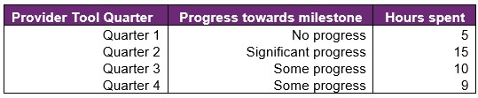
then "cumulative training hours" = 39 = 5 + 15 + 10 + 9 and the progress selected for John is "Significant progress" (the best progress of the 4 quarters). The "cumulative training hours" is then rounded down to the nearest whole number (e.g., 6.75 is rounded down to 6), and grouped into bands. Then for each cumulative training hours group (e.g., 0-9), the percentage of participants in each (best) progress category is calculated so that the sum of the row is 100%.

Appendix 2 – Model accuracy

The generalised linear model presented in Section 8 has the following accuracy:
Figure 42. Model accuracy – Gini and AUC
Measures | Training Data | Test Data
Gini | 0.56 | 0.47
AUC | 0.78 | 0.74

The closer the test set AUC and Gini is to 1, the better the model performance.
The Test Data AUC (and Gini) is typically smaller than the Training Data AUC (and Gini). This is because the model was built on the Training Data, hence predicts more accurately on it. The Test Data Gini and AUC however, give an indication of the model prediction accuracy when the model predicts on unseen data (on which it was not built).
Figure 43. Model accuracy – receiver operating curve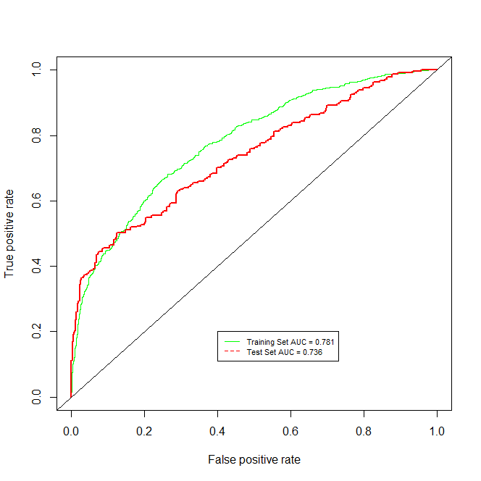

Figure 44. Model accuracy – actual versus predicted
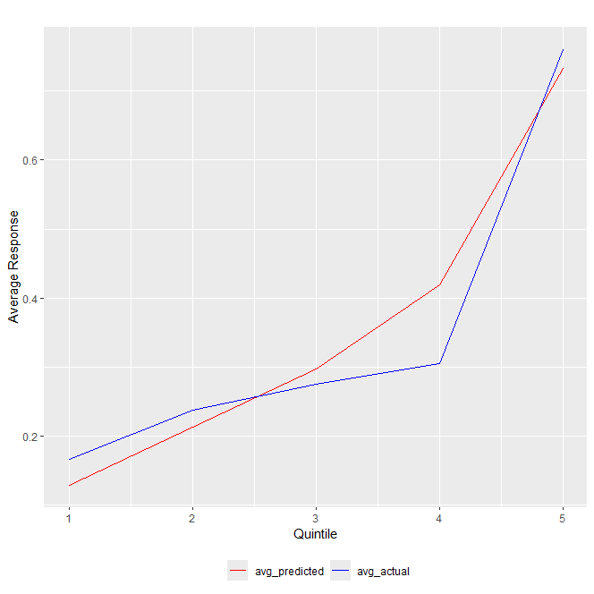

The model predicted probability (red) curve is close to the actual outcome (blue) curve, indicating that the model is able to accurately predict the probability of recipients finding paid employment.

Source: Australian Bureau of Statistics. For further information: Socio-Economic Indexes for Areas (SEIFA): Technical Paper, 2021 | Australian Bureau of Statistics (abs.gov.au) Link to the data: Socio-Economic Indexes for Areas (SEIFA), Australia, 2021 | Australian Bureau of Statistics (abs.gov.au) - Local Government Area, SA1 Distributions, SEIFA 2021.xlsx

