
National Disability Insurance Agency
Frequently Asked Questions
Claims and Payments
Getting paid as a Specialist Disability Accommodation (SDA) provider
22 May 2025 (updated March 2026)

Contents
National Disability Insurance Agency Frequently Asked Questions 1
Background 4
What is SDA? 4
Plan Management Types 5
Agency Management 5
Plan Management 5
Q. What information do I need to include in an invoice to the plan manager? 6
If the participant’s plan is in CRM, how do I get paid? 6
Q. Can I create or edit a service booking? 7
Q. Will I be notified if a service booking is created by the NDIA? 9
Q. If the participant has an existing SDA service booking in CRM, how do I get paid when their NDIS plan transitions to PACE? 9
Q. Does a service booking need to be shown as ‘Active’ to receive a payment? 9
If the participant’s plan is in PACE, how do I get paid? 10
‘myprovider’ relationship 11
Q. How long does it take to be paid as a ‘my provider’? 11
Q. How can I submit a new Relationship Request in the my NDIS provider portal? 11
Q. Is a participant able to have a ‘my provider’ relationship with more than one SDA provider at the same time? 12
Q. Do I need to have a general ‘my provider’ relationship in addition to an SDA ‘my provider’ relationship? 12
Q. If the ‘my provider’ relationship is created after the participant’s plan start date or move-in date, how do I claim the gap period? 12
Q. Can I end or extend the ‘my provider’ relationship? 12
Q. What happens if the ‘my provider’ relationship is rejected? 13
Bulk payment request 14
Q. How do I name the bulk payment request template? 14
Q. What is the date format of the bulk payment request template? 14
Q. When submitting a bulk payment request, what does it mean when a payment status is set as ‘Open’? 14
Q. Is there a guide about bulk payment rejection errors? 14
SDA Quotes 15
Q. How do I provide a quote to the NDIA? 15
Q. How do I know if a participant has received updated NDIS funding? 15
SDA Pricing Arrangements 15
Q. Have NDIS plans been updated to reflect the current Pricing Arrangements for SDA? 16
Q. Can I view the participant’s SDA funding amount in the my NDIS provider portal? 16
Q. When there are discrepancies between published SDA rates and individual NDIS plan funding amounts, what can I claim? 16
Q. What if I have already claimed more than the new SDA funding amount in a participant’s plan? 17
Q. Can a participant dispute a payment request? 17
SDA Vacancy Payments 18
Q. How do I submit a vacancy payment claim? 18
Q. How can I claim a vacancy payment if the participant has not provided a signed termination? 19

Background
The National Disability Insurance Agency (NDIA), through the Home & Living Capital Branch, has established a Specialist Disability Accommodation (SDA) webinar series as part of our role to steward the Home and Living capital market.
Within this series, we held online webinars about claims and payments for SDA providers. These webinars were delivered in March 2025. The Frequently Asked Questions (FAQ) in this document were those most often asked in the webinars. The FAQs also aims to assist you, as an SDA provider, with processes and issues that may be encountered when claiming SDA funding. This document does not replace resources on the National Disability Insurance Scheme (NDIS) website. The NDIS website is regularly updated, and this document should be read in conjunction with those resources.

What is SDA?
SDA is a range of housing designed for people with extreme functional impairment or very high support needs. SDA helps participants live more independently and allows other supports to be delivered better or more safely within the home.
We do not build, own or commission SDA. The upfront investment of buying or building SDA dwellings is borne by the owner or investor. Pricing limits for SDA are set through a legislative framework to generate appropriate returns for investing in SDA, covering build and maintenance costs. Please visit our website for more information about investment in SDA.
The NDIS provides SDA funding to eligible participants. People who live in SDA need to live in specialised homes, usually with very high levels of person-to-person support. To receive SDA funding, we must have deemed a participant is eligible for SDA. For more information about SDA eligibility and funding, refer to: Specialist disability accommodation | NDIS.
As a provider, you need to be registered with the NDIS Quality and Safeguards Commission to offer SDA. SDA funding can then be claimed by a registered SDA provider once we have enrolled the dwelling, and an eligible participant is residing in the dwelling.

Plan Management Types
A Local Area Coordinator (LAC) or NDIA planner will ask the participant how they would like to manage their NDIS funding. This includes helping the participant to choose the best way to manage their funds, based on their personal needs and circumstances. Participants can choose a different plan management type for different supports. For example, a participant could request that SDA is agency-managed, while other supports are plan-managed.
A participant can ask to change how their funding is managed at any point during their plan and as often as they would like. If a participant only wants to change how their funding is managed, this can be done through a plan variation. The Our Guideline – Changing your plan on the NDIS website includes more information.
We recommend that you work with the participant, to understand their approved SDA funding amount and plan management type. There are different ways that you will be able to claim SDA funding, depending on the participant’s chosen plan management type.

Agency Management
When a participants funding is Agency-managed, this means that they can choose services from a range of NDIS registered providers. For SDA, an SDA registered provider must be used. We manage the book-keeping and records of the participants spending, and you will be able to claim payments electronically. To do this, you will need to submit a payment through the myplace provider portal using the bulk payment request function and template. Refer to the Using the myplace provider portal step-by-step guides for details on making payment requests.

Plan Management
When a participants funding is Plan-managed, this means that we provide funding in their plan to pay for a plan manager. A participant can choose services from a range of NDIS registered and non-NDIS registered providers. However, for SDA an SDA registered provider must be used. A plan manager helps the participant to keep track of their funds, takes care of financial reporting, and pays you as the provider. To do this, you will need to submit a invoice to the participant’s plan manager. The plan manager will inform you of how to submit an invoice to them and what they require to claim for services.
It's important that payment related issues (where there is an appointed plan manager) are managed and escalated through the plan manager directly.
Q. What information do I need to include in an invoice to the plan manager?
When you submit an invoice, this must include the following information to minimise delays:
- Your SDA provider details including your business name, NDIS provider number and ABN
- The participants full name, NDIS number and address of the dwelling (including postcode). You must ensure that the address listed in the invoice matches the approved SDA enrolment address
- The support item number. You can find the SDA support item number in the NDIS Support Catalogue
- The amount and quantity for each unit of support
- The dates you are claiming for
- The total invoice amount.
Please note that SDA payments are GST free. GST will not need to be included in the total invoice amount.

If the participant’s plan is in CRM, how do I get paid?
If the participant’s plan is in CRM and their funds are Agency-managed, you will need to have a service booking in place. Service bookings put aside money in a participant’s budget to pay you for the services that you deliver. Once a service booking is in place, you will then submit a payment through the myplace provider portal using the bulk payment request function and template.
If the participant’s plan is in CRM and their funds are Plan-managed, you will need to submit an invoice to the participant’s plan manager. Please see above for information to include in an invoice.
Service bookings are only required in CRM. Once all participant plans are transferred to PACE, service bookings will no longer be required.

Q. Can I create or edit a service booking?
Yes. If the participant’s SDA funding is Agency-managed, we will create the initial service booking with the participant’s chosen provider. If the participant changes providers, the initial service booking will need to be ended by the original provider to ensure there is funding available for the incoming provider. You will then be able to create a new service booking via the myplace provider portal, this can only be done once the initial service booking has been ended.
For SDA, the stated support item must be selected when creating the service booking. If the participant has a stated item in their plan and you do not select the support category and stated support item, the portal will reject the service booking.
If the participant’s SDA funding is Plan-managed, we will create a service booking with the participant’s chosen plan manager. You will then need to send an invoice to the plan manager to receive a payment.
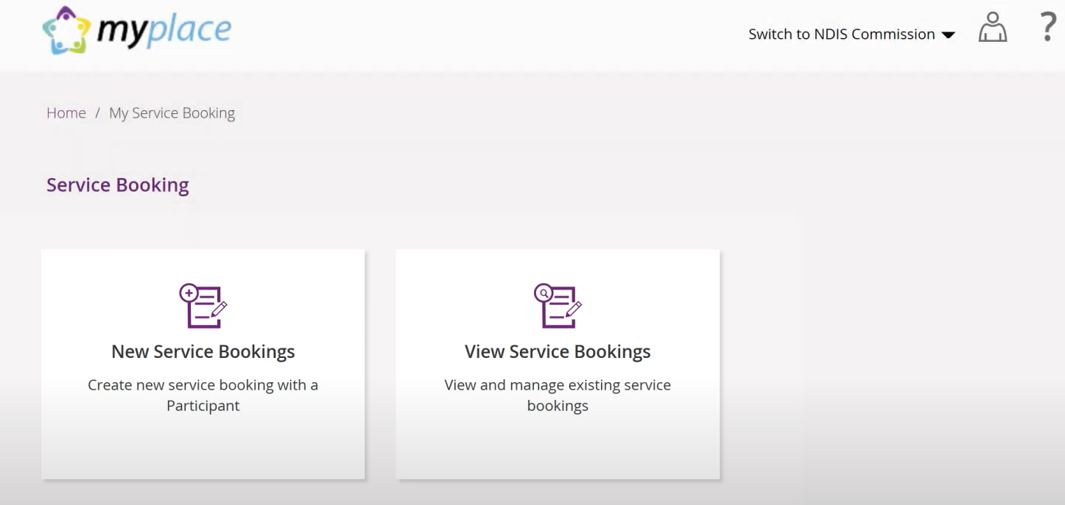

Q. Will I be notified if a service booking is created by the NDIA?
Yes. When a service booking is created, you will be sent a notification via the myplace provider portal. You will need to accept or decline this. You must accept the service booking request to receive a payment. You will then be able to create a payment request in line with the service booking.

Q. If the participant has an existing SDA service booking in CRM, how do I get paid when their NDIS plan transitions to PACE?
A participant with a NDIS plan in CRM will transition to PACE when a new plan is approved. When approved, any existing service bookings from CRM will be end-dated and you will have 90 days to lodge your payment request from the end date.
As the participant has now transitioned to PACE, if their funds are Agency-managed you will need to submit a payment request through the myplace provider portal using the bulk payment request function and template. Or, if their funds are Plan-managed, you will need to submit an invoice to the participant’s plan manager.
A service booking is no longer required.

Q. Does a service booking need to be shown as ‘Active’ to receive a payment?
Yes. If the status is ‘Active,’ this means the service booking has been accepted by both the participant and you as the provider.

If the participant’s plan is in PACE, how do I get paid?
As participants and their NDIS plans move to our new computer system, PACE, providers will not be able to claim using the single payment request function.
If the participant’s plan is in PACE and their funds are Agency-managed, you will need to submit a claim through the myplace provider portal using the bulk payment request function and template.
SDA providers can also use the my NDIS provider portal to submit a new request to be recorded as a participant’s ‘my provider ’. By recording a ‘my provider,’ participants are letting us know that you can receive payments for claims on their NDIS plan. Providers recorded as ‘my providers’ will generally be paid quicker than those who are not.
If the participant has transitioned from CRM to PACE, providers with existing service bookings will automatically be recorded as a ‘my provider’ when a participant’s plan is approved in PACE.
The Provider Learning Environment includes step by step tutorials for providers on how to submit new, extend and end current ‘my provider’ relationships through my NDIS provider portal.
If the participant’s plan is in PACE and their funds are Plan-managed, you will need to submit an invoice to the participant’s plan manager.
Please see above for information to include in an invoice.

‘myprovider’ relationship

Q. How long does it take to be paid as a ‘my provider’?
Claims are generally paid within 2 to 3 business days but can take up to 10 days.
If your claim is rejected and you can’t resolve this yourself, you can lodge a payment enquiry. In this case, your payment will be delayed as we individually assess your enquiry.
You can also contact us via the dedicated phone number for providers, support coordinators, and plan managers on 1300 311 675.

Q. How can I submit a new Relationship Request in my NDIS provider portal?
The ‘Relationship requests’ tab is a sub tab under the ‘Organisation’ page. In this tab, you will be able to request a new relationship with a participant. Click the ‘Add new request’ button, select the role ‘my provider’ and then select the specialised support category of ‘Specialist disability accommodation’ from the dropdown menu.
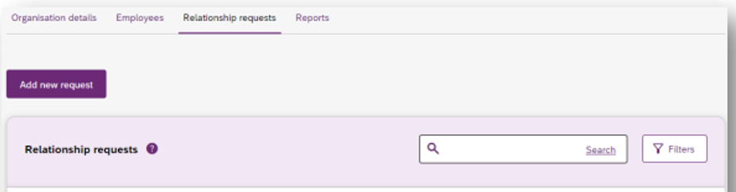
For the request to be valid, you must submit a new relationship request with a start date on or after the date the participant moved into the SDA dwelling. It is important to confirm that the details in the ‘my provider’ relationship align with the details you have agreed to in the participant’s service agreement.
For each participant residing in the SDA, you will need to create a new ‘my provider’ relationship.
Refer to the ‘Organisation’ section of the my NDIS provider portal step-by-step guide and the Provider Learning Environment for guidance on creating a ‘my provider’ relationship request.

Q. Is a participant able to have a ‘my provider’ relationship with more than one SDA provider at the same time?
You will only be able to claim SDA from a participant’s plan while you are the provider of their SDA supports. A ‘my provider’ relationship will need to be end dated when a participant vacates the SDA.

Q. Do I need to have a general ‘my provider’ relationship in addition to an SDA ‘my provider’ relationship?
When you submit a request for the specialised support category, SDA, a general ‘my provider’ relationship will be automatically created once the relationship is approved. If you deliver other Home & Living supports, you will need to create a separate ‘my provider’ relationship.

Q. If the ‘my provider’ relationship is created after the participant’s plan start date or move-in date, how do I claim the gap period?
To claim the gap period, you will need to submit a payment enquiry through my NDIS provider portal.

Q. Can I end or extend the ‘my provider’ relationship?
Yes. You can edit your ‘my provider’ relationship through the 'Provider roles' tab. If you are a ‘my provider’ already, you will see the ‘More’ Button in the ‘Actions’ column. Clicking the ‘More’ button will display two additional buttons – ‘Extend role’ and ‘End role.’ The ‘Extend role’ button will only appear if the relationship has an end date.
Please refer to The Provider Learning Environment where you can find more information on how to navigate the portal.
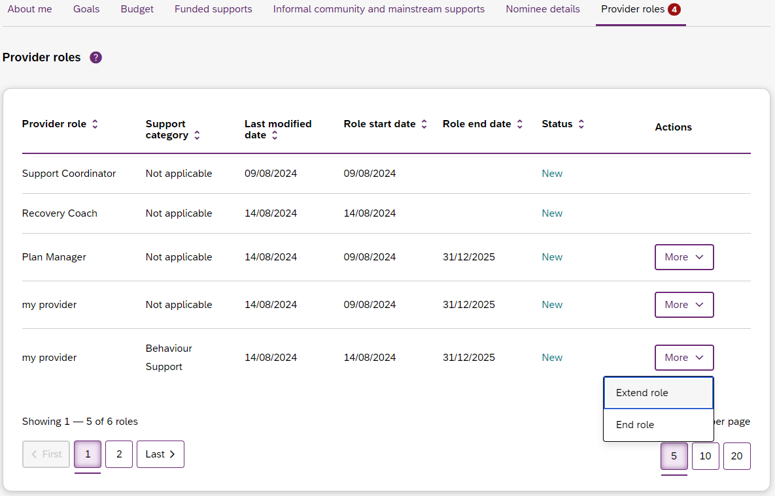

Q. What happens if the ‘my provider’ relationship is rejected?
You will receive an error message. If you receive an error message, you will need to
re-submit the relationship request. When you re-submit the request, it is important to notify the participant who will need to accept or reject the request.

Bulk payment request

Q. How do I name the bulk payment request template?
When naming the bulk payment request template, your filename must not exceed 20 characters in length including the extension .CSV as four of those characters. If you receive an error message in the portal and need to re-upload the file, you must rename the file. A duplicate error will display if you upload the same named file again.

Q. What is the date format of the bulk payment request template?
The start and end dates must be in the format YYYY-MM-DD. This is the accepted format; please check you use this correctly otherwise your claim will be rejected.

Q. When submitting a bulk payment request, what does it mean when a payment status is set as ‘Open’?
This means the payment request has been submitted and will be reviewed by the participant to accept or reject.

Q. Is there a guide about bulk payment rejection errors?
Yes. Refer to the Bulk Payment Request self-help guide. Rejection messages and resolutions are available in ‘Part 3: Bulk payment rejections, if you cannot rectify the issue yourself and the message states ‘Contact the NDIS for help’ you can submit a payment enquiry.

SDA Quotes
We may ask you to provide information about the enrolled dwelling a participant is moving into. This could be called a quote. This terminology is based on NDIS plans in our CRM system. You may also see this wording on some NDIS plans. If you are asked to provide further information or to provide a quote, please include:
- The SDA address. This must be consistent with the enrolment address in my NDIS provider portal
- Your NDIS provider registration number and legal name
- The participant’s agreed move-in date (please note that the lease commencement date may differ; however, the SDA provider is only eligible to claim SDA funding from the actual date the participant began residing in the property).

Q. How do I provide a quote to the NDIA?
When informing us of details about the participant’s SDA address and move in date, you can email enquiries@ndis.gov.au, using the subject title: SDA funding inclusion- Plan Variation. If you are also providing a quote for the SDA dwelling, please ensure the quote is attached to the email and titled: SDA funding inclusion- Plan Variation.
Alternatively, if you are supporting a participant to provide this information to us, they can call us on 1800 800 110 or submit a Change of details or change of situation form. In part C of this form: Information about what has changed, the form must state that a plan variation is required due to: SDA funding inclusion post SDA decision- request plan variation to include SDA funding.

Q. How do I know if a participant has received updated NDIS funding?
If a new SDA funding amount is approved, the participant will receive a copy of their new NDIS plan. You can check with the participant, their nominee, or their plan manager to understand the approved SDA funding amount.

SDA Pricing Arrangements
The NDIS Pricing Arrangements for SDA (previously the Price Guide for SDA) is a summary of price limits and other pricing arrangements that apply to SDA under the NDIS.

Q. Have NDIS plans been updated to reflect the current Pricing Arrangements for SDA?
The new prices for SDA came into effect on 1 July 2023. SDA pricing is indexed annually each year in July, and this indexation is automatically applied in plans.
If you have a question regarding Pricing Arrangements for SDA, please email enquiries@ndis.gov.au.

Q. Can I view the participant’s SDA funding amount in the my NDIS provider portal?
No. For details about the participant’s budget, it is important to discuss this with the participant, their family, carers, or their support coordinator. You can also talk to the participant about requesting a copy of their NDIS plan.
- Helpful questions that you can ask a participant to understand their funding, include:
  - Is SDA funded in your plan?
  - Does your funding align with the cost of the dwelling over the course of your plan?
  - How are your NDIS funds managed?

Q. When there are discrepancies between published SDA rates and individual NDIS plan funding amounts, what can I claim?
We set limits on the SDA prices that you can charge. As per the NDIS Pricing Arrangements for SDA, when claiming SDA from a participant’s plan, you are only entitled to claim the lesser of:
- the maximum per participant price for which the dwelling is enrolled; and
- the amount of SDA funding for which a participant has been approved eligible.

Q. What if I have already claimed more than the new SDA funding amount in a participant’s plan?
You can cancel a payment request in your payment history with a status of ‘Paid.’ Please note that you must be recorded as an account manager or primary contact to do so. Refer to the ‘Payment Request’ section of the Administering your services step-by-step guide for helpful steps.
We may:
- send you an invoice requesting repayment of the cancelled amount; or
- offset your future payment requests against the cancelled amount.
Please note: If you wish to return a payment that you have received after cancelling the payment request, please contact us via the dedicated phone number for providers, support coordinators, and plan managers on 1300 311 675.

Q. Can a participant dispute a payment request?
Yes. If the participant does not agree with the support, they can contact us or dispute the claim in the my NDIS participant portal. We will pause the payment while we look at the claim. We might ask the participant for more information and talk to you.
Claims we do not agree to pay will be shown as rejected in the my NDIS provider portal.

SDA Vacancy Payments
There are very limited circumstances in which SDA payments may continue for a period of time after a participant no longer physically resides at an enrolled SDA dwelling. This is called a vacancy payment. Refer to NDIS Pricing Arrangements for SDA for information about claiming payment for an SDA vacancy.

Q. How do I submit a vacancy payment claim?
Vacancy payments for Agency-managed participants are investigated by us. In this instance, you will need to submit a payment enquiry.
Within the payment enquiry, you will need to include:
- An invoice for the relevant period
- Evidence of notice to vacate
  - When the participant provides notice: dated evidence of written notice
  - When the SDA provider provides notice: dated evidence of written notice and behavioural risk evidence
- Evidence of the terminated service agreement, signed and dated by the participant. This will need to detail the last date the participant resided in the SDA.
- This is not required if the participant is deceased.
Vacancy payments for plan-managed participants are investigated by the plan manager. Please submit your invoice and other evidence required to the participant’s plan manager directly.
You are required to advise us of the vacancy within 5 business days of the event occurring (receiving or providing a notice to vacate) by emailing SDAENROLMENT@ndis.gov.au.
It is also important to note that requests for vacancy payment can only be submitted in arrears once the 60-90 days period has lapsed.

Q. How can I claim a vacancy payment if the participant has not provided a signed termination?
You will need to lodge a payment enquiry, including evidence that the participant has moved out of the dwelling, and an invoice. The participant may then be contacted to confirm the payment details.

