

my NDIS provider portal
Step-by-step guide
Specialist Disability Accommodation (SDA) Dwelling Enrolment

September 2025

Table of Contents
Changes from the last version 3
Introduction 3
What can you do in the my NDIS provider portal? 4
Minimum internet browser requirements 4
Accessing the my NDIS provider portal 4
Select an organisation 6
SDA Dwelling Enrolment page 7
Submit a new application to enrol a dwelling 8
Step 1 – Enter Dwelling address details 9
Step 2 – Enter your dwelling details 12
Step 3 – Dwelling Enrolment documents 16
Step 4 – Review Dwelling Enrolment 18
Step 5 – Authorised contacts and declaration 19
Withdraw a submitted Dwelling Enrolment application 22
Apply to Modify a Dwelling Enrolment 23
Submit an application to cancel a Dwelling Enrolment 25
Respond to a Request for Information 27
Dwelling enrolment application outcome 28
Applications to enrol or modify a dwelling as SDA 29
Applications to cancel a dwelling enrolment 29
Other Functions 30
Trouble shooting 34

Changes from the last version
The following updates have been made to the last published version of the my NDIS provider portal step-by-step SDA guide as of Setember 2025:
- better visibility of uploaded documents to the portal
- clearer option to discard unsaved changes
- updated screenshots of my NDIS provider portal

Introduction
- All applications to enrol dwellings as Specialist Disability Accommodation (SDA) need to be made through the my NDIS provider portal. The my NDIS provider portal is different from the myplace provider portal.
- The my NDIS provider portal allows SDA registered providers to create SDA dwelling enrolment applications online. You can send evidence, check on progress and manage the application from start to finish.
- If you would like to become a registered SDA provider contact the NDIS Quality and Safeguards Commission.
- The NDIA decides whether to enrol a dwelling when an SDA registered provider submits a completed application to enrol, after the dwelling is built.
- This step-by-step guide describes how the my NDIS provider portal works and includes instructions on how to create and manage dwelling enrolments using available functions in the portal.
You can get help in the portal by clicking and buttons.

What can you do in the my NDIS provider portal?
The my NDIS provider portal enables SDA registered providers to:
- create and submit new dwelling enrolment applications
- manage dwelling enrolment applications
- action requests for additional information
- view enrolled dwellings
- modify existing enrolments
- cancel existing enrolments.
Note: Use the myplace provider portal for all claims and payment enquiries.

Minimum internet browser requirements
To access the my NDIS provider portal please use one of the following browsers:
- Google Chrome
- Microsoft Internet Explorer 11 on Windows 8.1 or Windows 10
- Microsoft Edge
- Mozilla Firefox
- Safari on Mac OS X

Accessing the my NDIS provider portal
Individuals can access the my NDIS provider portal if they are already established as an authorised contact in the myplace provider portal.
For more information, refer to myplace provider portal step-by-step guides.
Users can access my NDIS provider portal from the links below:
- https://providers.apps.ndis.gov.au/myndisproviderportal
- Access PRODA and select my NDIS provider portal tile once logged in.

Note: If you have already signed in to PRODA you will skip the PRODA sign in page.
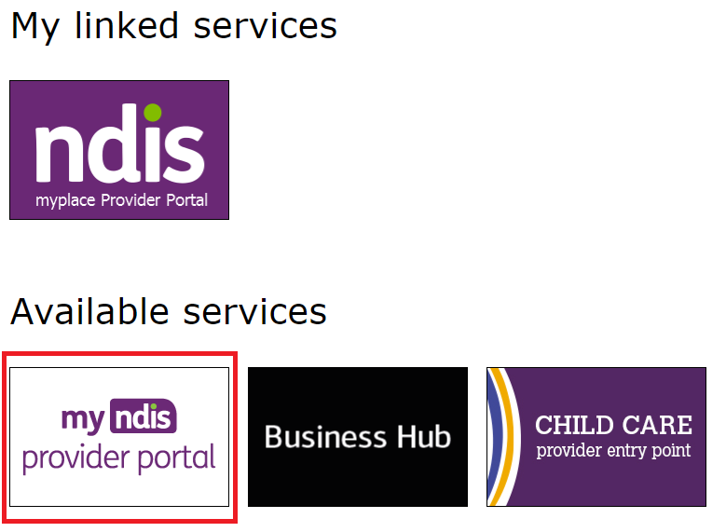

Once you have logged in you can save the SDA enrolment homepage page to your browser favourites.

Select an organisation
If you work for a single provider, you will be automatically taken to the Home page.
If you work on behalf of multiple organisations, you will be asked to select the organisation you wish to represent.
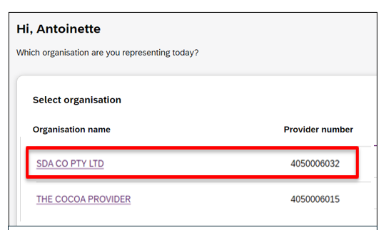
The organisation you have selected will show at the top left of the screen. You can change the organisation you are working on behalf of at any time by selecting the Acting as menu.

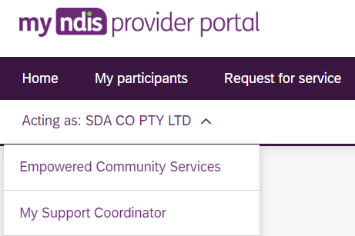
You can configure relationships between users and provider organisations in the existing myplace provider portal. Instructions for updating relationships can be found in the Part 2: Managing Your Information guide. Changes may take up to 24 hours to appear in the my NDIS provider portal.

SDA Dwelling Enrolment page
From the home page, select the SDA link in the main navigation menu bar at the top of the page.
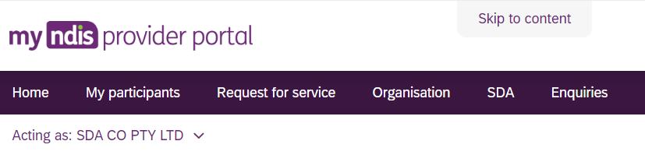

Note: If SDA doesn’t show in the top banner or in quick link menu of the Home page, you’ll need to contact the NDIS Quality and Safeguard Commission to check you have the Specialist Disability Accommodation registration group approved.
The SDA Dwelling enrolment page will display and show the Enrol a dwelling button. Dwellings that are already enrolled or pending an outcome will appear in the dwelling list.

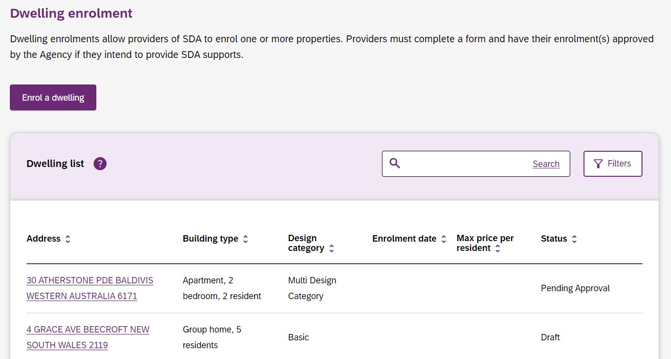

Submit a new application to enrol a dwelling
Select Enrol a dwelling to start a new dwelling enrolment application.
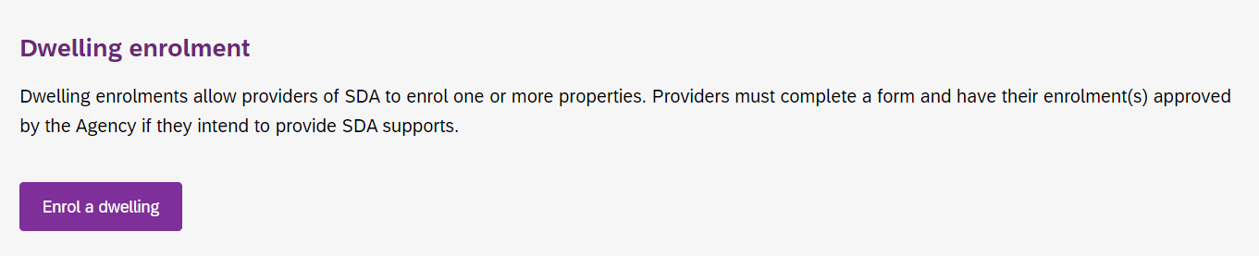
The Before you start page will open. Read the important information by clicking on each heading to open it or click Expand all sections to open all sections at the same time.
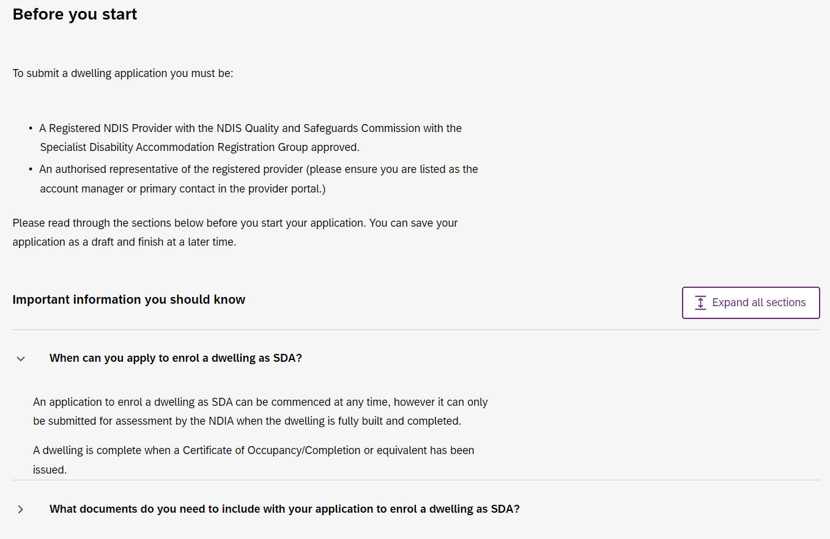
Once you have read all the information, select the Enrol a dwelling button at the bottom of the page to continue.
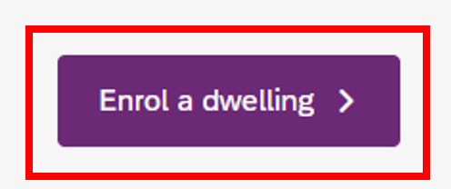

Step 1 – Enter Dwelling address details
You can apply to enrol a single dwelling or multiple dwellings in one session.
To apply to enrol a single dwelling, select No to Are you enrolling multiple dwellings?
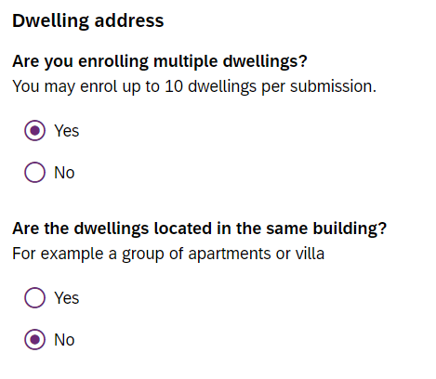
If you wish to enrol multiple dwellings, select Yes. A new question will appear - Are the dwellings located in the same building? Select Yes or No depending on the dwelling/s location. It is possible to apply to enrol up to 10 dwellings at the same time.

Enter the dwelling address(es) using the search function.
Note: If you are aware that this dwelling has previously been enrolled as SDA with a different SDA provider, please contact SDAenrolment@ndis.gov.au to confirm the correct address format to submit. Incorrect addressing will delay enrolment application processing.
If the address has not previously been enrolled, the address submitted must match how it is recorded in ownership documents (i.e. rates notice, occupancy certificate or other verifiable documents). The search results are populated from Addressify and all attempts to find the matching result in Addressify should be made prior to manually entering the address. Select the address from the options displayed in the drop-down.
If you are enrolling multiple dwellings in the same application, you’ll need to manually add a unit or apartment number for each address (e.g. Unit 1 or Unit 2).
If an address does not appear in the Addressify search results, select the Can’t find the address? button.
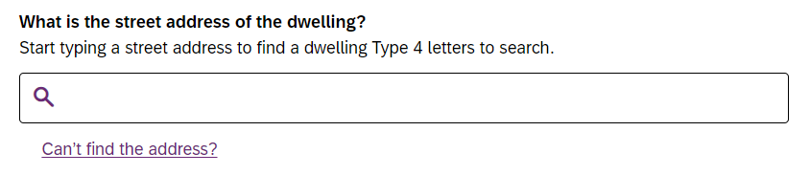
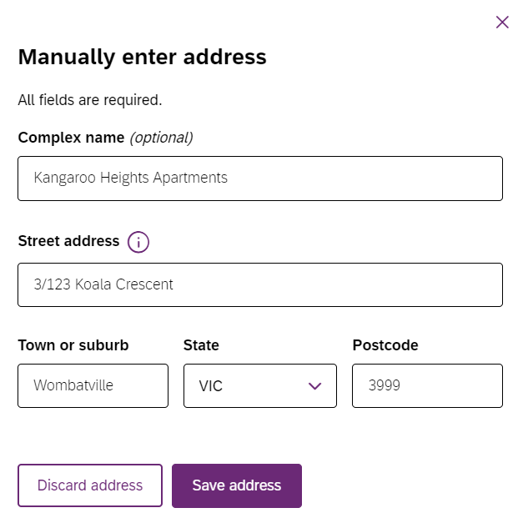
A new screen will open to Manually enter address. Enter the requested information. Select Save address to close the window and you’ll be returned to the previous page.

Note: If you make an error with the dwelling address, only the NDIA are able to amend once the application for enrolment has been saved. Refer to Apply to modify a dwelling enrolment.
Confirm whether the dwelling is built and select Continue to Details.
A dwelling is complete when a Certificate of Occupancy/Completion or equivalent has been issued.

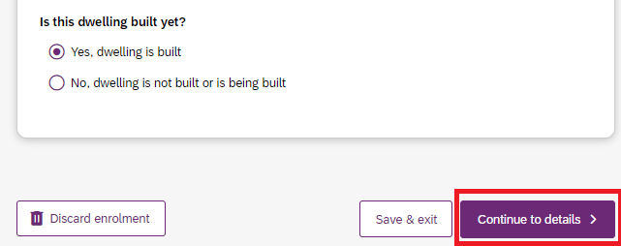
If you select ‘No, dwelling is not built or is being built’’, a pop-up window will appear. Select Continue Enrolment to close this screen. Your application will be saved as a draft, but it cannot be submitted. When the dwelling has been completed, you’ll be able to update the application and submit it.

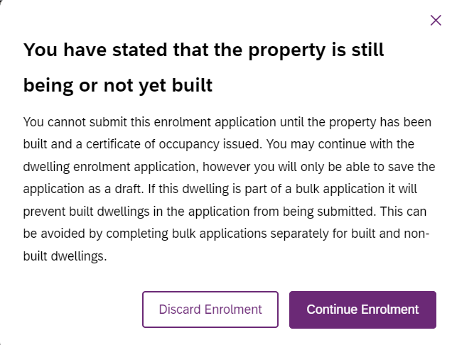

Discard enrolment in-progress application
If you decide not to submit the application to enrol the dwelling you can choose Discard enrolment.
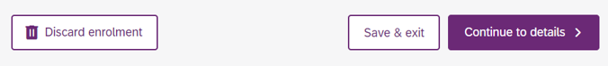
This means the dwelling will no longer show in your Dwelling List on the Home page. Once an application is discarded it cannot be retrieved. If you later want to enrol the dwelling, you will have to start a new application.

Save and exit an in-progress application
At any time, you can save your dwelling enrolment application and return to it later.
Select Save & exit at the bottom of the screen. Saved dwelling enrolment applications will appear on the SDA Dwelling Enrolment page with a status of Draft.

Step 2 – Enter your dwelling details
Providers must complete details accurately and the details entered must be a true reflection of the dwelling.
For more information about SDA types, Building Types, Design Categories and other features please refer to SDA Rules, NDIS Pricing Arrangements for SDA and the SDA Design Standard.
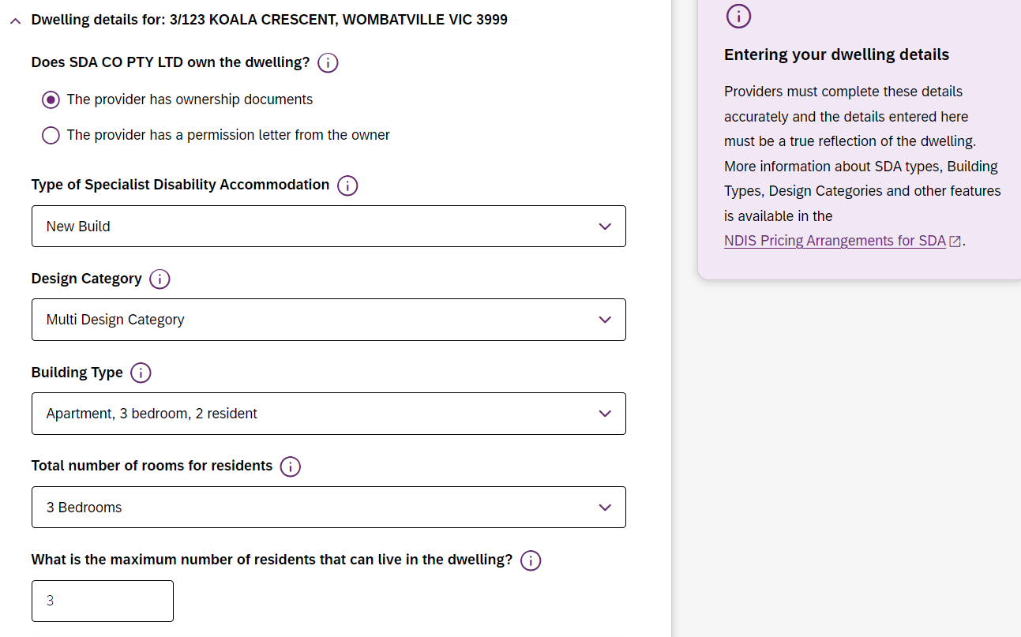Select the button for more information at each step.

Ownership
The name of the legal owner recorded in the dwelling enrolment application must match the ownership document submitted. For example, if the dwelling is owned by a company, the owner’s name recorded in the application must be the company name, not the name of a company’s representative.

Type of Specialist Disability Accommodation
Select from the drop-down list. Options available are Existing Stock, New Build, New Build (refurbishment) or Legacy Stock.

Design Category
Select from the drop-down list. Options available are Basic, Improved Liveability, Fully Accessible, Robust or High Physical Support. For more information on Design Category refer to Schedule 2 of the SDA Rules.
If the dwelling is fully compliant with a single design category, select that category from the drop-down list.
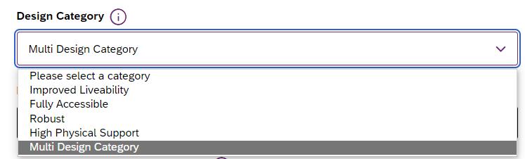

Multi-Design Category (MDC)
Introduced under the SDA Design Standard is also the flexibility to be able to enrol multi-design category (MDC) dwellings which are single dwellings that have bedrooms of different design categories.
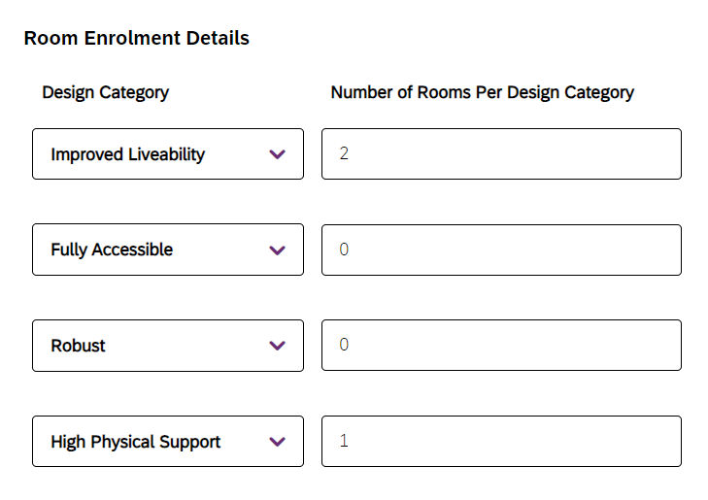
If you select Multi Design Category, a new question will appear, Room Enrolment Details. Populate the room level enrolment details by entering the number of bedrooms that comply with each Design Category.

Note: Only choose Multi Design Category if the dwelling is comprised of at least two bedrooms, each a different design category. For example, a 3-bedroom apartment is designed such that 1 bedroom is designed as High Physical Support and 2 bedrooms are designed as per Improved Liveability. In this example you would enter ‘2’ under Improved Liveability, ‘0’ for Fully Accessible and Robust, and ‘1’ for High Physical Support. The total number of rooms entered must equal the total number of residents for the chosen building type. For example, House 3 residents must have 3 rooms reported in the room enrolment details.

Building Type
Choose from Apartment, Villa/duplex/townhouse, House or Group Home. For additional information on Building Type refer to Schedule 1 of the SDA Rules and the NDIS Pricing Arrangements for SDA.

Total number of rooms for residents
The total number of rooms in the dwelling includes bedrooms plus On-site Overnight Assistant (OOA) and/or breakout rooms.

Number of residents
A ‘resident’ refers to anyone who permanently lives in the dwelling whether they are SDA eligible participant or not. Support staff who might stay overnight to provide on-site overnight assistance are not considered residents.
Note: For New Builds the maximum number of residents is 5.

On-Site Overnight Assistance (OOA)
If there is an additional room or apartment provided for the use of support staff who provide support services overnight to participants, the dwelling may be eligible to claim an OOA allowance. If the dwelling will be claiming OOA, select Yes. You must indicate if the OOA is shared with other dwellings. Submit the address of the OOA room/apartment in the OOA Space Details field.
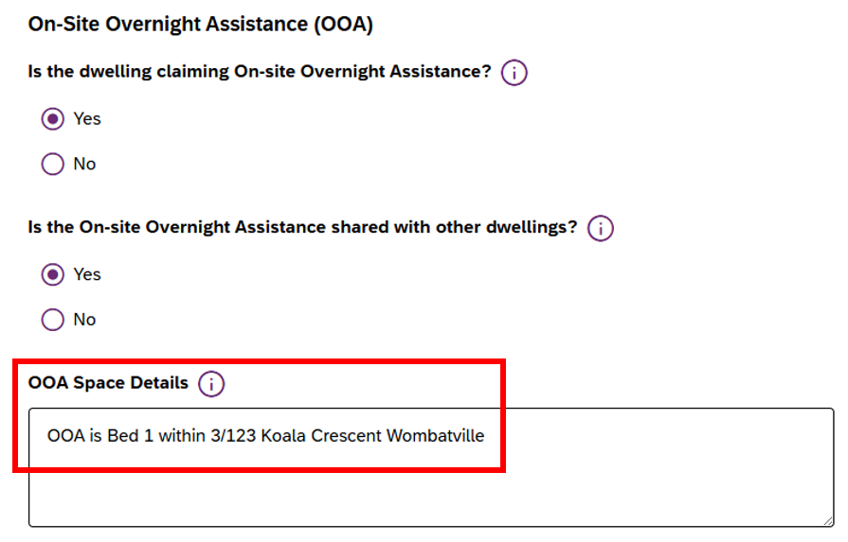
If the OOA is shared with other dwellings, you will need to indicate if the dwelling will or will not be claiming OOA. For example, OOA is payable for a maximum of 10 SDA apartments per one OOA apartment.
Further information about OOA is available in NDIS Pricing Arrangements for SDA.

Fire Sprinklers
If there are fire sprinklers installed, the dwelling may be eligible to claim a Fire Sprinkler allowance.
Select Yes or No.
Evidence will be required to be submitted if Yes is selected, for example a fire safety certificate or equivalent.

Separate Breakout Room
If an additional room is provided for use as a breakout room, the dwelling may be eligible to claim a breakout room allowance. A breakout room is a separate room designed to respond to the resident’s disability related needs.
Select Yes or No.
For Guidance as to when a breakout room allowance may be claimed, please refer to NDIS Pricing Arrangements for SDA.

NDIS Home Modifications
Properties that have had modifications which were funded in part or full by NDIS may not be eligible for enrolment. Refer to the SDA Rules for further details.
Select Yes or No.

Shared Land Restrictions
If the land parcel on which the dwelling is located is shared with any other dwellings select Yes. Evidence may be required to be submitted if Yes is selected. Please refer to section 31 of the SDA Rules for more information about density restrictions.
Intentional community
If the dwelling is part of an Intentional Community as defined in section 31(3) of the SDA Rules select Yes.

GST details
Applications for SDA Type New Build or New Build (refurbishment) will be required to provide GST details. For further information refer to NDIS Pricing Arrangements for SDA or consult your financial advisor or tax agent.
At question 1, select Yes only where the owner of the dwelling was required to pay GST on the construction, refurbishment or purchase price of the dwelling.
At question 2, select Yes where the owner of the dwelling was permitted by law to claim input tax credits in respect of those GST payments (whether or not they claimed those input tax credits).
If you receive a GST related error message, please contact SDAenrolment@ndis.gov.au.
Note: If you are enrolling multiple dwellings, you will need to repeat Steps 2 and 3 for each additional dwelling in the application. You can copy the details of the first dwelling to all dwellings by selecting the Apply details to all dwellings button.

Step 3 – Dwelling Enrolment documents
Documents are used as evidence to support your application. Listed documents are mandatory and must be labelled with relevant file names. You have the option to upload additional documents to support your application. Refer to SDA Dwelling Enrolment FAQ for additional information about mandatory documents.
Accepted file extensions are .doc, .pdf, .rtf, .png, .jpg and .tif. Size of attachments should not exceed 8MB. If you upload any attachments with a file size greater than 8MB the processing of your application may be delayed.
If you receive an error, check the file extension and size.
Use the drop-down menu to select the relevant category document you are uploading and select Choose a file button to upload the file from your device.
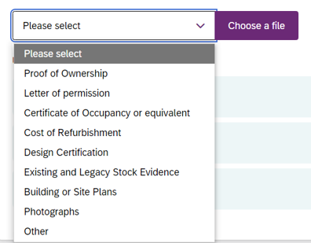

As you upload each document, the list of documents will be updated with a tick mark appearing next to the uploaded documents.
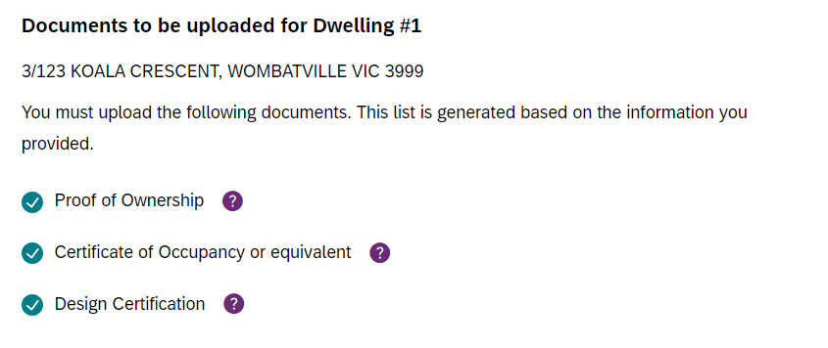

To delete an uploaded document, select the Delete button next to that file.
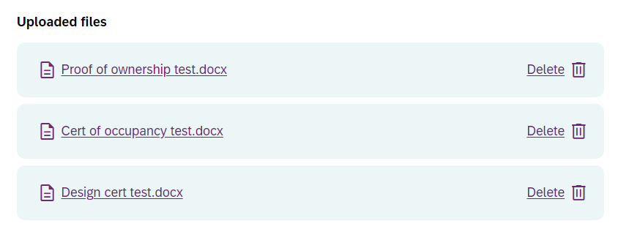

After you have uploaded the documents, select the Continue to Review button.
If you have not uploaded all the required mandatory documents an error will appear. You will not be able to continue your application until the document is uploaded.

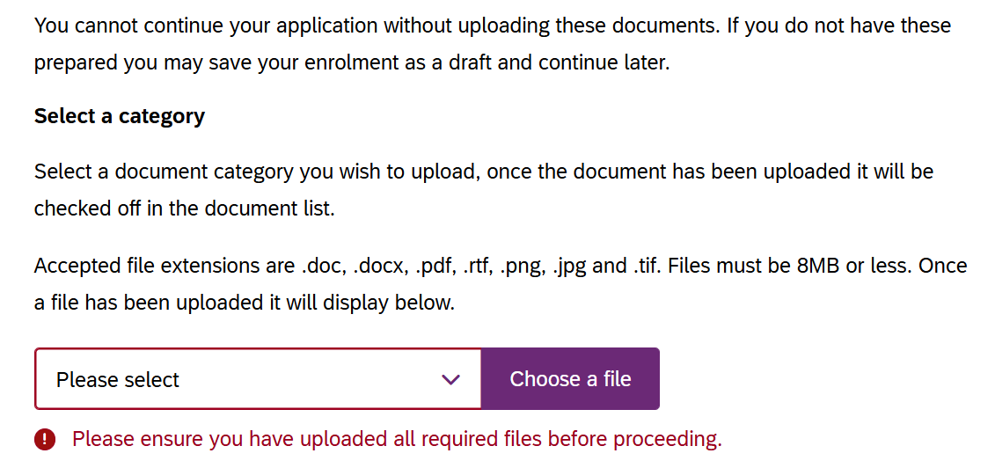

Note: SDA Dwelling Enrolment officers may request additional documents while processing your application. For further information refer to Respond to a Request for Information.

Step 4 – Review Dwelling Enrolment
Review the details submitted in your application to ensure they are correct.
If you identify any errors, select the relevant Edit button in the corresponding section. Selecting any of the below buttons will allow you to edit any of the information entered.

Note: If responses have been changed, you may be required to upload additional documents or answer additional questions. Any missed questions will be highlighted.
After making the relevant changes, select Save changes at the bottom of the page.
If you have uploaded all the mandatory documents and are satisfied with your dwelling enrolment application, select the Continue to declaration button.
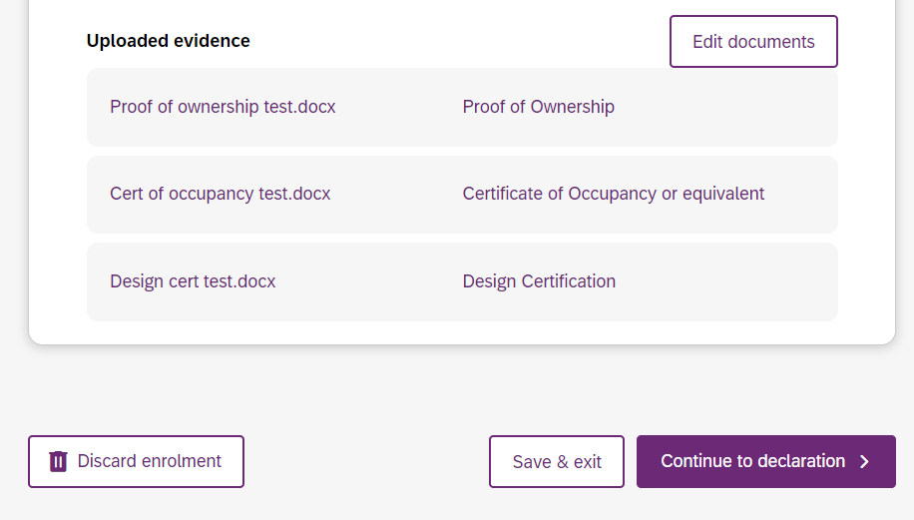

Step 5 – Authorised contacts and declaration
The dwelling enrolment application must be completed by an Authorised Contact Person. An Authorised Contact person is the Account Manager or Primary Contact of the provider organisation as configured in the myplace provider portal.
Choose the Primary Contact Person from the dropdown list and select the Select contact button to display details. Once selected the information will show in the box below. Review details for accuracy.
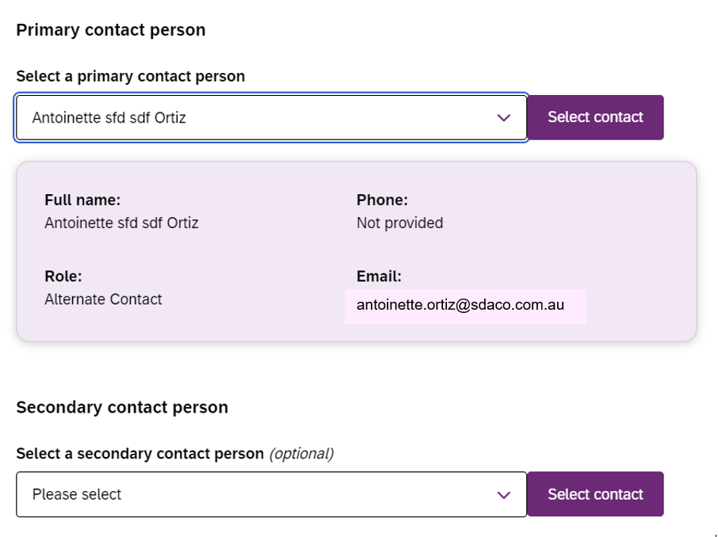

Repeat for Secondary Contact Person if applicable. Providing a secondary contact person is recommended, but not mandatory.

Review the Dwelling Enrolment Declaration before submitting your application.
When you are ready, choose the Authorising Officer from the dropdown list.
And then Select officer to display details. The authorising officer may be the same as the primary or secondary contact or another staff member.
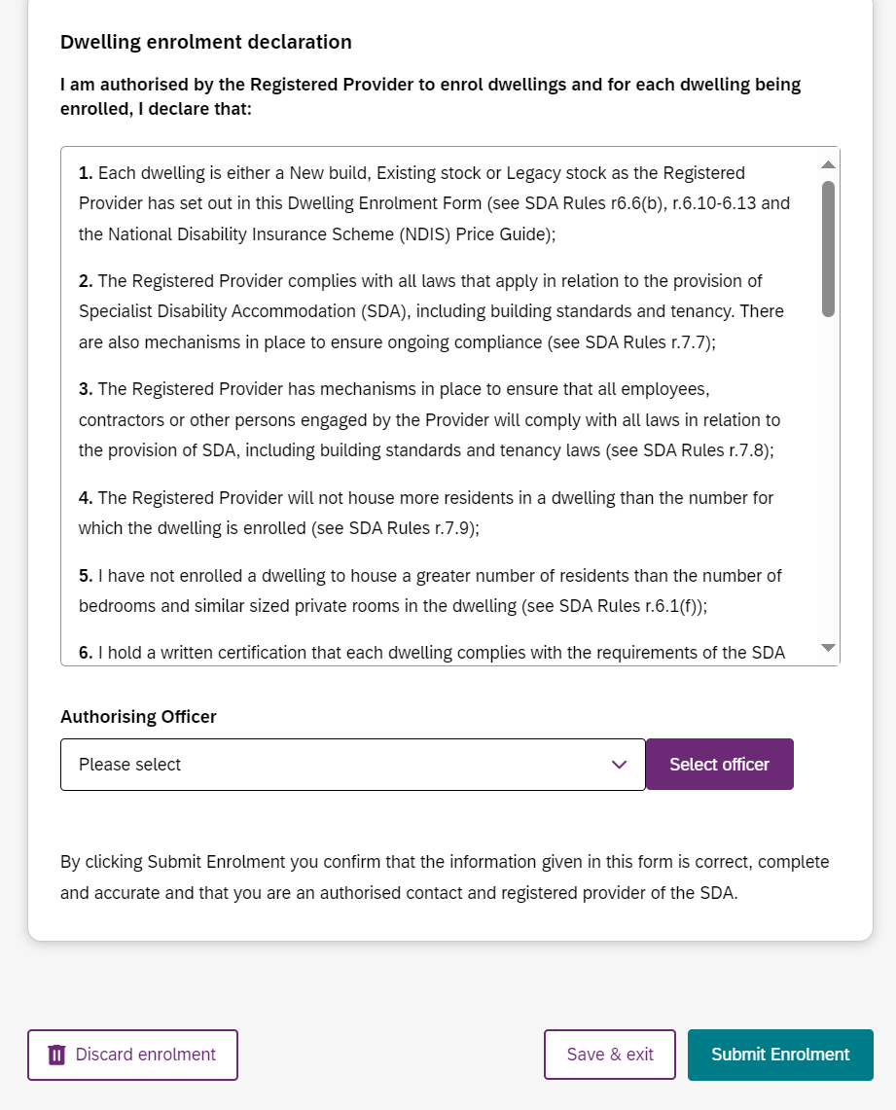

Complete the dwelling enrolment application by selecting Submit Enrolment.
Note: By completing the declaration and submitting the application, you certify that all the details provided in the application are accurate.
Once submitted the status of the dwelling on the SDA Dwelling Listing home page will change to Pending Approval. The application for enrolment will be sent to the SDA Dwelling Enrolment team for assessment.
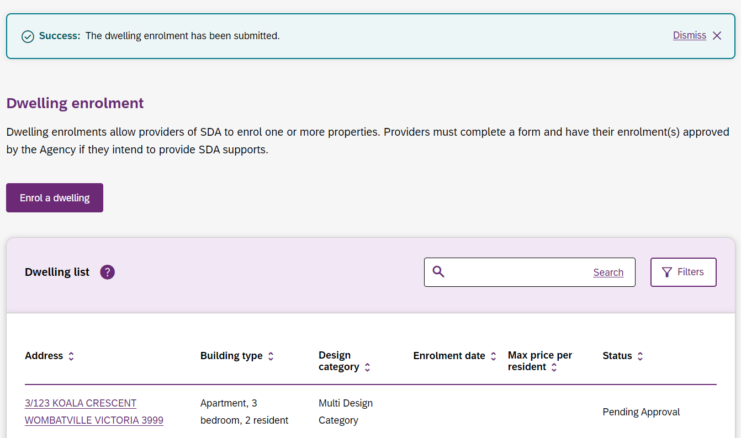
Providers are responsible for keeping organisation contacts up to date. If there are changes to organisation contacts or other details impacting provider dwelling enrolment application processes, please contact SDAEnrolment@ndis.gov.au for help.
Proceed to Dwelling enrolment application outcome.

Withdraw a submitted Dwelling Enrolment application
To withdraw a submitted dwelling enrolment application, navigate to the SDA dwelling enrolment page and select on the dwelling address.
Note: Only dwelling enrolment applications with a status of Pending Approval can be withdrawn.
Review the summary of the dwelling enrolment application details. To withdraw the application, select Withdraw enrolment button to continue. If you do not wish to proceed, select Back to enrolments list.
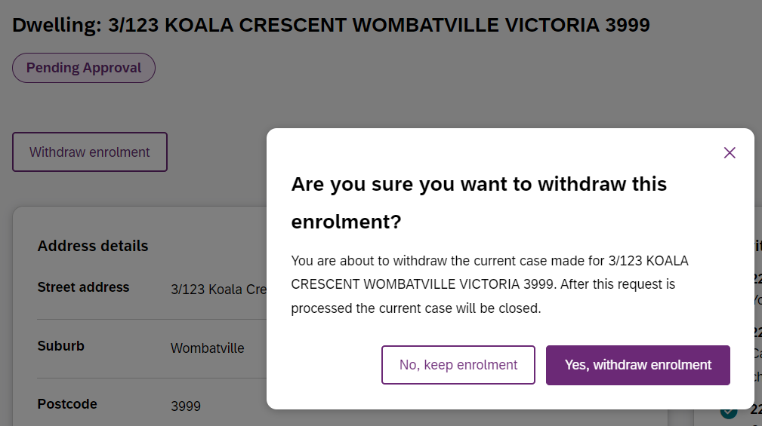

A confirmation screen will appear and advise that withdrawing the application to enrol will close the case. Select the Yes, withdraw enrolment button if you wish to continue or the No, keep enrolment button to stop withdrawing the application to enrol.
Note: If the dwelling enrolment application is withdrawn and you change your mind, you’ll need to start a new application. No letter will be issued to confirm the application has been withdrawn.

Apply to Modify a Dwelling Enrolment
If the characteristics of an enrolled dwelling change, an application to modify a dwelling enrolment can be submitted. An application to modify a dwelling enrolment is considered a new application to enrol and all evidence requirements apply.
On the SDA Dwelling Enrolments page, select the dwelling address. An application to modify a dwelling enrolment can only be created against dwellings with a status of Enrolled.
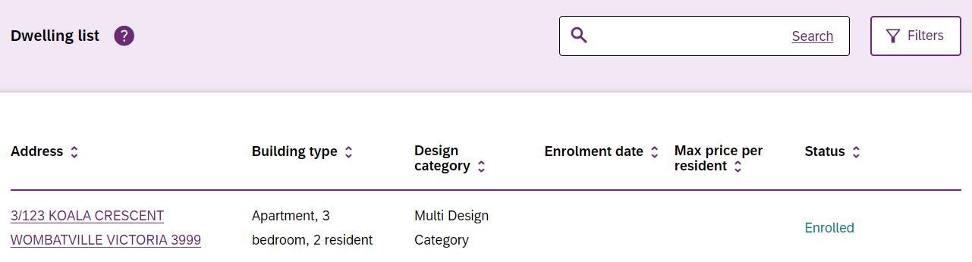
Note: Addresses are unable to be modified by providers on the portal. Please email SDAEnrolment@ndis.gov.au where amendments are required.
A summary of the dwelling enrolment characteristics can be viewed. Select Update enrolment to continue or Back to enrolments list if you do not wish to proceed.
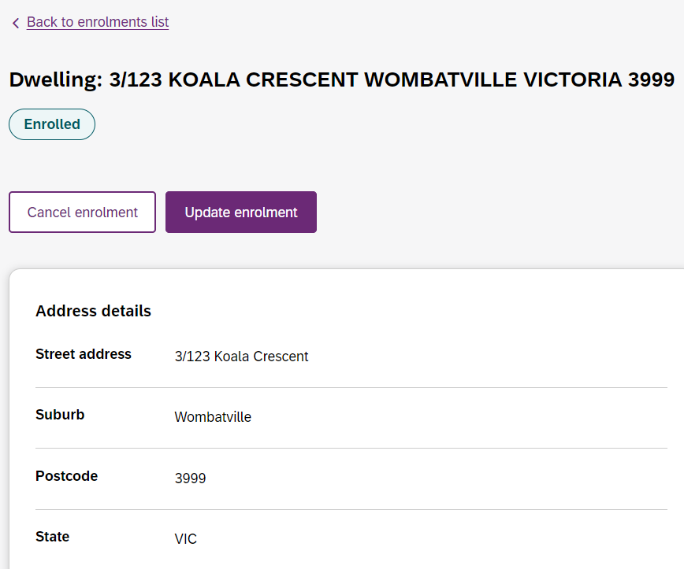
Review and update the required dwelling information and documentation.
Select Continue Enrolment to update the Primary and Secondary Contact Persons as well as the Authorising Officer.

Selecting Submit Enrolment will notify the NDIA that you have applied to modify a dwelling enrolment. The status of the dwelling on the SDA dwelling enrolments page will change to Pending Approval.
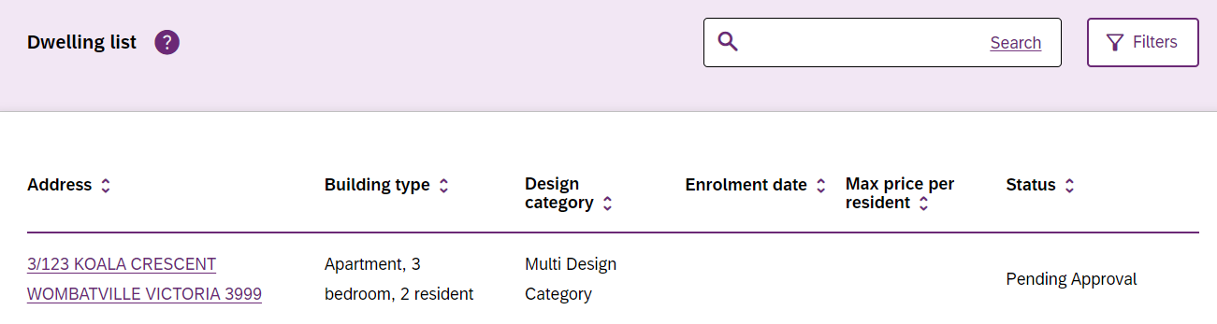

Proceed to Dwelling enrolment application outcome.
Note: Where there is a change in SDA provider, the dwelling enrolment must be cancelled by the outgoing provider before a new application can be lodged by the incoming provider. Refer to Submit an application to cancel a dwelling enrolment.

Submit an application to cancel a Dwelling Enrolment
Providers can cancel an enrolled dwelling via the my NDIS provider portal.
Cancelling a dwelling enrolment will mean that you can no longer claim SDA payments for NDIS participants that reside in the dwelling.
Once a dwelling enrolment is cancelled, a new application must be submitted if a provider wishes to enrol the dwelling as SDA again in the future.
On the SDA Dwelling Enrolments page, select the dwelling address. An application to cancel the enrolment of a dwelling can only be created against dwellings with a status of Enrolled.
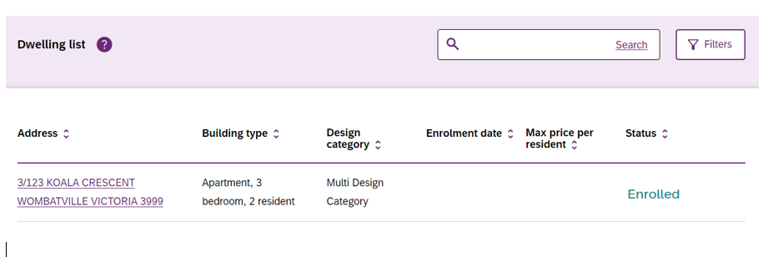

On the summary of the dwelling enrolment characteristics page, select Cancel enrolment to continue.
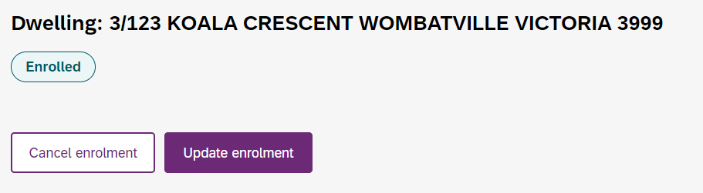

A pop-up window requesting the Reason for cancelling enrolment and Effective date of cancellation will open.
- The Reason for cancelling enrolment is a free text box.
- Effective date of cancellation means that payments are claimable up to and including this date but not into the future. For example, the date of 7 August 2025 has been submitted in the screen shot below. The provider is able to claim payments up to 7th August 2025, but not for 8 August 2025 onwards.
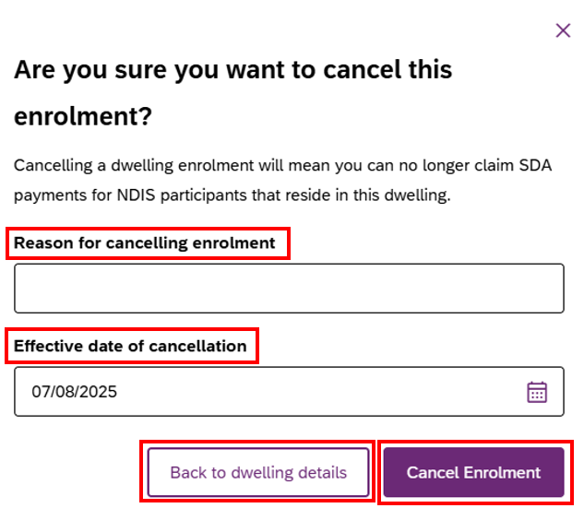

To submit the cancellation, select the Cancel Enrolment button.
If you do not wish to proceed select the Back to dwelling details button.
The NDIA will be notified that you have submitted an application to cancel the dwelling enrolment. The status of the dwelling on the portal home page will remain Enrolled until the application to cancel is finalised by the NDIA.
The status of the dwelling on the portal home page will change to Not Enrolled once the application to cancel enrolment is finalised.
Proceed to Dwelling enrolment application outcome.

Respond to a Request for Information
If the NDIA need more information the Primary Contact officer for the application will receive an email. The email will state what information is required. The status of the application on the portal home page will change to Pending Update.
Select the dwelling address with the status of Pending Update.
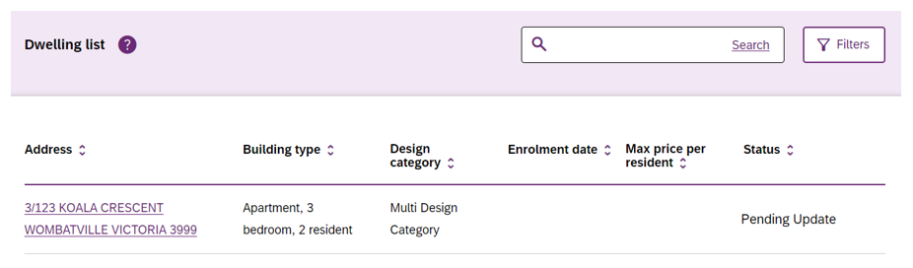

Select Respond to Request for Information.
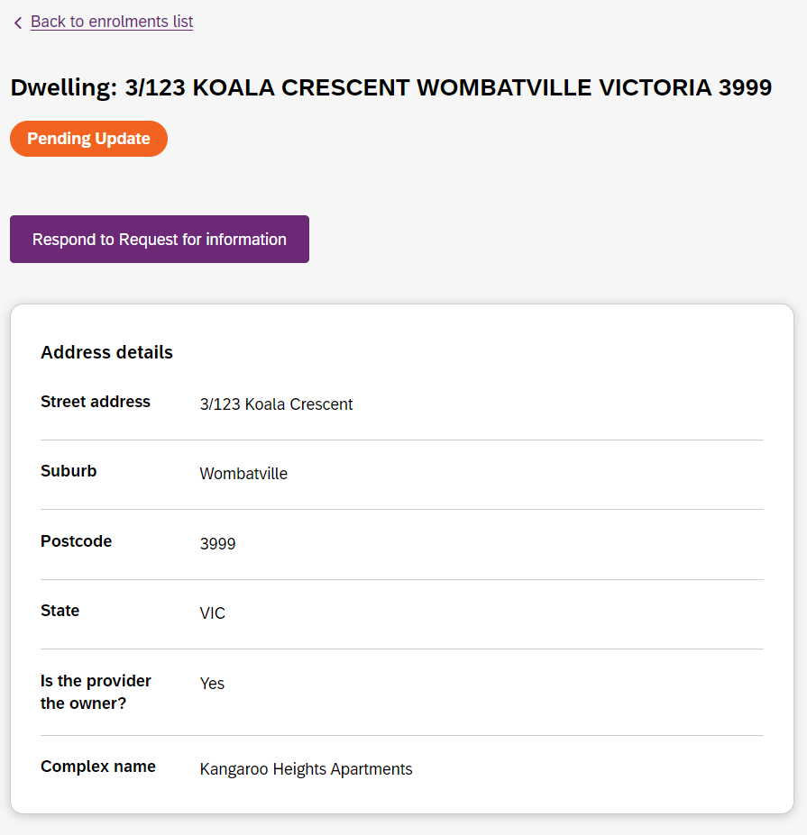
Review and update the required information and documentation and select the Continue Enrolment button. Update any changes to the Primary and Secondary Contact Person/s as well as the Authorising Officer.
Selecting Submit Enrolment will notify the NDIA that you have responded to their request for information and the application will continue to be assessed.
The status of the dwelling on the SDA dwelling enrolments page will update to Pending Approval.
If you receive an email requesting further information, always use the reply button on the email to provide your response. This ensures all the information and documents provided stay connected to the unique enrolment application (Case) ID.

Dwelling enrolment application outcome
When an outcome is finalised by the NDIA the portal generates an automated email. This is sent to the application primary contact with the subject line Outcome of application.

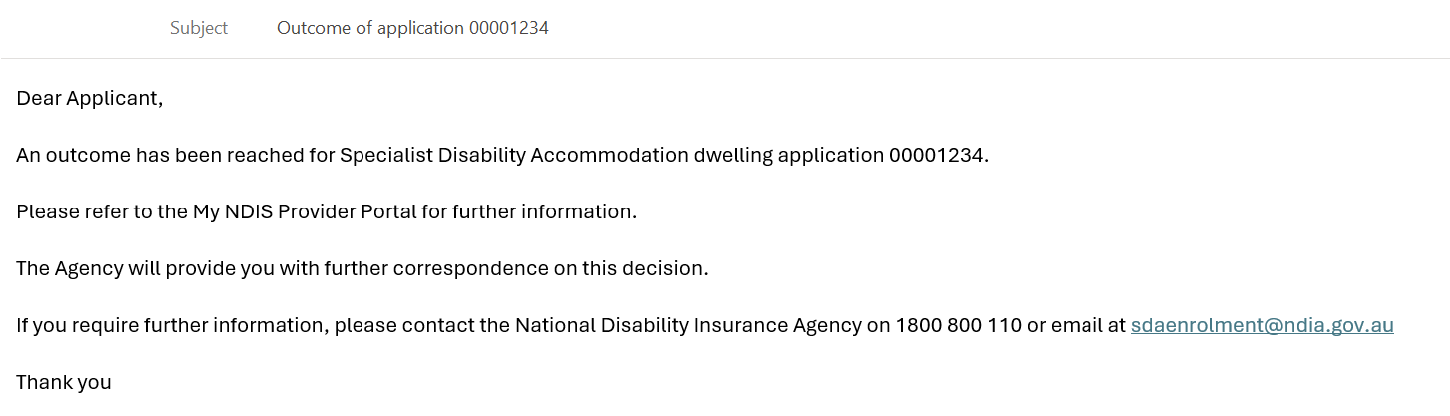

Note: The automated correspondence from the portal refers to an application number only, not a dwelling address. Further information is provided at Find Application Number.

Applications to enrol or modify a dwelling as SDA
When a dwelling enrolment application or application to modify a dwelling enrolment is approved, the NDIA will prepare and email the Certificate of Enrolment to the application contact. The certificate will include the dwelling address.
The enrolment status of the dwelling on the SDA dwelling enrolments page will immediately change to Enrolled. Providers can check the SDA dwelling enrolments page for status updates at any time.
If the dwelling enrolment application is not approved the NDIA will prepare and email a letter to the application contact. The letter will include the application ID and confirm the outcome, including the reasons why the application was not approved. The dwelling status in the portal home page will change to Not Enrolled.

Applications to cancel a dwelling enrolment
Where an application to cancel a dwelling enrolment is approved, the status of the dwelling in the portal home page will immediately change to Not Enrolled. Providers can check the portal home page for status updates at any time.

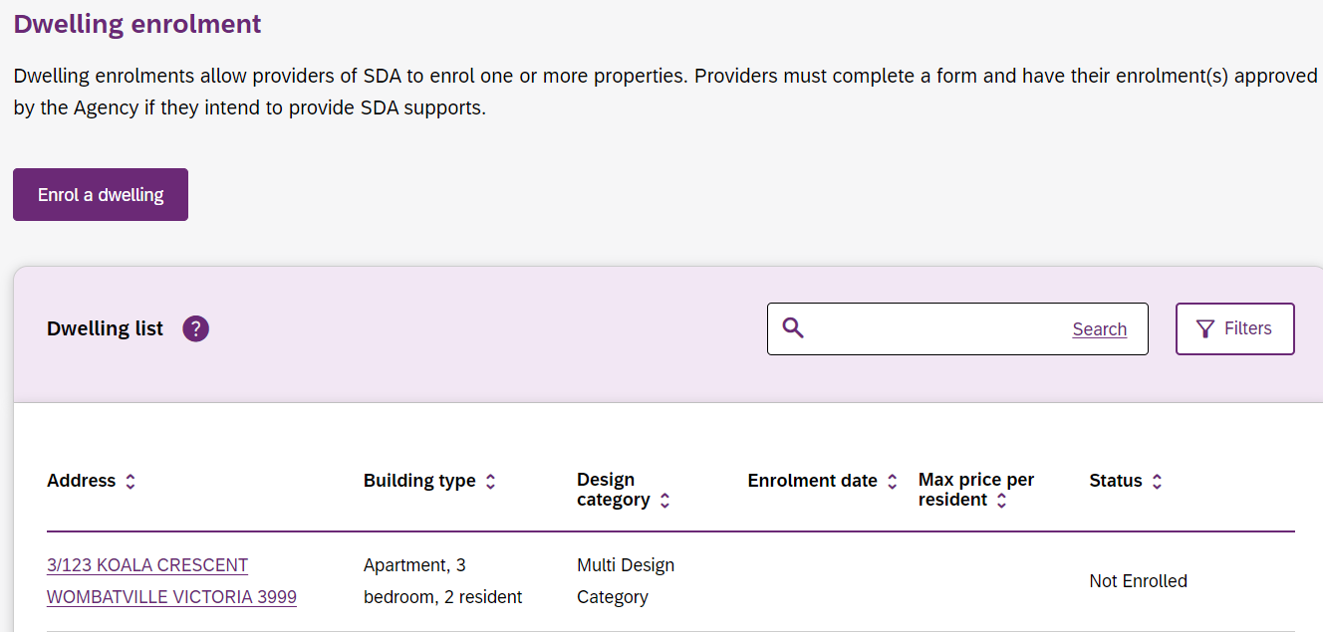

Other Functions
Find a dwelling
Your enrolled dwellings can be searched for using the search or filter functions. You may enter all or part of an address (e.g., postcode or suburb) in the search field and select Search.
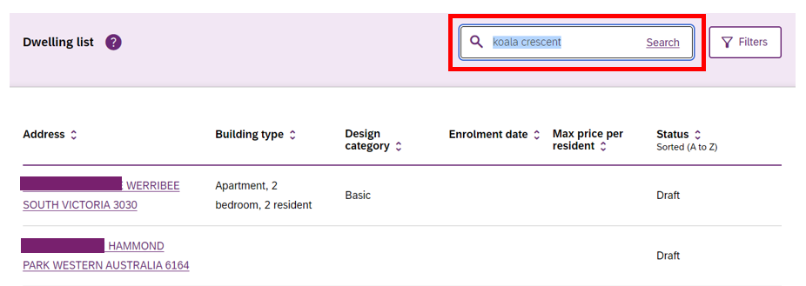

Select the Filters button to display the available filter options in the dropdown fields. You may select an option from one or more of the available dropdowns.
Select Apply Filters to filter the dwelling list.
You may use multiple filters and the search tool at the same time.
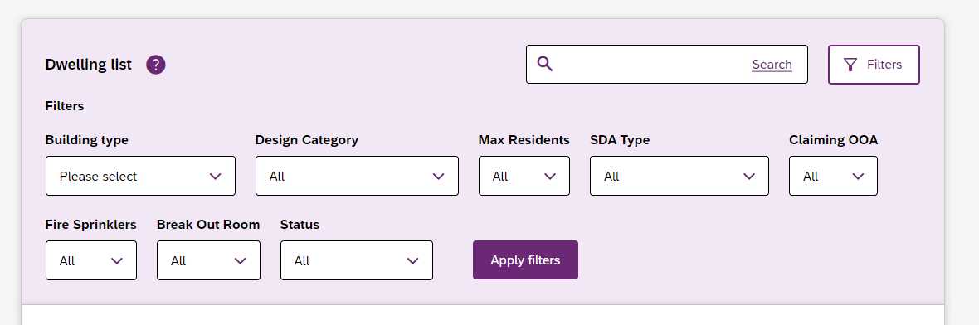

Sort Dwelling list
You can sort the dwellings list based on any of the listed columns.
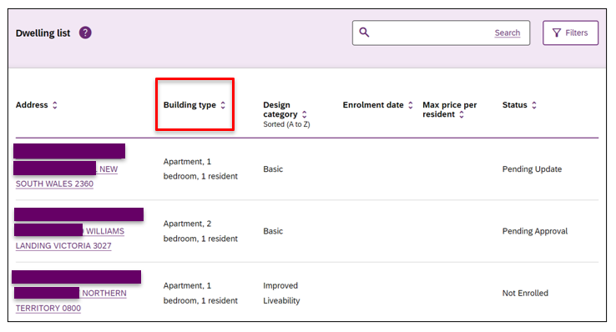
To apply a sort order, select the desired column heading to toggle between smallest to largest, largest to smallest, or alphabetically.
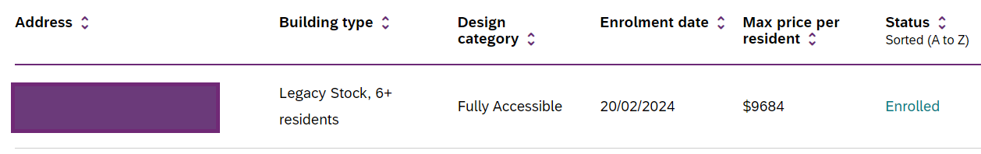

View dwelling enrolment value
From the SDA dwelling enrolments page, select a dwelling address with the status Enrolled to open the detail page for that dwelling.
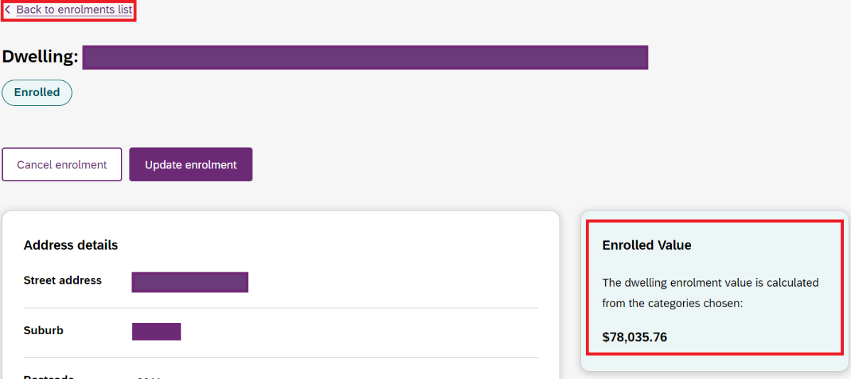
The Enrolled Value is displayed to the right in a green box.

Note: Where the dwelling is a multi-design category dwelling, the Enrolled Value box will not display a value. The enrolled value of each bedroom in the dwelling is displayed in Multi Design Category details. This is located beneath the dwelling details.
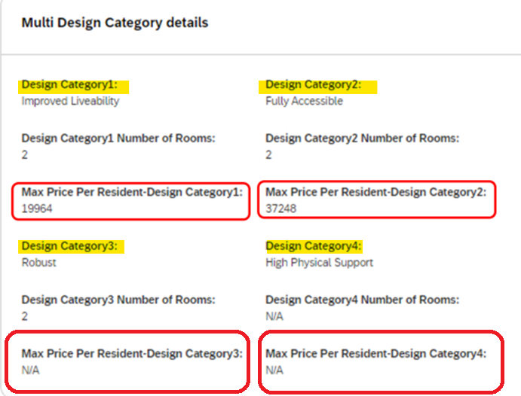
Return to the SDA dwelling enrolments page by selecting Back to enrolment list.
Find Application Number
Every dwelling enrolment application created generates a unique Application ID Number (also known as a Case). Correspondence automatically generated by the my NDIS provider portal references these ID numbers. Application (or Case) ID numbers can be found in the Activity log of each dwelling summary.
On the SDA dwelling enrolments page, select a dwelling address to open the detail page for that dwelling.
The Activity log displays in a column to the right of the screen, below the Enrolled Value. Each entry in the Activity log will start with a Case number. This is the Application ID Number (also known as Case ID Number).
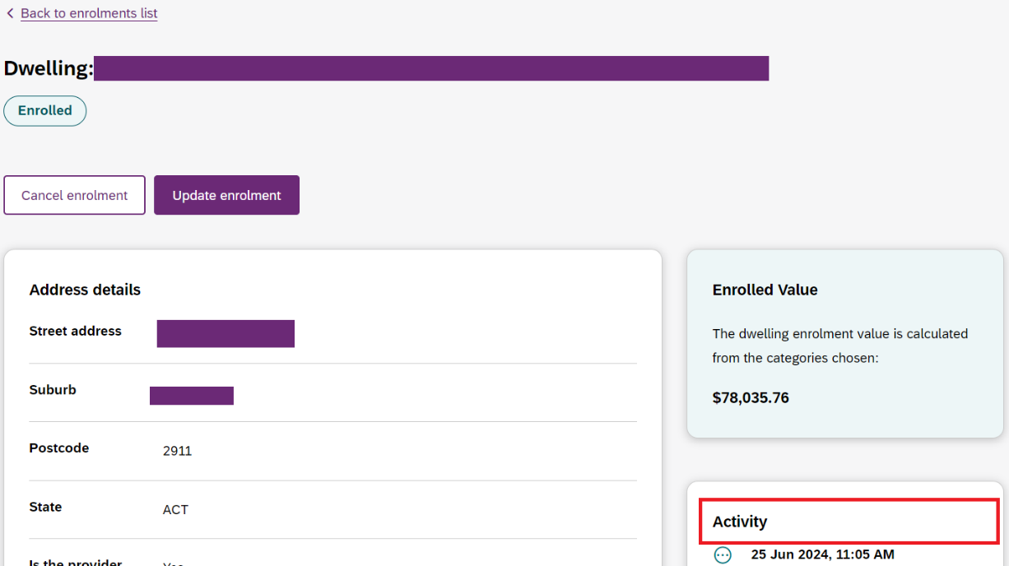
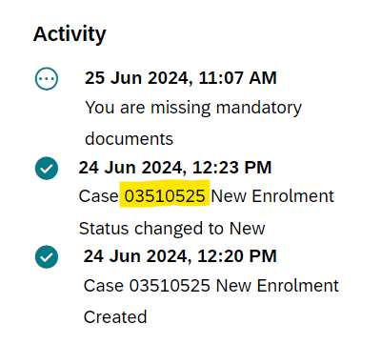
Return to the portal home page by selecting Back to enrolment list.

Trouble shooting
Duplicate Record
Only one application may be created for an address. If you receive an error because you are attempting to create an application for a dwelling that is already enrolled, please contact the SDA Enrolment Team at SDAEnrolment@ndis.gov.au.
Please include the address you are attempting to enrol and full screen shots from the provider portal. A team member will work with you to resolve the issue.
Reporting
The my NDIS provider portal does not have reporting functionality. Providers should use the information provided on the SDA dwellings page to support the creation of their own reports. The NDIA is not able to provide reports relating to providers’ enrolled dwellings.
Dwelling Enrolment History
When a request to modify existing dwelling enrolment is submitted and approved, the enrolment start date will be updated to the new approval date. The new start date shows when the changes were approved and the new maximum price per resident. It’s a good idea to maintain a summary register of dwelling enrolments, including any changes, and new start dates, and the maximum per resident prices.

Version Control

Version | Page | Details of Amendment | Date Published | Date of Effect
1.0 |  | my NDIS provider portal | 15 December 2021 | 15 December 2021
1.1
1.2
1.3 |  | Updates for the November 2022 release of my NDIS provider portal. Including capability to select an organisation. | 07 November 2022 | 07 November 2022
2.0 |  | Simplified guide to reflect availability of additional in-portal guidance and help-text.  Removed references to unavailable functionality.  Updated screenshots to capture the new look and feel of the SDA dwelling enrolment pages
3.0 |  | Updated screenshots to capture SDA dwelling enrolment pages  Simplified guide to reflect availability of additional in-portal guidance and help-text. | December 2024 | December 2024
4.0 |  | Updated screenshots to capture SDA dwelling enrolment pages  Additional information provided to reduce errors in applications | August 2025 | August 2025

