

NDIS myplace provider portal
Step-by-step guide
Part 1. Using the myplace provider portal

April 2026

Table of Contents
Changes from the last version 3
Introduction 4
What can you do in myplace? 4
Minimum internet browser requirements 4
How to contact NDIS 6
Accessing myplace 7
Set up your Digital ID and link to your business in RAM 10
myplace Portal home page 11
Provider portal navigation 15
Using a function 15
Returning to the myplace home page 16
Help and feedback 17
Getting help 17
Submit payment enquiries, complaints, compliments, feedback and other enquiries 17
Submit a complaint 19
Send feedback or a compliment 20
Submit an enquiry 21
Submit a payment enquiry 23
View existing complaints and enquiries 25

Changes from the last version

The following updates have been made to the last published version of the myplace provider portal step-by-step guide.

As of April 2026:
- Update to the “What you can do in the provider portals” section (Page 4)

Introduction
The myplace provider portal is a secure website developed for providers to manage their transactions with the NDIA, and view and manage their services with Participants.
This step-by-step guide describes how the myplace portal works and provides the general layouts of the menus and screens in the portal.
It also includes instructions for using each of the functions in the portal.

What can you do in myplace?

You can use the myplace provider portal to: | You can use the my NDIS provider portal to:
- View and update your contact details  - View your NDIS (National Disability Insurance Scheme) registration details including updates to registration groups and professions  - View messages received from NDIS  - Instant message with your linked participants  - Create and manage service bookings  - Create and view payment requests (previously known as claims)  - View and respond to quotes received from NDIS  - View referrals made to your organisation  - View Support Coordination Requests for Service and action these requests  - Upload required documents  - Submit and review enquiries or complaints  - Download reports about all your service bookings and participants  - Learn how to use my NDIS provider portal | - Select and switch between active organisations  - View broadcast messages  - View notifications  - Review, accept and decline Request for Service requests  - View participant details  - Review and submit your reporting requirement for Request for Service  - View participant plan and budget, where a participant has given consent  - View the Provider roles for participant  - Plan managers and my providers can request to add, extend and end a relationship with a participant  - View Organisation details  - Download reports  - View Employee details  - Extract key participant information in an excel report  - Submit and review claim and payments enquiries  - SDA providers can create and manage dwelling enrolments

Minimum internet browser requirements
To access myplace, there are minimum browser requirements. These are:
- Google Chrome
- Microsoft Internet Explorer 11 on Windows 8.1 or Windows 10
- Microsoft Edge
- Mozilla Firefox
- Safari on Mac OS X

How to contact NDIS
Contact the NDIS by
  NDIS Webchat  You can live chat with us about:  - myplace provider portal  - Service bookings  - Payment requests  - Quotes  - Referrals  - Request for service  - Searching for a register provider |   Phone  1300 311 675  You can call us about:  - myplace provider portal  - Service bookings  - Payment requests  - Quotes  - Referrals  - Request for service  - Searching for a register provider  - Submitting a general enquiry, feedback, compliment or a complaint |   You can use the provider portal to:  - Submit a payment enquiry  - Submit a general enquiry, feedback, compliment or a complaint  - Search for a provider  - Upload documents
  Email us  provider.support@ndis.gov.au  You can email us about:  - Submitting a general enquiry, feedback, compliment or a complaint  - Emailing a document, form report or letter |   Contact and Feedback form  NDIS Online Form  You can use the Online form to:  - Submit a general enquiry, feedback, compliment or a complaint  - Request a call back |   Mailing address  National Disability  Insurance Agency  GPO Box 700  Canberra ACT 2601  You can mail us  - Compliment, complaint or provide feedback,  - Document, form, report or letter

Accessing myplace
- Access the myplace provider portal using the “Portal sign in” button on the NDIS website and selecting "Provider portals” from the drop-down menu.
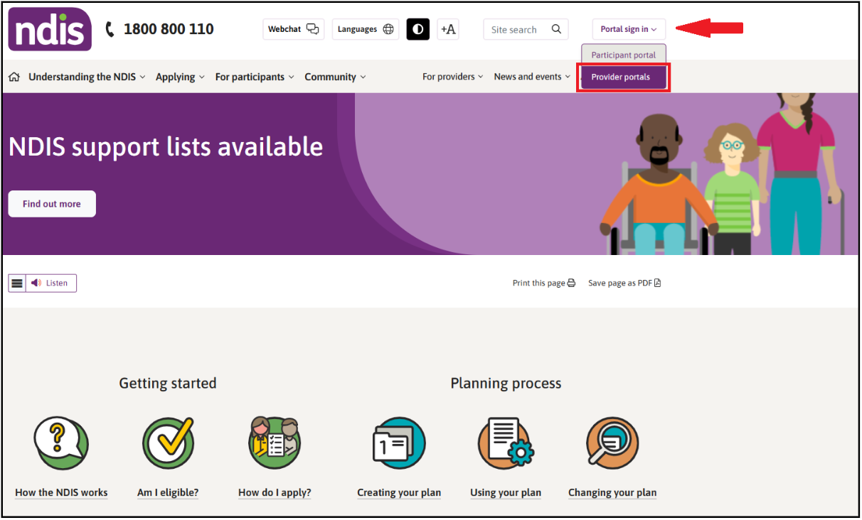
- Select the option "Continue with Digital ID" to log in with your myID.
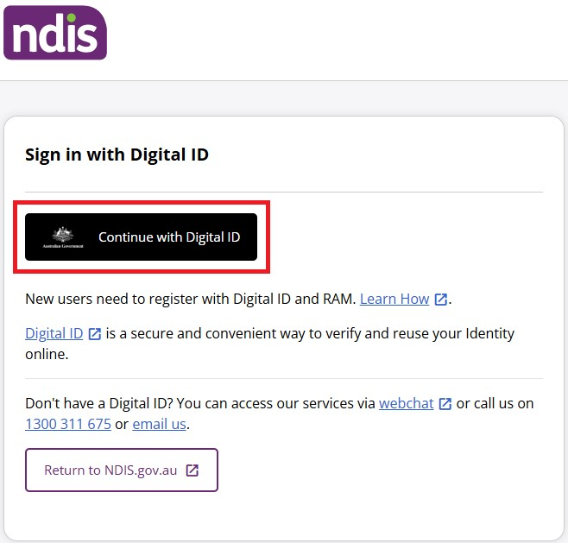

- Sign in with Digital ID
  - Select your identity provider to login using your myID.
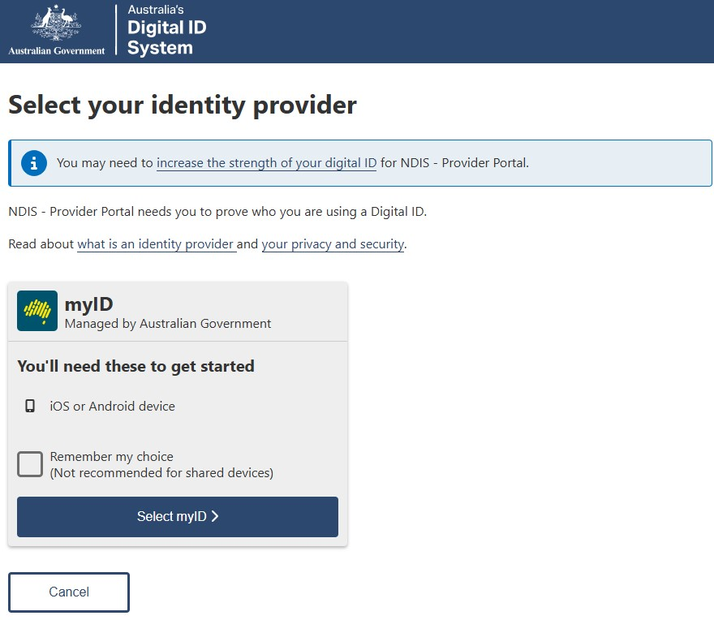
  - When you have selected myID, please log in using your personal myID login details.

  - Once you have successfully logged in to myID, if you hold the authority for more than one provider organisation, you’ll be directed to the RAM Australian Business Number (ABN) selection page where you will need to select which organisation you wish to act on behalf of in myplace provider portal. If you only hold authority to one provider organisation, this page will not appear.
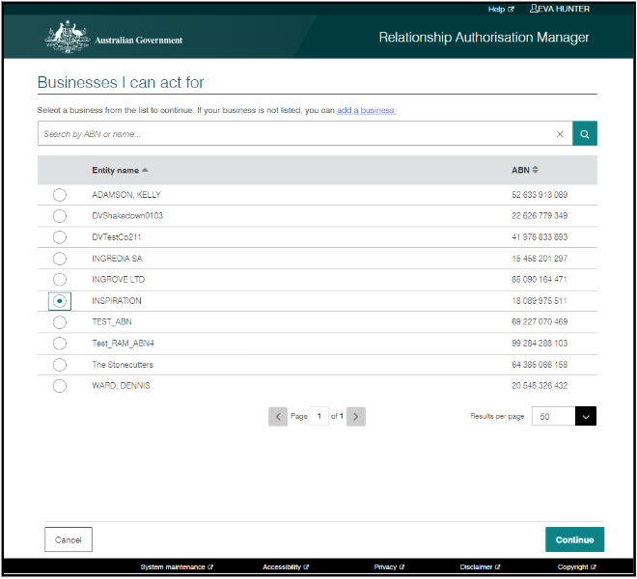
  - If you are authorised to access the NDIS Provider Portals for one provider organisation only, or once you have chosen an organisation from the RAM ABN selection page, the NDIS Provider Portals landing page will load where you will see the myplace provider portal tile.

  - Choose the myplace provider portal tile on the landing page (N.B State and Territory Public Trustee and Guardian staff will only be able to choose the myplace portal).
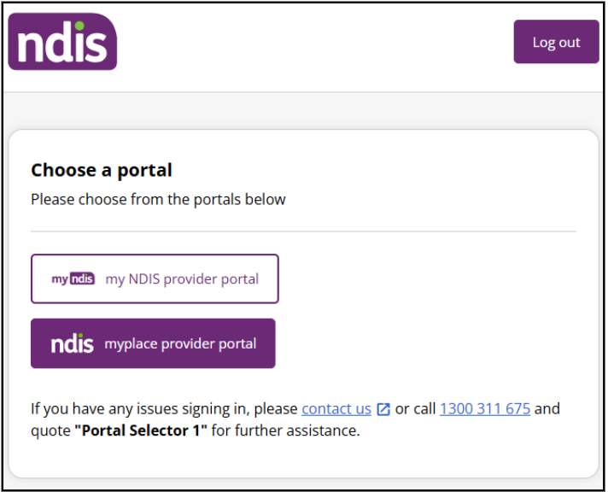

Set up your Digital ID and link to your business in RAM
If you do not have your myID set up, or you are not linked to a provider organisation in RAM, please refer to the myID and RAM Step-by-Step Guide for NDIS Provider Portals found on the NDIS website.

myplace Portal home page
The myplace home page contains a number of separate sections or functions.
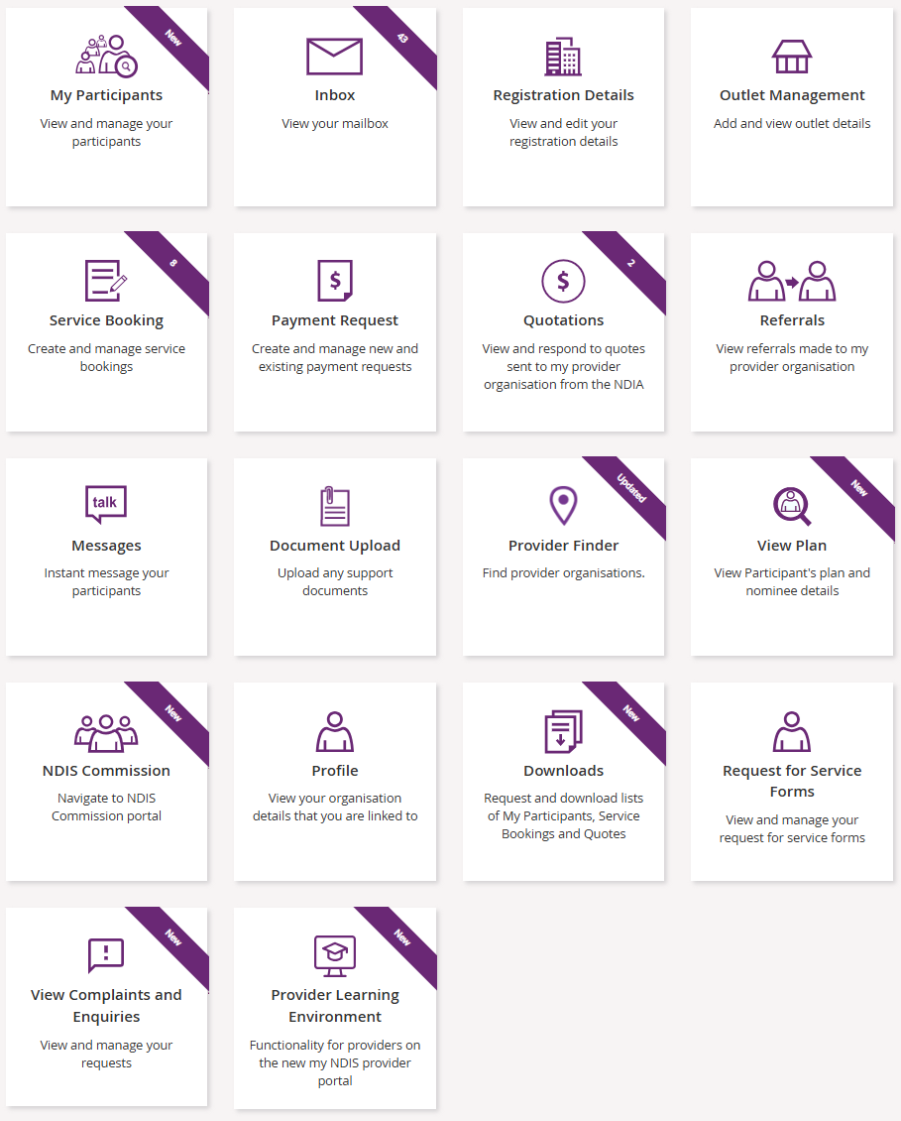
The following table provides an explanation of each of the information on the myplace portal home page.
myplace section | Function
 | The provider organisation you are acting for is displayed here. If you work for (and are linked to) more than one provider organisation, you can select which organisation you are using myplace for, by selecting the Change Provider icon.  .  If you only work for one provider organisation, you do not need to change any settings here.
 | This is where your username is displayed. You can use the drop-down button to return to the home page, switch to my NDIS portal, or log out of myplace at any time.
 | Select this icon at any time to return to the myplace home page.
 | Select this icon for simple explanations of the functions displayed on the screen.
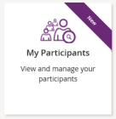 | View and manage your participants.
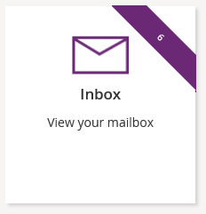 | View messages and letters sent to you by the NDIA.
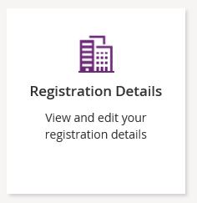 | View your registration details, including updates to Registration groups and Professions.
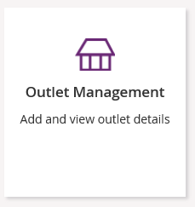 | View your organisation’s outlet details.
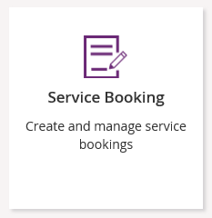 | Create and manage service bookings with participants.
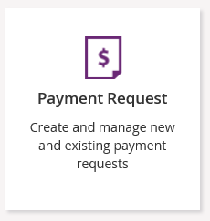 | Create and manage new and existing payment requests.
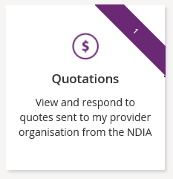 | View and respond to quotes sent to you by the NDIA.
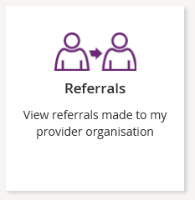 | View referrals made to your organisation.
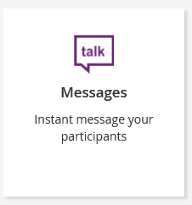 | Send instant messages to your Participants.
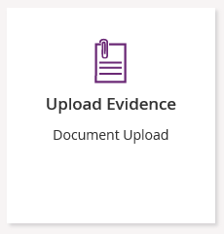 | Upload required documents.
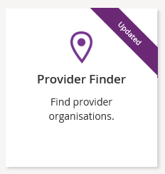 | Search for providers within a certain location.
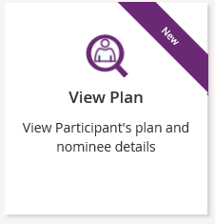 | View plan details when granted consent by a participant.
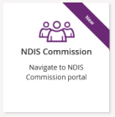 | Navigate to the NDIS Commission portal.
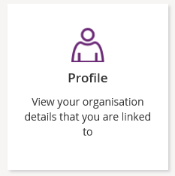 | View and edit information and contact details for yourself and your organisation.
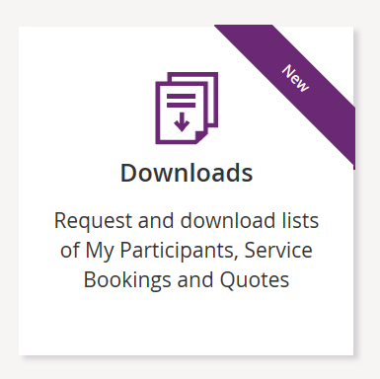 | Request and download service bookings information, quotes, or information for participants regarding their active service bookings.
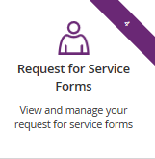 | View and action Support Coordination Requests for Service Forms.
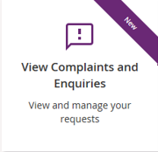 | Submit complaints, feedback, enquiries, payment enquiries and compliments.
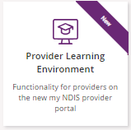 | Learn how to use the new my NDIS provider portal

Provider portal navigation

Using a function
Select the relevant tile displayed in the myplace home page to go into that section of the provider portal.
Tip: From most functions within the portal, the person icon on the top right of the screen will take you directly to your Profile.
You will note that some tiles have a purple banner across the top right-hand corner with a number showing. This indicates the number of items that have not been actioned. For example, the Inbox tile below shows a purple banner with the number ‘6’. This indicates that there are six messages in your Inbox requiring attention.

Returning to the myplace home page
You can return to the myplace home page in any of the following ways:
      - Select the myplace logo (top left corner of the portal page).
- Select the Home button (top left corner of the portal page) to return to the myplace home page.

- Select the Home link in the breadcrumb trail below the myplace logo.

Help and feedback

Getting help
Select the question mark icon (top right corner of the portal page) for simple explanations of the functions displayed.

Call NDIA on 1800 800 110 if you are unable to resolve a problem or need help to use myplace.

Submit payment enquiries, complaints, compliments, feedback and other enquiries
The View Complaints and Enquiries tile provides you with the options you need to submit:
- a payment enquiry
- complaints, compliments and other feedback
- any additional enquiries.
To access these functions:
- Go to the myplace home page and select the View Complaints and Enquiries tile.
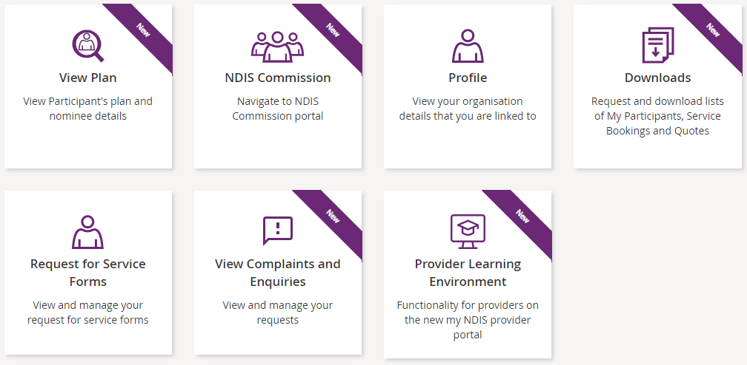
Note: You can also access the options you need by selecting the Feedback link in the page footer.

- On the View Complaints and Enquiries page, select Add new request.
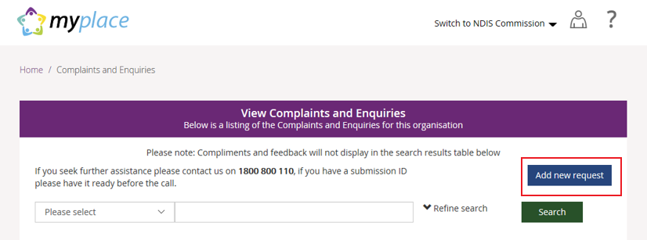
- The Add Feedback page will appear with your name, organisation name, registered business email address and phone details displayed.
On the Add Feedback page, use the Feedback type options to select the type of request you will be making.
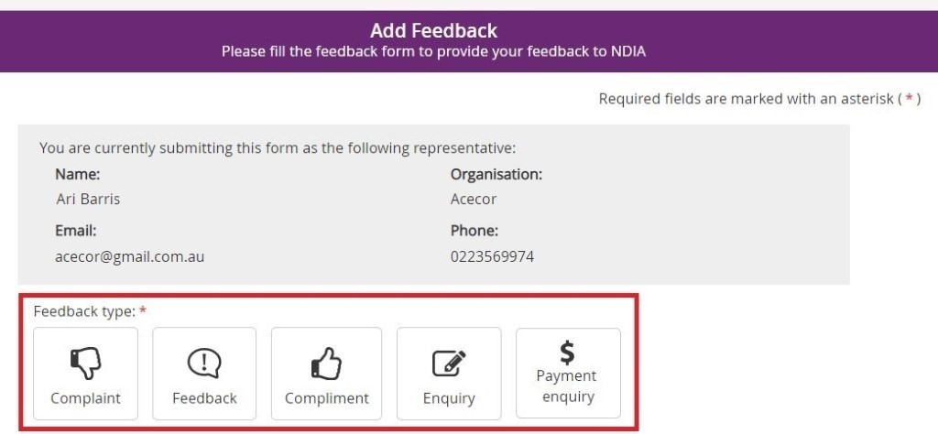
You can choose to:
- Submit a complaint
- Send feedback or a compliment
- Submit an enquiry
- Submit a payment enquiry.

Submit a complaint

- Select Complaint.
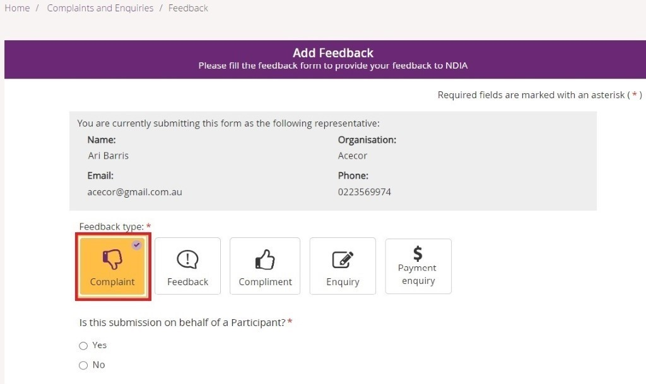
- Select whether this complaint is on behalf of a participant.
- If a complaint is submitted on behalf of a participant select Yes. Then enter the participant’s NDIS number, last name and date of birth and select Verify participant.
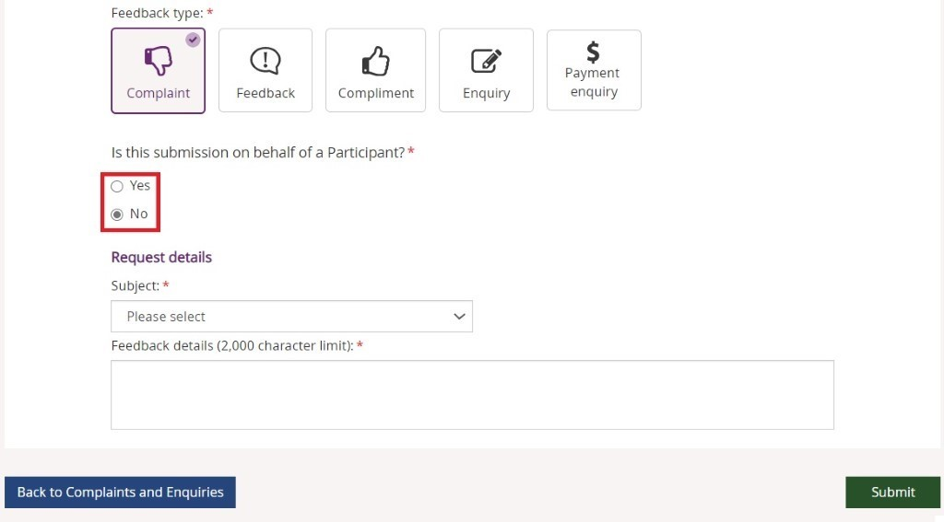
- If the complaint is not on behalf of a participant select No.
- In the Subject field, choose the subject that relates to your complaint from the drop-down list.
- In the Feedback details field, enter a description of your complaint. This field has a 2000-character limit.
- Select Submit to send your complaint to the NDIA.

Send feedback or a compliment

- Select Feedback or Compliment.
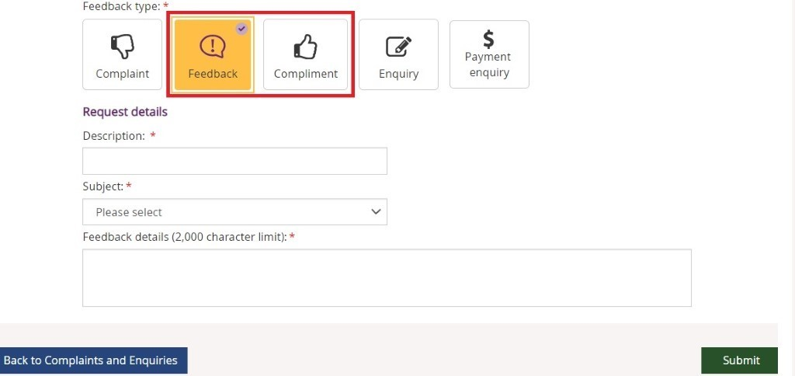
- In the Description field, provide a brief description of your feedback or compliment.
From the Subject drop-down, select the subject that relates to your feedback.
- In the Feedback details field, enter a description of the feedback. This field has a
2000-character limit.
- Select Submit to send your feedback to the NDIA.

Submit an enquiry

- Select Enquiry.
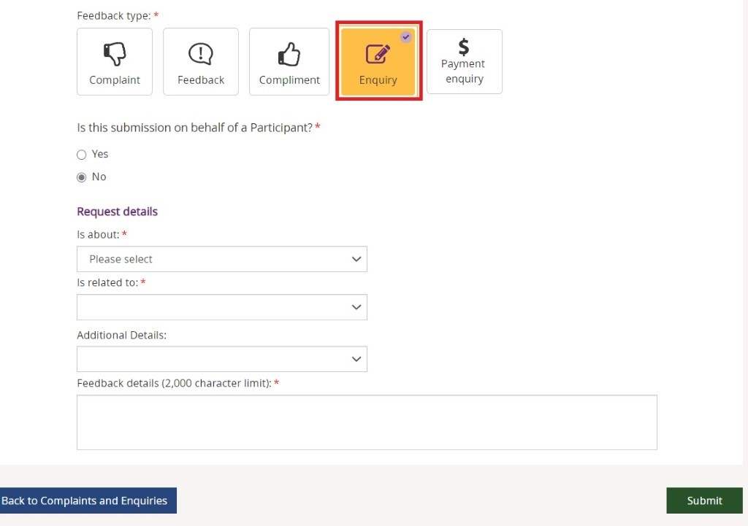
- Select whether this enquiry is on behalf of a participant.
  - If an enquiry is submitted on behalf of a participant select Yes. Then enter the participant’s NDIS number, last name and date of birth and select Verify participant.
  - If the enquiry is not on behalf of a participant select No.
- In the ‘Is about’ field, select the area that your enquiry is about from the drop-down list.
NOTE: This drop-down selection is mandatory to submit your enquiry.
- In the ‘Is related to’ field, select the area that your enquiry is about from the drop-down list. The available items are related to your previous drop-down selection made from the ‘Is about’. This drop-down is also a mandatory selection for your enquiry.
- In ‘Additional Details’, select an item that matches additional detail from the drop-down list. The available items are related to your previous drop-down selection made from Is related to. This selection is not a mandatory item to submit your enquiry.
- In Feedback details, enter a description of your enquiry. This field has a 2000-character limit.
- Select Submit to send your enquiry to the NDIA.

Submit a payment enquiry

You can submit a new payment enquiry on behalf of your organisation or submit a follow-up on a closed enquiry.
Note: We have improved the process of submitting a payment enquiry.
When you select the Payment enquiry tile in the myplace provider portal, you will be redirected to the Enquiries tab in my NDIS provider portal.
Further information on how to create a payment enquiry is detailed in the my NDIS provider portal guide.

Submit a new payment enquiry
1. Select Payment Enquiry.
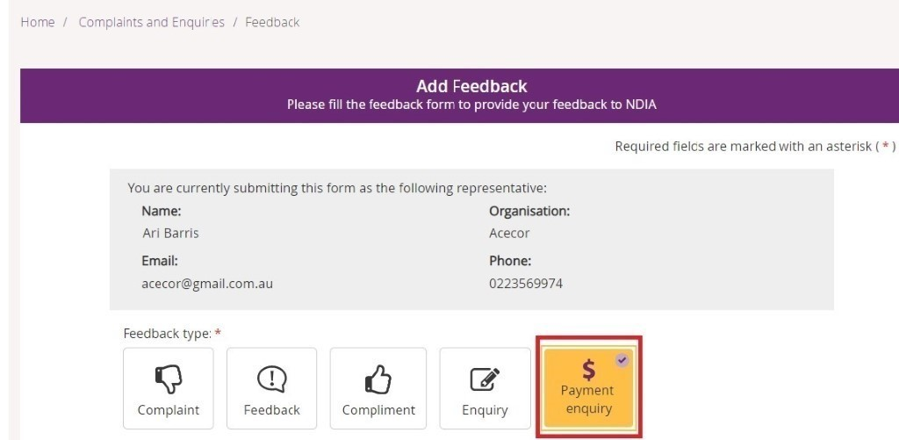

This will take you to my NDIS provider portal to submit your payment enquiry
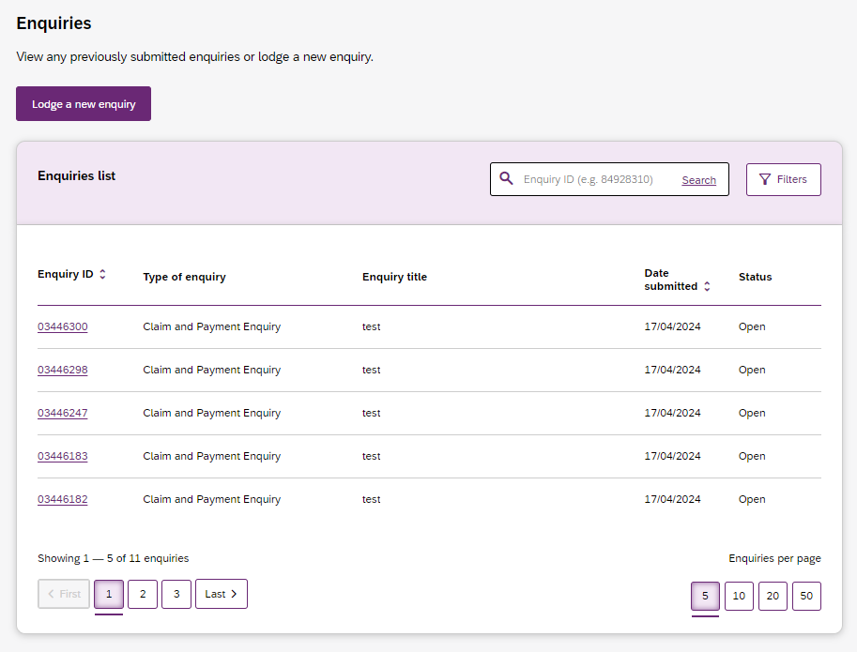
For further instructions, please refer to my NDIS provider portal step by step guide located in the myplace provider portal and resources | NDIS

View existing complaints and enquiries

- Select the View Complaints and Enquiries tile on the myplace home page.
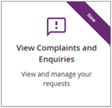

The View Complaints and Enquiries page displays your submitted complaints and enquiries. Use Next and Previous to navigate through lists that have more than 10 entries.
Note: For information about previously submitted compliments, payment enquiries or feedback, call NDIA on 1800 800 110.

Next to the free text search field use the drop-down selection to choose the criteria of the search:
- Submission ID
- Participant NDIS number
- Submitted by NDIS number
- Submitted by Surname.

Note: You cannot search by Submitted by NDIS Number and NDIS Surname when searching for a Payment Enquiry.
Enter the details of the complaint or enquiry in the search box and select Search.
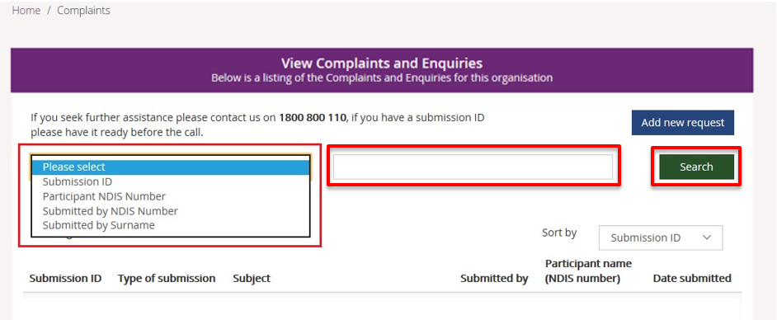
From the Sort By drop-down, select a sorting option:
- Submission ID
- Type of Submission
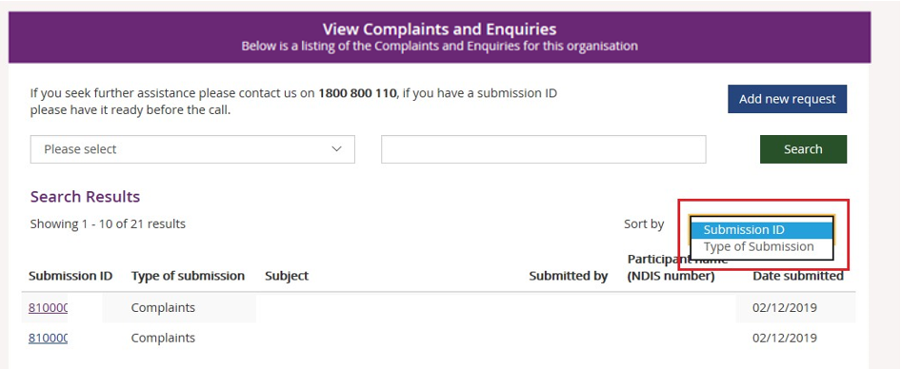
To view the details of the complaint or enquiry select the Submission ID (hyperlinked).
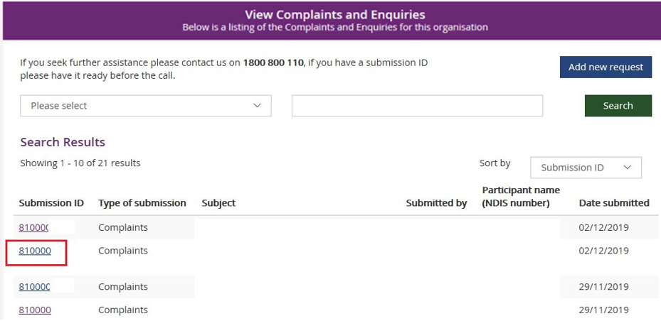
The details of the complaint or enquiry will be displayed.
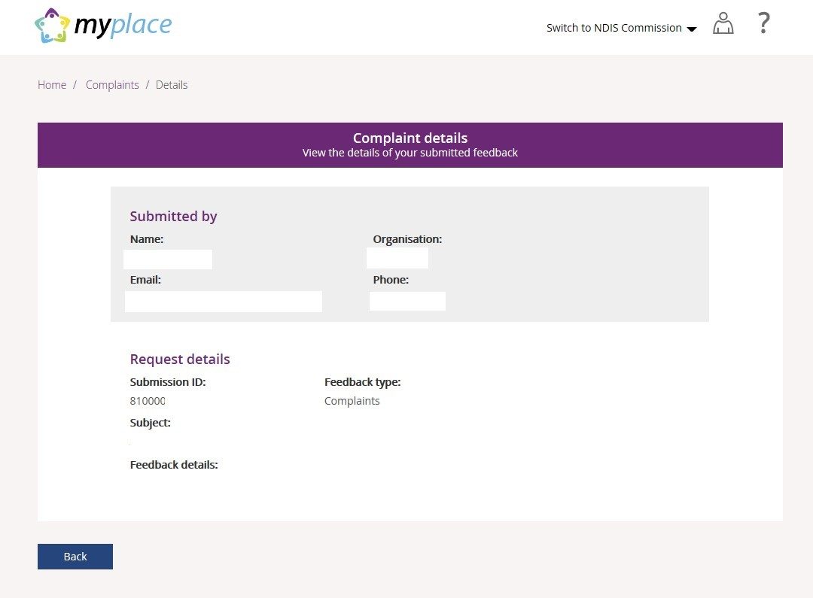
Select Back (bottom left corner of the page) to return to the search results.

Note: Enquiries created before the 5th of May 2024 can be viewed in the myplace provider portal.
Payment enquiries created after 5 May 2024 will be displayed in the Enquiries page of my NDIS provider portal.

You can only view your enquiry in the portal from where it was originally created.

If you made a payment enquiry through my NDIS provider portal, navigate to my NDIS provider portal Enquiries page.

For further instructions, please refer to my NDIS provider portal step by step guide located in the myplace provider portal and resources | NDIS

