
I

NDIS myplace provider portal
Step-by-step guide
September 2025

Table of Contents
Changes from the last version 4
Introduction 5
What can you do in myplace? 5
Minimum internet browser requirements 5
How to contact NDIS 6
Accessing myplace 7
Set up your Digital ID and link to your business in RAM 11
myplace Portal home page 12
Provider portal navigation 16
Using a function 16
Returning to the myplace home page 17
Help and feedback 18
Getting help 18
Submit payment enquiries, complaints, compliments, feedback and other enquiries 18
Submit a complaint 20
Send feedback or a compliment 21
Submit an enquiry 22
Submit a payment enquiry 23
View existing complaints and enquiries 25
Maintaining your information 29
Profile 30
About me 31
My organisation details 32
Organisational staff 36
Bank details 37
Managing correspondence and messages 38
Inbox 38
Messages 40
Starting a new instant message 40
Continuing a previous conversation 41
Administering your services 42
Finding Participants 42
View plan 44
Consent to view plan notification 53
Service bookings 54
Create service bookings 55
View service bookings 64
Accept or reject a new service booking 70
Accept or reject changes to a service booking 75
Edit support details on a service booking 83
End a service booking 85
Delete a service booking 87
Payment request 90
Create a payment request 90
Create a payment request for an Irregular SIL Support 100
View payment request 105
Cancel payment request 110
Recipient Created Tax Invoices (RCTI) 113
Bulk payment request upload 114
Payment summary 114
Advance summary and recovery instalment plan 118
Quotations 120
View a quote 120
Respond to a quote 123
Referrals 130
Requests for Service 131
View Support Coordination Requests for Service 131
Access and review Support Coordination Requests for Service 133
Accept or reject Support Coordination Requests for Service 136
Update Coordination Requests for Service Email Notification 138
Provider Finder 140
Upload evidence 143
Downloads 145
Download Service Bookings 146
Download Quotations 151
Download My Participants 153
Advance payment reconciliation report 157

Changes from the last version
The following updates have been made to the last published version of the myplace provider portal step-by-step guide.

As of September 2025:

- Cancel payment request section updated (Pages 110, 111, 112 & 113).

Introduction
The myplace provider portal is a secure website developed for providers to manage their transactions with the NDIA, and view and manage their services with Participants. This step-by-step guide describes how the myplace provider portal works and provides the general layouts of the menus and screens in the portal.
It also includes instructions for using each of the functions in the portal.

What can you do in myplace?
You can use myplace to:
View your contact details
View your NDIS (National Disability Insurance Scheme) registration details including updates to registration groups and professions
View messages received from NDIS
Instant message with your linked participants
Create and manage service bookings
Create and view payment requests (previously known as claims)
View and respond to quotes received from NDIS
View referrals made to your organisation
View Support Coordination Requests for Service and action these requests
Upload required documents
Submit and review enquiries or complaints
Download reports about all your service bookings and participants
Learn how to use my NDIS provider portal

Minimum internet browser requirements
To access myplace, there are minimum browser requirements. These are:
- Google Chrome
- Microsoft Internet Explorer 11 on Windows 8.1 or Windows 10
- Microsoft Edge
- Mozilla Firefox
- Safari on Mac OS X

How to contact NDIS
Contact the NDIS by
  NDIS Webchat  You can live chat with us about:  - myplace provider portal  - Service bookings  - Payment requests  - Quotes  - Referrals  - Request for service  - Searching for a register provider |   Phone  1300 311 675  You can call us about:  - myplace provider portal  - Service bookings  - Payment requests  - Quotes  - Referrals  - Request for service  - Searching for a register provider  - Submitting a general enquiry, feedback, compliment, or a complaint |   provider portal  You can use the provider portal to:  - Submit a payment enquiry  - Submit a general enquiry, feedback, compliment or a complaint  - Search for a provider  - Upload documents
  Email us  enquiries@ndis.gov.au  You can email us about:  - Submit a general enquiry, feedback, compliment, or complaint  - Email a document, form report or letter |   Contact and Feedback form  NDIS Online Form  You can use the Online form to:  - Submit a general enquiry, feedback, compliment, or a complaint  - Request a call back |   Mailing address  National Disability  Insurance Agency  GPO Box 700  Canberra ACT 2601  You can mail us to:  - Send a compliment, complaint or provide feedback,  - Document, form, report, or letter

Accessing myplace
- Access the myplace provider portal using the “Portal sign in” button on the NDIS website and selecting "Provider portals” from the drop-down menu.
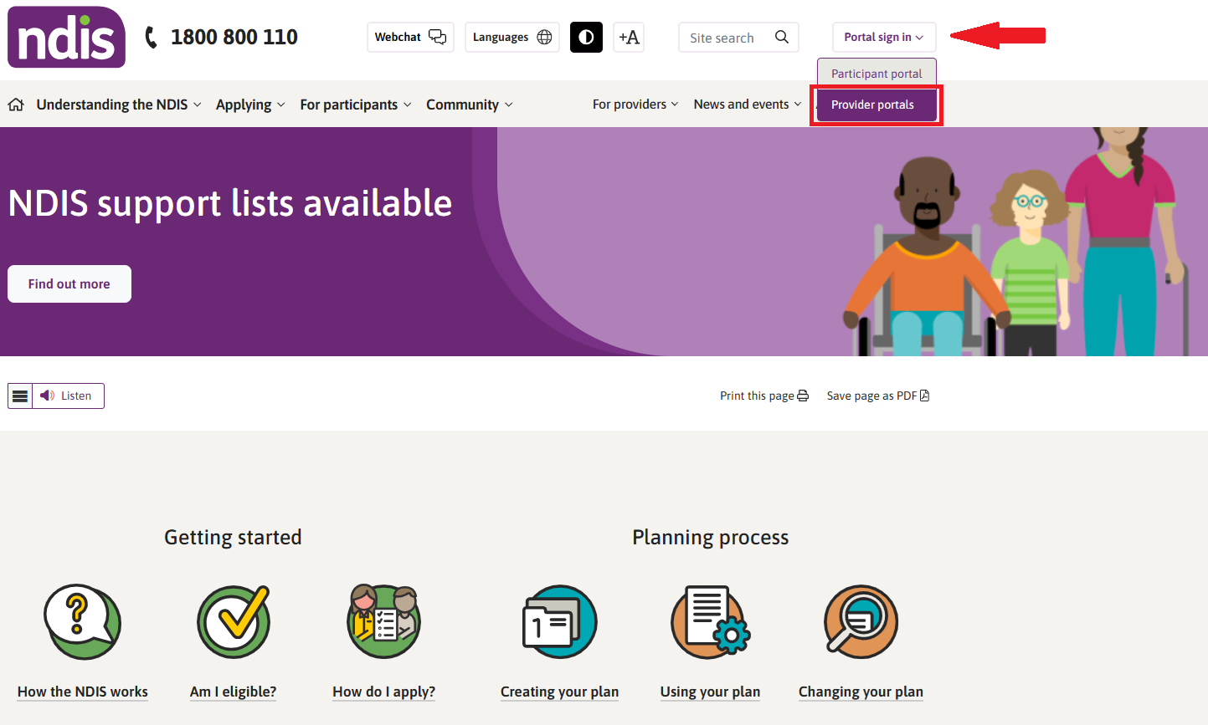

- Choose to log in using Digital ID if the provider organisation you wish to access the portal on behalf of, is set up in Relationship Authorisation Manager (RAM), otherwise choose to login using PRODA.
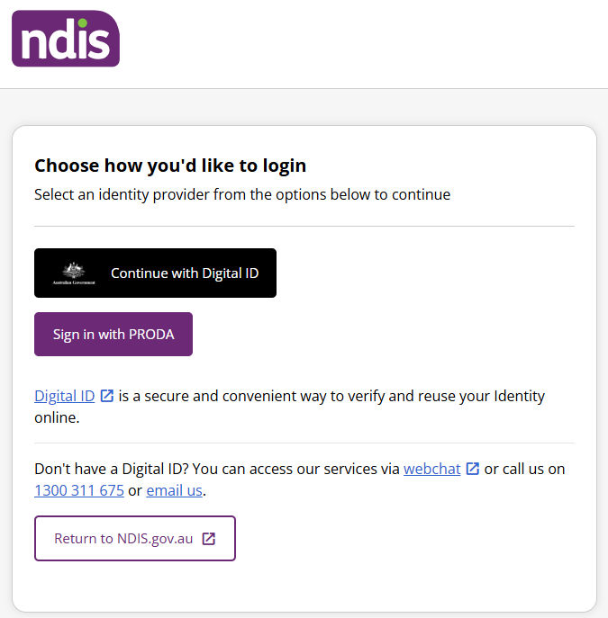

- Sign in with PRODA.
  - If you selected to login with PRODA, either enter your PRODA Username and Password then select Login, or select Login using your Digital ID. 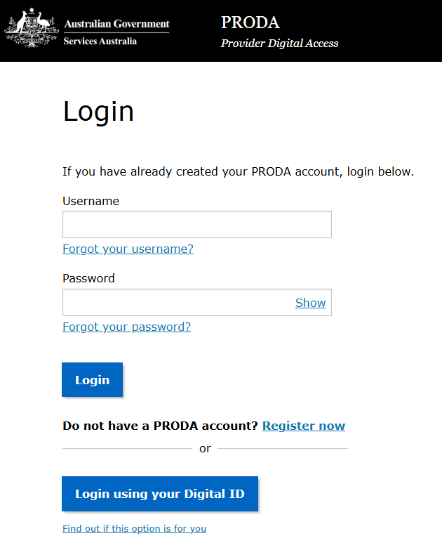
  - Once you have successfully logged in to PRODA you’ll be directed to a screen where you must select the organisation you want to work for in myplace provider portal. The list contains provider organisations that you work for (and are linked to) that have not been set up in RAM.
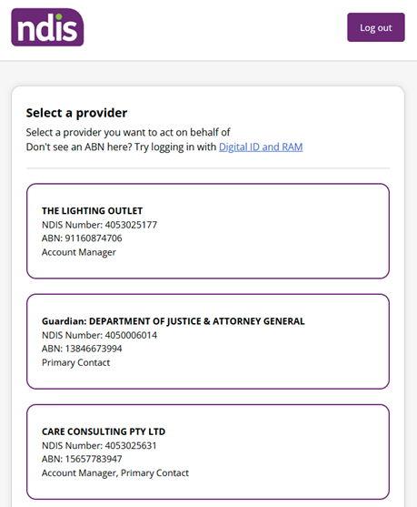
  - When you have selected an organisation, you want to act on behalf of, the NDIS Provider Portals landing page will load where you will see the myplace provider portal tile.

- Sign in with Digital ID
  - If you selected to login using Digital ID, you will need to select your identity provider which will be myID.
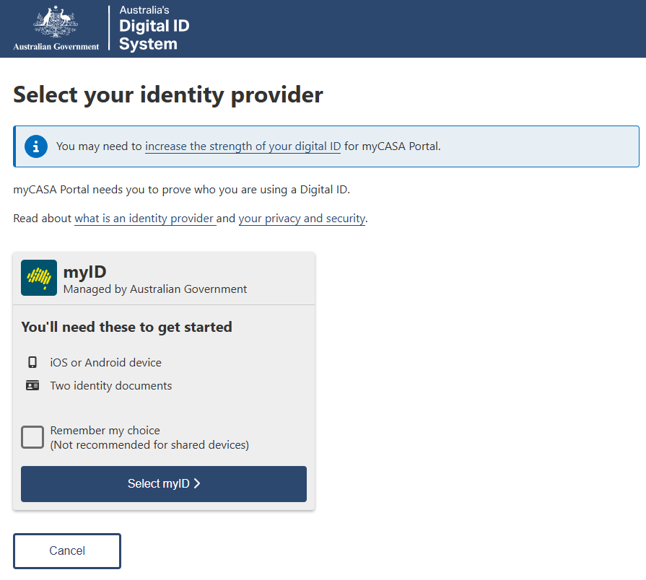
  - When you have selected myID, please log in using your personal myID login details.
  - NB
  - 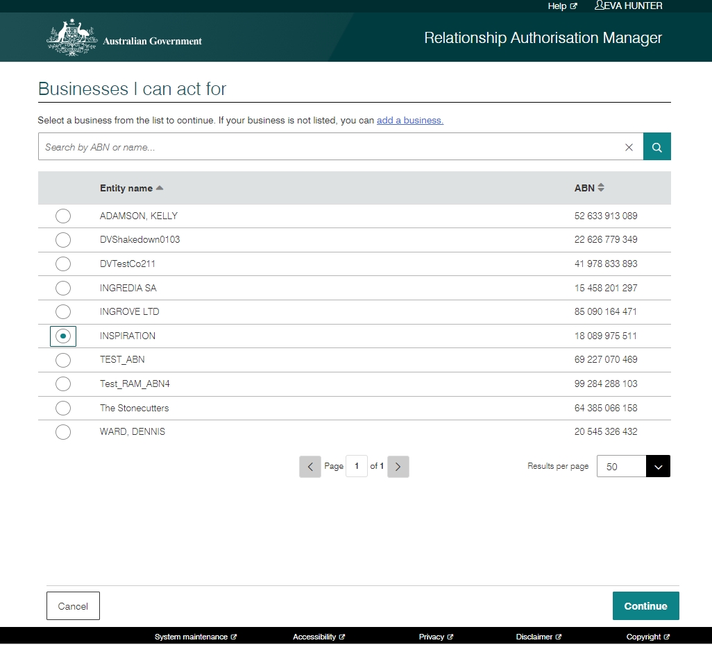
  - If you are authorised to access the NDIS Provider Portals for one provider organisation only, or once you have chosen an organisation from the RAM ABN selection page, the NDIS Provider Portals landing page will load where you will see the myplace provider portal tile.
- Choose the myplace provider portal tile on the landing page (N.B. State and Territory Public Trustee and Guardian staff will only be able to choose the myplace provider portal)
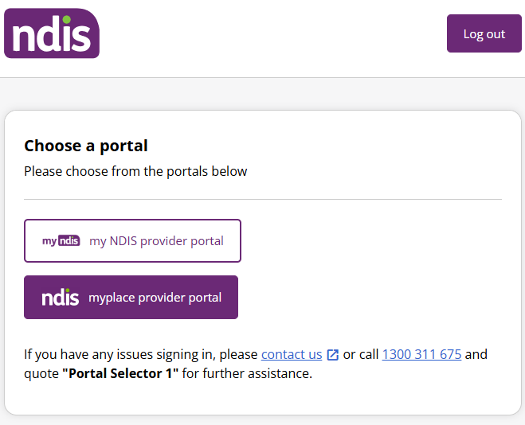

Set up your Digital ID and link to your business in RAM
If you do not have your myID set up, or you are not linked to a provider organisation in RAM, please refer to the myID and RAM Step-by-Step Guide for NDIS Provider Portals found on the NDIS website.

myplace Portal home page
The myplace home page contains a number of separate sections or function.
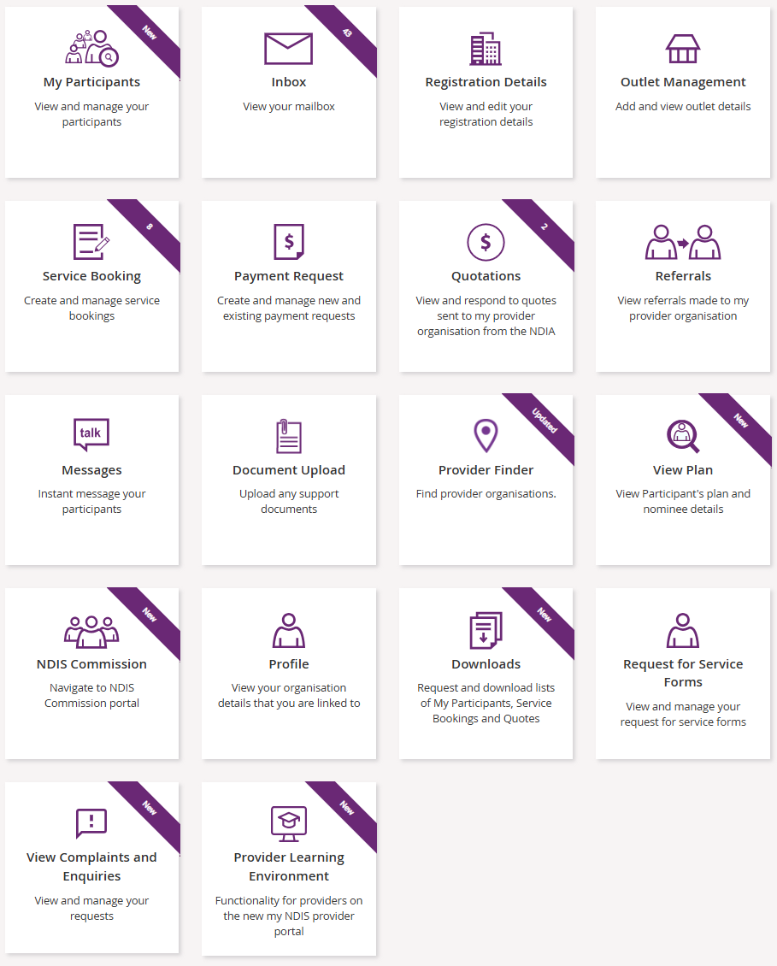
The following table provides an explanation of each of the information on the myplace portal home page.
myplace section | Function
 | The provider organisation you are acting for is displayed here. If you work for (and are linked to) more than one provider organisation, you can select which organisation you are using myplace for by selecting the Change Provider icon.  If you only work for one provider organisation, you do not need to change any settings here.
 | This is where your username is displayed. You can use the drop-down button to return to the home page, switch to the my NDIS portal, or logout of myplace at any time.
 | Select this icon at any time to return to the myplace home page.
 | Select this icon for simple explanations of the functions displayed on the screen.
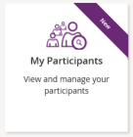 | View and manage your participants.
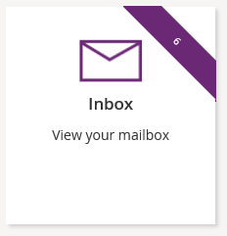 | View messages and letters sent to you by the NDIA.
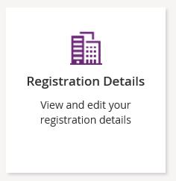 | View your registration details
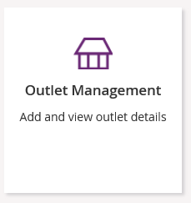 | View your organisation’s outlet details.
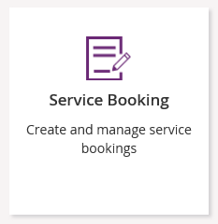 | Create and manage service bookings with participants.
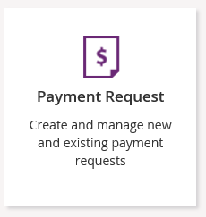 | Create and manage new and existing payment requests.
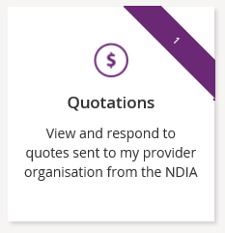 | View and respond to quotes sent to you by the NDIA.
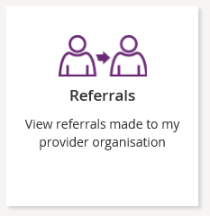 | View referrals made to your organisation.
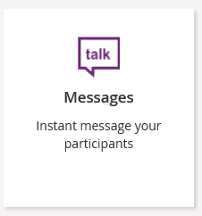 | Send instant messages to your Participants.
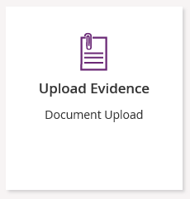 | Upload required documents.
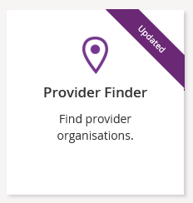 | Search for providers within a certain location.
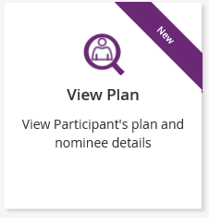 | View plan details when granted consent by a participant.
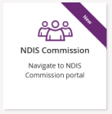 | Navigate to the NDIS Commission portal.
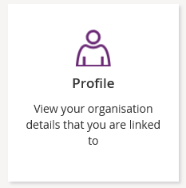 | View and edit information and contact details for yourself and your organisation.
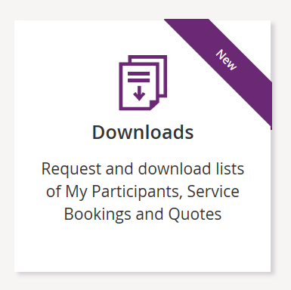 | Request and download service bookings information, quotes, or information for participants regarding their active service bookings
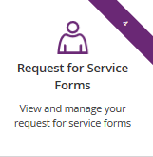 | View and action Support Coordination Requests for Service Forms.
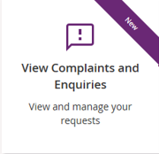 | Submit complaints, feedback, enquiries, payment enquiries and compliments.
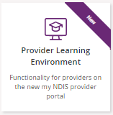 | Learn how to use the my NDIS provider portal.

Provider portal navigation

Using a function
Select the relevant tile displayed in the myplace home page to go into that section of the provider portal.
Tip: From most functions within the portal, the person icon on the top right of the screen will take you directly to your Profile.
You will note that some tiles have a purple banner across the top right-hand corner with a number showing. This indicates the number of items that have not been actioned. For example, the Inbox tile below shows a purple banner with the number ‘6’. This indicates that there are six messages in your Inbox requiring attention.

Returning to the myplace home page
You can return to the myplace home page in any of the following ways:
      - Select the myplace logo (top left corner of the portal page).
      - Select the Home button (top left corner of the portal page) to return to the myplace home page.

      - Select the Home link in the breadcrumb trail below the myplace logo.

Help and feedback

Getting help
Select the question mark icon (top right corner of the portal page) for simple explanations of the functions displayed.

Call NDIA on 1800 800 110 if you are unable to resolve a problem or need help to use myplace.

Submit payment enquiries, complaints, compliments, feedback and other enquiries
The View Complaints and Enquiries tile provides you with the options you need to submit:
- a payment enquiry
- complaints, compliments and other feedback
- any additional enquiries.
To access these functions:
- Go to the myplace home page and select the View Complaints and Enquiries tile.
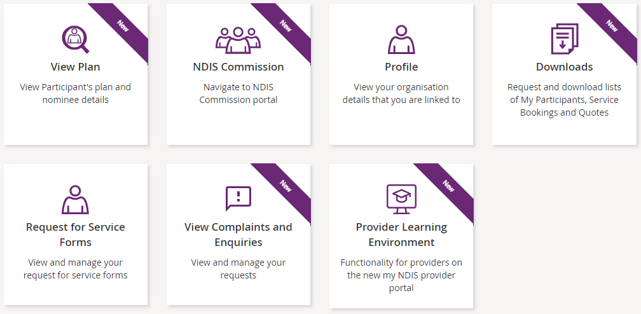
Note: You can also access the options you need by selecting the Feedback link in the page footer.

- On the View Complaints and Enquiries page, select Add new request.
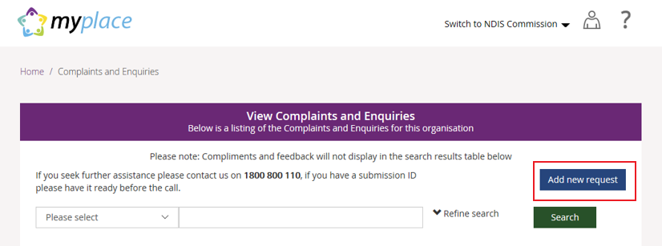
- The Add Feedback page will appear with your name, organisation name, registered business email address and phone details displayed.
On the Add Feedback page, use the Feedback type options to select the type of request you will be making.
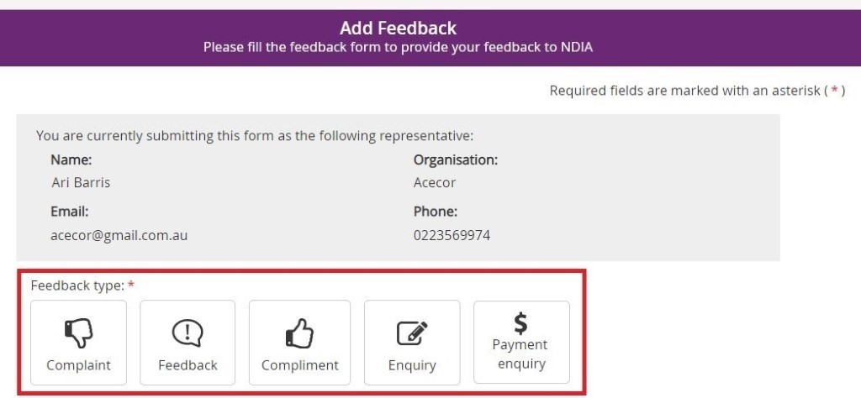
You can choose to:
- Submit a complaint
- Send feedback or a compliment
- Submit an enquiry
- Submit a payment enquiry.

Submit a complaint

- Select Complaint.
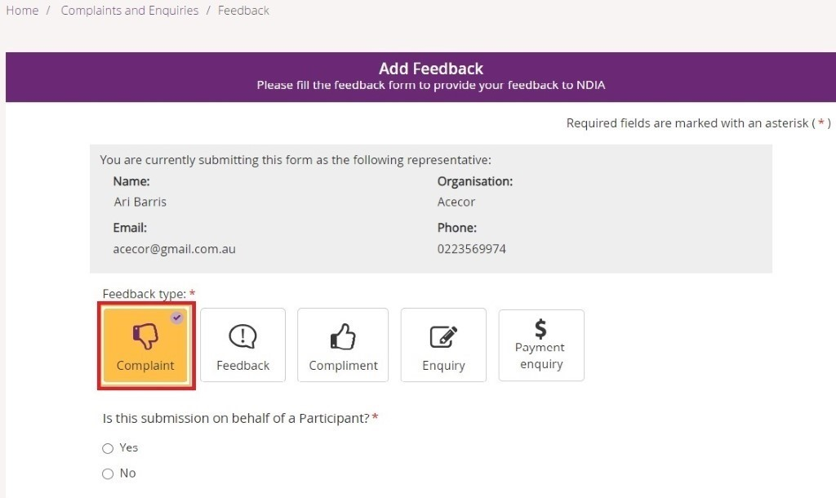
- Select whether this complaint is on behalf of a participant.
- If a complaint is submitted on behalf of a participant select Yes. Then enter the participant’s NDIS number, last name and date of birth and select Verify participant.
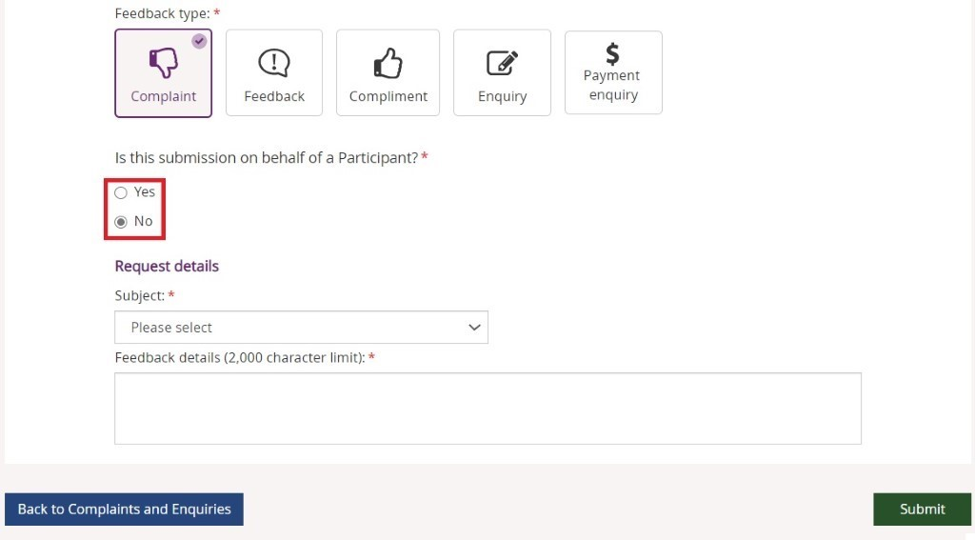
- If the complaint is not on behalf of a participant select No.
- In the Subject field, choose the subject that relates to your complaint from the drop-down list.
- In the Feedback details field, enter a description of your complaint. This field has a 2000-character limit.
- Select Submit to send your complaint to the NDIA.

Send feedback or a compliment

- Select Feedback or Compliment.
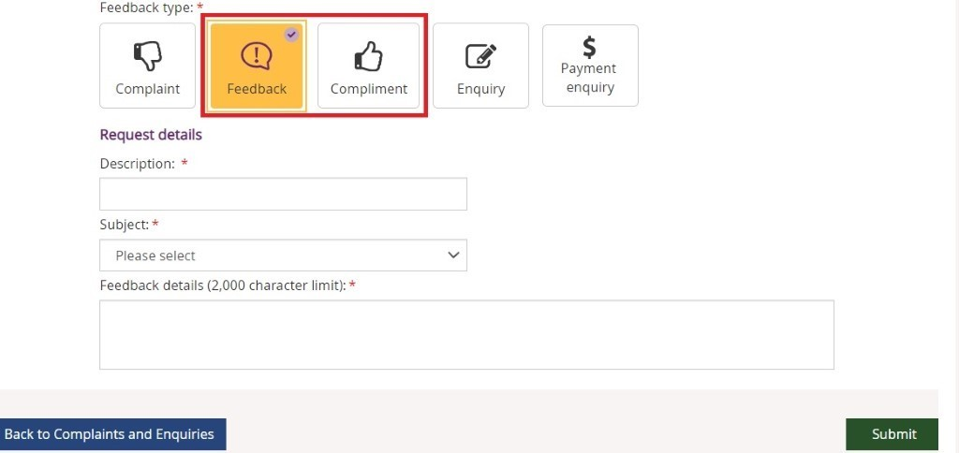
- In the Description field, provide a brief description of your feedback or compliment.
- From the Subject drop-down, select the subject that relates to your feedback.
- In the Feedback details field, enter a description of the feedback. This field has a 2000-character limit.
- Select Submit to send your feedback to the NDIA.

Submit an enquiry
- Select Enquiry.
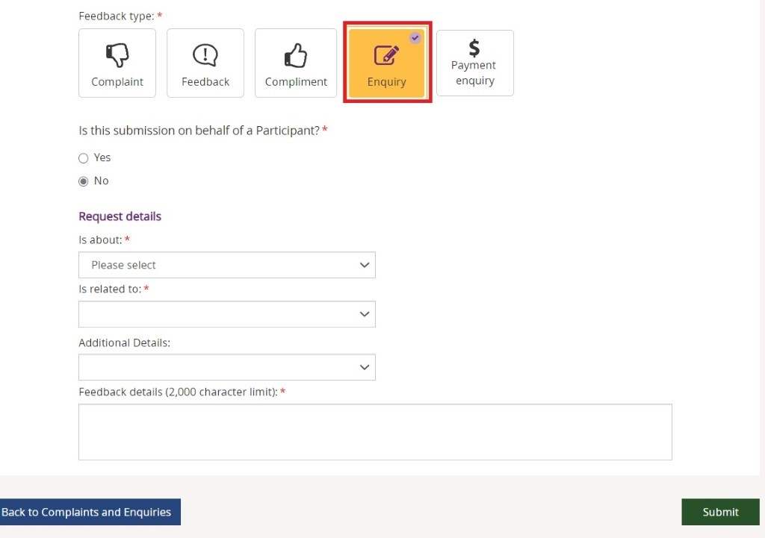
- Select whether this enquiry is on behalf of a participant.
  - If an enquiry is submitted on behalf of a participant select Yes. Then enter the participant’s NDIS number, last name and date of birth and select Verify participant.
  - If the enquiry is not on behalf of a participant select No.
- In the Is about field, select the area that your enquiry is about from the drop-down list.
NOTE: This drop-down selection is mandatory to submit your enquiry.
- In the Is related to field, select the area that your enquiry is about from the drop-down list. The available items are related to your previous drop-down selection made from the Is about. This drop-down is also a mandatory selection for your enquiry.
- In Additional Details, select an item that matches additional detail from the drop-down list. The available items are related to your previous drop-down selection made from Is related to. This selection is not a mandatory item to submit your enquiry.
- In Feedback details, enter a description of your enquiry. This field has a 2000-character limit.
- Select Submit to send your enquiry to the NDIA.

Submit a payment enquiry

You can submit a new payment enquiry on behalf of your organisation or submit a follow-up on a closed enquiry.

Note: We have improved the process of submitting a payment enquiry.

When you select the Payment enquiry tile in the myplace provider portal, you will be redirected to the Enquiries tab in my NDIS provider portal.

Further information on how to create a payment enquiry is detailed in the my NDIS provider portal guide.

Submit a new payment enquiry
1. Select Payment Enquiry.
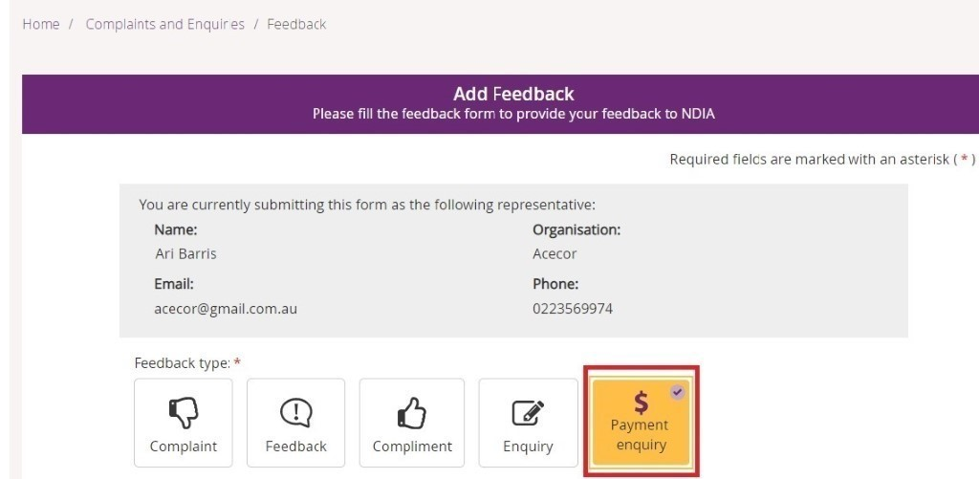

This will take you to my NDIS provider portal to submit your payment enquiry
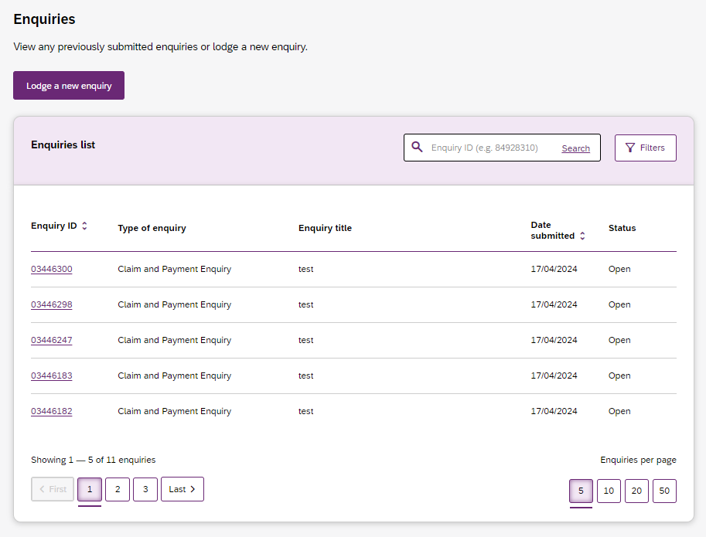
For further instructions, please refer to my NDIS provider portal step by step guide located in the myplace provider portal and resources | NDIS

View existing complaints and enquiries

Select the View Complaints and Enquiries tile on the myplace home page.

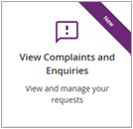

The View Complaints and Enquiries page displays your submitted complaints and enquiries. Use Next and Previous to navigate through lists that have more than 10 entries.
Note: For information about previously submitted compliments, payment enquiries or feedback, call NDIA on 1800 800 110.

Next to the free text search field use the drop-down selection to choose the criteria of the search:
- Submission ID
- Participant NDIS number
- Submitted by NDIS number
- Submitted by Surname.

Note: You cannot search by Submitted by NDIS Number and NDIS Surname when searching for a Payment Enquiry.
Enter the details of the complaint or enquiry in the search box and select Search.
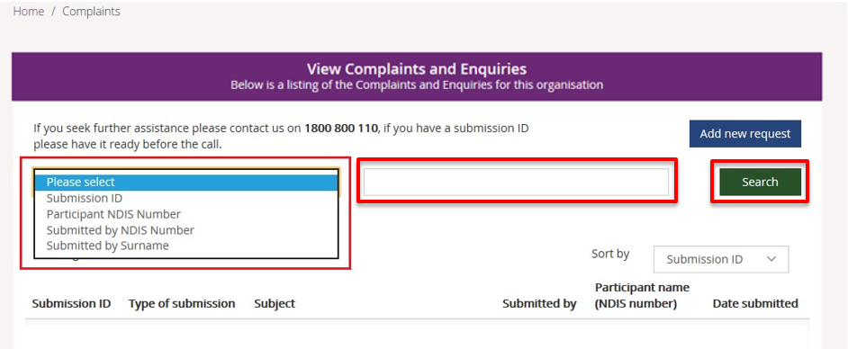
From the Sort By drop-down, select a sorting option:
- Submission ID
- Type of Submission
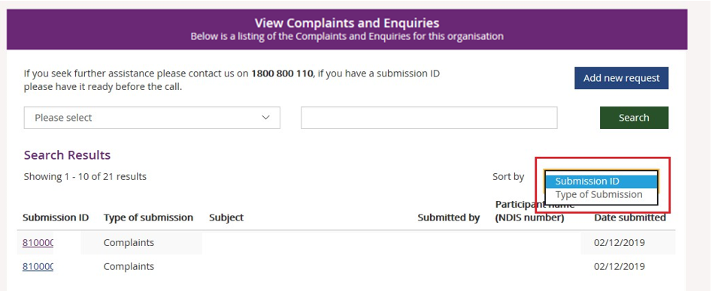
To view the details of the complaint or enquiry select the Submission ID (hyperlinked).
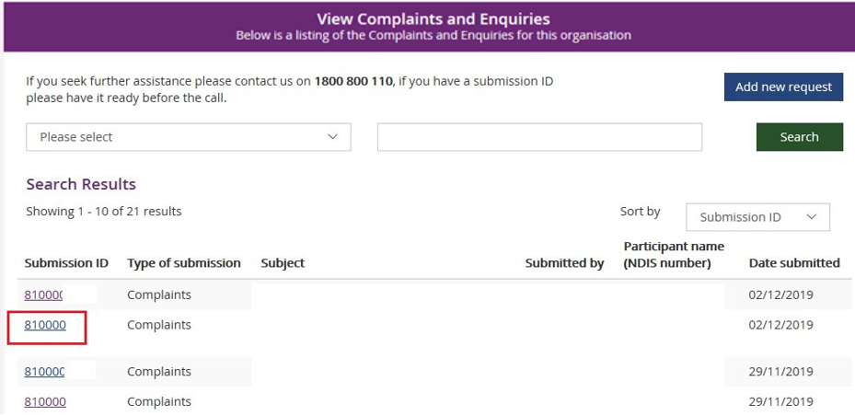
The details of the complaint or enquiry will be displayed.
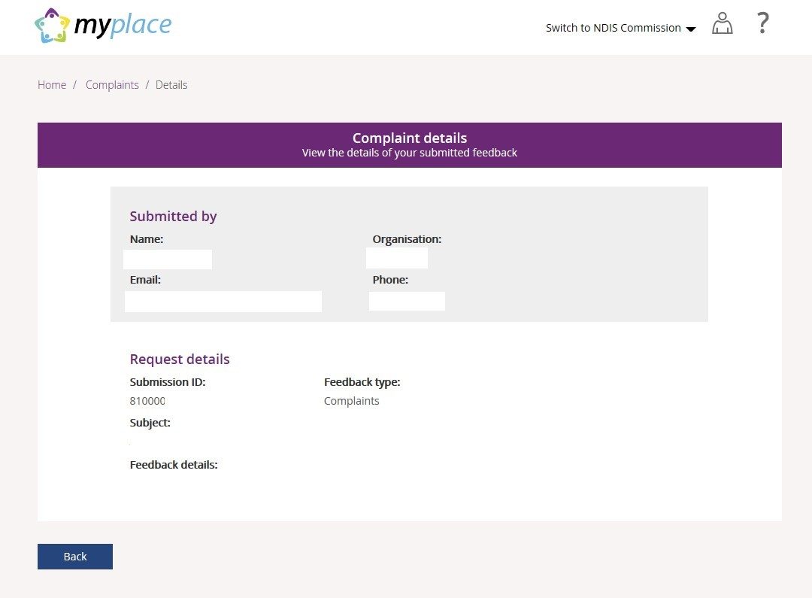
Select Back (bottom left corner of the page) to return to the search results.

Note: Enquiries created before the 5th of May 2024 can be viewed in the myplace provider portal.
Payment enquiries created after the 5th of May 2024 will be displayed in the Enquiries page of my NDIS provider portal.

You can only view your enquiry in the portal from where it was originally created.

If you made a payment enquiry through my NDIS provider portal, navigate to my NDIS provider portal Enquiries page.

For further instructions, please refer to my NDIS provider portal step by step guide located in the myplace provider portal and resources | NDIS

Maintaining your information
These functions enable you to:

- View your Profile (your and your organisation’s contact information and roles within the provider portal).
- View your Registration details (the services you are approved to provide under the NDIS). You need to register and maintain your registration details and registration groups with the NDIS Quality and Safeguards Commission.
- View your Outlets (the times and places from which you deliver services). To add or edit outlet information for outlet you will need to contact the NDIS Quality and Safeguards Commission.
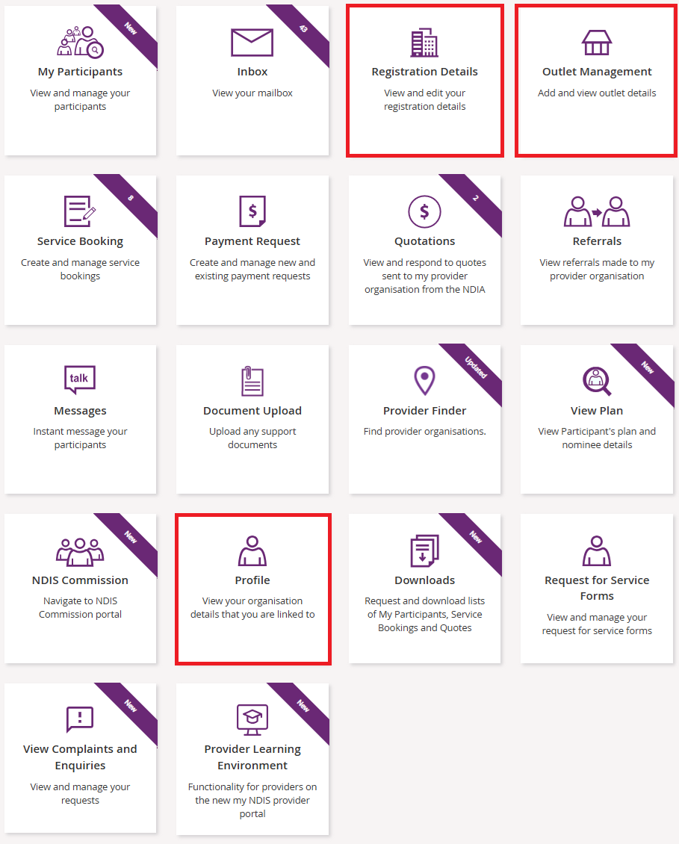

Profile
This allows you to view and update your personal details, and view (and update if you are the account manager for your organisation) the Provider Finder Display in your organisation details, organisation staff and bank details.
- Select the Profile tile on the myplace home page, or the Person icon from other pages.

- The Profile page displays. Use the Open and Close section buttons to see all the information.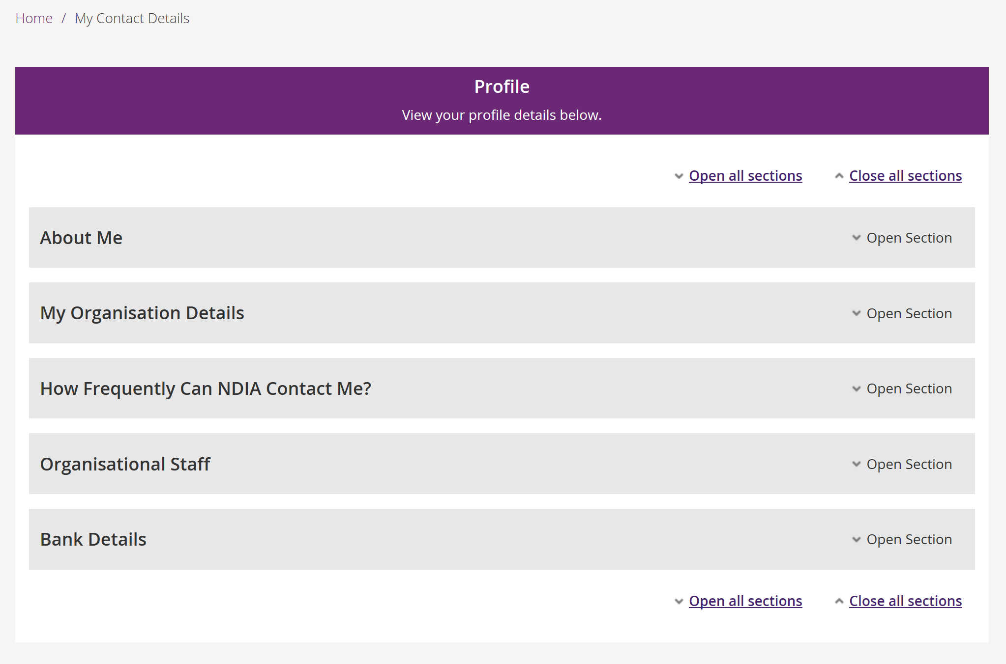

About me
- Select Edit in the About Me group to update your telephone numbers and email address.
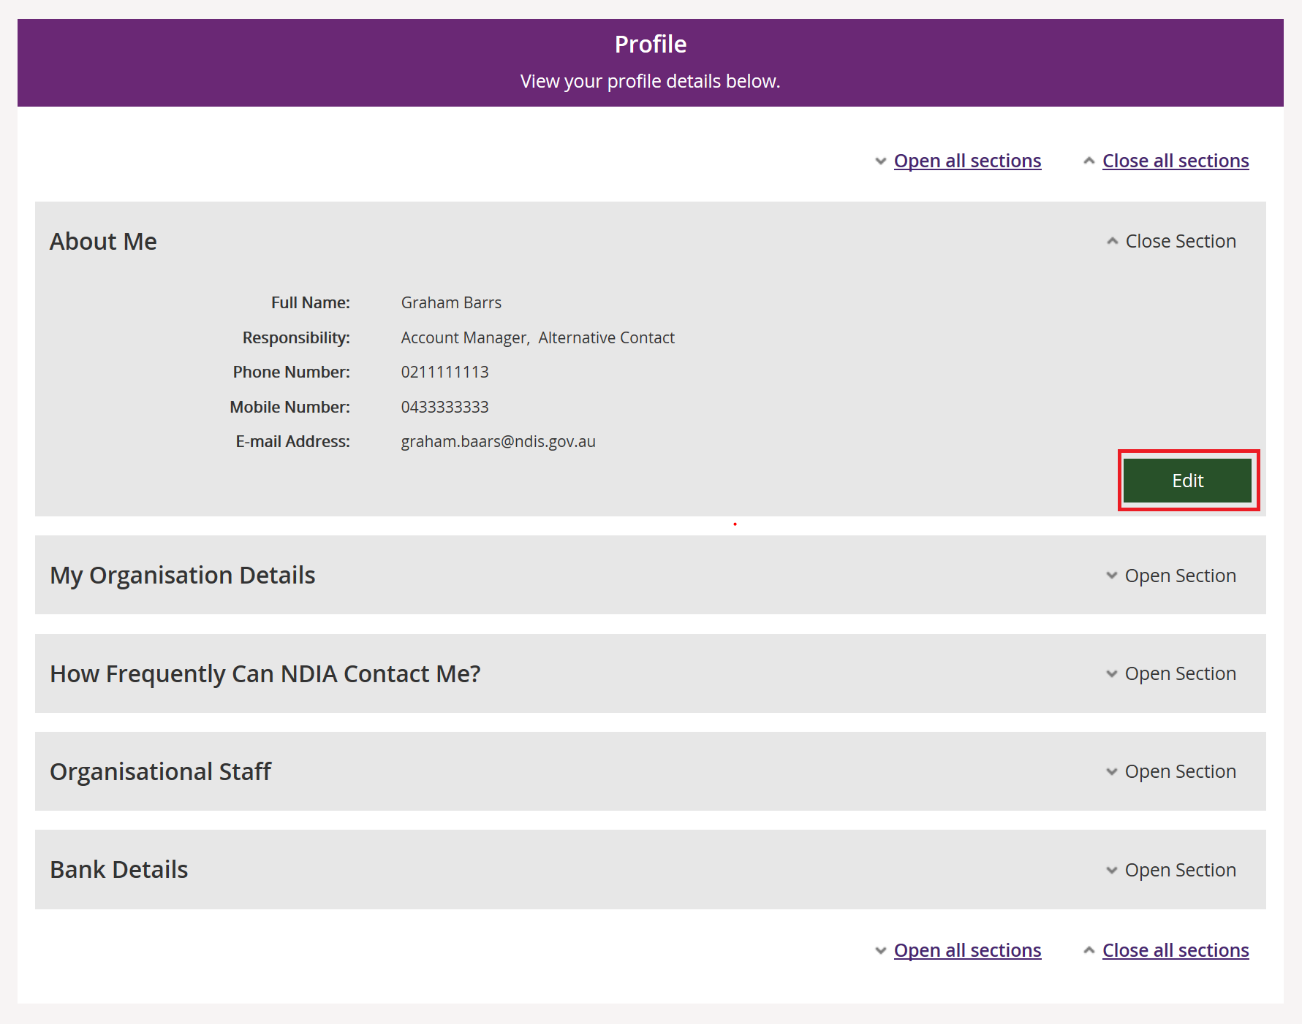
- Enter your changed details and select Update.
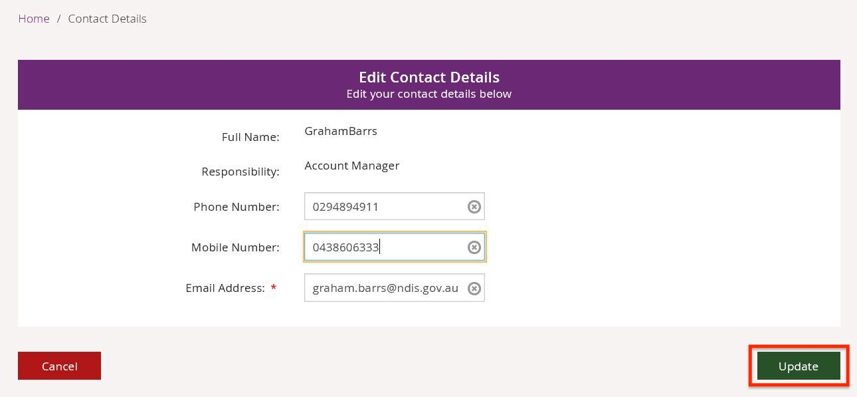
Note: If you do not wish to update your details, select Cancel. You can only change phone numbers and the email address.

My organisation details
- View name and contact information for your organisation in the My Organisation Details section.
- Select Edit to update whether the provider should display in the Provider Finder, and if so whether the address should also be displayed.
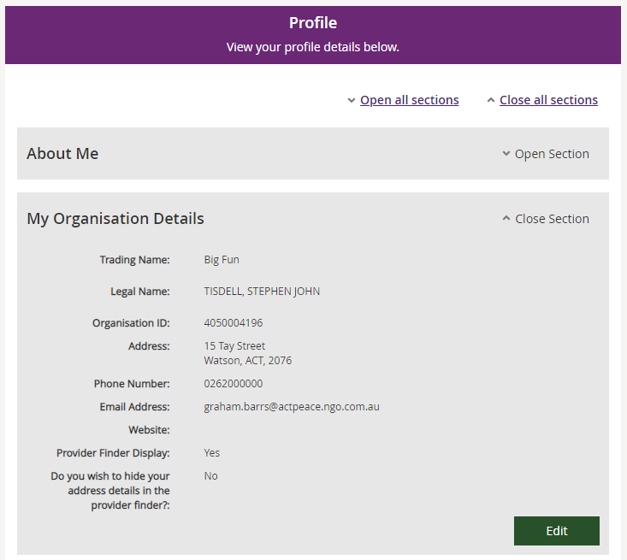
Note: The following steps are only available if you are the account manager for your organisation.
- Select ‘Yes’ if the provider should display in the Provider Finder, and if so whether the address should also be displayed. Then select Update.
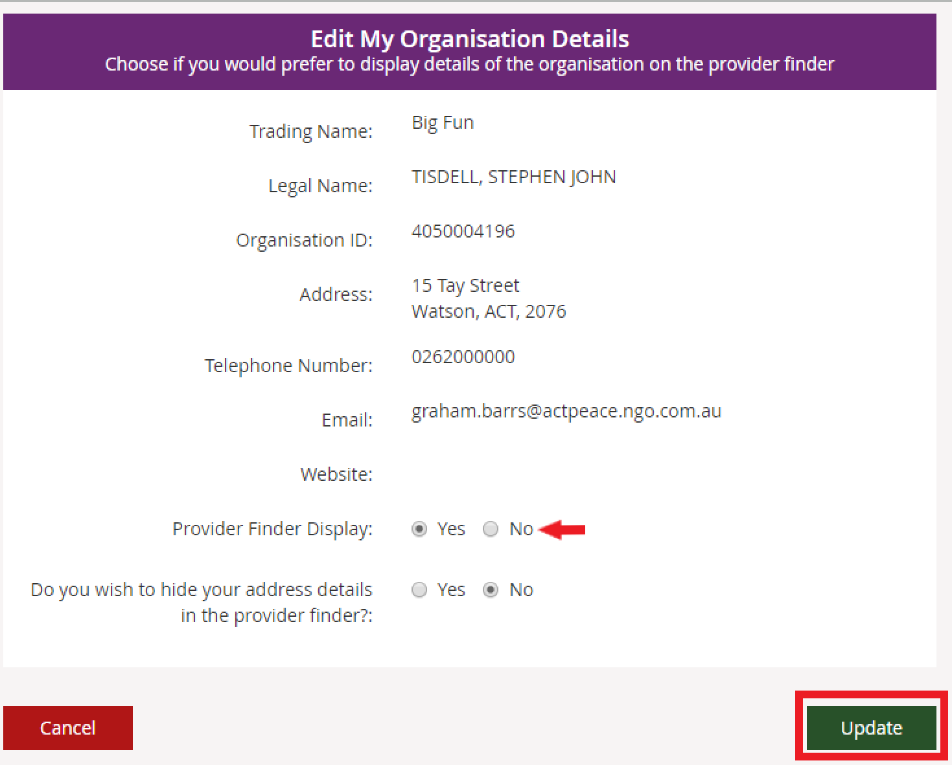
Note: To edit your organisation’s details including your email address, to make sure you receive important information, you will need to contact the NDIS Quality and Safeguards Commission.
How Frequently Can NDIA Contact Me?
Nominate how often your organisation wants to be notified about changes to service bookings and quotations, and new Requests for Service sent to your organization for review. For new Requests for Service you will be notified immediately. For service bookings and quotations, you can choose to be notified:
- Immediately
- Daily
- Weekly
- Never

Note: You will only be notified about service bookings and quotations that your organisation needs to action.

- Select Open Section to view or edit your information.
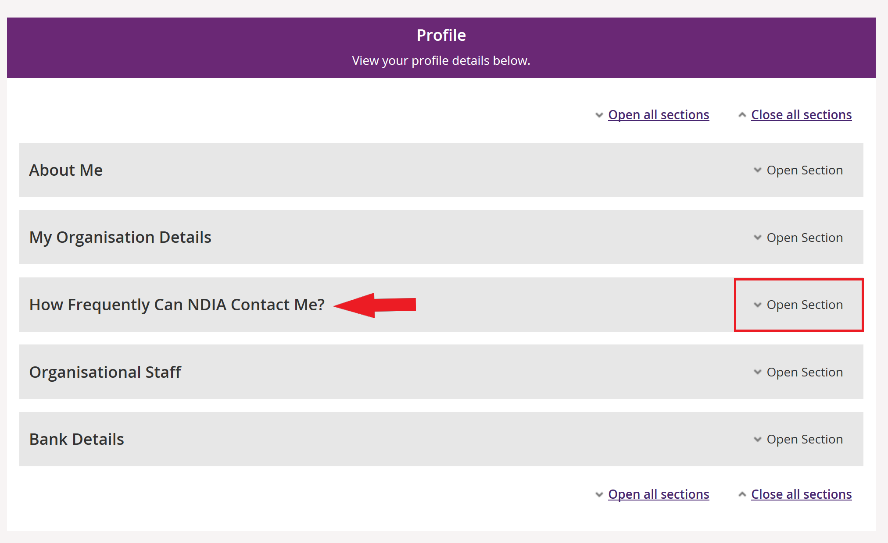

- Select Edit to update your preferred frequency.
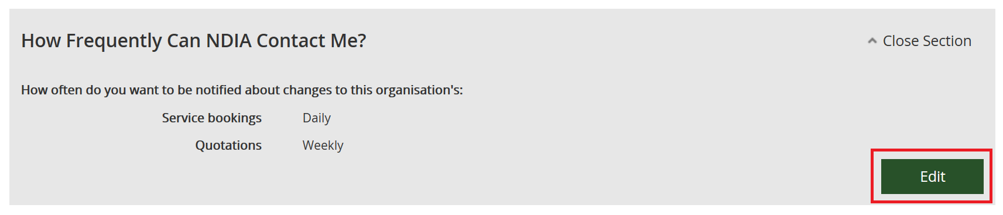
- Choose from the drop-down how often you wish to receive service bookings and quotations notifications and select Update:
- Immediately
- Daily
- Weekly
- Never
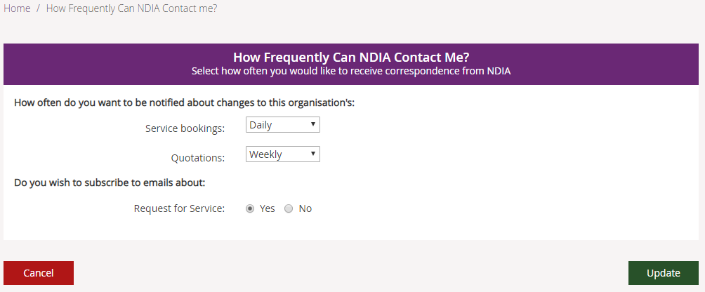
Note: If you choose daily or weekly, all changes for the previous day or week (Monday to Sunday) will be grouped together and sent in one message to your inbox.
- Choose from Yes and No to update your Request for Service email preferences.
- Select Cancel if you wish to cancel the selection. A popup box will appear asking for confirmation to return to the Profile screen without updating any contact details.
- Select Yes to return to the Profile screen; select No to return to the list of correspondence options and make a selection.
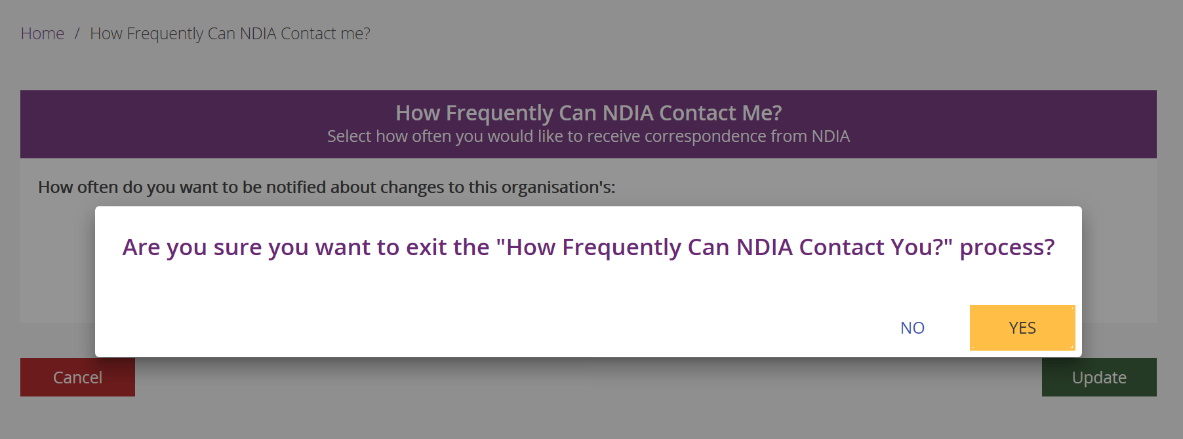

Organisational staff
Your role (also shown as Responsibility or Contact type depending on the screen) will be allocated to you by your organisation’s account manager.
If you are linked to multiple organisations, your role may vary between organisations.
Depending on your role, you can view your profile, edit your details, edit contacts and update bank account details. The roles available are:
Contact type / Responsibility role | Account manager | Primary contact | Alternative contact
Number allowed (per organisation) | Multiple | One | Unlimited
Create service bookings | Yes | Yes | Yes
Submit payment requests | Yes | Yes | Yes
Cancel paid and pending payment requests | Yes | Yes | No
Add/ remove contacts | Yes | No | No
Update bank account | Yes | No | No

If you have the account manager role, you can edit the staff roles for your organisation through the Organisational Staff section.

Important note: The first person who links to an organisation will be automatically assigned the roles primary contact and account manager. This applies when the registration is processed through the NDIS Quality and Safeguards Commission.
- Select End Role in the Action column to remove that access type from a contact.
- To add a new role to an existing contact, select Add Role.
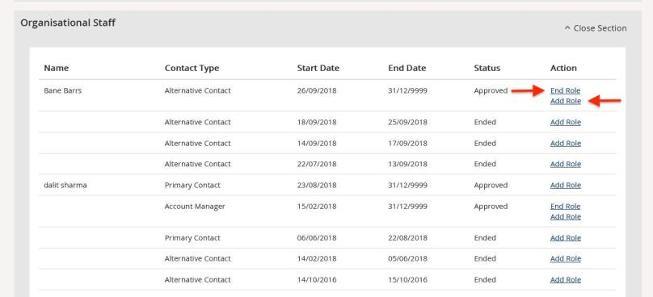
- Select the contact type from the Contact Type drop-down and select Update to save the record.
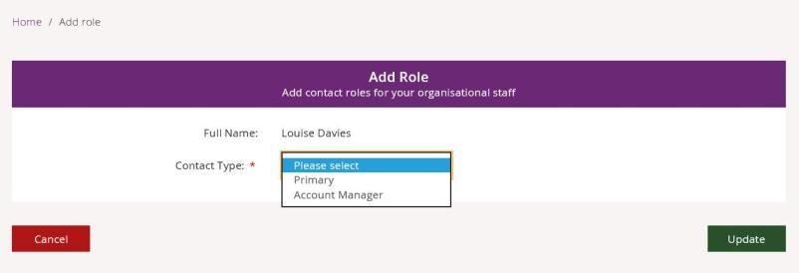
Tip: The Contact Type available to select will be limited to the roles the staff member does not hold.
Tip: An individual user cannot hold both primary contact and alternate contact roles at the same time.

Bank details
The NDIA will pay Payment Requests from your organisation to this account.

- To add bank account details, select Add Bank Detail from the Bank Details section.
Note: Only the account manager can add or edit bank accounts details.
Note: Bank details cannot be updated if there are payments approved but not yet paid. Changed bank details will take effect immediately.

- Complete the following fields:
- At Account Name, enter the bank account name.
- At BSB, enter the six-digit BSB number.
- At Account Number, enter the account number.
- Select Update.
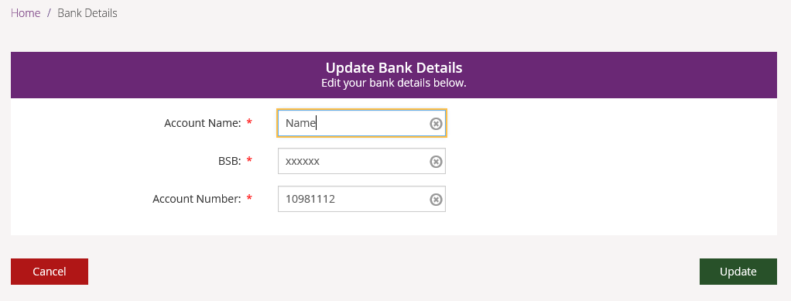
- Once you have saved your bank account details, use the Edit button if you need to change the account details.
Note: Whenever the bank account details are added or edited, the primary contact for your organisation will receive an SMS stating:
We have updated your bank account details as requested. Contact NDIA on 1800 800 110 if you need to.

Managing correspondence and messages

Inbox
All messages and letters sent to your organisation will appear in the Inbox. When you open the Inbox, you will see all messages, not just those relating to you or your participants. The number next to messages is the number of new (unread) messages received.
- Select the Inbox tile on the myplace home page.
- Your Inbox displays messages and letters received from NDIA.
Note: See How Frequently Can NDIA Contact Me? to choose how often you wish to be notified.
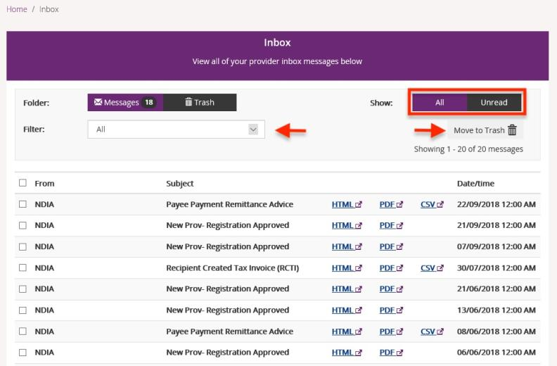
- Select Unread to show only messages that have not been opened.
- You can limit the list of messages to a particular type. Select the message type from the Filter drop-down.
- When you have processed a message, you can delete it by moving it to Trash. Select the check box to the left of the messages you wish to delete, select the Move to Trash link to delete all the selected messages.
- Select the blue file type link to open the message. The message will open in a separate window to enable you to continue processing in the portal while the message is open.
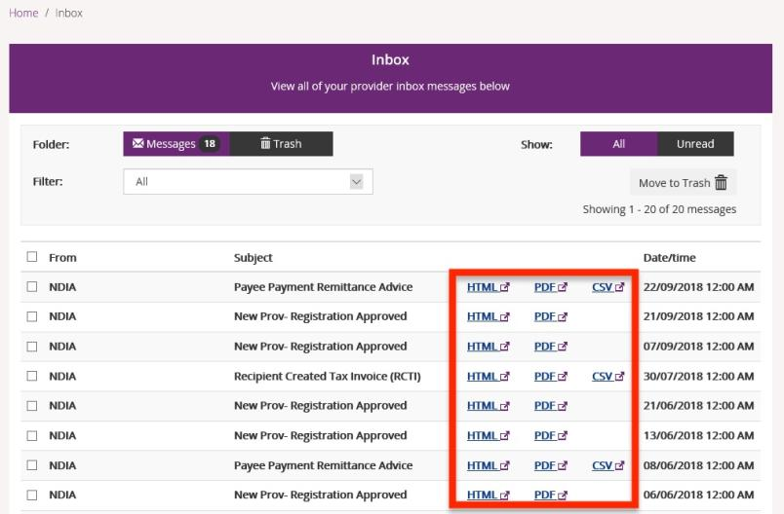

Messages
You can have online conversations with your participants through the instant messaging function.

Starting a new instant message
- Select the Messages tile on the myplace home page.
- Enter the participant’s NDIS Number and Last Name then select Search.
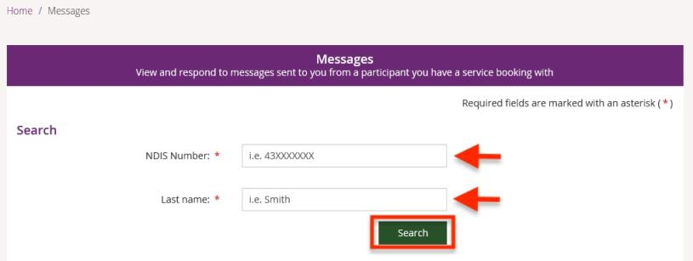
The Your Conversation window displays.
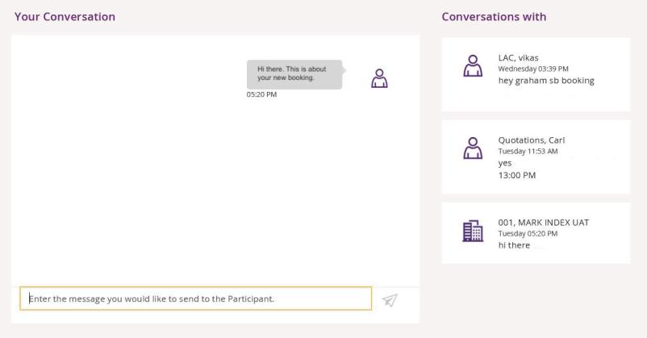

- Type your message in the message field which (highlighted by a yellow rectangular box).
- Select the paper aeroplane icon on the right-hand side of the message field to send.

Continuing a previous conversation
You can carry on past conversations by searching for the participant or finding the participant under the Conversations with panel.
To search for the participant, refer to starting a new instant message in Step 2 above.
If the participant is shown in the Conversations with panel on the right-hand side of the window, simply click on the participant and your conversation will be displayed.

Administering your services
These functions enable you to:
- Find your active Participants
- View a Participant’s plan (if you provide services to that participant and have their consent).
- View and manage your Service Bookings (these record which supports you will provide to participants, the value of the supports, and the period within which they will be provided).
- View and manage your Payment Requests (how you submit claims for payment for supports delivered).
- View and respond to Quotations (requests for quotes for supports from the Agency or a participant).
- View Referrals to your organisation (created by the Agency when a participant would like you to contact them).
- View and action Support Coordination Requests for Service.
- Use the Provider Finder (to find additional supports for a participant).
- Upload Evidence related to the participant or their supports.
- Download and view reports about all the service bookings you have with active participants and information about participants you have service bookings with, and also your quotation requests.

Finding Participants
All of your active participants will appear in My Participants. When you open My Participants, you can search for a participant and quickly view their plan, view or create service bookings and payment requests.

 The NDIA requires consent from participants to share their plans with providers. Only participants and their nominees can provide the NDIA with the consent to share their plans with providers. Participants have the choice to either share, or not share their plans with you and can withdraw consent at any time.

- Select the My Participants tile on the myplace home page.
- A list of active participants sorted by first name is displayed. From here you can select the links to view their plan, view or create service bookings and payment requests.
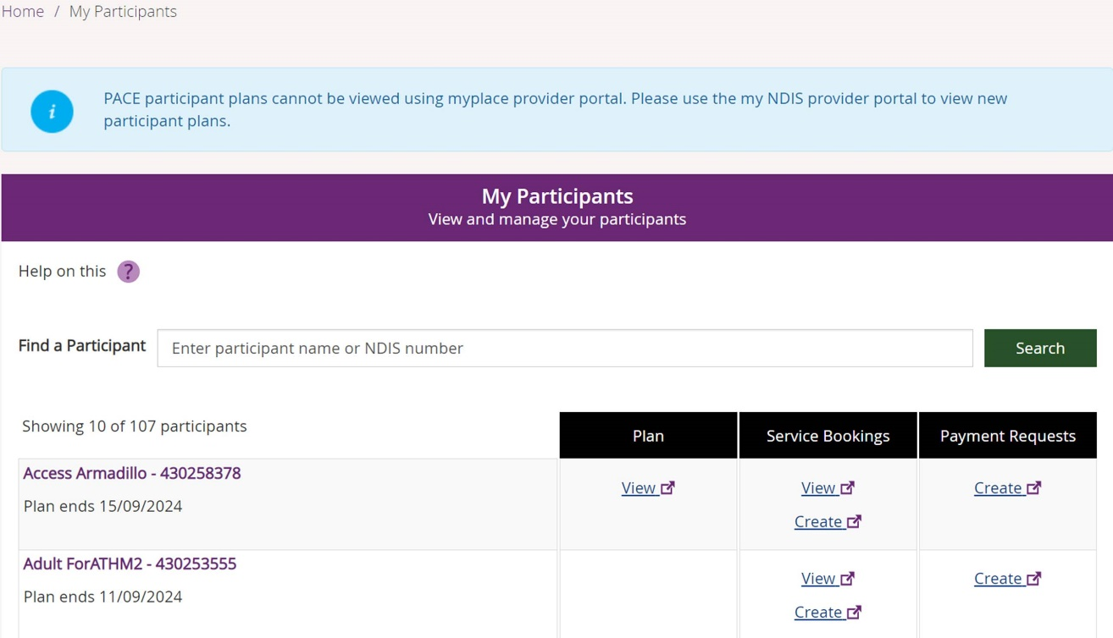
Note: PACE participant plans cannot be viewed using myplace provider portal. Please use the my NDIS provider portal to view new participants plans.

- To search for a participant, type their name or NDIS number in the Find a Participant field and select Search.
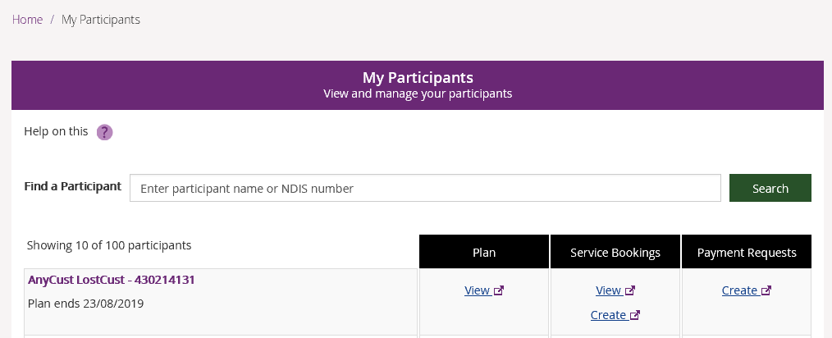
- To view the plan, select the View link and following instructions from Step 8 in the View Plan section below.

View plan
View Plan allows you to view the plans of participants that you have active service bookings with and have given the NDIA consent to share their plan with you.

The NDIA requires consent from participants to share their plans with providers. Only participants and their nominees can provide the NDIA with the consent to share their plans with providers. Participants have the choice to either share, or not share their plans with you and can withdraw consent at any time.

The 365-day plan auto-extension feature identifies plans near expiration and auto extends those plans up to 365 days, until the new plan review is approved to ensure that there is not a gap between the plans. The 365-day plan auto-extension feature will allow you to discuss the range of services participants might need during the extension period.

See Download Service Bookings if you want to download and identify any plans that are expiring and include service bookings that qualify for automatic extension.

- On the home page select View Plan.
A Participant Search screen displays.
- A drop-down menu displays for the search criteria field. Use the drop-down menu to select the criteria you wish to use. In this example we are searching by the Participant’s Name.
- Enter the participants first and last name in the search criteria field.
- Select Search.
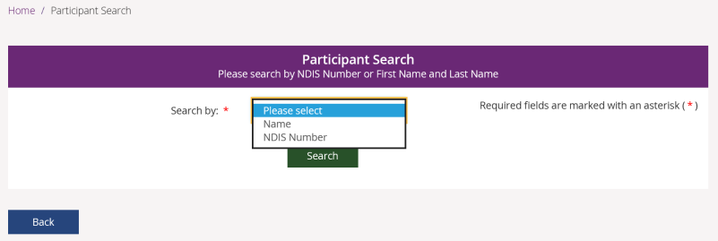
- You must enter both the participant’s first and last name to search. When a participant has a common name, it may be easier to search by NDIS Number. You will receive an error message if you don’t enter both names and will be asked to complete the required fields. The names entered must be an exact match for the system to find the participant.
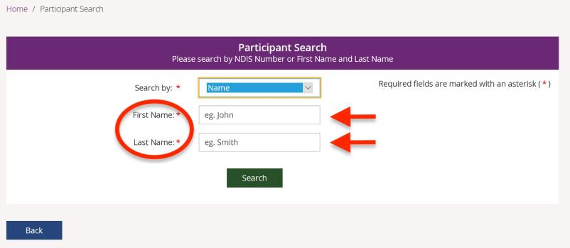
- You can only view a participant’s plan if you have an active service booking with the participant. If you do not have an active service booking you will receive an error message.
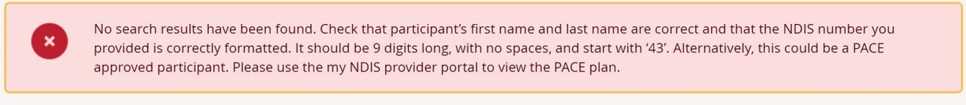
Note: To create the first service booking, you will need to work from the participant’s printed plan, or the information the participant provides to you.
Note: For a PACE approved participant you will need to use my NDIS provider portal to view the PACE plan.

- You can hover over the ‘?’ Help icon to obtain help on fields.
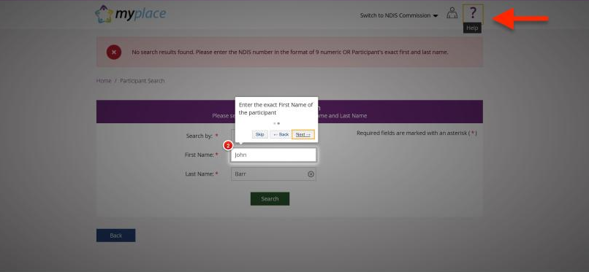
After searching for a participant, you will see the View Participant Plan page. Select the
required participant to open their plan details.
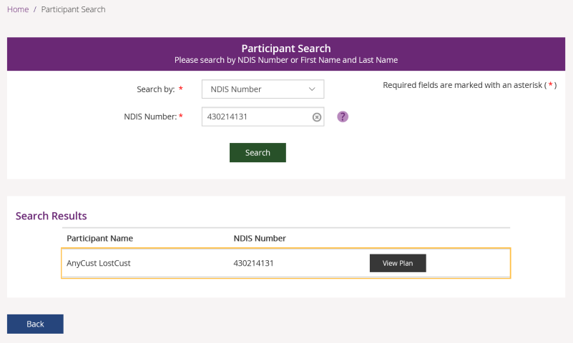
- The View Participant’s Plan page shows the participant’s details (name, gender, NDIS number, date of birth and interpreter need) as well as three open/close sections displaying the participant’s:
- Current Plan – displays the days remaining in the plan. Select the View Previous Plans button to view the details of past plans.
- Goals – listing the participant’s current plan and their medium to long term life goals
- Participant’s Nominee Details – showing the nominee’s name and relationship details, where a nominee exists.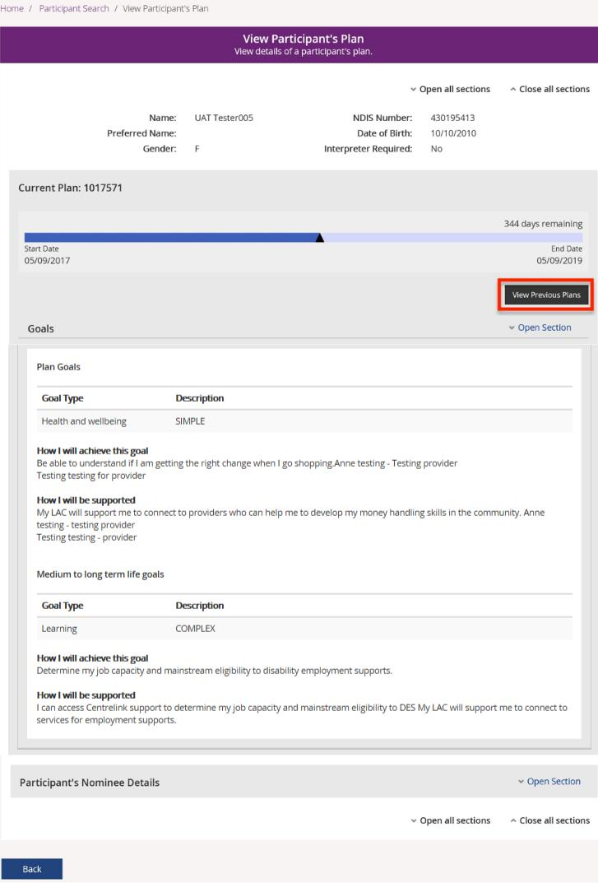
The View Participant’s Historical Plan page opens.
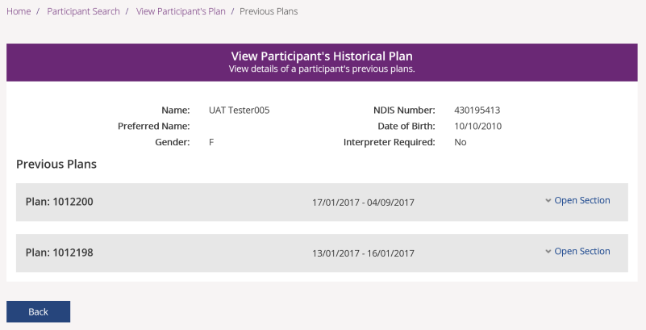
- Select Open Section to view details of past plans.
Note: This will only be available if the participant has previous plans.
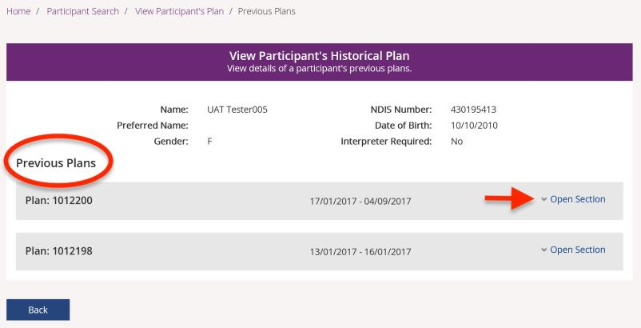
Important Note: Help text is available throughout the screens. Simply hover your cursor over the field you need more information about.
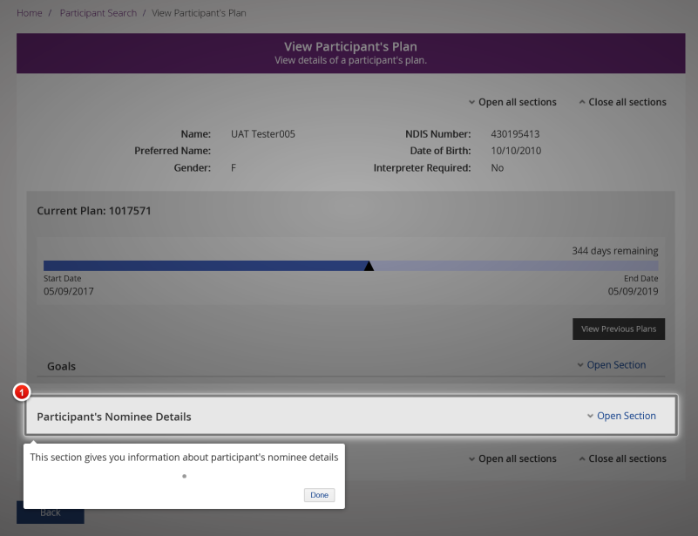
- When you have been given consent to view a participant’s plan and you are a registered plan manager with an active service booking you will see the information outlined at point five as well as information about the budget in a participant’s plan.
- By selecting Open Section, you will see the initial Approved Funds spent and the amount of Funds Remaining. Details of any Funds Allocated will also be shown.
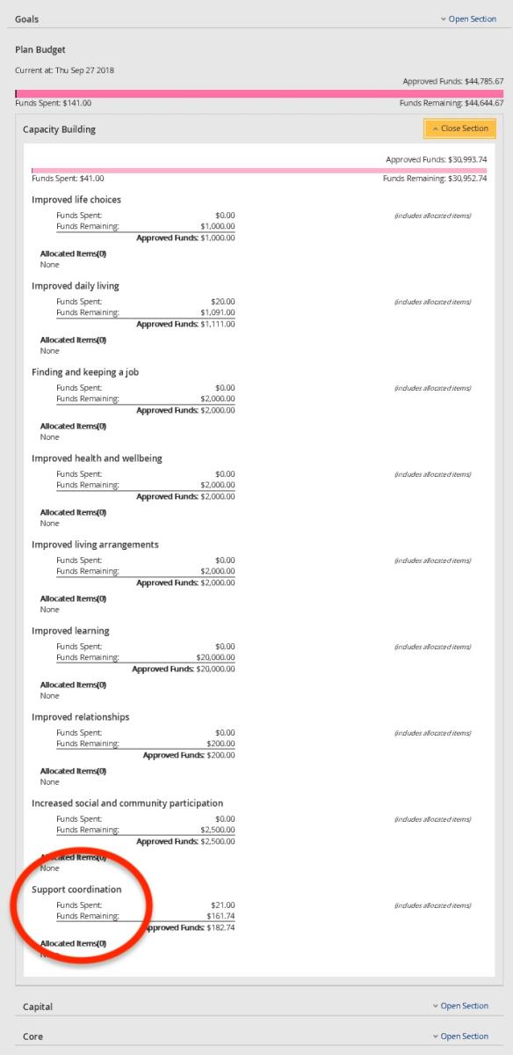
- In the Capital section, amounts will only be shown where a quote has been accepted. The amount will be shown as Approved Funds.
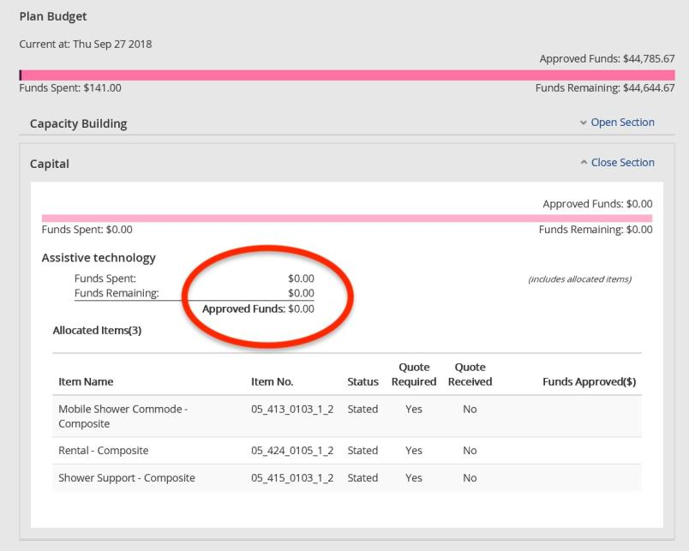
Note: When you have been given consent to view a participant’s plan and you are a registered support coordinator with an active service booking you will see the information outlined at points five and nine as well as information about the type of plan management in the plan and details of other community, mainstream and in kind supports.

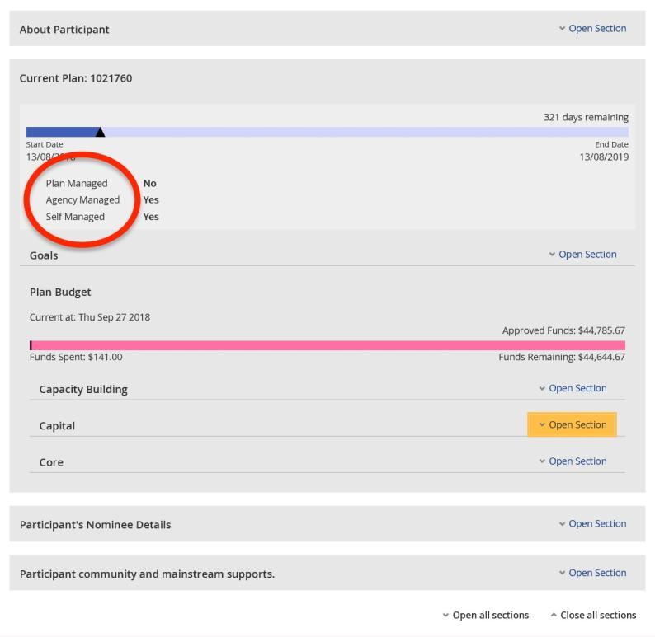

Consent to view plan notification
- You will receive via the Inbox, notification of consent to view a participant’s plan, as well as any changes to consent. This will be a message of type ‘Changes to plans shared with you’.
- See Inbox Step 4 for details of how to filter messages by type.

Service bookings

Prior to providing services to a participant, you need to ensure there is a service agreement (not held in the NDIS system) between you and the participant.
Service bookings must be completed before you provide supports to a participant and be paid for a service. It must be in line with the NDIS Pricing Arrangements and Price Limits and Support Catalogue

A service booking details support(s) that you will provide to a participant under the service agreement. Both you and the participant will need to agree to the service. A service booking must be in place before you can be paid for a service.
You can create and manage service bookings with your participants using myplace. Service bookings can also be created by participants, their nominee, or their plan manager. A participant may also be supported by an Agency representative to complete their service bookings.
Providers can:
1. Create a new service booking with a participant.
2. View and edit existing service bookings
3. Accept or reject a new service booking including providing a reason for rejection
4. Accept or reject a change to an existing service booking, including providing a reason for rejection
5. Edit support details on a service booking including duration, price and quantity
6. End a service booking including immediate cancellation
7. Delete a service booking
8. View Quote ID and select hyperlink to navigate to Quotation screen

Important points to note:
The dates of the service booking must be within the participant’s current plan.
If the dates of your service booking do not cover the whole plan duration, you can create additional service bookings or extend it to cover the plan. The dates of the service bookings (with the same support category) cannot overlap. Plan Managers should create their service bookings for the duration of the plan.
The 365-day plan auto-extension feature identifies plans near expiration and auto extends those plans up to 365 days, until the new plan review is approved to ensure that there is not a gap between the plans. The 365-day plan auto-extension feature will allow you to discuss the range of services participants might need during the extension period.
From 10 February 2020, participant plans that include funding for Specialist Disability Accommodation (SDA) will have the service booking extended and pro-rata funding is allocated automatically where the extension has been applied. Please continue to regularly submit payments requests in accordance with the agreed SDA service booking.
For participant plans approved after 1 July 2021, SIL is no longer a quotable support. If a participant’s plan receives an automatic extension, SIL providers will need to update the allocation of the SIL service bookings themselves.
From 9 May 2020, participant plans that include funding for Assistive Technology, in some circumstances, will have a service booking extended and pro-rata funding allocated automatically where the extension has been applied.
- The service booking must have at least one support category (displayed as Support Budget) included.
You can have multiple support categories within one service booking.
You can have additional service bookings for the participant for other support categories.
The Item Number field (line item) is not mandatory unless the item is stated in the plan.
- From the 27 March 2021, you can view the Quote ID of an approved quote in the ‘Find’ page, under Service bookings and can select the hyperlink to navigate you to the Quotation screen.
- You can view and search the quote ID attached to all historic service bookings on the ‘Find’ page, under Service bookings and Quotation page.
- For service booking without a quote, the quote ID column will show as ‘Not available.’

Create service bookings
Providers can create two types of service bookings depending on the participant's plan. Participant plans will have funding allocated at either a category level or an item level. Some will have funding at both levels. In this case, providers might need to create two separate service bookings.

IMPORTANT: The Agency recommends that service bookings be created at the category level, if possible. This allows providers and participants to negotiate, or access supports on a more flexible basis, especially for on-the-spot assessments or services. This is preferable to having to create another service booking for that item at a later date or having funds locked into a support line item that does not relate to the appropriate support.

Item level funding
If a participant has a stated item in their plan, and the provider tries to create a service booking in the support category but does not choose the stated support item, the portal will reject the service booking.

The stated support item must be selected to create a service booking.

Category level funding
If a participant has funding allocated at a category level, the provider can create a service booking at a category level.
This type of service booking allows providers to use participant funds more efficiently and delivers greater flexibility for participants to utilise their funding across different support items within a support category.

Service booking at the category level funding
- Select the Service Booking tile on the myplace home page.

The Service Booking page displays.
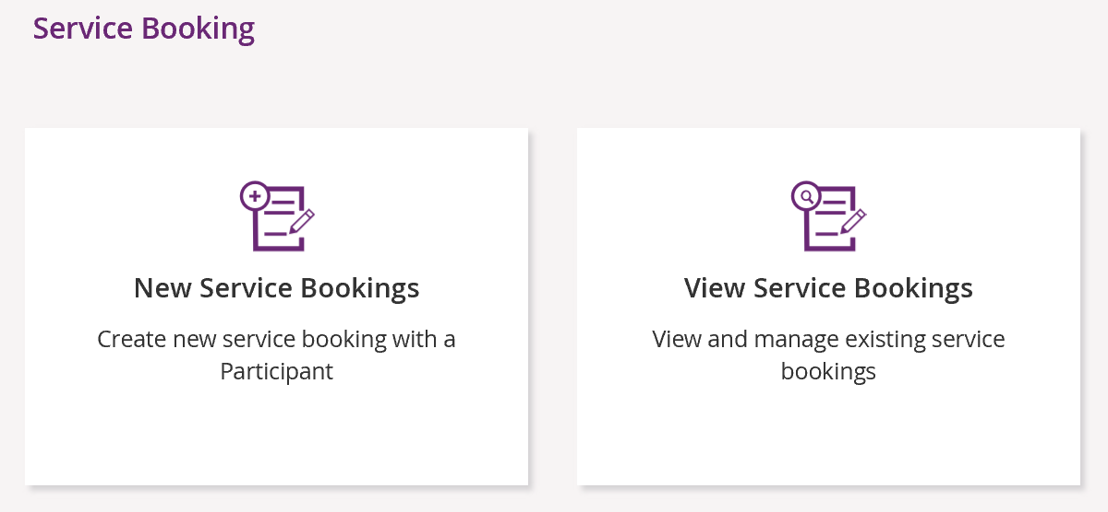
- Select the New Service Bookings tile.
The Add service booking page opens.
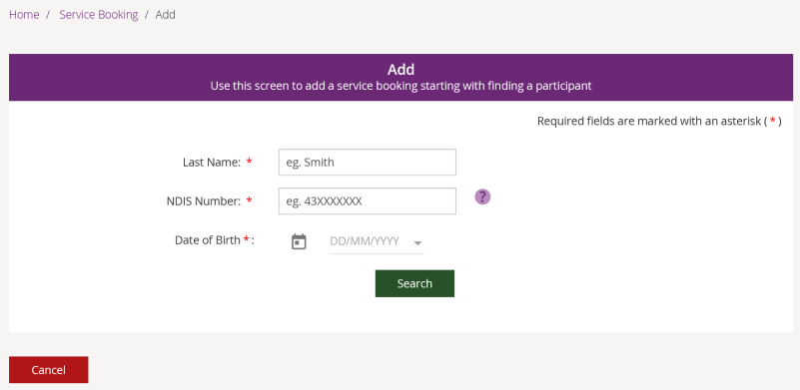

- Enter the participant’s Last Name, NDIS Number, Date of Birth and select Search.
The Service Booking Details section (Step 1) opens.
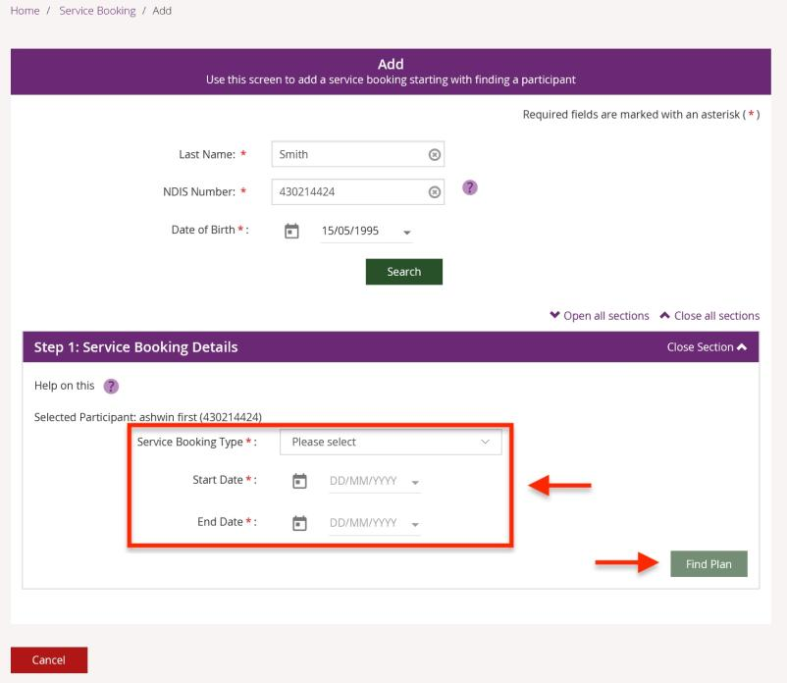

- Select the Service Booking Type. The types available are:
- Standard booking is available when funds are Agency managed. In most instances the only option will be standard booking.
- Plan managed booking is only available when a provider is managing participant funding, as specified in the plan. The plan manager provider must be registered to do this. To create a plan managed service booking, a standard service booking between the plan manager and participant must first exist. This standard service booking needs to include at least one item for financial intermediary supports.
Note: Plan managed Service Booking Process
- Plan management financial intermediary and monthly fees are stated items. These should be specified in the plan and the costs must be in line with the pricing guide.
- The plan manager must create a standard line-item service booking for the financial intermediary set up and monthly fees. To create standard line item refer to the steps in service booking at the Line-Item level.
- Once standard line-item service booking is created, the plan manager will be able to create plan managed service booking for plan managed funded supports within the plan. To create plan managed service booking, refer to steps 3 to 12.

In-Kind service booking is only managed by NDIA. In-kind are prepaid services funded by state, territory or Commonwealth governments. When these supports stop, you can create service bookings to claim the supports through NDIS. If you have any queries, please contact INKIND@ndis.gov.au

- Enter the start and end dates of the service booking. These dates cannot sit outside the date range of the plan.
- Select Find Plan.
The Select Plan section (Step 2) opens.
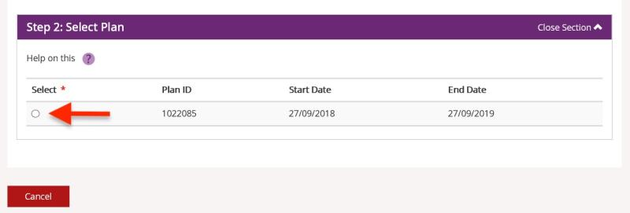
- Select the button of the plan you want to work with.
The Support Details section (Step 3) opens.
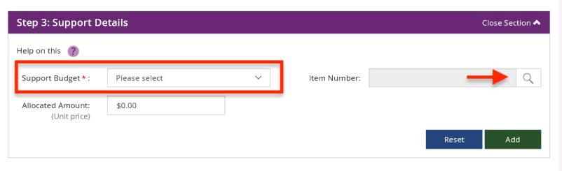
Note: The Item Number field (line item) is not mandatory unless the item is stated in the plan. Typically, an item is not stated but contact the participant to verify.
If you wish to select the Item Number, please refer to service booking at the Line-Item Level funding.
- Select the support category using the drop-down button for Support Budget.
9. Enter the Allocated Amount as agreed with the participant then select Add.
- Select Reset to clear all your entries and selections.
- If you need to add another support item, select Add.
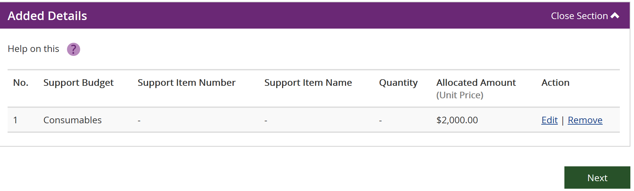
10. Once you have selected Next to continue, the booking and item details display. If you need to edit the details of the service booking, select Back.
11. Check the service booking is correct and when you are confident that everything is correct, add comments to the ‘Comments’ field to explain the booking.

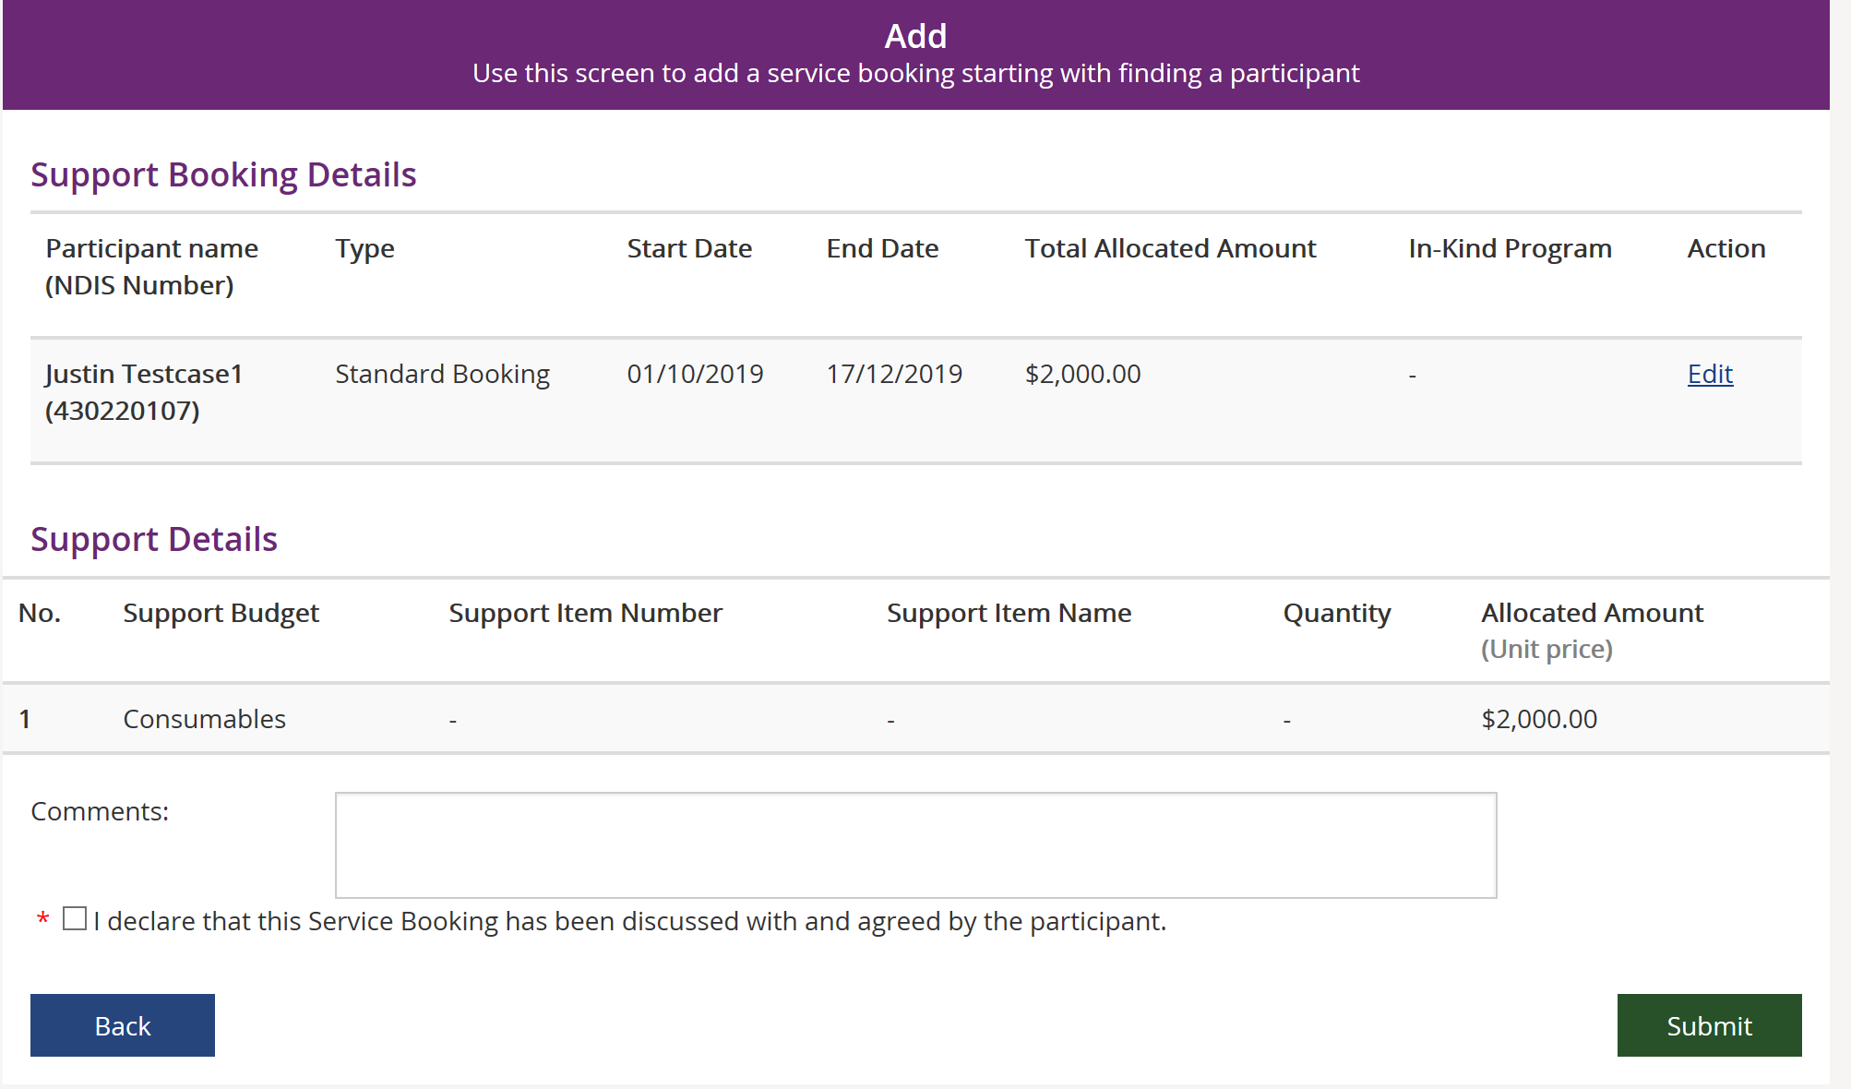
12. Ensure the service booking is as agreed with the participant, then tick the mandatory declaration and select Submit.
13. Select View Service Bookings to go directly to the View Service Bookings page, which is described in the steps below or select myplace logo to return to the home page.

Service booking at the line-item level
1. Follow steps 1 to 7 of service booking at the Category level funding to open the Support Details section.
2. Select the support category using the drop-down button for Support Budget.
3. Select the Item Number using the drop-down button.
Note: Only items which you are registered to provide will be displayed.
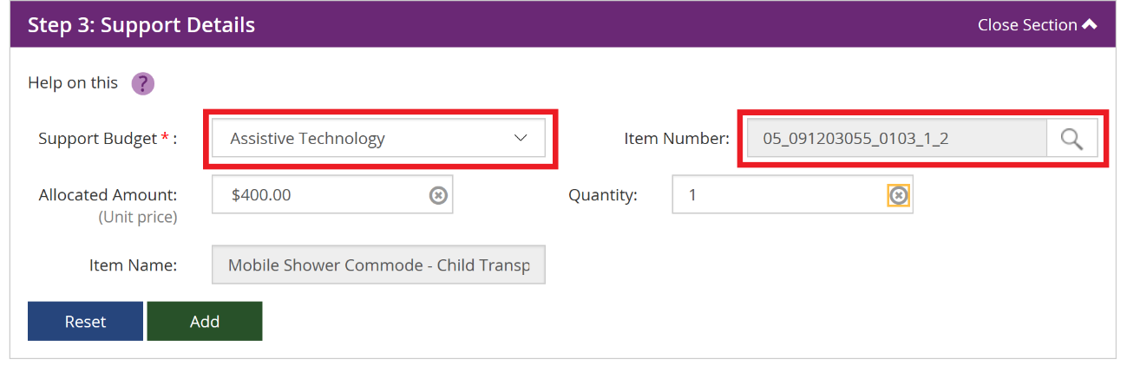
4. Enter the Allocated Amount and the Quantity as agreed with the participant then select Add.
- Select Reset to clear all your entries and selections.
- If you need to add another support item, select Add.
The support item added moves to the Added Details section. If these details are incorrect, you can edit or remove the entry using the Action links.
5. When the details are correct, select Next to continue.
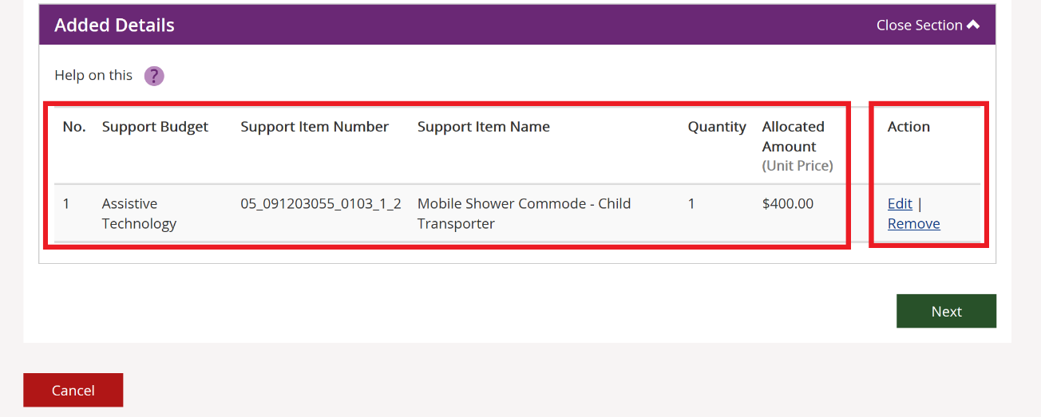

6. Once you have selected Next to continue, the booking and item details display. To edit the details of the service booking, select Back.
7. Check the service booking is correct and when you are confident that everything is correct, you can add comments to the ‘Comments’ field to explain the booking.
8. Ensure the service booking is as agreed with the participant, then tick the mandatory declaration and select Submit.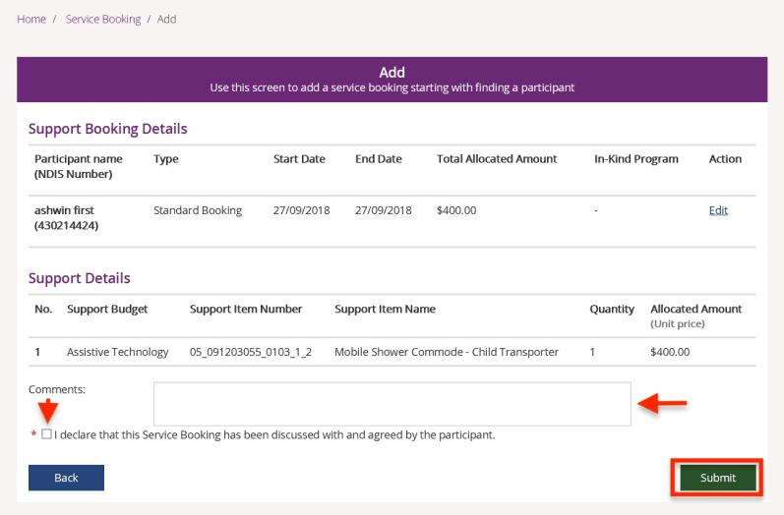
Note: The service booking is automatically approved for the participant when it is created. The booking confirmation page displays.

9. Select View Service Bookings to go directly to the View Service Bookings page, which is described in the steps below or select myplace logo to return to the home page.
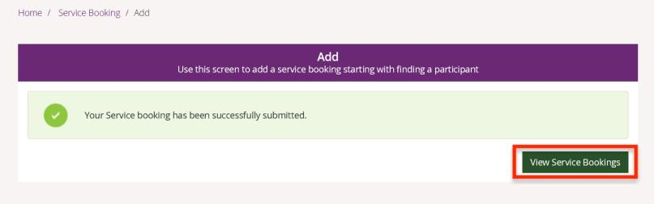

NOTE: For Quotable items NDIA will approve your quote and generally the related service booking is created automatically. In this case you are unable to create a service booking for quotable items (see Note for exceptions). Please refer to the Quotation section of this guide for further details.
NOTE: From 28th February 2022, Assistive Technology quotes valued under $15,000.00 no longer require a quote. You can create a service booking against an accepted line item for the price agreed with the participant (up to the allowable budget) in cases where a quotable Assistive Technology item has been automatically accepted but a service booking was not automatically created. These cases are usually identified by:
the funding for the item is now in the ‘Available’ funds, and
a comment has been added to the participant’s plan to reflect this change (in some cases the participant will have an email to indicate this).

View service bookings
Service bookings can also be created by participants, their nominee, an Agency representative or their plan manager. All your service bookings can be accessed through View Service Bookings.
- Select View Service Bookings on the Service Booking page. A list of your service bookings will be displayed. The service bookings are sorted by service booking number, with the most recent booking first.
- Select a Service Booking Number to view details of that booking.
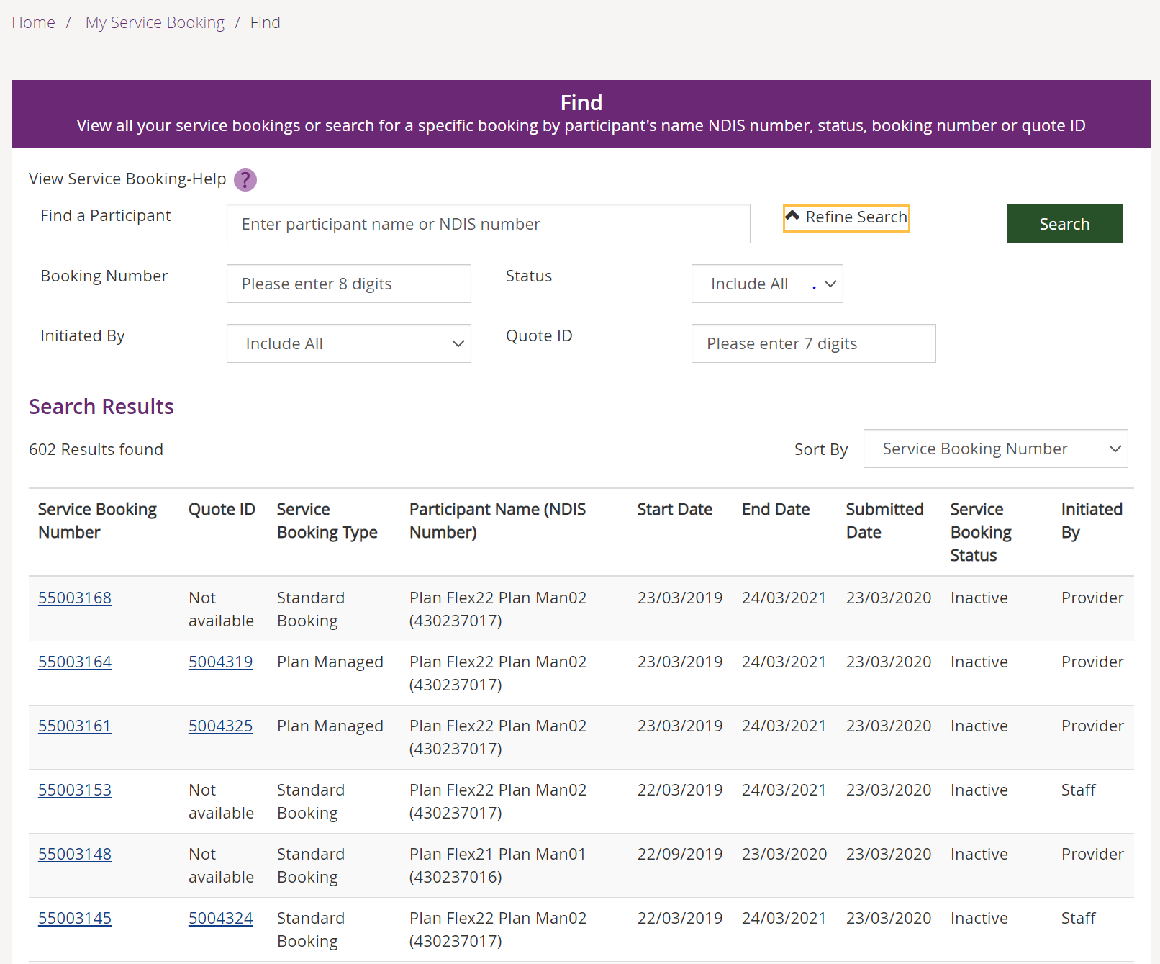
Note: Use the Next and Previous buttons at the bottom of the screen to navigate forwards and backwards through the lists that have more than 10 entries.
Note: You can view the Quote ID of an approved quote and select the hyperlink to navigate you to Quotation screen.
Tip: You may need whenever you make a new selection to re-select Refine Search (besides the Search button) to expand and view the sorting options available on screen.
- You can search the list of service bookings two ways:
  - By entering a participant’s name or NDIS number, or service booking number; then click the Search button.
  - By selecting from the Initiated By or Status dropdowns; then click the Search button.
Initiated By allows you to view and sort the service bookings by the party that initiated the booking — by All, Participant, Provider or Staff.
- Status allows you to view and sort the service bookings by:
    - Active / Inactive (these are listed in the results separately)
    - Awaiting Participant Review
    - Awaiting Review
    - Change Awaiting Participant Review
    - Review Change
    - Rejected
Note: These are explained below.
Service Booking Status | Definition
Active | The service booking has passed validation and been accepted by the participant and provider. It is currently within the dates where service delivery may occur and can have payment requests made against it.
Inactive | The service booking passed validation and was accepted by both participant and provider, but it has now expired (past the date of service delivery).  It can have payment requests made against it if the date of service delivery falls within the original service booking dates.
Awaiting participant review | The participant needs to review the new service booking.  Please note: If the participant does not have access to their myplace portal to review the service booking, you should contact the Agency.
Awaiting review | The provider needs to review the service booking and either accept or reject it (refer to Accept or reject a new service booking for further details).
Review change | The service booking has been modified by the participant or Agency. You need to accept the change to make the service booking active or reject the change to keep the service booking as it was (refer to Accept or reject a new service booking for further details).
Rejected | Either the participant or provider did not accept updates to the service booking. No payment requests can be made against it.
Change awaiting participant review | The participant needs to review the updated service booking.  Please note: if the participant does not have access to their myplace portal to review the service booking, please contact the Agency.

- You can then sort the list of Search Results by the column titles; just make your selection from the options in the Sort By drop-down to view all service bookings by:
- Service Booking Number
- Service Booking Start Date
- Service Booking End Date
- Submitted Date
- Service Booking Status
- Initiated By.

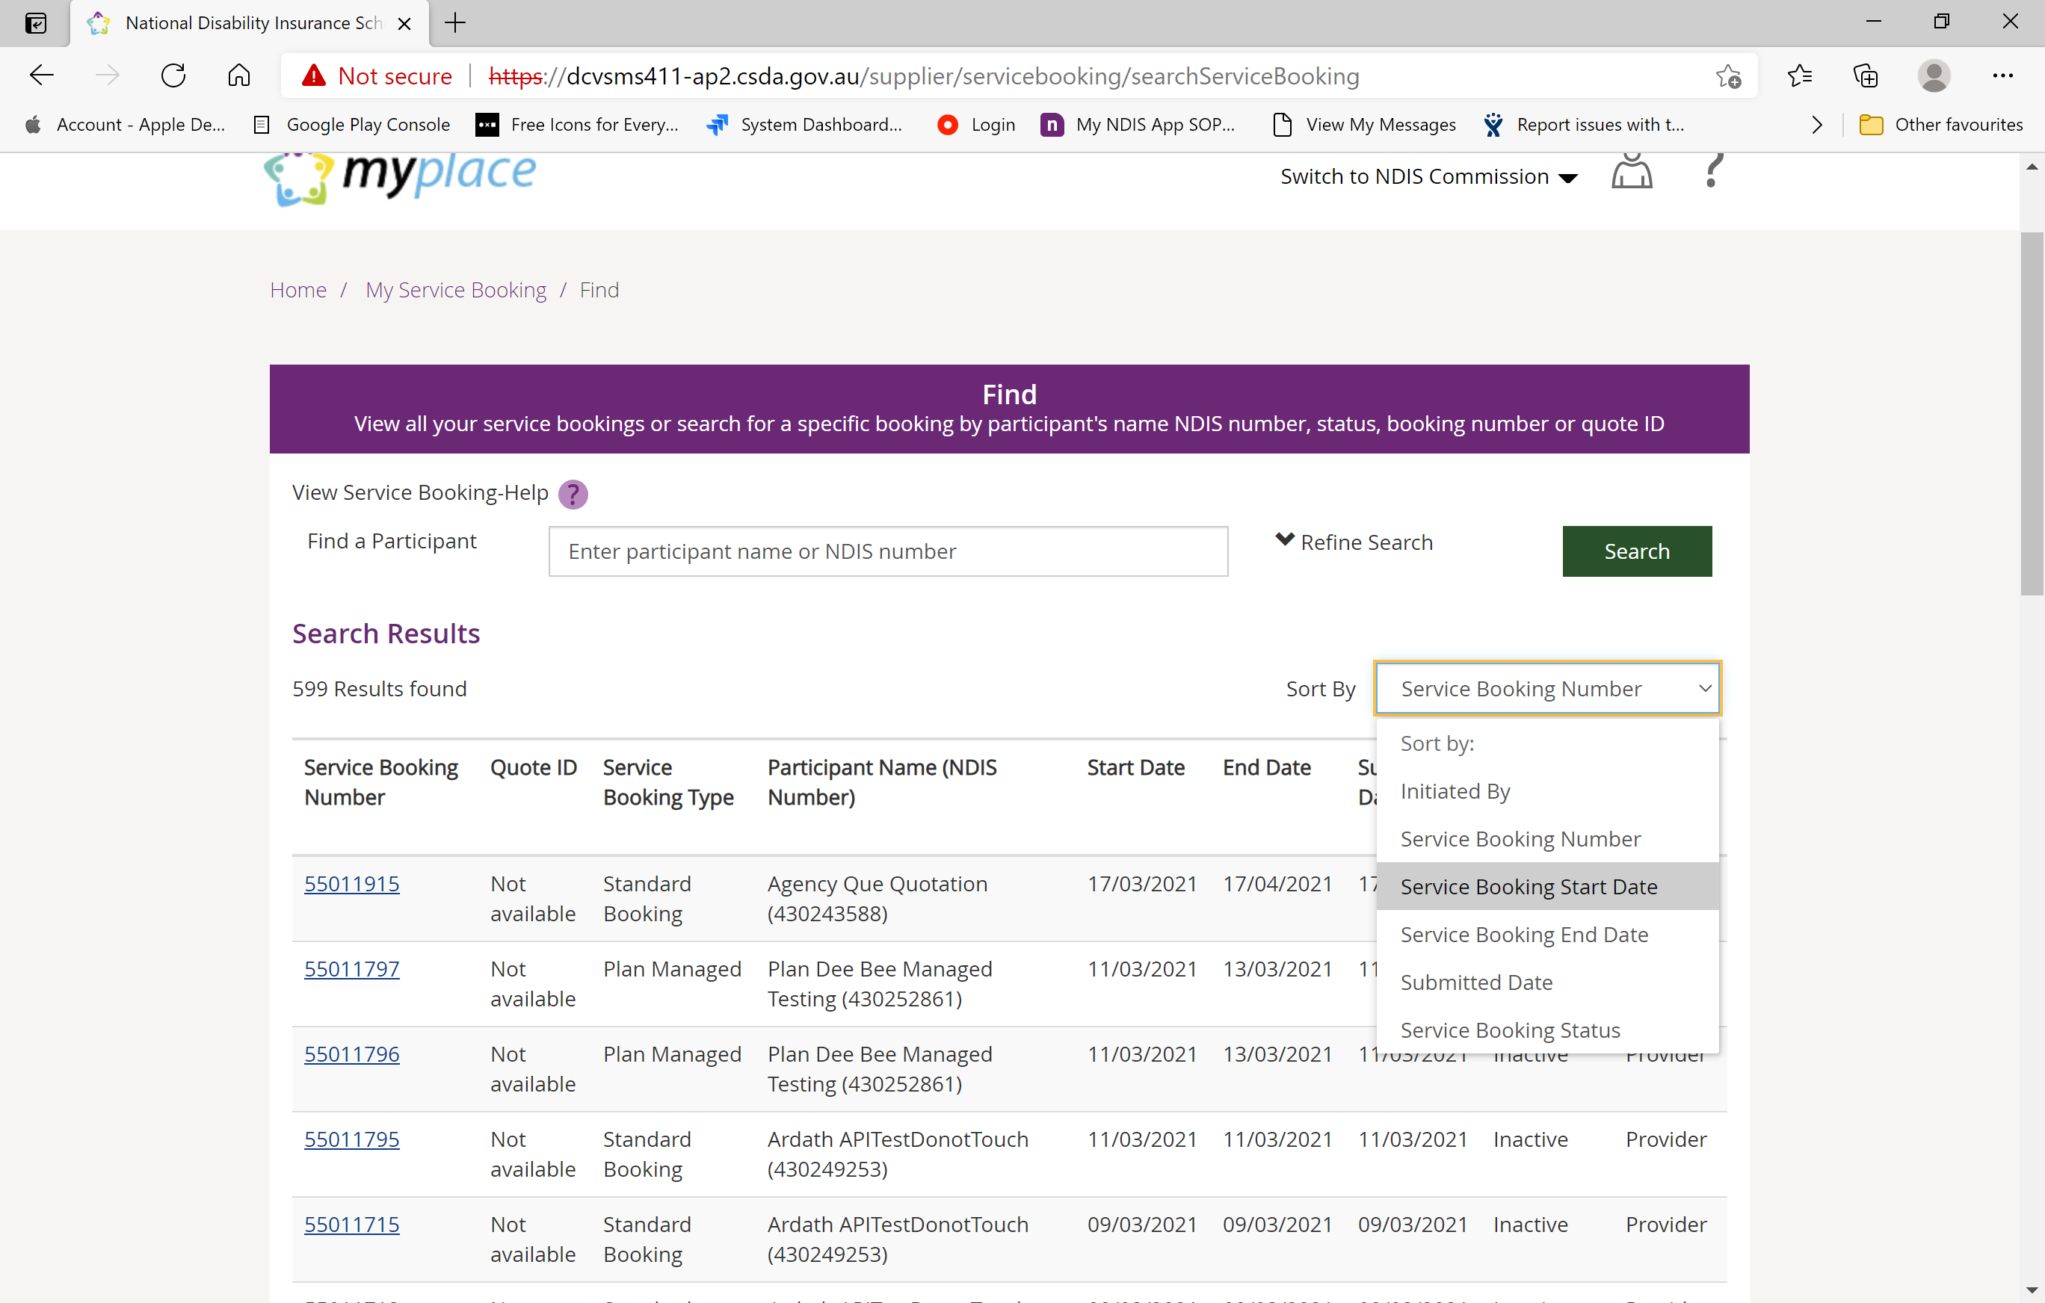
- Select a Service Booking Number to view details of that booking.
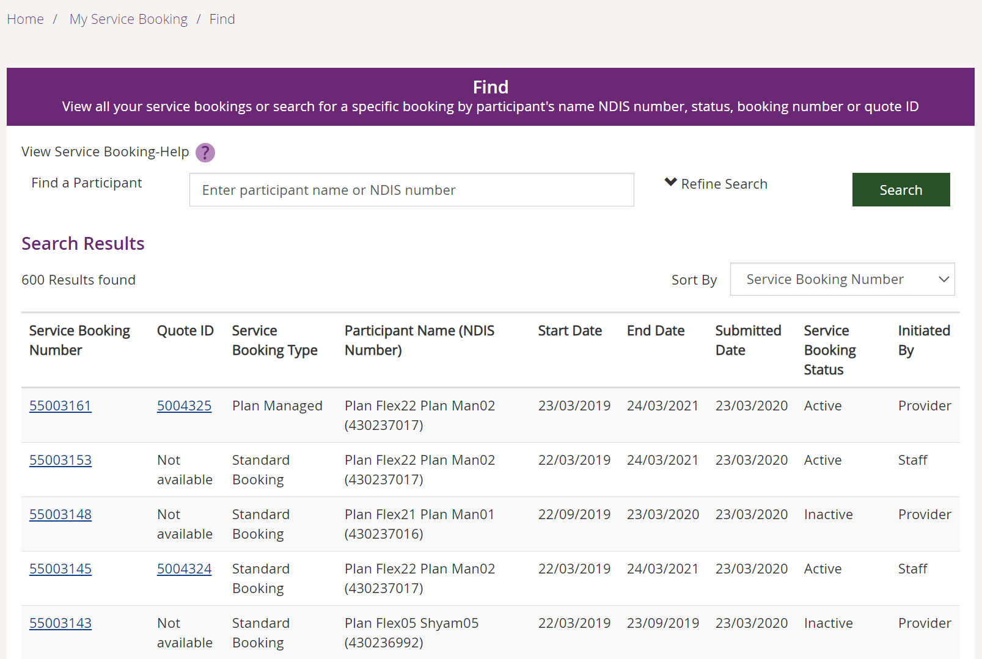
The details of the service booking display.
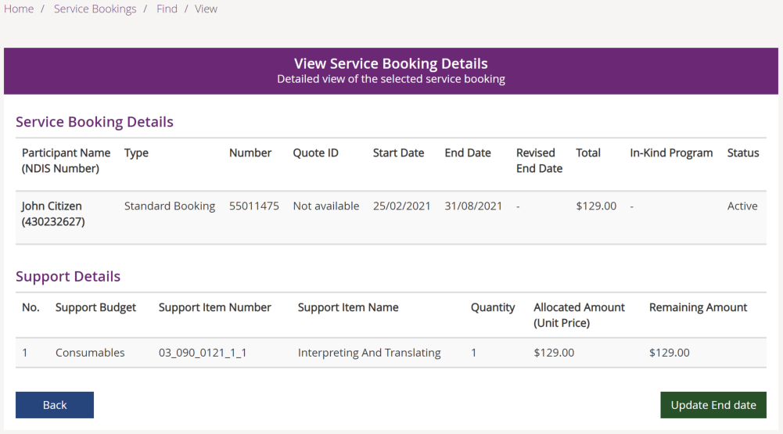

Note: End dates of service bookings that are about to expire, and that share the same end date as the plan they belong to, will be extended using the 365-day plan auto-extension feature. You will see an alert in the service booking screen to notify you when a service booking has received an extension: “The end date of this service booking has been changed to align with the participant’s plan dates”. You may need to change your service booking in the old plan.
When viewing service bookings within 90 days of an expired plan you will see the following alert:
Alert message displayed | Action
The Service Booking end date has changed to <Service Booking End Date displayed>. Funding within the Service Booking may be reduced after <Date displayed>. | You are encouraged to request payment for services provided to participants within 90 days of service.  Payment requests made after 90 days may cause a delay in payment.

When viewing service bookings after 90 days of an expired plan you will see the following alert:
Alert message displayed | Action
The Service Booking end date has changed to <Service Booking End Date displayed>. Funding within the Service Booking may have reduced from <Date displayed>. | Review the service booking details and if you are unable to submit your payment request contact NDIA on 1800 800 110.
- Select Back to return to the previous page.

Accept or reject a new service booking
New service bookings will have a status of ‘Awaiting Review’ and will need to be accepted to become active and enable service delivery and payment.
1. Select the View Service Bookings tile and expand the Refine Search drop-down.

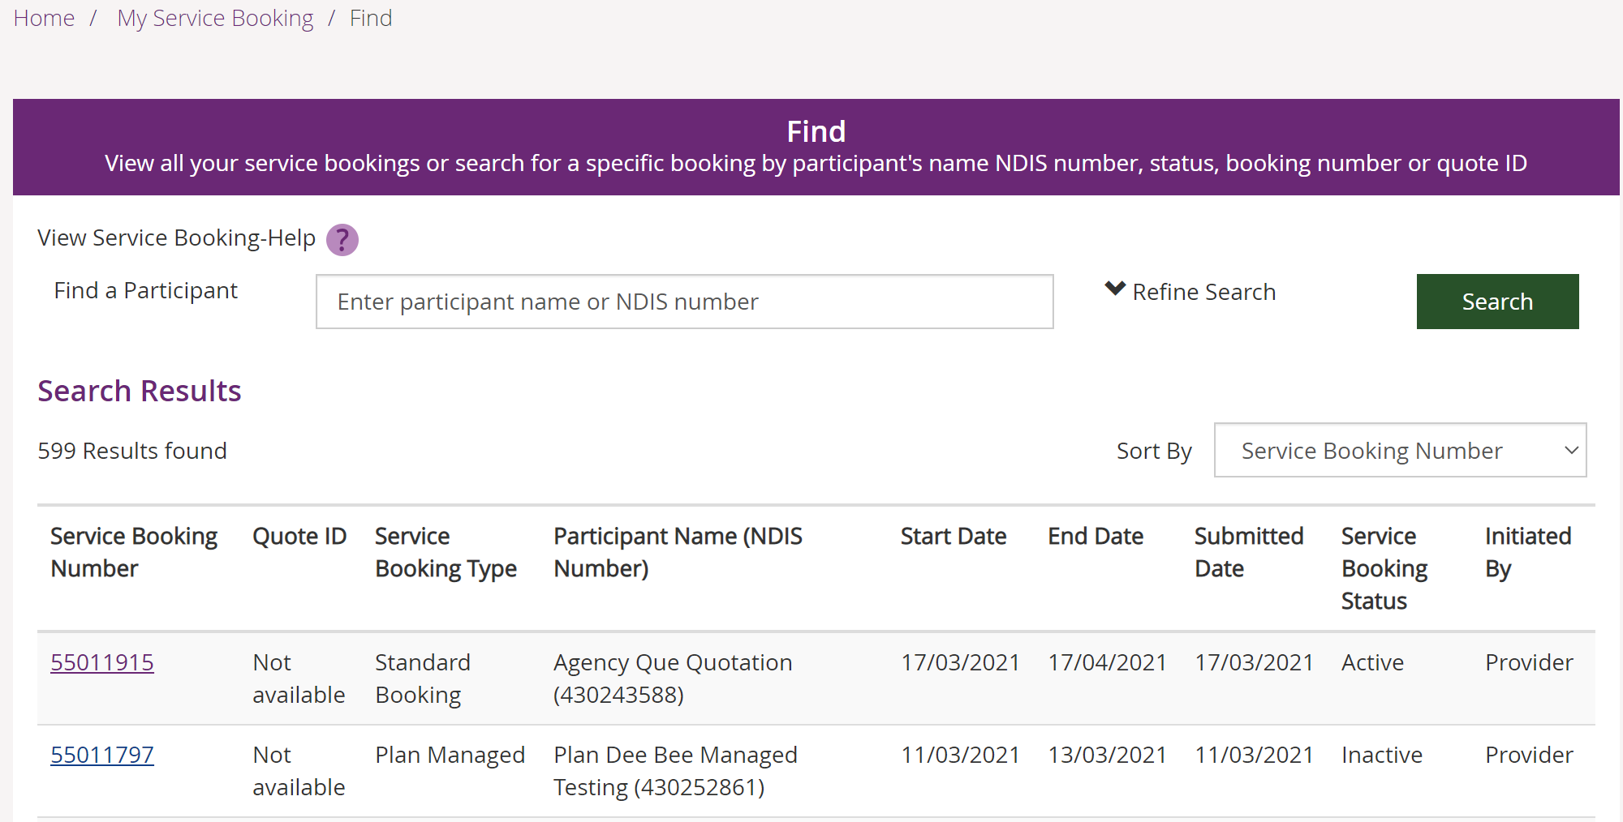
2. Click on the Status drop-down and select Awaiting Review; then click the Search button to display new service bookings awaiting review.

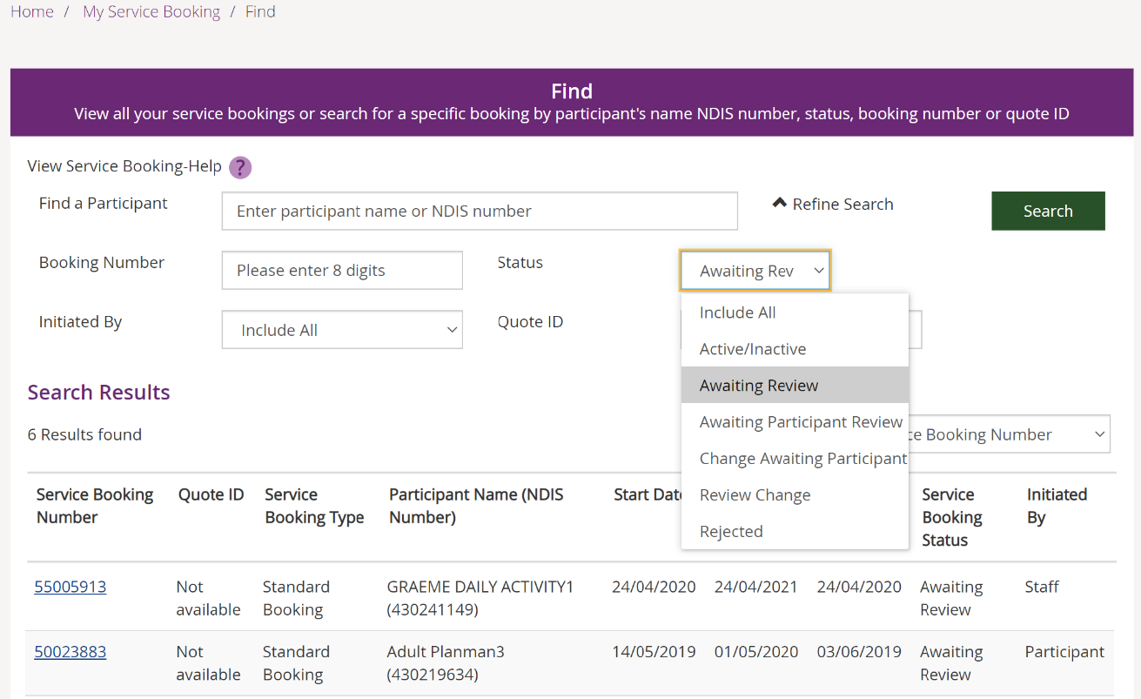
3. Select a Service Booking Number to view details of that booking.
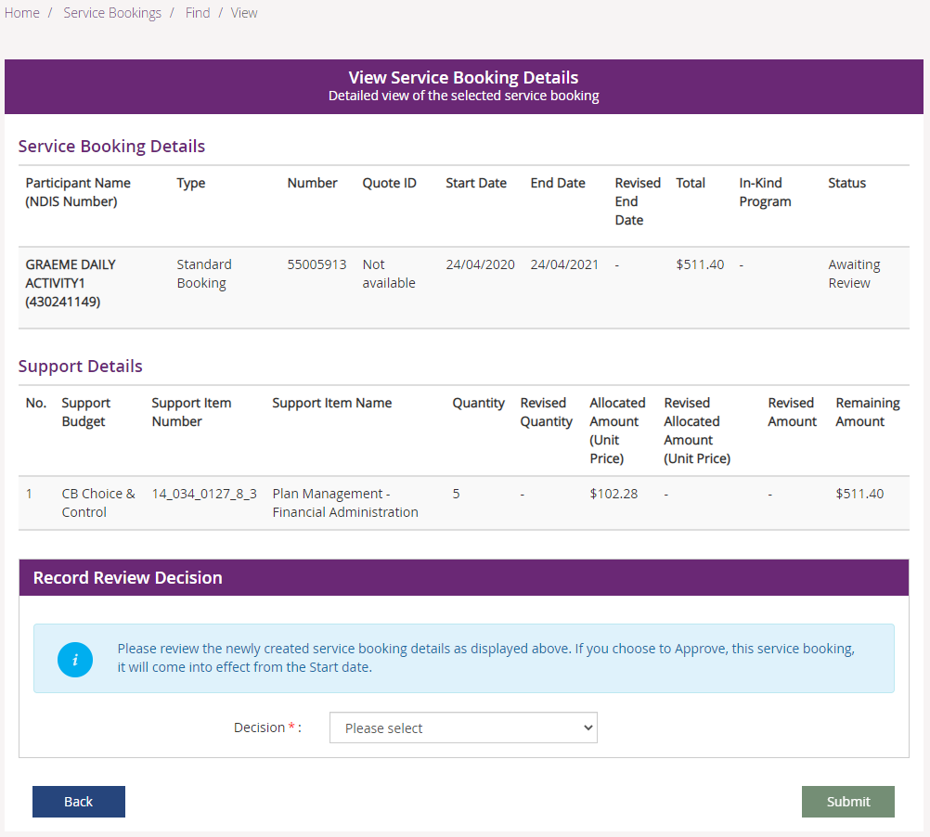
4. Review the service booking. If you decide to accept the service booking, select Accept from the Decision drop-down under Record Review Decision and select Submit.
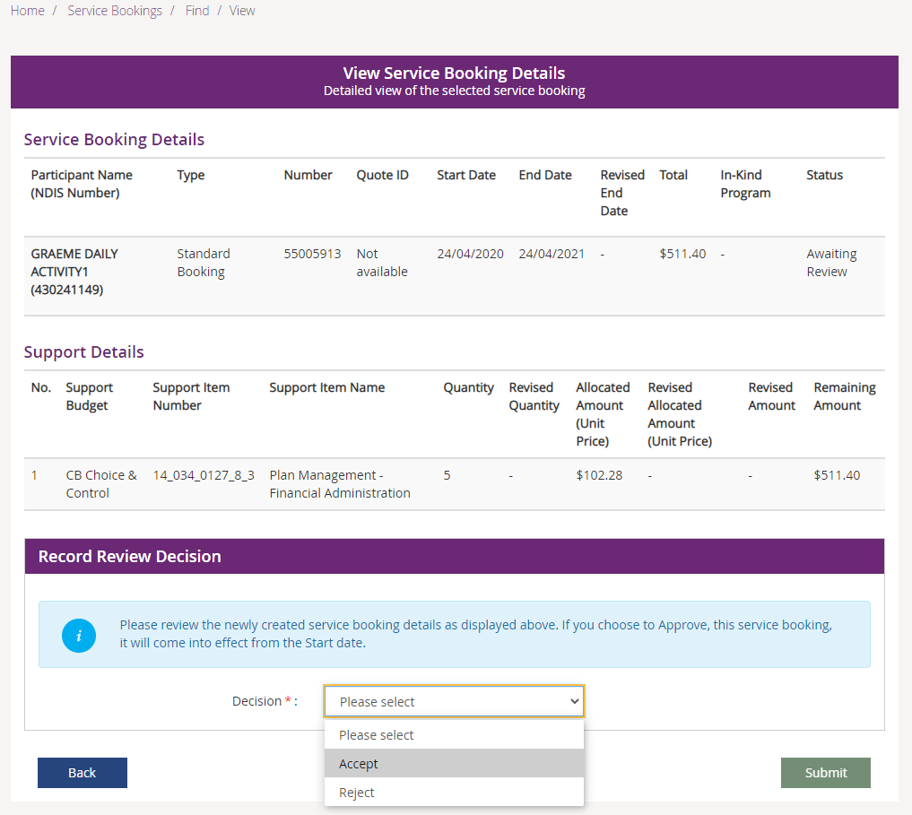

5. If you decide to reject the service booking, select a Reason for Rejection and select Submit.
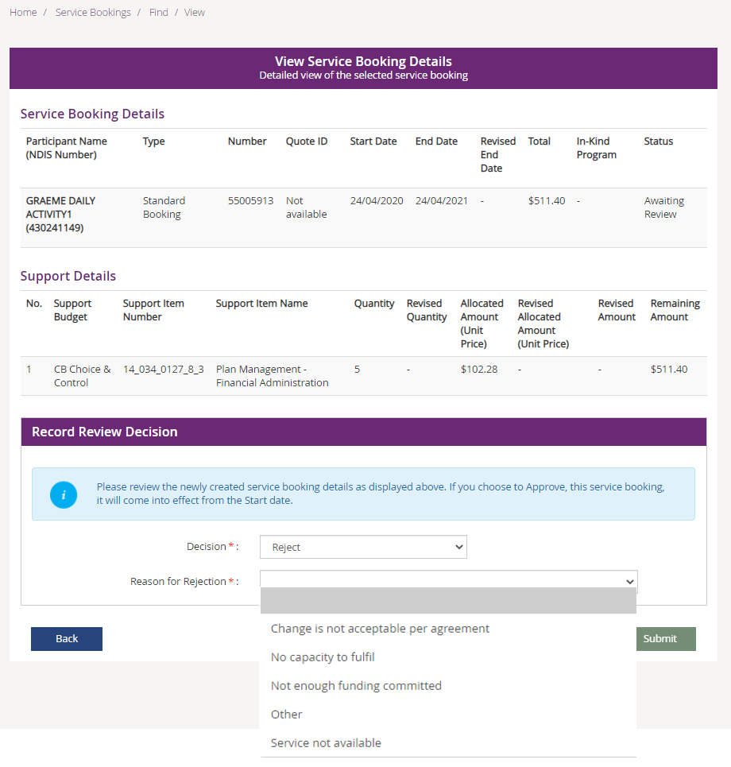

Accept or reject changes to a service booking
Service bookings that have been modified by the participant or Agency will have a status of ‘Review Change’. You can accept the changes to update the service booking or reject the change to keep the service booking as it was previously.
- Select the View Service Bookings tile and expand the Refine Search drop-down.

- Click on the Status drop-down and select Review Change; then click the Search button to display new service bookings requiring review.

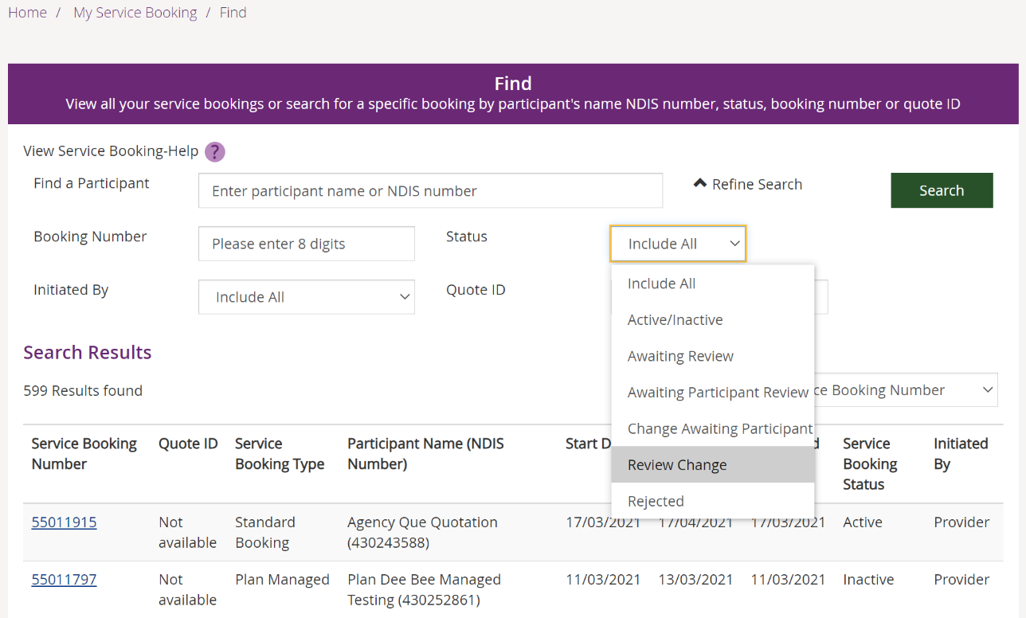
- Select a Service Booking Number to view details of that booking. The revised end date, quantity and amount are shown.
- Review the changes and decide whether to Accept or Reject the change.

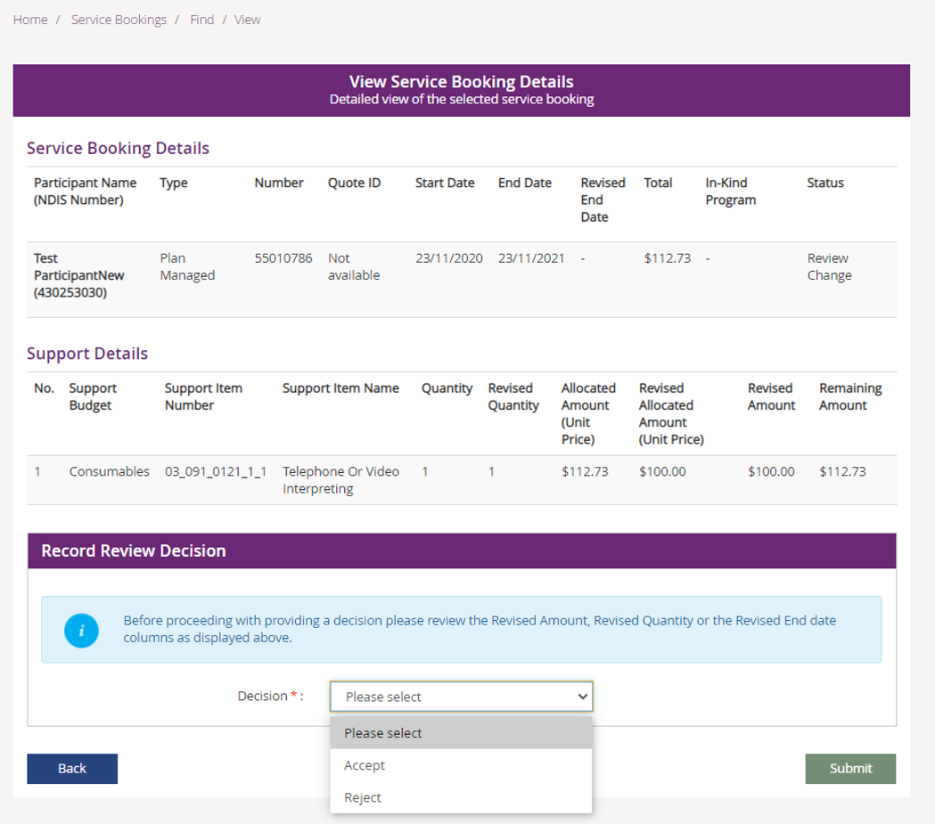

If you decide to accept the changes to the service booking, select Accept and select Submit.

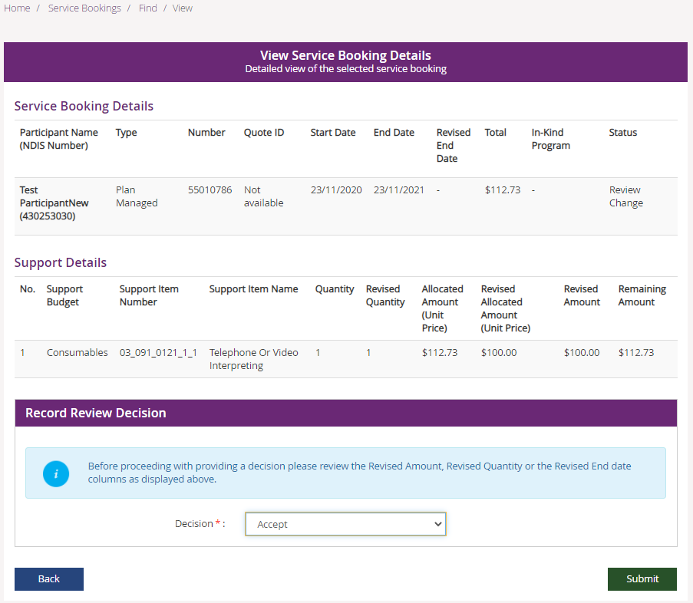
If you decide to reject the changes to service booking, select a Reason for Rejection and select Submit.

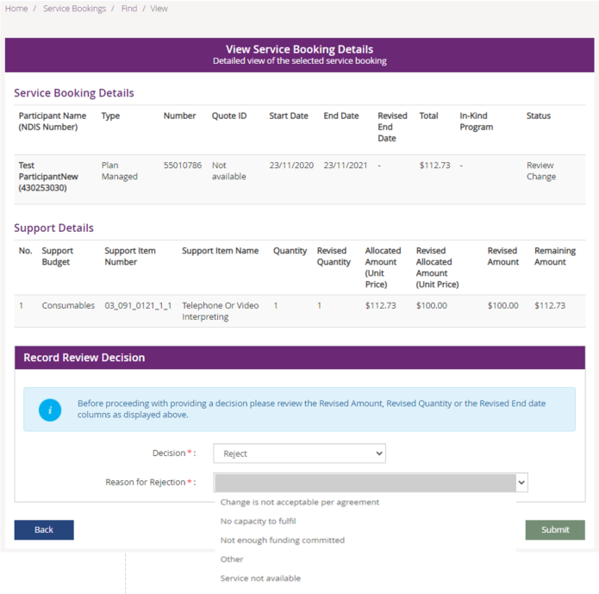

If you select Other as the reason, you will need to provide a Rejection Explanation and select Submit.

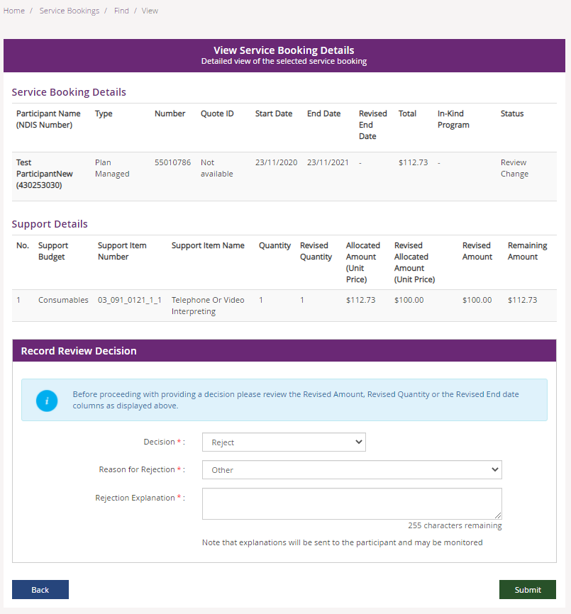

Service booking changes notification
A daily summary of all changes that have been made during the day is sent automatically to your Inbox overnight to help alert you to changes that require attention. Just filter your Inbox by ‘Changed Service Bookings’ and select your preferred format (HTML or PDF) to read the notification.

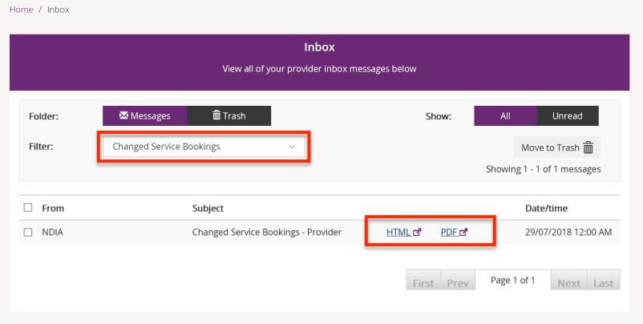

The notification summary of all service booking changes for all participants will be displayed:
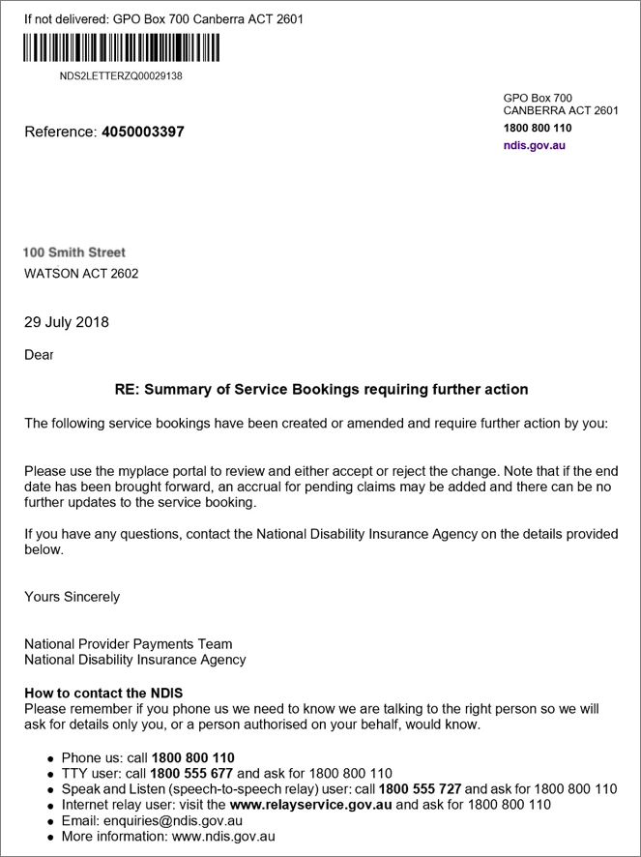

Edit support details on a service booking
You may need to amend some of the details on the service booking, such as quantity or allocated amount.
- Follow the steps outlined under View Service Bookings above.
- In the View Support Booking Details, select Update Allocation.

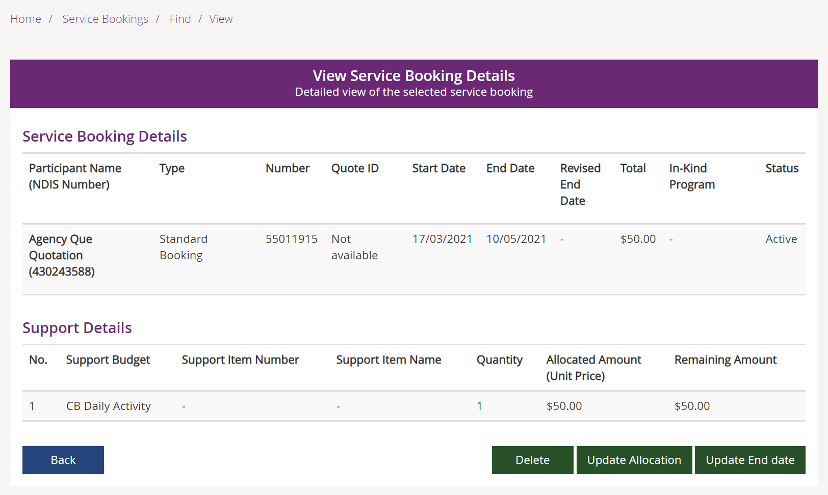
- Enter the new Quantity, Allocated Amount and check the Declaration to confirm that the service booking reflects what you have discussed and agreed with the participant.

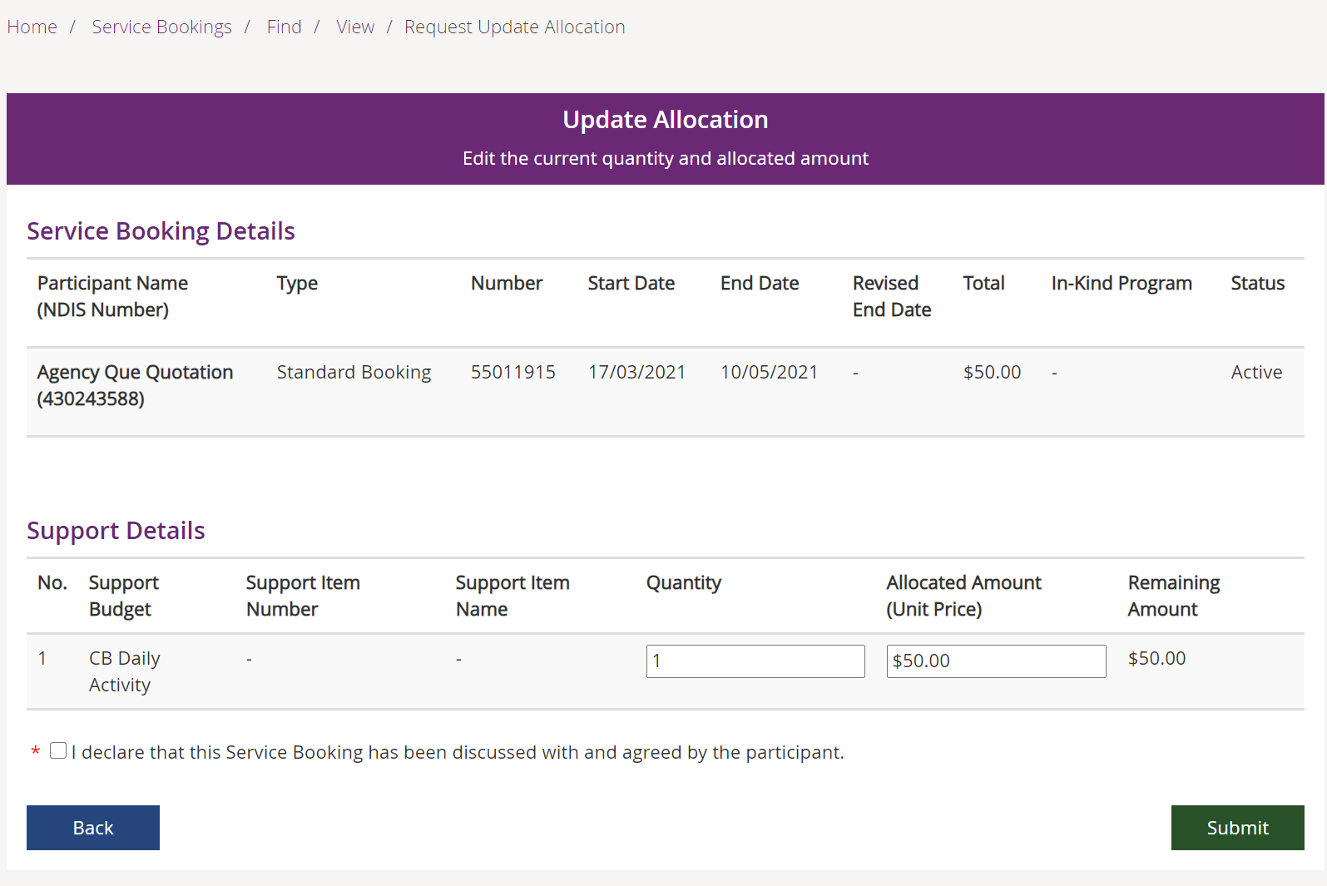
- Select Submit.

End a service booking
You might need to end a service booking if you are unable to continue to deliver the service, or the participant asks you to stop delivering the service.
IMPORTANT ACTIONS REGARDING END DATES
When you end the service booking you need to review:
      - All payment requests are up to date.
      - Accrued amounts are enough to cover any outstanding payment requests which you are yet to request payment for (which are yet to be submitted).

- Follow the steps outlined under View Service Bookings above.

- Select Update End Date
The Update End date screen displays
- Complete the following fields:
- At Service Booking End Date, enter the end date for the service booking and the reason for the change.
Note: If you want to change a service booking end date to today’s date, the participant is required to accept the change. You must check the ‘declaration’ at the bottom of the screen to indicate that you have discussed the change with the participant and that you are authorised by them to confirm the new end date.
At Reason for Change, select from the drop-down list. Some reasons are there to support participant choice, some provider choice, and some both.
- Enter the value of services delivered where a payment request has not yet been submitted at Accrual for pending payment requests. This is to ensure sufficient funds are retained against the service booking to pay for all services delivered.
- Tick the box at the Declaration. This is a compulsory field and the onus is on you, as the provider, to have discussed and gained consent from the participant to end the service booking.
- Select Submit.
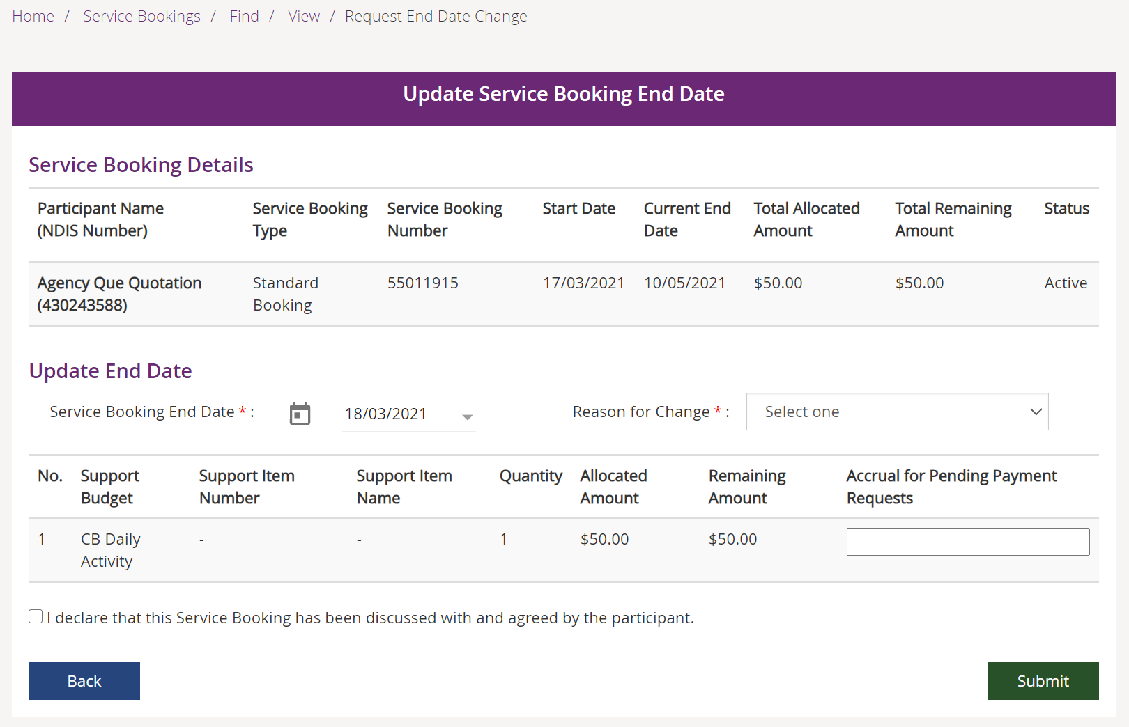
A warning will be displayed that following the update, Quantity, Allocated Amount (Unit Price) and End Date cannot be changed.
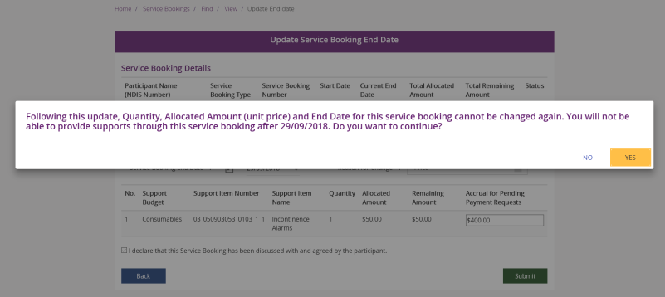
- Select Yes.

Delete a service booking
If you have created a service booking in error, you may wish to delete it. Service bookings can be deleted only if:
- There is no payment requested created or saved against it
- There is no accrual against it, and
- No payments made.

- Follow the steps outlined in the View Service Bookings above
- Find the service booking to delete
- In the View Service Booking Details, select the Delete button.

A warning will be displayed to confirm that once you delete it, the service booking will be removed from your list of services bookings permanently and you will not be able to provide services or request payment if you proceed.
- Select Yes.
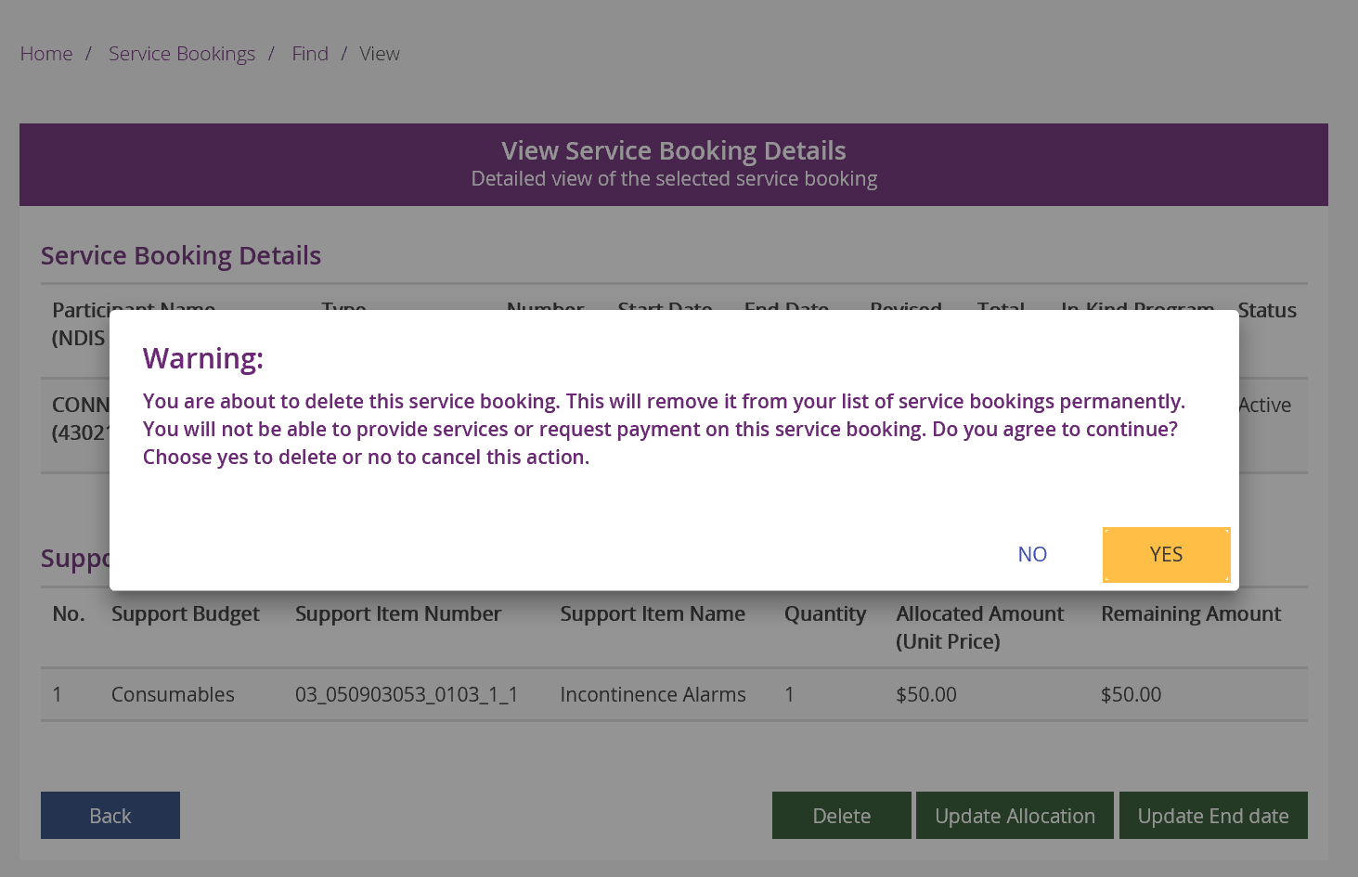
An information message confirms that the service booking has been deleted.
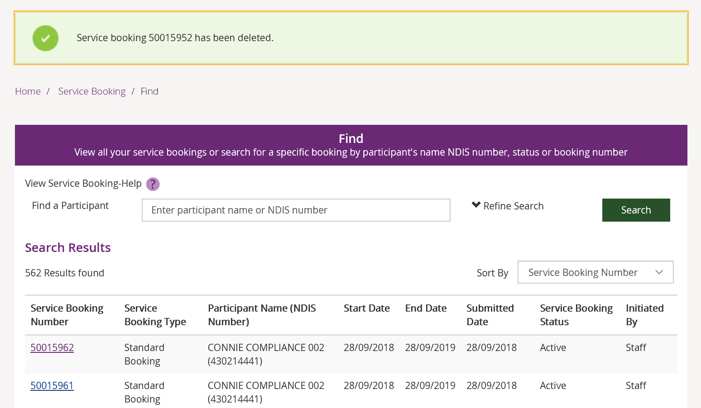

Payment request
Payment requests were previously known as claims. In this tile you can create and submit payment requests to NDIS. You can also go here to view a history of submitted payment requests.
IMPORTANT NOTES ABOUT PAYMENT REQUEST
You will need to have provided your bank account details to NDIS before a payment request can be created. Usually, you would have recorded your bank account details in the myplace portal after registering with NDIS (please see Bank Account Details section).
You are encouraged to request payment for services provided to participants within 90 days of service. Payment requests made after 90 days may cause a delay in payment.
Service bookings are created to hold/quarantine the funds for which providers can claim through payment requests.
Before submitting a payment request, check your service booking details to ensure: there is sufficient funding, service booking dates are within the plan dates, support category or line item are correct.
Once checked, payment requests can be created and must align with that service booking.
The information entered for the payment request must align with the service booking (i.e. you cannot enter a date that is outside the date range of the service booking)

Create a payment request
- Select the Payment Request tile on the myplace home page.

- Select Create Payment Request.
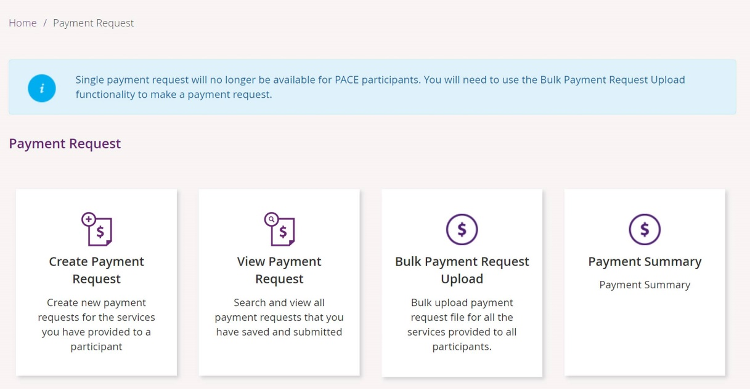
- Search for the participant you have provided services for. You can search for the participant by their first or last Name or NDIS Reference Number. Choose how you want to search by selecting the drop-down menu.
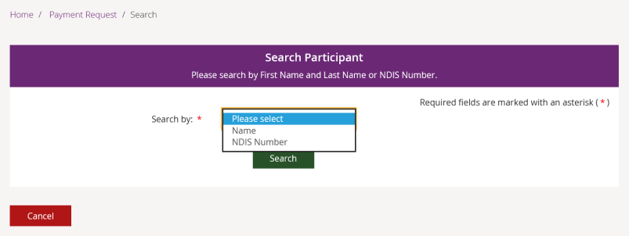
- Enter the details of the participant for whom you need to submit a payment request and select Search. In this example, the participant’s NDIS reference number is selected as the search criteria.
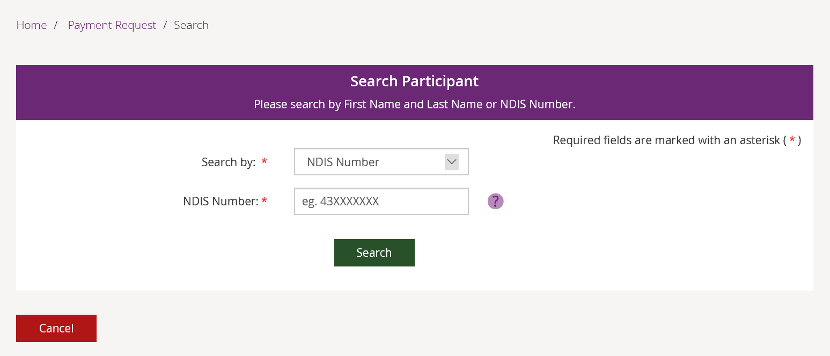
- From the search results, select the relevant participant’s name.
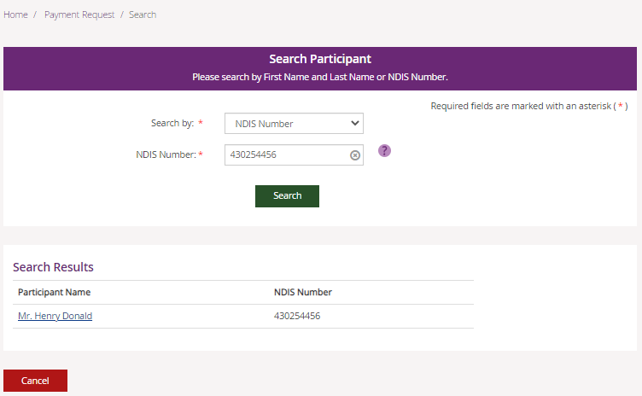
- The New Payment Request window appears. Required fields are marked with a red asterisk (*).

Note: Single payment request in no longer available for PACE Participants. You will need to use the Bulk Upload functionality to make a payment request.

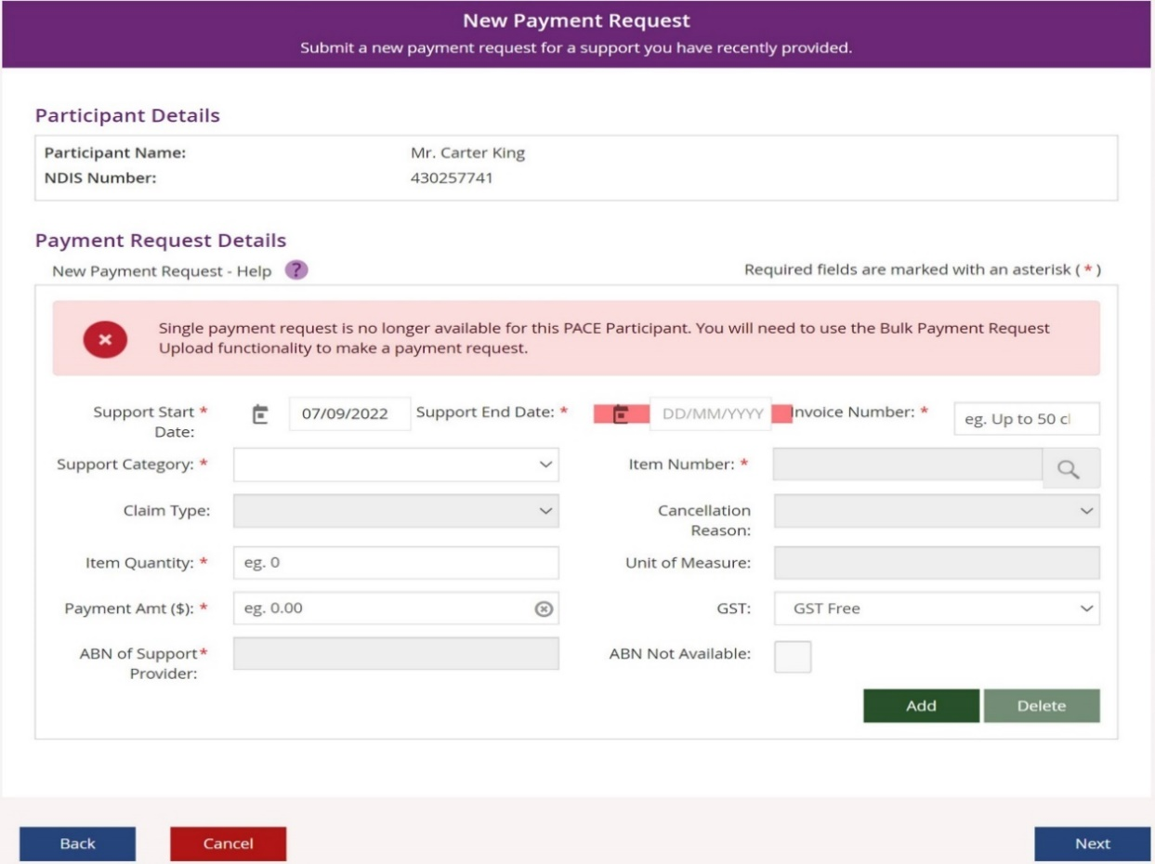

- Complete the Support Start Date and Support End Date fields.
- Enter your Invoice Number as a reference for your payment request. This invoice number is specific to your invoicing process and is not generated by NDIA.
- Select a support category from the Support Category drop-down.
Note SIL providers: If claiming weekly, select the support category ‘Core Daily Activity’.

- Select the Item Number magnifying glass icon to search for the item number. Then select the Support item number for the item you wish to submit a payment request for. Note SIL providers: If claiming weekly, select the weekly claiming Support item number specified in the NDIS Support Catalogue 2019-20 or the NDIS Pricing Arrangements and Price Limits.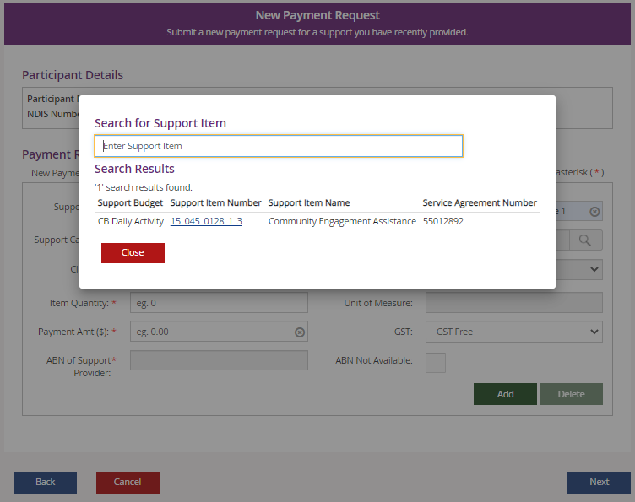
- Select the Claim Type. Refer to the NDIS Pricing Arrangements and Price Limits for further information on each claim type.
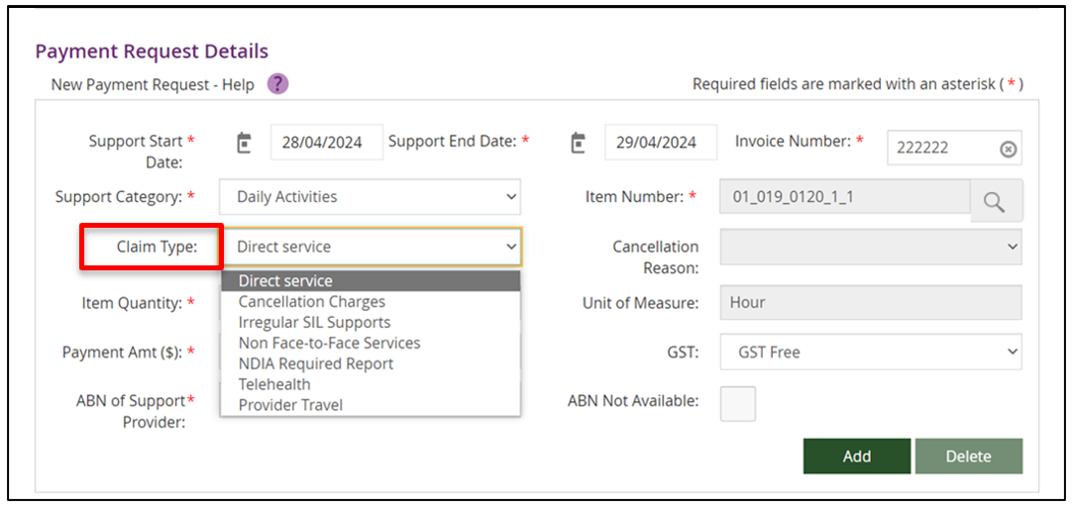
  - The ‘Assistance in Supported Independent Living - Weekly’ claim type should be used when a SIL provider will claim weekly, under the conditions specified in the NDIS Pricing Arrangements and Price Limits.
  - The ‘Irregular SIL Supports' claim type should be used when a SIL support is provided in unexpected or unplanned circumstances.
  - The ‘Telehealth’ claim field should be used when a support is provided as needed and with agreement from the participant.
  - The ‘Assistance in Supported Independent Living –Unplanned Exits’ claim type should be used when there is an irretrievable breakdown of supports/relationship which requires immediate exit. Refer to SIL Provider Guidance for further details around when this claim type can be used.
  - Note: Assistive Technology and Home Modification providers should refer to the Assistive Technology, Home Modifications and Consumables Code Guide on the NDIA Pricing arrangements | NDIS page for general claiming rules including AT Supplementary Charge codes and claiming for support items where notional unit prices apply.
- The ‘Cancellation Charges’ claim type should be used when a provider is claiming under the conditions of Short Notice Cancellations as specified in the NDIS Pricing Arrangements and Price Limits.
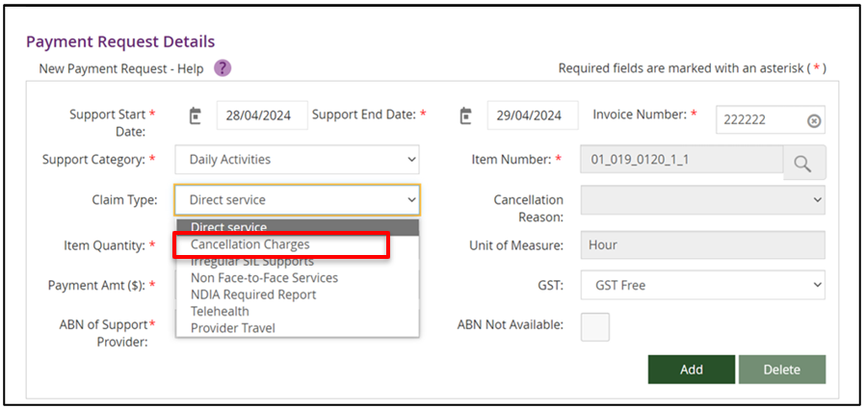
- If the Claim Type is ‘Cancellation Charges’, select the most appropriate cancellation reason.
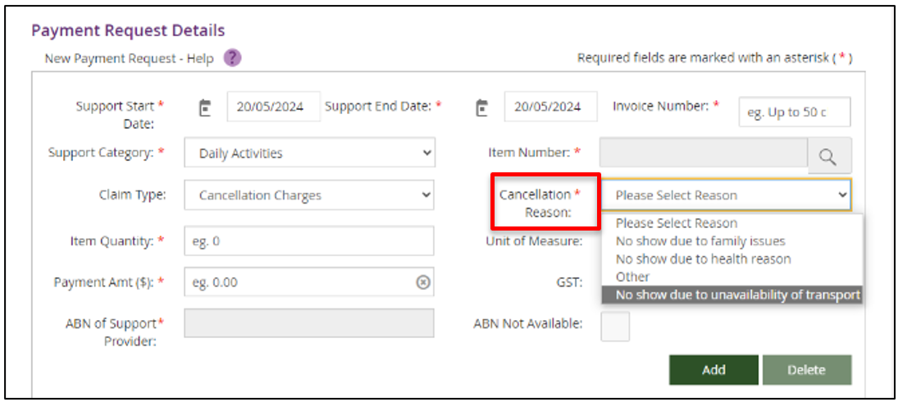
- Enter your Item Quantity. This may be either in line with how many hours or the number of services/support you have provided, consistent with the way you set up the service booking (i.e. if you want to request payment for 1 hour and 45 min you will need to enter 1.75 or if you are requesting payment for one product or service, you will enter 1).
Note SIL Providers: If claiming weekly, input the quantity as 1 to reflect 1 week.

- Complete the Payment Amount field. This is the total amount being requested; it is not the unit price amount.
Note SIL Providers: If claiming weekly, input the weekly amount.

- In the ABN of Support Provider field, enter the Australian Business Number (ABN) of the provider of the support or service.
  - To be valid, an ABN must have 11 digits. ABNs are required for both registered and unregistered provider payment requests.
  - For a plan managed service booking claim you will need to complete the ABN of Support Provider field manually.
  - If the provider has a valid reason for not providing an ABN, plan managers will have the option to:
Tick the ‘ABN Not Available’ checkbox and select either the ‘ATO Excluded Supply’ or ‘Participant Reimbursement’ in the ‘ABN Exemption Reason’ dropdown box for single payments
Note: If a supplier is exempt from quoting an ABN under ATO rules (i.e. ‘ATO excluded supply’), plan managers must ensure that:
  - the supplier provides a completed ATO Statement by a supplier form stating why they are exempt from providing an ABN
  - a valid tax invoice is included with all relevant information about the goods or services provided.
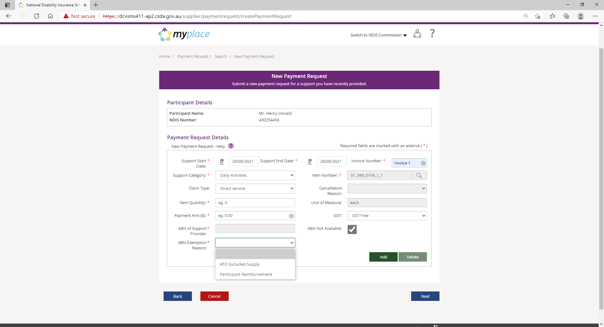
  - If you are making a claim against a standard service booking, the ABN of the registered provider (that is, your ABN) automatically appears and is not editable.
16. If you need to add more items for this participant, select Add to enter them.
To delete a line in a payment request, select Delete.
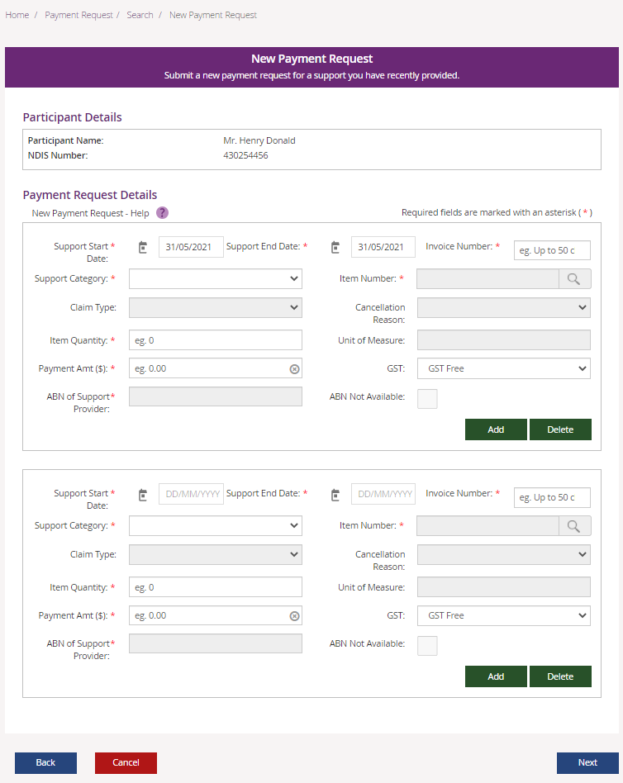
17. Select Next to continue to the next step.
18. On the Review Payment Request page, check the details of the payment request, including the support dates, claim type and ABN number.
If the payment request details are correct, select the mandatory NDIS Pricing Arrangements and Price Limit text acknowledgements checkbox at the bottom of the screen.
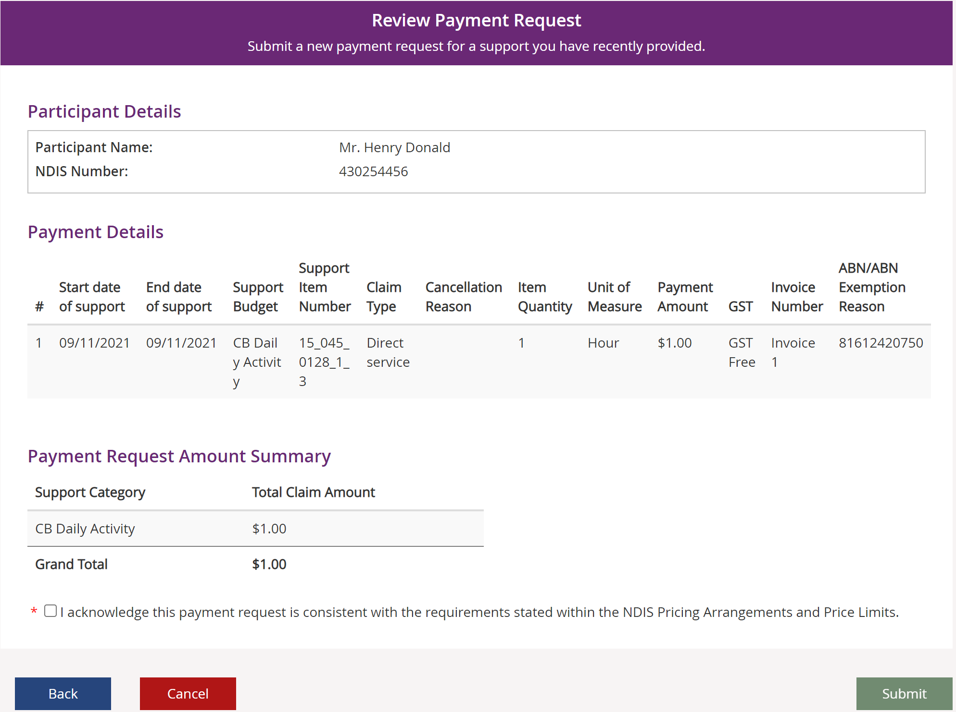

19. Select Submit.
- If you need to change any of the payment request details, select Back.
- If you do not wish to continue with this payment request, select Cancel.
- You will receive a confirmation once your payment request has been submitted.
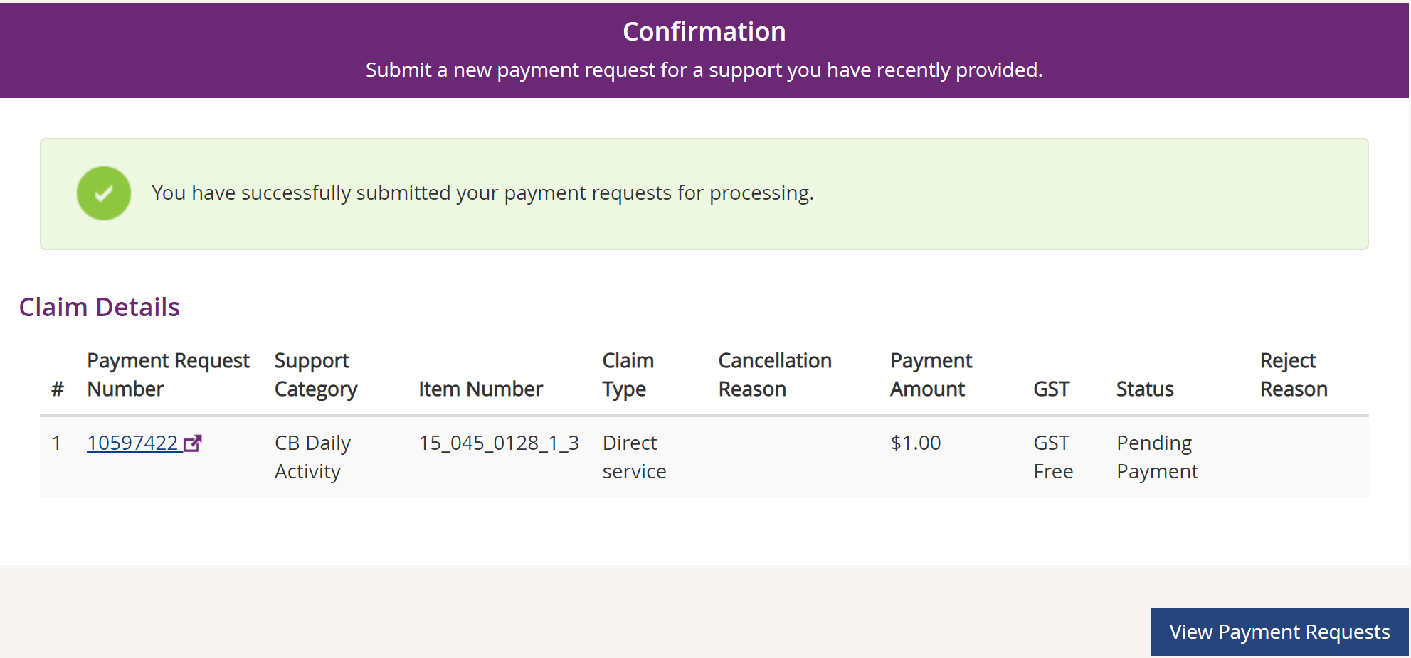
Note: You can view the Payment Request by selecting the hyperlink to navigate to the View Payment Request screen.

Create a payment request for an Irregular SIL Support
Irregular supports are considered separately from the regular SIL plan value and should be used when a SIL support is provided in unexpected or unplanned circumstances and additional funding to cover the costs is needed.

Participants have separate funding in the SIL plan for irregular supports that can be claimed for each time funding is required.

1. Follow the steps outline under View Service Bookings, pages 65 to 70.
2. Select your Irregular SIL support service booking.
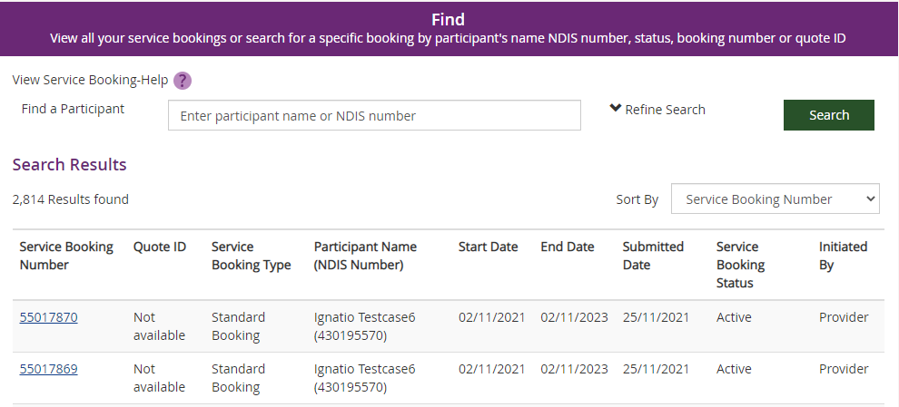
Regular service booking
Irregular service booking
The details of the service booking will display.
3. In the View Support Booking Details, select Update Allocation.
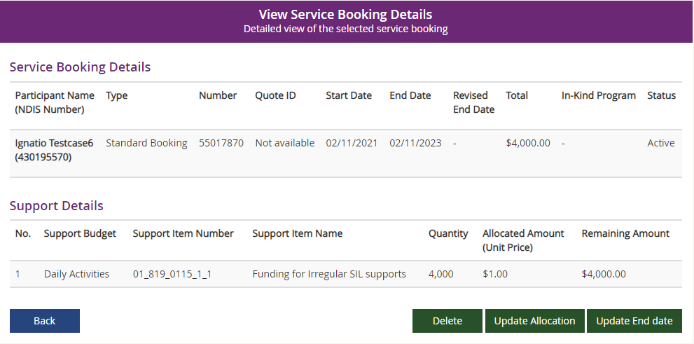

4. Reduce the Quantity by the amount of additional funding required. Check the Declaration to confirm that the service booking reflects what you have discussed and agreed with the participant.
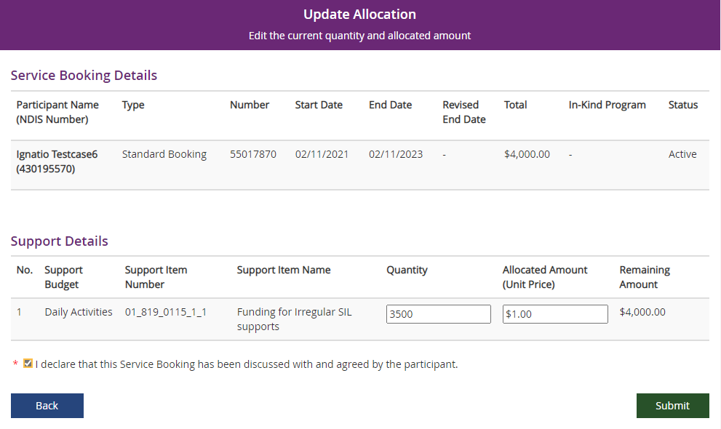

- Select Submit.
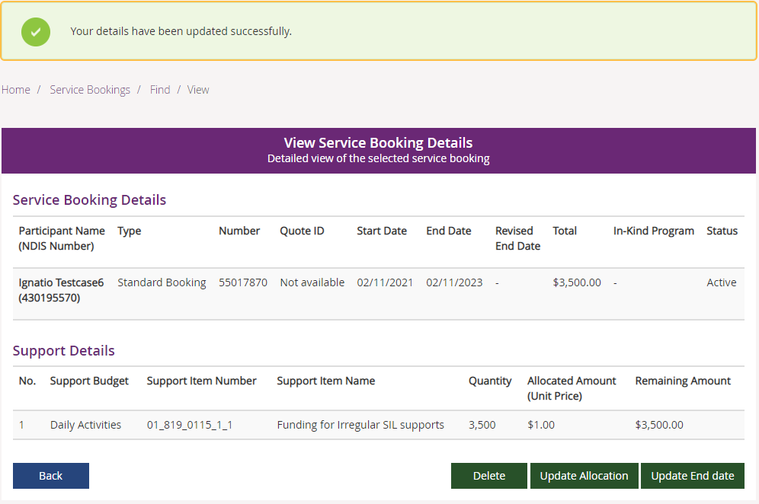
Note: You will notice that Remaining Amount has been reduced.

6. Return to the View Service Bookings, pages 65 to 70
7. Select your Regular SIL support service booking
Regular service booking
Irregular service booking
The details of the service booking will display.
8. In the View Support Booking Details, select Update Allocation.
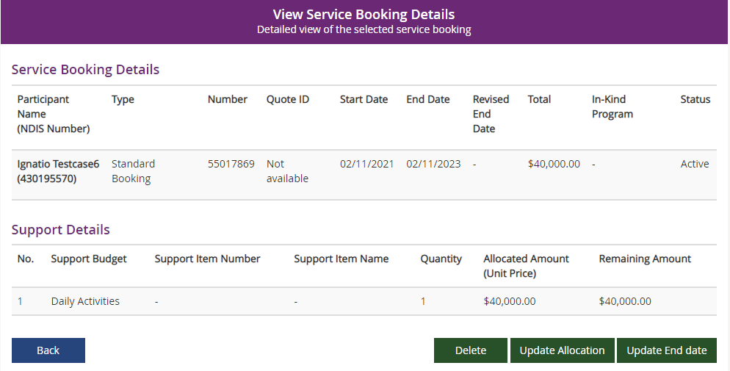
9. Increase the value of the Allocated Amount by the amount taken from the irregular service booking. Check the Declaration to confirm that the service booking reflects what you have discussed and agreed with the participant
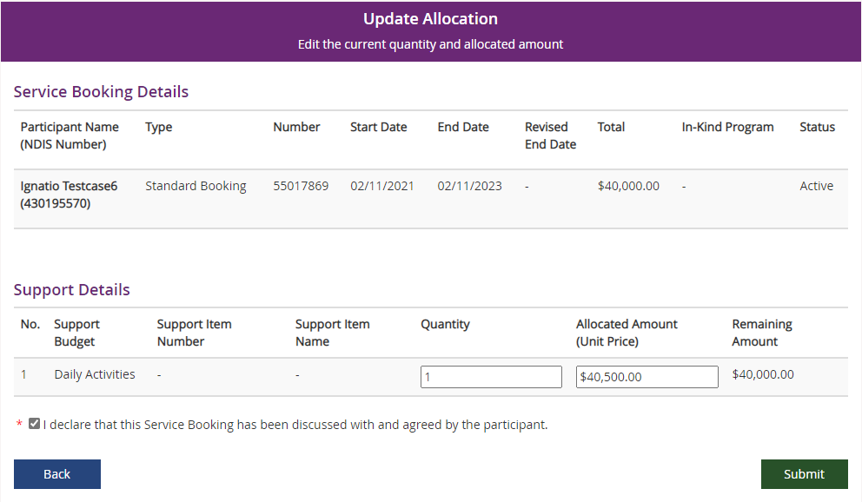
10. Select Submit
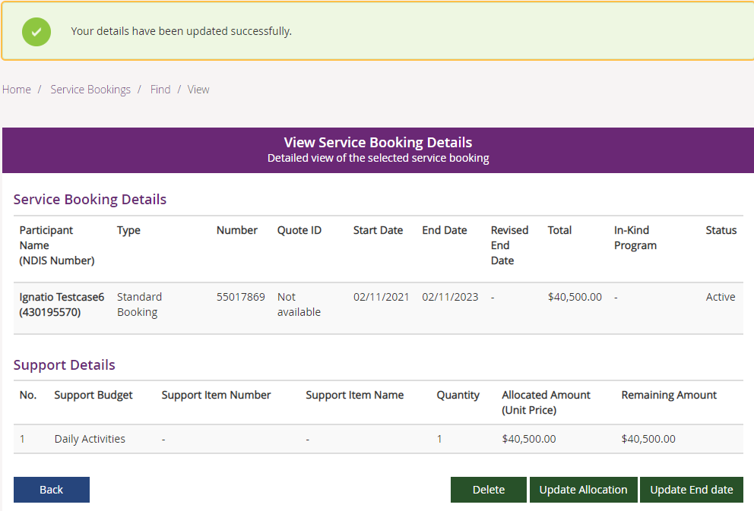
Note: You will notice that Remaining Amount has been increased.

11. Create a new payment request following the steps in Create a payment request, pages 88 to 96.
Note: The claim type should be ‘Irregular SIL Supports’.
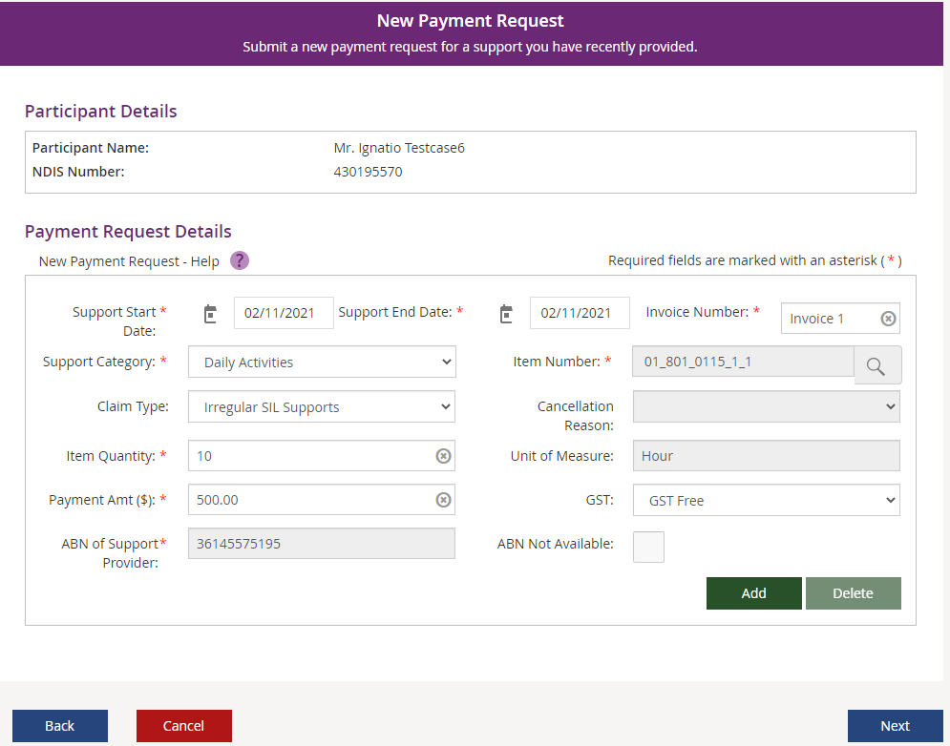

View payment request
You can view a history of submitted payment requests. You can view by submitted payment requests or bulk upload files.

Submitted payment requests
- Select View Payment Request on the Payment Request page.
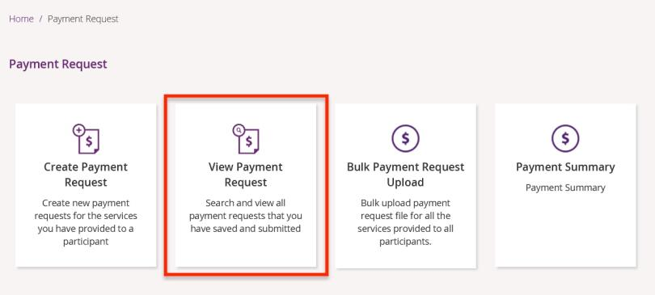
- At View By, select Submitted Payments Request from the drop-down list.
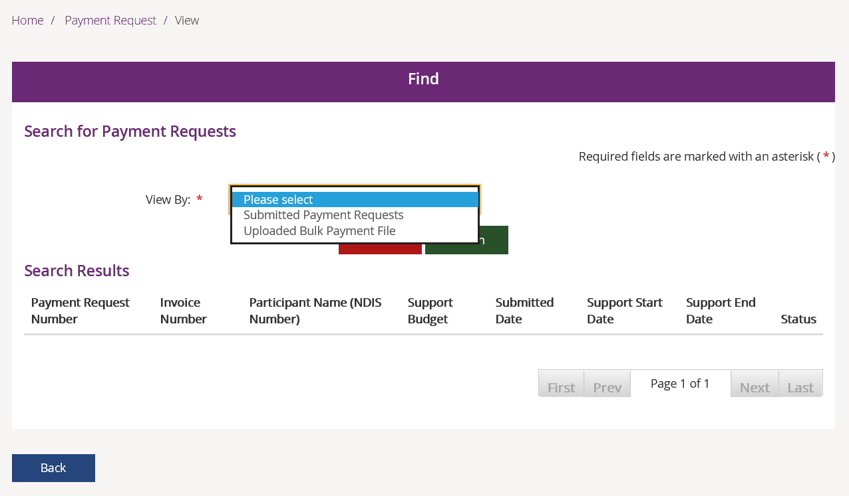
- Select the Search by drop-down and select the desired search criterion.
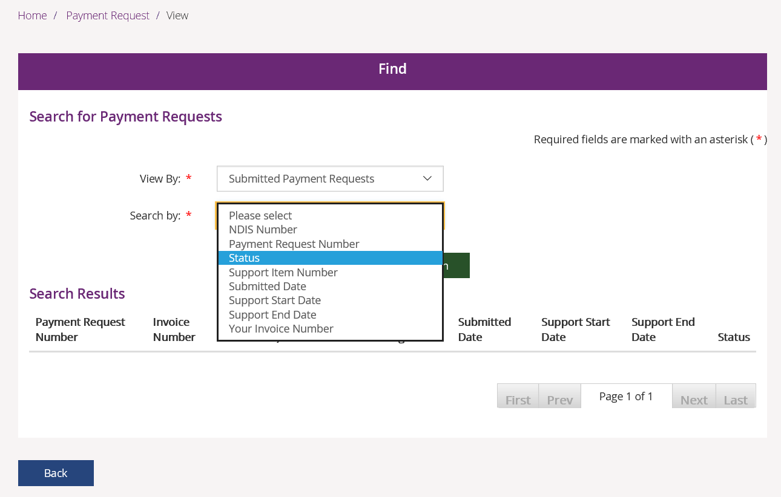
- Enter your search criterion and select Add to Criteria. You can add multiple search criteria.
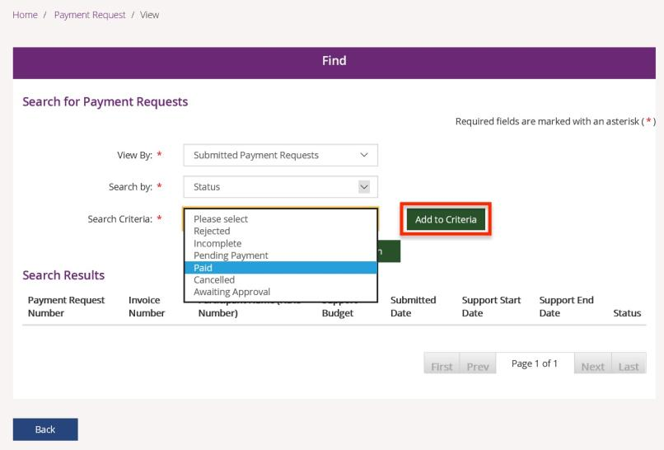
- You can search by various criteria - rejected, incomplete, pending payment, paid, cancelled, or awaiting approval. Select Add to Criteria to add more criteria to your search.
- Once you have entered all your criteria, select Search. Your search results display.
- Select the Payment Request Number to open details of that payment request.
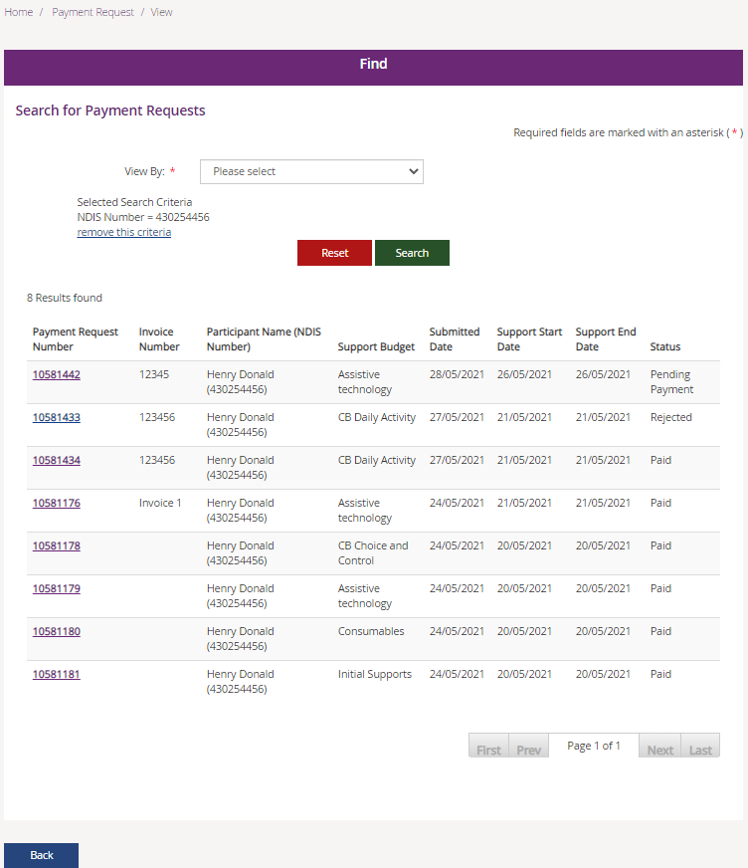

The table below explains what the different status criteria mean.
Payment Request Status | Definition
Paid | Payment has been approved and payment issued.
Incomplete | The payment request needs to be updated as it is incomplete.
Pending Payment | Payment is yet to be finalised.
Cancelled | The request has been cancelled.
Deleted | The request has been deleted.
Awaiting Approval | Approval required from the Agency.
Rejected | The payment was not processed and will not be visible to the user.
Open | The payment request is waiting for validation from the participant.

Note: You will not be able to view the participant’s name when a claim has a Rejected or Open status.

- When the details of the payment request display, select Back to return to the previous page.
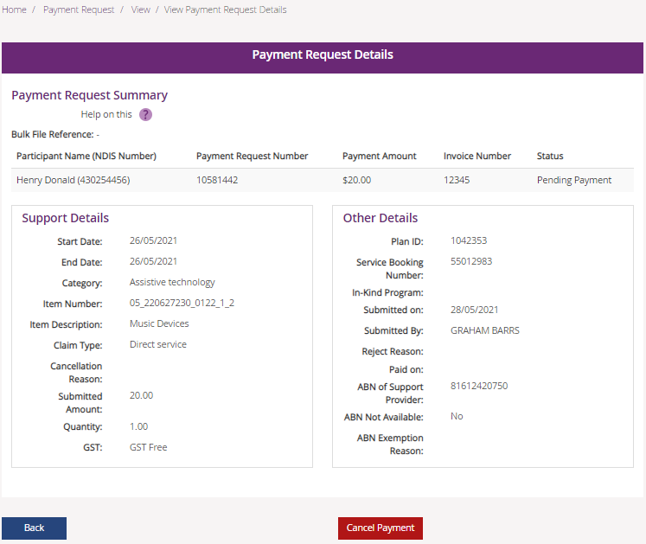

Uploaded bulk payment files
Further details on how to do this can be found in the Bulk payment request self-help guide on the NDIS website.

Cancel payment request
If you make a mistake with a payment request, you can cancel the request if it has a status of Pending payment or Paid. After the request is cancelled, you can enter a correct payment request if needed.

Note: You must be an account manager or primary contact to cancel payments.

If you cancel a payment request with a status of Pending payment (i.e. we have not yet paid you that amount) the payment request will not be processed.

If you cancel a payment request with a status of Paid (i.e. we have paid you that amount and you consider it to have been paid incorrectly), we will:
- Offset your future payment requests against the cancelled amount. or
- You may contact our National Contact Centre to pay back the debt directly

You can cancel any payment request in your payment history with a status of Paid.
Note: If we apply an offset, you will not receive any further payments until you have submitted payment requests which in total, equal the cancelled amount.

Note: If you wish to return a payment that you have received after cancelling the payment request, please contact us on 1800 800 110.
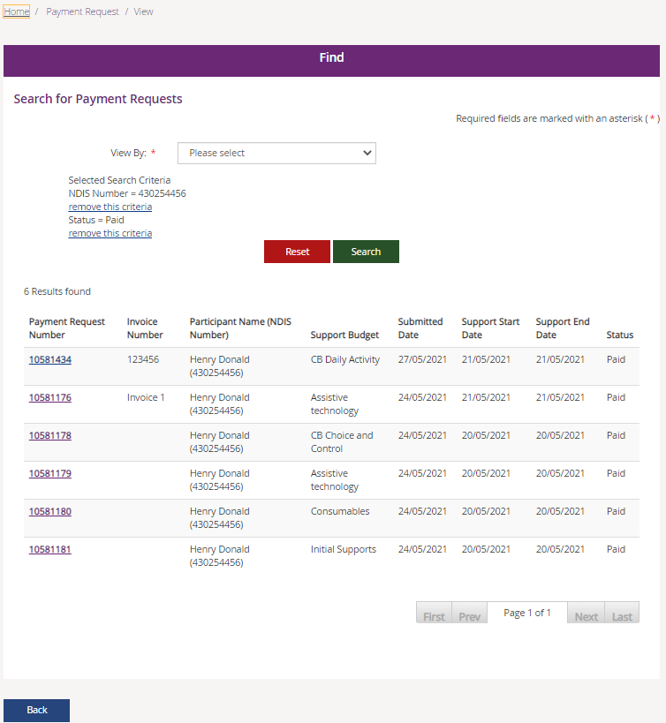
- Select the Payment Request Number link to display the Payment Request Details.

Note: Only payments that have the status of Paid or Pending Payment can be cancelled.
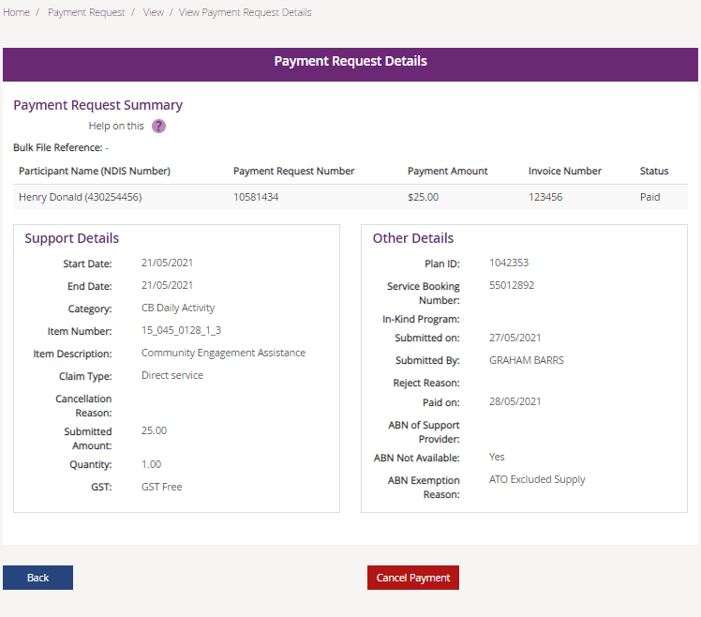
- Select Cancel Payment.
A message displays asking, “Are you sure you want to cancel this claim?
If the claim that you are cancelling has already been paid to your account, you will need to pay it back to us. You can pay the cancelled claim back to us by agreeing to reduce future payments by the amount of the cancelled claim.
By clicking "Yes", you agree to enter into an arrangement to reduce your future payments by the amount of the cancelled claim.
By clicking “No”, your claim will not be cancelled. If you wish to cancel your claim but pay it back another way, you need to contact us or call 1800 800 110 for more information””
- Select Yes.

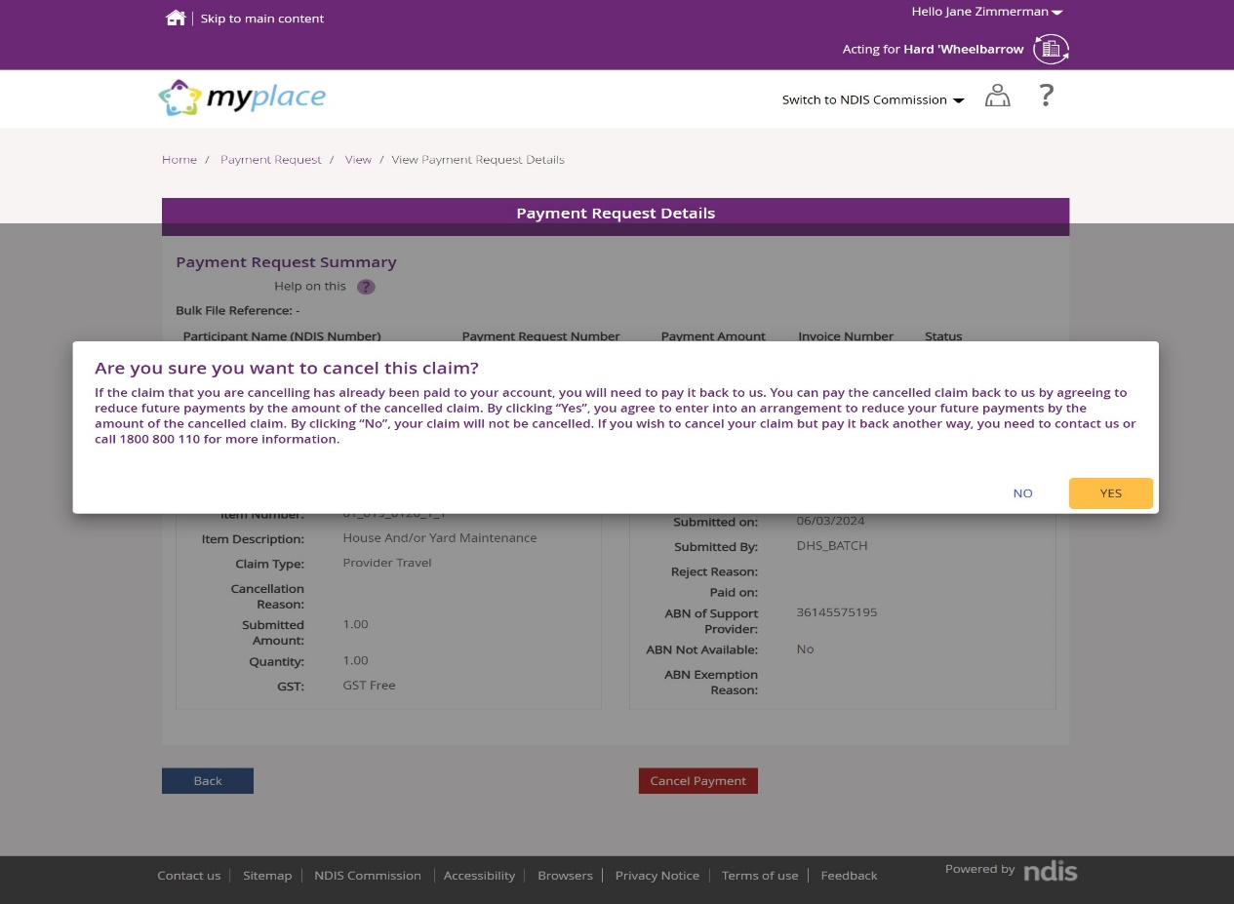

- The following message displays. If you search again for the payment request you will see it now has a status of Cancelled.

Recipient Created Tax Invoices (RCTI)
These are generated for each payment request or bulk upload. To make reconciliation simpler, all invoices for the same day are batched together.
Additionally, there is an ability to download RCTIs in PDF and Excel format.

Bulk payment request upload
You can upload payment requests in bulk. The payment requests can be uploaded in either .csv or .xml file formats. Use the current version of the bulk upload template available on the myplace portal.
Further details on how to do this can be found in the Bulk payment request self-help guide on the NDIS website.

Payment summary
You can view a summary of the payment requests and advance payments through Payment Summary. The payment requests summary can be up to a 30-day period and includes cleared (received) payments, pending payments, rejected payments and bulk upload file payments.
1. Select Payment Summary on the Payment Request page.
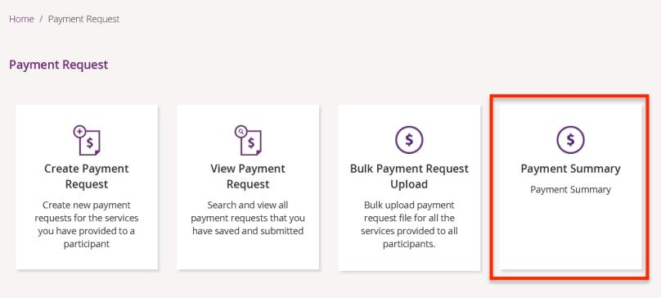
- Enter the From Date and To Date of the summary (up to a 30-day period).
Note: This is the date that the payment was requested.
Note: You can view you Pending Payment Request, Advance Summary and Advance Recovery Instalment Plan by selecting Open Section.

- Select Find Summary.
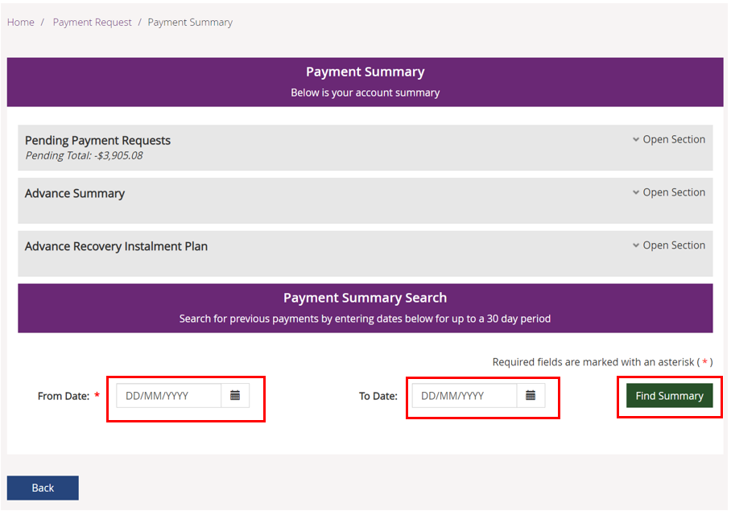
- Select Open Section to view the summary details.
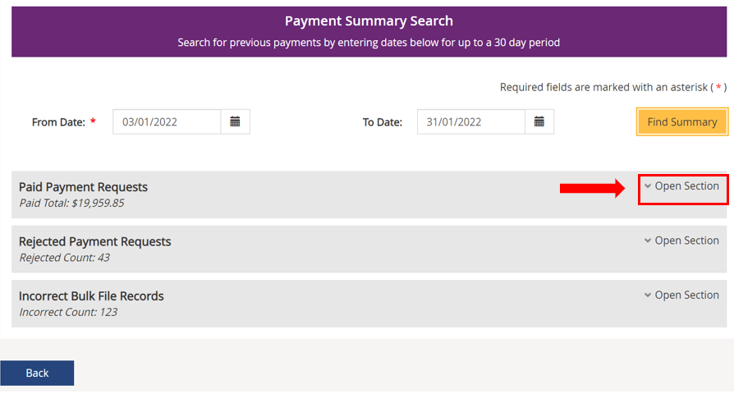

- Select Rightwards Arrow to view each Payment Run Date payment summary
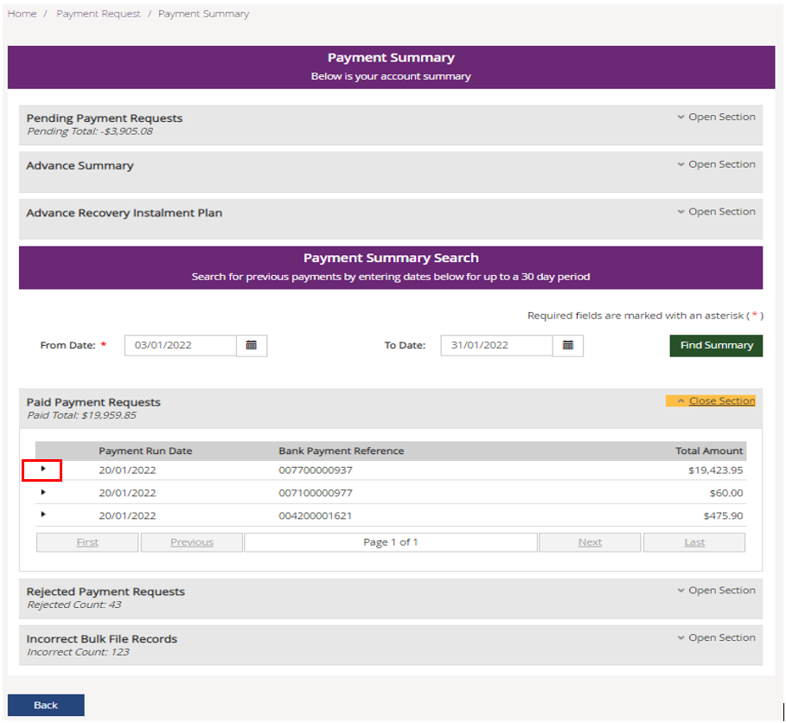

- Select Download Results
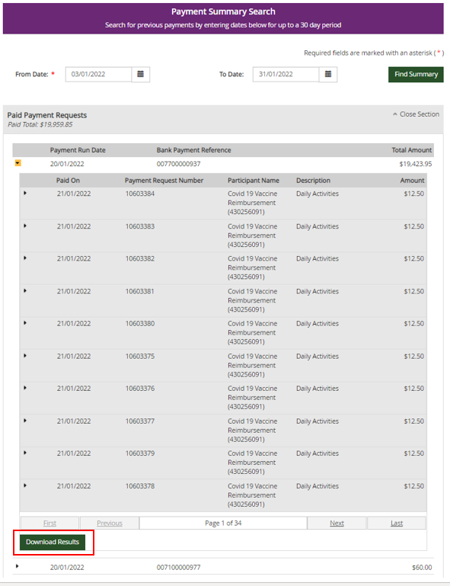

Advance summary and recovery instalment plan
If you have received an advance payment and a recovery instalment plan is in place, the Advance Recovery and Advance Recovery Instalment Plan sections let you view how much you currently owe and the value of the instalments.
      - Go to Advance Summary and select Open Section.
The section displays a summary of the total amount paid to you, the total amount recovered and the total amount remaining to be paid by you.
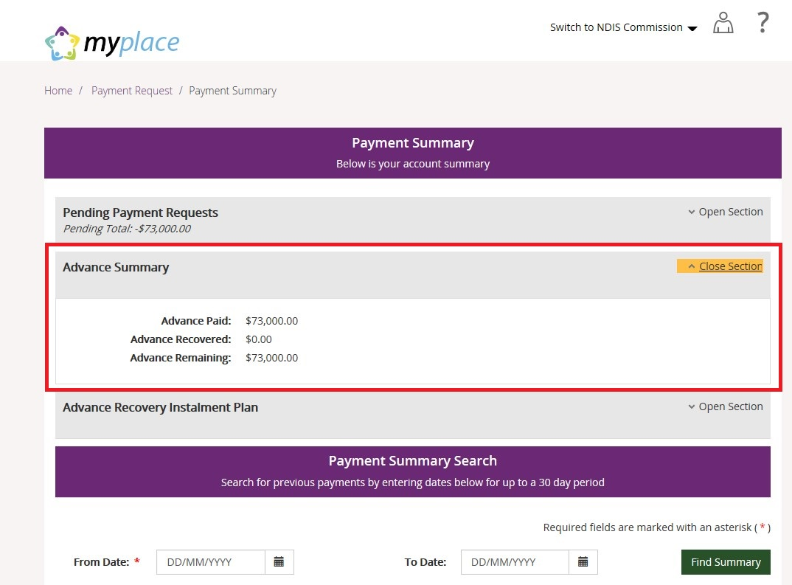
      - Go to Advance Recovery Instalment Plan and select Open Section.
The section displays a detailed table of each instalment in the recovery plan by recovery date, recovery instalment amount, recovered amount and remaining amount.
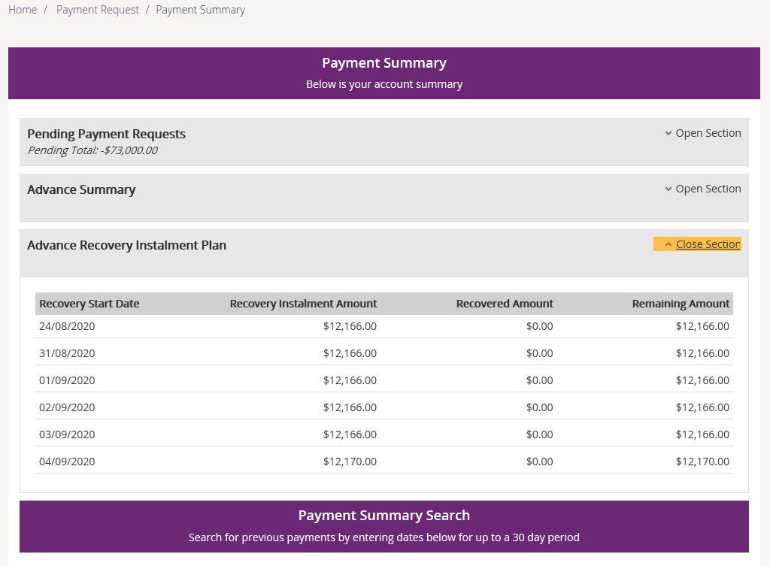
If you have any questions or concerns about advance recovery, contact NDIS at advance.payment1@ndis.gov.au.

Quotations

IMPORTANT NOTE FOR APPROVED QUOTES:
When NDIS approves your quote, you don’t need to create the related service booking, it is created automatically for you.
You will receive a message in your Inbox informing you that the service booking has been created.

This section allows you to view and respond to quotation requests sent to your organisation by the NDIA. Quotations enable you to submit quotes to provide particular supports on a participant’s plan.
Note: Many quotations are currently being managed outside the portal and entered into the system by the Agency to manage system limitations.
Note: You can view the Quote ID of an approved quote in the ‘Find’ screen for service bookings and select the hyperlink to navigate you to Quotation screen.
Note: From 28th February 2022, Assistive Technology quotes valued under $15,000.00 no longer require a quote. You can create a service booking against an accepted line item for the price agreed with the participant (up to the allowable budget) in cases where a quotable Assistive Technology item has been automatically accepted but a service booking was not automatically created. These cases are usually identified by:
- the funding for the item is now in the ‘Available’ funds, and
- a comment has been added to the participant’s plan to reflect this change (in some cases the participant will have an email to indicate this).

View a quote
- Select the Quotations tile on the myplace home page.
When a Quotation Request is received a banner notification will appear on the tile.
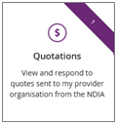
The Quotations page opens and your quotes will be displayed. The results will be organised under the following column headers:
- Find a participant: Enter either the participant name or their NDIS number.
- Sort by: Select an option from the drop-down list to sort the list by the column headers.
- Quote ID: The list of quotations requested by NDIA.
- Participant name (NDIS number): The name and NDIS number of the participant that the quotation relates to.
- Date requested: The date the quotation was requested by NDIA.
- Quote type: Shows the type of quotation.
- Description: Describes the item.
- Item: Shows the item number.
- Status: Shows the status of the quotation as one of the following:
  - Awaiting provider response
  - NDIA has received response
  - Quote has expired
  - Archived
  - Quote is accepted
  - Quote was unsuccessful
  - Quotation open
- Select Sort by to sort the list of quotes by any of these columns. Only one column can be sorted at a time. Use the previous / next page controls at the bottom of the page to move through the list. To return to the previous page, select Back.

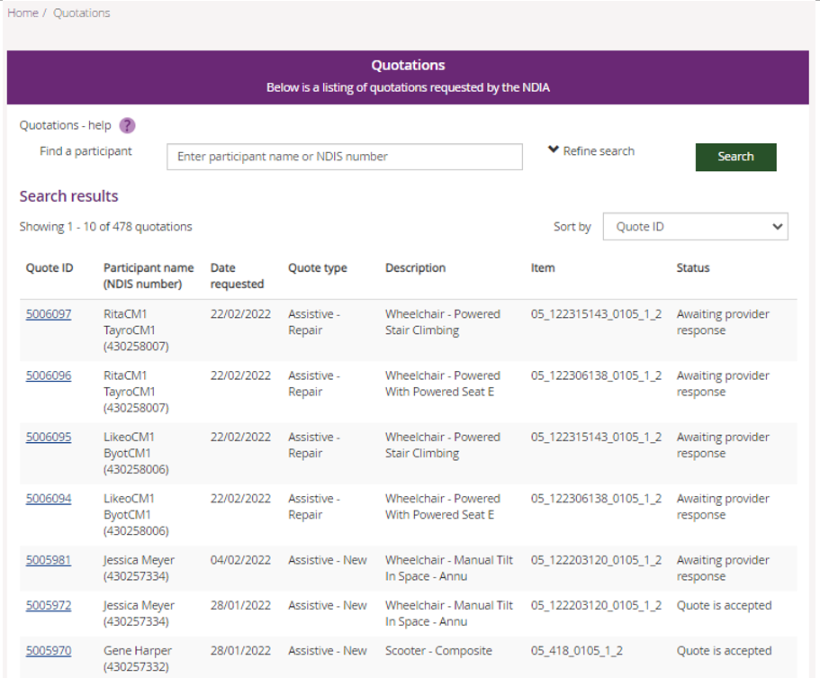

- To refine your search, select the Refine Search drop-down to display the filters you wish to search on — Quote ID, Quote type, Date requested, Status. You can enter multiple criteria to further refine the list.

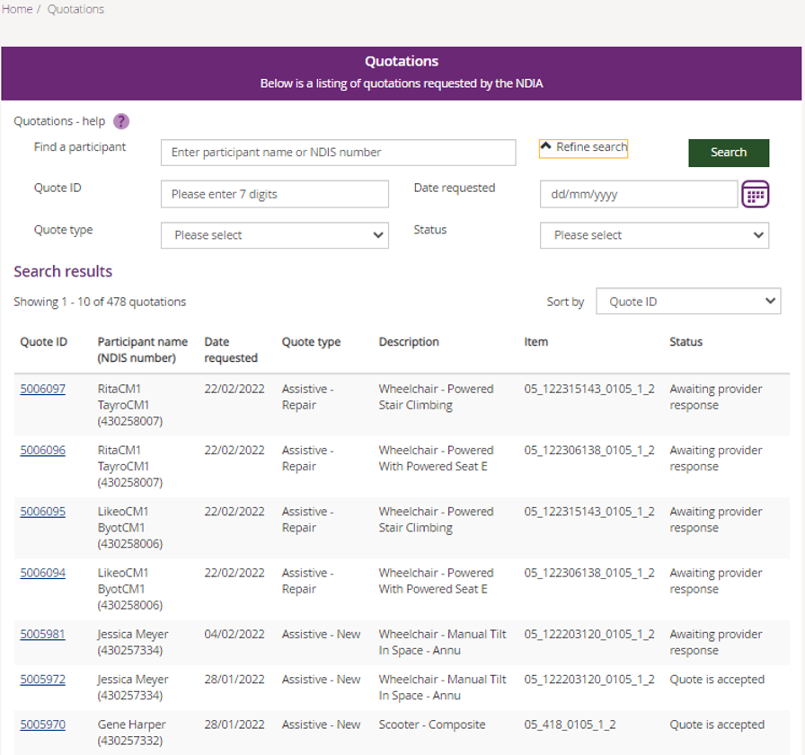
- To view details for a particular quote, select the quote number under the Quote ID column. The Quotation Details screen displays. It allows you to enter your quotation response and upload any documents directly to the quote request.
- Select the View quotations button to return to the list of quotations.
Note: For plans migrated from the NDIS trial only, there has been a temporary change to the myplace provider portal to bypass the quotation process. This has been implemented to allow payment requests to successfully be processed.

Respond to a quote
- To respond to a quotation request, complete the fields in the Quotation response tab:
Supply details: Enter all relevant information about the supply of the item or service.
- Specifications: Record the conditions of the quote.
- Inclusions: Enter all items that are included in the quote.
- Specific exclusions: Record any items that are excluded in the quote.
- Price per unit: Enter the total price of the quote per unit (excluding GST).
- Quantity: Specifies the item quantity.
- GST per unit: Record the GST amount.
- Terms of quote: Select the number of days that the quote is valid for - either 30 days or 60 days.
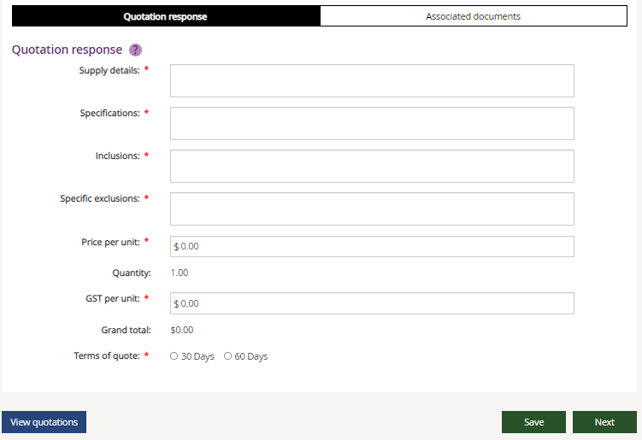
- Once you have entered all the information in the Quotation response tab, select the Associated documents tab to upload any documents relevant to your response.
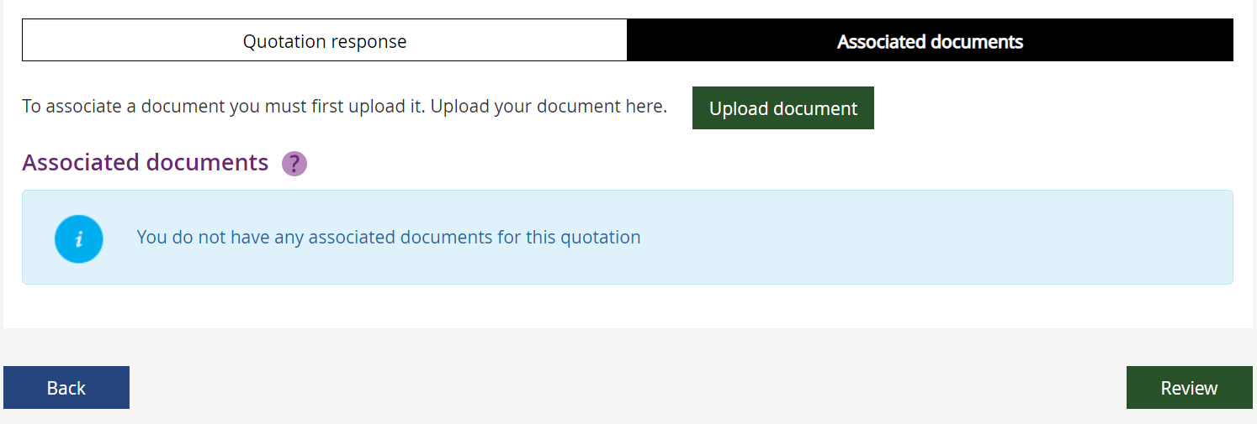
The Associated documents tab displays. It lists any documents you have previously associated with your response to this quotation. If you have not previously uploaded any documents, the message will display ‘You do not have any associated documents for this quotation’.
If you have previously uploaded a document, you will see it listed.
Select the Document name if you want to download and view the document. You will be taken through a set of document download instructions.
Select Remove under Actions if you want to remove the document from your list of documents. You will be shown a message asking you to confirm your intention to remove the document from your list — either Yes or No.
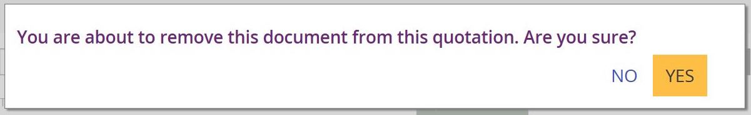
- To upload a document, select the Upload document button. A Document Upload window displays.
A list of Available documents is shown at the bottom of the window. These are documents that have previously been linked to this quote.
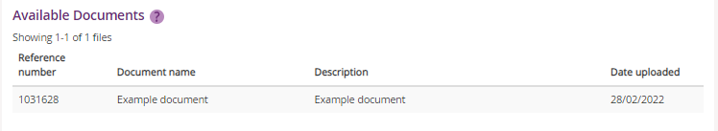
Note: Uploaded documents are labelled Available documents when you are viewing the Document upload form. The same documents are labelled Associated documents when you view them on other Quotations screens.
- Provide a Document name and Description.
Note: Use a meaningful short title for the document name, and a description that will help you distinguish this document from other documents in the list.
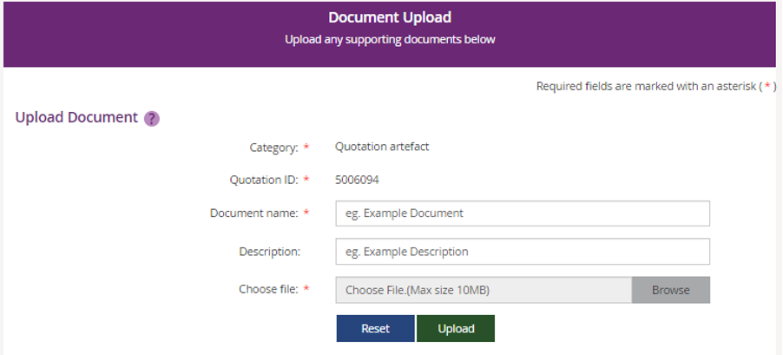
- Select Browse to locate the file you want to upload. The maximum file size you can upload is 47MB. Then select the Upload button.
Note: Any documents that you upload will also be visible to NDIA and participants.
A success message displays at the top of the page.

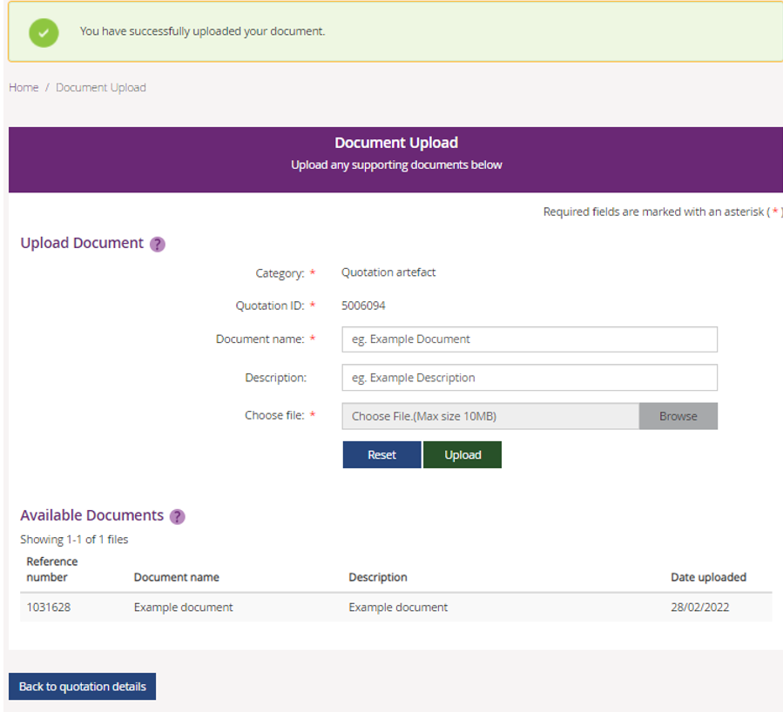
You will see that your file has been added to the Available documents list shown below the message.
- Select the Back to quotation details button to return to your response window.

Your quotations details screen displays.

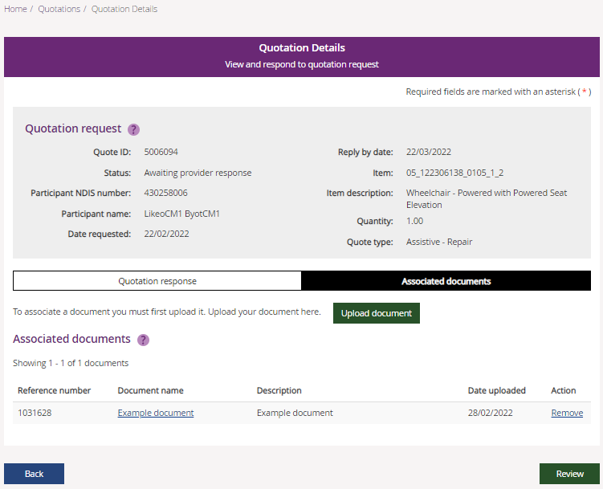
- Select the Review button to review the details of your response before you submit them to NDIA.
- Once you are satisfied that you have provided all necessary information and uploaded and/or removed relevant documents, select the Submit button.
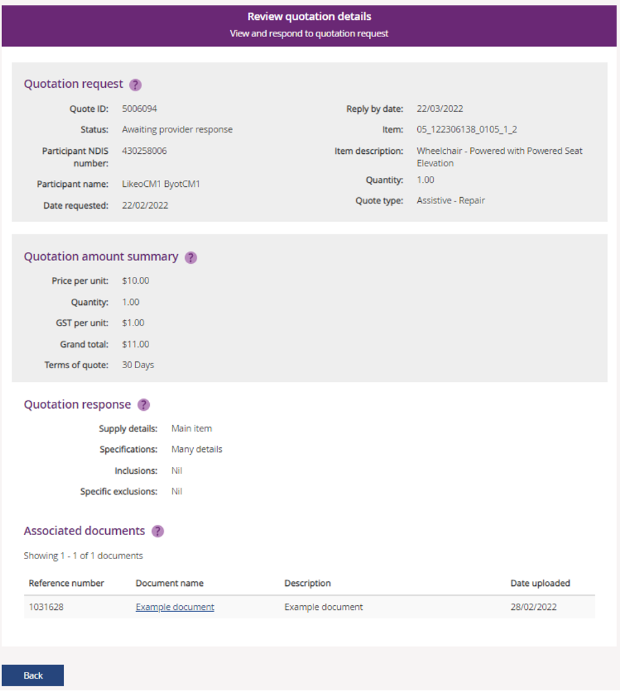
A message displays asking you to confirm your submission of the quotation - either Yes or No.
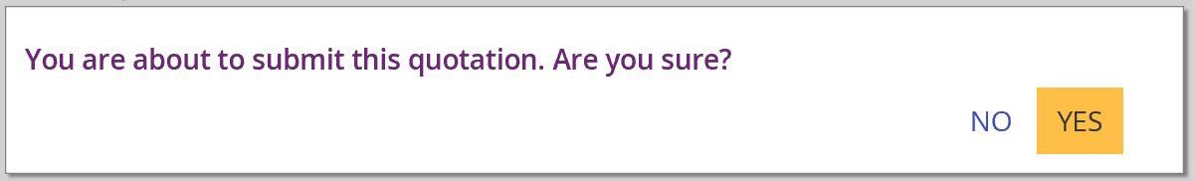
A success message displays at the top of your quotation details window.
The status of the quote changes for the quotation details to NDIA has received response.
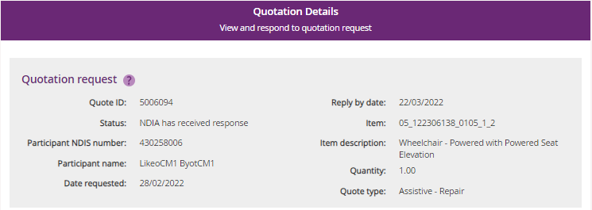
If the NDIA approves your quote, the status of the quote changes to Quote is accepted.
You will receive a message in your Inbox if the quote has been rejected by the NDIA.
Note: The system does not enable you to update and resubmit a revised quote. Where negotiation is required, please contact your local NDIA office prior to submitting your quote.

Referrals
This section allows you to view referrals made to your provider organisation by the Agency.
- Select the Referrals tile on the myplace home page.
The list of referrals opens.
- Select Home to go back to the myplace home page.
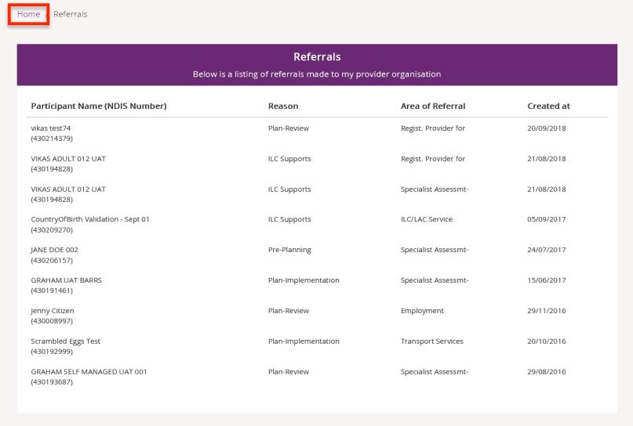

Requests for Service
This section allows you to:
- view Support Coordination Requests for Service sent to your provider organisation by the Agency
- access and review Support Coordination Requests for Service sent to your provider organisation by the Agency
- accept or reject Support Coordination Requests for Service sent to your provider organisation by the Agency.
- update your notification preferences for emails sent to you for Requests for Service.

View Support Coordination Requests for Service
      - Select the Request for Service Forms tile on the myplace home page.
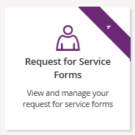

      - The full list of Request for Service Forms displays. It shows the complete list of requests for service issued to your organisation.
      - You can search for specific requests for service by participant name or NDIS number.
Note: Request for Service for approved PACE participant can be viewed in the my NDIS provider portal.
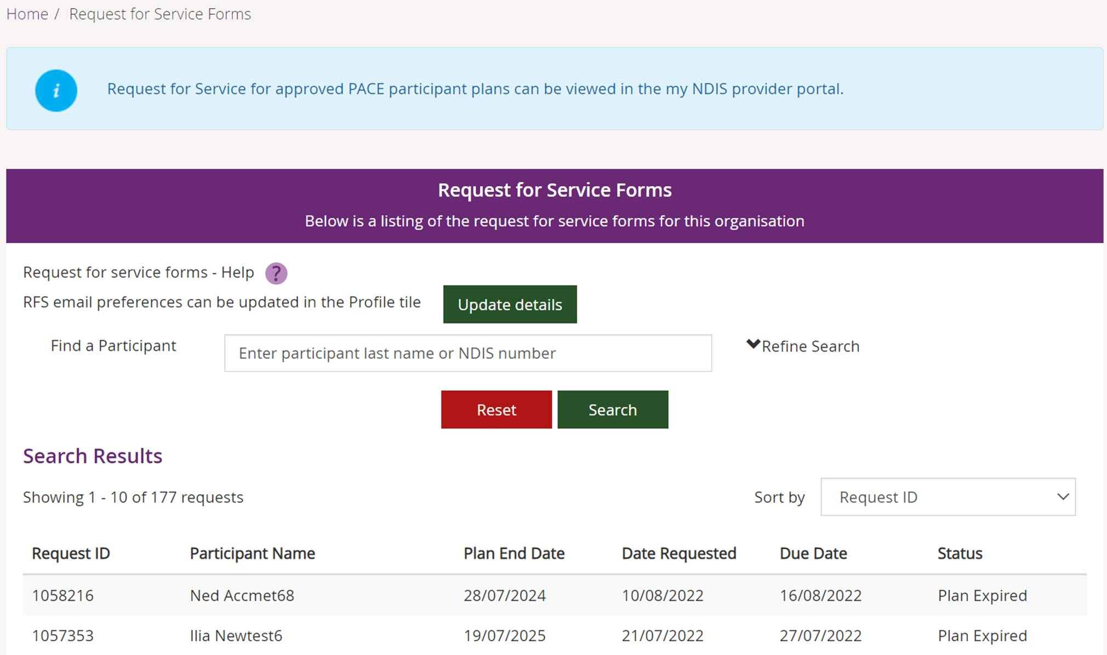
- Select an option from the Refine Search drop-down to sort the list by the column headers:
- Request ID: Individual Request ID for each request.
- Participant name: NDIS participant name.
- Plan End Date: Participant Plan End Date.
- Date Requested: The date the request for service was referred to your provider organisation.
- Due Date: The Due Date by which you need to respond to a Request for Service referral request.
- Status: Displays the status of the support coordination request for services:
  - Pending, awaiting your review and response (maximum of 4 days)
  - Accepted, provider has accepted the request
  - Rejected, provider has rejected the request
  - Expired, request has not been action by provider before due date
  - Cancelled, the request has been cancelled

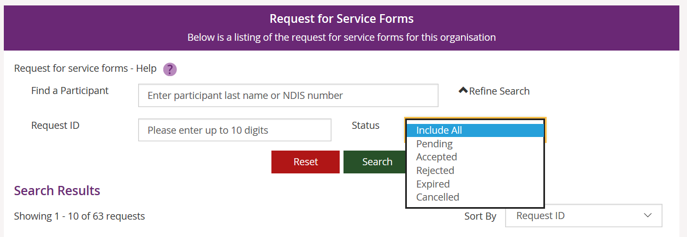
- You can also sort the results in the Sort By drop-down by Request ID and Status.

Access and review Support Coordination Requests for Service
1. To access and review a request for service, click on the specific Request ID. You can only access a request for service with a status of Pending or Accepted.
2. While the list will display all requests for service submitted to your provider organisation, you will not be able to access requests with a status of Cancelled, Rejected or Expired.

Select the underlined Request ID.
The Request for Service - Manage New Request for Service screen displays.
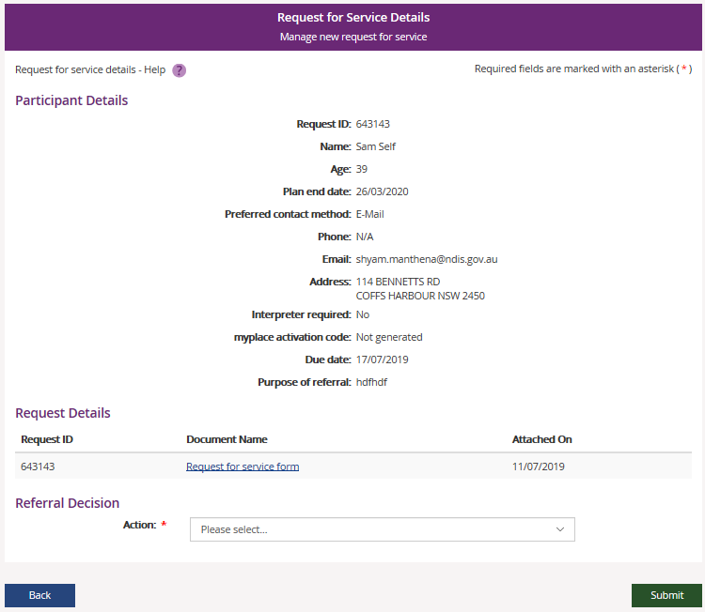

The screen shows the following information:
- Participants Details: the request ID, participant’s name, participant’s age, the NDIS plan end date, preferred contact method, phone number, email, address, if a participant requires an interpreter, the myplace activation code status, the due date to action the request, and why the Agency referred the support coordination request to your provider organisation.
- Request Details: the Request ID, document name, and date of attached. This section provide access to the individual request for service details.
- Referral Decision: This section allows you to respond to the Agency’s request for support coordination.
To access the detail for an individual Request for Service, select the Request for Services form link under the Document Name column header.

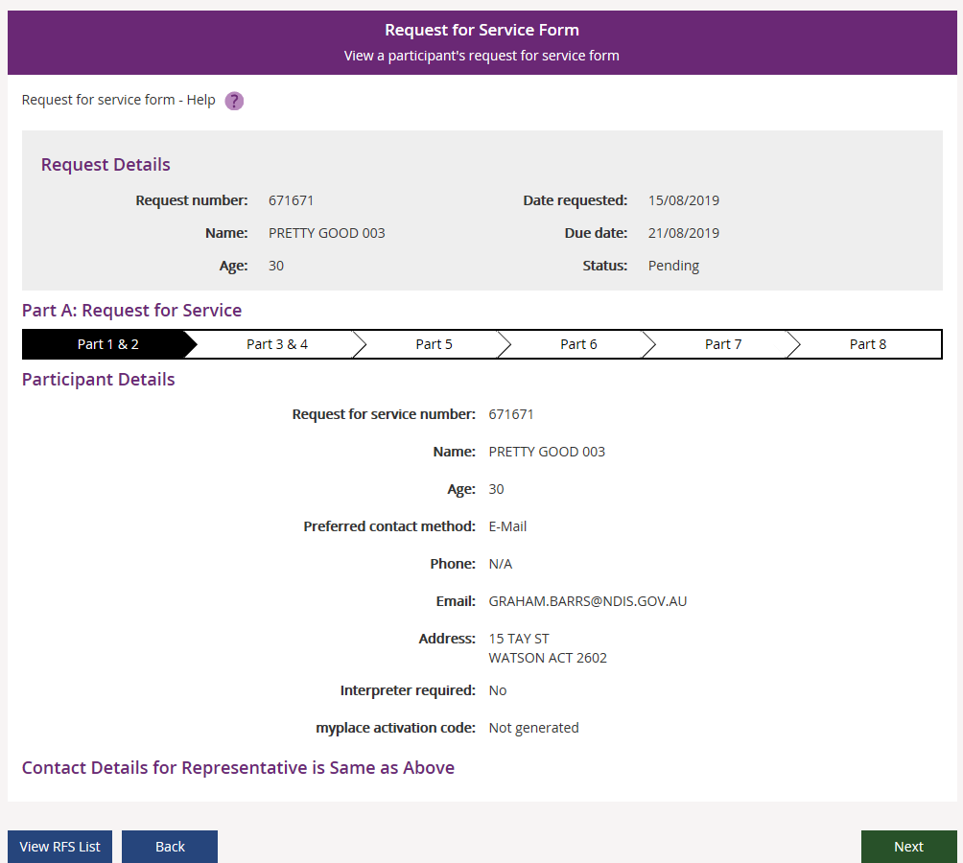

The request for service form displays. It comprises eight ‘parts’ — these are described below. Select the part name you are interested in. You can also select the Next or Back buttons below the part details to move from one part to another.

Note: Select the View RFS List button to display the full list of support coordination requests for service issued to your provider organisation.

The eight parts are as follows:

Part 1&2 displays the participant’s name, age, contact details and other information.
Part 3&4 displays the details of the request support coordination provider and the nature of the support coordination request.
Part 5 displays the referrals for assessment that are part of helping the participant to implement their pln.
Part 6 displays details for the participant such as disability information, living arrangements, relationships and supports.
Part 7 displays the participant’s goals.
Part 8 displays the participant’s funded supports included in the participant’s plan.

Accept or reject Support Coordination Requests for Service
The Referral Decision can be either Accept or Reject.
      - To accept or reject a Request for Service Form, select the underlined Request ID.
      - To accept the referral request, select Accept from the Action drop-down box and select the Submit button.
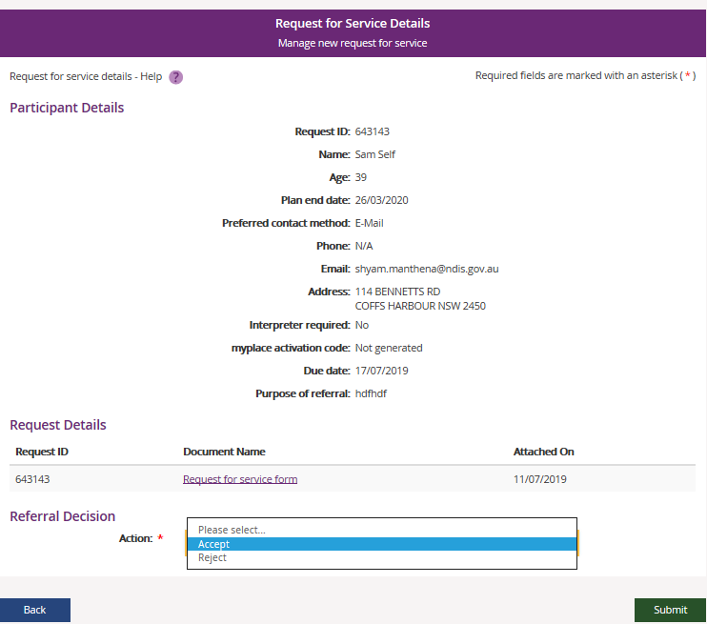
      - To reject the referral request, select Reject, followed by one of the four Reject Reasons in the drop-down box, and then select the Submit button.
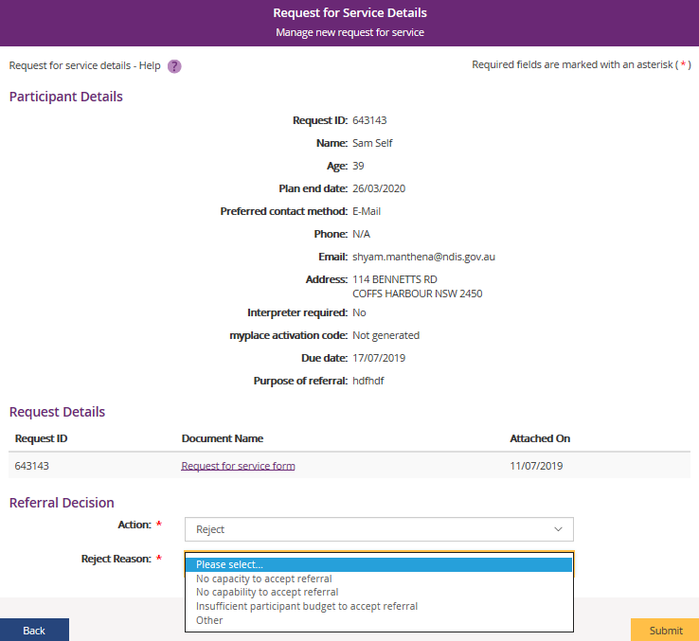

Update Coordination Requests for Service Email Notification
When your organisation receives a new Request for Service you will be notified by email immediately. You can decide if your organisation will or will not receive immediate email notifications.
- Select the Request for Service Forms tile on the myplace home page.
- The full list of Request for Service Forms displays. It shows the complete list of requests for service issued to your organisation.
- Select Update Details.
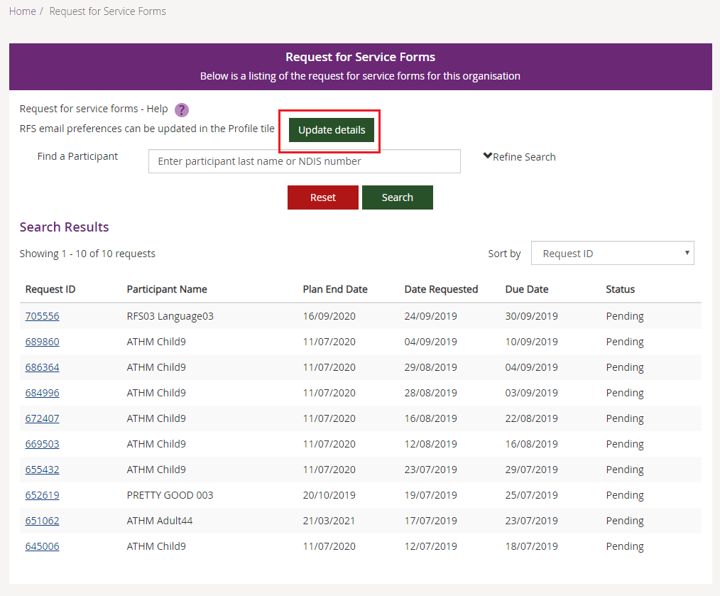
- The How Frequently Can NDIA Contact Me page
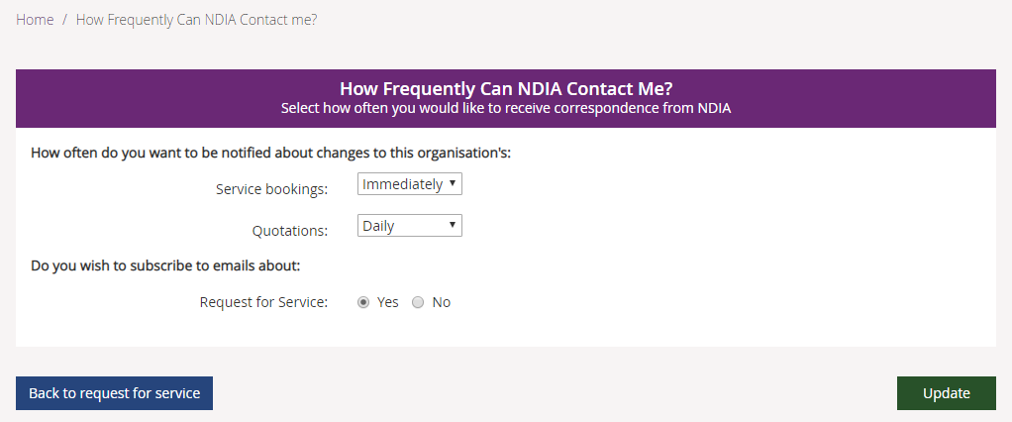
- Choose from Yes and No under Do you wish to subscribe to emails about Request for Service to update your Request for Service email preferences.
- Click Update
- The Request for Service Forms displays with a green banner message advising the contact details have been successfully updated.

Provider Finder
You may need to assist participants to find supports that you can’t provide. You can use the Provider Finder to search for providers within a specific area. You can also search by a Service (also known as Professions in Registration Groups).
- Select the Provider Finder tile on the myplace home page.
The Provider Finder page displays.
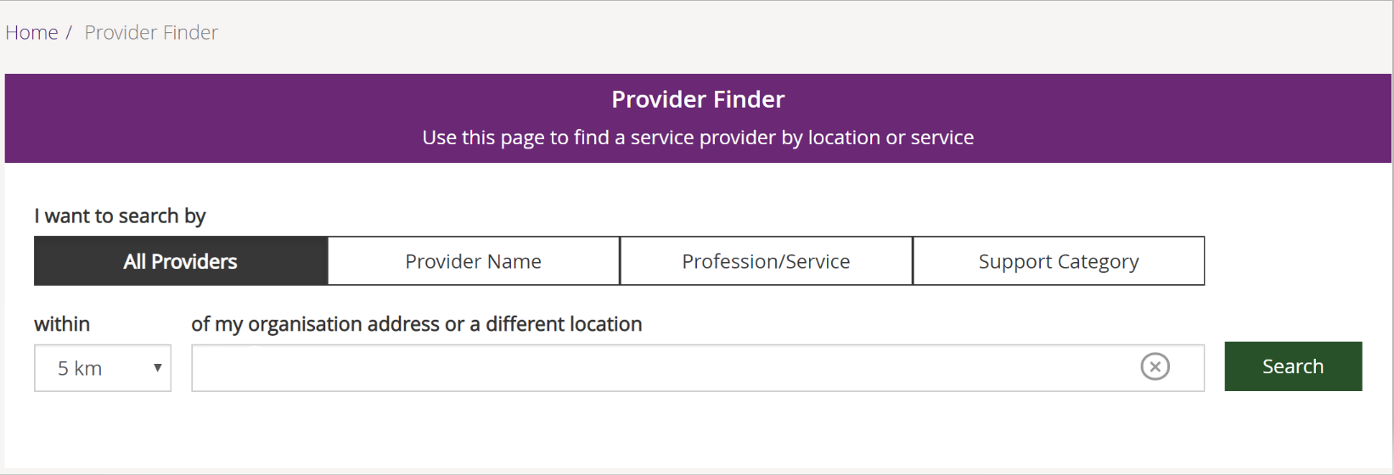
- You can search by different criteria:
- All Providers – This option will display all providers within the selected distance of your address.
- Provider Name – This option will allow you to enter the name of the provider you are looking for within the selected distance of your address.
- Profession/Service – This option will allow you to select the profession/service you are looking for within the selected distance to your address. The profession/service is listed in a drop-down menu.
- Support Category – This option will allow you to select the support category you are looking for within the selected distance to your address. The support categories are listed in a drop-down menu.

Tip: Start entering the address using street number and name, select from the valid addresses that are listed. The more detail you enter, the more refined the list.
At Within, select the radius of the search. This radius is based on the address in Near Location.

- Select Search. The results of the search display. Use the pagination functions to move through the results.
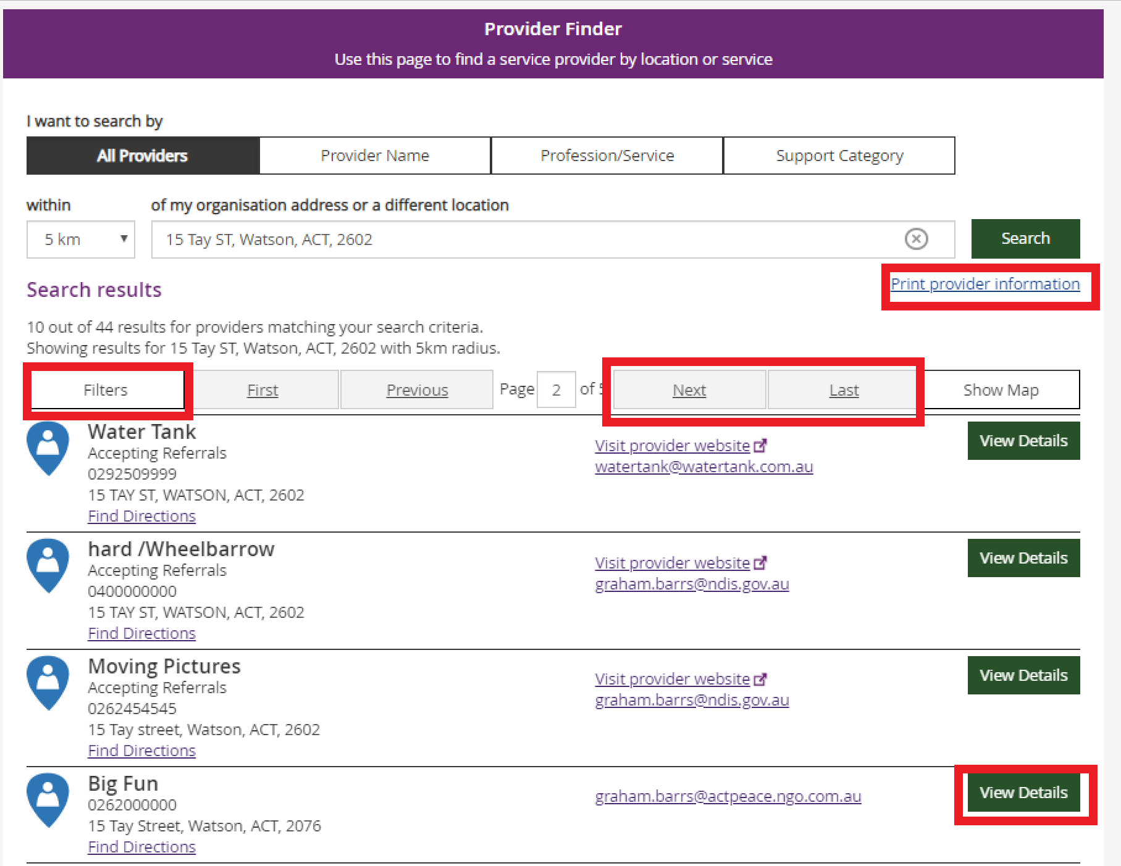
- Select View Details to see more information about the provider. Details of the provider display, including contact information, operating hours, services provided and contact information.
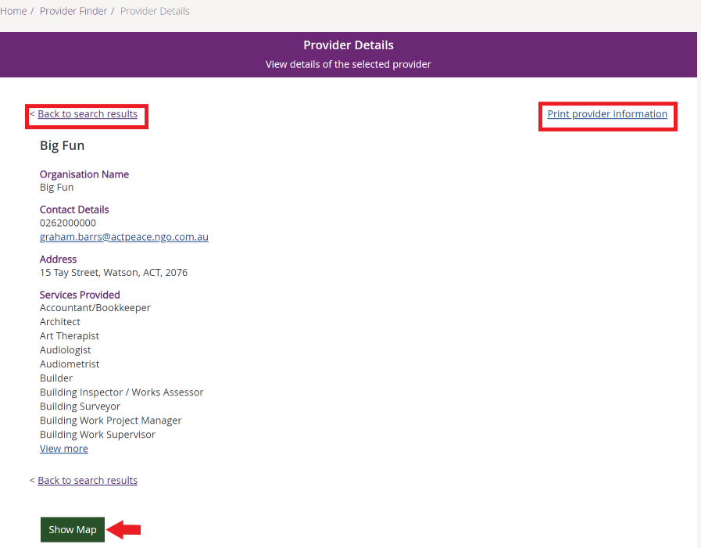
- Select Show Map to view the location of the provider. You can print the search results by selecting Print provider information. Or select Back to search results to return to the search results.
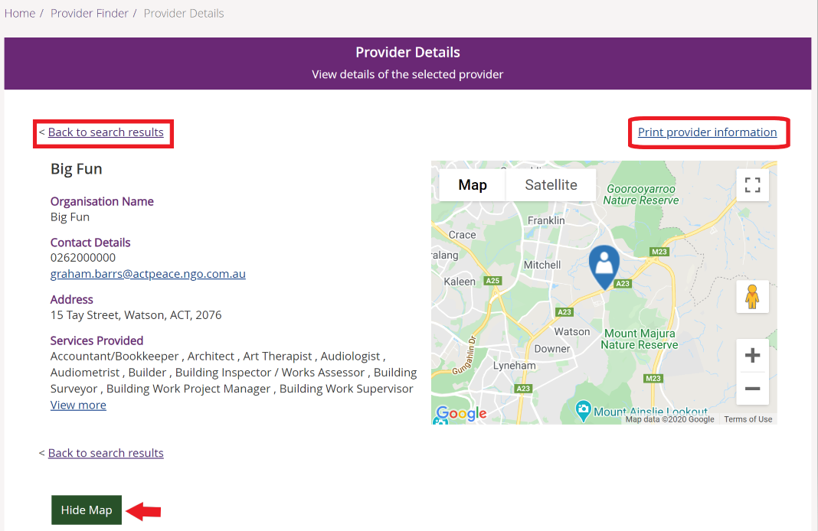
- You can print the search results by selecting Print provider information or Hide Map to return to the Provider Details page. Select Back to search results to return to the search results.

Upload evidence
For some processes (e.g. Quotations,) you need to provide additional information to the Agency. Upload Evidence provides this capability. This area enables you to upload documents to the NDIA.
- Select the Upload Evidence tile on the myplace home page.
The Document Upload page displays.
- Type in the Document Name (a meaningful name for you) and Description (what it contains).
- Select Browse to locate the document on your computer.
- Select the Upload button.
Note: Your uploaded documents will display under the Available Documents heading.
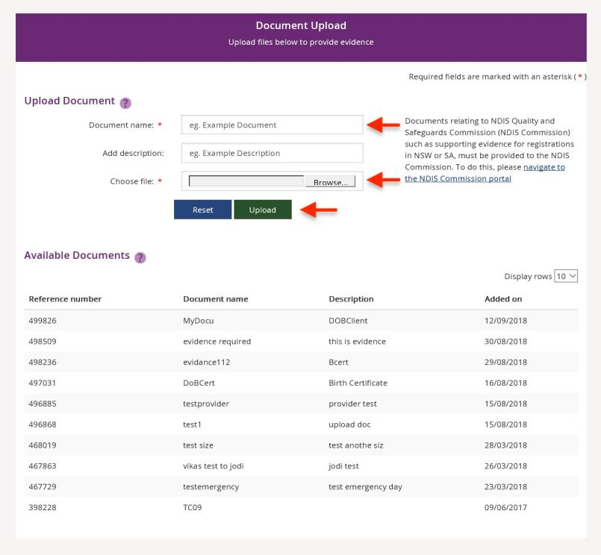
Note: You are not able to associate the document with an individual participant. If the document needs to be associated with the participant, please contact us on 1800 800 110.
Note: You are not able to open the document from within the portal, or remove it from the system after it is uploaded. If you uploaded the wrong document, please contact us on 1800 800 110.
Tip: Use meaningful document names and description. For example, put the type of document (e.g. Home Modification Plan) in the Document Name, and the Participant’s NDIS number in the Description.
Tip: Ensure you retain a copy of the uploaded file and are able to relate your copy to the Document Name and Description.

Downloads
You can download in just one report information about all the service bookings you have with active participants as well as information about all the participants that you have service bookings with and who have given the NDIA consent to share their plan with you. You can also download a list of your quotation requests.
- Select the Downloads tile on the myplace home page.
- After you click the Downloads tile, you will see a new tile screen with these options:
- Download Service Bookings
- Download Quotations
- Download My Participants
- Advance Payment Reconciliation Report.

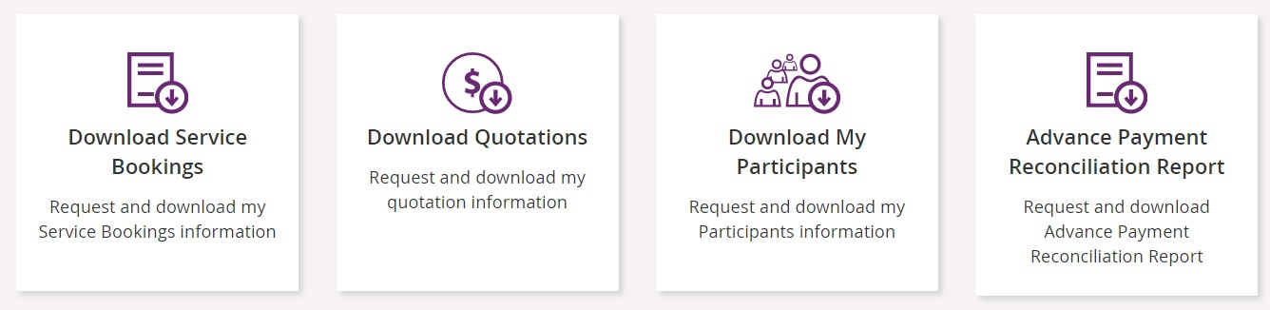

Download Service Bookings
This tile allows you to download reports listing all the active service bookings you have with participants.
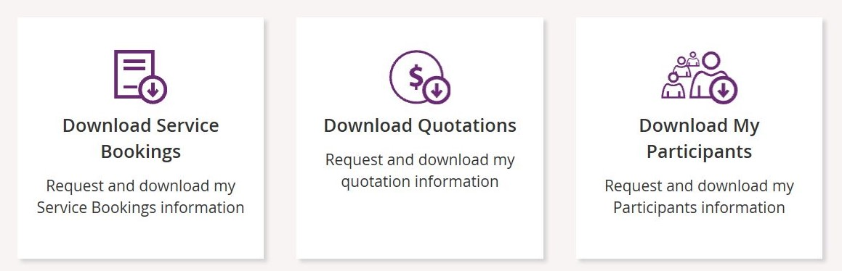
- Select Download Service Bookings to request and download a report containing your service bookings information.
The Download Service Bookings screen displays, listing all service bookings that were active for your organisation in the 90 days to today’s date.
Note: The download report will be available for 90 days. The reports older than 90 days will be automatically deleted.
Note: If you are downloading reports to identify any service bookings that have expired or are about to expire, to determine if they have been extended by the 365-day plan auto-extension feature, you should filter the report by plan end date in Excel.

- Select Request Download. Or select Back to go back to the Downloads page.
Note: You can also download one of the reports already listed.

The Download Service Bookings screen displays with a green tick and system message saying ‘The request for download has been submitted.’ You can select Cancel Request to cancel a download (pending report) that you have just requested. Or select Back to go back to the Downloads page.
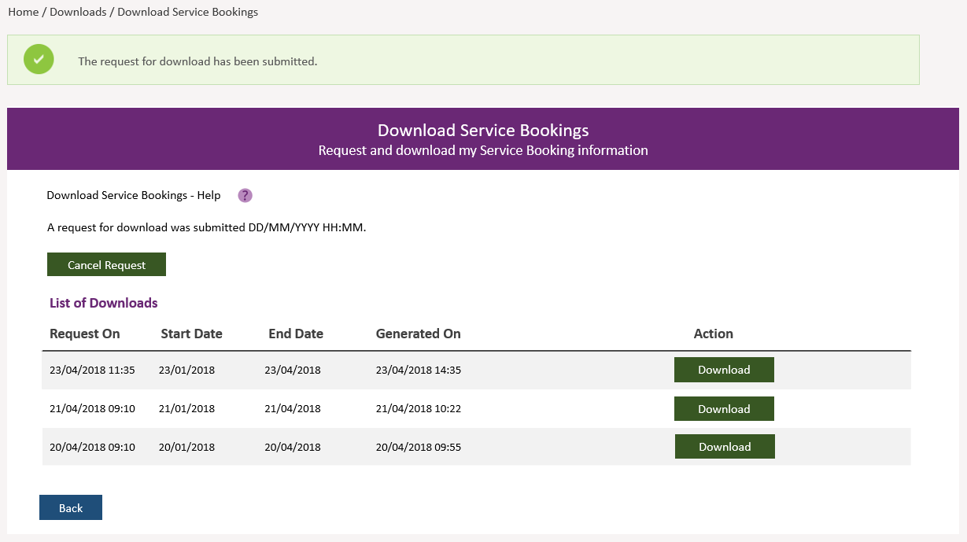
- You will need to refresh the list of reports to view and download the report you have just requested. To do this, select Back to go back to the Downloads page.
The Downloads page displays once more.
- Select the Download Service Bookings tile to view the list of available reports. Your report will be listed first.
Note: The system might occasionally experience delays of up to several hours when generating reports depending on the size of the report and system load at the time of request. In this case, you might need to repeat Steps 3 and 4 to see your report.

- Select Download to download the report you requested.
- When you select Download, an Acknowledgement window will pop up. Check the box to show you agree and will adhere to the acknowledgement regarding use of the information in the report that you are about to download.

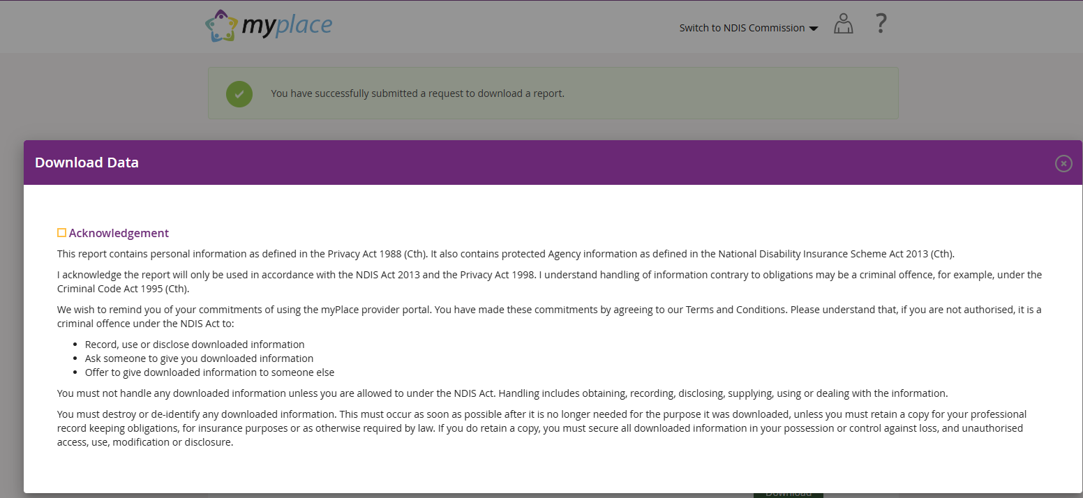

After you check the Acknowledgement box, the popup window will expand to display a number of file format download options.

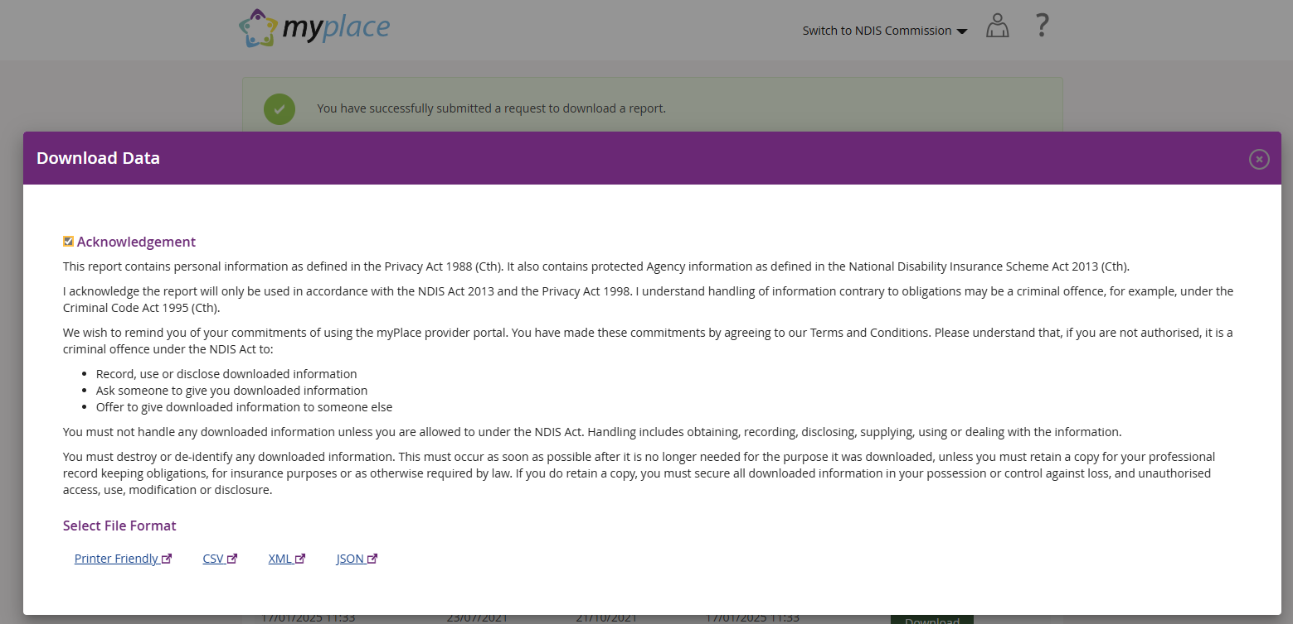

You have a choice of 4 format types depending on your business needs. They are:
- Printer friendly — a format that allows you to view the data as a printable, readable report. If you wish to, you can use this format to output a PDF version; you will need to select to ‘print to PDF’ if this function is supported by your computer
- CSV (Comma Separated Values) — typically used to open as a spreadsheet for sorting and filtering the data. Note that this download has two heading rows
- XML (eXtensible Mark-up Language) — a format for importing into business systems
- JSON (JavaScript Object Notation) — a simple format for importing into business applications

Download Quotations
This tile lets you download a list of all your quote requests.
1. Select Download Quotations to request and download your quote requests.
The Download Quotations screen displays a list of all quotes received by your organisation in the previous 90 days. If none were requested, no list will be displayed.
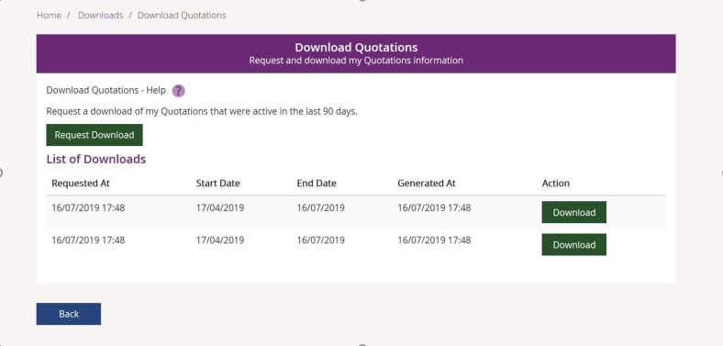
- Select Request Download. Or select Back to go back to the Downloads page.
Note: You can also download one of the reports already listed.
- When you select Request Download, an Acknowledgement window will pop up. Check the box to show you agree and will adhere to the acknowledgement regarding use of the information in the report that you are about to download.

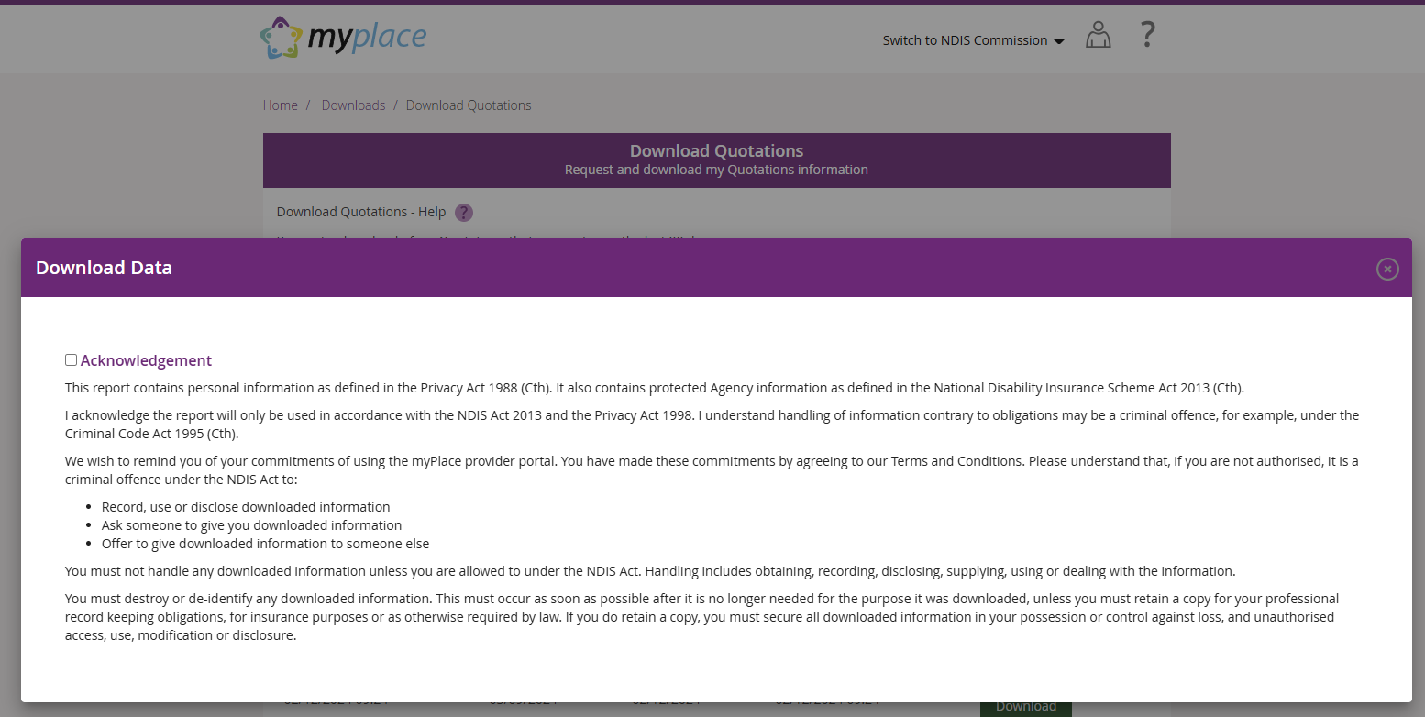
After you check the Acknowledgement box, the popup window will expand to display a number of file format download options.

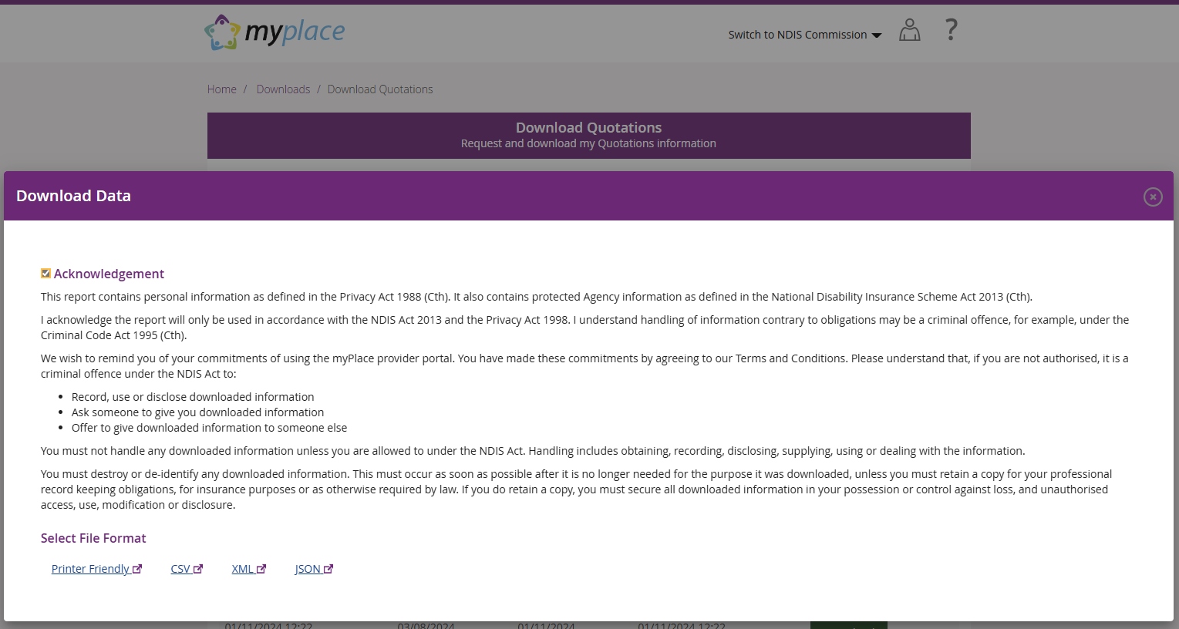
You have a choice of 4 format types depending on your business needs. They are:
- Printer friendly — a format that allows you to view the data as a printable, readable report. If you wish to, you can use this format to output a PDF version; you will need to select to ‘print to PDF’ if this function is supported by your computer
- CSV (Comma Separated Values) — typically used to open as a spreadsheet for sorting and filtering the data. Note that this download has two heading rows
- XML (eXtensible Mark-up Language) — a format for importing into business systems
- JSON (JavaScript Object Notation) — a simple format for importing into business applications

Download My Participants
This tile lets you download a list of participants that you have active service bookings with. The download expires 24 hours after the report is requested to ensure the data is always up to date.
Important note: You will only be able to access information for participants who have given your organisation their consent to access their information. The information will in turn be restricted to:
- Participant name
- NDIS number
- Plan number
- Plan start date
- Plan end date
- Gender
- Interpreter required.
      - Select Download My Participants to request and download your participant’s information.
The Download My Participants screen displays listing any reports requested by your organisation in the previous 24 hours. If none were requested, no list will be displayed.
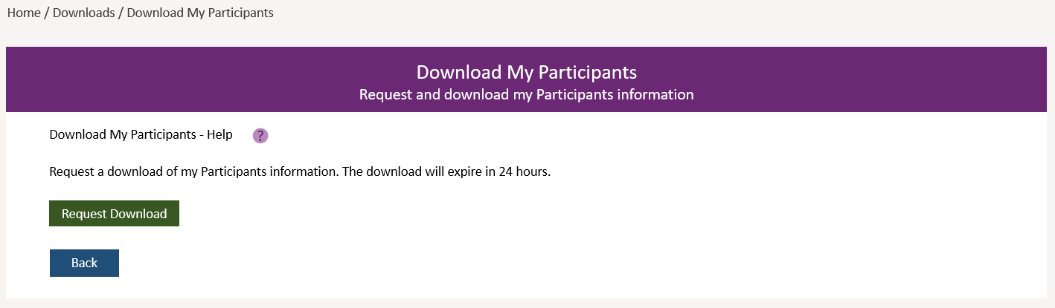
      - Select Request Download. Or select Back to go back to the Downloads page.
Note: You can also download one of the reports already listed.
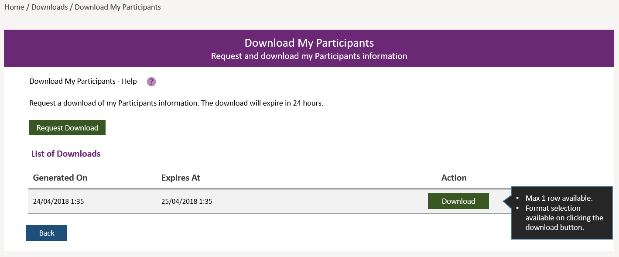

The Download My Participants screen displays with a green tick and system message saying ‘The request for download has been submitted.’ You can select Cancel Request to cancel a download (pending report) that you have just requested.
Or select Back to go back to the Downloads page.
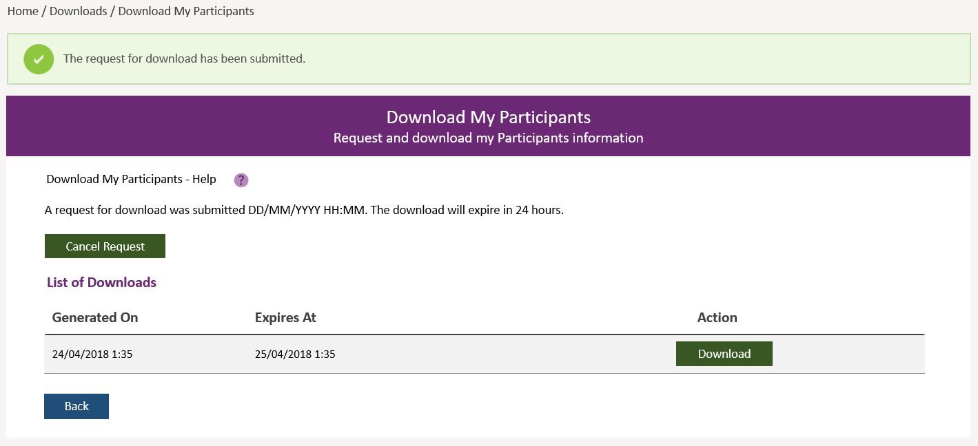
3. You will need to refresh the list of reports to view and download the report you have just requested. To do this, select Back to go back to the Downloads page.
The Downloads page displays once more.
4. Select the Download My Participants tile to view the list of available reports. Your report will be listed first.
Note: The system might occasionally experience delays of up to several hours when generating reports depending on the size of the report and system load at the time of request. In this case, you might need to repeat Steps 3 and 4 to see your report.
Select Download to download the report you requested.
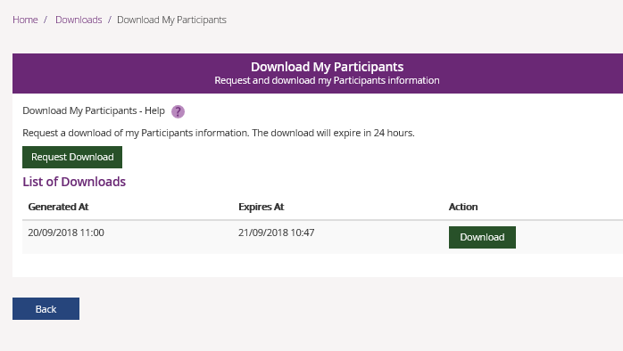
When you select Download, an Acknowledgement window will pop up. Check the box to show you agree and will adhere to the acknowledgement regarding use of the information in the report that you are about to download.

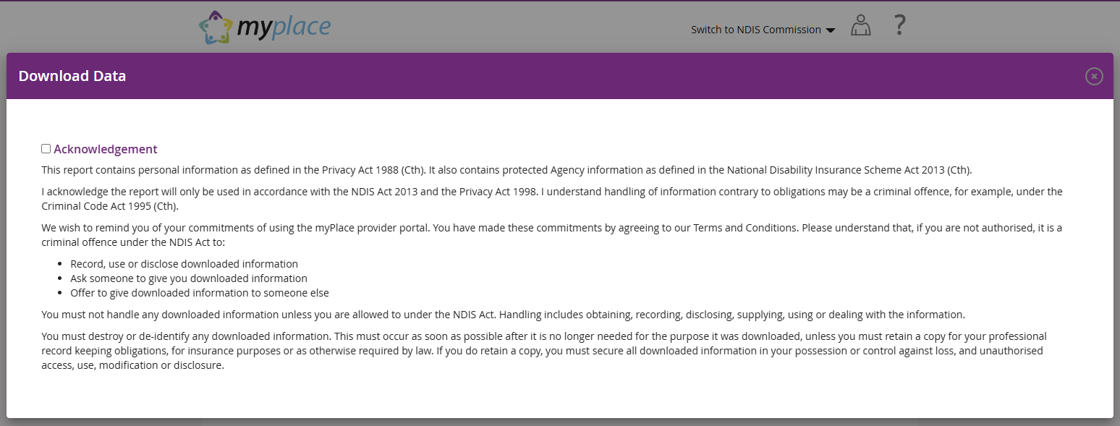
After you check the Acknowledgement box, the popup window will expand to display a number of file format download options.

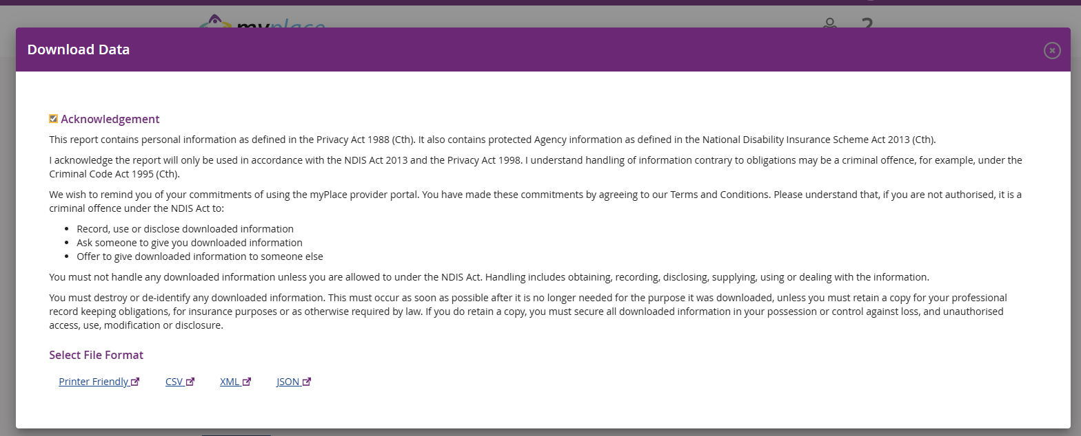
You have a choice of 4 format types depending on your business needs. They are:
Printer friendly — a format that allows you to view the data as a printable, readable report. If you wish to, you can use this format to output a PDF version; you will need to select to ‘print to PDF’ if this function is supported by your computer
- CSV (Comma Separated Values) — typically used to open as a spreadsheet for sorting and filtering the data. Note that this download has two heading rows
- XML (eXtensible Mark-up Language) — a format for importing into business systems
- JSON (JavaScript Object Notation) — a simple format for importing into business applications

Advance payment reconciliation report
The Advance Payment Reconciliation Report tile lets you download the advance payment reconciliation report in CSV format.
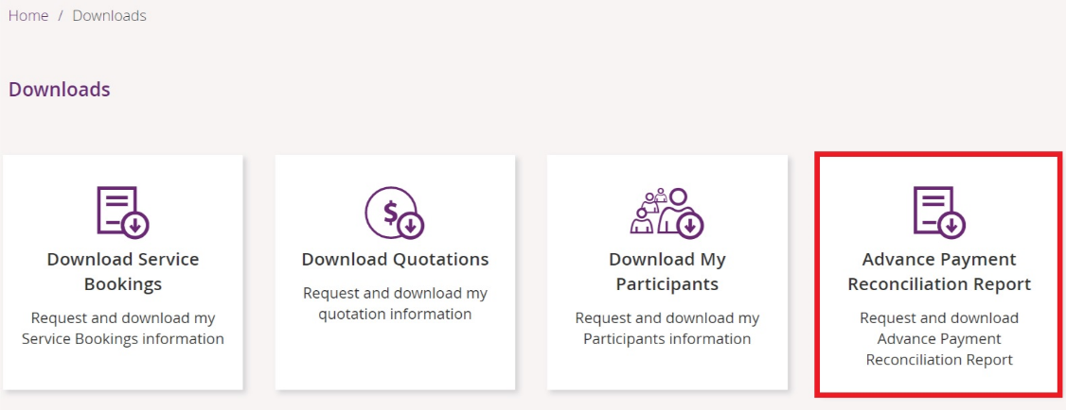
- Select Advance Payment Reconciliation Report.
- On the Advance Payment Reconciliation Report page, complete the From Date and To Date fields to set the date range for the report.
Note: The From and To dates must be within a 21-day period.
- Click Request Download. The system displays the request in the List of Downloads area.
- Click Download.
The report may take up to 10 minutes to download.
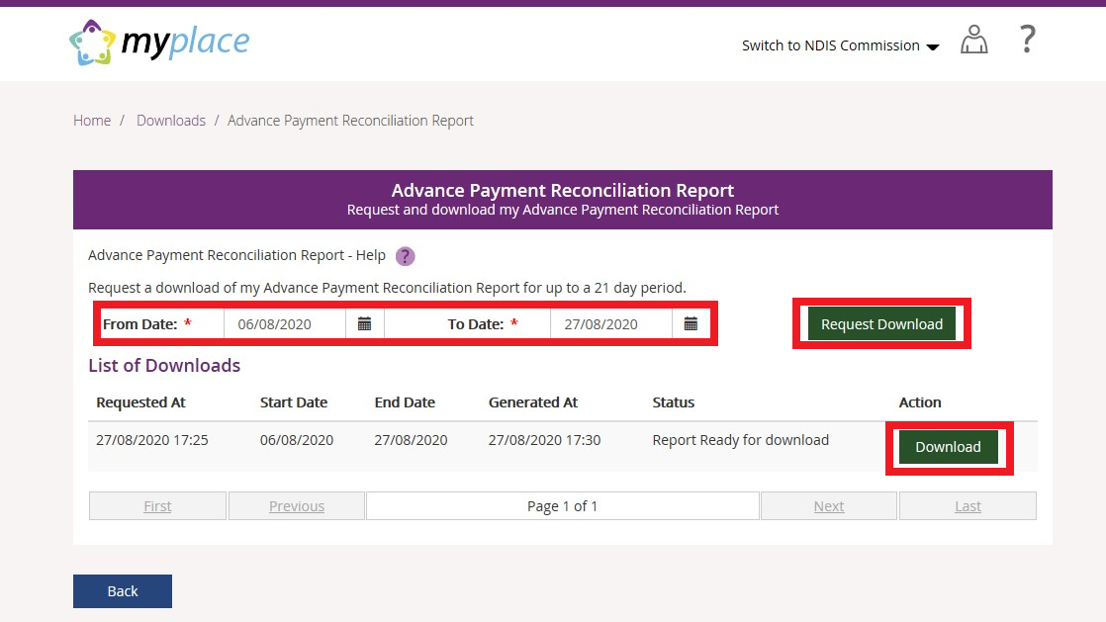
- Select the Acknowledgement checkbox. After you have acknowledged the message a link to a CSV file appears.
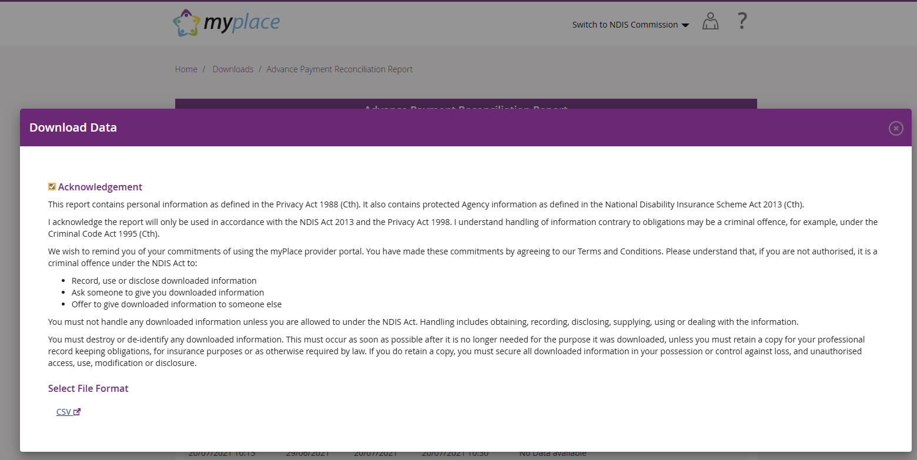
- Click the CSV link to download the report.
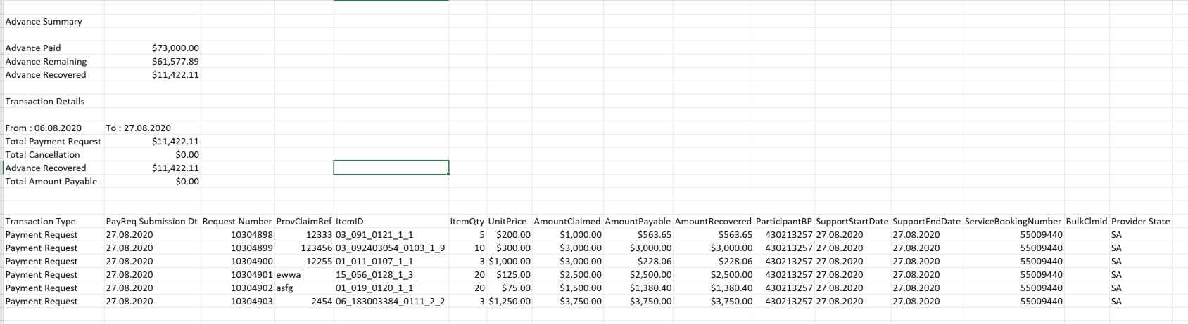
The Advance Payment Reconciliation Report summarises the total amount of the advance payment, the amount still owing, and the amount recovered.
It also displays the payment requests you made over the period of the report, alongside the amount the Agency deducted as advance payment recovery instalments.
Note: When viewing payment details, payment requests will have “offset” status against them for reconciliation purposes.

