
my NDIS provider portal

June 2026

Table of Contents
Changes from the last version 4
Introduction 5
What can I do in the provider portals? 5
Minimum browser requirements 6
Provider Learning Environment 6
How to contact NDIS 7
Access my NDIS provider portal 8
Set up your Digital ID and link to your business in RAM 10
Dashboard 10
Broadcast messages 11
Notifications 12
NDIS Quality and Safeguards Commission 12
Need some help with using my NDIS provider? 12
Quick links 13
Provider Portal Feedback Function 13
New Button to provide feedback for Provider portal: 13
Give my NDIS provider portal feedback page: 13
Feedback acknowledgement page 14
Selecting an organisation 15
Switching Portals 15
Notification Centre 16
my NDIS provider portal navigation 18
My Participants 19
Counter for New Participants 20
Maximum display of 2000 records on the My participant’s page 20
Sorting the participant relationships table 21
Search for and select a participant 21
View participant details 24
About Me 24
Goals 24
Budget 25
Funded Supports 30
Informal community and mainstream support 32
Participant nominee details 33
Provider roles 33
Extend or End provider roles 33
Request for Service 35
View Support Coordination Requests for Service 35
Maximum display of 2000 Requests on the Request history page 36
Respond to a Request for service 39
To Accept 39
To Decline 40
View the details of an accepted Request for service 41
Contact Details 42
Participant context 42
Reporting tasks 42
Submitted reports 42
Reporting tasks 42
Uploading reports for a Request for service 43
Organisation 45
View Organisation details 45
View Employee details 46
Relationship request tab for Registered Providers 47
Maximum display of 2000 requests on the Relationship requests page 48
Submit a new relationship request 48
Submit an Extend or End role request 50
Downloadable reports 51
Submit a payment enquiry 53
Submit a new payment enquiry 53
Linking Claims to Your Enquiry 55
Option a: Linking Claims (Recommended) 56
Option b: Manually Entering Claim Details 60
Finalising the Enquiry with Linked or Manually Entered Claims 61
Submit a payment enquiry on a closed enquiry 65
View existing payment enquiries 68
Maximum display of 2000 Records on the Enquiries page 72

Changes from the last version

The following updates have been made to the last published version of my NDIS provider portal step by step guide.

As of June 2026:
- Update to the “Introduction” section (Page 5-6)
- Provider feedback functionality added with screenshots. (Page 13-14)
- ‘Linking Claims to Your Enquiry’ section added with screenshots. (Page 55 to 63)

Introduction
The my NDIS provider portal is used for participants on the PACE system.
This is a separate portal to the myplace provider portal where you currently – and will continue to – manage your transactions with the NDIS, and the NDIS Integrity Portal Providers who are requested to use the NDIS integrity portal will be sent a letter explaining how and when to use the portal.
This step-by-step guide describes how my NDIS provider portal works and provides the general layouts of the menus and screens in the portal.
It also includes instructions for using each of the functions in the portal.

What can I do in the provider portals?
You can use my NDIS provider portal to: | - Select and switch between active organisations  - View broadcast messages  - View notifications  - Review, accept and decline Request for Service requests  - View participant details  - Review and submit your reporting requirement for Request for Service  - View participant plan and budget, where a participant has given consent  - View the Provider roles for participant  - Plan managers and my providers can request to add, extend and end a relationship with a participant  - View Organisation details  - Download reports  - View Employee details  - Extract key participant information in an excel report  - Submit and review claim and payments enquiries  - SDA providers can create and manage dwelling enrolments
You can use the myplace provider portal to: | - View and update your contact details  - View your NDIS (National Disability Insurance Scheme) registration details including updates to registration groups and professions  - View messages received from NDIS  - Instant message with your linked participants  - Create and manage service bookings  - Create and view payment requests (previously known as claims)  - View and respond to quotes received from NDIS  - View referrals made to your organisation  - View Support Coordination Requests for Service and action these requests  - Upload required documents  - Submit and review enquiries or complaints  - Download reports about all your service bookings and participants  - Access the provider learning environment to learn how to use my NDIS provider portal
You can use the Integrity portal to: | - Submit evidence for new claims  - Additional functionality will be added over time

Minimum browser requirements
To access my NDIS provider portal. Please use one of following browsers:
- Google Chrome
- Microsoft Edge
- Mozilla Firefox
- Safari on Mac OSX

Provider Learning Environment
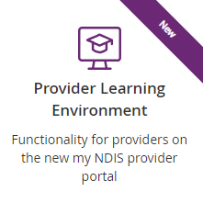
We have released a learning environment to help you learn to use the new my NDIS provider portal. You can access the provider learning environment via this link https://provider-portal-training.ndis.gov.au/
The new learning environment includes walk-through tutorials. The tailored tutorials are available in the learning environment for different provider types and reflect the access providers have within my NDIS provider portal.
The tutorials have easy to follow steps to help you learn the processes and will be updated with new tutorials as functionality is added to my NDIS provider portal.

How to contact NDIS

Contact the NDIS by
  NDIS Live Webchat  Webchat |   Phone  1300 311 675 |   Provider Portal Enquiry
You can live chat with us about: | You can call us about: | You can use the provider portal to:
- my NDIS provider portal  - Service bookings  - Payment requests  - Quotes  - Referrals  - Request for service  - Searching for a registered provider | - my NDIS provider portal  - Service bookings  - Payment requests  - Quotes  - Referrals  - Request for service  - Searching for a registered provider  - Submitting a general enquiry, feedback, compliment, or a complaint | - Submit a payment enquiry  - Submit a general enquiry, feedback, compliment, or a complaint  - Search for a provider  - Upload documents
  Email  provider.support@ndis.gov.au |   Contact & Feedback Form  NDIS Online Form |   Mail  National Disability Insurance Agency  PO Box 700  Canberra ACT 2601
You can email us about: | You can use the online form to: | You can mail us to:
- Submit a general enquiry, feedback, compliment, or complaint  - Email a document, form report or letter | - Submit a general enquiry, feedback, compliment, or a complaint  - Request a call back | - Send a compliment, complaint or provide feedback,  - Document, form, report or letter

Access my NDIS provider portal
Users can access my NDIS provider portal from the link on the NDIS home page (www.ndis.gov.au).
- Access my NDIS portal using the “Portal sign in” button on the NDIS website and selecting "Provider portals” from the pop-up menu.
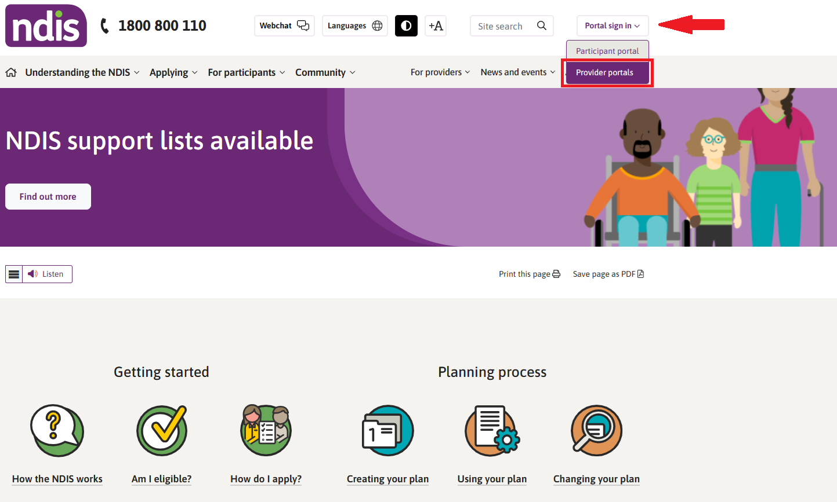

Select the option "Continue with Digital ID" to log in with your myID.
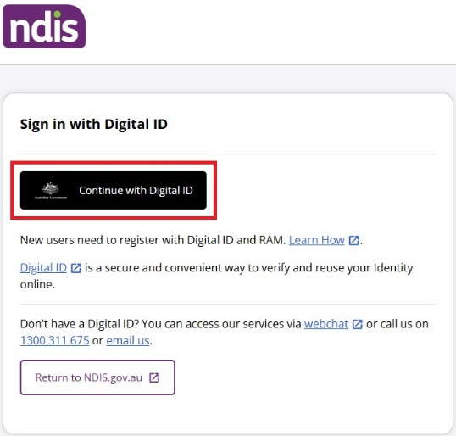

- Sign in with Digital ID
  - Select your identity provider to login using your myID.
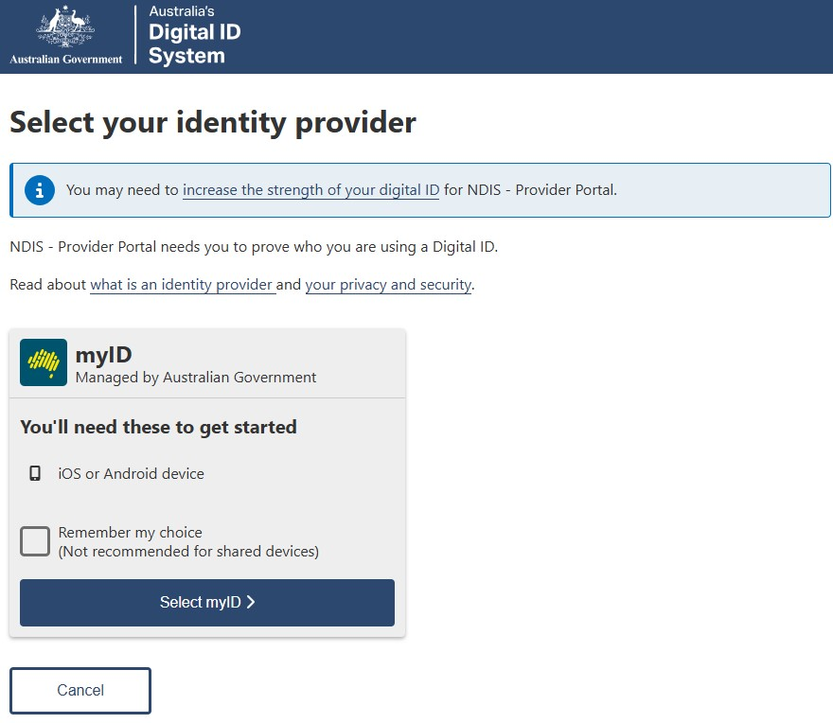
  - When you have selected myID, log in using your personal myID login details.
  - Select the organisation from the ‘Businesses I can act for’ in RAM.
Note: If you are only authorized on behalf of one organisation, you will be automatically redirected to the NDIS provider portals selected screen as shown below.
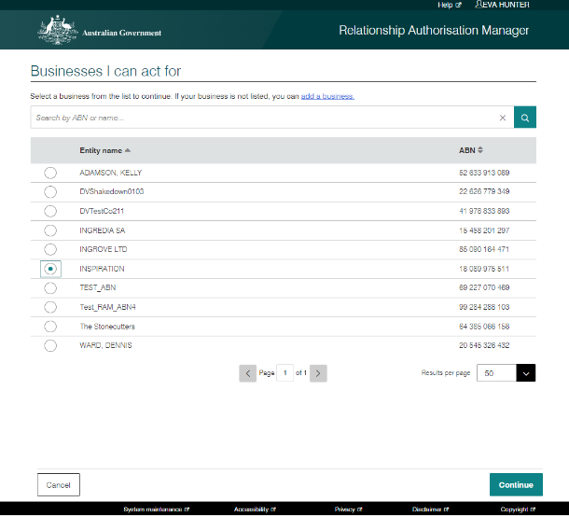
  - If you are authorised to access the NDIS Provider Portals for one provider organisation only, or once you have chosen an organisation from the RAM ABN selection page, the NDIS Provider Portals landing page will load where you will see my NDIS provider portal tile.
- Choose my NDIS provider portal tile on the landing page (N.B. my NDIS provider portal tile will not be available for State and Territory Public Trustee and Guardian staff. They will only be able to choose the myplace provider portal).

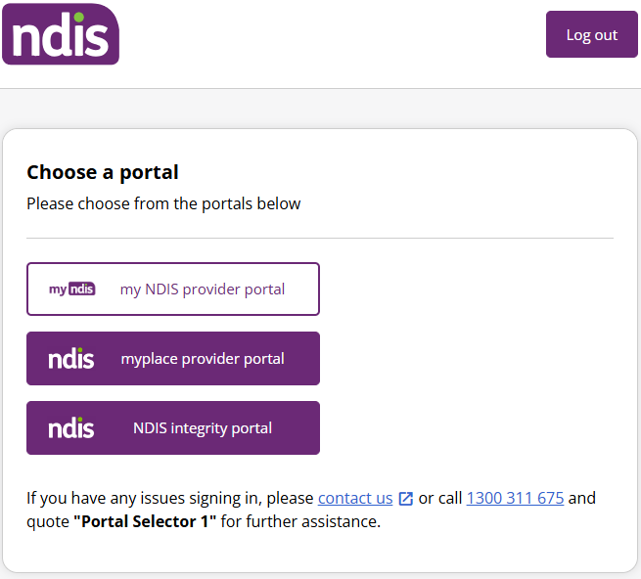

Set up your Digital ID and link to your business in RAM
If you do not have your myID set up, or you are not linked to a provider organisation in RAM, please refer to the myID and RAM Step-by-Step Guide for NDIS Provider Portals found on the NDIS website.

Dashboard
A dashboard is located when you access my NDIS provider portal.
The dashboard will provide you with useful information at a quick glance on:
- Broadcast messages
- Notifications
- NDIS Quality and Safeguards Commission
- Need some help
- Quick links
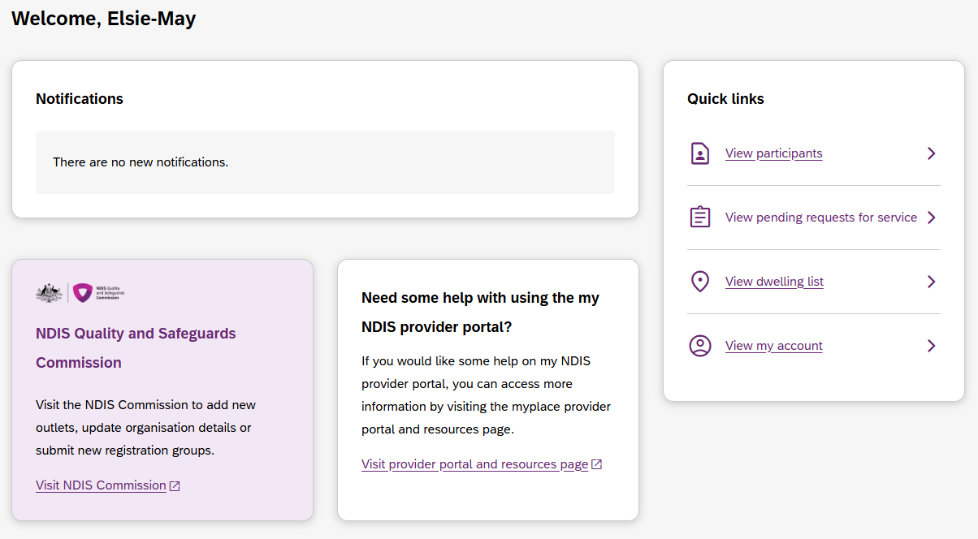
Figure 3 my NDIS provider portal dashboard page

Broadcast messages
A yellow banner will appear when scheduled maintenance to my NDIS provider portal is planned. The information displayed will be the date and time that the system will be unavailable.

Notifications
This card will display new notifications for:
- A new participant plan has been approved
- Changes have been made to your recorded my provider role
- Changes have been made to your recorded plan manager role.
- Changes have been made to your recorded support coordinator role.
- Changes have been made to your recorded recovery coach role.
- A new my provider role recorded.
- A new plan manager role recorded.
- A new support coordinator role recorded.
- A new recovery coach role recorded.
- A new request for service
- Changes have been made to the participant’s existing plan
You can select the hyperlink of the notifications, and it will navigate you to the corresponding tab in my NDIS provider portal.
- The new request for service notifications will direct you to Request for Service Pending request tab
- All the other notifications will direct you to the Participants record
If you have no notifications, then a message will appear advising you that you have no notifications to display.

NDIS Quality and Safeguards Commission
This card has a hyperlink to the NDIS commission.
You can select the hyperlink to navigate to the NDIS Quality and Safeguards Commission to update your registration, organisation, and outlet details.

Need some help with using my NDIS provider?
This card has a hyperlink to the NDIS provider and portal resource page.
You can select the hyperlink to navigate to the NDIS provider and portal resource page to access my NDIS provider portal guide.

Quick links
This card has hyperlinks to:
- View participants
- View pending requests for service
- View my account
You can select the hyperlinks to navigate to the to the corresponding tab in my NDIS provider portal.

Provider Portal Feedback Function

New Button to provide feedback for Provider portal:
You can give feedback about the Provider portal by clicking ‘Give provider portal feedback’ button, which is placed at the bottom of the screen. The button can be accessed from all the pages.

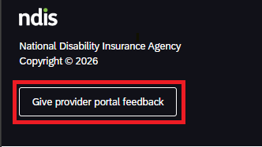
Figure 4: Provider portal feedback button

Give my NDIS provider portal feedback page:
You will be navigated to the next page to give feedback about the Provider portal. You can rate your experience within the portal by selecting the stars. You will have the option to elaborate on the star rating, suggest amendments, or let us know what’s working well for you’.
Clicking the ‘Submit feedback’ button will submit the feedback and navigate you to the feedback acknowledgement page.
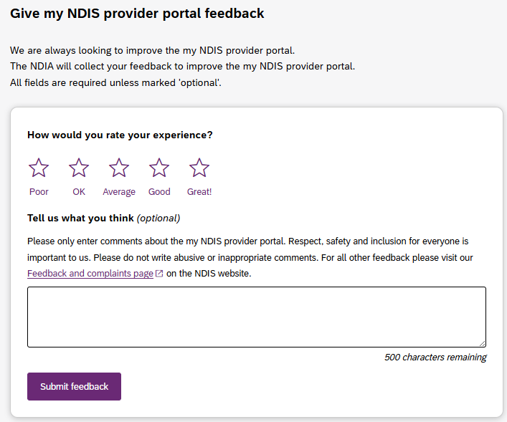
Figure 5: Provider portal feedback page

Feedback acknowledgement page
When you click the ‘Submit feedback’ button and the feedback is submitted successfully, you will be navigated to the feedback acknowledgement page.
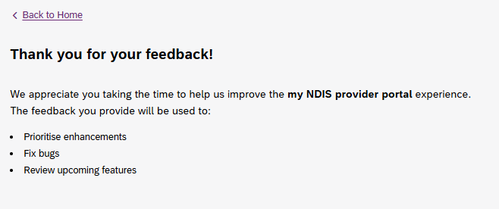
Figure 6: Feedback acknowledgement page

Selecting an organisation
If you work on behalf of more than one provider organisation, you can switch between those organisations from my NDIS provider portal.
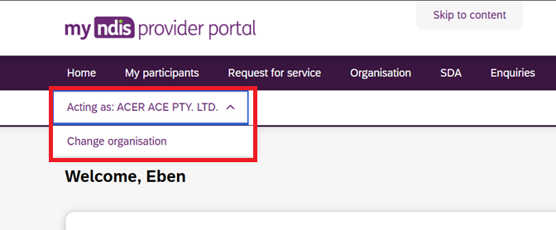
- Click ‘Acting As' dropdown button under top left of the navigation bar.
- This action reveals another button labelled "Change Organisation".
- Upon clicking this button, the user is redirected to Org/ABN selection screen in the same tab.
- User selects the new Org/ABN.
- Then the user is taken back to my NDIS provider portal dashboard for the new ABN in the same tab.

Switching Portals
Upon clicking the user profile icon in the top right of the navigation bar a drop-down menu appears that includes a button to navigate to myplace provider portal labelled ‘Go to myplace provider portal’.
When the user clicks ‘Go to myplace provider portal’ button, a new tab opens with myplace provider portal dashboard page for the same ABN/organisation that is currently selected.
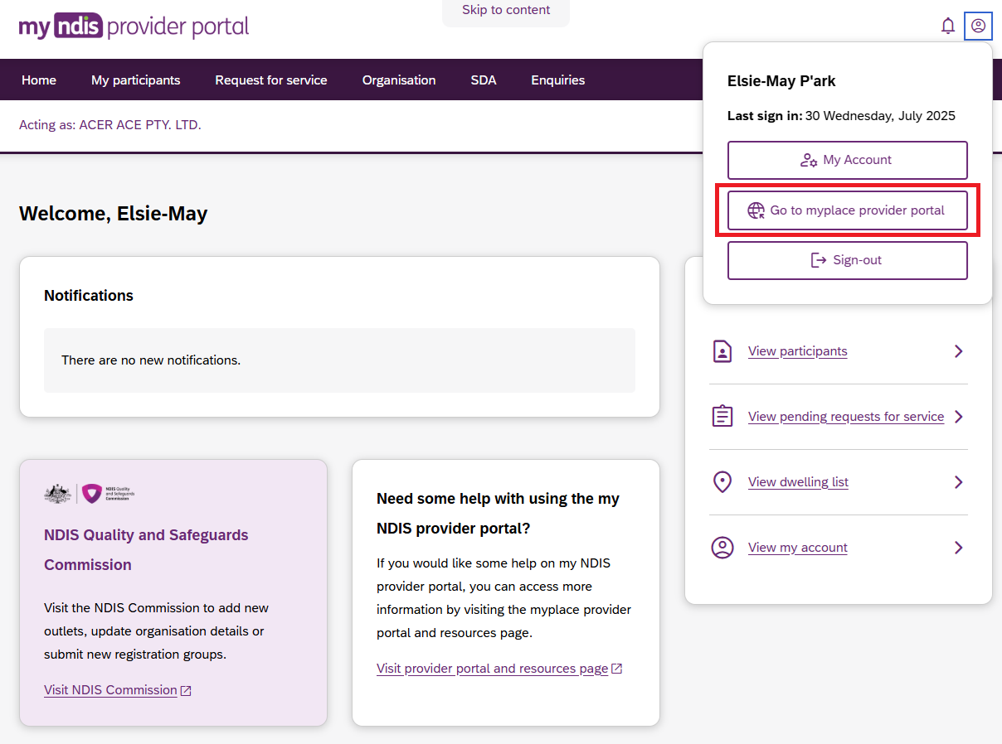

Notification Centre
A notification bell icon is located on the global navigation bar. This bell icon lets you know how many new notifications have been sent to your organisation today.

Figure 7 Bell icon for notifications

When you click on the bell notification the Notification Centre will display.
You will be able to view the new notifications for:
- A new participant plan has been approved
- Changes have been made to your recorded my provider role
- Changes have been made to your recorded plan manager role.
- Changes have been made to your recorded support coordinator role.
- Changes have been made to your recorded recovery coach role.
- A new my provider role recorded.
- A new plan manager role recorded.
- A new support coordinator role recorded.
- A new recovery coach role recorded.
- A new request for service
- Changes have been made to the participant’s existing plan

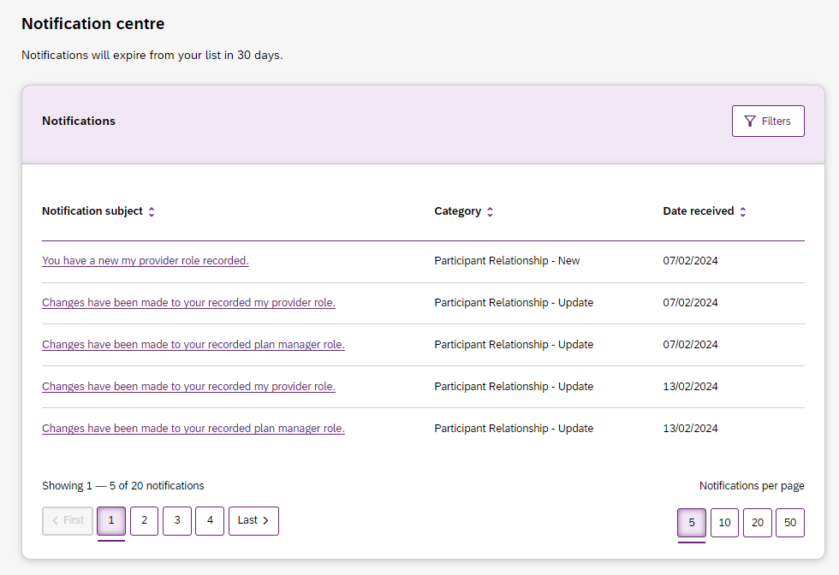
Figure 8 Notification centre

The encircled number beside the bell notification and the Notification centre page shows the number of notifications that you have received today.

my NDIS provider portal navigation

Depending on your organisation’s role you will see several tabs in my NDIS provider portal.
Home: allows you to navigate back to the dashboard
My participants: allows you to search for a participant associated with your organisation and view certain details about them and their plan.
Requests for service: allows you to manage requests for service, respond to requests and submit reports for requests.
Organisation: allows providers to view information about your Organisation, Employees, and Relationships requests.
SDA: allows providers to manage Specialist Disability Accommodation (SDA) dwelling enrolments.
Note
Instructions for using the SDA functions in my NDIS provider portal are provided
in a separate guide: my NDIS provider portal: Specialist Disability Accommodation (SDA) Dwelling Enrolment (Step-by-step guide).
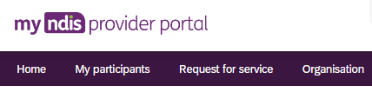
Figure 9 my NDIS provider portal navigation tabs

My Participants
The Participant relationship list allows you to search for a participant and view their plan when the participant has given the NDIA consent to share their plan with you.
The NDIA requires consent from participants to share their plans with providers. Only participants and their nominees can provide the NDIA with the consent to share their plans with providers. Participants have the choice to either share or not share their plans with you and can withdraw consent at any time.
In addition, you can view other information, including:
- NDIS number,
- Participant name
- Location
- Role
- Role start date
- Role end date
- Status
Note: The role column will state the role that you have with the participant. Roles can be my provider, plan manager, support coordinator or recovery coach. A participant may appear in the list more than once if you have multiple roles with them.
If a participant relationship started within the past 29 days AND is due to end within the next 29 days, the participant relationship will show the status of "Ending soon" by default. However, if the table is sorted manually by “Role start date”, those participant relationships will be displayed with status “New” and if the table is sorted by “Role end date”, they will be displayed with status “Ending soon”. Similarly, the same relationship will also appear in the filtered list when a ‘Status’ filter is applied. This means a participants could have either a 'New status' or an 'Ending soon status', under this circumstance.
Table 1 Role status
Participant status | Definition
New | Role started within the last 29 days.
Ending soon | Role ends within the next 29 days

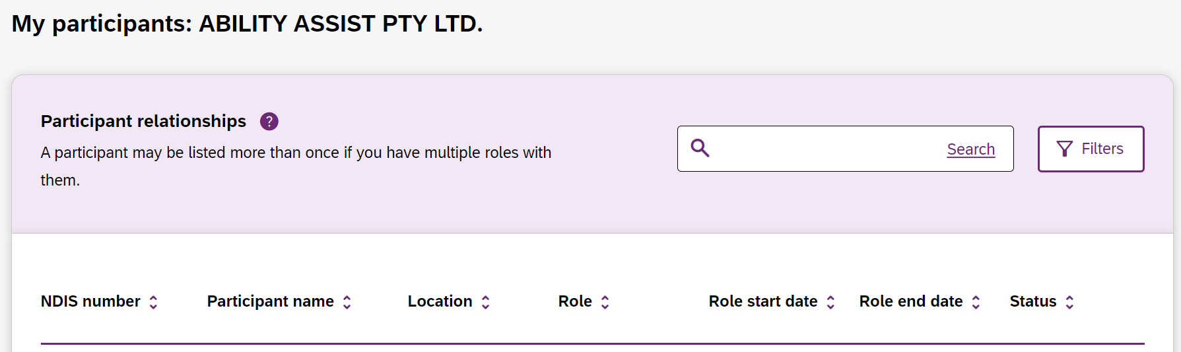
Figure 10 Participant List

Counter for New Participants
A counter will display next to organisation name that will show how many participants your organisation has with the status of ‘New’’.

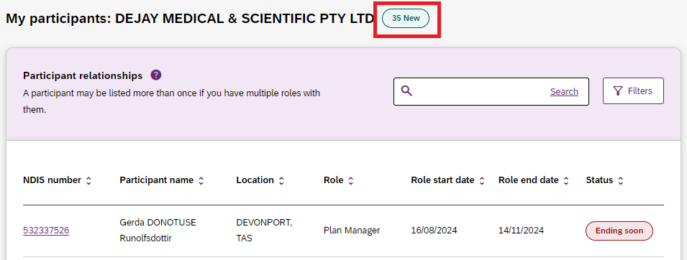
Figure 11 Counter for New Participants

Maximum display of 2000 records on the My participant’s page

This list will display a maximum of 2,000 records. The below error message will appear if this limit is exceeded. To view the remaining records, use the search and filter tools.

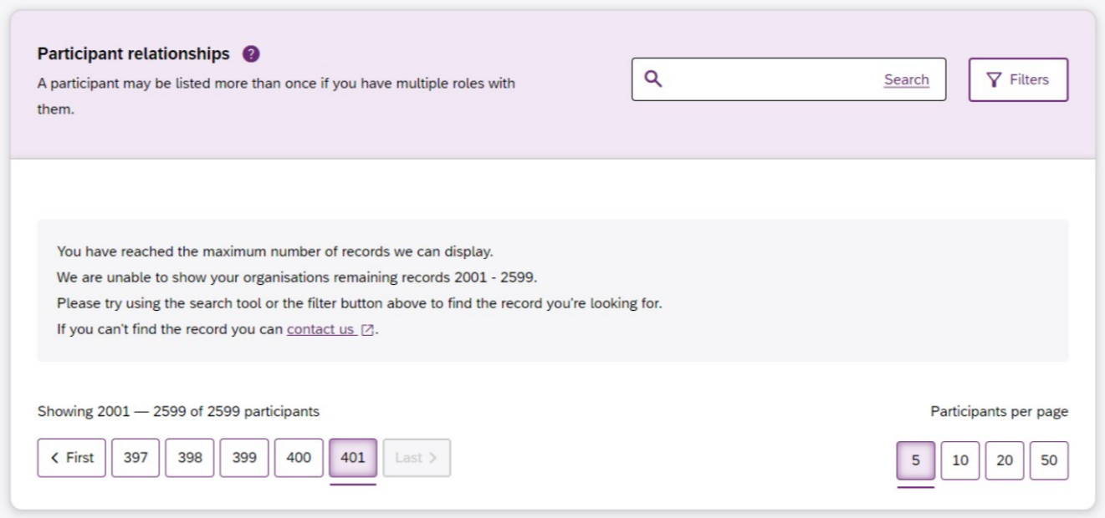
Figure 12 My participants page, 2000 records display error message

Sorting the participant relationships table
By default, all Participant relationships will be sorted in the ascending order of the ‘Role end date’. This will display Participant relationships with status ‘Ending soon’ at the top of the list followed by those with either the status of ‘New’ or no status.
When there are multiple records with the same Role end date, the records will be displayed in the alphabetical order of participants first name, ascending (A-Z).
Columns with an up-down chevron can be sorted in ascending and descending order by clicking the column headings.
Manual sorting of ‘Status’ column displays participant relationships sorted in descending order of the 'Role start date'. This will display participant relationships with the status ‘New’ at the top of the list followed by those with either the status of ‘Ending soon’ or no status.
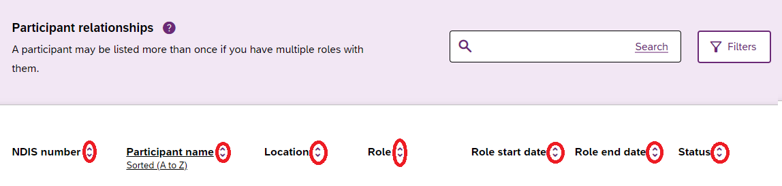
Figure 13 Sortable columns on My participants page

Search for and select a participant
To search for a participant:
- Select the My Participants tab
Figure 14 My Participants tab
2. A list of your active participants will be displayed.
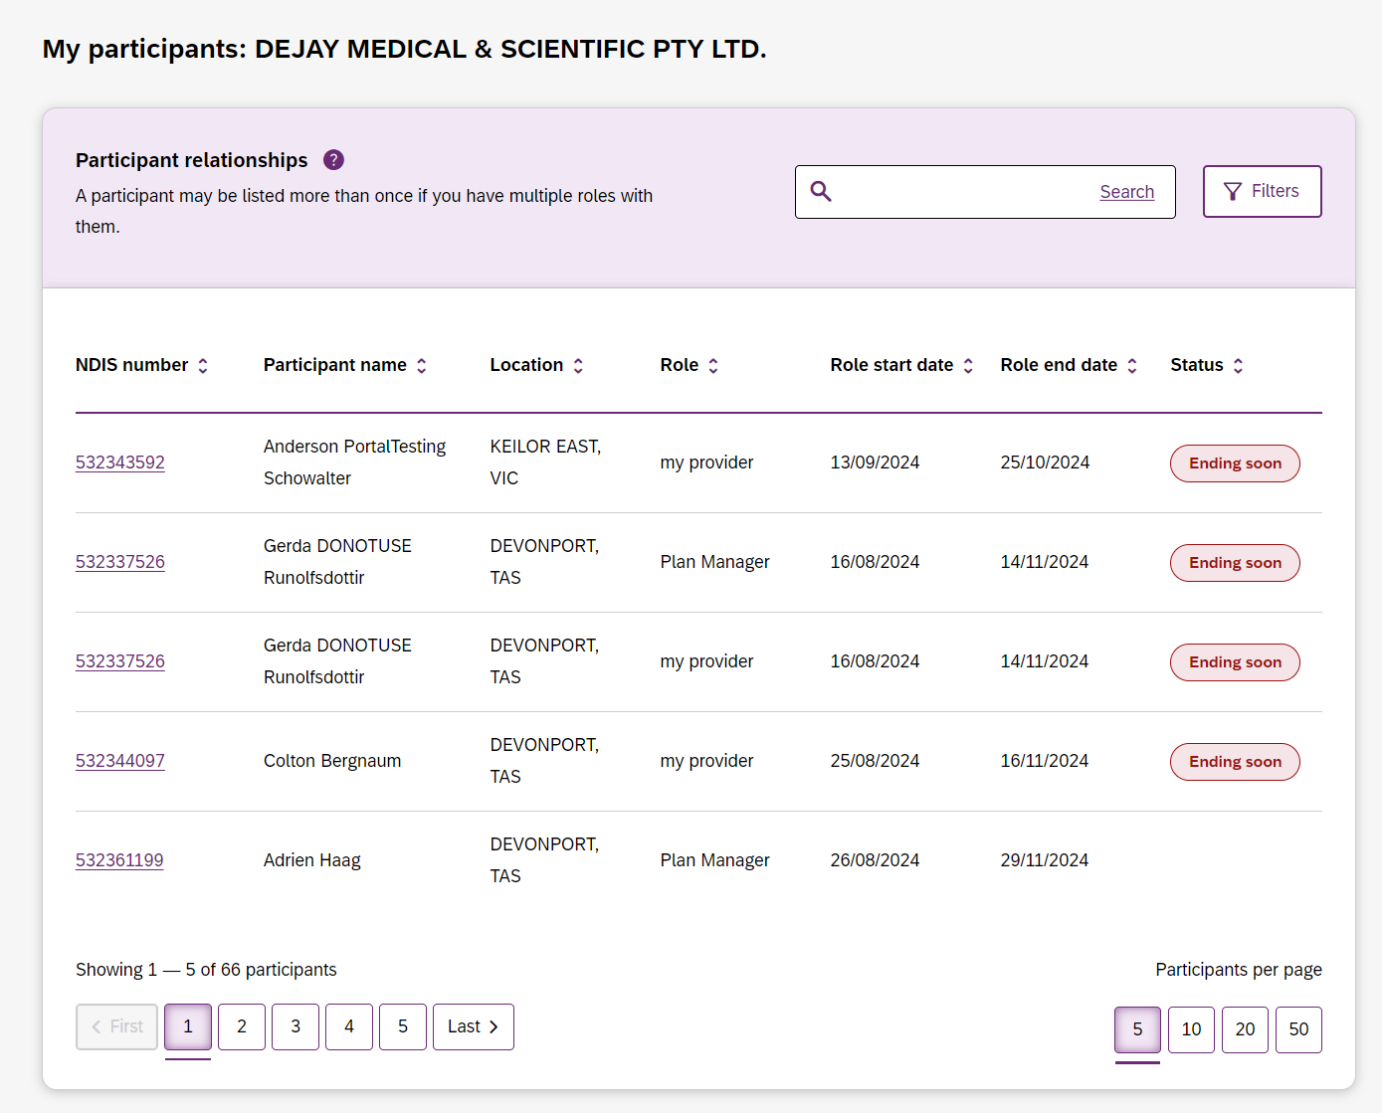
Figure 15 Participants relationships page

- To search for a participant, enter the participant NDIS number (for best results), or enter the participant’s name in the search box and click Search.
- To filter your list. Click on the Filters button. You can filter by choosing the Location, Role, Role start date, Role end date and/or Status and click Apply filters.

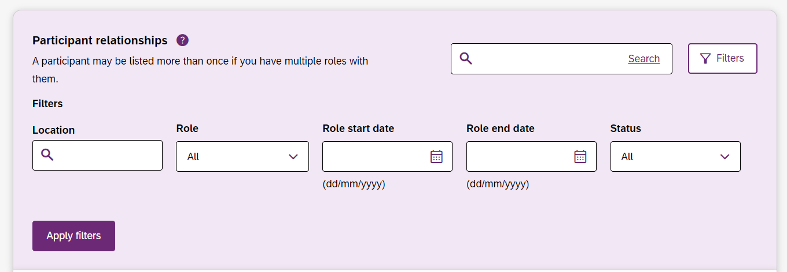
Figure 16 Participant Search Box and Filter options
5. To view the participant’s plan, click on their NDIS number.

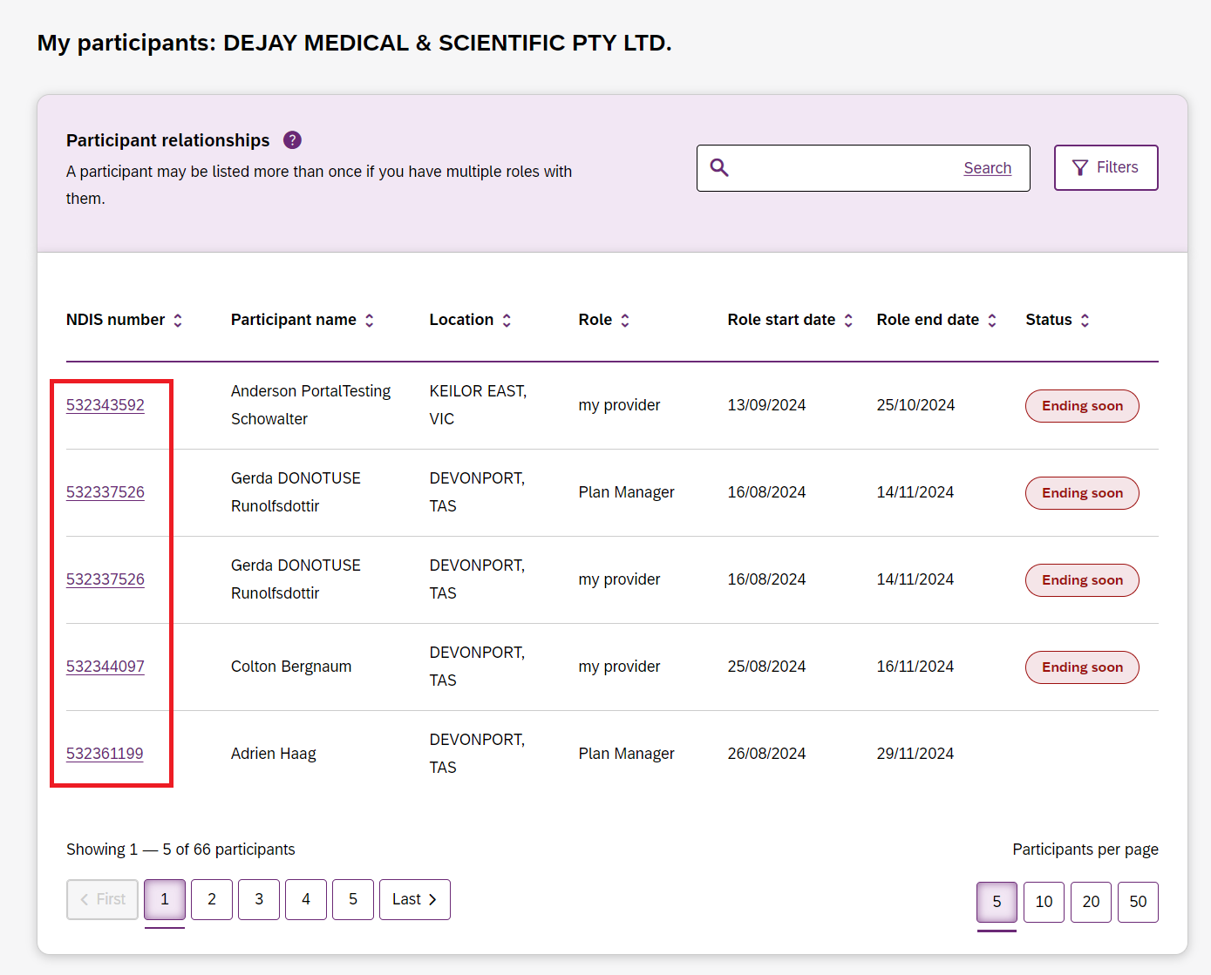
Figure 17 My participants home tab, showing links to the participant details page

View participant details
The Participant plan page shows the participant’s basic details, including their name, NDIS number, date of birth and contact details.
The NDIA requires consent from participants to share their plans with providers. Only participants and their nominees can provide the NDIA with the consent to share their plans with providers. Participants have the choice to either share or not share their plans with you and can withdraw consent at any time.
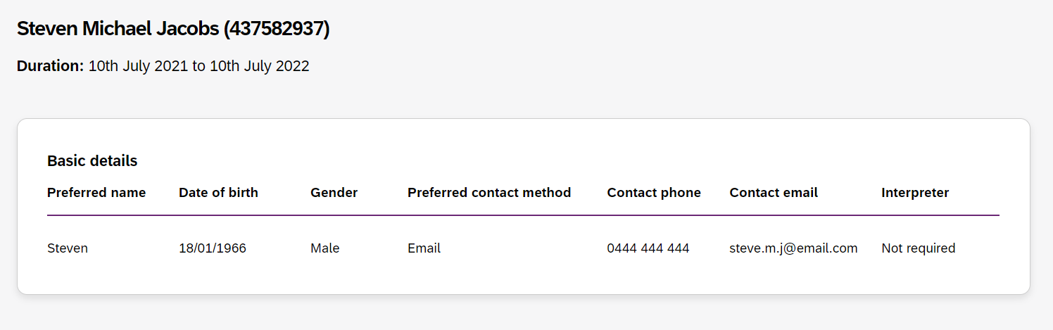
Figure 18 My Participants page showing basic details

Depending on your organisation’s registration the information which is displayed will vary. The following sections may be available:
- About me
- Goals
- Budget
- Funded Supports
- Informal community and mainstream support, and
- Participant nominee details.
To open each section, click on the relative tab.
Note: Due to the recent Section 33 Legislative Changes, the information seen within the Budget and Funded supports tab is dependent on whether the current approved plan includes funding periods or not. More information can be found on the Frequently asked questions about legislation | NDIS website.

About Me
The About me section shows details about the participant's daily life, living arrangements and strengths.
This section is only displayed when a participant has given consent to the support coordinator or psychosocial recovery coaches to view their plan.

Goals
The Goals section outlines a participant's goals and how they will reach them.
This section is only displayed when a participant has consented to you to view their goals.
By selecting “View goals history” a provider can view a participant’s past goals. A goal appears in this list when a participant informs NDIA that they no longer working towards a goal.
The goals history is only visible when a participant has allowed you to view their past goals, and you are either a support coordinator, psychosocial recovery coach or a plan manager.
Note: My provider role is unable to view past goals.

Budget
The budget tab shows details about participant’s live budget on the day of accessing the budget tab. This will include the amounts funded, spent, and remaining for claimable supports included in the participant’s plan.

By selecting ‘View budget history’ a provider may view a list of previous budgets and their dates. Selecting a previous budget from this list will display the details of funding for that budget period.

The budget history is only visible when a participant has consented for you to view their past budgets.
Note: When you have been given consent to view a participant current/historical plan and you are:
- Support coordinators or psychosocial recovery coaches you may view all budget details.
- Plan managers you can only view the plan managed budget details and whether the budget is available or exhausted for self-managed and agency managed budgets.
- As my provider budget details are not available.

Plans without Funding Periods
The Budget section may include details of each category of funds included in a participant’s plan, including:
- Core flexible: Self-managed funds
- Core flexible: Registered plan managed
- Core flexible: Agency managed
- Stated supports
- Recurring payments

Plans with Funding Periods
The Budget section includes a ‘Total funding amount’ accordion that describes how the participant’s total funding amount is calculated.
This accordion lists a breakdown of all the available funding components and their corresponding funding amounts that are included in the participant’s plan.
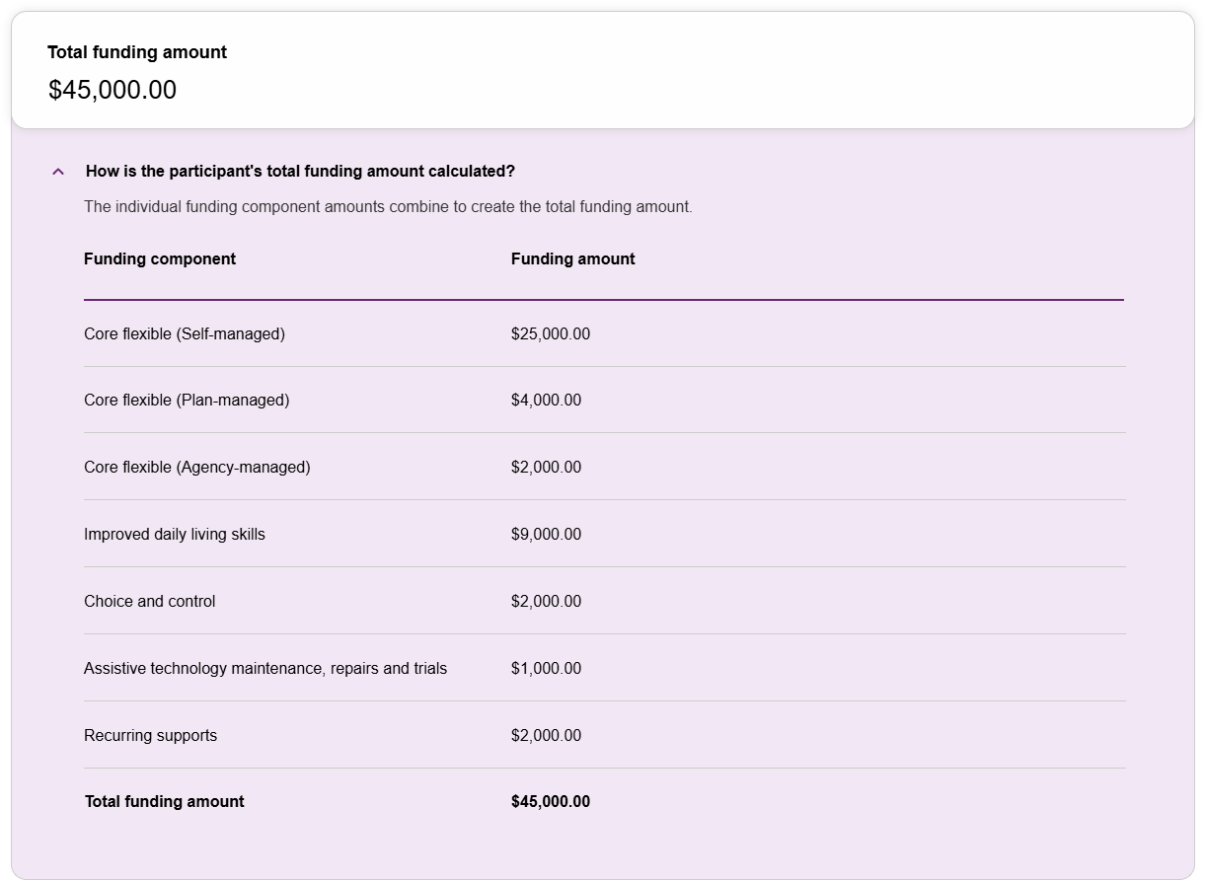
Figure 19 ‘Total funding amount’ accordion expanded view displaying information on funding components and their corresponding funding amount allocated to a participant’s plan that has funding periods. This image represents a Support co-ordinator/Recovery coach view.

The Budget section may include details of each funding component in a participant’s plan, including:
- Core Flexible (Self-managed)
- Core Flexible (Plan-managed)
- Core Flexible (Agency-managed)
- Stated supports
- Recurring Transport
For each funding component included within the plan, you will be able to see:
- Support Category – Name of the support category included in the funding component.
- Management Type – The fund management type for the funding component.
- Released - The total amount of funds made available for spending from the funding periods lapsed in the participant’s plan.
- Spent - The total amount of funds spent across the funding periods lapsed in the participant’s plan.
- Available - The total amount of funds available for the participant to spend during the current funding period. This amount includes any unspent funds from previous funding periods in the same plan alongside any funds released for the current funding period.
- Actions – The below are available under the Action column.
  - Funding period schedule – Displays a schedule of funding periods assigned to a funding component.
  - Support detail – Displays the base support description of the support category along with any additional comments relevant to this category.
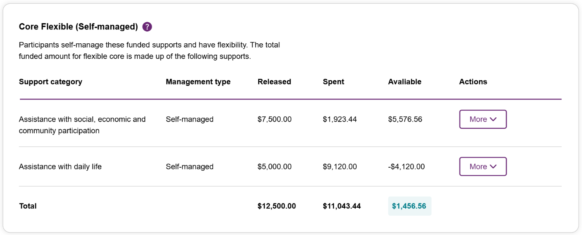Figure 20 Funding component card displaying information on supports included in a participant’s plan that has funding periods. This image represents a Support co-ordinator/Recovery coach view.

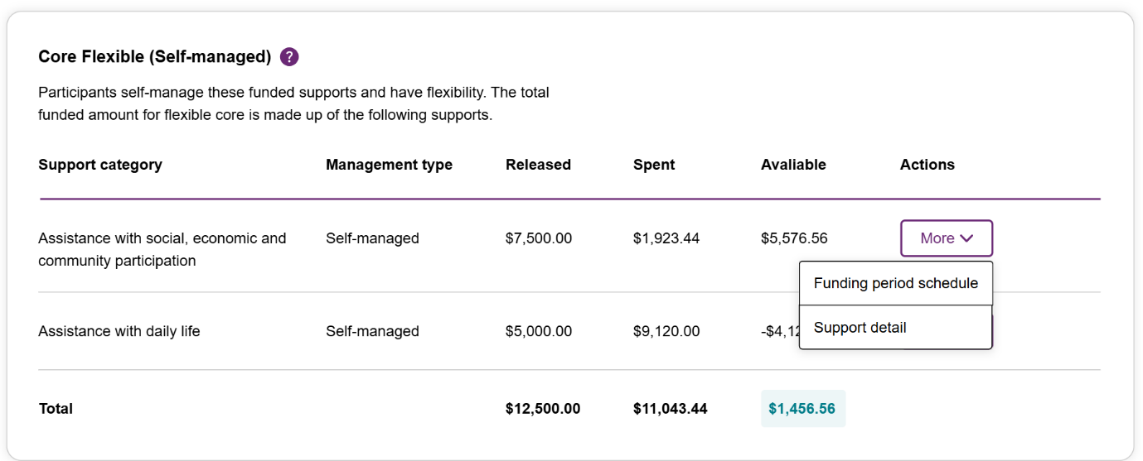
Figure 21 Funding component card displaying information on options of Funding period schedule and Support detail in a participant’s plan that has funding periods. This image represents a Support co-ordinator/Recovery coach view.

When you have the consent to view budget figures for a funding component, the Actions column will be displayed next to the Available column.
Clicking the 'More’ button will bring up two options - 'Funding period schedule’ and ‘Support detail’.
Clicking on the ‘Funding period schedule’ option will bring up a Funding period schedule pop up modal, which will display the following information for the funding component:
- Funding period - Displays the start and end date of a funding period.
- Length – Displays the length of the funding period. This will usually be 1, 3, 6, or 12 months.
  - Note: If a support category is added to a funding component after the plan is approved, you will see ‘Unavailable’ in the length column.
  - For example, once a plan is approved, if a support category (other than core flexible supports) is added to a plan through a variation, the funding period for the newly added support category will not match the other funding periods in the plan. Therefore, the new support category funding period length will display as ‘Unavailable’.
  - For core flexible supports, the display of ‘Unavailable’ would only occur when the entire core flexible component (of a single management type) is added to a plan after the plan is approved.

- Funding period amount - Displays funds allocated to any given funding period.
- Released - Displays 'Yes' or 'Not yet released' respectively for funds having been released for a given funding period or not.
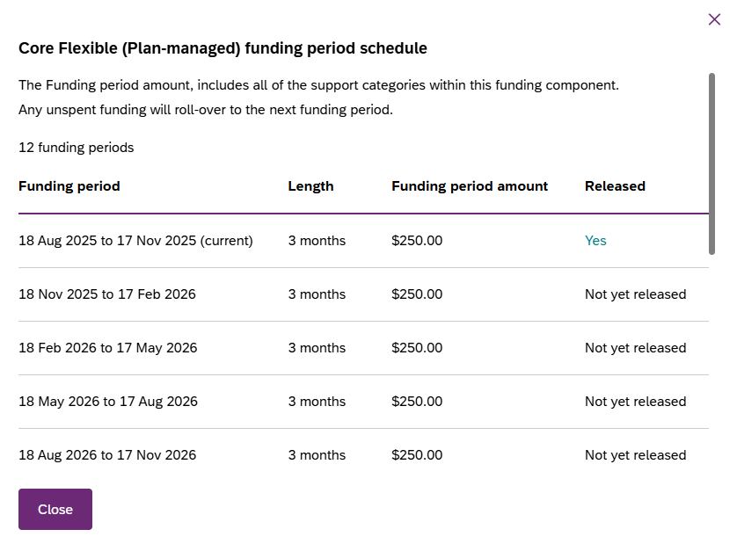
Figure 22 Funding period schedule pop-up displaying information on funding periods assigned to a specific funding component. This image represents a Support co-ordinator/Recovery coach view.

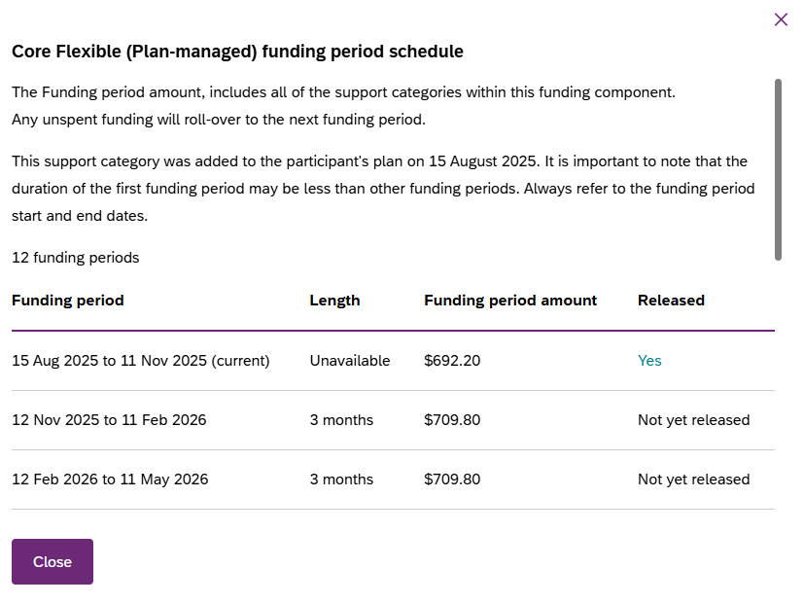
Figure 23 Funding period schedule modal displaying information for a funding component. This example has a support that was added after the plan approval therefore the length is 'unavailable'.
Clicking on ‘Support detail’ option will bring up a Support detail pop up modal to display the following information for the support category:
- Support detail header - Displays the name of the Funding component or support category.
- Support category name – Displays the name of all the support categories within the funding component in a expand-collapse modal.
- Support detail information – Displays the base support category description of each of the supports within the funding component along with all the plan comments available for the support separated by two-line breaks.
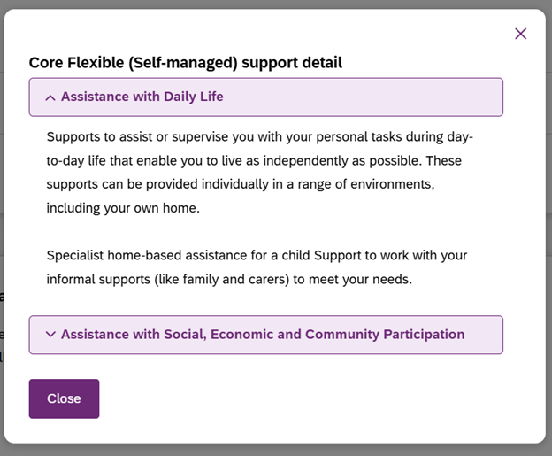
Figure 24 Support detail pop-up displaying the base support category description of the corresponding Support category included the funding component. This image represents a Support co-ordinator/Recovery coach view.

Funded Supports
The funded supports outline all the supports that are funded in a current plan, at the time of plan approval, that is, the budget information is not live and therefore does not include information on funds spent and funds remaining. Live budget details are available in the Budget tab.

By selecting ‘View funded supports history’ a provider may view a list of changes to a participant’s funded supports. Selecting a change reason (participant’s previous plan) from this list will display the details of funded supports at that point in time.

The funded supports history is only visible when a participant has given consent for you to view their funded supports history.

Note: When you have been given consent to view a participant current/historical funded support and you are:
- Support coordinators or psychosocial recovery coaches you may view all funded support details
- Plan managers can only view the plan managed funded supports details
- As my provider funded supports details are not available.

Note: We are aware indexation is not displayed in the historical funded supports pages. Please refer to the ‘Budget’ tab for budget amounts including indexation.

Plans without Funding Periods
The Funded supports section shows total funded supports for each support category, and details of the funding available in each category.

Plans with Funding Periods
The Funded supports section includes a ‘Total funding amount’ accordion that describes how the participant’s total funding amount is calculated.
This accordion lists a breakdown of all the available funding components and their corresponding funding amounts that are included in the participant’s plan.
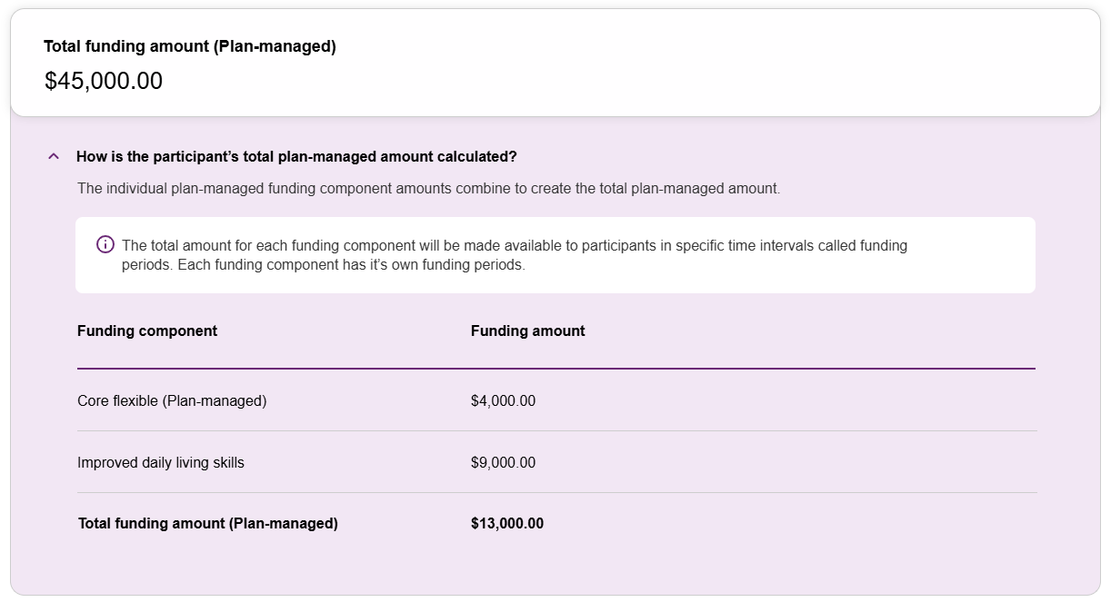
Figure 25 ‘Total funding amount (Plan-managed) accordion expanded view displaying information on funding components and their corresponding funding amount allocated to a participant’s plan that has funding periods. This image represents a Plan manager view.
The Funded supports section shows the total funding amount – the total amount for all reasonable and necessary supports funded in the participant’s plan.
Each funding component section is displayed in an accordion view which has both collapsible view and expanded view.
Within each collapsible view of a funding component, you will be able to see a summary of the funds allocated to it, that includes:
- Funding component name – Name of the funding component.
- Budget type – The budget type of the funding component. E.g., Flexible or stated.
- Management type – The fund management type for the funding component. E.g., Self-managed, Plan-managed or Agency-managed.
- Funding amount – Total amount allocated to the funding component.
Within each expanded view of a funding component, you will be able to see a detailed view of its funding period schedule and support details that includes:
- Support details section – Displays the support category description and relevant comments around support items funded under the support category.
- Funding period schedule section - Displays a schedule of funding periods assigned to a funding component. It includes the below details:

  - Displays total number - of funding periods for the funding component.
  - Funding period - Displays the start and end date of a funding period.
  - Length – Displays the length of the funding period. This will usually be 1, 3, 6, or 12 months.
    - Note: If a support category is added to a funding component after the plan is approved, you will see ‘Unavailable’ in the length column.
  - Funding period amount - Displays funds allocated to any given funding period.
  - Total – Displays the sum of all the funding period amount within the funding component.
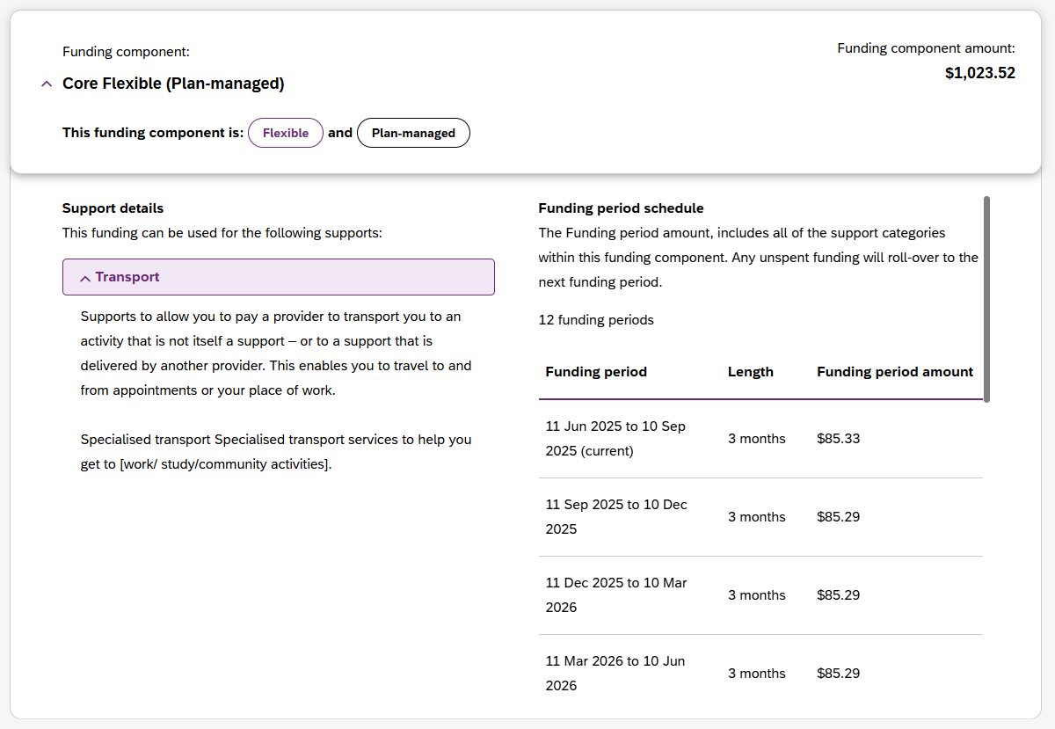
Figure 26 Funding component accordion within the Funded Support tab, showing information for the Core Flexible (Plan-managed) funding component

Informal community and mainstream support
The informal community and mainstream support section shows information around current support and new support for a participant. There are lists for the participant’s current supports and new support.
This section is only displayed when a participant has given consent to the Support Coordinator or Psychosocial Recovery Coach to view their plan.

Participant nominee details
The participant nominee detail section shows details for each nominee, the relationship type for a participant and contact details.
This section is displayed for all providers.

Provider roles
The provider roles section shows the role or roles that you have been assigned in the participant’s plan.
The Provider roles’ section displays a Support category details column.
It allows providers to see when they have been recorded as my provider for the delivery of specialist disability accommodation, home and living supports and/or behaviour supports in my NDIS provider portal.
If a provider is not recorded at the category level the new column will display ‘Not applicable’.

The portal will individually list each time a provider is recorded as a category level my provider.

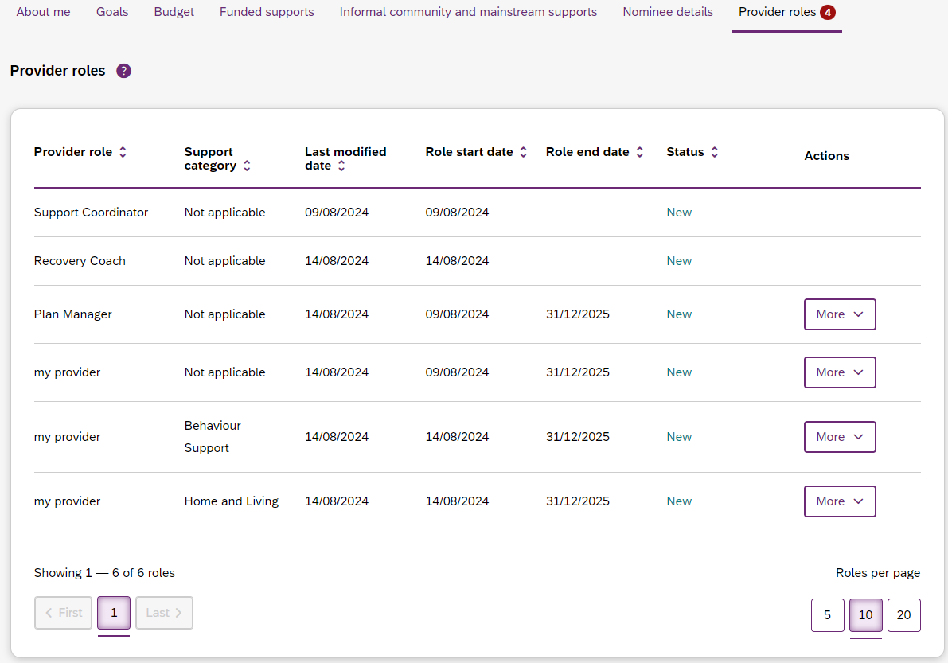
Figure 27 My Participants page showing links to sections with further information

Extend or End provider roles
If you are a plan manager or my provider, you will see the ‘More’ Button in the Actions column.
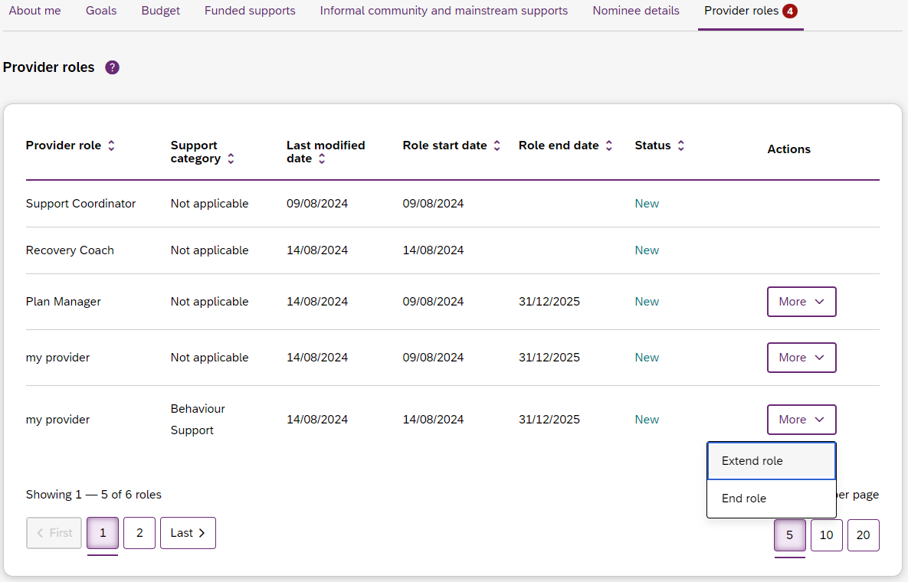
Figure 28 My Participants page showing links to Extend role and End role buttons

Clicking the More button will display two additional buttons – Extend role and End role - that allow you to request an extension to or end the selected provider role.
The Extend current role button will only appear if the relationship is not ongoing, i.e. it has an end date. You must choose the type of extension you want, an ongoing relationship or one that has an end date.
The End current role button allows you to end a current relationship with the participant.

Note: Requests to end my provider role earlier than previously recorded will not update my provider role end date if this role exists alongside the plan managers or my provider support category roles.
This is because my provider role needs to exist until the last day of the plan manager or my provider support category role, or both.
When ending my provider role with the participant, first you will need to end the plan manager or my provider support category role, or both, then end the my provider role, with the same end date.

Request for Service
The Request for service tab allows you to manage requests for service, respond to requests and submit reports for requests.

View Support Coordination Requests for Service
To view Support Coordination Requests for Service submitted to your organisation:
1. Select the Request for service tab.
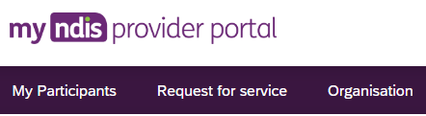
Figure 29 Request for service tab

2. This will display the Request for service page, and links for sections for:
Pending requests: view any pending requests for support coordination services sent to your provider organisation by the Agency. Allows you to review a pending request and either accept or reject the request.
Accepted Requests: view any previously accepted requests for service.
You can now search by:
- Request ID
- NDIS number
- Participant last name
Reporting Tasks: view and complete reporting tasks associated with requests.
Request History: view a history of requests.
You can Search by:
- Request ID (A guide text is displayed next to the search box, see figure below)
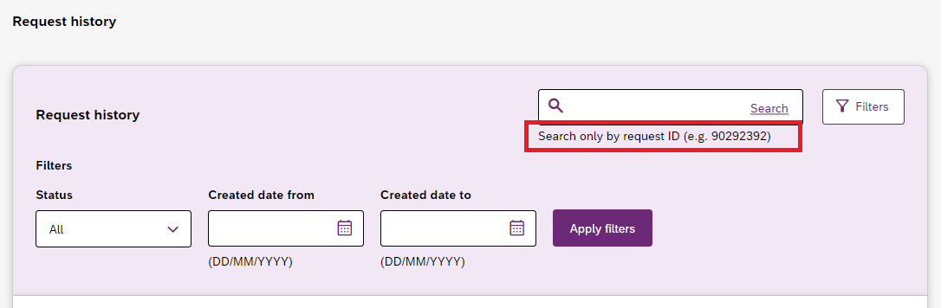
Figure 30 Request history page, Search box
Note:
- Input a minimum of 3 numbers in the search box to retrieve the required results. System will display an error message for anything less than 3 numbers in the search box.
- Default sorting of the columns is in descending order of Request ID.
- Sorting by age or status will display list in that order, however if there are more than one participant with same age or status a secondary sorting will be applied, which will display the participants in ascending order of their first name.
You can Filter by:
- Status
- Date From
- Date to

Maximum display of 2000 Requests on the Request history page
This list will display a maximum of 2,000 records. The below error message will appear if this limit is exceeded. To view the remaining records, use the search and filter tools.
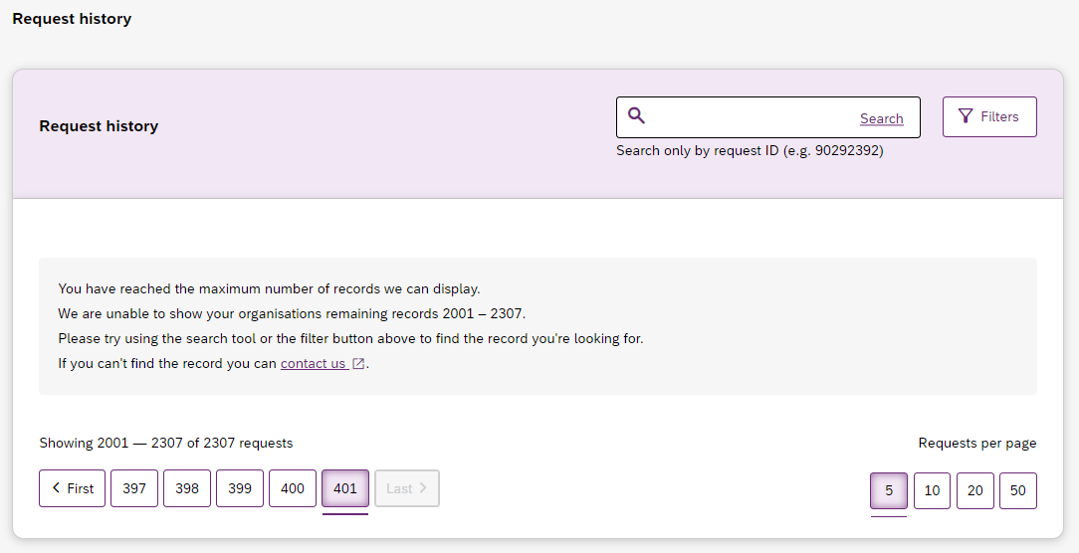
Figure 31 Request history page, 2000 requests display error message

The encircled number beside Pending requests link shows the number of outstanding, pending requests for service for your organisation.
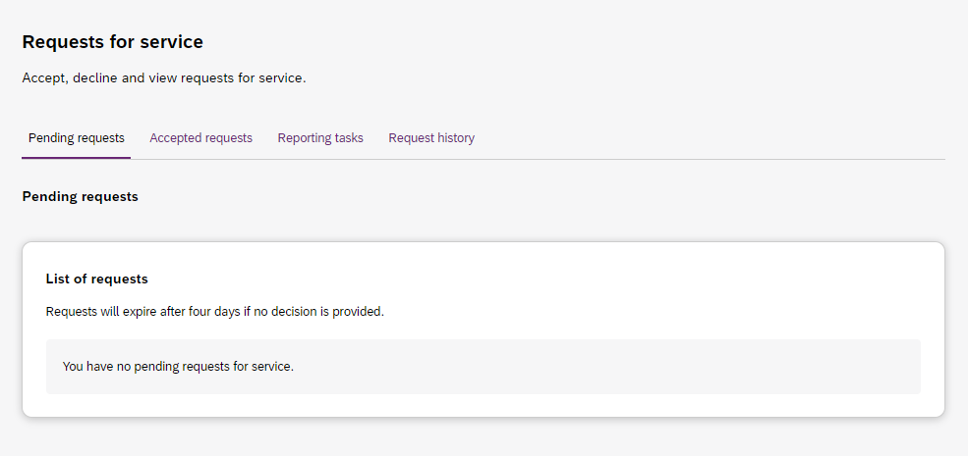
Figure 32 Requests for service page, showing links to sections

3. The Pending requests section will display a list of pending requests for service for your organisation. The following details are included for each request:
Request ID: A unique ID for each request.
Age: The participant’s current age.
Location: The participant’s suburb.
Disability: The main disability experienced by the participant.
Decision due: The due date for a response to the request.
Note: All RFS’s need to be accepted/declined within 5days from when its received. Any request which isn’t actioned within this time will expire automatically. A new RFS will need to be submitted to establish the relationship.
This list can be sorted by column, toggle between ascending and descending
sort-order by clicking the column heading.
4. To review the details of a pending request, click the link under the Request ID column.
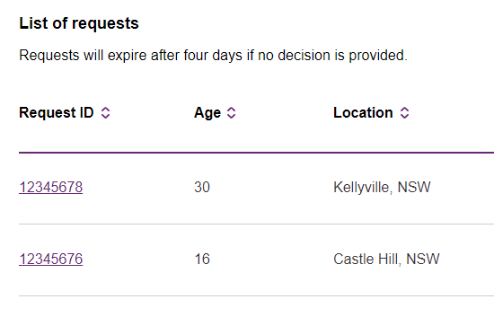

Figure 33 Opening a request for service

5. The Review pending request page shows some additional details:
Basic details: including the support budget and NDIS contact, as well as limited, anonymised details about the participant.
About Participant: further details about the participant’s disability and whether they require an interpreter.
Additional information section shows further detail about the support being requested.
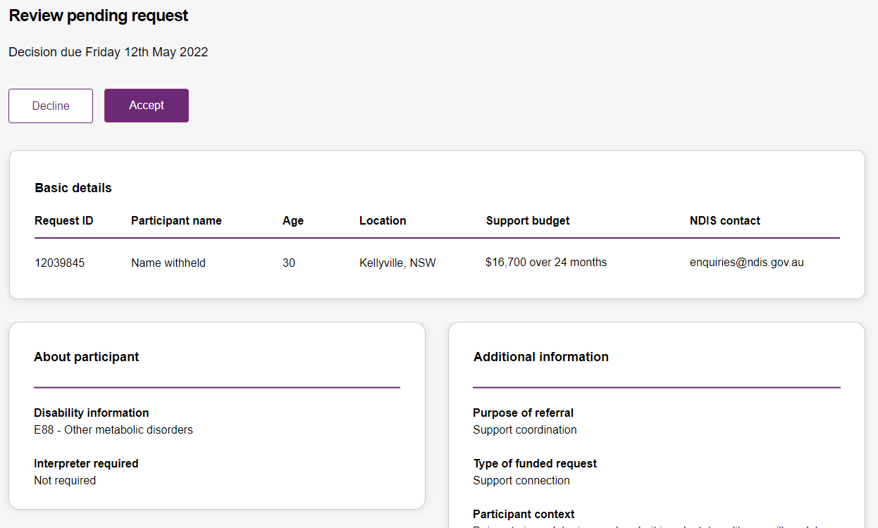
Figure 34 Review pending request page, showing request details.

Respond to a Request for service
Once you have reviewed the information and decided you may either accept or decline a request for service before the decision due date.
Note: Any request which isn’t actioned before the decision due date will expire automatically. A new RFS will need to be submitted to establish the relationship.

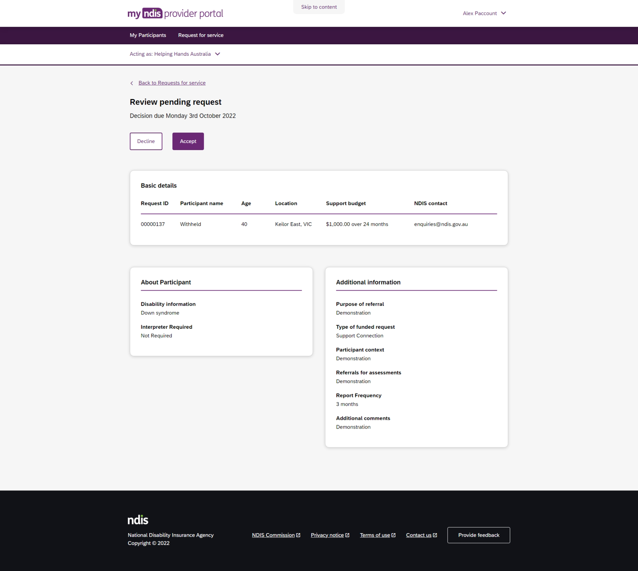
Figure 35 Decline and accept request buttons

To Accept
1. To accept the Pending request, click the Accept button near the top of the page.
2. You will be prompted to confirm that you have read all the available information, click the Accept request to do so.
3. Your acceptance will be confirmed in a banner displayed across the top of the page.
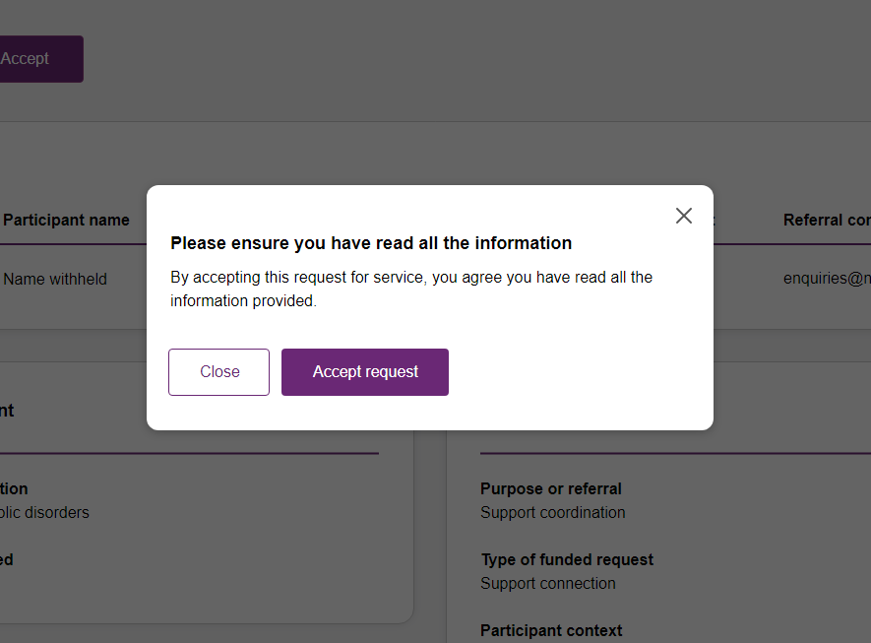
Figure 36 Prompt to confirm acceptance of a request for service.
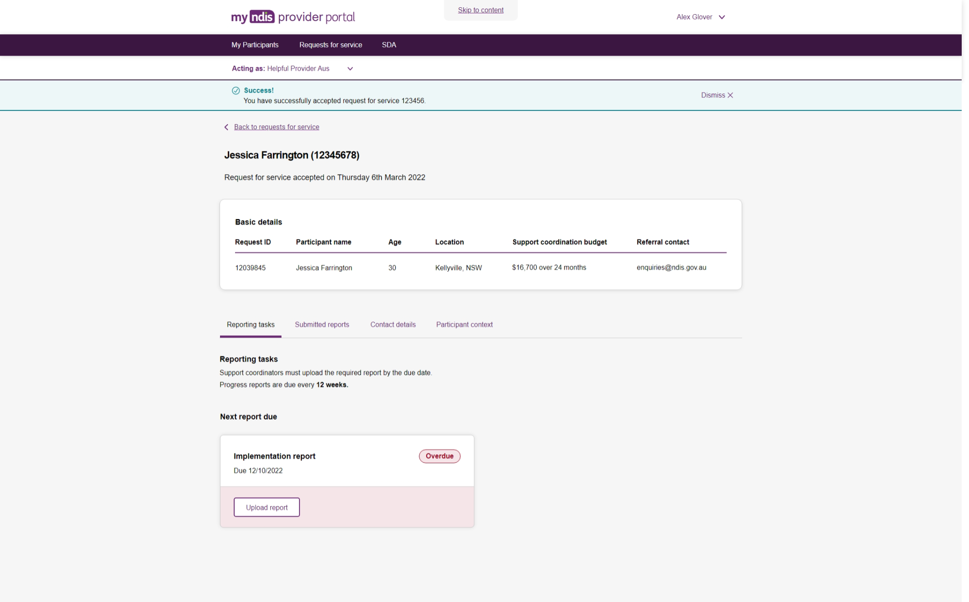
Figure 37 Confirmation of successfully accepting of a request for service

To Decline
4. To decline the Pending request, click the Decline button near the top of the page.
5. You will be prompted to provide a reason for declining the request for service
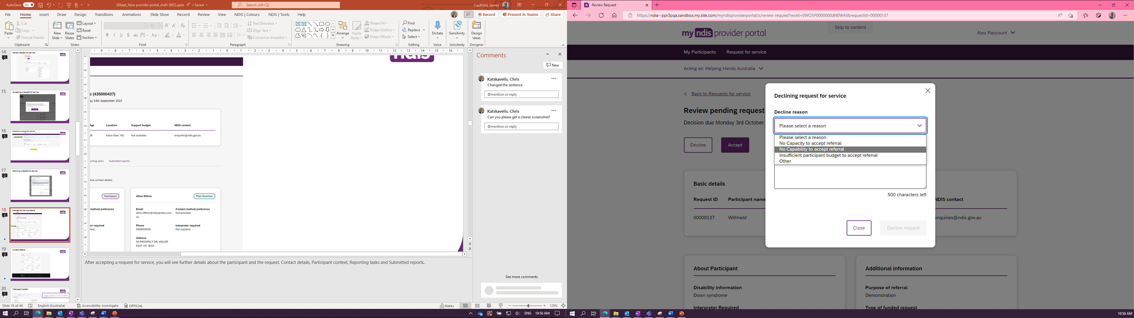
Figure 38 Declining a request for service
- Select the appropriate reason from the dropdown box, the options are:
- No capacity to accept referral
- No capability to accept referral
- Insufficient participant budget to accept referral
- Other
You may leave additional comments about why you declined the request in the textbox. If you selected ‘Other’ this field is mandatory, and you must provide additional comments.
6. Click Decline request to complete.
• The decline will be confirmed in a banner displayed across the top of the page.

View the details of an accepted Request for service
After accepting a request for service, you will be to view to additional details about the participant and the request. This includes:
- Participant name,
- Participant and participant representative contact details,
- Participant context,
- Reporting tasks, and
- Submitted reports.
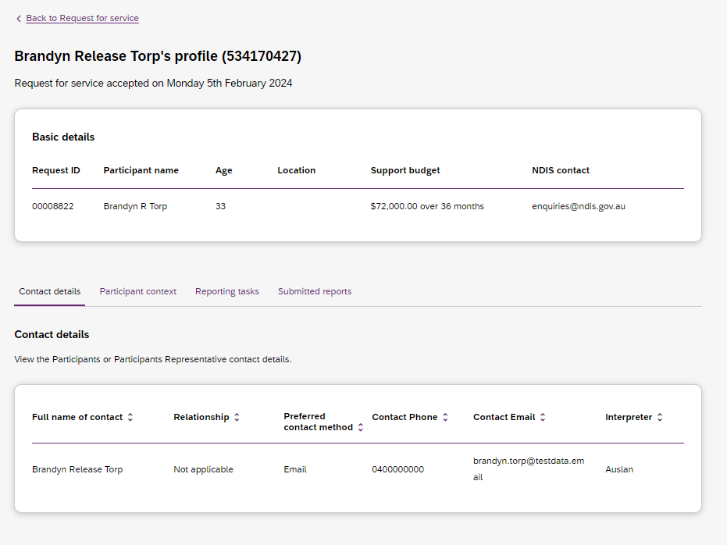
Figure 39 Request for service details page, available after accepting a request

To navigate the details of an accepted request for service use the links on the page
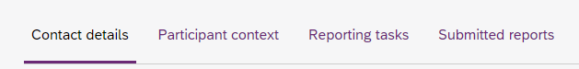
Figure 40 Request for service details page, details links

Contact Details
Contact details of the participant and/or the participant’s representative contact details.

Participant context
Participant context includes additional information about the participant and their disability, including:
- Disability information.
- Whether the participant requires an interpreter, and what language they use.
- Purpose of the referral and type of funded request.
- Report frequency.

Reporting tasks
Reporting tasks shows how often progress reports must be uploaded, and when the next report is due. It also allows for reports to be uploaded.

Submitted reports
Submitted reports shows a history of previously submitted reports for the selected request for service.

Reporting tasks
This tab displays all the reports that are due for your participants in the next 60 days.
1. Select the Request for service tab.
2. This will display the Request for service page, select the link to the Reporting tasks section.
3. This will display a list of reporting tasks for all the organisation’s participants, with columns for:
Request ID: The unique ID for each request.
Participant name: The participant’s current age.
NDIS Number: The participant’s suburb.
Report Type: The main disability experienced by the participant.
Due in: The number of days until the listed report is due, or Overdue if the report is past its due date.
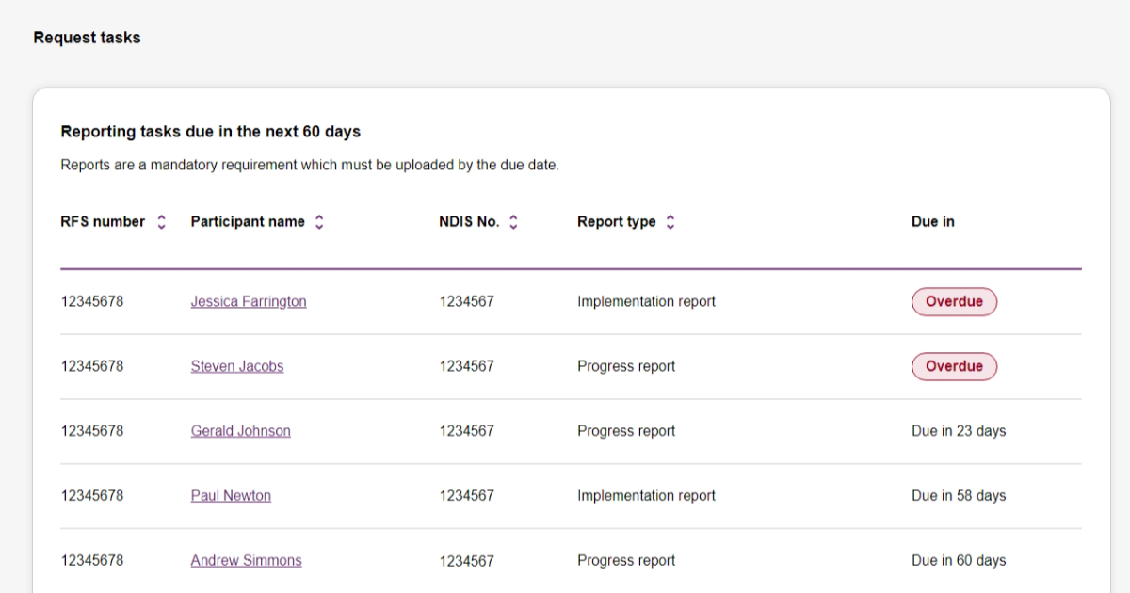
Figure 41 Reporting tasks for accepted requests

• Click the link on the Participant name to access the upload report page.

Uploading reports for a Request for service
1. To upload a report, access the Reporting tasks section of the relevant Request for service details page.
2. On the Reporting tasks page, check the type of report required, the due date and click the Upload report button.
3. You will be prompted to select a report file -files can be uploaded in the following formats and limitations:
File name: 30 characters long
File types: doc, docx, xls, xlsx, csv, pdf, jpeg, jpg, jpe, gif, bmp, png, xml, txt
Document size: 10 MB
4. Click Upload to start the upload and submit the report.
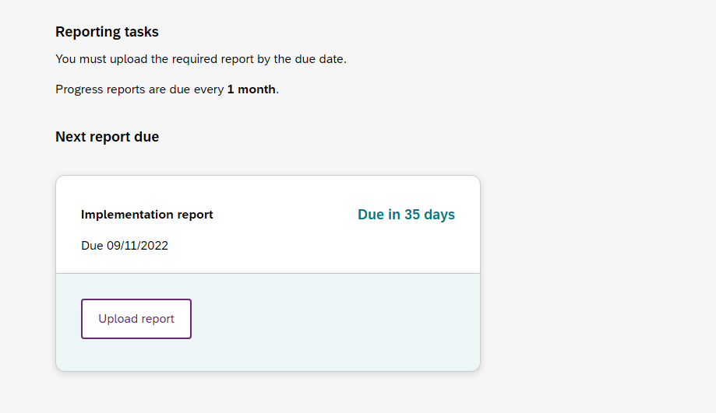
Figure 42 Request for service, report upload page
5. Once complete a banner will appear at the top of the page confirming that you have successfully uploaded a report.
6. You can review previously submitted reports in the previously submitted reports section of the request for service detail page.

Organisation

The Organisation tab allows you to view your Organisation details, Employees and Participants. It also allows you to request reports to extract key information out of my NDIS provider portal related to PACE participants and PACE claims.
Plan Managers will be able to view a Relationship request tab.

View Organisation details
The Organisation tab shows details stored about your organisation; these are:
- Organisation ID number
- Trading name
- ABN
- Address
- Email address
- Phone number
- Website address
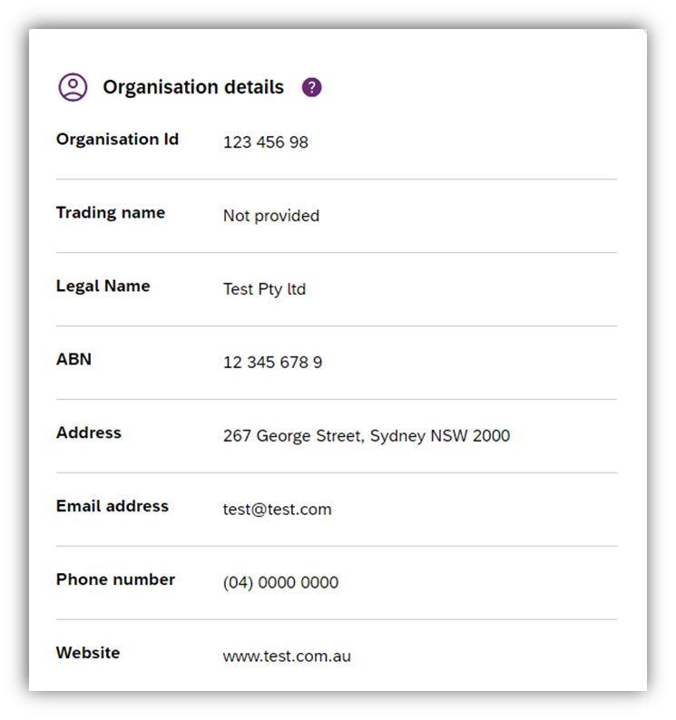
Figure 43 Organisation details

View Employee details
To view your employee’s details, select the Employees tab, the Employees tab shows a list of your employee’s name, role, start date and end date.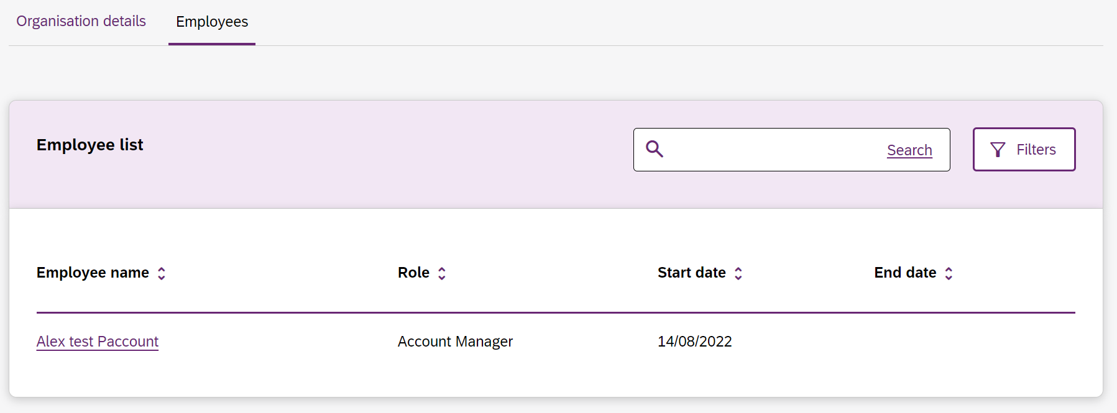
Figure 44 Employee list

To view the ‘Employees history’, select the hyperlink on the employee’s name and the role history page will list the employee’s role, start date and end date.
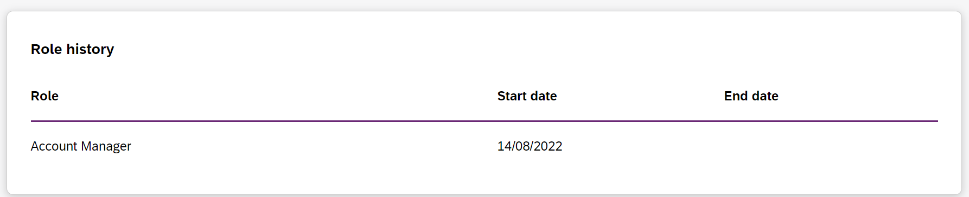
Figure 45 Employee list, Role history

Relationship request tab for Registered Providers
The Relationship Requests tab displays a list of requested relationships. The information available is the Reference ID, Participant name (NDIS number), the date the request was submitted, the role requested, the type of request and request status.
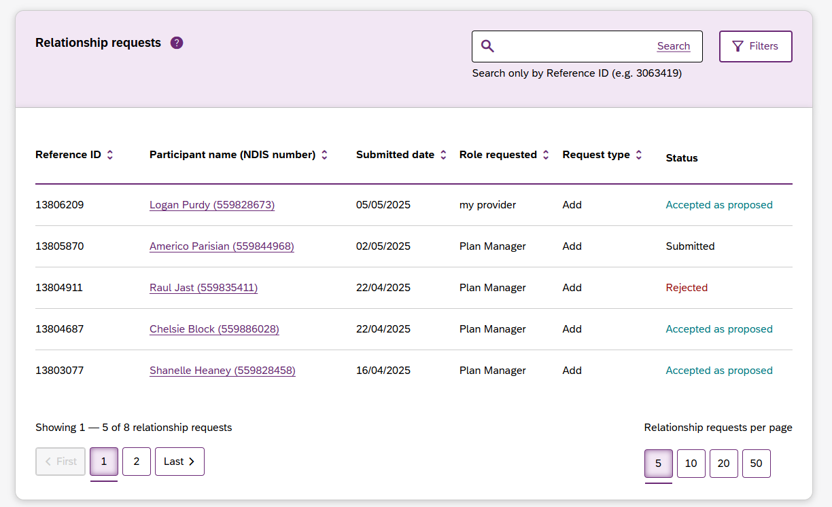
Figure 46 Relationship Requests

Note: The participant’s name is withheld until the relationship request has been approved.
You can now Search by:
- Reference ID (A guide text is displayed next to the search box, see figure below)
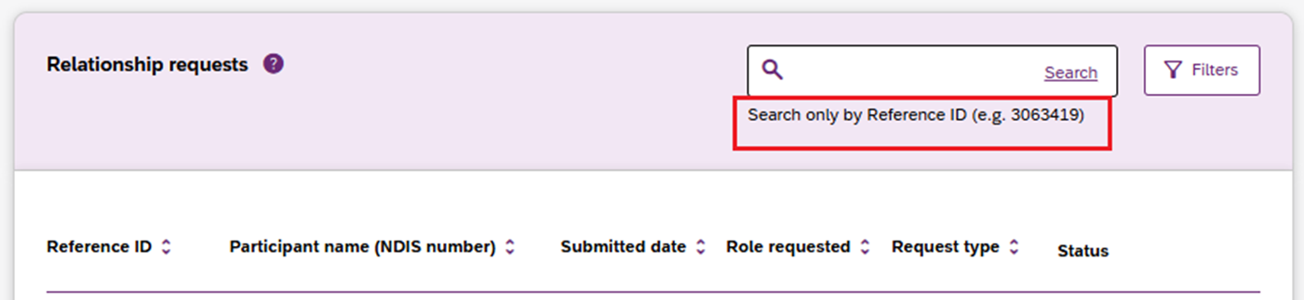Figure 47 Relationship Requests, Search box

Note:
- Input a minimum of 3 numbers in the search box to retrieve the required results. System will display an error message for anything less than 3 numbers in the search box.
- Default sorting of the columns is in descending order of submitted date.
- A secondary sort order is introduced:
  - When columns other than the 'Participant Name (NDIS Number)' and 'Submitted date' are sorted, the secondary sort order is ascending on participant first name (A to Z).
  - When the 'Participant Name (NDIS Number)' column is sorted, the secondary sort order is ascending on Submitted date (Oldest to newest).

Maximum display of 2000 requests on the Relationship requests page
This list will display a maximum of 2,000 records. The below error message will appear if this limit is exceeded. To view the remaining records, use the search and filter tools.
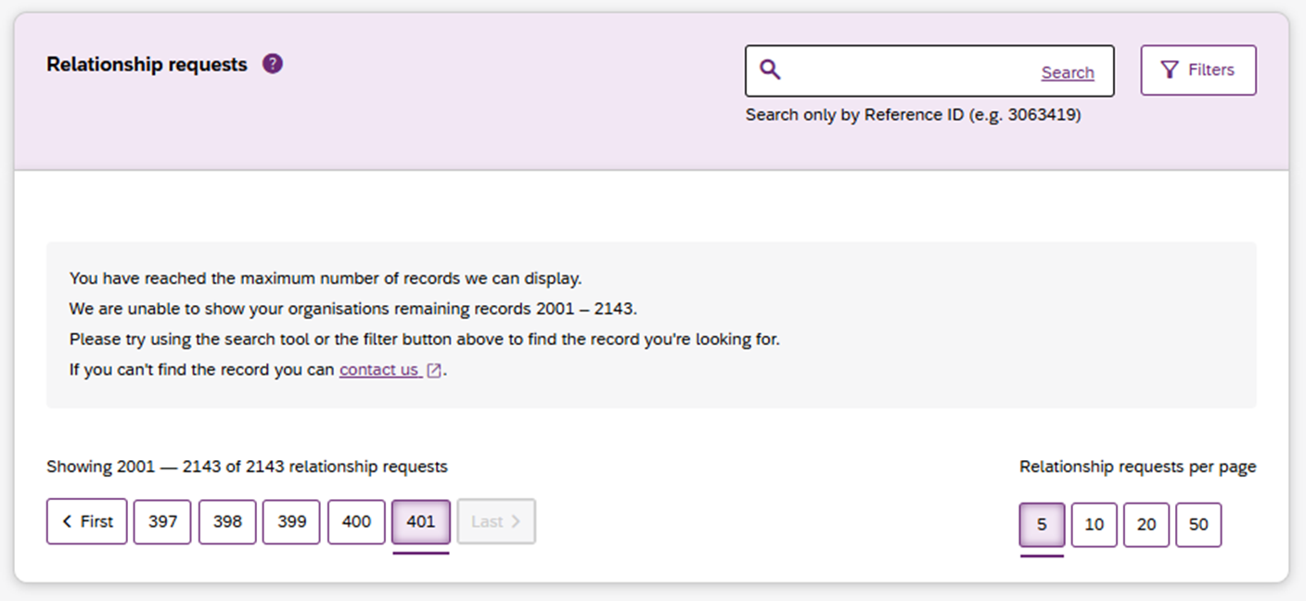Figure 48 Relationship requests 2k limit error page

Submit a new relationship request
You can submit a request to be added as a Plan Manager, my provider, or my provider at support category level by clicking on the Add new request button.
The New relationship request page will open with the following fields. Complete all the details and select the Submit request button.

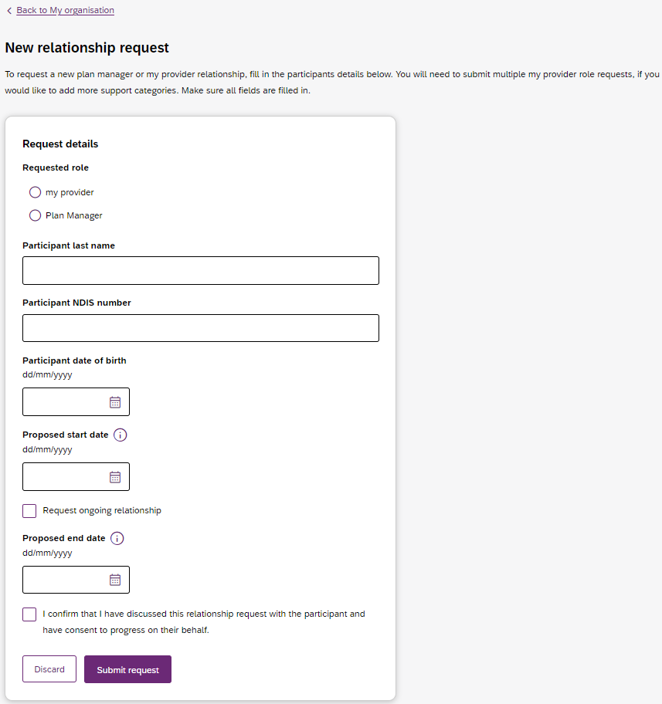
Figure 49 New Relationship Request form
Note: When my provider option is selected under the ‘Requested role’ form field, the ‘Specialised support category’ field becomes visible and has the ‘No support category’ option selected by default.
If you wish to request my provider – support category role, after selecting my provider option, you will need to select the support category that you wish to add to my provider role.
Requesting my provider - support category role or a plan manager role automatically creates my provider role. My provider role will need to exist until the last day of either my provider - support category role or a plan manager role.
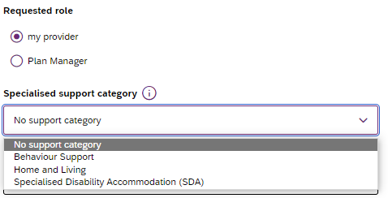
Figure 50 Requesting my provider role at a support category level.

If details or information provided is incorrect, then you will be able to view a message on the screen to assist in fixing the incorrect field.
If, however, the details or information provided is correct, then you will be directed to the Organisation page with the Relationship request tab open. Here you will see a message that the request is submitted successfully. The recently submitted request appears at the top of the Relationship requests table. However, participant details will be withheld until the relationship request has been approved.

Submit an Extend or End role request
Guidance on how to extend or end current provider roles is provided on Page 23 of this document.

Downloadable reports
The Downloadable Reports tab displays a list of reports requested in the past 24 hours. The information available is the type of report, request submitted date, file generated time, status.
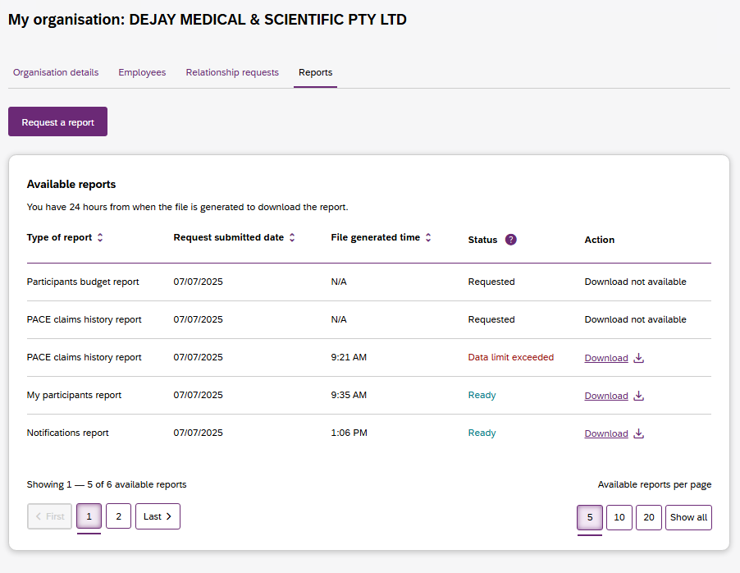
Figure 51 Available reports

You can request a report by clicking the Request a report button, which will open the Request a report page where you can select the type of report you want.
Each type of report has different filters, these are listed in Table 2 (below).
Table 2 Filter options for reports
Report type | Filters
Notifications | Received date from  Received date to  Notification category
My participants | Role start date  Role end date  From date  To date  Provide role
Participant budget report | First letter of participant surnames  Role start date from  Role start date to
PACE claims history report | Claim submitted date  Support start date  Claim Status, or  A Specific claim reference number.
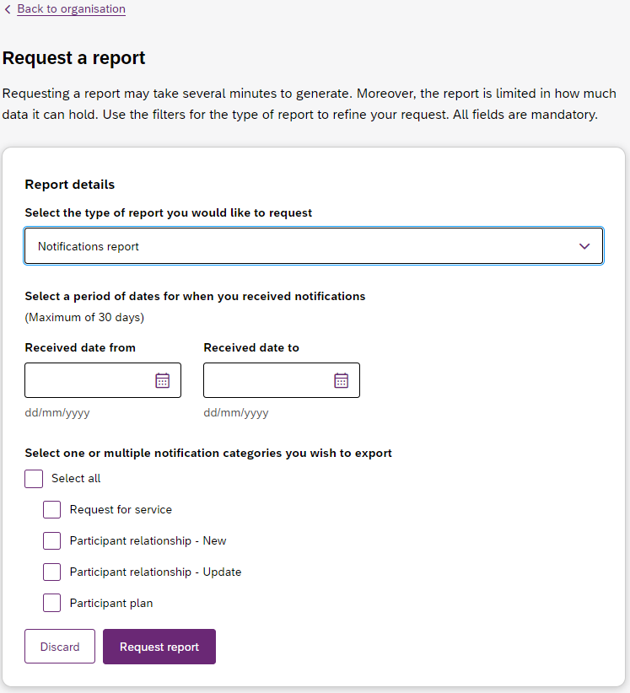
Figure 52 Request a report page showing notifications report.

After submitting your request, it will appear in the Available reports list. When a report is ready you can also download the .csv report file using the link in the action column.
Note: Report files are available to be downloaded for 24 hours. Also, only three reports of each type can be requested every 24 hours.

Submit a payment enquiry
You can submit a new payment enquiry on behalf of your organisation or submit a follow-up on a closed enquiry.

Submit a new payment enquiry
To submit a payment enquiry, click onto the Enquiries tab on the global navigation bar.
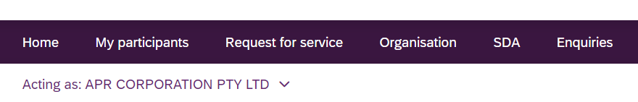
Figure 53 Enquiries tab on the global navigation toolbar

- Click onto Lodge a new enquiry
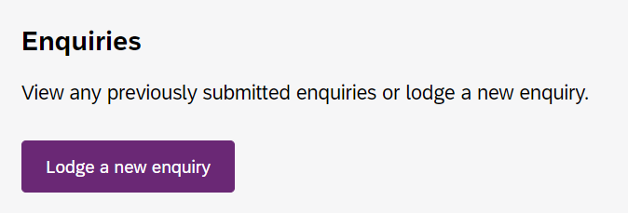
Figure 54 Lodge a new enquiry

- Select an enquiry type drop-down is automatically prefilled.

Note: All other enquiry types, including complaints and feedback, can be submitted through the myplace provider portal.
- To create a new enquiry, select: Yes, this is a new enquiry

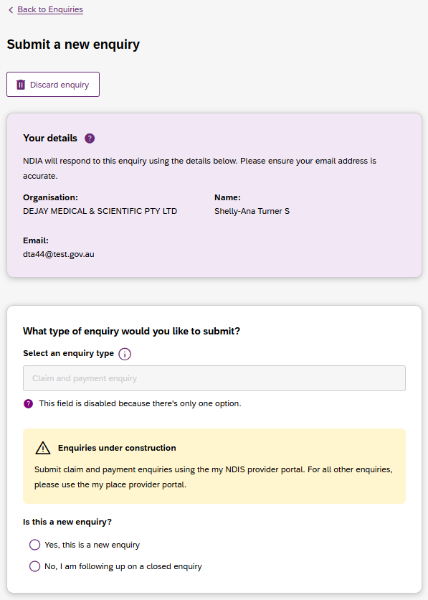
Figure 55 Submit a new enquiry

- Complete the details of the payment enquiry section by selecting a category:
- Issue with a bulk file
- Issue creating or editing a service booking
- Claims rejected
- Payment not received
- Issue cancelling claims
- Other claim or payment enquiry
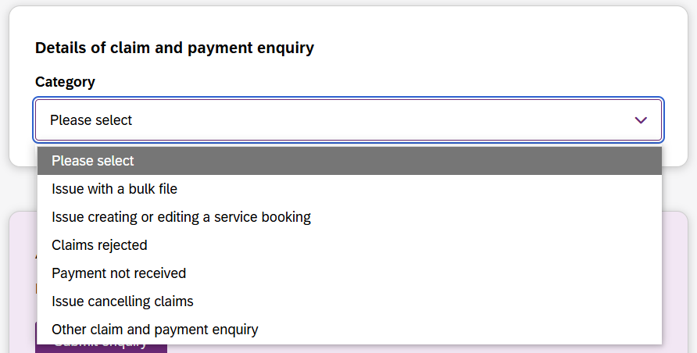
Figure 56 Enquiry categories

Note: The information you are required to submit is dependent on the payment enquiry category you have selected. Please make sure that you complete each field as required.

Linking Claims to Your Enquiry
When submitting an enquiry for the categories ‘Claims Rejected’, ‘Payment not received’, or ‘Issue cancelling claims’, you can now link specific claims directly to your request. This helps the NDIA resolve your enquiry more efficiently.
- Select one of the following claim and payment enquiry categories from the Category drop-down:
  - Claims Rejected
  - Payment not received
  - Issue cancelling claims
- A new section will appear: 'Would you like to link any claims to this enquiry?'
Note: Each enquiry can only be linked to one participant.
If your enquiry involves claims from multiple participants, you must submit a separate enquiry for each participant. In each enquiry, link and/or add the relevant claims individually.

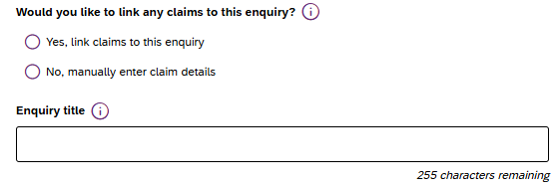
Figure 57: The ‘Payment enquiry’ card with the new field ‘Would you like to link any claims to this enquiry?’.

- Choose your preferred method:
  - Yes, link claims to this enquiry - Select this option to search for and select claims already in the system.
  - No, manually enter claim details - Select this option if you cannot find the claim or prefer to type the detail yourself.
Note: Enquiries with claim details manually entered, either by claim ID numbers or payment request numbers, will take longer to process and resolve in comparison to enquiries with linked claims.

Option a: Linking Claims (Recommended)
Selecting ‘Yes’ allows you to find claims/payment requests for a specific participant submitted from the myplace provider portal by the selected organisation.
- Enter the 9-digit Participant NDIS number in the field provided within the purple card.
  - Note: Only claims from 1 January 2026 onwards are available for linking. For earlier claims, you must select the manual entry option.
- Select Find claims to link to this enquiry.
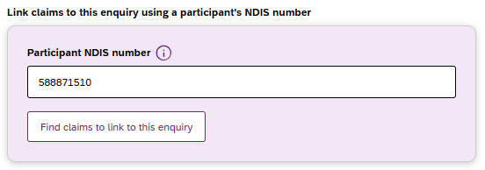
Figure 58: The Participant NDIS number input field and the ‘Find claims’ button.

- You will be navigated to the 'Link claim(s) to enquiry' page.
- Search and Filter: This table only includes claims/payment requests from the past 90 days for the selected organisation and participant. If no claims are displayed, use the ‘Support Start Date’ filter to find claims/payment requests submitted after 01/01/2026.
You can search by Claim ID or Payment Request number and filter the search by date range or claim status. A maximum of 1000 claims is displayed. Use the search tool or filter options to find more claims. You must link at least 1 claim to submit with the enquiry".
Note: ‘Claims rejected’ category enables linking of claims in ‘Rejected’ status only. ‘Payment not received’ category enables linking of claims in ‘Pending Verification’, ‘Pending Payment’, ‘Pending Cancellation’, ‘Cancelled’, ‘Paid – Cancelled’, ‘Rejected’, ‘Payment Failure’ and ‘Paid’ statuses.
‘Issue cancelling claims’ category enables linking of claims in ‘Pending Verification’, ‘Pending Payment’, ‘Pending Cancellation’, ‘Cancelled’, ‘Paid – Cancelled’, ‘Payment Failure’, ‘Paid - Pending Cancellation’ and ‘Paid’ statuses.
- Add Claims: Select Add next to each claim you wish to link. You can link up to 80 claims per enquiry.
Note: If you need to link more than 80 claims to an enquiry, you will need to create another enquiry and add/link the remaining claims to the new enquiry. The 1st enquiry should be referenced in the description to ensure that both enquiries are processed together.
  - Remove Claims: Selected claims could be removed from the list by selecting the ‘Remove’ button next to each claim.
  - The ‘Selected claims for linked enquiry’ counter at the bottom of the screen will track your progress.
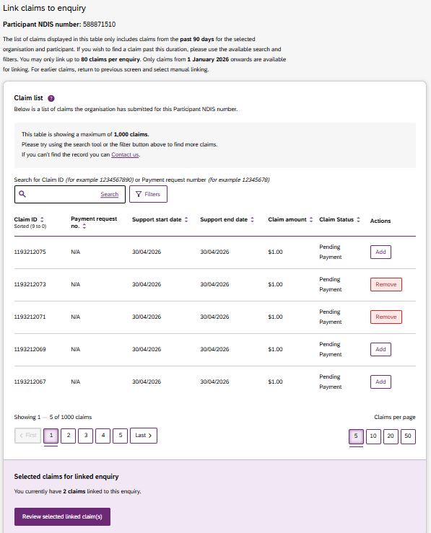.
Figure 59: The ‘Link claim(s) to enquiry’ table showing the ‘Add/Remove’ action buttons and the pagination controls.

- Select Review selected linked claim(s) to see the entire list of claims selected for linking.
- Once satisfied, select Link selected claim(s) to enquiry. You will be returned to the main enquiry form, where a summary of linked claims will be displayed. Or if you need to link more claims, then click ‘Link more claims’ button.

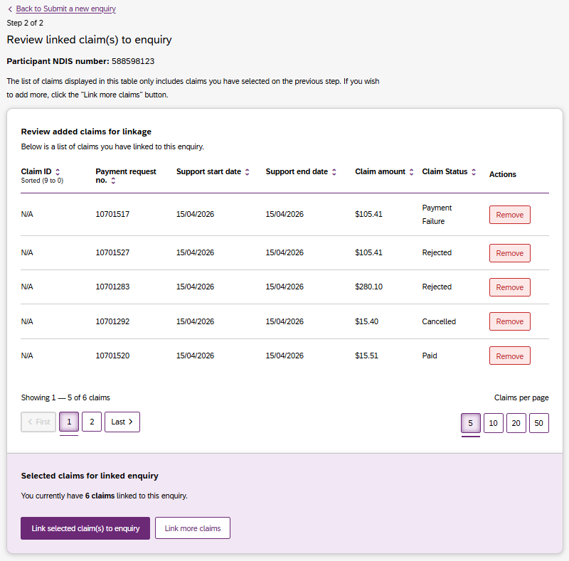
Figure 60: The ‘Review linked claim(s) to enquiry’ table showing the ‘Add/Remove’ action buttons and the pagination controls.

- When you return to the main enquiry form, the number of linked claims will be displayed above the participants NDIS number that you entered. If you need to view the added claims or link more claims, then click ‘View added’ button which will take you back to the review linked claims and you can add/remove claims.
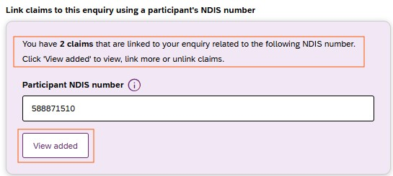
Figure 61: The number of ‘Linked claim(s) to enquiry’ and ‘View added’ button.

Option b: Manually Entering Claim Details
Note: Enquiries with claim details manually entered, either by claim ID numbers or payment request numbers, will take longer to process in comparison to enquiries with linked claims.
- If you select ‘No, manually enter claim details’, a message will appear advising that manual enquiries may take longer to process. You must select I understand to proceed.
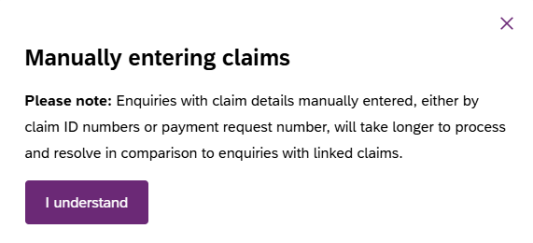
Figure 62: Message displayed upon selecting ‘No, manually enter claim details’ option

- Reference claims by adding claim ID/Payment request numbers: Selecting this option is recommended when you wish to make an enquiry about a specific claim
  - Adding by Claim ID/payment request number:
  - Type the ID (8–12 digits) and click ‘+ Add’ to add claim ID number.

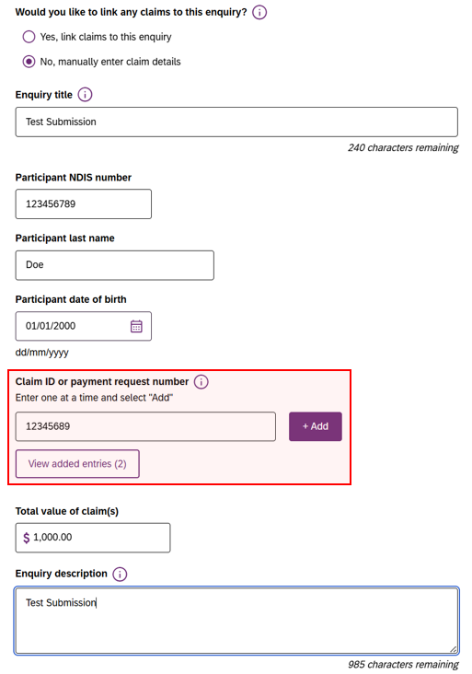
Figure 63: The manual entry field for entering ‘Claim ID’ or ‘Payment request number and the ‘Add’ button.
  - You can repeat these steps to add up to 80 claims. Use the View added claims button to review or remove IDs from your list.

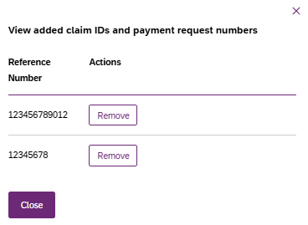
Figure 64: The manual entry field for entering ‘Claim ID’ or ‘Payment request number and the ‘Add’ button.

Finalising the Enquiry with Linked or Manually Entered Claims
Regardless of the linking method chosen, you must complete the remaining mandatory fields applicable for each category, these may include:
- Enquiry Title: Enter a short description of the enquiry that will allow you to identify this enquiry later. Please do not enter any personal information.
- Participant last name: Enter the participant’s last name.
- Participant date of birth: Enter the participant’s date of birth.
- Total Value of claim(s): Enter the total dollar amount (not required for 'Issue cancelling claims').
- Enquiry description: Provide as much detail as possible regarding the issue you are experiencing. Please avoid including any personally identifying information.
- Attach documents: If there are associated documents, select the Choose file to attach them. You can attach documents in.doc, .docx, .xls, .xlsx, .csv, .pdf, .jpeg, .jpg, .jpe, .gif, .bmp, .png, .pnt, .pntg, .xml, .txt format.
The file must be no larger than 5MB each. Up to 10 files may be uploaded.
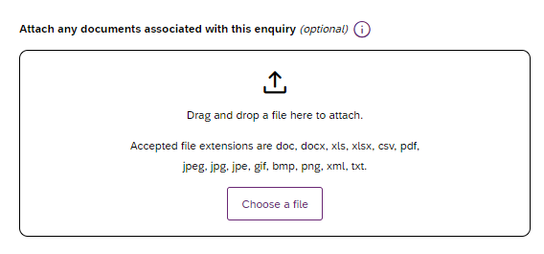
- Figure 65 Attaching a file to your enquiry.
Note: To ensure timely resolution of your enquiry, attach all related invoices.
- Submit Button: Click submit button to submit your claim and payments enquiry
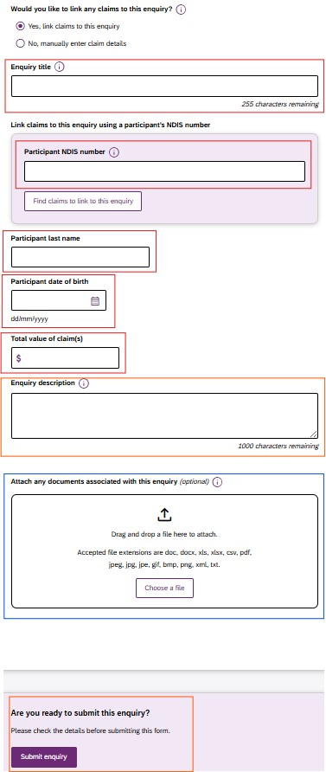
Figure 66: Mandatory fields for a complete enquiry form with and the final Submit button.

A list of your organisation’s submitted payment enquiries via my NDIS provider portal will be displayed on the Enquiries page. To review or receive updates on all payment enquiries submitted previously via the myplace provider portal, you will need to navigate to the myplace provider portal.
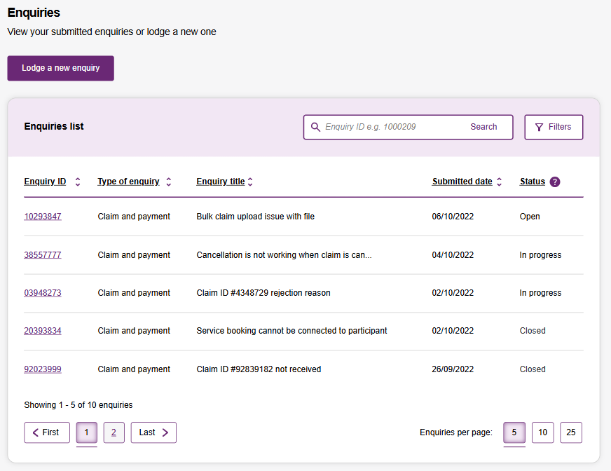
Figure 67 Enquiry page

One of three statuses will be displayed in the Status column:
Open – We have received your enquiry.
In progress – Your enquiry is under review. We may contact you for further information.
Closed – Your enquiry is resolved. Confirmation of the outcome of your enquiry has been sent to you.

Note: Only payment enquiries submitted by your organisation will be visible in the Enquiries list. For example, any enquiries submitted by NDIA staff members, on your behalf will not be listed here.

Submit a payment enquiry on a closed enquiry
To submit a payment enquiry, click onto the Enquiries tab.
Figure 68 Enquiries tab on the global navigation toolbar

- Click onto Lodge a new enquiry
Figure 69 Lodge a new enquiry

- Select an enquiry type dropdown is automatically prefilled.
Note: All other enquiry types, including complaints and feedback, can be submitted through the myplace provider portal.

- Choose: No, I am following up on a closed enquiry

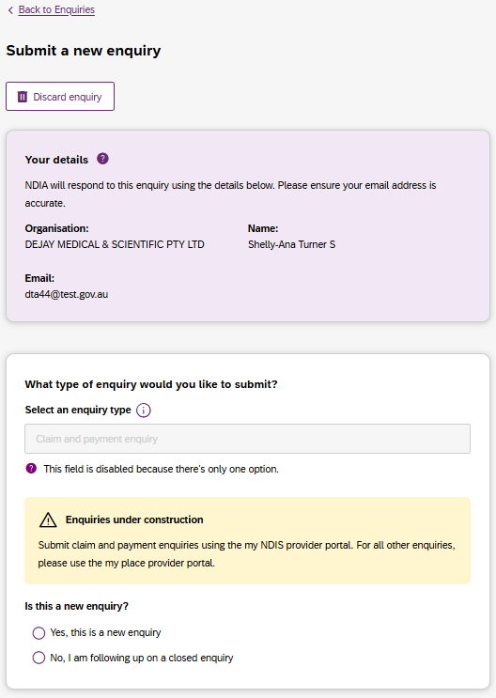
Figure 70 Follow up on a closed enquiry

The following compulsory fields appear for you to fill in: Enquiry title, Closed enquiry number, Date submitted and Follow-up comment.
Please note: In the ‘Closed enquiry number’ field, you may enter the ‘Enquiry number’ of a closed payment enquiry raised in my NDIS provider portal or the ‘Submission ID’ of a closed payment enquiry raised in the myplace provider portal. If there are associated documents, select Choose a file to attach them. You can attach documents in.doc, .docx, .xls, .xlsx, .csv, .pdf, .jpeg, .jpg, .jpe, .gif, .bmp, .png, .pnt, .pntg, .xml, .txt format.
The file must be no larger than 5MB each. Up to 10 files may be uploaded.
Figure 71 Attaching a file to your enquiry

View existing payment enquiries

Note: Enquiries created before 5 May 2024 can be viewed in the myplace provider portal. Payment enquiries created after 5 May 2024 will be displayed in the Enquiries page of my NDIS provider portal.
- You can only view your enquiry in the portal from where it was originally created.

- To view an existing enquiry, select an ‘Enquiry ID’ from the list of submitted enquiries from the table on enquiries landing page.

Figure 72 Submitted enquiries list
- If you cannot see the relevant enquiry ID record, you could use search and filter to locate the enquiry ID.
- One of three statuses will be displayed in the Status column:
  - Open – We have received your enquiry.
  - In progress – Your enquiry is under review. We may contact you for further information.
  - Closed – Your enquiry is resolved. Confirmation of the outcome of your enquiry has been sent to you.
Note: Only payment enquiries submitted by your organisation will be visible in the Enquiries list. For example, any enquiries submitted by NDIA staff members, on your behalf will not be listed here.

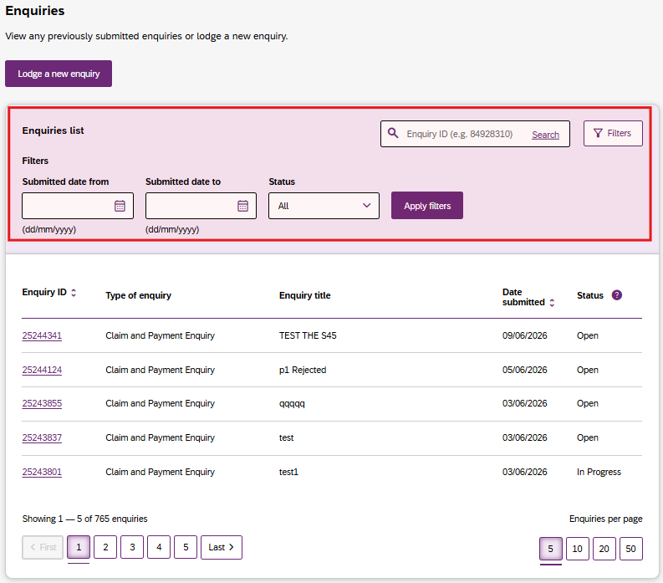
Figure 73 Search and filter options on the enquiries list table

Once you click the enquiry ID of a previously submitted enquiry, you will be transitioned to another page in the same window, which is the enquiry details page.
On this page you will be able to see two sub navigation tabs labelled ‘Enquiry details’ and ’Linked claims.’
Enquiry details sub-tab contains details related to the enquiry such as ‘Submission details’, ‘Enquiry details’ and ‘List of attached documents’

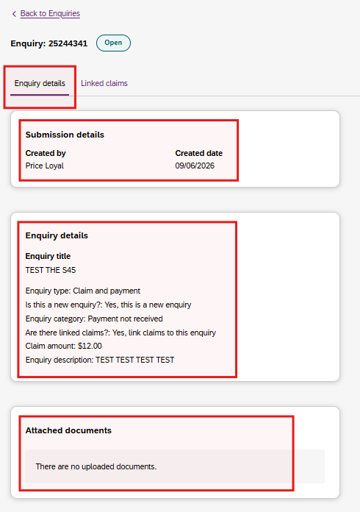
Figure 74 Enquiry details page with sub-navigation tabs

‘Linked claims’ tab will be shown where claims have been linked to an enquiry, and it will display the linked claims in a table. This tab will not be shown if no claims have been linked to the enquiry.

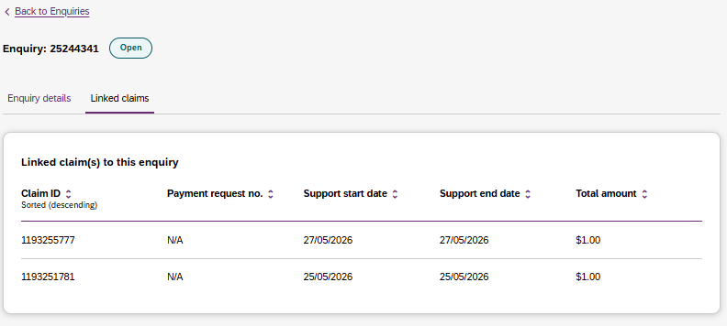
Figure 75 Linked claims sub-navigation tab

Maximum display of 2000 Records on the Enquiries page
This list will display a maximum of 2,000 records. The below error message will appear if this limit is exceeded. To view the remaining records, use the search and filter tools.
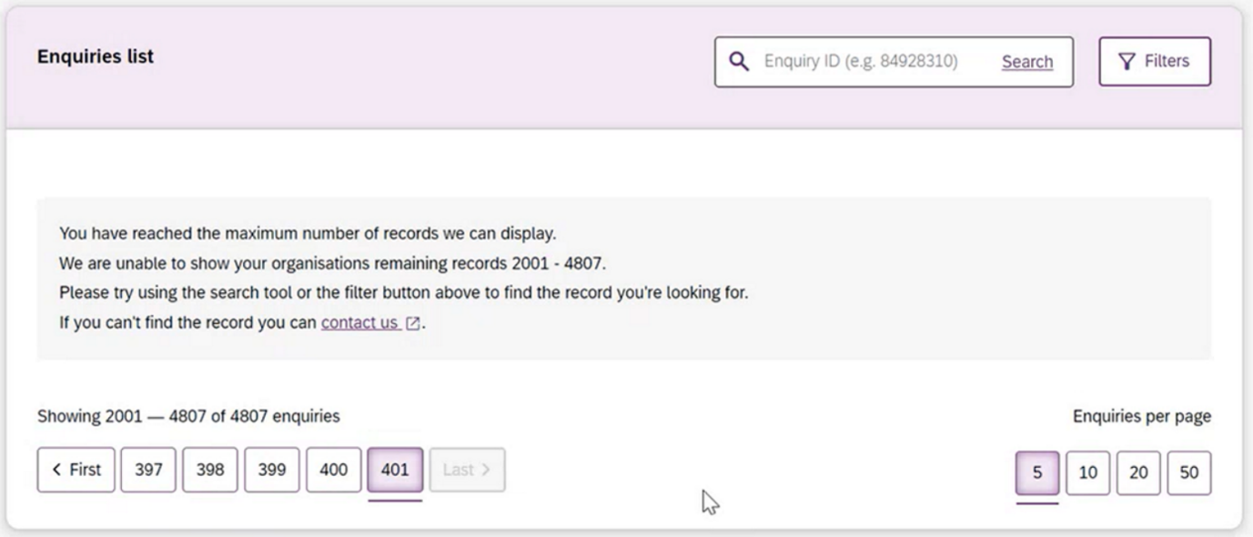
Figure 77 Enquiries page, 2000 records display error message

