Quality and Safeguards

working arrangements for transition to the NDIS in Northern Territory (NT)

Contents
1. Purpose 3
2. Background 4
3. Guiding principles 4
3.1 Individual safeguards 4
3.2 Service provider quality assurance and safeguards 5
3.3 Legislative safeguards 5
4. Registration process for providers of specialist disability supports in Northern Territory 7
4.1 Provider registration application form 7
4.2 Registration Groups 7
4.3 Providing evidence for specialist disability registration groups 7
4.4 Allied Health Professionals and Streamlined Assessment 9
4.5 NDIS Registration Groups 9
4.6 Commonwealth providers 12
5. Quality framework 14
5.1 Northern Territory quality framework 14
5.2 During transition 14
6. Criminal history screening 16
6.1 NT criminal history screening 16
6.2 During transition 16
7. Complaints 17
7.1 Commonwealth complaints systems during transition 17
7.2 NT complaints systems 17
7.3 During transition 17
8. Serious Incidents 20
8.1 NT Serious Incidents requirements 20
8.2 During transition 20
9. Restrictive practices 21
9.1 NT restrictive practices 21
9.2 During transition 21
10. Monitoring and compliance 22
10.1 NT monitoring and compliance systems 22
10.2 During transition 22

Acronyms
Acronym | Full name
NDIA | National Disability Insurance Agency
NDIS | National Disability Insurance Scheme

Purpose
This document provides the details of quality and safeguarding arrangements for Northern Territory’s transition to the NDIS. These Working Arrangements are agreed between the National Disability Insurance Agency, the Commonwealth of Australia and the NT Government.
The Commonwealth, NT and NDIA will jointly monitor the implementation of these working arrangements, including working together with relevant NT statutory bodies to manage quality and safeguards issues that arise during the transition to the NDIS in NT to ensure the best possible outcomes for participants.

Background
The National Disability Insurance Scheme Act Part 3 of Chapter 4 requires a person or entity to apply to be a registered provider of supports in relation to either or both of the following:
- managing the funding for supports under plans and
- the provision of supports.
The National Disability Insurance Scheme (Registered Providers of Supports) Rules 2013 (clause 73) may make provision in connection with the approval of persons or entities as registered providers of supports, including by prescribing criteria relating to:
- compliance with prescribed safeguards
- compliance with prescribed quality assurance standards and procedures.
Existing Commonwealth and state quality and safeguarding systems will apply to NDIS providers of specialist disability services in NT during transition.
The following arrangements have been agreed to between the NT and Commonwealth Governments, and the NDIA to ensure the existing systems include NDIS providers delivering specialist disability services in NT.

Guiding principles
The NDIA is working to ensure high quality services for people with disability that enable choice and control.
Consistent with the principles of the NDIS, individual, service and system level safeguards aim to achieve a balance between choice and control and adequate and appropriate safeguards.
The Commonwealth and NT governments, and the NDIA, will ensure that there are appropriate levels of safeguards for individuals, particularly where risk is identified. They will ensure that these safeguards are proportionate and risk-based.

Individual safeguards
The NDIS plan development and implementation will identify and support natural safeguards. The NDIS plan identifies the participant’s goals and aspirations, unique risks and appropriate safeguards for each individual, and is developed on a presumption of capacity, unless there is evidence to the contrary.
The individual safeguards depend on the person’s level of identified risk and need. Through the support needs assessment and planning process, the NDIA planning support coordinators will work with participants to identify their existing risks and safeguards, and to build intentional safeguards into the plan that reflect each participant’s needs.
The decisions of planners and participants in relation to the management of plans is guided by legislative provisions, which form the basis of NDIA practice guidance, conversation tools and information sheets for participants. It is the responsibility of the NDIA to determine the reasonable and necessary supports in a participant plan, and to ensure that participants who choose to self-manage some or all of the supports in their plan understand the risk implications and their responsibilities and expectations of self-managing NDIS funds.
The NDIA also requires planners to support their rationale for decisions and has review and quality audit arrangements in place to support best practice, ongoing quality assessment of plans and a culture of continuous improvement to benefit participants and enhance scheme performance.

Service provider quality assurance and safeguards
The Northern Territory (NT) Government released the Northern Territory Quality and Safeguarding Framework (NT Framework) in November 2016.
The NT Framework and assessment process will operate until full implementation of the National NDIS Quality and Safeguards Framework (National Framework). The NT Framework will support providers to prepare and meet the National Framework requirements in 2019. The NT Framework’s assessment process will also support the Northern Territory disability sector to strengthen its support offerings and will assist in the establishment of a sustainable provider market post full Scheme implementation.
The NT Framework aligns with the National Standards for Disability Services, 2013 and is consistent with the intent and approach of the National Framework. The Northern Territory Framework has a strong emphasis on cultural safety, security and competency as well as remote service provision. The NT Framework draws on the extensive consultation conducted by the Commonwealth on the National Framework as well as targeted consultations with the disability sector and other key stakeholders in the Northern Territory during its development.

Legislative safeguards
Providers in the NT must operate in accordance with a range of Commonwealth and Territory legislative requirements. Legislation that is particular relevant to providers include:
- Disability Services Act
- Disability Services Act 1986 (Cwlth)
- National Disability Insurance Scheme Act 2013 (Cwlth)
- National Disability Insurance Scheme (Registered Providers of Supports) Rules 2013 (Cwlth)
- Health and Community Services Complaints Act
- Carers Recognition Act
- Care and Protection of Children Act
- Guardianship of Adults Act
- Anti-Discrimination Act
- Work Health and Safety Act
- NT Building Act
- Children’s Commissioner Act

Safeguards under the NT Framework
As stipulated in the NT Bilateral Agreement, the NT Government is required to assess providers to deliver supports under the NDIS. The NT provider assessment process will facilitate the NDIS registration of existing providers who wish to continue to provide current support types, existing providers who wish to expand their services into new support types, and new providers who wish to provide disability support. Section 4.4 of this document outlines the NDIS Registration Groups for which compliance with the NT Framework is a prerequisite to NDIS registration. Also, providers do not need to participate in the NT assessment process if they do not intend to register with the NDIA to provide funded NDIS supports.
All disability services in the NT, including unregistered providers, are subject to the Health and Community Services Complaints Commission (Commission), an independent statutory body established under the Health and Community Services Complaints Act. The Commission assists Territorians to resolve complaints about health, disability and aged services and make recommendations to improve the quality of these services.
The NT rollout of the provider assessment process will align with the NDIS phasing arrangements. The initial focus of the assessment will be on supporting existing service providers of each region to become registered.

Overview of the NT Quality and Safeguards Framework
The Framework covers five key domains and corresponding elements with associated indicators of good practice. It also includes a provider self-assessment and independent assessment process. The Framework takes a risk-based approach to ensure that those areas where the risks are greatest and the consequences of harm most severe are addressed. Diagram 1 provides an overview of the NT Framework.

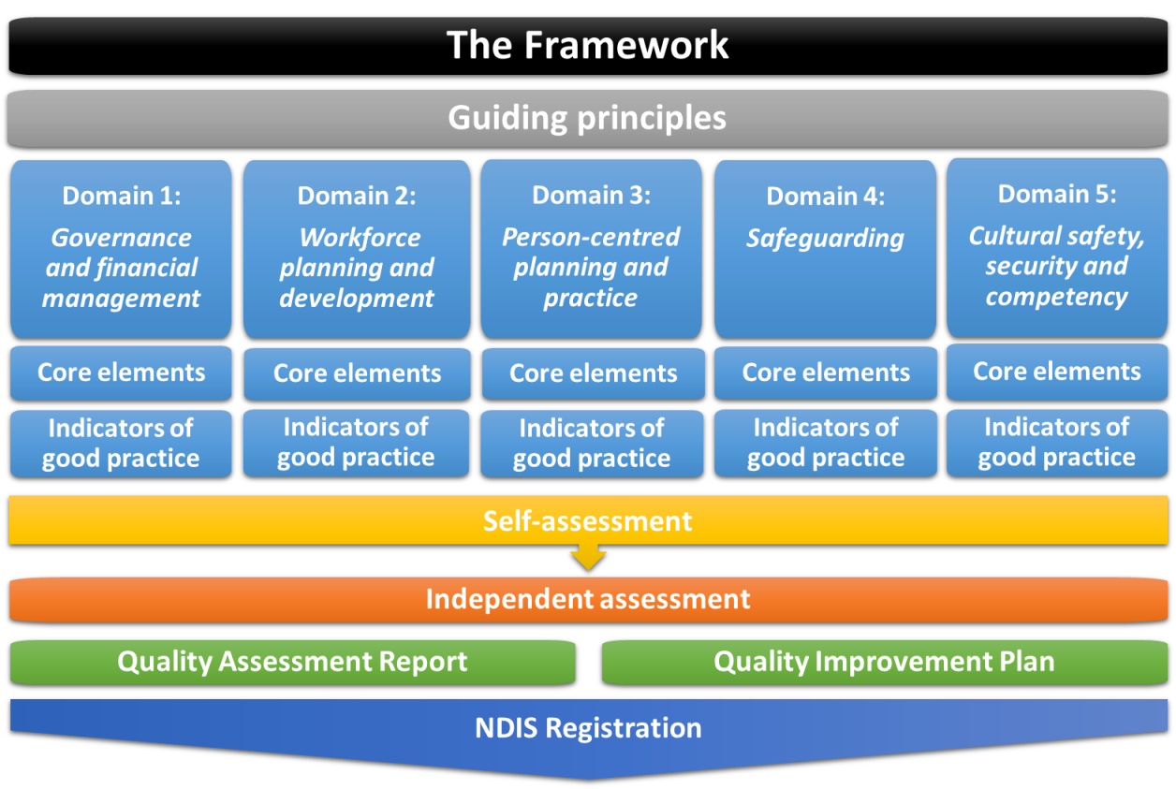
Diagram 1: Overview of the Framework

All providers intending to register with the NDIA to deliver particular NDIS supports in the NT must first successfully complete an assessment process against the NT Framework. Those Commonwealth funded providers who transition to deliver the same services through the NDIS will have a streamlined registration process due to existing accreditation and certification. Please see section 4.6 for further information.
The NT Framework supports a flexible approach to the assessment acknowledging the need for a strong focus on service development and capacity building.
NDIS registration includes an ongoing obligation to maintain compliance with the NT Framework during the NDIS transition (as reflected in the NDIA Terms of Business), and the NT Government may initiate a review of a provider or service type during the transition period to ensure adherence to the Framework.
The NT Government may issue practice guidelines and directions throughout the NDIS transition period. The practice guidelines and directions are a function of the Framework and providers will be notified in writing of practice guidelines and directions to which they will be required to adhere to throughout the transition. Details of NT practice guidance, directions and policy can be found at http://digitallibrary.health.nt.gov.au/prodjspui/

Registration process for providers of specialist disability supports in Northern Territory
Refer to Appendix 1: Provider registration process (for organisations delivering specialist disability services)

Provider registration application form
Providers registering with the NDIA must complete a Provider Registration Application Form and submit this form to the NDIA. Further information on how to register with the NDIA can be found in the Provider Toolkit.

Registration Groups
As part of the registration process, providers must declare that the people in their organisation are appropriately skilled to deliver the Registration Groups they are registering to deliver. The Provider Guide to Suitability describes the expectations for professional qualifications, professional association membership and experience.

Providing evidence for specialist disability registration groups
In the NT, NDIS providers of specialist disability services must comply with relevant NT and Commonwealth legislation. Providers must also comply with the NT Quality and Safeguarding Framework. The Framework is available to view at http://hdl.handle.net/10137/1155.
Within the Framework domains, there are elements with indicators of good practice that have been classified as ‘mandatory’ and others as ‘desirable’. Mandatory indicators are a mix of quality and safeguarding indicators that are essential for underpinning the safety, security and well-being of people with disability to fully exercise their rights and to lead the life they would like to live with the support of providers. Providers must demonstrate achievement or progress against the mandatory and desirable indicators of good practice to be registered.
The majority of indicators have been classified as desirable – meaning that these indicators reflect good practice and contemporary approaches to minimising the risk of harm, abuse or neglect of people with disability in circumstances of greater vulnerability. These indicators also focus on the quality of support provision within a person-centered practice where participants are able to fully exercise choice and control in relation to the supports they receive.
Assessment involves two key steps: a provider self-assessment, followed by an independent assessment conducted on-site by approved accredited assessors who have the necessary qualifications, skills and experience.
A self-assessment tool has been developed to enable providers to self-assess against the indicators of good practice requirements of the Framework. The tool is available through Breaking New Ground (BNG), NGO Services Online Standards and Performance Pathways (SPP) website.
The independent assessment will be conducted onsite by two qualified assessors (the assessment team) over a period of several days depending on the size, structure and geographic spread of the organisation. As part of the assessment process, assessors will seek to:
- review a range of documented evidence
- interview a range of staff within the organisation as well as participants, families and carers
- observe support provision, where appropriate.

The independent assessment process will result in the following:
- A comprehensive Assessment Report of achievement against the Framework requirements. It will contain a detailed commentary and assessment of each domain and its elements, including indicators of practice. The assessment process applies a four point developmental rating scale, and developmental scores will be determined for each domain that will quantify a provider’s achievement against Framework requirements.
- A Quality Improvement Plan (where applicable) against the Framework domains and elements with a checklist of key actions required and suggested timeframes for addressing actions.
The NT Government will consider the outcome of the assessment process and make a determination if the provider meets the Framework requirements. The NT Government will exercise a degree of flexibility regarding assessment – acknowledging the capacity building focus of the Framework. Based on the outcome of the assessment, the NT Government will recommend to the NDIA if a provider should be registered to deliver NDIS supports in the NT.
A provider will not be for registration with the NDIA if they fail to meet the mandatory indicators of good practice and is unable to demonstrate capacity to achieve these requirements within specified timeframes.

Allied Health Professionals and Streamlined Assessment
The NT Quality and Safeguarding assessment process includes a streamlined assessment component. This process is for sole traders and organisations who are registered with the NDIA to provide allied health supports and/or the NDIS registration groups identified as ‘streamlined’ under the Northern Territory Quality and Safeguarding Framework.

The streamlined assessment process, like the full assessment process, is facilitated by the NT Government. A key feature of the streamlined assessment process is the convening of a specialised panel for review and assessment of providers.

Sole traders and organisations within this cohort will be asked to provide the Office of Disability with evidence to support the applicants’ streamlined assessment to support their request for registration.
The purpose of the Panel is to provide expert advice on the suitability of sole traders and organisations requesting registration groups being delivered by an allied health professional and/or streamlined registration groups against the NT Quality and Safeguarding Framework, and make recommendations based on their assessments to the Assessor.

The Panel will operate from the date of formation (July 2017) to June 2019 when the NDIS is fully implemented in the NT. On behalf of the Panel, the Chairperson will make a written recommendation to the Office of Disability Assessor on the provider’s suitability to deliver requested supports under the NDIS based on the assessment outcomes of the Panel.

The Assessor will follow procedures as outlined in the Decision making guidelines for making recommendations for provider registration (May 2017) to make a recommendation to the NDIA on a providers suitability to provide NDIS supports in the NT.

NDIS Registration Groups
The NDIS Registration Groups for which assessment against the Framework is required are outlined below:
Registration Group | Requirement of the Framework/Full/Streamlined Assessment
Accommodation / Tenancy | No
Assistance Animals | No
Assist Access / Maintain Employment or Higher Education | No
Assistive Equipment for Recreation | Streamlined
Assistive Products for Personal Care and Safety | Streamlined
Assistive Products for Household Tasks | Streamlined
Assist-Life Stage, Transition | Streamlined
Assistance with Travel/Transport arrangements | Streamlined
Behaviour Support | Streamlined
Communications and Information Equipment | No
Community Nursing Care | Streamlined
Customised Prosthetics | Streamlined
Daily Personal Activities | Full
Daily Tasks/Shared Living | Full
Development-Life Skills | Full
Early Intervention Supports for Early Childhood | Streamlined
Exercise Physiology and Personal Training | Streamlined
Group and Centre Based Activities | Full
Hearing Equipment | No
Hearing Services | No
High Intensity Daily Personal Activities | Full
Home Modification | Streamlined
Household Tasks | Streamlined
Innovative Community Participation | No
Interpreting and Translation | No
Participate Community | Full
Personal Mobility Equipment | Streamlined
Plan Management | Streamlined
Specialist Disability Accommodation | No
Specialised Driver Training | No
Specialist Hearing Services | No
Support Co-ordination | Streamlined
Specialised Supported Employment | No
Therapeutic Supports | Streamlined
Vehicle modifications | No
Vision Equipment | No

Commonwealth providers

Commonwealth Quality and Safeguard Arrangements
Existing Commonwealth providers who transition to deliver the same services through the NDIS will continue to be required to meet the Quality and Safeguards terms outlined in their Commonwealth funding agreements in accordance with the Terms of Business for Registered Providers for the NDIA. These include the requirement for providers to:
- engage appropriately qualified staff to deliver the agreed services including meeting relevant Commonwealth arrangements and policies relating to Vulnerable Persons, Police Check and Criminal Offences
- ensure services are delivered in accordance with the National Standards for Disability Services under the Commonwealth Disability Services Act 1986
- meets the relevant national standards and accreditation requirements
- operate in line and comply with the requirements as set out within all state and territory and Commonwealth legislation and regulations
- apply the highest standards of duty of care
- ensure service provision is effective, efficient, and appropriately targeted
- ensure Aboriginal and Torres Strait Islander people have equal and equitable access to services
- have appropriate internal complaints mechanisms in place
- maintain adequate insurance
- report performance against identified performance indicators
- notify the Commonwealth of anything reasonably likely to affect the performance of the Activity or otherwise required under this Agreement
- provide necessary verification that the Grant was spent in accordance with the grant details
These providers will ensure NDIS participants who are accessing their services are aware they can still access the existing Commonwealth safeguard arrangements, when required, including:
- service provider complaints processes
- Department of Social Services complaints processes
- The Commonwealth Ombudsman
- The Australian Human Rights Commission
- Other mainstream law enforcement and legal avenues

Arrangements for existing Commonwealth funded services to expand their support offering
Current Commonwealth funded providers that intend to expand their service offering through the NDIS will need to apply directly to the NDIA for registration of new registration groups.
Providers will be required to attain and maintain certification for the expanded service type under the NT Quality and Safeguards Framework for the transition period or until a national quality and safeguard arrangement is agreed to.

Australian Disability Enterprises and employment support services delivered by the Commonwealth
Transitioning Australian Disability Enterprises will be required to continue to meet their obligations against their Funding Agreements while also maintaining certification under JAS-ANZ against the National Standards for Disability Services.
New Australian Disability Enterprises (ADE) and employment support providers continue to be required to attain and maintain certification under the National Standards for Disability Services for the transition period or until a national quality and safeguard systems is in place.

Commonwealth Continuity of Support Program
During the transition to full scheme, for providers delivering services to older people with disability under the Commonwealth Continuity of Support Program, NT and the Commonwealth intend to continue existing or comparable quality and safeguards arrangements using established mechanisms.

Quality framework

Northern Territory quality framework
The NT Quality and Safeguarding Framework is a system for assessing and improving the quality of disability services and for promoting quality outcomes to people with disability who access those services. The Framework is designed to:
- ensure providers are delivering the right supports through the right support staff
- ensure supports are delivered in an appropriate manner, that they reflect and respond to the needs and goals of the individual
- ensure people with disability have access to information and education to make informed decisions
- ensure participants in receipt of support are safe from the risk of harm, abuse and neglect
- protect and promote the rights of people with disability
- allow participants to take reasonable risks to achieve their goals.
The Framework has been designed to be fit-for-purpose, and while it aligns with the National Standards for Disability Standards and other relevant standards, it provides a level of flexibility to ensure service providers are given the opportunity to continually improve and innovate over time to meet the needs of participants.
The Framework and the assessment process during the NDIS transition period will be used as an opportunity to support service providers to prepare and meet the NDIS full Scheme national Framework in 2019. The assessment process will also support the NT disability sector to strengthen its support offerings and will assist in the establishment of a sustainable provider market post full Scheme implementation.

During transition
All NDIS providers of specialist disability supports must comply with the Framework and any practice guidelines or directions issued by the NT Government throughout the NDIS transition period. Please see section 4.5 for a list of those Registration Groups that require compliance with the NT Quality and Safeguarding Framework.

Alternative accreditation/certification
Providers can request the NT consider an existing alternative accreditation or certification as evidence of meeting the NT Quality and Safeguarding Framework. Requests will be considered on a case-by-case basis. If accepted, the alternative certification must be maintained for the transition period.

Notifiable issue – major non-compliance
The NT Government will notify the NDIA when an NDIS provider of specialist disability services has a major non-compliance to the NT Quality and Safeguarding Framework.
The NDIA will then initiate ‘show-cause’ action under s72 of the National Disability Insurance Scheme Act 2013.

Contact points – quality assurance
Contact point | By whom | To whom | Contact details
Initiate NT Quality and Safeguarding Framework assessment process | Provider | Territory | NDISProviderRegistration@nt.gov.au
Major non-compliance | Territory | NDIA | Quality.safeguards@ndis.gov.au
Advice that provider no longer meets requirements of the NT Q&S Framework (triggering s.72 of NDIS Act 2013) | Territory | NDIA | Quality.safeguards@ndis.gov.au

Criminal history screening

NT criminal history screening
Provider must act in accordance with all relevant Commonwealth and NT legislation, policies and guidelines, in regards to workforce screening, including a criminal history check through a national police check and obtaining a working with children clearance for the NT (Ochre card).

During transition
Provider must act in accordance with all relevant Commonwealth and NT legislation, policies and guidelines, in regards to workforce screening. This includes the mandatory good practice indicators outlined in the ‘Recruitment, Selection and Induction’ section of the Domains, Elements and Indicators Guide of the NT Framework.
Providers must ensure that all staff, volunteers and executive decision makers have undergone appropriate screening checks before commencing working with their organisation. This includes a criminal history check through a national police check and obtaining a working with children clearance for the NT (Ochre card).

Workforce
Providers must ensure that all staff, volunteers and executive decision makers are suitable for the roles they are performing. In particular, providers must ensure services are delivered by an appropriately skilled workforce that can support the health, developmental, complex care and behavioural needs of clients. Staff providing care should have a minimum qualification level of Certificate III Community Services Disability or equivalent, or a supported training plan to ensure that they achieve it in a reasonable timeframe. Where staff have no formal qualifications, they should have demonstrated skills and experience relevant to their duties.
Providers must ensure that all staff have appropriate support from supervisors with a minimum of Certificate IV Community Services Disability or equivalent.

Non-compliance
If an NDIS provider of specialist disability services fails to comply with the criminal history screening requirements, they no longer meet the requirements of the NT Quality and Safeguards Framework and the NT Government may rescind its recommendation for NDIS registration and advise the NDIA.

Complaints

Commonwealth complaints systems during transition
Any person who is not satisfied with their service provider's internal complaints and disputes mechanisms can contact the Complaints Resolution and Referral Service. Find more information about the service at online at www.crrs.net.au
The National Disability Abuse and Neglect Hotline is a telephone service for reporting cases of abuse and neglect of people with disability in the community. If a caller reports abuse or neglect in any situation, the Hotline will refer the report to an agency able to investigate or otherwise address the report, such as an ombudsman or complaints-handling body. The Hotline provides support to callers on how a complaint about abuse and neglect might be raised and resolved at the local level. Find more information about the Hotline at www.disabilityhotline.net.au/general/contact-us/
The Complaints Resolution and Referral Service and the National Disability Abuse and Neglect Hotline will operate through NDIS transition.
The Commonwealth Ombudsman can investigate complaints about the actions and decisions of Australian Government agency actions and decisions to see if they are wrong, unjust, unlawful, discriminatory or unfair. The Ombudsman also seeks remedies for people affected by administrative deficiencies and acts to improve public administration.
The Ombudsman has strong investigatory powers. If required, officers working in government agencies must produce documents and answer questions under oath during Ombudsman investigations.

NT complaints systems
The NT Quality and Safeguards Framework requires all NDIS providers of specialist disability services to establish and operate a clear and accessible complaints system to receive and resolve complaints about the services they provide. The service provider’s complaints system should include a mechanism to advise their service users of their right to complain to the Health and Community Services Complaints Commission if they are not satisfied with the outcome of their complaint.

During transition

Complaints managed by NDIA
During NDIS transition, the NDIA will operate a complaints management system for complaints in relation to:
- agency staff
- agency processes
- complaints about market capacity and availability of service provision.

Complaints about these matters can be made to the NDIA at feedback@ndis.gov.au. Find more information about this process at www.ndis.gov.au/about-us/contact-us/feedback-complaints.

Complaints managed by the state
The NT Government will have a role in managing complaints lodged about:
- NT funded disability providers
- NT directly delivered disability services
- NDIS providers of specialist disability services, when made by participants, their family, carers or advocates.
Providers are expected to manage complaints about the delivery of services and have established and published clear and accessible complaints processes for any complaints received. The provider must keep a register of all complaints received, including the outcomes and resolutions.
Where complaints are unable to be raised or resolved with the provider, the NT Department of Health may refer the complaint to the appropriate body. Depending on the nature of the complaint, this may be either:
- the Health and Community Services Complaints Commission
- the Office of the Public Guardian
- the Office of the Children’s Commissioner (complaints about vulnerable children, including children with disability)
- the Anti-Discrimination Commission.
The complaints process will reflect a ‘no wrong door’ approach ensuring effective access to complaints resolution for all participants, their family, carers, providers and advocates interacting with the NDIS.
Health and Community Services Complaints Commission
All disability services in the NT are subject to the Health and Community Services Complaints Commission (Commission) regardless of their funding source. The Commission provides assistance to Territorians to resolve complaints about health, disability and aged services and make recommendations to improve the quality of these services.
Please also see Appendix 2 for details of complaints process.

Referral pathway – Complaints
Type of complaint | Responsibility | Contact point
About a disability service provider or support, or about how the provider has managed a complaint | NT Office of Disability  Health and Community Services Complaints Commission | NDISProviderRegistration@nt.gov.au  hcscc@nt.gov.au
About how the NT Government has handled a complaint about a provider | Health and Community Services Complaints Commission  Ombudsman NT | hcscc@nt.gov.au  nt.ombudsman@nt.gov.au
About a decision to use restrictive practices | NT Office of Disability  Health and Community Services Complaints Commission | NDISProviderRegistration@nt.gov.au  hcscc@nt.gov.au
About a service or support provided by an unregistered provider, including consumer complaints covered by the Australian Consumer Law | Health and Community Services Complaints Commission  NT Consumer Affairs | hcscc@nt.gov.au  consumer@nt.gov.au
About an NDIA decision or staff member | NDIA | feedback@ndis.gov.au
An NDIA provided service or support (e.g. planning, Local Area Coordination etc.) | NDIA | feedback@ndis.gov.au
How the NDIA has managed a complaint | NDIA  Commonwealth Ombudsman | feedback@ndis.gov.au  via online complaint form at http://www.ombudsman.gov.au/making-a-complaint

Serious Incidents

NT Serious Incidents requirements
The NT Quality and Safeguarding Framework (Framework) requires all providers delivering supports under the NDIS in the Northern Territory to have policies and procedures to assist in the prevention, identification and response to critical incidents that impact upon participants.
The NT Government will issue all NDIS providers in the NT with Critical Incident Reporting Guidelines (Guidelines), which outlines the roles and responsibilities of providers in relation to the occurrence of a reportable incident. The Guidelines specify the scope of a critical incident, the reporting requirements and timeframes for notification to the Office of Disability. The Guidelines also provide opportunity to develop a Quality Improvement Plan to address actions against the indicators within the Framework aimed at the prevention of future critical incidents and participant harm.

During transition
Providers must adhere to the mandatory good practice indicators outlined in the ‘Critical Incident Management’ sections of the Framework and any practice guideline issued pursuant to the Framework and these practice indicators.
Providers have an obligation to notify the NT Government of a critical incident and provide information on the management of incidents within the determined timeframes. Providers are to have a policy and procedures in place for internal reporting, recording and management of near misses and incidents not within the scope of reportable incidents, and to undertake corrective action, and where necessary review and amend policies and procedures to prevent reoccurrence of incidents.
When a critical incident occurs, providers are required to follow the Guidelines, including reporting the critical incident to cirDisability.DOH@nt.gov.au within the timeframes outlined within the Guidelines.
A reported critical incident may constitute non-compliance under the Framework. If an NDIS provider of disability services fails to comply with the requirements of the Critical Incident Reporting Guidelines, the Northern Territory Government may engage the provider in quality improvement measures. If non-compliance with the requirements of the Critical Incident Reporting Guidelines is apparent, the Northern Territory Government will report this failure to the NDIA as a major non-compliance, and recommend the NDIA initiate ‘show cause’ process under s72 of the NDIS Act.
The NDIA’s role is limited to situations where a NDIA staff member witnesses or becomes aware of a critical incident involving a NT registered NDIS provider. In these circumstances, the NDIA will:
- Where necessary, initiate a crisis response to respond to the immediate needs of the participant involved and re-establish a safe environment if required;
- Inform the designated NT Government contact as soon as possible.
The NT Government will continue to support providers during transition to develop a positive reporting culture to assist providers to meet the full Scheme NDIS Quality and Safeguards Framework in 2019.

Restrictive practices

NT restrictive practices
Providers must act in accordance with all relevant Commonwealth and NT legislation, policies and guidelines, in regards to the use of restrictive practices.
The NT Government will issue guidelines regarding the use of restrictive practices to NDIS registered providers of specialist disability services. These guidelines reflect Commonwealth and NT legislation as well as NT Government policies and current best practice with regard to the implementation of restrictive practices. Throughout the transition to the NDIS, the NT Government will work with providers to ensure these guidelines are applied. Support will be made available to providers on an as needs basis.

During transition
Providers must act in accordance with all relevant Commonwealth and NT legislation, policies and guidelines, in regards to the use of restrictive practices. This includes the mandatory good practice indicators outlined in the ‘Information and Education for Participants and Support Workers’ and ‘Restrictive Practices’ sections of the Domains, Elements and Indicators Guide of the Framework and any practice guidelines issued pursuant to the Framework and these practice indicators..
Providers are required to have appropriate processes in place to authorise the use of restrictive practices, which includes restraint (physical, mechanical, environmental or chemical) or seclusion.

Major non-compliance
Failure to follow the Framework, its guidelines or directions with respect to restrictive practices may constitute major non-compliance under the Framework.
If an NDIS provider of specialist disability services fails to comply with the restrictive practice requirements, they may no longer meet the requirements of the NT Quality and Safeguards Framework and the NT Government may rescind approval for NDIS registration and advise the NDIA.

Monitoring and compliance

NT monitoring and compliance systems
Service providers are subject to complaints jurisdiction of the Health and Community Services Commissioner. The Health and Community Services Commissioner may monitor the outcome of a complaint following conciliation or an investigation.

During transition
In transition, all NDIS service providers will be subject to complaints jurisdiction by the Health and Community Services Commissioner; following a complaint, the Health and Community Services Commissioner may monitor the outcome following conciliation or an investigation.
In addition, the requirement of meeting the Framework, its guidelines and directions are an ongoing obligation during the NDIS transition, and the Northern Territory Government may initiate a review of a provider or service type during the transition period to ensure adherence to the Framework.

Preliminary notification
At the start of an investigation, the NT Government will notify the NDIA at quality.safeguards@ndis.gov.au of any NDIS provider of specialist disability services that does not comply with the requirements in NT.

Contact points – monitoring and compliance
Contact point | By whom | To whom | Contact details
Investigation that results in major non-compliance with NT Quality and Safeguard Framework requirements | Territory | NDIA | Quality.safeguards@ndis.gov.au
Request for advice regarding provider status | NDIA | Territory | NDISProviderRegistration@nt.gov.au

Appendix 1 – NT Provider Registration Process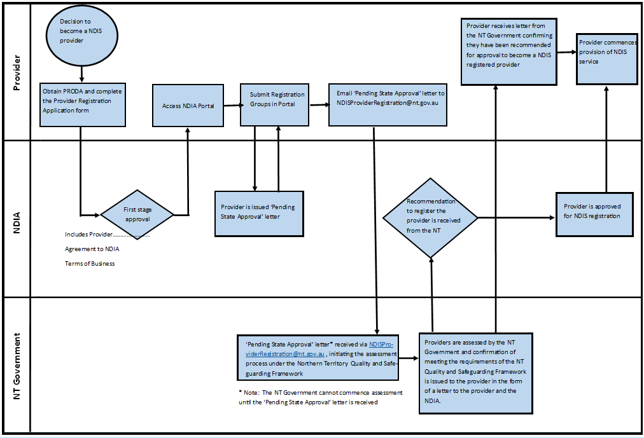
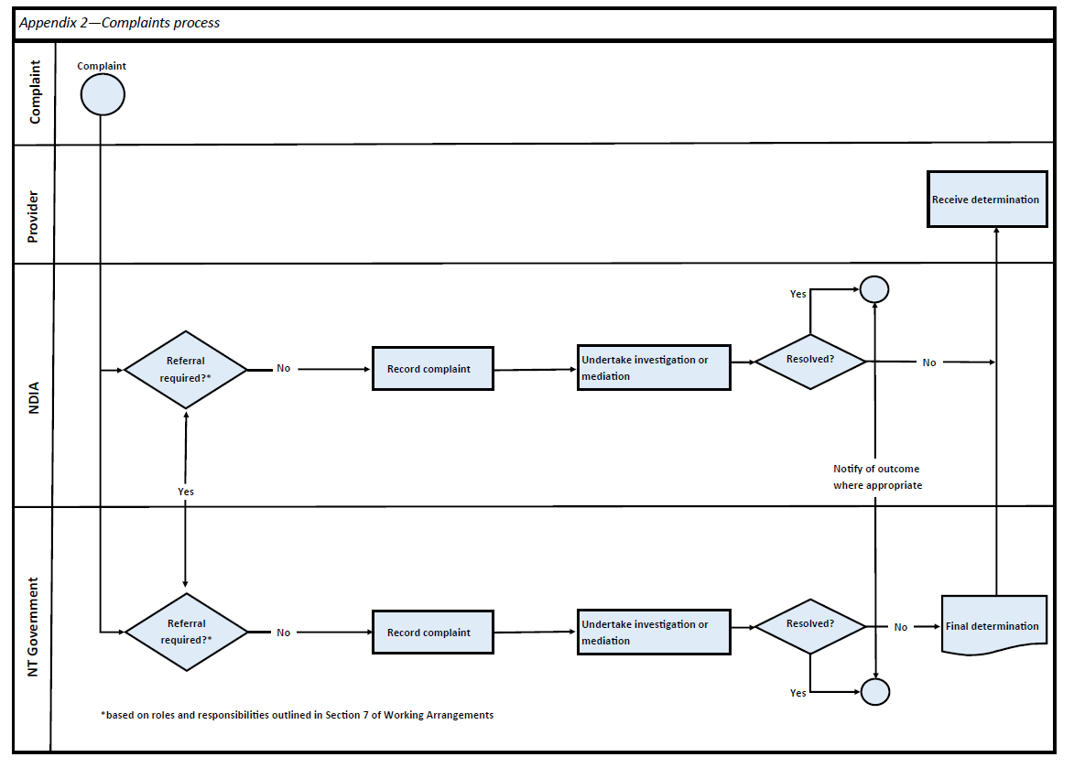
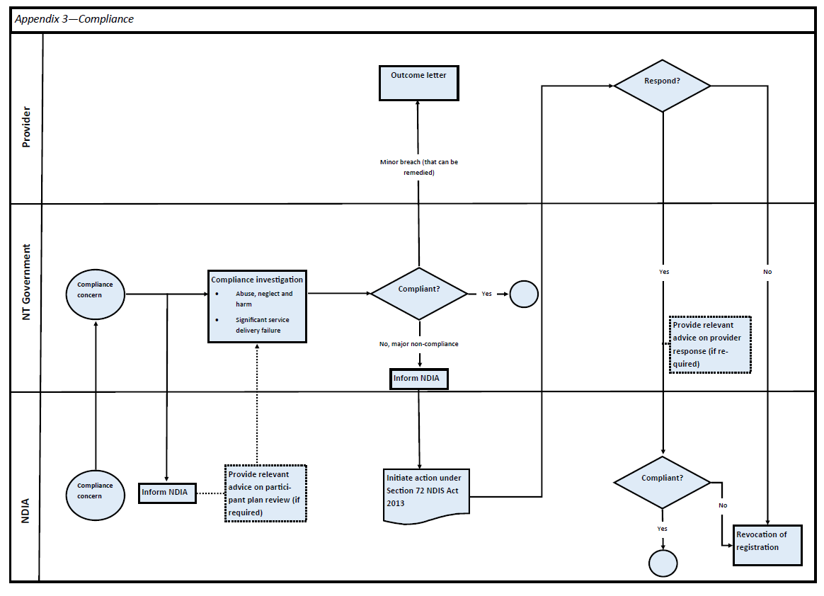
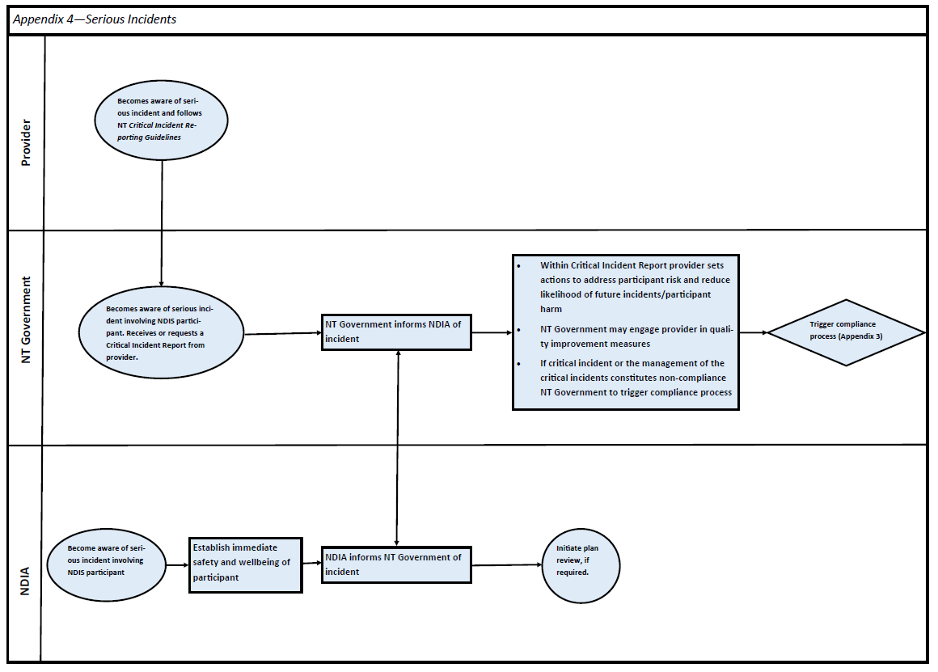

The Northern Territory Government has engaged BNG, a non-government organisation, to host the self-assessment tool. The tool is available from: <https://www.ngoservicesonline.com.au/nds-quality>
Refer to Table 1 of these Guidelines: ‘Process for assessment reporting and decision-making’.
A major non-conformity issue in most cases will relate to a matter of serious concern or noncompliance with key legislative safeguards.

